***[](http://arrl-ohio.org) August 2021 –***

***Back to School!***

***(Radio School that is…)***

|  |  |
| --- | --- |
| 🡪 From the Technical Coordinator | **🡪** From the Section Emergency Coordinator |
| **🡪** From the Public Information Coordinator | 🡪 From the Section Traffic Manager |
| **🡪** ARES Training Update | 🡪 Club Corner |
| 🡪 DX This Week | 🡪 Contest Corner |
| 🡪 One Question Questionnaire | 🡪 From The South 40 |
| 🡪 Final.. Final.. | |
| New To Ham Radio?  The OHIO Section is sponsoring learning and exploring sessions. Technical Specialist Jason – N8EI will be presenting one of those sessions on Tuesday, August 31st beginning at 7:30pm. His topic is “Beyond the Baofeng: Thoughts on Equipment Choices for New Hams.” You received your license. Picked up a $20 Baofeng. Tried to reach some repeaters with it. Now what?  Thomas Sly is inviting you to a scheduled Zoom meeting.  Topic: Ohio Section - “Beyond the Baofeng: Thoughts on Equipment Choices for New Hams.”  Time: Aug 31, 2021 07:00 PM Eastern Time (US and Canada)  Join Zoom Meeting  https://us02web.zoom.us/j/89913057151?pwd=QU5qd3gzQUVOclN1VjhpRHIzdGV1UT09  Meeting ID: 899 1305 7151  Passcode: 241591 | |

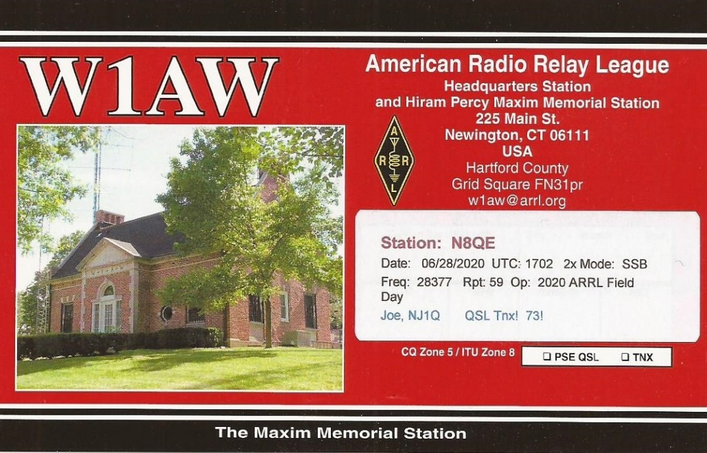

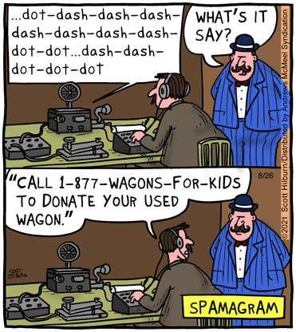

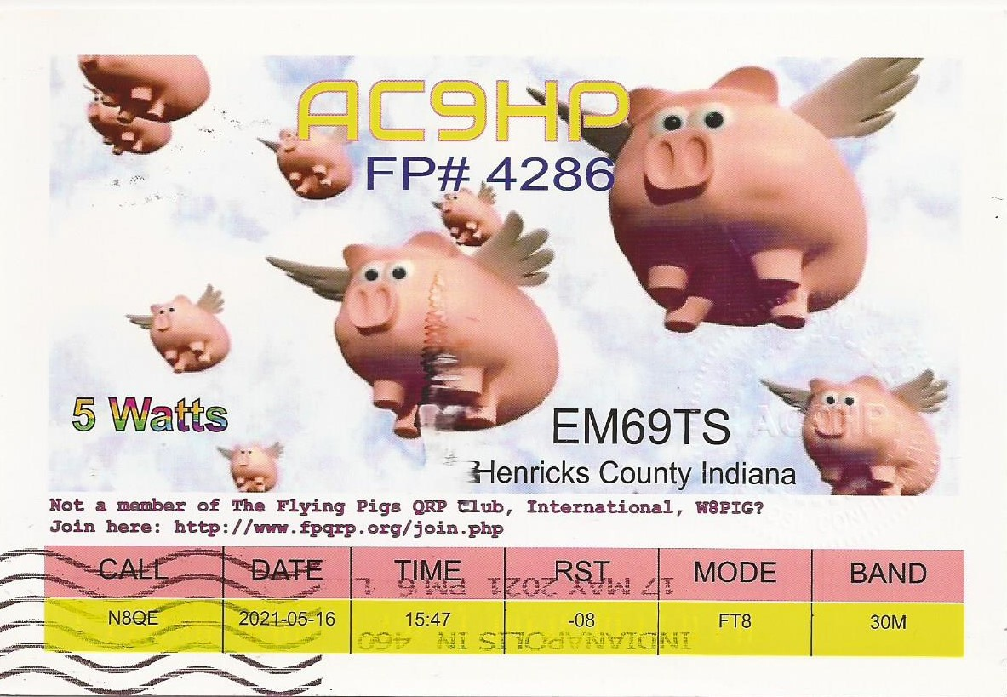

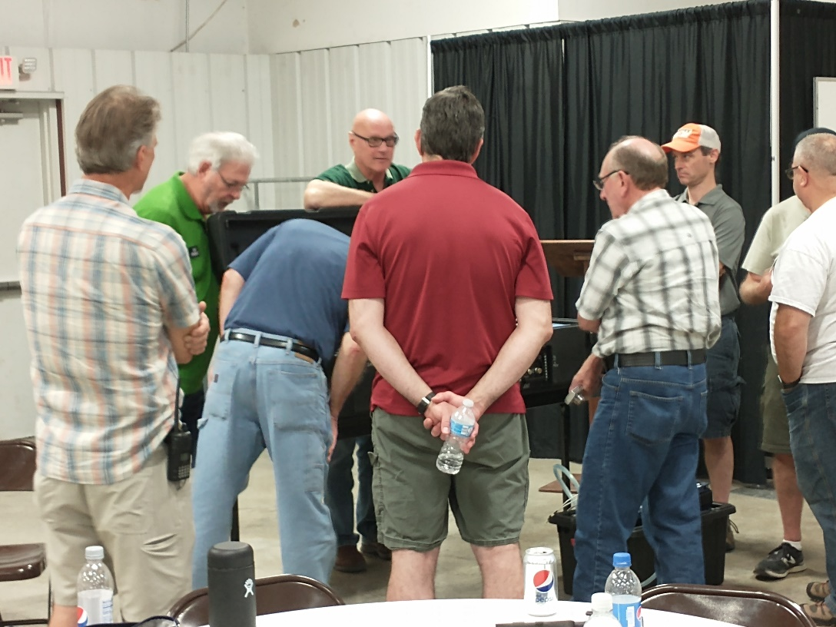

***What’s Everybody Looking At?***

***(Answer in the Final Final)***

***___________________________________________________________________***

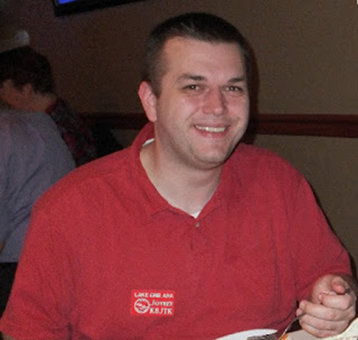***From the Technical Coordinator***

***Jeff Kopcak – K8JTK TC***

[k8jtk@arrl.net](mailto:k8jtk@arrl.net)

Hey gang,

PSA: make copies of old computing media now before that data is lost for good. Those of us that are old enough to know or remember what floppy disks are – and no, it’s not the 3D printed version of the save icon! This is my adventure in preserving legacy media.

Floppy disks, simply “floppy” or “disk”, was a data device based on usage of a flexible magnetic storage medium. Systems dating back to the Commodore utilized floppies and other formats such as cassette tapes. PCs first used 8-inch floppy disks, then 5 ¼ or “five-and-a-quarter-inch disk,” finally 3 ½ or “three-and-a-half-inch disk.” Most who are my age remember the 3.5” floppy because it was a very common storage medium for transporting research, papers, and data between home and school. Never had any 8” floppies. I’ve been around computers longer than most my age and have a couple 5.25” disks.

Later in high school and college (through about 2005), advances in storage technologies allowed for lager capacities at roughly the same size. The Zip disk was still considered a floppy but had rigid housing to protect the medium at about the same size as a 3.5” floppy, though twice as think. Zip disks could store 100 MB versus the 1.44 MB of the 3.5” floppy. Writable CDs became affordable as anyone could now “burn” an optical disk with a storage capacity of 650-700 MB. DVDs for videos and large capacity 4.7 GB storage were standard mid-to-late 2000’s. Those have since been superseded by multi-gigabyte USB solid-state and “cloud storage.”

If you’re like me and hung on to those floppies because they still have old games, maybe using them for document or picture storage – for some reason, or old programs you would like to use again. I started this project as I was sorting through old computer equipment and it was probably past time to preserve the data. That is, if they could still be read. Since I was going through this work of preserving data on floppies, I decided it was probably time to save CD-ROMs and DVD-ROMs as well. In theory, medium, especially optical, should last a good long while. However, all medium will degrade over time. It’s also a factor of how the disks were stored, the quality of the drive that wrote the disk, cleanness of the head, quality of the diskette, reading drive aligns with written tracks, to name a few.

Being anywhere from 15-25 years old or more, another reason for doing this is because new computer systems (desktops/laptops) are not coming with devices to read legacy media. The new laptop I received from work doesn’t even have standard USB (A) or HDMI ports! Most keyboards, mice, USB drives, image scanners, SDR dongles, etc. still use that type of port. This machine only comes with USB-C and I need an assortment of dongles to connect standard keyboards, mice, and monitors to the new laptop. They took a cue from Apple MacBook.

While I still have 5.25” disks, it was a much small number. Probably under 15. 3.5” disks, I probably have 150 – 200 laying around. Whether I got lucky, the drive/medium are of better quality, or better error correction/recovery, I had no problem reading the 5.25” disks. I thought: older medium, more problems. That was not true in my case.

Standard disclaimers: copying of some software (though the company may be long gone out-of-business), is still considered piracy – though highly unlikely really anyone cares. You are free to do with this information as you wish.

# Locating drives and media

First, locate legacy media (floppies, Zip disks, CD/DVD-ROMs) to be preserved. If labeled correctly, you might be able to tell right away which ones are worth saving. Things you or your kids did when they were younger might be worth saving, but that old accounting program, probably not. Emulation and virtualization technologies have come a long way and is quite possible to get those old programs running again with a little effort. That’s another article.

Next - locate a device to read that media. Throughout the years, I’ve hung on to a handful of old floppies, Zip, and, CD/DVD drives. Before throwing in the towel this early, consider that it might be easier than you think to locate a drive – should one not be readily available. A floppy disk drive, floppy cable, and old motherboard with a floppy controller is all you really need.

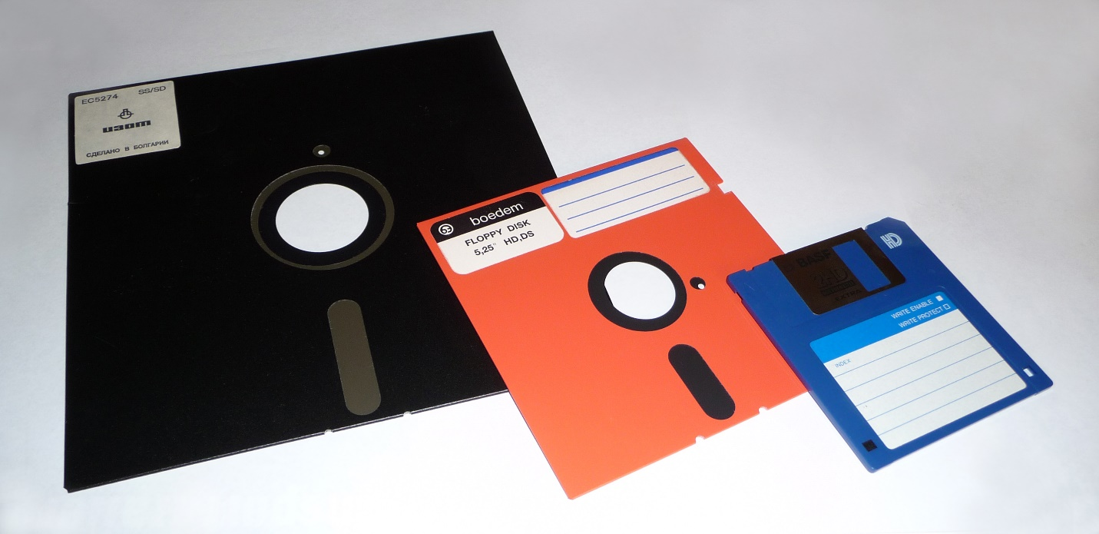

8-inch, 5¼-inch, and 3½-inch floppy disks (Wikipedia)

To find 8” drives, you’re probably going to eBay, computer surplus shops, or even a hamfest. They’re “vintage” on eBay, therefore asking prices are $100 and up for a drive. These old drives have been [successfully connected to modern PCs](https://www.vcfed.org/forum/forum/technical-support/vintage-computer-hardware/21299-hooking-up-an-8-floppy-to-a-modern-pc?20970-Hooking-up-an-8-quot-floppy-to-a-modern-PC=) with the help of an external controller or [adapter](http://www.smbaker.com/qume-842-8-floppy-drive-with-a-rc2014-z80-retrocomputer). My 5.25” floppy drive connected and worked just fine on a motherboard (late 2000’s era) I had laying around with a floppy controller. If a motherboard is not available, a floppy controller with USB capabilities from [KryoFlux](https://kryoflux.com/) or [GoTek](http://www.gotekemulator.com/P_view.asp?pid=54) would do the job. 3.5” floppy drives are readily available, have USB connections and cost about $20. Consider 5.25” and 3.5” combination drives if both formats are needed.

Early Zip drives came as an external device with a parallel port connection. They were god-awful slow. With more than a few Zip disks to copy, look for a drive with an ATAPI (IDE) connection if you have a motherboard with an IDE controller. Otherwise, opt for the USB drive version. ATAPI isn’t breaking any speed records either. They are quicker and you don’t have to find a motherboard with a parallel port and locate Zip drive drivers. The Zip 250 and 750 drives can read lower capacity disks. The Zip disk format has been long dead and the [Iomega](https://en.wikipedia.org/wiki/Iomega) company was bought and sold a few times, eventually being completely [discontinued](https://www.howtogeek.com/658287/even-25-years-later-the-iomega-zip-is-unforgettable/). All of these drives will be surplus/eBay/hamfest finds.

Operating system support still exists, at least on the PC side. A Windows 7 64-bit operating system handled all the formats I threw at it: 5.25” floppy, 3.5” floppy, Iomega Zip 100 ATAPI, and obviously CD/DVD. The Zip ATAPI/IDE interface showed up as a standard removable disk drive. An older PC with an older operating system increases your chances of a working combination.

Zip disks, in particular, had a proprietary software method of preventing accidental writing to the disk or requiring a password to read the disk. In the case where any of these protections were used, or any other proprietary method of encrypting media, those conditions under which the media was “locked” will likely need to be recreated in order to read or decrypt the data. The same legacy drive connected to a PC, same legacy operating system with drivers/applications used to write-protect or encrypt the disk – if you still have copies of all those programs. Not to mention, remembering the password.

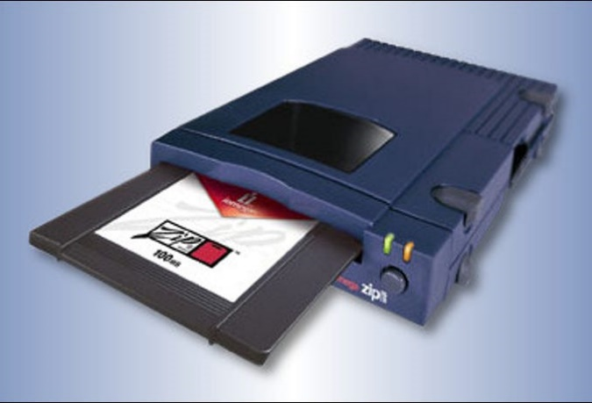

Parallel port Zip drive and disk (How-to Geek)

CDs and DVDs were no problem as those formats are somewhat current and operating systems include native support for those drives. Fedora 33 worked with all, though it doesn’t automatically load the floppy driver by default. I had to: *sudo modprobe floppy* . I did not test a copy of Windows 10. A Win10 rescue disk worked just fine with all formats so I suspect Windows 10 will be fine as well. Copying the data can be as easy as opening the drive in the desktop, selecting the contents, and copying files to a directory on your hard drive.

ISO files are a single file that contains the entire CD/DVD/Blu-Ray disc structure to precisely duplicate a disc. These are often used when downloading Linux/Unix distributions. Windows 10 can be downloaded as an ISO as well. Many utility and recovery tools available as ISO downloads are meant to be burned to disc or written to a bootable USB drive. Nearly all CD/DVD/Blu-ray authoring programs have the option of creating or burning ISO files.

IMG (sometimes referred to as IMA, standing for “image”) files are similar to ISOs but for floppy disks. IMG files are a single file, raw sector dump, of a medium. I have no scientific data to indicate drag-and-drop copying is just as-good-as creating an image file. If I had to guess reasons an image would be a better option: maybe a form of copy protection looks at a specific sector for a known value or possibly date & time stamps. If something wasn’t as expected, it might fail believing a copy was made. I came across one instance where straight copying files caused special characters to be converted. A “~” was converted to “_”. This is more likely to cause an issue for an installer program because a filename doesn’t match. To me, it just seems better to make a raw copy of the disk. Once again, the more complicated method is my preferred method.

My goal was to have an image made directly from the disk. In reading up, examples showed creating a ‘blank floppy image’ file, reading disk contents, and writing to the blank image. I did not want that as total disk size could be different. Disks containing my documents or picture files, I copied those to a folder on a hard drive. Disks containing programs or installation media, images of the disk were made.

A raw sector dump of a floppy disk occupying the same amount of space as if the disk was completely full. 1.44 MB disks will take up 1.44 MB, even if only 300K is written to the disk. 720K disks take up 720K. CD/DVD/Blu-ray ISO and BIN files will be the same size as the total amount of data written on the disc (333 MB disc = 333 MB ISO). For multi-gigabyte and terabyte hard drives, these sizes are nothing.

Next time, my adventures continue into creating, using, and storing image files.

The Section is sponsoring learning and exploring sessions. Technical Specialist Jason – N8EI will be presenting one of those sessions on August 31st. Details have been published in recent PostScrips and later in this edition. His topic is “Beyond the Baofeng: Thoughts on Equipment Choices for New Hams.” You received your license. Picked up a $20 Baofeng. Tried to reach some repeaters with it. Now what? Now comes a real station. He touches on prioritizing equipment purchases and gives recommendations on radios. It will be a good one not only for newly licensed hams but hams looking to improve their station.

Thanks for reading and 73… de Jeff – K8JTK

***From the Section Traffic Manager***

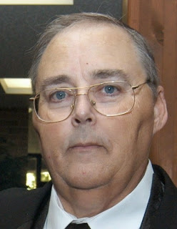***David Maynard, WA3EZN – STM***

[wa3ezn@att.net](mailto:wa3ezn@att.net)

Get Set for SET: ARRL Simulated Emergency Test Ahead, Plan Now

The 2021 ARRL Simulated Emergency Test (SET) is just ahead. The primary ARRL-sponsored national emergency exercise is designed to assess the skills and preparedness of Amateur Radio Emergency Service® (ARES®) volunteers, as well as those affiliated with other organizations involved with emergency and disaster response. The primary SET weekend is October 2-3, but Local and Section-wide exercises may take place throughout the fall. The annual SET encourages maximum participation by all amateur radio operators, partner organizations, and national, state, and local officials who typically engage in emergency or disaster response.

In addition to ARallied groups and public service-oriented radio amateurs are needed to fulfill important roles in this nationwide exercise.

The SET allows volunteers to test equipment, modes, and skills under simulated emergency conditions and scenarios. Individuals can use the time to update a "go-kit" for use during deployments and to ensure their home station's operational capability in an emergency or disaster. To get involved, contact your local ARRL Emergency Coordinator or Net Manager. Check on upcoming planned activities through local, state, or Section-wide nets. ES volunteers, radio amateurs active in the **National Traffic System**, Radio Amateur Civil Emergency Service (RACES), SKYWARN™, Community Emergency Response Team (CERT), and a variety of other

**BUCKEYE NET EARLY.** This CW net is in need of a net manager. WB8YLO has been doing a fine job as manager but has informed me that a family situation will keep him off the air for six months to a year. Efforts to find a new net manager has lead to the position still being open. In order to fill the reporting requirements I have offered and began to receive the individual NCS reports and will tabulate the results at the end of each month.

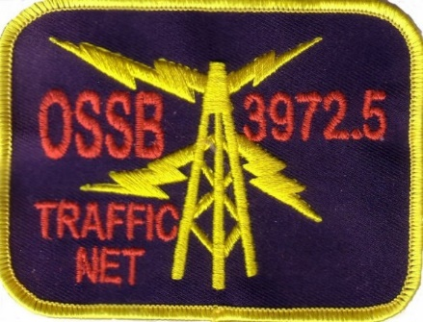

To find out if you would like traffic handling try listening or check into one of these nets.

**OHIO SINGLE SIDEBAND NET**

|  |  |  |  |
| --- | --- | --- | --- |
| **Morning session** | **10:30 AM** | **3972.5 KHz** | **every day** |
| **Afternoon session** | **4:15 PM** | **3972.5 KHz** | **every day** |
| **Evening session** | **6:15 PM** | **3972.5 KHz** | **every day** |

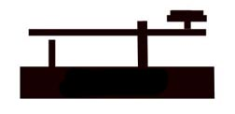**OHIO HF CW TRAFFIC NETS**

|  |  |  |  |
| --- | --- | --- | --- |
| **HF CW NETS** | **NET TIMES** | **FREQUENCY** | **NET MANAGERS** |
| **Buckeye Early** | **6:45 PM** | **3.580** | **WB8YLO** |
| **Buckeye Late** | **10:00 PM** | **3.590** | **WB9LBI** |
| **Ohio Slow Net** | **6:00 PM** | **3.53535** | **W8MAL** |

All net frequencies plus or minus QRM. .

**OHIO LOCAL VHF TRAFFIC NETS**

|  |  |  |  |
| --- | --- | --- | --- |
| **VHF NETS** | **NET TIMES** | **FREQUENCY** | **NET MANAGERS** |
| **BRTN** | **9:30 PM DAILY** | **145.230 PL 110.9** | **W8DJG** |
| **COTN** | **7:15 PM DAILY** | **146.970 PL 123.0** | **KD8TTE** |
| **MVTN** | **7:00 PM Mon** | **146.640** | **KC8HTP** |
| **NWOHARES** | **6:30 PM DAILY** | **146.10** | **N8TNV** |
| **TCTTN** | **9 PM Sun, Tues, Fri** | **146.94 PL 110.9** | **WB8YYS** |
| **TATN** | **8:00 PM DAILY** | **146.670 PL 123.0** | **WG8Z** |

On the 15TH of the month North West Ohio ARES Traffic Net meets on the alternate frequency of 146.94. These VHF net times and frequencies are those that have been reported to me by the net managers.

A few more words about ham radio etiquette. Etiquette does not simply mean knowing what fork to use at a formal dinner. It means knowing the "rules of the road" for any endeavor and knowing how to avoid embarrassing (or even offensive) missteps. Good operators are made, not born

Etiquette does not simply mean knowing what fork to use at a formal dinner. It means knowing the "rules of the road" for any endeavor and knowing how to avoid embarrassing (or even offensive) missteps. In this article, we will discuss the etiquette of on-the-air conversation, or ragchewing, as it is called.

**Knowing Where to Talk**

You should know enough about ham radio operation by now to surmise that you can't just turn on your radio and starting talking on any frequency that you want. While you will not find very specific "ragchew" frequencies listed in a guidebook, there are areas that you can transmit such casual conversations and areas on the radio spectrum to avoid.

Generally speaking, on HF frequencies below 30 MHz, it is safe to make a voice contact on the upper two-thirds of the band, while data modes such as Morse Code is on the lower-third. "DXing," or contests for distance contacts usually occur on the lower end of the band as well. This is true for two reasons. It is more difficult to make a long-distance contact since the signals are much weaker than short-distance contacts. For this reason, DX hams tend to congregate in the same isolated area of the band. Secondly, when the bands were originally divided into their various sub-bands, very few higher-class operators were found in the lower segments of each band.

Nets, which are generally very ordered meetings and places for specific types of conversation, tend to be far away from DX-ing on the band. So while DX-ing occurs at the lower end of the band, you will find most nets in the upper-third of the band.

On rare occasions, such as emergencies, the FCC can restrict certain frequencies for emergency traffic only. It is the responsibility of amateurs to keep clear and stay away from those frequencies during that time. The ARRL will send out bulletins about these emergency restrictions and announce them on the air and on their website.

**Knowing When to Talk**

Just as it is important to know where to talk, it is important to know when it is proper to do so. During the day on a weekday is the best time to find or initiate a ragchew, but do keep in mind the difference in time zones if you are contacting someone over a great distance. During weekdays, hams are at their day jobs or they are traveling and are probably looking for contacts.

On weekends, however, there is an enormous amount of traffic on the air and much of it will be organized – DX-ing, Nets, and other various functions. The good news is that you will find many people on the air, but the bad news is that it is considered impolite to interrupt meetings (Nets) for making casual conversations.

If the bands seem far too full on the weekends, there are some strategies that you can employ to make your calling experiences more pleasant:

1. Try a WARC band. The WARC bands are the 30m, 17m and 12m bands. They tend to be less crowded on the weekends, since the majority of DX-ing and Nets occur on the traditional bands.
2. You can use a data mode, such as Morse Code.
3. Use your receiver wisely. Adjust the filters to find those weaker signals.
4. Just change the frequency. There is plenty of space on the air so just go exploring!

**Identifying a Ragchewer**

When you hear a conversation on the air, there are some signs that will alert you that it might be a conversation that would welcome your input. You should use your own judgment to determine how relaxed the tone appears. It is acceptable to interrupt, or "break in," a conversation. Most hams will welcome an added contact to the conversation, but the only way to ascertain this is to listen to the verbal cues you are receiving from the conversation.

There are a few signs that should alert you that a conversation would not welcome an additional contact. If there is an enormous amount of callers contained within the conversation, it is probably a contest – a DX contest. This is not for conversation purposes, it is simply a contest to see who can contact the furthest station. If you wish to join the contest, respond, but if you are looking for a ragchew, change your frequency.

A "round table" is a popular form of ragchew. There are conversations among three or more hams on the same frequency who get together for an informal chat. It is not considered a Net, which is a formal meeting for a specific purpose. Each ham takes his or her turn in speaking and the conversation continues "around the table."

**Morse Code**

There are preferred methods for communicating via Morse Code. Using headphones is a good start since you need to listen very carefully to the tones to ascertain the codes. You should make sure that the volume is varied from time to time as it is dangerous to your ears to listen to the same tones over and over again.

A filter that is 500 Hz wide is best to use with Morse Code. You do not need a very wide filter for Morse Code transmissions and this should be a good size for most instances. You can purchase these filters whether you have a new or used radio. Do not use a narrower filter than 500 Hz, as this can actually cause an unnatural sound and, thus, negate the positive effects of the filter's ability to prevent interference.

Over time, with practice, you will be able to "copy" the Morse Code in your head rather than writing down all codes you are receiving. The best practice is simply listening – without trying to respond. Listen in on conversations without the pressure of having to respond. It truly is like learning a language and it opens up a whole new on-the-air experience.

**Professional Operation**

Part of the beauty of ham radio is being part of a larger community of hams that offer a useful service to society. A ham enjoys the privileges of amateur radio, including access to frequencies and protection under rules and from interference. Many hams choose to give back by assisting during emergency situations by offering communication and trained radio operators.

**Emergency Organizations**

Licensed hams are often called upon to assist in times of crisis and emergency. Hams have lent their voices and technological expertise for earthquakes, fires, natural disasters, and even for debris collection from the space shuttle *Columbia* accident.

After licensed hams have some radio experience, they may wish to participate in *emcomm*, which is a radio term for emergency communication. Emcomm is simply communication that tries to minimize the adverse effects of emergency situations.

Probably the largest emergency organization in the world of ham radio is the Amateur Radio Emergency Service (ARES), which is part of ARRL's Field Organization. Individual sections of the ARRL organize ARES, so the geographical reach of local ARES sections is based on population.

Hams with some radio experience can apply to volunteer positions within ARES in their local ARRL sections. Assistant Section Managers are needed to assist appointed Section Managers with tasks like working with local nets and collecting volunteer reports. Public Information Officers build good working relationships with local media and community leaders to publicize ham radio's public services. Official Observers help licensed hams stay within operating regulations to avoid FCC violations and also listen for unlicensed hams and other intrusions on amateur radio waves. Technical Specialists serve as consultants to hams and the ARRL on specific areas of specialty.

The ARRL offers training courses for licensed hams in how to handle emergencies. These courses are grant supported and are free to hams who successfully pass them. Interested hams can check the ARRL website at arrl.org for more information.

ARES handles emergencies that public safety and other civilian agencies respond to. Hams who wish to lend assistance to ARES need to register through their local ARRL section and join a local ARES team. ARES then handles training and simulation exercises for hams so that they can respond effectively in times of emergency.

Another emergency organization, the Radio Amateur Civil Emergency Service (RACES), is sponsored by the Federal Emergency Management Agency (FEMA) and responds when state or federal officials activate civil emergency response. To assist with RACES, a ham must be a member of RACES and also must be a member of and trained by a local civil defense preparedness group. It is recommended that a ham have some emergency experience, such as with ARES, before joining RACES. Joining RACES is through a state government's Auxiliary Communication Service.

A third organization is the Military Affiliate Radio Services (MARS). Each branch of the military has its own MARS program, and the overall organization is sponsored by the Department of Defense. MARS members can operate with special licenses on frequencies just outside the regular amateur frequencies. MARS volunteers handle connections between the military communications network and ham radio or between radios and the phone system, such as when deployed persons make contact with families at home.

**Emergency Preparations**

To be effective in times of emergency, a ham needs to prepare ahead of time. That way, when an emergency arises, a ham knows exactly what to do. It's wise to get to know team leaders and members of local emergency teams and also get to know the call signs of those who operate from Emergency Operating Centers (EOC). This will help knowing whom to contact and whom to listen for in times of emergency. Participating in regular exercises will help. Knowing the emergency net frequencies and names of leaders will also help so that in an emergency, a ham can zero in on the right band for emcomm.

It's also important to have the proper equipment and supplies ready to go as well. The ARRL can provide help in determining what a ham needs for the type of work she or he plans to do. In general, a ham should have a kit ready to go so that he or she can quickly get to the scene of an emergency. The kit should include versatile clothing, food that won't spoil and won't need preparation, water, lightweight radios and equipment, and a list of emcomm frequencies and telephone contacts. If a ham operates from home in an emergency, it's important to make sure that the radio can operate if electricity and the main antenna are both down.

**Emergency Operations**

When an emergency strikes, training in handling emergencies should guide a ham through the process. While all emergencies are different, this training helps cover all the important basics. In general, in cases of emergency, a ham should ensure that he or she, his or her family, and property are safe and secure. Otherwise, those needs must be attended to first. Then, a ham can begin monitoring emergency frequencies and follow instructions received from emergency officials over the frequency.

Hams can report emergencies, such as traffic accidents, using their radios if they have autopatch capabilities to connect with 911 over the radio. This involves breaking into a station's strong signal and gaining control of it to make the emergency report. Then, the rest is like making a regular 911 call.

Distress calls can be placed or received on ham radios. It's a great idea to store a frequency in a radio's memory where people most likely will be listening at any time. This way, any person can make a distress call if necessary. Making a distress call involves saying "Mayday," giving a call sign, stating location, stating the type of emergency, and stating the help needed. This can be repeated until someone responds. Similarly, upon hearing a distress call, a ham should write down all information given, respond to the call asking for more information, and contact 911 or appropriate agency for help. The agency may ask the ham to relay communications between the agency and the distressed party.

**Other Services**

The types of assistance that ham radio operators provide is not limited to emergencies. In fact, many hams participate in monitoring and reporting weather conditions. Under NOAA's SKYWARN program, weather nets on amateur radio frequencies report weather conditions directly to the National Weather Service.

Other public events, such as parades and sporting events, also need the help of amateur radio operators. These events usually coordinate with a local radio club or emergency group to help with their needs. Hams interested in volunteering should connect with the manager of the radio operations through the group assisting with the event.

**Nets and Traffic**

This chapter has referred to nets as a way that hams connect with a purpose of relaying emergency details or other information. A net is simply an on-air meeting of hams. These nets are scheduled for certain times and particular frequencies. Net activity is coordinated by a Net Control Station (NCS) that sets up, directs, and terminates the net. In nets that relay information back and forth, such as emergency cases, the NCS connects hams who have information to send with hams that can take the information. It is important that hams always check in with the NCS when ready to give or take messages.

Traffic handling is one of the oldest portions of ham radio, and it is way of passing messages from ham to ham until the message reaches its destination. Traffic handling uses its own set of procedures to ensure accuracy but may seem antiquated in today's world. However, traffic handling is still reliable, particularly in emergencies when more modern forms of communication may become unavailable. Hams can get involved in traffic handling by contacting the ARRL.

Be proud of your callsign and demonstrate your skills by saying it slowly and phonetically.

73

David WA3EZN

Ohio Section Traffic Manager

***From the Public Information Coordinator***

***John Ross, KD8IDJ - PIC***

[john.ross3@worldnet.att.net](mailto:john.ross3@worldnet.att.net)



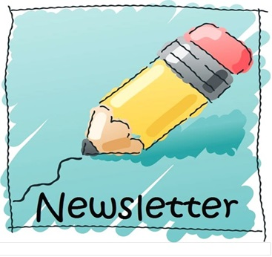

**THE 2022 OHIO SECTION NEWSLETTER CONTEST**

Just four months from now you can begin sending entries for the 2022 Ohio Section Newsletter Contest!!

If you publish your January newsletter in December you can enter the contest then. To be “officially” entered you’ll need two copies of newsletters from different months. The deadline is June 30 2022 and the judging will start just after the July 4th Holiday.

We have the BEST contest in the country and the BEST newsletters anywhere.

Also, another round  of congratulations to our 2021 winners who received their certificates at the Columbus Voice of Aladdin Hamfest last month.

**1st Place…The RADIOGRAM** Portage County Amateur Radio Service (PCARS)

**2nd Place…DELARANEWS** Delaware County Amateur Radio Association

**3rd Place…NEWS BEACON** Media County Amateur Radio Club

**4th Place…The WAVEBNDER** Western Reserve Amateur Radio Club

**Honorable Mention…the exchange** Southwest Ohio DX Association

Thanks to our judges who have been with us for eight years. We have a new cadre of judges for 2022…all PR, Journalism, and design professionals.

**NEW HAMS ON THE AIR**

One advantage to working from home is that I have ham radio right beside me and I get to talk to a lot of hams.

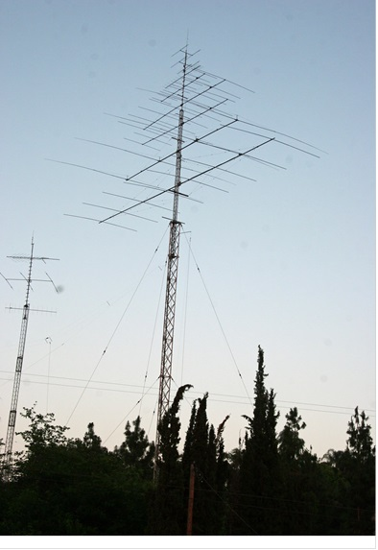The good news….make that GREAT NEWS…is many of those contacts lately have been with newly licensed Amateur Radio Operators!!!!

The folks I’ve talked with are mostly middle aged adults who are just now making some changes or returning home form military duty. All of them got the ticket on their own, bought an inexpensive radio and are trying out the repeaters and making contacts. Many are just going for the first contact and trying figure out the multi-function buttons. It’s great to hear these folks, listen to their stories and help if I can. I still remember Dale Williams a few years ago telling a group of would-be amateur radio operators…”get your license in a class…that way you’ll have someone to talk to on the air!” Still good words today but we all need to be listening for the new folks and do all we can to welcome them, encourage them and…just plain talk to them. Their questions are many…where can you pick up a better radio, is there a club I can join and what other repeaters are operating in the area.

The last two years not many clubs have been able to have face-to face meetings due to COVID and those meetings are a great place to welcome new hams. You might have heard that the cost of being a ham will increase next year due to a new fee schedule from the FCC….that alone can discourage new hams from continuing. The onus is really on us older operators to help the “newbies” and keep them interested, engaged and encouraged.

So listen carefully, offer to help when you and keep them talking and you’ll help keep all of us on the air!



**PIO ZOOM**

Work is continuing to get our PIO ZOOM meetings up and running.

I’m going to test the software in a few days and maybe try a trial run in late September.

Stay tuned for the info and I’ll send all of the PIO’s the link. If you don’t have ZOOM you download a copy for free…and it will work for any ZOOM meeting you want to join.

This is a BIG DEAL…at least for me. Getting all of us together I think will open new doors, new ideas and just be fun.

STAY TUNED!!!

That’s it for this month. Have GREAT LABOR DAY and 73!

John E. Ross

ARRL Ohio Section Public Information Coordinator

KD8IDJ

614-459-4292 Home

614-266-4292 Cell

***ARES Training Update***

***Jim Yoder, W8ERW – ARES Data Manager***

[w8erw@arrl.net](mailto:w8erw@arrl.net)

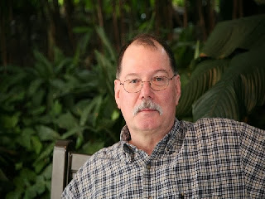

ARES Training Update

Mid Summer is here and we are already on the slide towards Fall and then Winter. Hey, but the Hamfests are returning in numbers. It is great to see that happening and I surely hope that we are not once again constrained by the effects of the pandemic. We have suffered enough, not the least of which is our inability to meet in association with one another.

The SET “Simulated Emergency Test” will soon be upon us. Are you thinking about it yet? Will you be participating? I hope so. Without regular practice we can’t be truly ready for an event that requires our assistance. This year’s SET exercise promises to engage as many as possible in real world situations that we might be immersed in at any time. Practice and training are vital elements of our preparedness posture. Let’s look at training for a moment.

I have been keeping and maintaining a database of all the training documents submitted for several years now. The process was initiated when the desirability of NIMS training was becoming common and was a requirement brought forth by many of our served agencies. A database is an efficient means to record the training information and to retrieve it when the information needs to be verified. However, do we not keep these records at the county level? Of course we should. Each EC should have and maintain a file of all training records and certificates. However, what would we do if the EC was incapacitated or otherwise unavailable to verify a member’s status or provide a copy of a certificate when a served agency might require it. The database attempts to solve this problem. Please ensure that I have these documents as well as your local ARES Group. While I do believe we have done an admirable job of working on the training objective, I am also sure that many have completed training that has not yet been documented.

I do not have a “Football’ as our president does. I do however, keep an electronic copy of the database and certificates with me at all times. This only is as good as you and your EC make it by insuring that any training that you take is documented in the database and I have an electronic copy of the certificates. Sending me a .pdf copy of your certificate(s) via email is all that is required to make this work. All of this serves to ensure that when we are called to support an emergency condition, any verification of training status can be provided quickly and accurately to our served agencies.

I am able to also provide back to you as EC’s and DEC’s a report listing the training that I have on file for your group(s). One of the additional benefits of maintaining a database is that the information can be presented in whatever format is desired. If there is a need or a desire that you have, please let me know and I will do my best to provide you with the report that you wish.

Now some good news and a chance to blow our horn(s), we are approaching 10,000 training certificates now on file. With just a little push, we can surely march past that number yet this year. Let’s also see if we can’t make ARES bigger by recruiting more Amateurs into this activity. Here is why I mention that.

The recent news from Newington on a greater emphasis for ARES is no accident. The league has recognized a greater importance to ARES by giving committee status to Emergency Communications and Field Services at the ARRL Board of Directors. There are only two other standing committees and now ARES joins them. Why this elevation to an increased visibility and attention by the Board of Directors you might ask? I will give you my personal thoughts here which I am confident will be validated. The pressure from commercial interests to gain more spectrum is a never-ending escalation by those who wish to profit by offering additional services to both the public and other commercial interests. The FCC has a daunting task as they try to achieve some form of balance between, we Amateurs and those commercial interests. We have not done badly thus far, but the necessity to demonstrate our value is not likely to end. We do have a lot of valuable spectrum at our disposal which we pay virtually nothing for. Commercial interests often pay huge amounts when additional frequencies are made available via FCC auction. This might give you an idea as to the value of what we have and the degree at which commercial interests would like to have it or take it from us. Our League officials in Newington and Division Directors are wise to place this added emphasis on Emergency Communications and Field Services.

We all can support ARES in the manner best suited to individual means. Many will be very active while others may lend their support when asked. Every one of us can be a part of the overall ARES effort even in a small way. ARES Training is one excellent way to become a more active participant. Obviously, there are many of us who, due to our other responsibilities and abilities, cannot drop everything in order to deploy elsewhere during a disaster. We can however provide a useful and needed support function locally. Completing FEMA NIMS training is an excellent means to ensure you will be ready to do so. NIMS is some rather basic stuff although it can become very important to anyone working through a disaster situation. I say basic because it is very straight forward and informative. NIMS outlines the structure and organization of a disaster response. Our first responders use it almost daily. It provides the framework so that everyone understands how it all works, allowing for the best application of resources to effectively manage a disaster however large or small.

Your ARRL Ohio Section team is always ready to assist you. Please feel free to contact any one of us with your questions and concerns.

Thanks & 73,

Jim W8ERW

w8erw@arrl.net

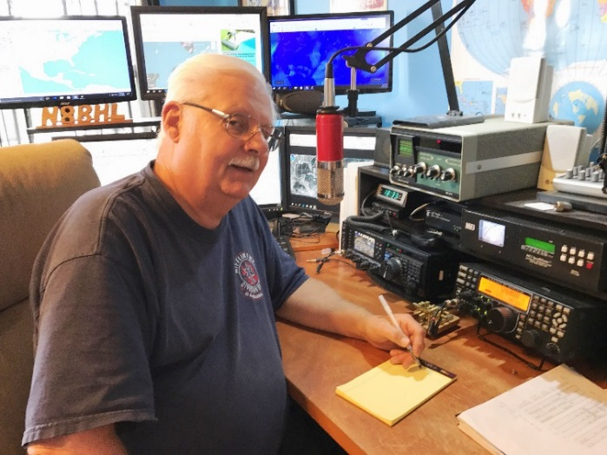***From the Section Emergency Coordinator***

***Stan Broadway, N8BHL - SEC***

[broadways@standi.com](mailto:broadways@standi.com)

Ohio Simulated Emergency Test – Not too early to plan!

The Ohio Section leadership has been working on the coming SET for October 2. For this exercise, we’re going to change the way our SET is operated and return to some more basic situations. We are conducting our SET exclusive to ARES. Understand that “Black Swan” exercises have been set for the same period in September-October. They are separate from ARES SET, which occurs only on Saturday October 2. You are of course welcome to participate in both, but ARES members are expected in the SET.

The nature of the scenario produces an interesting complexity, but it’s actually secondary. It doesn’t really matter ~why~ the power is down for an extended period… that could be caused by a number of situations, natural or man-made, each one slightly worse than the other. Our response would be pretty much the same for any reason- extended power out, communications down, no Internet and scarce repeaters. Experience has shown that in all likelihood a weather event or even possible widespread power outage might leave the Internet intact. In that event, we would certainly make use of the bridged DMR/Fusion system as one component of our plan. But we must be ready for the absolute worst, and this is probably it.

“A one-two punch!”

Ohio has been hit with a one-two punch of severe weather. At the leading edge of a major cold frontal system a Derecho develops which sweeps the entire state with high wind leaving damage in its wake. Pockets of 140 MPH wind are reported, with general sustained windspeeds of 80 MPH and higher gusts. Wires are downed, power is interrupted, and in several towns and cities damage is reported as buildings are blown down.   
But that’s not all. Behind this massive cold frontal line is extreme cold air, that promises to keep the entire Great Lakes region including Ohio at dangerously low temperatures for days. In the wake of the wind temperatures plummet to -30 and stay there for several days. Between the wind and cold, power is completely out, Internet is out, and after the first day cell service is spotty, more off than on.

This is the scenario that brings Ohio ARES operators into play in all our counties. What would that look like in YOUR county? Our SET is going to ask YOU as EC and DEC to think about the consequences in your own area and design a scenario that your volunteers would be asked to handle. Would your repeaters still function? Where would you deploy your people for communication? Fire stations, hospitals, Red Cross shelters all would likely need our help. And don’t forget the safety of our own people as they move around in the cold. A majority of homes would be frozen, and people would gather where there was heat, either in other homes or shelters. What would that look like in your local area?

This year, the Ohio SET is designed to use YOUR input to create the challenges you would face. We are also depending on you to set up traffic and messages to be sent within your county, across your district and statewide. In short, using the basic scenario, *do what makes sense to you* in designing your exercise.

We have some basics to help you structure your part of the exercise:

Our goals:

Activation. We want to practice alerting your entire group and having them ready.

Deployment. We would like as many as possible to actually deploy, set up a temporary station at that location, and send messages.

This will be “message intensive” – we need to send lots of traffic. We would like to lean toward digital traffic (think fldigi portable or Winlink) but you are free to use what’s been developed in your area.

This is the time to put NVIS Day, VHF Contest and other activities into practice!

Our concerns:

We want YOU to drive this SET. We will be sending a boilerplate package with tasks to complete, such as deploying to fire stations, Red Cross Shelters and more. We’ll have some messages which can be customized for your county.

We will need DEC’s to be active in designing nets, contacting EC’s and stimulating participation. We need EC’s to think about the impacts of such conditions and actually design challenges and systems to deal with your local issues. To what locations will you deploy your people? Can you set up a county-wide digital net using portable stations? What kind of message traffic would you expect?

I urge you now, if you’re an EC, to contact your county EMA Director and see if they would be interested in being a part. Ask what kinds of messages they would anticipate in such an event and try to create them. We want ALL ARES members to have a chance to deploy and participate, as an all-day event.

Now is the time to start thinking about this situation and begin to encourage your volunteers at all levels to participate and make it happen!

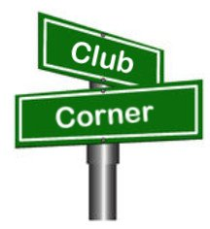***Club Corner***

This is YOUR corner of the newsletter. Send us what your club is doing, and we’ll make sure that it gets in. Got a special event or club project that you want everyone to know about? Send it to us!. Need help with a project? Send it to us.

Let us know what you club is up to. Are you going to have a special guest at your meeting or are you having a special anniversary?

Send it to: [webmaster@arrl-ohio.org](mailto:webmaster@arrl-ohio.org)

VE Sessions

Dayton Amateur Radio Association (DARA) If you are interested in testing for a new or upgraded license, please come see us at the DARA Clubhouse. If you have questions about testing, please email [exams.w8bi@gmail.com](mailto:exams.w8bi@gmail.com)

Lake County Amateur Radio Association (LCARA)

Saturday October 2, Saturday December 4

All exams start at noon and are held at the Kirtland Library, 9267 Chillicothe Rd. Kirtland, OH

Portage County Amateur Radio Service (PCARS)

Starting on August 7th, PCARS will resume VE testing at the PCARS club site in Ravenna.

Please visit the PCARS web site and check out the information about VE testing in the latest newsletter – [https://portcars.org/files/newsletter/2021/PCARS-June-21.pdf](https://r20.rs6.net/tn.jsp?f=001DxdXS40dvzmbl9m9sfY5l9IIoAGYYsZIQIObAktg-wnnAu__YbvuVuV1_NQmLDKapbqCCYZK1L6epi1k5lVvuEtL_I1T0LMdgzjsNGvi1UnoIj7Lpv0RFoxS8h0YOCVVODgyzQI8xFTrmQ0pr6RXkQVvSx_cjGgR-DubSFhvF7CPVtMoPBph8tt8RpjGjyyBlRFHzo_VhR4=&c=Oi-83JMf17RlM94bujSYqqAwfNyIPWszQZKKkjp6BM5J7PHkAvaFrA==&ch=Kr1c-7rzal6CKkNUvSX-jLXK5eG9iU0tKZ5xoqUUqM21mzFnc1rE3w==)  – see pages 8, 9 and 10 for details.

If you have any questions, don’t hesitate to contact me at KB8UUZ@gmail,com

On behalf of the VE team at PCARS, we all look forward to getting the VE testing going again and look forward to seeing you there – August 7th -10 am – at the PCARS club site in Ravenna.

US Coast Guard Aux 082-06-08 Indian Lake Ohio

October 09, 2021 9:30 AM at the Shrine Building

6401 Fruit St. Huntsville, OH 43225

Walk-ins welcome, but pre-registration is preferred. For further information please contact:

Samantha Holland at 937-592-2412

PCARS – Ohio State Parks On The Air

Hi everyone,

According to the countdown ticker on [ospota.org](http://ospota.org/), we are down to only 50 days till OSPOTA 2021. There’s several subjects I want to touch on, but this week, let’s start with the new class for Rovers.

So what is a Rover? Well, simply put, a Rover is a station that operates from more than one Ohio State Park during OSPOTA.

If you’re considering operating as a rover this year. These are the relevant sections of the 2021 rules concerning Rovers (**The complete rules can be found at**[**https://ospota.org/Files/OSPOTA-Rules-1Jan2021.pdf**](https://ospota.org/Files/OSPOTA-Rules-1Jan2021.pdf)).

**Entry Categories**

• MML - Multi-Op Multi-Transmitter Low Power (.1 to 100 watts) located at one Ohio State Park

• MMH - Multi-Op Multi-Transmitter High Power (>100 watts) located at one Ohio State Park

• MSL - Multi-Op Single-Transmitter Low Power (.1 to 100 watts) located at one Ohio State Park

• MSH - Multi-Op Single-Transmitter High Power (>100 watts) located at one Ohio State Park

• SL - Single Operator Low Power (.1 to 100 watts) located at one Ohio State Park

• SH - Single Operator High Power (>100 watts) located at one Ohio State Park

• INOH - Operator (Single or Multi) inside Ohio not at an Ohio State Park (low or high power)

• OUT - Operator (Single or Multi) outside of Ohio (low or high power)

**Note -**Rovers must choose one of the categories listed above. Rovers must submit a Summary Sheet for each park they activate inside the boundaries of the State Park. Rovers must use a /R as their call sign (example: K8BF/R).

**Miscellaneous**

Stations inside an Ohio State Park (includes Rovers) must make a minimum of **TEN**contacts. Four of the contacts being made to four other (different from where you are transmitting from) Ohio State Park stations.

**Rovers**should send their call with a /R at the end (example: K8BF/R). Rovers will submit a summary sheet for each park they activate. Rovers’ scores will be totaled up when their logs are checked and their total score will be the sum total of all the summary sheets they submit.

------------------------------------------------------

**FAQ**

**If I decide to be a rover, is there a special way to signup?**   
No signup is necessary. Just sign a “/R” (example: K8BF/R) after your callsign when operating, then make sure that you use that callsign on your summary sheets when submitting your entry.

**Are there provisions for contacting Hams planning to operating the same park as me ahead of time to coordinate, and avoid interference?**  
Most parks are large enough to allow ample spacing between stations, If you want to touch base all the same, just post your request to either the OSPOTA group on [groups.io](http://groups.io/), or the OSPOTA facebook group. If they see it, and choose to respond, then you will hear from them directly.

We do, however encourage you to share your plans to [PlannedParks@ospota.org](mailto:PlannedParks@ospota.org), so that we can add you to the Planned Activation page on [ospota.org](http://ospota.org/). the page is anonymous; not listing callsigns, but it tells you at a glance how much activity is planned.

**Do I need to make a minimum number of contacts?**Yes, all stations inside an Ohio State Park (including Rovers) must make a minimum of **TEN**contacts. Four of those contacts must be made to four other different Ohio State parks.

**How should I identify as a Rover on the air?**Roversshould send their call with a /R at the end (example: K8BF/R).

**I don’t see a Rover class on the summary sheet. How do I submit my rover entry?**  
Rovers must submit a summary sheet for each park they operate from. The callsign must be your call with a /R added (example: K8BF/R). Rovers’ scores will be totaled up when their logs are checked and their total score will be the sum total of all the summary sheets they submit.

**John Myers, KD8MQ**

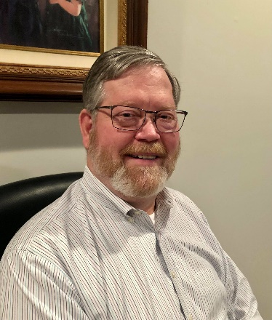

DX This Week – IOTA

Bill AJ8B (aj8b@arrl.net, @AJ8B, or www.aj8b.com)

CWOPs Member #1567

The Midwest DX Cluster spots included Alaska, Argentina, Asiatic Russia, Asiatic Turkey, Belgium, Belize, Brazil, Bulgaria, Canada, Canary Islands, Chile, Colombia, Czech Republic, Denmark, England, Estonia, European Russia, Fiji, France, Gibraltar, Greenland, Hungary, Indonesia, Iran, Iraq, Italy, Kuwait, Market Reef, Netherlands, Norway, Peru, Portugal, Puerto Rico, Romania, Slovenia, Spain, Tanzania, Ukraine, United States, Uruguay, and Venezuela. This brings the total number of entities spotted in the Midwest in 2021 to 192!

I received a card from 9H1TT- Andrea on Malta, FR4OM – J Phillipe on Reunion Island, and LW5HR – Diego in Argentina.

|  |  |
| --- | --- |
|  |  |
|  | |

Every month I challenge you to send me a copy of the QSL cards that you receive. My friend and mentor, Dave, K8DV, sent the following card confirming his 6 Meter QSO with the Republic of Suriname.

Thanks Dave! What did you receive?

*DAH DIT DIT DIT DAH DAH DIT DIT DIT DAH*

This week I wanted to share some information with you about the Islands on the Air (IOTA) program. With their permission, I will list some information from the IOTA team. I find that chasing entities and chasing IOTA counters really gives me things to shoot for. You may have noticed that Bernie, W3UR, always lists IOTA information in his daily newsletter. That is to help you hunt down these IOTA entities. I hope you enjoy this section.

Mission Statement

**IOTA Mission Statement:** To increase activity on the amateur radio bands by encouraging operations from island locations, to keep a database of contacts made by IOTA program participants and to recognize high performance in the making of such contacts.

**PROGRAMME OBJECTIVES:** The IOTA (Islands On The Air) Program is an amateur radio HF / VHF band activity program, administered by Islands On The Air (IOTA)Ltd (called here IOTA Management) in partnership with the Radio Society of Great Britain (RSGB).

Established in 1964 it promotes radio contacts with stations located on islands around the world to encourage greater use of the amateur bands, and to do this it draws on the widespread mystique surrounding islands. IOTA Management has grouped the oceans’ islands into some 1200 ‘IOTA groups’ with, for reasons of geography, varying numbers of ‘counters’, i.e. qualifying islands, in each group and has published the listings in the IOTA Directory and on the IOTA web-site at https://www.iota-world.org. The objective for the IOTA Island Chaser is to make radio contact with at least one counter in as

many of these groups as possible and for the IOTA Island Activator to provide such island contacts. IOTA Management encourages friendly competition among chasers by publishing details of participants’ performance in an Honor Roll and annual listings, as well as by recognizing it with certificates and prestige awards.

**KEY PROGRAM REQUIREMENTS**

For Island Chasers the main requirements for valid contacts are that they should be made:

•(LICENCE) in conformity with the operator’s licensing conditions, subject to program rules on the use of remote station, repeater or satellite-Aided operation

•(OPERATOR) by the operator personally

•(LOCATION) from the same DXCC entity and from a land-based location

•(DATES) since 15 November 1945

•(BANDS) on any bands licensed to the operator that are specified in the rules for the category of application

•(MODES) in Phone, CW and / or Data modes.

For Island Activators these same requirements apply, except that contacts should be made:

•(LICENCE) in conformity with the operator’s licensing conditions in the country concerned

•(LOCATION) from an island listed as valid for IOTA in the IOTA Directory or on the IOTA website, whether in the same DXCC entity or not

•(PERMISSION) with written permission where required from the government, local authorities and / or the island owners to land and operate. For a first-time operation from a previously unactivated IOTA group IOTA Management requires a minimum 1000 QSOs in 5 continents to be made on Phone or CW before confirming the provisional IOTA reference number. If the first operation does not make this total, the shortfall may be made up by a subsequent operation by another station. There is no minimum number of contacts required for operations from existing numbered groups that are confirmed. Island Activators are requested:

•(PROOF OF PRESENCE) to retain all documentation relating to their operation in case of challenge IOTA Management will need to seek sight of it in the case of operations from new or rare IOTA groups but may ask for it in the case of any operation

•(CONFIRMATION OF CONTACT) to establish reliable arrangements for contacts to be confirmed on request by paper QSL cards: printed with the island name (this is a requirement) and Issued on a nonselective basis and at no profit beyond recovery of costs.

Recognizing that for many island enthusiasts use of national QSL bureaus is the only feasible way of obtaining cards, IOTA Management asks Island Activators to consider making arrangements to QSL via the bureau, if necessary appointing a volunteer manager for this purpose, All Program Participants are requested:

•(ON-AIR BEHAVIOUR) to follow the guidance given in the DX Code of Conduct.

CATEGORIES OF APPLICATION

**Island Chasers’ Record Options**

There are four categories of application for a record: Standard HF, VHF / UHF, Club and SWL, the latter issued on a ‘Heard’ basis. Most applicants start with the Standard HF Category of Application.

Applicants may enter only one record per callsign and per DXCC entity in a category although they may enter more than one category. On opening a record they may indicate a mode specialization (Phone, CW or Data) but, if they do so, they will need to make all updates in the same mode failing which they move to All Modes

**The Performance Challenge**

The IOTA Program with its concept of contacts with island groups stemmed from an idea by SWL Geoff Watts, BRS-3129 in 1964 to provide an alternative to the ARRL’s DXCC Program that majored on countries, later called entities.

The issue of awards at various levels was a key feature of the program and, given that this was before the development of portable radio equipment as we know it today, finding and contacting island stations in field day mode, particularly the more remote ones, was a challenge.

**CERTIFICATES AND AWARDS**

22 separate certificates are available graded for performance. In addition, prestigious awards are issued at the highest level for confirmed contacts with 750 and 1000 Islands with appropriate enhancement shields

.

*DAH DIT DIT DIT DAH DAH DIT DIT DIT DAH*

CQDX CQDX CQDX CQDX CQDX CQDX CQDX CQDX CQDX

Here is an update from Bernie, W3UR, of the DailyDX and the WeeklyDX, the best source for DX information. <http://www>.dailydx.com/. Bernie has this to report:

**PJ7 - Sint Maarten -** W5JON has received the callsign PJ7JA for his upcoming October 18-23 trip to Sint Maarten. He'll be QRV on SSB and FT8 on 40 through 6 meters and plans to operate in the CQ WW DX SSB Contest. QSL direct via W5JON.

**CY0 - Sable Island -** The CY0C group have a revised date of October 2022. The island  
manager extended an invitation for then and the team has unanimously accepted.

*DAH DIT DIT DIT DAH DAH DIT DIT DIT DAH*

Below is a list of upcoming contests in the “Contest Corner”. I think this is important for someone who is trying to move up the DXCC ladder since entities that are on the rarer side and easiest to work in contests. Some of my best “catches” have been on the Sunday afternoon of a contest when the rarer entities are begging for QSOs. Of course, the gamble is that if you wait until Sunday, conditions may change, or they simply won’t be workable. However, it is not a bad gamble. Of course, why not work the contest and have some fun!  
Check out the WA7BNM Contest Calendar page (<https://www.contestcalendar.com/>) and CQ Magazine for more contests or more details.

The contests in red are those that I plan to spend some significant participation time on. PLEASE let me know if you are working contests and how you fared.

Thanks!

|  |  |  |
| --- | --- | --- |
| Sept. 1 | VHF-UHF FT8 Activity Contest | www.ft8activity.eu/index.php/en |
| Sept. 1 | UKEICC 80m Contests SSB | https://bit.ly/2SDPqQQ |
| Sept. 4 | AGCW Straight Key Party | https://bit.ly/3ngQSpB |
| Sept. 4 | Russian “Radio” RTTY WW Contest | https://bit.ly/3eWEtDl |
| Sept. 4 | **CWOPS CWOPEN 0000 – 0359Z** | https://cwops.org/cwops-tests/cw-open/ |
| Sept. 4 | **CWOPS CWOPEN 1200 – 1559Z** | https://cwops.org/cwops-tests/cw-open/ |
| Sept. 4 | **CWOPS CWOPEN 2000 – 2359Z** | https://cwops.org/cwops-tests/cw-open/ |
| Sept. 4-5 | All Asian DX Phone Contest | www.jarl.org/English/0-2.htm |
| Sept. 4-5 | Colorado QSO Party | http://ppraa.org/coqp |
| Sept. 4-5 | RSGB SSB Field Day | http://bit.ly/2OKdymu |
| Sept. 4-5 | PODXS 070 Club Jay Hudak Memorial 80M Sprint | http://bit.ly/2MkaaNt |
| Sept. 4-5 | Tennessee QSO Party | https://tnqp.org/rules |
| Sept. 6 | RSGB Autumn Series SSB | https://bit.ly/3p4eShW |
| Sept. 6-7 | MI QRP Labor Day CW Sprint | www.miqrp.net/contest |
| Sept. 8 | VHF-UHF FT8 Activity Contest | www.ft8activity.eu/index.php/en |
| Sept. 11 | **FOC QSO Party** | www.g4foc.org/qsoparty |
| Sept. 11-12 | Alabama QSO Party | www.alabamaqsoparty.org |
| Sept. 11-12 | SARL Field Day | http://bit.ly/H0IqQf |
| Sept. 11-12 | Russian Cup Digital Contest | www.qrz.ru/contest/detail/86.html |
| Sept. 11-12 | Worked All Europe SSB Contest | http://bit.ly/2vufgcb |
| Sept. 11-13 | ARRL September VHF QSO Party | www.arrl.org/september-vhf |
| Sept. 12 | North American CW Sprint | http://ncjweb.com/Sprint-Rules.pdf |
| Sept. 15 | RSGB Autumn Series CW | https://bit.ly/3p4eShW |
| Sept. 16 | Bavarian Contest Club QSO Party | https://bit.ly/2MDzviG |
| Sept. 18-19 | ARRL 10 GHz and UP Contest | www.arrl.org/10-ghz-up |
| Sept. 18-19 | Iowa QSO Party | www.w0yl.com/IAQP |
| Sept. 18-19 | New Hampshire QSO Party | www.w1wqm.org/nhqso |
| Sept. 18-19 | New Jersey QSO Party | http://bit.ly/1nDlf8V |
| Sept. 18-19 | QRP Afield | http://bit.ly/2QACxFu |
| Sept. 18-19 | SARL VHF/UHF Digital Contest | http://bit.ly/H0IqQf |
| Sept. 18-19 | Scandinavian CW Activity Contest | www.sactest.net/blog |
| Sept. 18-19 | Texas QSO Party | http://txqp.net |
| Sept. 18-19 | Washington State Salmon Run | http://salmonrun.wwdxc.org/rules |
| Sept. 19 | BARTG Sprint PSK63 | http://bartg.org.uk/wp/contests |
| Sept. 19 | North American RTTY Sprint | http://ncjweb.com/Sprint-Rules.pdf |
| Sept. 20 | 144 MHz Fall Sprint | http://svhfs.org/wp |
| Sept. 23 | RSGB Autumn Series Data | https://bit.ly/3p4eShW |
| Sept. 25 | AGCW UHF/VHF Contest | https://bit.ly/3lw91PK |
| **Sept. 25-26** | **CQWW RTTY DX Contest** | **www.cqwwrtty.com** |
| Sept. 25-26 | Maine QSO Party | www.ws1sm.com/MEQP.html |
| Sept. 28 | 222MHz Fall Sprint | http://svhfs.org/wp |
| Sept. 29 | UKEICC 80m Contests CW | https://bit.ly/2SDPqQQ |

TOP^

**OHIO’S** 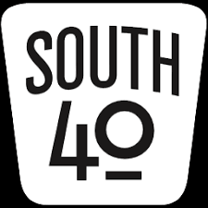

It’s usually good to get away from home for a break, but then it’s better to get back to the daily grind feeling recharged. However coming back from visiting college friends and relatives plus seeing scenery in 3-Land that I haven’t seen in years only to find Southern Ohio temperatures in the 90s I’m wondering if N8ZNR and my return from the Pennsylvania mountains was too soon. These final days in August with hot temps with pop-up storms are definitely the Dog Daze. But it’s now back to the business at hand letting you know what’s going on in Ohio’s South 40.

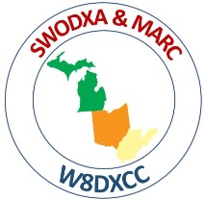It was definitely a great time seeing some folks not seen in months at Saturday’s Greater Cincinnati Hamfest and W8DXCC convention. Considering the COVID uptick, there was a good attendance and a number of inside and outside vendors at the event. With the return of COVID I’m certain there were concerns, but the **Milford ARC** and **Southwestern Ohio DX Association** are to be commended for putting on such a well- coordinated and safe event.

In order to free up MARC’s members for other hamfest duties, the **Highland ARA’**s VE team was asked to conduct license exams that morning. According to VE team leader Tom Mongold, Jr., KD8LDS, 20 plus people set for at least one element with a 10 year old boy making the grade.

In other testing news—Barbara Crockett recently traveled from Columbus to Ironton at attend the **Southern Ohio ARC**’s test session. According to SOARA’s VE team leader, Jerry Lockhart, W8HIC, Barbara’s trip was not in vain because she now is KE8SRN. Jeff Slattery, N8SUZ, reports two folks who passed their Technician licenses at the joint **Athens County ARA** and **Sunday Creek ARC** June test session upgraded at the two clubs August 16 session. James Reed, KE8SIQ, and Mary Moffat, KE8SIR are now the proud holders of General tickets. Reed is from Glouster and Mary from Nelsonville. The Athens club conducted a test session at their recent Trunkfest. James Young, Jr., KA8JEA, from Vienna, WV now holds an Amateur Extra license.

At its August meeting the **Clinton County ARA** tapped Seth Cunningham, K8SAC, as their new Public Information Officer.

On Saturday, September 4, the **Greater Mason County ARA** will provide communications for the annual Maysville, KY Rotary Club’s Two Bridge Run featuring a 10-miler and 5k walk. The 10-miler crosses the Simon Kenton and Harsha bridges over the Ohio River while the 5k walk crosses the river on the Simon Kenton Bridge into Aberdeen’s Riverside Park. Two events-two bridges-two states!

Just a reminder from the **Portsmouth RC** their monthly meeting for September has been changed to the second Monday in the month. Therefore they will be meeting on September 13 at the American Legion Hall in Portsmouth. They are now meeting on the first floor and not in the basement area. A delegation from the **Highland ARA** is expected to make their annual visit to the meeting.

On September 18 the **Hocking Valley ARA** will provide communications for the Hocking Hills Trail Run through the Hocking Hills State Park. The Club will also do a limited activation of Lake Logan during the September 11 Ohio State Parks on the Air event.

Bob McFarland, N8ZDL passes along information that the **Dayton ARA** is looking for volunteers to assist with the Young’s Dairy Charity Bike Tour on Saturday, September 11. The approximate 100 mile ride begins at 8 am at the dairy north of Yellow Springs, goes to Bellefontaine and then returns to Yellow Springs. Repeaters in Springfield and Bellefontaine will be used. If you can assist for a portion of the day or have questions, please contact Mike Crawford at [kc8gle@earthlink.net](mailto:kc8gle@earthlink.net).

Although band conditions were rather poor during the recent **Athens County ARA**’s W8V special event operation, still around 400 contacts were made mostly on CW and digital. A couple special event stations will take to the air in the coming weeks. The **Southern Ohio ARA** will conduct an ‘Iron Furnace on the Air’ special event operation on September 18 from the historic Vesuvius Iron Furnace at the Lake Vesuvius Recreation Area near Ironton. It starts at 10 AM and concludes at 2 PM. On September 25-26 the **West Chester ARA** will observe the 77th Anniversary of the Voice of America by conducting a special event operation. Look for them on 14.268 or 7.268. The **Highland ARA** will operate from the interior of the ‘World’s Largest Horseshoe Crab’ on October 2. Operations (focused on 40 and 20 meters) will start at 10 AM and continue until 4 PM. Email certificates confirming contacts will be available. Crabbie is located on SR 124 at the edge of Hillsboro. Visitors to each event are invited.

A reader passed along a flyer about the popular up-coming September 25 hamfest in Paintsville, KY sponsored by the **ARCS KY4ARC Club.** It is at the Paintsville Recreation Center and will open to the public at 8 AM and continue until 2 PM. Admission is $5. Contact Ron Grossl at [n4rlg@arrl.net](mailto:n4rlg@arrl.net) or 606-789-7767 for more information.

The father and son team of Eric (WD8RIF) and Miles (KD8KNC) McFarland were the first to find the ‘Fox’ at the recent **Athens County ARA**’s Foxhunting event. The next hunt will be September 4 with the ‘FOX’ somewhere within Athens County. Up the road in Logan, the **Hocking Valley ARC** has decided to hold their next fox hunt on October 16 and not to hold one in September. In the western part of the region the **Highland ARA** will hold one on October 9 according to Richie Hagen, N8CUB.

On Patriot’s Day, September 11, the **Greater Mason County ARA** will provide communications for the 13th annual Limestone Cycle Tour. Last year approximately 800 rider participated by riding one of the four official courses. All routes will start in Maysville, KY.

It’s always nice to get away from home and the routine for a few days. But it’s always good to return home and get back into the routine. However it’s especially a good feeling to find the latest *QST* waiting in the mailbox. A browse of the September issue not only showed the **West Chester ARA**’s special event information, but the *“World Above 50 MHz”* column showed AF5CC in Lawton, OK making a contact with Greenfield's Jim Orebaugh, N8AXB, during Field Day. This is a distance of about 1,000 miles. This contact was only eclipsed by Jim’s contact with the HARA K8HO Field Day station at New Vienna for a distance of 17 miles. Unfortunately the magazine also brought the news of the passing of three fellow hams within the South 40 coverage area. Those listed were: KF4JNV, Bill Dorsey, Flemingsburg, KY; N8KNA, Richard Wilson, Parkersburg, WV; and Gary Trustle, WB8SPV, of Waverly. Our thoughts and prayers are with each family member and their ham radio friends.

We have just learned of the passing of Debra Berry, the XYL of Tom Berry, KD8U. Debra and Tom had been married 49 years and are residents of New Vienna. Services are pending.

Don’t forget the annual Ohio State Parks on the Air Contest is quickly approaching. It begins at 10 AM on Saturday, September 11 and ends at 6 PM. The park activation list shows there are only 30 parks with potential activity. The list shows several Southern Ohio parks will be active at some time during the period, but there still are several showing no potential activity. I do know that Lake Hope, Shawnee and Lake Logan will have activity. I intend to be a rover. So look for me at Lake White, Scioto Trails, Lake Jackson, Lake Alma and perhaps Hocking Hills. OSPOTA is a fun event to participate in from a home station. However it’s a blast to get a few best ham friends together and head to a nearby state park to play radio for the day. Look at the [www.ospota.org](http://www.ospota.org) web site to find the rules and parks with no activity. Here’s hoping to put you in the log that day.

One of my personal favorite operating events is the Ohio QSO Party contest. Normally I work as a portable from N8ZNR and my Ohio Historic Century Farm in Clinton County. But because of the Cincinnati Hamfest I was unable to devote the entire contest period to an effort. I rushed home after the hamfest and spent a couple hours of air time putting out Highland County from the home station. This year I was surprised with a couple of “I enjoy your column” comments.

Well that does it for another week. Don’t hesitate to send along information about upcoming club events for consideration to insert in future columns. There are several clubs south of US 40 that have not been heard from. Information can be emailed to [w8kiw@arrl.net](mailto:w8kiw@arrl.net) or [highlandara@gmail.com](mailto:highlandara@gmail.com). Snail mail to 21 Highland Drive, Hillsboro, OH 45133 will even work.

Until next time be safe, healthy and ham radio active. 73, John, W8KIW

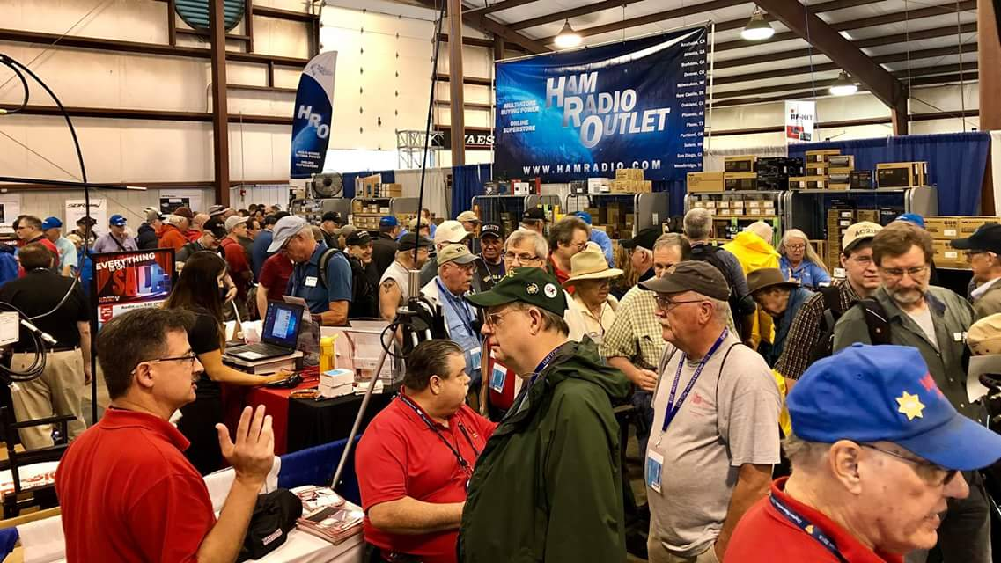[***Upcoming Hamfests***](http://arrl-ohio.org/hamfests.html)

We **DO** have some hamfests scheduled for 2021!! Yes, take a good look at the list, it’s growing every day!

|  |  |  |  |  |  |  |  |  |  |  |  |  |  |  |  |  |  |  |  |  |  |  |  |  |  |  |  |  |  |  |  |  |  |
| --- | --- | --- | --- | --- | --- | --- | --- | --- | --- | --- | --- | --- | --- | --- | --- | --- | --- | --- | --- | --- | --- | --- | --- | --- | --- | --- | --- | --- | --- | --- | --- | --- | --- |
| |  |  | | --- | --- | |  | | | **09/12/2021 -**[**Findlay Hamfest**](http://www.arrl.org/hamfests/findlay-hamfest-8) Location: Findlay, OH Sponsor: Findlay Radio Club Website: <http://www.findlayradioclub.org/hamfest>  [**Learn More**](http://www.arrl.org/hamfests/findlay-hamfest-8) | **09/18/2021** - [**Miami County Swap Meet**](http://w8fw.org/)  **Location:**Troy, OH  **Sponsor:** Miami County Amateur Radio Club  **Website:** [http://w8fw.org](http://w8fw.org/)  [**Learn More**](http://w8fw.org/) | | **09/18/2021 -**[**Mound Amateur Radio Assoc. Swap Meet**](http://www.arrl.org/hamfests/mound-amateur-radio-assoc-swap-meet)  **Location:**Miamisburg, OH **Sponsor:** MARA **Website:** [http://W8DYY.ORG](http://w8dyy.org/)  [**Learn More**](http://www.arrl.org/hamfests/mound-amateur-radio-assoc-swap-meet) | **09/26/2021 -**[**Cleveland Hamfest**](http://www.arrl.org/hamfests/cleveland-hamfest-1)  **Location:**Berea, OH **Sponsor:** Hamfest Association of Cleveland **Website:** [http://www.hac.org](http://www.hac.org/)  [**Learn More**](http://www.arrl.org/hamfests/cleveland-hamfest-1) | |  |  | | **10/02/2021 -**[**10th Annual Vette City Hamfest,**](http://www.arrl.org/hamfests/10th-annual-vette-city-hamfest-arrl-great-lakes-division-convention)  [**ARRL Great Lakes Division Convention**](http://www.arrl.org/hamfests/10th-annual-vette-city-hamfest-arrl-great-lakes-division-convention)  **Location:**Bowling Green , KY **Sponsor:** Kentucky Colonels Amateur Radio Club **Website:** [https://ky4bg.com](https://ky4bg.com/)  [**Learn More**](http://www.arrl.org/hamfests/10th-annual-vette-city-hamfest-arrl-great-lakes-division-convention) | | | **10/09/2021 -**[**Northwest Ohio Amateur Radio Club (NWOARC) hamfest**](http://www.arrl.org/hamfests/northwest-ohio-amateur-radio-club-nwoarc-hamfest)  **Location:**Westminster, OH **Sponsor:** NWOARC, Northwest Ohio Amateur Radio Club **Website:** [http://www.nwoarc.com](http://www.nwoarc.com/)  [**Learn More**](http://www.arrl.org/hamfests/northwest-ohio-amateur-radio-club-nwoarc-hamfest) | **10/31/2021 -**[**Massillon (Ohio) Hamfest**](http://www.arrl.org/hamfests/massillon-ohio-hamfest)  **Location:**Green, OH **Sponsor:** Massillon Amateur  Radio Club  **Website:** [http://w8np.org](http://w8np.org/)  [**Learn More**](http://www.arrl.org/hamfests/massillon-ohio-hamfest) | | **11/06/2021 -**[**GARC Hamfest**](http://www.arrl.org/hamfests/garc-hamfest-4) **Location:**Georgetown, OH **Sponsor:**Grant Amateur Radio Club  [**Learn More**](http://www.arrl.org/hamfests/garc-hamfest-4) | **12/04/2021 -**[**FCARC WinterFest**](http://www.arrl.org/hamfests/fcarc-winterfest-2)  **Location:**Delta, OH  **Sponsor:** Fulton County Amateur Radio Club  **Website:**<http://k8bxq.org/hamfest>  [**Learn More**](http://www.arrl.org/hamfests/fcarc-winterfest-2) | | Beyond OHIO! | | |  | |   Tom, I wanted you to know about the Paintsville, KY hamfest we will have Sept 25th.  I have attached a flyer and hope you can get the word out for us.  73,  Fred-WA4SWF-  [http://www.ky4arc.com](http://www.ky4arc.com/)  Where they’re located could be a nice drive and looks like it should draw hams from Ohio, West Virginia  and Kentucky. | |  |  | | --- | --- | | **08/07/2021 -** [**2021 Columbus Hamfest**](http://www.arrl.org/hamfests/2021-columbus-hamfest)  **Location:** Grove City, OH **Sponsor:**Aladdin Shrine Audio Unit **Website**: [http://columbushamfest.com](http://columbushamfest.com/)  [**Learn More**](http://www.arrl.org/hamfests/2021-columbus-hamfest) | 08/07/2021 - [MOVARC HAMFEST](http://www.arrl.org/hamfests/movarc-hamfest-6) **Location:** Bidwell, OH **Sponsor:**Mid-Ohio Valley Amateur Radio Club    [**Learn More**](http://www.arrl.org/hamfests/movarc-hamfest-6) | | **08/15/2021 -**[**WARA Tailgate Swap Meet**](http://www.arrl.org/hamfests/wara-tailgate-swap-meet)  **Location:**Warren, OH **Sponsor:** Warren Amateur Radio Association **Website:** [http://w8vtd.com](http://w8vtd.com/)  [**Learn More**](http://www.arrl.org/hamfests/wara-tailgate-swap-meet) | **08/28/2021 -**[**Cincinnati Hamfest℠**](http://www.arrl.org/hamfests/cincinnati-hamfest)  **Location:**Owensville, OH **Sponsor:** Milford ARC **Website:** [http://CincinnatiHamfest.org](http://cincinnatihamfest.org/)  [**Learn More**](http://www.arrl.org/hamfests/cincinnati-hamfest) | | **09/12/2021 -**[**Findlay Hamfest**](http://www.arrl.org/hamfests/findlay-hamfest-8) Location: Findlay, OH Sponsor: Findlay Radio Club Website: <http://www.findlayradioclub.org/hamfest>  [**Learn More**](http://www.arrl.org/hamfests/findlay-hamfest-8) | **09/18/2021** - [**Miami County Swap Meet**](http://w8fw.org/)  **Location:**Troy, OH  **Sponsor:** Miami County Amateur Radio Club  **Website:** [http://w8fw.org](http://w8fw.org/)    [**Learn More**](http://w8fw.org/) | | **09/18/2021 -**[**Mound Amateur Radio Assoc. Swap Meet**](http://www.arrl.org/hamfests/mound-amateur-radio-assoc-swap-meet)  **Location:**Miamisburg, OH **Sponsor:** MARA **Website:** [http://W8DYY.ORG](http://w8dyy.org/)  [**Learn More**](http://www.arrl.org/hamfests/mound-amateur-radio-assoc-swap-meet) | **09/26/2021 -**[**Cleveland Hamfest**](http://www.arrl.org/hamfests/cleveland-hamfest-1)  **Location:**Berea, OH **Sponsor:** Hamfest Association of Cleveland **Website:** [http://www.hac.org](http://www.hac.org/)  [**Learn More**](http://www.arrl.org/hamfests/cleveland-hamfest-1) | | **10/02/2021 -**[**10th Annual Vette City Hamfest,**](http://www.arrl.org/hamfests/10th-annual-vette-city-hamfest-arrl-great-lakes-division-convention)  [**ARRL Great Lakes Division Convention**](http://www.arrl.org/hamfests/10th-annual-vette-city-hamfest-arrl-great-lakes-division-convention)  **Location:**Bowling Green , KY **Sponsor:** Kentucky Colonels Amateur Radio Club **Website:** [https://ky4bg.com](https://ky4bg.com/)  [**Learn More**](http://www.arrl.org/hamfests/10th-annual-vette-city-hamfest-arrl-great-lakes-division-convention) | | | **10/09/2021 -**[**Northwest Ohio Amateur Radio Club (NWOARC) hamfest**](http://www.arrl.org/hamfests/northwest-ohio-amateur-radio-club-nwoarc-hamfest)  **Location:**Westminster, OH **Sponsor:** NWOARC, Northwest Ohio Amateur Radio Club **Website:** [http://www.nwoarc.com](http://www.nwoarc.com/)  [**Learn More**](http://www.arrl.org/hamfests/northwest-ohio-amateur-radio-club-nwoarc-hamfest) | **10/31/2021 -**[**Massillon (Ohio) Hamfest**](http://www.arrl.org/hamfests/massillon-ohio-hamfest)  **Location:**Green, OH **Sponsor:** Massillon Amateur Radio Club **Website:** [http://w8np.org](http://w8np.org/)  [**Learn More**](http://www.arrl.org/hamfests/massillon-ohio-hamfest) | | **11/06/2021 -**[**GARC Hamfest**](http://www.arrl.org/hamfests/garc-hamfest-4) **Location:**Georgetown, OH **Sponsor:**Grant Amateur Radio Club  [**Learn More**](http://www.arrl.org/hamfests/garc-hamfest-4) | **12/04/2021 -**[**FCARC WinterFest**](http://www.arrl.org/hamfests/fcarc-winterfest-2)  **Location:**Delta, OH  **Sponsor:** Fulton County Amateur Radio Club  **Website:**<http://k8bxq.org/hamfest>    [**Learn More**](http://www.arrl.org/hamfests/fcarc-winterfest-2) | |

Be sure to keep your eyes on this schedule as that when things start getting better and the vaccine rolls out to more and more, hamfests will surely get back to their normal schedule. Don’t see your hamfest listed?? Did anyone register it with ARRL? It’s really easy to do and you get a lot of FREE publicity if you do.

***Upcoming NIMS Training Opportunities***

Need to get those really hard to get ICS 300 and 400 classes to get to Level 3? They are now being offered with very limited virtual seating. Yes, these classes are being offered virtually now along with a lot of other classes that used to require in-class sessions. Want to see what and where these classes are being offered?

[**>> Click Here <<**](http://arrl-ohio.org/SEC/Ohio_EMA_Training_List_Feb_2021.pdf)

***Print an Official or Unofficial Copy of Your Amateur Radio License***

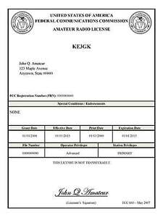*(By Anthony Luscre, K8ZT)*

As of February 17, 2015, the **FCC no longer routinely issues paper license documents** to Amateur Radio applicants and licensees. The Commission has maintained for some time now that the official Amateur Radio license authorization is the electronic record that exists in its Universal Licensing System (ULS). The FCC will continue to provide paper license documents to all licensees who notify the Commission that they prefer to receive one.

Licensees also will be able to print out an official authorization — as well as an unofficial “reference copy” — from the ULS License Manager. I’ve created a set of instructions on how you can request an **“official” printed copy of your license\***

[**Click here to download the instructions**](http://arrl-ohio.org/news/2020/print_your_license.pdf)

TOP^

***One Question Questionnaire***

Given how crazy 2020 was, and all the craziness that continues -

***“Have you been to a Hamfest yet this year?”***

From last week – “Have you got a QSL card for a QSO with W1AW” it’s

49% yes and 51% no out of 47 responses.

You’ll find the “One Question” questionnaire on the Ohio Section Website! <http://arrlohio.org> It’s all for fun and it’s not a scientific survey in any way, but we are learning some things that we didn’t know from these questions. I hope that you are enjoying answering these “One Question” questionnaires.

*****V.E. Test Sessions***

Many V.E.’s have decided to start testing once again, but with restrictions that need to be adhered to for sure. Here’s the link to find that V.E. Test session and what is expected of YOU before going. <http://www.arrl.org/find-an-amateur-radio-license-exam-session>

***Final… Final***

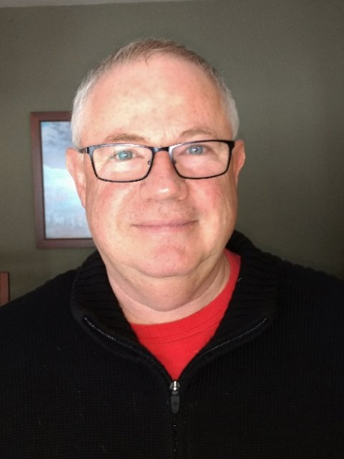This is the “Back to School” issue of the Ohio Section Journal. Sometimes I wish I could go back to school. I’d probably be a much better student now than I was at the time. The important thing to remember is: It’s never too late to take learning seriously. Every week, when I read what’s been written for the PostScript and the Ohio Section Journal, I’m amazed at what I learn just putting this all together. I’ve been to a number of hamfests and club meetings this year so far, and every one of them has been beneficial to my education. I hope that you will take advantage of all the learning and knowledge that’s available to you just because you are a ham. It seems to me there is no subject taught in school that cannot be reinforced with our Ham Radio experience.

Saturday I was at the Cincinnati Hamfest. It seemed to be one of the best ones so far, and I think what I’m seeing is that as we get further through this year more and more of you are coming out and the crowds are getting bigger as well as more venders and sellers setting up. I hope the trend continues……

After the Cincinnati Hamfest I sat in with the SWODXA conference. Although I had to duck out early, I did learn a few pretty interesting facts. Especially since I am really looking forward to Cycle 25 taking off ! I learned that of the most rare DX locations in existence, too many have been off limits to DXpeditions in recent times because of “environmental” concerns. We’ve always had to deal with “political” concerns (think N Korea) making an area off-limits, but this is something relatively new. Which leads me to the photo at the beginning of this issue captioned with the question “what’s everybody looking at?” The answer is RIB, which stands for “Radio In a Box”.

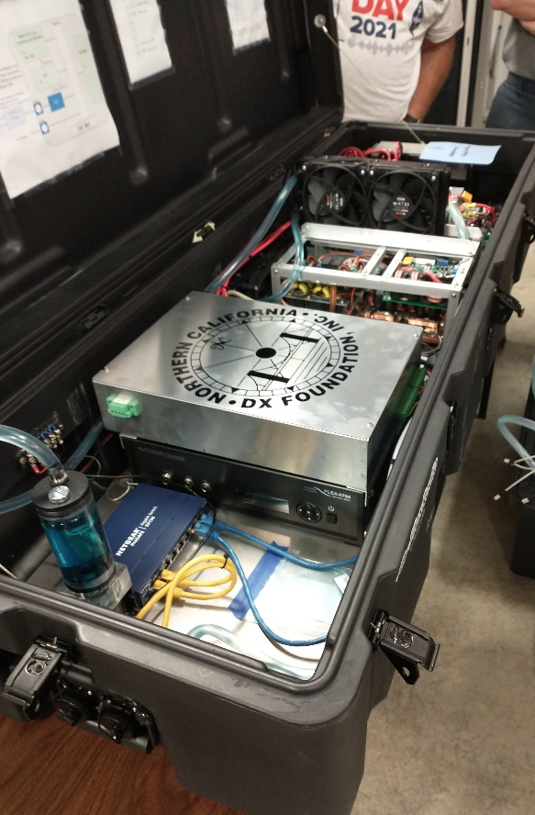This is an example of Hams dealing with the problems we face and coming up with unique solutions. This literally is a “Radio In a Box”, while at the same time it is really much more than that! Think “GO-Kit” for places you really can’t go to. Packed along with antennas, and power solutions, these are really sophisticated, high-powered (as in water-cooled amplifiers) remotely operated stations, designed to be put in a rare, and highly restricted area and left with a minimal amount of “human contact” over the time frame of a DXpedition. The stations are run remotely from some location where the humans will not be in a position to be detrimental to the environment simply by their presence.

Since these stations are being operated remotely, most humans, and *all of their support materials,* are kept off of, and out of the rare location, thus lessening the impact of their operations substantially! Hopefully, this is going to help more than a few of us catch a “rare one” during cycle 25.

I put together a “shack shot” for my local club newsletter and I’m going to put it in here. I know when I meet a ham, talk to a ham, I’m always thinking and wondering about what kind of station he might be operating from. This will give you just a little peek at my station and some of what my ham interests 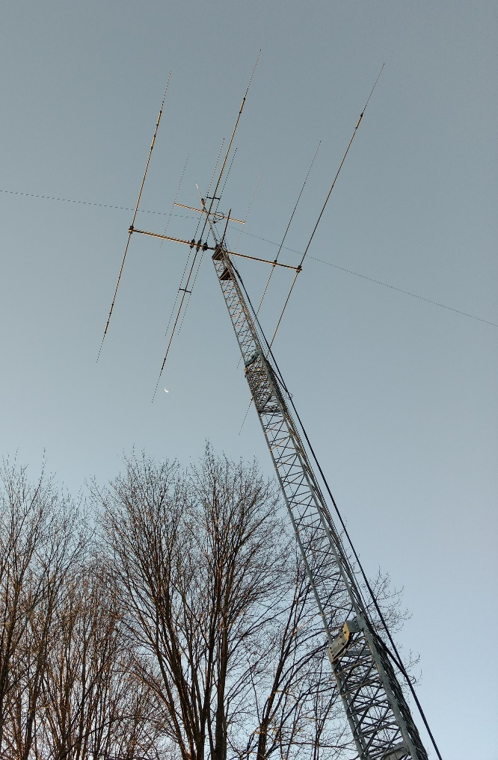are.

ARS WB8LCD

WB8LCD has gone through a lot of iterations through the years. I’m pretty happy with it now.

I’m also the receive site for the K8IV repeater. Let’s start outside at the Antennas. The tower is a 55’ crank up / Tilt over. It’s sitting in about 11 yards of concrete at the base. Not going anywhere! On top is a 20’ mast with a Hygain Explorer 14 down near the tower, an M2 3-element 6-meter yagi at the top (about 67’ high) and a 2-meter stick at the top which serves as the receive antenna for K8IV repeater. There’s also a 40 meter/80 meter dipole hung from the top of the tower. The 2-meter antenna feeds into the Icom 2-meter / 220 Mhz cross band transceiver in the basement and sends the 220 signal back to the 220 yagi on a 6’ pole next to the tower. It’s pointed towards KSU where the K8IV repeater transmitter site is located.

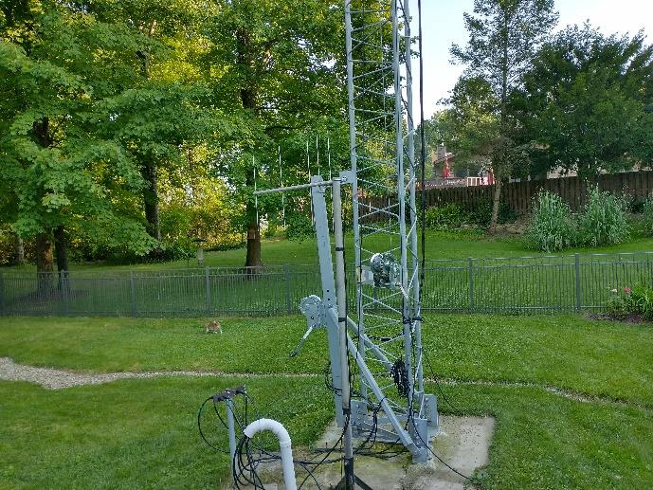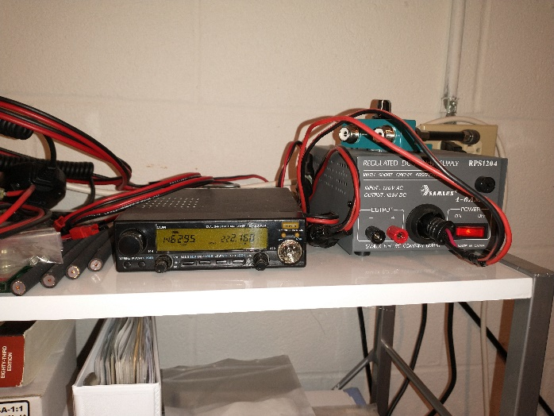

Inside, at the operating position I’ve got an Elecraft K3S with the matching Elecraft 500 watt amplifier. It’s a nice combination that works well together. For 2-meter FM, I use the Yaesu FT-817 into a short mobile whip located just outside the window well you can see in the picture. I really have to characterize myself as a “casual” operator. There’s a couple contests I like to run each year – OSPOTA and Sweepstakes are probably my two favorite. I’ll occasionally operate others, but, seems like the past few years have not left me too much time for a casual operation! I do enjoy working DX and Special Event Stations. When I get better control of my time I will go back to CW and try to regain my skills in that mode – I was actually pretty good at one time (at least my my pretty loose standards). I still enjoy operating portable and I have an Elecraft KX3 that goes out with me when we travel.

My station is a culmination of many years in the hobby. Although there’s a couple other hams here, if you hear a signal coming out of Sugar Bush Knolls – it’s probably me!

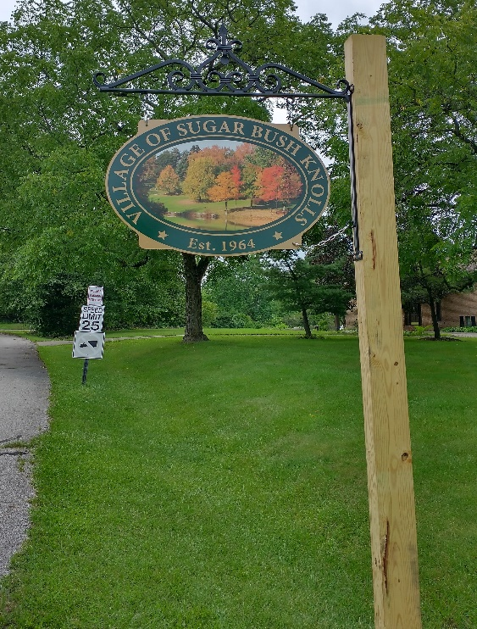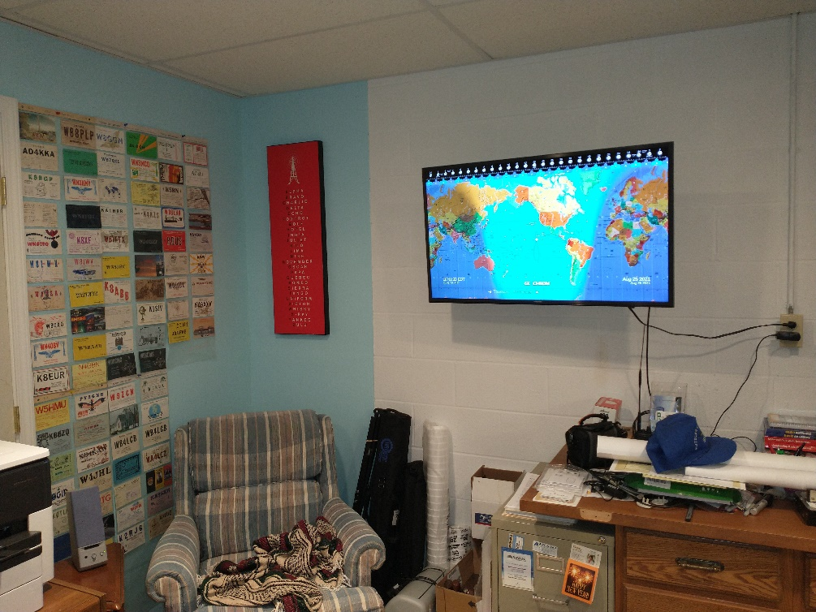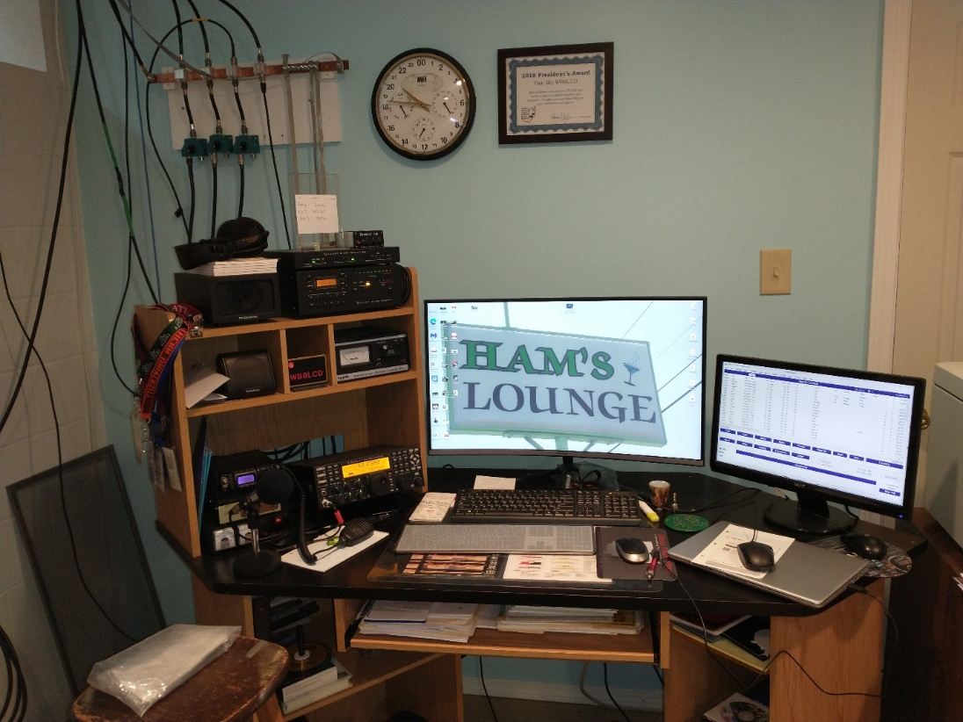

Thank you. Thank you all for making this the best hobby in the world!

73, de Tom WB8LCD ARRL OH Section Manager

[WB8LCD@ARRL.ORG](mailto:WB8LCD@ARRL.ORG)

330-554-4650

***“Swap & Shop” on the website***

Hey Gang,

Have you taken a look at the **Swap & Shop** page on the Ohio Section webpage yet?? Here’s a link that will take you there…

<http://arrl-ohio.org/sm/s-s.html>

Do you have equipment that you just don’t need or want anymore? Here’s a great venue to advertise it, and it’s FREE!!

Is your club doing a fund raiser to help raise money? After a lot of thought, it was decided that the Swap & Shop webpage could also contain these types of items as well.

The same rules will apply as do for the For Sales and Give-A-Ways and will only be posted for a month at a time. Please see the Terms & Conditions on the webpage.

If your club is doing a fund raiser and wants more exposure, please forward the information to me and I’ll advertise it on the Swap & Shop webpage for you. Now, I still want to remind you that it won’t be listed in this newsletter because it would take up way too much space, so your ad will only appear on the website. It is there for any individual to post equipment Wanted / For Sale or Give-Away as well as for Club Fund Raisers. No licensed vehicles/trailers or business advertising will be posted.

Postings are text only (no pictures or graphics) will be posted for a maximum of 1 month from date posting and require a contact phone number or email within the posting. Send your Wanted / For Sale or Give-Away post to:  [swap@arrlohio.org](mailto:swap@arrlohio.org)

***Back Issues of the PostScript and Ohio Section Journal***

Hey, did you know that PostScript and Ohio Section Journal (OSJ) are archived on the website? You can go back and look at any edition simply by clicking:

<http://arrl-ohio.org/news/index.html>

Ohio Section Cabinet

|  |  |
| --- | --- |
| Section Manager – Tom Sly, WB8LCD | Section Emergency Coordinator – Stan Broadway, N8BHL |
| Technical Coordinator – Jeff Kopcak, K8JTK | Section Traffic Manager – David Maynard, WA3EZN |
| State Government Liaison – Bob Winston, W2THU | Affiliated Clubs Coordinator – Tom Sly, WB8LCD |
| Section Youth Coordinator – Anthony Luscre, K8ZT | Public Information Coordinator – John Ross, KD8IDJ |

***Chit – Chat, and All That!***

Do you know someone that’s not getting these Newsletters? Please, forward a copy of this Newsletter over to them and have them “[Opt-In](mailto:Opt-In)” to start receiving them. Heck just have them send an email to: [webmaster@arrl-ohio.org](mailto:webmaster@arrl-ohio.org) to be added.

We now have many thousands of readers receiving these newsletters weekly. Quite impressive, I’d say! I urge all of you to make sure that everyone, regardless of whether they are a League member or not, get signed up to receive these weekly Newsletters.

You can always “Opt-Out” at any time if you feel this is not what you were expecting. It’s fun and very informative. All of your favorite past newsletters are now archived too.

You can go back at any time and read them. Just go to: <http://arrl-ohio.org/news/>

The pictures on the front page and throughout this newsletter are from various newsletters, Facebook posts and/or were sent directly to me in recent weeks. Take a good look at them, you just might be in one of the pictures! “SMILE… you’re in the Ohio Section News!!”

**Stop… We’ll be back next week with another exciting adventure for your reading pleasure!**

*The Ohio Section Journal (OSJ) is produced as a comprehensive look at all the programs within the Ohio Section. I sincerely hope that you have enjoyed this edition of the* *OSJ and will encourage your friends to join with you in receiving the latest news and information about the Ohio Section, and from around the world!*