[](http://arrl-ohio.org/news/) ***“Christmas”***

***Edition***

🡪 National News 🡪 The Handbook Give Away

🡪 Club Corner 🡪 DX This Week

🡪 Matt’s Corner 🡪 ARES Connect

🡪 From The South 40 🡪 Upcoming Hamfests

🡪 One Question Questionnaire 🡪 VE Testing

🡪 Final.. Final..

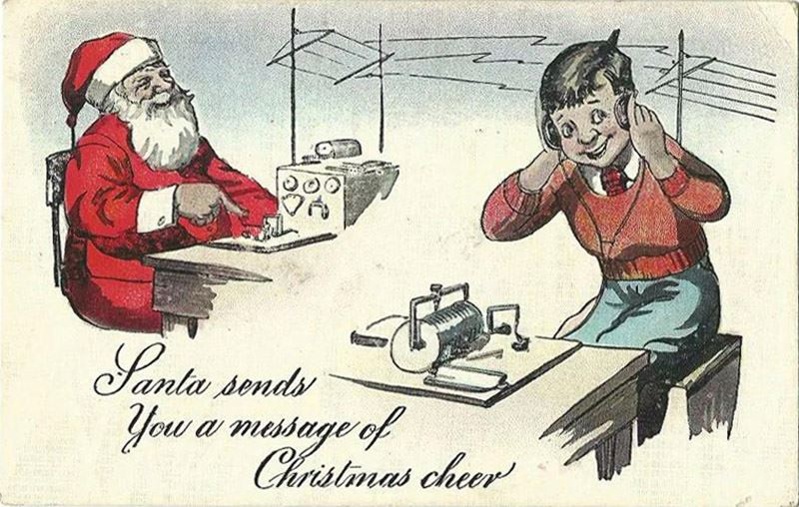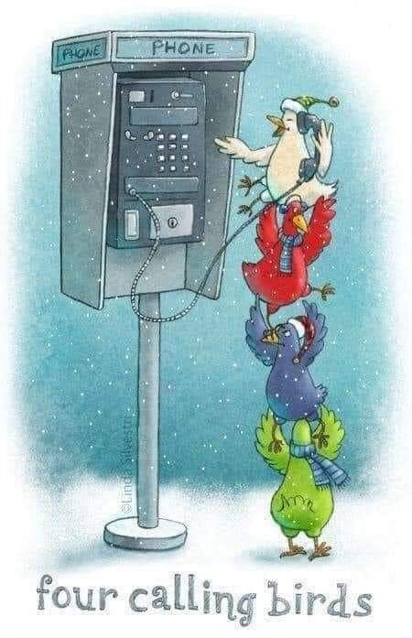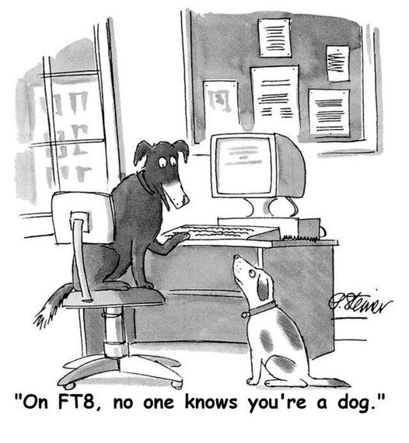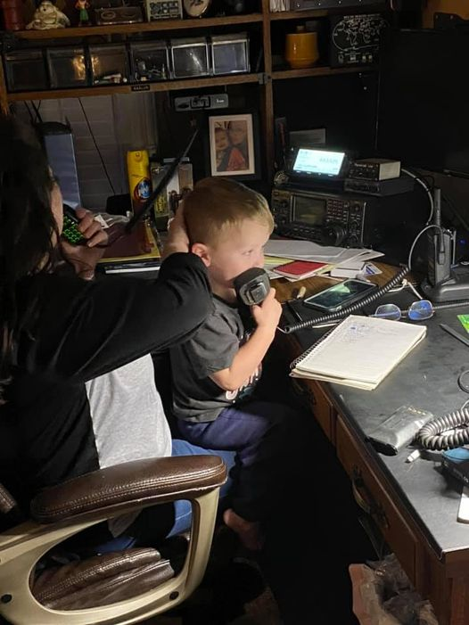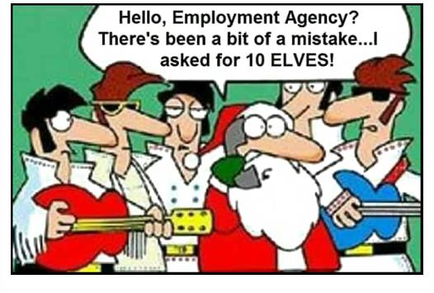

***National News***

*(from arrl and other sources)*



***FCC RULES THAT GOVERNMENT CONTRACTORS MUST HAVE CONSENT BEFORE ROBOCALLING CONSUMERS***

***For Immediate Release***

***Commission Protects Americans from Unwanted Federal, State, and Local Government Contractor Robocalls***

***--***

WASHINGTON, December 14, 2020—The Federal Communications Commission has ruled that government contractors must have consent before robocalling consumers. Today’s order reconsidered a 2016 interpretation of the Telephone Consumer Protection Act adopted by the prior FCC that allowed federal contractors to robocall consumers without their prior express consent.

The Order on Reconsideration confirms that contractors working for federal, state, or local governments—along with local governments themselves—must obtain consumer consent before making robocalls. The Commission also clarified that federal and state government callers, when acting in an official capacity, are not subject to the prior consent requirements of the TCPA. Today’s ruling does not supersede the Commission’s prior emergency calls exemptions, which apply to calls like those providing critical pandemic information.

The decision is the latest Commission action to protect consumers from unwanted robocalls. Other recent actions include empowering telephone companies to block illegal and unwanted robocalls before they reach consumer phones and adopting rules to restore trust in Caller ID information.

####

***Free PDF book about 50 MHz ham radio band***

*(Submitted by Gregory Drezdzon, WD9FTZ)*



The PDF book “Capture the MAGIC of Six Meters” by Jim Wilson, K5ND, is available for free download.   
  
It really does not take much on six meters — your existing HF+6-meter rig along with a simple antenna, even a dipole, will work. In this book, you will find out how I know that dipoles work along with how to build one of your own. 

TOP ^

This book will also provide plenty of insight into how you, too, can “Capture the Magic of Six Meters.” It covers propagation, equipment, software, antennas, awards and contesting, as well as assistance in finding the magic.  
  
Download the free PDF from:   
<https://www.k5nd.net/2020/08/capture-the-magic-of-six-meters-ebook/>

***ARRL Releases a New Edition of Storm Spotting and Amateur Radio***

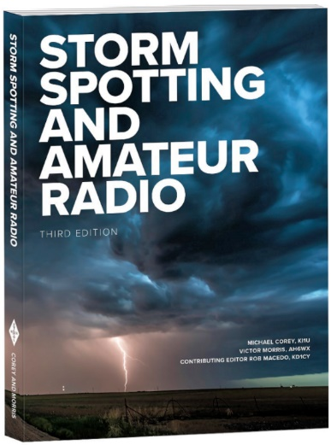The third edition of [***Storm Spotting and Amateur Radio***](http://www.arrl.org/shop/Storm-Spotting-and-Amateur-Radio-3rd-Edition/) is now available from ARRL. Storm spotting gives radio amateurs another way to offer a public service by using their skills as communicators.

In an average year, the US experiences more than 10,000 severe thunderstorms, 5,000 floods, and more than 1,000 tornadoes. During these weather events, ham radio volunteers provide real-time information to partners such as emergency managers and National Weather Service forecasters.

New in this edition are lessons learned and response reports from the 2017 hurricane season, among other things. Co-authors are University of Mississippi Professor of Emergency Management Michael Corey, KI1U, and former Embry Riddle Aeronautical University meteorology professor Victor Morris, AH6WX, with Contributing Editor Rob Macedo, KD1CY.

The third edition of [***Storm Spotting and Amateur Radio***](http://www.arrl.org/shop/Storm-Spotting-and-Amateur-Radio-3rd-Edition/) is available from the [**ARRL Store**](http://www.arrl.org/shop) or your [**ARRL Dealer**](http://www.arrl.org/arrl-publication-dealers). ARRL Item no. 1410, ISBN: 978-1-62595-135-9, $22.95 retail, special ARRL Member Price $19.95.) Call 860-594-0355 or, toll-free in the US, 888-277-5289. Also [**available**](https://www.amazon.com/dp/B08PPV2Y1Y/ref=cm_sw_em_r_mt_dp_YMu0FbGQEDS3G) in Amazon Kindle format.

####

***8,077 mile opening on 50 MHz between Australia and South America***

*(Submitted by Gregory Drezdzon, WD9FTZ)*

With the Summer Sporadic-E season in the southern hemisphere now in full swing, there was a remarkable opening on the 50 MHz band on the December 12 between Australia and South America.

The opening, believed to have been multi-hop Sporadic-E, was remarkable because of the distances involved, which were in the region of 8077.8 miles and the fact, that some of the signals crossed over part of Antarctica.

Stations in New Zealand were also able to get through to South America with distances in the region achieving 8,077 miles, too.

More info:  <https://ei7gl.blogspot.com/2020/12/remarkable-13000-km-opening-on-6-metres.html>

####

TOP ^

***Nominations Invited for 2021 CWops Award for Advancing the Art of CW***

[**CWops**](https://cwops.org/) is now accepting nominations for its 2021 [**Award for Advancing the Art of CW**](https://cwops.org/the-cwops-award-for-advancing-the-art-of-cw/). The award recognizes individuals, groups, or organizations that have made the greatest contribution(s) toward advancing the art or practice of radio communication by Morse code.

Candidates for the award may be authors of publications related to CW; CW recruiters, trainers, mentors, coaches, and instructors; public advocates of CW; organizers of CW activities; designers and inventors who advance the art or practice of CW, and other contributors to the art or practice of CW. The award is not limited to radio amateurs or their organizations. Nominations can be submitted via [**email**](mailto:awards@cwops.org),  [**copying**](mailto:secretary@cwops.org) the CWops secretary.

Nominations must be received by March 18, 2021. It should include the name(s) and call sign(s), if applicable, of nominee(s), and complete contact information. A detailed explanation supporting the nomination should be included along with the name, telephone number, email address, and call sign of the person submitting the nomination. An award presentation will take place at the 2021 [**Dayton Hamvention**](http://www.hamvention.org/)®.

####

***Dipoles Explored by G4CQM***

*(Submitted by Gregory Drezdzon, WD9FTZ)*

G4CQM's forensic investigation “Dipoles Explored” mutes myths about propagated on the Internet concerning the pros and cons of particular dipoles and their potential use as Yagi based driven elements.

To create a level playing field the following analysis has been carried out in K6STI's Antenna Optimizer Professional (AOP) version software. AOP is perfect for analysis of loops and bent elements because it includes a special correction for this problem that works without altering segmentation or increasing computation time.

Want more information… <https://qsl.net/g4cqm/wave_antennas/DIPOLES.html>

####

***SSTV Event to Help ARISS Mark 20 Years of Continuous Ham Radio Operation in Space***

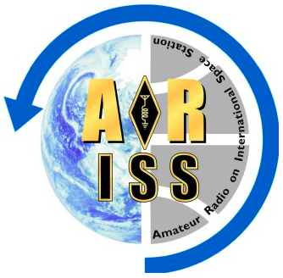Amateur Radio on the International Space Station ([**ARISS**](http://www.ariss.org/)) will continue its year-long 20th anniversary celebration of continuous ham radio operation from the ISS this month, with a slow-scan television (SSTV) event over the holidays. The first ARISS school contact took place in December 2000, not long after the first ISS crew arrived on station a month earlier and had made test contacts. The commemorative late-December SSTV event will be held December 24 through December 31, although dates are subject to change. The frequency will be 145.800 MHz, using SSTV PD-120 mode. Over its 20 years, ARISS has supported nearly 1,400 scheduled ham radio contacts with schools, student groups, and other education organizations.

TOP ^

“ARISS would not be the complex and growing program of education, operations, and hardware were it not for ARRL, AMSAT, NASA, and the ISS National Lab (INL),” said Rosalie White, K1STO, ARISS-US Delegate representing ARRL. “For these past 20 years and for the years to come, when we grow into lunar ham radio opportunities and more, the ARISS team will continue to be grateful to ARRL and all our sponsors. We could not do it without you!”

The ARISS ham radio gear, for what would become NA1SS on board the station, arrived ahead of the Expedition 1 crew, headed by Bill Shepherd, KD5GSL. Shepherd made the first ARISS school contact with students at Luther Burbank Elementary School in Illinois on December 21, 2000. NASA has marked the ARISS milestone with an [**infographic**](https://www.nasa.gov/mission_pages/station/research/news/iss-20-years-ham-radio-infographic) highlighting the educational contacts via amateur radio between astronaut crew members aboard the ISS and students.

ARISS will continue to sponsor various commemorative events through November 2021, including more of the very popular ARISS SSTV sessions. In celebration of the 20th anniversary of ham radio on the space station, ARISS took part in the ISS Research and Development Conference (ISSRDC) panel session, “20 Years of STEM Experiments on the ISS.” A [video](https://www.ariss.org/) developed for the session describes the program, conveys some key lessons learned over the past 20 years, and describes the ARISS team’s vision for the future.

“Twenty years of continuous operations is a phenomenal accomplishment,” said ARISS-International Chair Frank Bauer, KA3HDO, who’s been with the program from the start. “But what makes it even more extraordinary is that ARISS has achieved this through hundreds of volunteers who are passionate in paying it forward to our youth and ham radio community. On behalf of the ARISS International team, I would like to express our heartfelt thanks to every volunteer who has made ARISS such an amazing success over the past 20 years. Your passion, drive, creativity, and spirit made it happen.”

In September, ARISS [**announced**](http://www.arrl.org/news/first-element-of-ariss-next-generation-radio-system-installed-and-operating-on-iss) that the initial element of its next-generation Interoperable Radio System (IORS) had been installed in the ISS *Columbus* module, replacing outmoded and problematic station gear.

A helpful addition to the ARISS website is a “Current Status of ISS Stations,” which reports the present or coming operating mode of ARISS radios in the *Columbus* and *Service* modules. Click on General Contacts and then Current Status of ISS Stations on the drop-down menu of the ARISS website to access the reports.

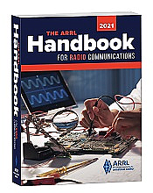***Handbook Give Away***

Hey Gang,

There will be 2 drawings this month - one for Christmas, and one at the end of the month!!! The first winner will be announced on Christmas Day - December 25th. Wow, what a Christmas gift this will be for someone! The second winner will be announced on January 1st. Each winner will be notified by email, so PLEASE use a valid email when completing the form.

**Hey.. If you enter BEFORE the December 24th deadline for the Christmas Drawing,**

**you'll automatically be entered for both drawings!! Now how much better can it get!**

TOP ^

To enter the drawing all you need to do is fill in a couple of boxes on the form.. That’s you need to do to be entered into a drawing for a 2021 ARRL softcover Handbook. There’s nothing else required (Oh.. You do need to be a resident of Ohio to win..) The winner will be mailed the Handbook at my cost.

Go to: <http://arrl-ohio.org/handbook-christmas.html> and get registered NOW.

What’s the catch? I want to get everyone checking in to the Ohio Section website as often as possible, and in order to register each month, you have to visit the website often! There’s nothing else to it. I pay all expenses, and from time to time,

Many of you ask me just how do I know when the drawing is on? Well, that’s easy all you need to do is check in on the Ohio Section Website on a regular basis and watch for the big **RED** Arrow that will appear on the left side of the page. This is the sign that the drawing is on and you need to get registered. So, keep a sharp eye out on the website and check in often! <http://arrl-ohio.org/>

***Club Corner***

This is YOUR cornner of the newsletter. Send me what your club is doing and I’ll make sure that it gets in. Got a special event or club project that you want everyone to know about? Send it to me!. Need help with a project? Send it to me.

Let me know what you club is up to. Are you going to have a special guest at your meeting or are you having a special anniversary?

Just sent it to: [webmaster@arrl-ohio.org](mailto:webmaster@arrl-ohio.org)

####

***Black River Radio Ops were on the air for the 2020 FT-Roundup.***

*(from Doug Dever, AB8M)*

For those not familiar with the FT-Roundup contest, it is essentially the same rules as the ARRL RTTY Roundup but exclusively uses FT4 and FT8.

Personally, I’m struggling to really “get in” to using FT-modes for contesting. The rate, even with FT4, is slower than Phone, CW, or RTTY.  The number of participants is fairly low.  Worst of all, everyone continues to stay confined to a 3kc window and will not spread out.  The net effect is that it is essentially a QRM fest, and with the timeslot nature of FT, you won’t know unless you stop mid-cycle to see if someone is on top of you.  (Usually it becomes obvious when you go from working stations to not working stations.)  This will remain an opportunity for hams to figure out for future FT contesting.

Band conditions.  While we’ve started to see some better band conditions in northern Ohio on the upper bands, they were rough for the contest.  There was very little 15m activity, and 10m activity was nonexistent.

TOP ^

Now that I’m done complaining about the mode and the band conditions… Jay, Jon, and I still had a good time.  FT RU is better than not having a radio activity for the weekend.  It was COVID friendly in that all 3 of us could operate from our own homes while still trash talking each other on VHF or via instant messenger.  Also, Jay worked out the kinks on SO2R operations - something that will likely be useful for future RTTY competitions.

Hopefully you gave it a go and one or all of us got you in the log book.  If not, don’t worry we’ll be at it again next year.  If you don’t want to wait a full year, the ARRL RTTY Roundup is coming up Jan 2 and 3 and includes RTTY, FT, PSK, AMTOR, ASCII, and Packet.

Contest Information:

FT Roundup ran from1800 UTC Dec 5 until 2359 UTC Dec 6.

|  |  |  |
| --- | --- | --- |
| KB8O: 91,464 pts  80 meters: 164 QSOs  40 meters: 315 QSOs  20 meters: 294 QSOs  15 meters: 114 QSOs  10 meters: 1 QSO | KM8V: 47,975 pts  80 meters: 105 QSOs  40 meters: 221 QSOs  20 meters: 112 QSOs  15 meters: 67 QSOs  10 meters: 0 QSOs | AB8M: 42,480 pts  80 meters: 82 QSOs  40 meters: 207 QSOs  20 meters: 195 QSOs  15 meters: 47 QSOs  10 meters: 0 QSOs |

***DX This Week***

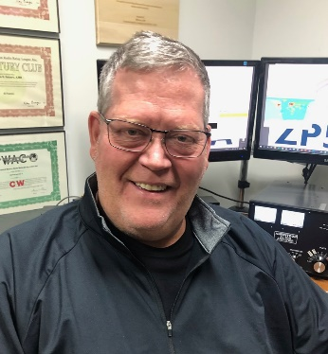*(from Bill, AJ8B)*

***DX This Week – Zones 36, 37, 38, 39, & 40***

***Bill AJ8B (aj8b@arrl.net, @AJ8B, or www.aj8b.com)***

***CWOPs Member #1567***

The Midwest DX Cluster spots that were posted last week included Aland Islands, Argentina, Asiatic Russia, Balearic Islands, Bonaire, Bosnia-Herzegovina, Brazil, Bulgaria, Canada, Chad, Colombia, Costa Rica, Cuba, Czech Republic, Dominica, European Russia, European Turkey, Falkland Islands, Fed. Rep. of Germany, France, Guam, Guatemala, Guernsey, Hong Kong, Hungary, Indonesia, Italy, Japan, Malawi, Malta, Mexico, Montenegro, Namibia, New Caledonia, New Zealand, Oman, Panama, Peru, Philippines, Poland, Puerto Rico, Sardinia, Slovenia, Spain, St. Helena, St. Lucia, Sudan, Suriname, Sweden, Tajikistan, United Nations HQ, and Uruguay.

***DAH DIT DIT DIT DAH DAH DIT DIT DIT DAH***

TOP ^

QSL cards received this week included Z81D, Diya in South Sudan.

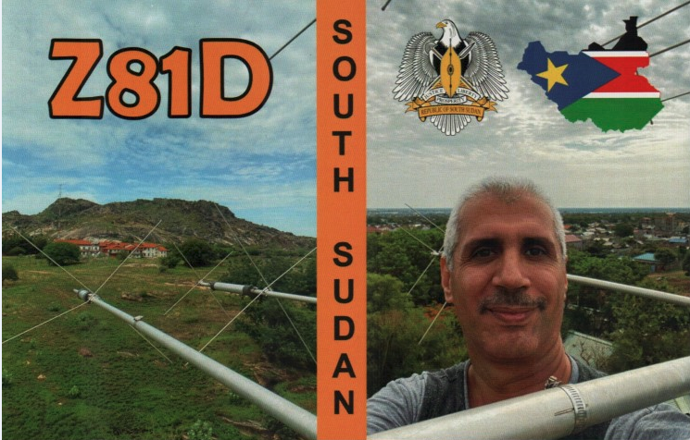

***DAH DIT DIT DIT DAH DAH DIT DIT DIT DAH***

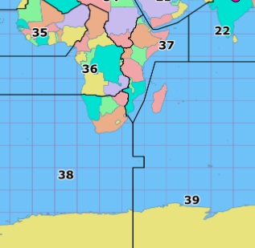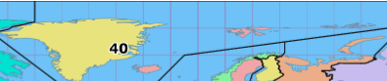So far this year, we have covered CQ zones 1 through 35. This week we will wrap up this review of CQ Zones with 36, 37, 38, 39 and 40. I hope you have found this exercise interesting.

With the Solar Activity slowly increasing, there are going to be more opportunities to work these entities and I hope you are ready!

Below is a list of the entities in each zone and the estimated number of hams in each country, for the data I could find.

**Zone 36.** Equatorial Zone of Africa: **D2** (Angola), **S9** (Sao Tome Principe), **TJ** (Cameroon), **TL** (Central African Rep.),

**TN** (Congo), **TR** (Gabon), **TT** (Chad), **ZD7** (St. Helena Is.), **ZD8** (Ascension Is.), **3C** (Equatorial Guinea), **3C0** (Annobon Is.), **9J** (Zambia), **9Q** (Democratic Rep. of Congo), **9U** (Burundi) and **9X** (Rwanda).

TOP ^

**Zone 37**. Eastern Zone of Africa: **C9** (Mozambique), **ET** (Ethiopia), **E3** (Eritrea), **J2** (Djibouti), **T5** (Somalia), **5H** - 173 (Tanzania), **5X** (Uganda), **5Z** (Kenya), **7O** (Socotra and Abd al Kuri islands ONLY) and **7Q** (Malawi).

**Zone 38**. South African Zone: **A2** (Botswana), **V5** (Namibia), **ZD9** (Tristan da Cunha Gough Is.), **Z2** (Zimbabwe), **ZS** – 6,000 (South Africa) and **ZS8** (Marion Is), **3DA** (Swaziland), **3Y** (Bouvet Is.), **7P** (Lesotho), and some Antarctic stations (See Notes Below)

**Zone 39**. Madagascar Zone: **D6** (Comoros), **FH** (Mayotte), **FR** (Reunion), **FT-G** (Glorioso), **FT-J&E** (Juan de Nova and Europa), **FT-T** (Tromelin), **FT W** (Crozet Is.), **FT-X** (Kerguelen Is.), **FT Z** (Amsterdam St. Paul Is.), **S7** (Seychelles), **VK0** (Heard Is.), **VQ9** (Chagos), **3B6/7** (Agalega St.Brandon Is.), **3B8** (Mauritius Is.), **3B9** (Rodriguez Is.), **5R** (Madagascar) and some Antarctic stations (See Notes Below)

**Zone 40.** North Atlantic Zone: **JW** (Svalbard), **JX** (Jan Mayen), **OX** (Greenland), **RI1FJ** (Franz Josef Land), and **TF** (Iceland).

(*) The Paracel Islands have no official or unofficial prefix

As part of our discussion in the last segment, Zone 36 contains many of the “Terrible T’s”. These countries appeared randomly and without any announced schedules for years. DXPeditions help to make them more accessible, but not as accessible as many of us would like!

Zone 37 has a couple of active representatives including 5H – Tanzania and 5Z – Kenya. The other entities are typically available during contests or DXPeditions.

Zone 38 is well represented by ZS – South Africa. 3Y – Bouvet was the target of a major DXPedtion 2 years ago but tragically it could not be completed. It is on the horizon.

Zone 39 is a collection of Island entities. There is some really great DX in this group.

Zone 40, the Ice group, is fairly easy to work over the course of the year.

I hope you found this glimpse of the Zones and entities interesting!

***CQDX CQDX CQDX CQDX CQDX CQDX CQDX CQDX CQDX***

Here is an update from Bernie, W3UR, of the DailyDX and the WeeklyDX, the best source for DX information. [http://www.dailydx.com/](http://www/dailydx.com). Bernie has this to report:

**3D2/R – Rotuma -** 3D2AG, Antoine, says so far, his Rotuma operation is on track, with the boat leaving December 12 and reaching Rotuma around the 14th.  He expects to be able to get on the air the 16th or 17th.

Antoine has just bought a 5KW diesel generator and next is buying a 200-liter drum of fuel, both of which he will take on the ship to Rotuma. His primary reason for the trip is to put up a memorial to his son, who died in a drowning accident on Rotuma, and is buried there.

TOP ^

Departure from Rotuma is January 14.  He figures that’ll mean his last operation from there may be on about the 12thof January.  As always, tropical weather, particularly cyclones, will be monitored.

Antoine plans to do most of his operating on 17, 15, 12 And 10 this time, due to higher sunspot numbers but he may still try to put up a 160-meter antenna (though previous info indicates a 160M inv. V.)

More particulars:  The QTH on Rotuma will be Fapufa, grid RH87ML, callsign 3D2AG/p, with an IC-7300 and IC-706MKIIG, 600 watts maximum to a Spiderbeam that covers 20, 17, 15, 12 and 10, inverted Vs for 160, 60, 40 and 30, a 5-element Cushcraft Yagi for 6, and the possible inverted L on an 18 meter tall pole for 160.  He can operate CW, FT8, SSB and RTTY.

For a 3D2AG QSL, to cover the postage cost use PayPal or OQRS.  Do not send direct SASEs because of a high risk of theft he says, and covid-19 mail service disruptions.  The Club Log OQRS upload will be when he is back home.  He is logging on paper for his CW QSOs, so he will have to retype the log.  LoTW will be available “once OQRS is performed for a QSL card on Club Log.  Otherwise, logs may be uploaded 12 months after the expedition.” Antoine notes that the pandemic situation may cause delays to some destinations like Europe and Japan. He will not have internet during the operation, so will not be getting emails or PSK reporter info.

**ON5AU** has created a webpage to remember **ON4UN**, John Devoldere, an icon of low-band DXing.  [http://on5au.be/Homage_to_ON4UN.html](http://r20.rs6.net/tn.jsp?f=001HqTy2JVuKLw6-HOsql90jV8CRjDoArmRYaIxEJfJJ9czCStpqTTbBRDN0xgPqxMd-9Wcze1ouj0-72C9v8-h26hSgy18EMF3PegSZgPHNarM-AUmzMJ7VEHgmiiu3yVmTJySRzewZSFVf1IySB3c-rTEaNgFX33_&c=VkQV7NhFPXSdDBMyuFipRUbVCKbFb8iKz0p9GxdyizxrKp86yWjBVQ==&ch=g9uDOZZFFlEq9NLDgYpy6RAvqnj0CCFhlYJ3XCGyDxBdgAF-qGe6Iw==)

The recent **CQWW CW 2020** raw scores are now online: [https://www.cqww.com/raw.htm?mode=cw](http://r20.rs6.net/tn.jsp?f=001HqTy2JVuKLw6-HOsql90jV8CRjDoArmRYaIxEJfJJ9czCStpqTTbBRDN0xgPqxMdIp384kHh90F05_KEIonlkbAHE4-gvjaXBYTCpP3V4bkOhM7mTLRPGt7KmGBtBz5kVIxDXYtpw-C4BjX5Heo7tIZ-IL84BYawxdIQqGg9KrA=&c=VkQV7NhFPXSdDBMyuFipRUbVCKbFb8iKz0p9GxdyizxrKp86yWjBVQ==&ch=g9uDOZZFFlEq9NLDgYpy6RAvqnj0CCFhlYJ3XCGyDxBdgAF-qGe6Iw==)

**New IOTA OC-298 and the 2021 Honour roll and annual listings**

By G3KMA, Roger Balister, IOTA General Manager

New IOTA OC-298 Tatakoto Atoll has now been confirmed following the opening up of QSO matching on LoTW for contacts with Cezar, VE3LYC’s recent TX0T operation (30 October – 5 November 2020). This has enabled credits made previously with the island by FO5RH, FO0CLA and TX5TES and credited to OC-066 to be transferred to the new number OC-298 where the evidence is clear. Record holders may wish to check if they now need to restore credit for OC-066 with a replacement card. Requests arising from this change of group number should be made using the normal update procedure through checkpoints. The current list of these is at Annex A in the IOTA Directory available [here](http://r20.rs6.net/tn.jsp?f=001-F8Gdm2v3FcVaT2UTi263funLre03yMKa6oIt4xcALYGDUhWehs1fCCzLziE03LGj0QsLxCHabezl0zQyBPwtBnnTxnyEVGaW80xO7d47rt1-fucuc26ouAAWL_7H9RJXfIFG8Lqfr3Y10RczkDnDR2gHOXQNvkjBCaDdo3v-yGoaKZ-XssWPMFRB94M5COieZ0d6wn-RTKErFoUcEL4aF-lFsgoOzqs&c=Wc2ESMApI3BWlM_ArAGySmKaiZpqH0oW-MbEojTlZPqTVCOc197G9A==&ch=nECW6WjxH4mqB6XHBsMS0Tg6Qf6F3d3ChzloUa6GG253dXCFFFyRUA==).

This is a suitable time to remind you that the last date for sending score updates to checkpoints, both online or by QSL cards, for inclusion in the 2021 Honour Roll and Annual Listings is 31 January 2021. If cards are postmarked after that date, and each year checkpoints receive some, they are processed in the normal way, but the scores are held over to the following year's listing. The current disruption to postal services as a result of coronavirus suggests that, where cards are to be sent, they should be sent in good time to enable credit to be given. It is important that participants who have not updated since the 2016 annual listings and wish to remain listed should note the 5-year cut-off rule and make a submission before 31 January 2021. If you have not logged into your record for more than two years, you will need to revalidate your registration through [info@iota-world.org](mailto:info@iota-world.org). Do not leave it to the last moment as you may run out of time.

***DAH DIT DIT DIT DAH DAH DIT DIT DIT DAH***

TOP ^



Below is a list of upcoming contests in the “Contest Corner”. I think this is important for someone who is trying to move up the DXCC ladder since entities that are on the rarer side and easiest to work in contests. Some of my best “catches” have been on the Sunday afternoon of a contest when the rarer entities are begging for QSOs. Of course, the gamble is that if you wait until Sunday, conditions may change, or they simply won’t be workable. However, it is not a bad gamble. Of course, why not work the contest and have some fun!  
Check out the WA7BNM Contest Calendar page (<https://www.contestcalendar.com/>) for more contests or more details.

The contests in red are those that I plan to spend some significant participation time on. PLEASE let me know if you are working contests and how you fared.

Thanks!

|  |  |  |
| --- | --- | --- |
| Dec. 21 | K1USN Slow Speed Test | [www.k1usn.com/sst.html](http://www.k1usn.com/sst.html) |
| Dec. 26 | DARC Xmas Contest | [www.darc.de/?id=820](http://www.darc.de/?id=820) |
| Dec. 26-27 | Stew Perry Topband Challenge | [www.kkn.net/stew](http://www.kkn.net/stew) |
| Dec. 27 | RAEM Contest | <http://raem.srr.ru/en/main> |
| Dec. 28 | K1USN Slow Speed Test | [www.k1usn.com/sst.html](http://www.k1usn.com/sst.html) |
| Jan. 1 | ARRL Straight Key Night | [www.arrl.org/straight-key-night](http://www.arrl.org/straight-key-night) |
| Jan. 1 | QRP ARCI New Year’s Day Sprint | [www.qrparci.org/contests](http://www.qrparci.org/contests) |
| Jan. 1 | SARTG New Year RTTY Contest | [www.sartg.com/contest/nyrules.htm](http://www.sartg.com/contest/nyrules.htm) |
| Jan. 1 | AGCW Happy New Year Contest | https://bit.ly/35nBqSR |
| Jan. 2-3 | ARRL RTTY Roundup | [www.arrl.org/rtty-roundup](http://www.arrl.org/rtty-roundup) |
| Jan. 2-3 | EU CW 160m Contest | [www.eucw.org/eu160.html](http://www.eucw.org/eu160.html) |
| Jan. 2-3 | Original QRP Contest | [www.qrpcc.de/contestrules/index.html](http://www.qrpcc.de/contestrules/index.html) |
| Jan. 3 | Veron SWL New Year Contest | <http://bit.ly/2L9eT1L> |
| Jan. 6 | UKEICC 80 Meter Contest SSB | https://bit.ly/2SDPqQQ |
| Jan. 9 | YB DX Contest SSB | https://ybdxcontest.com |
| Jan. 9-10 | AWA Linc Cundall Memorial Contest | https://bit.ly/3iDUm34 |
| Jan. 9-10 | North American CW QSO Party | <http://ncjweb.com/naqp> |
| Jan. 9-10 | UBA PSK63 Prefix Contest | <http://bit.ly/2Oi8fsa> |
| Jan. 10 | DARC 10-Meter Contest | <http://bit.ly/2pCiRo1> |
| Jan. 10 | NRAU – Baltic SSB Contest | [www.nrau.net](http://www.nrau.net/) |
| Jan. 10 | NRAU – Baltic CW Contest | [www.nrau.net](http://www.nrau.net/) |
| Jan 29 – 31 | CQWW 160M | <https://cq160.com/> |

TOP ^

|  |  |  |
| --- | --- | --- |
| Mar. 27 – 28 | CQWW WPX SSB | <https://www.cqwpx.com/> |
| May 21 | SWODXA DXDinner | [www.swodxaevents.org](http://www.swodxaevents.org) |
| May 29 – 30 | CQWW WPX CW | <https://www.cqwpx.com/> |
| August 28 | Ohio QSO Party | <https://www.ohqp.org/> |
| August 28 | W8DXCC Convention | [www.w8dxcc.com](http://www.w8dxcc.com) |

**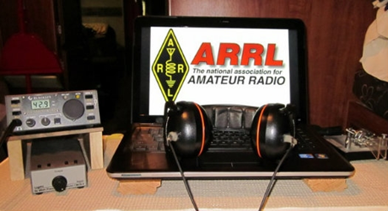*ARRL Contest Corner***

An expanded, downloadable version of *QST'*s’ [**Contest Corral**](http://www.arrl.org/contest-calendar) is available as a PDF. Check the sponsor’s ‘Website for information on operating time restrictions and other instructions.

***Ohio ARES VHF Simplex Contest - 2021***

***January 9 – 10AM through 4PM EDT.***

**The purpose of our annual simplex activity is to improve our station and antenna capabilities, and to test our coverage areas on simplex frequencies.**  These may be very important in times of emergency, when repeaters have failed, and simplex is the only method of emergency communication. We are NOT giving any consideration for backup power- this exercise is aimed at testing antennas and determining coverage areas.

**Bands**

All bands from 50 MHz up

We recommend the following frequencies:

50 MHz – Standard simplex calling frequencies *Your QSO Points X 10 for six meters!!*

146.49 (alternate 146. 46) for VHF

UHF and above - Standard simplex calling frequencies

**Modes**

ALL MODES are acceptable- it’s your choice

Digital- using any mode generally accepted by NBEMS/ARES in fldigi. (Default = Mt63 2K)

For more details of this really fun event go to:

[Ohio Simplex Contest – A short VHF and up radio contest (ohsimplex.org)](https://ohsimplex.org/)

####

***Contests you say? We’ve got contests…***

*(from Doug Dever, AB8M)*

***Winter blues coming around?***

Luckily, we’re in the thick of contest season to go along with being stuck at home while everything is closed. The past two weekends have hosted the ARRL 160 Meter Contest, [FT-Roundup](http://www.nw8s.com/news/ft-roundup-2020/), and the ARRL 10 Meter contest.

TOP ^

**[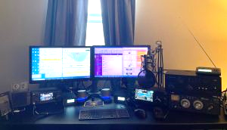](https://i1.wp.com/www.nw8s.com/wp-content/uploads/2020/12/ab8m-e1607918836207.jpg)AB8M Station**

I used both of these contests as an opportunity to work on my truly nascent code skills.  Contests are a good way to work on your receiving code proficiency as you have a lot of stations on the air, you have repetitive exchanges that you’ll hear again and again and can make mental associations with, and most of the folks are forcing you to copy it fast.  These contests not great opportunities for practicing sending code as you’ll likely want to use macros and/or a keyboard so that you’re not causing a bottleneck for the other stations trying to work the station you are calling.

[**ARRL 160 Meter Contest**](http://www.arrl.org/160-meter)**.**  This contest was fun for me.  In my previous QTH I simply didn’t have the room to put up anything that I could use on 160m.  (Ok, not entirely true – I did try loading up the gutter system on the building once and while it actually was a 50 ohm match, it was not an effective antenna.)  I still would be better suited by a longer antenna, but honestly, I can’t complain.  In the winter months when it is quiet, 160 is a great band.  (But if you’re new to 160 and running barefoot with a compromise antenna, don’t be surprised if some of those stations 20 over have trouble hearing you – routine users of the band often have dedicated 160m antennas and are running QRO.)   I wasn’t sure how my 135ft ladder line fed doublet was going to do as it is better suited for 80m but it worked out better than I expected.  In a 4 hour period I [worked 114 stations in 44 sections](https://3830scores.com/showrumor.php?arg=5Pa8z6qfyaivx). I did not work any DX.  (I spent the rest of the weekend on the [FT Roundup contest](http://www.nw8s.com/news/ft-roundup-2020/), so I only operated between 20:00 and 23:59 ET on Friday 12/4/20.)

[**ARRL 10 Meter Contest**](http://www.arrl.org/10-meter)**.**  One thing contesters quickly realize is that for mixed-mode contests, there’s usually a lot more activity on CW than on phone.  In most of these contests, CW contacts are worth more points.  Additionally, the narrow properties of CW allows the ear to decode it at a much lower signal to noise ratio than human speech.  In other words, you’ve got a better chance of hearing the weak ones and getting more points for them.  Since I was using the contests as an exercise to focus on listening to code, that was fine with me.

While we’re not at the bottom of the sunspot cycle anymore, the upper bands still are not great.  The contest started off with surprisingly good band conditions on Friday night.  I chatted briefly with KW8N when I worked him and he summed it up well, “I was just going to screw around for a little bit but band conditions are so good.”  Unfortunately, that didn’t continue for Saturday.  Saturday morning was marginal, and conditions only deteriorated from that through the rest of the day.  A surprise highlight was working Namibia on phone at 9am ET on Saturday.  Sunday was a better day with fairly decent conditions from the morning until late afternoon.  Every time I’d think about packing it in on Sunday afternoon, the band would shift slightly and open up to other states I hadn’t worked so that kept me coming back every hour or so to check.  There were no great DX openings, no wet a rope and throw it out the window and work the world moments, but still a lot of stations on the air and having fun in what was primarily a stateside contest.  NQ8O also got into the action for a couple hours Sunday handing out some Qs.

Results:

AB8M – Single Op, Mixed Mode, Assisted, High Power. Score: [21,756](https://3830scores.com/showrumor.php?arg=1TaxzEqgaqfvL). 108 CW QSOs, 43 SSB QSOs

NQ8O – Single Op, CW Only, Assisted, High Power. Score: 9960. 83 CW QSOs.

####

TOP ^

***Contest University will host Propagation Summit on January 23, 2021.***

Several radio propagation experts will share their knowledge during a Propagation Summit via Zoom, sponsored by Contest University ([**CTU**](https://www.contestuniversity.com/)). The event is scheduled for January 23, 2021. The presentation schedule includes:

* “Update on the Personal Space Weather Station Project and HamSCI Activities for 2021” with Nathaniel Frissell, W2NAF, at 11 AM EST (1600 UTC)
* “Solar Cycle 25 Predictions and Progress” with Carl Luetzelschwab, K9LA, at noon (1700 UTC)
* “Maximizing Performance of HF Antennas with Irregular Terrain” with Jim Breakall, WA3FET, at 1 PM EST (1800 UTC)
* “HF Ionospheric Propagation” with Frank Donovan, W3LPL, at 2 PM EST (1900 UTC).

[**Registration**](https://zoom.us/webinar/register/WN_dfLvFDxaTyakOWd_C7_puw) is free. An Icom IC-705 will be raffled off as a “door” prize. The winner must be present on Zoom to win. — *Thanks to CTU Chair Tim Duffy, K3LR*

All times are USA EST.

11 AM - "Update on the Personal Space Weather Station Project & HamSCI activities for 2021" - Dr. Nathaniel Frissell, W2NAF Noon - "Solar Cycle 25 Predictions & Progress" - Carl Luetzelschwab, K9LA

1 PM - "Maximizing Performance of HF Antennas with Irregular Terrain" - Dr.

James Breakall, WA3FET

2 PM - "HF Ionospheric Propagation" - Frank Donovan, W3LPL Drawing for an Icom IC-705 donated by Icom America and DX Engineering - both CTU sponsors. Winner must be present on Zoom to win.

To register for this free CTU Propagation Summit Webinar please go to :

<https://zoom.us/webinar/register/WN_dfLvFDxaTyakOWd_C7_puw>

Stay tuned to Contest University: <https://www.contestuniversity.com/>

73, Tim K3LR - Contest University Chairman

####

TOP ^

***DX News***

***ARLD051 DX news***

This week's bulletin was made possible with information provided by The Daily DX, the OPDX Bulletin, 425 DX News, DXNL, Contest Corral from QST and the ARRL Contest Calendar and WA7BNM web sites. Thanks to all.

**SRI LANKA, 4S.** Members of the Radio Society of Sri Lanka, formerly known as the Radio Society of Ceylon, celebrates its 70th anniversary with stations adding /70 to their call signs. QSL via operators' instructions.

**CYPRUS, 5B.** Alex, 5B4ALX is QRV as C4XMAS during the month of December. QSL via IZ4AMS.

**SPAIN, EA.** Special event station AO50UPC is QRV until December 30 to celebrate the 50th anniversary of the Universitat Politecnica de Catalunya. QSL direct.

**SAUDI ARABIA, HZ.** Members of the Saudi Amateur Radio Society are QRV with special event station HZ18SAT until December 27 to commemorate the start of the Saudi satellite 1C SO-50 18 years ago.

QSL via operators' instructions.

**OGASAWARA, JD1.** Harry, JG7PSJ is QRV as JD1BMH from Chichijima, IOTA AS-031, and plans to be here until January 9, 2021 unless plans change. Activity is on 40 to 10 meters using CW, SSB and RTTY. QSL direct to home call.

**ALASKA, KL7.** Jim, KL7KK is QRV from Bethel and is generally active on 80 meters using SSB around 1500 to 1600z and then from 1700 to 1900z, daily. QSL to home call.

**NETHERLANDS, PA.** Special event station PH20XMAS is QRV until January 3, 2021. Special event station PH21HNY is QRV until January 31, 2021. QSL both calls via bureau.

**SLOVENIA, S5.**  Members of the Radio Club Elektron Brezice are QRV with special event station S520SAFE until January 31, 2021 to support the STAY SAFE campaign and to express their gratitude to medical staff and care workers. QSL direct to S56IPS.

**POLAND, SP.** Members of team SP2PBM are QRV with special event callsign HF2021HNY until January 10, 2021. QSL via SP2PBM.

**GREECE, SV.** Nine multi operator special event stations, SX1A, SX2A, SX3A, SX4A, SX5A from Dodecanese, SX6A, SX7A, SX8A, and SX9A from Crete, are QRV in the countdown towards celebrations of the 200th anniversary of the Hellenic War of Independence in 1821. QSL via operators' instructions.

**SOUTH SUDAN, Z8.** Diya, YI1DZ is QRV as Z81D from Juba. Activity is on 80 to 10 meters, and possibly 160 meters, using SSB and FT8. QSL via OM3JW.

TOP ^

THIS WEEKEND ON THE RADIO. The ARRL CW Rookie Roundup, Feld Hell Sprint, OK DX RTTY Contest, RAC Winter Contest, Padang DX Contest and Croatian CW Contest are all on tap for this weekend.

The OK1WC Memorial, Run for the Bacon QRP CW Contest and K1USN Slow Speed Test are scheduled for December 21.

The RTTYOPS Weeksprint and Worldwide Sideband Activity Contest are scheduled for December 22.

The CWops Mini-CWT Test, SKCC CW Sprint and Phone Fray are scheduled for December 23.

The RTTYOPS Weeksprint is scheduled for December 24.

Please see December QST, page 63, and the ARRL and WA7BNM contest web sites for details.

***Special Events***

***Vienna Wireless Club Hosting a Very Special Event***

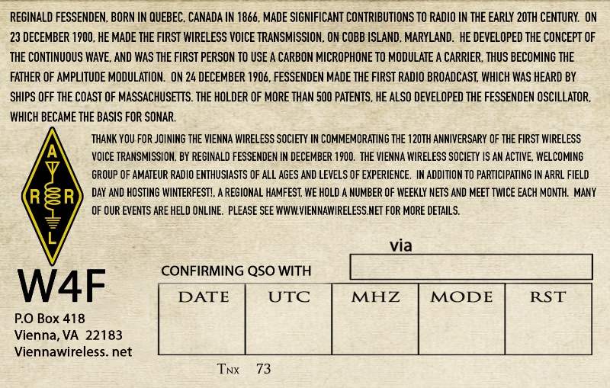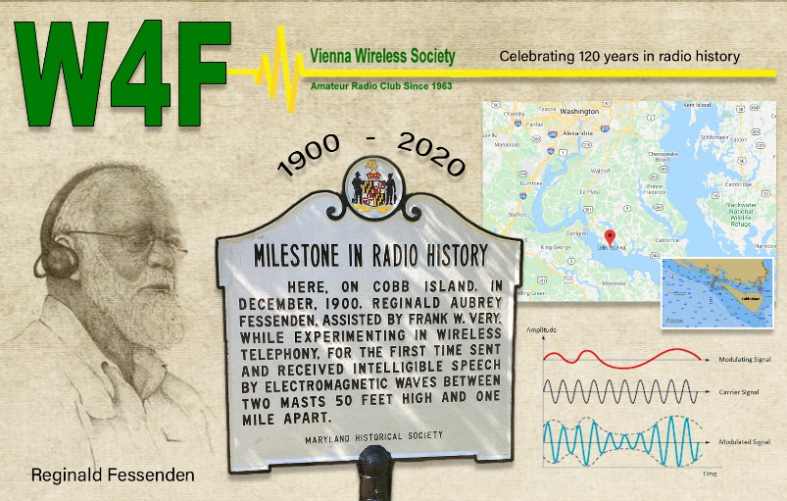

We at Vienna Wireless are hosting a special event, **W4F**, from **18-24 December**.  We are celebrating the 120th anniversary of the first voice transmission by wireless.  It was done by Reginald Fessenden on Cobb Island, which is just south of us here on the Potomac River, on 23 December 1900.

He was quite an inventor and electronics expert.  He made the first radio broadcast on Christmas Eve 1904, and was the inventor of the precursor to SONAR, as well as the first to use a carbon mike to transmit AM.

We plan to have club members operate from their home stations on all bands, and all modes throughout the week.

TOP ^

***Tuesday night ARES HF Net Update…***

*(from Stan, N8BHL)*

Hi all!  Well, the winter / gray line activity has clobbered 75 meters for local communications. Our last nets have been extremely difficult for all, and it looks to be getting worse.  So, as we have in the past, we will suspend the state ARES HF net on Tuesday evenings until probably the end of March (or whenever the band comes back.)   I want to thank you all for your dedication to our nets- check-ins have been impressive all year!

Even though the net is suspended, I will tell you that we’re scheduled to work December 12th to complete the installation of a 160-meter antenna. The outside work is complete, and we’re planning on the fairly complex run inside the building to get to the Sarge.  Assuming that can be completed, and assuming the antenna actually works (measure twice, cut once!) we may be trying our net on 160….so stay tuned!

In the meantime, thank you all so very much for your activity this crazy year! And on behalf of ARES leadership, we wish you the very best for the holiday season!

*****Matt’s Corner***

*(C. Matthew Curtin* [*KD8TTE@arrl.net*](mailto:KD8TTE@arrl.net)*)*

***SET 2020 Results Released***

December 20, 2020. Central Ohio Traffic Net (COTN) today releases the results of its annual Simulated Emergency Test (SET). In the Simulated Emergency Test, radio operators provided communication circuits to ensure highly resilient communication when usual telecommunications infrastructure was unavailable or unreliable.

Over a period of 48 hours, 33 stations (15 of which operated on non-grid power) moved a total of 110 messages. Actual time in operation during this period was 17 hours and 31 minutes

The operation was led for COTN by Chris Daniels KV8Z.

We reported results to the American Radio Relay League (ARRL) through its "Form B," and released the After-

Action Report (AAR), both of which are available on the Reports section of the COTN web site at [https://www.cotn.us/reports](https://www.google.com/url?q=https%3A%2F%2Fwww.cotn.us%2Freports&sa=D&sntz=1&usg=AFQjCNHCvqdOtJdJ6NP6XDYaluzGmMmPFg).

Greetings from Bexley Station KD8TTE! It has been quite a year all around, including for training. I want to thank everyone who has been participating in the training, sharing what they've learned, and helping us all to be better operators, developing greater capability, and providing more valuable service. I hope to work you on the air in 2021!

C. Matthew Curtin KD8TTE

<https://twitter.com/kd8tte>

<https://www.youtube.com/channel/UCA1NTJpAdzOEtP-vJ7_TH-Q>

TOP ^

***“ARES Connect”***

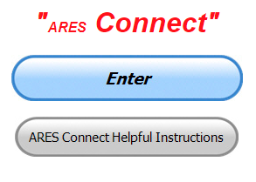

***Connecting Amateur Radio Volunteers with a Purpose***

Hey everyone… please make sure to go in and register your time to all of the events that you have signed up for. Be honest about the time spent. Don’t forget to get this done no later than **5 days** after the event has ended. I’m asking you to do this for our ability to run reports accurately.

**I want to remind all of you that you do not have to be an ARES or ARRL member to use this system. All licensed amateur radio operators throughout the country are welcome and strongly encouraged to use it.**

**Don’t forget to check out the “Frequently Asked Questions” area that has been added to the Ohio Section website.** It’s there to help you through any difficulties that you may have with ARES Connect. Now, if you don’t any posts that relate to what you are having difficulties with, we now also have an on-line “Guru” area as well. This will allow you to ask any questions that you may have about ARES Connect.

**Let’s get everyone on “ARES Connect!!!”**

***NIMS 300 & 400 Being Offered Virtually***

**TRAINING LINKS:**

• Ohio EMA Training Calendar

• Login to the DPS Training Campus

• Create a new account on the DPS Training Campus

**NOTE:**

• Seats available listed are as of the release of this update and will change quickly.

• All classes will be posted on the DPS training campus at least 60 days prior to the start of the course.

• Please read the Training Policy & Catalogue for more information on Ohio EMA trainings.

|  |  |  |  |
| --- | --- | --- | --- |
| **COURSE** | **DATE(S)** | **HOST COUNTY OR VIRTUAL** | **# SEATS AVAILABLE** |
| L-451 Academy I–Application of Advanced Individual Concepts in EM | March 1-5, 2021 | Virtual | 5 |
| ICS-300 Intermediate ICS | March 23 -26, 2021 | Virtual | 0 |
| G-108 Community Mass Care and Emergency Assistance | March 23-24, 2021 | Lake | 23 |
| ICS-400 Advanced ICS | March 30-April 1, 2021 | Virtual | 0 |
| ICS-300 Intermediate ICS | March 30-April 2, 2021 | Virtual | 24 |
| ICS-400 Advanced ICS | April 7-9, 2021 | Virtual | 24 |

TOP ^

|  |  |  |  |
| --- | --- | --- | --- |
| G-288 Local Volunteer and Donations Management | April 13-14, 2021 | Lake | 25 |
| ICS-300 Intermediate ICS | April 13 – 16, 2021 | Virtual | 17 |
| ICS-300 Intermediate ICS | April 27 – 30, 2021 | Virtual | 0 |
| L-452 Academy II–Assessment of Teams in Professional EM | May 3-7, 2021 | Virtual | 5 |
| G-288 Local Volunteer and Donations Management | May 12-13, 2021 | Union | 29 |
| G-191 ICS / EOC Interface | May 14, 2021 | Virtual | 23 |
| ICS-300 Intermediate ICS | May 18-20, 2021 | Virtual | 0 |
| ICS-400 Advanced ICS | June 1-4, 2021 | Virtual | 19 |
| ICS-400 Advanced ICS | June 16-18, 2021 | Virtual | 0 |
| L-453 Academy III–Contemporary Issues in the EM Organization | July 12-16, 2021 | Virtual | 5 |
| ICS-400 Advanced ICS | August 11 – 13, 2021 | Virtual | 0 |
| L-454 Academy IV–Advanced Concepts and Policy in the EM Profession | September 13-17, 2021 | Virtual | 5 |

***River Ice Spotter Training Scheduled***

Partners,

The National Weather Service will host a 45 min webinar for River Ice Spotters in the area on **January 26 at 10 AM.** The focus of this training will be on monitoring and reporting river ice. This information is used by the NWS, USACE, USGS, and local and state officials in our efforts to prepare and alert communities of threats posed by ice jam flooding. The training will be recorded if you are unable to attend at the scheduled time.

To register and find more information regarding this training please visit our website [www.weather.gov/cle/RiverIceSpotters](http://www.weather.gov/cle/RiverIceSpotters).

***From The South 40***

*(from John Levo,* [*W8KIW@arrl.net*](mailto:W8KIW@arrl.net)*)*

***From the South 40-Merry Christmas To All Edition***

Few of us will be sorry to see 2020 put behind us. We are battered, bruised and weary. It has been a tough, tough past several months. However, this week we will celebrate Christmas and its meaning. Although we may not celebrate in the same ways as we have in past years, it’s still a time to enjoy and connect with family and friends albeit by phone, email, Zoom or other social media. Why not make a concentrated effort to find some time to get on a local repeater or your favorite HF band and chat with friends-new and old! Ham radio is a contact sport!

TOP ^

So, from the beautiful rolling hills, valleys and backroads of the Southern Ohio region, Kathy, Pete (K9DOG) and I extend the best of Christmas greetings to our many ham radio friends, acquaintances and South 40 readers.

Have a safe and enjoyable holiday.

John and Kathy Levo

W8KIW and N8ZNR

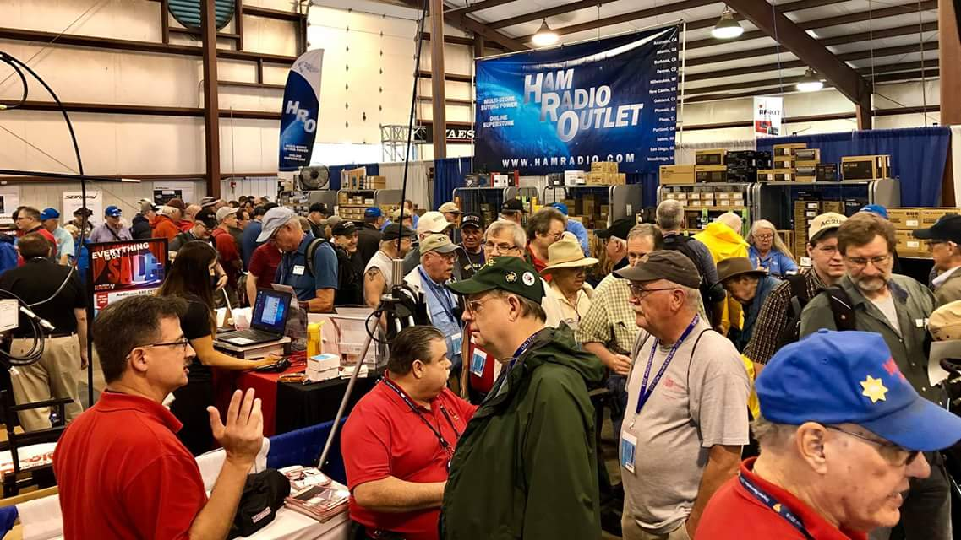[***Upcoming Hamfests***](http://arrl-ohio.org/hamfests.html)

We **DO** have some hamfests scheduled for 2021!! Yes, the first one out of the gate will be the NOARS Fest on March 7th.

[Ohio Hamfests](http://arrl-ohio.org/hamfests.html)

Be sure to keep your eyes on this schedule as that when things start getting better and the vaccine rolls out to more and more, hamfests will surely get back to their normal schedule. Don’t see your hamfest listed?? Did anyone register it with ARRL? It’s really easy to do and you get a lot of FREE publicity if you do.

Here’s a link to register your hamfest… [Hamfest/Convention Application Form](http://www.arrl.org/hamfest-convention-application)

|  |  |
| --- | --- |
| **03/07/2021 -**[**WINTERHAMFEST**](http://www.arrl.org/hamfests/winterhamfest-3)  **Location: Elyria, OH Sponsor: Northern Ohio Amateur Radio Society** [**Learn More**](http://www.arrl.org/hamfests/winterhamfest-3) | **04/25/2021 -**[**Athens Hamfest**](http://www.arrl.org/hamfests/athens-hamfest-9)  **Location:**Athens, OH **Sponsor:** Athens County Amateur Radio Association **Website:** <http://ac-ara.org/> [**Learn More**](http://www.arrl.org/hamfests/athens-hamfest-9) |
| **07/18/2021 -**[**VAN WERT HAMFEST**](http://www.arrl.org/hamfests/van-wert-hamfest-5)  **Location:**VAN WERT, OH **Type:** ARRL Hamfest **Sponsor:** VAN WERT AMATEUR RADIO CLUB **Website:** [http://W8FY.ORG](http://w8fy.org/) [**Learn More**](http://www.arrl.org/hamfests/van-wert-hamfest-5) | **09/26/2021 -**[**Cleveland Hamfest**](http://www.arrl.org/hamfests/cleveland-hamfest-1)  **Location:**Berea, OH **Type:** ARRL Hamfest **Sponsor:** Hamfest Association of Cleveland **Website:** [http://www.hac.org](http://www.hac.org/) [**Learn More**](http://www.arrl.org/hamfests/cleveland-hamfest-1) |

***One Question Questionnaire***

Hey Gang,

Survey Says”….. around 73% of you do keep a spare battery charged for your HT’s.. That’s really good to hear.

Ok, now on to the next question… Since New Year’s is just around the corner, let’s see just how many of you are in the festive spirit…

TOP ^

***“Have you thought of a New Year's resolution yet??”***

You’ll find the “One Question” questionnaire on the Ohio Section Website! <http://arrlohio.org> It’s all for fun and it’s not a scientific survey in any way, but we are learning some things that we didn’t know from these questions. I hope that you are enjoying answering these “One Question” questionnaires.

*****V.E. Test Sessions***

Many V.E.’s have decided to start testing once again, but with restrictions that need to be adhered to for sure. Here’s the link to find that V.E. Test session and what is expected of YOU before going. <http://www.arrl.org/find-an-amateur-radio-license-exam-session>

***Final.. Final..***

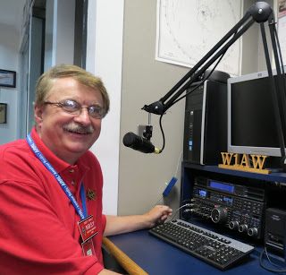

Hi Gang,

This week was a really calm week compared to a few recent ones. At least my pocketbook is now starting to recover from those past weeks of spend… spend… spend..

As we inch our way to Christmas and then New Years, Janie and I have been doing a lot of family holiday traditions. You know… baking sugar cookies, fudge and one of our most beloved cookies that actually came from a very good friend I used to work with. The cookie is called świń. The English translation is “Pigs” They are made mostly with sugar and a walnut – caramel filling. They actually melt in your mouth, and with coffee they are to die for!

I’m sure that you and your family have been doing the same thing these past couple of weeks, as that even though we can’t gather in large groups yet, we still have to keep the traditions going!! One of our other traditions over these many years has been going to the Trans-Siberian Orchestra Christmas concerts. This year was a bit different, we got to see the concert, but unfortunately it wasn’t in-person, it was virtual, and I’d have to say that this year wasn’t as good as years past. The music is always top notch, but it lost some of its pizzazz by not being live!! There’s just something not quite as good when viewing a laser show on the television instead of in-person.

Have you seen our monthly ARES Connect report for November? It’s pretty impressive to say the least. Want to see this and all the reports? [SEC Monthly Reports](http://arrl-ohio.org/SEC/reports.html)

TOP ^

Whelp, that’s going to do it for this week my friends! I’m still looking forward to visiting with all of you live or via Zoom, WebEX or whatever.

I really can’t wait for that time when we can all get together in person once again. Those are the times I cherish the most!!! Stay safe! We will get through this and when we do, we’ll have so much to talk about. Most of all… have FUN and get on the airwaves!!

73,

[***Scott, N8SY***](mailto:n8sy@n8sy.com)

***Print an Official or Unofficial Copy of Your Amateur Radio License***

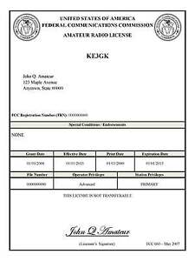*(By Anthony Luscre, K8ZT)*

As of February 17, 2015, the **FCC no longer routinely issues paper license documents** to Amateur Radio applicants and licensees. The Commission has maintained for some time now that the official Amateur Radio license authorization is the electronic record that exists in its Universal Licensing System (ULS). The FCC will continue to provide paper license documents to all licensees who notify the Commission that they prefer to receive one.

Licensees also will be able to print out an official authorization — as well as an unofficial “reference copy” — from the ULS License Manager. I’ve created a set of instructions on how you can request an **“official” printed copy of your license\***

[**Click here to download the instructions**](http://arrl-ohio.org/news/2020/print_your_license.pdf)

***A Hams “Night Before Christmas”***

(Submitted by Gregory Drezdzon, WD9FTZ)

Here’s a link to that wonderful old Christmas poem “A Night Before Christmas” amateur radio style..

<https://www.youtube.com/watch?v=xxJpunNf5WI&feature=youtu.be>



Hey Gang,

Have you taken a look at the **Swap & Shop** page on the Ohio Section webpage yet?? Here’s a link that will take you there…

<http://arrl-ohio.org/sm/s-s.html>

TOP ^

Do you have equipment that you just don’t need or want anymore? Here’s a great venue to advertise it, and it’s FREE!! Is your club doing a fund raiser to help raise money? After a lot of thought, it was decided that the Swap & Shop webpage could also contain these types of items as well. The same rules will apply as do for the For Sales and Give-A-Ways and will only be posted for a month at a time. Please see the Terms & Conditions on the webpage.

If your club is doing a fund raiser and wants more exposure, please forward the information to me and I’ll advertise it on the Swap & Shop webpage for you.

Now, I still want to remind you that it won’t be listed in this newsletter because it would take up way too much space, so your ad will only appear on the website. It is there for any individual to post equipment Wanted / For Sale or Give-Away as well as for Club Fund Raisers. No licensed vehicles/trailers or business advertising will be posted. Postings are text only (no pictures or graphics) will be posted for a maximum of 1 month from date posting and require a contact phone number or email within the posting. Send your Wanted / For Sale or Give-Away post to:  [swap@arrlohio.org](mailto:swap@arrlohio.org)

Ohio Section Cabinet

|  |  |
| --- | --- |
| Section Manager – Scott Yonally, N8SY | Assistant Section Manager – John Perone, W8RXX |
| Section Emergency Coordinator – Stan Broadway, N8BHL | Section Traffic Manager – David Maynard, WA3EZN |
| Technical Coordinator – Jeff Kopcak, K8JTK | Affiliated Clubs Coordinator – Tom Sly, WB8LCD |
| State Government Liaison – Bob Winston, W2THU | Public Information Coordinator – John Ross, KD8IDJ |
| Section Youth Coordinator – Anthony Lascre, K8ZT | |

***Back Issues of the PostScript and Ohio Section Journal***

Hey, did you know that PostScript and Ohio Section Journal (OSJ) are archived on the website? You can go back and look at any edition simply by clicking:

<http://arrl-ohio.org/news/index.html>

***Want to Share your Club Newsletter With Others?***



We have a webpage where you can download and read all of the newsletters that I get from around the state and even other sections!

Here’s the link to the page…. <http://arrl-ohio.org/club_news/index.html>

Please, if you don’t see your club newsletter posted, it’s because I’m not receiving it. Just have your newsletter editor contact me and I’ll get your club’s newsletter listed on the site!!

We all learn and steal (I mean, share) from each other’s work. So, get me your newsletter!!! Send it to: [webmaster@arrl-ohio.org](mailto:webmaster@arrl-ohio.org)

TOP ^

***Chit – Chat, and All That!***

Do you know someone that’s not getting these Newsletters? Please, forward a copy of this Newsletter over to them and have them “[Opt-In](mailto:Opt-In)” to start receiving them. Heck just have them send me an email to: [webmaster@arrl-ohio.org](mailto:webmaster@arrl-ohio.org) and we’ll get them added to the Ohio Section Emailing list.

We now have many thousands of readers receiving these newsletters weekly. Quite impressive, I’d say! I urge all of you to make sure that everyone, regardless of whether they are a League member or not, get signed up to receive these weekly Newsletters.

You can always “Opt-Out” at any time if you feel this is not what you were expecting. It’s fun and very informative. All of your favorite past newsletters are now archived too.

You can go back at any time and read them.

Just go to: <http://arrl-ohio.org/news/>

The pictures on the front page and throughout this newsletter are from various newsletters, Facebook posts and/or were sent directly to me in recent weeks. Take a good look at them, you just might be in one of the pictures! “SMILE… you’re in the Ohio Section News!!”

***Stop!!! You’ve reached the end of another week’s edition.***



TOP ^

*PostScript is produced as a weekly newsletter. I want to thank everyone that has contributed articles and ideas to make this an even better news source. I sincerely hope that you have enjoyed this edition and will encourage your friends to join with you in receiving the latest news and information about the Ohio Section, and news and events happening around the world!*