[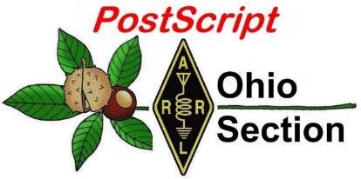](http://arrl-ohio.org/news/) ***“December 14th”***

***Edition***

🡪 National News 🡪 The Handbook Give Away

🡪 Club Corner 🡪 DX This Week

🡪 ARES Connect 🡪 Matt’s Corner

🡪 From The South 40 🡪 Upcoming Hamfests

🡪 One Question Questionnaire 🡪 VE Testing

🡪 Final.. Final..

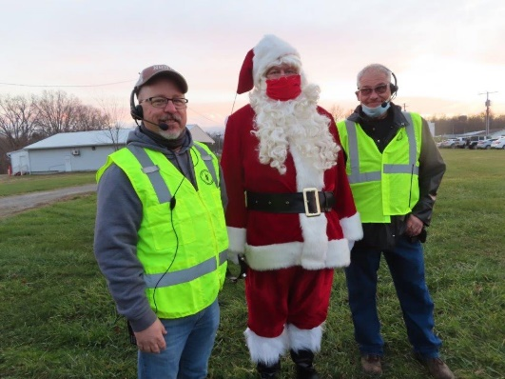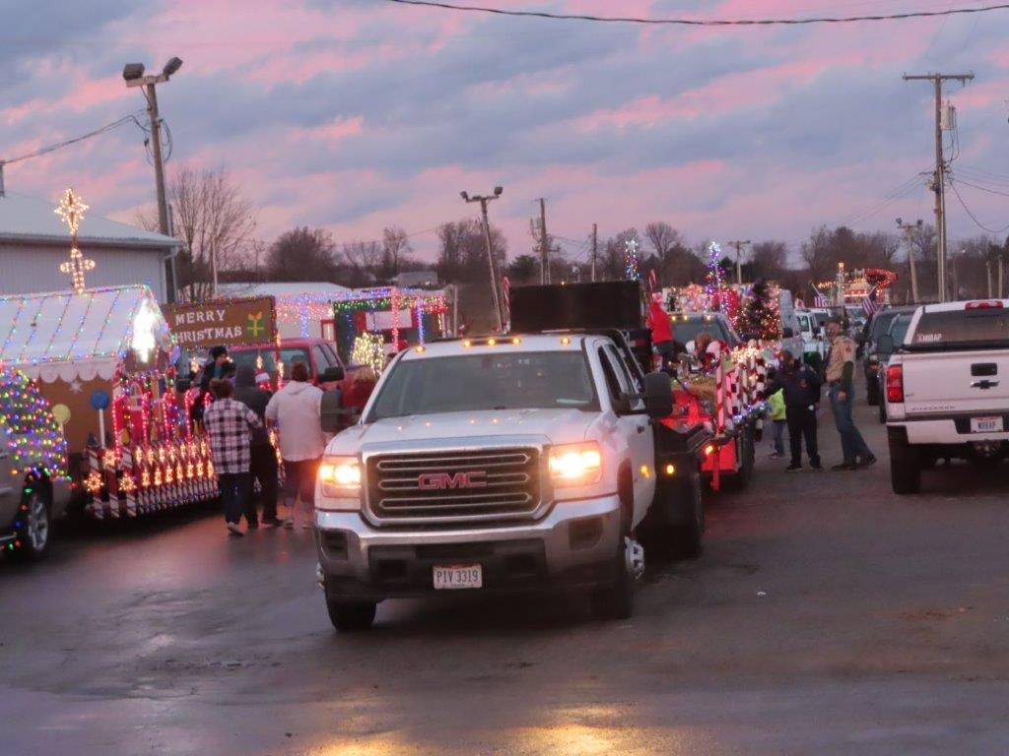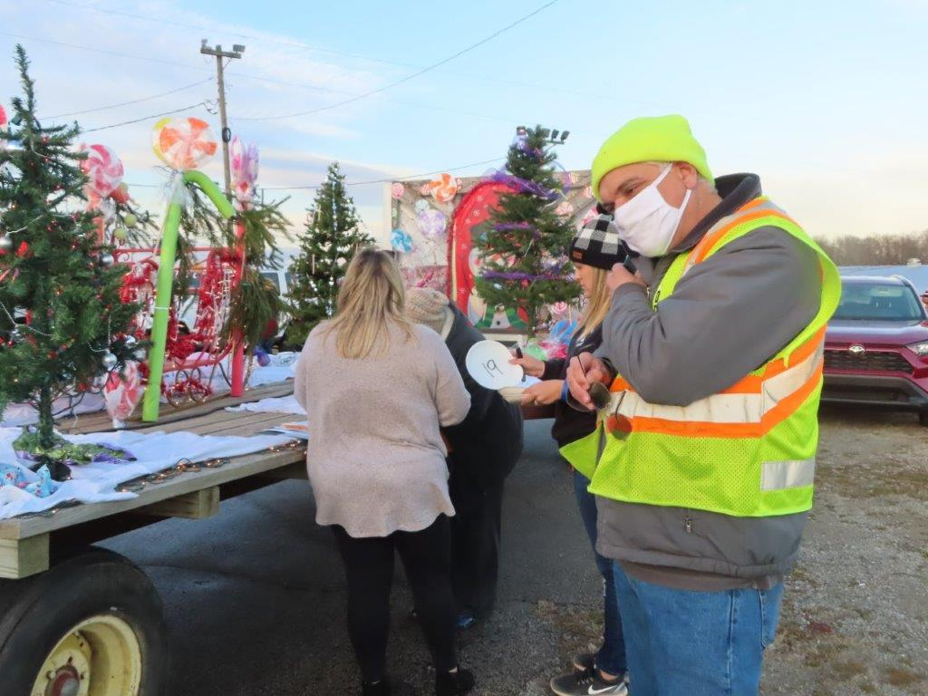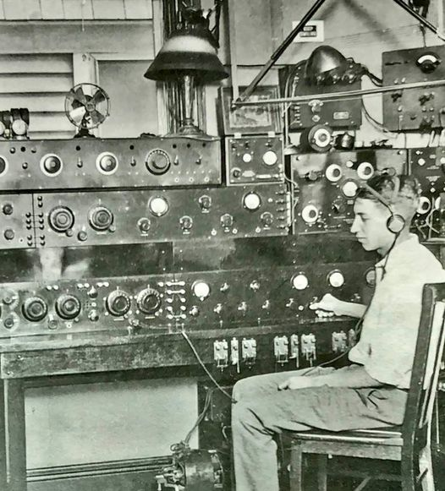

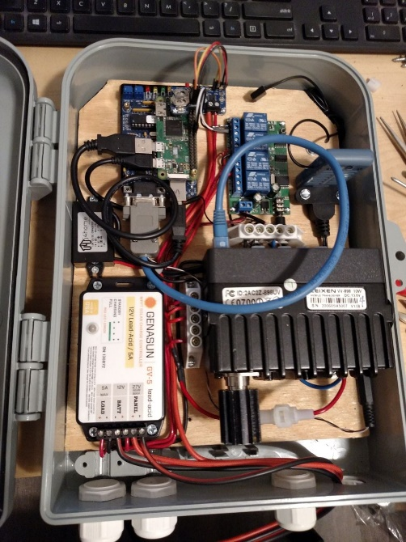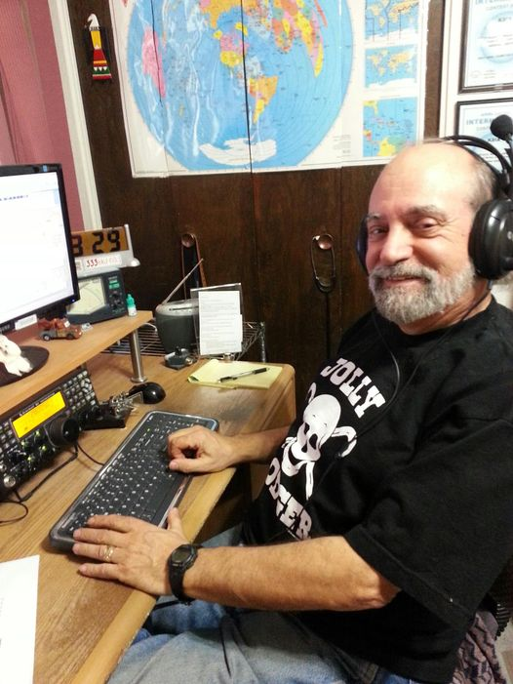

***National News***

*(from arrl and other sources)*

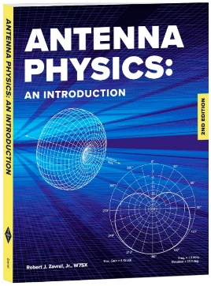

**New Antenna Physics Book from ARRL!**

Written to bridge the gap between basic theory and graduate-level engineering texts, the second edition of [***Antenna Physics: An Introduction***](http://www.arrl.org/shop/Antenna-Physics-An-Introduction-2nd-Edition/) includes new material to help you better understand the complexities of antenna theory.

World-recognized antenna technology authority Robert J. Zavrel, Jr., W7SX, is your guide to grasping a deeper understanding of how antenna systems function. In this book, he clearly communicates the theory and the mathematics that form the foundations upon which all antenna designs depend.

[***Antenna Physics: An Introduction***](http://www.arrl.org/shop/Antenna-Physics-An-Introduction-2nd-Edition/)***, 2nd ed,*** is available from the [ARRL Store](http://www.arrl.org/shop) or your [ARRL Dealer](http://www.arrl.org/arrl-publication-dealers). (ARRL Item no. 1359, ISBN: 978-1-62595-135-9, $34.95 retail, special ARRL Member Price $29.95). Call 860-594-0355 or, toll-free in the US, 888-277-5289. It will also be available for the Amazon Kindle.

####

***FCC Launches Proceeding on Revoking China Telecom's Authorizations***

The FCC today launched a proceeding to determine whether to end China Telecom (Americas) Corporation’s authority to provide domestic and international telecommunications services within the United States.

The Executive Branch has expressed concern about the “substantial and unacceptable national security and law enforcement risks associated with [China Telecom Americas’] continued access to U.S. telecommunications infrastructure…”

China Telecom Americas is indirectly and ultimately owned and controlled by the government of the People’s Republic of China. Protecting national security is an integral part of the Commission’s responsibility to advance the public interest, and today’s action seeks to protect the nation’s telecommunications infrastructure from potential security threats.

<https://www.fcc.gov/document/fcc-launches-proceeding-revoking-china-telecoms-authorizations>

####

***Canada’s public broadcaster announces new cuts to Radio Canada International***

*(Submitted by Gregory Drezdzon, WD9FTZ)*

Officials at CBC/Radio-Canada announced a fresh round of cuts at Radio Canada International (RCI) Dec. 3 as part of a “major transformation” of the beleaguered international service of Canada’s public broadcaster.

TOP ^

A joint statement released by Radio-Canada executive vice-president Michel Bissonnette and his CBC counterpart, Barbara Williams, said the goal of the transformation was “to ensure that the service remains a strong and relevant voice in the 21st-century media landscape.”

In all, the transformation will reduce the number of RCI employees by more than half, from the current 20 to nine, including five journalists assigned to translate and adapt CBC and Radio-Canada articles, three field reporters, and one chief editor.

RCI content will also get more visibility by being incorporated into CBCNews.ca and Radio-Canada.ca with its own portal page featuring all the languages, the statement said.

In 2012, CBC/Radio-Canada slashed RCI’s budget by nearly 80 percent, forcing it to abandon shortwave radio broadcasting altogether. The cuts also resulted in significant layoffs and the closure of RCI’s Russian, Ukrainian and Portuguese language services.

<https://www.rcinet.ca/en/2020/12/03/canadas-public-broadcaster-announces-new-cuts-to-radio-canada-international/>

####

***Australian Radio Amateurs Denied Access to 60 Meters***



After considering several options for a 5 MHz amateur allocation, the Australian Communications and Media Authority (ACMA) has come down in favor of national government interests. Following a formal consultation (a “proceeding” in FCC parlance), ACMA has decided not to permit ham operation on the 5351.5 – 5366.5 kHz band. The 15 kHz-wide band was allocated to the amateur service on a secondary basis in 2017, but as ACMA explained, “unresolved sharing issues” prevented ham radio use of the band, operated on by more than 500 other licensed services (mostly land mobile and aeronautical services), as well as by the Australian military.

Options ranged from Australia-wide access to the whole band or part of the band, to a segmented or channelized amateur allocation, to no amateur access. ACMA decided that national defense and security use of the allocation were “of high importance” in determining maximum public benefit and decided on the last option.

“In balancing Defense’s existing use of the 5351.5 – 5366.5 kHz band against the impacts of introducing use by the amateur service, the ACMA has decided not to support amateur use in the band,” the agency said. “Public and non-public submissions from the Department of Defense showed that expanding the use of the 5351.5 – 5366.5 kHz band to potentially several thousand amateur operators could impact important radiocommunications operations. The ACMA recognizes the high level of interest shown by the amateur community in adding this band and understands there will be disappointment. However, we are confident the decision is appropriate and consistent with the objects of the Radiocommunications Act. In particular, this includes supporting defense and national interest objectives.”

Australia’s International Amateur Radio Union (IARU) member-society, the Wireless Institute of Australia (WIA), argued for amateur access to 5351.5 – 5365 kHz as a compromise. A WIA survey showed most Australian radio amateurs preferred that choice.

TOP ^

WIA noted that because the band was agreed upon at World Radiocommunication Conference 2015 on a shared secondary basis, as well as allowing low power, such as 15 W EIRP (effective isotropic radiated power) operation, “amateur radio operators in over 80 countries around the world have been granted access to the band, including many of our near Pacific neighbors, New Zealand and Indonesia.”

“Australian amateur operators therefore have a strong desire to be able to commence communications on this band with these countries,” WIA concluded. Two spot 5 MHz frequencies are allocated to the Wireless Institute Civil Emergency Network (WICEN) “to provide emergency and safety communications.”

Radio amateurs in New Zealand lost access to 60 meters in late October. Use of this band by radio amateurs was provisional, allowing hams to use two frequencies in the band — 5353.0 kHz and 5362.0 kHz — as part of a trial.

In the US, ARRL proposed amateur access to the band in a 2017 Petition for Rule Making, seeking a new, contiguous secondary band at 5 MHz to the Amateur Radio Service. ARRL also asked the Commission to retain shared access to four of the current five 60-meter channels (one would be within the new band) as well as the current operating rules, including the 100 W PEP (peak envelope power) effective radiated power (ERP) limit. The federal government is the primary user of the 5 MHz spectrum. So-called “interoperability” frequencies in the band have been shared by amateur and federal government entities such as Military Auxiliary Radio System (MARS) during exercises and actual emergencies.

[**Information**](http://www.arrl.org/60-meter-faq) on US amateur access to 60 meters is available on the ARRL website. — Thanks to The 5 MHz Newsletter Editor Paul Gaskell, G4MWO

####

***Transatlantic Tests Mark 99th Anniversary***

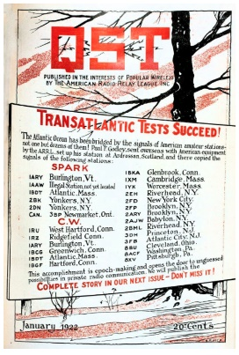On December 11, 1921, radio history was made when the signal from amateur station 1BCG in Greenwich, Connecticut, was heard in Ardrossan, Scotland, marking the first successful transatlantic radio transmission using shortwave frequencies. Between 1921 and 1924, radio amateurs experimented with transmitting across the Atlantic. Sponsored by ARRL, these Transatlantic Tests aimed to prove that shorter wavelength frequencies could propagate long distances using transmitters running less than 1 kW. The initial run of the Transatlantic Tests was a failure. For the second Transatlantic Tests, ARRL dispatched receiver designer Paul Godley, 2ZE, considered one of the best of operators the day, to Europe to listen for participating stations. His nine-tube receiver employed the latest superheterodyne technology, which he modified for the frequencies used.

In one of those historical coincidences, during his voyage to England, Godley met Harold Beverage, who convinced him to use a specially designed, highly sensitive, and directional 1,300-foot antenna, referred to as the Beverage Antenna.

During a pre-event dinner arranged by his British hosts, Godley also met wireless pioneer Guglielmo Marconi, who asked him to remind US amateurs that “I, too, am but an amateur.”

TOP ^

Over the course of the test period, more than two dozen stations were heard between 230 and 235 meters, roughly 1.3 MHz in what is now the AM broadcast band. Some utilized spark-gap transmitters, others employed vacuum-tube CW transmitters. The one heard most consistently was a CW transmitter operated by six members of the Radio Club Of America — Ernest Amy, 2VK; Edwin Armstrong; George Burghard, 2SS; Minton Cronkhite, 1BCG; John Grinan, NJ2PZ, and Walker Inman, 2BGM. From 1BCG, they transmitted their message at 2152 UTC (then GMT) on December 11, 1921:

“*No.1 de 1BCG. W-12 [Words 12], New York, Date 11/12-21, To Paul Godley, Ardrossan, Scotland, Hearty Congratulations, Burghard, Inman, Grinan, Armstrong, Amy, Cronkhite*”

Reporting on the accomplishment, ARRL Secretary Kenneth B. Warner, 1EH, declared, “Excelsior!” The designation “test” evolved to “contest.” Inaugural contests include Field Day in 1934, the International Test in 1927, Sweepstakes in 1930, and the ARRL DX contest in 1932. — *Thanks to Clark Burgard, N1BCG, and Mike Marinaro, WN1M*

####

***Lee Finkel, KY7M, Announced as New Editor of National Contest Journal***

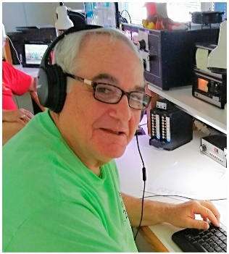Lee Finkel, KY7M, of Phoenix, Arizona, will begin his tenure as Editor of *National Contest Journal* ([***NCJ***](http://ncjweb.com/)) with the magazine’s January/February issue. Now an ARRL publication, *NCJ* is in its 48th year. Finkel, the 17th Editor, takes over the reins from Scott Wright, KØMD, a noted and regular amateur radio contester, who has helmed *NCJ* since January 2017.

“My hope is that I will be able to build on Scott Wright’s hard work and that of my other predecessors, the very supportive ARRL staff, and the impressive cadre of columnists and other writers, to continue making *NCJ* a valuable resource for the contesting community,” Finkel said. Most contesters will recognize his call sign from his regular contest activity. He’s also been a contributing writer for *NCJ* and other publications. A retired lawyer, mediator, arbitrator, and educator, he and his family have lived in Arizona since 1981.

Licensed as WN9EBT in 1962 in Chicago, Finkel said it wasn’t long before he discovered contesting. His participation in the now-defunct ARRL Communications Department (CD) Parties whetted his appetite for contesting. He also discovered DX contests and his “still-favorite CW Sweepstakes.”

But it wasn’t until after law school and a move to Phoenix, that he got serious about contesting. “After joining the Central Arizona DX Association (CADXA), I was rubbing shoulders with some serious contesters,” he said. That eventually led to operating as DX, initially at KP2A as part of a multi-multi contest operation, and later as a part of the Voodoo Contest Group, when he operated from more exotic locales in West Africa, such as Togo, Mali, Niger, and Liberia. He has also operated on teams from the Galapagos, Curacao, Cyprus, and Suriname.

“I love being on the other side of the US pileups, especially when our station is the only active station in a country,” he said. This year he had his first opportunity to operate from the DX side in the ARRL DX CW and Phone Contest at TI7W and KH7M, respectively.

TOP ^

Finkel is a member of the First-Class CW Operators’ Club ([**FOC**](https://www.g4foc.org/)) and [**CWops**](https://cwops.org/), past CADXA President, and a member of the Arizona Outlaws Contest Club ([**AOCC**](http://www.arizonaoutlaws.net/)). He serves on the Northern California DX Foundation [(**NCDXF**)](http://www.ncdxf.org/) Board of Directors. Finkel frequently operates the Top Band Club of Arizona remote station, NA7TB, originally built by Milt Jensen, N5IA (SK).

####

***FCC’s Annual Report Finds 5 States Diverted More Than $200M in 9-1-1 Fees***

*(Submitted by Gregory Drezdzon, WD9FTZ)*

The FCC’s annual report to Congress on the collection and distribution of 9-1-1 fees by states found that five states diverted more than $200 million in 9-1-1 fees to uses besides 9-1-1 in 2019.

Overall, states collected more than $3 billion in 9-1-1 fees in 2019. The five states diverting 9-1-1 fees in 2019 — *Nevada, New Jersey, New York, Rhode Island and West Virginia* — were the same five states that diverted fees in 2018. In 2018, those states diverted nearly $198 million.

The report found that New Jersey diverted 75.2%, or $93 million, of the fees; New York diverted 41.7%, or $97 million, of 9-1-1 fees; Rhode Island, diverted $54.4%, or $8.3 million; and West Virginia diverted 1.6%, or $1 million. Full diversion numbers for Nevada were not reported.

The report is at: <https://www.fcc.gov/files/12thannual911feereport2020pdf>

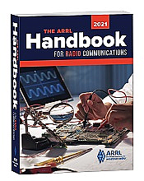***Handbook Give Away***

Hey Gang,

There will be 2 drawings this month - one for Christmas, and one at the end of the month!!!

The first winner will be announced on Christmas Day - December 25th. Wow, what a

Christmas gift this will be for someone! The second winner will be announced on January 1st. Each winner will be notified by email, so PLEASE use a valid email when completing the form.

**Hey.. If you enter BEFORE the December 24th deadline for the Christmas Drawing, you'll automatically be entered for both drawings!! Now how much better can it get!**

To enter the drawing all you need to do is fill in a couple of boxes on the form.. That’s you need to do to be entered into a drawing for a 2021 ARRL softcover Handbook. There’s nothing else required (Oh.. You do need to be a resident of Ohio to win..) The winner will be mailed the Handbook at my cost.

Go to: <http://arrl-ohio.org/handbook-christmas.html> and get registered NOW.

TOP ^

What’s the catch? I want to get everyone checking in to the Ohio Section website as often as possible, and in order to register each month, you have to visit the website often! There’s nothing else to it. I pay all expenses, and from time to time,

Many of you ask me just how do I know when the drawing is on? Well, that’s easy all you need to do is check in on the Ohio Section Website on a regular basis and watch for the big **RED** Arrow that will appear on the left side of the page. This is the sign that the drawing is on and you need to get registered. So, keep a sharp eye out on the website and check in often! <http://arrl-ohio.org/>

***Club Corner***

This is YOUR cornner of the newsletter. Send me what your club is doing and I’ll make sure that it gets in. Got a special event or club project that you want everyone to know about? Send it to me!. Need help with a project? Send it to me.

Let me know what you club is up to. Are you going to have a special guest at your meeting or are you having a special anniversary? Just sent it to: [n8sy@n8sy.com](mailto:n8sy@n8sy.com)

####

***DX This Week***

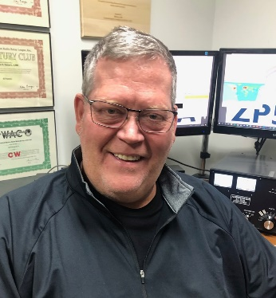*(from Bill, AJ8B)*

***DX This Week – K9LA***

***Bill AJ8B (aj8b@arrl.net, @AJ8B, or www.aj8b.com)***

***CWOPs Member #1567***

**Breaking News…….**

I just learned of this year long contest opportunity and I am very excited about it. If you already participate in the CQ Marathon, this will dovetail nicely with that activity. If you don’t then this is a good opportunity to get recognized for operating. Yes..you read that correctly, this is a ***Year Long Contest***. They call it a DX Ultra-Marathon as you get points for your DX QSOs, **ALL** your DX QSOs. Unlike the CQ Marathon where your final score is a country and zone count total, this score is calculated by the number of QSO points times the multiplier.

I have a daily goal of 5 DX entities, and I think this will fit my operating habits very well. What about you? Let me know your thoughts. To register and to read all about it, go to:

<https://www.dx-world.net/the-2021-cw-ssb-ultra-marathon/>

**And now back to your regularly scheduled DX news…**

TOP ^

The Midwest DX Cluster spots that were posted last week included Afghanistan, Alaska, Anguilla, Argentina, Australia, Belize, Brazil, Canary Islands, Ceuta & Melilla, Chile, Cuba, Curacao, Dominica, Ecuador, El Salvador, England, Falkland Islands, Fed. Rep. of Germany, France, Guadeloupe, Guatemala, Hawaii, Kaliningrad, Kingdom of Eswatini, Liechtenstein, Moldova, Namibia, New Caledonia, New Zealand, North Macedonia, Panama, Portugal, Puerto Rico, Seychelles, Slovenia, South Africa, Spain, St. Helena, St. Lucia, Trinidad & Tobago, Venezuela, Western Sahara, and Zambia. What did you work? Have you gotten an ATNO (All-Time New One) lately?

***DAH DIT DIT DIT DAH DAH DIT DIT DIT DAH***

QSL cards received this week included HK3W – Siso in Columbia, VP8ON – Donald in the Falkland Islands, RW6PA – Khamzat in Chechnya, Russia, and HC5DX – David in Ecuador, and ES2MC – Arvo in Estonia.

|  |  |
| --- | --- |
|  |  |

***DAH DIT DIT DIT DAH DAH DIT DIT DIT DAH***

This month, through the courtesy of K9LA, Carl, he is again allowing me to reprint his monthly feature article. It is an excellent treatise on “ZD7FT on 10m SSB”. This recently appeared on his website, [www.k9la.us](http://www.k9la.us). Hope you enjoy it.

**ZD7FT on 10m SSB on November 20 -** Around 1500 UTC (9:00 AM local time here in Ft Wayne, IN) on November 20, I wandered into the shack and saw some North American spots for ZD7FT on 28490 KHz. I turned on the AL811H amplifier, turned my Tennadyne T6 LPDA (log periodic dipole array) to the heading for ZD7 (109 degs), turned on the Ten-Tec OMNI 7 and dialed up 28490 KHz. ZD7FT had a decent signal (around S6) and soon was in the log at 1501 UTC.

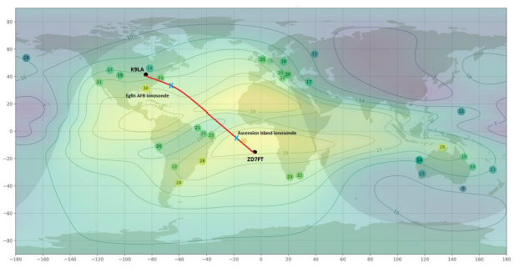

Here we are at solar minimum, with Cycle 25 just now showing signs of life. Why was propagation so good between ZD7 and North America on November 20? We might get a hint as to what was going on in the ionosphere by looking at the MUF (maximum useable frequency) map from Andrew Rodland, KC2G, at <http://prop.kc2g.com/> at 1530 UTC on November 20. It would have been nice for me to get the 1500 UTC map, but I didn’t think of doing that until a half hour later – old age is setting in!

TOP ^

The contour lines of the 3000 km MUF (assuming it’s the midpoint of a 3000 km path) are derived from ionosonde data, which are the dots with numbers. The short path from my location to ZD7 is shown in red.

Note that the Eglin AFB ionosonde in Florida (the yellow dot with 30) and the Ascension Island ionosonde (the yellow dot with 32) both have MUFs that could support 10 meters at 1530 UTC (as mentioned earlier, a half hour past my QSO time).

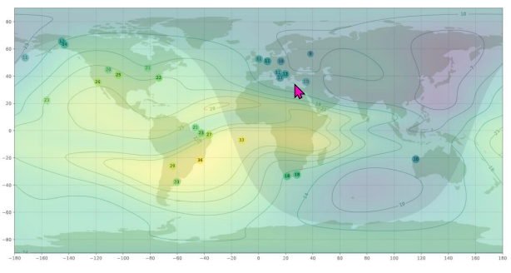Also note the blue X southeast of K9LA along the path and the blue X northwest of ZD7 along the path. These are points that are 1500 km from each end – where the RF would encounter the F2 region on the first hop out of each end for a 3000 km hop. The MUF on the K9LA end is in the vicinity of 28 MHz and the MUF on the ZD7 end is well above 28 MHz. Now let’s look at the same MUF map at 1950 UTC on November 20.

There are no data from Eglin AFB currently. In fact, there were no data at all between 1745 UTC and 2000 UTC. Data from the ionograms before 1745 UTC and after 2000 UTC show the MUF to be from the low 20s to the mid-20s – not enough to support 28 MHz. The MUF near the first hop out of ZD7 is still well above 28 MHz. Thus, North America was the critical end. If the MUF supported 28 MHz on the K9LA end, then the path was likely to be open.

Let’s now look at more detailed data from the Eglin AFB ionosonde data on the day before, the day of the ZD7FT spots and the day after. First, here’s the plot for foF2 – the F2 regio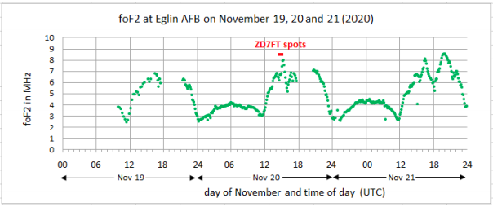n critical frequency. Multiplying foF2 by 3 gives an approximation for the MUF for a 3000 km F2 path. The MUF for a 3500 km path (that works out to 3 hops from ZD7FT to K9LA) would be a bit higher at about 28 MHz. The 3500 km MUF is higher because the wave is at a bit more of a grazing angle on the F2 region of the ionosphere.

The short horizontal red line in the plot is the time period over which there were ZD7FT spots (1438 UTC to 1505 UTC per PacketCluster). What’s noticeable is the short-term spike of foF2 during the ZD7FT spotting period. But there were even higher foF2 spikes on the next day. What we’re seeing on the 20th may be the start of an F2 region traveling ionospheric disturbance (TID) in the Eglin area that was instigated by a gravity wave propagating up from an event in the lower atmosphere. Was the spike in foF2 on November 20 the enabler for my QSO?

TOP ^

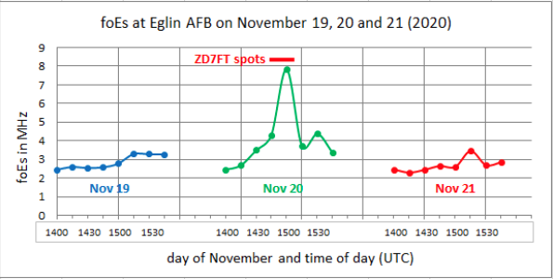

**Second,** let’s look at E region data from Eglin (both the normal foE data and the sporadic E foEs data) for the day before, the day of the ZD7FT spots and the day after. The normal E region data didn’t show anything unusual – the MUF was way too low for 28 MHz propagation. But foEs was a different story.

Here’s that plot. Multiplying foEs by 5 gives an approximation for the MUF for a 2000 km Es path of around 40 MHz. The spike in foEs occurs only on the 20th at the time of the ZD7FT spots. It suggests that 28 MHz could have been supported on the K9LA end for a short time. Was the spike in foEs on the 20th be the enabler for my ZD7FT QSO?

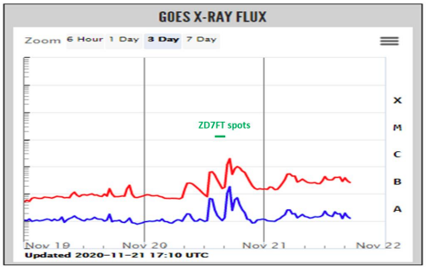**Third**, some minor solar flaring occurred on November 20. The following is a plot of X-ray flux for November 19 and 20 (and partial data for November 22) from <https://www.swpc.noaa.gov/> The blue curve is radiation from 0.05-0.4 nm. The red curve is radiation from 0.1-0.8 nm (the wavelength band that determines the class of the flare). Did this flaring enhance the F2 region?

The F2 region, which is responsible for most of our long distance QSOs, is ionized by EUV (extreme ultraviolet) radiation from about 10-100 nm. About 60% of the F2 region is the result of radiation around 30 nm. The above X-ray data does not tell us directly anything 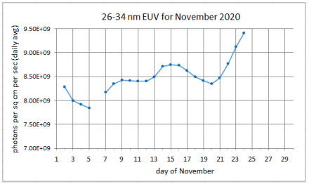about EUV radiation. So I downloaded 26-34 nm EUV data and plotted it for the month of November. On November 20, the EUV radiation, if anything, took a minor dip. Thus the flaring doesn’t appear to be the cause of the spike in foF2 (or even the spike in foEs). Of course, the generally increasing EUV radiation likely helped with the background F2 region ionization.

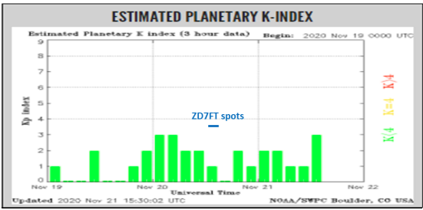The Kp index decreased around the time of the ZD7FT spots. Here’s the Kp index plot from https://www.swpc.noaa.gov/. The Kp index was 2 in the 09-12z period, 1 in the 12-15z period and 0 in the 15-18z period. Could this decrease in geomagnetic field activity have helped the F2 region? So what enabled this QSO on the K9LA end of the path?

TOP ^

A TID in the F2 region? Some sporadic E? Or a decrease in geomagnetic field activity? That’s a tough question to answer with the data we have. I would likely go with a traveling ionospheric disturbance causing a spike in foF2. It is highly likely that we will never know what really enabled this path. All we can do is list the possibilities and hope that one of them (or a combination of them?) was the enabler.

***DAH DIT DIT DIT DAH DAH DIT DIT DIT DAH***

**Top Band Soap Box -** As I previously mentioned, I will include news and notes about activity on 160M. The two guys that will be providing me with the scoop will be Dave, K8DV, and Chuck, K8CR. Both have achieved DXCC on 160 and both are active on 160M.

I participated in my first ARRL 160M contest. I worked 4 hours and averaged almost 60 QSOs an hour. It was a blast and I can’t wait until the end of January for the CQ 160M contest. The weekly report from Dave, K8DV, follows:

*This past week was similar to the week before with a few exceptions.  Saw a few openings on FT8 into Japan with solid copy on several stations and worked a half dozen different JA stations.  Over the weekend was the ARRL 160 contest which by all accounts looks to have had record number of participants.*

*Other than the contest there was almost no CW activity and SSB was only the rag chew crowd.  FT8 continues to be the mode producing the most activity not only on 160 but seems to be that way on the other bands as well.  Keep hunting as we are in the peak of 160.*

***DAH DIT DIT DIT DAH DAH DIT DIT DIT DAH***

**60 Meter Report from Joe, W8GEX**

There is still plenty of activity on the band, but new countries are rare. The Coronavirus has stopped DXpeditions from going out for new ones.

The new countries that are planning to come up on frequency include:

**8Q – Maldives -** G0VJG, Nobby, who is headed to Reethi Fura Island early next year gives us an update. The “License will not be issued till next year but been told 8Q7CQ will be reserved for me also told 60m will be add to license but can’t be 100% on that till I see it”, say Nobby. Dates of operation will be from January 14-29. “The world’s best QSL Manager”, M0OXO, Charles, will handle confirmations.

**Info from “Down Under” -** The following information was provided by Paul G4MWO. He is very knowledgeable about keeping us posted on new authorization’s worldwide. Thanks for all you do for 60m Paul:

The Radio Amateur Society of Australia (RASA) reports information from regulator ACMA that a decision on 60m in Australia is expected in December 2020.  
[https://vkradioamateurs.org/acma-advise-60m-decision-expected-in-december-2020/#:~:text=ACMA%20advise%20that%20a%20decision,be%20made%20in%20December%202020](https://60metersonline.us12.list-manage.com/track/click?u=99836838adcf6cb21aec9049a&id=1920643bdb&e=2f511515ce).

**Other 60 Meter Resources**

Paul Gaskell G4MWO, Editor *The 5 MHz Newsletter*. You can find the latest edition freely available at any time at: [https://www.dropbox.com/s/koz6msf74mtk76t/5%20MHz%20Newsletter.pdf?dl=0](https://60metersonline.us12.list-manage.com/track/click?u=99836838adcf6cb21aec9049a&id=d28ef53e58&e=2f511515ce)

TOP ^

The Newsletter Archive is at: [https://www.dropbox.com/sh/9si2gq8dnz73uy9/AACCZty4t4wQaF1mot3cA3d9a?dl=0](https://60metersonline.us12.list-manage.com/track/click?u=99836838adcf6cb21aec9049a&id=1d4ccf601b&e=2f511515ce)

Plus G4MWO’s Worldwide 5 MHz Amateur Allocations Chart:  
[https://www.dropbox.com/s/dhapwdfqyaraxh2/5%20MHz%20WW%20Amateur%20Allocations%20Chart%20%28%20c%29%20G4MWO.xls?dl=0](https://60metersonline.us12.list-manage.com/track/click?u=99836838adcf6cb21aec9049a&id=f79cf887f5&e=2f511515ce)

Wikipedia 60 Meter Band Page: [https://en.wikipedia.org/wiki/60-meter_band](https://60metersonline.us12.list-manage.com/track/click?u=99836838adcf6cb21aec9049a&id=5627ceb9e4&e=2f511515ce)

**CQDX CQDX CQDX CQDX CQDX CQDX CQDX CQDX CQDX**

Here is an update from Bernie, W3UR, of the DailyDX and the WeeklyDX, the best source for DX information. <http://www>.dailydx.com/. Bernie has this to report:

**The most powerful solar flare and CME thus far during solar cycle 25**From W3LPL, Frank Donovan

A solar flare from massive solar region 2786 at 1311Z on Sunday 29 November was the most powerful solar flare and coronal mass ejection (CME) thus far during solar cycle 25.  The sun's activity is now rapidly increasing after a slow increase in activity this year following solar minimum last December

The flare and CME erupted from just behind the southeast solar limb and was not Earth directed.  The shock enhancement/glancing blow from the CME may cause unsettled to active geomagnetic conditions on 1-2 December.  There is a chance for additional M-class solar flares through 2 December and a slight chance for much stronger X-class flares.

**The CQ Worldwide DX CW Contest**

With ops and stations still “doing things differently” in this coronavirus year, W3LPL set a USA record number of QSOs as a multi-single.  Multipliers were down because there were so few DXpeditions.  Frank says activity on 80-15 was fantastic and “It was a delight to have 10-meter propagation to Europe again.  There were many surprisingly strong Europeans signals, but activity was significantly lower than on the other bands.”

Here are the W3LPL M/S line totals, band, QSOs, zones and countries, left to right:

|  |  |  |  |
| --- | --- | --- | --- |
| Band | QSOs | Zones | Countries |
| 160 | 168 | 21 | 70 |
| 80 | 1116 | 32 | 99 |
| 40 | 1811 | 36 | 122 |
| 20 | 1480 | 37 | 129 |
| 15 | 1324 | 29 | 118 |
| 10 | 120 | 26 | 68 |
| Total | 6,019 | 181 | 606 |
| 13,505,707 Points | | | |

Up in northwest Pennsylvania, K3LR hosted two single band efforts by two of his top ops, K3UA on 15 and N2NC as K3LR on 20.

TOP ^

**LoTW News** By K0GW, Greg Widin, 2020 Chair, Logbook Committee

This note is in response to concerns about functioning of Logbook (LoTW) in the wake of slow processing after record participation in last weekend's CQ WW CW contest.

ARRL is aware of the slowdown. Though some have expressed concern about the slowdown, it does not indicate a problem. The system is purposely built to handle normal loads, but not to respond instantly to peak loads. This approach was deliberately chosen in an effort to be most efficient with members' dollars. The system will work through the backlog, as it has on numerous occasions previously following busy contest weekends.

At the same time, ARRL understands that the community's expectations may have changed over the years, as has the available technology. Accordingly, we are going to review the options available for cost-effective updates to Logbook to improve its peak handling capacity.

Though changes have already been suggested, data have not yet been analyzed to identify the exact nature of the performance bottleneck. It would be inappropriate to begin making changes in Logbook's systems until their performance has been understood.

Meanwhile, users of Logbook should not be concerned that their submissions are being properly recorded and will be properly confirmed if appropriate.

**6O – Somalia -** EP3CQ, Ali, returned to Mogadishu in the middle of last month, however upon arrival he got Covid-19 and has been isolated. He hopes to be cleared today and then be able to “install and run [his] station. Look for 6O1OO to be QRV very soon. As a reminder he will be in 6O for two months.

**JD1/O – Ogasawara Islands -** Following up on his announcement to go back to JD1BMH on Chichijima (AS-031) JG7PSJ, Harry, says he will be there from Monday December 14th until Saturday January 9th. He will be QRV on CW, SSB and RTTY on 7 through 28 MHz. QSL via the bureau or direct to JG7PSJ.

***DAH DIT DIT DIT DAH DAH DIT DIT DIT DAH***



Below is a list of upcoming contests in the “Contest Corner”. I think this is important for someone who is trying to move up the DXCC ladder since entities that are on the rarer side and easiest to work in contests. Some of my best “catches” have been on the Sunday afternoon of a contest when the rarer entities are begging for QSOs. Of course, the gamble is that if you wait until Sunday, conditions may change, or they simply won’t be workable. However, it is not a bad gamble. Of course, why not work the contest and have some fun!

Check out the WA7BNM Contest Calendar page <https://www.contestcalendar.com/> for more contests or more details.

The contests in red are those that I plan to spend some significant participation time on. PLEASE let me know if you are working contests and how you fared.

Thanks!

TOP ^

|  |  |  |
| --- | --- | --- |
| Dec. 13 | QRP ARCI Holiday Spirits Homebrew Sprint | [www.qrparci.org/contests](http://www.qrparci.org/contests) |
| Dec. 12-13 | ARRL 10M Contest | [www.arrl.org/10-meter](http://www.arrl.org/10-meter) |
| Dec. 14 | K1USN Slow Speed Test | [www.k1usn.com/sst.html](http://www.k1usn.com/sst.html) |
| Dec. 18 | AGB Party Contest | www.[ev5agb.com/contest/contests_e.htm](http://ev5agb.com/contest/contests_e.htm) |
| Dec. 18 | Russian 160-Meter Contest | [www.qrz.ru/contest/detail/90.html](http://www.qrz.ru/contest/detail/90.html) |
| Dec. 19 | RAC Winter Contest | [www.rac.ca/rac-canada-winter-contest-rules-2019](http://www.rac.ca/rac-canada-winter-contest-rules-2019) |
| Dec. 19-20 | Croatian CW Contest | [www.9acw.org/index.php/rules/english](http://www.9acw.org/index.php/rules/english) |
| Dec. 19-20 | Croatian CW Contest | [www.crk.cz/ENG/DXCONTE](http://www.crk.cz/ENG/DXCONTE) |
| Dec. 20 | ARRL Rookie Roundup, CW | [www.arrl.org/rookie-roundup](http://www.arrl.org/rookie-roundup) |
| Dec. 21 | K1USN Slow Speed Test | [www.k1usn.com/sst.html](http://www.k1usn.com/sst.html) |
| Dec. 26 | DARC Xmas Contest | [www.darc.de/?id=820](http://www.darc.de/?id=820) |
| Dec. 26-27 | Stew Perry Topband Challenge | [www.kkn.net/stew](http://www.kkn.net/stew) |
| Dec. 27 | RAEM Contest | <http://raem.srr.ru/en/main> |
| Jan 29 – 31 | CQWW 160M | <https://cq160.com/> |
| Mar. 27 – 28 | CQWW WPX SSB | <https://www.cqwpx.com/> |
| May 21 | SWODXA DXDinner | [www.swodxaevents.org](http://www.swodxaevents.org) |
| May 29 – 30 | CQWW WPX CW | <https://www.cqwpx.com/> |
| August 28 | Ohio QSO Party | <https://www.ohqp.org/> |
| August 28 | W8DXCC Convention | [www.w8dxcc.com](http://www.w8dxcc.com) |

**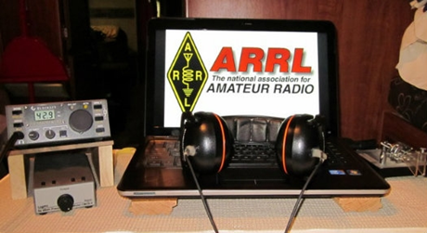*ARRL Contest Corner***

An expanded, downloadable version of *QST'*s’ [**Contest Corral**](http://www.arrl.org/contest-calendar) is available as a PDF. Check the sponsor’s ‘Website for information on operating time restrictions and other instructions.

***Ohio ARES VHF Simplex Contest - 2021***

***January 9 – 10AM through 4PM EDT.***

**The purpose of our annual simplex activity is to improve our station and antenna capabilities, and to test our coverage areas on simplex frequencies.**  These may be very important in times of emergency, when repeaters have failed, and simplex is the only method of emergency communication. We are NOT giving any consideration for backup power- this exercise is aimed at testing antennas and determining coverage areas.

**Bands**

All bands from 50 MHz up

We recommend the following frequencies:

50 MHz – Standard simplex calling frequencies *Your QSO Points X 10 for six meters!!*

146.49 (alternate 146. 46) for VHF

UHF and above - Standard simplex calling frequencies

TOP ^

**Modes**

ALL MODES are acceptable- it’s your choice

Digital- using any mode generally accepted by NBEMS/ARES in fldigi. (Default = Mt63 2K)

For more details of this really fun event go to:

[Ohio Simplex Contest – A short VHF and up radio contest (ohsimplex.org)](https://ohsimplex.org/)

####

***Events that you’ll want to know about***

|  |  |
| --- | --- |
| **December 14**   * [K1USN Slow Speed Test](http://www.k1usn.com/sst.html) * [4 States QRP Group Second Sunday Sprint](http://www.4sqrp.com/SSS/sss_rules.pdf) * [OK1WC Memorial (MWC)](https://memorial-ok1wc.cz/index.php?page=rules2l) | **December 15**   * [Worldwide Sideband Activity Contest](https://wwsac.com/rules.html) * [RTTYOPS Weeksprint](https://rttyops.wordpress.com/rtty-mini-contests/rttyops-weeksprint/) |
| **December 16**   * [NAQCC CW Sprint](http://naqcc.info/sprint/sprint202102.html) * [QRP Fox Hunt](http://www.qrpfoxhunt.org/winter_rules.htm) * [Phone Fray](http://www.perluma.com/Phone_Fray_Contest_Rules.pdf) * [CWops Mini-CWT Test](https://cwops.org/cwops-tests/) | **December 17**   * [CWops Mini-CWT Test](https://cwops.org/cwops-tests/) * [RTTYOPS Weeksprint](https://rttyops.wordpress.com/rtty-mini-contests/rttyops-weeksprint/) |
| **December 18**   * [NCCC RTTY Sprint](http://www.ncccsprint.com/rttyns.html) * [QRP Fox Hunt](http://www.qrpfoxhunt.org/winter_rules.htm) * [NCCC Sprint](http://www.ncccsprint.com/rules.html) * [AGB-Party Contest](http://www.ev5agb.com/contest/agb_party.htm) * [Russian 160-Meter Contest](http://www.qrz.ru/contest/detail/90.html) | **December 19**   * [RAC Winter Contest](https://wp.rac.ca/rac-canada-winter-contest-rules-2019/) * [Feld Hell Sprint](https://sites.google.com/site/feldhellclub/Home/contests/sprints/bingo-sprint) * [OK DX RTTY Contest](http://okrtty.crk.cz/index.php?page=english) * [Padang DX Contest](http://padangdxc.com/rules/) * [Croatian CW Contest](https://9acw.org/index.php/rules/english/129-rules-2019) * [RTTYOPS Weekend Sprint](https://rttyops.wordpress.com/rtty-mini-contests/rttyops-weekend-sprint/) |
| **December 20**   * [**ARRL Rookie Roundup, CW**](http://www.arrl.org/rookie-roundup) * [Run for the Bacon QRP Contest](http://qrpcontest.com/pigrun/) | **December 21**   * [K1USN Slow Speed Test](http://www.k1usn.com/sst.html) * [OK1WC Memorial (MWC)](https://memorial-ok1wc.cz/index.php?page=rules2l) |
| **December 22**   * [Worldwide Sideband Activity Contest](https://wwsac.com/rules.html) * [RTTYOPS Weeksprint](https://rttyops.wordpress.com/rtty-mini-contests/rttyops-weeksprint/) | **December 23**   * [SKCC Sprint](http://www.skccgroup.com/operating_activities/weekday_sprint/) * [Phone Fray](http://www.perluma.com/Phone_Fray_Contest_Rules.pdf) * [CWops Mini-CWT Test](https://cwops.org/cwops-tests/) |

####

TOP ^

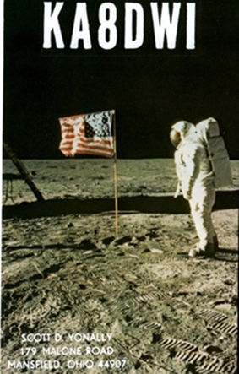***DX News***

***ARLD050 DX news***

This week's bulletin was made possible with information provided by The Daily DX, the OPDX Bulletin, 425 DX News, DXNL, Contest Corral from QST and the ARRL Contest Calendar and WA7BNM web sites. Thanks to all.

**ROTUMA, 3D2.** Tony, 3D2AG is QRV as 3D2AG/p until mid-January 2021.

Activity is on 160 to 6 meters, including 60 meters, using CW, SSB, RTTY and FT8. QSL direct to home call.

**MAURITANIA, 5T.** Tom, DL7BO is QRV as 5T7OO from Nouakchott and is here for the next few days. Activity is on 40 to 10 meters, and possibly 160 and 80 meters, using CW, SSB, RTTY and FT8. QSL direct to DJ6TF.

**SENEGAL, 6W.**  Look for a group of operators to be QRV as 6V1A from Goree Island, IOTA AF-045, from December 18 to 20. Activity will be on various HF bands using CW and SSB. QSL via LoTW.

**ZAMBIA, 9J.** Rob, IK2LON is QRV as 9J2RD while living in Ndola. Activity is on the HF, VHF and UHF bands using SSB, RTTY and FT8. QSL via IZ8CCW.

**SPAIN, EA.** Special event station AO50UPC will be QRV from December 15 to 30 to celebrate the 50th anniversary of the Polytechnic University of Catalonia. Activity will be on the HF bands. QSL via operators' instructions.

**ETHIOPIA, ET.** Operators Ken, K4ZW and Bob, W9XY are QRV as ET3AA from the Ethiopian Amateur Radio Society club station until December 12. Activity is in their spare time as they perform maintenance on the club station. QSL via N2OO.

**ITALY, I.** Members of the ARI Club of Grosseto are QRV with special event station IO5CNPP until December 20 in remembrance of the Heroes of Chernobyl. QSL via IZ5RHU.

**OGASAWARA, JD1.** Harry, JG7PSJ will be QRV as JD1BMH from Chichijima Island, IOTA AS-031, from December 14 to January 9, 2021. Activity will be on 40 to 10 meters using CW, SSB and RTTY. QSL direct to home call.

**JAN MAYEN, JX.** Erik, JX2US has been active on 20 meters CW between 1300 and 1500z. QSL via LA2US.

**LITHUANIA, LY.** Valerijus, LY2QT is QRV as LY20XMAS during December for the Christmas holiday. QSL to home call.

**PERU, OA.** Members of the Radio Club Peruano are QRV with special event call OA90O until the end of 2020 to celebrates the club's 90th anniversary. QSL via OA4O.

TOP ^

**FINLAND, OH.** Special event station OH9SCL is QRV from Lapland during the month of December. QSL via LoTW.

**GREECE, SV.** Members of the Radio Amateur Association of Greece are QRV with special event call SX2500S during December to commemorate the Battle of Salamis. Activity is on the HF bands using CW, SSB and various digital modes. QSL via bureau.

**AFGHANISTAN, T6.**  Robert, S53R is QRV as T6AA from Kabul until December 15. Activity is in his spare time. QSL to home call.

**MARSHALL ISLANDS, V7.** Neil, WD8CRT is QRV as V73NS from Kwajalein Atoll, IOTA OC-028. Activity is on 20, 17 and 15 meters using CW. His length of stay is unknown. QSL via W3HNK.

THIS WEEKEND ON THE RADIO. The ARRL 10-Meter Contest, NCCC RTTY Sprint, QRP 80-Meter CW Fox Hunt, NCCC CW Sprint, PODXS 070 Club Triple Play Low Band Sprint, TRC Digi Contest, SKCC Weekend CW Sprintathon, ARI 40/80 Contest, International Naval Contest, RTTYOPS Weekend Sprint, QRP ARCI Holiday Spirits Homebrew CW Sprint, CQC Great Colorado 20-Meter CW Snowshoe Run,

The OK1WC Memorial, MWC, K1USN Slow Speed CW Test and 4 States QRP Group Second Sunday Sprint are scheduled for December 14.

The RTTYOPS Weeksprint and Worldwide Sideband Activity Contest are scheduled for December 15.

The NAQCC CW Sprint, CWops Mini-CWT Test, Phone Fray and QRP 40-Meter CW Fox Hunt are scheduled for December 16.

Please see December QST, page 63, and the ARRL and WA7BNM contest web sites for details.

***Special Events***

***Vienna Wireless Club Hosting a Very Special Event***

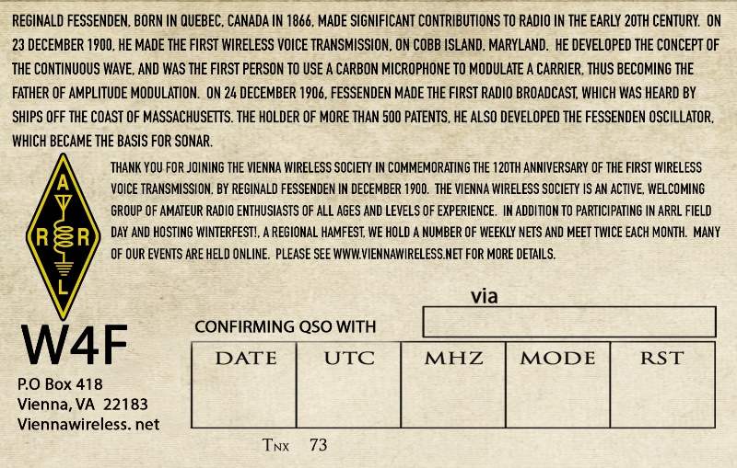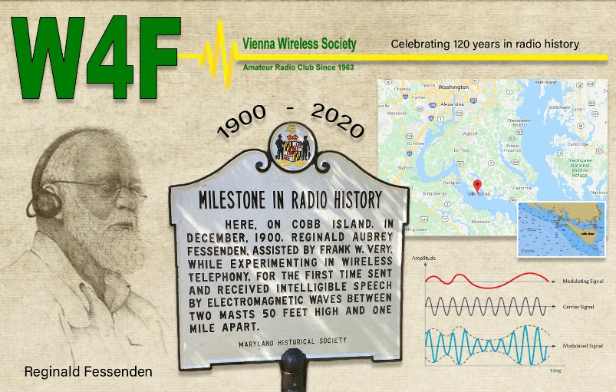

TOP ^

We at Vienna Wireless are hosting a special event, **W4F**, from **18-24 December**.  We are celebrating the 120th anniversary of the first voice transmission by wireless.  It was done by Reginald Fessenden on Cobb Island, which is just south of us here on the Potomac River, on 23 December 1900.

He was quite an inventor and electronics expert.  He made the first radio broadcast on Christmas Eve 1904, and was the inventor of the precursor to SONAR, as well as the first to use a carbon mike to transmit AM.

We plan to have club members operate from their home stations on all bands, and all modes throughout the week.

***Tuesday night ARES HF Net Update…***

*(from Stan, N8BHL)*

Hi all!  Well, the winter / gray line activity has clobbered 75 meters for local communications. Our last nets have been extremely difficult for all, and it looks to be getting worse.  So, as we have in the past, we will suspend the state ARES HF net on Tuesday evenings until probably the end of March (or whenever the band comes back.)   I want to thank you all for your dedication to our nets- check-ins have been impressive all year!

Even though the net is suspended, I will tell you that we’re scheduled to work December 12th to complete the installation of a 160-meter antenna. The outside work is complete, and we’re planning on the fairly complex run inside the building to get to the Sarge.  Assuming that can be completed, and assuming the antenna actually works (measure twice, cut once!) we may be trying our net on 160….so stay tuned!

In the meantime, thank you all so very much for your activity this crazy year! And on behalf of ARES leadership, we wish you the very best for the holiday season!

***“ARES Connect”***

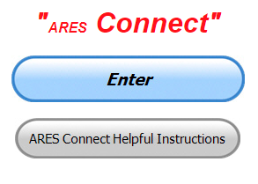

***Connecting Amateur Radio Volunteers with a Purpose***

Hey everyone… please make sure to go in and register your time to all of the events that you have signed up for. Be honest about the time spent. Don’t forget to get this done no later than **5 days** after the event has ended. I’m asking you to do this for our ability to run reports accurately.

**I want to remind all of you that you do not have to be an ARES or ARRL member to use this system. All licensed amateur radio operators throughout the country are welcome and strongly encouraged to use it.**

**Don’t forget to check out the “Frequently Asked Questions” area that has been added to the Ohio Section website.** It’s there to help you through any difficulties that you may have with ARES Connect. Now, if you don’t any posts that relate to what you are having difficulties with, we now also have an on-line “Guru” area as well. This will allow you to ask any questions that you may have about ARES Connect.

**Let’s get everyone on “ARES Connect!!!”**

TOP ^

***Matt’s Corner***

*(C. Matthew Curtin* [*KD8TTE@arrl.net*](mailto:KD8TTE@arrl.net)*)*

***A Few Quick Tips: Keep Operating!***

ECs, how are you doing with your planning for the VHF+ Contest? Have you made the assignments for covering your multipliers like rovers, portables, and EOCs? Are you building the capabilities of your operators by applying lessons from exercises and working through your Improvement Plan? See last week’s article for a detailed discussion on that.

Buckeye Net operation continues nicely, operating on NTS Cycle Two (13:00 localtime) daily. The net meets by default on 60m, which gives the best in-state propagation during that time of day. If you’re not able to transmit on 60m, you can still join us; most days net control will send stations down to 75m to relay others in. An important feature that we’ve built is the ability to operate multichannel, multiband, and multimode. In practice if you’ve got voice and NBEMS (applications fldigi and flamp will cover it), you can operate Buckeye Net.

This is all about continuous improvement, building capability, and demonstrating year over year advancement in capability and performance. See the QTC Internet email list for discussion of training, and the Buckeye Net training slide deck for the introduction. <https://www.blackswancomex.org/2021/prepare>

How about that solar storm? Instead of G3 radio blackouts, I heard openings on 6m up to Maine and 10m out over 1000 miles on Thursday, December 10.

We’ve seen a lot of movement in BBS and Winlink use in the Section, as well. This is great news; these are important tools for us in being able to perform our work in providing a means to send and receive messages when the usual options aren’t available. Have you practiced by working with the BRRO Monday Packet Net? Doug AB8M has a great article describing the operation up on the Black River Radio Ops site. It’s a good way to practice without everyone needing to operate at exactly the same time and on the same frequency. It’s a lot of fun seeing who has joined, where they’re from, and what words they’ve got to offer for the week. <http://www.nw8s.com/news/brro-monday-packet-net/>

If you’ve got questions about how to make this work locally, and how to get yourself organized locally for the VHF+ Contest, talk with your neighboring ECs and your DEC. Feel free to reach out to me directly! [kd8tte@pm.me](mailto:kd8tte@pm.me) We’re here to help each other to be ready to support our communities, making them safer and more resilient.

Take action now to get everyone ready to go so we can all enjoy the holidays, get our station upgrades done, test our new stuff, and be ready to go when it’s time for our next big Section event, the VHF+ Contest, or the “real deal” to serve our communities.

####

TOP ^

***NIMS 300 & 400 Being Offered Virtually***

**TRAINING LINKS:**

• Ohio EMA Training Calendar

• Login to the DPS Training Campus

• Create a new account on the DPS Training Campus

**NOTE:**

• Seats available listed are as of the release of this update and will change quickly.

• All classes will be posted on the DPS training campus at least 60 days prior to the start of the course.

• Please read the Training Policy & Catalogue for more information on Ohio EMA trainings.

|  |  |  |  |
| --- | --- | --- | --- |
| **COURSE** | **DATE(S)** | **HOST COUNTY OR VIRTUAL** | **# SEATS AVAILABLE** |
| L-451 Academy I–Application of Advanced Individual Concepts in EM | March 1-5, 2021 | Virtual | 5 |
| ICS-300 Intermediate ICS | March 23 -26, 2021 | Virtual | 0 |
| G-108 Community Mass Care and Emergency Assistance | March 23-24, 2021 | Lake | 23 |
| ICS-400 Advanced ICS | March 30-April 1, 2021 | Virtual | 0 |
| ICS-300 Intermediate ICS | March 30-April 2, 2021 | Virtual | 24 |
| ICS-400 Advanced ICS | April 7-9, 2021 | Virtual | 24 |
| G-288 Local Volunteer and Donations Management | April 13-14, 2021 | Lake | 25 |
| ICS-300 Intermediate ICS | April 13 – 16, 2021 | Virtual | 17 |
| ICS-300 Intermediate ICS | April 27 – 30, 2021 | Virtual | 0 |
| L-452 Academy II–Assessment of Teams in Professional EM | May 3-7, 2021 | Virtual | 5 |
| G-288 Local Volunteer and Donations Management | May 12-13, 2021 | Union | 29 |
| G-191 ICS / EOC Interface | May 14, 2021 | Virtual | 23 |
| ICS-300 Intermediate ICS | May 18-20, 2021 | Virtual | 0 |
| ICS-400 Advanced ICS | June 1-4, 2021 | Virtual | 19 |
| ICS-400 Advanced ICS | June 16-18, 2021 | Virtual | 0 |
| L-453 Academy III–Contemporary Issues in the EM Organization | July 12-16, 2021 | Virtual | 5 |
| ICS-400 Advanced ICS | August 11 – 13, 2021 | Virtual | 0 |
| L-454 Academy IV–Advanced Concepts and Policy in the EM Profession | September 13-17, 2021 | Virtual | 5 |

TOP ^

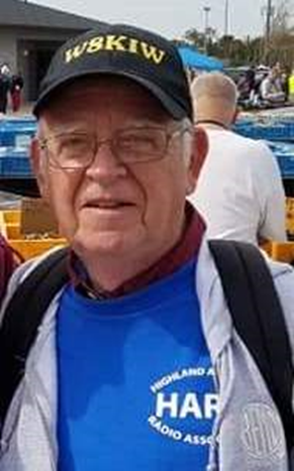***From The South 40***

*(from John Levo,* [*W8KIW@arrl.net*](mailto:W8KIW@arrl.net)*)*

***News From the South 40***

It’s hard to believe it’s almost time for the Jolly Fat Man to slide down the chimney and place that new super doper all frequency rig you have dreamed about under your Christmas tree. Although the virus has curtailed most year-end ham radio activities and gathering functions, some have still taken place.

The **Scioto Valley ARC** held its annual dinner this past Saturday afternoon at the Chillicothe Tumbleweed with a decent number of members in attendance, considering the virus concerns. The **Highland ARA**’s Brunch Bunch again had to forego their monthly physical gathering and instead meet over the airwaves of their linked Greenfield and Hillsboro repeaters with 18 checking in-even one from Maysville, KY. Systems are “All Go” for the **Athens County ARA**’s virtual Christmas dinner via Zoom on the 15th which will start at 7 pm to give members a chance to first eat their meals off camera and grab their favorite beverage before the meeting begins. South of the river, the **Tri-State ARA** decided to be safe instead of sorry and therefore cancel their annual Christmas dinner scheduled for the 15th.

Although the **Greater Mason County ARC** had to cancel their annual Christmas dinner, they still gathered to elect those who will lead the club in 2021. Larry Dodge, KG4PXA, was elected President and Brent Well, N4BDW, will be the Vice President. Holton Carpmell, KE4LCZ, was chosen as the new Secretary and Dr. Greg Taylor, KY4OD, will handle the money. Trustees chosen for the year will be Marty Sauer, KD4IXQ; Paul Earhart, WD4OQH and Clay Graves, KJ4HVL. Best wishes to all. Also cancelling their annual Christmas meeting dinner was Adams County’s **DeForest ARC**. But they too held their election by other methods. The officers for 2021 will be: after an absence Kim Paquette, N8YWX, will again serve as Club President; the Vice President will be Duff Kindt, K8TFG; Bill Hablitzel, K8WEH, will handle finances and Troy Peterson, N8XGR, is the Secretary.

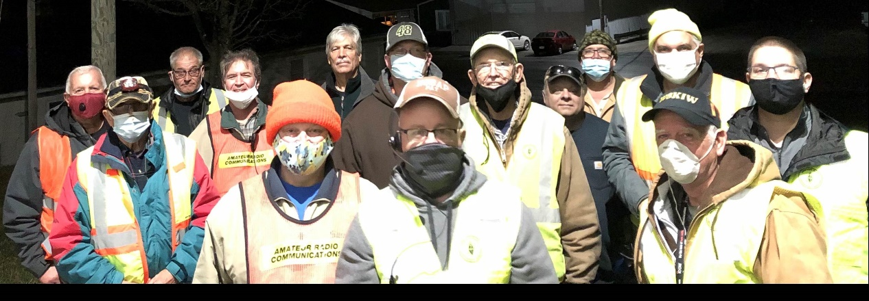Although many holiday parades in the region were cancelled this year, the Hillsboro Uptown Merchants Association’s annual Christmas Parade rolled through the streets of Hillsboro on Saturday evening in perfect weather. Eighteen **Highland ARA** members showed up at the county fairgrounds to assist with communications and parade lineup. Robb Allen, KE8PYG of Sabina, got an early Christmas gift that morning when he passed his General License and celebrated with participating in his first ham radio community event.

TOP ^

On Tuesday evening, the **Portsmouth RC** 8 pm Net set a modern check-in record with over 30 stations recognized. Net Control, Russ Jett, KB8AAK, welcomed not only PRC members but others checking in via EchoLink and Hillsboro’s linked repeater. A station in New Zealand checked in as did a former Portsmouth resident now living in Asheville, NC.

Last Saturday, members of the **Clinton County ARA** participated in the annual National Weather Service Recognition Day activity. Because of COVID 19 limitations, the WX8WIL station at the Wilmington NWS Office was unable to be used so club members ventured to their clubhouse and activated the call sign there. A lot of fun was had by those participating along with generating a good number of contacts on VHF and HF. Those participating were Andrew Adrian, W9AMA; Dave Gordley, K8DEG and Mark Atwell, KD8DGH.

Are your dues due? Because of the pandemic, a number of clubs throughout our region had to do away with hamfests and other fund-raising events this year. However, the bills for electricity, station maintenance, insurance and other expenses keep coming in. Therefore, some clubs may be experiencing or on the verge of a cash flow problem. As a number of clubs use a January 1 to December 31 membership year, why not go ahead and renew your membership and pay the dues instead of dragging them out until your next in person meeting? Additionally, if you are not a member of a local club or clubs, why not seek them out and support them with your membership? Or if you want to give something to a special ham on your shopping list, why not provide them a membership in your local club if they aren’t already a member. Or an ARRL membership? I’m certain it will be appreciated.

During this week’s **Athens County ARA** virtual meeting, the winner of the coveted annual NC8V Memorial Trophy will be announced. The award is presented to the ACARA member submitting the highest score in the past weekend’s ARRL 10-Meter Contest. Josh Cash, KE8EAS, is the current holder of the rotating award.

Speaking of ten meters, the **Athens County ARA** has started a 10-meter net on Tuesday evenings at 5 pm. It is on 28.350. The **Clinton County ARA** has a net on 28.421 each Wednesday evening at 9 and the **Highland ARA** has a 28.421 net each Sunday night at 9. According to their website, the **Mid-Ohio Valley ARC** also holds a Tuesday evening net on 28.305 at 8 pm. We have also heard of a **Southeast Ohio Ragchew Net** meeting on 28.485 on Sunday evenings at 2100. Any amateur, regardless of their license class, can check into these nets and all are welcome.

Congratulations to Greenfield’s Gregg Barr, KD8UVU, upon his retirement from law enforcement following a 45 year career. Saturday evening was his final shift when he served as a dispatcher for the Greenfield Police Department. Over the years Barr also served as an EMT Training Instructor. Gregg continues to serve his community as the McClain School District’s representative to the Great Oaks Vocational School District Board. We salute you Greg.

The **Highland ARA**’s President Jeff Collins, KD8VUY, lets area hams know HARA will once again host the popular New Year’s Net on the Hillsboro 147.21 and Greenfield 146.685 repeaters. It will start immediately following John Willis’ (KE8JEM) Midnight tolling by the large Hillsboro manufactured CS Bell bell gracing the front of the Highland County Highland House Museum. Any amateur within the footprint of either repeater is welcomed to check in. Who can tell- perhaps some other repeaters might even be linked in to celebrate this unique way for hams to “ring in the New Year”?

TOP ^

Athens’ Jeff Slattery, N8SUZ, reminds us of the upcoming January 9 Ohio VHF Simplex Contest which runs from 10 am until 4 pm. It happens on all standard simplex frequencies on bands-six meters and up. The purpose of the contest is to test our stations and antennas and to test our non-repeater coverage areas when in emergency times our repeaters may be off the air. Your column editor operated it as a rover last year and found it to be a lot of enjoyment as well as educational. Try it! You might like it!

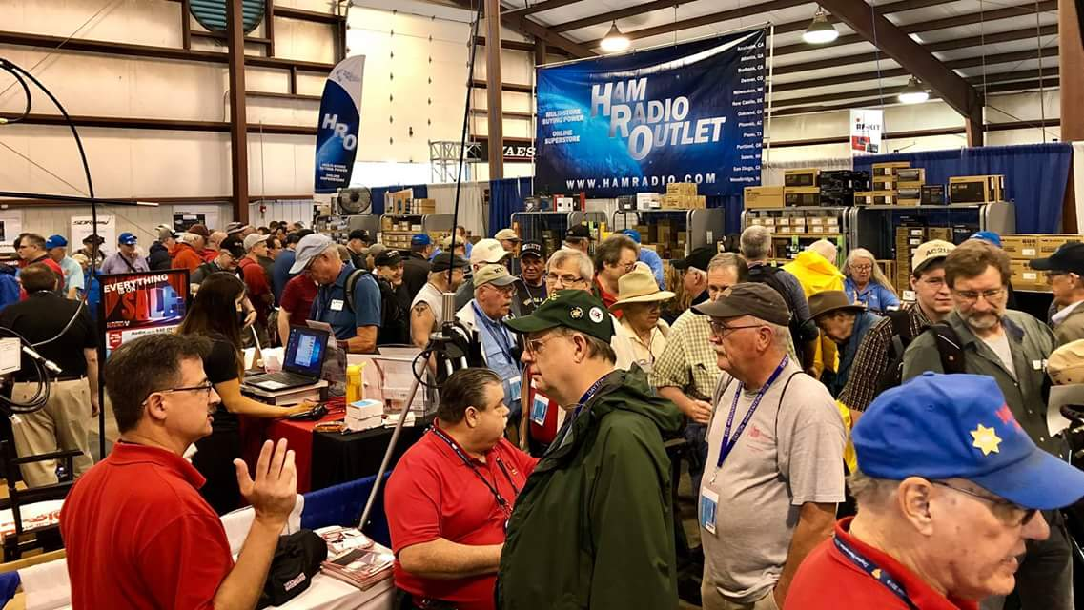[***Upcoming Hamfests***](http://arrl-ohio.org/hamfests.html)

**03/07/2021 -**[**WINTERHAMFEST**](http://www.arrl.org/hamfests/winterhamfest-3)

**Location: Elyria, OH  
Sponsor: Northern Ohio Amateur Radio Society**[**Learn More**](http://www.arrl.org/hamfests/winterhamfest-3)

|  |  |
| --- | --- |
| **04/25/2021 -**[**Athens Hamfest**](http://www.arrl.org/hamfests/athens-hamfest-9)  **Location:**Athens, OH **Sponsor:** Athens County Amateur Radio Association **Website:** <http://ac-ara.org/> [**Learn More**](http://www.arrl.org/hamfests/athens-hamfest-9) | **07/18/2021 -**[**VAN WERT HAMFEST**](http://www.arrl.org/hamfests/van-wert-hamfest-5)  **Location:**VAN WERT, OH **Type:** ARRL Hamfest **Sponsor:** VAN WERT AMATEUR RADIO CLUB **Website:** [http://W8FY.ORG](http://w8fy.org/) [**Learn More**](http://www.arrl.org/hamfests/van-wert-hamfest-5) |
| **09/26/2021 -**[**Cleveland Hamfest**](http://www.arrl.org/hamfests/cleveland-hamfest-1)  **Location:**Berea, OH **Type:** ARRL Hamfest **Sponsor:** Hamfest Association of Cleveland **Website:** [http://www.hac.org](http://www.hac.org/) [**Learn More**](http://www.arrl.org/hamfests/cleveland-hamfest-1) | |

***One Question Questionnaire***

Hey Gang,

Survey Says”….. around 22% of you do have a couch in your ham shacks! Wow, that’s fantastic!!! I guess you folks don’t have to worry about late night DX chasing. If you get tired you can just crash on the couch for a few hours.

Ok, now on to the next question… Let’s just see how prepared you all are. So that’s the inspiration for this next question.…

***“Do you keep a spare “Charged” battery ready to go for your handhelds??”***

TOP ^

You’ll find the “One Question” questionnaire on the Ohio Section Website! <http://arrlohio.org> It’s all in fun and it’s not a scientific survey in any way, but we are learning some things that we didn’t know from these questions. I hope that you are enjoying answering these “One Question” questionnaires.

*****V.E. Test Sessions***

Many V.E.’s have decided to start testing once again, but with restrictions that need to be adhered to for sure. Here’s the link to find that V.E. Test session and what is expected of YOU before going. <http://www.arrl.org/find-an-amateur-radio-license-exam-session>

***Final.. Final..***

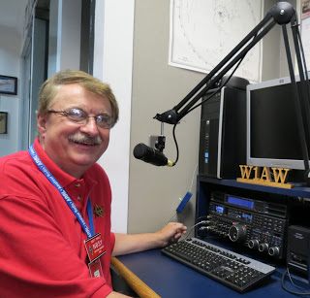

Hi Gang,

Wow… this week was one expensive week for me for sure. I had to buy 4 new tires for the car. Believe this or not, I actually got over 106,000 miles on this last set!! No, I didn’t wear them down to the cord, I still had 3/32” of tread left on them when they took them off.

What made me decide to get new tires was the snow that we got last week. You’re right, it wasn’t all that much, but I did notice the car doing a bit of slipping around and since the car is AWD with traction control on all 4 wheels, and I was having some trouble getting up my driveway, I decided not to try to go any further on those tires. And, since it was also time to get the oil changed anyway, it just made sense to get it all done at once, although my pocketbook is now much lighter for it. I guess the dealership felt really sorry for me as that they gave me an extra big discount (free) on the mounting and balancing, so it didn’t hurt quite as much as it could have.

I was going through all the stuff that I have acquired over the years as Section Manager and getting things sorted out for whomever will become the new Ohio Section Manager. (No, I don’t know who it will be right now, but I’m sure it will be announced very soon.) I ran across some personal files that got mixed in. I hadn’t seen this stuff for many, many years so it made me sit down and just do some remembering. After looking through all the papers it dawned on me that today (Monday) it will be exactly 30 years to the day that my life got totally changed.

Most of you don’t know that my first career was working at Westinghouse. The name got changed to White-Westinghouse a few years after I got there, but to all of us in the Mansfield area it will always be known it as the “Circle W.”

TOP ^

What really hit me going through all those papers was that it was on December 14, 1990 that the doors here on the Mansfield plant were permanently closed. Everything was moved to Webster City, Iowa, bringing to an end what I had thought would be my life-long career. Back in those days many folks would get a job at a facility like this and stay there all of their working lives. I had 20 years in before it closed and a really great job as a pressroom supervisor and captain on our fire brigade. Life was great until that day came!

Back then we had a government program called the “Job Training Partnership Act - JTPA” which was a re-training program that sent thousands of folks like me who had lost their jobs due to plant closures back to college or vocational school. Since I was already attending college, I continued on that path and I never looked back.

Now here’s where the younger folks really need to listen up… I got another job, and I was again going along happy as a supervisor and my college education taken care of, when out of the blue I got a call to come work for a guy that truly believed that HAMS make good engineers. He knew what you had to learn and know to be a HAM, and he knew that this didn’t come easy as he himself was a HAM. He knew how HAMS are experimenters and troubleshooters, thinking out of the box to make something work, not only with radio gear, but also with mechanical things as well.

So, my career took another course change, and I became a Quality Engineer and eventually a Quality / Safety and Environmental Manager over an entire manufacturing facility.

I put in over 25 years as an Engineer and finally retired in 2015. I will say that if I hadn’t been a HAM, I most likely would not have been given that wonderful opportunity to grow and utilize that educational opportunity that I was given. Thanks Jack, W8ZES for believing in me and amateur radio. It changed my life forever!!

Ok, now on to some other news that you might have missed… Did you see that we DO have some hamfests scheduled for 2021!! Yes, the first one out of the gate will be the NOARS Fest on March 7th. [Ohio Hamfests](http://arrl-ohio.org/hamfests.html)

Be sure to keep your eyes on this schedule as that when things start getting better and the vaccine rolls out to more and more, hamfests will surely get back to their normal schedule. Don’t see your hamfest listed?? Did anyone register it with ARRL? It’s really easy to do and you get a lot of FREE publicity if you do. Here’s a link to register your hamfest… [Hamfest/Convention Application Form](http://www.arrl.org/hamfest-convention-application)

Have you seen our monthly ARES Connect report for November? It’s pretty impressive to say the least. Want to see this and all the reports? [SEC Monthly Reports](http://arrl-ohio.org/SEC/reports.html)

Whelp, that’s going to do it for this week my friends! I’m still looking forward to visiting with all of you live or via Zoom, WebEX or whatever.

I really can’t wait for that time when we can all get together in person once again. Those are the times I cherish the most!!! Stay safe! We will get through this and when we do, we’ll have so much to talk about. Most of all… have FUN and get on the airwaves!!

73,

[***Scott, N8SY***](mailto:n8sy@n8sy.com)

TOP ^

***Print an Official or Unofficial Copy of Your Amateur Radio License***

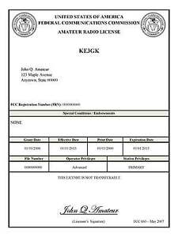*(By Anthony Luscre, K8ZT)*

As of February 17, 2015, the **FCC no longer routinely issues paper license documents** to Amateur Radio applicants and licensees. The Commission has maintained for some time now that the official Amateur Radio license authorization is the electronic record that exists in its Universal Licensing System (ULS). The FCC will continue to provide paper license documents to all licensees who notify the Commission that they prefer to receive one.

Licensees also will be able to print out an official authorization — as well as an unofficial “reference copy” — from the ULS License Manager. I’ve created a set of instructions on how you can request an **“official” printed copy of your license\*** [**Click here to download the instructions**](http://arrl-ohio.org/news/2020/print_your_license.pdf)

***A Hams “Night Before Christmas”***

(Submitted by Gregory Drezdzon, WD9FTZ)

Here’s a link to that wonderful old Christmas poem “A Night Before Christmas” amateur radio style..

<https://www.youtube.com/watch?v=xxJpunNf5WI&feature=youtu.be>



Hey Gang,

Have you taken a look at the **Swap & Shop** page on the Ohio Section webpage yet?? Here’s a link that will take you there…

<http://arrl-ohio.org/sm/s-s.html>

Do you have equipment that you just don’t need or want anymore? Here’s a great venue to advertise it, and it’s FREE!! Is your club doing a fund raiser to help raise money? After a lot of thought, it was decided that the Swap & Shop webpage could also contain these types of items as well. The same rules will apply as do for the For Sales and Give-A-Ways and will only be posted for a month at a time. Please see the Terms & Conditions on the webpage.

If your club is doing a fund raiser and wants more exposure, please forward the information to me and I’ll advertise it on the Swap & Shop webpage for you.

TOP ^

Now, I still want to remind you that it won’t be listed in this newsletter because it would take up way too much space, so your ad will only appear on the website. It is there for any individual to post equipment Wanted / For Sale or Give-Away as well as for Club Fund Raisers. No licensed vehicles/trailers or business advertising will be posted. Postings are text only (no pictures or graphics) will be posted for a maximum of 1 month from date posting and require a contact phone number or email within the posting. Send your Wanted / For Sale or Give-Away post to:  [swap@arrlohio.org](mailto:swap@arrlohio.org)

Ohio Section Cabinet

|  |  |
| --- | --- |
| Section Manager – Scott Yonally, N8SY | Assistant Section Manager – John Perone, W8RXX |
| Section Emergency Coordinator – Stan Broadway, N8BHL | Section Traffic Manager – David Maynard, WA3EZN |
| Technical Coordinator – Jeff Kopcak, K8JTK | Affiliated Clubs Coordinator – Tom Sly, WB8LCD |
| State Government Liaison – Bob Winston, W2THU | Public Information Coordinator – John Ross, KD8IDJ |
| Section Youth Coordinator – Anthony Lascre, K8ZT | |

***Back Issues of the PostScript and Ohio Section Journal***

Hey, did you know that PostScript and Ohio Section Journal (OSJ) are archived on the website? You can go back and look at any edition simply by clicking:

<http://arrl-ohio.org/news/index.html>

***Want to Share your Club Newsletter With Others?***



We have a webpage where you can download and read all of the newsletters that I get from around the state and even other sections!

Here’s the link to the page…. <http://arrl-ohio.org/club_news/index.html>

Please, if you don’t see your club newsletter posted, it’s because I’m not receiving it. Just have your newsletter editor contact me and I’ll get your club’s newsletter listed on the site!!

We all learn and steal (I mean, share) from each other’s work. So, get me your newsletter!!! Send it to: [n8sy@n8sy.com](mailto:n8sy@n8sy.com)

TOP ^

***Chit – Chat, and All That!***

Do you know someone that’s not getting these Newsletters? Please, forward a copy of this Newsletter over to them and have them “[Opt-In](mailto:Opt-In)” to start receiving them. Heck just have them send me an email [n8sy@n8sy.com](mailto:n8sy@n8sy.com) and I’ll get them added to the Ohio Section Emailing list.

We now have many thousands of readers receiving these newsletters weekly. Quite impressive, I’d say! I urge all of you to make sure that everyone, regardless of whether they are a League member or not, get signed up to receive these weekly Newsletters.

You can always “Opt-Out” at any time if you feel this is not what you were expecting. It’s fun and very informative. All of your favorite past newsletters are now archived too.

You can go back at any time and read them. Just go to: <http://arrl-ohio.org/news/>

Got questions, concerns or would just like to sit and chat awhile? Heck, I’ll even buy the coffee!! Give me a call at (419) 512-4445 or email me at: [n8sy@n8sy.com](mailto:n8sy@n8sy.com)

The pictures on the front page and throughout this newsletter are from various newsletters, Facebook posts and/or were sent directly to me in recent weeks. Take a good look at them, you just might be in one of the pictures! “SMILE… you’re in the Ohio Section News!!”

***Stop!!! You’ve reached the end of another week’s edition.***



TOP ^

*PostScript is produced as a weekly newsletter. I want to thank everyone that has contributed articles and ideas to make this an even better news source. I sincerely hope that you have enjoyed this edition and will encourage your friends to join with you in receiving the latest news and information about the Ohio Section, and news and events happening around the world!*