[](http://arrl-ohio.org/news/) ***“Remembrance”***

***Edition***

🡪 National News 🡪 The Handbook Give Away

🡪 Club Corner 🡪 Hamfests- None

🡪 DX This Week 🡪 ARES Connect

🡪 Matt’s Corner 🡪 From The South 40

🡪 One Question Questionnaire 🡪 VE Testing

🡪 Final.. Final..

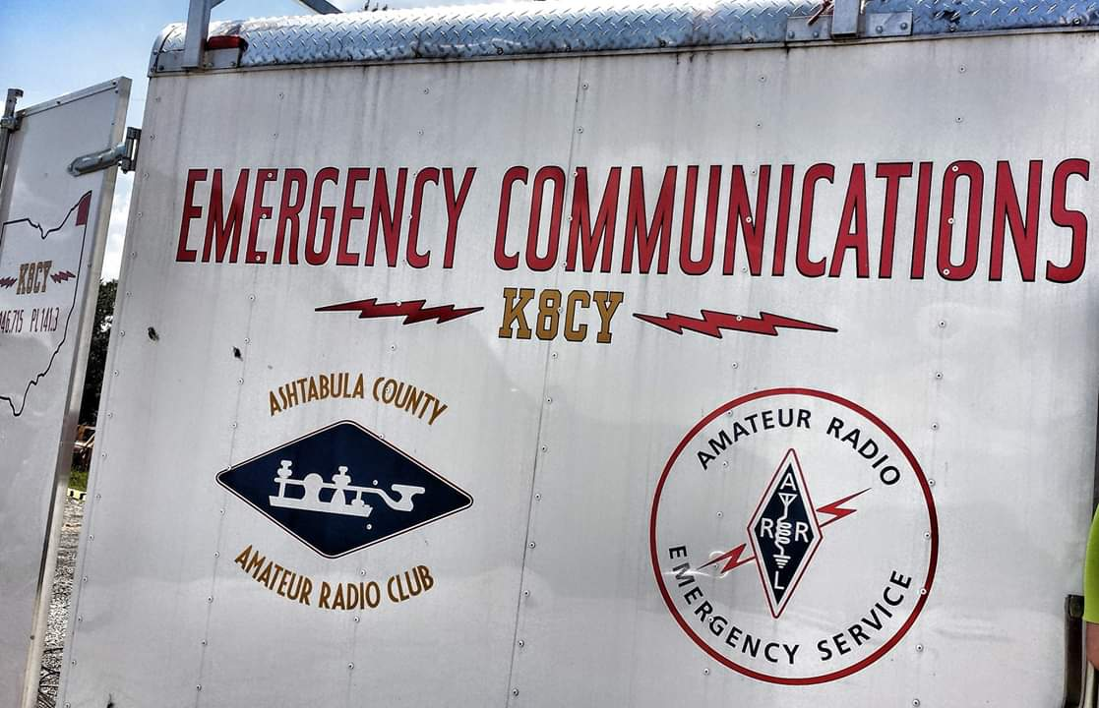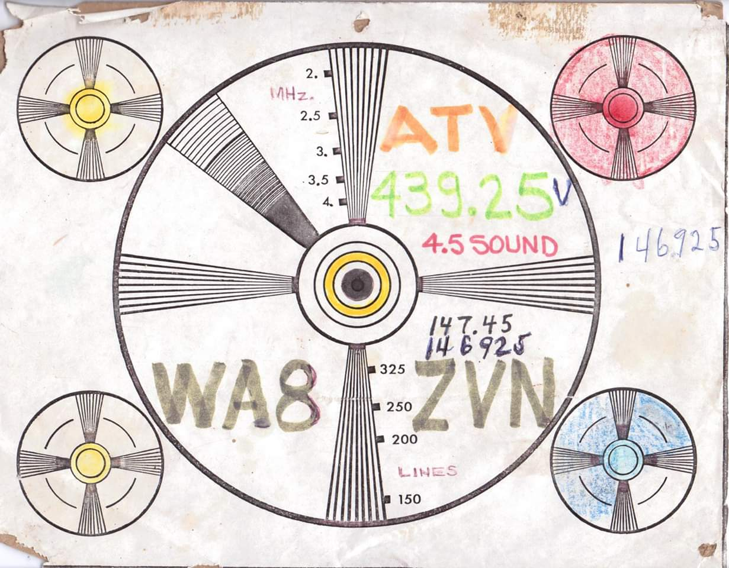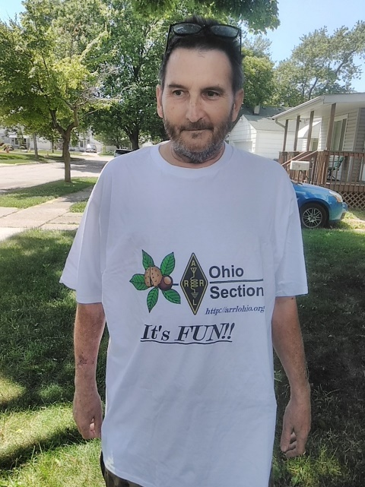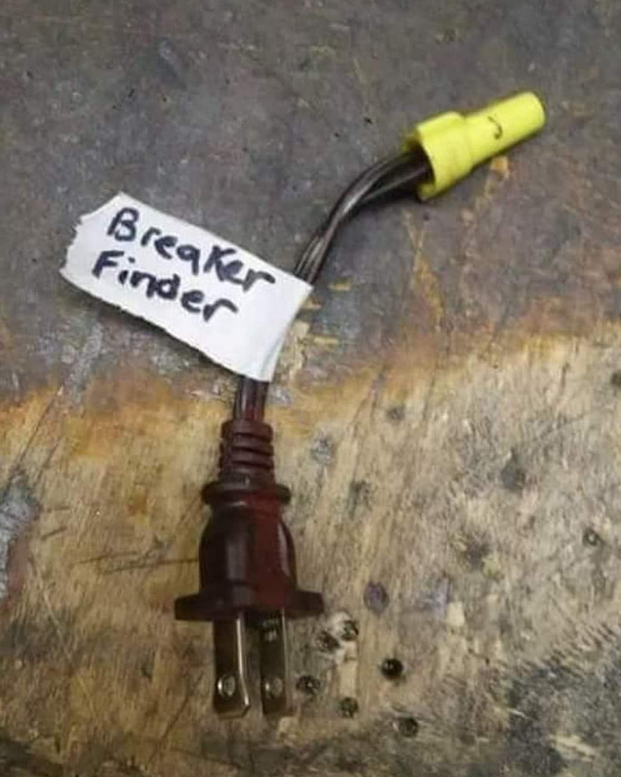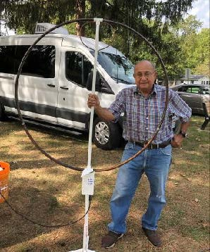

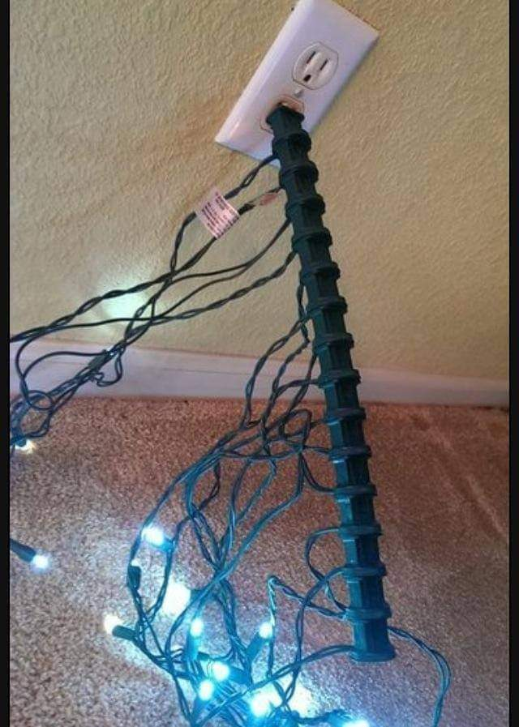

***National News***

*(from arrl and other sources)*

***FCC to Require Email Addresses on Applications***

Amateur radio licensees and candidates will have to provide the FCC with an email address on applications, effective sometime in mid-2021. If no email address is included, the FCC may dismiss the application as defective.

The FCC is fully transitioning to electronic correspondence and will no longer print or provide wireless licensees with hard-copy authorizations or registrations by mail.

A *Report and Orde*r ([***R&O***](https://www.fcc.gov/document/fcc-adopts-electronic-licensing-report-and-order)) on “Completing the Transition to Electronic Filing, Licenses and Authorizations, and Correspondence in the Wireless Radio Services” in WT Docket 19-212 was adopted on September 16. The new rules will go into effect 6 months after publication in the *Federal Register*, which hasn’t happened yet, but the FCC is already strongly encouraging applicants to provide an email address. When an email address is provided, licensees will receive an official electronic copy of their licenses when the application is granted.

Under Section 97.21 of the new rules, a person holding a valid amateur station license “must apply to the FCC for a modification of the license grant as necessary to show the correct mailing and email address, licensee name, club name, license trustee name, or license custodian name.” For a club or military recreation station license, the application must be presented in document form to a club station call sign administrator who must submit the information to the FCC in an electronic batch file.

Under new Section 97.23, each license will have to show the grantee's correct name, mailing address, and email address. “The email address must be an address where the grantee can receive electronic correspondence,” the amended rule will state. “Revocation of the station license or suspension of the operator license may result when correspondence from the FCC is returned as undeliverable because the grantee failed to provide the correct email address.”

-------------

***FCC Chairman Ajit Pai Departing Commission***

FCC Chairman Ajit Pai has [**announced**](https://docs.fcc.gov/public/attachments/DOC-368433A1.pdf) that he intends to leave the Commission on January 20, 2021, as the Biden Administration comes into office. The FCC chairman is appointed by the president.

“It has been the honor of a lifetime to serve at the Federal Communications Commission, including as Chairman of the FCC over the past 4 years,” Pai said. “I am grateful to President Trump for giving me the opportunity to lead the agency in 2017, to President Obama for appointing me as a Commissioner in 2012, and to Senate Majority Leader McConnell and the Senate for twice confirming me. To be the first Asian-American to chair the FCC has been a particular privilege. As I often say: only in America.”

The FCC has five members, typically three from the party in the White House.

####

TOP ^

***RadioShack Purchased by Online Retailer***

[**RadioShack**](http://www.radioshack.com/)® is back as an online retailer of electronics, offering some parts in its inventory that largely consists of radios, batteries, telephone gear, drones, computer accessories, and even cameras. The iconic company was recently purchased from General Wireless by Retail Ecommerce Ventures (REV).

No plans are in place to reopen RadioShack-owned stores, although some 400 brick-and-mortar outlets not affiliated with REV are operated by franchisees. REV, which specializes in online retail, has previously revamped the internet presence of such bankrupt businesses as Pier 1 Imports and Dressbarn, according to a news release.

During its heyday, RadioShack has some 8,000 retail outlets and once offered some amateur radio equipment, including some popular handheld transceivers and a 10-meter transceiver. RadioShack came out of its second bankruptcy in January 2018 with 400 dealers, an online retail presence, and a distribution center.

####

***Croatia (9A) becomes fifth country to grant access to the new 40 MHz band***

*(**Submitted by Gregory Drezdzon, WD9FTZ)*

We now have welcome news that Croatia has joined the small number of countries that has allowed operation on the new 40 MHz (8-metre) amateur band (*outside of the United States*).

Dragan Mojsilovic, 9A6W, reports that the national telecom authorities in Croatia have given him a one-year experimental license to operate from 40.660 MHz to 40.700 MHz in a slice of spectrum referred to as the Industrial, Scientific & Medical (ISM) band.

Croatia is now the *fifth* country in which it is possible to operate legally on 40 MHz. Ireland, Slovenia & South Africa already have allocations on the band while Lithuania is willing to allocate spot frequencies for experimental purposes.

It is hoped that other Croatian stations will follow Mojsilovic 's example and apply for permission to operate on this new amateur band. More info at:   <https://ei7gl.blogspot.com/2020/12/new-activity-from-croatia-on-40-mhz-dec.html>

-----------------------

***U.S. postal stoppage - Updated: November 27, 2020***

The U.S. Postal Service is temporarily suspending international mail acceptance for certain destinations due to service impacts related to the COVID-19 pandemic.

Suspension Due to Foreign Postal Operator Service Suspension  
------------------------------------------------------------  
Libya Madagascar Panama Turkmenistan

TOP ^

Suspension Due to Unavailability of Transportation  
-----------------------------------------------------------------  
Angola Guadeloupe Republic of Congo South Sudan  
Brunei Liberia Reunion (Bourbon) Tajikistan  
Chad Martinique St. Pierre & Miquelon Timor-Leste  
Cuba Mauritius Seychelles Yemen  
French Guiana Niger Sierra Leone

Customers: Please refrain from mailing items addressed to the countries listed above, until further notice.

For more details, see:  
<https://about.usps.com/newsroom/service-alerts/international/welcome.htm>

####

***Calling all stations: Join us for The December 2020 Eclipse Festival of Frequency Measurement - 9 December 2020 0000 to 16 December 2020 2359 UTC***

Changes in ionospheric electron density caused by space weather and diurnal solar changes are known to cause Doppler shifts on HF ray paths.

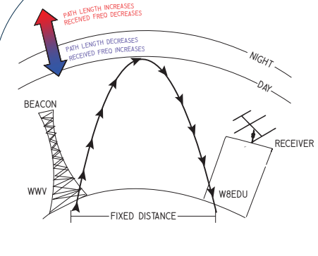HamSCI's first attempt at a measurement of these Doppler shifts was during the August 2017 total solar eclipse.  We plan a careful measurement during the 2024 eclipse. As part of the [**WWV centennial,**](http://www.wwv100.com/) 50 stations collected Doppler shift data for the original Festival of Frequency Measurement, demonstrating the value of volunteer participation in collecting this data.

During the [**June 2020 Eclipse Festival**](https://hamsci.org/node/415), we enlisted participants around the globe and experimented with different data collection protocols.  This winter, we request that all amateur radio stations, shortwave listeners, and others capable of making high-quality HF frequency measurements help us collect frequency data for the **December 14 total eclipse.**

Contact information: Kristina Collins: [**kd8oxt@case.edu**](mailto:kd8oxt@case.edu)

**This experiment will use only the 10 MHz transmissions.** If you can't get a good signal on 10 MHz, record another frequency and make sure the file is labeled appropriately. The recordings in this experiment are expected to show formations of the D-layer at stations' local sunrise and other daily events of the ionosphere, and the effects of the eclipse. Space weather varies day to day and some features may be prominent.  We'll see what we get!

More details can be found at: <https://hamsci.org/december-2020-eclipse-festival-frequency-measurement>

####

TOP ^

***December is YOTA Month***

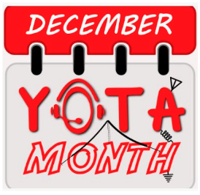The month of December has been designated as YOTA month. The annual initiative sponsored by Youngsters on the Air ([**YOTA**](http://www.ham-yota.com/)) initially focused on International Amateur Radio Union ([**IARU**](http://www.iaru.org/)) Region 1 (Europe, the Mideast, and Africa), with young radio amateurs taking to the air with YOTA-suffix call signs. YOTA ([**Youth on the Air**](https://youthontheair.org/yota-month/)) in Region 2 (the Americas) is following step, and [**K8Y**](https://www.qrz.com/db/k8y), [**K8O**](https://www.qrz.com/db/k8o), [**K8T**](https://www.qrz.com/db/k8t), and [**K8A**](https://www.qrz.com/db/k8a) will be on the air from the US.

The overarching idea is to demonstrate amateur radio to youth to encourage them to get licensed and for younger radio amateurs to get active on the ham bands.

YOTA-suffix stations have been on the air from the annual summer camp and other subregional camps in Region 1, but the COVID-19 pandemic sidelined those gatherings in 2020.

All radio amateurs can support this effort by contacting participating stations. An **awards program** is available.

During YOTA month 2019, 47 participating YOTA stations racked up nearly 130,000 contacts. Follow YOTA via Twitter: **@hamyota** and **@hamyota_official**. All young radio amateurs (up to age 26) are encouraged to participate. Direct questions via email to [**info@ham-yota.com**](mailto:info@ham-yota.com).

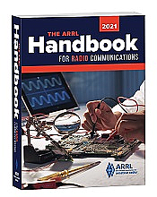***Handbook Give Away***

Hey Gang,

The winner of the November Give Away is… ***Melvin Glover, KE8DWN***

Now... Are you ready for this?? We’re be doing a Christmas and New Years Eve Give Away soon!!!! How will you know when it begins?? Well, that’s easy… Just keep checking into the Ohio Section Website and look for that big **RED** Arrow on the left side of the page!!!

This is the sign that the drawing is on and you need to get registered. So, keep a sharp eye out on the website and check in often! <http://arrl-ohio.org/>

***Club Corner***

This is YOUR cornner of the newsletter. Send me what your club is doing and I’ll make sure that it gets in. Got a special event or club project that you want everyone to know about? Send it to me!. Need help with a project? Send it to me.

Let me know what you club is up to. Are you going to have a special guest at your meeting or are you having a special anniversary? Just sent it to: [n8sy@n8sy.com](mailto:n8sy@n8sy.com)

####

TOP ^

Scott,

The Central Ohio Radio Club (CORC) congratulates you on your new position of the ARRL Great Lakes Division, Vice Director.

We have always appreciated your speaking and attendance at our meetings. Hopefully you and Janie will still find time with your new duties to visit now and then.

Enjoy the new position.

73, Laura / KA8IWB - CORC President

***DX This Week***

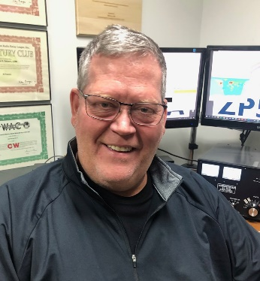*(from Bill, AJ8B)*

***DX This Week – Zones 33,34, & 35***

***Bill AJ8B (aj8b@arrl.net, @AJ8B, or www.aj8b.com)***

***CWOPs Member #1567***

The Midwest DX Cluster spots that were posted last week included Angola, Anguilla, Argentina, Azores, Belgium, Belize, Brazil, Canada, Canary Islands, Chad, Cuba, Denmark, Dominica, Dominican Republic, England, Falkland Islands, Fed. Rep. of Germany, Fiji, France, Gabon, Ghana, Guadeloupe, Guatemala, Haiti, Iceland, Indonesia, Ireland, Isle of Man, Italy, Kingdom of Eswatini, Liberia, Lithuania, Madeira Islands, Mali, Malta, Mauritius, Mexico, Montenegro, Morocco, Netherlands, North Cook Islands, Panama, Peru, Philippines, Poland, Portugal, Puerto Rico, San Marino, Saudi Arabia, Scotland, Serbia, Slovenia, South Africa, Spain, St. Lucia, Suriname, Ukraine, Wales, and Western Sahara..

***DAH DIT DIT DIT DAH DAH DIT DIT DIT DAH***

QSL cards received this week included KH2L – Ed in Guam and PS2T – The Curitiba Contest Station in Brazil, and F5ICC, Francois in Sarlat, France.

|  |  |
| --- | --- |
|  |  |

***DAH DIT DIT DIT DAH DAH DIT DIT DIT DAH***

TOP ^

So far this year, we have covered CQ zones 1 through 32. This week we will review Zones 33, 34, and 35. With the Solar Activity slowly increasing, there are going to be more opportunities to work these entities and I hope you are ready!

Below is a list of the entities in each zone and the estimated number of hams in each country, for the data I could find

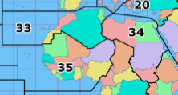**Zone 33. Northwestern Zone of Africa:** CN – 391 (Morocco), CT3 (Madeira Is), EA8 (Canary Is.), EA9 (Ceuta and/or Melilla), IG9 (Pelagic Is.), IH9 IG9 (Pantelleria Is. or Pelagic Islands), S0 (Western Sahara), 3V (Tunisia), and 7X (Algeria).

**Zone 34. Northeastern Zone of Africa:** ST (Sudan), SU (Egypt), Z8 (South Sudan) and 5A (Libya).

**Zone 35. Central Zone of Africa:** C5 (The Gambia), D4 (Cape Verde Is.), EL (Liberia), J5 (Guinea Bissau), TU - 500 (Cote d'Ivoire), TY (Benin), TZ (Mali), XT (Burkina Faso), 3X (Guinea), 5N - 158 (Nigeria), 5T (Mauritania), 5U (Niger), 5V (Togo), 6W (Senegal), 9G (Ghana) and 9L (Sierra Leone).

Zone 33 might also be called the destination zone! I have worked many hams who are on vacation or working a contest from many of the entities that make up Zone 33. One hint about zone 33, if you are using your logging software to notify you about needed entities being on the air, make sure that it is configured for IG9 and IH9. These are CQ entities but NOT ARRL DXCC entities. Something to look out for.

Zone 34 is a tough zone for the simple reason that many of these entities have had internal strife and may not be on the air for long periods of time. Another great group of entities to work during contests.

The “Terrible T’s” are in Africa and many of them are in Zone 35. These include TT – Chad, TZ – Mali, TU – Ivory Coast, TY – Benin, TJ – Cameroon, TR – Gabon, TN – Congo, TL – Central African Republic, and T5 – Somalia. Over the years there have been DXPeditions to these countries that have moved them slowly down the Most Wanted lists.

Good Luck with this group!

***DAH DIT DIT DIT DAH DAH DIT DIT DIT DAH***

**Top Band Soap Box -** As I previously mentioned, I will include news and notes about activity on 160M. The two guys that will be providing me with the scoop will be Dave, K8DV, and Chuck, K8CR. Both have achieved DXCC on 160 and both are active on 160M.

I told Dave and Chuck that I was not having much luck with my inverted L so far. Here are their sage responses…

TOP ^

What directions is your L? Mine is North West by Southeast, but it seems to have some omni properties. I was amazed at what I have worked to get to DXCC 160. How much power on 160?? 100watts for me was just too little.... When I got an amp for 160, I typically ran approximately 800 watts.

Have a good match?  Where on 160 band is it best? Remember, your trying to work basically at an AM low power broadcast station. Tune down to 1600-1700khz. There's some broadcast that can act like a beacon. I use that trick. Listen around there too for a reference. It’s hard to say do one thing, as 160 is quirky band....

* K8CR - Chuck

Patience is needed as topband DXCC does not come over night.  If possible, you could move the L but most liking will not make much difference.  As Chuck said the band is quirky and one-night Europe is pounding in and the next several weeks you will not hear them at all.

Keep putting yourself there and at some point, they will be there and work as many of them as you can as there is no promise as stated above will occur.

If possible, listen at gray line time.

Most of this past week has been mostly state side east coast to the Great Plains with only a few in the USA northwest and far west.   No Europe was heard on CW or copied on FT8.  Few stations in the Caribbean PJ4, 8P, CO and few Central America TI and HK.  Over the next few weeks if topband hold true to form starting around the second week of December or so you should start hearing Japan just before sunrise.

* K8DV - Dave

***DAH DIT DIT DIT DAH DAH DIT DIT DIT DAH***

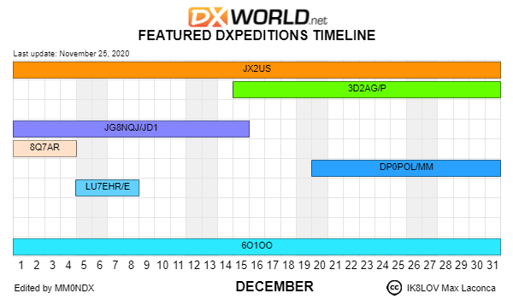

DX Calendar of announced DXPeditions from [www.dx-world.net](http://www.dx-world.net). Hopefully this will fill up as travel restrictions are relaxed.

***CQDX CQDX CQDX CQDX CQDX CQDX CQDX CQDX CQDX***

TOP ^

Here is an update from Bernie, W3UR, of the DailyDX and the WeeklyDX, the best source for DX information. <http://www>.dailydx.com/. Bernie has this to report:

**CE9 - Antarctica -** RY6A, Konstantin, says RX6A, Alexey Romov, ex-4K1B, 4K1C, 4K1K and 4K1L, has a work assignment at the “Progress Base” and the “Vostok Base” in Antarctica, callsign RI01ANT. First will be RX6A/MM aboard ship on the way, December 7-25. Then Romov will be at the base December 25 to May 30. He is expected to prefer CW and FT8, mostly on 40 meters. QSL via RX6A after he gets back home.

**YI – Iraq -** YI9/IU5HWS, Giorgio, has been on the air. He has finally gotten his official license and a new callsign, YI9WS. He plans to send out QSLs and is setting up a Logbook of the World account, dating to November 25. He is on assignment there so can only operate in his spare time. He occasionally asks for “outside EU only.” Skeds from outside of Europe may be sent by email to IK5SRF, using his email given on his QRZ.com page. Giorgio has a dipole and mostly is on 80, 40, 20, 17 and 15, with no CW activity at present. He has been on 80, 40, 17 and 15M SSB, 0815-0930Z on 17, 11-12Z on 15, 1805-1840 on 80 and 2040-2125 on 40.

**YOTA (Youth on the Air) month -** This activity will be all the month of December, with the goal of demonstrating ham radio to youth and encouraging them to get into ham radio and get on the air. Some of the stations planning to be on are: 7X2YOTA, 7X3YOTA, 9A0YOTA, 9A20YOTA, AP20YOTA, CN8YOTA, DB0YOTA, E71YOTA, EI0YOTA, ES9YOTA, GB20YOTA, HA6YOTA, HG0YOTA, HL0YOTA, II1YOTA, II9YOTA, K8A, K8O, K8T, K8Y, LY5YOTA, LZ0YOTA, OD5YOT, OH2YOTA, OL20YOTA, OM20YOTA, ON4YOTA, PA6YOTA, PB6YOTA, SH9YOTA, TC20YOTA, TF3YOTA, TM20YOTA, YL20YOTA, YT20YOTA, Z30YOTA and Z39YOTA. QSL them using LoTW. Paper QSLs can be gotten direct through Club Log OQRS or direct only via M0SDV. For more info and awards. mostly on 40 meters.

***DAH DIT DIT DIT DAH DAH DIT DIT DIT DAH***



Below is a list of upcoming contests in the “Contest Corner”. I think this is important for someone who is trying to move up the DXCC ladder since entities that are on the rarer side and easiest to work in contests. Some of my best “catches” have been on the Sunday afternoon of a contest when the rarer entities are begging for QSOs. Of course, the gamble is that if you wait until Sunday, conditions may change, or they simply won’t be workable. However, it is not a bad gamble. Of course, why not work the contest and have some fun!  
Check out the WA7BNM Contest Calendar page (<https://www.contestcalendar.com/>) for more contests or more details.

The contests in red are those that I plan to spend some significant participation time on. PLEASE let me know if you are working contests and how you fared.

Thanks!

TOP ^

|  |  |  |
| --- | --- | --- |
| Dec. 13 | QRP ARCI Holiday Spirits Homebrew Sprint | [www.qrparci.org/contests](http://www.qrparci.org/contests) |
| Dec. 12-13 | ARRL 10M Contest | [www.arrl.org/10-meter](http://www.arrl.org/10-meter) |
| Dec. 14 | K1USN Slow Speed Test | [www.k1usn.com/sst.html](http://www.k1usn.com/sst.html) |
| Dec. 18 | AGB Party Contest | www.[ev5agb.com/contest/contests_e.htm](http://ev5agb.com/contest/contests_e.htm) |
| Dec. 18 | Russian 160-Meter Contest | [www.qrz.ru/contest/detail/90.html](http://www.qrz.ru/contest/detail/90.html) |
| Dec. 19 | RAC Winter Contest | [www.rac.ca/rac-canada-winter-contest-rules-2019](http://www.rac.ca/rac-canada-winter-contest-rules-2019) |
| Dec. 19-20 | Croatian CW Contest | [www.9acw.org/index.php/rules/english](http://www.9acw.org/index.php/rules/english) |
| Dec. 19-20 | Croatian CW Contest | [www.crk.cz/ENG/DXCONTE](http://www.crk.cz/ENG/DXCONTE) |
| Dec. 20 | ARRL Rookie Roundup, CW | [www.arrl.org/rookie-roundup](http://www.arrl.org/rookie-roundup) |
| Dec. 21 | K1USN Slow Speed Test | [www.k1usn.com/sst.html](http://www.k1usn.com/sst.html) |
| Dec. 26 | DARC Xmas Contest | [www.darc.de/?id=820](http://www.darc.de/?id=820) |
| Dec. 26-27 | Stew Perry Topband Challenge | [www.kkn.net/stew](http://www.kkn.net/stew) |
| Dec. 27 | RAEM Contest | <http://raem.srr.ru/en/main> |
| Jan 29 – 31 | CQWW 160M | <https://cq160.com/> |
| Mar. 27 – 28 | CQWW WPX SSB | <https://www.cqwpx.com/> |
| May 21 | SWODXA DXDinner | [www.swodxaevents.org](http://www.swodxaevents.org) |
| May 29 – 30 | CQWW WPX CW | <https://www.cqwpx.com/> |
| August 28 | Ohio QSO Party | <https://www.ohqp.org/> |
| August 28 | W8DXCC Convention | [www.w8dxcc.com](http://www.w8dxcc.com) |

**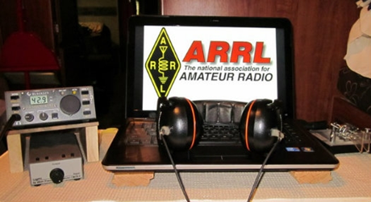*ARRL Contest Corner***

An expanded, downloadable version of *QST'*s’[**Contest Corral**](http://www.arrl.org/contest-calendar) is available as a PDF. Check the sponsor's’Web site for information on operating time restrictions and other instructions.

***Ohio ARES VHF Simplex Contest - 2021***

***January 9 – 10AM through 4PM EDT.***

**The purpose of our annual simplex activity is to improve our station and antenna capabilities, and to test our coverage areas on simplex frequencies.**  These may be very important in times of emergency, when repeaters have failed, and simplex is the only method of emergency communication. We are NOT giving any consideration for backup power- this exercise is aimed at testing antennas and determining coverage areas.

**Bands**

All bands from 50 MHz up

We recommend the following frequencies:

50 MHz – Standard simplex calling frequencies *Your QSO Points X 10 for six meters!!*

146.49 (alternate 146. 46) for VHF

UHF and above - Standard simplex calling frequencies

TOP ^

**Modes**

ALL MODES are acceptable- it’s your choice

Digital- using any mode generally accepted by NBEMS/ARES in fldigi. (Default = Mt63 2K)

For more details of this really fun event go to:

[Ohio Simplex Contest – A short VHF and up radio contest (ohsimplex.org)](https://ohsimplex.org/)

***DX News***

***ARLD049 DX news***

This week's bulletin was made possible with information provided by The Daily DX, the OPDX Bulletin, 425 DX News, DXNL, Contest Corral from QST and the ARRL Contest Calendar and WA7BNM web sites. Thanks to all.

**PORTUGAL, CT.** Valdemar, CT7AQD will be QRV as CQ750RSI throughout

2021 to commemorate the 750th anniversary of the birth of Elizabeth of Aragon, the queen consort of Portugal and patron saint of the city of Coimbra. QSL to home call.

**CUBA, CO.** Members of the Radio Club de Caibarien are QRV as T46W until December 29 to commemorate the first transmissions 100 years ago by the Cuban radio pioneer Manolin Alvarez. Activity is on 160 to 10 meters using CW, SSB and various digital modes. QSL via LoTW.

**SPAIN, EA.** Operators Pedro, EA5BJ, Gen, EA5EL, Antonio, EA5RM and Jose, EA5BCQ are QRV as EA5BJ/p, EA5EL/p, EA5RM/p and EA5BCQ/p, respectively, from Tabarca Island, IOTA EU-093, until December 6. Activity is on 80 to 10 meters using CW and SSB with two stations active. QSL to home calls.

**FRANCE, F.** Members of the Radio Club du Val d'Issole are QRV as TM20XMAS and TM21HNY. QSL both calls via F4GPB.

**JAN MAYEN, JX.** Erik, LA2US is QRV as JX2US until the end of March, 2021. Activity is on 160 to 12 meters using CW and FT8 in DXpedition mode. QSL to home call.

**HAWAII, KH6.** Alex, KU1CW is QRV as KH6/KU1CW from Oahu Island, IOTA OC-019. His length of stay is unknown. Activity is on various HF bands using mostly FT8 with some CW. QSL via LoTW.

**ARGENTINA, LU.**  Hernan, LU7EHR plans to be QRV as LU7EHR/E from La Isla Martin Garcia, IOTA SA-055, from December 5 to 8. Activity will be on the HF bands using SSB and FT8. QSL to home call.

**BULGARIA, LZ.** Special event station LZ2020XMAS is QRV from Sliven until January 1, 2021. QSL via LZ1VKI.

**NETHERLANDS, PA.** Special event stations PA20XMAS, PB20CLAUS and PD20SANTA are QRV during December. QSL via LoTW.

TOP ^

**SLOVENIA, S5.** Special event station S521PMC is QRV until January 3, 2021 to promote the PMC Contest. QSL via bureau.

**EUROPEAN RUSSIA, UA.** Saratow, R30MCHS and Kurgan, R30EMER are QRV until December 27 to mark the 30th anniversary of the Russian Ministry of Emergency Situations. QSL R30EMER via RW9QA and R30MCHS via R4CR.

**INDONESIA, YB.** A group of operators are QRV as 7C9B from Sumbawa Island, IOTA OC-150, until December 10. Activity is on 160 to 10 meters using SSB and FT8. QSL via DL3KZA.

**IRAQ, YI.** Giorgio, IU5HWS is QRV as YI9WS and remains active until January 20, 2021 in his spare time. QLS direct to home call.

THIS WEEKEND ON THE RADIO. The ARRL 160-Meter Contest, NCCC RTTY Sprint, QRP 80-Meter CW Fox Hunt, NCCC CW Sprint, UFT Meeting, Wake-Up. QRP CW Sprint, PRO CW Contest, RTTYOPS Weekend Sprint and FT Roundup are all on tap for this upcoming weekend.

The K1USN Slow Speed CW Test and OK1WC CW Memorial are scheduled for December 7.

The RTTYOPS Weeksprint, Worldwide Sideband Activity Contest and ARS Spartan Sprint are scheduled for December 8.

The VHF-UHF FT8 Activity Contest, CWops Mini-CWT Test, Phone Fray, NAQCC CW Sprint and QRP 40-Meter CW Fox Hunt are scheduled for December 9.

Please see December QST, page 63, and the ARRL and WA7BNM contest web sites for details.

***Special Events***

***Vienna Wireless Club Hosting a Very Special Event***

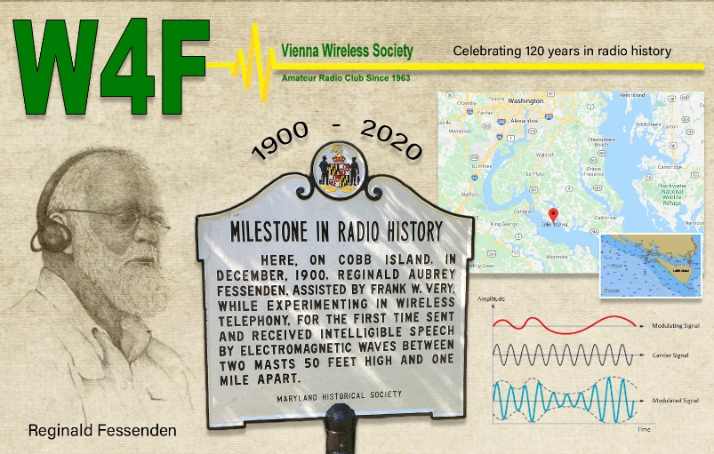

We at Vienna Wireless are hosting a special event, **W4F**, from **18-24 December**.  We are celebrating the 120th anniversary of the first voice transmission by wireless.  It was done by Reginald Fessenden on Cobb Island, which is just south of us here on the Potomac River, on 23 December 1900.

TOP ^

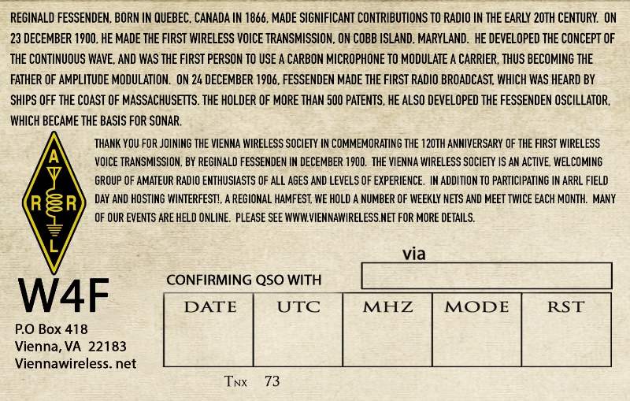

He was quite an inventor and electronics expert.  He made the first radio broadcast on Christmas Eve 1904, and was the inventor of the precursor to SONAR, as well as the first to use a carbon mike to transmit AM.

We plan to have club members operate from their home stations on all bands, and all modes throughout the week.

* **12/07/2020 | Pearl Harbor Remembrance Day**

**Dec 7, 1600Z-2130Z, W5KID**, Baton Rouge, LA. Baton Rouge Amateur Radio Club. 14.250 14.035 7.225 7.035. QSL. USS KIDD Amateur Radio Club, 305 S. River Road, Baton Rouge, LA 70802. Operation aboard the USS KIDD (DD-661). WW II Fletcher class destroyer. [qrz.com/db/w5kid](http://qrz.com/db/w5kid)

* **12/10/2020 | Commemoration of the Birth of PSK31**

**Dec 10-Dec 20, 1700Z-1700Z, K9Z**, Rochester, IL. Sangamon Valley Radio Club. 14.070 7.070; all bands, all modes. QSL. J. Mitch Hopper, K9ZXO, 536 E. Mill St., Rochester, IL 62563. All conversational modes will be used - all bands. [www.qrz.com/db/k9z](http://www.qrz.com/db/k9z)

* **12/12/2020 | USS Midway Museum Ship Special Event: Commemorating Pearl Harbor Remembrance Day**

**Dec 12, 1700Z-2359Z, NI6IW**, San Diego, CA. USS Midway (CV-41) Museum Ship. 14.320 7.250 14.070 (PSK31) D-STAR on various reflectors. QSL. USS Midway Museum Ship (COMEDTRA), 910 N Harbor Drive, San Diego, CA 92101.

* **12/17/2020 | Bethlehem on the Air**

**Dec 17-Dec 24, 1400Z-2300Z, KC5OUR**, Belen, NM. Valencia County Amateur Radio Association. 21.283 14.283 7.183 3.883. QSL. VCARA, P.O. Box 268, Peralta, NM 87068. For QSL card, SASE to VCARA. kc5our@arrl.net or [www.kc5our.com](http://www.kc5our.com/)

* **12/17/2020 | WX3MAS Special Event**

**Dec 17-Dec 20, 1400Z-2200Z, WX3MAS**, Nazareth, PA. Christmas City Amateur Radio Club. 14.265 7.270 3.850; CW and PSK31 on 20 and 40 meters, and FT8. Certificate & QSL. WX3MAS, 14 Gracedale Ave., Greystone Building, Nazareth, PA 18064. For commemorative certificate: Send QSL and 9X12 SASE. [www.dlarc.org](http://www.dlarc.org/)

* **12/18/2020 | 120th Anniversary of the First Wireless Voice Transmission**

**Dec 18-Dec 24, 0001Z-2359Z, W4F**, Vienna, VA. Vienna Wireless Society. 14.250 7.185. QSL. Vienna Wireless Society, W4F, PO Box 418, Vienna, VA 22183. W4F will be operating on 80, 40, 20,15,10, 6, and 2 meter amateur bands on CW, and SSB, as well as FT-8 using fox/hound mode. For QSL card, Please send SASE with your QSO information to : Vienna Wireless Society W4F PO Box 418 Vienna, VA 22183 [https://viennawireless.net](https://viennawireless.net/)

TOP ^

* **12/18/2020 | Major Edwin Howard Armstrong Memorial special event operation**

**Dec 18-Dec 20, 0000Z-2359Z, W4A**, Bluff City, TN. N9EN. 14.040 7.020 3.530. QSL. via the bureau or direct to Brad Anbro, N9EN, 1118 Walnut Grove Road, Bluff City, TN 37618.

* **12/19/2020 | 130th birthday of Major Edwin H. Armstrong**

**Dec 19-Dec 20, 1400Z-2200Z, W2XMN & W2XEA**, Loxahatchee, FL. Major Edwin H. Armstrong Memorial Radio Club. 28.400 18.150 14.265 7.195. QSL. Major Edwin H. Armstrong Memorial Radio Club, PO Box 1584, Loxahatchee, FL 33470. [www.qrz.com/db/w2xmn](http://www.qrz.com/db/w2xmn)

* **12/26/2020 | Battle of Trenton**

**Dec 26-Dec 31, 0000Z-2359Z, W2T**, Trenton, NJ. Delaware Valley Radio Association. 14.250. Certificate & QSL. DVRA, PO Box 7024, Trenton, NJ 08628. Info at w2q.com or on qrz.com QSL with SASE. Certificate of Commission in the Continental Army Signal Corps for address label and $5 payable to DVRA mailed to DVRA, PO Box 7024, West Trenton NJ 08628 [https://www.w2zq.com](https://www.w2zq.com/)

***Tuesday night ARES HF Net Update…***

(from Stan, N8BHL)

Hi all!  Well, the winter / gray line activity has clobbered 75 meters for local communications. Our last nets have been extremely difficult for all, and it looks to be getting worse.  So, as we have in the past, we will suspend the state ARES HF net on Tuesday evenings until probably the end of March (or whenever the band comes back.)   I want to thank you all for your dedication to our nets- check-ins have been impressive all year!

Even though the net is suspended, I will tell you that we’re scheduled to work December 12th to complete the installation of a 160-meter antenna. The outside work is complete, and we’re planning on the fairly complex run inside the building to get to the Sarge.  Assuming that can be completed, and assuming the antenna actually works (measure twice, cut once!) we may be trying our net on 160….so stay tuned!

In the meantime, thank you all so very much for your activity this crazy year! And on behalf of ARES leadership, we wish you the very best for the holiday season!

***“ARES Connect”***

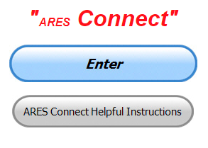

***Connecting Amateur Radio Volunteers with a Purpose***

Hey everyone… please make sure to go in and register your time to all of the events that you have signed up for. Be honest about the time spent. Don’t forget to get this done no later than **5 days** after the event has ended. I’m asking you to do this for our ability to run reports accurately.

**I want to remind all of you that you do not have to be an ARES or ARRL member to use this system. All licensed amateur radio operators throughout the country are welcome and strongly encouraged to use it.**

TOP ^

**Don’t forget to check out the “Frequently Asked Questions” area that has been added to the Ohio Section website.** It’s there to help you through any difficulties that you may have with ARES Connect. Now, if you don’t any posts that relate to what you are having difficulties with, we now also have an on-line “Guru” area as well. This will allow you to ask any questions that you may have about ARES Connect.

**Let’s get everyone on “ARES Connect!!!”**

***Matt’s Corner***

*(C. Matthew Curtin* [*KD8TTE@arrl.net*](mailto:KD8TTE@arrl.net)*)*

***Building Capability With the VHF+ Contest***

After completing the SET, we considered how to improve our capability by using scheduled events for training. (C. M. Curtin. “Emergency Communications Training 2020-21.” *Ohio Section Journal*, October 2020, pp. 46-48. <http://www.arrl-ohio.org/news/2020/OSJ-Oct-20.pdf>) Here we’ll consider how to use the VHF+ Contest in January as part of our Improvement Plans. This is for Emergency Coordinators to provide structure and support for the operators.

Hopefully your ARES group or AUXCOMM team has already completed your After Action Report / Improvement Plan (AAR/IP). If you haven’t, you might want to refer to the Ohio Section AAR/IP for BLACK SWAN 20. (<https://www.blackswancomex.org/2020/arrl-ohio-aarip>) That document walks through the objectives of the exercise one by one, discussing strengths and areas for improvement.

Appendix A provides some commentary that your team should be able to define for your own use based on your own performance. Planning operations based on objective observations of performance is critical for improvement.

To start planning VHF+ Contest operation, we begin with a review of the contest. (<https://ohsimplex.org/>) The idea is to score as many points as possible during the hours of operation. Let’s extract a synopsis:

1. Date: January 9, 2021
2. Hours: 10:00 a.m. until 4:00 p.m.
3. Bands: 50+ MHz
4. Operating Modes: any
5. Scoring: points awarded for each contact, contacts with certain Ohio Section officials, and contacts with EOC stations. Contacts must include a specified exchange of information, namely the station, county, and information needed for multipliers.
6. Scoring multipliers: scores are increased by multipliers for making contacts in more counties, operating a rover/mobile station, operating an EOC station, and operating a portable station.

Now let’s have a look at our Improvement Plan (IP). For the purpose of this article, we’ll assume that we’re working with an IP that has been locally adapted from the Section AAR/IP Appendix A. Going through the list of areas of improvement, and throwing out things that are not relevant to simplex operation at 50 MHz and above for a period limited to six hours, we’re left with this summary:

TOP ^

1. Activation Notice
2. Staffing Strike Teams
3. Organization to Mission Profile
4. Preparing to Operate at Start of Play
5. Engagement with Role
6. Network Configuration
7. Establish and Maintain Roles

With this high-level view of our goals and recent performance in mind, we can start to build up our local plan of operation. Being an exercise, the greatest benefit for improvement will come from using a framework like the Homeland Security Exercise Evaluation Program (HSEEP). DHS released new templates for this program this year, greatly simplifying them from earlier versions. (<https://preptoolkit.fema.gov/web/hseep-resources>)

Templates are broken down by part of the exercise cycle. As we’re talking about writing a plan for an exercise in the works, go to the Design and Development folder and see DD EEG Instructions, Developing EEG's Template 2017 508. The document gives brief instructions for development of a good Exercise Evaluation Guide (EEG). The template that you’ll want to use to start building your exercise plan (ExPlan) is DD Exercise Plan Template 2017 508. Don’t worry about the page count; a lot of the document is common for every exercise and won’t require your attention.

Focus on the articulation of your objectives. Remember, Objectives should be SMART: Specific, Measurable, Achievable, Relevant, and Time-Bounded. Let’s have a look at developing objectives for your exercise. They should be simple and straightforward but they should not be haphazard. ECs need to think things through if they’re to organize resources most effectively. Let’s look at the rules to see where the greatest bang for the buck can be found. (<https://ohsimplex.org/rules/>)

Let’s start with the bottom: spotting assistance. How can you provide spotting assistance? Will you operate a net to provide spotting information? What’s your schedule for net control operators? Will you run the net simplex, or will you run it on a repeater? Will you take reports that you compile and then issue as a bulletin? How often will you issue the bulletin? Who will get the reports and draft the bulletin? Who will transmit it? How and where will it be transmitted? Will you use a net? Will you just have stations listening and transmitting on specified frequencies? Will they be simplex or on a repeater? Will they be on HF? Will they come in and be issued by BBS, Winlink, or some other service? Contact points are good only on simplex at 50 MHz and up, but that doesn’t mean support can’t come on other bands, through repeaters, and so on. An EC that organizes spotting assistance will ensure that more stations are able to find the other stations out there operating, giving everyone more opportunity to score points.

Next let’s move up a section to the multipliers. We care about this first because this is going to tell us how we can make the most of the contact points that we’ve achieved. Total number of counties reached matters. Do your operators have good antenna systems? Should they erect field-expedient antennas for the day? Do they need help building or getting directional systems working? This is a good topic for your discussions in December and the first week of January. Maybe you should organize a little local pre-contest activity to give everyone a chance to help one another improve their VHF+ antenna systems.

TOP ^

Big multipliers exist for operation of an EOC station. Will your team be able to make the most of it? Maybe if you’re not able to get physical access to the facility right now you can come up with an alternative to operate the “EOC station.” Other operations that greatly improve scores are rover/mobile (e.g., car) and portable (e.g., setup in a park). Do you know who intends to operate rover and portable stations? Where will they be during the contest? Can they be coordinated so they are strategically located?

Finally, we get to the fundamentals of the contact. Each contact on 6 meters is worth 10 points, where all others are worth one. With such a bonus for 6m operation, do you have stations that will be taking advantage? If you’ve got only one station in the county that can work 6m, that station won’t do as well as if there are a bunch of others also operating on 6m that day. Again, talking about it and working on the plans during December and the first week of January can go a long way toward getting 6m operation squared away. And here’s where we see the incentive to get those EOC stations operating: your operators will get a five point bonus for working the EOC station. The last way we observe to get high-scoring contact points is with ARES officials at the level of Assistant Emergency Coordinator (AEC) and higher. Do you have your AECs operating? Are you? If the DEC is in your county, is that station operation? When and where? Is there a schedule? It’s not just about getting points for those ARES officials: they are operating to give everyone else a bonus for points. Get on the air and support your people!

Looking back over what needs to happen, we can start seeing that maybe you don’t want the EC to be running spotter nets or working on bulletins. Have someone else from the team perform those functions so the EC can make those exchanges and give other stations the points.

Having thought through the operation, we can now get to the business of articulating our objectives. Maybe they’ll look something like this.

1. Maintain county net according to SOP from 10:00 a.m. through 3:59 p.m.
2. Collect activity spotting reports for redistribution.
3. Distribute activity spotting reports via the county net “on the tens,” at minute “00,” “10,” “20,” “30,” “40,” and “50” of each hour.

Now let’s have a look back at that IP.

1. Activation Notice: how can we practice activation? Will the EC give details to everyone in the week or days leading up to the event? Will it come by way of a regular net? Will it be via BBS or Winlink? Will it include transmission of the Exercise Plan document? Will players instead get an Incident Action Plan (IAP) with Forms 201, 202, and 205 completed? Who will advise the DEC and the SEC that the operation is underway?
2. Staffing Strike Teams: Will there be any this year? Maybe a multi-operator portable station or EOC station will be organized as a Strike Team. Even if you can’t have people spending a lot of time together at the same place, do you have them organized as a Strike Team such that the station maintains ongoing operation, where one takes over for another at a specified moment, without interruption in operation?
3. Organization to Mission Profile: If you’re going to provide spotting support for your county, are you configured effectively? Do you have a defined net control station? How will the net control operator be relieved so as to avoid being “stuck” in that duty for the duration? Will you rotate shifts hourly? Do you have a station designated to receive spotting reports and to prepare the bulletins, ready to transmit according to the schedule?

TOP ^

1. Preparing to Operate at Start of Play: 10:00 a.m. the day of the exercise isn’t the time to start looking at how to get the job done. If you want to have your stations up and running as soon as their contacts are eligible for points, you’re going to need to be sure that people have the plan ahead of time. You should have your spotting net open already. Maybe you’ll want to have a briefing to ensure that everyone understands what’s happening and how they can participate.
2. Engagement With Role: This one is for the operators. Do they understand what their role in the overall picture is? Are they prepared to play the role, and to perform the duties of the role? Maybe some practice of some of those duties (like running a net, receiving a spotting report, or transmitting a compilation of spotting report) are things that should be practiced in the weeks leading up to the event.
3. Network Configuration: Now that we know what the “mission” is going to look like, let’s make sure that the net is properly configured. Will your net be configured to support all of the operators you need to cover? Will your activation notice get to the right people? How can you let the DEC and SEC know of your operation? Do you need to have liaison to another net? To a BBS or Winlink RMS?
4. Establish and Maintain Roles: Make that schedule, showing the roles and the hours so you can see who is playing which role at any point in the operation. Make sure that they understand their role, the duties, and the time that they’re expected to perform them. Make sure they stay in that role and don’t drift off to something else.

Addressing the concerns that arise in the IP while organizing resources to achieve the objectives spelled out for the contest will ensure that not only do people have a chance to turn on the radio and make a few contacts, but that they can support one another and make the most of their time on the air. The effort should yield results in higher scores, greater enjoyment, and improved performance.

Use that ExPlan template! Maybe start with the appendices. Maybe in Appendix D, the “site map” you’ll have a map of your county or district and show locations where there will be operations. Appendix C is the communications plan, which would be an excellent place to list your spotting net operation, information on where and how to send spotting reports, and how to pick them up. Don’t forget to include the recommended frequencies for operation!

If you’re operating as an ARES group without other players, you might drop Appendix B, or maybe enumerate the operators that you’re expecting to see. Appendix A is going to be your schedule, showing when your net opens, when transmissions are made, shift changes, and so on.

Including this kind of local information helps everyone to understand what they need to do to support one another, and to see where holes might exist, e.g., no net control operator from 1:00-2:00 p.m. It’s easier to plug holes when you see them before they’re upon you.

Now go to the General Information in the main part of the document. Right there you’ll spell out your objectives and associate them with the core capabilities that your group means to maintain. Finally, go to the Exercise Overview and since you’ve built out the rest of the document, you can now effectively summarize what information you need in that opening.

Once you’re finished there, make a pass to edit the document, complete the names, get rid of sections that don’t make sense, and you’re ready to share that with your team. The ExPlan is a document that all players, evaluators, and observers can see.

TOP ^

Make sure that everyone knows to keep good notes, to conduct a hot wash soon afterward, and document your performance. Perhaps the Exercise Evaluation Guides/Response/Response Operational Communications EEG Template 2017 508 would be a good basis for organizing your self-evaluation. In any case, be sure to complete the process by finishing that AAR/IP to you can see how your performance compared, and don’t forget to send in your station scores.

***NIMS 300 & 400 Being Offered Virtually***

**TRAINING LINKS:**

• Ohio EMA Training Calendar

• Login to the DPS Training Campus

• Create a new account on the DPS Training Campus

**NOTE:**

• Seats available listed are as of the release of this update and will change quickly.

• All classes will be posted on the DPS training campus at least 60 days prior to the start of the course.

• Please read the Training Policy & Catalogue for more information on Ohio EMA trainings.

|  |  |  |  |  |
| --- | --- | --- | --- | --- |
| **COURSE** | | **DATE(S)** | **HOST COUNTY OR VIRTUAL** | **# SEATS AVAILABLE** |
| **1** | **G-557 Rapid Needs Assessment** | **December 8, 2020** | **Virtual** | **0** |
| **2** | **ICS-300 Intermediate ICS** | **December 8-11, 2020** | **Virtual** | **0** |
| **3** | **G-289 Public Information Officer Awareness** | **December 14-15, 2020** | **Virtual** | **0** |
| **4** | **G-191 ICS / EOC Interface** | **December 16-17, 2020** | **Virtual** | **0** |
| **5** | **G-367 Emergency Planning for Campus Executives** | **December 18, 2020** | **Virtual** | **13** |
| **6** | **ICS-400 Advanced ICS** | **January 6-8, 2021** | **Virtual** | **0** |
| **7** | **G-386 Mass Fatalities Incident** | **January 12-13, 2021** | **Virtual** | **3** |
| **8** | **G290/291 Basic PIO Series** | **January 12-14, 2021** | **Virtual** | **0** |
| **9** | **ICS-400 Advanced ICS** | **January 20-22, 2021** | **Virtual** | **0** |
| **10** | **K-146 HSEEP** | **January 27-29, 2021** | **Virtual** | **0** |
| **11** | **OH-197 Planning for Access and Functional Needs in Emergencies** | **January 27-28, 2021** | **Virtual** | **12** |
| **12** | **ICS-300 Intermediate ICS** | **February 23-26, 2021** | **Virtual** | **0** |
| **13** | **OH-605 IA Damage Assessment** | **February 25, 2021** | **Virtual** | **17** |
| **14** | **OH-607 PA Cost Documentation / Damage Assessment** | **February 25, 2021** | **Virtual** | **18** |
| **15** | **G-386 Mass Fatalities Incident** | **March 10-11, 2021** | **Virtual** | **5** |
| **16** | **MGT-315 Critical Asset Risk Management** | **March 16-17, 2021** | **Virtual** | **5** |
| **17** | **MGT-414 Advanced Critical Infrastructure Protection** | **March 18, 2021** | **Virtual** | **5** |

TOP ^

|  |  |  |  |  |
| --- | --- | --- | --- | --- |
| **18** | **L-451 Academy I–Application of Advanced Individual Concepts in EM** | **March 1-5, 2021** | **Virtual** | **5** |
| **19** | **ICS-300 Intermediate ICS** | **March 23 -26, 2021** | **Virtual** | **0** |
| **20** | **G-108 Community Mass Care and Emergency Assistance** | **March 23-24, 2021** | **Lake** | **23** |
| **21** | **ICS-400 Advanced ICS** | **March 30-April 1, 2021** | **Virtual** | **0** |
| **22** | **ICS-300 Intermediate ICS** | **March 30-April 2, 2021** | **Virtual** | **24** |
| **23** | **ICS-400 Advanced ICS** | **April 7-9, 2021** | **Virtual** | **24** |
| **24** | **G-288 Local Volunteer and Donations Management** | **April 13-14, 2021** | **Lake** | **25** |
| **25** | **ICS-300 Intermediate ICS** | **April 13 – 16, 2021** | **Virtual** | **17** |
| **26** | **ICS-300 Intermediate ICS** | **April 27 – 30, 2021** | **Virtual** | **0** |
| **27** | **L-452 Academy II–Assessment of Teams in Professional EM** | **May 3-7, 2021** | **Virtual** | **5** |
| **28** | **G-288 Local Volunteer and Donations Management** | **May 12-13, 2021** | **Union** | **29** |
| **29** | **G-191 ICS / EOC Interface** | **May 14, 2021** | **Virtual** | **23** |
| **30** | **ICS-300 Intermediate ICS** | **May 18-20, 2021** | **Virtual** | **0** |
| **31** | **ICS-400 Advanced ICS** | **June 1-4, 2021** | **Virtual** | **19** |
| **32** | **ICS-400 Advanced ICS** | **June 16-18, 2021** | **Virtual** | **0** |
| **33** | **L-453 Academy III–Contemporary Issues in the EM Organization** | **July 12-16, 2021** | **Virtual** | **5** |
| **34** | **ICS-400 Advanced ICS** | **August 11 – 13, 2021** | **Virtual** | **0** |
| **35** | **L-454 Academy IV–Advanced Concepts and Policy in the EM Profession** | **September 13-17, 2021** | **Virtual** | **5** |

***From The South 40***

*(from John Levo,* [*W8KIW@arrl.net*](mailto:W8KIW@arrl.net)*)*

By now the Thanksgiving leftovers should be pretty much history and perhaps you’re just down to some turkey pot pie or hot shots. With the virus keeping a lot of people home, I am surprised there doesn’t seem to be that much activity on the airwaves though.

December historically is a month when most clubs have held their annual Christmas or annual meetings and elections. To the moment I know of only two that still have a form of dinner event still on the calendar. The **Tri-State ARA** is having a reservation only home cooked meal served at the radio museum on December 15. On the same evening the **Athens County ARA** is having a virtual Christmas dinner via Zoom. It will be interesting to see how they pass the green beans electronically.

TOP ^

The **Greater Mason County ARA** has decided not to have their traditional Christmas dinner meeting this year but will have a meeting in order to elect officers for 2021. The meeting will be this Tuesday.

**Grant ARC** President Ken Klosterman, KD8FKU, says the ballots are in the mail for their club’s election. The results will be announced on the Club’s December 17 7 pm net. The **Highland ARA** Nomination Committee Chairman Patrick Gilifillen, N8EWH, says HARA’s ballots were mailed this past Monday along with a membership renewal form.

Another tradition the virus has made a ‘no-go’ this year is the annual Santa On The Air Night conducted by the Tri-State ARA. A lot of children in the region will miss the opportunity to let Santa know what they really want to see under the tree on Christmas morning. However, children can still talk to Santa on the 3.916 Santa Net each evening until Christmas. The Net starts daily at 7:15 pm Central Time. More information can be found on their website: www.cqsanta.com

Although some communities throughout the Southern Ohio region decided to cancel their holiday parades this year, **Highland ARA** President Jeff Collins, KD8VUY, says the Hillsboro Uptown Business Association’s lighted parade will still take to the streets at 6 pm the evening of Saturday, December 12. Approximate a dozen hams are needed to assist with the line-up and coordination. Those who can assist are asked to be at the Highland County Fairgrounds between 3 and 4 to receive their assignments.

December 1 marked the start of a weekly 10 net sponsored by the **Athens County ARA**. They meet at 5 pm each Tuesday evening on 28.350.

**Southern Ohio ARA** President Tim Nicely, AC8VQ, intends to keep members advised of the Club’s meeting status on a month-to-month basis as the pandemic continues. However, the December 21 meeting will be conducted over Zoom at 7 pm.

The **Scioto Valley ARC** President Jesse Stanley, WD8CHP, is putting together a ham radio website focused on Ohio. The new launch will be called www.cqohio.com. The [www.forums.cqohio.com](http://www.forums.cqohio.com) portion of the site is already live.

The **Scioto Valley ARC** will hold its annual Christmas dinner on December 12 at the Tumbleweed Restaurant in Chillicothe.  It will be at 1 PM.  Although it is open to everyone, President Jesse Stanley, KC8CHP, requests advance notice of your intent to attend.

During this past Wednesday’s Statewide Early Warning Siren Test the **West Chester ARA** dispatched club members to each siren site in Fairfield to observe the operation of each unit. They determined if the unit operated, the time it began and ended sounding, the number of rotations the made during the test, the pitch of the sound and noted anything out of the usual. Following the conclusion of the test, members gave their reports which will then be given to the appropriate city and county officials.

On Saturday morning, December 12, hams within the reaches of the Hillsboro 147.21 (100 tone) and the Greenfield 146.685 (118.8 tone) are invited to join in the **Highland ARA’s** monthly Brunch Bunch gathering. Starting at 10 am, why not grab a cup of Joe, something to eat and tune your radio to one of the repeaters and spend some enjoyable time as Net Control Ken Lightner, KE8JEL, tries to keep control on the normally lively crowd. It’s a great way to start your weekend with usually around 20 new found friends. And who can imagine what the topic of discussion will be or the answer to the trivia question?

TOP ^

Christmas decorating time often offers opportunities to pick up items used in our hobby. For instance, there are a variety of tree holders that can be used to support antenna masts to at least eight feet and higher if properly guyed.

Most will hold lightweight six meter or UHF/VHF beams with no problem and are great for portable or emergency purposes. Another look for item is the wooden or metal poles used to put up holiday lights from the ground. These 10’ to 14’ poles can be used to lift antenna runs over tree branches or even used to support an antenna. Another neat item is the gizmo used to protect the junctions of light or extension cords.

I’ve found the ‘Mini Twist and Seal’ perfect for protecting PL259 coax connections on runs of mini 8x to RG213 cable. These items can usually be found at your wife’s favorite craft store or one of the big box home improvement ones.

“Lots of good memories.” “SIGH” was the comment from the **Clinton County ARA**’s Daun Yeagley, N8ASB when responding to the news of the collapse and destruction of the Arecibo Radio Telescope in Puerto Rico. As mentioned, a couple weeks back, Daun volunteered at the site and spent his time there calibrating instruments used to listen to the heavens. A video of the sudden collapse was posted on YouTube on Thursday.

Speaking of things falling, **Milford ARC** President Ron Brooks, AC8MA, sent a video of the implosion of the Club’s tower at their remote input site east of Milford in Miami Township. He reported the site had been declared unsafe. From the video it appeared everything went well with bringing the tower down. Its loss is not expected to impact the Club’s repeater coverage to a large degree.

Word comes via the **Southern Ohio ARA** of the change of telephone numbers for the Charleston, WV National Weather Service Office due to a conversion to a VoIP phone system. The unlisted number for Sky Warn Spotters to use is 1-800-401-9535. The old number will work temporarily.

The **Highland ARA**’s new Laurel VE team will hold their first 2021 test session on January 16 at the Highland County EMA Office in Hillsboro. The test will begin at 9 am. Seating is limited and advance reservations through signupgenius.com are necessary. There will be no walk-ins. Questions can be to Tom Mongold, KD8LDS, at 937-272-4207. Or you can email highlandara@gmail.com to receive the complete signupgenius address to get you to the correct reservation page.

The **Clinton County ARA** elected their 2021 officers on Thursday evening through a combination Zoom and in-person meeting. Dave Gordley (K8DEG) was re-elected President, Mark Atwell (KD8DGH)- Vice President, Sara Lamb (KS8P)–Secretary, Andrew Adrian (W9AMA)-Treasurer and Mike Boyle (WF8B) and David Chesney (KE8GII) will be Trustees.

Those passing their Technician Licenses at the recent **Greater Mason County ARA** test session now have their call signs. They are: Daniel Hughes, KO4JXW, Maysville, KY; Ryan Haynie, KE8QCN, Kenova, WV and Nathen Howard, KO4JXV, Morehead, KY. Congrats and welcome to each.

####

TOP ^

***One Question Questionnaire***

Hey Gang,

Survey Says”….. only about 33% of you gave on #GivingTuesday. Well, I do understand with COVID and all, it’s not easy to do. Let’s keep good thoughts on this for next year when things will be much better for sure!!

Ok, now on to the next question… Let’s just see how cozy we are in our ham shacks. Some of us have pretty luxurious creature features where we do our things, and some are pretty sparce for sure. So that’s the inspiration for this next question.…

***“Do you have a couch in your ham shack??”***

You’ll find the “One Question” questionnaire on the Ohio Section Website! <http://arrlohio.org> It’s all in fun and it’s not a scientific survey in any way, but we are learning some things that we didn’t know from these questions. I hope that you are enjoying answering these “One Question” questionnaires.

*****V.E. Test Sessions***

Many V.E.’s have decided to start testing once again, but with restrictions that need to be adhered to for sure. Here’s the link to find that V.E. Test session and what is expected of YOU before going. <http://www.arrl.org/find-an-amateur-radio-license-exam-session>

***Final.. Final..***

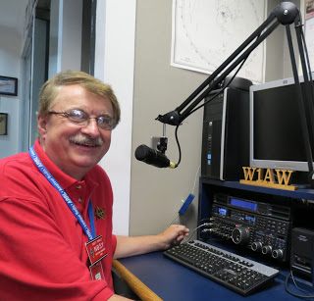

Hi Gang,

Wow… What a week we’ve had. Some of you got more than a foot of snow and others of us either got just a trace or so to nothing at all. For those of you who got nothing, your turn is coming soon!

This past week has been a very busy week for sure. Lots of Zoom meetings and lots of work getting the house all decked out for Christmas. Ok, I won’t kid you, I don’t do much of the decorating in the house. As I’m sure most of you guys will have to attest to. I’m sure your wives do most of the decorating. Oh sure, there’s exceptions, but for the most part, she is the one doing all the planning on just where those decorations will go on the tree and around the house.

TOP ^

We’ve been married for almost 50 years, so we have tons of “stuff” to spread around the house. Speaking of that, Janie gets out box after box of stuff right after Thanksgiving and it usually takes her right up to Christmas Eve to get it all displayed. Then comes New Years and she’s back at it packing it all away. Now, as she gets these boxes out of storage, I’m continually wondering just where in the world are we gonna’ put it all! If we really took inventory, I’d bet we could decorate 20 homes and still have plenty left over. Did you ever take inventory of all of your decorations? I’m sure we’re not the only ones with more decorations than places to put them.

Since it has been too cold to get the trikes out and ride, I’ve taken up walking on our treadmill. I will say that even with music videos and wireless headphones now available, I still get bored just walking in the same spot!!! I sure hope we get a few warm days soon so that I can go out on the trail and at least get to see some different sights. I love being out in the fresh air and seeing different things as you walk. You know, the turkey buzzards huddled up around a dead animal. Squirrels running around collecting anything that resembles nuts. Coyote on the prowl looking for their next meal. I’ve even come across snapping turtles sunbathing on the warm asphalt of the trail. These are common things to see around here, but it’s way better than a boring treadmill. I guess I’m gonna’ have to ask for a virtual headset for Christmas and take some videos to play back when I can’t get outside.

Whelp, that’s going to do it for this week my friends! I’m still looking forward to visiting with all of you live or via Zoom, WebEX or whatever.

I really can’t wait for that time when we can all get together in person once again. Those are the times I cherish the most!!! Stay safe! We will get through this and when we do, we’ll have so much to talk about. Most of all… have FUN and get on the airwaves!!

73,

[***Scott, N8SY***](mailto:n8sy@n8sy.com)

***Print an Official or Unofficial Copy of Your Amateur Radio License***

*(By Anthony Luscre, K8ZT)*

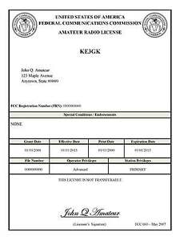As of February 17, 2015, the **FCC no longer routinely issues paper license documents** to Amateur Radio applicants and licensees. The Commission has maintained for some time now that the official Amateur Radio license authorization is the electronic record that exists in its Universal Licensing System (ULS). The FCC will continue to provide paper license documents to all licensees who notify the Commission that they prefer to receive one.

Licensees also will be able to print out an official authorization — as well as an unofficial “reference copy” — from the ULS License Manager. I’ve created a set of instructions on how you can request an **“official” printed copy of your license\*** [**Click here to download the instructions**](http://arrl-ohio.org/news/2020/print_your_license.pdf)

TOP ^

***A Hams “Night Before Christmas”***

(Submitted by Gregory Drezdzon, WD9FTZ)

Here’s a link to that wonderful old Christmas poem “A Night Before Christmas” amateur radio style..

<https://www.youtube.com/watch?v=xxJpunNf5WI&feature=youtu.be>

***National Pearl Harbor Remembrance Day***

Each year on Dec. 7, Pearl Harbor Survivors, veterans, and visitors from all over the world come together to honor and remember the 2,403 service members and civilians who were killed during the Japanese attack on Pearl Harbor on December 7, 1941. A further 1,178 people were injured in the attack, which permanently sank two U.S. Navy battleships (the USS Arizona and the USS Utah) and destroyed 188 aircraft.

This year’s event will be held on December 7th at the Pearl Harbor Visitor Center and will encompass the service and sacrifice traditionally commemorated in multiple ceremonies and sites the week of December 7th.

In order to protect our Pearl Harbor Survivors and World War II Veterans in attendance this year’s ceremony will be closed to the public. This event will be live streamed for public viewing via our Facebook page and [www.pearlharborevents.com](http://www.pearlharborevents.com)

The Pearl Harbor Visitor Center will reopen to the public for visitation on December 7th at 11:30 am, with USS Arizona Memorial Programs resuming and running every 30 minutes from 12 noon - 3 pm.

TOP ^



Hey Gang,

Have you taken a look at the **Swap & Shop** page on the Ohio Section webpage yet?? Here’s a link that will take you there…

<http://arrl-ohio.org/sm/s-s.html>

Do you have equipment that you just don’t need or want anymore? Here’s a great venue to advertise it, and it’s FREE!! Is your club doing a fund raiser to help raise money? After a lot of thought, it was decided that the Swap & Shop webpage could also contain these types of items as well. The same rules will apply as do for the For Sales and Give-A-Ways and will only be posted for a month at a time. Please see the Terms & Conditions on the webpage.

If your club is doing a fund raiser and wants more exposure, please forward the information to me and I’ll advertise it on the Swap & Shop webpage for you.

Now, I still want to remind you that it won’t be listed in this newsletter because it would take up way too much space, so your ad will only appear on the website. It is there for any individual to post equipment Wanted / For Sale or Give-Away as well as for Club Fund Raisers. No licensed vehicles/trailers or business advertising will be posted. Postings are text only (no pictures or graphics) will be posted for a maximum of 1 month from date posting and require a contact phone number or email within the posting. Send your Wanted / For Sale or Give-Away post to:  [swap@arrlohio.org](mailto:swap@arrlohio.org)

***Welcome New Subscriber(s)***

**Fred, KB8UUC**

Ohio Section Cabinet

|  |  |
| --- | --- |
| Section Manager – Scott Yonally, N8SY | Assistant Section Manager – John Perone, W8RXX |
| Section Emergency Coordinator – Stan Broadway, N8BHL | Section Traffic Manager – David Maynard, WA3EZN |
| Technical Coordinator – Jeff Kopcak, K8JTK | Affiliated Clubs Coordinator – Tom Sly, WB8LCD |
| State Government Liaison – Bob Winston, W2THU | Public Information Coordinator – John Ross, KD8IDJ |
| Section Youth Coordinator – Anthony Lascre, K8ZT | |

***Back Issues of the PostScript and Ohio Section Journal***

Hey, did you know that PostScript and Ohio Section Journal (OSJ) are archived on the website? You can go back and look at any edition simply by clicking:

<http://arrl-ohio.org/news/index.html>

TOP ^

***Want to Share your Club Newsletter With Others?***



We have a webpage where you can download and read all of the newsletters that I get from around the state and even other sections!

Here’s the link to the page…. <http://arrl-ohio.org/club_news/index.html>

Please, if you don’t see your club newsletter posted, it’s because I’m not receiving it. Just have your newsletter editor contact me and I’ll get your club’s newsletter listed on the site!!

We all learn and steal (I mean, share) from each other’s work. So, get me your newsletter!!! Send it to: [n8sy@n8sy.com](mailto:n8sy@n8sy.com)

***Chit – Chat, and All That!***

Do you know someone that’s not getting these Newsletters? Please, forward a copy of this Newsletter over to them and have them “[Opt-In](mailto:Opt-In)” to start receiving them. Heck just have them send me an email [n8sy@n8sy.com](mailto:n8sy@n8sy.com) and I’ll get them added to the Ohio Section Emailing list.

We now have many thousands of readers receiving these newsletters weekly. Quite impressive, I’d say! I urge all of you to make sure that everyone, regardless of whether they are a League member or not, get signed up to receive these weekly Newsletters.

You can always “Opt-Out” at any time if you feel this is not what you were expecting. It’s fun and very informative. All of your favorite past newsletters are now archived too.

You can go back at any time and read them. Just go to: <http://arrl-ohio.org/news/>

Got questions, concerns or would just like to sit and chat awhile? Heck, I’ll even buy the coffee!! Give me a call at (419) 512-4445 or email me at: [n8sy@n8sy.com](mailto:n8sy@n8sy.com)

The pictures on the front page and throughout this newsletter are from various newsletters, Facebook posts and/or were sent directly to me in recent weeks. Take a good look at them, you just might be in one of the pictures! “SMILE… you’re in the Ohio Section News!!”

TOP ^

*PostScript is produced as a weekly newsletter. I want to thank everyone that has contributed articles and ideas to make this an even better news source. I sincerely hope that you have enjoyed this edition and will encourage your friends to join with you in receiving the latest news and information about the Ohio Section, and news and events happening around the world!*