[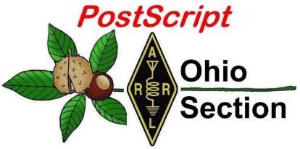](http://arrl-ohio.org/news/) ***“November 30th”***

***Edition***

🡪 National News 🡪 The Handbook Give Away

🡪 Club Corner 🡪 Hamfests- None

🡪 DX This Week 🡪 ARES Connect

🡪 Matt’s Corner 🡪 From The South 40

🡪 One Question Questionnaire 🡪 VE Testing

🡪 Final.. Final..

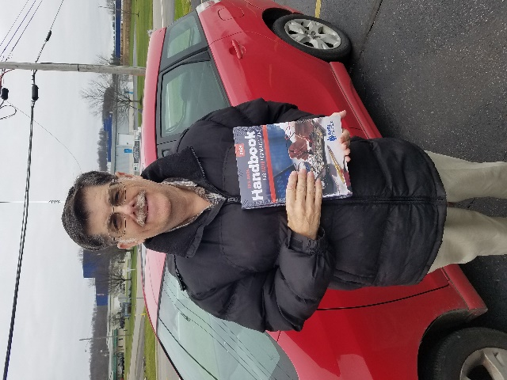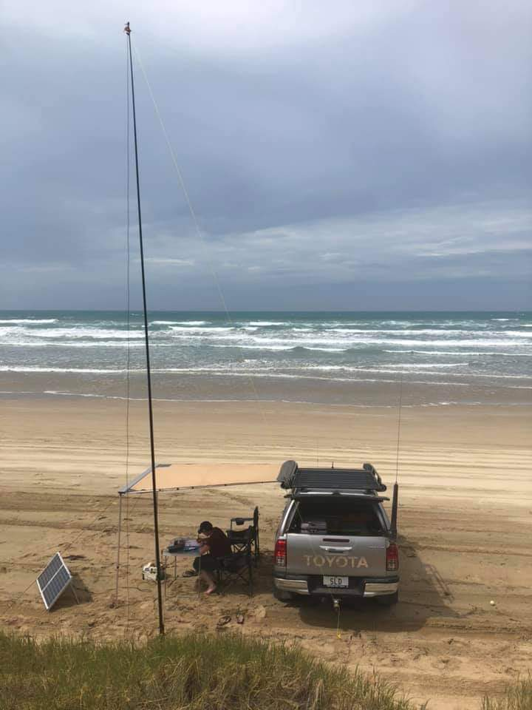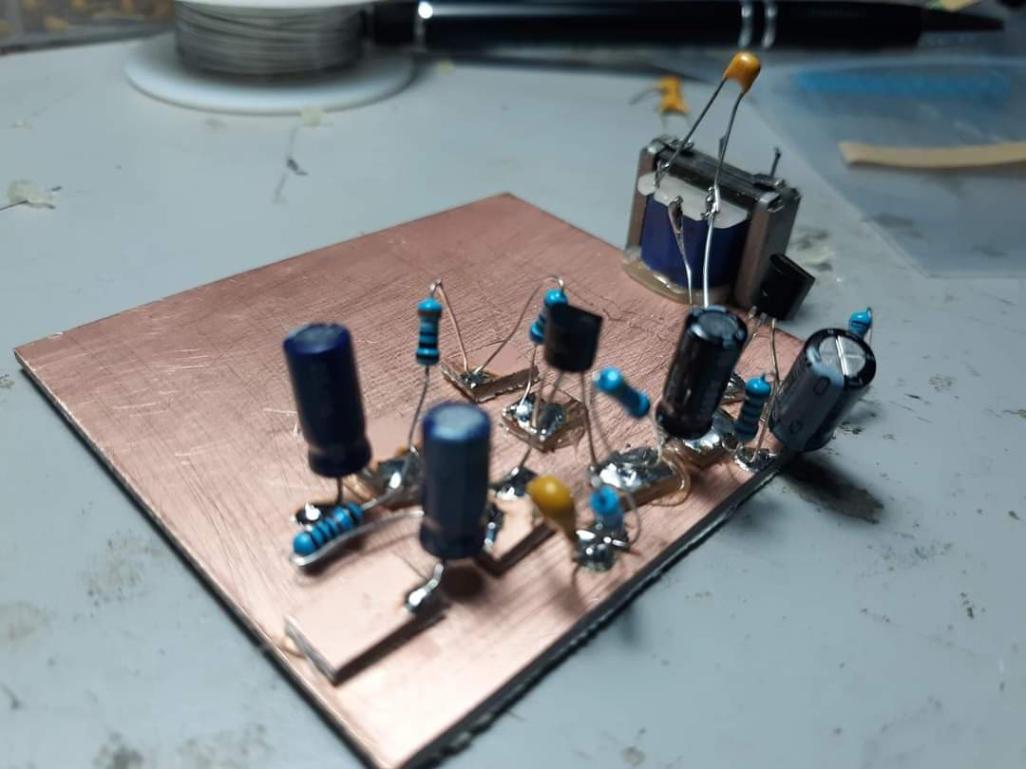

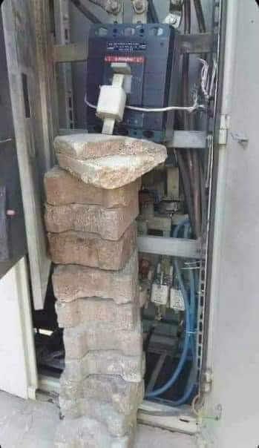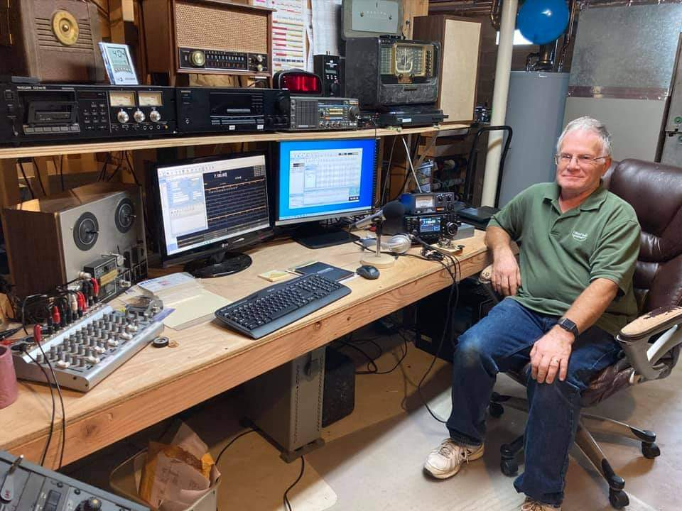



***National News***

*(from arrl and other sources)*

***Notice of ARRL Foundation Scholarship Application deadline***

The ARRL Foundation scholarship application period for the academic year 2021 ends on December 31, 2020. Section Managers are closer to the membership than any other ARRL official and I am asking you as a Section Manager to notify your membership of the deadline. The Foundation issued nearly $300,000 in scholarships in 2020 and for the academic year 2021 there has been a significant increase in the number of large dollar scholarships thanks to a generous contribution from the Amateur Radio Digital Communication group (ARDC).

For the academic year 2021, there are two new $25,000 scholarships, thirteen $10,000 scholarships, nine $5,000 scholarships as well as dozens of $1,000 and $500 scholarships.

A description of the many scholarships available is on-line. <http://www.arrl.org/scholarship-descriptions> It is also very easy to apply as scholarship applications are on-line. <http://www.arrl.org/scholarship-application>

Since only amateur radio operator students may apply, the chances of being selected for a scholarship are good. It would be a shame for your members to miss this opportunity. Please place a notice in your December Newsletter or send a separate E-Mail to your Section to let your members know that the ARRL Foundation offers over 100 scholarships and it only takes a simple online application to apply.

Since 1973, the ARRL Foundation, with the generosity of many donors and the hard work of a long line of dedicated Foundation Directors, has had a positive impact on the lives of many amateur radio operator students. To ensure that this positive impact does not wane, I ask each of you to timely notify your members of this opportunity. Being awarded an ARRL Foundation scholarship could mean the difference in whether a student can pursue their education in 2021 or not.

Thank you and the Foundation and I wish all of you a Happy Thanksgiving, a Merry Christmas and a Happy New Year.

####

***NanoVNA presentation by David Houser, KG5RDF***

*(Submitted by Gregory Drezdzon, WD9FTZ)*

David Houser of Coppell, Texas, KG5RDF, demonstrated how to use the low cost NanoVNA vector network analyzer at the annual Cowtown Hamfest in Forest Hill, Texas.

The Cowtown Amateur Radio Club in Fort Worth, Texas, operates the hamfest. This video and others are part of the club’s educational outreach program, to promote Amateur Radio and technology.

<https://www.youtube.com/watch?time_continue=2&v=y7PEDRN1PpY&feature=emb_logo>

####

TOP ^

***Arizona Congresswoman Introduces National Amateur Radio Operators Day Resolution***

US Representative Debbie Lesko of Arizona has introduced a [**resolution**](https://www.congress.gov/bill/116th-congress/house-resolution/1201/text) designating April 18, 2021, as National Amateur Radio Operators Day, to recognize the important contributions of amateur radio operators.

“Amateur radio operators are critical in times of crisis and our communities are safer thanks to their dedication to sharing important information with the public,” Lesko said. She was approached to introduce the resolution by 12-year-old Raymond, N7KCB, from Peoria, Arizona.

“I started [**Long Distance Responders**](https://www.hamresponder.com/) so I can help prepare the community for emergencies with amateur radio,” said Raymond. “There might be a price for a radio, but the ability and knowledge to help someone is truly priceless.”

As Lesko’s resolution notes, World Amateur Radio Day (WARD) is celebrated annually on April 18 to commemorate the founding of the International Amateur Radio Union ([**IARU**](http://www.iaru.org/)) in 1925, and she said her resolution recognizes the amateur radio community with a national day in the United States in 2021. The resolution cites the Amateur Radio Emergency Service (ARES®) for providing “invaluable emergency communications services following recent natural disasters, including but not limited to helping coordinate disaster relief efforts following Hurricanes Katrina, Wilma, and Maria and other extreme weather disasters.”

####

***Moscow Aviation Institute plans SSTV event from ISS***

*(Submitted by Gregory Drezdzon, WD9FTZ)*

Rodolfo Parisio, IW2BSF, reports that a Slow-Scan Television (SSTV) transmission event from the International Space Station is currently scheduled to begin on Tuesday, Dec. 1 starting at 12:30 UTC, ending at 18:25 UTC, and again on Wednesday, Dec. 2 starting at 11:50 UTC and ending at 18:25 UTC.

Listen for SSTV signals to be downlinked at 145.800 MHz +/- Doppler shift. The mode of transmission is expected to be PD 120. These times will allow for one pass over the Eastern USA near the end of the scheduled times.

Received images of reasonable quality can be posted at the ARISS SSTV Gallery at  <https://www.spaceflightsoftware.com/ARISS_SSTV/>

####

***ARRL Asks FCC to Allow 3.4-GHz Operation until Spectrum is Occupied***

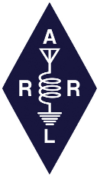In comments to the FCC, ARRL has argued that radio amateurs be allowed to continue shared operation in the 3.4 GHz band until 5G licensees who purchase the spectrum when the FCC puts it up for auction initiate incompatible operations. In its *Further Notice of Proposed Rulemaking* ([***FNPRM***](https://ecfsapi.fcc.gov/file/1002214202488/FCC-20-138A1.pdf)) in WT Docket 19-348, the FCC had proposed to sunset the band for amateur radio in two phases, governed by when new licenses are issued rather than when the new licensees begin to use the spectrum. In the *FNPRM*, the FCC solicited comments on whether alternatives exist to its proposal.

TOP ^

“Amateur activities further the public interest and should be permitted to continue on a secondary basis unless and until a new primary licensee is ready to occupy the spectrum in a preclusive manner,” ARRL told the FCC. “At a minimum, amateur operations should be permitted to continue indefinitely in the 3.3 – 3.45 GHz spectrum, where no new flexible licenses are under immediate consideration. The Commission could consider whether a registration or other mechanism similar to that found in Section 97.303(g) would facilitate avoiding interference.”

Section 97.303(g) contains specific frequency-sharing requirements for the 2200- and 630-meter amateur bands. ARRL said its comments were without prejudice to its pending *Petition for Reconsideration* of the FCC proposal to delete the amateur secondary allocation from the entire 3.3 – 3.5 MHz band.

ARRL noted that some 1,000 comments have been submitted by individual amateurs and amateur organizations at the initial stage of this proceeding. Those included one from the Emergency Communications Coordinator in the California Governor’s Office of Emergency Services, who wrote: “Over the years the State of California Governor's Office of Emergency Services Public Safety Communications Tactical Communications Unit has utilized Radio Amateur Television product during fire operations to gather intel and monitor threats to communications sites being affected by fires and fire weather events… Part of the backbone of the [amateur radio television] system utilizes the 3-GHz spectrum, and due to heavy spectrum usage in the 1.2 and 5.8 GHz spectrum, the 3 GHz spectrum becomes very important for frequency diversity supporting these networks…”

As ARRL noted, “Amateurs often select the 3.4-GHz spectrum precisely because other spectrum choices are sub-optimum or simply not available. Amateurs also are only secondary users on most of the other spectrum suitable for similar purposes,” ARRL said. “Links must be carefully engineered because of that secondary status, which applies to most of the 2.4- and all of the 5.8-GHz bands available to amateurs. In many geographic areas, it is a misconception that the 3.4 GHz operations easily can be moved to other bands.”

ARRL emphasized the importance of allowing amateurs to continue to use the 3.4 – 3.45 GHz portion in particular. “As stated by commenters during the initial stage of this proceeding, some of the equipment commonly used in this band for network linking cannot be re-channeled below 3.4 GHz,” ARRL said.

ARRL pointed out that in many geographic areas it could be years before the 3 GHz spectrum is actually put into use by commercial users, and argued that amateur radio should be allowed to continue to operations on a secondary, non-interference basis as it has done for decades with federal primary users, until new uses actually begin, rather than when licenses are issued.

####

***Coast Guard Proposes to Discontinue HF Voice Watchkeeping***

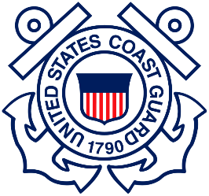The US Coast Guard has invited comments by January 21, 2021, on a proposal to discontinue HF voice watchkeeping. The [**proposal**](https://www.govinfo.gov/content/pkg/FR-2020-11-20/pdf/2020-25605.pdf) appeared on November 20 in the Federal Register. The USCG proposes to cease monitoring 4125, 6215, 8291, and 12,290 kHz, in the contiguous US and Hawaii, due to a lack of activity.

“We believe this change would have a low impact on the maritime public, as commercial satellite radios and Digital Selective Calling (DSC) marine-SSB HF radios have become more prevalent onboard vessels,” the Coast Guard said.

TOP ^

“However, we would like your comments on how you would be affected if we terminated monitoring HF voice-only distress frequencies within the contiguous US and Hawaii, particularly if you use HF, but do not currently have a commercial satellite radio or an HF DSC-capable radio aboard your vessel.”

The Coast Guard said it would continue to monitor HF DSC distress alerting for all existing regions and voice distress and hailing from Kodiak, Alaska, and Guam. The Maritime Mobile Service Net ([**MMSN**](https://www.mmsn.org/)) on 14.300 MHz remains available to less-equipped mariners who need assistance in emergencies.

####

***Ham Radio Discord Experiment***

*(Jason McCormick, N8EI)*

All,

In the spirit of building virtual ham communities and trying new things to attract the younger generations of hams, I’ve created a Discord Server called Ham Radio Chat: <https://discord.gg/kG8ny4d4vw>. A brief intro to Discord can be found at <https://youtu.be/TJ13BA3-NR4>.

My theory behind this is that while the Megalink Teams idea was sound in theory, it wasn’t a great community-building tool, the client was a bit to heavyweight for what we needed, and had a lot of startup processes. After I ended the Megalink Teams experiment, I did a lot of research on the “modern” online community scene including Discord, Teamspeak, Riot, and Matrix. I also talked to a colleague who works with FIRST Robotics keeps pre-teens and teens successfully engaged.

I also spent time observing the different generations at work and how they prefer to communicate and where they will actively engage. By far, across all demographics, Microsoft Teams generated far more collaboration, discussion, and engagement on both work and social topics than anything we have or do use. The younger demographics I interact with (Millennials, GenZ) almost completely avoid e-mail. To my everlasting irritation, they will almost without fail Teams message me about an e-mail rather than respond to the message. I’ve also had to train myself to find/remember Teams conversations and “dangling ToDos” to better interact with these generations.

Moving even further down the grouping, my daughter (14) who is in the last cohort of GenZ and almost a Gen Alpha (I guess they wrapped around) only has e-mail for password recovery. Every once in a while I send her an e-mail to test it out. She’s never responded to a single one and never checks it. Talking with her, none of her friends use or have e-mail that she knows. They also do not use Facebook at all and rarely Twitter. They mostly use Snapchat, Instargram (to some extent), Facetime, and then for more technical things (usually gaming) TeamSpeak and Discord.

Anyway, all that to be said, I figured it was time to try something radically different. If you’re interested, sign up and give it a shot. You can use a browser, full app on all platforms including Linux, or the mobile app.

Feel free to pass this around to others who might be interested. We’ll see how this sticks, and if it’s useful.

####

TOP ^

***Ham Radio Contact Spurred South Pole Visit***

*(Submitted by Gregory Drezdzon, WD9FTZ)*

Forbes magazine describes how an amateur radio contact with the Amundsen-Scott Station at the South Pole spurred Jim Clash, WA3JID, to travel there and operate the ham radio station

The article describes the contact in the early 1970s that changed his life:

I was a 15-year-old in Laurel, MD, when I obtained my general-class FCC license, which allowed me to transmit with 1,000 watts on select frequencies. I spent many an hour on my radio - between homework, sleep and my Baltimore Sun paper route - chatting with hams in countries all over the world, including Australia, the Seychelles Islands, Japan, Mozambique - even the Soviet Union during the Cold War.

Late one night, when I was on the 14-MHz frequency band, my life changed. A ham operator in Antarctica poked weakly through the static. Upon a closer listen, it was clear that not only was he in Antarctica, but at the Amundsen-Scott Station on the geographic South Pole. My heart skipped a few beats. The South Pole! That was about as wild and remote a place as my teenage imagination could conjure up.

Read the article at

<https://www.forbes.com/sites/jimclash/2020/11/23/south-pole-radio-contact-spurs-visit-to-the-bottom-of-the-world/?sh=5593f39637c3>

####

***Amateur radio not as impacted by social distancing***

*(from The Blade -www.toledoblade.com)*

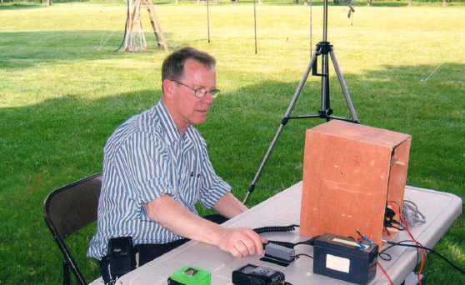While some hobbies have had to be curtailed because of the coronavirus pandemic, amateur radio — also known as ham radio — is one that isn’t as significantly affected by social distancing requirements.

Talking to others remotely, from as far as away as possible, has been a cornerstone for thousands of ham radio operators worldwide. Steve Stalker is in charge of education and radio licensing at Toledo Mobile Radio Association, and first became interested in the hobby as a seventh grader, when he learned Morse code as a Boy Scout.

Amateur radio not as impacted by social distancing. From his first contact with an operator in Long Beach, California to his most memorable one in Cork, Ireland, the hobby has brought years of enjoyment. But it is much more than that. In addition to casual conversation, local ham-radio enthusiasts provide emergency communication service should it be requested by such agencies as the Federal Emergency Management Agency, its Lucas County counterpart, the Red Cross, or the Salvation Army.

TOP ^

Amateur radio becomes a lifeline when storms or disasters take out normal modes of communication like phone lines, cellular phones, and the Internet, Mr. Stalker said. “We practice continuously for this purpose ... so if we do get called up, in 15 minutes we are ready,” Mr. Stalker said, adding that his 200-member club is the largest of five such groups in Lucas County. It serves northwest Ohio and southeast Michigan.

Even when other modes of communication are still available, ham radios can be useful because they provide a more immediate means of communication, which is especially handy when a large number of people need to be reached simultaneously. “The moment you get on the radio, they hear you,” Mr. Stalker said.

While the pandemic has not limited on-air activities for ham radio operators, in-person events like educational classes, license testing, and club events have been curtailed. “You make a lot of friends in the hobby, but the pandemic has kept up apart,” Mr. Stalker said.

The pandemic, he said, has not affected the club members’ readiness to provide an emergency service if called upon. Said Mr. Stalker: “When all else fails, we’re it!”

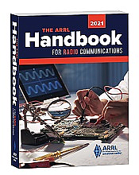***Handbook Give Away***

Hey Gang,

Have you registered for the “Handbook Giveaway” drawing yet? If you haven’t, go to: <http://arrl-ohio.org/handbook-thanksgiving.html> and get registered.

Hey.. We’re gonna’ have some extra fun this month. If you registered before November 26th (Thanksgiving) you’re already registered for the monthly drawing!!

The Thanksgiving Day winner is: ***Wyatt Cushing, KA1QLD***

**Now, we aren’t done just yet…. We will have another drawing on Monday night – 30 November as well.**

If you registered early, before Thanksgiving, you’re already registered. If you haven’t yet, you need to get to work fast, as it ends **today** (Monday – 30 November)!!

What’s the catch? I want to get everyone checking in to the Ohio Section website as often as possible, and in order to register each month, you have to visit the website often! There’s nothing else to it!!

[](http://arrl-ohio.org/handbook.html)Many of you ask me just how do I know when the drawing is on? Well, that’s easy all you need to do is check in on the Ohio Section Website on a regular basis and watch for the big **RED** Arrow that will appear on the left side of the page. This is the sign that the drawing is on and you need to get registered. So, keep a sharp eye out on the website and check in often! <http://arrl-ohio.org>

####

TOP ^

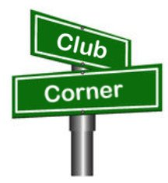***Club Corner***

This is YOUR cornner of the newsletter. Send me what your club is doing and I’ll make sure that it gets in. Got a special event or club project that you want everyone to know about? Send it to me!. Need help with a project? Send it to me.

Let me know what you club is up to. Are you going to have a special guest at your meeting or are you having a special anniversary? Just sent it to: [n8sy@n8sy.com](mailto:n8sy@n8sy.com)

####

***The Wayne County ARC Does tree lighting***

Thanks to all the efforts of the Wayne County ARC there’s been an annual Christmas Tree lighting for many years. This year, the Wooster Chamber of Commerce wanted to make sure that the Wayne County Amateur Radio Club got recognized for all of their efforts over the years. Here’s a link to the video. It’s about 3.5 minutes and really shows how grateful they are to their local amateur radio club.

Here’s a link to the video from the Chamber of Commerce: <https://youtu.be/mtW94DAmCoo>

####

Scott, Stan:

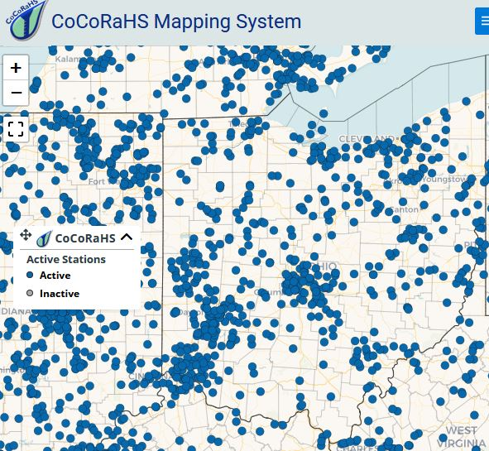

Re: today's Ohio Section Newsletter comment about National Weather Service offices inviting snow reports, a reminder that there is already a large Statewide volunteer rain/snow reporting network known as "CoCoRaHS".

(The Community Collaborative Rain, Hail and Snow Network.) See attached.

CoCoRaHS is a unique, non-profit, community-based network of volunteers of all ages and backgrounds working together to measure and map precipitation (rain, hail and snow). Observers report daily precipitation, including snowfall AND water content of snow (important for flood prediction).

Our own Athens County reporting page provides some good examples of what this looks like:

<https://climate.athens.oh.us/oh-at>

TOP ^

We also maintain a County Weather Hazards Monitoring page which is a kind of 'one stop' snapshot of the most common cold weather hazards our County encounters. One important component is that it not only displays "pobability of precipitation," but shows WHAT KIND AND HOW MUCH of each expected precip type. See: <https://w8kvk.com/AthensWX>.

Any Ohio ARES/SKYWARN observers who are serious about assisting NWS with snowfall monitoring may wish to consider becoming an Ohio CoCoRaHS volunteer.

Thank you for your interest. 73/ted W8KVK Athens Co.

####

***Amateur Radio Direction Finding and Fox Hunting ARDF***

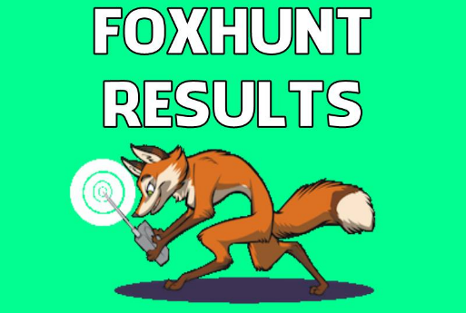

1st Place in the Hocking Valley Amateur Radio Club Fox Hunt on Saturday, Nov. 21st 2020 went to Nick Arnold KD8FKB in his first hunt, assisted by his wife.

There were six teams hunting the Fox in Hocking County. He wins bragging rights and may choose to be the next Fox in the next scheduled Fox Hunt. Congratulations!

####

***A Real Thanksgiving Treat***

*(from Jimmy Caudill, AF8JC)*

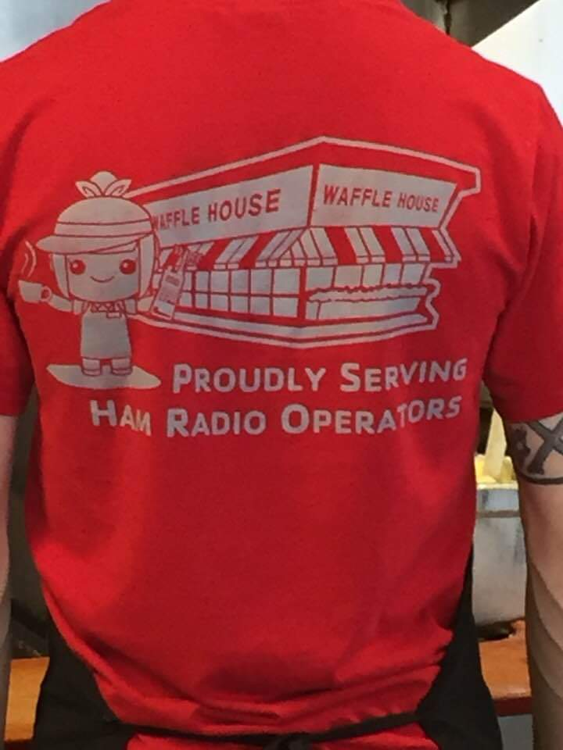

For Thanksgiving, the wife (KD8VWE) and I decided to just go out to eat at Waffle House. Here is what the cook was wearing.

We are fortunate to live in a very “ham friendly/supportive “ area. The Hamvention is a major event, known worldwide, and has always been in the Dayton area. I think it is great that the local area Waffle House network had these T-shirts made and the staff actually wears them.

TOP ^

***DX This Week***

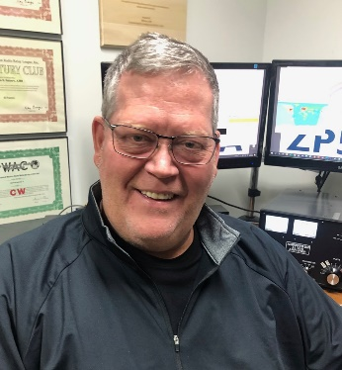*(from Bill, AJ8B)*

***DX This Week – COVID Activities***

***Bill AJ8B (aj8b@arrl.net, @AJ8B, or www.aj8b.com)***

***CWOPs Member #1567***

The Midwest DX Cluster spots that were posted last week included Afghanistan, Alaska, Argentina, Asiatic Turkey, Australia, Belgium, Belize, Bolivia, Brazil, Canary Islands, Crete, Cuba, Denmark, DPR of Korea, Easter Island, England, Fiji, Finland, French Guiana, Ghana, Hawaii, Isle of Man, Italy, Jamaica, Malawi, Mali, Mauritania, Mexico, Moldova, Montenegro, Namibia, New Zealand, Portugal, South Africa, Spain, St. Lucia, St. Martin, Uruguay, US Virgin Islands, and Venezuela..

***DAH DIT DIT DIT DAH DAH DIT DIT DIT DAH***

QSL cards received this week included A45XR - Krzysztof in Oman, R9FM - Vlad in Asiatic Russia, T77LA - Angelo in San Marino, 4X5MZ Josef in Ashketon in Israel, HD0DX from the Ecuador DX Club, and 9K2HN - Hamad in Abdaly, Kuwait.

|  |  |
| --- | --- |
|  |  |
|  |  |

***DAH DIT DIT DIT DAH DAH DIT DIT DIT DAH***

TOP ^

***International COVID-19 Activities***

***I sent an email to all of those hams who have graciously allowed me to interview them for the Southwest Ohio DX Association (SWODXA) newsletter over the past 4 years asking them “What have you changed in your amateur radio "life" as a result of COVID?“ I was absolutely thrilled with the response. Hope you enjoy!***

Hello Bill,

1/ Improved my morse

2/ Gained DXCC,WAS,WAC Plus other awards

3/ Took the plunge and embraced data modes excellent ft4/8, JS8, PSK31

4/ Given me more time in helping those just entering the hobby

**Doug G0LUH**

Good evening sir.

I want to answer your question— “What has changed since COVID 19?”

I have not changed as a keen DXer and contester, but band condition and solar numbers have changed drastically. That is why I am more into digital modes at this time and a little SSB because of band conditions. Hopefully solar figures will improve in the near future for everyone to enjoy all facets of ham radio.

Even with a small HF station and VHF/UHF station I want to enjoy every mode possible.

Thanks for listening

**73 de ZS2EC Theunis from Port Elizabeth Eastern Cape of South Africa**

Hi Bill,

You'll be always welcome to contact me and I will reply to your questions as sincerely as I can.

Concerning COVID, it, of course, changed our lifestyle, being obliged to take drastic precautions to keep safe. The only change in my Radio Ham life is that I am more active than before being stuck at home most of the time having plenty of time to be on the air.

We are still in a semi-lockdown situation, but we can go to work and move around to visit the family and friends but still have to wear a mask in public.

The airport was opened on the 1st of October all passengers have to stay in quarantine for a 14 days period. I hope things are going well your side, stay safe and healthy.

73,

**Pat—3B8FA**

Hello dear Bill!

Hope that you are doing well, and you are all healthy! It would be my pleasure and please feel free to write!

TOP ^

I think that we all saw that during the lockdown in the quarantine, it was an opportunity to spend more time on the radio! Suddenly all the bands were busy and full! There were some early contests were the participation was much more than the expected. Yes, at first it was great! But then you realized that there could be no DX-peditions, and that you couldn’t run a contest with your team from the contest stations! At J42L we are lucky to have a Flex 6600, so we could work remotely, but still, not the same! We missed all the fun! So there was more operating from our QTH. 73 de **SV2ESW**.....

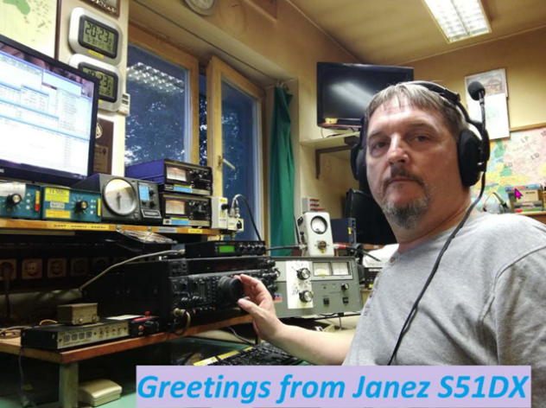Hey, Bill! No problem, I hope my answers will satisfy you.

What have you changed in your amateur radio "life" as a result of COVID?

I was always very active on the bands. For more than 30 years I run the station on daily basis. That also means that I didn't change my life because Corona. Especially not HAM life. I'm lucky that our location is close to my home, even the spring restriction on traveling to another municipality doesn't hit me. On the other hand, I'm retired from 2019, I have even some more time to be on the radio. I'm close to 50,000 QSO this year - I can say that I'm even more active than before.

Regards from Slovenia, de **Janez S51DX**

Hi Bill,

Nothing has changed in my amateur radio life as a result of COVID 19. Although so far about 15,000 cases have been recorded in Zambia with 333 deaths life has changed very little. Few people are taking any preventative measures at all, schools have reopened, bars and restaurants have reopened but infection figures have dropped.

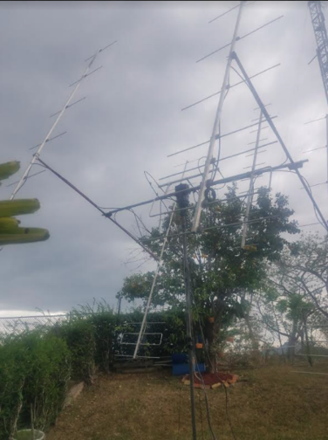As I am retired, I rarely leave home at all so the poor propagation is more of a hindrance to my operating than the virus. For much of the day the bands are dead or signals just too weak for me to copy underneath my local power line noise. Bands begin to open around 16hrs local time. I get in a couple of hours of operating before they close again.

**73 Brian , 9J2BO**

 Hi Bill ,

The answer to your question (What have you changed in your amateur radio "life" as a result of COVID?) Not really much but I have gotten into 2m EME and a bit of 70 CM EME , really  my work has me very busy of late  and not much time for radio at this time.

Regards,

Chris **9Y4D.**

TOP ^

Bill,

Because of Covid-19 it has become hard to travel outside the borders of Denmark. Although it is not forbidden there are plenty of rules for the different countries that influence travelers like me. So instead of traveling to other countries I travel in Denmark and have been active from more places here.

We do have our Danish Headquarters Station placed in Odense, the town of Hans Christian Andersen. This is a central place in Denmark, and I use about 1½ hour to get there with my radio equipment. There is a 25-meter tower with a tri-bander and wire antennas for low bands. A nice shack and good surroundings! I have used this place for WPX CW, SAC CW, CW-open and more.

South of where I live there is a local club with the same antenna arrangement. It is in Aabenraa, about 20km north of the German border. I have done more CW contests from this place.

I am a member of Danish Contest Academy who have a great station in the middle of Jutland. You may know the call sign OZ5E, doing many multi operator contests. I am doing more LO-Band contests from here where I can use an excellent Beverage antenna system together with a self-supporting 26m vertical doing a splendid job on Top-Band. I am planning to be there in the CQ WW CW Contest late November. [http://oz5e.dk](http://oz5e.dk/)

I had plans for travelling to Albania and Greenland this year but the Covid-19 stopped my plans so far.  In February this year I was on Madeira participating in the ARRL DX CW Contest with my call sign CR3EE and it seems to be the only travelling out of Denmark for me this year. I look forward to come back to the "good old times"  ;o)

**OZ2I Henning Andresen**

Hi Bill—An interesting question…

I’m no psychiatrist, however, it’s interesting is observe human behavior during this pandemic. Drivers here have become increasingly impatient, erratic, discourteous, and downright dangerous, so much so, Rosie and I avoid leaving the safety and security of our home (in a gated community) unless absolutely necessary. The same is generally true in other aspects of everyday life here – folks are under tremendous and increasing stress - everyone needs to be more aware and sensitive, and increasingly prudent in order to avoid trouble.

I’m sure Colombia is not unique in this regard, Bill.

This is in response to your question: “**What have you changed in your amateur radio "life" as a result of COVID**?”. I hope my thoughts are not too far off topic.

 1)    As you probably know, I only operate on 20 thru 10 meters (no antennas for 160, 80 or 40 meters), however, and it could be attributable to propagation, I’ve noticed a decline (especially in the last 3 months) in the amount of SSB and CW activity. On the other hand, the level of FT-8 activity seems to have remained the same. Perhaps, it’s a reflection of people’s general mood and/or willingness to engage with others (in a personal way) during the pandemic – I’m not sure.

As a consequence, I’ve found myself less active than usual (fewer folks to speak with on SSB and CW). On the other hand, there has been no shortage of possible FT-8 contacts – worldwide.

TOP ^

2)    I like to share with others, e.g., Internet links to interesting YouTube videos, PDF copies of various magazines I receive, technical articles, white papers, etc. As the pandemic has progressed, I’ve noticed a steady decline in the level, and/or the timeliness of responses from friends with whom I normally share. Some friends just “*slowly-faded-away*” over time, while others suddenly “*disappeared*” overnight.

Less than 25% of those with whom I regularly share have maintained the usual “back-and-forth” communication. As a consequence, and in an effort to be more “*sensitive*” to others, I have tailored (reduced) the quantity of what I usually share. I’m also being more selective with whom I attempt to share.

Bill, this may not be what you were expecting; it is nonetheless what has changed in my amateur radio life as a result of COVID.

BTW, my wife has been a practicing physician (GP) here for more than 25 years – Rosie is one of the most empathetic, sensitive, and “*life-aware*” people you could ever hope to meet. She and I regularly discuss everything from my continuing cultural adaptation to Colombia , to the vagaries and realities of poverty in Bogota. My response above is somewhat influenced by this.

73, stay safe and keep well, Bill.

**John HK3C—**[***www.hk3c.ca***](http://www.hk3c.ca/)

Hi Bill,

Thank you for giving me the opportunity to collaborate with one of the most important Clubs that I know. Of course, I will be happy to help as much as possible.

As for the question, COVID19 has greatly modified Amateur Radio

Negative:  
 - No DXpeditions  
 - Contests or special activations cannot be carried out like friends.  
 Positive:  
 - A handful of old Radio Hams are active again due to lockdown.  
 - We have had time at home to make more radio and to improve our Shacks.

Best 73 **Jose EC6DX**

Hi Bill,

Thank you for your email.

Fortunately, the terrible impact Corvid virus has had worldwide has not had the same impact here in Tasmania to date with only a few cases reported some time ago. The local government took very swift action to outside travelers closing the border to all but essential people. It certainly changed the way of normal life with numbers limited in shops, sanitizing hands, and shopping trollies.

TOP ^

One thing I have noticed is the normal flu season here is almost non-existent. Amateur radio wise I have noticed a big increase in digital operators to the point I have had to limit the number of QSO’s to one per mode/band in my log to give a fair chance to operators to have OC006 TASMANIA Isl.in their log. Tasmania Island only has a limited number of active digital Amateur radio operators and the pile ups were causing long periods of no decodes.

New operators receiving a B4 report relates to being in my log already on same band and mode this being clearly stated on my qrz.com-vk7ac page a useful site to find operators general information.

**— Norman VK7AC**

Hello Bill,

In Germany most of the licensed or SWL radio amateurs are organized in 1 of over 1,000 DOKs, the smallest unit of amateurs in DARC (German amateur Radio club) and each DOK has its own QSL manager.

Usually the members of a DOK have a meeting at monthly basis, but as meetings were not allowed, we had a virtual meeting by video conferencing.

Now we have a greater meeting room where the social distance of 2 meters to each other is guaranteed and we can meet us personally, so the situation now has normalized.

The bidirectional QSL exchange with my QSL Mgr. was and is no problem, but there is a problem sending QSL cards directly to some countries that do not accept mails from Germany. As a result, I got my QSL cards back from Barbados #62, Brunei #345, French Polynesia #175, Mongolia #363 and Trinidad and Tobago #90.

73 es gud DX

**Walter (DE0WAF @qsl.net)**

First of all, people aged 60 and over are a huge loss for the world. It is a great loss for future generations that they will not be able to transfer their experiences to the world. I am very sorry for all the American people and world humanity.

Returning to the amateur radio activity, we continue on our way by saying that life is beautiful at home.

Health comes first then the hobby.

"What have you changed in your amateur radio "life" as a result of covid?"

I usually work with CW Morse. **The number of operators around the world using CW has decreased significantly due to covid.** This is because teens often work with Digi mods like FT8. However, there are quite a few using CW over the age of 60.

** You asked what changed in my life. HF doesn't taste as good as old anymore. Here I am very sorry for this situation.

I hope this curse ends before more people die and hopefully future generations will put a little more emphasis on cw.

  God bless you and all your loved ones. **73 de TA4LYL  -Yigit KAYNAK (ADAM)**

TOP ^

Hello Bill,

Thanks for your honorable mail. Yes, I remember the previous report couple years ago. I can cooperate with you now of course. So, my answer to your question is:

The COVID craziness did not change my HAM radio life at all. Although I have more free time, due staying at home more, I did not spend more time on radio hobby. I have a daily routine, DXing on low bands early in the morning, it is independent of COVID. Maybe more activities, I could meet more partners on low bands. The reason of this might be the "stay home" in USA and other part of the world, or the bad propagation on higher bands.

Fortunately, I feel quite healthy myself, everyday do some sports, activities (swimming, biking, running) and try to eat healthy foods (more vegetables and fruits).

I live in the suburban part of Kecskemet city, in house of garden, the "stay home" did not take difficulties in my life.

Have a nice day!

**Peter—HA8RM**

I am too ornery to let Covid-19 dampen my enjoyment of life, itself, let alone my hobby.  However, limited foreign travel has delayed at least one DXPedition.  So, when we are able to effect the trip, it will make the experience that much sweeter.  While on the subject of ‘sweet’, this staying at home thing has provided more opportunities to have quality time with my wife.  That is a positive.  Even going to the grocery is an opportunity for a date.

Radio wise, I have been Beta testing paddle input CW options with the developer of the MFJ RigPi product.  Early in the pandemic, I spent a bit of time on whistle mode (FT8/FT4).  My computer will get with your computer to let you know my thoughts on the experience!

**Jay – K4ZLE**

**Hello Bill and Hello friends from SWODXA !**

I hope that all members of SWODXA are OK and in a good health condition!

Bill,

Yes, I am agree to reply of your questions. It's a pleasure for me to contact with you and with members of SWODXA.

About your first question - What have you changed in your amateur radio "life" as a result of COVID?

As you already know - every year I organize expeditions to different countries in the Pacific Ocean. In 2020 I had also planned an expedition to Niue and Tonga. Preparations for this expedition began in March 2020. Tickets for the trip were purchased, accommodation was also arranged. The antenna and technical equipment for the expedition was provided and tested.

TOP ^

We, the team of E6АМ & A35GC, hoped until the end that this expedition would be realized!

Unfortunately for our great regret and disappointment at the end of August 2020, we were informed by Air New Zealand that all our flights were canceled due to COVID - 19 restrictive measures! In this situation - our expedition to E6 and A35 was postponed to October and November 2021.

The short answer to your question is: COVID - 19 caused my expedition, planned for October and early November 2020, to fail.

Personally - I live as before the appearance of COVID -19. Since the beginning of this "Pandemic", I have been working without stopping and living without paying any attention to this virus! All that I do is maintain good personal hygiene and a strong immune system. I don't wear a mask and I don't use gloves. I know that the only thing that can save me from this virus is a strong immune system!

Bill—So, for now!

My best wishes to you and all members of SWODXA !

Kind Regards!

**73! Stan, LZ1GC ( E6AM & A35GC ).**

Hi Bill

Many thanks indeed for your email and the question and I do apologize for the delay in replying.

So far, St Helena has been COVID free due to the restrictions imposed by the St Helena Government and the island’s Health Directorate. We aim to keep it that way until a vaccine can be found to eradicate it once and for all. Our biggest fear is that we only have a population of just about 4,000 and if it were to reach our island then it is possible that it will wipe us all out!

I am sorry I can’t contribute anything else and good luck with the newsletter, I really enjoy reading it.

Take care, stay safe and 73

**De John ZD7JC**

**St Helena Island**

***DAH DIT DIT DIT DAH DAH DIT DIT DIT DAH***

**Top Band Soap Box -** As I mentioned at the beginning, starting this week and running until April 15th, I will include news and notes about activity on 160M. The two guys that will be providing me with the scoop will be Dave, K8DV, and Chuck, K8CR. Both have achieved DXCC on 160 and both are active on 160M. I asked Dave, K8CR, what approach he would take now if he had to start over but retained the knowledge and experience, he has gained. Here is Dave’s response.

That is a loaded question with two different answers, if I were to start like I had never been on topband, chasing DX much like I did when I got my 160 DXCC, I would just jump in and work everything I could here and sort it all out at a later date.  Something like if you work enough stations you will eventually get the ones you need, not a lot of thinking but good for the first 30 or so.

TOP ^

I will say the following with the assumption that I am already on 160 and this is without mention of antenna, radio, amplifier, or other hardware but strictly, from an operating point of view.

If I were to start over today, I would pay close attention to the greyline and be in the shack on the band as many times as I could between October and March.  I would also get on as much as I could at sunrise and maybe even a little before.  I would put in some late nights too as sometimes the band will produce good DX around 0400 or 0500 here in southwest Ohio.

Whenever not in the shack I would have FT8 running and would go back and review what it captured to see what I might have missed and to see if any DX is being heard.

I might even plot out date and time to predict when I should be in the shack.  I would also stick with CW and FT8 as SSB just isn't going to produce the results that you need for chasing DX.

Finally, I would work new states for WAS while I was at it to keep boredom from setting in. Besides, that is good for 3 entities, USA, AK and HI.

Reviewing this makes me glad that I don't have to start all over! I am not sure I could do it in 2 seasons like I did it the first time.

***CQDX CQDX CQDX CQDX CQDX CQDX CQDX CQDX CQDX***

Here is an update from Bernie, W3UR, of the DailyDX and the WeeklyDX, the best source for DX information. <http://www>.dailydx.com/. Bernie has this to report:

**F – France -** F8KGH, the Radio Club du Val d’Issole, will have TM1SAFE on the air November 20 to December 4.  QSL via F4GPB or use eQSL, LoTW or OQRS.

**OH – Finland -** OG1XMAS will be on the air November 29 to December 26 by the OH9A group, the Market Reef DX Association.  QSL through either LoTW or Club Log.

**ON – Belgium -** OP19MSF is on the air until December 13, MSF standing for Medecins Sans Frontieres (Doctors Without Borders), highlighting that group’s work, especially in the global virus crisis.  Putting on this activity is the ON4CRD group, the Radio Club of Durnal.  QSL bureau or direct.

**SP – Poland -** Eight special callsigns are on now and running to December 21 to note the 20 years of operations from the International Space Station. The calls from Poland are 3Z20ARISS, HF20ISS, HF7ISS, HF8ISS, HF9ISS, SN20ISS, SN3ISS and SO1SS.  A certificate is available: [https://ariss.pzk.org.pl/20yHAMonISS/](http://r20.rs6.net/tn.jsp?f=001m9GsLxT_qVMknV1AeNu8IamuFpcv_vOAinrBfGlJjaGKHcR1zi-9j9j3EuG5m3XjMl5ILav1wBFgfOisnMx4A9KKefjyk72HQ31Ni3IKGF88idVHxWLPNN6Kk3dJoUzrgYDIJxcj7LM8lDbTnTwRN-yMyyNpEarKdGxTGZbvNyU=&c=c77iIeToHB3VGURGQBw2Cy0PDX9s16b6wgwzQYtJtA7gncMEdweoaQ==&ch=jgQVmeV3N2eU1Bykq7h8OBXorVvNCZsvS64woz0JONoc-Xriq651JA==).  [https://www.ariss.org/](http://r20.rs6.net/tn.jsp?f=001m9GsLxT_qVMknV1AeNu8IamuFpcv_vOAinrBfGlJjaGKHcR1zi-9j9j3EuG5m3XjBtuL1hFtzRn49cdtZblIK34neEEwMRY_lS03hXGDXQaHN1v9sEQEdxR5avgod_eJkywgWYTY9Qk=&c=c77iIeToHB3VGURGQBw2Cy0PDX9s16b6wgwzQYtJtA7gncMEdweoaQ==&ch=jgQVmeV3N2eU1Bykq7h8OBXorVvNCZsvS64woz0JONoc-Xriq651JA==).

***DAH DIT DIT DIT DAH DAH DIT DIT DIT DAH***

TOP ^



Below is a list of upcoming contests in the “Contest Corner”. I think this is important for someone who is trying to move up the DXCC ladder since entities that are on the rarer side and easiest to work in contests. Some of my best “catches” have been on the Sunday afternoon of a contest when the rarer entities are begging for QSOs. Of course, the gamble is that if you wait until Sunday, conditions may change, or they simply won’t be workable. However, it is not a bad gamble. Of course, why not work the contest and have some fun!  
Check out the WA7BNM Contest Calendar page (<https://www.contestcalendar.com/>) for more contests or more details.

The contests in red are those that I plan to spend some significant participation time on. PLEASE let me know if you are working contests and how you fared.

Thanks!

|  |  |  |
| --- | --- | --- |
| Dec. 4 – 6 | ARRL 160M | <http://www.arrl.org/160-meter> |
| Dec. 5-6 | PRO CW Contest | [www.procontestclub.ro/PCC%20Rules.html](http://www.procontestclub.ro/PCC%20Rules.html) |
|  | FT Roundup | [www.rttycontesting.com/ft8-roundup/rules](http://www.rttycontesting.com/ft8-roundup/rules) |
|  | UFT Contest | [bit.ly/2Mh0LDc](https://bit.ly/2Mh0LDc) |
| Dec. 7 | K1USN Slow Speed Test | [www.k1usn.com/sst.html](http://www.k1usn.com/sst.html) |
| Dec. 13 | QRP ARCI Holiday Spirits Homebrew Sprint | [www.qrparci.org/contests](http://www.qrparci.org/contests) |
| Dec. 12-13 | ARRL 10M Contest | [www.arrl.org/10-meter](http://www.arrl.org/10-meter) |
|  |  |  |
|  |  |  |
| Dec. 14 | K1USN Slow Speed Test | [www.k1usn.com/sst.html](http://www.k1usn.com/sst.html) |
| Dec. 18 | AGB Party Contest | www.[ev5agb.com/contest/contests_e.htm](http://ev5agb.com/contest/contests_e.htm) |
| Dec. 18 | Russian 160-Meter Contest | [www.qrz.ru/contest/detail/90.html](http://www.qrz.ru/contest/detail/90.html) |
| Dec. 19 | RAC Winter Contest | [www.rac.ca/rac-canada-winter-contest-rules-2019](http://www.rac.ca/rac-canada-winter-contest-rules-2019) |
|  |  |  |
| Jan 29 – 31 | CQWW 160M | <https://cq160.com/> |
| Mar. 27 – 28 | CQWW WPX SSB | <https://www.cqwpx.com/> |
| May 21 | SWODXA DXDinner | [www.swodxaevents.org](http://www.swodxaevents.org) |
| May 29 – 30 | CQWW WPX CW | <https://www.cqwpx.com/> |
| August 28 | Ohio QSO Party | <https://www.ohqp.org/> |
| August 28 | W8DXCC Convention | [www.w8dxcc.com](http://www.w8dxcc.com) |

TOP ^

**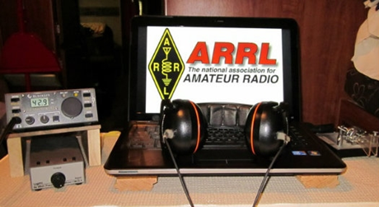*ARRL Contest Corner***

An expanded, downloadable version of *QST'*s’[**Contest Corral**](http://www.arrl.org/contest-calendar) is available as a PDF. Check the sponsor's’Web site for information on operating time restrictions and other instructions.

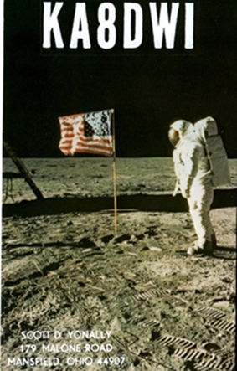***DX News***

***ARLD048 DX news***

This week's bulletin was made possible with information provided by KD7WPJ, The Daily DX, the OPDX Bulletin, 425 DX News, DXNL, Contest Corral from QST and the ARRL Contest Calendar and WA7BNM web sites.

Thanks to all.

**MALDIVES, 8Q.**  Marko, N5ZO and Oliver, W6NV are QRV as 8Q7ZO and 8Q7NV, respectively, until December 2. They will be active as 8Q7ZO in the CQ World Wide DX CW contest. QSL 8Q7ZO direct via OH0XX and 8Q7NV direct to home call.

**EAST MALAYSIA, 9M6.** Saty, JE1JKL is QRV as 9M6NA during the CQ World Wide DX CW contest. Activity will be on 40 to 10 meters. QSL via LoTW.

**CUBA, CO.** Members of the Radio Club de Caibarien are QRV as T46W until December 29 to commemorate the first transmissions 100 years ago by the Cuban radio pioneer Manolin Alvarez. Activity is on 160 to 10 meters using CW, SSB and various digital modes. QSL via LoTW.

**SPAIN, EA.** Special event station EF42C will be QRV from November 28 to December 13 to celebrate the 42nd anniversary of the Spanish Constitution. QSL via EB5R.

**GUERNSEY, GU.**  Bob, GU4YOX will be QRV in the CQ World Wide DX CW contest on 40 meters. QSL via bureau. In addition, look for Dick, GU4CHY to be QRV in the contest on 20 meters. QSL direct to home call.

**ITALY, I.** Raf, IH9YMC will be QRV from Pantelleria Island, IOTA AF-018, during the CQ World Wide DX CW contest. QSL via LoTW.

**ST. VINCENT, J8.** Oleh, UR5BCP is QRV as J8/UR5BCP until November 28. Activity is on the higher HF bands using mainly digital modes. This includes some limited activity in the CQ World Wide DX CW contest. QSL via KD7WPJ.

TOP ^

**JAN MAYEN, JX.** Erik, LA2US is QRV as JX2US until the end of March, 2021. Activity is on 160 to 12 meters using CW and FT8 in DXpedition mode. QSL to home call.

**US VIRGIN ISLANDS, KP2.**  Daniel, K8RF will be QRV as NP2J in the CQ World Wide DX CW contest on 160 meters. QSL direct to home call.

**FINLAND, OH.** Members of the Market Reef DX Association will be QRV as OG1XMAS from November 29 to December 26. Activity will be on all bands and modes. QSL via LoTW.

**ALAND ISLANDS, OH0.** Juha, OH2N, Kari, OH2XX, Jukka, OH6DD and Tomi, OH6EI plan to be QRV as OH0Z in the CQ World Wide DX CW contest.

QSL via W0MM.

**ARUBA, P4.** John, W2GD is QRV as P40W until December 1. Activity is on 30, 17 and 12 meters as time permits. This includes being an entry in the CQ World Wide DX CW contest. QSL via N2MM.

**NETHERLANDS, PA**. Special event stations PA20XMAS, PB20CLAUS and PD20SANTA will be QRV during December. QSL via LoTW.

**BONAIRE, PJ4.** Martin, DL6KR plans to be QRV as PJ4/DL6KR in the CQ World Wide DX CW contest. Operators DL3KMS, DL1COP and DC7MO are QRV as PJ4/homecalls until November 29. QSL to home calls.

**SWEDEN, SM.** Lars, SM3EAE and Goran, SM5SIC will be QRV as SI9AM in the CQ World Wide DX CW contest. This will be the last activity from the King Chulalongkorn Memorial Amateur Radio Society Visitor's station. QSL via SM3FJF.

**TURKS AND CAICOS ISLANDS, VP5.** Jim, K4QPL will be QRV as VP5M in the CQ World Wide DX CW contest. QSL direct to home call.

**INDONESIA, YB.** Look for YB0ECT to be QRV in the CQ World Wide DX CW contest on 20 meters. QSL via W2FB. In addition, Yohanes, YB2DX plans to be QRV in the CQ World Wide DX CW contest as an All Band entry. QSL direct to home call.

**NEW ZEALAND, ZL.** Geoff, ZL3GA, Paul, ZL4TT and Phil, ZL3PAH will be QRV as ZL3X in the CQ World Wide DX CW contest. QSL via LoTW.

**PARAGUAY, ZP.** Manu, ZP9MCE plans to be QRV in the CQ World Wide DX CW contest with a focus on the low bands. QSL via LoTW.

THIS WEEKEND ON THE RADIO. The ARRL EME Contest, CQ Worldwide DX CW Contest, NCCC RTTY Sprint, NCCC CW Sprint and RTTYOPS Weekend Sprint are all on tap for this upcoming weekend.

The OK1WC Memorial, QCX CW Challenge and K1USN Slow Speed Test are scheduled for November 30.

The RTTYOPS Weeksprint, Worldwide Sideband Activity Contest and QCX CW Challenge are scheduled for December 1.

TOP ^

***Special Events***

***Vienna Wireless Club Hosting a Very Special Event***

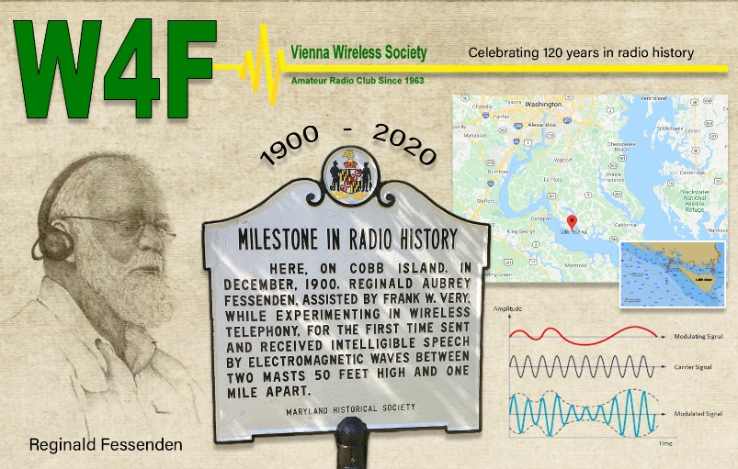

We at Vienna Wireless are hosting a special event, **W4F**, from **18-24 December**.  We are celebrating the 120th anniversary of the first voice transmission by wireless.  It was done by Reginald Fessenden on Cobb Island, which is just south of us here on the Potomac River, on 23 December 1900.

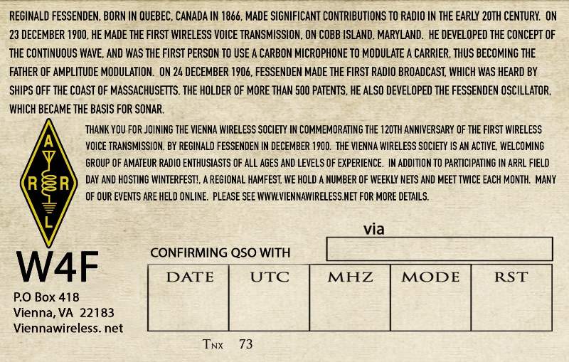He was quite an inventor and electronics expert.  He made the first radio broadcast on Christmas Eve 1904, and was the inventor of the precursor to SONAR, as well as the first to use a carbon mike to transmit AM.

We plan to have club members operate from their home stations on all bands, and all modes throughout the week.

* **12/01/2020 | Best DAM Christmas**

**Dec 1-Dec 31, 0001Z-1159Z, KE0TGG**, Edwards, MO. D.A.R.K. Dam Amateur Radio Klub. 28.440 14.240 7.240 3.840. Certificate & QSL. Roger Henley, 32018 Hwy 7, Edwards, MO 65326. [https://damark.org](https://damark.org/)

* **12/04/2020 | Pearl Harbor Day Commemoration**

**Dec 4-Dec 14, 1300Z-2200Z, W2W**, Baltimore, MD. Amateur Radio Club of the National Electronics Museum. 14.241 14.041 7.241 7.041. Certificate & QSL. W2W-Pearl Harbor, PO Box 1693, MS 4015, Baltimore, MD 21203. Amateur Radio Club of the National Electronics Museum (ARCNEM) will operate W2W in commemoration of the anniversary of Pearl Harbor Day and the role of electronics in WWII. The Museum is closed, so Club members will work the Special Event from their home stations. Primary operation will be Dec 4-Dec 7 with additional operation possible during the Dec 8-Dec 14 period, as operator availability permits. Operation on 80M (3.541, 3.841) and digital modes possible during event. Frequencies +/- according to QRM. QSL and Certificate available via SASE; details at [ww-2.us](http://ww-2.us/)

* **12/05/2020 | Celebrating the 21st Amendment to the US Constitution**

**Dec 5-Dec 6, 0500Z-0500Z, W8A**, Kent, OH. Breweries On The Air. 14.240 7.240. Certificate. Thomas R Sly, WB8LCD, 1480 Lake Martin Dr., Kent, OH 44240. [www.breweriesontheair.com](http://www.breweriesontheair.com/)

TOP ^

* **12/05/2020 | Christmas in Bethlehem**

**Dec 5, 1300Z-2200Z, W9WWI**, Bethlehem, IN. Clark County Amateur Radio Club of Indiana. 14.240; all bands, all modes. Certificate. W9WWI , P.O.Box 201, Sellersburg, IN 47172. Celebrating A safe and healthy Christmas in Bethlehem. SASE please. [https://www.clarkcountyarc.org](https://www.clarkcountyarc.org/)

* **12/05/2020 | Woronoco Heights Outdoor Adventure/SCOTA**

**Dec 5, 1300Z-1900Z, W1M**, Russell, MA. Western Mass Council--BSA. 14.290 14.060 10.115 7.190. Certificate. Tom Barker, 329 Faraway Road, Whitefield, NH 03598. All logging is done on paper and then uploaded to LoTW and eQSL. A QSL card can be had for a 4x6 SASE. W1M will operate on Brandmeister TG 3100 for demonstration purposes. Expect to see different call signs. Covid-19 may interrupt this event.

* **12/07/2020 | Pearl Harbor Remembrance Day**

**Dec 7, 1600Z-2130Z, W5KID**, Baton Rouge, LA. Baton Rouge Amateur Radio Club. 14.250 14.035 7.225 7.035. QSL. USS KIDD Amateur Radio Club, 305 S. River Road, Baton Rouge, LA 70802. Operation aboard the USS KIDD (DD-661). WW II Fletcher class destroyer. [qrz.com/db/w5kid](http://qrz.com/db/w5kid)

* **12/10/2020 | Commemoration of the Birth of PSK31**

**Dec 10-Dec 20, 1700Z-1700Z, K9Z**, Rochester, IL. Sangamon Valley Radio Club. 14.070 7.070; all bands, all modes. QSL. J. Mitch Hopper, K9ZXO, 536 E. Mill St., Rochester, IL 62563. All conversational modes will be used - all bands. [www.qrz.com/db/k9z](http://www.qrz.com/db/k9z)

* **12/12/2020 | USS Midway Museum Ship Special Event: Commemorating Pearl Harbor Remembrance Day**

**Dec 12, 1700Z-2359Z, NI6IW**, San Diego, CA. USS Midway (CV-41) Museum Ship. 14.320 7.250 14.070 (PSK31) D-STAR on various reflectors. QSL. USS Midway Museum Ship (COMEDTRA), 910 N Harbor Drive, San Diego, CA 92101.

***“ARES Connect”***

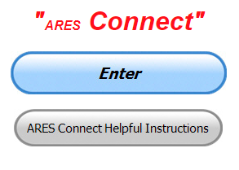

***Connecting Amateur Radio Volunteers with a Purpose***

Hey everyone… please make sure to go in and register your time to all of the events that you have signed up for. Be honest about the time spent. Don’t forget to get this done no later than **5 days** after the event has ended. I’m asking you to do this for our ability to run reports accurately.

**I want to remind all of you that you do not have to be an ARES or ARRL member to use this system. All licensed amateur radio operators throughout the country are welcome and strongly encouraged to use it.**

**Don’t forget to check out the “Frequently Asked Questions” area that has been added to the Ohio Section website.** It’s there to help you through any difficulties that you may have with ARES Connect. Now, if you don’t any posts that relate to what you are having difficulties with, we now also have an on-line “Guru” area as well. This will allow you to ask any questions that you may have about ARES Connect.

**Let’s get everyone on “ARES Connect!!!”**

####

TOP ^

***The Red Cross EmComm Fall Drill 2020 – Summary and Results***

The Red Cross nationwide emergency communications drill was held on Saturday, November 14, with ARES and other operators asked to demonstrate the ability to deliver digital messages using Red Cross forms to specific addresses via Winlink. Participants were tasked with sending one message to the Red Cross Divisional Clearinghouse for their geographic area.

Only Winlink-generated messages were requested. This drill was an exercise in sending messages from local sites to one of seven Divisional Clearinghouses (that is, one for each of the six Red Cross Divisions, plus Hawaii) both to practice and to demonstrate the capability of amateur radio operators across the nation to relay information in times of need.

This drill used the messaging program Winlink as the method of delivering preformatted messages. Operators were free to use any connection mode that they had available, including the variety of digital modes on HF, VHF, UHF and Telnet.

The goal was to encourage more operators to become familiar with Winlink and its associated message templates. The primary message template for this exercise was the ARC-213 found in the Winlink catalog of forms templates. This message format allows for standardized messages to be sent and allows for the messages to be easily evaluated for correctness.

The drill started at 9:00 Eastern time and continued until 18:00 local time in each time zone. Thus, there was a 9-hour window for each operator to create and send his/her message.

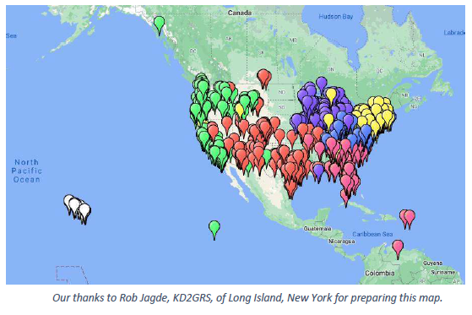After many hours of number-crunching by our Divisional Clearinghouse managers, the results are in… a staggering 1,750 messages were sent by 1,550 amateur radio operators in forty-seven states, plus Puerto Rico, Venezuela and Canada.

This is about twice the number of the very successful first Drill in Spring of 2020.

The map shows the locations of the participating radio operators.

For a zoomable map, go here:

[ARC Drill 2020-11-14 - Google My Maps](https://www.google.com/maps/d/u/0/viewer?ll=10.050625266534123%2C0&z=2&mid=1Ep-rXb_aOExZAZSlXb0Jx6DRyRuqgfp4)

The Red Cross EmComm Steering Committee will begin planning for 2021 Spring and Fall Drills soon. The very popular Winlink training and practice sessions, called Winlink Thursdays, will continue on at least a monthly basis going forward.

An important goal is to continue to raise the bar for Winlink Proficiency and Bill McFarland’s (N0AXZ) Winlink Thursdays are instrumental in this.

There will be a follow-up report with lessons learned and additional information in the near future.

TOP ^

***From the Section Emergency Coordinator***

***Stan Broadway, N8BHL - SEC***

[broadways@standi.com](mailto:broadways@standi.com)

***First snowstorm***

You all know how the winter storm / snowfall forecasts can vary wildly, and the first storm of the season will be no different.  While it’s simply too early and there are too many variables to build a solid forecast, it looks like everyone will see snow and windy conditions- can it be a major storm?  I have no clue, but this is a good time to make ready in case it grows into more than we’d bargained for.

Earlier forecasts called for a significant amount of snow- perhaps 6” with windy conditions and gusts to 40.  You can imagine especially as the first winter storm of the season some motorist would yell, “Everybody to the ditches!!” and life would get difficult. Thankfully, that’s being toned down now, with the latest forecast discussion:  (Note: “ensemble” refers to the computer models. DGZ lift involves air temps and lift that are needed to create snow)

**Wilmington:**

(T)he most likely scenario is for this storm to bring a swath of moderate accumulations centered from approximately from the Whitewater Valley of Indiana, northeast into west central Ohio, with a more widespread lighter accumulation over many areas south/east of that line with lightest amounts / least potential across south central Ohio and northern KY.

Vast majority of ensemble members are coming around to this - with considerations to warm soils, lack of deep DGZ lift, and long-duration mostly light to moderate rates. Still enough uncertainty and potential for higher accums and disruptive impacts to pay close attention through the weekend, but it seems the dramatically high amounts that we had seen in deterministic runs and some ensemble members in the last 48 hours are becoming few and far between.  But with phasing systems, need to maintain awareness on trends until confidence increases.

As the winter weather moves from southwest Ohio to the east, it begins to affect the eastern and northeastern part of Ohio.

**Cleveland:**

So, to summarize:

*It will rain much of Monday, transitioning to snow Monday night

*Snow could potentially last into Tuesday night and even Wednesday for some areas

*Confidence is high that much of the area will receive at least a few inches of snow Monday night through Wednesday

*There is potential for significant snowfall accumulations, but many things will have to come together for that to happen

*Now is the time to prepare. Get the winter gear ready, and make sure your snow blower is ready to go!

TOP ^

**WHAT WE PLAN**

The initial forecasts had this building with very windy conditions into a situation that could have been dangerous. Now, as the forecasts and computer models get more accurate the predictions have back off considerably to just the first seasonal snow.

So, it’s a good time to review our ‘standard’ winter plans!

In the case where we do get into dangerous wind and accumulations, we would opt to open our digital nets in order to provide information to the Watch Desk at the Ohio EOC.  Typically, we’d only be listening for reports, but we would want to establish a presence there for the Sarge.  Here’s what you could expect:

* First priority is to your local weather net with your reports
* Any significant snow/wind or other storm effects (blocked roadways, wide area outages, sheltering) would be valuable for us
* Weather-related band noise permitting, we would try to operation 3.902 but would depend more on digital voice.  We would begin very informally, mostly just listening to DMR 3139 statewide, and if available Fusion Ohio Link.
* If the situation got really out of control (think 1978), we would bridge DMR and Fusion and launch a more controlled net.

Incidentally, the same criteria can be applied to widespread flooding as we sometimes experience in Ohio.

In this case where we ‘only’ have a few inches of snow I don’t expect any need for statewide activity. With warm ground I wouldn’t expect it to last very long after the storm passes. You may become involved in either scenario with your local weather nets- so by all means be ready with charged batteries and plans for winter driving in mind!

We do have enough lead time that we can get the winter supplies into our vehicles, check everything we need to and of course rid the grocery stores of eggs, bread, and milk (A “French Toast” Storm!)  My best advice is just watch the forecasts this weekend and be ready.

Anybody needs me, I’ll be out making snow angels.  Have fun, and be safe!!

-Stan

***Matt’s Corner***

*(C. Matthew Curtin* [*KD8TTE@arrl.net*](mailto:KD8TTE@arrl.net)*)*

***Buckeye Net Achieves High Performance***

***With Mixed-Mode and Cross-Band Operation***

Last week we started the discussion of 60-meter (5 MHz) operation. It’s the right frequency for NVIS propagation during our NTS Cycle Two (13:00 local time) operation under current operating conditions. It has some advantages in the ability to mix digital and phone emissions on the same channel, but has limitations in number of available channels and stations able to use it. This week we’ll pick up to show how we use 60 meters for voice control of the net and transmission of bulletins for all stations, then concurrently work on 75 and 80 meters.

TOP ^

Picking up net status from last week, let’s suppose that we now have a net where we’ve got stations and status:

AAA District 1 rep completed transmission of the bulletin for all stations.

EEE District 5 rep received the bulletin from AAA.

III District 9 rep received the bulletin from AAA but is missing block 2.

JJJ District 10 rep has a message for a site in District 1.

Net control can now direct AAA to take JJJ to channel 80F1, try to establish contact with MFSK64, and take traffic. AAA replies “going,” JJJ replies “going,” and both move to the frequency and configuration specified in the net’s signal operating instructions (SOI) document as 80F1. AAA (the receiving station) calls JJJ (the sending station) with MFSK64, either using a handy macro (“READY”) from BNM or with a terse signal for ready: JJJ DE AAA QRV

If the transmission isn’t answered and decoded properly, the station makes the call again, moving to a narrower and more robust version of the protocol, MFSK32 and sends ready/QRV again. If that doesn’t work, the receiving station steps down again to MFSK16 and sends ready/QRV a third time. If there’s no success after three times, the station leaves 80F1 and returns to the net control channel and reports “no joy.” The sending station does the same after allowing for enough time for three transmissions or hearing the transmissions but not being able to decode. In any case, the stations are now back on the voice channel and can talk with the net control operator about what was happening and work out whatever alternative they need, and try again, perhaps on 40 meters, or using a more robust albeit slower mode like OLIVIA.

In any case, once contact has been established, the sender transmits the message in the mode where contact was made with FLAMP, the recipient uses the FLAMP (receive tab) “Report” button to issue a report of reception, indicating any missing blocks. The sender can use the Transmit tab’s “Fetch” button to parse the transmission, and have the missing blocks fill into the “blocks” field. (If it doesn’t work, the user can manually enter them, separating block numbers either by space or comma, and using 0 [zero] for the preamble.) The sender then can hit the “Xmit” button again and now only the missing blocks will be sent. The receiver’s FLAMP will take good blocks and put them into the message, assembling the message.

Stations can do this back and forth until the message is complete. (BNM procedure is to stop after three transmissions for relaying traffic just like for establishing contact. If it doesn’t work by then, procedure is to return to net control channel to talk about what’s happening and see if there’s a better way to get the job done.)

After net control directed AAA and JJJ to 80F1, net control directed III to take EEE to 80F2, establish contact with MFSK64, and then to send a report and get fills from EEE.

All while AAA is taking the message from JJJ on 80F1, III was able to complete the bulletin by having EEE use the “Fetch” button in the Receive tab (or manually populate the “blocks” field), then hit the “Relay” button. EEE then transmits only the blocks that AAA needs, and as a “relay” rather than original transmission so that AAA’s FLAMP recognizes the blocks as part of a transmission that it already has in part. AAA hits “Report” in the Receive tab and they continue this until the entire message is complete and reassembled at AAA, when the “Report” instead of listing missing blocks says CONFIRMED.

Particularly when conditions are bad, net control may and often will direct other stations to make calls for stations for the net. (See, C. M. Curtin, “Net Control in Poor Conditions.” QNI Newsletter. September 2020, pp. 3-6. <https://qninewsletterdotnet.files.wordpress.com/2020/08/qni-2020-9.pdf>)

TOP ^

Net calls don’t necessarily need to take place on the net’s main control channel. For example, in our 60-meter operation, we know that we’ve got stations who can listen to but cannot transmit on 60 meters. As we’ve been practicing in the last week, as the net is being called up, net control can send a station joining the net off to another frequency, on another band, to call for stations there. Again, having an SOI helps us here.

If net control (NCS) has station AAA in the net on 60 meters, a station that listens on 60 but cannot transmit there can be relayed into the net: NCS: AAA - this is NCS - Call for stations on 75P - over

AAA: AAA Going

The monitoring station HHH heard the instruction and knows to go to 75P. Then we have:

AAA: Any Buckeye Net Station - this is AAA - Stations for the net? - over

HHH: AAA - this is HHH - Ohio ARES District 8 - no traffic - over

AAA: HHH - this is AAA - Roger - you are in the net with no traffic - wait - out

After finishing calls for stations, AAA returns to the net’s control channel and when net control calls for returning stations or is otherwise not engaged, AAA relays in the stations and status.

AAA: NCS - this is AAA - Joining the net is HHH - district 8 - no traffic - over

NCS: AAA - NCS - Roger - out

Now the net has another station, HHH, representing another ARES district, under the control of the net and able to exchange traffic. Since HHH is monitoring, net control can direct HHH to other net channels for traffic exchange.

The question arises: why not do all of this on 75 meters if we need 75 meters to get all of the stations in the net? Remember, we’re operating at a time where the amount of relaying to be done to hold the net together is too great. The most common case is that 60 meters is best, and if AAA cannot make contact on 75 meters with HHH, then station BBB elsewhere in the state might be able to make contact.

The last example for this week: stations that can copy 60 meters digitally but cannot transmit digital signals on 60 meters. Those stations can simply voice report their traffic reception.

AAA transmits a bulletin on the control channel as directed by net control.

EEE hits the Report button in FLAMP Receive tab

III has a rig that can transmit voice on 60 meters but not digital. The station reports by voice:

This is III - missing block 2 - over

At the end of the list of stations able to respond on the control channel, net control sends the 75 meter relay station back to 75P to pick up a voice report from HHH and relay it back on the control channel. Once all of the reports are in, net control can direct the net to complete relay, using any of the channels on any of the bands in the SOI that make sense for completing the fills.

These techniques have demonstrated quite a bit of value. In recent nets running in a relatively slow mode for training, assessment, and discussion our operations have run from 60-90 minutes, with stations from about half of the ARES districts, with operations on two bands, completing sometimes more than 20 message relays.

If you’re interested in training but don’t have the ability to operate on HF at all, you can follow along using an Internet-connected HF receiver and Google Meet. Find a receiver at <http://kiwisdr.com/public/> to find the net and to hear it.

TOP ^

Join the Google Meet (open during the full net on Thursday, Saturday, Sunday, and by request) to watch one of the other stations’ computer screens so you can observe FLAMP and FLDIGI in operation. Ask net control or email me for the code: [kd8tte@pm.me](mailto:kd8tte@pm.me).

Whether you can join by HF or not, we of course welcome you to join our discussion and training on the Internet email list QTC at <https://groups.io/g/QTC>

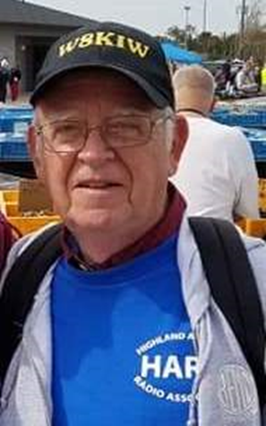***From The South 40***

*(from John Levo,* [*W8KIW@arrl.net*](mailto:W8KIW@arrl.net)*)*

***Post Thanksgiving South 40***

Another clubs Christmas dinner gathering has ‘somewhat’ bit the dust as the **Athens County ARA** has decided to cancel their physical get together in favor of a virtual one via Zoom on December 15. President Eric McFadden, WD8RIF, will provide all members with the log-in details prior to the meeting.

The **Hocking Valley ARA**’s monthly Fox Hunt was won by the team of Nick Arnold, KD8FKB, and his wife. What is neat about this win is that it was done using a tape measure antenna that Nick recently built at an antenna building clinic conducted by the **Athens County ARA**. As the winner of the contest, Nick has the honor of being the ‘Fox’ at a future event.

**Highland ARA** President Jeff Collins, KD8VUY, states that although many communities are cancelling their holiday parades the annual Hillsboro Holiday Parade is still on. HARA members are asked to gather at the Highland County Fairgrounds on December 12 between 3 and 4 to start assisting with the parade line up. Collins says usually a minimum of 10 amateurs are needed to provide the necessary communications for the line-up. The only problem yet to resolve is where they will traditionally gather after the parade to get coffee and eats.

Speaking of parades, the annual Cambridge Elks Christmas Parade is to take place on Saturday evening, November 28. **Cambridge ARA** members assisting with the line-up are asked to be at the Elk’s parking lot at 3 pm to receive their assignments. The Club will also have an entry in the parade. The monthly CARA meeting scheduled for that morning has been cancelled.

Kentucky correspondent Brent Wells, N4BDW, tells us COVID forced the **Greater Mason County ARA** to delay their planned test sessions. However, the club was able to hold its first test session in some time on a past Saturday. The test session resulted in three new licenses and 4 upgrades. Once processed by the FCC new Technician licenses will be granted to Ron Haynie of Kenova, WV; Nathen Howard of Morehead, KY and Daniel Hughes of Maysville, KY. Oral “Rocky” Royse upgraded to Extra and Clay Buser (KO4FYC), Holton Cartmell (KE4LCZ) and Charles Hunter (KN4HFS) now can operate on the General portions of the HF bands. Congratulations to all.

It was great news for our service to learn that brand new hams in Highland, Pike and Ross Counties got on the HF bands and participated in the recent ARRL November Phone Sweepstakes. I’m certain other stations in Southern Ohio, Northeastern Kentucky and Northwestern West Virginia were active too. Not only were only the newer hams active in the contest, but some of us old geezers were in there too.

TOP ^

Looking for something to do between now and the New Year? Why not plan for an enjoyable visit to the **West Chester RC**’s Voice of America Museum and WC8VOA amateur station? It’s scheduled to be open every weekend between 1 and 4 through the end of the year. Or, how about a visit to the **Tri-State ARA**’s Museum of Radio and Technology in Huntington? They too are open most weekends, but it’s advisable to contact them first before making the trip. Both are well worth the journey. Be prepared to be blown away by the exhibits and the tidbits you’ll learn about the history of radio.

The **Clinton County ARA** will hold a physical meeting on Thursday, December 3 at the Foster Boyd Cancer Center in Wilmington. The meeting will begin at 7:30. Health safety requirements will be observed.

Recently some **Highland ARA** members were discussing Ohio’s mail in license plate renewal system and the delays encountered receiving the renewal sticker and registration card. Several felt the need to provide a current copy of your license each year was a reason for the delay. One mentioned he had been waiting for three months and although his check had cleared his bank account and he had received a sticker for a utility trailer, he was still waiting for the ham call sticker for his truck. Another said his local BMV office told him the pandemic was causing a processing backlog of mail-in renewals at the State level, but his expired plate would still be good for at least 90 days.

Another who was making an out of state trip even called Columbus and was told the same. But when he expressed concerns about driving out of state on expired plates, he was not assured other states would recognize Ohio’s extension. With today’s technology wouldn’t it be possible for the Ohio BMV to do something to eliminate this yearly request or electronically cross check the FCC data base? The next time you talk to your State Senator or Representative you might bring the subject up.

***NIMS 300 & 400 Being Offered Virtually***

To All FEMA Region V RECCWG Membership,

On behalf of Paul Hughes, he would like to extend an invitation of the below NIMS Training being offered by our state partner at WI Emergency Management. If you are interested in attending the valuable training sessions, please contact Mr. Kevin Wernet for additional information at the end of this email.

The NIMS virtual training program classes have been posted to the training  portal and are available at <https://www.trainingwisconsin.org/Schedule.aspx>

1. Student attending virtual training will be required to attend an onboarding prior to class. The onboarding session is designed to work through any access issues and ensure students can find documents, move between work groups, and share information with other students. The experience so far has been that the onboarding allows students to focus on the training instead of the virtual platform they are using once class begins. A member of the Exercise and Training Section will contact students to schedule the onboarding sessions.
2. All classes will be set with max of 8 students to a work group or POD to allow maximum interaction while in the online environment. *Note: additional instructors have been added to posted classes to achieve the 1:8 instructor ratio with maximum attendance of 24 students. This may be adjusted as the program matures.*

TOP ^

1. ICS-300 and G2300 have been scheduled as 4 days 6 hours each to meet the 24-hour requirement
2. ICS 400 have been scheduled as 3 days 6 hours to meet the 18-hour requirement.
3. Where feasible G191 has been scheduled as 2 days 4 hours each to meet the 8-hour requirement
4. In addition to the daytime offerings of ICS-300, one reoccurring weeknight 4 hour each night class has been scheduled to meet the MABAS request to accommodate volunteer agencies.

|  |  |  |  |  |  |  |  |
| --- | --- | --- | --- | --- | --- | --- | --- |
| ICS- 300  8:30-3:30  *PM classes 5:30-9:30 |  | Jan  12-15 |  | Mar  23-26 |  | May  11-14 | *Evening MABAS class Jan through Feb= 6 x evenings 4 hours. *Note: While this targets volunteers, all are welcome to sign up.* |
| *Jan 13, 20, 27 Feb 3, 10, 17 |
| ICS-400  8:30-3:30 | Dec  8-10 |  | Feb  9-11 |  | Apr  21-23 |  |  |
| G2300  8:30-3:30 | Dec 14-18 |  | Feb  16-19 |  | Apr  27-30 |  |  |
| G191  8:00-12:00 |  | Jan 20-21 |  | Mar  18-19 |  | May  25-26 |  |

Respectfully, Kevin Wernet, MEP, WCEM (608) 242-3331 [Kevin.wernet@wisconsin.gov](mailto:Kevin.wernet@wisconsin.gov)

***One Question Questionnaire***



Hey Gang,

Survey Says”….. about 34% of you can speak another language. That’s fantastic!!

Ok, now on to the next question… “GivingTuesday” will be this week, Tuesday, 01 December. So, what’s “GivingTuesday”? “GivingTuesday” is a global generosity movement unleashing the power of people and organizations to transform their communities and the world.

Here’s a link to their website to get a more detailed explanation. <https://www.givingtuesday.org/>

“#GivingTuesday” was created in 2012 as a simple idea: a day that encourages people to do good. Over the past seven years, it has grown into a global movement that inspires hundreds of millions of people to give, collaborate, and celebrate generosity. So that’s the inspiration for this next question.…

***“Will you be giving something back on “#GivingTuesday”??”***

TOP ^

You’ll find the “One Question” questionnaire on the Ohio Section Website! <http://arrlohio.org> It’s all in fun and it’s not a scientific survey in any way, but we are learning some things that we didn’t know from these questions. I hope that you are enjoying answering these “One Question” questionnaires.

***Print an Official or Unofficial Copy of Your Amateur Radio License***

*(By Anthony Luscre, K8ZT)*

As of February 17, 2015, the **FCC no longer routinely issues paper license documents** to Amateur Radio applicants and licensees. The Commission has maintained for some time now that the official Amateur Radio license authorization is the electronic record that exists in its Universal Licensing System (ULS). The FCC will continue to provide paper license documents to all licensees who notify the Commission that they prefer to receive one.

Licensees also will be able to print out an official authorization — as well as an unofficial “reference copy” — from the ULS License Manager. I’ve created a set of instructions on how you can request an **“official” printed copy of your license\*** [**Click here to download the instructions**](http://arrl-ohio.org/news/2020/print_your_license.pdf)

*****V.E. Test Sessions***

Many V.E.’s have decided to start testing once again, but with restrictions that need to be adhered to for sure. Here’s the link to find that V.E. Test session and what is expected of YOU before going. <http://www.arrl.org/find-an-amateur-radio-license-exam-session>

***Final.. Final..***

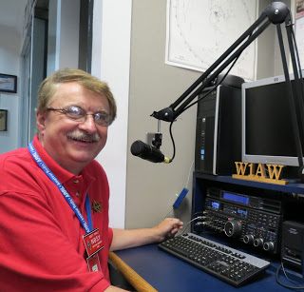

Hi Gang,

I trust most of you did like me on Thanksgiving Day, you gobbled up as much as you could and then waddled over to the easy chair and crashed for the rest of the day!

Normally we’d have a house full of family and kids yelling and screaming as well as the parents screaming at the kids, but not this year. We did have our daughter’s family here and the grandkids are older now, so they know that when grandpa’ falls asleep just to be quiet. Ha..ha.. That’s when the noise level goes from a moderate 120db to around 300db!! They want to make sure ol’ grandpa’ didn’t miss out on anything.

TOP ^

I’m also happy to announce that I didn’t have any accidents this year either. It was definitely a good day for me. Yes, I was reminded by my daughter that just 7 years ago I had to be taken to the hospital for my broken ankle and she was left holding down the fort to finish up cooking and making sure everyone got served (except me of course). I was in the hospital and since I was going under the knife the next morning to have my ankle taken care of, I wasn’t allowed to eat anything all Thanksgiving Day. Oh wait, I was given a real treat around 6pm or so… That’s when they came in with this 2-gallon jug of milky white chalk flavored stuff and said that I had to finish it all up by midnight!! They then told me that if it didn’t do its job, I’d have to repeat it until it did!

Luckily it worked the first time and I had the surgery and I’m now the proud owner of a titanium plate that’s about 2 inches wide and 10 inches long. Oh, to hold the broken bones together I was given 14 stainless-steel screws that were drilled through what was left of my bones into that titanium plate.

Now, you’d thing after all of that that I then could have my turkey dinner, right? Nope, they only served turkey on Thanksgiving Day and of course, my dinner was something much different than that, so no turkey dinner for me! The hospital said that I could get that when I got home. They kept reassuring me that there would be plenty to eat there….

Now you’d think that the family would have some mercy for me laying in the hospital on Thanksgiving with 2 broken ankle bones and would have at least saved me 1 slice of turkey, wouldn’t you? When I got home 4 days later there wasn’t anything to eat at all. They not only ate the turkey, but they ate all the rest as well. No dressing, mashed potatoes, no green bean casserole, and no pumpkin pie!!

I’m here to tell ya’, what they couldn’t eat they took home in doggie bags. I got home and had to be helped up the steps because I was on newly acquired crutches and wasn’t doing all that good with them yet. I was at least expecting to get something to munch on that would take some of the sting out of missing Thanksgiving… Anything left over would have sufficed. Not my luck. I got nothing. The place was plucked cleaner than the turkey they ate! This was the year I didn’t have Thanksgiving and trust me; I’ll go to the bitter end to NEVER do anything like that again!!

I want to report on my tractor for those who are still asking… Yes, I got it back just this past weekend after paying a king’s ransom for it. Wow. I took it in for just on issue, no drive power, and I got it back with a hole bunch of new parts that they also found to be of issue. I did learn one thing from them. When you tell them to go over it and fix what needs repaired, they do just that! They had a bill waiting for me that was 2 pages long with all the stuff they repaired, replaced or adjusted. I didn’t know that you could have such a list for a little garden tractor, but it definitely took a bit out of my wallet. Oh well, with everything that they found and fixed or replaced I should have absolutely no problems next mowing season for sure!

Whelp, that’s going to do it for this week my friends! I’m still looking forward to visiting with all of you live or via Zoom, WebEX or whatever.

I really can’t wait for that time when we can all get together in person once again. Those are the times I cherish the most!!! Stay safe! We will get through this and when we do, we’ll have so much to talk about. Most of all… have FUN and get on the airwaves!!

73,

[***Scott, N8SY***](mailto:n8sy@n8sy.com)

TOP ^



Hey Gang,

Have you taken a look at the **Swap & Shop** page on the Ohio Section webpage yet?? Here’s a link that will take you there…

<http://arrl-ohio.org/sm/s-s.html>

Do you have equipment that you just don’t need or want anymore? Here’s a great venue to advertise it, and it’s FREE!! Is your club doing a fund raiser to help raise money? After a lot of thought, it was decided that the Swap & Shop webpage could also contain these types of items as well. The same rules will apply as do for the For Sales and Give-A-Ways and will only be posted for a month at a time. Please see the Terms & Conditions on the webpage.

If your club is doing a fund raiser and wants more exposure, please forward the information to me and I’ll advertise it on the Swap & Shop webpage for you.

Now, I still want to remind you that it won’t be listed in this newsletter because it would take up way too much space, so your ad will only appear on the website. It is there for any individual to post equipment Wanted / For Sale or Give-Away as well as for Club Fund Raisers. No licensed vehicles/trailers or business advertising will be posted. Postings are text only (no pictures or graphics) will be posted for a maximum of 1 month from date posting and require a contact phone number or email within the posting. Send your Wanted / For Sale or Give-Away post to:  [swap@arrlohio.org](mailto:swap@arrlohio.org)

***Welcome New Subscriber(s)***

**Christopher, KG7UJH**

Ohio Section Cabinet

|  |  |
| --- | --- |
| Section Manager – Scott Yonally, N8SY | Assistant Section Manager – John Perone, W8RXX |
| Section Emergency Coordinator – Stan Broadway, N8BHL | Section Traffic Manager – David Maynard, WA3EZN |
| Technical Coordinator – Jeff Kopcak, K8JTK | Affiliated Clubs Coordinator – Tom Sly, WB8LCD |
| State Government Liaison – Bob Winston, W2THU | Public Information Coordinator – John Ross, KD8IDJ |
| Section Youth Coordinator – Anthony Lascre, K8ZT | |

***Back Issues of the PostScript and Ohio Section Journal***

Hey, did you know that PostScript and Ohio Section Journal (OSJ) are archived on the website? You can go back and look at any edition simply by clicking:

<http://arrl-ohio.org/news/index.html>

TOP ^

***Want to Share your Club Newsletter With Others?***



We have a webpage where you can download and read all of the newsletters that I get from around the state and even other sections!

Here’s the link to the page…. <http://arrl-ohio.org/club_news/index.html>

Please, if you don’t see your club newsletter posted, it’s because I’m not receiving it. Just have your newsletter editor contact me and I’ll get your club’s newsletter listed on the site!!

We all learn and steal (I mean, share) from each other’s work. So, get me your newsletter!!! Send it to: [n8sy@n8sy.com](mailto:n8sy@n8sy.com)

***Chit – Chat, and All That!***

Do you know someone that’s not getting these Newsletters? Please, forward a copy of this Newsletter over to them and have them “[Opt-In](mailto:Opt-In)” to start receiving them. Heck just have them send me an email [n8sy@n8sy.com](mailto:n8sy@n8sy.com) and I’ll get them added to the Ohio Section Emailing list.

We now have many thousands of readers receiving these newsletters weekly. Quite impressive, I’d say! I urge all of you to make sure that everyone, regardless of whether they are a League member or not, get signed up to receive these weekly Newsletters.

You can always “Opt-Out” at any time if you feel this is not what you were expecting. It’s fun and very informative. All of your favorite past newsletters are now archived too.

You can go back at any time and read them. Just go to: <http://arrl-ohio.org/news/>

Got questions, concerns or would just like to sit and chat awhile? Heck, I’ll even buy the coffee!! Give me a call at (419) 512-4445 or email me at: [n8sy@n8sy.com](mailto:n8sy@n8sy.com)

The pictures on the front page and throughout this newsletter are from various newsletters, Facebook posts and/or were sent directly to me in recent weeks. Take a good look at them, you just might be in one of the pictures! “SMILE… you’re in the Ohio Section News!!”

TOP ^

*PostScript is produced as a weekly newsletter. I want to thank everyone that has contributed articles and ideas to make this an even better news source. I sincerely hope that you have enjoyed this edition and will encourage your friends to join with you in receiving the latest news and information about the Ohio Section, and news and events happening around the world!*