[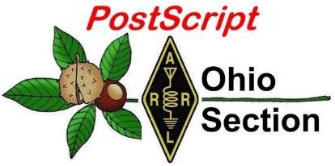](http://arrl-ohio.org/news/) ***“November 16th”***

***Edition***

🡪 [National News](#national) 🡪 [The Handbook Give Away](#handbook)

🡪 [Club Corner](#club) 🡪 Hamfests- None

🡪 [DX This Week](#dx) 🡪 [ARES Connect](#connect)

🡪 [Matt’s Corner](#Matt) 🡪 [VE Testing](#ve)

🡪 [One Question Questionnaire](#one) 🡪 [Final.. Final..](#final)

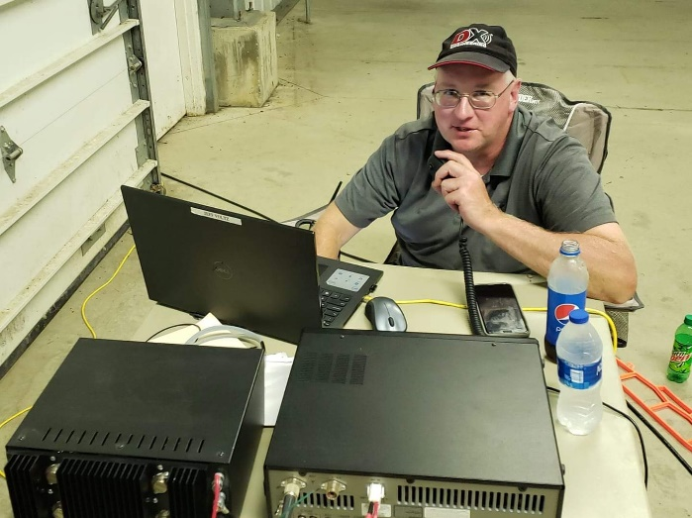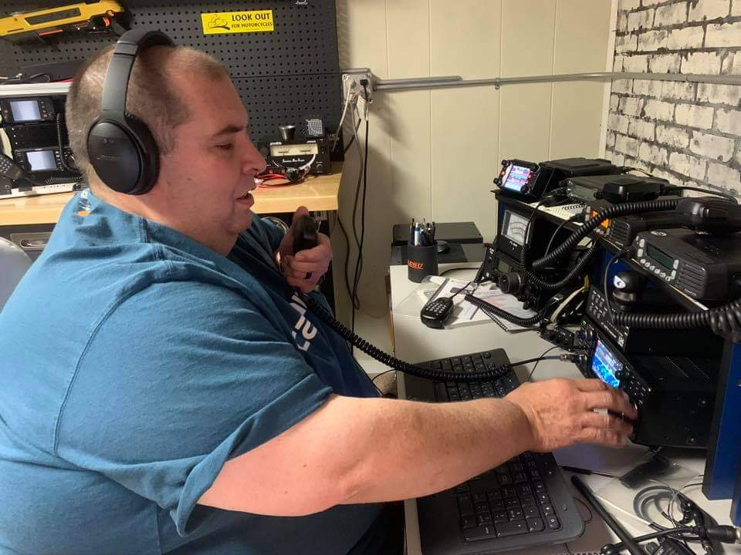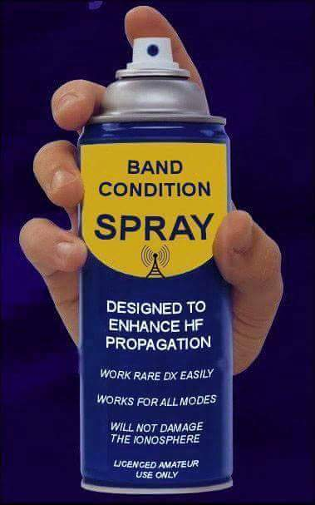

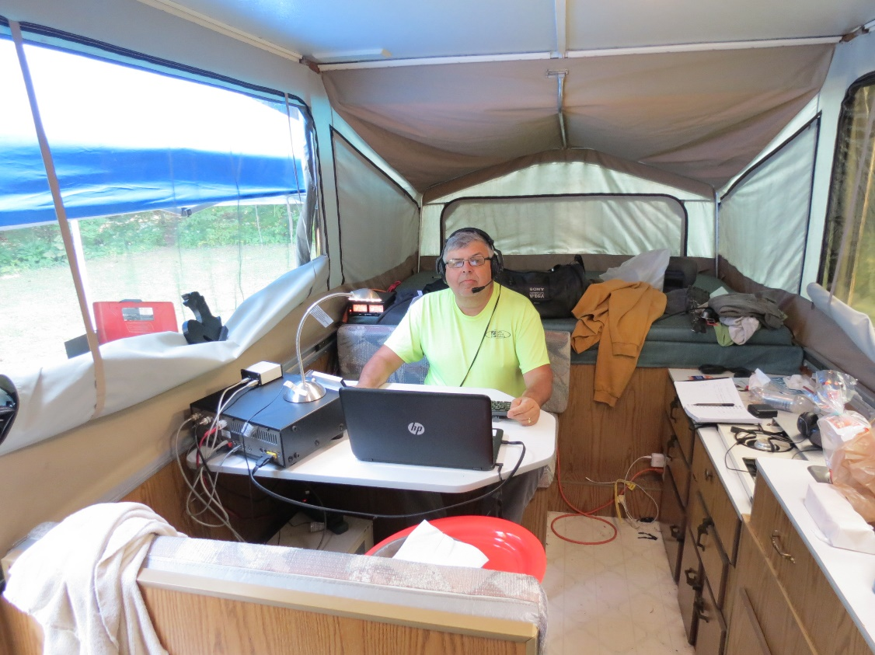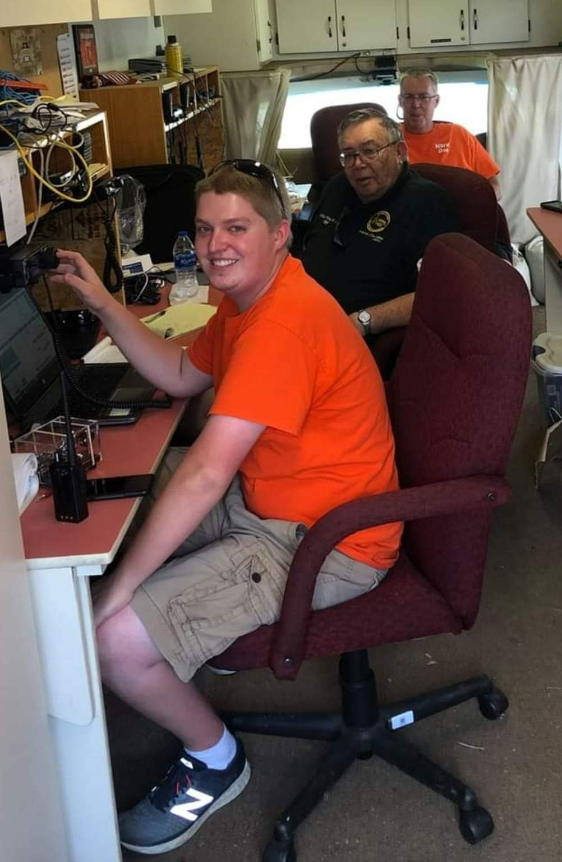

***National News***

*(from arrl and other sources)*

***ARRL Learning Network Webinars***

Visit the ARRL Learning Network website (a members-only benefit) to [register](http://www.arrl.org/arrl-learning-network) for upcoming sessions and to view previously recorded sessions. The schedule is subject to change.

**Amateur Radio's Role at the Boston Marathon Bombing: Steve Schwarm, W3EVE**

Amateur radio has played a significant role in public service communications forthe Boston Marathon for several decades. That role was put to the test in 2013 when two bombs were exploded near the finish line. This presentation will describe the role that ham radio played at the marathon and how that role changed due to the bombing.

**Tuesday, December 8, 2020, 10 AM PST / 1 PM EST (1800 UTC)**

**Learn and Have Fun with Morse Code: Howard Bernstein, WB2UZE, and Jim Crites, W6JIM**

Morse code, or "CW," is a popular ham radio operating mode. Learning CW does not have to be an arduous or lonely experience. Learn, practice, and enjoy CW with the methods used by the Long Island CW Club.

**Thursday, December 17, 2020, 5 PM PST / 8 PM EST (0100 UTC on Friday, December 18)**

####

***NASA reestablishes contact with 43-year-old Voyager 2***

*(Submitted by Gregory Drezdzon, WD9FTZ)*

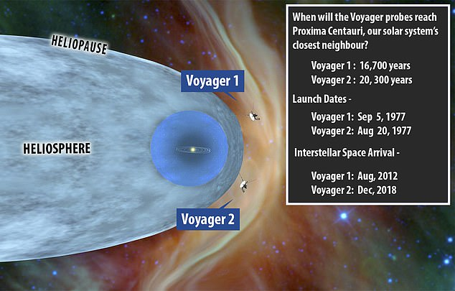

NASA has reestablished contact with its Voyager 2 spacecraft as it travels more than 1.6 billion miles from Earth – after the probe was left flying solo for seven months while repairs were made to the radio antenna in Australia they use to control it.

Mission operators sent a series of commands to the 43-year-old probe using the ground-based Deep Space Station 43 (DSS43) antenna, which established a signal confirming the ‘call’ was received.

[TOP](#top) ^

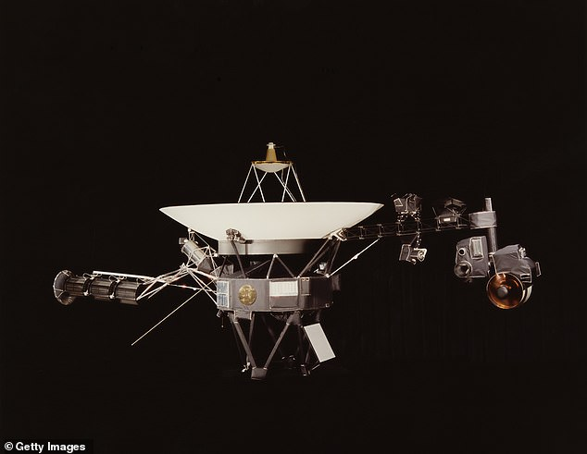

DSS43 had been offline since March while NASA completed a series of hardware upgrades but tested the new components by sending commands to the craft.

However, due to the distance, the ground team had to wait more than 34 hours for a reply – but Voyager 2 received the commands and sent back a ‘hello.’

To read the full story, see—

<https://www.dailymail.co.uk/sciencetech/article-8909935/NASA-reestablishes-contact-43-year-old-Voyager-2-11-6-BILLION-miles-Earth.html?ito=social-facebook&fbclid=IwAR3qeGovuZ4ujqlTK4A-NFG57HkobFM2066oaJFqNtUn0RUhigzG81U_iPE>

####

***Low-Frequency Station SAQ Broadcasts UN Day Message of Unity in Face of COVID-19***

On United Nations Day, October 24, the Alexanderson alternator station SAQ in Sweden transmitted a message on 17.2 kHz urging unity in the face of the COVID-19 pandemic. The message transcript follows.

"CQ CQ CQ DE SAQ SAQ SAQ This is Grimeton Radio/SAQ in a transmission using the Alexanderson 200 kW alternator on 17.2 kHz. The global COVID-19 pandemic challenges people and nations to unite to minimize the negative consequences for individuals and societies, and to uphold the advancements in public health made in recent decades. Good health and wellbeing is a prerequisite for a peaceful and sustainable global development, and health equity cannot be achieved without peace and human security."

The message was signed by Anders Tegnell, chief epidemiologist of Sweden's Public Health Agency. SAQ notes that QSL information is on the [Alexanderson alternator website](http://www.alexander.n.se/).

SAQ received some 400 listener reports from all over the world, with just 20 reporting they were unable to copy the message.

"As usual, we have received very many reports from north, central, and eastern Europe," the SAQ report said. "We also have received reports from the US and some from Russia and Japan. The farthest reports comes from Tasmania, south of Melbourne, approximately 16,000 kilometers (9,942 miles) from Grimeton, Sweden."

The entire [transmission event](https://www.youtube.com/watch?v=OErGFaT1esI&feature=youtu.be) was also broadcast on the SAQ YouTube channel, with some technical problems experienced.

[TOP](#top) ^

Following the United Nations Day transmission, singer [Anna Louise Ekman](http://www.annalouiseekman.se/) performed a concert in the transmitter hall with songs in Swedish and Italian. She was accompanied by her pianist, Oscar Johansson, and her sister, violinist Åsa Grimberg.

####

***1,900 plus mile contact made on 433 MHz from St.Helena to South Africa***

*(Submitted by Gregory Drezdzon, WD9FTZ)*

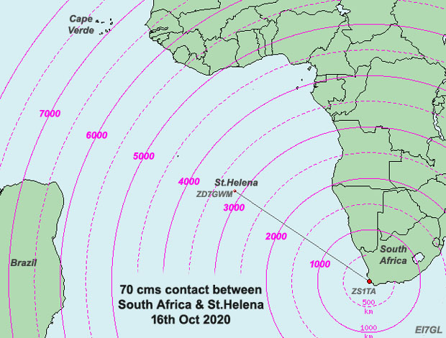

On the October 16, 2020, there was a remarkable contact made on the 70cm band between South Africa and St. Helena in the South Atlantic.

The contact at 433 MHz was made between Garry, ZD7GWM, on St.,Helena Island and Tom, ZS1TA, in South Africa. The distance was approximately 1,948.6 miles and what was even more amazing was that the contact was made using FM!

To put this remarkable contact on 70cm into context, the 1,948.6 mile distance is equivalent to the path across the North Atlantic between Newfoundland and Ireland. It is believed that the mode of propagation was probably a marine duct.

More information is at:

<https://ei7gl.blogspot.com/2020/11/3000km-plus-contact-made-on-433-mhz.html>

Related story of a 3,293.2 mile Trans-Equatorial Propagation SSB contact 144 MHz contact in November 2020:

<https://ei7gl.blogspot.com/2020/11/5300km-tep-opening-on-144-mhz-between.html>

####



***20th anniversary of first ham radio operation from ISS***

*(Submitted by Gregory Drezdzon, WD9FTZ)*

On November 13, 2000, the International Space Station Expedition-1 crew turned on the ARISS Ericsson radio for the first time. Several contacts were completed with ARISS ground stations around the world to validate the new radio communications system 

These inaugural contacts launched an incredible two-decade operations journey on ISS, enabling ARISS to inspire, engage and educate our next generation of explorers and provide the ham radio community a platform for lifelong learning and experimentation.

[TOP](#top) ^

In celebration of the ISS 20th anniversary, ARISS was part of an ISS Research and Development Conference Panel session entitled “20 years of STEM Experiments on the ISS.”  The video link below, developed for this panel session, describes our program, celebrates our 20th anniversary, conveys some key lessons learned over the past 20 years and describes the ARISS team’s vision for the future.

<https://www.youtube.com/watch?time_continue=2&v=r73xSHwA9Vg&feature=emb_logo>

******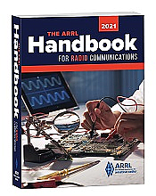***Thanksgiving Handbook Give Away***

Hey Gang,

Have you registered for the “Handbook Giveaway” drawing yet? If you haven’t, go to: <http://arrl-ohio.org/handbook-thanksgiving.html> and get registered.

Hey.. We’re gonna’ have some extra fun this month. If you register before November 26th (Thanksgiving) you’ll be eligible for a special drawing on Thanksgiving morning. Yup.. I’m going to give away an additional Handbook just to make someone’s Thanksgiving really Thankful!! Will it be you? Who knows!! One thing is for sure, if you don’t register, you can’t win!

And…. This month, if you register early, before Thanksgiving, you’ll have 2 changes at winning a book. We won’t dump the entries from the Thanksgiving drawing. We’ll keep them and continue to take registrations until the end of the month! This gives you 2 changes at winning!!

What’s the catch? I want to get everyone checking in to the Ohio Section website as often as possible, and in order to register each month, you have to visit the website often! There’s nothing else to it!!

[](http://arrl-ohio.org/handbook.html)Many of you ask me just how do I know when the drawing is on? Well, that’s easy all you need to do is check in on the Ohio Section Website on a regular basis and watch for the big **RED** Arrow that will appear on the left side of the page. This is the sign that the drawing is on and you need to get registered. So, keep a sharp eye out on the website and check in often! <http://arrl-ohio.org>

***Club Corner***

***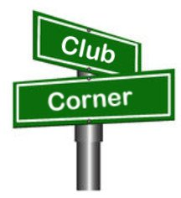***This is YOUR cornner of the newsletter. Send me what your club is doing and I’ll make sure that it gets in. Got a special event or club project that you want everyone to know about? Send it to me!. Need help with a project? Send it to me.

Let me know what you club is up to. Are you going to have a special guest at your meeting or are you having a special anniversary? Just sent it to: [n8sy@n8sy.com](mailto:n8sy@n8sy.com)

####

[TOP](#top) ^

***Is It Time For Your Club To Submit Their Annual ARRL Club Affiliation Report?***

The Ohio Section has 114 active Affiliated Clubs and with the year starting to come to a close, I thought it might be a good time to put this reminder about making sure your club has done its annual report in the newsletter. Is your club listed below? If it is then you need to contact your club officers and let them know that they need to go in and do their club’s annual report because it’s either past due or coming close to the time it needs updating.

This is really important to your club to keep this record updated so that new folks as well as others know how to contact you if needed. Why should we care about that?

Over the years I’ve received phone calls from folks taking care of estates and such and are looking for a club near them to donate equipment and such. This has been very beneficial to several clubs, as that in one instance it netted them a complete new Icom HF and VHF station.

Who needs to be the one to update the record? Any of the officers of your club. Not sure how to do this? It’s very quick and easy to do. You do need to be logged into the ARRL website as a user. So, if YOUR dues are due, please make sure that you’ve taken care of that first!

Here’s a link to get you started. <http://www.arrl.org/Groups/view/grant-amateur-radio-club/type:club> just click on the “edit” button in the upper right-hand corner of the page, make any changes necessary and then click the “Submit” button. That’s all there is to it. The following are the clubs that need attention at this time.

|  |  |
| --- | --- |
| Voice Of Aladdin ARC | North Coast Contesters |
| SUNDAY CREEK AR FEDERATION | Dial Radio Club |
| OHIO UNIVERSITY AMATEUR RADIO CLUB | TOLEDO RADIO AMATEUR CLUB |
| Wood County Amateur Club | SOUTHWEST OHIO DX ASSOCIATION |
| MORROW COUNTY AMATEUR RADIO SERVICE | Henry County Arc Inc |
| MAD RIVER RADIO CLUB | Newark Amateur Radio Assn |
| CASE AMATEUR RADIO CLUB | GEAUGA AMATEUR RADIO ASSOCIATION |
| NOT QUITE WORKABLE CONTEST CLUB | Lake County ARA Inc |
| ARC OF OHIO STATE UNIVERSITY | PORTSMOUTH RADIO CLUB |
| Conneaut Amateur Radio Club | Franklin County Ohio ARES |
| Ottawa County ARC | CENTRAL OH SEVERE WEATHER NET |
| Dayton Amateur Radio Assn | KENTON AMATEUR RADIO CLUB |
| Preble Amateur Radio Assn | FIRELANDS AMATEUR REPEATER ASSOCIATION |
| BUTLER COUNTY AMATEUR RADIO ASSOCIATION | CLARK COUNTY ARA |
| Crawford County ARC | Goodyear Arc |
| GRANT AMATEUR RADIO CLUB | Southeast Amateur Radio Net |
| WILDERNESS OUTBACK DX CREW | TOLEDO MOBILE RADIO ASSOCIATION |
| BUTLER COUNTY VHF ASSOCIATION | Miami County Arc |
| HAMILTON AMATEUR RADIO CLUB | VAN WERT AMATEUR RADIO CLUB; INC. |

[TOP](#top) ^

|  |  |
| --- | --- |
| JACKSON COUNTY AMATEUR RADIO CLUB | FULTON COUNTY ARC |
| Lancaster & Fairfield Cty ARC | FULTON COUNTY ARC |
| Bearcat DX Club | FULTON COUNTY ARC |
| Morgan Amateur Radio Club | DeForest ARC; Inc. |
| Portage ARC Inc | 20 OVER 9 RADIO CLUB INC |
| WESTERN RESERVE AMATEUR RADIO CLUB | |

***DX This Week***

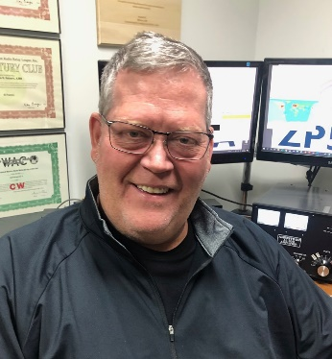*(from Bill, AJ8B)*

***DX This Week – Zones 30, 31, and 32***

***Bill AJ8B (aj8b@arrl.net, @AJ8B, or www.aj8b.com)***

***CWOPs Member #1567***

Here were the spots for the past week that were seen in the Midwest: Argentina, Azores, Belgium, Belize, Brazil, Canada, Canary Islands, Corsica, Croatia, Cuba, Dominica, Dominican Republic, Fed. Rep. of Germany, Fiji, Finland, France, Gabon, Hawaii, Hungary, Ireland, Italy, Kenya, Malawi, Mali, Mauritania, Mexico, Montenegro, Morocco, Netherlands, New Zealand, Northern Ireland, Oman, Panama, Peru, Poland, Puerto Rico, Reunion Island, Scotland, South Africa, Spain, Sweden, US Virgin Islands, Venezuela, Western Sahara, and Zambia. A little bit more each as we move up the Solar Cycle. A couple of you have dropped me a note about these spots. I am glad that you like to see what is going on!

I did receive QSL cards from EI9FVB, Declan in Cork, Ireland, and SV1EAG, Hilas in Greece. Let me know what you received.

|  |  |
| --- | --- |
|  |  |

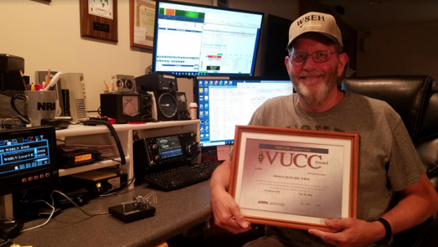

***Congratulations to Ernie, W8EH***

*Below is what Ernie submitted regarding his VUCC Satellite award to the Dial Radio Club newsletter a few months ago. To the right is a picture of Ernie with his certificate sitting in his upstairs shack.*

*Last week he received a confirmation letter that his WAZ mixed award (first time) has been approved and waiting for printing. Well done Ernie!*

[TOP](#top) ^

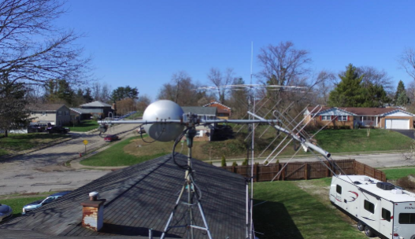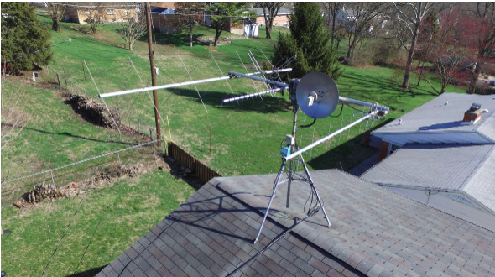Ernie W8EH has been a long-time satellite operator. The first satellite contact was in 1978. That was before computers calculated orbits for us. Back then we had to get orbital information from the ARRL bulletins and use a paper and plastic “Oscar Locator” to plot the orbits. Things have changed for the better. Now the W8EH station has steerable beam antennas controlled by computer. And the radio frequency adjustments are also controlled by the computer. The longest contact was with a station in New Zealand using the high orbit Oscar 40. That satellite had a 2.4 GHz downlink and required a good dish and down converter to hear it.

Ernie has been gathering grid squares and finally was able to get 100 confirmations for VUCC Satellite by using the ARRL Logbook of the World online QSL system. The 100th satellite grid contact was with a station in Scotland using the new Russian linear satellite RS-44.

W8EH’s other satellite awards include the Oscar Satellite Communications Achievement Award, and the 51 on AO-51 award.

***DAH DIT DIT DIT DAH DAH DIT DIT DIT DAH***

This week I am reprinting the interview with Andrey, R2FAQ. This originally appeared in the Southwest Ohio DX Association newsletter, *The Exchange.* Hope you enjoy this.

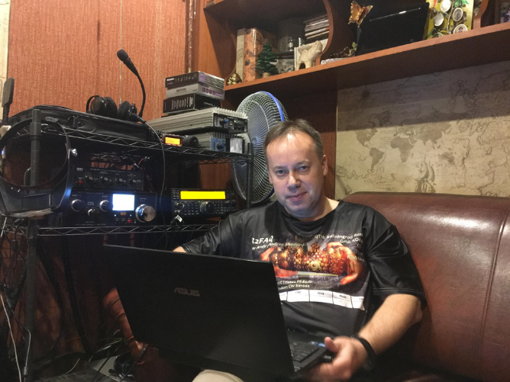Interview with Andrey, R2FAQ

*I worked Andrey and checked out his QRZ.com webpage. I was amazed at the information he posted and the projects he has taken on. He was kind enough to answer my questions and more!*

**AJ8B:** How did you first get interested in amateur radio?

**R2FAQ:** Back in 1971, when I was 8 years old, my uncle gave me a headset, a diode and a coil of wire. From this I made my first detector receiver. After that, my whole life was closely connected with radio: a collective children's radio station UK2FBJ, a Naval institute with a specialty radio engineer, service in the Navy ...

**AJ8B:** When did you get first get on the air?

**R2FAQ:** After finishing service in the Navy, my professional activity is not connected with radio. My CB-band activity was not enough for me. I felt the need for more radio. Therefore, I passed the exam and received my personal callsign in 2014. I consider 2014 to be my Amateur radio Year of birth, although I started on the collective radio station in the 1970s.

[TOP](#top) ^

**AJ8B:** Do you have a favorite band or mode?

**R2FAQ:** Statistics show that I have the most connections at 20 meters, in digital, in FT-8.

Taking this opportunity, I want to thank Joe Taylor and the entire development team for the excellent work in promoting digital communications.

**AJ8B:** In reviewing your QRZ.com page, I see that you have been very successful with chasing countries and with contests. Any secrets to your success?

**R2FAQ:** I rarely participate in contests. Successes came by themselves. There are no special secrets, but I try to spend at least an hour or two behind the transceiver every day.

**AJ8B:** What license levels do you have in Kaliningrad?

**R2FAQ:** According to the Russian classification, I have the 2nd category, which gives me the same rights as the highest - the 1st category, except for the 4-digit call sign, which is important for quick work in contests.

**AJ8B:** Describe what you are currently using:

**R2FAQ:** Transceiver Kenwood TS-590SG, a pair of amplifiers HLA-300, antenna tuner MFJ-962D, phase suppressor MFJ-1026, aviation headphones. Stationary antennas - Windom and Gap Titan DX. For mobile and portable communications - Yaesu FT-857D, with tuner MFJ-941E or LDG Z-11 PRO II, antenna - Opek HVT-600. Of course, several portable UHF/VHF radio stations, including DMR and Sea-band.

**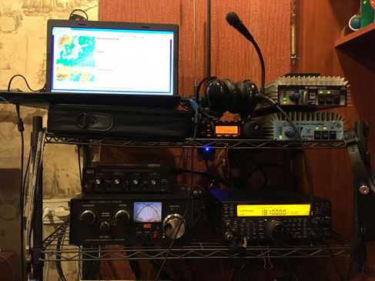AJ8B:** What advice do you have for those of us trying to break pileups to work DX?

**R2FAQ:** Listen, wait for the right moment ... there is no point in trying to shout out the loudest all.

**AJ8B:** Based on your webpage, it seems that you have done quite a bit of antenna work to optimize your verticals, specifically the Gap Titan. Can you tell us what you learned?

**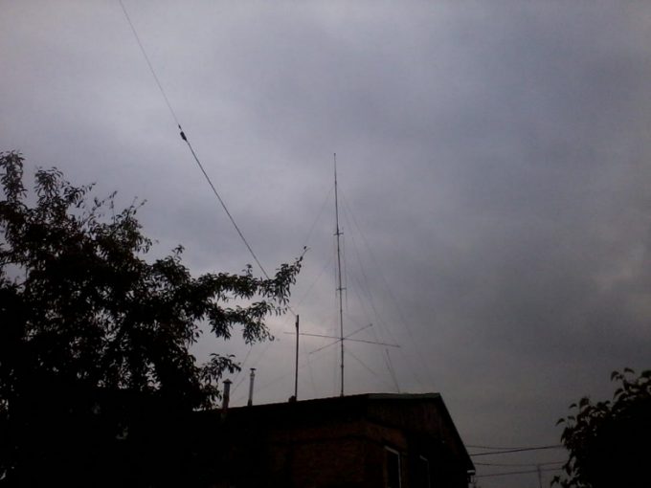R2FAQ:** Unfortunately, I do not have the ability to suspend dipoles at a sufficient height to provide low radiation angles, which is important for DX. Therefore, the choice was among the verticals. Normal GP requires radials that occupy a large area. I was approached by Gap Titan DX - a multi-band asymmetrical vertical dipole. It suits me: low angles of radiation, multi-bandwidth and a small area for its installation. I had to modify my antenna: replace the capacitor at the top with a more powerful and different nominal and play with the length of the elements.

**AJ8B:** Any QSLing hints?

**R2FAQ:** Everything is simple: the exact frequency, exact time, minimally sufficient power and… patience.

**AJ8B:** What coaching/advice would you give new amateurs?

**R2FAQ:** Everybody started and made mistakes. It is necessary to study at any age ... preferably by textbooks, and not by "opinions" from the Internet.

[TOP](#top) ^

**AJ8B:** Thank you for taking the time to answer my questions. Is there anything you would like to share with us?

**R2FAQ:** I want to thank You for the opportunity to speak. I want to wish prosperity to You and SWODXA!

***CQDX CQDX CQDX CQDX CQDX CQDX CQDX CQDX CQDX***

Here is an update from Bernie, W3UR, of the DailyDX and the WeeklyDX, the best source for DX information. <http://www.dailydx.com/> Bernie has this to report:

**3Y/B – Bouvet Island**

The following update was posted yesterday on the Rebel DX Group’s Facebook page…

“We are still pushing with the missing budget ($24300) to finalize last payment for the vessel to make 3Y0I happen. So far (as an international team) we still can’t travel to South Africa due the Covid situation.

Bouvet is not cancelled! All our equipment is ready there, waiting for us. Time is running like crazy, also Antarctic summer will not wait for us so long… Please keep in mind that we will maybe need to reschedule this trip for the next season.

In the meantime, Dom 3Z9DX received his Fijian government travel permit to go back to the Pacific Rebel Base as a backup plan. There is three different DXCC’s around: 3D2/C Conway, 3D2/R Rotuma, 3D2 Fiji + several IOTAs including some very rare groups. Unfortunately, cyclone season starts from November to March… so all looks very difficult and hard from logistic point of view. Let’s see what happens soon.”

**5U - Niger -** F4IHN, Adrien, has the unusual 5UAIHM callsign, noting he is still at home in France. He expects to be back in Niger in January but possibly December. He has thought his operational dates would be January 7 to February 11 from Niamey where he will have a 5-watt Yaesu FT-817 to wire antennas for 40 and 20 CW. He will have only paper QSLing, via F4IHM direct “100%” and the REF bureau too.

**JX – Jan Mayen -** The JX0X expedition was cancelled but JX2US is still on from Olonkin City through next March by LA2US/JW2US. Someone has been pirating the JX2US call, says the real JX2US (LA2US), Erik. He is posting his log on Club Log. As of 1906Z on November 11 7,151 QSOs have been made. He asks to please spot him on the DX Cluster Network, after your QSO! JX2US has been worked on 160, 80, 30 and 17, mostly FT8 F/H, and “some CW.” QSL through Club Log OQRS: https://clublog.org/logsearch/JX2US. When he is back in Norway, he will open OQRS and upload to LoTW. Do not send direct requests to Jan Mayen, he says.

**TZ – Mali -** This week DK1CE, Ulmar Schmidt, is heading back to Bamako, Mali. He will be there for a month and operating as TZ1CE from the QTH of TZ4AM, Jeff. Some of the time Ulmar is expected to be QRV on FT8, “for those who are interested in that mode”, says Jeff. Activity is expected to be “close to full time” on 1.8 through 28 MHz, including SSB. Look for TZ1CE to be on the air November 13 to December 8 from Bamako. He will be using an Elecraft K3S and KPA 1500, 400 watts on CW and 1,000 watts PEP on SSB to Yagis and dipoles, an inverted L for 160 and beverages once they’re completed, on 160, 80, 40, 30, 20, 17, 15, 12 and 10. QSL to DK1CE bureau or direct, no Club Log or LoTW. He says he will send out a bureau card for every QSO.

[TOP](#top) ^

**TZ – Mali -** “Provided COVID doesn't interfere with travel on Air France TZ4AM, Jeff, will be heading back in Miami, Florida. He’ll be staying stateside for about 2 and a half months. While he is away DK1CE, Ulmar, will be doing a one-man operations from Jeff’s station as TZ1CE. He plans to do some FT8 operating, “which will make a lot of people happy”, says Jeff

***DAH DIT DIT DIT DAH DAH DIT DIT DIT DAH***



Below is a list of upcoming contests in the “Contest Corner”. I think this is important for someone who is trying to move up the DXCC ladder since entities that are on the rarer side and easiest to work in contests. Some of my best “catches” have been on the Sunday afternoon of a contest when the rarer entities are begging for QSOs. Of course, the gamble is that if you wait until Sunday, conditions may change, or they simply won’t be workable. However, it is not a bad gamble. Of course, why not work the contest and have some fun!  
Check out the WA7BNM Contest Calendar page (<https://www.contestcalendar.com/>) for more contests or more details.

The contests in red are those that I plan to spend some significant participation time on. PLEASE let me know if you are working contests and how you fared. Thanks!

|  |  |  |
| --- | --- | --- |
| Nov. 20 | YO International PSK31 Contest | [www.yo5crq.ro/Rules.htm](http://www.yo5crq.ro/Rules.htm) |
| Nov. 21 | RSGB 2nd 1.8 MHZ Contest CW | <https://tinyurl.com/y378u9wn> |
| Nov. 21-22 | All Austrian 160M Contest | <http://bit.ly/32ZYYd4> |
|  | LZ DX Contest | <http://lzdx.bfra.bg/rulesen.html> |
|  | REF 160-Meter Contest | <https://bit.ly/3iHzsQU> |
|  | SARL Newbie Party | <http://bit.ly/H0IqQf> |
| Nov. 21-23 | ARRL SSB Sweepstakes | [www.arrl.org/sweepstakes](http://www.arrl.org/sweepstakes) |
| Nov. 25 | UKEICC 80 Meter Contest CW | <http://bit.ly/2MbaURB> |
| Nov. 26 | RSGB Autumn Series, CW | <https://bit.ly/2XF8mSB> |
| Nov. 28–29 | CQWW CW | <https://www.cqww.com/> |
| Dec. 4 – 6 | ARRL 160M | <http://www.arrl.org/160-meter> |
| Dec. 5-6 | PRO CW Contest | [www.procontestclub.ro/PCC%20Rules.html](http://www.procontestclub.ro/PCC%20Rules.html) |
|  | FT Roundup | [www.rttycontesting.com/ft8-roundup/rules](http://www.rttycontesting.com/ft8-roundup/rules) |
|  | UFT Contest | [bit.ly/2Mh0LDc](https://bit.ly/2Mh0LDc) |
| Dec. 7 | K1USN Slow Speed Test | [www.k1usn.com/sst.html](http://www.k1usn.com/sst.html) |
| Dec. 13 | QRP ARCI Holiday Spirits Homebrew Sprint | [www.qrparci.org/contests](http://www.qrparci.org/contests) |

[TOP](#top) ^

|  |  |  |
| --- | --- | --- |
| Dec. 12-13 | ARRL 10M Contest | [www.arrl.org/10-meter](http://www.arrl.org/10-meter) |
|  | PODXS070 Club Triple Play Low Band Sprint | https://[bit.ly/2L9eT1L](http://bit.ly/2L9eT1L) |
| Jan 29 – 31 | CQWW 160M | <https://cq160.com/> |
| Mar. 27 – 28 | CQWW WPX SSB | <https://www.cqwpx.com/> |
| May 21 | SWODXA DXDinner | [www.swodxaevents.org](http://www.swodxaevents.org) |
| May 29 – 30 | CQWW WPX CW | <https://www.cqwpx.com/> |
| August 28 | Ohio QSO Party | <https://www.ohqp.org/> |
| August 28 | W8DXCC Convention | [www.w8dxcc.com](http://www.w8dxcc.com) |

**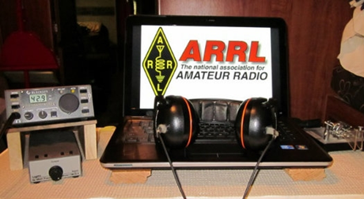*ARRL Contest Corner***

An expanded, downloadable version of *QST'*s’[**Contest Corral**](http://www.arrl.org/contest-calendar) is available as a PDF. Check the sponsor's’Web site for information on operating time restrictions and other instructions.

***A “Clean Sweep” in ARRL November Sweepstakes Means Working 84 Sections this Year***

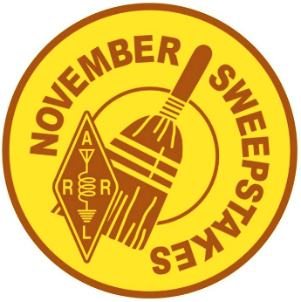The ever-popular [ARRL November Sweepstakes](http://arrl.org/sweepstakes) (SS) weekends are upon us — one for CW and the other for SSB — and this year, participants will have to search out an additional  Section. The SSB event is **November 20 – 22** (UTC). Each Sweepstakes leg begins at 2100 UTC on Saturday and runs through 0259 UTC on Monday. Stations may operate 24 of the available 30 hours. An SS *Operating Guide* package, available via the SS web page, explains how to participate in Sweepstakes. Clubs or public service teams that are considering participating in SS will find the guide to be a useful source for information. This year marks the 79th SS event, which attracts more than 3,000 entries each fall for both weekends.

The number of [**ARRL and Radio Amateurs of Canada (RAC)**](https://contests.arrl.org/contestmultipliers.php) sections rose to 84 earlier this year with the addition of Prince Edward Island (PE) as a separate entity. The objective of SS — or “sweeps” — is to work as many stations in as many of the 84 sections as possible within 24 hours of operating. The number of sections worked is a score multiplier, and working all of them — a “clean sweep” in SS parlance — is the goal of many SS aficionados, who qualify for a clean sweep coffee mug. Hardcore SS operators try to run up the contact and multiplier counts by staying in the chair for the allowed 24 hours.

Some multipliers are rarer and/or harder to work, and these can vary from year to year. For many years, the most difficult SS multiplier was considered to be Northern Territories (NT) in Canada, where J. Allen, VY1JA, in Yukon Territory, was often the only station available. Allen has stepped back from amateur radio, however, owing to health issues. Making a clean sweep also requires working Alaska and Hawaii (or another station in the Pacific Section), as well as Newfoundland/Labrador (NL) and Prince Edward Island (PE) in the other direction. On the rarer side, finding — and working — stations in Alberta (AB), North Dakota (ND), Northern New York (NNY), US Virgin Islands (VI), Wyoming (WY), and Delaware (DE) has proven vexing for some SS operators. Nonetheless, even stations with modest equipment and antennas can enjoy success. Many stations like to operate in the QRP category (output of 5 W or less), although that challenge has been more daunting in the lower rungs of the solar cycle.

[TOP](#top) ^

ARRL November Sweepstakes is the oldest domestic radiosport event (the first was in 1930). The SS contest exchange has deep roots in message-handling protocol and replicates a radiogram preamble. In SS, stations exchange:

* A consecutive serial number (NR). Operators do not have to add leading zeros on contact numbers less than 100.
* Operating category — **Q** for Single Op QRP; **A** for Single Op, Low Power (up to 150 W output); **B** for Single Op, High Power (greater than 150 W output); **U** for Single Op, Unlimited, regardless of power; **M** for Multioperator, regardless of power, and **S** for School Club.
* **Your call sign.**
* Check (CK) — the last two digits of the year of first license for either operator or station.
* Section — [**ARRL/RAC Section**](http://contests.arrl.org/contestmultipliers.php).

The SS *Operating Guide* package, available for [download](http://www.arrl.org/sweepstakes), includes all rules and examples of log formatting. The deadline to submit CW entries is November 16. The deadline to submit phone entries is November 29.

[**Direct**](mailto:contests@arrl.org) questions to the ARRL Contest Program.

####

|  |  |
| --- | --- |
| **November 16**   * [CQ-WE Contest](http://cqwe.cboh.org/rules.html) * [K1USN Slow Speed Test](http://www.k1usn.com/sst.html) * [RSGB FT4 Contest Series](https://www.rsgbcc.org/hf/rules/2020/r80m_ft4.shtml)   [Feld Hell Sprint](https://sites.google.com/site/feldhellclub/Home/contests/sprints/low-down-sprint) | **November 17**   * [Worldwide Sideband Activity Contest](https://wwsac.com/rules.html) * [RTTYOPS Weeksprint](https://rttyops.wordpress.com/rtty-mini-contests/rttyops-weeksprint/) |
| **November 18**   * [QRP Fox Hunt](http://www.qrpfoxhunt.org/winter_rules.htm) * [Phone Fray](http://www.perluma.com/Phone_Fray_Contest_Rules.pdf) * [CWops Mini-CWT Test](https://cwops.org/cwops-tests/) | **November 19**   * [NAQCC CW Sprint](http://naqcc.info/sprint/sprint201901_160.html) * [CWops Mini-CWT Test](https://cwops.org/cwops-tests/) * [RTTYOPS Weeksprint](https://rttyops.wordpress.com/rtty-mini-contests/rttyops-weeksprint/) |
| **November 20**   * [NCCC RTTY Sprint](http://www.ncccsprint.com/rttyns.html) * [QRP Fox Hunt](http://www.qrpfoxhunt.org/winter_rules.htm) * [NCCC Sprint](http://www.ncccsprint.com/rules.html) * [YO International PSK31 Contest](http://www.yo5crq.ro/Rules.htm) | **November 21**   * [SARL Field Day Contest](http://www.sarl.org.za/Web3/Members/DoDocDownload.aspx?X=20191211183027qzNhzFo0EI.PDF) * [LZ DX Contest](http://lzdx.bfra.org/rulesen.html) * [RTTYOPS Weekend Sprint](https://rttyops.wordpress.com/rtty-mini-contests/rttyops-weekend-sprint/) * [All Austrian 160-Meter Contest](https://www.oevsv.at/export/shared/.content/.galleries/Downloads_Referate/HF-Referat-Downloads/Rules_AOEC_160m.pdf) * [REF 160-Meter Contest](http://concours.r-e-f.org/reglements/actuels/reg_ref160_en_201812.pdf) * [RSGB 1.8 MHz Contest](https://www.rsgbcc.org/hf/rules/2020/r160m.shtml) * [**ARRL Sweepstakes Contest, SSB**](http://www.arrl.org/sweepstakes) |
| **November 23**   * [K1USN Slow Speed Test](http://www.k1usn.com/sst.html) | **November 24**   * [Worldwide Sideband Activity Contest](https://wwsac.com/rules.html)   [RTTYOPS Weeksprint](https://rttyops.wordpress.com/rtty-mini-contests/rttyops-weeksprint/) |
| **November 25**   * [SKCC Sprint](http://www.skccgroup.com/operating_activities/weekday_sprint/) * [Phone Fray](http://www.perluma.com/Phone_Fray_Contest_Rules.pdf) * [CWops Mini-CWT Test](https://cwops.org/cwops-tests/) * [UKEICC 80m Contest](https://www.ukeicc.com/80m-rules.php) |  |

[TOP](#top) ^

***DX News***

***ARLD046 DX news***

This week's bulletin was made possible with information provided by The Daily DX, the OPDX Bulletin, 425 DX News, DXNL, Contest Corral from QST and the ARRL Contest Calendar and WA7BNM web sites. Thanks to all.

**FRENCH POLYNESIA, FO.** Jay, KE6GLA is operating portable as FO/KE6GLA from Bora Bora (OC-067). QSL via his home call.

**ST. VINCENT, J8.** Oleh, UR5BCP (aka KD7WPJ) plans to operate in the CQ WW DX CW Contest for a few hours as J8/UR5BCP as a single op, low power entry. He will be on location from November 21 to 28. QSL via KD7WPJ.

**UNITED NATIONS, 4U.** Special event station 4U75UN is QRV until the end of 2020 to celebrate the United Nation's 75th anniversary. QSL via HB9BOU.

**U.S. VIRGIN ISLANDS, KP2.** Dan, K8RF will be QRV as NP2J in the CQ WW DX CW Contest as a single band, 160 meter entry. QSL via K8RF direct or via LoTW.

**ISRAEL, 4X.** Special event station 4X0RMN will be QRV from Ramon Crater on November 13 and 14. QSL via 4X6ZM.

**MALAWI, 7Q.** Members of the Russian Robinson Club Team will be QRV as 7Q7RU near Embangweni until November 18. Activity will be on 160 meters to 70 centimeters using CW, SSB and FT8 in DXpedition mode, and on various satellites. QSL via R7AL.

**CHINA, BY.** Dale, BA4TB is QRV as B9/BA4TB from Xining city in the Qinghai province. QSL to home call.

**INDONESIA, YB.** YB0ECT will be a 20 meter, single band, high power entry in the CQ WW DX CW Contest. QSL via W2FB.

**PANAMA, HP.** Special event station 3E1FP is QRV during the month of November to celebrate the 116th anniversary of Vida Republicana of Panama. Activity is on 80 to 10 meters using CW, SSB, FT8 and FT4.

QSL via HP3BSM.

**SINGAPORE, 9V.** James, 9V1YC has been active using FT8 on 30 meters. QSL via W5UE.

**DJIBOUTI, J2.** Rene, DL2JRM will be QRV as J28XX. Activity is on 80 to 10 meters using CW and SSB. QSL to home call.

**WESTERN SAHARA, S0.** S01WS has been QRV on 17 meters using SSB around 1800z. QSL direct.

[TOP](#top) ^

**MALI, TZ.** Ulmar, DK1CE will be QRV as TZ1CE from Bamako for a month. Activity will be on 160 to 10 meters using FT8. QSL to home call.

**BRAZIL, PY.** Sandro, PY1SAN and Marc, PY1CMT are QRV as ZX6BA from November 13 to 15, and as PR1S from November 16 to 18. They will be using satellites QO-100, AO-07, FO-29, RS-44 on CW and SSB. They will also be on HF with a 5W rig using CW and FT8. QSL via LoTW.

**SOUTH SUDAN, Z8.** Sigfrido, IW9FMD is QRV as Z81S while working with the United Nations Mission here. His length of stay is unknown. Activity is in his free time. QSL direct to IT9YVO.

**ALBANIA, ZA.** Sandro, IN3PPH is QRV as ZA/IN3PPH from Qerret. Activity of late has been on 80, 40 and 20 meters using FT8. QSL via operator's instructions.

THIS WEEKEND ON THE RADIO. The WAE DX Contest RTTY, PODXS 070 Club Triple Play Low Band Sprint, 10-10 International Fall Contest Digital, JIDX Phone Contest, SARL VHF/UHF Analogue Contest, OK/OM DX Contest, CQ-WE Contest, Homebrew and Old-time Equipment Party and the Run for the Bacon QRP Contest are all on tap for this weekend.

***W1AW Winter Operating Schedule***

**Morning Schedule:**

Time Mode Days

------------------- ---- ---------

1400 UTC (9 AM EST) CWs Wed, Fri

1400 UTC (9 AM EST) CWf Tue, Thu

**Daily Visitor Operating Hours:**

1500 UTC to 1700 UTC - (10 AM to 12 PM EST)

1800 UTC to 2045 UTC - (1 PM to 3:45 PM EST)

(Station closed 1700 to 1800 UTC (12 PM to 1 PM EST))

**Afternoon/Evening Schedule:**

2100 UTC (4 PM EST) CWf Mon, Wed, Fri

2100 " " CWs Tue, Thu

2200 " (5 PM EST) CWb Daily

2300 " (6 PM EST) DIGITAL Daily

0000 " (7 PM EST) CWs Mon, Wed, Fri

0000 " " CWf Tue, Thu

0100 " (8 PM EST) CWb Daily

0200 " (9 PM EST) DIGITAL Daily

0245 " (9:45 PM EST) VOICE Daily

0300 " (10 PM EST) CWf Mon, Wed, Fri

0300 " " CWs Tue, Thu

0400 " (11 PM EST) CWb Daily

[TOP](#top) ^

Frequencies (MHz)

-----------------

CW: 1.8025 3.5815 7.0475 14.0475 18.0975 21.0675 28.0675 50.350 147.555

DIGITAL: - 3.5975 7.095 14.095 18.1025 21.095 28.095 50.350 147.555

VOICE: 1.855 3.990 7.290 14.290 18.160 21.390 28.590 50.350 147.555

**Notes:**

CWs = Morse Code practice (slow) = 5, 7.5, 10, 13 and 15 WPM CWf = Morse Code practice (fast) = 35, 30, 25, 20, 15, 13 and 10 WPM CWb = Morse Code Bulletins = 18 WPM

CW frequencies include code practices, Qualifying Runs and CW bulletins. DIGITAL = BAUDOT (45.45 baud), BPSK31 and MFSK16 in a revolving schedule.

Code practice texts are from QST, and the source of each practice is given at the beginning of each practice and at the beginning of alternate speeds.

On Tuesdays and Fridays at 2330 UTC (6:30 PM EST), Keplerian Elements for active amateur satellites are sent on the regular digital frequencies.

A DX bulletin replaces or is added to the regular bulletins between 0100 UTC (8 PM EST) Thursdays and 0100 UTC (8 PM EST) Fridays.

Audio from W1AW's CW code practices, CW/digital bulletins and phone bulletin is available using EchoLink via the W1AW Conference Server named "W1AWBDCT." The monthly W1AW Qualifying Runs are presented here as well. The audio is sent in real-time and runs concurrently with W1AW's regular transmission schedule.

All users who connect to the conference server are muted. Please note that any questions or comments about this server should not be sent via the "Text" window in EchoLink. Please direct any questions or comments to [w1aw@arrl.org](mailto:w1aw@arrl.org) .

In a communications emergency, monitor W1AW for special bulletins as follows: Voice on the hour, Digital at 15 minutes past the hour, and CW on the half hour.

All licensed amateurs may operate the station from 1500 UTC to 1700 UTC (10 AM to 12 PM EST), and then from 1800 UTC to 2045 UTC (1 PM to 3:45 PM EST) Monday through Friday. Be sure to bring your current FCC amateur radio license or a photocopy.

However, please note that because of current COVID-19 restrictions, W1AW is not open for visitor operations at this time. The W1AW Operating Schedule may also be found on page 87 in the November 2020 issue of QST or on the web at, <http://www.arrl.org/w1aw-operating-schedule> .

####

[TOP](#top) ^

***Special Events***

* **11/17/2020 | NRA's 149th Birthday Party**

**Nov 17, 1500Z-2359Z, K7GST**, Paulden, AZ. Yavapai Amateur Radio Club. 21.335 14.250 14.040 7.250. Certificate. YARC, P.O. Box 11994, Prescott, AZ 86304. Certificate. E-certificate available, see website for details. [www.w7yrc.org/nrabirthday](http://www.w7yrc.org/nrabirthday)

* **11/17/2020 | Skyview Radio Society Founder's Day**

**Nov 17, 1500Z-2100Z, W3GH**, New Kensington, PA. Skyview Radio Society. 14.260 7.240 . QSL. Skyview Radio Society, Founders Day Event, 2335 Turkey Ridge Road, New Kensington, PA 15068. QSO exchange : Call sign, RST and QTH QSL cards will be sent to verified contacts who submit SASE to: Skyview Radio Society, Founder's Day Special Event, 2335 Turkey Ridge Road, Upper Burrell, PA 15068. [jfpainter@yahoo.com](mailto:)

* **11/19/2020 | Hammarlund Hullabaloo**

**Nov 19-Nov 21, 1800Z-1900Z, KM4PMO/W4H**, Mars Hill, NC. High Appalachian Mountain Amateur Radio Society. 14.250 7.250. Certificate & QSL. Jerry H. Robinson, PO Box 366, Mars Hill, NC 28754-0366. The 2020 Hammarlund Radio Hullabaloo special event station will be operated by the High Appalachian Mountain Amateur Radio Society (HAMARS) on November 19-21, 2020. The birthday of Oscar Hammarlund was November 19, 1861. The Hammarlund radio factory was located in Mars Hill, NC, from 1951 to 1973. HAMARS is located in Madison County, NC. So crank up your Hammarlund radios and make contact with us. Contacts by other radios are, of course, also welcome. [JerryRobinson@ieee.org](mailto:)

* **11/21/2020 | 175th Anniversary of Concordia United Church of Christ**

**Nov 21, 0800Z-2000Z, K9S**, Belleville, IL. St. Clair Amateur Radio Club. 14.380 14.350 14. 340 14.250. QSL. Len Peak, 108 Sheffield Dr., Belleville, IL 62223. [www.scarc.net](http://www.scarc.net/)

* **12/04/2020 | Pearl Harbor Day Commemoration**

**Dec 4-Dec 14, 1300Z-2200Z, W2W**, Baltimore, MD. Amateur Radio Club of the National Electronics Museum. 14.241 14.041 7.241 7.041. Certificate & QSL. W2W-Pearl Harbor, PO Box 1693, MS 4015, Baltimore, MD 21203. Amateur Radio Club of the National Electronics Museum (ARCNEM) will operate W2W in commemoration of the anniversary of Pearl Harbor Day and the role of electronics in WWII. The Museum is closed, so Club members will work the Special Event from their home stations. Primary operation will be Dec 4-Dec 7 with additional operation possible during the Dec 8-Dec 14 period, as operator availability permits. Operation on 80M (3.541, 3.841) and digital modes possible during event. Frequencies +/- according to QRM. QSL and Certificate available via SASE; details at [ww-2.us](http://ww-2.us/)

* **12/05/2020 | Celebrating the 21st Amendment to the US Constitution**

**Dec 5-Dec 6, 0500Z-0500Z, W8A**, Kent, OH. Breweries On The Air. 14.240 7.240. Certificate. Thomas R Sly, WB8LCD, 1480 Lake Martin Dr., Kent, OH 44240. [www.breweriesontheair.com](http://www.breweriesontheair.com/)

* **12/05/2020 | Christmas in Bethlehem**

**Dec 5, 1300Z-2200Z, W9WWI**, Bethlehem, IN. Clark County Amateur Radio Club of Indiana. 14.240; all bands, all modes. Certificate. W9WWI , P.O.Box 201, Sellersburg, IN 47172. Celebrating A safe and healthy Christmas in Bethlehem. Operating from the school house in Bethlehem Indiana. SASE please. [https://www.clarkcountyarc.org](https://www.clarkcountyarc.org/)

[TOP](#top) ^

* **12/05/2020 | Woronoco Heights Outdoor Adventure/SCOTA**

**Dec 5, 1300Z-1900Z, W1M**, Russell, MA. Western Mass Council--BSA. 14.290 14.060 10.115 7.190. Certificate. Tom Barker, 329 Faraway Road, Whitefield, NH 03598. All logging is done on paper and then uploaded to LoTW and eQSL. A QSL card can be had for a 4x6 SASE. W1M will operate on Brandmeister TG 3100 for demonstration purposes. Expect to see different call signs. Covid-19 may interrupt this event.

***“ARES Connect”***

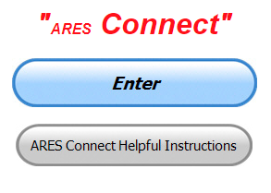

***Connecting Amateur Radio Volunteers with a Purpose***

Hey everyone… please make sure to go in and register your time to all of the events that you have signed up for. Be honest about the time spent. Don’t forget to get this done no later than **5 days** after the event has ended. I’m asking you to do this for our ability to run reports accurately.

**I want to remind all of you that you do not have to be an ARES or ARRL member to use this system. All licensed amateur radio operators throughout the country are welcome and strongly encouraged to use it.**

**Don’t forget to check out the “Frequently Asked Questions” area that has been added to the Ohio Section website.** It’s there to help you through any difficulties that you may have with ARES Connect. Now, if you don’t any posts that relate to what you are having difficulties with, we now also have an on-line “Guru” area as well. This will allow you to ask any questions that you may have about ARES Connect.

**Let’s get everyone on “ARES Connect!!!”**

***Here’s the “Top 10” hour earners so far in November:***

|  |  |  |  |
| --- | --- | --- | --- |
|  | **Name** | **Events** | **Hours** |
| **1** | Dan Stahl (KC8PBU) | 84 | 109.84 |
| **2** | Dwight Bonifield (W8TJT) | 76 | 103.00 |
| **3** | Daniel Schlick (KB8LKH) | 6 | 55.00 |
| **4** | Christopher Domenick (KC8CAD) | 10 | 50.60 |
| **5** | James Yoder (W8ERW) | 8 | 49.50 |
| **6** | Ron Wilch (KE8PX) | 68 | 39.00 |
| **7** | Alan Rothweiler (N8CJ) | 14 | 38.70 |
| **8** | Michael Lacumsky (W8MAL) | 28 | 34.95 |
| **9** | Bret Stemen (KD8SCL) | 12 | 34.00 |
| **10** | Greg Dersarkisian (KD8SSJ) | 11 | 32.00 |

####

[TOP](#top) ^

***Buckeye Net Starts 60 Meter Operation for NTS Cycle Two***

*(C. Matthew Curtin KD8TTE)*

This year has been one of experimentation for amateur radio messaging in the Ohio Section. We’ve been working hard to bring the Section’s traffic system into the position of being able to support ARES, and to train members of ARES programs in critical tasks such as message origination and delivery. We now invite you, to join us in the undertaking of establishing an effective Section-wide mixed-mode messaging net on 60m, at 13:00, currently thrice weekly.

Using our experience in operations and exercises over the past few years, Buckeye Net has developed a mixed-mode model for operations that we tried for the first time in the May 30 American Red Cross Emergency Communications National Radio Simulation. We continued through the summer and into fall as we ran the County Information Report Project 20 and operated during the Simulated Emergency Test as we participated in BLACK SWAN 20. As part of BLACK SWAN, we for the first time ever handled Integrated Public Alert & Warning System (IPAWS) messages sent radio-only from FEMA headquarters to individual county EMA stations.

A distinguishing feature of Buckeye Net Mixed-Mode (BNM) is controlling the net by voice and moving traffic with digital using the Narrow Band Emergency Messaging Software (NBEMS) suite including FLDIGI, FLAMP, and FLMSG. The net is also capable of moving messages with voice procedure or CW where appropriate. The net is designed to be multi-channel, allowing for traffic to relay from station to station on frequencies different from the control channel. More traffic can move in less time thanks to this parallelization.

Being able to control the net by voice makes identification of problems, discussion of procedure, and on-air training much easier. Movement of traffic with a digital mode including mathematical checksums for validation of correct receipt makes it possible to move data in any format without the need to perform manual conversion between native and transmission formats at origination and delivery.

Another element of BNM operation has been working throughout the day. We have been practicing critical skills like relay to hold a net together when conditions are poor and more recently, being more frequency agile so that we can operate on the bands that are most appropriate for the immediate need. Lately this has meant that our National Traffic System (NTS) Cycle Two operation has been on 60 meters (5 MHz).

The 60-meter band is a U.S. government band, with amateur operation permitted on a secondary basis on five specified channels. BLACK SWAN 17 was the first non-Department of Defense exercise to make use of a special provision of this band: the ability for amateur and government stations to interoperate. At 5 MHz, the band is often just the right band for mid-day NVIS propagation to cover in-state and nearby operations, precisely what we would hope for for a Section net.

NTS is a *system*, a set of schedules and common procedures that allows for coordinated movement of messages by relay, where the station bringing the message to the airwaves and the station receiving the message from the airways for delivery to a person cannot hear each other or operate directly.

[TOP](#top) ^

Rather than having haphazard operation that means a station with a message to be moved to another part of the Section must listen for another station that is closer, NTS ensures that nets will meet at (or near) particular times in a way that local nets happen within a window, Section nets happen within another window, and so on with the regional nets tying Sections together, and Areas tying Regions together. We can cover this in more depth in a future article.

The Ohio Section already has nets that cover the Section operating in Cycle One (Section time 10:00 local time) with the Ohio Single Sideband Net (OSSBN) operating at 10:30 daily. OSSBN also operates in Cycles Three and Four at 16:15 and 18:45, respectively. We also have Cycle Four operation daily in the CW sessions of Buckeye Net at 18:45 (BN Early) and 22:00 (BN Late). The Ohio Slow Net (OSN) as a training net operates technically a good bit ahead of the prescribed time for Cycle Four operation, thus making it possible for operators to go to both OSN and other Cycle Four nets like BN Early and OSSBN.

BNM is starting to fill a gap in the operational schedule with operations at 13:00, the prescribed time for Section nets to operate in Cycle Two. We have been operating on both Saturday and Sunday at 13:00 and are continuing to do so. We have been operating a Cycle Four net on Thursday but are now moving that session to Cycle Two. Finally, after regular testing, we are moving our primary band for operating during Cycle Two to 60m, channel 4 (5371.5 kHz USB phone; emissions centered at 5373 kHz).

Thus, our schedule is now Thursday, Saturday, and Sunday at 13:00. We will call the net on 60m, starting on channel 4, moving as needed to avoid interference to channels 5, 1, 2, then 3. Expect to use voice on 60m and to be moved off-frequency (and likely off-band, probably to 80m) for movement of traffic digitally. Also, to aid in training, we also hold open a Google Meet where we can project our computer screen so others can see what’s happening and follow along, or debug problems in transmissions. We’ve also been using KiwiSDR feeds via Internet to hear how signals are received at various stations in and nearby the state.

We’re updating the Signal Operating Instructions (SOI) and the corresponding FLDIGI macro package as we look for the best places to establish regular operation on 75 meters, as we’ll certainly need to use at other times when 60 meters isn’t the right band. Note that because 60-meter band channel selection in many amateur rigs is different, we do not have macros for channel selection on that band.

We look forward to working with you in developing this concept and procedures for net operation. Whether you have traffic or not, we hope that you’ll join us, and come ready to work, learning and teaching in the art of radio messaging. As more join us we are looking to expand operation, so we’re able to cover NTS Cycle Two every day of the week, as a complement to the other nets of the Ohio Section, both in timing and in capability.

Don’t hesitate to reach out to me directly if you have any questions. Reach me by Winlink at KD8TTE or by Internet email at [kd8tte@pm.me](mailto:kd8tte@pm.me).

***NIMS 300 & 400 Being Offered Virtually***

To All FEMA Region V RECCWG Membership,

On behalf of Paul Hughes, he would like to extend an invitation of the below NIMS Training being offered by our state partner at WI Emergency Management.

[TOP](#top) ^

If you are interested in attending the valuable training sessions, please contact Mr. Kevin Wernet for additional information at the end of this email.

**Please share with others who may benefit from the training listed below.**

The NIMS virtual training program classes have been posted to the training  portal and are available at <https://www.trainingwisconsin.org/Schedule.aspx>

1. Student attending virtual training will be required to attend an onboarding prior to class. The onboarding session is designed to work through any access issues and ensure students can find documents, move between work groups, and share information with other students. The experience so far has been that the onboarding allows students to focus on the training instead of the virtual platform they are using once class begins. A member of the Exercise and Training Section will contact students to schedule the onboarding sessions.
2. All classes will be set with max of 8 students to a work group or POD to allow maximum interaction while in the online environment. *Note: additional instructors have been added to posted classes to achieve the 1:8 instructor ratio with maximum attendance of 24 students. This may be adjusted as the program matures.*
3. ICS-300 and G2300 have been scheduled as 4 days 6 hours each to meet the 24-hour requirement
4. ICS 400 have been scheduled as 3 days 6 hours to meet the 18-hour requirement.
5. Where feasible G191 has been scheduled as 2 days 4 hours each to meet the 8-hour requirement
6. In addition to the daytime offerings of ICS-300, one reoccurring weeknight 4 hour each night class has been scheduled to meet the MABAS request to accommodate volunteer agencies.

|  |  |  |  |  |  |  |  |  |
| --- | --- | --- | --- | --- | --- | --- | --- | --- |
| ICS- 300  8:30-3:30  \*PM classes 5:30-9:30 | Nov  3-6 |  | Jan  12-15 |  | Mar  23-26 |  | May  11-14 | \*Evening MABAS class Jan through Feb= 6 x evenings 4 hours. *Note: While this targets volunteers, all are welcome to sign up.* |
| \*Jan 13, 20, 27 Feb 3, 10, 17 |
| ICS-400  8:30-3:30 |  | Dec  8-10 |  | Feb  9-11 |  | Apr  21-23 |  |  |
| G2300  8:30-3:30 |  | Dec 14-18 |  | Feb  16-19 |  | Apr  27-30 |  |  |
| G191  8:00-12:00 | Nov 18-19 |  | Jan 20-21 |  | Mar  18-19 |  | May  25-26 |  |

Respectfully,

Kevin Wernet, MEP, WCEM (608) 242-3331 [Kevin.wernet@wisconsin.gov](mailto:Kevin.wernet@wisconsin.gov)

*(ed. note… these classes are “on-line” which is extremely rare. If you’ve ever wanted to get ICS 300 & 400 in, this is a great opportunity for sure!!!)*

[TOP](#top) ^

***CARBON MONOXIDE (CO) POISONING***

Hi Gang,

I’m sure that a number of you are asking what the heck is the Section Manager writing about this stuff, it’s not Amateur Radio related!! Well my friends, you are very mistaken. It’s not only Amateur Radio related, it is something that as a HAM operator you may not ever have thought about. Where's your ham shack located? In the basement, garage or outbuilding? Most generally ham shacks are **not** in the living room or main part of the house. As such, heating devices are usually some sort of a supplemental heater/furnace, and that’s why I’m writing about this.

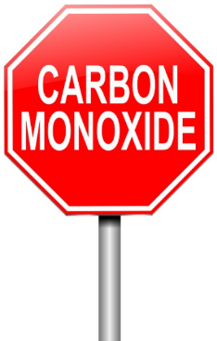First, let’s describe what Carbon Monoxide (CO) is. Carbon Monoxide (CO) is the poisonous gases emitted from carbon fueled heat sources (i.e.. gas or fuel oil furnaces, wood burning fireplaces or stoves, kerosene heaters, propane heaters). I could go on, but I think you get the idea. It’s colorless, odorless and it will definitely kill you if you breathe very much of it in. How does this gas kill? It actually migrates into the blood stream and replaces the oxygen in your blood with the Carbon Monoxide. Once it invades your blood stream it will be with you for a very long time, in fact, most of your life! Just ask any firefighter about that. Going into burning buildings without a Self-Contained Breathing Apparatus (SCBA) on will definitely subject you to Carbon Monoxide poisoning, and it takes years and years to get it out of your system, if ever.

Sometimes, if consumed in a large enough quantity, you may need a complete blood transfusion to just keep you alive. Yes Virginia, it is that deadly!!

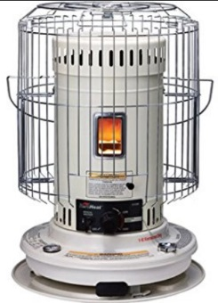Why am I writing about this? It’s very personal to me. A number of years ago a very close friend (and his entire family) died in their sleep because they consumed Carbon Monoxide (CO) without knowing it. They lived in an old house on the north side of Mansfield and because it was old, it was drafty with leaks around the doors, windows and the walls didn’t have any insulation in them. We had gotten a cold snap in early November, and back in the middle 1970’s kerosene heaters were all the rage to supplement heat in just this kind of house. Well, with the help of my co-workers we were able to purchase a big kerosene heater to help them through this cold snap. They got the heater all set up and running and all was fine for the first several days, then on the third day the dad came to work complaining of a very bad headache. None of us thought much about it that day and the dad continued his job on the assembly line with the rest of us. The next afternoon we all found out that the heater had been malfunctioning and every member of the family had died of this very dangerous gas.

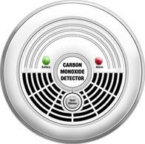I was absolutely torn apart. I had been one of several people at work that helped take up the collection to purchase the heater. It took me a long, long time to get over that. Don’t get me wrong, there’s nothing wrong with using these types of supplemental heating sources but be very careful when you do. At that time CO detectors were truly non-existent for homes, and the ones that were available were for scientific and commercial use, and cost hundreds and hundreds of dollars. That’s all changed now. CO detectors are as cheap now as smoke detectors. You can get one for as little as $10 now. That’s an extremely cheap form of protection from this deadly gas.

[TOP](#top) ^

Winter is coming up fast. I don’t know about how it is at your house, but here in the little burg of Lexington, when it gets cold outside, you’ll see the smoke coming out of many chimneys around here. That means that the temperature has dropped to below where it is comfortable. This is the point where the furnaces come on and people start thinking about lighting up the fireplaces and so forth. Now if these devices haven’t been recently serviced, birds can make nests in the chimney’s and like your car, the heat source most likely needs a tune-up to make sure that it’s running efficiently and safely. Having the chimney stuffed up with bird nests or the heat source not burning correctly can cause Carbon Monoxide to accumulate in your house without you even knowing it. That’s where the CO detector comes into play... Please, please buy one, or two of these really inexpensive CO detectors for your safety and use it!

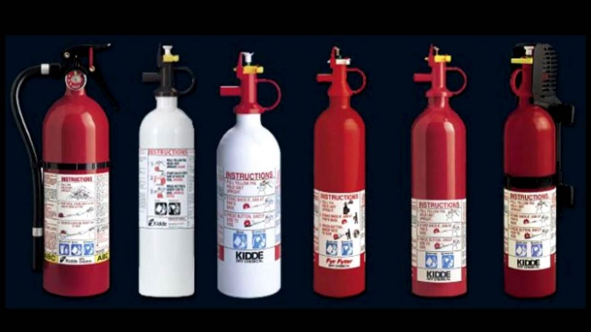By the way, it’s not all about detection either. Do you have a properly rated fire extinguisher within your reach? If not, get one. Learn how to properly use it. It will save you from a lot of damage if you know how to use it properly. Don’t assume that all you do is pull the pin and squeeze the trigger. It’s about knowing how to sweep and aim at the base of the fire. Do yourself a HUGE favor, buy an extinguisher or two and teach your entire family how to properly use them!

Yes, even the kids need to know how to properly use a fire extinguisher!

**####**

***Run Classic (Older) Versions of Windows on your Raspberry Pi***

*(Submitted by Gregory Drezdzon, WD9FTZ)*

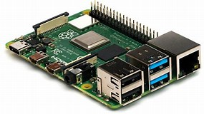Relive your youth by building a Pi-powered Windows 98 smartwatch or just by booting up classic 90's operating systems including XP on your Pi.

Remember when Windows 98 needed a computer costing $1,000+ to run comfortably?  Almost 20 years later, the early Microsoft OS runs on a computer that sells for just $25 and that is so small it fits on your wrist.

This Raspberry Pi-powered, Windows 98 wristwatch is a [project by amateur technology enthusiast 314Reactor](https://314reactor.com/2017/03/01/windows-98-wrist-watch/).

To get the venerable OS running on the Pi's ARM-based hardware, 314Reactor used the open-source machine emulator QEMU, which provides a virtual Intel 486 machine. He used his own copy of Windows 98, from which he extracted the necessary .img file.

[TOP](#top) ^

[Full instructions for building the watch are available here](https://314reactor.com/2017/03/01/windows-98-wrist-watch/" \t "_blank), along with much of the code needed.

Adding the necessary hardware to the Pi was described as "relatively painless" by 314Reactor, provided you have experience hooking up electronics to the Pi's general-purpose input/output (GPIO) pins.

To read more, visit:

<https://www.techrepublic.com/article/classic-windows-on-a-35-computer-how-to-fire-up-windows-3-1-95-98-and-xp-on-your-raspberry-pi/>

<https://www.raspberrypi.org/forums/viewtopic.php?f=41&t=117228>

[https://www.qemu.org](https://www.qemu.org/)

***Get Active with APRS***

*(by Jason McCormick, N8EI)*

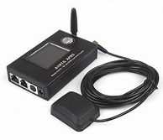Chances are you’ve heard of APRS. It’s commonly used to broadcast position data by mobile hams on the go. It’s also often used to track balloons with radios around the world. If you aren’t into position tracking or balloons, you might have ignored APRS and this has given rise to the misunderstanding of APRS being solely a tool to report positions of things. However, including positional data is only part of what APRS can do. APRS has been developed since 1984 by Bob Bruninga WB4APR. The original name of the protocol was the Connectionless Emergency Traffic System (CETS). Later it evolved into the Automatic Position Reporting System and finally the Automatic Packet Reporting System we have today. The theory and use of APRS is well documented on the Internet. But, in summary, APRS can send many different types of “packets” of information, including arbitrary text messages between endpoints.

The Wayne Technical Fanatics (ww8tf.club) have long been experimenting with different uses of APRS, notably it has long operated two digipeaters (digital packet repeaters) in [Akron](https://www.aprsdirect.com/details/main/sid/1218724) and [Rittman](https://www.aprsdirect.com/details/main/sid/761678) under the WW8TF callsigns. Recently, this service was expanded to a high-profile site in [Wooster](https://www.aprsdirect.com/details/main/sid/3344058) with the site support of Wayne Co. ARES (Doug Hunter KE8JNH) and the Wayne Co. EMA. The coverage of these digipeaters based on real APRS traffic events can be see [here](https://ww8tf.club/wp-content/uploads/2020/11/APRS-Coverage.png). Digipeaters repeat the AX.25 APRS packets around a given geographic area over RF on 144.390MHz.

As with most things these days, there is a tie-in to the Internet. There are many systems that blend the Internet and APRS to create some interesting capabilities. WTF has been experimenting with an IoT sensor protocol called MQTT to send short messages to APRS listeners from random Internet-connected items. The is a “publish and subscribe” model that can be used to inject status messages of all sorts into the APRS system. Another system at smsgate.org allows sending and receiving messages between SMS-enabled phones and APRS-enabled radios. There are many others, and the possibilities are endless.

[TOP](#top) ^

There is one piece to APRS that sits between these systems to connect them – the IGate. An IGate operates as a broker between the APRS packets transmitted with AX.25 over RF and APRS messages sent and received using the Internet and the IP Protocol. IGates come in two types, as one-way or “listening” IGate and a two-way or “full” IGate. A one-way IGate listens for APRS AX.25 packets and simply repeats the APRS messages into the Internet. This is how mapping of positional information like aprsdirect.com or aprs.fi get their data. A two-way IGate will listen for RF messages like the one-way IGate. But it will also originate messages -either on its own or based on messages received from the Internet - and broadcast them out using RF to the digipeaters for consumption by APRS endpoints.

The WW8TF-15 “Norton” IGate as a one-way IGate for quite a while using a Raspberry Pi with an RTL-SDR dongle craftily grafted onto my VHF/UHF amplified HD TV antenna. While this works well for telling the Internet about positioning packets and weather reports, it doesn’t enable the rest of the APRS functionality. Northeast Ohio is rich in digipeaters, but there are only a few two-way IGates so WTF decided to build another one to support redundancy and resiliency of the APRS system in the area. The RTL-SDR dongle was replaced with a Motorola CDM1250 and a DMK URI USB audio interface. The grafting onto the TV antenna was sadly replaced with a boring, standard antenna. The new system went live on October 18th.

Building a two-way IGate service both helps understand the ARPS system and provides a great way to contribute to the amateur community. The build process of the software portion of a two-way IGate can be found at <https://ww8tf.club/building-an-aprs-igate/>. All you need a functional FM radio, a reasonable antenna, some form of a CM108-based USB sound card (Masters Communications RA-series devices, DMK URIx, even cheap dongles on Amazon), wiring to put it all together, and some patience with learning/using Linux.

Even if you don’t want to tackle an IGate  using Linux, there’s a number of Windows-based solutions out there such as APRSISCE/32  and no limit to creative ways to connect an FM radio to your computer to do APRS (and Winlink and lots of other cool stuff). Look at the manuals for your FM radios. Maybe Yaseu, Icom, and Kenwood HTs and mobiles support ARPS. Learning and using APRS might be a good winter project, especially since it looks like we’re in for a long, socially distanced winter.



***Special Event This Tuesday November 17, 9 p.m. ET***

Join us Tuesday for A Conversation with KDKA's Program Manager, Jim Graci

Join RCA as we celebrate the 100th Anniversary of KDKA, by hosting a conversation with KDKA's Program Manager, Jim Graci. Hosted by RCA President Emeritus Tim Duffy, Tim and Jim will take a walk down memory lane, where you will learn about many of the historical activities that KDKA participated in over the years.

This free event is a terrific precursor to the Technical Symposium, coming up later in the week on 11/21.

Pre-Registration is required. [Register TODAY!](https://www.radioclubofamerica.org/events/rca-special-interview-with-kdkas-jim-graci/)

[TOP](#top) ^

***One Question Questionnaire***



Hey Gang,

Survey Says”….. about 40% of you have done like I did and accidently grabbed the wrong end of a soldering iron. Wow does that ever hurt and you can rest assure that it’s one mistake that I will not repeat!

Ok, now on to the next question… Thanksgiving is just around the corner and many of the Candy Stores are already starting to advertise their “Black Friday” sales on all sorts of items including amateur radio equipment and all sorts of electronics, so, with that in mind…

***“Have you started your Christmas Shopping yet??”***

You’ll find the “One Question” questionnaire on the Ohio Section Website! http://arrlohio.org It’s all in fun and it’s not a scientific survey in any way, but we are learning some things that we didn’t know from these questions. I hope that you are enjoying answering these “One Question” questionnaires.

*****V.E. Test Sessions***

Many V.E.’s have decided to start testing once again, but with restrictions that need to be adhered to for sure. Here’s the link to find that V.E. Test session and what is expected of YOU before going. <http://www.arrl.org/find-an-amateur-radio-license-exam-session>

***Final.. Final..***

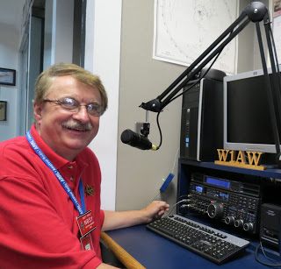

Hi Gang,

This past week has been the warmest November that I can remember in a very long time. Janie and I got out on the trikes a number of times and it was great fun peddling around the area just looking at all that our wonderful state has to offer. The sights and smells of fall are everywhere.

The tractor is still in the repair shop, but that’s ok. The grass has pretty much quit growing for the season and the wind that we’ve been having has taken care of any residual leaves that have fallen since I got them mulched up the last time. Now it’s up to the neighbors to take care of them.

[TOP](#top) ^

I have been working around the house getting it ready for winter. Since we have double glazed casement windows throughout the house, all I have to do is make sure that they get seated properly in their frames and that’s that, they are ready for the winter.

I’ve been making sure that the generator is gassed up and will start on the first pull. Around here we never know just when we will need it next, as that we are at the end of the power line for our provider and our power can go out on a day when there’s absolutely no wind and the sun is shining nice and bright. I can’t explain it, but that’s been the history here in the big metropolis of Lexington for as long as Lexington has been here. Most everyone here has some sort of backup power ready to go, that’s how prevalent the power outages are around here. Oh well. Even though we have this issue, I wouldn’t move for the world.

For those of you who might have noticed, there’s again no Hamfest listing this week. That’s because there’s just no hamfests for the foreseeable future. And with the rise in numbers for COVID-19 lately I really don’t expect to see another hamfest for some time to come. Let’s all keep our fingers crossed that there will be a vaccine ready soon. I don’t want to miss another Dayton or NOARS Fest or ….

Did you file your complaint against the proposed $50 fee by the FCC for license issue and renewal? The deadline is Monday, November 16th, TODAY!! So, you still have time, but you have to act on it now.

You can check out the sample letter that I have as well as the step-by-step instructions for filing with the FCC at: <http://arrl-ohio.org/sm/20-270/> The sample letter will help you word your letter in your own words. Please be sure to end the letter with your name, call sign as well as address.

Have you taken the time to check out the ARES Connect reports that are on-line? These reports are there for you. Take advantage of them to boost up your training as well as your ham radio participation! Here’s a link to just one of the reports… <http://arrl-ohio.org/SEC/reports.html> You can also see how the Ohio Section is doing compared with the other Sections in the Great Lakes Division by [clicking here](http://arrl-greatlakes.org/ac2.html)

As most of you know I have been the lead volunteer for ARES Connect with helping other Sections around the country getting things up and running for some time now. I have to say that this experience has been very enlightening. I have gotten to see the inner workings of many of the 71 Sections and how they are setup and work with their served agencies and adjacent Sections. It’s made me realize even more just how you folks here in the Great Lakes Division (Michigan, Kentucky and Ohio) embrace changes and strive to do your very best to help your served agencies, and adjacent Sections to make them even better. I thank you for what you do and for making the Great Lakes Division the best Division in the country! Believe you me, it is appreciated, and noticed!!

Whelp, that’s going to do it for this week my friends! I’m still looking forward to visiting with all of you live or via Zoom, WebEX or whatever.

I really can’t wait for that time when we can all get together in person once again. Those are the times I cherish the most!!! Stay safe! We will get through this and when we do, we’ll have so much to talk about. Most of all… have FUN and get on the airwaves!!

73,

[***Scott, N8SY***](mailto:n8sy@n8sy.com)

[TOP](#top) ^



Hey Gang,

Have you taken a look at the **Swap & Shop** page on the Ohio Section webpage yet?? Here’s a link that will take you there…

<http://arrl-ohio.org/sm/s-s.html>

Do you have equipment that you just don’t need or want anymore? Here’s a great venue to advertise it, and it’s FREE!! Is your club doing a fund raiser to help raise money? After a lot of thought, it was decided that the Swap & Shop webpage could also contain these types of items as well. The same rules will apply as do for the For Sales and Give-A-Ways and will only be posted for a month at a time. Please see the Terms & Conditions on the webpage.

If your club is doing a fund raiser and wants more exposure, please forward the information to me and I’ll advertise it on the Swap & Shop webpage for you.

Now, I still want to remind you that it won’t be listed in this newsletter because it would take up way too much space, so your ad will only appear on the website. It is there for any individual to post equipment Wanted / For Sale or Give-Away as well as for Club Fund Raisers. No licensed vehicles/trailers or business advertising will be posted. Postings are text only (no pictures or graphics) will be posted for a maximum of 1 month from date posting and require a contact phone number or email within the posting. Send your Wanted / For Sale or Give-Away post to:  [swap@arrlohio.org](mailto:swap@arrlohio.org)

Ohio Section Cabinet

|  |  |
| --- | --- |
| Section Manager – Scott Yonally, N8SY | Assistant Section Manager – John Perone, W8RXX |
| Section Emergency Coordinator – Stan Broadway, N8BHL | Section Traffic Manager – David Maynard, WA3EZN |
| Technical Coordinator – Jeff Kopcak, K8JTK | Affiliated Clubs Coordinator – Tom Sly, WB8LCD |
| State Government Liaison – Bob Winston, W2THU | Public Information Coordinator – John Ross, KD8IDJ |
| Section Youth Coordinator – Anthony Lascre, K8ZT | |

***Back Issues of the PostScript and Ohio Section Journal***

Hey, did you know that PostScript and Ohio Section Journal (OSJ) are archived on the website? You can go back and look at any edition simply by clicking:

<http://arrl-ohio.org/news/index.html>

[TOP](#top) ^

***Want to Share your Club Newsletter With Others?***



We have a webpage where you can download and read all of the newsletters that I get from around the state and even other sections!

Here’s the link to the page…. <http://arrl-ohio.org/club_news/index.html>

Please, if you don’t see your club newsletter posted, it’s because I’m not receiving it. Just have your newsletter editor contact me and I’ll get your club’s newsletter listed on the site!!

We all learn and steal (I mean, share) from each other’s work. So, get me your newsletter!!! Send it to: [n8sy@n8sy.com](mailto:n8sy@n8sy.com)

***Chit – Chat, and All That!***

Do you know someone that’s not getting these Newsletters? Please, forward a copy of this Newsletter over to them and have them “[Opt-In](mailto:Opt-In)” to start receiving them. Heck just have them send me an email [n8sy@n8sy.com](mailto:n8sy@n8sy.com) and I’ll get them added to the Ohio Section Emailing list.

We now have many thousands of readers receiving these newsletters weekly. Quite impressive, I’d say! I urge all of you to make sure that everyone, regardless of whether they are a League member or not, get signed up to receive these weekly Newsletters.

You can always “Opt-Out” at any time if you feel this is not what you were expecting. It’s fun and very informative. All of your favorite past newsletters are now archived too.

You can go back at any time and read them. Just go to: <http://arrl-ohio.org/news/>

Got questions, concerns or would just like to sit and chat awhile? Heck, I’ll even buy the coffee!! Give me a call at (419) 512-4445 or email me at: [n8sy@n8sy.com](mailto:n8sy@n8sy.com)

The pictures on the front page and throughout this newsletter are from various newsletters, Facebook posts and/or were sent directly to me in recent weeks. Take a good look at them, you just might be in one of the pictures! “SMILE… you’re in the Ohio Section News!!”

[TOP](#top) ^

*PostScript is produced as a weekly newsletter. I want to thank everyone that has contributed articles and ideas to make this an even better news source. I sincerely hope that you have enjoyed this edition and will encourage your friends to join with you in receiving the latest news and information about the Ohio Section, and news and events happening around the world!*