[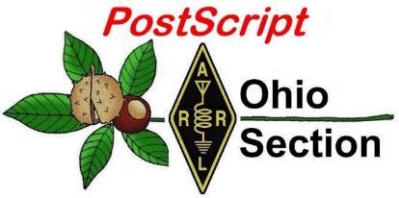](http://arrl-ohio.org/news/) ***November 2nd***

***Edition***

🡪 National News 🡪 The Handbook Give Away

🡪 Club Corner 🡪 Hamfests

🡪 DX This Week 🡪 ARES Connect

🡪 VE Testing 🡪 One Question Questionnaire

🡪 From The South 40 🡪 Final.. Final..

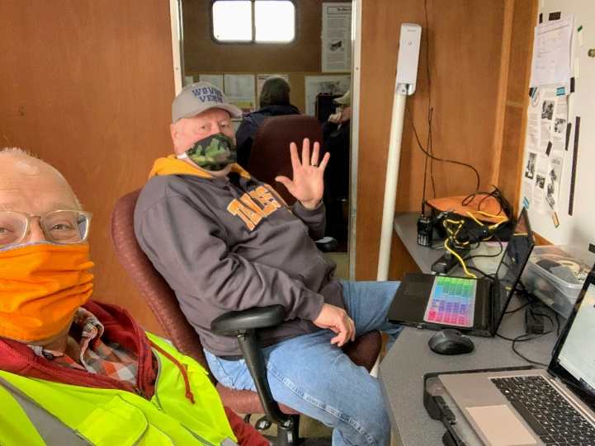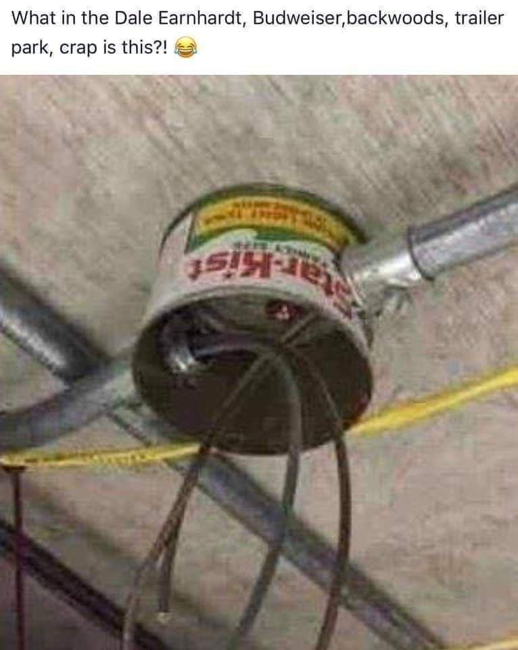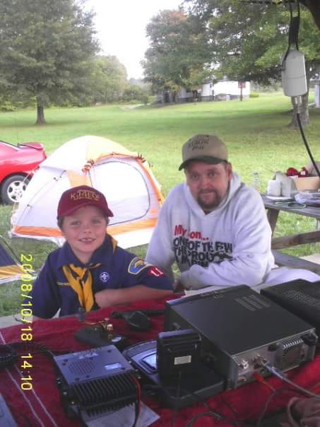

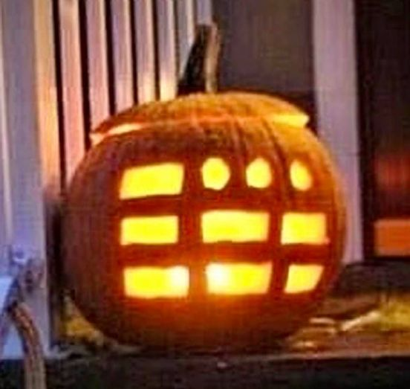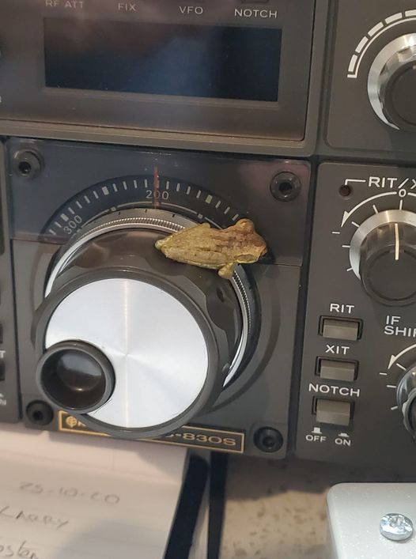

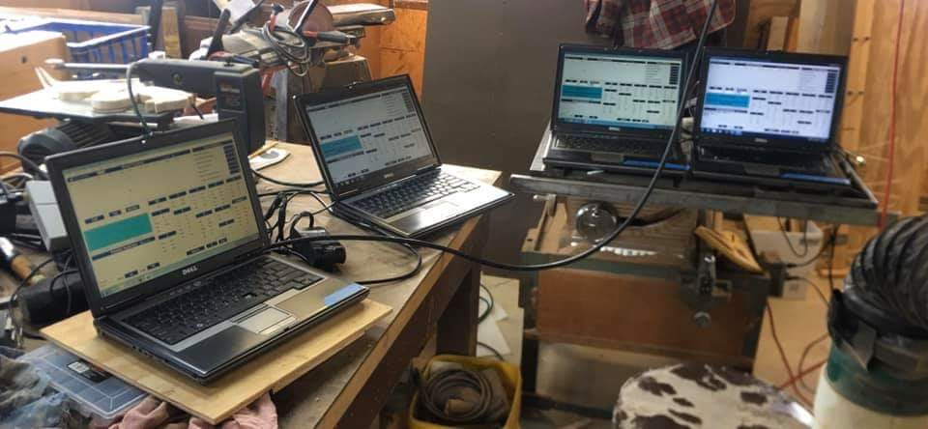

***National News***

*(from arrl and other sources)*

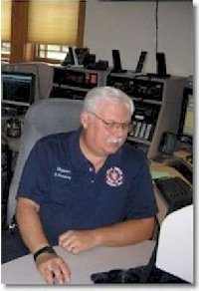

***Ohio’s SEC, Stan, N8BHL, Named as CQ Magazine’s Emergency Communications Editor***

CQ Magazine has announced that Ohio’s Section Emergency Coordinator Stan Broadway, N8BHL, has been named as the magazine's Emergency Communications Editor.

Licensed for more than 40 years, Broadway first was attracted to ham radio by listening to a VHF severe weather net in Ohio and to the Hurricane Watch Net, for which he currently serves as a board member and net control operator.

####

***ARRL Learning Network Webinars***

Visit the ARRL Learning Network website (a members-only benefit) to [register](http://www.arrl.org/arrl-learning-network) for upcoming sessions and to view previously recorded session. The schedule is subject to change.

**How to Get Started in Amateur Radio Contesting: Ohio’s Section Youth Coordinator, Anthony Luscre, K8ZT**

Why do hams participate in on-air contests? How would I benefit from contesting? What do I need to get started in contesting? What are good contests for beginners? Where can I learn more? This session will answer all of these questions and more.

**Tuesday, November 3, 2020, 10 AM PST / 1 PM EST (1800 UTC)**

####

***Guidelines Issued for ARRL DX Contest Multioperator Stations***

ARRL has issued guidelines for multioperator stations competing in the [ARRL DX Contest](http://www.arrl.org/arrl-dx) (CW and phone). With the global pandemic continuing to impose restrictions on social gatherings, multioperator contest stations may not be able to operate normally while still adhering to local social distancing guidelines. ARRL has decided to make temporary accommodations for a multioperator station to participate in these popular ARRL contests, under these guidelines:

TOP ^

* Team members may operate from their home stations in conjunction with the multioperator station.
* Their home station must be located within a radius of 100 kilometers (62 miles) of the multioperator contest station.
* Their home station must be located within the same DXCC entity as the multioperator contest station. In the case of US and Canadian stations, all team member stations *must be in the same US state or Canadian province*.
* All team member stations must use the same call sign and exchange as the multioperator contest station for the duration of the contest.
* Logging software must be networked, so that all team member stations are using a common log.
* Individual operators may not work the multioperator contest station or other team member stations using a personal call sign or other call sign.
* All multioperator rules, such as band changes and number of signals on a band, still apply. See the full [contest rules](http://www.arrl.org/arrl-dx) for details.
* The team must determine and control band assignments, ensuring that no more than one team station is transmitting on any given band at a time.

The multioperator contest station may be staffed at less than full capacity while maintaining safe practices, so operating with a combination of team members at home stations and team members at the contest station is permissible.

The CW contest takes place on the third full weekend in February (February 20 - 21, 2021). The phone contest takes place on the first full weekend in March (March 6 - 7, 2021).

For questions, [contact](mailto:contests@arrl.org) the ARRL Contest Branch.

####

***FCC Releases Report on June T-Mobile Outage***

*(From Radioresource, submitted by Gregory Drezdzon, WD9FTZ)*

The Federal Communications Commission recently released a 19-page report detailing the causes and impact of a nationwide T-Mobile outage that occurred in June 2020, along with actions that can help prevent similar outages in the future.

“T-Mobile’s outage was a failure,” said FCC Chairman Ajit Pai. “Our staff investigation found that the company did not follow several established network reliability best practices that could have either prevented the outage or at least mitigated its impact. All telecommunications providers must ensure they are adhering to relevant industry best practices, and I encourage network reliability standards bodies to apply their expertise to the issues identified in this report for further study.”

On June 15, T-Mobile experienced an outage on its wireless networks that lasted over 12 hours, disrupting calling and texting services nationwide, including 9-1-1 service, as well as access to data service in some areas.

TOP ^

The FCC’s Public Safety Homeland Security Bureau estimated that at least 41% of all calls on T-Mobile’s network failed during the outage, including at least 23,621 failed calls to 9-1-1.

According to the FCC, the outage was caused by an equipment failure and exacerbated by a network routing misconfiguration. The outage was magnified by a software flaw in T-Mobile’s network that had been latent for months and interfered with customers’ ability to initiate or receive voice calls during the outage.

The FCC report also identified network reliability best practices that could have prevented the outage or mitigated its effects, including providers periodically auditing the diversity of their networks. The FCC also recommended several network reliability issues for further examination by standards bodies.

In keeping with past practice, the bureau plans to release a public notice, based on its analysis of this and other recent outages, reminding companies of industry-accepted best practices, including those recommended by the FCC’s Communications Security, Reliability and Interoperability Council (CSRIC), and their importance.

The FCC will also contact major transport providers to discuss their network practices and offer assistance to smaller providers to help ensure that the nation’s communications networks remain robust, reliable and resilient.

T-Mobile merged with the Sprint Corporation earlier in 2020, and the Sprint brand was discontinued on August 2nd.

The full report is at: <https://docs.fcc.gov/public/attachments/DOC-367699A1.pdf> .

####

***ARRL Urges Members to Join in Strongly Opposing FCC’s Application Fees Proposal***



ARRL will file comments in firm opposition to an FCC proposal to impose a $50 fee on amateur radio license and application fees. With the November 16 comment deadline fast approaching, ARRL urges members to add their voices to ARRL’s by filing opposition comments of their own. The FCC *Notice of Proposed Rulemaking* ([***NPRM***](https://tinyurl.com/yyk8f2yp)) MD Docket 20-270 appeared in the October 15 edition of *The Federal Register* and sets deadlines of November 16 to comment and November 30 to post reply comments, which are comments on comments already filed. ARRL has prepared a [***Guide to Filing Comments with the FCC***](http://www.arrl.org/FCC-Fees-Proposal) which includes tips for preparing comments and step-by-step filing instructions. File comments on MD Docket 20-270 using the FCC’s Electronic Comment Filing System ([**ECFS**](https://www.fcc.gov/ecfs/filings)).

Under the proposal, amateur radio licensees would pay a $50 fee for each amateur radio application for new licenses, license renewals, upgrades to existing licenses, and vanity call sign requests. The FCC also has proposed a $50 fee to obtain a printed copy of a license. Excluded are applications for administrative updates, such as changes of address, and annual regulatory fees. Amateur Service licensees have been exempted from application fees for several years.

The FCC proposal is contained in a *Notice of Proposed Rulemaking* ([*NPRM*](https://docs.fcc.gov/public/attachments/FCC-20-116A1.pdf)) in MD Docket 20-270, which was adopted to implement portions of the “Repack Airwaves Yielding Better Access for Users of Modern Services Act” of 2018 — the so-called “[**Ray Baum’s Act**](https://www.congress.gov/115/plaws/publ141/PLAW-115publ141.pdf).”

TOP ^

The Act requires that the FCC switch from a Congressionally-mandated fee structure to a cost-based system of assessment. In its *NPRM*, the FCC proposed application fees for a broad range of services that use the FCC’s Universal Licensing System (ULS), including the Amateur Radio Service. The 2018 statute excludes the Amateur Service from annual regulatory fees, but not from application fees. The FCC proposal affects all FCC services and does not single out amateur radio.

ARRL is encouraging members to file comments that stress amateur radio’s contributions to the country and communities. ARRL’s [***Guide to Filing Comments***](http://www.arrl.org/FCC-Fees-Proposal) includes “talking points” that may be helpful in preparing comments. These stress amateur radio’s role in volunteering communication support during disasters and emergencies, and inspiring students to pursue education and careers in engineering, radio technology, and communications.

As the FCC explained in its *NPRM*, Congress, through the Ray Baum’s Act, is compelling regulatory agencies such as the FCC to recover from applicants the costs involved in filing and handling applications.

In its *NPRM* the FCC encouraged licensees to update their own information online without charge. Many, if not most, Amateur Service applications may be handled via the largely automated Universal License Service (ULS). The Ray Baum’s Act does not exempt filing fees in the Amateur Radio Service, and the FCC stopped assessing fees for vanity call signs several years ago.

See also “[**FCC Proposes to Reinstate Amateur Radio Service Fees**](http://www.arrl.org/news/fcc-proposes-to-reinstate-amateur-radio-service-fees),” reported by ARRL in August, and a [**summary page**](http://www.arrl.org/FCC-Fees-Proposal) of the proceeding.

####

***New Zealand Radio Amateurs Lose Access to 60 Meters***

Radio amateurs in New Zealand no longer have access to 60 meters, effective on October 24. Use of the band by radio amateurs in New Zealand is provisional, allowing hams there to use two frequencies in the band — 5353.0 kHz and 5362.0 kHz — as part of a “trial.”

New Zealand Amateur Radio Transmitters (NZART), the national amateur radio organization, said the New Zealand Defence Force (NZDF) advised the organization that it was not willing to approve another renewal of the 5 MHz trial allocation. NZART has indicated that it will continue to work with telecoms regulator RSM to see if other ways may be available to provide access to 5 MHz frequencies by New Zealand amateurs.

As in the US, the federal government and military are primary on the 5 MHz band. According to NZART, the decision was not made lightly by NZDF, but access to that part of the HF spectrum is very important to support NZDF’s new platforms, tactical radio equipment, and updated HF site equipment in the delivery chain.

“Additionally, access to HF is a key part of their communications plans both in New Zealand and to support our forces overseas,” NZART explained. “While this is a disappointing outcome, NZART would like to thank NZDF for allowing us to take part in the trial, and we look forward to working with them in the future on matters of common interest.” *— Thanks to Paul Gaskell, G4MWO/*The 5 MHz Newsletter

####

TOP ^

**FCC AUTHORIZES ALL-DIGITAL AM RADIO**

*(submitted by Gregory Drezdzon, WD9FTZ)*

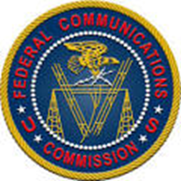

WASHINGTON, October 27, 2020—The Federal Communications Commission today adopted a Report and Order that allows AM radio stations to operate using all-digital broadcast signals in the United States.

AM broadcasters will be able to voluntarily choose whether and when to convert to all-digital operation from their current analog or hybrid analog/digital signals.

All-digital broadcasting offers AM listeners significantly improved audio quality and more reliable coverage over a wider listenable area than analog or hybrid digital broadcasts. It also allows broadcasters to provide additional services to the public, such as song title and artist information. These enhancements will enable AM broadcasters to better compete in today’s media marketplace.

Today’s Order establishes technical rules to protect existing AM broadcast stations from interference. In addition, stations converting to all-digital operation will be required to notify the Commission and the public 30 days in advance of their transition.

These stations must provide at least one free over-the-air digital programming stream that is comparable to or better in audio quality than a standard analog broadcast. They also must continue to participate in the Emergency Alert System. The Order envisions that AM broadcasters will decide whether to convert to all-digital operation based on the conditions in their respective markets.

Action by the Commission October 27, 2020 by Report and Order (FCC 20-154). Chairman Pai, Commissioners O’Rielly, Carr, Rosenworcel, and Starks approving. Chairman Pai, and Commissioner Rosenworcel issuing separate statements.

MB Docket Nos. 19-311, 13-249

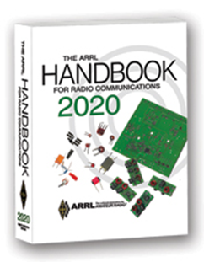***The Handbook Give Away***

Hey Gang,

The winner of the October Give Away is… ***TRAVIS FASKO, KB8QIE***

Many of you ask me just how do I know when the drawing is on? Well, that’s easy all you need to do is check in on the Ohio Section Website on a regular basis and watch for the big **RED** Arrow that will appear on the left side of the page.

This is the sign that the drawing is on and you need to get registered. So, keep a sharp eye out on the website and check in often! <http://arrl-ohio.org/>

TOP ^

***Club Corner***

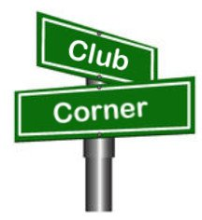

This is YOUR cornner of the newsletter. Send me what your club is doing and I’ll make sure that it gets in. Got a special event or club project that you want everyone to know about? Send it to me!. Need help with a project? Send it to me.

Let me know what you club is up to. Are you going to have a special guest at your meeting or are you having a special anniversary? Just sent it to: [n8sy@n8sy.com](mailto:n8sy@n8sy.com)

####

***CRES Invites Special Guest To Its Meeting… You’re Invited Too***

The CRES club has invited Carole Perry, WB2MGP to be its Guest Speaker for the night. The meeting will begin around **7:00pm on November 5th** via Zoom. They’d like to invite you as well. Interested? Contact Tom, N4HAI at: [tomfoy@gmail.com](mailto:tomfoy@gmail.com) for the Zoom meeting details.

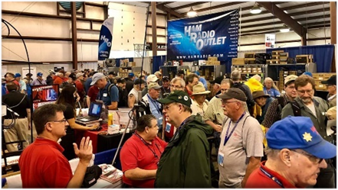

[***Upcoming Hamfests***](http://arrl-ohio.org/hamfests.html) ***for 2020***

**11/08/2020 – Outdoor Swap N Shop**

Location: Livonia Michigan

Sponsor: The Livonia Amateur Radio Repeater Group Outdoor

Website: <https://www.dropbox.com/s/66utqgicbs2pxrz/Repeater%20Swap-page-001.jpg?dl=0>

***DX This Week***

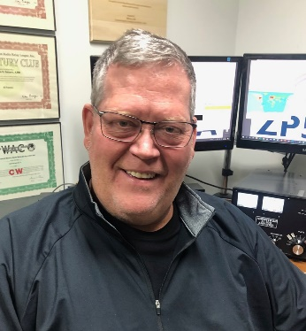*(from Bill, AJ8B)*

***DX This Week – 9G2DX Interview Part 2***

***Bill AJ8B (***[***aj8b@arrl.net***](mailto:aj8b@arrl.net)***, @AJ8B, or*** [***www.aj8b.com***](http://www.aj8b.com)***)***

***CWOPs Member #1567***

This week there was a wide variety of DX spotted in the Midwest including Anguilla, Argentina, Austria, Azores, Belize, Bermuda, Brazil, Chile, Colombia, Cuba, Czech Republic, DPR of Korea, England, European Russia, Finland, France, Germany, Gibraltar, Hungary, Italy, Kingdom of Eswatini, Madeira Islands, Mali, Mauritania, Mexico, New Zealand, Panama, Puerto Rico, Republic of Kosovo, Romania, San Marino, Sardinia, Scotland, Seychelles, Slovak Republic, Slovenia, South Africa, Spain, Trinidad & Tobago, and Western Sahara. Let me know what you worked.

TOP ^

***DAH DIT DIT DIT DAH DAH DIT DIT DIT DAH***

I did receive QSL cards from HK3J, German in Bogota, Colombia; 5Z4VJ, Andy in Nairobi, Kenya; HZ1SK, Samir in Jeddah, Saudi Arabia; 3D2TS, Phil in Suva, Fiji Island, and OD5YA, Gus in Beirut.

|  |  |
| --- | --- |
|  |  |
|  |  |

***DAH DIT DIT DIT DAH DAH DIT DIT DIT DAH***

Last week we had part 1 of the 9G2DX DXPedition to Ghana. Below is part 2. Please let me know if you like these kinds of topics in the Ohio Section Journal.

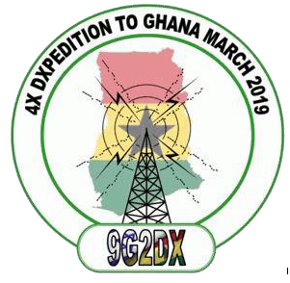

9G2DX – 4X DXPedition to Ghana   
Part 2—March 2019   
Written by: Zvika Segal 4Z1ZV

*Courtesy of Joe, W8GEX*

Our next two destination were national parks: Kakum National Park (WFF004), about 3 hour drive west of Accra and Shai Hills Resources National Park (WFF007) about a one hour drive north of Accra.

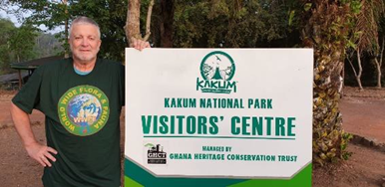

At both parks the hospitality was warm and the park management, rangers and local people went above and beyond the call of duty to support us in any way they could. This included helping us to turn every tree into antenna pole, carry our equipment, and providing the best locations for operating. No need to explain that “best” is a relative term.

TOP ^

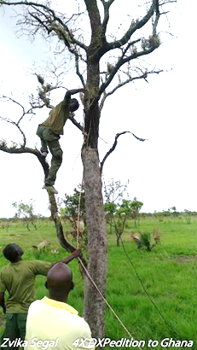General lodging conditions in the parks do not meet western standards. There is a lack of hot water and low pressure to no water flow at all. Some of us slept on inflatable mattresses either in a tent or on the ground and had to shower using a bucket and a bottle like in the good old days.

During one of the nights we stayed in Shai Hills Park, a thunderstorm began, so the team had to rush and pack the radio equipment into the cars.

We also learned the hard way that wet trees are like a Faraday Cage. They effectively block propagation and radio conditions were just dead.

Following the adventure in the parks we went back to “civilization;” a high-class hotel in Accra which means clean rooms, hot water, and breakfast.

The last few days we went back to the beach resort and set up for the fourth time, all the stations and antennas. With the good seashore conditions, the “harvest” was above 1,000 QSOs per day.

Early the next morning, the driver knocked on my door and was happy to share with me that he took down and re-packed all the antennas other than the Spider Beam.

It turns out that he misunderstood the requirements to leave all antennas as is other than the Spider Beam. The Spider Beam was going to be relocated to near Haim’s office. Hence, we had the set up all the antennas for a fifth time.

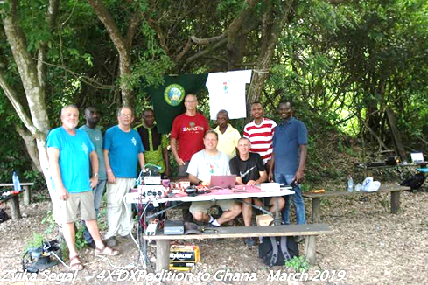One of our tasks was to leave Haim with a well installed radio station. Part of the challenge was to take apart the Spider Beam and transfer it and re- install it on two containers at Haim’s office.

Zeev did a fantastic job in marking each piece of the spider parts and elements using color masking technology. As suspected the re-setup of the antenna took a while due to its huge size (over 10X10 meters) and limited available space.

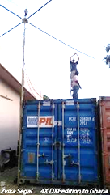

The local metal shop owner who was hired by Haim to supply a multi-pipe telescopic poles, gave us some additional insight to the way things work in Africa. There needed to be at least one dedicated Western guy attached to him, otherwise he would go to sleep. The welding machine was a real museum piece complete with a rusted transformer which was probably older than us. In addition, there was a magnificent extension cord which came equipped with neither plugs nor sockets. I will leave it to your imagination to guess how it worked.

TOP ^

Before departing Ghana, we had a meeting with NCA, the Ghana Communication Authority. A professional presentation was delivered by Haim to the manager and his 20 engineers, some of whom had taken part in our operation.

Ghana was also a great place to celebrate birthdays of 3 team members – Dov, myself and Haim who will soon celebrate a round number of years.

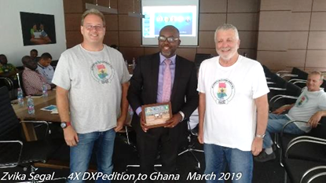  
Last night in Ghana, In the Chinese restaurant, we were exposed to the African version of “happy birthday song” along with fireworks and ice-cream cake.

Overall, we made in a net of 5 days of operation (3 locations and 4 setup and take down jobs), all combined with a lot of fun and adventures, over 5,200 QSOs. Over 50% CW by Dov and the balance divided between SSB and FT8. We worked over 80 countries including Antarctica and over 30 QSO with 4X stations back at our home in Israel.

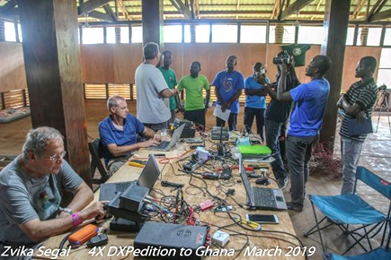All QSOs were logged into digital log s/w, at least once per day uploaded to eQSL and then screened of duplicates and errors. A corrected ADIF file was sent once per day to Mark Rosenberg 4X1KS, who supported us in setting up QRZ.COM, LoTW and clublog.com. He also acted as our focal point for all issues and daily reviewed and uploaded the QSOs to clublog.com. This helped to maintain very low level of errors (probably 2 complaints out of our over 5,200) and looked quite professional.

I would like to take this opportunity to thank the dedicated team, to Dov for his vision, to Mark for his support as well as reviewing and editing this article, to Charles Wilmott M0OXO who is still

acting as our QSL manager, to NCA management, to all of the local people who helped us succeed and did their best to give us warm hospitality, and last but not least, to Haim Lewy who made our dream come true with a lot of effort and investment

***CQDX CQDX CQDX CQDX CQDX CQDX CQDX CQDX CQDX***

Here is an update from Bernie, W3UR, of the DailyDX and the WeeklyDX, the best source for DX information. <http://www>.dailydx.com/. Bernie has this to report:

What to know who your neighbor hams are?  [https://haminfo.tetranz.com/map](http://r20.rs6.net/tn.jsp?f=001Ie-fN2OK36BLdVRqCBC5OP2FfcO8JpFWDyi0Gc7duOy0Yvjl_LixFkJ_KsogiNRzTm5-7nv4Dhelc2Fh7cBaU8jIYYsVfGlvvBQ5X8bcgIpH26oyiFNr02dpUIBB5paTGeIZuwDWTkUtRxmPgzpiJ5-0VWKweaNi&c=lNjZr0Z3bNnQi6LubhyhqO2wClfsLNXq6oXV0YyMbMzqUbc7I5H22Q==&ch=jQuvyQrWngU3zevhAPdAeMMNINlhBzkcpf0mMUbaz6P6pUDkfX1vFQ==)

TOP ^

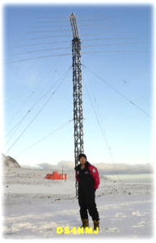8Q – Maldives HB9SHD (H44SHD), Remo, tells us his trip to Kandolho Island “may change at any time” this is “due to the current situation. While there, November 2-29, he will be diving and some holiday style operating on the ham bands. He thanks local op 8Q7PR, Parker Rasheed, who help Remo get his 8Q7RM license within two days. This will not be a “hardcore DX-pedition” but rather a holiday style operation with plans to be on SSB, Digital and CW. “Please note that the schedule is subject to change due to the actual situation”, says Remo. Remo plans to use an FT-991 with an FT-891 for back up. For antennas he’ll have a SteppIR CrankIR “if within Baggage allowance otherwise” a vertical with auto tuner, dipole or something else. Activity is expected on 1.8 through 50 MHz on SSB, FT8/FT4, CW, which he admits will be QRS as he is a little rusty.

VP8/SH – Shetland Islands DS4NMJ, Lee, gives details on his 2021 work assignment at the King Se-Jong Korean Antarctic Scientific Base on King George Island in the South Shetland Islands.

This will be his third trip there where he will be QRV as DT8A again. The base is located at 62° 13’ 26” south, 58° 47’ 27” west. He expects to arrive around January 15th. After the changeover he expects to begin operating once again as DT8A sometime in February. Lee is expected to be there through the end of next year. He’ll have a Mark V FT-1000MP running 200 watts into a dipole for activity on CW, FT8 and SSB on 1.8 through 28 MHz. QSOs will be uploaded to Club Log and LoTW. QSL via DS5TOS.

Miscellaneous QSL Information - With OM2SA’s (Jurai Sipos) passing October 1 at the age of 67, K0BJ is picking up the QSL manager duties. OM2SA managed QSLing for the KM9D and KF4TUG expeditions between 1991 and 2011, which included 3D2MO, TW0MO, 9M2/KM9D, 9M6/KM9D, A35MO, A35TO, CE0Z/KM9D, ET1QMA, E51TUG, FK/KF4TUG, FK/KM9D, FO/KM9D, FO0MOT, FO0MOT/p, FW0MO, FW0YL, H40MY, H44MY, H44TO, KM9D/KH8, T21MY, T2YL, T31MY, T32MO, T88CF, V63MY, V63TO, XR0ZY, YJ0AMY, YJ0ATU, ZF2MO, ZK1TUG, ZK2MO, ZK2TO, ZL/KM9D and ZL1CMY. K0BJ says those still wanting a paper QSL should contact him and he can make a “homebrew” out that, he says, will meet IOTA requirements.

***DAH DIT DIT DIT DAH DAH DIT DIT DIT DAH***



Below is a list of upcoming contests in the “Contest Corner”. I think this is important for someone who is trying to move up the DXCC ladder since entities that are on the rarer side and easiest to work in contests. Some of my best “catches” have been on the Sunday afternoon of a contest when the rarer entities are begging for QSOs. Of course, the gamble is that if you wait until Sunday, conditions may change, or they simply won’t be workable. However, it is not a bad gamble. Of course, why not work the contest and have some fun!

The contests in red are those that I plan to spend some significant participation time on. PLEASE let me know if you are working contests and how you fared.

Thanks!

TOP ^

|  |  |  |
| --- | --- | --- |
| Nov. 4 | UKEICC 80 Meter Contest SSB | <http://bit.ly/2MbaURB> |
| Nov. 7-8 | IPARC Contest Ukrainian DX Contest | www.iparc.de |
| Nov. 7-9 | ARRL CW Sweepstakes | [www.arrl.org/sweepstakes](http://www.arrl.org/sweepstakes) |
| Nov. 8 | ANET Sprint Contest | <https://fediea.org/news/?news=20201108> |
| Nov. 8 | FIRAC HF Contest | [www.firac.de/html/contest.html](http://www.firac.de/html/contest.html) |
| Nov. 11 | RSGB Autumn Series, SSB | <https://bit.ly/2XF8mSB> |
| Nov. 14-15 | 10-10 Digital Fall Contest | <http://bit.ly/1FrFeBc> |
| Nov. 14-15 | JIDX Phone Contest | [www.jidx.org](http://www.jidx.org) |
| Nov. 14-15 | OK/OM CW DX Contest | <http://bit.ly/19rrRjl> |
| Nov. 14-15 | Worked All Europe RTTY Contest | <http://bit.ly/2vufgcb> |
| Nov. 14-16 | CQ-WE Contest | <http://cqwe.cboh.org/rules.html> |
| Nov. 14-16 | PODXS070 Club Triple Play Low Band Sprint | <http://bit.ly/2Cq2yUA> |
| Nov. 15 | YO Int’l PSK31 Contest | <http://bit.ly/2w93WEd> |
| Nov. 16 | RSGB FT4 Contest Series | <http://bit.ly/38xg9V7> |
| Nov. 20 | YO International PSK31 Contest | [www.yo5crq.ro/Rules.htm](http://www.yo5crq.ro/Rules.htm) |
| Nov. 21 | RSGB 2nd 1.8 MHZ Contest CW | <https://tinyurl.com/y378u9wn> |
| Nov. 21-22 | All Austrian 160M Contest | <http://bit.ly/32ZYYd4> |
| Nov. 21-22 | LZ DX Contest | <http://lzdx.bfra.bg/rulesen.html> |
| Nov. 21-22 | REF 160-Meter Contest | <https://bit.ly/3iHzsQU> |
| Nov. 21-22 | SARL Newbie Party | <http://bit.ly/H0IqQf> |
| Nov. 21-23 | ARRL SSB Sweepstakes | [www.arrl.org/sweepstakes](http://www.arrl.org/sweepstakes) |
| Nov. 25 | UKEICC 80 Meter Contest CW | <http://bit.ly/2MbaURB> |
| Nov. 26 | RSGB Autumn Series, CW | <https://bit.ly/2XF8mSB> |
| Nov. 28–29 | CQWW CW | <https://www.cqww.com/> |
| Dec. 4 – 6 | ARRL 160M | <http://www.arrl.org/160-meter> |
| Jan 29 – 31 | CQWW 160M | <https://cq160.com/> |
|  | Winter FD | <https://www.winterfieldday.com/> |
| Feb. 20 – 21 | ARRL CW | <http://www.arrl.org/arrl-dx> |
| Mar. 6 – 7 | ARRL SSB | <http://www.arrl.org/arrl-dx> |
| Mar. 27 – 28 | CQWW WPX SSB | <https://www.cqwpx.com/> |
| May 21 | SWODXA DXDinner | [www.swodxaevents.org](http://www.swodxaevents.org) |
| May 29 – 30 | CQWW WPX CW | <https://www.cqwpx.com/> |
| August 28 | Ohio QSO Party | <https://www.ohqp.org/> |
| August 28 | W8DXCC Convention | [www.w8dxcc.com](http://www.w8dxcc.com) |

TOP ^

**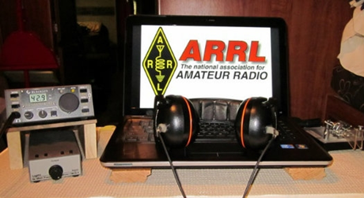*ARRL Contest Corner***

An expanded, downloadable version of *QST'*s’[**Contest Corral**](http://www.arrl.org/contest-calendar) is available as a PDF. Check the sponsor's’Web site for information on operating time restrictions and other instructions.

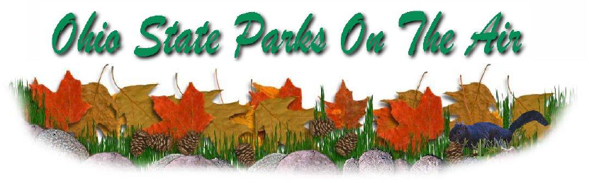####

***Ohio State Parks On The Air (OSPOTA) 2020 is in the history books.***

*(from Tom, KB8UUZ OSPOTA Chairman)*

This year the weather was perfect for everyone in the state. Even with the Covid-19 situation, we had 95 logs submitted for Ohio State Parks On The Air 2020 contest.

The all-volunteer OSPOTA Contest Committee has gone over the submitted logs and summary sheets from all of the participants.

It looked as if the bands were cooperating and a LOT of contacts were made this year. Ohio State Park activations were up and from what I have seen so far, everyone really had a FUN day playing radio and enjoying the Ohio State Parks.

Many of the stations replied to my request for write ups and pictures showing the set ups and operation during OSPOTA 2020 and are in this report for all to see how much FUN everyone had.

Thanks goes out to the committee for working hard to get through all of the logs. You have to remember - the OSPOTA committee are all volunteers **(there are five PCARS members that do this - KB8UUZ, KD8MQ, W8PT, KB8UHN and W8KNO)** and getting time set aside to spend HOURS going over logs them compiling the results, printing certificates, mailing to the top 3 in each category and the writing it all up for the newsletter is not an easy task that can be done quickly.

TOP ^

This was the first year for all logs to be submitted in Cabrillo format (no paper logs) and a special ‘Hats-Off’ to John, KD8MQ for running all of the logs through a computer checking program. John had a lot of work to get them all to work properly.

During November the first-place framed certificates and the second & third place certificated will be mailed out. So keep an eye on the mail box if you were one of the top three finishers in your category!

Full details of the scores, who all participated and even some really great pictures of those participating can be found at: <http://arrl-ohio.org/club_news/Nov-20/OSPOTA-2020_results.pdf>

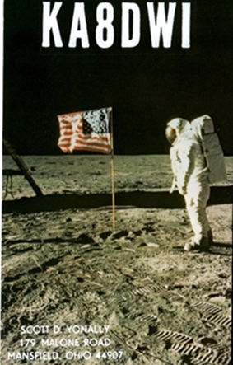***DX News***

***ARLD044 DX news***

This week's bulletin was made possible with information provided by The Daily DX, the OPDX Bulletin, 425 DX News, DXNL, Contest Corral from QST and the ARRL Contest Calendar and WA7BNM web sites. Thanks to all.

**TURKEY, TA.** Special call sign TC35FSF will be active from November

9 to 11 to celebrate the 35th anniversary of the Free Software Foundation, formed in 1985 in order to promote open-source software. Look for activity on 20 and 15 meters using SSB, PSK31 and Olivia 8/250. QSL via TA2OZQ and LoTW.

**MALDIVES, 8Q.** Remo, HB9SHD plans to be active as 8Q7RM from Kandolhu Island (AS-013) from November 2 to 29. Activity will be holiday style on various HF bands using CW, SSB and digital modes. QSL via HB9SHD.

**BELIZE, V3.** Bob, W0YBS will be active as V31CO from Cay Caulker until November 13. Activity will be on 80 to 10 meters including 30, 17 and 12 meters, using CW, SSB, FT8 and RTTY. QSL via W0YBS and LoTW.

**NEW ZEALAND, ZM4.** Operators Ark, ZL/EI9KC, Michael, ZL2MY, Holger, ZL3IO, Wes, ZL3TE (W3SE), Xenia, ZL4YL and possibly Gary, ZL2IFB will be active as ZM4T during the CQWW DX CW Contest as a Multi-2 entry. QSL via LoTW, ClubLog's OQRS or direct to ZL3IO.

**AFGHANISTAN, T6.** Robert, S53R plans to remain in the capital city working in his spare time as T6AA until mid-December.

**CHILE, CE.** CB500AM, operated by members of El Grupo Magallanes DX, will celebrate the 500th anniversary of the discovery of the Strait of Magellan on November 1 on 3685, 7138, 14230, 21330 and 28445 kHz. Operators are Pedro, CE8PVT, Walter, CE8MGZ, Alfonso, CE8APC, Carlos, CD8CKV, Ricardo, CD8RFU, and Giovanni, CD8GOO. QSL via CE8PVT.

**MOROCCO, CN.** CN45MS from Oujda commemorates the 45th anniversary of the Green March, from November 1 to 7. QSL via RW6HS.

TOP ^

**SPAIN, EA.** The URE section San Fernando (EA7URF) joins the Strait of Magellan celebrations with the call sign AM500ETS until November 8. They are QRV on HF on SSB, CW and digital modes. QSL via EA7URF, direct or via the bureau, LoTW, eQSL.

**FRANCE, F.** Members of the Radio Club Vendeen (F6KUF) will be active with the call sign TM9VG from November 1 to 15 celebrating the 9th Vendee Globe, a single-handed non-stop yacht race around the world.

QSL via F6KUF to the bureau or F5OEV direct. Also, TM50CDG operated by Michel, F8GGZ, will be QRV from November 9 to 22 to mark 130 years since the birth of Charles de Gaulle, who died 50 years ago.

Michel plans to be on 160 to 20 meters using SSB and CW. He plans a bureau card blast for all the QSOs.

**ENGLAND, G.** Members of the Rotary International Fellowship are currently operating as GB0RPP to promote World Polio Day and raise awareness of the Polio Plus organization. They will be QRV until November 7. All QSOs will be confirmed automatically with a bureau QSL. Cards are managed by G3LUW and G3SZF.

**ECUADOR, HD.** The Azuay Radio Club celebrates the 200th anniversary of the city Cuenca from October 31 to November 3 with the call sign HD200C. Also, members of the HC DX Group plan to operate as HD1X from October 31 to November 3 from a tropical rain forest in the Choco region. They will be QRV on HF using SSB, SSTV, FT8 and FT4. QSL via EC5R direct.

**ITALY, I.** The ARI Fidenza Club (IQ4FE) puts a number of special event call signs on the air during 2020 to commemorate the life and achievements of Guglielmo Marconi. During November, II4RVT commemorates the beginnings of Radio Vatican in 1931. QSL via IQ4FE.

**BELGIUM, ON.** Special event station OP20FENIKS honors the memory of the women and men who were involved in the reconstruction efforts in and around Westhoek after the end of World War I. Look for them on HF on SSB, CW and digital modes. QSL to ON5YL direct or via the bureau.

**NETHERLANDS, PA.** Frank, PF1SCT honors the memory of rock guitarist Eddie Han Halen (1955-2020) with the call sign PA5150EVH, until January 31, 2021. QSL via the bureau to PF1SCT. Also, look for Ray, PA5DX and Wim, PD8DX to be activating PA20XMAS, PD20SANTA and PD20HNY during the 2020 Christmas Holiday Season. There will be no QSLs but an award will be offered.

**POLAND, SP.** The club station SP6PRT in Wroclaw celebrates its 60th anniversary with the call sign SP60PRT until the end of 2020. QSL via SP6PRT.

**CANADA, VE.** Michael, VE3NOO celebrates the founding of the Hudson Bay Company 350 years ago with the call sign XM3B. He will be QRV through November. QSL via VE3NOO, direct or via the bureau.

**FINLAND, OH.** Members of the Market Reef Christmas DX Association (OH9A gang) will be operating special event station OG1XMAS on all bands and modes from November 29 to December 26. QSL via LoTW and Club Log.

**HAWAII, KH6.** Jim, N6TJ will travel to the KH7M station on the Big Island for the CQWW DX CW Contest. He plans to be a single op, all band entry. QSL via KH6ZM.

TOP ^

**SOUTH SHETLAND ISLANDS, DT8.** Lee, DS4NMJ plans to be active again from the King Se-Jong Korean Antarctic Base on King George Island as DT8A sometime in 2021. Activity will be on various HF bands using CW, SSB and FT8, with 100 watts. QSL via DS5TOS.

THIS WEEKEND ON THE RADIO. The Zombie Shuffle CW, Russian WW MultiMode Contest, UK/EI DX Contest, North American SSB Sprint, Silent Key Memorial Contest CW and Classic Exchange CW are all on tap for this weekend. Please see October QST, page 69, the ARRL Contest Calendar and WA7BNM Contest websites for details.

***Special Events***

* **11/02/2020 | 45th Anniversary, Sinking of SS Edmund Fitzgerald**

**Nov 2-Nov 16, 0000Z-2359Z, W8F**, Livonia, MI. Livonia Amateur Radio Club . 14.260 14.040 7.240 7.040. Certificate. Tas Foley, K8TAS, 37255 Eureka Rd., Romulus, MI 48174. On Saturday, November 14, W8F will operate from the Dossin Great Lakes Museum on Belle Isle, Detroit MI 1600-2000 UTC. Certificate: SASE to K8TAS [livoniaarc.com](http://livoniaarc.com/)

* **11/06/2020 | 2020 Stuart Air Show**

**Nov 6-Nov 8, 1400Z-2200Z, N4A**, Stuart, FL. Martin County ARES/RACES. 14.280 21.280. Certificate. MC ARES/RACES, PO Box 2769, Stuart, FL 34995. [martincountyfloridaaresracesinc.cloverpad.org](http://martincountyfloridaaresracesinc.cloverpad.org/)

* **11/06/2020 | 81st Anniversary of the Coast Guard Auxiliary**

**Nov 6-Nov 8, 0001Z-2359Z, W1H**, Elkins, NH. US Coast Guard Auxiliiary. 14.301 7.195 3.941. QSL. Bill Hopwood, P.O. Box 272, Elkins, NH 03233-0272. A commemorative QSL card is available on request. Please send a SASE.

* **11/06/2020 | 85th Anniversary of Amateur Radio in Sedalia/Pettis County Missouri**

**Nov 6-Nov 22, 1500Z-2359Z, WA0SDO**, Sedalia, MO. Sedalia Pettis Amateur Radio Klub (SPARK). 80M 40M 20M 10M. Certificate. Paul Withers, 19449 Hwy H, Hughesville, MO 65334. The first three weekends in November we will be operating. A certificate will be available for download. [wa0sdo.org](http://wa0sdo.org/)

* **11/06/2020 | Commemorating US Coast Guard Auxiliary 81st Anniversary**

**Nov 6-Nov 8, 1400Z-2200Z, N1A**, Plainville, CT. US Coast Guard Aux. District 13-North. 14.265 7.265. QSL. Charles I Motes Jr, 22 Woodside Lane, Plainville, CT 06062. Send SASE for QSL.

* **11/06/2020 | Commemorating US Coast Guard Auxiliary 81st Anniversary**

**Nov 6-Nov 8, 1400Z-2200Z, W8C**, Rochester, MI. US Coast Guard Aux. District 9-Central . 21.335 14,275 7.275 3.975. QSL. USCGAUX 81st Anniversary, 1853 Willowood Rd, Rochester, MI 48307. <https://uscgauxnational.blogspot.com/2020/06/81st-anniversary-of-us-coast-guard.html>

* **11/06/2020 | Remembering the Edmund Fitzgerald**

**Nov 6-Nov 8, 1500Z-2355Z, W0JH W0F**, Stillwater, MN. Stillwater, MN Amateur Radio Assoc - SARA. 21.360 14.260 7.260 3.860. Certificate. Via email , only to, EdFitzgerald2020@radioham.org. Call signs: WØJH (for phone) and WØF (for CW & Digital). We will have multiple stations simultaneously using the same call signs, as they are operating on different bands. QSL certificates may only be requested and sent via email address: [EdFitzgerald2020@radioham.org](mailto:EdFitzgerald2020@radioham.org)

TOP ^

*In keeping with COVID-19 social distancing requirements, we will operate from our individual QTHs this year. (Most of our Ops are in the Minneapolis/St. Paul area.) This is the 16th consecutive year, the club is conducting this Special Event.*[*radioham.org*](http://radioham.org/)

* **11/06/2020 | Stone Mountain Ham Fest Commemorative Special Event**

**Nov 7-Nov 9, 0000Z-2359Z, W4BOC**, Stone Mountain, GA. Stone Mountain Hamfest. 146.760. Certificate & QSL. Stone Mountain Hamfest, P. O. Box 1282, Stone Mountain, GA 30086. Stone Mountain Hamfest Inaugural Commemorative Special Event Stations K4A – K4M – K4R – K4C – W4BOC/P (Bonus Station) HF frequencies will be 80, 40, 20, modes will be SSB, CW, and FT8. Starting Saturday, November 7th, ending Monday the 9th. 48 hours [stonemountainhamfest.com](http://stonemountainhamfest.com/)

* **11/06/2020 | US Coast Guard Auxiliary 81st Anniversary**

**Nov 6-Nov 8, 1400Z-2300Z, N6Z**, San Jose, CA. US Coast Guard Auxiliary, District 11 North. 14.074 21.074 7.074 14.225. QSL. Alan T Stanton, 1524 Rosecrest Ter, San Jose, CA 95126.

* **11/06/2020 | US Coast Guard Auxiliary 81st Anniversary - Division 1 (Central Long Island) First Southern Region**

**Nov 6-Nov 8, 0000Z-2359Z, N2G**, Copiague, NY. US Coast Guard Auxiliary Division 1 (Central Long Island) First Southern Region. 7.247. QSL. George Tranos, PO Box 657, Copiague, NY 11726. Plan is to be active in ARRL November Sweepstakes CW

* **11/07/2020 | Florence Nightingale Bicentenary 2020**

**Nov 7-Dec 4, 1800Z-2000Z, GB200FN**, Romsey, UNITED KINGDOM. RSGB. 14.210 3.665. QSL. John Wakefield, Oakhurst, Lower Common Road, Romsey SO51 6BT, UNITED KINGDOM. [www.qrz.com/db/gb200fn](http://www.qrz.com/db/gb200fn)

* **11/07/2020 | Honoring Veterans for Veterans Day**

**Nov 7, 1500Z-2200Z, W0FSB**, Waterloo, IA. Five Sullivan Brothers Amateur Radio Club. 18.124 14.240 7.240. Certificate & QSL. Five Sullivan Brothers ARC, 3186 Brandon Diagonal Blvd, Brandon, IA 52210. For QSL card: Send card and #10 SASE; For Certificate & QSL: Send QSL, address label and 3 Forever stamps; For eQSL & Certificate: Send eQSL, then an email to w0fsb@outlook.com, requesting a .jpg file of the certificate that you can print yourself [www.qrz.com/db/w0fsb](http://www.qrz.com/db/w0fsb)

* **11/07/2020 | Mooseheart Founders Day Celebrating 107 Years**

**Nov 7, 1600Z-2300Z, K9M**, Mooseheart, IL. Fox River Radio League. 21.265 14.265 7.265 3.815. QSL. Moose International, Attn: Gordon Dailey - Activities, 155 S. International Dr., Mooseheart, IL 60539-1172. We will also work FT8 check website for band(s). QSL with SASE. For more information on Mooseheart Child City and School www.mooseheart.org [www.frrl.org](http://www.frrl.org/)

* **11/07/2020 | Portage County Amateur Radio Service 15th Anniversary**

**Nov 7-Nov 15, 0001Z-2359Z, K8BF**, Mantua, OH. Portage County (Ohio) Amateur Radio Service. 21.315 14.285 7.185 3.815. Certificate. Tom Parkinson, 9992 State Route 700, Mantua, OH 44255. PCARS Club members will be on 160/80/40/20/15/10/6/2/70cm/EchoLink(K8SRR) - all modes as K8BF. Color certificate (8"x10") or QSL card available with your QSL card and SASE to Tom Parkinson - 9992 State Route 700 - Mantua, OH 44255. Join us in our 15th year celebration as an Amateur Radio Club ! [www.portcars.org](http://www.portcars.org/)

TOP ^

* **11/07/2020 | SFRC OTA-trifecta**

**Nov 7, 1915Z-2230Z, W6P**, San Francisco, CA. San Francisco Radio Club. 14.328 7.250. QSL. Antonis Papatsaras (SFARC), 1388 Sutter Street, STE 715, San Francisco, CA 94109. This is going to be the first Angel Island Trifecta event by the San Francisco Radio Club. We will have three stations 1x SOTA, 1xPOTA and 1xIOTA operating under the same special event call sign. All stations will be battery operated. [sfarc.org](http://sfarc.org/)

* **11/07/2020 | USS Cobia WWII Submarine Celebrating Veterans Day**

**Nov 7-Nov 8, 1400Z-2100Z, NB9QV**, Manitowoc, WI. USS Cobia Amateur Radio Club. 14.240 +/- 7.240 +/-. QSL. Fred Neuenfeldt, 4932 S. 10th St., Manitowoc, WI 54220-9121. Send your qsl and #10 Envelope for QSL [www.qrz.com/db/nb9qv](http://www.qrz.com/db/nb9qv)

***“ARES Connect”***

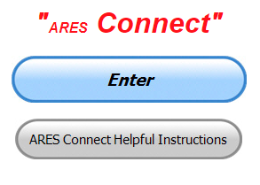

***Connecting Amateur Radio Volunteers with a Purpose***

Hey everyone… please make sure to go in and register your time to all of the events that you have signed up for. Don’t forget to get this done no later than

**5 days** after the event has ended. I’m asking you to do this for our ability to run reports accurately.

**I want to remind all of you that you do not have to be an ARES or ARRL member to use this system. All licensed amateur radio operators throughout the country are welcome and strongly encouraged to use it.**

**Don’t forget to check out the “Frequently Asked Questions” area that has been added to the Ohio Section website.** It’s there to help you through any difficulties that you may have with ARES Connect. Now, if you don’t any posts that relate to what you are having difficulties with, we now also have an on-line “Guru” area as well. This will allow you to ask any questions that you may have about ARES Connect.

**Let’s get everyone on “ARES Connect!!!”**

***Here’s the top 10 hour earners for the month of October:***

|  |  |  |  |
| --- | --- | --- | --- |
|  | **Name** | **Events** | **Hours** |
| **1** | Dan Stahl (KC8PBU) | 164 | 181.90 |
| **2** | Dwight Bonifield (W8TJT) | 146 | 181.20 |
| **3** | Christopher Domenick (KC8CAD) | 33 | 133.00 |
| **4** | Greg Dersarkisian (KD8SSJ) | 24 | 121.70 |
| **5** | Bret Stemen (KD8SCL) | 29 | 113.50 |
| **6** | James Yoder (W8ERW) | 21 | 112.51 |
| **7** | Leo Dubois, Jr. (KE8OOS) | 62 | 98.95 |
| **8** | Ron Wilch (KE8PX) | 144 | 97.50 |
| **9** | Michael Walker (AB8MW) | 70 | 79.25 |
| **10** | John Hilliard (W8OF) | 24 | 78.00 |

TOP ^

***Wanted: YOU… Relay Station!***

*(C. Matthew Curtin, KD8TTE)*

Are you looking to build useful radio skills and to put them to use in times of emergency? We have a unique opportunity before us, following up directly from BLACK SWAN 20, with a small exercise involving state agencies and infrastructure provided by FEMA in December. And more will follow, but to play you need to get started now, so we can start the training slow, the exercises small, developing skills and procedures all along the way so that we’re ready when the time for emergency communication comes.

The Ohio Section is looking for people to represent their Ohio county or their Ohio ARES District in a radio net designed specifically to support radio-only messaging in a way that's flexible and powerful. This isn't a tune-in-and-listen net: it's an effort to join, whatever your current skill level, if you want to get better, operate with others who care about good operation, be ready to put it to good use, and join nets you already work.

If you're not yet a General class licensee or don't yet have a working HF station but are interested, join us anyway to coordinate your training and upgrading efforts, and to find how you can operate with us within the scope of your operating privileges and station capability.

**What you'll get:**

Relationships: You'll get to know likeminded operators around the state

Skill: You'll learn and exercise fundamentals of two-way radio communication

Satisfaction: You'll grow in capability, teach others what you know, and see benefit in the growth of amateur radio as a viable service to the public for voluntary noncommercial communication, especially in times of emergency.

**What you need to get started:**

Attitude: To learn and to apply skill to serve

Equipment: VHF, FM Voice

Engagement: This isn't a passive experience, you're doing work as part of a team

Coordination: Net members have functions, you need to work with others, maybe reach out to them

Development: Expect to add NBEMS capability, and HF capability, with others' help and encouragement.

We’re looking afresh at the question of message relay, and in five months, we’ve gone from nonexistence to the ability to control the net in voice, to move messages of any format, and to move messages in any mode. The concept has been put to the test in an exercise that is now being briefed throughout the world of emergency management and homeland security at the federal, state, and local levels. The Ohio Section’s work has been instrumental in developing new capabilities for the protection of life and property.

Next week, I’ll explain more in my commentary on the BLACK SWAN 20 AAR/IP, training priorities, and opportunities to exercise capabilities new and old.

Participation and hard work have allowed us to develop and to refine the procedures that make all of this work. We’d like to have you join us as we develop this capability further. Please complete the form and let us know a little about your station capability and hours of operation! <https://forms.gle/F7rKkX1L4xFymay37>

TOP ^

***From The South 40***

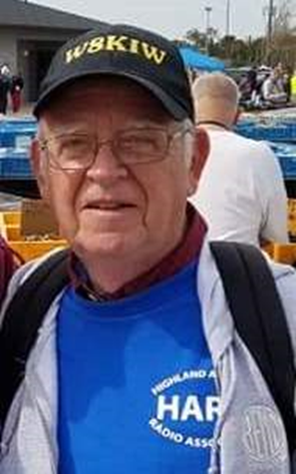*(from John Levo,* [*W8KIW@arrl.net*](mailto:W8KIW@arrl.net)*)*

***From the South 40***

Here’s hoping the ghosts and goblins didn’t play any Halloween pranks on your amateur radio activities and you still have some treats left to enjoy during those days when the weather outside is less than ideal and the bands are as dead as some Halloween creatures. With Halloween out of the way, now is the time to look forward (?) to this week’s Election Day. My wife Kathy (N8ZNR) and I are Highland County election officials and we can’t it stress enough for you to **please**, **go to the polls** and regardless of whom you support participate with casting your ballot. While speaking of elections, remember the ARRL’s Great Lakes Division races to choose our Division Director and the Vice Director are underway. Our Division is fortunate to have some great candidates for each office. If you are a League member and have yet to return your ballot, please vote and mail it in the coming days.

Speaking of elections, many Southern Ohio region clubs have been trying to conduct nominations and hold elections. But COVID 19 has gotten into the way. Adams County’s **DeForest ARC** has the nomination process underway, but the Athens and Ironton clubs had to delay their processes a month while Hillsboro decided to hold up nominations until after November 3. Although their December 8 meeting will be over the air the election will be conducted via the mail. The **Clinton County ARA** is accepting nominations via their web site. Other clubs are probably experiencing the same type issues during this most unusual year.

A big “Shout Out” to the **Southern Ohio ARA** on successfully renewing their Special Service Club designation. Information Officer Mike Love, WB8YKS, states the effort was easily done and they were able to renew the Affiliated Club status at the same time. Last week’s OSJ listing of Ohio inactive affiliated clubs was an eye opener. A number of “South 40” clubs listed were right here in Southern Ohio. If you noticed your club on the list, please take action and contact the folks within your club to get the status updated and back on track. Even our friends across the River should take a look at their club’s status in their own sections.

As a teenager growing up in Louisa, KY Fred Jones spend a lot of time at Compton’s Fix It Shop watching and helping the owner fix and make things, including ham radio transmitters and receivers. It was there he became interested in the Morse Code and earning his ham radio license (WA4SWF) before graduating high school or learning to drive. After retiring from a career at Armco Steel, the 74-year-old Jones still finds enjoyment pounding the key daily on traffic nets and “talking” with friends. Jones life was shared with Tri-State newspaper readers a while back by Huntington’s feature columnist Clyde Beal. Beal recently published a book featuring some of the most interesting Tri State people he has interviewed during his 13 years writing the weekly feature. And Jones’ life with his dots and dashes are a featured chapter in the book. The book is available from the author.

Members of the **Highland ARA**’s newly formed VE team are gearing up for their first self-conducted test session according to assistant VE team coordinator Pat Hagen, N8BAP. Hagen states VE coordinator Tom Mongold, KD8LDS, has been working closely with Fayette ARA VE leader Jim Scott, N8ORJ, to get everything ready for the November 7 test session in Hillsboro. Hagen invites anyone interested in becoming a VE team member to contact either Tom or himself.

TOP ^

Hagen is also the **Highland ARA** Net Manager and reminds those who check into the Monday evening 147.21/146.685 net of the new starting time. With the change to Standard Time the net will now start at 8 PM. Currently around 30 people check in each week.

In anticipation of the **Southern Ohio ARA** conducting their November and December meetings on-line using the Zoom Meetings app, the club will conduct a test of the meeting app a week prior to the November 16 meeting. SOARA’s Tim Nicely, AC8VQ, and Dave Bruce, KD8NYN, will share their knowledge of the app with those participating. Updates will be available on the Club’s 8:30 Thursday evening two meter.

Logan’s **Hocking Valley ARC** has come up with a creative club activity because the Pandemic forced it to cancel many of its traditional events. For the past two months the Club has conducted Hocking County Fox Hunts as a way for their members to engage in a Club conducted activity while safely staying in their vehicles. The “fox” can be located anywhere in Hocking County but must be visible from the roadway. Bill Hopstetter, W8LGX, reports there has been a lot of interest in the hunts and whether to hold one in November will be discussed at their upcoming meeting.

According to **Clinton County ARC** Information Officer Andrew Adrian, W9AMA, the Club will meet this Thursday evening, November 5 at the Boyd Cancer Center, Farquhar Avenue, (between West Locust and West Main Streets), Wilmington. The meeting will begin at 7:30 PM. Since the meeting is in a medical facility masks must be worn to enter and exit the building, but social distancing will allow removal once seated. Because of the local spike in cases, temperatures may be required at the door. More details can be found at <https://ccara.net>

Last week it was mentioned the **Tri-State ARA** was awaiting the arrival of the cement trucks to pour the foundations for the two new towers at the West Virginia Museum of Radio and Technology in suburban Huntington. President Bud Cyr says the concrete is now poured and curing and a base is ready for installation. Another is being fabricated. It’s been decided to delay the tower erections until Spring.

Also, from South of the river comes this news. Because of a linking issue the **Greater Mason County ARC** will begin a temporary net on Sunday evenings until the issue is resolved. The modified net begins on the Maysville 145.47 (no tone or squelch tail) machine at 8:15. It will then move to the Beechburg 146.955 (107.2) repeater at the normal 8:30 net time. During the “second edition” of the net, the Beechburg repeater is linked with one in Morehead, KY.

Brian Shapiro, KC8ZUF, has an ARRL General License study manual on order, but does not expect delivery until after the start of an on-line class. Therefore, he would like to borrow a manual until his arrives. If you have one and would allow his use, please contact him at [shapiro@ohio.edu](mailto:shapiro@ohio.edu)

The **Athens County ARA** recently held its monthly meeting via a Zoom teleconference. According to Eric McFadden, WD8RIF, the assumption is the ever-popular Athens Hamfest will be held on the last Sunday in April and planning shall continue. Nominations for offices were made and voting will be by mail with ballots to be returned prior to the November meeting. Other items discussed were the traditional Christmas dinner and club participation in Winter Field Day. Both were tabled until the next meeting.

####

TOP ^

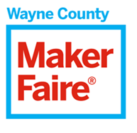

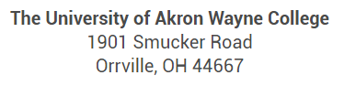

Hello everyone,

The [Maker Faire Wayne County](https://waynecounty.makerfaire.com/) is a **family-friendly showcase of invention, creativity and resourcefulness** and a celebration of the Maker Movement.  It’s a place where people show what they are making and share what they are learning.  Makers range from tech enthusiasts to crafters to homesteaders to scientists to garage tinkerers.  They are of all ages and backgrounds.  The aim of Maker Faire is to **entertain, inform, connect and grow this community.**

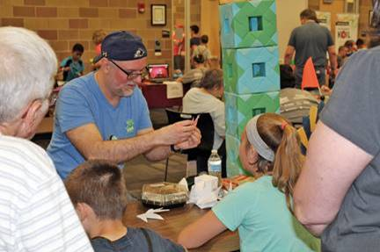

The Daily Record said it best: “Dubbed the ‘Greatest Show and Tell on Earth’; over **1,200 people** flocked to the third annual faire at the University of Akron Wayne College the summer before last.  It was a fresh experience with **favorite makers from previous years** along with new makers and new things to see and do.

It’s coming! [Virtual Maker Faire Cleveland](https://cleveland.makerfaire.com/) is **Saturday, November 7th starting at 10:00 a.m.**

[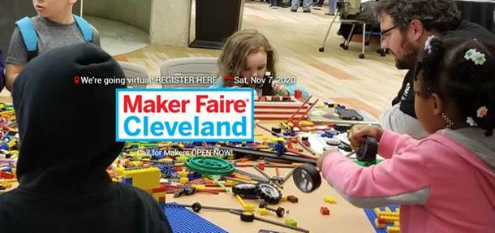](https://cleveland.makerfaire.com/)

TOP ^

**Maker Faire Cleveland** is a family-friendly gathering centered around invention, creativity and resourcefulness, and an exuberant celebration of the **CLE's Maker spirit.**

Join us for a day of:

-- sneak peeks into Maker lairs around the CLE...including anything from your neighbor's garage to the **NASA Glenn Research Center.**

-- workshops and Maker demonstrations you can follow at home

-- connections to cool CLE Makers

-- inspiration to fuel your Maker ideas and spark your own projects

Then, join the new **Maker Faire Cleveland community** online at makeprojects.com to showcase your projects, collaborate with others, and tap into a whole new world for Makers of all ages.

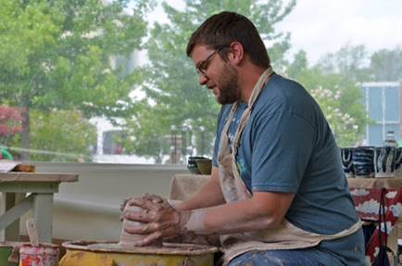We are **proud to showcase Ohio makers** who participated in Maker Faire Wayne County.  One of these groups is the [**Wayne Center for the Arts**](http://www.wayneartscenter.org/).  The Center promotes artistic creativity, education, and presentation for a collaborative, inclusive, and vibrant cultural community.  The mission of Wayne Center for the Arts is to enrich lives and strengthen communities through art.  It strives to be relevant, accessible, and affordable to all residents of Wayne County while providing services and programs that are of the highest quality.

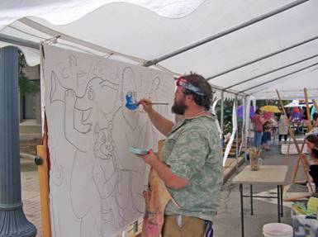

At Maker Faire Wayne County, representatives from Wayne Center for the Arts showed faire attendees how to **make paper bag flowers**.  The following year, the Center brought a **pottery wheel** to make beautiful works during the faire to the amazement of fair goers of all ages.  The Center’s new location in Wooster also supports activities offered by [Schantz Makerspace](https://www.schantzmakerspace.com/), another regular participant in Maker Faire Wayne County.

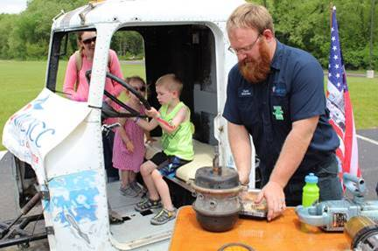

Another group that participated in Maker Faire Wayne County is the [**Wayne County Schools Career Center**](http://www.wayne-jvs.k12.oh.us/)**.**  Juniors and seniors from the Truck Mechanics program built a **Mini Semi Truck Golf Cart.**  This project was created so students can practice maneuvering a semi truck and trailer around in a parking lot and simulate backing into a loading dock.

TOP ^

WCSCC brought their mini semi golf cart truck to the faire and setup an **outdoor obstacle course** that younger attendees pedaled a Big Wheel through.  Diesel Technologies is one of many programs at WCSCC that teaches students how to do oil changes, brake service, and basic repairs for semi-tractors.  [Click here](http://www.wayne-jvs.k12.oh.us/hs/programs/) for all of the **amazing program offerings at WCSCC!**

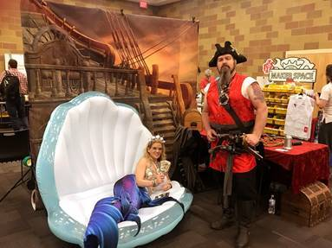Rounding out our participating makers are the **Pirates of the Rusty Cutlass,** a group of pirate entertainers that educate people about nautical and pirate history.  Sailin' aboard th' Inferno, we be th' Pirates o' th' Rusty Cutlass - th' grandest crew o' skallywags yew'll eva cross paths wit'.  They be Pirates fer hire, yer best choice for **Pirate Entertainers in Northeast Ohio.**  Parties, life-events, community and charity events - they do it all!

At the faire, the Pirates dressed to the hilt (pun intended), displaying **authentic pirate-ty novelties** and perusing the crowds with their antics.  There was a beautiful **mermaid-in-shell** for photo shoots with the kids!  Their booth was a fun place to visit for all.

If you would like to know more about the Wayne Center for the Arts, the WCSCC Truck Mechanics program, or Pirates of the Rusty Cutlass, please contact: [tjh1@uakron.edu](mailto:tjh1@uakron.edu)

***One Question Questionnaire***



Hey Gang,

Survey Says”….. about 36% of you have experienced some paranormal experience in your lifetime!

Ok, now on to the next question… With winter fast approaching and all of us will surely be spending more time in our shacks, this next question has to do with how you have your electric service to your shack setup.

So, here goes….

***“Do you have a master power cut off switch in your shack??”***

You’ll find the “One Question” questionnaire on the Ohio Section Website! http://arrlohio.org It’s all in fun and it’s not a scientific survey in any way, but we are learning some things that we didn’t know from these questions. I hope that you are enjoying answering these “One Question” questionnaires.

TOP ^

*****V.E. Test Sessions***

Many V.E.’s have decided to start testing once again, but with restrictions that need to be adhered to for sure. Here’s the link to find that V.E. Test session and what is expected of YOU before going. <http://www.arrl.org/find-an-amateur-radio-license-exam-session>

***Final.. Final..***

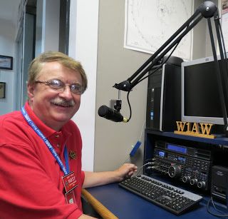Hi Gang,

This has been another really great week! I got some leaves raked and set out to the curb for the village to come and pickup. Yes, here in the big metropolis of Lexington they still do things like that. And yes, they do have a higher tax base than most towns around, but it’s for things like this so it doesn’t hurt quite as bad. I will say, with as many trees as we have, it seems raking is a never-ending job around here.

I also attended a rare in-person Hamfest as well this past week! The Massillon club moved their hamfest to the **MAPS Air Museum** behind the Akron Airport and it was really great! Not only did we attend a great hamfest, but we also got to see a lot of really cool aircraft as well.

This new location is really easy to get to and there were lots of hard surface parking available as well. No more parking on a grass field. The hamfest was very well attended, especially since this was a new location for them. It seems that anytime you move a hamfest, it takes a bit of time for everyone to get used to. Oh well…

The Massillon Hamfest is going to do it for the hamfests in Ohio this year, although there is one more hamfest on the schedule, but not in Ohio. It’s in Livonia Michigan next weekend if you are interested. Here’s a link to their hamfest info… <https://www.dropbox.com/s/66utqgicbs2pxrz/Repeater%20Swap-page-001.jpg?dl=0>

I hope you saw that our very own Stan, N8BHL has found himself with another job besides being our Section Emergency Coordinator. He’s now the Emergency Communications Editor for CQ Magazine as well. What an honor that is for Stan. Please give him an “Atta Boy” the next time you talk to him!

Have you filed your complaint against the proposed $50 fee by the FCC for license issue and renewal? If you haven’t you can check out the sample letter that I have as well as the stet-by-step instructions for filing with the FCC at: <http://arrl-ohio.org/sm/20-270/> The sample letter will help you word your letter in your own words. Please be sure to end the letter with your name, call sign as well as address.

TOP ^

Have you taken the time to check out the reports that are on-line? These reports are there for you. Take advantage of them to boost up your training as well as your ham radio participation! Here’s a link to just one of the reports… <http://arrl-ohio.org/SEC/reports.html> You can also see how the Ohio Section is doing compared with the other Sections in the Great Lakes Division by [clicking here](http://arrl-greatlakes.org/ac2.html)

Whelp, that’s going to do it for this week my friends! I’m still looking forward to visiting with all of you live or via Zoom, WebEX or whatever.

I really can’t wait for that time when we can all get together in person once again. Those are the times I cherish the most!!! Stay safe! We will get through this and when we do, we’ll have so much to talk about. Most of all… have FUN and get on the airwaves!!

73,

[***Scott, N8SY***](mailto:n8sy@n8sy.com)



Hey Gang,

Have you taken a look at the **Swap & Shop** page on the Ohio Section webpage yet?? Here’s a link that will take you there…

<http://arrl-ohio.org/sm/s-s.html>

Do you have equipment that you just don’t need or want anymore? Here’s a great venue to advertise it, and it’s FREE!! Is your club doing a fund raiser to help raise money? After a lot of thought, it was decided that the Swap & Shop webpage could also contain these types of items as well. The same rules will apply as do for the For Sales and Give-A-Ways and will only be posted for a month at a time. Please see the Terms & Conditions on the webpage.

If your club is doing a fund raiser and wants more exposure, please forward the information to me and I’ll advertise it on the Swap & Shop webpage for you.

Now, I still want to remind you that it won’t be listed in this newsletter because it would take up way too much space, so your ad will only appear on the website. It is there for any individual to post equipment Wanted / For Sale or Give-Away as well as for Club Fund Raisers. No licensed vehicles/trailers or business advertising will be posted. Postings are text only (no pictures or graphics) will be posted for a maximum of 1 month from date posting and require a contact phone number or email within the posting. Send your Wanted / For Sale or Give-Away post to:  [swap@arrlohio.org](mailto:swap@arrlohio.org)

***Welcome New Subscriber(s)***

**Heather, KE8OVK; William, W8LGX**

TOP ^

Ohio Section Cabinet

|  |  |
| --- | --- |
| Section Manager – Scott Yonally, N8SY | Assistant Section Manager – John Perone, W8RXX |
| Section Emergency Coordinator – Stan Broadway, N8BHL | Section Traffic Manager – David Maynard, WA3EZN |
| Technical Coordinator – Jeff Kopcak, K8JTK | Affiliated Clubs Coordinator – Tom Sly, WB8LCD |
| State Government Liaison – Bob Winston, W2THU | Public Information Coordinator – John Ross, KD8IDJ |
| Section Youth Coordinator – Anthony Lascre, K8ZT | |

***Back Issues of the PostScript and Ohio Section Journal***

Hey, did you know that PostScript and Ohio Section Journal (OSJ) are archived on the website? You can go back and look at any edition simply by clicking:

<http://arrl-ohio.org/news/index.html>

***Want to Share your Club Newsletter With Others?***



We have a webpage where you can download and read all of the newsletters that I get from around the state and even other sections!

Here’s the link to the page…. <http://arrl-ohio.org/club_news/index.html>

Please, if you don’t see your club newsletter posted, it’s because I’m not receiving it. Just have your newsletter editor contact me and I’ll get your club’s newsletter listed on the site!!

We all learn and steal (I mean, share) from each other’s work. So, get me your newsletter!!! Send it to: [n8sy@n8sy.com](mailto:n8sy@n8sy.com)

***Chit – Chat, and All That!***

Do you know someone that’s not getting these Newsletters? Please, forward a copy of this Newsletter over to them and have them “[Opt-In](mailto:Opt-In)” to start receiving them. Heck just have them send me an email [n8sy@n8sy.com](mailto:n8sy@n8sy.com) and I’ll get them added to the Ohio Section Emailing list.

We now have many thousands of readers receiving these newsletters weekly. Quite impressive, I’d say! I urge all of you to make sure that everyone, regardless of whether they are a League member or not, get signed up to receive these weekly Newsletters.

TOP ^

You can always “Opt-Out” at any time if you feel this is not what you were expecting. It’s fun and very informative. All of your favorite past newsletters are now archived too.

You can go back at any time and read them. Just go to: <http://arrl-ohio.org/news/>

Got questions, concerns or would just like to sit and chat awhile? Heck, I’ll even buy the coffee!! Give me a call at (419) 512-4445 or email me at: [n8sy@n8sy.com](mailto:n8sy@n8sy.com)

The pictures on the front page and throughout this newsletter are from various newsletters, Facebook posts and/or were sent directly to me in recent weeks. Take a good look at them, you just might be in one of the pictures! “SMILE… you’re in the Ohio Section News!!”

***Stop!!! You’ve reached the end of another week’s edition.***

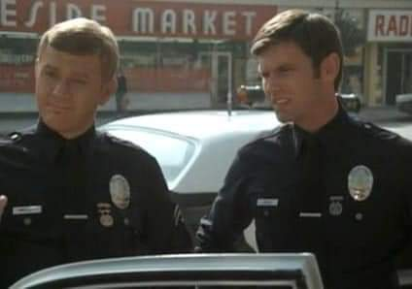

TOP ^

*PostScript is produced as a weekly newsletter. I want to thank everyone that has contributed articles and ideas to make this an even better news source. I sincerely hope that you have enjoyed this edition and will encourage your friends to join with you in receiving the latest news and information about the Ohio Section, and news and events happening around the world!*