[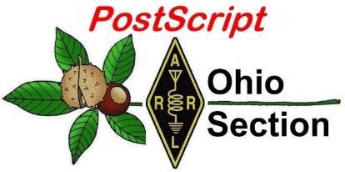](http://arrl-ohio.org/news/)***October 19th***

***Edition***

🡪 [National News](#national) 🡪 [The Handbook Give Away](#handbook)

🡪 [Club Corner](#club) 🡪 [Hamfests](#hamfest)

🡪 [DX This Week](#dx) 🡪 [ARES Connect](#connect)

🡪 [VE Testing](#ve) 🡪 [One Question Questionnaire](#one)

🡪 [From The South 40](#south) 🡪 [Final.. Final..](#final)

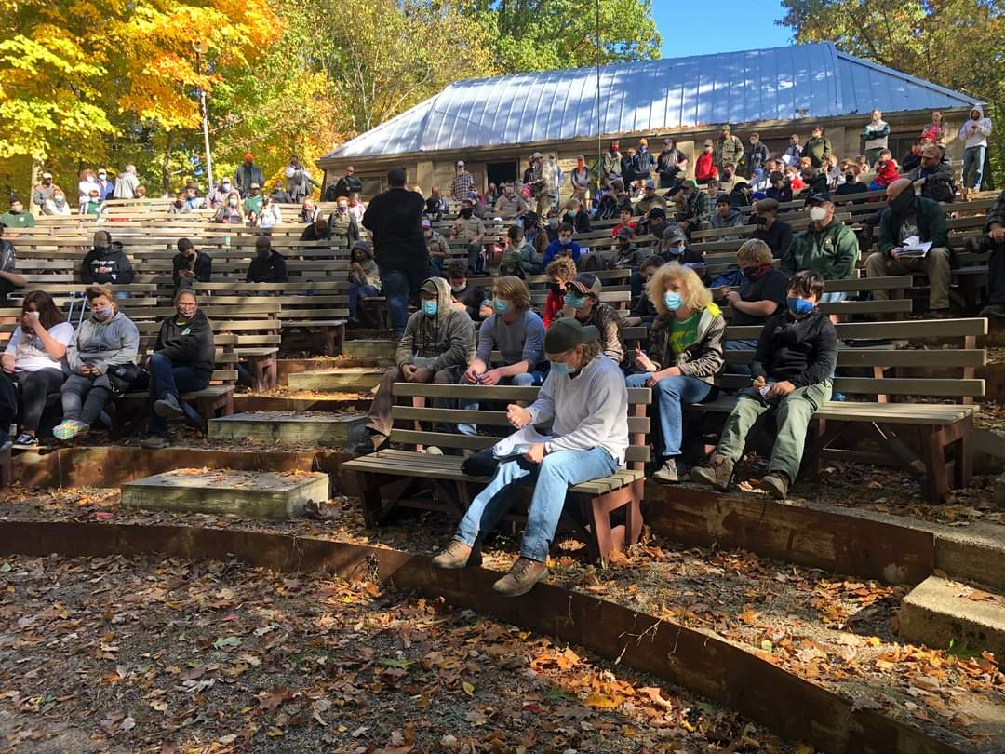

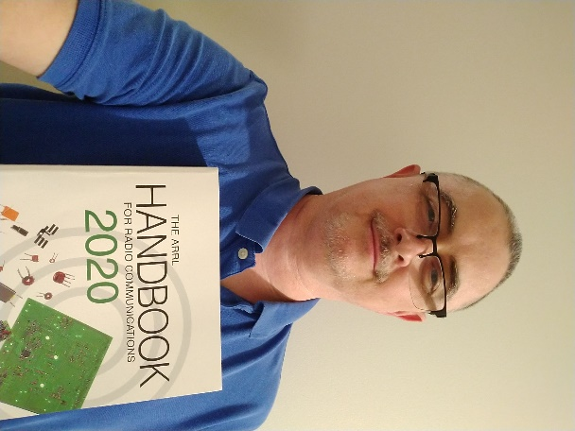

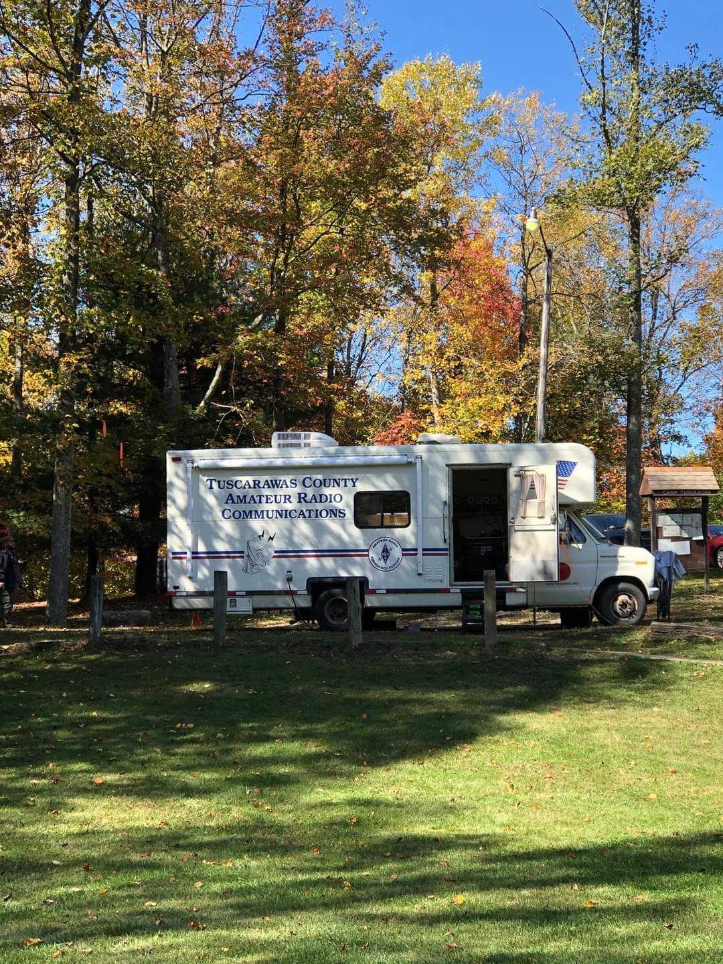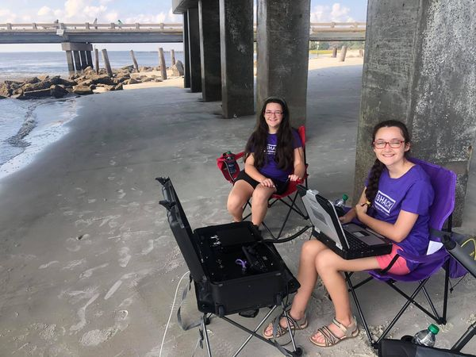

***National News***

*(from arrl and other sources)*

***Notice of Proposed Rulemaking - Call To Action***

Greetings fellow Great Lakes Division hams. It is time to protest the imposition of fees for Amateur Radio Licensing. The fees Notice of Proposed Rulemaking was published in this morning’s Federal Register (<https://tinyurl.com/yyk8f2yp>). The deadline for comments is November 16, and the Reply comment deadline is November 30.

With this in mind, I am extending the following suggestions you might consider using in writing to the FCC in response to the NPRM. Our thanks to Dave Siddall K3ZJ, ARRL Counsel, for these guidelines. Be sure to carefully review the paragraphs; "Some Suggestions" as the information therein will assist with much of the applicable background.

This subject is critical, the timing is critical. I urge you to contact the FCC. Address and related information is contained in the article referenced in the Federal Register. Please use your own words to express your objections to the proposed fees.

**(Good) Arguments Against FCC Fees for Radio Amateurs**

Amateurs contribute to the public good. In many areas they provide an emergency communications backbone capability at no taxpayer cost.

Consistently we have witnessed storms and natural disasters completely wipe out internet, cellular, and other means of communication. Radio amateurs often fill that void on an unmatched, flexible basis when

needed. One recent example is the California wildfires.

Unlike operators in other FCC licensed services, Amateur Radio operators by law – domestic and international -- must eschew using their license for any pecuniary interest. Amateurs are prohibited from earning or charging any money for any communications activity. The expenses for their equipment and activities come out of their own pockets, with no opportunity for reimbursement or payment of any kind.

The United States is experiencing a severe lack of RF engineers and expertise at the very time it is needed by the burgeoning wireless industries. Amateur radio is helping to meet the deficit, but much more is needed and youngsters (High School and College-aged) are least able to afford licensing fees. RF knowledge and related digital expertise is needed to maintain U.S. leadership in wireless industries. At a minimum, young people (below the age of 26) should be exempt from the proposed license fees.

Amateur radio is self-regulating. (a) Amateur examinations are written and administered by radio amateur volunteers. (b) Examination results and paperwork most often are submitted electronically to the FCC.

Electronic submission could be required if there would be a cost savings to the Commission. (c) Amateur radio educational classes are conducted by volunteers who by-and-large do not charge fees or tuition for teaching. (d)

The amateur service, in cooperation with the FCC’s Enforcement Bureau, has a volunteer corps that monitors the amateur airwaves and has programs that try to prevent their misuse before FCC involvement might be needed.

[TOP](#top) ^

The amateurs also observe non-amateur signals both within amateur spectrum and outside it, and report unusual or suspicious signals.

Amateur radio continues to be a source of significant technological innovation that should be encouraged, not discouraged.

**Some Suggestions**

We do not recommend arguing that the $50. fee every 10 years, which amounts to $5.00 a year, will “kill” amateur radio, even though as proposed this is for each covered application, which includes upgrade applications. Tech-General-Extra could be $150. If exams taken at different sessions, a substantial amount. But it “rings” the wrong way to say the whole service turns on $5/year for each licensee. If that’s all it would take….

The Commission argues that the charges are required by the statute. The word used is “shall”, which is mandatory, not optional. But the statute does not set the amount, nor does it prohibit reasonable exceptions – evidenced by the Commission’s proposal to exempt from fees administrative update applications based on policy grounds.

This is not “aimed at amateur radio to kill it.” There is a long history and precedent on charging fees for the licensing service involved, just as there is for passports, green cards, drivers' licenses (issued by states), etc. Better to make pertinent arguments on why the fees would impair the public benefits of the amateur radio service than argue that the whole service might die as a result of a fee that, in fact, is less than the fee many of us paid in the 1960’s and 1970’s.

For background: this proceeding is being handled by staff unfamiliar with amateur radio. It is being handled in the FCC’s Office of Managing Director (OMD), not in the Wireless Telecommunications Bureau where the amateur-specific Part 97 matters are handled. The focus of OMD is accounting – budgets and the like for the entire Commission.

The fee proposals cover every FCC license and service across the board and the consideration was directed by Congress. It is recommended keeping “ham jargon” out of comments, it won’t be understood by the intended recipients.

Thank you.

ARRL Great Lakes Division Director: Dale R Williams, WA8EFK

####

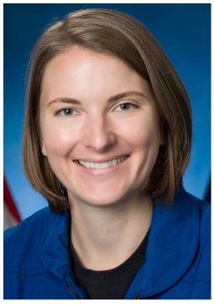***Two More Astronauts Earn Amateur Radio Licenses***

Although the lockdown of Johnson Space Center (JSC) postponed amateur radio training and licensing over the past 7 months, NASA ISS Ham Project Coordinator Kenneth Ransom, N5VHO, was able to work with all of the new astronaut-class graduates, as well as offer some refresher courses with already-licensed astronauts. Licensed astronauts on the International Space Station (ISS) may operate the on-station ham radio equipment without restrictions.

[TOP](#top) ^

Astronauts often participate in Amateur Radio on the International Space Station ([**ARISS**](http://www.ariss.org/)) contacts with schools and groups on Earth.

NASA Astronaut Kayla Barron, who completed her introductory course in June and received basic ham radio operations training in late September, recently tested and received the call sign KI5LAL.

European Space Agency astronaut Matthias Maurer passed his amateur radio exam on July 30, and he got his basic ham operations training in July. He now is KI5KFH.

Astronauts Shane Kimbrough, KE5HOD, and Shannon Walker, KD5DXB, completed the refresher course earlier this year. Two other new astronauts are in the queue to take the Technician license exam. *— Thanks to Rosalie White, K1STO*

####

***Multiple Balloons Carrying Ham Radio Payloads Launched***

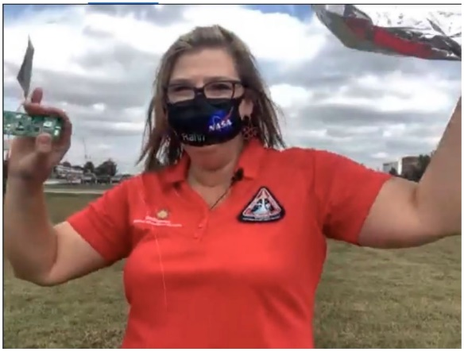Eleven schools across the US launched helium-filled balloons carrying amateur radio payloads on October 9. The Smithsonian Air and Space Museum [**live-streamed**](https://www.facebook.com/airandspace/videos/1936985526444386) the multiple launches. The balloons are trackable via ham radio on [**APRS**](http://www.aprsdirect.com/) (either 144.39 MHz FM or 144.34 MHz FM).

The lighter-than-air vehicles were intended to head east around the globe, although there’s no accounting for upper air currents. Altitudes were expected to be in the 20,000 – 25,000 foot range, with the balloons taking a few days to cross the Atlantic Ocean.

Some of the balloons are already out over the Atlantic, and one, the KS1LAS-1 balloon, launched from Washington, was reported over the Mediterranean on October 14, moving at a speedy 69 MPH at an altitude of some 40,400 feet.

The K4NVA-1 balloon launched from Northern Virginia was reported on October 11 just east of St. Johns, Newfoundland, at just over 23,100 feet, moving at 62 MPH. Others are still over North America and/or not heading in the intended direction.

The NW3DC-1 and NW3DC-2 balloons, sent up from Washington, DC, were last reported on launch day close together just off Maryland’s Eastern Shore.

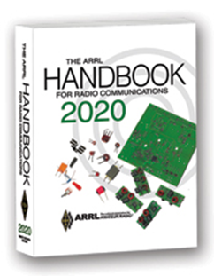***The Handbook Give Away***

Hey Gang,

Have you registered for the “Handbook Giveaway” drawing for this month yet? If you haven’t, go to: <http://arrl-ohio.org/handbook.html> and get yourself registered now!

[TOP](#top) ^

What’s the catch? I want to get everyone checking in to the Ohio Section website as often as possible, and in order to register each month, you have to visit the website often! There’s nothing else to it. I pay all expenses and I usually “Give Away” more than just a Handbook too!!

Many of you ask me just how do I know when the drawing is on? Well, that’s easy all you need to do is check in on the Ohio Section Website on a regular basis and watch for the big [RED](http://arrl-ohio.org/handbook.html) Arrow that will appear on the left side of the page. This is the sign that the drawing is on and you need to get registered. So, keep a sharp eye out on the website and check in often!

***Club Corner***

***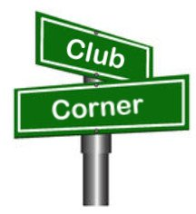***

This is YOUR cornner of the newsletter. Send me what your club is doing and I’ll make sure that it gets in. Got a special event or club project that you want everyone to know about? Send it to me!. Need help with a project? Send it to me.

Let me know what you club is up to. Are you going to have a special guest at your meeting or are you having a special anniversary? Just sent it to: [n8sy@n8sy.com](mailto:n8sy@n8sy.com)

####

***Lake County ARA Needs Help with Marathon***

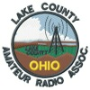

All,

We are still looking for Volunteer radio operators to help with the Northern Ohio Marathon and 5 team relays coming up on **November 1st**. This year's route is a 13-mile course thru northern Mentor. Start /Finish is Mentor Civic Center.

Contact  [wb8zgh@arrl.net](mailto:%20wb8zgh@arrl.net) or [kb8bke@arrl.net](mailto:kb8bke@arrl.net) if you have questions.

Please use the attached form to sign up.  
<https://docs.google.com/forms/d/e/1FAIpQLSeGKv2ssCPJu83p_XH1sGIddGylePBWQv0KRXj6F1v8XenD5g/viewform?usp=sf_link>

####



***Pumpkin Patrol***

Lorain County is looking for additional volunteers for Pumpkin Patrol. During the evenings of **October 30, 31, and November 1**, volunteers will be assigned to locations throughout Lorain County to watch for any suspicious activity occurring around area bridges.

[TOP](#top) ^

Net control will be run out of the Lorain Ohio Highway Patrol post to have direct contact with Troopers in case activity is observed. Shifts start around 6PM and go until approximately midnight.

To sign up, contact Keith KD8GXL at [kd8gxl@gmail.com](mailto:kd8gxl@gmail.com)

**I'm told there may also be free home cooked chili!**

####

***Radiogram Practice***

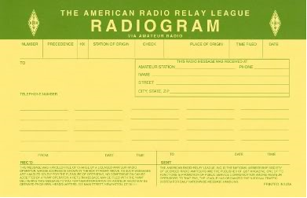

Below is some info from Jon KM8V about a radiogram practice he developed for ARES District 10. ALL are welcome to participate, not just ARES members.

The ARRL and RRI are putting some focus on how to take advantage of existing NTS/RRI traffic network infrastructure and provide the capability to pass served-agency ICS-213 traffic on these networks.

Many ARES operators are not necessarily familiar with the NTS or how to pass radiogram traffic. This is a good skill to have and can even earn you points on Field Day. If you are outside of Ohio ARES District 10 and would like to participate, please do, all are welcome.

**District 10 Monthly Exercise – October 2020:**

• Goal: Every D10 ARES member originates a Radiogram to KM8V or AB8M.

• Send via existing NTS net:

o Ohio Single Sideband Net – <http://ossbn.org/>

o Tri-County Traffic Net – <http://tricountytraffic.net/>

o Buckeye Net – <https://buckeyenetweb.wordpress.com/>

o OHDEN – <http://arrl-ohio.org/SEC/ohden/index.html>

o Burning River Traffic Net – <https://www.qsl.net/brtn>

o Try to send via a phone net for this exercise, not Winlink.

• How to send a Radiogram – <http://www.ws1sm.com/Message-Handling.html>

**Action:**

• Send a radiogram to Jon or Doug between Oct 11 and Oct 31 2020

• Radiogram body contents – answer these questions (25 words total max):

o Trivia question: What do the Amateur Radio Stations NA1SS and RS0ISS have in common?

o Do you have Winlink capability on VHF?

o Would you check-in to a monthly District 10 Net?

[TOP](#top) ^

• Address radiogram to one of below:

DOUG DEVER AB8M

BROADVIEW HTS OH 44147

JON ANHOLD KM8V

FAIRVIEW PARK OH 44126

**Bonus Points:**

• Check in to the Black River Radio Ops Monday Winlink / Packet Net

o Every Monday: <http://www.nw8s.com/news/brro-monday-packet-net/>

• Note: There are no points

####



Hello everyone,

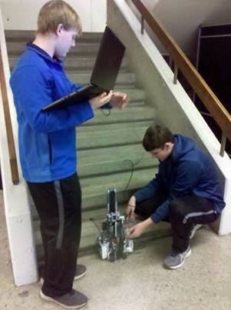It’s hard to believe that the Fall semester is nearly halfway finished.  Fall is absolutely gorgeous this year with bright red and golden leaves adorning every inch of our rural campus.

Students in the Tools for Engineering class will be unveiling robots soon, including robots for the Battle Bots tournament in November.  The most challenging project for this class is the stair step climbing robots which reveal some really original student designs.

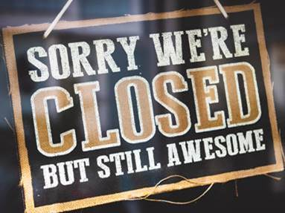Even though the 3D Lab is closed over the fall semester due to COVID precautions, its services are ready and available.  If you have projects that need 3D printed, laser engraved, vinyl signage made, etc., reply to this email with your request.  We will perform the work in the 3D Lab at no cost for pick-up later.  [Here is a list of our equipment](https://blogs.uakron.edu/waynec3/equipment/) to aid in making your projects come to life.  Want to find a makerspace to work on projects there?  Attached is a list of area makerspaces; contact them before arriving to determine any restrictions/temporary closures due to COVID.

Despite COVID causing people to stay home more often than not, makers still wanna make! Ben Engle, an alumni of the University of Akron Wayne College always wanted to build his own DIY version of a Jazzmaster guitar.

[TOP](#top) ^

[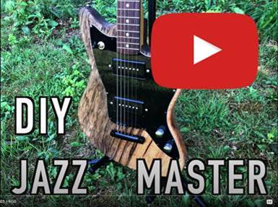](https://www.youtube.com/watch?v=-yk6u1yPnvs)

He found a piece of Black Limba wood in a scrap bin, perfect for a guitar body.  He designed the body with Fusion 360, then milled the wood with a CNC machine that he assembled from scratch.  The video is amazing, showing the design work, milling the body and acrylic face, and Ben playing his new guitar at the end.  What a beautiful piece!  Ben’s not a bad guitarist, either.

Makers in our area are dreaming up new ideas all of the time.  Bob, one of our community members, had an idea of using a leaf blower to safely clean house gutters without scaling a roof.  He explained this idea to Joe, one of our 3D Lab staff, involving the creation of an adapter to connect an inexpensive gutter drain pipe to the leaf blower.

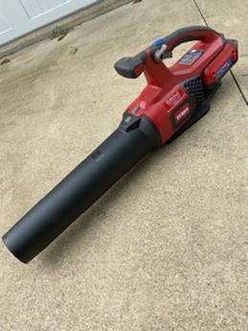   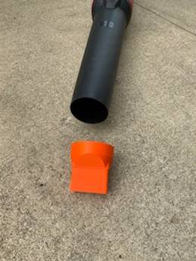   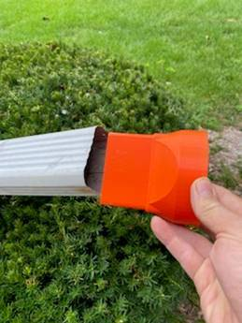

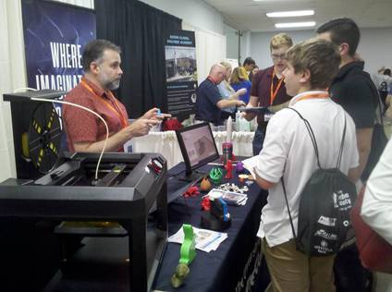The above photos shows the adapter connected a straight piece of gutter pipe, but Bob also attached the adapter to a “U”-shaped gutter pipe, allowing him to stand at ground level with the leaf blower, the forced air blowing up and then down again to clean roof gutters from above quite easily!

This time last year, the 3D Lab made a road trip to the Made in Medina County event.  Its mission is to raise awareness and educate the residents, students, and businesses as to the economic importance and career opportunities of our manufacturing industry.

[TOP](#top) ^

Tabled next to another University of Akron booth (the Chemistry Department was demonstrating exploding foam of all things), the 3D Lab table and 3D printer demonstration were fascinating to all ages of event goers.  Quite a few had never seen a 3D printer before and students were interested in how they can further a career in engineering.

Stay tuned next week as we introduce more interesting folks who participated in last year’s Maker Faire!

|  |  |
| --- | --- |
| 3d-printing-news | See how 3D printing inside the body could patch stomach ulcers <https://www.scientificamerican.com/article/3-d-printing-inside-the-body-could-patch-stomach-ulcers>  Can a 3D printer print food?  A resounding yes! <https://all3dp.com/2/3d-printed-food-3d-printing-food> |
|  |  |
| diy | Does your 3D printer print only one color?  Learn how to create multi-color filament for a rainbow of possibilities!  <https://all3dp.com/1/weekend-project-create-your-own-multi-color-filament-with-3d-printed-filament> |
|  | [Maker Faire Wayne County 2021 is canceled out of COVID19 precautions](https://waynecounty.makerfaire.com/).  Still wanted to attend a maker faire this year?  Try virtual [Maker Faire Cleveland](https://cleveland.makerfaire.com/) this November! |
|  |  |
|  | Maker Monday is postponed out of COVID19 precautions.  Please check [www.schantzmakerspace.com](http://www.schantzmakerspace.com) for future meeting dates, workshops, and activities as some dates have changed. |
|  |  |
|  | We offer a free “listserv” that allows to you ask questions to members in the makerspace. It’s great for sharing ideas, forming friendships, and helping & advising each other. To join, send an email to <listserv@lists.uakron.edu> with  "SUBSCRIBE MAKERSPACE-GROUP" in the subject line. |

Tom Hammond, M.A. - Technical Support Services - Wayne College - The University of Akron

####

[TOP](#top) ^

***General License Classes Being Offered***

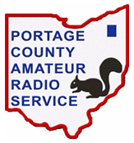If you have a Technician class license you need to upgrade to General to be able to participate in all of the HF activities that PCARS sponsors. Here's your chance!

I will be starting a "self-study" upgrade class on Tuesday October 20th. It's open to all PCARS members at no cost for the class. We will be using the ARRL study guide, so that will be your only cost for the class. You can get it from DX Engineering or the ARRL directly. We will also be using YouTube videos, followed up with local, live zoom sessions to keep everyone on track.

Send me an email directly - [tomsly29@gmail.com](mailto:tomsly29@gmail.com) - if you want to be registered for the class.

Presuming no "bad-news" on the COVID front, PCARS will be having a VE session on Saturday, December 5th.

####

***Two Great Speakers and Programs Coming to the Cuyahoga Falls ARC***

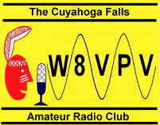

The Cuyahoga Falls Amateur Radio Club ([www.cfarc.org](http://www.cfarc.org)) is inviting you to attend one or both of its upcoming programs online via Zoom on October 28th (7:15 PM) and Nov 11th (6:15 PM). Two well-known speakers, one from just across the state line and one from across the Atlantic, will be providing two great presentations:



* **Oct 28th- Tim Duffy, K3LR**, world-famous contester and Chief Executive Officer of DX Engineering, will present ***"DXing and DX University.”***
* **Nov 11th- Steve Nichols, G0KYA**, famous author from England, will present ***“Antennas for a Small (or even no) Garden"*** (*garden* is the British expression for the American *backyard*)

For Zoom connection information and other details, [visit this link](https://sites.google.com/site/cfarccal/qst/oct28thnov11th-cfarcmeetingprograms-specialguests).

####

[TOP](#top) ^

***JOTA and Camp Tuscazoar***

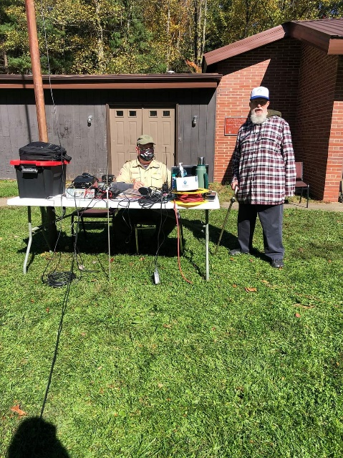

K8T JOTA & Radio Merit Badge at Camp Tuscazoar Special Event Call Sign Celebrating 100th Anniversary of Camp Tuscazoar. Lots of Scouts having a great time!

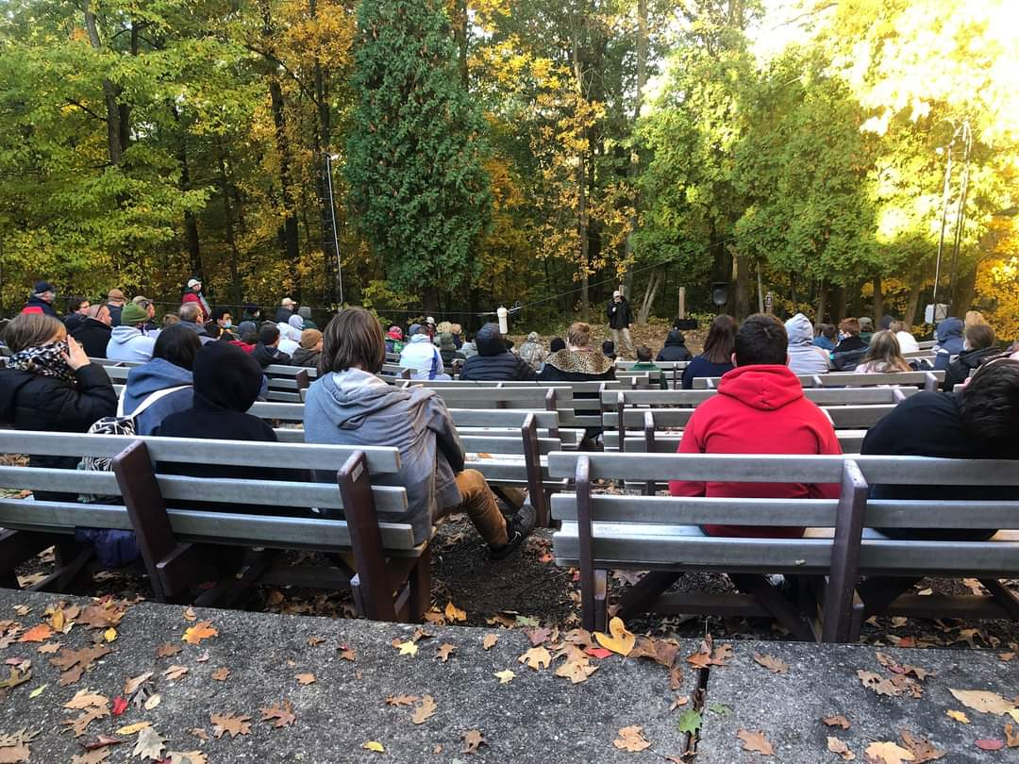97 Merit Badges were earned today!  They were hoping for 100 on the 100th anniversary... so close!

A big thanks to Renny for running Radio all day and helping set up and tear down. John D was there all day assisting.   Heath ran the fox hunt.  Brent helped with logistics and setup.  Greg helped with logistics, plus all the other things Greg always does for us. And a big thank you to all the people on the repeaters, I know I heard Butch, Cindy, Betty, Neil, Evan and I am sure others handed out contacts.   Great event that Dale let us be a part of with the Canton, Massillon, and Alliance clubs coming together to help instruct the event for Camp Tuscazoar.    
  
And of course, Happy 100th Birthday to Camp Tuscazoar, thanks for letting us be part of it!

####

***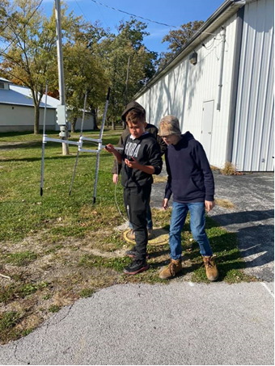***

***JOTA and Seneca County ARES***

Scouts from Troop 499 participated in JOTA 2020.

The Scouts learned about emergency preparedness from Seneca County Staff, Amateur Radio Operators from the Seneca Radio Club and Seneca County ARES.

The scouts did a lost scout plan, made yagi antennas, got on the air and then did a lost scout drill using the yagi antennas they had built.

Nine Radio operators helped out the 18 scouts.

[TOP](#top) ^

***A BARN RAISING (FOR AN OHIO EMERGENCY MESSAGE NET)***

We've got a Barn Raising underway for Buckeye Net Mixed-Mode (BNM). Applying lessons learned over the past four months, we're building up reliable daily service to all Ohio ARES districts. Help build the future!

This isn't a net for just check-ins: we get the net called up relatively quickly (voice) and have messages to move with digital (NBEMS) across different channels. The model has worked effectively over the past four months, but it does show that it takes some practice to work well. We need net control, assistant net control, and liaison operators.

See the link for details and how to be a part of the program. We're looking forward to working with you.

<https://forms.gle/XsxV5o26YJLAG78K8>

***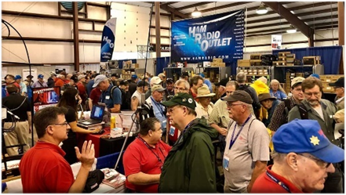***

[***Upcoming Hamfests***](http://arrl-ohio.org/hamfests.html) ***for 2020***

**11/01/2020 – 60th Massillon Hamfest**Location: Massillon, OH  
Sponsor: Massillon Amateur Radio Club  
Website: <http://w8np.org/hamfest.htm>

***New Location…***

The new location is: The MAPS (Military Air Preservation Society) large Hangar at 5383 Massillon Road, Green, OH (route 241).

VE exams will be given.  Registration at 8:30 a.m.  Exams at 9 a.m.

*Masks are required! Temperatures will be taken on everyone entering the facility*

**11/08/2020 – Outdoor Swap N Shop**

Location: Livonia Michigan

Sponsor: The Livonia Amateur Radio Repeater Group Outdoor

Website: <https://www.dropbox.com/s/66utqgicbs2pxrz/Repeater%20Swap-page-001.jpg?dl=0>

***DX This Week***

*(from Bill, AJ8B)*

***DX This Week – 160M***

***Bill AJ8B (aj8b@arrl.net, @AJ8B, or ww***[***w.aj8b***](http://w.aj8b)***.com)***

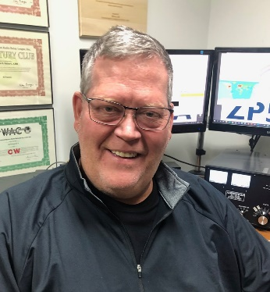***CWOPs Member #1567***

[TOP](#top) ^

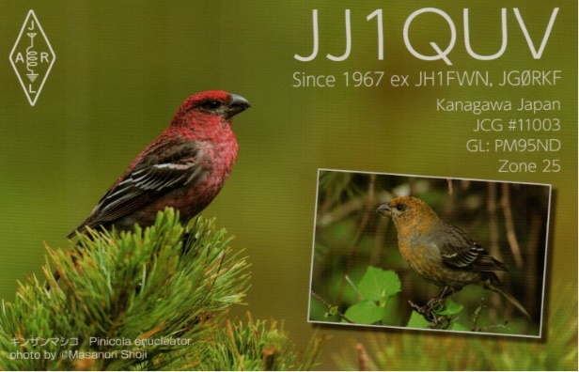This week there was quite a bit of DX being spotted. These included Algeria, Asiatic Turkey, Austria, Belgium, Belize, Bosnia-Herzegovina, Canada, Canary Islands, Corsica, Croatia, Cyprus, Denmark, Dodecanese, England, European Russia, Fed. Rep. of Germany, Finland, France, Gabon, Ghana, Gibraltar, Greece, Guadeloupe, Hungary, Isle of Man, Israel, Italy, Japan, Kuwait, Lakshadweep Islands, Lebanon, Mali, Malta, Mauritania, Mexico, Namibia, Netherlands, Northern Ireland, Poland, Reunion Island, Scotland, Sicily, Slovak Republic, Slovenia, South Africa, Spain, Sweden, Switzerland, Ukraine, US Virgin Islands, and Venezuela. Let me know what you worked.

I received a QSL card from JJ1QUV, Masa in Kanaqawa, Japan. Did you receive any? I did get an email asking what format I can receive cards in. .jpg, .bmp, or .png are all fine. Also, I can most likely convert any format you send me, so don’t be shy!

***DAH DIT DIT DIT DAH DAH DIT DIT DIT DAH***

Uncle Frank and I were having a QSO on 30 meters and we started setting our fall/winter goals. His goal is to expand his 160M DXCC count. My goal is to do the same. The problem is that Frank has already exceeded the 100 entities needed for DXCC and I have a total of 12! I have some work to do! I asked Dave, K8DV, at what time should I put up my 160 M inverted “L”? Dave told me to get it going around the weekend of the time change. So, with the time change just a few weeks away, I will be doing that soon. It did get me thinking about some of the aspects of getting on 160 and I wanted to pass along the thoughts of top band guru, K9LA – Carl. I am reprinting his article that first appeared in the November 2006 issue of CQ with Carl’s permission. Next week will be some follow up information from Carl as well.

**An Introduction to Operating on 160m** - –perating on 160 meters has always been a challenge. Two of the biggest challenges are the physical size of efficient antennas and noise when receiving. The purpose of this article is to provide appropriate information to address these two challenges, along with general information about other issues necessary to get your feet wet on topband (also known as the Gentleman’s Band).

**A Short History of 160m -** –he 160m band has been around for a long time. In the First Edition of the Radio Amateur’s Handbook (1926, published by the ARRL), Amateurs had an allocation from 150 meters to 200 meters in wavelength (that’s 2 MHz down to 1.5 MHz). Due to AM broadcast stations and other services, the 160m band was eventually narrowed up to 1.8 to 2.0 MHz.

Because of LORAN issues (LORAN is a radio location service), there have been power and frequency restrictions over the years. For example, during my early years in Amateur Radio in northwest Indiana (early 1960s) I could only operate from 1800 to 1825 KHz with a maximum power of 200 W during the day and 50 W during the night. There were similar restrictions in other areas of the country.

Nowadays those of us in the US can operate anywhere from 1.8 to 2.0 MHz at up to 1500 W PEP output. Of course, you should always strive to use the minimum power to make the QSO.

[TOP](#top) ^

The first order of business for an introduction to 160m is to look at the band plan for 160m ñ what frequencies should we use for CW, what frequencies should we use for SSB, what frequencies should we use for AM, etc.

**160m Band Plan -** –nlike our HF bands, the FCC (Federal Communications Commission) does not regulate 160m with respect to band segmentation by mode. Legally any mode can operate anywhere. But obviously this could cause (and has caused) conflicts.

To impart order to this issue, a Gentleman’s Agreement band plan was developed by an ARRL Ad Hoc committee with input from users of 160m. The recommended band plan is shown in Table 1. You are strongly encouraged to adhere to this plan. A little cooperation among fellow Amateurs can go a long way!

|  |  |
| --- | --- |
| 1.800 - –.000 | CW |
| 1.800 - –.810 | Digital Modes |
| 1.810 | CW QRP |
| 1.843-2.000 | SSB, SSTV and other wideband modes |
| 1.910 | SSB QRP |
| 1.995 - –.000 | Experimental |
| 1.999 - –.000 | Beacons |

*Table 1 160m Band Plan*

With the band plan outlined, a couple comments on where activities take place is in order. Rag chewing on 160m starts around 1.843 MHz and extends all the way up to 2.0 MHz. There is a lot of spectrum above 1.9 MHz that is relatively lightly used, so you might want to consider moving up there for your rag chewing activities. AM aficionados hang out around 1.885 MHz, and my efforts with my Viking Ranger II and Drake 2B with a homebrew converter). Finally, most DXing on 160m outside of contests is done on CW in the lower 35 KHz or so of the band. If you want to work DX on 160m, knowing code is almost a must due to CW ís inherent weak signal advantage over SSB and the CW bandwidth letting in less noise (more on this latter aspect in a bit).

Since LSB (lower side band) is normally used on 160m, note that 1.843 MHz refers to the carrier frequency for LSB. The intent here is to keep the side bands at 1.840 MHz and above (since the bandwidth of an SSB signal is about 3 KHz). And there is no segmentation by license class ñ General, Advanced, and Extra class licenses have equal access to the entire band.

**When Is 160m Good? -** –ow that we know where we should operate in the 160m band, the next issue to address is when should we operate, that is, when is 160m good?

If your interest is only for local QSOs (rag chewing, nets, etc.), then 160m is good anytime, day or night, summer or winter. And where we are in a solar cycle won’t matter, either.

If your interest in 160m is DXing, then there are times, seasons, and phases of a sunspot cycle when 160m is best. Due to excessive daytime D region absorption, 160m is useful for DXing when the path is in darkness or very near darkness. Because of geomagnetic field activity considerations, 160m is best during the winter months and from solar minimum to a couple years thereafter.

[TOP](#top) ^

The latter portion of the previous sentence says now is the time to get on 160m if you’re pursuing DXCC or WAZ. We are at solar minimum between Cycles 23 and 24, and the next couple of winter seasons (2006-2007, 2007-2008, and possibly 2008-2009) should offer excellent opportunities for the DX minded.

**Simple Transmitting Antennas -** –s stated in the introduction to this article, the first biggest challenge for operating on 160m is the physical size of an efficient transmitting antenna. The length of a half wavelength dipole at 1.85 MHz is approximately 253 feet (each side would be about 127 feet). That’s quite a bit of a horizontal span for those on small lots.

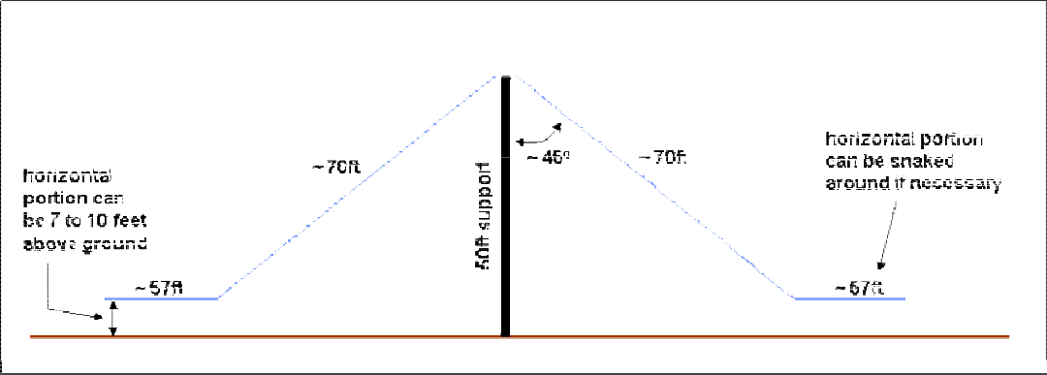An easy way to overcome this horizontal span requirement is to make the dipole into an inverted vee. For example, the top of a 50-foot tower or 50-foot support could be used as the center point for the inverted-vee.

Figure 1shows this position

The sloping portion of each side of the inverted vee could be approximately 70 feet, with the remaining 57 feet running horizontal to the ground and even snaked around a bit to fit the lot. This would make an excellent antenna for local activity on 160m (but don’t be surprised if you work DX with it ñ the ionosphere can be the great equalizer among different stations).

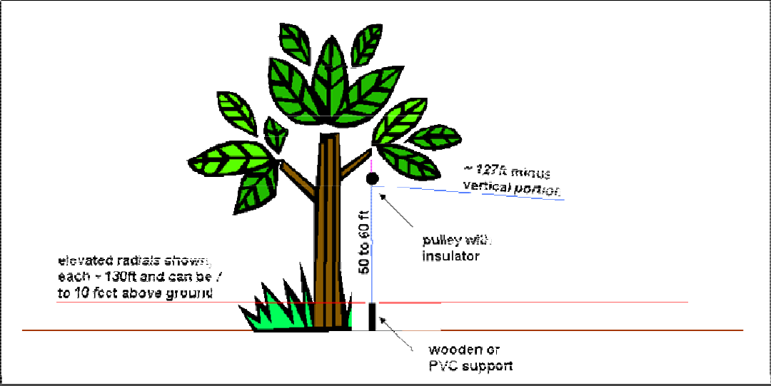If your interest is DXing, generally you’ll want an antenna that puts more of its energy at the lower elevation angles. Perhaps the simplest antenna to fit this bill is the inverted-L. The total radiator length needed would only be about 127 feet, as this is essentially a vertical antenna operated against ground. A tree could be used to support the vertical portion of the inverted-L, with the remaining length (127 feet minus the vertical portion) sloping down to a convenient support. Figure 2 shows this configuration using a tree for the support. Either buried radials, radials lying on the ground, or elevated radials could be used to provide the ground image for this antenna.

Figure 2 is what I use on 160m, with a pulley in a nice tall tree anchoring the vertical portion and six elevated radials at about 7 feet to keep the deer from running into them.

Figure 2 Inverted L Installation

[TOP](#top) ^

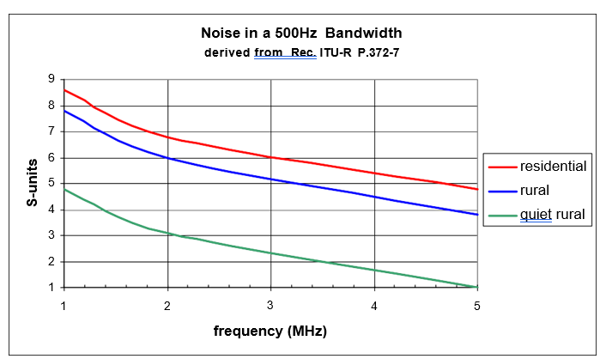**Noise -** –he second biggest challenge noted in the opening paragraph (mostly affecting those interested in DXing) is noise and is noise and its impact on the ability to hear weak signals. There are two sources of noise that make receiving on 160m difficult: man-made noise (machinery, appliances, lights, and so forth) and atmospheric noise (static from lightning discharges propagating into your QTH). Figure 3 shows the magnitude of the noise problem (from data in the International Telecommunications Union document Rec. ITU-R P.372-7)

The three curves in Figure 3 are the expected noise from a short monopole antenna in a CW bandwidth (500Hz) in terms of S-units for three noise environments: residential, rural, and a quiet rural area. This plot should be used as a ballpark guideline, as your mileage may vary according to your specific local conditions.

I would expect the noise received by the inverted-L in Figure 2 to roughly agree with the short monopole data in Figure 3, with the inverted-vee of Figure 1 maybe a bit better due to some directivity (see the next section). For the data in Figure 3, I assumed S9 was -73 dBm (50 microvolts) and an S- unit was 5 dB (based on my measurements, this is typical of current receivers).

In a residential area, the expected noise on 160m in a CW bandwidth is around S7. Wow! Even moving to a rural area only knocks this down to S6. Heading out into the country puts the noise at S3. That S3 value is the level of noise in a CW bandwidth on my OMNI VI Plus using my inverted-L.

The S3 value doesn’t sound like much but remember that the noise floor of a modern receiver is around -130 dBm. Using a signal generator, the S3 value on my OMNI VI translates to about -103 dBm. Thus, I am giving up almost 30 dB of hear-ability, which is the difference between my external noise level and my receiver’s noise floor when using my inverted-L for receive.

Be aware that the data in Figure 3 assumes you don’t have a particularly troublesome local man-made noise source that masks everything else (for example, a noisy utility line). If you do, then you have your work cut out to eliminate it. On a personal note, the most interesting noise source I’ve had to find, and resolve was an electric blanket used by our neighbors to keep their cat warm.

**Simple Receiving Antennas-** When you first start out on 160m, you’ll probably use your transmit antenna for receive. As you progress with your 160m activities, you may need to work weaker signals that are at or even below the noise level resulting from using your transmit antenna.

[TOP](#top) ^

This is where low noise receiving antennas come into play. Regardless of the category of the low-noise antenna, they all work on the same principle ñ increase the directivity of the antenna (make front-to-back and front-to-side ratios larger) to reduce the total amount of noise being received from around the compass. This assumes the arriving noise is not a localized source as mentioned in the previous section. And if there is a noise source in the direction you want to receive, you have a real problem.

The improvement in hear-ability for a given low-noise receiving antenna will generally follow the narrowness of the pattern ñ a narrower pattern will let less noise into your receiver and lower your noise level, and thus will thus allow you to hear closer to your receiver’s noise floor. From this consideration, we can make a first-order list of how effective some of the common low-noise receiving antennas will be. In order of least effective to most effective, they are:

**Short Beverage (80m long)**

Elongated terminated loops (EWE, Flag, K9AY, etc) Standard Beverage (160m long) 4-Square (quarter wavelength spacing) Long Beverage (300m long)

Remember that new layers of DX may be heard with noise reductions of as little as 3 db. So, don’t rule out the antennas in the first two categories. Even though they are small, they will probably fit on almost any lot. And they might just make the difference for you in making a QSO.

If your only problem is that of a troublesome localized noise source mentioned earlier that defies elimination, consider using a small loop antenna to null out that direction.

**Propagation and Predictions -** –f we look at worldwide electron densities, we’ll see that the ionosphere always has enough ionization to refract 160m back to Earth for multi-hop propagation ñ even during the dead of night at solar minimum. Thus, the problem on 160m is not with the MUF (maximum usable frequency), it is with the amount of absorption and the resulting signal strength. This was the basic premise mentioned previously in the When Is 160m Good? section ñ due to absorption, the best place for 160m RF is in the dark ionosphere.

Now if you’ve used propagation predictions on our HF bands, you’ve probably noticed that most of them do not include 160m. There’s a very good reason for this because of the impact of the Earth’s magnetic field on three basic propagation parameters. With 160m being so close to the electron gyro-frequency, the magnitude of the magnetic field and the direction of propagation with respect to the direction of the magnetic field modify the amount of absorption incurred, the amount of refraction incurred, and the polarization of the wave(s). This can get very complicated very quickly over long paths, and the proper way to address this rigorously is with full-blown ray tracing software.

Over the years there have been several studies by 160m enthusiasts to come up with a simple method to predict whether 160m is going to be good on a given night. These studies have usually been based on solar flux and K or A indices. These efforts have not met with much success, as they do not consider all the variables that appear to be involved with propagation on 160m ñ especially events that happen in the lower ionosphere to enable ducting mechanisms and reduce absorption. In general, a quiet geomagnetic field seems to be a requisite, but it doesn’t appear to be the only requisite.

[TOP](#top) ^

This all comes down to two simple pieces of advice with respect to propagation on 160m:

1. Use the excellent mapping feature in many of our propagation prediction programs to determine the best times for 160m propagation over the desired path with respect to darkness along the path. Pay attention to sunrise and sunset times at your QTH and at the other end of the path for possible signal strength enhancements.

2. Get on the band to check it out in real-time. Watching DX Cluster spots also helps to get a real-time assessment.

***CQDX CQDX CQDX CQDX CQDX CQDX CQDX CQDX CQDX***

Here is an update from Bernie, W3UR, of the DailyDX and the WeeklyDX, the best source for DX information. <http://www>.dailydx.com/. Bernie has this to report:

JX0X - –inal call for support

By LA7GIA, Ken Opskar

We have negotiated a vessel contract and are ready to sign it. However, the financial situation is such that the individual donations have stopped. We fully understand that for many people the Covid-19 have had an impact on their personal economy and life. As well we know that our DXPedition to Jan Mayen is in exactly 1-year time from now, and people might think it is too early to support us. We have been working on this project since April 2019, we have invested much time in planning and preparing this trip with all the permits and negotiations – and we feel we’re so close. While we have received 8900 USD from individuals in 3 months, this is not getting us to Jan Mayen when our budget is 105,000 USD+. We depend on upfront support to sign the vessel contract, and as it is now it is too risky for us to proceed with the project unless we see an increase in the support.

We had a team meeting yesterday and the final decision to go to JX will be taken in 3-week time. This decision will depend heavily on if we think we have enough support from the individual DXers. If you support us, you will of course receive a QSL card and express LoTW as part of the donation. In addition, we guarantee a 100% refund of all donations if we decide to cancel the trip next month. <http://jx0x.com/support/>

**HamCation Cancelled -** –he 75th [HamCation](http://r20.rs6.net/tn.jsp?f=001Pjcs44wWvRWLNbOEmOc3QVcEFmioquXBgDCetgxOXcd5fIZZ03M8FwAUFgAcCJBCfiEZAZmDbgYOjjve3UOfuJd3i9uwV7bwlmDWhHln_24sM4Cbs8CisDtcbU_mrwIMhvBwvNtvziWgV7Fw1XJ7xg==&c=oJvYhtjH0tF2SYIdu8J023VfDWRTddh1IYn-3BNEpwDSqje1yM9-Tg==&ch=P3u7zKjWAAJoS97HJKX4Xpzfit9EpjDwM2liUVYCHToDSJ7w_Kj9jQ==" \t "_blank), held in Orlando, was supposed to take place in February 2021 but is now being postponed to February 11-13, 2022.

K5ZD, Randy Thompson, points out in impact the Covid-19 pandemic has made on the CQ WPX SSB and CW Contest. Check out the [two graphs](http://r20.rs6.net/tn.jsp?f=001BDKHGsjqVo37o9H2XplV71e54o2YM4xMX8Re8hRTWsHi2A47km0LMR3f6C6LtOT34yySQppmP92lLHiI035DLMdIpwvVU7uSthmCj-vPgsruU1XHezfvJ9XVW3CU2fxP6yPoSjKP3WyNCMs1yRBbkQ==&c=qj1225giBfIuyS9br9XafOEfEAKmMTdmJhTC1S5-B7Ow23YRly8Hgw==&ch=bQFWF0UQ5EBQMnYCCBZoQCuP3PmyzV1jSsg01fcC2HSKJv9D8kJ0PA==) to see how the “entries soared with everyone at home”.

**Presentation:** W3LPL, Frank Donovan, gave a video presentation on "T“e History of Trans-Atlantic Radio Communications.”  This was to the “Redwood Empire DX Association.”  Frank notes among other things he talked about the 1921 Transatlantic test, “closely related to the early development of ‘Top Band.’”  [https://www.youtube.com/channel/UCvaNpw-\_F6QPAe8T41tzK3w/](http://r20.rs6.net/tn.jsp?f=001LTfmdiZx49DT2hnPdIwj08BQj9bMspgyViEW9fM63Ggrmg0345PvZWgVlDzvNrlML_ij4xT_qR2kEmlKEO-YNem2K0vBu6CpGpntOiCtXAu2HHnwXzVO-YlWHNUblwxStyHY4HqoRgZYF4zqBDXvPzFktv4LZjMjuhnSnHCLLNe4EwNI2FktWBjgdJX9az4C&c=pPY4aNsNE67x3xN2xuPVNWKcFlUxaA1zFFXEKkhEnjnVqU_06wX06A==&ch=hBEtKWCFm9ozRQxTjUCW5xegDXJU6oe9n4heNQXudlRDlr1sw9TfSA==)

***DAH DIT DIT DIT DAH DAH DIT DIT DIT DAH***

[TOP](#top) ^



As promised last week, you will find a list of upcoming contests in the “Contest Corner”. I think this is important for someone who is trying to move up the DXCC ladder since entities that are on the rarer side and easiest to work in contests. Some of my best “catches” have been on the Sunday afternoon of a contest when the rarer entities are begging for QSOs. Of course, the gamble is that if you wait until Sunday, conditions may change or they simply won’t be workable. However, it is not a bad gamble. Of course, why not work the contest and have some fun!

The contests in red are those that I plan to spend some significant participation time on. PLEASE let me know if you are working contests and how you fared.

|  |  |  |
| --- | --- | --- |
| Oct. 21 | AGCW Semi-Automatic Key Evening | <http://bit.ly/2LCDywm> |
| Oct. 29 | RSGB Autumn Series SSB | <https://bit.ly/2XF8mSB> |
| Oct. 24–25 | CQWW SSB | <https://www.cqww.com/> |
|  | | |
| Nov. 28–29 | CQWW CW | <https://www.cqww.com/> |
| Dec. 4 – 6 | ARRL 160M | <http://www.arrl.org/160-meter> |
| Jan 29 – 31 | CQWW 160M | <https://cq160.com/> |
|  | Winter FD | <https://www.winterfieldday.com/> |
| Feb. 20 – 21 | ARRL CW | <http://www.arrl.org/arrl-dx> |
| Mar. 6 – 7 | ARRL SSB | <http://www.arrl.org/arrl-dx> |
| Mar. 27 – 28 | CQWW WPX SSB | <https://www.cqwpx.com/> |
| May 21 | SWODXA DXDinner | [www.swodxaevents.org](http://www.swodxaevents.org) |
| May 29 – 30 | CQWW WPX CW | <https://www.cqwpx.com/> |
| August 28 | Ohio QSO Party | <https://www.ohqp.org/> |
| August 28 | W8DXCC Convention | [www.w8dxcc.com](http://www.w8dxcc.com) |
|  |  |  |

**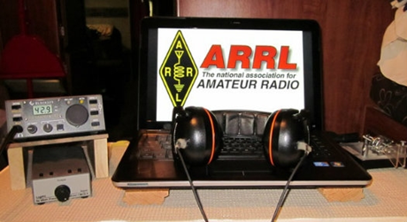*ARRL Contest Corner***

An expanded, downloadable version of *QST'*s’[**Contest Corral**](http://www.arrl.org/contest-calendar) is available as a PDF. Check the sponsor's’Web site for information on operating time restrictions and other instructions.

|  |  |
| --- | --- |
| **October 19**   * [K1USN Slow Speed Test](http://www.k1usn.com/sst.html) * [**ARRL School Club Roundup**](http://www.arrl.org/school-club-roundup) * [Telephone Pioneers QSO Party](http://www.tpqso.com/wp-content/uploads/2019/07/TPQSO-Announcement-2020.pdf) * [RSGB FT4 Contest Series](https://www.rsgbcc.org/hf/rules/2020/r80m_ft4.shtml)**October 21** * [Phone Fray](http://www.perluma.com/Phone_Fray_Contest_Rules.pdf) * [CWops Mini-CWT Test](https://cwops.org/cwops-tests/)**October 23** * [NCCC RTTY Sprint](http://www.ncccsprint.com/rttyns.html) * [NCCC Sprint](http://www.ncccsprint.com/rules.html) | **October 20**   * [Classic Exchange, Phone](http://www.classicexchange.org/announcments/Fall_2020_CX_Rules.pdf) * [Worldwide Sideband Activity Contest](https://wwsac.com/rules.html) * [RTTYOPS Weeksprint](https://rttyops.wordpress.com/rtty-mini-contests/rttyops-weeksprint/) |

[TOP](#top) ^

|  |  |
| --- | --- |
| **October 22**   * [CWops Mini-CWT Test](https://cwops.org/cwops-tests/) * [RTTYOPS Weeksprint](https://rttyops.wordpress.com/rtty-mini-contests/rttyops-weeksprint/) | **October 24**   * [CQ Worldwide DX Contest, SSB](http://cqww.com/) * [Kentucky State Parks on the Air](https://k4msu.com/kypota/)   [RTTYOPS Weekend Sprint](https://rttyops.wordpress.com/rtty-mini-contests/rttyops-weekend-sprint/) |
| **October 26**   * [K1USN Slow Speed Test](http://www.k1usn.com/sst.html) * [QCX Challenge](http://www.qrp-labs.com/party.html) | **October 27**   * [Worldwide Sideband Activity Contest](https://wwsac.com/rules.html) * [QCX Challenge](http://www.qrp-labs.com/party.html) * [RTTYOPS Weeksprint](https://rttyops.wordpress.com/rtty-mini-contests/rttyops-weeksprint/) |
| **October 28**   * [SKCC Sprint](http://www.skccgroup.com/operating_activities/weekday_sprint/) * [Phone Fray](http://www.perluma.com/Phone_Fray_Contest_Rules.pdf) * [CWops Mini-CWT Test](https://cwops.org/cwops-tests/) * [UKEICC 80m Contest](https://www.ukeicc.com/80m-rules.php) | |

***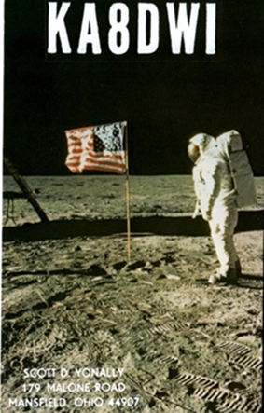DX News***

***ARLD042 DX news***

This week's’bulletin was made possible with information provided by The Daily DX, the OPDX Bulletin, 425 DX News, DXNL, Contest Corral from QST and the ARRL Contest Calendar and WA7BNM web sites. Thanks to all.

**UGANDA, 5X.** John, 5X1JT is QRV from Nansana while on work assignment for the next two years. QSL via operator’s ‘instructions.

**MALAWI, 7Q.** Don, K6ZO is QRV as 7Q6M while working at the Embangweni Mission Hospital project. He is active in his spare time until December 5. QSL direct to home call.

**GHANA, 9G.** Tom, DL2RMC is QRV as 9G5FI and is here for at least one year. Activity is on all HF bands using CW, SSB and FT8. This includes being active on Satellite QO-100. QSL via DL1RTL.

**EAST MALAYSIA, 9M6.** Special event station 9M4JAY will be QRV from Miri, Sarawak during the 63rdScouts Jamboree On The Air event. QSL direct.

**UNITED ARAB EMIRATES, A6.** A number of stations are QRV as A6050Y and A6050Y/1-9 until October 31 to promote the next 50 years in the Emirates and as part of the Emirate Centennial Plan. QSL via operators' ’nstructions.

**BAHAMAS, C6.**  Richard, KN4CV will be QRV as KN4CV/C6A from Alice Town, Bimini Islands, IOTA NA-001. Activity will be on the various HF bands. QSL to home call.

**GUADELOUPE, FG.** Philippe, F1DUZ is QRV as FG4KH until November 5. This includes being an entry in the upcoming CQ World Wide DX SSB contest. QSL to home call.

[TOP](#top) ^

**LIECHTENSTEIN, HB0.**  Loick, HB9HBY is QRV as HB0/HB9HBY until October 18. Activity is on the HF bands using CW, SSB and FT8. QSL via EB7DX.

**THAILAND, HS.** The new call sign for His Majesty the King Vajiralongkorn is now HS10A.

**ITALY, I.**  In celebration of the 75th anniversary of the founding of the United Nations, members of the UN Global Service Center ARC in Brindisi are QRV as 4U75B until December 31. QSL via 9A2AA.

**ANTARCTICA.**  Members and operators of the Japanese Antarctic Research Expedition team are QRV as 8J1RL from Showa Research Station, Queen Maud Land, IOTA AN-015, until January 2021. Activity is on various HF bands using CW and various digital modes. QSL via JG2MLI.

**ST. VINCENT, J8.** Mac, 8P5AB is QRV as J88/8P5AB until December 3. Activity is on various HF bands using FT8 and VHF bands using various digital modes. QSL direct to home call.

**SVALBARD, JW.** Erwann, LB1QI is QRV as JW/LB1QI from Spitsbergen Island, IOTA EU-026, until October 18. Activity is on 160 to 6 meters using CW and SSB. QSL to home call.

**AUSTRIA, OE.** Jo, OE6VIE is QRV with special event call sign OE65VIE from Styria until December 31 to celebrate the 65th anniversary of the Austrian State Treaty. QSL via the bureau.

**ARUBA, P4.** Members of the Aruba Amateur Radio Club are QRV as P42WW until October 31 to commemorate the 75th anniversary of the end of World War II. QSL via P41G.

**NETHERLANDS, PA.** Special call PA5150EVH is QRV until January 31, 2021 to pay tribute to famous rock guitarist Eddie van Halen who was born in Amsterdam in 1955. QSL via PF1SCT.

**EGYPT, SU.** Members of the Egyptian Radio Amateurs Society are QRV as SU8J until October 18 to commemorate the official opening of the nature reserve Tigris Valley. Activity is on 160 to 10 meters using SSB, FT8 and FT4. QSL via SU1SK.

THIS WEEKEND ON THE RADIO. The Scout Jamboree On The Air, NCCC RTTY Sprint, NCCC CW Sprint, JARTS World Wide RTTY Contest, Araucaria World Wide VHF Contest, 10-10 International Fall CW Contest, New York QSO Party, Worked All Germany Contest, Stew Perry Topband Challenge, Feld Hell Sprint, Argentina National 7 MHz SSB Contest, Asia-Pacific Fall CW Sprint, UBA ON 2-Meter Contest, Classic Phone Exchange, Illinois QSO Party, RSGB RoLo 80-Meter CW and the Run for the Bacon QRP CW Contest are all on tap for this upcoming weekend.

The ARRL School Club Roundup runs from October 19 to 23.

The RSGB FT4 Contest Series, K1USN Slow Speed CW Test and Telephone Pioneers QSO Party are scheduled for October 19. The Worldwide Sideband Activity Contest and RTTYOPS Weeksprint are scheduled for October 20. The Phone Fray and CWops Mini-CWT Test are scheduled for October 21.

Please see October 2020 QST, page 69, and the ARRL Contest Calendar and WA7BNM Contest websites for details.

[TOP](#top) ^

***Special Events***

* **10/23/2020 | BCARC Chili Cookoff**

**Oct 23-Oct 26, 1200Z-0400Z, W4C**, Pikeville, TN. Bledsoe County Amateur Radio Club. 3.885 7.290 14.286 146.520. Certificate & QSL. Bledsoe County Amateur Radio Club, P.O. Box 13, Pikeville, TN 37367. QSL Cards available for all stations, Certificates Available for those who work the station between 2300-0300 UTC on 24 October [BledsoeARC@bledsoe.net](mailto:)

* **10/24/2020 | The Captain Kidd DX Hunt**

**Oct 24, 1100Z-1700Z, W1WDT**, Milford, CT. Woodmont Amateur Radio Association. 50.885 28.885 14.285 7.285. QSL. Woodmont Amateur Radio Assoc., 128 Kings Highway, Milford, CT 06460. [www.wara.club](http://www.wara.club/)

* **10/31/2020 | A Night On Bald Mountain**

**Oct 31-Nov 1, 2100Z-0500Z, WA4TRS**, Fairview, NC. The Road Show Amateur Radio Club Inc.. 7.250. Certificate & QSL. The Road Show ARC, 57 Echo Lake Drive, Fairview, NC 28730. Join Us, for a Night in The Cemetery on Top of Bald Mountain, don't worry there are accommodation available for YOU! Just Check the Website [roadshowarc.org](http://roadshowarc.org/)

* **10/31/2020 | Boo to You !**

**Oct 31-Nov 1, 0000Z-0559Z, KC5BOO**, Cleburne, TX. KC5BOO. 14.240. QSL. Judy Cox, 3701 Park Rd. 21, Cleburne, TX 76033. [kc5boo@yahoo.com](mailto:)

* **10/31/2020 | Halloween from Transylvania (La)**

**Oct 31, 1400Z-2230Z, K5ZRO**, Transylvania, LA. Vicksburg Amateur Radio Club. 7.270 SSB 14.270 SSB. Certificate. Malcolm Keown, 64 Lake Circle, Vicksburg, MS 39180. Info@vicksburgarc.club or [www.vicksburgarc.club](http://www.vicksburgarc.club/)

* **10/31/2020 | Missles and More Museum**

**Oct 31, 1300Z-2000Z, NC4PC**, Hampstead, NC. Hampstead Hams. 7.074 7.272 14.310 21.390. Certificate. Randy Scott KA4SQN, PO Box 117, Hampstead, NC 28443. Other frequencies: 28.460 146.520 146.820 443.550 [town.dale@yahoo.com](mailto:)

* **10/31/2020 | National World War I Museum and Memorial**

**Oct 31, 1500Z-2300Z, WW1USA**, Kansas City, MO. National World War I Museum and Memorial. 14.225 SSB 7.250 SSB 14.060 CW 7.060 CW. Certificate. WW1USA Amateur Radio Station, World War 1 Museum and Memorial, 2 Memorial Drive, Kansas City, MO 64108. We will be commemorating the 102nd anniversary of the Armistice, which ended the fighting in World War 1. Our operation will be inside the Museum, in the Postcard Gallery. All local and visiting hams are invited to come visit. ww1isa@theworldwar.org or [www.qrz.com/db/ww1isa](http://www.qrz.com/db/ww1isa)

* **11/01/2020 | 4th Annual 27 Lighthouses in the South West Desert**

**Nov 1-Nov 11, 0000Z-0023Z, K7LHC**, Lake Havasu City, AZ. London Bridge Amateur Radio Association. 21.300 18.145 14.250 7.250. Certificate. LBARA, P.O. Box 984, Lake Havasu City, AZ 86405. [www.lbara.org](http://www.lbara.org/)

[TOP](#top) ^

* **11/01/2020 | KDKA 100 Year Anniversary**

**Nov 1-Nov 30, 0000Z-2359Z, W8XK, K3A/D/K**, Pittsburgh, PA. KDKA 100 Group. 14.260 14.030 7.260 7.030. Certificate & QSL. See website, for QSL and certificate, information. Special event stations Celebrating 100 years of KDKA as the 1st commercial broadcast station located in East Pittsburgh, Saxonburg and Hampton Township Pennsylvania. The special event operation is for entire month of November. Multiple Pittsburgh area amateur radio clubs will be participating. Look for special event call signs K3A, K3D, K3K and W8XK. Work all four call signs and obtain a special commemorative certificate. (W8XK will QSL to W3WN. K3A. K3D and K3K will QSL to K3MJW.) SEE QRZ PAGES FOR QSL INFORMATION. radiofreebob@gmail.com [www.qrz.com/db/w8xk](http://www.qrz.com/db/w8xk)

* **11/01/2020 | Star City of the South**

**Nov 1, 1400Z-2100Z, W4CA**, Roanoke, VA. Roanoke Valley Amateur Radio Club. 7.245 14.245. QSL. Roanoke Valley ARC, P.O Box 2002, Roanoke, VA 24009. Commemorating the Roanoke Star on Mill Mountain shining its light on the city below since November 1949 and giving the nickname "Star City Of The South" to Roanoke, VA. www.millmountainstar.com or [www.w4ca.com](http://www.w4ca.com/)

* **11/01/2020 | USCG Auxiliary 81st Anniversary**

**Nov 1-Nov 8, 0800Z-0621Z, W2G**, Freeport, NY. USCG Auxiliary Division 13 Station Jones Beach. 14.200 10.118 7.190 3.885. QSL. W2G, 3813 Verleye St , Seaford, NY 11783. USCG Station Jones Beach, NY - Maritime Operations from CG 45706 are possible. Please SASE Only for QSL. Via W2ANQ

* **11/01/2020 | Veterans Day**

**Nov 1-Nov 14, 0000Z-0000Z, N5VET**, Cleburne, TX. Club KC5NX. 14.235 14.270 14.045 7.235. QSL. Club KC5NX, 9200 Summit Court West, Cleburne, TX 76033. We will be back on the air again this year for our Annual Veterans Day Special Event. Please QSL to Club KC5NX with SASE. We will have multi operators and will be on as many bands as possible. club.kc5nx@gmail.com or <https://www.dxwatch.com/dxsd1/dxsd1.php?f=0&c=N5VET&t=dx>

***“ARES Connect”***

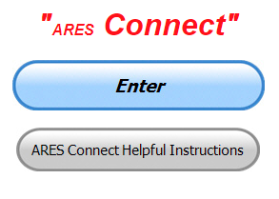

***Connecting Amateur Radio Volunteers with a Purpose***

Hey everyone… please make sure to go in and register your time to all of the events that you have signed up for. Don’t forget to get this done no later than

**5 days** after the event has ended. I’m asking you to do this for our ability to run reports accurately.

**I want to remind all of you that you do not have to be an ARES or ARRL member to use this system. All licensed amateur radio operators throughout the country are welcome and strongly encouraged to use it.**

**Don’t forget to check out the “Frequently Asked Questions” area that has been added to the Ohio Section website.** It’s there to help you through any difficulties that you may have with ARES Connect. Now, if you don’t any posts that relate to what you are having difficulties with, we now also have an on-line “Guru” area as well. This will allow you to ask any questions that you may have about ARES Connect.

**Let’s get everyone on “ARES Connect!!!”**

[TOP](#top) ^

***Here’s the top 10 hour earners so far for the month of October:***

|  |  |  |  |
| --- | --- | --- | --- |
|  | **Name** | **Events** | **Hours** |
| **1** | Dan Stahl (KC8PBU) | 89 | 138.65 |
| **2** | Dwight Bonifield (W8TJT) | 82 | 103.50 |
| **3** | Leo Dubois, Jr. (KE8OOS) | 52 | 97.95 |
| **4** | Greg Dersarkisian (KD8SSJ) | 15 | 93.70 |
| **5** | Christopher Domenick (KC8CAD) | 18 | 76.30 |
| **6** | John Hilliard (W8OF) | 15 | 70.00 |
| **7** | Ron Wilch (KE8PX) | 77 | 62.50 |
| **8** | Bret Stemen (KD8SCL) | 11 | 60.50 |
| **9** | Marcel Casavant (AD8CM) | 20 | 58.50 |
| **10** | Michael Walker (AB8MW) | 49 | 55.25 |

***Radio Message Training Coming Soon***

*(C. Matthew Curtin, KD8TTE)*

Imagine that your neighborhood has lost a critical service and as it goes to resolve the problem, regular communications needed to restore the service are unavailable. Now the single operator amateur radio station that you’ve got running at the EOC is suddenly looking like there’s an important job to be done. As local volunteers join the net and the team organizes a schedule to provide ongoing coverage, two things become evident.

The first is that the EOC needs to be able to send and receive written messages, and the second is that you don’t have the operators to staff that station to the hours needed by the agency for a duration of more than a day or two. Now imagine that not only are you able to configure to perform the messaging function but that you get the operators needed to complete the schedule, all while staying under the direction of your local Emergency Coordinator.

That’s exactly what ARES needs to be able to do and we’re looking to undertake a training program that will make that vision more than an assertion, more than a concept, but a system that demonstrates that capability.

With SET feedback hotwash and commentary still trickling in we don’t yet have an After Action Report / Improvement Plan (AAR/IP) but I expect that we will around the end of the month, and we’ll use that as the basis for training in a program that we’ll run over the course of the year leading up to next year’s SET.

This training is, as all training is, a no-fault learning environment. The SET is “the big one,” not one giant incident, but many local incidents that take place at the same time. Our work with federal and state agencies in the BLACK SWAN exercise is a natural way to exercise the ARES mission of providing emergency communications service on behalf of agencies and the NTS mission of providing message relay nets on behalf of ARES, the agencies ARES serves, and the public directly.

[TOP](#top) ^

That said, there are a few things that you should expect from the training program.

1. We’ll have a regular schedule of concise lessons that are focused on a particular skill.
2. The lessons will be in order, so the first will assume nothing about the experience or skill of the trainee, but subsequently assume that the earlier skills have been acquired.
3. Each of the lessons will include hands-on activity, making immediate use of what we’ve covered.
4. The pace will be steady but not too fast, giving everyone time needed to see the material and put it to work, without falling behind.
5. We’re going to have exercises throughout the year that will start small and focused and start incorporating more elements along the way.
6. We’ll make the most out of the event calendar so that while we’re doing our events, we’ll be sure to have an emergency communications element to include.

As for what impact our work is having, it’s not just a matter of local operators who take the time to train being more capable: we’re able to demonstrate completion of tasks that otherwise would not be possible. Earlier this week I read a draft of a FEMA AAR/IP of their participation in BLACK SWAN 20 and I’ve had followup from FEMA, the Winlink Development Team, and other agencies. Whatever difficulty we had, we did have a critical mass of the operation work well enough to prove a concept.

If you’ve got particular topics that you want covered, please be sure to let me know and as I’m developing the curriculum and delivery materials, I’ll be sure that we include everything needed to get that mission done. Looking forward to hearing from you. Send me Internet email to [kd8tte@pm.me](mailto:kd8tte@pm.me) or by Winlink to KD8TTE.

***From The South 40***

*(from John Levo,* [*W8KIW@arrl.net*](mailto:W8KIW@arrl.net)*)*

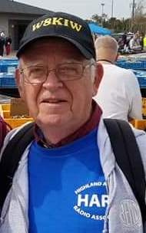“There will be a HamVention in 2021. Plans are well underway.” were the words of HamVention Spokesman Michael Kalter, W8CI, spoken to the members of the Highland ARA on Tuesday evening as he told about the annual event. Approximately 25 HARA members met at the offices of the County EMA in Hillsboro. At the meeting the membership voted to proceed with planning for an annual Christmas dinner on December 8 and learned HARA has been asked to provide communications and line up assistance for the annual Hillsboro Christmas Parade in early December. Comments were heard from two candidates running for ARRL Great Lakes Division offices.

Kentucky correspondent Brent Wells, N4BDW, lets us know that fellow Greater Mason County ARA member Michael Mullins, KN4COE, appears on a KB9VBR YouTube video making a park to park contact. Mullins is heard near the start of the video. KB9VBR was operating from the Apostle Islands National Lakefront and Mullins from K1261-Kincaid Lake in Northern Kentucky. Mullins joins those Southern Ohio and Northern Kentucky hams now pursuing parks, summits or counties.

[TOP](#top) ^

The cages and foundations are in place for two new 50-foot towers and awaiting the cement trucks to arrive Tuesday at the West Virginia Museum of Radio and Technology in Huntington. Allowing time for the concrete to cure, it appears major work on erecting the towers may not take place until early spring. However, Project Manager Bob Ripley, KD8YRQ, says other preparation work will continue. According to Tri-State ARA Club President Bud Cyr, KB8KMH, anyone wishing to help should contact Ripley.

Two South 40 hams made the W1AW QSL card page in November’s QST. Lancaster’s Roger Dickson, KA8V, and Wilmington’s Tom Sherwood, W8AAZ, cards are displayed on page 28 of the just received edition. Sherwood’s card indicates a 2014 20 meter contact with the ARRL’s special event station W100AW. Hillsboro’s KD8TUR, Dave Tourtelot, had his card displayed for a CW contact a couple months ago.

Special Event Station W3R commemorating the 30th Anniversary of the 1990 Cincinnati Red’s ‘Wire to Wire’ World Championship are still underway. However last week’s passing of that team’s Joe Morgan does put a damper on the observation. Milford ARC President Ron Brooks, AC8MA, says stations are active on all bands and all modes as time permits. The operation will conclude on Tuesday, October 20.

Elections will be held at the October 19 Southern Ohio ARA meeting according to Information Officer Mike Love, WB8YKS. The 7 pm meeting is at the Lawrence County EMA Office in Coal Grove.

The newly formed Laurel Highland ARA VE’s team leader, Tom Mongold, KD8LDS, announces pre-registration is required for the team’s November 7 license test session and only two seats remain as of Saturday morning. It will be at 1 pm at the Highland County EMA Office in Hillsboro. Sign-up at [www.signupgenius.com/go/10c0d48adac23a7fec16-hara2](http://www.signupgenius.com/go/10c0d48adac23a7fec16-hara2)

The Greater Mason County ARA Maysville Fusion 145.47 repeater is now on the air, although not presently linked with the Beechburg machine.

Word from Jeramy Duncan, KD8QDQ, is the Sunday Creek Amateur Radio Federation has decided to cancel their annual Nelsonville Hamfest because of the public health concerns caused by COVID-19.

***One Question Questionnaire***



Hey Gang,

Survey Says”….. about 91% of you know how to solder on a PL 259 to a piece of coax. This is really good. Know we know who to call on when we need some connectors installed!

Ok, now since fall is here and all of our summer fun is fast coming to a close we will be finding ourselves with some extra time on our hands. Now, that extra time can go to a good cause – upgrading your license! So, this brings up our question of the week…

***“Will you be upgrading your license in 2021??”***

[TOP](#top) ^

You’ll find the “One Question” questionnaire on the Ohio Section Website! <http://arrlohio.org> It’s all in fun and it’s not a scientific survey in any way, but we are learning some things that we didn’t know from these questions. I hope that you are enjoying answering these “One Question” questionnaires.

*****V.E. Test Sessions***

Many V.E.’s have decided to start testing once again, but with restrictions that need to be adhered to for sure. Here’s the link to find that V.E. Test session and what is expected of YOU before going. <http://www.arrl.org/find-an-amateur-radio-license-exam-session>

####

***Athens Test Session has NEW location***

We need to change the location for the Athens County Amateur Radio Association/SCARF VE session for **October 19, 2020**, 7:00 PM - Our local Red Cross facilities are still closed to any meetings other than bloodmobiles.

The new location is: **Athens Masonic Complex - 12 West Carpenter Street - Athens, OH  45701**

**Masks and temperature checks required. Park in the rear. This is next to the old National Guard Armory at the end of Court Street.**

***Final.. Final..***

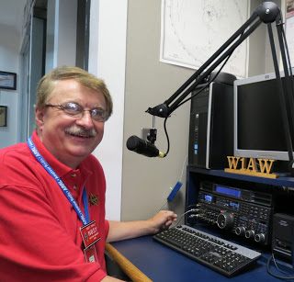Hi Gang,

This has been a great week for sure! I got to attend a rare in-person club meeting with the Highland County Amateur Radio Association this past week. It felt really good getting back on the road and traveling down to visit with the folks from HARA. We had a blast for sure. I also had a lot of fun attending a number of virtual club meetings again and I even got to sit in on one on-the-air club meetings as well!

One other benefit to all of this COVID stuff is that we are all getting on the air more. I’ve been busy checking into many of your club nets all over the Section. DMR and Echolink really make a big difference in being able to connect to those places that wouldn’t otherwise be possible. I’m even checking into a number of HF nets that usually escape me because of being on the road at the time the net is going on. It’s really been great!

[TOP](#top) ^

I got to do a little more training and instruction with some folks on the other side of the country this past week for ARES Connect. It seems that they are now getting up and running with the new system. It’s great being able to help out other Sections around the country and showing off what the Ohio Section is doing.

Have you taken the time to check out the reports that are on-line? These reports are there for you. Take advantage of them to boost up your training as well as your ham radio participation! Here’s a link to just one of the reports… <http://arrl-ohio.org/SEC/reports.html>

Whelp, that’s going to do it for this week my friends! I’m still looking forward to visiting with all of you live or via Zoom, WebEX or whatever.

I really can’t wait for that time when we can all get together in person once again. Those are the times I cherish the most!!! Stay safe! We will get through this and when we do, we’ll have so much to talk about. Most of all… have FUN and get on the airwaves!!

73,

[***Scott, N8SY***](mailto:n8sy@n8sy.com)



Hey Gang,

Have you taken a look at the **Swap & Shop** page on the Ohio Section webpage yet?? Here’s a link that will take you there…

<http://arrl-ohio.org/sm/s-s.html>

Do you have equipment that you just don’t need or want anymore? Here’s a great venue to advertise it, and it’s FREE!! Is your club doing a fund raiser to help raise money? After a lot of thought, it was decided that the Swap & Shop webpage could also contain these types of items as well. The same rules will apply as do for the For Sales and Give-A-Ways and will only be posted for a month at a time. Please see the Terms & Conditions on the webpage.

If your club is doing a fund raiser and wants more exposure, please forward the information to me and I’ll advertise it on the Swap & Shop webpage for you.

Now, I still want to remind you that it won’t be listed in this newsletter because it would take up way too much space, so your ad will only appear on the website. It is there for any individual to post equipment Wanted / For Sale or Give-Away as well as for Club Fund Raisers. No licensed vehicles/trailers or business advertising will be posted. Postings are text only (no pictures or graphics) will be posted for a maximum of 1 month from date posting and require a contact phone number or email within the posting. Send your Wanted / For Sale or Give-Away post to:  [swap@arrlohio.org](mailto:swap@arrlohio.org)

[TOP](#top) ^

***Welcome New Subscriber(s)***

**Bill, KJ8I; Bill, N2FZ**

Ohio Section Cabinet

|  |  |
| --- | --- |
| Section Manager – Scott Yonally, N8SY | Assistant Section Manager – John Perone, W8RXX |
| Section Emergency Coordinator – Stan Broadway, N8BHL | Section Traffic Manager – David Maynard, WA3EZN |
| Technical Coordinator – Jeff Kopcak, K8JTK | Affiliated Clubs Coordinator – Tom Sly, WB8LCD |
| State Government Liaison – Bob Winston, W2THU | Public Information Coordinator – John Ross, KD8IDJ |
| Section Youth Coordinator – Anthony Lascre, K8ZT | |

***Back Issues of the PostScript and Ohio Section Journal***

Hey, did you know that PostScript and Ohio Section Journal (OSJ) are archived on the website? You can go back and look at any edition simply by clicking:

<http://arrl-ohio.org/news/index.html>

***Want to Share your Club Newsletter With Others?***



We have a webpage where you can download and read all of the newsletters that I get from around the state and even other sections!

Here’s the link to the page…. <http://arrl-ohio.org/club_news/index.html>

Please, if you don’t see your club newsletter posted, it’s because I’m not receiving it. Just have your newsletter editor contact me and I’ll get your club’s newsletter listed on the site!!

We all learn and steal (I mean, share) from each other’s work. So, get me your newsletter!!! Send it to: [n8sy@n8sy.com](mailto:n8sy@n8sy.com)

[TOP](#top) ^

***Chit – Chat, and All That!***

Do you know someone that’s not getting these Newsletters? Please, forward a copy of this Newsletter over to them and have them “[Opt-In](mailto:Opt-In)” to start receiving them. Heck just have them send me an email [n8sy@n8sy.com](mailto:n8sy@n8sy.com) and I’ll get them added to the Ohio Section Emailing list.

We now have many thousands of readers receiving these newsletters weekly. Quite impressive, I’d say! I urge all of you to make sure that everyone, regardless of whether they are a League member or not, get signed up to receive these weekly Newsletters.

You can always “Opt-Out” at any time if you feel this is not what you were expecting. It’s fun and very informative. All of your favorite past newsletters are now archived too.

You can go back at any time and read them. Just go to: <http://arrl-ohio.org/news/>

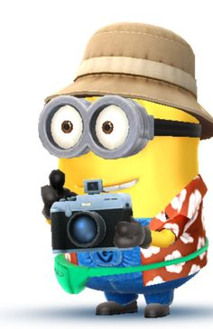Got questions, concerns or would just like to sit and chat awhile? Heck, I’ll even buy the coffee!! Give me a call at (419) 512-4445 or email me at: [n8sy@n8sy.com](mailto:n8sy@n8sy.com)

The pictures on the front page and throughout this newsletter are from various newsletters, Facebook posts and/or were sent directly to me in recent weeks. Take a good look at them, you just might be in one of the pictures! “SMILE… you’re in the Ohio Section News!!”

***Stop!!! You’ve reached the end of another week’s edition.***

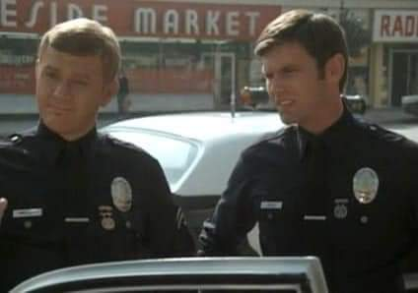

[TOP](#top) ^

*PostScript is produced as a weekly newsletter. I want to thank everyone that has contributed articles and ideas to make this an even better news source. I sincerely hope that you have enjoyed this edition and will encourage your friends to join with you in receiving the latest news and information about the Ohio Section, and news and events happening around the world!*