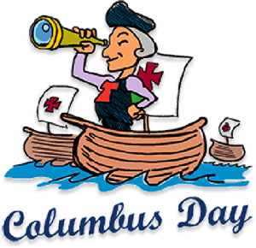

[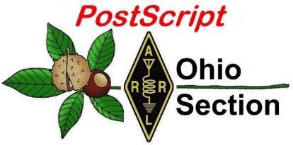](http://arrl-ohio.org/news/) ***Columbus Day***

***Edition***

🡪 National News 🡪 The Handbook Give Away

🡪 Club Corner 🡪 Hamfests

🡪 DX This Week 🡪 ARES Connect

🡪 VE Testing 🡪 One Question Questionnaire

🡪 From The South 40 🡪 Final.. Final..

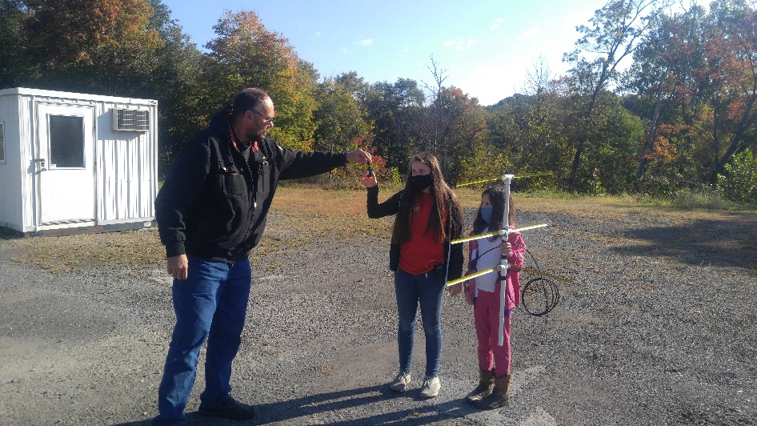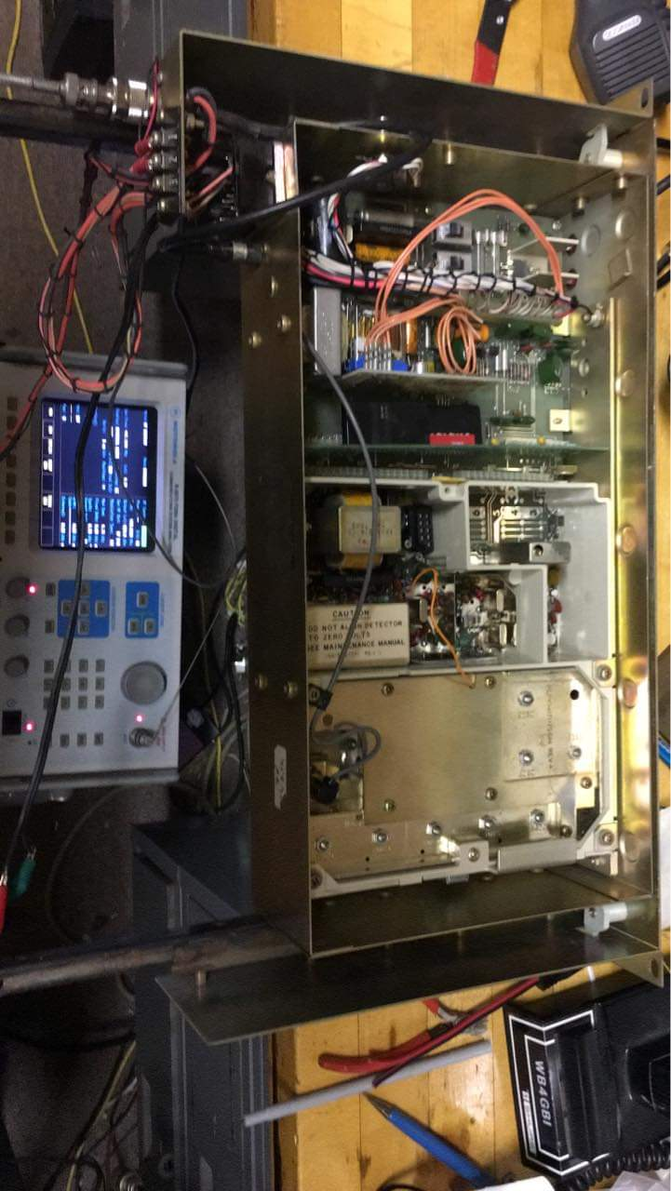

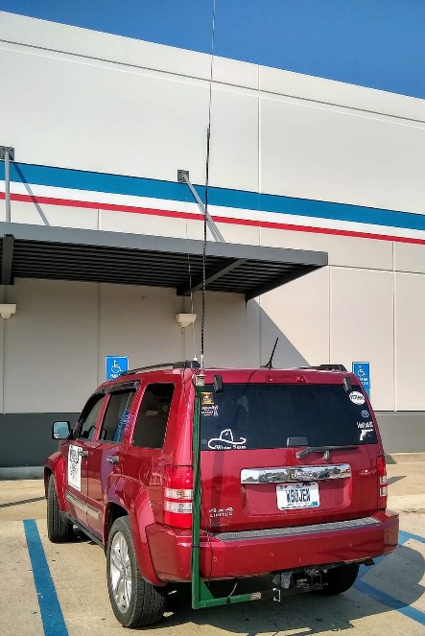

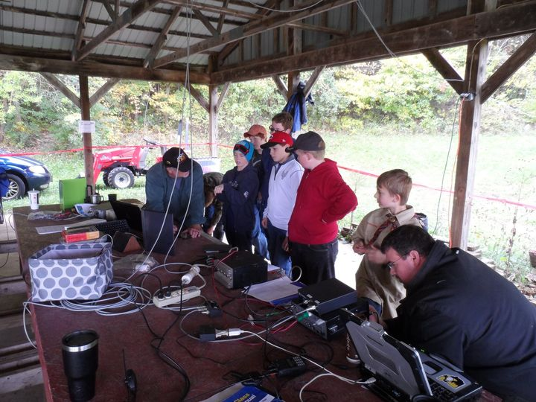

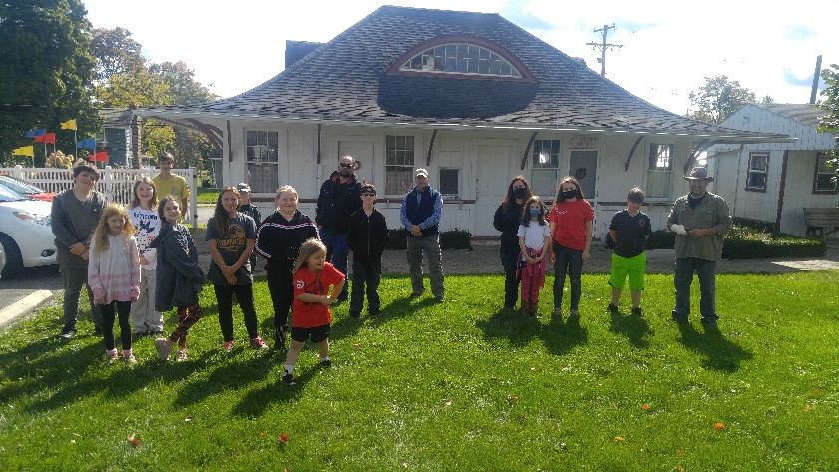

***National News***

*(from arrl and other sources)*

***FCC Orders Amateur Access to 3.5 GHz Band to “Sunset”***

Despite vigorous and continuing opposition from ARRL and others, the FCC has ordered the “sunsetting” of the 3.3 – 3.5-GHz amateur radio secondary spectrum allocation. The decision allows current amateur activity on the band to continue, “grandfathering” the amateur operations subject to a later decision. The FCC proposed two deadlines for amateur operations to cease on the band. The first would apply to the 3.4 – 3.5 GHz segment, the second to 3.3 – 3.4 GHz. The FCC will establish the dates once it reviews additional comments.

“We adopt our proposal from the *Notice of Proposed Rulemaking* to remove the amateur allocation from the 3.3 – 3.5 GHz band,” the FCC said in its *R&O*. “[W]e adopt changes to our rules today that provide for the sunset of the secondary amateur allocation in the band, but allow continued use of the band for amateur operations, pending resolution of the issues raised in the *Further Notice*.”

The *Report and Order* ([***R&O***](https://ecfsapi.fcc.gov/file/1002214202488/FCC-20-138A1.pdf)) and *Further Notice of Proposed Rulemaking*in WT Docket No. 19-348 adopted on September 30 followed a 2019 FCC *Notice of Proposed Rulemaking*(*NPRM*) in which the FCC proposed re-allocating 3.45 – 3.55 GHz for “flexible-use service” and auctioning the desirable “mid-band” spectrum (generally defined as between 1 GHz and 6 GHz) to 5G providers. These and other recent spectrum-repurposing actions stem from the MOBILE NOW Act, enacted in 2018, in which Congress directed the Commission to make additional spectrum available to auction for mobile and fixed wireless broadband. The FCC action is consistent with worldwide allocations adopted by the ITU for these frequencies.

In the run-up to the Commission’s decision, ARRL met with the FCC’s professional staff to explain its concerns and to answer questions. Subsequently, ARRL met with the wireless advisors to the FCC Chairman and two Commissioners. In those meetings, ARRL reiterated that continued secondary status for amateurs will not impair or devalue use of this spectrum by the primary licensees intending to provide 5G or other service. ARRL noted amateur radio’s long history of successful coexistence with primary users of the 9 cm band, sharing this spectrum with the federal government users and secondary, non-federal occupants.

ARRL pointed out that vital links in amateur television and amateur radio high-speed mesh networks using the band have been especially valuable during such emergency situations as the [**wildfires**](https://ecfsapi.fcc.gov/file/10924040735543/ATN20FCC20Parte20Sept.2C%202020.pdf)currently raging on the west coast. Deleting the amateur secondary allocation will result in lost opportunities for experimentation and public service with no public interest benefit to make up for that.

ARRL argued that deleting the secondary allocation would waste the scarce spectrum resource, particularly in areas where commercial services often do not construct full facilities due to small populations. The FCC action means that amateur radio will lose access to the 3.5-GHz secondary allocation even where commercial operations do not exist. ARRL told the Commission that it should not intentionally allow this spectrum to be vacant and unused, wasting the public resource, when amateurs can use some portion of it in many geographic areas with no detriment to any other licensee, just as it has in the past. ARRL argues that amateur operations should be permitted until and unless an actual potential for interference exists.

TOP ^

Deletion of the 3.3 – 3.5 GHz secondary amateur allocation will become effective on the effective date of the FCC’s order, but amateur radio operation as of that date may continue while the FCC finalizes rules to license spectrum in the 3.45 – 3.55 GHz band and establishes deadlines for amateur operations to cease. The FCC proposed allowing amateur operation in the 3.3 – 3.4 GHz portion of the band to continue “pending further decisions about the future of this portion of the spectrum,” the timing for which is unknown. The Commission proposed to mandate that operations cease in the 3.4 – 3.5 GHz portion when commercial licensing commences for the new 3.45 – 3.55 GHz “5G” band, which is predicted to begin in the first half of 2022.

“[W]e seek comment on whether it is in the public interest to sunset amateur use in the 3.3 – 3.55 GHz band in two separate phases, e.g., first above 3.4 GHz, which is the focus of [the *R&O*] and later in that portion of the band below 3.4 GHz,” the FCC said.

ARRL expressed gratitude to the many members and organizations that joined ARRL in challenging the FCC throughout this nearly year-long proceeding. They included multiple radio clubs, weak signal enthusiasts, moonbounce participants, and the Amateur Radio Emergency Data Network (AREDN), the Amateur Television Network (ATN), AMSAT, and Open Research Institute (ORI).

ARRL will continue its efforts to preserve secondary amateur radio access to 3.3 – 3.5 GHz. Members are invited to share comments by visiting [**www.arrl.org/3-GHz-Band**](http://www.arrl.org/3-GHz-Band).

“We recognize that any loss of our privileges will most directly impact radio amateurs who use the frequencies to operate and innovate,” said ARRL President Rick Roderick, K5UR. “Such instances only embolden ARRL’s role to protect and advocate for the Amateur Radio Service and Amateur Satellite Service. There will be continued threats to our spectrum. So I urge all amateurs, now more than ever, to strengthen our hold by being ceaseless in our public service, experimenting, and discovery throughout the radio spectrum.”

####

***IARU Region 2 Releases 2020 Revision of its Band Plan***

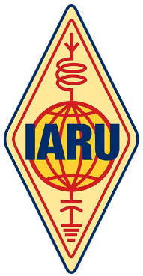

International Amateur Radio Union Region 2 ([**IARU R2**](https://www.iaru-r2.org/en/reference/band-plans/)) — the Americas — has released the September 2020 revision of its [**Band Plan**](https://www.iaru-r2.org/wp-content/uploads/2020/02/IARU-Region-2-Band-plan.pdf) and made procedural changes to shorten the time to reflect future adjustments. The Band Plan includes a change approved at the October 2019 General Assembly to add an Amateur Satellite uplink subband, 21.125 to 21.450 MHz, on a non-exclusive basis. This matches similar changes in the Region 1 and Region 3 band plans.

A number of administrative changes have been made to the text, although the Band Plan itself has not been modified. These changes include:

* Modifications to the wording of the Band Plan to ensure that national regulators understand it is a voluntary document, and that countries may depart from the plan based on national requirements.
* Definitions additions: Amateur Radio Direction Finding (ARDF), primary service, secondary service, and several acronyms.
* Inclusion of information detailing the primary and secondary users in each amateur radio allocation band.
* Correction of minor typographical errors.

TOP ^

At its May 2020 meeting, the IARU R2 Executive Committee added text to the Standard Operating Procedures that provides a process for the Band Plan to be updated in a more timely manner. Prior to this change, Band Plan modifications could only be approved at a General Assembly, held once every 3 years. Under the new provision, the Band Planning Committee may circulate proposed changes to member-societies with the approval of the Executive Committee. “Should no more than one objection be received within a 60-day period, the change shall be deemed accepted and reported as such at the next conference,” the Band Planning Committee’s terms of references state.

####

**ARRL National Convention and Orlando Hamcation® Postponed to February 2022**

ARRL and the Orlando Amateur Radio Club (OARC) have announced that the ARRL National Convention and Orlando **[HamCation](http://www.hamcation.com/)**® — which was to host the convention — have been postponed until February 10 – 13, 2022. The convention had been set for next February.

“The joint decision came after considering the national public health emergency including the health and safety of all participants, the uncertainty that continues to impact our organizations, and the reluctance to travel to, and attend, large events,” said ARRL CEO David Minster, NA2AA.

“We regret the disruption to the hard work already completed by so many volunteers preparing for the ARRL National Convention and HamCation.”

“While postponing was a difficult decision, our top priority is delivering a safe and successful HamCation experience for everyone, including our attendees, dedicated volunteers, exhibitors, and service partners,” said HamCation General Chairman Michael Cauley, W4MCA.

OARC President John Knott, N4JTK, noted that holding the convention in 2022 will mark the 75th anniversary of HamCation — one of the largest annually held gatherings of radio amateurs in the US. The published gate figure for 2020 was 24,200 for all 3 days.

“We want our diamond anniversary show to be an exciting, five-star event,” said Knott. “We look forward to seeing you in Orlando in 2022, and hope that you and your loved ones remain safe in the months to come.”

A full day of National Convention programming and training sessions was previously scheduled to precede HamCation. That will be rescheduled for Thursday, February 10, 2022. HamCation will host the rest of the convention on Friday, Saturday, and Sunday, February 11 –13, 2022 at the Central Florida Fairgrounds and Expo Park in Orlando — an 87-acre lakefront fairgrounds.

Cauley said HamCation may organize some online presentations and programs for what would have been HamCation 2021 next February. A QSO party is also under consideration. The **[HamCation website](http://www.hamcation.com/)** will soon post details, including information for anyone seeking refunds and other options for pre-purchased tickets and exhibit space. Follow HamCation on [**Facebook**](https://www.facebook.com/Hamcation/), [**Twitter**](https://twitter.com/Hamcation), and [**Instagram**](https://www.instagram.com/Hamcation/).

Further details and any changes will be shared via these official websites:

* [**2022 ARRL National Convention**](http://www.arrl.org/expo)
* [**Orlando HamCation**](http://www.hamcation.com/)

####

TOP ^

***ARISS to Celebrate 20 Years of Ham Radio on the International Space Station***

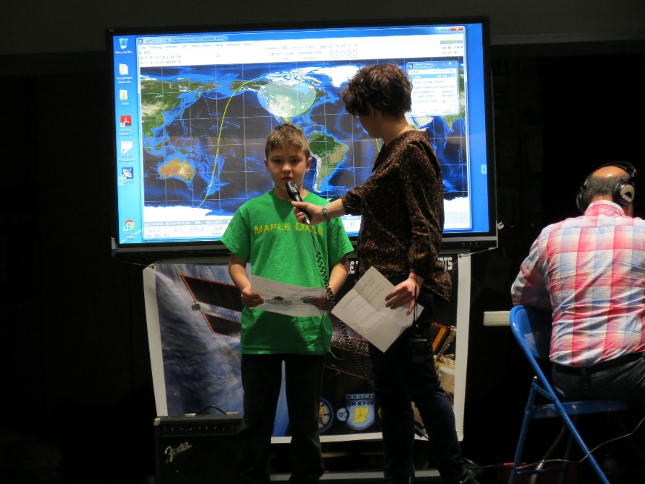Amateur Radio on the International Space Station ([**ARISS**](http://www.ariss.org/)) will soon celebrate 20 years of continuous ham radio operations on the International Space Station (ISS). NASA is commemorating the milestone with a newly produced [**infographic**](https://www.nasa.gov/mission_pages/station/research/news/iss-20-years-ham-radio-infographic) highlighting the educational contacts via amateur radio between astronaut crew members aboard the ISS and students. Over its 20 years, ARISS has supported nearly 1,400 scheduled ham radio contacts with schools, student groups, and other organizations.

Planning for ARISS began in 1996 as a cooperative venture among national amateur radio and amateur satellite societies, with support from their respective space agencies. The ARISS ham radio gear actually arrived on the station before the Expedition 1 crew, headed by Commander Bill Shepherd, KD5GSL. The FCC issued ham radio call sign NA1SS for ISS operations. After Expedition 1 arrived on station, some initial tests with ARISS ham radio ground stations and individual hams confirmed the ham gear was working properly. The first ARISS school contact was made with students at Luther Burbank Elementary School in Illinois on December 21, 2000, with Shepherd at the helm of NA1SS on the ISS, and ARISS operations team mentor Charlie Sufana, AJ9N, guiding the operation on the ground.

NASA produced a [**video**](https://youtu.be/1clACXLdDhs) of students talking with astronaut Chris Cassidy, KF5KDR, during an ARISS contact in May 2020.

Before and during scheduled ham radio contacts, students, educators, parents, and communities learn about space and related technologies, and radio communication using amateur radio. ARISS has inspired thousands of students, promoting exploration through educational experiences spanning science, technology, engineering, the arts, and mathematics.

ARISS relies on a large network of amateur radio operator volunteers, many associated with radio clubs in the communities where students and groups participating in the contact reside. ARISS volunteers support satellite ground stations, serve as technical mentors, and provide additional help in the areas of education, community outreach, and public relations.

While student-to-astronaut radio contacts are a primary objective for ARISS, the capability has also inspired further experimentation for amateur radio in space and evaluation of new technologies. In September, ARISS [announced](http://www.arrl.org/news/first-element-of-ariss-next-generation-radio-system-installed-and-operating-on-iss) that the initial element of its next-generation ham radio system had been installed in the ISS *Columbus* module. The new radio system replaces equipment originally certified for spaceflight in mid-2000. The onboard ham station also provides a contingency communications system for the ISS crew. Several astronauts have also enjoyed using NA1SS to make casual contacts with — and delighting — earthbound members of the ham radio community.

TOP ^

In the US, ARISS sponsors include [**ARRL**](http://www.arrl.org/), [**AMSAT**](http://www.amsat.org/), and **NASA**, the ISS National Lab-Space Station Explorers, and NASA’s Space Communications and Navigation program. Global organizing partners include International Amateur Radio Union ([**IARU**](http://www.iaru.org/)) member-societies as well as AMSAT organizations, and space agencies in Canada, Europe, Russia, Japan, and elsewhere.

The next proposal window for US schools and educational organizations to [**host an amateur radio contact**](https://www.ariss.org/hosting-an-ariss-contact-in-the-us.html) with a crew member on board the ISS opened on October 1 for contacts that would take place from July through December 2021.

Like many educators who have coordinated ARISS radio contacts for their students, teacher Rita Wright, KC9CDL, an ARRL member, described the first ARISS school contact as inspirational and having a lasting impact on their community. Five months after their contact, nearly 500 students greeted Bill Shepherd when he visited Luther Burbank School. Wright said it was “like tossing a pebble into a stream.”

“The ripple effects are still occurring, and I suspect will continue to occur for a long time,” she said. “We have a young staff, and witnessing these events has inspired some to look for other interdisciplinary projects. They are beginning their dream. Many of our students are looking forward to careers associated with the space industry.”

####

***Amateur Radio on the International Space Station - Contact Opportunity***

***Call for Proposals***

**New Proposal Window is October 1st, 2020 to November 24, 2020**

September 30, 2020 --- The Amateur Radio on the International Space Station (ARISS) Program is seeking formal and informal education institutions and organizations, individually or working together, to host an Amateur Radio contact with a crew member on board the ISS. ARISS anticipates that the contact would be held between July 1, 2021 and December 30, 2021. Crew scheduling and ISS orbits will determine the exact contact dates. To maximize these radio contact opportunities, ARISS is looking for organizations that will draw large numbers of participants and integrate the contact into a well-developed education plan.

**The deadline to submit a proposal is November 24th, 2020.** Proposal information and more details such as expectations, proposal guidelines and the proposal form can be found at [www.ariss.org](http://www.ariss.org/). An ARISS Introductory Webinar session will be held on October 8, 2020 at 8 PM ET.  **The Eventbrite link to sign up is:** [https://ariss-proposal-webinar-fall-2020.eventbrite.com](https://ariss-proposal-webinar-fall-2020.eventbrite.com/)

The Opportunity

Crew members aboard the International Space Station will participate in scheduled Amateur Radio contacts. These radio contacts are approximately 10 minutes in length and allow students to interact with the astronauts through a question-and-answer session.

TOP ^

An ARISS contact is a voice-only communication opportunity via Amateur Radio between astronauts and cosmonauts aboard the space station and classrooms and communities. ARISS contacts afford education audiences the opportunity to learn firsthand from astronauts what it is like to live and work in space and to learn about space research conducted on the ISS. Students also will have an opportunity to learn about satellite communication, wireless technology, and radio science.

Because of the nature of human spaceflight and the complexity of scheduling activities aboard the ISS, organizations must demonstrate flexibility to accommodate changes in dates and times of the radio contact.

Amateur Radio organizations around the world with the support of NASA and space agencies in Russia, Canada, Japan and Europe present educational organizations with this opportunity. The ham radio organizations’ volunteer efforts provide the equipment and operational support to enable communication between crew on the ISS and students around the world using Amateur Radio.

Please direct any questions to [ariss.us.education@gmail.com](mailto:ariss.us.education@gmail.com) .

**About ARISS:**

Amateur Radio on the International Space Station (ARISS) is a cooperative venture of international amateur radio societies and the space agencies that support the International Space Station (ISS). In the United States, sponsors are the Radio Amateur Satellite Corporation (AMSAT), the American Radio Relay League (ARRL), the ISS National Lab-Space Station Explorers, and NASA’s Space Communications and Navigation program. The primary goal of ARISS is to promote exploration of science, technology, engineering, the arts, and mathematics topics by organizing scheduled contacts via amateur radio between crew members aboard the ISS and students. Before and during these radio contacts, students, educators, parents, and communities learn about space, space technologies, and amateur radio. For more information, see [www.ariss.org](http://www.ariss.org/).

Media Contact: Dave Jordan, AA4KN - ARISS PR

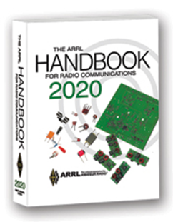***The Handbook Give Away***

Hey Gang,

The “Handbook Giveaway” drawing will soon be returning for another big “Give Away”

Many of you ask me just how do I know when the drawing is on? Well, that’s easy all you need to do is check in on the Ohio Section Website on a regular basis and watch for the big [**RED**](http://arrl-ohio.org/handbook.html)Arrow that will appear on the left side of the page. This is the sign that the drawing is on and you need to get registered. So, keep a sharp eye out on the website and check in often! <http://arrl-ohio.org>

What’s the catch? I want to get everyone checking in to the Ohio Section website as often as possible, and in order to register each month, you have to visit the website often! There’s nothing else to it. I pay all expenses, and from time to time, I Give Away more than just a Handbook. And, you’ll never know just what months will be those special times that I will have more than just a Handbook to Give Away!!

TOP ^

***Club Corner***

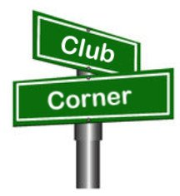

This is YOUR cornner of the newsletter. Send me what your club is doing and I’ll make sure that it gets in. Got a special event or club project that you want everyone to know about? Send it to me!. Need help with a project? Send it to me.

Let me know what you club is up to. Are you going to have a special guest at your meeting or are you having a special anniversary? Just sent it to: [n8sy@n8sy.com](mailto:n8sy@n8sy.com)

####

***Ham Radio Class Now Forming***



As a Licensed Ham Radio Operator You Get To

• Serve Your Community

• Talk To Other Hams On The Radio

• Meet New Friends

• Have Your Own Individual Call Sign

The Toledo Mobile Radio Assn. will be holding a 8 week course where you will learn everything you need to earn your entry level FCC Amateur Radio license and begin to talk on the radio with other hams in the area. Morse code is no longer required for any Amateur license.

Textbooks are required - ARRL *Ham Radio License Manual* **4th Ed**. Available locally from Steve – KC8TVW while supplies last. Also available from Amazon.com or [www.ARRL.org](http://www.ARRL.org) Cost locally, $30.

Format of the class will be approximately 45 minutes of video to watch prior to our Tuesday night sessions. Starting **October 13** at 7:00 p.m. we will meet via Zoom to discuss the assigned video(s) and answer any student’s questions.

**Pre-registration is required.** The test will be given at a site to be determined on Dec. 12. Cost of test is $15.

TMRA does not charge for the class. Class Dates: **October 13 – Dec 1, 2020 (7:00-9:00 p.m.)**

For more information please contact: Steve Stalker KC8TVW - 419-467-3734 [kc8tvw@arrl.net](mailto:kc8tvw@arrl.net)

####

TOP ^

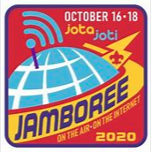***JOTA Special Event Station***

*(from Dale Lamm, NX8J)*

Hi Scott,

A cooperative effort between amateur radio clubs in Stark and Tuscarawas counties takes place October 17. The annual JOTA-JOTI is the largest single Scouting event in the world. As part of the 100th anniversary of historic Camp Tuscazoar, special event station K8T will be active on **October 17** from the camp.

We'll be on or near the recommended Scouting frequencies using several modes, primarily SSB on 80, 40 and 20 meters.

We are also conducting a Radio Merit Badge session that day (following Scouts BSA safety protocols). Please give a listen and share your stories about camping or Scouting with us.

Myself and Jeff Voltz, KE8BKP of the Tusco club are the ringleaders. We have participation from Tusco, Canton, and Massillon clubs. Thus far we are up to 79 registered Scouts who want to earn Radio Merit Badge.

Pre-registration is needed, no walk-ins. Contact the camp for registration, but at this point, our plates are very full.

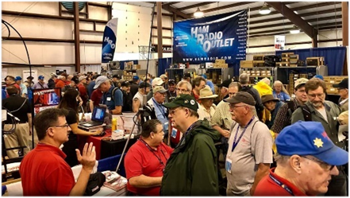

[***Upcoming Hamfests***](http://arrl-ohio.org/hamfests.html) ***for 2020***

**11/01/2020 - 60th Massillon Hamfest**Location: Massillon, OH  
Sponsor: Massillon Amateur Radio Club  
Website: <http://w8np.org/hamfest.htm>

***New Location…***

The new location is: The MAPS (Military Air Preservation Society) large Hangar at 5383 Massillon Road, Green, OH (route 241).

***Masks are required!***

***Temperatures will be taken on everyone entering the facility***

***ONLINE-ICS-300 INTERMEDIATE ICS FOR EXPANDING EVENTS***

*(Hosted by: Wayne County EMA -* ***November 2 – 5, 2020*** *(4 partial days)*

**Course Description:** This 21-hour classroom course provides training for personnel who require advanced application of the Incident Command System (ICS) and Individuals who may assume a supervisory role in incidents. This course expands upon information covered in the ICS 100 and ICS 200 courses.

TOP ^

**Application Deadline:** Ten working days prior to the course - Seating availability is limited so register early

**Course Registration time:** 8:00 am – 8:30 am (on day one)

**Course Time:** 8:30 am to 3:30 pm on day one with a one-hour lunch 8:30 am to 1:30 pm – day two, three and four of the courses

**Training Location:** Virtually Online via Microsoft’s MS Teams Software

**Recommended Participants:** FEMA designed this course for individuals who may assume a supervisory role in expanding incidents or Type 3 incidents.

**Note:** During a Type 3 incident, some or all of the Command and General Staff positions may be activated, as well as Division/Group Supervisor and/or Unit Leader level positions. These incidents may extend into multiple operational periods.

**Required Prerequisites:** Individuals must complete the IS-100.c Introduction to the Incident Command System, IS-200.c Basic Incident Command System for Initial Response, IS-700.b An Introduction to the National Incident Management System and IS-800.c National Response Framework courses prior to attending the ICS-300 Intermediate course and provide copies of their certificates of completion to the instructors on day one of the course.

**Enrollment:** Students must enroll via the Department of Public Safety Training Campus website: https://trainingcampus.dps.ohio.gov/CourseMill/home.html. Course registration will close 10 working days prior to the course start date and applicants can check enrollment/approval status via the Department of Public Safety Training Campus website.

**####**

***ONLINE-ICS-400 ADVANCED ICS FOR COMMAND & GENERAL STAFF***

*(Hosted by: Wayne County EMA -* ***November 16 – 18, 2020*** *(3 partial days)*

**Course Description:** This 15-hour classroom course provides training for personnel who require advanced application of the Incident Command System (ICS). This course expands upon information covered in ICS-100, 200, 700, 800 and ICS-300 courses, which are the prerequisites for the ICS-400 course.

The target audience for this course is senior personnel who expect to perform in a management capacity in an Area Command or Multi-Agency Coordination Entity.

**Application Deadline:** Ten working days prior to the course - Seating availability is limited so register early

**Course Registration time:** 8:00 am – 8:30 am (on day one)

**Course Time:** 8:30 am to 1:30 pm all three days of the course

**Training Location:** Virtually Online via Microsoft’s MS Teams Software

TOP ^

**Recommended Participants:** FEMA designed the course for Senior Personnel who expect to perform in a management capacity in an Area Command or Multi-Agency Coordination Entity.

**Required Prerequisites:** Individuals must complete the IS-100.c Introduction to the Incident Command System, IS-200.c Basic Incident Command System for Initial Response, IS-700.b An Introduction to the National Incident Management System and the IS-800.c National Response Framework, an Introduction courses. In addition, ICS-300 Intermediate courses prior to attending the ICS-400 Advanced course and provide copies of their certificates of completion to the instructors on day one of the course.

**Enrollment:** Students must enroll via the Department of Public Safety Training Campus website: https://trainingcampus.dps.ohio.gov/CourseMill/home.html. Course registration will close 10 working days prior to the course start date and applicants can check enrollment/approval status via the Department of Public Safety Training Campus website.

**Course Costs for both classes:** There is no charge for participants to attend this course. However, Lodging, Meals, Per Diem and all other travel expenses are the responsibility of the student or the parent organization.

**State Point of Contact for both of these classes is:** Gary Lehman, Planner 3, Ohio EMA, Training Point of Contact, (614) 799-3663 [gdlehman@dps.ohio.gov](mailto:gdlehman@dps.ohio.gov)

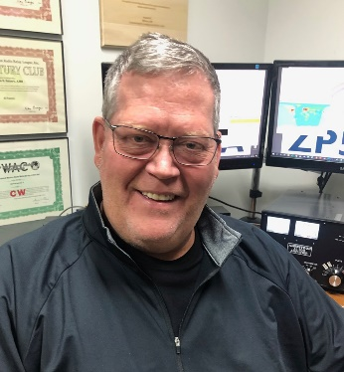***DX This Week***

*(from Bill, AJ8B)*

***DX This Week – K9LA***

***Bill AJ8B (aj8b@arrl.net, @AJ8B, or www.aj8b.com)***

***CWOPs Member #1567***

Before we move on to our regular business, I want to say a heartfelt THANKS to those of you that sent along kind comments about my recent Podcast Today interview with Eric, 4Z1UG. It was a lot of fun to do and even more so with the kind comments.

This past week really supplied some interesting DX. There were many entities spotted in the Midwest including Afghanistan, Anguilla, Austria, Azores, Belgium, Belize, Bosnia-Herzegovina, Brazil, Bulgaria, Canada, Ceuta & Melilla, Croatia, Cuba, Cyprus, Denmark, Dodecanese, England, Fed. Rep. of Germany, Finland, France, Haiti, Indonesia, Ireland, Isle of Man, Italy, Kuwait, Latvia, Lebanon, Madeira Islands, Mexico, Netherlands, North Cook Islands, Northern Ireland, Norway, Oman, Panama, Poland, Portugal, Puerto Rico, Romania, Scotland, Serbia, Sicily, South Africa, Spain, Sweden, Ukraine, and Wales. Let me know what you worked.

TOP ^

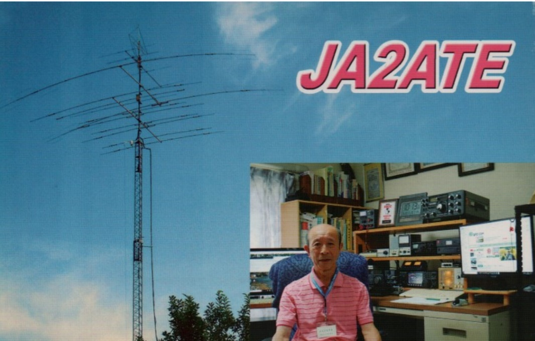

I received a QSL card from JA2ATE, Iku in Aichi, Japan. I have also sorted the “N” cards that I received from the Buro and will be sending them out in the next week. If you have an “8N” call, you may have something heading your way. Stay tuned!

Clublog has sent out their Most Needed countries list as of 10/1. I have listed the top 50 below. You can always go to Clublog.org and select Most Needed to get the entire survey. This is really accurate as it is based on the QSOs that have been uploaded and QSOs confirmed. In years past, there would be a survey sent out and some number of hams would respond. This was a long process!

|  |  |  |
| --- | --- | --- |
| 1 | P5 | [DPRK (NORTH KOREA)](https://clublog.org/mostwanted2.php?dxcc=344) |
| 2 | FT5/W | [CROZET ISLAND](https://clublog.org/mostwanted2.php?dxcc=41) |
| 3 | BS7H | [SCARBOROUGH REEF](https://clublog.org/mostwanted2.php?dxcc=506) |
| 4 | 3Y/B | [BOUVET ISLAND](https://clublog.org/mostwanted2.php?dxcc=24) |
| 5 | BV9P | [PRATAS ISLAND](https://clublog.org/mostwanted2.php?dxcc=505) |
| 6 | FT/G | [GLORIOSO ISLAND](https://clublog.org/mostwanted2.php?dxcc=99) |
| 7 | FT5/X | [KERGUELEN ISLAND](https://clublog.org/mostwanted2.php?dxcc=131) |
| 8 | ZS8 | [PRINCE EDWARD & MARION ISLANDS](https://clublog.org/mostwanted2.php?dxcc=201) |
| 9 | SV/A | [MOUNT ATHOS](https://clublog.org/mostwanted2.php?dxcc=180) |
| 10 | YK | [SYRIA](https://clublog.org/mostwanted2.php?dxcc=384) |
| 11 | CE0X | [SAN FELIX ISLANDS](https://clublog.org/mostwanted2.php?dxcc=217) |
| 12 | EZ | [TURKMENISTAN](https://clublog.org/mostwanted2.php?dxcc=280) |
| 13 | VK0M | [MACQUARIE ISLAND](https://clublog.org/mostwanted2.php?dxcc=153) |
| 14 | KH7K | [KURE ISLAND](https://clublog.org/mostwanted2.php?dxcc=138) |
| 15 | 3Y/P | [PETER 1 ISLAND](https://clublog.org/mostwanted2.php?dxcc=199) |

TOP ^

|  |  |  |
| --- | --- | --- |
| 16 | KH3 | [JOHNSTON ISLAND](https://clublog.org/mostwanted2.php?dxcc=123) |
| 17 | JD/M | [MINAMI TORISHIMA](https://clublog.org/mostwanted2.php?dxcc=177) |
| 18 | YV0 | [AVES ISLAND](https://clublog.org/mostwanted2.php?dxcc=17) |
| 19 | PY0T | [TRINDADE & MARTIM VAZ ISLANDS](https://clublog.org/mostwanted2.php?dxcc=273) |
| 20 | AP | [PAKISTAN](https://clublog.org/mostwanted2.php?dxcc=372) |
| 21 | XZ | [MYANMAR](https://clublog.org/mostwanted2.php?dxcc=309) |
| 22 | S2 | [BANGLADESH](https://clublog.org/mostwanted2.php?dxcc=305) |
| 23 | FT/T | [TROMELIN ISLAND](https://clublog.org/mostwanted2.php?dxcc=276) |
| 24 | VK0H | [HEARD ISLAND](https://clublog.org/mostwanted2.php?dxcc=111) |
| 25 | VU4 | [ANDAMAN & NICOBAR ISLANDS](https://clublog.org/mostwanted2.php?dxcc=11) |
| 26 | VU7 | [LAKSHADWEEP ISLANDS](https://clublog.org/mostwanted2.php?dxcc=142) |
| 27 | PY0S | [SAINT PETER AND PAUL ROCKS](https://clublog.org/mostwanted2.php?dxcc=253) |
| 28 | 9N | [NEPAL](https://clublog.org/mostwanted2.php?dxcc=369) |
| 29 | VP8S | [SOUTH SANDWICH ISLANDS](https://clublog.org/mostwanted2.php?dxcc=240) |
| 30 | 1S | [SPRATLY ISLANDS](https://clublog.org/mostwanted2.php?dxcc=247) |
| 31 | KH4 | [MIDWAY ISLAND](https://clublog.org/mostwanted2.php?dxcc=174) |
| 32 | A5 | [BHUTAN](https://clublog.org/mostwanted2.php?dxcc=306) |
| 33 | FT/J | [JUAN DE NOVA, EUROPA](https://clublog.org/mostwanted2.php?dxcc=124) |
| 34 | FK/C | [CHESTERFIELD IS.](https://clublog.org/mostwanted2.php?dxcc=512) |
| 35 | ZL9 | [NEW ZEALAND SUBANTARCTIC ISLANDS](https://clublog.org/mostwanted2.php?dxcc=16) |
| 36 | VK9C | [COCOS (KEELING) ISLAND](https://clublog.org/mostwanted2.php?dxcc=38) |
| 37 | XX9 | [MACAO](https://clublog.org/mostwanted2.php?dxcc=152) |
| 38 | XU | [CAMBODIA](https://clublog.org/mostwanted2.php?dxcc=312) |
| 39 | VK9X | [CHRISTMAS ISLAND](https://clublog.org/mostwanted2.php?dxcc=35) |
| 40 | T5 | [SOMALIA](https://clublog.org/mostwanted2.php?dxcc=232) |
| 41 | 3A | [MONACO](https://clublog.org/mostwanted2.php?dxcc=260) |
| 42 | 5A | [LIBYA](https://clublog.org/mostwanted2.php?dxcc=436) |
| 43 | 7O | [YEMEN](https://clublog.org/mostwanted2.php?dxcc=492) |

TOP ^

|  |  |  |
| --- | --- | --- |
| 44 | 3B7 | [AGALEGA & ST BRANDON ISLANDS](https://clublog.org/mostwanted2.php?dxcc=4) |
| 45 | ZD9 | [TRISTAN DA CUNHA & GOUGH ISLANDS](https://clublog.org/mostwanted2.php?dxcc=274) |
| 46 | EP | [IRAN](https://clublog.org/mostwanted2.php?dxcc=330) |
| 47 | 4W | [TIMOR-LESTE](https://clublog.org/mostwanted2.php?dxcc=511) |
| 48 | YA | [AFGHANISTAN](https://clublog.org/mostwanted2.php?dxcc=3) |
| 49 | ZL8 | [KERMADEC ISLAND](https://clublog.org/mostwanted2.php?dxcc=133) |
| 50 | 8Q | [MALDIVES](https://clublog.org/mostwanted2.php?dxcc=159) |

***DAH DIT DIT DIT DAH DAH DIT DIT DIT DAH***

As with previous months, I am offering the current monthly article from Carl, K9LA. I hope you enjoy this.

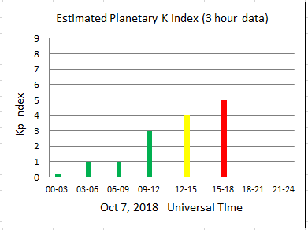Pop Quiz

Carl Luetzelschwab K9LA

Suppose you’re monitoring the K indices (at <https://www.swpc.noaa.gov/>in the chart, for example) and you see the following progression on a given day for the first six values of the Kp index (Kp is the 3-hour planetary K index – a compilation of many observatories to see a worldwide view of the activity of the Earth’s magnetic field).

What should you do?

1. Turn off your radio as the F2 region is going to be depleted of electrons and there won’t be any propagation.
2. Check the higher HF bands for enhanced propagation.

If you chose A, you might miss out on a golden opportunity to enjoy some unusual propagation. If you chose B, you probably realize that there can be a short-term enhancement in F2 region propagation on low and mid latitude paths when the K index initially spikes up.

The B scenario is what happened for the 2018 running of the California QSO Party (October 6 and 7). On Saturday the 6th, no W6 stations were heard on 10-meters here in the Midwest. That isn’t unusual as the MUF (maximum usable frequency) for this path at solar minimum during the daytime would only be about 20 MHz.

TOP ^

But on Sunday the 7th, the path from the Midwest to W6 on 10-meters opened. What happened was an enhancement in the F2 region electron density due to the Kp index spiking up in the 12- 15z period on October 7. This is the positive phase of a geomagnetic storm.

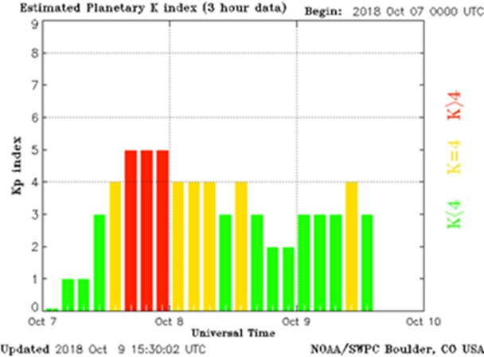

Here’s the Kp index for October 7, 8 and 9 of 2018. It’s a more complete picture of the previous Kp index plot.

You can see the Kp index spiking up to 4 in the 12-15z period on the 7th, and to 5 in the 15-18z, 18-21z and 21-24z periods on the 7th before settling down a bit.

And we’re in luck – the Boulder ionosonde is along the Midwest to W6 path and is about at the midpoint. Here’s the Boulder 3000 km MUF data for the first 8 days in October 2018. This is the MUF for a 3000 km path with Boulder as the midpoint.

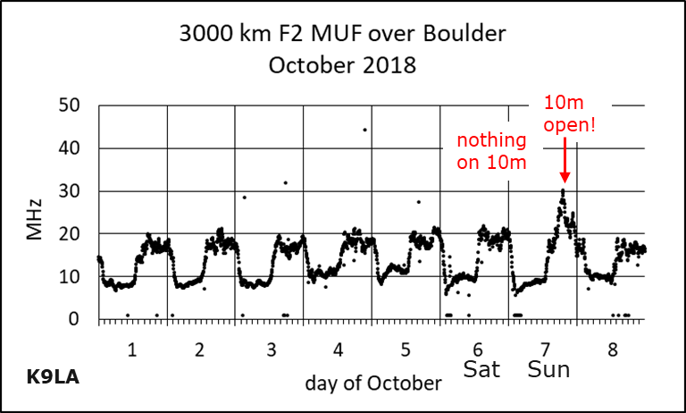For the first 6 days of October 2018, the maximum MUF during the daytime was indeed around 20 MHz. But after the Kp index spiked up on the 7th, the MUF increased to a bit over 30 MHz for a short time. Thus 10-meters opened up and there were many QSOs to be had if you were on 10-meters at the right time.

So the next time the Kp index spikes up, don’t immediately turn off your radio. Check the higher HF bands to see if there is an F2 region enhancement. It doesn’t happen all the time, but it’s worth a quick check.

***CQDX CQDX CQDX CQDX CQDX CQDX CQDX CQDX CQDX***

Here is an update from Bernie, W3UR, of the DailyDX and the WeeklyDX, the best source for DX information. <http://www>.dailydx.com/. Bernie has this to report:

TOP ^

**HS – Thailand -** Callsign HS10A has been given to Thailand’s King Vajiralongkorn, an advanced class license.  This happened in Amphon Hall in Dusit Palace on September 24.  The national telecom regulator, NBTC, and its General Sukit Khamasundara, and the head of RAST, the national Amateur Radio society, Jakkree Hantongkom, made the [presentation](http://r20.rs6.net/tn.jsp?f=001Y6Jyv4RdLJj8ZsTYiJHulpNnHK9W3kEjaStM-utUB2gEGHj1FS3bI5f9hTPRLGQ7KGRuHGzh6COqElQ3Z65JzA5_rwDB5r0rAREe3FmZv_Bd_pkfzAV-5jaTFdAjG9j5CCcEtkGys6j93bT_kTv0g88SJdgYadbJkGAx2es7itsIiuyNmNs-svKQVdcScfh4&c=VLH8luuo_QoKIbWv_FuGjN5y7GAxq7rnXylBCDwPnHJmq-bqbKo4zA==&ch=2rX1q7jmGHVRuvcgnUoO56ZS3ZuE9iTFhfkYEkRcwT3noYZHCWa3rQ==) of the license and also provided radio equipment, an Icom IC-7300 for HF and an IC-9700 VHF/UHF transceiver, plus antennas and peripherals, all supported by the G. Simon Radio Company, Ltd.

**OE – Austria -** The United Nations Amateur Radio Contest DX Club located at the Vienna International Center in Vienna, Austria has been granted special callsign 4U75A in celebration of the 75th anniversary of the United Nations. The callsign is valid from September 29 to December 31, 2020. This will count for OE – Austria for DXCC purposes and 4U1VIC – ITU Vienna International Center for the CQ Awards and Contests. QSL via UA3DX.

**4U_UN – United Nations Headquarters -** The United Nations Amateur Radio Club (UNARC) will be celebrating the 75th anniversary of the United Nations with special callsign 4U75UN. Currently there is no “set operations schedule” says UNARC President K2QI, James Sarte. As a reminder the 4U1UN station is capable of being operated remotely. The 4U1UN QRZ.com page states “The station is located on the 42nd floor of UN Headquarters in New York City, while the control point is on the ground floor.” We also know oftentimes the station is operated remotely offsite. QSL manager HB9BOU, Herbert, “already has QSL cards ready”.

**E5/N - North Cook Islands -** Warwick Latham, E51WL, on Penrhyn Atoll, North Cook Islands, is operating as time permits, he says, on 80, 40, 30, 20, 17 and 15 and has even made some contacts on 10 and 6.  His Acom amp has been repaired thanks to Val at Acom.  The amp gives him 6M high power capability again and he made EME QSOs at his moonrise with two of the big guns in late September, with his fixed elevation antenna. He can do moonrise and moonset from 0 to 20 and 20 to 0 elevations.  He has built his 2M OWL 9-element beam and is looking at ZL for WSPR beacon signals from ZL1RS.

Email him if you want to try EME “at reasonable conditions for me,” he says.  Warwick says QSLs go out on every outgoing airplane flight as usual but Cook Islands postal does not send inbound mail regularly.  To avoid the potential six-month delay and cost of an SASE containing USD to cover his postage back to you, he has offered to respond to PayPal remittance to cover his mailing cost, with QSO info in the PayPal note.  He says this avoids the possibility of anyone in the postal process from stealing the cash sent in envelopes.  His PayPal account is:  [164mack@gmail.com](mailto:164mack@gmail.com).  US $3 covers his mailing cost.

**9G – Ghana -** 9G5FI by DL2RMC, Tom (aka HZ1FI, SU9TH, V31FI and other callsigns), says after his HZ and SU visits he is now in Accra, Ghana doing vocational training, currently the “Ghana Skills Development Initiative,” a project which goes through September, 2022.  He expects to be there for at least the next year.  He says the license came through fast, easy in Ghana.  He quickly put up a 10M vertical wire with one 10M-long radial, fed through a manual tuner at the feedpoint and his IC-7300 transceiver.  He is in a five-story building and has roof access and that’s where the antenna is.  He made 400 QSOs the first night, almost all FT8, but he says he prefers CW and contests.  He started up October 1.  With his 100 watts he is on “all bands,” including the QO-100 satellite, and says 160 and 80 may be difficult with this vertical.  He is on CW, FT8 and SSB.  QSL via the bureau or direct to DL1RTL, Heiko Mann, in Germany.  Club Log will also work.  Tom has applied for his LoTW certificate and also uses eQSL.  Soon he will have a website.  [www.dl2rmc.com](http://r20.rs6.net/tn.jsp?f=001Y6Jyv4RdLJj8ZsTYiJHulpNnHK9W3kEjaStM-utUB2gEGHj1FS3bI2kUUL9kQ5M-_aJlTDOyCbqvaanLTiQZk1hwQw1NLDTyHSFVYf013Sfc88A2X2ZbMQVaSTV7kKNjQKCrXqXHze8=&c=VLH8luuo_QoKIbWv_FuGjN5y7GAxq7rnXylBCDwPnHJmq-bqbKo4zA==&ch=2rX1q7jmGHVRuvcgnUoO56ZS3ZuE9iTFhfkYEkRcwT3noYZHCWa3rQ==).

TOP ^

**JW – Svalbard -** LA7QIA, Peter, is back on Svalbard to “be part of the maintenance team at [the] club station [JW5E](http://r20.rs6.net/tn.jsp?f=001Y6Jyv4RdLJj8ZsTYiJHulpNnHK9W3kEjaStM-utUB2gEGHj1FS3bI5f9hTPRLGQ7Iq-tjTdY3sgmjYZoqlt4l7Lf-q4FcTX02LSeXlSoPVKzq5-ZGj0aAsYt7gAlmIArNVwTGW8d-p0=&c=VLH8luuo_QoKIbWv_FuGjN5y7GAxq7rnXylBCDwPnHJmq-bqbKo4zA==&ch=2rX1q7jmGHVRuvcgnUoO56ZS3ZuE9iTFhfkYEkRcwT3noYZHCWa3rQ==). “Yesterday we installed two new antennas from JK Antennas: A Navassa 6-20 meter beam @85 feet and a JK401 40 meter dipole @90 feet” says Peter. The station is once again QRV on 160 through 6 meters. In his spare time Peter has been QRV as JW7QIA and will “try to be active on 160 CW and/or FT8 the next couple of nights”. He will also be QRV “on other bands between [his] work tasks”. Peter will be departing the island this Thursday and plans to return for the CQ WW DX SSB. QSL preferably via LoTW or direct to LA7QIA.

***DAH DIT DIT DIT DAH DAH DIT DIT DIT DAH***



As promised last week, you will find a list of upcoming contests in the “Contest Corner”. I think this is important for someone who is trying to move up the DXCC ladder since entities that are on the rarer side and easiest to work in contests. Some of my best “catches” have been on the Sunday afternoon of a contest when the rarer entities are begging for QSOs. Of course, the gamble is that if you wait until Sunday, conditions may change, or they simply won’t be workable. However, it is not a bad gamble. Of course, why not work the contest and have some fun!

The contests in red are those that I plan to spend some significant participation time on. PLEASE let me know if you are working contests and how you fared.

|  |  |  |
| --- | --- | --- |
| Oct. 14 | RSGB Autumn Series Data | https://bit.ly/2XF8mSB |
| Oct. 17-18 | 10-10 Intl. Fall CW Contest | <http://bit.ly/1FrFeBc> |
|  | New York QSO Party | [www.nyqp.org](http://www.nyqp.org) |
|  | JARTS WW RTTY Contest | <http://jarts.jp/rules2020.html> |
|  | Worked All Germany Contest | <http://bit.ly/2uDQRSV> |
|  | Stew Perry Topband Distance Challenge | [www.kkn.net/stew/stew_rules.html](http://www.kkn.net/stew/stew_rules.html) |
| Oct. 18 | Asia-Pacific CW Sprint | <http://jsfc.org/apsprint> |
| Oct. 18 | RSGB RoLo CW Contest | [www.rsgbcc.org/hf/rules/2020/rolo.shtml](http://www.rsgbcc.org/hf/rules/2020/rolo.shtml) |
| Oct. 18-19 | Illinois QSO Party | [www.w9awe.org/ILQP.html](http://www.w9awe.org/ILQP.html) |
| Oct. 19 | RSGB FT4 Contest Series | <http://bit.ly/38xg9V7> |
| Oct. 21 | AGCW Semi-Automatic Key Evening | <http://bit.ly/2LCDywm> |
| Oct. 29 | RSGB Autumn Series SSB | <https://bit.ly/2XF8mSB> |
| Oct. 24–25 | CQWW SSB | <https://www.cqww.com/> |
|  | | |
| Nov. 28–29 | CQWW CW | <https://www.cqww.com/> |
| Dec. 4 – 6 | ARRL 160M | <http://www.arrl.org/160-meter> |
| Jan 29 – 31 | CQWW 160M | <https://cq160.com/> |
|  | Winter FD | <https://www.winterfieldday.com/> |
| Feb. 20 – 21 | ARRL CW | <http://www.arrl.org/arrl-dx> |
| Mar. 6 – 7 | ARRL SSB | <http://www.arrl.org/arrl-dx> |
| Mar. 27 – 28 | CQWW WPX SSB | <https://www.cqwpx.com/> |

TOP ^

|  |  |  |
| --- | --- | --- |
| May 21 | SWODXA DXDinner | [www.swodxaevents.org](http://www.swodxaevents.org) |
| May 29 – 30 | CQWW WPX CW | <https://www.cqwpx.com/> |
| August 28 | Ohio QSO Party | <https://www.ohqp.org/> |
| August 28 | W8DXCC Convention | [www.w8dxcc.com](http://www.w8dxcc.com) |
|  |  |  |

**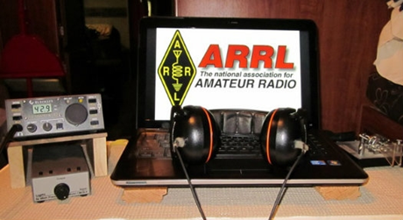*ARRL Contest Corner***

An expanded, downloadable version of *QST'*s’[**Contest Corral**](http://www.arrl.org/contest-calendar) is available as a PDF. Check the sponsor's’Web site for information on operating time restrictions and other instructions.

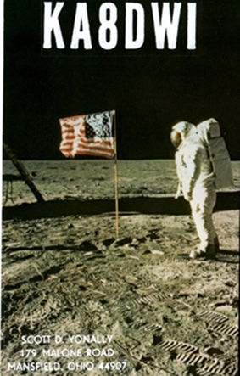***DX News***

***ARLD041 DX news***

This week's bulletin was made possible with information provided by OZ2I, The Daily DX, the OPDX Bulletin, 425 DX News, DXNL, Contest Corral from QST and the ARRL Contest Calendar and WA7BNM web sites.

Thanks to all.

**MALAWI, 7Q.** Don, K6ZO is QRV as 7Q6M until mid December while working at the Embangweni Mission Hospital in Northern Malawi. He is active in his spare time. QSL via operator's instructions.

**WEST MALAYSIA, 9M2.** Yoshida, JE1SCJ is QRV as 9M4DXX from Penang Island, IOTA AS-015, until the end of December 2020. He operates FT8 on the weekends. QSL via bureau.

**BOTSWANA, A2.** Leon, A25SL is usually QRV on 20 meters SSB around 1700 to 1830z. QSL via N4GNR.

**UNITED ARAB EMIRATES, A6.** Phil, G4VAJ is licensed as A65IJ and will soon be QRV from Dubai. QSL via operator's instructions.

**ST. VINCENT, J8.** Mac, 8P5AB will be QRV as J88/8P5AB from October 10 to December 3. Activity will be on the HF bands using FT8 and various digital modes on the VHF bands. QSL direct to home call.

**MINAMI TORISHIMA,** JD1. Take, JG8NQJ is QRV as JG8NQJ/JD1 from Minami Torishima, IOTA OC-073, until mid January 2021. He is active in his spare time on 40 and 30 meters using CW. QSL via JA8CJY.

TOP ^

**SVALBARD, JW.** Operators LA7XK, LA6VM and LA9DL are QRV as JW7XK, JW6VM, and JW9DL, respectively, until October 12. Activity is on the HF bands using CW, SSB and various digital modes. This includes being active as JW5X in the Scandinavian Activity SSB Contest. QSL to home calls and JW5X via LA5X. In addition, a group of operators are QRV as JW4O until October 12. Activity is on 80, 40, 20, 15 and

10 meters. This includes being an entry in the Scandinavian Activity SSB Contest. QSL via LoTW.

**JAN MAYEN, JX.** Erik, LA2US will be QRV as JX2US from Olonkin City until March 2021. QSL via LoTW.

**AUSTRIA, OE.** Members of the VIC Amateur Radio Contest are QRV with special call sign 4U75A from Vienna until December 31 to celebrate the 75th anniversary of the United Nations. Activity is on 80, 40,

20 and 15 meters using CW and SSB. QSL via UA3DX.

**DENMARK, OZ.** Special event station OZ100MILL will be QRV from October 15 to December 15 to celebrate the 100 year anniversary of the unification in 1920 of Southern Jutland with Denmark. Activity is on all HF bands using CW, SSB, RTTY and other digital modes. QSL via bureau.

**SWEDEN, SM.** Palle, SA0BYP and Johan, SA3BYC will be QRV as SI9AM during the Scandinavian Activity SSB contest. QSL via SM3FJF.

**MARSHALL ISLANDS, V7.** Randy, KX4QD is QRV as V7/KX4QD from Kwajalein and is active on 40 and 20 meters using FT8 normally after 0600z. QSL to home call.

**CAMBODIA, XU.** Tad, XU7AKU is usually QRV on 40 meters using CW around 1230 to 1430z. QSL via JA1DXA.

**MACAO, XX9.** Leong, XX9ET is usually QRV on 17 meters using FT8 from 1130 to 1330z. QSL direct.

**REPUBLIC OF KOSOVO, Z6.** Wolf, DM2AUJ, Guenter, DL2AWG, Peter, DL3APO, Rainer, DL2AMD, Werner, DJ9KH and Franz, DL9GFB will be QRV as Z66DX from October 15 to 28. Activity will be on 160 to 10 meters using CW, SSB and FT8 with three stations active. QSL via DL2AWG.

THIS WEEKEND ON THE RADIO. The ARRL EME Contest, NCCC RTTY Sprint, NCCC CW Sprint, Makrothen RTTY Contest, QRP ARCI Fall CW QSO Party, 10-10 International 10-10 Day Sprint, Nevada QSO Party, Oceania DX CW Contest, Microwave Fall Sprint, SKCC Weekend CW Sprintathon, Scandinavian Activity SSB Contest, Arizona QSO Party, Pennsylvania QSO Party, Cosack's Honor VHF/UHF Contest, FISTS Fall Unlimited CW Sprint, South Dakota QSO Party, PODXS 070 Club 160-Meter Great Pumpkin Sprint, UBA ON 80-Meter Contest and UBA ON 6-Meter Contest will certainly keep contesters busy this upcoming weekend.

The 4 States QRP Group Second Sunday Sprint and K1USN Slow Speed CW Test are scheduled for October 12.

The RTTYOPS Weeksprint and Worldwide Sideband Activity Contest are scheduled for October 13.

The VHF-UHF FT8 Activity Contest, RSGB 80-Meter Autumn Data Series, AGCW Semi-Automatic Key Evening, NAQCC CW Sprint, CWops Mini-CWT Test and Phone Fray are scheduled for October 14.

TOP ^

***Special Events***

* **10/16/2020 | 30th Anniversary Cincinnati Reds World Series Champions**

**Oct 16-Oct 21, 0000Z-2359Z, W3R**, Milford, OH. Milford (OH) Amateur Radio Club. 7.030 7.200 7.074. QSL. Dave Vest K8DV, 2934 Rontina DR, Goshen, OH 45122. [www.w8mrc.com](http://www.w8mrc.com/)

* **10/17/2020 | Woronoco Heights Outdoor Adventure/SCOTA/JOTA/JOTI**

**Oct 17, 1300Z-1900Z, W1M**, Russell, MA. Western Mass. Council--BSA. 14.290 14.060 10.115 7.190. QSL. Tom Barker, 329 Faraway Road, Whitefield, NH 03598. Due to JOTA/JOTI, W1M will also operate on BrandMeister TG 907 and its affiliated TAC talk groups. All logging is done by paper. QSL card available on eQSL or for a 4x6 sase.

* **10/17/2020 | Yorktown Surrender Day Event**

**Oct 17, 1400Z-2000Z, K4RC**, Yorktown, VA. Williamsburg Area Amateur Radio Club. 14.265 7.265. QSL. QSL Manager, K4RC, P.O. Box 1470, Williamsburg, VA 23187. 239th anniversary of British surrendering to the Americans ending the Revolutionary War. [www.k4rc.net](http://www.k4rc.net/)

* **10/18/2020 | Commemorating 80th Anniversary of U.S.C.G Auxiliary**

**Oct 18-Oct 20, 1400Z-2300Z, N4U**, Benton, KY. United States Coast Guard Auxiliary. 14.070 14.250 7.070 7.250. QSL. Mary Husfield, 4156 Barge Island Road, Benton, KY 42025-6039. 80th Anniversary of United States Coast Guard Auxiliary. QSL to KC4TIE, Special Card returned with SASE. Mainly digital modes.

* **10/24/2020 | The Captain Kidd DX Hunt**

**Oct 24, 1100Z-1700Z, W1WDT**, Milford, CT. Woodmont Amateur Radio Association. 50.885 28.885 14.285 7.285. QSL. Woodmont Amateur Radio Assoc., 128 Kings Highway, Milford, CT 06460. [www.wara.club](http://www.wara.club/)

* **10/31/2020 | A Night On Bald Mountain**

**Oct 31-Nov 1, 2100Z-0500Z, WA4TRS**, Fairview, NC. The Road Show Amateur Radio Club Inc.. 7.250. Certificate & QSL. The Road Show ARC, 57 Echo Lake Drive, Fairview, NC 28730. Join Us, for a Night in The Cemetery on Top of Bald Mountain, don't worry there are accommodation available for YOU! Just Check the Website [roadshowarc.org](http://roadshowarc.org/)

* **10/31/2020 | Boo to You !**

**Oct 31-Nov 1, 0000Z-0559Z, KC5BOO**, Cleburne, TX. KC5BOO. 14.240. QSL. Judy Cox, 3701 Park Rd. 21, Cleburne, TX 76033. [kc5boo@yahoo.com](mailto:)

* **10/31/2020 | Halloween from Transylvania (La)**

**Oct 31, 1400Z-2230Z, K5ZRO**, Transylvania, LA. Vicksburg Amateur Radio Club. 7.270 SSB 14.270 SSB. Certificate. Malcolm Keown, 64 Lake Circle, Vicksburg, MS 39180. Info@vicksburgarc.club or [www.vicksburgarc.club](http://www.vicksburgarc.club/)

TOP ^

* **10/31/2020 | National World War I Museum and Memorial**

**Oct 31, 1500Z-2300Z, WW1USA**, Kansas City, MO. National World War I Museum and Memorial. 14.225 SSB 7.250 SSB 14.060 CW 7.060 CW. Certificate. WW1USA Amateur Radio Station, World War 1 Museum and Memorial, 2 Memorial Drive, Kansas City, MO 64108. We will be commemorating the 102nd anniversary of the Armistice, which ended the fighting in World War 1. Our operation will be inside the Museum, in the Postcard Gallery. All local and visiting hams are invited to come visit. ww1isa@theworldwar.org or [www.qrz.com/db/ww1isa](http://www.qrz.com/db/ww1isa)

* **11/01/2020 | 4th Annual 27 Lighthouses in the South West Desert**

**Nov 1-Nov 11, 0000Z-0023Z, K7LHC**, Lake Havasu City, AZ. London Bridge Amateur Radio Association. 21.300 18.145 14.250 7.250. Certificate. LBARA, P.O. Box 984, Lake Havasu City, AZ 86405. [www.lbara.org](http://www.lbara.org/)

* **11/01/2020 | KDKA 100 Year Anniversary**

**Nov 1-Nov 30, 0000Z-2359Z, W8XK, K3A/D/K**, Pittsburgh, PA. KDKA 100 Group. 14.260 14.030 7.260 7.030. Certificate & QSL. See website, for QSL and certificate, information. Special event stations Celebrating 100 years of KDKA as the 1st commercial broadcast station located in East Pittsburgh, Saxonburg and Hampton Township Pennsylvania. The special event operation is for entire month of November. Multiple Pittsburgh area amateur radio clubs will be participating. Look for special event call signs K3A, K3D, K3K and W8XK. Work all four call signs and obtain a special commemorative certificate. (W8XK will QSL to W3WN. K3A. K3D and K3K will QSL to K3MJW.) SEE QRZ PAGES FOR QSL INFORMATION. radiofreebob@gmail.com [www.qrz.com/db/w8xk](http://www.qrz.com/db/w8xk)

* **11/01/2020 | Star City of the South**

**Nov 1, 1400Z-2100Z, W4CA**, Roanoke, VA. Roanoke Valley Amateur Radio Club. 7.245 14.245. QSL. Roanoke Valley ARC, P.O Box 2002, Roanoke, VA 24009. Commemorating the Roanoke Star on Mill Mountain shining its light on the city below since November 1949 and giving the nickname "Star City Of The South" to Roanoke, VA. www.millmountainstar.com or [www.w4ca.com](http://www.w4ca.com/)

* **11/01/2020 | USCG Auxiliary 81st Anniversary**

**Nov 1-Nov 8, 0800Z-0621Z, W2G**, Freeport, NY. USCG Auxiliary Division 13 Station Jones Beach. 14.200 10.118 7.190 3.885. QSL. W2G, 3813 Verleye St , Seaford, NY 11783. USCG Station Jones Beach, NY - Maritime Operations from CG 45706 are possible. Please SASE Only for QSL. Via W2ANQ

* **11/01/2020 | Veterans Day**

**Nov 1-Nov 14, 0000Z-0000Z, N5VET**, Cleburne, TX. Club KC5NX. 14.235 14.270 14.045 7.235. QSL. Club KC5NX, 9200 Summit Court West, Cleburne, TX 76033. We will be back on the air again this year for our Annual Veterans Day Special Event. Please QSL to Club KC5NX with SASE. We will have multi operators and will be on as many bands as possible. club.kc5nx@gmail.com or <https://www.dxwatch.com/dxsd1/dxsd1.php?f=0&c=N5VET&t=dx>

* **11/02/2020 | 45th Anniversary, Sinking of SS Edmund Fitzgerald**

**Nov 2-Nov 16, 0000Z-2359Z, W8F**, Livonia, MI. Livonia Amateur Radio Club . 14.260 14.040 7.240 7.040. Certificate. Tas Foley, K8TAS, 37255 Eureka Rd., Romulus, MI 48174. On Saturday, November 14, W8F will operate from the Dossin Great Lakes Museum on Belle Isle, Detroit MI 1600-2000 UTC. Certificate: SASE to K8TAS [livoniaarc.com](http://livoniaarc.com/)

TOP ^

***“ARES Connect”***

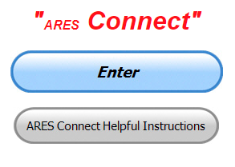

***Connecting Amateur Radio Volunteers with a Purpose***

Hey everyone… please make sure to go in and register your time to all of the events that you have signed up for. Don’t forget to get this done no later than

**5 days** after the event has ended. I’m asking you to do this for our ability to run reports accurately.

**I want to remind all of you that you do not have to be an ARES or ARRL member to use this system. All licensed amateur radio operators throughout the country are welcome and strongly encouraged to use it.**

**Don’t forget to check out the “Frequently Asked Questions” area that has been added to the Ohio Section website.** It’s there to help you through any difficulties that you may have with ARES Connect. Now, if you don’t any posts that relate to what you are having difficulties with, we now also have an on-line “Guru” area as well. This will allow you to ask any questions that you may have about ARES Connect.

**Let’s get everyone on “ARES Connect!!!”**

***Here’s the top 10 hour earners so far for the month of October:***

|  |  |  |  |
| --- | --- | --- | --- |
|  | **Name** | **Events** | **Hours** |
| **1** | Dan Stahl (KC8PBU) | 45 | 97.81 |
| **2** | Dwight Bonifield (W8TJT) | 56 | 73.00 |
| **3** | Leo Dubois, Jr. (KE8OOS) | 42 | 58.95 |
| **4** | Bret Stemen (KD8SCL) | 7 | 56.00 |
| **5** | Greg Dersarkisian (KD8SSJ) | 7 | 55.50 |
| **6** | Marcel Casavant (AD8CM) | 12 | 53.70 |
| **7** | Christopher Domenick (KC8CAD) | 11 | 53.45 |
| **8** | Daniel Schlick (KB8LKH) | 16 | 51.50 |
| **9** | Michael Walker (AB8MW) | 36 | 45.00 |
| **10** | Ron Wilch (KE8PX) | 50 | 44.50 |

***What the SET Taught Us, and BLACK SWAN 20 Scenario Replays Available***

*(from: C. Matthew Curtin KD8TTE)*

If you missed significant play during the SET, I’m sorry. I can offer an option to experience exercise play, and if you like you can even use it for your SET if you like. Let’s see what we learned from the exercise and how that can set us up to operate better when we’ve got several incidents underway at once.

TOP ^

First, let me fill you in on a little bit of how the exercise was designed and how that led to some counties not getting activation calls. Considerable time and relevant expertise went into design and planning of the exercise to be realistic. Physicians with specialties in emergency medicine and toxicology, law enforcement officers, and emergency managers made up the planning team and created a realistic exercise. Computer scientists with specializations in networking and cybersecurity created the scenario for commercial communication system failures. The Ohio Section Emergency Response Plan (OSERP) and operational experience from the ARRL Ohio Section went into the activation plan. Finally, we undertook a project designed to train operators to originate, relay, and deliver messages in the County Information Report Project 20 that began in July, supported by my weekly articles in the Ohio Section newsletter and the YouTube video series. Finally, we set the expectation that this is a no-fault learning environment.

Next, we look at the exercise objectives. We established three objectives up front: (1) Receive activation notices from served agencies, (2) Activate volunteers per SOP, and (3) Establish communication nets per SOP. This is where we experienced difficulty. Activation details were sent on Friday afternoon as planned to each of the counties that would get the initial activations, even including details like which other counties and districts would be supporting their operation. It doesn’t look like coordination or planning for how to organize and to staff stations, or the nets to support them got serious discussion started on Friday afternoon. (See my article from two weeks ago, “Time for SET: BLACK SWAN 20 Is Here.”)

When Saturday got underway, we opened with a briefing before the start of coordinated play, laying out the general scenario and the use of video conferences to simulate sites, and that every operator had two tasks to do to start with: (1) To originate a message for themselves and (2) to relay that message on the air to get it started in the process toward delivery to a specific station. Activated ECs were instructed to call upon their support chains, to schedule their resources, and to get those operating positions staffed. Simulating sites with video conferences was a problem. People had difficulty understanding where they were supposed to be and controllers had to explain the organization and tasking spelled out in the activation plans individually in several cases. The real-world clock was still ticking, and three of eight sites (Meets) had difficulty getting opened in any reasonable amount of time, leaving the operators with only their two individual tasks, plus a third task that came from the IPAWS message relay, but even those weren’t happening in many places. Counties and districts were not coordinating via the HF Emergency Net. Districts were not well represented to pick up IPAWS messages from Buckeye Net. The mission and even tasking was spelled out in activation plans but as is often the case in an emergency, plans don’t survive first contact with reality on the ground.

We ultimately did not have a lot of activity coming into the various parts of the control cell until the afternoon, and even then it was pretty light for the most part. Batches of messages started flowing better on Saturday afternoon, but by then many of the groups were winding down their play for the day, and many for the weekend. A few local groups and districts had people undertake heroic efforts to develop their own injects for use on Day 2 to ensure that even if they could not connect to the larger scenario that their people would have significant activity.

Even among those activated we got some strange reports by the end of the day, including that the radio operators were asking their controllers to transcribe the messages spoken by the on-scene incident commanders rather than watching the videos to transcribe for themselves. Some stations were sending messages to anyone they could contact, rather than working within the exercise play. Others had confused their roles so badly that they thought they were both at a hospital and at a trauma scene and sent messages to themselves.

TOP ^

This is a no-fault learning environment. So, what did we learn? Activation does not happen quite the way that we expect. Execution of a plan does not come from a written specification of objectives and instructions read by an EC and relayed through the support chain. Using video conferences to simulate sites is hard and people have a difficult time keeping track of which role they’re playing and where they are supposed to be. Establishing ad hoc communications with specific counties can be difficult. Organization of nets or schedules to relay messages in and out of an affected area requires a lot more than a station or two who can use voice procedure or NBEMS to send and receive messages.

We also learned that the amateur operators maintained a calm, professional demeanor even as things got stressful. We learned that the Ohio Section has increased significantly the number of operators able to use NBEMS. A lot of stations are able to work in a field-expedient manner, including operation on emergency/non-grid power. The operation showed that HF multichannel/multimode nets can work really well for moving a lot of traffic. We were able to demonstrate for the first time ever that messages can be moved from the IPAWS system into the state from FEMA and relayed down to the county level and even to individual stations, all with radio-only, no internet service, and even make the jump from SHARES HF service to amateur radio. Expect to see this being highlighted as a model for the rest of the nation for integration of amateur radio into emergency communication.

The experience taught us a lot but nevertheless left a lot of people feeling like they weren’t an important part of exercise play. Let me emphasize this point: whether you got an activation notice as you expected, simply being ready for tasking is an important part of the exercise. We certainly did not intend to leave anyone untasked, and we had a lot to put into play that did not get injected because of earlier problems.

Here is where we’re going to take what we’ve learned and give everyone a chance to participate more directly. Plans are preliminary but we’re working on a few replays of the exercise that will allow for any amateur radio force to participate on a scale that is more tailored for them specifically. The basic scenario will remain the same, but rather than tasking an initially responding team, we’re going to task each directly from exercise controllers. We’re also going to specify the structure of the response and the support to be engaged. ECs will have time to understand the tasking, to get the roles filled, and to do so with rolling hours so that players will not need to devote an entire day to the exercise. Take a two-hour shift or two, letting the entirety of the response force filling those roles in those times ensure that there is coverage for the period of exercise play.

We’ll even provide a template for the local exercise operation that the EC can complete and will need to share back with the exercise controller to be sure that the lead player and the controller are looking at the same resource allocations.

Interested? <https://www.blackswancomex.org/2020/register>

***The Ohio Slow Net***

*(from Michael Lacumsky W8MAL, Net Manager)*

I would like to extend a very warm “Thank You” to Steve Judd, WB8YLO of Toledo for holding down the fort while the search for a new Ohio Slow Net Manager took place. That search ended on October 1 when I was appointed to serve the Net as Manager.

TOP ^

As Steve puts it: The purpose of the Ohio Slow Net (OSN) is to provide training and experience in the unique aspects of operating in a CW traffic net. The nature of CW signals makes it desirable to use pro-signs and Q signals to speed up net operations. CW net operators also use many common abbreviations to speed up net operations and to increase accuracy. The OSN is run at about ten words per minute. This allows operators with slower CW skills to join in and begin learning right away. Frequent operating on the OSN will provide an opportunity for those operators to improve their CW speed as well as learn CW net procedures. The goal of the OSN is to provide operators with sufficient CW skill and knowledge to operate effectively on the Buckeye Net using CW should that capability be needed.

The OSN is generally run using characters formed at 15 to 18 words per minute and sent with additional spacing making the over-all rate about ten words per minute. The purpose for this is to make it easy for the operators to recognize the individual characters at a higher speed and to provide the extra inter-character space to assist those operators with slower speed capability to join in right away and begin learning CW procedures. Currently, the net meets weekdays (except major holidays) on 3535.35kc at 2200z.

***From The South 40***

*(from John Levo,* [*W8KIW@arrl.net*](mailto:W8KIW@arrl.net)*)*

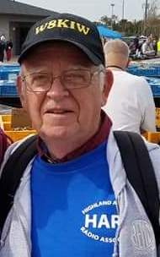Because of COVID-19 the Southeastern Ohio Red Cross Building is still closed for use by outside groups. Therefore, the upcoming October 19 Athens County ARA VE testing session has been relocated to the Athens Masonic Complex according to ACARA’s VE coordinator Jeff Slattery, N8SUZ.

The test will begin at 7 pm at the complex located at 12 West Carpenter Street in Athens. Social distancing, temperature checks and masks will be required. Parking is available in the rear of the building. Jeff can be contacted at 740-541-0972 for more information.

Highland County’s Administration Building’s public conference room is still closed to outside use according to Highland ARA President Jeff Collins. He stated that since the Administration Building is still closed, the club’s October 13th meeting has been relocated to the county EMA office at 1487 North High Street, Hillsboro. The meeting will begin at 7 pm and everyone is to wear a mask and maintain social distancing.

Recently Laurel District 8 VE Coordinator Phil Carter announced the formation and approval of a new Laurel VE team in Southern Ohio. With the assistance and support of the Fayette ARA’s VE Team Leader Jim Scott, N8ORJ, a Highland ARA VE team is authorized to start giving examinations.

Tom Mongold, Jr., KD8LDS, is the team leader with Pat Hagen, N8BAP, as backup. HARA entered the ARRL VE program early on, but later relied upon teams from the Clinton County ARA and the Fayette ARA to provide testing opportunities. Currently many HARA members are VEs in other club’s programs and with the Dayton ARA HamVention program.

TOP ^

The Southern Ohio ARA will hold their elections at their October 19 meeting at the new Lawrence County EMA Office, 515 Park Avenue in Coal Grove. According to SOARA Information Officer Michael Love, WB8YKS, masks must be worn while in the building and social distancing will be observed. In lieu of the Club’s traditional November Christmas dinner, the Club will tentatively hold a business meeting on November 16 at the EOC.

***One Question Questionnaire***



Hey Gang,

Survey Says”….. Only around 46% of you have reviewed your fire escape plans with your family members. Wow…. That’s way lower than I expected. Please, do it now if you haven’t already!!!!

Ok, now since fall is here and we are all spending our extra time getting things ready for winter. This usually mean that we are all thinking about whether it’s time to replace our coax before winter takes its toll on that older coax. This usually mean that we will need to be able to put a connect on the end of the coax, and that’s this week’s question for you…

***“Do you know how to solder a PL 259 connector onto a piece of coaxial cable??”***

You’ll find the “One Question” questionnaire on the Ohio Section Website! <http://arrlohio.org> It’s all in fun and it’s not a scientific survey in any way, but we are learning some things that we didn’t know from these questions. I hope that you are enjoying answering these “One Question” questionnaires.

*****V.E. Test Sessions***

Many V.E.’s have decided to start testing once again, but with restrictions that need to be adhered to for sure. Here’s the link to find that V.E. Test session and what is expected of YOU before going. <http://www.arrl.org/find-an-amateur-radio-license-exam-session>

####

***Athens Test Session has NEW location***

We need to change the location for the Athens County Amateur Radio Association/SCARF VE session for October 19, 2020, 7:00 PM - Our local Red Cross facilities are still closed to any meetings other than bloodmobiles.

The new location is: **Athens Masonic Complex - 12 West Carpenter Street - Athens, OH  45701**

**Masks and temperature checks required. Park in the rear. This is next to the old National Guard Armory at the end of Court Street.**

TOP ^

***Final.. Final..***

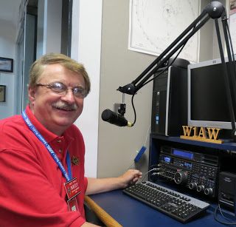Hi Gang,

Like weeks past I’ve been really active in attending and presenting at more and more club meetings. It’s been really great getting to visit with all of you, but I do have to admit, I miss not being there in person. Zoom and all of the different ways of getting us together are great alternatives, but there’s nothing like an in-person meeting to generate that camaraderie that we all have for each other as HAMS. I really miss not getting out on the road going from one club meeting to another. But even though this is a downer, there is a positive side to this!

I have been able to attend and talk at more meetings than ever before! So, as they say, when one door closes, another door opens up is really hitting the mark for sure! Who would have ever thought we’d be doing what we are doing today? Let’s just keep our fingers and toes crossed that there will be a vaccine soon which will allow us to start to get back to some kind of normal again.

One other benefit to all of this COVID stuff is that we are all getting on the air more too. Many clubs around are having their meetings on the air instead of trying to meet in person. This is really great, especially if they are meeting on repeaters with Echolink/IRLP capabilities. This gives those outside of the repeater’s range to join in as well. I’ve been sitting in on a number of clubs “on the air” get together’ s and it’s been great!

This past week I also got to participate in a webinar from VolunteerHub. This one was different than most of the webinars that they do, it was part of a bigger affair that was happening called “BBCon – Global Virtue Gathering”. It was a 2-day virtual seminar much like what was produced earlier this summer as a virtual hamfest, only this one was much more concentrated on businesses. Anyway, while waiting for the webinar to begin those of us that were on the call got to actually talk with the VolunteerHub representatives. As we chatted, I found out that the CEO of VolunteerHub is actually a ham radio operator himself!!! And…. He lives here in Ohio!!! Wow, who would have guessed that one folks! Now, not only did I get to personally chat with them about ham radio but, I also turned in a suggestion that would make getting signed up for events even faster and easier for us. At first, they kinda’ blew off the idea, but after I kept pressing them about it and how it would really help our volunteers, other VolunteerHub customers that were on this call started speaking up that it would benefit them as well, and it took off from there! Wow.. Now having a number of folks asking questions about it really got their attention! As we discussed the possibilities and even some additional options that they suggested, we were told that the software developers were already working on some modifications to the feature we were discussing. Now I have to say that there really is power with the masses, as more and more of us on this call got to discussing all the possibilities with this modification, the more the representatives found out that I had hit an accord with everyone on the call and it wasn’t going to go away anytime soon. So, they agreed to write up an additional work order for the modification to this feature and give it to the software developers…

If we are lucky and everything goes just right, we just might have this new option come out before the end of the year. But I’m not making any promises on that since we also have to take into consideration that they too have COVID issues to deal with.

TOP ^

This past week I had the opportunity to do some more instruction on ARES Connect with a couple of other Sections in the country. It was a lot of fun being able to show them all the benefits to this new system and watch their eyes light up when they discover all the great information that can be obtained from it. It’s like watching the kids at Christmas!

Speaking of benefits to this new system, have you taken the time to check out the reports that are on-line? These reports are there for you. Take advantage of them to boost up your training as well as your ham radio participation! Here’s a link to just one of the reports… <http://arrl-ohio.org/SEC/reports.html>

Whelp, that’s going to do it for this week my friends! I’m still looking forward to visiting with all of you live or via Zoom, WebEX or whatever.

I really can’t wait for that time when we can all get together in person once again. Those are the times I cherish the most!!! Stay safe! We will get through this and when we do, we’ll have so much to talk about. Most of all… have FUN and get on the airwaves!!

73,

[***Scott, N8SY***](mailto:n8sy@n8sy.com)

***Weather Underground and Other Ham Weather Stations***

[](http://arrl-ohio.org/wus.html)Hey Gang,

This has really grown into a really cool area with reports literally coming in from all over the state!!

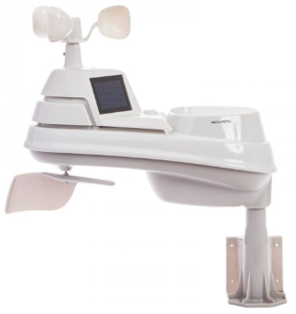It’s really fun to see just how much the weather varies across the state and this gives you access to each individual station very quickly and easily.

Hey gang, if you haven’t looked at your Weather Underground dashboard lately you might want to. It seems that the nice folks there have taken the time to upgrade your dashboard. The new design is still being worked on from what information that I could gather, but they have done a really nice job. The new design is really easy to view and contains the same information at before, but it’s laid out in a really professional manor.

Now, our list of stations is growing all the time. How’s about your station? Is it listed with us? It doesn’t necessarily have to be a Weather Underground reporting station.

I’d love to have any weather station that is connected to the internet available for all of us to view, especially when the weather gets bad out. The more stations reporting the better.

Thanks to everyone who has contributed to this effort. If you haven’t, you really should take a look at the various weather stations around the state when we get bad weather coming in. You can really see just where the line of storms are as they cross through the state.

TOP ^

It is very fascinating to watch it all unfold right you’re your easy chair, and all the data is real time! Here’s a link to all of those listed… <http://arrl-ohio.org/wus.html>

We’re got a really good collection of stations from all over and have tons of room to add more for sure. How’s about sharing your weather information with all of us! All that you need to do is send me your Weather Underground ID and your call sign and I’ll take it from there. Sent it to: [n8sy@n8sy.com](mailto:n8sy@n8sy.com)



Hey Gang,

Have you taken a look at the **Swap & Shop** page on the Ohio Section webpage yet?? Here’s a link that will take you there…

<http://arrl-ohio.org/sm/s-s.html>

Do you have equipment that you just don’t need or want anymore? Here’s a great venue to advertise it, and it’s FREE!! Is your club doing a fund raiser to help raise money? After a lot of thought, it was decided that the Swap & Shop webpage could also contain these types of items as well. The same rules will apply as do for the For Sales and Give-A-Ways and will only be posted for a month at a time. Please see the Terms & Conditions on the webpage.

If your club is doing a fund raiser and wants more exposure, please forward the information to me and I’ll advertise it on the Swap & Shop webpage for you.

Now, I still want to remind you that it won’t be listed in this newsletter because it would take up way too much space, so your ad will only appear on the website. It is there for any individual to post equipment Wanted / For Sale or Give-Away as well as for Club Fund Raisers. No licensed vehicles/trailers or business advertising will be posted. Postings are text only (no pictures or graphics) will be posted for a maximum of 1 month from date posting and require a contact phone number or email within the posting. Send your Wanted / For Sale or Give-Away post to:  [swap@arrlohio.org](mailto:swap@arrlohio.org)

***Welcome New Subscriber(s)***

**Howard, KE4NIU; Steven, AC9GK**

Ohio Section Cabinet

|  |  |
| --- | --- |
| Section Manager – Scott Yonally, N8SY | Assistant Section Manager – John Perone, W8RXX |
| Section Emergency Coordinator – Stan Broadway, N8BHL | Section Traffic Manager – David Maynard, WA3EZN |
| Technical Coordinator – Jeff Kopcak, K8JTK | Affiliated Clubs Coordinator – Tom Sly, WB8LCD |
| State Government Liaison – Bob Winston, W2THU | Public Information Coordinator – John Ross, KD8IDJ |
| Section Youth Coordinator – Anthony Lascre, K8ZT | |

TOP ^

***Back Issues of the PostScript and Ohio Section Journal***

Hey, did you know that PostScript and Ohio Section Journal (OSJ) are archived on the website? You can go back and look at any edition simply by clicking:

<http://arrl-ohio.org/news/index.html>

***Want to Share your Club Newsletter With Others?***



We have a webpage where you can download and read all of the newsletters that I get from around the state and even other sections!

Here’s the link to the page…. <http://arrl-ohio.org/club_news/index.html>

Please, if you don’t see your club newsletter posted, it’s because I’m not receiving it. Just have your newsletter editor contact me and I’ll get your club’s newsletter listed on the site!!

We all learn and steal (I mean, share) from each other’s work. So, get me your newsletter!!! Send it to: [n8sy@n8sy.com](mailto:n8sy@n8sy.com)

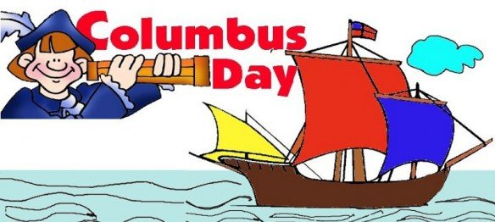

**Columbus Day** is a national holiday in many countries of the Americas and elsewhere which officially celebrates the anniversary of Christopher Columbus's arrival in the Americas on October 12, 1492 (Julian Calendar; it would have been October 21, 1492 on the Gregorian Proleptic Calendar, which extends the Gregorian Calendar to dates prior to its adoption in 1582).

Christopher Columbus was an Italian explorer on behalf of Spain, who set sail across the Atlantic Ocean in search of a faster route to the Far East only to land at the New World. His first voyage to the New World on the Spanish ships *Santa María*, *Niña*, and *La Pinta* took approximately three months. Columbus and his crew's arrival to the New World initiated the Columbian Exchange which introduced the transfer of plants, animals, culture, human populations, and technology in between the New World and the Old World.

The landing is celebrated as Columbus Day in the United States, but the name varies on the international spectrum. In some Latin American countries, October 12 is known as *Día de la Raza* or (Day of the Race). This is the case for Mexico, which inspired Jose Vasconcelos's book celebrating the Day of the Iberoamerican Race.

TOP ^

***Chit – Chat, and All That!***

Do you know someone that’s not getting these Newsletters? Please, forward a copy of this Newsletter over to them and have them “[Opt-In](mailto:Opt-In)” to start receiving them. Heck just have them send me an email [n8sy@n8sy.com](mailto:n8sy@n8sy.com) and I’ll get them added to the Ohio Section Emailing list.

We now have many thousands of readers receiving these newsletters weekly. Quite impressive, I’d say! I urge all of you to make sure that everyone, regardless of whether they are a League member or not, get signed up to receive these weekly Newsletters.

You can always “Opt-Out” at any time if you feel this is not what you were expecting. It’s fun and very informative. All of your favorite past newsletters are now archived too.

You can go back at any time and read them. Just go to: <http://arrl-ohio.org/news/>

Got questions, concerns or would just like to sit and chat awhile? Heck, I’ll even buy the coffee!! Give me a call at (419) 512-4445 or email me at: [n8sy@n8sy.com](mailto:n8sy@n8sy.com)

The pictures on the front page and throughout this newsletter are from various newsletters, Facebook posts and/or were sent directly to me in recent weeks. Take a good look at them, you just might be in one of the pictures! “SMILE… you’re in the Ohio Section News!!”

***Stop!!! You’ve reached the end of another week’s edition.***

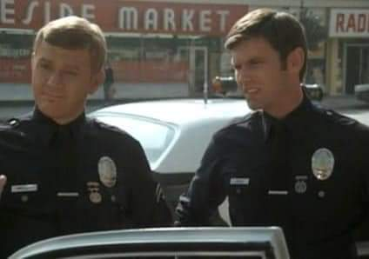

TOP ^

*PostScript is produced as a weekly newsletter. I want to thank everyone that has contributed articles and ideas to make this an even better news source. I sincerely hope that you have enjoyed this edition and will encourage your friends to join with you in receiving the latest news and information about the Ohio Section, and news and events happening around the world!*