[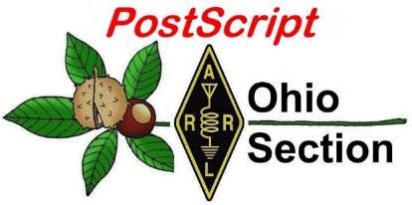](http://arrl-ohio.org/news/) ***Fire Prevention***

***Week Edition***

🡪 National News 🡪 The Handbook Give Away

🡪 Club Corner 🡪 Hamfests

🡪 DX This Week 🡪 ARES Connect

🡪 VE Testing 🡪 One Question Questionnaire

🡪 From The South 40 🡪 Final.. Final..

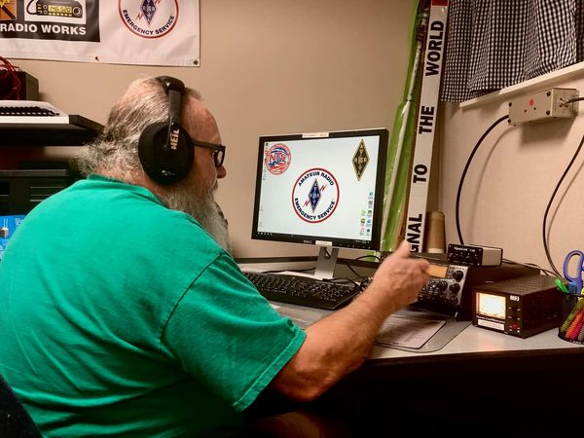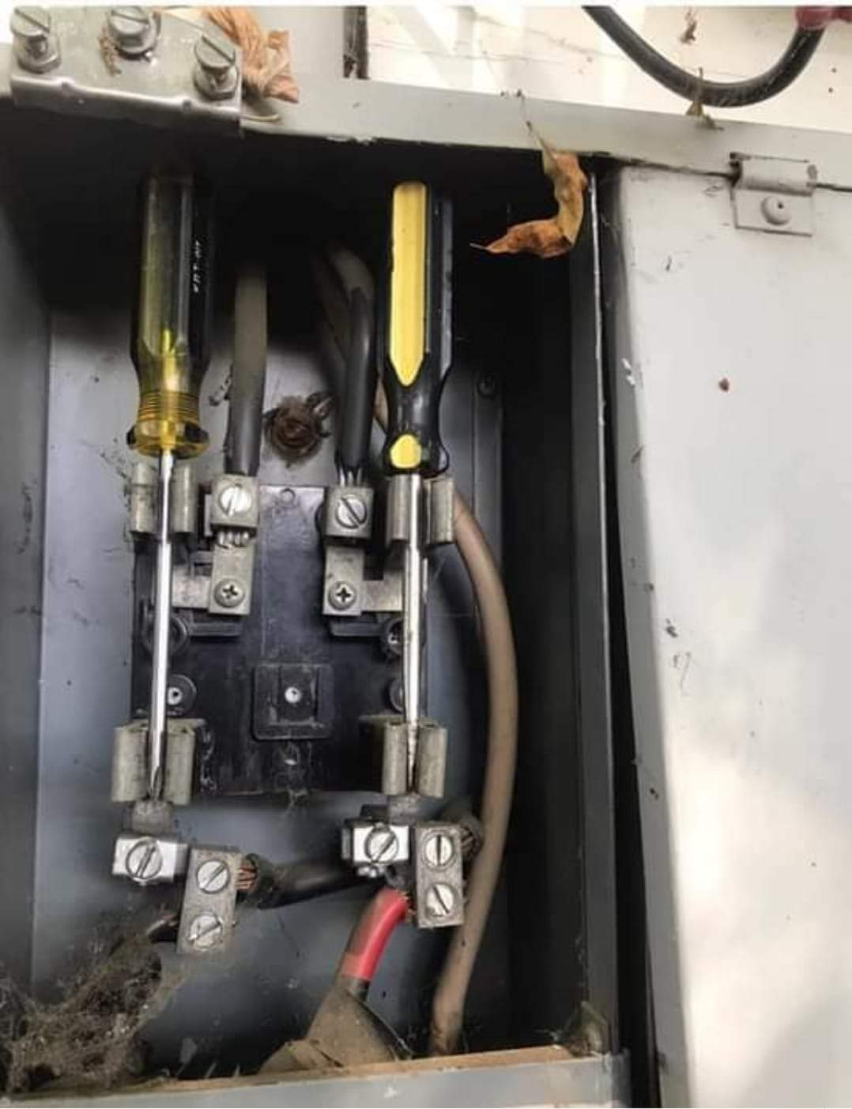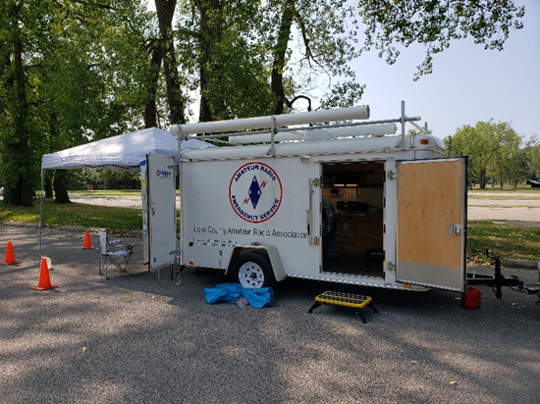

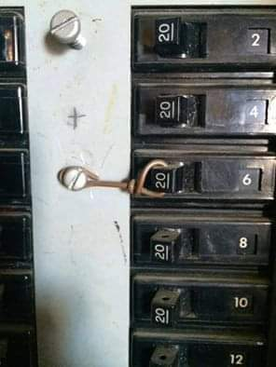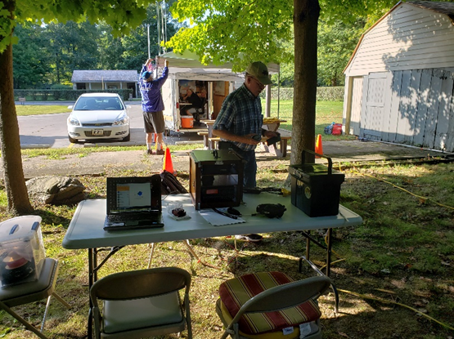

***National News***

*(from arrl and other sources)*

***Pandemic-Delayed ARRL 2019 Annual Report Released***

The 2019 ARRL *Annual Report*is now available in print and [**online**](http://www.arrl.org/annual-reports). The publication’s release was delayed as a consequence of the coronavirus pandemic. Print copies for members who are interested will be available soon. ARRL President Rick Roderick, K5UR, called 2019 “an exciting year for ARRL,” with several new initiatives moving through planning and development for rollout in 2020.

“Two of them — *On the Air* magazine and the ARRL Online Learning Center — signify steps taken toward the ‘new generation of hams’ that I’ve been talking about in the past few *Annual Reports*,” President Roderick said. “They’ve been asking ARRL for help finding their way in amateur radio for so long, wanting to know everything from how to serve their communities, how to integrate the ham radio hobby and service with all the demands that modern life makes upon them, and even simply how to determine which parts of ham radio interest them.”

President Roderick also cited the development in 2019 of the ARRL Online Learning Center — an array of online courses that will at first serve new hams and later expand to courses and materials for hams at all skill levels. The Online Learning Center is expected to launch in early 2021.

“2019 was more than busy for ARRL — it was productive and constructive,” President Roderick concluded. “We’re growing and changing, and we do it all for you, the members, with an eye on our mission: to advance the art, science, and enjoyment of amateur radio.”

ARRL membership was essentially flat from 2018 at 156,755 — likely a result of the membership dues increase in 2019 but still slightly above projections.

The ARRL Volunteer Monitor Program was developed in 2019, replacing the Official Observers program. The new VM Program is a formal agreement between the FCC and ARRL in which trained volunteers will monitor the bands and collect evidence that may be used both to correct misconduct and to recognize exemplary on-the-air operation.

The *Report* summarizes a raft of responses to emergencies and disasters by Amateur Radio Emergency Service (ARES®) volunteers. ARES membership grew by 3,130 in 2019, and a new *ARES Comprehensive Plan* was introduced.

Financially, ARRL had a particularly good year in 2019, producing a $596,000 gain from operations, along with strong investment markets resulting in an overall net asset gain of $3.75 million. The *Report* includes complete financials for 2019 compared with 2018, and the numbers show that total revenues and expenses were both slightly up from 2018. Dues revenues remain ARRL’s largest revenue source, at $6.77 million for the year.

“Members have continued their generous support of the organization through voluntary contributions — both with and without donor restrictions,” the *Report*recounted. “A total of $1.7 million was contributed in 2019, with almost $400,000 coming from bequests.” Total expenses were up by less than 1%. Total ARRL assets stood at $36.6 million at the end of 2019, up from $32.4 million at the end of 2018.

TOP ^

“In summary, ARRL’s financial condition continues to be good and provides a strong financial foundation for the organization,” the *Report* said. “This financial position will also provide the resources for ARRL to maintain its solid infrastructure while meeting the evolving needs, desires, and demands of today’s and tomorrow’s amateur radio community.”

####

***Slow-Scan Television Transmissions from ISS Planned***

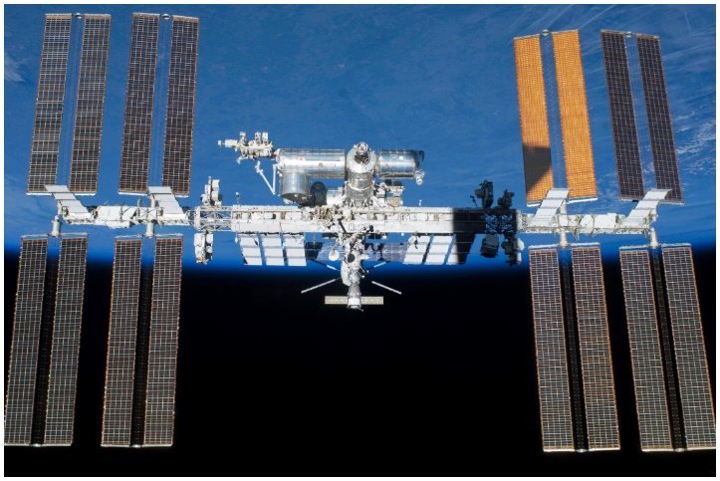A Moscow Aviation Institute MAI-75 slow-scan television (SSTV) experiment event is planned for Wednesday, September 30, from 1305 UTC to 1845 UTC, and Thursday, October 1, from 1230 UTC to 1745 UTC. SSTV signals will be transmitted on 145.800 MHz, ± Doppler shift. The expected mode will be PD 120, and the call sign will be RS0ISS. Received images of reasonable quality may be posted on the [**ARISS SSTV Gallery**](https://www.spaceflightsoftware.com/ARISS_SSTV/).

####

***Former Dayton Hamvention Venue Hara Arena is Being Demolished***

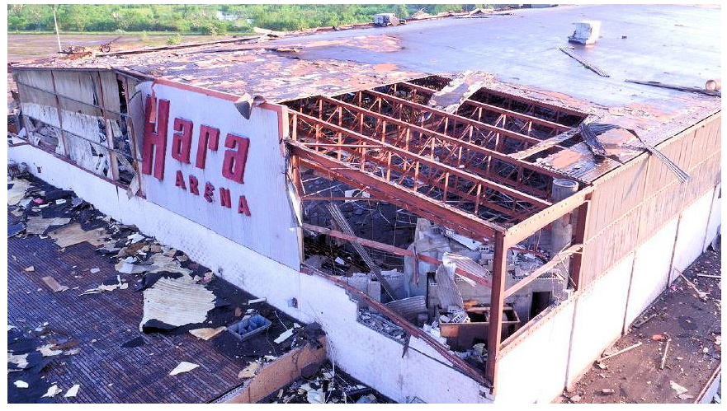Hara Arena, the former venue for [**Dayton Hamvention**](http://www.hamvention.org/)® and myriad sports, entertainment, and other presentations over the years, will soon be history. In the wake of a failed attempt to revitalize the tornado-damaged complex, officials in the city of Trotwood, Ohio — where Hara Arena is actually located — announced plans last week to raze the complex and rezone the property from commercial recreation to light industrial.

“The complex suffered extensive damage during the 2019 Memorial Day tornado outbreak,” the city said in a news release on September 25, taking note of hopes to salvage the complex. “However, redeveloping the property would be a challenge due to the extent of the damage, so the decision was made, and a contract has been secured to demolish the legendary venue.”

The city said the zoning change will allow manufacturing, distribution centers, and call centers to establish their businesses in the area.

“We are excited for what the future holds for this property,” Trotwood Mayor Mary McDonald said.

TOP ^

The *Dayton Daily News*reported that the owners of the property have said the iconic marquee spelling out “Hara Arena” atop the main arena will be preserved and auctioned off at a later date, with the proceeds donated to charity.

The Hara complex and the surrounding real estate occupy some 128 acres all together.

Owner Corey Heitz told the *Dayton Daily News* that it will take up to 6 months to tear down the buildings completely, and he hopes to have “something” there in the next 12 months.

Hara Arena had served as the venue for Dayton Hamvention from 1964 until 2016. Hamvention [**announced**](http://hamvention.org/dayton-hamvention-2017-venue-announcement/) in July 2016 that Hara Arena would be closing and that Hamvention would continue. The show is now held at the Greene County Fairgrounds and Expo Center.

Over its six-decade history, Hara Arena hosted concerts by performers that included the Rolling Stones and the Grateful Dead; it was also where hockey legend Wayne Gretzky played his first professional hockey game.

####

***WSJT-X Beta Release Introduces Digital Protocols Designed for LF and MF Bands***

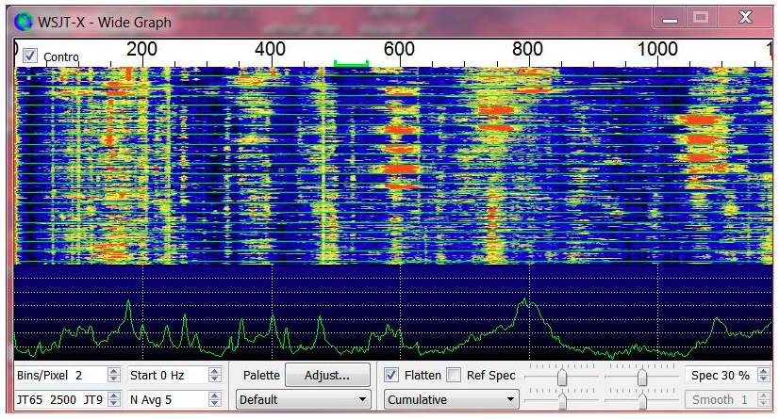The latest beta release of the *WSJT-X* digital software suite includes digital protocols particularly designed for communication on LF and MF bands, such as 2200 meters and 630 meters, and its developers say that during its first few months of testing, contacts have spanned intercontinental paths “many times” on those bands. New protocols [**FST4 and FST4W**](http://physics.princeton.edu/pulsar/k1jt/FST4_Quick_Start.pdf) are included in *WSJT-X* version 2.3.0-rc1 (release candidate 1). FST4 is for two-way contacts, while FST4W is for “quasi-beacon” style WSPR transmissions. Both modes offer a range of options for T/R-sequence lengths and threshold decoding sensitivities extending well into the –40 dB range, developers said.

“On these bands, their fundamental sensitivities are better than other *WSJT-X* modes with the same sequence lengths, approaching the theoretical limits for their rates of information throughput,” the *WSJT-X* development team said in releasing version 2.3.0-rc1. The developers said, “FST4 and FST4W do not require the strict, independent time-synchronization and phase-locking of modes like EbNaut,” a protocol for VLF and LF communication.

The *WSJT-X* development team said operators familiar with the software suite will find using FST4 and FST4W straightforward. “Most on-screen controls, auto-sequencing, and other features behave as in other modes,” the developers said. “Operating conventions on the LF and MF bands make it useful to have additional user controls to set the active frequency range used by the decoder.”

TOP ^

The new modes use 4-GFSK modulation and share common software for encoding and decoding messages. FST4 offers T/R sequence lengths of 15, 30, 60, 120, 300, 900, and 1,800 seconds, while FST4W omits the lengths shorter than 120 seconds. Submode names, such as FST4-60 and FST4W-300, indicate sequence length in seconds.

Message payloads contain either 77 bits — as in FT4, FT8, and MSK144 — or 50 bits for the WSPR-like messages of FST4W. Message formats displayed to the user are like those in the other 77-bit and 50-bit modes in *WSJT-X*. Forward error correction uses a low-density parity check (LDPC) code with 240 information and parity bits. Transmissions consist of 160 symbols: 120 information-carrying symbols of two bits each, interspersed with five groups of eight predefined synchronization symbols.

Threshold sensitivity (SNR in a 2500 Hz bandwidth, yielding a 50% probability of decode) was measured for each sub-mode using simulations over the additive white Gaussian noise (AWGN) channel. As with other recently developed modes in *WSJT-X*, a feature called a priori (AP) decoding can improve sensitivity by several additional decibels as information is accumulated during a standard minimal contact or FST4W operating session.

“Keep in mind that these are very narrow-band modes; achieving the sensitivities listed in the table requires that oscillator drifts and path-induced Doppler shifts must be less than the tone spacing, over the full sequence length,” the developers said.

*WSJT-X*version 2.3 offers 12 different protocols: FST4, FT4, FT8, JT4, JT9, JT65, QRA64, ISCAT, MSK144, WSPR, FST4W, and Echo. The first seven are designed for making reliable contacts under weak-signal conditions and use nearly identical message structure and source encoding.

The [***WSJT-X 2.3 User Guide***](http://physics.princeton.edu/pulsar/k1jt/wsjtx-doc/wsjtx-main-2.3.0-rc1_en.html#NEW_FEATURES) and the [**Release Notes**](http://physics.princeton.edu/pulsar/k1jt/Release_Notes.txt) include additional information.

####

***Get Ready for the 15th Annual ARRL Online Auction!***

The [**15th Annual ARRL Online Auction**](http://www.arrl.org/arrl-on-line-auction) will open for an “early bird” preview and registration on Thursday, October 8, and will open for bidding at 10 AM EDT (1400 UTC) on Thursday, October 15. The Auction is sponsored by GigaParts. The 2020 ARRL Online Auction includes a large assortment of ARRL Product Review items, including an SPE Expert 1.5K-FA HF amplifier, ACOM 120S 160 – 6-meter linear amplifier, Yaesu FTDX101D HF + 6-meter transceiver, and an Icom IC-9700 VHF/UHF multi-mode transceiver.

The ARRL Online Auction also features a wide assortment of vintage books, including *The ARRL Handbook*, *Radio for Everybody,* and *CQ Ghost Ship.*

This year, bidders will find a large variety of equipment, vintage books, novelty items, ARRL bundle packs, and a number of special items donated by the cast and crew of Fox Television’s *Last Man Standing*, starring Tim Allen as Mike Baxter, KA0XTT.

In order to place a bid, you must register on the ARRL Online Auction website. You may browse the website and scope out those “must-have” items without being a registered bidder, and you can register at any time during the auction.

TOP ^

If you are interested in some great bargains — and some great fun — check out the 2020 ARRL Online Auction, which concludes on October 22 at 10 PM EDT (0200 UTC on October 26 in North America). Registration begins on October 8 at 10 AM EDT (1400 UTC) during the auction preview.

Proceeds from the Online Auction benefit ARRL education programs, including activities to license new hams, strengthen Amateur Radio Emergency Service (ARES) training, offer continuing technical and operating education, and create instructional materials.

####

***Receiver Overload Performance: strong signal handling***

*(Submitted by Gregory Drezdzon, WD9FTZ)*

Receiver strong signal handling performance is just as important as the sensitivity, an Electronics Notes article explains why   
  
One challenging area of radio receiver design is that of achieving a good strong signal and overload performance whilst also maintaining a high level of sensitivity.  
  
The overload performance is important because the radio needs to be sufficiently sensitive to receive very weak signals, but it must also be able to manage the strong signals without overloading.  
  
Read the story at Electronic Notes:   
<https://www.electronics-notes.com/articles/radio/receiver-overload-strong-signal/basics.php>

***From the Section Youth Coordinator***

*Anthony Luscre, K8ZT - SYC*

[k8zt@arrl.net](mailto:k8zt@arrl.net)

**Sterling Mann, N0SSC, is IARU Region 2’s Liaison for Youth**

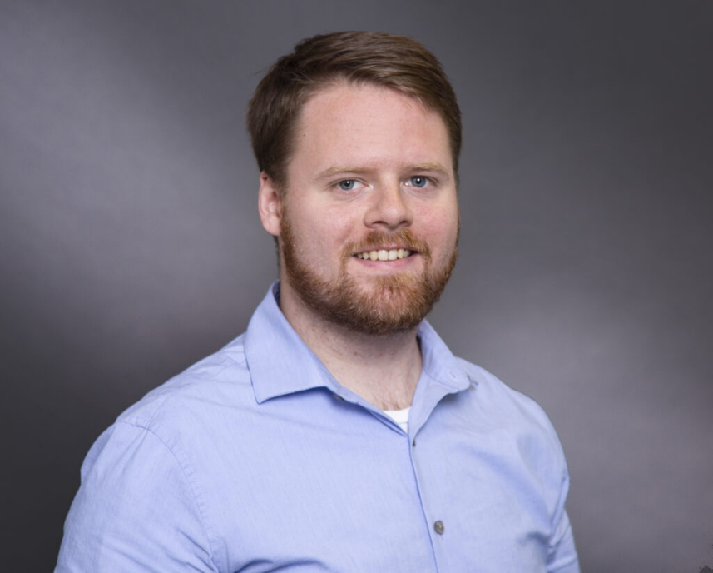The IARU Region 2 (R2) Executive Committee is pleased to announce that Sterling Mann, N0SSC has agreed to be the region’s Liaison for Youth. IARU R2 will provide support and assistance to the Liaison in reaching out to young hams throughout the Americas and their member societies. The goal is to develop and promote interest in amateur radio on the part of young hams through self-sustaining groups and activities. Mr. Mann can be contacted at [youth@iaru-r2.org](mailto:youth@iaru-r2.org) and @r2youth on Twitter.

**Background**

Amateur radio is often viewed as an old man’s passion. Features that attracted many current hams, such as providing a real-time social network, have been supplanted by advances in technology available to virtually anyone anywhere.

TOP ^

Wireless communications is an important aspect of modern life with amateurs having the opportunity to experience it in a unique and personal way. Developing and promoting this experience is key to attracting interest from younger people of all genders and is key to ensuring the future of amateur radio.

**Role**

The Liaison for Youth role is unique. It is NOT a coordinator of formalized, highly structured committee or set of working groups. This function implements a novel Young Ham Action Plan to connect with, engage, inspire, and mentor young hams throughout the Americas. The Liaison’s role is to be a point of contact for building links to and between the many groups already developing organically via internet discussion platforms, on-the-air nets, and virtual clusters of interest - even before the COVID-19 pandemic. The Liaison is to help set-up, develop, and grow self-sufficient communities of young hams connected through common cultural, lingual, and geographic backgrounds, assisted by IARU Region 2 and its member societies.

**Initiative**

This initiative is builds on the successful examples of other youth groups, namely Youngsters on the Air (of IARU Region 1) and Youth on the Air (a youth ham radio camp in the Americas), as well as the Young Amateurs Radio Club (a large all-online community of young hams) among many.

The goal of creating this Liaison position is to encourage and expand the level of peer to peer interaction among young hams all over IARU Region 2.

Along with on-the air activities, online meetups, workshops, competitions and mini-contests, brainstorming sessions, and speaking invitations are all envisioned as future events. When in-person gatherings are again possible, there can be summits, regional camps, and even conventions. The Liaison is there to assist by providing organizing documents and templates that will be useful for leaders to establish their own local communities of young hams.

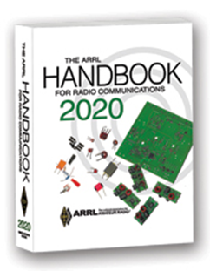***The Handbook Give Away***

Hey Gang,

The winner of the September Give Away is… ***Kevin Goshe, AD8FL***

Many of you ask me just how do I know when the drawing is on? Well, that’s easy all you need to do is check in on the Ohio Section Website on a regular basis and watch for the big **RED** Arrow that will appear on the left side of the page.

This is the sign that the drawing is on and you need to get registered. So, keep a sharp eye out on the website and check in often! <http://arrl-ohio.org/>

TOP ^

***Club Corner***

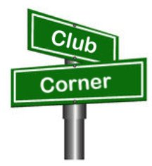

This is YOUR cornner of the newsletter. Send me what your club is doing and I’ll make sure that it gets in. Got a special event or club project that you want everyone to know about? Send it to me!. Need help with a project? Send it to me.

Let me know what you club is up to. Are you going to have a special guest at your meeting or are you having a special anniversary? Just sent it to: [n8sy@n8sy.com](mailto:n8sy@n8sy.com)

####

***Athens County ARA building project***

*(from Jeff, N8SUZ)*

On Saturday, September 26, several members of the Athens County Amateur Radio Association gathered in the Athens Red Cross parking lot for a club antenna building project. The selected antenna was a folding copper cactus J-pole for 2 m/70 cm from a March, 2005 QST article. The club had a similar building project several years ago.  Members from that build have been using their antennas for several of our public service and emergency exercise events which encouraged newer members to ask for a repeat of the group build.

We had a wonderful sunny day with a light breeze that made for comfortable conditions for working outside with our propane torches.  A total of seven members were present. Four were new to the build while two came to assist and fine tune their previously built projects.  DEC Jeff Slattery, N8SUZ gathered the materials for the kits and served as chief inspector and advisor for the project.

Those building their first antenna were Michael Baxla, KE8ICP, Joe Weber, KE8LRZ, Nick Arnold, KD8FKB and Marc Richards, KC8MCW. Assisting were Eric McFadden, WD8RIF and Kirk Groeneveld, KC8JRV.

Jeff has a couple of extra kits without the double suction cup tool (for mounting on a vertical surface) if anyone is interested. Contact Jeff to get one.

Also, don't forget that tonight, Monday, September 28 is the night for our weekly 2 meter and 70 cm FM nets starting at 7 PM.

####



***Ham Radio Class Now Forming***

As a Licensed Ham Radio Operator You Get To

• Serve Your Community

• Talk To Other Hams On The Radio

• Meet New Friends

• Have Your Own Individual Call Sign

TOP ^

The Toledo Mobile Radio Assn. will be holding a 8 week course where you will learn everything you need to earn your entry level FCC Amateur Radio license and begin to talk on the radio with other hams in the area. Morse code is no longer required for any Amateur license.

Textbooks are required - ARRL *Ham Radio License Manual* **4th Ed**. Available locally from Steve – KC8TVW while supplies last. Also available from Amazon.com or [www.ARRL.org](http://www.ARRL.org) Cost locally, $30.

Format of the class will be approximately 45 minutes of video to watch prior to our Tuesday night sessions. Starting October 13 at 7:00 p.m. we will meet via Zoom to discuss the assigned video(s) and answer any student’s questions.

**Pre-registration is required.** The test will be given at a site to be determined on Dec. 12. Cost of test is $15.

TMRA does not charge for the class. Class Dates: **October 13 – Dec 1, 2020 (7:00-9:00 p.m.)**

For more information please contact: Steve Stalker KC8TVW - 419-467-3734 [kc8tvw@arrl.net](mailto:kc8tvw@arrl.net)

***ONLINE-ICS-300 INTERMEDIATE ICS FOR EXPANDING EVENTS***

*(Hosted by: Wayne County EMA -* ***November 2 – 5, 2020*** *(4 partial days)*

**Course Description:** This 21-hour classroom course provides training for personnel who require advanced application of the Incident Command System (ICS) and Individuals who may assume a supervisory role in incidents. This course expands upon information covered in the ICS 100 and ICS 200 courses.

**Application Deadline:** Ten working days prior to the course - Seating availability is limited so register early

**Course Registration time:** 8:00 am – 8:30 am (on day one)

**Course Time:** 8:30 am to 3:30 pm on day one with a one-hour lunch 8:30 am to 1:30 pm – day two, three and four of the courses

**Training Location:** Virtually Online via Microsoft’s MS Teams Software

**Recommended Participants:** FEMA designed this course for individuals who may assume a supervisory role in expanding incidents or Type 3 incidents.

**Note:** During a Type 3 incident, some or all of the Command and General Staff positions may be activated, as well as Division/Group Supervisor and/or Unit Leader level positions. These incidents may extend into multiple operational periods.

**Required Prerequisites:** Individuals must complete the IS-100.c Introduction to the Incident Command System, IS-200.c Basic Incident Command System for Initial Response, IS-700.b An Introduction to the National Incident Management System and IS-800.c National Response Framework courses prior to attending the ICS-300 Intermediate course and provide copies of their certificates of completion to the instructors on day one of the course.

TOP ^

**Enrollment:** Students must enroll via the Department of Public Safety Training Campus website: https://trainingcampus.dps.ohio.gov/CourseMill/home.html. Course registration will close 10 working days prior to the course start date and applicants can check enrollment/approval status via the Department of Public Safety Training Campus website.

**####**

***ONLINE-ICS-400 ADVANCED ICS FOR COMMAND & GENERAL STAFF***

*(Hosted by: Wayne County EMA -* ***November 16 – 18, 2020*** *(3 partial days)*

**Course Description:** This 15-hour classroom course provides training for personnel who require advanced application of the Incident Command System (ICS). This course expands upon information covered in ICS-100, 200, 700, 800 and ICS-300 courses, which are the prerequisites for the ICS-400 course.

The target audience for this course is senior personnel who expect to perform in a management capacity in an Area Command or Multi-Agency Coordination Entity.

**Application Deadline:** Ten working days prior to the course - Seating availability is limited so register early

**Course Registration time:** 8:00 am – 8:30 am (on day one)

**Course Time:** 8:30 am to 1:30 pm all three days of the course

**Training Location:** Virtually Online via Microsoft’s MS Teams Software

**Recommended Participants:** FEMA designed the course for Senior Personnel who expect to perform in a management capacity in an Area Command or Multi-Agency Coordination Entity.

**Required Prerequisites:** Individuals must complete the IS-100.c Introduction to the Incident Command System, IS-200.c Basic Incident Command System for Initial Response, IS-700.b An Introduction to the National Incident Management System and the IS-800.c National Response Framework, an Introduction courses. In addition, ICS-300 Intermediate courses prior to attending the ICS-400 Advanced course and provide copies of their certificates of completion to the instructors on day one of the course.

**Enrollment:** Students must enroll via the Department of Public Safety Training Campus website: https://trainingcampus.dps.ohio.gov/CourseMill/home.html. Course registration will close 10 working days prior to the course start date and applicants can check enrollment/approval status via the Department of Public Safety Training Campus website.

**Course Costs for both classes:** There is no charge for participants to attend this course. However, Lodging, Meals, Per Diem and all other travel expenses are the responsibility of the student or the parent organization.

**State Point of Contact for both of these classes is:** Gary Lehman, Planner 3, Ohio EMA, Training Point of Contact, (614) 799-3663 [gdlehman@dps.ohio.gov](mailto:gdlehman@dps.ohio.gov)

TOP ^

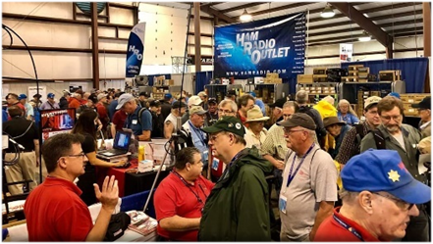

[***Upcoming Hamfests***](http://arrl-ohio.org/hamfests.html) ***for 2020***

**11/01/2020 - 60th Massillon Hamfest**Location: Massillon, OH  
Sponsor: Massillon Amateur Radio Club  
Website: <http://w8np.org/hamfest.htm>

***New Location…***

The new location is: The MAPS (Military Air Preservation Society) large Hangar at 5383 Massillon Road, Green, OH (route 241).

***Masks are required!***

***Temperatures will be taken on everyone entering the facility***

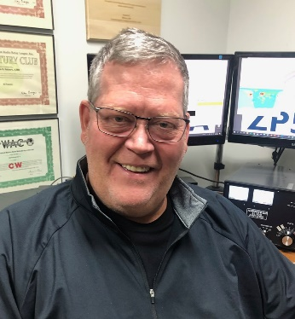***DX This Week***

*(from Bill, AJ8B)*

***DX This Week – Zones 28, 28, & 29***

***Bill AJ8B (aj8b@arrl.net, @AJ8B, or www.aj8b.com)***

***CWOPs Member #1567***

Congratulations to Chuck, K8CR for achieving DXCC on 160M! This is a major accomplishment and I know that Chuck feels great! (Clamato and Vodka all around!)

Let me know if you have achieved a new level, a new award, or just worked an ATNO. (All Time New One) Share the joy, we are all working on this together!

This past week really supplied some interesting DX. There were many entities spotted in the Midwest including Australia, Austria, Belarus, Belgium, Brazil, Bulgaria, Canada, Ceuta & Melilla, Costa Rica, Croatia, Cuba, Czech Republic, Ecuador, England, European Russia, Fed. Rep. of Germany, Fiji, Finland, France, Greenland, Guatemala, Hungary, Indonesia, Italy, Japan, Kazakhstan, Lithuania, Madeira Islands, Mali, Mexico, Netherlands, New Caledonia, New Zealand, Panama, Philippines, Poland, Puerto Rico, Republic of Korea, San Marino, Scotland, Serbia, Sicily, Slovak Republic, Slovenia, Spain, St. Lucia, Suriname, Sweden, Thailand, Tunisia, Ukraine, United Arab Emirates, US Virgin Islands, Venezuela, Vienna Intl Ctr, and West Malaysia. Let me know what you worked.

TOP ^

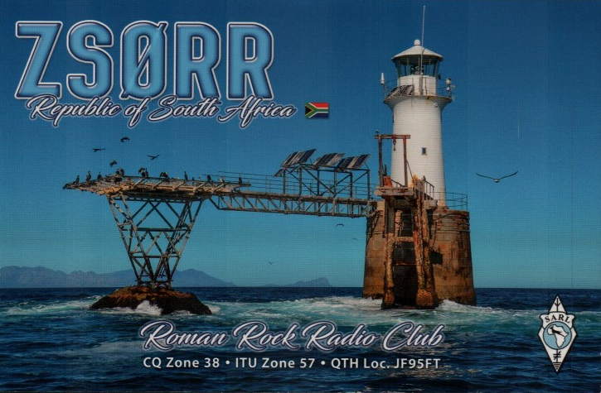

QSL cards received ZS0RR – The Roman Rock Radio Club in the Republic of South Africa. Let me know if you received any.

**The Milford ARC** in Ohio is organizing an activity to celebrate the Cincinnati Reds’ World Series event 30 years ago (1990).  The club will have W3R on the air October 16-20.  They plan to be on “all bands and modes.”  The team stared in the year 1889.  [www.mlb.com/reds/hall-of-fame](http://r20.rs6.net/tn.jsp?f=001ZUKC06L9yXdXXeKxOgHsH4pFxOuNEj-r5uSwjrHhuD7OO3K4cIJ-4BFKtPvFDO3x6FRYfafLzBT1dcbF7TF1VyIs2W8nlJ9GD0i40NzhGBuFfkffufCvcaJyFG2GVRYJaQ1HJlFqWk37jzYlVORrn6zmA6lsTAys&c=Pds0FOXkZbhIhy0HITGmVsA-BHWOyprZbXvVlm2rcAuOqmG9BFijgA==&ch=HbHcL5LONK9GOf5bi7IuVwYtC4uzhWDd0JZnscBHgs0-GXuNgGY_nQ==) and [www.w8mrc.com](http://r20.rs6.net/tn.jsp?f=001ZUKC06L9yXdXXeKxOgHsH4pFxOuNEj-r5uSwjrHhuD7OO3K4cIJ-4BFKtPvFDO3xFjGlE-zCdhYkyvKCMIGhb2prO6Ii3lf8_PGZombMU_ZA7QG9R3ftjUaF7YDNQDHhD1kSECcgt8Q=&c=Pds0FOXkZbhIhy0HITGmVsA-BHWOyprZbXvVlm2rcAuOqmG9BFijgA==&ch=HbHcL5LONK9GOf5bi7IuVwYtC4uzhWDd0JZnscBHgs0-GXuNgGY_nQ==).

***DAH DIT DIT DIT DAH DAH DIT DIT DIT DAH***

CQ Zones 27, 28, and 29

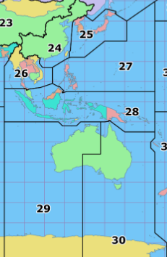So far this year, we have covered CQ zones 1 through 26. This week we will review Zones 27, 28, and 29. Below is a list of the entities in each zone and the estimated number of hams in each country, for the data I could find.

**Zone 27. Philippine Zone**: BS7 (Scarborough Reef), DU (Philippines)- 4,000, JD1 (Minami Torishima), JD1 (Ogasawara), T8 (Palau), KH2 (Guam), KH0 (Mariana Is.), V6 (Fed. States of Micronesia).

**Zone 28. Indonesian Zone**: H4 (Solomon Is.), P2 (Papua New Guinea), V8 (Brunei), YB (Indonesia) – 27,815, 4W (East Timor), 9M (West and East Malaysia) and 9V (Singapore) - 95.

**Zone 29. Western Zone of Australia**: VK6 (Western Australia), VK8 (Northern Territory), VK9X (Christmas Is.), VK9C (Cocos Keeling Is.) and some Antarctic stations.

**Antarctic notes:**

The boundaries of CQ zones 12, 13, 29, 30, 32, 38 and 39 converge at the South Pole. Stations KC4AAA and KC4USN are at the South Pole and will count for any one of the listed zones. Most Antarctic stations indicate their zone on the QSL card.

TOP ^

These zones can be very difficult at times and you need to understand and work the gray line a times. Zone 27 is most easily workable by chasing DU stations. I was fortunate to work both JD1 entities in 1991 as part of a DXPedition. I only have those QSOs to date. I have worked KH0, KH2, and V6 during CQWW contests several times.

Zone 28 is well represented by the YB hams. P2 is active and 9V1YC is on weekly representing Singapore. Your best shot at Zone 29 are the VK6 hams and the two KC4 stations. Good Hunting!

***CQDX CQDX CQDX CQDX CQDX CQDX CQDX CQDX CQDX***

Here is an update from Bernie, W3UR, of the DailyDX and the WeeklyDX, the best source for DX information. <http://www>.dailydx.com/. Bernie has this to report:

**ET – Ethiopia -** “Baring any changes, we're planning to operate overnight” says K4ZW, Ken Claerbout, who has been in Ethiopia since the weekend and is helping the ET3AA club station once again. Plans including doing RTTY, some CW and hoping to get the club members up on FT8. Overnight activity will begin around 1700Z today through 0400Z on Wednesday. Ken says, “Some may have noticed the ET3AA RBN has been down for a while.” This was as a result of “the university being closed”. While there Ken will assist the club members “to bring that back on line too”.

**5U – Niger -** French Amateur Radio operator F4IHM, Adrien Fourrier, is now on mission in Niamey. He will be QRV as 5U4IHM using an FT-817 and a wire antenna. Listen for him on CW using a straight key on 40 and 20 meters. He is new to CW. QSL direct or via the REF QSL Bureau to F4IHM.

**JW – Svalbard -** Provided the Covid situation allows them to travel LA6VM, Erling; LA9DL, Just; and LA7XK, Halvard; will be heading to Longyearbyen, Svalbard to operate as JW6VM, JW9DL and JW7XK respectively between October 7 and 12. Plans are for JW9DL and JW6VM to operate on HF, while JW7XK will be on the satellites, mostly RS-44. Each day the will be “a couple of RS-44 passes” including the possibility to work Japan. During the Scandinavian Activity Contest, SSB, they will be operating as JW5X.

**PZ – Suriname -** DJ4EL’s October 11-25 operation from PZ5GE, is still a go, but the dates are changed to October 12-24 now.  He has gotten his airplane tickets.  Markus plans to be on 80-10 SSB and CW and plans to go to Papegaaien Island, IOTA SA-092, during the October 16-19 part.  You can follow him on Twitter, @rapanuiman.

**J8 – St. Vincent and the Grenadines -** 8P5AB, Mac, will be there October 10 to December 3.  He says his favorite parts of ham radio are APRS, WirexS, Winlink, Satellites, FT8 and WSPR, but he plans to give out some QSOs on HF too.

**Solar Cycle 25 Strikes Back -** SpaceWeather.com reports “The face of the sun is blank now, but it won't be blank for long. A new sunspot group is about to rotate over the eastern edge of the sun. Its magnetic canopy is visible in this image from NASA's Solar Dynamics Observatory. As NASA and NOAA recently announced, Solar Cycle 25 has begun. But it's having trouble breaking the icy grip of Solar Minimum. The coming sunspot group could break the quiet. We'll find out by mid-week when it rotates into view. Stay tuned.”

***DAH DIT DIT DIT DAH DAH DIT DIT DIT DAH***

TOP ^



As promised last week, you will find a list of upcoming contests in the “Contest Corner”. I think this is important for someone who is trying to move up the DXCC ladder since entities that are on the rarer side and easiest to work in contests. Some of my best “catches” have been on the Sunday afternoon of a contest when the rarer entities are begging for QSOs. Of course, the gamble is that if you wait until Sunday, conditions may change, or they simply won’t be workable. However, it is not a bad gamble. Of course, why not work the contest and have some fun!

The contests in red are those that I plan to spend some significant participation time on. PLEASE let me know if you are working contests and how you fared.

Thanks!

|  |  |  |
| --- | --- | --- |
| Oct. 5 | RSGB Autumn Series CW | <https://bit.ly/2XF8mSB> |
| Oct. 7 | UKEICC 80m Contest SSB | <http://bit.ly/2MbaURB> |
| Oct. 9-11 | Nevada QSO Party | <http://nvqso.com/contest-rules> |
| Oct. 10 | 10-10 Intl. 10-10 Day Sprint | <http://bit.ly/1FrFeBc> |
|  | FISTS Fall Unlimited Sprint | [www.fistsna.org/operating.html#sprints](http://www.fistsna.org/operating.html#sprints) |
|  | QRP ARCI Fall QSO Party | [www.qrparci.org/contests](http://www.qrparci.org/contests) |
| Oct. 10 - 11 | Arizona QSO Party | [www.azqsoparty.org](http://www.azqsoparty.org) |
|  | Pennsylvania QSO Party | [http://paqso.org](http://paqso.org/) |
|  | Makrothen RTTY Contest | <http://bit.ly/2uZd6oF> |
|  | Oceania CW DX Contest | [www.oceaniadxcontest.com](http://www.oceaniadxcontest.com/) |
|  | PODSX 070 Club 160M Great Pumpkin Sprint | <http://bit.ly/2RUkcE6> |
|  | Scandinavian SSB Activity Contest | [www.sactest.net/blog](http://www.sactest.net/blog) |
|  | South Dakota QSO Party | https://sdqsoparty.com |
| Oct. 14 | RSGB Autumn Series Data | https://bit.ly/2XF8mSB |
| Oct. 17-18 | 10-10 Intl. Fall CW Contest | <http://bit.ly/1FrFeBc> |
|  | New York QSO Party | [www.nyqp.org](http://www.nyqp.org) |
|  | JARTS WW RTTY Contest | <http://jarts.jp/rules2020.html> |
|  | Worked All Germany Contest | <http://bit.ly/2uDQRSV> |
|  | Stew Perry Topband Distance Challenge | [www.kkn.net/stew/stew_rules.html](http://www.kkn.net/stew/stew_rules.html) |
| Oct. 18 | Asia-Pacific CW Sprint | <http://jsfc.org/apsprint> |
| Oct. 18 | RSGB RoLo CW Contest | [www.rsgbcc.org/hf/rules/2020/rolo.shtml](http://www.rsgbcc.org/hf/rules/2020/rolo.shtml) |
| Oct. 18-19 | Illinois QSO Party | [www.w9awe.org/ILQP.html](http://www.w9awe.org/ILQP.html) |
| Oct. 19 | RSGB FT4 Contest Series | <http://bit.ly/38xg9V7> |
| Oct. 21 | AGCW Semi-Automatic Key Evening | <http://bit.ly/2LCDywm> |
| Oct. 29 | RSGB Autumn Series SSB | <https://bit.ly/2XF8mSB> |
| Oct. 24–25 | CQWW SSB | <https://www.cqww.com/> |
|  | | |

TOP ^

|  |  |  |
| --- | --- | --- |
| Nov. 28–29 | CQWW CW | <https://www.cqww.com/> |
| Dec. 4 – 6 | ARRL 160M | <http://www.arrl.org/160-meter> |
| Jan 29 – 31 | CQWW 160M | <https://cq160.com/> |
|  | Winter FD | <https://www.winterfieldday.com/> |
| Feb. 20 – 21 | ARRL CW | <http://www.arrl.org/arrl-dx> |
| Mar. 6 – 7 | ARRL SSB | <http://www.arrl.org/arrl-dx> |
| Mar. 27 – 28 | CQWW WPX SSB | <https://www.cqwpx.com/> |
| May 21 | SWODXA DXDinner | [www.swodxaevents.org](http://www.swodxaevents.org) |
| May 29 – 30 | CQWW WPX CW | <https://www.cqwpx.com/> |
| August 28 | Ohio QSO Party | <https://www.ohqp.org/> |
| August 28 | W8DXCC Convention | [www.w8dxcc.com](http://www.w8dxcc.com) |
|  |  |  |

**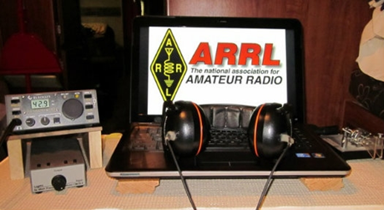*ARRL Contest Corner***

An expanded, downloadable version of *QST'*s’[**Contest Corral**](http://www.arrl.org/contest-calendar) is available as a PDF. Check the sponsor's’Web site for information on operating time restrictions and other instructions.

***DX News***

***ARLD040 DX news***

******This week's bulletin was made possible with information provided by The Daily DX, the OPDX Bulletin, 425 DX News, DXNL, Contest Corral from QST and the ARRL Contest Calendar and WA7BNM web sites. Thanks to all.

**NIGER, 5U.** Adrien, F4IHM is QRV as 5U4IHM while on a mission in Niamey. He is active using slow CW on 40 and 20 meters. QSL to home call.

**CHILE, CE.** Members of the Chilean Pacific DX Group are QRV with special event call XR500M during October to celebrate the 500th anniversary of Magellan's navigation of the strait named after him. QSL via XQ7UP.

**OGASAWARA, JD.** Makoto, will be QRV as JD1BLY from Chichijima, IOTA AS-031, from October 3 to 6. Activity is on the HF bands and 6 meters using CW, SSB and FT8, and on 630 meters using JT9. QSL via JI5RPT.

**SVALBARD, JW.** A group of operators from NRRL's Oslogruppen will be QRV as JW4O from Longyearbyen, IOTA EU-026, from October 8 to 12. The primary reason for this activity is to operate in the upcoming Scandinavian Activity SSB contest. QSL via operators' instructions.

TOP ^

**CURACAO, PJ2.** Operators Angelo, PJ2AFM, Carlo, PJ2CF and Sergio, PJ2SM will be QRV with special call sign PJ2C on October 10 to celebrate the 10th anniversary for the new start for the islands of the Netherlands Antilles. Activity will be on 20 meters using SSB, and if conditions require it, 20 and 17 meters FT8. QSL via EC5AHA.

**SURINAME, PZ.** Yudel, CO7XY is now QRV as PZ2YT from Nickerie. Activity of late has been on 20 meters using SSB. QSL via Paypal, see info at QRZ.com.

**DODECANESE, SV5.** Wolf, DL3DRN is QRV as SV5/DL3DRN from Kolymbia, Rhodes, IOTA EU-001, until October 14. Activity is on the HF bands using CW, SSB and RTTY. QSL to home call.

**TURKEY, TA.** Members of the Tango Alpha Ham Radio Club will be QRV with special event call sign TC6EKM from October 3 to 7 to celebrate the Liberation of Istanbul on October 6, 1923. Activity will be on the HF bands using various digital modes. QSL via operators' instructions.

**UKRAINE, UR.** Special event station EN100LT is QRV until the end of March 2021 to celebrate the 100th anniversary of the Kharkiv Theater for Children and Youth. QSL via UT5LU.

THIS WEEKEND ON THE RADIO. The NCCC RTTY Sprint, NCCC CW Sprint, Portable Operations Challenge, TRC DX Contest, Oceania DX Phone Contest, German Telegraphy Contest, Russian World Wide Digital Contest, IARU Region 1 UHF/Microwaves Contest, YLRL DX/NA YL Anniversary Contest, California QSO Party, International HELL-Contest, RTTYOPS Weekend Sprint, FISTS Fall Slow Speed Sprint, SKCC CW QSO Party, RSGB DX Contest and the UBA ON SSB Contest will certainly keep contesters busy this upcoming weekend.

The K1USN Slow Speed CW Test and RSGB 80-Meter Autumn CW Series scheduled for October 5.

The RTTYOPS Weeksprint, ARS Spartan CW Sprint and Worldwide Sideband Activity Contest are scheduled for October 6.

The VHF-UHF FT8 Activity Contest, UKEICC 80-Meter SSB Contest, 432 MHz Fall Sprint, Phone Fray and CWops Mini-CWT CW Test are scheduled for October 7.

Please see October 2020 QST, page 69, and the ARRL Contest Calendar and WA7BNM Contest websites for details.

***Special Events***

* **10/08/2020 | Anniversary of Towamencin Encampment**

**Oct 8-Oct 16, 0400Z-2359Z, W3T**, Harleysville, PA. WV2M. 14.074 14.030 7.074 7.030; modes are SSB, CW and FT8. Primary Mode will be FT8. QSL. Frank Gallo, 106 Tweed Way, Harleysville, PA 19438. [www.w3t.info](http://www.w3t.info/)

* **10/10/2020 | Arizona QSO Party**

**Oct 10-Oct 11, 1500Z-0500Z, W7A**, Tucson, AZ. Radio Society of Tucson. 14.248 14.048 7.189 3.848. Certificate. Bill, Clark, 222 N Suntan Dr, Vail, AZ 85641. [https://www.azqsoparty.org](https://www.azqsoparty.org/)

TOP ^

* **10/10/2020 | Eisenhower Birthday Special Event**

**Oct 10-Oct 18, 0000Z-2359Z, W5I/W5K/W5E**, Sherman, TX. Grayson County ARC. 14.250 7.250 14.040 7.040. QSL. Grayson County ARC, PO Box 642, Sherman, TX 75091. Help us celebrate the birthday of Dwight D. Eisenhower, the 34th president of the United States by contacting each of the call signs we'll be using...W5I, W5K & W5E. Contact all 3 and you'll spell IKE. IKE was born on October 14,1890 in Denison, Texas. Please visit qrz.com/db/w5i for additional information about Ike and QSL information. [https://graysoncountyarc.org](https://graysoncountyarc.org/)

* **10/10/2020 | Third Annual Get Your Parks ON!**

**Oct 10-Oct 18, 0000Z-2359Z, Various**, Various. World Wide Flora and Fauna. 14.244 14.044 10.124 7.044. Certificate. N9MM, 4245 Holstein Dr., Cleveland, TX 77328. In celebration of Earth Science Week. The event is open to Amateur Radio operators around the world and is sponsored by the U.S. affiliate of World Wide Flora and Fauna. Since October 1998, the American Geosciences Institute has organized Earth Science Week, a national and international event to help the public gain a better understanding and appreciation of the Earth sciences and to encourage stewardship of the Earth, common goals shared by the Amateur Radio program World Wide Flora and Fauna. Both programs encourage their participants to get outside and enjoy nature. During this International and on-the-air celebration hams throughout the world can participate in one of two ways. First, hams can be Activators who will set up and operate their radio stations in geological and nature centers, be they places like National or State Parks, National Monuments, protected nature habitats, or National or State Forests. Or they can be Hunters that will operate from their home stations, search out the Activators, and make over-the-air radio contacts. Get Your Park ON! will start October 10 at 0000 UTC and run through October 18 at 2359 UTC. Operators from around the world are encouraged to participate in this year’s International event. Adjunct to the Get Your Park ON! on the air activities, Earth Science Week 2020 [www.wwff.us](http://www.wwff.us/)

* **10/10/2020 | USS Midway Museum Ship Special Event: Celebrating birthday of US Navy in Oct 1775**

**Oct 10, 1600Z-2300Z, NI6IW**, San Diego, CA. USS Midway (CV-41) Museum Ship. 14.320 7.250 14.070 (PSK31) D-STAR on various reflectors. QSL. USS Midway Museum Ship (COMEDTRA), 910 N Harbor Drive, San Diego, CA 92101.

* **10/11/2020 | 140th Anniversary of the Current Maryland Flag**

**Oct 11-Oct 12, 1800Z-0300Z, N3APS**, Orinda, CA. Expatriate Marylanders Radio Club. 14.320 7.275 28.425 146.550. QSL. M.G. Vurek, P.O. Box 617, Orinda, CA 94563. [www.qrz.com/db/n3aps](http://www.qrz.com/db/n3aps)

* **10/16/2020 | 30th Anniversary Cincinnati Reds World Series Champions**

**Oct 16-Oct 21, 0000Z-2359Z, W3R**, Milford, OH. Milford (OH) Amateur Radio Club. 7.030 7.200 7.074. QSL. Dave Vest K8DV, 2934 Rontina DR, Goshen, OH 45122. [www.w8mrc.com](http://www.w8mrc.com/)

* **10/17/2020 | Woronoco Heights Outdoor Adventure/SCOTA/JOTA/JOTI**

**Oct 17, 1300Z-1900Z, W1M**, Russell, MA. Western Mass. Council--BSA. 14.290 14.060 10.115 7.190. QSL. Tom Barker, 329 Faraway Road, Whitefield, NH 03598. Due to JOTA/JOTI, W1M will also operate on BrandMeister TG 907 and its affiliated TAC talk groups. All logging is done by paper. QSL card available on eQSL or for a 4x6 sase.

TOP ^

* **10/17/2020 | Yorktown Surrender Day Event**

**Oct 17, 1400Z-2000Z, K4RC**, Yorktown, VA. Williamsburg Area Amateur Radio Club. 14.265 7.265. QSL. QSL Manager, K4RC, P.O. Box 1470, Williamsburg, VA 23187. 239th anniversary of British surrendering to the Americans ending the Revolutionary War. [www.k4rc.net](http://www.k4rc.net/)

* **10/18/2020 | Commemorating 80th Anniversary of U.S.C.G Auxiliary**

**Oct 18-Oct 20, 1400Z-2300Z, N4U**, Benton, KY. United States Coast Guard Auxiliary. 14.070 14.250 7.070 7.250. QSL. Mary Husfield, 4156 Barge Island Road, Benton, KY 42025-6039. 80th Anniversary of United States Coast Guard Auxiliary. QSL to KC4TIE, Special Card returned with SASE. Mainly digital modes.

* **10/24/2020 | The Captain Kidd DX Hunt**

**Oct 24, 1100Z-1700Z, W1WDT**, Milford, CT. Woodmont Amateur Radio Association. 50.885 28.885 14.285 7.285. QSL. Woodmont Amateur Radio Assoc., 128 Kings Highway, Milford, CT 06460. [www.wara.club](http://www.wara.club/)

* **10/31/2020 | A Night On Bald Mountain**

**Oct 31-Nov 1, 2100Z-0500Z, WA4TRS**, Fairview, NC. The Road Show Amateur Radio Club Inc.. 7.250. Certificate & QSL. The Road Show ARC, 57 Echo Lake Drive, Fairview, NC 28730. Join Us, for a Night in The Cemetery on Top of Bald Mountain, don't worry there are accommodation available for YOU! Just Check the Website [roadshowarc.org](http://roadshowarc.org/)

***“ARES Connect”***

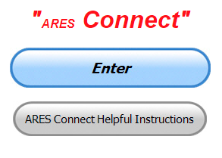

***Connecting Amateur Radio Volunteers with a Purpose***

Hey everyone… please make sure to go in and register your time to all of the events that you have signed up for. Don’t forget to get this done no later than

**5 days** after the event has ended. I’m asking you to do this for our ability to run reports accurately.

**I want to remind all of you that you do not have to be an ARES or ARRL member to use this system. All licensed amateur radio operators throughout the country are welcome and strongly encouraged to use it.**

**Don’t forget to check out the “Frequently Asked Questions” area that has been added to the Ohio Section website.** It’s there to help you through any difficulties that you may have with ARES Connect. Now, if you don’t any posts that relate to what you are having difficulties with, we now also have an on-line “Guru” area as well. This will allow you to ask any questions that you may have about ARES Connect.

**Let’s get everyone in the Ohio Section on “ARES Connect!!!” Simply go to:** <https://arrl.volunteerhub.com/lp/oh/> and get yourself registered and using the system.

TOP ^

***Here’s the top 10 hour earners for the month of September:***

|  |  |  |  |
| --- | --- | --- | --- |
|  | **Name** | **Events** | **Hours** |
| **1** | Leo Dubois, Jr. (KE8OOS) | 182 | 247.03 |
| **2** | Dwight Bonifield (W8TJT) | 175 | 239.50 |
| **3** | Daniel Schlick (KB8LKH) | 33 | 144.85 |
| **4** | James Yoder (W8ERW) | 22 | 129.90 |
| **5** | Dan Stahl (KC8PBU) | 85 | 117.00 |
| **6** | Alan Rothweiler (N8CJ) | 33 | 109.00 |
| **7** | Christopher Domenick (KC8CAD) | 31 | 104.90 |
| **8** | Michael Lacumsky (W8MAL) | 52 | 101.50 |
| **9** | Bret Stemen (KD8SCL) | 30 | 86.00 |
| **10** | Greg Dersarkisian (KD8SSJ) | 17 | 85.50 |

***SET Finished; Time for Follow-Through***

*(from: C. Matthew Curtin KD8TTE)*

As you’re reading this, the SET is or will soon be at an end. It’s going to take some time to sort through all of the activity logs and to compile all of the results. Before we can do that, though, everyone has a few final things to do:

**All Players**: If you participated in Ohio’s SET or the larger BLACK SWAN exercise, we want to hear from you. In lieu of a hot wash (difficult to conduct by videoconference with 100 people), we are collecting information for the After-Action Report/Improvement Plan via online survey. See <https://www.blackswancomex.org/2020/hotwash>.

**Net Managers (ARES and NTS)**: Complete your Form B.You can get it from ARRL at <http://www.arrl.org/files/file/Public%20Service/Form%20B%20SET%202020.docx>.

**Emergency Coordinators**: Make sure that your Net Manager (or you, if you don’t have a separate Net Manager) complete Form B. Also, complete your Form A. You can get it from ARRL at <http://www.arrl.org/files/file/Public%20Service/Form%20A%20SET%202020.docx>.

As I’m writing this, we’re only halfway through. (Sleep is no substitute for caffeine.) I’ll have more to share next week, but I want to thank everyone for their participation in the SET, the larger BLACK SWAN exercise, and the County Information Report Project 20 that provided a framework for building and training. Based on what we have seen so far, it looks like the Ohio Section is much more capable than just a few years ago. The training is working. In fact, the BLACK SWAN exercise accomplished things that haven’t ever been done, and we can expect to see Ohio used as a model for how to integrate federal and state government emergency communications with volunteers in amateur radio. There are also some improvements to be made, where we’ll be focusing training in the coming year. But first, take the time to enjoy the win.

TOP ^

I’ll leave you with this message. This came into Buckeye Net Saturday morning, unsolicited, for distribution throughout the Ohio Section and to all of the BLACK SWAN players. It’s not simulated.

***SenderName: IPAWS Lab***

***Headline: TEST ONLY Black Swan IPAWS Message from FEMA Transmitted over High Frequency Radio***

***TEST6,TEST6,TEST6***

***Description: Thanks from FEMA Strategic Integration to all participants in the Black Swan Exercise***

Amateur radio really can really make a difference in the effectiveness of emergency and disaster response and recovery. It takes will, it takes time, and it takes effort. The Ohio Section has provided that, and the SET did show what we can do when all else fails.

***From The South 40***

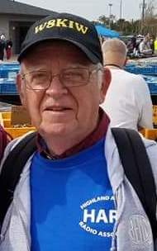*(from John Levo,* [*W8KIW@arrl.net*](mailto:W8KIW@arrl.net)*)*

Things on the South 40 are rather quiet now that Fall is officially with us. Our hams who are farmers are beginning to get into the fields and you may even hear some “combine or 18-wheel mobiles” on the air as they harvest their crops and take them to market. Now that schools are getting back to some form of instruction, hams that are teachers or students are not having the extra time to hit the airwaves. One young and very active ham from the Greenfield area is now back to the regional vocational school (KE8OJG) and another (KE8PAQ) was supposed to be in his first quarter at Ohio University, but now finds himself with on-line classes until Spring quarter. Some hams who postponed vacation travels and are suffering from cabin fever because of the virus are now traveling. So area repeaters are quieter than usual and HF band conditions are limiting the number of contacts on our HF frequencies.

The Portsmouth Radio Club will conduct a test session this Monday evening at the Portsmouth American Legion Post in downtown Portsmouth. According to Jerry Lockhart, W8HIC, it will begin at 5:30 pm and all elements will be given. Walk-ins are welcome. The monthly club meeting follows the test session. On October 19 the Athens County ARA will conduct a test session at the Athens/Southeastern Ohio Red Cross Building beginning at 7 pm. The Tri-State ARA in Huntington, WV reports all seats for their October 10 test session have been filled.

There is still a bit of time left to register for the upcoming on-line October 5 virtual Sky Warn Training conducted by the Wilmington Office of the National Weather Service. It will start at 6 pm and continue until 8. Pre-registration to www.weather.gov/iln/onlinespotter is required. Two sessions have been held during the past couple of months and the reports say it is a great program.

Memorial services will be held October 10 in Hamersville for Gary Donner, K8BE. He was a member of Brown County’s Grant Radio Club.

TOP ^

This in from Mike Love, WB8YKS - The Southern Ohio Amateur Radio Association’s (SOARA) tentatively scheduled Christmas in November Dinner at Frisch’s Big Boy restaurant in Ironton, Ohio has been canceled because of the Covid-19 virus.

Officers for 2021

According to SOARA’s constitution during the September 2020 meeting nominations were made for the 2021.

Officers. Nothing has changed.

* Tim Nicely, AC8VQ President
* Eddie Jenkins N8URU Vice President
* James Reneau N4REN Secretary
* Dave Bruce, KD8NYN Treasurer

Nominations will be presented at the October 19th meeting at which time a motion from the floor will be made for additional nominations or to be closed. Subsequently, a vote will take place.

Additionally, SOARA business meetings are “tentatively” scheduled for November 16, and December 21. Updates will be provided on the Thursday, Two Meter Net 146.715 / 146.610 at 8:30 PM.

The meetings will take place at the new Lawrence County, Ohio Emergency Management Agency’s, EOC, 515 Park Avenue in Coal Grove, Ohio at 7:00 PM.

The EMA Director, Michael Boster has stated, “A face mask is to be worn upon entry and while in the building at ALL times.” Additionally, social distancing is to be observed.

Hopefully, everything will be back to normal soon.

The Athens County ARA has posted information about their recent participation in the Ohio State Parks on the Air operating event. According to Eric McFadden, WD8RIF, the Club operated from the Bulldog Shelter House at Stroud’s Run State Park for the eight-hour contest. Fifteen members, spouses and guests participated during the day. 171 contacts were logged, and 37 state parks worked. Eric stated this year’s score was greater than those of the past two years.

A couple area clubs conduct ten-meter nets worthy of notice. The Highland ARA has a gathering on Sunday evenings at 9 on 28.421. On Wednesday evening at 9 the Clinton County ARA meets also on 28.421. HARA net control Ron Bogard, WD8AIG, even recalls the evening that the well-known AM broadcast transmitter enginer “Timtron” (Tim Smith, WA1HLR) dropped by during a band opening. Timtron is also regularly heard on international shortwave station WBCQ in Maine with a ham radio related program.

As said, there’s not that much to report this time around. If your club is in an area South of US 40 or Interstate 70, I want to hear from you so I can share with the rest of Ohio what your club is doing. Send that information to [jlevo@cinci.rr.com](mailto:jlevo@cinci.rr.com)

Until next time

73, John

TOP ^

***One Question Questionnaire***



Hey Gang,

Survey Says”….. Yes - 71% of you stated that you would be involved with this years S.E.T. That’s really great!

Ok, now since this upcoming weekend is Fire Prevention Week, here’s a question that should get your attention!

***“Will you and your family be reviewing your fire escape plans??”***

You’ll find the “One Question” questionnaire on the Ohio Section Website! <http://arrlohio.org> It’s all in fun and it’s not a scientific survey in any way, but we are learning some things that we didn’t know from these questions. I hope that you are enjoying answering these “One Question” questionnaires.

*****V.E. Test Sessions***

Many V.E.’s have decided to start testing once again, but with restrictions that need to be adhered to for sure. Here’s the link to find that V.E. Test session and what is expected of YOU before going. <http://www.arrl.org/find-an-amateur-radio-license-exam-session>

***National Weather Service - Wilmington Conducting On-Line Skywarn Training***

The National Weather Service - Wilmington - has scheduled a live online spotter training class for this autumn season on **October 5 from 6 pm to 8 pm EDT**.  NWS partners and the general public are welcome to attend the live online spotter training class. Registration is required, and can be completed at: <https://register.gotowebinar.com/register/4844007736691537676>

**As a reminder, if an individual registers, then becomes unable to attend, the individual is encouraged to cancel, freeing up that spot for another person.**

Feel free to share this with others within your counties or jurisdictions. Within a couple days, we will also promote this class via social media and on our office webpage.

One note: if a significant severe weather or flood event is forecast for or occurs on October 5, there is the possibility this webinar would need to be postponed.  Please let me know if you have any questions or comments.

Thanks, Brandon Peloquin - Warning Coordination Meteorologist - NWS Wilmington, OH

TOP ^

***Weather Underground and Other Ham Weather Stations***

[](http://arrl-ohio.org/wus.html)Hey Gang,

This has really grown into a really cool area with reports literally coming in from all over the state!!

It’s really fun to see just how much the weather varies across the state and this gives you access to each individual station very quickly and easily.

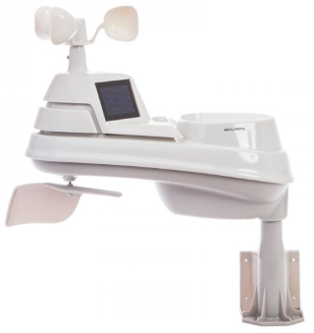Hey gang, if you haven’t looked at your Weather Underground dashboard lately you might want to. It seems that the nice folks there have taken the time to upgrade your dashboard. The new design is still being worked on from what information that I could gather, but they have done a really nice job. The new design is really easy to view and contains the same information at before, but it’s laid out in a really professional manor.

Now, our list of stations is growing all the time. How’s about your station? Is it listed with us? It doesn’t necessarily have to be a Weather Underground reporting station.

I’d love to have any weather station that is connected to the internet available for all of us to view, especially when the weather gets bad out. The more stations reporting the better.

Thanks to everyone who has contributed to this effort. If you haven’t, you really should take a look at the various weather stations around the state when we get bad weather coming in. You can really see just where the line of storms are as they cross through the state. It is very fascinating to watch it all unfold right you’re your easy chair, and all the data is real time! Here’s a link to all of those listed… <http://arrl-ohio.org/wus.html>

We’re got a really good collection of stations from all over and have tons of room to add more for sure. How’s about sharing your weather information with all of us! All that you need to do is send me your Weather Underground ID and your call sign and I’ll take it from there. Sent it to: [n8sy@n8sy.com](mailto:n8sy@n8sy.com)

***Fire Prevention Week – October 4 - 10***

The National Fire Protection Association [has announced](https://www.nfpa.org/News-and-Research/Publications-and-media/Press-Room/News-releases/2020/NFPA-announces-Serve-Up-Fire-Safety-in-the-Kitchen-as-theme-for-Fire-Prevention-Week-2020) the theme of Fire Prevention Week 2020 is “Serve Up Fire Safety in the Kitchen.” Cooking is the leading cause of home fires and home fire injuries in the U.S. Use the week of October 4-10 to educate your community on cooking hazards, the dangers of unattended cooking, and precautions they can take to prevent cooking-related fires. [Access resources](https://www.nfpa.org/fpw).

TOP ^

***Final.. Final..***

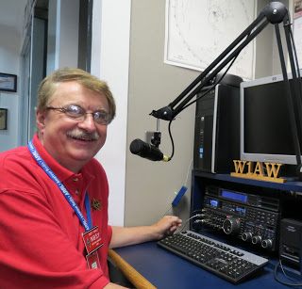Hi Gang,

This past week has been another really busy one for me. I attended several more on-line question and answer sessions with clubs this past week as well as just dropping in on a couple of club meetings a“Trunk-Fest” as well. I have to admit it, I really loved going to the Trunk-Fest that the Clinton County ARA had last Saturday. It was somewhat cold, but the weather held out nicely and those in attendance weren’t disappointed. I saw some really great deals and got to talk with a number of you that I hadn’t seen in some time due to COVID.. Yes, we all kept to the social distancing guidelines and did elbow bumps instead of handshakes, but even though we were restricted by all of that, it was still the highlight of my week just to be there in person.

Zoom and all the other conference call apps are a great substitute for when travel just isn’t always possible, and I expect it will be used a bunch more even after the pandemic has been forgotten about, and that just might not be a bad thing either.

Many of the clubs that have employed one of the conference call apps are finding that it is giving some folks (like those that don’t drive at night or get around easily) a new opportunity to join back in on the meetings and fun and this gives folks that just can’t get out a real opportunity to get involved once again. No tell me, is that a bad thing?

Whelp, that’s going to do it for this week my friends! I’m still looking forward to visiting with all of you live or via Zoom, WebEX or whatever.

I really can’t wait for that time when we can all get together in person once again. Those are the times I cherish the most!!! Stay safe! We will get through this and when we do, we’ll have so much to talk about. Most of all… have FUN and get on the airwaves!!

73,

[***Scott, N8SY***](mailto:n8sy@n8sy.com)

Hey Gang,

Have you taken a look at the **Swap & Shop** page on the Ohio Section webpage yet?? Here’s a link that will take you there…

<http://arrl-ohio.org/sm/s-s.html>

Do you have equipment that you just don’t need or want anymore? Here’s a great venue to advertise it, and it’s FREE!!

TOP ^

Is your club doing a fund raiser to help raise money? After a lot of thought, it was decided that the Swap & Shop webpage could also contain these types of items as well. The same rules will apply as do for the For Sales and Give-A-Ways and will only be posted for a month at a time. Please see the Terms & Conditions on the webpage.

If your club is doing a fund raiser and wants more exposure, please forward the information to me and I’ll advertise it on the Swap & Shop webpage for you.

Now, I still want to remind you that it won’t be listed in this newsletter because it would take up way too much space, so your ad will only appear on the website. It is there for any individual to post equipment Wanted / For Sale or Give-Away as well as for Club Fund Raisers. No licensed vehicles/trailers or business advertising will be posted. Postings are text only (no pictures or graphics) will be posted for a maximum of 1 month from date posting and require a contact phone number or email within the posting. Send your Wanted / For Sale or Give-Away post to:  [swap@arrlohio.org](mailto:swap@arrlohio.org)

***Back Issues of the PostScript and Ohio Section Journal***

Hey, did you know that PostScript and Ohio Section Journal (OSJ) are archived on the website? You can go back and look at any edition simply by clicking:

<http://arrl-ohio.org/news/index.html>

***Want to Share your Club Newsletter With Others?***



We have a webpage where you can download and read all of the newsletters that I get from around the state and even other sections!

Here’s the link to the page…. <http://arrl-ohio.org/club_news/index.html>

Please, if you don’t see your club newsletter posted, it’s because I’m not receiving it. Just have your newsletter editor contact me and I’ll get your club’s newsletter listed on the site!!

We all learn and steal (I mean, share) from each other’s work. So, get me your newsletter!!! Send it to: [n8sy@n8sy.com](mailto:n8sy@n8sy.com)

Ohio Section Cabinet

|  |  |
| --- | --- |
| Section Manager – Scott Yonally, N8SY | Assistant Section Manager – John Perone, W8RXX |
| Section Emergency Coordinator – Stan Broadway, N8BHL | Section Traffic Manager – David Maynard, WA3EZN |
| Technical Coordinator – Jeff Kopcak, K8JTK | Affiliated Clubs Coordinator – Tom Sly, WB8LCD |
| State Government Liaison – Bob Winston, W2THU | Public Information Coordinator – John Ross, KD8IDJ |
| Section Youth Coordinator – Anthony Lascre, K8ZT | |

TOP ^

***Chit – Chat, and All That!***

Do you know someone that’s not getting these Newsletters? Please, forward a copy of this Newsletter over to them and have them “[Opt-In](mailto:Opt-In)” to start receiving them. Heck just have them send me an email [n8sy@n8sy.com](mailto:n8sy@n8sy.com) and I’ll get them added to the Ohio Section Emailing list.

We now have many thousands of readers receiving these newsletters weekly. Quite impressive, I’d say! I urge all of you to make sure that everyone, regardless of whether they are a League member or not, get signed up to receive these weekly Newsletters.

You can always “Opt-Out” at any time if you feel this is not what you were expecting. It’s fun and very informative. All of your favorite past newsletters are now archived too.

You can go back at any time and read them. Just go to: <http://arrl-ohio.org/news/>

Got questions, concerns or would just like to sit and chat awhile? Heck, I’ll even buy the coffee!! Give me a call at (419) 512-4445 or email me at: [n8sy@n8sy.com](mailto:n8sy@n8sy.com)

The pictures on the front page and throughout this newsletter are from various newsletters, Facebook posts and/or were sent directly to me in recent weeks. Take a good look at them, you just might be in one of the pictures! “SMILE… you’re in the Ohio Section News!!”

***Stop!!! You’ve reached the end of another week’s edition.***

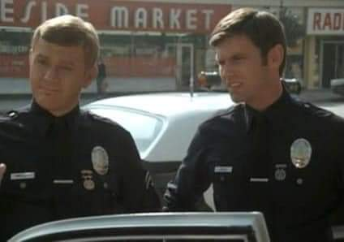

TOP ^

*PostScript is produced as a weekly newsletter. I want to thank everyone that has contributed articles and ideas to make this an even better news source. I sincerely hope that you have enjoyed this edition and will encourage your friends to join with you in receiving the latest news and information about the Ohio Section, and news and events happening around the world!*