[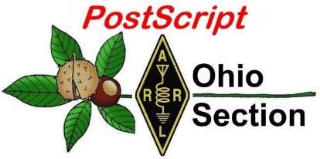](http://arrl-ohio.org/news/) ***Fall Has Arrived***

***Edition***

🡪 National News 🡪 The Handbook Give Away

🡪 Club Corner 🡪 Hamfests

🡪 DX This Week 🡪 ARES Connect

🡪 VE Testing 🡪 One Question Questionnaire

🡪 From The South 40 🡪 Final.. Final..

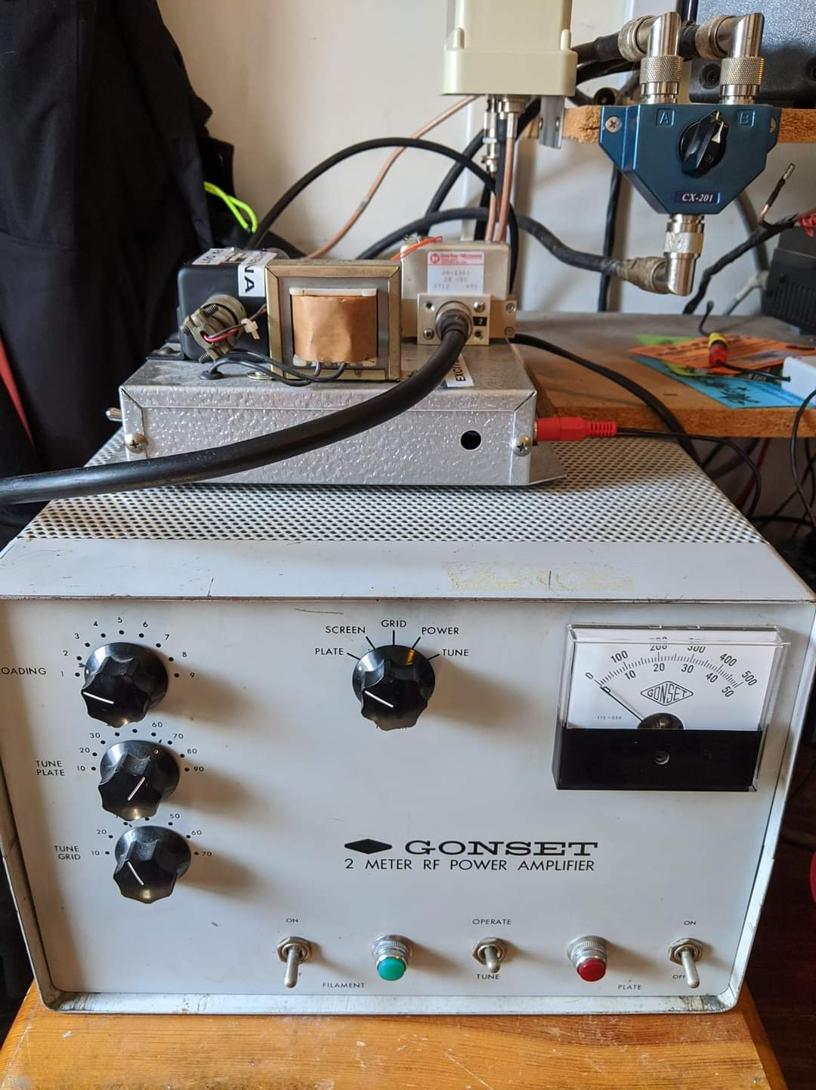

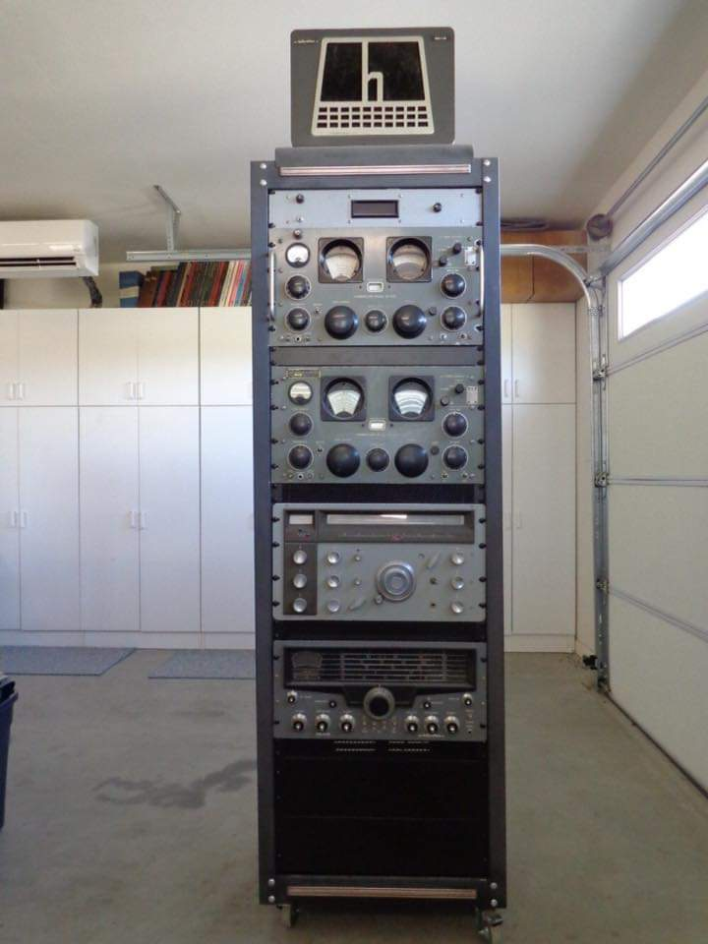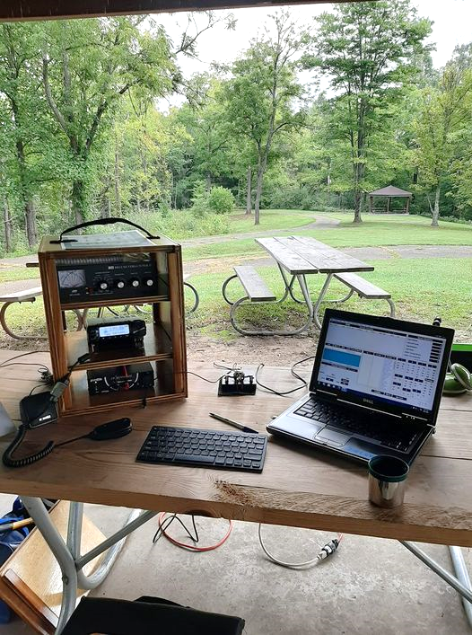

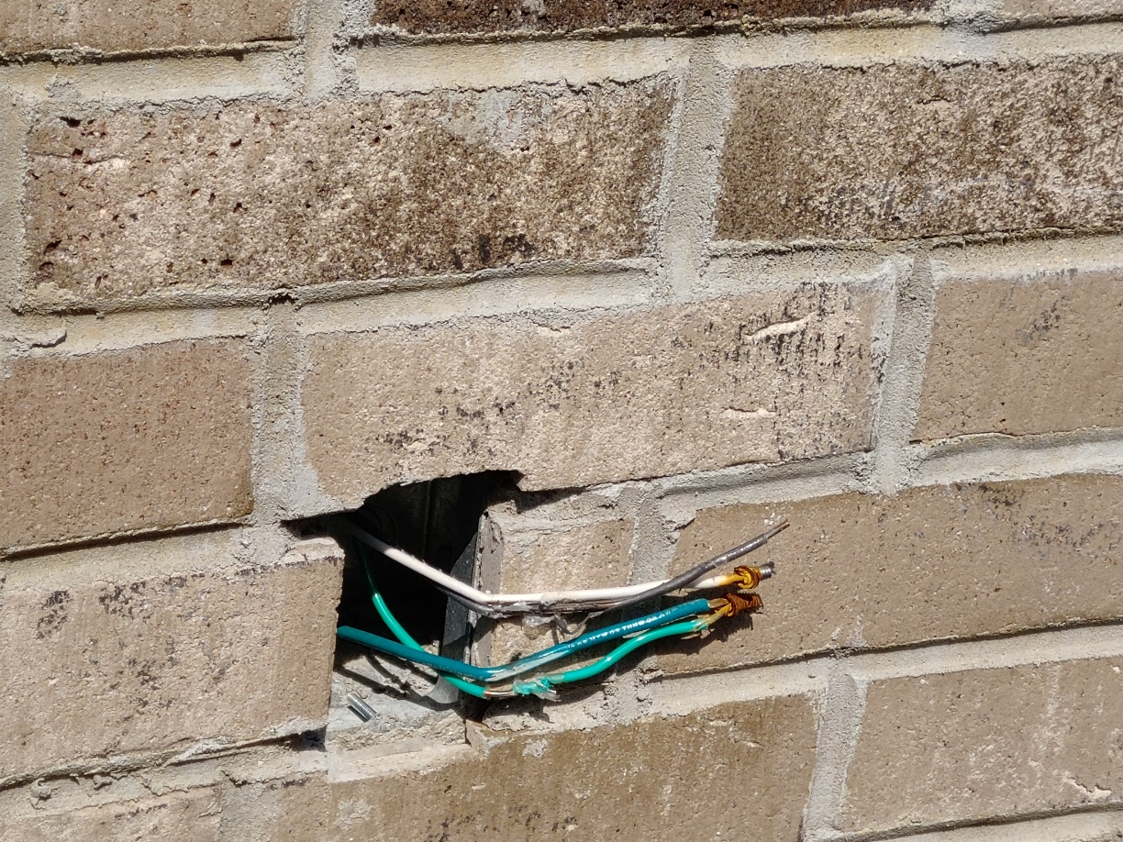

***National News***

*(from arrl and other sources)*

***5-MHz Interoperability Channels Designated for Wildfires and Hurricane Sally Response***

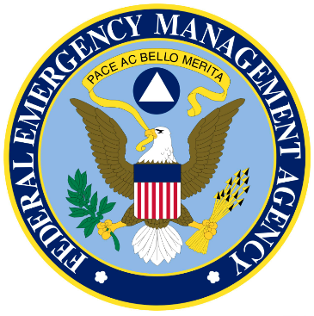The Federal Emergency Management Agency (FEMA) has announced that two 60-meter channels have been made available, as necessary, for interoperability between US Government stations and US amateur radio stations involved in emergency communications related to the wildland firefighting response in California, Oregon, and Washington, and to Hurricane Sally. These interoperability channels will remain active until the need for these channels no longer exists:

* Channel 1 — primary voice traffic 5332 kHz channel center, 5330.5 kHz USB voice
* Channel 2 — digital traffic 5348 kHz channel center, 5346.5 kHz USB with 1.5-kHz offset to center of digital waveform.

Frequencies may be modified or added to by FEMA Region 10 for their area or operations due to existing 5-MHz/60-meter interoperability plans for their region.

Amateur radio is secondary on the 5-MHz band and should yield to operational traffic related to wildland firefighting and hurricane response. Although the intended use for these channels is interoperability between federal government stations and licensed US amateur radio stations, federal government stations are primary users and amateurs are secondary users.

The Military Auxiliary Radio System (MARS) is following FEMA’s lead on the interoperability channel designations for the wildfire and hurricane response. [**Army MARS**](https://netcom.army.mil/mars/) Program Manager Paul English, WD8DBY, says he has alerted all MARS members of the FEMA channel designations and MARS members are prepared to support response efforts as needed.

####

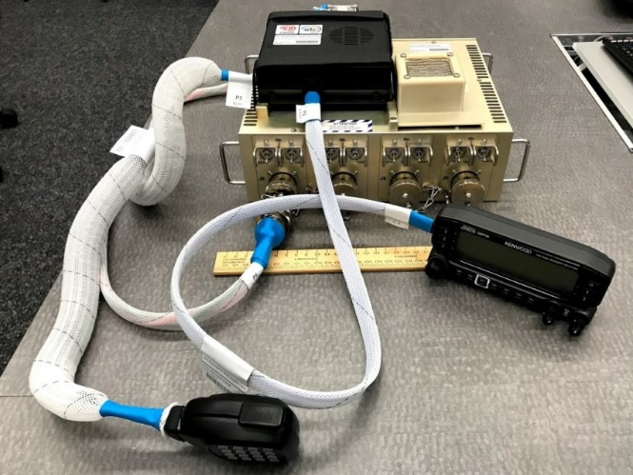***New Ham Radio Onboard The ISS Is On The Air***

*(Posted by* [*K0LWC*](http://k0lwc.com/author/admin/) *and submitted by Gregory Drezdzon, WD9FTZ)*

The [Amateur Radio on the International Space Station (ARISS)](https://www.ariss.org/) team has announced the new ham radio FM repeater is now active aboard the International Space Station (ISS) as of September 2, 2020 at 1:02 GMT.

TOP ^

**Ham radio and the International Space Station**

Ham Radio operators have enjoyed making contact with the ISS for many years. The holy grail has always been[talking to ISS astronauts on FM simplex (145.800)](https://www.youtube.com/watch?v=93z5x_ulQVY) — but those can be rare chance encounters. Ham radio operators have also enjoyed slow-scan television (SSTV) broadcasts and APRS packet radio via the ISS digipeater. Now we get to work the world’s most expensive FM repeater thanks to the new InterOperable Radio System (IORS) installed on the ISS.

The InterOperable Radio System (IORS) replaces an ancient Ericsson radio system and packet module that were certified for spaceflight over two decades ago. The 5 watt HT that was aboard the ISS was getting worn out after many years of use. The Ericsson radio looks like something from a 1990s episode of Cops.

5-watt Ericcson radio aboard the International Space Station that has now been replaced by the new InterOperable Radio System (IORS) radio system.

The new IORS was launched from Kennedy Space Center on March 6, 2020 onboard the SpaceX CRS-20 resupply mission. It consists of a custom space-modified Kenwood D710GA transceiver and an ARISS-developed multi-voltage power supply. The equipment was installed by NASA astronaut Chris Cassidy (KF5KDR).

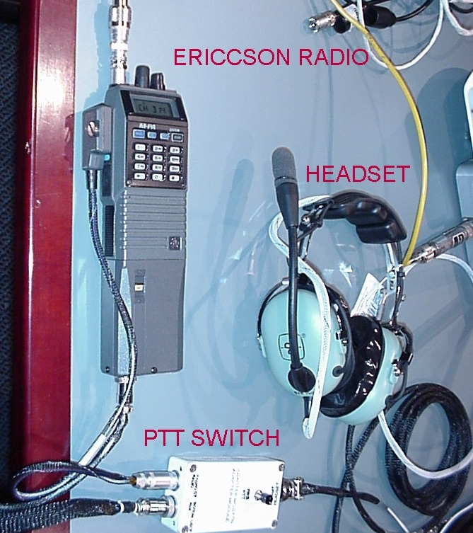**New Kenwood D710G ‘Space Flight Edition’**

The radio now being used is a Kenwood D710G and was engineered specifically for space flight. JVCKENWOOD USA and the ARISS worked closely to modify the D710G. The upgrades were performed by JVCKENWOOD and include:

* **Output power is hardware limited to 25 watts for the safety of the International Space Station**
* **Custom firmware and menus tailored for operation onboard the ISS**
* **Higher output/high-reliability fan to allow continuous repeater operation.**

Continuous fan operation is an important feature in space for the reliability of the radio. There is no convection in microgravity, so all heat-generating components need to be cooled by moving air or conduction. If the radio burns up, there isn’t a Ham Radio Outlet down the street to grab parts.

**Ham radio antennas on the International Space Station**

The ISS features four different vertical antennas on the spacecraft. The reason for four antennas is redundancy in case of an antenna failure. They are made of flexible metal tape that are coated in Kapton, a polyimide film that can withstand extreme temperatures. The antennas are designed to withstand kick loads of 125 lbs.

TOP ^

Three of the four antennas are identical and measure 0.5-meter (1.5 foot) in length and each can support both transmit and receive operations on 2 meters, 70 cm, L-band, and S-band. The fourth antenna has a 2.5-meter (8 foot) long vertical whip that can be used to support High Frequency (HF) operations, particularly on 10 meters. However, no HF radio is currently aboard the space station.

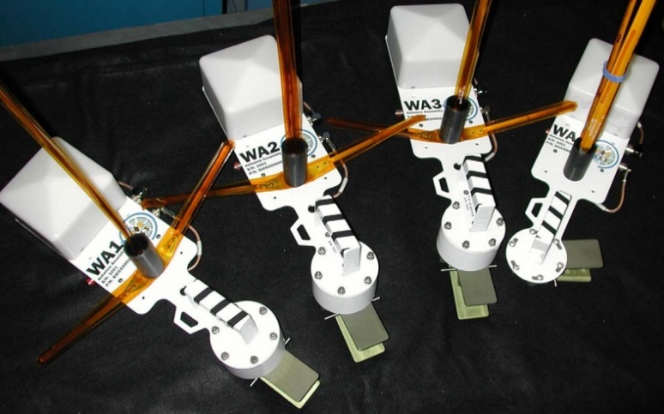

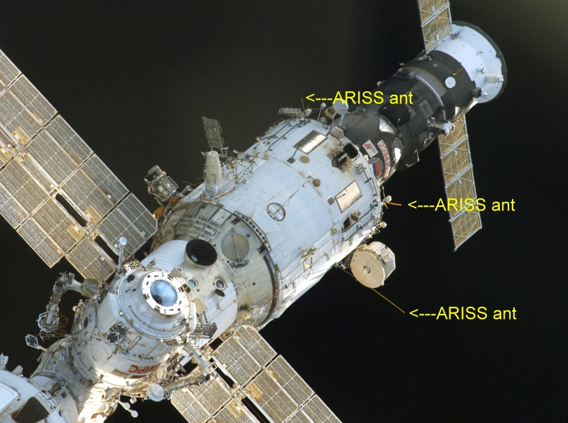*Antenna mounts for the VHF/UHF antennas on the ISS.Three antennas on the  Russian Zvezda Service Module.Vertical antenna on the ISS used by the new IORS (Kenwood D710G) pointed towards earth*

**Challenges of ham radio in space**

One of the most significant challenges with installing ham radio equipment on the International Space Station is power. The Muliti-Voltage Power Supply (MVPS) that powers the radio has to operate from either 120VDC or 28VDC and meet both NASA and Russian requirements, which are different. NASA also has stringent and detailed safety and engineering requirements.

Multi-Volt Power Supply that will power the Kenwood D710 aboard the ISS

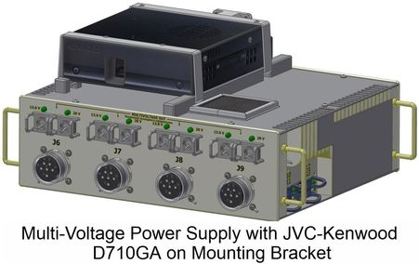The ARISS had to meet strict power quality and Electromagnetic Interference/Electromagnetic Compatibility specifications and limits. Even things like fan sound level, temperature rise, specific LED colors, special connectors, and non-flammable wiring. Even air filtering was a massive consideration as dust and lint are a real issue onboard the ISS.

**ARISS and getting ham radio aboard the ISS**

If you’ve made contact with the International Space Station in any way via ham radio you have the Amateur Radio on the International Space Station (ARISS) to thank. The group was created and is managed by an international working group, including several countries in Europe as well as Japan, Russia, Canada, and the United States of America.

The organization is run by volunteers from the national amateur radio organizations and the international AMSAT (Radio Amateur Satellite Corporation) organizations from each country.

TOP ^

Since ARISS is international in scope, the team coordinates locally with their respective space agency and as an international team through ARISS working group meetings, teleconferences and webinars.

As you can imagine, the coordination between countries, space agencies, ham radio manufacturers and the ham community at-large is a time-intensive process — and it’s all volunteer. I urge you to consider [donating to the ARISS](https://www.ariss.org/donate.html).

**Trying the new ISS FM repeater**

I couldn’t wait to try the new FM repeater myself. During a recent pass I tried to make contact with my friend Dan, KB0TDW, in Council Bluffs, IA.

ISS FM repeater information

**Downlink**: 437.800 +/- doppler

**Uplink:** 145.990 (67hz PL Tone)

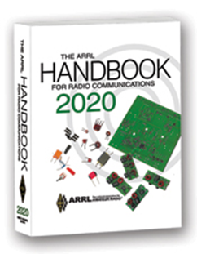***The Handbook Give Away***

Hey Gang,

Have you registered for the “Handbook Giveaway” drawing for this month yet? If you haven’t, go to: <http://arrl-ohio.org/handbook.html> and get yourself registered now!

What’s the catch? I want to get everyone checking in to the Ohio Section website as often as possible, and in order to register each month, you have to visit the website often! There’s nothing else to it. I pay all expenses and I usually “Give Away” more than just a Handbook too!!

Many of you ask me just how do I know when the drawing is on? Well, that’s easy all you need to do is check in on the Ohio Section Website on a regular basis and watch for the big [RED](http://arrl-ohio.org/handbook.html) Arrow that will appear on the left side of the page. This is the sign that the drawing is on and you need to get registered. So, keep a sharp eye out on the website and check in often!

***Club Corner***

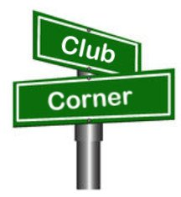

This is YOUR cornner of the newsletter. Send me what your club is doing and I’ll make sure that it gets in. Got a special event or club project that you want everyone to know about? Send it to me!. Need help with a project? Send it to me.

Let me know what you club is up to. Are you going to have a special guest at your meeting or are you having a special anniversary? Just sent it to: [n8sy@n8sy.com](mailto:n8sy@n8sy.com)

####

TOP ^

***ARRL Collegiate Amateur radio initiative***

*(from Justin Wolters, N8FCC)*

Good evening everyone, this is Justin - N8FCC, I'm the one working on getting the Grand Valley State University ARC W8GVU back on the air and I thought this week I would share a photo of our shack.  
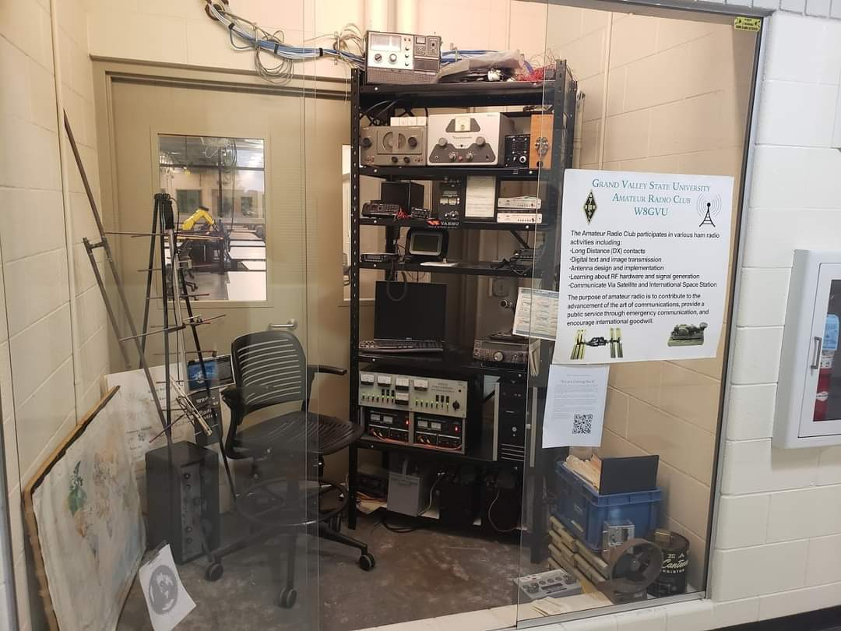As you can see, it really is a shack, with about space for 1 person, but there is plenty of stuff to keep us occupied.

We won’t be on the air for the QSO party this weekend, at least on HF, but hopefully in the coming weeks I'll be able to announce that we got our dipole up!

Hope y'all have many contacts this weekend!

####

***Alliance ARC Is Adding A New Net***

Hi Scott,

I want to tell you about a new Alliance Amateur Radio Club Digital Net. It will be weekly net on Thursday nights at 7:30pm local.

It’s going to be a digital net on 10 meters at 28.122 MHz where Novices and Technicians can also join in. We will be using the mode Olivia 8-500.

Come join us **starting October 1st**. Oh, and don’t forget to get signed up on ARES Connect for this event as well!!

73,

Doug, KB8DNQ

####

***30th ANNIVERSARY CINCINNATI REDS WORLD CHAMPIONS***

The Cincinnati Reds and the Milford Amateur Radio Club commemorate the 30th anniversary of the Cincinnati Reds winning the World Series.

TOP ^

Cincinnati, Ohio (September 20, 2020) The Cincinnati Reds and the Milford Amateur Radio Club (MARC) are pleased to commemorate the 30th anniversary of the 1990 World Champion Cincinnati Reds. MARC members will be operating an on-the-air special event with ham radio operators worldwide. Our special event, operating under the callsign W3R, begins Friday, October 16 through Tuesday, October 20, 2020. MARC members will be operating on all bands and all modes as time permits.

MARC president, Ron Brooks, comments about the event, “Our organization is thrilled to commemorate this anniversary in conjunction with the Cincinnati Reds. With the technology of ham radio, we are able to share this celebration with baseball fans worldwide. Our members eagerly await the special event to promote both the Reds and our region via amateur radio.“

The Milford Amateur Radio Club, a member of the American Radio Relay League, was established in 1974. MARC membership is open to all amateur radio licensees and non-licensees alike.

Please visit [www.mlb.com/reds/hall-of-fame](https://www.mlb.com/reds/hall-of-fame) for information about the Cincinnati Reds and the Reds Hall of Fame, and [www.w8mrc.com](http://www.w8mrc.com) for information about the Milford Amateur Radio club, membership, and programs.

This on-the-air event, celebrating the Cincinnati Reds, is one of the many varied special events ham radio can commemorate. Special events in amateur radio celebrate persons, places, events, and anniversaries of note.

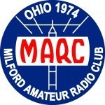

Media Contact:

Peter Kulik, K8PK

[k8pk@arrl.net](mailto:k8pk@arrl.net)

Milford Amateur Radio Club

####

***Fox Hunting Build***          
The TUSCO Amateur Radio Club will hold our first Fox Hunting build Day   
  
When: October 20, 2020  
Time: 4:00 pm   
Where: Dover Faith United Methodists Church  
 420 N Wooster Ave  
 Dover, OH 44622  
  
Some items we will be using for the build:

* 1/2” PVC
* Wood Dial rod/ Broom Sticks
* Aluminum clothesline wire

TOP ^

* Coax & connector
* Attenuator

Whatever Fox people have built

Plan to bring you plans and supplies to build an antenna.   Don’t have any ideas, come and assist.

***Design and Operation of SET 2020***

*(C. Matthew Curtin KD8TTE)*

***Introduction: Why We Run SET, and Why You Should Participate***

We advertise the amateur radio service generally and the Amateur Radio Emergency Service (ARES) in particular as the means to communicate “when all else fails.” If we are to wear the “emergency communications” moniker we need to test the system, demonstrate our capabilities, and provide realistic operating experience for our volunteers. Those are the goals of ARRL’s Simulated Emergency Test (SET).

Controlling exercises, cooking up exercise scenarios, and coordinating among agencies are not critical tasks for amateur radio operators. In fact, the more time that you spend doing that, the less time that you’re spending on the critical functions of training, coordinating, and supporting radio tasks. Looking to exercise with other counties’ ARES programs, or other forces like CERT? Have them all register for exercise play (if they’re radio teams) or as actors (if they’re agencies or non-radio functions), and you have exercise controllers that will activate them all, putting them all in play. The only thing you need to do is be sure that you’re all playing at the same time.

Now imagine that not only is the scenario and control actually provided for you, but designed to test, demonstrate, and exercise the fundamental tasks that are part of your “mission profile.”

Exercise operation means that you spend your time on the radio, in shifts, to operate a station on behalf of an agency. Your tasks are to originate messages going out, to deliver messages coming in, and to relay messages to and from the nets that will carry those messages in and out of your area. ECs will spend time managing a schedule of volunteers to see that all of the stations are populated, that additional help is requested of the DECs, and that additional capability is provided to the DECs. The DECs can focus on coordinating resources within the district, as well as providing and requesting additional resources to or from the Section. This is ARES in action: not a group of 10 hams in the local county, but a group of 10 hams in the local county supported by a coordinated system of 1,000 other ARES volunteers working together with scores more in the system of message relay nets to provide resilient communications in time of emergency.

The only way that it could be better is for the operation to result in an *After Action Report / Improvement Plan* that sets forth the training priorities for the coming year, and becomes the basis for a Section-wide training program to help volunteers of any experience level develop their operating skills for better alignment with the mission of ARES. That’s precisely what this year’s SET is all about.

TOP ^

**Answers to Frequently Asked Questions**

We have seen a lot of interest from amateur radio groups and individuals for coordinated SET play this year. This is encouraging. Here are some of the most common questions we get, and answers that will help you to plan your participation. We expect that you’ll be challenged but not overwhelmed, working in unusual conditions but within your capabilities, and providing a critical function but not responsible for the success of the whole mission. You’ll be part of a team that is in turn part of a larger team, a *system* of communications.

Can we safely play while we still have community spread of Covid-19?

**Yes. Activation will not require any physical movement.** Each “site” that has activated, whether a hospital, an incident scene, a shelter, an EOC, or elsewhere, will be a videoconference provided by Google Meet. When it’s time to activate, rather than driving to a location with all of your gear and setting up, you simply set up at home, a park, or wherever you’re able to operate safely *and with Internet access*, get on the air, and join the Meet.

Others in the Meet will be an exercise controller, playing the role of a staff member from a served agency.

Is Google Meet hard to use?

Google Meet is straightforward: there’s no special software to download and maintain if you’re on a computer with a web browser. You’ll need a Google Account (you can make a free Gmail account just for this purpose if you like). If you’ve got a mobile device, there’s a simple app you can use. We’re also holding twice-daily practice sessions in the run-up to SET so you can have a chance to test your equipment, confirm that things are working as you’d hope, and see how to get the best operation.

**Starting September 21, with the last session on October 2, we’ll be meeting at 7 a.m. and 7 p.m. every day at** [**https://meet.google.com/bcs-dzcy-nah**](https://meet.google.com/bcs-dzcy-nah)**.** If you have the app or go just to meet.google.com, the code that you’ll need to join is the same as what’s on the right side of the last / in the URL: bcs-dzcy-nah. (When you are activated for the exercise, you'll have a different Meet code, one specific to the location that you will “join.”)

We’re not asking you to go to all of these: exercise controllers are operating the Meet twice daily for you to test and to gain experience with the system. Join one or more of the sessions, say hello, listen to others, see what’s presented on-screen, and develop some comfort with the system if you need it.

**I’m not comfortable with handling record traffic. How can I come up to speed on this?**

We’ve got a video series on YouTube that walks through the process of origination, relay, and delivery of messages. A playlist organizes the sessions in a logical order. Parts of the various videos overlap, helping to reinforce critical topics, and to show several applications of the same principle.

<https://www.youtube.com/playlist?list=PLvYr6g3seaV36sBZUvCV7Y9nibFVQAmPF>

We also have a short series of brief videos (under 10 minutes each) called “Hip Pocket Training,” that address specific topics based on actual performance of message handling during the County Information Report Project 20.

<https://www.youtube.com/playlist?list=PLvYr6g3seaV21B1PuqI6R3dHKaqA0amfR>

TOP ^

**Is this exercise realistic?**

It will be highly realistic in terms of the scenario and tasks undertaken by amateur radio. Artificialities will come primarily from Covid-19 protection protocol (use of Meet instead of face-to-face) and the pace of play (we’re not going to overwhelm capacity with need all at once).

The exercise is being run by the Signal Section at the headquarters of 4th Civil Support and Sustainment Brigade, Ohio Military Reserve, an agency of the State of Ohio, part of the Ohio Adjutant General’s Office. Other participants include elements from the 179th Airlift Wing, Ohio Air National Guard; Central Ohio Poison Center; Toledo Emergency Medicine; The Ohio State University Emergency Medicine; Federal Emergency Management Agency (FEMA) Integrated Public Alert & Warning System R&D; Department of Homeland Security SHAred RESources HF Program; and others. Each of these forces has an interest in making communication work when it’s needed to respond to a disaster.

Message content will be coming from qualified professionals in disciplines like medicine and emergency management, to other professionals in the same field. Radio operators will not likely understand the contents of the messages but nevertheless must be able to support a reliable means for responders in one part of the state to exchange messages with responders in another part of the state.

Many carry professional qualifications but are working as unpaid volunteers because they want to help all of these emergency management and disaster response resources exercise together, to build our capability to work together, making our communities more resilient.

The exercise will be extremely realistic and challenging, but your tasks will be within your capability. We are all responders working together, and we want for everyone to succeed, just as we would want in a widespread emergency where normal communications are unavailable.

**Am I going to need to work with federal and military stations?**

If you’re a volunteer in a local county ARES program or on an NTS traffic net, you’ll be working within the amatuer radio spectrum. You’ll be working with net control operators and other station operators like you, and probably the same ones you work with all the time, supporting agencies in your own area.

In some cases, you might be working with amateur radio operators from other programs. For example, if you’re in Franklin County and the number of available operators exceeds the need, the Emergency Coordinator will advise the District Emergency Coordinator of the additional capability. If Knox County (in the same District) needs operators to meet the need there, the EC will tell the DEC that they need more help. The DEC will work with the ECs of Franklin and Knox County to put Franklin Co ARES members on task with Knox Co ARES. Except instead of driving to a location in Knox County, the Franklin County operators will just join the Meet(s) for the site(s) “in” Knox County.

**Am I going to need to be able to work HF digital, 60 meters, or other new modes?**

Whatever capability you’ve developed so far is the capability that you bring to the exercise. You’re part of a team, so all capabilities are valuable additions. Even if you’re able to operate only a 2m HT, you’ve got yourself an “emergency power” station that’s going to count for joining nets, and that you can use for the relay of messages.

TOP ^

In fact, you could be one of several operators “on the scene” (in the Meet) that makes up the auxiliary communications team, and while one with a powerful radio station that can work simplex for the whole county might be the one relaying messages in and out of the net, you can be the one talking to the agency personnel, originating and delivering the messages being transmitted on and off of the site.

**I know all of that stuff! How do I put that to use?**

On the other hand, if you have capability and experience, we can put that to work. Everyone should find a place in this exercise that’s interesting and challenging.

Can you act as a liaison between your District net and the Section net, work the DTN system, Winlink, and NBEMS+SSB on HF, you can volunteer your services at the Section’s NTS net, Buckeye Net. Similarly if you have experience as a net control operator on HF, Steve Judd WB8YLO would love to hear from you. Email him at [steve@wb8ylo.net](mailto:steve@wb8ylo.net) to volunteer and get trained up for Buckeye Net procedures.

**Do I need to work for 48 hours?**

***You individually should not work for 48 hours.*** If your organization can, you should. If you’ve got a county with 10 participants, it’s better to have two or three on at a time in shifts of four hours than 10 all at once. In disaster response, ongoing operation tends to be more important than a short-lived burst of capability. See our video series on the SET for discussions of planning, scheduling, and operating during SET for ECs and Net Managers at <https://www.youtube.com/playlist?list=PLvYr6g3seaV0yVw_dc79vhIdd1nMSZkWr>.

**What if my ARES group or net is tiny?**

Every group is welcome to play. If you’re a small group you might not have an agency of your own to support, but you might be brought in by our DEC to assist another county. Not every county will experience the same level of impact all at once, so resources will be needed at various locations as the scenario develops. Every group of any size can help.

Alternatively, if you’re a tiny group in an important area that’s affected in the scenario, you might have the agency working with you for help. If the need overwhelms your capability, you need only for your EC to reach out to your DEC to request additional resources, and your operating schedule can start filling up with operators “coming from” other counties nearby to help you support your agency.

If you’re an individual operator where there is no active ARES program or your ARES group is not participating, you may contact your District Emergency Coordinator to be assigned to another group in your District. If you don’t know where to go, please contact the Section Emergency Coordinator, Stan Broadway N8BHL at [stan@standi.com](mailto:stan@standi.com). He will find you the right team to connect to!

Where can I go for more information?

A current version of this Q&A is available from <https://www.blackswancomex.org/2020/FAQ>. The site has additional information for various audiences.

What you cannot get from the exercise web site:

* Your task list (that’s up to your local EC or Net Manager, so go to them and volunteer!)
* Your local procedures (we’re not micromanaging, you should be using local procedures as you always do)

TOP ^

* Exercise scenario (that will develop in the days leading up to the start of exercise play for the amateur radio stations, just like a real emergency)

You can also follow developments on the Twitter feed at <https://twitter.com/kd8tte>.

**This sounds intimidating; should I really play? Is next year better?**

BLACK SWAN is undoubtedly a large exercise, with many moving parts. But you are not responsible for running the exercise, and you are not being asked to perform every task individually.

Whatever your experience and capability, we want your participation. We are going to try things that have not been done before. Everyone will experience some success and some things that don’t go right. This is a no-fault learning environment, we’re here to help each other improve, and now is the time. Results of the operation this year will be published, and the Ohio Section will be using that information to establish the training priorities and content for the coming year.

We’ll do SET again next year, and if you train with us, using the objectives and techniques that come out of this year’s performance, you’ll be more capable and comfortable next year, and again the year after. That’s what this is all about: testing the system, demonstrating what it can do, and gaining experience needed to make the system better.

I look forward to hearing you on the air.

73

Train hard. Have fun!

####

**Stop! Wait a minute. You’re over-thinking this whole thing!**

A lot of planning has gone into this year’s Simulated Emergency Test- and we’ve taken a lot of your responses from years past to heart. But have we made this too simple? We’re getting a lot of questions that suggest you may be over thinking.

**We have three simple goals:**

1. To determine strengths and weaknesses in an exercise of ARES groups at the local and section levels.
2. To provide a public demonstration of amateur radio to partner organizations.
3. To help amateurs gain experience in communications using standard procedures and a variety of modes under simulated emergency conditions.

**This year’s SET has been carefully crafted with several basic considerations in mind.**

* ARES members need to be able to send and receive a simple message. It’s our most basic function. Unfortunately, many of us don’t exhibit real, current skill in that process, and it’s time to improve! So that’s it. That’s the SET in a sentence.

TOP ^

* Since we can’t work “face to face” and to avoid “mask to mask”, the word “simulation” takes on a lot more impact this year. It’s not practical for most of us to work inside the real EOC or Red Cross Chapter, so we need to exercise our abilities without exercising our vehicles. Many will simply operate from home (simulating a shelter, etc.) Others will be able to use the County Control Station successfully as the event hub. We hope to keep everyone busy enough that it will be both fun and realistic!
* The real challenge for each county EC is what’s going on in that county. You probably don’t live and breath the ‘big picture’, although it’s always helpful to know where you fit in. But the reality is what faces you on your local level is most important.
* While in years past we’ve suggested (begged, pleaded) with EC’s to create their own exercise to fit into the SET theme, that pretty much doesn’t happen. The result is a boring, short session which can see a brief check-in on the repeater, and then everybody goes home. Despite our best intentions and best laid scenarios, that kind of exercise does no one any good. So we’re creating local scenarios for you. They’re NOT random, they’re customized for your geographic area.
* The scenario is "local for you" (you're supporting local agency) but the agency has to work with other agencies over distance, which is the reason we need record traffic, not just tactical stuff in-county. The exercise is designed to allow for everyone to play local while showing that we collectively can support state-wide operations.
* In order to create realism so you can imagine being in an EOC or other command environment, we’re using the meeting resources of Google to keep EC’s connected with actual authoritative managers and experts over the duration of the 48 hour event. Zoom doesn’t provide the opportunity to stay logged in that long. Google is simpler than Zoom, in that there’s no software to download. So the EC will be able to see someone in authority ask for a message to be sent, and then the EC will be able to deliver messages directly to the authority. It’s almost as real as being in the EOC! (It will help if you have a camera-equipped computer.)
* YOU can determine how many hours you operate- you can specify those hours when you sign up for the event on the blackswancomex.org/2020 website.

So, the basics are the basics. Being asked to send a message. Relaying that message. Receiving the message and delivering it to the person in charge. Pretty simple, right?

At the 20,000 ft. level, there’s a lot more happening. The exercise begins the Tuesday prior to the active weekend and involves not only the state EMA but FEMA (we have permission to cross-talk on 60 meters with FEMA and SHARES stations – odd callsigns and all- again) and even Washington DC. Our focus will be on the success of the ***message delivery system*** in handling all of this stuff. This is big time!

SET designer Matt Curtin, KD8TTE, has made this as painless as possible. There is a series of simple requests involving email and message construction that you should be receiving and responding. This is an education thing, taking you step-by-step through a traffic handling sequence.

If that’s not enough- Matt has actually created an SET 2020 course on video! Subscribe to KD8TTE on YouTube and select the playlists. Then, get ready to learn! These are well done and actually interesting to watch!

TOP ^

Please consider ramping up your efforts October 3-4 for Ohio’s SET! We will not excel under duress and surprise challenges no matter how noble our intent … we will fall back to the level of our training. If we don’t train and if we don’t stay proficient in our most basic skills, we will be in for an embarrassing evaluation after the real emergency.

**Take advantage of our “no fault” opportunity to be on your best game!**

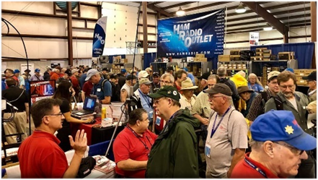

[***Upcoming Hamfests***](http://arrl-ohio.org/hamfests.html) ***for 2020***

**09/27/2020 | Cleveland Hamfest and Computer Show**

***Canceled***

**10/10/2020 - Northwest Ohio Amateur Radio Club (NWOARC) Fall Hamfest*****Canceled***

**11/01/2020 - 60th Massillon Hamfest**Location: Massillon, OH  
 Sponsor: Massillon Amateur Radio Club  
 Website: <http://w8np.org/hamfest.htm>

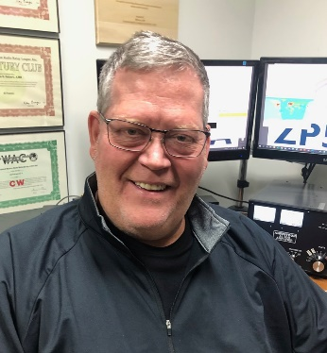***DX This Week***

*(from Bill, AJ8B)*

***DX This Week – Zones 24, 25, 26***

***Bill AJ8B (aj8b@arrl.net, @AJ8B, or www.aj8b.com)***

***CWOPs Member #1567***

This week is our buffet week. There are several DX topics that I wanted to pass along to you. First is the list of entities spotted in the Midwest. Several of you have indicated that you enjoy reviewing the list just to see what you missed!

Secondly, we have a QSL Bureau update. Third, a discussion about a weekly slow speed CW activity that you can participate in. Joe, W8GEX, gives us a 60M update. There is also a discussion about Zones 24, 25, and 26. Throw in the Contest Corner and an update from Bernie, W3UR and you have a full buffet. Bon Appetit!

This past week really supplied some interesting DX. There were many entities spotted in the Midwest including Angola, Argentina, Asiatic Russia, Asiatic Turkey, Austria, Bosnia-Herzegovina, Bulgaria, Canary Islands, Cape Verde, Croatia, Czech Republic, England, European Russia, Germany, France, Greece, Greenland, Hungary, Isle of Man, Israel, Italy, Kenya, Madeira Islands, Mali, Mexico, Moldova, Peru, Poland, Romania, Sardinia, Scotland, Slovenia, South Africa, Spain, Sweden, Trinidad & Tobago, Ukraine, Wales, and Zambia. Good week with quite a bit of DX. Let me know what you worked.

TOP ^

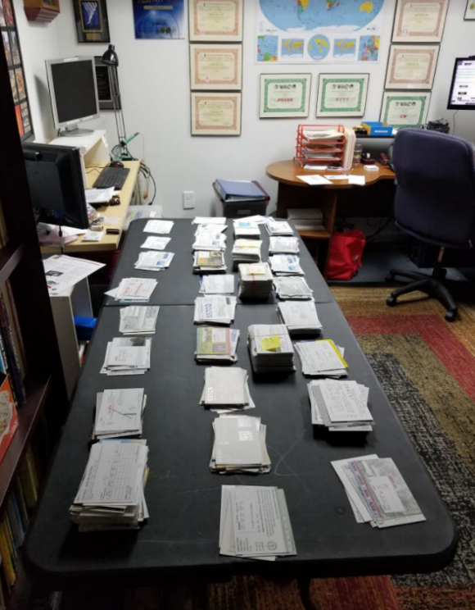

**Let the Sorting Begin**

I received a package from Jack, N8DX, the manager of the 8th Area QSL bureau. Jack told us that bureau business has been slow, but he did send along the cards he had for me. I am the letter N sorter and will get these out as soon as I can. If you haven’t sent your envelopes to your letter sorter, why haven’t you? You can find out all of the details at <https://arrl-greatlakes.org/8th_bureau.htm>

***DAH DIT DIT DIT DAH DAH DIT DIT DIT DAH***

**K1USN’s New Weekly Slow Speed Test**

The CWops Club (CWops) promotes the art of CW for those who wish to expand and improve their on-the-air experiences. CWops’ CW Academy (CWA) program has produced thousands of successful graduates who have gone on to become everyday CW operators. Hundreds of CWA grads have become CWops members after demonstrating their ability to understand and communicate in CW at speeds of 25 WPM and higher!

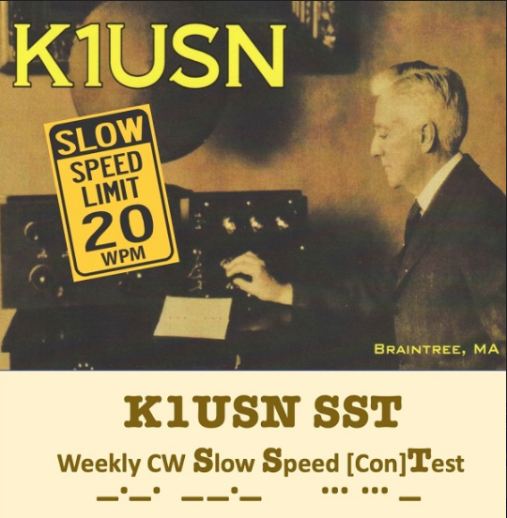CWops’ three weekly 25 to 40+ WPM CWT sprints are exciting, stimulating and a great way to improve CW copying ability, operating skills, and propagation knowledge. The CWTs create bonds of friendship among CW-loving operators around the world.

Now, for those just getting started in CW contesting and others who prefer a more leisurely pace, several members of both the K1USN Radio Club and CWops are starting a weekly one-hour slow speed CW contest, the SST. **Please join us!**

K1USN’s new Slow Speed Test is designed to encourage and assist those who signed up for CWA to learn CW or to improve their CW skills but are not yet copying 25 WPM, as well as all others who feel like “taking it slow and easy” once per week both for their own pleasure and to help others out.

CWops currently offers a total of nine “slow speed” CWT’s per year just after the three CWA graduations where all are asked to slow down to 20 WPM. Many CWA grads make contacts in those sessions, enjoying a well-earned rush of accomplishment. The SST will expand those opportunities for success to 52 weeks per year!

TOP ^

All of us old enough to remember our Novice days recall the rush of adrenalin and the sweaty grip on our J-38 (or Radio Shack) keys during those very first CW QSOs. This is what it must feel like for the new CW operators we want to encourage.

The weekly slow speed SST is also for operators who currently participate in regular CWT sessions, but only as S & P (Search and Pounce) entrants. The weekly 20 WPM or slower SSTs can build their confidence to find open frequencies and begin calling CQ, first in the SSTs and then in the more crowded and frenetic full speed CWTs. Successfully crossing that CQing threshold is another real accomplishment!

We hope many SST participants become sufficiently comfortable with CW contesting to enjoy the regular higher speed CWT sessions, other big CW contests, and smaller local and regional QSO parties, using N1MM+ (or other) computer loggers, spotting networks, call history files, live online scoring, etc. We welcome everybody to join in the SSTs whether high speed CW contesting is your goal or not, including new ops making their first attempts at completing a CW QSO.

In addition to SST’s 20 WPM upper speed limit, we ask all to be patient, supportive, and willing to slow down further as necessary to assist another op in completing an SST QSO.

CWA recommends using electronic keyers and paddles, but if you are more comfortable with some other device, please feel free to join us in the SSTs using a straight key, cootie key, bug or paddles. Unlike high speed contests, where QSO rate is king and a CQing/“running” station expects only the required exchange and confirms a contact with simply “dit” or “R”, the SST encourages sending brief friendly greetings to the other Op.

Friendliness is part of taking it slow and easy! So please join us in the SSTs! All you need is an HF radio, an antenna, and the desire to become, and assist others to become, better CW operators!

**Time and Day: 0000 UTC Monday (Sunday 8 PM EDT)**

  Suggested initial SST frequencies:

  80 meters 3.532 - 3.539 40 meters 7.032 - 7.039 20 meters 14.032 - 14.039

Exchange: Name + state/province/country

Sample SST QSO

  K1RV: CQ SST K1RV

N1DC: N1DC

K1RV: N1DC Pi MA

N1DC: GE Pi RICK MA

K1RV: GL RICK TU K1RV SST

For more info or questions about our SST, please email us at: [k1usn.radioclub.sst@gmail.com](mailto:k1usn.radioclub.sst@gmail.com)or visit us at [http://www.k1usn.com/sst](http://r20.rs6.net/tn.jsp?f=0017FyTxS3I0U1pXXCTzdJKuAJVPnMz2nCVI8GPiTCEy6evMgeI7LOk1A6Bjc1tRYQ43GKZYLqhiOrt_Ypba-s2DPEuzGN1KR5C8J1sX510fJWuBqVuf3DKXYLvJteT9qcoZTQtPtVeCS-w_cb0munz-Q==&c=QqCsUJq9OWtf0VNGc9-_yh7el3gXqY9eaRhzX8p249OawnIhkpj_Lw==&ch=s7j7pvchS82TJqCglxGeGgdDyccPyvihXDhepQppjUPBNxCtxyMJ0Q==)

Additional info about our SST will be found at: [https://www.contestcalendar.com/weeklycont.php](http://r20.rs6.net/tn.jsp?f=0017FyTxS3I0U1pXXCTzdJKuAJVPnMz2nCVI8GPiTCEy6evMgeI7LOk1Eet4z36CQYeDXGLvjEsRYJmsZJM-1xYP2TwwRbPyvjb1t7d7TAc9g2k_nBuoXWL8Uz8WK9lkBwUSeMQYZhXF3R7ocDrL1P4HUoVNCKHK3F_mCV4e-VWql8=&c=QqCsUJq9OWtf0VNGc9-_yh7el3gXqY9eaRhzX8p249OawnIhkpj_Lw==&ch=s7j7pvchS82TJqCglxGeGgdDyccPyvihXDhepQppjUPBNxCtxyMJ0Q==)

The K1USN SST N1MM+ UDC (User defined Contest) file will available for download here - [https://n1mmwp.hamdocs.com/manual-supported/contests-setup/setup-udc-contests/](http://r20.rs6.net/tn.jsp?f=0017FyTxS3I0U1pXXCTzdJKuAJVPnMz2nCVI8GPiTCEy6evMgeI7LOk1A6Bjc1tRYQ4aN-k9ElH_CV9oTq4Uoru-VX7uFSMSYgVDLBAXH5UyvZQ0Et8k0kqDt0UjK2mooLgsi2qdJZJCQ-NLCTYyW9mJa_CTSXKoDAZc_RN-MqWlNl1Y4nEE5urLivSHqzaRLAvTjiUk3do6NUWVbqnilNSV6R2CfxoGCSL&c=QqCsUJq9OWtf0VNGc9-_yh7el3gXqY9eaRhzX8p249OawnIhkpj_Lw==&ch=s7j7pvchS82TJqCglxGeGgdDyccPyvihXDhepQppjUPBNxCtxyMJ0Q==)

TOP ^

***DAH DIT DIT DIT DAH DAH DIT DIT DIT DAH***

**60 Meter Update –** Joe, W8GEX, the guardian of 60 meters sends along some 60 M information:

3X – Guinea - F4AJQ, Frank, says the F6KOP team, noting their successful E44CC Palestine operation in February, is now planning another operation, this one for next January.  Assuming the borders open after COVID-19 and they can travel safely, they plan to be on Guinea’s Kassa Island, IOTA AF-051, QRV on 160-10 “with maybe 60M,” CW, SSB, RTTY and FT8, with five stations on simultaneously.  They will have three beams, several verticals and receiving antennas too.  The callsign, operators and other details will be forthcoming soon.  
   
FP – St. Pierre and Miquelon Islands - Due to travel restrictions KV1J, Eric, had to cancel his September 22 to October 6 trip to Miquelon Island. He is now planning to go to FP in the June/July 2021 time frame. Eric will be returning to Miquelon operating as FP/KV1J from June 29 through July 13, 2021.

With the new French 60 meter allocation he will be concentrating on that band with a 1/4 wave vertical antenna. Logs will be loaded each night to LoTW and Club Log.   
QSL via KV1J direct, buro or LoTW. [http://www.kv1j.com/fp/July21.html](https://60metersonline.us12.list-manage.com/track/click?u=99836838adcf6cb21aec9049a&id=7a668297fe&e=2f511515ce)

**From Paul G4MWO *The 5 MHz Newsletter***  
I’ve revised the Wiki 60 Meter Band page’s ‘External Links’ section to give more prominence to Newsletters/Blogs. You can find the latest edition freely available at any time at  
[https://www.dropbox.com/s/koz6msf74mtk76t/5%20MHz%20Newsletter.pdf?dl=0](https://60metersonline.us12.list-manage.com/track/click?u=99836838adcf6cb21aec9049a&id=205b46343e&e=2f511515ce)  
and the Newsletter Archive is at  
[https://www.dropbox.com/sh/9si2gq8dnz73uy9/AACCZty4t4wQaF1mot3cA3d9a?dl=0](https://60metersonline.us12.list-manage.com/track/click?u=99836838adcf6cb21aec9049a&id=e7cd72008f&e=2f511515ce)  
   
G5MHZ – Remembering Gordon - In the UK, the 5 MHz, or 60 m band has been available to Full UK licensees since August 2002. This we owe to the initiative of Gordon Adams, G3LEQ, at the time Spectrum Director of the Radio Society of Great Britain, who was central to negotiations with the Regulator and the UK Ministry of Defence, the primary user of the band.

One of the elements of Gordon’s proposals for use of the band was as a vehicle for countrywide coverage of the GB2RS news bulletin, produced by the RSGB. This has taken place regularly on a Sunday since the band’s inception by a team of newsreaders, several of whom were part of the group that assisted Gordon in his work to achieve 5 MHz access.

Sadly, Gordon became a Silent Key in February 2018 and the GB2RS 5 MHz news reading team looked for a way to actively remember Gordon’s vital contribution. The opportunity arose when Ofcom recently released the G5 + 3 Letter call series. The 5 MHz Newsreaders, as ‘The 5 MHz Pioneers Group’ applied for and received the call G5MHZ.

The call G5MHZ is in recognition and remembrance of the work done by Gordon in obtaining a band at 5 Megahertz for UK Radio Amateurs. The callsign? ‘5 MHz’ is obvious and the ‘G’? Well what else could it stand for but Gordon!

Watch for G5MHZ on 60 meters.

TOP ^

***DAH DIT DIT DIT DAH DAH DIT DIT DIT DAH***

**Zones 24, 25, and 26**

So far this year, we have covered CQ zones 1 through 23. This week we will review Zones 24, 25, and 26. Below is a list of the entities in each zone and the estimated number of hams in each country, for the data I could find.

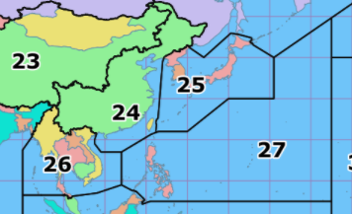**Zone 24. Eastern Zone of Asia: BV9P** (Pratas Is.), **BV** (Taiwan), **BY1, BY2, BY3A‑F** (TianJin), **BY3M‑R** (HeBei), **BY3S-X** (ShanXi), **BY4, BY5, BY6, BY7, BY8, BY9A‑F** (ShaanXi), **VR** (Hong Kong), and **XX** (Macau).

**Zone 25. Japanese Zone: HL** 42,632 (South Korea), **JA** 435,831(Japan), and **P5** (North Korea).

**Zone 26. Southeastern Zone of Asia**: * (Paracel Islands), **3W** (Vietnam), **E2** (Thailand), **VU** (Andaman and Nicobar Islands), **XU** (Cambodia), **XW** (Laos), **XZ** (Myanmar), and **1S/9M0** (Spratly Islands)

This group of Zones has proven to be the toughest for me. There are plenty of JA’s to work and a good collection of HL stations. Thailand, Taiwan, and Viet Nam are spotted occasionally. There are a few others that are only available when DXPeditions hit the air. This group is the group that you take off work for!

***DAH DIT DIT DIT DAH DAH DIT DIT DIT DAH***

CQDX CQDX CQDX CQDX CQDX CQDX CQDX CQDX CQDX

Here is an update from Bernie, W3UR, of the DailyDX and the WeeklyDX, the best source for DX information. <http://www>.dailydx.com/. Bernie has this to report:

**VP9 – Bermuda -** N1SNB, Jeff, will be heading to Bermuda for the CQ World Wide DX SSB Contest. Listen for VP9/N1SNB from October 21-26. He’ll be at the VP9GE station running low power into a tribander and wires. Jeff reminds everyone this trip will be subject to “travel restrictions” which including “passing COVID tests on departure and arrival”. QSL via LoTW.

**V7 – Kwajalein Atoll V7/KX4QD**, Randy Hisle, went on the air about a year ago, on “Roi Namur.” The V7/KX4QD home hamshack has an IC-7300 and the club station (V73AX) an IC-7410 and other gear.

V7/KX4QD puts out 100 watts and under the V73AX callsign at the club station it’s a KW. The antennas are an MFJ multiband inverted V at home and a TH7 at the club, plus a log periodic and a multiband vertical, equipped for 40, 20, 17, 15, 12, 10 and 6. They are found in CW, SSB, FT8 and RTTY. QSL via: PSC 701 Box 978 APO AP; 96555 You may also QSL through LoTW, and V73AX uses Club Log. Randy notes Kwajalein has the largest lagoon in the world, surrounded by tiny islands that are remains of a giant volcano. When the volcano eroded the coral reef remained. Many World War Two battles were fought there and atomic bomb tests were done nearby.

TOP ^

It is known as a scuba diving paradise due to the natural reefs and WW2 wrecks to be explored. Kwajalein Island is leased from the Marshall Islands and is operated by the US Army, with missile defense the main mission. No personal automobiles are allowed; people use bicycles. With the island a few miles long, it takes an hour to ride around the entire island on a bike.

V7/KX4QD, Randy, is a broadcast engineer working for Armed Forces Network, bringing US TV to islanders, both military and civilian. He operates from home, usually with no more than 50 watts, to his inverted V. The KW station is the old MARS hamshack that has the tribander and KW. Corrosion problems often cause the rotor to freeze, with the salt, sand and humidity and year-round temperatures of 80-90F. So far, Randy has found 6-7 hams there and three are active. He has applied for a regular V7 callsign for himself and he has ordered QSL cards. He is overwhelmed with card requests as he waits for his blank cards to arrive. With his more limited station at home he mostly does FT8 from there and is now “playing around with RTTY.”

**3V – Tunisia KF5EYY**, Ash, will again be on the air with the 3V8SS callsign, this time in the CQWW RTTY weekend, single op all band low power. QSL through LoTW or via LX1NO. www.kf5eyy.info.

***DAH DIT DIT DIT DAH DAH DIT DIT DIT DAH***



As promised last week, you will find a list of upcoming contests in the “Contest Corner”. I think this is important for someone who is trying to move up the DXCC ladder since entities that are on the rarer side and easiest to work in contests. Some of my best “catches” have been on the Sunday afternoon of a contest when the rarer entities are begging for QSOs. Of course, the gamble is that if you wait until Sunday, conditions may change or they simply won’t be workable. However, it is not a bad gamble. Of course, why not work the contest and have some fun!

The contests in red are those that I plan to spend some significant participation time on. PLEASE let me know if you are working contests and how you fared.

|  |  |  |
| --- | --- | --- |
| Sept. 19-20 | All Africa Int. DX Contest | <http://bit.ly/H0IqQf> |
|  | Iowa QSO Party | [www.w0yl.com/IAQP](http://www.w0yl.com/IAQP) |
|  | New Hampshire QSO Party | [www.w1wqm.org/nhqso](http://www.w1wqm.org/nhqso) |
|  | New Jersey QSO Party | <http://bit.ly/1nDlf8V> |
|  | QRP Afield | <http://bit.ly/2QACxFu> |
|  | Scandinavian CW Activity Contest | [www.sactest.net/blog](http://www.sactest.net/blog) |
|  | Washington State Salmon Run | [www.wwdxc.org](http://www.wwdxc.org) |
| Sept. 20 | BARTG Sprint 75 | <http://bartg.org.uk/wp/contests> |
|  | North American RTTY Sprint | <http://ncjweb.com/Sprint-Rules.pdf> |
| Sept. 24 | RSGB Autumn Series Data | <https://bit.ly/2XF8mSB> |
| Sept. 26-27 | CQWW RTTY DX Contest | [www.cqwwrtty.com](http://www.cqwwrtty.com) |
|  | Maine QSO Party | [www.ws1sm.com/MEQP.html](http://www.ws1sm.com/MEQP.html) |
|  | Nancy Kott-Fists Memorial KNOWCW | <http://fistsna.org/operating.html> |

TOP ^

|  |  |  |
| --- | --- | --- |
| Sept. 28 | RSGB FT4 Contest Series | <http://bit.ly/38xg9V7> |
| Sept. 30 | UKEICC 80m Contests CW | <http://bit>.ly/2MbaURB |
| October 2020 | | |
| Oct. 1 | SARL 80m QSO Party | <http://bit.ly/H0IqQf> |
| Oct. 3 | German Telegraphy Contest | <http://bit.ly/291wozN> |
| Oct. 3-4 | YLRL DX/NA YL Anniversary Contest | <https://ylrl.org/wp/dx-na-yl-contest> |
|  | California QSO Party | [www.cqp.org/Rules.html](http://www.cqp.org/Rules.html) |
|  | Oceania Phone DX Contest | [www.oceaniadxcontest.com](http://www.oceaniadxcontest.com) |
|  | Russian WW Digital Contest | <http://bit.ly/2MF8xoC> |
|  | SKCC QSO Party | <http://bit.ly/2Xl2vyx> |
|  | TRC DX Contest | <https://trcdx.org/rules-trc-dx> |
| Oct. 4 | Peanut Power QRP Sprint | [www.nogaqrp.org](http://www.nogaqrp.org) |
| Oct. 4 | RSGB DX Contest | <https://bit.ly/3iWoeZQ> |
| Oct. 5 | RSGB Autumn Series CW | <https://bit.ly/2XF8mSB> |
| Oct. 7 | UKEICC 80m Contest SSB | <http://bit.ly/2MbaURB> |
| Oct. 9-11 | Nevada QSO Party | <http://nvqso.com/contest-rules> |
| Oct. 10 | 10-10 Intl. 10-10 Day Sprint | <http://bit.ly/1FrFeBc> |
|  | FISTS Fall Unlimited Sprint | [www.fistsna.org/operating.html#sprints](http://www.fistsna.org/operating.html#sprints) |
|  | QRP ARCI Fall QSO Party | [www.qrparci.org/contests](http://www.qrparci.org/contests) |
| Oct. 10-11 | Arizona QSO Party | [www.azqsoparty.org](http://www.azqsoparty.org) |

**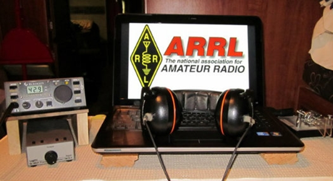*ARRL Contest Corner***

An expanded, downloadable version of *QST'*s’[**Contest Corral**](http://www.arrl.org/contest-calendar) is available as a PDF. Check the sponsor's’Web site for information on operating time restrictions and other instructions.

|  |  |
| --- | --- |
| **September 21**   * [K1USN Slow Speed Test](http://www.k1usn.com/sst.html) * [144 MHz Fall Sprint](http://svhfs.org/2020FallSprintRules.pdf) | **September 22**   * [Worldwide Sideband Activity Contest](https://wwsac.com/rules.html) * [RTTYOPS Weeksprint](https://rttyops.wordpress.com/rtty-mini-contests/rttyops-weeksprint/) |
| **September 23**   * [SKCC Sprint](http://www.skccgroup.com/operating_activities/weekday_sprint/) * [Phone Fray](http://www.perluma.com/Phone_Fray_Contest_Rules.pdf) * [CWops Mini-CWT Test](https://cwops.org/cwops-tests/) | **September 24**   * [CWops Mini-CWT Test](https://cwops.org/cwops-tests/) * [RTTYOPS Weeksprint](https://rttyops.wordpress.com/rtty-mini-contests/rttyops-weeksprint/) * [RSGB 80m Autumn Series, Data](https://www.rsgbcc.org/hf/rules/2020/rautumn.shtml) |

TOP ^

|  |  |
| --- | --- |
| **September 25**   * [NCCC RTTY Sprint](http://www.ncccsprint.com/rttyns.html) * [NCCC Sprint](http://www.ncccsprint.com/rules.html) | **September 28**   * [K1USN Slow Speed Test](http://www.k1usn.com/sst.html) * [QCX Challenge](http://www.qrp-labs.com/party.html) * [RSGB FT4 Contest Series](https://www.rsgbcc.org/hf/rules/2020/r80m_ft4.shtml) * [QCX Challenge](http://www.qrp-labs.com/party.html) |
| **September 26**   * [CQ Worldwide DX Contest, RTTY](http://www.cqwwrtty.com/) * [Maine QSO Party](http://www.ws1sm.com/MEQP.html) * [AGCW VHF/UHF Contest](http://www.agcw.org/index.php/en/contests-and-cw-activities/vhf-uhf-contest) | **September 29**   * [Worldwide Sideband Activity Contest](https://wwsac.com/rules.html) * [QCX Challenge](http://www.qrp-labs.com/party.html) * [RTTYOPS Weeksprint](https://rttyops.wordpress.com/rtty-mini-contests/rttyops-weeksprint/) * [222 MHz Fall Sprint](http://svhfs.org/2020FallSprintRules.pdf) |
| **September 30**   * [Phone Fray](http://www.perluma.com/Phone_Fray_Contest_Rules.pdf) * [CWops Mini-CWT Test](https://cwops.org/cwops-tests/) * [UKEICC 80m Contest](https://www.ukeicc.com/80m-rules.php) |  |

---------------------------

***A sign of the Times***

Frank, W3LPL, and Tim, K3LR, jointly announced that "Due to health concerns caused by COVID-19, the W3LPL and K3LR teams have made the decision not to compete in the Multi Multi or Multi Two categories during CQWW Phone and CQWW CW for 2020.

W3LPL and K3LR have mutually come to the conclusion that we cannot take the risk of someone getting sick with the number of people involved in Multi Multi category operations."

According to Jeff, KU8E, W3LPL has been on the air in the MM category during the CQ WW DX Contests every year but one since 1978. K3LR, since 1994. Others have pointed out that many of the stalwart Caribbean multi-multi contest stations may also be dark this contest season due to travel restrictions.

***DX News***

***ARLD038 DX news***

This week's bulletin was made possible with information provided by The Daily DX, the OPDX Bulletin, 425 DX News, DXNL, Contest Corral from QST and the ARRL Contest Calendar and WA7BNM web sites. Thanks to all.

**KUWAIT, 9K.** Members of the Kuwait Amateur Radio Society are QRV with special call sign 9K90KSA until September 25 to celebrate Saudi Arabia's 90th National Day. QSL via 9K2RA.

**BALEARIC ISLANDS, EA6.** Philippe, EA4NF is QRV as EA6/EA4NF from Formentera Island, IOTA EU-004, until February 21. Activity is on the LEO Satellites. QSL via LoTW.

TOP ^

****SCOTLAND, GM.** Paul, G4PVM will be QRV as GM4PVM from the Isle of Mull, IOTA EU-008, from September 22 to 26. Activity will be holiday style on 40 to 10 meters using CW and SSB. QSL via LoTW.

**SAUDI ARABIA, HZ.** Special event stations 7Z90AL, 7Z90SJ, 7Z90AQ, 7Z90WW, 7Z90OO, HZ90SK, HZ90SM, HZ90BW, HZ90TL, HZ90LG, HZ90BT, HZ90DG, and HZ90ND are QRV until September 25 to celebrate Saudi Arabia's 90th National Day. Activity is on the HF bands using CW, SSB and various digital modes. QSL via operators' instructions.

**ITALY, I.** Members of the Oriental Sicily Contest Team are QRV as ID9OSC from Panarea Island, IOTA EU-017, until September 20 to celebrate the team's 10th anniversary. QSL via IT9ZZO.

**JAN MAYEN, JX.** Erik, LA2US will be QRV as JX2US from Olonkinbyen from October 2020 to March 2021. Activity will be in his spare time on 160, 80, 40, 30, and 20 meters using CW and FT8 in DXpedition mode. QSL via LoTW.

**BELGIUM, ON.** Members of the Pajottenlandse Radio Amateur Club will be QRV with special call sign OT5ABI from September 19 to October 18 to raise awareness of the work being done by the NAH Liga for Acquired Brain Injury. QSL direct to ON6LC.

**FAROE ISLANDS, OY.** Operators Torsten, DL4APJ and Udo, DL2AQI are QRV as OY/DL4APJ and OY/DL2AQI, respectively, until September 23. Activity is holiday style on 80 to 10 meters using CW, SSB and various digital modes. QSL to home calls.

**BONAIRE, PJ4.** Rich, M5RIC plans to be QRV as PJ4/M5RIC from September 22 to 29. This includes being active as PJ4CC in the upcoming CQ World Wide DX RTTY contest. QSL via M0OXO.

**SWEDEN, SM.** Ric, DL2VFR and Klaus, DL7UXG are QRV as SD7V/3 and SD3G, respectively, from Alnon Island, IOTA EU-087, until September 21. Activity is on the HF bands using CW, SSB, FT8 and FT4. This includes an entry in the Scandinavian Activity CW contest. QSL via bureau.

**DODECANESE, SV5.** Claudio, HB9OAU is QRV as SV5/HB9OAU from Karpathos Island, IOTA EU-001, until September 25. Activity is on 80 to 10 meters using SSB, RTTY and possibly FT8. QSL to home call.

**INDONESIA, YB.** Members of the Indonesian Amateur Radio Organization of the Local City of Bandung are QRV with special call sign 8A100GB from Bandung, Java Island, IOTA OC-021, until September 30 to commemorate the 100th anniversary of Gedung Sate. Activity is on all bands and modes, and possibly various Satellites and EME. QSL via 8A100GB.

THIS WEEKEND ON THE RADIO. The ARRL 10 GHz and Up Contest, North American RTTY Sprint, NCCC RTTY Sprint, NCCC CW Sprint, AGB 80-Meter NEMIGA Contest, Collegiate QSO Party, Scandinavian Activity CW Contest, SARL VHF/UHF Digital Contest, All Africa International DX Contest, Iowa QSO Party, QRP Afield, New Hampshire QSO Party, New Jersey QSO Party, Washington State Salmon Run, Wisconsin Parks on the Air, RTTYOPS Weekend Sprint, Feld Hell Sprint, BARTG Sprint 75 and the Run for the Bacon QRP CW Contest will certainly keep contesters busy this upcoming weekend.

TOP ^

The RTTYOPS Weeksprint and Worldwide Sideband Activity Contest are scheduled for September 22.

The CWops Mini-CWT Test, SKCC Sprint and Phone Fray are scheduled for September 23.

Please see September 2020 QST, page 71, and the ARRL Contest Calendar and WA7BNM Contest websites for details.

***Special Events***

* **09/25/2020 | Amateur Radio Software Award**

**Sep 25-Oct 5, 2200Z-0500Z, K1A**, Ames, IA. Amateur Radio Software Award Committee. 14.260 7.190. QSL. Amateur Radio Software Awards, Special Event Station, P.O. Box 126, Ames, IA 50010-0126. The special event station promotes innovative, free and open amateur radio software. The 2020 Amateur Radio Software Award recipient Anthony Good and his K3NG Arduino CW Keyer software project will be honored during the event. Nominations for the 2021 awards will also be encouraged. The Amateur Radio Software Award is an annual international award for the recognition of software projects that enhance amateur radio. The award aims to promote amateur radio software development which adhere to the same spirit as amateur radio itself: innovative, free and open. To receive the special event QSL card for your contact(s) please send SASE by November 1st to "Amateur Radio Software Awards, Special Event Station, P.O. Box 126, Ames, IA 50010, USA". More info about the special event and the up-to-date schedule can be found at <https://amateurradiosoftwareaward.github.io/special-event.html>

* **09/26/2020 | 84th Anniversary, SENARC Emergency Communication Exercise**

**Sep 26-Sep 27, 1500Z-2100Z, N0N**, Johnson, NE. southeast Nebraska Amateur Radio Club. 14.230 7.180. Certificate & QSL. Charles Bennett, P.O. Box 67181, Lincoln, NE 68506. From Coryell Park. senebrradioclub@gmail.com or <https://www.facebook.com/SENRC>

* **09/26/2020 | Covered Bridge Special Event**

**Sep 26, 1200Z-2200Z, K1SV**, North Bennington, VT. Southern Vermont Amateur Radio Club (SOVARC). 28.333 14.318 7.245 146.520 . QSL. Charles Watson Jr., 1071 East Rd., Bennington, VT 05201. [sovarc.org](http://sovarc.org/)

* **09/26/2020 | Somernites Cruise 20th Season**

**Sep 26, 1700Z-2200Z, K4S**, Somerset, KY. Lake Cumberland Amateur Radio Association. 14.268 7.238. QSL. Lake Cumberland Amateur Radio Association, 600 South Highway 837, Nancy, KY 42544. [www.lcara.net](http://www.lcara.net/)

* **09/26/2020 | US Airmail Beacon System**

**Sep 26, 1200Z-2300Z, K0A**, Inver Grove Heights, MN. South Metro Amateur Radio Club. 14.250 7.074 7.040. Certificate. Downloadable;, see, website. 100th anniversary of the establishment of the North American Transcontinental Air Mail Route and its beacon/navigation system. Look for K0A on CW, SSB and FT8. Certificate downloadable from www.semarc.org after event. [semarc.org](http://semarc.org/)

* **10/02/2020 | Anniversary of the dedication of Mission Dolores, San Francisco, 1776**

**Oct 2-Oct 12, 0000Z-2359Z, N6D**, Healdsburg, CA. Will Pattullo, AE6YB. 14.265 7.265. QSL. Will Pattullo, 161 Presidential Circle, Healdsburg, CA 95448. Special Event commemorating the dedication anniversary of Mission Dolores, San Francisco, California, October 9, 1776. <https://www.qrz.com/db/AE6YB>

TOP ^

* **10/02/2020 | Lester Dent - Doc Savage Special Event**

**Oct 2-Oct 3, 1500Z-2300Z, W0D**, Macon, MO. Macon County Amateur Radio Club. 14.270 7.200 3.950. Certificate. Macon County ARC, P.O. Box 13, Macon, MO 63552. The Macon County Amateur Radio Club will operate the Lester Dent-Doc Savage Mystery Special Event W0D, in Macon, MO. The purpose of the Special Event is to honor of the accomplishments of Lester Dent, one of the most prolific writers of Pulp Fiction, world class adventurer, pilot, creator of the Dent Master Fiction Plot Formula and an Amateur Radio Operator. The Special Event also commemorates the 87th "Birthday" of Doc Savage the first modern superhero, Lester Dent's creation. A colorful certificate will be provided to those that contact the Special Event Station and send a QSL including a # 10 SASE to the Macon County Amateur Radio Club, PO Box 13, Macon, MO 63552. dbagley@cvalley.net or [https://www.maconcountymissouriarc.org](https://www.maconcountymissouriarc.org/)

* **10/03/2020 | California QSO Party - Trinity County**

**Oct 3-Oct 4, 1600Z-2200Z, K6KS**, Lewiston, CA. Northern California Contest Club. 14.220; 80 40 20 15 meters SSB. QSL. Steve Mosconi, PO Box 990331, Redding, CA 96099. I will be active from Trinity County, California, for the 55th Running of the California QSO Party. I will be active on 80, 40, 20 and 15 meter SSB. [www.qrz.com/db/k6ks](http://www.qrz.com/db/k6ks)

* **10/03/2020 | New England Wireless & Steam Museum Yankee Steam-Up**

**Oct 3, 1300Z-2000Z, N1EPJ**, East Greenwich, RI. Massie Wireless Club. 3.558 14.058 7.25 14.258. QSL. Massie Wireless Club N1EPJ, P.O. Box 883, East Greenwich, RI 02818. The Massie Wireless Club will activate call sign N1EPJ to commemorate Steam-Up Day, an annual event for over 50 years. For QSL, send a SASE to: Massie Wireless Club N1EPJ, P.O. Box 883, East Greenwich, RI 02818. Suggested CW frequencies: 3.558, 7.058, and 14.058. Suggested SSB frequencies: 3.825, 7.25, and 14.258. Operating from morning to late afternoon (13:00 - 20:00 UTC). Check the museum website (http://www.newsm.org) and QRZ page for updated details [NEWSM.ORG](http://newsm.org/)

* **10/04/2020 | Nation Fire Prevention Week Special Event**

**Oct 4-Oct 10, 0001Z-2359Z, N3F**, Dickson City, PA. KB3WLE. 14.250 7.245. Certificate & QSL. KD2CUO, c/o Siemens Fire Safety USA, 8 Fernwood Road, Florham Park, NJ 07932. [hamfire.com](http://hamfire.com/)

* **10/08/2020 | Anniversary of Towamencin Encampment**

**Oct 8-Oct 16, 0400Z-2359Z, W3T**, Harleysville, PA. WV2M. 14.074 14.030 7.074 7.030; modes are SSB, CW and FT8. Primary Mode will be FT8. QSL. Frank Gallo, 106 Tweed Way, Harleysville, PA 19438. [www.w3t.info](http://www.w3t.info/)

***“ARES Connect”***

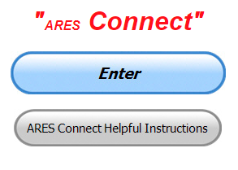

***Connecting Amateur Radio Volunteers with a Purpose***

Hey everyone… please make sure to go in and register your time to all of the events that you have signed up for. Don’t forget to get this done no later than **5 days** after the event has ended. I’m asking you to do this for our ability to run reports accurately.

**I want to remind all of you that you do not have to be an ARES or ARRL member to use this system. All licensed amateur radio operators throughout the country are welcome and strongly encouraged to use it.**

TOP ^

**Don’t forget to check out the “Frequently Asked Questions” area that has been added to the Ohio Section website.** It’s there to help you through any difficulties that you may have with ARES Connect. Now, if you don’t any posts that relate to what you are having difficulties with, we now also have an on-line “Guru” area as well. This will allow you to ask any questions that you may have about ARES Connect.

**Let’s get everyone in the Ohio Section on “ARES Connect!!!” Simply go to:** <https://arrl.volunteerhub.com/lp/oh/> and get yourself registered and using the system.

***Here’s the top 10 hour earners so far in September:***

|  |  |  |  |
| --- | --- | --- | --- |
|  | **Name** | **Events** | **Hours** |
| **1** | Dwight Bonifield (W8TJT) | 112 | 156.00 |
| **2** | Leo Dubois, Jr. (KE8OOS) | 113 | 117.83 |
| **3** | Dan Stahl (KC8PBU) | 53 | 86.00 |
| **4** | James Yoder (W8ERW) | 10 | 67.25 |
| **5** | Christopher Domenick (KC8CAD) | 20 | 61.20 |
| **6** | Greg Dersarkisian (KD8SSJ) | 12 | 61.00 |
| **7** | Alan Rothweiler (N8CJ) | 22 | 51.00 |
| **8** | Bret Stemen (KD8SCL) | 22 | 47.50 |
| **9** | Diane Warner (KE8HLD) | 14 | 43.00 |
| **10** | Daniel Schlick (KB8LKH) | 18 | 37.10 |

***From The South 40***

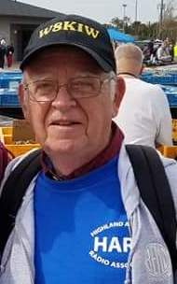*(from John Levo,* [*W8KIW@arrl.net*](mailto:W8KIW@arrl.net)*)*

Welcome again to news of what’s happening from the South 40. But first, thanks to those of you who sent notes concerning the column and especially those commenting about the passing of Bill ‘Doc’ Terrell, W8NTZ. I will make sure family members receive those messages.

The buzz throughout the region was the mid-week two-meter propagation. Although not that many area hams have made successful contacts, a lot of us enjoyed listening to distant repeaters and the contacts or attempted contacts on simplex. Tuesday evening had repeaters from Chicago to Central New York being heard. A Northern Chicago area machine was giving the Washington CH/Fayette ARA’s 147.27 net a run for its money Tuesday evening. On Wednesday a Northern Ohio ham was heard in QSO with a Missouri station on 146.55 and New Vienna’s Richie Hagen (N8CUB) made a 236 mile contact with a station in Boone, NC who had made a contact into Maine earlier in the day.

TOP ^

The Canadian VE3RSB repeater in Burlington, Ontario was heard on the Hillsboro 147.21 frequency-almost 350 miles. It was an interesting experience for many of our newer hams and some of us older ones too.

In 1990 the Cincinnati Reds stunned the baseball world by their ‘wire to wire’ win of the National League pennant and then sweeping the World Series. To commemorate the 30th anniversary of the feat, the Milford ARC has teamed with the Reds and will operate special event station W3R from October 16 through the 20th. MARC President Ron Brooks, AC8MA, states this operation in conjunction with the Reds is a great opportunity to celebrate this noteworthy occasion and promote the Reds and Southern Ohio region worldwide. Contact the Milford ARC at www.w8mrc.com for additional information.

The Portsmouth RC has restarted their monthly Laurels testing sessions. This month they had seven successful candidates for new licenses or upgrades. Tech licenses were earned by Charles Carter who is now KO4HCM, Travis Holden of Chillicothe who is now KE8PJE and Jeff Holmes is now K04HCN. Sam Johnson (W8SKJ) and Doug Broyles (KE8ORQ) each from Bainbridge upgraded to General as did Ironton’s Joseph Rudmann (KE8PHE). Greg Lawrence (W3WVA) from Huntington, WV upgraded to Extra. Those sessions are on the first Monday of each month at the American Legion Hall in downtown Portsmouth. The Southern Ohio ARA is holding a test session on September 21 in Coal Grove. Word from the Athens County ARA is they will sponsor a test session on October 19 at the Red Cross Building in Athens. It will begin at 7 pm. The Milford ARC states their monthly test sessions are on hold until the health emergency passes. Congrats also go to Mike Mider, KE8OJE, for passing his General test on-line. Across the river, Mason County EMA Director Bill Busser is now KO4FYC.

A good time was had by all who attended the annual Highland ARA Fall Picnic on Sunday afternoon. Hosts K8BAZ and KD8TUR report several dozen members and spouses attended the function at their rural Highland County farm.

Word from Athens’s Jeff Slattery, N8SUZ, is the annual Bobcat Trail Marathon scheduled for this fall at Burr Oak State Park has been cancelled by the sponsor. The Athens County ARA has provided communications for the event for many years.

The Southern Ohio ARA will hold their monthly meeting this Monday, September 21, at the Lawrence County EMA Center at Coal Grove. The meeting will be held following a VE test session to begin at 6 pm. Those testing and/or attending the meeting are asked to enter through the back-parking lot door. Walk-ins for the test session are welcome. All elements will be given.

Although Christmas is some distance away, some area clubs are already making plans and finding preplanning difficult. Ironton’s Southern Ohio ARA’s usual location for their dinner has closed and therefore they have moved the November 16 event to Frisch’s in Ironton. But even at that it is still subject to change. Highland ARA Secretary Kathy Levo, N8ZNR, states their dinner meeting is questionable because the church where it is usually held still has not reopened its gathering hall. Other venues allowing for a catered dinner still limit attendee numbers. Last year over 80 attended the event.

The Portsmouth Radio Club has already firmed their annual Christmas Dinner Meeting plans. It will be held at the Gathering Place in Wheelersburg. The highlight of the evening is the fundraising auction led by Gary Caldwell, WX8G, where you may find yourself buying and item you weren’t even bidding on.

TOP ^

Pat (N8BAP) and brother Richie (N8CUB) report their W8P operation from Paint Creek during the recent Ohio State Parks on the air drew a number of newly licensed hams and served as a great introduction to the world of HF radio. Four made their first HF contacts. They also reported several campers stopped by their campground location to see what was happening.

The previous virtual storm spotter training sessions have been so successful the Wilmington National Weather Service has scheduled another. The session will begin on Monday, October 5 at 6 pm and last until about 8. They are requiring an on-line preregistration. More information is available at [www.weather.gov/iln/onlinespotter](http://www.weather.gov/iln/onlinespotter).

Anyone wishing to try to work the new repeater on the International Space Station as it crosses over the Western section of Southern Ohio may have a chance on Sunday, Monday and Tuesday nights. According to the Cincinnati Enquirer, on Sunday a four-minute pass will occur from the west to northeast at 8:17 pm. It will again pass at 9:54 for a minute from the northwest. On Monday there will be a three-minute pass starting at 9:06 from the northwest to the northeast and about 15° above the horizon. A three-minute pass will happen at 8:19 on Tuesday evening at 21 degrees with a northwest to northeast movement. The repeater has an uplink of 145.99 with a 437.80 downlink. A 67 hz tone is needed. Some Southern Ohio stations have reported hearing past passes but no successful contacts have been reported to date.

***One Question Questionnaire***

Hey Gang,

“Survey Says”….. the answers really fooled me big time this week. Here’s how you responded

I belong to only one club: 40.17% - I belong to two clubs: 23.08%

I belong to three clubs 6.84% - I belong to four clubs 2.56%

I belong to more than four clubs 1.71% - I belong to NO clubs 25.64%

Ok, let’s move on to the next question. This upcoming week is Safety Week here in Ohio. Let’s find out just how many of you have membered that you are supposed to change out the batteries in your smoke detectors, and let’s also not forget to do the same with your Carbon Monoxide detectors as well

So, what we want to know with this question is just how many clubs you repeatedly belong to.

***“Have you changed the batteries in your Smoke and Carbon Monoxide detectors??”***

You’ll find the “One Question” questionnaire on the Ohio Section Website! <http://arrlohio.org> It’s all in fun and it’s not a scientific survey in any way, but we are learning some things that we didn’t know from these questions. I hope that you are enjoying answering these “One Question” questionnaires.

TOP ^

*****V.E. Test Sessions***

Many V.E.’s have decided to start testing once again, but with restrictions that need to be adhered to for sure. Here’s the link to find that V.E. Test session and what is expected of YOU before going. <http://www.arrl.org/find-an-amateur-radio-license-exam-session>

**PCARS - VE Testing - Saturday October 3rd at 10 AM Sharp**

There WILL be a VE Test Session at the PCARS Club Site in Ravenna on Saturday - October 3, 2020 - Starts at 10 am sharp.

- You MUST register in advance - NO WALK-INS will be accepted. Send an email to [KB8UUZ@gmail.com](mailto:KB8UUZ@gmail.com) to register.

- You will be required to have, in advance, a Form 605 - properly filled in and signed. Once you register a form 605 will be sent to you via email. You can print it out and fill it in.

- If you are sick, have a cough, a high temperature or have been exposed to COVID-19 or someone that has been infected - please, do not come to the club site.

- You will wear a mask covering your mouth and nose at all times.

- No food or snacks allowed.

**Only people that are testing will be allowed in the building.**

- $15.00 Fee Payment will only be by check or exact change. We cannot make change

- If paying by check, make check out to: "ARRL-VEC" Fee is $15.00

**Ensure you have the following:**

A picture ID such as a valid Driver's License, State ID, School ID, or US Passport.

* If you are under 16 years of age, a parent or guardian must be able to vouch for you and you need a copy of your birth certificate (you do not have to give us a copy, we just have to see and verify)
* If you are taking a Technician test you will need either your FRN number (you can apply for an FRN on the FCC website) or Social Security Number.
* If you are upgrading to General or Extra - You MUST bring your original valid amateur radio license and a copy of your valid amateur radio license to turn in with your Form 605.

**Bring your own pencils and pens.**

Any questions? Contact [KB8UUZ@gmail.com](mailto:KB8UUZ@gmail.com)

TOP ^

***National Weather Service - Wilmington Conducting On-Line Skywarn Training***

Partners,

The National Weather Service - Wilmington - has scheduled a live online spotter training class for this autumn season on **October 5 from 6 pm to 8 pm EDT**.  NWS partners and the general public are welcome to attend the live online spotter training class. Registration is required, and can be completed at: <https://register.gotowebinar.com/register/4844007736691537676>

**As a reminder, if an individual registers, then becomes unable to attend, the individual is encouraged to cancel, freeing up that spot for another person.**

Feel free to share this with others within your counties or jurisdictions. Within a couple days, we will also promote this class via social media and on our office webpage.

One note: if a significant severe weather or flood event is forecast for or occurs on October 5, there is the possibility this webinar would need to be postponed.  Please let me know if you have any questions or comments.

Thanks,

Brandon Peloquin - Warning Coordination Meteorologist - NWS Wilmington, OH

***Weather Underground and Other Ham Weather Stations***

[](http://arrl-ohio.org/wus.html)Hey Gang,

This has really grown into a really cool area with reports literally coming in from all over the state!!

It’s really fun to see just how much the weather varies across the state and this gives you access to each individual station very quickly and easily.

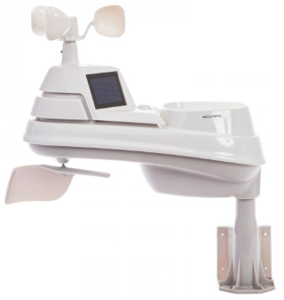Hey gang, if you haven’t looked at your Weather Underground dashboard lately you might want to. It seems that the nice folks there have taken the time to upgrade your dashboard. The new design is still being worked on from what information that I could gather, but they have done a really nice job. The new design is really easy to view and contains the same information at before, but it’s laid out in a really professional manor.

Now, our list of stations is growing all the time. How’s about your station? Is it listed with us? It doesn’t necessarily have to be a Weather Underground reporting station.

I’d love to have any weather station that is connected to the internet available for all of us to view, especially when the weather gets bad out. The more stations reporting the better.

TOP ^

Thanks to everyone who has contributed to this effort. If you haven’t, you really should take a look at the various weather stations around the state when we get bad weather coming in. You can really see just where the line of storms are as they cross through the state. It is very fascinating to watch it all unfold right you’re your easy chair, and all the data is real time! Here’s a link to all of those listed… <http://arrl-ohio.org/wus.html>

We’re got a really good collection of stations from all over and have tons of room to add more for sure. How’s about sharing your weather information with all of us! All that you need to do is send me your Weather Underground ID and your call sign and I’ll take it from there. Sent it to: [n8sy@n8sy.com](mailto:n8sy@n8sy.com)

***Final.. Final..***

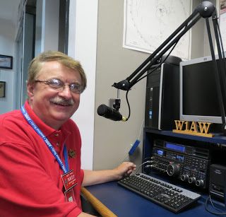Hi Gang,

This past week has been a really busy one. I attended several on-line question and answer sessions with clubs this past week as well as attending 4 different club meetings too.

Several of the club meetings I attended I actually got to do live – in person!! I have to admit, I really liked the idea of getting back out and actually seeing all of you once again.

We all kept to the social distancing guidelines and did elbow bumps instead of handshakes, but even though we all wore our masks and such, it was still the highlight of my week just to be there in person.

Zoom and all the other conference call apps are a great substitute for when travel just isn’t always possible, and I expect it will be used a bunch more even after the pandemic has been forgotten about, and that just might not be a bad thing either.

Many of the clubs that have employed one of the conference call apps are finding that it is giving some folks (like those that don’t drive at night or get around easily) a new opportunity to join back in on the meetings and fun and this gives folks that just can’t get out a real opportunity to get involved once again. No tell me, is that a bad thing?

It’s also giving folks from great distances the opportunity to join in as well. I’ve seen my friends Carole Perry and Tim Duffy a lot more now than ever attending meetings all over the place. And, it’s all because they don’t have to travel. They can sit back in their office chair in the shack and join in on any meeting with just the click of a button!

I’ve also seen a number of guest speakers at some smaller meetings that just would not have happened if the speaker needed to travel to their meeting. We’ve all complained about not having enough guest speakers available to help draw our members back to meetings, COVID-19 may have just found us a way of doing it!!

TOP ^

Ok… I’ve had a few folks ask if I got that closet cleaned out yet. The quick answer is no. After Janie and I looked at all the stuff that was laying on the floor waiting for an answer – Keep – Don’t Keep, we both decided that this just wasn’t the right time to do this. So, back into the closet everything went, at least for now. Some day we’ll have to make those hard decisions for sure, but for now, it can wait a little while longer!!

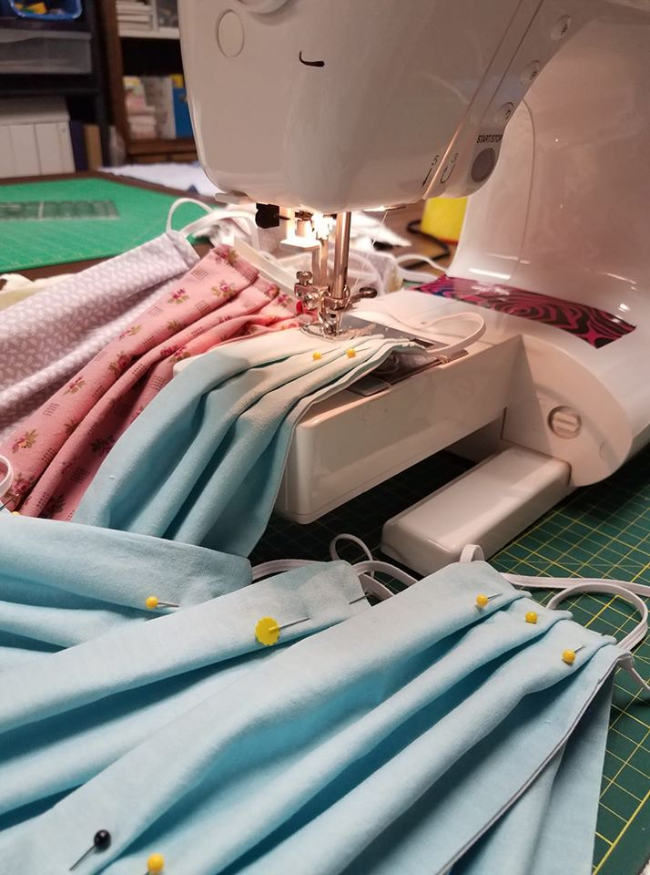For those of you who have asked what the count is now on how many masks Janie has made here’s what she told me. She’s lost count when she reached her goal of 2,000 masks. She knows that she’s well over that goal, but just stopped trying to count them all. I’m going to let the cat out of the bag on some very special masks that she made just for the Handbook Give Away… They are made from the ARRL 100th Anniversary Bandanna’s.

Whelp, that’s going to do it for this week my friends! I’m still looking forward to visiting with all of you live or via Zoom, WebEX or whatever. I really can’t wait for that time when we can all get together in person once again. Those are the times I cherish the most!!! Stay safe! We will get through this and when we do, we’ll have so much to talk about. Most of all… have FUN and get on the airwaves!!

73,

[***Scott, N8SY***](mailto:n8sy@n8sy.com)

Hey Gang,

Have you taken a look at the **Swap & Shop** page on the Ohio Section webpage yet?? Here’s a link that will take you there…

<http://arrl-ohio.org/sm/s-s.html>

Do you have equipment that you just don’t need or want anymore? Here’s a great venue to advertise it, and it’s FREE!!

Is your club doing a fund raiser to help raise money? After a lot of thought, it was decided that the Swap & Shop webpage could also contain these types of items as well. The same rules will apply as do for the For Sales and Give-A-Ways and will only be posted for a month at a time. Please see the Terms & Conditions on the webpage.

If your club is doing a fund raiser and wants more exposure, please forward the information to me and I’ll advertise it on the Swap & Shop webpage for you.

Now, I still want to remind you that it won’t be listed in this newsletter because it would take up way too much space, so your ad will only appear on the website. It is there for any individual to post equipment Wanted / For Sale or Give-Away as well as for Club Fund Raisers. No licensed vehicles/trailers or business advertising will be posted. Postings are text only (no pictures or graphics) will be posted for a maximum of 1 month from date posting and require a contact phone number or email within the posting. Send your Wanted / For Sale or Give-Away post to:  [swap@arrlohio.org](mailto:swap@arrlohio.org)

TOP ^

***Welcome New Subscriber(s)***

**Doug, N8FRJ; Clifford, KE8PDZ**

***Back Issues of the PostScript and Ohio Section Journal***

Hey, did you know that PostScript and Ohio Section Journal (OSJ) are archived on the website? You can go back and look at any edition simply by clicking:

<http://arrl-ohio.org/news/index.html>

***Want to Share your Club Newsletter With Others?***



We have a webpage where you can download and read all of the newsletters that I get from around the state and even other sections!

Here’s the link to the page…. <http://arrl-ohio.org/club_news/index.html>

Please, if you don’t see your club newsletter posted, it’s because I’m not receiving it. Just have your newsletter editor contact me and I’ll get your club’s newsletter listed on the site!!

We all learn and steal (I mean, share) from each other’s work. So, get me your newsletter!!! Send it to: [n8sy@n8sy.com](mailto:n8sy@n8sy.com)

Ohio Section Cabinet

|  |  |
| --- | --- |
| Section Manager – Scott Yonally, N8SY | Assistant Section Manager – John Perone, W8RXX |
| Section Emergency Coordinator – Stan Broadway, N8BHL | Section Traffic Manager – David Maynard, WA3EZN |
| Technical Coordinator – Jeff Kopcak, K8JTK | Affiliated Clubs Coordinator – Tom Sly, WB8LCD |
| State Government Liaison – Bob Winston, W2THU | Public Information Coordinator – John Ross, KD8IDJ |
| Section Youth Coordinator – Anthony Lascre, K8ZT | |

***It’s Fall!!!***

The fall equinox arrives on **Tuesday, September 22, 2020, at 9:31 A.M.** EDT. The equinox occurs at the same moment worldwide. What Is the Autumnal Equinox? Autumn days come quickly, like the running of a hound on the moor.

TOP ^

***Chit – Chat, and All That!***

Do you know someone that’s not getting these Newsletters? Please, forward a copy of this Newsletter over to them and have them “[Opt-In](mailto:Opt-In)” to start receiving them. Heck just have them send me an email [n8sy@n8sy.com](mailto:n8sy@n8sy.com) and I’ll get them added to the Ohio Section Emailing list.

We now have many thousands of readers receiving these newsletters weekly. Quite impressive, I’d say! I urge all of you to make sure that everyone, regardless of whether they are a League member or not, get signed up to receive these weekly Newsletters.

You can always “Opt-Out” at any time if you feel this is not what you were expecting. It’s fun and very informative. All of your favorite past newsletters are now archived too.

You can go back at any time and read them. Just go to: <http://arrl-ohio.org/news/>

Got questions, concerns or would just like to sit and chat awhile? Heck, I’ll even buy the coffee!! Give me a call at (419) 512-4445 or email me at: [n8sy@n8sy.com](mailto:n8sy@n8sy.com)

The pictures on the front page and throughout this newsletter are from various newsletters, Facebook posts and/or were sent directly to me in recent weeks. Take a good look at them, you just might be in one of the pictures! “SMILE… you’re in the Ohio Section News!!”

***Stop!!! You’ve reached the end of this week’s edition.***

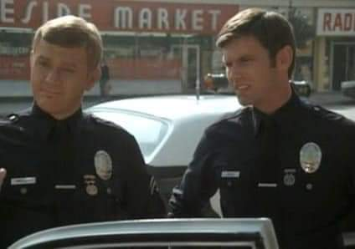

TOP ^

*PostScript is produced as a weekly newsletter. I want to thank everyone that has contributed articles and ideas to make this an even better news source. I sincerely hope that you have enjoyed this edition and will encourage your friends to join with you in receiving the latest news and information about the Ohio Section, and news and events happening around the world!*