[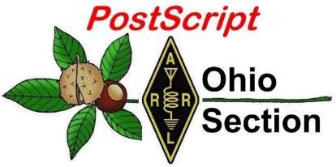](http://arrl-ohio.org/news/) ***September 14th***

***Edition***

🡪 National News 🡪 The Handbook Give Away

🡪 Club Corner 🡪 Hamfests

🡪 DX This Week 🡪 ARES Connect

🡪 VE Testing 🡪 One Question Questionnaire

🡪 From Points South 🡪 Final.. Final..

***OSPOTA 2020***

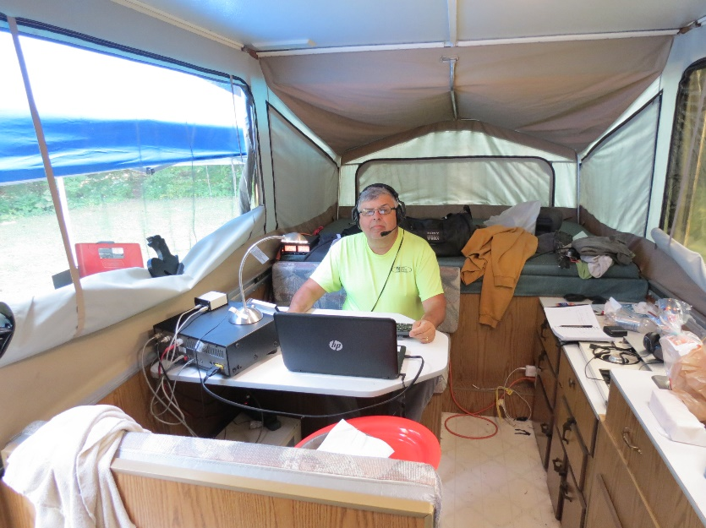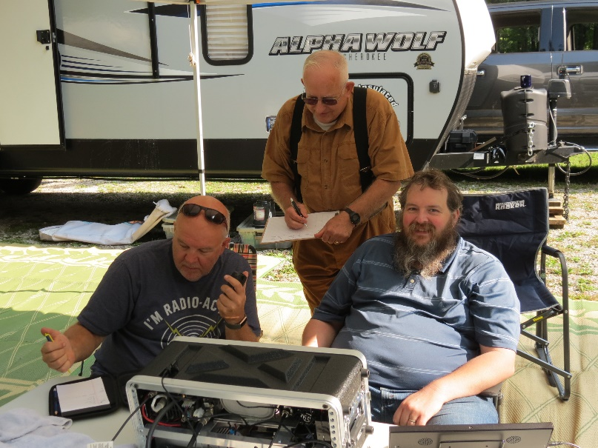

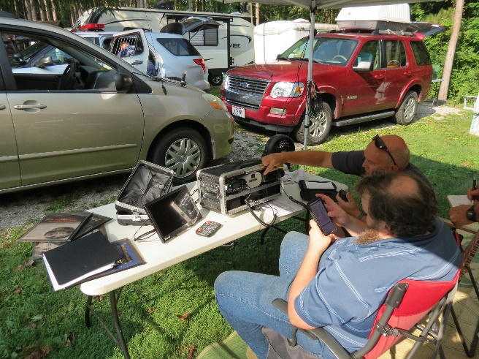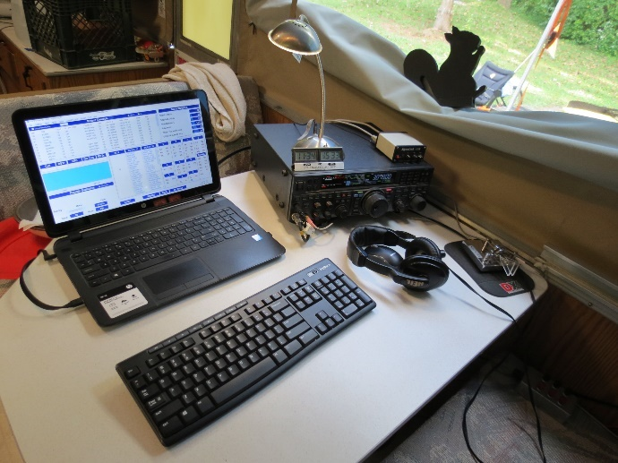

***National News***

*(from arrl and other sources)*

**Air Force Research Laboratory Tracks Sporadic E**

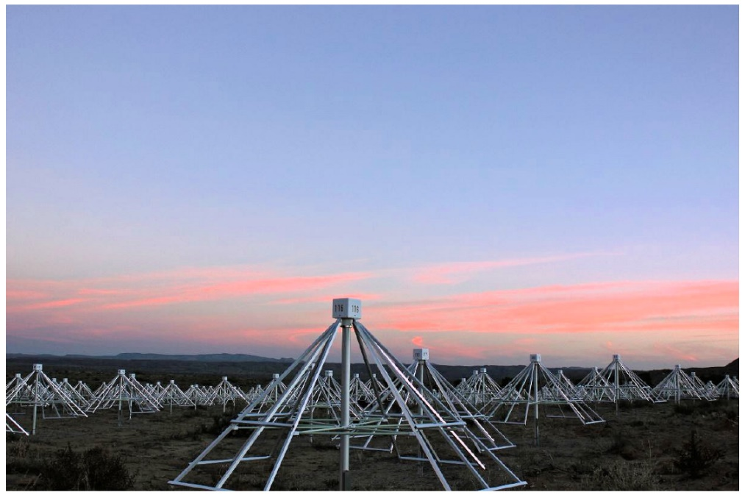Researchers at the Air Force Research Laboratory ([**AFRL**](http://www.afresearchlab.com/)) in New Mexico have discovered a new way to track and characterize sporadic E, which occurs when large structures of dense plasma form naturally in the upper atmosphere. These plasma structures, which occur at mid-latitude locations around the world, can affect radio wave propagation in both positive and negative ways. VHF enthusiasts frequently take advantage of sporadic-E propagation (or E-skip) to work stations outside of their local area.

“Previous methods to observe these structures were insufficient for identifying and tracking these structures over large regions,” said Ken Obenberger, a research physicist at AFRL. “It would be advantageous to actively identify where these structures are, where they are going, and how dense they are. And we thought we could find a better way.”

The new method, developed by Obenberger and collaborators at AFRL and the University of New Mexico, leverages unintentional RF emissions from power lines, and using broadband radio noise, they can map and track dense sporadic-E structures.

“Since power lines are widespread, we can observe sporadic E over a very large region surrounding our observatory, the Long Wavelength Array (LWA), an asset of our collaborators at the University of New Mexico,” Obenberger said. “This technique could be used anywhere in the world where there is an electrical grid and an instrument similar to the LWA, and we are lucky because there are not many.”

This kind of technology could be of interest to those who rely on HF and VHF frequencies, such as radio amateurs, mariners, broadcasters, and the military.

Radio amateurs have long taken advantage of sporadic E for long-range communication in the VHF bands, such as 6 and 2 meters. Climatology of sporadic E can provide a probability that it will occur, but the actual presence of sporadic E can only be determined through trial-and-error observations.

“This is similar to how meteorologists can predict how likely thunderstorms will occur in the afternoons above New Mexico during monsoon season, but use Doppler radar to identify and track specific thunderstorms as they occur,” notes Chris Fallen, KL3WX, one of Obenberger’s collaborators at AFRL. “Ken’s technique basically provides weather radar for sporadic E, only using radio noise from power lines as the radar transmitter.”

Having accurate “now-casting” of sporadic E could prove critical during disaster situations where hams may play a key role in supporting communication of vital information.

TOP ^

“Better understanding will lead to improved design and use of radio systems that mitigate the negative effects and take advantage of the good effects, thereby ensuring a stronger emergency communication network,” Obenberger said. “We are interested in sporadic E and the effect it has on radio wave propagation, both good and bad.” *— Thanks to Joanne Perkins, Air Force Research Laboratory*

####

***To ARRL Members:***

Members are reminded that there are contested elections in the Dakota, Great Lakes and Midwest Divisions. Unfortunately, incorrect information regarding the use of electronic balloting in ARRL Division elections was disseminated in the Midwest Division. ARRL does not use electronic voting. The only way you will be able to cast a vote is by U.S. Postal Service mail and, as a member driven organization, we urge you to participate by casting -- mailing in – your ballot. Ballots will be mailed out to members, accompanied by photographs of each candidate and a 300-word statement (if provided by a candidate) by October 1, 2020. If you do not receive your ballot by October 16, please contact [cpereira@arrl.org](mailto:cpereira@arrl.org).

Thank you for being a loyal member of the ARRL.

*The Ethics & Elections Committee of the Board of Directors,*

*Fred Hopengarten, K1VR, Chairman*

*Jeff Ryan, K0RM*

*Mike Ritz, W7VO*

####

***ARRL Technical Service Award Conferred***

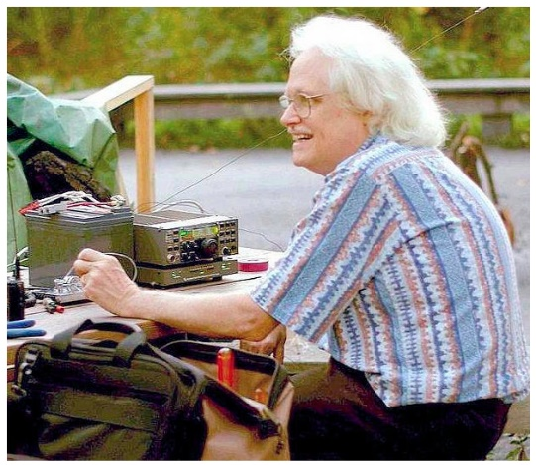The ARRL Board of Directors has named James W. Brown, K9YC, of Santa Cruz, California as the recipient of the 2020 ARRL Technical Service Award. The Board cited Brown’s frequent contributions to — and presentations at — amateur radio forums at conventions including Dayton Hamvention®, Pacificon, and the International DX and Contesting Convention in Visalia, California.

He also has collaborated with the ARRL Lab, contributed to various ARRL publications, including *The ARRL Handbook*, *The ARRL Antenna Book*, and others, and shared his technical and educational expertise in the fields of audio engineering, RFI, and other aspects of electronics and engineering. Brown shares his knowledge and expertise with the amateur radio community via his [**informational website**](http://k9yc.com/publish.htm).

The Board said, “Brown continues to provide his expertise as a means of ‘giving back’ to the amateur community, in the spirit of the amateurs that worked with him when he was first licensed at the age of 13.”

####

TOP ^

***Plants grow faster with 40 meter radio emissions***

*(Submitted by Gregory Drezdzon, WD9FTZ)*

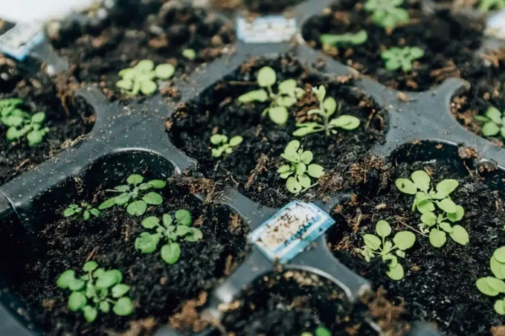

New Scientist magazine reported on August 14 issue that researchers in Paris have discovered the growth of plant seedlings was faster after they subjected the plants to frequencies in the 40-meter band.

The researchers from the Sorbonne University found that RF pulses at 7 MHz altered a type of biological protein receptor that controls plant growth rates in cress seedlings making them grow faster than normal.

The researchers say similar biological receptors occur across insects, birds and other animals too, including humans.

These receptors have roles not only in growth rates but also in regulating biological “clocks” or in birds navigating by the Earth’s magnetic field.

This is the first time that radio signals have been found to affect biological receptors and it has implications around whether life itself could be impacted by RFI.

<https://www.newscientist.com/article/2251835-plant-protein-responds-to-radio-waves-by-making-seedlings-grow-faster/>

####

***Programming Your Radio For The ISS Crossband Repeater With Chirp***

*(from Mike Thompson, WB8ERJ’s* [*Blog site*](https://mikestechblog.com/programming-your-radio-for-the-iss-crossband-repeater-with-chirp/)*)*

As of September 2, 2020, the new **FM Crossband repeater** on board the [International Space Station](https://www.nasa.gov/mission_pages/station/main/index.html) is activated. This is great news as it has been quite a while since anything significant has happened with*Ham radio on board the ISS*. Early reports indicate that the receiver is quite sensitive and can be used with just a handheld such as a Baofeng.

If you have never done any space communications via ham radio, there are some things to get acquainted with. The most important one is Doppler Shift. This can be a bit tricky. What is happening is that as ISS is moving and transmitting, you have to have to adjust your receive/downlink frequency. It is the same phenomenon as a passing train blowing its whistle, and you hear the tone of the whistle drop as it passes by you. In the case of the ISS, what you have to do is to listen a little bit higher when it is coming at you. As it is more overhead, you will hear it become noisy in your receiver. Just tune down 5 kHz, and you will hear it. As the ISS moves away from you, you will have to tune down another 5 kHz.

TOP ^

The new crossband repeater on the ISS has an uplink frequency of 145.990 mHz and a downlink frequency of 437.800 mHz. In order to access the crossband repeater, it requires a 67 Hz tone on your radio. Also, this is an FM repeater.

The best way to handle doppler is to pre-program the frequencies into your radio. I use the [Chirp program](https://chirp.danplanet.com/projects/chirp/wiki/Home). Its free and open source. This is what I use for my [Yaesu FT-857D](https://www.yaesu.com/indexVS.cfm?cmd=DisplayProducts&encProdID=8CBB7C4BDBAF40129AD4253A4987523C) as well as my various handhelds like my [Baofeng](https://baofengtech.com/) radios. You can download [Chirp here](https://chirp.danplanet.com/projects/chirp/wiki/Download) if you don’t already have it.

Below is a screenshot of a portion of my chirp file for my FT-857. I have programmed 5 channels for the ISS Crossband Repeater. This allows me to easily adjust for doppler as things get quite busy when working the ISS Crossband repeater.

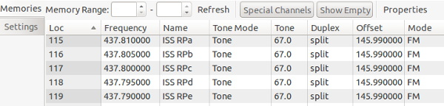

Some items to note, I gave each channel a specific name. Obviously, it starts with ISS so I know what satellite I am dealing with. In addition, I also added RP for Repeater. The reason for this is that there are other ham radio rigs on board the ISS such as APRS and I didn’t want to get confused. Additionally, I added a lower case letter at the end.

So, at the beginning of the ISS pass, I start out on the channel labeled ISS RPa and listen. Sometimes on a low pass I will toggle between ISS RPa and ISS RPb since the effect of Doppler isn’t as pronounced on a low pass as it is on a more overhead pass.

Speaking of listening, its best to run your radio unsquelched. In the past I have missed passes of other satellites because I had my radio squelched. Even though unsquelched can be annoying, it does give you the best chance for success in working the ISS crossband repeater.

Once your radio is programmed, the next problem is knowing when the ISS is visible. There are several satellite

tracking programs available for download. Being a Linux guy, I use [gpredict](http://gpredict.oz9aec.net/). Its free and open source. There are other windows and MAC based satellite tracking programs as well. Doing a google search and you will find several for whatever computer you are using.

Another option if you don’t want to download and install software is to use [N2YO’s Satellite page for the ISS](https://www.n2yo.com/?s=25544). There are also apps for android and iPhone to tracking satellites as well.

One thing I do when working the ISS crossband repeater is record the pass. This helps with logging as it is very fast paced and its quite easy to mis-write a call.

Hope to catch you on the ISS repeater someday!

####

TOP ^

***Raspberry Pi ham radio tutorial***

*(Submitted by Gregory Drezdzon, WD9FTZ)*

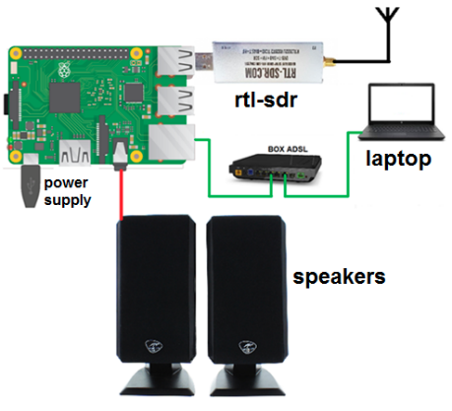

Al Williams, WD5GNR, writes **a** tutorial using Raspberry Pi for amateur radio produced by Anthony Le Cren, F4GOH.

<https://hamprojects.wordpress.com/2020/09/06/raspberry-pi-for-ham-radio/>

<https://hackaday.com/2020/09/08/tutorial-for-setting-up-raspberry-pi-for-ham-radio-use/>

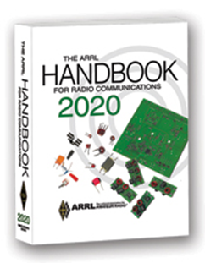***The Handbook Give Away***

Hey Gang,

Have you registered for the “Handbook Giveaway” drawing for this month yet? If you haven’t, go to: <http://arrl-ohio.org/handbook.html> and get yourself registered now!

What’s the catch? I want to get everyone checking in to the Ohio Section website as often as possible, and in order to register each month, you have to visit the website often! There’s nothing else to it. I pay all expenses and I usually “Give Away” more than just a Handbook too!!

Many of you ask me just how do I know when the drawing is on? Well, that’s easy all you need to do is check in on the Ohio Section Website on a regular basis and watch for the big [RED](http://arrl-ohio.org/handbook.html) Arrow that will appear on the left side of the page. This is the sign that the drawing is on and you need to get registered. So, keep a sharp eye out on the website and check in often!

***Club Corner***

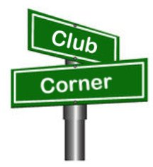

This is YOUR cornner of the newsletter. Send me what your club is doing and I’ll make sure that it gets in. Got a special event or club project that you want everyone to know about? Send it to me!. Need help with a project? Send it to me.

Let me know what you club is up to. Are you going to have a special guest at your meeting or are you having a special anniversary? Just sent it to: [n8sy@n8sy.com](mailto:n8sy@n8sy.com)

TOP ^

***Why Simulated Emergency Test is Important***

*(C. Matthew Curtin KD8TTE)*

We're less than three weeks away, and now it's time to finalize our plans for the annual Simulated Emergency Test (SET). We've been training for twelve weeks for this, developing the idea of what we're doing and how to do it. Today I want to consider why we run the SET.

Amateur radio exists as a service for several reasons, spelled out clearly in the regulations that define the amateur radio service in the United States. The value that we provide as a public service in times of emergency is critical to the justification. Right at the opening of the regulation, we see:

*§ 97.1 Basis and purpose.*

*The rules and regulations in this part are designed to provide an amateur radio service having a fundamental purpose as expressed in the following principles:*

*(a) Recognition and enhancement of the value of the amateur service to the public as a voluntary noncommercial communication service, particularly with respect to providing emergency communications.*

The SET's threefold purpose goes right to this first fundamental principle for the existence of an amateur radio service. ARRL defines the SET including its purpose, which I'll paraphrase as

1. Test our capability,
2. Demonstrate our capability, and
3. Develop our operators' capabilities.

We'll briefly discuss each.

**Test Our Capability**

The full text is "To find out the strengths and weaknesses of ARES, NTS, RACES and other groups in providing emergency communications." Note it isn't to theorize or to postulate, but "to find out." It's an examination of performance.

Most of us have probably heard stories of computer systems that suffered catastrophic data storage failure, and the people who said how happy they are to have those data recovery plans and expensive backups. We've also heard the stories of the backups that were blank because the backup process didn't actually run, or backed up the wrong part of the system. The point is that an untested plan isn't a reliable one, and a plan for handling an emergency is no good if it's not reliable.

Thus, the SET supports the first principle of amateur radio purpose.

**Demonstrate Our Capability**

The full text reads, "To provide a demonstration--to served and partner agencies such as the American Red Cross, the emergency management agency and through the news media--of the value to the public that Amateur Radio provides, particularly in time of need."

Again, it's not assertion, but demonstration. It's "show, don't tell."

TOP ^

Demonstrating individual tasks, showing off a go kit in action, and getting an antenna up are all great things. But they're not enough. To show the value of the service, it needs to demonstrate what can be done end to end. Not just within a single county, but how that county can remain connected to the rest of the state, and the rest of the country, through the emergency service we provide.

Only when the SET is working with others can we demonstrate our ability to address the needs of a community during an emergency. That's why we all operate at the same time as much as possible, why ARES and NTS work together to originate, relay, and deliver messages.

Thus, the public and officials serving them can see that amateur radio isn't just the local club of people who do… something with radios. They can see the system in action and understand what the nationwide network of amateur radio operators can do for them in an emergency. When they understand how it works in practice with realistic conditions, they can build the service into their emergency management plans.

**Develop Our Operators' Capabilities**

The last element of the SET's purpose is "To help radio amateurs gain experience in communications using standard procedures and a variety of modes under simulated-emergency conditions."

We're not just putting the EC and some top operators on display. We need to recruit, train, and integrate newer licensees into the Field Organization that provides the emergency communications service. SET is how to do it: the exercise helps us all to focus our attention on specific fundamental objectives. Experienced operators can show the newer how to achieve them. The newer can ask questions and bring fresh perspectives that help to improve options and performance.

Thus the entire system of ARES, NTS, and other amateur radio organizations strengthens, improving capability and reliability in the first principle of amateur radio's purpose.

The County Information Report Project 20 has a few objectives left to help prepare for SET. We've got an exiting exercise ahead of us, where local play will be locally focused, but coordinated more broadly, improving realism, and again this year testing things that haven't been tried before.

Take the time now to register your SET operation with us. Registration is for limited time: exercise planners and controllers will need time to integrate your operation.

<https://www.blackswancomex.org/2020/register>

Train hard. Have fun!

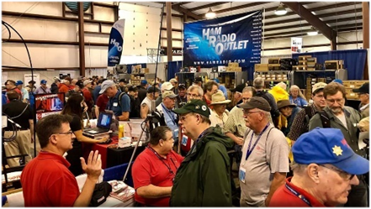

[***Upcoming Hamfests***](http://arrl-ohio.org/hamfests.html) ***for 2020***

**09/27/2020 | Cleveland Hamfest and Computer Show**

***Canceled***

**10/10/2020 - Northwest Ohio Amateur Radio Club (NWOARC) Fall Hamfest*****Canceled***

TOP ^

**11/01/2020 - 60th Massillon Hamfest**Location: Massillon, OH  
 Sponsor: Massillon Amateur Radio Club  
 Website: <http://w8np.org/hamfest.htm>

**11/14-15/2020 – Fort Wayne Hamfest and Computer Expo**

***Canceled***

**12/05/2020 - Winterfest 2020**Location: Delta, OH  
Sponsor: Fulton County Amateur Radio Club  
Website: <http://k8bxq.org/hamfest>

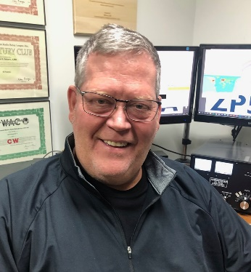***DX This Week***

*(from Bill, AJ8B)*

***DX This Week – State QSO Parties***

***Bill AJ8B (aj8b@arrl.net, @AJ8B, or www.aj8b.com)***

***CWOPs Member #1567***

This past week really supplied some interesting DX. There were many entities spotted in the Midwest including Angola, Argentina, Azores, Bosnia-Herzegovina, Brazil, Bulgaria, Canary Islands, Cayman Islands, Chatham Islands, Chile, China, Colombia, Costa Rica, Cuba, Czech Republic, Dominican Republic, England, Falkland Islands, France, Germany, Gibraltar, Greece, Greenland, Guadeloupe, Hawaii, Hungary, Italy, Japan, Kenya, Kyrgyzstan, Mauritania, Mexico, Netherlands, New Caledonia, New Zealand, Northern Ireland, Norway, Panama, Portugal, Puerto Rico, Sardinia, Slovenia, Spain, St. Martin, Ukraine, Uruguay, and Venezuela.

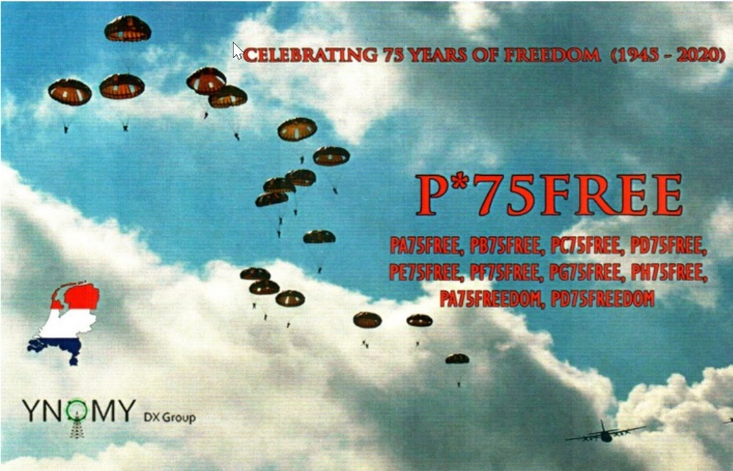I received QSL cards from CU3ED, David in the Azores, VP2VP/MM from Martti, OH2BH, and a commemorative QSL card from PF75FREE. (Shown) This QSL card commemorates the 75 years of freedom since the end of World War II.

I had a great discussion on 30 meters with Uncle Frank this past week. I have two excellent articles to share with you and they are both timely. I could not decide which to highlight. Frank suggested both and since he is always right, I have included them both!

TOP ^

The first is from propagation guru, Carl, K9LA. Carl has permitted me to reprint this and it is very interesting.

The second article is about a national State QSO party contest and is reprinted with the permission of the National Contest Journal.

The Future of Propagation Predictions Carl Luetzelschwab K9LA September 2020

I’ve been working on a project that got me thinking about what’s in the future for propagation predictions. I’ve broken my thoughts into two issues: the ionospheric model in our propagation predictions and how propagation predictions will be used.

**Model Issues**

**The F2 region model -** Much effort is currently underway to better understand the day-to-day variability of the F2 region. Our present understanding of this short-term variability is statistical in nature, and that’s why our propagation predictions give us monthly median values (usually MUF and signal strength) versus a smoothed solar index (either smoothed sunspot number or smoothed 10.7 cm solar flux). The problem is that this short-term variability depends on more than just solar radiation. Yes, solar radiation instigates ionization, but geomagnetic field activity can modify the amount of ionization at any given point on Earth. But that’s still not the whole story. The third variable is events at ground level and in the lower atmosphere that can couple up to the ionosphere to possibly further modify the amount of ionization at a given location. As research into this third variable continues, parameters to define these events need to be defined. Then a model relating these parameters to the effects on the ionosphere needs to be developed. Eventually this will lead to daily propagation predictions – in other words, what is the ionosphere really doing right now.

**Assimilation of ionosonde/TEC data** - Until events at ground level and in the lower atmosphere are well understood and characterized, assimilative models of the ionosphere will be further developed. Real-time ionosonde data and/or real-time TEC (total electron content) data will be used to make our monthly median predictions closer to real-time conditions. The Committee on Space Research (COSPAR) and the International Union of Radio Science (URSI) is working towards this goal with the International Reference Ionosphere (IRI). It is called the IRI Real-Time model.

For more information on this, see reference 1 below

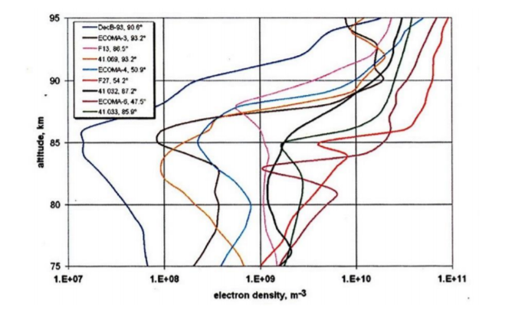

TOP ^

**The D region model** **-** The part of the ionosphere that we know the least about with respect to short-term variability is the D region. The model of it in our prediction programs is based on a limited number of rocket flights, a limited amount of incoherent scatter radar data and theoretical considerations. The model assumes a smooth electron density profile versus D region height. In the following figure, compare that smooth model to what the D region can look like in the real world from actual measurements. Experimental and theoretical research into the lower atmosphere and lower ionosphere is needed to give us a better understanding of the region that is most important on our lower HF bands (due to ionospheric absorption).

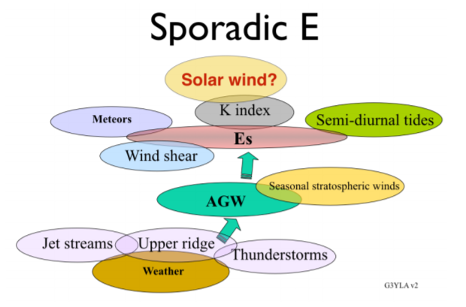**Sporadic E -** Our understanding of sporadic E still isn’t complete. We know the basic drivers of sporadic E, and experimental data (most recently from occultation data from GPS frequencies) has given us the most likely times and locations for sporadic E. But we can’t predict exactly when and where it will occur. It would be nice to have this in our propagation predictions. Jim Bacon, G3YLA, a professional meteorologist in the United Kingdom, is investigating the tie between sporadic E and underlying “weather” phenomena per the following sketch [reference 2].

**How propagation predictions will be used -** The current SDR radios, and even some analog radios (like my Ten-Tec OMNI 7), have screens that could be used to display propagation predictions and related information. The particulars of your station could be input to the prediction software. This could include antenna gains (from antenna modeling software such as EZNEC or 4nec2), your man-made noise environment, transmit powers and even receiver MDS (minimum discernible signal) for analysis on the higher HF bands and 6-Meters where man-made noise may not be the limiting factor. With assimilative ionospheric models, turning on the radio could display a worldwide MUF (maximum usable frequency) map that represents near real-time conditions. With a full model that includes the three variables, current space weather data and current terrestrial “weather” data could be downloaded to give the same information. Sporadic E predictions could also be included. For DX chasers, your DXCC status could be input to the software.

Propagation predictions to your needed entities (by band and even by mode) could be displayed – not only predictions for right now, but also when the best time might be. And if the time is right now to work a new entity on one of our bands, the prediction software could change your radio to the right band, turn on the amplifier and turn your antenna to the DXCC entity. For contesters, the predictions could display the best band to be on right now to maximize your score per the contest rules. These predictions would include your station specifics so you’re not getting predictions for legal limit power when you’re QRP. I’m sure there are other innovations coming. We’ll just have to wait to see what happens.

**Summary -**  One thing I haven’t discussed is a fully-automated station. That can be done now with the digital modes and advancing technology will allow it to happen with the other modes (if it already hasn’t!).

References 1) Bilitza, D., D. Altadill, V. Truhlik, V. Shubin, I. Galkin, B. Reinisch, and X. Huang (2017), International Reference Ionosphere 2016: From ionospheric climate to real-time weather predictions, Space Weather, 15, 418-429, doi:10.1002/2016SW001593.

2) <https://www.youtube.com/watch?v=wn5as91ndG4>

**\*\*\*\*\***

TOP ^

***Taking QSO Party Contesting to the Next Level***

*(Tom Williams, N2CU /* [*n2cu@roadrunner.com*](mailto:n2cu@roadrunner.com)*)*

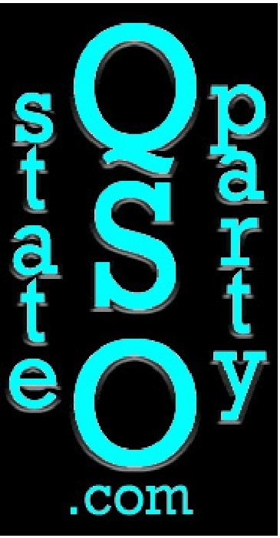State QSO parties have been in the contesting arena for decades. Pennsylvania has had a QSO party since 1957, Washington and California since 1966; Georgia also has had one for more than 50 years.

I recall operating my state's New York QSO parties in the mid-1970s, before it went away for decades. A new sponsor revived it. Some states with little or no state QSO party activity have joined forces with neighboring states to create regional QSO parties. The New England QSO Party (NEOP) and the 7th Call Area QSO Party (7OP) are two examples. State QSO party participants may include non-contesters just stopping by to let you know you're being heard, the casual contester doing only search and pounce, or the serious contester operating full -time SO2R. Mobiles and rovers activating multiple

- and often rare - counties are the lifeblood of these events. County hunters also can benefit from QSO parties by working stations in rare counties that might not have resident hams or are infrequently activated.

On any given weekend, you're likely to find a QSO party on the schedule, and they're a great way to keep your contesting skills sharp. Some states take a friendly approach, with participants taking time on the air to explain the contest or tell you about the weather. Camaraderie among operators often stems from making repeated contacts with the same stations on other bands and/or modes.

Interest in state QSO parties has surged over the past few years, and states that had been dormant in this regard have again joined in the fun. Doing well in a contest can earn you a plaque or certificate, and some even offer modest prizes as an added incentive.

Some smaller QSO parties don't have enough on-the-air presence to attract out-of-state participants. Those of us who love to operate these events felt that something needed to be done to increase interest and activity.

As avid QPers, Dave Edmonds, WN4AFP, and Stan Zawrotny, K4SBZ, brainstormed how they could establish a national program/points system in which competitive QPers could battle it out one contest at a time throughout the year. Another objective was to tie all QSO parties together to create something bigger than just individual contests.

Dave and Stan wanted to create two programs - one for participation and one for performance. The goal would be an increase in contacts for in-state participants and more logs submitted to the QP organizers, as well as building relationships between contesters. A prime example is what Paul Newberry, N4PN (SK), brought to the contesting community. Not only could he win just about any contest but would always take time to greet his radio friends and have a short chat in the midst of the battle.

**The State QSO Party Challenge**

The first step was to establish the State QSO Party Challenge (SQP). This year-long competition would award points for cumulative number of contacts made and the number of states QSO parties participated in. The goal would be to encourage operators to participate in as many QSO parties as possible and become hooked on them.

TOP ^

The more QSO parties you work, the better your own state's party will be, because you learn how they work and how to play in them. The only requirements would be to participate in at least two QSO parties, make at least two contacts in each, and submit your scores to <https://3830scores.com/> . The results would be tabulated, and results published.

The second step would be to create a recognition program for the operators who put in the effort to win the OPs they enter. This would encourage competitive QPers to participate in more events and to challenge each other weekend after weekend. The QSO Party Cup leaderboard will be updated as results of each QSO party are published. The expectation is that we will see a much higher level of interest in the QPs and the QPs will gain prestige within the contesting world.

As 2020 approached, Dave and Stan decided to focus their energy on building the State QSO Party Challenge. Stan provided Dave with 3830 data in an Excel spreadsheet that included 1,296 operators who had participated in QSO parties during 2019. The next task was to find an internet home for the leaderboard and post statistics. Dave contacted Bruce Horn, WA7BNM, and he offered to help.

Dave hoped that they could roll out the 2020 State QSO Party Challenge before the initial QSO parties of the year took place - Minnesota, British Columbia, and Vermont all happen during the first weekend in February.

That was only 7 weeks away. Just 29 days before the planned kick-off, Bruce said he would launch the State QSO Party Challenge page on 3830 once the State QSO Party website was up and running. Additional team members were recruited. Mark, WB9CIF, a very active QPer and manager for the Indiana QSO Party signed on. About 2 weeks later, Jeff, N8II, and I agreed to join the team. Bruce launched the State QSO Party Challenge page on 3830scores.com 3 days ahead of our target date. To see current statistics, visit 3830scores. com and click the SOP Challenge link under Special Summaries.

The team began sending out news releases, contacting managers of other QSO parties, ARRL, CQ Magazine, and anyone else that could help spread the word of this exciting new competition. ARRL included our news release in The ARRL Contest Update newsletter, and Valerie Hotzfeld, NV9L, delivered a presentation on the State QSO Party Challenge on the Ham Nation webcast. The publicity seems to have stoked interest, resulting in greater participation in the early events. “I have a feeling that the Challenge provided an incentive to actively participate in all three QSO parties on the first weekend of February," British Columbia QSO Party Coordinator Rebecca Kimoto, VA?BEC, said. With many of the logs I received for BCQP, participants mentioned that it was the Challenge that prompted them to get in the hunt for BC stations. The State QSO Party Challenge seems to be off to a great start."

Vermont QSO Party Manager Mitch Stern, W1SJ, judged the QSO Party Challenge a winner. 'This year, folks were finding and working the Vermont stations on multiple bands and modes," he said. "This is despite the fact that conditions were quite poor with the sunspot number around O." He said one in-state operator who logged 276 FT8 contacts last year was able to maintain runs on CW due to the additional participation. More CW meant less FT8.

The Minnesota QSO Party obliterated its old record for number of logs submitted. "It's pretty evident from the data that the idea of a year-long State QSO Party competition struck a chord with a lot of participants, especially the non-Minnesota folks," said Mark Endorf, WA0MHJ, the MNQP director.

TOP ^

As of this writing, Vermont has received 259 logs (117% greater than 2019), and Minnesota, 419 logs (57% greater than 2019). Something magical is happening in QSO party contesting. Discussion of awards for both the SQP Challenge and the SQP Cup are in the works, and we recently received notice that lcom America wants to be a sponsor. We are also planning "Worked All QSO Parties" awards, which will be offered in 2021 to operators who par­ ticipate in all 46 approved QSO parties during the calendar year. So, why don't you join us in the fun?

For additional information, visit the State QSO Party website, <http://stateqsoparty.com/>



As promised last week, you will find a list of upcoming contests in the “Contest Corner”. I think this is important for someone who is trying to move up the DXCC ladder since entities that are on the rarer side and easiest to work in contests. Some of my best “catches” have been on the Sunday afternoon of a contest when the rarer entities are begging for QSOs. Of course, the gamble is that if you wait until Sunday, conditions may change or they simply won’t be workable. However, it is not a bad gamble. Of course, why not work the contest and have some fun!

The contests in red are those that I plan to spend some significant participation time on. PLEASE let me know if you are working contests and how you fared.

Thanks!

|  |  |  |
| --- | --- | --- |
| Sept. 16 | RSGB Autumn Series CW | <https://bit.ly/2XF8mSB> |
| Sept. 17 | Bavarian Contest Club QSO Party | <https://bit.ly/2MDzviG> |
| Sept. 18 | AGB NEMIGA Contest | <https://bit.ly/2AWBbRK> |
| Sept. 19 | Feld Hell Sprint | <http://bit.ly/2JcbOwW> |
|  | FOC QSO Party | [www.g4foc.org/qsoparty](http://www.g4foc.org/qsoparty) |
| Sept. 19-20 | All Africa Int. DX Contest | <http://bit.ly/H0IqQf> |
|  | ARRL 10 GHz and UP Contest | [www.arrl.org/10-ghz-up](http://www.arrl.org/10-ghz-up) |
|  | Iowa QSO Party | [www.w0yl.com/IAQP](http://www.w0yl.com/IAQP) |
|  | New Hampshire QSO Party | [www.w1wqm.org/nhqso](http://www.w1wqm.org/nhqso) |
|  | New Jersey QSO Party | <http://bit.ly/1nDlf8V> |
|  | QRP Afield | <http://bit.ly/2QACxFu> |
| Spet. 19-20 | SARL VHF/UHF Digital Contest | <http://bit.ly/H0IqQf> |
|  | Scandinavian CW Activity Contest | [www.sactest.net/blog](http://www.sactest.net/blog) |
|  | Washington State Salmon Run | [www.wwdxc.org](http://www.wwdxc.org) |
| Sept. 20 | BARTG Sprint 75 | <http://bartg.org.uk/wp/contests> |
|  | North American RTTY Sprint | <http://ncjweb.com/Sprint-Rules.pdf> |
| Sept. 21 | 144 MHz Fall Sprint | <http://svhfs.org/wp> |
| Sept. 24 | RSGB Autumn Series Data | <https://bit.ly/2XF8mSB> |
| Sept. 26 | AGCW UHF/VHF Contest | <http://bit.ly/292ubSX> |

TOP ^

|  |  |  |
| --- | --- | --- |
| Sept. 26-27 | CQWW RTTY DX Contest | [www.cqwwrtty.com](http://www.cqwwrtty.com) |
|  | Maine QSO Party | [www.ws1sm.com/MEQP.html](http://www.ws1sm.com/MEQP.html) |
|  | Nancy Kott-Fists Memorial KNOWCW | <http://fistsna.org/operating.html> |
| Sept. 28 | RSGB FT4 Contest Series | <http://bit.ly/38xg9V7> |
| Sept. 30 | UKEICC 80m Contests CW | http://bit.ly/2MbaURB |

***Route 66 On The Air - Sept 12-20***

|  |  |
| --- | --- |
|  |  |
|  |  |

The [Citrus Belt Amateur Radio Club](http://r20.rs6.net/tn.jsp?f=0017nFrUT5-V4dhY7QBU4ONy7_P6TOflVjbVzqYE83cWuYbUqCbOqn4w9iM2FcC5skYNVlpH2_5VKFC6p2C3y6pSxJAlE7O7-ewz1MjZbrXFxxiDbBaYUJ-booPUe4LmkvQC0EcL_d7odA=&c=0aR4Js65mgrevclprIJ7QFwxJgrthXMcRHAgjeC6BM3rhryq3Gq_NQ==&ch=ajBEahluhFyObVDdrGxxL41nihEOcU0gF6K5DW6YjBYoxSpAo-KpnQ==) will sponsor its 21st "Route 66 on the Air" special event September 12 - 20, with 21 stations, each with a 1 × 1 call sign -- W6A through W6U -- from cities along the highway. Route 66 is famous in American history as a major highway from the midwest to the west coast and is associated with American car culture as well as with the vintage *Route 66* television program in the early 1960s.

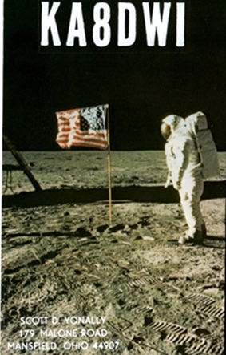***DX News***

***ARLD037 DX news***

This week's bulletin was made possible with information provided by XQ7UP, IW1RBI, The Daily DX, the OPDX Bulletin, 425 DX News, DXNL, Contest Corral from QST and the ARRL Contest Calendar and WA7BNM web sites. Thanks to all.

**MONACO, 3A.** Ennio, IW1RBI is QRV as 3A/IW1RBI until September 13.

Activity is on 80 to 6 meters using SSB, RTTY and FT8. QSL to home call.

**CHILE, CE.** Operators Mau, CE7KF, Juan, CE3BN, Roberto, CE3DOH and Esteban, XQ7UP are QRV with special call sign XR210CHI during September to celebrate Chile's 210th anniversary of independence. Activity is on the HF bands using SSB and various digital modes. QSL via XQ7UP.

**FEDERAL REPUBLIC OF GERMANY, DA.**  Special call sign DK70DARC is active until the end of December to celebrate the 70th anniversary of the Deutscher Amateur Radio Club. QSL via the bureau.

**FRANCE, F.** Members of the Radio Club Aunis are QRV with special event call sign TM17TDF until September 15 during the Tour de France. Activity is on the HF bands. QSL via F8FZC.

**SAINT BARTHELEMY, FJ.** Operators Franck, FG4ST, Marco, FS4WBS and Claude, FS5GL will be QRV as TO0Z from September 14 to 17. QSL via IZ1MHY.

TOP ^

**SAUDI ARABIA, HZ.** Members of the Saudi Amateur Radio Society will be QRV as HZ90ND from September 17 to 25 to celebrate the 90th anniversary of their National Day of the Unification of the Kingdom of Saudi Arabia. Activity will be on all bands and modes. QSL via operators' instructions.

**FAROE ISLANDS, OY.** Udo, DL2AQI and Torsten, DL4APJ will be QRV as OY/home calls from Streymoy Island, IOTA EU-018, from September 15 to 23. Activity will be on 80 to 10 meters using CW, SSB and various digital modes. QSL to home calls.

**SWEDEN, SM.** Frank, DH0JAE and Immo, DL8MF are QRV as SM/home calls near Bergudden Lighthouse, ARLHS SWE-091, on Holmon Island, IOTA EU-135, until September 16. Activity is on the HF bands using CW and SSB. QSL to home calls.

**DODECANESE, SV5.** Claudio, HB9OAU will be QRV as SV5/HB9OAU from Karpathos Island, IOTA EU-001, from September 12 to 24. Activity will be holiday style on 80 to 10 meters using SSB and RTTY. QSL to home call.

**UKRAINE, UR.** Special event station EN370LL is QRV during the month of September to celebrate the 370th anniversary of the town of Liubotyn. QSL via operators' instructions.

**CANADA, VE.** Members of the London Amateur Radio Club are QRV with special call sign VE3LON100 until the end of September to celebrate the 100th anniversary of the club. QSL via operators' instructions.

**AUSTRALIA, VK.**  Special event station VI75WW2 is QRV until November 11 to commemorate the end of World War II. QSL via operators' instructions.

**INDONESIA, YB.** Special event station 8A387KRW is QRV until September 14 to celebrate the 387th anniversary of the Karawang District. Activity is on 80, 40, 20, 15 and 2 meters using CW, SSB and FT8. In addition, members of the Orari Lokal Kabupaten Sukabumi club are QRV as 8A150SMI until September 13 to celebrate the 150th anniversary of the city of Sukabumi. QSL via operators'

instructions.

**ALBANIA, ZA.** Franz, OE6TQG is QRV as ZA/OE6TQG from Lake Shkodral until September 17. Activity is on the HF bands using all modes. QSL to home call.

THIS WEEKEND ON THE RADIO. The ARRL September VHF Contest, ARRL EME Contest, Worked All Europe DX SSB Contest, NCCC RTTY Sprint, NCCC Sprint CW Ladder, FOC CW QSO Party, SARL Field Day Contest, SKCC Weekend CW Sprintathon, Ohio State Parks on the Air, Texas QSO Party, Alabama QSO Party, Russian Cup Digital Contest, RTTYOPS Weekend Sprint and North American CW Sprint will certainly keep contesters busy this upcoming weekend.

The 4 States QRP Group Second Sunday Sprint and K1USN Slow Speed Test are scheduled for September 14.

The Worldwide Sideband Activity Contest and RTTYOPS Weeksprint are scheduled for September 15.

The RSGB 80-Meter CW Autumn Series, Phone Fray and CWops Mini-CWT Test are scheduled for September 16. Please see September 2020 QST, page 71, and the ARRL Contest Calendar and WA7BNM Contest websites.

TOP ^

***Special Events***

* **09/14/2020 | Texas DX Society 50th Anniversary**

**Sep 14-Oct 13, 0000Z-2359Z, K5DX/50**, Houston, TX. Texas DX Society. 14.074 14.040 7.074 7.040. QSL. Texas DX Society – K5DX/50, 5303 S Mason Rd Apt 212, Katy, TX 77450. Celebration of 50 years of Contesting and DX by our members. We plan to operate on 160-10 meters, 40 KHz above lower band edge for CW, on standard FT4 & FT8 frequencies, and 40 KHz above the lower edge of the General class phone band for SSB. We will operate on the VHF/UHF bands if there is propagation. [https://k5dx-50.tdxs.net](https://k5dx-50.tdxs.net/)

* **09/16/2020 | National Football League Centennial Celebration**

***Canceled***

* **09/16/2020 | The Saving of the Liberty Bell**

**Sep 16-Sep 25, 0400Z-2359Z, W3L**, Harleysville, PA. WV2M. 14.074 14.030 7.074 7.030; modes are SSB, CW and FT8. Primary Mode will be FT8. QSL. Frank Gallo, 106 Tweed Way, Harleysville, PA 19438. [www.w3l.info](http://www.w3l.info/)

* **09/18/2020 | Silver State Classic Challenge**

**Sep 18-Sep 20, 0101Z-0101Z, NV7V**, Las Vegas, NV. Clark County NV ARES. 147.18 145.22 145.24 446.60. Certificate. Tim, Duerson, 3719 Robin Knot Court, North Las Vegas, NV 89084. 40 hams providing safety communication for a non-profit and Guinness Book of records certified world's fastest race on a public highway and individual HF radio recreation overnight. www.sscc.us or [www.ccnvares.org](http://www.ccnvares.org/)

* **09/19/2020 | Clay County Pioneer Day Henrietta Texas**

**Sep 18-Sep 19, 2300Z-2259Z, KF5DFD**, Henrietta, TX. Clay County AMateur Radio Club. 14.255 7.255. Certificate. Michael B Boydston, 103 N. Crockett, Henrietta, TX 76365. The gathering of old-time residents of Clay County was called for August 19, 1932, at 3 p.m. by a group of local club women. The Clay County Pioneer Association was organized at this meeting. Committees were appointed to formulate it's Constitution and By-Laws, and to arrange for its First Reunion October 28, 1932. Check in to the net and learn more about the interesting history of Clay County Texas. [NOTE NEW TIME/DATE] [mbrentusa@gmail.com](mailto:)

* **09/19/2020 | Wisconsin Parks On The Air**

**Sep 19, 1100Z-2300Z, W9ZL**, Appleton, WI. Fox Cities Amateur Radio Club. 21.350 14.260 7.220 3.850. Certificate. Kenneth Ross, P.O. Box 2346, Appleton, WI 54912. The Fox Cities Amateur Radio Club (FCARC) is pleased to support the Wisconsin Parks on the Air (WIPOTA) operating contest. This contest is to promote public awareness of ham radio within Wisconsin’s beautiful state park system. [wipota.com](http://wipota.com/)

* **09/19/2020 | Woronoako Heights Outdoor Adventure/Scout Camps on the Air**

**Sep 19, 1300Z-1900Z, W1M**, Russell, MA. Western Mass Council BSA. 14.290 14.060 10.115 7.190 . QSL. Tom Barker, 329 Faraway Road, Whitefield, NH 03598. Manual logging as well as eQSL are used. 4x6 SASE helpful.

TOP ^

***“ARES Connect”***

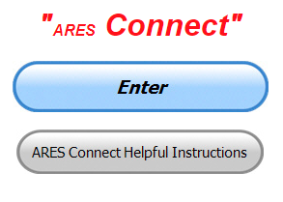

***Connecting Amateur Radio Volunteers with a Purpose***

Hey everyone… please make sure to go in and register your time to all of the events that you have signed up for. Don’t forget to get this done no later than **5 days** after the event has ended. I’m asking you to do this for our ability to run reports accurately.

**I want to remind all of you that you do not have to be an ARES or ARRL member to use this system. All licensed amateur radio operators throughout the country are welcome and strongly encouraged to use it.**

**Something new** has been added to Events in ARES Connect. A “Notes” area has been added for Admins to use. This new feature will automatically appear when you go to setup a new Event in ARES Connect. Since all of our volunteers have the Events Monitor set on their accounts, they can view the notes contained, but have no editing abilities. This new area was just setup this past week and I think it will be very useful for leaving notes to the volunteers and any notes that the admins may have about the event.

**Also newly added** is a “Frequently Asked Questions” area has been added to the Ohio Section website to help you through any difficulties that you may have with ARES Connect. Now, if you don’t any posts that relate to what you are having difficulties with, we now also have an on-line “Guru” area as well. This will allow you to ask any questions that you may have about ARES Connect.

Over the past several weeks I have given you some shortcuts that save you a lot of time and frustration getting signed up and recording your hours. We have had a few new folks join the ranks and are now starting to use the system as well. Please, we want every ham in the country using this system, if you know of someone that isn’t registered and using the system, get with them and help them get on their way with ARES Connect.

One question that I get asked by Section Managers and Section Emergency Coordinators all over the country is how do you know that a person who indicates he’s a Level Two or Three truly has had that training?

Here in Ohio Section we have a statewide database. This database was started years ago and has been a real great help to a few when they’ve lost their records and had no backups. This database is a repository for everyone’s NIMS certificates as well as any additional training that you have turned in. If you need to retrieve copies of your certificates and just can’t find them, you can request for them to be sent to you from what we have on file. It will be sent as it was received. With this database available, vetting a volunteer becomes a fairly simple process, at least as far as whether they have the training or not. If you are in the statewide database as a Level Two, that’s how you are listed in ARES Connect.

The ARES Connect database is regularly checked against our statewide database. This reconciliation process is what gives the system its credibility. This process is just like what each and every one of us do with our checking accounts every month. If it doesn’t balance out, then a thorough search is done to find the discrepancy.

The books have to balance! Currently we have 1440 volunteers in the database and our Database Manager, Jim, W8ERW does a fantastic job of making sure each volunteer is credited properly for the Level they have trained to.

TOP ^

Our most common mismatch found in the databases is when someone changes their call sign. ARES Connect will not allow the volunteer to change their Logon. So, a mismatch will occur even if the volunteer changes their call sign in the system. It hasn’t been anything that’s overwhelming, but if you’ve changed your call sign we will catch that up with a change to your Logon, as well along with a follow-up email letting you know that your Logon was changed.

**Let’s get everyone in the Ohio Section on “ARES Connect!!!” Simply go to:** <https://arrl.volunteerhub.com/lp/oh/> and get yourself registered and using the system.

***Here’s the top 10 hour earners so far in September:***

|  |  |  |  |
| --- | --- | --- | --- |
|  | **Name** | **Events** | **Hours** |
| **1** | Leo Dubois, Jr. (KE8OOS) | 71 | 74.58 |
| **2** | Dwight Bonifield (W8TJT) | 69 | 71.00 |
| **3** | Dan Stahl (KC8PBU) | 34 | 65.00 |
| **4** | Christopher Domenick (KC8CAD) | 13 | 41.70 |
| **5** | Bret Stemen (KD8SCL) | 14 | 41.00 |
| **6** | Daniel Schlick (KB8LKH) | 4 | 36.10 |
| **7** | James Yoder (W8ERW) | 6 | 30.75 |
| **8** | Ron Wilch (KE8PX) | 52 | 26.50 |
| **9** | Michael Lacumsky (W8MAL) | 11 | 26.00 |
| **10** | Alan Rothweiler (N8CJ) | 12 | 20.00 |

***From Points South***

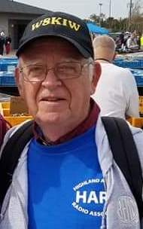*(from John Levo,* [*W8KIW@arrl.net*](mailto:W8KIW@arrl.net)*)*

Ohio Section Journal readers I am honored to be asked by Section Manager Scott to pen periodic articles about ham radio activities South of US 40. Perhaps the column should be retitled “The South 40” to reflect the mostly rural nature of the region. These articles are meant to let others know that ham radio is alive and well in Southern Ohio and in the many Northern West Virginia and Kentucky counties that border Ohio.

Yes, Scott and I go back some time, but neither of us were on first name bases with Marconi or the “Old Man”.

A little bit about me. I’m a retired Highland County banker living in Hillsboro. My wife Kathy (N8ZNR) is a retired high school teacher. We also own an Ohio Historic Family Farm situated on the highest point in Clinton County. It is the site for the annual joint Highland ARA and Clinton County ARA Field Day operation.

TOP ^

I also operate from there for the Ohio QSO Party and the Ohio Simplex Test. We have two adult children. David lives and works for an international architectural firm in New York City and Jennifer is a graphic designer for Hydro-Flask in Bend, Oregon. Of course, we can’t overlook our trusted beagle Pete-K9DOG.

I got into ham radio when a student at New Vienna where in 1963 I earned my Novice ticket (WN8KIW). Over the years I earned my 20 WPM Amateur Extra and have achieved DXCC and WAS. I’m also a VE for the Laurel, ARRL and W5YI programs and a certified ARRL instructor. However, my greatest ham radio accomplishment is earning USA-CA #798 for working all USA counties and transmitting from all 50 states, five Canadian provinces and all 88 Ohio counties.

Kathy and I are mostly active in the Highland ARA and members of some other area clubs. I am a 50-year member of the ARRL. Pete, Kathy and I also enjoy attending hamfests where we get to meet those we talk with over the air face-to-face. For the past eight years I have edited the weekly Monday Morning Memo that is distributed to the Southern Ohio ham community.

I’m excited about this opportunity to let OSJ readers know about the many clubs and hundreds of hams throughout the Ohio River Valley and the many activities taking place in the region. I can be contacted by e-mail ([jlevo@cinci.rr.com](mailto:jlevo@cinci.rr.com)) or snail mail at 21 Highland Drive, Hillsboro, OH 45133.

My plan to be a rover during Saturday’s Ohio State Parks on the Air was shelved by the memorial service for my early mentor, Bill ‘Doc’ Terrell, W8NTZ. However, I was able to get a bit of airtime during the day and hear or work several Southern Ohio clubs operating from our beautiful state parks. My home Highland ARA activated both Rocky Fork and Paint Creek. The Clinton County ARA operated from Cowan Lake. The Athens County ARA was heard from Stroud’s Run while on up US 33 the Hocking Valley ARA was active at Lake Logan and the Sunday Creek ARF worked from Burr Oak. The Fayette ARA activated Deer Creek and the Cambridge ARA was at Blue Rock. The crew from the Portsmouth RC headed to Shawnee while non-club operations took place at Tar Hollow and Pike Lake. Marietta’s K8RYU operated from at least six parks as a rover. Weather wise it was a great day to be outside, even though band conditions left something to be desired.

I’m wondering if some of the smoke from the Western fires were a propagation factor?

***New Guide for ARRL Logbook of The World (LoTW) Now Available***

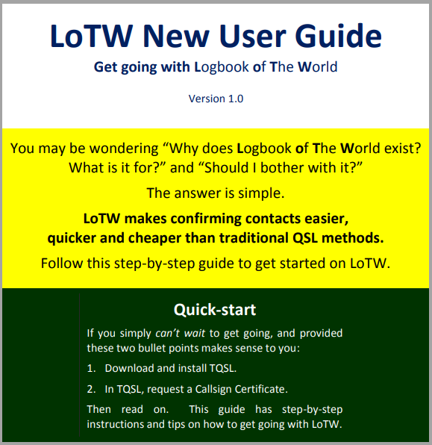*(from Anthony Luscre, K8ZT)*



In the last few months, a group of hams has been collaborating online through a shared Google Document to create a new guide to ARRL Logbook of The World (LoTW). This effort lead by chief editor Gary, ZL2IFB/G4IFB has resulted in a complete guide for both new and established users of LoTW.

The document is available at [www.g4ifb.com/LoTW_New_User_Guide.pdf](https://www.g4ifb.com/LoTW_New_User_Guide.pdf)

TOP ^

***One Question Questionnaire***

Hey Gang,

“Survey Says”….. about 18% of you planned on working the OSPAO over this last weekend. That’s a lot less than I would have thought would be participating.

Ok, let’s move on to the next question. Let’s find out just how many clubs, if any, do you belong to on a regular basis. A lot of us will join a club and only belong for a year, then we find that it’s not a good fit for us and we don’t renew.

So, what we want to know with this question is just how many clubs you repeatedly belong to.

***“How many ham radio clubs do you belong to on a regular basis??”***

You’ll find the “One Question” questionnaire on the Ohio Section Website! <http://arrlohio.org> It’s all in fun and it’s not a scientific survey in any way, but we are learning some things that we didn’t know from these questions. I hope that you are enjoying answering these “One Question” questionnaires.

*****V.E. Test Sessions***

Many V.E.’s have decided to start testing once again, but with restrictions that need to be adhered to for sure. Here’s the link to find that V.E. Test session and what is expected of YOU before going. <http://www.arrl.org/find-an-amateur-radio-license-exam-session>

***National Weather Service - Wilmington Conducting On-Line Skywarn Training***

Partners,

The National Weather Service - Wilmington - has scheduled a live online spotter training class for this autumn season on **October 5 from 6 pm to 8 pm EDT**.  NWS partners and the general public are welcome to attend the live online spotter training class. Registration is required, and can be completed at: <https://register.gotowebinar.com/register/4844007736691537676>

**As a reminder, if an individual registers, then becomes unable to attend, the individual is encouraged to cancel, freeing up that spot for another person.**

Feel free to share this with others within your counties or jurisdictions. Within a couple days, we will also promote this class via social media and on our office webpage.

TOP ^

One note: if a significant severe weather or flood event is forecast for or occurs on October 5, there is the possibility this webinar would need to be postponed.  Please let me know if you have any questions or comments.

Thanks,

Brandon Peloquin

Warning Coordination Meteorologist

NWS Wilmington, OH

***Weather Underground and Other Ham Weather Stations***

[](http://arrl-ohio.org/wus.html)Hey Gang,

I see that we haven’t run this article enough over the months. Last week I got several new weather stations to post on the website. This has really grown into a really cool area with reports literally coming in from all over the state!!

It’s really fun to see just how much the weather varies across the state and this gives you access to each individual station very quickly and easily.

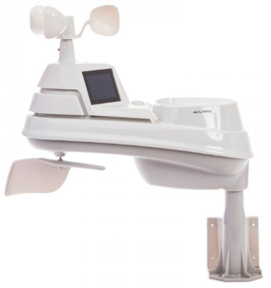Hey gang, if you haven’t looked at your Weather Underground dashboard lately you might want to. It seems that the nice folks there have taken the time to upgrade your dashboard. The new design is still being worked on from what information that I could gather, but they have done a really nice job. The new design is really easy to view and contains the same information at before, but it’s laid out in a really professional manor.

Now, our list of stations is growing all the time. How’s about your station? Is it listed with us? It doesn’t necessarily have to be a Weather Underground reporting station.

I’d love to have any weather station that is connected to the internet available for all of us to view, especially when the weather gets bad out. The more stations reporting the better.

Thanks to everyone who has contributed to this effort. If you haven’t, you really should take a look at the various weather stations around the state when we get bad weather coming in. You can really see just where the line of storms are as they cross through the state. It is very fascinating to watch it all unfold right you’re your easy chair, and all the data is real time! Here’s a link to all of those listed… <http://arrl-ohio.org/wus.html>

We’re got a really good collection of stations from all over and have tons of room to add more for sure. How’s about sharing your weather information with all of us! All that you need to do is send me your Weather Underground ID and your call sign and I’ll take it from there. Sent it to: [n8sy@n8sy.com](mailto:n8sy@n8sy.com)

####

TOP ^

***Call for Speakers: ARRL Learning Network***

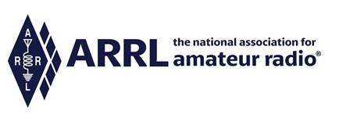  
The [ARRL Learning Network](http://www.arrl.org/arrl-learning-network) has quickly become a very popular new member benefit! During the months of July and August we offered 7 webinars presented by member-volunteers, with over 1,500 live attendees! Feedback from members has been extremely positive, and we are looking forward to offering more webinars every month. The schedule for September and October can be found online, along with a link to recording of past sessions. More webinars are added regularly: <http://www.arrl.org/arrl-learning-network>

We appreciate your help in continuing to promote this initiative to prospective speakers -- members you know who are **dynamic, knowledgeable, and experienced speakers**. Please consider speakers and presenters from throughout the clubs and hamfests held in your Section. Add a short, personal invitation, and direct them to the following brief online form: <http://www.arrl.org/ARRL-Learning-Network-Speakers-Form>

Thanks for your help in promoting this worthwhile ARRL membership benefit!

Kris Bickell, K1BIC - Lifelong Learning Manager

<http://www.arrl.org/lifelong-learning>

***Final.. Final..***

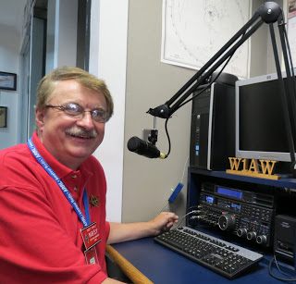Hi Gang,

Wow, has this past week ever been a wild one for sure. We had a great start to the holiday weekend, but unfortunately for some, the weekend ended with a lot of wind and rain. Yes folks, we did have a lot of damage reported from many different areas of the state on Labor Day. There were many trees and power lines down and some were without power for a couple of days afterward.

Did you see the announcement by our Great Lakes Director about the Marietta ARC? They were given special recognition by the ARRL Board of Director just recently for 100 years of ARRL Affiliation. Here’s the excerpt from the Board Minutes.

***“36.*** *Mr. Williams moved, seconded by Mr. Abernethy that:*

***WHEREAS,*** *The Marietta Radio League of Marietta, Ohio, became affiliated with the American Radio League on August 27, 1920, as indicated by their attached charter signed by Hiram Percy Maxim; and*

***WHEREAS,*** *The Marietta Radio League as it grew and became more active did change its name to Marietta Amateur Radio Society in 1934 and later to the Marietta Amateur Radio Club; and*

TOP ^

***WHEREAS,*** *Marietta Amateur Radio Club, now continues to serve its local amateur radio community and the Marietta, OH region in general;*

***THEREFORE,*** *it is hereby resolved that:*

*The Marietta Amateur Radio Club is recognized and sincerely thanked by the ARRL Board of Directors for their full century of affiliation and for fulfilling the ARRL Mission, “Advancing the art, science and enjoyment of Amateur Radio”, with sincere wishes for many more years of continued success.*

*The motion* ***CARRIED (with applause).”***

Want to see the full version of the ARRL Board Minutes? [>> Click Here <<](http://arrl-ohio.org/news/2020/Final%20Minutes%20-%20July_August%20%20Board_Meeting%202020.pdf)

**Congratulations to the Marietta Radio Club for their 100 plus years!!!!**

Ok… Changing bands… This past week has been another really fast paced, meeting filled week for sure! From the crazy weather that hit on Labor Day, to Zoom meetings and in person visits with some OSPOTA sites this past weekend really made the time fly by for sure. I love getting out and visiting with you, even though we still have to do some of the social distancing stuff yet. This week was also one of getting ready for winter around here. The big chore of this past week was one of cleaning out the garage closet.

I know that most of you are like Janie and I, we have this “stuff” that we just don’t use, but we are really afraid to just give it away or throw it out for fear of needing it right after we do. So, I’m sure like you, we find a corner or closet to put it in so that we can wait it out and see if we really need it. Well, this COVID stuff really hit our house hard with lots of extra time to gather up stuff that we don’t use and put it in the closet for another time.

This past week another time had come. My chore was to go out to that closet and really decide what’s going to stay and what’s going to go. The first indication that this was a bad idea was when I opened the closet door, I got hit with several items!!!

Yes, we’ve seemed to have just thrown it in and slammed the door shut quickly so that it couldn’t escape, but it has come to that time now where someone has to go in and just make some hard decisions. Yes, that someone was me. Wow… What a week I’ve had just making piles, yes piles. It’s no easier now to decide if it stays or goes than it was 6 months ago. Oh, I have found some old items that the decision was easy to make. We had an old coffee maker that still worked, but it had seen its better days and we have a great little replacement that has been working just fine for those 6 months. So, into the pile to go to our church free appliance store. The same thing with 2 old TV’s that we just don’t need as well. So, the one big pile is now 7 piles all spread out in the garage. No, I can’t get the car in there anymore, but hopefully this next week I will figure out what I need to do to get all this “stuff” back into that closet and make it look like I have actually gotten rid of things.

Whelp, that’s going to do it for this week my friend! I’m still looking forward to visiting with all of you via Zoom, WebEX or whatever. I really can’t wait for that time when we can all get together in person once again. Those are the times I cherish the most!!! Stay safe my friends! We will get through this and when we do, we’ll have so much to talk about. Most of all… have FUN and get on the airwaves!!

73,

[***Scott, N8SY***](mailto:n8sy@n8sy.com)

TOP ^

Hey Gang,

Have you taken a look at the **Swap & Shop** page on the Ohio Section webpage yet?? Here’s a link that will take you there…

<http://arrl-ohio.org/sm/s-s.html>

Do you have equipment that you just don’t need or want anymore? Here’s a great venue to advertise it, and it’s FREE!!

Is your club doing a fund raiser to help raise money? After a lot of thought, it was decided that the Swap & Shop webpage could also contain these types of items as well. The same rules will apply as do for the For Sales and Give-A-Ways and will only be posted for a month at a time. Please see the Terms & Conditions on the webpage.

If your club is doing a fund raiser and wants more exposure, please forward the information to me and I’ll advertise it on the Swap & Shop webpage for you.

Now, I still want to remind you that it won’t be listed in this newsletter because it would take up way too much space, so your ad will only appear on the website. It is there for any individual to post equipment Wanted / For Sale or Give-Away as well as for Club Fund Raisers. No licensed vehicles/trailers or business advertising will be posted. Postings are text only (no pictures or graphics) will be posted for a maximum of 1 month from date posting and require a contact phone number or email within the posting. Send your Wanted / For Sale or Give-Away post to:  [swap@arrlohio.org](mailto:swap@arrlohio.org)

***Welcome New Subscriber(s)***

**Jim, W0NB**

***Back Issues of the PostScript and Ohio Section Journal***

Hey, did you know that PostScript and Ohio Section Journal (OSJ) are archived on the website? You can go back and look at any edition simply by clicking:

<http://arrl-ohio.org/news/index.html>

***Want to Share your Club Newsletter With Others?***



We have a webpage where you can download and read all of the newsletters that I get from around the state and even other sections!

Here’s the link to the page…. <http://arrl-ohio.org/club_news/index.html>

TOP ^

Please, if you don’t see your club newsletter posted, it’s because I’m not receiving it. Just have your newsletter editor contact me and I’ll get your club’s newsletter listed on the site!!

We all learn and steal (I mean, share) from each other’s work. So, get me your newsletter!!! Send it to: [n8sy@n8sy.com](mailto:n8sy@n8sy.com)

Ohio Section Cabinet

|  |  |
| --- | --- |
| Section Manager – Scott Yonally, N8SY | Assistant Section Manager – John Perone, W8RXX |
| Section Emergency Coordinator – Stan Broadway, N8BHL | Section Traffic Manager – David Maynard, WA3EZN |
| Technical Coordinator – Jeff Kopcak, K8JTK | Affiliated Clubs Coordinator – Tom Sly, WB8LCD |
| State Government Liaison – Bob Winston, W2THU | Public Information Coordinator – John Ross, KD8IDJ |
| Section Youth Coordinator – Anthony Lascre, K8ZT | |

***Chit – Chat, and All That!***

Do you know someone that’s not getting these Newsletters? Please, forward a copy of this Newsletter over to them and have them “[Opt-In](mailto:Opt-In)” to start receiving them. Heck just have them send me an email [n8sy@n8sy.com](mailto:n8sy@n8sy.com) and I’ll get them added to the Ohio Section Emailing list.

We now have many thousands of readers receiving these newsletters weekly. Quite impressive, I’d say! I urge all of you to make sure that everyone, regardless of whether they are a League member or not, get signed up to receive these weekly Newsletters.

You can always “Opt-Out” at any time if you feel this is not what you were expecting. It’s fun and very informative. All of your favorite past newsletters are now archived too.

You can go back at any time and read them. Just go to: <http://arrl-ohio.org/news/>

Got questions, concerns or would just like to sit and chat awhile? Heck, I’ll even buy the coffee!! Give me a call at (419) 512-4445 or email me at: [n8sy@n8sy.com](mailto:n8sy@n8sy.com)

The pictures on the front page and throughout this newsletter are from various newsletters, Facebook posts and/or were sent directly to me in recent weeks. Take a good look at them, you just might be in one of the pictures! “SMILE… you’re in the Ohio Section News!!”

TOP ^

*PostScript is produced as a weekly newsletter. I want to thank everyone that has contributed articles and ideas to make this an even better news source. I sincerely hope that you have enjoyed this edition and will encourage your friends to join with you in receiving the latest news and information about the Ohio Section, and news and events happening around the world!*