[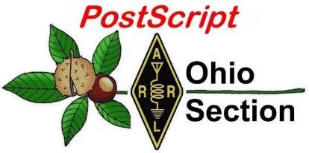](http://arrl-ohio.org/news/) ***Labor Day***

***Edition***

🡪 National News 🡪 The Handbook Give Away

🡪 Club Corner 🡪 Hamfests

🡪 DX This Week 🡪 ARES Connect

🡪 VE Testing 🡪 One Question Questionnaire

🡪 From Points South 🡪 Final.. Final..

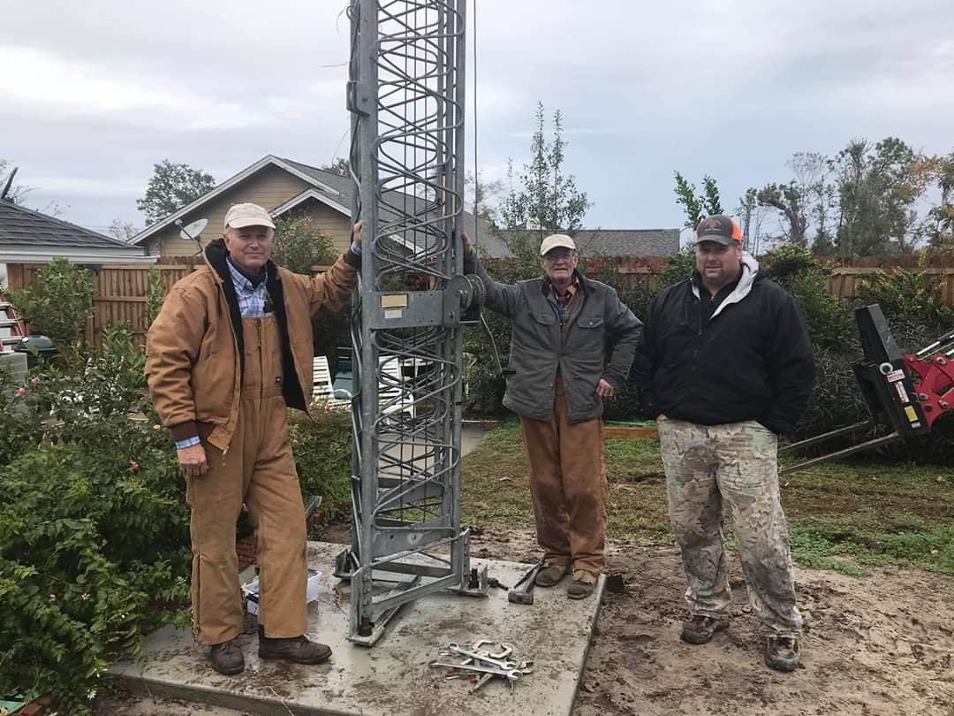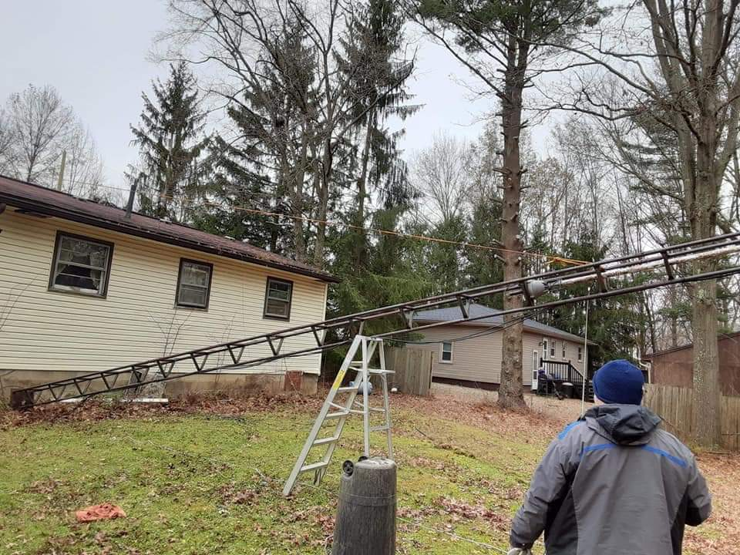

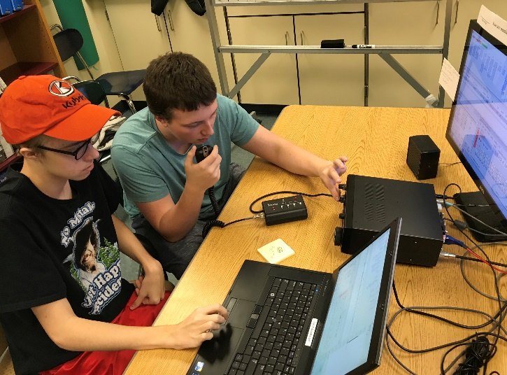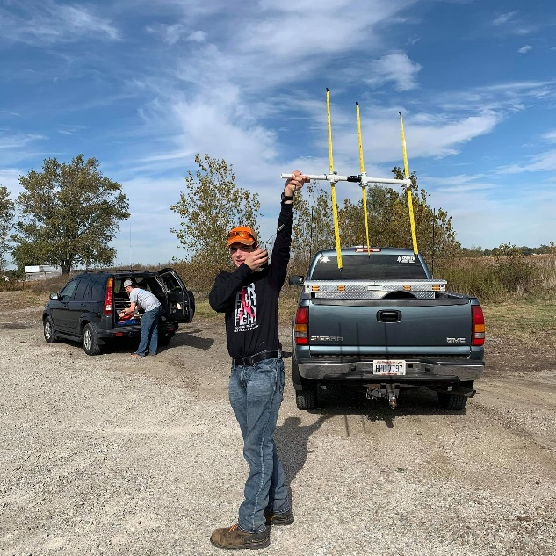

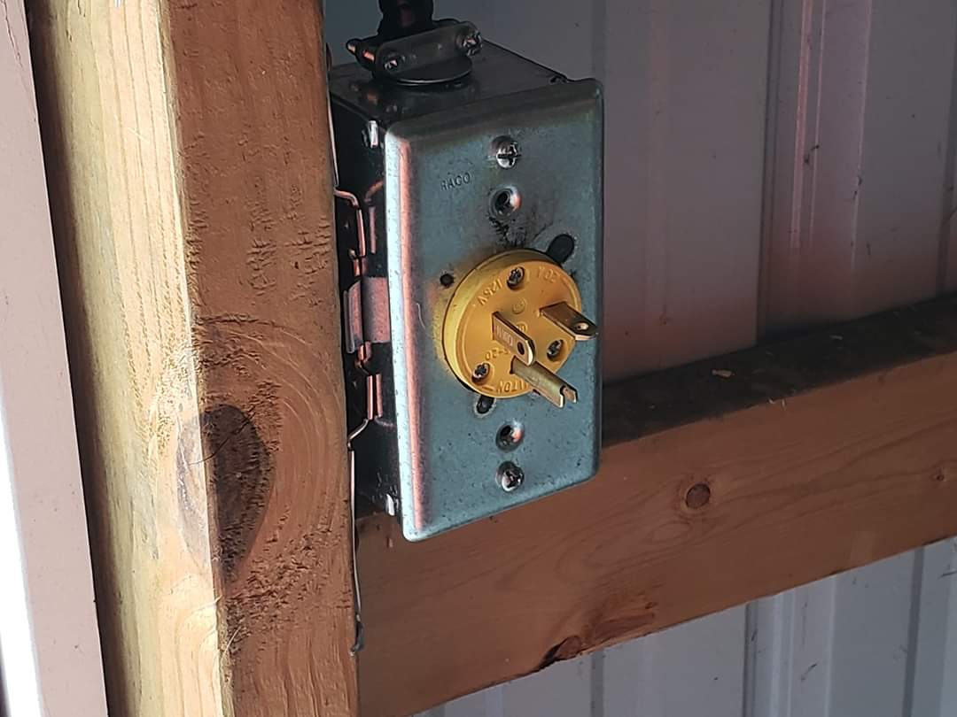

***National News***

*(from arrl and other sources)*

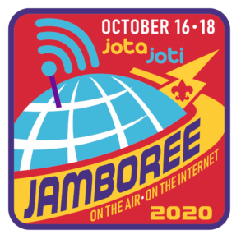***Scouting’s Jamboree on the Air Set for October 16, 17, and 18***

Jamboree on the Air ([**JOTA**](https://www.scouting.org/international/jota-joti/)) and Jamboree on the Internet (JOTI) will be held this year on October 16, 17, and 18. [**Register**](https://www.jotajoti.info/) online as an individual or as a group.

Jamboree on the Air is the largest Scouting event in the world. In a typical year, more than 1 million Scouts participate in JOTA, with over 11,000 stations operated by 20,000+ young radio amateurs from 150+ countries around the world.

[**JOTA details**](https://k2bsa.net/jota/) are available on the K2BSA website. The website menu will direct users to additional supporting information. K2BSA’s Jim Wilson, K5ND, says many locations are already offering virtual radio merit badge classes “and no doubt will be using similar approaches for Jamboree on the Air.”

####

***Hurricane Watch Net Logs More than 29 Hours of Continuous Operation for Laura***

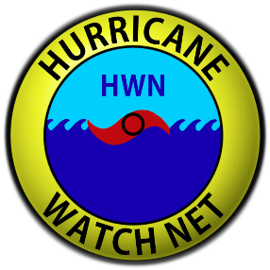The Hurricane Watch Net ([HWN](http://www.hwn.org/)) logged 29.5 hours of continuous operation in advance of Hurricane Laura, beginning at 1300 UTC on August 26, and after the storm made landfall.

One primary function of the HWN is to elicit real-time ground-level weather conditions and initial damage assessments from radio amateurs in the affected area and relay that information to the National Hurricane

Center ([**NHC**](http://www.nhc.noaa.gov/)) via [**WX4NHC**](http://wx4nhc.org/).

“Since Laura had become a Major Hurricane (Category 3) overnight, well ahead of earlier forecasts, we opened our net on both 14.325 MHz and 7.268 MHz,” said HWN Manager Bobby Graves, KB5HAV. “We did this for two reasons. HF propagation was horrible on both bands, and we wanted to make sure anyone trying to contact us would be able to do so.” Graves said it strained resources, but the net was able to get its job done. The HWN remained in continuous operation until Thursday, August 27, at 1830 UTC, well after Hurricane Laura made landfall in Louisiana, near the Texas border.

“In many ways, Laura seemed similar to Hurricane Michael in 2018, as it rapidly intensified close to landfall, nearly becoming a Category 5 hurricane,” Graves said. “Additionally, with major hurricanes, you normally have a few eye-wall replacement cycles. I don’t recall there ever being one [with Laura], and meteorologists I know agree.”

Graves noted that on Wednesday afternoon, forecasters at the National Hurricane Center used a phrase not typically heard, in order to get a point across: unsurvivable storm surge. The ominous prediction certainly caught on with the media and was widely repeated.

“Given the terrain for the projected impact of Laura, the storm surge was expected to move well inland, as far as 40 miles, with depths as high as 15 to 20 feet in some areas,” he said.

TOP ^

Throughout its more than a day of operations, the HWN collected and forwarded numerous surface reports to the National Hurricane Center. Graves said that Emergency Management in Louisiana checked in with the net on 14.325 MHz to announce its presence on 7.255 MHz. “After Laura was downgraded to a tropical storm, we shifted gears and began asking for post-storm reports from those affected by Laura,” Graves recounted. “We also called for emergency or priority traffic.” Graves expressed his appreciation to other stations for moving aside for the net to use 14.325 and 7.268 MHz. “Having a clear frequency certainly makes our job easier, and we know those in the affected area greatly appreciate it as well,” he said.

Graves noted that the forecast for this year’s hurricane season is reminiscent to that of 2005, when Hurricane Katrina struck. “It is forecast to be a very busy season,” he said. “When it comes to hurricane season, never drop your guard.” Families should have plans in place ahead of a major storm, and to factor the COVID-19 pandemic into those plans, he advised.

####

***Goodbye 3G: Here's when T-Mobile, AT&T and Verizon will shut it off***

*(Submitted by: Karl Beckman, WA8NVW – by Mike Dano – Editorial Director, 5G and Mobile Strategies)*

After roughly two decades, it's time to start saying goodbye to 3G. Since launching the technology around 2002 and using it to bring to life initial smartphones like the iPhone, all of the nation's big wireless network operators are preparing to shutter their 3G networks in the next few years.

"To better support the high data usage on our network, we are sunsetting our 3G network to boost capacity for next generation technologies," explained AT&T in a statement to Light Reading. Indeed, 3G is quickly heading the way of cassette tapes and Blockbuster video – it played an important role during its heyday, but it has been superseded by more capable technologies like 5G.

But how exactly will this 3G shutdown occur? Here's where each major US wireless network operator stands in the move away from 3G:

**Table 1: Tracking the 3G sunset**

|  |  |  |  |  |
| --- | --- | --- | --- | --- |
|  | **When** | **Why** | **How** | **The details** |
| **Verizon** | End of 2020 | "Virtually all Verizon data traffic runs on our 4G LTE network.  We have very few customers who are still accessing our 3G network." | Customers "are welcome to call into our customer service team and we will be happy to help them." | [FAQs](https://www.verizonwireless.com/support/knowledge-base-218813/) |
| **AT&T** | "Early" 2022 | "This will help free up spectrum to better accommodate next generation technologies and services." | "We will work with our customers during this transition." | [FAQs](https://www.business.att.com/explore/make-the-switch.html) |
| **T-Mobile** | "Over the next several years" but "we haven't shared timing." | "We will be phasing out some older technologies ... to free up even more capacity for LTE and 5G." | "We'll make sure any affected customers are aware in advance to make adjustments if needed." | N/A |

TOP ^

Importantly, all of these carriers have already taken the first big step toward shutting down their 3G networks: They are no longer activating any 3G devices. This is a common move among wireless network operators looking to shift to newer technologies – typically they enact it a few years before an actual network shutdown on the assumption that most customers will naturally upgrade to a newer, supported device before service is shut off.

Further, many operators are content to drag out the process. For example, Verizon decided to [delay its own 3G shutdown by a year](https://www.lightreading.com/mobile/3g-hspa/verizon-delays-3g-network-shutdown/d/d-id/753147).

To be clear, the great 3G shutdown in the US has precedent. For example, Sprint [recently shuttered](https://www.lightreading.com/sprint-plots-wimax-shutdown-backhaul-upgrade/d/d-id/708596) its WiMAX network. And AT&T [discontinued service](https://www.lightreading.com/mobile/4g-lte/atandt-sunsetting-2g-expanding-mexico-lte/d/d-id/722940) on its 2G network in 2017. According to AT&T's [filings with the SEC around that time](https://www.sec.gov/Archives/edgar/data/732717/000073271716000233/q3_10q.htm), it counted 4 million customers on its 2G network, the bulk of which were IoT devices.

####

***ARRL Bulletin 21***

***FCC Application Fee Proposal Proceeding is Open for Comments***

Comments are being accepted on the Notice of Proposed Rulemaking (NPRM) in MD Docket 20-270, which proposes application fees for radio amateurs. Formal deadlines for comments and reply comments will be determined once the NPRM appears in the Federal Register.

Comments may be filed now, however, by using the FCC's Electronic Comment Filing System (ECFS), located at, <https://www.fcc.gov/ecfs/filings> , and posting to MD Docket No. 20-270. The docket is already open for accepting comments, even though deadlines have not yet been set.

The NPRM can be found online in PDF format at, <https://docs.fcc.gov/public/attachments/FCC-20-116A1.pdf> .

####

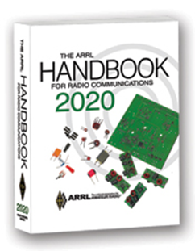***The Handbook Give Away***

Hey Gang,

The winner of the August Give Away is… ***Thomas Cooper, N8OSC***

Many of you ask me just how do I know when the drawing is on? Well, that’s easy all you need to do is check in on the Ohio Section Website on a regular basis and watch for the big **RED** Arrow that will appear on the left side of the page.

This is the sign that the drawing is on and you need to get registered. So, keep a sharp eye out on the website and check in often! <http://arrl-ohio.org/>

TOP ^

***Club Corner***

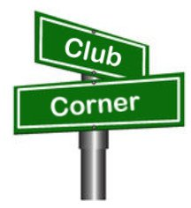

This is YOUR cornner of the newsletter. Send me what your club is doing and I’ll make sure that it gets in. Got a special event or club project that you want everyone to know about? Send it to me!. Need help with a project? Send it to me.

Let me know what you club is up to. Are you going to have a special guest at your meeting or are you having a special anniversary? Just sent it to: [n8sy@n8sy.com](mailto:n8sy@n8sy.com)

####

***Three Kentucky posts form a relationship through ham radio clubs***

*(from: The American Legion)*

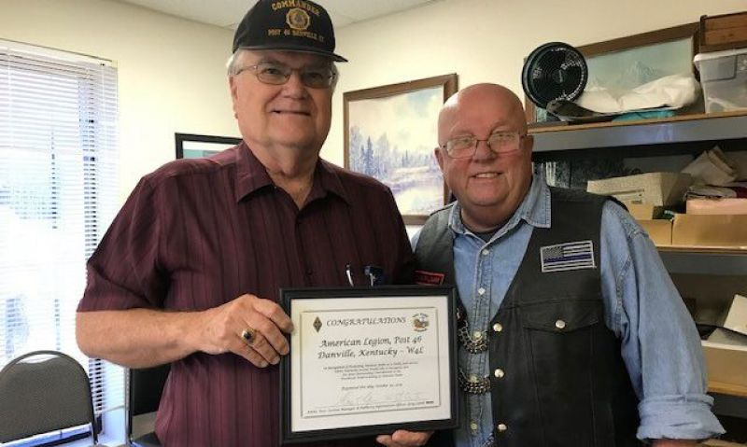

Tony Cromwell, commander of Boyle American Legion Post 46 in Danville, Ky., recently authored a report to his District 8 commander about how his post’s ham radio club has been helping other posts around it to start ham clubs of their own.

TOP ^

During a district meeting around the beginning of 2019, Cromwell gave an update on his post’s radio program; a [story](https://www.legion.org/documents/legion/pdf/CQ_Post_46_ham_article.pdf) in CQ magazine from later that year describes how Post 46 gave a new home to a local ham club. Chris Gootee, commander of Nelson County American Legion Post 42 in Bardstown, also attended the district meeting although it wasn’t his own and approached Cromwell afterward; he had hams at his own post.

“I always like to look around and see what interests the different members of the post may have,” Gootee said. “If we can do something that a few members are interested in, we try to get it started and then let them run with it to keep the program going. Starting up an amateur radio club was an easy decision.”

“We exchanged information and I asked our radio group to contact his members,” according to Cromwell. “That started an ongoing friendship with members of both groups visiting each other. As a result, they were able to establish a Post 42 amateur radio club, and they sign in to our D-Star nets.” Recently, Gootee himself obtained an FCC license and called in to one of Post 46’s regular nets. Cromwell, also a ham, greeted him and congratulated him on the new club.

“Having the amateur radio club as part of our post has … been a plus for us,” Gootee added. “It works as a recruiting tool for the Legion and our Sons. We hope to add an Auxiliary member to the radio club in the future.” Post 42 has gained a new Legionnaire, with another moving to Kentucky soon, and five new Sons members, as well as three more radio club members. Gootee concluded, “How can you go wrong when you grow your family?”

During the same period, Greg Lamb – a member of Moon Brothers Sons of The American Legion Squadron 275 in Independence, and a ham operator who is also an ARRL assistant section manager – presented Post 46 and its radio club with an ARRL state commendation stemming from the CQ article. Lamb discovered The American Legion through Post 46’s nets “Listening to the net I found at about the wonderful existence of the Legion Family. With that I found my local post, which is very involved in my community. I joined the Sons and my fiancée, also a ham and a Marine veteran, joined the Legion and we both joined the Riders.” When they were going to be in the area, a time was arranged to present the commendation and tour Post 46.

“We have become part of the Post 46 family – at least, that’s how they make me feel,” according to Lamb. “And they directly contributed to new American Legion members and now officers, and now forming our own TALARC club for Post 275!”

“These three posts have now established what I call a ‘sisterhood of posts,’” Cromwell said. “A warm, supportive, ongoing relationship that would not exist but for the radio activity.”

####

***ARRL DARA Scholarship Winners Announced***

**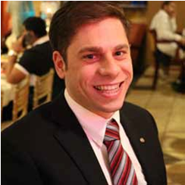***(By Mark Tessneer, KB8ZR & RF Carrier)*

**Michael Fluegemann, KE8AQW**, recently completed his second year of graduate school at The University of Michigan – Dearborn, where he is pursuing his MSE in Electrical Engineering. He graduated Cum Laude from the University of Alabama in 2016, where he earned his BS in Electrical Engineering.

TOP ^

Michael was first licensed in 2015, he is an ARRL Life Member and he has been very active in amateur radio. He has been a volunteer examiner since 2016 and he has helped with five test sessions. Michael has been a member of the Tin Lizzy Club, K8UTT, since 2016 and he has been the club’s treasurer since 2018. He is also a member of the GM Amateur Radio Club, WW8GM; the Motor City Radio Club, W8MRM; the Livonia ARC, K8UNS; and the University of Michigan ARC, W8UM, where he is Trustee of secondary call sign, W8AXZ. Michael was a member of the University of Alabama ARC, W4UAL, from 2015 to 2016; he served as President of W4UAL in 2015, helping to plan outdoor operating events.

Michael has been learning morse code since 2016. He took the CWOPs levels 1 and 2 in 2016. He then passed the FCC commercial radiotelegraph license test in 2018. Michael recently joined the Long Island CW Club, W2LCW, and he has been attending their classes.

He was involved in the California QRP Club and attended Pacificon. While studying abroad in Sevilla, Spain, Michael joined a club there and participated in outdoor operating events and a contest. He has built many kits including the QCX, NorCal40, and several kits from QRP-Guys including an antenna tuner and random wire antenna. He likes to participate in contests such as the November Sweepstakes and Michigan QSO party.

Michael’s first exposure to amateur radio was on a scout camp out in middle school. There was a station set up and he was able to speak to a pilot. That is when he learned that his father was a ham, N8GBK. However, it wasn’t until Michael was studying for his undergraduate degree that he became interested in becoming a ham himself. He learned that his school had an amateur radio club from his electromagnetism professor, and he attended a meeting where the speaker was Don Keith, N4KC. Michael became licensed the following semester and upgraded to extra class a month later.

Michael is also an Eagle Scout and earned the Chris Hainsey Ultimate Team Player Award in 2015. He has volunteered to be a merit badge counselor for the Boy Scouts of America. He is a member of the Circle-K organization at the University of Michigan and he has been a volunteer at Michigan Youth Leadership since 2011. In addition to his numerous amateur radio and volunteer activities, Michael is an avid sailboat racer.

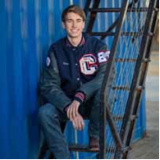**Ian Parker, KG5LST**, is a recent graduate of Southwest Covenant High School in Oklahoma City, Oklahoma. This fall, he will be attending Oklahoma State University studying pre-med with a goal of becoming an ER doctor.

Ian was first licensed in 2015 and he is an ARRL member. He was a Memorial Marathon volunteer for two years. Ian notes that amateur radio has taught him how to pursue a goal to its finish. Amateur radio has shown him how to be a leader that helps others and how to learn from those who know more in certain areas. Ian also credits amateur radio with connecting him with others who he would not have known otherwise.

While in high school, Ian was on the headmaster’s honor roll from 2017 to 2019 and the Oklahoma Honors Society in 2019. He was on the student council in 2018 and received an award for Best Male Supporting Actor in 2019. Ian was a member of the jazz, concert and pep bands and was the manager of and a player on the football team. He also participated in the Patriot Project for all four years of high school, which consisted of volunteering for the Yukon Park Service.

TOP ^

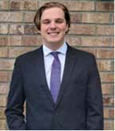**Logan Selph, KN4PTA**, is a recent graduate of Brunswick County Early College High School in Bolivia, North Carolina. This fall, he will be attending the University of North Carolina at Chapel Hill with plans to major in Astrophysics.

Logan was first licensed in 2018. One of his favorite amateur radio activities is AMSAT operation and he also loves hopping on repeaters with his VHF/UHF radios. For his senior project, he focused on Yagi antennas and AMSAT operation to make a cheap setup for entering AMSAT operators (one that costs less than $70 rather than some other starter setups that cost $300). Logan’s mentor was John Brier, KG4AKV, who runs the YouTube channel SpaceComms.

Logan first discovered amateur radio after his home was hit by Hurricane Florence and he and his family were forced to move to New Orleans. There, his uncle, KW5ARC, enlightened him to the fact that he could hear and talk to astronauts through amateur radio. Logan spent the entire car ride home studying for his exam and he now holds an Extra Class license. He notes that amateur radio has given him a wonderful hobby that lets him learn and create and provides him with useful information that he will need in the future.

While in high school, Logan was a member of the National Honor Society, the Astronomy Club, the NC Star Party and QuizBowl, where his team was invited to Nationals in 2019. His research article, “An Analysis on Exoplanets and How They are Affected by Different Factors in their Star System,” was published in the Journal of Emerging Investigators, a Harvard Graduate-run journal for high schoolers and middle schoolers.

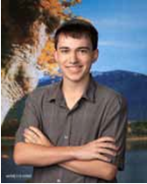**Matthew Spiker, KE8FGB**, is a recent graduate of Jefferson High School in Shenandoah Junction, West Virginia. This fall, he will be attending the Georgia Institute of Technology with plans to major in Electrical Engineering and Computer Science.

Matthew was first licensed in 2016 and he is an ARRL member. He is a member of the Opequon Radio Society and the Young Amateurs Radio Club (YARC). YARC was created in late 2017 to help promote amateur radio among youth; Matthew is currently a board member. He gave a presentation at Hamvention 2018 Youth Forums about a homemade APRS transmitter.

Michael notes that amateur radio has played a huge role in his life by giving a practical purpose and outlet to his interest in electronics. He has long been interested in the inner workings of computers and circuitry, and the expansion into electronics along with radio signals and signal processing in ham radio has become his primary interest and hobby.

While in high school, Michael was an Eagle Scout holding the position of scribe, an Intel International Science and Engineering Fair finalist, the West Virginia Region 8 Science Fair first place grand prize winner, the West Virginia Regional Science Fair category winner, a National Honor Society member, a Science National Honor Society member, an AP Scholar, an AP Scholar with Distinction and a CyberPatriot XI State Champion.

TOP ^

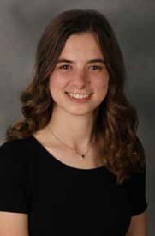**Samara Steinfeld, KC3OFN**, is a recent graduate of Mount Lebanon High School in Pittsburgh, Pennsylvania. This fall, she will be attending the University of Chicago with plans to major in Physics Research.

Samara was first licensed in 2019. Her interest in amateur radio stems from a weather balloon project. Samara and some classmates were inspired by a weather balloon launched by a group of students in the school district years ago. After brainstorming, they decided to do something similar. Their goal was to build a weather balloon from scratch but also send up yeast and seeds inside it to see how cosmic and UV rays impact gene expression. They wanted to have redundant systems for tracking, so they became interested in APRS tracking as one of the systems. Along with other students, Samara studied to pass the Technician test.

As soon as she opened the ARRL study guide, she became fascinated with the physics, practical know-how, and community that encompasses every aspect of amateur radio. Samara currently holds a technician class license with plans to get her general class license in the future.

While in high school, Samara was a member of the National Honor Society, the Science Club, the Orchestra, Pulse Literary Magazine and the Student Council. She earned the Certificate of Merit from the Society of Women Engineers, the Certificate of Merit at the Covestro Pittsburgh Regional Science & Engineering Fair, the Brandels Book Award for “Social Action and Civic Engagement,” and the Commonwealth of Pennsylvania Higher Education Assistance Agency Certificate of Merit in recognition of outstanding performance among Pennsylvanians on the College Board SAT or ACT, among others. She was the project leader of BioBalloon (weather balloon) extracurricular project and was a teenage representative on the Settled Rabbi Search Committee for Temple Emanuel of South Hills.

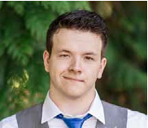**Zachary Whitlock, KJ7AGP**, recently completed his junior year at the Oregon Institute of Technology in Willsonville, Oregon. He will be continuing his studies there in the fall, where he is pursuing a degree in Electrical Engineering Technology.

Zachary was first licensed in 2018 and he is an ARRL member. He enjoys experimenting with 2m radios, building Yagi antennas and attempting to receive data from satellites. Zachary also uses SDR radios to explore VHF and UHF data modes and local communication and explores the use of repeaters and calling frequencies. He has successfully encouraged most of his family and many friends to get their amateur radio licenses and has taught them the basics of both HF and VHF/UHF communication. Zachary has been working with his father to make a foolproof keying circuit and robust transmitter for less advanced family members so that they can easily use the lower bands without expensive or complicated hardware. They have successfully gotten a computer and a phone to automatically key a 10W transmitter with both Morse and Hell Schreiber modes.

Zachary states, “Amateur radio has really opened my eyes to the possibilities of communication without cell phones. The ability to talk directly to another person with an ‘infrastructure-less’ system can be hugely useful. Besides that, the hobby is highly educational to an aspiring electrical engineer and the challenges that high frequencies present are driving forces in my educational goals.”

TOP ^

In addition to his many amateur radio activities, Zachary is also a Phi Theta Kappa member and has volunteered at Phillip Foster Farm, an Oregon historical site in Estacada, Oregon. He is also interested in automotive tinkering, machine shop work, 3-D printing, and programming.

####

***ARRL Foundation 2020 Scholarship - Ohio Section Recipients***

Linda Anderson, KE8HPZ – The Medical Amateur Radio Council (MARCO) Scholarship

Emily Boban, KE8ERE – The Scholarship of the Morris Radio Club of New Jersey

Frances Bonte, KE8HPA – The ARRL Foundation General Fund Scholarship

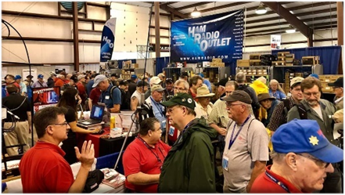

[***Upcoming Hamfests***](http://arrl-ohio.org/hamfests.html) ***for 2020***

**09/13/2020 - Findlay Hamfest** ***Canceled***

**09/27/2020 | Cleveland Hamfest and Computer Show**

***Canceled***

**10/10/2020 - Northwest Ohio Amateur Radio Club (NWOARC) Fall Hamfest*****Canceled***

**11/01/2020 - 60th Massillon Hamfest**Location: Massillon, OH  
 Sponsor: Massillon Amateur Radio Club  
 Website: <http://w8np.org/hamfest.htm>

**11/14-15/2020 – Fort Wayne Hamfest and Computer Expo**

***Canceled***

**12/05/2020 - Winterfest 2020**Location: Delta, OH  
Sponsor: Fulton County Amateur Radio Club  
Website: <http://k8bxq.org/hamfest>

####

TOP ^

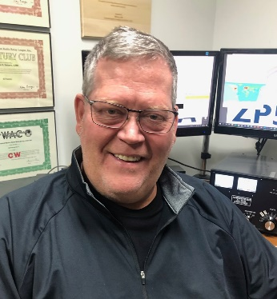***DX This Week***

*(from Bill, AJ8B)*

***DX This Week – IZ0MQN***

***Bill AJ8B (aj8b@arrl.net, @AJ8B, or*** [***www.aj8b.com***](http://www.aj8b.com)***)***

***CWOPs Member #1567***

It did take a few days to get back into the shack after the Ohio QSO Party. I hope that you spent some time in the QSO party also. There was some activity this past week including Alaska, Algeria, Angola, Argentina, Austria, Bolivia, Bosnia-Herzegovina, Brazil, Bulgaria, Ceuta & Melilla, Colombia, Costa Rica, Denmark, Ecuador, El Salvador, England, European Russia, Germany, France, Gibraltar, Greenland, Guadeloupe, Iceland, Italy, Kuwait, Mali, Mexico, Moldova, Peru, Poland, Puerto Rico, Qatar, San Marino, Sardinia, Scotland, Slovenia, Spain, St. Lucia, Sweden, Switzerland, Trinidad & Tobago, Ukraine, and Venezuela.

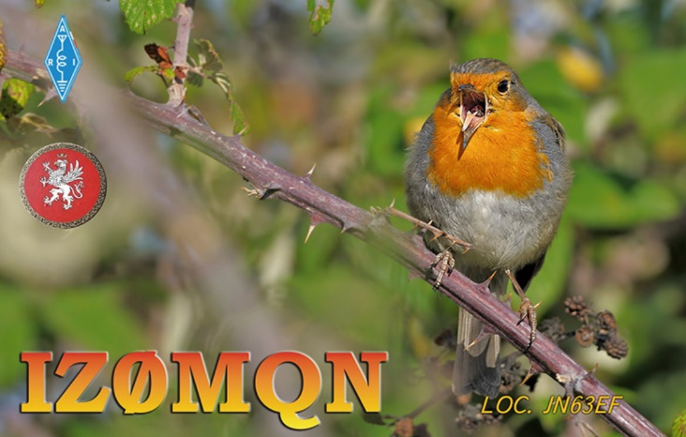I received a QSL card from Janusz, PJ5/SP9FIH, who I worked while he was activating Sint Eustatius.

After taking the summer off, the SouthWest Ohio DX Association will hold their first meeting since June on Thursday, September 10th. It will be a virtual meeting. If you have any interest in DX, please send me an email ([aj8b@arrl.org](mailto:aj8b@arrl.org)) and I will make sure you get the meeting details.

Below is an interview with IZ0MQN – Ivo. It first appeared in the SWODXA DX Newsletter and is reprinted with the permission of SWODXA.

Interview with Ivo, IZ0MQN. *I worked Ivo and had to check out his QRZ.com webpage. I found a huge collection of awards and very interesting information. I know that you will enjoy this interview. With Ivo’s permission, I have edited it slightly.*

**AJ8B:** How did you first get interested in amateur   
radio?  
**IZ0MQN:** in 1985 I was on the town “band”. Working in 11 meters (pirate) where I collected more than 300 countries.  
  
**AJ8B:** When did you get on the air?  
**IZ0MQN:** In 2007, they discovered a rare tumor (chondrosarcoma) I decided it was time to get my license!  
  
**AJ8B:** Do you have a favorite band or mode?  
**IZ0MQN:** The most beautiful band is 12 meters. I don't have a favorite band, but I work FM, SSB, CW, MMD digital modes,

TOP ^

**AJ8B:** In reviewing your QRZ.com page, I see that you have been very successful with chasing countries and with contests. Any secrets to your success?  
**IZ0MQN:** I don't know what my secret is.  
  
**AJ8B:** I also noticed that you like to operate from many locations. What equipment do you use? How do you pick the location?  
**IZ0MQN:** I got an Icom 735 (1991) self-constructed antennas, inverted v dipole. On rare occasions, I use a series of MFJ single-band stylus. My position varies according to the respect of the diploma rules.

**AJ8B:** You are an extremely accomplished contester. Any tips that you can share?  
**IZ0MQN:** Take care of your antenna in the smallest details.  
  
**AJ8B:** What license levels do you have in Italy?  
**IZ0MQN:** Maximum level  
  
**AJ8B:** Describe what you are currently using:  
**IZ0MQN:** My Icom735 and an Icom 7300 station. My antennas are dipoles and a small 2-element directive, all strictly self-built.

**AJ8B:** What advice do you have for those trying to break pileups to work DX?  
**IZ0MQN:** I don't use amplifiers, I only run 100W. My experience comes from the CB. Listen a lot, have a lot of madness, try to locate the station, and hit at the right time!!

**AJ8B:** Any QSLing hints?  
**IZ0MQN:** The QSLer must respect the station and their own feelings (mine represents my passion for my cancer)  
  
**AJ8B:** Thanks for taking the time to answer my questions. Is there anything you would like to share with us?  
**IZ0MQN:** Thanks to you, I am a simple ham radio operator. With simplicity you can manage to have excellent results! with you I would like to share my passion for radio (I owe my health, or maybe life on the radio)   
  
73 IZ0MQN

Ciao 73 de IZ0MQN ROSADI IVO MAURO  
C.O.T.A. Member 453-SM  
PER ÆTHERA OMNI SERVO

***CQDX CQDX CQDX CQDX CQDX CQDX CQDX CQDX CQDX***

Here is an update from Bernie, W3UR, of the DailyDX and the WeeklyDX, the best source for DX information. http://www.dailydx.com/. Bernie has this to report:

**UA – European Russia -** R450STAR and R450AKSU, September 1-30 are for the 450th anniversary of Cossack settlements in Starocherkasskava and Aksaysskava, now known as Aksay in Rostov Oblast.  There will be a certificate available. QSL through OQRS. <http://r6l.hamlog.ru>.

TOP ^

**UA – European Russia -** MDXC, the Miller DX Club, will have special call R13KHL on the air starting today and going to September 6.  It marks the beginning of the 13th season of the Kontinental Hockey League.  Ops are RW1F, RD1A, RW1A, RW1C, RU1M and RW1CW.  QSL through Club Log OQRS.

**LY – Latvia -** LY784A celebrates the 784 years of the town, Siauliai.  This one will be on CW and SSB until September 30.  QSL via LY5A.

**JA – Japan -** 8N1M is a special callsign for JH1XUP from Minato-ku in Tokyo September 1 to December 31, the HF bands, various modes.  QSL direct to 8N1M or through the bureau.

**G – England -** The RAF Amateur Radio Society will put GB80BOB on the air September 1-28 for the 80th anniversary of the Battle of Britain. QSL via 2E0NDZ. [https://www.rafars.org/](http://r20.rs6.net/tn.jsp?f=001NCqXG-v2AZkzQVDIizBDxJwSikkdoXN5P3WxK0vZ6Obb3jvqyeO5Rfv98Ldj0wJJXV91kwaCocB6ySU0Sja0SGkgVhSDzD58zy3xu7eRhYox8d18BBtvDzVP4X0t26jvxO5pur_JAJsJ4QJN_YHsVQ==&c=lpSgIncSozBoZpNjtVYSrcmkKAOMbv7SA0BLpOmT5MTHk988KfXpDw==&ch=IEFrbOVHSpwfJJpU26VNObSXCi9pCms3-BFdq0gVExI4dG69rukl_g==)

**HF Digital Mode Band Plan Review**

*(The following was posted by K1ZZ, Dave Sumner, as an IARU News Release)*

Because frequency allocations and amateur radio operating interests vary in different parts of the world, the development of band plans – voluntary guidelines on the use of the spectrum that is available to radio amateurs – is a responsibility of the three IARU regional organizations.

Each of the three Regions has a band planning committee to focus on this work. In recent years there have been increased efforts to bring the regional band plans into alignment wherever possible. Final approval of band plan revisions is generally given by the regional conferences of IARU member-societies that are held every three years on a rotating basis.

This approach to band planning generally has kept pace with the evolution of amateur radio operating. However, the explosive growth in HF (below 30 MHz) digital modes, particularly FT8, has led to perceived overcrowding of HF digital mode band segments. Accordingly, a working group has been formed consisting of representatives of the three regional band planning committees. This is the first time the three Regions have joined together to directly coordinate band planning efforts.

The working group has already had fruitful discussions with the WSJT Development Group led by Joe Taylor, K1JT. Additional discussions, including with other HF stakeholders, will be held as part of a fundamental review of the different HF digital modes, and how they can be best categorized and arranged to share the limited spectrum available.

The main aim is to develop solutions that reduce congestion within very popular mode segments while preventing mutual interference between incompatible modes to the greatest extent possible. While the proposed band plan revisions will have to be approved by member-societies in each Region, recent administrative changes mean that the changes can be implemented without having to wait for the regional conferences.

Amateurs are encouraged to follow progress through their IARU member-society and the respective IARU websites, all of which can be reached via [www.iaru.org](http://www.iaru.org).

**OJ0 – Market Reef  -** 60 meter ops from Europe found OJ0JR, Henri, on 5 MHz (5353 KHz) starting just before 1900 through 2230Z.

TOP ^

**TZ – Mali** – Despite the dustup in the news TZ4AM, Jeff, is safe and was very active yesterday. He was reported on 14.000.7 MHz just before 1700Z and then again from 2119 to 2130Z and then on 7.000.7 MHz between 2137 and 2200Z. Listen for Jeff on 14195, 14000.7 as well on 40, 30 and 17 meters. Jeff reports there has been shooting in his neighborhood.



As promised last week, you will find a list of upcoming contests in the “Contest Corner”. I think this is important for someone who is trying to move up the DXCC ladder since entities that are on the rarer side and easiest to work in contests. Some of my best “catches” have been on the Sunday afternoon of a contest when the rarer entities are begging for QSOs. Of course, the gamble is that if you wait until Sunday, conditions may change, or they simply won’t be workable. However, it is not a bad gamble. Of course, why not work the contest and have some fun!

The contests in **red** are those that I plan to spend some significant participation time on. PLEASE let me know if you are working contests and how you fared.

Thanks!

|  |  |  |
| --- | --- | --- |
| Sept. 16 | RSGB Autumn Series CW | <https://bit.ly/2XF8mSB> |
| Sept. 17 | Bavarian Contest Club QSO Party | <https://bit.ly/2MDzviG> |
| Sept. 18 | AGB NEMIGA Contest | <https://bit.ly/2AWBbRK> |
| Sept. 19 | Feld Hell Sprint | <http://bit.ly/2JcbOwW> |
|  | FOC QSO Party | [www.g4foc.org/qsoparty](http://www.g4foc.org/qsoparty) |
| Sept. 19-20 | All Africa Int. DX Contest | <http://bit.ly/H0IqQf> |
|  | ARRL 10 GHz and UP Contest | [www.arrl.org/10-ghz-up](http://www.arrl.org/10-ghz-up) |
|  | Iowa QSO Party | [www.w0yl.com/IAQP](http://www.w0yl.com/IAQP) |
|  | New Hampshire QSO Party | [www.w1wqm.org/nhqso](http://www.w1wqm.org/nhqso) |
|  | New Jersey QSO Party | <http://bit.ly/1nDlf8V> |
|  | QRP Afield | <http://bit.ly/2QACxFu> |
|  | SARL VHF/UHF Digital Contest | <http://bit.ly/H0IqQf> |
|  | Scandinavian CW Activity Contest | [www.sactest.net/blog](http://www.sactest.net/blog) |
|  | Washington State Salmon Run | [www.wwdxc.org](http://www.wwdxc.org) |

TOP ^

|  |  |  |
| --- | --- | --- |
| Sept. 20 | BARTG Sprint 75 | <http://bartg.org.uk/wp/contests> |
|  | North American RTTY Sprint | <http://ncjweb.com/Sprint-Rules.pdf> |
| Sept. 21 | 144 MHz Fall Sprint | <http://svhfs.org/wp> |
| Sept. 24 | RSGB Autumn Series Data | <https://bit.ly/2XF8mSB> |
| Sept. 26 | AGCW UHF/VHF Contest | <http://bit.ly/292ubSX> |
| Sept. 26-27 | CQWW RTTY DX Contest | [www.cqwwrtty.com](http://www.cqwwrtty.com) |
|  | Maine QSO Party | [www.ws1sm.com/MEQP.html](http://www.ws1sm.com/MEQP.html) |
|  | Nancy Kott-Fists Memorial KNOWCW | <http://fistsna.org/operating.html> |
| Sept. 28 | RSGB FT4 Contest Series | <http://bit.ly/38xg9V7> |
| Sept. 30 | UKEICC 80m Contests CW | http://bit.ly/2MbaURB |

You can also find a downloadable version of Contests listed in QST Magazine by clicking here:

[**Contest Corral**](http://www.arrl.org/contest-calendar)

####

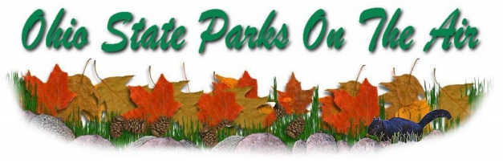

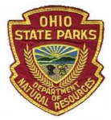

The Portage County Amateur Radio Service, Inc. (PCARS) announces the 13th Annual “Ohio State Parks On the Air” (OSPOTA) contest, from the hours of 10 am to 6 pm ET (1400 UTC to 2200 UTC).

13th OSPOTA - **September 12, 2020**

14th OSPOTA - September 11, 2021

15th OSPOTA - September 10, 2022

16th OSPOTA - September 9, 2023

17th OSPOTA - September 7, 2024

18th OSPOTA - September 6, 2025

19th OSPOTA - September 12, 2026

20th OSPOTA - September 11, 2027

**Always the first Saturday after the Labor Day holiday.**

TOP ^

For hams throughout the State of Ohio, this is your opportunity to visit and enjoy the amenities offered by the 75 beautiful State Parks here in Ohio. Don’t just make a day of it - spend the weekend at the park of your choice. No matter whether you are camping or staying at one of the outstanding lodges or resorts, you will find that the parks are one of Ohio’s greatest assets. Find out more about the Ohio State Parks at: <http://parks.ohiodnr.gov/>

In past years, hundreds of Amateur Radio Operators (hams) from around the country participated in the event. With the success of OSPOTA, we hope to have amateur radio operators at every Ohio State Park.

This contest places a premium on working stations located in the Ohio State Parks. That means that it is critical to have as many parks activated as possible. The challenge for Ohio stations will be to work HF in the 50 to 300 mile range. This is the perfect opportunity to learn more about the design and deployment of Near Vertical Incident Skywave (NVIS) antennas. You can find numerous designs on the Internet and in various Amateur Radio antenna manuals. Along with your operating skills, it will be a chance to showcase your antenna building skills as well.

Individuals and multiple operators can operate Ohio State Park stations. Non-park stations in Ohio as well as stations outside of Ohio can also compete. Contacts can be made on 80, 40, 20, 15 and 10 meters using SSB. All contacts have the same point values. Make sure that you read the Rules, FAQ’s and get your forms for the contest that are posted on the OSPOTA website: [www.ospota.org](http://www.ospota.org) before the contest.

So, get to an Ohio State Park and get On The Air in September. Have some fun with this contest!

73 for now, OSPOTA Contest Committee

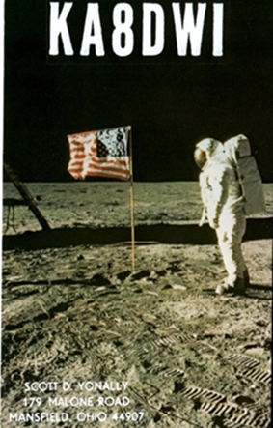***DX News***

***ARLD036 DX news***

This week's bulletin was made possible with information provided by The Daily DX, the OPDX Bulletin, 425 DX News, DXNL, Contest Corral from QST and the ARRL Contest Calendar and WA7BNM web sites. Thanks to all.

**CROATIA, 9A.** Neno, 9A5N and Tom, 9A2AA are QRV as home calls/p from Lastovo Island, IOTA EU-016, as well as several other nearby islands until September 11. Activity is on the HF bands. QSL to home calls.

**MALTA, 9H.** Reiner, DL2AAZ is QRV as 9H3TI from Gozo, IOTA EU-023, until September 18. Activity is holiday style on 40 to 6 meters using CW and SSB. He is also active as 9H3SAT on Satellite QO-100 using CW and SSB. QSL to home call.

**QATAR, A7.** Station A71SDC is QRV until September 13 to join the Spanish celebrations of Asturias. QSL via EA1AUM.

TOP ^

**SPAIN, EA.** Members of Cartagena Team will be QRV as AO5CLE from Cartagena from September 5 to 20 to commemorate the 100th anniversary of the Spanish Legion. Activity will be on various HF and VHF bands using CW, SSB, FT8 and other digital modes. QSL via bureau.

**FRANCE, F.** Special call sign TM5SF will be QRV from September 5 to

19 for the 51st edition of the Solitaire du Figaro multi-stage sailing race. QSL via F8KGS.

**ENGLAND, G.** Members of the RAF Amateur Radio Society are QRV with special call GB80BOB until September 28 to commemorate the 80th anniversary of the Battle of Britain. QSL direct to 2E0NDZ.

**LITHUANIA, LY.** Special event station LY784A is QRV during September to celebrate the 784th anniversary of the city of Siauliai. QSL via LY5A.

**ARUBA, P4.** Members of the Aruba Amateur Radio Club are QRV as P42WW until September 30 to commemorate the 75th anniversary of the end of World War II. QSL via operators' instructions.

**NETHERLANDS, PA.** Special event station PD538RNI is QRV until September 30 to commemorate Radio Northsea International and Radio Veronica. QSL via PD0ARI.

**GREECE, SV.** Special event station SX300ML will be QRV from September 5 to 19 to commemorate the Battle of Thermopylae. QSL direct to SV2GWY.

**EUROPEAN RUSSIA, UA.** Special event station R450STAR is active during September to commemorate the 450th anniversary of Starocherkasskaya. In addition, special event station R450AKSU is QRV during September to celebrate the founding of Aksaysskaya, now known as Aksay City. QSL via RM6LW.

**MEXICO, XE.** Members of the Radio Club de Radio Aficionados Hidrocalidos are QRV with special event call 4A50CRH until the end of 2020 to celebrate the club's 50th anniversary. Activity is on

160 to 6 meters using CW, SSB, FM and digital modes. This includes some Satellite activity as well. QSL via XE2AU.

**GIBRALTAR, ZB.** Stations from Gibraltar may use the ZG prefix until September 10 to celebrate Gibraltar National Week.

THIS WEEKEND ON THE RADIO. The All Asian DX Phone Contest, IARU Region 1 SSB Field Day, RSGB SSB Field Day, G3ZQS Memorial Straight Key Contest, CWops Mini-CWT Test, NRAU 10-Meter Activity Contest, RTTYOPS Weeksprint, SKCC Sprint Europe, NCCC RTTY Sprint, NCCC Sprint CW Ladder, Russian RTTY World Wide Contest, CWOps CW Open, Wake-Up. QRP CW Sprint, Colorado QSO Party, AGCW Straight Key Party, IARU Region 1 145 MHz Contest, PODXS 070 Club Jay Hudak Memorial 80-Meter PSK31 Sprint, WAB 144 MHz QRO Phone and Tennessee QSO Party will certainly keep contesters busy this upcoming weekend.

The RSGB 80-Meter SSB Autumn Series and MI QRP Labor Day CW Sprint are scheduled for September 7. The RTTYOPS Weeksprint, ARS Spartan CW Sprint and Worldwide Sideband Activity Contest are scheduled for September 8.

The VHF-UHF FT8 Activity Contest, Phone Fray and CWops Mini-CWT Test are scheduled for September 9.

TOP ^

***Special Events***

* **09/07/2020 | Disaster Communication Action Team Field Day Operations**

**Sep 7, 1300Z-2300Z, KD1CAT**, Birmingham, AL. Disaster Communication Action Team. 7.195 7.210 14.230 14.240. Certificate. Tim Cameron, PO Box 59345, Birmingham, AL 35209. Disaster Communication Action Team will have the monthly field day communication event on Labor Day 2020. Please join us. [www.disastercat.org](http://www.disastercat.org/)

* **09/09/2020 | Dog Island IOTA DXpedition NA-085 K4D**

**Sep 9-Sep 18, 0000Z-2359Z, K4D**, Carribelle, FL. K5TEN (Operator). 14.275 14.074 7.190 7.074. QSL. Bruce Brady K5TEN, 208 Mt Tabor Rd, Hot Springs National Park, AR 71913. Very rare IOTA island, rare grid square & rare county. (NA-085), EL79, Franklin County. Rescheduled from June due to Covid19. [k5ten@aol.com](mailto:)

* **09/10/2020 | 19th anniversary of the attack on the World Trade Center in New York City.**

**Sep 10-Sep 14, 0000Z-0300Z, WA2NYC**, Staten Island, NY. Wireless Association of New York City. 14.390 7,238 28.450 D-Star XRF 020B. QSL. Wireless Association of New York City, 233 Wolverine Street, Staten Island, NY 10406. We remember the over twenty nine hundred people that lost their lives on that day [www.qrz.com/db/wa2nyc](http://www.qrz.com/db/wa2nyc)

* **09/12/2020 | 4th Annual William Becknell Heritage Days Special Event - Founder of the Santa Fe Trail**

**Sep 12-Sep 13, 1400Z-2200Z, WB0SFT/KC0VYS**, Overland Park, KS. William Becknell Santa Fe Trail Heritage Days. 21.365 14.265 7.265 3.865 1.830; SSB CW FT8. Certificate & QSL. See website, for information on, receiving certificate or QSL. On the trail 1x1 calls, W0B through W9B, and Parks on the Air (K-4579) activation. QRZ and LoTW. See website for details, and how to receive a certificate and/or QSL. [www.wb0sft.org](http://www.wb0sft.org/)

* **09/12/2020 | BLUE RIDGE BONANZA**

**Sep 12, 1400Z-2100Z, W4CA**, Roanoke, VA. Roanoke Valley ARC. 14.245 7.245. QSL. Roanoke Valley ARC, P.O. Box 2002, Roanoke, VA 24009. Commemorating the beginning of construction of the Blue Ridge Parkway in September, 1935. A 469 mile scenic road running along the spine of the Blue Ridge Mountains through Virginia and North Carolina. [w4ca.com](http://w4ca.com/)

* **09/12/2020 | K4MIA - National POW MIA Recognition Day**

**Sep 12-Sep 22, 0000Z-2359Z, K4MIA**, Loxahatchee, FL. PBSE. 28.400 18.150 14.265 7.195. QSL. Michael Bald, 6758 Hall Blvd., Loxahatchee, FL 33470. Observances of National POW MIA Recognition Day are held across this country on the third Friday in September each year. This year it will be on September 18. This will be the 12th year this special event station has been activated. The day was established to honor our prisoners of war and those who are still missing in action. There will be sister stations K4MIA/5 K4MIA/7 K4MIA/8 in operation some days. Also contacts will be made on various digital modes. See QRZ for a copy of this years QSL and for additional information. Because of the volume of requests you MUST SEND SASE to get a returned QSL. Please take time to remember our POW's and MIA's as well as their families www.qrz.com/db/k4mia [www.qrz.com/db/k4mia](http://www.qrz.com/db/k4mia)

TOP ^

* **09/12/2020 | Route 66 On the Air**

**Sep 12-Sep 20, 0000Z-2359Z, W6H**, Rio Rancho, NM. Albuquerque DX Association. 14.266 14.033 7.266 7.033. Certificate & QSL. Bill Mader, 4701 Sombrerete Rd SE, Rio Rancho, NM 87124. Use http://w6jbt.org for certificates plus frequencies and other information. Use QRZ.com for QSL information. Get your kicks on Route 66! <https://groups.io/g/adxa>

* **09/12/2020 | Route 66 On The Air**

**Sep 12-Sep 20, 0000Z-2359Z, W6JBT**, San Bernardino, CA. Citrus Belt Amateur Radio Club. 3.866 7.266 14.266 28.466. Certificate & QSL. Citrus Belt Amateur Radio Club, PO Box 3788, San Bernardino, CA 92413. The Citrus Belt Amateur Radio Club of San Bernardino, California will host the 21st annual Route 66 On The Air special event, September 12–20. The event offers radio amateurs a chance to perhaps relive their own Route 66 memories and to celebrate the famed highway’s rich history. Opened in 1926, US Route 66 was the first major improved highway to link the West Coast with the nation’s heartland; it once served as the backdrop for a popular TV show and has been the subject of songs and stories. There will be 21 stations — two of them “rovers” — operating in or around the major cities along Route 66 from Santa Monica, California to Chicago, Illinois. They will use 1 × 1 W6-prefix special event call signs. The Route 66 special event stations will concentrate activity on these frequencies: CW — 3.533, 7.033, 10.110, 14.033, 18.080, 21.033, 24.900, 28.033, and 50.033 MH; SSB — 3.866, 7.266, 14.266, 18.164, 21.366, 24.966, 28.466, and 50.166 MHz; Digital — 3.580, 7.070, 10.140, 14.070, 18.100, 21.070, 24.920, and 28.120 MHz.

Some participating clubs will also use their local VHF and UHF repeaters. Radio amateurs who operate while driving on Route 66 may take part in the event by using the designations “mobile 66” or “/66” after their call signs. Each participating club will issue its own commemorative QSL card to celebrate this event. Certificates and other items are available. See [www.w6jbt.org](http://www.w6jbt.org) for event rules and information [www.w6jbt.org](http://www.w6jbt.org/)

* **09/12/2020 | Route 66 On the Air**

**Sep 12-Sep 20, 0000Z-2359Z, W6L**, Tulsa, OK. Tulsa Amateur Radio Club. 14.266. QSL. Tulsa Amateur Radio Club, PO Box 4283, Tulsa, OK 74159. Route 66 On the Air is organized by the Citrus Belt Amateur Radio Club; see www.w6jbt.org for list of participating stations. [www.w5ias.com](http://www.w5ias.com/)

* **09/12/2020 | USS Midway Museum Ship Special Event: Commissioning of the USS Midway September 1945**

**Sep 12, 1600Z-2300Z, NI6IW**, San Diego, CA. USS Midway (CV-41) Museum Ship. 14.320 7.250 14.070 (PSK31) D-STAR on various reflectors. QSL. USS Midway Museum Ship (COMEDTRA), 910 N Harbor Drive, San Diego, CA 92101.

* **09/14/2020 | Texas DX Society 50th Anniversary**

**Sep 14-Oct 13, 0000Z-2359Z, K5DX/50**, Houston, TX. Texas DX Society. 14.074 14.040 7.074 7.040. QSL. Texas DX Society – K5DX/50, 5303 S Mason Rd Apt 212, Katy, TX 77450. Celebration of 50 years of Contesting and DX by our members. We plan to operate on 160-10 meters, 40 KHz above lower band edge for CW, on standard FT4 & FT8 frequencies, and 40 KHz above the lower edge of the General class phone band for SSB. We will operate on the VHF/UHF bands if there is propagation. [https://k5dx-50.tdxs.net](https://k5dx-50.tdxs.net/)

* **09/16/2020 | National Football League Centennial Celebration**

***Canceled***

####

TOP ^

***“ARES Connect”***

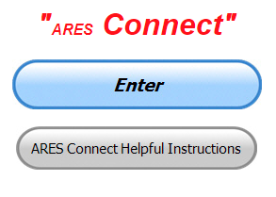

***Connecting Amateur Radio Volunteers with a Purpose***

Hey everyone… please make sure to go in and register your time to all of the events that you have signed up for. Don’t forget to get this done no later than **5 days** after the event has ended. I’m asking you to do this for our ability to run reports accurately.

**I want to remind all of you that you do not have to be an ARES or ARRL member to use this system. All licensed amateur radio operators throughout the country are welcome and strongly encouraged to use it.**

Over the past several weeks I have given you some shortcuts that save you a lot of time and frustration getting signed up and recording your hours. We have had a few new folks join the ranks and are now starting to use the system as well. Please, we want every ham in the country using this system, if you know of someone that isn’t registered and using the system, get with them and help them get on their way with ARES Connect.

***Here’s the top 10 hour earners for the month of August:***

|  |  |  |  |
| --- | --- | --- | --- |
|  | **Name** | **Events** | **Hours** |
| **1** | Dwight Bonifield (W8TJT) | 169 | 238.50 |
| **2** | Leo Dubois, Jr. (KE8OOS) | 140 | 192.34 |
| **3** | James Yoder (W8ERW) | 25 | 156.50 |
| **4** | Daniel Schlick (KB8LKH) | 30 | 139.00 |
| **5** | Bret Stemen (KD8SCL) | 49 | 135.00 |
| **6** | Dan Stahl (KC8PBU) | 92 | 115.25 |
| **7** | Christopher Domenick (KC8CAD) | 32 | 104.45 |
| **8** | Alan Rothweiler (N8CJ) | 28 | 102.50 |
| **9** | Mathew Nickoson (KC8NZJ) | 18 | 88.00 |
| **10** | David Noeth (KD8ACO) | 4 | 73.50 |

**Let’s get everyone in the Ohio Section on “ARES Connect!!!” Simply go to:** <https://arrl.volunteerhub.com/lp/oh/> and get yourself registered and using the system.

I’ve been asked by many of you on just how the Ohio Section stacks up against the nation as far as reporting goes. I have been doing the national report for months now, and I have to say that Ohio’s numbers are really, really good.

Here’s the national report that I ran for August – 2020. There were 47 Sections reporting activity in ARES Connect for August.

TOP ^

|  |  |  |  |
| --- | --- | --- | --- |
| **Breakdown by Event Category**  **August 2020** |  |  |  |
|  | # of Events / Category | # of Persons | # of Hours |
| Communications Emergency | 9 | 47 | 107 |
| Community Event | 49 | 128 | 730.75 |
| Exercise | 26 | 170 | 169.45 |
| Meeting | 219 | 872 | 1,474.94 |
| Net | 1,954 | 7,032 | 6,088.13 |
| Skywarn | 108 | 510 | 1,135.10 |
| Training | 164 | 585 | 1,486.94 |
| Miscellaneous | 43 | 70 | 337.50 |
| Unclassified – All events not listed above | 2,741 | 8,866 | 9,765.67 |
|  |  |  |  |
| **Total** | **5,313** | **18,280** | **21,295.48** |

Here’s the breakdown for the Ohio Section for August - 2020.

|  |  |  |  |
| --- | --- | --- | --- |
| **Breakdown by Event Category**  **Ohio Section – August 2020** |  |  |  |
|  | # of Events / Category | # of Persons | # of Hours |
| Communications Emergency | 1 | 3 | 0.5 |
| Community Event | 25 | 55 | 383.5 |
| Exercise | 5 | 61 | 21.5 |
| Meeting | 41 | 229 | 354.6 |
| Net | 557 | 2208 | 2132.43 |
| Skywarn | 26 | 196 | 173.9 |
| Training | 62 | 209 | 827.46 |
| Miscellaneous | 41 | 60 | 362 |
| Unclassified – All events not listed above | 566 | 1986 | 2318.47 |
|  |  |  |  |
| **Total** | **1,324** | **5007** | **6,574.36** |

As you can see, the Ohio Section makes up about 31% of the reported hours. That’s substantial folks!!!

Want to see how this stacks up within the Great Lakes Division? Here’s a link that will allow you to see the cumulative numbers between the 3 Sections of the Great Lakes Division <http://arrl-greatlakes.org/ac2.html>

I think the dollar amount that is given back to our communities should impress you the most. Remember, most of this reporting year was done under a pandemic where very few meetings, or events have taken place. Now you can see why this information is so valuable. Just imagine going to your local government agency and showing them these numbers. Well folks, that’s exactly what’s being done!!! So, if you haven’t taken the time to get your volunteering time recorded, do so now!!

TOP ^

***SET Is the First Weekend Of October; Are You Ready?***

*(C. Matthew Curtin KD8TTE)*

Now that County Information Report Project 20 (CIRP20) Objective 10 has gone out, ARES operators should have been able to start experiencing realistic emergency communications tasking. Counties without district nets, and district nets now need to be sure that they establish liaison to Buckeye Net Mixed Mode sessions. If you can't work Buckeye Net or a net that can, your options for radio messaging are severely limited. There's time to fix it, but we're now down to the wire. Act now!

ARES operators create messages on behalf of agencies, in a process called *origination*. NTS operators move those messages from station to station in a process called *relay*. ARES operators at the other end get those messages to receiving agency personnel in a process called *delivery*. ARES and NTS aren't two services: they're both specializations within the ARRL Field Organization.

This is exactly the job of amateur radio in an emergency: to move messages for others in need. “Not being comfortable” with the task isn’t reason not to do it: it’s reason to train and get comfortable. You’ve got about 1000 other volunteers in the ARES program in the Ohio Section who are working side by side with you, and want you to succeed.

Every single one of us at one point didn’t know how to do these tasks. Whether you’ve had your license for 70 years or 70 minutes, there is a place for you and we can train you to do your part!

See my radio messaging video series at <https://www.youtube.com/playlist?list=PLvYr6g3seaV36sBZUvCV7Y9nibFVQAmPF> and keep on reading for links to more help.

If you're an ARES emergency coordinator or a net manager of either ARES or NTS nets, you'll want to see my video series on preparing for the SET, Simulated Emergency Test 2020: <https://www.youtube.com/playlist?list=PLvYr6g3seaV0yVw_dc79vhIdd1nMSZkWr>

This year you can register with BLACK SWAN exercise controllers, indicating your force strength and intended hours of operation, and then just work the event. No creating an exercise necessary. Exercise messages will be released from government stations using 60m (ch 4) starting at 8 p.m. on Tuesday, September 29 and amateur stations will have the ability to make contact and exchange information with those stations. Authorization for interoperability has been granted by the FEMA Spectrum Manager, with notice given to FCC.

A controller will contact the representative (EC or NM, usually) on Friday before to give the critical information: the mission for amateur radio, the served agency requesting it, and information needed to get radio operations established. This year to address Covid 19 concerns, our sites will be virtual. Radio operators when activated will get a Meet code, and join with their browser. No login or special software is necessary but I recommend giving it a try ahead of time.

We will hold "BLACK SWAN Virtual Site Test" sessions at 7 a.m. and 7 p.m. every day beginning September 21. This will give everyone plenty of opportunity to test their equipment and make any needed adjustment. The URL will be sent by radio message to each DEC and Net Manager as part of CIRP20 Objective 12, released on the 7 p.m. session of Buckeye Net (mixed mode) on September 17.

TOP ^

We're training! Train with us. Email, video, and by video conference. Sign up now to get be ready! <https://www.blackswancomex.org/2020/amateur-radio-volunteers>

We've got some exciting developments in the works. You can follow the latest on my YouTube channel at <https://www.youtube.com/channel/UCA1NTJpAdzOEtP-vJ7_TH-Q> or my Twitter feed at <https://www.twitter.com/kd8tte>.

If you’ve got questions, ask now, while there is still time. If you don’t know what questions you’re likely to have then actively participate with CIRP20. If you are performing those tasks, you will have everything you need to work effectively in the SET. Tell your EC to task you!

Train hard! Be ready! Have fun!

***From Points South***

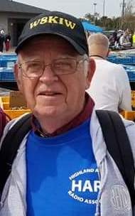*(from John Levo,* [*W8KIW@arrl.net*](mailto:W8KIW@arrl.net)*)*

The word received Friday morning is this year's Fort Wayne, Indiana Hamfest has followed the likes of most hamfests and decided to cancel their traditional early November hamfest for this year.  The following announcement was posted on their Facebook page:

*“The Fort Wayne Hamfest Steering Committee has closely followed the progression of CDC, Indiana State, and local Health Dept individual recommendations and large gathering guidance. Consultation with annual volunteers and long-time loyal vendors indicates a growing consensus their attendance would be limited due to pandemic concerns. Our host venue is going to great lengths to minimize infection risk, recently published recommendations stating, “Individuals 65 years of age or older, or those in high risk categories with underlying health conditions, should consider not attending any event at the facility.” The Indiana Governor has extended the mandatory mask wearing order through the end of October.*

*“In the face of this much credible pandemic risk, the Steering Committee has decided to cancel this year’s Fort Wayne Hamfest for the health safety of our valued guests, vendors, and volunteers. We share your disappointment and hope for a swift end to the pandemic so we may again meet for eyeball QSOL’s and support favorite ham gear vendors at hamfests across the country.*

*“We look forward to hosting a healthy and safe Fort Wayne Hamfest on November 13 & 14, 2021. See you next year!”*

The word from Perry County is a new DMR repeater is on from the New Lexington area.  It is on 442.075 and believed to be supported by the Zanesville club.

COVID-19 really has played a number on test sessions this year.  However, the Athens County ARC found a way to conduct a test session recently.

TOP ^

According to Jeff Slattery, N8SUZ, three new hams have received their licenses and three others upgraded.  Those earning their first licenses are Mark Cooper, KE8PHJ of Jackson; David Partridge, KE8PHK, of Dayton and Douglas Fedder, KE8PHL, of Athens. Athen's - Michael Baxla, KE8ICP, upgraded to General as did Michael DeVaughn, K8MPD, from Marietta.  Justin Hillyer, KE8OLG, who hails from Corning is now an Extra.  Congrats to all.

This coming Saturday, September 12, marks the annual Ohio State Parks on the Air operating event.  It starts at 10 am and continues until 6 pm.  A look at the event's website indicates a number of Southern Ohio parks will see activity, but there are many others showing no planned operations.  Hint-hint!

Highland ARA President Jeff Collins, KD8VUY, states the club will hold a special meeting on Tuesday evening, September 8 at the Harmony Lake shelter house at Hillsboro's Liberty Park.  It will begin at 6:30 pm because of the shorter evening daylight.

Bill Sayler, AJ8B's Southwest Ohio DX Association's newsletter is now on-line.  It is packed with a lot of great information and articles.  There's even a photo of one of our Southern Ohio hams in it.  It always is a great read-even if you are not into DX’ing.  Also, Joe Pater's (W8GEX) 60 Meter newsletter has been posted and it too has some good information about what is happening on that band.

***One Question Questionnaire***

Hey Gang,

“Survey Says”….. More than 50% of you won’t be renewing your license if there is a $50 fee involved. This is very substantial!! I know that this survey isn’t very scientific, but if that many of you feel that strongly about this fee, we definitely need to be working on letting the FCC know that this just isn’t acceptable to any of us!!

Ok, let’s move on to the next question. As you’ve seen in the articles above September 12th is Ohio State Parks on the Air and that’s what the next question is leading up to….

***“Will you be working the OSPOA Contest??”***

You’ll find the “One Question” questionnaire on the Ohio Section Website! <http://arrlohio.org> It’s all in fun and it’s not a scientific survey in any way, but we are learning some things that we didn’t know from these questions. I hope that you are enjoying answering these “One Question” questionnaires.

*****V.E. Test Sessions***

Many V.E.’s have decided to start testing once again, but with restrictions that need to be adhered to for sure. Here’s the link to find that V.E. Test session and what is expected of YOU before going. <http://www.arrl.org/find-an-amateur-radio-license-exam-session>

####

TOP ^

***Ohio Valley Amateur Radio Club - Ohio Valley Amateur Radio VE Testing September 2020***

The Ohio Valley Amateur Radio Club will be holding testing at the Warrick County EOC. The next testing will be… **September 12th at 9:00am** at the Old Boonville Courthouse - 3rd Floor. Entrance will be through the North lower level doors (Signs will be posted guiding the way)

The cost for the test is $10. WHAT TO BRING WITH YOU TO THE AMATEUR RADIO TEST  
Two forms of identification, including at least one photo ID (Driver’s license, Employer’s identity card, or a Student ID) - A calculator - Your FCC Federal Registration Number (FRN)  
Information here: <https://www.fcc.gov/wireless/support/universal-licensing-system-uls-resources/getting-fcc-registration-number-frn>

**Upgrade Exams:**Your current Original License and a photocopy any original “Certificate of Successful Completion of Examination” (CSCE) and a photocopy. Your FCC Federal Registration Number (FRN)

For Additional Information: Chris L. Owen (KC9CLO) - [KC9CLO@gmail.com](mailto:KC9CLO@gmail.com)

***Cleveland National Weather Service Office Moving***

Partners,

The National Weather Service Cleveland Weather Forecast Office (WFO) will be moving to a new building on or about September 14, 2020. The new office is located in 925 Keynote Circle Suite #314, Brooklyn Heights Ohio 44131. The radar and the official climate observing equipment (ASOS) will remain at the existing location at the Cleveland Hopkins International Airport.

The new public phone number for WFO Cleveland included recorded forecasts will be: 216-416-2900

Most NWS forecast products and services will be uninterrupted by utilizing a combination of remote computing capabilities as well as backup support from the Weather Forecast Office in Buffalo, NY.

Radar data will be unavailable for approximately 8 to 12 hours during the move starting around 8am September 14th.

Ten NOAA Weather Radio transmitters will be temporarily off the air for up to a couple of days during the move to the new facility. These include:

* Akron, OH KDO-94 162.400 MHZ
* Youngstown, OH WWG-56 162.500 MHZ
* Cleveland, OH KHB-59 162.550 MHZ
* Mansfield, OH WWG-57 162.450 MHZ
* Bellevue, OH KHB-97 162.400 MHZ

TOP ^

* Carey, OH KZZ-47 162.525 MHZ
* Toledo, OH WXL-51 162.500 MHZ
* Grafton, OH WNG-698 162.500 MHZ
* Meadville, PA KZZ-32 162.475 MHZ
* Erie, PA KEC-58 162.400 MHZ

####

***National Weather Service - Wilmington Conducting On-Line Skywarn Training***

Partners,

The National Weather Service - Wilmington - has scheduled a live online spotter training class for this autumn season on **October 5 from 6 pm to 8 pm EDT**.  NWS partners and the general public are welcome to attend the live online spotter training class. Registration is required, and can be completed at: <https://register.gotowebinar.com/register/4844007736691537676>

**As a reminder, if an individual registers, then becomes unable to attend, the individual is encouraged to cancel, freeing up that spot for another person.**

Feel free to share this with others within your counties or jurisdictions. Within a couple days, we will also promote this class via social media and on our office webpage.

One note: if a significant severe weather or flood event is forecast for or occurs on October 5, there is the possibility this webinar would need to be postponed.  Please let me know if you have any questions or comments.

Thanks, Brandon Peloquin - Warning Coordination Meteorologist - NWS Wilmington, OH

***Weather Underground and Other Ham Weather Stations***

[](http://arrl-ohio.org/wus.html)Have you visited the webpage to see all the Weather Underground stations yet? It’s really fun to see just how much the weather varies across the state and this gives you access to each individual station very quickly and easily.

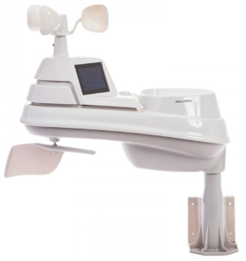Hey gang, if you haven’t looked at your Weather Underground dashboard lately you might want to. It seems that the nice folks there have taken the time to upgrade your dashboard. The new design is still being worked on from what information that I could gather, but they have done a really nice job. The new design is really easy to view and contains the same information at before, but it’s laid out in a really professional manor.

Now, our list of stations is growing all the time. How’s about your station? Is it listed with us? It doesn’t necessarily have to be a Weather Underground reporting station.

TOP ^

I’d love to have any weather station that is connected to the internet available for all of us to view, especially when the weather gets bad out. The more stations reporting the better.

Thanks to everyone who has contributed to this effort. If you haven’t, you really should take a look at the various weather stations around the state when we get bad weather coming in. You can really see just where the line of storms are as they cross through the state. It is very fascinating to watch it all unfold right you’re your easy chair, and all the data is real time! Here’s a link to all of those listed… <http://arrl-ohio.org/wus.html>

We’re got a really good collection of stations from all over and have tons of room to add more for sure. How’s about sharing your weather information with all of us! All that you need to do is send me your Weather Underground ID and your call sign and I’ll take it from there. Sent it to: [n8sy@n8sy.com](mailto:n8sy@n8sy.com)

***Call for Speakers: ARRL Learning Network***

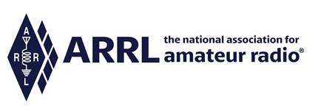  
The [ARRL Learning Network](http://www.arrl.org/arrl-learning-network) has quickly become a very popular new member benefit! During the months of July and August we offered 7 webinars presented by member-volunteers, with over 1,500 live attendees! Feedback from members has been extremely positive, and we are looking forward to offering more webinars every month. The schedule for September and October can be found online, along with a link to recording of past sessions. More webinars are added regularly: <http://www.arrl.org/arrl-learning-network>

We appreciate your help in continuing to promote this initiative to prospective speakers -- members you know who are **dynamic, knowledgeable, and experienced speakers**. Please consider speakers and presenters from throughout the clubs and hamfests held in your Section. Add a short, personal invitation, and direct them to the following brief online form: <http://www.arrl.org/ARRL-Learning-Network-Speakers-Form>

Thanks for your help in promoting this worthwhile ARRL membership benefit!

Kris Bickell, K1BIC - Lifelong Learning Manager

<http://www.arrl.org/lifelong-learning>

***Get ready for S.E.T.!!***

Hey gang!  This year’s SET will be October 3 and 4, and it’s going to be a big one!!   As you know, we have been working on Matt’s curriculum of traffic management to take ARES in Ohio up to the next level- by making us much more proficient in sending messages….the one main thing we’re tasked with doing!

Matt’s plans this year will make this a LOCAL exercise for your county, and counties around you.  Yes, there’s a broader umbrella program involved, that actually involves FEMA, Washington DC, but the focus is on YOUR county, and the effort has been to put together a realistic exercise that you might easily face in real life.

TOP ^

So let’s get warmed up!  Take a look at this video:  <https://youtu.be/gPYvqfGARm4>   and see if that helps get you excited.

We are creating a “message handling” curriculum for ALL ARES members, we think you’ll like it! So far, viewer testing has been really positive!

So take a look and get ready for the SET October 3 and 4th!  It’s getting closer.

-Stan

***Final.. Final..***

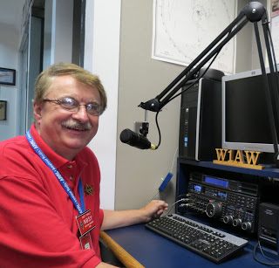Hi Gang,

I hope that you’ve all taken a good look at our newest column “From Points South.” I’m sure some of you will recognize the writer of this column as the editor of the Monday Morning Memo, John Levo, W8KIW.

John and I have been great friends for more years than either of us probably wants to admit to. John agreed to write articles for us centered around – you guessed it, the southern end of not only our state (Ohio), but that of West Virginia and our Sister Section Kentucky as well! Having John onboard brings a much more inclusive and robust newsletter than ever before.

Now to find someone in that Section above us that would be willing to spend a little time writing. Anyone in Michigan got any ideas??

Changing bands… Labor Day weekend is the traditional time summer ends. Yes, this is just a tradition and we still have lots of summer days ahead of us. I will say this past week the nights have been starting to get a bit colder with a temperature of 50.9 degrees being recorded on September 5th here at the “tree stump.”

Fall is fast approaching and that means we will soon have leaves to pick up. I’ve got 32 trees (most of them big old maples) to really let loose with the shower of leaves. So, there’ll be plenty of raking and mulching happening around here in the next couple of months. Last year the leaves fell clear up into December and yes, I was out in the cold, windy, rainy weather making sure that they got set out to the curb for our village to collect up. The yard is also going to need some fertilizer this year and the house needs to get all those little cracks and crevices filled in so the cold air can’t get at us when the Gales of November start.

Yes, I even have to get the snow-thrower out and make sure that the engine will start and that the thrower blades will turn freely. All this and more just because summer officially ends on Tuesday, September 22, 9:31 A.M. EDT and fall begins.

TOP ^

Ok, that’s the negative stuff! Let’s leave that behind for now and focus on some positive things about fall I really like. One of my biggest favorites is high school football. Our local schools football field is just down the street from us. You can literally walk to it it’s so close. On those warmer nights Janie and I just sit out front and listen to the announcer. You can tell exactly when our team has scored a touchdown and when they didn’t just by the way the crowd sounds. This year has been really different, however. Since crowds aren’t allowed due to COVID-19, you can’t tell what’s happening since there’s no crowd noise to judge it on, so I had to break out the radio the other week just to get some feel for what was happening with the game.

I also noticed the other day that my favorite apple farm just up the road from us is starting to advertise their world-famous apple donuts for sale. Oh wow... there’s nothing better on a cold morning than to wake up to a hot cup of coffee and a warm apple donut drenched with sugar glazing all over it! Yes, it’s a calorie killer, but it’s so good, it’s worth scrimping on something else throughout the day just to have a bite of one of those donuts!!

This past week has really flown by! I attended a bunch of Zoom meetings by clubs all over the state. I even attended a couple of meetings that were outside of the state as well. It seems like every night there was a meeting or two to attend. I spoke at several of them and was just a listener at several others. During the day and after I got done with the chores that Janie had given me, I even found some time to ride my Trike!

**New toy in the mail to play with…** As many of you know I recently had a devil of a time with my 4 – BTV vertical HF antenna and how it just didn’t want to tune up in the amateur bands very well. After borrowing an antenna analyzer from one of my mentors here in Mansfield, I found the problems with the antenna and finally got them all fixed. I quickly discovered how great having one of these cool magic boxes is for making adjustments on your antenna’s. This got me thinking that I really need to have one of these boxes for myself.

Now comes the rub. I quickly discovered that these little “boxes” can be very expensive. How expensive you ask? Well, the range I found starts around $275 and works up to $1,000 and more, just depending on how fancy of a box you want. I have to be honest here, I got discouraged very quickly, as most of you can imagine. After talking with a number of YOU, you told me about an alternative analyzer that really saves on the pocketbook and it does everything that the really expensive units do, and I think even more.

I looked around at all the analyzers and with the help from a lot of you on recommendations, I bought a “NanoVNA” analyzer. I just got it in the mail and now I’m really gonna’ have some fun playing with this new analyzer and comparing what I get with it compared to what I got with the MFJ – 259 C that I had borrowed originally. I documented all resonate points on all of my antennas, so I have a really good set of parameters to start with, so I should see correlation between the two if everything works as it should. At least that’s the plan.

**Bicycle Mobile project**…. I’ve been working on getting some brackets and getting them mounted to the bike so that I will have a proper place to mount a radio on. There’s so little to mount too it’s not been an easy project to do, but I’m not giving up.

**Changing Subjects… Let’s not forget to take a quick look at ARES Connect**

Ok, now that you have the secrets of how to get yourself signed up over longer periods of time, and you now know how to quickly report your time, are you now convinced that it’s worth a few minutes of your time each week to use ARES Connect? Remember, this system isn’t there so much for ARRL Headquarters as it is for us. Yes, we are using the data to show our government leaders here in Ohio just what we are doing to help our communities.

TOP ^

Have you looked at the breakdown per county on the website yet? We have a “per county” dashboard of the hours recorded in ARES Connect for each county. We also list those District only events as well as the hours recorded for Section wide functions. These are the hours of actual volunteers and not anonymous hours. Want to see how many hours your county has gotten so far? Go to… <http://arrl-ohio.org/SEC/reports.html>

This page is updated regularly, so you can see what’s happening in real time in your county. Don’t see hours recorded in your county? That’s because you haven’t done **your part** and gotten your time recorded.

Have you seen the latest Section Emergency Coordinators report? If not, you can view it by going to:

<http://arrl-ohio.org/SEC/reports.html>

Whelp, my final go around before gong QRT… I’m still busy and having a blast doing Zoom meetings for all the clubs out there that are meeting “virtually.” I’m really hoping that we call can get back to those great “in-person” meetings soon.

Stay safe my friends! I want to see all of you soon at a meeting or hamfest! We will get through this and when we do, we’ll have so much to talk about. Most of all… have FUN and get on the airwaves!!

73,

[***Scott, N8SY***](mailto:n8sy@n8sy.com)

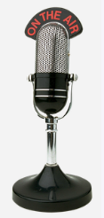***This and That’s***

**From Ted - W8KVK** - Ohio EmComm supporters interested in digital modes and technologies, may wish to watch for the final agenda for the TAPR/ARRL (Virtual) Digital Communications Conference.

**Sept 11-12, 2020**. Free YouTube live stream. $30 for full Zoom interactive. <https://tapr.org/dcc>

####

**From Dave, WA3EZN** - All United States traffic operators are advised that U.S. Army MARS may be injecting Radiogram-ICS213 messages into the traffic system in advance of a planned interoperability exercise on a date(s) yet to be determined. Please distribute the following QNC announcement to all RRI and NTS traffic networks. Thank you:

<http://radio-relay.org/wp-content/uploads/2020/08/QNC-RADIOGRAM-ALL-US-TRAFFIC-OPS-311531Z-AUG-2020.pdf>

You can also find this article at: COTN news index. <https://www.cotn.us/news>

####

TOP ^

**From Jim, W8ERW** - I have recorded IS-00245.b for K8RJH. Thanks, Ron, for submitting your certificate.  
This makes **284 Certificates that Ron has on file!**  Wow.... Ron has set the bar very high for anyone looking to beat his record on NIMS courses completed.

Hey Gang,

Have you taken a look at the **Swap & Shop** page on the Ohio Section webpage yet?? Here’s a link that will take you there…

<http://arrl-ohio.org/sm/s-s.html>

Do you have equipment that you just don’t need or want anymore? Here’s a great venue to advertise it, and it’s FREE!!

Is your club doing a fund raiser to help raise money? After a lot of thought, it was decided that the Swap & Shop webpage could also contain these types of items as well.

The same rules will apply as do for the For Sales and Give-A-Ways and will only be posted for a month at a time. Please see the Terms & Conditions on the webpage.

If your club is doing a fund raiser and wants more exposure, please forward the information to me and I’ll advertise it on the Swap & Shop webpage for you.

Now, I still want to remind you that it won’t be listed in this newsletter because it would take up way too much space, so your ad will only appear on the website. It is there for any individual to post equipment Wanted / For Sale or Give-Away as well as for Club Fund Raisers. No licensed vehicles/trailers or business advertising will be posted.

Postings are text only (no pictures or graphics) will be posted for a maximum of 1 month from date posting and require a contact phone number or email within the posting. Send your Wanted / For Sale or Give-Away post to:  [swap@arrlohio.org](mailto:swap@arrlohio.org)

Ohio Section Cabinet

|  |  |
| --- | --- |
| Section Manager – Scott Yonally, N8SY | Assistant Section Manager – John Perone, W8RXX |
| Section Emergency Coordinator – Stan Broadway, N8BHL | Section Traffic Manager – David Maynard, WA3EZN |
| Technical Coordinator – Jeff Kopcak, K8JTK | Affiliated Clubs Coordinator – Tom Sly, WB8LCD |
| State Government Liaison – Bob Winston, W2THU | Public Information Coordinator – John Ross, KD8IDJ |
| Section Youth Coordinator – Anthony Lascre, K8ZT | |

***Welcome New Subscriber(s)***

**Ai Loan**

TOP ^

***Back Issues of the PostScript and Ohio Section Journal***

Hey, did you know that PostScript and Ohio Section Journal (OSJ) are archived on the website? You can go back and look at any edition simply by clicking:

<http://arrl-ohio.org/news/index.html>

***Want to Share your Club Newsletter With Others?***

We have a webpage where you can download and read all of the newsletters that I get from around the state and even other sections!

Here’s the link to the page…. <http://arrl-ohio.org/club_news/index.html>

Please, if you don’t see your club newsletter posted, it’s because I’m not receiving it. Just have your newsletter editor contact me and I’ll get your club’s newsletter listed on the site!!

We all learn and steal (I mean, share) from each other’s work. So, get me your newsletter!!! Send it to: [n8sy@n8sy.com](mailto:n8sy@n8sy.com)

***History of Labor Day***

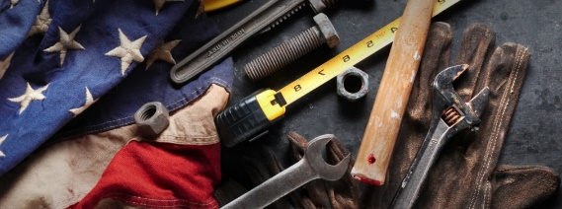

**Labor Day: What it Means**

Labor Day, the first Monday in September, is a creation of the labor movement and is dedicated to the social and economic achievements of American workers. It constitutes a yearly national tribute to the contribution’s workers have made to the strength, prosperity, and well-being of our country.

**Labor Day Legislation**

The first governmental recognition came through municipal ordinances passed in 1885 and 1886. From these, a movement developed to secure state legislation. The first state bill was introduced into the New York legislature, but the first to become law was passed by Oregon on February 21, 1887. During 1887, four more states – Colorado, Massachusetts, New Jersey, and New York – created the Labor Day holiday by legislative enactment. By the end of the decade Connecticut, Nebraska, and Pennsylvania had followed suit. By 1894, 23 more states had adopted the holiday, and on June 28, 1894, Congress passed an act making the first Monday in September of each year a legal holiday in the District of Columbia and the territories.

**The First Labor Day**

The first Labor Day holiday was celebrated on Tuesday, September 5, 1882, in New York City, in accordance with the plans of the Central Labor Union. The Central Labor Union held its second Labor Day holiday just a year later, on September 5, 1883. By 1894, 23 more states had adopted the holiday, and on June 28, 1894, President Grover Cleveland signed a law making the first Monday in September of each year a national holiday.

TOP ^

***Chit – Chat, and All That!***

Do you know someone that’s not getting these Newsletters? Please, forward a copy of this Newsletter over to them and have them “[Opt-In](mailto:Opt-In)” to start receiving them. Heck just have them send me an email [n8sy@n8sy.com](mailto:n8sy@n8sy.com) and I’ll get them added to the Ohio Section Emailing list.

We now have many thousands of readers receiving these newsletters weekly. Quite impressive, I’d say! I urge all of you to make sure that everyone, regardless of whether they are a League member or not, get signed up to receive these weekly Newsletters.

You can always “Opt-Out” at any time if you feel this is not what you were expecting. It’s fun and very informative. All of your favorite past newsletters are now archived too.

You can go back at any time and read them. Just go to: <http://arrl-ohio.org/news/>

Got questions, concerns or would just like to sit and chat awhile? Heck, I’ll even buy the coffee!! Give me a call at (419) 512-4445 or email me at: [n8sy@n8sy.com](mailto:n8sy@n8sy.com)

The pictures on the front page and throughout this newsletter are from various newsletters, Facebook posts and/or were sent directly to me in recent weeks. Take a good look at them, you just might be in one of the pictures! “SMILE… you’re in the Ohio Section News!!”

TOP ^

*PostScript is produced as a weekly newsletter. I want to thank everyone that has contributed articles and ideas to make this an even better news source. I sincerely hope that you have enjoyed this edition and will encourage your friends to join with you in receiving the latest news and information about the Ohio Section, and news and events happening around the world!*