[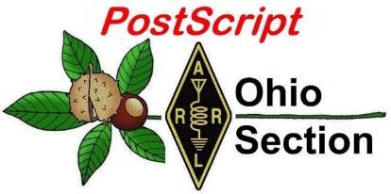](http://arrl-ohio.org/news/) ***August 17th***

***Edition***

🡪 National News 🡪 The Handbook Give Away

🡪 Club Corner 🡪 Hamfests

🡪 DX This Week 🡪 ARES Connect

🡪 VE Testing 🡪 One Question Questionnaire

🡪 Final.. Final..

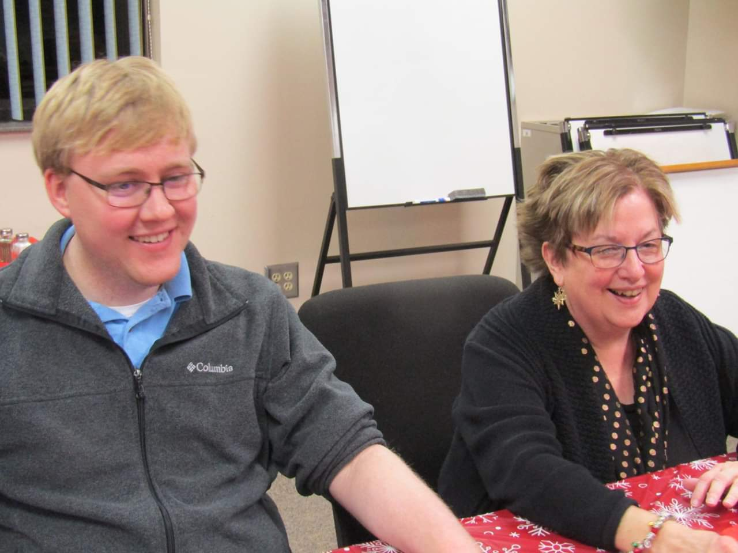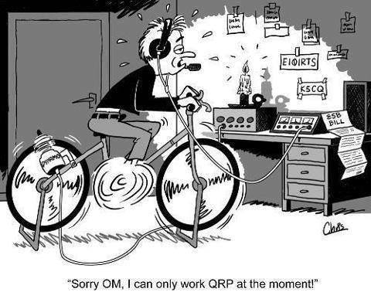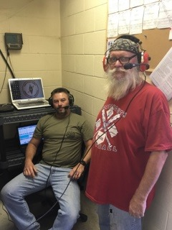

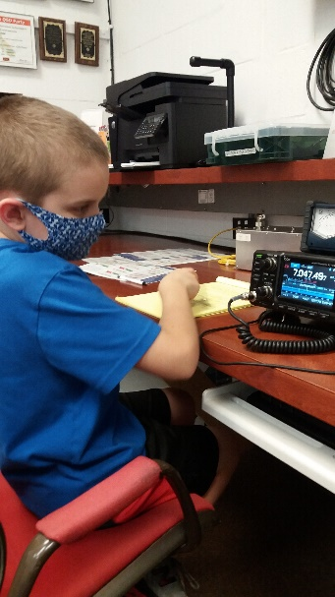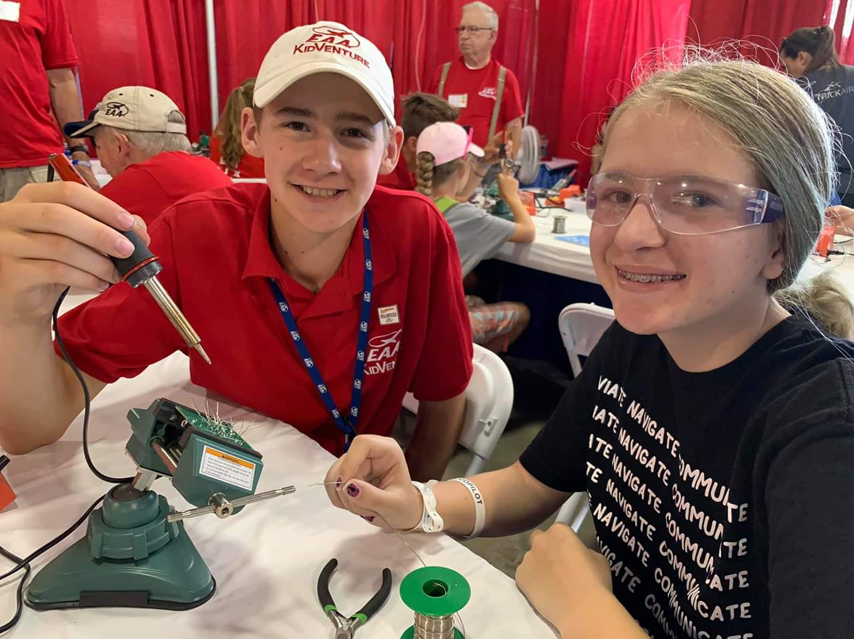

***National News***

*(from arrl and other sources)*

***Emergency Management Director Selected by ARRL Board of Directors***

**ARRL Hires Paul Z. Gilbert, KE5ZW, as Director of Emergency Management**

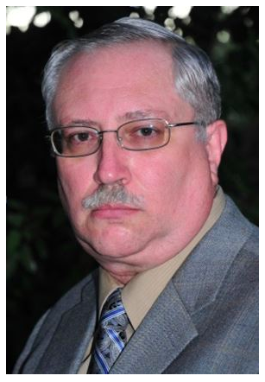

As another step in ARRL’s increased focus on strengthening its emergency communications capabilities and long-standing working relationships with federal and state agencies and private emergency response organizations, ARRL has hired Paul Z. Gilbert, KE5ZW, of Cedar Park, TX as its first Director of Emergency Management.

Gilbert brings more than 30 years of experience in public service in both his professional and amateur radio endeavors. Beginning with his appointment as Emergency Coordinator in 1987, he has held multiple positions in the ARRL Field Organization. Currently in his second term as South Texas Section Manager, he has also served for more than a decade as the West Gulf Division’s Assistant Director for Public Service, acting as liaison between Division leadership and local, state, and federal emergency management organizations.

Professionally, Gilbert most recently was Radio Officer, HQ Staff, for the Texas State Guard, where for the past 6 years he has been responsible for planning and implementation of the organization’s communications capabilities. Previously he was a Public Safety Radio Coordinator for a Texas agency, charged with overseeing that organization’s large-scale disaster communications response and identifying and eliminating in-state interoperability issues.

Gilbert, who has an Amateur Extra-class license, is a member of ARMY MARS, and holds numerous DHS certifications, including COML, COMT, COMT Instructor, and AUXCOM Communicator. He is a member of the FEMA Regional Emergency Communications Coordination Working Group (RECCWG), a graduate of the FEMA Emergency Management Institute’s Exercise Design Course, and was a founding member of the Texas Division of Emergency Management Communications Coordination Group.

In his new role, Gilbert will manage a team responsible for supporting ARRL Emergency Communications (EmComm) programs and services, including the Amateur Radio Emergency Service® (ARES®) and National Traffic System (NTS), as well as lead the continued modernization of those programs in consonance with the future emergency communications needs of the public and ARRL’s key partners.

####

***Campus Radio Clubs Face an Altered Fall Landscape***

Many colleges and universities are preparing incoming students for fall classes, amid a complex landscape of re-entry plans due to COVID-19. Schools are pursuing a variety of instructional modalities, including live and asynchronous online classes, reduced-size or no in-person classes, and hybrid classes with some mix of it all. At schools where in-person attendance is allowed, the emphasis is on classes. Related student activities, such as sports, clubs, and so on may be nonexistent or extremely limited, due to the demands of social distancing and the need to repurpose facilities and rooms for lower densities.

TOP ^

As institutions are forced to make hard choices, it’s going to be more important than ever for school amateur radio clubs to find ways to continue, even if in-person meetings are impossible.

Some campus radio clubs continue to sponsor training and testing of new hams by using videoconferencing and asynchronous communications to offer instruction and support. ARRL’s [**Instructor Discount Program**](http://www.arrl.org/instructor-discount-program) includes reduced-price self-study license manuals, including the popular [***ARRL Ham Radio License Manual***](http://www.arrl.org/shop/Ham-Radio-License-Manual/). The discount program is ordinarily offered to ARRL-registered instructors, ***but ARRL has temporarily extended the program to any in-school students who call to order*ARRL License Manuals*by referencing their school radio club or their ARRL-registered instructor***. Call toll-free (888) 277-5289, Monday – Friday, 8 AM – 5 PM Eastern Time.

Club instructors can download free [**instructional resources**](http://www.arrl.org/instruction-arrl-resources) for use with *The ARRL Ham Radio License Manual*, including PowerPoint slides, syllabus, and study review questions. Some college clubs are providing scheduled online license tests. For example, the [**Columbia University Amateur Radio Club**](https://www.w2aee.columbia.edu/) in New York City and the [**MIT Radio Society**](http://w1mx.mit.edu/) in Cambridge, Massachusetts, have scheduled online license examinations.

To make club resources available when in-person gatherings are not possible, some college clubs have remote-enabled their radio stations. California Polytechnic (Cal Poly) recently shared the details of the monthly ARRL Collegiate Amateur Radio Initiative ([**CARI**](http://www.arrl.org/collegiate-amateur-radio)) web conference in July. The monthly [**online**](https://attendee.gotowebinar.com/register/1807916378484261378) conferences continue into the fall.

The [**Collegiate QSO Party**](https://collegiateqsoparty.com/)**is planned for September 19 – 20**. The QSO Party is an operating event focused on amateur radio clubs at colleges and universities around the world. Each fall, the Collegiate QSO Party provides an opportunity for clubs to demonstrate amateur radio to new members, engage with alumni, and promote activity throughout college and university communities.

For school clubs that can find a way to keep their members involved, these times could be an opportunity, as there will be fewer extracurricular activities competing for students’ time and attention. The student population in general is already comfortable and thriving with a variety of online activities. The key to getting, and keeping, more young people involved in amateur radio may be to follow their lead: more online and non-traditional amateur radio-based activities, where the “radio part” is a component of a high-altitude balloon, semi-autonomous seafaring robot, or communications network.

####

***QSO Today Virtual Ham Expo to Become Twice-Yearly Event***

The [**QSO Today Virtual Ham Expo**](https://www.qsotodayhamexpo.com/) over the August 8 – 9 weekend appears to have been an unmitigated success, so much so that another virtual event will be held next March.

“It was far better than we expected,” Virtual Ham Expo chair Eric Guth, 4Z1UG/WA6IGR, told ARRL. “We had over 26,000 registered and over 14,000 on the platform both days.”

Guth said event sponsors and exhibitors that he’s heard from so far “are thrilled with the turnout, engagement, and responses that they received.” He said they’re also enthusiastic about the second QSO Today Virtual Ham Expo, set for March 13 – 14, 2021. “Our plan is to offer this twice a year,” Guth added

TOP ^

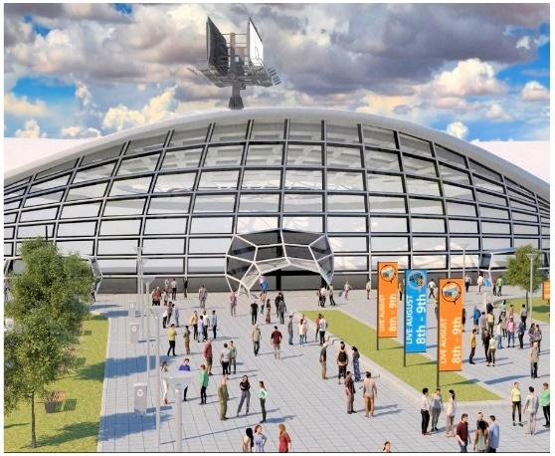The show, an ARRL-sanctioned event, was developed on the [**vFairs**](http://www.vfairs.com/) virtual conference platform, and cleverly re-created the atmosphere of a typical large hamfest, with several tracks of forum sessions on a wide array of topics. Those who had registered but did not log into the live event can see it all [**on demand**](https://qsotoday.vfairs.com/) until September 9.

“All of the services, except the chat, are running,” Guth noted. “The doors are still open.”

Dozens of video presentations are available to replay, including the keynote given by ARRL Maxim Society Member Dr. Scott Wright, K0MD, “COVID-19: Amateur Radio’s Impact on Problem Solving to Create a Global Response to the Pandemic.” Presentations from other ARRL member-volunteers span technical and operating interests, including “Everything you need to know about Lithium Batteries” with Marcel Stieber, AI6MS, and an introduction to creating Arduino-based projects for home and ham radio, with Glen Popiel, KW5GP. Presentations highlighting young ham involvement and development include “Youth in Ham Radio,” moderated by Carole Perry, WB2MGP, with six youth presenters.

Icom, a principal sponsor of the event, had team members from around the globe staff their exhibits. Icom America Senior Sales Manager Ray Novak, N9JA, said the event supported their new product launches including Icom’s new IC-705 HF – 430 MHz all-mode 10-W transceiver, which just received FCC certification.

“We really enjoyed the virtual event,” said Novak. “It is our goal to see this grow and to have hams from the various countries attend in anticipation of this becoming a multilingual event as we all are starving for ham radio events during this pandemic.”

Kevin Zanjani, KI6DHQ, of Bioenno Power, also gave the virtual event high marks. The show, he said, “was quite exciting and a great platform to interact with customers and the entire ham radio community during these times.” Bioenno Power, based in Southern California, is a provider of Lithium-Polymer (LiPo) batteries and solar-power devices. Zanjani said the chatroom was very effective to engage with customers. “Many also dropped by to say hello as well, so we found that nice.”

Product Development Manager Bob Inderbitzen, NQ1R, was among the ARRL representatives engaging with event attendees using text and video chat. He described the experience as having some similarities and some difference from an in-person convention.

“Our team answered questions about ARRL membership programs and services, amateur radio licensing, and even had some fun challenging visitors to our booth with ham radio trivia,” he said. Physically located at ARRL Headquarters in Newington, Connecticut, Inderbitzen treated more than 500 visitors to live, online tours from inside Hiram Maxim Memorial Station W1AW.

“It was fun to see a screen full of smiling faces, and to answer questions in real time. The experience had an on-air feel. I should have kept track of all of the US states and countries I connected with,” he said. A short welcome [**video**](https://youtu.be/BStzRccXhBQ) greeted visitors at the ARRL booth.

Guth said the organizers’ challenge going forward is to reduce the workflow in putting the show together. “But all in all, it was a lot of work, I have a great team, the volunteer speakers and moderators were out of this world, and I am grateful to our sponsors and exhibitors for footing the bill,” he added.

TOP ^

Guth said that the main complaint he heard about was the show’s use of a leaderboard for awarding prizes. “We used it because the sponsors and exhibitors paid for their booths and donated the prizes,” he said. “The Leaderboard rewarded those who visited exhibitors, chatted with them, watched their videos, and downloaded their documents.” “We will evaluate other games for March that also increase engagement,” he added.

####

***IARU Announces HF Digital Mode Band Plan Review***

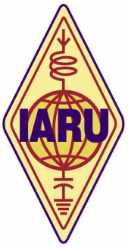

An International Amateur Radio Union (IARU) working group has been formed to develop solutions to reduce congestion within very popular mode segments while preventing mutual interference between “incompatible modes” as much as possible. The working group includes representatives of the three regional band-planning committees, marking the first time the IARU three regions have joined together to directly coordinate band planning efforts.

“Because frequency allocations and amateur radio operating interests vary in different parts of the world, the development of band plans — voluntary guidelines on the use of the spectrum that is available to radio amateurs — is a responsibility of the three IARU regional organizations,” the IARU explained in announcing the working group. “Each of the three regions has a band-planning committee to focus on this work.”

The IARU says this approach to band planning has generally kept pace with the evolution of amateur radio operating, but the explosive growth in HF digital modes, particularly FT8, has led to perceived overcrowding of HF digital-mode band segments.

The new working group has already had fruitful discussions with the *WSJT* Development Group led by Joe Taylor, K1JT. Additional discussions, including with other HF stakeholders, will be held as part of a fundamental review of the different HF digital modes, and how they can be best categorized and arranged to share the limited spectrum available.

In recent years, moves have been made to bring the regional band plans into alignment wherever possible. Final approval of any band plan revisions typically occurs during regional conferences of IARU member-societies, held every 3 years on a rotating basis.

While the proposed band plan revisions will have to be approved by member-societies in each region, recent administrative changes mean that revisions can be implemented without having to wait for the regional conferences.

***Hamfest Goes Silent***

*(from The Courier – Sara Arthurs and submitted by Gregory Drezdzon, WD9FTZ)*

The Findlay Radio Club has canceled its upcoming Hamfest, which typically draws about 2,000 ham radio enthusiasts to Findlay. But club members remain eager to share their hobby with anyone who’s interested.

TOP ^

Dave Dryden, chairman of the now-canceled event, said one thing he loves about the hobby is “there’s always something new.”

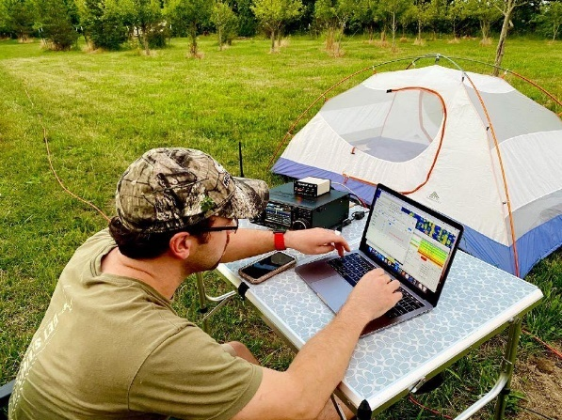

And without the internet or a phone line, he can talk to someone in New Zealand through ham radio, he said. Or, he can “listen to the (International) Space Station as it goes over.” Today, some people do connect their radios to their computers, Dryden said.

The club announced Wednesday that the festival, which had been scheduled for Sept. 13, has been canceled for the first time in its 78-year history. The event, hosted by the club and held at the Hancock County Fairgrounds, typically attracts about 2,000 ham radio enthusiasts from Ohio, Michigan, Indiana and Canada.

The Hamfest was described in a press release as “a cross between a trade show, a swap meet, and a conference.” Dryden said the format of the event made it impossible to transition to a virtual version online.

In an interview with The Courier, Dryden said vendors come from all over the country to sell new and used equipment. And, in something akin to “a tailgate party,” individual enthusiasts bring items to swap, with everyone going from car to car trading items.

“There’s an in-person, social dimension to the event that doesn’t translate easily to an online platform,” Dryden said in the press release. “Hams want to see all the stuff, touch all the merchandise, and bargain over the price. Thousands of conversations and personal interactions are occurring in the course of a few hours that just wouldn’t happen with an online event.”

In addition to selling and trading equipment, the event serves as an educational forum.

Dryden said Findlay’s is one of the oldest local events.

This year’s Hamfest isn’t the only local amateur radio event to be affected by the coronavirus. The guidelines for Field Day, an national American Radio Relay League event held each year on the third full weekend in June in which hams head outdoors and operate their radio stations “in the field” and “off the grid” using battery, solar, wind, or generator power, had to be modified according to Evan Hartman, emergency coordinator for Hancock County Amateur Radio Emergency Service and chairman for the local Field Day.

“We increased the physical spacing between the four radio stations we set up and operated over the weekend, and the rules for the competition were modified this year to allow the scores of operators in the field, based on the number and location of radio contacts they made, to be combined with the scores of other team members who felt more safe operating from stations at their homes," he said.

The Findlay Radio Club has supported the Susan G. Komen Race for the Cure event in Findlay for many years by providing field communications support on the day of the event, before, during, and after the race, according to current radio club president and longtime chairman of the club’s race support committee Allen Clark. This year’s Virtual Race for the Cure will change that role.

But the Findlay Radio Club is eager to continue connecting with the local community and introducing non-hams to the fun of amateur radio by offering training classes, monthly ham radio license testing and other local events.

TOP ^

For the month of August, the club has set up a display in the Findlay-Hancock County Public Library (next to the reference desk) that showcases the breadth of amateur radio today.

Dryden said about half of the local club members are “gray-haired like me,” but many are in their 20s or 30s.

For more information on the club, visit findlayradioclub.org.

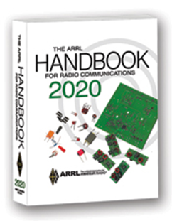***The Handbook Give Away***

Hey Gang,

Have you registered for the “Handbook Giveaway” drawing for this month yet? If you haven’t, go to: <http://arrl-ohio.org/handbook.html> and get yourself registered now!

What’s the catch? I want to get everyone checking in to the Ohio Section website as often as possible, and in order to register each month, you have to visit the website often! There’s nothing else to it. I pay all expenses and I usually “Give Away” more than just a Handbook too!!

Many of you ask me just how do I know when the drawing is on? Well, that’s easy all you need to do is check in on the Ohio Section Website on a regular basis and watch for the big [RED](http://arrl-ohio.org/handbook.html) Arrow that will appear on the left side of the page. This is the sign that the drawing is on and you need to get registered. So, keep a sharp eye out on the website and check in often!

***Club Corner***

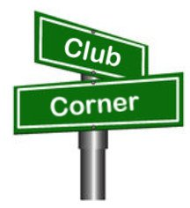

This is YOUR cornner of the newsletter. Send me what your club is doing and I’ll make sure that it gets in. Got a special event or club project that you want everyone to know about? Send it to me!. Need help with a project? Send it to me.

Let me know what you club is up to. Are you going to have a special guest at your meeting or are you having a special anniversary? Just sent it to: [n8sy@n8sy.com](mailto:n8sy@n8sy.com)

####

The Toledo Mobile Radio Association (TMRA) will have a fox hunt **September 16 at 6:30p**, with a rain date of September 19 at 1p.

The “hunt” kicks off from Swan Creek Metropark, Airport Highway entrance. This will be an in-park hunt that may or may not require participants to cover some ground.

Those who would like to learn this sport can be teamed up with an experienced hunter. For more information contact [W8MAL@QSL.NET](mailto:W8MAL@QSL.NET)

####

TOP ^

***Tri-State ARA Has Successful VE Test Session***

The Tri-State ARA congratulates the following folks who attended their August 8 test session:

James P. Toschi - KE8OUH - Charleston, WV - Earned an upgrade to General. Joseph T. Rudmann - Ironton, OH - Earned a Technician license. David L. Wright - Louisa, KY - Earned a Technician license.

I would like to extend my personal thanks to my friend Judy Taylor WD8EOP for volunteering to conduct the session in my absence.

Our sessions are ARRL. We are currently running with restrictions due to the pandemic. Up to date info can be found on our website: [www.qsl.net/w8va](http://www.qsl.net/w8va)

The Highland ARA also wishes to acknowledge the following new hams who entered the hobby at a recent test session.  Bainbridge's Doug Broyles is now KE8ORQ and Hillsboro's Jason Maines is KE8ORR and Blake Gall, KE8PAQ. A special shout out goes to Jim Scott-N8ORJ of the Fayette ARA who conducted the test for HARA.

Bud Cyr, KB8KMH, reminds hams in the region that the West Virginia Museum of Radio and Technology in Huntington is currently open on Saturday 10am - 4:00pm and Sunday 1:00pm - 4:00pm.

For anyone interested in electronics or any type of radio communications it is a GEM and well worth a visit.  You can spend hours there and still not see everything.

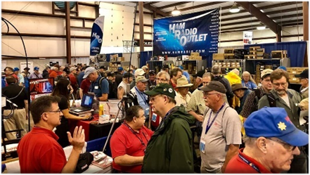

[***Upcoming Hamfests***](http://arrl-ohio.org/hamfests.html) ***for 2020***

**09/13/2020 - Findlay Hamfest** ***Canceled***

**09/27/2020 | Cleveland Hamfest and Computer Show**

***Canceled***

|  |
| --- |
| **10/10/2020 - Northwest Ohio Amateur Radio Club (NWOARC) Fall Hamfest Location: Westminster, OH Sponsor: NWOARC, Northwest Ohio Amateur Radio Club Website:**[**http://www.nwoarc.com**](http://www.nwoarc.com/) |

***Wanted… Assistant Section Youth Coordinator***  
Anthony Luscre, K8ZTthe Ohio SYC has begun a search for one or two Assistant Section Youth Coordinators that would work with him to help support youth activities across the Ohio Section. If you are interested in this position or know someone that might be interested please email him <[k8zt@arrl.net](mailto:k8zt@arrl.net)> with information.

TOP ^

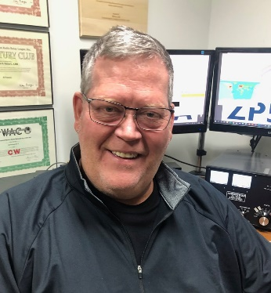***DX This Week***

*(from Bill, AJ8B)*

***DX This Week – Ohio QSO Party***

***Bill AJ8B (***[***aj8b@arrl.net***](mailto:aj8b@arrl.net)***, @AJ8B, or*** [***www.aj8b.com***](http://www.aj8b.com)***)   
 CWOPs Member #1567***

There are signs of Cycle 25 begining to be more active. The entities spotted in the midwest this week did not necessaily indicate that. However, the following entities were spotted: Algeria, Angola, Argentina, Austria, Belarus, Belgium, Bermuda, Bosnia-Herzegovina, Brazil, Bulgaria, Canada, Canary Islands, Ceuta & Melilla, Chile, Colombia, Croatia, Curacao, Cyprus, Czech Republic, Denmark, Dominica, Dominican Republic, Ecuador, England, European Russia, European Turkey, Germany, France, Georgia, Gibraltar, Hungary, Ireland, Israel, Italy, Jamaica, Japan, Kaliningrad, Kazakhstan, Kuwait, Latvia, Lithuania, Luxembourg, Martinique, Mauritania, Mexico, Moldova, Montenegro, Netherlands, New Zealand, Nicaragua, Norway, Panama, Philippines, Poland, Portugal, Puerto Rico, Romania, Sardinia, Saudi Arabia, Serbia, Sicily, Slovak Republic, Slovenia, Spain, Sweden, Switzerland, Ukraine, United Arab Emirates, Uruguay, and Venezuela.Let me know what you worked!

I try to participate in as many contests as I can during the year. I consider the contest season running from the fourth Saturday in August to Memorial Day weekend of the next year. The significance of August to May is that the Ohio QSO party (OQP) is held on the fourth weekend in August and the CQWW WPX CW contest is held during the last weekend in May. Although I do participate in as many state QSO parties (and other contests) as I can, my focus is on the Ohio QSO Party. The majority of the information presented here is from the Ohio QSO Party website and is used here courtesy of the Mad River Radio Club.

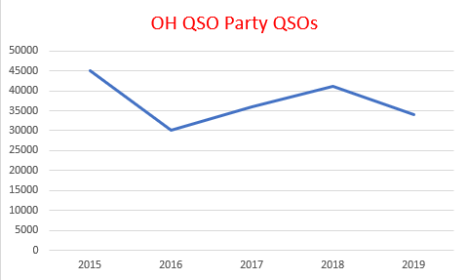Why the Ohio QSO Party? The objective of the contest is for Amateurs inside the state of Ohio to contact as many Amateurs as possible both inside and outside of Ohio. For Amateurs outside the state of Ohio to contact as many Ohio stations as possible. Non-Ohio stations may work only Ohio stations, while Ohio stations may contact anyone.

The Ohio QSO Party is an opportunity for amateur radio operators around the world to celebrate the great state of Ohio.

What does this have to do with DX? Well, chasing DX requires operating skill, patience, and a solid knowledge of your equipment. Contests require all of this for an extended period. In the case of the OQP, this is a 12-hour long contest where one of the biggest factors is BITS. (Butt in the Seat – Thanks Dave, K8DV) In addition, it is really a lot of fun!

TOP ^

If you have any interest at all, please visit <https://www.ohqp.org/> and browse the links on the left hand side and explore the site. You’ll find the rules, past scores, planned operations for this year’s event, scoring records and more.

If you review Figure 1 the table that you will see that there is a lot of activity during this contest. Since 2015, the OQP has had an average of 38,091 QSOs submitted. Last year it would seem that activity was down about 5%, but, with the storms this time of year as well as the sunspot activity, it isn’t to be surprised. I hope that it is even busier this year.

**How can you get up to the minute info on OhQP, post questions or tell everyone about your OhQP experience…**

OhQP has a mail list (reflector). You can subscribe (allowing you to post messages or to view the archives. This is the only place on the web to get “official” information on the Ohio QSO Party. We are not on FaceBook, Twitter or anywhere else. Since 1999 the Mad River Radio Club has brought you the Ohio QSO Party.

***CQDX CQDX CQDX CQDX CQDX CQDX CQDX CQDX CQDX***

Here is an update from Bernie, W3UR, of the DailyDX and the WeeklyDX, the best source for DX information. <http://www.dailydx.com/>. Bernie has this to report:

**ZL7 – Chatham Islands -** “I have moved to the Chathams on a permanent basis as I have a permanent job here along with a house” reports ZL3STU, Stuart. He has been there since July 14th and has been issued the callsign ZL7STU. Stu has a 100 watt IC-706MKii and an HF edz End fed line. Listen for activity on 80 through 6 meters (grid locator AE16sa). The Chatham Islands (ZL7) now has three Amateur Radio operators. QSL ZL7STU via M0OXO.

**JD1/O – Ogasawara Islands -** JI5RPT, Makoto, is heading back to Chichijima Island (AS-031) and plans to be QRV from October 3-6, as JD1BLY. It’s possible his schedule could “change depending on the status of COVID-19”. Activity will be on FT8, CW and SSB on 630 through 6 meters as well Satellite RS-44. His focus will be on the 630 meter band (JT9), 160 meters SSB, Satellite RS-44 and FT8 on the HF bands. You can search his [**log**](http://r20.rs6.net/tn.jsp?f=001p7DkRZlk3lYj1DkCQ7kZsp_w8xUnGUi7_VZiD7nPE3AXOixuo0nUMb8jD6kZZ3_kOZ4kFL6bDE_m6pwLrBrvU9EO-90xL-K1DOxmCY5rxDP_DktiKA0gHRhwk9vIVsIH8iqsWyh1MsIP3fq7AwB8Bw==&c=8Y-bbLIEBSs49Y8m4ir3hTVh5uwe5_XBhQH2UR_YUtK-rJSjjTID8g==&ch=I3BA6aTBmwQ7wCn8UV6IpmDKGctCFwr5uu4avGP8xDxivduWCUeTwg==). Makoto will be posting updates on his [**Twitter account**](http://r20.rs6.net/tn.jsp?f=001p7DkRZlk3lYj1DkCQ7kZsp_w8xUnGUi7_VZiD7nPE3AXOixuo0nUMb8jD6kZZ3_kdMTl-yEXfg8RoGXf6GOtNg9c-Q-oOBsffm9ygSD_v93VBqr3tZtojMNiRgUroYI3Qjoe2jAqNBLfZGOI_rmhEw==&c=8Y-bbLIEBSs49Y8m4ir3hTVh5uwe5_XBhQH2UR_YUtK-rJSjjTID8g==&ch=I3BA6aTBmwQ7wCn8UV6IpmDKGctCFwr5uu4avGP8xDxivduWCUeTwg==). QSL via his home callsign JI5RPT.

**JW – Svalbard -** LB1QI, Erwann, “was able to secure a trip to Svalbard in September 2020 between the 24/09/2020 and the 27/09/2020”. He will be hosted by the JW5E radio club station using their antennas for activity on CW and SSB on 1.8 through 50 MHz as JW/LB1QI. Erwann will be taking his Yaesu FT-857D and Juma PA1000 amplifier. QSL direct, via the bureau or LoTW.

**CE – Chile -** Between August 5 and October 13, 2010 33 Chilean minors were trapped in a mine in the Atacama Desert. To commemorate the event special call CB33M will be QRV by the Radio Club Eternautas from August 5 to October 13, 2020. QSL via CE3ETR.

TOP ^

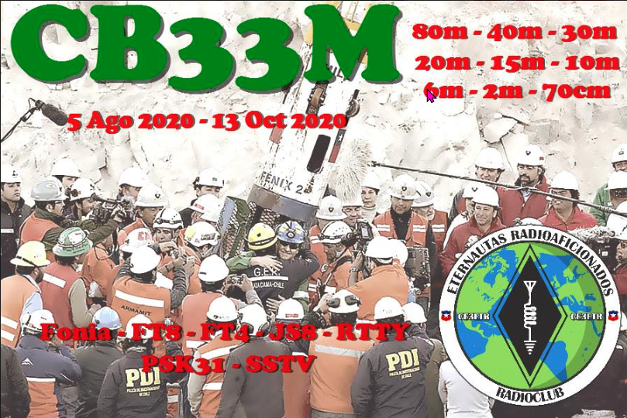

***DX News***

***ARLD033 DX news***

This week's bulletin was made possible with information provided by The Daily DX, the OPDX Bulletin, 425 DX News, DXNL, Contest Corral from QST and the ARRL Contest Calendar and WA7BNM web sites. Thanks to all.

**MEXICO, 6E.** Ramon, XE1KK will be using special call sign 6E6E until December 31. He plans to use it in the CQWW DX SSB Contest in October and possibly in other contests. Most of his activity outside of the contests will be on FT8/FT4 on 160 to 6 meters. QSL via LoTW only.

**GHANA, 9G.** Matteo, IZ4YGS will be active as 9G5GS from Sanzule, until September 15. Activity will be limited to his spare time on 160 to 10 meters using mostly FT8 (F/H) and SSB. He will also be active through the QO-100 geostationary satellite, USB mode. He will update daily to ClubLog. QSL via LoTW, IZ4YGS direct or eQSL.

**CHILE, CB33.** Members of the Radio Club Eternautas (CE3ETR) are now active as CB33M until October 13. Activity is to commemorate the 10th anniversary of the August 2010 landslide in a mine in the north part of Chile where 33 miners were trapped for 3 months until their rescue was carried out. Operations will be on 80 meters through 70 cm using CW, SSB and digital modes FT8/FT4, JS8, RTTY, PSK31 and SSTV. QSL via PO BOX 12096, Santiago, Chile.

TOP ^

**OGASAWARA, JD1.** Makoto, JI5RPT will be active as JD1BLY from Chichijima Island (AS-031) from October 3 to 6. The schedule may change depending on the status of COVID-19. Activity will be on 630 to 6 meters using CW, SSB and the digital modes (No 6 meter EME). He will focus on the 630 meter band, 160 meter SSB, the RS-44 satellite and FT8 on the HF bands. 630 meter activity will be mainly on JT9. QSL via his home call sign.

**UNITED STATES, N7.** Look for special event station N7C to be active until August 15 for the 16th annual celebration of the Navajo Code Talkers. QSL to Herb, N7HG or N7C, at the QRZ.com address.

**TURKEY, TC3.** Look for special event stations TC3GP and TC3GS to be active until August 23, to commemorate the 105th anniversary of the Battle of Gallipoli. QSL via YM3KCN.

**FRANCE, TM.** Operators Christian, F5OHH and Didier, F4ELJ will be active as TM2LW from the Kerprigent Lighthouse (ILLW FR-031, ARLHS FRA-769, DFCF 22-036, DMF 22-011, WW Locator IN88GS) near Lannion during the International Lighthouse Lightship Weekend (ILLW), August 22 and 23. Activity will be on various HF and VHF bands using CW, SSB and the digital modes. QSL via F4ELJ.

**FRANCE, TM76.** Members of the Radio Club du Val d'issole (F8KGH) will use the special call sign TM76DP until August 22 to commemorate the 76th anniversary of the Provence Beach Landings (DRAGOON operation) in August 1944. Activity will be on 80 to 6 meters using CW, SSB and the digital modes. QSL via F4GPB.

**HONG KONG, VR.** Members of Hong Kong Amateur Radio Transmitting Society (HARTS) will be active with special call sign VR2HK9O in celebration of the 90th anniversary of their Society. Operations have been on 20 meter SSB. QSL via VR2HK direct or by the Bureau.

**CAMBODIA, XU7.**  Tad, JA1DFK will be active as XU7AKU and XU7AKV from Phnom Penh. Activity will be on 160 to 6 meters using mostly CW and SSB. QSL via JA1DXA or ClubLog's OQRS.

**DENMARK, OZ.** OZ200EM is on the air until the end of the year, honoring the memory of Hans Christian Orsted, who discovered the principle of electromagnetism 200 years ago. QSL via OZ1ACB.

**CHATHAM ISLANDS, ZL7.** Stuart, ZL3STU has moved to Canterbury on the Chatham Islands (OC-038) and now uses the call sign ZL7STU on 80 to 6 meter using SSB and FT8. QSL for both calls via M0OXO.

**SARDINIA, IS0.**  Gil, IZ2DLV will be active holiday style until August 28 signing IS0/IZ2DLV on 60 to 15 meters using SSB, CW and FT8. QSL via IZ2DLV (d/B), ClubLog, LoTW.

**FINLAND, OH.** Operators Vesa, OH5MNH, Orvo, OH5NE and SWL Aki plan to operate OH5B during the International Lighthouse/Lightship Weekend (ILLW), August 22 and 23 from the Luovukkaluoto lighthouse in Southern Carelia. QSL via OH5AB.

**INDIA, VU.** In celebration of the 74th anniversary of India's Independence Day, August 15th, special event station AT5AUG will be QRV by members of the West Bengal Radio Club from August 14 to 16.

QSL via eQSL to VU2NRO.

**BALEARIC ISLANDS, EA6.**  Rolf, DL8AZ will be operating holiday style as EA6/DL8AZ until August 17. He will use SSB on 40 through 10 meters. QSL via DL8AZ either direct or to the DARC QSL bureau.

TOP ^

**BONAIRE, PJ4.** PJ4TEN is a special event station during October for the 10th anniversary of 10-10-10, the date the Netherlands Antilles was dissolved and Bonaire became a special municipality of the Netherlands and a new DXCC entity. QSL via M0URX direct, OQRS, or LoTW.

**GREECE, SV.** SV1AHH and SV1GGF will be QRV as SX1AFM from September

1 to 30, celebrating the 70 years of the Hellenic Air Force History Museum. They will be on 80 to 6 using all modes. QSL via qrz.com information.

THIS WEEKEND ON THE RADIO. SARTG WW RTTY Contest, ARRL 10 GHz and Up Contest, Russian District Award Contest, Keyman's Club of Japan Contest, Feld Hell Sprint, North American QSO Party, CVA DX Contest, SARL HF Digital Contest, NJQRP Skeeter Hunt, ARRL Rookie Roundup and the Run for the Bacon QRP Contest are all on tap for this weekend.

Please see August 2020 QST, page 69 and ARRL Contest Calendar and WA7BNM Contest websites for details.

**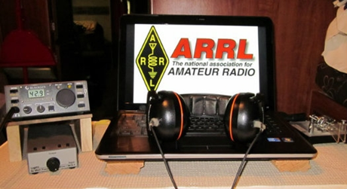*ARRL Contest Corner***

An expanded, downloadable version of *QST'*s’[**Contest Corral**](http://www.arrl.org/contest-calendar) is available as a PDF. Check the sponsor's’Web site for information on operating time restrictions and other instructions.

|  |  |
| --- | --- |
| **August 19**   * [Phone Fray](http://www.perluma.com/Phone_Fray_Contest_Rules.pdf) * [CWops Mini-CWT Test](https://cwops.org/cwops-tests/) | **August 22**   * [**Ohio QSO Party**](https://www.ohqp.org/)   Sponsored by Mad River Radio Club (MMRC)  A note from Scott N3FJP regarding his logging software:  Scott notes that his "Ohio QSO Party Contest Logs (In State 4.4 and Out of State 4.3) have been updated for the rule change to include 160 meters."  It is suggested that if you are going to use N3FJP State QSO Software to log during the contest, please download the updated OH QSO Party software from his site. |

***Ohio QSO Party***

The Ohio QSO Party is coming up on **August 22**. Please read the not about the changes to N3FJP's contest logging software and that you need to download the latest version of the Ohio QSOParty log.

Also, A reminder that the **Ohio QSO Party is from noon till midnight EDT**. There will be lots of activity from Ohio and in spite of COVID-19. There will be several mobile operations taking place, plus some home stations, EOC stations and rovers.

TOP ^

Want more information about the Ohio QSO Party? Here’s a link: [https://www.ohqp.org/](http://r20.rs6.net/tn.jsp?f=0015f-Hq-VS-b4XNJJK73ceENv8IIeY2JgX_-p-s0wqXzN4G5F6WQED8L3Pa2A_rbiRwTwCO0FetBd6vnh9--yvE_9qz0awrE5PHKxgOBtg6VY9xIkw6iBKBLLi_iGFRRziyiVceyNcaWQ=&c=JgjXUupg8mI62Ghbvm1_MVcZfV_gAbHEG-DFBno426EiJBqD3m8J_Q==&ch=K6pBLIvgJiPE_wZzF-0kFLVozmlVUFa2yZMrtt_v4kBcsVQahEHlJA==)

Also, the State QSO Party Challenge is going on full bore so your score counts TWICE once for OHQP and once for the Challenge! Info for the Challenge: [http://stateqsoparty.com/](http://r20.rs6.net/tn.jsp?f=0015f-Hq-VS-b4XNJJK73ceENv8IIeY2JgX_-p-s0wqXzN4G5F6WQED8GslaOMyoR0jNoyig8WGppFG3_divExr-bimPpSi7-bCpXWVDzO-w8lz9-xDrwwoMd0_0S8E5M7GM4Nlb7nuHJ5hPZMGC2qR2Q==&c=JgjXUupg8mI62Ghbvm1_MVcZfV_gAbHEG-DFBno426EiJBqD3m8J_Q==&ch=K6pBLIvgJiPE_wZzF-0kFLVozmlVUFa2yZMrtt_v4kBcsVQahEHlJA==) Currently there are 55 counties with planned activity with many stations signing up daily on the activity page. Check that here: [https://www.ohqp.org/index.php/view-plans/](http://r20.rs6.net/tn.jsp?f=0015f-Hq-VS-b4XNJJK73ceENv8IIeY2JgX_-p-s0wqXzN4G5F6WQED8L3Pa2A_rbiRpMek7wZA-Ktrkcw54bFl-xq0Bh9GDeL_5WZAMaupSy7D25ad-4rvQC1P9dn98UXRraNhrHrSZlkwOOo349ElMW7kmh3bQIZvyYpvQ_kEY24=&c=JgjXUupg8mI62Ghbvm1_MVcZfV_gAbHEG-DFBno426EiJBqD3m8J_Q==&ch=K6pBLIvgJiPE_wZzF-0kFLVozmlVUFa2yZMrtt_v4kBcsVQahEHlJA==)

####

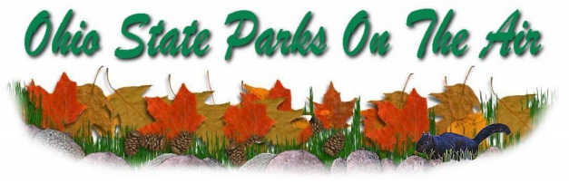

The Portage County Amateur Radio Service, Inc. (PCARS) announces the 13th Annual “Ohio State Parks On the Air” (OSPOTA) contest, from the hours of 10 am to 6 pm ET (1400 UTC to 2200 UTC).



13th OSPOTA - **September 12, 2020**

14th OSPOTA - September 11, 2021

15th OSPOTA - September 10, 2022

16th OSPOTA - September 9, 2023

17th OSPOTA - September 7, 2024

18th OSPOTA - September 6, 2025

19th OSPOTA - September 12, 2026

20th OSPOTA - September 11, 2027

**Always the first Saturday after the Labor Day holiday.**

For hams throughout the State of Ohio, this is your opportunity to visit and enjoy the amenities offered by the 75 beautiful State Parks here in Ohio. Don’t just make a day of it - spend the weekend at the park of your choice. No matter whether you are camping or staying at one of the outstanding lodges or resorts, you will find that the parks are one of Ohio’s greatest assets. Find out more about the Ohio State Parks at: <http://parks.ohiodnr.gov/>

In past years, hundreds of Amateur Radio Operators (hams) from around the country participated in the event. With the success of OSPOTA, we hope to have amateur radio operators at every Ohio State Park.

This contest places a premium on working stations located in the Ohio State Parks. That means that it is critical to have as many parks activated as possible. The challenge for Ohio stations will be to work HF in the 50 to 300 mile range. This is the perfect opportunity to learn more about the design and deployment of Near Vertical Incident Skywave (NVIS) antennas. You can find numerous designs on the Internet and in various Amateur Radio antenna manuals. Along with your operating skills, it will be a chance to showcase your antenna building skills as well.

TOP ^

Individuals and multiple operators can operate Ohio State Park stations. Non-park stations in Ohio as well as stations outside of Ohio can also compete. Contacts can be made on 80, 40, 20, 15 and 10 meters using SSB. All contacts have the same point values. Make sure that you read the Rules, FAQ’s and get your forms for the contest that are posted on the OSPOTA website: [www.ospota.org](http://www.ospota.org) before the contest.

So, get to an Ohio State Park and get On The Air in September. Have some fun with this contest!

73 for now, OSPOTA Contest Committee

***Special Events***

* **08/22/2020 | National Park Service Founders Day**

**Aug 22-Aug 30, 1200Z-2300Z, N1P**, Canfield, OH. NPS Ranger News. 14.255 7.290. Certificate. Certificate, available online only, see website. Online certificate only, see website <https://www.qrz.com/db/N1P>

* **08/22/2020 | Southwest Reef Lighthouse/ILLW/US0176**

**Aug 22-Aug 24, 0001Z-1800Z, W5BMC**, Berwick, LA. Bayouland Emergency Amateur Radio Service/BEARS. 14.275 7.275. QSL. Jackie Price, 708 Front St., Morgan City, LA 70380. The Southwest Reef Lighthouse sits on the bank of the Atchafalaya River in Lighthouse Park in Berwick. The station is a permanent facility at the Memorial Ray Rasberry, WB5LKR(SK) tower in Lighthouse Park

* **08/27/2020 | Burning Man**

**Aug 27-Sep 7, 1200Z-1200Z, W7B**, Gerlach, NV. Mansonian. 28.375 21.325 14.250. QSL. George Badger, 4602 Fairway Dr, Soquel, CA 95073. SASE for QSL please. [w7b@w3ab.org](mailto:)

* **08/28/2020 | 15th Anniversary of Hurricanes Katrina & Rita**

**Aug 28-Aug 30, 2300Z-2359Z, K5R**, Mandeville, LA. KD5PCK. 40, 20, and17 meters, general portions. Certificate. Scott Hernandez, 957 Nancy St. , Mandeville, LA 70448. In August & September of 2005, Hurricanes Katrina & Rita made landfall in Louisiana. Katrina striking near Buras, LA and Rita landing near the Louisiana/Texas border. When all else failed, hams from across the nation assisted with establishing communications into and out of the entire gulf coast area. Commemoration of the 15th anniversary of these two devastating storms will take place on air the weekend of August 28 through 30, 2020. Look for activities in the General portions of 40, 20 and 17 meters. More information regarding operations and certificates on the K5R QRZ page. <https://www.facebook.com/groups/katrina5rita>

* **08/28/2020 | RESCHEDULED -100th Vermontville TWP Fire and EMS Association Annual Dance**

**Aug 29-Sep 7, 0900Z-0900Z, W8S**, Vermontville, MI. Rodney L. Harmon. 446.000 MHZ PL 74.4 Hz. 145.560 MHZ 147.080 MHZ PL 103.5 Hz IRLP NODe #4868. Certificate. Rodney L. Harmon, WK8H, 172 East Second St, Vermontville, MI 49096-9455. Rescheduled from June 27, 2020, to August 29, 2020, due to health concerns of the COVID-19 pandemic. [wk8h_michigan@att.net](mailto:)

TOP ^

* **08/29/2020 | Buhl Day 105th Anniversary of Buhl Farm Park**

**Aug 29-Sep 7, 0000Z-2359Z, W3B**, Sharon, PA. Mercer County Amateur Radio Club. 145.350 14.240 7.185 DSTAR Reflector 63C. QSL. Mercer County Amateur Rsdio Club, P.O. Box 996, Sharon, PA 16146. The Mercer County Amateur Radio Club is celebrating BUHL DAY, the 105th Anniversary of Buhl Farm Park, which covers 300 acres and was given to the Shenango Valley community by Frank Buhl a local industrialist, for the use and recreation purposes of the community in Mercer County, PA. As conditions permit you will find operators at various time on 7.185, 14.240, 145.350, DSTAR Reflector 63C from August 29 to September 7, 2020 and the club will be providing communications for a half marathon. Check the www.w3lif.org webpage for scheduled times of W3B operation or the QRZ website for W3B for more information. [www.w3lif.org](http://www.w3lif.org/)

* **08/30/2020 | Auburn, Cord, Duesenberg Festival**

**Aug 30-Sep 9, 0000Z-0000Z, K9A**, Auburn, IN. Northeastern Indiana Amateur Radio Association. 14.074 7.225 7.074; SSB, FT8, and CW. Certificate & QSL. K9A c/o Northeastern Indiana ARA, P.O. Box 145, Auburn, IN 46706. See website or QRZ for information on receiving a QSL or Certificate. [www.w9ou.org](http://www.w9ou.org/)

* **09/02/2020 | 75th Anniversary of the Victory Over Japan Ending World War II**

**Sep 2-Sep 17, 1800Z-2359Z, W2V**, Ansonia, CT. VOA Radio Club. 21.345 14.345 7.245 3.845. QSL. Dave Arruzza, 32 Benz Street, Ansonia, CT 06401. w2v.se@yahoo.com or [www.qrz.com/db/w2v](http://www.qrz.com/db/w2v)

* **09/04/2020 | Florence Nightingale Bicentenary 2020**

**Sep 4-Oct 1, 1800Z-2000Z, GB200FN**, Romsey, UNITED KINGDOM. RSGB. 14.200 3.665. QSL. John Wakefield, Oakhurst, Lower Common Road, Romsey SO51 6BT, UNITED KINGDOM  [www.qrz.com/db/gb200fn](http://www.qrz.com/db/gb200fn)

***“ARES Connect”***

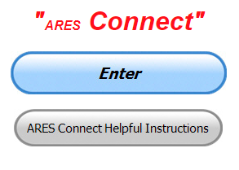

***Connecting Amateur Radio Volunteers with a Purpose***

Hey everyone… please make sure to go in and register your time to all of the events that you have signed up for. Don’t forget to get this done no later than **5 days** after the event has ended. I’m asking you to do this for our ability to run reports accurately.

**I want to remind all of you that you do not have to be an ARES or ARRL member to use this system. All licensed amateur radio operators throughout the country are welcome and strongly encouraged to use it.**

I’m hearing from many of you that getting signed up for events just takes too much of your valuable time and because it does - you’ve lost interest in doing anything with ARES Connect. Well, I want to let you know that I heard you, and I now have a real time saver for you. Interested???? Keep reading…

Because everyone not assigned as a system Administrator in the Ohio Section has had the additional User Grouping “Ohio Events Monitor” added to their account. (Admins already have this ability).

This additional User Group assignment gives you some additional privileges. One of those privileges is the ability to go in and register yourself to any of the recurring events that you normally participate in (Nets, Meetings, Training or whatever might be there). This means that with just a couple of keystrokes you can quickly sign yourself up to that event for weeks, months or even years all at once!!!

TOP ^

I know that taking the time to get signed up for events has been one of the biggest complaints for everyone. And I also know that some of you aren’t using the system because you have to waste a bunch of time signing up for the same event over and over. So, I’ve created a way for you to be able to sign-up just once for that recurring event and it takes care of it for weeks, months or even years all at once!! **And…** it takes less than 5 minutes to do it!!!! Do I still have you interested??? Keep reading…

Yes, that’s right you no longer have to go through every event and signup anymore. You now have the ability to sign-up for as many recurrences of that event that are in the system… **and it will take less than 5 minutes to do it!!!** Are you still interested???? Keep reading….

Ok, now that I’ve got your full attention, let’s get started. I want you to follow these instructions exactly and make sure that you don’t try to invent a new way of doing it. You’ll just end up frustrated and left out. After reading these instructions and still can get it, let me know. I’ll make sure that you do. [n8sy@n8sy.com](mailto:n8sy@n8sy.com)

First, you do need to log on to the ARES Connect system as you normally would and then click on the “Admin” link just to the left of your name. This brings up the dashboard.

Once you see that, you then need to look in the upper right corner of your screen. Your name will be appearing. Click on your name to open up a drop-down box.

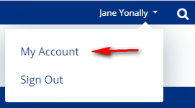

Click on “My Account” Be sure that your mouse is over “My Account” and not the “Sign Out.”

You now will see in approximately the middle of your screen a yellow “Add Registration” button. Click on this button to open up the listings of all of the events.



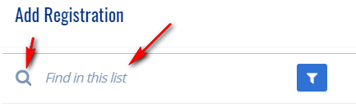Type in the name of the event that you want to sign up for and hit the little magnifying glass just to the left of your text.

Spelling is important, but the system can usually figure out what you are looking for with as little as 3 letters. Obviously, the closer you come to spelling it correctly, the better your odds of getting the event that you want the first time.

TOP ^

Now, once you have hit the magnifying glass it will go out and find every event with what you’ve typed. This will bring up all of those events with that spelling. Here for example I only used the first 3 letters and it found the Barometer Net. This just happened to be the one I was looking for, so now I have a couple of options that I can do.

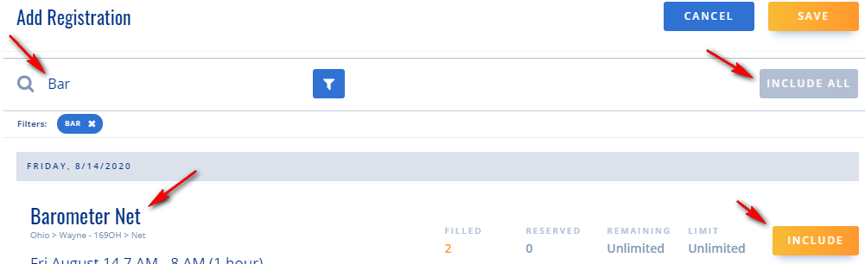

It has presented me with every Barometer Net event that is in the system. I can go through each one of them and select “INCLUDE” OR….. if I want to save a lot of time and frustration, I can simply go up to the little gray “INCLUDE ALL” box and hit that.

At this point I want to caution you to be sure before you hit the “INCLUDE ALL” button that you are attaching yourself to only those events that you want to be attached to. It would be very prudent to scan down the list and make sure that those are the events that you want to sign up for. If they are, great!!! Simply hit the “INCLUDE ALL” and your done. If there are other events listed, you’ll need to go back and spell the name of the event more precisely to assure that you’ve only got those events that you want.

The “INCLUDE ALL” button automatically signs you up to all of those events listed at once.

**NOTE>>> If what you are signing up for has more than 40 events (like a daily or weekly would) you will have to repeat the signup process until you have gotten all of the events that you want. The system will only process 40 events at a time.**

Now, I’ve heard from some of you that you don’t like signing up for events that you might not be able to participate in. It’s perfectly OK to sign-up for events in the future that you may not attend, especially things like NETS where attendance can sometimes be sporadic anyway. Having you sign up for these recurring events like this will save you a lot of time and keystrokes.

Now, I also have a time saver for you for recording your time as well, but you’ll have to wait until next week for that one.

Want to see your name appear in the list below? There’s only one way of doing that, you have to sign-up for events and then enter your time in afterward. Are you a regular on a NET or other event? You can sign you up for the entire life of the event if you want. What’s the advantage of that? No more registering, that part is done automatically for you. You still need to enter your time, but that’s all!!!

TOP ^

***Here’s are the top 10 hours earners so far for the month of August:***

|  |  |  |  |
| --- | --- | --- | --- |
|  | **Name** | **Events** | **Hours** |
| **1** | Dwight Bonifield (W8TJT) | 88 | 119.00 |
| **2** | Leo Dubois, Jr. (KE8OOS) | 61 | 84.50 |
| **3** | Dan Stahl (KC8PBU) | 48 | 71.25 |
| **4** | James Yoder (W8ERW) | 7 | 58.00 |
| **5** | Christopher Domenick (KC8CAD) | 15 | 50.80 |
| **6** | Bret Stemen (KD8SCL) | 21 | 48.00 |
| **7** | Alan Rothweiler (N8CJ) | 14 | 38.50 |
| **8** | Joseph Wigal (W8JTW) | 44 | 32.75 |
| **9** | David Maynard (WA3EZN) | 41 | 26.50 |
| **10** | Greg Dersarkisian (KD8SSJ) | 9 | 25.00 |

**Let’s get everyone in the Ohio Section on “ARES Connect!!!” Simply go to:** <https://arrl.volunteerhub.com/lp/oh/> and get yourself registered and using the system.

***Reliable Messaging Requires Action***

*(C. Matthew Curtin KD8TTE)*

ARES organizations throughout Ohio are developing their messaging capability. Now in addition to District 9 going (and staying!) “green,” and Districts 1 and 3 breaking into “yellow,” District 8 has gone green, achieving a 100% response rate on Objective 6. This past week, District 5 held a test session for district messaging and successfully relayed messages. We’ve now got half of Ohio ARES Districts operating at 40% or more in receiving instructions through radio messages and responding via radio message.

This is great work and is by no means as simple as having a couple of stations in-county use fldigi to talk through a repeater. If you’re a DEC having trouble getting started, reach out to another DEC for tips on how to get going, or talk to me. We’re now well into this project and have about six weeks before SET. If you’re still showing zero percent participation, welcome to the last minute!

If you’re an EC, you need to demonstrate your county’s ability to perform this fundamental task. Some have dismissed the project as irrelevant because it’s using the traditional radiogram format, which is a curious assertion since the agencies watching the project haven’t made that assertion. Some have asked whether they should send back QSL, as if using control signals for radiotelegraphy has anything to do with message format.

If you’re an ARES volunteer, this is the opportunity to train up and to learn the essential skills necessary to perform the task at hand. Having completed the ICS and NIMS foundational courses 100, 200, 700, and 800 won’t make you a competent radio operator any more than having your amateur radio license will. Only through practice can you achieve proficiency and comfort needed to operate in an emergency.

TOP ^

Whatever your affiliation in ARES or the traffic system, I invite you to train with me. We’ve started the process, now we’re going to tighten it up and help one another to see this undertaking to completion. I’ve got an online form that you can complete to get connected with us. It’s just a few questions and will get you connected to the other operators in the Section that are making this vision of a viable Section-wide messaging layer a reality, whatever level of activity you have in your own county or on your own traffic net.

Check us out at <https://forms.gle/6psSDYRM9mEAaBkX6>.

Thank you for your work so far. I’m looking forward to training with you.

***One Question Questionnaire***

Hey Gang,

“Survey Says”….. about 89**%** of you have built some sort of an antenna for HF. Now that’s a stat that really surprises me. I didn’t expect the number to be that high. It’s fantastic that so many have the knowledge to build an HF antenna when needed.

Ok, now, on to next question… This one I’m really curious about. In my shack I have a shelf for all of my HT’s, that way I can grab them quickly and don’t have to hunt around for where I may have laid it down last. So, looking at that thought, here’s the next question…

***“How many Hand-Held Radios do you have that you can quickly find??”***

You’ll find the “One Question” questionnaire on the Ohio Section Website! <http://arrlohio.org> It’s all in fun and it’s not a scientific survey in any way, but we are learning some things that we didn’t know from these questions. I hope that you are enjoying answering these “One Question” questionnaires.

***V.E. Test Sessions***

**

Many V.E.’s have decided to start testing once again, but with restrictions that need to be adhered to for sure. Here’s the link to find that V.E. Test session and what is expected of YOU before going. <http://www.arrl.org/find-an-amateur-radio-license-exam-session>

####

***Athens VE Exam Session Monday, August 17***

Session Details: (Contact Jeff, [N8SUZ@arrl.net](mailto:N8SUZ@arrl.net) for questions)  
<http://www.arrl.org/exam_sessions/athens-oh-45701-2059-18>

TOP ^

***Final.. Final..***

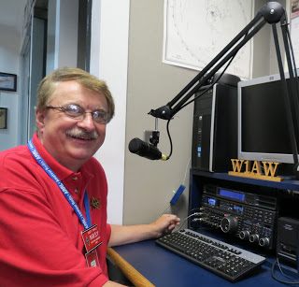Hi Gang,

First, I want to thank all of you that have volunteered your antenna analyzers or knowledge of which one is the best for the money. I couldn’t believe just how many of you have them. I guess I’ve been living in the dark ages way too long.

My mentor here in Mansfield has volunteered his MFJ for me to use and I’ve taken him up on the offer. I have also decided that I will be looking to get the NanoVNA with the big 4” screen when it becomes available at the candy store. Many of you, including the Great Lakes Director told me that this really would do the job for me and not break the bank doing it.

Now I just need to find the time and decent weather (it’s been way too hot to mess with antennas lately) to get to work getting my vertical all setup and operating where I want it.

**Ok, moving on to another subject…** Are you ready for the Simulated Emergency Test (S.E.T.) coming up in October? Matt, KD8TTE has been very busy writing up some homework for all of us to do for the S.E.T. It’s gonna’ be a lot of fun for everyone that participates, so start planning now and you really need to read Matt’s column to get the full effect on what he and Stan have in store for us this year.

**Let’s not forget to take a quick look at ARES Connect**

Have you looked at the breakdown per county on the website yet? We have a “per county” dashboard of the hours recorded in ARES Connect for each county. We also list those District only events as well as the hours recorded for Section wide functions. These are the hours of actual volunteers and not anonymous hours. Want to see how many hours your county has gotten so far? Go to… <http://arrl-ohio.org/SEC/reports.html>

This page is updated regularly, so you can see what’s happening in real time in your county. Don’t see hours recorded in your county? That’s because you haven’t done **your part** and gotten your time recorded.

Have you seen the latest Section Emergency Coordinators report? If not, you can view it by going to:

<http://arrl-ohio.org/SEC/reports.html>

**Moving to a new subject… Club Affiliation and Special Service Club renewals**

I want to ask all of you folks that are responsible for your clubs if you have sent in your annual club affiliation report yet? Yes, this is an annual thing that you need to be doing. It’s very easy to do and you do it on-line. Once finished, your club’s affiliation date is updated and that’s it. Getting this annual report turned in takes all of 5 minutes to do, but it does so much for your club. With the update out of town folks know when your meetings are, they also know who to contact if they have questions about your club. This is really important to do.

Now, I also want to address those same folks if your club is/was a Special Services Club. We’ve had many clubs in our Section with that very distinguished distinction. It’s something to be very proud of, but it too requires you to renew.

TOP ^

For the SSC’s it’s every two years. I know that this confuses things since you’re not always looking at the records to see when your renewal dates are, but… It’s equally important for you to renew your SSC. To renew the SSC, you are required to do a little more work than just updating who’s the new president and such. You need to keep a record of your clubs outstanding activities and make sure that those activities are listed on your new/renewal form for SSC.

I always advise everyone whether completing the forms for the first time or this is your 10th time, keep a copy of the completed form information.

Whelp, my final go around before gong QRT… I had a blast doing Zoom presentations for the OH-KY-IN and Massillon clubs this past week. I only wish that they could have been in-person meetings, but that will come.

Stay safe my friends! I want to see all of you soon at a meeting or hamfest! We will get through this and when we do, we’ll have so much to talk about. Most of all… have FUN and get on the airwaves!!

73,

[***Scott, N8SY***](mailto:n8sy@n8sy.com)

####

***Swap & Shop Has Added Club Raffles To Its Listings On The Webpage***

Hey Gang,

Have you taken a look at the **Swap & Shop** page on the Ohio Section webpage yet?? Here’s a link that will take you there…

<http://arrl-ohio.org/sm/s-s.html>

Do you have equipment that you just don’t need or want anymore? Here’s a great venue to advertise it, and it’s FREE!! Is your club doing a fund raiser to help raise money? After a lot of thought, it was decided that the Swap & Shop webpage could also contain these types of items as well.

The same rules will apply as do for the For Sales and Give-A-Ways and will only be posted for a month at a time. Please see the Terms & Conditions on the webpage.

If your club is doing a fund raiser and wants more exposure, please forward the information to me and I’ll advertise it on the Swap & Shop webpage for you. Now, I still want to remind you that it won’t be listed in this newsletter because it would take up way too much space, so your ad will only appear on the website. It is there for any individual to post equipment Wanted / For Sale or Give-Away as well as for Club Fund Raisers. No licensed vehicles/trailers or business advertising will be posted.

Postings are text only (no pictures or graphics) will be posted for a maximum of 1 month from date posting and require a contact phone number or email within the posting. Send your Wanted / For Sale or Give-Away post to:  [swap@arrlohio.org](mailto:swap@arrlohio.org)

TOP ^

Ohio Section Cabinet

|  |  |
| --- | --- |
| Section Manager – Scott Yonally, N8SY | Assistant Section Manager – John Perone, W8RXX |
| Section Emergency Coordinator – Stan Broadway, N8BHL | Section Traffic Manager – David Maynard, WA3EZN |
| Technical Coordinator – Jeff Kopcak, K8JTK | Affiliated Clubs Coordinator – Tom Sly, WB8LCD |
| State Government Liaison – Bob Winston, W2THU | Public Information Coordinator – John Ross, KD8IDJ |
| Section Youth Coordinator – Anthony Lascre, K8ZT | |

***Back Issues of the PostScript and Ohio Section Journal***

Hey, did you know that PostScript and Ohio Section Journal (OSJ) are archived on the website? You can go back and look at any edition simply by clicking:

<http://arrl-ohio.org/news/index.html>

***Want to Share your Club Newsletter With Others?***

We have a webpage where you can download and read all of the newsletters that I get from around the state and even other sections!

Here’s the link to the page…. <http://arrl-ohio.org/club_news/index.html>

Please, if you don’t see your club newsletter posted, it’s because I’m not receiving it. Just have your newsletter editor contact me and I’ll get your club’s newsletter listed on the site!!

We all learn and steal (I mean, share) from each other’s work. So, get me your newsletter!!! Send it to: [n8sy@n8sy.com](mailto:n8sy@n8sy.com)

***Welcome New Subscriber(s)***

**Edward, N8OYY; Michael, KD8GBZ; Ryan, KB8RCR; Nick, KE8PEL**

TOP ^

***Chit – Chat, and All That!***

Do you know someone that’s not getting these Newsletters? Please, forward a copy of this Newsletter over to them and have them “[Opt-In](mailto:Opt-In)” to start receiving them. Heck just have them send me an email [n8sy@n8sy.com](mailto:n8sy@n8sy.com) and I’ll get them added to the Ohio Section Emailing list.

We now have many thousands of readers receiving these newsletters weekly. Quite impressive, I’d say! I urge all of you to make sure that everyone, regardless of whether they are a League member or not, get signed up to receive these weekly Newsletters.

You can always “Opt-Out” at any time if you feel this is not what you were expecting. It’s fun and very informative. All of your favorite past newsletters are now archived too.

You can go back at any time and read them. Just go to: <http://arrl-ohio.org/news/>

Got questions, concerns or would just like to sit and chat awhile? Heck, I’ll even buy the coffee!! Give me a call at (419) 512-4445 or email me at: [n8sy@n8sy.com](mailto:n8sy@n8sy.com)

The pictures on the front page and throughout this newsletter are from various newsletters, Facebook posts and/or were sent directly to me in recent weeks. Take a good look at them, you just might be in one of the pictures! “SMILE… you’re in the Ohio Section News!!”

***And that’s all there is!!***

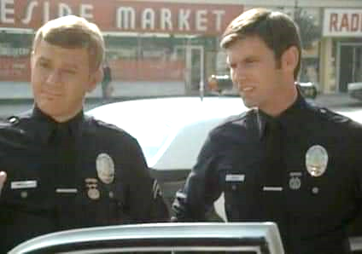

TOP ^

***See Ya’ next week.***

*PostScript is produced as a weekly newsletter. I want to thank everyone that has contributed articles and ideas to make this an even better news source. I sincerely hope that you have enjoyed this edition and will encourage your friends to join with you in receiving the latest news and information about the Ohio Section, and news and events happening around the world!*