[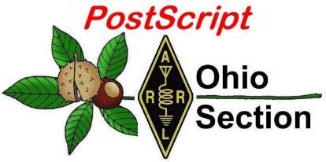](http://arrl-ohio.org/news/) ***August 10th***

***Edition***

🡪 National News 🡪 The Handbook Give Away

🡪 Club Corner 🡪 Hamfests

🡪 DX This Week 🡪 ARES Connect

🡪 VE Testing 🡪 One Question Questionnaire

🡪 Final.. Final..

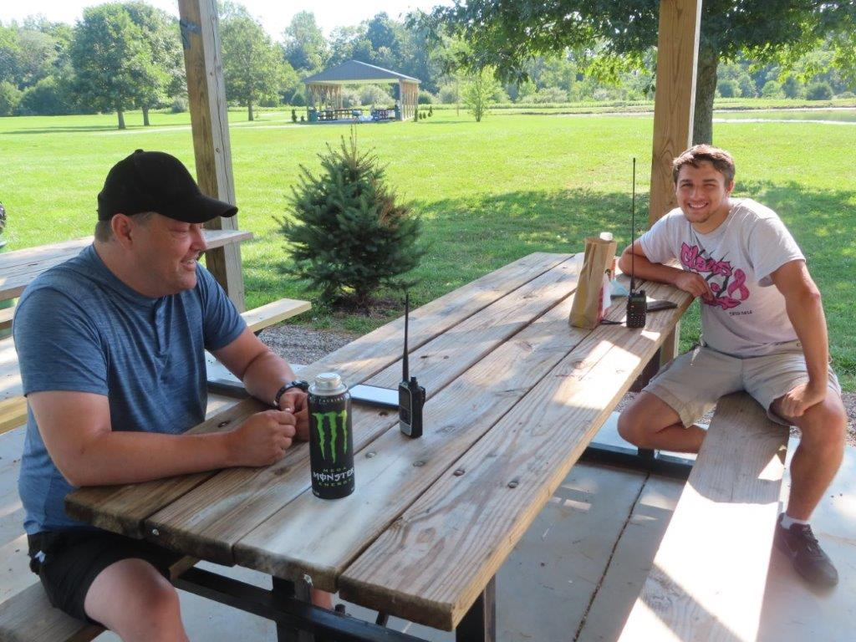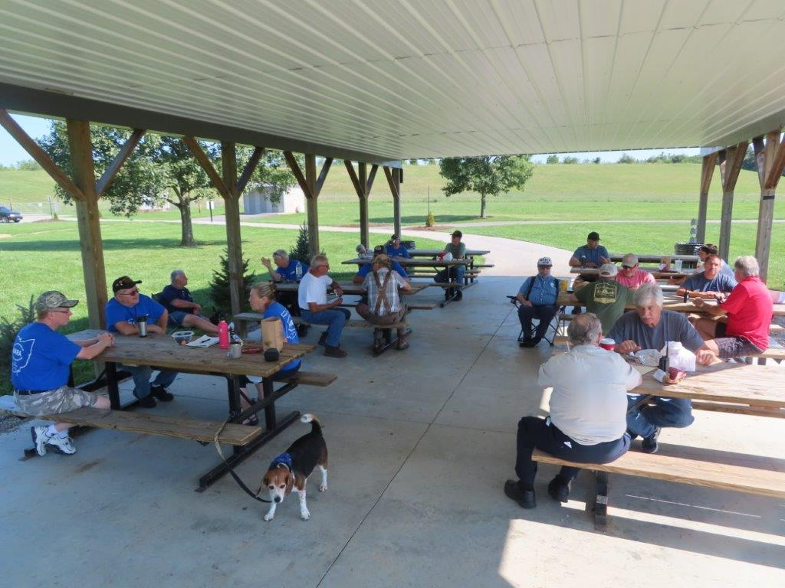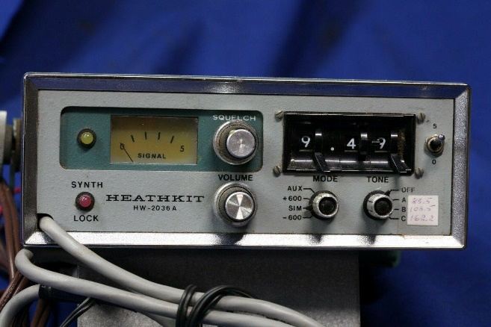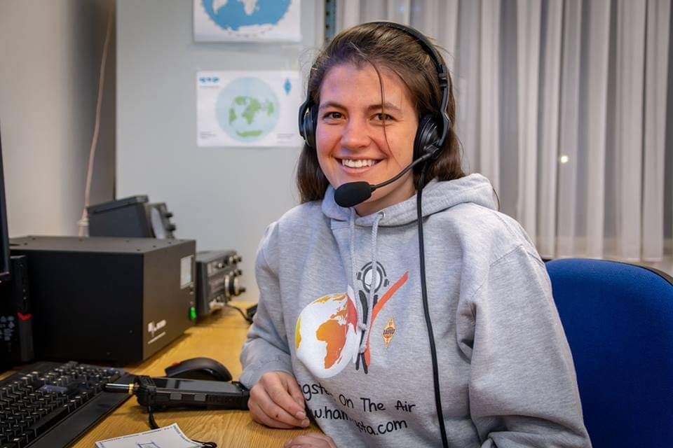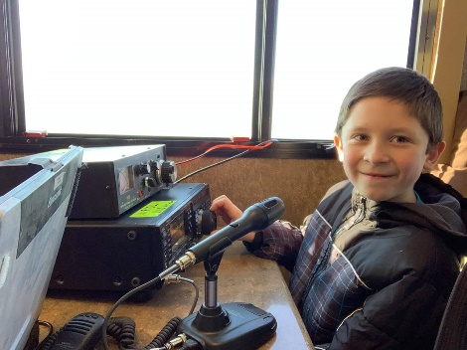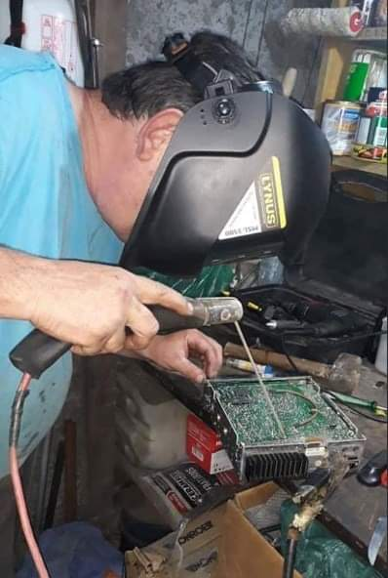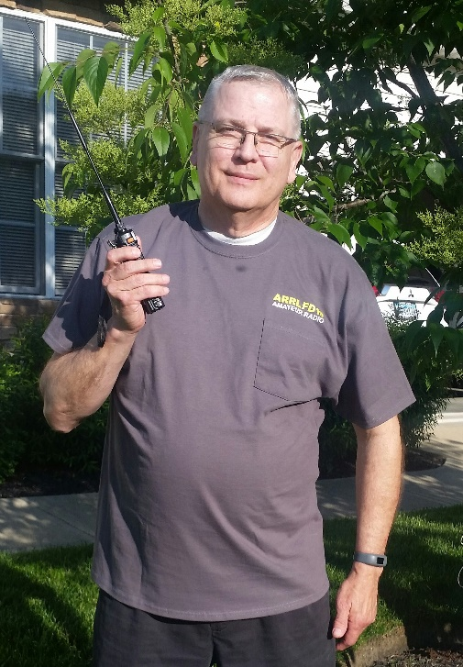

***National News***

*(from arrl and other sources)*

***Outages Affect Receipt of Applications, FCC License Processing***

The Newington, Connecticut, US Post Office, which serves ARRL Headquarters, is without power, so ARRL is receiving little or no mail, affecting the receipt of amateur radio exam session paperwork as well as other mail and parcels.

The outage is a result from damage due to Tropical Storm Isaias. In addition, the FCC electronic batch filing system was down for about 24 hours and did not process any license applications — amateur or commercial — during that period. The FCC batch-file system now appears to be operating normally.

####

***Radio Amateur Takes Part in Historic First Commercial Human Spaceflight to ISS***

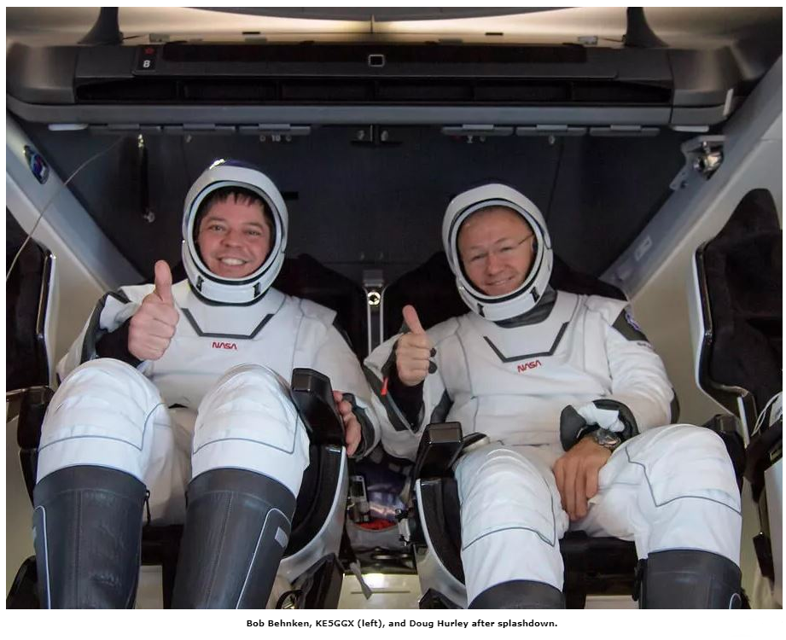Bob Behnken, KE5GGX, was one of two NASA astronauts who made spaceflight history over the weekend. Behnken and Doug Hurley were the first astronauts since the 1970s to make a water landing, after their Crew Dragon capsule splashed down in the Gulf of Mexico on Sunday. On May 30, the pair made history as the first live crew to be launched into space in a commercial vehicle, for a stay on the International Space Station (ISS), marking the return of human spaceflight to US soil for the first time in nearly a decade.

A SpaceX Falcon 9 vehicle carried the crew into orbit from Cape Canaveral. The so-called “Demo-2” was the last major test for SpaceX’s human spaceflight system, to be certified by NASA for operational crew missions to and from the ISS. Four huge parachutes carried the Crew Dragon capsule to a safe splashdown near Pensacola, Florida, on Sunday, August 1.

“On behalf of the SpaceX and NASA teams, welcome back to planet Earth,” SpaceX Engineer Michael Heiman radioed to the crew after their landing. “And thanks for flying SpaceX.”

NASA Administrator Jim Bridenstine proclaimed that the US was entering a new era of human spaceflight, noting that NASA was no longer the only option for US space travel. “We are going to be a customer,” he said. NASA has contracted with two companies — SpaceX and Boeing — to ferry astronaut crews to and from the ISS.

TOP ^

While part of the space station crew for 2 months, Behnken and Astronaut Chris Cassidy, KF5KDR, the sole American on board when their *Endeavour* capsule docked, carried out four spacewalks to install new batteries on the ISS.

The SpaceX Crew Dragon vehicle was designed for short-term missions, and Behnken and Hurley’s mission had only been expected to last a week. As a result, Behnken did not receive Amateur Radio on the International Space Station (ARISS) training on the radio gear in the Russian sector. NASA subsequently decided to monitor the mission and make a decision on how long the Crew Dragon would stay. Cassidy fielded all ARISS school contacts.

####

***ARRL Volunteer Monitors Recognize Good Operators***

ARRL Volunteer Monitors recognized 13 operators in 10 states with Good Operator letters during the second quarter of 2020. Among the operators recognized were CW and SSB operators on 20 and 40 meters, outstanding net operators on 2 meters (including a net control of the Central Indiana SKYWARN Net), and an operator on 40 meters who demonstrated exemplary courtesy and assistance to amateurs with technical issues.

####

***Smartphone app helps identify unknown data modes***

*(Submitted by Gregory Drezdzon, WD9FTZ)*

There's an incredible amount of radio signals. It's impossible to know them all, let alone recognize them. So why not get help from SignalID? At the moment, it recognizes about twenty signals (the exhaustive list is below) With only 5 seconds of recording time, it tries to recognize the signal.

**To use it:**

Set the frequency and bandwidth properly.  
Selecting the frequency range. (0-30 MHz / Other) Place the microphone of the telephone near the loudspeaker. (The quieter the environment is around, the fewer errors will occur) Press the big button that dances. Wait 5 seconds. (Time required for record)

**Tips:**

The algorithm is based on frequency; a wrong tuning of your radio/SDR will result in an erroneous detection.

The recording is limited to 5 seconds, for practical reasons. Recognition of a signal may require several attempts.

Here is the non-exhaustive list of recognized signals :

- RTTY (Commercial 85Hz, 170Hz, 450Hz, 850Hz, Amateur 170Hz)

- Pactorl (Standard, FSP, FEC, SELCALL)

- ASCII (170Hz)

TOP ^

- ALIS

- Codan8580 (200Hz, 250Hz)

- CIS36_50

- CIS40_5

- CIS50_50

- STANAG 4285 (GEN, SYS3000 FEC, 8PSK, TFC, IDLE, SYS3000)

- FT4

- FT8

- WEFAX (120, 240)

- 2G ALE

- 3G ALE

- CHIP64

- APRS (Burst)

And more! The following links below are a complete list in the application.

What’s even more fantastic is that the app is open source!

<https://github.com/Neosama/SignalID>

<https://www.youtube.com/watch?v=E-y1Ts1q2RU&feature=youtu.be>

<https://play.google.com/store/apps/details?id=com.tortillum.signalid>

####

***ARRL Board Confers Awards and Recognitions***

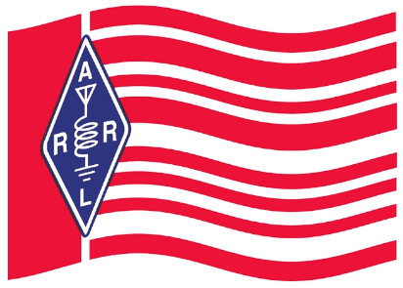

Meeting in virtual session July 17 – 18, the ARRL Board of Directors conferred three major awards.

**The Hiram Percy Maxim Award**

The ARRL Board conferred the 2020 ARRL Hiram Percy Maxim Award on Jacob M. Nagel, AD0JA, of Wright City, Missouri. Licensed since 2012, the Board cited Nagel for exemplifying the spirit of amateur radio by learning new technologies, providing community service, and helping with emergency communication. ARRL’s top youth honor, the Hiram Percy Maxim Memorial Award is given annually to a radio amateur and ARRL member under the age of 21. The award consists of a $1,500 stipend and an engrave plaque, to be presented at an ARRL convention or event.

The Board cited Nagel’s involvement in providing technical assistance to the OKAW Valley Amateur Radio Club and the Egyptian Radio Club of Illinois for the installation and upgrading of their club repeaters; advising the Germantown, Illinois, Fire Department on upgrading its communication systems; speaking at the 2016 Dayton Hamvention® Youth Forum; sharing his expertise in on-line forums, and active involvement in projects that allow him to integrate his amateur radio knowledge with other technical ventures in electronics.

**Knight Distinguished Service Award**

The Board named veteran ARRL Rhode Island Section Manager Robert G. “Bob” Beaudet, W1YRC, of Cumberland, Rhode Island, as the recipient of the Knight Distinguished Service Award, given to an ARRL Section Manager. Beaudet has been Rhode Island SM since 2002.

TOP ^

The Board cited Beaudet’s active promotion of ARRL activities in his Section, including visiting hundreds of Field Day operations; participating in many Volunteer Examiner test sessions; attending at countless club meetings; staying active as a contester, DXer, and mentor, and serving as a model to other Section Managers. The Board said “Beaudet’s leadership of the ARRL Rhode Island Section Field Organization has led to a strong working cadre of volunteers within the Section.”

*(Ed Note… I know personally just how Bob must feel right now. I was the recipient of this really great award last year!!)*

**Doug DeMaw, W1FB, Technical Excellence Award**

The Board named Al Rabassa, NW2M, of Rockville, Maryland, as the recipient of the Doug DeMaw, W1FB, Technical Excellence Award. The Board cited Rabassa’s frequent contributions to the *QST* “Hints and Kinks” column, and his *QST* technical articles, including “The Basics of Fan Cooling.” The Board also noted that Rabassa has served as a subject-matter expert of the Yaesu FT-101 transceiver, maintaining a website devoted to the technical aspects of the vintage transceiver series.

**Recognitions**

The Board recognized the Fort Wayne Radio Club on its centennial and 90 years of ARRL affiliation, and the Radio Club of Tacoma for 100 years as an ARRL-affiliated club.

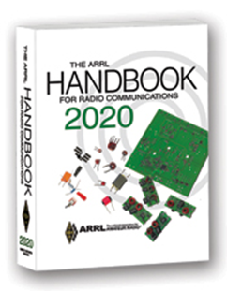***The Handbook Give Away***

Hey Gang,

The “Handbook Giveaway” drawing will soon be returning for another big “Give Away”

Many of you ask me just how do I know when the drawing is on? Well, that’s easy all you need to do is check in on the Ohio Section Website on a regular basis and watch for the big [**RED**](http://arrl-ohio.org/handbook.html)Arrow that will appear on the left side of the page. This is the sign that the drawing is on and you need to get registered. So, keep a sharp eye out on the website and check in often! <http://arrl-ohio.org>

What’s the catch? I want to get everyone checking in to the Ohio Section website as often as possible, and in order to register each month, you have to visit the website often! There’s nothing else to it.

***Club Corner***



This is YOUR cornner of the newsletter. Send me what your club is doing and I’ll make sure that it gets in. Got a special event or club project that you want everyone to know about? Send it to me!. Need help with a project? Send it to me.

Let me know what you club is up to. Are you going to have a special guest at your meeting or are you having a special anniversary? Just sent it to: [n8sy@n8sy.com](mailto:n8sy@n8sy.com)

####

TOP ^

***Lucas County ARES – Simplex Contest***

On **August 15th** the Lucas County ARES group is having a **Simplex Contest** -  the following are the rules:

1) Maximum wattage is 50 watts

2) Each Call Sign is one contact; this keeps two operators from just going through the simplex frequencies contacting each other.

3) Each contact equals one point, Lucas County Emergency Operations Center (aka Trailer) equals five points, and any out of state contacts other than Michigan equals ten points.

4) You have to give your approximate location from where you your station was set up at. (Example: Airport and South)

5) Would like to know what type of antenna you use.  Example: Dipole, Beam, Vertical, or maybe a mag mount.

6) Email your results in PDF form to Tim KD8IZU by August 29 th at boxcar@... with the subject: Simplex. The winner will be announced at the September ARES Meeting with an email to follow with the results.

7) FM only, so the new hams have a chance since most new hams either buy a mobile or a HT a their first radio.

####

***Ohio Amateur Radio operator helps with N95 Masks***

*(from: WTAP - Marietta)*

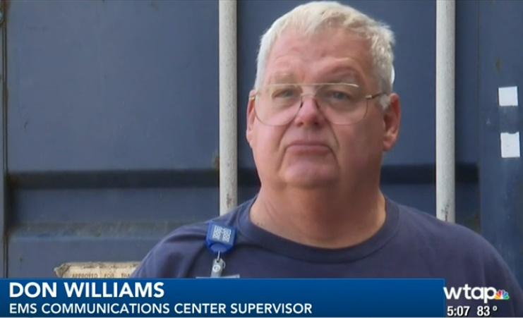Back in April, the Memorial Health System and the Marietta Fire Department teamed up to disinfect n95 masks for first responders and healthcare providers across the region.

“We put the masks in on a metal shelf and this process takes a hydrogen peroxide solution and it vaporizes it and it puts the level up to 75 parts per million,” said Don Williams (N8NUS), EMS Communications Center Supervisor. “That doesn’t mean a lot to a lot of people, but at that level it is a hazardous level. It runs it up to that level and then it will sit on the product for approximately 10-15 minutes and then it goes into an aeration phase.” So far, they have run over twenty cycles and disinfected over 6,000 masks.

About twenty-five agencies from across the Mid-Ohio Valley have utilized this service, which is covered by a grant from the Ohio Department of Health. The decontaminations take place weekly

####

TOP ^

***Wayne County Looking For Help With A Special Project***

*(From Doug Hunter, KE8JNH - Wayne County EC)*

I am looking for a little help. During the month of August, I plan to run what I am calling "Celebrity Net Control" on our weekly DMR (Bolo) net.

The concept is to involve local community leaders to serve as "net control" of the net. The goal of this is to allow these folks to see that amateur radio is alive and well.

I will be using police and fire chiefs, mayors, county commissioners all from Wayne County to serve as the net control folks. Naturally I will be alongside them logging and keeping things on track.

You can help by securing 4-5 other operators from other points of the state to "check-in". Most of the people on the net are local, but we can add to the "wow" factor by having a few not so local check-ins.

The net takes place on Mondays at 8pm on DMR talkgroup 311070. At the beginning of the net we take the people who have registered via ARES connect first and then follow that with "regular check-ins"

I hope you can help and play along.

####

***ARRL 2020 Simulated Emergency Test (SET) Scheduled for October 3 - 4 Weekend***

The 2020 ARRL Simulated Emergency Test (SET) will take place October 3 - 4. The annual, nationwide exercise provides Amateur Radio Emergency Service (ARES) volunteers the chance to test personal emergency-operating skills and communication readiness in a simulated emergency deployment. ARRL is asking participants to adhere to Center for Disease Control (CDC) and local health department COVID-19 [guidelines](https://www.cdc.gov/coronavirus/2019-ncov/) by staying home, maintaining safe distances when around people, and following recommended cleaning and disinfecting practices.

ARRL Field Organization leadership at the Section and local levels -- as well as many other volunteers who are active in public service and emergency communication -- are developing emergency scenarios with a variety of agencies and organizations they've partnered with in the past during real emergencies and disasters.

Given the ongoing pandemic, an in-person emergency exercise may not be possible this year, but volunteers are encouraged to adapt to the circumstances. Station and skills readiness are tenets of the Amateur Radio Service. Any time we spend on the air will contribute to developing and practicing our personal radio communication capability.

Volunteers with ARES, the National Traffic System (NTS), the Radio Amateur Civil Emergency Service (RACES), SKYWARN™, Community Emergency Response Team (CERT), Salvation Army Team Emergency Radio Network (SATERN), and other allied groups and public service-oriented amateur radio groups are among those eligible to participate in the SET to practice emergency operation plans, nets, and procedures.

TOP ^

ARRL has long-standing [relationships](http://www.arrl.org/served-agencies-and-partners/) with several national organizations including the American Red Cross, the National Weather Service, the Federal Emergency Management Agency, and the Salvation Army, among others.

This year's SET can be a chance to reach out to these partners -- at a safe distance and/or via online meetings and teleconferences -- to establish or review plans and develop working relationships.

ARRL Field Organization leaders have the option of conducting local or Section-wide SETs on dates other than the October 3 - 4 focal-point weekend, but no later than the end of the calendar year. Contact your local ARRL Emergency Coordinator or Net Manager or ask your Section Manager.

**Here in the Ohio Section we have a really exciting event planned for all of you participating in the S.E.T. Here’s a video about some of what we are planning from our very own Matt Curtin, KD8TTE.**

<https://youtu.be/xfWvbiH-PYU?fbclid=IwAR2vjY-yh4G73YkygDWVfIEhRdvMvT9KKsbn-VC_SGfc05TdelG64NtJero>

####

***The Ohio Section Is Building Emergency Infrastructure***

*(C. Matthew Curtin, KD8TTE)*

We continue making progress in the building of messaging infrastructure for ARES! District 1 and District 6 have joined District 9 in getting over 60% of active county programs exercising radio messaging through the layers of section-district-county and back to the section.

As our SEC has been saying, ARES operators must learn to message effectively. Served agencies want messages and data relayed in many cases. As we’ve seen with the recent May 30 Red Cross exercise, information may be relayed in arbitrary format. The ICS-213 is not the only format that you need to handle.

Some of our ECs and AECs have asked why we’re using radiograms, with various assertions included like it’s an antiquated form, agencies don’t want to use it, and so on. I appreciate these questions because they highlight a real training need, and one that this project specifically seeks to address.

Here’s a secret: The all-capital-letter radiogram form is not the end-game here.

The radiogram is, however, a place to start building the means by which we can effectively message throughout the entire section. Whether operators are using CW, digital, or voice, they can learn how to perform critical tasks for served agencies, namely:

1. **Origination**: getting a message into the format for transmission,
2. **Relay-Transmission**: sending a message to another station so it arrives at the next station exactly as it is at this station,
3. **Relay-Receipt**: copying a message to another station so it arrives at this station exactly as it was at the previous station, and

TOP ^

1. **Delivery**: getting the message from transmission format to presentation for the agency personnel.

These are the tasks, and every ARES organization must be able to perform them. What does the “radiogram” have to do with this job?

Reliable systems for message relay include critical information along with the message itself. Such information are known as *headers* in the Internet Message Format as well as other internet-related protocols. In radio messages, such information is known as a *preamble.*

I didn’t write “in amateur radio messages;” I wrote “in radio messages” because that is exactly what I mean. Whether in military, government, or amateur radio services, formal messages come with a preamble that assist in the handling of the message.

Whether you’re tasked with relaying something in the form of an ICS-213, an arbitrary comma-separated-value (CSV) file, or something entirely different, transmission over a radio circuit is aided with the preamble.

We are starting with the radiogram but we aren’t stopping there. We’re starting with the radiogram because when it comes time for moving ICS-213, ICS-214, ICS-205, arbitrary-format electronic files, etc., you’ll need to know how to identify the item to transmit. You’ll need to keep track of when it was originated, and how. You’ll need to know how to record when it was transmitted, and to which station. You’ll need to know how to record when it was received, and from which station. You’ll need to know how to observe problems in transmission, and how to resolve them. You’ll need to know how to record when the item was delivered, to whom, and how.

If you can’t do that with a radiogram, you can’t do it with information in other formats.

In addition to training our ARES organizations to perform these critical tasks on behalf of served agencies, these messages are training our traffic operators: the volunteers who provide the circuits that make it possible to communicate at the District and Section levels, as well as beyond.

This exercise has been reviewed by personnel at State of Ohio agencies: they have deemed it “realistic,” and the capability we’re demonstrating “valuable.” Even if your local chapter of the Red Cross, some other disaster relief organization, or your local EMA isn’t thinking about moving messages in and out of the area, that’s because they’re assuming that someone can do that job. If you’re part of the team, that someone they’re relying on is you. Now is the time to build up the skills and to score the points that will allow us when it comes time for the After Action Report, to show that the Ohio Section is capable of providing emergency communications.

Deciding that you’re “not a traffic person,” proclaiming the radiogram format “antiquated,” or otherwise finding an excuse not to participate isn’t an option. The project is underway, the reports are being compiled, and our served agencies are interested. They’re watching where the capability does and does not exist, not by assertion but by demonstration. This isn’t difficult and there is support. What it does require is engagement: you simply need to decide to do the job.

The tasks are straightforward and can be done by anyone in the area. The EC need not perform the task: the EC is an Emergency Coordinator, not an Emergency Doer Of Everything. Organize your volunteers, help connect them to training, work with your District Emergency Coordinator, and me, to get any help needed to establish the structure for your ARES organization to be able to receive incoming messages being sent by radio from your DEC.

TOP ^

Districts, do the same: establish an assistant if needed to handle the job of messaging among the counties in-district, and to represent that District at the Section, so you can receive incoming radio messages from the Section Emergency Coordinator.

No one is telling you that you need to use paper forms for any of this. I, myself, generally work “by Mill,” i.e., typing into a computer, rather than handwriting to a pre-printed form, even on manual nets.

Furthermore, the Narrow Band Emergency Messaging Software (NBEMS) is common, open-source software that works on VHF/UHF as well as HF, and is the common means by which ARES organizations have been practicing relay of messages on nets. The *FLMSG* program part of the NBEMS suite has electronic forms that assist operators to originate messages and to get them into the right format. There’s even a radiogram form that will assist you in getting your message created, whether you’re a DEC messaging ECs, or an EC messaging back to the Assistant Section Emergency Coordinator taking the County Information Reports.

Finally, Buckeye Net, the ARRL Ohio Section Traffic Net, runs mixed-mode nets on HF every Thursday at 7 p.m. local time. This is where the ASEC releases the messages to each of the DECs. The net is called up by voice, and messages are transmitted with FLMSG. The net also can take messages coming back up from the counties through the districts, or from the counties directly. We’re starting with this net’s mode of operation once weekly. As we have more operators become proficient in these tasks, as well as additional tasks like net control, we expect to move to a schedule of daily nets, and several-times-daily nets. Of course even now, we are preparing to operate at any time when activated by the Section Emergency Coordinator or Section Traffic Manager.

Get started on Buckeye Net by downloading the FLDIGI macro set and the Signal Operating Instructions at <https://buckeyenetweb.wordpress.com/reference/>.

If you’re stuck, not sure how to get started, take a look at my video describing the organization of RF message routing in the Section at <https://www.youtube.com/watch?time_continue=591&v=xfWvbiH-PYU>.

If you’re still stuck, contact me. *I am here to help you get the job done!* Send email: [kd8tte@pm.me](mailto:kd8tte@pm.me). Send WInlink: KD8TTE. Call me! 614-398-0045.

We are performing a long-overdue function in the Ohio Section: integrating the resources of amateur radio, organized to support one another in ensuring that our agencies, organizations, and people they serve can rely on us to communicate even “when all else fails.”

73

####

***Wanted… Assistant Section Youth Coordinator***  
Anthony Luscre, K8ZTthe Ohio SYC has begun a search for one or two Assistant Section Youth Coordinators that would work with him to help support youth activities across the Ohio Section. If you are interested in this position or know someone that might be interested please email him <[k8zt@arrl.net](mailto:k8zt@arrl.net)> with information.

TOP ^

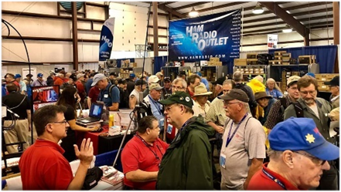

[***Upcoming Hamfests***](http://arrl-ohio.org/hamfests.html) ***for 2020***

**09/13/2020 - Findlay Hamfest** ***Canceled***

**09/27/2020 | Cleveland Hamfest and Computer Show**

***Canceled***

|  |
| --- |
| **10/10/2020 - Northwest Ohio Amateur Radio Club (NWOARC) Fall Hamfest Location: Westminster, OH Sponsor: NWOARC, Northwest Ohio Amateur Radio Club Website:**[**http://www.nwoarc.com**](http://www.nwoarc.com/) |

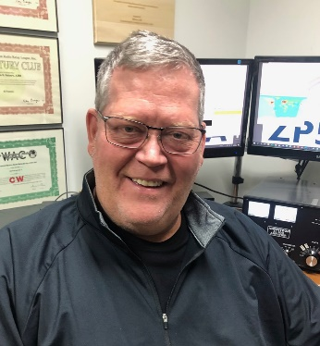***DX This Week***

*(from Bill, AJ8B)*

***DX This Week – UA4CC***

***Bill AJ8B (***[***aj8b@arrl.net***](mailto:aj8b@arrl.net)***, @AJ8B, or*** [***www.aj8b.com***](http://www.aj8b.com)***)   
 CWOPs Member #1567***

The cluster was a bit more active the past week with misdwest spoys from Algeria, Andorra, Angola, Argentina, Asiatic Turkey, Austria, Bolivia, Bonaire, Brazil, Canada, Canary Islands, Chile, Colombia, Costa Rica, Czech Republic, Denmark, El Salvador, England, European Russia, European Turkey, Faroe Islands, France, Germany, Gibraltar, Greece, Hawaii, Italy, Japan, Kuwait, Mali, Malta, Mauritania, Netherlands, Northern Ireland, Norway, Panama, Puerto Rico, Serbia, Sicily, Slovak Republic, Slovenia, Spain, Sri Lanka, St. Helena, St. Lucia, Sweden, Trinidad & Tobago, Uruguay, Venezuela, Wales, and Zambia. Let me know what you worked!

Of the many interviews that I have been a part of, the interview with Arkady, UA4CC, was one of the most interesting. About 3 weeks after I sent him a copy of the newsletter, we were able to have a CW QSO that lasted for a solid 25 minutes. It was a great way to wrap up our relationship. I hope you enjoy this interview.

***Interview with UA4CC—Arkady***

After working UA4CC and reviewing is QRZ.com webpage, I knew he would be an interesting ham for our newsletter. He can be reached at [*ua4cc@remolltd.com*](mailto:ua4cc@remolltd.com)

TOP ^

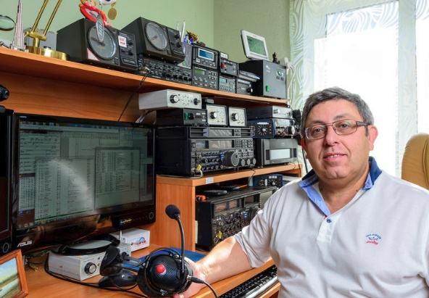**AJ8B:** How did you first get interested in amateur radio?

**UA4CC:** My father was an engineer by education (not radio), he liked to design things. He made transistor receivers. I loved to be around, ask questions and ask more questions. Soon I became involved in the process and had assembled my first super regenerative receiver for the MW band. Dad had collected all the magazines "Radio" since 1962. I looked through them with interest. Most of all I was interested in notes about short-wave radio amateurs, rivalries, expeditions. Gradually, the dream itself appeared on the air. It's good that the dream came true!

**AJ8B:** When did you get on the air?

**UA4CC:** In our city there was a section of short waves at the Palace of Pioneers. Something like scouts. There was a local radio station, UK4CAS. Her boss was Valery UA4CM (ex UA4DK). I started going to classes somewhere around 1971. The group studied Morse code, the basics of radio engineering, and the rules of radio communications. We observed how senior interpreters and Valery made connections in the air. Soon, having checked my knowledge and skills, the manager allowed me to make my first QSO. It was evening time on of 20 meters. I heard the CW CQ Swedish amateur radio (unfortunately, forgot the call sign) and called it. The first QSO took place! My happiness knew no bounds! Soon I received my first individual license, in December 1975. This was UA4CDC.At that time, I was still in high school. In the early 1990s, I received a category 1 license (similar to Extra Class) and changed my callsign to UA4CC. Since then, this call has not changed.

**AJ8B:** Do you have a favorite band or mode?

**UA4CC:** Of course, preferences change. But I always loved CW the most. For the last 10 years I have been living in a country zone, in an individual house. Here we managed to create quite good antennas on the low bands, especially receiving antennas that are inaccessible in the city. Since then, I have been focusing on the most difficult for DXing band - 160 m. Progress cannot be stopped. Recently, I began to actively use digital modes of communication, mainly FT8. Generally, I believe that Mr. Taylor made a revolution in amateur radio and is ready to talk about it in more detail, but this is beyond the scope of this interview.

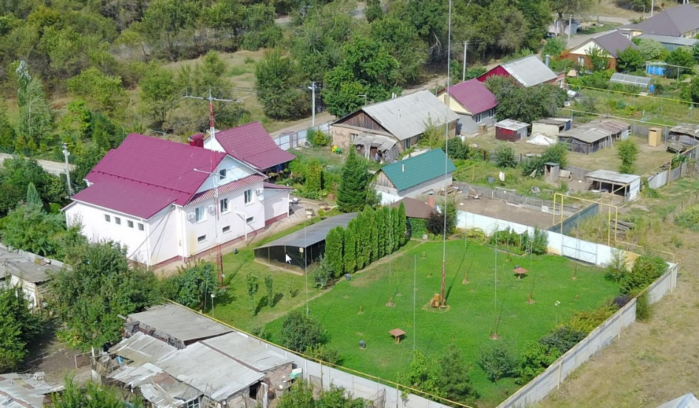

**AJ8B:** It would appear that you have an excellent location to work DX when you are home. Close to the Ukraine, Georgia, Azerbaijan, The Black Sea and the Caspian Sea along the Volga River. Looks terrific!

**AJ8B:** How is propagation from this excellent QTH?

**UA4CC:** So, maybe we are close to the places you mentioned. But we are very far from DX of Central America, the Eastern Pacific. I do not think that there are any particularly winning QTHs. My QTH is far from the seas and oceans, I think it negatively affects the conditions.

Often, we hear stations from Scandinavia or, on the contrary, Italy, DX work, and we don’t even have any traces! In Russia there is a saying "good where there are no us." I think this is about the propagation!

TOP ^

**AJ8B:** In reviewing your QRZ.com page, I see that you have been very active from various locations. What is your favorite location and why?

**UA4CC:** I am not an DX-expeditioner in the full sense of the word. My friend Arunas LY2IJ from Lithuania and I go to various exotic places with our spouses, taking the radio with us. This is the format that I call “transceiver-chill”. Despite this "light" format, we take with us everything necessary for actuality on the low bands, especially at 160 m. In this format, we have visited in recent years, FS, J8, 3DA, C9, 9Y4. I like every place where we have not been. I would not allocate any of these locations.

**AJ8B:**  The pictures on qrz.com show that you have many excellent antennas. Can you describe your antenna farm?

**UA4CC:** I do not think that I have very good antennas. Many colleagues from Russia, the former USSR have much better setup. Today I have db18e from SteppIR 3 ele YAGI, also the "old" 3 ele SteppIR fixed to 300 deg. I have a vertical for 160 and 80 m in height a little more than 30 m with a large number of buried radials up to 42 meters long. In addition, I have a backup vertical antenna for 160 and 80 meters with a height of 25 meters. The VHF / UHF mast with a height of about 20 meters has 16 yagi elements per 2 meters with a traverse length of 9.5 meters, 25 elemental yagis for a range of 70 cm and 2x67 yagi elements per 23 cm. I don't have a setup to work EME. In general, I am not very active on VHF / UHF, although I have antennas. You can see another 7 elements of the yaga on the range of 6 meters, however, so far this range, to our great regret, has not been approved for use by radio amateurs in Russia. This year, the country is giving up analog TV and we all hope to start working on the magic band.

**AJ8B:**  What equipment do you use?

**UA4CC:** I use the YAESU FTDX9000D and FTDX5000 transceivers on HF. On VHF, I use a KENWOOD TS2000X. Various amplifiers are available from YAESU, OM-POWER, I0JXX. I use a K3 Elecraft transceiver at my remotely controlled station in Montenegro 4O7CC. In addition, there is the Elecraft K3 for travel and the SPE 1,3KA-FA amplifierю

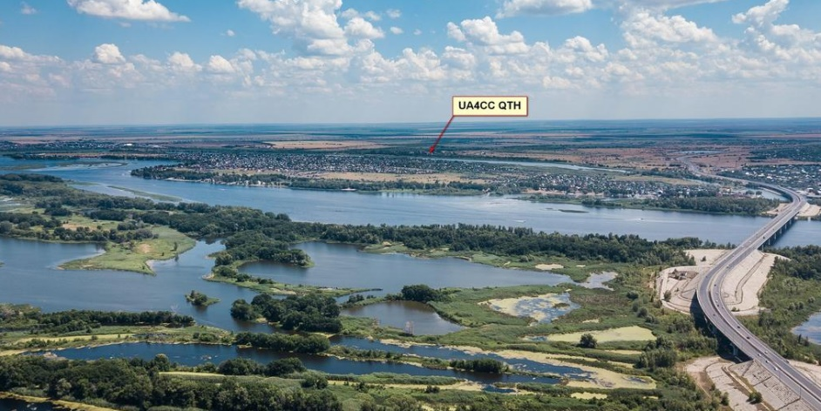**AJ8B:**  Do you take your equipment with you when you go on these DXPeditions?

**UA4CC:** Yes, almost always. Only in the Palau T8CC did I use a rented on-site transceiver and amplifier. With us we take the antenna. When traveling, the Elecraft K3 transceiver and an amplifier from Italy SPE 1.3KA-FA are used. In addition, we carry a lot of auxiliary equipment (transceiver interface, filters, cables, wires, insulators and antenna ropes, telescopic fishing rods, devices for mounting receiving antennas, and much, much more! In most cases, they have to strongly overpay for the extra luggage.

**AJ8B:**  What advice do you have for those of us trying to break pileups to work DX?

**UA4CC:** The format of the interview will not allow to describe in detail the methods of "calling DX" in the pileup. Briefly:

- if after the first 1-2 calls you have not been answered, call again, your chances increase.

- Try to listen more.

- select the freest frequency in the file.

- try to understand the logic of DX forwarding in frequency and predict where its receiver will be in the next second.

TOP ^

- Do not repeat your call sign if DX has received you correctly. You just mislead the operator and he doubts the correctness of your call sign.

**AJ8B:**  What coaching/advice would you give new amateurs?

**UA4CC:** The main rule of a novice operator is to listen more than transmit! When working CW, choose the speed with which your correspondent transmits. If you have not accepted something - do not hesitate to ask again. Do not be afraid, experience will come with time, no one will judge you for mistakes.

***CQDX CQDX CQDX CQDX CQDX CQDX CQDX CQDX CQDX***

Here is an update from Bernie, W3UR, of the DailyDX and the WeeklyDX, the best source for DX information. <http://www.dailydx.com/>. Bernie has this to report:

**VP6R Pitcairn DXpedition Final Chapter**

**By W8HC, Hal Turley**

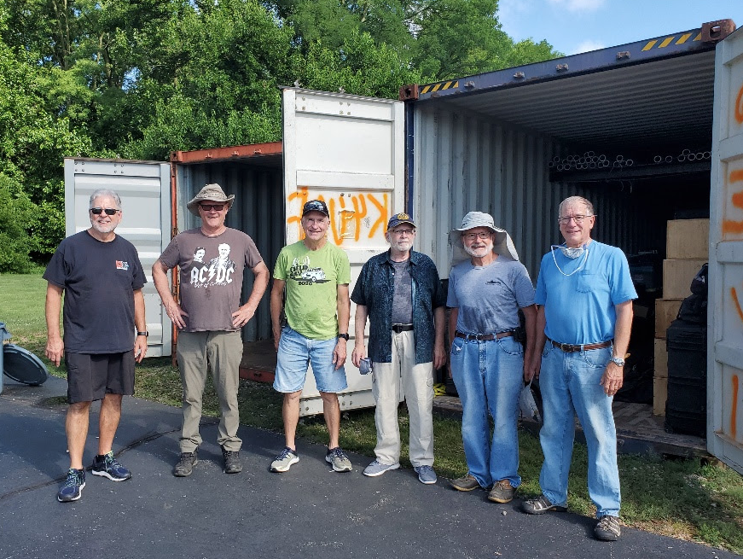VP6R team members (L-R) W8HC, Hal; W6IZT, Gregg; K9CT, Craig; N4GRN, George; W0GJ, Glenn; and K0IR, Ralph; unloaded the Pitcairn Island DXpedition 20-foot shipping container and are getting ready for their next adventure.

Six members of the VP6R team met in Peoria, IL last week to write the final chapter of the 2019 Pitcairn operation conducted by Pacific Islands DXpedition Group PIDXG). Actually, the primary purpose of the meeting was to unload the DXpedition's 20-foot shipping container with all of the VP6R DXpedition stations, antennas, supplies and personal gear that had just arrived from New Zealand. It had returned to Craig K9CT's place of business following an incredible 14-month journey that was prolonged by the outbreak of the Corona virus and ensuing global pandemic.

On hand for the container unloading party were DXpeditioners George N4GRN, Gregg W6IZT, Glenn W0GJ, Ralph K0IR, Craig K9CT and Hal W8HC who wasted little time in the summer heat removing the dozens of palletized totes, Pelican cases, plywood boxes and antenna systems. All equipment was inspected, inventoried and staged. The team is happy to report that all returned items appear to be in great shape in spite of the long and circuitous journey out in the Pacific.

The FlexRadio 6700s and Maestros which performed flawlessly on Pitcairn, as well as the Acom power amps were prepared for return shipment back to FlexRadio and DX Engineering respectively. The impressive falling derrick antenna components, designed and supplied by DX Engineering, will be used on future DXpeditions.

TOP ^

The VP6R team left behind a few antennas at Pitcairn for three of the resident hams. It is worth mentioning that Meralda Warren VP6MW will soon be QRV with a new rig she purchased from DX Engineering and is currently in shipment to the Island. For anyone who might have missed VP6R yet still needing Pitcairn for a "new one," it has been suggested you contact Meralda via her email address listed in [**QRZ.com**](http://r20.rs6.net/tn.jsp?f=001Jc7yxqnZ3anoZ9zCMScLgTobHT88nI-VZcrnR93jkNEQTXjD0hlWw-pC63Z63jKXbmn7Iz1HrEzHDwh7mOzsZcafb8pelaDctc6O6mFeivEDWlT5VGAIJSlU2-jWg92JDEcXDaQ634w=&c=AESzGNsilTDalQUZB7ybAJoDBpDyjxG85QUHE_IVHZ0rPU_BQ1rGSA==&ch=UMGbmyamR1mnW2LMu7LOKcmGaLxovwQWCaVSGKPbtO2jN18B2Q1mPw==) or, by contacting her new QSL manager- Mike W0VTT also of the VP6R team, to arrange a possible schedule.

According to Gregg W6IZT, who made a 9-hour drive from his Georgia QTH to participate in the VP6R container unloading party, "We had a very productive two days and accomplished a lot at Craig's. But even more than that, being together with some of our team following all of the cancellations and travel restrictions as a result of the pandemic was a very nice mini-reunion for us after these past 5 or 6 months."

The members of the VP6R team once again extend their thanks to the global DX community, sponsors and generous donors for their part in making this DXpedition such a success. Of course, special acknowledgement and appreciation goes out to FlexRadio, DX Engineering and Acom Amplifiers for providing VP6R with world-class stations. The team also wants to send along its heartfelt thanks to the wonderful Pitcairn people for their generous hospitality and friendship, "They made us feel like family in every respect and we will never forget the amazing time we had at Pitcairn Island," reminded Glenn W0GJ.

Finally, this Peoria meeting by the Pacific Island DXpeditioners also provided them with an opportunity to discuss their future DXpedition plans and possibilities... Please QRX... more to follow.

**DX Engineering Hamfest and DX Academy**

On July 25th, DX Engineering held their “Hamfest and DX Academy,” this year doing it online.  K3LR points us to the video of the whole thing:  [**https://www.youtube.com/watch?v=PC6iIVZAH88**](http://r20.rs6.net/tn.jsp?f=001tv7RTqEzwhNHWbaq2oCg2IYtQobyero7zN0Ssl02Krs8k4lpt0zdo_w6ETNIvrr7ivxmhrRync8Qk04bUaqeADDvTExvE_q7auyQ6zfY9H5-gCp98bluufx7cYsK81qJZLAy5T3dhxyuan5hQD8GXegGSihFSOzARepBD0C3d-RqZtT9nhJQyw==&c=60PxtjeD6nDOFpxTnqtk7JmQittGPbjqkeUF6EMQS2Jh5I4ZtavCmA==&ch=xXlIN_bsftffirdfODQnyTsGlOEgsx64uPYl7VWvEXhcTVV8aPjYgQ==).

**Heard Island VK0IR 1997**

**By KK6EK, Dr. Bob Schmieder**

As you know, Cordell Expeditions carried out an expedition to Heard Island in Jan/Feb 1997, using the callsign VK0IR. Recently I discovered about 6 hours of video that I had shot during the expedition, but which had never been seen (not even by me!). I divided the collection into six parts, which I have posted to Youtube:

Part 1 Preparation                [**https://youtu.be/IGcbjiFWAig**](http://r20.rs6.net/tn.jsp?f=00128GTd1nZv1gdtUH4QrjZDpFctJ2b60iRoe7nvqxdn1ql0sYVrY_3f0O2Xn-7D-7mmdXRj4IAjw8zdYCiMKKKKkrgcNuNDjfpkO1FrfMcphvuVThrvNm-Q-mpD7H2ocrun8woyxmu3C3w-9IZXdkBkg==&c=gBf3o2V_B1hQ96F6ItSfqQqMLfpUYaUAoyyC50nN4ccug69yLU_H-Q==&ch=s0bEKMWBV9qEoUAxiBPJw_E_R1Qh9jjYku-0JQ6ml3Jfs_nhoKfuiw==)

Part 2 Outbound                   [**https://youtu.be/RFCzL5dyDkM**](http://r20.rs6.net/tn.jsp?f=00128GTd1nZv1gdtUH4QrjZDpFctJ2b60iRoe7nvqxdn1ql0sYVrY_3f0O2Xn-7D-7mAqdg2lOKLU5u-75kCmSGiYi3oEx1_8-b--30Denv2dqaRwbeRKItWHhYqhseBEa_snO5WBz_yhQ8eohSP-zY0w==&c=gBf3o2V_B1hQ96F6ItSfqQqMLfpUYaUAoyyC50nN4ccug69yLU_H-Q==&ch=s0bEKMWBV9qEoUAxiBPJw_E_R1Qh9jjYku-0JQ6ml3Jfs_nhoKfuiw==)

Part 3 Landing/setup              [**https://youtu.be/50ykT4acnV8**](http://r20.rs6.net/tn.jsp?f=00128GTd1nZv1gdtUH4QrjZDpFctJ2b60iRoe7nvqxdn1ql0sYVrY_3f0O2Xn-7D-7mSRhah3aFp-AGI7kJcc5SkD7g2no2kLsgRw_Bbyd1gcZ1cx6POqY4n4DFIXall9RpeHrA4usiVbHyqPxa16uMwA==&c=gBf3o2V_B1hQ96F6ItSfqQqMLfpUYaUAoyyC50nN4ccug69yLU_H-Q==&ch=s0bEKMWBV9qEoUAxiBPJw_E_R1Qh9jjYku-0JQ6ml3Jfs_nhoKfuiw==)

Part 4 Operations                 [**https://youtu.be/kYX-F1mulTo**](http://r20.rs6.net/tn.jsp?f=00128GTd1nZv1gdtUH4QrjZDpFctJ2b60iRoe7nvqxdn1ql0sYVrY_3f0O2Xn-7D-7mGZyA0kXTzogrWGJ1ees4RLp0EunTePbErSonhIjhyLMs11UMNmAfm9PGU1nflWRNXjKuBTCHpmI384LSfL5e1A==&c=gBf3o2V_B1hQ96F6ItSfqQqMLfpUYaUAoyyC50nN4ccug69yLU_H-Q==&ch=s0bEKMWBV9qEoUAxiBPJw_E_R1Qh9jjYku-0JQ6ml3Jfs_nhoKfuiw==)

Part 5 Environment                [**https://youtu.be/gXNAKC--ElI**](http://r20.rs6.net/tn.jsp?f=00128GTd1nZv1gdtUH4QrjZDpFctJ2b60iRoe7nvqxdn1ql0sYVrY_3f0O2Xn-7D-7mAsXzzZIsHEyh6JLoIAnA8cn54e3MBNrfknyQO9YFI69nol4Uc5ubWSr-O0TgMiK8wZnKsaDyG8OYYDPePMq_4Q==&c=gBf3o2V_B1hQ96F6ItSfqQqMLfpUYaUAoyyC50nN4ccug69yLU_H-Q==&ch=s0bEKMWBV9qEoUAxiBPJw_E_R1Qh9jjYku-0JQ6ml3Jfs_nhoKfuiw==)

Part 6 Departure                  [**https://youtu.be/uGFiFw3TWxY**](http://r20.rs6.net/tn.jsp?f=00128GTd1nZv1gdtUH4QrjZDpFctJ2b60iRoe7nvqxdn1ql0sYVrY_3f0O2Xn-7D-7mpris_Yo2qrp5naEC2QzXEDoXB_qqOZpZlwM6dxW-8NgjL8IWBJX3JaIkKfRf2iZL0fPdzANp4yMZ48sGfhi_Yg==&c=gBf3o2V_B1hQ96F6ItSfqQqMLfpUYaUAoyyC50nN4ccug69yLU_H-Q==&ch=s0bEKMWBV9qEoUAxiBPJw_E_R1Qh9jjYku-0JQ6ml3Jfs_nhoKfuiw==)

You can also find these by going to [**Youtube.com**](http://r20.rs6.net/tn.jsp?f=00128GTd1nZv1gdtUH4QrjZDpFctJ2b60iRoe7nvqxdn1ql0sYVrY_3f0O2Xn-7D-7meUl4fMiDu_90RtcIaFa04OzZ_H4N-qo-rcujIWp3LD1I8fcncl2cAwtg9BqLdtJcyL1MCTylsvQ=&c=gBf3o2V_B1hQ96F6ItSfqQqMLfpUYaUAoyyC50nN4ccug69yLU_H-Q==&ch=s0bEKMWBV9qEoUAxiBPJw_E_R1Qh9jjYku-0JQ6ml3Jfs_nhoKfuiw==) and searching on “Robert Schmieder Heard Island.”

**Here is the introduction to each of the videos.**

On 11 Jan 1997, twenty men were landed on one of the most remote places in the world: Heard Island, located in the Southern Ocean, almost to Antarctica. They set up a village with all life support, including accommodations, light and power, galley, and a huge array of radios, antennas, and satellite communications gear.

TOP ^

Over the next two weeks, using the callsign VK0IR, the team logged 80,673 contacts with radio operators worldwide, a new world record for self-supported expeditions. The team also made daily explorations around the island to document the rocks, glaciers, rivers, plants, birds, and seals that are the dominant residents of this live volcano. Many of you will remember this expedition, and quite a few of you made significant contributions.

The expedition was documented in numerous articles, presentations, and professional videos, and received many awards, including a 2020 poll that ranks it #1 among all such expeditions of the past 30 years.

Unnoticed at the time, the author shot six hours of video of all aspects of the project. Unfortunately, these videos were lost until mid-2020, 23 years later.

No one, including the author, had ever viewed these videos. Upon finding them, the author divided the material into 6 separate Parts. Other than separation into the Parts, the videos needed little editing. They contain almost all of the material that was shot in 1997, and most of it is in exactly the order it was shot.

***DX News***

***ARLD032 DX news***

This week's bulletin was made possible with information provided by The Daily DX, the OPDX Bulletin, 425 DX News, DXNL, Contest Corral from QST and the ARRL Contest Calendar and WA7BNM web sites. Thanks to all.

**BARBADOS, 8P.** Mathieu, VA2MVR is QRV as 8P9QC from Pine Gardens until September 12. Activity is mainly on 40 and 20 meters using SSB with a possibility of FT8 and FT4. QSL via LoTW.

**GHANA, 9G.** Matteo, IZ4YGS will be QRV as 9G5GS from August 8 to September 15. Activity will be on the HF bands using mostly SSB and FT8, and on Satellite QO-100. QSL direct to home call.

**MOROCCO, CN.** Hassan, CN8SG is QRV with special call sign CN21SG from Kenitra to celebrate the 21st anniversary of the reign of his Majesty King of Morocco Mohammed VI. Activity is on the various HF bands. QSL via EA7FTR.

**CANARY ISLANDS, EA8.** Philippe, EA4NF, will be QRV as EA8/EA4NF from Lanzarote Island, IOTA AF-004, and Grid Squares IL38 and IL39, from August 10 to 17. Activity is on the FM and Linear Satellites in Full-Duplex mode. QSL via LoTW.

**FRANCE, F.** Members of the radio club F8KGH will be QRV with special call TM76DP from August 8 to 22 to commemorate the 76th anniversary of the Provence Landing in August 1944. Activity will be on 80 to 6 meters using CW, SSB and various digital modes. QSL via operators'

instructions.

**COLOMBIA, HK.** Members of the Colombian Amateur Radio League are QRV with special call sign 5K87LR from Bogota until August 31 to celebrate the 87th anniversary of the LCRA. Activity is on the HF bands. QSL via LoTW.

TOP ^

**REPUBLIC OF KOREA, HL.**  Members of the KARL Chungbuk HQ are QRV with special call HL75V during August to celebrates the liberation of the Korean peninsula 75 years ago. QSL via 6K0MF.

**ITALY, I.** Simone, IU4HRJ is QRV as IM0/IU4HRJ from Maddalena Island, IOTA EU-041, until August 10. Activity is on 40 to 2 meters using SSB and various digital modes. He plans to possibly activate some DCI/WCA reference numbers as well. QSL to home call.

**SARDINIA, IS0.** Gil, IZ2DLV will be QRV as IS0/IZ2DLV from Portobello di Gallura from August 10 to 28. Activity will be on 60 to 15 meters using CW, SSB and FT8. QSL direct to home call.

**GREECE, SV.** Francesco, IK6QON will be QRV as SV8/IK6QON from Corfu, IOTA EU-052, from August 9 to 20. Activity will be holiday style on 40 to 6 meters using CW and SSB. QSL to home call.

**TURKEY, TA.** Stations TC3GP and TC3GS are QRV until August 23 to commemorate the 105th anniversary of the Battle of Gallipoli. QSL via YM3KCN.

**CORSICA, TK.** Frans, DJ0TP is QRV as TK/DJ0TP until September 14. Activity is holiday style on the HF bands. QSL to home call.

**EUROPEAN RUSSIA, UA.** A large group of operators are QRV as R90WDWR from the Bryansk Region until August 16 to mark the 90th anniversary of the formation of the Russian Airborne Troops. Activity is on 160 to 10 meters. QSL via RZ5D.

**MEXICO, XE.**  Ramon, XE1KK is QRV with special call 6E6E until the end of 2020. Activity is on 160 to 6 meters using mostly FT8 and FT4. This includes being active on the upcoming CQ World Wide DX Phone and other contests. QSL via LoTW.

**CHATHAM ISLANDS, ZL7.** Operators Chris, ZL2DX and Catherine, ZL2QT are QRV as ZL7DX and ZL7QT, respectively, from Waitangi, IOTA OC-038, for the next few years. Activity is on the various HF bands and 6 meters EME. QSL via M0OXO.

THIS WEEKEND ON THE RADIO. The QRP 20-Meter CW Fox Hunt, NCCC RTTY Sprint, NCCC CW Sprint, Worked All Europe DX CW Contest, QRP ARCI European CW Sprint, SKCC Weekend CW Sprintathon, Maryland-DC QSO Party and RTTYOPS Weekend Sprint are all on tap for this weekend.

The 4 States QRP Group Second Sunday Sprint and SARL 40-Meter SSB Youth Sprint are scheduled for August.

The RTTYOPS Weeksprint, Worldwide Sideband Activity Contest and MMMonVHF/DUBUS 144 MHz Meteorscatter Sprint Contest are scheduled for August 11.

The VHF-UHF FT8 Activity Contest, CWops Mini-CWT Test, NAQCC CW Sprint and Phone Fray are scheduled for August 12.

Please see August 2020 QST, page 69, and ARRL Contest Calendar and WA7BNM Contest Web Sites for details.

TOP ^

**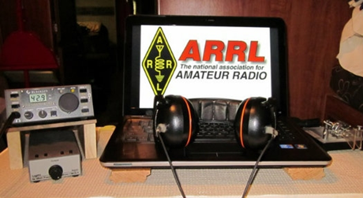*ARRL Contest Corner***

An expanded, downloadable version of *QST'*s’[**Contest Corral**](http://www.arrl.org/contest-calendar) is available as a PDF. Check the sponsor's’Web site for information on operating time restrictions and other instructions.

|  |  |
| --- | --- |
| **August 10**   * [4 States QRP Group Second Sunday Sprint](http://www.4sqrp.com/SSS/sss_rules.pdf) * [SARL Youth Sprint](http://www.sarl.org.za/Web3/Members/DoDocDownload.aspx?X=20191122180528bLHEaj4vF4.PDF) | **August 11**   * [Worldwide Sideband Activity Contest](https://wwsac.com/rules.html) * [MMMonVHF/DUBUS 144 MHz Meteorscatter Sprint Contest](http://www.mmmonvhf.de/ctestinfo.php) * [RTTYOPS Weeksprint](https://rttyops.wordpress.com/rtty-mini-contests/rttyops-weeksprint/) |
| **August 12**   * [NAQCC CW Sprint](http://naqcc.info/sprint/sprint202009.html) * [Phone Fray](http://www.perluma.com/Phone_Fray_Contest_Rules.pdf) * [VHF-UHF FT8 Activity Contest](http://www.ft8activity.eu/index.php/en/) * [CWops Mini-CWT Test](https://cwops.org/cwops-tests/) | **August 13**   * [CWops Mini-CWT Test](https://cwops.org/cwops-tests/) * [RTTYOPS Weeksprint](https://rttyops.wordpress.com/rtty-mini-contests/rttyops-weeksprint/) |
| **August 14**   * [QRP Fox Hunt](http://www.qrpfoxhunt.org/summer_rules.htm) * [NCCC RTTY Sprint](http://www.ncccsprint.com/rttyns.html) * [NCCC Sprint](http://www.ncccsprint.com/rules.html) | **August 15**   * [SARTG WW RTTY Contest](http://www.sartg.com/contest/wwrules.htm) * [**ARRL 10 GHz and Up Contest**](http://www.arrl.org/10-ghz-up) * [Russian District Award Contest](http://rdaward.org/rdac1.htm) * [Tisza Cup](https://www.tiszacup.eu/index.php/en/contest-rules) * [Keyman's Club of Japan Contest](https://kcj-cw.com/contest/rule/2020_41_kcj_dx_.pdf) * [Feld Hell Sprint](https://sites.google.com/site/feldhellclub/Home/contests/sprints/hell-on-wheels-sprint) * [**North American QSO Party, SSB**](http://www.ncjweb.com/NAQP-Rules.pdf) * [CVA DX Contest, CW](http://cvadx.org/regulamento/) |
| **August 16**   * [SARTG WW RTTY Contest](http://www.sartg.com/contest/wwrules.htm) * [SARL HF Digital Contest](http://www.sarl.org.za/Web3/Members/DoDocDownload.aspx?X=20191211183027qzNhzFo0EI.PDF) * [NJQRP Skeeter Hunt](https://www.qsl.net/w2lj/) * [**ARRL Rookie Roundup, RTTY**](http://www.arrl.org/rookie-roundup) * [Run for the Bacon QRP Contest](http://qrpcontest.com/pigrun/) | **August 18**   * [Worldwide Sideband Activity Contest](https://wwsac.com/rules.html) * [RTTYOPS Weeksprint](https://rttyops.wordpress.com/rtty-mini-contests/rttyops-weeksprint/) |
|  |  |

TOP ^

|  |  |
| --- | --- |
| **August 19**   * [Phone Fray](http://www.perluma.com/Phone_Fray_Contest_Rules.pdf) * [CWops Mini-CWT Test](https://cwops.org/cwops-tests/) | **August 22**   * [**Ohio QSO Party**](https://www.ohqp.org/)   Sponsored by Mad River Radio Club (MMRC)  A note from Scott N3FJP regarding his logging software:  Scott notes that his "Ohio QSO Party Contest Logs (In State 4.4 and Out of State 4.3) have been updated for the rule change to include 160 meters."  It is suggested that if you are going to use N3FJP State QSO Software to log during the contest, please download the updated OH QSO Party software from his site. |

####

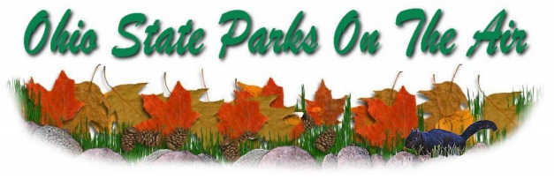

The Portage County Amateur Radio Service, Inc. (PCARS) announces the 13th Annual “Ohio State Parks On the Air” (OSPOTA) contest, from the hours of 10 am to 6 pm ET (1400 UTC to 2200 UTC).



13th OSPOTA - September 12, 2020

14th OSPOTA - September 11, 2021

15th OSPOTA - September 10, 2022

16th OSPOTA - September 9, 2023

17th OSPOTA - September 7, 2024

18th OSPOTA - September 6, 2025

19th OSPOTA - September 12, 2026

20th OSPOTA - September 11, 2027

**Always the first Saturday after the Labor Day holiday.**

For hams throughout the State of Ohio, this is your opportunity to visit and enjoy the amenities offered by the 75 beautiful State Parks here in Ohio. Don’t just make a day of it - spend the weekend at the park of your choice. No matter whether you are camping or staying at one of the outstanding lodges or resorts, you will find that the parks are one of Ohio’s greatest assets. Find out more about the Ohio State Parks at: <http://parks.ohiodnr.gov/>

TOP ^

In past years, hundreds of Amateur Radio Operators (hams) from around the country participated in the event. With the success of OSPOTA, we hope to have amateur radio operators at every Ohio State Park.

This contest places a premium on working stations located in the Ohio State Parks. That means that it is critical to have as many parks activated as possible. The challenge for Ohio stations will be to work HF in the 50 to 300 mile range. This is the perfect opportunity to learn more about the design and deployment of Near Vertical Incident Skywave (NVIS) antennas. You can find numerous designs on the Internet and in various Amateur Radio antenna manuals. Along with your operating skills, it will be a chance to showcase your antenna building skills as well.

Individuals and multiple operators can operate Ohio State Park stations. Non-park stations in Ohio as well as stations outside of Ohio can also compete. Contacts can be made on 80, 40, 20, 15 and 10 meters using SSB. All contacts have the same point values. Make sure that you read the Rules, FAQ’s and get your forms for the contest that are posted on the OSPOTA website: www.ospota.org before the contest. So get to an Ohio State Park and get On The Air in September. Have some fun with this contest!

73 for now, OSPOTA Contest Committee

***Special Events***

* **08/11/2020 | Navajo Code Talkers S/E**

**Aug 11-Aug 15, 0000Z-0000Z, N7C**, Window Rock, AZ. Herbert Goodluck, N7HG. 18.133 14.265 7.265. Certificate & QSL. Navajo Code Talkers, PO Box 06, Chinle, AZ 86503. [www.qrz.com/db/n7c](http://www.qrz.com/db/n7c)

* **08/12/2020 | 2020 IL State Fair**

**Aug 12-Aug 24, 0000Z-0000Z, W9I**, Springfield, IL. Sangamon Valley Radio Club. 14.250 7.150. QSL. J. Mitch Hopper, K9ZXO, 536 E. Mill St., Rochester, IL 62563. [www.svrc.org](http://www.svrc.org/)

* **08/12/2020 | Iowa State Parks On-the-Air Centennial – Fort Atkinson**

**Aug 12, 1500Z-1900Z, W0OEL**, Fayette, IA. Rural Iowa and Buchanan County Amateur Radio Clubs. 14.240 7.240. Certificate. Great River Amateur Radio Club, P.O. Box 1384, Dubuque, IA 52004. IASPOTA-2020 Fort Atkinson is not the stuff of which legends are made. Fort Atkinson was built to keep the Winnebago Indians on Neutral Ground (a 40-mile-wide strip of land established by the Treaty of 1830) after their removal from Wisconsin in 1840, and to provide protection for them from the Sioux, Sauk, Fox and from white intruders on Indian land. Certificate & QSL managed by Great River Amateur Radio Club, P.O. Box 1384, Dubuque, IA 52004. QSL for contact; certificate for 5 parks. See website for complete information, http://www.w0dbq.org/rule [https://www.w0oel.com](https://www.w0oel.com/)

* **08/15/2020 | Appalachian Trail Anniversary**

**Aug 15, 1400Z-2100Z, N4F**, Franklin, NC. Franklin Amateur Radio Club, Franklin, N.C.. 7.265 SSB 14.265 SSB 7.045 CW 14.045 CW. QSL. Franklin Amateur Radio Club K2BHQ, 505 North Sugar Creek Dr. , Franklin, NC 28734. Appalachian Trail (AT) Special Event Station celebrating the 83rd birthday of the AT. Opening on August 14, 1937 and spanning 2,181 miles from Springer Mountain, Georgia to Mount Katahdin, Maine, the AT is the longest continuously marked footpath in the world. The Franklin Amateur Radio Club in Franklin, NC will locate our special event station at the Rock Gap trailhead on the AT. Commemorative QSL with SASE to K2BHQ address on QRZ [k2bhqemail@gmail.com](mailto:)

TOP ^

* **08/22/2020 | National Park Service Founders Day**

**Aug 22-Aug 30, 1200Z-2300Z, N1P**, Canfield, OH. NPS Ranger News. 14.255 7.290. Certificate. Certificate, available online only, see website. Online certificate only, see website <https://www.qrz.com/db/N1P>

* **08/22/2020 | Southwest Reef Lighthouse/ILLW/US0176**

**Aug 22-Aug 24, 0001Z-1800Z, W5BMC**, Berwick, LA. Bayouland Emergency Amateur Radio Service/BEARS. 14.275 7.275. QSL. Jackie Price, 708 Front St., Morgan City, LA 70380. The Southwest Reef Lighthouse sits on the bank of the Atchafalaya River in Lighthouse Park in Berwick. The station is a permanent facility at the Memorial Ray Rasberry, WB5LKR(SK) tower in Lighthouse Park

* **08/27/2020 | Burning Man**

**Aug 27-Sep 7, 1200Z-1200Z, W7B**, Gerlach, NV. Mansonian. 28.375 21.325 14.250. QSL. George Badger, 4602 Fairway Dr, Soquel, CA 95073. SASE for QSL please. [w7b@w3ab.org](mailto:)

* **08/28/2020 | 15th Anniversary of Hurricanes Katrina & Rita**

**Aug 28-Aug 30, 2300Z-2359Z, K5R**, Mandeville, LA. KD5PCK. 40, 20, and17 meters, general portions. Certificate. Scott Hernandez, 957 Nancy St. , Mandeville, LA 70448. In August & September of 2005, Hurricanes Katrina & Rita made landfall in Louisiana. Katrina striking near Buras, LA and Rita landing near the Louisiana/Texas border. When all else failed, hams from across the nation assisted with establishing communications into and out of the entire gulf coast area. Commemoration of the 15th anniversary of these two devastating storms will take place on air the weekend of August 28 through 30, 2020. Look for activities in the General portions of 40, 20 and 17 meters. More information regarding operations and certificates on the K5R QRZ page. <https://www.facebook.com/groups/katrina5rita>

* **08/28/2020 | RESCHEDULED -100th Vermontville TWP Fire and EMS Association Annual Dance**

**Aug 29-Sep 7, 0900Z-0900Z, W8S**, Vermontville, MI. Rodney L. Harmon. 446.000 MHZ PL 74.4 Hz. 145.560 MHZ 147.080 MHZ PL 103.5 Hz IRLP NODe #4868. Certificate. Rodney L. Harmon, WK8H, 172 East Second St, Vermontville, MI 49096-9455. Rescheduled from June 27, 2020, to August 29, 2020, due to health concerns of the COVID-19 pandemic. [wk8h_michigan@att.net](mailto:)

* **08/29/2020 | Buhl Day 105th Anniversary of Buhl Farm Park**

**Aug 29-Sep 7, 0000Z-2359Z, W3B**, Sharon, PA. Mercer County Amateur Radio Club. 145.350 14.240 7.185 DSTAR Reflector 63C. QSL. Mercer County Amateur Rsdio Club, P.O. Box 996, Sharon, PA 16146. The Mercer County Amateur Radio Club is celebrating BUHL DAY, the 105th Anniversary of Buhl Farm Park, which covers 300 acres and was given to the Shenango Valley community by Frank Buhl a local industrialist, for the use and recreation purposes of the community in Mercer County, PA. As conditions permit you will find operators at various time on 7.185, 14.240, 145.350, DSTAR Reflector 63C from August 29 to September 7, 2020 and the club will be providing communications for a half marathon. Check the www.w3lif.org webpage for scheduled times of W3B operation or the QRZ website for W3B for more information. [www.w3lif.org](http://www.w3lif.org/)

* **08/30/2020 | Auburn, Cord, Duesenberg Festival**

**Aug 30-Sep 9, 0000Z-0000Z, K9A**, Auburn, IN. Northeastern Indiana Amateur Radio Association. 14.074 7.225 7.074; SSB, FT8, and CW. Certificate & QSL. K9A c/o Northeastern Indiana ARA, P.O. Box 145, Auburn, IN 46706. See website or QRZ for information on receiving a QSL or Certificate. [www.w9ou.org](http://www.w9ou.org/)

TOP ^

***“ARES Connect”***

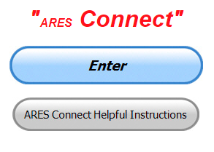

***Connecting Amateur Radio Volunteers with a Purpose***

Hey everyone… please make sure to go in and register your time to all of the events that you have signed up for. Don’t forget to get this done no later than **5 days** after the event has ended. I’m asking you to do this for our ability to run reports accurately.

**I want to remind all of you that you do not have to be an ARES or ARRL member to use this system. All licensed amateur radio operators throughout the country are welcome and strongly encouraged to use it.**

Want to see your name appear in the list below? There’s only one way of doing that, you have to sign-up for events and then enter your time in afterward. Are you a regular on a NET or other event? We can sign you up for the entire life of the event if you want. What’s the advantage of that? No more registering, that part is done automatically for you. You still need to enter your time, but that’s all!!!

Want more information on this great way of never forgetting to register? Just ask…. [n8sy@n8sy.com](mailto:n8sy@n8sy.com) I’m here to get you started on your way.

***Here’s are the top 10 hours earners so far for the month of August:***

|  |  |  |  |
| --- | --- | --- | --- |
|  | **Name** | **Events** | **Hours** |
| **1** | Dwight Bonifield (W8TJT) | 46 | 62.50 |
| **2** | Dan Stahl (KC8PBU) | 26 | 56.50 |
| **3** | Leo Dubois, Jr. (KE8OOS) | 27 | 34.75 |
| **4** | James Yoder (W8ERW) | 3 | 27.50 |
| **5** | Christopher Domenick (KC8CAD) | 8 | 27.00 |
| **6** | Bret Stemen (KD8SCL) | 10 | 26.50 |
| **7** | Joseph Wigal (W8JTW) | 24 | 19.75 |
| **8** | Mathew Nickoson (KC8NZJ) | 5 | 14.75 |
| **9** | Greg Dersarkisian (KD8SSJ) | 4 | 13.00 |
| **10** | Alan Rothweiler (N8CJ) | 6 | 12.00 |

**Let’s get everyone in the Ohio Section on “ARES Connect!!!” Simply go to:** <https://arrl.volunteerhub.com/lp/oh/> and get yourself registered and using the system.

#####

TOP ^

***One Question Questionnaire***

Hey Gang,

“Survey Says”….. about 78**%** of you have some sort of a CW filter in your HF rig. That’s fantastic!!! When all of those other modes just don’t work, remember that still have CW to go to

Ok, now, on to next question… Following up with another question that relates to the previous ones, let’s find out how many of you are any kind of experimenter with HF antenna’s.

So, the next question is…

***“Have you ever built your own antenna for HF??”***

You’ll find the “One Question” questionnaire on the Ohio Section Website! <http://arrlohio.org> It’s all in fun and it’s not a scientific survey in any way, but we are learning some things that we didn’t know from these questions. I hope that you are enjoying answering these “One Question” questionnaires.

***V.E. Test Sessions***

**

Many V.E.’s have decided to start testing once again, but with restrictions that need to be adhered to for sure. Here’s the link to find that V.E. Test session and what is expected of YOU before going. <http://www.arrl.org/find-an-amateur-radio-license-exam-session>

####

The Dayton Amateur Radio Association (DARA) VE Team will be hosting a **FREE** license test at the DARA clubhouse on **August, 15th at 10:30 am**.

Testing for all license classes will be available. **Pre-registration is required to test due to Covid-19**.

Anyone interested in attending should email [exams.w8bi@gmail.com](mailto:exams.w8bi@gmail.com) for a registration form.

TOP ^

***Final.. Final..***

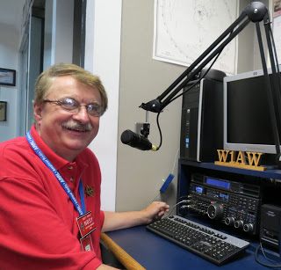Hi Gang,

What a great week this has been. The weather has been perfect for getting out and doing all of those yard things that have needed attention for some time now.

Janie and I are getting out and riding our bikes about 15 to 20 miles every day. We are so lucky to have a number of great bike trails right around us to choose from. I have been taking my DMR radio along on some of my rides and working a few people as “bicycle mobile.” It’s been a blast to do, but I am so looking forward on working some HF from the bike as well. I’m currently working on a rack so that will let me mount a small QRP HF rig on the bike. I do have one very large issue to overcome with this project. I chose to go with a big 26” wheel on the back and didn’t think about how much room that would consume. Because the tire is so large, it’s a little more difficult to find the needed room for any kind of rig and still get the bike to fit in the car in the end. I’m not discouraged yet! I’ll find a way to get something on there for sure! I’ve already mapped out a place to put the antenna and it will only take a minute to mount it.

With this more normal weather that we’ve had lately, I also decided to do some fine-tuning adjustments on my 4 BTV vertical antenna. Wow, has this ever turned out to been a challenge! I bought the 4 BTV last year and got it working so that I could make some contacts on it, but I wasn’t really happy where the antenna seemed to be resonate at. I decided that I needed to do some fine tuning and that would make it better. Boy, if I had only known then what I know now!

I have played with the adjustments these past several weeks and now have it really messed up. It doesn’t seem resonate on any frequency right now. It seems that when I get it tuned for the portion of the 10-meter band that I want, 20-meters gets all out of whack.

I get the 10 and 20-meter working fine, and 15-meters goes out. I just can’t seem to get things working my way. This has had me running back and forth from the antenna to the shack a million times and still no success.

So, after some research in my ARRL Antenna handbook I find that doing these adjustments would be much easier to do, and save getting yelled at for tracking up the house if I just had an analyzer setup at the base of the antenna.

I started looking into the various antenna analyzers that are out there and got really discouraged fast. Some of these analyzers have a price tags larger than what I paid for my FT 920 new! I was on a Zoom call the other night with the DARA Thursday Night Group and they gave me some really good suggestions on some new analyzers that don’t break the bank (under $100) and will keep me from having to run back and forth like a crazy person. Now I just have to wait for one of my favorite candy stores to get them in!!

TOP ^

**Ok, moving on to another subject…** Are you ready for the Simulated Emergency Test (S.E.T.) coming up in October? Matt, KD8TTE has been very busy writing up some homework for all of us to do for the S.E.T. It’s gonna’ be a lot of fun for everyone that participates, so start planning now and you really need to read Matt’s column to get the full effect on what he and Stan have in store for us this year.

**Let’s not forget to take a quick look at ARES Connect**

Have you looked at the breakdown per county on the website yet? We have a “per county” dashboard of the hours recorded in ARES Connect for each county. We also list those District only events as well as the hours recorded for Section wide functions. These are the hours of actual volunteers and not anonymous hours. Want to see how many hours your county has gotten so far? Go to… <http://arrl-ohio.org/SEC/reports.html>

This page is updated regularly, so you can see what’s happening in real time in your county. Don’t see hours recorded in your county? That’s because you haven’t done **your part** and gotten your time recorded.

Have you seen the latest Section Emergency Coordinators report? If not, you can view it by going to:

<http://arrl-ohio.org/SEC/reports.html>

**Moving to a new subject Club Affiliation and Special Service Club renewals**

I want to ask all of you folks that are responsible for your clubs if you have sent in your annual club affiliation report yet? Yes, this is an annual thing that you need to be doing. It’s very easy to do and you do it on-line. Once finished, your club’s affiliation date is updated and that’s it. Getting this annual report turned in takes all of 5 minutes to do, but it does so much for your club. With the update out of town folks know when your meetings are, they also know who to contact if they have questions about your club. This is really important to do.

Now, I also want to address those same folks if your club is/was a Special Services Club. We’ve had many clubs in our Section with that very distinguished distinction. It’s something to be very proud of, but it too requires you to renew. For the SSC’s it’s every two years. I know that this confuses things since you’re not always looking at the records to see when your renewal dates are, but… It’s equally important for you to renew your SSC. To renew the SSC, you are required to do a little more work than just updating who’s the new president and such. You need to keep a record of your clubs outstanding activities and make sure that those activities are listed on your new/renewal form for SSC.

I always advise everyone whether completing the forms for the first time or this is your 10th time, keep a copy of the completed form information.

Whelp, my final go around before gong QRT… I had a blast doing Zoom presentations for the OH-KY-IN and Massillon clubs this past week. I only wish that they could have been in-person meetings, but that will come.

Stay safe my friends! I want to see all of you soon at a meeting or hamfest! We will get through this and when we do, we’ll have so much to talk about. Most of all… have FUN and get on the airwaves!!

73,

[***Scott, N8SY***](mailto:n8sy@n8sy.com)

TOP ^

Ohio Section Cabinet

|  |  |
| --- | --- |
| Section Manager – Scott Yonally, N8SY | Assistant Section Manager – John Perone, W8RXX |
| Section Emergency Coordinator – Stan Broadway, N8BHL | Section Traffic Manager – David Maynard, WA3EZN |
| Technical Coordinator – Jeff Kopcak, K8JTK | Affiliated Clubs Coordinator – Tom Sly, WB8LCD |
| State Government Liaison – Bob Winston, W2THU | Public Information Coordinator – John Ross, KD8IDJ |
| Section Youth Coordinator – Anthony Lascre, K8ZT | |

***Swap & Shop Has Added Club Raffles To Its Listings On The Webpage***

Hey Gang,

Have you taken a look at the **Swap & Shop** page on the Ohio Section webpage yet?? Here’s a link that will take you there…

<http://arrl-ohio.org/sm/s-s.html>

Do you have equipment that you just don’t need or want anymore? Here’s a great venue to advertise it, and it’s FREE!! Is your club doing a fund raiser to help raise money? After a lot of thought, it was decided that the Swap & Shop webpage could also contain these types of items as well.

The same rules will apply as do for the For Sales and Give-A-Ways and will only be posted for a month at a time. Please see the Terms & Conditions on the webpage.

If your club is doing a fund raiser and wants more exposure, please forward the information to me and I’ll advertise it on the Swap & Shop webpage for you. Now, I still want to remind you that it won’t be listed in this newsletter because it would take up way too much space, so your ad will only appear on the website. It is there for any individual to post equipment Wanted / For Sale or Give-Away as well as for Club Fund Raisers. No licensed vehicles/trailers or business advertising will be posted.

Postings are text only (no pictures or graphics) will be posted for a maximum of 1 month from date posting and require a contact phone number or email within the posting. Send your Wanted / For Sale or Give-Away post to:  [swap@arrlohio.org](mailto:swap@arrlohio.org)

***Back Issues of the PostScript and Ohio Section Journal***

Hey, did you know that PostScript and Ohio Section Journal (OSJ) are archived on the website? You can go back and look at any edition simply by clicking:

<http://arrl-ohio.org/news/index.html>

***Welcome New Subscriber(s)***

**Marion, W8NUT**

TOP ^

***Want to Share your Club Newsletter With Others?***

We have a webpage where you can download and read all of the newsletters that I get from around the state and even other sections!

Here’s the link to the page…. <http://arrl-ohio.org/club_news/index.html>

Please, if you don’t see your club newsletter posted, it’s because I’m not receiving it. Just have your newsletter editor contact me and I’ll get your club’s newsletter listed on the site!!

We all learn and steal (I mean, share) from each other’s work. So, get me your newsletter!!! Send it to: [n8sy@n8sy.com](mailto:n8sy@n8sy.com)

***Chit – Chat, and All That!***

Do you know someone that’s not getting these Newsletters? Please, forward a copy of this Newsletter over to them and have them “[Opt-In](mailto:Opt-In)” to start receiving them. Heck just have them send me an email [n8sy@n8sy.com](mailto:n8sy@n8sy.com) and I’ll get them added to the Ohio Section Emailing list.

We now have many thousands of readers receiving these newsletters weekly. Quite impressive, I’d say! I urge all of you to make sure that everyone, regardless of whether they are a League member or not, get signed up to receive these weekly Newsletters.

You can always “Opt-Out” at any time if you feel this is not what you were expecting. It’s fun and very informative. All of your favorite past newsletters are now archived too.

You can go back at any time and read them. Just go to: <http://arrl-ohio.org/news/>

Got questions, concerns or would just like to sit and chat awhile? Heck, I’ll even buy the coffee!! Give me a call at (419) 512-4445 or email me at: [n8sy@n8sy.com](mailto:n8sy@n8sy.com)

The pictures on the front page and throughout this newsletter are from various newsletters, Facebook posts and/or were sent directly to me in recent weeks. Take a good look at them, you just might be in one of the pictures! “SMILE… you’re in the Ohio Section News!!”

TOP ^

*PostScript is produced as a weekly newsletter. I want to thank everyone that has contributed articles and ideas to make this an even better news source. I sincerely hope that you have enjoyed this edition and will encourage your friends to join with you in receiving the latest news and information about the Ohio Section, and news and events happening around the world!*