[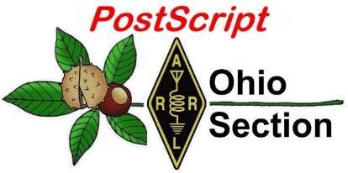](http://arrl-ohio.org/news/) ***August 3rd***

***Edition***

🡪 National News 🡪 The Handbook Give Away

🡪 Club Corner 🡪 Hamfests

🡪 DX This Week 🡪 ARES Connect

🡪 VE Testing 🡪 One Question Questionnaire

🡪 Final.. Final..

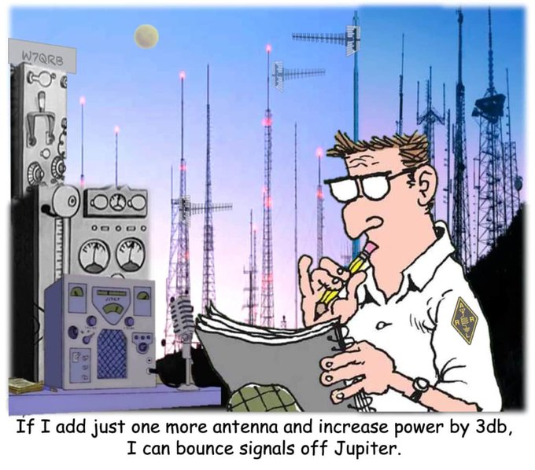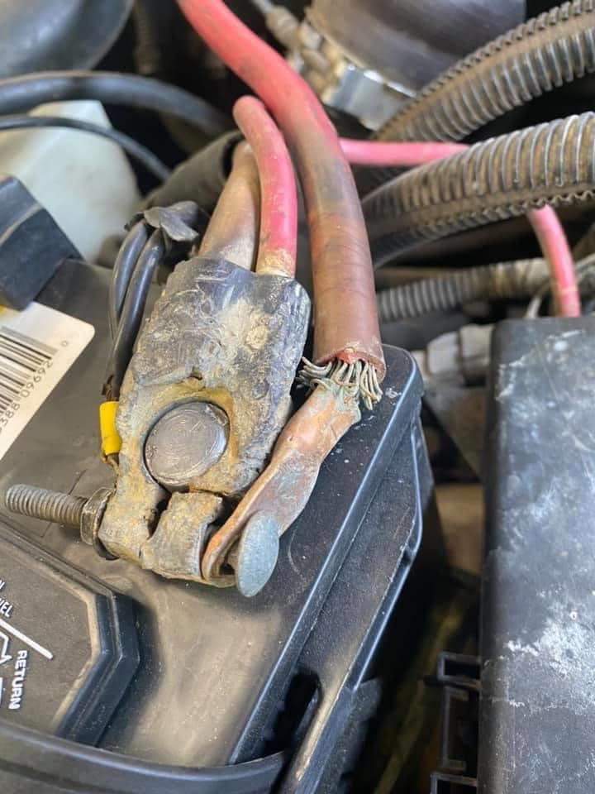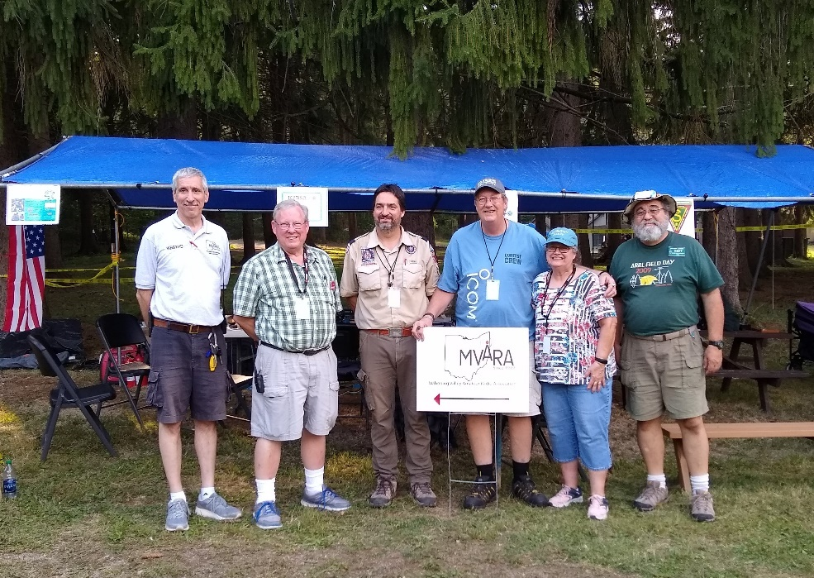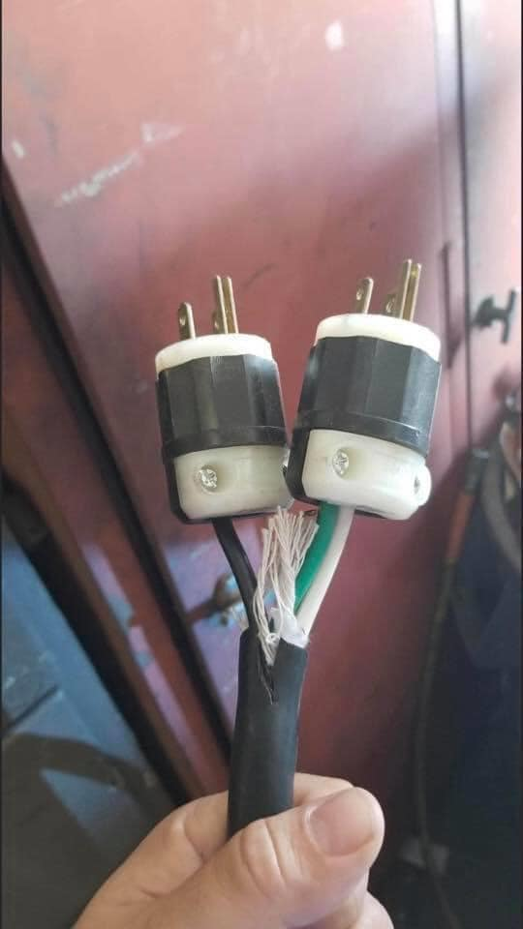

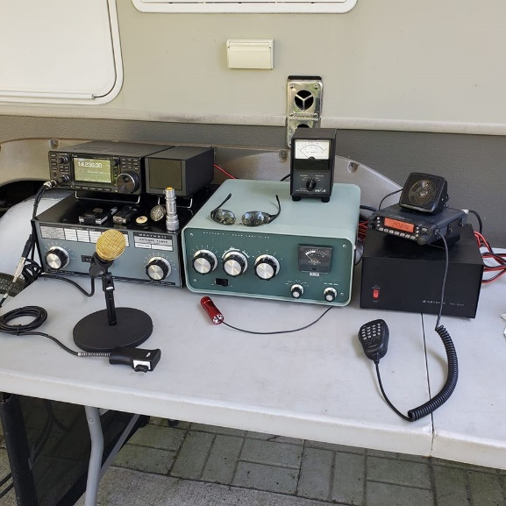

***National News***

*(from arrl and other sources)*

***ARRL/TAPR Digital Communications Conference Seeks Papers***

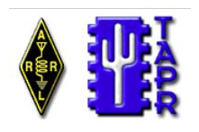Technical papers are being solicited for presentation at the 2020 ARRL/[TAPR](http://www.tapr.org/) Digital Communications Conference (DCC), September 11 – 13. Due to the coronavirus pandemic, this year’s conference will be held online. Papers will also be published in the *Conference Proceedings*. Authors do not need to participate in the conference to have their papers included in the *Proceedings*. The submission deadline is August 15, 2020. Submit papers via [**email**](mailto:maty@arrl.org)to Maty Weinberg, KB1EIB. Papers will be published exactly as submitted, and authors will retain all rights.

####

***AMSAT Partners with University of Maine WiSe-Net Lab to Develop State’s First CubeSat***

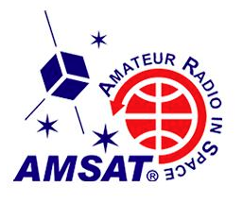

The University of Maine Wireless Sensing Laboratory (WiSe-Net Lab) and AMSAT have signed an agreement to collaborate on building and operating MESAT1, Maine’s first small satellite. Carrying an amateur radio payload in addition to science payloads, MESAT1 is set to launch sometime in the next 3 years under NASA’s CubeSat Launch Initiative (CSLI), which provides opportunities for nanosatellite science and technology payloads built by universities, schools, and nonprofits to ride-share on space launches. AMSAT President Clayton Coleman, W5PFG, celebrated the announcement.

“This is a great day for AMSAT and UMaine’s WiSe-Net Lab,” Coleman said. “This partnership is a true win-win for both education and the amateur radio community. The collaborative effort under AMSAT’s engineering and operations teams has once again succeeded to bring another opportunity to AMSAT.”

MESAT1 will be one of 18 small research satellites selected by NASA to carry auxiliary payloads into space between 2021 and 2023. The CubeSat is being developed in partnership with the University of Maine (UMaine) and the University of Southern Maine (USM), along with a trio of K – 12 schools. UMaine graduate students and USM undergraduates will collaborate on CubeSat design, development, integration, and testing.

UMaine’s WiSe-Net Lab, established in 2005, is involved in aerospace and space research. The lab was founded by Ali Abedi, KB1VJV, assistant vice president for research and director of the Center for Undergraduate Research at the university’s main campus in Orono. Lab researchers have developed the first wireless sensor network for NASA’s lunar habitation project and launched wireless leak detection to the International Space Station.

The MESAT1 initiative will enable K – 12 students and teachers in Maine to access space data for educational and research purposes and encourage students to pursue STEM (science, technology, engineering, and math) careers. MESAT1 was awarded $300,000 from NASA. The project also received $150,000 in NASA Maine Space Grant Consortium funding for graduate student research. Folding in additional funding from UMaine and USM to support undergraduate student research brings the total funding to $522,000 over 3 years.

TOP ^

AMSAT will provide a linear transponder module (LTM) along with integration and operational support for MESAT1. AMSAT’s LTM incorporates a VHF/UHF telemetry beacon, command receiver, and linear transponder. It will be available for worldwide amateur radio use once the satellite is commissioned.*— Thanks to AMSAT and the University of Maine*

####

***FCC Fines HobbyKing Nearly $3 Million for Marketing Unauthorized Drone Transmitters***

The FCC has issued a *Forfeiture Order* ([***FO***](https://docs.fcc.gov/public/attachments/FCC-20-101A1.pdf)) calling for HobbyKing to pay a fine of $2,861,128 for marketing drone transmitters that do not comply with FCC rules. An FCC Enforcement Bureau investigation stemmed in part from a 2017 ARRL [**complaint**](http://www.arrl.org/files/file/Regulatory/Drone20Transmitter20FINAL20filing2011%202017.pdf) that HobbyKing was selling drone transmitters that operated on amateur and non-amateur frequencies, in some instances marketing them as amateur radio equipment. The fine affirms the monetary penalty sought in a June 2018 FCC *Notice of Apparent Liability*([***NAL***](https://docs.fcc.gov/public/attachments/FCC-18-71A1.pdf)). The FCC said its investigation found that dozens of devices marketed by the company transmitted in unauthorized radio frequency bands and, in some cases, operated at excessive power levels. “Such unlawful transmissions could interfere with key government and public safety services, like aviation systems,” the FCC said.“We have fully considered HobbyKing’s response to the *NAL*, which does not contest any facts and includes only a variety of legal arguments, none of which we find persuasive,” the FCC said in the *FO*. “We therefore adopt the $2,861,128 forfeiture penalty proposed in the *NAL*.”

The FCC pointed out in the *FO* that it has previously made clear that “[d]evices used in the Amateur Radio Service do not require authorization prior to being imported into the United States, but devices for other services, including the CB service, require Commission approval.” The FCC investigation found that 65 models of devices marketed by HobbyKing should have had FCC certification.

Responding to the *NAL*, HobbyKing claimed to have ceased marketing the 65 models the FCC identified, but promised only to make “best efforts” not to market other noncompliant RF devices. “HobbyKing has a continuing obligation to market only radio frequency equipment that is properly authorized,” the FCC said. “We therefore remind HobbyKing that continuing to market noncompliant radio frequency devices could result in further significant forfeitures.”

HobbyKing has 30 days to pay the fine. If it fails to do so, the matter will be referred to the Department of Justice for collection.

####

***FT8 experiment on 40 MHz - August 1st to 15th***

*(Submitted by Gregory Drezdzon, WD9FTZ)*

Between August 1 and15, LY2YR and S50B will be experimenting with the FT8 digital mode on the new 8-meter band. [Note: Eight (8) meters is not authorized in the United States.]

Gintas, LY2YR in Lithuania will be transmitting on 40.220 MHz, while Borut, S50B in Slovenia will be transmitting on 40.680 MHz.

TOP ^

Both stations will mainly be active from 10:00 to 21:00 UTC and would welcome any reception reports.

More info: <https://ei7gl.blogspot.com/2020/08/ft8-experiment-on-40-mhz-1st-to-15th.html>

####

***The Ohio Section Shows that RR in ARRL Means Radio Relay***

*(C. Matthew Curtin KD8TTE)*

Amateur radio can get the message through “when all else fails” only if the operator’s practice. The go-kits are fun but what if you’re there to communicate on behalf of an agency, NGO, or individual with someone you can’t reach directly? How will you receive incoming messages?

The answer to both questions is message relay. We use relay services. Telephone is real-time: everyone must be there to hear and to respond. Email is store-and-forward: store a message here then forward it on to the next point until it reaches its destination, where it will wait for the recipient to open it. Even for short messages, many people prefer SMS (“text”) over a phone call.

The Ohio Section’s County Information Report (CIR) Project 20 is showing how to make this work in practice, and we’ve got some exciting news. The project is a training program to establish and enhance our ability for our Amateur Radio Emergency Service® (ARES®) stations to communicate vital information with *any other ARES station solely by amateur radio, whether the other station can be heard or is even on the air at the time*.

First, a word about ARES in Ohio. As is the case elsewhere, ARES is organized by county. An ARES program volunteer is appointed the Emergency Coordinator (EC) for the program in that county. The EC is the face of amateur radio in public service, providing auxiliary and emergency communications services for disaster relief and public safety. Training and operation typically take place on VHF and UHF radio nets often supported by repeaters, and they work well, providing reliable communication even when other options don’t. In recent years, outreach by ECs to local emergency management agencies has led to establishing stations at county emergency operations centers (EOCs). Many EOCs now also have HF stations and can communicate with one another and the State of Ohio’s EOC station, W8SGT.

ARES is more than a county program, however. Counties are organized into one of 10 Districts, each of which has a District Emergency Coordinator (DEC), whom ECs can use to get additional volunteers or other resources as needed in the county. DECs contact other ECs in the district, who in turn can activate or otherwise provide support for the neighboring program in need. DECs can similarly request additional help by turning to the Section Emergency Coordinator (SEC), who can in turn request help from other DECs, who of course turn to their ECs.

Coordination among counties, with districts, and with the section takes place by email or phone, leaving us with the question: what if those don’t work reliably? How can a county provide information to another EC or a DEC, or back to the SEC? The answer takes us back to the beginning of the article: radio message relay. But how does it work in practice? Enter the County Information Report, discussed in previous issues of the Ohio Section newsletter.

TOP ^

We’re happy to report that after four objectives sent from the Section to the District, and in turn from the District to the counties has led to county information being reported back to the section by radio message relay from all around the state. District 9 has already achieved a response rate of 80% or greater from counties that have ECs on all objectives due so far. In addition, D9 has begun operations of a district net for coordinating among the counties of D9.

Congratulations to DEC Steve AA8BN; ECs Frank KD8JXP, Dick WD8SDH, Bob N8CUX, Gary KD8OSI, Tracy K8TAE, Joe W8JTW; and all of the ARES volunteers of Belmont, Coshocton, Guernsey, Jefferson, Noble, Tuscarawas, and Washington counties!

Thanks to the traffic handlers of Buckeye Net and Ohio Single Sideband Net for providing five scheduled nets every day of the week (six including an HF NBEMS net on Thursday) to relay messages among districts, and the Central Ohio Traffic Net for picking up messages for me from the Section nets and seeing that I get them in a timely fashion.

Which district will be next to have 80 or more of its counties achieving objectives? Will it be yours? Learn more about the project and how you can participate from my video summary at <https://youtu.be/xfWvbiH-PYU> and subscribe to the channel to be alerted to new videos offering training tips to help you be an effective communicator.

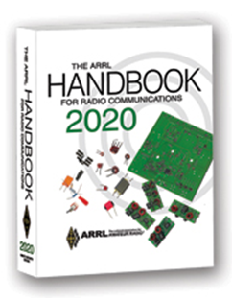***The Handbook Give Away***

Hey Gang,

The winner of the July Give Away is… ***Eric Jessen, N8AUC***

Many of you ask me just how do I know when the drawing is on? Well, that’s easy all you need to do is check in on the Ohio Section Website on a regular basis and watch for the big **RED** Arrow that will appear on the left side of the page.

This is the sign that the drawing is on and you need to get registered. So, keep a sharp eye out on the website and check in often! <http://arrl-ohio.org/>

***Club Corner***



This is YOUR cornner of the newsletter. Send me what your club is doing and I’ll make sure that it gets in. Got a special event or club project that you want everyone to know about? Send it to me!. Need help with a project? Send it to me.

Let me know what you club is up to. Are you going to have a special guest at your meeting or are you having a special anniversary? Just sent it to: [n8sy@n8sy.com](mailto:n8sy@n8sy.com)

####

TOP ^

***Lorain County ARA Installs New Antenna’s***

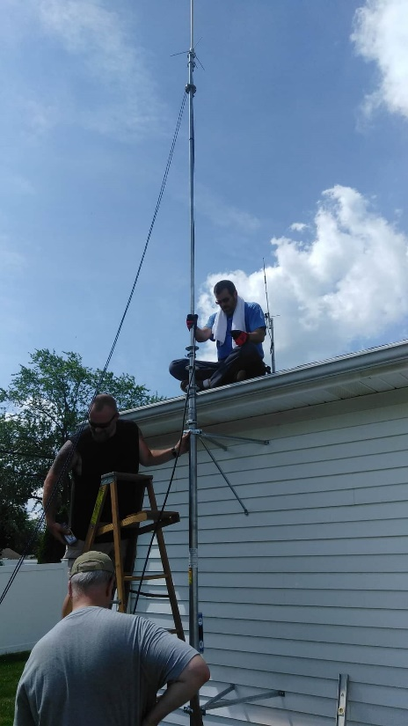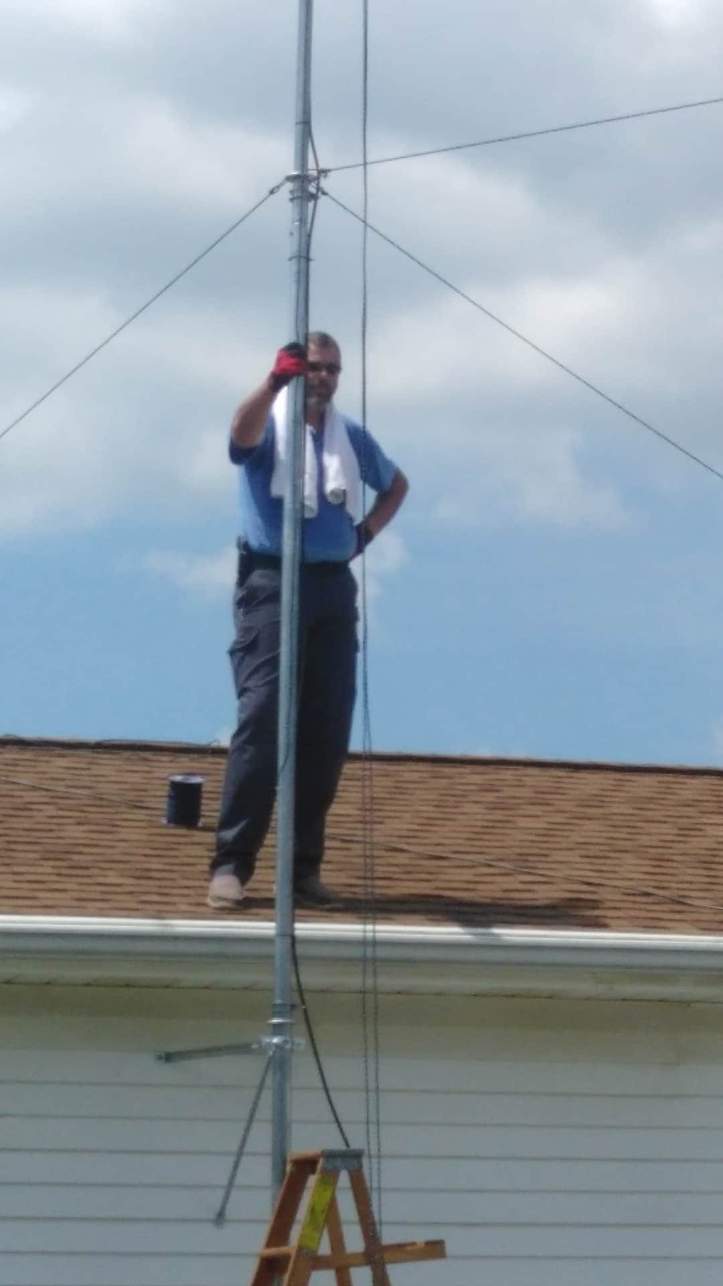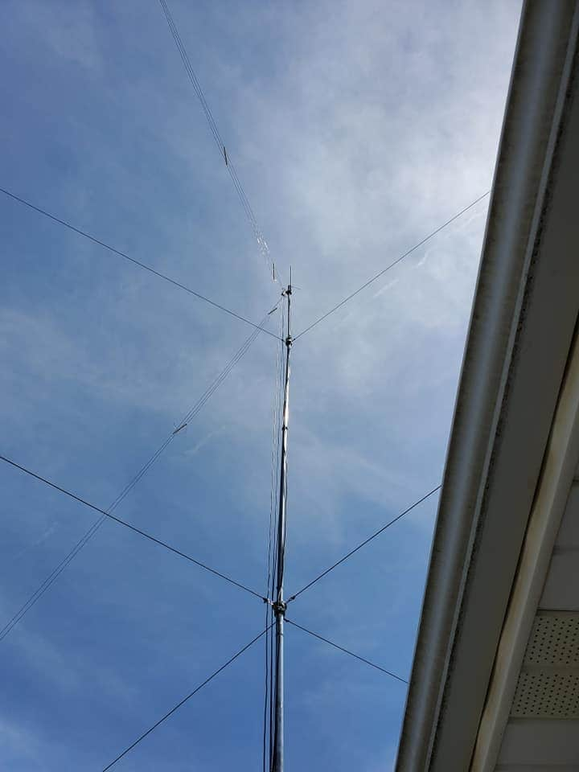The Lorain County Amateur Radio Association erected a Rohn H50 44' mast. On the mast is a Diamond X50A VHF/UHF vertical and an HF fan dipole. for 40/80/17 meters and the tuner takes care of the rest.

Thanks to Eric N8AUC, Andy K8ALG, and Greg W8ZAG for the "antenna party".  This is defiantly an upgrade from my previous antenna configuration!

####

***Highland Amateur Radio Association Helps with Graves***

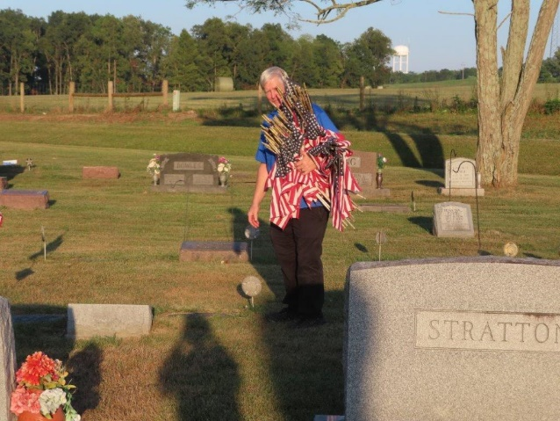

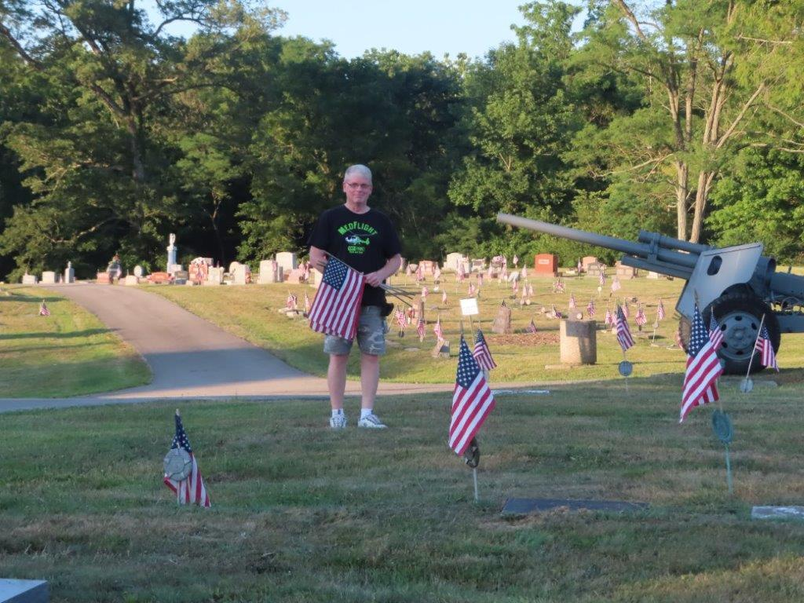

TOP ^

On a beautiful Wednesday evening eleven members of the Highland Amateur Radio Association gathered at the Hillsboro Cemetery to assist removing flags from the graves of between 900 and 1,000 veterans who are buried in the cemetery. Those veterans represent all wars from the Revolutionary War to the most recent conflicts.

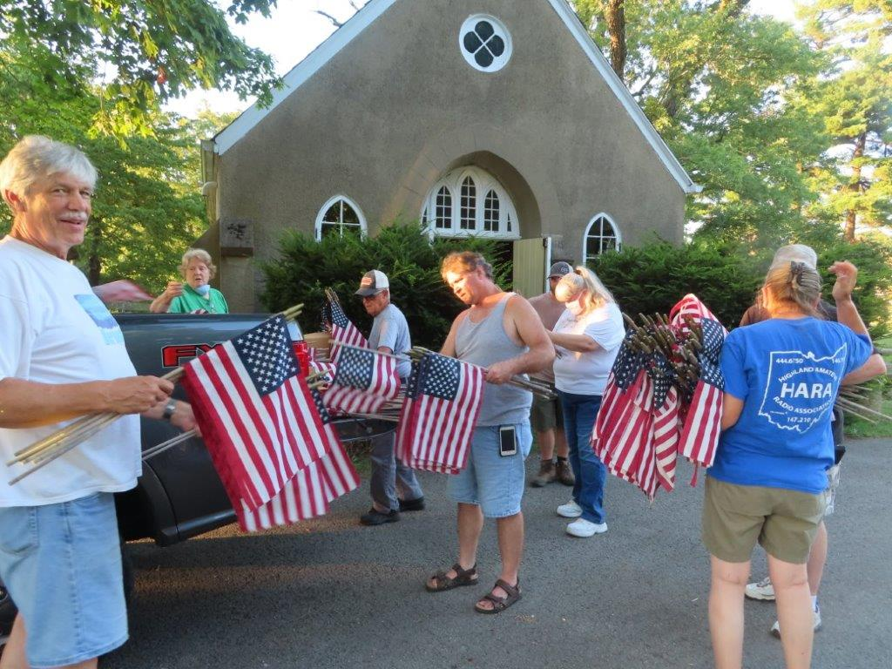There is even a casualty of the Indian Wars who has an honored spot in the cemetery. He is Casper Collins whom the City of Casper, WY is named after.

For the past two years HARA has assisted the Cemetery Association by placing the flags on graves prior to Memorial Day and then removing them following the Fourth of July.

Although this is not a radio themed activity, HARA members believe in giving back to Hillsboro and Highland County through community involvement. These types of activities have caught the positive attention of local leaders and the public who then want to know more about amateur radio and how it can be used. This has led to over 50 people gaining their amateur radio licenses in what is a rural Southern Ohio county.

***Wanted… Assistant Section Youth Coordinator***  
Anthony Luscre, K8ZTthe Ohio SYC has begun a search for one or two Assistant Section Youth Coordinators that would work with him to help support youth activities across the Ohio Section. If you are interested in this position or know someone that might be interested please email him <[k8zt@arrl.net](mailto:k8zt@arrl.net)> with information.

***Wayne County Looking For Help With A Special Project***

*(From Doug Hunter, KE8JNH - Wayne County EC)*

I am looking for a little help. During the month of August, I plan to run what I am calling "Celebrity Net Control" on our weekly DMR (Bolo) net.

The concept is to involve local community leaders to serve as "net control" of the net. The goal of this is to allow these folks to see that amateur radio is alive and well.

I will be using police and fire chiefs, mayors, county commissioners all from Wayne County to serve as the net control folks. Naturally I will be alongside them logging and keeping things on track.

You can help by securing 4-5 other operators from other points of the state to "check-in". Most of the people on the net are local, but we can add to the "wow" factor by having a few not so local check-ins.

The net takes place on Mondays at 8pm on DMR talkgroup 311070. At the beginning of the net we take the people who have registered via ARES connect first and then follow that with "regular check-ins"

I hope you can help and play along.

TOP ^

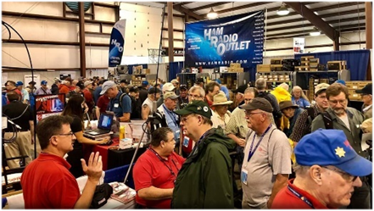

[***Upcoming Hamfests***](http://arrl-ohio.org/hamfests.html) ***for 2020***

**08/15/2020 - Clinton County Ohio ARA Hamfest**

***Canceled***

**09/13/2020 - Findlay Hamfest** ***Canceled***

**09/27/2020 | Cleveland Hamfest and Computer Show**

***Canceled***

|  |
| --- |
| **10/10/2020 - Northwest Ohio Amateur Radio Club (NWOARC) Fall Hamfest Location: Westminster, OH Sponsor: NWOARC, Northwest Ohio Amateur Radio Club Website:**[**http://www.nwoarc.com**](http://www.nwoarc.com/) |

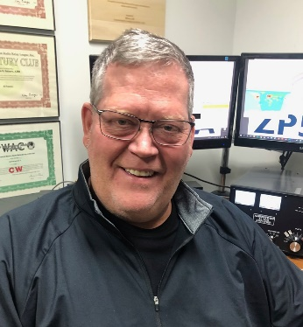***DX This Week***

*(from Bill, AJ8B)*

***DX This Week – Centinial***

***Bill AJ8B (***[***aj8b@arrl.net***](mailto:aj8b@arrl.net)***, @AJ8B, or*** [***www.aj8b.com***](http://www.aj8b.com)***)   
 CWOPs Member #1567***

I hope you are staying safe and tuning the bands. This week, stations in the midwest spotted Aruba, Australia, Azores, Barbados, Belize, Brazil, Bulgaria, China, Costa Rica, Cuba, Czech Republic, Dodecanese, Dominican Republic, East Malaysia, Falkland Islands, Fiji, Finland, France, Guadeloupe, Guernsey, Hong Kong, Isle of Man, Korea, Martinique, Netherlands, New Caledonia, New Zealand, Northern Ireland, Philippines, Puerto Rico, Singapore, South Africa, Spain, St. Martin, Sweden, Taiwan, Thailand, Trinidad & Tobago, Venezuela, and Vietnam. Let me know what you worked!

I received QSL cards from OH5C in Finland, ZA/IK2RLM – Marco in Albania, HZ1TT – Ali in Saudi Arabia, and HB0/HB9LCW – Silvio in Liechtenstein.

Before 1990, Albania was not really represented on the air and at one time was a top 5 needed DXCC entity! International politics does affect ham radio.

TOP ^

|  |  |
| --- | --- |
|  |  |
|  |  |
|  |  |

So, what is the weekly topic for this edition? Gratitude. This is the 100th DX This Week “Column” in the Ohio Section Journal (OSJ). I am very grateful to several people for being able to do this every week and I think occasion marks a good time to thank those people as well as to review what we have published.

The first person is, Scott, N8SY. I met Scott at the Milford Hamfest in 2018. We chatted a bit and he reviewed the SWODXA Newsletter that we had been putting out. He suggested that I put something together for the OSJ. I told him that I would think about it, but I initially balked. I could not imagine what I could offer that people would want to read. However, as always, Scott was encouraging, personable, and helpful. I know how much time it takes to put one article together each week, but I can’t imagine how much time Scott puts in each week. I am sure that it is a full-time job, second to keeping Janie happy of course.

The first column appeared in the 2018 Labor Day addition and we were off and running.

There are several other hams that I should thank as well. Jay, K4ZLE, is the first ham author that I had met. Jay writes authoritatively about many topics because he has been out there experiencing it and then writing about it. He told me that when he first put pen to paper, he also had some doubts about who would want to read what he was writing. Jay has suggested topics, sent along his stack of magazines, articles, and thoughts on a regular basis to keep me going and I could not be more appreciative. He has never turned down a request to assist and has really been a great help.

Joe, W8GEX, has been an ongoing inspiration. Joe continues to surprise me with stories about DXpeditions, hams, and events that I want to write about. Like Jay, Joe is very well connected and is happy to share those connections to the benefit of us all. Several times I have called Joe to discuss one topic, only to be moved on to another that I could really learn about and then share.

TOP ^

Dave, K8DV, is another one of the mentors that I rely on. My OM, K8DWE (SK) was a mentor for me and I know that Dave’s dad, KZ4G, was a great mentor for him. I really enjoy hearing stories about ham life in WV in the old days. It really allows me to slip back into those times with my OM as well. I remember a conversation we had over breakfast discussing his Model 15 RTTY setup. By the time we were done, I swore I could see paper dust all over the table.

Of course, there is a downside to everyone, and Dave is no exception. Thanks to Dave, I am now the N Card Sorter for the 8th area QSL bureau and involved with the W8DXCC DX Convention. He saw that I needed something to do and helped me find those things.

Over the past 99 editions, you have seen articles reproduced from all three of these guys. I hope they will continue to share the wealth with us all.

Just for fun, I thought I would list some of the topics we have covered. Below is a list of the more generic topics.

|  |  |  |
| --- | --- | --- |
| What is an entity? | LISTEN! | Sunspots |
| DXSPots | 1A0M Article | Digital |
| Clublog | Psychology of the QRMer | 60 Meters |
| Solar Numbers | WAZ | DXCC Card Checking |
| DXA Application | Reverse Beacon Network | DXCC LoTW |
| DX Goals | Cluster Spotting | DXCC w/Cards |
| Top 100 Needed | Mobile DXCC | DXCC First Level |
| FT8 | Zones 1 – 5 | DXCC Second Level |
| Digital Modes Club | Zones 6 – 8 | Noise |
| DAK QSL Display Board | Zones 9 – 11 | Gray Line |
| K9LA – Solar Guru | Zones 12 – 14 | Pilot Stations |
| SWL is Alive and Well | Zones 15 – 17 | Contest Dates |
| Ultimate Awards Center | Zones 18 - 20 | Working Split |

Here is a list of topics grouped by QSLing or CW:

|  |  |  |  |
| --- | --- | --- | --- |
| QSL | QSL Cards | CW | The anatomy of a CW QSO |
|  | QSL Routes |  | CW Shorthand |
|  | Outgoing QSL Buro |  | CWops |
|  | Incoming QSL Buro |  | CW Academy |
|  | New to QSLing |  | RUFZXP for CW |
|  |  |  | Morse Runner |

The SouthWest Ohio DX Association allows me to reprint interviews that I have had with various hams around the world. I hope you have enjoyed these interviews.

|  |  |  |
| --- | --- | --- |
| HK3C | 9J2BO | OM2VL |
| ZM1A | HA8RM | 9Y4D |
| H40GC | LU7YS | ZS6JES |
| ZD7JC | 3B8FA | D44EE |
| ZS6C | LA7GIA | S51DX |

TOP ^

Finally, there are a couple of topics that appear on a regular rotation. The ARRL Propagation Charts have intrigued a few readers.

I like to list what is being heard on the DXcluster each week to let you know that there is DX out there to be worked.

Bernie, W3UR, allows me to reprint anything I like from the DailyDX or the WeeklyDX informatioin that he puts out. Thanks Bernie!

I also try to keep you up to date on Regional Conventions and upcoming Contests. W8GEX, Joe – the Czar of 60 Meters is allowing me to reprint his monthly 60 Meter newsletter. Thanks Joe.

Finally, Carl, K9LA, has given me permission to reprint his monthly newsletter which is absolutely fascinating. I hope you enjoy it too!

Enough rambling. I really need to know what interests you. Just drop me a note and I will do my best.

Stay Safe, Keep Listening, and Good Hunting!

AJ8B – Bill ([aj8b@arrl.net](mailto:aj8b@arrl.net))

***CQDX CQDX CQDX CQDX CQDX CQDX CQDX CQDX CQDX***

Here is an update from Bernie, W3UR, of the DailyDX and the WeeklyDX, the best source for DX information. <http://www.dailydx.com/>. Bernie has this to report:

For Immediate Release: July 20, 2020

QSO Today Virtual Ham Expo

Tel: +1-213-577-0092

[brad.grob@qsotoday.com](mailto:brad.grob@qsotoday.com)

11,000+ Early Registrations For QSO Today Virtual Ham Expo!

Los Angeles, CA: QSO Today host Eric Guth, 4Z1UG, announced that the first QSO Today Virtual Ham Expo scheduled for August 8-9, 2020 has already registered over 11,000 hams. “Since the Expo is a completely new experience for the ham radio community, it’s great that so many people are excited and already registered. And with almost 3 weeks before the event, the number of registrants continues to increase significantly every day”, said Eric, 4Z1UG. For more information, go to www.qsotodayhamexpo.com. Attendance is free and there are early bird prize incentives (donated by sponsors) for registering by July 24, 2020.

This Expo is built on a live virtual platform commonly used by Fortune 500 companies and major universities. It’s much more than just a Zoom meeting - the platform simulates a convention experience with an exhibit hall and booths staffed by live attendants, speaker auditorium, and lobby. Anybody can attend virtually with an internet connection and computer, tablet, or smartphone.   At the Expo, participants can take advantage of this technology in different ways.

TOP ^

There are 4 different speaker tracks on a variety of topics with plenty of great content for everyone. Speakers will present via video and have prepared excellent, engaging presentations. Speakers can also provide related material such as slides and white papers which attendees can download. Every session will have a Q&A where people can submit questions in real time via chat and then speakers will answer those questions using video or audio.

There are 30+ booths for attendees to visit. Exhibitors have many options to engage with attendees.  For example, Elecraft has created professional video demonstrations of their latest transceivers. Each booth can provide downloadable content including videos, spec sheets, and manuals.  Content can be saved by attendees in a virtual briefcase for reading later or emailing to a friend. Attendees can easily interact one-on-one with booth representatives via video, voice, or text chat using a system similar to Skype. While most booths will be staff during from 8:00 AM to 6:00 PM PST on August 8 and 9, some Exhibitors will extend hours through their overseas reps.

The Expo organizers will attempt to integrate radio with the virtual platform by having DMR, Allstar, D-Star, and other talk groups available for hams to meet on the air around the Expo.

Said Eric, 4Z1UG, “the experience of a virtual Expo is not meant to replace in-person conventions. However, I strongly believe that virtual events in our industry are here to stay permanently. Given COVID-19 and its likely lasting impact on travel, especially given our demographic, this virtual Expo enables the ham community to continue coming together to learn and engage.

It also provides an opportunity for those who have never been to an in-person event to participate in this amazing experience.  Younger hams who have grown up with the Internet will feel right at home with our platform, making it easier for them to participate and find their place in this remarkable hobby.”

Attendees will be able to access all speaker presentations and Exhibitor booth content for 30 days after the Expo by simply returning to the Expo site.

Icom is the Expo’s Platinum Sponsor, along with Gold Sponsors: GigaParts, RT Systems, FlexRadio, RFinder, DX Engineering, Elecraft, RigExpert, and NCG (Comet Antenna).

For more information and to register, go to [www.qsotodayhamexpo.com](http://www.qsotodayhamexpo.com).  Attendance is free and there are early bird prize incentives for registering by July 24, 2020.

QSO Today Virtual Ham Radio Expo, KEG Media, Inc., 4470 W Sunset Blvd #92485, Los Angeles, CA 90027, USA, +1-213-577-0091

***DX News***

***ARLD031 DX news***

This week's bulletin was made possible with information provided by The Daily DX, the OPDX Bulletin, 425 DX News, DXNL, Contest Corral from QST and the ARRL Contest Calendar and WA7BNM web sites.

Thanks to all.

TOP ^

****UGANDA, 5X.** Shabu, M0KRI is QRV as 5X1RI until mid-August. QSL to home call.

**FEDERAL REPUBLIC OF GERMANY, DA.** Members of the German section of the International Police Association are QRV with special event station DL70IPA to celebrate the 70th anniversary of the organization. Activity is Sundays and Thursdays during August and September on 40 and 80 meters, respectively. They may be active on 20 meters depending on conditions. QSL via bureau.

**FRANCE, F.** Members of radio club F4KKE at Saint-Martin-des-Besaces in Normandy are QRV with special callsign TM11AD until August 3 to commemorate the role played by the British 11th Armored Division during Operation Bluecoat in July and August 1944. Activity is on the HF bands using CW, SSB and various digital modes. QSL via F4KKE.

**ENGLAND, G.** Special event stations GB75PEACE, GB1945PE and GB1945PJ will be QRV during August to mark the end of World War II in the Pacific. QSL via LoTW.

**HUNGARY, HA.** Members of the Hungarian FIRAC are QRV with special event call sign HA70MAV from Budapest until December 1 to celebrate the 70th anniversary of the Hungarian Railway. Activity is on various HF bands. QSL via LoTW.

**ITALY, I.** Simone, IU4HRJ will be QRV as IM0/IU4HRJ from Maddalena Island, IOTA EU-041, from August 4 to 10. Activity will be on the HF bands using SSB and various digital modes. QSL to home call.

**FINLAND, OH.** Jukka, OH3OJ is QRV as OH3OJ/1 from Kaurissalo Island, IOTA EU-096, until August 5. Activity is on 80 to 6 meters using CW, some SSB, and FT8. QSL to home call.

**ARUBA, P4.** Thomas, KM4VI will be QRV as P4/KM4VI from August 2 to 7. Activity will be on the HF bands using SSB and QRP power. QSL direct to home call.

**NETHERLANDS, PA.** Special event station PI75VERON is QRV until the end of 2020 to celebrate the 75th anniversary of the Dutch National Club VERON. QSL via PA1AW.

**MEXICO, XE.** Special event station 4A2MAX is QRV during August to honor the memory of Maximilian Kolbe. Activity will be on the HF bands using CW, SSB and various digital modes. QSL via LoTW.

**VIET NAM, XV.** Jesus, WP4JBG is QRV as XV9G from Ho Chi Minh City. Activity is on the HF bands. QSL via operator's instructions.

**LAOS, XW.** Mike, XW2DX is QRV as XW2DX from Vientiane and is here for the next five years. Activity is on 20, 15 and 10 meters. QSL via RM0L.

THIS WEEKEND ON THE RADIO. The ARRL 222 MHz and Up Distance Contest, North American CW QSO Party, QRP 20-Meter CW Fox Hunt, NCCC RTTY Sprint, NCCC CW Sprint, Batavia FT8 Contest, 10-10 International Summer SSB Contest.

TOP ^

European HF Championship, WAB 144 MHz Low Power Phone, RTTYOPS Weekend Sprint and SARL HF Phone Contest will certainly keep contesters busy this upcoming weekend.

The RTTYOPS Weeksprint, ARS Spartan CW Sprint and Worldwide Sideband Activity Contest are scheduled for August 4.

The VHF-UHF FT8 Activity Contest, CWops Mini-CWT Test and Phone Fray are scheduled for August 5.

Please see July 2020 QST, page 74, August 2020 QST, page 69, and ARRL Contest Calendar and WA7BNM Contest Web Sites for details.

**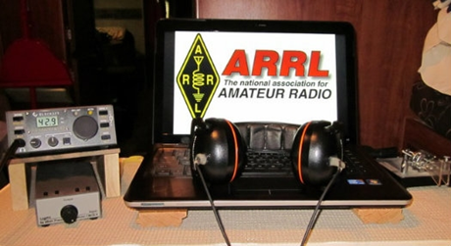*ARRL Contest Corner***

An expanded, downloadable version of *QST'*s’[**Contest Corral**](http://www.arrl.org/contest-calendar) is available as a PDF. Check the sponsor's’Web site for information on operating time restrictions and other instructions.

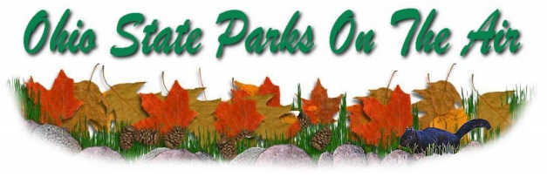

The Portage County Amateur Radio Service, Inc. (PCARS) announces the 13th Annual “Ohio State Parks On the Air” (OSPOTA) contest, from the hours of 10 am to 6 pm ET (1400 UTC to 2200 UTC).



13 th OSPOTA - September 12, 2020

14 th OSPOTA - September 11, 2021

15 th OSPOTA - September 10, 2022

16 th OSPOTA - September 9, 2023

17 th OSPOTA - September 7, 2024

18 th OSPOTA - September 6, 2025

19 th OSPOTA - September 12, 2026

20 th OSPOTA - September 11, 2027

**Always the first Saturday after the Labor Day holiday.**

For hams throughout the State of Ohio, this is your opportunity to visit and enjoy the amenities offered by the 75 beautiful State Parks here in Ohio. Don’t just make a day of it - spend the weekend at the park of your choice. No matter whether you are camping or staying at one of the outstanding lodges or resorts, you will find that the parks are one of Ohio’s greatest assets. Find out more about the Ohio State Parks at: <http://parks.ohiodnr.gov/>

TOP ^

In past years, hundreds of Amateur Radio Operators (hams) from around the country participated in the event. With the success of OSPOTA, we hope to have amateur radio operators at every Ohio State Park.

This contest places a premium on working stations located in the Ohio State Parks. That means that it is critical to have as many parks activated as possible. The challenge for Ohio stations will be to work HF in the 50 to 300 mile range. This is the perfect opportunity to learn more about the design and deployment of Near Vertical Incident Skywave (NVIS) antennas. You can find numerous designs on the Internet and in various Amateur Radio antenna manuals. Along with your operating skills, it will be a chance to showcase your antenna building skills as well.

Individuals and multiple operators can operate Ohio State Park stations. Non-park stations in Ohio as well as stations outside of Ohio can also compete.

Contacts can be made on 80, 40, 20, 15 and 10 meters using SSB. All contacts have the same point values.

Make sure that you read the Rules, FAQ’s and get your forms for the contest that are posted on the OSPOTA website: www.ospota.org before the contest. So get to an Ohio State Park and get On The Air in September. Have some fun with this contest!

Learn more about PCARS at [www.portcars.org](http://www.portcars.org).

73 for now, OSPOTA Contest Committee

***Special Events***

* **08/03/2020 | National Order of the Arrow Conference**

**Aug 3-Aug 8, 1300Z-2300Z, K2BSA/various**, Various cities. Boy Scouts of America Order of the Arrow. 21.360 14.290 14.065 7.190. QSL. QSL , per operator's, instructions. The National Order of the Arrow Conference, scheduled for Michigan State University, has been cancelled, so amateurs who are OA members will be operating K2BSA in many call areas during the week of August 3. QSL via operator's instructions. [k2bsa.net](http://k2bsa.net/)

* **08/04/2020 | US Coast Guard 230th Birthday**

**Aug 4-Aug 5, 1400Z-0400Z, K1CG**, Port Angeles, WA. CG CW Operators Association. 21.052 14.052 7.052 3.552. QSL. CG CW Operators Association, Fred Goodwin, 424 N. Bagley Creek Rd, Port Angeles, WA 98362. [www.qrz.com/db/k1cg](http://www.qrz.com/db/k1cg)

* **08/08/2020 | USS Midway Museum Ship Special Event: USS Nautilus first sub under the North Pole on 8/3/58**

**Aug 8, 1600Z-2300Z, NI6IW**, San Diego, CA. USS Midway (CV-41) Museum Ship. 14.320 7.250 14.070 (PSK31) D-STAR on various reflectors. QSL. USS Midway Museum Ship (COMEDTRA), 910 N Harbor Drive, San Diego, CA 92101.

* **08/11/2020 | Navajo Code Talkers S/E**

**Aug 11-Aug 15, 0000Z-0000Z, N7C**, Window Rock, AZ. Herbert Goodluck, N7HG. 18.133 14.265 7.265. Certificate & QSL. Navajo Code Talkers, PO Box 06, Chinle, AZ 86503. [www.qrz.com/db/n7c](http://www.qrz.com/db/n7c)

TOP ^

* **08/12/2020 | 2020 IL State Fair**

**Aug 12-Aug 24, 0000Z-0000Z, W9I**, Springfield, IL. Sangamon Valley Radio Club. 14.250 7.150. QSL. J. Mitch Hopper, K9ZXO, 536 E. Mill St., Rochester, IL 62563. [www.svrc.org](http://www.svrc.org/)

* **08/12/2020 | Iowa State Parks On-the-Air Centennial – Fort Atkinson**

**Aug 12, 1500Z-1900Z, W0OEL**, Fayette, IA. Rural Iowa and Buchanan County Amateur Radio Clubs. 14.240 7.240. Certificate. Great River Amateur Radio Club, P.O. Box 1384, Dubuque, IA 52004. IASPOTA-2020 Fort Atkinson is not the stuff of which legends are made. Fort Atkinson was built to keep the Winnebago Indians on Neutral Ground (a 40-mile-wide strip of land established by the Treaty of 1830) after their removal from Wisconsin in 1840, and to provide protection for them from the Sioux, Sauk, Fox and from white intruders on Indian land. Certificate & QSL managed by Great River Amateur Radio Club, P.O. Box 1384, Dubuque, IA 52004. QSL for contact; certificate for 5 parks. See website for complete information, http://www.w0dbq.org/rule [https://www.w0oel.com](https://www.w0oel.com/)

* **08/15/2020 | Appalachian Trail Anniversary**

**Aug 15, 1400Z-2100Z, N4F**, Franklin, NC. Franklin Amateur Radio Club, Franklin, N.C.. 7.265 SSB 14.265 SSB 7.045 CW 14.045 CW. QSL. Franklin Amateur Radio Club K2BHQ, 505 North Sugar Creek Dr. , Franklin, NC 28734. Appalachian Trail (AT) Special Event Station celebrating the 83rd birthday of the AT. Opening on August 14, 1937 and spanning 2,181 miles from Springer Mountain, Georgia to Mount Katahdin, Maine, the AT is the longest continuously marked footpath in the world. The Franklin Amateur Radio Club in Franklin, NC will locate our special event station at the Rock Gap trailhead on the AT. Commemorative QSL with SASE to K2BHQ address on QRZ [k2bhqemail@gmail.com](mailto:)

* **08/22/2020 | National Park Service Founders Day**

**Aug 22-Aug 30, 1200Z-2300Z, N1P**, Canfield, OH. NPS Ranger News. 14.255 7.290. Certificate. Certificate, available online only, see website. Online certificate only, see website <https://www.qrz.com/db/N1P>

* **08/22/2020 | Southwest Reef Lighthouse/ILLW/US0176**

**Aug 22-Aug 24, 0001Z-1800Z, W5BMC**, Berwick, LA. Bayouland Emergency Amateur Radio Service/BEARS. 14.275 7.275. QSL. Jackie Price, 708 Front St., Morgan City, LA 70380. The Southwest Reef Lighthouse sits on the bank of the Atchafalaya River in Lighthouse Park in Berwick. The station is a permanent facility at the Memorial Ray Rasberry, WB5LKR(SK) tower in Lighthouse Park

* **8/27/2020 | Burning Man**

**Aug 27-Sep 7, 1200Z-1200Z, W7B**, Gerlach, NV. Mansonian. 28.375 21.325 14.250. QSL. George Badger, 4602 Fairway Dr, Soquel, CA 95073. SASE for QSL please. [w7b@w3ab.org](mailto:)

* **08/28/2020 | 15th Anniversary of Hurricanes Katrina & Rita**

**Aug 28-Aug 30, 2300Z-2359Z, K5R**, Mandeville, LA. KD5PCK. 40, 20, and17 meters, general portions. Certificate. Scott Hernandez, 957 Nancy St. , Mandeville, LA 70448. In August & September of 2005, Hurricanes Katrina & Rita made landfall in Louisiana. Katrina striking near Buras, LA and Rita landing near the Louisiana/Texas border. When all else failed, hams from across the nation assisted with establishing communications into and out of the entire gulf coast area. Commemoration of the 15th anniversary of these two devastating storms will take place on air the weekend of August 28 through 30, 2020. Look for activities in the General portions of 40, 20 and 17 meters. More information regarding operations and certificates on the K5R QRZ page. <https://www.facebook.com/groups/katrina5rita>

* **08/28/2020 | RESCHEDULED -100th Vermontville TWP Fire and EMS Association Annual Dance**

TOP ^

**Aug 29-Sep 7, 0900Z-0900Z, W8S**, Vermontville, MI. Rodney L. Harmon. 446.000 MHZ PL 74.4 Hz. 145.560 MHZ 147.080 MHZ PL 103.5 Hz IRLP NODe #4868. Certificate. Rodney L. Harmon, WK8H, 172 East Second St, Vermontville, MI 49096-9455. Rescheduled from June 27, 2020, to August 29, 2020, due to health concerns of the COVID-19 pandemic. [wk8h_michigan@att.net](mailto:)

***“ARES Connect”***

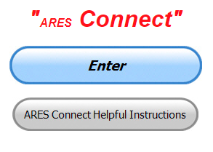

***Connecting Amateur Radio Volunteers with a Purpose***

Hey everyone… please make sure to go in and register your time to all of the events that you have signed up for. Don’t forget to get this done no later than **5 days** after the event has ended. I’m asking you to do this for our ability to run reports accurately.

**I want to remind all of you that you do not have to be an ARES or ARRL member to use this system. All licensed amateur radio operators throughout the country are welcome and strongly encouraged to use it.**

Want to see your name appear in the list below? There’s only one way of doing that, you have to sign-up for events and then enter your time in afterward. Are you a regular on a NET or other event? We can sign you up for the entire life of the event if you want. What’s the advantage of that? No more registering, that part is done automatically for you. You still need to enter your time, but that’s all!!!

Want more information on this great way of never forgetting to register? Just ask…. [n8sy@n8sy.com](mailto:n8sy@n8sy.com) I’m here to get you started on your way.

**Hey Admins…** Here’s a great way of getting the word out quickly about a Skywarn Event happening that could have a major impact on a number of communities.

**Here’s what one Admin did in Eastern New York..**

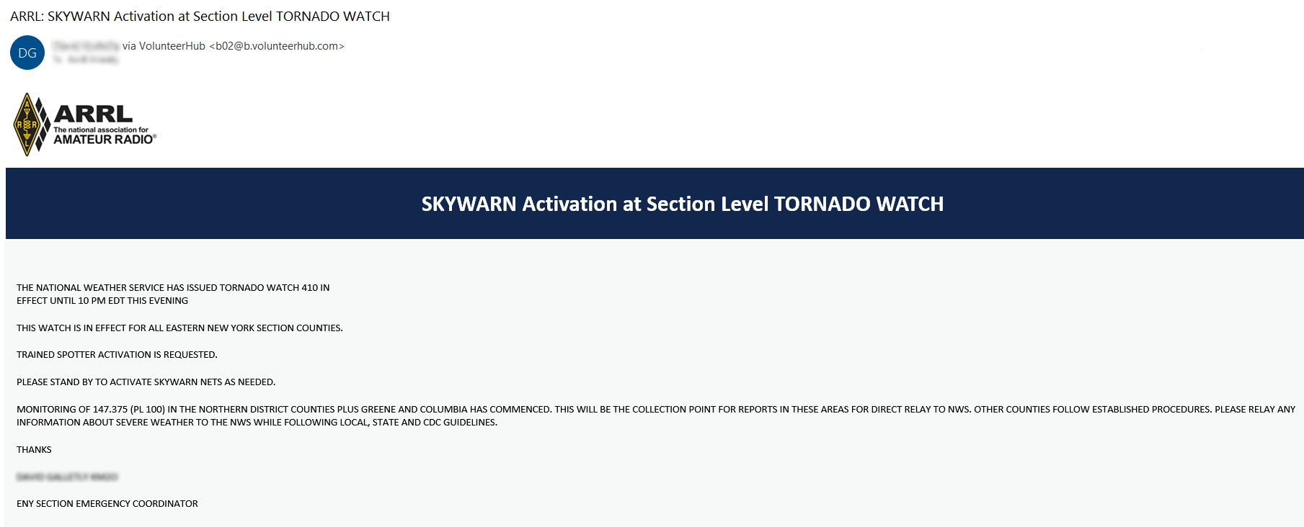

TOP ^

It’s quick, informative and takes less than a minute to do this. Think of the potential, you can alert an entire county, district or the whole section if you need to, like in this alert.

What a great tool for the toolbox!!!!!

***Here’s are the top 10 hours earners for the month of July:***

|  |  |  |  |
| --- | --- | --- | --- |
|  | **Name** | **Events** | **Hours** |
| **1** | Dwight Bonifield (W8TJT) | 175 | 210.40 |
| **2** | Leo Dubois, Jr. (KE8OOS) | 62 | 155.75 |
| **3** | Mathew Nickoson (KC8NZJ) | 18 | 127.00 |
| **4** | James Yoder (W8ERW) | 19 | 122.41 |
| **5** | Daniel Schlick (KB8LKH) | 23 | 116.80 |
| **6** | Bret Stemen (KD8SCL) | 47 | 114.50 |
| **7** | Christopher Domenick (KC8CAD) | 29 | 102.40 |
| **8** | Dan Stahl (KC8PBU) | 98 | 101.41 |
| **9** | Alan Rothweiler (N8CJ) | 31 | 72.00 |
| **10** | Elmer Thomas (KE8HNK) | 59 | 56.75 |

**Let’s get everyone in the Ohio Section on “ARES Connect!!!” Simply go to:** <https://arrl.volunteerhub.com/lp/oh/> and get yourself registered and using the system.

***One Question Questionnaire***

Hey Gang,

“Survey Says”….. about 74**%** of you have a straight key for sending CW. That’s really great!!!

Ok, now, on to next question… Let’s find out how many of you have a CW filtering in your HF rigs. se my “keyer” fails. So, let’s find out if you do as well.

So, the next question is…

***“Do you have a CW Filter in your HF Rig??”***

You’ll find the “One Question” questionnaire on the Ohio Section Website! <http://arrlohio.org> It’s all in fun and it’s not a scientific survey in any way, but we are learning some things that we didn’t know from these questions. I hope that you are enjoying answering these “One Question” questionnaires.

TOP ^

***V.E. Test Sessions***

**

Many V.E.’s have decided to start testing once again, but with restrictions that need to be adhered to for sure. Here’s the link to find that V.E. Test session and what is expected of YOU before going. <http://www.arrl.org/find-an-amateur-radio-license-exam-session>

####

The Toledo Mobile Radio Association (TMRA) is pleased to announce an “in person” V.E. session [on Aug 8th 2020](x-apple-data-detectors://10) at Lusher Park in Haskins Ohio.  Registration will be [at 08:30](x-apple-data-detectors://11) testing [starts at 09:00](x-apple-data-detectors://12) Candidates must pre-register by [August 6th 2020](x-apple-data-detectors://13).  
  
A standard fee of $15 is required and correct change (Cash only please) as well as a photo copy of any current CSCEs or licenses, and a current photo ID will be required.

COVID 19 Protocol Notice…. New for this test session all applicants must bring a blue or black ink pen, due to Covid 19 Pens will not be provided.  Face Masks or Coverings will be required. Due to Gov. Dewines limits on group size, Walk-ins will not be welcome for this Test Session.

Contact Mike/W8MAL for any questions, more info or to reserve a space in this Session.   
Mike/W8MAL [419-707-7116](tel:419-707-7116) [w8mal@arrl.net](mailto:w8mal@arrl.net)

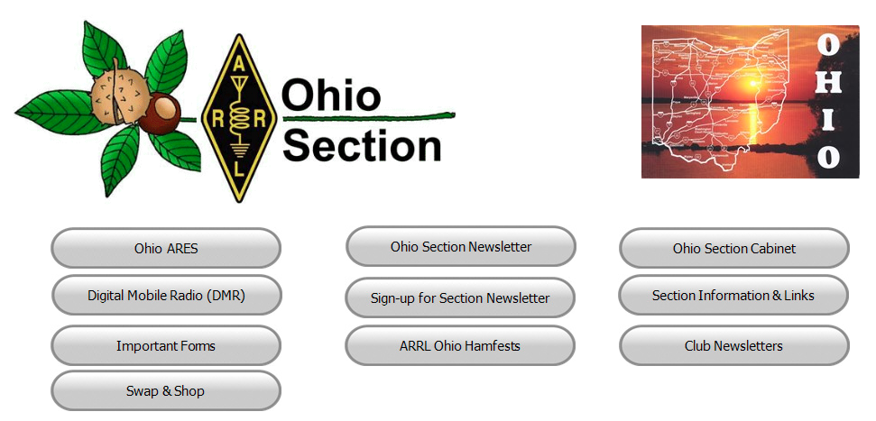***ARRL-Ohio.org Website Statistics.***

From time to time it’s good to post the statistics from the Ohio Section website. It’s actually something that is very interesting to see just how the website has progressed over these many years and if it’s meeting the needs of our viewers.

TOP ^

The Ohio Section website was created in 1999. In those early day’s websites were just becoming all the fashion and it seemed like everyone had one. Most became stagnate within 6 months or so and were useless since the information wasn’t up to date.

Those first few years in a website’s life are usually the hardest. Webmasters come and go, and little attention is given to the website and making sure it stays current and easy to access the most used information.

Another problem that comes with this is when there’s a change in webmasters. Yes, sometimes this is really important to do, but continuity for the website is very important too. Each of us has a different way of how we access and disseminate information. That’s why it is important for whomever is taking care of the website to be monitoring how the viewers are getting along with it and improving on how to get to that all-important information out there where it can quickly be viewed.

Last week in his article our PIC, John, KD8IDJ pointed out that it’s sometimes very difficult to find the club newsletter on a website. He was determined to find them all for the newsletter contest, but sometimes it just wasn’t easy to do. He also mentioned that not everyone views your information like the newsletter from a big screen monitor as well. This means that you need to be aware of how your viewers are looking at the information on your website too. You also need to be sure that your website’s main page loads quickly. A study was done several years ago, and it was discovered that Americans are very impatient, they won’t wait more than 24 seconds for the webpage to load. If it takes too long, they will just leave and never see your website. Make sure that the main page loads up fast.

Remember, the newsletter is the life blood of your club. A link to your newsletter should stand out and be easy to find. If you want folks to come and visit with your club, this is one of the best way’s of making sure that they know how to get to your meeting.

Speaking of having your meetings listed in the newsletter, have them listed prominently on your website too. Be clear on just where your meeting is! For the locals I’m sure they know that your club meets at the old Hiner’s grocery store behind the now torn down old Texaco gas station that closed up 25 years ago. But, for those traveling from out of your area, they haven’t a clue where that is. Addresses are a must. Today with the advancements in GPS technology, there’s very few places that can’t be found within a few hundred feet, if you give them an address to go by. You might even post a map of the exact location too. This is extremely useful if the location is within a group of buildings or the location is difficult to see.

In 2014 a hard examination of our website was done in order to better understand who was actually using it. Polls were taken on the website itself as well as at meetings about the website and what YOU, the viewers wanted to see on it. That’s when it was discovered that a lot of you didn’t even know we had a website!

So, with that information and some help from the professional field as well, it was decided that some major changes had to be made if it was ever going to be of value to YOU.

Since then, a lot of work has gone into those 2,500 plus pages of information and fun and it is hoped that you enjoy and use the Ohio Section website to its fullest.

Got a suggestion for the website? Contact me at: [n8sy@n8sy.com](mailto:n8sy@n8sy.com)

On the next couple of pages are just a few of the statistics that are looked at regularly to see how the website is performing.

TOP ^

Here’s the statistics from 2014, our starting date.

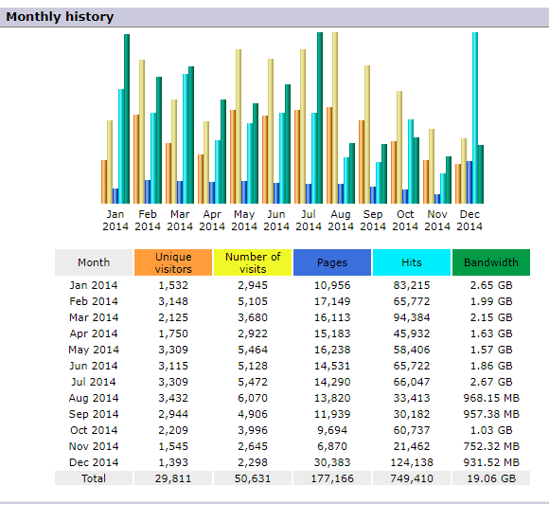

Here’s the statistics from January through July 2020.

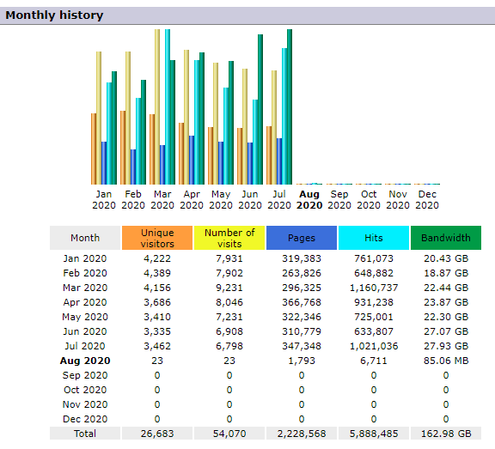

TOP ^

To help me understand how you are using the website I employ several metrics to see just how effective our website is for our user group. Here’s several different metrics that speaks volumes on our viewers.

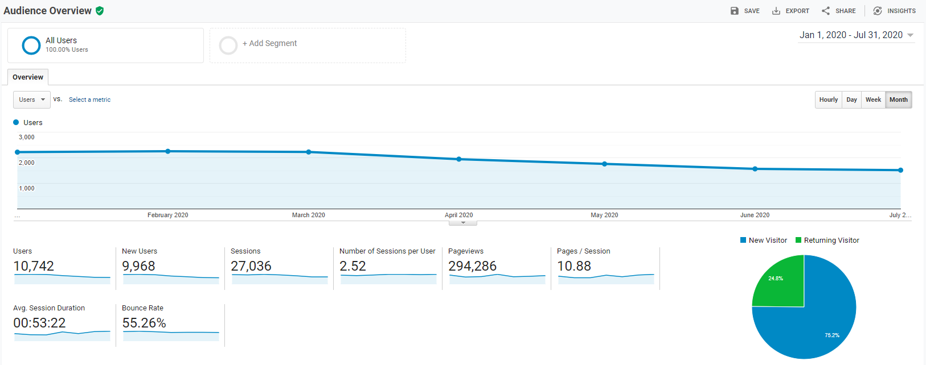

Even knowing what browser and operating system as well as what type of a device your viewing our website is also very important. No, this isn’t a “Big Brother” thing, but it is needed information on what you are using to view our website in order for us to shape the webpages for the best viewing.

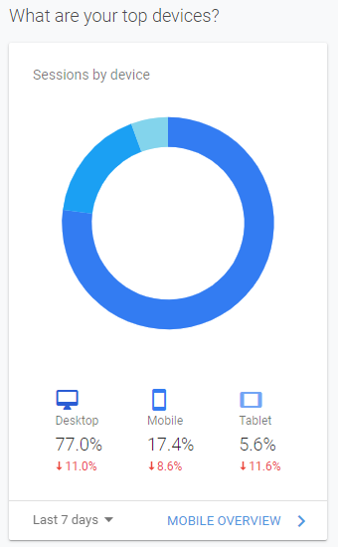

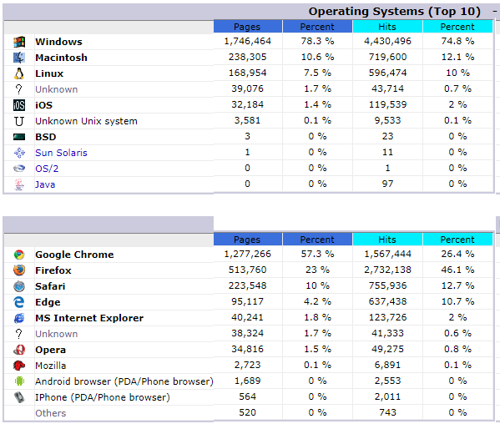

TOP ^

***Final.. Final..***

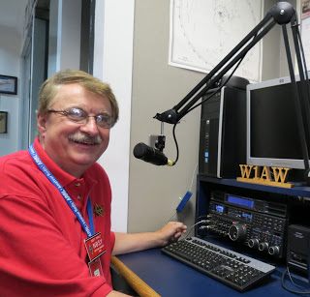Hi Gang,

Well, this week has been pretty dry here. We did get a little water, but not enough to fill a mouse’s water bowl. My grass has already died and decided to hibernate for the rest of the season. All that’s left to mow now is the weeds, they never seem to die off, not matter how little rain they get.

**Ok, moving on to another subject…** Are you ready for the Simulated Emergency Test (S.E.T.) coming up in October? Matt, KD8TTE has been very busy writing up some homework for all of us to do for the S.E.T. It’s gonna’ be a lot of fun for everyone that participates, so start planning now and you really need to read Matt’s column to get the full effect on what he and Stan have in store for us this year.

**Moving on to another subject…** Did you see that Findlay and Cleveland Hamfest have now canceled? I did get word that the Massillon Hamfest was being planned for some time around the beginning of November, so maybe we’ll still have at least a couple of hamfests to go to before the end of the year.

Don’t forget to take a look at the hamfest listing on the website before setting out on your hamfest adventures. It seems that more and more of them are deciding to play it safe for their members and attendee’s and are canceling them. So before you set out on that adventure [>>click here<<](http://www.arrl-ohio.org/hamfests.html)  first!!

There’s been an update on the Digital Mobile Radio (DMR) webpage thanks to Greg, WD9FTZ. He’s updated the DMR Net Listing. Go take a look. <http://arrl-ohio.org/digital/DMR%20Nets%200730%202020.pdf>

**Newsletter email “tracking”…**

A few of you have noticed that there seems to be a “tracking” kernel attached to PostScript and the OSJ newsletter email and have reported it to me as possible spam. I do want to clear up that issue as that it’s not spam but rather a something that MailChimp does to track the email and monitors who is opening up the email and who no longer has a valid email. Due to some issues with Gmail, Yahoo Mail, Outlook and a few others late last fall we started experiencing many of you not getting the newsletter. After some investigation we found that these and other email server companies started tightening down on what they would allow to come through on their incoming email servers. Several editors like myself were at our wits ends trying to deal with those issues and still get our newsletters out there for you to read.

That’s when I started to investigate into an outside email server where I could send from and would avoid this problem altogether. I found MailChimp. They seem to have an “in” with all of the major email server companies and have agreements with them to drastically limit spam emails. Now with that agreement comes the need to monitor if emails are going through, being read and so forth. Actually, this is not a bad thing, as that once I switched over from our own email server to MailChimp I quickly discovered we had been emailing out to a lot of “no longer a working email” accounts. Wow, if I had only known. So, after many hours of cleaning up my non-ARRL email list, we now have a good working outside email list of those of you who either don’t subscribe to the ARRL email or are not yet ARRL members. Someday we need to talk about that last item.

TOP ^

So, if you are one of those that have been suspicious of the email that I send out because of this tracking kernel, this is the reason why it’s there.

Oh, I will say that MailChimp does a very good job of keeping track of those “soft” and “hard” bounces on your emails. This let’s me know if you didn’t get my email because of your email box possibly being full or your email account has been terminated. They also take good care to make sure that if you don’t want to receive my emails any longer to cut them off quickly and simply. Although we have so few of those…

**Let’s not forget to take a quick look at ARES Connect**

Have you looked at the breakdown per county on the website yet? We have a “per county” dashboard of the hours recorded in ARES Connect for each county. We also list those District only events as well as the hours recorded for Section wide functions. These are the hours of actual volunteers and not anonymous hours. Want to see how many hours your county has gotten so far? Go to… <http://arrl-ohio.org/SEC/reports.html>

This page is updated regularly, so you can see what’s happening in real time in your county. Don’t see hours recorded in your county? That’s because you haven’t done **your part** and gotten your time recorded.

Have you seen the latest Section Emergency Coordinators report? If not, you can view it by going to:

<http://arrl-ohio.org/SEC/reports.html>

These are just a few of the postings on the Ohio Section Website. Did you know that the website has been around since 1999? Yes, it’s now celebrating its 21st birthday. Let’s all say, “Happy Birthday” and take a look around at all of the various pages that are there. Just an FYI… We have over 2,500 pages for your enjoyment.

Whelp, my final go around before gong QRT… Stay safe my friends! I want to see all of you soon at a meeting or hamfest! We will get through this and when we do, we’ll have so much to talk about. Most of all… have FUN and get on the airwaves!!

73,

[***Scott, N8SY***](mailto:n8sy@n8sy.com)

***Welcome New Subscriber(s)***

**Keith, N8CEP**

***Swap & Shop Has Added Club Raffles To Its Listings On The Webpage***

Hey Gang,

Have you taken a look at the **Swap & Shop** page on the Ohio Section webpage yet?? Here’s a link that will take you there…

<http://arrl-ohio.org/sm/s-s.html>

Do you have equipment that you just don’t need or want anymore? Here’s a great venue to advertise it, and it’s FREE!!

TOP ^

Is your club doing a fund raiser to help raise money? After a lot of thought, it was decided that the Swap & Shop webpage could also contain these types of items as well.

The same rules will apply as do for the For Sales and Give-A-Ways and will only be posted for a month at a time. Please see the Terms & Conditions on the webpage.

If your club is doing a fund raiser and wants more exposure, please forward the information to me and I’ll advertise it on the Swap & Shop webpage for you. Now, I still want to remind you that it won’t be listed in this newsletter because it would take up way too much space, so your ad will only appear on the website. It is there for any individual to post equipment Wanted / For Sale or Give-Away as well as for Club Fund Raisers. No licensed vehicles/trailers or business advertising will be posted.

Postings are text only (no pictures or graphics) will be posted for a maximum of 1 month from date posting and require a contact phone number or email within the posting. Send your Wanted / For Sale or Give-Away post to:  [swap@arrlohio.org](mailto:swap@arrlohio.org)

***Want to Share your Club Newsletter With Others?***

We have a webpage where you can download and read all of the newsletters that I get from around the state and even other sections!

Here’s the link to the page…. <http://arrl-ohio.org/club_news/index.html>

Please, if you don’t see your club newsletter posted, it’s because I’m not receiving it. Just have your newsletter editor contact me and I’ll get your club’s newsletter listed on the site!!

We all learn and steal (I mean, share) from each other’s work. So, get me your newsletter!!! Send it to: [n8sy@n8sy.com](mailto:n8sy@n8sy.com)

***Back Issues of the PostScript and Ohio Section Journal***

Hey, did you know that PostScript and Ohio Section Journal (OSJ) are archived on the website? You can go back and look at any edition simply by clicking:

<http://arrl-ohio.org/news/index.html>

Ohio Section Cabinet

|  |  |
| --- | --- |
| Section Manager – Scott Yonally, N8SY | Assistant Section Manager – John Perone, W8RXX |
| Section Emergency Coordinator – Stan Broadway, N8BHL | Section Traffic Manager – David Maynard, WA3EZN |
| Technical Coordinator – Jeff Kopcak, K8JTK | Affiliated Clubs Coordinator – Tom Sly, WB8LCD |
| State Government Liaison – Bob Winston, W2THU | Public Information Coordinator – John Ross, KD8IDJ |
| Section Youth Coordinator – Anthony Lascre, K8ZT | |

TOP ^

***Chit – Chat, and All That!***

Do you know someone that’s not getting these Newsletters? Please, forward a copy of this Newsletter over to them and have them “[Opt-In](mailto:Opt-In)” to start receiving them. Heck just have them send me an email [n8sy@n8sy.com](mailto:n8sy@n8sy.com) and I’ll get them added to the Ohio Section Emailing list.

We now have many thousands of readers receiving these newsletters weekly. Quite impressive, I’d say! I urge all of you to make sure that everyone, regardless of whether they are a League member or not, get signed up to receive these weekly Newsletters.

You can always “Opt-Out” at any time if you feel this is not what you were expecting. It’s fun and very informative. All of your favorite past newsletters are now archived too.

You can go back at any time and read them. Just go to: <http://arrl-ohio.org/news/>

Got questions, concerns or would just like to sit and chat awhile? Heck, I’ll even buy the coffee!! Give me a call at (419) 512-4445 or email me at: [n8sy@n8sy.com](mailto:n8sy@n8sy.com)

The pictures on the front page and throughout this newsletter are from various newsletters, Facebook posts and/or were sent directly to me in recent weeks. Take a good look at them, you just might be in one of the pictures! “SMILE… you’re in the Ohio Section News!!”

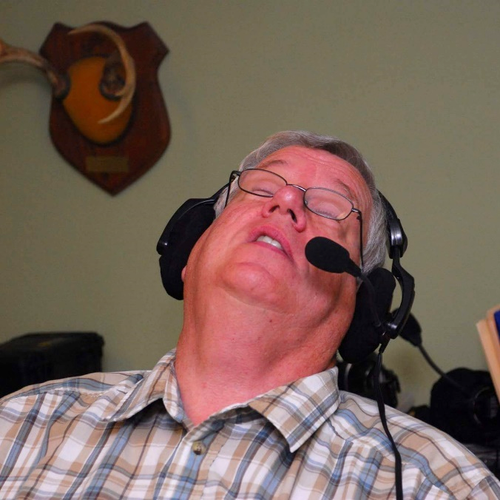

TOP ^

***Yes, we’ve finally come to the end!!!***

*PostScript is produced as a weekly newsletter. I want to thank everyone that has contributed articles and ideas to make this an even better news source. I sincerely hope that you have enjoyed this edition and will encourage your friends to join with you in receiving the latest news and information about the Ohio Section, and news and events happening around the world!*