[](http://arrl-ohio.org/news/) ***July 20th***

***Edition***

🡪 National News 🡪 The Handbook Give Away

🡪 Club Corner 🡪 Hamfests

🡪 DX This Week 🡪 ARES Connect

🡪 VE Testing 🡪 One Question Questionnaire

🡪 Final.. Final..

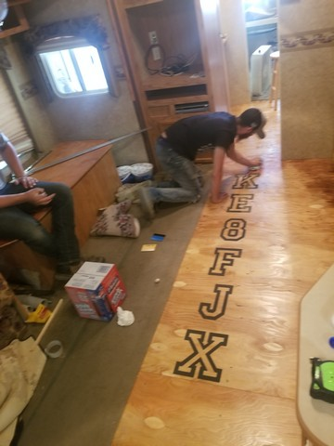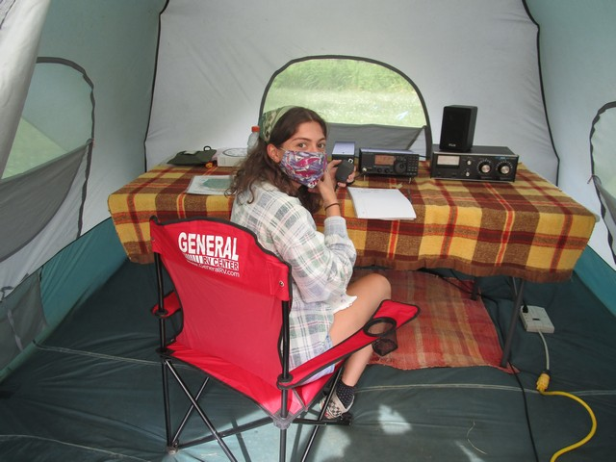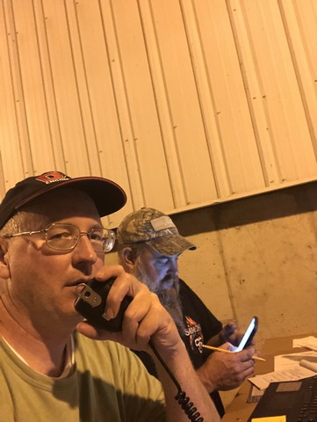

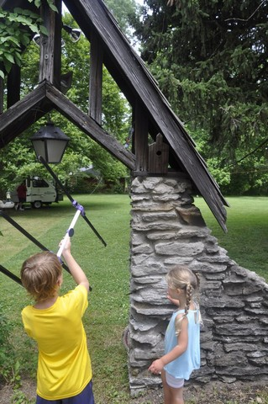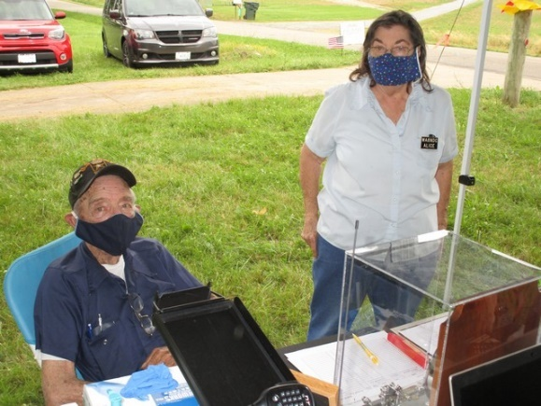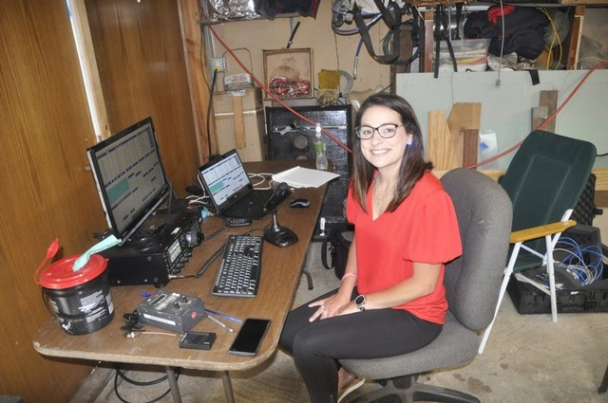

***National News***

*(from arrl and other sources)*

***Mark Your Calendars for the DXE Virtual Hamfest and DX Academy in July***

Join the Elmers at DX Engineering and a host of Ham Radio luminaries on **Saturday, July 25**, 2020, for the first DXE Virtual Hamfest and DX Academy—two online events combined into a full day of fun, learning, and drawings for DX Engineering gift cards.  
  
Both events are free and open to all. Click [**here**](https://zoom.us/webinar/register/8815941419418/WN_jfOkG02UTfKugtuTqIpV2g) to register. Once signed up, you will receive a link to access the events in real-time on the Zoom webinar platform, or you can watch live on the DX Engineering YouTube channel.

The day kicks off with the DXE Virtual Hamfest, featuring presentations from top contributors to [OnAllBands](https://www.onallbands.com/) (DX Engineering’s blog site), and the latest news and answers to your questions about recent and upcoming products, including the [RF-KIT RF2K-S Linear Amplifier](https://www.dxengineering.com/search/brand/rf-kit/product-line/rf-kit-power-amplifiers-rf2k-s?autoview=SKU&sortby=Default&sortorder=Ascending) (sold exclusively in North America by DX Engineering), the [RT-4500HD Heavy-Duty Rotator](https://www.dxengineering.com/search/product-line/dx-engineering-rt-4500hd-rotator-reservation?autoview=SKU&N=part-type%3Arotator-units_rotator-combos&sortby=Default&sortorder=Ascending), and the [Ladder Line Surge Protector](https://www.dxengineering.com/search/product-line/dx-engineering-ladder-line-surge-protector?autoview=SKU&keyword=ladder%20line%20surge%20protector&sortby=BestKeywordMatch&sortorder=Ascending).

**DXE Virtual Hamfest Schedule** (times are EDT)

* 9 am:               Introduction by Tim Duffy, K3LR, CEO of DX Engineering  
  9:15 am:          DXE Product Discussion with Scott Jones, N3RA  
  9:30 am:          Ward Silver, N0AX, Radiosport: Training for Public Service  
  10 am:             DXE Product Discussion with Steve Hannah, KC8YSU  
  10:15 am:        Sean Kutzko, KX9X, Working Amateur Radio Satellites  
  10:45 am:        DXE Product Discussion with Tim Duffy, K3LR  
  11 am:             Anthony Luscre, K8ZT, Youth in Amateur Radio  
  11:30 am:        DXE Question and Answer, Wrap-up, and Drawing for a $1,000 DX Engineering Gift Card*

The afternoon will be all about improving your skills at making long-distance contacts. Sponsored by Icom America and DX Engineering, the first-ever online DX Academy brings together experts to share advice from their years of on-air experience.

**DX Academy Schedule** (times are EDT)

1 pm:               Introduction by Tim Duffy, K3LR  
1:15 pm           Jerry Rosalius, WB9Z, Low Band Antennas for DXing  
2:15 pm            Ray Novak, N9JA, Icom Product Showcase, IC-705  
2:45 pm            Glenn Johnson, W0GJ, VP6R DXpedition to Pitcairn Island  
3:45 pm            Valerie Hotzfeld, NV9L, Operating Tools and Ideas for Becoming a Better DXer  
4:45 pm            Wrap-up and Drawing for a $1,000 DX Engineering Gift Card*

*To win, you must be registered and present on Zoom during the drawings.

####

TOP ^

***Field Day 2020 is Shaping Up to be One for the Record Books***

ARRL Contest Program Manager Paul Bourque, N1SFE, reported that ARRL has received more than 8,700 online Field Day entries by mid-week, and paper-only entries have started arriving too.

“As many participants chose to operate from home this year — and given the 2020 rules waivers, we have seen a tremendous increase in entries over last year’s event,” Bourque said. “Most of the entries received have been through the online [**web app**](http://field-day.arrl.org/fdentry.php), and Headquarters staffers have begun processing the paper entries this week. The 2020 waivers allowed individual club members to attribute their scores to their clubs.

Participants who submitted entries online are encouraged to check the Field Day [**entries received**](http://field-day.arrl.org/fdentriesrcvd.php) page to verify that their entries are marked as complete, and that the club name entered is correct. Entries with a status of “pending” are incomplete entries that are missing one or more items, and these need to be completed for an official entry. Share your stories and photos using the ARRL [**soapbox**](http://field-day.arrl.org/fdsoapbox.php) or via social media, such as on the ARRL [**Field Day Facebook group**](https://www.facebook.com/groups/arrlfd/).

####

***Your Participation Is Needed***

Hi everyone, Andrej KB8QGR here and I am calling CQ… CQ… CQ… all hams across the nation for eyeball QSO's and help.

Ok so here is the deal. I have been selected to participate in a reality show. I am now realizing that what I have gotten myself into is a LOT more difficult (Maybe impossible) than it first seemed. It is a race from Los Angeles California to New York. We will be paired up with a partner. There will be Six teams of two people each. We have been given 3 months to complete this task. (THREE MONTHS!?!?!?!?)

Wait a second... We are allowed to bring with us to the start of our race our phones, a power bank to charge our phones, a flashlight, our clothes and toiletries. THATS IT!!! No cash, no credit cards, nothing that would give us an advantage over our rivals.

**Oh. and it takes place on a riding lawnmower!!! LOL...OMG!!!!!**

OK now for the serious part of my plea. My team will be allowed to barter lawn cutting and whatever other services to whomever we meet along the way (as long as it is not illegal) to get food, fuel, shelter etc. to get across this great nation of ours. The rules stipulate that we can receive one bit of help from one person. For

example Alan gives our team food. Chuck can give us fuel but if we need some oil for the tractor we are out of luck until we can get assistance from Todd. The rules also say that if someone wants to give us something out of the goodness of their hearts we can and will definitely accept that kind of charity. Another biggie is the towing rule.

We will have a small trailer that we pull behind our own lawnmower. If you happen to live a few miles east of where we meet AND you have a hitch on your vehicle you could tow us up to 20 miles!!! That is what is going to save us from the elements. We cannot receive any cash from anyone, just goods and sevices.

TOP ^

Now for the big beg. I'm begging any and all hams in the Los Angeles area to plz, plz, plz, come out to the opening of our race and donate or lend to me an HT that I can recharge from either a 12 or 5 volt source. If I can use the 2-meter calling frequency WE can win this race together!!! Here is a list of things that I believe my team will need in addition to the HT to get a leg up on our competition. This list is not set in stone, if you think of something else that I might require along the way then please feel free to bring it along to the start of the race and we can take a look at it.

1. 5-gallon gas cans. I think 2 or 3 would be great. Now according to the rules, I don't know if they will allow them to be filled with fuel but if not then some good hams to fill our tanks to start.

2. A tarp. To cover our trailer. That will be our shelter from the weather while one member of the team drives the other can rest under the tarp. The trailer I'm told is 4ft.x6ft. I hope it has sides. If not, I hope there is a ham east of LA that might be able to help us put some sides on the trailer so we can have a roof over our heads. The tarp should be around 8ft. x 10ft. in size.

3. A good sized cooler and plastic tote with a lid so we can keep our clothes and hopefully that HT dry and out of the weather. Worst case scenario a bunch of those huge garbage bags could work also.

4. Some rope to keep the cooler and tote strapped to our trailer. It will also help to lash the tarp to the trailer so it doesn't blow away.

5. Wire... What good MacGyver type guy doesn't need wire? I'm thinking some 16, 18 or 20 GA or speaker wire for whatever reason. One reason I can think of is to wire up some canned soups or other canned foods close to the motor so we can heat up dinner or tea or whatever. Also, to wire up a way to charge the HT with the mower. Oh, and wire cutters maybe a multitool of some sort.

6. A thousand other little things that might help us along the way like canned soups, one or two of those slow-moving vehicle orange triangles for the back of the trailer or tractor or both. A compass for obvious reasons. Toilet paper just in case. Marvel mystery oil. Some pillows and or air mattress to put in the trailer to sleep on. Wipes so we can keep clean on the road if we don't have access to water. Several Gallon jugs of water.

Almost forgot the race start date and time is 4pm local time in Los Angeles. I do not have an address yet but as soon as I do, I will send it out to my section manager in Michigan and he can hopefully forward it out ASAP to everyone else. Let's show the world that there is a great hobby called amateur radio and after being around for over 100 years it is alive and kicking and relevant. Let’s show the world that there IS a need for ham radio.

Let’s all show the world that during these trying times that there are still good and decent people out there today.

Thanks in advance to all who will (hopefully) come out to support myself and my team at the start of his race and all along the way to New York.

Andrej KB8QGR - My email is [bullseyetenx@gmail.com](mailto:bullseyetenx@gmail.com) thanks in advance, Andrej

####

TOP ^

***International Lighthouse Lightship Weekend on Track for 2020***

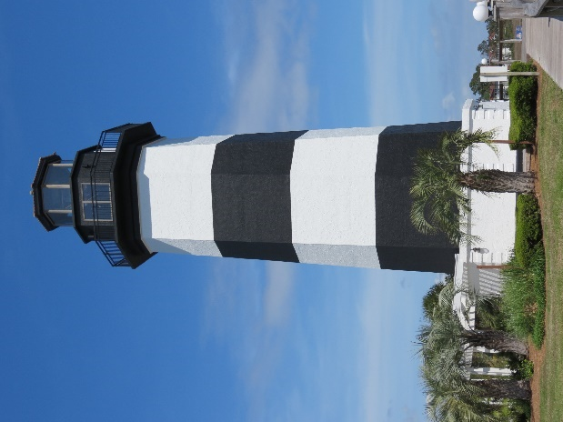Registrations for this year’s popular International Lighthouse Lightship Weekend ([**ILLW**](https://illw.net/)) appear to have been largely unaffected by the current COVID-19 pandemic. The event will take place this year over the August 22 – 23 weekend. By mid-July, more than 200 entries had been received, and some 400 are expected to have signed up by the event weekend.

New to this year’s event is Corsica at Phare d’Alistro, which for ILLW purposes carries the French number of FR0030. Two lighthouses in Ghana will be on the air for the first time, as well as Buck Island Lighthouse in the US Virgin Islands (VI0001). Germany is well in the lead with 54 entries, followed by Australia with 29 entries, and the US with 27 entries.

This event is designed as a fun weekend to encourage exposure to amateur radio and lighthouses to the visiting public, and ILLW stresses contacts should be more than just an exchange of signal reports. All participants are urged to observe local COVID-19 safety guidelines. *—Thanks to Kevin Mulcahey, VK2CE*

####

***AMSAT Says Husky-1 CubeSat Project Helped Pave the Way for Future Missions***

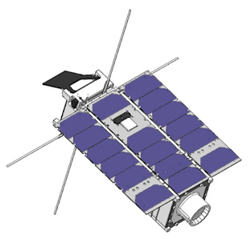

[**AMSAT**](http://ww.amsat.org/) Vice President of Engineering Jerry Buxton, N0JY, said that while it was disappointing that the amateur transponder on [**HuskySat-1**](https://sites.google.com/uw.edu/huskysatellitelab/home) (HO-107) was not available any longer, following the satellite’s science missions, the overall HuskySat-1 project and mission “were quite beneficial for our partner and for AMSAT.” The linear transponder module (LTM) on HuskySat-1 was operational for more than 3 months, failing during or just after a period of full sun when LTM temperatures topped 80 °C (176 °F). HuskySat-1 was the first CubeSat from the Husky Satellite Lab at the University of Washington and the first mission with AMSAT’s LTM V/u transponder on board. University researchers conducted their work using an FCC Part 5 Experimental license.

“The HuskySat-1 team was able to command their satellite and experiments and receive the telemetry they sought, and AMSAT was able to work through the extensive process of making a new design for a ‘black box’ radio module that can be integrated into a non-AMSAT spacecraft and fly in the space environment,” Buxton said in a recent post to the AMSAT-BB reflector. “While licensed and operated as an amateur radio satellite by AMSAT during the transponder use, some facts set HO-107 apart from our Fox-1 CubeSats and other AMSAT satellites,” Buxton explained, pointing out that HuskySat-1 was not an AMSAT satellite.

“We have no control and may not have any insight into how a partner actually uses the LTM,” he said. “While we see the LTM temperatures and many of the other typical data fields that we downlink to *FoxTelem* regarding LTM health, data such as temperature of the host environment as well as other specific information like power and the state of the other systems in a host satellite may or may not be available to us. Whether LTM is operated within design limits is entirely up to the host.”

TOP ^

Buxton said the HuskySat team and AMSAT cooperated smoothly on the mission. He said the HuskySat-1 team is processing and studying its data for use in their thesis and classes and preparing it for release “in a specific way typical of such an institution today,” he said. “AMSAT is generally more forthcoming with information about our missions, but what we can and have said about this mission is determined by UW.”

Buxton said the LTM concept is now becoming available for other non-AMSAT CubeSats to fly amateur radio on their mission.

“HO-107 is the pilot production of LTM and was developed in partnership with UW HuskySat-1,” Buxton explained. “It was the first CubeSat radio module designed and built by AMSAT for use in other host CubeSats, and UW was key in working with us through the design and processes needed to provide such a module. They did not buy it as such, nor did we give it to them as an ‘off-the-shelf’ product, as we plan to for future LTM production.”

LTM was developed from the Fox-1E linear transponder design. “Overall, the HuskySat-1 team was quite happy with the telemetry and command performance, even with the LTM anomalies showing up toward the end of their experiments,” Buxton said. “In the process of getting HuskySat-1 to orbit several students became interested in amateur radio, and we have already had preliminary discussions of future joint mission plans.”

“There is no doubt that HO-107 was a success in many ways beyond the operational life of the transponder,” Buxton added. —*Thanks to*AMSAT News Service

####

***Building Effective Radio Messaging Infrastructure in Ohio***

*(C. Matthew Curtin KD8TTE)*

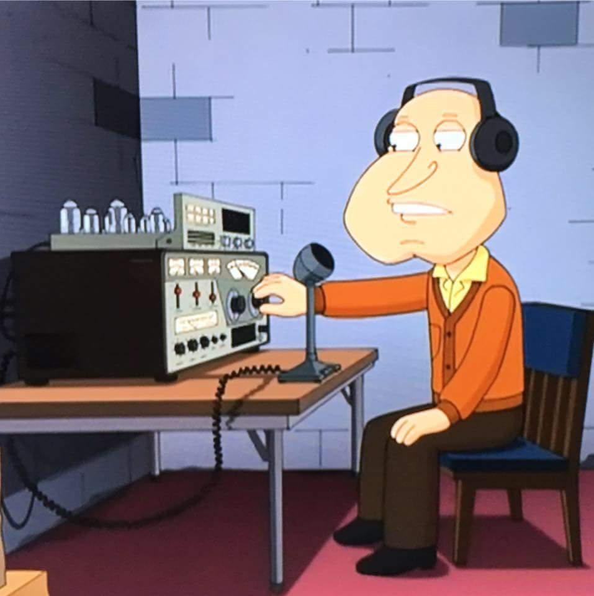Thanks for all of the comments, questions, and words of encouragement for the County Information Report Project 20! (See “County Information Report Project 20 Underway,” *PostScript.* July 13, 2020.) We hear the phrase “when all else fails” a lot, advertising that even when all of the usual means of communication have failed, the amateur radio service and the licensees who use it will be there to fulfill the mandate of 47 CFR 97.1(a):

Recognition and enhancement of the value of the amateur service to the public as a voluntary noncommercial communication service, particularly with respect to providing emergency communications.

Thousands of radio amateurs volunteer time every month developing and maintaining radio communication skills by operating in events, in exercises, and on message relay nets. A survey recently sent to all of Ohio’s emergency coordinators (ECs) shows that of 88 counties in Ohio, 37 responded. That means 51 didn’t respond to a five-question survey. Among those that did respond, about 68% have weekly nets, with another 5% operating semimonthly, and 11% holding nets monthly. Others have no regular net, are just starting their own, or work other nets. This is good work: it takes effort and dedication to have a regular net, even if it’s only for the purpose of confirming that the equipment is working and the operators know how to use it as a single-channel conduit for talking.

TOP ^

Yet, the question remains: in an emergency that includes compromise of communication infrastructure, how would the affected area reach out further, for one county to reach out to another to activate a mutual aid agreement? How would a county ARES EC reach the District Emergency Coordinator (DEC) for additional resources? The *Ohio Section Emergency Response Plan (OSERP)* calls for a district net to support such cases, yet only 35% of responding counties reported using the net in the past six months, with another 14% using a district net in the past year.

How would the DEC ask other district ECs or the Section Emergency Coordinator for resources from outside of the district? In the survey we didn’t limit the question to responses from DECs but we did ask all ECs about their ability to reach the Section. Absent a district net, a section net will tie together stations from out of the county. (*OSERP* calls for “wide-area nets,” but these as described would be implemented on an *ad hoc* basis.) Looking at various resources called for by OSERP, we see respondents reporting activity as follows

|  |  |  |
| --- | --- | --- |
| Resource | Used in the past 6 months | Used in past 7-12 months |
| Ohio DMR Talk Group | 40% | +10% |
| ARES HF Net (W8SGT) | 40% | +15% |
| OHDEN | 43% | +14% |

Realtime dispatch-style “tactical” nets are not the only conduits for information, of course. The store-and-forward systems for relay of record traffic are integral to amateur radio’s communication mission. (The second R of ARRL stands for “relay” for a reason, even if Newington doesn’t seem to remember the fact.) The Winlink Global Radio Email system, the National Traffic System (NTS), and independent traffic nets all fit this bill. *OSERP* calls for liaison to the traffic nets but is vague about how they are to be used except for welfare traffic. Recent performance of traffic nets in the May 30 Red Cross exercise and Field Day shows that these services provide ARES operators more options for movement of messages—including those in formats like the ICS Form 213 (General Message) and Red Cross 6409 (Disaster Requisition). How well do Ohio’s active ARES organizations make use of these resources?

|  |  |  |
| --- | --- | --- |
| Resource | Used in past 6 months | Used in past 7-12 months |
| Winlink (HF) | 29% | No additional |
| Winlink (6m) | 3% | No additional |
| Winlink (144+ MHz) | 24% | No additional |
| NTS via local net | 14% | +5% |
| NTS via section net | 16% | +3% |
| NTS via digital NTSD/DTN | 3% | +3% |

TOP ^

This activity represents ongoing time and money invested by volunteers around the state. It is important that we recognize this effort, we find those who are undertaking this work, and connect them with others who are similarly dedicated to the proposition that amateur radio is a powerful tool that can be employed for the good of the public by operators who are licensed, trained, and well-practiced.

Back to our questions: in an emergency that includes compromise of communication infrastructure, how would the affected area reach out further, for one county to reach out to another? How would a county EC reach the District Emergency Coordinator (DEC) for additional resources? How would a DEC reach out to the SEC?

The answer in all cases is *generally* the same: making use of outlets that reach beyond the boundaries of a county, use of liaison stations, and coordination of these local stations to ensure that they can be activated as needed, and relied upon for the movement of messages in an emergency, performing reliably. What that means specifically to each county, each district, and even in the Ohio Section (as compared to any other of ARRL’s 71 sections) may vary but we won’t know how until we try it, refine it, and try again.

We thus return to the County Information Report Project 20. This effort, already underway, is testing our ability to move messages from one level to another, to relay effectively, and to provide a reliable means of messaging throughout the Ohio Section. Please join us as we endeavor to accomplish these weekly objectives as we move through the summer and into the fall. I again draw your attention to the project’s concept of operation, online at <https://docs.google.com/document/d/1IOOchjz052K1-dDb79Vxz1c0kDm-kQOyeiQCd9Go2tg/edit>.

This project is a no-fault training environment, where we have the ability to try things, assessing performance of procedures and ideas, memorializing and promulgating what does work, changing what does not, trying again, and reassessing. Success here is a choice that begins with each of us taking that first step forward, saying “I will volunteer,” taking a simple task seriously, doing it to the best of our ability, and assessing the performance of the system—we all work together as a system—with eyes wide open. Everyone who participates will make mistakes. No one learns from easy success; we learn from challenges, whether we overcome them, or they get the better of us that day. Either way, when we take the time to learn our lesson and to prepare, we can repeat this cycle until we achieve the objective. Not only are we better for it: the entire system is stronger for the capability that we bring.

If you are active in your local ARES program, good! Please contact your EC to see how you can help in the County Information Report Project. If you’re not active in your local ARES program, reach out to your EC to see how you can help in the County Information Report Project—that’s how you can get active. If there is no ARES program in your county, find a neighboring county’s program to join. (We have programs that draw from more than two counties and can serve both. You can be part of a new one!) If you’re active in the traffic nets, good! Keep at it and ask your net manager where the net needs additional help. Maybe you’ll learn to work as a net control operator, to act as a liaison station, or to use new modes of operation. Watch for training to be offered—it is coming!—and jump on the opportunity to take it.

Progress will seem slow in coming, which is why we measure. Choose to be part of tomorrow’s more auxiliary radio messaging system, participate weekly, and learn from what you experience and see around you. Just watch what we look like in late September by comparison to today.

TOP ^

A final thought on this week’s installment on the County Information Report Project: we’re intentionally pushing groups that decades ago bifurcated and trained separately to work together because it’s what’s needed to accomplish the likely mission at hand. Whether the logo you wear says “ARES” or “NTS,” operate with patience and kindness. Follow the Robustness Principle that guided successful development of the Internet for decades: “Be conservative in what you do, be liberal in what you accept from others.” (J. Postel. Transmission Control Protocol, RFC 793. Sep. 1981) That might require going with another operator off-frequency to talk like real people and find out what the sending station is trying to do and helping to get it accomplished in the context of the receiving environment.

It might require working more slowly or using a mode that’s less familiar to you. Work with each other: we’re all volunteers training to serve the needs of our families and neighbors in a time of crisis.

####

***Radio Club of America Announces 2020 Award Recipients and Fellows***

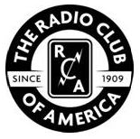The Radio Club of America ([**RCA**](https://www.radioclubofamerica.org/)) has announced its 2020 award recipients and fellows, several of whom are radio amateurs. Recipients and fellows will be celebrated at RCA’s 111th Banquet & Awards Presentation on Friday, November 20, in Pittsburgh, Pennsylvania.

* Barry Goldwater Award: Bob Bruninga, WB4APR, for unique contributions to the field of amateur radio.
* Edgar F. Johnson Pioneer Citation Award: Tokuzo Inoue, JA3FA, for noteworthy contributions to the success of the radio industry.
* The Jack Poppele Award: John Schadler for important and long-term contributions to the field of radio broadcasting.
* The Jay Kitchen Leadership Award: Michael T.N. Fitch in recognition of achievement of a high level of success leading a wireless association.
* The Ralph Batcher Memorial Award: Eric P. Wenaas, Ph. D., for significant work in preserving the history of radio and electronic communications.
* RCA President’s Award: Ron Jakubowski, K2RJ, for service and dedication to the Radio Club of America.
* RCA Special Services Award: Ernie Blair, WA4BPS, to recognize an RCA member who has performed significant work to advance the goals and objectives of the Radio Club of America.
* The Sarnoff Citation: Robert Rouleau, VE2P, and Norman Pearl, VE2BQS, for exceptional contributions of a technical or non-technical nature to the advancement of electronic communications.
* US Navy Captain George P. McGinnis Memorial Award: CTRCM John A. “Gus” Gustafson, USN (Ret.) for service and dedication to the advancement and preservation of US Naval Cryptology, as nominated by the US Naval Cryptologic Veterans Association (NCVA).
* The Vivian Carr Award: Emily Calandrelli, KD8PKR, in recognition of an outstanding woman’s achievements in the wireless industry.

TOP ^

**2020 RCA Fellows**

Elevation to Fellow is made by nomination of members in good standing for at least 5 years, in recognition of contributions to the art and science of radio communications, broadcast, or to the Radio Club of America.

* Jim Bugel
* Raymond L. Grimes, N8RG
* Tracey M. Hilburn
* Paul A. Scutieri
* Alan S. Tilles
* David Witkowski, W6DTW

A [**complete listing**](https://www.radioclubofamerica.org/about-us/awards/) of RCA awards and previous recipients is on the RCA website.

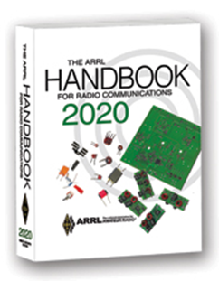***The Handbook Give Away***

Hey Gang,

Have you registered for the “Handbook Giveaway” drawing for this month yet? If you haven’t, go to: <http://arrl-ohio.org/handbook.html> and get yourself registered now!

What’s the catch? I want to get everyone checking in to the Ohio Section website as often as possible, and in order to register each month, you have to visit the website often! There’s nothing else to it. I pay all expenses and I usually “Give Away” more than just a Handbook too!!

Many of you ask me just how do I know when the drawing is on? Well, that’s easy all you need to do is check in on the Ohio Section Website on a regular basis and watch for the big [RED](http://arrl-ohio.org/handbook.html) Arrow that will appear on the left side of the page. This is the sign that the drawing is on and you need to get registered. So, keep a sharp eye out on the website and check in often!

***Club Corner***



This is YOUR cornner of the newsletter. Send me what your club is doing and I’ll make sure that it gets in. Got a special event or club project that you want everyone to know about? Send it to me!. Need help with a project? Send it to me.

Let me know what you club is up to. Are you going to have a special guest at your meeting or are you having a special anniversary? Just sent it to: [n8sy@n8sy.com](mailto:n8sy@n8sy.com)

####

***The Bellbrook Amateur Radio Club, Bellbrook, Ohio celebrated their 44th anniversary on July 4, 2020!!***

####

TOP ^

***SilverWoo 2020 Award Winners***

The one-of-a-kind SilverWoo 2020 Field Day Event sponsored by the Silvercreek Amateur Radio Association and the Wayne Amateur Radio Club. We had a total of 12 operators log submissions for 11,818 QSO points and 13,258 points overall. This was a very enjoyable way to spend Field Day 2020. However I think we will all be looking forward to a normal Field Day next year (hopefully)!

A full [list of scores](https://silverwoo.org/scores.html) and [the award winners](https://silverwoo.org/awards.html) are available at <https://silverwoo.org> .

**Best Overall Score**

John Bastin K8AJS – 4,196 pts

**Best Operator Score**

John Bastin K8AJS – 4,196 pts

**Best Operator Score – Medina County**

Jeff Royer W8TB – 1,582 pts

**Best Operator Score – Summit County**

Allan “Zeke” Zadiraka AB8OU – 1,196 pts

**Best Operator Score – Wayne County**

John Bastin K8AJS – 4,096 pts

####

***TUSCAZOAR Adventure Race***

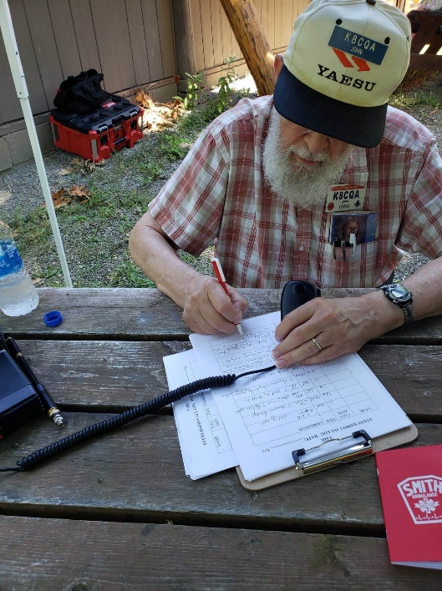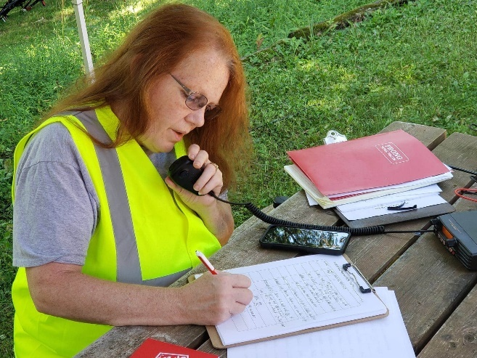Today the TUSCO Amateur Radio Club and Tuscarawas county ARES Group, along with Volunteers from Canton ARC & Massillon ARC provided Communications for the Camp Tuscazoar Adventure Race held at Camp Tuscazoar in Dover Ohio.

The race included Orienteering, Running, Kayaking, and Mountain Biking. We set up a net control station to aid race officials in keeping track of race progress, accounting for all contestants, and providing Communications to requests emergency services.

The event went extremely well, our group did an excellent job. We had some lost participants we had to account for, a minor bike accident, and some dehydrated contestants that needed to be picked up since they were unable to finish.

TOP ^

It was a fun event, great community service, and a very good ARES Exercise setting up Net Control and running Simplex with extended service from a cross band repeater we set up. Since this is in the Dover Dam Area, it was a great place do have an ARES Exercise!

Regards - Jeff Voltz, KE8BKP - TUSCO Amateur Radio Club Activities Chair

####

***The Northwest Ohio ARES Traffic Net Needs Help***

The Northwest Ohio ARES Traffic Net is in need of General and/or Extra Class licensees with either voice or CW capabilities to relay traffic from the VHF net to the HF nets, no experience is necessary.

The NW Ohio ARES Traffic Net meets daily at 6:30PM on the W8RZM 147.375 repeater.

The Ohio Single Sideband Net meets daily at 10:30AM, 4:15PM and 6:45PM on 3.9725 MHz. The Ohio Section also has three CW Nets, the Ohio Slow Net meets daily at 6:00PM on 3.53535 and runs at approximately 10 WPM.

The Buckeye Net-Early meets daily at 6:45PM on 3.580 and runs between 15-20 WPM. Finally, the Buckeye Net-Late meets daily at 10PM on 3.590 and runs in the same range as the Early Net. Currently, there are only 2 volunteers that cover 7 days a week, and most nets there isn't a volunteer at all. Please consider volunteering for an hour a week, you never know, you may like it.

For more information on traffic handling, or volunteering to assist relaying traffic please check into the VHF net or contact Colleen Roth N8TNV, Steve Denniss KC8IDM, or Michael Lacumsky W8MAL.

####

***Upcoming Event Status Update***

Below is a list of events STILL HAPPENING Cleveland area that Event Support Group will be participating in. We still need volunteers for all! Be sure to click and bookmark the "View Full Event Calendar" link below.

• AFSP Out of the Darkness Walk Communications Support on **September 26**, 2020 09:30

• Cleveland Hamfest Volunteers on **September 27**, 2020 06:00

• Making Strides of Cleveland *Communications Support* on **October 10**, 2020 08:00

Our friends over at the Geauga Amateur Radio Association have begun compiling a list of as many radio related cancellations as they can. Be sure to check it frequently at <https://geaugaara.org/coronavirus/>

####

TOP ^

***2020 Cleveland Hamfest STILL ON!***

That's right, the 2020 Cleveland Hamfest is NOT CANCELLED. We are watching the situation very closely and will update everyone if anything changes. As of now the Hamfest Association of Cleveland is still moving forward with plans for the 2020 Cleveland Hamfest on Sunday, September 27. Indoor Vendors, please visit [www.hac.org](http://www.hac.org) and click “vendor information” at the top for more info.

Make sure you head on over to [www.hac.org](http://www.hac.org) for the latest info and be sure to click “Join Our Mailing List” to get all the latest updates.

####

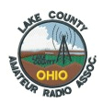***Lake County ARA Cancels Picnic***

Regrettably, the board has decided the club picnic scheduled for **July 26th**, is now **CANCELED.**

Although the Lake Metro-Parks are open, the State guidelines for social gatherings remains limited to 10 or fewer people and given the recent up trend in reported COVID-19 cases, we simply do not want to risk the health of our members and guests.

We will continue to hold club membership and board meetings online. Reminder notices will be sent out the week prior.

####

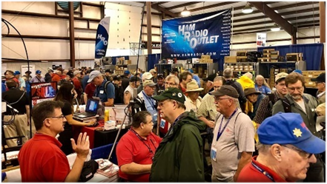

[***Upcoming Hamfests***](http://arrl-ohio.org/hamfests.html) ***for 2020***

**~~07/26/2020 - Portage Hamfair '20~~**~~Location: Ravenna, OH  
Sponsor: Portage Amateur Radio Club, Inc.  
Website:~~ [~~http://hamfair.com~~](http://hamfair.com) ***~~Canceled~~***

|  |  |
| --- | --- |
| **~~08/01/2020 | Columbus Hamfest~~** ~~Location: Grove City, OH Sponsor: Voice of Aladdin/ Audio Unit of Aladdin Shrine Website:~~ [~~http://columbushamfest.com~~](http://columbushamfest.com/)***~~Canceled~~*** | **~~08/08/2020 | DXE Hamfest,~~**  **~~ARRL Ohio Section Convention~~** ~~Location: Tallmadge, OH Sponsor: DX Engineering Website:~~ [~~http://dxengineering.com~~](http://dxengineering.com/)  ***~~Canceled~~*** |
| **08/15/2020 - Clinton County Ohio ARA Hamfest**  Location: Wilmington, OH  Sponsor: Clinton County ARA  Website: <http://ccara.net> | **~~08/29/2020 - Milford Hamfest~~** ~~Location: Owensville, OH Sponsor: Milford Amateur Radio Club Website:~~ [~~http://www.w8mrc.com~~](http://www.w8mrc.com/)  ***~~Canceled~~*** |

TOP ^

|  |  |
| --- | --- |
| **09/13/2020 - Findlay Hamfest** Location: Findlay, OH Sponsor: Findlay Radio Club Website: [http://findlayradioclub.org](http://findlayradioclub.org/) | **09/27/2020 | Cleveland Hamfest and**  **Computer Show** Location: Berea, OH Sponsor: Hamfest Association of Cleveland Website: [http://www.hac.org](http://www.hac.org/) |

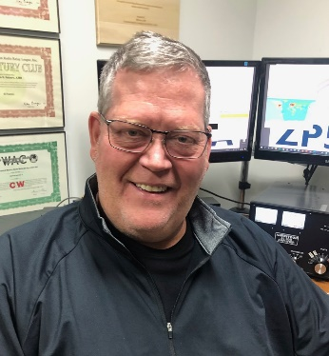***DX This Week***

*(from Bill, AJ8B)*

***DX This Week – DXCC Second Level***

***Bill AJ8B (***[***aj8b@arrl.net***](mailto:aj8b@arrl.net)***, @AJ8B, or*** [***www.aj8b.com***](http://www.aj8b.com)***)   
 CWOPs Member #1567***

On the DX side of the cluster, there were some interesting entities spotted including Asiatic Turkey, Australia, Bahrain, Belgium, Belize, China, Denmark, Ecuador, England, European Russia, Fed. Rep. of Germany, France, Greece, Hungary, Iceland, Indonesia, Ireland, Isle of Man, Japan, Kazakhstan, Mexico, Netherlands, New Caledonia, North Macedonia, Northern Ireland, Norway, Oman, Panama, Scotland, St. Lucia, Taiwan, Venezuela, and Wales. Let me know what you worked!

The Milford Amateur Radio Club has announced that their hamfest that was originally rescheduled for August 29th is now scheduled for August of 2021! Go to <https://cincinnatihamfest.org/> and fill out the request form to be added to the updates list. This also means that the W8DXCC convention has been rescheduled. We hope to have major announcements about both of these events soon. Go to [www.w8dxcc.com](http://www.w8dxcc.com) and sign up for updates.

A few months ago, I had proposed that one way to achieve DXCC and to not get overwhelmed was to break it in to 3 parts; First 125 (Most Wanted #340 – #216), Mid Tier (Most Wanted #215 – #101), and the final 100! (#100 - #1). However, as you work yourself through the second tier you find that you now have 240 Confirmed!

Below is a table that contains the second tier of entities.

|  |  |  |  |  |  |  |  |  |
| --- | --- | --- | --- | --- | --- | --- | --- | --- |
| 215 | VP2V | [BRITISH VIRGIN ISLANDS](https://clublog.org/mostwanted2.php?dxcc=65) | 177 | FO/M | [MARQUESAS ISLANDS](https://clublog.org/mostwanted2.php?dxcc=509) | 139 | J5 | [GUINEA-BISSAU](https://clublog.org/mostwanted2.php?dxcc=109) |
| 214 | 5T | [MAURITANIA](https://clublog.org/mostwanted2.php?dxcc=444) | 176 | A3 | [TONGA](https://clublog.org/mostwanted2.php?dxcc=160) | 138 | P2 | [PAPUA NEW GUINEA](https://clublog.org/mostwanted2.php?dxcc=163) |
| 213 | CP | [BOLIVIA](https://clublog.org/mostwanted2.php?dxcc=104) | 175 | 9G | [GHANA](https://clublog.org/mostwanted2.php?dxcc=424) | 137 | 3B9 | [RODRIGUEZ ISLAND](https://clublog.org/mostwanted2.php?dxcc=207) |
| 212 | CE9 | [ANTARCTICA](https://clublog.org/mostwanted2.php?dxcc=13) | 174 | VP8H | [SOUTH SHETLAND ISLANDS](https://clublog.org/mostwanted2.php?dxcc=241) | 136 | 5Z | [KENYA](https://clublog.org/mostwanted2.php?dxcc=430) |
| 211 | FO | [FRENCH POLYNESIA](https://clublog.org/mostwanted2.php?dxcc=175) | 173 | V7 | [MARSHALL ISLANDS](https://clublog.org/mostwanted2.php?dxcc=168) | 135 | 9M6 | [EAST MALAYSIA](https://clublog.org/mostwanted2.php?dxcc=46) |
| 210 | PJ5 | [SABA & ST EUSTATIUS](https://clublog.org/mostwanted2.php?dxcc=519) | 172 | S0 | [WESTERN SAHARA](https://clublog.org/mostwanted2.php?dxcc=302) | 134 | A9 | [BAHRAIN](https://clublog.org/mostwanted2.php?dxcc=304) |

TOP ^

|  |  |  |  |  |  |  |  |  |
| --- | --- | --- | --- | --- | --- | --- | --- | --- |
| 209 | FK | [NEW CALEDONIA](https://clublog.org/mostwanted2.php?dxcc=162) | 171 | E5/N | [NORTH COOK ISLANDS](https://clublog.org/mostwanted2.php?dxcc=191) | 133 | EK | [ARMENIA](https://clublog.org/mostwanted2.php?dxcc=14) |
| 208 | ZD7 | [SAINT HELENA](https://clublog.org/mostwanted2.php?dxcc=250) | 170 | E6 | [NIUE](https://clublog.org/mostwanted2.php?dxcc=188) | 132 | 5H | [TANZANIA](https://clublog.org/mostwanted2.php?dxcc=470) |
| 207 | 5W | [SAMOA](https://clublog.org/mostwanted2.php?dxcc=190) | 169 | EL | [LIBERIA](https://clublog.org/mostwanted2.php?dxcc=434) | 131 | 7P | [LESOTHO](https://clublog.org/mostwanted2.php?dxcc=432) |
| 206 | BY | [CHINA](https://clublog.org/mostwanted2.php?dxcc=318) | 168 | HS | [THAILAND](https://clublog.org/mostwanted2.php?dxcc=387) | 130 | VP6/D | [DUCIE ISLAND](https://clublog.org/mostwanted2.php?dxcc=513) |
| 205 | 8R | [GUYANA](https://clublog.org/mostwanted2.php?dxcc=129) | 167 | KH8 | [AMERICAN SAMOA](https://clublog.org/mostwanted2.php?dxcc=9) | 129 | 5R | [MADAGASCAR](https://clublog.org/mostwanted2.php?dxcc=438) |
| 204 | HC8 | [GALAPAGOS ISLANDS](https://clublog.org/mostwanted2.php?dxcc=71) | 166 | 9L | [SIERRA LEONE](https://clublog.org/mostwanted2.php?dxcc=458) | 128 | 9Q | [DEM. REP. OF THE CONGO](https://clublog.org/mostwanted2.php?dxcc=414) |
| 203 | 7X | [ALGERIA](https://clublog.org/mostwanted2.php?dxcc=400) | 165 | CE0Z | [JUAN FERNANDEZ ISLANDS](https://clublog.org/mostwanted2.php?dxcc=125) | 127 | CY0 | [SABLE ISLAND](https://clublog.org/mostwanted2.php?dxcc=211) |
| 202 | HB0 | [LIECHTENSTEIN](https://clublog.org/mostwanted2.php?dxcc=251) | 164 | JT | [MONGOLIA](https://clublog.org/mostwanted2.php?dxcc=363) | 126 | T30 | [WESTERN KIRIBATI](https://clublog.org/mostwanted2.php?dxcc=301) |
| 201 | A6 | [UNITED ARAB EMIRATES](https://clublog.org/mostwanted2.php?dxcc=391) | 163 | 3B8 | [MAURITIUS ISLAND](https://clublog.org/mostwanted2.php?dxcc=165) | 125 | T2 | [TUVALU](https://clublog.org/mostwanted2.php?dxcc=282) |
| 200 | J8 | [SAINT VINCENT](https://clublog.org/mostwanted2.php?dxcc=98) | 162 | CY9 | [SAINT PAUL ISLAND](https://clublog.org/mostwanted2.php?dxcc=252) | 124 | ZK3 | [TOKELAU ISLANDS](https://clublog.org/mostwanted2.php?dxcc=270) |
| 199 | OD | [LEBANON](https://clublog.org/mostwanted2.php?dxcc=354) | 161 | VK9N | [NORFOLK ISLAND](https://clublog.org/mostwanted2.php?dxcc=189) | 123 | 9X | [RWANDA](https://clublog.org/mostwanted2.php?dxcc=454) |
| 198 | 3D2 | [FIJI ISLANDS](https://clublog.org/mostwanted2.php?dxcc=176) | 160 | KH0 | [MARIANA ISLANDS](https://clublog.org/mostwanted2.php?dxcc=166) | 122 | T8 | [PALAU](https://clublog.org/mostwanted2.php?dxcc=22) |
| 197 | A4 | [OMAN](https://clublog.org/mostwanted2.php?dxcc=370) | 159 | FO/A | [AUSTRAL ISLANDS](https://clublog.org/mostwanted2.php?dxcc=508) | 121 | ZL7 | [CHATHAM ISLAND](https://clublog.org/mostwanted2.php?dxcc=34) |
| 196 | HZ | [SAUDI ARABIA](https://clublog.org/mostwanted2.php?dxcc=378) | 158 | A7 | [QATAR](https://clublog.org/mostwanted2.php?dxcc=376) | 120 | OY | [FAROE ISLANDS](https://clublog.org/mostwanted2.php?dxcc=222) |
| 195 | JW | [SVALBARD](https://clublog.org/mostwanted2.php?dxcc=259) | 157 | 5N | [NIGERIA](https://clublog.org/mostwanted2.php?dxcc=450) | 119 | XF4 | [REVILLAGIGEDO](https://clublog.org/mostwanted2.php?dxcc=204) |
| 194 | ZD8 | [ASCENSION ISLAND](https://clublog.org/mostwanted2.php?dxcc=205) | 156 | S9 | [SAO TOME & PRINCIPE](https://clublog.org/mostwanted2.php?dxcc=219) | 118 | VK9L | [LORD HOWE ISLAND](https://clublog.org/mostwanted2.php?dxcc=147) |
| 193 | FJ | [SAINT BARTHELEMY](https://clublog.org/mostwanted2.php?dxcc=516) | 155 | XT | [BURKINA FASO](https://clublog.org/mostwanted2.php?dxcc=480) | 117 | 9J | [ZAMBIA](https://clublog.org/mostwanted2.php?dxcc=482) |
| 192 | C5 | [THE GAMBIA](https://clublog.org/mostwanted2.php?dxcc=422) | 154 | BU | [TAIWAN](https://clublog.org/mostwanted2.php?dxcc=386) | 116 | SU | [EGYPT](https://clublog.org/mostwanted2.php?dxcc=478) |
| 191 | SV5 | [DODECANESE](https://clublog.org/mostwanted2.php?dxcc=45) | 153 | VR | [HONG KONG](https://clublog.org/mostwanted2.php?dxcc=321) | 115 | FO/C | [CLIPPERTON ISLAND](https://clublog.org/mostwanted2.php?dxcc=36) |
| 190 | PY0F | [FERNANDO DE NORONHA](https://clublog.org/mostwanted2.php?dxcc=56) | 152 | 3XA | [GUINEA](https://clublog.org/mostwanted2.php?dxcc=107) | 114 | YJ | [VANUATU](https://clublog.org/mostwanted2.php?dxcc=158) |
| 189 | CE0Y | [EASTER ISLAND](https://clublog.org/mostwanted2.php?dxcc=47) | 151 | D2 | [ANGOLA](https://clublog.org/mostwanted2.php?dxcc=401) | 113 | 5X | [UGANDA](https://clublog.org/mostwanted2.php?dxcc=286) |
| 188 | T32 | [EASTERN KIRIBATI](https://clublog.org/mostwanted2.php?dxcc=48) | 150 | 3V | [TUNISIA](https://clublog.org/mostwanted2.php?dxcc=474) | 112 | S7 | [SEYCHELLES ISLANDS](https://clublog.org/mostwanted2.php?dxcc=379) |
| 187 | T7 | [SAN MARINO](https://clublog.org/mostwanted2.php?dxcc=278) | 149 | FW | [WALLIS & FUTUNA ISLANDS](https://clublog.org/mostwanted2.php?dxcc=298) | 111 | V6 | [MICRONESIA](https://clublog.org/mostwanted2.php?dxcc=173) |
| 186 | VU | [INDIA](https://clublog.org/mostwanted2.php?dxcc=324) | 148 | ZA | [ALBANIA](https://clublog.org/mostwanted2.php?dxcc=7) | 110 | Z2 | [ZIMBABWE](https://clublog.org/mostwanted2.php?dxcc=452) |
| 185 | FP | [SAINT PIERRE & MIQUELON](https://clublog.org/mostwanted2.php?dxcc=277) | 147 | TR | [GABON](https://clublog.org/mostwanted2.php?dxcc=420) | 109 | OJ0 | [MARKET REEF](https://clublog.org/mostwanted2.php?dxcc=167) |

TOP ^

|  |  |  |  |  |  |  |  |  |
| --- | --- | --- | --- | --- | --- | --- | --- | --- |
| 184 | FR | [REUNION ISLAND](https://clublog.org/mostwanted2.php?dxcc=453) | 146 | 3DA | [KINGDOM OF ESWATINI](https://clublog.org/mostwanted2.php?dxcc=468) | 108 | TJ | [CAMEROON](https://clublog.org/mostwanted2.php?dxcc=406) |
| 183 | ZB2 | [GIBRALTAR](https://clublog.org/mostwanted2.php?dxcc=233) | 145 | KP1 | [NAVASSA ISLAND](https://clublog.org/mostwanted2.php?dxcc=182) | 107 | A2 | [BOTSWANA](https://clublog.org/mostwanted2.php?dxcc=402) |
| 182 | VP6 | [PITCAIRN ISLAND](https://clublog.org/mostwanted2.php?dxcc=172) | 144 | TZ | [MALI](https://clublog.org/mostwanted2.php?dxcc=442) | 106 | C21 | [NAURU](https://clublog.org/mostwanted2.php?dxcc=157) |
| 181 | 4L | [GEORGIA](https://clublog.org/mostwanted2.php?dxcc=75) | 143 | JY | [JORDAN](https://clublog.org/mostwanted2.php?dxcc=342) | 105 | 4J | [AZERBAIJAN](https://clublog.org/mostwanted2.php?dxcc=18) |
| 180 | C31 | [ANDORRA](https://clublog.org/mostwanted2.php?dxcc=203) | 142 | 5V7 | [TOGO](https://clublog.org/mostwanted2.php?dxcc=483) | 104 | TN | [REPUBLIC OF THE CONGO](https://clublog.org/mostwanted2.php?dxcc=412) |
| 179 | DU | [PHILIPPINES](https://clublog.org/mostwanted2.php?dxcc=375) | 141 | C9 | [MOZAMBIQUE](https://clublog.org/mostwanted2.php?dxcc=181) | 103 | 3D2/R | [ROTUMA](https://clublog.org/mostwanted2.php?dxcc=460) |
| 178 | TU | [COTE D'IVOIRE](https://clublog.org/mostwanted2.php?dxcc=428) | 140 | TY | [BENIN](https://clublog.org/mostwanted2.php?dxcc=416) | 102 | 5U | [NIGER](https://clublog.org/mostwanted2.php?dxcc=187) |

There are three aspects of your “station” that you need to consider to keep moving along; Equipment, Tactics, and Knowledge.

**Equipment**

There have been many debates about where to spend your money, on the antenna or on the amplifier. In my experience, putting money in your antenna is never a bad idea. You can get 3 dB gain with your antenna and increase your receive capability where the amplifier can give you up to 3 dB on transmit alone. Also, don’t discount receive only antennas for the low bands.

Most newer transceivers have better receivers than older transceivers. However, I confirmed my first 200 with wire antennas, a vertical, and a Heathkit HW-101. It can be done! Your budget will most likely drive this decision.

Headphones – This may be the most important part of your station. I don’t sit down at the rig without my headphones on. The acoustics in my shack are OK, but with ambient noise and the other things that your radio is competing with, comfortable headphones are a must! And, comfortable means you can wear them for hours at a time.

K0MD, Scott, suggested to me that the ability to work multi modes is very important. CW is a must as you work up the entity list. The digital modes are important as well. Recently, 5T5PA, Johannes, from Mauritania, has been all over the bands on FT8. I have heard of several hams working Johannes for an ATNO (All-Time New One) on FT8. I know there is some objection to FT8 and that is OK. I worked him for a new one on the bands that I needed Mauritania.

K4ZLE, Jay, suggest that you **know** your equipment. I currently have an FT-950 and I review the operating manual each August in preparation for the contest season. I simply can’t remember the finer points of operating the rig in regard to filters and other DSP functions and I need to review these regularly.

K8DV, Dave, suggested that operating Split is CRITICAL. I have followed Dave’s advice and use split even when the station I want to work is operating simplex. It helps to vary your transmit frequency a bit and sometimes tweaking the receive frequency will allow you to copy the station more clearly.

TOP ^

**Tactics**

There are a variety of ways to find and work what you need. QSO Parties, International Contests, and Regional contests are a great start. W8GEX has always encouraged me to approach stations that I need and to not be shy. I took that approach several years ago during the W7 QSO party. There was a 3V who was calling a W7 in ID on 40 M. Once the 3V had worked him, I “tail ended” and asked him to go “up 5.” He did and I worked my first 3V on 40 Meters. I sent a follow up letter with my QSL card and apologized for “stalking” him. He said he did not mind at all and actually preferred random QSOs instead of large pileups.

The major ARRL DX contests and CQWW DX contests are a great time to work the DX you need. The prime time is Sunday afternoon. You are gambling that conditions won’t “tank” but, I have worked some choice entities on the first or second call late in contests. The big stations have worked the DX early in the contest and you are now competing with other stations just like yours.

Regional contests are great as well. The All Asian DX contest is an example.

Learn and use the NCDXF Beacon Network ([www.ncdxf.org/pages/beacons.html](http://www.ncdxf.org/pages/beacons.html)). When I was using my rig in my car, I downloaded the NCDXF beacon app on to my phone and used that to determine what band might be open.

You should stay on top of DX activity. Announced DXPeditions can be tracked at [www.ng3k.com](http://www.ng3k.com). The DailyDX and WeeklyDX are terrific resources for current and upcoming activity. (Contact W3UR to get a free trial - [*bernie@dailydx.com*](mailto:bernie@dailydx.com)). The website [www.DXSummit.fi](http://www.DXSummit.fi) is a great site where you can do spot research.

Logging software has done more than to just replace the log book! I use the DXLab Suite of Software from Dave, AA6YQ. You can use DX spots and integrated propogation resources to predict when those entities you need will be reachable. I have my DXLab configured in such a way so that when an Entity I need is “spotted” in the midwest, I receive a text message. We used to have a “phone rotation” where if one of us worked a rare entity then we have a phone chain and would call each other independent of the time of day or night. My XYL loved that!

**Knowledge**

Knowledge is a crtical piece of the mid-tier puzzle.

There are some great resources you can take advantage of. Many clubs have newsletters that can be obtained for free and there are DX Clubs to join. 75% of what I have learned in my almost 50 years of DXing was passed along to me by members of the SouthWest Ohio DX Association. We are all kindred spiries and love to talk and teach!

The two DX clubs in Ohio that I am aware of are The Northern Ohio DX Association and the afore mentioned Southwest Ohio DX Association.

The Northern Ohio DX Association can be checked out at (<http://www.papays.com/nodxa.html>). Tedd Mirgliotta, KB8NW, is the president and the editor of the OPDX Bulletin. One of the defacto sources of regular DX Information. They also hold monthly meetings.

The SouthWest Ohio DX Association (SWODXA) ([www.swodxa.org](http://www.swodxa.org)) is another Ohio based organization. They have monthly meetings in the Dayton/Cincinnati area. SWODXA is also internationally known for bestowing the DXPedition of the Year® award.

TOP ^

This coveted award has been granted to the top DXPeditions each year since 1984 and has been received by the “Who’s Who” of the DX world. The award is presented at the DX Dinner® which is held the Friday night of Hamvention weekend. CQ also announces and presents the newest inductees in to the CQ Hall of Fame and the Island Radio Expedition Foundation will announce its IOTA DXPeditioner of the Year. ([www.swodxaevents.org](http://www.swodxaevents.org))

Blogs, Podcasts, Youtube, and Websites are other great sources of information. Finally, there are a couple of books that you should have. Several of these are out of print but I confirmed that they are all available on eBay. Below is a list:

|  |  |
| --- | --- |
| Title | Comment |
| ARRL: Propagation & Radio Science | Excellent coverage of electromagnetic waves |
| ARRL : Antenna Physics : An Introduction | Takes me back to my high school and college classes – I use this often |
| Low Band DXing – ON4UN | Widely considered the bible on Low band antennas and DXing |
| The Complete DXer – W9KNI | Excellent overall review of techniques and terms |
| A Year of DX – W9KNI | Review of Bob’s year attempting to win the CQ DX Marathon. I read this every other year for inspiration |
| AC6V’s Amateur Radio & DX Reference Guide | This complete book covers every aspect of ham radio pertaining to DX |
| DXA – The Real Time online radio log server – KK6EK | Bob goes in to great details the other side of the pileup and his creation of the DXA software. Great and informative read. |

Good luck on the mid-tier chase and let me know if I can help!

***CQDX CQDX CQDX CQDX CQDX CQDX CQDX CQDX CQDX***

Here is an update from Bernie, W3UR, of the DailyDX and the WeeklyDX, the best source for DX information. <http://www.dailydx.com/>. Bernie has this to report:

**W4DXCC –** From K4SV – Dave

**The W4DXCC team has decided that we will postpone the 2020 W4DXCC convention until 2021.**  
Important Details:

1. If you made hotel reservations, they will cancel and the hotel will contact you directly.  
2. We have moved the convention dates to September 24th and 25th, 2021  
3. You should make new hotel reservations for 2021  
4. Any Online reservations placed will be Refunded.

TOP ^

This is something beyond our control and want to thank everyone for attempting to attend this year. We look forward to seeing each of you next year. Take care and be safe.  
  
Check out the Website and learn about the W4DXCC DX and Contest Convention.

Best 73

See you soon,  
Dave Anderson, K4SV - Convention leader - [Dave@w4dxcc.com](mailto:Dave@w4dxcc.com)

**JX – Jan Mayen Island** - Four ops plan to put JX0X on the air September 15 to October 5, 2021. A two-week operation is planned during that three-week window of time. The island was made a “nature reserve” “some years ago,” imposing “heavy restrictions on where to set up a camp. Camping is strictly forbidden in the nature reserve itself.” It is controlled by Norway’s armed forces. The military has authorized a site on the west side of the island for this operation. The ops say it is the best spot to work North America, unobstructed across the saltwater.

The license and callsign are confirmed and the permits are in hand. Actual departure from northern Norway is September 15, 2021 in the afternoon for the three-day voyage. Setup is expected September 18, 2021 with operation starting within the first 24 hours. For the operators’ safety, the military requires the ship to standby offshore. Weather is a consideration with winter storms typically starting up in October.

The ops are LA7GIA as team leader, and ops RA9USU, DL5EBE (R4BE) and SM5LRR (RM2D). They will be on CW, digital and SSB, three stations 24/7, focusing on 160, 80, 60, 40 and 30M. Jan Mayen has been worked a lot more on SSB so they plan to emphasize CW and digital modes, hoping for high rates during short band openings.

These are all familiar calls, highly experienced operators with many DX operations to their credit.

At present, the JX0X operation will be equipped with Elecraft K3 radios, Kenwood TS590A radios or equivalent, to Expert 1.3 amps or others. The antenna farm is a top loaded vertical on 18M spiderbeam pole, possibly a pair of those. On 80, a vertical on 18M spiderbeam pole. 60, a vertical on fiberglass pole. 40 and 30, both with a single or pair of verticals. 20, 17, 15, 12, 10 and 6, a pair of hexbeams on aluminum poles. Special receiving antennas, a K9AY, SAL, DHDL and BOGs. There will be backup antennas and backup masts.

The log will be OQRS on Club Log when they get back home. There will be no internet access during the operation. The LoTW upload will be a month later to sponsors, six months later for others. QSL via UA3DX: Nick L. Averyanov Cvetnoj bul, 9-130 Vlasikha, Moscow, obl. 143010

**9G – Ghana** - Matteo, IZ4YGS, travels to Ghana July 24. After quarantine he will be at his station starting August 8 and going to mid-September. The callsign there is 9G5GS. Matteo’s job is keeping the commercial power in the country going, so he works night and day as needed. His gear is an FT-891 and KW amp. He likes the QO-100 geostationary satellite, USB mode and updates the log daily on Club Log. QSL through OQRS, LoTW, eQSL or direct to the IZ4YGS address.

**D4 – Cape Verde Islands** - Cape Verde has a new Amateur Radio Operator. He is D44PM, Pierpaolo Maggioni, an Italian who lives in the capital city of Praia on Santiago Island. QSL via IZ4DPV.

TOP ^

**F – France** - TM11AD will be by the “British Breakout from Normandy Museum” in its annual “liberation festival,” August 1- 2. Radio club F4KKE is organizing this activity. The number 11 in the call is for the British 11th Armoured Division,” who liberated the area on July 31, 1944. TM11AD will be on HF CW, SSB and digital modes, and hope to use genuine WWII era gear, demoing it to the public. QSL via F4KKE and there will be daily LoTW and Club Log uploads.

**Midway KH6VV/KH4 update**

July 08,2020

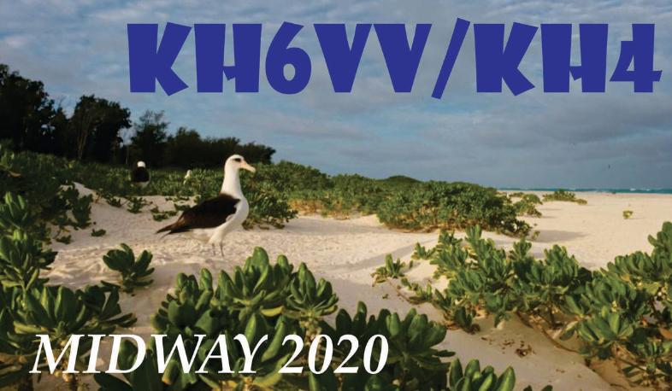

We've all seen the latest pandemic news, it's not progressing in a good direction or anything like the earlier predictions. The U.S. now has 132,000 deaths and the forecast is for 200,000 by November. We have encountered a strong and understandable pushback related to the original operation date of October 2020. Once the posability of moving the operation to the second half of February 2001 the conversation turned more positive. The application for the Special Use Permit for Midway has now been edited and now proposes a period of the second half of Feburay and will be submitted this week.

Two things now need to happen:

1. We need more operator interest.

2. We need more donations to the expedition PayPal page. ([KH6VV@outlook.com](mailto:KH6VV@outlook.com))

Mahalo Ron KH6DV

***DX News***

***ARLD029 DX news***

This week's bulletin was made possible with information provided by The Daily DX, the OPDX Bulletin, 425 DX News, DXNL, Contest Corral from QST and the ARRL Contest Calendar and WA7BNM web sites. Thanks to all.

**BRUNEI, V8.** V84SPU will celebrate the 74th birthday of His Majesty Sultan Haji Hassanal Bolkiah Muizzaddin Waddaulah. Activity will be from July 18 to 31 on all bands and modes. QSL direct only.

**UNITED ARAB EMIRATES, A6.** To commemorate the launch of the Mars "Hope Probe" and the 50th anniversary of the union of the UAE, special event station A60EMM will be QRV with multiple stations (i.e. A60EMM/1 /2, etc.) QSL details are on qrz.com.

**FINLAND, OH.** From July 17 to 30, Ric, DL2VFR plans to be QRV as OH73ELK, mainly on CW. QSL via the OH QSL Bureau.

TOP ^

**BOSNIA AND HERZEGOVINA, E7.** Members of the Nikola Tesla Radio Club are celebrating Tesla's 164th birthday with the call sign E7TESLA until July 20. QSL via E77E direct or via the Bureau or eQSL.

**HUNGARY, HA.** The Hungarian FIRAC group is active with the call sign HA70MAV until December 1. QSL via LoTW or eQSL.

**ITALY, I.** Members of the Italian Naval Old Rhythmers Club

(I.N.O.R.C.) will be using the call sign II0ICEH from July 18 to August 1 to commemorate the Andrea Doria disaster. QSL via Bureau.

**OGASAWARA, JD1.** Takashi, JH1FFW is QRV as JD1/JH1FFW until July 19 on 40 to 6 meters using SSB and FT8. QSL via the Bureau to his home call, LoTW or eQSL.

**UNITED STATES OF AMERICA, K.** The Grayson County Amateur Radio Club commemorates the Red River Bridge War of 1931, a boundary conflict between Oklahoma and Texas, with the call sign W5I from July 18 to 26. QSL via K5GCC direct or via the Bureau, LoTW or eQSL.

**BULGARIA, LZ.** George, LZ2VP is QRV as LZ77VP until the end of July.

QSL via LZ2VP.

**GREECE, SV.** Members of the Radio Amateur Association of Western Peloponnese (RAAWP) are dedicating the special event call sign SX3SP to the memory of Saint Paisios of Mount Athos, until July 31. QSL via LoTW or eQSL.

**DODECANESE ISLANDS, SV5.** Stathis, SV5DKL plans to participate in the RSGB IOTA Contest, July 25 and 26, in the single-op, all-band, CW, High-power category from his home station on Rhodes Island. QSL via his home call. After the contest he will upload to LoTW, Club Log and eQSL.

**TAIWAN, BV.** BX2AB is planning to operate as BV0WPX from the PengHu Islands during the RSGB IOTA Contest, July 25 and 26. He will be single-op assisted. QSL via BV2KI. Also, Bruce, BV2KI will be QRV in the contest as BV9AYA. He will be single-op assisted. QSL via home call.

**GHANA, 9G.** Matteo, IZ4YGS travels to Ghana on July 24. After quarantine he will be at his station starting August 8 and continuing until mid-September as 9G5GS. QSL via OQRS, LoTW, eQSL or direct to the IZ4YGS address.

**TURKEY, TA.** YM9SIX is a new six meter beacon, running five watts to a vertical on 50.403.5. It is located at the QTH of TA7OM in grid KN80. Testing is underway. It appears it may be moved to grid LN10 and another frequency at some point.

**FRANCE, F.** Station TM11AD will be operated by the British Breakout from Normandy Museum in its annual liberation festival, on August 1 and 2. Look for them on HF CW, SSB and digital modes. They are hoping to use genuine WWII era gear and demonstrating it to the public. QSL via F4KKE, LoTW or Club Log.

**MALTA, 9H.** Reiner, DL2AAZ plans to be QRV from September 4 to 18, holiday style, if there are no COVID-19 concerns. Call signs 9H3TI and 9H3SAT have been requested. He will be QRV on 40 to 6 meters and 13/3cm on the QO-100 satellite, using SSB and CW. QSL via the Bureau, no Club Log or LoTW.

TOP ^

**UKRAINE, EM44.** Look for EM44L to be active from the Regional Landscape Park "Feldman Ecopark" (URFF-0194; New One) on July 18 and 19. QSL via UT5LU.

**SVALBARD, JW.** Erwann, LB1QI will be active as JW/LB1QI from the JW5E club station in Lonyearben from September 24 to 27. Activity will be on 160 to 6 meters using CW and SSB. QSL via LB1QI, direct, by the Bureau, LoTW or ClubLog.

**THE NETHERLANDS, PA75.** Special event station PA75WSN will be active until the end of the year to commemorate the 75th anniversary of the liberation of The Netherlands in World War II. Activity will be on various HF and UHF bands using SSB and the Digital modes. QSL via the Bureau or direct. See QRZ.com for details.

**RUSSIA, UE45.** Members of the Fifth Ocean Club are active as UE45SA until July 19. Activity is to celebrate 45th anniversary of Apollo-Soyuz joint mission in space. Operators are Victor, RV3YR and Viktor, RN3YN and R3YC. QSL via RV3YR, direct, via the Bureau or Clublog. See qrz.com for more details.

**FT8DMC ANNIVERSARY.** More special call signs celebrating the 3rd anniversary of the FT8 Digital Mode Club, until July 31 include CB3DMC, XR3DMC and XR3FT8 from Chile (QSL direct to CE3GCA); GB8DMC from England (operated by G8LIY, QSL via qrz.com, and OZ8FTDM from Denmark (operated by OZ1KZX, QSL via LoTW and eQSL).

THIS WEEKEND ON THE RADIO. The Russian Radio Team Championship, Trans-Tasman Low-Bands Challenge, Feld Hell Sprint, North American QSO Party, RTTY, CQ Worldwide VHF Contest, RSGB Low Power Contest, Run for the Bacon QRP Contest and the CQC Great Colorado Gold Rush are all on tap for this weekend. The SKCC Sprint is on July 22 and the RSGB 80-Meter Club Championship, Data is on July 23. Please see July 2020 QST, page 74 and ARRL Contest Calendar and WA7BNM Contest Web Sites for details.

**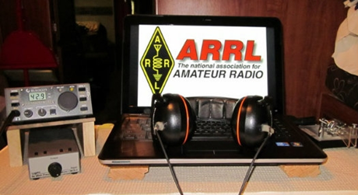*ARRL Contest Corner***

An expanded, downloadable version of *QST'*s’[**Contest Corral**](http://www.arrl.org/contest-calendar) is available as a PDF. Check the sponsor's’Web site for information on operating time restrictions and other instructions.

####

***We're making several changes for the 2020 Ohio QSO Party:***

1. We're adding 160 meters. Based on 160 meter activity in other QSO Parties I don't expect this to make a huge difference, but it should provide an opportunity for some "fresh meat" QSOs when things get slow late on Saturday night.

2. We're dropping the "One station/one call" rule. So you can also use a club call or other call for an additional entry, to enjoy being a new station while making more QSOs possible for others. This is intended to allow more potential QSOs for everybody, not as a way to inflate scores of friends.

TOP ^

We hope you all will join us for the 2020 OhQP on **Saturday, August 22**, from noon to midnight EDT (1600z - 0400z) !

73  -   Jim   K8MR - OhQP Chairman

***Special Events***

* **07/20/2020 | EAA Airventure 2020 - EVENT HAS BEEN CANCELLED**

**Jul 20-Jul 25, 1300Z-2030Z, W9ZL**, Appleton, WI. Fox Cities Amateur Radio Club. 50.150 14.270 7.240. Certificate. W9ZL Special Event, P.O. Box 2346, Appleton, WI 54912. Starting on Monday July 20 through Sunday July 25 2020 the W9ZL EAA Airventure Special Event Station will be on the air. We will be operating from 1300 UTC to 2030 UTC Monday through Saturday, and 1300 UTC to 1700 UTC on Sunday July 25 2020.

We will be operating on 14,270, 7,250 and 50,150. EVENT HAS BEEN CANCELED [www.fcarc.club](http://www.fcarc.club/)

* **07/23/2020 | HamExposition New England THIS EVENT HAS BEEN CANCELLED**

**Jul 23-Jul 26, 0000Z-2359Z, W1UE**, Marlborough, MA. HamExposition Committee. 14.250 14.030 7.200 7.030. QSL. LoTW or Dennis G Egan, W1UE, 166 Wilson St., Marlborough, MA 01752. THIS EVENT HAS BEEN CANCELED [w1ue73@gmail.com](mailto:)

* **07/25/2020 | In Remembrance of the 305th Anniversary of the Spanish 1715 Treasure Fleet, lost in a hurricane on their way to Spain.**

**Jul 25, 1300Z-1900Z, W4OT**, Vero Beach, FL. Vero Beach Amateur Radio Club . 14.327; D-STAR Ref078C. Certificate. Vero Beach Amateur Radio Club c/o IRC EOC, 4225 43rd Ave., Vero Beach, FL 32967. [w4ot.webs.com](http://w4ot.webs.com/)

* **07/25/2020 | NSS 79th annual Convention**

**Jul 25-Jul 31, 1800Z-1800Z, K8V**, Elkins, WV. National Speleological Society. 14.285 14.050 7.195. QSL. Sam Rowe, 2749 Commercial Ave, Madison, WI 53704-4868. CW, slow speed, Saturday only. [www.nss2020.caves.org](http://www.nss2020.caves.org/)

* **07/31/2020 | Sheboygan Brat Days**

**Jul 31-Aug 2, 1700Z-0100Z, W9B**, Sheboygan, WI. Sheboygan County Amateur Radio Club. 14.240 7.240. Certificate. Sheboygan County Amateur Radio Club, c/o Steve Eisold, 4235 N. 29th St., Sheboygan, WI 53083. 67th Annual Sheboygan Brat Days, celebrating the sausage that made Sheboygan famous! 14.240, 7.240 - noon to 8:00 p.m. CDT Friday and Saturday. Certificate only: W9VCL Sheboygan County Amateur Radio Club, 4235 N. 29th Street, Sheboygan, WI 53083. Please include $2.00 for 8-1/2x11 mailed in manila envelope or send $1 and SASE #10 (certificate will be folded). More information: [https://www.w9vcl.com](https://www.w9vcl.com/)

* **08/01/2020 | Pro Football Hall of Fame Enshrinement Festival - THIS EVENT HAS BEEN CANCELLED**

**Aug 1-Aug 9, 0000Z-2359Z, W8AL**, Canton, OH. Canton Amateur Radio Club. 14.300 14.030 7.250 7.030 3.950 3.530 (Watch for FT8 or other digital modes); BM DMR 313989. Certificate. Canton ARC - W8AL, C/O: Justin W8JKC, PO BOX 8673, Canton, OH 44711-8673. THIS EVENT HAS BEEN CANCELED [www.w8al.org](http://www.w8al.org/)

TOP ^

* **08/01/2020 | W5G : OK Green Corn Rebellion 103rd Anniversary**

**Aug 1-Aug 14, 0000Z-2359Z, W5G**, Edmond, OK. KG5JST. 14.074 7.078 7.074. QSL. James M Branum, KG5JST, P.O. Box 721411, Oklahoma City, OK 73172. This special event station will be operating field day style from several locations in Oklahoma (including at some of the sites of the events of the Green Corn Rebellion of 1917). I primarily will be on FT8 and JS8Call but also will be doing some voice (SSB and FM). QSL via LOTW, QRZ.com or by postal. A special QSL card will be sent to anyone who asks for one, including SWLs. [greencorn.org/w5g](http://greencorn.org/w5g)

* **08/02/2020 | River City Days**

**Aug 2, 1400Z-2020Z, W0R**, Red Wing, MN. Hiawatha Valley Amateur Radio Club. 14.250 7.250 147.300. Certificate. Bill Eichenlaub, 1966 Launa Ave, Red Wing, MN 55066. This is a celebration of the Mississippi River and what it has done for this river town. [hvamateurradioclub.com](http://hvamateurradioclub.com/)

***“ARES Connect”***

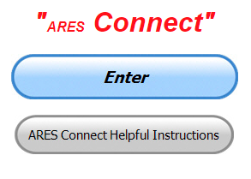

***Connecting Amateur Radio Volunteers with a Purpose***

ARES Connect is ARRL's newest tool and it's not just for ARES personnel anymore. It's a total management recording system that allows a more robust and efficient way of managing ALL of our Amateur Radio volunteers throughout the country.

The ARRL has long recognized that it can be a difficult and a challenging process to properly manage our volunteers and all of their activities in this fast paced and ever-changing world. For this reason, the ARRL has partnered with VolunteerHub in creating the ultimate assistant - "ARES Connect"

This is an event-based system that frees up our county, district and section managers time by electronically recording all of our events, volunteers and their credentials as well as their volunteered time, all in one place. This system replaces the need for our managers to manually keep track of their volunteers. And, since this is a web based application, all of the records are kept in the clouds, secured and distributable by only persons with the proper credentials, making the transfer of those records quick and easy to do during times of manager transitions.

ARES Connect gives our entire leadership the easy ability to promote their events throughout their entire section, reduce scheduling conflicts of upcoming activities and making it easier for us to manage our volunteer resources more effectively. It gives us a much more robust way to monitor our volunteers as they register for and record their time utilizing the latest "on-line" applications that can be quickly setup and utilized in the field on any computer, smart phone or tablet. The reports generated by these applications contain a wealth of information that can be easily shared with our served agencies instantaneously, as this system utilizes "live data."

Having this tool saves our leadership much valuable time, reduces their workload, keeps permanent records of our activities, and volunteered time, volunteers and their credentials, as well as has the ability to mass or selectively email our volunteers when needed.

TOP ^

By utilizing the most advanced up to the minute data gathering processes, ARES Connect has dramatically changed our reporting abilities from a labor intensive monthly overview, to a very detailed and up to the minute report that can be generated at any time by our leadership.

**You do not have to be an ARES or ARRL member to use this system. All licensed amateur radio operators throughout the country are welcome.**

**Everyone –** please make sure to go into all of the events that you have signed up ***for and get your hours registered no later than 5 days after the event has ended****.*

Folks, I’m seeing a lot of folks that have signed up for events not entering their time after the event. This is a very important piece of using “Connect.” Your hours need to be recorded and it’s so easy to do.

Let’s run through how so in case you have forgotten. If you have already gotten signed up for an event, all you have to do afterword to get your time entered is at any time after the event has ended, log into “Connect.” And then click on your name in the upper right-hand corner of the page. This will bring up a drop-down menu where you will then click on “View Hours.”

This brings up another screen where you can “Report Hours” as well as “View Hour History” You’ll want to click on “Report Hours.” You will then be presented one at a time by chronological order each event that you have signed up for and hours have not yet been reported on.

Type in those hours in the “Hours Worked” box and hit “Submit”… Keep doing this until you have no more hours to report…. That’s all there is to it. Now, if you are following the request above and doing this at least every 5 days or more often, this will only take you a minute or so to complete.

***Here’s are the top 10 hours earners so far the month of July:***

|  |  |  |  |
| --- | --- | --- | --- |
|  | **Name** | **Events** | **Hours** |
| **1** | Dwight Bonifield (W8TJT) | 100 | 101.90 |
| **2** | Dan Stahl (KC8PBU) | 55 | 66.91 |
| **3** | Christopher Domenick (KC8CAD) | 17 | 54.45 |
| **4** | Leo Dubois, Jr. (KE8OOS) | 29 | 53.00 |
| **5** | James Yoder (W8ERW) | 10 | 49.91 |
| **6** | Alan Rothweiler (N8CJ) | 16 | 47.50 |
| **7** | Daniel Schlick (KB8LKH) | 13 | 39.50 |
| **8** | Bret Stemen (KD8SCL) | 26 | 36.00 |
| **9** | Elmer Thomas (KE8HNK) | 37 | 33.75 |
| **10** | Joseph Wigal (W8JTW) | 30 | 32.25 |

**Let’s get everyone in the Ohio Section on “ARES Connect!!!” Simply go to:** <https://arrl.volunteerhub.com/lp/oh/> and get yourself registered and using the system.

TOP ^

***Hey County and District E.C.s…***

Do you want a listing of all your volunteers registered in ARES Connect? Would you like to have a report by hours for your county? Let me know, these reports can be generated very quickly and easily for you. All you need to do is ask. Let me know if you want a report run… email me at: [n8sy@n8sy.com](mailto:n8sy@n8sy.com)

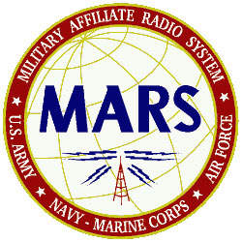***MARS Announces HF Skills Exercise***  
Members of the Military Auxiliary Radio System (MARS) will conduct an HF skills exercise **July 20 – 24** to hone their operating skills and messaging-handling capabilities.

MARS members will be reaching out to the amateur radio community via  the 60-meters Channel 1 Net (5330.5 kHz dial) twice a day, the SATERN HF  net (14.265 MHz), and by contacting various stations via HFLink  throughout the exercise.

MARS members will be requesting assistance with collecting county status information as well as airport weather information, called METARs. MARS members will also be passing ICS 213 messages to numerous Department of Defense (DoD), federal, and amateur radio addressees.

This exercise will be announced via WWV at 00:10 and via WWVH at 00:50 starting on or about July 13. WWV and WWVH listeners will be asked to take an online listener survey. This HF radio training event will not impact regular communications. — Thanks to Paul English, Chief, Army MARS

####

***One Question Questionnaire***

Hey Gang,

“Survey Says”….. Only about 59**%** of us have a fire extinguisher in our shacks. Wow… This is not a good percentage. Please, if you don’t have one, get one. They’re the cheapest investment that you can make for protecting your equipment from being lost in a fire!

Ok, now, on to next question… Let’s find out how many of you practice good fire prevention procedures in your shack. So, the next question is…

***“Are You Up-To-Date with your First Aid Training ??”***

You’ll find the “One Question” questionnaire on the Ohio Section Website! <http://arrlohio.org> It’s all in fun and it’s not a scientific survey in any way, but we are learning some things that we didn’t know from these questions. I hope that you are enjoying answering these “One Question” questionnaires.

TOP ^

***V.E. Test Sessions***

**

Many V.E.’s have decided to start testing once again, but with restrictions that need to be adhered to for sure. Here’s the link to find that V.E. Test session and what is expected of YOU before going. <http://www.arrl.org/find-an-amateur-radio-license-exam-session>

####

***Lake County ARA Holding V.E. Testing in August***

Lake County ARA will be holding a V.E. Test Session on **August 1st** at the Lake County Metroparks – Chapin Forest Reservation. The address is: 9938 Chillicothe Road (Rt 306) - Quarry Shelter

Chapin Forest is 3.3 miles south of I-90 on Route 306, in Kirtland. The park is on the west (the right side going south) of 306. The Quarry Shelter is almost immediately on the right as one enters the reservation.

The tests will start at **12 noon.** Please arrive a few minutes earlier. Pre-registration is suggested, although we hope to have plenty of seats available.

To register, you will need the NCVEC 605 Form, which will be available at the test. If you would like to complete one ahead of time, be sure it is the Sept 2017 version or later. You can find it by Googling “NCVEC quick-form 605” and clicking on the url for a pdf of the form.

Be sure to bring **the original and a copy of both your license** **and any CSCEs you may have to the exam.** The cost is $15.00, and if you wish to pay by check, it should be made out to the ARRL/VEC. Identification with your picture is also necessary, such as a driver’s license. To pre-register, or if you have any questions, please contact Scott Farnham, KO8O, at (440)256-0320, or [scottfarnham@roadrunner.com](mailto:scottfarnham@roadrunner.com)

***Final.. Final..***

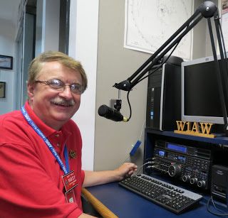Hi Gang,

Wow… another a hot week last week! Please be sure to keep yourself hydrated. Drink lots of fluids and remember heat prostration and heat stroke are something to keep at the top of your mind when outside or even working hard inside when the temperature is this hot.

I don’t know about you, but here in the big metropolis of Lexington we haven’t had a drop of rain for many weeks now. The grass and other plants have all but shriveled up and now dying off. I want to remind all of you that this is not the time to have a campfire going, at least around here! I know that we’ll all be wishing for warm weather come about January / February for sure!

TOP ^

Ok, moving on to another subject… ARES Connect comes to mind. Have you looked at the breakdown per county on the ARES webpage? There is a listing posted per county of the hours recorded in ARES Connect. These are the hours of actual volunteers and not anonymous hours. Want to see how many hours your county has gotten so far?

Go to… <http://arrl-ohio.org/SEC/ARES-Connect-County.html> This page is updated regularly, so you can see

what is happening in real time in your county. Don’t see hours recorded in your county? That’s because you haven’t done your part and gotten your time recorded. Don’t know how? Let me know, I’ll teach you everything that you need to know to get you started.

Have you seen the latest Section Emergency Coordinators report? If not you can view it by going to:

<http://www.arrl-ohio.org/SEC/reports/2020/ARES%20Connect%20Monthly%20Report%20-%20June%202020.pdf>

Whelp, my final go around before gong QRT… Stay safe my friends! I want to see all of you soon at a meeting or hamfest! We will get through this and when we do, we’ll have so much to talk about. Most of all… have FUN and get on the airwaves!!

73,

[***Scott, N8SY***](mailto:n8sy@n8sy.com)

***ARES CONNECT Update: Connecting Amateur Radio Volunteers with a Purpose***

The ARRL's ARES Connect tool is not just for ARES anymore: It's evolved to become a robust and efficient data entry/retrieval portal, report generator and management system for *all* Amateur Radio public service volunteers.

ARES Connect is a data base that allows leadership officials such as Section, District and county Emergency Coordinators to register events and profile volunteers -- their capabilities, training experience, certifications, credentials, and service hours. It renders obsolete the need for leadership teams to manually keep track of their volunteers. With this web-based application, all records are kept in the cloud, secure but easily accessed by administrators when needed.

Leadership teams have the ability of promoting their events and reducing scheduling conflicts of upcoming activities, making it easier to direct volunteer resources more efficiently. The ARES Connect application can be quickly setup and used in the field on any PC, smart phone or tablet. The reports generated by ARES Connect contain a wealth of information that can be easily shared with our served partner agencies instantaneously.

**Our Volunteers**

"New Volunteers" who sign-up for an account on the system are held for Administrators to properly vet. Once vetted, they are assigned to a county and district, and can then upload their profile information, sign-up for events and get their volunteer time recorded for those events. Service points are compiled by the system for the volunteers and coordinators to monitor and issue awards, etc.

TOP ^

**ARES Connect is for All Volunteers, not just ARES**

Some volunteers are members of other groups such as RACES, CERT, etc., and harbor the misconception that ARES Connect is an ARES-only service. *This is not true*. ARES Connect is for *all* amateur radio operators engaged in public service. Note, however, that a volunteer signed up for ARES Connect does not automatically become an ARES member-registrant in an ARES group. Registration of an ARES member is still the decision of the local Emergency Coordinator and/or District Emergency Coordinator as it has always been.

**ARES Connect Features for Leadership Officials**

Section, District, county Emergency Coordinators:

1. You can keep your ARES member data separate from data for other program (such as RACES) volunteers, yet still combine both groups' information in your reports when needed.

2. You can quickly check what level of training each volunteer has been vetted for based on their training records and other documents within their personal profile. You can setup events for your ARES team separately or include all operators within your county/district. The system can send email notifications and confirmations to your volunteers when they register for an event, as well as send reminders at a pre-set date or time when the event is about to happen. The system can send "thank you for your service" emails after the event with a link to where the volunteer can log their service time (number of hours worked).

3. You can easily setup recurring events and link your regular attendees to those events, saving your volunteers' time by already having them registered. All they have to do is record their time. If your Administrators have opted to use the "Events Monitor" selection, your volunteers have the ability to go back in time and post-register and post their service hours to any event in the past. This option also allows your volunteers to register themselves to recurring events such as weekly or monthly nets and meetings.

4. There's a "Kiosk" function that allows the volunteer via a QR Code to check into an event (eg., meeting or race). By using the Kiosk mode, the volunteer is automatically recorded, nothing further is required for the volunteer or Administrator to do.

**ARES Connect Reports**

ARES Connect allows ARRL leadership officials to keep track of volunteers, documents such as FEMA ICS course completion certificates, and generate reports quickly with accountability while maintaining flexibility and uniformity across all 71 ARRL sections in the country. Just about any kind of report can be generated from the data gathered from ARES Connect for use by ARRL HQ, served partner agencies and others, rendering the old reporting and forms submission obsolete.

**Other Benefits to Using ARES Connect**

ARES Connect gives you the ability to monitor for, highlight and recognize volunteers who are especially active, reporting high numbers of hours served and/or events worked. A "Top 10" listing for hours logged is published on the ARES Connect dashboard. Every few months the operator with the most hours volunteered receives a certificate or gift of some kind, a great way of rewarding volunteers for a job well done. The data also assists the SEC, EC or DEC, in detecting areas of inactivity where improvement/help might be needed.

Leadership officials can also efficiently share the data and reports with local, regional or state EMA Directors or County Commissioners, demonstrating the breadth, depth and value of your volunteers' services rendered.

TOP ^

Another efficiency derived from using ARES Connect is that monthly reporting by your ECs and DECs is no longer necessary; even the monthly report to ARRL Headquarters is no longer required. ARES Connect contains the reporting data automatically, which can be downloaded and/or queried at any time by those needing it.

For examples of reports that can be generated, see <http://arrl-greatlakes.org/ac.html> for an entire division report. By visiting <http://arrl-greatlakes.org/ac2.html> you can see the report of the division's sections. In another example, data can be filtered down to the county level -- see [http://arrl-ohio.org/SEC/ARES Connect-County.html](http://arrl-ohio.org/SEC/ARES-Connect-County.html) These dashboards are all derived from data obtained directly from ARES Connect.

There are currently over 14,000 registered users in the system. Sign up for the section in which you reside by using the following format (substitute your section's official 2- or 3-character abbreviation for "nfl," which is the Northern Florida Section). <http://nfl.arrl.volunteerhub.com/> -- *Scott Yonally, N8SY, ARRL Ohio Section Manager*

***Welcome New Subscriber(s)***

**Ted, W8DIC; Raymond, W8CSM**

***Swap & Shop Has Added Club Raffles To Its Listings On The Webpage***

Hey Gang,

Have you taken a look at the **Swap & Shop** page on the Ohio Section webpage yet?? Here’s a link that will take you there…

<http://arrl-ohio.org/sm/s-s.html>

Do you have equipment that you just don’t need or want anymore? Here’s a great venue to advertise it, and it’s FREE!!

Is your club doing a fund raiser to help raise money? After a lot of thought, it was decided that the Swap & Shop webpage could also contain these types of items as well.

The same rules will apply as do for the For Sales and Give-A-Ways and will only be posted for a month at a time. Please see the Terms & Conditions on the webpage.

If your club is doing a fund raiser and wants more exposure, please forward the information to me and I’ll advertise it on the Swap & Shop webpage for you. Now, I still want to remind you that it won’t be listed in this newsletter because it would take up way too much space, so your ad will only appear on the website. It is there for any individual to post equipment Wanted / For Sale or Give-Away as well as for Club Fund Raisers. No licensed vehicles/trailers or business advertising will be posted.

Postings are text only (no pictures or graphics) will be posted for a maximum of 1 month from date posting and require a contact phone number or email within the posting. Send your Wanted / For Sale or Give-Away post to:  [swap@arrlohio.org](mailto:swap@arrlohio.org)

TOP ^

***Want to Share your Club Newsletter With Others?***

We have a webpage where you can download and read all of the newsletters that I get from around the state and even other sections!

Here’s the link to the page…. <http://arrl-ohio.org/club_news/index.html>

Please, if you don’t see your club newsletter posted, it’s because I’m not receiving it. Just have your newsletter editor contact me and I’ll get your club’s newsletter listed on the site!!

We all learn and steal (I mean, share) from each other’s work. So, get me your newsletter!!! Send it to: [n8sy@n8sy.com](mailto:n8sy@n8sy.com)

***Back Issues of the PostScript and Ohio Section Journal***

Hey, did you know that PostScript and Ohio Section Journal (OSJ) are archived on the website? You can go back and look at any edition simply by clicking:

<http://arrl-ohio.org/news/index.html>

Ohio Section Cabinet

|  |  |
| --- | --- |
| Section Manager – Scott Yonally, N8SY | Assistant Section Manager – John Perone, W8RXX |
| Section Emergency Coordinator – Stan Broadway, N8BHL | Section Traffic Manager – David Maynard, WA3EZN |
| Technical Coordinator – Jeff Kopcak, K8JTK | Affiliated Clubs Coordinator – Tom Sly, WB8LCD |
| State Government Liaison – Bob Winston, W2THU | Public Information Coordinator – John Ross, KD8IDJ |
| Section Youth Coordinator – Anthony Lascre, K8ZT | |

TOP ^

***Chit – Chat, and All That!***

Do you know someone that’s not getting these Newsletters? Please, forward a copy of this Newsletter over to them and have them “[Opt-In](mailto:Opt-In)” to start receiving them. Heck just have them send me an email [n8sy@n8sy.com](mailto:n8sy@n8sy.com) and I’ll get them added to the Ohio Section Emailing list.

We now have many thousands of readers receiving these newsletters weekly. Quite impressive, I’d say! I urge all of you to make sure that everyone, regardless of whether they are a League member or not, get signed up to receive these weekly Newsletters.

You can always “Opt-Out” at any time if you feel this is not what you were expecting. It’s fun and very informative. All of your favorite past newsletters are now archived too.

You can go back at any time and read them. Just go to: <http://arrl-ohio.org/news/>

Got questions, concerns or would just like to sit and chat awhile? Heck, I’ll even buy the coffee!! Give me a call at (419) 512-4445 or email me at: [n8sy@n8sy.com](mailto:n8sy@n8sy.com)

The pictures on the front page and throughout this newsletter are from various newsletters, Facebook posts and/or were sent directly to me in recent weeks. Take a good look at them, you just might be in one of the pictures! “SMILE… you’re in the Ohio Section News!!”

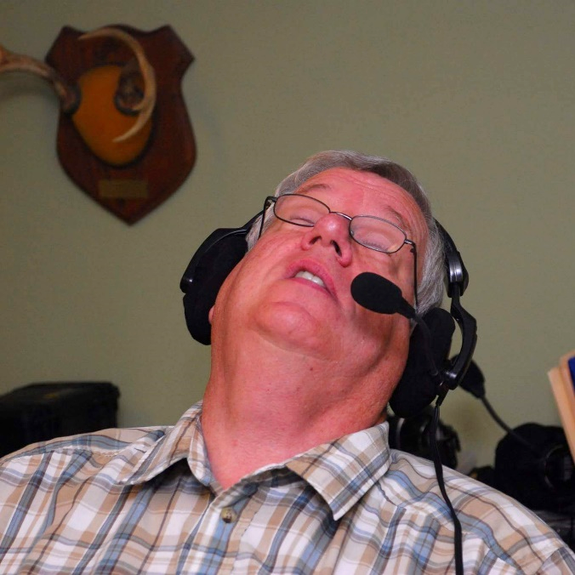

TOP ^

***Yes, we’ve finally come to the end!!!***

*PostScript is produced as a weekly newsletter. I want to thank everyone that has contributed articles and ideas to make this an even better news source. I sincerely hope that you have enjoyed this edition and will encourage your friends to join with you in receiving the latest news and information about the Ohio Section, and news and events happening around the world!*