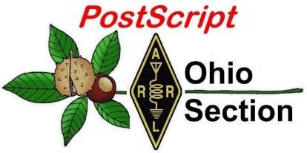
July 13th

Edition

National News The Handbook Give Away

Club Corner Hamfests

DX This Week ARES Connect

VE Testing One Question Questionnaire

Final.. Final..

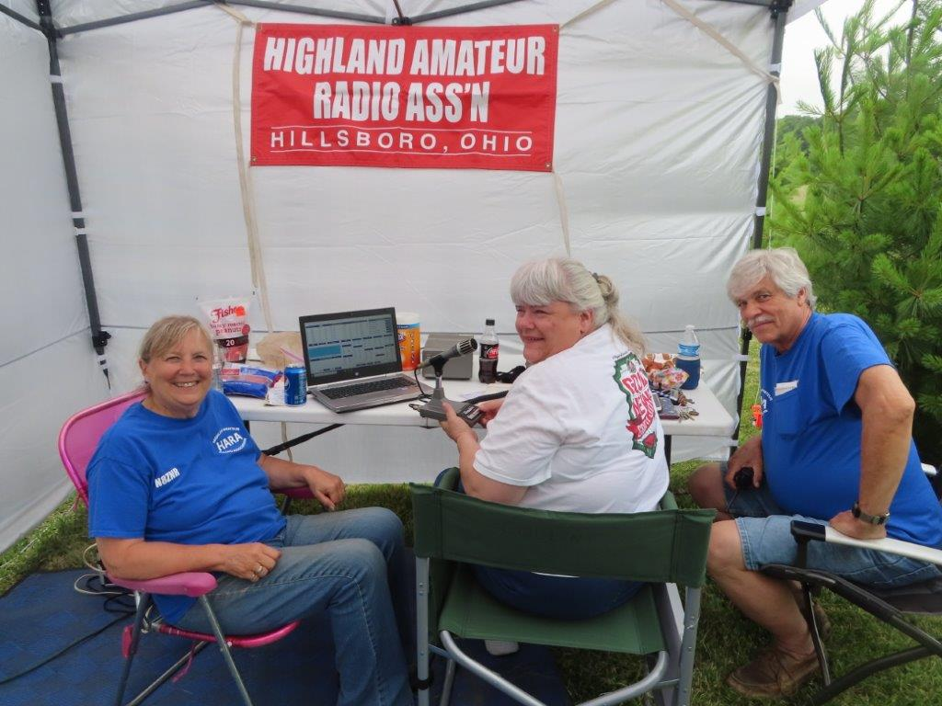
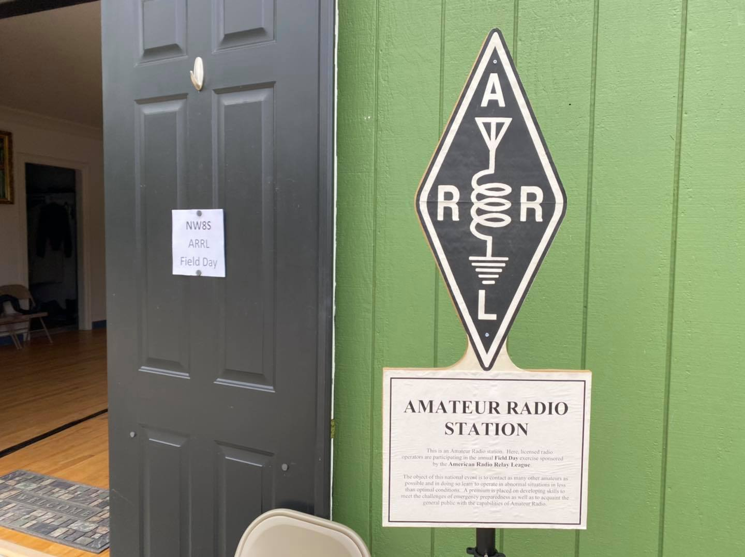
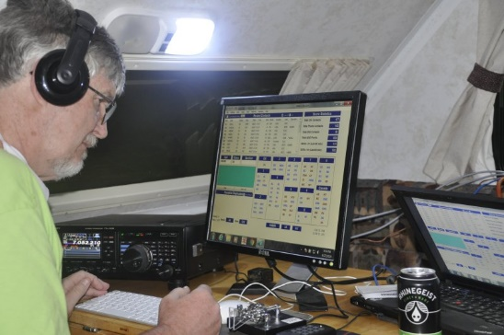
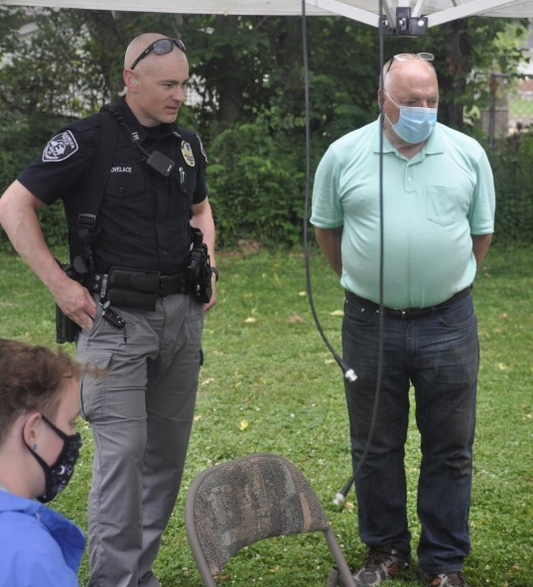
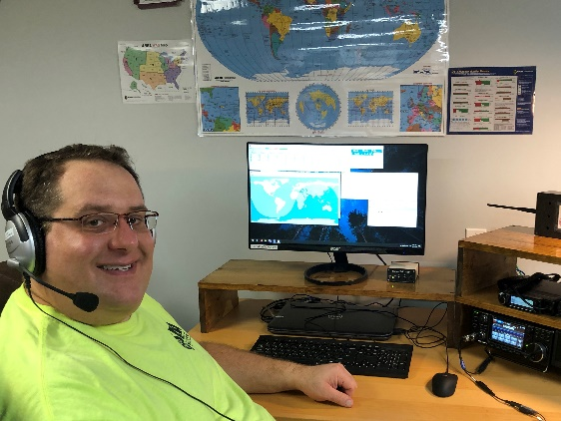

National News
(from arrl and other sources)

Hamilton County, Ohio ARES
Amateur Radio Emergency Services - “When All Else Fails”
---------------------------------------------------------------------------------------------

Radio Operators Assist at Covid-19 Test Sites
Justin Patrick Moore, KE8COY

Cincinnati, Ohio – Area communications operators lend support at Covid-19 testing sites. Ham radio operators from the Hamilton County Amateur Radio Emergency Service (ARES) are working with the Hamilton County Health Department (HCHD) to monitor the weather at outdoor testing sites. They are also there to provide an extra communications link for the people on the ground back to HCHD, where there is a dedicated ham radio station.

ARES members who are trained SkyWARN Spotters are monitoring the local weather for potential impacts that could affect the safety of the participants at the COVID-19 testing sites. These Hams will be on site during the next several weeks, sharing weather information with HCHD administration. This allows the admin team to focus on the operations of the site while knowing that someone is keeping a watchful eye on the weather conditions, ready to relay and alert as necessary.

One such incident occurred on Tuesday, June 30. At approximately 3:30 pm HCHD administration and local officials decided to pause testing due to lightning detected in the area. Based on additional information provided by Ham operators, health officials continued the pause until the local area was clear of threatening weather. This ‘real time’ weather information is critical and adds an extra layer of support and safety to workers and visitors. All in all, ARES is projecting to put in hundreds of volunteer hours assisting the HCHD during this pandemic crisis.

In anticipation of the further use of their volunteer services ARES has begun conducting exercises in the event they are needed for communications should a vaccine for Covid-19 be developed. In this potential situation radio operators would be located at the Health Department PODs (Point of Dispense) to again serve as a backup link between the staff at the site and a communicator at the station in the Health Department. To prepare they have started by running a tabletop exercise over Zoom to assess their equipment needs and discuss any challenges that may be involved for radio communication between sites. This is to be followed by actual testing of radio capabilities between sites in the field to ensure they will be ready to serve their community in time of need.

Justin Patrick Moore, PIO HamCo ARES
4211 Chambers St.
Cincinnati, OH 45223
Justinpatrickdreamer@gmail.com
(513) 508-5651 C
(513) 541-6373 H

####
TOP ^
Invited guest presenters will cover topics from three categories:
- Personal Communications - like getting started in the digital modes, or radio sport
- Emergency communications - like tips for public service communication volunteers
- Radio electronics and technology - like QRP kit building, or understanding propagation

Presentations should be short; 30 minutes plus a 15 minute Q&A. Presenters will use live video to share their knowledge, advice, smiling faces, PowerPoint slides, screen-sharing, or other demonstration items. If you've given a forum, you already know what to do! Presentations will also be recorded, so members can view these any time afterwards.

Its easy to get started. Complete the online Speakers Form:
www.arrl.org/ARRL-Learning-Network-Speakers-Form

Selected presenters will be contacted and invited to schedule their webinar from a list of upcoming available date/time slots. An ARRL staff member will help coordinate the details with you, so you'll be ready for your presentation day!

Thank you. Together we're advancing the art, science, and enjoyment of amateur radio!
73,
ARRL Learning Network

Bob Inderbitzen, NQ1R - Product Development Manager
Tel: (860) 594-0213 FAX: (860) 594-0303
rinderbitzen@arrl.org

####

TOP ^
County Information Report Project 20 Underway
(from C. Matthew Curtin KD8TTE)

The Ohio Section has begun a program of training the Field Organization for large-scale emergency operations. The County Information Report Project 20 is an effort to establish radio-only messaging throughout the entire Ohio Section, useful both to support county ARES programs, and the organizations the volunteers of those programs serve. Be sure that your county is participating, that you are supporting your county in this effort. If your county does not have an Emergency Coordinator (EC), find your District EC (DEC) to see if you can provide support at the District level, whether a neighboring county might have a program you can join, or what else might make sense for you to do.

Before we get into the program itself, I want to establish a basic common operating framework for ARES in the Ohio Section. How can we provide effective radio communication on a volunteer force? A few key principles of program design and operation follow.

- Licensed radio amateurs provide volunteer support of these organizations’ operations, typically in auxiliary communications roles, providing highly-resilient communications that will work even when primary means (phone, Internet, commercial radio) fail.
- The radio amateurs are trained and organized in the Amateur Radio Emergency Service (ARES) program of the American Radio Relay League (ARRL).
- ARES organizations are organized at the county level, establishing and maintaining relationships with the government agencies and non-government organizations that provide humanitarian aid, disaster relief, and public events in the area.
- Volunteers living in the areas that they serve are likely also to suffer the same impacts as their neighbors, limiting their ability to provide volunteer service.
- County-level ARES programs are supported by one of ten Districts, groups of counties in the area, allowing for volunteers to be supported by similarly-trained and similarly-equipped volunteers who can provide additional personnel and equipment as needed.
- Districts are in turn supported by the Section, which can draw similarly-trained and similarly-equipped volunteers from anywhere in the State.

We understand this when thinking about large events like marathons, air shows, or other events that have tens of thousands or hundreds of thousands of people involved and where upwards of 100 ARES operators may be active.

There is a different case for us to consider, though: where only perhaps a half-dozen or a dozen radio operators may be active in the county, but the county needs to communicate with others outside of the county. This is a model that we’ve built and tested repeatedly in the Ohio Section: where county EMAs can join a net with the State EMA. Where there is a small amount of tactical information that needs to be quickly exchanged among a couple of stations, where others can be standing by, that model can work effectively, as we’ve seen with the relay of severe weather information from local SKYWARN nets through a Section-wide ARES net to the Ohio Emergency Operations Center Watch Desk.

What we saw in the May 30 exercise, though, where ARES operators acted in service not of county and state EOCs, but on behalf of Red Cross shelters and clearinghouses, was a different model entirely. We didn’t have a large number of stations, most with nothing to do, but a large number of stations, and a certainty that all would need to be able to send and to receive messages.

TOP ^
In that exercise, “Part A” provided a means to draft and to relay messages using the NBEMS software and to transmit by digital means around the county, up to the district, and up to the Section. What the exercise highlighted, though, is that many ARES groups are able to operate well within their own counties but when it comes to reaching out beyond the county, they’re not able to work effectively.

Returning to the model outlined above, what we see is that there is focus on operators and getting operators on site. Nevertheless, when getting a message passed from one place to another is the mission, the need is for few stations on-site, more stations on-frequency, and organized for the purpose of getting that traffic effectively delivered through a system of message relay stations.

The National Traffic System (NTS) and its predecessors have been at the heart of amateur radio in public service going all the way back to the founding of the ARRL (that second R is for “relay” for a reason!). Routine greetings were often sent through NTS, and kept the system working. As ARES was organized and its mission developed, it was unfortunately done without consideration of what assets might be available to help that mission. A big asset not given much thought has been NTS.

Consider again, the concept of support for the ARES volunteers performing the communication mission for organizations where it isn’t a small number of stations needing to send quick tactical information to one another, but where there is a need for written documents, completed forms, or other records that need to be moved from any station to any other station.

- The operators on-site can use the county net for getting support.
- Where the county needs support, it should be able to turn to the district.
- Where the district needs support, it should be able to turn to the Section.

This isn’t limited to operators. This concept applies equally well to the concept of circuits, outlets, and relays to ensure that communications will work not only locally or dependent entirely on local resources, but coordinated as part of a larger communications force.

The County Information Report Project 20 is designed to make simple yet regular tasks to be undertaken by DECs, ECs, and ARES volunteers to ensure that they have the ability to move messages up and down the support chain using only radio frequency.

Imagine if your county were isolated because of a communications emergency caused by anything you can imagine. Without the ability to place a phone call or send email, how would you reach out to the district for help? How would your district reach out to the Section?

This is exactly what we are doing. Weekly I issue a directive to each of ten DECs for them to direct each of the ECs in the district that will result in a message coming back to me from each county ARES organization. Sometimes gaps are being filled in now with email, but we are specifically moving not to make this be an acceptable status quo. The point is to make the entire system work up and down the chain using only RF.
The first objective in this program was to complete a survey about the capabilities and performance of the county ARES organization. A similar survey went to each of the net managers of the ten Ohio traffic nets. As of this writing we’re still a few hours away from the survey closing, but preliminary results are nevertheless illuminating. (For the purpose of calculating response rates, we eliminate any non-responsive county with a vacant EC position.)

TOP ^

Group | Response Rate
ARES District 1 | 40%
ARES District 2 | 50%
ARES District 3 | 25%
ARES District 4 | 60%
ARES District 5 | 50%
ARES District 6 | 83%
ARES District 7 | 50%
ARES District 8 | 33%
ARES District 9 | 100%
ARES District 10 | 60%
NTS Local Nets | 60%
NTS District | 100%
NTS Section | 100%

A second objective was released on the multi-mode (SSB, NBEMS, CW) Buckeye Net held on Thursday at 7 p.m. Districts and nets without representatives were sent their messages via Winlink. We’re looking forward to
You can expect to see each week a message from me that should generate messages within each district, which should in turn generate messages from each county and back to me. We’ll track everyone’s progress, provide support and training where needed, and ultimately help to ensure that all of us are able to bring to bear critical skills in a time of need, while remaining connected to the larger world around us.

The complete County Information Report Project 20 Concept of Operations can be found online at https://docs.google.com/document/d/1IOOchjz052K1-dDb79Vxz1c0kDm-kQOyeiQCd9Go2tg/edit?usp=sharing.

If you’ve got questions or comments, I’m always happy to help. Send a radiogram to KD8TTE BEXLEY OH 43209 or email to kd8tte@pm.me

####

TOP ^
Introducing The ARRL Current

ARRL has a new way to let members know when the digital editions of QST and other publications are available. Distributed via email, The ARRL Current offers a monthly overview of ARRL publications and member benefits. The inaugural edition launched in June.

Subscribe now to receive each issue going forward. Manage your email preferences from your ARRL account (members must first be registered on the ARRL website).

Go to the Edit Email Subscriptions page, select The ARRL Current, and then click Save.

####

QSO Today Virtual Ham Expo Announces Full Lineup of Speakers

The first QSO Today Virtual Ham Expo Saturday and Sunday, August 8 – 9, has confirmed what it’s callin g “a packed lineup of over 70 great speakers” for the ARRL-sanctioned event. Attendance is free and registration is open.

Presentations will cover a range of topics, with two tracks focused on providing hands-on, practical advice for those just getting started in amateur radio. Steve Johnston, WD8DAS, will demonstrate basic soldering techniques for repairing equipment and building projects. Marcel Stieber, AI6MS, will offer an overview of common battery types, discussing the pros and cons of each — including battery chemistry, common uses and misuses, and everyday application tips.

For experienced operators, topics will cover new techniques, equipment upgrading, 3D printing, and more. Glenn Johnson, WØGJ, will attempt to answer the question, “Is 3 dB Worth a Divorce?” and cover a wide range of antenna topics. Jim Veatch, WA2EUJ, will explain how to build a QRP radio. In his presentation, “The Slot Antenna — Undiscovered Country for Most Hams,” John Portune, W6NBC, will demonstrate how a satellite TV dish can be “slotted” to make an effective outdoor 2-meter or UHF antenna for use in antenna-restricted neighborhoods.

Prominent youth educator Carole Perry, WB2MGP, will moderate a lineup featuring amateur radio’s future leaders. Audrey McElroy, KM4BUN, will speak on, “Getting Girls Involved in STEM, Specifically Amateur Radio!” while hot-air ballooning will be the focus of a talk by Jack McElroy, KM4ZIA, “Highly Flying Kids with HAB.”

QSO Today’s Eric Guth, 4Z1UG, says that one challenge to any ham radio convention, whether in person or virtual, is keeping the content of presentations from becoming overly complicated and overwhelming. “For our inaugural virtual Expo, we’ve made sure that there are great speakers for both beginners and experienced hams,” Guth said. “We’ve asked all of our speakers to be laser focused on their topics while providing hands-on, practical advice.” Each presentation will wrap up with a live question-and-answer session.

For more information or to register, visit the QSO Today Virtual Ham Expo website. Attendance is free, and there are early bird prize incentives for registering by July 24.

####
TOP ^
Maritime Mobile Service Network Comes to the Aid of Vessel in Distress
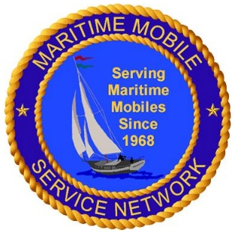
The Maritime Mobile Service Net (MMSN) on 14.300 MHz came to the assistance of a sailing vessel on June 25. MMSN control operator Steven Carpenter, K9UA, took a call on 20 meters from Ian Cummings, KB4SG, the skipper of the Mystic Lady, then some 40 miles east of Florida. Cummings reported that his engine had failed as he was attempting to return to his home port of Stuart, Florida. He not only had insufficient wind, but a strong current was carrying the vessel out to sea.

Cummings had been unable to reach any station via his VHF marine radio, since he was too far from the coast. Assisting in the call was Robert Wynhoff, K5HUT, also an MMSN net control operator. Cummings said his vessel, with one passenger on board, was drifting northwest toward the South Carolina coast.
“A major concern was that the vessel was heading directly towards a lee shore,” the MMSN reported. “Lee shores are shallow, dangerous areas which are a hazard to watercraft. Vessels could be pushed into the shallow area by the wind, possibly running aground and breaking up.”

Carpenter contacted Cummings’ family, who had already called the Sea Tow marine towing service. Sea Tow advised Carpenter to tell the captain to head closer to shore by sailing west, if possible. Carpenter told Cummings that if he was unable to get nearer to shore, he would notify the US Coast Guard, which was already monitoring the situation.

As the MMSN reported, “The Mystic Lady was able to make some headway, but it was very slow. Members of the MMSN made additional calls via landline to the captain’s family as to the ongoing status of those on board. The family was concerned but relieved that communication was established and that all were well.”
Several hours later, the captain advised that the wind had picked up, allowing him to head close enough to shore for Sea Tow to reach the vessel and take it back to port.

The Pacific Seafarers’ Net, which monitors 14.300 MHz from the West Coast after the MMSN secures at 0200 UTC, kept in touch with the Mystic Lady into the night while it was under tow.

The tired, grateful captain later messaged the net, “A million thanks to everyone last night who helped rescue us on 14.300. Everyone chipped in as we drifted north in the Gulf Stream 60 miles headed to a lee shore. The MMSN net control and several others stayed with us for hours, phoned people, and were immensely helpful. The situation on board was dangerous. We are now safely under tow home. You folks are amazing!”

In operation since 1968, the MMSN monitors 14.300 MHz 70 hours a week to assist vessels and others in need of assistance. — Thanks to MMSN Net Manager Jeff Savasta, KB4JKL

####

DIY Weather Satellite Ground Station
(Submitted by Gregory Drezdzon, WD9FTZ)

Sasha M6IOR, and Sophie M6NYX, have made available a guide for the reception of NOAA satellite images using software defined radio on Windows or MacOS. The guide gives a few ways to receive an Automatic Picture Transmission (APT) from active National Oceanic and Atmospheric Administration (NOAA) satellites in the 137 MHz band.
TOP ^
Read the guide at:
https://publiclab.org/notes/sashae/06-26-2020/diy-satellite-ground-station

More:
http://www.wmo.int/pages/prog/sat/meetings/IPT-SWeISS-1/documents/6.1.5_CGMS-45-NOAA-WP-04_PPT.pdf

####

Pandemic adds real-world element to Radio Field Day
(by DAN STARCHER – thebargainhunter.com)

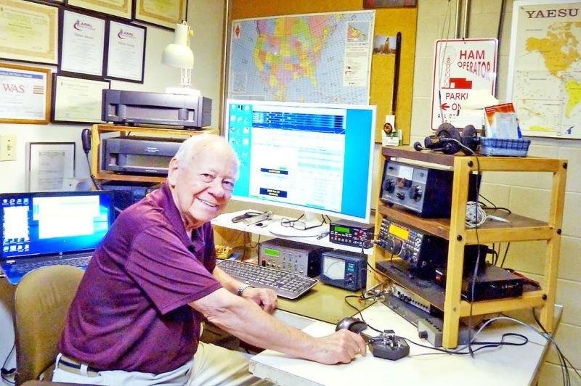
Dan Starcher

Wayne Amateur Radio Club member Russ McQuate sits at his amateur radio station. McQuate and others throughout North America participated in Field Day this year from home due to the COVID-19 pandemic.

Things were a little different from past American Radio Relay League (ARRL) Field Day events for two local amateur radio clubs due to the ongoing COVID-19 pandemic. But, they were no less successful.
The Silvercreek Amateur Radio Association (SARA), from the tri-county Summit-Wayne-Medina area, and the Wayne Amateur Radio Club (WARC) in Wooster teamed up and got creative. Due to the increasing number of positive tests for COVID-19, the two groups decided that a virtual Field Day should be conducted for the safety of their membership.

The two clubs came together, virtually, for a one-year-only event that encouraged local amateur radio operators — or HAMS — to participate in the activity from home or under other approved conditions. Operators participated from their basements, garages and back yards.

TOP ^
“Field Day was different for most radio clubs this year (due to the COVID-19 pandemic). Most clubs have significant, elaborate pre-planned events happening,” said Jason McCormick, Vice President of SARA. “This year, Field Day was closer to the original spirit of the event. Operating in adverse conditions captured exactly what Field Day is about.”

Field Day is an annual simulation exercise where HAMS put their communications skills to the test by establishing temporary radio stations in public areas to provide emergency communication services.
The yearly activity takes place on the last weekend in June. It highlights amateur radio’s ability to work reliably and remotely under less than optimal conditions from almost any location in the world to create a wireless communications network.

Typically, SARA members would gather at the American Legion hall in Rittman for the function, and WARC would operate out of the communications building at the corner of Oldman and Burbank roads in Wooster.
Since there wasn’t a central location as in the years past, each HAM that participated had to be entirely self-sufficient for the 24-hour event.

“We don’t rely on electricity for Field Day,” McCormick said. “Typically, when the club meets for Field Day, generators and solar panels are provided. This year, each individual had to supply their own source of power not connected to the power grid. So, it tested each operator’s skills a little bit more.”
Interest in HAM radio is high. In 2019, more than 36,000 people from thousands of locations throughout North America participated in Field Day exercises, and there are more than 750,000 licensed amateur operators in the
United States, according to McCormick.

Some take their interest in the hobby more seriously and become part of the Amateur Radio Emergency Services corps (ARES). ARES volunteers train alongside police and fire personnel on how to respond in emergencies. ARES members are willing to step up, and, using their radio equipment, provide communication services during emergencies and disasters.

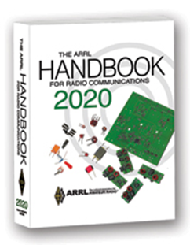
The Handbook Give Away

Hey Gang,

The “Handbook Giveaway” drawing will soon be returning for another big “Give Away”

Many of you ask me just how do I know when the drawing is on? Well, that’s easy all you need to do is check in on the Ohio Section Website on a regular basis and watch for the big RED Arrow that will appear on the left side of the page. This is the sign that the drawing is on and you need to get registered. So, keep a sharp eye out on the website and check in often! http://arrl-ohio.org

What’s the catch? I want to get everyone checking in to the Ohio Section website as often as possible, and in order to register each month, you have to visit the website often! There’s nothing else to it. I pay all expenses, and from time to time, I Give Away more than just a Handbook. And, you’ll never know just what months will be those special times that I will have more than just a Handbook to Give Away!!

TOP ^

Club Corner
This is YOUR cornner of the newsletter. Send me what your club is doing and I’ll make sure that it gets in. Got a special event or club project that you want everyone to know about? Send it to me!. Need help with a project? Send it to me.

Let me know what you club is up to. Are you going to have a special guest at your meeting or are you having a special anniversary? Just sent it to: n8sy@n8sy.com

####

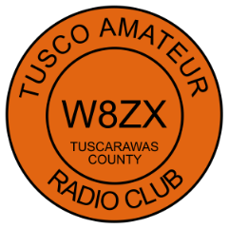
The TUSCO Amateur Radio Club is providing Communications for the Camp Tuscazoar Adventure Race July 18, 2020. We are looking for any interested hams that may be interested in helping. We are meeting in the parking lot (Camp Tuscazoar, 6066 Boy Scout Road NE, Dover OH 44622) at 8:00 am, bring an HT.

Contact KE8BKP Jeff Voltz at 330-690-6072 if interested in helping. All participants will be asked to follow state requirements for social distancing.

####

The Northwest Ohio ARES Traffic Net Needs Help

The Northwest Ohio ARES Traffic Net is in need of General and/or Extra Class licensees with either voice or CW capabilities to relay traffic from the VHF net to the HF nets, no experience is necessary.

The NW Ohio ARES Traffic Net meets daily at 6:30PM on the W8RZM 147.375 repeater.

The Ohio Single Sideband Net meets daily at 10:30AM, 4:15PM and 6:45PM on 3.9725 MHz. The Ohio Section also has three CW Nets, the Ohio Slow Net meets daily at 6:00PM on 3.53535 and runs at approximately 10 WPM.

The Buckeye Net-Early meets daily at 6:45PM on 3.580 and runs between 15-20 WPM. Finally, the Buckeye Net-Late meets daily at 10PM on 3.590 and runs in the same range as the Early Net. Currently, there are only 2 volunteers that cover 7 days a week, and most nets there isn't a volunteer at all. Please consider volunteering for an hour a week, you never know, you may like it.

For more information on traffic handling, or volunteering to assist relaying traffic please check into the VHF net or contact Colleen Roth N8TNV, Steve Denniss KC8IDM, or Michael Lacumsky W8MAL.

####

TOP ^
Upcoming Event Status Update
The MS150 Buckeye Breakaway ride will NOT be happening this year anymore. It has been converted to a virtual event.

Below is a list of events STILL HAPPENING Cleveland area that Event Support Group will be participating in. We still need volunteers for all! Be sure to click and bookmark the "View Full Event Calendar" link below.

• AFSP Out of the Darkness Walk Communications Support on September 26, 2020 09:30
• Cleveland Hamfest Volunteers on September 27, 2020 06:00
• Making Strides of Cleveland *Communications Support* on October 10, 2020 08:00

Our friends over at the Geauga Amateur Radio Association have begun compiling a list of as many radio related cancellations as they can. Be sure to check it frequently at https://geaugaara.org/coronavirus/.

####

2020 Cleveland Hamfest STILL ON!
That's right, the 2020 Cleveland Hamfest is NOT CANCELLED. We are watching the situation very closely and will update everyone if anything changes. As of now the Hamfest Association of Cleveland is still moving forward with plans for the 2020 Cleveland Hamfest on Sunday, September 27. Indoor Vendors, please visit www.hac.org and click “vendor information” at the top for more info.

Make sure you head on over to www.hac.org for the latest info and be sure to click “Join Our Mailing List” to get all the latest updates.

####

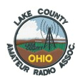
Lake County ARA Cancels Picnic

Regrettably, the board has decided the club picnic scheduled for July 26th, is now CANCELLED.
Although the Lake Metro-Parks are open, the State guidelines for social gatherings remains limited to 10 or fewer people and given the recent up trend in reported COVID-19 cases, we simply do not want to risk the health of our members and guests.
We will continue to hold club membership and board meetings online. Reminder notices will be sent out the week prior.
Be well & '73

TOP ^

Conference Bridge Now Available

Hey Gang,

With the government still keeping many of the meeting locations closed down it has really become a struggle for clubs all over our Section to find ways of having their meetings

Well, the Ohio Section came up with a tool for the toolbox that will allow you to have a video/phone conference meeting and stay within the CDC’s guidelines for distancing.

We’ve partnered up with Zoom, one of the premiere video conferencing bridges in the country and we now have the ability to do our own “on-line” conferences.

Our Zoom account allows for up to 100 persons at a time to be connected with not only audio, but video as well. This is sooooo 21st century. You can share your screen for those really fancy presentations, see everyone that’s connected with a camera on the call and really do a first-class meeting with this technology. No, you don’t need to have a computer. Zoom will also allow you to just call in on your regular or cellular phone too. That is what makes this so great.

Some groups have come up with using their repeaters to help take the place of the meetings. Skype and Free Conference Call are also some ideas that clubs are experimenting with. What a wonderful way of using the technology that we have in place!

I think it is really great no matter what you use for all of us to keep in contact with each other. We used to use our repeaters way more back in the day, but for some reason we’ve kinda’ gotten away from even thinking of using them or other technology to stay in contact, especially with our older hams that might not be able to get out at night, or just aren’t as mobile as they used to be. Ham radio is one way for all of us to make those very important contacts with each other to be sure we are all ok and safe. Zoom is another tool in the toolbox for us to use. So, if you want to try Zoom or have a meeting using it, just let me know. n8sy@n8sy.com

Another Zoom Conferencing Available

In order to help facilitate virtual meetings, webinars, and presentations for Cleveland-area clubs and groups, and in line with our charter to support and promote Amateur Radio, The Hamfest Association of Cleveland has procured a paid Zoom video conferencing account for use by area Amateur Radio clubs.

Any area club that wishes to use it may request the scheduling of a Zoom call from HAC on a first-come, first-served basis using the form at http://www.hac.org/zoom.

All we ask is that you thank the Hamfest Association for the use of Zoom during your meeting.
Zoom calls are limited to 100 participants, and 24 hours in duration (here's’hoping your meeting isn't’24 hours long).

Amateur Radio-related uses only please.

TOP ^
If your club or group would like to use the HAC Zoom for your meeting, please complete the form below to make your request.

73 de W8HAC
http://www.hac.org/zoom/

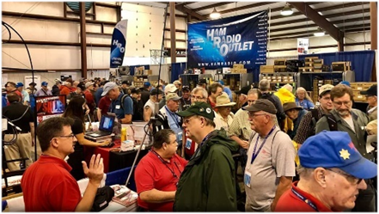

Upcoming Hamfests for 2020

07/18/2020 | NOARSfest
Location: Elyria, OH
Sponsor: Northern Ohio Amateur Radio Society
Website: https://www.facebook.com/NOARS.K8KRG
Canceled

07/19/2020 | Van Wert Hamfest  Location: Van Wert, OH  Sponsor: Van wert Amateur Radio Club  Website: http://w8fy.org | 07/26/2020 - Portage Hamfair '20  Location: Ravenna, OH  Sponsor: Portage Amateur Radio Club, Inc.  Website: http://hamfair.com  Canceled
08/01/2020 | Columbus Hamfest  Location: Grove City, OH  Sponsor: Voice of Aladdin/ Audio Unit of Aladdin Shrine  Website: http://columbushamfest.com  Canceled | 08/08/2020 | DXE Hamfest,  ARRL Ohio Section Convention  Location: Tallmadge, OH  Sponsor: DX Engineering  Website: http://dxengineering.com  Canceled
08/15/2020 - Clinton County Ohio ARA Hamfest  Location: Wilmington, OH  Sponsor: Clinton County ARA  Website: http://ccara.net | 08/29/2020 - Milford Hamfest  Location: Owensville, OH  Sponsor: Milford Amateur Radio Club  Website: http://www.w8mrc.com  Canceled
09/27/2020 | Cleveland Hamfest and
Computer Show
Location: Berea, OH
Sponsor: Hamfest Association of Cleveland
Website: http://www.hac.org
Click on “Join Our Mailing List” to stay updated.

TOP ^

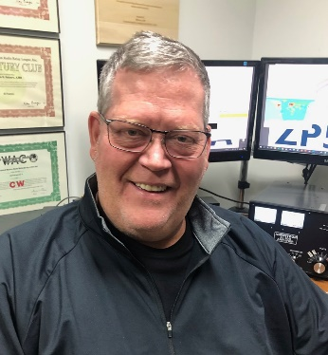
DX This Week
(from Bill, AJ8B)

DX This Week – ZS6JES
Bill AJ8B (aj8b@arrl.net, @AJ8B, or www.aj8b.com)
CWOPs Member #1567
The 13 Colonies contest really dominated the spotting clusters this past week. Did you work towards a certificate? I did get a clean sweep on CW and FT8. Always fun to work them and to track them. On the DX side of the cluster, there were some interesting entities spotted including Aruba, Austria, Barbados, Canada, Chile, Easter Island, Ecuador, England, European Russia, Fiji, France, Guadeloupe, Hawaii, Hungary, Indonesia, Ireland, Israel, Italy, Japan, Moldova, Netherlands, New Caledonia, New Zealand, Philippines, Poland, Puerto Rico, Republic of Korea, Slovenia, Spain, St. Lucia, Suriname, Taiwan, Ukraine, and Venezuela. Let me know what you worked!

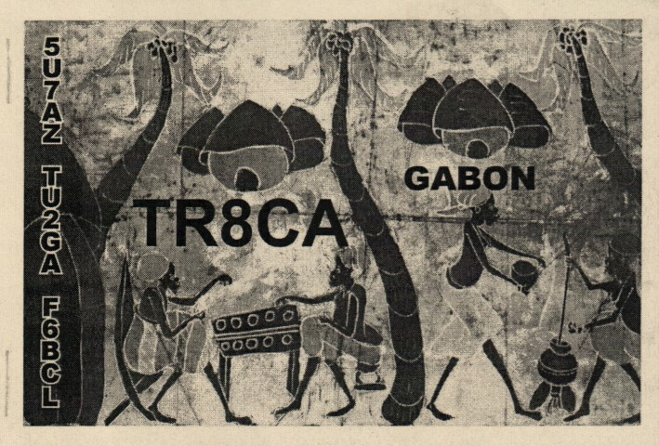
I received a QSL card from TR8CA, Alain, in Gabon. Although I was confirming a QSO on 80M, Alain also verified a QSO from 2014 on 40 M. He had done that via LOTW, but, it us always fun to get the card.

If you have not checked it out, the latest edition of the SWODXA DX Newsletter, the Exchange, is available. Just go to https://www.swodxa.org/newsletters/

The interview below was conducted with ZS6JES, Jess. He is a first-class operator and an accomplished ham. This is reprinted with the permission of the SouthWest OH DX Association.

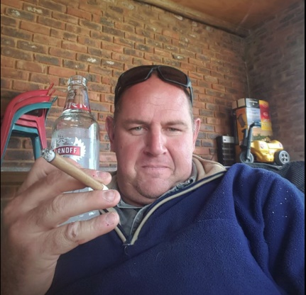
Interview with ZS6JES—Jess
I recently worked Jess on FT8 and asked him to please answer a few questions. He agreed, so, I sent them along! I have worked Jess 3 times, on three bands, all on FT8. I hope to work him on CW someday so I can chat a bit.

AJ8B: How did you first get interested in amateur radio?
ZS6JES: I started out with CB Radio back in 1987 and from there my interested just keep growing.

AJ8B: When did you get on the air?
ZS6JES: I got my Ham license in 1991.

AJ8B: It appears that you have been on many modes and bands. Do you have a favorite?
ZS6JES: At this point I am into digital (FT8) mostly on HF bands try to work all the hf bands from 10 to 80m

TOP ^
AJ8B: In reviewing your QRZ.com page, I see that you have been very successful with chasing countries and with contests. Any secrets to your success?
ZS6JES: Well I keep my eyes on all the different webpages and look when new expeditions is coming up...and sometimes it is just luck I would say.

AJ8B: You are an extremely accomplished contester. Any tips that you can share?
ZS6JES: I am not really a contester taking part in the ARRL Grid Chase 2018 but sitting down at the tip off Africa make it a bit difficult with the band conditions.

AJ8B: What license levels do you have in South Africa?
ZS6JES: We use to have 3 levels: ZR restricted to VHF ( needed to do 12 words CD to move up to ZS but that been phased out now you just do your test and a assessment 0),ZS is your unrestricted and then ZU that is mainly for the youngster that wants to get into Ham Radio.

AJ8B: Describe what you are currently using:
ZS6JES: My equipment at this point is Radio Icom IC-7610 and IC-7100, The antenna is a Hy-Gain TH 6 DX and amp is a Kenwood TL-922
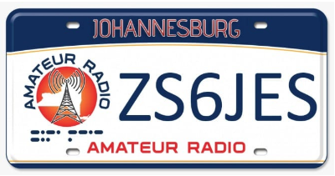
AJ8B: What other hobbies do you have?
ZS6JES: Hunting and Fishing.

AJ8B: What advice do you have for those of us trying to break pileups to work DX?
ZS6JES: Just keep on trying you will get there.

AJ8B: Any QSLing hints?
ZS6JES: Register with QRZ and LoTW for me that works great it is quick and easy....

AJ8B: What coaching/advice would you give new amateurs?
ZS6JES: Believe in yourself give it your best shot and enjoy it after all it is one of the most interesting hobbies you can get into..

AJ8B: Thanks for taking the time to answer my questions. Is there anything you would like to share with us?
ZS6JES: If you want to become a good Ham pay attention to the bands and know witch band to use when with that you can get those scares one in the log.

Here is an update from Bernie, W3UR, of the DailyDX and the WeeklyDX, the best source for DX information. http://www.dailydx.com/. Bernie has this to report:

CQDX CQDX CQDX CQDX CQDX CQDX CQDX CQDX CQDX

ZB - Gibraltar - In celebration of Gibraltar National Day, which take place on September 10th, ZB2 and ZB3 stations can use the ZG prefix from September 4-10.

UA – European Russia - R108WWS is a special callsign that notes the 108 years of the military Air Forces of Russia, August 1-16. Operating will be RV3YR and RN3YN. QSL direct to one of the ops apparently, or bureau or OQRS.

TOP ^
5Z – Kenya - PA1TS, Joost, is now living in Naivasha, Kenya and is waiting for his Kenyan callsign. He may show up on the air as 5Z4/PA1TS.

Z6 – Kosovo - German team Z66DX will be on from Pristina, the capital, October 15-28, 160-10 including the WARC-79 bands, CW, SSB, RTTY and FT8. On the operator list are DJ9KH, DL2AMD, DL2AWG, DL3APO, DL9GFB and DM2AUJ. There is that popular ICOM rig again; they will have three IC-7300s, plus RF amps, 800 watts, to verticals for 160 and 80, plus loops and verticals on “spider poles” for other bands. They have some target frequencies, which are:

CW on 1822.5, 3526, 7026, 10102, 18086, 21026, 24906 and 28026.
SSB on 3805, 7095, 14210, 18120, 21275, 24955 and 28465.
RTTY on 7044, 10145, 14095 and 18105.
FT8 on 1836, 3569, 7056, 10131, 14091, 18095, 21091, 24911 and 28091.

QSL through Club Log OQRS for direct or bureau. This is what they prefer. A backup option is via DL2AWG bureau or direct, with SAE and 3 USD or 3 EUR. The LoTW upload will be six months later. “No eQSL!” they say. As is standard, if their cost of return postage is not covered, your card will go to you through the bureau. http://www.z66dx.de/?Welcome

ZB – Gibraltar - September 4-10 will be “Gibraltar National Week,” when “the rock” marks its 1967 self-determination referendum. The exact date of that 1967 event is September 10. Stations will switch to special prefix ZG, so ZB2TT will become ZG2TT during that week. He will not have a special card printed but will modify his regular ZB card. He will upload the log to M0URX’s OQRS after September 10 and will upload to LoTW too.

Finally,…check this out from Bernie…W3LPL says it’s one of many conflicting forecasts but “Let’s hope it’s correct… enjoy it while you can… in five billion years the sun will burn out.” He is commenting on K1HTV’s note that five scientists associated with the National Center for Atmospheric Research, the Centre for Fusion, Space and Astrophysics, the University of Maryland Department of Astronomy, the NASA Goddard Space Flight Center, Centre for the Analysis of Time Series, London School of Economics and Political Science School of Engineering and Innovation have a “bold prediction” about solar cycle 25.

They have a document called “Overlapping Magnetic Activity Cycles and the Sunspot Number: Forecasting Sunspot Cycle 25 Amplitude,” they say they believe the next sunspot cycle “will have a magnitude that rivals the top few since records began,” “in stark contrast to the community consensus estimate of sunspot cycle 25 magnitude.” K1HTV, Rich, a major 6M DX fan, says it could mean F2 skip on 50 MHz like has never been experienced in the history of radio, “a real treat.” This article explains the prediction: https://arxiv.org/pdf/2006.15263.pdf.

60 Meter Update by Joe Pater, W8GEX
W8GEX, the king of 60 meters, has graciously allowed me to reprint his most recent 60 Meter Update. You can subscribe by sending an email to Joe at W8GEX@aol.com. You can also follow the Facebook group at https://www.facebook.com/groups/347995275954755/. You can check out their website at www.60metersonline.com.

3X – Guinea - F4AJQ, Frank, says the F6KOP team, noting their successful E44CC Palestine operation in February, are now planning another operation, this one for next January.

TOP ^
Assuming the borders open after COVID-19 and they can travel safely, they plan to be on Guinea’s Kassa Island, IOTA AF-051, QRV on 160-10 “with maybe 60M,” CW, SSB, RTTY and FT8, with five stations on simultaneously. They will have three beams, several verticals and receiving antennas too. The callsign, operators and other details will be forthcoming soon.
Latest email from Frank:

Hello Joe
For the moment we are still ok for our XP in 3X. I am currently preparing the file for the license with the authorizations to be on the air on 60 meters. I hope that we will not have another big problem with COVID 19 so that the f6kop team will be on the island of KASSA in January 2021.
Have a good day and see you soon.

73 thanks, Frank F4JQ

LZ1GC, Stan, says an expedition by him and LZ1PM is September 28 to October 17, callsign E6AM for 160, 80, 60 and 40 and a Hexbeam. They will be on 160-10 including 60 bands. For a QSL, go through OQRS for direct or bureau, or via LZ1GC or the LZ bureau. Below are his latest updates:

Dear Joe,
Still is so early to say what will be happened, but I am working very hard to prepare E6AM & A35GC DXpedition 2020. Transit travel is permit via VK and ZL, but the problem is 2 weeks quarantine on E6 and A35. I have permanently contacts via e-mail with the officer which sent me the A35GC licence.. He said me that A35GC quarantine is till 31 August 2020.

Joe,
There is enough time - about 3 months - Our tickets are purchased and our departure day from Bulgaria to the Pacific is 26 September 2020. I hope that the COVID - 19 quarantine for arrivals will be lifted by then! If the quarantine do not lifted, then I will postponed E6AM & A35GC DXpedition for next October, but this expedition will be fact!!!

WEBSITE of the expedition: WWW.C21GC.COM

73! Stan, LZ1GC ( E6AM & A35GC ).

A3 – Tonga: A35GC will be the second stop for LZ1GC but apparently without LZ1PM. This will be Tongatapu Island, OC-049. This stop will be October 19, to November 2.
CW, SSB, RTTY and FT8. QSL through OQRS for direct or bureau or via LZ1GC.

TO5T Saint Pierre & Miquelon: Postponed

Swains Island

Dear friends,
Due to the Covid-19 pandemic it is still impossible to travel to Swains Island. This means that we have to postpone our DXpedition until spring 2021 at the earliest.

TOP ^
Alex Jennings and the team will start planning again as soon as we are allowed to travel to American Samoa without restrictions (such as 14 days in quarantine). All equipment already purchased is waiting for us in Pago Pago. We are very disappointed with this postponement, but if we look at it from a positive angle, propagation will be better next year!

We continue our Swains DXpedition project and keep you informed via our mailing list, website and the social media channels such as Facebook and Twitter.

The Swains DXpedition Team https://swains2020.lldxt.eu/

Recent Activity

ZL2BH, ZL2CC, ZL2JO and ZL4OL all have been active on 5.362.

Remember this is their winter as well as South Africa.

Upcoming DXpeditions

TO5T Saint Pierre & Miquelon: September 22 to Oct. 6, 2020 ++++ Postponed

E6AM – Niue: LZ1GC, and LZ1PM September 28 to October 17

A35GC – Tonga: October 19 to November 2.

DX News

ARLD028 DX news

This week's bulletin was made possible with information provided by The Daily DX, the OPDX Bulletin, 425 DX News, DXNL, Contest Corral from QST and the ARRL Contest Calendar and WA7BNM web sites. Thanks to all.

THAILAND, HS. Champ, E21EIC will operate E2A in the IARU HF World Championship in a SOAB Mixed effort. QSL via E21EIC and LoTW.

CROATIA, 9A. Members of the Radio Klub Novi Bokanjac are operating as 9A164T from Zadar to mark the birthday of Nikola Tesla. QSL via bureau or eQSL.

PHILIPPINES, DU. Members of the Ham Society of the Philippines are operating as DZ30SH from Malolos City until August 29, supporting STAYHOME activities. QSL via LoTW or eQSL.

BOSNIA AND HERZEGOVINA, E7. Vedo, E72U informs us that E7HQ will be the Headquarters Station of ARABH in the IARU contest. QSL via E70ARA or LoTW.

BONAIRE, PJ4. John, K4BAI will participate in the IARU HF World Championship as PJ4A. Before and after the contest he will sign PJ4/K4BAI. QSL via K4BAI

TOP ^
RUSSIA, RA. Victor, RV3YR and Viktor, RN3YN will commemorate the first Soviet-American space flight in the Apollo-Soyuz program with the call sign UE45SA. They will be QRV from July 11 to 19. QSL via RV3YR (d/B) or ClubLog OQRS.

POLAND, SP. Special event station SN87LOT commemorates the transatlantic flight of the Lithuanian pilots Steponas Darius and Stasys Girenas 87 years ago. QSL via SP1PMY, direct or via the bureau.

CANADA, VE. VC3STYWELL, the third COVID-19 special event station run by The Seven Thirty Social Distancing Net, will be active until July 19. QSL via VE3ES.

INDONESIA, YB. Special event station 8A343CJR celebrates the 343rd anniversary of the Cianjur District on Java. They will be QRV until July 12 on 80, 40, 20, 15 and 2 meters using CW, SSB, RTTY, FT8 and FM. QSL via direct from info at qrz.com.

GREENLAND, OX. Bo, OZ1DJJ will be QRV from Aasiaat Island as OX3LX until July 30. Look for him on 40 to 4 meters. He will also try to activate other islands of this IOTA group. QSL via OZ0J.

OGASAWARA, JD. Tony, JD1/JH1FFW will be QRV from July 15 to 19 on 40, 20, 15, 10 and 6 meters using SSB and FT8. QSL via LoTW, eQSL or the bureau system.

FAROE ISLANDS, OY. Torsten, OY/DL4APJ and Udo, OY/DL2AQI will be QRV September 15 to 23, holiday style on 80 to 10 meters, using CW, SSB, RTTY, PSK and FT8. QSL to their home QTHs direct, or via the DARC bureau, eQSL or LoTW.

KOSOVO, Z6. German team Z66DX will be QRV from October 15 to 28, on 160 to 10 meters, including the newer bands. Look for them using CW, SSB, RTTY and FT8. Operators are DJ9KH, DL2AMD, DL2AWG, DL3APO, DL9GFB and DM2AUJ. QSL through Club Log OQRS for direct or bureau. The LoTW upload will come later.

RUSSIA, R1. The Russian Robinson Club announces that Milhail, R1MJ, Yulia, R1CBL and Vitalia, RA1AGJ will be QRV from Gogland Island (EU-133) from July 23 to 28. They plan to operate in the RSGB IOTA Contest with their individual calls. Activity will be on 160 to 15 meters. QSL via home calls.

BULGARIA, LZ. During this year's IARU HF World Championship the Bulgarian Federation of Radio Amateurs 80 meter HQ station will be transmitting as LZ0AA from The Vakarel Transmitter broadcasting facility which has been off the air since January 1, 2015. The transmit antenna, which was erected in 1937, is 215 meters high. After the contest the antenna will be taken down.

CORSICA, TK. Max, DL8UW is active as TK4VQO. He is QRV on 160 to 6 meters using CW and SSB. You can also find him every day on the Medical Assistance Radio (MAR) net on 14332 kHz at 0730z. QSL via home call.

TOP ^
BURKINA FASO, XT2. Max, DK1MAX will be active as XT2MAX sometime during November to December. Activity is usually holiday style on all bands using mostly CW and FT8. Look for more details to be forthcoming.

THIS WEEKEND ON THE RADIO. The IARU HF World Championship, FISTS Summer Unlimited Sprint, SKCC Weekend Sprintathon and the QRP ARCI Summer Homebrew Sprint will keep contesters busy this weekend. The 4 States QRP Group Second Sunday Sprint is on July 13, the RSGB 80-Meter Club Championship, SSB is on July 15, and the NAQCC CW Sprint is on July 16. Please see July 2020 QST page 74 and the ARRL Contest Calendar and WA7BNM Contest Web Site for details.

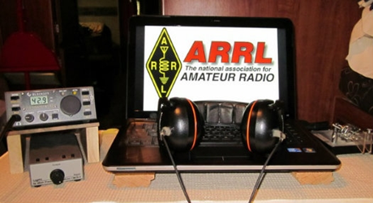
ARRL Contest Corner

An expanded, downloadable version of QST's’Contest Corral is available as a PDF. Check the sponsor's’Web site for information on operating time restrictions and other instructions.

####

We're making several changes for the 2020 Ohio QSO Party:

1. We're adding 160 meters. Based on 160 meter activity in other QSO Parties I don't expect this to make a huge difference, but it should provide an opportunity for some "fresh meat" QSOs when things get slow late on Saturday night.

2. We're dropping the "One station/one call" rule. So you can also use a club call or other call for an additional entry, to enjoy being a new station while making more QSOs possible for others. This is intended to allow more potential QSOs for everybody, not as a way to inflate scores of friends.

We hope you all will join us for the 2020 OhQP on Saturday, August 22, from noon to midnight EDT (1600z - 0400z) !

73 - Jim K8MR - OhQP Chairman

Special Events

- 07/17/2020 | South Carolina Peach Festival
Jul 17-Jul 19, 0400Z-0400Z, W4W, Gaffney, SC. Cherokee County Coroner’s Office. 147.240 145.250 145.190 442.500. Certificate & QSL. Dennis Fowler, P.O. Box 1210, Gaffney, SC 29342. To commemorate the 43rd annual South Carolina Peach Festival in Gaffney, South Carolina. dfowler@cherokeecountycoroner.com

- 07/18/2020 | Kearney Junction Park
Jul 18, 1300Z-2200Z, W0KY, Kearney, NE. Midway Amateur Radio Club. 21.345 21.045 14.290 14.045. Certificate. Henry Angle, N0HA, 307 E. 35th St., Kearney, NE 68847.

TOP ^
- 07/18/2020 | Red River Bridge War Special Event
Jul 18-Jul 26, 0000Z-2359Z, W5I, Sherman, TX. Grayson County ARC. 14.250 7.250 14.040 7.040. QSL. Grayson County ARC, PO Box 642, Sherman, TX 75091. The Red River Bridge War was a dispute between Texas and Oklahoma over a new bridge that was built across the Red River in 1931. Tempers were high but no blood was shed during this dispute. Please visit qrz.com/db/w5i for more information about the war and QSL information. https://graysoncountyarc.org

- 07/20/2020 | EAA Airventure 2020 - EVENT HAS BEEN CANCELLED
Jul 20-Jul 25, 1300Z-2030Z, W9ZL, Appleton, WI. Fox Cities Amateur Radio Club. 50.150 14.270 7.240. Certificate. W9ZL Special Event, P.O. Box 2346, Appleton, WI 54912. Starting on Monday July 20 through Sunday July 25 2020 the W9ZL EAA Airventure Special Event Station will be on the air. We will be operating from 1300 UTC to 2030 UTC Monday through Saturday, and 1300 UTC to 1700 UTC on Sunday July 25 2020. We will be operating on 14,270, 7,250 and 50,150. EVENT HAS BEEN CANCELLED www.fcarc.club

- 07/23/2020 | HamExposition New England THIS EVENT HAS BEEN CANCELLED
Jul 23-Jul 26, 0000Z-2359Z, W1UE, Marlborough, MA. HamExposition Committee. 14.250 14.030 7.200 7.030. QSL. LoTW or Dennis G Egan, W1UE, 166 Wilson St., Marlborough, MA 01752. THIS EVENT HAS BEEN CANCELLED w1ue73@gmail.com

- 07/25/2020 | In Remembrance of the 305th Anniversary of the Spanish 1715 Treasure Fleet, lost in
a hurricane on their way to Spain.

- Jul 25, 1300Z-1900Z, W4OT, Vero Beach, FL. Vero Beach Amateur Radio Club . 14.327; D-STAR
Ref078C. Certificate. Vero Beach Amateur Radio Club c/o IRC EOC, 4225 43rd Ave., Vero Beach, FL 32967. w4ot.webs.com

- 07/25/2020 | NSS 79th annual Convention
Jul 25-Jul 31, 1800Z-1800Z, K8V, Elkins, WV. National Speleological Society. 14.285 14.050 7.195. QSL. Sam Rowe, 2749 Commercial Ave, Madison, WI 53704-4868. CW, slow speed, Saturday only. www.nss2020.caves.org

- 07/31/2020 | Sheboygan Brat Days
Jul 31-Aug 2, 1700Z-0100Z, W9B, Sheboygan, WI. Sheboygan County Amateur Radio Club. 14.240 7.240. Certificate. Sheboygan County Amateur Radio Club, c/o Steve Eisold, 4235 N. 29th St., Sheboygan, WI 53083. 67th Annual Sheboygan Brat Days, celebrating the sausage that made Sheboygan famous! 14.240, 7.240 - noon to 8:00 p.m. CDT Friday and Saturday. Certificate only: W9VCL Sheboygan County Amateur Radio Club, 4235 N. 29th Street, Sheboygan, WI 53083. Please include $2.00 for 8-1/2x11 mailed in manila envelope or send $1 and SASE #10 (certificate will be folded). More information: https://www.w9vcl.com

- 08/01/2020 | Pro Football Hall of Fame Enshrinement Festival
Aug 1-Aug 9, 0000Z-2359Z, W8AL, Canton, OH. Canton Amateur Radio Club. 14.300 14.030 7.250 7.030 3.950 3.530 (Watch for FT8 or other digital modes); BM DMR 313989. Certificate. Canton ARC - W8AL, C/O: Justin W8JKC, PO BOX 8673, Canton, OH 44711-8673. www.w8al.org

TOP ^

“ARES Connect”
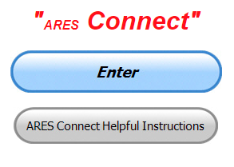
Connecting Amateur Radio Volunteers with a Purpose

ARES Connect is ARRL's newest tool and it's not just for ARES personnel anymore. It's a total management recording system that allows a more robust and efficient way of managing ALL of our Amateur Radio volunteers throughout the country.

The ARRL has long recognized that it can be a difficult and a challenging process to properly manage our volunteers and all of their activities in this fast paced and ever-changing world. For this reason, the ARRL has partnered with VolunteerHub in creating the ultimate assistant - "ARES Connect"

This is an event-based system that frees up our county, district and section managers time by electronically recording all of our events, volunteers and their credentials as well as their volunteered time, all in one place. This system replaces the need for our managers to manually keep track of their volunteers. And, since this is a web based application, all of the records are kept in the clouds, secured and distributable by only persons with the proper credentials, making the transfer of those records quick and easy to do during times of manager transitions.

ARES Connect gives our entire leadership the easy ability to promote their events throughout their entire section, reduce scheduling conflicts of upcoming activities and making it easier for us to manage our volunteer resources more effectively. It gives us a much more robust way to monitor our volunteers as they register for and record their time utilizing the latest "on-line" applications that can be quickly setup and utilized in the field on any computer, smart phone or tablet. The reports generated by these applications contain a wealth of information that can be easily shared with our served agencies instantaneously, as this system utilizes "live data."

Having this tool saves our leadership much valuable time, reduces their workload, keeps permanent records of our activities, and volunteered time, volunteers and their credentials, as well as has the ability to mass or selectively email our volunteers when needed.

By utilizing the most advanced up to the minute data gathering processes, ARES Connect has dramatically changed our reporting abilities from a labor intensive monthly overview, to a very detailed and up to the minute report that can be generated at any time by our leadership.

You do not have to be an ARES or ARRL member to use this system. All licensed amateur radio operators throughout the country are welcome.

Everyone – please make sure to go into all of the events that you have signed up for and get your hours registered no later than 5 days after the event has ended.

Folks, I’m seeing a lot of folks that have signed up for events not entering their time after the event. This is a very important piece of using “Connect.” Your hours need to be recorded and it’s so easy to do.

TOP ^
Let’s run through how so in case you have forgotten. If you have already gotten signed up for an event, all you have to do afterword to get your time entered is at any time after the event has ended, log into “Connect.” And then click on your name in the upper right-hand corner of the page. This will bring up a drop-down menu where you will then click on “View Hours.”

This brings up another screen where you can “Report Hours” as well as “View Hour History” You’ll want to click on “Report Hours.” You will then be presented one at a time by chronological order each event that you have signed up for and hours have not yet been reported on.

Type in those hours in the “Hours Worked” box and hit “Submit”… Keep doing this until you have no more hours to report…. That’s all there is to it. Now, if you are following the request above and doing this at least every 5 days or more often, this will only take you a minute or so to complete.

Here’s are the top 10 hours earners so far the month of July:

 | Name | Events | Hours
1 | Dwight Bonifield (W8TJT) | 59 | 54.40
2 | Leo Dubois, Jr. (KE8OOS) | 17 | 38.50
3 | Dan Stahl (KC8PBU) | 24 | 38.41
4 | Christopher Domenick (KC8CAD) | 11 | 34.05
5 | Alan Rothweiler (N8CJ) | 11 | 28.50
6 | John Major (KD8MMY) | 9 | 27.50
7 | Dennis Niehaus (KD8ZLB) | 7 | 27.00
8 | Bret Stemen (KD8SCL) | 16 | 25.50
9 | Robert Gaskins (KE8HWD) | 6 | 24.50
10 | James Yoder (W8ERW) | 5 | 23.66

Let’s get everyone in the Ohio Section on “ARES Connect!!!” Simply go to: https://arrl.volunteerhub.com/lp/oh/ and get yourself registered and using the system.

Hey County and District E.C.s…
Do you want a listing of all your volunteers registered in ARES Connect? Would you like to have a report by hours for your county? Let me know, these reports can be generated very quickly and easily for you. All you need to do is ask. Let me know if you want a report run… email me at: n8sy@n8sy.com

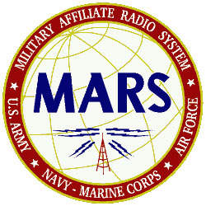
MARS Announces HF Skills Exercise
Members of the Military Auxiliary Radio System (MARS) will conduct an HF skills exercise July 20 – 24 to hone their operating skills and messaging-handling capabilities.
MARS members will be reaching out to the amateur radio community via the 60-meters Channel 1 Net (5330.5 kHz dial) twice a day, the SATERN HF net (14.265 MHz), and by contacting various stations via HFLink throughout the exercise.

TOP ^
MARS members will be requesting assistance with collecting county status information as well as airport weather information, called METARs. MARS members will also be passing ICS 213 messages to numerous Department of Defense (DoD), federal, and amateur radio addressees.
This exercise will be announced via WWV at 00:10 and via WWVH at 00:50 starting on or about July 13. WWV and WWVH listeners will be asked to take an online listener survey. This HF radio training event will not impact regular communications. — Thanks to Paul English, Chief, Army MARS

####

ESA guide to picking up ISS SSTV
(Submitted by Gregory Drezdzon, WD9FTZ)

The Register reports that the European Space Agency released tutorials explaining how to pick up the amateur radio Slow Scan TV (SSTV) tutorials transmitted from the International Space Station
Got plans for the weekend? No? How about pulling that Pi out of the drawer or dusting off an old laptop and getting ready to grab some images from the ISS, courtesy of ESA boffins [1].
The system makes use of the Web Software Defined Receivers (WebSDR) scattered around the world, which allow multiple users to listen in and tune the receiver simultaneously. The audio generated can then be piped into a SSTV decoder (ESA directed us to RX-SSTV, which will have a crack at rendering an image).
The example cited for a WebSDR by ESA is the AMSAT-UK / BATC one hosted at Goonhilly Earth Station in Cornwall, which allows users to listen in on the 144 – 146MHz VHF band. ISS voice and data starts at 145.800 MHz FM, but only if the station is actually transmitting and in range of the station.

[Boffins - British slang term for a scientist, engineer, or other person engaged in technical or scientific research and development.]
Read The Register article at: https://www.theregister.com/2020/07/10/esa_iss_sstv/

Field Day Pictures…

Hey Gang,

Now that Field Day is in the books did you remember to take pictures? If you did, did you send them to me? Please don’t forget to send me pictures of your Field Day operations! Take a look at what I’ve collected so far! http://arrl-ohio.org/fd-20

Over the years we’ve collected thousands of pictures of Field Day sites and used some of those for our Ohio Section Banner. Let’s not miss out just because of a little inconvenience like COVID-19, let’s keep the Ohio Section tradition going and send me those pictures at: n8sy@n8sy.com !!

TOP ^

One Question Questionnaire

Hey Gang,

“Survey Says”….. Just about 50% of us ground our antennas when not in use. That’s not as good as it should be! For safety sake, you really need to make sure that your antennas are grounded when not in use. This will definitely save you from having one very bad afternoon for sure!

Ok, now, on to next question… Let’s find out how many of you practice good fire prevention procedures in your shack. So, the next question is…

“Do you keep a Fire Extinguisher handy in your shack ??”

You’ll find the “One Question” questionnaire on the Ohio Section Website! http://arrlohio.org It’s all in fun and it’s not a scientific survey in any way, but we are learning some things that we didn’t know from these questions. I hope that you are enjoying answering these “One Question” questionnaires.

V.E. Test Sessions
Many V.E.’s have decided to start testing once again, but with restrictions that need to be adhered to for sure. Here’s the link to find that V.E. Test session and what is expected of YOU before going. http://www.arrl.org/find-an-amateur-radio-license-exam-session

####

Lake County ARA Holding V.E. Testing in August

Lake County ARA will be holding a V.E. Test Session on August 1st at the Lake County Metroparks – Chapin Forest Reservation. The address is: 9938 Chillicothe Road (Rt 306) - Quarry Shelter

Chapin Forest is 3.3 miles south of I-90 on Route 306, in Kirtland. The park is on the west (the right side going south) of 306. The Quarry Shelter is almost immediately on the right as one enters the reservation.

The tests will start at 12 noon. Please arrive a few minutes earlier. Pre-registration is suggested, although we hope to have plenty of seats available.

To register, you will need the NCVEC 605 Form, which will be available at the test. If you would like to complete one ahead of time, be sure it is the Sept 2017 version or later. You can find it by Googling “NCVEC quick-form 605” and clicking on the url for a pdf of the form.

Be sure to bring the original and a copy of both your license and any CSCEs you may have to the exam. The cost is $15.00, and if you wish to pay by check, it should be made out to the ARRL/VEC. Identification with your picture is also necessary, such as a driver’s license. To pre-register, or if you have any questions, please contact Scott Farnham, KO8O, at (440)256-0320, or scottfarnham@roadrunner.com

TOP ^

Final.. Final..

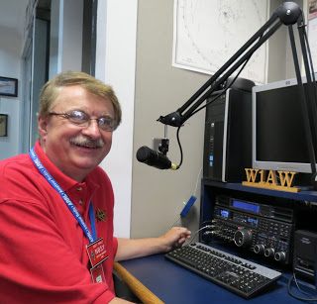
Hi Gang,

Wow has this ever been a hot week or what! I have mentioned before about my mower being in the shop, but with this heat my grass has just stopped growing altogether. Even the robot mower next door isn’t mowing as much as it was. Hopefully, we’ll get some rain soon, otherwise I will have to start seeding my lawn again. This time it will have to wait until the fall when it cools back down.

Ok, moving on to another subject… ARES Connect comes tgo mind. Have you looked at the breakdown per county on the ARES webpage? There is a listing posted per county of the hours recorded in ARES Connect. These are the hours of actual volunteers and not anonymous hours. Want to see how many hours your county has gotten so far?
Go to… http://arrl-ohio.org/SEC/ARES-Connect-County.html This page is updated regularly, so you can see what is happening in real time in your county. Don’t see hours recorded in your county? That’s because you haven’t done your part and gotten your time recorded. Don’t know how? Let me know, I’ll teach you everything that you need to know to get you started.

Have you seen the latest Section Emergency Coordinators report? If not you can view it by going to:
http://www.arrl-ohio.org/SEC/reports/2020/ARES%20Connect%20Monthly%20Report%20-%20June%202020.pdf

Whelp, my final go around before gong QRT… Stay safe my friends! I want to see all of you soon at a meeting or hamfest! We will get through this and when we do, we’ll have so much to talk about. Most of all… have FUN and get on the airwaves!!

73,

Scott, N8SY

NIST Scientists Create New Recipe for Single-Atom Transistors
(Submitted by Gregory Drezdzon, WD9FTZ)

Linking multiple copies of these devices may lay the foundation for quantum computing
Once unimaginable, transistors consisting only of several-atom clusters or even single atoms promise to become the building blocks of a new generation of computers with unparalleled memory and processing power. But to realize the full potential of these tiny transistors — miniature electrical on-off switches — researchers must find a way to make many copies of these notoriously difficult-to-fabricate components.

TOP ^
Now, researchers at the National Institute of Standards and Technology (NIST) and their colleagues at the University of Maryland have developed a step-by-step recipe to produce the atomic-scale devices. Using these instructions, the NIST-led team has become only the second in the world to construct a single-atom transistor and the first to fabricate a series of single electron transistors with atom-scale control over the devices’ geometry.

To read the full story, visit:
https://www.nist.gov/news-events/news/2020/05/nist-scientists-create-new-recipe-single-atom-transistors

Ohio Section Cabinet
Section Manager – Scott Yonally, N8SY | Assistant Section Manager – John Perone, W8RXX
Section Emergency Coordinator – Stan Broadway, N8BHL | Section Traffic Manager – David Maynard, WA3EZN
Technical Coordinator – Jeff Kopcak, K8JTK | Affiliated Clubs Coordinator – Tom Sly, WB8LCD
State Government Liaison – Bob Winston, W2THU | Public Information Coordinator – John Ross, KD8IDJ
Section Youth Coordinator – Anthony Lascre, K8ZT

Welcome New Subscriber(s)

Doug, AB8M; Loren, W8PSK; Ted, N8MP; Fred, KF3EMS; Phil, KD8RGW

Swap & Shop Has Added Club Raffles To Its Listings On The Webpage

Hey Gang,

Have you taken a look at the Swap & Shop page on the Ohio Section webpage yet?? Here’s a link that will take you there…
http://arrl-ohio.org/sm/s-s.html

Do you have equipment that you just don’t need or want anymore? Here’s a great venue to advertise it, and it’s FREE!!

Is your club doing a fund raiser to help raise money? After a lot of thought, it was decided that the Swap & Shop webpage could also contain these types of items as well.

The same rules will apply as do for the For Sales and Give-A-Ways and will only be posted for a month at a time. Please see the Terms & Conditions on the webpage.

If your club is doing a fund raiser and wants more exposure, please forward the information to me and I’ll advertise it on the Swap & Shop webpage for you. Now, I still want to remind you that it won’t be listed in this newsletter because it would take up way too much space, so your ad will only appear on the website. It is there for any individual to post equipment Wanted / For Sale or Give-Away as well as for Club Fund Raisers. No licensed vehicles/trailers or business advertising will be posted.

TOP ^
Postings are text only (no pictures or graphics) will be posted for a maximum of 1 month from date posting and require a contact phone number or email within the posting. Send your Wanted / For Sale or Give-Away post to: swap@arrlohio.org

Back Issues of the PostScript and Ohio Section Journal

Hey, did you know that PostScript and Ohio Section Journal (OSJ) are archived on the website? You can go back and look at any edition simply by clicking:
http://arrl-ohio.org/news/index.html

Chit – Chat, and All That!

Do you know someone that’s not getting these Newsletters? Please, forward a copy of this Newsletter over to them and have them “Opt-In” to start receiving them. Heck just have them send me an email n8sy@n8sy.com and I’ll get them added to the Ohio Section Emailing list.

We now have many thousands of readers receiving these newsletters weekly. Quite impressive, I’d say! I urge all of you to make sure that everyone, regardless of whether they are a League member or not, get signed up to receive these weekly Newsletters.

You can always “Opt-Out” at any time if you feel this is not what you were expecting. It’s fun and very informative. All of your favorite past newsletters are now archived too.
You can go back at any time and read them. Just go to: http://arrl-ohio.org/news/

Got questions, concerns or would just like to sit and chat awhile? Heck, I’ll even buy the coffee!! Give me a call at (419) 512-4445 or email me at: n8sy@n8sy.com

The pictures on the front page and throughout this newsletter are from various newsletters, Facebook posts and/or were sent directly to me in recent weeks. Take a good look at them, you just might be in one of the pictures! “SMILE… you’re in the Ohio Section News!!”

TOP ^

PostScript is produced as a weekly newsletter. I want to thank everyone that has contributed articles and ideas to make this an even better news source. I sincerely hope that you have enjoyed this edition and will encourage your friends to join with you in receiving the latest news and information about the Ohio Section, and news and events happening around the world!

