[](http://arrl-ohio.org/news/) ***July 6th***

***Edition***

🡪 National News 🡪 The Handbook Give Away

🡪 Club Corner 🡪 Hamfests

🡪 DX This Week 🡪 ARES Connect

🡪 VE Testing 🡪 One Question Questionnaire

🡪 Final.. Final..

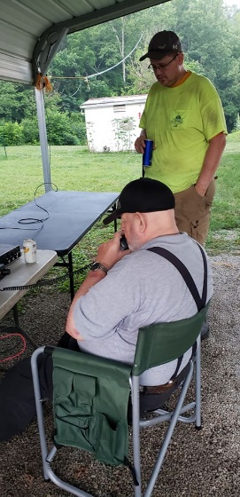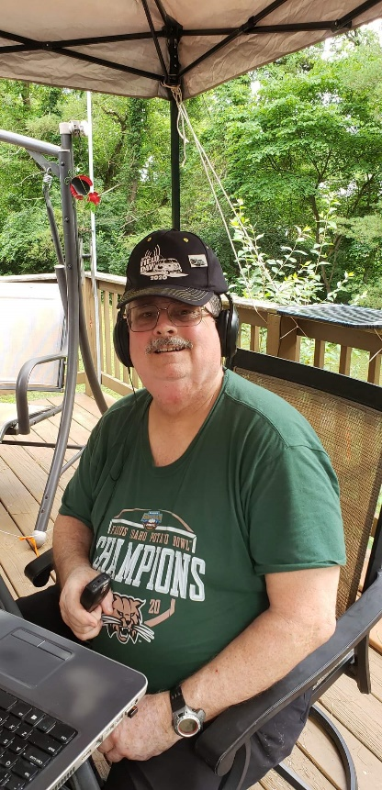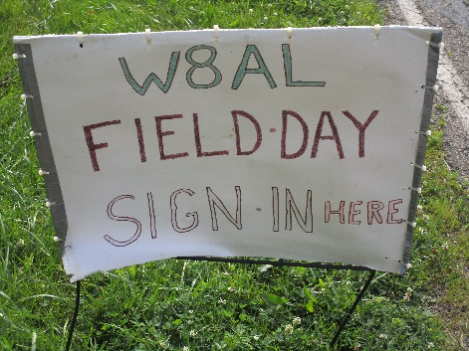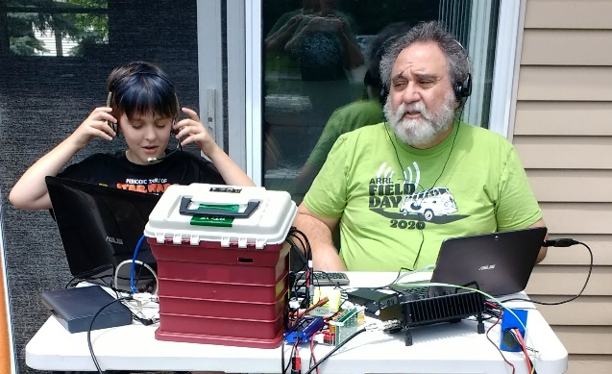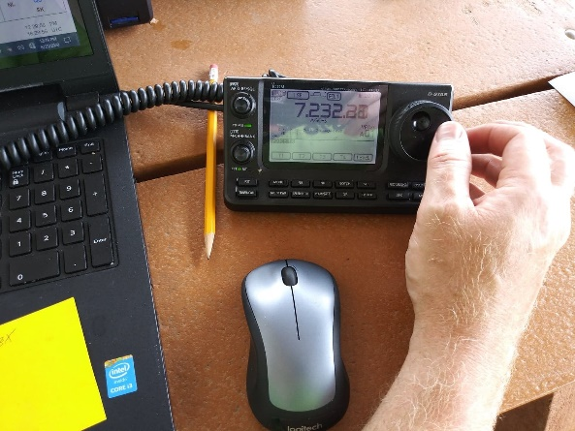

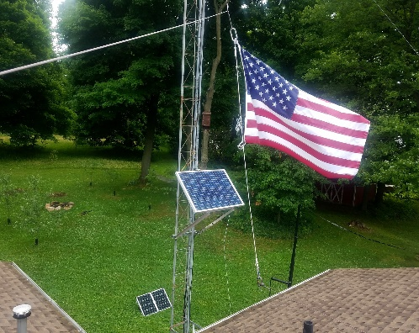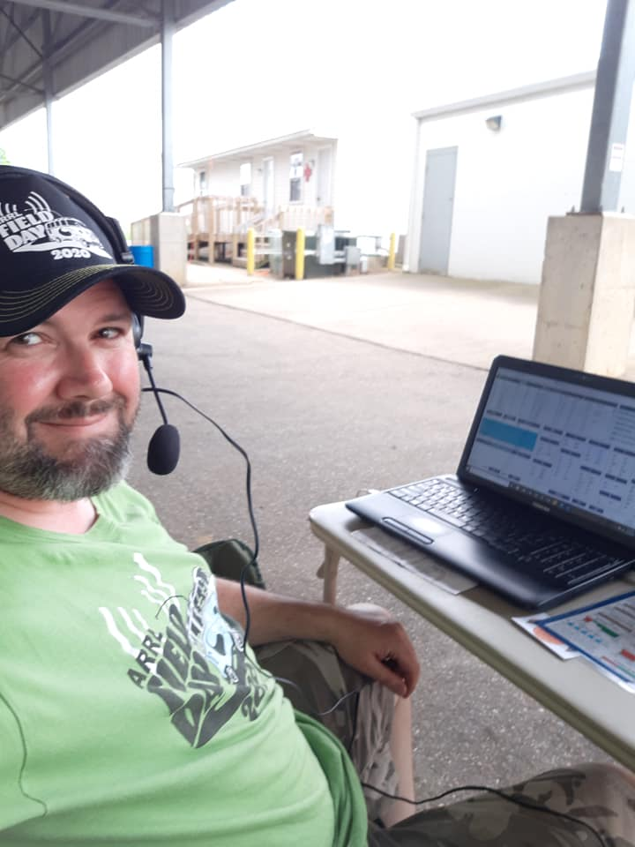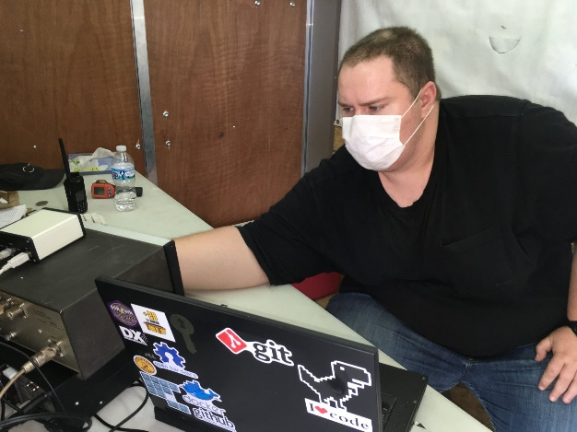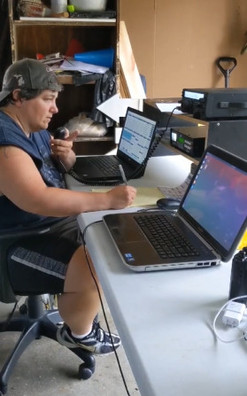

***National News***

*(from arrl and other sources)*

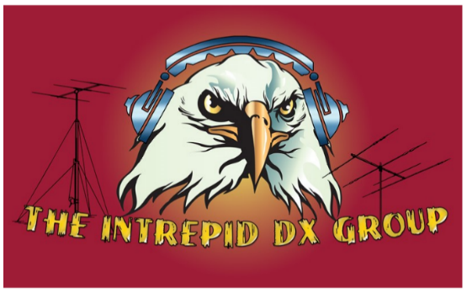

***Intrepid-DX Group Announces Youth Essay Contest***

The Intrepid-DX Group, a US-based IRS 501©(3) nonprofit organization that promotes amateur radio in developing countries, has announced its first Youth Essay Contest. The prize is a new Icom IC-7300 transceiver, which the winner must agree to keep and use for 1 year.

Participants will prepare a two-page essay answering these questions: (1) What are your amateur radio goals? And (2) What can we do to attract more youth to amateur radio?

The competition is open to US amateur radio licensees aged 19 or younger. [**Submit**](mailto:intrepiddxgroup@gmail.com) essays in text or MS *Word* attachment by July 31, 2020, or mail to The Intrepid-DX Group, 3052 Wetmore Dr, San Jose, CA 95148, postmarked by July 31, 2020. The winner will be announced on August 10 on the [**Intrepid-DX Group website**](http://www.intrepid-dx.com/) and on its [**Facebook page**](https://www.facebook.com/The-Intrepid-DX-Group-180857615282553). [**Email**](mailto:pauln6pse@gmail.com) for more information.

The Intrepid-DX Group hopes to make the Youth Essay Contest an annual event.

####

***“We've bought the wrong satellites': UK tech gamble baffles experts”***

*(Submitted by Gregory Drezdzon, WD9FTZ)*

"The UK government's plan to invest hundreds of millions of pounds in a satellite broadband company has been described as 'nonsensical' by experts, who say the company doesn't even make the right type of satellite the country needs after Brexit," reports The Guardian.

"The investment in OneWeb is intended to mitigate against the UK losing access to the EU's Galileo satellite navigation system. But OneWeb - in which the UK will own a 20% stake following the investment - currently operates a completely different type of satellite network from that typically used to run such navigation systems."

OneWeb is building a global satellite internet delivery platform similar to Starlink and plans to piggyback a British navigation system on the satellites. But the satellites will be in low Earth orbit at 12,000 km altitude, compared to other navigation systems at 20,000 km.

"The fundamental starting point is, yes, we've bought the wrong satellites," said Dr Bleddyn Bowen, a space policy expert at the University of Leicester. "It's bolting an unproven technology on to a mega-constellation that's designed to do something else. It's a tech and business gamble."

OneWeb filed for bankruptcy in March. For more of the story click on the link below.

<https://www.theguardian.com/science/2020/jun/26/satellite-experts-oneweb-investment-uk-galileo-brexit>

####

TOP ^

***Prominent Radio Amateur Helping to Lead US Convalescent Plasma Expanded Access Study***

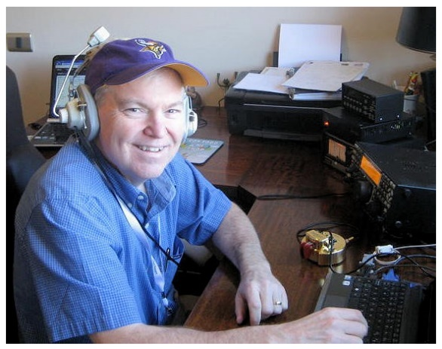Well-known contester, DXer, and *National Contest Journal* (*NCJ*) Editor Scott Wright, K0MD, has been “substantially” stepping back from ham radio while offering his expertise to the US convalescent plasma [**COVID-19 Expanded Access Program**](http://www.uscovidplasma.org/). The study began in early April under the leadership of Dr. Michael Joyner, MD, of the Mayo Clinic; Dr. Peter Marks, MD, PhD and Dr. Nicole Verdun, MD, of the US Food and Drug Administration; Dr. Arturo Casavedall, MD, PhD, of Johns Hopkins University, and Wright, who is with the Mayo Clinic. Dr. Marks is AB3XC.

“The US Convalescent Plasma Expanded Access Program is a collaborative project between the US government and the Mayo Clinic to provide access to convalescent plasma for patients in the US who are hospitalized with COVID 19,” Wright told ARRL. The work has been referenced during White House press briefings and in congressional testimony. The US government-supported study collects and provides blood plasma recovered from COVID-19 patients, which contains antibodies that may help fight the disease. The Mayo Clinic is the lead institution for the program.

“My role was to organize the infrastructure and the research approach, and to help lead the set-up of the data collection and of the website teams, while overseeing the study conduct and regulatory compliance,” Wright explained.

According to a June 18 *Washington Post* [**article**](https://www.washingtonpost.com/health/2020/06/18/blood-plasma-people-who-recovered-is-safe-covid-19-treatment-study-says/), “A large study of 20,000 hospitalized COVID-19 patients who received transfusions of blood plasma from people who recovered found the treatment was safe and suggests giving it to people early in the disease may be beneficial.”

An initial [**safety report**](https://dm5migu4zj3pb.cloudfront.net/manuscripts/140000/140200/JCI140200.v1.pdf) on 5,000 patients appeared in May in the *Journal of Clinical Investigation*. The [**safety study**](https://els-jbs-prod-cdn.jbs.elsevierhealth.com/pb/assets/raw/Health%20Advance/journals/jmcp/jmcp_ft95_6_8.pdf) on 20,000 subjects referenced in the *Washington Post* article was published earlier this month in the *Mayo Clinic Proceedings.*

Wright said most scientific studies of this magnitude take months to a year with planning and execution to get under way. In this case, the study team went from zero to 60 in a few short weeks.

“We started in less than a week. Most studies recruit 2,500 – 5,000 patients,” Wright said. “We have recruited over 30,000 patients in 10 weeks, exceeding all expectations.”

Hospitals in all 50 states and several US territories are participating, Wright said, and more than 8,000 physician-scientists are working with the team as investigators at their hospitals. “We also helped manage the start-up of collection of convalescent plasma by the large blood organizations, such as the American Red Cross, by strategically connecting donor pools and people willing to donate with the blood collection centers.”

Wright’s study responsibilities, which are on top of his regular day job, have required him to work daily, including weekends, for all of April, most of May, and all of June. “It has been intense,” he said.

TOP ^

Wright said an FDA announcement on the benefit of convalescent plasma was expected soon. “We are working on a third publication now to submit to a major international medical journal for publication on whether the study has shown that use of convalescent plasma reduces mortality,” Wright added. The FDA has been [**inviting donations**](https://www.fda.gov/emergency-preparedness-and-response/coronavirus-disease-2019-covid-19/donate-covid-19-plasma) of convalescent plasma from individuals who have fully recovered from COVID-19.

Wright will be the keynote speaker at the [***QSO Today Virtual Ham Expo***](http://www.qsotodayhamexpo.com/) August 8 – 9 to discuss the study, its results, and, he said, “linking it to skills acquired through ham radio.

####

**Annual 13 Colonies Event Gets Under Way on July 1**

The annual [**13 Colonies**](http://www.13colonies.us/) special event will begin on July 1 at 1300 UTC and conclude on July 8 at 0400 UTC. Stations representing the original 13 British colonies, plus two bonus stations, will be on the air with 1 × 1 call signs. The event sponsor stresses that participants do not need to work all 13 colony stations to obtain a certificate and do not need to work the two bonus stations for a clean sweep. All HF bands will be in play, with the exception of 60 meters, and simplex on 2 and 6 meters is encouraged. All modes of operation may be represented.

* This year will mark the 12th occurrence of the event. Look for:
* K2A, New York
* K2B, Virginia
* K2C, Rhode Island
* K2D, Connecticut
* K2E, Delaware
* K2F, Maryland
* K2G, Georgia
* K2H, Massachusetts
* K2I, New Jersey
* K2J, North Carolina
* K2K, New Hampshire
* K2L, South Carolina
* K2M, Pennsylvania.

Bonus station WM3PEN will be in Philadelphia (the call sign commemorates the Pennsylvania colony’s founder, William Penn). The other bonus station will be GB13COL in the UK.

####

***NANOVNA V2 NOW READILY AVAILABLE FOR $60***

*(Submitted by Gregory Drezdzon, WD9FTZ)*

The much awaited NanoVNA V2 (Vector Network Analyzer) is now [readily available for around $60 + shipping from the Tindie store](https://www.tindie.com/products/hcxqsgroup/nanovna-v2/). Shipping is noted to begin on June 30th due to a public holiday and you must agree to possible pandemic delays, although feedback from earlier customers indicates that most countries appear to be receiving the packages in good time. You can also add a calibration kit for $10 extra, or a calibration kit and acrylic enclosure for $14 extra.

TOP ^

We note that the NanoVNA V2 is an open source project created by OwOComm, a [research organization with a mission to further "intellectual communism"](https://github.com/owocomm-0). Therefore any factory is free to produce their own version from the designs, and hence several other versions have already been showing up on marketplaces like Aliexpress/eBay.

However, for now it is probably safer to buy directly from the original manufacturers on the Tindie store. [According to the developer](https://groups.io/g/nanovna-users/topic/v2_aliexpress_sellers/74580019?p=,,,20,0,0,0::recentpostdate%2Fsticky,,,20,2,0,74580019) , the quality of the "unofficial" clones that are showing up on Aliexpress and eBay is not yet known. The official version also supports the original developer and funds future software development.

A Vector Network Analyzer (VNA) is an extremely useful tool for radio hobbyists as it allows you to tune antennas, filters, and measure cable loss among other applications. Until recently a VNA would cost hundreds if not thousands of dollars. However, the original NanoVNA brought expensive VNA capabilities to the masses with its low $40 pricing.

The original design was limited to a maximum frequency of only 900 MHz. **The new V2 design pushes this maximum frequency up to 3 GHz officially, and unofficially up to 4.4 GHz with reduced performance.** It also improves on overall dynamic range and maintains the affordable price.

<https://www.rtl-sdr.com/nanovna-v2-now-readily-available-for-60-us-stock-available-at-rl/>

User guide: <https://github.com/nanovna/NanoVNA-QT/raw/master/ug1101.pdf>

Specifications:

* Frequency range: **50kHz - 3GHz**
* System dynamic range (calibrated): **70dB (up to 1.5GHz), 60dB (up to 3GHz)**
* S11 noise floor (calibrated): **-50dB (up to 1.5GHz), -40dB (up to 3GHz)**
* Sweep rate: **100 points/s**
* Display: **2.8'', 320 x 240**
* USB interface: **Micro USB**
* Power: **USB, 300mA**
* Battery: **not included. Includes charging circuitry. User can install a 1000mAh - 2000mAh lithium-ion battery with maximum dimensions 6 x 40 x 60 mm.**
* Battery connector: **JST-XH 2.54mm**
* Maximum sweep points (on device): **201**
* Maximum sweep points (USB): **1024**
* Port 2 return loss (1.5GHz): **20dB typ**
* Port 2 return loss (3GHz): **13dB min**
* VNA-QT software supported platforms: **Linux, Windows (7+)**, Mac OS planned

####

***Call For Speakers: ARRL Learning Network***

ARRL is readying the ARRL Learning Network — a series of online webinars presented by member-volunteers, for members. Like hamfest forums and radio club presentations, these webinars are intended to help members get more active, involved, and engaged in amateur radio.

TOP ^

|  |
| --- |
|  |
| |  |  | | --- | --- | | Invited guest presenters will cover topics from three categories:   * Personal Communications - like getting started in the digital modes, or radio sport * Emergency communications - like tips for public service communication volunteers * Radio electronics and technology - like QRP kit building, or understanding propagation |  | |
| Presentations should be short; 30 minutes plus a 15 minute Q&A. Presenters will use live video to share their knowledge, advice, smiling faces, PowerPoint slides, screen-sharing, or other demonstration items. If you've given a forum, you already know what to do! Presentations will also be recorded, so members can view these any time afterwards. |
| |  | | --- | | **Its easy to get started. Complete the online Speakers Form:**  [**www.arrl.org/ARRL-Learning-Network-Speakers-Form**](www.arrl.org/ARRL-Learning-Network-Speakers-Form) | |
| Selected presenters will be contacted and invited to schedule their webinar from a list of upcoming available date/time slots. An ARRL staff member will help coordinate the details with you, so you'll be ready for your presentation day! |
| Thank you. Together **we're advancing the art, science, and enjoyment of amateur radio!**  73,  **ARRL Learning Network**  Bob Inderbitzen, NQ1R - Product Development Manager Tel: (860) 594-0213 FAX: (860) 594-0303 [rinderbitzen@arrl.org](mailto:rinderbitzen@arrl.org) |

####

TOP ^

***MONDAY MORNING MEMO UPDATE***

*(from John Levo, W8KIW)*

soon after the COVID-19 hit and Southern Ohio region ham events came to a halt. The Ohio Section Journal is the current way to find out what is happening throughout the State as a whole. Once the State is fully reopened and clubs can again meet and hold events, the MMM fully intends to return in some form.

Field Day was truly different this year because of the health emergency. The Highland ARA is the only club I’m aware of that operated from a traditional type location. Even with that, their member participation was down because of concerns about group gatherings. A personal observation is that I hope the “D” classification will disappear. Home stations running big power with wide signals caused a lot of marginal signals from needed sections to be missed.

A couple clubs have held test sessions during the emergency. Field Day morning saw the Scioto Valley ARC hold a test session at their clubhouse near Scioto Trails State Park. Chris Adams is now KE8OTR and Thomas Noonan is now KE8OTQ. Chris got both the Tech and General licenses and Thomas received his Tech. Both are from Kingston. Chillicothe’s Mike Mathuews (KC8WIW) upgraded to Extra and Jeffrey Blackburn (KO4EPA) was a happy camper returning to Lexington, KY with his Extra. Although the Governor’s proclamation cancelled an originally scheduled test session, with the assistance of the Fayette ARA on May 9 the Highland ARA held a test session for their recent license class. As a result, new Technician ham licenses were issued to: Jon Salyer-KE8OJB; Joseph Salyer-KE8OJC; Scott Bitzer-KE8OJD; Mike Mider-KE8OJE; Jeff Baldwin-KE8OJF and Branson Hayslip-KE8OJG. Upgrades to General were made by Anthony Gorrell-KE8DUV and Greg Brown-N8GPB. Pat Hagen, N8BAP, walked away with his Extra. A follow-up session was held in June to accommodate others in the class. Bainbridge’s Doug Broyles became KE8ORQ and Hillsboro’s Jason Maines is now KE8ORR. Richie Hagen, N8CUP, upgraded to Extra at the session.

The Clinton County ARA is to resume in person meetings this week. They will meet on Thursday evening, July 2, at the Boyd Cancer Center in Wilmington at 7:30 pm. That morning they will resume their monthly breakfasts at the Wilmington Bob Evans at 8 am.

####

[](https://blogs.uakron.edu/waynec3/)

Hello everyone,

Summer began in earnestness this week with sunny, hot days and thankfully cool nights.  With more people staying-at-home, “makers” have plenty of time to build amazing projects.  Check-out a video of this amazing [squirrel obstacle course](https://www.youtube.com/watch?v=hFZFjoX2cGg) where our furry friends work for their food!

TOP ^

[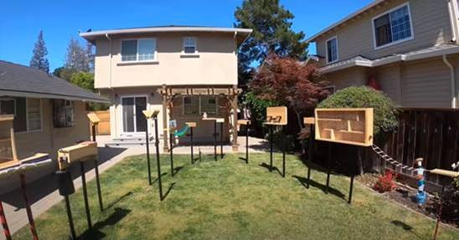](https://www.youtube.com/watch?v=hFZFjoX2cGg)

Even though the 3D Lab is closed over the summer due to COVID precautions, its services are ready and available!  If you have projects that need 3D printed, laser engraved, vinyl signage made, etc., reply to this email with your request.  We will perform the work in the 3D Lab at no cost for pick-up later.  [Here is a list of our equipment](https://blogs.uakron.edu/waynec3/equipment/) to aid in making your projects come to life.

Last semester, Tristan spent time in the 3D Lab designing something ingenious, a GoPro camera mount for the tip of his snowboarding boot!  This way he can take selfie videos while careening over moguls.  The camera mounts sideways (not forward) which works surprisingly well during snowboarding gymnastics.

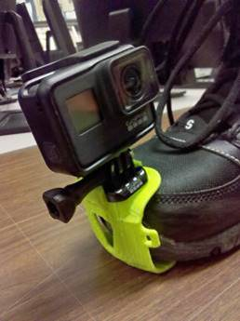

The design was refined numerous times.  Tristan chose ABS filament for its ruggedness but found that walking on gravel quickly destroyed his first iteration.  Thicker infill was needed for the mount innards, an easy adjustment while 3D printing.  The mount also had a difficult time staying attached to his boot, requiring a (successful) redesign.  He printed the mounts on our [LulzBot Taz 5](https://www.lulzbot.com/store/filament) printer which can make objects out of a variety of materials such as [these](https://www.lulzbot.com/store/filament).  Good job, Tristan!

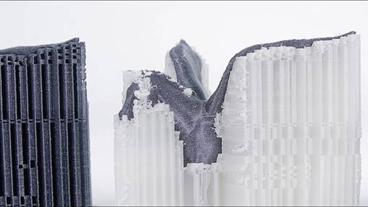Over the spring semester, another student (Andy) aimed to produce detailed figurines for Dungeons and Dragons role playing campaigns.  Plastic based 3D printing is fairly detailed, producing thin layers as fine as 0.1mm to build objects with.  Even so, consumer-grade 3D printers struggle with supports which are pillars of plastic to raise overhangs (such as a figurine’s arms) which must be carefully removed after printing.  Check-out this dragon with a ton of support material under its wings:

TOP ^

To solve these problems with, Andy used the 3D Labs’ [FormLabs Form 1+](https://formlabs.com/) resin 3D printer.  This machine prints objects with 4x the detail of traditional 3D printing (layers as fine as 0.25mm).  Supports are still needed, but they are simpler and much easier to remove.  After printing, the resin is cured in a special ultraviolet light chamber that he built.  He then meticulously cleaned up each figurine after printing, producing some startling pieces!

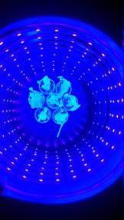

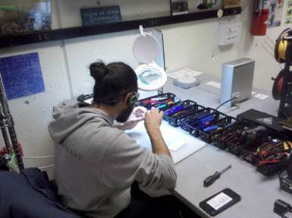

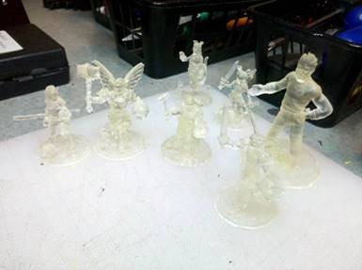Every Fall semester, engineering students in the Tools for Engineering class host an exciting event: the famous Battle Bots Tournament!  Students spend several weeks building custom LEGO Mindstorms robots with a single purpose: to push an opponent’s robot off the arena and/or (more entertainingly) disable or destroy it.  The tournament makes for tense moments and good laughs!  This past semester was no different.  Students used the phones or game controllers to move robots around the arena with varying degrees of mastery.

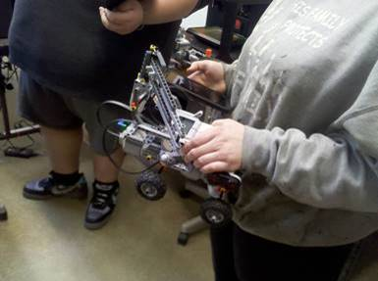   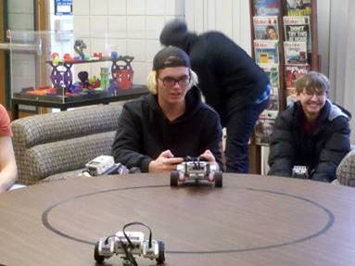

Students built robots for other tasks during the semester, such as identifying balls by color and “catching” them, an endurance marathon through the college halls, and the dreadfully difficult stair climbing competition.  The ingenuity of our students every semester never ceases to amaze.

TOP ^

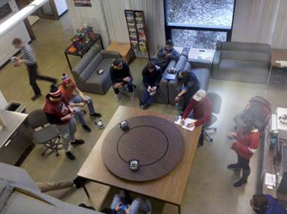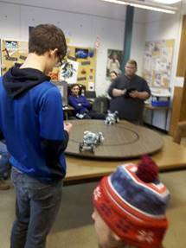

Stay tuned next week as we introduce more interesting folks who participated in last year’s Maker Faire!

Until then…

Tom

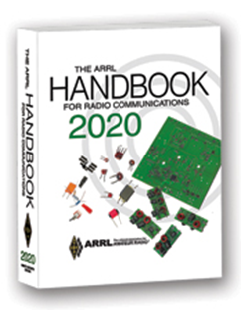***The Handbook Give Away***

Hey Gang,

The winner of the June Give Away is… ***Greg Straley, KC8DVG***

Many of you ask me just how do I know when the drawing is on? Well, that’s easy all you need to do is check in on the Ohio Section Website on a regular basis and watch for the big **RED** Arrow that will appear on the left side of the page.



This is the sign that the drawing is on and you need to get registered. So, keep a sharp eye out on the website and check in often! <http://arrl-ohio.org/>

***Club Corner***



This is YOUR cornner of the newsletter. Send me what your club is doing and I’ll make sure that it gets in. Got a special event or club project that you want everyone to know about? Send it to me!. Need help with a project? Send it to me.

Let me know what you club is up to. Are you going to have a special guest at your meeting or are you having a special anniversary? Just sent it to: [n8sy@n8sy.com](mailto:n8sy@n8sy.com)

####

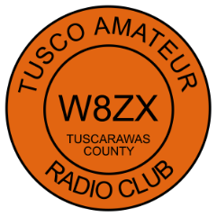The TUSCO Amateur Radio Club is providing Communications for the Camp Tuscazoar Adventure Race July 18, 2020. We are looking for any interested hams that may be interested in helping. We are meeting in the parking lot (Camp Tuscazoar, 6066 Boy Scout Road NE, Dover OH 44622) at 8:00 am, bring an HT.

**Contact KE8BKP Jeff Voltz at 330-690-6072** if interested in helping. All participants will be asked to follow state requirements for social distancing.

####

TOP ^

***QSL Cards for Brazilian Youth***

*(from SARA general announcements)*

All,

Please see a message below from Aenoir PY2SKY. They are working to collect non-contact QSL cards for a scouting project. If you are interested in participating, please send a QSL card by **July 15th** to **Garry Foster W8GMF**:

Garry Foster W8GMF

545 SkyLark Ave

Wooster, OH 44691

Thanks.

Jason

--------------------------------------------------------------

Greetings Garry M. Foster - W8GMF

Wayne Amateur Radio Club - W8WOO

My name is ADENOIR.  My call sign is PY2SKY.

Here in my city I am part of a group of young Scouts. We have a project in which we teach the hobby of amateur radio to the boys and girls in our Boy Scout group. Our young scouts are setting up a large QSL card display panel for radio stations in Brazil and other countries. If possible, we would like to receive a copy of your QSL card or a postcard from your city and country. This card will have no value as confirmation of contact, but as a collection item. For our young people, this exchange of culture is very important. It would be an honor to receive a letter from the post office so far. Collectible items will also be warmly welcomed.

I hope to find you soon in the Ham bands in better conditions for propagation.

A big hug from the scouts from Brazil.

Looking forward to your correspondence.

73 my friend.

ADENOIR - PY2SKY  (∴)

P. O. BOX: 281

TATUÍ - SP

BRAZIL

18.270-970

####

TOP ^

***The Northwest Ohio ARES Traffic Net Needs Help***

The Northwest Ohio ARES Traffic Net is in need of General and/or Extra Class licensees with either voice or CW capabilities to relay traffic from the VHF net to the HF nets, no experience is necessary.

The NW Ohio ARES Traffic Net meets daily at 6:30PM on the W8RZM 147.375 repeater.

The Ohio Single Sideband Net meets daily at 10:30AM, 4:15PM and 6:45PM on 3.9725 MHz. The Ohio Section also has three CW Nets, the Ohio Slow Net meets daily at 6:00PM on 3.53535 and runs at approximately 10 WPM.

The Buckeye Net-Early meets daily at 6:45PM on 3.580 and runs between 15-20 WPM. Finally, the Buckeye Net-Late meets daily at 10PM on 3.590 and runs in the same range as the Early Net. Currently, there are only 2 volunteers that cover 7 days a week, and most nets there isn't a volunteer at all. Please consider volunteering for an hour a week, you never know, you may like it.

For more information on traffic handling, or volunteering to assist relaying traffic please check into the VHF net or contact Colleen Roth N8TNV, Steve Denniss KC8IDM, or Michael Lacumsky W8MAL.

####

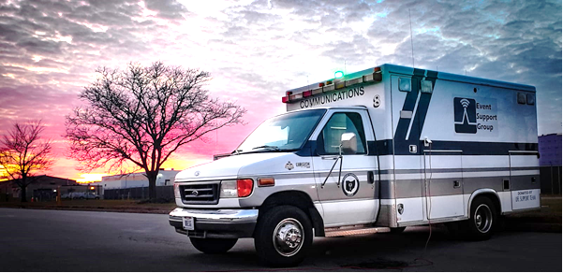***Packet Network Handbook Giveaway***

Jon KM8V and Doug AB8M gave a great presentation on setting up packet at the June ARES meeting. The recording is available on YouTube and can be found on Jon's page at km8v.com

Thanks to Scott Yonally N8SY, the Ohio Section Manager, has donated a Handbook for me to give out to someone who participates in the newly created Monday Packet Net.

To be eligible, all you have to do is get on any Monday in June and send a packet message via RF to the Monday Night Packet Net. You will be credit with one drawing entry per check in during the month of June. (BBS and Winlink count as separate check ins as long as they both originate via RF).

This isn’t a conventional net where all participants meet simultaneously. Instead, the concept is that amateurs send a message anytime between 0600 and 2100 on Monday. All messages will be acknowledged, and you will receive a response on Tuesday.

But wait, there's more! Want an extra entry in the drawing? Now you can have TWO extra entries. As you're doing your field day weekend fun, send a BBS or a winlink message to AB8M using the Winlink ICS-213 template. Send it anytime on Saturday or Sunday - and you can still check-in to the net on Monday. Field Day check ins MUST be formatted in an ICS-213 template to be eligible!

There are two contact address – you can choose to send to either one or to both – it is up to you: Packet BBS: [AB8M@AB8M.#CLE.OH.USA.NOAM](mailto:AB8M@AB8M.#CLE.OH.USA.NOAM) Winlink: [AB8M@winlink.org](mailto:AB8M@winlink.org)

TOP ^

Stations are encouraged to contact over the air via a Packet BBS of their choosing. Our hope is that we will learn of other packet stations in Ohio that we can relay with.

Stations should send in the Subject: Monday BRRO Packet Net. In the body of the message please include name, location, and your entry node into the packet network.

If you do not receive a response to a message by 9pm on Tuesday or receive a bounce message, please send an email to [dougdever@gmail.com](mailto:dougdever@gmail.com) with the details.

A list of some known Cleveland area packet nodes and digi’s are listed on: <https://www.km8v.com/packet/>

***Upcoming Event Status Update***

The MS150 Buckeye Breakaway ride will NOT be happening this year anymore. It has been converted to a virtual event.

Below is a list of events STILL HAPPENING Cleveland area that Event Support Group will be participating in. We still need volunteers for all! Be sure to click and bookmark the "View Full Event Calendar" link below.

• Field Day GOTA Station on June 27, 2020 14:00

• ARES Meeting on July 12, 2020 14:00

• AFSP Out of the Darkness Walk Communications Support on September 26, 2020 09:30

• Cleveland Hamfest Volunteers on September 27, 2020 06:00

• Making Strides of Cleveland *Communications Support* on October 10, 2020 08:00

Our friends over at the Geauga Amateur Radio Association have begun compiling a list of as many radio related cancellations as they can. Be sure to check it frequently at https://geaugaara.org/coronavirus/.

***2020 Cleveland Hamfest STILL ON!***

That's right, the 2020 Cleveland Hamfest is NOT CANCELLED. We are watching the situation very closely and will update everyone if anything changes. As of now the Hamfest Association of Cleveland is still moving forward with plans for the 2020 Cleveland Hamfest on Sunday, September 27. Indoor Vendors, please visit [www.hac.org](http://www.hac.org) and click “vendor information” at the top for more info.

Make sure you head on over to [www.hac.org](http://www.hac.org) for the latest info and be sure to click “Join Our Mailing List” to get all the latest updates.

####

***Conference Bridge Now Available***

Hey Gang,

With the government still keeping many of the meeting locations closed down it has really become a struggle for clubs all over our Section to find ways of having their meetings

Well, the Ohio Section came up with a tool for the toolbox that will allow you to have a video/phone conference meeting and stay within the CDC’s guidelines for distancing.

TOP ^

We’ve partnered up with Zoom, one of the premiere video conferencing bridges in the country and we now have the ability to do our own “on-line” conferences.

Our Zoom account allows for up to 100 persons at a time to be connected with not only audio, but video as well. This is sooooo 21st century. You can share your screen for those really fancy presentations, see everyone that’s connected with a camera on the call and really do a first-class meeting with this technology. No, you don’t need to have a computer. Zoom will also allow you to just call in on your regular or cellular phone too. That is what makes this so great.

Some groups have come up with using their repeaters to help take the place of the meetings. Skype and Free Conference Call are also some ideas that clubs are experimenting with. What a wonderful way of using the technology that we have in place!

I think it is really great no matter what you use for all of us to keep in contact with each other. We used to use our repeaters way more back in the day, but for some reason we’ve kinda’ gotten away from even thinking of using them or other technology to stay in contact, especially with our older hams that might not be able to get out at night, or just aren’t as mobile as they used to be. Ham radio is one way for all of us to make those very important contacts with each other to be sure we are all ok and safe. Zoom is another tool in the toolbox for us to use. So, if you want to try Zoom or have a meeting using it, just let me know. [n8sy@n8sy.com](mailto:n8sy@n8sy.com)

####

***Another Zoom Conferencing Available***

In order to help facilitate virtual meetings, webinars, and presentations for Cleveland-area clubs and groups, and in line with our charter to support and promote Amateur Radio, The Hamfest Association of Cleveland has procured a paid [Zoom](https://zoom.us) video conferencing account for use by area Amateur Radio clubs.

Any area club that wishes to use it may request the scheduling of a Zoom call from HAC on a first-come, first-served basis using the form at <http://www.hac.org/zoom>.

All we ask is that you thank the Hamfest Association for the use of Zoom during your meeting.

Zoom calls are limited to 100 participants, and 24 hours in duration (here's hoping your meeting isn't 24 hours long).

Amateur Radio-related uses only please.

If your club or group would like to use the HAC Zoom for your meeting, please complete the form below to make your request.

73 de W8HAC

<http://www.hac.org/zoom/>

TOP ^

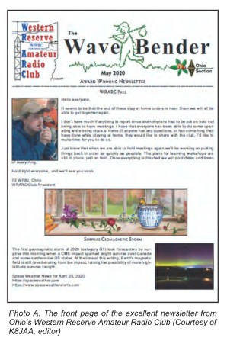***Ohio Newsletter Recognized in CQ Magazine***

***“Don’t Forget The Newsletter and Website”***

Each month I look forward to reviewing news from my own from my own club and I sneak a peek at many others by visiting their respective websites. It’s vital to keep that information fresh and a great way to shar some “How To” technical info in graphic form that can’t be adequately shared over the air.

I’ll do a shout-out to Ohio’s Western Reserve Amateur Radio Club and newsletter editor Jane Avnet, K8JAA.

Each month she assembles and distributes a multipage newsletter that’s newsy, topical, and punctuated with a bit of humor. It’s distributed via email in PDF format so it’s easy to read and distributed to anyone who wants it. This proactive approach to distribution is another way to reach club members who may not be able to participate in the nets and, in recent months, unable to attend meetings. Their newsletter format is a good template for other clubs to emulate. If you need samples, an archive is available at the club’s website, [www.wrarc.net](http://www.wrarc.net)

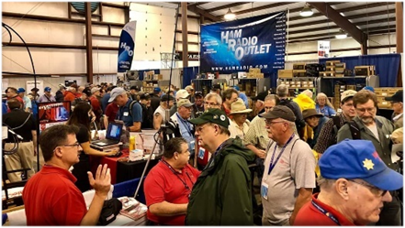

[***Upcoming Hamfests***](http://arrl-ohio.org/hamfests.html) ***for 2020***

**~~07/18/2020 | NOARSfest~~**

~~Location: Elyria, OH~~

~~Sponsor: Northern Ohio Amateur Radio Society~~

~~Website:~~ [~~https://www.facebook.com/NOARS.K8KRG~~](https://www.facebook.com/NOARS.K8KRG)

***~~Canceled~~***

|  |  |
| --- | --- |
| **07/19/2020 | Van Wert Hamfest** Location: Van Wert, OH Sponsor: Van wert Amateur Radio Club Website: [http://w8fy.org](http://w8fy.org/) | **~~07/26/2020 - Portage Hamfair '20~~** ~~Location: Ravenna, OH Sponsor: Portage Amateur Radio Club, Inc. Website:~~ [~~http://hamfair.com~~](http://hamfair.com) ***~~Canceled~~*** |
| **~~08/01/2020 | Columbus Hamfest~~** ~~Location: Grove City, OH Sponsor: Voice of Aladdin/ Audio Unit of Aladdin Shrine Website:~~ [~~http://columbushamfest.com~~](http://columbushamfest.com/)***~~Canceled~~*** | **~~08/08/2020 | DXE Hamfest,~~**  **~~ARRL Ohio Section Convention~~** ~~Location: Tallmadge, OH Sponsor: DX Engineering Website:~~ [~~http://dxengineering.com~~](http://dxengineering.com/)  ***~~Canceled~~*** |

TOP ^

|  |  |
| --- | --- |
| **08/15/2020 - Clinton County Ohio ARA Hamfest**  Location: Wilmington, OH  Sponsor: Clinton County ARA  Website: <http://ccara.net> | ***New Date***  **08/29/2020 - Milford Hamfest** Location: Owensville, OH Sponsor: Milford Amateur Radio Club Website: [http://www.w8mrc.com](http://www.w8mrc.com/) |
| **09/27/2020 | Cleveland Hamfest and**  **Computer Show** Location: Berea, OH Sponsor: Hamfest Association of Cleveland Website: [http://www.hac.org](http://www.hac.org/)  **Click on “Join Our Mailing List” to stay updated.** | |

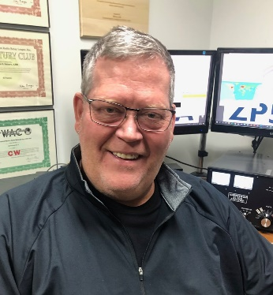***DX This Week***

*(from Bill, AJ8B)*

***DX This Week – Zones 15, 16, and 17***

***Bill AJ8B (***[***aj8b@arrl.net***](mailto:aj8b@arrl.net)***, @AJ8B, or*** [***www.aj8b.com***](http://www.aj8b.com)***)   
 CWOPs Member #1567***

This week there were some interesting entities spotted including Anguilla, Bonaire, Brazil, Bulgaria, Canada, Canary Islands, Ceuta & Melilla Islands, Colombia, Croatia, Cuba, Denmark, England, European Russia, Fed. Rep. of Germany, Guernsey, Hungary, India, Isle of Man, Italy, Japan, Kenya, Kuwait, Lebanon, Liechtenstein, Madeira Islands, Mexico, Netherlands, Northern Ireland, Oman, Portugal, Puerto Rico, Scotland, Serbia, Slovakia, Spain, St. Lucia, and Zambia. There were two mornings when I heard over 10 JAs on thje low end of 40 meters and they were all very workable. Let me know what you worked!

I had several QSL cards returned last week that I had sent via the direct route. With the COVID restrictions, some mail is not being accepted in other countries. I will wait 90 days and resend. One that I did receive was ZA/IZ7PMQ – Mastroviti in Albania. (Shown) This was a DXPedition that the Italians took on during the lock down as they could drive there, and they were already familiar with the area.

TOP ^

**CQ Zones 15, 16, and 17**

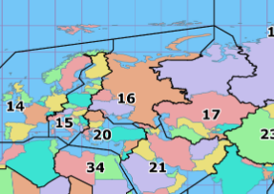So far this year, we have covered CQ zones 1 through 14. This week we will review Zones 15 – 17. Below is a list of the entities in each zone and the estimated number of hams in each country, for the data I could find.

**Zone 15:** Central European Zone: E7 (Bosnia Herzegovina) – 1,758, ES (Estonia) – 1,000, HA (Hungary) – 9,000, HV (Vatican), I (Italy) – 30,000, IS0 (Sardinia), LY (Lithuania) - 810, OE (Austria) – 5,967, OH (Finland) – 5,000, OH0 (Aland Is.), OJ0 (Market Reef), OK (Czech Rep.) - 786, OM (Slovakia) - 930, S5 (Slovenia) – 6,500, SP (Poland) – 16,000, T7 (San Marino), TK (Corsica), UA2,F,K, RA2,UB2-UI2 (Kaliningrad), YL (Latvia) - 190, YU (Serbia), ZA (Albania), Z3 (Macedonia) - 620, 1A0 (SMOM), 4O (Montenegro), 9A (Croatia), 9H (Malta).

Zone 15 – The challenges for me in Zone 15 have been: HV – Have worked the Vatican station 3 times, OJ0 –Have worked Market Reef 3 times, and 1A0 – Have worked them twice. The first time I worked 1A0 was in 2015. Fortunately, I came down with the flu the very day they were operating a special event station.

**Zone 16:** Eastern Zone of Europe: EW (Belarus) – 1,359, ER (Moldova) - 192, UA1, UA2(except for RA2 and UA2-UI2), UA3. UA4, UA5, UA6, UA7, UA9, UA9 (S, T, W), and UR (Ukraine) – 17,265.

Zone 16 – Most of these entities I have worked during the CQWW contests. Some of the Ukrainian ops I have worked have been among the nicest guys and are happy to chat about their “working conditions.”

**Zone 17:** Western Zone of Siberia: EX (Kirgizstan), EY (Tajikistan), EZ (Turkmenistan), UA8,9 (A, B,C,D, F, G, J. K, L, M, N, Q,R, X), UK (Uzbekistan), UN (Kazakhstan).

Zone 17 – This zone has been a challenge for me. Last year we discussed what conditions were like towards the peak of the sunspot cycle. I have worked EX, EY, EZ, and UK 3 times each on different bands or modes, all between June of 1990 and August of 1991. In forty years, I have not worked them before or after that. This really surprised me as I gathered information for this column and it makes me want to focus on this zone!

One of the easier ways to pick up zones is during the CQWW contests. The exchange between stations is a signal report and your zone. If you are tuning across the band and hear “599 16”, you will automatically know that this station is operating in zone 16. As the adage goes, work them first and worry about the zone later.

Good Hunting!

***CQDX CQDX CQDX CQDX CQDX CQDX CQDX CQDX CQDX***

Here is an update from Bernie, W3UR, of the DailyDX and the WeeklyDX, the best source for DX information. <http://www.dailydx.com/>. Bernie has this to report:

TOP ^

**HB0 – Liechtenstein -** When HB9HBY, Loick and HB9TWU, Greg, are QRV from here July 24, 25 and 26 they will need to each use their own calls as HB0/home calls. On that Saturday they will jointly use a special callsign. More details on that callsign yet to be announced. They are planning to be QRV on 80 through 6 meters on SSB, CW and FT8. Equipment will include an FT-891 with an Italian RM amplifier running between 300 and 500 watts into dipoles.

**VU – India -** VU2TUO has been issued special Covid-19 callsign AT2ARA, which is valid through September 23, 2020.

**Jan Mayen DXPedition 2021** –

JX0X By LA7GIA, Ken Opskar

The following news for The Daily DX is from LA7GIA, Ken, who did a six hour operation last year as JX7GIA on April 4, 2019. Before that JX had not been QRV since 2014. Now for the details directly from Ken:

We would like to announce the Jan Mayen 2021 low band trip with the callsign JX0X.

For about 14 months we have been planning a trip to Jan Mayen, which has a high ranking on the low bands (#20+) as well on CW and Digi mode.

Going to Jan Mayen has proved to be a difficult task. Finally, we have all permissions needed from the Military and the Norwegian authorities for an international team to enter Jan Mayen on a 2-week DXPedition in late September 2021.

The JX0X team members are; Ken LA7GIA Mats RM2D Dima RA9USU Dominik R4BE (DL5EBE)

This is an all band, all mode DXPedition. But we will focus on low bands 160-30 using CW and Digi mode. We will also do other bands like 60, 20 and possible 17m depending on conditions, and we will be on SSB.

We have been given the best QTH to work NA and Japan with beach access and our antenna farm close to saltwater. Our low band verticals combined with 1 kW amplifiers and 4 stations up and running shall give you the best possibility in many years to work that much needed low band slot. In fact, it will be 21 years since the last 160m QSO from Jan Mayen according to Club Log.

Going to Jan Mayen in Sep/Oct is not an easy task and the budget for this trip is currently in the range of 90k

USD. To do this trip we depend on support from clubs & foundations, corporate and individuals. We will provide a webpage with more info soon.

Thanks, On behalf of the JX0X team - Ken LA7GIA

***DX news***

***ARLD027 DX news***

This week's bulletin was made possible with information provided by The Daily DX, the OPDX Bulletin, 425 DX News, DXNL, Contest Corral from QST and the ARRL Contest Calendar and WA7BNM web sites. Thanks to all.

**MONACO, 3A.** Ennio, IW1RBI will be QRV as 3A/IW1RBI beginning July 6. His length of stay is unknown. Activity will be on 30 to 6 meters using SSB and FT8. QSL to home call.

TOP ^

***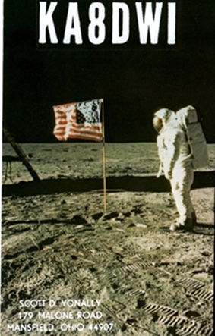*KUWAIT, 9K.** Special event station 9K8FTDMC is QRV until July 31 to celebrate the 3rd anniversary of the FT8 Digital Mode Club. QSL via operators' instructions.

**UNITED ARAB EMIRATES, A6.** Special event station A60FTDMC is QRV until July 31 to celebrate the 3rd anniversary of the FT8 Digital Mode Club. QSL via operators' instructions.

**BAHRAIN, A9.** Special event station A91FTDMC is QRV until July 31 to celebrate the 3rd anniversary of the FT8 Digital Mode Club. QSL via operators' instructions.

**ENGLAND, G.** Larry, G4HLN is QRV with special event call GB100GKU until July 28 to commemorate the 100th anniversary of the long-range maritime radio service in the United Kingdom. Activity is on the HF bands using CW. QSL via bureau.

**SWITZERLAND, HB.** Special event station HB15SOTA is QRV until May 8, 2021 to mark the 15th anniversary of SOTA activities in Switzerland. QSL via operators' instructions.

**SAUDI ARABIA, HZ.** Members of the Saudi Wireless Amateur Association are QRV with special event station HZ8FTDMC until July 31 to celebrate the 3rd anniversary of the FT8 Digital Mode Club. QSL via operators' instructions.

**JAPAN, JA.** Special event station 8N1ABIKO is QRV until the end of 2020 in celebration of the founding of Abiko-City, IOTA AS-007. QSL via bureau.

**LEBANON, OD.** Special event station OD5FTDMC is QRV until July 31 to celebrate the 3rd anniversary of the FT8 Digital Mode Club. QSL via operators' instructions.

**ANTARCTICA.** Alexander, RX3ABI is QRV as RI1ANM from Mirny Base, IOTA AN-016, until early 2021 while on work assignment. Activity is in his spare time on 40 and 20 meters using FT8. QSL to home call.

**EGYPT, SU.**  Special event station SU8FTDMC is QRV until July 31 to celebrate the 3rd anniversary of the FT8 Digital Mode Club. QSL via operators' instructions.

**CORSICA, TK.** Max, DL8UW is QRV as TK4VQO from Olmeto and expects to be here for the next few years. Activity is on 160 to 6 meters using CW and SSB. QSL direct to home call.

**EUROPEAN RUSSIA, UA.** Special event stations R100RT and R100TSSR are QRV until July 10 to celebrate the 100th anniversary of the Republic of Tatarstan. QSL via operators' instructions.

**VANUATU, YJ.** Operators YJ8CW, YJ8ED and YJ8RN are QRV as YJ40IND until the end of July to celebrate the 40th anniversary of Vanuatu's Independence. Activity is on 40, 20, and 15 meters using CW, SSB and FT8. QSL direct.

**NEW ZEALAND, ZL.** Special event station ZL65FTDMC is QRV until July 31 to celebrate the 3rd anniversary of the FT8 Digital Mode Club. QSL via operators' instructions.

TOP ^

THIS WEEKEND ON THE RADIO. The 10-10 International Spirit of 76 QSO Party, QRP 20-Meter CW Fox Hunt, NCCC RTTY Sprint, NCCC CW Sprint, FISTS Summer Slow Speed CW Sprint, YBDXC 80-Meter SSB Contest, DL-DX RTTY Contest, Marconi Memorial HF CW Contest, Original QRP CW Contest, TA VHF/UHF Contest and PODXS 070 Club 40-Meter Firecracker PSK31 Sprint are all on tap for this upcoming weekend.

The RSGB 80-Meter Club CW Championship is scheduled for July 6.

The RTTYOPS Weeksprint, ARS Spartan CW Sprint and Worldwide Sideband Activity Contest are scheduled for July 17.

The VHF-UHF FT8 Activity Contest, CWops Mini-CWT Test and Phone Fray are scheduled for July 8.

The 13 Colonies Special Event runs until July 8.

A number of Special Event Stations are using the FTDMC suffix until July 31 to celebrate the 3rd anniversary of the FT8 Digital Mode Club.

Please see July 2020 QST, page 69, and the ARRL Contest Calendar and WA7BNM Contest Web Sites for details.

**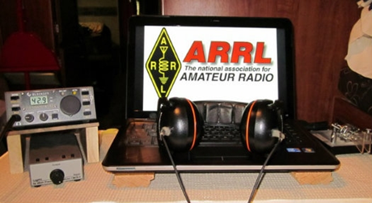*ARRL Contest Corner***

An expanded, downloadable version of *QST'*s’[**Contest Corral**](http://www.arrl.org/contest-calendar) is available as a PDF. Check the sponsor's’Web site for information on operating time restrictions and other instructions.

####

***We're making several changes for the 2020 Ohio QSO Party:***

1. We're adding 160 meters. Based on 160 meter activity in other QSO Parties I don't expect this to make a huge difference, but it should provide an opportunity for some "fresh meat" QSOs when things get slow late on Saturday night.

2. We're dropping the "One station/one call" rule. So you can also use a club call or other call for an additional entry, to enjoy being a new station while making more QSOs possible for others. This is intended to allow more potential QSOs for everybody, not as a way to inflate scores of friends.

We hope you all will join us for the 2020 OhQP on **Saturday, August 22**, from noon to midnight EDT (1600z - 0400z) !

73  -   Jim   K8MR

OhQP Chairman

####

TOP ^

***Special Events***

* **07/11/2020 | Dalton Gang SES**

**Jul 11-Jul 13, 1700Z-2359Z, W5D**, Adair, OK. Mayes County Amateur Radio Club. 14.240 7.225 3.850. QSL. MCARC, P.O. Box 1195, Spavinaw, OK 74366. MCARC@qsl.net; www.qrz.com/db/w5d or [www.mcarc.me](http://www.mcarc.me/)

* **07/11/2020 | Peace Cross Celebration**

**Jul 11, 1300Z-1900Z, N3V**, Lanham, MD. American Legion Post 275. 7.275; 145.43 PL114.8. Certificate & QSL. The American Legionpost 275 TALARC, 8201 Martin Luther King Jr. Hwy, Lanham, MD 20706. QSL cards & certificate can be obtained with SASE. wa3dvo@gmail.com or [www.qrz.com/db/n3v](http://www.qrz.com/db/n3v)

* **07/11/2020 | USS Midway Museum Ship Special Event: Independence Day**

**Jul 11, 1600Z-2300Z, NI6IW**, San Diego, CA. USS Midway (CV-41) Museum Ship. 14.320 7.250 14.070 (PSK31) D-STAR on various reflectors. QSL. USS Midway (CV-41) COMEDTRA, 910 N Harbor Drive, San Diego, CA 92101.

* **07/12/2020 | Iowa State Parks On-the-Air Centennial – Volga River**

**Jul 12, 1500Z-1900Z, W0OEL**, Fayette, IA. Rural Iowa Amateur Radio Club. 14.240 7.240. Certificate & QSL. Great River Amateur Radio Club, P.O. Box 1384, Dubuque, IA 52004. IASPOTA-2020 Located in one of the most scenic parts of the state. Northeast Iowa is often referred to as "Little Switzerland" because of its rugged topography, rock outcroppings and forest cover – a sharp contrast to the rolling hills, farmland and scattered stands of timber found in the majority of the state. Certificate & QSL managed by Great River Amateur Radio Club, P.O. Box 1384, Dubuque, IA 52004. QSL for contact; certificate for 5 parks. See website for complete information, http://www.w0dbq.org/rules or [https://www.w0oel.com](https://www.w0oel.com/)

* **07/17/2020 | South Carolina Peach Festival**

**Jul 17-Jul 19, 0400Z-0400Z, W4W**, Gaffney, SC. Cherokee County Coroner’s Office. 147.240 145.250 145.190 442.500. Certificate & QSL. Dennis Fowler, P.O. Box 1210, Gaffney, SC 29342. To commemorate the 43rd annual South Carolina Peach Festival in Gaffney, South Carolina. [dfowler@cherokeecountycoroner.com](mailto:)

* **07/18/2020 | Kearney Junction Park**

**Jul 18, 1300Z-2200Z, W0KY**, Kearney, NE. Midway Amateur Radio Club. 21.345 21.045 14.290 14.045. Certificate. Henry Angle, N0HA, 307 E. 35th St., Kearney, NE 68847.

* **07/18/2020 | Red River Bridge War Special Event**

**Jul 18-Jul 26, 0000Z-2359Z, W5I**, Sherman, TX. Grayson County ARC. 14.250 7.250 14.040 7.040. QSL. Grayson County ARC, PO Box 642, Sherman, TX 75091. The Red River Bridge War was a dispute between Texas and Oklahoma over a new bridge that was built across the Red River in 1931. Tempers were high but no blood was shed during this dispute. Please visit qrz.com/db/w5i for more information about the war and QSL information. [https://graysoncountyarc.org](https://graysoncountyarc.org/)

* **07/20/2020 | EAA Airventure 2020 - EVENT HAS BEEN CANCELLED**

**Jul 20-Jul 25, 1300Z-2030Z, W9ZL**, Appleton, WI. Fox Cities Amateur Radio Club. 50.150 14.270 7.240. Certificate. W9ZL Special Event, P.O. Box 2346, Appleton, WI 54912. Starting on Monday July 20 through Sunday July 25 2020 the W9ZL EAA Airventure Special Event Station will be on the air. We will be operating from 1300 UTC to 2030 UTC Monday through Saturday, and 1300 UTC to 1700 UTC on Sunday July 25 2020. We will be operating on 14,270, 7,250 and 50,150. EVENT HAS BEEN CANCELLED [www.fcarc.club](http://www.fcarc.club/)

TOP ^

* **07/23/2020 | HamExposition New England THIS EVENT HAS BEEN CANCELLED**

**Jul 23-Jul 26, 0000Z-2359Z, W1UE**, Marlborough, MA. HamExposition Committee. 14.250 14.030 7.200 7.030. QSL. LoTW or Dennis G Egan, W1UE, 166 Wilson St., Marlborough, MA 01752. THIS EVENT HAS BEEN CANCELLED [w1ue73@gmail.com](mailto:)

* **07/25/2020 | In Remembrance of the 305th Anniversary of the Spanish 1715 Treasure Fleet, lost in a hurricane on their way to Spain.**

**Jul 25, 1300Z-1900Z, W4OT**, Vero Beach, FL. Vero Beach Amateur Radio Club . 14.327; D-STAR Ref078C. Certificate. Vero Beach Amateur Radio Club c/o IRC EOC, 4225 43rd Ave., Vero Beach, FL 32967. [w4ot.webs.com](http://w4ot.webs.com/)

* **07/25/2020 | NSS 79th annual Convention**

**Jul 25-Jul 31, 1800Z-1800Z, K8V**, Elkins, WV. National Speleological Society. 14.285 14.050 7.195. QSL. Sam Rowe, 2749 Commercial Ave, Madison, WI 53704-4868. CW, slow speed, Saturday only. [www.nss2020.caves.org](http://www.nss2020.caves.org/)

* **07/31/2020 | Sheboygan Brat Days**

**Jul 31-Aug 2, 1700Z-0100Z, W9B**, Sheboygan, WI. Sheboygan County Amateur Radio Club. 14.240 7.240. Certificate. Sheboygan County Amateur Radio Club, c/o Steve Eisold, 4235 N. 29th St., Sheboygan, WI 53083. 67th Annual Sheboygan Brat Days, celebrating the sausage that made Sheboygan famous! 14.240, 7.240 - noon to 8:00 p.m. CDT Friday and Saturday. Certificate only: W9VCL Sheboygan County Amateur Radio Club, 4235 N. 29th Street, Sheboygan, WI 53083. Please include $2.00 for 8-1/2x11 mailed in manila envelope or send $1 and SASE #10 (certificate will be folded). More information: [https://www.w9vcl.com](https://www.w9vcl.com/)

***“ARES Connect”***

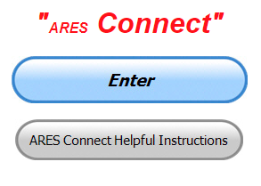

**Everyone –** please make sure to go into all of the events that you have signed up ***for and get your hours registered no later than 5 days after the event has ended****.*

Folks, I’m seeing a lot of folks that have signed up for events not entering their time after the event. This is a very important piece of using “Connect.” Your hours need to be recorded and it’s so easy to do.

**I would like to add…. Since Field Day has now come and gone and most of us operated from home, make sure to log yourself into one of the Field Day events that are already in ARES Connect and get your hours recorded.**

Let’s run through how so in case you have forgotten. If you have already gotten signed up for an event, all you have to do afterword to get your time entered is at any time after the event has ended, log into “Connect.” And then click on your name in the upper right-hand corner of the page. This will bring up a drop-down menu where you will then click on “View Hours.”

This brings up another screen where you can “Report Hours” as well as “View Hour History” You’ll want to click on “Report Hours.” You will then be presented one at a time by chronological order each event that you have signed up for and hours have not yet been reported on.

TOP ^

Type in those hours in the “Hours Worked” box and hit “Submit”… Keep doing this until you have no more hours to report…. That’s all there is to it. Now, if you are following the request above and doing this at least every 5 days or more often, this will only take you a minute or so to complete.

**Now, isn’t that easy? Yes, and we all need to be diligent at doing it promptly.**

***Here’s are the top 10 hours earners for the month of June:***

|  |  |  |  |
| --- | --- | --- | --- |
|  | **Name** | **Events** | **Hours** |
| **1** | Daniel Schlick (KB8LKH) | 27 | 162.95 |
| **2** | Bryan Hoffman (KC8EGV) | 20 | 133.00 |
| **3** | John DeGutis (N8LVA) | 3 | 125.50 |
| **4** | Dwight Bonifield (W8TJT) | 115 | 115.30 |
| **5** | Christopher Domenick (KC8CAD) | 26 | 113.55 |
| **6** | James Yoder (W8ERW) | 24 | 112.11 |
| **7** | John Major (KD8MMY) | 27 | 110.50 |
| **8** | Greg Dersarkisian (KD8SSJ) | 18 | 110.00 |
| **9** | Bret Stemen (KD8SCL) | 36 | 107.50 |
| **10** | Michael Lacumsky (W8MAL) | 22 | 106.50 |

**Let’s get everyone in the Ohio Section on “ARES Connect!!!” Simply go to:** <https://arrl.volunteerhub.com/lp/oh/> and get yourself registered and using the system.

***Hey County and District E.C.s…***

Do you want a listing of all your volunteers registered in ARES Connect? Would you like to have a report by hours for your county? Let me know, these reports can be generated very quickly and easily for you. All you need to do is ask. Let me know if you want a report run… email me at: [n8sy@n8sy.com](mailto:n8sy@n8sy.com)

***Field Day Pictures…***

Hey Gang,

Now that Field Day is in the books did you remember to take pictures? If you did, did you send them to me? Please don’t forget to send me pictures of your Field Day operations! Take a look at what I’ve collected so far! <http://arrl-ohio.org/fd-20>

Over the years we’ve collected thousands of pictures of Field Day sites and used some of those for our Ohio Section Banner. Let’s not miss out just because of a little inconvenience like COVID-19, let’s keep the Ohio Section tradition going and send me those pictures at: [n8sy@n8sy.com](mailto:n8sy@n8sy.com) !!

TOP ^

***One Question Questionnaire***

Hey Gang,

“Survey Says”….. about 8.5**%** of us are “left handed.” Wow… That’s really great, as that the national average is only around 5%!!! Glad to know that the Ohio Section excels in “lefties!!”

Ok, now, on to next question… Let’s find out how many of you practice good electrical procedures in your shack. So, the next question for you to answer...

***“Do you ground your antennas when you’re not using the radio??”***

You’ll find the “One Question” questionnaire on the Ohio Section Website! <http://arrlohio.org> It’s all in fun and it’s not a scientific survey in any way, but we are learning some things that we didn’t know from these questions. I hope that you are enjoying answering these “One Question” questionnaires.

***V.E. Test Sessions***

**

Many V.E.’s have decided to start testing once again, but with restrictions that need to be adhered to for sure. Here’s the link to find that V.E. Test session and what is expected of YOU before going. <http://www.arrl.org/find-an-amateur-radio-license-exam-session>

####

***Lake County ARA Holding V.E. Testing in August***

Lake County ARA will be holding a V.E. Test Session on **August 1st** at the Lake County Metroparks – Chapin Forest Reservation. The address is: 9938 Chillicothe Road (Rt 306) - Quarry Shelter

Chapin Forest is 3.3 miles south of I-90 on Route 306, in Kirtland. The park is on the west (the right side going south) of 306. The Quarry Shelter is almost immediately on the right as one enters the reservation.

The tests will start at **12 noon.** Please arrive a few minutes earlier. Pre-registration is suggested, although we hope to have plenty of seats available.

To register, you will need the NCVEC 605 Form, which will be available at the test. If you would like to complete one ahead of time, be sure it is the Sept 2017 version or later. You can find it by Googling “NCVEC quick-form 605” and clicking on the url for a pdf of the form.

Be sure to bring **the original and a copy of both your license** **and any CSCEs you may have to the exam.** The cost is $15.00, and if you wish to pay by check, it should be made out to the ARRL/VEC. Identification with your picture is also necessary, such as a driver’s license. To pre-register, or if you have any questions, please contact Scott Farnham, KO8O, at (440)256-0320, or [scottfarnham@roadrunner.com](mailto:scottfarnham@roadrunner.com)

TOP ^

***Swap & Shop Has Added Club Raffles To Its Listings On The Webpage***

Hey Gang,

Have you taken a look at the **Swap & Shop** page on the Ohio Section webpage yet?? Here’s a link that will take you there…

<http://arrl-ohio.org/sm/s-s.html>

Do you have equipment that you just don’t need or want anymore? Here’s a great venue to advertise it, and it’s FREE!!

***>> NEW… <<***

Is your club doing a fund raiser to help raise money? After a lot of thought, it was decided that the Swap & Shop webpage could also contain these types of items as well.

The same rules will apply as do for the For Sales and Give-A-Ways and will only be posted for a month at a time. Please see the Terms & Conditions on the webpage.

If your club is doing a fund raiser and wants more exposure, please forward the information to me and I’ll advertise it on the Swap & Shop webpage for you. Now, I still want to remind you that it won’t be listed in this newsletter because it would take up way too much space, so your ad will only appear on the website. It is there for any individual to post equipment Wanted / For Sale or Give-Away as well as for Club Fund Raisers. No licensed vehicles/trailers or business advertising will be posted.

Postings are text only (no pictures or graphics) will be posted for a maximum of 1 month from date posting and require a contact phone number or email within the posting. Send your Wanted / For Sale or Give-Away post to:  [swap@arrlohio.org](mailto:swap@arrlohio.org)

***Final.. Final..***

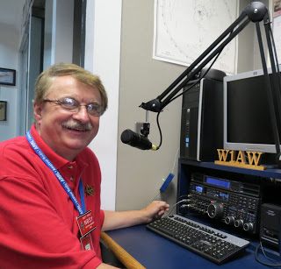Hi Gang,

This has been a really busy week catching up on all the yard work around here. Janie and I built 3 flower box gardens and I finally got my vertical antenna boxed in and all the weeds removed from around the coax and ground radials. I now have a garden box around it and it’s filled with some gravel to hold down the weeds from coming back.

I had promised Janie 3 years ago to build the garden boxes, but the projects had to be put on hold after my motorcycle accident. After that we just didn’t seem to get the energy until this week to even consider it. Now, that’s checked off on my “honey do” list! How about you? Are you getting those planned projects done now that you are confined to home more?

TOP ^

I know that some of you are fascinated by my reports on the robot mower that my neighbor has roaming around his yard. Well, it’s not doing so well in these recent days of high heat and humidity, in fact, it up and died the other night and it seems that the neighbor just doesn’t care! It’s out in the middle of his lawn just sitting there for the past 3 days now. The poor creature looks so pathetic, if it weren’t for the fact that it does have an alarm that sounds and sends text messages all over the place when moved, I would pick it up and put it in its charger for him.

I hope that you got to work Field Day this year. I actually visited a couple of Field Day sites that were close by and I even got to operate this year! I stayed down in the Novice/Technician portions of the band to help them out. They were the ones really hurt the most by this pandemic. I had a great QSO with one Novice that has been a Novice since the late 70’s and he stated to me that he wouldn’t give it up for anything. He then looked me up and gave me a call to personally thank me for taking the time to come down in the Novice/Tech area of the bands to make contacts.

Don’t forget that Field Day is a great event to add a lot of time to your ARES Connect account. Yes, Field Day is a recordable event even though you had a lot of fun doing it. You can count the time that it took to setup, operate and even teardown. Yes, if you were really aggressive, this could mean that you have more than 24 hours of reportable time to record. Don’t lose out on getting this recorded!! Remember, everyone has the ability to go back and pickup events in the past. If you don’t remember how to do it or need help with this or anything to do with ARES Connect contact me directly. I’ll work you through it. Many events that we do are FUN and, in most cases, very informative as well. We learn so much from doing events like this, especially since we had to stay at home and do most of the work ourselves.

Hey, speaking of ARES Connect, have you taken a look at the breakdown per county on the ARES webpage? There is a listing posted per county of the hours recorded in ARES Connect. These are the hours of actual volunteers and not anonymous hours. Want to see how many hours your county has gotten so far? Go to… <http://arrl-ohio.org/SEC/ARES-Connect-County.html> This page is updated regularly, so you can see what is happening in real time in your county. Don’t see hours recorded in your county? That’s because you haven’t done your part and gotten your time recorded. Don’t know how? Let me know, I’ll teach you everything that you need to know to get you started.

Whelp, my final go around before gong QRT… Stay safe my friends! I want to see all of you soon at a meeting or hamfest! We will get through this and when we do, we’ll have so much to talk about. Most of all… have FUN and get on the airwaves!!

73,

[***Scott, N8SY***](mailto:n8sy@n8sy.com)

Ohio Section Cabinet

|  |  |
| --- | --- |
| Section Manager – Scott Yonally, N8SY | Assistant Section Manager – John Perone, W8RXX |
| Section Emergency Coordinator – Stan Broadway, N8BHL | Section Traffic Manager – David Maynard, WA3EZN |
| Technical Coordinator – Jeff Kopcak, K8JTK | Affiliated Clubs Coordinator – Tom Sly, WB8LCD |
| State Government Liaison – Bob Winston, W2THU | Public Information Coordinator – John Ross, KD8IDJ |
| Section Youth Coordinator – Anthony Lascre, K8ZT | |

TOP ^

***Welcome New Subscriber(s)***

**John McKeon; Jim, KR9U; Scott, KD8XB & Logan, KE8OIB**

***Back Issues of the PostScript and Ohio Section Journal***

Hey, did you know that PostScript and Ohio Section Journal (OSJ) are archived on the website? You can go back and look at any edition simply by clicking:

<http://arrl-ohio.org/news/index.html>

***Chit – Chat, and All That!***

Do you know someone that’s not getting these Newsletters? Please, forward a copy of this Newsletter over to them and have them “[Opt-In](mailto:Opt-In)” to start receiving them. Heck just have them send me an email [n8sy@n8sy.com](mailto:n8sy@n8sy.com) and I’ll get them added to the Ohio Section Emailing list.

We now have many thousands of readers receiving these newsletters weekly. Quite impressive, I’d say! I urge all of you to make sure that everyone, regardless of whether they are a League member or not, get signed up to receive these weekly Newsletters.

You can always “[Opt-Out](http://arrl-ohio.org/forwarder/forwarding.html)” at any time if you feel this is not what you were expecting. It’s fun and very informative. All of your favorite past newsletters are now archived too.

You can go back at any time and read them. Just go to: <http://arrl-ohio.org/news/>

Got questions, concerns or would just like to sit and chat awhile? Heck, I’ll even buy the coffee!! Give me a call at (419) 512-4445 or email me at: [n8sy@n8sy.com](mailto:n8sy@n8sy.com)

The pictures on the front page and throughout this newsletter are from various newsletters, Facebook posts and/or were sent directly to me in recent weeks. Take a good look at them, you just might be in one of the pictures! “SMILE… you’re in the Ohio Section News!!”

TOP ^

*PostScript is produced as a weekly newsletter. I want to thank everyone that has contributed articles and ideas to make this an even better news source. I sincerely hope that you have enjoyed this edition and will encourage your friends to join with you in receiving the latest news and information about the Ohio Section, and news and events happening around the world!*