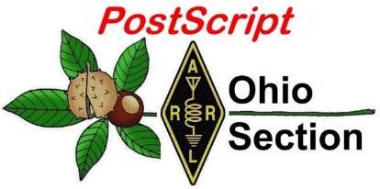
Field Day
Edition

National News The Handbook Give Away

Club Corner Hamfests

DX This Week ARES Connect

VE Testing One Question Questionnaire

Final.. Final..

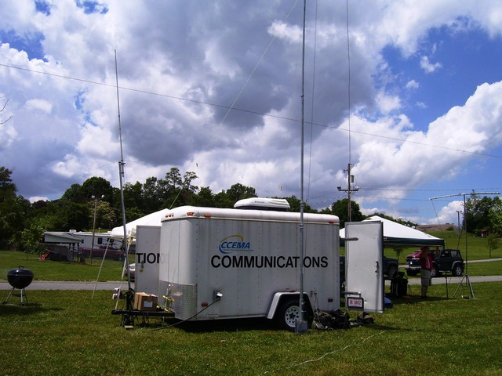
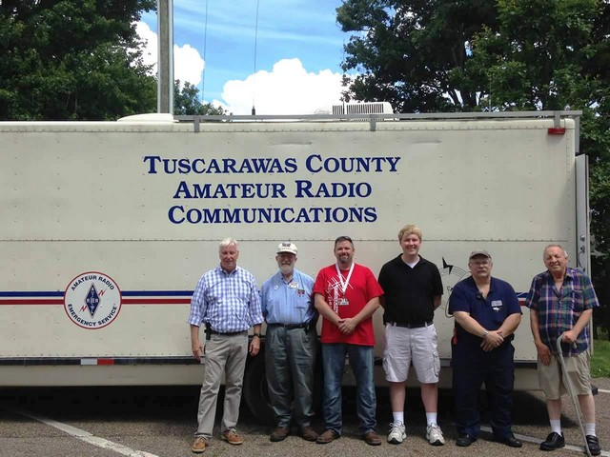

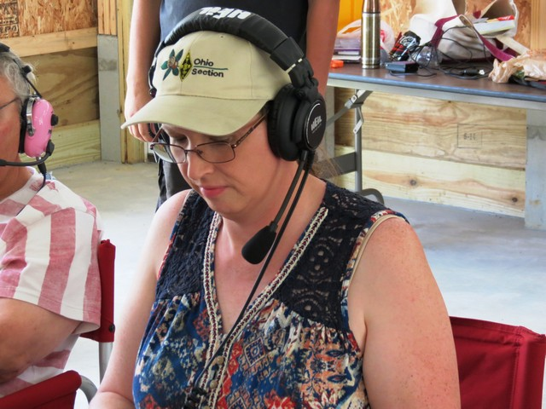
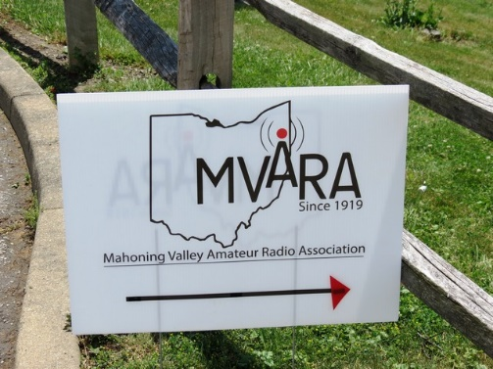
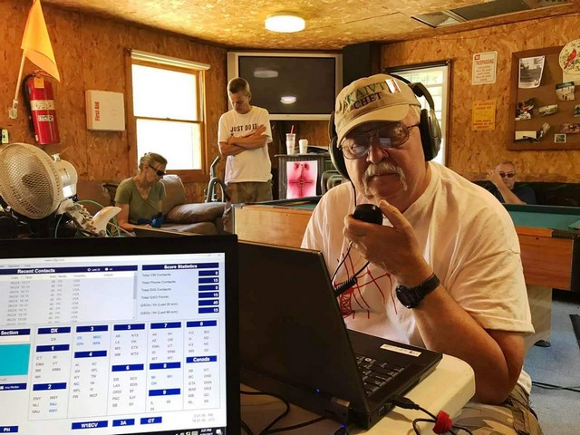

National News
(from arrl and other sources)

Volunteer Monitor Program Recognizes Good Operators

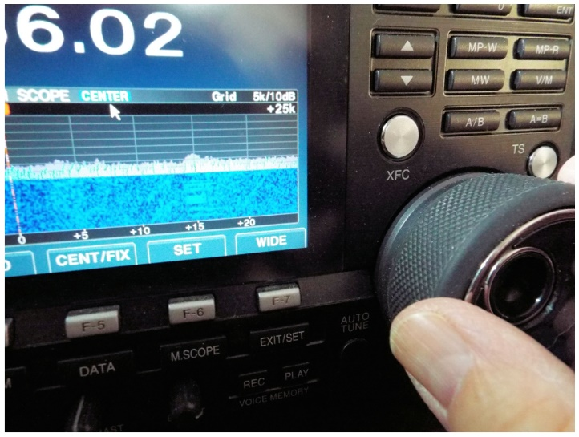
Volunteer Monitor Program Coordinator Riley Hollingsworth, K4ZDH, said the program has recognized numerous radio amateurs with Good Operator Notices.

“One facet of the ARRL and FCC agreement that set up the Volunteer Monitor Program calls for ARRL to recognize especially good amateur radio behavior, in order to encourage compliance with FCC rules and further the efficiency of the Amateur Radio Service,” Hollingsworth said. “Seventeen operators in 15 states received Good Operator Notices in the first quarter of 2020. The Good Operator Notices went to veteran operators as well as newcomers, including a 13-year-old in North Carolina for CW operation during the Youth on the Air Special Event, and a 14-year-old in Wyoming for SSB operation.”

Hollingsworth also said that a 2-meter repeater operator received a Good Operator Report for establishing and managing a COVID-19 net in Pennsylvania, while other operators of various license classes received notices for everyday SSB and CW operation on the HF bands. Recipients were nominated on the basis of operation observed by Volunteer Monitors.

According to Hollingsworth, Volunteer Monitors reported 2,035 hours monitoring on HF monitoring, and 2,856 hours monitoring on VHF/UHF and other frequencies during May. Two cases were referred to FCC.
After kicking off on January 1, the new Volunteer Monitor Program ramped up to operational status earlier this spring, starting with a “soft rollout” that started on February1, designed to familiarize Volunteer Monitors (VMs) with issues on the bands and to put into practice what to report — and what to ignore, based on their training.

VMs not only look for operating discrepancies, but for examples of good operating. Hollingsworth is using a system called VMTRAC — developed by a VM — to measure the work of VMs and determine instances that qualify for good operator or discrepancy notices, referral to the FCC, or follow-up with FCC requests to the VM program. — Thanks to Riley Hollingsworth, K4ZDH

####

Ham Gets 30 Days in Jail for On Air Harassment
(Submitted by Gregory Drezdzon, WD9FTZ)

The Tennessee Court of Appeals in Knoxville, Tenn., has affirmed a 30-day jail term based on violation of a court order which directed a Tennessee ham, Michael J. Mgrdichian, N2FUV, to refrain from contacting another ham.

TOP ^
The trial court, and now the appeals court, has declared that Michael J. Mgrdichian violated the court's directive on three (3) occasions, resulting in three (3) separate jail sentences for 10 days each.
The victim in the case asked for a temporary order of protection, which was granted. The order specified that Michael J. Mgrdichian was not to contact the victim. The pertinent command for this appeal stated that Respondent Mgrdichian would “not contact the petitioner either directly or indirectly, by phone, email, messages, mail, or any other type of communication or contact.”
After violating the order by contacting the victim on three occasions via ham radio, and being found guilty of criminal contempt of court, Mgrdichian argued in his appeal that the trial court lacked jurisdiction due to Federal Communications Commission preemption of radio matters, and that he did not know that he was facing three jail terms and three fines, by violating the court order on three occasions.
In a June 4, 2020, hearing, the victim returned to court to complain that the perpetrator was continuing the behaviors previously complained about, and Mgrdichian was found guilty and fined for two additional counts of civil contempt of court, adding to the three original counts of criminal contempt.
The victim has also complained that Mgrdichian lied to the court in official documents, and asked the court to issue subpoenas regarding a number of emails, specifically to unmask the IP addresses of the senders, to match the IP addresses to Mgrdichian's IP address for future proceedings, either civil or criminal, or both. The victim was instructed by the court on how to obtain the subpoenas sought.
On June 11, 2020, the state appeals court in Tennessee found that Mgrdichian had received adequate notice in court documents, and that the trial court's jail sentences and fines were appropriate.

The appeals court affirmed the trial court and remanded the case for further proceedings as deemed necessary. The court decisively found that FCC rules do not preclude a state court from preventing an amateur from stalking and harassing another amateur in the same state and that in those cases, local courts have jurisdiction.
In short, at least in Tennessee and Florida, the FCC rules do not prevent a local court from issuing an order of protection containing a penalty of jail time for violation, when one amateur is alleged to be harassing and stalking another amateur, within the same state. Moreover, Tennessee and Florida have now both affirmed the court's authority to jail perpetrators who violate said court orders, even when contact is via amateur radio.
In reaching their decision, the Florida court relied heavily on the brief filed by the victim, and on their own analysis, which contained a previous Florida case, where the respondent also argued that the FCC preempted the local court's authority.
https://www.tncourts.gov/sites/default/files/faucon_v._mgridichian_e2019-01343.pdf
https://law.justia.com/cases/florida/fifth-district-court-of-appeal/2008/5d07-2590-op.html

####

TOP ^
Youth on the Air in the Americas Announces At-Home Bonus Summer Activities

Youth on the Air in the Americas is planning additional home-based activities for this summer, due to the postponement of its inaugural summer camp at the National Voice of America Museum of Broadcasting in West Chester Township, Ohio. Virtual YOTA Day will take place on Wednesday, June 24. Activities will include a series of youth-led forums and some competitions that can be done from home — even without a radio. Virtual YOTA Day begins at 1800 UTC on June 24 and continues until 2400 UTC.

Those who had been selected to attend YOTA camp 2020 will be able to meet on Zoom for a day of learning and fun, plus a chance to win prizes, but anyone interested will be able to get in on Virtual YOTA Day via the official Youth on the Air YouTube channel and play along at home. Some activities will include learning how to track down the location of a transmitter without leaving your chair, sharpening contesting skills, and more.
During the week of June 21 – 26, when the camp was to take place, special event station W8Y will be on the air on all bands and modes. Those selected to attend YOTA Camp 2020 will take turns operating as W8Y throughout the week from the station of their own choosing. Campers should contact Marty Sullaway, NN1C, to be added to the schedule.

Youth on the Air will operate Field Day using a remote station in southwestern Ohio. Logging will be done by remote desktop. Campers can sign up at YouthOnTheAir.org for a time slot on the remote station provided by Jay Slough, K4ZLE. Contact Chris Brault, KD8YVJ, with questions.

Youth on the Air will be a club choice for Field Day score submissions. Participating operators age 25 or younger choosing to operate Field Day from a home station can contribute their scores to an aggregate club score for this year only. Enter “Youth on the Air” as the club name on the Field Day entry.

More information about YOTA in the Americas can be found at YouthOnTheAir.org and on YOTAregion2 on Facebook, Twitter, Instagram, and YouTube.

####

Former FEMA Administrator Craig Fugate, KK4INZ, Says Emergency Communications Will be the Next COVID Challenge

Craig Fugate, KK4INZ, FEMA Administrator during the Obama Administration, expressed powerful remarks in a recent edition of The Hill. Fugate's comments prompted Bob Inderbitzen, NQ1R, of the ARRL HQ staff, to respond:

"He's spot-on. I know I'm preaching to the choir, but Fugate's remarks help underscore the important and continuing role of radio amateurs in this nation and world where smartphones are now the common denominator. The radio amateur is skilled in both radio technology and radio communications - valuable resources in a society where "wireless" connects nearly everything, and few know how it works. Irrespective of the frequencies or equipment we use, the Federal Government has deemed radio amateurs so valuable we're referred to as a "reservoir ... of trained operators, technicians, and electronics experts" and recognized for our value to the public, especially in providing emergency communications:

TOP ^
- We can deploy temporary communications infrastructure using our own personal communications capability and equipment. As we learned during recent hurricanes, this means we can give service to the public and our partners in emergency response even before repairs are made to regular communication networks.
- Just because an emergency responder is equipped with a working communication system doesn't mean they have the training to use it under adverse conditions or fix it. We've similarly learned that the training some radio amateurs pursue to communicate and exchange critical information (traffic) is a valuable skill during emergencies. This is why so many of our volunteers also support communications during events and marathons - even shadowing EMTs and Red Cross personnel.

"A pilot-ham recently explained to me why she got her Amateur Radio Service license: she said avionics and the pilot's ability to communicate-by-radio require more training and skill than you get learning to fly. Ham radio has become her breadboard for developing a technical competency with radio communication and her on-air practice." - Bob Inderbitzen, NQ1R, Product Development Manager, ARRL Administrative Headquarters

[Thanks go to Bill Morine, N2COP, ARRL Vice Director of the Roanoke Division, for calling the article to our attention and commenting: "I'm glad you agree that Fugate's remarks are poignant and relevant, not only to ham radio overall, but especially to Field Day. This year we are encouraging that all social media posts related to Field Day please include the hashtag #ARRLFD to help generate more awareness." -- ed.]

####

Amateur Radio Discussed at CEPT Meeting
International Amateur Radio Union (IARU) Region 1 reports the 96th virtual meeting of the European Conference of Postal and Telecommunications Administrations (CEPT) Frequency Management Working Group (FMWG) on June 8 – 12 dealt with several amateur radio matters. According to IARU Region 1, the European Common Allocation Table (ECA) was reviewed, resulting in a revised version for consultation with stakeholders. IARU was able to amend the 241 – 250 GHz band entry to correct some errors.

The state of the 50 – 52 MHz band in CEPT countries was also updated to take WRC-19 decisions into account. Last year, Ukraine requested that it be included in CEPT ECC Recommendation T/R 61–02, the recommendation that defines the Harmonized Amateur Radio Examination Certificate (HAREC), and this was agreed. Romania had contacted the FMWG chairman concerning the possibility of introducing electronic amateur radio licensing. This idea been passed to CEPT’s Radio Amateur Forum Group for further discussion and possible action.

The meeting also discussed developing a regulatory framework for wireless power transfer (WPT) going forward, and attendees agreed that the CEPT Spectrum Engineering Working Group should continue to study the full range of WPT applications and emissions and that no regulatory steps would be taken until that work is complete. Meeting documents are available.

####

TOP ^
WB8VGE of North Lawrence, Ohio – Wins the June QST Cover Plaque Award
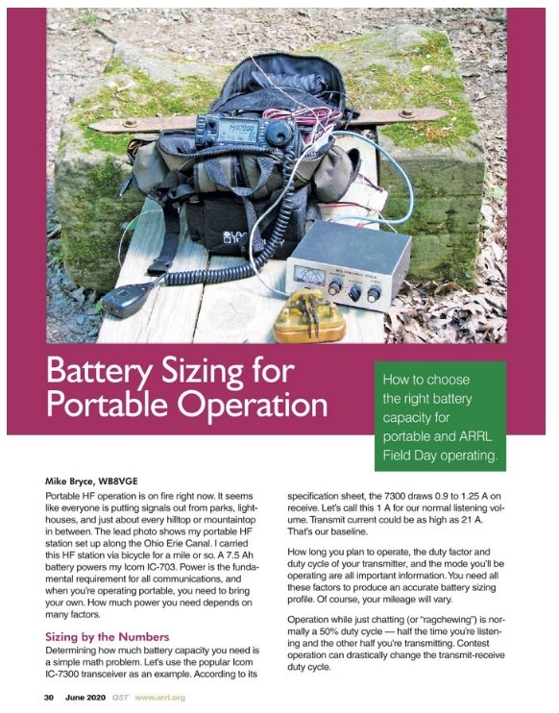

Mike Bryce's article “"Battery Sizing for Portable Operation" offered valuable information, not only for the upcoming ARRL Field Day, but for portable operating generally. Thanks to Mike’s advice, readers will be able to avoid unpleasant surprises!

QST Cover Plaque Awards are given to the author or authors of the most popular article in each issue. You choose the winners by casting your vote online at www.arrl.org/cover-plaque-poll. Log in now and pick your favorite article in the July issue!

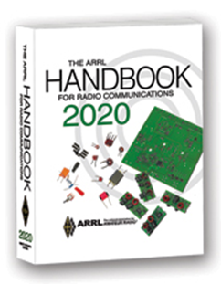
The Handbook Give Away

Hey Gang,

Have you registered for the “Handbook Giveaway” drawing for this month yet? If you haven’t, go to: http://arrl-ohio.org/handbook.html and get yourself registered now!

What’s the catch? I want to get everyone checking in to the Ohio Section website as often as possible, and in order to register each month, you have to visit the website often! There’s nothing else to it. I pay all expenses and I usually “Give Away” more than just a Handbook too!!

Many of you ask me just how do I know when the drawing is on? Well, that’s easy all you need to do is check in on the Ohio Section Website on a regular basis and watch for the big RED Arrow that will appear on the left side of the page. This is the sign that the drawing is on and you need to get registered. So, keep a sharp eye out on the website and check in often!

TOP ^

Club Corner

This is YOUR cornner of the newsletter. Send me what your club is doing and I’ll make sure that it gets in. Got a special event or club project that you want everyone to know about? Send it to me!. Need help with a project? Send it to me.

Let me know what you club is up to. Are you going to have a special guest at your meeting or are you having a special anniversary? Just sent it to: n8sy@n8sy.com

####

The Northwest Ohio ARES Traffic Net Needs Help

The Northwest Ohio ARES Traffic Net is in need of General and/or Extra Class licensees with either voice or CW capabilities to relay traffic from the VHF net to the HF nets, no experience is necessary.

The NW Ohio ARES Traffic Net meets daily at 6:30PM on the W8RZM 147.375 repeater.

The Ohio Single Sideband Net meets daily at 10:30AM, 4:15PM and 6:45PM on 3.9725 MHz. The Ohio Section also has three CW Nets, the Ohio Slow Net meets daily at 6:00PM on 3.53535 and runs at approximately 10 WPM.

The Buckeye Net-Early meets daily at 6:45PM on 3.580 and runs between 15-20 WPM. Finally, the Buckeye Net-Late meets daily at 10PM on 3.590 and runs in the same range as the Early Net. Currently, there are only 2 volunteers that cover 7 days a week, and most nets there isn't a volunteer at all. Please consider volunteering for an hour a week, you never know, you may like it.

For more information on traffic handling, or volunteering to assist relaying traffic please check into the VHF net or contact Colleen Roth N8TNV, Steve Denniss KC8IDM, or Michael Lacumsky W8MAL.

####

Make Field Day Great Again in 2020!

With COVID-19 spoiling the fun of Field Day for many clubs, Silvercreek Amateur Radio Association (SARA) and WARC decided to do something about it! The SilverWoo Field Day Event is a joint effort between the Silvercreek Amateur Radio Association and the Wayne Amateur Radio Clubs. This one-year-only event will provide incentives for hams to operate Field Day from home or in other approved conditions for Field Day 2020. There will be several awards offered based on various Field Day performance criteria. See silverwoo.org for more details and join in the fun!

####

TOP ^
Geauga County ham radio operators taking part in ARRL Field Day
(Reprinted from “The News Herald - Staff report editor@news-herald.com Jun 20, 2020 Comments)

Ham radio operators from the Geauga County area will be participating in a national amateur radio exercise from 2 p.m. on June 27 until 2 p.m. on June 28.

The event is ARRL Field Day, an annual amateur radio activity organized since 1933 by ARRL, the national association for amateur radio in the United States, according to a news release.

Hams from across North America ordinarily participate in Field Day by establishing temporary ham radio stations in public locations to demonstrate their skill and service. Field Day highlights ham radio’s ability to work reliably under any conditions from almost any location and create an independent, wireless communications network.

However, due to the pandemic, this year’s event will be markedly different from years past, the release stated.

Continuing public health restrictions and social distancing practices will limit group gatherings for Field Day. Instead, hams from Geauga County will use the radio stations set up in their homes or taken to their backyards and other locations to operate individually.

Many hams have portable radio communication capability that includes alternative energy sources such as generators, solar panels, and batteries to power their equipment.

This year's event is also noteworthy given the arrival of a rather active early hurricane season, the release stated.

“Hams have a long history of serving our communities when storms or other disasters damage critical communication infrastructure, including cell towers,” said ARRL spokesperson Bob Inderbitzen in the release. “Ham radio functions completely independently of the Internet and phone systems and a station can be set up almost anywhere in minutes.”

During Field Day 2019, more than 36,000 hams participated from thousands of locations across North America. According to ARRL, there are more than 750,000 amateur radio licensees in the US, and an estimated 3 million worldwide.

Hams range in age from as young as 9 to older than 100. A self-study license guide is available from ARRL, "The ARRL Ham Radio License Manual."

Upcoming Hamfests for 2020
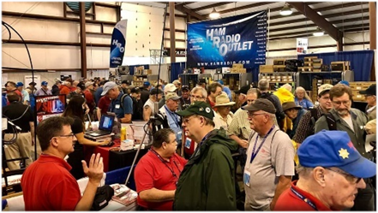

07/18/2020 | NOARSfest
Location: Elyria, OH
Sponsor: Northern Ohio Amateur Radio Society
Website: https://www.facebook.com/NOARS.K8KRG
Canceled

TOP ^
07/19/2020 | Van Wert Hamfest  Location: Van Wert, OH  Sponsor: Van wert Amateur Radio Club  Website: http://w8fy.org | 07/26/2020 - Portage Hamfair '20  Location: Ravenna, OH  Sponsor: Portage Amateur Radio Club, Inc.  Website: http://hamfair.com  Canceled
08/01/2020 | Columbus Hamfest  Location: Grove City, OH  Sponsor: Voice of Aladdin/ Audio Unit of Aladdin Shrine  Website: http://columbushamfest.com  Canceled | 08/08/2020 | DXE Hamfest,  ARRL Ohio Section Convention  Location: Tallmadge, OH  Sponsor: DX Engineering  Website: http://dxengineering.com  Canceled
New Date  08/29/2020 - Milford Hamfest  Location: Owensville, OH  Sponsor: Milford Amateur Radio Club  Website: http://www.w8mrc.com | 09/27/2020 | Cleveland Hamfest and  Computer Show  Location: Berea, OH  Sponsor: Hamfest Association of Cleveland  Website: http://www.hac.org  Click on “Join Our Mailing List”  to stay updated.

Tri-State Amateur Radio Association – Huntington West Virginia Hamfest 2020
Canceled
####

Webpage for Cancelled Hamfests

ARRL has created a webpage that will search the ARRL Hamfest and Convention Database for canceled events. >> Click Here <<

Field Day Pictures…

Hey Gang,

I know that a lot of you are planning on staying home and operating Field Day from there. That’s ok, but don’t forget to send me pictures of your Field Day operations!

Over the years we’ve collected thousands of pictures of Field Day sites and used some of those for our Ohio Section Banner. Let’s not miss out just because of a little inconvenience like COVID-19, let’s keep the pictures coming in.

TOP ^
Here’s just a few from past Field Days…
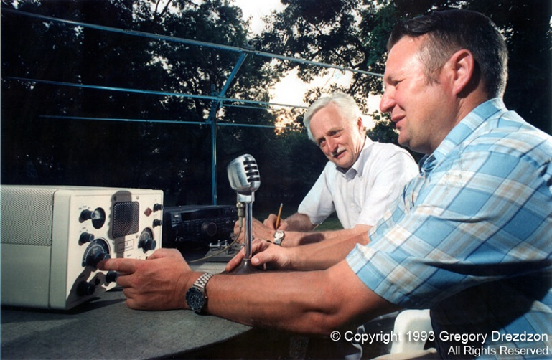
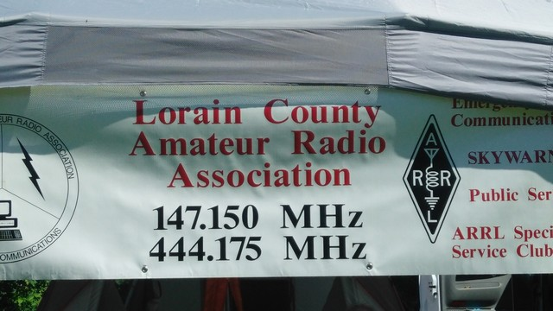
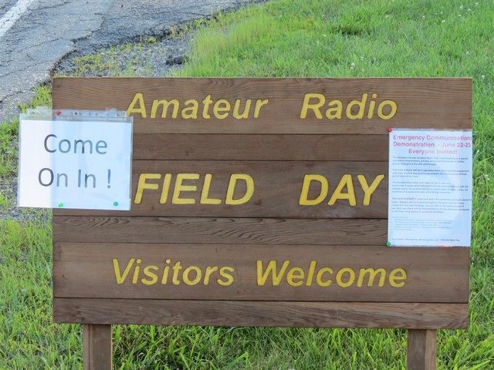
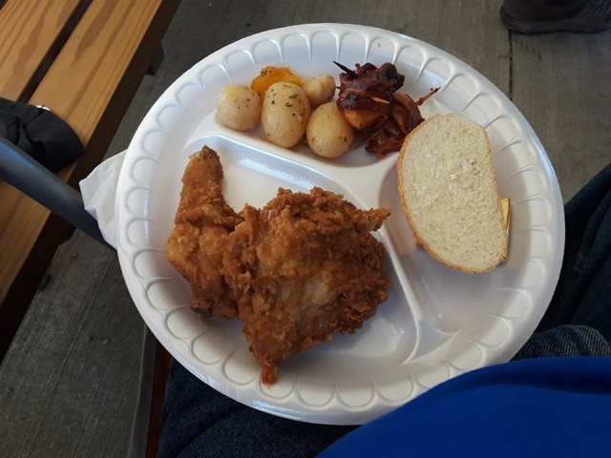
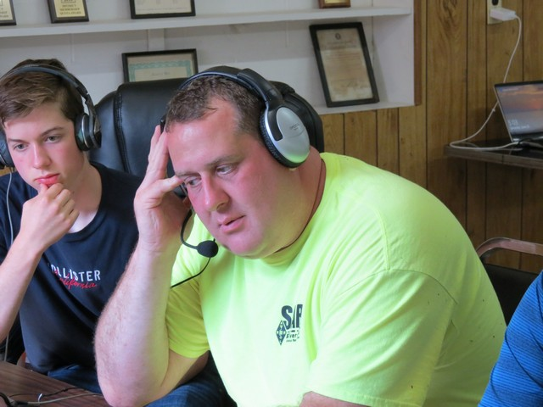
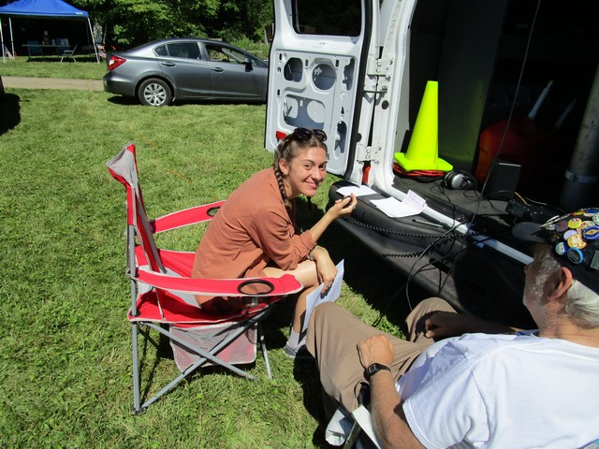

TOP ^

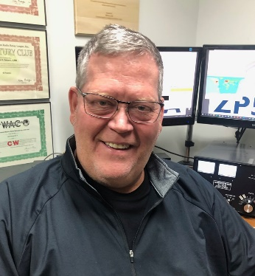
DX This Week
(from Bill, AJ8B)

DX This Week – LoTW
Bill AJ8B (aj8b@arrl.net, @AJ8B, or www.aj8b.com)
CWOPs Member #1567
New sunspots come appeared from Cycle 25! We are all awaiting an increase in the indexes, solar flux, and better conditions. With this good news, I was surprised that we did not have more entities spotted on the cluster. Entities that were spotted by stations in the Midwest included Argentina, Asiatic Russia, Australia, Azores, Canary Islands, England,, Estonia, European Russia, Fed. Rep. of Germany, France, Guernsey Island, Iceland, Italy, Japan, Kazakhstan, Mexico, Netherlands, New Zealand, Republic of Korea, Serbia, Soviet Georgia, Spain, St. Lucia, Thailand, Ukraine, and Vietnam.

I did receive some QSLs cards this week including VK6HH – Steve in Perth, Australia, VK3DEK – Derek in Moyston, Australia, VK2BY, Bradley in Claremont, Australia, (Pictured), IK3ZBM – Diego in Italy, (Pictured), and S57JK – Janko in Slovenia (Pictured).

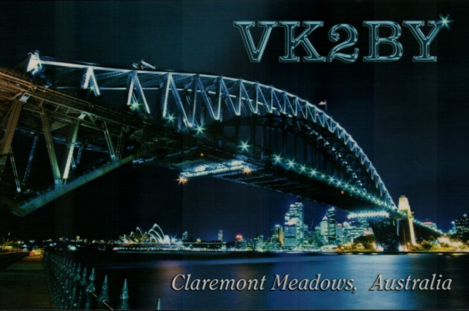

What a Birthday Present!

W8GEX, Joe, turned 40+ this past week. He also experienced a fantastic opening on 6 meters; a birthday present from the propagation gods perhaps?

TOP ^
Sunday evening, he worked 50 Japanese stations, plus HL3GOB (Korea) and BA4SI (China) for new ones. His opening started at 2330Z and ended at 0047Z. He’s worked Japan on 6 before but this is the best he has seen. Congrats to Joe!

SWODXA DX Contest Results
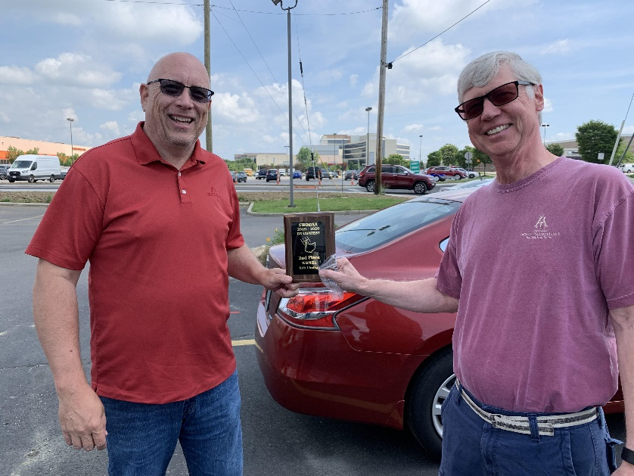
The results of the 2019/2020 DX Contest sponsored by the SouthWest OH DX Association were announced by the contest chairman, Chuck, K8CR. The final standings are:

#1 - AJ8B – Bill Salyers
#2 – W8MRL – Rob Lindsay
#3 – W8RES – Bob Stothfang

In reviewing the final scores and all the submissions, K8CR said “A noble effort from all. Thanks everybody, same time next year we'll do
it again”
The picture shows club president NR8Z, Tom, presenting the plaque to W8MRL, Rob. Congratulations to all.

DXCC Card Checking de Dave, K8DV

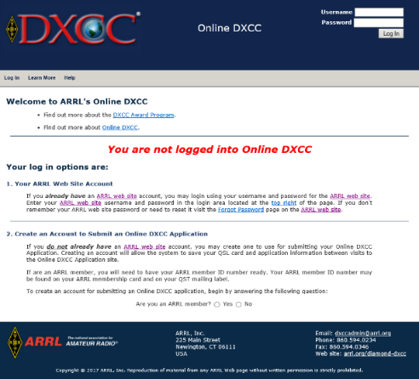
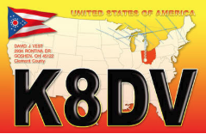
In the last issue I gave a very high-level view of DXCC and card checking. This week we can start to break down the process piece by piece. I am going to start with Online Electronic DXCC Application, http://www.arrl.org/online-dxcc-application which has to be one of the best things the ARRL and DXCC Desk have done since the creation of the program back in the thirties. No more worrying about the order of the cards, no more do multiple QSO cards go at the front or back of the list, just enter as you receive new QSLs in whatever order.

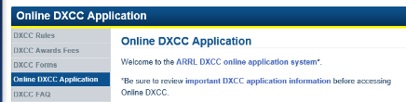
When you use the link above you will be taken to a page that looks something like this:
From there click on “ARRL DXCC online application system” and you will end up at the sign in screen.

TOP ^
Once at the sign in screen, in the upper right-hand corner you will see two boxes, labeled “Username” and “Password”. These are the same credentials that you would use to log into the ARRL members section of the ARRL homepage. This is most likely your “Callsign” and a password that you created.

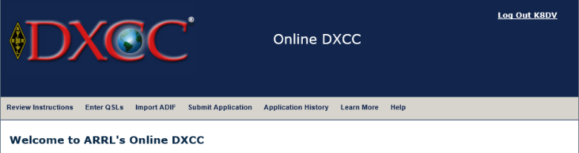
Once you have entered your login information you should see a page where the top of it looks something like the image to the left.

On this page you will also find the step by step instructions, so I will not include those here. The next step is to start entering QSL/QSO information. Start by clicking on “Enter QSLs” in the gray menu bar. You will end up on a page and down at the bottom you should see an entry screen.

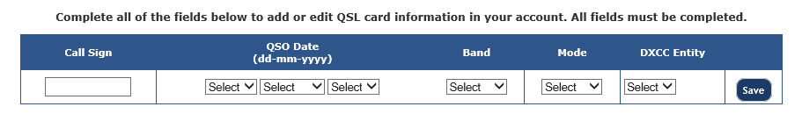

You are now ready to enter QSL/QSO information. When entering your data use the drop downs, you may find that the DXCC Entity may be filled out for you or give you a choice of several entities, such as when you enter a callsign starting with VP8 you will have several choices and you should select the entity that is printed on the card itself. Once you start entering QSO/QSL information you will see the list appear below the entry screen.

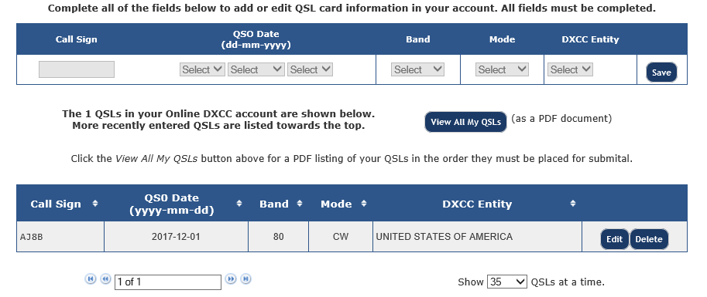

After you have entered all your data and have all your cards in the same order at which they are entered you will need to click the “Submit Application” button in the gray toolbar at the top of the screen.

TOP ^
At this point you can enter your payment info and other information. Once you do this you will see a button to review application this will bring up a PDF of your application, print all pages of this as this is the application itself and the QSL listing. Bring the printout, QSLs and envelope with at least one unit of first-class postage to me for checking. Also did I mention that the fees for using this for your DXCC application is cheaper than the manual form and usually faster as well.

Have a good DX season and keep those DXCC applications coming and if there is a card checking topic you would like to see covered in the future just let me know at k8dv@cinci.rr.com

CQDX CQDX CQDX CQDX CQDX CQDX CQDX CQDX CQDX

Here is an update from Bernie, W3UR, of the DailyDX and the WeeklyDX, the best source for DX information. http://www.dailydx.com/. Bernie has this to report:

FT8DMC 3rd Anniversary-Activity Days 2020 www.ft8dmc.eu (www.facebook.com/groups/FT8DMC/) To commemorate our 3rd anniversary, special event stations will be on air during the FT8DMC Activity Days from July 1st to July 31st. All stations will bear the FTDMC or FTDM suffix, referring to the third anniversary of the FT8 Digital Mode Club. The following stations will be active: An FTDMC Anniversary Award can be earned by working the FTDMC and FTDM stations and collecting points applicable for various award classes: • Bronze: 10 QSO’s with at least 5 different special 'FTDMC/FTDM' stations • Silver: 20 QSO’s with at least 10 different special 'FTDMC/FTDM' stations • Gold: 30 QSO’s with at least 15 different special 'FTDMC/FTDM' stations Please note: working the same station on the same band in the same mode is a 'dupe' QSO and will not be considered for the award. The award will be available for free in a digital format. How to obtain this awards? Use UAAC software (https://epc-mc.eu/index.php?lang=de) for the application. For updates, membership etc. please check our Website www.ft8dmc.eu 73 and have fun chasing! Jo Engelbrecht, OE4VIE (President) Hannes Gruensteidl, OE1SGU (Vice President/PR manager)

FT4 & FT8 - K1JT, Joe, and associates are explaining the FT4 and FT8 protocols, figuring ops may be interested in how it works, the implementation of WSJT-X. He says all the technical details are in a paper by K9AN, Steve Franke; G4WJS, Bill Somerville; and himself, K1JT, Joe Taylor, published in the July-August issue of QEX magazine. A copy is on the WSJT website:
https://physics.princeton.edu/pulsar/k1jt/FT4_FT8_QEX.pdf.

DX Convention 2021 - Organizers are announcing the “Visalia” International DX & Contesting Convention, IDXCC and “a choice of two Vs.” The challenge, looking ahead to 2021, is whether to have an in-person convention or a “virtual” one, hoping for the normal face-to-face meeting and asking themselves “What will our ‘new normal’ be like by next April?” and “Can we guarantee a covid-free environment for our attendees?” They have consulted with medical experts, epidemiologists and long-time attendees and have decided it will be virtual next year, spanning two weekends in April.

Part 1, April 16-18 and part 2, April 23-25. Each will be “a unique 3-day event,” without duplication. Registration will be in early 2021, registration dates to be announced.

The new name, IDXCC, the International DX & Contesting Convention, “more accurately reflects what the convention has actually become over the years; a gathering of both avid DXers and contesters from around the world.”

TOP ^
There will be forums, technical talks, Dxpedition reports, awards, etc. There will be a contest academy, DX University, and hands-on demos, webinars by exhibitors and special guests, a chaotic “eyeball QSO hour,” “dinners without dinner,” the dinners for IOTA, “topband,” and contesting, “creative QSL card checking,” “great raffle prizes,” and “lasting memories.”

They summarize that “Whether you’re an old-timer or newcomer, you can have a safe, front-row seat at the first-ever virtual DX and contesting convention next April without leaving your QTH.” Sponsored by the Northern California DX Club, the story of this ionic get-together is here: www.dxconvention.org.

DX news
ARLD025 DX news

This week's bulletin was made possible with information provided by W2GD, The Daily DX, the OPDX Bulletin, 425 DX News, DXNL, Contest Corral from QST and the ARRL Contest Calendar and WA7BNM web sites.

WEST MALAYSIA, 9M2. Members of the Malaysian Amateur Radio Transmitters are QRV with special call 9M2STAYHOME until August 11 to support and promote social distancing to encourage people to stay within their homes to slow the spread of COVID-19. QSL via operators' instructions.

UNITED ARAB EMIRATES, A6. Special event station A60CH is QRV from Sharjah during the COVID-19 pandemic. QSL via EA7FTR.

BAHRAIN, A9. In recognition of June 23 being United Nations Public Service Day, Fawaz, A92AA is QRV using special event station A91PSD until June 23. QSL to home call.

SPAIN, EA. Members of the URE section San Fernando will be QRV with special event callsign AM500ISJ from June 20 to 28 to mark a milestone made during Magellan's circumnavigation of the globe. QSL via EA7URF.

ENGLAND, G. Special event station GB125NT is QRV until June 28 from the Marconi Lizard Wireless Station to draw attention to the 125th anniversary of the National Trust. QSL via operators' instructions.

ALAND ISLANDS, OH0. Bosse, OH0BHU has been active on 6 meters using mostly SSB with some CW. QSL direct to home call.

DENMARK, OZ. Michael, OZ1KZX is QRV as 5P2LND from Langeland Island, IOTA EU-172, until June 20. Activity is holiday style on the HF bands. QSL via LoTW.

BONAIRE, PJ4. John, W2GD will be QRV as PJ4/W2GD on June 20 and 21. He will be QRV as time permits with a focus on the All Asia DX CW contest. QSL via LoTW.

TOP ^
EUROPEAN RUSSIA, UA. Special event station R300WORF is QRV until August 31 to commemorate the 300th anniversary of the birth of Dmitriy Ivanovitch Vinogradov, the inventor of Russian porcelain. QSL via operator's instructions.

FALKLAND ISLANDS. Bob, VP8HDM will be QRV as VP8HDM/A from various locations during International Museum Weekends 2020. QSL via VP8LP.

INDONESIA, YB. Members of the ORARI Lokal Blitar will be QRV with special event callsign 8A50BK on June 20 and 21. QSL via direct.

SOUTH SUDAN, Z8. Diya, Z81D is monitoring for 6 meter FT4 stations. He is also active on 40 to 12 meters. QSL via OM3JW.

THIS WEEKEND ON THE RADIO. ARRL SSB Kids Day, All Asian DX CW Contest, International Museum Weekends 2020, NCCC CW Sprint, RSGB Hope SSB QSO Party, Battle of Carabobo International Contest, Ukrainian DX Classic RTTY Contest, IARU Region 1 50/70 MHz Contest, Stew Perry Topband CW Challenge, West Virginia QSO Party, RTTYOPS Weekend Sprint, Feld Hell Sprint, WAB 50 MHz Phone and Run for the Bacon QRP CW Contest are all on tap for this upcoming weekend.

The RSGB Hope CW QSO Party is scheduled for June 22.

The RTTYOPS Weeksprint, Worldwide Sideband Activity Contest and RSGB Hope FT4 QSO Party are scheduled for June 23.

The SKCC CW Sprint, CWops Mini-CWT Test, RSGB Hope SSB QSO Party, and Phone Fray are scheduled for June 24.

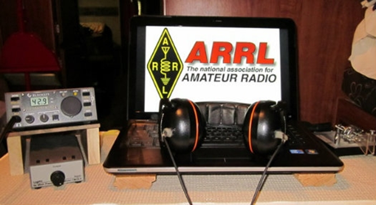
ARRL Contest Corner

An expanded, downloadable version of QST's’Contest Corral is available as a PDF. Check the sponsor's’Web site for information on operating time restrictions and other instructions.

Special Events

- 06/22/2020 | BSA Camp Horseshoe Scout Reservation
Jun 22-Aug 9, 1600Z-1600Z, K2BSA/3, Rising Sun, MD. Chester County Council BSA Camp Horseshoe Scout Reservation. 14.325. QSL. Walt Beattie, 2315 Bradley Way, Pottstown, PA 19464-2684. Chester County Council BSA Camp Horseshoe Scout Reservation will be operating from its new council owned camp radio station as K2BSA/3 during all seven weeks of summer camp which runs from June 22 to August 9, 2020. Licensed staff, scouts, and scouters will be using the station for educational purposes, radio merit badge, and to get the youth on the air. Operations will primarily be on 20 and 40 meters but the camp station is capable of operating from 80 meters and up. Modes will be SSB, digital PSK/RTTY, and CW when possible.

QSL cards are welcomed. SASE for reply please. If possible, please ID operator you spoke with. Thank you for your support and working our youth at camp!
https://k2bsa.net/2020/02/camp-horseshoe-2019-summer-camp-k2bsa-3

- 06/24/2020 | Field Day 2020, Commemorating the Lives of President Ronald & Mrs. Nancy Reagan
Jun 24-Jun 30, 0000Z-2359Z, N6R, Simi Valley, CA. Ventura County Amateur Radio Society, Simi Settlers Amateur Radio Club and other area Amateur Radio Operators. 21.320 14.255 7.260 3.810. QSL. Peter S. Heins, 1559 Norwich Ave., Thousand Oaks, CA 91360. www.qrz.com/db/n6r

- 06/25/2020 | Vermontville TWP Fire & EMS 100th Annual Dance
Jun 25-Jul 6, 0900Z-0900Z, W8S, Vermontville, MI. Rodney Harmon WK8H Fire/EMS Dance Committee. 446.200 MHz PL 74.4; 147.080 MHz PL 103.5; 145.560 MHz; IRLP Node 4868. QSL. Rodney L. Harmon, WK8H, 172 East Second St., Vermontville, MI 49096-9455. A Century of the Annual Fire EMS Dance wk8h_michigan@att.net

- 06/27/2020 | 38th Anniversary Jupiter Tequesta repeater Group/Field Day
Jun 27-Jun 28, 0730Z-1700Z, AG4BV, Jupiter, FL. Jupiter Tequesta Repeater Group. 14.214 14.174 14.164 14.184. QSL. Albert Moreschi II, 11826 154 Rd N, Jupiter, FL 33478. 38th Anniversary Jupiter Tequesta Repeater Group and ARRL Field Day Event on the Beach in Jupiter, Fla www.jtrg.org

- 06/28/2020 | Boy Scouts of America Trail to Eagle XXVI
Jun 28-Jul 3, 1300Z-0500Z, K2BSA/8, Metamora, MI. Garden City Amateur Radio Club. 14.330 7.270 3.840. QSL. Richard Zarczynski, AC8FJ, 7371 N. Farmington Road, Westland, MI 48185-6900. K2BSA/8 will operate at the D-Bar-A Scout Ranch during the week as time permits. We will also be teaching the Radio merit badge to our scouts. michiganscouting.org/event/trail-to-eagle-xxvi-2019-trail-to-eagle

“ARES Connect”
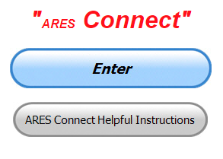
Everyone – please make sure to go into all of the events that you have signed up for and get your hours registered no later than 5 days after the event has ended.

Folks, I’m seeing a lot of folks that have signed up for events not entering their time after the event. This is a very important piece of using “Connect.” Your hours need to be recorded and it’s so easy to do.

Let’s run through how so in case you have forgotten. If you have already gotten signed up for an event, all you have to do afterword to get your time entered is at any time after the event has ended, log into “Connect.” And then click on your name in the upper right-hand corner of the page. This will bring up a drop-down menu where you will then click on “View Hours.”

This brings up another screen where you can “Report Hours” as well as “View Hour History” You’ll want to click on “Report Hours.” You will then be presented one at a time by chronological order each event that you have signed up for and hours have not yet been reported on.

TOP ^
Type in those hours in the “Hours Worked” box and hit “Submit”… Keep doing this until you have no more hours to report…. That’s all there is to it. Now, if you are following the request above and doing this at least every 5 days or more often, this will only take you a minute or so to complete.

Now, isn’t that easy? Yes, and we all need to be diligent at doing it promptly.

Here’s are the top 10 hours earners so far for June:

 | Name | Events | Hours
1 | Daniel Schlick (KB8LKH) | 17 | 106.50
2 | Greg Dersarkisian (KD8SSJ) | 14 | 95.00
3 | John Major (KD8MMY) | 15 | 61.50
4 | Dan Stahl (KC8PBU) | 58 | 61.19
5 | Christopher Domenick (KC8CAD) | 17 | 60.55
6 | Diane Warner (KE8HLD) | 18 | 56.00
7 | James Yoder (W8ERW) | 16 | 55.83
8 | Bret Stemen (KD8SCL) | 26 | 46.50
9 | Dwight Bonifield (W8TJT) | 70 | 43.85
10 | Michael Lacumsky (W8MAL) | 13 | 38.50

Let’s get everyone in the Ohio Section on “ARES Connect!!!” Simply go to: https://arrl.volunteerhub.com/lp/oh/ and get yourself registered and using the system.

One Question Questionnaire

Hey Gang,

“Survey Says”….. about 92% of you actually have it right. You use (C.) Rosin-Core Solder for the best way to make solid electrical connections.

Now, on to next question… Don’t cheat and look up the correct answer. You either know it or you don’t. If you don’t, you need to start reading up on things for sure.

How Will You Be Operating This Field Day??”

You’ll find the “One Question” questionnaire on the Ohio Section Website! http://arrlohio.org It’s all in fun and it’s not a scientific survey in any way, but we are learning some things that we didn’t know from these questions. I hope that you are enjoying answering these “One Question” questionnaires.

TOP ^

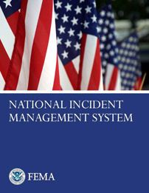
Special ICS 300 & 400 Training being offered – Canceled

Though not part of the ARRL curriculum, another good class is:
ICS/EOC Interface Workshop (G-191), September 16

Prerequisites for this course is completion of IS-100, IS-200, IS-700 and IS-800. All 4 of these courses are online and free from FEMA Independent Studies program.

For more information go to https://kyem.ky.gov/training/Pages/default.aspx and scroll down to September.

Gregg Hendry, W8DUQ

V.E. Test Sessions

Many V.E.’s have decided to start testing once again, but with restrictions that need to be adhered to for sure.

Here’s the link to find that V.E. Test session and what is expected of YOU before going.

http://www.arrl.org/find-an-amateur-radio-license-exam-session

####

Lake County ARA Holding V.E. Testing in August

Lake County ARA will be holding a V.E. Test Session on August 1st at the Lake County Metroparks – Chapin Forest Reservation. The address is: 9938 Chillicothe Road (Rt 306) - Quarry Shelter

Chapin Forest is 3.3 miles south of I-90 on Route 306, in Kirtland. The park is on the west (the right side going south) of 306. The Quarry Shelter is almost immediately on the right as one enters the reservation.

The tests will start at 12 noon. Please arrive a few minutes earlier. Pre-registration is suggested, although we hope to have plenty of seats available.

To register, you will need the NCVEC 605 Form, which will be available at the test. If you would like to complete one ahead of time, be sure it is the Sept 2017 version or later. You can find it by Googling “NCVEC quick-form 605” and clicking on the url for a pdf of the form.

Be sure to bring the original and a copy of both your license and any CSCEs you may have to the exam. The cost is $15.00, and if you wish to pay by check, it should be made out to the ARRL/VEC. Identification with your picture is also necessary, such as a driver’s license. To pre-register, or if you have any questions, please contact Scott Farnham, KO8O, at (440)256-0320, or scottfarnham@roadrunner.com

####

TOP ^

Swap & Shop Has Added Club Raffles To Its Listings On The Webpage

Hey Gang,

Have you taken a look at the Swap & Shop page on the Ohio Section webpage yet??

Here’s a link that will take you there… http://arrl-ohio.org/sm/s-s.html

Do you have equipment that you just don’t need or want anymore? Here’s a great venue to advertise it, and it’s FREE!!

NEW…

Is your club doing a fund raiser to help raise money? After a lot of thought, it was decided that the Swap & Shop webpage could also contain these types of items as well.

The same rules will apply as do for the For Sales and Give-Aways, and will only be posted for a month at a time. Please see the Terms & Conditions on the webpage.

If your club is doing a fund raiser and wants more exposure, please forward the information to me and I’ll advertise it on the Swap & Shop webpage for you.

Now, I still want to remind you that it won’t be listed in this newsletter because it would take up way too much space, so your ad will only appear on the website. It is there for any individual to post equipment Wanted / For Sale or Give-Away as well as for Club Fund Raisers. No licensed vehicles/trailers or business advertising will be posted.

Postings are text only (no pictures or graphics) will be posted for a maximum of 1 month from date posting and require a contact phone number or email within the posting.

Send your Wanted / For Sale or Give-Away post to: swap@arrlohio.org

New Extra Exams take effect July 1
New Extra Class Element 4 Exams will take effect for exam sessions beginning Wednesday July 1, 2020
The newly revised pool, released in January 2020 (updated and re-released in February and March 2020) by the Question Pool Committee (QPC) of the National Conference of Volunteer Examiner Coordinators (NCVEC), must be in use starting July 1. There are ten graphics required for this pool.
With the Extra class exam questions changing July 1, new test designs must be used effective that day. Previous ARRL VEC supplied Extra class exam booklet versions (2016 series) and computer-generated Extra class exams created from the 2016 question pool are only valid until midnight June 30, 2020. At that time VE Team leaders should destroy or throw away the old versions of the Extra exams (do not return them to VEC). To avoid a mix-up at the session, do not save old exam versions.
TOP ^
VEC Exam Maker Software Update
The new Element 4 Extra class question pool is available in the VE Exam Maker exam generating software.
Exam Maker Instructions
Exam Maker should automatically prompt users to check for Software updates. If not, select “Update” and then “Check for Software Updates” from the menu. Check YES to update to Exam Maker version V 1.51.
In Exam Maker from the menu bar, select “Update” and then “Update Exam Data”. A log-in area will appear on screen. Next type your call sign in the “ARRL/VEC Username” box AND in the “Password” box. Then click the “Execute” button. It will only take several seconds for all the question pool files to download.
The screen must read “Exam Database Initialized” when the task is complete for the question pools to be revised to the most up-to-date pools for exam generation.
The New Extra class question pool (2020-2024) will be available for use for exams starting July 1. The current Extra question pool (2016-2020) will be available only until June 30.
Our Sincere Thanks
In the last few months, we’ve all had to navigate unprecedented challenges that we never imagined we’d be facing. Your understanding, flexibility and loyalty have filled the ARRL VEC, with immense gratitude.
We thank you for your flexibility in embracing a new way to remotely deliver examinations to the public and are grateful for your understanding and your adjustment to these changes quickly.
As we are grappling with an issue of enormous scale and human impact, we want to assure you that we are here offering support every step of the way.

Final.. Final..

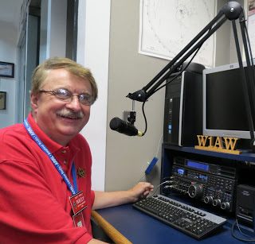
Hi Gang,

Has this been a week of hot weather? Wow. I can remember just the other day when it was only in the 50’s and rain in the forecast every day!

The construction zone has disappeared in the front of our house. I have to admit it, it does look beautiful. It’s quite a change from the old concrete sidewalk and front porch.

Now, I just gotta’ get the riding mower fixed. It’s still in the shop with an expected date for them to work on it around the first of August! Wow… I am seriously thinking of trying to mow this big lawn with a self-propelled mower.

TOP ^
Oh, by the way, I haven’t reported on the robot mower the neighbor has lately. It’s still climbing trees and making a mess out of the neighbor’s backyard. Oh well, at least it is HIS yard looking like a goat had been there, mine just looks overgrown. I guess we both aren’t expecting to get into the “House Beautiful” magazine any time soon!

I have been asked by a number of folks about the governor’s proclamation that we usually get. Unfortunately, we most likely won’t be getting one this year. The folks that Bob, W2THU contacted several months ago at the statehouse told him that they are only concentrating on the COVID-19 situation. They did promise if things opened up that they would do it, but so far it doesn’t look like the state building will be opened in time for them to get this done for us this year.

Whelp, my final go around before gong QRT… Stay safe my friends! I want to see all of you soon at a meeting or hamfest! We will get through this and when we do, we’ll have so much to talk about. Most of all… have FUN and get on the airwaves!!

73,

Scott, N8SY

Ohio Section Cabinet
Section Manager – Scott Yonally, N8SY | Assistant Section Manager – John Perone, W8RXX
Section Emergency Coordinator – Stan Broadway, N8BHL | Section Traffic Manager – David Maynard, WA3EZN
Technical Coordinator – Jeff Kopcak, K8JTK | Affiliated Clubs Coordinator – Tom Sly, WB8LCD
State Government Liaison – Bob Winston, W2THU | Public Information Coordinator – John Ross, KD8IDJ
Section Youth Coordinator – Anthony Lascre, K8ZT

Welcome New Subscriber(s)

Robert, VA3BXG

Back Issues of the PostScript and Ohio Section Journal

Hey, did you know that PostScript and Ohio Section Journal (OSJ) are archived on the website? You can go back and look at any edition simply by clicking:
http://arrl-ohio.org/news/index.html

TOP ^

Chit – Chat, and All That!

Do you know someone that’s not getting these Newsletters? Please, forward a copy of this Newsletter over to them and have them “Opt-In” to start receiving them. Heck just have them send me an email n8sy@n8sy.com and I’ll get them added to the Ohio Section Emailing list.

We now have many thousands of readers receiving these newsletters weekly. Quite impressive, I’d say! I urge all of you to make sure that everyone, regardless of whether they are a League member or not, get signed up to receive these weekly Newsletters.

You can always “Opt-Out” at any time if you feel this is not what you were expecting. It’s fun and very informative. All of your favorite past newsletters are now archived too.
You can go back at any time and read them. Just go to: http://arrl-ohio.org/news/

Got questions, concerns or would just like to sit and chat awhile? Heck, I’ll even buy the coffee!! Give me a call at (419) 512-4445 or email me at: n8sy@n8sy.com

The pictures on the front page and throughout this newsletter are from various newsletters, Facebook posts and/or were sent directly to me in recent weeks. Take a good look at them, you just might be in one of the pictures! “SMILE… you’re in the Ohio Section News!!”

TOP ^

PostScript is produced as a weekly newsletter. I want to thank everyone that has contributed articles and ideas to make this an even better news source. I sincerely hope that you have enjoyed this edition and will encourage your friends to join with you in receiving the latest news and information about the Ohio Section, and news and events happening around the world!

