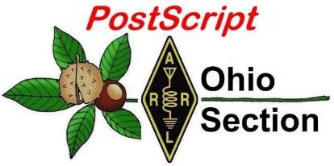
June 15th
Edition

National News The Handbook Give Away

Club Corner Hamfests

DX This Week ARES Connect

VE Testing One Question Questionnaire

Final.. Final..

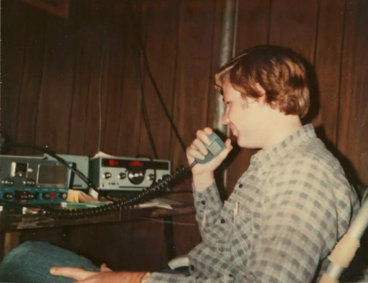
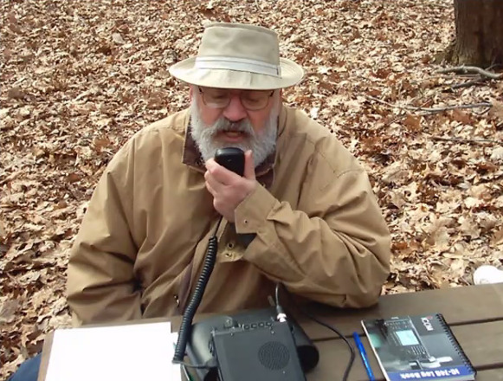
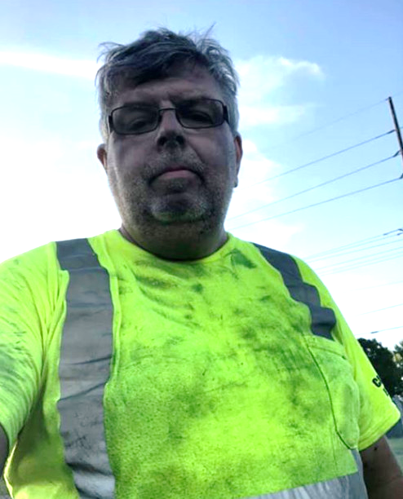
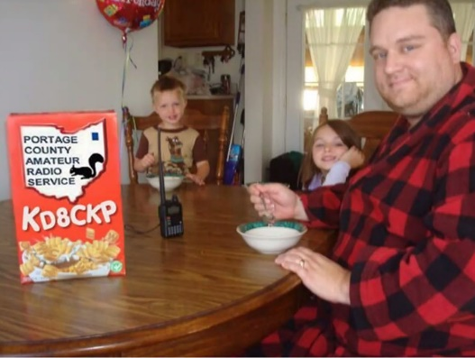
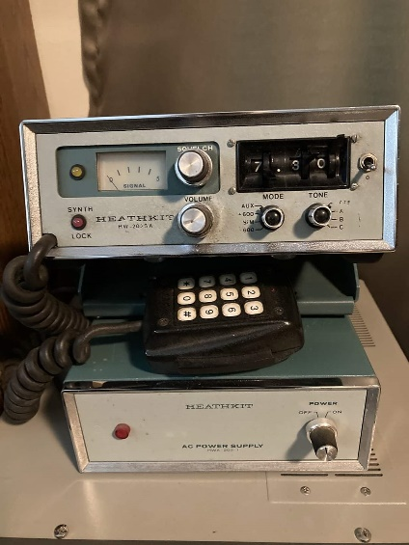
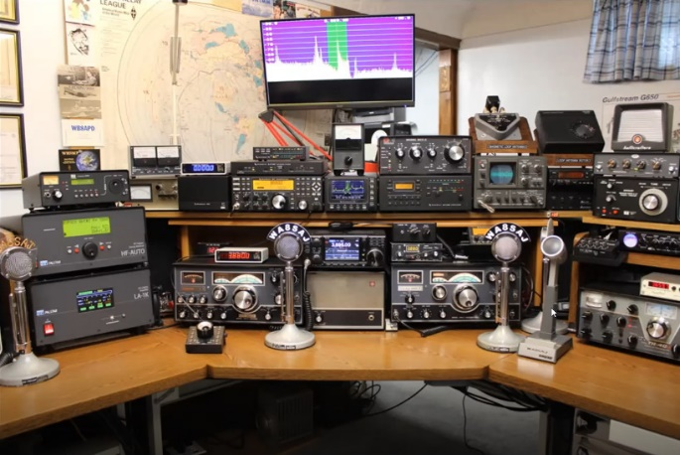

National News
(from arrl and other sources)

ARRL Contest Program Issues Field Day 2020 FAQ

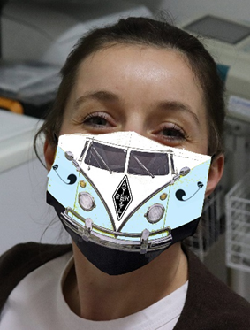
The ARRL Contest Program has released some Frequently Asked Questions related to the Field Day temporary rule waivers. On May 28, the ARRL Programs and Services Committee (PSC) adopted these provisions only for the June 27 – 28, 2020, event: (1) Class D stations may work all other Field Day stations, including other Class D stations, for points, and (2) an aggregate club score will be published, which will be the sum of all individual entries that indicate a specific club. Contact the ARRL Contest Program with any questions related to Field Day 2020.

Q: Several of our club members are going to operate independently and wish to attribute their scores to the aggregate club score. What call sign should they use?

A: Participants should use their own call signs. Except for Class C (mobile) entries, all transmitters, receivers, and antennas must be located within a 1,000-foot-diameter circle may operate using a single call sign. This prohibits the use of a single call sign from more than one location. Under the 2020 waiver, those operating from home, including backyard operations, must use their own station call signs. Multiple home stations operating with a club call sign or modified club call sign, such as W1AW-1, W1AW-2, W1AW-3, etc, are not allowed.

Q: How does my club submit an aggregate club score? Does the club need to add up each participating member’s scores and submit a club entry with the aggregate score under the club call sign?

A: Each participant will submit his or her own independent entry under his or her call sign. ARRL will calculate the aggregate score based upon the club name entered on the official Field Day entry form via the web applet (preferred method) or on the paper Field Day entry form. In order for results to be tabulated correctly, all club participants must enter the club’s official name exactly the same, avoiding abbreviations or acronyms. This is important!

Q: Our group is still planning to operate at the usual Field Day site, but some members do not feel comfortable gathering in a large group this year. Can we still submit an entry using the club call sign, as well as have members operating from home using their own call signs?

A: Yes. If your club is still hosting a group Field Day effort, it will submit an entry as usual, using the club call sign. Club members operating at home will submit separate entries with their own call signs and will enter the club name on the entry form for club aggregate scoring.

Q: Can a club member operate from home using the club call sign?

A: Yes, but the call sign may only be used in one location. The member must receive permission from the trustee of the club call sign.

TOP ^
Q: Our club normally enters Field Day in Class A. If we operate from our home stations, in which class should individual members enter in order to be included in the aggregate club score?

A: Each member will operate independently and will submit the entry using whatever class that applies to their operation. Typically, home stations running on commercial ac power are Class D, while home stations running on battery, solar, generator, or the like (i.e., not from ac mains) are Class E. When the results are published, each club member will be listed in the results under the class in which they operated. For 2020 only, aggregate club scores will be listed by the club name in a separate listing.

Q: Our club will have 10 members operating from home as Class D stations. Should they worry about working the same station on the same band and mode (duplicates)?

A: Because members are operating as separate entries using their own call signs, the contacts are not considered duplicates.

Q: Does the club need to be an ARRL-affiliated club to participate in Field Day?

A: No. All clubs and groups are welcome to participate in ARRL Field Day.

Q: How will bonus points be calculated for the aggregate club scores? Can individual club members still earn bonus points?

A: All individual scores, including bonus points, will be added together to determine the aggregate club score. Refer to the complete rules to determine eligibility for bonus points. — Thanks to Paul Bourque, N1SFE, ARRL Contest Program Manager

####

Radio hams help in cyclone
(Submitted by Gregory Drezdzon, WD9FTZ)

The Hindustan Times (India) reports nine amateur radio operators came to the aid of district officials during Cyclone Nisarga.

The newspaper says:

As all modes of communication collapsed in less than half-an-hour after severe cyclone Nisarga made landfall over Raigad district last June 3, a group of nine independent ham radio operators using wireless communication became the eyes and ears for the district administration. Their centers? A station without a roof in Shrivardhan, the district headquarters in Alibag and vehicles in Mahabaleshwar.

The entire exercise from the afternoon of June 2 to June 5 evening (when mobile network availability returned in some areas) saw continuous relay of information about deaths, injuries, evacuations, scale of damage (trees loss, falling power lines, and network towers), relief and rehabilitation requirements, across low-lying areas in Shrivardhan, Mhasala, Dighi, Murud, Revdanda, Nagaon, Revas, and Alibag areas in Raigad from the police, local authorities and citizens to radio operators and in turn to the authorities across different parts.

TOP ^
Read the full story at:
https://www.hindustantimes.com/mumbai-news/9-ham-radio-operators-come-to-the-aid-of-district-officials-during-cyclone-nisarga/story-WUM4gMzAjaLJoSxcJ7URZJ.html

Cyclone Nisarga: India's Mumbai escapes worst cyclone in decades
https://www.bbc.co.uk/news/world-asia-india-52900967

####

International Postal Service Disrupted

The US Postal Service (USPS) has temporarily suspended international mail acceptance for items addressed to certain destinations due to service impacts related to the COVID-19 pandemic. This situation could result in the return or loss of mail, such as QSL cards, addressed to affected parts of the world. The USPS has posted a list of affected countries, which is updated regularly.

The Postal Service will, upon request, refund postage and fees on mail bearing a customs stamp that’s returned due to the suspension of service, or the sender may re-mail returned items with existing postage once service has been restored. When re-mailing under this option, customers should cross out the markings “Mail Service Suspended — Return to Sender.”

WD9FTZ Sets New Record in 3 State Area

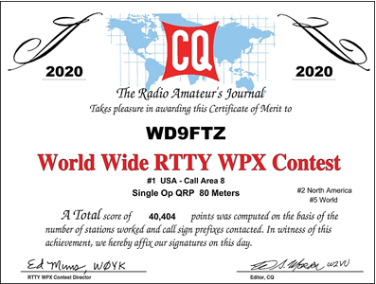
Gregory Drezdzon, WD9FTZ, of Akron, established a new record for the Eight Area call district, during the CQ World-Wide RTTY WPX radio contest held on February 8 and 9, 2020.

The Eight Area call district encompasses Michigan, Ohio, and West Virginia.

Even when solar minimum conditions existed, Drezdzon was able to place second in the United States, second in North America and 5th in the world.

Working only the 80-meter amateur radio band, Drezdzon contacted 165 different stations using 5 watts or less of power, including 111 different callsign prefixes during14.3 hours of operation.

TOP ^
The objective of the contest was to contact as many amateurs and prefixes as possible during the period of operation using radio teletype.

According to the CQ RTTY WPX Contest website, this radio contest attracts upward of 20,000 participants annually.

The site states 3,090 logs were received in 2020. The highest number of logs received was in 2012, where 3,546 logs were submitted. This contest dates back to 1995 when 199 logs were entered.

The future date of this contest is February 13 and 14, 2021.

####

Black River Radio Ops
(from Jon Anhold, KM8V)

On June 7th, Doug AB8M and Jon KM8V of the Black River Radio Ops did a talk for the Cuyahoga County ARES virtual meeting on packet radio and Winlink, and their efforts in re-building the packet radio network in Northeast Ohio. Recently the Winlink RMS gateways were used in support of the American Red Cross exercise on May 30th 2020.

We are actively looking for more users on the packet network, as well as looking for sites to place packet nodes in order to expand coverage in the region.

The webex replay and presentation are available here:

https://www.km8v.com/hamradio/cuyahoga-ares-packet-radio-june-2020/

Additionally, Doug AB8M has started a Monday Packet Practice Net. Details are available here:

http://www.nw8s.com/news/brro-monday-packet-net/

More details on the Cleveland area packet network are available at https://www.km8v.com/packet/ and more information on Black River Radio Ops is available at http://nw8s.com/

73 de KM8V - Black River Radio Ops

####

ARRL Announces Updated Features on Contest Portal

The much-anticipated updated features at the ARRL Contest portal are here! These web-based tools provide an updated interface to contest data for all ARRL-sponsored contest events, including:

- Contest Score viewer, including a searchable call history and records
- Submitted logs and raw scores for recent events

TOP ^
- Downloadable Comma Separated Values (CSV) files of contest results
- Club Competition scores, including total and individual scores
- Soapbox page for posting and viewing contest stories, photos, and other media
- Downloadable, printable certificates suitable for framing
- Log Checking Reports (LCRs)
- Access to public logs
- Contest results articles and line scores

ARRL Contest portal users will notice other minor changes to the site, as some functions have been moved on the page for better functionality and flow. The ARRL Contest portal is now a one-stop shop for all ARRL-sponsored contests. From the site, you can access everything, from the start time of a contest to your post-event certificate of accomplishment. All ARRL contest information is now conveniently located in one centralized location.

Contact the Contest Program Manager for more information on the updated features and on ARRL contests in
general.

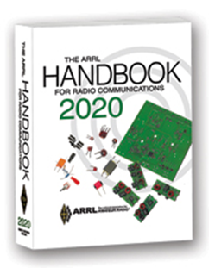
The Handbook Give Away

Hey Gang,

Have you registered for the “Handbook Giveaway” drawing for this month yet? If you haven’t, go to: http://arrl-ohio.org/handbook.html and get yourself registered now!

What’s the catch? I want to get everyone checking in to the Ohio Section website as often as possible, and in order to register each month, you have to visit the website often! There’s nothing else to it. I pay all expenses and I usually “Give Away” more than just a Handbook too!!

Many of you ask me just how do I know when the drawing is on? Well, that’s easy all you need to do is check in on the Ohio Section Website on a regular basis and watch for the big RED Arrow that will appear on the left side of the page. This is the sign that the drawing is on and you need to get registered. So, keep a sharp eye out on the website and check in often!

Club Corner

This is YOUR cornner of the newsletter. Send me what your club is doing and I’ll make sure that it gets in. Got a special event or club project that you want everyone to know about? Send it to me!. Need help with a project? Send it to me.

Let me know what you club is up to. Are you going to have a special guest at your meeting or are you having a special anniversary? Just sent it to: n8sy@n8sy.com

####

TOP ^
The Northwest Ohio ARES Traffic Net Needs Help

The Northwest Ohio ARES Traffic Net is in need of General and/or Extra Class licensees with either voice or CW capabilities to relay traffic from the VHF net to the HF nets, no experience is necessary.

The NW Ohio ARES Traffic Net meets daily at 6:30PM on the W8RZM 147.375 repeater.

The Ohio Single Sideband Net meets daily at 10:30AM, 4:15PM and 6:45PM on 3.9725 MHz. The Ohio Section also has three CW Nets, the Ohio Slow Net meets daily at 6:00PM on 3.53535 and runs at approximately 10 WPM.

The Buckeye Net-Early meets daily at 6:45PM on 3.580 and runs between 15-20 WPM. Finally, the Buckeye Net-Late meets daily at 10PM on 3.590 and runs in the same range as the Early Net. Currently, there are only 2 volunteers that cover 7 days a week, and most nets there isn't a volunteer at all. Please consider volunteering for an hour a week, you never know, you may like it.

For more information on traffic handling, or volunteering to assist relaying traffic please check into the VHF net or contact Colleen Roth N8TNV, Steve Denniss KC8IDM, or Michael Lacumsky W8MAL.

####

Make Field Day Great Again in 2020!

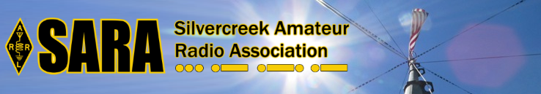
With COVID-19 spoiling the fun of Field Day for many clubs, Silvercreek Amateur Radio Association (SARA) and WARC decided to do something about it! The SilverWoo Field Day Event is a joint effort between the Silvercreek Amateur Radio Association and the Wayne Amateur Radio Clubs. This one-year-only event will provide incentives for hams to operate Field Day from home or in other approved conditions for Field Day 2020. There will be several awards offered based on various Field Day performance criteria. See silverwoo.org for more details and join in the fun!

Upcoming Hamfests for 2020
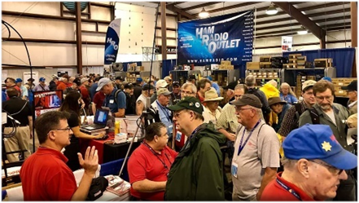
07/18/2020 | NOARSfest
Location: Elyria, OH
Sponsor: Northern Ohio Amateur Radio Society
Website: https://www.facebook.com/NOARS.K8KRG
Canceled

07/19/2020 | Van Wert Hamfest
Location: Van Wert, OH
Sponsor: Van wert Amateur Radio Club
Website: http://w8fy.org

TOP ^
07/26/2020 - Portage Hamfair '20  Location: Ravenna, OH  Sponsor: Portage Amateur Radio Club, Inc.  Website: http://hamfair.com  Canceled | 08/01/2020 | Columbus Hamfest  Location: Grove City, OH  Sponsor: Voice of Aladdin/ Audio Unit of Aladdin Shrine  Website: http://columbushamfest.com  Canceled
08/08/2020 | DXE Hamfest,  ARRL Ohio Section Convention  Location: Tallmadge, OH  Sponsor: DX Engineering  Website: http://dxengineering.com  Canceled | New Date  08/29/2020 - Milford Hamfest  Location: Owensville, OH  Sponsor: Milford Amateur Radio Club  Website: http://www.w8mrc.com
09/27/2020 | Cleveland Hamfest and Computer Show
Location: Berea, OH
Sponsor: Hamfest Association of Cleveland
Website: http://www.hac.org
Click on “Join Our Mailing List” to stay updated.

Tri-State Amateur Radio Association – Huntington West Virginia Hamfest 2020
Canceled
####

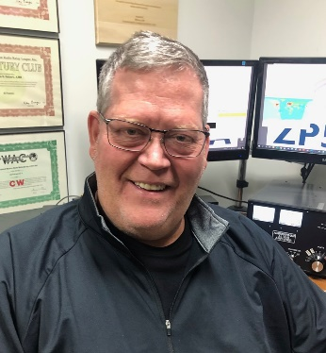
DX This Week
(from Bill, AJ8B)

DX This Week – Card Checking
Bill AJ8B (aj8b@arrl.net, @AJ8B, or www.aj8b.com)
CWOPs Member #1567

There have been some indications that Solar Cycle 25 is starting to warm up…slightly. The bands seemed to be in pretty good condition. I had several nice CW QSOs on a couple of nights. Entities that were spotted by stations in the Midwest included Alaska, Austria, Azores, Balearic Islands, Barbados, Belgium, Canary Islands, Ceuta & Melilla, Chile, China, Costa Rica, Croatia, Czech Republic, Denmark, Ecuador, England, European Russia, Fed. Rep. of Germany, France, Gibraltar, Georgia, Greece, Greenland, Guadeloupe, Guernsey, Ireland, Isle of Man, Italy, Jamaica, Japan, Jersey, Kaliningrad, Kenya, Kuwait, Lithuania, Luxembourg, Mauritania, Mexico, Netherlands, New Zealand, Nicaragua, Norfolk Island, Northern Ireland, Pakistan, Poland, Portugal, Sardinia, Scotland, Senegal, Sicily, Slovenia, Spain, Switzerland, Trinidad & tobago, US Virgin Islands, Venezuela, and Wales.

TOP ^
I did receive some QSLs cards this week including VK3XZ – Mike in Australia, and TZ4AM – Jeff in Mali (pictured)

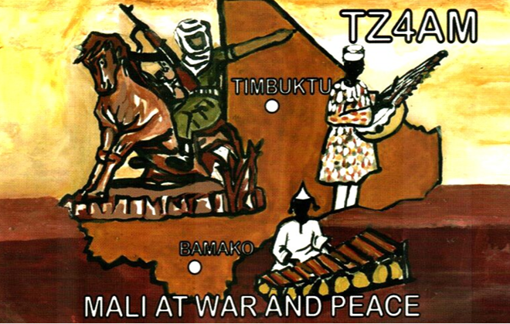
Two of the articles that I received the most positive feedback from last year were the articles on card checking and DXCC via LoTW. I will reprint those excellent articles from K8DV, Dave, this week and next. I hope that new readers of DX this Week will find them interesting and let me know!
If you are checking this weekly, I hope it is because you have an interest in DX and have or are working towards DXCC. For starters, DXCC or the DX Century Club award is an award earned by making and confirming contacts with licensed amateur operators in at least 100 "entities" (countries) around the world.

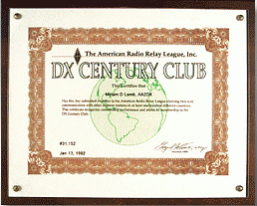
The award is granted by the DX Desk at the ARRL. All radio amateurs are eligible to apply although applicants from the US, its possessions and Puerto Rico must be ARRL members. Proof of two-way contacts, either in the form of QSL cards or online confirmations in the Logbook of The world (LoTW), must be submitted the ARRL. Each DXCC award certificate is dated and individually numbered and is widely recognized among the global amateur radio community as confirmation that the holder is an accomplished DXer.
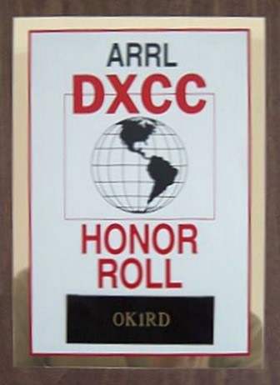
The top honor in the DXCC program is the DXCC Honor Roll. This is available to only those who are within 10 entities of the currently available total. We are at 340 countries available, so, Honor Roll participants would have 331 confirmed to be eligible.
The strength of the program has been the verification process of QSOs (contacts) for hams to get credit. 2003 was a significant year for the DXCC program as the ARRL launched its’ Logbook of the World online logbook. If you had confirmed QSOs in LoTW, they would be confirmed in the database and no QSL cards were required. For this installment of the “DX This Week” column, we will only review the checking of QSL cards. The following two weeks will cover the LoTW application process and the physical QSL card submission process. One of the most knowledgeable hams on the DXCC process (and, lucky for me, an Elmer) is Dave, K8DV. Dave has graciously agreed to allow me to reprint a three-part article on the validation of QSL Cards, submission of credits for the DXCC award via LoTW and submission via QSL Cards. These articles originally appeared in the SWODXA newsletter, The Exchange.

TOP ^
DXCC Card Checking by Dave, K8DV

As a member of SWODXA and an ARRL Field card checker, I wanted to take a few minutes and share some information concerning checking cards.

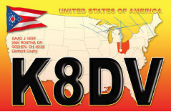

To avoid problems with field checking your application be sure to follow the instructions on the ARRL website http://www.arrl.org/dxcc-rules. Note that as of April 2, 2012, there are 2 ways of doing a paper card submission; online and traditional. You can no longer do a hybrid LoTW and paper card submission on a single application. It is absolutely necessary that you follow all the instructions and have all the paperwork properly filled out or a card checker will not be able to check your cards. Submissions via LoTW and paper cards are treated as 2 separate applications, the good news is there is no longer any up charge for submitting more than a single application per year.

If you use the preferred Online Electronic DXCC Application http://www.arrl.org/online-dxcc-application for your paper cards it will be easier and cheaper for you. It will also go a lot faster at HQ when they get your paperwork since you already entered your card data in the ARRL system. With the online application you can enter the cards in any order. Just make sure to enter the QSOs on cards with multiple QSOs together to facilitate checking. The reason you don’t have to sort by band then mode is because there is minimal data entry work at HQ when they get your field checked application. Payment is made online and not handled by the card checker.
You can also use the Traditional Application forms http://www.arrl.org/dxcc-forms where you fill in and print the PDF forms for the application and record sheets. Make sure to follow those instructions. A traditional application will cost you roughly twice as much as the online application to cover data entry costs at HQ. With a traditional application you must sort cards by band then by mode with all the multiple QSO cards being listed last to facilitate data entry at ARRL HQ. If you use the traditional application, make sure you include valid credit card info on the bottom of the PDF application form. Payment by card is best as cash presents problems for the checker as I must deposit the cash and pay via my own card or write a check to cover.

Whichever way you do it, follow those instructions and make sure the cards are properly sorted in the same order as your DXCC Record Sheet. Also make certain that all the QSL card information (call, date, band, mode, country) has been entered correctly on the record sheet.

As a card checker and holder of 160 M DXCC, I can check cards for 160, I can also check deleted countries. In addition to DXCC, I can check WAS, VUCC, WAC cards for award credit.

If you are meeting with a field card checker, remember to bring the following:

- Cards sorted per your Record Sheet
- Printed copy of the signed and dated Application Sheet
- Printed copy of the DXCC Record Sheet
- Stamped envelope addressed to
DXCC Desk, ARRL HQ, 225 Main Street, Newington, CT 06111 so we can mail your application to HQ.

TOP ^
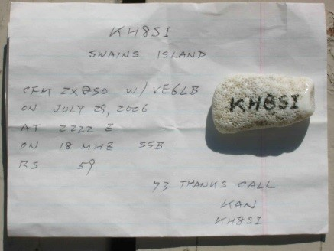
What does the field checker review on each card? Each card should have the Entity Name as it is shown on the DXCC List, the call signs of both stations, the date, time, band, and mode. RS(T) is NOT required. To avoid confusion for the station and the checker, always use UTC for the time and date. QSL cards not containing all required information may be rejected.

Does it have to be a formally printed QSL card? This is a picture of a QSL “napkin” that was submitted and accepted for credit.
Other errors that occur can be that the DX station left your call sign off and handwriting can be an issue.

You may receive a QSL that shows your freq as 10M when you worked him on 10.1 MHZ. Is that 10M or 30M?

Next week, Dave will take us through the online process.

CQDX CQDX CQDX CQDX CQDX CQDX CQDX CQDX CQDX

Here is an update from Bernie, W3UR, of the DailyDX and the WeeklyDX, the best source for DX information. http://www.dailydx.com/. Bernie has this to report:

FT8 vs. FT4 – from K1JT, Joe Taylor Joe, noting the transatlantic six-meter opening(s), says he is enjoying the multi-hop sporadic E, “an excellent test of the original design goals for FT8, and more recently also FT4.” Over several hours he worked 76 European stations, 37 with FT8 on 50.313 (mostly) or 50.323. The other 39 were FT4 on 50.318, “in just 44 minutes.” Joe says, “I strongly recommend that for such openings in the future you should try FT4. It’s twice as fast as FT8, with only a 3db penalty on the AWGN channel. The sensitivity penalty is even less on a fading channel.” Joe says it was also an excellent opportunity to use good operating practices. “As recommended, most European stations transmitted in the first/even sequence in both FT4 and FT8. North American stations transmitted in second sequence. This procedure minimizes QRN from strong local stations and helps everyone to work DX.”

3X – Guinea - F4AJQ, Frank, says the F6KOP team, noting their successful E44CC Palestine operation in February, are now planning another operation, this one for next January. Assuming the borders open after COVID-19 and they can travel safely, they plan to be on Guinea’s Kassa Island, IOTA AF-051, QRV on 160-10 “with maybe 60M,” CW, SSB, RTTY and FT8, with five stations on simultaneously. They will have three beams, several verticals and receiving antennas too. The callsign, operators and other details will be forthcoming soon.
5T - Mauritania 5T5PA (aka PA5X), Johannes has been running the 5T station remotely the last few weeks (see The Weekly DX 20-16). He returned safely to his home in The Netherlands, two weeks on a ship. He hopes to be back to Mauritania in person “as soon as flights are scheduled again.” Your editor asked Johannes about the possibility of six-meter operation remotely and he said “Unfortunately, I cannot operate 6M remote from 5T,” but his grid is IL10lw and he expects to be back there within a few weeks and catch some of the 6M openings.

TOP ^
KH9 – Wake Island & V73 – Kwajalein - WW6RG, Randy Avery, is planning an operation from KH9. He was hopeful to be able to put V73, Kwajalein Atoll, on the air in the coming weeks but travel restrictions are preventing that. He may try again in July. Meantime, Wake is still in the works for operations Monday, June 15 and Wednesday June 17, from 04- 08Z. It will be 20 and 17 meters with five watts, with a short break at 05Z during those four-hour activities. QSL to his home QTH, WW6RG

DX news
ARLD024 DX news

This week's bulletin was made possible with information provided by The Daily DX, the OPDX Bulletin, 425 DX News, DXNL, Contest Corral from QST and the ARRL Contest Calendar and WA7BNM web sites. Thanks to all.

CUBA, CO. Special event station CO200SMP is QRV until June 30 to celebrate the 200th anniversary of San Miguel del Padron, one of the fifteen municipalities that make up the city of Havana. Activity is on the HF bands using CW, SSB and FT8. QSL direct to CO2AME.

ANGOLA, D2. Gabriel, D2EB, has 6 meter capabilities and may soon be active from Grid Square JI61pe. QSL via IZ3ETU.

ENGLAND, G. Members of the Chelmsford Amateur Radio Society will be QRV with special event station GB100MZX from June 13 to 20 to commemorate the first official British radio broadcast 100 years ago. QSL via operators' instructions.

WALES, GW. Members of Dragon Amateur Radio Club are QRV from special event station GB0MZX until June 21 to commemorate the first official British radio broadcast 100 years ago. QSL via operators'
instructions.

JAPAN, JA. Katsu, JR7AMZ is QRV from Oshima, IOTA AS-206. Activity is on the HF bands using mostly FT8. QSL via JA7ZRY.

SVALBARD, JW. Bjorn, LA5NUA and Jurn, LA5LUA are QRV as JW5NUA and JW5LUA, respectively. QSL via operators' instructions.

BRAZIL, PY. Members of the Clube de Radioamadores de Sao Miguel do Oeste are QRV with special call ZZ60CRASMO during June to celebrate the club's 60th anniversary. QSL direct to PP5DZ.

SOMALIA, T5. Ali, 6O1OO has been active on 20 meters using FT4 in DXpedition mode around 2320z. QSL direct to home call.

CHAD, TT. Nicolas, TT8SN has been active on 6 meters using FT8 just after 1000z. QSL via DL9USA.

MALI, TZ. Jeff, TZ4AM has been QRV on 20 meters CW around 0820z. QSL via W0SA.

TOP ^
EUROPEAN RUSSIA, UA. Special event station R20RUS and RU20RU are QRV until June 14 to celebrate Russia Day. QSL via operators' instructions.

AUSTRALIA, VK. Members of the Wireless Institute of Australia are QRV with special call VI110WIA until the end of 2020 to celebrate the club's 110th anniversary. Activity is on the HF bands. QSL via LoTW.

INDIA, VU. Verghese, VU3WNI is QRV with special call AU9VV until August 20 while participating in the STAY-HOME activities. In addition, VU2USI is QRV as AT2SAH until August 19. QSL via operators' instructions.

CAYMAN ISLANDS, ZF. Frank, KK5XX is QRV as ZF2FD from Grand Cayman, IOTA NA-016, until June 17. Activity is holiday style on 80, 40 and 20 meters using CW and SSB. QSL to home call.

THIS WEEKEND ON THE RADIO. The ARRL June VHF Contest, NCCC RTTY Sprint, NCCC CW Sprint, RSGB Hope QSO CW Party, SMIRK 6-Meter Contest, DRCG World Wide RTTY Contest, Asia-Pacific SSB Sprint, SKCC Weekend CW Sprintathon, Portugal Day Contest, AGCW VHF/UHF Contest, GACW WWSA CW DX Contest, REF DDFM 6-Meter Contest and RTTYOPS Weekend Sprint will certainly keep contesters busy this upcoming weekend.

The RSGB Hope QSO FT4 Party, RSGB FT4 Contest Series and 4 States QRP Group Second Sunday Sprint are all scheduled for June 15.

The RTTYOPS Weeksprint, SARL Youth 40-Meter SSB Sprint, RSGB Hope QSO SSB Party and Worldwide Sideband Activity Contest are scheduled for June 16.

The RSGB Hope QSO CW Party, CWops Mini-CWT Test, NAQCC CW Sprint and Phone Fray are scheduled for June 17.

The 11th World Castles Weekend runs until June 21.

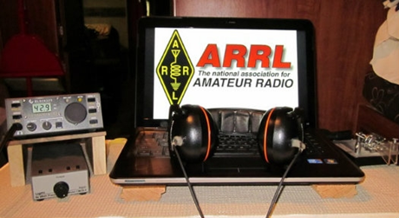
ARRL Contest Corner

An expanded, downloadable version of QST's’Contest Corral is available as a PDF. Check the sponsor's’Web site for information on operating time restrictions and other instructions.

Special Events

- 06/16/2020 | WPAFDA 50th Anniversary
Jun 16-Jun 30, 0000Z-2359Z, W3W, New Kensington, PA. Western Pennsylvania Field Day Association - KS3N . 3.850 7.250 14.250. QSL. Tom Straub, 1020, Edgewood Road, New Kensington, PA 15068. SASE requested Wpafda.webnode.com

TOP ^
- 06/19/2020 | Crescent City Fireball Anniversary
Jun 19-Jun 22, 1300Z-0100Z, W9C, Crescent City, IL. Metro DX Club. 14.280 14.050 7.280 7.050. Certificate & QSL. Jim Mornar N9TK, 8607 W. Kendall Ln. , Orland Park, IL 60462. A certificate to be returned by email may be requested by sending an email to n9tk@comcast.net.To receive a printed certificate and QSL card, please send a self-addressed 9x12 envelope with three (3) ounces postage ($1.40) attached to N9TK, our QSL manager for W9C: Metro DX Club c/o Jim Mornar N9TK, 8607 W. Kendall Lane, Orland Park, IL 60462 USA. www.metrodxclub.com

- 06/20/2020 | Kids Day Lawton, OK
Jun 20, 1800Z-2359Z, K1D, Lawton, OK. Frank Phillips Memorial Repeater Association, AB5J. 21.250 14.250 14.045 7.250. QSL. Ronald Grossman, 1308 SW Washington Ave., Lawton, OK 73501. Celebrating the ARRL Kids Day in Lawton, OK> Please contact us using Special Event Callsign K1D. QSL available SASE. We will be on FT-8, CW, SSB, DMR, etc. Lets support the Kids!!

- 06/20/2020 | Treasure Island
Jun 20, 1200Z-2300Z, K5E, Bonham, TX. Fannin County Amateur Radio Club K5FRC. 28.415 14.265 7.265 3.815. QSL. Fannin County ARC, P.O. Box 553, Bonham, TX 75418. Join in on the voyage on Treasure Island, within Lake Texoma. We will experiment with FT4 Digital. SASE for QSL card. www.k5frc.org

- 06/22/2020 | BSA Camp Horseshoe Scout Reservation
Jun 22-Aug 9, 1600Z-1600Z, K2BSA/3, Rising Sun, MD. Chester County Council BSA Camp Horseshoe Scout Reservation. 14.325. QSL. Walt Beattie, 2315 Bradley Way, Pottstown, PA 19464-2684. Chester County Council BSA Camp Horseshoe Scout Reservation will be operating from its new council owned camp radio station as K2BSA/3 during all seven weeks of summer camp which runs from June 22 to August 9, 2020. Licensed staff, scouts, and scouters will be using the station for educational purposes, radio merit badge, and to get the youth on the air. Operations will primarily be on 20 and 40 meters but the camp station is capable of operating from 80 meters and up. Modes will be SSB, digital PSK/RTTY, and CW when possible. QSL cards are welcomed. SASE for reply please. If possible, please ID operator you spoke with. Thank you for your support and working our youth at camp!
https://k2bsa.net/2020/02/camp-horseshoe-2019-summer-camp-k2bsa-3

- 06/24/2020 | Field Day 2020, Commemorating the Lives of President Ronald & Mrs. Nancy Reagan
Jun 24-Jun 30, 0000Z-2359Z, N6R, Simi Valley, CA. Ventura County Amateur Radio Society, Simi Settlers Amateur Radio Club and other area Amateur Radio Operators. 21.320 14.255 7.260 3.810. QSL. Peter S. Heins, 1559 Norwich Ave., Thousand Oaks, CA 91360. www.qrz.com/db/n6r

- 06/25/2020 | Vermontville TWP Fire & EMS 100th Annual Dance
Jun 25-Jul 6, 0900Z-0900Z, W8S, Vermontville, MI. Rodney Harmon WK8H Fire/EMS Dance Committee. 446.200 MHz PL 74.4; 147.080 MHz PL 103.5; 145.560 MHz; IRLP Node 4868. QSL. Rodney L. Harmon, WK8H, 172 East Second St., Vermontville, MI 49096-9455. A Century of the Annual Fire EMS Dance wk8h_michigan@att.net

- 06/27/2020 | 38th Anniversary Jupiter Tequesta repeater Group/Field Day
Jun 27-Jun 28, 0730Z-1700Z, AG4BV, Jupiter, FL. Jupiter Tequesta Repeater Group. 14.214 14.174 14.164 14.184. QSL. Albert Moreschi II, 11826 154 Rd N, Jupiter, FL 33478. 38th Anniversary Jupiter Tequesta Repeater Group and ARRL Field Day Event on the Beach in Jupiter, Fla www.jtrg.org

TOP ^
- 06/28/2020 | Boy Scouts of America Trail to Eagle XXVI
Jun 28-Jul 3, 1300Z-0500Z, K2BSA/8, Metamora, MI. Garden City Amateur Radio Club. 14.330 7.270 3.840. QSL. Richard Zarczynski, AC8FJ, 7371 N. Farmington Road, Westland, MI 48185-6900. K2BSA/8 will operate at the D-Bar-A Scout Ranch during the week as time permits. We will also be teaching the Radio merit badge to our scouts. michiganscouting.org/event/trail-to-eagle-xxvi-2019-trail-to-eagle

2020 Field Day Club Preparation; It’ Not Too Soon!
(By Anthony Luscre, K8ZT)

Over the last couple of weeks, I have been busy preparing materials, doing online presentations and answering questions from both clubs and individuals concerned about their 2020 Field Day plans under COVID-19 precautions.

I have put together a slideshow “Field Day in Social Distancing” available at tiny.cc/fdsd. It is a “live” document and I am constantly making additions and corrections based on reader feedback and changes in ARRL rules.

On June 3rd I did an online presentation of the slideshow as part of the IARU Region 2’s Workshop series. You can view the Youtube video recording of this workshop at https://youtu.be/xLk5_BIpF6s?t=509

One the of the things I address at length are opportunities for Technician (and legacy Novice) Licensees to operate solo FD stations:
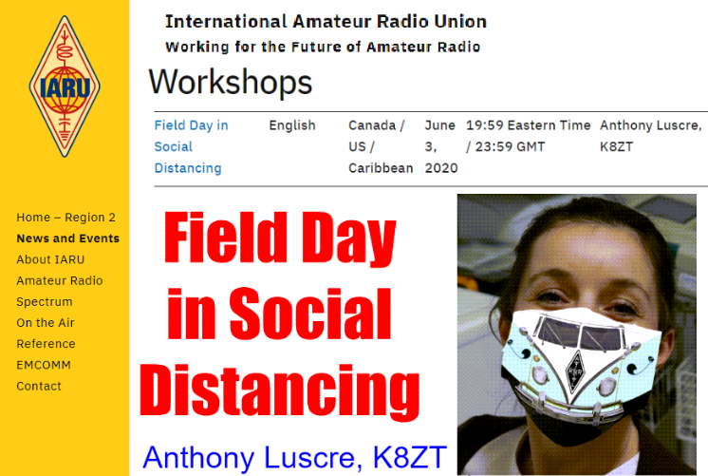
- VHF Station
  - 6 SSB & Digital
  - 2 Meter FM Simplex
- Satellite Contacts
- 10 Meter SSB & Digital
- CW Only Operations on 80, 40 and/or 15 Meters
If these operators are going to be successful in making contacts (especially if e-skip propagation on 10 & 6 Meters does not raise its head) we need to make sure all operators take time out of their HF operations to both monitor and call CQ in bands and modes available to Techs.

Included in the slideshow are links to a number of resources for planning your or your club’s 2020 FD including but not limited to:

- A Google Document that you can edit and use for your club’s newsletter, website or as an email to members. The document condenses much of the slideshow into a text-based document with the ability to address club-specific issues- tiny.cc/sfda.

- A comparison of Portable Antennas and resources for each of the types discussed- tiny.cc/portant.

TOP ^
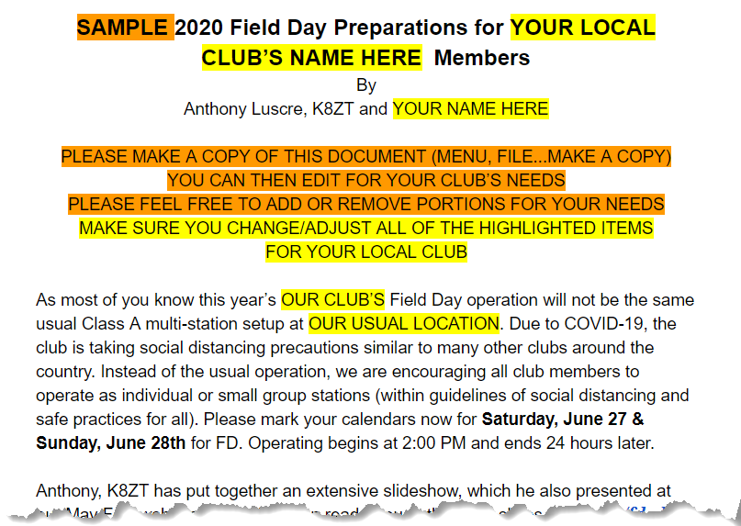
- A FD Public Information table & Educational activity handout- tiny.cc/hry. You could print this out laminate and put it on a table a safe distance from your actual public operation explaining, “Here is what we are doing and some information about us, sorry we can not have you closer to demonstrate everything to you. Hope to see you next year.”

- FT8 & FT4 - An Introduction Presentation- tiny.cc/ft8ft4

- FT8/FT4 Quick Start Operator Guide- tiny.cc/ftqs

- "Having Fun with Morse"- tiny.cc/fwm

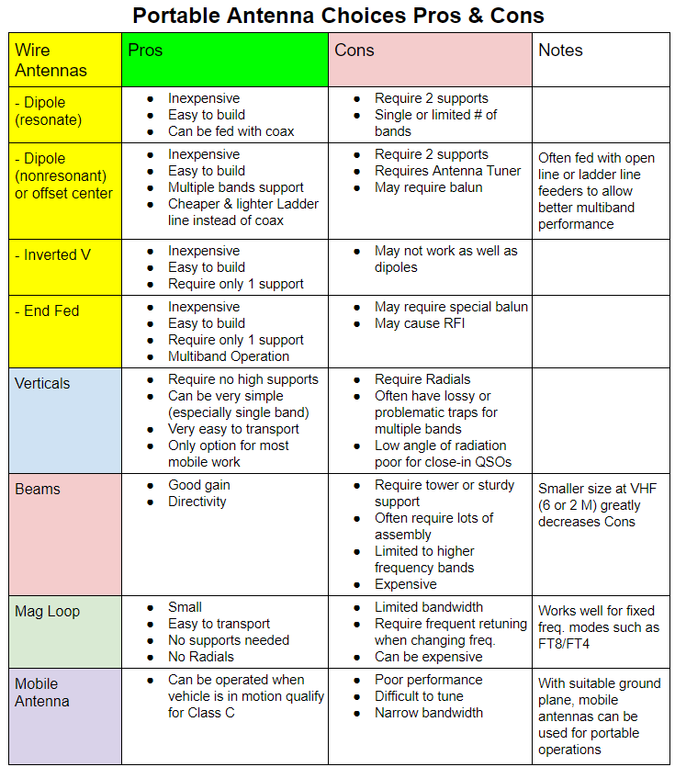

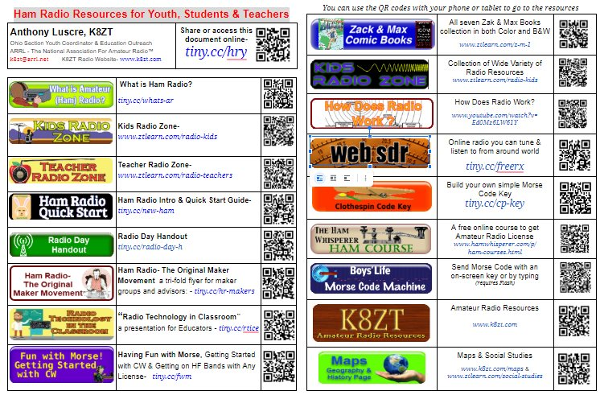

TOP ^

“ARES Connect”
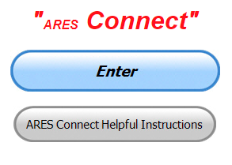
Everyone – please make sure to go into all of the events that you have signed up for and get your hours registered no later than 5 days after the event has ended.

Folks, I’m seeing a lot of folks that have signed up for events not entering their time after the event. This is a very important piece of using “Connect.” Your hours need to be recorded and it’s so easy to do.

Let’s run through how so in case you have forgotten. If you have already gotten signed up for an event, all you have to do afterword to get your time entered is at any time after the event has ended, log into “Connect.” And then click on your name in the upper right-hand corner of the page. This will bring up a drop-down menu where you will then click on “View Hours.”

This brings up another screen where you can “Report Hours” as well as “View Hour History” You’ll want to click on “Report Hours.” You will then be presented one at a time by chronological order each event that you have signed up for and hours have not yet been reported on.

Type in those hours in the “Hours Worked” box and hit “Submit”… Keep doing this until you have no more hours to report…. That’s all there is to it. Now, if you are following the request above and doing this at least every 5 days or more often, this will only take you a minute or so to complete.

Now, isn’t that easy? Yes, and we all need to be diligent at doing it promptly.

Here’s are the top 10 hours earners so far for June:

 | Name | Events | Hours
1 | John Major (KD8MMY) | 10 | 58.00
2 | Dan Stahl (KC8PBU) | 35 | 49.09
3 | Christopher Domenick (KC8CAD) | 10 | 37.65
4 | Bryan Hoffman (KC8EGV) | 5 | 36.50
5 | Bret Stemen (KD8SCL) | 18 | 31.50
6 | James Yoder (W8ERW) | 10 | 29.33
7 | Greg Dersarkisian (KD8SSJ) | 7 | 29.00
8 | Daniel Schlick (KB8LKH) | 10 | 29.00
9 | Dwight Bonifield (W8TJT) | 41 | 28.05
10 | Earl Paazig (W8BR) | 12 | 27.50

Let’s get everyone in the Ohio Section on “ARES Connect!!!” Simply go to: https://arrl.volunteerhub.com/lp/oh/ and get yourself registered and using the system.

TOP ^

Special ICS 300 & 400 Training being offered

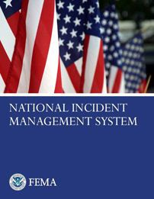
For those interested in attaining ARES Level 3 certification, the State of Kentucky plans to offer these courses in Ashland at the Boyd County EMA:

Intermediate ICS for Expanding Incidents (ICS-300) June 23-25
Advanced ICS Command & General Staff for Complex Incidents (ICS-400)
July 14-15

Though not part of the ARRL curriculum, another good class is:

ICS/EOC Interface Workshop (G-191), September 16

Prerequisites for these courses is completion of IS-100, IS-200, IS-700 and IS-800. All 4 of these courses are online and free from FEMA Independent Studies program.

For more information go to https://kyem.ky.gov/training/Pages/default.aspx and scroll down to June, July and September.

Gregg Hendry, W8DUQ

Amateur Radio - Active During Protests in Hamilton County

This past weekend myself and another member spent all day monitoring several frequencies and bands during a large protest. We called them Baofeng bands for fun!

When we presented the idea to the Cincinnati PD, they jumped on the chance for us to monitor. We provided them just another tool on the toolbox.

We accomplished a few things.
We confirmed that there were no use of radios as the primary form of communication, however, we did provide some recordings of traffic for them to analyze. It may turn out to be something after all !

Police intelligence is impressed with our capabilities because they do not have what we provided. We are now available for future use.

It established another positive relationship with a served agency with a need. We were able to provide additional pictures and video of the protesters for their use. We were contacted several times to send what we saw.

In the intelligence business, not finding info that could be there, is information.

The protest we had was not a large organization. It was mostly locals and young folks who probably did not do a lot of coordination between themselves. The police department confirmed that any coordination that was done, was on cell phones. We did hear a few folks refer to 'check your cell phone'.

TOP ^
The bottom line here is the opportunity to provide an additional service, for free, to a served agency was a mutual plus. Who knows, we may be called by the Cincinnati Police next time.

Brick walls are tough to go through. However, just the fact that you offered a plan to the served agency is a plus even with a 'no'. At least now they know that you have another capability to provide them if the need arises.

Bryan, KC8EGV - Hamilton County EC

One Question Questionnaire

Hey Gang,

“Survey Says”….. about 89% of you actually know that you use “Lower Side-Band” (B) on 160 – 75/80 and 40 meters. Looks like some of you need to get on those bands and get active!

Now, on to next question… Don’t cheat and look up the correct answer. You either know it or you don’t. If you don’t, you need to start reading up on things for sure.

Which of the following types of solder is best for radio and electronic use??”

You’ll find the “One Question” questionnaire on the Ohio Section Website! http://arrlohio.org It’s all in fun and it’s not a scientific survey in any way, but we are learning some things that we didn’t know from these questions. I hope that you are enjoying answering these “One Question” questionnaires.

V.E. Test Sessions

Many V.E.’s have decided to start testing once again, but with restrictions that need to be adhered to for sure.

Here’s the link to find that V.E. Test session and what is expected of YOU before going.

http://www.arrl.org/find-an-amateur-radio-license-exam-session

####

Lisbon Area Amateur Radio Association Holding VE Test Session

There will be a V.E. test session on Saturday - June 20, 2020 at 11am at the Columbiana Police Department - 28 South. Vine Street in Columbiana.
The V.E. session will be held in the parking lot and you will be inside of your car during the test with V.E.'s observing the session.

TOP ^
Pre-registration is required. Please email Don Kemp, NN8B.oh@gmail.com with the following information:
Name & License Class you are testing for. Cut off for registration is Thursday, June 18, 2020 at 5pm.
Proper ID and $15.00 testing fee required. Cash or check made out to ARRL VEC.

####

Lake County ARA Holding V.E. Testing in August

Lake County ARA will be holding a V.E. Test Session on August 1st at the Lake County Metroparks – Chapin Forest Reservation. The address is: 9938 Chillicothe Road (Rt 306) - Quarry Shelter

Chapin Forest is 3.3 miles south of I-90 on Route 306, in Kirtland. The park is on the west (the right side going south) of 306. The Quarry Shelter is almost immediately on the right as one enters the reservation.

The tests will start at 12 noon. Please arrive a few minutes earlier. Pre-registration is suggested, although we hope to have plenty of seats available.

To register, you will need the NCVEC 605 Form, which will be available at the test. If you would like to complete one ahead of time, be sure it is the Sept 2017 version or later. You can find it by Googling “NCVEC quick-form 605” and clicking on the url for a pdf of the form.

Be sure to bring the original and a copy of both your license and any CSCEs you may have to the exam. The cost is $15.00, and if you wish to pay by check, it should be made out to the ARRL/VEC. Identification with your picture is also necessary, such as a driver’s license. To pre-register, or if you have any questions, please contact Scott Farnham, KO8O, at (440)256-0320, or scottfarnham@roadrunner.com

Fairfield ARES Goes Camping
(from: Diane Warner, KE8HLD - Assistant EC, Fairfield County ARES)

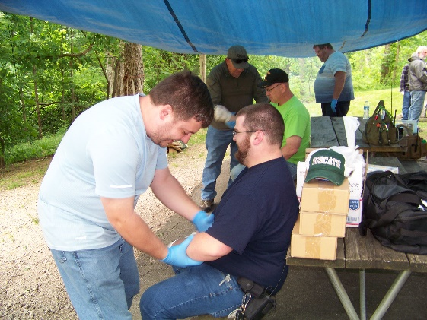
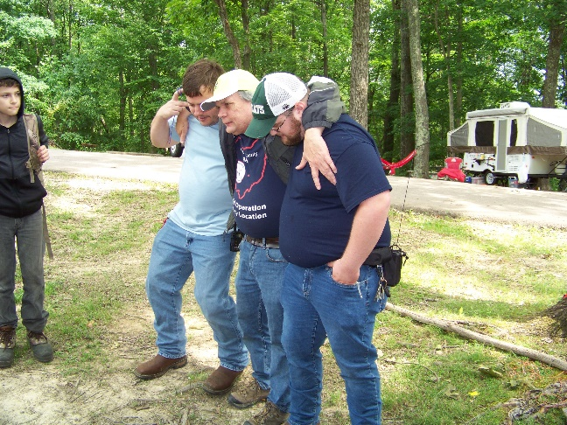
This weekend the Fairfield County ARES had a weekend camping trip with an all-day training event on Saturday. We had a Red Cross Certified Instructor teach us wilderness first aid. We learned how to make a stretcher and basic first aid skills geared towards the wilderness.

Our primitive fire instructor taught the team how to use flint and steel to start a fire. We ran a search and rescue scenario with our Medical Officer (First Aid Instructor) fielding the medical injuries, (part of the scenario) during the search and rescue. We learned what to pack in our backpacks when out in the field.

TOP ^
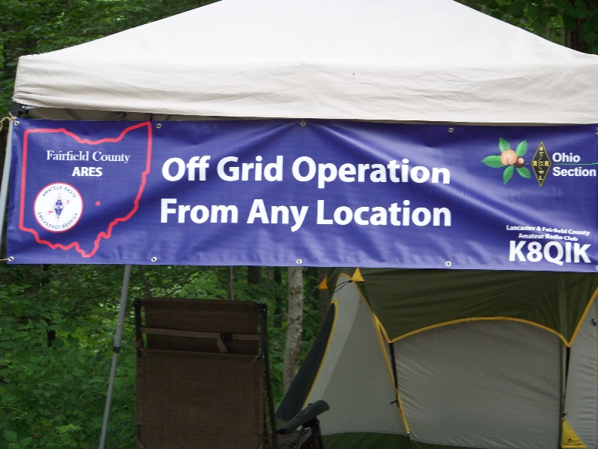
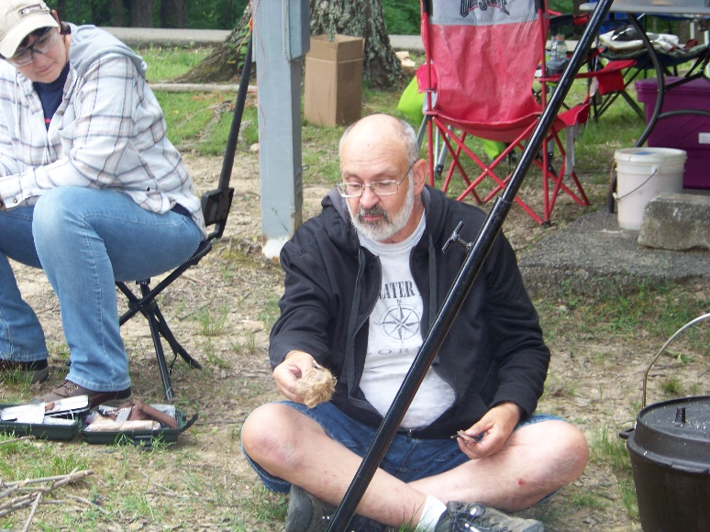
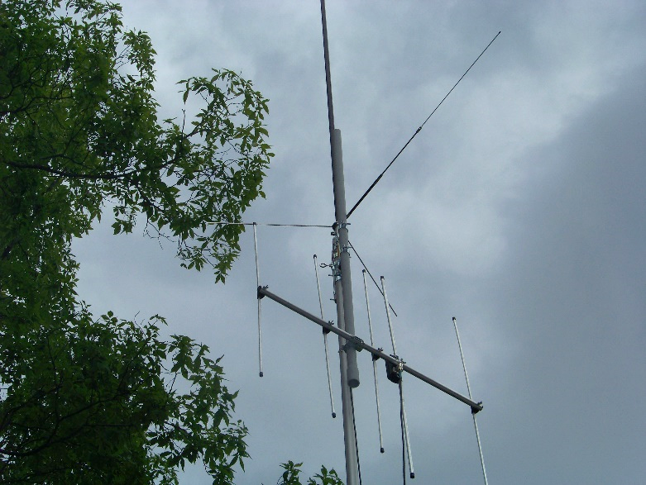
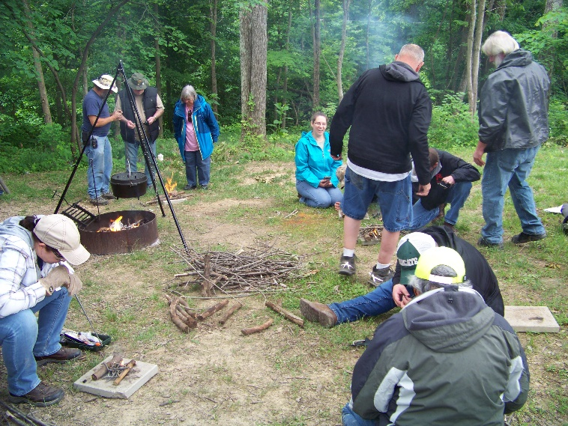

Final.. Final..

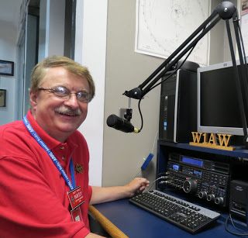
Hi Gang,

This has been a really great week. The weather has finally decided to turn into a bit of summer, and I took advantage of it for sure, and so did this guy we hired to install a brick patio on the front of our house! He came with a backhoe and literally ripped up the sidewalk, trees and shrubs and anything living in the front yard, all in one big swipe. It looked so pitiful out there.

Now it looks like a construction zone of a high-rise building! There’s dirt, stone, bricks, blocks and what have you all out in the front yard. Wow, all the neighbors around here are starring and wondering what in the world are we doing. I have to wonder as well. But they tell me it will really change the looks of the house, and right now I have no doubt of that!

TOP ^
Now, I want to also say that being prepared is a huge chunk of what an Amateur Radio operator should be. This last week I was in the middle of a presentation on Zoom when we had a major power failure here.

Now, the only way the folks on the other end even knew that anything happened was the lights behind me went out and my UPS’s started beeping. Other than that, everything kept going just as though nothing had happened. Are you prepared? Yes, my radios are also on UPS’s as well. This way they will carry me though until I get the generator out and fire it up. And YES, we were out of power for a little over 3 hours due to a tree falling across the power lines the other night. I have seen reports that we even had tornadoes all around the state as well.

Moving down the band a bit…. Are you on the air?? The bands have been opening up quite a bit and you really need to take advange of that when you can. I urge all of you to stay up on the band conditions and get on the air whenever possible.

By now I think everyone has at least some concept of how Field Day will go this year. Since they changed the rules so that the 1D stations can talk and get credit for making contact with other 1D stations I will be staying home and trying like all of you to make as many contacts as I can this year. This will be my first year staying home in quite a while. So, if you hear me on, don’t be shy!!! I will be on 10 meters and some of the Novice areas to give them some contacts as well. I strongly encourage all of you to do the same.

I have been asked by a number of folks about the governor’s proclamation that we usually get. Unfortunately, we most likely won’t be getting one this year. The folks that Bob, W2THU contacted several months ago at the statehouse told him that they are only concentrating on the COVID-19 situation. They did promise if things opened up that they would do it, but so far it doesn’t look like the state building will be opened in time for them to get this done for us this year.

Whelp, my final go around before gong QRT… Stay safe my friends! I want to see all of you soon at a meeting or hamfest! We will get through this and when we do, we’ll have so much to talk about. Most of all… have FUN and get on the airwaves!!

73,

Scott, N8SY

Ohio Section Cabinet
Section Manager – Scott Yonally, N8SY | Assistant Section Manager – John Perone, W8RXX
Section Emergency Coordinator – Stan Broadway, N8BHL | Section Traffic Manager – David Maynard, WA3EZN
Technical Coordinator – Jeff Kopcak, K8JTK | Affiliated Clubs Coordinator – Tom Sly, WB8LCD
State Government Liaison – Bob Winston, W2THU | Public Information Coordinator – John Ross, KD8IDJ
Section Youth Coordinator – Anthony Lascre, K8ZT

Welcome New Subscriber(s)

Bill Sempf; Randy, KE8MXD

TOP ^

Back Issues of the PostScript and Ohio Section Journal

Hey, did you know that PostScript and Ohio Section Journal (OSJ) are archived on the website? You can go back and look at any edition simply by clicking:
http://arrl-ohio.org/news/index.html

Chit – Chat, and All That!

Do you know someone that’s not getting these Newsletters? Please, forward a copy of this Newsletter over to them and have them “Opt-In” to start receiving them. Heck just have them send me an email n8sy@n8sy.com and I’ll get them added to the Ohio Section Emailing list.

We now have many thousands of readers receiving these newsletters weekly. Quite impressive, I’d say! I urge all of you to make sure that everyone, regardless of whether they are a League member or not, get signed up to receive these weekly Newsletters.

You can always “Opt-Out” at any time if you feel this is not what you were expecting. It’s fun and very informative. All of your favorite past newsletters are now archived too.
You can go back at any time and read them. Just go to: http://arrl-ohio.org/news/

Got questions, concerns or would just like to sit and chat awhile? Heck, I’ll even buy the coffee!! Give me a call at (419) 512-4445 or email me at: n8sy@n8sy.com

The pictures on the front page and throughout this newsletter are from various newsletters, Facebook posts and/or were sent directly to me in recent weeks. Take a good look at them, you just might be in one of the pictures! “SMILE… you’re in the Ohio Section News!!”

TOP ^

PostScript is produced as a weekly newsletter. I want to thank everyone that has contributed articles and ideas to make this an even better news source. I sincerely hope that you have enjoyed this edition and will encourage your friends to join with you in receiving the latest news and information about the Ohio Section, and news and events happening around the world!

