[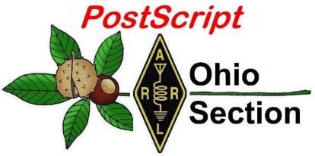](http://arrl-ohio.org/news/) ***June 1st***

***Edition***

🡪 National News 🡪 The Handbook Give Away

🡪 Club Corner 🡪 Hamfests

🡪 DX This Week 🡪 ARES Connect

🡪 VE Testing 🡪 One Question Questionnaire

🡪 Final.. Final..

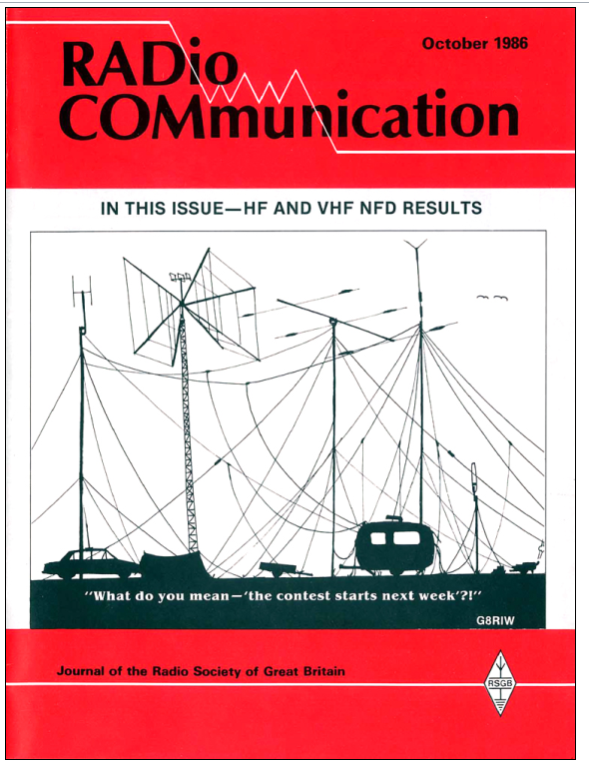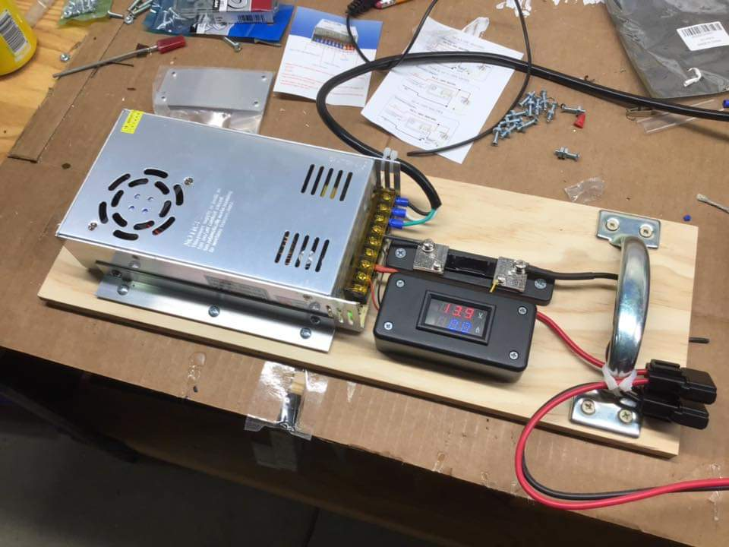

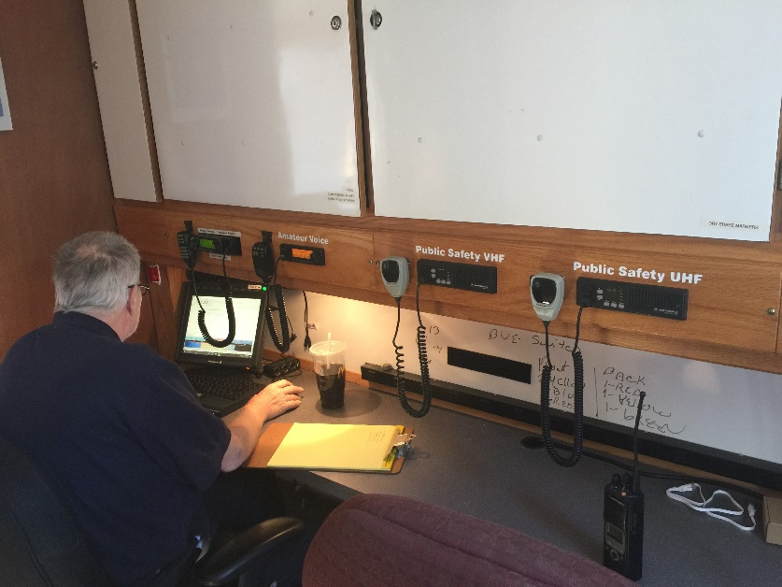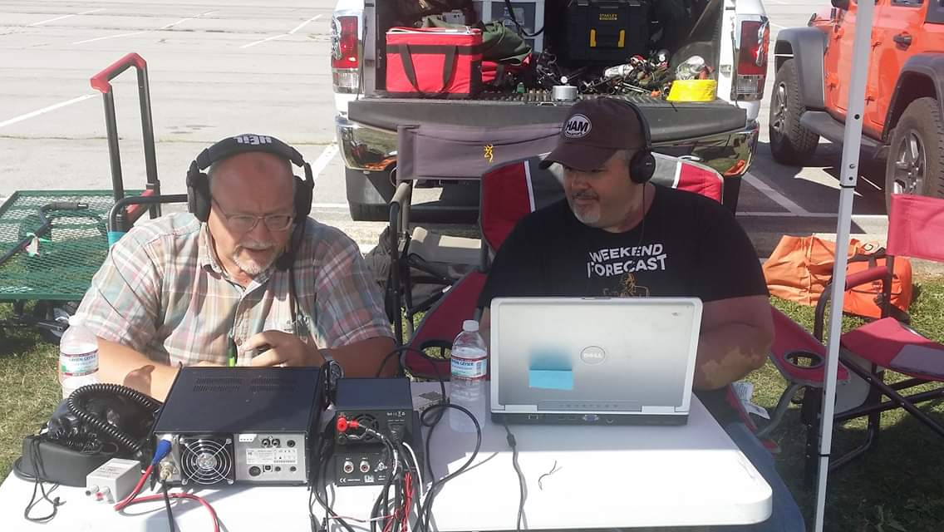

***National News***

*(from arrl and other sources)*

Temporary Rule Waivers Announced for 2020 ARRL Field Day

With one month to go before 2020 [ARRL Field Day](http://www.arrl.org/fieldday), June 27 - 28, the ARRL Programs and Services Committee (PSC) has adopted two temporary rule waivers for the event:

**1) For Field Day 2020 only, Class D stations may work all other Field Day stations, including other Class D stations, for points.**

[Field Day rule 4.6](http://www.arrl.org/field-day-rules#classd) defines Class D stations as "Home stations," including stations operating from permanent or licensed station locations using commercial power. Class D stations ordinarily may only count contacts made with Class A, B, C, E, and F Field Day stations, but the temporary rule waiver for 2020 allows Class D stations to count contacts with other Class D stations for QSO credit.

**2) In addition, for 2020 only, an aggregate club score will be published, which will be the sum of all individual entries indicating a specific club (similar to the aggregate score totals used in ARRL affiliated club competitions).**

Ordinarily, club names are only published in the results for Class A and Class F entries, but the temporary rule waiver for 2020 allows participants from [any Class](http://www.arrl.org/field-day-rules#class) to optionally include a single club name with their submitted results following Field Day.

For example, if Podunk Hollow Radio Club members Becky, W1BXY, and Hiram, W1AW, both participate in 2020 Field Day -- Hiram from his Class D home station, and Becky from her Class C mobile station -- both can include the radio club's name when reporting their individual results. The published results listing will include individual scores for Hiram and Becky, plus a combined score for all entries identified as Podunk Hollow Radio Club.

The temporary rule waivers were adopted by the PSC on May 27, 2020.

ARRL Field Day is one of the biggest events on the amateur radio calendar, with over 36,000 participants in 2019, including entries from 3,113 radio clubs and emergency operations centers. In most years, Field Day is also the largest annual demonstration of ham radio, because many radio clubs organize their participation in public places such as parks and schools.

Due to the COVID-19 pandemic, many radio clubs have made decisions to cancel their group participation in ARRL Field Day this year due to public health recommendations and/or requirements, or to significantly modify their participation for safe social distancing practices. The temporary rule waivers allow greater flexibility in recognizing the value of individual and club participation regardless of entry class.

ARRL is contacting logging program developers about the temporary rule waivers so developers can release updated versions of their software prior to Field Day weekend.

TOP ^

Participants are reminded that the preferred method of submitting entries after Field Day is via the [web applet](https://field-day.arrl.org/fdentry.php). The ARRL Field Day rules include instructions for [submitting entries](http://www.arrl.org/field-day-rules#reporting) after the event. Entries must be submitted or postmarked by Tuesday, July 28, 2020.

The ARRL Field Day [web page](http://www.arrl.org/fieldday) includes a series of articles with ideas and advice for adapting participation this year.

***(Ohio Section Note about Field Day… Normally the Ohio Section would have a Proclamation from the Ohio Governor designating the week before Field Day as Amateur Radio Week by this time. We have been advised by the Director, Constituent Affairs that due to the response of COVID-19 they are unable to process our request. They further state that if their office does resume normal operations before Field Day, they will process our request. We will keep everyone apprised if there is any new developments.)***

####

***Another New Beta Version of WSJT-X is Available***

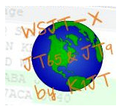

A new beta (“release candidate”), *WSJT-X* version 2.2.0-rc2, is now available for downloading from the [**WSJT-** **X website**](https://physics.princeton.edu/pulsar/K1JT/wsjtx.html), along with a [**list of new features**](https://physics.princeton.edu/pulsar/K1JT/wsjtx-doc/wsjtx-main-2.2.0-rc2_en.html#NEW_FEATURES). The *WSJT-X* development team has also published additional FT8 “overflow” frequencies. The *WSJT-X* 2.2.0-rc2 [**Release Notes**](https://physics.princeton.edu/pulsar/K1JT/Release_Notes.txt) explain:

“Increasing FT8 usage on 40, 30, and 20 meters means that the default 3 kHz subbands are often wall-to-wall with signals. Overcrowding encourages some to turn on their amplifiers, which only makes things worse. On a trial basis, and in response to numerous suggestions from around the world, we have added a second set of suggested dial frequencies for FT8 on three HF bands and also on 6 meters…7.071, 10.133, 14.071, and 50.310 MHz.

"These frequencies will appear in your drop-down band-selector list after you go to the ‘Settings | Frequencies’ tab, right-click on the frequency table, and select ‘Reset.’ Alternatively, you can add the new FT8 frequencies manually. When the conventional FT8 subband on 6, 20, 30, or 40 meters seems too full, please try moving your dial frequency down 3 kHz! [A]s currently implemented, *WSJT-X* will set your dial to the lowest frequency for the selected mode and band, when you switch bands.”

The latest “general availability” (GA) release is *WSJT-X* 2.1.2.

####

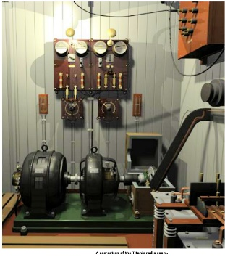***Federal Judge Okays Retrieval of Titanic***

***Marconi Wireless Equipment***

A US federal judge in Virginia has given permission to retrieve the ill-fated RMS *Titanic*’s Marconi wireless gear, which transmitted distress calls from the sinking ocean liner during its maiden voyage. Judge Rebecca Beach Smith of the US District Court in Norfolk ruled that the radio gear is historically and culturally important and could soon be lost within the rapidly decaying wreck. The *Titanic* sank after striking an iceberg some 370 miles off the coast of Newfoundland in 1912.

TOP ^

“The Marconi device has significant historical, educational, scientific, and cultural value as the device used to make distress calls while the *Titanic* was sinking,” Judge Smith wrote in her ruling. She said the company would be permitted “minimally to cut into the wreck” to access the radio room.

David Concannon, a lawyer for R.M.S Titanic Inc., which the court has recognized as the steward of the vessel’s artifacts, said the company would try to avoid cutting into the ship, noting that the radio room may be reachable via a skylight that was already open. More legal wrangling may lie ahead.

The National Oceanic and Atmospheric Administration (NOAA) contends that the retrieval expedition is still prohibited under US law and under an international agreement between the US and the UK.

R.M.S Titanic has said the radio transmitter could unlock some of the secrets about a missed warning message and distress calls sent from the ship.

“It tells an important story,” Concannon said. “It tells of the heroism of the operators that saved the lives of 705 people. They worked until water was lapping at their feet.”

In an April court filing, NOAA argued against the salvage effort, saying that any benefit to be realized from cutting into the vessel to recover the Marconi equipment would not be “worth the cost to the resource and not in the public interest.”

RMS *Titanic* sought permission to carry out what it called a “surgical removal and retrieval” of the Marconi radio equipment. As might be expected, the deteriorating Marconi equipment is in poor shape after more than a century under water. The undersea retrieval would mark the first time an artifact was collected from within the *Titanic*, which many believe should remain undisturbed as the final resting place of some 1,500 victims of the maritime disaster. The wreck sits on the ocean floor some 2 1/2 miles beneath the surface, and remained undiscovered until 1985. R.M.S. Titanic said it plans to use a manned submarine to reach the wreck and then deploy a remotely controlled sub to retrieve the radio equipment.

####

***Hytera America Files for Chapter 11 Bankruptcy***

*(By Danny Ramey, Radioresource, submitted by Gregory Drezdzon, WD9FTZ)*

Hytera America and Hytera America (West) filed for Chapter 11 bankruptcy May 26, citing ongoing lawsuits brought by Motorola Solutions and the impact of the COVID-19 pandemic.

In a statement, the company said that it plans to use the Chapter 11 restructuring process to address the issues caused by those two events.

“Nearly 20 years ago, Hytera began partnering with American dealers and bringing the most innovative and valuable LMR solutions to the market, while constantly seeking to improve support and service to our dealers and customers,” Hytera America President Alla Huang said in a statement. “We remain committed to our tradition of excellence and are confident in our sustainable growth for the future. We look forward to introducing our new product lines such as Hytera HALO nationwide group communications, a total solution of PoC (push-to-talk over cellular) hardware, software and cloud services, as well as facial recognition and temperature-measuring integrated access control solution and next-generation Digital Mobile Radio (DMR).”

TOP ^

Additionally, Hytera said that it is working with it dealers to help first responders and medical organizations combat the ongoing coronavirus pandemic. During the past few months, Hytera has donated two-way radios to multiple hospitals in cities such as New York.

In its voluntary petition for bankruptcy, Hytera America estimated that it has 1,000 – 5,000 creditors, and estimated that it had $10 million – $50 million in assets against $500 million – $1 billion in liabilities. A large portion of the liabilities includes legal damages owed to Motorola Solutions.

In February, a jury for the U.S. District Court for the Northern District of Illinois awarded Motorola $764.6 million in damages. The damages to Motorola are the single largest claim on the petition. The next largest claim is for $620,231 to SAF Tehnika, which is listed as a trade debt. Most of the other outstanding claims are trade debts to various companies ranging from $3,000 – $120,000.

####

***FT8 used for ham radio Moonbounce (EME) contact***

*(Submitted by Gregory Drezdzon, WD9FTZ)*

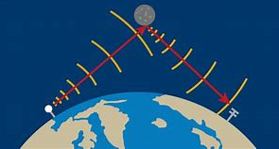

Joe Taylor, K1JT, reports what is possibly the first FT8 contact via Moonbouce (EME) which took place on Thursday, May 21, 2020, between Paul, W2HRO, and Peter, PA2V.

Taylor writes: Paul and Peter used WSJT-X 2.2.0-rc1, a beta-release candidate for version 2.2 of the program WSJT-X. Both stations have moderate 4-yagi setups on 432. Conditions today were not particularly good: degradation around 3 dB, and the sun only 20 degrees from the Moon.

For terrestrial use the FT8 decoder searches over the range -2.5 to +2.4s for clock offset DT between transmitting and receiving stations. When "Decode after EME delay" is checked on the WSJT-X "Settings" screen, the accessible DT range becomes -0.5 to +4.4 s. Just right for EME.

FT8 uses 8-GFSK modulation with tones separated by 6.25 Hz. At the time of this QSO the expected Doppler spread on the W2HRO - PA2V EME path was 8 Hz, which causes some additional loss of sensitivity. As you'll see in screen shots posted here, copy was solid in both directions:

<https://physics.princeton.edu/pulsar/k1jt/W2HRO_PA2V_432_EME_1.jpg>

<https://physics.princeton.edu/pulsar/k1jt/W2HRO_PA2V_432_EME_2.jpg>

Why might you want to use FT8 instead of "Old Reliable JT65" for EME QSOs? FT8 is about 4 dB less sensitive than JT65, but with 15-second T/R sequences it's four times faster and it doesn't use Deep Search.

When I was active in EME contests on 144 MHz, I was always frustrated that even with reasonably strong (for EME) signals, one's maximum JT65 QSO rate is about 12 per hour. With FT8 you can do 40 per hour, as long as workable stations are available.

What about FT8 EME on 1296 MHz? It might work, but Doppler spread will probably make standard FT8 a problem. But if there were sufficient interest, we could make an "FT8B" or "FT8C" with wider tone spacing.

TOP ^

Please try FT8 for EME on any of the bands 144, 432, and 1296 MHz, and let us know your results.

73, Joe, K1JT

The popular WSJT-X software for FT8 can be downloaded from: <https://physics.princeton.edu/pulsar/k1jt/>

Moon-Net Email Reflector: <http://mailman.pe1itr.com/mailman/listinfo/moon-net>

####

***IARU - Region 2 Workshops***

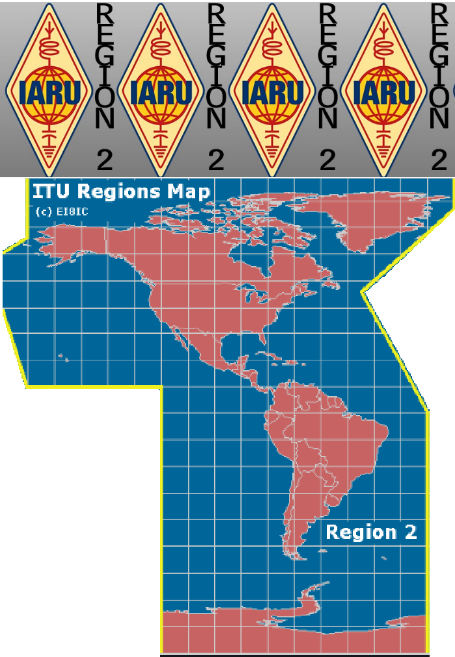

The IARU Region 2 has begun a series of free online workshops. These workshops include a variety of subjects and many are provided in both English and Spanish.

You can see a list of currently scheduled free workshops at [www.iaru-r2.org/en/news-and-events/workshops](http://www.iaru-r2.org/en/news-and-events/workshops).

The workshops are presented in three formats:

1. Live via Zoom
2. Live simulcast via Youtube for both overflow attendees and viewers with lower Internet bandwidth
3. As recordings after the event on [IARU-2 Youtube Channel](https://www.youtube.com/channel/UCnG2Srz0bsKmTbF2r3YNneQ)

Upcoming session speakers include the Ohio Section’s Youth Coordinator (SYC) Anthony Luscre, K8ZT. Anthony will be doing two workshops:

* **Field Day in Social Distancing**- June 3, 2020, 19:59 EDT / 23:59 GMT
* **FT8/FT4 Digital Modes** - June 10, 2020, 19:59 EDT / 23:59 GMT

Other currently scheduled sessions include:

* **Satellite Communications for Beginners** (English), May 27, 2020, 19:59 EDT / 23:59 GMT with Patrick Stoddard, WD9EWK

Registration is free, but required. To register for the June 3rd Workshop visit- [https://www.iaru-r2.org/en/news-and-events/workshops/field-day-in-social-distancing](https://www.iaru-r2.org/en/news-and-events/workshops/field-day-in-social-distancing/).



Previous workshops, available on [IARU-2 Youtube Channel](https://www.youtube.com/channel/UCnG2Srz0bsKmTbF2r3YNneQ), include:

* Comunicaciones Satelitales 101 (Spain)
* EmCom - WinLink 101 - US/Canada (English)
* EmCom - WinLink 101 - Caribbean (English)
* Emcom - WinLink 101 (Spain)

<https://www.iaru-r2.org/en/news-and-events/workshops/>

TOP ^

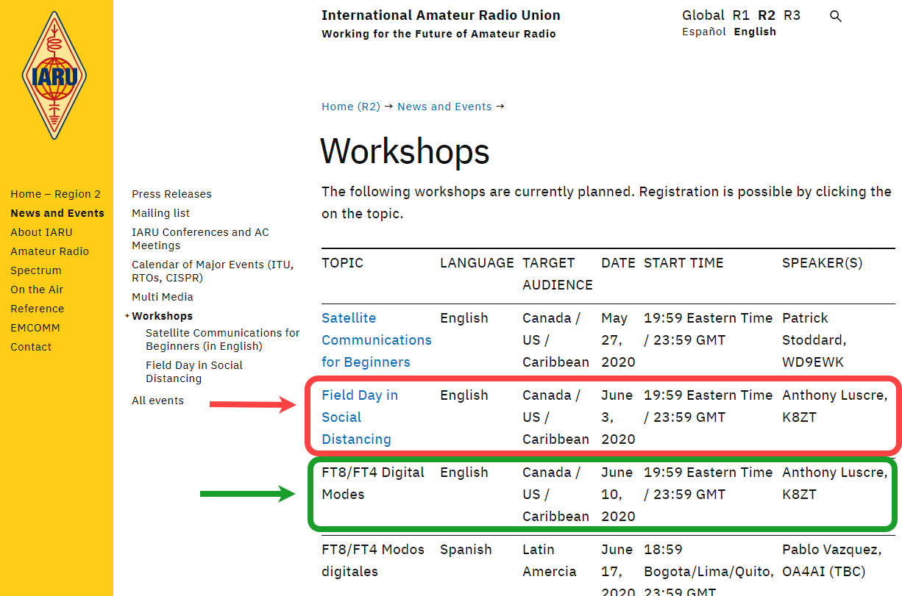

####

***Global COVID-19 Radio Event Set for June 6 - 7***

Stations bearing call signs that promote the "stay-at-home" message and the value of social distancing and isolation have sprung up during the COVID-19 pandemic, with some 150,000 messages of support shared around the world. An [on-air gathering](http://ko8sca.com/rules.pdf) over the June 6 - 7 weekend will offer a further opportunity for stay-at-home stations and radio amateurs to share greetings in a contest-like framework, looking toward the day that restrictions will ease, eventually making the stay-at-home injunction obsolete. The patron of the STAYHOME radio [campaign](https://www.qrz.com/db/OH2STAYHOME) is Finland's Foreign Minister Pekka Haavisto, and the worldwide activity has the endorsement of International Amateur Radio Union (IARU) President Tim Ellam, VE6SH/G4HUA, and the United Nations Amateur Radio Club.

"Amateur radio operators across the world are experiencing something we have never seen before, with the current COVID-19 pandemic," Ellam said. "In times like this, on-the-air activities can benefit our communities and ourselves. Events such as this are important to improve operating skills. It is also encouraging us to get on the air and keep active, as well as promoting social distancing."

TOP ^

Ellam expressed thanks to the national regulators in more than three dozen countries that made special stay-at-home-suffix call signs available for amateur use.

Sponsoring the event and campaign are the Finnish Amateur Radio League (SRAL), in cooperation with Araucaria DX Group (ADXG) of Brazil, and Radio Arcala (OH8X) in Finland.

UN Amateur Radio Club President James Sarte, K2QI, has said that 4U1UN will be on the air to support of the global STAY HOME movement, as will sister stations 4U1GSC (operated as 4U9STAYHOME) and 4U1A (operated as 4U2STAYHOME).

Special event station W2I/STAYHOME, helmed by Ria Jairam, N2RJ, and Peter Dougherty, W2IRT, will also be on the air, operating CW, SSB, and FT8 simultaneously. (Jairam is ARRL Hudson Division Director.)

The STAYHOME event gets under way at 1000 UTC on Saturday, June 6, concluding 24 hours later. Bands will include 80, 40, 20, 15, and 10 meters, with CW, SSB, and digital (FT4/FT8 only). Exchange is a signal report and operator age, except for FT4/FT8 reports. Awards and certificates in the various operating categories will be available. [Email](mailto:py2zea@gmail.com) for more information.

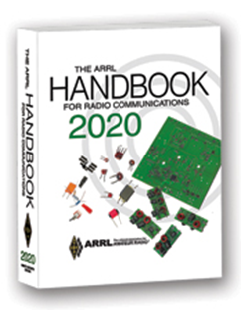***The Handbook Give Away***

Hey Gang,

The winner of the May Give Away is… ***Mike Burg, N8QQN***

Many of you ask me just how do I know when the drawing is on? Well, that’s easy all you need to do is check in on the Ohio Section Website on a regular basis and watch for the big **RED** Arrow that will appear on the left side of the page.

This is the sign that the drawing is on and you need to get registered. So, keep a sharp eye out on the website and check in often! <http://arrl-ohio.org/>

***Club Corner***

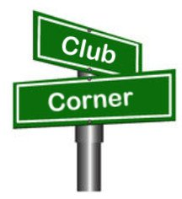

This is YOUR cornner of the newsletter. Send me what your club is doing and I’ll make sure that it gets in. Got a special event or club project that you want everyone to know about? Send it to me!. Need help with a project? Send it to me.

Let me know what you club is up to. Are you going to have a special guest at your meeting or are you having a special anniversary? Just sent it to: [n8sy@n8sy.com](mailto:n8sy@n8sy.com)

####

TOP ^

***Silvercreek Amateur Radio Association V.E. Testing***

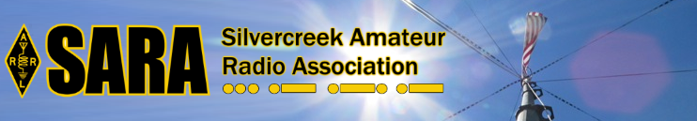

The Silvercreek Amateur Radio Association (SARA) **IS** having a VE Session on **Saturday June 6th**.

Information about the test session can be found here: <https://w8wky.org/license-exams/>

####

***KY QSO Party Coming – First Full Weekend In June***

**What is the Kentucky QSO Party?**

The Kentucky QSO Party is an annual event in which many ham radio operators in Kentucky get on the air for 12 hours so that others from around the world can make contacts with Kentucky.  It is a great way to contact Kentucky on different bands and modes for awards like Worked All States (WAS) and County Hunters.  Many rare counties in Kentucky will be activated during the event.

**Stations Outside of KY**

Amateurs from outside of Kentucky will typically listen for Kentucky stations calling CQ KYQP on or near the suggested operating frequencies (see the Rules page).  When you hear a KY station calling CQ, come back to them by sending or saying your call.

If the KY station hears you, it will give your call and then an RST report and the county in which it is located.  Kentucky stations should send a three-letter abbreviation for the county (see the Counties page for a complete list of all of the counties in the state and the proper three letter abbreviation).

Once you receive the exchange from the KY station, it is your turn to send your exchange.  For stations outside of KY, you send an RST report and your state or province (or if outside of the USA or Canada, you simply send DX).  If the KY station receives your exchange, it will thank you and you are done.  Log your contact either on a paper log or use one of the many excellent logging programs that can be setup for the KY QSO Party (see the Log Submissions page).

These logging programs will automatically verify the three letter county abbreviations as you enter them, keep track of and prevent duplicate contacts and provide a running total of the number of contacts and your total score based on the KYQP rules. **Non-KY stations can only workstations in KY**.

**Stations in KY**

Stations in Kentucky will typically call CQ KYQP on or near the suggested operating frequencies (see Rules page).  When a station comes back to your CQ, you send your exchange:  RST plus the three-letter abbreviation for your county.  Note: it is important to not just send or say the full name of your county.  It is better operating practice to send the county abbreviation (see Counties page).  For example, KY stations operating from McCracken county should simply say or send 599 MCC (if on SSB, 599 Mike, Charlie, Charlie).  After you have sent your exchange, listen for the other station’s response and enter their exchange as noted above.  Once you have entered the correct exchange from the other station, simply say “Thank you” or TU and then call QRZ? or CQ KYQP to work other stations.  **Note that KY stations can work both stations outside of KY and other stations in KY**.

TOP ^

**Bonus KY Stations**

Each year a few Kentucky Club Stations will be designed before the contest as **bonus stations**.  Anyone inside or outside of Kentucky can work all the bonus stations once per band and mode and earn 100 bonus points for each completed contact.  The bonus stations for the **2020 KYQP** will be **W4NJA, KY4KY and K4MSU**.  (See Rules.)  Logging programs do not need to track the bonus points earned in each log.  If the log is submitted as a Cabrillo file, the KYQP contest committee will calculate the bonus points earned and add those points automatically to each submitted log as the log is being checked for accuracy.  The final results posted after the contest on the KYQP website will include the bonus points earned as part of each station’s final score.

**After the Contest**

Once the contest is over, we encourage all participants to send in their logs.  See the Log Submissions page for more detail.  We will post the results once all logs are checked and verified (see the Results and Awards page).  Everyone sending in a log will receive a Certificate of Participation.

**See You on the Air!**

We hope this brief tutorial will help new ham radio operators understand how easy and fun it can be to participate.  Like other QSO Parties, the Kentucky QSO Party is a relaxed and welcoming event.  If you are new to QSO parties, we hope that you try to make a few contacts in the KYQP.  Once you’ve made a few, you will quickly get the hang of it.

Want more info? Here’s a link: <http://www.kyqsoparty.org/getting-started/>

####

***Amateur Radio and Engineering Join Forces at Case Western Reserve University***

***“Every engineer should have an amateur radio license!” is a motto adopted by Case Amateur Radio Club, W8EDU of Case Western Reserve University in Cleveland, Ohio. CWRU students join the radio club for experiences that round out the rigors of academia and broaden their college experience.***

The radio club’s faculty advisor is ARRL Life Member David Kazdan, AD8Y, an adjunct assistant professor of electrical engineering. He also uses amateur radio as a teaching tool at CWRU. “Every amateur radio club has its own aims and reasons for being,” Kazdan explained.

“The Case Amateur Radio Club invites members of the university to operate amateur station W8EDU, to study radio physics and engineering with us, to design and build equipment and software, and to use the station as a research laboratory.”

Last summer, Kazdan urged senior civil engineering undergraduate student Rachel Zable, KE8HWA, for help from a sophomore class to make a project of surveying the radio club’s Field Day site for trees and the best placement of antennas. The site is a small university-owned farm near campus where the club sets up annually for Field Day and to demonstrate its temporary, emergency communication capability. “Sure! I’m the teaching assistant for that course in the fall!,” Zable responded.

TOP ^

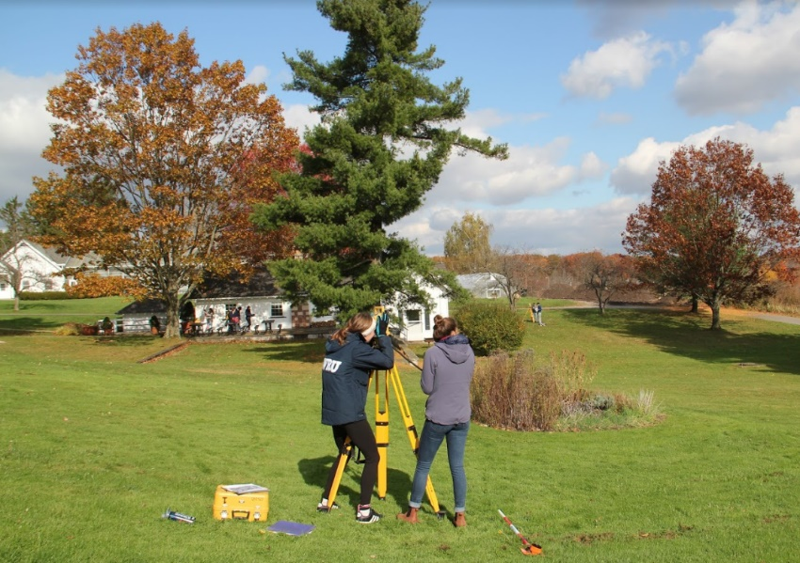

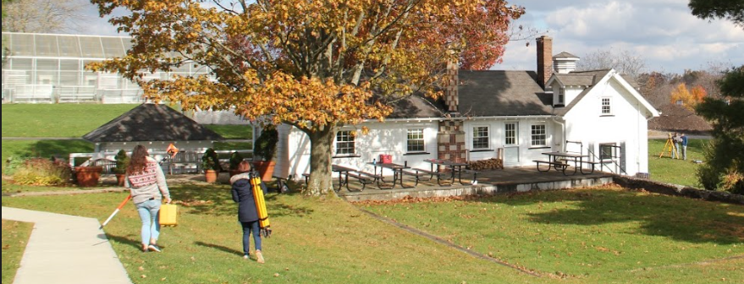Professor Katie P. Wheaton leads the Surveying and Computer Graphics course and supported the project. Her class planned their surveying equipment needs, procedures, and data reporting. Then they traded the classroom for the field, joining the radio club for two visits at the farm. “We coordinated the visits using 2-meter handheld radios,” said Kazdan. “Most of the civil engineering students had never heard of amateur radio before this. Then the report appeared. It was amazing.” The class processed measured data in AutoCAD, and ultimately produced a thirty-page document for their ‘client’ -- the radio club. The report included recommended antenna locations, safest cable paths and lengths, and cost estimates. “This opportunity allowed students to apply the surveying skills learned in class to solve a real-life problem. About a third of the class has now earned their ham radio licenses!”

Case ARC President Aidan Montare, KB3UMD, described another recent collaboration, connecting radio club members with the Case Rocket Team. The rocket team is based out of the university’s mechanical and aerospace engineering departments and includes a diverse group of undergraduates from across science, mathematics, and engineering disciplines.

“The rocket team was designing a capability to transmit live video from its rocket to meet an objective for an upcoming competition,” said Montare. “They came to the radio club in the spirit of ‘engineering consulting’ for help improving their prototype system.” He explained that the video signal was weak and wouldn’t work in flight. The two groups met together on the banks of Lake Erie to measure the performance of a variety of antennas and different orientations across a simulated flight path. This ultimately led to improvements to the quality of the video transmission and reception. “The experience even improved my own understanding of radio and antennas. I got to ‘see’ the effect of signal polarization in practice,” said Montare. “Many members of the rocket team have since gotten into amateur radio too.”

TOP ^

Case Amateur Radio Club attracts students, faculty, staff, and alumni -- including students unfamiliar with ham radio, and those who earned licenses even before college. Like many university radio clubs, Case ARC serves its community as a place to make new friends around a common interest, and as a steward of radio communication education and practice.

Here's the slide show we presented to the class.  It's what began the project:

[2019_10_20 Civil Engineering surveying class clients talk on antennas at CWRU farm.pptx](https://drive.google.com/file/d/1F0OBfYExd16V0QYo09SQWbSFZeDYMSz6/view?usp=sharing)

####

***Amateurs In Southern Ohio Answer The Call***

Amateurs from across the Tri-State Area (Ohio, Kentucky, and West Virginia) answered the call for help to provide communications for the 152nd Ironton-Lawrence County Memorial Day Parade, May 25, 2020.  James Rowe, N8TVO Southern Ohio Amateur Radio Association (SOARA) member, parade liaison for Ham Radio communications, and 2020 parade Grand Marshall, put out a call for Hams to help with parade communications this year.  The following 12 Hams answered his call:

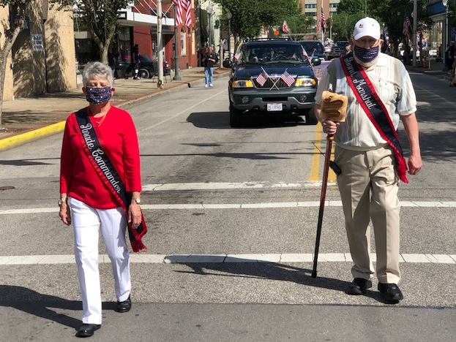Tim Nicely AC8VQ

Dave Bruce KD8NYN

Fred Herr WD8AGH

James Reneau N4REN

Joe Thompson KD8FPX

Eddie Jenkins N8URU

Annabelle Jenkins KB8TGI

James Rowe N8TVO

Michael Love WB8YKS

Don Kemper KN4KSS

Keith Brooks N8DKB (Net Control)

Jerry Lockhart W8HIC 

All of the eleven Hams had participated in prior parade events but none like this record-book event.  When the call went out for help, with it was a requirement of face masks and social distancing of those participating. The parade had been condensed from about three hours to twenty minutes and with NO spectators along the streets.  The parade was altered from a few miles to just a few blocks.  Eddie Jenkins N8URU said, “The city this year was like a ghost town when compared to prior parades with crowds of over 30,000.  However, the legacy of the nation’s longest continuously running Memorial Day Parade was preserved.

“James Rowe, N8TVO Parade Commander said, “There were  a lot of events across Ohio that were cancelled, so we were fortunate to have received  approval from the Ohio Governor’s Office, Health Departments, and Ironton City Mayor’s office for the required permits. The permits had restrictions for the safety and health of everyone.

TOP ^

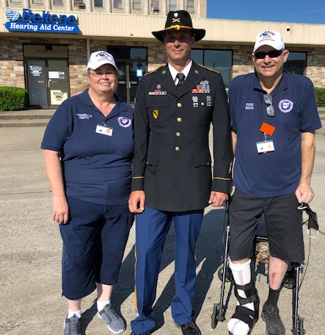

It was a beautiful day with deep blue sunny skies for the vintage aircraft circling above the parade and the live TV broadcasting, which was also recorded for later playback.  The news media was in abundance including WASZ-TV, a Huntington, West Virginia station.  Tony Cavalier a longtime TV personality and meteorologist, interviewed Annabelle Jenkins, KB8TGI as to the role Hams were playing in the parade. Annabelle pointed out the emergency service aspect of the Hams and their training as well as the network / net control that was in place in the event of a parade emergency.

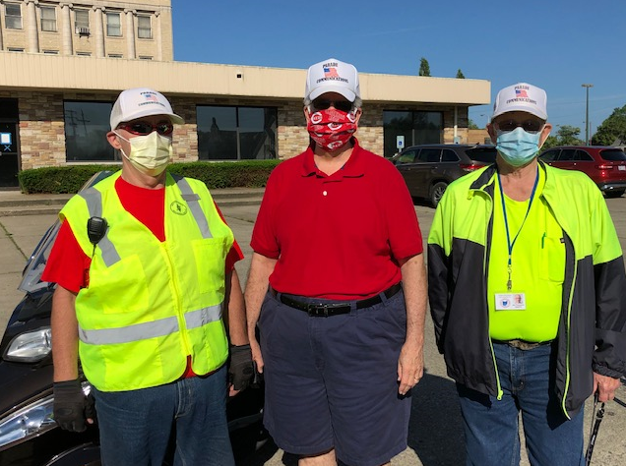Thankfully, there were no emergencies and the parade went smoothly. Tim Nicely, AC8VQ President of SOARA said, “I am glad the parade continued this year and that the Hams came out to help even during this time of the coronavirus.  This is what we train for and provides an opportunity to demonstrate our training to the thousands watching the parade by television and to our government officials, all of which is so important to preserving our hobby.”

Michael Love, WB8YKS

Southern Ohio Amateur Radio Association

Lawrence County Amateur Radio Emergency Service

Public Information Officer

####

***WWII veteran marks his 100th virus-style***

*(By Jen Baldulf - Staff writer - Dayton Daily News)*

SUGARCREEK TWP. — Friends and neighbors celebrated a birthday milestone Monday for a World War II veteran who turned 100.

TOP ^

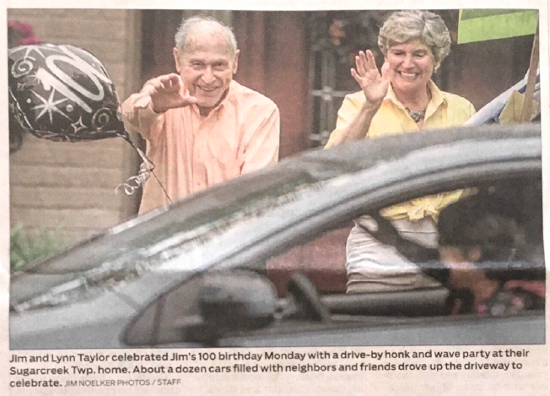

About 10 carloads of people drove by, honking and waving at Jim Taylor to mark his special day. A second group of his wife's bridge club were slated to drive by later.

Still, it’s not the birthday celebration Taylor expected due to the coronavirus pandemic. “It ruined my whole party,” Taylor said. He and his wife, Lynn, had to postpone his party and are planning a celebration with about 70 people this September, so long as COVID-19 cooperates.

Taylor was born May 18, 1920, in California. As a teenager he listened to theoretical physicist Albert Einstein speak and was able to watch aviation pioneer Charles Lindbergh land an aircraft.

After two years of college, in 1942 Taylor enlisted in the Army Air Corps, where he was a weather officer after attending a special training school. He achieved the rank of first lieutenant and was stationed at an airport in Egypt, he said. He served until 1947 and then returned to college to become a physicist. He worked on the Manhattan Project and came to the Dayton area in 1967 to work at the Mound Laboratories in Miamisburg.

He was married for 60 years before his first died. They raised four children.

In the community, ‘Taylor sang with the choir at David's United Church of Christ from 1967 to 2016, volunteered for more than 20 years at Kettering Medical Center and was known as an avid cyclist well into his 80's

Now, he still stays active walking and getting outdoors and enjoys riding his three-wheeled scooter.

**Additional Note...** James R (Dick) Taylor, WB8MMW is also an avid Ham Radio Operator and a “Life Member” of the Mound Amateur Radio Association (MARA).

[***Upcoming Hamfests***](http://arrl-ohio.org/hamfests.html) ***for 2020***

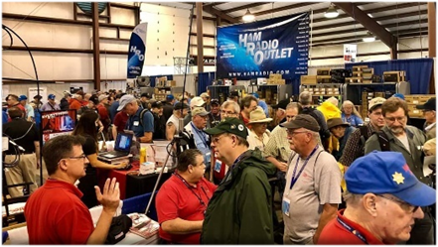

**06/06/2020 | FCARC Summer Hamfest**Location: Wauseon, OH  
Sponsor: Fulton County Amateur Radio Club  
Website: <http://k8bxq.org/hamfest>

TOP ^

|  |  |
| --- | --- |
| **07/19/2020 | Van Wert Hamfest** Location: Van Wert, OH Sponsor: Van wert Amateur Radio Club Website: [http://w8fy.org](http://w8fy.org/) | **07/26/2020 - Portage Hamfair '20** Location: Ravenna, OH Sponsor: Portage Amateur Radio Club, Inc. Website: [http://hamfair.com](http://hamfair.com/)   ***Canceled*** |
| **08/01/2020 | Columbus Hamfest** Location: Grove City, OH Sponsor: Voice of Aladdin/ Audio Unit of Aladdin Shrine Website: [http://columbushamfest.com](http://columbushamfest.com/)  ***Canceled*** | **08/08/2020 | DXE Hamfest,**  **ARRL Ohio Section Convention** Location: Tallmadge, OH Sponsor: DX Engineering Website: [http://dxengineering.com](http://dxengineering.com/)  ***Canceled*** |
| ***New Date***  **08/29/2020 - Milford Hamfest** Location: Owensville, OH Sponsor: Milford Amateur Radio Club Website: [http://www.w8mrc.com](http://www.w8mrc.com/) | **09/27/2020 | Cleveland Hamfest and Computer Show** Location: Berea, OH Sponsor: Hamfest Association of Cleveland Website: [http://www.hac.org](http://www.hac.org/)  **Click on “Join Our Mailing List” to stay updated.** |

**####**

***Webpage for Cancelled Hamfests***

ARRL has created a webpage that will search the ARRL Hamfest and Convention Database for canceled events. [>> Click Here <<](http://www.arrl.org/hamfests/search/canceled)

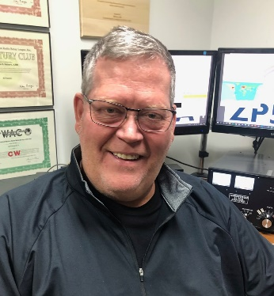***DX This Week***

*(from Bill, AJ8B)*

***DX This Week – UAC   
 Bill AJ8B (***[***aj8b@arrl.net***](mailto:aj8b@arrl.net)***, @AJ8B, or*** [***www.aj8b.com***](http://www.aj8b.com)***)   
 CWOPs Member #1567***

Hope you are doing well and listening with your “ears squinted”. If you follow a DX cluster, this past week you may have heard Alaska, Anguilla, Argentina, Asiatic Turkey, Belgium, Bolivia, Bonaire, Brazil, Bulgaria, Canada, Canary Islands, Chile, Cuba, Curacao, Denmark, Dominican Republic, European Russia, Fed. Rep. of Germany, France, French Guiana, Gibraltar, Grenada, Guadeloupe, Guam, Haiti, Hawaii, Hungary, Israel, Italy, Japan, Kuwait, Luxembourg, Malta, Mauritania, Mexico, Moldova, Montenegro, Morocco, New Zealand, Norway, Panama, Serbia, Sicily, Slovenia, Spain, St. Lucia, St. Martin, Trinidad & Tobago, Ukraine, United Arab Emirates, Uruguay, US Virgin Islands, Venezuela, and Wales.

TOP ^

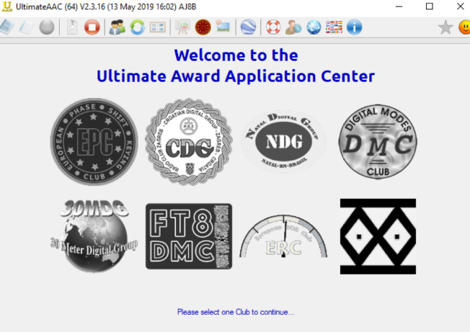Uncle Frank and I had a solid CW QSO on 30 meters and the topic was “paper chasing”. We both enjoyed earning our DXCC and DXCC endorsements as well as WAC, WAS etc., Frank has been working a lot of folks on FT8 and was wondering about awards etc. that might be earned using FT8. I happen to be on a QRZ.com page of an avid FT8 DXers from Serbia and read about something called UAAC. UAAC is an abbreviation for the Ultimate Award Application Center. DK5UR has built a very easy to use and understand interface that “talks” to hundreds of awards.

Each of these awards has a very colorful award certificate for reaching various levels. Once a month I load an adif of my logbook into the UAAC and it evaluates what awards I have earned and have become eligible for. These awards are downloadable as soon as you earn them. All of this is available at no cost. Since my interest in UAAC has started, I have joined the Digital Modes Club (DMC), European PSK Club (EPC), FT8 Digital Modes Club (FT8DMC), and the 30 Meters Digital Group. (30MDG).

After you explore these options and then register for the ones that you are interested in, you will receive a membership number from each group. You can load that number in to the UAAC and then have the UAAC app evaluate your logbook. In my case, within a few hours, I received about 30 certificates from the organizations. The software can be accessed at

<https://www.eupsk.com/index.php?option=com_content&view=article&id=8&Itemid=112>

(This is not to brag, just to share!) Samples are below:



TOP ^





|  |  |
| --- | --- |
|  |  |
|  |  |
|  |  |
|  |  |
|  |  |

***CQDX CQDX CQDX CQDX CQDX CQDX CQDX CQDX CQDX***

Here is an update from Bernie, W3UR, of the DailyDX and the WeeklyDX, the best source for DX information. <http://www.dailydx.com/>. Bernie has this to report:

**W9DXCC 2020 has been canceled**

**By K9KE, John McCormick**

______________________________________________________________

The board of directors for the Northern Illinois DX Association voted unanimously on May 19 to cancel this year’s W9DXCC convention due to the coronavirus pandemic and expected limitations in Illinois surrounding large gatherings this fall. Plans are already being made to book the 2021 convention at the Marriott in Naperville, where the 68th annual W9DXCC had been scheduled for Sept. 11-12.

Thank you for your continued support of W9DXCC and we look forward to gathering in person again in 2021. There have been tentative discussions about a possible virtual convention this year. Updates will be shared via email and the website if there are developments.

For more information: [http://w9dxcc.com/](http://r20.rs6.net/tn.jsp?f=0018vog5fe5PNQGGcp20Ot-LarMJLwkCAFQ_Zka2zHEkux5t32_Ix0G0moAiRfsFPD3k5WNuaqbRC0ZpwxJt3FLTKbnLw8VSmwqogPY00pm1uVIkyyMVsUk-mskqwZwcpy2awLr1jxCcIs=&c=KIAEFCQeUP8oJpfeCEQFx8-AMLR1w4pTeUqqU8SFGLm3RZa5NqD8xA==&ch=POFvzw1FVytQzR6stYLsJ3XRFxB0fxnRwBg79ibLTxX3GFacJgiKMw==)

TOP ^

**Introduction of IOTA QSO matching via LoTW**

**By G3KMA, Roger Balister**

________________________________________________________________

Islands On The Air (IOTA) Ltd is delighted to announce the implementation of the ARRL application which allows the use of QSO matching via LoTW.

We wish to thank ARRL for having made their application available. This will allow IOTA chasers to obtain credits by matching their logs with those at LoTW in addition to those at Club Log. We have a lot of work ahead of us to identify the time windows of past IOTA operations and this will be phased in over the next few months. An initial list of operations arising from the link-up with LoTW has been added to the database and these will become available for QSO matching from Thursday 21 May.

Further additions will be made on an ongoing basis. We are sure that the IOTA community will welcome this development for which they have long been pressing. Instructions for LoTW QSO matching are found [**here**](http://r20.rs6.net/tn.jsp?f=001qhXTjh6YNTHlq-9fCEt45X1L3el8ANmIY-2OXBKknEHZFtYbEF7qe6VAoZ5KPEcFn_AoecItBmEtJYk4H8I0HGJrNz__K_3j3CdbCjyidTzmj0eaMpgzLBnXclOCcvfpomOysIjPhxfjiE8EHw1Td1kgvRr811ninC6eHrWHgOKBZYI0Qh_8PEg3AlkpEZ1w&c=ZKI5ZULHReVcUVSTUN1kRw9DQGK-346s_qeXPHgXhlZgK9r7A-bqcQ==&ch=Wy8KUAXaVwSnvFJjyAW8Io8Nkue3epcYbvlMaNH4QBlr1VO0j31gPQ==), and notes on Accepted Activations [**here**](http://r20.rs6.net/tn.jsp?f=001qhXTjh6YNTHlq-9fCEt45X1L3el8ANmIY-2OXBKknEHZFtYbEF7qe6VAoZ5KPEcFOn4l1NDHEiX6U10dg6bcHXKFjtod8ErI-ntHCKlmYWm17l9swGjhEBojrbHLzmU5ooX_oysEGH9NK9_a6b1JKoSqfIQ-eNIuG9bo02EkgcuqtRUUXcxeHAreMyqVQhkI&c=ZKI5ZULHReVcUVSTUN1kRw9DQGK-346s_qeXPHgXhlZgK9r7A-bqcQ==&ch=Wy8KUAXaVwSnvFJjyAW8Io8Nkue3epcYbvlMaNH4QBlr1VO0j31gPQ==).

**HB0 – Liechtenstein -** HB0/HB9HBY, Lonck, plans to be on during July, the dates not yet nailed down.  He will be equipped with a Yaesu FT-891 to a multiband dipole.  He will be on the WARC-79 bands and all the others, SSB, CW and FT8, except for 160M.  QSL via the bureau or direct with 2USD.  Club Log and LoTW will also work.

**TG – Guatemala -** TG6/K4RSO, Steve Osborne, made a permanent move to El Progreso, Guatemala, two years ago.  In February his son made a trip to the US and crated up the radio gear.  It arrived a week ago with only slight damage.  Steve is now setting it up and putting up an antenna and then plans to get on the air, primarily digital modes.  He particularly wants to be able to speak to the US if infrastructure goes down during an emergency.

***FOR IMMEDIATE RELEASE***

New York, May, 27, 2020

**UNITED NATIONS, 4U1UN AND W2I/STAYHOME PARTCIPATE THE JUNE, 06-07, 2020, ON-THE-AIR COVID-19 COMMUNICATION EVENT**

James K2QI, President of United Nations Radio Club (UNARC) reports that on June 6 & 7, 2020, the U.N. HQ station 4U1UN will be QRV in support of the global STAY HOME movement, an event endorsed by IARU President, Tim Ellam as well as under the patronage of the Foreign Minister of Finland, Pekka Haavisto.

The United Nations Amateur Club 4U1UN, as well as its sister stations 4U1GSC (operated as 4U9STAYHOME) and 4U1A (operated as 4U2STAYHOME) look forward to making contact with many stations during this special event.

Headed by Ria Jairam, N2RJ and Peter Dougherty, W2IRT the special event W2I/STAYHOME on June 6 & 7, 2020 will be activated on SSB, CW and FT8 simultaneously.

TOP ^

***DX news***

***ARLD022 DX news***

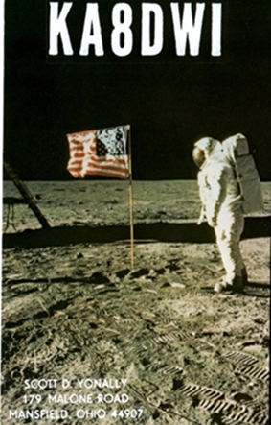This week's bulletin was made possible with information provided by The Daily DX, the OPDX Bulletin, 425 DX News, DXNL, Contest Corral from QST and the ARRL Contest Calendar and WA7BNM web sites. Thanks to all.

**GEORGIA, 4L.** Vaho, 4L8A plans to be QRV in the CQ World Wide WPX CW contest from Tbilisi as a Single Op/Single Band on 20 meters entry.

QSL via M0OXO.

**BARBADOS, 8P.** Charles, 8P6ET will be QRV as 8P1W in the CQ World Wide WPX CW contest. QSL via KU9C.

**UNITED ARAB EMIRATES, A6.** Members of the Emirates Amateur Radio Society are QRV with twelve stations with the suffix NMT, which stands for National Medical Taskforce, during the COVID-19 pandemic crisis. Stations A60NMT/1 through A60NMT/12 are active, although the length of their activity is unknown. QSL via operators' instructions.

**CHINA, BY.** Members of the ZhangJiaGang Amateur Radio Association will be active as BI4WXD during the CQ World Wide WPX CW contest as a Multi 2/High Power entry. QSL via BI4SCC.

**PHILIPPINES, DU.** Tim, M0FGC is QRV as DU3TW while permanently living in Arayat. Activity is on 80, 40, 20, 17 and 15 meters using mostly CW, with some SSB, FT8 and WSPR. QSL via LoTW.

**ENGLAND, G.** Special event station GB2CDK will be QRV from June 1 to 12 to commemorate the 150th anniversary of the June 9, 1870 death of author Charles Dickens.

**MONGOLIA, JT.** Special event station JU85UIA celebrates the founding of the University of Internal Affairs 85 years ago. QSL direct to JT1CH.

**ALASKA, KL7.** Brayden, KC1KUG will be QRV as KL7/KC1KUG from Fire Island, IOTA NA-158, from June 2 to 27. Activity will be mainly on 40 and 20 meters, and possibly 30 and 17 meters, using CW, SSB and FT8. QSL direct to home call.

**U.S. VIRGIN ISLANDS, KP2.** Yuriy, N2TTA plans to be QRV as WP2DX in the CQ World Wide WPX CW contest as a Single Op/Low Power entry. QSL via LoTW.

**LITHUANIA, LY.** Rolandas, LY5AA plans to be QRV as LY88A in the CQ World Wide WPX CW contest as a Single Band on 160 meters entry. QSL direct to home call.

**AUSTRIA, OE.** Hannes, OE1SGU is QRV with special call sign OE30MAGICBAND from Vienna until June 30 to celebrate the 30th anniversary of the allocation of the 6 meter band to Austrian amateurs. Activity is mainly on 6 meters using CW, SSB and various digital modes. QSL via LoTW.

TOP ^

**ALAND ISLANDS, OH0.** Team OH0Z will be QRV in the CQ World Wide WPX CW contest as a Multi/Single entry, although their main purpose will be antenna work. QSL via W0MM.

**DENMARK, OZ.** Henning, OZ2I will be QRV as 5Q6EE from Odense in the CQ World Wide WPX CW contest as a Single Op/Low Power entry. QSL to home call.

**GUATEMALA, YS.** Enrique, YS1RM is QRV as TG9/YS1RM from Guatemala City. Activity is on various HF bands and modes. His length of stay is unknown. QSL direct to home call.

**COSTA RICA, TI.** Kam, TI5/N3KS plans to be QRV as TI7W in the CQ World Wide WPX CW contest as a Single Op/All Band/High Power entry. QSL via W4FS.

**CANADA, VE.** Jean, VE2JCW will be QRV with special event call sign VE2SPEED during June in reference to the Montreal Grand Prix, even though the event is cancelled. QSL direct to home call.

**CAYMAN ISLANDS, ZF.** William, KO7SS will be QRV as ZF2SS in the CQ World Wide WPX CW contest. QSL via LoTW.

**NEW ZEALAND, ZL.** Holger, ZL3IO and Jacky, ZL3CW will be QRV as ZM4T and ZM1A, respectively, in the CQ World Wide WPX CW contest. QSL direct to home calls.

**PARAGUAY, ZP.** Manu, ZP9MCE will be QRV in the CQ World Wide WPX CW contest as a Single Op/Single Band on 160 meters entry. QSL via LoTW.

THIS WEEKEND ON THE RADIO. The CQ World Wide WPX CW Contest, PODXS 070 Club Three Day Weekend Contest, NCCC RTTY Sprint, NCCC CW Sprint, RSGB Hope QSO Party, Feld Hell Sprint and RTTYOPS Weekend Sprint will certainly keep contesters busy this upcoming weekend.

The RSGB 80-Meter Club Data Championship is scheduled for June 1. The RTTYOPS Weeksprint, ARS Spartan CW Sprint and Worldwide Sideband Activity Contest are scheduled for June 2.

The Phone Fray and CWops Mini-CWT CW Test are scheduled for June 3. Please see May 2020 QST, page 69 and the ARRL Contest Calendar and WA7BNM Contest Web Sites for details.

***Amazing opening on 144 MHz from Cape Verde Islands to Poland***

*(Submitted by Gregory Drezdzon, WD9FTZ)*

On Friday, May 29, 2020, there was an extensive Sporadic-E opening across Europe, which reached as high as 144 MHz allowing stations across the continent to make many contacts.  
  
The longest contacts were from the Cape Verde Islands off the coast of Africa to Poland on 144 MHz. The longest path recorded seems to have been when the **FT8 signals** from D4VHF were heard by SP5XMU in Warsaw, a distance of just over 5,600 km (3,024.75 nm).

<https://ei7gl.blogspot.com/2020/05/amazing-opening-on-144-mhz-from-cape.html>

TOP ^

**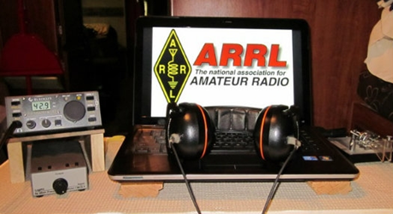*ARRL Contest Corner***

An expanded, downloadable version of *QST'*s’[**Contest Corral**](http://www.arrl.org/contest-calendar) is available as a PDF. Check the sponsor's’Web site for information on operating time restrictions and other instructions.

***Special Events***

**06/01/2020 | Dog Island IOTA DXpedition to NA-085/EL79**

**Jun 1-Jun 11, 0059Z-2359Z, K4D**, Caribbelle, FL. K5TEN. 14.074 7.074 14.235 7.190. QSL. Bruce Brady, 208 Mt Tabor Rd., Hot Springs National Park, AR 71913. Rare grid EL79. Rare IOTA NA-085. Paper QSL preferred, also LoTW and eQSL. See website for QSL details. rockradio1@aol.com or [www.qrz.com/db/k4d](http://www.qrz.com/db/k4d)

* **6/01/2020 | Monterey, CA 250th Anniversary 1770-2020**

**Jun 1-Jun 7, 0001Z-2359Z, N6M**, Monterey, CA. West Coast DX Group. 14.250 7.250. QSL. G. Costello, WC6DX, P.O. Box 1332, Monterey, CA 93942-1332.

* **06/03/2020 | W2W - D-Day Commemoration**

**Jun 3-Jun 10, 1300Z-2200Z, W2W**, Baltimore, MD. Amateur Radio Club of the National Electronics Museum. 14.244 14.044 7.244 7.044; operation on 80 meters (3.544, 3.844) and digital modes possible during event.. Certificate & QSL. W2W D-Day, P.O. Box 1693, MS 4015, Baltimore, MD 21203. Amateur Radio Club of the National Electronics Museum (ARCNEM) will operate W2W in commemoration of the anniversary of D-Day and the role of electronics in WWII. Primary operation will be June 6-June 7 with additional operation possible during the June 3-5 and 8-10 periods as operator availability permits. Frequencies +/- according to QRM. QSL and Certificate available via SASE; details at [ww-2.us](http://ww-2.us/)

* **06/05/2020 | Salvation Army National Donut Day**

**Jun 5, 1400Z-2200Z, KØSAL**, Lincoln, NE. Lincoln SATERN. 14.318. Certificate & QSL. Charles Bennett, P.O. Box 67181, Lincoln, NE 68506. [kd0ptk@gmail.com](mailto:)

* **06/06/2020 | Museum Ships Weekend**

**Jun 6-Jun 7, 1630Z-2130Z, W5KID**, Baton Rouge, LA. Baton Rouge Amateur Radio Club. 14.250 14.035 7.225 7.035. QSL. USS KIDD Amateur Radio Club, 305 S. River Road, Baton Rouge, LA 70802. Operation onboard the USS KIDD (DD-661), WW II Fletcher class destroyer. [qrz.com/db/w5kid](http://qrz.com/db/w5kid)

* **06/06/2020 | Museum Ships Weekend**

**Jun 6-Jun 7, 1300Z-2100Z, K8E**, Toledo, OH. Toledo Mobile Radio Association. 14.260 14.039 7.260 7.039. Certificate. K8E Col. James M. Schoonmaker Team, P.O. Box 9673, Toledo, OH 43697. [www.tmrahamradio.org](http://www.tmrahamradio.org/)

**06/06/2020 | WWII Sub USS Cobia On the Air**

**Jun 6-Jun 7, 1400Z-2100Z, NB9QV**, Manitowoc, WI. USS Cobia Amateur Radio Club. 14.240 +/- 7.240 +/-. QSL. Fred Neuenfeldt, 4932 S. 10th St., Manitowoc, Wi 54220-9121. For qsl send your qsl and a SASE #10 envelope to:W6BSF [www.qrz.com/db/nb9qv](http://www.qrz.com/db/nb9qv)

TOP ^

* **06/06/2020 | Nuclear Submarine USS Nautilus SSN 571**

**Jun 6-Jun 7, 0000Z-2359Z, N1S**, Groton, CT. Generations Amateur Radio Club . 28.400 14.280 7.250 3.870. QSL. Bureau via K3LBD; direct to Generations Amateur Radio Club, 110 Vinegar Hill Road, Gales Ferry, CT 06335-1713. Details on QRZ N1S and K3LBD pages. NAUTILUS information http://www.ussnautilus.org/. [www.qrz.com/db/n1s](http://www.qrz.com/db/n1s)

* **06/06/2020 | Museum Ships Weekend Event - THIS EVENT HAS BEEN CANCELLED**

**Jun 6-Jun 7, 0001Z-2359Z, NJ2BB**, Camden, NJ. Battle Ship New Jersey Amateur Radio Station. 14.262 14.040 7.262 7.040. Certificate & QSL. Margaret Burgess, KB2BRR, 150 Schooner Ave., Barnegat, NJ 08005. This is not a contest, just a fun operating event. All stations that work at least 15 different ships of those listed as participating will receive a certificate if they send a copy of their log entries showing these contacts. THIS EVENT HAS BEEN CANCELLED. [www.nj2bb.org](http://www.nj2bb.org/)

* **06/06/2020 | Selfridge Air National Guard Base Open House & Air Show**

**Jun 6-Jun 7, 0800Z-1800Z, N8S**, Harrison Township, MI. Utica Shelby Emergency Communication Association. 14.230 7.180. QSL. USECA c/o N8S, PO Box 46331, Mount Clemens, MI 48046.

***“ARES Connect”***

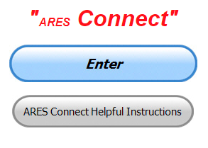

**Everyone –** please make sure to go into all of the events that you have signed up ***for and get your hours registered no later than 5 days after the event has ended****.*

Folks, I’m seeing a lot of folks that have signed up for events not entering their time after the event. This is a very important piece of using “Connect.” Your hours need to be recorded and it’s so easy to do.

Let’s run through how so in case you have forgotten. If you have already gotten signed up for an event, all you have to do afterword to get your time entered is at any time after the event has ended, log into “Connect.” And then click on your name in the upper right-hand corner of the page. This will bring up a drop-down menu where you will then click on “View Hours.”

This brings up another screen where you can “Report Hours” as well as “View Hour History” You’ll want to click on “Report Hours.” You will then be presented one at a time by chronological order each event that you have signed up for and hours have not yet been reported on.

Type in those hours in the “Hours Worked” box and hit “Submit”… Keep doing this until you have no more hours to report…. That’s all there is to it. Now, if you are following the request above and doing this at least every 5 days or more often, this will only take you a minute or so to complete.

**We still have a number of recurring events created but no activity reported for them.** Please, if this event is no longer needed, let me know and I can delete it from the masters. I know that many of you setup recurring events to learn how, but if they aren’t going to be used, let’s get them cleared out.

TOP ^

Also… If you are setting up events, please don’t set a limit for how many folks can sign-up unless absolutely necessary. This causes issues when doing reports. It’s also counter-productive since the reason for you to list the event is to get as many volunteers as you can to attend. When you set limits, it discourages folks from signing up.

**Now, isn’t that easy? Yes, and we all need to be diligent at doing it promptly.**

***Here’s are the top 10 hours earners so far for May:***

|  |  |  |  |
| --- | --- | --- | --- |
|  | **Name** | **Events** | **Hours** |
| **1** | Christopher Domenick (KC8CAD) | 29 | 99.10 |
| **2** | James Yoder (W8ERW) | 14 | 92.35 |
| **3** | Bret Stemen (KD8SCL) | 27 | 88.50 |
| **4** | Dan Stahl (KC8PBU) | 88 | 74.05 |
| **5** | Greg Dersarkisian (KD8SSJ) | 19 | 59.00 |
| **6** | Daniel Schlick (KB8LKH) | 28 | 58.52 |
| **7** | Alan Rothweiler (N8CJ) | 28 | 58.45 |
| **8** | Dwight Bonifield (W8TJT) | 72 | 57.15 |
| **9** | Earl Paazig (W8BR) | 27 | 52.00 |
| **10** | Elmer Thomas (KE8HNK) | 49 | 44.75 |

**Let’s get everyone in the Ohio Section on “ARES Connect!!!” Simply go to:** <https://arrl.volunteerhub.com/lp/oh/> and get yourself registered and using the system.

***Special ICS 300 & 400 Training being offered***

For those interested in attaining ARES Level 3 certification, the State of Kentucky plans to offer these courses in Ashland at the Boyd County EMA:

Intermediate ICS for Expanding Incidents (ICS-300) **June 23-25**

Advanced ICS Command & General Staff for Complex Incidents (ICS-400) **July 14-15**

Though not part of the ARRL curriculum, another good class is:

ICS/EOC Interface Workshop (G-191), **September 16**

Prerequisites for these courses is completion of IS-100, IS-200, IS-700 and IS-800.  All 4 of these courses are online and free from FEMA Independent Studies program.

For more information go to <https://kyem.ky.gov/training/Pages/default.aspx> and scroll down to June, July and September.

Gregg Hendry, W8DUQ

TOP ^

***One Question Questionnaire***

Hey Gang,

“Survey Says”….. It shows that about **70%** of you are going to work Field Day from your homes. That’s fantastic!!! I wish all of you the very best of band conditions.

Now, on to next question. Since the new Extra exam is going to start on July 1st, I thought I’d give you a question from the Extra Test this week. Let’s see how many of you answer this correctly without having to look it up… Remember, no cheating, you either know it or you don’t.…

***“What amateur band consistently yields long-path enhancement***

***using a modest antenna of relatively high gain??”***

You’ll find the “One Question” questionnaire on the Ohio Section Website! <http://arrlohio.org> It’s all in fun and it’s not a scientific survey in any way, but we are learning some things that we didn’t know from these questions. I hope that you are enjoying answering these “One Question” questionnaires.

***New – Dashboard for the Ohio Section’s ARES Connect***

Many of you have been following the new Dashboard for the Great Lakes Division and have asked if I can break the numbers down to for the Ohio Section to the county level.

After some thought and research I’ve found a way of getting a worthwhile report that is not only easy to read and understand, but one that can be very useful for everyone to be able to track the events and hours that they have participated in.

The Dashboard gives the county name and the hours recorded for that particular county. If you want more details, you’ll need to download the Excel file that will break it all down for you. You can take a look at all 88 counties and what they’ve been up to.

Here’s a link for you… <http://arrl-ohio.org/SEC/ARES-Connect-County.html>

***V.E. Test Sessions***

**

Many V.E.’s have decided to start testing once again, but with restrictions that need to be adhered to for sure.

Here’s the link to find that V.E. Test session and what is expected of YOU before going.

<http://www.arrl.org/find-an-amateur-radio-license-exam-session>

TOP ^

***Final.. Final..***

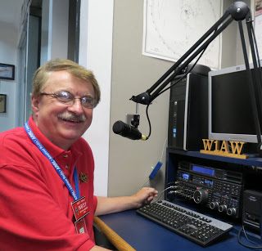Hi Gang,

Wow… Another amazing week has gone by. It seems like an eternity since I’ve attended an in-person meeting or hamfest.

Are you on the air?? I’ve been reading a lot of great information about the band conditions lately and it sounds like it’s starting to swing our way for a change. I urge all of you to stay up on the band conditions and get on the air whenever possible.

I hope that you have all read the great news about the change in Field Day rules. The change will allow many folks to operate Field Day and stay home, obeying the governor’s orders. I wish this COVID-19 stuff was all over, but unfortunately it isn’t, and it is gonna’ be here for a while yet.

Now, as far as Field Day, please keep in mind that it isn’t a weekend of “contesting.” Field Day was actually designed to be a public display on how amateur radio can be effective when everything else is either overloaded, or non-existent. Now, since we really can’t do the public displays without going through all the hub-bub of sanitizing and making sure everyone keeps a safe distance, we’re going to have to rethink how we are going to go about this, so let’s keep things in perspective. Field Day is actually designed to be an event to show the public that we CAN truly live up to what we advertise everyday… “When All Else Fails…”

So, how to you keep the spirit of Field Day alive? You get on the air! Make those contacts and you take pictures, lots of them! Make posts on Facebook, Twitter and other social media outlets. Don’t forget to send me your pictures too. I’ll get them posted on a gallery on the website for all to see. Let’s let the folks know that you really can operate “When All Else Fails!!!”

Now, let’s not forget the ones being hurt the most by all of this separation. The Novices and Technicians… YES Novices… We have over 350 licensed Novices in Ohio still!!!! Let’s get down on 10 meters and do some operating too. This way everyone can participate. Oh… and don’t forget that 6 meters is really starting to get hot as well

We’ve had a few updates on the Ohio Section website… Greg, WD9FTZ has updated the DMR Net listing and Daniel, KB8LKH has updated the CS800D instruction sheet.

Whelp, my final go around before gong QRT… Stay safe my friends! I want to see all of you soon at a meeting or hamfest! We will get through this and when we do, we’ll have so much to talk about. Most of all… have FUN and get on the airwaves!!

73,

***Scott, N8SY***

TOP ^

***Swap & Shop Has Come to the Ohio Section Website***

Hey Gang,

Have you taken a look at the **Swap & Shop** page on the Ohio Section webpage yet??

Here’s a link that will take you there… <http://arrl-ohio.org/sm/s-s.html>

Do you have equipment that you just don’t need or want anymore? Here’s a great venue to advertise it, and it’s FREE!!

No, it won’t be listed in this newsletter because it would take up way too much space, so your ad will only appear on the website. It is there for any individual to post equipment Wanted / For Sale or Give-Away. No licensed vehicles/trailers or business advertising will be posted.

Postings are text only (no pictures or graphics) will be posted for a maximum of 1 month from date posting and require a contact phone number or email within the posting.

Send your Wanted / For Sale or Give-Away post to:  [swap@arrlohio.org](mailto:swap@arrlohio.org)

Ohio Section Cabinet

|  |  |
| --- | --- |
| Section Manager – Scott Yonally, N8SY | Assistant Section Manager – John Perone, W8RXX |
| Section Emergency Coordinator – Stan Broadway, N8BHL | Section Traffic Manager – David Maynard, WA3EZN |
| Technical Coordinator – Jeff Kopcak, K8JTK | Affiliated Clubs Coordinator – Tom Sly, WB8LCD |
| State Government Liaison – Bob Winston, W2THU | Public Information Coordinator – John Ross, KD8IDJ |
| Section Youth Coordinator – Anthony Lascre, K8ZT | |

***Welcome New Subscribers***

**Tom, KE8BRN and Tim, N8PDS**

***Back Issues of the PostScript and Ohio Section Journal***

Hey, did you know that PostScript and Ohio Section Journal (OSJ) are archived on the website? You can go back and look at any edition simply by clicking:

<http://arrl-ohio.org/news/index.html>

TOP ^

***Chit – Chat, and All That!***

Do you know someone that’s not getting these Newsletters? Please, forward a copy of this Newsletter over to them and have them “[Opt-In](mailto:Opt-In)” to start receiving them. Heck just have them send me an email [n8sy@n8sy.com](mailto:n8sy@n8sy.com) and I’ll get them added to the Ohio Section Emailing list.

We now have many thousands of readers receiving these newsletters weekly. Quite impressive, I’d say! I urge all of you to make sure that everyone, regardless of whether they are a League member or not, get signed up to receive these weekly Newsletters.

You can always “[Opt-Out](http://arrl-ohio.org/forwarder/forwarding.html)” at any time if you feel this is not what you were expecting. It’s fun and very informative. All of your favorite past newsletters are now archived too.

You can go back at any time and read them. Just go to: <http://arrl-ohio.org/news/>

Got questions, concerns or would just like to sit and chat awhile? Heck, I’ll even buy the coffee!! Give me a call at (419) 512-4445 or email me at: [n8sy@n8sy.com](mailto:n8sy@n8sy.com)

The pictures on the front page and throughout this newsletter are from various newsletters, Facebook posts and/or were sent directly to me in recent weeks. Take a good look at them, you just might be in one of the pictures! “SMILE… you’re in the Ohio Section News!!”

TOP ^

*PostScript is produced as a weekly newsletter. I want to thank everyone that has contributed articles and ideas to make this an even better news source. I sincerely hope that you have enjoyed this edition and will encourage your friends to join with you in receiving the latest news and information about the Ohio Section, and news and events happening around the world!*