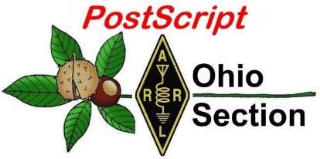
May 18th
Edition

National News The Handbook Give Away

Club Corner Hamfests

DX This Week ARES Connect

VE Testing One Question Questionnaire

Final.. Final..

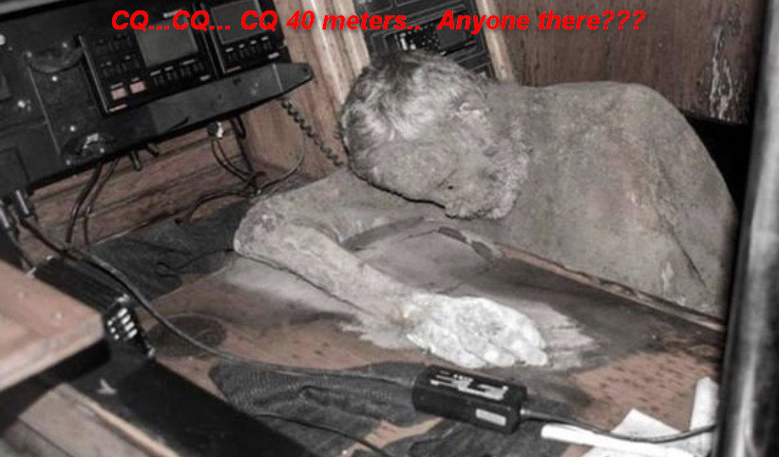
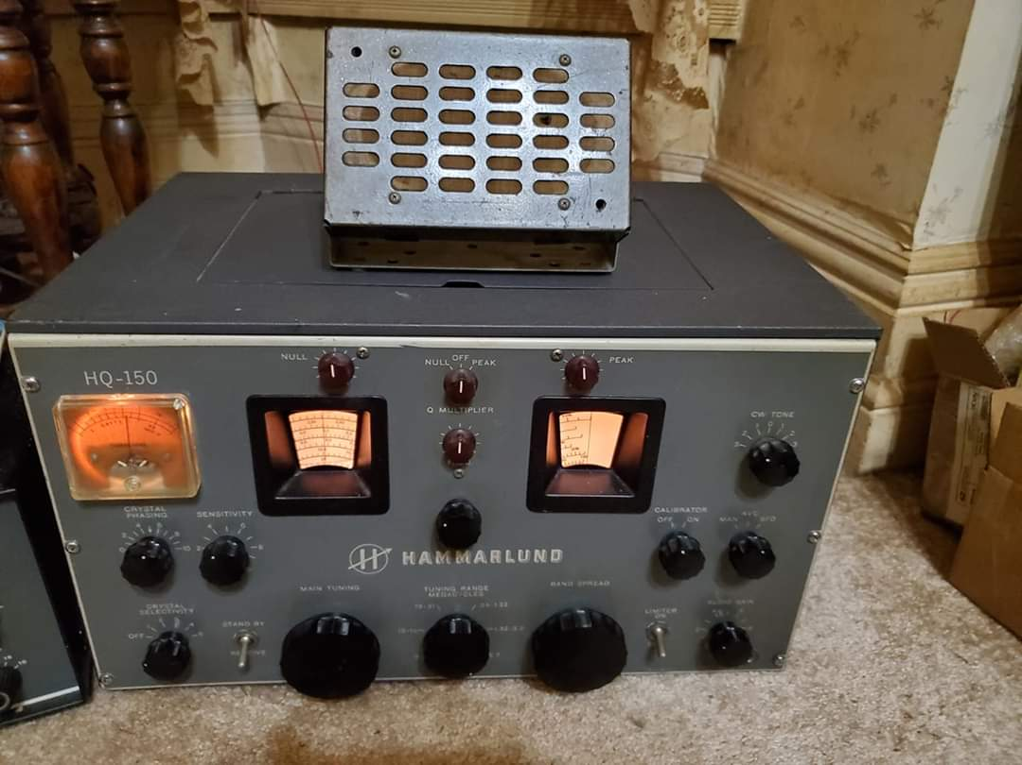
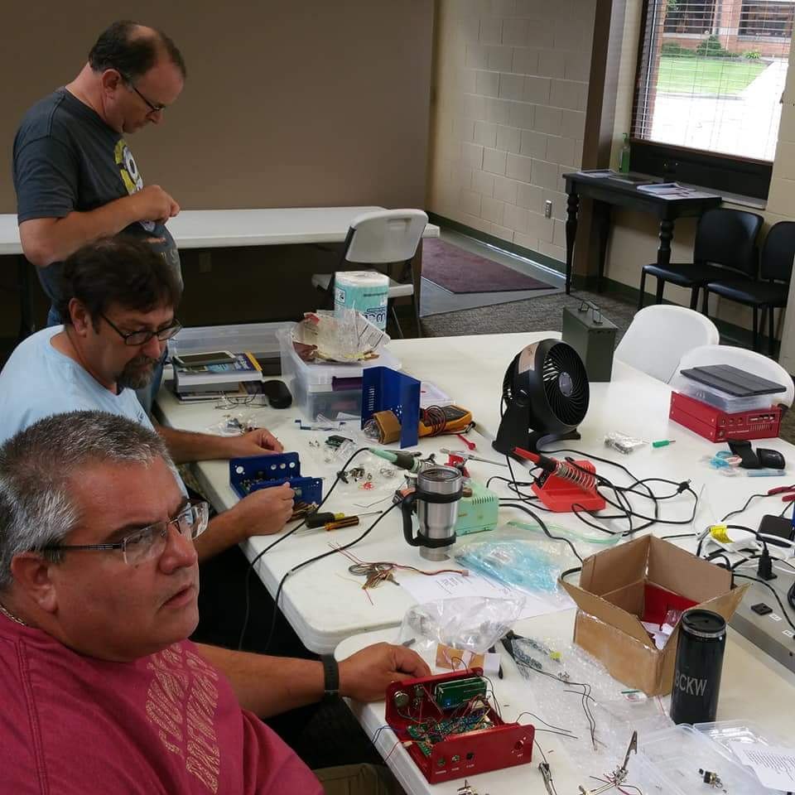
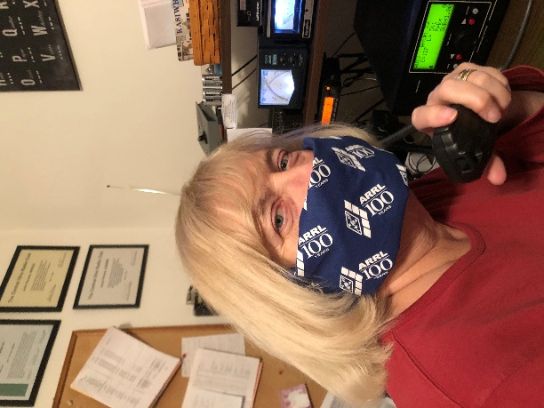

National News
(from arrl and other sources)

Socially Distanced In-Person Exam Sessions Held in US and Norway

With some states starting to relax restrictions on events and activities, the Grant County, Oregon, Amateur Radio Emergency Service (ARES®) held an in-person exam session on April 26 in the town of John Day that adhered to social distancing recommendations. Exam organizers held the gathering to within Oregon’s 10-person limit for gatherings, keeping everyone 6 feet apart and requiring all participants to wear face masks. The exam session was held outdoors under a car port.

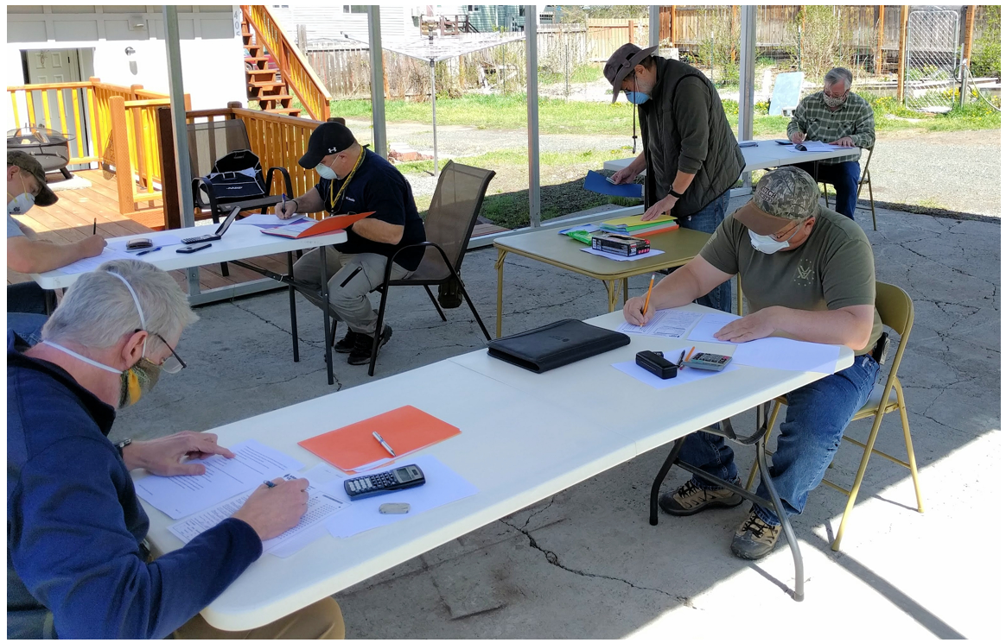

“We had an exceptionally successful test session, with candidates passing exams at every amateur radio level,” said Ed Ellesson, AF7YX, the ARRL Volunteer Examiner Liaison for the Grant County Amateur Radio Club. Grant County Emergency Coordinator Steve Fletcher, K7AA, noted that many clubs had canceled their planned sessions due to the coronavirus pandemic. “Grant County decided to approach the problem by obeying all the restrictions but still holding the exam,” he said. “As a result, we had people come here from all over the state.”

In Oklahoma, the Mid-Del Amateur Radio Club, W5MWC, administered an open-air exam session on April 25 that held to social distancing guidelines. Over the course of the 3-hour session, 16 candidates tested and all were successful. One candidate passed all three exam elements to come away with his Amateur Extra-class license.

TOP ^
Another open-air amateur exam session took place recently in Norway. The LA3F radio amateur club south of Oslo had just completed its annual course for prospective radio amateurs, and three candidates were ready to take their exam when Norway began shutting down activities and gatherings due to the coronavirus pandemic.

Not to be deterred, International Amateur Radio Union Vice President Ole Garpestad, LA2RR, arranged with Norwegian regulatory authorities to hold an outdoor exam session compatible with the social distancing and other safety guidelines in place. Garpestad met with the three candidates in the forest outside a local scout cottage, and, with candidates seated at tables at least 5 meters (about 16 feet) apart, he administered the exam.

With the temperature at around 10 °C (about 50 °F), everyone dressed warmly. Garpestad reported that all three candidates passed, and LA5EUA, LB8QI, and LB8RI were welcomed to the world of amateur radio. — Thanks to Steve Fletcher, K7AA, and Don Beattie, G3BJ, via IARU Region 1

####

Amateur Radio Gains Significant Boost in UK by Connecting People During Lockdown

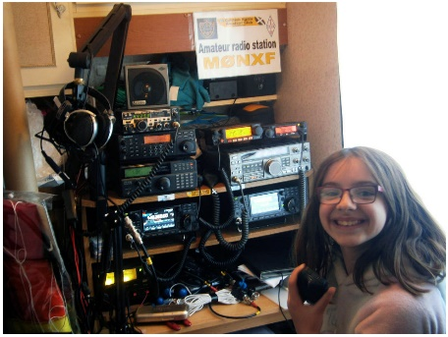
A recent BBC news feature outlines how ham radio has gotten a significant boost by connecting people during the COVID-19 lockdown in the UK. The article, by Vanessa Pearce, quotes the Radio Society of Great Britain (RSGB) — the UK’s IARU member-society — as saying that many former hams are now returning to the hobby. Mark Rider, G3VHJ — a retired engineer who lives alone in North Warwickshire — said that after the lockdown restricted his occasional trips to the pub, rehearsing with musician friends, and visiting his wife in a nursing home, he decided to dust off his ham radio equipment “to seek out some other social interaction.” Rider said that ragchewing has become one of the highlights of his day. “Just speaking to somebody else in the same situation is very rewarding,” he said. The 67-year-old told BBC News that keeping in touch with others has been more important since his wife suffered a stroke.

RSGB General Manager Steve Thomas, M1ACB, said the society has experienced a three-fold increase in license examination applications since social distancing rules were put into place. The UK has about 75,000 amateur licensees.

Eleven-year-old Anne-Marie Rowland, 2E0RUX, of Cornwall, worked with the Cornish Amateur Radio Club to conduct informal twice-weekly nets to help keep people in touch. “We have some regulars, but also some new people join in,” she told the BBC. Her father, Bill, M0NXF, runs a net that has attracted older radio amateurs who are self-isolating, to help them feel connected.

The RSGB recently instituted its “Get on the Air to Care” (#GOTA2C) campaign in conjunction with the
National Health Service and its GB1NHS amateur station to promote amateur radio use during the pandemic lockdown. Some stations have been adding /NHS to their call signs to support the effort, which aim to support the emotional health and wellbeing of the amateur radio community.

The RSGB introduced remote administration of entry-level Foundation-class amateur radio exams in mid-April. Pete Sipple, M0PSX, told BBC News that he’s seen a “massive” surge in demand for training courses and exam session and has had to up the number of course offerings.

####
TOP ^
Planning Your ARRL Field Day 2020 Operation

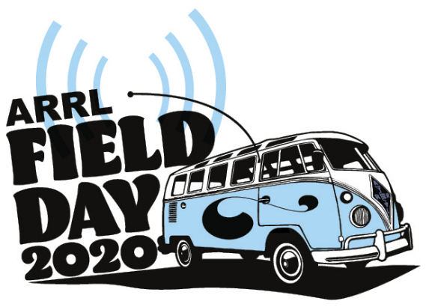
For most of us, ARRL Field Day 2020 is going to look quite different than it did in past years. Considering the impact of social distancing due to the pandemic, many radio clubs and large groups will not gather in their usual Field Day locations this year. Whether you are a seasoned veteran or a Field Day first-timer, there are many questions about how to participate in amateur radio’s largest annual on-air event under these unusual circumstances. Here are some tips and suggestions to help you plan this year’s operation.

Don’t Forget 6 Meters
Remember, Field Day is a non-adjudicated operating event and not a “full speed ahead” contest. It is also not an HF-only event. All amateur radio bands above 50 MHz may be used during the event too. This includes 6 meters, which often offers significant propagation enhancements in the summer months around Field Day weekend, to help you make contacts. The band is available to amateurs holding a Technician-class license or higher. If you have an HF/VHF/UHF multi-mode transceiver, try making SSB, CW, or digital contacts on 6 meters. You don’t need fancy beams or large antenna arrays. A simple vertical or dipole will allow you to experience operating on the “Magic Band.”

Activities for Techs
One suggestion for clubs to consider in order to increase participation among their Technician-class members is to schedule specific times where these club members will monitor designated VHF and UHF simplex frequencies for Field Day activity. Keep in mind that the published national FM simplex calling frequencies should be avoided, and the use of repeaters is prohibited for Field Day contacts. This way, members who have equipment capable of VHF/UHF-only operation may be able to participate from their homes or vehicles. Your club can choose a list of frequencies and scheduled times in advance, and publish them in the club newsletter, or via email or other electronic means before the start of the event. On the HF bands, Technician-class licensees have CW privileges on 80, 40, and 15 meters, as well as RTTY/data and SSB phone privileges on 10 meters. If you aren’t a CW operator, try calling CQ on 10-meter SSB in the late afternoon and early evening on Saturday and see if conditions are favorable for long-distance communications. Try experimenting with a simple wire antenna for 10 meters. You might discover that the band can offer plenty of unexpected propagation.

Get Set Up for Digital Modes
You might want to explore one of the newer FT4/FT8 digital modes on 10 meters, 6 meters, or even the VHF/UHF bands. These modes offer an opportunity to make weak-signal contacts when band conditions often do not support voice communication. There have been reports of some great 6-meter openings in recent weeks, and these are likely to occur more frequently as the summer months approach. If you’ve never experimented with digital modes, perhaps this year is an opportunity to give them a try.Setup is relatively straightforward. You’ll need a computer and a digital interface to connect the radio to the computer, and you’ll need to download one of the digital mode software packages such as the free WSJT-X suite, which incorporates FT8 and FT4. Many modern transceivers have built-in support for digital modes, so in those cases, all you’ll need is the proper cable to connect the radio to the computer’s USB port. You’ll need software that supports the ARRL Field Day exchange (WSJT-X version 2.0 or later, for example). ARRL’s book Get on the Air with HF Digital (2nd Edition) is also a great primer for anyone beginning to explore the digital modes.

TOP ^
The Excitement of Ham Satellites
Another area you might wish to explore is operating via one of the amateur radio satellites, or “birds,” as they’re often called. Many hams have had success making contacts via the FM satellites by using a VHF/UHF handheld radio and a small handheld directional antenna, or a multi-mode VHF/UHF transceiver for the linear (SSB and CW) satellites. You’ll only be able to work the satellites when they are overhead, so you’ll need to know when they will be visible at your operating location. Visit AMSAT’s Online Satellite Pass Prediction page to see which ones will be orbiting overhead, and at what times they’ll be visible. You can find many satellite operating tips and resources on the AMSAT website too.

An Opportunity for Learning
ARRL Field Day 2020 may be the year you decide to participate solo, or with other members of your household. You may want to focus on expanding your knowledge base and experiment with new modes or bands that you never thought of using before. If you’re a mentor to a newer ham, Field Day can be an opportunity to share some of your knowledge, and for you to expand your own operating horizons. This might be the year to leave your Field Day comfort zone and try something new!

The Southwest Ohio DX Association Presents DXPedition of the Year
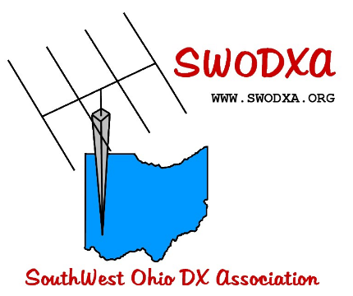
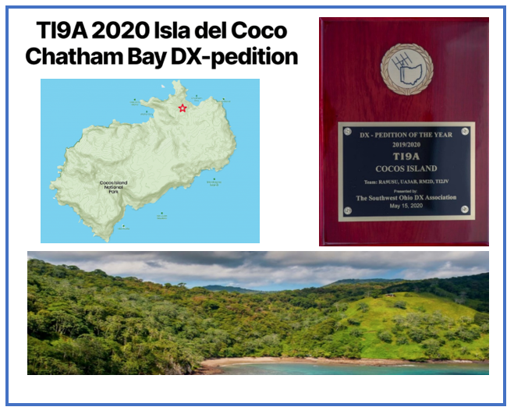

The Southwest Ohio DX Association is pleased to present this year’s DXPedition of the Year Award to the TI9A Cocos Island DXPedition.
The DXPedition team included: Dmitry, RA9USU; Andrey, UA3AB; Mats, RM2D and Jorge, TI2JV.

We congratulate you on a well-organized and well-run DXPedition from a challenging location.

A video of the announcement is available at: https://www.swodxa.org/dxpedition-of-the-year/)

TOP ^

Huskysat-1 transponder is open
(Submitted by Gregory Drezdzon, WD9FTZ)

After a week of testing, the transponder on HuskySat-1 is enabled and open for use and testing.

It’s fairly sensitive, and 5-10 watts is plenty most of the time. There are some fades due to satellite orientation, and some passes are definitely better than others. The opera- tions and engineering teams are also watching a few anomalies. Please keep an eye on the beacon during transponder ops, for those with spectrum scopes. Strong signals may impact the beacon strength.

HuskySat-1 is the Husky Satellite Lab at University of Washington’s first cubesat, and the first mission with AMSAT’s linear transponder module (LTM-1), a V/u transponder and integrated telemetry beacon and command receiver. UW recently completed their Part 5 operations and have graciously let AMSAT’s Part 97 transponder operations commence.

This transponder module is available for use in educational cubesat missions willing to enable the transponder for worldwide use. Contact myself or VP Engineering Jerry Buxton for additional details.

Reports and observations are welcome to the amsat-bb mailing list.

Congratulations to Husky Satellite Lab, and to the entire AMSAT Engineering team for keeping amateur radio in space. Thanks to Dr. Mark Hammond, N8MH, for commissioning and operations support.

73, Drew, KO4MA
AMSAT VP Operations

HuskySat-1 V/u inverting transponder, 145.910 to 145.940 uplink, 435.810 to 435.840 downlink, telemetry beacon 1200 baud BPSK at 435.800

####

New Beta of FT4 and FT8 software WSJT
(Submitted by Gregory Drezdzon, WD9FTZ)

Joe Taylor, K1JT, reports the new beta version of the popular FT4 and FT8 software, WSJT-X version 2.2.0, is a significant program upgrade offering many new features

Taylor writes:

The first candidate release, WSJT-X 2.2.0-rc1, is now available for download and use by beta testers. This candidate release is your first chance to test the new features and provide feedback to the WSJT Development Group.

A list of program changes since WSJT-X 2.1.2 can be found in the cumulative Release Notes: http://physics.princeton.edu/pulsar/k1jt/Release_Notes.txt

TOP ^
... and also in the updated WSJT-X 2.2.0 User Guide here: http://www.physics.princeton.edu/pulsar/K1JT/wsjtx-doc/wsjtx-main-2.2.0-rc1.html#NEW_FEATURES

Upgrading from earlier versions of WSJT-X should be seamless. There is no need to uninstall a previous version or move any files. Users might want to install to a different directory from your WSJT-X 2.1.2 installation.

Links to installation packages for Windows, Linux, and Macintosh are available here:
http://physics.princeton.edu/pulsar/k1jt/wsjtx.html

Scroll down to find "Candidate release: WSJT-X 2.2.0-rc1.

You can also download the packages from our SourceForge site:
https://sourceforge.net/projects/wsjt/files/

It may take a short time for the SourceForge site to be updated.

WSJT-X is licensed under the terms of Version 3 of the GNU General Public License (GPL). Development of this software is a cooperative project to which many amateur radio operators have contributed. If you use our code, please have the courtesy to let us know about it. If you find bugs or make improvements to the code, please report them to us in a timely fashion.

We hope you will enjoy using this beta release of WSJT-X 2.2.0. Please report bugs by following instructions found here in the User Guide: http://www.physics.princeton.edu/pulsar/K1JT/wsjtx-doc/wsjtx-main-2.2.0-rc1.html#_bug_reports

73 from Joe, K1JT, Steve, K9AN, and Bill, G4WJS,
WSJT Development Group

--------

Additional information on the new 40 MHz beacon in Ireland

Recently it was announced that the new 8-metre beacon in Ireland is now on air. Here are more details about its operation.

The new EI1KNH beacon operates on a frequency of 40.013 MHz and is only the second operational amateur 8-meter beacon in the world. It runs 20 watts into a converted CB vertical antenna on an elevated site about 12 sm to the south of Dublin. While it is blocked somewhat by local mountains to the west, the take off towards the UK and Europe is excellent.

(Usage of 40 MHz by amateur radio operators in the United States is prohibited.)

The beacon went on air on the May 9, 2020, and it was reported just two days later on the 11th by a station in the south-east of France in a Sporadic-E opening.

In the same Sporadic-E opening, EI stations successfully completed 40 MHz to 50 MHz crossband contacts with stations in Austria and Germany.

TOP ^
It is hoped that the new beacon will generate more interest around Europe and around the world for those wishing to carry out tests on this new VHF band.

More details about the beacon can be found here: https://ei7gl.blogspot.com/2020/05/new-irish-40-mhz-beacon-now-operational.html

Field Day 2020 – what’s it look like?
(from Stan, N8BHL)

I don’t have to tell you about 2020 so far. Regardless of our own conclusions the government-enforced shutdown of life-in-general has caused numerous events to go away. On the bright side, being restricted to our homes has had the benefit of allowing time to re-focus on the really important factors of our lives.
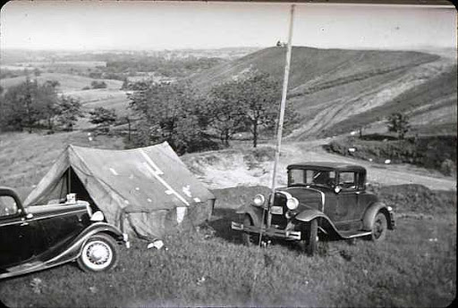
Since the first Field Day took place in 1933, hams have practiced the rapid deployment of radio stations in emergency or remote conditions. Think: hams step up in wake of cataclysmic end-of-the-world disaster to save humanity with our ability to create a working station from two bales of straw, masking tape and a bolt of string. OK, not quite that but you get the idea. And the ARRL had the idea back in 1933 as hams literally took to the fields. It was nothing like today- they operated out of tents, on wooden crates, or from cars using large tube-type radios and a variety of power sources. It was a test of survival as well as communication. Over the years, as we’ve become more “first world” in our approach to the outdoors our Field Days have evolved: miniature radios and computers with battery or solar power operated from a comfortable RV with large gatherings of club members. Oh, and real bathrooms.

Regardless of how much fun we have at our club gatherings and our well-regulated operations, are we truly carrying out the spirit of those old hams and their original intent? Actually, I would say yes, we are indeed! Our capabilities have expanded with technology and our services could just as easily “save humanity” as back in the day.

Just like the development of technology, the “family” aspect of ham radio has blossomed as well. Look, I get it. Our club traditionally has a giant hog roast and a pot-luck dinner on that Saturday night for 100 club members and family. It’s more about the gathering than the radios, and that’s very pleasant. At the same time the “scorecard” aspect has increased the competitive nature as well. For many clubs, groups, and individuals Field Day is a highlight of the ham radio year.
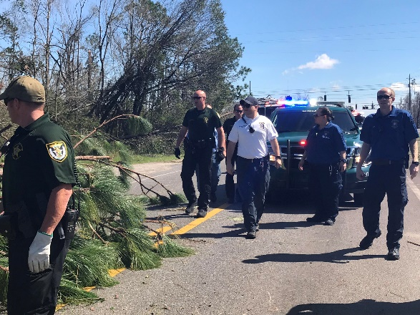
And then came 2020.

Over the years we’ve put together a complex multi-piece puzzle and our younger sibling just came along and dashed it all to the floor. After suitably dealing with the sibling (sometimes spankings are worth it!) we then come to grips with the pile on the floor- and realize this isn’t want we’d imagined.

TOP ^
So, it is with 2020. We’re finding that just as broad-brushed restrictions don’t apply equally across the nation or even a state, broad-brushed rules can become inequitable when parts of the playing fields have been blocked off. While some states are wide open, others are under soft Marshall Law… and the competition thus becomes wholly unequal.

Can we take this year’s gift of re-focusing our priorities, to return to the original Field Days and the real purpose? All the rest is fun and surely important, but we need to be able to set up a working radio station under “emergency” conditions to serve our communities. An emergency won’t play out the way we expect. This is the challenge of 2020. Can we get back to basics and perform? Scores are not important when it comes to getting through with a message. Big dinners and parties are not critical when it comes to sending critical messages.

Can you string together a working antenna? Can you pull a battery and make your HF radio work? Can you accurately record information from other stations under poor conditions? Can you sit for hours fighting noise, mosquitoes, and distraction to make this all work? Can you recognize that this isn’t “ARES’s problem”, this is ham radio’s duty? 2020 gives us that challenge. Are we up for it?

Madison County Amateur Radio Club Press Release
(by Nick Pittner, N8NAP)

While many of us spend our Stay-At-Home time glued to the tv, reading, or playing board games, the members of the Madison County Amateur Radio Club have been actively honing their communications skills. The radio club, made up of federally licensed amateur radio operators (hams) in Madison and central Ohio counties have used their communications capabilities to reach out to area ham operators, offering a nightly mix of entertainment, fun and technical programs to help put the time to good use.

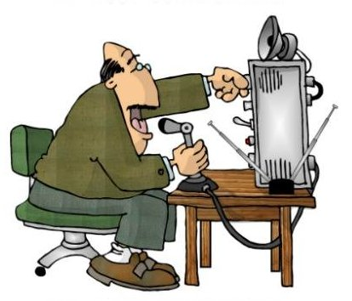
For years, the club has conducted a weekly Tuesday evening net using its amateur radio repeater system. The net involves over-the-air discussions with each ham transmitting from his or her home station moderated by a designated net control station. After the invasion of Covid-19 and the Governor’s Stay-At-Home order, the weekly net became a near nightly “Cabin Fever” net, meeting at 8:00 p.m. most evenings and often joined by 20 or more area hams in Madison and area counties. Presentations have been made on a wide variety of topics, including substantive issues such as the use of ham radio software, meteor scatter communication, storage battery technology and antenna law in Ohio as well as a variety of just-for-fun trivia contests.

Another regular feature of the net relates to Amateur Radio Emergency Service (ARES) preparedness for providing radio communication services in the event of an emergency. Coordinating with statewide and national ARES activities, the Madison County ARES can provide a wide range of communications services to agencies such as the county and State Emergency Management Authority (EMA), the Red Cross, area hospitals and other service agencies. In the past these communications services have provided life-saving resources to many disaster victims, including Hurricane Katrina and the 911 Disasters. The club members understand the importance of preparedness for such events.

TOP ^
The club’s repeater system can be heard at 147.285 MHz, FM, and it permits hams even with low-power handheld radios to reach a distance of 30-45 miles from the transmitter site in the county. The club’s weekly net can be heard at 8:00 p.m. on Tuesday evenings. Hams who are properly licensed and who have the necessary radio equipment are welcome to join and participate in any of the nets; club membership is not necessary. Listeners are always welcome whether licensed or not. The Cabin Fever net operates on the same frequencies, and at the same time. To learn more about amateur radio and consider becoming licensed, see http://www.arrl.org/what-is-ham-radio.

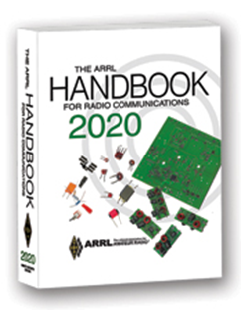
The Handbook Give Away

Hey Gang,

Have you registered for the “Handbook Giveaway” drawing for this month yet? If you haven’t, go to: http://arrl-ohio.org/handbook.html and get yourself registered now!

What’s the catch? I want to get everyone checking in to the Ohio Section website as often as possible, and in order to register each month, you have to visit the website often! There’s nothing else to it. I pay all expenses and I usually “Give Away” more than just a Handbook too!!

Many of you ask me just how do I know when the drawing is on? Well, that’s easy all you need to do is check in on the Ohio Section Website on a regular basis and watch for the big RED Arrow that will appear on the left side of the page. This is the sign that the drawing is on and you need to get registered. So, keep a sharp eye out on the website and check in often!

Club Corner
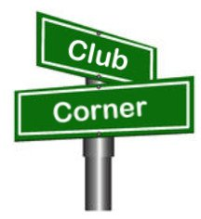
This is YOUR cornner of the newsletter. Send me what your club is doing and I’ll make sure that it gets in. Got a special event or club project that you want everyone to know about? Send it to me!. Need help with a project? Send it to me.

Let me know what you club is up to. Are you going to have a special guest at your meeting or are you having a special anniversary? Just sent it to: n8sy@n8sy.com

####

Mahoning Valley Amateur Radio Association’s 2-Meter Contest

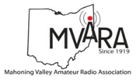
The MVARA is excited to once again try and bring you the Mahoning Valley Amateur Radio Association 2-Meter contest May 30, 2020 from 1:00 to 4:00 PM. We thought it would be fun to shake off the winter doldrums and Coronavirus / Covid 19 stuck at home blues by getting on the air for a local contest. It will be an opportunity to reconnect with old friends and make some new ones.

TOP ^
Old timers may remember participating in the Lou Malice Memorial Contest years ago. The MV 2 Meter Contest will be a similar two-meter simplex contest. Stations will simply exchange call signs and a 6-digit designator as defined in the contest rules. The contest format will allow participations to evaluate their stations simplex capabilities. This information can be valuable in an emergency.

No 100-watt base station, no problem. There will be two categories a low power home category of 5 watts or less and a high-power home category of more than 5 watts so everyone will have a level playing field.

There will be NO ROVER STATIONS. Your health is our major concern. Awards will be given for the highest scoring high power home and highest scoring low power home. Top 5 winners in each category will be posted on our website www.mvara.org by August 1, 2020. Awards will be mailed to the winners and second and third place will receive honorable mentions.

For contest rules, print out grid maps and to submit your logs on line please go to: http://mvara.org/Mv2mc.html. Paper logs can be submitted to:

MVARA
P.O. Box 14141
Youngstown, Oh 44514

This year the contest will be dedicated to the memory of pioneer valley ham Lou Malice WA8PKN whose dedication to amateur ham radio touched the lives of all of us. Even if you never had the pleasure of knowing Lou you are still part of his legacy. Chances are good that the ham that inspired you and encouraged you to become part of amateur radio were, themselves, inspired, encouraged, and trained by Lou.

We hope to hear you on the air.

####

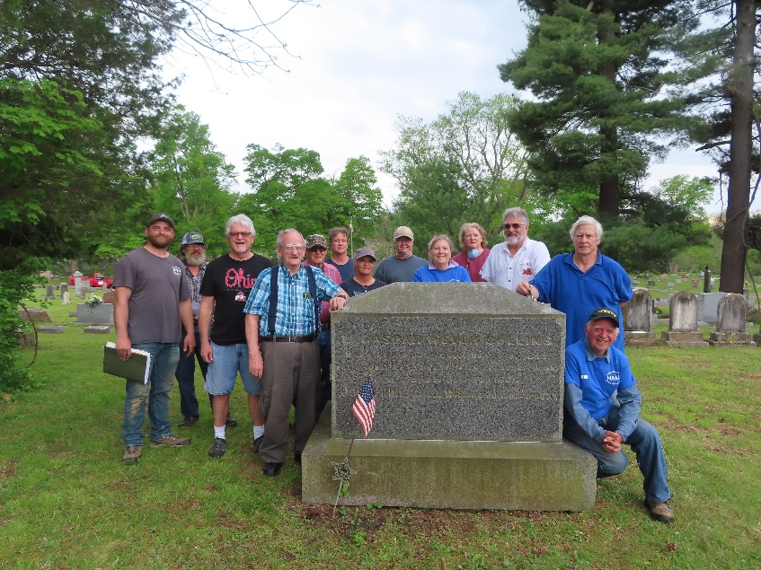
Highland ARA Helps with Memorial Day

In preparation for Memorial Day, several members of the Highland Amateur Radio Association assisted the Hillsboro Cemetery Association, the Highland County Historical Society and the local DAR Chapter place flags honoring the 900+ veterans who are buried in the Hillsboro Cemetery.

The project took a bit over an hour to cover the 30 acres thanks to the number of hams who assisted.

HARA members participating are shown at the grave of Caspar Collins, a Hillsboro native who was killed during the Indian Wars and for whom Casper, Wyoming is named. Caspar's father is also buried at this grave site. He was the first territorial governor of what was to become the State of Colorado. Fort Collins, CO is named in his honor.

####

TOP ^
Silvercreek Amateur Radio Association V.E. Testing

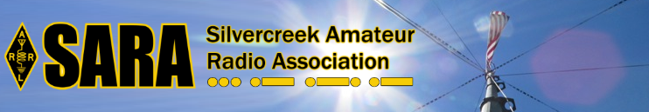
The Silvercreek Amateur Radio Association (SARA) **IS** having a VE Session on Saturday June 6th.

Information about the test session can be found here: https://w8wky.org/license-exams/

Upcoming Hamfests for 2020
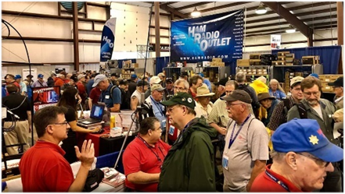

06/06/2020 | FCARC Summer Hamfest
Location: Wauseon, OH
Sponsor: Fulton County Amateur Radio Club
Website: http://k8bxq.org/hamfest

07/19/2020 | Van Wert Hamfest
Location: Van Wert, OH
Sponsor: Van wert Amateur Radio Club
Website: http://w8fy.org
07/26/2020 - Portage Hamfair '20
Location: Ravenna, OH
Sponsor: Portage Amateur Radio Club, Inc.
Website: http://hamfair.com
Canceled

08/01/2020 | Columbus Hamfest
Location: Grove City, OH
Sponsor: Voice of Aladdin/ Audio Unit of Aladdin Shrine
Website: http://columbushamfest.com
Canceled

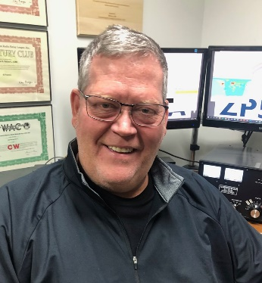
DX This Week
(from Bill, AJ8B)

DX This Week – Incoming QSL Buro
Bill AJ8B (aj8b@arrl.net, @AJ8B, or www.aj8b.com)
CWOPs Member #1567

I hope you have developed a daily “listening routine” on the bands. I usually start at the low end of 80 and then move up. Sometimes you have to do some research to see who has historically been on frequency and then listen as if they were there. DX operators have habits like everyone else.

TOP ^
They have a favorite frequency and time, so, take notes. I thought the bands were relatively busy, but there were not as many entities spotted as normal. However, the entities that were spotted in the US Midwest included Alaska, Belgium, Canary Islands, Czech Republic, Dodecanese, Ecuador, European Russia, Fed. Rep. of Germany, Isle of Man, Jamaica, Lebanon, Lithuania, Mexico, Morocco, Mount Athos, Poland, Slovenia, Sweden, Ukraine, and United Nations HQ. I did receive a couple of stateside cards this past week from K4YT – Karl in Virginia, KB1EFS – Steven in Massachusetts, and KL1JP – Dan in Fairbanks, Alaska.

(Pictured). Yep..that is a female moose that was standing in his driveway! Did you get any or send any this week?

Last week, I gave details about the ARRL Outgoing QSL Bureau. This is a cost-effective way to get physical QSL cards from your station to the DX Station. The tradeoff is time. The process also works in reverse and here is how it happens.

From the ARRL Great Lakes Division website: http://arrl-greatlakes.org/8th_bureau.htm

General QSL Bureau Information - The 8th call area bureau operates as part of the ARRL's volunteer QSL bureau system. As such, the operating expenses are paid by the league's members, although the bureau service is open to all US hams whether ARRL members or not. If you are not a league member, and use the incoming bureau, won't you consider joining today?

The bureau is 100% volunteer staffed. Each bureau worker forgoes their time to provide a service to you and we want to provide the best service possible within the bounds of reasonableness and fiscal responsibility. If you will follow the guidelines listed here, you will receive better service and our volunteers will have time to enjoy other aspects of our hobby, etc.
The 8th district central bureau is located at the Voice of America Museum in West Chester where it is one of the permanent displays. It is a work in progress, but if you have a chance to visit the VOA museum, be sure to look for the bureau. We do not encourage "just stopping by to pick up your cards" as there is no one there to release them to you. In addition, the only cards at the central bureau will be those that have not been forwarded to the individual letter managers. The best time to visit would be when the West Chester Amateur Radio Association (http://www.wc8voa.org/ ) has their regular meeting, if you want a more detailed bureau visit. Specifically, the Bureau Address is: 8th Area QSL Bureau / P.O. Box 307 / West Chester, Ohio 45071-0307. The Bureau Manager is John (Jack) Shirley, N8DX (n8dx@arrl.net)

Overall, DX QSL bureaus sort cards based on call areas of the USA and regularly send boxes of QSL cards to the appropriate bureau. In our case, the 8th area bureau accepts the shipment of these boxes and then sorts them in to 26 groups, A through Z, based on the first letter after the number 8. At regular intervals, these 26 groups are delivered to the appropriate sorter who then furthers sorts them by call sign. For this to work, there are several things to pay attention to.

TOP ^
#1 Do Not Send Your Outgoing QSL Cards to Us
We cannot process them; they will be sent back to you in your bureau envelopes. Outgoing cards should be sent to ARRL HQ. This includes cards for non-8th area US stations from any source, including any you may pick up from DX stations or bureaus on your out of US travels. You cannot use the ARRL bureau system to send cards to other U.S stations within the 48 contiguous states--for contacts between U.S. stations. Any cards sent for U.S.-to-U.S. contacts will also be sent back to you using your bureau SASE. You may use the ARRL bureau system for DX stations who have a U.S. manager, such as VK0IR cards via W8XXX, or XE3/K8XXX via K8XYZ. If you send cards via the bureau to a manager, make sure you list the full call of the manager, not just via "W8 bureau." There is no way we can know who handle or manages cards for every DX station around the world.
#2 Please Be Patient
QSL cards are rarely received by the bureau for contacts less than four months old. Most cards are for contacts made between a year and two years prior. Some cards come through the system as much as five years or more after the QSO. Some foreign bureaus send out cards only a few times a year. Most come by boat, which is very slow mail, indeed. There was a survey done of all cards received over a two-month period. Of those cards that had "TNX QSL" checked, less than 5% were for contacts within a year of the QSO. This means if the station you worked waited for your card before returning one, the minimum turn-around will be a year or more. Many DXers who are relatively new to DXing tend to work "big gun" or loud stations. These stations work many U.S. stations, and in most cases, wait for your card before sending you one. Those DX stations who answer your CQ are much more likely to send their cards first, rather than those whose CQ you answer.
Keep Envelopes on File with the Bureau
#3 - If you work DX at all, you should expect to receive bureau cards, especially if you work any DX contest. Do not forget that most SWL's send via the bureau as well. Unclaimed cards are the bureau's biggest problem. Send NON-clasp-fastening, end-opening envelopes, between 5X7 and 6X9 inches in size. Unless you receive lots and lots of bureau cards DO NOT send more than three or four SASE (self-addressed stamped envelopes) at a time.

DO NOT use envelopes smaller or larger that 5X7 or 6X9. Smaller envelopes will not hold some of the larger DX cards; larger envelopes won't fit in our files, are more likely to come apart in the mail process AND with current postage rates, cost more to use. Non-standard and padded envelopes may be returned to you empty. Padded envelopes are larger than 1/4 inch and incur a higher fee just like envelope larger than 6 x 9. Several of the letter managers are moving to or have implemented a cash basis process for their letters. This has been done because of the frequent postage rate changes and the futility of trying to keep appropriate postage on the envelopes.

Most of our Managers have email access. If you have an email address, PLEASE INCLUDE IT whenever you write to the bureau or your Letter Manager. Make sure to include your email address when you send SASEs to the bureau or to your Manager as well. This will help us to communicate with you much more quickly than by conventional snail mail. If your email address changes, make sure you notify your Manager of the change.
Please DO NOT SEND USED ENVELOPES to the bureau. We will *NOT* attempt to use used envelopes. More than one trip through the postal system greatly increases the chance the envelope will come apart in the postal system, with the loss of your cards.

TOP ^
When you prepare envelopes for us, NEATLY print your call, in BLOCK LETTERS, in the upper left corner, in the place where a normal return address goes. Some people do such a poor job of writing their calls we need to look up the suspected call in the Callbook and match the name/address to make sure of the call. Certain letters can be especially troublesome -- like V and U, for instance. Take the time to make a very pointed V and a round or square bottom U. Keep this in mind when filling out cards to send via any bureau. It is a real headache for bureau workers trying to decide who the card really goes to; we don't want to guess which letter you really mean. Address each envelope to yourself in the center of the envelope. Remember, these are your cards. If we can't read your call or the postman can't read your address, you won't get them. If you have a change of address, send us address labels to cover your old address. Many people write so large, there is no room to write a change of address on their SASE.

If sending envelopes with stamps, affix enough postage to cover at least one ounce. currently, the post office is selling a "forever" stamp good for one unit of postage.
We do clear out all cards once a year. No matter how much postage on your SASE, and how few cards you have, once a year we will send you what you have. When postal rates go up, you should send extra stamps to cover the cost increase. Most people never think to send us extra postage when the rates go up.
#4 - NEVER put more than one call on an envelope. We cannot cross-reference upgrades, vanity calls, and family calls. Some of the Letter Managers live many miles apart. There is no way to share an envelope between two Letter Managers. If you send an envelope with SASEs for more than one call, make sure you include a note saying you have done so. We don't take the time to look at each SASE you send us. If there is no note pointing out the fact you've sent SASE for multiple call, we simply pass them on to the Letter Manager for the first SASE we see. You may include a self-addressed postcard which we will return, letting you know your SASEs have arrived safely.
PLEASE NOTE: If you expect to receive cards under more than one call sign, please keep separate SASEs at all the Letters or 2Bureaus where you expect cards to be received. We will not "forward" cards for one call to another letter manager within our bureau or to another bureau unless you provide the SASE. It is/was your call and your QSO, if you want the cards, provide the SASE.
Again, the normal mailing cycle for the bureau is about every four to six weeks. If you don't worry about us wasting your postage, put "mail every cycle" on the bottom of each SASE and we will send you what you have each time, without the need to fill your SASE to the value of postage you've placed on it. If you are a big gun contester, DXPeditioner, or manager of a very active DX station, and get a pound or more a month, you may request your Letter Manager to box your cards to save on postage. Don't send money for this via the bureau. This MUST be between you and your Letter Manager, with the check made out in his name. If he does not want to take the time to do it, and requests you just send him SASE, that is the way it will be. The volunteer Letter Managers have enough of a job, and it is up to them if they want to do more. Any money for this extra service must be between you and your Letter Manager, not the bureau.
On the other hand, if you do not want to receive bureau cards, please advise your letter manager that you do not want them. If you are the manager for a DX station, including your own DX operations, and do not want bureau cards for those operations, but do want bureau cards for your US to DX contacts, we will not return the DX cards to the originator. We will destroy them. Also, be advised, if you elect to pursue this scenario, we will not be responsible for destroying cards you wanted to receive and were accidently destroyed. Remember, we are all volunteers and every special request takes volunteer time.

TOP ^
The Standard Operating Guidelines for ARRL QSL Bureaus states: "QSL cards on file which are unclaimed for a period longer than 90 days may be destroyed by the Bureau Manager (or Letter Manager) without further authority." PLEASE NOTE: Individual Letter Managers may elect to hold unclaimed QSL Cards for a longer period, at their discretion. Once we have made reasonable attempts to contact you that you have cards at the bureau and have received no correspondence (SASE) from you and destroyed your cards, we will make a note in our files and *NOT* contact you again. We will continue to destroy your cards on a continuing basis until we receive instructions to the contrary. You may consider this extreme but consider again that the biggest problem we have is unclaimed cards and the effort our volunteer letter managers expend trying to get them to the intended recipients. Before we destroy the cards, the following has occurred: A card has been sent, not at your expense, to your address of record, according to the FCC data base. (If that address is incorrect, you are not complying with the FCC regulations and are operating illegally!) In addition to the card, an email has been attempted using the address, <your-call>@arrl.net and/or any address in the various on-line callbooks.
1x1 calls: A new headache for the bureau are the new 1X1 calls being issued. You may do a good job of trying to tell each QSO to send the cards via N8???, but you can be sure some cards are going to come into the bureau with just the call N8?. There is no way for us to know who these cards go to if you don't supply SASE for these 1X1 special calls. It appears it is even more of a headache, since the same 1X1 calls will be re-issued to other special event stations, time-after-time. Make sure you list the time frame of the special event 1X1 on your SASE, so we will know who gets what cards. You had the 'FUN' of using the 1x1, you should follow through with the SASE.

Bureau Operating Procedures
The mail is picked up at the PO Box on a regular basis, approximately once per week. There may be as little as five pounds to as much as 200 pounds in a week. You can visualize this by thinking of a stack of QSL cards ranging from 9 inches high, to over 29 feet high, each week. At the central bureau we sort the cards into 27 piles - one for each letter of the alphabet according to the first letter of the suffix and one for mis sorts from the other bureau, cards sent to the 8th area bureau that should go to the 9th area bureau, for example.
The cards are then conveyed to the individual Letter Managers. Some managers will personally pick the cards up from the central bureau every few weeks. Most are mailed via USPS or UPS every four to eight weeks, depending on volume.

If you send a request for information to your Letter Manager via the Bureau address, it may have just missed the last pickup, requiring another six weeks to make it to your Letter Manager. It will save you time to check directly with your Letter Manager if you just want to check on the status of your cards and SASE.
Good cooperation between the DXer and the bureau is important to ensure a smooth flow of cards. Remember that the people who work at the bureau are all volunteers. At the peak of the last cycle, we handled over two tons of cards a year. In the trough of the cycle relatively few cards are received. We are on the downslide now. For that reason and with the implementation of Log Book of the World, you should expect card volume to begin to drop off.

#5 - With that in mind, please pay close attention to the above information, and the following DO'S and DON'TS.

TOP ^
- DO keep self-addressed 5X7 or 6X9 envelopes on file with your call in the upper left corner. Affix at least one ounce of postage to each. After checking the Letter Manager list above, you may send your SASE directly to your Letter Manager.

- DO put your Call Sign on the outside of all envelopes containing SASEs or requests for information, sent to the Bureau or your Letter Manager. This will keep your envelope from having to be opened by Bureau Staff to determine where it should be forwarded.
- DO keep envelopes at all Letters and Bureaus where you expect to receive Cards. If you have had a call sign change, we have no way of forwarding your old cards to your new Letter Manager, so please have an SASE waiting at both the old and new call sign Letter Managers Bureau.
- DO include your E-Mail address with all correspondence to the Bureau or your Letter Manager.
- DO send the bureau enough postage to cover the SASE on file and enough to cover postal rate increases.
- DO respond quickly to any bureau request for more SASE or additional postage. Remember, unclaimed cards are the bureau's single biggest problem.
- DO include an SASE with any information request to the bureau.
- DO notify the bureau in writing if you don't want your cards.
- DON'T expect DX cards to arrive for at least a year after contact. Overseas delivery is very slow. Most cards are over a year old when received by the Bureau.
- DON'T send your outgoing cards to this bureau.

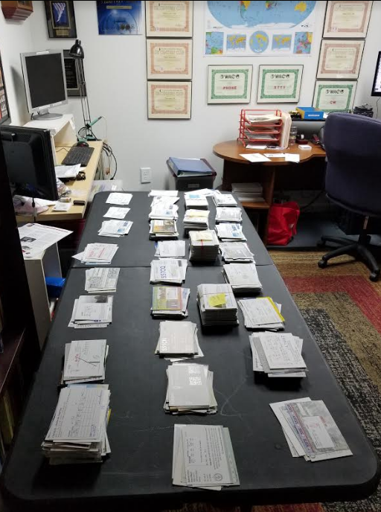

This is a picture of my “sorting desk” after Caption Jack delivers a box of cards for me to sort and send to the recipients. I am the “N” letter sorter which mean that I process QSL cards for hams whose calls are between AA8N and WY8ZZZ! It does take time, but, it is also very rewarding. Please follow the directions I have provided above. If you have any questions about any callsign, you can drop me a line.

TOP ^
CQDX CQDX CQDX CQDX CQDX CQDX CQDX CQDX CQDX

Here is an update from Bernie, W3UR, of the DailyDX and the WeeklyDX, the best source for DX information. http://www.dailydx.com/. Bernie has this to report:

CY0 – Sable Island - WA4DAN, Murray, and N0TG, Randy, remind everyone of the October 17-26, 2020 CY0C DXPedition to Sable Island. If you are bored during the Coronavirus Stay At Home and are “looking for something to do?” they suggest checking out their website. “Check out the sponsors, maybe even become one, visit the team page to see who’s who, and enjoy viewing the team’s previous video [2019] DXPedition to St. Paul”. The MPG4 video can be downloaded and shared with friends and your club. Also while on the website check out and participate in their “Sable most needed band, mode, ATNO, etc.”

CQ DX Marathon Manager K9EL, John Sweeney, has a Callsign Notes and Bad Spots pages to help those participating in the annual event.

JD1/O – Ogasawara Islands - JD1BHA (aka JR7ISY), Mikio Goto is living permanently on Hahajima (Haha Island), which counts as AS-031 for IOTA. He has an IC-756ProIII and IC-PW1, FT-991A and UTV-1200BII (transverter for 23cm) and an IC-7300. Mikio can operate on 160m-23cm. He is mostly active on FT8 and CW and occasionally on SSB. As for antennas he has a 43 foot Vertical and G5RV on HF, a 2 element Swissquad on 6 meters, a two band Yagi (5 elements and 8 elements) for 2m and 70cm and a groundplane for 2m/70cm/23cm. YA – Afghanistan

OX, V7, VQ9, KH9 and V2 – Greenland, Marshall Islands, Chagos Islands, Wake Island and Antigua and Barbuda - Due to the Coronavirus issues at our Military Bases WW6RG, Randy, has not been able to get to some of his normal destinations. However, it seems things are likely to open “up in the next month or so”. With that in mind over the next few months Randy expects travel to Thule, Greenland; Kwajalein; Diego Garcia; Wake Island; and Antigua. Once he has more details, he’ll keep us posted on times and dates.

FW – Wallis and Futuna Islands KH0/KC0W - Tom, is working on plans for a DXPedition as FW/KC0W to Wallis Island (OC-054), “unfortunately due to the state of the world right now most DXPeditions are kinda stuck”. Tom has obtained “time off from work” and is “waiting for travel to open up once again”. Over the past month the airport in “Saipan has been closed”. The dates of this DXPedition will be announced “as soon as international travel is accessible again” as Tom is “just kinda putting the word out there that a FW land DXPedition will happen (hopefully) sometime in the near future”. He plans to take an Elecraft rig and KW amp with hopes of being close to salt water to use verticals. Activity is planned for CW on 7 through 50 MHz, “the possibility of FT8 on 160/80 only”. Once there Tom will put in a “strong emphasis on Europe & East Coast USA”. QSOs will be uploaded to Club Log. QSL direct to KC0W.

DX news

ARLD020 DX news

This week's bulletin was made possible with information provided by The Daily DX, the OPDX Bulletin, 425 DX News, DXNL, Contest Corral from QST and the ARRL Contest Calendar and WA7BNM web sites. Thanks to all.

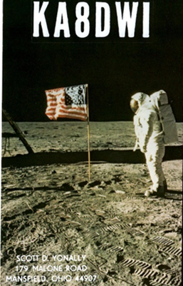
GREENLAND, OX. Bo, OZ1DJJ is QRV from Aasiaat Island (NA-134) as OX3LX, in his spare time. He will be active until May 21. QSL via OZ0J.

GEORGIA, 4L. Look for Vakhtang, 4L8A in the CQ WPX CW contest May
30 and 31, on 20 meters, single op. QSL via M0OXO, OQRS and LoTW.

SINGAPORE, 9V. 9V1STAYHOME will be active until June 30. QSL via via LoTW only.

THAILAND, HS. Members of the Radio Amateur Society of Thailand
(RAST) will be active as E2STAYHOME until July 15. QSL via E21EIC (d/B), LoTW or ClubLog.

GUANTANAMO BAY, KG4. Kelly, KG4NE expects to be QRV until at least May 28, with activity on 40 and 6 meters. QSL via LoTW, eQSL or his home call, NM7H.

KENYA, 5Z. Members of the Radio Society of Kenya (RSK) are joining the COVID-19 effort with the call sign 5Z4STAYHOME. QSL via bureau.

WEST MALAYSIA, 9M2. The Malaysian Amateur Radio Transmitters Society (MARTS) will be QRV with special event call signs 9M4STAYHOME, 9M4COVID and 9M4DUDUKRUMAH for three months, beginning on May 15. Look for them on the HF bands using SSB, CW and digital modes. QSL via bureau or 9W2PD direct.

SPAIN, EA. AM40LAR celebrates the 40th anniversary of a radio program dedicated to amateur radio and broadcast by RNE Radio 4. They are QRV until May 31. QSL via eQSL or LoTW.

ENGLAND, G. GB2CCW will be active during the second half of May, honoring care workers during the pandemic. QSL via eQSL only. Also, stations celebrating the end of World War II include GB0PIE, GB1PIJ and GB4VED. QSL all via eQSL.

NETHERLANDS, PA. PD75DDAY commemorates the liberation of the Netherlands during World War II. They will be QRV until the end of May. QSL via bureau.

AUSTRALIA, VK. Australian amateurs may use the prefix AX on May 17 to mark the World Telecommunication Day.

INDIA, VU. Members of the Tripura Ham Radio Club support the present stay-at-home operations as AT2THC until August 1 on the HF bands. QSL via VU2LJB.

STAY AT HOME SPECIAL EVENT STATIONS. The following stations join the ranks to support stay at home efforts: 6Y6STAYHOME, AU2COV, GB2CCW, HA0HOME, HA0STAY, OE1STAYHOME and SZ3STAYHOME.

CANADA, VE. Jean, VE2JCW will use special call sign VE2SPEED, through the month of June to commemorate the Montreal Grand Prix, even if the race is canceled. QSL via VE2JCW info on QRZ.com.

TOP ^
COLOMBIA, 5J. 5JSTAYHOME is the latest COVID-19 special event station from Colombia. Note there is only one number in the call sign.

MOROCCO, CN. Look for 5C1WTIS to celebrate World Telecommunication and Information Society Day, until May 17. QSL via RW6HS.

SAUDIA ARABIA, HZ. The Saudi Amateur Radio Society will join the on air activity for World Telecommunication and Information Society Day with HZ1WTIS, until May 17. Also, HZ1DG is a new six meter beacon, transmitting on 50.055 MHz and using 5 watts into a vertical antenna. The grid locator is LK18gf.

GERMANY, DL. Station DL70IPA will be QRV as part of the 70th anniversary of the International Police Association. IPARC, the IPA Radio Club, plans various operations in August and November.

JAPAN, JA. Members of the Yoneyama HF Club (JR0YHF) will be operating special event station 8J0K in celebration of the 80th anniversary of Kashiwazaki city in Niigata Japan. They will be QRV until March 31, 2021, on 1.8 MHz through 5.7 GHz.

USA, K. Special event station K7P is on the air until May 16 to remember law enforcement officers killed in the line of duty. Look for them on 40 and 20 meters. There will be a commemorative QSL card. QSL direct with SASE to N7WR.

SAMOA, 5W. COVID-19 special event call 5W19STAYSAFE will be operated by Atsu, 5W1SA. Samoa is one of the very few places on earth that has no reported cases of the novel Coronavirus due to the early government lockdown.

THIS WEEKEND ON THE RADIO. The UN DX Contest, NZART Sangster Shield Contest, Portuguese Navy Day Contest, His Majesty King of Spain Contest, Aegean RTTY Contest, Feld Hell Sprint and the Run for the Bacon QRP Contest are all on tap for this weekend. The RSGB FT4 Contest Series is on May 18. Please see May 2020 QST, page 69 and the ARRL Contest Calendar and WA7BNM Contest Web Site for details.

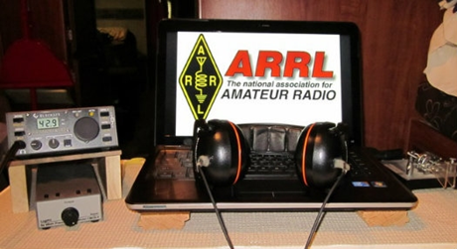
ARRL Contest Corner

An expanded, downloadable version of QST's’Contest Corral is available as a PDF. Check the sponsor's’Web site for information on operating time restrictions and other instructions.

Special Events

- 05/18/2020 | Memorial Day
May 18-May 25, 0000Z-0000Z, K1A, Cleburne, TX. Club KC5NX. 14.250 14.045 7.233 7.045. QSL. Club KC5NX, 9200 Summit Court West, Cleburne, TX 76033-8212. K1A will be on the air the week May 18th till the 26th to honor the many lives lost in the service of the United State Military. Sponsored by Club KC5NX deep in the Heart of Texas! club.kc5nx@gmail.com or www.qrz.com/db/kc5nx

TOP ^
- 05/18/2020 | The Indianapolis 500
May 18-May 24, 0400Z-0400Z, W9IMS, Indianapolis, IN. The Indianapolis Motor Speedway Amateur Radio Club. 18.140 14.245 7.245 3.840. Certificate & QSL. Indianapolis Motor Speedway Amateur Radio Club, P.O. Box 30954, Indianapolis, IN 46230. See the website for ALL information! www.w9ims.org

- 05/20/2020 | Apollo 11
May 20, 1330Z-2030Z, K2CAM, Garden City, NY. Long Island Mobile Amateur Radio Club in support of the Cradle of Aviation Museum. 21.340 14.240 7240. QSL. LIMARC, P.O. Box 392, Levittown, NY 11756. The aerospace industry on Long Island was a significant part of the moon landing project. Much of that history is displaued at the Cradle of Aviation. Visit https://www.cradleofaviation.org/ or www.limarc.org

- 05/22/2020 | Birthplace of Memorial Day -- Boalsburg, PA
May 22-May 25, 2000Z-2000Z, W3M, Boalsburg, PA. Nittany Amateur Radio Club. 14.245 7.185 3.845 146.85 (-). QSL. W3M c/o, Nittany Amateur Radio Club, P.O. Box 614, State College, PA 16801. https://www.qrz.com/lookup?callsign=W3M

- 05/22/2020 | Memorial Day
May 22-May 26, 0100Z-1000Z, K5E, Rockdale, TX. KI5DQ. 144.250 14.265 7.265. QSL. James Hunt, 1026 Valentine Dr., Sherman, TX 75090. Memorial Day - to honor and remember those made the ultimate sacrifice in service to our nation. Camp out @ Apache Pass Event Center. 14.265, 7.265mhz +/-5 and 144.250 usb. SASE for QSL card @ KI5DQ.

- 05/23/2020 | 4th Annual Special Event at the Fort Pierce Navy Seal Museum Honoring National Military Month
May 23, 1300Z-1900Z, W4OT, Fort Pierce, FL. Vero Beach Amateur Radio Club. 14.330 +/-; D-STAR Ref078C. Certificate. Vero Beach Amateur Radio Club, c/o IRC EOC, 4225 43rd Avenue, Vero Beach, FL 32967. The National Navy SEAL Museum is the only museum dedicated solely to preserving the history of the United States Navy SEALs and their predecessors. Located in Fort Pierce, Florida, the Museum resides on the training grounds of the original Navy combat divers, the Frogmen. Built to honor the men who served with fortitude and dedication, the Navy SEAL Museum first opened its doors on Veterans Day in 1985.

From humble beginnings, the facility has experienced tremendous growth, achieving national stature in 2007. The main objective of the Museum remains the promotion of public education by providing the opportunity to explore the history of the United States Navy SEALs through interactive exhibits, while honoring the fallen at the Navy SEAL Memorial and caring for those warriors’ families through the Trident House Charities Program. https://w4ot.webs.com

- 05/23/2020 | 4th Annual William Becknell Heritage Days Special Event - Founder of the Santa Fe Trail
May 23-May 24, 1400Z-2200Z, WB0SFT/KC0VYS, Overland Park, KS. William Becknell Santa Fe Trail Heritage Days. 21.365 14.265 7.265 3.865 1.830; SSB CW FT8. Certificate & QSL. See website, for information on, receiving certificate or QSL. On the trail 1x1 calls, W0B through W9B, and Parks on the Air (K-4579) activation. QRZ and LoTW. See website for details, and how to receive a certificate and/or QSL. www.wb0sft.org

TOP ^
- 05/23/2020 | Gulf Coast Hurricanes Special Event 2020
May 23-May 27, 0001Z-2359Z, AG5Z, Purvis, MS. Larry Morgan. 3.862 7.250 14.255 21.300. Certificate. Larry Morgan, 96 Oak Haven Rd., Purvis, MS 39475. Stations include W4F Florida, W4A Alabama, W5M Mississippi, W5L Louisiana, W5T Texas, bonus station K5H (Katrina 5 Hurricane) Hurricane experiences discussions are encouraged. For this reason FT8 contacts will not count. This special event is to increase awareness of the hurricane season that will start on June 1. www.ag5z.net

- 05/23/2020 | Strange Antenna Challenge
May 23-May 25, 0001Z-2359Z, K0S, Springfield, MO. Erik Weaver, N0EW. 28.400 14.300 7.200 3.900. QSL. Erik Weaver, 4857 E. Farm Rd. 136, Springfield, MO 65809. Antennas for the Strange Antenna Challenge are to be constructed of unusual, make-shift, or debris material that may be on hand following a natural disaster. Past examples include bridges, statues, folding chairs, bed springs, fences, beer/pop cans, tomato cages, and shopping carts. Basically, just do NOT use standard pipe or wire antennas. We encourage any ham who wishes to become their own special event station, by simply appending /k0s onto your own call sign, and you need to respond to your own QSL requests. N0EW will be operating the three letter call sign K0S. This is tons of fun! I encourage you to promote your club with this "strange" event, and let the media know what you are doing! erikeweaver@gmail.com

- 05/25/2020 | Memorial Day Observance THIS EVENT HAS BEEN CANCELLED
May 25, 1600Z-2130Z, W5KID, Baton Rouge, LA. Baton Rouge Amateur Radio Club. 14.250 14.035 7.225 7.035. QSL. USS KIDD Amateur Radio Club, 305 S. River Road, Baton Rouge, LA 70802. Operation aboard the USS KIDD (DD-661), WW II Fletcher class destroyer. THIS EVENT HAS BEEN CANCELLED. qrz.com/db/w5kid

- 05/30/2020 | Audie Murphy
May 30, 1300Z-2200Z, W2A, Christiansburg, VA. New River Valley Amateur Radio Club. 14.262 7.262 3.860. QSL. Danny Wylam, 710 Mc Daniel Dr., Christiansburg, VA 24073. Brush Mountain,VA, on the Appalachian Trail near the Audie Murphy Memorial. dannywylam@gmail.com

- 05/30/2020 | Girl Scout Camporee
May 30, 1500Z-2000Z, K2G, Kingston, NY. Overlook Mountain Amateur Radio Club. 14.240; DMR Tg 31630. QSL. Overlook Mountain Amateur Radio Club, P.O. Box 48, Hurley, NY 12443. Local talk-in 146.805, -0.6, PL 103.5 www.omarcclub.org

- 05/30/2020 | Mike the Headless Chicken Festival
May 30, 1600Z-2359Z, W0M, Fruita, CO. Western Colorado Amateur Radio Club. 14.235 14.074 7.230 7.074. QSL. WCARC , Mike the Headless Chicken, 2695 Patterson Rd. Ste. 2 Box 118, Grand Junction, CO 81506-8815. Phone and FT8 on 20 and 40 meters. Local 2 meter repeater 146.940. CW demonstration as requested on 20 or 40 meters. QSL card direct or by LOTW. See City of Fruita site http://miketheheadlesschicken.org for history. www.w0rrz.org

- 05/31/2020 | Iowa State Parks On-the-Air Centennial – Backbone
May 31, 1500Z-1900Z, W0OEL, Dundee, IA. Rural Iowa and Buchanan County Amateur Radio Clubs. 14.240 7.240. Certificate & QSL. Great River ARC, P.O. Box 1384, Dubuque, IA 52004. IASPOTA-2020 Dedicated in 1920 as Iowa’s first state park. The steep and narrow ridge of bedrock from the Maquoketa River forms the highest point in northeast Iowa the Devil’s Backbone - giving the park its legendary name. Certificate & QSL managed by Great River Amateur Radio Club, P.O. Box 1384, Dubuque, IA 52004. QSL for contact; certificate for 5 parks. See website for complete information. www.w0dbq.org/rules or www.w0oel.com

TOP ^

Special ICS 300 & 400 Training being offered

For those interested in attaining ARES Level 3 certification, the State of Kentucky plans to offer these courses in Ashland at the Boyd County EMA:

Intermediate ICS for Expanding Incidents (ICS-300) June 23-25
Advanced ICS Command & General Staff for Complex Incidents (ICS-400) July 14-15

Though not part of the ARRL curriculum, another good class is:

ICS/EOC Interface Workshop (G-191), September 16

Prerequisites for these courses is completion of IS-100, IS-200, IS-700 and IS-800. All 4 of these courses are online and free from FEMA Independent Studies program.

For more information go to https://kyem.ky.gov/training/Pages/default.aspx and scroll down to June, July and September.

Gregg Hendry, W8DUQ

“ARES Connect”
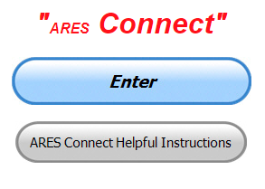
Everyone – please make sure to go into all of the events that you have signed up for and get your hours registered no later than 5 days after the event has ended.

Folks, I’m seeing a lot of folks that have signed up for events not entering their time after the event. This is a very important piece of using “Connect.” Your hours need to be recorded and it’s so easy to do.

Let’s run through how so in case you have forgotten. If you have already gotten signed up for an event, all you have to do afterword to get your time entered is at any time after the event has ended, log into “Connect.” And then click on your name in the upper right-hand corner of the page. This will bring up a drop-down menu where you will then click on “View Hours.”

This brings up another screen where you can “Report Hours” as well as “View Hour History” You’ll want to click on “Report Hours.” You will then be presented one at a time by chronological order each event that you have signed up for and hours have not yet been reported on.

Type in those hours in the “Hours Worked” box and hit “Submit”… Keep doing this until you have no more hours to report…. That’s all there is to it. Now, if you are following the request above and doing this at least every 5 days or more often, this will only take you a minute or so to complete.

TOP ^
We still have a number of recurring events created but no activity reported for them. Please, if this event is no longer needed, let me know and I can delete it from the masters. I know that many of you setup recurring events to learn how, but if they aren’t going to be used, let’s get them cleared out.

Also… If you are setting up events, please don’t set a limit for how many folks can sign-up unless absolutely necessary. This causes issues when doing reports. It’s also counter-productive since the reason for you to list the event is to get as many volunteers as you can to attend. When you set limits, it discourages folks from signing up.

Now, isn’t that easy? Yes, and we all need to be diligent at doing it promptly.

Here’s are the top 10 hours earners for May:

 | Name | Events | Hours
1 | Daniel Schlick (KB8LKH) | 17 | 54.42
2 | Dan Stahl (KC8PBU) | 47 | 52.42
3 | Alan Rothweiler (N8CJ) | 18 | 42.75
4 | Bret Stemen (KD8SCL) | 15 | 42
5 | Greg Dersarkisian (KD8SSJ) | 11 | 40.5
6 | LaVergne Pabian (N8HLP) | 7 | 35
7 | Earl Paazig (W8BR) | 13 | 31
8 | David Brett (KD8NZF) | 18 | 28
9 | Elmer Thomas (KE8HNK) | 24 | 22
10 | Francis Sole (wb8yhd) | 10 | 21

Let’s get everyone in the Ohio Section on “ARES Connect!!!” Simply go to: https://arrl.volunteerhub.com/lp/oh/ and get yourself registered and using the system.

One Question Questionnaire

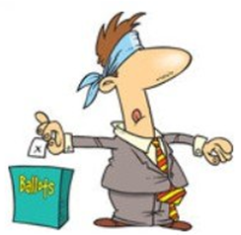
Hey Gang,

“Survey Says”….. It shows that about 73% of you would will not be getting together with family this Memorial Day. That’s really not too surprising with all the uncertainty in the state and country right now.

Now, on to next question.

“Have you earned the ARRL Worked All States Award Yet?”

You’ll find the “One Question” questionnaire on the Ohio Section Website! http://arrlohio.org It’s all in fun and it’s not a scientific survey in any way, but we are learning some things that we didn’t know from these questions. I hope that you are enjoying answering these “One Question” questionnaires.

TOP ^

New – Dashboard for the Ohio Section’s ARES Connect

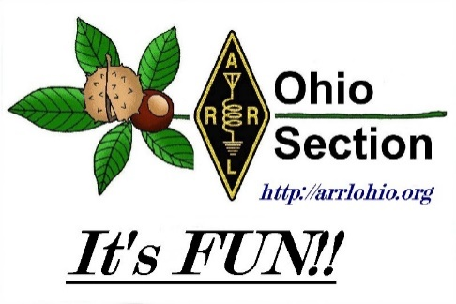
Many of you have been following the new Dashboard for the Great Lakes Division and have asked if I can break the numbers down to for the Ohio Section to the county level.

After some thought and research I’ve found a way of getting a worthwhile report that is not only easy to read and understand, but one that can be very useful for everyone to be able to track the events and hours that they have participated in.

The Dashboard gives the county name and the hours recorded for that particular county. If you want more details, you’ll need to download the Excel file that will break it all down for you. You can take a look at all 88 counties and what they’ve been up to.

Here’s a link for you… http://arrl-ohio.org/SEC/ARES-Connect-County.html

V.E. Test Sessions
For the most part, all V.E. testing has stopped until such time as we can once again gather in groups.

Keep on studying and taking those practice tests to keep what you’ve learned fresh in your mind. We will get out of this soon and testing will resume, so you’ll want to be prepared for when it does return.

30 May Nationwide Red Cross Radio Drill

Overall Goals:
- Activate county level ARES organizations for shelter communications.
- Pass messages containing Red Cross information between simulated shelters and County Control Station with an emphasis on digital communication.
- Organize and pass message to a state hub via fldigi or WinLink.

Details
- Activate county level ARES organizations in a configuration to serve Red Cross and shelters. This would typically be a second layer to existing EMA/EOC communications after a large event.
- Simulate deployment of ARES stations to likely local shelter sites. Establish a central control station - under OSERP this would typically be the “County Control Station”.
  - The exercise assumes NO POWER, no phones, no Internet so at the least your “Shelter stations” must run auxiliary power.
  - Lack of power also dictates: NO REPEATERS so arrange your simplex nets accordingly.

TOP ^
- Pass standard Red Cross message forms from shelter to Control.
  - Note: the national preferred format is WinLink. In Ohio, we would fall back to fldigi, which has the capability to transmit Red Cross forms.
  - Voice messaging is acceptable at the local level
- Counties may optionally forward to District Control Stations if district nets are activated, or forward directly via HF to our hub stations for Ohio.
  - For this exercise we are not contemplating using “The Sarge” since it’s committed to Ohio EMA (and would typically be in use for that function.)
  - Just as would happen at the local level, we will need to create a second-level net to handle state Red Cross messaging. We have a few options that are undecided but are fairly certain one station will be at the Delaware Chapter (N8DCA) on HF (80 meters) fldigi. We can also have voice communications if necessary but will probably try to stay in digital mode around 3585 (MT631KL 3000 or in bad conditions Olivia 8/500 3000)
  - We do not have direct RF WinLink access at Delaware, but for purposes of the exercise we will have Internet access at our state hub station(s). Winlink messages should go to N8DCA.
- Log and track your performance; create AAR to show our effectiveness to Red Cross.

Time Period
The exercise will take place May 30

May 28: A 213 will go out to all counties requesting stations to prepare for shelter activity deployment. (Remember, this is simulated deployment!)

May 30: The national timeframe launches the exercise at 1PM local (1700 UTC) with requests for forms (6409) from shelters. Shelter stations send 6409 to County Control Station. Make sure “This is an exercise” is included at the beginning of each form.

Forms will be transmitted to state network control stations (again, at least N8DCA there may be others).

Need more info? Contact Stan at: stan@standi.com

####
Additional Information

Hey everybody! I was going to send this to Matt as he is structuring the topology, but then thought you all could benefit from this in terms of setting up your counties for May 30.

One of the biggest points of discussion was “Where do the messages go??”

ARC plans on using the Dayton Chapter K8DRC station (Miami Valley Chapter now) as the receiving point for ALL messages.

The Delaware station N8DCA will be on as a potential HF relay point for stations that can’t directly reach Dayton on HF.

We will need to create a VHF path to help rely into Dayton from the western part of Ohio, the same with Delaware in Central Ohio.

TOP ^
Those ARES stations that have WinLink (Thinking Cincinnati here mostly) can enter messages directly to Dayton.

So, we’ll need a topology that takes those destinations in mind.

Our collective understanding is that the ARC will furnish 6409 (requisition forms) to us, to be ‘originated from shelters’ within a county.

Matt will work on building out the network, but now we have something to go on.

For DEC’s PLEASE encourage your county EC’s to participate! This is important to ARES, allowing us to demonstrate to ARC that we can handle messages accurately to their Chapters. It shouldn’t take a lot of time- I’m hoping for three stations in each county to merely originate on fldigi/flmsg their forms.

For all: there is a Red Cross message .zip that contains the proper forms. They do NOT behave as native flmsg forms, but are easily accessed from the “custom form” dropdown. Union County EC ED Liddle, KE8ANU, has put together instructions on these forms… https://youtu.be/9CqMAaP4wc8 Share out the link if you like.

Thanks for participating!! We’ll get more information out to you when Matt has worked his magic.

-Stan

Final.. Final..

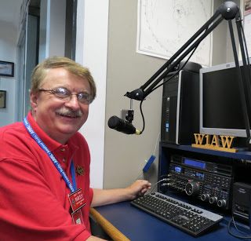
Hi Gang,

This past week has been interesting for sure. It seems like we’ve finally turned the corner on our weather. I finally got out and mowed the lawn for the first time this year and even found some time to go out and ride the Trike a couple of times. Feels good, but now I’m a tad bit sore from all the extracurricular activities. Oh well, I guess you can’t have your cake and eat it too!..

It looks like AccuWeather was spot on the target for their long-range forecast of this past weekend. It would have been a real experience at the Greene County Fairgrounds for sure. I’m confident that next year will be absolutely beautiful with no rain and the temperature in the mid 70’s. Stuff will be flying off of the shelves of our vendors and the Flea Market will have absolutely nothing left to sell by Sunday morning. Am I an optimist? Absolutely, but I also know how hams are, they’ve been cooped up for a very long time and that mad money that they’ve saved is burning a whole in their wallets. Bargains will be abounding since the vendors didn’t sell anything over this period of lockdown, so there’s a lot of pent up purchasing power that will have to be exhausted.

TOP ^
Switching Bands… It appears that the governor is slowly allowing the opening up of retail stores which has brought out the absolute need for some folks to go and shop! I watched the opening of a store on the news the other night and you would have thought that it was Black Friday the way folks rushed the doors as they were being unlocked. I can’t believe how many folks just couldn’t wait to spend their stimulus checks on stuff they probably don’t even need, they just needed to spend! Oh well, this too will be something that we can all sit back and reflect on a few years from now.

Now, on the subject of the governor opening things up a bit. I’ve been hearing from some folks that are making plans for Field Day. Yes, it’s just about a month away right now and plans need to be made for sure. But please, keep in mind that the governor still hasn’t released the order for having more than 10 people gathered, and even though we can gather in really small groups, everyone has to remain at least 2-meters apart from each other. This means no real picnics or club gatherings to celebrate Field Day. No, I don’t like this either, but it is what our government officials have decided is best for us and our state right now.

Now, as far as Field Day. Please keep in mind that it isn’t a weekend of “contesting.” Field Day was actually designed to be a public display on how amateur radio can be effective when everything else is either overloaded, or non-existent. Now, since we really can’t do the public displays without going through all the hub-bub of sanitizing and making sure everyone keeps a safe distance, we’re going to have to rethink how we are going to go about this. Yes, we can use our new technology and just remote everything so that we can just “stay at home.” But, is that what Field Day is about? No.. And, like I said at the beginning, it’s not a “Contest” either. I know that there are points to be had and a goal of obtaining the top prize (pride) by being number 1 in the country for your setup, but let’s keep things in perspective. Field Day is actually designed to be an event to show the public that we CAN truly live up to what we advertise everyday… “When All Else Fails…”

Operating by remote, as some have suggested, may not be an option when “all else fails.” This is a test of your ability to go out into the field with very little preparation and very little to work with, and setup a “communications station” where you can make contact with those outside of the your affected area. It’s not about bringing in mobile towers that stand 100-foot-tall and 50 KW generators that can light up half a city. It’s also not about scouting out locations that have internet connections that would rival the best Internet Service Providers and bathrooms and fully equipped kitchens on station. It’s about doing this event with as little as possible and still being able to communicate with the outside world.

If this were an actual emergency, you won’t most likely have the luxury of all those creature features. You’ll be looking for a tree or any kind of structure that is still standing, so that you can throw a wire over it to get some height. It’s about knowing how to get your station up and running when there’s not much else working. You’ll also most likely not have any ability to bring in those fancy mobile vans or trailers, as that the roads may not be cleared enough for that. So, what do you do? You improvise, you use what’s available to you and you show the public that we truly are there and able to operate “When All Else Fails…” How? Easy, you set up your station using what you have available and take pictures. Make posts on Facebook, Twitter and other social media outlets. Let the folks know that you really can operate “When All Else Fails!!!”

I’m sure a number of you can pull up memories of Field Days in the past. I sure can. I can remember back in the 50’s and early 60’s going out with my brother to a Field Day event. No, I wasn’t a ham operator yet, but I did log for my brother. Were things different then? Yes, we actually went out into a field and setup. We setup the operations around 1pm on Saturday and had several stations up and running fully by 2pm. Nothing was fancy, we operated using the radios of the day (tubes) and wire antennas with tuners.

TOP ^
No fancy towers or beams back then, we kept it simple and easy to setup, operate and teardown later. We didn’t have the fancy computer software packages that automatically kept track of our contacts and dupes. This was something that was done by hand. We operated from small noisy gasoline generators that would run about 3 to 4 hours and then had to be refueled, not the big trailer mounted 25 or 50 KW diesel generators that some use today. No coffee makers, microwave ovens or any other devices that would consume power and take away from our ability to operate.

Yes, in today’s standard this was absolutely primitive! Caveman stuff for sure, but it was truly the way Field Day is supposed to be operated. Only the bare necessities. So, will things be different this year? Well, I guess it depends on how you look at it. If you compare it to what we used to do, no, not really. I for one am looking forward to setting up my generator and radio in our backyard gazebo and throwing up a wire antenna or two in the trees around me and seeing what happens.

Oh, I will say this. The ones I see being the most hurt by all of this separation are not the big clubs or groups, but rather the vast majority of hams who are the Technician Class licensees. They won’t get the advantage of operating outside of their normal operating privileges like they could at Field Day where there’s a control op beside them. So, with that in mind, how’s about you folks that are making preparations to operate take them into consideration and try operating in the 10-meter band for a bit. Give the Tech’s a break and allow them to enjoy the weekend just like you will. You know, you can meet some very interesting folks down there. You just might be surprised who you will make contact with. I for one am planning on spending some time down in the 10-meter band making contact with whomever is there.

Switching Banks again… I’m still attending lots of meetings and get-togethers on Zoom, Go To Meeting and the like. It’s been great fun being able to “sit in” on meetings in the comfort of my ham shack and listening to all the great things our clubs around Ohio are planning once this “Stay Home” order is completely lifted.

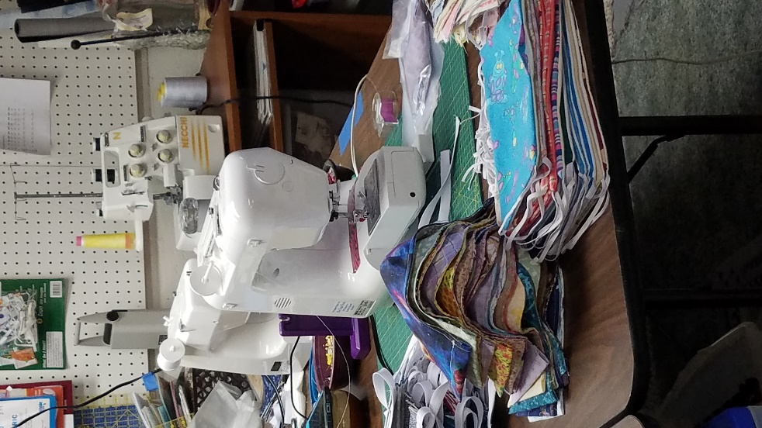
We are also experiencing more and more hamfests being canceled or postponed because of COVID-19. I really hate to see this, but I do understand. Your health and safety mean more than any hamfest goodie for sure. And, look at the bright side of things. That money you’ve set aside for hamfests will still be there months from now and I’ll bet that the deals will even be better when all of this opens fully back up.

Moving down the band for a final look… Janie’s still making her masks. I do have to admit, I’ve lost count after she hit the 1,000 mark. It just seems like she’s really gotten this down to a science. What an assembly line she has going. No, I don’t go over and visit her much when she’s in her sewing room. I’m afraid that if I do, I’ll get drafted into helping with some portion of the assembly line and never get back out.

Here’s a picture of “Her Shack.” And no, you are not seeing things. There is actually 3 sewing machines in this picture! She actually has a couple of more machines that aren’t pictured as well. What an assembly line she has going.

TOP ^
Whelp, my final go around before gong QRT… Stay safe my friends! I want to see all of you soon at a meeting or hamfest! We will get through this and when we do, we’ll have so much to talk about. Most of all… have FUN and get on the airwaves!!

73,

Scott, N8SY

Swap & Shop Has Come to the Ohio Section Website

Hey Gang,

Have you taken a look at the Swap & Shop page on the Ohio Section webpage yet??

Here’s a link that will take you there… http://arrl-ohio.org/sm/s-s.html

Do you have equipment that you just don’t need or want anymore? Here’s a great venue to advertise it, and it’s FREE!!

No, it won’t be listed in this newsletter because it would take up way too much space, so your ad will only appear on the website. It is there for any individual to post equipment Wanted / For Sale or Give-Away. No licensed vehicles/trailers or business advertising will be posted.

Postings are text only (no pictures or graphics) will be posted for a maximum of 1 month from date posting and require a contact phone number or email within the posting.

Send your Wanted / For Sale or Give-Away post to: swap@arrlohio.org

Ohio Section Cabinet
Section Manager – Scott Yonally, N8SY | Assistant Section Manager – John Perone, W8RXX
Section Emergency Coordinator – Stan Broadway, N8BHL | Section Traffic Manager – David Maynard, WA3EZN
Technical Coordinator – Jeff Kopcak, K8JTK | Affiliated Clubs Coordinator – Tom Sly, WB8LCD
State Government Liaison – Bob Winston, W2THU | Public Information Coordinator – John Ross, KD8IDJ
Section Youth Coordinator – Anthony Lascre, K8ZT

Welcome New Subscribers

Matthew Fox & Sean, KM4SFF

TOP ^

Back Issues of the PostScript and Ohio Section Journal

Hey, did you know that PostScript and Ohio Section Journal (OSJ) are archived on the website? You can go back and look at any edition simply by clicking:
http://arrl-ohio.org/news/index.html

Chit – Chat, and All That!

Do you know someone that’s not getting these Newsletters? Please, forward a copy of this Newsletter over to them and have them “Opt-In” to start receiving them. Heck just have them send me an email n8sy@n8sy.com and I’ll get them added to the Ohio Section Emailing list.

We now have many thousands of readers receiving these newsletters weekly. Quite impressive, I’d say! I urge all of you to make sure that everyone, regardless of whether they are a League member or not, get signed up to receive these weekly Newsletters.

You can always “Opt-Out” at any time if you feel this is not what you were expecting. It’s fun and very informative. All of your favorite past newsletters are now archived too.
You can go back at any time and read them. Just go to: http://arrl-ohio.org/news/

Got questions, concerns or would just like to sit and chat awhile? Heck, I’ll even buy the coffee!! Give me a call at (419) 512-4445 or email me at: n8sy@n8sy.com

The pictures on the front page and throughout this newsletter are from various newsletters, Facebook posts and/or were sent directly to me in recent weeks. Take a good look at them, you just might be in one of the pictures! “SMILE… you’re in the Ohio Section News!!”

TOP ^

PostScript is produced as a weekly newsletter. I want to thank everyone that has contributed articles and ideas to make this an even better news source. I sincerely hope that you have enjoyed this edition and will encourage your friends to join with you in receiving the latest news and information about the Ohio Section, and news and events happening around the world!

