[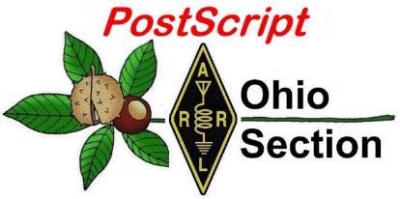](http://arrl-ohio.org/news/) ***May 11th***

***Edition***

🡪 National News 🡪 The Handbook Give Away

🡪 Club Corner 🡪 Hamfests

🡪 DX This Week 🡪 ARES Connect

🡪 VE Testing 🡪 One Question Questionnaire

🡪 Final.. Final..

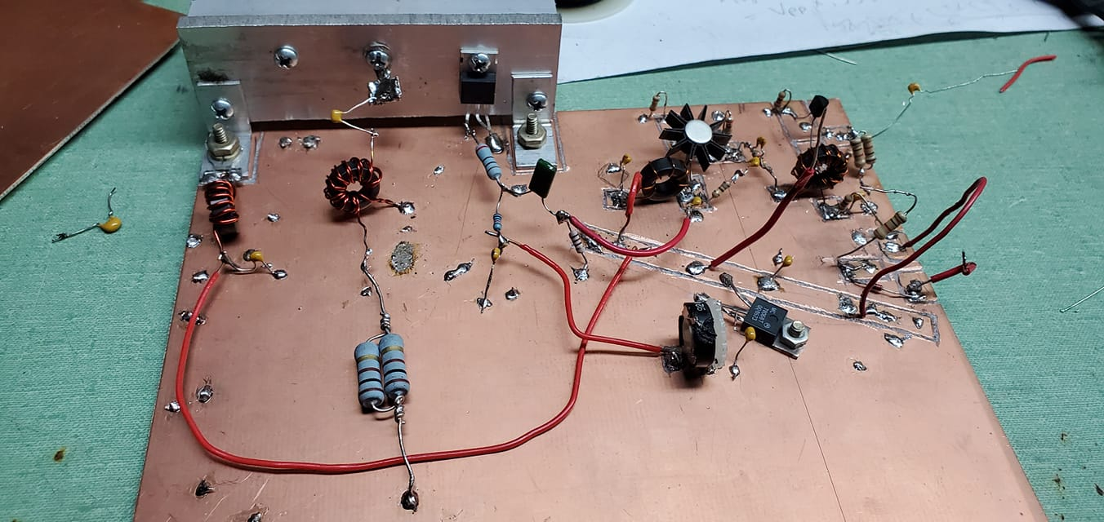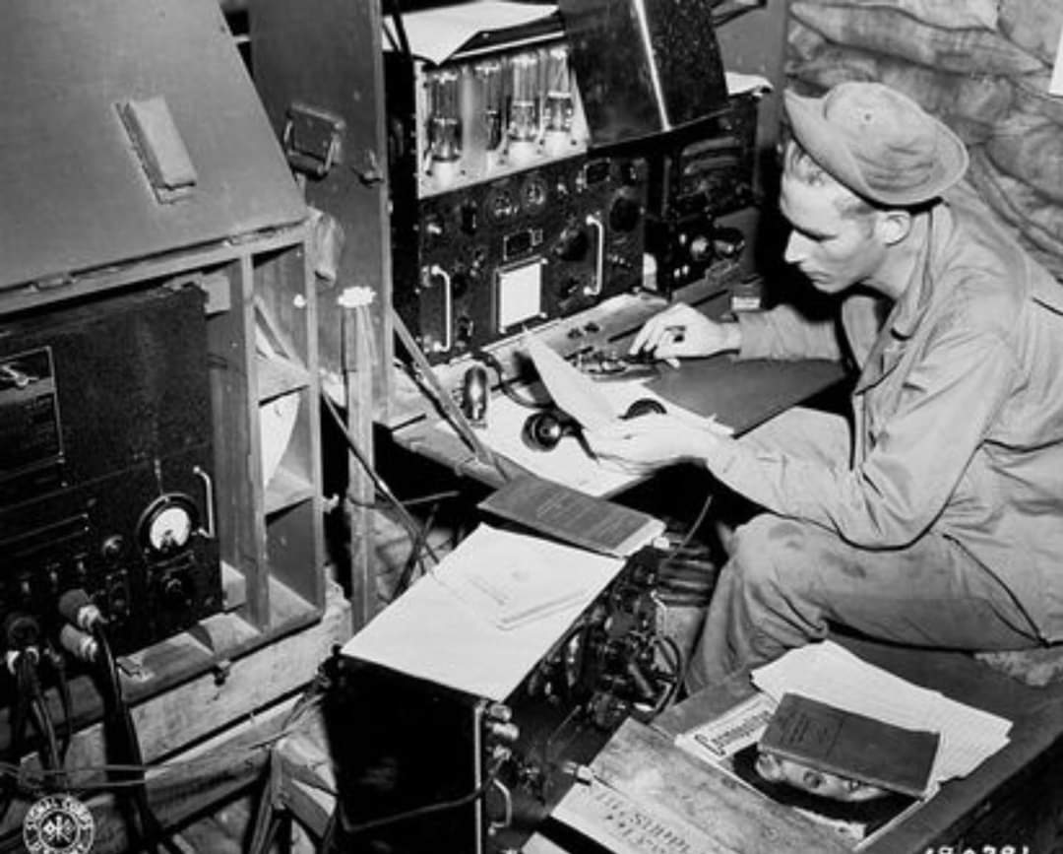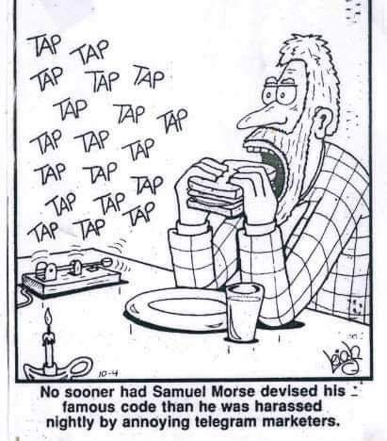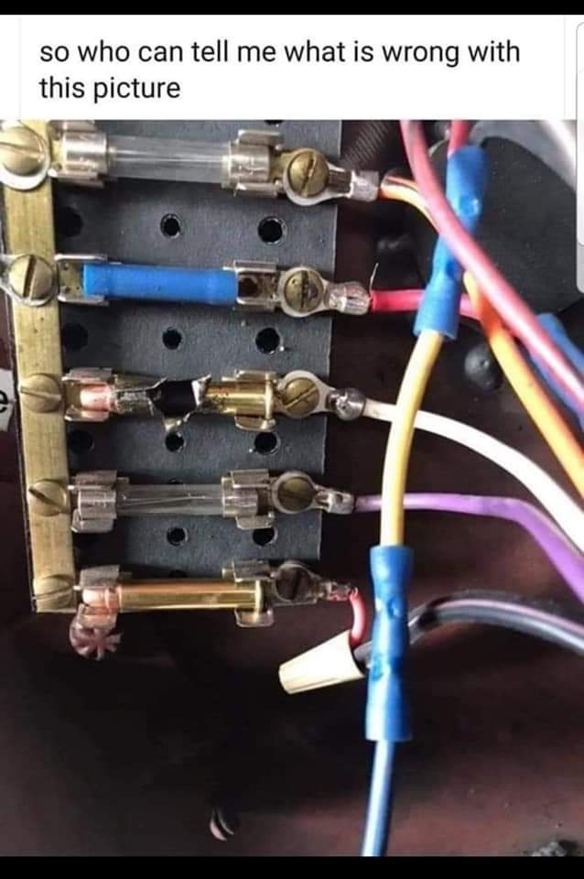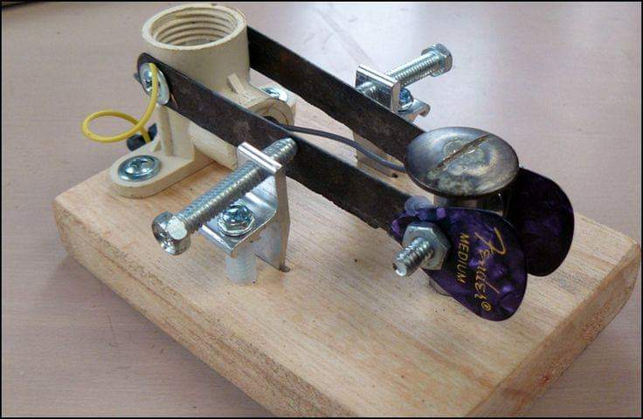

***National News***

*(from arrl and other sources)*

***Ham-Com Cancels 2020 Show***

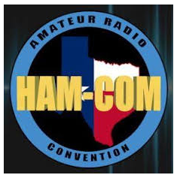[**Ham-Com**](http://www.hamcom.org/) will not take place in 2020, due to the COVID-19 pandemic. “While we have held out hope that this year we would be able to host Ham-Com 2020 as a light at the end of the long tunnel of the COVID-19 virus, it is with great sadness that we must inform all that we are canceling Ham-Com 2020, with the event postponed until June 17, 18, and 19, 2021,” Ham-Com Board of Directors President Bill Nelson, AB5QZ, said in a [**statement**](https://sites.google.com/hamcom.org/ham-com).

“Payments made to Ham-Com for the 2020 event for general admission, vendor booths, and flea market tables will also be rolled to the 2021 event. Thank you for your understanding and we are looking forward to the next Ham-Com.”

####

***FCC Providing Flexibility to Volunteer Examiners in Developing Remote Testing Methods***



The FCC has clarified that nothing in its rules prohibits remote amateur radio testing, and no prior approval is needed to conduct remote exam sessions.

“The Commission provides flexibility to volunteer examiners and coordinators who wish to develop remote testing methods or to increase remote testing programs already in place,” the FCC said in an April 30 [**news release**](https://docs.fcc.gov/public/attachments/DA-20-467A1.pdf). “We recognize that some volunteer examiner coordinators may not have the immediate capacity for widespread remote testing. We expect those volunteer examiner coordinators with limited remote testing capacity to work closely with those requesting such testing to prioritize any available remote testing slots.”

ARRL Volunteer Examiner Coordinator Manager Maria Somma, AB1FM, said she’s gratified to see that the FCC appreciates the need for remote testing. “Many of our VEs and VE Teams have been employing remotely proctored exam sessions with both video and in-person components, and following social-distancing protocols, where necessary” she said. “Some ARRL VE teams have [**shown great promise**](http://www.arrl.org/news/remotely-administered-amateur-exam-systems-showing-promise) in administering exams remotely.” Somma also said that as states begin to lift restrictions, the possibility exists to restart in-person amateur radio exam opportunities.

“We urge our VE teams to keep up to date so they can make informed decisions based on local community guidelines, as each community is unique,” she said. “Our volunteers should use their best judgement when deciding whether or not to begin conducting in-person exam sessions. It is important to us that you feel confident when choosing your course of action, because the health and safety of our VEs and the examinees is the top priority. VE teams that choose to conduct in-person sessions should re-start consistent with local restrictions and guidelines.”

To find amateur radio license exam sessions in your area, [**visit**](http://www.arrl.org/exam) the ARRL website. Candidates should verify with their VE teams that the exam session *is* being held and if any special procedures are required to attend.

####

TOP ^

***AMSAT Solicits Nominations for the 2020 Board of Directors Election***

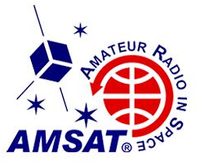[**AMSAT**](http://www.amsat.org/) is soliciting candidate nominations for the 2020 Board of Directors Election set for later this year, to fill the seats of three incumbent Directors whose 2-year terms expire in 2020: Tom Clark, K3IO; Mark Hammond, N8MH, and Bruce Paige, KK5DO. AMSAT members may further elect up to two Alternate Directors for 1-year terms. Valid Director nominations must be in writing and require either one “member-society” or five current individual members in good standing to nominate an AMSAT member.

Send written nominations — in electronic form, including email, or electronic image of a paper document — including the nominee’s name, call sign, and contact information, as well as the nominators’ names, call signs, and contact information, to AMSAT Secretary [**Brennan Price**](mailto:brennanprice@verizon.net), N4QX, 300 Locust St. SE, Unit E, Vienna, VA 22180-4869, with a copy to AMSAT Manager [**Martha Saragovitz**](mailto:martha@amsat.org). Fax transmissions cannot be accepted, because the AMSAT office is closed.

Petitions must be received no later than June 15.

####

***D.E.A.R.S. Wins Big***

If you haven’t seen it, the DEARS / KD8NOM took a big win in the 2020 spring SCR. The kids not only took 1st place in Elementary, but if you had overall schools (elementary, middle school, high school, college) they would have been second only to Texas A&M University!!

Here’s the link... <http://contests.arrl.org/scrscores.php?iid=710>

Now ain’t this a kicker.... after such great work that the kids have done.... they can’t celebrate because of COVID-19. We’re looking into a solution to getting them together to celebrate.

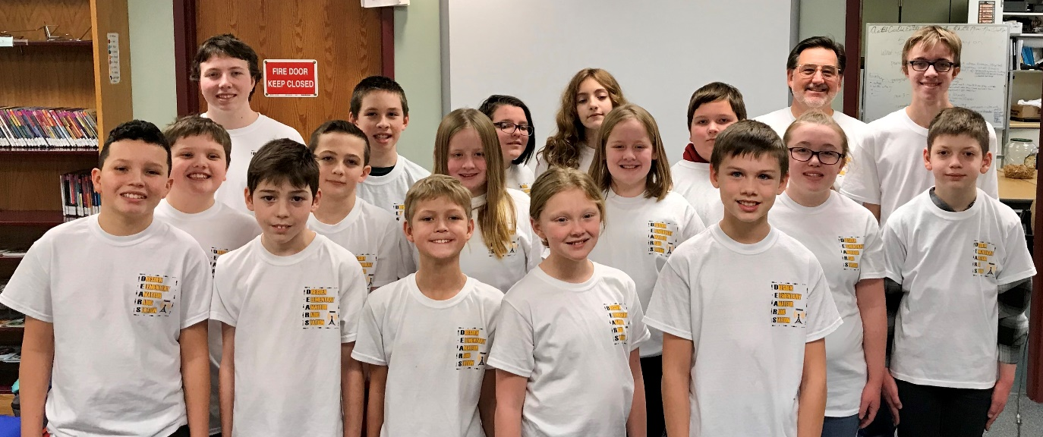

Have a great day!

Very ’73 Jim  WX8J

####

TOP ^

***ARRL VE Teams around the country now doing video testing***

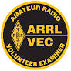I’ve heard from so many of you asking about ARRL VE testing and when it will resume. I’ve also heard from a lot of you that have asked about remote, or video testing and if it will be allowed.

Here’s the latest info from the ARRL VEC herself.

The ARRL VEC has a number of VE teams around the country conducting video-supervised exam sessions using online exams.

Let us know if you would like to look at the instructions and protocols.

We also have teams that are conducting in-person sessions using strict procedures and fillable forms to minimize contact.

Sincerely,

Maria Somma, AB1FM

ARRL VEC Manager

**ARRL, the national association for Amateur Radio**®

225 Main Street, Newington, CT 06111-1494 USA

Phone: 1-888-277-5289

FAX: 1-860-594-0339

Email:  [msomma@arrl.org](mailto:msomma@arrl.org)

ARRL Web:  [www.arrl.org](http://www.arrl.org/)

####

***June 1st - New RF Exposure Rules will be implemented by the FCC***

Hey Gang,

This is something that you really need to read over. There are new RF exposure rules that will be taking effect on June 1st.

Preliminary Report on Changes to FCC RF Exposure Rules, 2020, courtesy of the ARRL RF Safety Committee.

How Radio Amateurs Must Evaluate Human Exposure from their Stations Differently Beginning June 1, 2020:

FCC Human Exposure Rules

• Originally released in 1998

• Radio amateurs were introduced to human exposure limits for the first time • ARRL published 'RF Exposure and You'

• Minor rule changes were made in 2013, but no changes for Radio Amateurs

TOP ^

**FCC Human Exposure Rules Updates**

• New rule changes were published in the April 1, 2020 Federal Register

• New rules take effect June 1, 2020

• Rule changes to 47 CFR Parts 1, 2, 15, 18, 22, 24, 25, 27, 73, 90, 95, 97 and 101

• Amateur Radio Service is affected by Parts 1, 2, and 97

**What Has Changed**

• Amateurs No Longer Have Categorical Exclusions to Evaluation • Stations with power at the antenna input below certain limits did not have to perform routine evaluations.

• No mobile transmitters had to perform routine evaluations.

• New Exemptions to Routine Evaluation are based on frequency, power and distance.

• All transmitters/emitters that are within 20 cm of the body must be evaluated with SAR (Specific Absorption Rate).

• SAR modeling is accepted in addition to SAR testing.

**New Exemptions**

• Based on ERP and frequency

• New formulas used for antennas closer than 40 cm to a person, exceeding the levels in the new formulas determines if SAR Evaluation must be performed

**What about HTs?**

• The 2 m HT is not covered under the new Exemptions:

• Its antenna is within 20 cm of the head

• Its frequency is < 300 MHz

• No known SAR tests have been performed with Amateur HTs

• SAR testing is too complex for most hams to perform

• SAR modeling is also too complex for most hams to perform

• Newly produced amateur HTs will have to be characterized by their manufacturers for SAR

**How Will Hams Follow the Rules Going Forward?**

• Fortunately, the new rules have been released with a 2-year transition period.

• The FCC’s aids for following human exposure rules:

OET Bulletin 65 and OET Bulletin 65 Supplement B for Radio Amateurs will have to be revised.

• The ARRL RF Safety Committee is working with the FCC personnel to revise these documents.

• ARRL is working on finding or developing tools that all hams can use to perform exposure assessments.

With kindest regards, Kai Siwiak, KE4PT - Member ARRL RF Safety Committee

***Ham’s stepping up to help a friend in need***

*(Submitted by Ken Dorsey – KA8OAD)*

At this difficult time there are many who are facing an even more difficult time because of their job situation. In fact, many of us may be dealing with financial hardship at this time but if you are capable let’s not forget those who may be in need of a small token of gratitude for their service.

The Silver Creek Amateur Radio Association (SARA) holds their monthly meetings at a local restaurant, Beef O Brady’s, in Wadsworth beginning with dinner followed by our regular meeting.

TOP ^

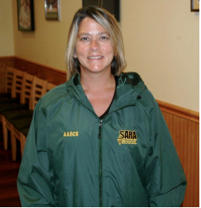As we all know, the restaurant industry was particularly hard hit by this pandemic outbreak. Our long-time server and friend, Karen, is no exception.

Karen has been incredibly diligent and accommodating for our club in the years that we have met at “Beef’s”. During the statewide mandated restaurant shutdown, due to the Corona Virus outbreak, she worked for a week and a half serving take-out but with 3 children at home decided that she didn't want to endanger her family and is currently not working because of this decision. Learning of her situation the members of SARA indicated they would like to help Karen and her family during this Coronavirus crisis. Using donations via PayPal and personal checks the SARA club was able to raise $800 to assist Karen and her family during this difficult time.

This is a perfect opportunity to support others affected by Covid-19 and to show the local community and our friends that Amateur Radio is more than just “radio”. If your club or group meets at a restaurant or other eating establishment think about the people who were there working to serve you and how you might be able to help them during the Covid-19 crisis.

***From the Section Youth Coordinator***

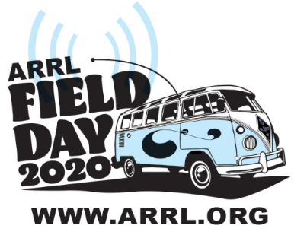***Anthony Luscre, K8ZT - SYC***

[k8zt@arrl.net](mailto:k8zt@arrl.net)

***ARRL FD and COVID-19 Social Distancing, What’s Your Plan?***

I have a feeling that ARRL Field Day, the premier Summer Radio Activity for most Amateur Radio Clubs, is going to be a little different this year. With limits imposed by the COVID-19 precautions of Social Distancing and the higher risk populations present in most AR Clubs, club officers are scratching their collective heads to decide how they are going to do FD this year.

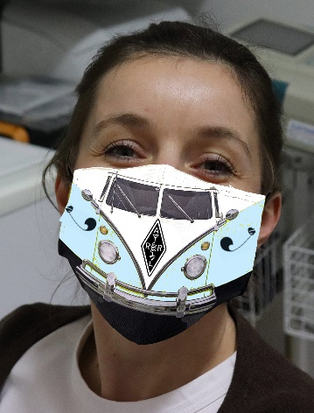Traditionally FD was the event where many Hams were first exposed to HF operating, setting up antennas and stations, simplex SSB VHF (not FM repeater operation) and Contest style contacts. It is a time of fellowship and learning that is impossible to replace.

But this year we may have to take a break from the normal mode of club-sponsored operations, but we do not have to skip operating FD.

I have put together a Slideshow Presentation- “Field Day in Social Distancing”. You can read through the presentation, share it with fellow club members and even have me present it to your club as an online meeting presentation. Here is the link - [tiny.cc/fdsd](http://tiny.cc/fdsd).

Before We Go too Far, SAFETY FIRST!

* By its nature Socially Distanced FD is a compromise in many ways with untested tools, equipment and plans

TOP ^

* Thus we need to be even more vigilant
  + Don’t Rush
  + Don’t Cut Corners
  + Don’t Go Near Overhead Wiring!!!!
  + Care when climbing, better yet avoid climbing whenever possible
  + Be careful with Generators
    - Gasoline, especially refueling
    - Carbon Monoxide fumes in enclosed spaces

Some of the highlights of the presentation:

* What FD Classes are they and how does each adapt to Social Distancing
  + Class B solo or duo operations
  + Ideas for Class C mobile operations
  + Class D and E operations from your home
  + Using a vehicle to do a Class B operation with the advantages of the vehicle as a shelter and power source but with the advantage of larger, more efficient portable instead of mobile antennas
* Operations for those without a station or even an HF radio at home
  + Remote operation of stations
    - Permanent (home) stations
    - Temporary field station (along the lines of a club set up Class A station)
  + Home VHF operations
  + Increased use of simplex FM
* FD Options for Technician Licensees (Technician class Licensees have additional limitations due to operating privileges)
  + VHF Station 6 and/or 2 Meter
  + Satellite Contacts
  + 10 Meter SSB
  + CW Only Operations on 80, 40 and/or 15 M (including ideas for those with little or no code proficiency- [tiny.cc/fwm](http://tiny.cc/fwm))
* A call for local clubs and ARRL officials alike to encourage operation on less frequently used bands and modes to provide opportunities for Technician Licensees and newly licensed hams of all classes
  + Calling CQ on 10 Meters for local/regional contacts even during poor band conditions
  + 2 Meter FM Simplex to provide local contacts
  + Slower speed CW opportunities at top of old Novice band CW allocations
* FD Logging Software and help with setup and use

Another thought for FD this year-- consider getting younger family members at your house involved in your home or vehicle-based FD, but remember to keep safe with both Social Distancing and regular FD safety.

Here is the link to “Field Day in Social Distancing”. - [tiny.cc/fdsd](http://tiny.cc/fdsd). You can read through the presentation and please share it with fellow club members via your club’s newsletters, website and nets. If you are looking for an online meeting presentation, I would be happy to do this for you. If you prefer another talk here are seven I have been recently presenting remotely:

1. [Field Day in Social Distancing](http://tiny.fdsd)
2. [FT8 & FT4- Digital Soundcard Modes](http://tiny.cc/ft8ft4)
3. [Software & Web Resources for Contesting](http://tiny.cc/gl-contest)
4. [QSLing in Online World](http://tiny.cc/qx3)
5. [Having Fun with Morse Code](http://tiny.cc/fwm)
6. [Top Secret- Techniques to work DXCC and WAS](http://tiny.cc/ham50)

TOP ^

1. Ideas & Resources for Growing Youth Involvement in Amateur Radio (based on my article in March 2020 CQ Magazine)

Recently, through these presentations, I have been able to meet club members around the state of Ohio that I never would have imagined I’d have an opportunity to speak to. It has been great and I am always looking for more opportunities to present (and I don’t limit to Ohio) so have your club program director contact me at [k8zt@arrl.net](mailto:k8zt@arrl.net). Visit my website [www.k8zt.com](http://www.k8zt.com) for a wide variety of resources during this time of imposed isolation.



Hello everyone,

The maker community in Wayne County is making an impact in the effort to fight COVID-19 and its spread.  Wooster Community Hospital, Chamber of Commerce, West Hill Nursing Home, Aultman Orrville Hospital, UA Campus Cupboard, and other recipients are receiving community-made supplies that are out-of-stock elsewhere.  Schantz MakerSpace, Wayne College 3D Lab, and members who frequent these makerspaces are connecting PPE items to needed institutions and people on a continual basis through the pandemic.

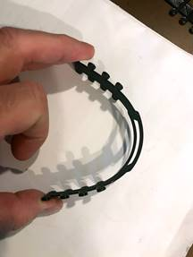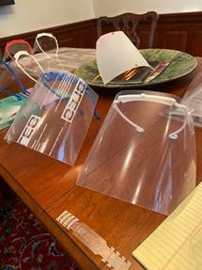

What amazes me about this effort is how many minds are working together to improve the PPE items we’re producing.  Face shields are important for medical staff, protecting them from bodily fluids as they help infected or potentially infected patients.

There are numerous “frame” designs that can be downloaded, and 3D printed.  The makerspace community tried many of them, ultimately modifying an existing design to speed-up production, have a better fit, easier assembly.  Different materials were tried for the clear protective shield including acrylic sheeting, overhead transparencies, and others.  This truly is a community effort to provide the best PPE items possible in the fastest time.

TOP ^

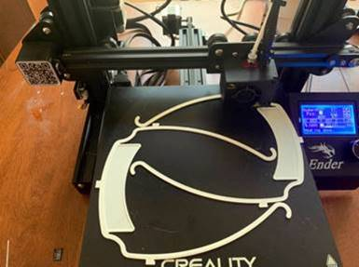   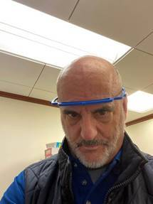   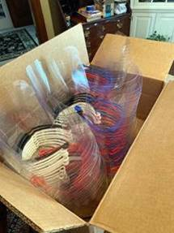

***Field Day 2020 — A Time to Adapt***

Many individuals and groups organizing events for [**Field Day**](http://www.arrl.org/field-day) 2020 have been contacting ARRL for guidance on how to adapt their planned activities in this unprecedented time of social distancing and uncertainty.

“Due to the unique situation presented this year, this can be an opportunity for you, your club, and/or group to try something new,” ARRL Contest Manager Paul Bourque, N1SFE, said. “Field Day isn’t about doing things the same way year after year. Use this year to develop and employ a new approach that is in line with the current circumstances.”

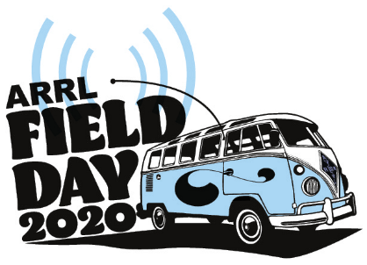Social distancing and state and local requirements very likely will impact just how — and even whether — you are able to participate in Field Day this year. ARRL continues monitoring the coronavirus situation, paying close attention to information and guidance offered by the Centers for Disease Control and Prevention ([**CDC**](https://www.cdc.gov/coronavirus/2019-ncov/index.html)). If social distancing means that Class A with a 30-member team set up in a city park won’t work this year, then it’s time for a Plan B. Part of the Field Day concept has always been adapting your operation to the situation at hand. At its heart, Field Day is an emergency communication demonstration. Field Day rules are flexible enough to allow individuals and groups to adjust their participation and strategies in a way that still addresses their needs while being fun. Some possibilities:

* Encourage club members to operate from their home stations on emergency power (Class E).
* Use the club’s repeater as a means for individual participants to keep in touch during the event.
* Family members interested in operating Field Day and unable to participate as part of a larger group may want to consider setting up a portable station in the backyard with a temporary antenna.

One big impact this year will be a decline in public visibility and any interaction with the visitors. Prudence may dictate dispensing with the ham radio PR table to attract passersby, should you set up in a more public location. It’s okay not to score all the bonus points you may have attempted in the past.

TOP ^

Local and served agency officials may be unwilling to visit, which is understandable under the circumstances. Do be sure to reach out to them as part of your preparations and remind them that you look forward to continuing your working relationship with them in the future.

The impact will differ from place to place, so ARRL recommends that all amateur radio clubs participating in Field Day stay in regular contact with local or state public health officials for their advice and guidance on hosting Field Day activities.

Demonstrating an understanding of the health crisis we all face and your willingness to adapt will show that you and your club or group are good working partners with local or served agencies.

“With any emergency preparedness exercise, it’s not about adapting the situation to your operation, it’s about adapting your operation to the situation that presents itself,” Bourque said. “Try something different. Learn something new about how you prepare. It may be a challenge, and you may have to ask yourself if you’re up to the challenge. We hope to hear you on the air over the **June 27 – 28 weekend**.” *— Thanks to Paul Bourque, N1SFE, and Dan Henderson, N1ND*

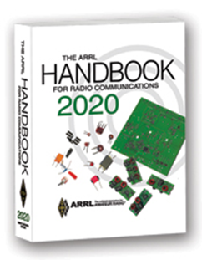***The Handbook Give Away***

Hey Gang,

The “Handbook Giveaway” drawing will soon be returning for another big “Give Away”

Many of you ask me just how do I know when the drawing is on? Well, that’s easy all you need to do is check in on the Ohio Section Website on a regular basis and watch for the big [**RED**](http://arrl-ohio.org/handbook.html)Arrow that will appear on the left side of the page. This is the sign that the drawing is on and you need to get registered. So, keep a sharp eye out on the website and check in often! <http://arrl-ohio.org>

What’s the catch? I want to get everyone checking in to the Ohio Section website as often as possible, and in order to register each month, you have to visit the website often! There’s nothing else to it. I pay all expenses, and from time to time, I Give Away more than just a Handbook. And, you’ll never know just what months will be those special times that I will have more than just a Handbook to Give Away!!

***Club Corner***

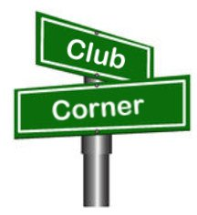

This is YOUR cornner of the newsletter. Send me what your club is doing and I’ll make sure that it gets in. Got a special event or club project that you want everyone to know about? Send it to me!. Need help with a project? Send it to me.

Let me know what you club is up to. Are you going to have a special guest at your meeting or are you having a special anniversary? Just sent it to: [n8sy@n8sy.com](mailto:n8sy@n8sy.com)

####

TOP ^

***Mahoning Valley Amateur Radio Association’s 2-Meter Contest***

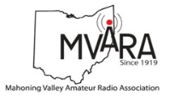The MVARA is excited to once again try and bring you the Mahoning Valley Amateur Radio Association 2  Meter contest May 30, 2020 from 1:00 to 4:00 PM.  We thought it would be fun to shake off the winter doldrums and Coronavirus / Covid 19 stuck at home blues by getting on the air for a local contest.  It will be an opportunity to reconnect with old friends and make some new ones.

Old timers may remember participating in the Lou Malice Memorial Contest years ago. The MV 2 Meter Contest will be a similar two-meter simplex contest.  Stations will simply exchange call signs and a 6-digit designator as defined in the contest rules.  The contest format will allow participations to evaluate their stations simplex capabilities.  This information can be valuable in an emergency.

No 100-watt base station, no problem.  There will be two categories a low power home category of 5 watts or less and a high-power home category of more than 5 watts so everyone will have a level playing field.

There will be NO ROVER STATIONS.  Your health is our major concern.  Awards will be given for the highest scoring high power home and highest scoring low power home.  Top 5 winners in each category will be posted on our website [www.mvara.org](http://www.mvara.org) by August 1, 2020.  Awards will be mailed to the winners and second and third place will receive honorable mentions.

For contest rules, print out grid maps and to submit your logs on line please go to: <http://mvara.org/Mv2mc.html>.  Paper logs can be submitted to:

MVARA

P.O. Box 14141

Youngstown, Oh 44514

This year the contest will be dedicated to the memory of pioneer valley ham Lou Malice WA8PKN whose dedication to amateur ham radio touched the lives of all of us.  Even if you never had the pleasure of knowing Lou you are still part of his legacy.  Chances are good that the ham that inspired you and encouraged you to become part of amateur radio were, themselves, inspired, encouraged, and trained by Lou.

We hope to hear you on the air.

[***Upcoming Hamfests***](http://arrl-ohio.org/hamfests.html) ***for 2020***

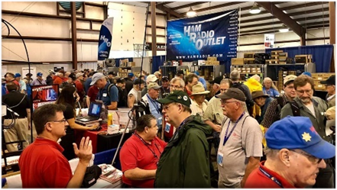

**06/06/2020 | FCARC Summer Hamfest**Location: Wauseon, OH  
Sponsor: Fulton County Amateur Radio Club  
Website: <http://k8bxq.org/hamfest>

**07/19/2020 | Van Wert Hamfest**  
Location: Van Wert, OH  
Sponsor: Van wert Amateur Radio Club  
Website: [http://w8fy.org](http://w8fy.org/)

TOP ^

**07/26/2020 - Portage Hamfair '20**Location: Ravenna, OH  
Sponsor: Portage Amateur Radio Club, Inc.  
Website: [http://hamfair.com](http://hamfair.com/)

**08/01/2020 | Columbus Hamfest**  
Location: Grove City, OH  
Sponsor: Voice of Aladdin/ Audio Unit of Aladdin Shrine  
Website: [http://columbushamfest.com](http://columbushamfest.com/)   
 ***Canceled***

####

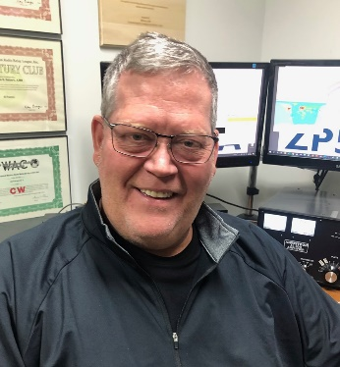***DX This Week***

*(from Bill, AJ8B)*

***DX This Week – Outgoing QSL Buro   
 Bill AJ8B (***[***aj8b@arrl.net***](mailto:aj8b@arrl.net)***, @AJ8B, or*** [***www.aj8b.com***](http://www.aj8b.com)***)   
 CWOPs Member #1567***

Hope you are doing well and tuning around. If you were around the cluster this past week, there were many different entities to be worked. These included Afghanistan, Asiatic Turkey, Bahrain, Belgium, Belize, Bosnia-Herzegovina, Bulgaria, China, Cuba, Cyprus, Dominican Republic, European Russia, Falkland Islands, Fed. Rep. of Germany, Finland, France, Hawaii, Hungary, Indonesia, Isle of Man, Israel, Jersey, Kazakhstan, Kenya, Mauritania, Philippines, Republic of Kosovo, Suriname, Sweden, Thailand, Trinidad & Tobago, and the UN HQ.

Just a slow trickle of QSL cards this week, but, I received 5H4WZ – Peter in Tanzania, 5H3UA – Sasha on Zanzibar Island in Tanzania, OM7M – Peter in Slovakia, KI5FTP – Chris in TX, and S57RV – Vojko in Slovenia. (Pictured). Did you get any or send any this week?

I did receive LOTW confirmation from ON4QX, confirming a QSO we had during the CQWW RTTY on 10M in 1999!

You can tell that I like to send and receive QSL cards. Two years ago, I passed along information about the Outgoing and Incoming QSL bureaus. I am repeating that information this week and next. This would be a great time to send those cards out!

TOP ^

I have gotten a couple of questions about QSLs – Does anyone send paper QSL cards anymore? Isn’t it very expensive to send cards to non-US stations? It may be time to discuss the ARRL QSL bureau. There are two parts, the outgoing and incoming bureau. For this edition, we will address the outgoing bureau. Next week, we can discuss the incoming bureau.

There are a couple of reasons to collect QSL cards. There are a few awards that are not linked with LoTW, there are some hams who don’t use LoTW but will confirm via a paper card, there are some beautiful and creative QSL cards to be seen, and there is a tradition of exchanging cards. My first “DX” was with VE3FGO and I still have that card from 1970!

The information that is typically on a QSL card is both callsigns, the location of the station you are confirming as shown in the DXCC Entity list, the date and time (ALWAYS use UTC time), the frequency, and the mode used. The signal report is NOT required, but, is usually included. It is also helpful if the QSL displays the ITU and CQ Zones, grid square designation, and the US county.

Most hams now include club affiliations and their email address as well. All this information, along with a bit of personalization, can fit on a standard 3.5” by 5.5” card. Many hams put their location information and callsign on the front and the QSO information on the back. If you are handwriting information on the card and you make a mistake, throw the card out and start over. The station receiving the card may not be able to use what appears to be an “altered” QSL card.

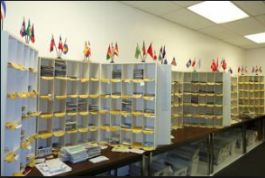There are several advantages to using the ARRL Outgoing QSL Bureau including a good percentage of returned cards, least expensive, and it can be used to send to foreign QSL managers. The disadvantages are that the bureau is not used by all DXers and it takes time. I have gotten cards for QSOs that were older than 5 years! I am hearing from some of the bureau volunteers that the volume of QSL cards processed has increased dramatically due largely to the use of FT8 by so many hams. More QSOs more QSLs!

The basic concept is that you bundle up your cards and send them to the ARRL. The cards are then sorted by entity and then, at some predetermined time interval, sent to the remote QSL bureaus.

Figure 1 ARRL Outgoing QSL Bureau

Of course, there are rules that you need to follow so that the ARRL Outgoing QSL Bureau can process the cards and get them added to the shipments to foreign QSL bureaus. (More details can be found at <http://www.arrl.org/outgoing-qsl-service> .)

I want to highlight a few critical points in this process:

* Send larger packages of card to the bureau. I usually send a hundred or so quarterly. At a minimum, I send a package yearly.
* Write the recipients call sign on the back of the card, use upper-left hand side; and flip cards forward facing the same direction. Business side up with no blank sides facing forward. This allows the sorter to quickly determine where the card needs to be sent without reading the front of the card. For instance, if 6Y1V uses OH3RB as the QSL manager, you would put OH3RB on the back-left hand side of the card along the edge. Print this CLEARLY!

TOP ^

* Sort cards in alphabetical order according to parent and alternate prefixes. This is important for slotting the cards and eliminates returns because cards went to the wrong bureau. Keep all country prefixes together. Example: The prefix 2E belong to England so these cards will go with your G cards for England. The prefix TM is for France, so these cards will go with your F cards.
* Do not separate the cards with slips of paper, rubber bands, etc. This only slows down handling of the cards.

When you prepare the package for the bureau, you must include:

* Proof of ARRL Membership
* Fees & Payment – There is a charge for this service that covers shipping costs. The charge is a $7 QSL Bureau fee and $1.15 per ounce. For example, a package containing 1.5 pounds of cards — 24 ounces, or about 225 cards — will cost $34.60. Please see the information below for additional pricing details. The minimum charge is $8.15 for one ounce or less. The same 200+ cards sent with an air mail stamp alone would cost $106 not counting return postage or the envelope. Quite the bargain!
* Pay by check or money order with your callsign written on the check. I include an SASE that the volunteers will put in the mail to let you know that the cards were received.
* Put all of this together (QSL Cards, Proof of Membership, Fee, and an SASE if desired) and ship it to:

ARRL Outgoing QSL Service

225 Main Street

Newington, CT 06111-1494.

As always, if you are having DX success just drop me a line and let me know what you are doing! If you have questions or recommendations for a topic, please send that along as well.

***CQDX CQDX CQDX CQDX CQDX CQDX CQDX CQDX CQDX***

Registration now open for Contest University Online 2020

By K3LR, Tim Duffy, CTU Chairman

__________________________________________________________

Go to the [**Contest University website**](http://r20.rs6.net/tn.jsp?f=0016C47raKVL5k_W50fkCjD58xubWKd0Yd265gQ30bywQL9_M9mZO5q93a-qG2RJjl1sZjrFVx-YhCoR2CIVX-BYJ_VfFVQoqxlVQR2VtQaUPyB2fpqotv3nne0mytkGH8dSo470I-GZyllogpQRUEeGA==&c=OmK90yeKkgOT8mg4A2pt8u-pUmFMDcLAiqoB_1kQpLQxprrA5qEIZw==&ch=Wa_HdlANIEbKK4a8UljHGSaBp-pcfNJcwmlrWOtpkK3Mq1H3jQEyEw==) to register for the free CTU online via Zoom webinar bridge. CTU online will be held live May 14th starting at 8:45 AM EDT (1245Z). CTU 2020 will be recorded.

Thanks to K8MNJ, N9JA, W3CDG, KA9FOX and all the CTU 2020 professors for making this happen!

**E2 – Thailand -** E2STAYHOME is from RAST, the Radio Amateur Society of Thailand until July 15.  QSL via E21EIC or LoTW.  Champ says he will QSL everyone through the bureau.

**5Z – Kenya -** 5Z4/G3AB, Andy, is staying on in Nairobi, though most staff and families have gone back to the UK during the pandemic.  Andy is on CW in his evenings, working North America and others on 20 and 17.  He has an IC7300 and ACOM 1000 amp, a hexbeam and verticals that cover 80, 60, 40 and 30.  A 5Z4 callsign is pending.

**9A – Croatia -** 9A1CHRIS is from the Radio Klub Grada Zaboka, 9A0Z, today through May 10, honoring Kresimir “Chris” Kovarik, 9a5K, who was born on May 8, 1974 and passed away last year.  A special downloadable QSL will be on [**http://www.9a0z.com/**](http://r20.rs6.net/tn.jsp?f=001MoWWLaoMhC9wubYBgIZ9muil5ZL7bEre8m4BQpf9JfVqkGemm52pimvt2KPRVgGMnKlLTYUKdLdeyPSjaiD587GomWjfVUKJpXiKze8mUrjjn0wfE9MtvqNpJMrZ6u0fGBwQLxHnS_8=&c=zCz7hjfYcd6RQkFceL41T123oKtdDSjBLL7Z5gm19H0jd0buXSY1ZQ==&ch=gFXrcud394w7S5HOVmfOmoBOBuqyNJvcA87m0l4pMvZio4ufSaMpeA==).  Chris was a past president of the Croatian Amateur Radio Association, HRS and Vice Chairman of the IARU Region 1 HF Committee, the creator of DXlog.net and three-time WRTC competitor and a new CQ Contest Hall of Fame member as of last year.

TOP ^

**G – England -** New callsigns commemorating the end of World War II in Europe are GB4VVV with G0SFJ operating, which started up April 27 and runs to May 11.  The V stands for “victory” of course.  QSL through eQSL only.  GB75VET has M0IRU operating through May 28.  QSL via M0IRU or LoTW.

***DX news***

***ARLD019 DX news***

This week's bulletin was made possible with information provided by The Daily DX, the OPDX Bulletin, 425 DX News, DXNL, Contest Corral from QST and the ARRL Contest Calendar and WA7BNM web sites. Thanks to all.

**MOUNT ATHOS, SV/A.** Monk Iakovos, SV2RSG/A will be QRV until May 10. Activity will be on 20 meters using CW and SSB. QSL via SV2RSG/A direct to Monk Iakovos Kutlumusian, Holy Monastery Koutloumousiou, Karyes, 63086, Greece.

**AZERBAIJAN, 4K75.** Look for Azerbaijani amateur radio operators to be using either 4J75 or 4K75 prefixes starting May 5, to celebrate the 75th anniversary of the victory in WW2. The length of the activity is not known at this time.

**INDONESIA, 8C2.** Members of the ORARI are active as 8C2WFH (Work From Home), until May 19. Activity is on 80, 40, 20, 15 and 10 meters using CW, SSB, RTTY, BPSK31 and FT8.

**JAPAN, 8J.** Look for special event station 8J1ITU to be QRV from April 30 to May 31. Activity is to celebrate the anniversary of the ITU World Telecommunication and Information Society Day on May 17.

QSL via the JARL Bureau or eQSL.

**UNITED ARAB EMIRATES, A60.** Look for activity under special call sign A60FTDMC during FT8DMC activity weeks, July 1 to 31, on various HF bands. QSL via OE4VIE.

**INDIA, AU2.** Members of the West Bengal Radio Club, VU2WB, will be active as AU2COV until July 26. Activity is to provide assistance in fighting against the COVID-19 pandemic. QSL via VU2WB.

**ENGLAND, GB75.** Members of the RSGB Contest Club will activate the following call signs May 1 to 31 and August 1 to 31: GB1945PE, GB1945PJ and GB75PEACE. Operations will be on various HF bands and

6 meters using CW, SSB and the digital modes. QSLs are only via LoTW and eQSL. No paper QSL cards.

**SOUTH KOREA, HL40.** Look for special event station HL40GDM until May 31. Activity is to celebrate the 40th anniversary of the May 18 Democratic Uprising in Gwangju. Operations will be on all bands and modes. QSL via HL4CCM, direct, by the Bureau, eQSL or ClubLog.

**AUSTRIA, OE50.** Jo, OE4VIE is active as OE50MHZ until June 30 to mark the 30th anniversary of the first provisional release of the frequency range 50 to 52 MHz for Amateur Radio in Austria. Operations will be on CW, SSB and the digital modes on 6 meters. QSL via LoTW and eQSL, paper QSLs will be sent automatically via the Bureau.

TOP ^

**POLAND, SN100.** Czeslaw, SP9FZU will be active with the special call sign SN100PS in memory of Second Silesian Civil War in 1920. Activity will be on various HF bands. QSL via SP9KAG, by the Bureau or direct.

**STAY AT HOME STATIONS.** More special event stations will join the cause to raise awareness of restrictions necessary to fight the spread of the coronavirus and to thank health and medical workers worldwide, including:

3G2HOME Chile, HG20HO Hungary, 4J0STAYHOME Azerbaijan, 4MSTAYHOME Venezuela, HZ1STAYHOME Saudi Arabia, 4U2STAYHOME Austria, IO6STAY Italy, 4X2BESAFE Israel, 5B4STAYHOME Cyprus, 5W19STAYSAFE Samoa, K2H United States, 6Y6STAYHOME Jamaica, 8A1HOME Indonesia, OD50SH Lebanon, OH0PYSYKOTONA Finland, 9K9STAYHOME Kuwait, A60SH/1 U.A.E., OH0STAYHOME Aland Island, AT2GOK India, ON4HEROES Belgium, AX2020STAYHOME Australia, CH2IR Canada, CN20SH Morocco, CQ8STAYHOME Azores, CT1STAYHOME Portugal, CV7STAYHOME Uruguay, DX0STAYHOME Philippines, E2STAYHOME Thailand and E7STAYHOME Bosnia & Herzegovina.

**KENYA, 5Z.** Andy, 5Z4/G3AB is QRV on CW in his evenings on 20 and 17 meters.

**ZAMBIA, 9J.** Mario, IK1MYT is QRV as 9J2MYT. He plans to be QRV through the end of this month. Look for him using SSB on 20, 17, 15 and 10 meters. QSL direct only, to IZ3KVD.

**75TH ANNIVERSARY OF WWII.** During the month of May, many stations will be active commemorating the end of World War II. Look for the following special event prefixes to be active: 4X75 Israel, RP75 Russia, EV75 Belarus, GB75 England and N. Ireland, GU75 Guernsey, UP75 Kazakhstan.

THIS WEEKEND ON THE RADIO. The SARL VHF/UHF Digital Contest, CQ-M International DX Contest, VOLTA WW RTTY Contest, SKCC Weekend Sprintathon, Arkansas QSO Party, FISTS Spring Unlimited Sprint, 50 MHz Spring Sprint and the WAB 7 MHz Phone Contest are on tap for this weekend. The 4 States QRP Group Second Sunday Sprint is on May 11 and the RSGB 80-Meter Club Championship is on May 13. Please see May 2020 QST, page 69 and the ARRL Contest Calendar and WA7BNM Contest Web Sites for details.

**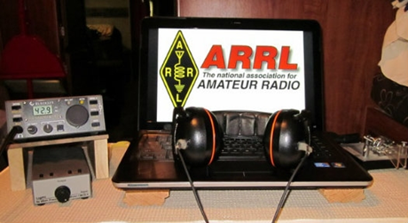*ARRL Contest Corner***

An expanded, downloadable version of *QST'*s’[**Contest Corral**](http://www.arrl.org/contest-calendar) is available as a PDF. Check the sponsor's’Web site for information on operating time restrictions and other instructions.

***Special Events***

* **05/16/2020 | 2020 Emergency Medical Services Week**

**May 16-May 24, 0000Z-2359Z, W9A**, Junction City, WI. Wood County ARES/RACES W9WCA. 14.275 7.275 3.975; DMR 31550 / WiresX K9WCA. QSL. Wood County ARES/RACES, Attn: W9A Special Event, 3530 Bohn Dr., Wisconsin Rapids, WI 54494.

TOP ^

All modes will be in play on HF along with digital modes - DMR, WiresX, Fusion, NXDN, P25, and possibly D-Star. Monitor the Wood County ARES/RACES Facebook page for current information during the event. QSL with SASE. kb9stb@gmail.com or [www.facebook.com/WoodCoARESRACES](http://www.facebook.com/WoodCoARESRACES)

* **05/16/2020 | Amateur Radio Day on the Prairie THIS EVENT HAS BEEN CANCELLED**

**May 16, 1530Z-2000Z, KS0KS**, Tallgrass Prairie National Preserve, Strong City, KS. Santa Fe Trail Amateur Radio Club. 18.145 14.280 10.115 7.245. QSL. SFTARC, P.O. Box 3144, Olathe, KS 66063. THIS EVENT HAS BEEN CANCELLED [sftarc.org](http://sftarc.org/)

* **05/16/2020 | American Airpower Museum**

**May 16-May 17, 1430Z-1930Z, W2GSB**, Farmingdale, NY. Great South Bay Amateur Radio Club. 14.280 14.050 7.265 7.050. QSL. Great South Bay ARC, P.O. Box 1356, West Babylon, NY 11704. Armed Forces Weekend celebration at the American Airpower Museum at Republic Airport in Farmingdale, NY [www.gsbarc.org](http://www.gsbarc.org/)

* **05/16/2020 | Armed Forces Day at the National Cryptologic Museum**

**May 16, 1300Z-1900Z, N3M**, Fort George G Meade, MD. National Cryptologic Museum. 7.200. QSL. Charles Dorcey, 9210 Dewberry Ln., College Park, MD 20740. See website; email QSL photo. In the event of hazardous weather, the station will be a static display inside the museum. [www.qrz.com/db/ab3na](http://www.qrz.com/db/ab3na)

* **05/16/2020 | Armed Forces Day Observance THIS EVENT HAS BEEN CANCELLED**

**May 16, 1630Z-2130Z, W5KID**, Baton Rouge, LA. Baton Rouge Amateur Radio Club. 14.250 14.035 7.225 7.035. QSL. USS KIDD Amateur Radio Club, 305 S. River Road, Baton Rouge, LA 70802. Operation aboard the USS KIDD (DD-661), WW II Fletcher Class destroyer. THIS EVENT HAS BEEN CANCELLED. [qrz.com/db/w5kid](http://qrz.com/db/w5kid)

* **05/16/2020 | Clark County Amateur Radio Club's 90th Anniversary and Mt. St. Helen's Eruption 40th Anniversary Special Event Station**

**May 16-May 25, 1400Z-0600Z, W7AIA**, Vancouver, WA. Clark County Amateur Radio Club. 14.225 14.030 7.185 7.030. Certificate & QSL. Clark County Amateur Radio Club, P.O. Box 1424, Vancouver, WA 98668. [www.w7aia.org](http://www.w7aia.org/)

* **05/16/2020 | May in the Mountains**

**May 16, 1400Z-2200Z, W4D**, Sevierville, TN. Sevier County Emergency Radio Service. 7.180 LSB. QSL. Thomas Baxter, W9TPB, 2054 James Road, Sevierville, TN 37876. Celebrating the coming of Spring to the Great Smoky Mountains. For more information please visit our web site at [https://www.eventqsl.webs.com](https://www.eventqsl.webs.com/)

* **05/16/2020 | Tennessee Mountain Laurel Festival**

**May 16, 1400Z-2000Z, W4BSF**, Oneida, TN. Big South Fork Amateur Radio Club. 7.245. QSL. Big South Fork Amateur Radio Club , P.O. Box 334, Sunbright, TN 37872. [www.bsfarc.com/index.php/mtnlaurel](http://www.bsfarc.com/index.php/mtnlaurel)

* **05/16/2020 | WHOA/SCOTA**

**May 16, 1300Z-1900Z, W1M**, Russell, MA. Western Mass Council-Scouting USA. 7.060 7.190 14.060 14.290. QSL. tom barker, 329 faraway road, Whitefield, NH 03598. paper logging is used--there is a delay in sending out qsl cards--sase is required

TOP ^

* **05/18/2020 | Memorial Day**

**May 18-May 25, 0000Z-0000Z, K1A**, Cleburne, TX. Club KC5NX. 14.250 14.045 7.233 7.045. QSL. Club KC5NX, 9200 Summit Court West, Cleburne, TX 76033-8212. K1A will be on the air the week May 18th till the 26th to honor the many lives lost in the service of the United State Military. Sponsored by Club KC5NX deep in the Heart of Texas! club.kc5nx@gmail.com or [www.qrz.com/db/kc5nx](http://www.qrz.com/db/kc5nx)

* **05/18/2020 | The Indianapolis 500**

**May 18-May 24, 0400Z-0400Z, W9IMS**, Indianapolis, IN. The Indianapolis Motor Speedway Amateur Radio Club. 18.140 14.245 7.245 3.840. Certificate & QSL. Indianapolis Motor Speedway Amateur Radio Club, P.O. Box 30954, Indianapolis, IN 46230. See the website for ALL information! [www.w9ims.org](http://www.w9ims.org/)

* **05/20/2020 | Apollo 11**

**May 20, 1330Z-2030Z, K2CAM**, Garden City, NY. Long Island Mobile Amateur Radio Club in support of the Cradle of Aviation Museum. 21.340 14.240 7240. QSL. LIMARC, P.O. Box 392, Levittown, NY 11756. The aerospace industry on Long Island was a significant part of the moon landing project. Much of that history is displaued at the Cradle of Aviation. Visit https://www.cradleofaviation.org/ or [www.limarc.org](http://www.limarc.org/)

***“ARES Connect”***

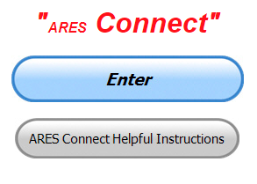

**Everyone –** please make sure to go into all of the events that you have signed up ***for and get your hours registered no later than 5 days after the event has ended****.*

Folks, I’m seeing a lot of folks that have signed up for events not entering their time after the event. This is a very important piece of using “Connect.” Your hours need to be recorded and it’s so easy to do.

Let’s run through how so in case you have forgotten. If you have already gotten signed up for an event, all you have to do afterword to get your time entered is at any time after the event has ended, log into “Connect.” And then click on your name in the upper right-hand corner of the page. This will bring up a drop-down menu where you will then click on “View Hours.”

This brings up another screen where you can “Report Hours” as well as “View Hour History” You’ll want to click on “Report Hours.” You will then be presented one at a time by chronological order each event that you have signed up for and hours have not yet been reported on.

Type in those hours in the “Hours Worked” box and hit “Submit”… Keep doing this until you have no more hours to report…. That’s all there is to it. Now, if you are following the request above and doing this at least every 5 days or more often, this will only take you a minute or so to complete.

**We still have a number of recurring events created but no activity reported for them.** Please, if this event is no longer needed, let me know and I can delete it from the masters. I know that many of you setup recurring events to learn how, but if they aren’t going to be used, let’s get them cleared out.

TOP ^

Also… If you are setting up events, please don’t set a limit for how many folks can sign-up unless absolutely necessary. This causes issues when doing reports. It’s also counter-productive since the reason for you to list the event is to get as many volunteers as you can to attend. When you set limits, it discourages folks from signing up.

**Now, isn’t that easy? Yes, and we all need to be diligent at doing it promptly.**

***Here’s are the top 10 hours earners for May:***

|  |  |  |  |
| --- | --- | --- | --- |
|  | **Name** | **Events** | **Hours** |
| **1** | Christopher Domenick (KC8CAD) | 10 | 34.75 |
| **2** | Dan Stahl (KC8PBU) | 21 | 33.35 |
| **3** | James Yoder (w8erw) | 4 | 27.70 |
| **4** | Alan Rothweiler (N8CJ) | 8 | 23.00 |
| **5** | LaVergne Pabian (N8HLP) | 4 | 22.00 |
| **6** | Earl Paazig (W8BR) | 8 | 21.00 |
| **7** | Bret Stemen (KD8SCL) | 7 | 14.50 |
| **8** | Elmer Thomas (KE8HNK) | 13 | 12.50 |
| **9** | James Garber (W8CEN) | 11 | 12.00 |
| **10** | David Brett (KD8NZF) | 11 | 11.00 |

**Let’s get everyone in the Ohio Section on “ARES Connect!!!” Simply go to:** <https://arrl.volunteerhub.com/lp/oh/> and get yourself registered and using the system.

***Special ICS 300 & 400 Training being offered***

For those interested in attaining ARES Level 3 certification, the State of Kentucky plans to offer these courses in Ashland at the Boyd County EMA:

Intermediate ICS for Expanding Incidents (ICS-300) **June 23-25**

Advanced ICS Command & General Staff for Complex Incidents (ICS-400) **July 14-15**

Though not part of the ARRL curriculum, another good class is:

ICS/EOC Interface Workshop (G-191), **September 16**

Prerequisites for these courses is completion of IS-100, IS-200, IS-700 and IS-800.  All 4 of these courses are online and free from FEMA Independent Studies program.

For more information go to <https://kyem.ky.gov/training/Pages/default.aspx> and scroll down to June, July and September.

Gregg Hendry, W8DUQ

TOP ^

***New - Dashboard for Great Lakes Division ARES Connect***

Now that ARES Connect has been fully implemented within the Great Lakes Division, have you ever wondered just what our three Sections actually contribute to our combined communities?

We now have a Dashboard on the Great Lakes Division website that will tell you that exact information. Since ARES Connect is an “on-line” and up to the minute reporting system, we now have the ability to obtain this very detailed information.

ARES Connect is full of details that we’ve never been able to obtain before, and because of that, we now can see a much more detailed view of what the Division is doing. Oh, I guess I should also mention that you can also see the data broken down into each Section as well. Now, ain’t that something!!!

Want to take a look? Here’s a link… <http://arrl-greatlakes.org/ac.html> Oh, and don’t forget to check out the rest of the Division’s website as well!!!!

***One Question Questionnaire***

Hey Gang,

“Survey Says”….. It shows that about 55% of you would not attend a hamfest if the ban on large gatherings were lifted today. It also shows about 40**%** of you would attend a hamfest. I have to admit, I’m personally not really sure if it’s time yet to lift the restrictions on large gatherings yet. There’s still too much uncertainty about how this virus is spread.

Now, on to next question.

***“Will you be getting together with family over Memorial Day?”***

You’ll find the “One Question” questionnaire on the Ohio Section Website! <http://arrlohio.org> It’s all in fun and it’s not a scientific survey in any way, but we are learning some things that we didn’t know from these questions. I hope that you are enjoying answering these “One Question” questionnaires.

***New – Dashboard for the Ohio Section’s ARES Connect***

Many of you have been following the new Dashboard for the Great Lakes Division and have asked if I can break the numbers down to for the Ohio Section to the county level.

After some thought and research I’ve found a way of getting a worthwhile report that is not only easy to read and understand, but one that can be very useful for everyone to be able to track the events and hours that they have participated in.

TOP ^

The Dashboard gives the county name and the hours recorded for that particular county. If you want more details, you’ll need to download the Excel file that will break it all down for you. You can take a look at all 88 counties and what they’ve been up to.

Here’s a link for you… <http://arrl-ohio.org/SEC/ARES-Connect-County.html>

***Coronavirus Creating Short-Term Delivery Delays from ARRL Headquarters***

ARRL is currently experiencing delays in the fulfillment of orders due to a record number of orders received in the past weeks. Combined with excessive demands on many shipping carriers, our members and customers should expect a 1 – 3 week delay in the delivery of their orders over the next few weeks.

State of Connecticut safety requirements limit the number of employees allowed within the warehouse at one time to ensure their health and safety, further contributing to the fulfillment slowdown. Warehouse personnel are utilizing all available resources to get customers their products as quickly as possible and anticipate that the standard 3 – 7 day US delivery time will be restored sometime in June, once the state mandate has relaxed.

ARRL remains committed to making sure that all customers get their orders as quickly as possible. We greatly appreciate everyone’s patience and understanding during this time and thank you for your continued support of amateur radio and ARRL.

***V.E. Test Sessions***

**

For the most part, all V.E. testing has stopped until such time as we can once again gather in groups.

Keep on studying and taking those practice tests to keep what you’ve learned fresh in your mind. We will get out of this soon and testing will resume, so you’ll want to be prepared for when it does return.

***ARRL-Ohio.org Website Stats for April***

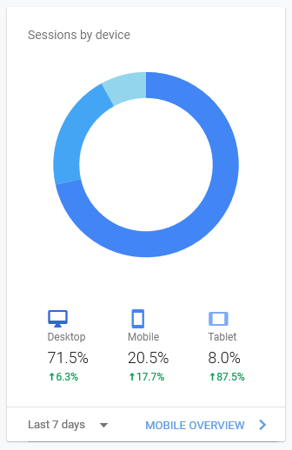

|  |  |  |  |
| --- | --- | --- | --- |
| Reported period | Month Apr 2020 |  |  |
| First visit | 01 Apr 2020 - 00:01 |  |  |
| Last visit | 30 Apr 2020 - 23:59 |  |  |
|  |  |  |  |
|  | Pages | Hits | Bandwidth |
| Viewed traffic * | 366,768 | 931,238 | 23.87 GB |

TOP ^

***30 May Nationwide Red Cross Radio Drill***

**Overall Goals:**

1. Activate county level ARES organizations for shelter communications.
2. Pass messages containing Red Cross information between simulated shelters and County Control Station with an emphasis on digital communication.
3. Organize and pass message to a state hub via fldigi or WinLink.

**Details**

1. Activate county level ARES organizations in a configuration to serve Red Cross and shelters. This would typically be a second layer to existing EMA/EOC communications after a large event.
2. Simulate deployment of ARES stations to likely local shelter sites. Establish a central control station - under OSERP this would typically be the “County Control Station”.
   1. The exercise assumes NO POWER, no phones, no Internet so at the least your “Shelter stations” must run auxiliary power.
   2. Lack of power also dictates: NO REPEATERS so arrange your simplex nets accordingly.
3. Pass standard Red Cross message forms from shelter to Control.
   1. Note: the national preferred format is WinLink. In Ohio, we would fall back to fldigi, which has the capability to transmit Red Cross forms.
   2. Voice messaging is acceptable at the local level
4. Counties may optionally forward to District Control Stations if district nets are activated, or forward directly via HF to our hub stations for Ohio.
   1. For this exercise we are not contemplating using “The Sarge” since it’s committed to Ohio EMA (and would typically be in use for that function.)
   2. Just as would happen at the local level, we will need to create a second-level net to handle state Red Cross messaging. We have a few options that are undecided but are fairly certain one station will be at the Delaware Chapter (N8DCA) on HF (80 meters) fldigi. We can also have voice communications if necessary but will probably try to stay in digital mode around 3585 (MT631KL 3000 or in bad conditions Olivia 8/500 3000)
   3. We do not have direct RF WinLink access at Delaware, but for purposes of the exercise we will have Internet access at our state hub station(s). Winlink messages should go to N8DCA.
5. Log and track your performance; create AAR to show our effectiveness to Red Cross.

**Time Period**

The exercise will take place May 30

May 28: A 213 will go out to all counties requesting stations to prepare for shelter activity deployment. (Remember, this is simulated deployment!)

**May 30:** The national timeframe launches the exercise at 1PM local (1700 UTC) with requests for forms (6409) from shelters. Shelter stations send 6409 to County Control Station. Make sure “This is an exercise” is included at the beginning of each form.

Forms will be transmitted to state network control stations (again, at least N8DCA there may be others).

Need more info? Contact Stan at: [stan@standi.com](mailto:stan@standi.com)

TOP ^

***Final.. Final..***

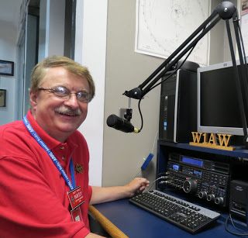Hi Gang,

This upcoming week would have been Dayton Hamvention weekend! Wow, it seems that even the weather doesn’t want to cooperate with us this year! Yes, it’s supposed to be much warmer, in the lower 70’s, but according to AccuWeather, there is a good chance of rain for Thursday, Friday, Saturday and Sunday!!! As they say “a little rain must fall…”

Janie’s still on her mission making masks. We had a great suggestion from one of our readers about seeking out the sporting goods stores for bungie cords to replace the shortage of elastic. When looking around for these, Janie found something even better! She found the makers of the bungie ropes used in those wild jumps off of bridges have switched over to making a really special bungie cord just for the making of these masks. Now the best part of this is that the factory is up in the Medina area! Yes, Ohio made!!! Fantastic. She ordered several rolls of this cord and it came in just 2 days! It’s really cool and I think it’s gonna’ make the mask way more comfortable as well. But, the best part of all of this is the fact that it’s Ohio born!

The weather hasn’t been cooperating much for Janie and I to get out on our Trikes this past week. We might just get to squeak in sometime around the middle of this week, but it will depend. We’re both fair weather riders and it has to be at least 50 degrees before we like going out. Ahhh the days when I used to ride the motorcycle in the snow! I had a fun time back then, but as time moves forward, I don’t care for getting that cold much anymore.

It appears that the governor is going to open up some things around here a bit. I’m still out on whether it’s a good thing or not. On something like this virus, I’d rather be safe than not alive! And, on the subject of opening things up a bit, the gov’ still hasn’t given any hint as to when we will be able to have a hamfest yet. But, you can bet the bank when he does give a green light for these types of events to happen, we’ll all be wearing masks for sure!! No if’s, and’s or buts about it. We will have that caveat attached to just about any group functions you can imagine for a very long time to come.

I’m still attending lots of meetings and get-togethers on Zoom, Go To Meeting and the like. It’s been great fun being able to “sit in” on meetings in the comfort of my ham shack and listening to all the great things our clubs around Ohio are planning once this “Stay Home” order is completely lifted.

Whelp, my final go around before gong QRT… Stay safe my friends! I want to see all of you soon at a meeting or hamfest! We will get through this and when we do, we’ll have so much to talk about. Most of all… have FUN and get on the airwaves!!

73,

***Scott, N8SY***

TOP ^

Ohio Section Cabinet

|  |  |
| --- | --- |
| Section Manager – Scott Yonally, N8SY | Assistant Section Manager – John Perone, W8RXX |
| Section Emergency Coordinator – Stan Broadway, N8BHL | Section Traffic Manager – David Maynard, WA3EZN |
| Technical Coordinator – Jeff Kopcak, K8JTK | Affiliated Clubs Coordinator – Tom Sly, WB8LCD |
| State Government Liaison – Bob Winston, W2THU | Public Information Coordinator – John Ross, KD8IDJ |
| Section Youth Coordinator – Anthony Lascre, K8ZT | |

***Swap & Shop Has Come to the Ohio Section Website***

Hey Gang,

Have you taken a look at the **Swap & Shop** page on the Ohio Section webpage yet??

Here’s a link that will take you there… <http://arrl-ohio.org/sm/s-s.html>

Do you have equipment that you just don’t need or want anymore? Here’s a great venue to advertise it, and it’s FREE!!

No, it won’t be listed in this newsletter because it would take up way too much space, so your ad will only appear on the website. It is there for any individual to post equipment Wanted / For Sale or Give-Away. No licensed vehicles/trailers or business advertising will be posted.

Postings are text only (no pictures or graphics) will be posted for a maximum of 1 month from date posting and require a contact phone number or email within the posting.

Send your Wanted / For Sale or Give-Away post to:  [swap@arrlohio.org](mailto:swap@arrlohio.org)

***Welcome New Subscribers***

**John, KE8LGH and Charles, KC2CNU**

***Back Issues of the PostScript and Ohio Section Journal***

Hey, did you know that PostScript and Ohio Section Journal (OSJ) are archived on the website? You can go back and look at any edition simply by clicking:

<http://arrl-ohio.org/news/index.html>

TOP ^

***Updated Information... Want to Share your Club Newsletter With Others?***

We have a new webpage where you can download and read all of the newsletters that I get from around the state.

Here’s the link to the page…. <http://arrl-ohio.org/club_news/index.html>

Please, if you don’t see your club newsletter posted, it’s probably because I’m not receiving it, or I just cannot convert it over to Adobe Acrobat. Have your newsletter editor contact me and let’s see if we can get your club’s newsletter on the site!! We all learn and steal (I mean, share) from each other’s work. So, let’s give this new webpage a real workout and send me your newsletter!!! Send it to: [n8sy@n8sy.com](mailto:n8sy@n8sy.com)

***Chit – Chat, and All That!***

Do you know someone that’s not getting these Newsletters? Please, forward a copy of this Newsletter over to them and have them “[Opt-In](mailto:Opt-In)” to start receiving them. Heck just have them send me an email [n8sy@n8sy.com](mailto:n8sy@n8sy.com) and I’ll get them added to the Ohio Section Emailing list.

We now have many thousands of readers receiving these newsletters weekly. Quite impressive, I’d say! I urge all of you to make sure that everyone, regardless of whether they are a League member or not, get signed up to receive these weekly Newsletters.

You can always “[Opt-Out](http://arrl-ohio.org/forwarder/forwarding.html)” at any time if you feel this is not what you were expecting. It’s fun and very informative. All of your favorite past newsletters are now archived too.

You can go back at any time and read them. Just go to: <http://arrl-ohio.org/news/>

Got questions, concerns or would just like to sit and chat awhile? Heck, I’ll even buy the coffee!! Give me a call at (419) 512-4445 or email me at: [n8sy@n8sy.com](mailto:n8sy@n8sy.com)

The pictures on the front page and throughout this newsletter are from various newsletters, Facebook posts and/or were sent directly to me in recent weeks. Take a good look at them, you just might be in one of the pictures! “SMILE… you’re in the Ohio Section News!!”

TOP ^

*PostScript is produced as a weekly newsletter. I want to thank everyone that has contributed articles and ideas to make this an even better news source. I sincerely hope that you have enjoyed this edition and will encourage your friends to join with you in receiving the latest news and information about the Ohio Section, and news and events happening around the world!*