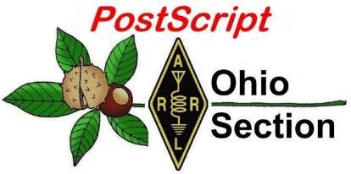
Cinco de Mayo
Edition

National News The Handbook Give Away

Club Corner Hamfests

DX This Week ARES Connect

VE Testing One Question Questionnaire

Final.. Final..

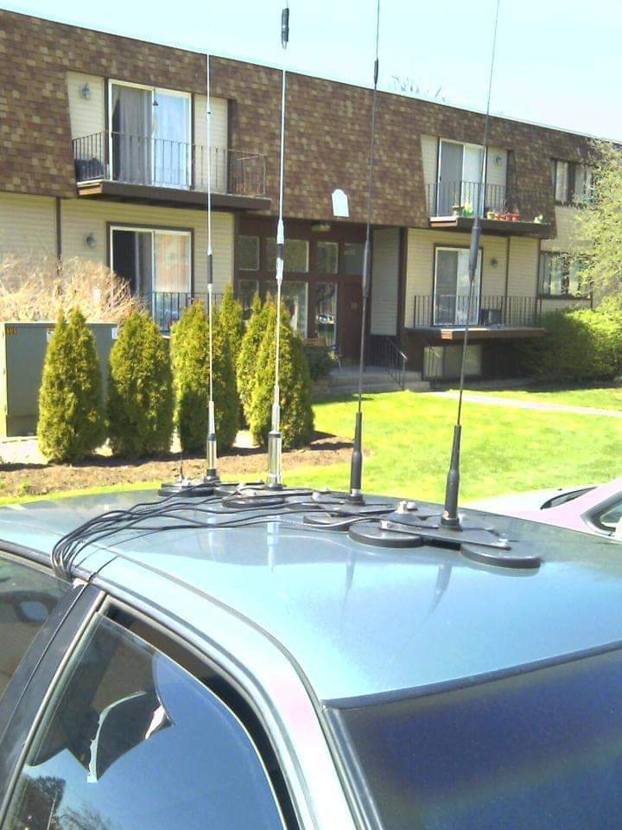
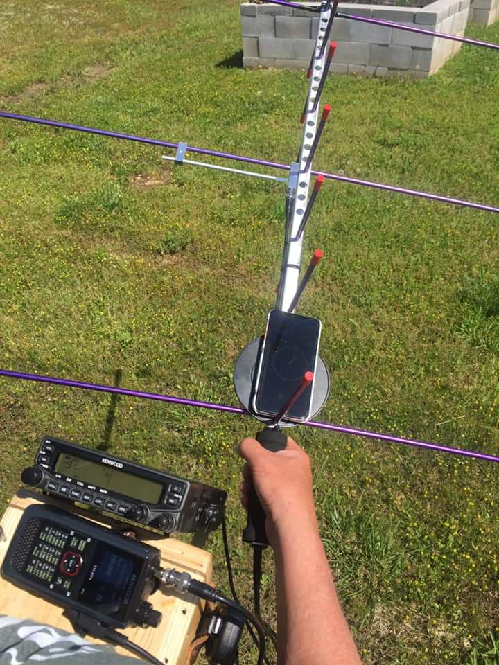
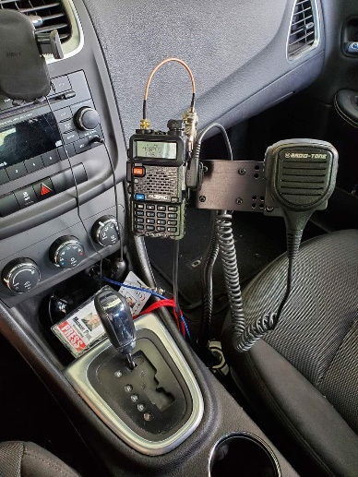
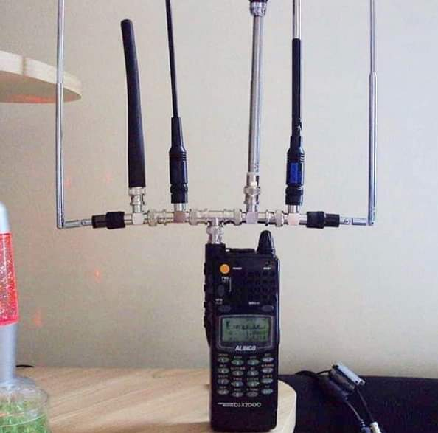
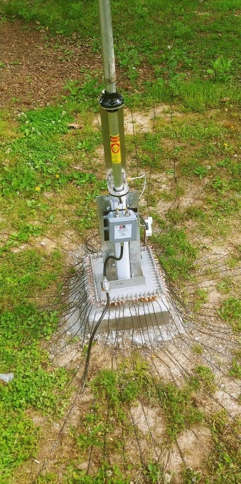

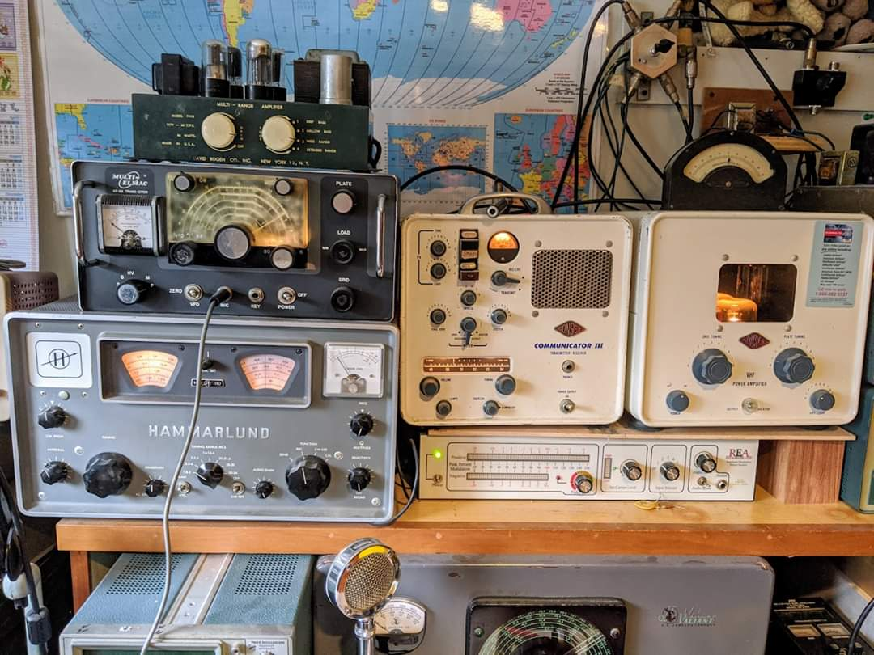

National News
(from arrl and other sources)

ARISS to Experiment with School Contacts Using “Multipoint Telebridge” Approach

Amateur Radio on the International Space Station (ARISS) is hoping to adopt a concept it’s calling the “multipoint telebridge contact via amateur radio” that will allow stay-at-home students to take part in amateur radio contacts with members of the space station crew. ARISS has used telebridge stations in the past to enable contacts at times when the ISS orbit does not pass overhead to permit a direct radio contact with the school or other location. In a conventional ARISS telebridge contact, an amateur station ground station in a favorable location for an ISS pass on the scheduled day makes the contact and handles two-way audio between the station and the contact site. ARISS said its new multipoint telebridge approach will permit simultaneous reception by families, school faculty, and the public.

“During the last several weeks, efforts to contain the spread of the COVID-19 virus have resulted in massive school closures worldwide,” ARISS said this week in a news release. “In addition, the stay-at-home policies invoked by authorities initially shut down opportunities for ARISS school contacts for the near future.”
ARISS will put its multipoint telebridge scheme to the test during a contact with a group of Northern Virginia students on April 30. For the event, an ARISS telebridge ground station will link with an ISS crew member via radio, and homebound students and their teacher will be linked individually via the telebridge station. Under the teacher’s direction, each at-home student will take a turn to ask the astronaut one question on a prepared list.
“This approach is a huge pivot for ARISS, but we feel it is a great strategic move for ARISS,” said ARISS-International Chair Frank Bauer, KA3HDO. “In these times of isolation due to the virus, these ARISS connections provide a fantastic psychological boost to students, families, educators, and the public. And they continue our longstanding efforts to inspire, engage, and educate students in STEAM subjects and encourage them to pursue STEAM careers.”

The April 30 contact, set to start around 1335 UTC, will involve 5-to-10-year old pupils. Fred Kemmerer, AB1OC, in Hollis, New Hampshire, will serve as the telebridge station, and the ISS side of the contact should be audible over the New Hampshire region on the 145.80 MHz downlink. A live stream is expected to be available.

####

FCC Confirms that Amateur Radio Service License Exams May be Held Remotely
(FCC and Radioresource - Submitted by Gregory Drezdzon, WD9FTZ)

The Federal Communication Commission released a notice, Thursday, April 30, saying that remote tests for the amateur radio service are not prohibited, and prior FCC approval is not required to conduct remote tests.

The amateur radio service provides opportunities for self-training, intercommunication and technical investigations for qualified persons. To operate an amateur radio service station, an operator must have an FCC license.

TOP ^
The FCC issues three classes of operator licenses, and the class for which each licensee is qualified is determined during an examination by volunteer examiners, who conduct the testing on behalf of FCC-certified volunteer examiner coordinators.

Many potential amateur radio test takers and volunteer examiners have contacted the FCC to request that the commission allow remote testing in light of current public health guidelines regarding social distancing during the COVID-19 pandemic.

“The commission provides flexibility to volunteer examiners and coordinators who wish to develop remote testing methods or to increase remote testing programs already in place,” the notice said. “We recognize that some volunteer examiner coordinators may not have the immediate capacity for widespread remote testing. We expect those volunteer examiner coordinators with limited remote testing capacity to work closely with those requesting such testing to prioritize any available remote testing slots.”

https://docs.fcc.gov/public/attachments/DA-20-467A1.pdf

####

FCC Adopts a New Official Seal in Anticipation of Relocation

In anticipation of its upcoming move, the FCC has adopted a new FCC seal. The redesigned seal is the product of an agency-wide contest that solicited proposals from employees and contractors. The winning design, submitted by Umasankar Arumugam, was selected by a vote of the agency’s employees and contractors.

The revised design incorporates several elements: communications technologies currently transforming our world; four stars on the outer seal border, drawing from the legacy of the predecessor Federal Radio Commission seal; 18 stars on the shield, recognizing the current number of bureaus and offices; and the eagle and shield, identifying the FCC as a federal government agency.

Over the next few months, the FCC will incorporate the new seal on official stationery, business cards, publications, and other materials, including on its website and throughout its new Headquarters. Official use of the new seal will begin following completion of the agency’s move from the Portals to its new Headquarters. The date of the move is to be determined and has been delayed due to COVID-19. — FCC news release

####

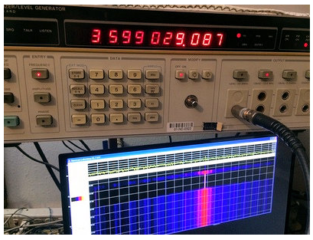
Frequency Measuring Test Results Posted

The results of the spring 2020 Frequency Measuring Test (FMT), conducted on April 24, have been posted. Coming in at the top of the list for stations entering readings of both the 40-meter and 80-meter frequencies was Steve Cerwin, WA5FRF. His average error rate was 0.004902 parts per million (ppm).The Top 10 looked like this, with average error rates in ppm. Bill De Carle, VE2IQ, has posted a ranked
list of participants who submitted readings for both frequencies.

TOP ^

1. | WA5FRF | 0.004902
2. | WA2IKL | 0.005584
3. | N7WS | 0.005636
4. | N9CIF | 0.006999
5. | NJ0U | 0.007051
6. | N8OBJ | 0.007655
7. | AD5MT | 0.008415
8. | KB3UMD | 0.008415
9. | WB6RJH | 0.008492
10 | AB4RS | 0.009174

Today’s FMTs are conducted completely online, with no manual log-checking or intervention. Connie Marshall, K5CM, provides Bruce Horn, WA7BNM, with the precise actual frequencies, participating individuals submit their measurements, and machines handle the rest. Ninety-eight radio amateurs took part on the April 2020 FMT. The next FMT will take place in November.

Taking part in the FMT does not require special laboratory equipment. Modern HF transceivers can measure frequency quite accurately, and SDR-based receivers and available software can enable precise frequency measurements. Today’s FMT leaders are able to accurately measure beyond the number of decimal places (out to 5) that a typical transceiver will display, however. One station participating in the 2019 spring FMT used an Elecraft KX3 and Spectrum Lab audio software. Another employed his Elecraft K3 transceiver and tuning forks to get within 1 Hz of the mark on both bands.

Some information on how to measure the frequency of a carrier is available on Marshall’s website as well as in past articles in QST. Visit the FMT-Nuts discussion group on groups.io.

####

Online Registration Opens for Free Virtual Contest University

Contest University (CTU), a staple of Dayton Hamvention, will take place online this year through the Zoom video platform, and all sessions will be free. Visit the CTU website to register. Live CTU sessions via Zoom will get under way on Thursday, May 14, 1245 UTC - 8:45 AM EDT, and will be recorded and archived.

Go to the Contest University website to register http://contestuniversity.com

Thanks to CTU Chair Tim Duffy, K3LR, K8MNJ, N9JA, W3CDG, KA9FOX and all the CTU 2020 professors for making this happen!

####

TOP ^
First contact made on 40 MHz between Ireland and Lithuania
(Submitted by Gregory Drezdzon, WD9FTZ)

On Wednesday, April 29, 2020, EI4GNB in Ireland completed a digital FT8 contact with LY2YR on 40.220 MHz on the new 8-meter band.

Not only was this an EI-LY first but it was also the very first contact made between any two countries on the band.

The distance was approximately 2,039 km or 1,101 nm and the mode of propagation was Sporadic-E.

It should be noted that while Lithuania does not have an official allocation at 40 MHz, although the licensing authorities in the country kindly gave LY2YR special permission to carry out experiments on the spot frequencies of 40.220 MHz and 40.680 MHz.
(Note: Usage of 8-meters in the United States by amateur radio operations is currently prohibited.)

This is a model that could perhaps be adapted by other interested radio amateurs in other countries. It may be easier to get special permission to use spot frequencies for a limited period of time rather than a general allocation.

It is hoped that there will be activity from Slovenia very soon and hopefully this will generate more interest in this fascinating VHF band.

More information can be found here:
https://ei7gl.blogspot.com/2020/05/first-contact-made-on-40-mhz-between.html

####

Russian DOSAAF-85 (RS-44) Amateur Radio Satellite Transponder Now Active

The amateur radio linear transponder (SSB/CW) on the Russian DOSAAF-85 (RS-44) has been activated. Dmitry Pashkov, R4UAB, explains that RS-85 is a small scientific satellite built by specialists at Information Satellite Systems and students at Siberian State Aerospace University (SibSAU).

The satellite’s name commemorates the 85th anniversary of the Voluntary Society for the Assistance to the Army, Aviation, and Navy (DOSAAF), the organization responsible for the military training of Soviet youth.
This is the third satellite created by the specialists of ISS-Reshetnev and is based on the Yubileyniy platform, which features a hexagonal prism structure with body-mounted solar cells. It was launched into orbit last December 26 from the Plesetsk Cosmodrome and is in an elliptical orbit with a perigee of 1,175 kilometers (729 miles), an apogee of 1,511 kilometers (937 miles), and an inclination of 82.5°.

Transmitter power is 5 W, and the beacon is on 435.605 MHz (identifying as RS44). The transponder is inverting, with uplink centered at 145.965 MHz ±30 kHz, and downlink centered at 435.640 MHz ±30 kHz.
LoTW accepts contacts via DOSAAF-85 as "RS44."

TOP ^

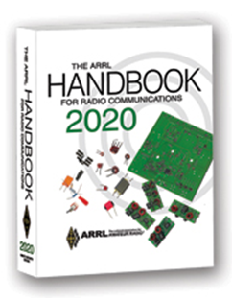
The Handbook Give Away

Hey Gang,

The winner of the February Give Away is… William Williams KC8WVG

Many of you ask me just how do I know when the drawing is on? Well, that’s easy all you need to do is check in on the Ohio Section Website on a regular basis and watch for the big RED Arrow that will appear on the left side of the page.

This is the sign that the drawing is on and you need to get registered. So, keep a sharp eye out on the website and check in often! http://arrl-ohio.org/

Club Corner
This is YOUR cornner of the newsletter. Send me what your club is doing and I’ll make sure that it gets in. Got a special event or club project that you want everyone to know about? Send it to me!. Need help with a project? Send it to me.

Let me know what you club is up to. Are you going to have a special guest at your meeting or are you having a special anniversary? Just sent it to: n8sy@n8sy.com

####

Pan Ohio Hope Ride - –2020 Event Update

The safety of our riders, volunteers, and staff always comes first. The Pan Ohio Hope Ride staff and volunteer leadership committees have been actively monitoring the ongoing COVID-19 crisis and holding contingency planning sessions since early March. It has become increasingly apparent that we will not be able to safely travel or gather as a large group this summer. It is also highly likely that some of our partnering colleges, parks, and municipalities will not be available for our use.

As such, we have made the difficult decision to cancel the in-person 4-day event as we know it and shift the 2020 Pan Ohio Hope Ride to a primarily virtual experience.

Further information can be found in our 2020 Virtual Pan Ohio Hope Ride FAQ, including details on registration and lodging fees and highlights of our planned virtual events. We will keep this document updated as the situation evolves, and our plans develop.

TOP ^
Now our mission needs you more than ever and the funds you’re raising are even more critical. We are so grateful for the passion and dedication of our millions of volunteers and supporters. Thank you for your continued support of our mission and for all you are doing to help lead the fight for a world without cancer.
​2020 Virtual Pan Ohio Hope Ride FAQ

https://docs.google.com/document/d/121bHOIbtO6aF8sqRFXfm6wLt0XKvsTfjaVTuaXtboBU/edit

####

Cleveland Marathon Converted to Virtual Event

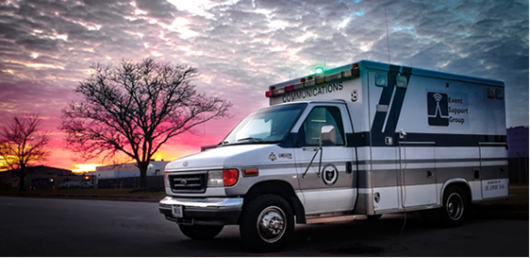
The Cleveland Marathon has officially been moved to a “virtual event”. This means we will obviously have no communications responsibilities. Thanks very much for your willingness to work this very important event. Because of this, I will also be cancelling the May Cuyahoga County ARES meeting which was to be a review of the Marathon procedures.

If you want to read the full statement from the Marathon, you may find it here https://www.clevelandmarathon.com/media/recent-news/rite-aid-cleveland-marathon-goes-virtual-due-to-covid-19.aspx

####

Upcoming Event Status Update

Below is an update on the future radio related events in the Cleveland area.

• May 16-17 Cleveland Marathon Cancelled (converted to virtual events)
• June 14 Sunday in June Bike Ride Cancelled

Our friends over at the Geauga Amateur Radio Association have begun compiling a list of as many radio related cancellations as they can. Be sure to check it frequently at https://geaugaara.org/coronavirus/

####

Dave Kalter Memorial Youth DX Adventure
Unfortunately, our 2020 trip to Curacao has fallen victim to the covid-19 virus. It was set for July 11-17, 2020. Conditions and restrictions on the island remain locked down and we anticipate they will not change in time to finalize our trip. We are very disappointed but understand. The group wishes the best for the people of Curacao and pray for their health and safety.

We are extremely grateful for the generosity of the CCC in hosting us again on short notice and rescuing our 2020 event. Our best wishes for the group as they deal with the issues in keeping the site up during these times.

TOP ^
Especially the loss of PJ2T during all the contests! Of course several of the contests have eliminated the multi-multi categories. Maybe we will see them on the bands as a remotely operated station.

We plan to extend the 2020 team to our 2021 trip as long as the individuals are still available.

Jim Storms AB8YK

Upcoming Hamfests for 2020
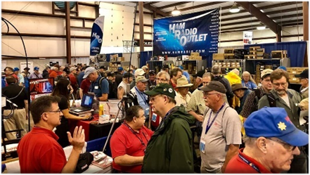
05/15-16-17/2020 | Dayton Hamvention
Cancelled

06/06/2020 | FCARC Summer Hamfest
Location: Wauseon, OH
Sponsor: Fulton County Amateur Radio Club
Website: http://k8bxq.org/hamfest

07/19/2020 | Van Wert Hamfest
Location: Van Wert, OH
Sponsor: Van wert Amateur Radio Club
Website: http://w8fy.org

####

Webpage for Cancelled Hamfests

ARRL has created a webpage that will search the ARRL Hamfest and Convention Database for canceled events. >> Click Here <<

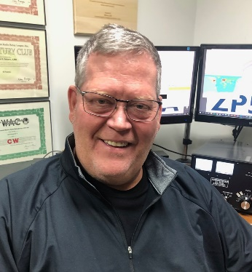
DX This Week
(from Bill, AJ8B)

DX This Week – 3B8FA
Bill AJ8B (aj8b@arrl.net, @AJ8B, or www.aj8b.com)
CWOPs Member #1567

Hope you are doing well and tuning around. If you were around the cluster this past week, there were many different entities to be worked. These included Afghanistan, Alaska, Australia, Costa Rica, Cuba, Dominican Republic, England, European Russia, Fed. Rep. of Germany, Finland, Hong Kong, Indonesia, Italy, Jamaica, Japan, Korea, Latvia, Lithuania, Moldova, Netherlands, Poland, Romania, Samoa, Suriname, Sweden, Switzerland, and Ukraine.

TOP ^

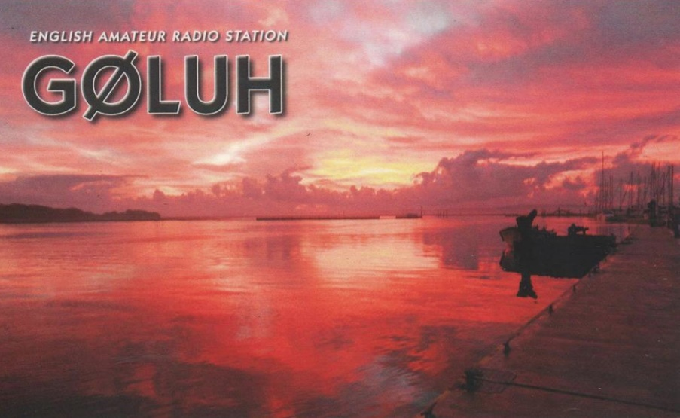

I received a couple of cards this week: Great CW OP – F5IN – Michel in France, VK7XX – John in Tasmania, and G0LUH – Douglas from England (Pictured). Did you get any or send any this week?

This week, I thought I would share an interview that I conducted with Patrice, 3B8FA. He is a solid operator and a good guy to chat with. Check out his qrz.com web page and even frop him a note!

Interview with Patrice—3B8FA
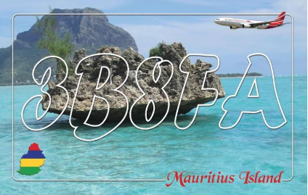
After working Patrice, 3B8FA, I took a moment to review his QRZ.com webpage and was very impressed in all that he had accomplished. He kindly agreed to answer a few questions for us..

AJ8B: How did you first get interested in amateur radio?
3B8FA: I got involved in amateur radio because I used to help my elder brother (3b8du) with his antenna setup. I started, like many of us, by being an SWL. I remember using 3B8-101 number sign, that was in +/-1976.

AJ8B: When did you get on the air?
3B8FA: I got my class A license in 1979 and was the youngest HAM at that time.

AJ8B: It appears that you have been on many modes and bands. Do you have a favorite?
3B8FA: One thing I never liked is CW even though I passed the 12 words/minute test easily.

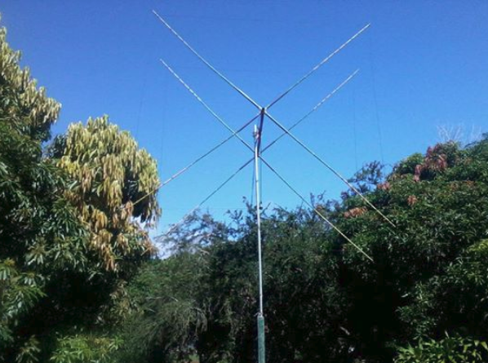
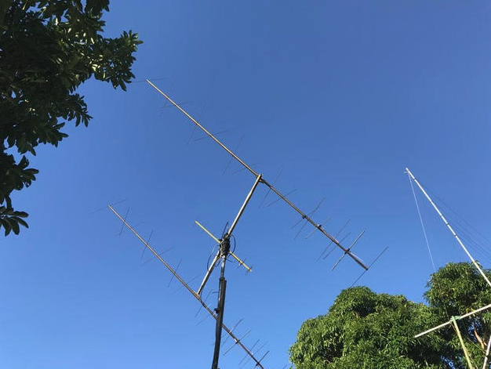

TOP ^
AJ8B: In reviewing your QRZ.com page, I see that you have been very successful with chasing countries and with contests. Any secrets to your success?
3B8FA: I have never been a DXer or a contester, but I did take part in a few contests, particularly when I discovered the SSTV mode. I am interested in most aspects of our hobby, the last one is EME which I started a few months ago with quite good results considering my modest station. I am also involved in tropo ducting on 2m between the Indian ocean countries (3B9, FR, ZS). I am very active in Low Earth Orbiting (LEO) satellite activity as well using all the V/U and FM birds, being amongst the first to receive AO94 lunar orbiting satellite with a 15-element homemade Quagi antenna.

AJ8B: Describe what you are currently using:
3B8FA: Actually, I'm using a Kenwood TS2000 as main rig also have a Yaesu FT897 spare rig.

AJ8B: Any QSLing hints?
3B8FA: Nothing particular about QSLing, only that I don't make paper QSL collection anymore, but I do have the paper cards for those interested.

AJ8B: I noticed on your webpage that you have also been active from 3B7 - Do you get there often?
3B8FA: Concerning 3B7, that was a trip my brother and I undertook to test his new sailing boat which he took 14 years to finish. So, I brought my equipment in view to make SSTV active from there, that was a great first! I worked also in PSK mode and had a great time fishing there.

AJ8B: What coaching/advice would you give new amateurs?
3B8FA: Unfortunately, I noticed very bad operating behavior since the last decade so I will ask to all newcomer and seniors to keep the HAM spirit to its original values.

AJ8B: Thanks for taking the time to answer my questions. Is there anything you would like to share with us?
3B8FA: Here you can find more information about amateur radio in Mauritius, history and much more. https://mars3b8.wordpress.com/

Best 73,
Pat—3b8fa

CQDX CQDX CQDX CQDX CQDX CQDX CQDX CQDX CQDX

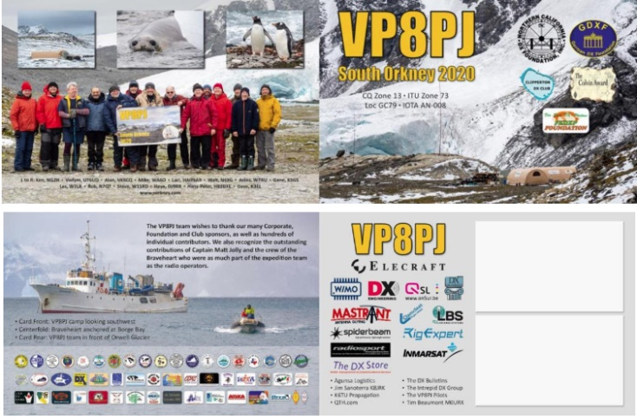
Here is an update from Bernie, W3UR, of the DailyDX and the WeeklyDX, the best source for DX information. http://www.dailydx.com/. Bernie has this to report:

VP8PJ Update - As promised, this is the primary QSL card for the project.

Thanks to all who processed a request on OQRS or mailed their request to Tim M0URX.

The cards will be shipped from ON5UR Print Services in Belgium to the UK. Tim has already printed the QSO labels, address labels and printed the postage. As soon as Tim receives the cards he will stuff the envelops and take to the post office.

TOP ^
With the Covid19 airline disruptions international mail is slower than normal, so please have patience.

As a reminder, all VP8PJ confirmation processing is handled by Tim M0URX, from the UK.

Buro cards will be placed in the buro system in early 2021.

73, GS K5GS

************************

5W – Samoa - “Talofa (love and affection) from Samoa!”, says 5W1SA, Atsu, where there has been no reported cases of the Covid-19. “Yes, the Island is really isolated from any other land and the Samoa Government decided close the boarder at the early stage”, reports Atsu. He will soon be signing 5W19STAYSAFE as he wishes “everybody Stay Safe at your places and we will see the end of pandemic as soon as possible”. QSL via LoTW only as he does not plan to have any paper QSLs for this operation.

9G – Ghana - IZ4YGS, Matteo, is currently working in the Ellembelle District in Western Ghana until May 15th. He is QRV from Sanzule as 9G5GS on most days between 2000 and 2300Z and sometimes between 1200 and 1400Z and after 1700Z. He operates on FT8 using the Fox and Hound mode operating on 3.590, 7.056, 10.131, 14.090, 18.095, 21.091, 24.926 and 28.091 MHz. QSL via IK4YGS, LoTW or eQSL.

VU – India - AT2TNX is a special thank you for health care and others keeping societies going during the COVID-19 era. Organizers say this special “expresses special gratitude towards front line warriors serving us all during this Covid-19 pandemic.” VU2KWJ in Mumbai, Jatin Shah, will be at the radio. He also used this callsign back in 2015 for other purposes.
A second special station from India is AT2SHI, standing for “Stay Home India.” VU2UUU, Kaustav Saha from Gurugram says it’s spreading awareness of “Stay Home Stay Safe.”

4X – Israel - 4X2BESAFE has been on the air this month. They say “Stay home, be well, do radio!” QSL via 4Z1TL; direct with SAE and 3 USD, “please no IRCs, SWL direct only.”

EU – Belarus
Special calls will commemorate the end of World War II. They are EV75M, EV75F, EV75K, EV75P, EV75G, EV75GK and EV75PP. Look for them on the air May 2-9, part of “Memorial Pobeda-75.”

UA – Russia - The 425 DX News reports that many Russian stations will be using special prefix RP75 May 2-9, with the P standing for “pobeda,” which means “victory.” This marks the 75 years since the end of World War II. https://pobeda.srr.ru/.

DX news

ARLD018 DX news

This week's bulletin was made possible with information provided by The Daily DX, the OPDX Bulletin, 425 DX News, DXNL, Contest Corral from QST and the ARRL Contest Calendar and WA7BNM web sites. Thanks to all.

TOP ^
BAHRAIN, A9. Operators Fawaz, A92AA, Ahmed, A92AB and Ely, A93LT will be active as A91WTIS from May 10 to 17 for World Telecommunication and Information Society Day. Activity will be on various HF bands. QSL via A92AA, direct.

ANTARCTICA, 8J. Members of the Japanese Antarctic Research Expedition team (JARE) will be active as 8J1RL from Showa Research Station, Queen Maud Land (AN-015), until January 2021. Listen for operators Take, JA1AGS and Hiro, JH7JCX. Activity will be on various HF bands using CW and the digital modes. QSL via JG2MLI or the JARL Bureau.

CHILE, 3G2. Stay-At-Home station 3G2HOME is now QRV. Activity has been mainly on 20 meter CW. QSL via LoTW only.

ISRAEL, 4X2. Isaac, 4Z1TL will activate Stay-At-Home station 4X2BESAFE until August 12. Activity will be on various HF bands. QSL via 4Z1TL, direct. No IRCs.

JAMAICA, 6Y6. Nigel, 6Y5HN is supporting the COVID-19 Stay-At-Home event as 6Y6STAYHOME. Activity has been on 40 meters. QSL via EA5GL.

CHINA, B0-9. Members of the Chinese Radio Amateurs Club (CRAC) will activate 10 special event call signs (B0CRA - B9CRA) across their country to make QSOs with hams all over the world. Operations will take place from May 1 to 7. QSL via BA1GG.

CANADA, CH2. Ian, VO2IR is active as CH2IR until June 20 to remind everyone to Stay-At-Home. Activity is on various HF bands. QSL via VO2IR.

LEBANON, OD5/OD50. Members of the Radio Amateurs of Lebanon (RAL) will activate special event call signs OD50SH and OD5STAYHOME to spread awareness and Stay-At-Home as part of social distancing policies during the COVID-19 outbreak. QSL via IZ8CLM.

BELARUS, EU. The following special event stations will take part in the Pobeda-75 commemoration of the end of World War II: EV75B, EV75F, EV75GK, EV75K, EV75M and EV75PG.

ENGLAND, G. Members of the RSGB Contest Club will put GB1945PE, GB1945PJ and GB75PEACE on the air during May and August to mark Victory in Europe and Victory in Japan Days. QSL only via LoTW and eQSL. Also, The Royal Air Force Amateur Radio Society (RAFARS) marks the end of World War II in Europe with the call sign GB75VED from May 1 to 28. QSL via 2E0NDZ.

ITALY, I. The ARI Fidenza Club (IQ4FE) will put a number of special event stations on the air during 2020 to commemorate the life and achievements of Guglielmo Marconi. During May, II4TEA commemorates the first transatlantic transmission in 1903. QSL via IQ4FE.

BULGARIA, LZ. The Bulgarian Federation of Radio Amateurs (BFRA) celebrates its 50th anniversary with the call sign LZ50BFRA until the year's end. QSL via bureau to LZ1BJ.

TOP ^
AUSTRIA, OE. Alex, OE3DMA will be active with the call sign OE60IPA on April 30 and May 1 for the 60th anniversary of the International Police Association. QSL to OE3DMA via bureau.

RUSSIA, RP. A large number of special event call signs with the prefix RP75 will be active from Russia celebrating the end of World War II.

AUSTRALIA, VK. Station VI250COOK commemorates Captain James Cook's voyage on HMS Endeavour along Australia's east coast with activity from May 1 to August 31. For QSL information see qrz.com.

STAY AT HOME. More stations in the stay at home effort:
4U2STAYHOME, 5W19STAYHOME, AT2SHI, IO6STAY, OD50SH, OD5STAYHOME, OE1STAYHOME and OQ1HOME.

THIS WEEKEND ON THE RADIO. The Araucaria World Wide VHF Contest,
10-10 International Spring Contest, CW, RCC Cup, Microwave Spring Sprint, ARI International DX Contest, 7th Call Area QSO Party, Indiana QSO Party, RTTYOPS Weekend Sprint, Delaware QSO Party, FISTS Spring Slow Speed Sprint and the New England QSO Party are all on tap for this weekend. Please see May 2020 QST, page 69 and the ARRL Contest Calendar and WA7BNM Contest Web Sites for details.

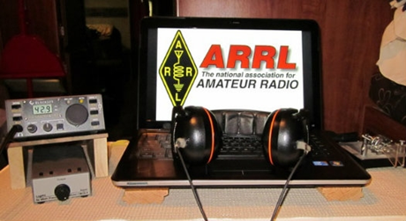
ARRL Contest Corner

An expanded, downloadable version of QST's’Contest Corral is available as a PDF. Check the sponsor's’Web site for information on operating time restrictions and other instructions.

Special Events

05/04/2020 | Florence Nightingale Bicentenary
May 4-May 31, 1400Z-2359Z, GB200FN, Romsey, UNITED KINGDOM. RSGB. 14.190 3.650. QSL. John Wakefield, Oakhurst, Lower Common Road, Romsey SO51 6BT, UNITED KINGDOM. www.qrz.com/db/gb200fn

- 05/05/2020 | World Pulmonary Hypertension Day
May 5, 0001Z-2359Z, W2H, Forked River, NJ. K2JSS. 14.250 14.074 7.074 3.573. QSL. Jack Bartky, 2209 Longwood Dr., Forked River, NJ 08731. K2JSS@arrl.net

- 05/08/2020 | 75th Anniversary of the Victory in Europe
May 8-May 23, 1800Z-2359Z, W2V, Ansonia, CT. VOA Radio Club. 14.345 21.345 7.245 3.845. QSL. Dave Arruzza, 32 Benz Street, Ansonia, CT 06401. w2v.se@yahoo.com or www.qrz.com/db/w2v

TOP ^
- 05/08/2020 | Golden Spike Celebration Special Event Station W7G
May 8-May 9, 1500Z-2300Z, W7G, Corinne, UT. Ogden Amateur Radio Club (OARC) - W7SU. 14.255 7.235 14.040 7.040. QSL. Ogden Amateur Radio Club (OARC) - W7SU, P.O. Box 3353, Ogden, UT 84409. Golden Spike Celebration Commemorating the Anniversary of the 1869 Driving of the Golden Spike, completing the Transcontinental Railroad at Promontory Summit, Utah. Golden Spike National Historical Park - National Parks Service 6200 North 22300 West, Promontory Summit, UT 84307. http://ogdenarc.org or w7g.org

- 05/08/2020 | Utah Valley Hamfest 2020
May 8-May 9, 0900Z-1700Z, K7UVA, Orem, UT. Utah Valley Amateur Radio Club. 14.280 7.200 7.080. QSL. Utah Valley Amateur Radio Club, PO Box 1288, Orem, UT 84059-1288. https://utahvalleyhamfest.com

- 05/09/2020 | COSI Big Science Celebration
May 9, 1400Z-2000Z, W8LT, Columbus, OH. Friends of W8LT. 14.250 14.074. QSL. Larry Feth, 40 Bevis Hall, 1080 Carmack Rd., Columbus, OH 43210. https://www.qrz.com/db/w8lt

- 05/09/2020 | Jamestown Landing Day Event
May 9, 1400Z-2000Z, K4RC, Jamestown, VA. Williamsburg Area Amateur Radio Club. 14.265 7.265. QSL. QSL Manager, K4RC, P.O. Box 1470, Williamsburg, VA 23187. 413th anniversary of English establishing the oldest English-speaking colony on the American continent. www.k4rc.net

- 05/09/2020 | World War 1 Armistice Commemoration
May 9, 1400Z-2200Z, WW1USA, Kansas City, MO. National World War I Museum and Memorial. SSB 14.225 7.250 CW 14.060 7.060. Certificate. WW1USA Amateur Radio Station, 2 Memorial Drive, Kansas City, MO 64108. We are commemorating the 101st anniversary of the signing of the peace treaties ending World War 1. Our operations will be on the south lawn of the Museum. All local and visiting hams are invited to come visit. ww1usa@theworldwar.org or www.qrz.com/db/ww1usa

Mount Athos – Monday May 4th
(from Chuck, W8PT & PCARS)

It was reported that Monk Iakovos said he would depart for Mount Athos on Monday May (not June) 4th confirming activity will be on 20 meters and will give more details soon. So for those of you, like myself, who need this DXCC entity, keep your rigs on and your ears tuned to 20m. This is all the info I have so far.

“ARES Connect”
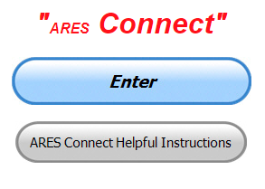
Everyone – please make sure to go into all of the events that you have signed up for and get your hours registered no later than 5 days after the event has ended.

Folks, I’m seeing a lot of folks that have signed up for events not entering their time after the event. This is a very important piece of using “Connect.” Your hours need to be recorded and it’s so easy to do.

TOP ^
Let’s run through how so in case you have forgotten. If you have already gotten signed up for an event, all you have to do afterword to get your time entered is at any time after the event has ended, log into “Connect.” And then click on your name in the upper right-hand corner of the page. This will bring up a drop-down menu where you will then click on “View Hours.”

This brings up another screen where you can “Report Hours” as well as “View Hour History” You’ll want to click on “Report Hours.” You will then be presented one at a time by chronological order each event that you have signed up for and hours have not yet been reported on.

Type in those hours in the “Hours Worked” box and hit “Submit”… Keep doing this until you have no more hours to report…. That’s all there is to it. Now, if you are following the request above and doing this at least every 5 days or more often, this will only take you a minute or so to complete.

We still have a number of recurring events created but no activity reported for them. Please, if this event is no longer needed, let me know and I can delete it from the masters. I know that many of you setup recurring events to learn how, but if they aren’t going to be used, let’s get them cleared out.

Also… If you are setting up events, please don’t set a limit for how many folks can sign-up unless absolutely necessary. This causes issues when doing reports. It’s also counter-productive since the reason for you to list the event is to get as many volunteers as you can to attend. When you set limits, it discourages folks from signing up.

Now, isn’t that easy? Yes, and we all need to be diligent at doing it promptly.

Here’s are the top 10 hours earners for April:

 | Name | Events | Hours
1 | Michael Lacumsky (W8MAL) | 42 | 87.00
2 | Christopher Domenick (KC8CAD) | 29 | 82.25
3 | James Yoder (w8erw) | 18 | 76.00
4 | Henry Ruminski (W8HJR) | 33 | 71.15
5 | Dan Stahl (KC8PBU) | 71 | 70.99
6 | Bret Stemen (KD8SCL) | 28 | 62.00
7 | James Garber (W8CEN) | 40 | 59.75
8 | Earl Paazig (W8BR) | 27 | 57.50
9 | Alan Rothweiler (N8CJ) | 22 | 56.25
10 | Greg Dersarkisian (KD8SSJ) | 17 | 54.00

Let’s get everyone in the Ohio Section on “ARES Connect!!!” Simply go to: https://arrl.volunteerhub.com/lp/oh/ and get yourself registered and using the system.

TOP ^

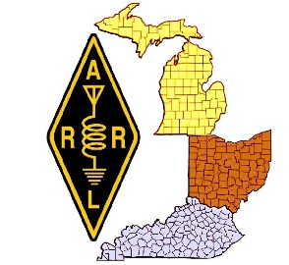
New - Dashboard for Great Lakes Division ARES Connect

Now that ARES Connect has been fully implemented within the Great Lakes Division, have you ever wondered just what our three Sections actually contribute to our combined communities?

We now have a Dashboard on the Great Lakes Division website that will tell you that exact information. Since ARES Connect is an “on-line” and up to the minute reporting system, we now have the ability to obtain this very detailed information.

ARES Connect is full of details that we’ve never been able to obtain before, and because of that, we now can see a much more detailed view of what the Division is doing. Oh, I guess I should also mention that you can also see the data broken down into each Section as well. Now, ain’t that something!!!

Want to take a look? Here’s a link… http://arrl-greatlakes.org/ac.html

Oh, and don’t forget to checkout the rest of the Division’s website as well!!!!

V.E. Test Sessions
For the most part, all V.E. testing has stopped until such time as we can once again gather in groups.

Keep on studying and taking those practice tests to keep what you’ve learned fresh in your mind. We will get out of this soon and testing will resume, so you’ll want to be prepared for when it does return.

One Question Questionnaire

Hey Gang,

“Survey Says”….. Just about 18% of you like the new “On The Air” magazine over QST. Wow… I would have thought that this would have been much a much larger percentage by the way everyone has been talking.

Now, on to next question.

“If all restrictions on large gathering were lifted today,
would you attend a hamfest this next weekend?

You’ll find the “One Question” questionnaire on the Ohio Section Website! http://arrlohio.org It’s all in fun and it’s not a scientific survey in any way, but we are learning some things that we didn’t know from these questions. I hope that you are enjoying answering these “One Question” questionnaires.

TOP ^

2020 Weather Safety Week Events
- Lightning Safety Awareness Week: June 21-27
- Ohio’s Winter Safety Awareness Week: November 15-21

ARRL Members now have digital access to all four magazines!

No matter your level of experience in ham radio, you’ll find articles and stories for you.

ARRL members will now receive digital access to four ARRL magazines beginning with their latest issues. Joining QST and On the Air on a digital platform will be the bimonthly editions of QEX — The Forum for Communications Experimenters and NCJ — National Contest Journal. QEX includes articles, columns, and other features ranging from construction projects to more advanced technical information in radio theory and practice.

NCJ targets radio amateurs active in radiosport, and includes scores, technical articles, contributions from top contesters, and advice for radiosport enthusiasts alike.

"All members can enjoy specialized content and a high-quality reading experience whether at their desk or on the go. Offering this suite of digital magazines is an opportunity for us to give members more of what they want while adding value to ARRL membership” said ARRL Publications Manager Steve Ford, WB8IMY.

ARRL’s digital magazine editions provide replicas of the printed editions with added functionality, allowing users to fully search issues, enlarge pages, share articles, and more. All four are easily accessible through any web browser from members-only links. The free ARRL Magazines app also supports downloading complete issues for offline reading. It is available for iOS and Android in the Apple App Store and Google Play.

For more information visit www.arrl.org/arrl-magazines

Conference Bridge Now Available to Clubs in Ohio

Hey Gang,

With the government closing down all meetings of 10 or more persons it has become a struggle for clubs all over our Section to find ways of having their meetings, and as you can see in the “Club Corner” section of this newsletter all the cancellations that have happened recently.

Well, the Ohio Section has come up with a tool for the toolbox that will allow you to have a video/phone conference meeting and stay within the CDC’s guidelines for distancing.

TOP ^
We’ve partnered up with Zoom, one of the premiere video conferencing bridges in the country and we now have the ability to do our own “on-line” conferences.

Our Zoom account allows for up to 100 persons at a time to be connected with not only audio, but video as well. This is sooooo 21st century. You can share your screen for those really fancy presentations, see everyone that’s connected with a camera on the call and really do a first-class meeting with this technology. No, you don’t need to have a computer. Zoom will also allow you to just call in on your regular or cellular phone too. That is what makes this so great.

I think it is really great for all of us to keep in contact with each other, especially with our older hams that might not be able to get out at night, or just aren’t as mobile as they used to be.

Ham radio is a great way for all of us to make those very important contacts with each other to be sure we are all ok and safe. Zoom is another tool in the toolbox for us to use. So, if you want to try Zoom or have a meeting using it, just let me know. n8sy@n8sy.com

Final.. Final..

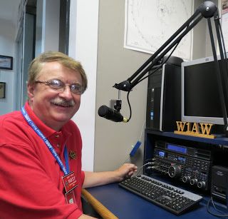
Hi Gang,

Where did the month of April go?? I cannot believe we’re in the first week of May already! This time last year I was working hard at getting all the final touches ready for the big show that would soon be coming up, along with the greatest Wouff Hong ever performed! Yes, I am prejudice about that last item. The Mighty Wouff Hong Performers are the best, and hopefully you’ll get to see them all again next spring!

I’m still attending lots of meetings and get-togethers on Zoom, Go To Meeting and the like. It’s been great fun being able to “sit in” on meetings in the comfort of my ham shack and listening to all the great things our clubs around Ohio are planning once this “Stay Home” order is completely lifted. For now, it’s just planning. I’m sure that you are all just as anxious to get things back to somewhat normal as I am.

I’ve been asked by many of you about V.E. Testing and when it is coming back. Well, as that the state has modified the strict “Stay at Home” orders and relaxed it just a bit, we are now allowed to move around a little more freely than before. I will say that the testing decision will be up to each of the V.E. Teams as to just when they feel it is safe enough for them and you to resume testing.

I also know, and I want YOU to realize that things will be different for sure. Since we still have the restriction of 10 or less persons in a gathering, the testing sessions will be smaller for sure. No more “room full of applicants” for some time to come. And, let us not forget that we still have the 6-foot (2 meter) separation requirement as well.

TOP ^
Another hot topic that I am being asked is “will we ever see remote testing?” My answer is yes, I feel confident that the V.E.C.’s around the country will come up with a great way of making that happen. I know that in several areas of the country remote testing has already happened, and those lessons learned I’m sure will be examined by all the V.E.C.’s in the country.

Have you gotten registered in ARES Connect yet? I want you to know that ARES Connect is not just for ARES. It is a reporting system for everyone to use. Yes, we do have a special place just for our ARES teams within ARES Connect, but if you are not interested in ARES, you still need to use the system as well.

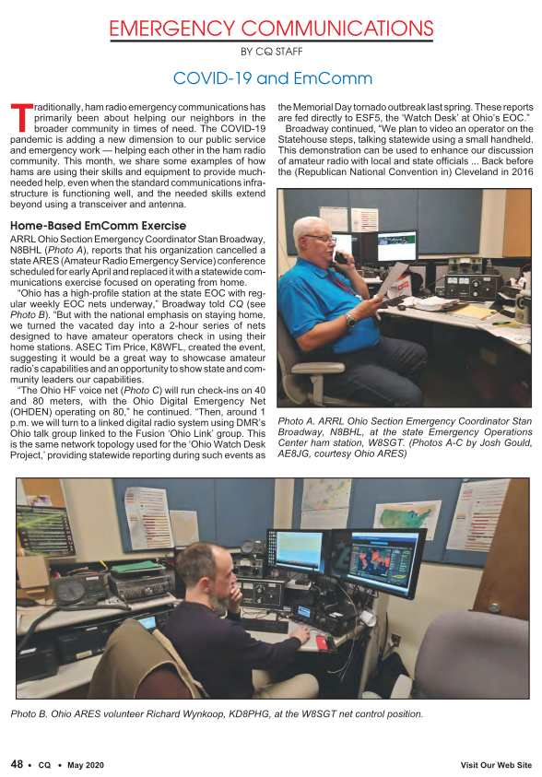

Why is this so important? As many of you know, before this pandemic hit the news, our governor had made it his special project to get a more robust “Texting Law” put into place here in Ohio. This has not been forgotten about. The Ohio Section has been proactively working with our legislators to get amateur radio exempt from this law and information gathered from ARES Connect on what amateurs in Ohio are doing is great evidence to give to those legislators as to what we do for our fellow Ohioans. We can even break it down to show just how much we’ve given back in each county. Yes, this is extremely important information, and your help is needed. All I ask of you is to simply start using the system. That’s it! Need help getting registered, or have questions? I’m here for you. Give me a call or write to me. Either way, I want every ham in Ohio to start using the system. This benefits everyone in more ways than you could imagine!

TOP ^
Something that also helps is what we are doing at the state EOC.. There’s a great article about Stan our (Section Emergency Coordinator) and the great crew at the “Sarge” in the May issue of CQ Magazine. If you haven’t seen it yet, you really need to get a copy and read it.

Changing the subject…
This week I want to tell you all what has been happening around the Yonally house for the past couple of months. As some of you know, Janie has been working hard at making masks for our church, friends, nursing homes and even a couple of hospitals in the area. To date she has made over 1,000 masks. Our son-in-law has even gotten her to make some masks for his co-workers at his place of work.

She’s even making some with the metal bridges in them. Although she doesn’t really like that type so much. The metal bar is hard to get sewn in without breaking her needles. Some of them have a pocket inside for an additional filter (heaven only knows what people use for that extra filtering). And, some are just the plain old face coverings that the CDC has given its approval on for use during this pandemic.

But that’s not the reason for this writing. I wanted to tell you a sort of “behind the scenes” story on just how she gets some of the materials that go into these masks. It’s been a real adventure for sure.

When the governor finally decided to allow the “sewing guru’s” to make these masks he had no idea of the flood gates he was opening. I know that it may sound funny, but the shortages in food and toilet paper like we’ve seen has also hit the sewing world too. In particular, the need for 1/8” wide elastic. To make the mask hold tight to your face it takes something with some elasticity in it to hold it on, thus the need for elastic. Yes, a rubber band will also work, but if you plan on wearing it for any period of time, you need something to cushion the rubber so that it won’t dig into the back of your ears. And, rubber bands really don’t hold up well to multiple washings, especially since you have to use hot water. It tends to destroy the rubber, especially using some of the new antibacterial soaps today.

So, once the permission was given, the folks making these masks immediately hit the store shelves all over the country and bought up all the elastic that there was. Oh, I should mention that you really can’t use wider elastic and just cut it down, because when you go to wash the mask the agitation, soap and hot water will make the modified elastic fray and not be usable after just a couple of washings. So, this means that it really needs to be 1/8” elastic only, if you want the mask to last and to be comfortable over a long period of time.

So, as you can imagine, it didn’t take long before the stores, including Amazon and the like were completely out of stock, and you guessed it, the majority of elastic is now made in China! As that China is where this all started and they shut down their factory’s months ago, now what do you do?

Well, this might just be the only time in Facebook’s history that it actually became useful for something good. You put the word out on Facebook to everyone that you are looking for 1/8” elastic to make masks with! Now, with that said, there are a lot of folks that had it for one reason or the other and never used it. It was just on the shelves gathering dust, or whatever. So, you ask if they will donate what they have, and that’s where this story is going, on those adventures to pick up that all that rare elastic.

Now as most of you know Janie and I live in almost the exact center of Ohio, so getting to any point in the state isn’t that hard for us. When Janie put the word out, we got calls from all over. Folks willing to donate, but since we were the ones asking for the favor, it was up to us to go pick it up, sometimes this was in some really unusual places.

TOP ^

As you know, I’m no stranger to traveling. I’d travel 300 miles through a corn field to get to a hamfest. So, I figured that this would be a piece of cake for sure. Ha...

Janie and I found ourselves going to a few places to pick up elastic where the sun hasn’t even found them yet! I hate to admit it, but even though some of the locations were somewhat scary, it has been a great adventure for the both of us. We’ve been to some really “out in the backwoods” places, but the folks all have been wonderful and very generous indeed.

There’s been a few times where we’ve ventured onto an old farm or a very isolated house and we’ve both joked that it was like going on a drug deal. The folks would leave the supplies on or under some of the strangest things. She’d go up to the porch and grab what was there and leave a thank you note in return. It’s gotten to where I’ve started calling her “Juanita Bandito” just because of the way she has gotten some of the supplies lately.

Now, on the delivery side of things has been equally interesting. When she drops off masks to the hospital for example, she goes to the front entrance way and stands off to the side of the door and extends her arm out going just inside the building where a worker grabs the package and that’s the exchange. We’ve also left the masks for friends in some very odd places as well. Inside a doghouse, under a porch mat, hanging off of a lamp post are just a few of the more notable places. The nursing homes are the best. You just go inside to the waiting area, they take your temperature and you hand them the masks. Like I said, it’s like being a drug runner sometimes, hiding and gathering the stash over, under and inside of things. It’s definitely been an adventure for both of us, and we’ve both discovered an Ohio that we never knew existed before.
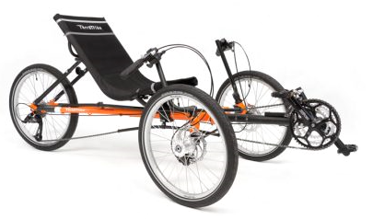
Moving to a different subject…
We did get the trikes out this last weekend and rode about 20 miles or so. It’s such great fun getting out and just taking a relaxing ride out with nature and leaving the cell phone behind for an hour or so. Sorry if you were trying to call me when I was out on the Trike.

Have you gotten out? You really need to. I’m sure that you’ll find yourself much more relaxed afterward too.

On a Final Note…
Today (Monday) being May 4th I would be really be remiss if I didn’t say something about this very special and tragic day in Ohio’s history. Today marks the 50th anniversary of the Kent State shootings. I was a junior in a northeastern Ohio high school when this happened and yes, I do remember it very well.

Please, even if you don’t know all the details about Kent State, take a minute of your day today to read up on what happened that tragic day in Ohio’s history. Here’s a link for you… https://www.kent.edu/

Whelp, my final go around before gong QRT… Stay safe my friends! I want to see all of you soon at a meeting or hamfest! We will get through this and when we do, we’ll have so much to talk about. Most of all… have FUN and get on the airwaves!!

73,

Scott, N8SY

TOP ^

66-year-old man rescued from ham radio tower
(Submitted by Gregory Drezdzon, WD9FTZ)

RAPID CITY, S.D. - Rescue crews came to the aid of a man stuck on a ham radio tower on Big Piney Road Wednesday, April 29.

The man was stuck about 20-feet above ground and the Sheriff’s office says his arm was pinned under a retractable part of the tower.

A high angle rescue was performed, and the jaws of life were then used to free the man’s arm from the tower.
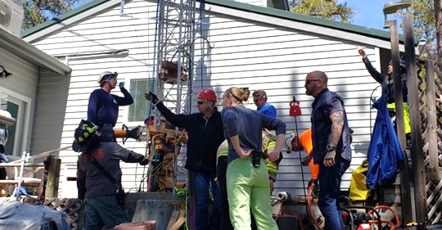

The man was wearing no safety equipment and he was there helping a friend do some work on the tower.

The condition of the injured man was not reported.

Responding agencies included the Rapid City Fire Department, Pennington County Search & Rescue, Pennington County Sheriff’s Office, and the Johnson Siding VFD.
https://kbhbradio.com/Rescue-crews-help-man-stuck-on-Ham-radio-tower

Watch a short video of the news report at:
https://www.newscenter1.tv/66-year-old-man-rescued-from-ham-radio-tower/
https://kbhbradio.com/Rescue-crews-help-man-stuck-on-Ham-radio-tower

Additional DX News
(from PCARS)

LATEST ONES IN THE STAYHOME FAMILY

News from Bangkok, Thailand and the world.

It was today when the Thai radio regulator, NBTC, granted a permit E2STAYHOME for Thailand to join the COVID-19 movement as the country number 33. RAST president, Jack, HS1FVL was on 20M to kick-off the special event while Champ, E21EIC with his wife JC, E20NKB handed out the very first QSOs.

On the same day, Andy, 5Z/G3AB informed that their regulator was in the process for allowing the locals to air the 5Z4STAYHOME special event station which would bring Africa to join the movement, enhancing the messages that governments throughout the world are releasing to their citizens.

Amateur radio is not only promoting the good-will and sense of belonging during these hard times but also keeping its communication network available for this unfortunate period.

TOP ^

Ohio Section Cabinet
Section Manager – Scott Yonally, N8SY | Assistant Section Manager – John Perone, W8RXX
Section Emergency Coordinator – Stan Broadway, N8BHL | Section Traffic Manager – David Maynard, WA3EZN
Technical Coordinator – Jeff Kopcak, K8JTK | Affiliated Clubs Coordinator – Tom Sly, WB8LCD
State Government Liaison – Bob Winston, W2THU | Public Information Coordinator – John Ross, KD8IDJ
Section Youth Coordinator – Anthony Lascre, K8ZT

Welcome New Subscribers

Jay, KD8SGE; Jim Leezer

Swap & Shop Has Come to the Ohio Section Website

Hey Gang,

Have you taken a look at the Swap & Shop page on the Ohio Section webpage yet??

Here’s a link that will take you there… http://arrl-ohio.org/sm/s-s.html

Do you have equipment that you just don’t need or want anymore? Here’s a great venue to advertise it, and it’s FREE!!

No, it won’t be listed in this newsletter because it would take up way too much space, so your ad will only appear on the website. It is there for any individual to post equipment Wanted / For Sale or Give-Away. No licensed vehicles/trailers or business advertising will be posted.

Postings are text only (no pictures or graphics) will be posted for a maximum of 1 month from date posting and require a contact phone number or email within the posting.

Send your Wanted / For Sale or Give-Away post to: swap@arrlohio.org

Back Issues of the PostScript and Ohio Section Journal

Hey, did you know that PostScript and Ohio Section Journal (OSJ) are archived on the website? You can go back and look at any edition simply by clicking:
http://arrl-ohio.org/news/index.html

TOP ^

Updated Information... Want to Share your Club Newsletter With Others?

We have a new webpage where you can download and read all of the newsletters that I get from around the state.

Here’s the link to the page…. http://arrl-ohio.org/club_news/index.html

Please, if you don’t see your club newsletter posted, it’s probably because I’m not receiving it, or I just cannot convert it over to Adobe Acrobat. Have your newsletter editor contact me and let’s see if we can get your club’s newsletter on the site!! We all learn and steal (I mean, share) from each other’s work. So, let’s give this new webpage a real workout and send me your newsletter!!! Send it to: n8sy@n8sy.com

Chit – Chat, and All That!

Do you know someone that’s not getting these Newsletters? Please, forward a copy of this Newsletter over to them and have them “Opt-In” to start receiving them. Heck just have them send me an email n8sy@n8sy.com and I’ll get them added to the Ohio Section Emailing list.

We now have many thousands of readers receiving these newsletters weekly. Quite impressive, I’d say! I urge all of you to make sure that everyone, regardless of whether they are a League member or not, get signed up to receive these weekly Newsletters.

You can always “Opt-Out” at any time if you feel this is not what you were expecting. It’s fun and very informative. All of your favorite past newsletters are now archived too.
You can go back at any time and read them. Just go to: http://arrl-ohio.org/news/

Got questions, concerns or would just like to sit and chat awhile? Heck, I’ll even buy the coffee!! Give me a call at (419) 512-4445 or email me at: n8sy@n8sy.com

The pictures on the front page and throughout this newsletter are from various newsletters, Facebook posts and/or were sent directly to me in recent weeks. Take a good look at them, you just might be in one of the pictures! “SMILE… you’re in the Ohio Section News!!”

TOP ^

PostScript is produced as a weekly newsletter. I want to thank everyone that has contributed articles and ideas to make this an even better news source. I sincerely hope that you have enjoyed this edition and will encourage your friends to join with you in receiving the latest news and information about the Ohio Section, and news and events happening around the world!

