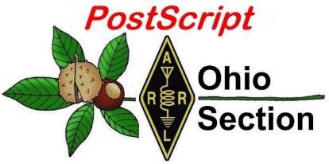
April 20th
Edition

National News The Handbook Give Away

Club Corner Hamfests

DX This Week ARES Connect

VE Testing One Question Questionnaire

Final.. Final..

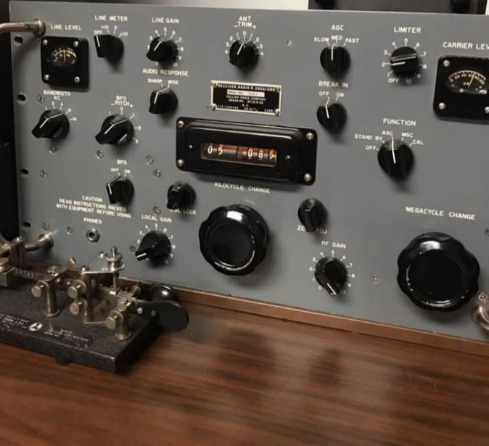
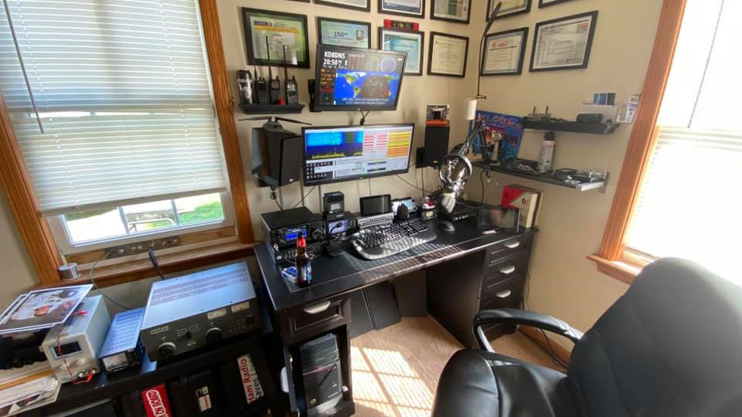
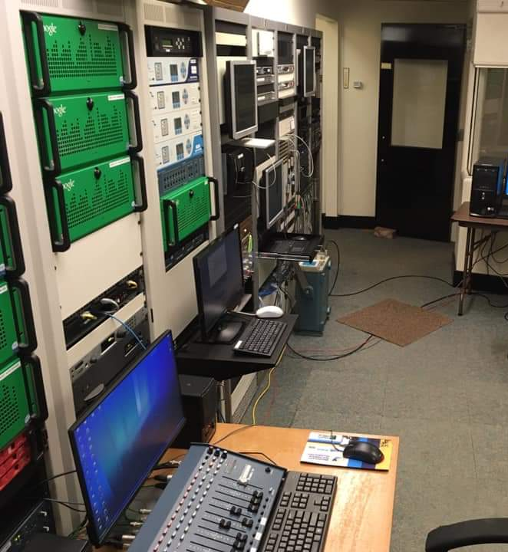
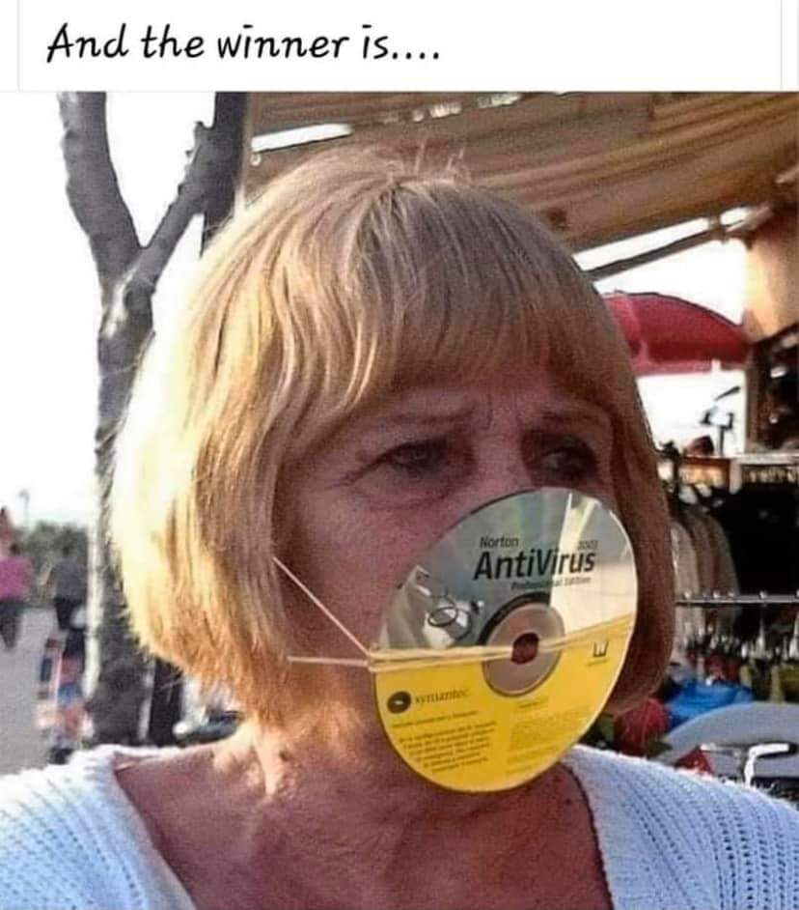
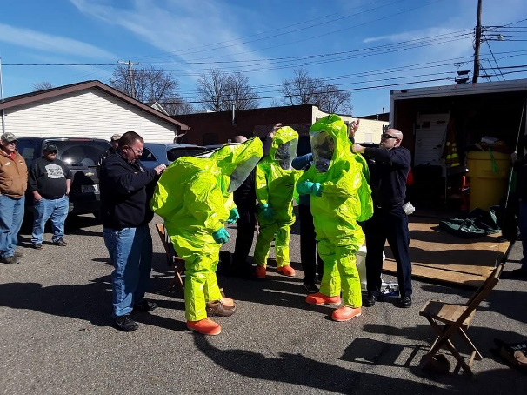

National News
(from arrl and other sources)

Youth Team Postpones its Planned CQ WPX CW Operation from K3LR

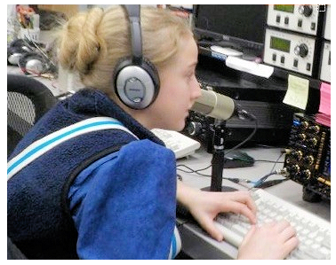
The youthful Team Exuberance has announced that it’s postponing its planned CQ WPX CW contest operation from K3LR until May 2021. Team Exuberance will compete in the multi-two category.

“While this decision was not taken lightly, it was clearly the appropriate action in light of the coronavirus pandemic,” team member Bryant Rascoll, KG5HVO, said in an announcement. “Thank you to all individuals and clubs who financially contributed to our fundraising efforts,” he said.

Those seeking to have their 2020 contributions refunded should email him or Marty Sullaway, NN1C. All funds retained will go toward Team Exuberance’s next operation, Rascoll said. — Thanks to Bryant Rascoll, KG5HVO

####

ARISS Altering its Approach in Light of COVID-19 Pandemic
In a message to Amateur Radio on the International Space Station (ARISS) team members, sponsors, and educational institutions, ARISS International President Frank Bauer, KA3HDO, outlined how ARISS is transforming its activities as a result of the COVID-19 pandemic.

“Our primary objective in these challenging times is to protect all students, faculty, astronauts, and our volunteer team in all we do,” Bauer said, noting the international scope of ARISS and the space station. “Each one of us, around the globe, is dealing with the COVID-19 virus in one way or another. Each area of the globe is unique in the virus spread as well as in the government policy to protect their people. And the situation in each location is changing rapidly.”

ARISS has postponed school/group contacts in Georgia, Tennessee, and California, as well as in South Africa and Romania. At least one school/group contact in the UK has been canceled altogether.

“ARISS needs to be prepared for a longer term effect — months,” Bauer said. “As a result, we have instituted an immediate response effort followed by a more strategic, longer term, initiative to protect all. ARISS leadership, working with a physician on the leadership team, is carefully reviewing all of our procedures in light of the evolving COVID-19 recommendations. We will continue to monitor the local and global situations and will modify our local and global planning as these situations change.”

Bauer said that over the short term, ARISS mentors will work with each school or organization in the ham radio contact queue “to determine the way forward.” He said ARISS would rely on local government COVID-19 policy for guidance in deciding whether to cancel or postpone a contact or to modify the contact schedule. “But in each case, we are encouraging all to put health and safety first. And each contact decision is being carefully scrutinized by the senior ARISS International leadership team,” he said.

TOP ^
Bauer said that several initiatives are in the works over the longer term “to transform how we interact with students and host educational institutions in light of COVID-19” by engaging with students and educational institutions virtually. One possibility, he said, is ARISS “virtual school” contacts, employing ARISS telebridge ground stations around the world to link individual students at home with audio and streaming video. Typically, telebridge stations serve as ground stations for ARISS contacts with schools not in the footprint of an ISS orbital pass. “ARISS plans to transition into this model in the next couple of weeks,” Bauer said.

ARISS also is planning several slow-scan television (SSTV) sessions, during which images from the ISS would be transmitted to at-home students. “These can be received directly, if a student has a radio, or indirectly, if a student connects to a remote station via internet or goes to the ARISS SSTV Gallery, where all downloaded images can be posted and reviewed,” Bauer explained.

Bauer characterized the ARISS long-term approach as “a huge pivot” for the organization, but said ARISS considers it “a great strategic move” going forward. “It should be noted that one reason we were allowed to set up ARISS on ISS was to help astronauts improve their psychological well-being by allowing them to freely talk to students, friends, and ham radio operators on the ground,” he said. “We are now at a juncture, with COVID-19, to help do the same for students — in other words, providing a psychological well-being STEM motivation to students, faculty, and the local community through ARISS on-orbit connections — virus free!”

####

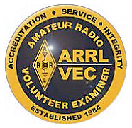
ARRL VE Newsletter - April 16, 2020
We will continue to update our volunteer examiners as new information becomes available.
Thank you for you service to the community.
Remotely Administered Amateur Exam Systems Showing Promise
Facing a growing demand for amateur radio exam sessions in a time of social distancing and stay-at-home orders, sponsors of some Volunteer Examiner (VE) teams have risen to the challenge and are developing systems to remotely proctor test sessions.
“Many of our VEs and VE Teams have been working on remotely proctored exam session ideas, employing both video and in-person components — following social distancing protocols,” ARRL Volunteer Examiner Coordinator (VEC) Manager Maria Somma, AB1FM, said. “We have been receiving interesting and innovative suggestions, and we appreciate the dedication and ingenuity our examiners have shown.”
The Spalding County Amateur Radio Club in Georgia is among those that have come up with plans to remotely administer amateur exams while complying with ARRL VEC testing standards during COVID-19 stay-home mandates and social distancing guidelines. Current systems leverage Zoom video-teleconferencing technology, the “Fill & Sign” feature of Adobe PDFs, reliable email, appropriate computer equipment and internet connection, and no volunteer examiners (VEs) present at individual remote test sites. The Georgia club collaborated and shared ideas with the Emergency Amateur Radio Club (EARC) in Hawaii, which has successfully conducted sessions since 2011 with its own remote testing system, initially with paper exams with a proctor on site and now with fillable PDFs, with no on-site proctor.

TOP ^
The Georgia club obtained ARRL VEC approval to administer video-supervised exams. The club’s David Robinson, K4WVZ, said the first exam session took place this week, with another set for next week, and “many more in the pipeline” going forward.
“We have started with testing just one candidate at a time but are planning to ramp up to multiple candidates — probably two or three — simultaneously,” Robinson told ARRL. “Before we do that, we want a few more single sessions under our belt and a few more Video VEs trained. It also gives us an opportunity to garner lessons learned from each test session and upgrade our procedures accordingly.” Robinson said this week’s session went “exceedingly well,” and the candidate passed the test.
The club’s procedures entail a pre-exam video interview with candidates to ensure they understand all the requirements and procedures. “This also allows us to test the candidate’s ability to work with the video and computer technology before the actual exam,” Robinson explained. “Training sessions were conducted for VEs to make sure they understood their role and how to use the technology.”
Following the exam, the VEs score the test and sign off on the paperwork, with the VE Team Leader submitting the application online and by mail, per ARRL VEC instructions. Application and successful exam are first accepted and then submitted to the FCC for processing.
New England Amateur Radio Inc (NE1AR), an affiliate of New England Sci-Tech, (NESciTech), has taken it one step further, Somma said. It got the approval of ARRL VEC to begin trials of what it describes as “completely online testing with strict rules and protocols for maintaining the integrity of the testing environment.” NE1AR is limiting candidates to one exam per candidate, due to the current candidate backlog and the “difficulty of administering exams online.” Candidates must agree to a list of protocols, which include no visitors (or pets) in the exam room and a cell-phone camera scan of the entire room and exam area “to show that there are no materials or people [in the room] that could aid in taking the exam.” If the VE team suspects the possibility of cheating, the exam may be terminated and the candidate barred from future online exam sessions.
“We began a series of trials on April 1 under ARRL VEC review and have now been asked to help train more VE Teams on the process,” NE1AR President Bob Phinney, K5TEC, told ARRL. “We have now tested 12 applicants and are still working on streamlining the process. We are working with the software developer of the exam delivery system to help them adapt the system for video-supervised testing.” At present, Phinney said, only one person at a time can be tested. Another time-related issue is how long it takes a candidate to go through the NE1AR security protocol. “Sometimes, the setup and follow-up for an exam take far longer than the exam itself, in order that we provide complete integrity of the exam session,” he said.
With pressure continuing to build to provide testing compatible with COVID-19 guidelines and stay-home orders, ARRL VEC Manager Maria Somma, AB1FM, has asked the amateur radio community to be patient. “Please remember that with the introduction of significant new processes such as these, that there should be proof of concept, establishment of protocols and procedures, and beta testing, before expanding to a larger audience,” she said this week. Somma said video-supervised exam sessions require a different skillset than in-person exam administration, and not all teams will be equipped to deliver video exams right away.
“ARRL is pleased to be one of the leaders in providing an opportunity, although limited initially, for video-supervised exams in this time of social distancing and isolation required by the current health situation,” Somma said.
####
TOP ^
ARRL Announces New Benefits for Members

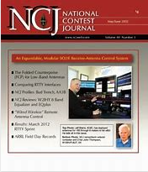
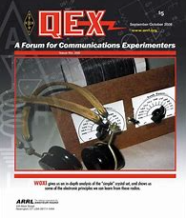
ARRL members will now receive digital access to four ARRL magazines beginning with their latest issues. Joining QST and On the Air magazines on a digital platform will be the bimonthly editions of QEX — The Forum for Communications Experimenters and NCJ — National Contest Journal. QEX includes articles, columns, and other features ranging from construction projects to more advanced technical information in radio theory and practice. NCJ, published since 1973, targets radio amateurs active in radiosport. NCJ includes scores, technical articles, contributions from top contesters, and advice for beginners and seasoned radiosport enthusiasts alike.

“Feedback from ARRL members and our readership surveys has shown that our magazines are one of the most valued member benefits,” said ARRL Publications Manager Steve Ford, WB8IMY. “Our investment in digital access provides another channel through which we can deliver content to our members across the expanse of interests and activities in amateur radio. All members can enjoy specialized content and a high-quality reading experience whether at their desk or on the go. Offering this suite of digital magazines is an opportunity for us to give members more of what they want while adding value to ARRL membership.”

ARRL’s digital magazine editions provide replicas of the printed editions with added functionality, allowing users to fully search issues, enlarge pages, share articles, and more. The free ARRL Magazines app also supports downloading complete issues onto your mobile device or tablet for offline reading.

Members who have elected to receive a printed QST or On the Air as part of their membership benefits will continue to have this service. Members may not substitute a print subscription of QEX or NCJ as their delivered magazine member benefit. Print subscriptions of QEX and NCJ will continue to be available at additional cost for those who want to receive them.

All four magazines are easily accessed through any web browser from members-only links. The free ARRL Magazines app is available for iOS and Android in the Apple App Store and Google Play. If you’re already an ARRL member and previously created an arrl.org website account, your username and password will provide you access to the digital editions, whether online or in the app. Members who have not previously registered will need to create a new account. If you’ve forgotten your password, visit www.arrl.org/forgot-password, or email circulation@arrl.org for assistance.

Previous and prospective members can join ARRL and take advantage of this and other membership benefits.

####

2020 Youth on the Air in the Americas Camp is Canceled

The inaugural camp for radio amateurs in the Americas aged 15 through 25 has been put off until next year. It was set to take place June 21 – 26 at the National Voice of America Museum of Broadcasting in West Chester Township (North Cincinnati, Ohio). It has been rescheduled for July 2021. Campers accepted to the 2020 camp will have the first chance to register for the next year’s camp. The daily schedule and plan for the 2020 camp will be the same for the 2021 camp as much as possible.

TOP ^
The committee found that July was a more accessible date for the widest range of campers to attend.

The committee is also looking at ideas for a shortened, virtual camp this summer, so that campers can participate in limited activities from home. The camp was meant to focus on building peer and mentor relationships and taking amateur radio to the next level.

While many sponsors and donors have already expressed support for holding over funds received for 2020 to use in 2021, refunds of donations made to the camp are being offered. Groups or individuals wishing to receive a refund should contact director Neil Rapp, WB9VPG. Less than $350 of the money spent thus far went to items that may not be usable in 2021, Rapp said.

More information about YOTA in the Americas can be found at YouthOnTheAir and on YOTAregion2 on Facebook, Twitter, Instagram, and YouTube.

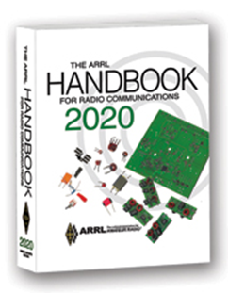
The Handbook Give Away

Hey Gang,

Have you registered for the “Handbook Giveaway” drawing for this month yet? If you haven’t, go to: http://arrl-ohio.org/handbook.html and get yourself registered now!

What’s the catch? I want to get everyone checking in to the Ohio Section website as often as possible, and in order to register each month, you have to visit the website often! There’s nothing else to it. I pay all expenses and I usually “Give Away” more than just a Handbook too!!

Many of you ask me just how do I know when the drawing is on? Well, that’s easy all you need to do is check in on the Ohio Section Website on a regular basis and watch for the big RED Arrow that will appear on the left side of the page. This is the sign that the drawing is on and you need to get registered. So, keep a sharp eye out on the website and check in often!

Club Corner

This is YOUR cornner of the newsletter. Send me what your club is doing and I’ll make sure that it gets in. Got a special event or club project that you want everyone to know about? Send it to me!. Need help with a project? Send it to me.

Let me know what you club is up to. Are you going to have a special guest at your meeting or are you having a special anniversary? Just sent it to: n8sy@n8sy.com

####

The Franklin County ARES Group General License Classes Suspended

Due to the Covid-19 stay at home orders, no classes may be held. We are suspending classes for General Class license candidates until further notice.

TOP ^
If conditions have improved by the Fall classes may be offered again. Until then please observe safe social distancing and other precautions to protect yourself and others. We truly are all in this together.

####

Skywarn Training Opportunity – But you’ll have to act really fast to get registered

The NWS in Wilmington is going to host the Weather Spotter Training online Monday (today). Please feel free to pass on to anyone you feel would like to attend as this is a great training opportunity. Thank you and well wishes to everyone

EMA Partners,

NWS Wilmington has scheduled a live online spotter training class for Monday, April 20 from 4 pm to 6 pm EDT.

NWS partners and the general public are welcome to attend the live online spotter training class. Registration is required, and can be completed at: https://register.gotowebinar.com/register/3764775498575311630

This will be NWS Wilmington's first online spotter training class. If it goes well and there is continued interest/demand for this, we'll schedule additional ones. I apologize for the short notice -- as last week's severe weather and tornadoes delayed our promotion. Any future classes will be promoted with more advanced notice.

Feel free to share this with others within your counties or jurisdictions. We will also promote this class via social media and on our office webpage.

Please let me know if you have any questions.

Thanks,
Brandon Peloquin Warning Coordination Meteorologist NWS Wilmington, OH

####

NORC Net
(Northwestern Ohio Regional Communications)

The “NORC - 2 Net” (Northwest Ohio Regional Communications–2 Meter) is scheduled for 1:00 PM, the 1st Wednesday of each month. There are 4 repeaters designated for the NORC-2 net, 147.375/Oregon (primary), 146.610/Toledo, 147.255/Republic and 146.790/Bowling Green.

This net is designed to provide backup emergency communications for Hospitals, Healthcare Facilities and County EOC’s in Ohio ARES Districts 1 & 2.

The “NORC-HF Net” (Northwest Ohio Regional Communications-HF) is scheduled for 11:00 AM the 1st Saturday of each month. The net begins on 3.915 +/- then moves to 7.215 +/-.

TOP ^
This net is designed to provide backup emergency communications between County EOC’s in Ohio ARES Districts 1 & 2 and the State EOC (W8SGT), all check-ins are welcome.
Any questions please contact: Dan Stahl - KC8PBU - NORC Net Manager kc8pbu@gmail.com

####

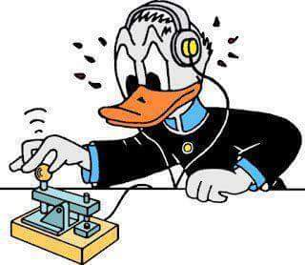
CW Learning Net In the Toledo Area

Monday's 7:00 pm starting March 30 on the 147.270 (pl 103.5) W8HHF Repeater. CW learning net. Starting from scratch for the newcomers to the CW mode. General CW mode and equipment discussion as well as learning CW.

Steve KC8TVW

####

Hamvention QSO Party Saturday May 16!
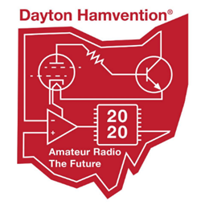
Let's celebrate the many years we have all had at the Great Gathering we call Hamvention. We also want to remember Ron Moorefield W8ILC who never missed a Hamvention and contributed to our club until his recent death. Let's light up the airwaves with our remembrances of Hamvention’s of the past! See you on the air! K3LR, Tim Duffy and W8CI, Michael Kalter.

Here is the deal: 12-hour event, 8 a.m. to 8 p.m. EDST on Saturday of Hamvention May 16, 2020. Operate CW or SSB on 160, 80, 40, 20, 15 and 10 meters. The exchange is a signal report and first year you attended Hamvention. If you have never attended Hamvention, you send 2020.

Send your score (number of QSOs) to 3830scores.com within 5 days of the event. You can print a certificate on line via www.HVQP.org. More details will appear on the Hamvention QSO Party web site being set up now.

Special bonus: W8BI, the club call of the Dayton Amateur Radio Association (DARA is the host of Hamvention) will be activated by designated DARA members from their home stations. You can add 10 points for each band/mode QSO with W8BI (12 available). So you can earn 120 bonus points (like having 120 additional QSOs).

####

Cleveland Marathon Converted to Virtual Event

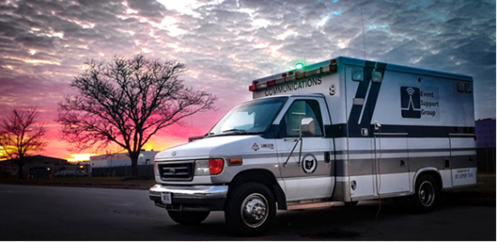
The Cleveland Marathon has officially been moved to a “virtual event”. This means we will obviously have no communications responsibilities. Thanks very much for your willingness to work this very important event. Because of this, I will also be cancelling the May Cuyahoga County ARES meeting which was to be a review of the Marathon procedures.

TOP ^
If you want to read the full statement from the Marathon, you may find it here https://www.clevelandmarathon.com/media/recent-news/rite-aid-cleveland-marathon-goes-virtual-due-to-covid-19.aspx

####

Upcoming Event Status Update

Below is an update on the future radio related events in the Cleveland area.

• April 26, May 3 Cuyahoga ARES Meetings Cancelled
• April 26 American Cancer Society Pan Ohio Hope Ride, Heroes of Hope Ride Cancelled
• April 25 NVIS organized operation cancelled, please operate from home instead
• May 16-17 Cleveland Marathon Cancelled (converted to virtual events)
• June 14 Sunday in June Bike Ride Cancelled

Our friends over at the Geauga Amateur Radio Association have begun compiling a list of as many radio related cancellations as they can. Be sure to check it frequently at https://geaugaara.org/coronavirus/

Upcoming Hamfests for 2020
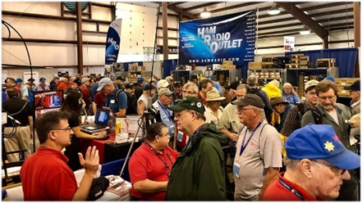
04/26/2020 | Athens Hamfest
Location: Athens, OH
Sponsor: Athens County Amateur Radio Association
Website: http://www.ac-ara.org/
Cancelled

05/15-16-17/2020 | Dayton Hamvention
Cancelled

06/06/2020 | FCARC Summer Hamfest
Location: Wauseon, OH
Sponsor: Fulton County Amateur Radio Club
Website: http://k8bxq.org/hamfest

07/19/2020 | Van Wert Hamfest
Location: Van Wert, OH
Sponsor: Van wert Amateur Radio Club
Website: http://w8fy.org
07/26/2020 - Portage Hamfair '20
Location: Ravenna, OH
Sponsor: Portage Amateur Radio Club, Inc.
Website: http://hamfair.com

####

TOP ^
Webpage for Cancelled Hamfests

ARRL has created a webpage that will search the ARRL Hamfest and Convention Database for canceled events. >> Click Here <<

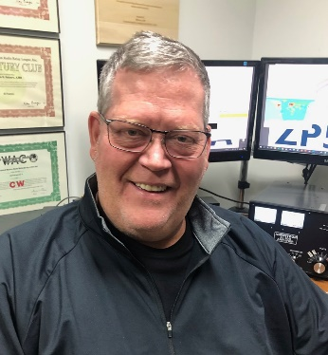
DX This Week
(from Bill, AJ8B)

DX This Week – D44EE Interview
Bill AJ8B (aj8b@arrl.net, @AJ8B, or www.aj8b.com)
CWOPs Member #1567

Cabin fever might be setting in, however, I have been heads down on “hammy” stuffy including this update, the next edition of the SWODXA Newsletter due at newsstands at the end of the month, applying for our club DX contest, and the voting for the DXPedition of the Year award. This is the most sought-after award in the DXPedition community, and the announcement is normally made at the DXDinner® on the Friday night of Hamvention® weekend. And the DXPedition of the year is…you did not really think I was going to announce it here, did you? You will have to wait until 5/15!
If you were around the cluster this past week, there were many different entities to be worked. These included Alaska, Angola, Argentina, Azores, Balearic Islands, Barbados, Belarus, Belgium, Belize, Bosnia-Herzegovina, Brazil, Bulgaria, Canary Islands, Chile, Colombia, Corsica, Costa Rica, Dominica, European Russia, European Turkey, France, Greece, Hungary, Ireland, Israel, Italy, Mali, Malta, Mexico, Moldova, Montenegro, New Zealand, Northern Ireland, Oman, Portugal, Puerto Rico, Samoa, San Marino, Saudi Arabia, Scotland, Serbia, Sicily, Slovenia, Spain, St. Helena, St. Lucia, St. Martin, Trinidad & Tobago, Ukraine, United Nations HQ, Uruguay, Vienna Intl Ctr, and Wales

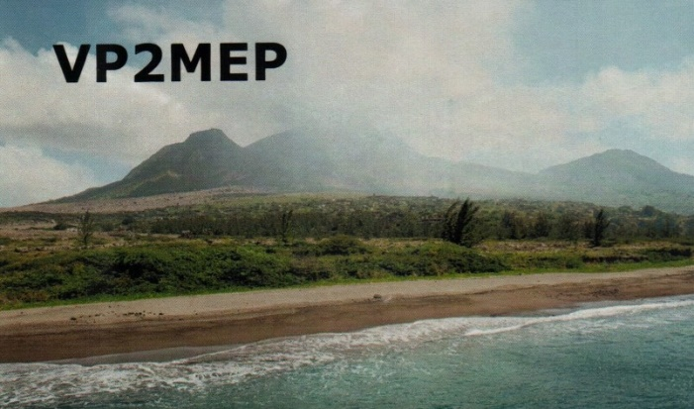
I received a couple of cards this week: KI6DY – Bob from Kansas, N0KV – Barry from Colorado, and VP2MEP – Ed from Montserrat (Pictured). VP2MEP was a 160M contact from the past February. Did you get any or send any this week?

As I have been doing over the past 2 years, I have been reprinting various interviews I have had with DXers worldwide. These have proven to be very interesting and insightful and this week’s interview is no different.

An Interview with D44EE/OZ1BII—Henning Andreson (mail@oz1bii.dk)
OZ1BII was active with call sign D44EE 19-24 February 2015 and 15-20 February 2018. I was fortunate enough to work him for several band slots. After a bit of research, I realized that I had worked Henning on Greenland, Malta and from his home QTH. Seemed like someone we needed to hear from and lucky for us, he agreed.

TOP ^
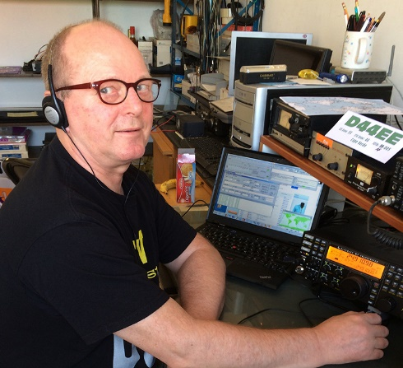
AJ8B: How did you first get interested in amateur radio?
OZ1BII: As teenager I got a new friend and he used CB radio. Quickly I was interested in the use of antennas and the possibilities for contacts over a greater distance to our neighbor town 30km away. I was a bit fascinated of the electronics and within a year I had built power supply and got a “big” antenna on my roof. Now I talked with friends in most of Denmark and participated in local club with foxhunting and other radio activities alike. The year was 1972 and I was 18-year-old.

1973 was the year when I joined the army and I was lucky to be picked for the Jutland Telegraph regiment. Here I was found ready for learning the Morse code and be a radio operator. The first 3 month it was only classroom training in Morse code and, of course the other military things. Then, the first time I get to listen in a HF radio, I was completely sold. It was a very whole new world for me to explore and every time I had a chance, I turned on the radio. One of the other soldiers was a radio amateur with his own OZ call sign and he told me that it was possible to make this wonderful thing from my own home.
In 1974 I started the technical training and in 1975 I went to the final Test at the “Danish Post & Telegraph Service” (Now Danish Energy Agency). I got my C-License with medium technical skill and Morse at 60 wpm - My HAM Radio career has started.

AJ8B: When did you get on the air?
OZ1BII: My residential was in an old house on the top 3rd floor in the middle of Haderslev. The owner of the residential was a nice and friendly man and so were the neighbors, so I got permission to put up a W3DZZ dipole antenna. And I bought my first radio station with CW in mind. It was a Ten-Tec Argonaut 509 and I loved that radio from the very start. Both the receiver and transmitter did a superb job and I especially was happy with the silent QSK. That fantastic pin-diode QSK was my reason to buy exactly that radio and I still own a Ten-Tec with super QSK but now its name is Eagle.

My very first QSO was December 19th at 12:30 UTC. 80m band was used and I had contact with DM4ZEB in former Eastern Germany. 30 minutes later I got in contact with SP1GPI in Poland. My debut on the radio waves had happened!

AJ8B: Do you have a favorite band or mode?
OZ1BII: Do I have a favorite mode - sure - I only have one mode: CW. About favorite band I cannot tell. I only work on the HF bands and they often are so different in depth and width of the sound that they all can give me surprises. Some days the 40m is flat and there are no signals that can make a sound, only noise. Other days it is like an adventure giving me ZL with good signals and a completely big room with more clear signals around without interfering. Although I do have roofing filters, I seldom use them sharper than 450 Hz.

I think I had the greatest band-experience in 2012 when I was active from Greenland as XP2I. Early in the morning September the 14th I had some nice openings on 160m band inside the Aurora belt. I managed to work both EU and NA stations with band closing about every 10 mins for about 5 mins. In November I was back and made some more QSO’s on 160m. My distance record was the contact with EY8MM Nodir in Dushanbe, Tajikistan more than 7200 kilometers away.

TOP ^
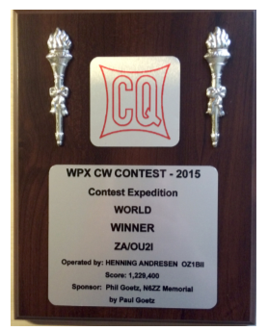
AJ8B: In reviewing your QRZ.com page, I see that you have been very successful using CW and in contests. Any secrets to your success?
OZ1BII: Here you see my two “secrets”: rhythm and endurance. That is my keywords and I think that a contest QSO is all about rhythm - nothing more. It’s nearly like working DX where you are just one of hundreds in a pileup. In DX-ing the keywords are rhythm and frequency. In contest you only have rhythm.

Endurance is what I use in the middle of the night when the QSO rate is not measurable, the sleep is pressing and the excuses for a break are many. In these long boring night-hours I sometimes go crazy and increase the Morse speed more and more until reaching my personal maximum speed with my paddle. Sometimes that is spreading some wake-up waves and more stations come in with fast speed. I get instantly awake and happy when a new multiplier suddenly comes out of the loudspeaker - so to say - out of the blue. That is worth waiting for.

AJ8B: What license levels do you have in Denmark and what do you hold?
OZ1BII: In Denmark we have only three levels of license nowadays. A, B and D.
The D license is for VHF/UHF only and power limit is 50 Watt. No technical skills and no home-built radios on the frequencies.

The B license is for All bands and power limit is 100 Watt. Limited technical skills test. The A license is for all bands and power limit 1000 Watt. Extended technical skills test. CEPT. I am holding the A license including the CEPT.

AJ8B: Describe what you are currently using at your home station:
OZ1BII: I am living in an apartment in the middle of the old town with many restrictions for the buildings. So I do not have any chance to put up antenna here where I live. Another place in town, at my family, I have put up a simple 21-meter-long wire attached to a 12-meter fiberglass mast and mounted as Inverted-L. An UNUN 9:1 is placed at the bottom feed point and I use it for all bands 160-10m with varying success.

In 2011 I started again with amateur radio and I bought a Ten-Tec Eagle. Also I had a great experience with Ten-Tec and I loved the little radio. In 2012 I gave myself another radio for Christmas, a 4-year-old Elecraft K3. It was a jump up in quality and still the K3 is THE #1 radio for me.

AJ8B: When I first worked you, you were on a DXPedition to Cape Verde, D44EE. How/why did you choose D4?
OZ1BII: I am very interested in traveling and have always liked to explore other territories. Nowadays we all are so privileged to have the possibility for travelling all over the world and these possibilities I use as often as possible.
When traveling with radio I mostly travel alone. It’s cheaper, it’s easier and it’s more challenging.

TOP ^
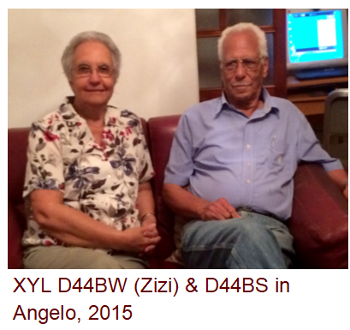
In 2015 I wanted to seriously participate in the ARRL Int. DX Contest. So, I looked for an exotic place like Azores islands, Canary Islands and Madeira. After a lot of e-mail contacts to OH I EA CT amateurs, I found out the islands were all occupied with no places left for me. Cape Verde came to my mind and the D4C station is famous. I wrote to many different contacts on the islands and one of them told me to try contact Angelo D44BS who live in Praia, the Capital of Cape Verde.

Angelo was kindly inviting me to use his station for the contest and I prepared the journey with train, flight and hotel. Angelo is a well-known radio amateur in Cape Verde for many years and is holding the D44BS call sign together with the D4CBS and D4A. Angelo is the beholder of the CQ 5-Band WAZ Award #1.

It turned out to be one of the most enjoyable and exciting tours and the contest score gave me 8th place in the world for DX stations (Lo Power All Band). I was using my Elecraft K3 100 Watt together with Angelo’s 2elm 40m beam plus 3 elm 20-15-10m and 80m dipole.

AJ8B: Had you been on other DXPeditions? If so, how does D4 compare?
OZ1BII:
XP2I - Greenland five times 2012 & 2013 - CQ WPX, SAC, LZ DX, CQ WW

ZF2EE - Cayman Islands two times - 2014 and 2015 - CQ WW and WAEDC

9H3EE - Malta two times - 2015 and 2018 - CQ WW and CQ WPX

ZA/OU2I - Albania two times - 2015 and 2017 - CQ WPX and CQ WPX

IT/OU2I - Sicily one time - 2014

D44EE - Cape Verde two times - 2015 and 2018 - ARRL DX and ARRL DX

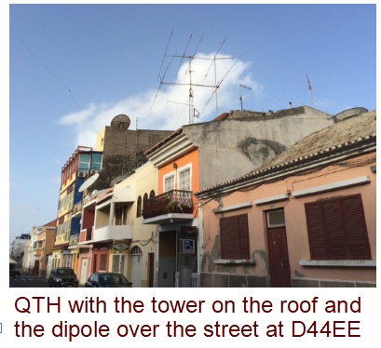
I cannot tell which one was best, but I can tell that Sicily (IT) was no good because I had no good antenna. Malta (9H) was a sad experience because the stormy weather on broke my fiberglass mast more times and I had an unusual high noise level so I could not hear stations calling me. Especially US stations were very disappointed because they could hear me, but I did only hear noise.

D4 is very good for radio and the noise level in the middle of the capital was no problem. I had nearly constant pileup from US and that is where I really feel the Flow.

AJ8B: Were there any challenges to the D4 DXPedtions?
OZ1BII: Because I visited Angelo and Zizi, and were using their shack and antennas, I had no problems whatsoever regarding operation.

TOP ^
License was easy to get, and I got an “EE” call sign that I like best. Bringing my Elecraft radio didn’t give me any troubles in the customs area and the hotel where I slept was small and cozy at a good price.

AJ8B: What equipment do you prefer when you are on a DXPedition?
OZ1BII: I do prefer my Elecraft K3 with my Palm Radio paddle at the bottom and my Lenovo Thinkpad computer with UcxLog program. I can have it all in my suitcase, which I do not have as hand luggage, and only two places (Cayman Islands and Albania) wanted me to open the luggage and explain what it was.

In Malta and Albania, I brought my own antenna. It is a 10-meter mini fiberglass mast from www.DX-Wire.de in Germany, only 67 cm long so it just fits in my big luggage. Only in Albania it has done a good job.

On Cayman Island I rent a condo with antenna the first time and next time I had an appointment with Andrew and was invited to use the ZF1A club station antennas.

In Greenland I was using my Ten-Tec Eagle and I was welcomed by Jesper OX3KQ, also a huge contester. He helped me getting to the clubhouse placed in the mountains and showed me all the antennas and how to heat the small shack. It was very comfortable and with great hospitality. In Praia at D44BS I brought my Elecraft and used Angelo’s antennas.

AJ8B: Do you have any DXPeditions planned in the future?
OZ1BII: Surely, I am returning to Albania. It has been two nice experiences in the WPX contest. I got a plaque in 2015 for the CQ WPX World Winner - Contest Expedition. And I got two good friends in Tirana, ZF1F Fatos and ZF1U Edmond. Also, I have met OH2TA and OH2BH in Albania building a new radio station for contest use. Hopefully I will visit Angelo and Zizi again for ARRL DX Contest. In 2015 I was #8 DX and #3 AF. In 2018 I was #6 DX and #2 AF. Next time I will do better)

AJ8B: What advice do you have for those of us trying to break pileups to work DX?
OZ1BII: Rhythm, rhythm and rhythm. If you have difficulties getting in contact, you need to listen.
Do the operator use a fixed scheme for the receive frequency and can you figure that out. Does he sweep up or down the pileup? Some time it is best to stay on the same TX frequency and other times you must try following his receiver.

With “Rhythm” I mean your rhythm relative to the DX. It is essential to start your transmission at just the right moment - the moment the DX start listening. When I'm at the narrow end of a pileup, my senses are very sharp. When I have sent TU my brain changes to reception and I often get caught by the call sign that starts right now. However, one (or many) powerful stations may come in and press the original signal and sometimes I must change the concentration to another call sign that I can capture.

Here you may listen to a pileup I tried to serve - I call EU http://www.oz1bii.dk/dx-d44ee.htm

AJ8B: Any QSLing hints?
OZ1BII: I prefer LoTW and then eQSL. If you need paper QSL, ordering via OQRS is the preferred way for me. I upload all logs to LoTW, eQSL and ClubLog and it will be done as soon as possible after my return home. Direct QSL cards can be sent, but in Denmark we have almost switched to exclusively digital mail and that’s why letters are very expensive to send. A normal letter abroad costs 5 USD. I am grateful for donations via my webpage, but there are no requirements at all.

TOP ^
AJ8B: What coaching/advice would you give new amateurs?
OZ1BII: If you find the airwaves exciting then GO FOR IT.
There is no short way to learn Morse code, but you will get thousand-fold back the energy you lay in training. It’s all worth it.

I was lucky to join the telegraph troops when I was serving in the Danish army and in that way, I got some very professional training in both radio skills and Morse code.

But for most pre-radio amateurs the greatest success will come in a local club where you may get an Elmer with the same interests as you. He is the one who can give you the biggest step towards The World’s Best Hobby.
Listen to a HF radio and feel the Magic. Participate in a HF Contest and do feel the “Flow”.

(PS. Flow - as explained in a great article by Brooke Allen, N2BA - https://brookeallen.com )

AJ8B: Any QSLing hints?
OZ1BII: I prefer LoTW and then eQSL. If you need paper QSL, ordering via OQRS is the preferred way for me. I upload all logs to LoTW, eQSL and ClubLog and it will be done as soon as possible after my return home. Direct QSL cards can be sent, but in Denmark we have almost switched to exclusively digital mail and that’s why letters are very expensive to send. A normal letter abroad costs 5 USD. I am grateful for donations via my webpage, but there are no requirements at all.

AJ8B: Thanks for taking the time to answer my questions. Is there anything you would like to share with us?
OZ1BII: Thanks for reading my story. Hopefully we do meet on the airwaves again.

CQDX CQDX CQDX CQDX CQDX CQDX CQDX CQDX CQDX

Here is an update from Bernie, W3UR, of the DailyDX and the WeeklyDX, the best source for DX information. http://www.dailydx.com/. Bernie has this to report:

FOR IMMEDIATE RELEASE, APRIL 07, 2020, Helsinki, Finland

SRAL – The Finnish Amateur Radio League

PLEASE JOIN THE GLOBAL AMATEUR RADIO NETWORK AS YOU STAY HOME

In the world-wide amateur radio community, social distancing is not an issue. The ham radio network operates by radio waves with signals flying high and wide, across all borders near and far. Amateur radio operators are well-known as communicators during the happy days, but also during times of crisis. Even if physically locked down, the world is wide open for them. They are encouraged to communicate, keeping their channels clear and their minds and skills sharp for global messaging if needed. While they now extend the physical distance between friends, at the same time they grow closer in their social distance – their minds and hearts.

The Finnish Amateur Radio League (SRAL) with the support of the Finnish Communication Agency (TRAFICOM) are working together to increase awareness and promote the normal orders of each society during this unfortunate period. To do so, the three-million strong amateur radio community is encouraged to stay in touch and keep up their global network.

TOP ^
With that charter and mission in mind the SRAL invites all amateurs to join forces. Keep up the radio activity and the global social network!

TIME PERIOD from Thursday, April 08,2020 16.00 UTC thru July 08,2020, 2359 UTC

Contacts are encouraged to STAYHOME stations as well as to all friends around the world, but also for the purpose of the below-mentioned GMA (DXCC) Award:

MESSAGING WINDOW
While contacts are permitted on all amateur radio bands (CW, SSB and FT8/4) the core activity is targeted to the windows of 14250–14270 and 14050-14060 KHz and 3740-3760 and 3530-3540 KHz. The SRAL stations are typically active on that window from 12 UTC and 16 UTC onwards respectively.

RADIO MESSAGE ITSELF
Temporary QSH (Stay Happy & Healthy) which may change during the period.

MESSENGER STATION NETWORK
SRAL is launching ten (10) different stations from OH0 thru OH9 who sign with STAYHOME suffixes, such as OH5STAYHOME. The other stations from other countries signing STAYHOME are qualified to this program. Such stations include 9KSTAYHOME or VESTAYHOME with the RAST (Thailand) E2STAYHOME station expected to join the network soon.

For coordination purposes please kindly inform stayhome@sral.fi accordingly.

GMA - GLOBAL MESSENGER AWARD
This award honors contacts to 100 or more different countries (DXCC), during this time period, which should include at least five (5) messenger (STAY HOME) stations.

SHA – STAYHOME AWARD
There will also be an award for contacting a minimum of five (5) OH*STAYHOME -prefixes with a maximum number of other stations in other countries signing the STAYHOME -suffix. In Finland all numbers/regions 0 thru 9 will be activated. The highest number contacted, and all with up to three (3) less than the achieved maximum will be awarded.

MESSENGER STATION NETWORK
SRAL launches ten (10) different stations from OH0 thru OH9 who sign with STAYHOME suffixes, such as OH5 STAYHOME. The other stations from other countries signing STAYHOME are qualified to this program. Such as 9KSTAYHOME or VESTAYHOME etc.

Some special activities for specific durations within this overall time period will be announced separately through international amateur radio press.

StayHome-hotline: stayhome@sral.fi
QSL manager: Miika, OH2BAD
Awards: Martti, OH2BH (details TBA)
Supporting network: OH1NX, OH2BAD, OH2BH, OH2KI, OH2KM, OH4UI

OHs are a serious bunch: https://www.youtube.com/watch?v=SqGRnlXplx0

TOP ^

DX news

ARLD016 DX news

This week's bulletin was made possible with information provided by F6AJA, DU1EV, The Daily DX, the OPDX Bulletin, 425 DX News, DXNL, Contest Corral from QST and the ARRL Contest Calendar and WA7BNM web sites. Thanks to all.

BOSNIA & HERZEGOVINA, E7. Hams here are joining STAY HOME campaign, and will be operating with special call sign E7STAYHOME until May
31. Activity will be on all bands and modes.

TAJIKISTAN, EY. Look for EY8BS with EME operations from April 30 to May 5 from grid MM48il.

FRANCE, TM. TM95WARD is active on all bands until April 19 for World Amateur Radio Day. QSL via F6BEE.

SPAIN, EE1. During the month of April, look for special event station EE1MGY to be QRV to commemorate the inauguration and subsequent sinking of the legendary ship R. M. S. Titanic. Activity will take place on the 160 meter band only. Operations will be on CW, FT8 and WSPR. QSL via the Bureau, direct or to EB1LO.

EASTER ISLAND, CE0Y. Hans-Martin, DK2HM will be QRV as XR0YHM from August 27 to September 7, on 80 to 10 meters using SSB and digital modes. QSL via OQRS on Club Log, LoTW, eQSL, direct or bureau to DK2HM.

NORWAY, LN1. The Norwegian National Guard's Radio Amateur Club (LA1V) is QRV as LN1V during all of 2020, but mainly during the month of May, to mark the 75th anniversary of the liberation of Norway at the end of World War II. Operations will be on 160 meters to 70 centimeters (including 60 and 4 meters) using CW, SSB and the digital modes. QSL via LA4LN, either direct or via the Bureau, but no electronic QSLs.

ANTARCTICA, RI1. Alexander, RX3ABI will be active as RI1ANM from the Russian Mirny Station in Queen Mary Land, (AN-016), on the coast of the Davis Sea, until early 2021. Activity will be on various HF
bands during his spare time. QSL via home call.

MALDIVES, 8Q. Yusuke, JJ1DQR is planning to be active as 8Q7QR from Male Island (AS-013) from September 4 to 8. Activity will be on various HF bands using SSB and FT8. He will also be in the All
Asian DX SSB Contest, September 5 and 6. QSL via JJ1DQR, direct or by the Bureau.

GUATEMALA, TG9. Dwight, VE7BV plans to be active as TG9BBV from November 1 to 30. Activity will be holiday style on most bands using mostly CW with some SSB and FT8. QSL via VE7BV, direct, by
the Bureau or LoTW.

TOP ^
SPANISH ENTITIES, EA, EA6, EA8, EA9. Spain, Balearic Islands, Canary Islands and Ceuta and Melilla will participate in World Amateur Radio Day activities and the 95th anniversary of IARU. Stations from Spain will be AM1WARD, AM2WARD, AM3WARD, AM4WARD, AM5WARD and AM7WARD. Ops in EA6 will use AM6WARD. AM8WARD will be QRV from EA8. AM9WARD will be used from EA9.

BRAZIL, PY. ZW8THANKS is a tribute to health care professionals fighting COVID-19. Look for them on all bands and modes including satellites. The operator team includes PS8TV, PS8DX, PS8CW, PS8RF,
PS8ET, PS8HF, PS8NF, PS8BR, PY3YD and PT9AL. QSL via eQSL, LoTW or regular post.

PHILIPPINES, DU. Special event station DX0STAYHOME is from the Philippine Amateur Radio Association for the duration of their community quarantine. Eddie, DU1EV says, ''We encourage everyone to stay home and operate their amateur radio stations.''

UNITED NATIONS, 4U. United Nations HQ station 4U1UN was reported on F/H FT8 on 20 and 40 meters.

CANADA, VE. The Radio Amateurs of Canada will activate the following special event calls for the World Amateur Radio Day on April 18: VA2RAC, VA3RAC, VE1RAC, VE4RAC, VE5RAC, VE6RAC, VE7RAC,
VE8RAC, VE9RAC, VO1RAC, VO2RAC, VY0RAC, VY1RAC, and VY2RAC.

UGANDA, 5X. Shabu, M0KRI, ex-9U4RI, plans to be active as 5X1RI sometime during the end of July to mid-August.

BELARUS, EW. Station EV75F commemorates the 75 years since the end of World War II. QSL direct via EW3E or go through Club Log's OQRS.

ENGLAND, G. Special call GB75PEACE will be used by RSGB members as part of VE Day and VJ Day celebrations, May 1 to 31 and August 1 to 31. They will be QRV on the HF bands and 6 meters using phone, CW and digital. QSL via LoTW or eQSL only, no paper QSLs.

SAUDI ARABIA, HZ. Celebrating World Radio Amateur Radio day, HZ1WARD will be QRV until April 18.

DENMARK, OZ. 5P0WARD and 5P0WHD will be active April 18 for World Amateur Radio Day. QSL via OQRS, LoTW, eQSL or to OZ1ACB.

THIS WEEKEND ON THE RADIO. The ES Open HF Championship, Worked All Provinces of China DX Contest, YU DX Contest, QRP To the Field, CQMM DX Contest, Texas State Parks On the Air, Michigan QSO Party, EA QRP CW Contest, Feld Hell Sprint, Ontario QSO Party and ARRL Rookie Roundup, SSB will keep contesters busy this weekend.

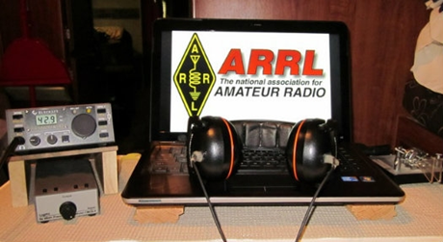
ARRL Contest Corner

An expanded, downloadable version of QST's Contest Corral is available as a PDF. Check the sponsor's Web site for information on operating time restrictions and other instructions.

TOP ^

Special Events

- 04/22/2020 | Earth Day at Great Falls National Historical Park
Apr 22, 1500Z-2100Z, W2NPT, Paterson, NJ. Fair Lawn Amateur Radio Club. 14.245 14.045 7.245 7.045. QSL. Fair Lawn Amateur Radio Club, 10-10 20th Street, Fair Lawn, NJ 07410. Event location is : Paterson Great Falls National Historical Park 72 McBride Avenue Paterson, NJ 07501 www.FairLawnARC.org

- 04/24/2020 | West Point Military Academy 58th Annual Scout Camporee
Apr 24-Apr 26, 1800Z-2359Z, W2P, Brooklyn, NY. James Gallo / Ten Mile River Scout Museum ARC. 21.358 14.258 7.258 3.858. QSL. James Gallo, 149 Marine Avenue, Brooklyn, NY 11209.

- 04/25/2020 | 50th Anniversary of Hot Springs Village, Arkansas
Apr 25, 1300Z-2200Z, W5HSV, Hot Springs Village, AR. Hot Springs Village Amateur Radio Club. 14.240 7.240 147.015 (PL tone 114.8 EchoLink node: 869766). Certificate. David, Johnson, 28 Descollar Cir., Hot Springs Village, AR 71909. www.w5hsv.weebly.com

- 04/25/2020 | Chardon Maple Festival
Apr 25-Apr 26, 1400Z-2200Z, W8G, Chardon, OH. Geauga Amateur Radio Association . 14.250. QSL. Larry Shimerka, 965 Primrose Dr, Seven HIlls, OH 44131. www.geaugaara.org

- 04/25/2020 | International Marconi Day
Apr 25, 0000Z-2359Z, W4S, Fernandina Beach, FL. Cornish Radio Amateur Club. 7.200. Certificate & QSL. Brian Page, 1717 Tidewell Trace, Lawrenceville, GA 30043. W4S will operate from Fernandina Beach, Florida, site of the 1911 Marconi Company station MSF, an official Marconi Station. QSL from W4S for single contact. A certificate from the Cornish Radio Amateur Club is offered for operators establishing contact with 15 official IMD stations. Details are on the web site. www.gx4crc.com/gb4imd

- 04/25/2020 | San Jacinto Day Special Event
Apr 25-Apr 26, 1500Z-2300Z, K5T, Nacogdoches, TX. Nacogdoches Amateur Radio Club. 14.260 14.174 7.220 7.174. QSL. Army Curtis, 167 County Rd. 2093, Nacogdoches, TX 75965. All contacts will be confirmed via LOTW. QSL requests must include SASE. W5NAC.com

- 04/25/2020 | WHOA/SCOTA
Apr 25, 1300Z-1900Z, W1M, Russell, MA. Western Mass Council Scouting USA. 7.060 7.190 14.060 14.290. QSL. Tom Barker, 329 Faraway Road, Whitefield, NH 03598. paper logging is used--there is a delay in sending out qsl cards. sase required for qsl card

- 05/01/2020 | Old Timers Day
May 1-May 3, 0001Z-2359Z, W4T, Dickson, TN. Dickson County Amateur Radio Club. 14.280 7.245 3.980 146.520. QSL. Vollie Miller, 1755 E. Piney Rd., Dickson, TN 37055-3835. www.wc4dc.org

- 05/02/2020 | IA State Park On The Air (Lake Darling)
May 2, 1400Z-2200Z, W0ARC, Washington, IA. Washington Area Amateur Radio Club, Inc.. 14.275 14.070 7.225 7.080. QSL. Mark Lukins, 802 N. 2nd Ave., Washington, IA 52353. www.waarc.net

TOP ^
- 05/02/2020 | Lahontan Dam 105th Anniversary, Churchill County, NV
May 2, 1500Z-2300Z, K7L, Fallon, NV. Amateur Radio of Churchill County. 14.280. Certificate. eCertificate , request to, nv7ccfallon@gmail.com . nv7ccfallon@gmail.com

- 05/02/2020 | Marion County Ohio Bicentennial - Celebrating 200 Years
May 2-May 3, 1400Z-2100Z, WW8MRN, Marion, OH. Marion Amateur Radio Club. 147.300; 14.300 14.030 7.250 7.030 3.950 3.530; digital 7.040 3.590 1.070. Certificate & QSL. Dustin Holbrook, P.O. Box 252, Marion, OH 43301.

- 05/03/2020 | The INDYCAR Grand Prix
May 3-May 9, 0400Z-0400Z, W9IMS, Indianapolis, IN. The Indianapolis Motor Speedway Amateur Radio Club. 18.140 14.245 7.245 3.840. Certificate & QSL. Indianapolis Motor Speedway Amateur Radio Club, P.O. Box 30954, Indianapolis, IN 46230. See website for all details. www.w9ims.org

- 05/04/2020 | Florence Nightingale Bicentenary
May 4-May 31, 1400Z-2359Z, GB200FN, Romsey, UNITED KINGDOM. RSGB. 14.190 3.650. QSL. John Wakefield, Oakhurst, Lower Common Road, Romsey SO51 6BT, UNITED KINGDOM. www.qrz.com/db/gb200fn

- 05/05/2020 | World Pulmonary Hypertension Day
May 5, 0001Z-2359Z, W2H, Forked River, NJ. K2JSS. 14.250 14.074 7.074 3.573. QSL. Jack Bartky, 2209 Longwood Dr., Forked River, NJ 08731. K2JSS@arrl.net

####

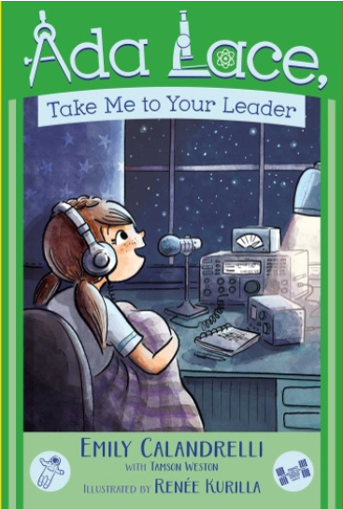
From the Section Youth Coordinator
(Anthony Luscre, K8ZT – SYC)
k8zt@arrl.net

Story From Space- Ada Lace, Take Me to Your Leader
by Emily Calandrelli
Thursday morning I put together a project for teachers to assign to their at home students. It is a fun non-graded activity. It includes a series of three reading sessions from the space station by Astronaut Anne McClain. It focuses on a number of subjects-- space, Amateur Radio, Ada Lovelace (one of inventors of what we now call computer algorithms), Computer Programming, NASA, etc. The project is presented as a Google Slideshow with embedded Youtube videos and Internet links. You can get the presentation at this link.

A short link is also available for you to share with interested parties- tiny.cc/ada-lace. Please share with any Elementary/Middle School teachers you may know and/or directly with youngsters you may know.

Ada Lace, Take Me to Your Leader and other books by Emily Calandrelli are available from your usual sources of books and would make a great present for any youngsters in your life.

TOP ^

NVIS DAY IS COMING!
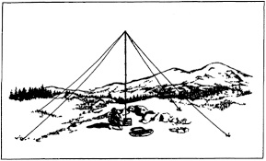
NVIS Day is the ARRL Ohio Section event to test your NVIS antenna designs and builds. Join us on Saturday, April 25th to show how well amateur radio can keep Ohio communicating! This is not a contest: it’s an event for Ohio stations to operate with other Ohio stations and understand how well they hear and are heard.

THE DETAILS
Date: Saturday, April 25
Time: Start at 10 A.M., end at 4 P.M.
Power: Up to but no more than 100w
Exchange: six-digit grid, power, and true—measured—signal report
Schedule: This isn’t a contest, so take your time! Try different designs! Have lunch!

We’ve had some questions about NVIS day, April 25. This is not intended to be a large group activity, and it can be done with two or three at a home. That’s probably more appropriate this year but parks are still open. So far, we are pretty sure NVIS day will go on as scheduled. We’ll watch closely and are open to change.

“ARES Connect”
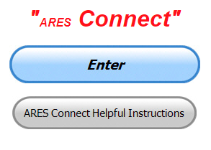
Everyone – please make sure to go into all of the events that you have signed up for and get your hours registered no later than 5 days after the event has ended.

Folks, I’m seeing a lot of folks that have signed up for events not entering their time after the event. This is a very important piece of using “Connect.” Your hours need to be recorded and it’s so easy to do.

Let’s run through how so in case you have forgotten. If you have already gotten signed up for an event, all you have to do afterword to get your time entered is at any time after the event has ended, log into “Connect.” And then click on your name in the upper right-hand corner of the page. This will bring up a drop-down menu where you will then click on “View Hours.” This brings up another screen where you can “Report Hours” as well as “View Hour History” You’ll want to click on “Report Hours.” You will then be presented one at a time by chronological order each event that you have signed up for and hours have not yet been reported on.

Type in those hours in the “Hours Worked” box and hit “Submit”… Keep doing this until you have no more hours to report…. That’s all there is to it. Now, if you are following the request above and doing this at least every 5 days or more often, this will only take you a minute or so to complete.

Admins… If you are wondering how to get an overview of all of your events you can simply go into reports and using the new Event by Participation by Event (version 2) you can not only see who registered for your event, but you also can see if he/she has inputted their hours for it as well. Take advantage of this new report to help you get the time entered into your events.

TOP ^
We still have a number of recurring events created but no activity reported for them. Please, if this event is no longer needed, let me know and I can delete it from the masters. I know that many of you setup recurring events to learn how, but if they aren’t going to be used, let’s get them cleared out.

Also… If you are setting up events, please don’t set a limit for how many folks can sign-up unless absolutely necessary. This causes issues when doing reports. It’s also counter-productive since the reason for you to list the event is to get as many volunteers as you can to attend. When you set limits, it discourages folks from signing up.

Now, isn’t that easy? Yes, and we all need to be diligent at doing it promptly.

Here’s the top 10 hours earners so far for April:

 | Name | Events | Hours
1 | Christopher Domenick (KC8CAD) | 15 | 58.50
2 | Dan Stahl (KC8PBU) | 39 | 52.82
3 | Bret Stemen (KD8SCL) | 19 | 46.50
4 | Gordon Broadway (N8BHL) | 21 | 40.00
5 | Richard Wynkoop (KD8PHG) | 19 | 33.95
6 | Michael Lacumsky (W8MAL) | 24 | 32.25
7 | Earl Paazig (W8BR) | 16 | 31.75
8 | James Garber (W8CEN) | 21 | 30.75
9 | Greg Dersarkisian (KD8SSJ) | 11 | 29.50
10 | James Yoder (w8erw) | 10 | 29.00

Let’s get everyone in the Ohio Section on “ARES Connect!!!” Simply go to: https://arrl.volunteerhub.com/lp/oh/ and get yourself registered and using the system.

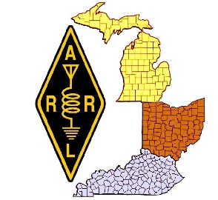
New - Dashboard for Great Lakes Division ARES Connect

Now that ARES Connect has been fully implemented within the Great Lakes Division, have you ever wondered just what our three Sections actually contribute to our combined communities?

We now have a Dashboard on the Great Lakes Division website that will tell you that exact information. Since ARES Connect is an “on-line” and up to the minute reporting system, we now have the ability to obtain this very detailed information.

ARES Connect is full of details that we’ve never been able to obtain before, and because of that, we now can see a much more detailed view of what the Division is doing. Oh, I guess I should also mention that you can also see the data broken down into each Section as well. Now, ain’t that something!!!

Want to take a look? Here’s a link… http://arrl-greatlakes.org/ac.html

Oh, and don’t forget to checkout the rest of the Division’s website as well!!!!

TOP ^

V.E. Test Sessions
For the most part, all V.E. testing has stopped until such time as we can once again gather in groups.

Keep on studying and taking those practice tests to keep what you’ve learned fresh in your mind. We will get out of this soon and testing will resume, so you’ll want to be prepared for when it does return.

One Question Questionnaire

Hey Gang,

“Survey Says”….. Around 77% of you got this right. For those of you who just flat out don’t know, the correct answer is 30 meters.

Ok, it looks like we need some work on the General Class License testing.. Now, once again I will remind you not to cheat and go to Google to look it up. This is for fun, but it also gives you some idea of whether you need to do some studying in your down time.

“How does antenna height affect the horizontal (azimuthal)
radiation pattern of a horizontal dipole HF antenna?”

You’ll find the “One Question” questionnaire on the Ohio Section Website! http://arrlohio.org It’s all in fun and it’s not a scientific survey in any way, but we are learning some things that we didn’t know from these questions. I hope that you are enjoying answering these “One Question” questionnaires.

2020 Weather Safety Week Events
- Lightning Safety Awareness Week: June 21-27
- Ohio’s Winter Safety Awareness Week: November 15-21

Conference Bridge Now Available to Clubs in Ohio

Hey Gang,

With the government closing down all meetings of 10 or more persons it has become a struggle for clubs all over our Section to find ways of having their meetings, and as you can see in the “Club Corner” section of this newsletter all the cancellations that have happened recently.

TOP ^
Well, the Ohio Section has come up with a tool for the toolbox that will allow you to have a video/phone conference meeting and stay within the CDC’s guidelines for distancing. We’ve partnered up with Zoom, one of the premiere video conferencing bridges in the country and we now have the ability to do our own “on-line” conferences.

Our Zoom account allows for up to 100 persons at a time to be connected with not only audio, but video as well. This is sooooo 21st century. You can share your screen for those really fancy presentations, see everyone that’s connected with a camera on the call and really do a first-class meeting with this technology. No, you don’t need to have a computer. Zoom will also allow you to just call in on your regular or cellular phone too. That is what makes this so great.

I know that there has been a lot of stories lately about ZoomBombing and how it can really disrupt a meeting pretty quickly. Zoom just this past week implemented two separate changes to their system to keep this from happening. These changes are in direct response to this issue. But, in defense of Zoom, I will say from all the articles that I’ve read about the ZoomBombing it seems to me this could have been resolved with the account holder taking a little more precaution when setting up their meetings in the first place. Having an open meeting where anyone could simply take control and the Host is left powerless is not a good idea.

There always needs to be a moderator that can quickly and easily take FULL control of the situation just in case, much like a Control Operator that the FCC requires us to have when allowing others to use our radios. Anyway, Zoom has changed the defaults to how a meeting gets setup now, and it will be much more difficult for anyone just to takeover a meeting without the Host’s permission. Problem solved.

I think it is really great for all of us to keep in contact with each other, especially with our older hams that might not be able to get out at night, or just aren’t as mobile as they used to be.

Ham radio is a great way for all of us to make those very important contacts with each other to be sure we are all ok and safe. Zoom is another tool in the toolbox for us to use. So, if you want to try Zoom or have a meeting using it, just let me know. n8sy@n8sy.com

Motorola Solutions Asks Court for Permanent Injunction Against Hytera
(By Danny Ramey, Web Editor Radioresource, Submitted by Gregory Drezdzon, WD9FTZ)

Motorola Solutions asked a judge in the U.S. District Court for the Northern District of Illinois to enter a permanent injunction against Hytera Communications. The proposed injunction would prevent Hytera from selling or distributing products using Motorola trade secrets around the world.

Motorola previously asked the court for a temporary injunction as the case moved through post-trial procedures.

In February, an Illinois jury awarded Motorola $764.6 million in damages after it determined that Hytera had used Motorola trade secrets in its Digital Mobile Radio (DMR) products. Motorola first sued Hytera in March 2017, alleging that three former Motorola employees had downloaded Motorola’s proprietary information and then went to work for Hytera.

In its motion for a permanent injunction, Motorola argued that such an injunction is necessary to prevent Hytera from continuing to use its trade secrets in its DMR products.

TOP ^
“Accordingly, entry of a worldwide permanent injunction is necessary to stop Hytera’s flagrant disregard of the laws protecting Motorola’s trade secrets and copyrights and the continued irreparable harm to Motorola caused by Hytera’s theft,” the motion said.

When considering entering an injunction, a judge must decide whether the party has succeeded on the “merits of its case,” Motorola said, further arguing that Motorola clearly has, because after a three-month trial, the jury returned a verdict in Motorola’s favor in less than three hours.

“In addition, as explained in Motorola’s TRO (temporary restraining order) briefing, the jury’s general verdict is no impediment to the entry of a permanent injunction,” the motion said. “The jury awarded the full compensatory damages Motorola sought, meaning the jury necessarily found Hytera misappropriated all of Motorola’s trade secrets.”

Further, Motorola argued that without a permanent injunction, its business will be irreparably harmed because Hytera’s use of its trade secrets is causing it to lose market share and forcing it to lower its prices.

“Hytera now sells the second-most DMR radios globally and has the second most dealers globally,” the motion said. “Those gains have come at the price of Motorola’s market share, which steadily declined due to Hytera in the years leading up to this lawsuit. … And because the DMR products at issue have a life span of seven to 10 years, every sale and customer that Motorola loses to Hytera is one that it will take Motorola at least that many years to get back, if ever.”

In a motion opposing Motorola’s temporary injunction request, Hytera argued that an injunction was unnecessary because of the large amount of damages the jury awarded Motorola.

Additionally, Hytera argued that some of the damages acted as a perpetual license for the use of some of the Motorola’s trade secrets.

In its motion for the permanent injunction, Motorola argued that the damage Hytera is doing to its market share is not quantifiable, and therefore, the damages awarded by the jury do not cover it.

Additionally, Motorola said that Hytera has been able to offer its products using Motorola’s trade secrets at prices 8%-15% lower than Motorola’s, which has cut into Motorola’s profits.

“As a result of those lower prices, customers have purchased Hytera’s accused products over Motorola’s products on the basis of price,” Motorola’s motion said. “Motorola has been forced to lower its prices or offer price exceptions in every region to compete with Hytera, and if Hytera is not enjoined, Motorola will have to continue to lower its prices in order to compete with the accused products. This pervasive and global price erosion cannot be remedied by a money judgment.”

Motorola also disputed Hytera’s idea that monetary damages awarded by the jury served as a perpetual license for its technology.

“The jury was not instructed on a reasonable royalty by agreement of the parties, and with no evidence and no instruction, the jury could not, and did not, award a fully paid-up license,” Motorola argued.

Motorola said that if the court decides not to implement a permanent injunction against Hytera, it should require Hytera to pay a “reasonable royalty” to Motorola for the use of its trade secrets.

TOP ^
“Hytera should not be permitted to continue selling products it made based on, and/or that contain or are otherwise derived from, Motorola’s trade secrets and copyrighted source code in the first place, but in no circumstance, should Hytera be permitted to do so freely,” the motion said.

Finally, Motorola argued that a permanent injunction would be in the public interest despite Hytera’s argument that such an injunction would lead to a “one-player” market in the DMR market. Motorola said that Hytera had undermined that argument during the trial with evidence and statements that acknowledged the existence of other DMR manufacturers besides Hytera and Motorola.

Motorola argued that not implementing an injunction would hurt the public interest because if companies thieving from others are allowed to continue profiting from a theft, companies will be discouraged from investing in research and development (R&D) that can benefit consumers and the world.

In its opposition to Motorola’s request for a temporary restraining order, Hytera took issue with Motorola’s request for a worldwide injunction, arguing that the U.S. court did not have the jurisdiction to regulate the sale of the products outside the U.S.
Motorola argued that the Defend Trade Secrets Act (DTSA), which is one of the acts Motorola filed its lawsuit under, applies outside the U.S. if “any act in furtherance of the offense was committed in the United States.”

Hytera’s response to Motorola’s motion is due at the end of April. Hytera also filed a motion asking for a new trial in the case. The court will likely not decide on those motions until at least mid- to late May.

Final.. Final..

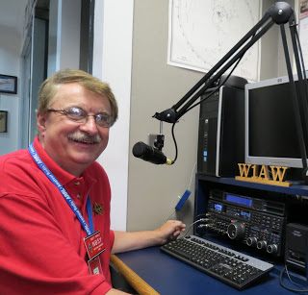
Hi Gang,

We’ve got another week marked off of the calendar under the “Stay At Home” orders, although it sounds like we’re gonna’ have those orders modified some in the very near future.

After listening to the President and our Governor last Friday, it sounds like some things will be opening back up within the next few weeks. I’m so glad, it’s really been depressing to see just how many shops, restaurants and the like are closed. I’ve already heard from a few local shop owners that have decided not to open back up. That’s so unfortunate. Here in the Richland County area we have a really cool motto…. “Be Focal, Buy Local.” That’s gonna’ be a lot more difficult now.

As they have been warning everyone, things aren’t going to be the same for a very long time to come. I have to agree, hugs, handshakes and gatherings like hamfests, club meetings and banquets where we are all packed in just aren’t going to happen for some time to come yet, I’m afraid that’s a reality that we’re all gonna’ have to come to grips with. I know that many of you are chomping at the bit to get to a hamfest to buy something amateur radio! I want that to happen too, but the reality is, it might not happen for a while yet. One undisputable fact that many governments around the world have discovered is that social distancing does work to fight the spread of this killer. That’s a huge game changer for sure.

TOP ^
I will say this, I’ve still been able to attend a lot of club meetings and luncheons, and yes, I’m still attending some morning breakfast club gatherings too. Thanks to your willingness to utilize new and old ideas like Skype, Zoom and EchoLink. It’s been great being able to take advantage of all the various ways we have to stay together yet keep our distance! Kudo’s to everyone out there that has “adapted and overcome” the obstacles. Has your club been finding new ways of having meetings yet? If not, why not? Please, don’t just stop having meetings because you can’t do them in a building. Your club needs to hear from its officers on what’s going on, even if nothing is happening, just getting together and making sure that your fellow hams are OK is vitally important. Remember, your club didn’t just stop because of COVID-19. Take advantage of the technology out there and make good use of your clubs’ resources!

Let’s move down the band….. Janie and I have been out briefly on the trails a few times this past week, but not on the bikes since the weather just hasn’t cooperated very well, but that’s ok, we’ve got lots of time yet and many warm days ahead of us. How’s about you? Are you getting out and getting some fresh air? You need to. Go out and clean up the yard. Do some spring cleaning in that overcrowded garage or shed. Put the snow thrower away and get the lawn mower out. Even my neighbor has gotten “Robbie” the robot lawn mower back out. It seems that the neighbor is still having a little problem with him getting confused and just going around in circles sometimes. It’s been a blast watching him hit some of the natural obstacles that seem to just magically appear, like sticks and tree roots that have surfaced since the last time he went in that direction. I thought he was going to explode one day when he hit a tree root and bounced back a foot or so. You would have thought he’d get the idea that there is something there he needs to avoid, but no, he just keeps going after it like a dog with a bone. I watched him attack this tree root for almost a half an hour before neighbor finally came out and shut him off. Well, that’s how I spend some of my time out in the yard, how’s about you?

I know that this next thought sounds like a broken record, but I do want to make sure that you are taking care of YOU. Yes, making a joke once in a while is good for the brain and the body. One thing that we all have to start talking about is our mental health. This is just as important as our physical health and humor is a good way of staying mentally healthy. Stay active, meeting with your ham buddies on the air or on the phone. Seeing one another either visually or just hearing a familiar voice has a huge positive impact on your brain. Yes, it’s ok to crack a joke now and again. This relieves the tension and it’s also good exercise. Yes, exercise. You use many more muscles in your face and body when you laugh than when you frown. Ok, I won’t belittle this subject anymore. You’ve all gotten the idea. Now do something FUNNY!!!!

Update on Janie, KB8YPW. She’s now closing in on having made 600 masks for our church, local nursing homes and several hospitals as well. You don’t dare go into her room for fear of getting put to work. No, I don’t sew, but she has a full assembly line going and she’ll find you something to do, even if it’s just running the vacuum cleaner!

Whelp, my final go around before gong QRT… Stay safe my friends! I want to see all of you soon at a meeting or hamfest! We will get through this and when we do, we’ll have so much to talk about. Most of all… have FUN and get on the airwaves!!

73,

Scott, N8SY

####

TOP ^

Ohio Section Cabinet
Section Manager – Scott Yonally, N8SY | Assistant Section Manager – John Perone, W8RXX
Section Emergency Coordinator – Stan Broadway, N8BHL | Section Traffic Manager – David Maynard, WA3EZN
Technical Coordinator – Jeff Kopcak, K8JTK | Affiliated Clubs Coordinator – Tom Sly, WB8LCD
State Government Liaison – Bob Winston, W2THU | Public Information Coordinator – John Ross, KD8IDJ
Section Youth Coordinator – Anthony Lascre, K8ZT

Swap & Shop Has Come to the Ohio Section Website

Hey Gang,

Have you taken a look at the Swap & Shop page on the Ohio Section webpage yet??

Here’s a link that will take you there… http://arrl-ohio.org/sm/s-s.html

Do you have equipment that you just don’t need or want anymore? Here’s a great venue to advertise it, and it’s FREE!!

No, it won’t be listed in this newsletter because it would take up way too much space, so your ad will only appear on the website. It is there for any individual to post equipment Wanted / For Sale or Give-Away. No licensed vehicles/trailers or business advertising will be posted.

Postings are text only (no pictures or graphics) will be posted for a maximum of 1 month from date posting and require a contact phone number or email within the posting.

Send your Wanted / For Sale or Give-Away post to: swap@arrlohio.org

####

Here’s another site that you can advertise your For Sale’s or Wanted stuff. It’s free, but I strongly advise you to read all of the instructions before advertising. Here’s the link: https://www.secondhandradio.com/Search.aspx?c=33

Welcome New Subscribers

Ken, W4CCZ; Tom, K8DMM; William, KC8WVG

Back Issues of the PostScript and Ohio Section Journal

Hey, did you know that PostScript and Ohio Section Journal (OSJ) are archived on the website? You can go back and look at any edition simply by clicking:
http://arrl-ohio.org/news/index.html

TOP ^

Updated Information... Want to Share your Club Newsletter With Others?

We have a new webpage where you can download and read all of the newsletters that I get from around the state.

Here’s the link to the page…. http://arrl-ohio.org/club_news/index.html

Please, if you don’t see your club newsletter posted, it’s probably because I’m not receiving it, or I just cannot convert it over to Adobe Acrobat. Have your newsletter editor contact me and let’s see if we can get your club’s newsletter on the site!! We all learn and steal (I mean, share) from each other’s work. So, let’s give this new webpage a real workout and send me your newsletter!!! Send it to: n8sy@n8sy.com

Chit – Chat, and All That!

Do you know someone that’s not getting these Newsletters? Please, forward a copy of this Newsletter over to them and have them “Opt-In” to start receiving them. Heck just have them send me an email n8sy@n8sy.com and I’ll get them added to the Ohio Section Emailing list.

We now have many thousands of readers receiving these newsletters weekly. Quite impressive, I’d say! I urge all of you to make sure that everyone, regardless of whether they are a League member or not, get signed up to receive these weekly Newsletters.

You can always “Opt-Out” at any time if you feel this is not what you were expecting. It’s fun and very informative. All of your favorite past newsletters are now archived too.
You can go back at any time and read them. Just go to: http://arrl-ohio.org/news/

Got questions, concerns or would just like to sit and chat awhile? Heck, I’ll even buy the coffee!! Give me a call at (419) 512-4445 or email me at: n8sy@n8sy.com

The pictures on the front page and throughout this newsletter are from various newsletters, Facebook posts and/or were sent directly to me in recent weeks. Take a good look at them, you just might be in one of the pictures! “SMILE… you’re in the Ohio Section News!!”

TOP ^

PostScript is produced as a weekly newsletter. I want to thank everyone that has contributed articles and ideas to make this an even better news source. I sincerely hope that you have enjoyed this edition and will encourage your friends to join with you in receiving the latest news and information about the Ohio Section, and news and events happening around the world!

