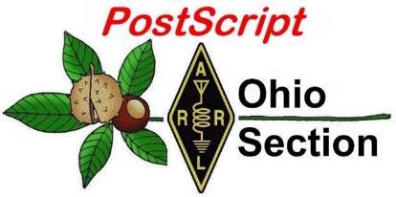
Tax Day
Edition

National News The Handbook Give Away

Club Corner Hamfests

DX This Week ARES Connect

VE Testing One Question Questionnaire

Final.. Final..

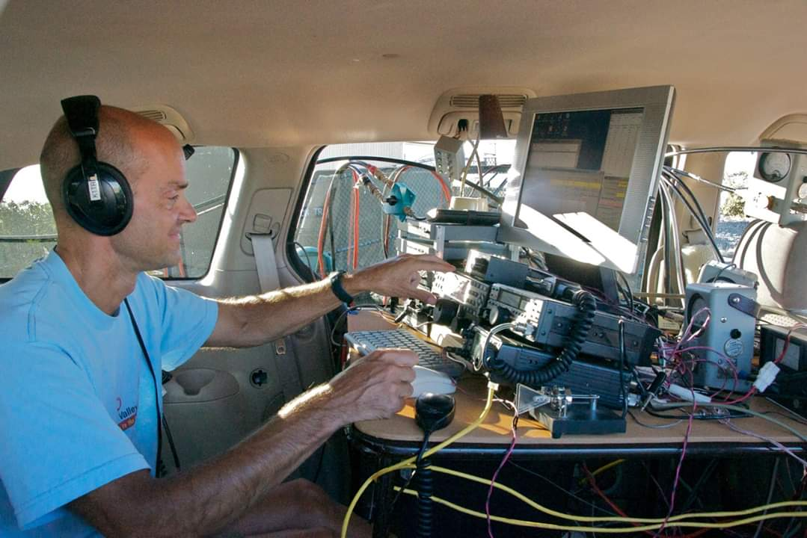

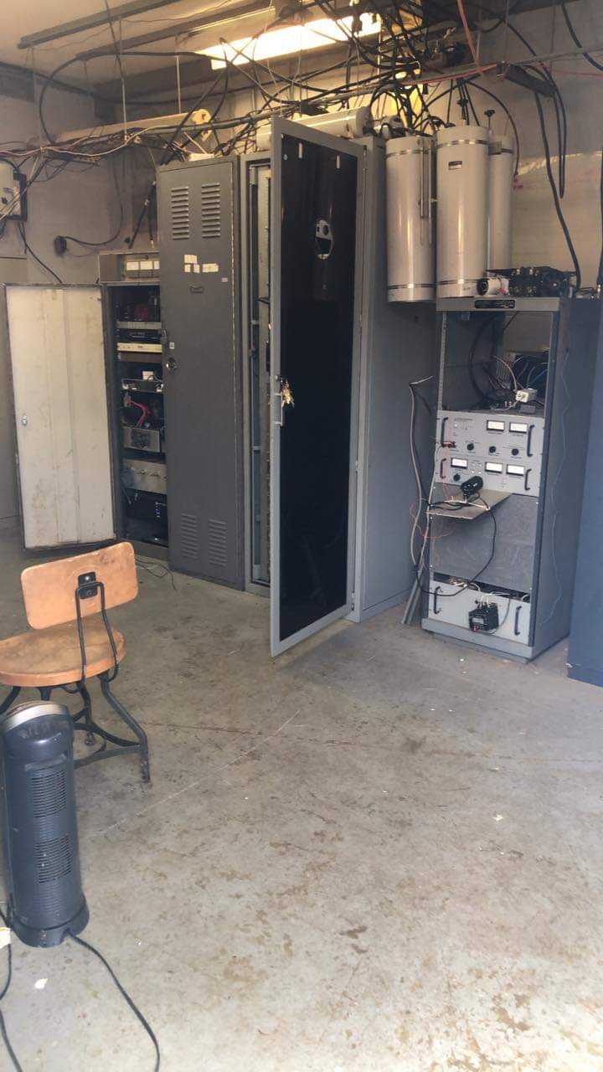
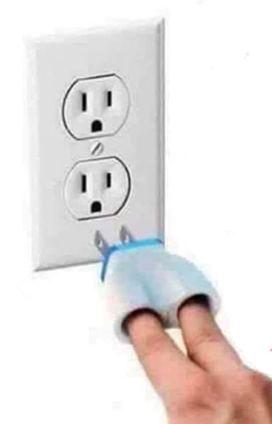

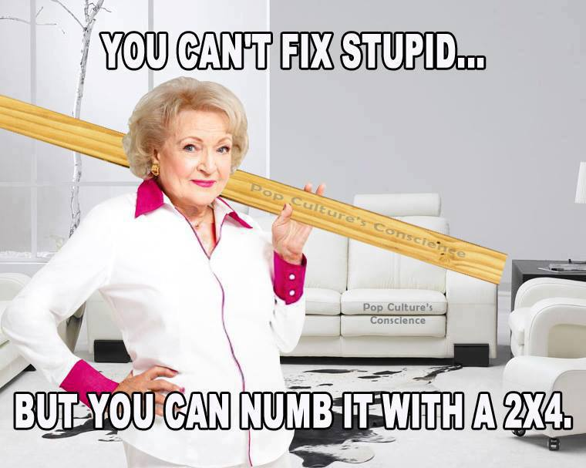

National News
(from arrl and other sources)

Use of Special Call Sign Suffixes in the US During COVID-19 Pandemic

Some countries have authorized selected radio amateurs or organizations to identify with longer-than-normal suffixes that relate to the COVID-19 pandemic, such as “STAYHOME.” FCC Part 97 Amateur Radio Service rules do not provide for amateur call sign suffixes longer than three characters, but a potential workaround exists.

As §97.119(c) of the FCC’s Amateur Radio Service rules states: “One or more indicators may be included with the call sign. Each indicator must be separated from the call sign by the slant mark (/) or by any suitable word that denotes the slant mark. If an indicator is self-assigned, it must be included before, after, or both before and after, the call sign. No self-assigned indicator may conflict with any other indicator specified by the FCC Rules or with any prefix assigned to another country.”

While ARRL has no plans to sponsor or support an effort as an ARRL contest-based activity, licensees desiring to do this as a one-off stay-at-home event are welcome to do so.

####

Icom Announces Delay in Delivery of New IC-705 Transceiver
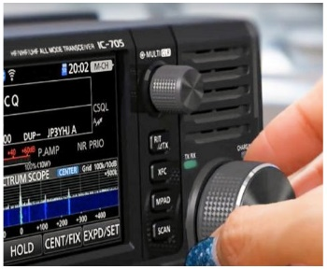
Icom has announced that delivery of the new IC-705 HF – 430 MHz all-mode 10 W transceiver, which was scheduled to be released in March, has been pushed back to later this year because the coronavirus pandemic has delayed the delivery of some components. “We are sorry to share this disappointing news,” Icom said, “and as soon as we have more information, we will post it on our website and social media pages.” Many radio amateurs had made reservations for the IC-705.

####

Japan to Expand Access to 160 Meters

Yoshi Shoji, JG7AMD, reports that Japan’s Ministry of Internal Affairs and Communications is about to expand access to 160 meters for radio amateurs and permit SSB on that band. The current 160-meter band in Japan consists of 1810 – 1825 kHz (CW) plus 1907.5 – 1912.5 for CW and data. Japan will allocate 1800 – 1810 kHz and 1825 – 1875 kHz for all amateur radio modes. The effective date has not yet been announced.

####

TOP ^
Randy Thompson, K5ZD, Named as Interim CQ WPX Contest Director
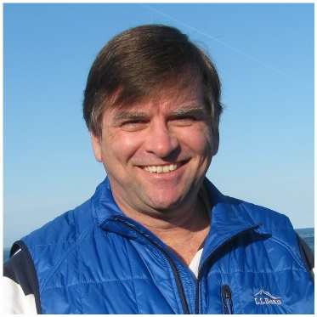
Randy Thompson, K5ZD, is filling in as CQ WPX Contest Director. CQ’s Rich Moseson, W2VU, announced the appointment of Thompson as interim director following the resignation of Terry Zivney, N4TZ, who had been the director for 7 years. Thompson previously served as director of the CQ World Wide Contest and is a long-time CQ Contest Committee member. Anyone interested in taking on the WPX Director position on a permanent basis should contact Moseson.

####

New TQSL Version 2.5.2 Provides Better LoTW Rover Support, Other Improvements
The latest version of TrustedQSL (TQSL), version 2.5.2, offers improved Logbook of The World (LoTW) support for operations from several locations, as well as the ability to detect uploads that contain incorrect location data. The primary new feature in TQSL 2.5.2 allows logging programs, in conjunction with TQSL, to avoid incorrect contact uploads, while adding mechanisms to allow easy uploading of logs for roving stations. LoTW had required rovers to identify each location used as a separate location in TQSL. The new version of TQSL allows these operations to be handled much more smoothly by using information from the station’s logging program.

When a log is signed by TQSL, the station details — call Sign, DXCC entity, grid square, and other location details provided by the selected station location (and call sign certificate) — are compared with the details in the log. If the US state and station location in a log do not agree, TQSL 2.5.2 will reject the contact, detecting errors in instances when an incorrect station location has been chosen. This feature will necessitate changes in many logging programs, because it requires that the log provide station details previously not used by TQSL. Once a logging program supplies these (MY_STATE, MY_DXCC, MY_CQ_ZONE, etc.), then TQSL will validate them against the log. Currently, Cabrillo logs use the CALLSIGN field to verify that the contacts are for the correct call sign.

Optionally, a station performing roaming operations (e.g., from multiple grid squares) can choose to have TQSL assume that the log is correct. When call sign or home station are provided with the log, TQSL will automatically update the details on the upload. Select “Override Station Location with QTH Details from your Log” on the “Log Handling” preference page to enable this feature.

This release also includes an update to the most recent TQSL configuration file. — Thanks to Rick Murphy, K1MU

####

TOP ^
World Amateur Radio Day on April 18 Celebrates 95th Anniversary of the IARU

Saturday, April 18, is World Amateur Radio Day (WARD), this year marking the 95th anniversary of the International Amateur Radio Union (IARU). Around the world, amateur radio special event stations — most sponsored by IARU member-societies — will mark the event on the air, starting on April 18 at 0000 UTC and continuing until April 19, at 0000, honing skills and capabilities while enjoying global friendship with other amateurs worldwide. The theme for WARD is “Celebrating Amateur Radio’s Contribution to Society.” IARU President Tim Ellam, VE6SH/G4HUA, notes that the COVID-19 pandemic casts the event in a different light than in years past.

“A few short weeks ago, many of us could not imagine the levels of isolation that we are now dealing with and the sacrifices of many on the front lines of the pandemic,” Ellam said. “As we have done in past challenges to our society, amateur radio will play a key part in keeping people connected and assisting those who need support.”

Ellam said he’s coming off his own 14-day isolation after returning from overseas. “I am touched by the kindness of strangers who assisted me when I was unable to leave my house,” he said. “It strikes me amateur radio operators, who give so much during these times of crisis are not limited to assisting over the air. Amateurs are true volunteers, and I would encourage everyone to assist in the community as they are able to.”

On April 18, 1925, the IARU was formed in Paris, with ARRL cofounder Hiram Percy Maxim, 1AW, in attendance. Radio amateurs were the first to discover that shortwave spectrum could support worldwide propagation, and in the rush to use these shorter wavelengths, amateur radio found itself “in grave danger of being pushed aside,” as IARU history puts it. Two years later, at the International Radiotelegraph Conference, amateur radio gained allocations still recognized today — 160, 80, 40, 20, and 10 meters. From an initial 25 countries, the IARU has grown to include 160 member-societies in three regions.

How to Participate
- Get on the air. Create your own personal “event” to talk about amateur radio. (To list your World Amateur Radio Day event, contact IARU Secretary David Sumner, K1ZZ.)
- Check into the Echolink World Conference and IRLP 9251. The special event call sign will be W7W.
- Look for and contact stations using the W7W call sign.
- Create and hold a special net on World Amateur Radio Day to draw attention to the event and allow hams to start talking about our hobby.
- Spread the word. If you’re responsible for club publicity, send a press release and do public relations outreach to highlight the event.
- Promote your personal World Amateur Radio Day activity on social media by using the hashtag #WorldAmateurRadioDay on Twitter and Facebook.
- Use the poster and flyer that IARU provides in publicizing the event, amateur radio, and your group or club.

TOP ^
World Amateur Radio Day is not a contest but an opportunity to talk about the value of amateur radio to the public and our fellow amateur colleagues. It is also a great opportunity to talk about your club and amateur radio in local media.

In this time of social isolation, amateur radio continues to remain relevant in bringing people together. “Social distancing” has long been a positive practice in the hobby by bringing people together culturally through radio while providing essential communication in the service of communities.

“My wish for this World Amateur Radio Day is for everyone to stay safe, follow the advice of medical professionals and use amateur radio and your skills to help us through this crisis,” Ellam said.

####

Historic first transatlantic contact made on 432 MHz using FT8
(Submitted by Gregory Drezdzon, WD9FTZ)

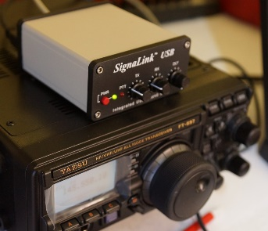
On Tuesday April 7, 2020, a historic contact was made on the FT8 digital mode on 432 MHz between D4VHF on the Cape Verde Islands off the coast of Africa and FG8OJ in Guadeloupe in the Caribbean.
This was the first 70cm transatlantic contact without using satellites or the moon. The most likely mode of propagation was marine ducting with the signal being trapped close to the ocean.
This FT8 contact which was about 3,867 km or 2088 nm in length.

https://ei7gl.blogspot.com/2020/04/first-trans-atlantic-contact-made-on.html

####
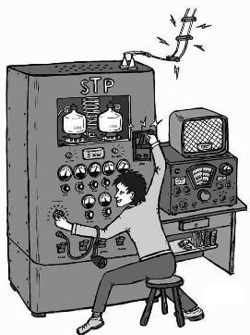
144 MHz Transatlantic record extended to almost 4,760 km
(Submitted by Gregory Drezdzon, WD9FTZ)

The incredible tropo conditions between Cape Verde Islands and the Caribbean continue to amaze with transatlantic contacts on 144 MHz and 432 MHz.

On Wednesday, April 8, 2020, D4VHF in the Cape Verde Islands managed to work PJ2BR on Curacao on 144 MHz using the FT8 digital mode.

The distance was approximately 4,759 km (2570.2 nm), which is roughly 300 km further than the previous transatlantic record of 4,460 km set between D41CV and NP4BM on Puerto Rico in June of 2019.

The new 2 meter transatlantic record distance was about 10 km short of the IARU Region-1, 144 MHz tropo record of 4,769 km (2575 nm).

More info at: https://ei7gl.blogspot.com/2020/04/144-mhz-trans-atlantic-record-extended.html

####
TOP ^
2019 Ohio QSO Party Results Are Posted

The results of the 2019 Ohio QSO Party are now posted on the OhQP web site, www.ohqp.org

Thanks to all who participated - we hope to see you back in 2020! Be sure to mark your calendars:
Saturday, August 22, 2020, 1600Z to 0400Z (Noon to midnight EDT)

Meanwhile, stay safe and sane!

73 - Jim K8MR OhQP Chairman

####

Armed Forces Day Cross Band HF Test Postponed

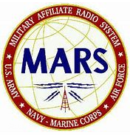
Due to the on-going COVID-19 response and mitigation actions, the Armed Forces Day (AFD) HF event originally scheduled for Saturday 9 May is being postponed.

Due to the uncertainty of when the “stay at home” orders will be lifted across the US. AFD planners chose to postpone this year’s event since the government stations who typically support this event may not be available.

AFD planners are considering scheduling an event in honor of Veteran’s Day in November as a make-up event depending on COVID-19 mitigation actions.

We thank you for your understanding and look forward to executing an event in the near future

From the Section Youth Coordinator
Anthony Luscre, K8ZT - SYC
k8zt@arrl.net

Now You Have Time to Actually Read the Manual!

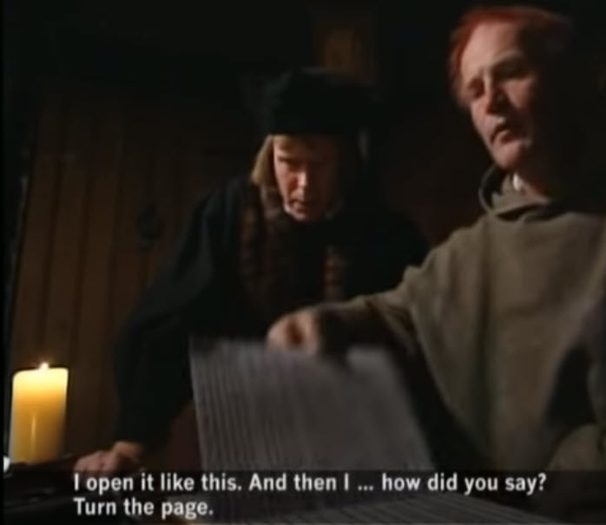
We are always saying we are too busy to get to things, but all of sudden with COVID-19 self-isolating, most of us actually do have some time to do things. One of the things we never have time for is reading the instruction manual when we receive a new radio or start using a new software program. So, I am suggesting you take this opportunity, you may be astounded by what you learn or at least get a few tips for more successful, efficient and/or enjoyable operation. It may almost be as exciting as getting a whole new radio with all the additional functions you will now have available once you learn how to use them after reading the manual.

TOP ^
Steps
- Find the manual
- Not finding the manual, resort to looking for an online copy*

* Here are some links that might help find the manual
- Yaesu - www.yaesu.com
- Icom- www.icomamerica.com/en/amateur
- Kenwood- www.kenwood.com/usa/com/amateur
- Elecraft- https://elecraft.com/pages/manuals-downloads
- Flex- www.flexradio.com
- Ten-Tec- www.tentec.com/category/product-documentation
- Alinco- www.alinco.com/products.html
- MFJ Enterprises- https://mfjenterprises.com/pages/product-manuals
- www.k8zt.com/radios
- Ham Radio Manual Sources - AC6V- www.ac6v.com/manuals.php
- RadioManual.eu- www.radiomanual.eu
- CQHAM.RU- www.cqham.ru/sch_eng.html
- Prepare a favorite beverage
- Sit down and enjoy the reading, but don’t forget the notepad to jot down a few notes

Alternatives
- Watch a video on Youtube
  - On your radio
  - On a software program you use (Logging software, WSJT-X, N1MM, FLDigi, etc.)
  - On a new mode, you would like to learn about (FT8, PSK, DMR, etc.)
- Watch a video recording of a radio club presentation, blog, etc.
- Fair Lawn ARC- link
- http://www.k8zt.com/ham-news and look for the blogs
- ARRL
  - On the Air
  - The Doctor is In
  - So Now What?
- With the desired software program open, press the F1 key or use the menu to bring up the program’s Help.
- Follow one of these links for software program help
  - FT8 & FT4
  - WSJT-X
  - FT8 Operating Guide
  - Additional information on Digital Modes including FT8 & FT4 including guides for setting up specific models of radio www.k8zt.com/digital
- N1MM+ Contesting Software
  - Getting Started Guide
  - Downloadable guide
  - Manual – At-A-Glance
- Consider creating a help guide for your favorite radio or piece of software to share with other hams (by the way this is one of the best ways for you to learn yourself as you organize information and prepare guide)
  - Record a Youtube Video

TOP ^
  - Write an online guide
  - Create a flow chart or step-by-step guide on a specific operation
  - Create a Quick Guide
  - Prepare a presentation to share with your local club once meetings restart or online as a Zoom or other meeting program
  - Some of the software tools I find useful in creating the above materials include:
    - Screen Capture Software
      - My favorite, SnagIt by Techsmith software
      - Awesome Screen Capture Chrome Extension
    - Video Capture
      - Screencastify
      - Loom

P.S. If you have not watched the old, but funny Middle Ages Help Desk Video, pictured above here is the link

Are your club members suffering from “cabin fever”?
(from Lyn Alfman, N8IMW)

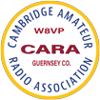
Members of the Cambridge Amateur Radio Association were starting to suffer from “cabin fever” since they had their monthly meetings, Thursday lunches, and other social gatherings canceled. The only thing bringing them together was the Tuesday night net.

So, at the March 31 Tuesday night net, Sonny Alfman, W8FHF, decided to try something different. He proposed having a “Cabin Fever Social Hour” from 8 to 9 PM each evening with a different subject or two each night and perhaps a trivia question on the local repeater 146.850 MHz, PL 91.5. On Tuesday nights, the social time will start immediately after the formal net.

Starting April 1, various members have checked in for an informal gathering on the local repeater. Someone acts as net control, so not everyone tries speaking at once. So far, approximately 20 percent of the membership has checked in most evenings. Hopefully, this social event will continue long past the “stay at home” order has been lifted.

Maybe your club could use this as an example to help alleviate “cabin fever” in your area.

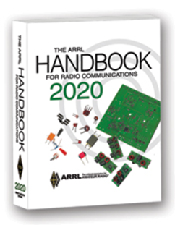
The Handbook Give Away

Hey Gang,

Have you registered for the “Handbook Giveaway” drawing for this month yet? If you haven’t, go to: http://arrl-ohio.org/handbook.html and get yourself registered now!

What’s the catch? I want to get everyone checking in to the Ohio Section website as often as possible, and in order to register each month, you have to visit the website often! There’s nothing else to it. I pay all expenses and I usually “Give Away” more than just a Handbook too!!

TOP ^
Many of you ask me just how do I know when the drawing is on? Well, that’s easy all you need to do is check in on the Ohio Section Website on a regular basis and watch for the big RED Arrow that will appear on the left side of the page. This is the sign that the drawing is on and you need to get registered. So, keep a sharp eye out on the website and check in often!

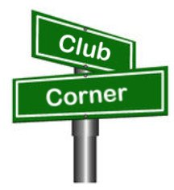
Club Corner

This is YOUR cornner of the newsletter. Send me what your club is doing and I’ll make sure that it gets in. Got a special event or club project that you want everyone to know about? Send it to me!. Need help with a project? Send it to me.

Let me know what you club is up to. Are you going to have a special guest at your meeting or are you having a special anniversary? Just sent it to: n8sy@n8sy.com

####

CW Learning Net In the Toledo Area
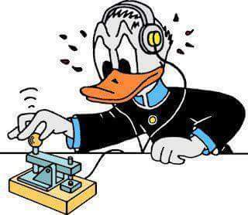
Monday's 7:00 pm starting March 30 on the 147.270 (pl 103.5) W8HHF Repeater. CW learning net. Starting from scratch for the newcomers to the CW mode. General CW mode and equipment discussion as well as learning CW.

Steve KC8TVW

####

Hamvention QSO Party Saturday May 16!
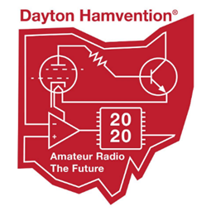
Let's celebrate the many years we have all had at the Great Gathering we call Hamvention. We also want to remember Ron Moorefield W8ILC who never missed a Hamvention and contributed to our club until his recent death. Let's light up the airwaves with our remembrances of Hamvention’s of the past! See you on the air! K3LR, Tim Duffy and W8CI, Michael Kalter.

Here is the deal: 12-hour event, 8 a.m. to 8 p.m. EDST on Saturday of Hamvention May 16, 2020. Operate CW or SSB on 160, 80, 40, 20, 15 and 10 meters. The exchange is a signal report and first year you attended Hamvention. If you have never attended Hamvention, you send 2020.

Send your score (number of QSOs) to 3830scores.com within 5 days of the event. You can print a certificate on line via www.HVQP.org. More details will appear on the Hamvention QSO Party web site being set up now.

Special bonus: W8BI, the club call of the Dayton Amateur Radio Association (DARA is the host of Hamvention) will be activated by designated DARA members from their home stations. You can add 10 points for each band/mode QSO with W8BI (12 available). So you can earn 120 bonus points (like having 120 additional QSOs).

####
TOP ^
NORC Net
(Northwestern Ohio Regional Communications)

The “NORC - 2 Net” (Northwest Ohio Regional Communications–2 Meter) is scheduled for 1:00 PM, the 1st Wednesday of each month. There are 4 repeaters designated for the NORC-2 net, 147.375/Oregon (primary), 146.610/Toledo, 147.255/Republic and 146.790/Bowling Green.

This net is designed to provide backup emergency communications for Hospitals, Healthcare Facilities and County EOC’s in Ohio ARES Districts 1 & 2.

The “NORC-HF Net” (Northwest Ohio Regional Communications-HF) is scheduled for 11:00 AM the 1st Saturday of each month. The net begins on 3.915 +/- then moves to 7.215 +/-.

This net is designed to provide backup emergency communications between County EOC’s in Ohio ARES Districts 1 & 2 and the State EOC (W8SGT), all check-ins are welcome.
Any questions please contact: Dan Stahl - KC8PBU - NORC Net Manager kc8pbu@gmail.com

####

Cleveland Marathon Converted to Virtual Event

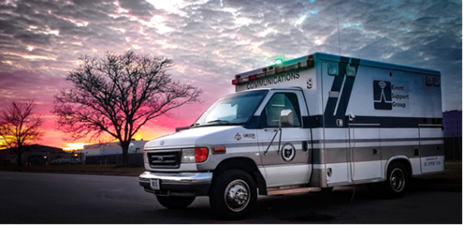
The Cleveland Marathon has officially been moved to a “virtual event”. This means we will obviously have no communications responsibilities. Thanks very much for your willingness to work this very important event. Because of this, I will also be cancelling the May Cuyahoga County ARES meeting which was to be a review of the Marathon procedures.

If you want to read the full statement from the Marathon, you may find it here https://www.clevelandmarathon.com/media/recent-news/rite-aid-cleveland-marathon-goes-virtual-due-to-covid-19.aspx

####

Upcoming Event Status Update

Below is an update on the future radio related events in the Cleveland area.

• April 26, May 3 Cuyahoga ARES Meetings Cancelled
• April 26 American Cancer Society Pan Ohio Hope Ride, Heroes of Hope Ride Cancelled
• April 25 NVIS organized operation cancelled, please operate from home instead
• May 16-17 Cleveland Marathon Cancelled (converted to virtual events)
• June 14 Sunday in June Bike Ride Cancelled

Our friends over at the Geauga Amateur Radio Association have begun compiling a list of as many radio related cancellations as they can. Be sure to check it frequently at https://geaugaara.org/coronavirus/

TOP ^
With the Ohio ARES Conference being cancelled, there will be a series of brief nets held instead that everyone is encouraged to participate in. These should be quick nets taking check-ins and that's it.

Upcoming Hamfests for 2020
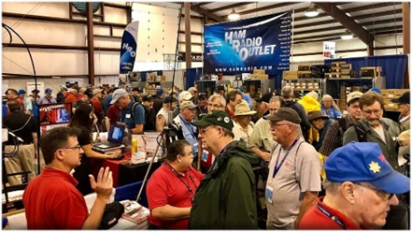
04/18/2020 | Portsmouth Radio Club Hamfest
Postponed

04/26/2020 | Athens Hamfest
Location: Athens, OH
Sponsor: Athens County Amateur Radio Association
Website: http://www.ac-ara.org/
Cancelled

05/15-16-17/2020 | Dayton Hamvention
Cancelled

06/06/2020 | FCARC Summer Hamfest
Location: Wauseon, OH
Sponsor: Fulton County Amateur Radio Club
Website: http://k8bxq.org/hamfest

07/19/2020 | Van Wert Hamfest
Location: Van Wert, OH
Sponsor: Van wert Amateur Radio Club
Website: http://w8fy.org
07/26/2020 - Portage Hamfair '20
Location: Ravenna, OH
Sponsor: Portage Amateur Radio Club, Inc.
Website: http://hamfair.com

08/01/2020 | Columbus Hamfest
Location: Grove City, OH
Sponsor: Voice of Aladdin/ Audio Unit of Aladdin Shrine
Website: http://columbushamfest.com

####

Webpage for Cancelled Hamfests

ARRL has created a webpage that will search the ARRL Hamfest and Convention Database for canceled events. >> Click Here <<

####

TOP ^

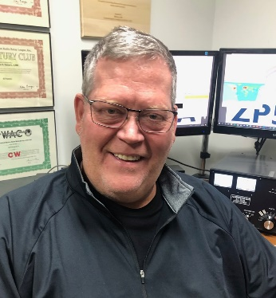
DX This Week
(from Bill, AJ8B)

DX This Week – Zones 9, 10, and 11
Bill AJ8B (aj8b@arrl.net, @AJ8B, or www.aj8b.com)
CWOPs Member #1567

I hope you are safe and following all the recommended guidelines. Are you brushing up on your CW? Have you tried a new mode? What about your QSL cards?

If you were around the cluster this past week, there were many different entities to be worked. These included Argentina, Ascension Island, Asiatic Russia, Australia, Azores, Balearic Islands, Barbados, Belgium, Bolivia, Bosnia-Herzegovina, Brazil, Bulgaria, Canada, Canary Islands, Chile, Colombia, Costa Rica, Croatia, Czech

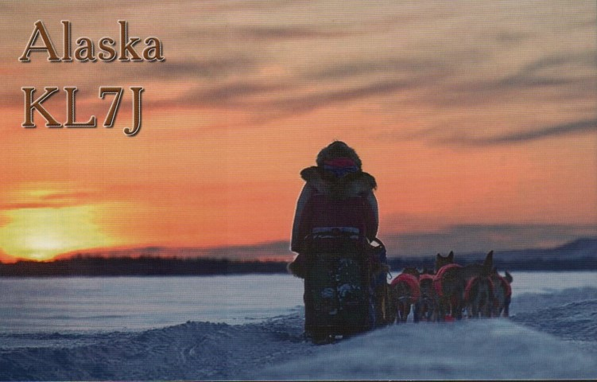
Republic, Dominican Republic, Ecuador, England, Fed. Rep. of Germany, Fiji, Finland, France, Guatemala, Hawaii, Hungary, Ireland, Italy, Japan, Kenya, Mexico, Morocco, New Zealand, Norfolk Island, North Macedonia, Ogasawara, Oman, Panama, Paraguay, Philippines, Portugal, Puerto Rico, Republic of Korea, Republic of South Sudan, San Marino, Scotland, Serbia, Slovak Republic, Slovenia, Spain, St. Helena, St. Lucia, Suriname, Switzerland, Tajikistan, Thailand, Trinidad & Tobago, Ukraine, Uruguay, and Venezuela.

I received a couple of cards this week: WB5AAA, Jim from Louisiana, K1HTV, Rich from Virginia, JA7ZFN – Masa in Japan, and KL7J – Les in Alaska (Pictured). Did you get any or send any this week?

If you need a break from your current activities, take a look at the great Antenna work video posted by F2DX at: https://www.dx-world.net/f2dx-antenna-work-april-2020/

Zones 9, 10, and 11
This week we will continue our exploration of the CQ Zones. Zones 9,10, and 11 are the Northern Zone of South America, Western Zone of South America, and the Central Zone of South America. Below is a breakout of the entities that are contained in the zones and the number of licensed amateurs if that data was available.

Zone 9. Northern Zone of South America: FY (French Guyana), HK (Colombia) – 6,500, HK0 (Malpelo Is.), PJ2 (Curacao), PJ4 (Bonaire), PZ (Surinam) - 93, YV (Venezuela) – 10,600, 8R (Guiana), P4 Aruba and 9Y (Trinidad and Tobago Is.). - 445

Zone 10. Western Zone of South America: CP (Bolivia) – 1,385, HC (Ecuador) – 2,006, HC8 (Galapagos Is.), and OA (Peru) - 3,080.

TOP ^
Zone 11. Central Zone of South America: PY (Brazil) – 32,053, PY0 - F (Fernando de Noronha, PY0 - S (St. Peter and Paul Rocks) and PY0 - T (Trinidad Martin Vaz), ZP (Paraguay) – 5,085.

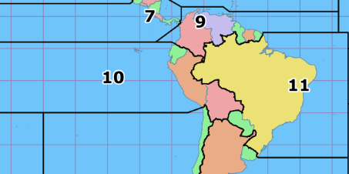
The PY0 group has always been a challenge for me. I have worked Fernando de Noronha (PY0-F) several times, Trinidad Martin Vaz (PY0-T), but never St. Peter and Paul Rocks (PY0 – S).PY0-S was last activated in November of 2012 and is currently ranked #29 on the Clublog Most Wanted list. I am hoping that a DXPedition will occur from there in the next year or so!

I used information from http://www.n0hr.com/ham_radio_population.htm for the ham population. Also, you should monitor several sources including the Oh Section Bulletin and https://www.ng3k.com/misc/adxo.html for upcoming DXPeditions to entities in CQ Zone 9, 10, and 11.

CQDX CQDX CQDX CQDX CQDX CQDX CQDX CQDX CQDX

Here is an update from Bernie, W3UR, of the DailyDX and the WeeklyDX, the best source for DX information. http://www.dailydx.com/. Bernie has this to report:

TF – Iceland - TF3WARD will be IRA, the Icelandic Radio Amateurs, April 18, to celebrate World Amateur Radio Day. There will be a special QSL card, says TF3JB, President of IRA.

G – United Kingdom - GB0NHS will highlight the UK’s National Health Service that is on the forefront of the battle against COVID-19. GB8NHS and GB5NHS will also be on from Northern Ireland (GI). At least for GB5NHS, QSLing is by LoTW only.

OE – Austria - OE20M is a special call April 24-26 to mark Marconi’s birth on April 25, 1874. QSL through the bureau to OE1WHC or direct to:

DokuFunk, OE20M
An den Steinfeldern 4A
1230 Wien AUSTRIA

SP – Poland - Callsign SN0KURP from the SP5KVW Radio Club Baza promotes the Kurpie ethnic region, this one on the air April 5 to May 31. QSL through the bureau.

5T – Mauritania - 5T5PA (aka PA5X), Johannes, says because of the pandemic he will temporarily leave Mauritania, sailing back to the Netherlands between April 6-18. He will be maritime mobile on the vessel “Dutch Power.” His callsign will be PA5X/MM with his IC-7300 to a vertical and a wire antenna, 40 and 20 meters SSB and FT8. Daily position reports will be on JS8Call. QSL via PA5X or through OQRS or LoTW. Johannes plans to be back in Mauritania when things return to normal and flights resume, hopefully by June.

TOP ^
UR – Ukraine - EM65LR is in memory of UR2LR, Vlad Lisnykov, a silent key last year. Friends of his have EM65LR on the air now through May 18. QSL via UR2LM.

KH8/S - Swains Island - The planned expedition group have updated their blog on their website. New dates have caused DJ9ON to bow out due to other obligations in that timeframe. PA9M, Marcel, will take his place. Marcel is an experienced op with a lot of low band and contest experience. The trip is now planned for September 23 to October 6 with 10 operators, planning activity on all the HF bands, CW, SSB, FT8 and RTTY, four stations, two camps.

DX news

ARLD015 DX news

This week's bulletin was made possible with information provided by The Daily DX, the OPDX Bulletin, 425 DX News, DXNL, Contest Corral from QST and the ARRL Contest Calendar and WA7BNM web sites. Thanks to all.

ST. KITTS, V4. John, W5JON will be QRV as V47JA from June 11 to July 2. Activity will be on 160 to 6 meters, including 60 meters, using SSB and FT8, with emphasis on 6 and 160 meter FT8. All QSLs to W5JON direct or via LoTW.

UNITED STATES, W3. Special event station W3A will be active from April 17 to 30 to bring attention to World Autism Awareness Month. Activity will be on various HF bands using FT8, CW and some SSB. Please QSL direct to WA3MD and include SASE. DX Stations should include return postage if direct. QSL is also ok via the Bureau.

NORTHERN IRELAND, GI. Special event call sign GB75VEC, will be used from the MI0MOD station in Lisburn City in May and June to mark the 75th anniversary of VE Day ending World War II.

SPAIN, EA. EE1MGY commemorates the Titanic's inaugural voyage and sinking. Operations will be through April on 160 meters on CW, FT8, and WSPR. QSL to EB1LO, direct or via the Bureau.

SOLOMON ISLANDS, H4. Bernhard, DL2GAC continues to be active as H44MS on 40 and 17 meters using SSB and FT8.

JAPAN, JA. 8J4ROSE is QRV to celebrate the Fukuyama Roses Festival until May 17. QSL via bureau.

BRAZIL, PY. Gustavo, PT2ADM is QRV as ZW75FEB, commemorating the end of World War II and honoring the memory of his father, who fought in Italy as part of the Brazilian Expeditionary Force (FEB).
Operations continue until the end of May. QSL via PT2ADM, direct or via the Bureau.

TURKEY, TA. Members of the YM3KB team mark Turkey's National Sovereignty and Children's Day, April 23, with operations throughout the month as TC100KIDS on the HF bands using SSB, CW and FT8. QSL via YM3KB. Also, Metin, TA2BZ is QRV as TC19MED to pay tribute to workers in the medical sectors, until May 29. QSL via TA2BZ.

TOP ^
LUXEMBOURG, LX. Members of the Radioamateurs du Luxembourg (R.L.) will be operating special event station LX5WARD for the 2020 World Amateur Radio Day, until April 26. Special QSLs will be available via the LX IARU QSL Bureau.

GUERNSEY, GU75. The Guernsey Amateur Radio Society (GARS) will be running a special event station from May 6 to 12 to mark the 75th anniversary of the Liberation of Guernsey from Occupying Forces. Using the call sign GU75LIB, activity will be on the HF bands, all modes, QO100, and possibly some 2 meter and 70cm activity as well. QSL via the Bureau, or direct to Dave, GU8ITE (QTHR).

SPECIAL STAY AT HOME STATIONS/ACTIVITIES. Be looking for many special event stations to hit the airwaves to promote ''STAY-AT-HOME'' and raise awareness for the restrictions necessary to fight the spread of the corona virus. These stations include: 8A1STAYHOME (Indonesia), 9K9STAYHOME (Kuwait), A60SH/1 SH=StayHome (United Arab Emirates), A60SH/2, A60SH/3, A60SH/4, A60SH/5, AX2020STAYHOME (Australia), GB5NHS (NHS=National Health Service), HZ1STAYHOME (Saudi Arabia), TC1STAYHOME (Turkey), VC2STAYHOM (Canada) and XM2STAYHOM (Canada). QSL via operator's instructions.

NIUE, E6. Operators Stan, LZ1GC and Ivan, LZ1PM will be active as E6AM from September 28 to October 17. Activity will be on 160 to 6 meters using CW, SSB, RTTY and FT8. QSL via LZ1GC, ClubLog's OQRS, direct or via the Bureau.

TONGA, A3. Stan and Ivan will move on to Tonga as A35GC from October 19 to November 2. Activity will be on 160 to 10 meters using CW, SSB, RTTY and FT8. QSL via LZ1GC, ClubLog's OQRS, direct or via the Bureau.

GHANA, 9G. Matteo, IZ4YGS expects to be active as 9G5GS sometime between April 13 and May 15. Activity will be limited to his spare time on 160 to 10 meters using mostly FT8 (F/H) and SSB. QSL via LoTW, IZ4YGS direct or eQSL.

THIS WEEKEND ON THE RADIO. The QRP ARCI Spring QSO Party, JIDX CW Contest, OK/OM DX Contest, SSB, F9AA Cup, PSK, FTn DX Contest, SKCC Weekend Sprintathon, New Mexico QSO Party, North Dakota QSO Party, Georgia QSO Party, Yuri Gagarin International DX Contest, WAB 3.5/7/14 MHz Data Modes, International Vintage Contest HF and the Hungarian Straight Key Contest are all on tap for this weekend.

Please see April 2020 QST, page 71 and the ARRL and WA7BNM Contest Web Sites for details.

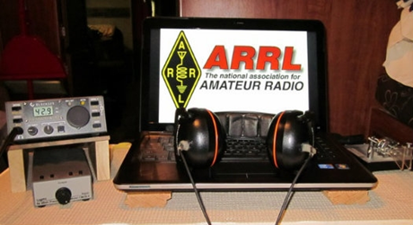
ARRL Contest Corner

An expanded, downloadable version of QST's Contest Corral is available as a PDF. Check the sponsor's Web site for information on operating time restrictions and other instructions.

TOP ^

Special Events

- 04/14/2020 | Sinking of the Titanic - 108th Anniversary
Apr 14-Apr 15, 1540Z-0100Z, AL4US, Pigeon Forge, TN. American Legion Post 104 Amateur Radio Club. 14.280 7.180 14.280. QSL. AL4US, c/o American Legion Post 104 , P.O. Box 4242, Sevierville, TN 37864. www.tnpost104.org

- 04/15/2020 | Franklin County VA Moonshine Heritage Month
Apr 15-Apr 30, 0500Z-0000Z, W4M, Glade Hill, VA. Whiskey 4 Moonshine - W4M. All standard digital frequencies; Phone: 28.400 21.300 14.250 7.215 3.850 1.900; CW 28.100 21.105 14.050 7.050 3.550. QSL. Bryant Johnson, P.O. Box 103, Glade Hill, VA 24092. Franklin County VA is considered by many to be the Moonshine capital of the world. In celebration of the 100th anniversary of the passage of Prohibition we will commemorate the heritage of the moonshiners with a special event station that will operate for the period of 4-15-2020 until 4-30-2020 on 10 meters thru 160 meters. https://www.facebook.com/groups/2476533519124786

- 04/18/2020 | 2020 Feast of the Ramson - THIS EVENT HAS BEEN CANCELLED
Apr 18, 0800Z-1400Z, W8TFC, Richwood, WV. The Family Center Amateur Radio Club. 147.015 14.220 7.220 3.820. Certificate. W8TFC, 3 Valley Avenue, Richwood, WV 26261. Certificates will be provided via E-Mail. THIS EVENT HAS BEEN CANCELLED www.thefamilycenterofrichwoodwv.org/Ham/default.html

- 04/18/2020 | Activation of State Parks in the State of Texas
Apr 18-Apr 20, 1400Z-0200Z, K5LRK, The Colony, TX. Lake Area Amateur Radio Klub. CW bottom of band +40 kHz; Phone - general segment +25 kHz and 28.350; VHF - 50.200 and 144.200 MHz. QSL. Ken Rainy, AC3EZ, 529 Kenilworth Ave., Little Elm, TX 75068. Times are daily. www.k5lrk.com

- 04/18/2020 | April In Durand, IL
Apr 18, 1500Z-2100Z, K9K, Durand, IL. Winnebago County IL ARES/Skywarn. 14.270 7.190 3.840. QSL. Randy Long, 212 East Main St., Durand, IL 61024. This is a small town home show. We will have a booth promoting ham radio as a hobby and service to the local community. Our plan is to have two HF stations and one UHF/VHF station working during the event. The general public will have the opportunity to experience hands-on with the GOTA 2 meter station and watch and listen to our members make contacts on the HF stations and possibly satellite contacts all day. www.ecom1.com

- 04/18/2020 | Franklin,LA Bicentennial in Conjunction with Bayou Teche Black Bear Festival and Wooden Boat Show
Apr 18, 1600Z-2100Z, W5BMC, Franklin, LA. Bayouland Emergency Amateur Radio Service (BEARS). 14.250 7.250. QSL. Jackie Price, 708 Front St., Morgan City, LA 70380.

- 04/18/2020 | Maker Faire Connecticut
Apr 18-Apr 19, 0900Z-1700Z, N1M, Westport, CT. Connecticut ARES. 14.225. Certificate. NA1RA, P.O. Box 354, New Milford, CT 06776. Celebrating the 9th annual Maker Faire Connecticut www.ctares.org

- 04/18/2020 | Parma Radio Club 8th Annual Earth Day
Apr 18, 1500Z-2000Z, W8PRC, Cleveland, OH. Parma Radio Club. 7.195 14.245 145.410 . QSL. Parma Radio Club, 8111 Laumer Avenue, Cleveland, OH 44105. Public invited. Our 8th Annual Earth Day Celebration Event. Operating on "ol sol" power from the historic educational Stearns Farm & Homestead at the town center of Parma, Ohio. www.parmaradioclub.com

TOP ^
- 04/18/2020 | Peekskill Cortlandt Amateur Radio Association 20th Anniversary Celebration
Apr 18, 1400Z-2000Z, W2NYW, Crompond, NY. Peekskill Cortlandt Amateur Radio Association (PCARA). 7.235 14.235 7.048 14.048. Certificate & QSL. PCARA, P.O. Box 146, Crompond, NY 10517. Certificate and QSL available by mail or e-mail. Please provide 9x12 envelope with sufficient postage for unfolded certificate. mail@pcara.org

- 04/18/2020 | The Safe Return of Apollo 13 - 50th Anniversary
Apr 18, 1600Z-2100Z, K7T, Tucson, AZ. Oro Valley Amateur Radio Club. CW 14.040 7.040; USB 14.250; FT8 18.100. Certificate. Send request to, qsl@tucsonhamradio.org for, certificate.. No paper QSLs please. www.tucsonhamradio.org

- 04/18/2020 | Walter Reed Special Event
Apr 18, 1400Z-1900Z, W4HZL, Gloucester, VA. Middle Peninsula Amateur Radio Club. 14.260 7.260. QSL. QSL Manager, W4HZL, P.O. Box 1121, Gloucester Point, VA 23062. Commemoration of Walter Reed, a US Army General born in Gloucester, Va. His work helped eradicate Yellow Fever and allowed construction of the Panama Canal to continue. www.mparc.net

- 04/18/2020 | World Amateur Radio Day
Apr 18-Apr 19, 1200Z-1200Z, W7W, Ogden, UT. Nevada Amateur Radio Repeaters, Inc.. HF frequencies; EchoLink conference *World* 479886 IRLP 9251 VOIP . Certificate & QSL. Thomas Harrington , 636 West 24th St., Ogden, UT 84401. wrn-wfn.com

- 04/18/2020 | World Amateur Radio Day 2020
Apr 18-Apr 19, 1600Z-0400Z, W2W, Rochester, NY. DoDropin Echolink Conference Node 355800. 446.025. Certificate & QSL. W2JLD/John Derycke, 85 Amherst St., Apt. 2, Rochester, NY 14607. This is a VOIP/ECHOLINK Special Event, *DODROPIN* Node 355800 Allstar Node 47620. To obtain a special event QSL Card and a certificate, send a S.A.S.E. TO : W2JLD/JOHN DERYCKE 85 AMHERST ST ROCHESTER NY 14607 w2jld2@gmail.com

####

SEA-PAC 2020 Cancellation Notice

For some time the SEA-PAC Executive Committee has monitored the COVID-19 pandemic working closely with our local health, public and government partners in assessing this unprecedented situation.

With approximately 60 days until the event, the Executive Committee has made the decision to cancel the SEA-PAC convention for 2020. Convention fees paid will be refunded.

This conclusion is based on the deadly seriousness of the virus, the rate of expansion, and the recovery time after the crisis apex is achieved. But more importantly, it is based on the genuine concern for the health and safety of the attendees, vendors and presenters.

Details regarding this cancellation will be posted at www.seapac.org. Thank you for your understanding and we are looking forward to the next SEA-PAC on 4, 5, and 6 June 2021.

Gary J Takis K7GJT SEA-PAC 2020 Chairman

TOP ^
For those that have preregistered, please note that SEA-PAC will be refunding your fees including registration, banquet, workshop and any other fees that you submitted on the registration form. We will not refund any travel related expenses, including those non-refundable.

Please note that we will refund by the way you paid. If you paid by PayPal, then you will get a PayPal credit to you. If you paid by check, you will receive a SEA-PAC check. This process of refunding may take a few days, but be assured that your refund will be coming.

####

Annual Armed Forces Day Crossband Test Postponed
Due to the ongoing COVID-19 response and mitigation actions, the 2020 Armed Forces Day (AFD) Crossband Test scheduled for Saturday, May 9, has been postponed.

Because it’s uncertain just when stay-at-home orders will be lifted across the US, AFD planners chose to postpone this year’s event, because the government stations that typically support this event may not be available. Armed Forces Day Crossband Test planners are considering scheduling a November event in honor of Veteran’s Day, depending on COVID-19 mitigation actions.

During the AFD Crossband Test, military stations in various locations transmit on selected military frequencies and announce the specific ham frequencies they are monitoring to work radio amateurs. — Thanks to US Army MARS Program Chief Paul English, WD8DBY

NVIS DAY IS COMING!
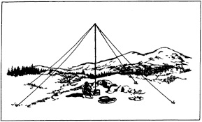
NVIS Day is the ARRL Ohio Section event to test your NVIS antenna designs and builds. Join us on Saturday, April 25th to show how well amateur radio can keep Ohio communicating! This is not a contest: it’s an event for Ohio stations to operate with other Ohio stations and understand how well they hear and are heard.
THE DETAILS
Date: Saturday, April 25
Time: Start at 10 A.M., end at 4 P.M.
Power: Up to but no more than 100w
Exchange: six-digit grid, power, and true—measured—signal report
Schedule: This isn’t a contest, so take your time! Try different designs! Have lunch!

We’ve had some questions about NVIS day, April 25. This is not intended to be a large group activity, and it can be done with two or three at a home. That’s probably more appropriate this year but parks are still open. So far, we are pretty sure NVIS day will go on as scheduled. We’ll watch closely and are open to change.

TOP ^

“ARES Connect”
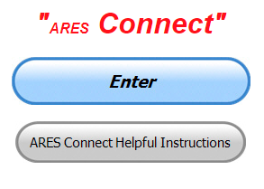
Everyone – please make sure to go into all of the events that you have signed up for and get your hours registered no later than 5 days after the event has ended.

Folks, I’m seeing a lot of folks that have signed up for events not entering their time after the event. This is a very important piece of using “Connect.” Your hours need to be recorded and it’s so easy to do.

Let’s run through how so in case you have forgotten. If you have already gotten signed up for an event, all you have to do afterword to get your time entered is at any time after the event has ended, log into “Connect.” And then click on your name in the upper right-hand corner of the page. This will bring up a drop-down menu where you will then click on “View Hours.”

This brings up another screen where you can “Report Hours” as well as “View Hour History” You’ll want to click on “Report Hours.” You will then be presented one at a time by chronological order each event that you have signed up for and hours have not yet been reported on.

Type in those hours in the “Hours Worked” box and hit “Submit”… Keep doing this until you have no more hours to report…. That’s all there is to it. Now, if you are following the request above and doing this at least every 5 days or more often, this will only take you a minute or so to complete.

Now, isn’t that easy? Yes, and we all need to be diligent at doing it promptly.

Here’s the top 10 hours earners so far for April:

 | Name | Events | Hours
1 | Dan Stahl (KC8PBU) | 21 | 42.62
2 | Christopher Domenick (KC8CAD) | 10 | 40.50
3 | Bret Stemen (KD8SCL) | 11 | 30.50
4 | Michael Lacumsky (W8MAL) | 16 | 21.25
5 | Richard Wynkoop (KD8PHG) | 12 | 19.95
6 | Earl Paazig (W8BR) | 9 | 19.75
7 | Bryan Hoffman (KC8EGV) | 17 | 19.25
8 | Arthur Burnett (KB8UNJ) | 13 | 18.25
9 | James Neal (WD8JLP) | 8 | 18.00
10 | Michael Walker (AB8MW) | 11 | 17.00

Let’s get everyone in the Ohio Section on “ARES Connect!!!” Simply go to: https://arrl.volunteerhub.com/lp/oh/ and get yourself registered and using the system.

TOP ^
Admins… If you are wondering how to get an overview of all of your events you can simply go into reports and using the new Event by Participation by Event (version 2) you can not only see who registered for your event, but you also can see if he/she has inputted their hours for it as well. Take advantage of this new report to help you get the time entered into your events.

We still have a number of recurring events created but no activity reported for them. Please, if this event is no longer needed, let me know and I can delete it from the masters. I know that many of you setup recurring events to learn how, but if they aren’t going to be used, let’s get them cleared out.

Also… If you are setting up events, please don’t set a limit for how many folks can sign-up unless absolutely necessary. This causes issues when doing reports. It’s also counter-productive since the reason for you to list the event is to get as many volunteers as you can to attend. When you set limits, it discourages folks from signing up.

V.E. Test Sessions
For the most part, all V.E. testing has stopped until such time as we can once again gather in groups.

Keep on studying and taking those practice tests to keep what you’ve learned fresh in your mind. We will get out of this soon and testing will resume, so you’ll want to be prepared for when it does return.

One Question Questionnaire

Hey Gang,
Alright!!! “Survey Says”….. Around 90% actually know the correct answer to the Ohm’s Law question… That means that about 10% of you need to still need to study some more!!! By the way, for those in the 10%, the correct answer was 30 watts. Remember, P = I * E

Let’s keep this going for a bit but raise the stakes just a little higher. In stead of giving you questions from the Technician Class License test, let’s start asking some from the General Class License exams… Now no cheating and going to Google to look it up. Most of you should know this without the aid of a powerful search engine.

“On which of the following bands is image transmission prohibited”

You’ll find the “One Question” questionnaire on the Ohio Section Website! http://arrlohio.org It’s all in fun and it’s not a scientific survey in any way, but we are learning some things that we didn’t know from these questions. I hope that you are enjoying answering these “One Question” questionnaires.

TOP ^

2020 Weather Safety Week Events
- Lightning Safety Awareness Week: June 21-27
- Ohio’s Winter Safety Awareness Week: November 15-21

Conference Bridge Now Available to Clubs in Ohio

Hey Gang,

With the government closing down all meetings of 10 or more persons it has become a struggle for clubs all over our Section to find ways of having their meetings, and as you can see in the “Club Corner” section of this newsletter all the cancellations that have happened recently.

Well, the Ohio Section has come up with a tool for the toolbox that will allow you to have a video/phone conference meeting and stay within the CDC’s guidelines for distancing. We’ve partnered up with Zoom, one of the premiere video conferencing bridges in the country and we now have the ability to do our own “on-line” conferences.

Our Zoom account allows for up to 100 persons at a time to be connected with not only audio, but video as well. This is sooooo 21st century. You can share your screen for those really fancy presentations, see everyone that’s connected with a camera on the call and really do a first-class meeting with this technology. No, you don’t need to have a computer. Zoom will also allow you to just call in on your regular or cellular phone too. That is what makes this so great.

I know that there has been a lot of stories lately about ZoomBombing and how it can really disrupt a meeting pretty quickly. Zoom just this past week implemented two separate changes to their system to keep this from happening. These changes are in direct response to this issue. But, in defense of Zoom, I will say from all the articles that I’ve read about the ZoomBombing it seems to me this could have been resolved with the account holder taking a little more precaution when setting up their meetings in the first place. Having an open meeting where anyone could simply take control and the Host is left powerless is not a good idea. There always needs to be a moderator that can quickly and easily take FULL control of the situation just in case, much like a Control Operator that the FCC requires us to have when allowing others to use our radios. Anyway, Zoom has changed the defaults to how a meeting gets setup now, and it will be much more difficult for anyone just to takeover a meeting without the Host’s permission. Problem solved.

I think it is really great for all of us to keep in contact with each other, especially with our older hams that might not be able to get out at night, or just aren’t as mobile as they used to be.

Ham radio is a great way for all of us to make those very important contacts with each other to be sure we are all ok and safe. Zoom is another tool in the toolbox for us to use. So, if you want to try Zoom or have a meeting using it, just let me know. n8sy@n8sy.com

####
TOP ^

Final.. Final..

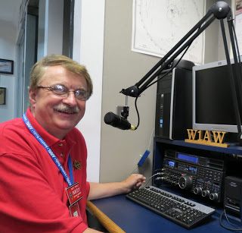
Hi Gang,

Welp, we’ve all made it through another week of being “locked down.” It’s really strange going out in the yard and not seeing anyone out and about like we used to. I have to tell you that my yard has never looked so clean with all the sticks picked up and things trimmed up! Janie says our annual plants will be going in very soon too. Amazing what can get done when you are forced to stay at home.

Janie and I have been out on the bikes a couple of times this past week, but it doesn’t look like the weather will give us much time on the trails this next week. Oh well… We’ve got lots of time yet, spring has just sprung, and we’ve got many warm days ahead of us yet.

I have to tell you it’s been interesting sitting in on all the club and ARES meetings this past week. Yes, they were observing all the rules, yet they had their meetings on “Zoom” as well as “WebEx” and even a couple on “Free Conference Call” and “Go To Meeting.” I’ve actually been able to keep my 4 – 5 meetings per week schedule even though I haven’t put one mile on the car!!! Wow, who would have ever guessed that one!

Look, I realize that things are tough, but as you can see, you can still have your normal club meetings without too much difficulty. In fact, I wouldn’t be surprised that most folks attending these meetings were not quite dressed as they would be if they at their normal meeting locations.

Yup, folks only see the top half you what you are wearing, so if you want to have your pajama bottoms on and your favorite liquid refreshment in hand, who’s to know. I’m suspecting that when the time comes to end all of this madness, some won’t end the on-line meetings because of convenience! As many are finding on-line meetings are really easy to do. Presentations and even videos can be shown just like at a regular meeting. The only thing that you can’t do is pass around that really rare QSL card or Raspberry Pi project you put together, but it’s close. You’re still getting that face to face and even some education too. The other night the presenter at one meeting I attended was in Fort Myers, Florida while the rest of us were sitting here in Ohio! The meeting went off even better than if we were at the club house getting this presentation one on one, because we were all sitting in our own comfy chairs with refreshments of our choice listening intently while all in the comfort of our homes. No worries about catching something from someone.

Let’s move down the band….. Has your club been finding new ways of having meetings yet? I am hearing of some more virtual breakfasts and lunches starting. We’ve also got many new “on air” meetings going on around the state too. It’s been fun seeing how many clubs have rediscovered their own repeaters and are using them to keep their membership informed on what is happening with the club. Please, don’t just stop having meetings because you can’t do them in a building. Your club needs to hear from its officers on what’s going on. Remember, your club didn’t just stop because of COVID-19.

TOP ^
Other clubs are starting to use video teleconferencing options as well. That works really great when you want to do presentations and such. It doesn’t take all that much effort to do them either. A desktop / laptop computer, tablet or smart phone will give you a lot of additional options for your club members to use too.

Now, I know that you can’t turn on the TV or radio without hearing all the doom and gloom. But, don’t forget to keep your sense of humor in all of this. Yes, making a joke once in a while is good for the brain and the body. One thing that we have to start talking about is our mental health. This is just as important as our physical health and humor is a good way of staying mentally healthy. Stay active, meeting with your ham buddies on the air or on the phone. Seeing one another either visually or just hearing a familiar voice has a huge positive impact on your brain. Yes, it’s ok to crack a joke now and again. This relieves the tension and it’s also good exercise. Yes, exercise. You use many more muscles in your face and body when you laugh than when you frown. Ok, I won’t belittle this subject anymore. You’ve all gotten the idea. Now SMILE!!!!

Update on Janie, KB8YPW. She’s now made over 400 masks for our church, local nursing homes and several hospitals as well. I’ve been afraid to go over to her room for fear of getting put to work. She’s got a real assembly line going and she’s a slave drive if there ever was one!

Whelp, my final go around before gong QRT… Stay safe my friends! I want to see all of you soon at a meeting or hamfest! We will get through this and when we do, we’ll have so much to talk about. Most of all… have FUN and get on the airwaves!! I’m listening and “I Don’t Hear YOU!!!”

73,

Scott, N8SY

Ohio Section Cabinet
Section Manager – Scott Yonally, N8SY | Assistant Section Manager – John Perone, W8RXX
Section Emergency Coordinator – Stan Broadway, N8BHL | Section Traffic Manager – David Maynard, WA3EZN
Technical Coordinator – Jeff Kopcak, K8JTK | Affiliated Clubs Coordinator – Tom Sly, WB8LCD
State Government Liaison – Bob Winston, W2THU | Public Information Coordinator – John Ross, KD8IDJ
Section Youth Coordinator – Anthony Lascre, K8ZT

Swap & Shop Has Come to the Ohio Section Website

Hey Gang,

Have you taken a look at the Swap & Shop page on the Ohio Section webpage yet??

Here’s a link that will take you there… http://arrl-ohio.org/sm/s-s.html

Do you have equipment that you just don’t need or want anymore? Here’s a great venue to advertise it, and it’s FREE!!

TOP ^
No, it won’t be listed in this newsletter because it would take up way too much space, so your ad will only appear on the website. It is there for any individual to post equipment Wanted / For Sale or Give-Away. No licensed vehicles/trailers or business advertising will be posted.

Postings are text only (no pictures or graphics) will be posted for a maximum of 1 month from date posting and require a contact phone number or email within the posting.

Send your Wanted / For Sale or Give-Away post to: swap@arrlohio.org

####

Here’s another site that you can advertise your For Sale’s or Wanted stuff. It’s free, but I strongly advise you to read all of the instructions before advertising. Here’s the link: https://www.secondhandradio.com/Search.aspx?c=33

Welcome New Subscribers

John, KE8NXU; Jack, N8DGW; John, N4KJU; John, WA8KAQ

Back Issues of the PostScript and Ohio Section Journal

Hey, did you know that PostScript and Ohio Section Journal (OSJ) are archived on the website? You can go back and look at any edition simply by clicking:
http://arrl-ohio.org/news/index.html

Updated Information... Want to Share your Club Newsletter With Others?

We have a new webpage where you can download and read all of the newsletters that I get from around the state.

Here’s the link to the page…. http://arrl-ohio.org/club_news/index.html

Please, if you don’t see your club newsletter posted, it’s probably because I’m not receiving it, or I just cannot convert it over to Adobe Acrobat. Have your newsletter editor contact me and let’s see if we can get your club’s newsletter on the site!! We all learn and steal (I mean, share) from each other’s work. So, let’s give this new webpage a real workout and send me your newsletter!!! Send it to: n8sy@n8sy.com

TOP ^

Amateur radio operators turn to analog tech to communicate during pandemic
(Submitted by Gregory Drezdzon, WD9FTZ)

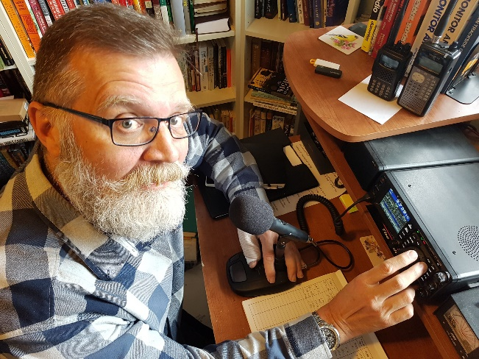
Vancouver's City News 1130 reports amateur radio operators have turned to analog tech to communicate during the COVID-19 pandemic.
The 24-hour live news radio station says: While millions of isolated people around the world discover new digital ways of staying in touch, some are going back to the analog basics.
Paul Judd of Maple Ridge, BC, is part of a small but passionate community of amateur radio operators. “It’s one of the most elemental ways of communicating between two persons or two stations or two places without having the huge infrastructure” of other forms of communication, Judd said.
Amateur radio operator Paul Judd poses with his home station in Maple Ridge (photo courtesy of Paul Judd)
Judd, whose call sign is VA7XQ, fires up his home station daily to check in with fellow ham radio users around the region and, sometimes, around the world.
The check-ins with different networks – or nets, as they’re known – allow operators to ensure their gear is working properly, but they also allow for more casual conversation.
Read the full story at:
https://www.citynews1130.com/2020/04/09/amateur-radio-operators-turn-to-analog-tech-to-communicate-during-pandemic/

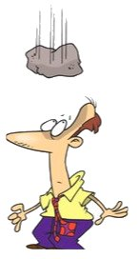
Murphy's Laws
(You’ll just never know when he’ll strike!!)

- The printer is either out of toner or there is no paper only when the client asks for 10 copies of a 120 page report by evening.

- The CD drive will not be even detected only when you want to cull out information from some CD. Just the day before that, you would have been playing music and it would have worked fine.

- The network would snap just when you were explaining an important point over a NetMeeting conference call.

- The telephones won't work when you need to call long distance urgently.

- The client will call only when you had left for a coffee break. And when you call back, he/she won't be available in office.

TOP ^

Chit – Chat, and All That!

Do you know someone that’s not getting these Newsletters? Please, forward a copy of this Newsletter over to them and have them “Opt-In” to start receiving them. Heck just have them send me an email n8sy@n8sy.com and I’ll get them added to the Ohio Section Emailing list.

We now have many thousands of readers receiving these newsletters weekly. Quite impressive, I’d say! I urge all of you to make sure that everyone, regardless of whether they are a League member or not, get signed up to receive these weekly Newsletters.

You can always “Opt-Out” at any time if you feel this is not what you were expecting. It’s fun and very informative. All of your favorite past newsletters are now archived too.
You can go back at any time and read them. Just go to: http://arrl-ohio.org/news/

Got questions, concerns or would just like to sit and chat awhile? Heck, I’ll even buy the coffee!! Give me a call at (419) 512-4445 or email me at: n8sy@n8sy.com

The pictures on the front page and throughout this newsletter are from various newsletters, Facebook posts and/or were sent directly to me in recent weeks. Take a good look at them, you just might be in one of the pictures! “SMILE… you’re in the Ohio Section News!!”

TOP ^

PostScript is produced as a weekly newsletter. I want to thank everyone that has contributed articles and ideas to make this an even better news source. I sincerely hope that you have enjoyed this edition and will encourage your friends to join with you in receiving the latest news and information about the Ohio Section, and news and events happening around the world!

