[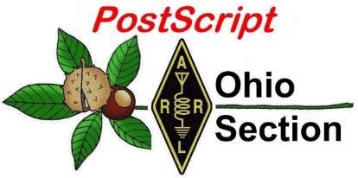](http://arrl-ohio.org/news/) ***April 6th***

***Edition***

🡪 National News 🡪 The Handbook Give Away

🡪 Club Corner 🡪 Hamfests

🡪 DX This Week 🡪 ARES Connect

🡪 VE Testing 🡪 One Question Questionnaire

🡪 Final.. Final..

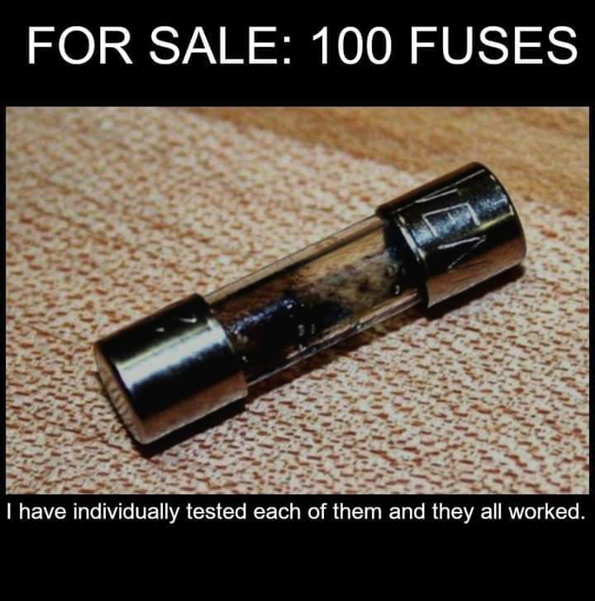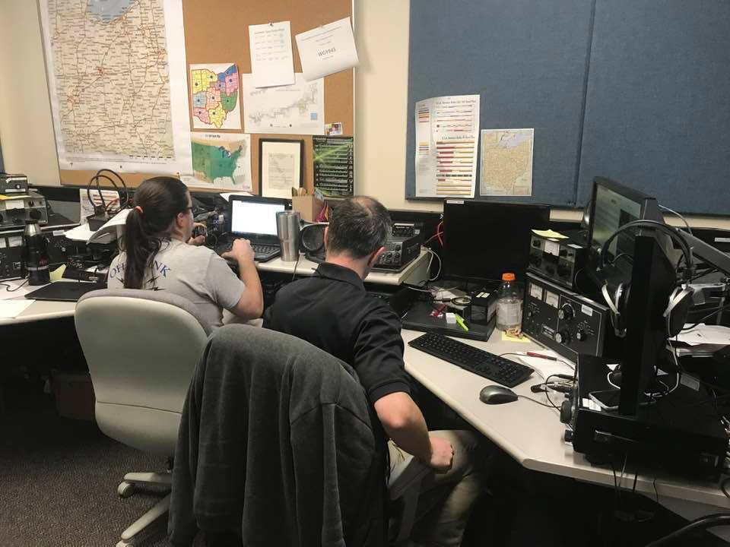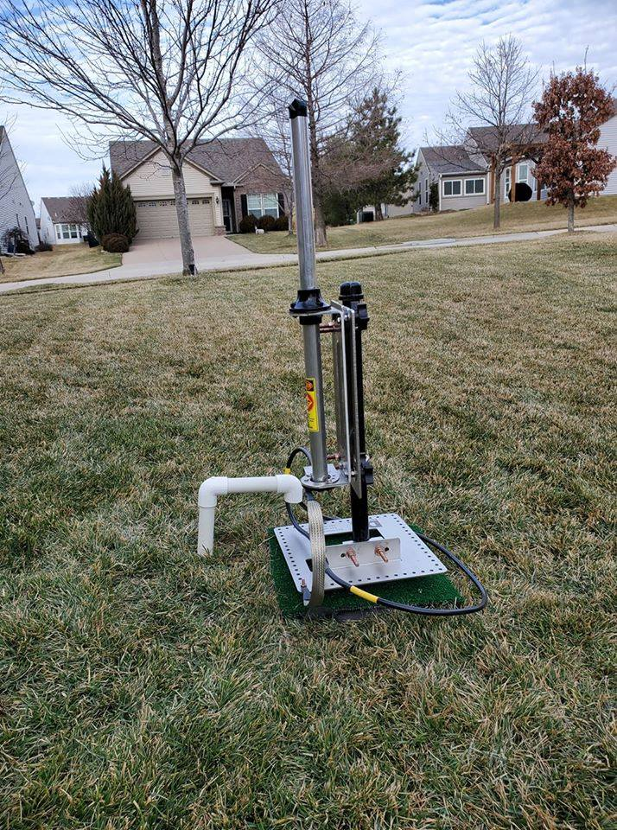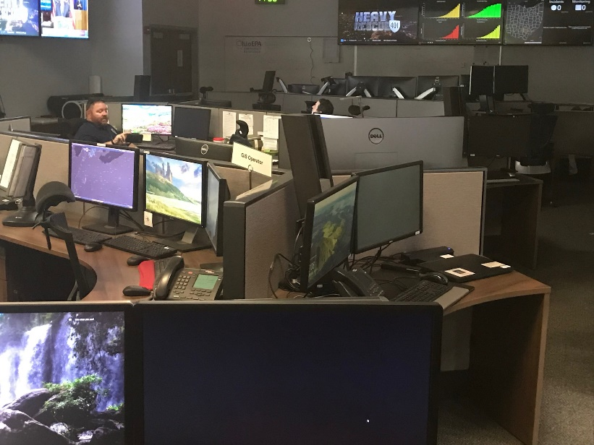

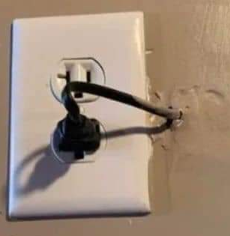

***National News***

*(from arrl and other sources)*

***FCC Grants Temporary Emergency Authority to WISPs Operating in 5.8 GHz Band***

The FCC has [**granted**](https://docs.fcc.gov/public/attachments/DOC-363358A2.pdf) temporary permission to wireless internet service providers (WISPs) in rural portions of 29 states and the US Virgin Islands to operate in the 5.8 GHz band (5.850 – 5.895 GHz). The authorization, to help meet the temporary surge in demand for residential fixed broadband services during the COVID-19 pandemic, was one of multiple waivers issued in the past week that grant temporary access to a variety of bands in response to the uptick in residential broadband demand.

The 5.8-GHz grants were effective on March 26. Each grant is for 60 days, provided individual WISPs file STA applications within 10 days of March 26. Amateur Radio shares this spectrum on a secondary basis with Dedicated Short-Range Communications (DSRC) systems and industrial, scientific, and medical (ISM) applications, and that status remains unchanged.

“[E]ach applicant is independently responsible for complying with the conditions of its grant,” the FCC’s Keith D. Harper, Associate Chief of the Wireless Telecommunications Bureau Mobility Division wrote in granting the request. “Applicants are advised that this includes ensuring proper protection of incumbents in the 5.8 GHz band.” The Commission noted that WISPs are responsible for ensuring that they do not cause interference to existing licensees.

According to the request, each of the WISPs provides fixed wireless broadband service in rural areas, primarily relying on unlicensed spectrum for last-mile connections to end users. “Many of the WISPs’ customers have no other alternative to terrestrial broadband services,” the request said.

Commenting earlier this month in response to an FCC *Notice of Proposed Rule Making* (*NPRM*) in WT Docket 19-138 — in which the FCC said it would “take a fresh and comprehensive look” at the rules for the 5.8 GHz band — ARRL called the FCC’s attention to the widespread use of the 5.8 GHz band for amateur mesh and amateur television networks, as well as links that radio amateurs have engineered into the band on a non-interference secondary basis “and which often are used directly for public service purposes when there are no other facilities available.”

The Commission’s emergency grant explicitly requires that the WISP operations be conducted on a non-interference basis. If unexpected interference within this spectrum range is experienced, radio amateurs should consult [**Attachment 1**](https://docs.fcc.gov/public/attachments/DOC-363358A2.pdf) of the grant and contact the WISP indicated at the address and email address provided.

####

***A Message for ARRL Member Volunteers for Responding to COVID-19***

**Dear Member Volunteer,**  
  
The ARRL staff team has received many inquiries from our members seeking guidance or offering suggestions during the current crisis. We hope everyone is adhering to CDC and local health department guidelines by staying home, maintaining safe distances when around people, and following sanitary practices.

TOP ^

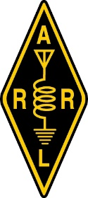Many radio clubs have canceled upcoming meetings, exam sessions, hamfests & conventions. ARRL has established a web page with news, information, cancellations, and resources of interest to ARRL members and our global amateur radio community. Visit [**www.arrl.org/COVID-19**](http://www.arrl.org/COVID-19).  
  
With many radio amateurs staying home there are opportunities to get on the air and call CQ or meet on the local repeater. We certainly don’t need a reason to get on the air, after all, that’s what hams do.  
  
In terms of ham radio preparedness, this current crisis has not disrupted communications on a national scale. We know many of our members practice and train for a personal radio communication capability that can be called on when disaster strikes. Amateur Radio Emergency Service® (ARES) volunteers and our partners in providing emergency communications already routinely monitor the information and requests from Emergency Coordinators and the like. Station and skills readiness are tenets of the Amateur Radio Service – and this current crisis hasn’t changed this.  
  
If you are a radio amateur serving your community through ARES or by volunteering with any of our partners in providing public service communications, ***thank you***. ARES members routinely monitor the information and requests from their ARES Emergency Coordinators. We are grateful for all the ways you stand-ready to support the emergency service personnel in your communities when disaster strikes.  
  
Again, we encourage all member volunteers to remain safe, and to follow the guidelines and requests of your national and local government officials and public health leaders. For those members who are healthy and safe at home, we can encourage you to get on the air:

* **Get on the air.** As online fatigue and a feeling of isolation will inevitably creep into our “new normal,” being on-air will introduce variety into our communication practices. As many of us are now homebound or working and studying from home, turning on a radio to connect with your ham radio peers will be welcome respite!
* **Radio Clubs.** Think of this current challenge as an opportunity to encourage our club’s members to get on the air. Move (short) meetings to the club’s repeater, and encourage check-ins. Organize skeds, nets, and challenges. Try different bands (HF, VHF, UHF…) and modes. This will also help new radio amateurs gain practical operating experience.
* **Readiness.** Station and skills readiness are tenets of the Amateur Radio Service. Any time we spend on the air will contribute to developing and practicing our personal radio communication capability.

Every day, we draw inspiration from members who share our passion for radio communications. We are grateful to support radio amateurs in our common pursuit of skill, service, and discovery. ARRL remains steadfast in serving you.  
  
Thank you. We hope that you and your loved ones remain safe.

This page, [**www.arrl.org/coronavirus**](https://www.arrl.org/coronavirus) or [**www.arrl.org/COVID-19**](https://www.arrl.org/COVID-19), includes news and information of interest to ARRL members and our global amateur radio community.

####

TOP ^

***ARRL VE Newsletter - April 2020*  
==================================================**

**To All ARRL Members and ARRL VEC accredited Volunteer Examiners:**

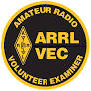  
We know many examiners have canceled Amateur Radio License exam sessions to meet the requirements and recommendations of national and local government and health officials. **The health and safety of examinees and our Volunteer Examiners is first and foremost in any decision-making process.** ARRL VEC does not offer video supervised online Amateur Radio licensing exams at the present time. However, we know some VE Teams are exploring alternative formats on a local basis. Please continue to use ARRL’s License Exam Search to find scheduled exam sessions in your area and verify with the local exam team that the session is still being held. Please visit [**www.arrl.org/exam**](http://www.arrl.org/exam).   
  
ARRL VEC is continuing to process license examination materials received from Volunteer Examiners who have completed exam sessions although under the circumstances there are some delays. For qualified examinees, ARRL VEC forwards electronically all required data to the FCC.  
  
We understand there are examination candidates who continue their studies toward new Amateur Radio Licenses and license upgrades. We also know some will be frustrated that, at this time, ARRL VEC does not offer online licensing exams. Amateur radio is not alone in this challenge, though.   
  
While each of us continues to respond to the immediate evolving crisis, we also know that we must keep an eye to our future. Throughout its decades of service, the VEC system has served the FCC as a shining example of the successes of a privatized system. The ARRL VEC and our Volunteer Examiners are recognized throughout the Amateur Radio Service for our integrity and efficiency. Adapting our all-volunteer license examination administration will be a challenge, but one we are committed to undertake in order to advance the program and improve service.   
  
While we face unprecedented challenges, opportunities also await. We are grateful to support radio amateurs in our common pursuit of skill, service, and discovery. ARRL and ARRL VEC remain steadfast in serving you. We will provide updates as they become available.  
  
  
**========================================================================**

**The ARRL VEC Staff is Ready to Serve You**

As always, the dedicated VEC staff are here to answer any questions you may have.   
  
ARRL VE toll free number:  1-800-9ARRLVE (1-800-927-7583)  
Address:  ARRL VEC,  225 Main St,  Newington CT 06111  
Email:  [VEC@arrl.org](mailto:VEC@arrl.org)   
Web:  [www.arrl.org/volunteer-examiners](http://www.arrl.org/volunteer-examiners)   
ARRL VEC Fax:  860-594-0339

TOP ^

***From the Section Youth Coordinator***

***Anthony Luscre, K8ZT - SYC***

[k8zt@arrl.net](mailto:k8zt@arrl.net)

**CQ Magazine Article on Youth Resources- Available for Free!**

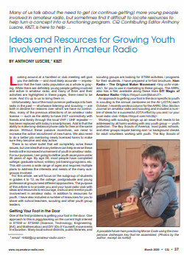

Last week in the OSJ I mentioned the following:

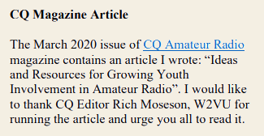

Now I have some additional, good news-- in the time since I wrote the article CQ Magazine has announced that the March 2020 and April 2020 ***CQ Amateur Radio*** issues will be available for free online reading. This means you can read my entire article even if you are not currently a subscriber to CQ; below are the details on the offer:



**Stuck at home?**

**Events and activities cancelled?**

**Feeling cut off from friends and family?**

**Remember your radio!**

In view of the "stay at home and flatten the curve" recommendations from the health experts during this worldwide pandemic, *CQ* would like to give everyone the opportunity to escape the news alerts for a brief period and enjoy the hobby they love through the pages of *CQ!*

TOP ^

View the March and April issues of *CQ* magazine at no charge! It's easy, simply send an email to [FreeIssues@cq-amateur-radio.com](mailto:FreeIssues@cq-amateur-radio.com) and we'll send you the March issue now and the April issue on April 1st!

Take advantage of this opportunity to read *CQ -* free of charge - and keep connected with the latest trends and activities in amateur radio! Stay home... stay well!

A day or two after you send the email you will receive a message from CQ Magazine on how you access your free issues.

***Tips for a Better Video Call***

*(By Bruce Hennes, Hennes Communications)*

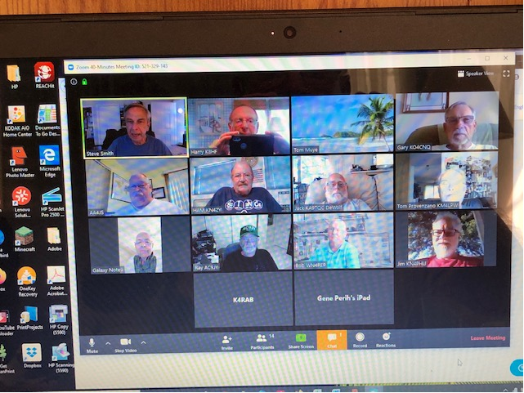Whether you’re using FaceTime, Zoom, Hangouts, WebEx, Teams or any of the other video call platforms, there are a few universal do’s and don’ts if you want to look and sound professional:

**DO** make sure there is light on your face.  Before you start the video call, look at yourself on the screen and see what you look like.  You may need to turn on an overhead light or even add a table lamp or other light source, pointed towards your face.

**DO** make sure you are looking directly into the camera lens.  Whether you have to adjust your chair or the camera itself, your eyes should be at the exact same level as the camera lens.

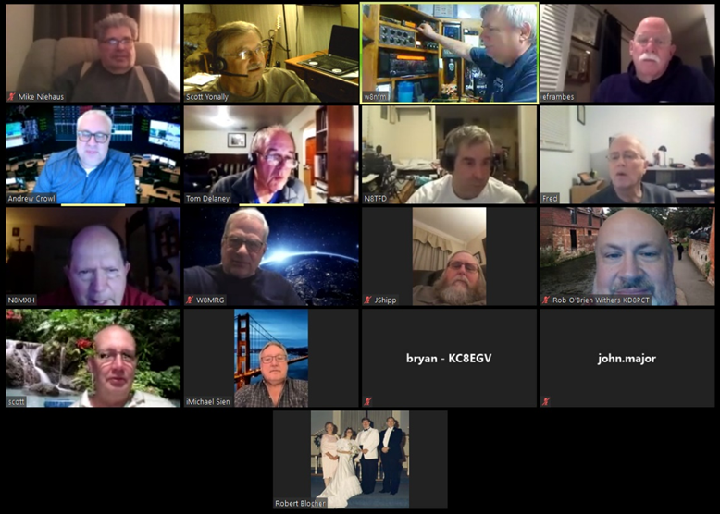

**DO** make sure you’re making eye contact.  Studies show that people who make eye contact increase their believability ratio exponentially.  If you’re looking at the screen, you’re not making eye contact.  Is it difficult to look directly into the camera lens and have an extended conversation?  Is it even tougher to conduct a webinar for 30 or 60 minutes or longer, looking into the camera lens the entire time?  You betcha.  Suggestion:  partially cover the screen with a piece of paper so you’re not tempted to look at it.  Even if you’re on your mobile phone using FaceTime or another video program, remember:  the camera lens isn’t in the middle of the screen – it’s on the edge of the screen.

**DO** be sure to look at the television news programs, and pundit shows.  Especially these days, so many more of those interviews are taking place with people in their home offices rather than in the TV studios.  Turn the sound off so you concentrate on the “performance,” (what you’re looking at) rather than what’s being said.  Notice, too, who’s making eye contact with you and who isn’t.

TOP ^

**DO** be aware of what’s behind you.  A simple background is always best.  A neat, but busy bookshelf can work, too.  But clutter is just that. *(Ed Note.. Zoom allows you to create any background that suites you.. sometimes this can be a real ice breaker, but don’t do this if you are doing it for work!)*

**DO** be aware of your body posture.  Sit up straight!  And don’t forget to smile, or at the very least, look pleasant.

**DO** be animated.  A little body movement or moving your head just a little makes you look interesting instead of stiff.  Be sure to talk with your hands, too.  Sitting with your hands folded – stiff.  Using one or two hands to make small hand motions that punctuate your important points from time-to-time – animated and interesting.

**DO** be sure that your mobile phone is set to vibrate or off.  And if you have a landline, be sure to unplug it or otherwise make certain it doesn’t ring.

**DO** make sure the dog is down and the kids are quiet.

**DO** make sure you have enough bandwidth.  If you have a number of people in the house all actively using the internet, you might need them to stop while you’re on the video call.

**DO** mute your audio when you’re not speaking.

**DON’T** sit in front of a bright window.  You’ll be “backlit” and your face will be dark and difficult to see.

**DON’T** use a room that’s “hard.”  If you’re in a room with many hard surfaces and without drapes, carpet or other sound-absorbing materials, you’ll sound like you’re in a warehouse.

**DON’T** sit too close to the camera.  Don’t sit too far, either.  You want to be in the “Goldilocks Zone,” where you’re just at the “right” distance.

**DON’T** check your email or play with video games while you’re on a video call.  You think you can do so without anyone noticing your head is down or that your eyes are moving around?  Wrong !  And beware:  If you’re using Zoom, the host can tell if you’re also using another program while you’re on the call.

**DON’T** wear professional clothing from the waist up and sweatpants or shorts waist down *( Ed note… now this is way more information than most of us need. Whatca’ wearing is not something that most need to know..).*  If you want to feel and act professional, then dress in a professional manner.  Plus, what happens if all of a sudden you have to get up?  As well, avoid clunky jewelry, loud, clashing patterns or anything that’s distracting.

**DON’T** do a media interview without being prepared and knowing what points you want to make.  If the answer to a question is legal, moral and ethical, answer the question, but be prepared to pivot over to your “key messages.”

TOP ^

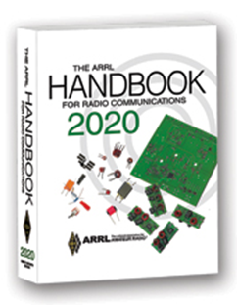***The Handbook Give Away***

Hey Gang,

The winner of the February Give Away is… ***Fred Zehring, KD8UMP***

Many of you ask me just how do I know when the drawing is on? Well, that’s easy all you need to do is check in on the Ohio Section Website on a regular basis and watch for the big **RED** Arrow that will appear on the left side of the page.

This is the sign that the drawing is on and you need to get registered. So, keep a sharp eye out on the website and check in often! <http://arrl-ohio.org/>

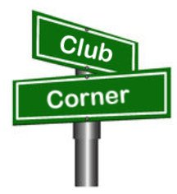***Club Corner***

This is YOUR cornner of the newsletter. Send me what your club is doing and I’ll make sure that it gets in. Got a special event or club project that you want everyone to know about? Send it to me!. Need help with a project? Send it to me.

Let me know what you club is up to. Are you going to have a special guest at your meeting or are you having a special anniversary? Just sent it to: [n8sy@n8sy.com](mailto:n8sy@n8sy.com)

####

***CW Learning Net In the Toledo Area***

**Monday's 7:00 pm** starting March 30 on the 147.270 (pl 103.5) W8HHF Repeater

CW learning net. Starting from scratch for the newcomers to the CW mode.

General CW mode and equipment discussion as well as learning CW.

Steve KC8TVW

####

TOP ^

***Hamvention QSO Party Saturday May 16!***

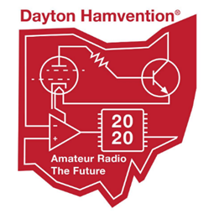

Let's celebrate the many years we have all had at the Great Gathering we call Hamvention. We also want to remember Ron Moorefield W8ILC who never missed a Hamvention and contributed to our club until his recent death. Let's light up the airwaves with our remembrances of Hamvention’s of the past! See you on the air! K3LR, Tim Duffy and W8CI, Michael Kalter.

Here is the deal: 12-hour event, 8 a.m. to 8 p.m. EDST on Saturday of Hamvention May 16, 2020. Operate CW or SSB on 160, 80, 40, 20, 15 and 10 meters. The exchange is a signal report and first year you attended Hamvention. If you have never attended Hamvention, you send 2020.

Send your score (number of QSOs) to [3830scores.com](http://3830scores.com) within 5 days of the event. You can print a certificate on line via [www.HVQP.org](https://urldefense.proofpoint.com/v2/url?u=http-3A__www.hvqp.org_&d=DwMFaQ&c=3buyMx9JlH1z22L_G5pM28wz_Ru6WjhVHwo-vpeS0Gk&r=NjqR7RpL_NGbbm9LBNshFtM0oo10hP5Cllk1S_DBZ6s&m=wMocOQXnr8dJgLWOK3izVSb46kHtAY57F4WoPI3sr5c&s=lQ7Z7bY9Dzr2iE934Tp3nP0wYX_oyghBlNyOAhm0W60&e=). More details will appear on the Hamvention QSO Party web site being set up now.

Special bonus: W8BI, the club call of the Dayton Amateur Radio Association (DARA is the host of Hamvention) will be activated by designated DARA members from their home stations. You can add 10 points for each band/mode QSO with W8BI (12 available). So you can earn 120 bonus points (like having 120 additional QSOs).

####

***Phony Hamvention Vendor’s List***

Hamvention vendors and attendees, we have become aware of an organization that is offering to sell Hamvention vendors a list of our attendees.  This email is a hoax.  This is nothing more than criminals taking advantage of a crisis.  Many organizations are being targeted by this type of scam.

It is imperative that everyone keep their guard up during these trying times.

Wishing everyone the best!

73, Hamvention Team

####

***NORC Net***

*(Northwestern Ohio Regional Communications)*

The “NORC - 2 Net” (Northwest Ohio Regional Communications–2 Meter) is scheduled for 1:00 PM, the 1st Wednesday of each month. There are 4 repeaters designated for the NORC-2 net, 147.375/Oregon (primary), 146.610/Toledo, 147.255/Republic and 146.790/Bowling Green.

This net is designed to provide backup emergency communications for Hospitals, Healthcare Facilities and County EOC’s in Ohio ARES Districts 1 & 2.

TOP ^

The “NORC-HF Net” (Northwest Ohio Regional Communications-HF) is scheduled for 11:00 AM the 1st Saturday of each month. The net begins on 3.915 +/- then moves to 7.215 +/-.

This net is designed to provide backup emergency communications between County EOC’s in Ohio ARES Districts 1 & 2 and the State EOC (W8SGT), all check-ins are welcome.  
Any questions please contact: Dan Stahl - KC8PBU - NORC Net Manager [kc8pbu@gmail.com](mailto:kc8pbu@gmail.com)

####

***Cleveland Marathon Converted to Virtual Event***

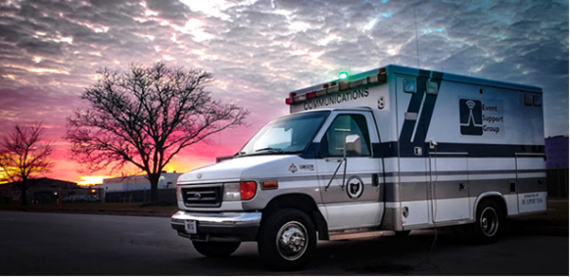The Cleveland Marathon has officially been moved to a “virtual event”. This means we will obviously have no communications responsibilities. Thanks very much for your willingness to work this very important event. Because of this, I will also be cancelling the May Cuyahoga County ARES meeting which was to be a review of the Marathon procedures.

If you want to read the full statement from the Marathon, you may find it here <https://www.clevelandmarathon.com/media/recent-news/rite-aid-cleveland-marathon-goes-virtual-due-to-covid-19.aspx>

***Upcoming Event Status Update***

Below is an update on the future radio related events in the Cleveland area.

• March 22, April 26, May 3 Cuyahoga ARES Meetings Cancelled

• March 25 Statewide Tornado Drill Cancelled

• April 4 Ohio ARES Conference Cancelled (see below for alternative net frequencies)

• April 26 American Cancer Society Pan Ohio Hope Ride, Heroes of Hope Ride Cancelled

• April 25 NVIS organized operation cancelled, please operate from home instead

• May 16-17 Cleveland Marathon Cancelled (converted to virtual events)

• June 14 Sunday in June Bike Ride Cancelled

Our friends over at the Geauga Amateur Radio Association have begun compiling a list of as many radio related cancellations as they can. Be sure to check it frequently at <https://geaugaara.org/coronavirus/>

With the Ohio ARES Conference being cancelled, there will be a series of brief nets held instead that everyone is encouraged to participate in. These should be quick nets taking check-ins and that's it.

**April 4, 2020 Nets**

11 AM: Checkin net on 40 meters 7.240 +/- QRM

11:30 AM: Checkin net on 80 meters 3.902 +/-

12:15 PM: Checkin net on 80 for OHDEN 3585

1:00 PM: Checkin net on DMR Ohio (3139) and Fusion “Ohio Link: 31399

TOP ^

[***Upcoming Hamfests***](http://arrl-ohio.org/hamfests.html) ***for 2020***

***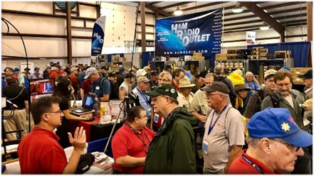*04/11/2020 | 66th Annual Cuyahoga Falls Amateur Radio Club**

***Cancelled***

We regret to inform you that we have made the decision to cancel the 66th annual Cuyahoga Falls Amateur Radio Club Hamfest. This is done as an effort to protect our audience and in compliance with the Ohio Department of Health directives. We are evaluating other options for this year. If you purchased an advance sale ticket, please go to the [www.cfarc.org](http://www.cfarc.org) website and click on the “Hamfest Canceled” button for refund information. We thank you for your past patronage and urge you to check our web site periodically for updates about our Hamfest plans.

**04/18/2020 | Portsmouth Radio Club Hamfest**

***Postponed***

**04/26/2020 | Athens Hamfest**  
Location: Athens, OH  
Sponsor: Athens County Amateur Radio Association  
Website: <http://www.ac-ara.org/>

***Cancelled***

**05/15-16-17/2020 | Dayton Hamvention**

***Cancelled***

**06/06/2020 | FCARC Summer Hamfest**Location: Wauseon, OH  
Sponsor: Fulton County Amateur Radio Club  
Website: <http://k8bxq.org/hamfest>

####

***Webpage for Cancelled Hamfests***

ARRL has created a webpage that will search the ARRL Hamfest and Convention Database for canceled events. [>> Click Here <<](http://www.arrl.org/hamfests/search/canceled)

TOP ^

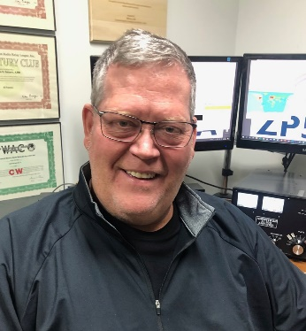***DX This Week***

*(from Bill, AJ8B)*

***DX This Week – CWA  
 Bill AJ8B (***[***aj8b@arrl.net***](mailto:aj8b@arrl.net)***, @AJ8B, or*** [***www.aj8b.com***](http://www.aj8b.com)***)   
 CWOPs Member #1567***

If you were around the cluster this past week, there were many different entities to be worked. These included Alaska, Argentina, Australia, Austria, Barbados, Belarus, Belize, Brazil, Canary Islands, Cape Verde, Chile, Colombia, Costa Rica, Cuba, Dominican Republic, Ecuador, England, Fed. Rep. of Germany, France, French Guiana, Guam, Haiti, Hungary, Ireland, Italy, Japan, Kenya, Madeira Islands, Martinique, Mauritania, Mexico, New Zealand, Norway, Paraguay, Peru, Poland, Portugal, Puerto Rico, Serbia, Slovak Republic, Slovenia, Spain, St. Martin, Ukraine, United Arab Emirates, Uruguay, US Virgin Islands, and Venezuela.

There bands have been affected, indirectly, by the Coronavirus. I noticed many more stations on the air. I had several CW QSOs last week in excess of 20 minutes! That was a blast. My goal is to have at least one “regular” QSO on CW each week. The other thing I had noticed was that many of the DXpeditions for locations that are activated for the CQWW WPX SSB contest this past week were not on the air. There have been two years where I did not work J8 (St. Vincent) because of hurricanes. Normally, a group activates J8 for the WPX SSB and WPX CW contests and that is my best chance to check them off of the CQ Marathon list! Well, if it were easy, it would not be worth achieving!

The first full week of the month is the time when I pass along the current DXpedition calendars. However, at this time, both calendars simply say “No DXpeditions scheduled at this time.” I will pass that along when they become active.

As far as passing some time, I would suggest going to <https://www.dx-world.net/category/dxpedition-movies/> and reviewing DXpedition movies that they have there. They are very interesting and will give you an idea of the challenges these volunteers face to bring an entity on the air for “the deserving.”

I received a card from NS2R, now W8PP, as well as a kind note. He was one of the first hams I QSOd with on 160M this fast fall. I also received Z61DX – The Republic of Kosovo. (Pictured). Did you get any or send any this week?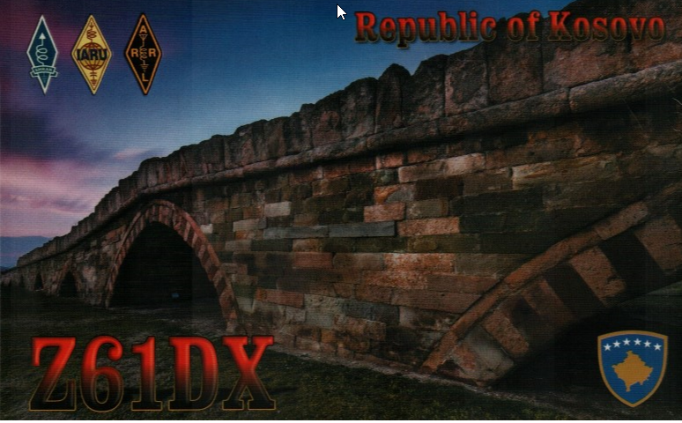

I mentioned above that I wanted to have lengthier QSOs on CW. Once you become “conversational” with CW, it is fairly easy. Many hams are building an interest in working CW. I think that there are two parts to learning CW.

TOP ^

The first is the mechanics of it; the formation of the characters, the proper sending, and overcoming the fear of that first QSO. The second part is the semantics of a CW QSO. CW QSOs have their own language. It is important to learn that as well. Below is my annual discussion of the CWOPs organization, the CW Academy. There are now more than 2500 members of the CWOPs club and many of them have come through the CW Academy. Please contact me if you have any interest in this group.

***CW Academy***

*(By Bill, AJ8B CWops ID #1567)*

CW Academy (CWA) is an internet-based Morse code training curriculum. CWA was formed to directly address growing problems including a lack of skilled advisors, lack of training in sending and the geographical dispersion of interested students. The solution was to organize a volunteer group of CW skilled advisors, provide training in sending AND copying and to use online video/audio conferencing for training. The results have been nothing short of amazing. We have been averaging over 80 students per semester and 80% of those complete the program. In addition, a growing number surpass the 25- wpm rate, and some become CW Academy advisors! Currently CWA is staffed by CWops and its members. There are over 20 volunteer advisors. It is a unique training program that has three levels. The program is given three times per year with each semester lasting 8 weeks.

The 3 levels of training are broken out as Level 1 (beginners), Level 2(those with speed above 10 wpm and below 20 wpm and Level 3. (for those with speeds above 20 wpm) CWA is held three times per year – Jan-Feb, Apr -May and Sep-Oct. Each eight-week semester typically has groups of 5 students (or less) with an assigned advisor who meets ‘online’ two evenings per week for about 45 minutes per session. Level 1 spends 5 weeks learning all Morse characters, numbers, some punctuation, useful Qsigns. The remaining 3 weeks are spent doing simulated CW QSOing, contesting, and DX pile-up training. The objective of Level 1 is to attain speeds above 10 wpm, to attain skill with QSO protocols, to get acquainted with CW contesting and DXing

Level 2 is tailored to the aspirations of the students in each group It stresses improved head copying skills, better sending, further training in QSOing, contesting, and DXing. The objective of level 2 is to attain speeds above 20-wpm, to attain skill with QSO protocols, to gain experience with CW contesting and DXing

Level 3 is also tailored to the aspirations of the students in each group. It stresses improved head copying skills, better sending, further training in QSOing, contesting, and DXing. The objective to Level 3 is basically the same as Level 2 but at 25 WPM and above, namely, to attain speeds above 25- wpm, to attain skill with QSO protocols, to gain experience with CW contesting and DXing.

**Propagation Charts -** Below are the propagation charts offered by the ARRL at <http://www.arrl.org/propagation> for March. I would recommend that you reference the excellent QST article by Jerry Hall, K1TD. This originally appeared in QST, October of 1994. The explanation for the charts from the ARRL is below:

*When are the bands open? These charts, generated using CAPman, show probabilities for average HF propagation in the month of February for the paths indicated. The horizontal axes show Coordinated Universal Time (UTC), and the vertical axes frequency in MHz.*

TOP ^

*On 10% of the days of this period, the highest frequencies propagated will be at least as high as the upper red curves (HPF, highest possible frequency) and on 50% of the days they will be at least as high as the green curves (MUF, classical maximum usable frequency). The blue curves show the lowest usable frequency (LUF) for a 1500-W CW transmitter. For SSB or a lower transmitter power, the LUF will be somewhat higher than the blue curves indicate. See Oct 1994 QST, pp 27-30, and Feb 1995 QST, pp 34-36, for more details. The predictions assume an observed 2800-MHz solar flux value of 73. This is a Very Low level of solar activity. See the detailed propagation tables on The ARRL Antenna Book CD-ROM.*

*Reprinted with permission of the ARRL © 2020*

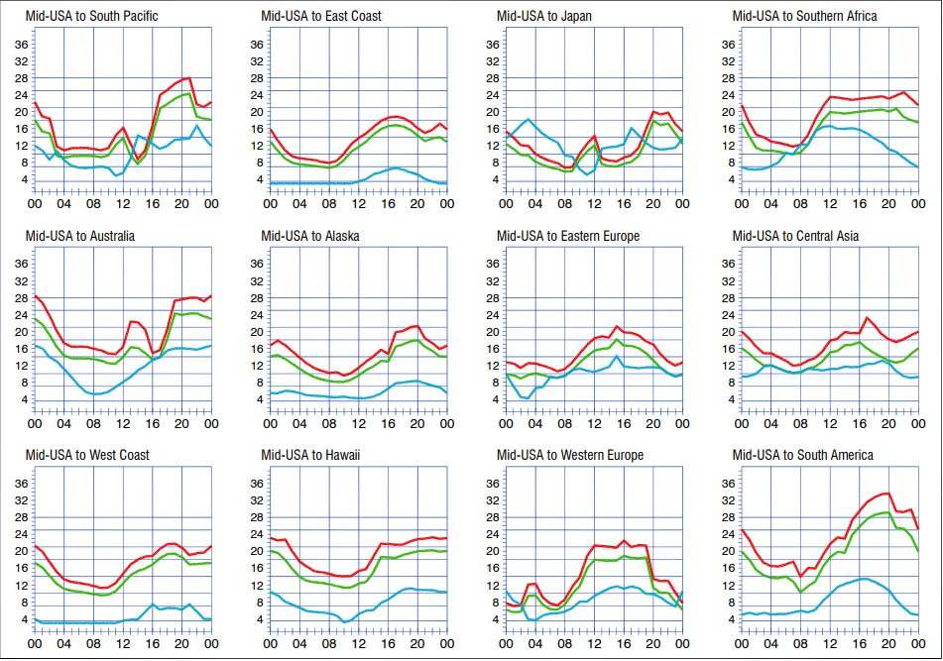

***CQDX CQDX CQDX CQDX CQDX CQDX CQDX CQDX CQDX***

Here is an update from Bernie, W3UR, of the DailyDX and the WeeklyDX, the best source for DX information. <http://www.dailydx.com/>. Bernie has this to report:

**OK – Czech Republic -** OL700CO, OL700LTV and OL700DKO are special event callsigns through the end of the year, marking the 700th anniversary of the town, Dobruska. [http://www.ok1kgi.com](http://r20.rs6.net/tn.jsp?f=001H_dNSZz_mK7mZUmY9mRtnayICyOK5eMTiYNg8bgFQ3fd8wEGCM1hwvbh_mI0sCPIBPVMqjoHHi6GNMaM1jVR5vlpc-hQ-DwjS5X94mhNwkrrzWRA6tDUn_dYYGRHJ6GSoNXqa0DNZDc=&c=r2CyNh6-CdDk9xj5QMBKnBGEfsnuhkEYsIIianAXEzmvTx-Z25hQgw==&ch=ucA81BbVEtn0npLEFhXx59h8DeUFttXZDmeIcUIm15b9Z3LC441hSA==). QSL only through OQRS. [http://www.ok1kqi.com/ol700/ol700.html](http://r20.rs6.net/tn.jsp?f=001H_dNSZz_mK7mZUmY9mRtnayICyOK5eMTiYNg8bgFQ3fd8wEGCM1hwvbh_mI0sCPINyh1Nvmh19gFkBHD6Mhb6sC9WoCZe4WgkzLUY9y_ExHwf5R6KB8pAaEbWSquLAg132n64K7nHFJa5KYRZC3mpjncdHUsCD4_GxDfwLSSVU4=&c=r2CyNh6-CdDk9xj5QMBKnBGEfsnuhkEYsIIianAXEzmvTx-Z25hQgw==&ch=ucA81BbVEtn0npLEFhXx59h8DeUFttXZDmeIcUIm15b9Z3LC441hSA==) for info on an award program.

**EA – Spain -** AO5DXX from Spain and AO5DXX/8 from the Canary Islands will be on the air April 1-15 to mark the 15 years of the DXXE Group. QSL via LoTW.

TOP ^

**SP - Poland -** Special callsign SN100KW will mark the 100th anniversary of the birth of Pope John Paul II, born with the name Karol Wojtyla. He lived from 1920 to 2005. This one will be on the air April 1 to May 31. QSL through SP3PGS.

**VK – Australia -** AX2020STAYHOME is a special call from RASA, the Radio Amateur Society of Australia. They encourage all hams to stay at home (and get on the air). They suggest you can email your stories to them, as you stay home: [www.vkradioamateurs.org](http://r20.rs6.net/tn.jsp?f=001H_dNSZz_mK7mZUmY9mRtnayICyOK5eMTiYNg8bgFQ3fd8wEGCM1hwvbh_mI0sCPIfIyDSOpdZhOypfvBJk_HScJzO6cZYlw20hPMxVllF81Pxay-bLONjDG0kCRdDHNrF_5QJynVME4xTX58VqKk387wGUmwTAji&c=r2CyNh6-CdDk9xj5QMBKnBGEfsnuhkEYsIIianAXEzmvTx-Z25hQgw==&ch=ucA81BbVEtn0npLEFhXx59h8DeUFttXZDmeIcUIm15b9Z3LC441hSA==) and [info@vkradioamateurs.org](mailto:info@vkradioamateurs.org). They are working on QSL policies.

**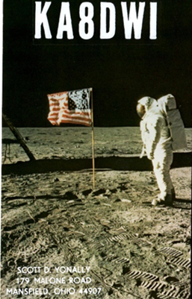*DX news***

***ARLD014 DX news***

This week's bulletin was made possible with information provided by The Daily DX, the OPDX Bulletin, 425 DX News, DXNL, Contest Corral from QST and the ARRL Contest Calendar and WA7BNM web sites. Thanks to all.

**NORFOLK ISLAND, VK9N.** Janusz, SP9FIH continues to be active as VK9NK. Activity is on 160 to 10 meters using SSB, RTTY and FT8. QSL via SP9FIH or ClubLog's OQRS.

**TURKEY, TA.** TC100KIDS is QRV until the end of the month. Look for them on SSB and CW. This event is for the National Sovereignty and Children's Day. Also, members of the Tango Alpha Ham Radio Club (YM1KE) will be active using the special event call sign TC1STAYHOME for awareness of COVID-19 pandemic, until May 5. QSL via info on [www.QRZ.com](http://www.QRZ.com)

**BRAZIL, PY.** Special call ZW75FEB celebrates the 75th anniversary of the end of World War II and will be QRV through May 31. QSL via PT2ADM, bureau or direct. Also, during April, special event station ZW60DF celebrates the inauguration of Brasilia as Brazil's new capital in 1960. QSL via LoTW or PT2GTI.

**SERBIA, YU.** Look for special call YU2020IARU through the end of the year, to note the 25th General Conference of the International Amateur Radio Union.

**CZECH REPUBLIC, OL30.** Members of the Czechoslovak DX Club will be active as OL30DXC until the end of the year, to celebrate CSDXC's 30th anniversary. Operations will be on various HF and VHF bands using CW, SSB, FM and digital modes. QSL via OK2PXJ.

**PALAU, T8.** Operators Hirotaka, JA6KYU, Munehiro, JR6DRH, Mike, JA6EGL and Toshiya, JH6HZH, will be active as T88HS, T88RH, T88SM and T88HZ, respectively, from October 14 to 21. Activity will be holiday style on 160 to 6 meters using CW, SSB and digital modes. QSL via home calls.

**SPAIN, EA.**  The DXXE Group marks its 15th anniversary with the call signs AO5DXX, operator Salva, EA5BB and AO5DXX/8, operator Juan, EA8RM, until April 15. QSL via LoTW.

TOP ^

**FRANCE, TM.** Thierry, F4GVO joins the DXXE celebrations as TM15DXXE during the first half of April. QSL via LoTW.

**ITALY, I.** The Mediterraneo DX Club celebrates its 10th anniversary during April as II5MPI. QSL via LoTW. In addition, the ARI Fidenza Club is putting a number of special event call signs on the air during 2020 to commemorate the life and achievements of Guglielmo Marconi. In April, II4FTX celebrates the first transatlantic wireless broadcast in 1901. QSL via IQ4FE.

**BULGARIA, LZ.** The Bulgarian Radio Club Blagovestnik (LZ1KCP) honors the memory of Orthodox saints during April with the call sign LZ603IL. QSL via bureau or LZ1KCP direct.

**NETHERLANDS, PA.** Special event station PA75ASN commemorates the liberation of the city of Assen during World War II. They are QRV until May 7. QSL via bureau or direct via PA0VCC.

**SLOVENIA, S5.** Members of the radio club S59FOP will be marking Earth Day, April 22, on the air with the call sign S50EARTH during April. QSL via eQSL.

**POLAND, SP.** SN100KW commemorates the 100th birthday of Pope John Paul II (born Karol Jozef Wojtyla) on May 18 in 1920. They will be QRV during April and May on the HF bands. QSL via SP3PGS.

**AUSTRALIA, VK.** The Western and Northern Suburbs Amateur Radio Club (WANSARC) celebrates its 50th anniversary as VI50AWS, until the end of August.

**SAUDI ARABIA, HZ.** Special event call HZ1WARD will be on the air during the 2020 World Amateur Radio Day, April 18th.

THIS WEEKEND ON THE RADIO. The LZ Open 40 Meter Sprint Contest, PODXS 070 Club PSK 31 Flavors Contest, Nebraska QSO Party, Louisiana QSO Party, Mississippi QSO Party, Missouri QSO Party, Florida State Parks On the Air, SP DX Contest, EA RTTY Contest, North American SSB Sprint, UBA Spring Contest, 6 Meters and the RSGB RoLo SSB will keep contesters very busy this weekend.

Please see April 2020 QST, page 71 and the ARRL and WA7BNM contest websites for details.

**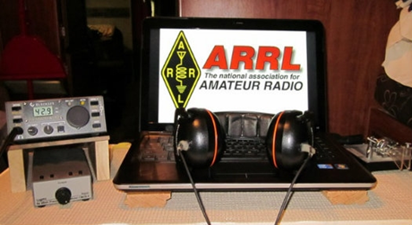*ARRL Contest Corner***

An expanded, downloadable version of *QST'*s [**Contest Corral**](http://www.arrl.org/contest-calendar) is available as a PDF. Check the sponsor's Web site for information on operating time restrictions and other instructions.

TOP ^

***Special Events***

* **04/08/2020 | Remembering the Lincoln Assassination - 155th year**

**Apr 8-Apr 15, 0000Z-0000Z, K9L**, Springfield, IL. Sangamon Valley Radio Club. All modes, all bands. 14.250 14.070 7.270 3.860. QSL. K9L c/o Mitch Hopper, 536 E. Mill St., Rochester, IL 62563. [www.svrc.org/k9l](http://www.svrc.org/k9l)

* **04/11/2020 | Apollo 13 50th Anniversary**

**Apr 11-Apr 17, 0000Z-2359Z, NN4SA etc**, Huntsville, AL. NASA Amateur Radio Clubs. 14.271. QSL. Check QRZ.COM for individual club, various, various. Numerous NASA clubs will be on the air. Check DX cluster for frequencies and call signs. Contact the appropriate club for QSL information. [https://nasaontheair.wordpress.com](https://nasaontheair.wordpress.com/)

* **04/14/2020 | Sinking of the Titanic - 108th Anniversary**

**Apr 14-Apr 15, 1540Z-0100Z, AL4US**, Pigeon Forge, TN. American Legion Post 104 Amateur Radio Club. 14.280 7.180 14.280. QSL. AL4US, c/o American Legion Post 104 , P.O. Box 4242, Sevierville, TN 37864. [www.tnpost104.org](http://www.tnpost104.org/)

* **04/15/2020 | Franklin County VA Moonshine Heritage Month**

**Apr 15-Apr 30, 0500Z-0000Z, W4M**, Glade Hill, VA. Whiskey 4 Moonshine - W4M. All standard digital frequencies; Phone: 28.400 21.300 14.250 7.215 3.850 1.900; CW 28.100 21.105 14.050 7.050 3.550. QSL. Bryant Johnson, P.O. Box 103, Glade Hill, VA 24092. Franklin County VA is considered by many to be the Moonshine capital of the world. In celebration of the 100th anniversary of the passage of Prohibition we will commemorate the heritage of the moonshiners with a special event station that will operate for the period of 4-15-2020 until 4-30-2020 on 10 meters thru 160 meters. <https://www.facebook.com/groups/2476533519124786>

* **04/18/2020 | 2020 Feast of the Ramson**

**Apr 18, 0800Z-1400Z, W8TFC**, Richwood, WV. The Family Center Amateur Radio Club. 147.015 14.220 7.220 3.820. Certificate. W8TFC, 3 Valley Avenue, Richwood, WV 26261. Certificates will be provided via E-Mail [www.thefamilycenterofrichwoodwv.org/Ham/default.html](http://www.thefamilycenterofrichwoodwv.org/Ham/default.html)

* **04/18/2020 | Activation of State Parks in the State of Texas**

**Apr 18-Apr 20, 1400Z-0200Z, K5LRK**, The Colony, TX. Lake Area Amateur Radio Klub. CW bottom of band +40 kHz; Phone - general segment +25 kHz and 28.350; VHF - 50.200 and 144.200 MHz. QSL. Ken Rainy, AC3EZ, 529 Kenilworth Ave., Little Elm, TX 75068. Times are daily. [www.k5lrk.com](http://www.k5lrk.com/)

* **04/18/2020 | April In Durand, IL**

**Apr 18, 1500Z-2100Z, K9K**, Durand, IL. Winnebago County IL ARES/Skywarn. 14.270 7.190 3.840. QSL. Randy Long, 212 East Main St., Durand, IL 61024. This is a small town home show. We will have a booth promoting ham radio as a hobby and service to the local community. Our plan is to have two HF stations and one UHF/VHF station working during the event. The general public will have the opportunity to experience hands-on with the GOTA 2 meter station and watch and listen to our members make contacts on the HF stations and possibly satellite contacts all day. [www.ecom1.com](http://www.ecom1.com/)

TOP ^

* **04/18/2020 | Franklin,LA Bicentennial in Conjunction with Bayou Teche Black Bear Festival and Wooden Boat Show**

**Apr 18, 1600Z-2100Z, W5BMC**, Franklin, LA. Bayouland Emergency Amateur Radio Service (BEARS). 14.250 7.250. QSL. Jackie Price, 708 Front St., Morgan City, LA 70380.

* **04/18/2020 | Maker Faire Connecticut**

**Apr 18-Apr 19, 0900Z-1700Z, N1M**, Westport, CT. Connecticut ARES. 14.225. Certificate. NA1RA, P.O. Box 354, New Milford, CT 06776. Celebrating the 9th annual Maker Faire Connecticut [www.ctares.org](http://www.ctares.org/)

* **04/18/2020 | Parma Radio Club 8th Annual Earth Day**

**Apr 18, 1500Z-2000Z, W8PRC**, Cleveland, OH. Parma Radio Club. 7.195 14.245 145.410 . QSL. Parma Radio Club, 8111 Laumer Avenue, Cleveland, OH 44105. Public invited. Our 8th Annual Earth Day Celebration Event. Operating on "ol sol" power from the historic educational Stearns Farm & Homestead at the town center of Parma, Ohio. [www.parmaradioclub.com](http://www.parmaradioclub.com/)

* **04/18/2020 | The Safe Return of Apollo 13 - 50th Anniversary**

**Apr 18, 1600Z-2100Z, K7T**, Tucson, AZ. Oro Valley Amateur Radio Club. CW 14.040 7.040; USB 14.250; FT8 18.100. Certificate. Send request to, qsl@tucsonhamradio.org for, certificate.. No paper QSLs please. [www.tucsonhamradio.org](http://www.tucsonhamradio.org/)

* **04/18/2020 | Walter Reed Special Event**

**Apr 18, 1400Z-1900Z, W4HZL**, Gloucester, VA. Middle Peninsula Amateur Radio Club. 14.260 7.260. QSL. QSL Manager, W4HZL, P.O. Box 1121, Gloucester Point, VA 23062. Commemoration of Walter Reed, a US Army General born in Gloucester, Va. His work helped eradicate Yellow Fever and allowed construction of the Panama Canal to continue. [www.mparc.net](http://www.mparc.net/)

* **04/18/2020 | World Amateur Radio Day**

**Apr 18-Apr 19, 1200Z-1200Z, W7W**, Ogden, UT. Nevada Amateur Radio Repeaters, Inc.. HF frequencies; EchoLink conference *World* 479886 IRLP 9251 VOIP . Certificate & QSL. Thomas Harrington , 636 West 24th St., Ogden, UT 84401. [wrn-wfn.com](http://wrn-wfn.com/)

**04/18/2020 | World Amateur Radio Day 2020**

**Apr 18-Apr 19, 1600Z-0400Z, W2W**, Rochester, NY. DoDropin Echolink Conference Node 355800. 446.025. Certificate & QSL. W2JLD/John Derycke, 85 Amherst St., Apt. 2, Rochester, NY 14607. This is a VOIP/ECHOLINK Special Event, *DODROPIN* Node 355800 Allstar Node 47620. To obtain a special event QSL Card and a certificate, send a S.A.S.E. TO : W2JLD/JOHN DERYCKE 85 AMHERST ST ROCHESTER NY 14607 [w2jld2@gmail.com](mailto:)

***Ohio ARES Statewide “Stay at home” Exercise A Huge Success!***

Ohio continues under a state of emergency with “Stay at home” orders in place. Because the Ohio ARES Conference was cancelled, we opted to fully test communication around Ohio with the majority of stations being operated from home. Our schedule called for a SSB net on 40 and 80 meters, and nets with the Ohio Digital Emergency Net (OHDEN) concurrent on 40 and 80.

TOP ^

A major project was the bridging of the Ohio talk group on DMR with the “Ohio Link” group on Fusion… merging the two statewide talk paths and operating across over 200 repeaters in Ohio. More connections were accomplished as operators used hot spots, etc.

***Results:***

40 meters was too long and not serviceable for our HF purposes. 80 meters, however, was wide open across the state with stations able to hear nearly every other station in the net. In 80-meter voice activity the Ohio EOC station (W8SGT) logged 132 stations, representing 59 of Ohio’s 88 counties. For every call logged, operators suggest there were at least three more stations that didn’t get through the pileups as Ohio ARES districts were called.

The digital voice network bridging was a major undertaking. While other links have been carried out, this is the first-time approval was given for both statewide talk paths to be linked. The technical linking was a success- clean audio and good control was the rule. Because it was experimental, manual logging slowed things a bit, but over 200 stations were logged, evenly divided across Ohio’s ten ARES districts. It was a groundbreaking success, and several lessons were learned. First, it’s necessary to keep the net slow-paced to allow all the repeaters to key up before speaking. Logging automatically will improve speed from the net control station.

Meanwhile, the Ohio Emergency Digital Network (OHDEN) was working with Olivia to assure connectivity. Checking in was slow, but over thirty digital stations were logged.

This was an excellent test of our ability to talk statewide over several bands and modes.

Want to hear a couple of sound bites from the event? Here’s a couple of links that will take you to a couple of short videos. Thanks to **Jason, N8EI** for recording them.

<https://youtu.be/rXvbx7TPcys>

<https://youtu.be/L3gemmJ6574>

***ARES Training Update***

I hesitate to say so, but ARES Training is benefitting from the current pandemic situation. I can’t imagine any of us enjoying not being able to work, do our necessary errands and especially family functions during this very trying time. It is noted however, the extra time afforded to many of us has allowed for a lot of additional FEMA training to be completed. There has been a stream of daily new submissions to the training database. Many are completing NIMS while others are completing additional training.

I thought I might take a few moments and review a couple of training opportunities/issues.

The Professional Development Series certificate is also a nice milestone of achievement. This is especially true for those who have pursued the Alternate Level 3 by taking the seven FEMA online courses.

FEMA does require the most current issue of some of those 7 alternate courses along with ICS-235. Many of you are only lacking ICS-235 to attain the PDS certificate. I would encourage you to have a look and go for it. It’s always nice to be recognized for your achievement.

TOP ^

As you might be aware, we have been tracking two FEMA courses in addition to the NIMS series and ICS-300/400. ICS-706 & ICS-802, FEMA has deleted ICS-802 from the current offerings as a result of updates and restructuring. The material has been incorporated elsewhere. Both of these courses are still valid for submission to the database. Anyone holding certificates should continue to submit either of them. ICS-706 does remain available. We will not be specifically tracking these courses and they will not be required for ARES. They will be acceptable however as are the many other FEMA online course offerings.

The ARES training database now has over 9,250 certificates on file. 674 members have attained Level 2 and 177 are at Level 3. 48 have obtained the Professional Development Series Certificate. 162 have completed the ARRL EC-001 course. ARES Connect registrations have also been increasing daily and are now at 1,365. Many more have completed additional FEMA and other courses. These numbers are a significant accomplishment and evidence of the great ARES program we have within the Ohio Section. All of you in the field are the heavy lifters. I am privileged to keep your records as I watch this amazing effort unfold in front of me.

Please everyone be safe and if you have any questions, please don’t hesitate to ask. Kudos to you all for this outstanding effort and Thank you, Jim, W8ERW [w8erw@arrl.net](mailto:w8erw@arrl.net)

***NVIS DAY IS COMING!***

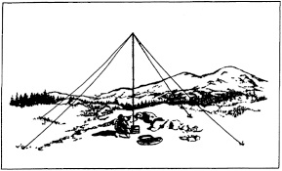

NVIS Day is the ARRL Ohio Section event to test your NVIS antenna designs and builds. Join us on Saturday, April 25th to show how well amateur radio can keep Ohio communicating! This is not a contest: it’s an event for Ohio stations to operate with other Ohio stations and understand how well they hear and are heard.

**THE DETAILS**

**Date: Saturday, April 25**

**Time: Start at 10 A.M., end at 4 P.M.**

**Power: Up to but no more than 100w**

**Exchange: six-digit grid, power, and true—measured—signal report**

**Schedule: This isn’t a contest, so take your time! Try different designs! Have lunch!**

We’ve had some questions about NVIS day, April 25.  This is not intended to be a large group activity, and it can be done with two or three at a home. That’s probably more appropriate this year but parks are still open. So far, we are pretty sure NVIS day will go on as scheduled.  We’ll watch closely and are open to change.

***“ARES Connect”***

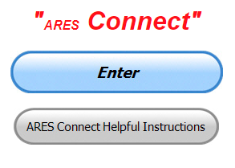

**Everyone –** please make sure to go into all of the events that you have signed up ***for and get your hours registered no later than 5 days after the event has ended****.*

Folks, I’m seeing a lot of folks that have signed up for events not entering their time after the event. This is a very important piece of using “Connect.” Your hours need to be recorded and it’s so easy to do.

TOP ^

Let’s run through how so in case you have forgotten. If you have already gotten signed up for an event, all you have to do afterword to get your time entered is at any time after the event has ended, log into “Connect.” And then click on your name in the upper right-hand corner of the page. This will bring up a drop-down menu where you will then click on “View Hours.”

This brings up another screen where you can “Report Hours” as well as “View Hour History” You’ll want to click on “Report Hours.” You will then be presented one at a time by chronological order each event that you have signed up for and hours have not yet been reported on.

Type in those hours in the “Hours Worked” box and hit “Submit”… Keep doing this until you have no more hours to report…. That’s all there is to it. Now, if you are following the request above and doing this at least every 5 days or more often, this will only take you a minute or so to complete.

**Now, isn’t that easy? Yes, and we all need to be diligent at doing it promptly.**

***Here’s the top 10 hours earners for March:***

|  |  |  |  |
| --- | --- | --- | --- |
|  | **Name** | **Events** | **Hours** |
| **1** | Greg Dersarkisian (KD8SSJ) | 22 | 141.00 |
| **2** | James Yoder (w8erw) | 29 | 132.63 |
| **3** | Bret Stemen (KD8SCL) | 38 | 104.50 |
| **4** | John Hilliard (w8of) | 24 | 103.50 |
| **5** | David Noeth (KD8ACO) | 9 | 96.00 |
| **6** | Michael Lacumsky (W8MAL) | 46 | 89.70 |
| **7** | Timothy Gray (KD8IZU) | 2 | 76.00 |
| **8** | John Major (KD8MMY) | 21 | 75.50 |
| **9** | Daniel Schlick (KB8LKH) | 21 | 74.00 |
| **10** | Henry Ruminski (W8HJR) | 31 | 69.83 |

**Let’s get everyone in the Ohio Section on “ARES Connect!!!” Simply go to:** <https://arrl.volunteerhub.com/lp/oh/> and get yourself registered and using the system.

**Admins…** If you are wondering how to get an overview of all of your events you can simply go into reports and using the new Event by Participation by Event (version 2) you can not only see who registered for your event, but you also can see if he/she has inputted their hours for it as well. Take advantage of this new report to help you get the time entered into your events.

**We still have a number of recurring events created but no activity reported for them.** Please, if this event is no longer needed, let me know and I can delete it from the masters. I know that many of you setup recurring events to learn how, but if they aren’t going to be used, let’s get them cleared out.

Also… If you are setting up events, please don’t set a limit for how many folks can sign-up unless absolutely necessary. This causes issues when doing reports. It’s also counter-productive since the reason for you to list the event is to get as many volunteers as you can to attend. When you set limits, it discourages folks from signing up.

TOP ^

***Some Countries Permitting “STAYHOME”-Suffix Call Signs during COVID-19 Pandemic***

Some countries around the world are allowing radio amateurs to use special “STAYHOME” call sign suffixes. For example, listen for 8A1STAYHOME from Indonesia, and A60STAYHOME/# call signs from the United Arab Emirates.

In Canada, Michael Shamash, VE2MXU, is using VC2STAYHOM “to raise awareness for social distancing during the COVID-19 pandemic.” Canada limits call sign suffixes to seven characters.

Australia has permitted the Radio Amateur Society of Australia (RASA) to use the special call sign AX2020STAYHOME. At 14 characters, that may set a record for world’s longest call sign. Also look for 9K9STAYHOME from the Kuwait Amateur Radio Society; TC1STAYHOME, the COVID-19 special event call sign from Turkey, and HZ1STAYHOME from the Saudi Amateur Radio Society.

***Spain Grants Unlicensed Individuals Permission to Use Amateur Stations During Lockdown***



Spain’s International Amateur Radio Union (IARU) member-society URE has obtained [temporary permission](https://avancedigital.gob.es/espectro/radioaficionados/autorizaciones/Documents/resolucion-autorizacion-radioficionados-estado-alarma.pdf) from the country’s telecommunications regulator for unlicensed people to use amateur stations during the coronavirus lockdown.

“The main objective of the request is to disseminate and promote amateur radio among schoolchildren who must be confined at home,” the announcement from the Ministry of Economic Affairs and Digital Infrastructure said. “This activity offers young people the opportunity to gain practical experience in telecommunications technology, promotes education in technological subjects, and is a socially enriching family activity.”

The temporary authorization would be in place while the state of alert and mandatory confinement measures are in effect in Spain. Non-licensed individuals could operate an amateur station only under the direct supervision of the licensee, under current amateur radio rules and regulations.

####

***V.E. Test Sessions***

**

For the latest testing site information please **>>** [**Click Here**](http://www.arrl.org/find-an-amateur-radio-license-exam-session) **<<** The ARRL site tracks all of the VE testing sites that register with them, including W5YI and Laurel. ARRL gives you a number of different ways of sorting to find that site that is closest to you as well.

TOP ^

***One Question Questionnaire***

Hey Gang,



Ok.. “Survey Says”….. Around 74% actually know what INDUCTANCE is. Wow, I would have thought that number to be much higher since this is one of the questions from the Technician Class License exams!! I would say that about 26% of you better take the time that you have off right now and study!!!

Ok, I’ve got another NEW – one question – for you to answer. Again, this one comes from the Technician Class Question Pool….

**“How much power is being used in a circuit when the applied voltage is 12 volts DC and the current is 2.5 amperes”**

You’ll find the “One Question” questionnaire on the Ohio Section Website! <http://arrlohio.org> It’s all in fun and it’s not a scientific survey in any way, but we are learning some things that we didn’t know from these questions. I hope that you are enjoying answering these “One Question” questionnaires.

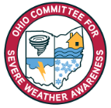***2020 Weather Safety Week Events***

* Lightning Safety Awareness Week: June 21-27
* Ohio’s Winter Safety Awareness Week: November 15-21

***Circuit Board for Bare-Bones Ventilator Moves Toward Production with Radio Amateurs’ Help***

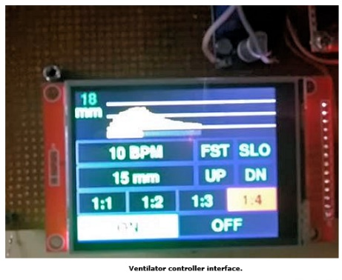Radio amateurs continue to play key roles in developing the electronic control system for an open-source/architecture, modular, low-cost human patient ventilator. The device itself was designed by researcher Sem Lampotang and his team at University of Florida Health — the school’s academic health center — using such commonly available components as PVC pipe and lawn-sprinkler valves. The idea is to create a bare-bones ventilator that could serve in the event of a ventilator shortage.

“The way I looked at it is, if you’re going to run out of ventilators, then we’re not even trying to reproduce the sophisticated ventilators out there,” Lampotang said. “If we run out, you have to decide who gets one and who doesn’t. How do you decide that? The power of our approach is that every well-intentioned volunteer who has access to Home Depot, Ace, Lowe’s, or their equivalent worldwide can build one.”

TOP ^

His team is working on adding safety features to meet regulatory guidelines, then they will run engineering tests to determine safety, accuracy, and endurance of the machine, which can be built for as little as $125 to $250.

Dr. Gordon Gibby, KX4Z — a retired associate professor of anesthesiology at the University of Florida and an electrical engineer — is among those involved in the project, developing control-system prototypes.

He reports that a trial printed circuit board is being created, populated, and tested prior to large-scale fabrication. “This should lead to a documented open-source design that can be replicated or improved upon by any interested manufacturer,” Gibby said, noting that the board could be built anywhere in the world, based on the Arduino Nano microcontroller.

“A huge amount of work has gone on in the design of the circuit boards,” Gibby told ARRL. “We have at least two, maybe three designs, ready for fabrication.” Current design specifications and a video of prototypes have been [posted online](https://simulation.health.ufl.edu/technology-development/open-source-ventilator-project/). The Arduino-based control software will set the respiratory rate and other key parameters in treating critically ill coronavirus victims. Other radio amateurs involved in the control system aspect of the project include Jack Purdum, W8TEE, and uBITX transceiver maker Ashhar Farhan, VU2ESE.

Using a [Groups.io](http://groups.io/) forum, up to 140 volunteers have been studying or working to push the project to completion. Software is being created by multiple volunteers, with amateur radio operators involved in that phase as well.

The ventilator’s valves will precisely time the flow of compressed oxygen into a patient with lungs weakened by viral pneumonia in order to extend life and allow time for the body to clear the infection.

Among the project’s assumptions: The Food and Drug Administration will waive clearance for the bare-bones design, if a massive shortage develops; traditional medical components and supplies used in ventilators will be in short supply, and transportation will be impaired or disrupted.

####

***Final.. Final..***

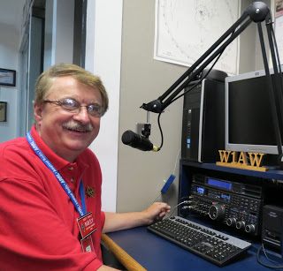Hi Gang,

Well, I have to say that this past week my life has been something like an old-fashioned county song. It started off ok, but then it seemed like one thing after another started to break on me. First came the issue with getting a nail stuck in my left front tire on my car. Not a biggie, but just a nuisance since it activated my Tire Pressure Indicator lamp on the dashboard. Then came an issue with my big desktop computer and having some problems with getting the latest update of Windows to load. It would go to 4% then restart and tell me that it couldn’t finish the updates and would have to remove the uninstalled update. Of course, since it didn’t load successfully it would have to keep trying and trying and trying. It was relentless at wanting to update. With that also came some issues with Zoom and some of its features all of a sudden not working right.

TOP ^

The features were just fine on my laptop, but a no go for the desktop. Next came the biggest of my problems this week. I had already made an appointment to take my car into the dealership for some needed repairs that I knew about. I had also added the repair of my tire then came the “Check Engine” light on the dashboard. Wow.. it seemed like my car doesn’t like the time off from traveling. I called the dealership about that and they moved up my appointment so that I could get it in a lot faster. So, I took it in and within 2 hours I had the bad news. They found a huge hole in the manifold. This is a very expensive repair and one that would take days to do since that’s something they don’t usually keep in stock. So, I was without wheels for 4 days while that got fixed. Now, if all of this isn’t bad enough then came a problem with my CS-800D DMR / Analog VHF and UHF transceiver. It decided to just go funky and it locked itself up. When it did this, it shut down the receive, transmit and even my ability to talk to it via my computer. What a week this has become. All of this happened between Monday and Wednesday. I was ready to just climb in bed and stay there for fear of something else going wrong.

Thursday came with some good news. I had called Connect Systems about my radio problems and they got my radio unlocked and with that I loaded up a new code plug and wa-lah, I’m back up and running. Now just after that happened, I got a call from the dealership. They told me they had my car all finished up and ready to go. They also let me know that the repairs weren’t as bad as they had originally thought. Yes, they still had to replace the manifold (expensive), but they didn’t’ have to replace all the sensors that mount on it. The sensors on my old manifold checked good and operational, so they just moved them over from the old manifold. So, the repairs were about $200 less than originally quoted. Since the nail in my tire was stuck in the tread and not in the sidewall, they simply removed the nail and put a plug in the tire. This also cured the Tire Pressure Indicator problems as well. I got the car home and after doing some major research on the issues with the Windows updates I found an article from Microsoft with a link to a repair just for this issue. It actually unloads your Windows 10 and installs a completely new version of Windows 10. With this new version loaded, it will now allow you to easily and safely load up the updates that the old version was having so many issues with. That’s now fixed. Oh, along with this fix my issues with some of the features in Zoom, they cleared up as well.

Thursday was a great day for me. I needed that for sure. So, if you think that you have problems and the world is beating you up, just remember, this could have been YOU. I hope that this makes you thankful that you had the week that you had instead of the week I had.

Now, when’s that stimulus check supposed to come???

Let’s move down the band….. Has your club been finding new ways of having meetings yet? I know of some virtual breakfasts and lunches that have been happening with great success. We’ve also got many new “on air” meetings going on around the state too. It’s been fun seeing how many clubs have rediscovered their own repeaters and are using them to keep their membership informed on what is happening with the club. Other clubs are starting to use video teleconferencing options as well. That works really great when you want to do presentations and such. It doesn’t take all that much effort to do them either. A desktop / laptop computer, tablet or smart phone will give you a lot of additional options for your club members to use too.

Fellow Hams… It’s important for all of us to keep a watchful eye on each other. A video meeting, phone call or even a rap on the widow or front door is good for our spirits. On the latter action, please remember to stay 6 feet away after the person answers the door. A friendly smiling face always does a lot good to bring one’s spirits back up. We need to stay in contact with each other, making sure that each of us is ok. “Adapt and overcome” and “Yankee Ingenuity” and of course our new state motto “Ohio Strong” are the new mottos of our clubs today. It’s been really great seeing so many different ways of staying in touch with each other.

TOP ^

Now, I know that you can’t turn on the TV or radio without hearing all the doom and gloom. But, don’t forget to keep your sense of humor in all of this. Yes, making a joke once in a while is good for the brain and the body. Yes, COVID-19 is serious business, but one thing that we also have to start talking about is our mental health too. This is just as important as our physical health and humor is a good way of staying mentally healthy. Stay active, meeting with your ham buddies on the air or on the phone. Seeing one another either visually or just hearing a familiar voice has a huge positive impact on your brain. Yes, it’s ok to crack a joke now and again. This relieves the tension and it’s also good exercise. Yes, exercise. You use many more muscles in your face and body when you laugh than when you frown. Ok, I won’t belittle this subject anymore. You’ve all gotten the idea. Now SMILE!!!!

As an FYI for those who have asked… Janie, KB8YPW, my YL, is doing just great. As many of you know she loves to sew. Now, with the entire world now asking for homemade masks she’s really found a niche for something that she can help out with during this time of need. So far, she’s made over 220 masks for our local nursing homes, several hospitals, and of course family and friends and our neighbors too. She’s been asked to make them for money but refuses and donates them to whoever needs them with lots of love attached!! She’s right now working on another batch of 100 masks destined to who knows where. I have a hard time going into her sewing room for fear of interrupting the mass production setup that she has going.

Whelp, final go around before gong QRT… That’s going to do it for this week. Stay safe, enjoy the sunshine when we have it, and be sure to get out and get some fresh air!! But, most of all… have FUN and get on the airwaves!! I’m listening to a number of different bands and I’m not hearing you.

73,

***Scott, N8SY***

Ohio Section Cabinet

|  |  |
| --- | --- |
| Section Manager – Scott Yonally, N8SY | Assistant Section Manager – John Perone, W8RXX |
| Section Emergency Coordinator – Stan Broadway, N8BHL | Section Traffic Manager – David Maynard, WA3EZN |
| Technical Coordinator – Jeff Kopcak, K8JTK | Affiliated Clubs Coordinator – Tom Sly, WB8LCD |
| State Government Liaison – Bob Winston, W2THU | Public Information Coordinator – John Ross, KD8IDJ |
| Section Youth Coordinator – Anthony Lascre, K8ZT | |

***Swap & Shop Has Come to the Ohio Section Website***

Hey Gang,

Have you taken a look at the **Swap & Shop** page on the Ohio Section webpage yet??

Here’s a link that will take you there… <http://arrl-ohio.org/sm/s-s.html>

Do you have equipment that you just don’t need or want anymore? Here’s a great venue to advertise it, and it’s FREE!!

TOP ^

No, it won’t be listed in this newsletter because it would take up way too much space, so your ad will only appear on the website. It is there for any individual to post equipment Wanted / For Sale or Give-Away. No licensed vehicles/trailers or business advertising will be posted.

Postings are text only (no pictures or graphics) will be posted for a maximum of 1 month from date posting and require a contact phone number or email within the posting.

Send your Wanted / For Sale or Give-Away post to:  [swap@arrlohio.org](mailto:swap@arrlohio.org)

***Welcome New Subscribers***

**Dave, N8JNX**

***Back Issues of the PostScript and Ohio Section Journal***

Hey, did you know that PostScript and Ohio Section Journal (OSJ) are archived on the website? You can go back and look at any edition simply by clicking:

<http://arrl-ohio.org/news/index.html>

***Updated Information... Want to Share your Club Newsletter With Others?***

We have a new webpage where you can download and read all of the newsletters that I get from around the state.

Here’s the link to the page…. <http://arrl-ohio.org/club_news/index.html>

Please, if you don’t see your club newsletter posted, it’s probably because I’m not receiving it, or I just cannot convert it over to Adobe Acrobat. Have your newsletter editor contact me and let’s see if we can get your club’s newsletter on the site!! We all learn and steal (I mean, share) from each other’s work. So, let’s give this new webpage a real workout and send me your newsletter!!! Send it to: [n8sy@n8sy.com](mailto:n8sy@n8sy.com)

*****Murphy's Laws***

*(You’ll just never know when he’ll strike!!)*

* Disaster will occur when visitors are in the room.
* A subject interesting to the teacher will bore students.
* The time a teacher takes in explaining is inversely proportional to the information retained by students.
* A meeting's length will be directly proportional to the boredom the speaker produces.

TOP ^

***Chit – Chat, and All That!***

Do you know someone that’s not getting these Newsletters? Please, forward a copy of this Newsletter over to them and have them “[Opt-In](http://arrl-ohio.org/forwarder/forwarding.html)” to start receiving them. Heck just have them send me an email [n8sy@n8sy.com](mailto:n8sy@n8sy.com) and I’ll get them added to the Ohio Section Emailing list.

We now have many thousands of readers receiving these newsletters weekly. Quite impressive, I’d say! I urge all of you to make sure that everyone, regardless of whether they are a League member or not, get signed up to receive these weekly Newsletters.

You can always “[Opt-Out](http://arrl-ohio.org/forwarder/forwarding.html)” at any time if you feel this is not what you were expecting. It’s fun and very informative. All of your favorite past newsletters are now archived too.

You can go back at any time and read them. Just go to: <http://arrl-ohio.org/news/>

Got questions, concerns or would just like to sit and chat awhile? Heck, I’ll even buy the coffee!! Give me a call at (419) 512-4445 or email me at: [n8sy@n8sy.com](mailto:n8sy@n8sy.com)

The pictures on the front page and throughout this newsletter are from various newsletters, Facebook posts and/or were sent directly to me in recent weeks. Take a good look at them, you just might be in one of the pictures! “SMILE… you’re in the Ohio Section News!!”

TOP ^

*PostScript is produced as a weekly newsletter. I want to thank everyone that has contributed articles and ideas to make this an even better news source. I sincerely hope that you have enjoyed this edition and will encourage your friends to join with you in receiving the latest news and information about the Ohio Section, and news and events happening around the world!*