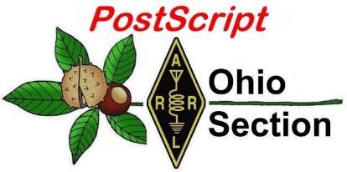
COVID 19
Edition

National News The Handbook Give Away

Club Corner Hamfests

DX This Week One Question Questionnaire

VE Testing ARES Connect

Special NIMS Training Final.. Final..

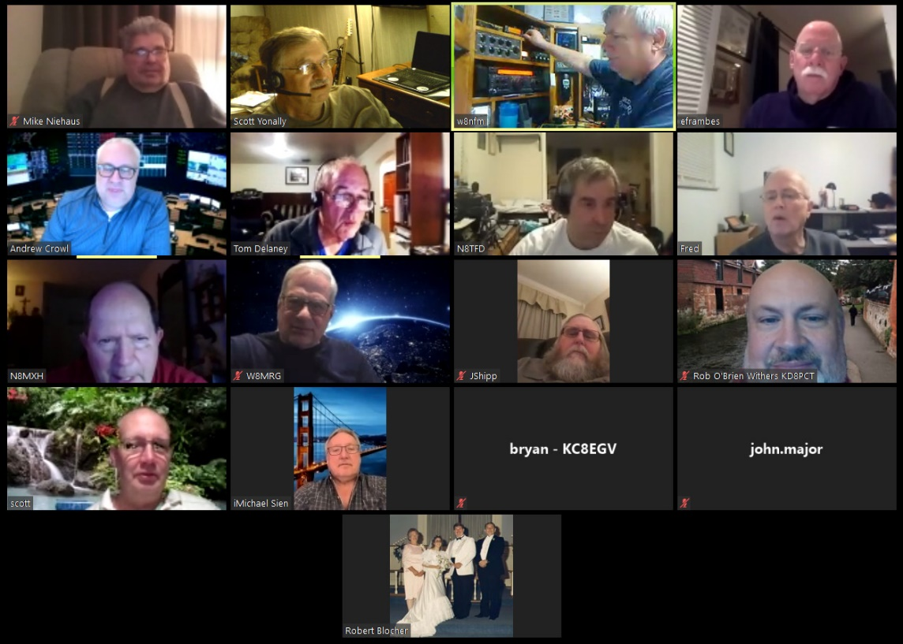
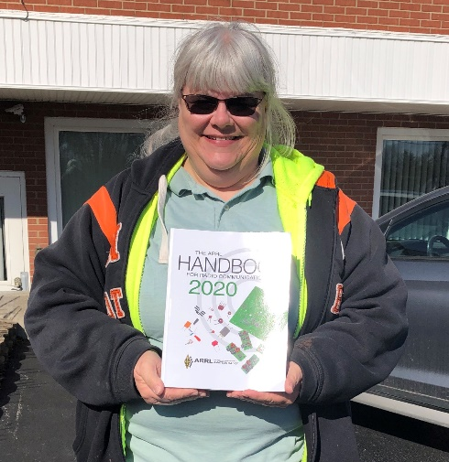
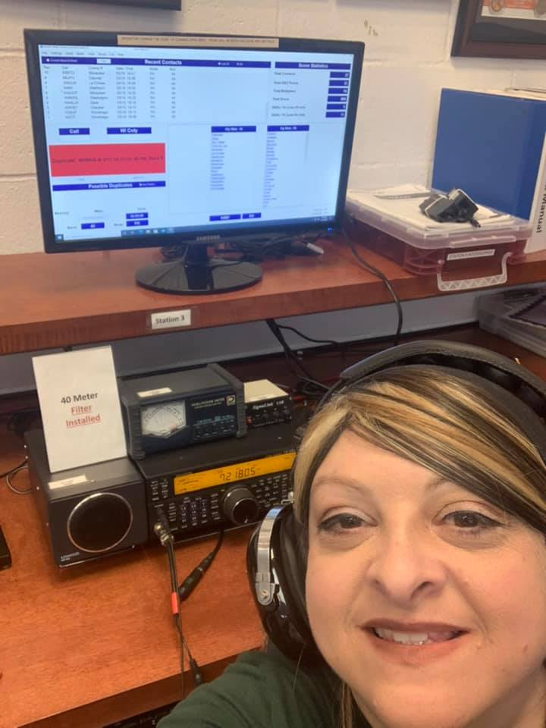

National News
(from arrl and other sources)

Canceled Ohio ARES State Conference Morphs into Statewide Communication Exercise

Ohio Amateur Radio Emergency Service (ARES) canceled the Ohio ARES State Conference set for April 4 due to the coronavirus pandemic and repurposed the date for a statewide communication exercise, with an emphasis on communicating from home.

“Ohio has a high-profile station at the state Emergency Operations Center (EOC), with regular weekly EOC nets,” ARES Section Emergency Coordinator Stan Broadway, N8BHL, said. “But with the national emphasis on staying home, we turned the vacated day into a 2-hour series of nets designed to have amateur operators check in using their home stations.”

The exercise was the brainchild of Assistant SEC Tim Price, K8WFL, who suggested it would be a great way to showcase amateur radio’s capabilities for state and community leaders. The Ohio HF Emergency Net will take check-ins on 40 and 80 meters (SSB), with the Ohio Digital Emergency Net (OHDEN) operating on 80 meters. Then, around 1 PM ET, a linked digital radio system will be brought into play, using DMR’s Ohio talk group linked to the Fusion “Ohio Link” group. Broadway said stations will simply check in; no traffic will be handled. “It’s just designed to prove we can communicate from home, while locked down, and still get the job done,” he told ARRL.

“This is the same network topology used for the Ohio Watch Desk Project, providing statewide reporting during such events as the Memorial Day tornado outbreak last spring,” Broadway said. The reports are fed directly to the watch desk at Ohio’s state EOC, to enhance situational awareness for state emergency managers. “We plan to video an operator on the Statehouse steps, talking statewide using a small handheld,” Broadway said. “This demonstration can be used to enhance our discussion of amateur radio with local and state officials.”

Broadway said HF can be problematic most of the time if storms are moving across, producing static, and digital modes fill in the gap. “We used this [approach] during a couple tornado outbreaks to bring real-time local observation to the Ohio Emergency Management Agency Watch Desk,” he said. — Thanks to Stan Broadway, N8BHL

####

ARRL VE Newsletter - March 2020
Coronavirus (COVID-19) information for ARRL VEs
==================================================
We know that our VEs have a lot of questions and concerns with respect to the Coronavirus (COVID-19) and we are reaching out to share with you what we are doing.
We want you to know that your health and safety is top priority and we are taking the coronavirus outbreak very seriously.

TOP ^
We have been monitoring the U.S. Centers for Disease Control (CDC) website for information updates.
We understand that with the rapidly changing updates on restrictions and cancelled or postponed public events, our VE teams are in different locations and should do what is best for them and their communities.
We urge you to stay informed so you can make informed decisions based on your local communities’ guidelines, as each community is unique. Then use your best judgement when deciding whether or not to conduct, postpone, or cancel an exam session.
As we navigate this ever-changing situation community-by-community, it is important to us that you feel confident when choosing your course of action.
So our VEs and teams can make informed decisions about the Coronavirus (COVID-19), please get the latest report from the Centers for Disease Control (CDC) at https://www.cdc.gov/coronavirus/2019-ncov/index.html or your local health department website.
We cannot stress enough that we are being proactive because your health and safety is our foremost priority.
We will continue to monitor developments and evaluate the situation to support our VEs as needs arise.
If you have any concerns or questions, or would like to cancel or postpone your exam session, please email the VEC department at VEC@arrl.org.
We are privileged to serve you and thank you for your ongoing support of our VE program.
73, Maria Somma, AB1FM

####

FCC Levies $18,000 Fine on Louisiana Amateur Radio Licensee

In an enforcement case prompted by complaints filed in 2017, the FCC has imposed an $18,000 forfeiture on Jerry W. Materne, KC5CSG, of Lake Charles, Louisiana, for intentional interference and failure to identify. The FCC had proposed the fine in a Notice of Apparent Liability (NAL) in the case in July 2018, and, based on Materne’s response to the NAL, the agency affirmed the fine in a March 12 Forfeiture Order (FO).

As the FCC recounted in the FO, an FCC agent “observed Materne causing intentional interference to a local repeater by generating digital noise into an analog radio.” The agent further reported that Materne failed to transmit his call sign, as required.

Materne disputed the FCC’s findings, arguing that the NAL should be canceled because the agent “was mistaken in his determination that the source of the interference was Materne’s station” as his radio was not capable of operating on the repeater frequency in question, the FCC said in the NO. Materne also asserted that he is unable to pay the fine and suggested in his response that the FCC should be able to access his financial information.
The FCC countered that the radio the agent observed in Materne’s possession was capable of operating on the frequency in question. “We therefore are unpersuaded…that the proposed forfeiture should be cancelled because, he alleges, he was not the party causing interference to the repeater and the radio in his possession could not operate on the frequency in question,” the FCC said in affirming the findings of the NAL.

TOP ^
“We are also unpersuaded by Materne’s argument that he lacks the ability to pay the full $18,000 forfeiture.” The FCC said Materne failed to provide the FCC with proof of inability to pay, as required by the NAL.

The FCC gave Materne 30 days to pay the fine, or face having the case turned over to the US Department of Justice for enforcement.

####

Distance Learning – Learn Morse Code
(from PCARS)

With many youngsters at loose ends as a result of school closings due to COVAD-19 concerns, the Long Island CW Club is offering students free on-line instruction to learn Morse code.

Howard Bernstein, WB2UZE, a founding member of the Long Island CW Club explained that learning Morse is a fun and educational activity for children of all ages that can fill part of the gap left by the current unfortunate situation that has closed so many schools across the country.

Therefore the Long Island CW Club will be offering on-line Morse code classes each Monday through Friday starting on Monday, March 23rd specifically for school-agers anywhere across the country or overseas.

Instruction will be conducted via Zoom on-line video conferencing, requiring a computer equipped with a microphone and camera.

Classes for elementary school-aged children will run 30-minutes starting at 12:00 noon EDT (16:00Z) , followed by 45-minute classes for middle and high-school-aged youngsters starting at 12:45 p.m. EDT (16:45Z)

There is no charge for participation, but parental permission is required through advance registration by contacting the class instructor, Robb Zarges, K2MZ, by e-mail at k2mz@yahoo.com or telephone at 508-8318248.

The Long Island CW Club (www.longislandcwclub.org) is dedicated to the history and preservation of Morse code communications. Its team of 15 instructors offers 25 on-line video conference classes each week at different skill levels, currently serving more than 300 students in 44 states and ten countries.

####

JVC KENWOOD Amateur Radio Equipment Selected for Use on ISS
(Radioreference, submitted by Gregory Drezdzon, WD9FTZ)

JVC KENWOOD announced that its Kenwood TM-D710GA amateur radio equipment was selected for operational use on the International Space Station (ISS).

The TM-D710GA is designed for use on the ISS and will be installed in the Columbus European laboratory sometime after the March 7 successful launch of SpaceX CRS-20 (Falcon 9 rocket).

TOP ^
The radio will be used for communications between astronauts and school children participating in the Amateur Radio on the International Space Station (ARISS) educational outreach program. Astronauts can also use it during their off-duty time and as a backup emergency communications tool.

KENWOOD TM-D700E amateur radio equipment was installed on the ISS in 2003 at the request of ARISS. ARISS was established to promote science, space and radio technology education through the operation of amateur radio equipment in space. Since then, KENWOOD radios customized for the ISS have been developed based on ARISS specifications.

The TM-D710GA was selected for installation on the ISS and is designated by ARISS as the next-generation radio system. This model features special specifications for use on the ISS, with a heat dissipation performance for microgravity, as well as enhancements, additions or changes of core operational functions.

TM-D710GA will be used for School Contacts, an ARISS program that provides children around the world with an opportunity to communicate with astronauts in space. In addition, it will be used to support the operation of slow scan TV (SSTV) to transmit still images, provide packet radio communication, run a voice repeater and serve as backup communications in case of a communications failure between the ISS and the ground station.

This model is also slated for installation on Zvezda, a Russian service module on the ISS, around the end of 2020. JVCKENWOOD, as shown by this contribution to this international space project, is committed to providing products and solutions that sustain and enhance corporate value while making contributions to society.

####

To ARRL Members

This message is to let our members know that the ARRL remains operational to meet the needs of our members during this Coronavirus outbreak. At the same time, we are taking steps to help protect the health and safety of ARRL Headquarters employees in line with the recommendations being provided by U.S. and Connecticut state health officials and governmental leaders.

We have arranged for many of our staff, depending on their job responsibilities and requirements, to work remotely during this unprecedented time. This helps the organization reduce the number of people in the building and improve our “social distancing” capabilities.

At the present time, all departments at ARRL Headquarters are functioning and customer service representatives remain available to answer your questions or direct you to the appropriate department to assist you. During this period, though, we strongly encourage members to use email as the preferred method of communication with ARRL in order to get you the timeliest response possible.

In particular, the ARRL’s VEC Department has been dealing with a higher-than-normal volume of emails and phone calls, and the staff there asks for your patience while they attempt to answer everyone as quickly as possible. There has been some significant disruption to VE exam schedules, given the restrictions that have been placed on gatherings in many locales.

TOP ^
As with our employees, the health and safety of our Volunteer Examiners is a top priority and we have informed our VEs that they need to follow their local community's guidelines and then use their best judgement when deciding whether to conduct, postpone, or cancel an exam session.

As previously reported, we have suspended all visits and tours of ARRL Headquarters and W1AW, so we have asked all volunteers to stay home until further notice.

All of these actions will remain in place until further notice. We will continue to monitor conditions from this outbreak and follow any additional guidelines provided by federal and state health professionals and government officials. We thank you for your understanding and patience during this difficult time.

73,
Barry J. Shelley, N1VXY
Interim Chief Executive Officer

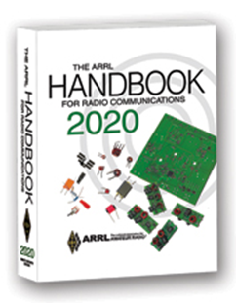
The Handbook Give Away

Hey Gang,

Have you registered for the “Handbook Giveaway” drawing for this month yet? If you haven’t, go to: http://arrl-ohio.org/handbook.html and get yourself registered now!

What’s the catch? I want to get everyone checking in to the Ohio Section website as often as possible, and in order to register each month, you have to visit the website often! There’s nothing else to it. I pay all expenses and I usually “Give Away” more than just a Handbook too!!

Many of you ask me just how do I know when the drawing is on? Well, that’s easy all you need to do is check in on the Ohio Section Website on a regular basis and watch for the big RED Arrow that will appear on the left side of the page. This is the sign that the drawing is on and you need to get registered. So, keep a sharp eye out on the website and check in often!

Club Corner

This is YOUR cornner of the newsletter. Send me what your club is doing and I’ll make sure that it gets in. Got a special event or club project that you want everyone to know about? Send it to me!. Need help with a project? Send it to me.

Let me know what you club is up to. Are you going to have a special guest at your meeting or are you having a special anniversary? Just sent it to: n8sy@n8sy.com

####
TOP ^
Mahoning Valley ARA to hold Two-Meter Contest

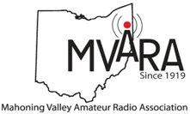
Cancelled

####

New Ham Info Class -
(Hosted by Toledo Mobile Radio Association )

I'm new to Amateur Radio! Now what?!

As well as TMRA sponsored Technician License classes (scheduled for March 21st and April 4th)
Cancelled

####

Geauga Amateur Radio Association Putting On Technician Classes

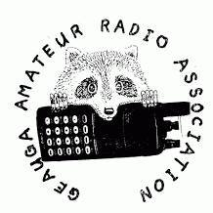
Cancelled

####

Pan Ohio Hope Ride Heroes of Hope! SAG Support

The American Cancer Society will be hosting a ride in Columbus Ohio. Heroes of Hope is a single-day, family-friendly event that will give families and casual cyclists the opportunity to join the Pan Ohio Hope Ride community in support of vital American Cancer Society research, programs, and patient services.

To volunteer to provide SAG support for this event, please: sign up here

TOP ^
When: Sunday, April 26, 2020
Where: Scioto Audubon Metro Park, Columbus, OH

Details:
• Family-friendly trail routes ranging from 3-15 miles (all ages welcome)
• Fully-supported, scenic road routes of approximately 32.8 and 62 miles (18+ only)
• Post-ride celebration with food and fun for all ages
• Inspiration from some Heroes of Hope in the fight against cancer - researchers, patient navigators, and survivors
• Costume and bike decorating contests for kids and adults
• After party at local family-friendly brewery

####

Cleveland Marathon

As always, we are looking for a lot of help for the Cleveland Marathon May 16 and 17. Yes, it's unfortunately on Hamvention weekend as usual and no, they aren't going to change the date of the marathon just because of that (yes people have suggested that. Seriously)

We normally need about 10 people to work the 5k on Saturday ending about noon and about 40 to work the actual Marathon on Sunday ending about 3p. If you are available to help, please sign up. If you need to leave early, that usually is not a problem so please don't be afraid to ask. Please sign up here.

####

Maker Faire Postponed

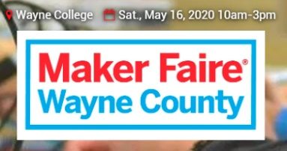
With heavy hearts but clear consciences…

…Maker Faire Wayne County team has made the decision to postpone this year’s 2020 event — originally scheduled for Saturday, May 16 — until Spring of 2021. This decision was made primarily out of concern for our community due to the unpredictable nature of the current coronavirus outbreaks. We are also following guidance from both the CDC, the Ohio Dept. of Health, and the Governor’s office, that recommends canceling events of 250+ people and limiting travel.

We expect to have the actual date for 2021’s faire nailed down and will let you know as soon as we do. Our apologies to our wonderful makers, volunteers, sponsors and vendors, but we do feel we are making the correct decision with respect to the health and comfort of all the wonderful people who participate and visit with us every year.

Be well, make cool things, and wash those hands! 🙂

Tom - Maker Faire Wayne County

####

TOP ^
OH-KY-IN Classes and Exams

OH-KY-IN is proud to host class and exam sessions for Tech, General and Extra level amateur radio licenses. Please note, our classes are free, but you will be required to purchase your own copy of the approved study guide to bring to the first class.

Class | Dates | Location
Technician | Five consecutive Monday evenings starting April 6th, 2020 and running through May 4th from 7:00 PM to 9:00 PM. | American Red Cross - 2111 Dana Ave, Cincinnati, OH 45207

General | Five consecutive Monday evenings starting April 6th, 2020 and running through May 4th from 7:00 PM to 9:00 PM. | American Red Cross - 2111 Dana Ave, Cincinnati, OH 45207

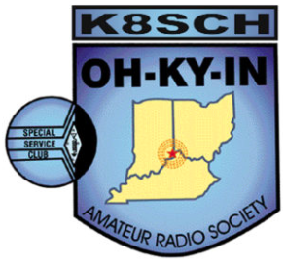
Exam Session
- What – OH-KY-IN is holding an amateur radio licensing exam session.

- When – Saturday May 9th, 9:00 AM

- Where – American Red Cross – 2111 Dana Ave, Cincinnati, OH 45207.

- Who – Anyone can take the exam; taking the OH-KY-IN class is not required.

- How – Please refer to the following link for what to bring to an ARRL exam session: http://www.arrl.org/what-to-bring-to-an-exam-session. The current exam fee is $15.

For all questions or to sign up for a class, please email Mike/KD8ZLB

####

General License Classes Being Offered

The Franklin County Ohio Amateur Radio Emergency Service group will offer classes to achieve a General Class license. Classes will be held at the Whitehall Branch public library at 4445 E. Broad Street, Whitehall, OH. Plenty of parking is available.

Classes begin April 23 through May 21, Thursdays from 6 to 8:30 PM. This is a no cost course of study. Your only cost will be for a study guide and testing fee, depending on which organization you choose to test with.
You do not need to be a member of the FCOHARES to participate.

TOP ^
Course registration is required. Each student should acquire a study guide to begin familiarization with the material prior to starting the class. Although this is a mid-level technology course, no advanced level math is involved. Some demonstrations will be presented during classes.

As this is an upgrade class, everyone should be a Technician class license holder. We will use the ARRL General 2019 – 2023 study guide. Start studying because we will hit the ground running come April 23rd.
Pre-registration is required. Send email to John Buck at kd8rtp@arrl.net. Please include name, email address, phone/text number.

I hope you can join us. Classes will be limited to 13 students due to room capacity, thus the need for pre-registration.

Conference Bridge Now Available

Hey Gang,

With the government closing down all meetings of 10 or more persons it has become a struggle for clubs all over our Section to find ways of having their meetings, and as you can see in the “Club Corner” section of this newsletter all the cancellations that have happened.

Well, the Ohio Section has come up with a tool for the toolbox that will allow you to have a video/phone conference meeting and stay within the CDC’s guidelines for distancing. We’ve partnered up with Zoom, one of the premiere video conferencing bridges in the country and we now have the ability to do our own “on-line” conferences.

Our Zoom account allows for up to 100 persons at a time to be connected with not only audio, but video as well. This is sooooo 21st century. You can share your screen for those really fancy presentations, see everyone that’s connected with a camera on the call and really do a first-class meeting with this technology. No, you don’t need to have a computer. Zoom will also allow you to just call in on your regular or cellular phone too. That is what makes this so great.

Some groups have come up with using their repeaters to help take the place of the meetings. Skype and Free Conference Call are also some ideas that clubs are experimenting with. What a wonderful way of using the technology that we have in place!

I think it is really great no matter what you use for all of us to keep in contact with each other. We used to use our repeaters way more back in the day, but for some reason we’ve kinda’ gotten away from even thinking of using them or other technology to stay in contact, especially with our older hams that might not be able to get out at night, or just aren’t as mobile as they used to be. Ham radio is one way for all of us to make those very important contacts with each other to be sure we are all ok and safe. Zoom is another tool in the toolbox for us to use. So, if you want to try Zoom or have a meeting using it, just let me know. n8sy@n8sy.com

####

TOP ^

From Jeff, K8JTK – Ohio Section - Technical Coordinator

Anyone wanting a meet-up place can use the system I've been working on the last few months. Currently, offers 6 full-time modes interlinked for interop... ham radio VoIP modes.

- EchoLink: K8JTK-R 233196
- AllStar Link: 50394
- Hamshack Hotline: 94026
- DMR: Brandmeister 31983
- D-STAR: DCS/XLX983 A
- YSF: K8JTK Hub 17374
Since I'm working from home I've linked up my Wires-X room: K8JTK-ROOM 40680

http://www.k8jtk.org/ham-radio/k8jtk-hub-digital-voip-mutimode-interlink-system/

Upcoming Hamfests for 2020
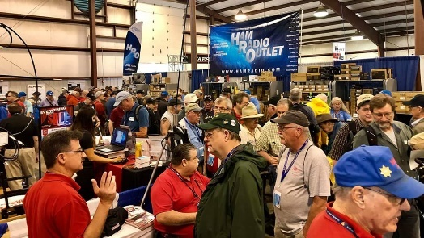

03/21/2020 | Mid-Ohio Valley ARC Hamfest
Postponed

04/11/2020 | 66th Annual Cuyahoga Falls Amateur Radio Club
Cancelled

We regret to inform you that we have made the decision to cancel the 66th annual Cuyahoga Falls Amateur Radio Club Hamfest. This is done as an effort to protect our audience and in compliance with the Ohio Department of Health directives. We are evaluating other options for this year. If you purchased an advance sale ticket, please go to the www.cfarc.org website and click on the “Hamfest Canceled” button for refund information. We thank you for your past patronage and urge you to check our web site periodically for updates about our Hamfest plans.

04/18/2020 | Portsmouth Radio Club Hamfest
Postponed

04/26/2020 | Athens Hamfest
Location: Athens, OH
Sponsor: Athens County Amateur Radio Association
Website: http://www.ac-ara.org/

05/15-16-17/2020 | Dayton Hamvention
Cancelled

TOP ^
06/06/2020 | FCARC Summer Hamfest
Location: Wauseon, OH
Sponsor: Fulton County Amateur Radio Club
Website: http://k8bxq.org/hamfest

Webpage for Cancelled Hamfests

ARRL has created a webpage that will search the ARRL Hamfest and Convention Database for canceled events. >> Click Here <<

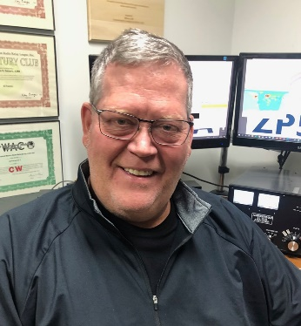
DX This Week
(from Bill, AJ8B)

DX This Week –
Bill AJ8B (aj8b@arrl.net, @AJ8B, or www.aj8b.com)
CWOPs Member #1567

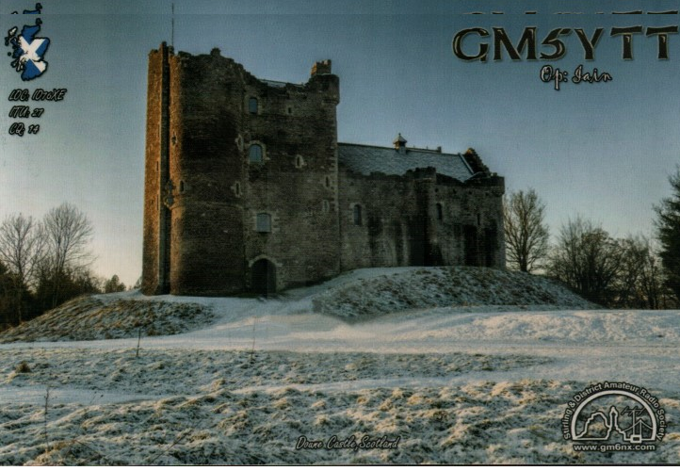
Afghanistan, Argentina, Armenia, Asiatic Russia, Australia, Austria, Azores, Belize, Brazil, British Virgin Islands, Bulgaria, Chile, China, Costa Rica, Cyprus, Czech Republic, Denmark, European Russia, Fed. Rep. of Germany, Fiji, Finland, Guernsey, Israel, Italy, Japan, Jersey, Kazakhstan, Kyrgyzstan, Latvia, Lithuania, Mauritania, Poland, Puerto Rico, Republic of Korea, Reunion Island, Rodriguez Island, Saudi Arabia, Scotland, Slovak Republic, Slovenia, Spain, St. Martin, Thailand, Ukraine, and Vietnam. Did you work any of these?

It was a tough week for receiving QSL cards, at least in quantity. I only received YO7CW – Romania and GM5YTT - Scotland. (Pictured). Did you get any this week?

Uncle Frank and I were chatting on 30M about what we were going to do this weekend since there was no basketball, no preseason baseball etc. We came up with a couple of ideas that I wanted to pass along. These might help you fill in some time until the Coronavirus passes in the next couple of weeks.

Check on the status of your account at the QSL Buro | Review any confirmations needed for any variety of awards that are out there.
Have you tried FT-8? | How is your code speed? Practice
Review old log books and reflect on some great QSOs. Send me a note about them | Send me ideas for this column
How about an antenna project for the spring? More Radials?

TOP ^
Speaking of this column, I always wonder if anyone is reading this and getting anything out of it. When a distinguished DXer mentions something, it really makes the day. Robert, WD8NVN, let me know that he enjoys the topics and I appreciate his saying that. When someone of his caliber mentions it, it must be OK so thanks to Robert.

With the permission of the SouthWest OH DX Association, I am reprinting an interview that I conducted with ZS6C, Geoff. I hope you enjoy this as much as I did.

Interview with Geoff—ZS6C

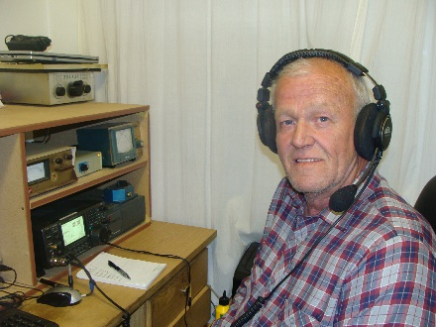
When I worked Geoffrey, ZS6C, I immediately went to his QRZ.com webpage. Wow...has Geoff racked up some accomplishments. I immediately sent him an email asking if he would consent to an interview. He replied within hours! Please visit his qrz.com webpage contact him at glevey@gmail.com .

AJ8B: How did you first get interested in amateur radio?
ZS6C: My Father was a ham so I grew up around radio. I sat for the exam in 1973 whilst still at school but did not make it. Family and career then took precedence.

AJ8B: When did you first get on the air?
ZS6C: It was only in 2005 that I wrote the exam again and made it. From then on, the bug bit and there was no stopping me. My first callsign was ZS6GRL but in 2014 I became ZS6C.

AJ8B: Do you have a favourite band or mode?
ZS6C: Not really, I look at the cluster and go where the action is. Being at the bottom of the world does not make things easier. At the moment I am concentrating on the digital modes (FT8) for contacts due to the propagation.

AJ8B: In reviewing your QRZ.com page, it becomes quickly apparent that you work all bands and all modes with contesting, chasing DX, and general operating. What do you like to do the most?
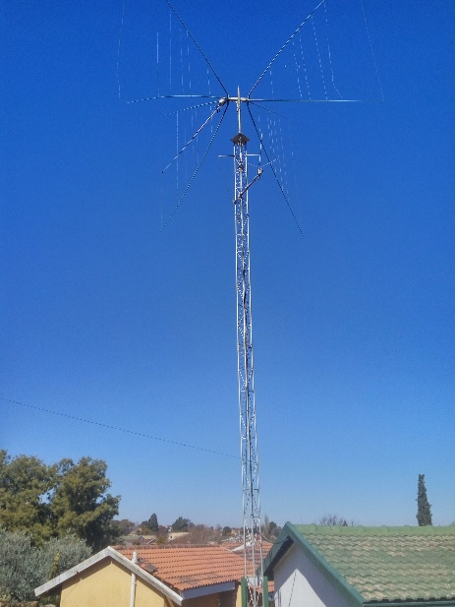
ZS6C: I really enjoy contesting. I try and partake in as many contests as possible, irrespective of mode. I am the Contest manager for the South African Radio League (SARL) as well as my Club West Rand Amateur Radio Club (ZS6WR). Next in line is chasing DX. There is not a better feeling than “snagging” an ATNO. I am not a fan of “rag chewing” but sometimes there is a place for it.

AJ8B: You are an extremely accomplished contester. Any secret to your success that you can share?
ZS6C: Basically, just a passion for Amateur Radio and trying to do my best against my fellow peers and “Lady Luck” and remember – you’re competing with yourself.

AJ8B: Describe what you are currently using:
ZS6C: My current operating conditions are an ICOM IC-746Pro, into a 6-Band 2 element Spider Quad situated about 15M up. For digital work I also use a Rigblaster Advantage.

TOP ^
I do have an old linear that I sometimes use but it needs some TLC at the moment. In contests 99% of the time I always run barefoot (100W). For mobile or portable work, I use an ICOM IC-7000

AJ8B: In reviewing your online logbook, it would appear that you have propagation to all parts of the world most of the time! Have you had experience elsewhere and how does the propagation compare?
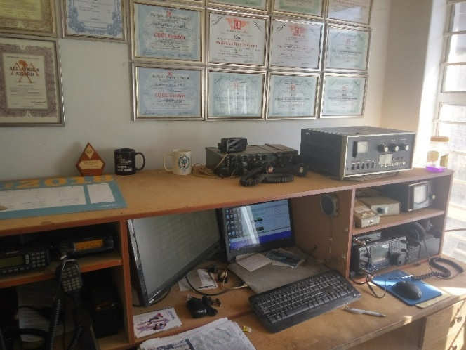
ZS6C: I cannot compare propagation elsewhere as I have no experience of it. Occasionally I am lucky with propagation, but it is really difficult sometimes as most of the Stations always have their antennas pointing East to West or visa versa and forget about us down South. Most times I have the EU and NA wall to try and break which is challenging.
AJ8B: For most of us, the thought of being in Africa is exciting as it is a very exotic location. Are there special challenges to operating from South Africa?
ZS6C: Some places might be exotic but there is a saying that “Africa is not for Sissies.” As mentioned above we are usually forgotten down here, but on the other hand I suppose the amount of activity that comes from Africa does not warrant the rare stations concentrating on us. I would appeal to DX-peditions to let Africa call whenever we hear them as I am sure we will not cause QRM due to our numbers.

AJ8B: What advice do you have for those of us trying to break pileups to work DX?
ZS6C: For me personally you need to have patience, try and work out the strategy of the operator. Listening plays an important role. Luck is also a major factor
AJ8B: Any QSLing hints?
ZS6C: My QSLing policy is on QRZ.com. I prefer LoTW as it is quicker, easier, and cheaper. Unfortunately, our postal system is non-existent. It is a lottery as to whether post gets received or sent out. I also use the other electronic QSL sites.

AJ8B: What coaching/advice would you give new amateurs?
ZS6C: As you have done the hard work in getting your license, put it to good use. Although there are many facets to the hobby, I encourage new hams to take part in contests and chase DX. Most importantly try and stick to the “DX Code of Conduct”

AJ8B: Thanks for taking the time to answer my questions. Is there anything you would like to share with us?
ZS6C: Amateur radio is a fantastic hobby. I think it is the only hobby that has so many facets to it, so you need to find your “niche” and once you do, go for it with vigour.

CQDX CQDX CQDX CQDX CQDX CQDX CQDX CQDX CQDX

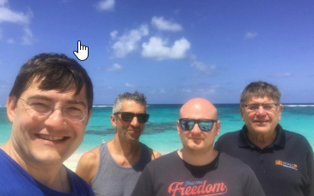

Here is an update from Bernie, W3UR, of the DailyDX and the WeeklyDX, the best source for DX information. http://www.dailydx.com/. Bernie has this to report:

TOP ^
VP2VB DXPEDITION TEAM ON THEIR WAY BACK HOME

After making almost 18K QSOs in the spirit of the original VP2VB callsign of the famous DXpeditioner Danny Weil and honoring his Yasme boat which originally sailed out of the British Virgin Islands, our group returned home yesterday happy and healthy from their temporary outpost of the Anegada Island, in spite of the troubled world of today.

The highlights were meeting two of the (few) local hams in VP2V: Kenneth, VP2VK and George, VP2VQ. Out of almost 300 residents of Anegada our host on the island accidentally identified himself as 86- year old VP2VK. When the group blew up one of their 12VDC powers supplies, they found one at VP2VK, rusty and not used for decades but yet supplying the proper voltage. And to our total surprise we also discovered in his garage his more recent equipment, in the form of a brand new, still unused Stepper 3EL beam.

In Tortola, BVI our group had met George, VP2VQ working hard to rebuild his house and the great famous station which were both destroyed in 2017 by the hurricane Irma. Due to the corona virus risk our meeting was held on both sides of the heavy gates of his property. The VP2VB team prayed for strength for George to restore his station but also to make a full recovery on his recent surgery. Signs of recovery are promising as we saw a new Cushcraft R9 antenna already standing as a landmark at his location.

A totally magical event was experienced in Puerto Rico when the non-USA members of the VP2VB DXPedition were to enter USA in their way home to Europe, with their cancelled visas due to the recent presidential decree. The immigration staff were working hard to obtain an exemption from very high up and finally they were able to obtain one. Some people are critical of US immigration, but we will love them forever and ever. To make sure we reached the NYC flight, the immigration officers did the heavy lifting both literally and figuratively by taking all our (heavy) antenna and equipment bags and bypassing the security gates and accompanied the team to the departing gate. Thank you to those great people whom we will remember forever!
As of today the team members have found their own passage home: Adrian, KO8SCA to New York, Sandro, VE7NY to BC of Canada and Martti, OH2BH and Niko, OH2GEK are expecting their national airline Finnair to pick up them up later today on Finnair’s very last flight out of the USA prior to closing their airspace. There are many rich stories in Amateur Radio and VP2VB is one of those.

As the low bands were the main targets of the DXPedition, the results for a 2 stations/4 operators/5 days operation speak for themselves: 160m 1837 QSOs and 80m 3157 QSOs. We also tried to focus on Asia & Europe where demand for VP2V is very high on top band and so the team was able to give an incredible high number of 160M ATNO to those continents.

Let’s all give our best and keep up our hopes high that the world and amateur radio, can return to its normal routine and happiness.

﻿See you on the uninfected radio waves soon!
For the memory of Danny Weill, VP2VB

The VP2VB team,
KO8SCA, OH2BH, OH2GEK and VE7NY
PS: The Club Log OQRS is now available.

TOP ^

DX news

ARLD012 DX news

This week's bulletin was made possible with information provided by OK1CO, The Daily DX, the OPDX Bulletin, 425 DX News, DXNL, Contest Corral from QST and the ARRL Contest Calendar and WA7BNM web sites.
Thanks to all.

MALDIVES, 8Q. Noel, F6BGC is QRV as 8Q7NC from Veligandu Island, Rashdoo Atoll, IOTA AS-013, until March 21. Activity is holiday style on 80 to 10 meters using CW, SSB and various digital modes. QSL direct to home call.

BOLIVIA, CP. Operators R7AL, RK8A, RW9JZ and RZ3K will be QRV as CP6/home calls near Santa Cruz de la Sierra from March 24 to April 6. Activity will be on 160 to 10 meters using CW, SSB and FT8 in DXpedition mode. QSL via operators' instructions.

FEDERAL REPUBLIC OF GERMANY, DA. Special event station DM30RSV will be QRV from March 24 to October 30. QSL via bureau.

CAPE VERDE, D4. Max, IZ4DPV is QRV as D4F from Sao Vicente until March 31. He will be active in the Russian DX contest and the upcoming CQ World Wide WPX SSB contest. QSL to home call.

MARTINIQUE, FM. Miguel, EA1BP will be QRV as FM/EA1BP from March 24 to 31. Activity will be on 160 to 6 meters using CW and SSB. This includes being an entry in the upcoming CQ World Wide WPX SSB contest. QSL to home call.

JAPAN, JA. Take, JA8COE is QRV as JA8COE/0 from Sado Island, IOTA AS-206, until March 22. Activity will be on the HF bands using CW and FT8. QSL to home call.

CZECH REPUBLIC, OK. Special event stations OL700DKA, OL700CO and OL700LTV are QRV during 2020 to commemorate 700 years since the first written mention of the town of Dobruska. Activity is on the HF bands. QSL via operators' instructions.

SEYCHELLES, S7. Nick, G7EQM is QRV as S79EQM from Praslin Island, IOTA AF-024, until March 29. Activity is on 20 meters using SSB and FT8. QSL via operator's instructions.

EGYPT, SU. Tom, DL2RMC is QRV as SU9TH. Activity is currently on 40, 20, 15 and 10 meters using CW, SSB and FT8. QSL to home call.

TURKEY, TA. Special event call TC18GL is QRV until March 22 to commemorate the March 18th anniversary of the Gallipoli naval battle. In addition, look for clubs YM1KTR, YM1KE and YM1KAD to also be active. Activity is on the HF bands. QSL via operators'
instructions.

TOP ^
NAMIBIA, V5. Pat, KI4SVM is QRV as V5/KI4SVM until March 28. Activity is holiday style on the HF bands using CW and SSB. This may include being active from SOTA references as well. QSL to home call.

MEXICO, XE. Special event station 6E3MAYA is QRV until March 23 for the Equinoccio Maya from the Mexican states of Tabasco, Yucatan, Campeche and Quintana Roo. QSL via bureau.

VANUATU, YJ. Chris, VK2YUS will be QRV as YJ0CA from Efate, IOTA OC-035, from March 22 to April 1. Activity will be on 40, 20, 15 and 10 meters. This includes being an entry in the upcoming CQ World Wide WPX SSB contest. QSL direct to home call.

THIS WEEKEND ON THE RADIO. The BARTG HF RTTY Contest, Russian DX Contest, NCCC RTTY Sprint, QRP 80-Meter CW Fox Hunt, NCCC CW Sprint, AGCW VHF/UHF Contest, Virginia QSO Party, Feld Hell Sprint, UBA Spring SSB Contest and NSARA Contest are all on tap for this weekend.

The SKCC CW Sprint, CWops Mini-CWT Test, UKEICC 80-Meter CW Contest, Phone Fray and QRP 40-Meter CW Fox Hunt are scheduled for March 25.

Special Events

- 03/24/2020 | The Buckingham Army Airfield
Mar 24-Mar 26, 1300Z-2000Z, W4LX, Fort Myers, FL. Fort Myers Amateur Radio Club. 14.240 21.240. Certificate & QSL. Fort Myers Amateur Radio Club, P.O.Box 061183, Fort Myers, FL 33906. 9 AM to 4 PM local time. fmarc.net

- 03/28/2020 | Battle of Horseshoe Bend (Creek Indian War) Anniversary
Mar 28, 1400Z-2100Z, N4H, Daviston, AL. Lake Martin Amateur Radio Club. 14.250 7.280 3.850. Certificate & QSL. John Philips, PO Box 938, Alexander City, AL 35011. Commemorating the 206th anniversary of the Battle of Horseshoe Bend. This battle brought a close to the Creek War, made Andrew Jackson an American hero and opened much of present day Alabama for settlement. SASE for QSL or SAS (large envelope rate) 9X12 envelope for QSL & certificate. www.facebook.com/K4YWE/ or www.qrz.com/db/n4h

- 03/28/2020 | Cherry Blossom Special Event Station
Mar 28, 1400Z-2000Z, W4BKM, Macon, GA. Macon Amateur Radio Club. 14.240 7.225. Certificate. Macon Amateur Radio Club, P.O. Box 4682, Macon, GA 31208. www.w4bkm.org

- 03/29/2020 | Vietnam War Veterans Day
Mar 29, 1630Z-2130Z, W5KID, Baton Rouge, LA. Baton Rouge Amateur Radio Club. 14.250 14.035 7.225 7.035. QSL. USS KIDD Amateur Radio Club, 305 S. River Road, Baton Rouge, LA 70802. Operation aboard the USS KIDD, DD-661, WW II Fletcher class destroyer. qrz.com/db/w5kid

- 03/31/2020 | Sun-N-Fun International Fly-in and Conference
Mar 31-Apr 5, 1400Z-2100Z, W4S, Lakeland, FL. Sun-n-Fun and Tom Ruhlmann (W9IPR). 14.250. QSL. Tom Ruhlmann, W9IPR, 465 Beechwood Drive, Cedarburg, WI 53012. W4S has been our call sign for the past several years. We typically have 12 or more operators and from several states. Walk up operators are welcome as schedules allow. We will be running about 500 watts to a beam.. Event description available at www.sun-n-fun.org www.sun-n-fun.org

TOP ^
- 04/08/2020 | Remembering the Lincoln Assassination - 155th year
Apr 8-Apr 15, 0000Z-0000Z, K9L, Springfield, IL. Sangamon Valley Radio Club. All modes, all bands. 14.250 14.070 7.270 3.860. QSL. K9L c/o Mitch Hopper, 536 E. Mill St., Rochester, IL 62563. www.svrc.org/k9l

- 04/11/2020 | Apollo 13 50th Anniversary
Apr 11-Apr 17, 0000Z-2359Z, NN4SA etc, Huntsville, AL. NASA Amateur Radio Clubs. 14.271. QSL. Check QRZ.COM for individual club, various, various. Numerous NASA clubs will be on the air. Check DX cluster for frequencies and call signs. Contact the appropriate club for QSL information. https://nasaontheair.wordpress.com

- 04/14/2020 | Sinking of the Titanic - 108th Anniversary
Apr 14-Apr 15, 1540Z-0100Z, AL4US, Pigeon Forge, TN. American Legion Post 104 Amateur Radio Club. 14.280 7.180 14.280. QSL. AL4US, c/o American Legion Post 104 , P.O. Box 4242, Sevierville, TN 37864. www.tnpost104.org

- 04/15/2020 | Franklin County VA Moonshine Heritage Month
Apr 15-Apr 30, 0500Z-0000Z, W4M, Glade Hill, VA. Whiskey 4 Moonshine - W4M. All standard digital frequencies; Phone: 28.400 21.300 14.250 7.215 3.850 1.900; CW 28.100 21.105 14.050 7.050 3.550. QSL. Bryant Johnson, P.O. Box 103, Glade Hill, VA 24092. Franklin County VA is considered by many to be the Moonshine capital of the world. In celebration of the 100th anniversary of the passage of Prohibition we will commemorate the heritage of the moonshiners with a special event station that will operate for the period of 4-15-2020 until 4-30-2020 on 10 meters thru 160 meters. https://www.facebook.com/groups/2476533519124786

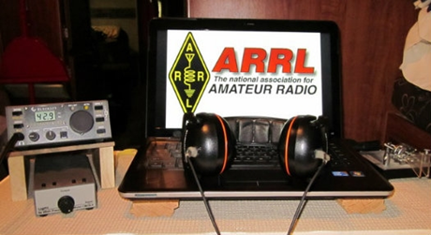
ARRL Contest Corner

An expanded, downloadable version of QST's Contest Corral is available as a PDF. Check the sponsor's Web site for information on operating time restrictions and other instructions.

March 25  - SKCC Sprint  - QRP Fox Hunt  - Phone Fray  - CWops Mini-CWT Test  - UKEICC 80m Contest | March 26  - CWops Mini-CWT Test  - RSGB 80m Club Championship, SSB
March 27  - NCCC RTTY Sprint  - QRP Fox Hunt  - NCCC Sprint | March 28  - FOC QSO Party  - CQ WW WPX Contest, SSB
TOP ^  March 30  - QCX Challenge | March 31  - QCX Challenge
April 1
- QRP Fox Hunt
- Phone Fray
- CWops Mini-CWT Test
- UKEICC 80m Contest

Attention ALL Ohio…

ARES OHIO SPRING CONFERENCE! Cancelled

As they say, “BREAKING NEWS!!”

Because Ohio State has limited large lecture hall environments to combat spread of the flu, our venue for the April 4 Ohio ARES Conference has been closed. The conference is canceled.

Scene fades, shifts to typical office room:

One: Well, I think I have the flu. I feel crappy.
Two: Ah, that’s too bad. Hope you feel better.
One: This might be the Coronavirus…
Two: Screams! Back-peddles like a cartoon character. Dashes for the door. Misses door slams into wall.

Backstep. Screams again. Dives outdoor, into waiting bathtub full of Clorox. Spends next two and a half minutes underwater, er, under Clorox, wondering if inhaling the Clorox would kill any lung-based germs. Simultaneously calculates where to find the most toilet paper and hand sanitizer to be stocked for the inevitable quarantine. Life as we know it is over. Emerges as a blonde, bleach odor lingers for days.

Because I now have a degree in communicable disease from Facebook with advanced studies at Google Tech, I know the truth: the common flu (influenza B and A) has resulted in over 3,000 hospitalizations in Ohio. Most (166) were in the northern part of Ohio. Nationally just this year there have been 13 ~million~ flu cases with 6600 flu-related deaths.

The death rate ranges from 6% to 6.9% for those cases. As of this writing, the Coronavirus carries a reported caseload of 121,000 worldwide- just over 1,000 in the US. There have been 31 deaths. That’s a rate of 3.4% (WHO estimate). And if you do get it, you might well think you have a spring cold.

All that said, the better medical minds I’ve talked with all suggest the best advice is to ward off any potential for large scale infection by reducing the possibility of spread early in the game. Thus, the state’s Department of Health cancellation of most of the Arnold, universities around the state (led by Ohio State) cancelling lecture-hall type interaction and most school systems limiting attendance.

TOP ^
Another casualty is the Ohio ARES State Conference, which was set for April 4. In keeping with Ohio State’s limiting of large gatherings, the large lecture hall which we’d scheduled was closed, and that included our meeting. That’s fine, we completely understand that decision. At this point, looks like we’ll see you in 2021!

So- what exactly would be in store for ARES and amateur radio if this does actually hit the fan? It’s way too much of a stretch to morph this into a communication emergency. But like any pandemic threat, there are places amateur radio could serve. Are you ready?

- POD dispensation: The concept of a POD (Point of Distribution) is entrenched in handling many emergencies. These are distribution locations where supplies of many types can be handed out to the public. In the case pf a pandemic type situation, it’s conceivable that a POD might hand out prophylactic supplies (masks, inoculations, even food etc.) One agency trained in POD dispersal is the Ohio Military Reserve. While that have a comm unit, OHMR and ARES have worked together and would likely do so. That would involve portable stations, antennas, and message-oriented nets. Our own safety would be of highest concern in these cases.

- Health: Each county has its own health system. While many have MARCS radios, in my experience the vast majority have no clue because they don’t use these. Cellphones are the main (and best) way for them to communication in normal business. However, during an emergency situation overloading might cause issues, and they would probably need more people in general to assist. That’s another place ARES members could step in.

- Shelter: In general, Red Cross would be responsible if shelters were set up for any reason. Our national agreement with ARC (American Red Cross) provides ARES as a primary means of communication from shelter to ARC bases. Our own general approach is if there are two forms of communication (cell and landline phones, for instance) we aren’t particularly needed. When it gets to one form (perhaps overloaded cell systems and/or spotty landline) then ARES is needed to provide communications at each shelter. This along would be a daunting manpower challenge for many- and would likely involve our mutual aid system to backfill manpower.

- EOC general: Many EOC’s are already spun up to watch the situation, including the State EOC in Columbus. In most counties, staffing does not accommodate handling a large number of telephone calls. In other situations, ARES members who have just sat down to answer phones have all been very welcomed by EMA staff and we’ve provided a lot of valued assistance in doing so.

- Watch Desk Project: Like other statewide situations, our “Watch Desk Project” would likely come into play for relaying observed situations to the state. We would no doubt use HF/OHDEN and have our station open on the DMR Ohio talk group (3139) as well as the Fusion bridge. This additional avenue for information flow would be useful.

You might be able to come up with even more potential applications. The whole point here is to do a “What if?” discussion and take any steps necessary now to be ready.

So, what are we going to do?
Let’s imagine for a moment that it really does hit the fan. The Governor shuts everything down. Nobody moves (except responders). This is a situation where we might easily become very important!

TOP ^
Let’s test ourselves! Instead of having the conference April 4, let’s conduct a drill that would be applied during this emergency, during a blizzard, or any other widespread situation! Here’s the plan:

- 11 AM: Check-in net on 40 meters 7.240 +/- QRM
- 11:30 AM: Check-in net on 80 meters 3.902 +/-
- 12:15 PM: Check-in net on 80 for OHDEN 3.585
- 1:00 PM: Check-in net on DMR Ohio (3139) and Fusion “Ohio Link: 31399

This will be a quick check-in only net, no traffic. It’s just designed to prove we can communicate from home, while ‘locked down’ and still get the job done! Hope to hear you on the air!

It’s SO nice to have 80 meters back!
With the change of time back to Daylight Savings, we have found our Tuesday evening net to be on the good side of the gray line- and what a difference it made! The first Tuesday after time shift saw both OHDEN and the voice net in wonderful territory. Not only were our voice signals strong, but stations reported they could hear almost all the other stations around the state! Now ~that’s~ a nice way to communication across Ohio! I hope the bands stay friendly now. In the meantime, we’ll continue working on our 160-meter antenna at the state (it’s up, but not working well yet).

We still need to add more skilled operators to the Sarge! If you’re within an hour drive of Dublin/Worthington and you are interested, please let me know!

My home county (Delaware) has already handled one public service event, and like yours, we are gearing up for the ‘event season’. Now’s a great time to refresh on handling public service events, operating successful nets, and keeping the ‘back room’ of event management in order: contact your event person early, confirm details, and recruit volunteers early – then send detailed information in time for them to be prepared. It all works smoothly when you start early!

Several have asked where ARES fits in assisting with the current Coronavirus situation. I’m not sure I see any one overarching function but there are several possibilities we can all get ready to provide if asked. Most of all, it is not a communications emergency. We have to assume that normal channels will remain functioning. What emerges as a possibility is overburdened cell service and degraded performance as a result. The same would be possible for some Internet systems. These are normally very robust, so it would take a lot to degrade their efficiency. Then again….

There are some ‘standard’ ARES applications that present a possibility. Now is the time to have a conversation with your EMA Director, and ask them if they see places we could fit in.

Here are some ideas:

- Shelter Communications – should the Red Cross be requested to establish shelters; we might well become involved. My own test is if there is reliable cell and landline service to the shelter, we probably aren’t needed. When standard phone service is down to only one of those, we should begin staffing. That would be something you would work out with your local chapter.

TOP ^
- Pandemic distribution – Are you written into your county’s pandemic protocols? We could provide communication for distribution or management of supplies/medications with our local health departments. PODS (point of distribution) would probably be established and may need communication. This would be a critical function.

- Hospital net – Should hospital information bog their system we might be able to help with our existing hospital networks that are already in place, or that could be installed quickly.

- Health Departments – The typical health department is understaffed and under-communicated. Ramping up any departmental activity might require our assistance.

- Food distribution – If we continue to ‘run’ on our grocery stores (don’t get me started!) we could be dealing with some serious shortages. Food and medications are important to provide especially to our health-challenged residents. It’s not really radio-centric but helping to deliver meals or meds might be something to consider if their normal channels of distribution and delivery fail.

- “Watch Desk” communications – Our proven statewide digital/HF nets might be pressed into providing intel reports to the state Watch Desk, or WebEOC.

How efficient is your communication using home stations? Our VHF Simplex Contest is designed to provide some basic coverage mapping and last fall’s SET did the same. If you have not tested your simplex net recently, it might be a good time! I’ve heard from Mahoning County which plans to integrate a VHF simplex net into April 4th activities. Good idea! Do you have a plan to include hospitals, potential POD locations, and other conceivable functions in your communication system?

I have no idea what this will turn into- is it bad, getting worse, or are we dealing with a Y2k scenario? Don’t have the answer, but it’s prudent to do some ‘what-if’s’ and prepared accordingly. In the meantime, remember that we have radios! We might not need to meet in person, but we can still get our jobs done! What are YOU thinking about in addition to this?? Please let me know! Our best posture is to be prepared with creative suggestions for our partners.

Be safe, be prepared, and like yo’ mamma taught you: ~wash your hands!~

An Additional Note…

Stan and I wanted to personally thank all of the repeater owners around Ohio for their continued support in allowing us (Ohio ARES) the ability to use their repeater systems to alert and communicate to our ARES groups utilizing the best methods we feel is appropriate. One of those methods is utilizing the statewide talk group (3139) on DMR. You all have all been extremely supportive over the years in allowing us that opportunity to freely use your systems and we sincerely hope that you continue that support for all of Ohio.

As we all know, the new digital modes (DMR, D-Star & System Fusion) can be extremely useful tools in the toolbox for their ability to communicate to large areas at one time. This ability has been greatly enhanced with the new ability to interconnect all of these digital modes together, which makes these tools even more useful in the emergency communications toolbox.

We acknowledge that this can tie up a large number of repeaters around our great state, but in order for all of us to maintain our readiness, we need to continually test not only ourselves, but our systems as well.

TOP ^
We also recognize the need to test and maintain our VHF/UHF analog repeaters, as well as our HF and simplex capabilities too. As such, this can also tie up some of those frequencies that might normally have other activities happening on them.

This testing keeps us all safe and strong and gives us the ability to demonstrate to our government officials and others that we, as Ohio Amateur Radio operators, are here and very well prepared to supplement any communications needs in times where the current systems are either overloaded, or non-existent.

Stan and I both thank you for your time, knowledge and equipment in making the Ohio Section the best in the country. The Ohio Section is extremely blessed to have this support from all of you.

####

NVIS DAY IS COMING!

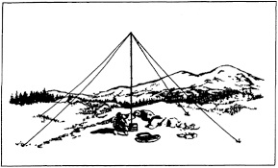
NVIS Day is the ARRL Ohio Section event to test your NVIS antenna designs and builds. Join us on Saturday, April 25th to show how well amateur radio can keep Ohio communicating! This is not a contest: it’s an event for Ohio stations to operate with other Ohio stations and understand how well they hear and are heard.

THE DETAILS
Date: Saturday, April 25
Time: Start at 10 A.M., end at 4 P.M.
Power: Up to but no more than 100w
Exchange: six-digit grid, power, and true—measured—signal report
Schedule: This isn’t a contest, so take your time! Try different designs! Have lunch!

We’ve had some questions about NVIS day, April 25. This is not intended to be a large group activity, and it can be done with two or three at a home. That’s probably more appropriate this year but parks are still open. So far, we are pretty sure NVIS day will go on as scheduled. We’ll watch closely and are open to change.

V.E. Test Sessions

For the latest testing site information please >> Click Here << The ARRL site tracks all of the VE testing sites that register with them, including W5YI and Laurel. ARRL gives you a number of different ways of sorting to find that site that is closest to you as well.

One Question Questionnaire

Hey Gang,

Ok.. “Survey Says”….. Around 37% of you have done some programming on an Arduino Controller. Fantastic!!

TOP ^
Ok, I’ve got another NEW – one question – for you to answer. This one will really test your knowledge of radio trivia.. On a lot of the old-time radios there was a knob that you tuned called a “BFO.” So, here’s the question for the week.

“Do you know what a BFO is used for???”

You’ll find the “One Question” questionnaire on the Ohio Section Website! http://arrlohio.org It’s all in fun and it’s not a scientific survey in any way, but we are learning some things that we didn’t know from these questions. I hope that you are enjoying answering these “One Question” questionnaires.

2020 Weather Safety Week Events
- Ohio’s Severe Weather Awareness Week: March 22-28

- Statewide Tornado Drill: Wednesday, March 25 at 9:50 am
Cancelled

“ARES Connect”
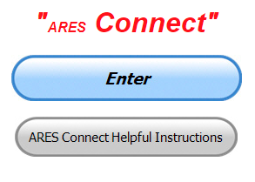
Everyone – please make sure to go into all of the events that you have signed up for and get your hours registered no later than 5 days after the event has ended.

Folks, I’m seeing a lot of folks that have signed up for events not entering their time after the event. This is a very important piece of using “Connect.” Your hours need to be recorded and it’s so easy to do.

Let’s run through how so in case you have forgotten. If you have already gotten signed up for an event, all you have to do afterword to get your time entered is at any time after the event has ended, log into “Connect.” And then click on your name in the upper right-hand corner of the page. This will bring up a drop-down menu where you will then click on “View Hours.”

This brings up another screen where you can “Report Hours” as well as “View Hour History” You’ll want to click on “Report Hours.” You will then be presented one at a time by chronological order each event that you have signed up for and hours have not yet been reported on.

Type in those hours in the “Hours Worked” box and hit “Submit”… Keep doing this until you have no more hours to report…. That’s all there is to it. Now, if you are following the request above and doing this at least every 5 days or more often, this will only take you a minute or so to complete.

Now, isn’t that easy? Yes, and we all need to be diligent at doing it promptly.

TOP ^
Here’s the top 10 hours earners so far for March:

 | Name | Events | Hours
1 | Bret Stemen (KD8SCL) | 29 | 86.00
2 | James Yoder (w8erw) | 17 | 55.75
3 | Dan Stahl (KC8PBU) | 55 | 53.92
4 | John Major (KD8MMY) | 12 | 51.50
5 | Greg Dersarkisian (KD8SSJ) | 14 | 47.50
6 | Christopher Domenick (KC8CAD) | 18 | 46.75
7 | John Hilliard (w8of) | 16 | 43.50
8 | Earl Paazig (W8BR) | 14 | 42.00
9 | James Neal (WD8JLP) | 25 | 41.90
10 | Alan Rothweiler (N8CJ) | 24 | 40.00

Let’s get everyone in the Ohio Section on “ARES Connect!!!” Simply go to: https://arrl.volunteerhub.com/lp/oh/ and get yourself registered and using the system.

Admins… If you are wondering how to get an overview of all of your events you can simply go into reports and using the new Event by Participation by Event (version 2) you can not only see who registered for your event, but you also can see if he/she has inputted their hours for it as well. Take advantage of this new report to help you get the time entered into your events.

We still have a number of recurring events created but no activity reported for them. Please, if this event is no longer needed, let me know and I can delete it from the masters. I know that many of you setup recurring events to learn how, but if they aren’t going to be used, let’s get them cleared out.

Also… If you are setting up events, please don’t set a limit for how many folks can sign-up unless absolutely necessary. This causes issues when doing reports. It’s also counter-productive since the reason for you to list the event is to get as many volunteers as you can to attend. When you set limits, it discourages folks from signing up.

Special NIMS Training Available

G-557 RAPID ASSESSMENT PLANNING COURSE
Hosted by: Fulton County Emergency Management Agency
Tuesday, June 9, 2020

Course Description: This course provides information and resources to enable participants to develop an effective Damage Assessment Program and conduct rapid and effective needs assessments. A good assessment allows community leaders to prioritize response actions ensuring the greatest life-saving and life sustaining benefits. Since resources are often limited in the first few hours of a disaster or emergency an effective rapid needs assessment allows for the efficient and effective use of those resources. Likewise, it allows local officials to evaluate their needs and request those resources that are not available in their jurisdiction to support life sustaining and life saving measures.

TOP ^
This is a “Required” course in the Advanced Professional Series (APS) program
Application Deadline: May 26, 2020
Time of Course: Registration: 7:45 am – 8:00 am Course Time: 8:00 am – 4:00 pm
Location: Fulton County Welcome Center/EOC - 8848 State Highway 108 Wauseon, Ohio 43567
Supported By: The Ohio Emergency Management Agency

Recommended Participants: Local officials who are responsible for assessing, collecting, and reporting damages during and after any event that causes damage of private, public, and critical infrastructure.

Recommended Prerequisite: IS0100.c, Introduction to the Incident Command System, ICS 100; IS0200.c, Incident Command System for Single Resources and Initial Action Incidents; IS0700.b, National Incident Management System, An Introduction; IS0800.b, National Response Framework, An Introduction; IS0120.a, An Introduction to Exercises; and IS0130, Exercise Evaluation and Improvement Planning. These courses are available online by going to https://training.fema.gov/is/crslist.aspx?all=true

Enrollment: Students must enroll via the Department of Public Safety Training Campus website: https://trainingcampus.dps.ohio.gov/cm/cm710/pstc/pstc.html Course registration will generally close 10 working days prior to the course start date. You can check enrollment/approval status via the Department of Public Safety Training Campus website.

County Point of Contact: Peggy Volkman, Administrative Assistant, (419) 337-9207, peggyvolkman@fultoncountyoh.com

####

EMA-ICS300 Licking County May 19-21

This 21-hour course provides training for personnel who require advanced application of the Incident Command System (ICS). This course expands upon information covered in the ICS-100 and ICS-200 courses. This course is for individuals who may assume a supervisory role in incidents. Note: During a Type 3 incident, some or all of the Command and General Staff positions may be activated, as well as Division/Group Supervisor and/or Unit Leader level positions. These incidents may extend into multiple operational periods.
Licking County EMA/911 783 Irving Wick Drive West Heath, Ohio 4305

####

EMA-ICS400 Licking County May 27-28

This training is a 15-hour classroom course that provides training for personnel who require advanced application of the Incident Command System (ICS). This course expands upon information covered in ICS-100, 200, 700, 800 and ICS-300 courses, which are the prerequisites for the ICS-400 course.

The target audience for this course is senior personnel who are expected to perform in a management capacity in an Area Command or Multi-Agency Coordination Entity. Licking County EMA/911 783 Irving Wick Drive West Heath, Ohio 43056

####

TOP ^
AWR 148: Crisis Management for School-Based Incidents – June 9th
Training sponsored by: Licking County EMA
Location: Licking County Administration Building Room “A” in Basement - 20 South 2nd Street - Newark

AWR 148: Crisis Management for School-Based Incidents - Partnering Rural Law Enforcement, First Responders, and Local School Systems is an 8-hour, OHS-approved course designed to educate rural law enforcement personnel as well as school administrators and staff on the elements that would allow for an effective response to school-based emergencies. Schools in small, rural, and remote areas across the country account for almost 23 percent of the total student population (more than 11 million students) .

Rural schools, law enforcement, and other emergency responders are often limited in resources, so it is imperative that all potentially affected parties collaborate on planning, preparing, communicating, responding, and recovering from a school-based incident.

This tuition-free course is beneficial for rural police and sheriff departments, school administrators, school resource officers, counselors, and others involved in school safety and security.

Topics covered include:
• Introduction to Incident Planning and Preparedness
• Proactive Threat Mitigation
• Incident Response
• Incident Recovery
• Vulnerability Assessments
• Threat Assessment Management
• Incident Defusing and Debriefing
• Reunification
• Anniversaries, Memorials, "Copy-Cats"

To register, please visit our website:
https://www.ruraltraining.org/training/schedule/2020-06-09-awr148-newark-oh-001/

Please sign-up no later than May 26, 2020 as a minimum of 20 registrations must be received by this date to confirm the class will be held. Should you have any questions regarding the facility or location please contact John Wieber at 740-404-5034 or jwieber@lcounty.com

####

MGT 417: Crisis Management for School Based Incidence – July 23 - 24
Training sponsored by: Licking County EMA
Location: Licking County Administration Building
Room “A” in Basement - 20 South 2nd Street - Newark

The purpose of this performance-level course is to provide the operational-level details to support many of the topics covered in the U.S. Department of Homeland Security (OHS) approved AWR 148: Crisis Management for School-Based Incidents - Partnering Rural Law Enforcement and the Local School Systems awareness-level course. Rural schools, law enforcement, other emergency responders, and community stakeholders are often limited in their access to resources, so it is imperative that all potentially affected parties collaborate in planning, preparation, communication, response, and recovery in the event of a school-based incident.

TOP ^
Topics covered in this course include:
• All-Hazards Planning and Preparedness
• Vulnerability Assessments
• Threat Assessment Management
• All-Hazards Response
• All-Hazards Recovery
• Scenario-Based Activities

Registration Deadline: July 9, 2020

To register, please visit our website:
https://www.ruraltraining.org/training/schedule/2020-07-23-mgt417-newark-oh-001/

Please sign-up no later than May 26, 2020 as a minimum of 20 registrations must be received by this date to confirm the class will be held. Should you have any questions regarding the facility or location please contact John Wieber at 740-404-5034 or jwieber@lcounty.com

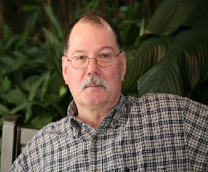
ARES Training Update
Jim Yoder, W8ERW – ARES Data Manager
w8erw@arrl.net

ARES Training Update

Are we not in the midst of something unthinkable, Hamfests being canceled, Our Great Lakes Convention not to happen and the 2020 ARES Conference dropped, all due to the Covid-19 Viral scare now being called a global pandemic. Certainly, none of us would have thought it possible. No, I am not making light of this as it is real and serious. Perhaps the lesson here is that we were not ready for this and we should have been. It is a complex issue and one not easily anticipated. The economic and social issues that begin to cascade as a result are enormous. Some are even calling the event a conspiracy. We as Amateurs should be taking a step back and use this as an example of what we might one day need to be prepared for. The reality of it may be in our laps and the question must be asked. “Are we ready?”

This event as it unfolds in our midst lends much relevance to the necessity to train ourselves and prepare. We certainly hope that we will very soon be on the other side of this and it will be over. What if not and it continues to expand and worsen? We can expect the NIMS training that we have taken will be utilized and become beneficial in a very real sense rather than a thought process we were made aware of while taking all these online classes. Let’s hope this does not become a reality, but a firm reminder of the importance of preparing and maintaining a readiness that can serve us well when it is needed.

By the time you read this, I am sure a lot will have changed. Indeed, the national and local response is being updated regularly. We as Amateurs may be called upon to support our communities as they begin to implement these changes that will be difficult and trying on each of us and our families. Please be safe. We can all do our part to ensure our own safety, the safety of our families and the safety of our communities.

TOP ^
As I write this, our local EMA’s are and have been actively involved in planning and implementing the responses that are in place and will come. ARES is a part of the planning. We are involved and very likely will be asked to for our services in support these responses as they are initiated. Now would be a good time to check our equipment and anything that we may need to be a valued resource to our served agencies and communities.

As we begin to absorb all that is happening, we must remember to take care of ourselves and family. We are of no use if we allow ourselves to fall victim to the situation that we endeavor to resolve. Please remain on alert to local conditions and the instructions being given by the Governor and local administrations.

ARES will issue requests for support via local means as necessary. Please also remain in contact with your local ARES organization for updates and any request for Amateur Radio Support.

Thank you for your support,

James E Yoder, W8ERW
340,000 Honda portable generators recalled for fire hazard

Ten fires have already been reported.

Honda is recalling about 340,000 portable generators because of a fire and burn hazard. Ten fires have already been reported.

The recall is for Honda EB2200i, EU2200i, EU2200i Companion and EU2200i Camo Portable Generators. The Consumer Product Safety Commission says the generator's inverter assembly can short circuit with the presence of saltwater. This can cause the unit to smoke or catch fire.

This recall follows a separate recall a year ago for 200,000 units of Honda generators. In that one, it was warned that the generator could leak gasoline from the fuel valve, posing fire and burn hazards. Owners who took part in that recall are urged to take part in this one as well.

Here are the model names and serial number ranges:

EB2200i
- EAJT -1000001 thru 1011342
EU2200i
- EAMT-1000001 thru 2098790
EU2200i Companion
- EAMT-1000001 thru 2098790
EU2200i Camo
- EAMT-1000001 thru 2098790

Recalled Honda EB2200i and EU2200i Camo portable generators.

TOP ^
Consumer Product Safety Commission

Consumers are urged to stop using the recalled generators immediately and contact a local authorized Honda Power Equipment service dealer to schedule a free repair.

The generators were sold at authorized Honda Power Equipment Dealers, The Home Depot and other home improvement stores nationwide, and online from February 2018 through January 2020 for between $1,100 to $1,300.

Scientists Create Quantum Sensor That Covers Entire Radio Frequency Spectrum
(Submitted by John Whitt, Jr, AI4FR, and forwarded by Gregory Drezdzon, WD9FTZ)

By U.S. Army CCDC Army Research Laboratory Public Affairs - March 19, 2020

ADELPHI, Md. -- A quantum sensor could give Soldiers a way to detect communication signals over the entire radio frequency spectrum, from 0 to 100 GHz, said researchers from the Army.

Such wide spectral coverage by a single antenna is impossible with a traditional receiver system, and would require multiple systems of individual antennas, amplifiers and other components.

In 2018, Army scientists were the first in the world to create a quantum receiver that uses highly excited, super-sensitive atoms—known as Rydberg atoms—to detect communications signals, said David Meyer, a scientist at the U.S. Army Combat Capabilities Development Command's Army Research Laboratory.

Researchers calculated the receiver's channel capacity, or rate of data transmission, based on fundamental principles, and then achieved that performance experimentally in their lab—improving on other groups' results by orders of magnitude, Meyer said.

"These new sensors can be very small and virtually undetectable, giving Soldiers a disruptive advantage," Meyer said. "Rydberg-atom based sensors have only recently been considered for general electric field sensing applications, including as a communications receiver. While Rydberg atoms are known to be broadly sensitive, a quantitative description of the sensitivity over the entire operational range has never been done."

To assess potential applications, Army scientists conducted an analysis of the Rydberg sensor's sensitivity to oscillating electric fields over an enormous range of frequencies—from 0 to 10¹² Hertz. The results show that the Rydberg sensor can reliably detect signals over the entire spectrum and compare favorably with other established electric field sensor technologies, such as electro-optic crystals and dipole antenna-coupled passive electronics.

"Quantum mechanics allows us to know the sensor calibration and ultimate performance to a very high degree, and it's identical for every sensor," Meyer said. "This result is an important step in determining how this system could be used in the field."

This work supports the Army's modernization priorities in next-generation computer networks and assured position, navigation and timing, as it could potentially influence novel communications concepts or approaches to detection of RF signals for geolocation.

TOP ^
In the future, Army scientists will investigate methods to continue to improve the sensitivity to detect even weaker signals and expand detection protocols for more complicated waveforms.

The full story is at:
https://phys.org/news/2020-03-scientists-quantum-sensor-entire-radio.html

https://www.army.mil/article/233809/army_scientists_create_innovative_quantum_sensor

Final.. Final..
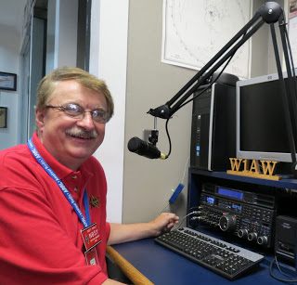
Hey Gang...

Wow… I thought this would never get this crazy. Bars, restaurants and even tattoo parlors now getting shut down due directly to COVID 19 and the actions necessary to keep it from spreading. Again, my advice to all of you is to use common sense. If you feel that you are exposing yourself to an environment that could cause you to get sick, avoid it! Nothing is that important that it’s worth risking your life for, not even toilet paper! Hi.. Hi..

Listen to what the CDC is staying and following their guidelines to be clean and safe. Use the 6-foot rule whenever possible and stop shaking hands and giving hugs. For now, use your elbows.

Yes, this is a bit awkward, especially at 6 feet, but where there’s a way as they say! Most of all, do what your mama taught you... “wash your hands - often!!” and don’t forget to wash behind your ears too!!

Moving down the log a bit…

For those of you that were preparing to take one of the Amateur Radio exams, I’m really sorry, but you’ll just have to wait a little longer. On the bright side of this, it gives you just a little more time to prepare. I know that this is not what everyone wants to hear, but we do need to heed the warnings and just stay put as much as possible.

I want to encourage all of you to make sure that your ARRL dues are up to date. Now that you are home and have some spare time on your hands, maybe you could take a couple of minutes of that spare time and go on-line and renew your dues now. “Being a part of a great organization like ARRL is really important to you and to all of us. Your voice is heard and heard loud and clear not only here in Ohio, but also at Headquarters.

I hope that the leaders of your local clubs were paying attention to the article about the new teleconference bridge that the Ohio Section has (Zoom). With it you don’t have to cancel your club meetings. That’s right, you can have an “On-Line” meeting instead. You don’t have to have any fancy equipment either, you can connect using a regular hard-wired phone if you wish. Now, if that doesn’t appeal to you, or you feel that things have to be done on Amateur Radio, how’s about having your meeting on your local repeater?

TOP ^
This past week I have been involved with both, a teleconference meeting as well as an over the air meeting. Both were very effective and got the business done, and after all, isn’t that why you go to the meetings?

It’s funny how when we close one door to something, another seems to pop up for us to take advantage of. It was probably always there, but until we are forced to change, we never see the obvious.

Have you gotten signed up for ARES Connect yet? Even though the name implies that it’s for ARES, it isn’t just ARES we want to have using it. This program is for everyone. Yes, ARES is a part of it, but so are you, even if you are not a part of ARES. Need help? There’s a guide we have to get you started on your way.
Just >>Click Here<<

Whelp, final go around before gong QRT… That’s going to do it for this week. Stay safe, enjoy the sunshine when we have it, and most of all… have FUN and don’t let the COVID 19 kooties prevent you from getting on the AIR!!

73,

Scott, N8SY

Last Minute News…

Refund Procedures in Place for Dayton Hamvention-Associated Social Events

Refunds are being processed for Dayton Hamvention-associated social gatherings, including Contest University, Contest Dinner, and Top Band Dinner.

Each event has its own procedures. Those who signed up for the DX Dinner will be able to obtain refunds via PayPal. An email to all registrants will provide details. — Thanks to Tim Duffy, K3LR, SWODXA

FCC Commissioner Michael O’Rielly Nominated for Another Term

President Donald Trump has nominated FCC Commissioner Michael O’Rielly for another 5-year term on the Commission. The nomination was sent to the US Senate on March 18. O’Rielly was initially appointed to the FCC in 2013 by President Barack Obama.

“During my tenure at the Commission, I have advocated for preserving and advancing American free market principles to develop common sense regulation and eliminate unnecessary rules that hurt consumers,” O’Rielly said in a statement, expressing appreciation to President Trump.

“I hope to continue this work should the Senate decide to approve my nomination.” If the Senate confirms O’Rielly’s nomination, the new term would date retroactively to last July and end in 2024.

In a statement, FCC Chairman Ajit Pai praised O’Rielly’s work in such areas as 3.5 GHz spectrum policy.

TOP ^

Ohio Section Cabinet
Section Manager – Scott Yonally, N8SY | Assistant Section Manager – John Perone, W8RXX
Section Emergency Coordinator – Stan Broadway, N8BHL | Section Traffic Manager – David Maynard, WA3EZN
Technical Coordinator – Jeff Kopcak, K8JTK | Affiliated Clubs Coordinator – Tom Sly, WB8LCD
State Government Liaison – Bob Winston, W2THU | Public Information Coordinator – John Ross, KD8IDJ
Section Youth Coordinator – Anthony Lascre, K8ZT

Swap & Shop Has Come to the Ohio Section Website

Hey Gang,

Have you taken a look at the Swap & Shop page on the Ohio Section webpage yet??

Here’s a link that will take you there… http://arrl-ohio.org/sm/s-s.html

Do you have equipment that you just don’t need or want anymore? Here’s a great venue to advertise it, and it’s FREE!! No, it won’t be listed in this newsletter because it would take up way too much space, so your ad will only appear on the website. It is there for any individual to post equipment Wanted / For Sale or Give-Away. No licensed vehicles/trailers or business advertising will be posted.

Postings are text only (no pictures or graphics) will be posted for a maximum of 1 month from date posting and require a contact phone number or email within the posting.

Send your Wanted / For Sale or Give-Away post to: swap@arrlohio.org

Welcome New Subscribers

Richard, KK6WMM; Wayne, NC8F; Richard, KC8NWJ; Tony Aristide

Back Issues of the PostScript and Ohio Section Journal

Hey, did you know that PostScript and Ohio Section Journal (OSJ) are archived on the website? You can go back and look at any edition simply by clicking:
http://arrl-ohio.org/news/index.html

TOP ^

Updated Information... Want to Share your Club Newsletter With Others?

We have a new webpage where you can download and read all of the newsletters that I get from around the state.

Here’s the link to the page…. http://arrl-ohio.org/club_news/index.html

Please, if you don’t see your club newsletter posted, it’s probably because I’m not receiving it, or I just cannot convert it over to Adobe Acrobat. Have your newsletter editor contact me and let’s see if we can get your club’s newsletter on the site!! We all learn and steal (I mean, share) from each other’s work. So, let’s give this new webpage a real workout and send me your newsletter!!! Send it to: n8sy@n8sy.com

Chit – Chat, and All That!

Do you know someone that’s not getting these Newsletters? Please, forward a copy of this Newsletter over to them and have them “Opt-In” to start receiving them. Heck just have them send me an email n8sy@n8sy.com and I’ll get them added to the Ohio Section Emailing list.

We now have many thousands of readers receiving these newsletters weekly. Quite impressive, I’d say! I urge all of you to make sure that everyone, regardless of whether they are a League member or not, get signed up to receive these weekly Newsletters.

You can always “Opt-Out” at any time if you feel this is not what you were expecting. It’s fun and very informative. All of your favorite past newsletters are now archived too.
You can go back at any time and read them. Just go to: http://arrl-ohio.org/news/

Got questions, concerns or would just like to sit and chat awhile? Heck, I’ll even buy the coffee!! Give me a call at (419) 512-4445 or email me at: n8sy@n8sy.com

The pictures on the front page and throughout this newsletter are from various newsletters, Facebook posts and/or were sent directly to me in recent weeks. Take a good look at them, you just might be in one of the pictures! “SMILE… you’re in the Ohio Section News!!”

TOP ^

PostScript is produced as a weekly newsletter. I want to thank everyone that has contributed articles and ideas to make this an even better news source. I sincerely hope that you have enjoyed this edition and will encourage your friends to join with you in receiving the latest news and information about the Ohio Section, and news and events happening around the world!

