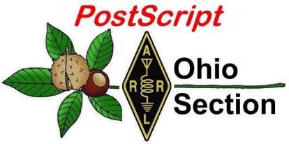
St. Patrick’s Day
Edition

National News The Handbook Give Away

Club Corner Hamfests

DX This Week One Question Questionnaire

VE Testing ARES Connect

Special NIMS Training Final.. Final..

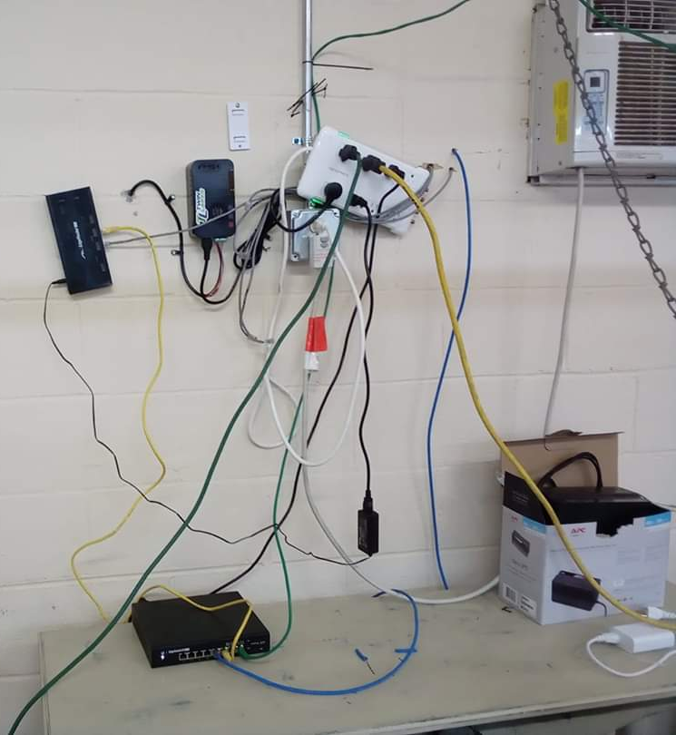
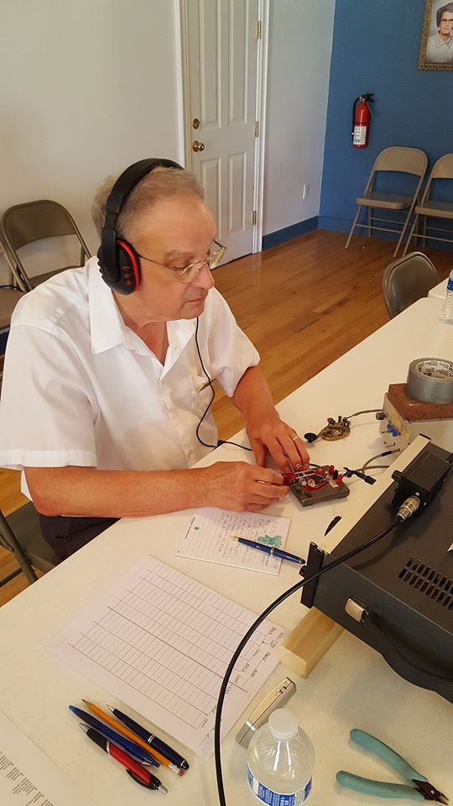
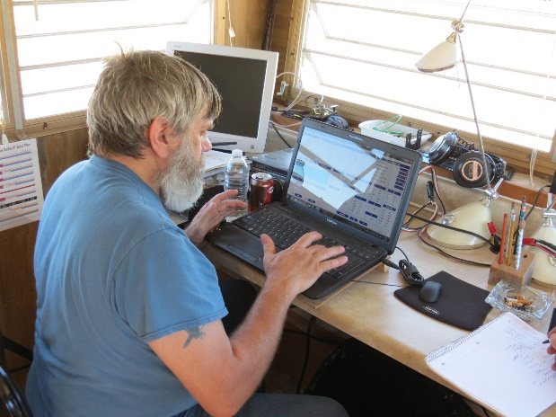

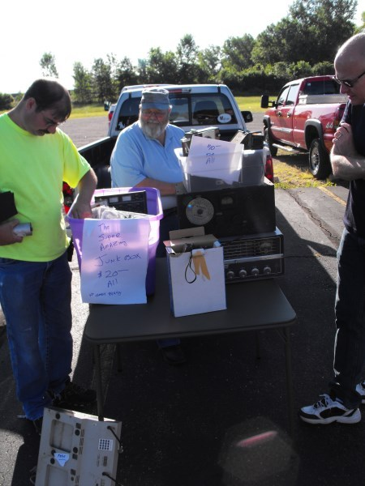

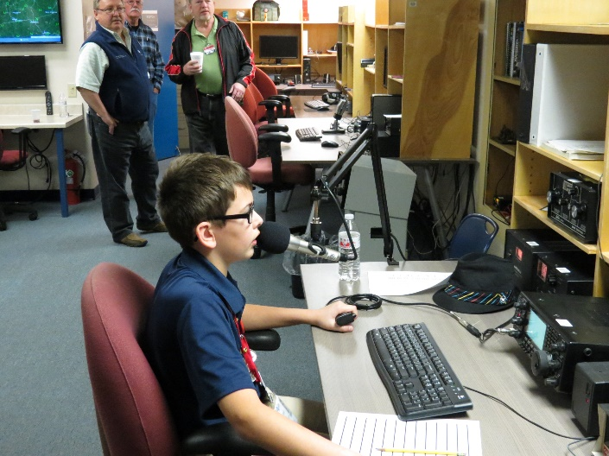

National News
(from arrl and other sources)

Dayton Hamvention Cancelled!!

The Hamvention Executive Committee has been monitoring the COVID19 pandemic. We have worked very closely with our local and state health Departments. It is with a very heavy heart the Hamvention Executive Committee has decided to cancel Hamvention for this year.

This decision is extremely difficult for us but with around two months until the Great Gathering we felt this action necessary.

More specific details regarding the closure will soon be posted on our website www.hamvention.org.

Thank you for your understanding in this time of International Crisis.

Jack Gerbs
General Chairman HV2020

Climate change: New rules could spell end of 'throwaway culture'
(BBC, submitted by Gregory Drezdzon, WD9FTZ)

BBC News report: New rules could spell the death of a "throwaway" culture in which products are bought, used briefly, then binned. The regulations will apply to a range of everyday items such as mobile phones, textiles, electronics, batteries, construction and packaging. They will ensure products are designed and manufactured so they last - and so they're repairable if they go wrong.

It should mean that your phone last longer and proves easier to fix. That may be especially true if the display or the battery needs changing. It's part of a worldwide movement called the Right to Repair, which has spawned citizens' repair workshops in several UK cities.

The plan is being presented by the European Commission. It's likely to create standards for the UK, too - even after Brexit. That's because it probably won't be worthwhile for manufacturers to make lower-grade models that can only be sold in Britain.

'Ambitious' proposal
It's all part of what one green group is calling the most ambitious and comprehensive proposal ever put forward to reduce the environmental and climate impact of the things we use and wear. Proposals aim at making environmentally friendly products the norm. It could mean manufacturers using screws to hold parts in place, rather than glue.

Want more on this story? Here’s a link: https://www.bbc.co.uk/news/science-environment-46797396

TOP ^

W1AW Operating Schedule
Updated March 9, 2020

Pacific | Mtn | Cent | East | UTC |  | Mon | Tue | Wed | Thu | Fri
6 am | 7 am | 8 am | 9 am | 1300z |  |  | Fast Code | Slow Code | Fast Code | Slow Code
7 - 9 am  10 am -12:45 pm | 8 - 10 am  11 am -1:45 pm | 9 - 11 am  Noon - 2:45 pm | 10 am - Noon  1 - 3:45 pm | 1400z to 1600z  1700z to 1945z |  | Visiting Operator Time  (Station closed from 1600z to 1700z - 12 PM to 1 PM ET)
1 pm | 2 pm | 3 pm | 4 pm | 2000z |  | Fast Code | Slow Code | Fast Code | Slow Code | Fast Code
2 pm | 3 pm | 4 pm | 5 pm | 2100z |  | Code Bulletin
3 pm | 4 pm | 5 pm | 6 pm | 2200z |  | Digital Bulletin
4 pm | 5 pm | 6 pm | 7 pm | 2300z |  | Slow Code | Fast Code | Slow Code | Fast Code | Slow Code
5 pm | 6 pm | 7 pm | 8 pm | 0000z |  | Code Bulletin
6 pm | 7 pm | 8 pm | 9 pm | 0100z |  | Digital Bulletin
6:45 pm | 7:45 pm | 8:45 pm | 9:45 pm | 0145z |  | Voice Bulletin
7 pm | 8 pm | 9 pm | 10 pm | 0200z |  | Fast Code | Slow Code | Fast Code | Slow Code | Fast Code
8 pm | 9 pm | 10 pm | 11 pm | 0300z |  | Code Bulletin

W1AW's transmitting schedule occurs at the same local Eastern time throughout the year.
The schedule may change if your local time does not have seasonal adjustments.

Daily Morse Code Practice QST Source
Code practice text is from the pages of QST magazine, the League's membership journal. The source is given at the beginning of each practice session and alternate speeds within each session. For example, "Text is from September 2019 QST, pages 46" indicates that the practice session's plain text is from the article on page 46.
Click here to see the table for each daily Morse Code Practice text.

Morse Code Transmissions
Frequencies are 1.8025, 3.5815, 7.0475, 14.0475, 18.0975, 21.0675, 28.0675, 50.350, and 147.555 MHz.
Slow Code = practice sent at 5, 7-1/2, 10, 13 and 15 words per minute (wpm).
Fast Code = practice sent at 35, 30, 25, 20, 15, 13 and 10 wpm.
Code bulletins are sent at 18 wpm.
CW frequencies include code practices, Qualifying Runs and CW bulletins.

World Wide Web: You can also find W1AW code practice here on ARRLWeb, in MP3 format. Other resources can be found on the ARRLWeb Learn CW page.

TOP ^
W1AW Qualifying Runs are sent on the same frequencies as the Morse code transmissions. West Coast Qualifying Runs are also transmitted monthly by K6KPH, K9JM or KH6TU on 3590 kHz, as well as 3581.5, 7047.5, 14047.5, 18097.5, and 21067.5 kHz. At the beginning of each code practice session, the schedule for the next qualifying run is presented. Underline one minute of the highest speed you copied, certify that your copy was made without aid, and send it to ARRL for grading. Please include your name, call sign (if any) and complete mailing address. The initial certificate is available for a $10 fee. Subsequent endorsement stickers are available for a $7.50 fee.

Digital Transmissions
Frequencies are 3.5975, 7.095, 14.095, 18.1025, 21.095, 28.095, 50.350, and 147.555 MHz.
Bulletins are sent using 45.45-baud Baudot, PSK31 in BPSK mode and MFSK16 on a daily revolving schedule. The actual daily schedule can be found here.

Keplerian elements for many amateur satellites will be sent on the regular digital frequencies on Tuesdays and Fridays at 6:30 PM Eastern Time using Baudot and PSK31.

Voice Transmissions
Frequencies are 1.855, 3.99, 7.29, 14.29, 18.16, 21.39, 28.59, 50.350, and 147.555 MHz.
Voice transmissions on 7.290 MHz are in AM, double-sideband full-carrier.

W1AW EchoLink Conference Server - W1AWBDCT
Audio from W1AW’s CW code practices and CW/digital/phone bulletins is available using EchoLink via the W1AW Conference Server “W1AWBDCT.” The monthly W1AW Qualifying Runs are presented here as well. The audio is sent in real-time and runs concurrently with W1AW’s regular transmission schedule.
All users who connect to the conference server are muted. Please note that any questions or comments about this server should not be sent via the “Text” window in EchoLink. Please send any questions or comments to w1aw@arrl.org.

Please note that W1AW is also present on the list of active EchoLink stations. However, W1AW is listed as "BUSY" since this connection is used for the conference server.

####

ARISS Celebrating Successful Launch Carrying Interoperable Radio System to ISS

Amateur Radio on the International Space Station (ARISS) is celebrating the successful launch and docking of the SpaceX-20 commercial resupply mission to the International Space Station (ISS). One payload on the flight is the ARISS Interoperable Radio System (IORS), which ARISS calls “the foundational element of the ARISS next-generation radio system” on the space station. Amateur radio has been an integral component of ISS missions since 2000. The Dragon cargo capsule docked successfully with the space station on March 9. ARISS-US Delegate for ARRL Rosalie White, K1STO, said hundreds of ARRL members contributed to make the IORS project happen, and ARISS is celebrating the 4-year-long IORS project.

TOP ^
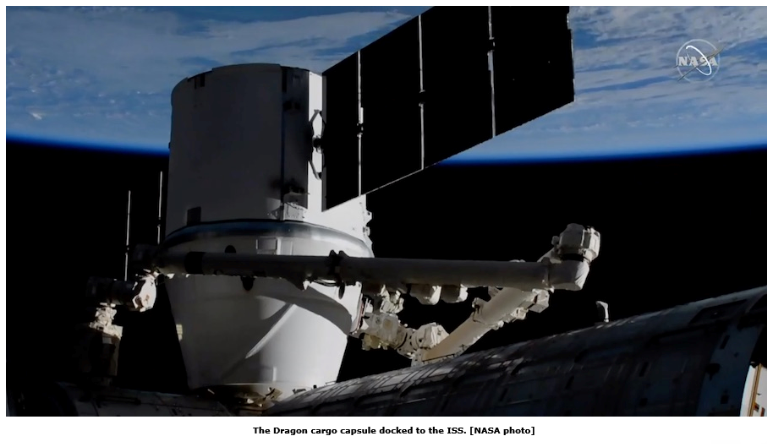
“ARISS is truly grateful to ARRL and AMSAT for their co-sponsorship and support of ARISS since day one,” White said. “ARISS greatly appreciates the hundreds of ham radio operators who have stood by ARISS, sending financial support and encouragement. A robust ham station is on its way to replace the broken radio on the ISS, and tens of thousands of hams will enjoy strong ARISS packet and ARISS SSTV signals as a result. In addition, thousands of students will discover and use ham radio to talk with a ham-astronaut. We hope to see the trend continue where more ARISS teachers and local clubs set up school ham clubs.” The new system includes a higher-power radio, an enhanced voice repeater, updated digital packet radio (APRS), and slow-scan television (SSTV) capabilities for both the US and Russian space station segments.

White called the March 7 launch, “beautiful, flawless.” ARRL President Rick Roderick, K5UR, told ARISS that he had his fingers crossed for a successful launch.

According to NASA Mission Control, it will take the three ISS crew members up to a month to unload and stow the 4,300 pounds of cargo on board the Dragon capsule, and the IORS is not a priority. The actual ham equipment will be installed in the ISS Columbus module. Another IORS unit is in line to be launched and installed in the Russian segment of the ISS later this year.

The IORS consists of a custom-modified JVCKenwood TM-D710GA transceiver, a multi-voltage power supply, and interconnecting cables. The ARISS hardware team will assemble four flight units — and 10 IORS units in all — to support onboard flight operations, training, operations planning, and hardware testing.
ARISS-International Chair Frank Bauer, KA3HDO, said earlier this year that future upgrades and enhancements to the next-generation system are in various stages of design and development. These include a repaired Ham Video system — currently planned for launch in mid-to-late 2020, an L-band (uplink) repeater, a microwave “Ham Communicator,” and Lunar Gateway prototype experiment.

####

ARRL Suspending Tours and Guest Visits to Headquarters, W1AW
As part of efforts under way to help protect the health and safety of ARRL Headquarters employees and volunteers from the impacts of the coronavirus, ARRL has decided to suspend all tours and guest visits to Hiram Percy Maxim Memorial Station W1AW and ARRL Headquarters, effective Monday, March 16. Out of an abundance of caution, this suspension will be in effect until further notice.

TOP ^
We apologize for any inconvenience this may cause to our members and their guests who had been planning to visit us in Newington, Connecticut. We feel, however, that this is a necessary precaution and is in keeping with the guidance being provided by federal and local health professionals.

We appreciate everyone’s patience and understanding as we all endeavor to deal with this difficult public health situation.

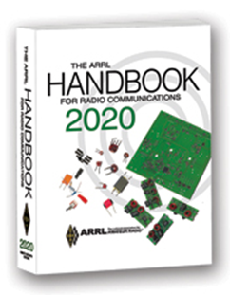
The Handbook Give Away

Hey Gang,

Have you registered for the “Handbook Giveaway” drawing for this month yet? If you haven’t, go to: http://arrl-ohio.org/handbook.html and get yourself registered now!

What’s the catch? I want to get everyone checking in to the Ohio Section website as often as possible, and in order to register each month, you have to visit the website often! There’s nothing else to it. I pay all expenses and I usually “Give Away” more than just a Handbook too!!

Many of you ask me just how do I know when the drawing is on? Well, that’s easy all you need to do is check in on the Ohio Section Website on a regular basis and watch for the big RED Arrow that will appear on the left side of the page. This is the sign that the drawing is on and you need to get registered. So, keep a sharp eye out on the website and check in often!

Club Corner

This is YOUR cornner of the newsletter. Send me what your club is doing and I’ll make sure that it gets in. Got a special event or club project that you want everyone to know about? Send it to me!. Need help with a project? Send it to me.

Let me know what you club is up to. Are you going to have a special guest at your meeting or are you having a special anniversary? Just sent it to: n8sy@n8sy.com

####

Mahoning Valley ARA to hold Two-Meter Contest

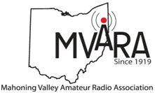
The MVARA is excited to announce the Mahoning Valley Two Meter Contest Saturday March 21, 2020 from 7:00 to 10:00 pm. We thought it would be fun to see if valley hams would enjoy shaking off the winter doldrums by getting on the air for a local contest. It will be an opportunity to talk to old friends and make new ones.

TOP ^
Old timers may remember participating in the Lou Malice Memorial Contest years ago. The MV 2 Meter Contest will be a similar two-meter simplex contest. Stations will simply exchange grid squares as defined in the contest rules. The contest format will allow participants to evaluate their stations simplex capabilities.

This information could be valuable in an emergency. No 100-watt base station, no problem. There will be a low power category of 5 watts or less and a high-power category of greater than 5 watts so everyone will have a level playing field. Awards will be given for the highest scoring Low Power Home, High Power Home, Low Power Rover, and High-Power Rover stations at the June 11, 2020 MVARA meeting.

For contest rules and a list of rover stations and the grids they plan to activate go to www.mvara.org/Mv2mc.html

This year the contest will be dedicated to the memory of pioneer Valley ham Lou Malice WA8PKN whose dedication to amateur radio touched the lives of all of us. Even if you never had the pleasure of knowing Lou you are still part of his legacy. Chances are good that the hams who inspired and encouraged you to become part of amateur radio were, themselves, inspired, encouraged, and trained by Lou.

####

New Ham Info Class -
(Hosted by Toledo Mobile Radio Association )

Relaxed Learning Session: I'm new to Amateur Radio! Now what?!

Join Toledo Mobile Radio Association Members at the Lucas County EMS Training Center Apr 18th, 9am-2pm for a FREE learning and Q&A session that should work to help you get started with some of the practical items that we all wish we knew when starting off in Ham Radio. Any/everyone is welcome, and you do not have to have attended the class to attend. Most hams licensed less than 3 years will find the session useful.

This session will be run as a "class", but is open to ANY questions along the way. Folks are free to come and go as you wish. This training session is a great place to get to know TMRA members and for newer amateur radio operators to ask questions related to items they are concerned about or need help with. We know that this hobby has a lot of new items for everyone to get familiar with, so this is an attempt to short-cut that learning!
We'll discuss and help new hams resolve some of the typical early ham radio challenges including (but not limited to) the following types of discussion items (no specific order);
1. Answer any early questions and discuss list of items that we all have soon after becoming a ham. (and worries that we each had)

2. Discuss Hand-held and mobile radio types / drawbacks and benefits. Who can help me program it? How can I make my HT more effective?

TOP ^
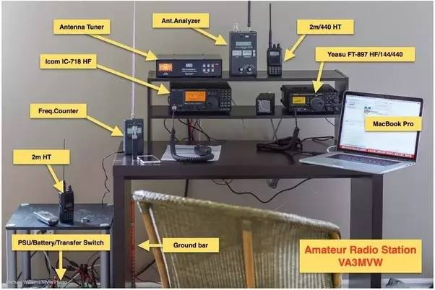
3. What is needed to setup and use a mobile or "base" radio - in car or in home (and benefits and types).
4. Discuss Effective Radiated Power in terms of Antenna benefits - Discuss types of antennas indoor/outdoor options (and why). Horizontal vs. Vertical antennas.
5. Types of feedline (we often refer to "coax) and what you will need (and for what) - and where to find it.
6. VHF/UHF vs HF - Who can I talk to and when?
7. Discuss using local Repeaters, internet linked repeaters, PL Tones, (repeaterbook/radio reference),
8 . Discuss Simplex vs Repeater typical etiquette (just so you know) - Examples: Q signals, calling CQ, breaks
9. First Contacts – what to expect (most important, you won't be judged so don't "sweat it".... really...)
10. Hamfests + Ham Conventions - Why bother?
11. Where should I buy equipment and what are the risks?
12. Useful websites
13. Foxhunting and Satellites - how/where?
14. Where to find manuals and information?
15. If there is time: Antenna Analyzers and SWR Meters - what are they and when do I need one?
16. If there is time: N vs PL-259, vs SMA, versus BNC connectors
17. Benefits of joining organizations/clubs
18. Foxhunts - what are they and how does it work? Do I need anything?
19. HF - club events (what can I participate with?) - Operating events.
20. Callsigns, vanity and considerations
21. QSL Cards and Logbook of the World
22. Propagation - Tropo ducting, Sporatic E, Aurora, sunspot cycle, seasonal patterns
We look forward to seeing you there!

####

Geauga Amateur Radio Association Putting On Technician Classes

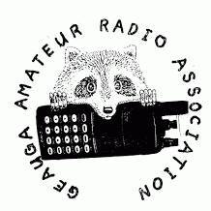
GARA's technician class will be held at the Geauga County Emergency Operations Center in Chardon, every Thursday at 6:30PM from April 2 through May 7.

We'll have an exam session the following Sunday while the material is still fresh, and the exam is free of charge.

For more information and to sign up, please go to https://geaugaara.org/classes/technician.

####

TOP ^

Pan Ohio Hope Ride Heroes of Hope! SAG Support

The American Cancer Society will be hosting a ride in Columbus Ohio. Heroes of Hope is a single-day, family-friendly event that will give families and casual cyclists the opportunity to join the Pan Ohio Hope Ride community in support of vital American Cancer Society research, programs, and patient services.

To volunteer to provide SAG support for this event, please: sign up here

When: Sunday, April 26, 2020
Where: Scioto Audubon Metro Park, Columbus, OH

Details:
• Family-friendly trail routes ranging from 3-15 miles (all ages welcome)
• Fully-supported, scenic road routes of approximately 32.8 and 62 miles (18+ only)
• Post-ride celebration with food and fun for all ages
• Inspiration from some Heroes of Hope in the fight against cancer - researchers, patient navigators, and survivors
• Costume and bike decorating contests for kids and adults
• After party at local family-friendly brewery

####

Cleveland Marathon

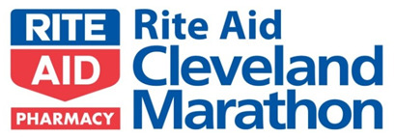
As always, we are looking for a lot of help for the Cleveland Marathon May 16 and 17. Yes, it's unfortunately on Hamvention weekend as usual and no, they aren't going to change the date of the marathon just because of that (yes people have suggested that. Seriously)

We normally need about 10 people to work the 5k on Saturday ending about noon and about 40 to work the actual Marathon on Sunday ending about 3p. If you are available to help, please sign up. If you need to leave early, that usually is not a problem so please don't be afraid to ask. Please sign up here.

####

Maker Faire Coming
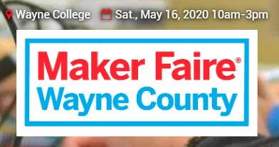
Saturday, May 16, 2020 from 10 a.m.-3 p.m.

The University of Akron Wayne College
1901 Smucker Road
Orrville, OH 44667

>> Click Here << for more information

####

TOP ^

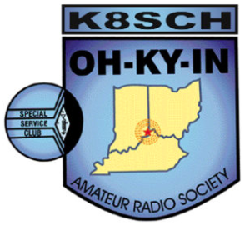
OH-KY-IN Classes and Exams

OH-KY-IN is proud to host class and exam sessions for Tech, General and Extra level amateur radio licenses. Please note, our classes are free, but you will be required to purchase your own copy of the approved study guide to bring to the first class.

Class | Dates | Location
Technician | Five consecutive Monday evenings starting April 6th, 2020 and running through May 4th from 7:00 PM to 9:00 PM. | American Red Cross - 2111 Dana Ave, Cincinnati, OH 45207

General | Five consecutive Monday evenings starting April 6th, 2020 and running through May 4th from 7:00 PM to 9:00 PM. | American Red Cross - 2111 Dana Ave, Cincinnati, OH 45207

Exam Session
- What – OH-KY-IN is holding an amateur radio licensing exam session.

- When – Saturday May 9th, 9:00 AM

- Where – American Red Cross – 2111 Dana Ave, Cincinnati, OH 45207.

- Who – Anyone can take the exam; taking the OH-KY-IN class is not required.

- How – Please refer to the following link for what to bring to an ARRL exam session: http://www.arrl.org/what-to-bring-to-an-exam-session. The current exam fee is $15.

For all questions or to sign up for a class, please email Mike/KD8ZLB

####

General License Classes Being Offered

The Franklin County Ohio Amateur Radio Emergency Service group will offer classes to achieve a General Class license. Classes will be held at the Whitehall Branch public library at 4445 E. Broad Street, Whitehall, OH. Plenty of parking is available.

Classes begin April 23 through May 21, Thursdays from 6 to 8:30 PM. This is a no cost course of study. Your only cost will be for a study guide and testing fee, depending on which organization you choose to test with.
You do not need to be a member of the FCOHARES to participate.

TOP ^
Course registration is required. Each student should acquire a study guide to begin familiarization with the material prior to starting the class. Although this is a mid-level technology course, no advanced level math is involved. Some demonstrations will be presented during classes.

As this is an upgrade class, everyone should be a Technician class license holder. We will use the ARRL General 2019 – 2023 study guide. Start studying because we will hit the ground running come April 23rd.
Pre-registration is required. Send email to John Buck at kd8rtp@arrl.net. Please include name, email address, phone/text number.

I hope you can join us. Classes will be limited to 13 students due to room capacity, thus the need for pre-registration.

Upcoming Hamfests for 2020
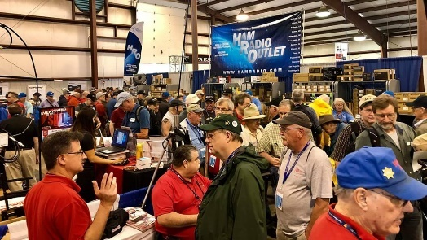
03/21/2020 | Mid-Ohio Valley ARC Hamfest

Postponed

04/11/2020 | 66th Annual Cuyahoga Falls Amateur Radio Club
Cancelled

04/18/2020 | Portsmouth Radio Club Hamfest
Location: Portsmouth , OH
Sponsor: Portsmouth Radio Club
Website: http://portsmouthradioclub.com

04/26/2020 | Athens Hamfest
Location: Athens, OH
Sponsor: Athens County Amateur Radio Association
Website: http://www.ac-ara.org/

05/15-16-17/2020 | Dayton Hamvention
Location: Xenia, OH
Sponsor: Dayton Amateur Radio Association
Website: https://hamvention.org/
Cancelled

06/06/2020 | FCARC Summer Hamfest
Location: Wauseon, OH
Sponsor: Fulton County Amateur Radio Club
Website: http://k8bxq.org/hamfest

TOP ^

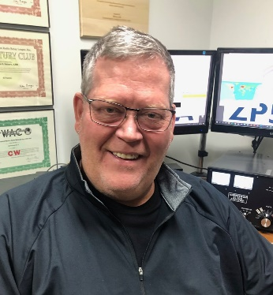
DX This Week
(from Bill, AJ8B)

DX This Week – Your First 100 Confirmed Entities
Bill AJ8B (aj8b@arrl.net, @AJ8B, or www.aj8b.com)
CWOPs Member #1567

Boy, am I spoiled! In the “old days”, we used to work the DX and do our best to verify that they got our call correct. Most of the time they did, but occasionally we would get the dreaded “Not in Log” weeks or more later. You had to balance between getting an “insurance contact” on each band and being a pest by the DXPedition. I am referring to the VP8PJ DXPedition to the South Orkney Islands. They had not been able to upload logs to their logging website, so we have had to work and trust! They were trying, and getting very close, to having 70,000+ QSOs in the log. Congratulations to them for a job well done!

In addition to the South Orkney Islands DXPedition, there were Midwest spots for Andorra, Antigua & Barbuda, Argentina, Aruba, Asiatic Turkey, Azores, Balearic Islands, Barbados, Belarus, Belgium, Bonaire, Bosnia-Herzegovina, Brazil, Brunei Darussalam, Bulgaria, Canary Islands, Cape Verde, Cayman Islands, China, Costa Rica, Croatia, Curacao, Cyprus, Czech Republic, Denmark, Dominican Republic, Ecuador, England, Estonia, European Russia, Germany, Finland, France, French Guiana, Greece, Guadeloupe, Hawaii, Honduras, Hungary, Indonesia, Ireland, Israel, Italy, Japan, Jersey, Kaliningrad, Latvia, Liechtenstein, Lithuania, Luxembourg, Martinique, Moldova, Montserrat, Namibia, Netherlands, Northern Ireland, Norway, Panama, Paraguay, Poland, Portugal, Puerto Rico, Reunion Island, Romania, Rwanda, Scotland, Serbia, Sicily, Singapore, Sint Maarten, Slovak Republic, Slovenia, South Africa, St. Kitts & Nevis, St. Lucia, St. Martin, Sweden, Switzerland, Taiwan, Thailand, Trinidad & Tobago, Turks & Caicos Islands, Ukraine, Uruguay, US Virgin Islands, Vatican City, Wales, West Malaysia, and Zambia. Did you work any of these?

The Mailman delivered cards from 9H6A – Malta, E77A – Bosnia and Herzegovina, and JF2XGF -Japan. (Pictured).

I have been asked about earning DXCC and making the Honor Roll. It seems to be an unsurmountable task that only those with huge stations and a lot of “aluminum” in the air can achieve. At first pass, I would agree with that – if it is something you want to achieve in a very short time.

In my own personal Honor Roll quest, I have not competed against all the other stations out there, I have just set my own goals and had to be satisfied with the results. However, having done this since 1971, with school, family, kids, grandkids, and work commitments, I have finally broken the 300 barrier, typically with no more than 100W and a dipole or vertical.

TOP ^
You must be in it for the long run, but you can also divide up the quest in to short segments. When we would drive to the in laws in Rhode Island, we usually divided the drive up into quarters to make it more manageable. Hitting the OH-PA border was Q1, Buffalo was Q2, I-95 was Q3 and Providence was the end. Well, not exactly quarters, but, close enough! It is all about perspective. Remember the old joke “How do you eat an elephant?” – “One bite at a time.”

I have taken the same approach to DXCC and the Honor Roll. One of my Elmers, and friends, is Jay, K4ZLE. Jay takes a similar approach analogous to collecting flowers. Dividing the Honor Roll into three groups, you will get:

- First 125 (Most Wanted #340 – #216)
The “weeds” – easy to pull – K4ZLE
You now have 125 Confirmed!

- Mid Tier (Most Wanted #215 – #101)
The “wildflowers” – Plentiful & Beautiful – K4ZLE
You now have 240 Confirmed!

- Top Tier & Honor Roll –
(Most Wanted #100 – #1)

“Basic Horticulture” is needed! You are at the Top of the Heap!

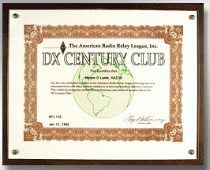
For this week we will focus on the First 125, the “weeds.” Based on the Most Wanted List on Clublog.org, we find that the following 125 Entities are the most frequently worked from North America: (From 340 to 216) USA, Canada, Italy, Spain, Brazil, France, Germany, Cuba, Mexico, Venezuela, Puerto Rico, European Russia, England, Argentina, Belgium, Slovenia, Hawaii, Hungary, Canary Islands, Poland, Japan, Netherlands, Czech Republic, Colombia, Portugal, Ukraine, Croatia, Alaska, Chile, Costa Rica, Dominican Republic, Austria, Australia, Ireland, Sweden, Finland, Slovak Republic, Switzerland, Asiatic Russia, New Zealand, Scotland, Us Virgin Islands, Azores, Bulgaria, Aruba, Serbia, Lithuania, Ecuador, Greece, Denmark, Uruguay, Bosnia-Herzegovina, Wales, Norway, Guatemala, Cayman Islands, Curacao, Romania, Madeira Islands, Belize, Barbados, Republic Of South Africa, Belarus, Northern Ireland, Estonia, Panama, Guadeloupe, Bonaire, Martinique, Morocco, Luxembourg, Balearic Islands, Jamaica, Trinidad & Tobago, Latvia, Iceland, Bahamas, Honduras, Nicaragua, Peru, Paraguay, Saint Lucia, Turks & Caicos Islands, Israel, Cyprus, French Guiana, Suriname, Bermuda, Antigua & Barbuda, Anguilla, Cape Verde, Dominica, Saint Kitts & Nevis, Sardinia, Ceuta & Melilla, Kaliningrad, Crete, Moldova, Guantanamo Bay, Greenland, Montserrat, Kazakhstan, North Macedonia, Haiti, Indonesia, Isle Of Man, San Andres Island, Corsica, Grenada, Turkey, Kuwait, Sint Maarten, South Cook Islands, Guam, El Salvador, Aland Islands, Jersey, Montenegro, Namibia, Galapagos Islands, Falkland Islands, Malta, Senegal, Antarctica, and Republic Of Korea.

There is some corresponding equipment and knowledge needed for the first 125. My Eico 720 transmitter, a Hallicrafters SX-100 receiver, a couple of dipoles and my paper logs was what I used to snare the first 125.

TOP ^
The first 60 of those were the hardest of all the entities I have confirmed for several reasons. For starters, I was a Novice running 75 watts. Secondly, I was limited to crystal control. I recall that the majority, if not all, of the first 60 were worked during contests! Those were the days…

The side benefit of the first 125 are the levels of achievement you can reach. For instance, you will earn your DXCC certificate. You will most likely earn your Worked All Continents award as well. Both of the awards can be endorsed so that they indicate a particular band or mode.
To get ready for the next group of entities, I would recommend several things that will ultimately make an impact on your attempt to reach the Honor Roll. This includes:
- Use the Grey Line. If you don’t know what that is, check previous versions of the Oh Section Journal, the SWODXA Newsletter, QST archives, or google it.
- Propagation changes; Know How, When, and Why
- Learn your rig! Splits and filters will be VERY important
- READ – The Weekly DX, the Daily DX, the Complete DX’er, DX Club newsletters
- Embrace CW – www.cwops/org
- Review DX University – www.dxuniversity.com
- Join a DX Club

Above all, have fun! In a few weeks, we can explore the second “bite of the elephant”. Until then, Good Hunting!

CQDX CQDX CQDX CQDX CQDX CQDX CQDX CQDX CQDX

We have already sold over half of the available tickets, so, if you are interested, get your tickets now.

SWODXA DX DINNER® ANNOUNCEMENT

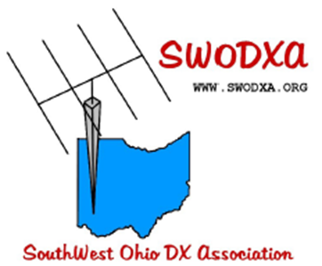
FOR IMMEDIATE RELEASE

The SouthWest Ohio DX Association (SWODXA) has announced that
Debbie Anderson will be the keynote speaker at the 35th annual DX Dinner®. The dinner, held in conjunction with the 2020 Dayton Hamvention®, will be on Friday, May 15th, at the Marriott Hotel in Dayton.

Debbie Anderson, only child of Joseph and Dorothy Desch, grew up feeling that her family was unusual. Her father, engineer at NCR for 34 years, often mentioned events during WW2, before she was born. When asked about WW2, however, Mr. Desch would stall or quickly change the topic.

TOP ^
After his death in 1987 Debbie began a slow but steady search for information about her father’s wartime work. Slowly the story of wartime codebreaking was uncovered—specifically, reading German communications hidden in the Enigma cipher.

She’s been speaking on this topic since 1990. She also maintains a web site [http://daytoncodebreakers.org] on the Dayton codebreaking story and was associate producer of a documentary Dayton Codebreakers which has played on American Public Television since 2006.

For more information and to order dinner tickets, visit WWW.SWODXAEVENTS.ORG

Here is an update from Bernie, W3UR, of the DailyDX and the WeeklyDX, the best source for DX information. http://www.dailydx.com/. Bernie has this to report:

XW – Laos - 3W3B, Bruce Ault, says “Here we go again!” He plans XW4XR operations March 30 to April 12, plus or minus a day or two. Bruce will be on CW, FT8 and FT4, 60 through 6 meters, emphasizing 60, 40 and 30. QSL via E21EIC or through LoTW.

KH3 - Johnston Island - KK7L, John Mitton, says the U.S. Fish & Wildlife Service is looking for volunteers to work on Johnston for six months at a time. John says it’s hard work and the living conditions are primitive. A U.S. passport is required and the application deadline is March 16:
https://www.fws.gov/refuge/Johnston_Atoll/what_we_do/get_involved/CAST.html

VP8/o – South Orkney - The VP8PJ group left the island early Saturday. By midday Saturday the log had been updated, with “lots of activity trying to access.” Earlier today the VP8PJ team gave an update on their travel. “We're making good time, currently about 2.5 days travel to Punta Arenas remain. Everyone is catching up on their sleep & resting in their bunks. The sea conditions are as we expected.”

S7 – Seychelles - G7EQM will be QRV as S79EQM on 20 SSB and FT8 apparently starting as early as today and going to March 29. Nicholas has an FT891 and quarter-wave vertical for 20. He says it is “really only a family holiday this time, so maybe a couple of hours a day, [to] keep the XYL happy!!!”

CY0 – Sable Island - N0TG, Randy, and the rest of the group planning to go there in October this year are busy planning. They have a survey on their website asking DXers where they most need CY0. Donations for upfront costs are being accepted too. http://www.CY0dxpedition.net.

DX news
ARLD011 DX news

This week's bulletin was made possible with information provided by The Daily DX, the OPDX Bulletin, 425 DX News, DXNL, Contest Corral from QST and the ARRL Contest Calendar and WA7BNM web sites. Thanks to all.

MAURITIUS, 3B8. Nigel, G3TXF is QRV as 3B8XF until March 28. This includes being an entry in the RSGB Commonwealth contest. QSL via LoTW.

TOP ^
MALDIVES, 8Q. Noel, F6BGC is QRV as 8Q7NC from Veligandu Island, IOTA AS-013, until March 21. Activity is on 80 to 10 meters using CW, SSB and various digital modes. QSL via LoTW.

GHANA, 9G. Alan, G3XAQ is QRV as 9G5XA from Accra. Activity is on 160 to 10 meters using CW. This includes being an entry in the RSGB Commonwealth contest. His length of stay is unknown. QSL direct to G3SWH.
KUWAIT, 9K. Members of the Kuwait Amateur Radio Society are QRV as 9K2F from Failaka Island, IOTA AS-118, until March 15. QSL via 9K2RA.

BAHRAIN, A9. Special event station A91GP is QRV until March 22 to celebrate the 2020 Bahrain Grand Prix. QSL via A92AA.

EASTER ISLAND, CE0. Mike, VE7ACN will be QRV as CE0Y/VE7ACN from March 19 to 30. Activity will be on 80 to 10 meters, and possibly 160 meters if conditions permit, using mainly CW. QSL to home call.

PHILIPPINES, DU. Lenny, N7MOT is QRV as DU6/N7MOT from Panay Island, IOTA OC-129. Activity is on 80 to 6 meters using SSB and FT8. He is generally active on 80 and 40 meters around 1200 to 1600z, and 20 meters between 2300 and 0300z. QSL via LoTW.

SPAIN, EA. Special event station EH3DWN will be QRV from March 14 to 21 to mark World Down Syndrome Day on March 21. QSL via LoTW.

NORTHERN IRELAND, GI. Special event calls GB0SPD, GB2SPD and GB4SPD will be QRV from March 16 to 18 during the St. Patrick's Day On The Air operating event. QSL via operators' instructions.

LITHUANIA, LY. Special event stations LY11LY and LY30LY are QRV during March to celebrate Lithuania's independence. QSL LY11LY via LY2QT and LY30LY via LY5A.

CURACAO, PJ2. Andreas, DK5ON will be QRV as PJ2/DK5ON from March 15 to 31. Activity will be on 80 to 6 meters, including 60 meters, using CW, SSB, RTTY, FT8 and FT4. This includes being entries in the upcoming Russian DX and CQ World Wide WPX contests. QSL to home call.

ST. PETER AND ST. PAUL ROCKS, PY0S. Look for PQ0S to be QRV from March 14 to 16. Activity will be on 80 to 10 meters using CW, SSB and various digital modes. QSL via PP5BZ.

SLOVENIA, S5. Members of Radio Club Cerkno are QRV with special event call S500E for all of 2020 to mark half a million QSOs made from the S50E station. QSL via LoTW.

SEYCHELLES, S7. Nick, G7EQM is QRV as S79EQM until March 29. Activity is holiday style on 20 meters using SSB and FT8. QSL to home call.

BELIZE, V3. Iain, G4SGX is QRV as V31GX. This includes being an entry in the RSGB Commonwealth contest. QSL via M0OXO.

TOP ^
NAMIBIA, V5. Pat, KI4SVM will be QRV as V5/KI4SVM from March 14 to 28. Activity will be holiday style on the HF bands using CW and SSB. This may include being active from SOTA references as well.
QSL to home call.

CAYMAN ISLANDS, ZF. Colin, G4CWH is QRV as ZF2CA. Activity is on 160 to 10 meters using CW and SSB. This includes being an entry in the RSGB Commonwealth contest. QSL direct to home call.

NEW ZEALAND, ZL. Frank, ZL2BR, Geoff, ZL3GA, Phil, ZL3PAH and Paul, ZL4TT will be QRV as ZM2B in the RSGB Commonwealth contest. QSL via LoTW.

THIS WEEKEND ON THE RADIO. The Stew Perry Topband CW Challenge, QRP 40-Meter CW Fox Hunt, NCCC RTTY Sprint, QRP 80-Meter CW Fox Hunt, NCCC Sprint, YB DX RTTY Contest, RSGB Commonwealth Contest, SARL VHF/UHF Analogue Contest, F9AA SSB Cup, South America 10 Meter Contest, AGCW QRP CW Contest, Oklahoma QSO Party, EA PSK63 Contest, TESLA Memorial HF CW Contest, QCWA QSO Party, Idaho QSO Party,

QRP ARCI Spring Thaw SSB Shootout, North American RTTY Sprint, UBA Spring 2-Meter Contest, Wisconsin QSO Party and Run for the Bacon QRP CW Contest will certainly keep contesters busy this upcoming weekend.

The Bucharest Digital FT4 Contest and RSGB FT4 Contest Series are scheduled for March 16. The CLARA Chatter Party is scheduled for March 17. The 40-Meter QRP CW Fox Hunt and Phone Fray are scheduled for March 18.

Please see March QST, page 79, and the ARRL and WA7BNM Contest Web Sites for details.

####

Special Events

- 03/16/2020 | Maine Bicentennial Special Event
Mar 16-Mar 22, 0000Z-2359Z, W1L, Various cities, ME. Maine Bicentennial Special Event Group. HF, 6 and 2 meters; SSB, CW, and digital. Certificate. Tim Watson, KB1HNZ, PO Box 6833, Scarborough, ME 04070. Calls include K1B, K1J, K1P, W1C, W1H, W1K, W1L, W1O, W1P, W1S, W1W, and W1Y. Certificate for contact; endorsements for bands, modes, and clean sweep of contact with each of the Maine 200 Special Event call signs. www.maine200specialevent.com

- 03/17/2020 | Maine Bicentennial Special Event
Mar 17-Mar 22, 0000Z-2359Z, W1L, Boothbay Harbor, ME. Boothbay Harbor Memorial Library. 14.262 7.262 3.962. Certificate. Via email to , Al Sirois:, director@bbhlibrary.org. This is a special activation from the Boothbay Harbor Library. n1mhc@arrl.net or www.bbhlibrary.org

- 03/20/2020 | Alcatraz Federal Penitentiary Anniversary of Closing
Mar 20-Mar 31, 0000Z-2359Z, N6A, Healdsburg, CA. Will Pattullo, AE6YB. 21.265 14.265 7.265 3.815. QSL. Will Pattullo, 161 Presidential Circle, Healdsburg, CA 95448. N6A, Special Event for the Anniversary of the closing of the Federal Penitentiary on Alcatraz Island in San Francisco Bay, March 21, 1963. www.qrz.com/db/ae6yb

TOP ^
- 03/24/2020 | The Buckingham Army Airfield
Mar 24-Mar 26, 1300Z-2000Z, W4LX, Fort Myers, FL. Fort Myers Amateur Radio Club. 14.240 21.240. Certificate & QSL. Fort Myers Amateur Radio Club, P.O.Box 061183, Fort Myers, FL 33906. 9 AM to 4 PM local time. fmarc.net

- 03/28/2020 | Battle of Horseshoe Bend (Creek Indian War) Anniversary
Mar 28, 1400Z-2100Z, N4H, Daviston, AL. Lake Martin Amateur Radio Club. 14.250 7.280 3.850. Certificate & QSL. John Philips, PO Box 938, Alexander City, AL 35011. Commemorating the 206th anniversary of the Battle of Horseshoe Bend. This battle brought a close to the Creek War, made Andrew Jackson an American hero and opened much of present day Alabama for settlement. SASE for QSL or SAS (large envelope rate) 9X12 envelope for QSL & certificate. www.facebook.com/K4YWE/ or www.qrz.com/db/n4h

- 03/28/2020 | Cherry Blossom Special Event Station
Mar 28, 1400Z-2000Z, W4BKM, Macon, GA. Macon Amateur Radio Club. 14.240 7.225. Certificate. Macon Amateur Radio Club, P.O. Box 4682, Macon, GA 31208. www.w4bkm.org

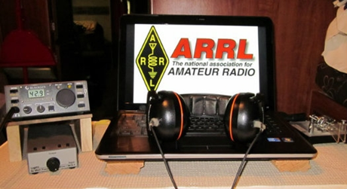
ARRL Contest Corner

An expanded, downloadable version of QST's Contest Corral is available as a PDF. Check the sponsor's Web site for information on operating time restrictions and other instructions.

Attention ALL Ohio…

ARES OHIO SPRING CONFERENCE! Cancelled

As they say, “BREAKING NEWS!!”

Because Ohio State has limited large lecture hall environments to combat spread of the flu, our venue for the April 4 Ohio ARES Conference has been closed. The conference is canceled.

Scene fades, shifts to typical office room:

One: Well, I think I have the flu. I feel crappy.
Two: Ah, that’s too bad. Hope you feel better.
One: This might be the Coronavirus…
Two: Screams! Back-peddles like a cartoon character. Dashes for the door. Misses door slams into wall.

Backstep. Screams again. Dives outdoor, into waiting bathtub full of Clorox. Spends next two and a half minutes underwater, er, under Clorox, wondering if inhaling the Clorox would kill any lung-based germs. Simultaneously calculates where to find the most toilet paper and hand sanitizer to be stocked for the inevitable quarantine. Life as we know it is over. Emerges as a blonde, bleach odor lingers for days.

TOP ^
Because I now have a degree in communicable disease from Facebook with advanced studies at Google Tech, I know the truth: the common flu (influenza B and A) has resulted in over 3,000 hospitalizations in Ohio. Most (166) were in the northern part of Ohio. Nationally just this year there have been 13 ~million~ flu cases with 6600 flu-related deaths.

The death rate ranges from 6% to 6.9% for those cases. As of this writing, the Coronavirus carries a reported caseload of 121,000 worldwide- just over 1,000 in the US. There have been 31 deaths. That’s a rate of 3.4% (WHO estimate). And if you do get it, you might well think you have a spring cold.

All that said, the better medical minds I’ve talked with all suggest the best advice is to ward off any potential for large scale infection by reducing the possibility of spread early in the game. Thus, the state’s Department of Health cancellation of most of the Arnold, universities around the state (led by Ohio State) cancelling lecture-hall type interaction and most school systems limiting attendance.

Another casualty is the Ohio ARES State Conference, which was set for April 4. In keeping with Ohio State’s limiting of large gatherings, the large lecture hall which we’d scheduled was closed, and that included our meeting. That’s fine, we completely understand that decision. At this point, looks like we’ll see you in 2021!

So- what exactly would be in store for ARES and amateur radio if this does actually hit the fan? It’s way too much of a stretch to morph this into a communication emergency. But like any pandemic threat, there are places amateur radio could serve. Are you ready?

- POD dispensation: The concept of a POD (Point of Distribution) is entrenched in handling many emergencies. These are distribution locations where supplies of many types can be handed out to the public. In the case pf a pandemic type situation, it’s conceivable that a POD might hand out prophylactic supplies (masks, inoculations, even food etc.) One agency trained in POD dispersal is the Ohio Military Reserve. While that have a comm unit, OHMR and ARES have worked together and would likely do so. That would involve portable stations, antennas, and message-oriented nets. Our own safety would be of highest concern in these cases.

- Health: Each county has its own health system. While many have MARCS radios, in my experience the vast majority have no clue because they don’t use these. Cellphones are the main (and best) way for them to communication in normal business. However, during an emergency situation overloading might cause issues, and they would probably need more people in general to assist. That’s another place ARES members could step in.

- Shelter: In general, Red Cross would be responsible if shelters were set up for any reason. Our national agreement with ARC (American Red Cross) provides ARES as a primary means of communication from shelter to ARC bases. Our own general approach is if there are two forms of communication (cell and landline phones, for instance) we aren’t particularly needed. When it gets to one form (perhaps overloaded cell systems and/or spotty landline) then ARES is needed to provide communications at each shelter. This along would be a daunting manpower challenge for many- and would likely involve our mutual aid system to backfill manpower.

- EOC general: Many EOC’s are already spun up to watch the situation, including the State EOC in Columbus. In most counties, staffing does not accommodate handling a large number of telephone calls. In other situations, ARES members who have just sat down to answer phones have all been very welcomed by EMA staff and we’ve provided a lot of valued assistance in doing so.

TOP ^
- Watch Desk Project: Like other statewide situations, our “Watch Desk Project” would likely come into play for relaying observed situations to the state. We would no doubt use HF/OHDEN and have our station open on the DMR Ohio talk group (3139) as well as the Fusion bridge. This additional avenue for information flow would be useful.

You might be able to come up with even more potential applications. The whole point here is to do a “What if?” discussion and take any steps necessary now to be ready.

So, what are we going to do?
Let’s imagine for a moment that it really does hit the fan. The Governor shuts everything down. Nobody moves (except responders). This is a situation where we might easily become very important!

Let’s test ourselves! Instead of having the conference April 4, let’s conduct a drill that would be applied during this emergency, during a blizzard, or any other widespread situation! Here’s the plan:

- 11 AM: Check-in net on 40 meters 7.240 +/- QRM
- 11:30 AM: Check-in net on 80 meters 3.902 +/-
- 12:15 PM: Check-in net on 80 for OHDEN 3.585
- 1:00 PM: Check-in net on DMR Ohio (3139) and Fusion “Ohio Link: 31399

This will be a quick check-in only net, no traffic. It’s just designed to prove we can communicate from home, while ‘locked down’ and still get the job done! Hope to hear you on the air!

It’s SO nice to have 80 meters back!
With the change of time back to Daylight Savings, we have found our Tuesday evening net to be on the good side of the gray line- and what a difference it made! The first Tuesday after time shift saw both OHDEN and the voice net in wonderful territory. Not only were our voice signals strong, but stations reported they could hear almost all the other stations around the state! Now ~that’s~ a nice way to communication across Ohio! I hope the bands stay friendly now. In the meantime, we’ll continue working on our 160-meter antenna at the state (it’s up, but not working well yet).

We still need to add more skilled operators to the Sarge! If you’re within an hour drive of Dublin/Worthington and you are interested, please let me know!

My home county (Delaware) has already handled one public service event, and like yours, we are gearing up for the ‘event season’. Now’s a great time to refresh on handling public service events, operating successful nets, and keeping the ‘back room’ of event management in order: contact your event person early, confirm details, and recruit volunteers early – then send detailed information in time for them to be prepared. It all works smoothly when you start early!

Several have asked where ARES fits in assisting with the current Coronavirus situation. I’m not sure I see any one overarching function but there are several possibilities we can all get ready to provide if asked. Most of all, it is not a communications emergency. We have to assume that normal channels will remain functioning. What emerges as a possibility is overburdened cell service and degraded performance as a result. The same would be possible for some Internet systems. These are normally very robust, so it would take a lot to degrade their efficiency. Then again….

TOP ^
There are some ‘standard’ ARES applications that present a possibility. Now is the time to have a conversation with your EMA Director, and ask them if they see places we could fit in.

Here are some ideas:

- Shelter Communications – should the Red Cross be requested to establish shelters; we might well become involved. My own test is if there is reliable cell and landline service to the shelter, we probably aren’t needed. When standard phone service is down to only one of those, we should begin staffing. That would be something you would work out with your local chapter.

- Pandemic distribution – Are you written into your county’s pandemic protocols? We could provide communication for distribution or management of supplies/medications with our local health departments. PODS (point of distribution) would probably be established and may need communication. This would be a critical function.

- Hospital net – Should hospital information bog their system we might be able to help with our existing hospital networks that are already in place, or that could be installed quickly.

- Health Departments – The typical health department is understaffed and under-communicated. Ramping up any departmental activity might require our assistance.

- Food distribution – If we continue to ‘run’ on our grocery stores (don’t get me started!) we could be dealing with some serious shortages. Food and medications are important to provide especially to our health-challenged residents. It’s not really radio-centric but helping to deliver meals or meds might be something to consider if their normal channels of distribution and delivery fail.

- “Watch Desk” communications – Our proven statewide digital/HF nets might be pressed into providing intel reports to the state Watch Desk, or WebEOC.

How efficient is your communication using home stations? Our VHF Simplex Contest is designed to provide some basic coverage mapping and last fall’s SET did the same. If you have not tested your simplex net recently, it might be a good time! I’ve heard from Mahoning County which plans to integrate a VHF simplex net into April 4th activities. Good idea! Do you have a plan to include hospitals, potential POD locations, and other conceivable functions in your communication system?

I have no idea what this will turn into- is it bad, getting worse, or are we dealing with a Y2k scenario? Don’t have the answer, but it’s prudent to do some ‘what-if’s’ and prepared accordingly. In the meantime, remember that we have radios! We might not need to meet in person, but we can still get our jobs done! What are YOU thinking about in addition to this?? Please let me know! Our best posture is to be prepared with creative suggestions for our partners.

Be safe, be prepared, and like yo’ mamma taught you: ~wash your hands!~

####

TOP ^
NVIS DAY IS COMING!

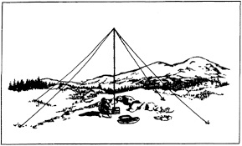
NVIS Day is the ARRL Ohio Section event to test your NVIS antenna designs and builds. Join us on Saturday, April 25th to show how well amateur radio can keep Ohio communicating! This is not a contest: it’s an event for Ohio stations to operate with other Ohio stations and understand how well they hear and are heard.

THE DETAILS
Date: Saturday, April 25
Time: Start at 10 A.M., end at 4 P.M.
Power: Up to but no more than 100w
Exchange: six-digit grid, power, and true—measured—signal report
Schedule: This isn’t a contest, so take your time! Try different designs! Have lunch!

V.E. Test Sessions

For the latest testing site information please >> Click Here << The ARRL site tracks all of the VE testing sites that register with them, including W5YI and Laurel. ARRL gives you a number of different ways of sorting to find that site that is closest to you as well.

One Question Questionnaire
Hey Gang,

Ok.. “Survey Says”….. 43% of you don’t seem to have a fear of soldering surface mount components to a circuit board. Fantastic!!

Ok, I’ve got another NEW – one question – for you to answer. This one comes from Doug, WA8UWV. With all sorts of projects being made from those tiny little micro-computers called Arduino’s, this next question begs to ask….

“Have you programmed an Arduino Controller ???”

You’ll find the “One Question” questionnaire on the Ohio Section Website! http://arrlohio.org It’s all in fun and it’s not a scientific survey in any way, but we are learning some things that we didn’t know from these questions. I hope that you are enjoying answering these “One Question” questionnaires.

2020 Weather Safety Week Events
- Ohio’s Severe Weather Awareness Week: March 22-28
- Statewide Tornado Drill: Wednesday, March 25 at 9:50 am

TOP ^

“ARES Connect”
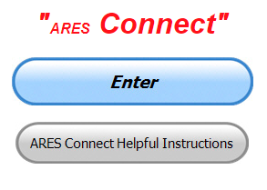
Everyone – please make sure to go into all of the events that you have signed up for and get your hours registered no later than 5 days after the event has ended.

Folks, I’m seeing a lot of folks that have signed up for events not entering their time after the event. This is a very important piece of using “Connect.” Your hours need to be recorded and it’s so easy to do.

Let’s run through how so in case you have forgotten. If you have already gotten signed up for an event, all you have to do afterword to get your time entered is at any time after the event has ended, log into “Connect.” And then click on your name in the upper right-hand corner of the page. This will bring up a drop-down menu where you will then click on “View Hours.”

This brings up another screen where you can “Report Hours” as well as “View Hour History” You’ll want to click on “Report Hours.” You will then be presented one at a time by chronological order each event that you have signed up for and hours have not yet been reported on.

Type in those hours in the “Hours Worked” box and hit “Submit”… Keep doing this until you have no more hours to report…. That’s all there is to it. Now, if you are following the request above and doing this at least every 5 days or more often, this will only take you a minute or so to complete.

Now, isn’t that easy? Yes, and we all need to be diligent at doing it promptly.

Here’s the top 5 hours earners so far for March:

 | Name | Events | Hours
1 | Bret Stemen (KD8SCL) | 17 | 48.00
2 | Greg Dersarkisian (KD8SSJ) | 10 | 47.50
3 | John Hilliard (w8of) | 10 | 43.50
4 | James Yoder (w8erw) | 11 | 41.75
5 | Dan Stahl (KC8PBU) | 34 | 41.02

Let’s get everyone in the Ohio Section on “ARES Connect!!!” Simply go to: https://arrl.volunteerhub.com/lp/oh/ and get yourself registered and using the system.

Admins… If you are wondering how to get an overview of all of your events you can simply go into reports and using the new Event by Participation by Event (version 2) you can not only see who registered for your event, but you also can see if he/she has inputted their hours for it as well. Take advantage of this new report to help you get the time entered into your events.

We still have a number of recurring events created but no activity reported for them. Please, if this event is no longer needed, let me know and I can delete it from the masters. I know that many of you setup recurring events to learn how, but if they aren’t going to be used, let’s get them cleared out.

TOP ^
Also… If you are setting up events, please don’t set a limit for how many folks can sign-up unless absolutely necessary. This causes issues when doing reports. It’s also counter-productive since the reason for you to list the event is to get as many volunteers as you can to attend. When you set limits, it discourages folks from signing up.

Special NIMS Training Available

G-557 RAPID ASSESSMENT PLANNING COURSE
Hosted by: Fulton County Emergency Management Agency
Tuesday, June 9, 2020

Course Description: This course provides information and resources to enable participants to develop an effective Damage Assessment Program and conduct rapid and effective needs assessments. A good assessment allows community leaders to prioritize response actions ensuring the greatest life-saving and life sustaining benefits. Since resources are often limited in the first few hours of a disaster or emergency an effective rapid needs assessment allows for the efficient and effective use of those resources. Likewise, it allows local officials to evaluate their needs and request those resources that are not available in their jurisdiction to support life sustaining and life saving measures.

This is a “Required” course in the Advanced Professional Series (APS) program
Application Deadline: May 26, 2020
Time of Course: Registration: 7:45 am – 8:00 am
Course Time: 8:00 am – 4:00 pm
Location: Fulton County Welcome Center/EOC - 8848 State Highway 108 Wauseon, Ohio 43567
Supported By: The Ohio Emergency Management Agency

Recommended Participants: Local officials who are responsible for assessing, collecting, and reporting damages during and after any event that causes damage of private, public, and critical infrastructure.

Recommended Prerequisite: IS0100.c, Introduction to the Incident Command System, ICS 100; IS0200.c, Incident Command System for Single Resources and Initial Action Incidents; IS0700.b, National Incident Management System, An Introduction; IS0800.b, National Response Framework, An Introduction; IS0120.a, An Introduction to Exercises; and IS0130, Exercise Evaluation and Improvement Planning. These courses are available online by going to https://training.fema.gov/is/crslist.aspx?all=true

Enrollment: Students must enroll via the Department of Public Safety Training Campus website: https://trainingcampus.dps.ohio.gov/cm/cm710/pstc/pstc.html Course registration will generally close 10 working days prior to the course start date. You can check enrollment/approval status via the Department of Public Safety Training Campus website.

Course Costs: This course is free to participants. Lodging, meals and all other expenses are the students’ responsibility.

County Point of Contact: Peggy Volkman, Administrative Assistant, (419) 337-9207, peggyvolkman@fultoncountyoh.com

####

TOP ^
EMA-G289 PUBLIC INFORMATION OFFICER (PIO) AWARENESS
Hosted by: Youngstown State University Police Department April 7, 2020

Course Description: The Public Information Officer (PIO) Awareness Course is a “Free” course designed to familiarize participants with the concepts underlying the PIO role. The material provides a basic understanding of the PIO function for those new to the position.

It orients the participants to the public information function and the role of the PIO in the public safety / emergency management environment. This training forms the foundation for more advanced training that takes participants from the awareness level to the mastery level in their public information careers. Additionally, it provides those in executive level roles the necessary knowledge of PIO roles and responsibilities during an emergency.

Application Deadline: March 24, 2020

Time of Course: Registration: 7:30 am – 8:00 am Course Time: 8:00 am – 5:00 pm
Location: Youngstown State University Police Department - 266 West Wood St. Youngstown
Supported By: The Ohio Emergency Management Agency

Recommended Participants: The primary audience for this training is individuals who have public information responsibilities as their main job or as an auxiliary function at the federal, state, local, tribal, or territorial level of government, and in the private and nongovernmental sectors.

Recommended Prerequisite: IS-100 Introduction to Incident Command System; IS-702 NIMS Public Information Systems; and IS-909 Community Preparedness: Implementing Activities for Everyone

Enrollment: Students must enroll via the Department of Public Safety Training Campus website: https://trainingcampus.dps.ohio.gov/cm/cm710/pstc/pstc.html. Course registration will generally close 10 working days prior to the course start date. You can check enrollment/approval status via the Department of Public Safety Training Campus website.

Course Costs: This course is free to participants. Lodging, Meals, Per Diem and all other travel expenses are the responsibility of the student or the parent organization. The FY 2019/2020 Ohio EMA Training Catalog at http://ema.ohio.gov/Training.aspx provides additional information.

County Point of Contact: Adam Guerrieri. (330) 503 – 4626. ajguerrieri@ysu.edu

####

Below are trainings that can be found by following this link: https://services.dps.ohio.gov/CIMS/.

- G-191 ICS-EOC Interface (Lawrence County April 2020)
- G-289 Public Information Officer (PIO) Awareness (Fulton County April 2020)
- G-289 Public Information Officer (PIO) Awareness (Hocking County April 2020)
- G-318 Mitigation Planning Workshop (Cuyahoga County April 2020)
- G-402 ICS Overview for Executives and Senior Officials (Franklin County April 2020)
- OH-202 Debris Management Workshop (Stark County April 2020)

TOP ^
Intended Audience: Law Enforcement, Emergency Services, Emergency Managers, Communications, Government, Volunteers, State, Local, Tribal, and Territorial Personnel

For more questions or concerns regarding CIMS please contact CIMS@dps.ohio.gov.

####

EMA-ICS300 Licking County May 19-21

This 21-hour course provides training for personnel who require advanced application of the Incident Command System (ICS). This course expands upon information covered in the ICS-100 and ICS-200 courses. This course is for individuals who may assume a supervisory role in incidents. Note: During a Type 3 incident, some or all of the Command and General Staff positions may be activated, as well as Division/Group Supervisor and/or Unit Leader level positions. These incidents may extend into multiple operational periods.
Licking County EMA/911 783 Irving Wick Drive West Heath, Ohio 4305

####

EMA-ICS400 Licking County May 27-28

This training is a 15-hour classroom course that provides training for personnel who require advanced application of the Incident Command System (ICS). This course expands upon information covered in ICS-100, 200, 700, 800 and ICS-300 courses, which are the prerequisites for the ICS-400 course.

The target audience for this course is senior personnel who are expected to perform in a management capacity in an Area Command or Multi-Agency Coordination Entity.

Licking County EMA/911 783 Irving Wick Drive West Heath, Ohio 43056

####

AWR 148: Crisis Management for School-Based Incidents – June 9th
Training sponsored by: Licking County EMA
Location: Licking County Administration Building Room “A” in Basement - 20 South 2nd Street - Newark

AWR 148: Crisis Management for School-Based Incidents - Partnering Rural Law Enforcement, First Responders, and Local School Systems is an 8-hour, OHS-approved course designed to educate rural law enforcement personnel as well as school administrators and staff on the elements that would allow for an effective response to school-based emergencies. Schools in small, rural, and remote areas across the country account for almost 23 percent of the total student population (more than 11 million students) .

Rural schools, law enforcement, and other emergency responders are often limited in resources, so it is imperative that all potentially affected parties collaborate on planning, preparing, communicating, responding, and recovering from a school-based incident.

This tuition-free course is beneficial for rural police and sheriff departments, school administrators, school resource officers, counselors, and others involved in school safety and security.

TOP ^
Topics covered include:
• Introduction to Incident Planning and Preparedness
• Proactive Threat Mitigation
• Incident Response
• Incident Recovery
• Vulnerability Assessments
• Threat Assessment Management
• Incident Defusing and Debriefing
• Reunification
• Anniversaries, Memorials, "Copy-Cats"

To register, please visit our website:
https://www.ruraltraining.org/training/schedule/2020-06-09-awr148-newark-oh-001/

Please sign-up no later than May 26, 2020 as a minimum of 20 registrations must be received by this date to confirm the class will be held. Should you have any questions regarding the facility or location please contact John Wieber at 740-404-5034 or jwieber@lcounty.com

####

MGT 417: Crisis Management for School Based Incidence – July 23 - 24
Training sponsored by: Licking County EMA
Location: Licking County Administration Building
Room “A” in Basement - 20 South 2nd Street - Newark

The purpose of this performance-level course is to provide the operational-level details to support many of the topics covered in the U.S. Department of Homeland Security (OHS) approved AWR 148: Crisis Management for School-Based Incidents - Partnering Rural Law Enforcement and the Local School Systems awareness-level course. Rural schools, law enforcement, other emergency responders, and community stakeholders are often limited in their access to resources, so it is imperative that all potentially affected parties collaborate in planning, preparation, communication, response, and recovery in the event of a school-based incident.

Topics covered in this course include:
• All-Hazards Planning and Preparedness
• Vulnerability Assessments
• Threat Assessment Management
• All-Hazards Response
• All-Hazards Recovery
• Scenario-Based Activities

Registration Deadline: July 9, 2020

To register, please visit our website:
https://www.ruraltraining.org/training/schedule/2020-07-23-mgt417-newark-oh-001/

Please sign-up no later than May 26, 2020 as a minimum of 20 registrations must be received by this date to confirm the class will be held. Should you have any questions regarding the facility or location please contact John Wieber at 740-404-5034 or jwieber@lcounty.com

TOP ^

Great Lakes Division Award Recipients Announced

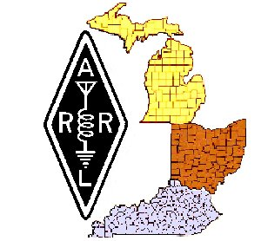
Unfortunately the Great Lakes Division Convention had to be cancelled due to the COVID 19 crisis, so even though a formal presentation wasn’t done as planned, we still want to take the time to recognize those among us who represent amateur radio in a very significant way, either over the past year or two, or throughout their time as hams.

So, with a big round of applause please… We announce the following persons:

Gary Johnston, KI4LA, winner of the George S. Wilson III, W4OYI, Lifetime Achievement Award;

Steve Smith, N8AR, and Larry Gauthier, K8UT, joint winners of the Technical Achievement Award;

John Papay, K8YSE, winner of the DX Achievement Award;

And “The Radiogram,” the monthly newsletter of the Portage County Amateur Radio Service, as the winner of the Joseph J. Phillips, K8QOE, Newsletter Award.

This year we are also giving a special “Director’s Award” for outstanding service to the amateur radio community to: John Loughmiller, KB9AT, for his design work on a database for the new Volunteer Monitoring program established at Headquarters.

Our sincerest thanks to the many people who made nominations for these and other awards. The quantity and quality of the nominations was excellent this year. Our thanks also to the committee members who had the difficult task of choosing the winners from the many nominations received.

Dale Williams, WA8EFK, Director

From the Section Youth Coordinator
Anthony Luscre, K8ZT - SYC
k8zt@arrl.net

Coronavirus disease (COVID-19) and Amateur Radio

No, I won’t go over all the public health warnings you have heard, or even give you a Microbiology/Infectious Disease lecture (even if one of my previous careers was as Clinical Medical Microbiologist)! What I want to talk about instead is offering your club members a program in lieu of canceled ham radio club meetings. I have two sessions I prepared for the Great Lakes Division Convention originally scheduled for March 14th but canceled because of COVID-19 measures and would be willing to present these as online webinars for your club members via the Internet. In addition, I have two other topics if you would prefer these

TOP ^
Available sessions are:

- FT8 & FT4- Digital Soundcard Modes

- Software & Web Resources for Contesting

- Having Fun with Morse Code

- Top Secret- Techniques to work DXCC and WAS

You can click on any of the sessions to see the slide deck I use for my online presentation. If you are interested in having a presentation for your group:
- We will schedule a time

- I will provide a link for your club members

- Your members will go to the link at the appointed time
  - They can use a computer, tablet or phone

  - A microphone and camera are suggested if they would like to be able to ask questions directly or if they prefer they can forgo camera and mic and use texting to ask questions

  - They do not need to be together in one place as separate simultaneous connections are supported
    - Up to 25 fully interactive users (camera & mic ability)

    - Up to 100 view & text only uses

ATTENTION All Canton Amateur Radio Club persons!!

Due to the national emergency, this week's Canton Amateur Radio Club meeting will not be held at the usual Stark County EMA location.

Instead, we will conduct the meeting over the air, on the W8AL repeater. Club officers will act as net control. Attendence will be taken by roll call, using the 2020 club roster. Others may check in after the roll call. The W8AL repeater is located in Canton and can be heard on 146.79 MHz with a PL of 141.3 Hz.

If you prefer, you may listen (but not transmit) to the meeting on the internet in two places. One is the W8AL.ORG web site. Click REPEATERS on the menu bar, then click on the player which appears. The other method is to browse to nx8j.perbit.stream/player, then click the PLAY control that appears.

The business portion will begin at 7:30 PM, followed by a discussion on QRP operations led by Roger W8VE.

73 de Dale NX8J
President CARC

TOP ^

Final.. Final..
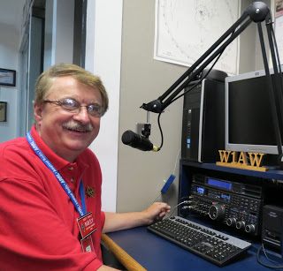
Hey Gang...

This has been the craziest week ever!!!! I’ve heard from so many of you about the COVID 19 actions of late. Some pro and some not.

My simple advice is to use common sense. If you feel that you are exposing yourself to an environment that could cause you to get sick, then avoid it.

Listen the what the CDC is staying and following their guidelines to be clean and safe. Use the 6-foot rule whenever possible and stop shaking hands and giving hugs. For now, use your elbows. Yes, this is a bit awkward, but you know, it’s actually fun to do something different for a change. Most of all, do what your mama taught you... “wash your hands - often!!”

Please be understanding when event organizers decide to cancel their events. This is a huge decision for them to make. It effects so many folks, not only you, but it also affects places to eat, gas stations, hotels and so forth. They lose too. Ok, nuff said on that subject…

Moving down the log a bit…

I want to encourage all of you to make sure that your ARRL dues are up-to-date. I know that his must sound like a broken record, but… “Being a part of a great organization like ARRL is really important to you and to all of us. Your voice is heard and heard loud and clear not only here in Ohio, but also at Headquarters.

Whelp, final go around before gong QRT… That’s going to do it for this week. Stay safe, enjoy the sunshine when we have it, and most of all… have FUN and now that COVID 19 is preventing you from going to meetings and hamfests, it’s time to “GET ON THE AIR!!”

73,

Scott, N8SY

Spring Arrives!!

The spring equinox (also called the March equinox or vernal equinox) falls on Thursday, March 19, which is earlier than it's been in over a century!

This event marks the astronomical first day of spring in the Northern Hemisphere.

TOP ^

Ohio Section Cabinet
Section Manager – Scott Yonally, N8SY | Assistant Section Manager – John Perone, W8RXX
Section Emergency Coordinator – Stan Broadway, N8BHL | Section Traffic Manager – David Maynard, WA3EZN
Technical Coordinator – Jeff Kopcak, K8JTK | Affiliated Clubs Coordinator – Tom Sly, WB8LCD
State Government Liaison – Bob Winston, W2THU | Public Information Coordinator – John Ross, KD8IDJ
Section Youth Coordinator – Anthony Lascre, K8ZT

Swap & Shop Has Come to the Ohio Section Website

Hey Gang,

Have you taken a look at the Swap & Shop page on the Ohio Section webpage yet??

Here’s a link that will take you there… http://arrl-ohio.org/sm/s-s.html

Do you have equipment that you just don’t need or want anymore? Here’s a great venue to advertise it, and it’s FREE!! No, it won’t be listed in this newsletter because it would take up way too much space, so your ad will only appear on the website. It is there for any individual to post equipment Wanted / For Sale or Give-Away. No licensed vehicles/trailers or business advertising will be posted.

Postings are text only (no pictures or graphics) will be posted for a maximum of 1 month from date posting and require a contact phone number or email within the posting.

Send your Wanted / For Sale or Give-Away post to: swap@arrlohio.org

Welcome New Subscribers

Laurence, KM4YMQ

Back Issues of the PostScript and Ohio Section Journal

Hey, did you know that PostScript and Ohio Section Journal (OSJ) are archived on the website? You can go back and look at any edition simply by clicking:
http://arrl-ohio.org/news/index.html

TOP ^

Updated Information... Want to Share your Club Newsletter With Others?

We have a new webpage where you can download and read all of the newsletters that I get from around the state.

Here’s the link to the page…. http://arrl-ohio.org/club_news/index.html

Please, if you don’t see your club newsletter posted, it’s probably because I’m not receiving it, or I just cannot convert it over to Adobe Acrobat. Have your newsletter editor contact me and let’s see if we can get your club’s newsletter on the site!! We all learn and steal (I mean, share) from each other’s work. So, let’s give this new webpage a real workout and send me your newsletter!!! Send it to: n8sy@n8sy.com

Chit – Chat, and All That!

Do you know someone that’s not getting these Newsletters? Please, forward a copy of this Newsletter over to them and have them “Opt-In” to start receiving them. Heck just have them send me an email n8sy@n8sy.com and I’ll get them added to the Ohio Section Emailing list.

We now have many thousands of readers receiving these newsletters weekly. Quite impressive, I’d say! I urge all of you to make sure that everyone, regardless of whether they are a League member or not, get signed up to receive these weekly Newsletters.

You can always “Opt-Out” at any time if you feel this is not what you were expecting. It’s fun and very informative. All of your favorite past newsletters are now archived too.
You can go back at any time and read them. Just go to: http://arrl-ohio.org/news/

Got questions, concerns or would just like to sit and chat awhile? Heck, I’ll even buy the coffee!! Give me a call at (419) 512-4445 or email me at: n8sy@n8sy.com

The pictures on the front page and throughout this newsletter are from various newsletters, Facebook posts and/or were sent directly to me in recent weeks. Take a good look at them, you just might be in one of the pictures! “SMILE… you’re in the Ohio Section News!!”

TOP ^

PostScript is produced as a weekly newsletter. I want to thank everyone that has contributed articles and ideas to make this an even better news source. I sincerely hope that you have enjoyed this edition and will encourage your friends to join with you in receiving the latest news and information about the Ohio Section, and news and events happening around the world!

