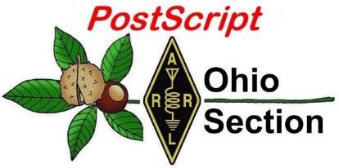
Spring has Sprung
Edition

National News The Handbook Give Away

Club Corner Hamfests

DX This Week One Question Questionnaire

VE Testing ARES Connect

Special NIMS Training Final.. Final..

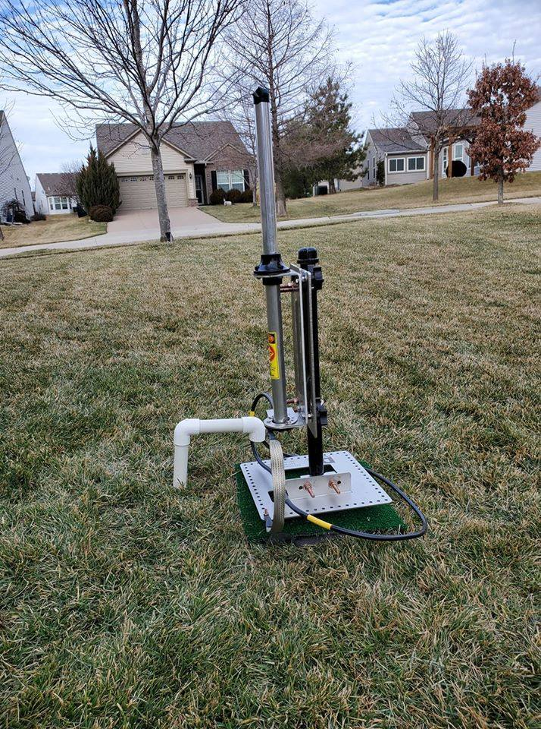
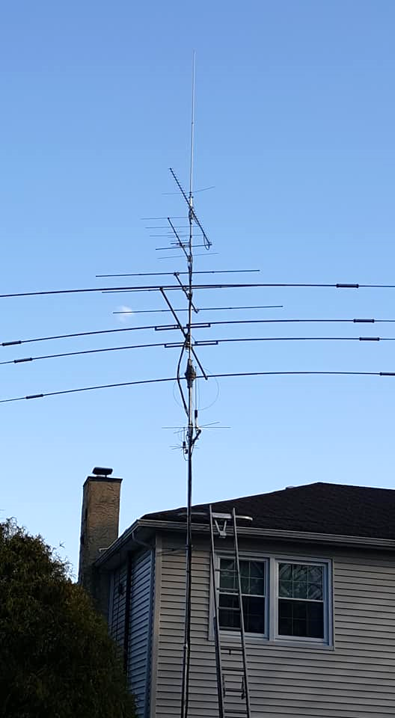
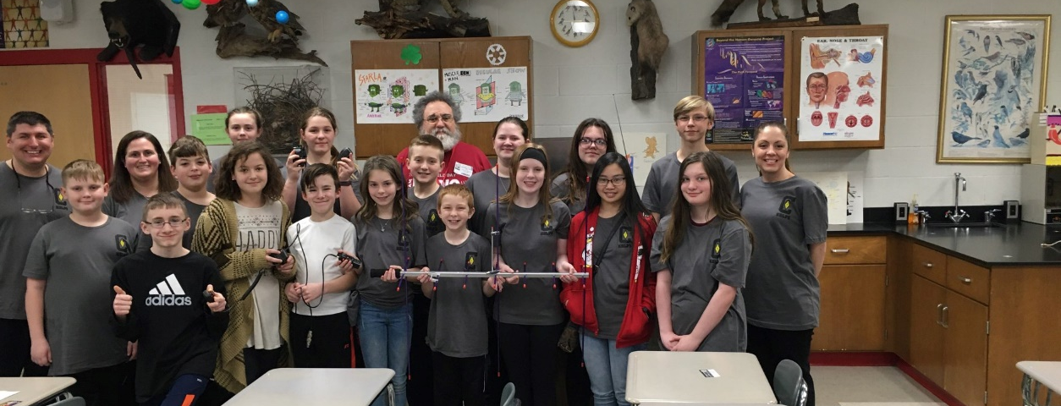
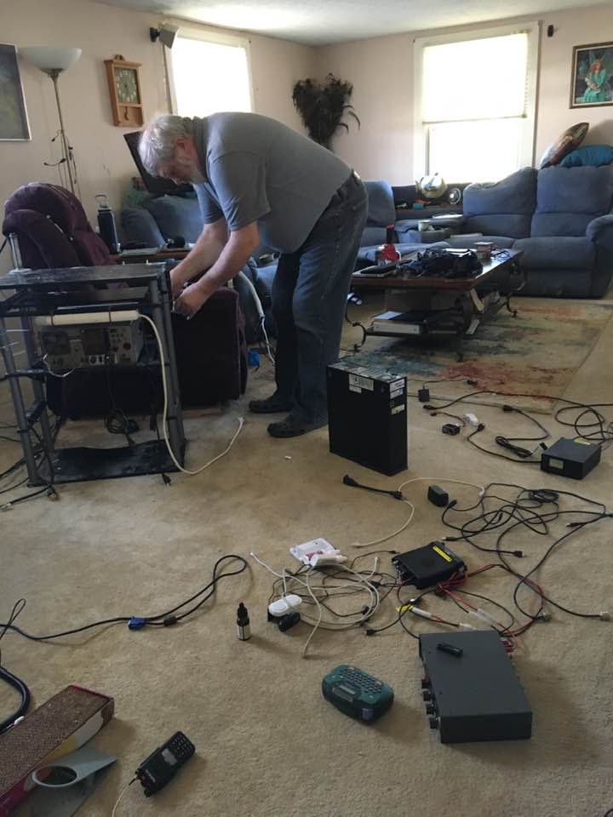

National News
(from arrl and other sources)

Foundation for Amateur Radio Invites 2020 – 2021 Academic Year Scholarship Applications

The Foundation for Amateur Radio Inc. (FAR) has invited applications for the 2020 – 2021 academic year for the scholarships it administers. Applications must be submitted via the online form. Several questions ask for essay responses. The deadline for initial submissions is April 30, 2020. Applicants may amend their applications until May 7.

All applicants must hold a valid amateur radio license and be enrolled or accepted for enrollment at an accredited university, college, or technical school. Applicants attending school outside the US must provide a brochure describing the school. Students do not apply for specific scholarships; each application will be considered for all of the scholarships for which the applicant is qualified. QCWA scholarships and the Chichester Memorial Scholarship all require recommendations to be awarded. Data entered onto the application goes directly into an encrypted, password-protected PDF file available only to the review committee. No part of the application is stored online.

More information is available on the FAR website, or contact Dave Prestel, W8AJR, telephone (443) 812-4403.

####

ARRL Foundation Announces Matching Scholarship Grants by Amateur Radio Digital Communications
ARRL Foundation President Dr. David Woolweaver, K5RAV, announced this week that the non-profit Amateur Radio Digital Communications (ARDC) has generously agreed to award a grant to the ARRL Foundation to match the Foundation’s 2020-2021 scholarships on a dollar-for-dollar basis, up to a total of $200,000.

“The ARRL Foundation Board is honored to partner with ARDC to award ARDC’s Amateur Radio Digital Communications’ Brian H. Kantor, WB6CYT, Memorial Scholarship grant for 2020,” Woolweaver said. “These scholarships, made possible by ARDC’s generous contribution, will assist many young amateur radio operators in their pursuit of education at colleges, universities, and graduate schools.”

Last July, ARDC announced it would use the proceeds from its sale of some 4 million unused consecutive AMPRNet internet addresses to fund its operations and to establish a program of grants and scholarships to support communications and networking research — with a strong emphasis on amateur radio. ARDC has said that it intends to award “a total of several million dollars in grants of varied amounts” to qualified beneficiaries, to be used in accordance with ARDC’s mission.

ARDC awarded grants in 2019 and so far in 2020 to several amateur radio-related entities, including a generous award to the Amateur Radio on the International Space Station (ARISS), the Foundation for Amateur Radio scholarship program, the GNU Radio Project, TAPR, and the YASME Foundation.

TOP ^
The ARRL Foundation and ARDC are negotiating the terms of for ARDC’s 2021 – 2022 academic year scholarship awards, which will consist of scholarships separate from those the ARRL Foundation already administers

The winners of the ARRL and matching ARDC scholarship awards for the upcoming school year will be announced in the September issue of QST.

####

Motorola Wins Multimillion Dollar Theft of Trade Secrets Case against Hytera

A jury for the US District Court of the Northern District of Illinois has awarded Motorola Solutions damages of $764.6 million in its theft of trade secrets and copyright infringement lawsuit against Hytera Communications of Shenzhen, China— the maximum Motorola Solutions had sought.

In early 2017 Motorola filed complaints in federal court alleging that Hytera’s digital mobile radio (DMR) products employed techniques and systems that infringed on Motorola Solutions’ patents and trade secrets. Already known for its Land Mobile Radio Service products, Hytera entered the Amateur Radio DMR market in 2016. Its ham products include the Hytera AR482Gi digital mobile radio.

Motorola alleged that proprietary and patented information was taken illegally by three former company engineers who went to work for Hytera, as “part of a deliberate scheme to steal and copy” its technology. The company said it would seek a global injunction to prevent Hytera from trade secret misappropriation and copyright infringement, a Motorola spokesperson said following the verdict.

“Today’s verdicts are a tremendous victory for Motorola Solutions and a clear repudiation of the illegal and anticompetitive tactics employed by Hytera over the last decade,” the company said in a statement.
Motorola said technology features it developed started showing up in Hytera products soon after Hytera began hiring former Motorola engineers in 2008, according to the lawsuit.

The court victory marks Motorola’s fourth legal win against Hytera. In 2018, the US International Trade Commission (ITC) ruled that Hytera had infringed several Motorola patents and issued an exclusion order preventing the importation, distribution, or sale of Hytera products found to be infringing the Motorola patents. Two courts in Germany also ruled that Hytera infringed on Motorola patents and implemented injunctions against those infringing products.

In a statement, Hytera expressed disappointment and disagreement with the verdict. “Hytera believes the verdict is unsupported by the evidence presented at trial. Hytera will appeal the verdict and is prepared for the appeal procedures ahead, which may take multiple years. Hytera maintains its faith that the American justice system will ultimately provide a fair outcome in this matter,” the company said on its website. Hytera went on to say that it has “enhanced its corporate governance and added new policies and procedures related to intellectual property and the onboarding of new employees.” Hytera said it’s “engaged in an ongoing process of removing the affected source code from the products at issue and has been rolling out updated software to the marketplace.”

####

TOP ^
McGan Award
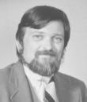
Hello all,

I want to let everyone know that nominations now being accepted for 2020 McGan Silver Antenna Award for excellence in public relations

To recognize and celebrate those efforts, the ARRL Public Relations Committee solicits nominations for the Philip J. McGan Memorial Silver Antenna Award, which is presented annually to an amateur radio operator who has demonstrated success in his or her public relations efforts on behalf of amateur radio and who best exemplifies the volunteer spirit of Philip McGan.

McGan, WA2MBQ (SK), a journalist himself, was the first chairman of the ARRL’s Public Relations Committee, which helped reinvigorate the League’s commitment to public relations. To honor McGan, members of the New Hampshire Amateur Radio Association joined with the ARRL Board of Directors to establish an award that would pay lasting tribute to the important contributions he made on behalf of Amateur Radio.

Public relations activities for which the McGan Award is presented include efforts specifically directed at bringing amateur radio to the media’s and the public’s attention in a positive light. This may include traditional methods, like sending out news releases or arranging interviews, or via less-traditional methods, such as hosting a radio show or being an active public speaker.

The ARRL Board of Directors will choose the award winner at its July 2020 meeting, based on recommendations from the ARRL Public Relations Committee, which has responsibility for reviewing the nominations and accompanying submitted material.

To be eligible, a nominee must be a full ARRL member in good standing at the time of nomination. The award is given only to an individual, and a nominee may not be a current ARRL officer, director, vice director or paid staff member, or a member of the ARRL Public Relations Committee. A nominee must not be compensated for any public relations work involving amateur radio (including payment for articles).

A nominee’s efforts must fit the definition of public relations. Also, the McGan Award is for promotion of amateur radio to the non-amateur radio community.

Nominations must be received at ARRL HQ in Newington by the close of business on Friday, May 15, 2020. Nominations must be on an official entry form, which can be found and downloaded from this web page (http://www.arrl.org/phil-mcgan-award) in pdf format. Anyone may make a nomination.

Thank you for helping us recognize those who are doing great work to publicize the important role that amateur radio plays in our communities.

Dave N1RSN

David Isgur, N1RSN – Media and Communications Manager

####

TOP ^
Henry Radio Los Angeles Founder Ted Henry, W6UOU, is 100
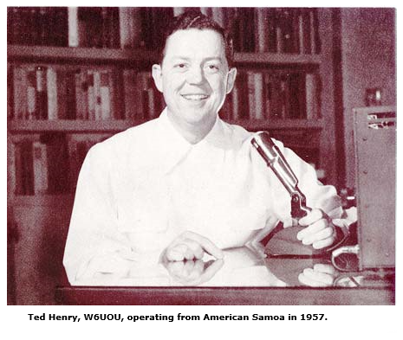
Henry Radio Los Angeles founder Ted Henry, W6UOU, turned 100 years old on January 25. The fascinating Henry family history in amateur radio marketing and manufacturing dates back to the late 1920s.

The original Henry Radio shop, started by Ted’s brother Bob Henry, W0ARA, opened in 1927 in their hometown of Butler, Missouri, selling equipment and parts for the then-new ham radio hobby. The store stayed in business until Bob Henry died in 1985. Henry Radio Stores advertisements in ham radio magazines were a familiar sight in the post-war years.

Ted and another brother, Walt, later W6ZN, worked with Bob Henry during the early years and became fascinated with ham radio. After Ted moved to Los Angeles in 1941, he opened a small radio shop on Westwood Boulevard, which he operated while attending college at UCLA with the intention of going into teaching. His shop survived the suspension of amateur radio during World War II by purchasing gear from hams and reselling it to MARS stations around the world, and by manufacturing crystals (in Butler and Los Angeles) for Hallicrafters’ war production.

Ted and his wife Meredith, W6WNE, ran the LA store, which grew quickly after the war, expanding to a new location on West Olympic Boulevard, where it operated for nearly 35 years, becoming a gathering spot for hams visiting from around the world.

Walt Henry opened a Henry Radio branch in Anaheim, California, in the 1960s, which closed in 1990, after his health declined.

In 1962, Ted Henry saw the opportunity to supply tube-type power amplifiers for the ham radio market and began manufacturing the original Henry 2K. The plant was so successful that Henry expanded into the industrial RF equipment sector. In the 1970s, the company developed its own line of solid-state amplifiers, which it still manufactures for various services. From 1962 until 2005, Henry Radio built approximately 40,000 assorted amplifiers and industrial power generators before closing down the factory in 2005.

Henry Radio also became the first Kenwood dealer in the US and marketed the Tempo line of ham gear. The store opened its current facility in 1981 on South Bundy Drive in Los Angeles. Henry Radio is the oldest dealer for the Bird line of RF test equipment, imports Tohtsu coaxial relays from Japan, and manages a trunked radio system, in addition to marketing radio accessories and specialized RF parts and equipment.

Ted and Meredith’s son, also Ted, W6YEY, took over day-to-day operation of the business in 1971. The elder Henry retired from the business in 2005. Many of the popular line of HF amplifiers remain in use today. — Thanks to Marty Woll, N6VI; Henry Radio

####

TOP ^
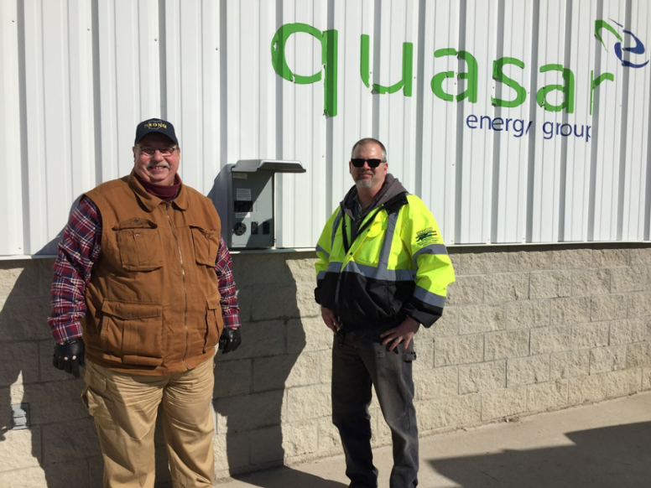
FOR IMMEDIATE RELEASE

February 25, 2020

Contact: Fred Pieper fredpiep@bright.net,
President, Paulding County Ohio Amateur Radio Club

First in the Nation Emergency Communications Power Panel

PAULDING COUNTY, OHIO -- The Paulding County Ohio Amateur Radio Club in conjunction with Haviland Drainage Products now has an emergency communications power panel. The panel will be able to provide power even when the electric grid is down.
Fred Pieper and Bruce Weidenhamer check out the emergency power panel at the digester at Haviland Drainage Products

The power panel was installed at the digester at Haviland Drainage Products. The digester operates independent of the grid and will be able to provide power for an extended period of time even when the grid is offline.

The radio club was gifted a recreational trailer which they are converting into an emergency communications trailer. The trailer when finished will be able to provide potential lifesaving communications to the proper authorities when conventional means of communication are not available.

Radio club members refine their skills regularly and can play a quiet but significant role during an emergency. Most counties have amateur radio clubs. According to Fred Pieper, club president, “Although club members view their involvement as a hobby (they reach out and talk to fellow amateur radio operators from their community, around the state, nation and internationally), most are also available upon request to provide communication services during emergencies and at community events.”

Amateur radio clubs have partnerships with such agencies as the American Red Cross, National Hurricane Center, National Volunteer Organizations Active in Disaster, Department of Homeland Security Citizen Corps, Salvation Army and Civil Air Patrol and the National Weather Service.

For more information about this project or Amateur Radio, email Fred Pieper at fredpiep@bright.net.

####

FCC Proposes Fines on 4 Carriers for Allegedly Selling Customer Location Data
(From Radioreference, submitted by Gregory Drezdzon, WD9FTZ)
The Federal Communication Commission proposed fines against the nation’s four largest wireless carriers for apparently selling access to their customers’ location information without taking reasonable measures to protect against unauthorized access to that information. T-Mobile faces a proposed fine of more than $91 million, AT&T faces a proposed fine of more than $57 million, Verizon’s proposed fine is more than $48 million and Sprint’s fine is more than $12 million.

TOP ^
The size of the proposed fines for the four carriers differs based on the length of time each apparently continued to sell access to its customer location information without reasonable safeguards and the number of entities to which each carrier continued to sell such access.

The FCC also admonished these carriers for apparently disclosing their customers’ location information, without their authorization, to a third party. The carriers can respond to the fines.

The FCC’s Enforcement Bureau opened the investigation following public reports that a Missouri Sheriff, Cory Hutcheson, used a “location-finding service” operated by Securus, a provider of communications services to correctional facilities, to access the location information of the wireless carriers’ customers without their consent between 2014 and 2017.

In some cases, Hutcheson provided Securus with irrelevant documents such as his health insurance policy, his auto insurance policy, and pages from sheriff training manuals as evidence of his authorization to access wireless customer location data.

“American consumers take their wireless phones with them wherever they go,” said FCC Chairman Ajit Pai. “And information about a wireless customer’s location is highly personal and sensitive.

The FCC has long had clear rules on the books requiring all phone companies to protect their customers’ personal information.

Since 2007, these companies have been on notice that they must take reasonable precautions to safeguard this data and that the FCC will take strong enforcement action if they don’t. Today, we do just that. This FCC will not tolerate phone companies putting Americans’ privacy at risk.”

The Communications Act requires telecommunications carriers to protect the confidentiality of certain customer data related to the provision of telecommunications service, including location information.

FCC rules make clear that carriers must take reasonable measures to discover and protect against attempts to gain unauthorized access to this data. The rules also require that carriers or those acting on their behalf generally must obtain affirmative, express consent from a customer before using, disclosing, or allowing access to this data. And carriers are liable for the actions of those acting on their behalf.

All four carriers sold access to their customers’ location information to “aggregators,” who then resold access to such information to third-party location-based service providers such as Securus.

Although their exact practices varied, each carrier relied heavily on contract-based assurances that the location-based services providers acting on the carriers’ behalf would obtain consent from the wireless carrier’s customer before accessing that customer’s location information.

Hutcheson’s unauthorized access of hundreds of wireless customers’ location information made clear that the carriers’ existing measures to safeguard this data were inadequate.

Yet, all four carriers apparently continued to sell access to their customers’ location information without putting in place reasonable safeguards to ensure that the dozens of location-based services providers acting on their behalf were actually obtaining consumer consent.

TOP ^
Although the carriers had several commonsense options to impose reasonable safeguards, such as verifying consent directly with customers via text message or app, the carriers apparently failed to take the reasonable steps needed to protect customers from unreasonable risk of unauthorized disclosure.

The proposed actions, called notices of apparent liability (NALs) for forfeiture and admonishment, contain allegations that advise the parties on how they have apparently violated the law and set forth a proposed monetary penalty.

Neither the allegations nor the proposed sanctions in the NALs are final FCC actions. The parties will be given an opportunity to respond, and the commission will consider the parties’ evidence and legal arguments before taking further action to resolve these matters. The commission may not impose a greater monetary penalty than the amount proposed in the NAL in its final resolution of whether the parties have violated the law.

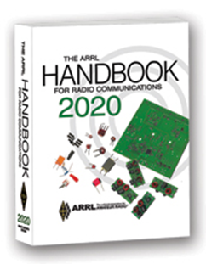
The Handbook Give Away

Hey Gang,

The “Handbook Giveaway” drawing will soon be returning for another big “Give Away”

Many of you ask me just how do I know when the drawing is on? Well, that’s easy all you need to do is check in on the Ohio Section Website on a regular basis and watch for the big RED Arrow that will appear on the left side of the page. This is the sign that the drawing is on and you need to get registered. So, keep a sharp eye out on the website and check in often! http://arrl-ohio.org

What’s the catch? I want to get everyone checking in to the Ohio Section website as often as possible, and in order to register each month, you have to visit the website often! There’s nothing else to it. I pay all expenses, and from time to time, I Give Away more than just a Handbook. And, you’ll never know just what months will be those special times that I will have more than just a Handbook to Give Away!!

Club Corner

This is YOUR cornner of the newsletter. Send me what your club is doing and I’ll make sure that it gets in. Got a special event or club project that you want everyone to know about? Send it to me!. Need help with a project? Send it to me.

Let me know what you club is up to. Are you going to have a special guest at your meeting or are you having a special anniversary? Just sent it to: n8sy@n8sy.com

####

TOP ^
Mahoning Valley ARA to hold Two-Meter Contest

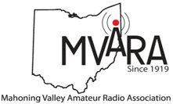
The MVARA is excited to announce the Mahoning Valley Two Meter Contest Saturday March 21, 2020 from 7:00 to 10:00 pm. We thought it would be fun to see if valley hams would enjoy shaking off the winter doldrums by getting on the air for a local contest. It will be an opportunity to talk to old friends and make new ones.

Old timers may remember participating in the Lou Malice Memorial Contest years ago. The MV 2 Meter Contest will be a similar two-meter simplex contest. Stations will simply exchange grid squares as defined in the contest rules. The contest format will allow participants to evaluate their stations simplex capabilities.

This information could be valuable in an emergency. No 100-watt base station, no problem. There will be a low power category of 5 watts or less and a high-power category of greater than 5 watts so everyone will have a level playing field. Awards will be given for the highest scoring Low Power Home, High Power Home, Low Power Rover, and High-Power Rover stations at the June 11, 2020 MVARA meeting.

For contest rules and a list of rover stations and the grids they plan to activate go to www.mvara.org/Mv2mc.html

This year the contest will be dedicated to the memory of pioneer Valley ham Lou Malice WA8PKN whose dedication to amateur radio touched the lives of all of us. Even if you never had the pleasure of knowing Lou you are still part of his legacy. Chances are good that the hams who inspired and encouraged you to become part of amateur radio were, themselves, inspired, encouraged, and trained by Lou.

We hope to hear you on the air! Scott Wilton KE4UHC – President

####

Ohio’s Portsmouth Agencies Join FirstNet
(Radioreference, submitted by Gregory Drezdzon, WD9FTZ)

The Portsmouth (Ohio) Police and Fire Departments are connecting their first responders to the First Responder Network Authority (FirstNet) communications network for public safety. The departments are using FirstNet on modems and department-issued smartphones.

“With FirstNet, our officers can respond more efficiently and effectively,” said Acting Portsmouth Police Chief Debra Brewer. “From crisis situations like a standoff with an armed suspect to supporting citizen safety during large events, we are now able to better serve the Portsmouth community.”

“FirstNet helps us stay connected to the critical information we need,” said Portsmouth Fire Chief William V. Raison.

####

TOP ^
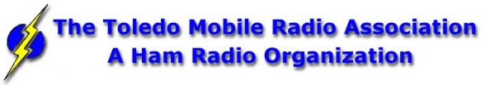
New Ham Info Class -
(Hosted by Toledo Mobile Radio Association )

Relaxed Learning Session: I'm new to Amateur Radio! Now what?!

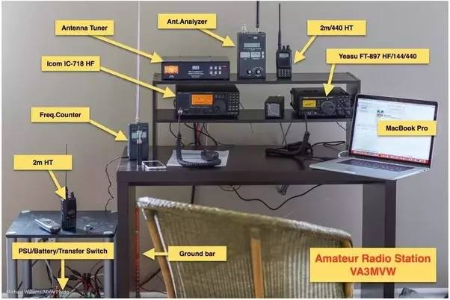
Join Toledo Mobile Radio Association Members at the Lucas County EMS Training Center Apr 18th, 9am-2pm for a FREE learning and Q&A session that should work to help you get started with some of the practical items that we all wish we knew when starting off in Ham Radio. Any/everyone is welcome, and you do not have to have attended the class to attend. Most hams licensed less than 3 years will find the session useful.
This session will be run as a "class", but is open to ANY questions along the way. Folks are free to come and go as you wish. This training session is a great place to get to know TMRA members and for newer amateur radio operators to ask questions related to items they are concerned about or need help with. We know that this hobby has a lot of new items for everyone to get familiar with, so this is an attempt to short-cut that learning!
We'll discuss and help new hams resolve some of the typical early ham radio challenges including (but not limited to) the following types of discussion items (no specific order);
1. Answer any early questions and discuss list of items that we all have soon after becoming a ham. (and worries that we each had)
2. Discuss Hand-held and mobile radio types / drawbacks and benefits. Who can help me program it? How can I make my HT more effective?
3. What is needed to setup and use a mobile or "base" radio - in car or in home (and benefits and types).
4. Discuss Effective Radiated Power in terms of Antenna benefits - Discuss types of antennas indoor/outdoor options (and why). Horizontal vs. Vertical antennas.
5. Types of feedline (we often refer to "coax) and what you will need (and for what) - and where to find it.
6. VHF/UHF vs HF - Who can I talk to and when?
7. Discuss using local Repeaters, internet linked repeaters, PL Tones, (repeaterbook/radio reference),
8 . Discuss Simplex vs Repeater typical etiquette (just so you know) - Examples: Q signals, calling CQ, breaks
9. First Contacts – what to expect (most important, you won't be judged so don't "sweat it".... really...)
10. Hamfests + Ham Conventions - Why bother?
11. Where should I buy equipment and what are the risks?
12. Useful websites
13. Foxhunting and Satellites - how/where?
14. Where to find manuals and information?
15. If there is time: Antenna Analyzers and SWR Meters - what are they and when do I need one?
16. If there is time: N vs PL-259, vs SMA, versus BNC connectors
17. Benefits of joining organizations/clubs
18. Foxhunts - what are they and how does it work? Do I need anything?
19. HF - club events (what can I participate with?) - Operating events.
TOP ^
20. Callsigns, vanity and considerations
21. QSL Cards and Logbook of the World
22. Propagation - Tropo ducting, Sporatic E, Aurora, sunspot cycle, seasonal patterns
We look forward to seeing you there!

####

Technician License Classes Scheduled in Newark
Classes are being hosted and sponsored by: Earl, W8BR, in conjunction with, Newark Amateur Radio Association and the American Red Cross - East & South-Central Ohio Chapter

Place: 143 S. 30th St., Newark, Ohio 43055 https://goo.gl/maps/CSbgxAbaU322
Dates: Saturday, March 14; March 21; March 28; April 4; April 11. Saturday, April 18 will be the exam.

Time: 9:00 AM to 12:00 PM (No lunch break)

Registration: Students must register in advance with Mr. Earl Paazig, email@paazig.net or by phone at 740-828-1057 or 740-504-1950. Registrations may be limited.

Cost to participants: The course is free however participants must provide and come prepared with writing and note-taking materials. This will be a fast-paced course. You won’t want to miss a note. Students will be required to download and print a free copy of the Study Guide available at: https://paazig.net/owncloud/index.php/s/wT13jVN4zm1BTOP/download

Optionally, the participants would be encouraged to purchase a book costing $32.95 plus shipping. http://www.arrl.org/shop/Ham-Radio-License-Manual/?page=1

####

Licking County Storm Spotter Training

Wednesday April 15th at the Pataskala Police Department – 623 West Broad Street

####

Geauga Amateur Radio Association Putting On Technician Classes

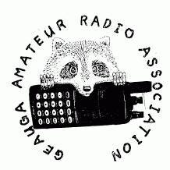
GARA's technician class will be held at the Geauga County Emergency Operations Center in Chardon, every Thursday at 6:30PM from April 2 through May 7.

We'll have an exam session the following Sunday while the material is still fresh, and the exam is free of charge.

For more information and to sign up, please go to https://geaugaara.org/classes/technician.

####

TOP ^
Pan Ohio Hope Ride Heroes of Hope! SAG Support

The American Cancer Society will be hosting a ride in Columbus Ohio. Heroes of Hope is a single-day, family-friendly event that will give families and casual cyclists the opportunity to join the Pan Ohio Hope Ride community in support of vital American Cancer Society research, programs, and patient services.

To volunteer to provide SAG support for this event, please: sign up here

When: Sunday, April 26, 2020
Where: Scioto Audubon Metro Park, Columbus, OH

Details:
• Family-friendly trail routes ranging from 3-15 miles (all ages welcome)
• Fully-supported, scenic road routes of approximately 32.8 and 62 miles (18+ only)
• Post-ride celebration with food and fun for all ages
• Inspiration from some Heroes of Hope in the fight against cancer - researchers, patient navigators, and survivors
• Costume and bike decorating contests for kids and adults
• After party at local family-friendly brewery

####

Skywarn Net Control Training March Meeting

In case you missed it at the February meeting, there was some interest in having GEARS organize a Skywarn program in the county.

Skywarn is a program of the National Weather Service that uses amateur radio as one component, and to that end, GEARS will be a participant. Our job is to get accurate and high-quality reports to NWS in a timely fashion during severe weather situations.

At the March GEARS meeting (March 11 at 7:00PM), I will present a training program designed to help us learn how to run high-quality Skywarn nets. We'll discuss the general structure of the amateur radio portion of the Skywarn program and then get into the details of running and participating in nets.

I have secured permission from Eric KF8YK to use any of his repeaters in the county (146.94, 444.225, 444.8125, 444.5625) for Skywarn. We'll have a comms plan soon. He's also offered to install a weather alerting system on 94 for us when he finds time.

Note that this will not be the same as Skywarn spotter training from the National Weather Service. As I am not a meteorologist, I am not qualified to train you on actual weather spotting. This is specific training for amateur radio operators who wish to participate in Skywarn nets. There will be no Skywarn spotter training from NWS this year.

Starting with the GEARS net this Monday, March 2nd, we will have an additional portion of the net with Skywarn information. This training is in the new version of the net script that will be sent out, and we'll include this section from the beginning of March through the end of October.

TOP ^
I am aware that there has previously been a Skywarn group in the county, and we will ensure we do not interfere with them.

See you on the 11th! - Dave/AD8G

####

Cleveland Marathon

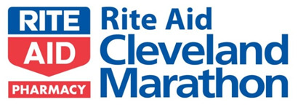
As always, we are looking for a lot of help for the Cleveland Marathon May 16 and 17. Yes, it's unfortunately on Hamvention weekend as usual and no, they aren't going to change the date of the marathon just because of that (yes people have suggested that. Seriously)

We normally need about 10 people to work the 5k on Saturday ending about noon and about 40 to work the actual Marathon on Sunday ending about 3p. If you are available to help, please sign up. If you need to leave early, that usually is not a problem so please don't be afraid to ask. Please sign up here.

####

Maker Faire Coming
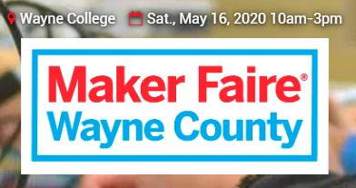
Saturday, May 16, 2020 from 10 a.m.-3 p.m.

The University of Akron Wayne College
1901 Smucker Road
Orrville, OH 44667

>> Click Here << for more information

####

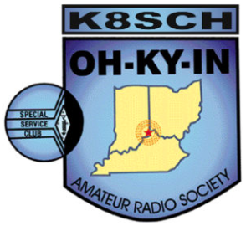
OH-KY-IN Classes and Exams

OH-KY-IN is proud to host class and exam sessions for Tech, General and Extra level amateur radio licenses. Please note, our classes are free, but you will be required to purchase your own copy of the approved study guide to bring to the first class.

Class | Dates | Location
Technician | Five consecutive Monday evenings starting April 6th, 2020 and running through May 4th from 7:00 PM to 9:00 PM. | American Red Cross - 2111 Dana Ave, Cincinnati, OH 45207

TOP ^

General | Five consecutive Monday evenings starting April 6th, 2020 and running through May 4th from 7:00 PM to 9:00 PM. | American Red Cross - 2111 Dana Ave, Cincinnati, OH 45207
Extra | Five consecutive Monday evenings starting March 2nd, 2020 and running through May 4th from 7:00 PM to 9:00 PM. | Hamilton County Communications Center 2377 Civic Center Dr, Cincinnati, OH 45231

Exam Session
- What – OH-KY-IN is holding an amateur radio licensing exam session.

- When – Saturday May 9th , 9:00 AM

- Where – American Red Cross – 2111 Dana Ave, Cincinnati, OH 45207.

- Who – Anyone can take the exam; taking the OH-KY-IN class is not required.

- How – Please refer to the following link for what to bring to an ARRL exam session: http://www.arrl.org/what-to-bring-to-an-exam-session. The current exam fee is $15.

For all questions or to sign up for a class, please email Mike/KD8ZLB

####

General License Classes Being Offered

The Franklin County Ohio Amateur Radio Emergency Service group will offer classes to achieve a General Class license. Classes will be held at the Whitehall Branch public library at 4445 E. Broad Street, Whitehall, OH. Plenty of parking is available.

Classes begin April 23 through May 21, Thursdays from 6 to 8:30 PM. This is a no cost course of study. Your only cost will be for a study guide and testing fee, depending on which organization you choose to test with.
You do not need to be a member of the FCOHARES to participate.

Course registration is required. Each student should acquire a study guide to begin familiarization with the material prior to starting the class. Although this is a mid-level technology course, no advanced level math is involved. Some demonstrations will be presented during classes.

As this is an upgrade class, everyone should be a Technician class license holder. We will use the ARRL General 2019 – 2023 study guide. Start studying because we will hit the ground running come April 23rd.
Pre-registration is required. Send email to John Buck at kd8rtp@arrl.net. Please include name, email address, phone/text number.

I hope you can join us. Classes will be limited to 13 students due to room capacity, thus the need for pre-registration.

TOP ^

Upcoming Hamfests for 2020
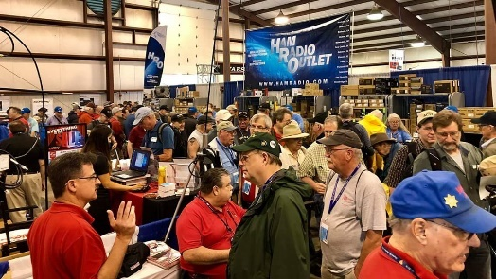
03/14-15/2020 | Toledo Hamfest,
ARRL Great Lakes Division Convention
Location: Perrysburg, OH
Sponsor: Toledo Mobile Radio Association
Website: http://www.toledoglc.org/

03/21/2020 | Mid-Ohio Valley ARC Hamfest
Location: Gallipolis, OH
Sponsor: Mid-Ohio Valley Amateur Radio Club, Inc.
Website: http://sites.google.com/site/midohiovalleyarc/

04/11/2020 | 66th Annual Cuyahoga Falls Amateur Radio Club Hamfest
Location: Cuyahoga Falls, OH
Sponsor: Cuyahoga Falls Amateur Radio Club, Inc.
Website: http://www.cfarc.org/hamfest.php

04/18/2020 | Portsmouth Radio Club Hamfest
Location: Portsmouth , OH
Sponsor: Portsmouth Radio Club
Website: http://portsmouthradioclub.com

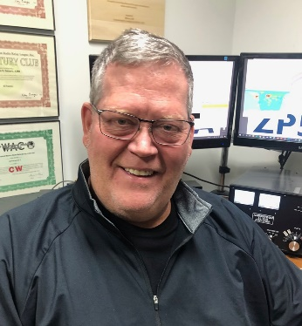
DX This Week
(from Bill, AJ8B)

DX This Week – DX Year in Review
Bill AJ8B (aj8b@arrl.net, @AJ8B, or www.aj8b.com)
CWOPs Member #1567

Alaska, Albania, Austria, Bahamas, Belarus, Belgium, Bulgaria, Canary Islands, Cayman Islands, Crete, Croatia, Cyprus, Czech Republic, Egypt, England, European Russia, Fed. Rep. of Germany, France, Greece, Guernsey, Haiti, Honduras, Hungary, Indonesia, Isle of Man, Italy, Jamaica, Japan, Jordan, Kenya, Liechtenstein, Lithuania, Mali, Malta, Montenegro, Netherlands, Philippines, Poland, Puerto Rico, Romania, San Marino, Sicily, Slovenia, South Africa, South Orkney Islands, Switzerland, Taiwan, Thailand, and Trinidad & Tobago were spotted from the Midwest in the past week. Did you work any of these or at least VP8?

The Mailman delivered cards from S53O – Slovenia, JA8ECS – Japan, 5T5PA – Mauritania, and V51MA - Namibia (Pictured).

TOP ^
The card from S53O was particularly interesting. I worked Ljubo on 2/21/15, mailed a direct QSL card on 3/15/2015, and received my reply this week on 2/25/2020. Almost 5 years to the day! I really appreciate LoTW at times like this!

This edition is a bit longer than normal and thanks to Scott, N8SY, for allowing me a bit more space this week!

Every January, Joe Reisert, W1JR, compiles a review of the previous years’ DX “scene” for the Daily DX. This year, Bernie, W3UR, the editor of the Daily DX, has given us exclusive permission to reprint this review. This is a comprehensive review that is very interesting and only available to Daily DX and Weekly DX subscribers.

However, Bernie has agreed to allow me to reprint it here and in the SWODXA Newsletter. If you have a second, please send Bernie a thank you email for supporting DX activities like this. (bernie@dailydx.com)
First, we need to take at upcoming contests and DXpeditions - shown below.

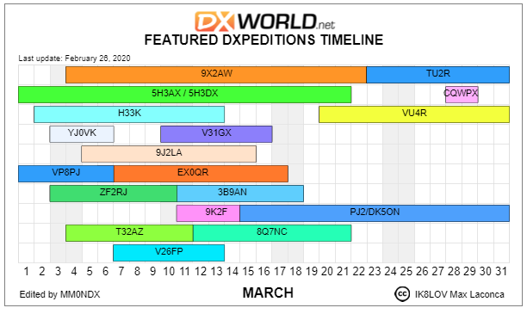

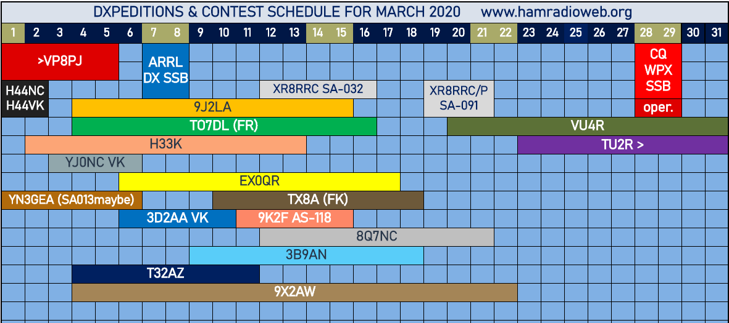

TOP ^
2019 Overview: This was another difficult year for DXers. As we approach Solar Minimum, radio propagation is poor at best especially on the higher HF bands. Only two of the 20 “Most Wanted Entities” were activated and those operations were by single ops. There were approximately 283 entities activated, five less than in 2018. There were at least a dozen large scale DXpeditions for the Deserving. A major DXpedition to Bouvet I. (3Y0I) failed to land.
2019 in Review: Activity overall was down on SSB and CW since it is now being shared in a big way with the weak signal digital modes. Despite the radio conditions, activity as usual was good from the Caribbean and Africa.

The cost to stage or finance a DXpedition is increasing as is the difficulty to activate the rarer entities. See “Who Pays for that New One,” QST, October 2018, pg. 69. Participant’s often have to share at least 50% of the total cost and hope for donations to cover the rest of the trip.

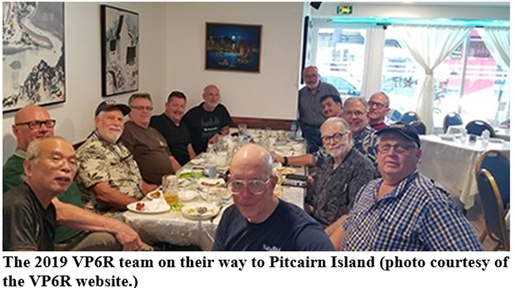
The 3Y0I DXpedition to Bouvet Island ran into problems with the ship as they approached within about 70 miles (125 km) of the island and they had to return to ZS-Land. Several other DXpeditions also encountered difficulties which either limited operations or made their life miserable.

Antennas blew down, torrential rain and mud along with an operator severely injured in a fall who had to be shipped out (VP6R), gear impounded (J20DX and 3D2VR), security problems and gear stolen (P29VCX), needed an armored car (6O7O), wire and antennas stolen (D44TWO) were just a few of the problems encountered to provide a new entity to the Deserving. Sometimes these difficulties impacted the number of contacts that were made, or the bands used. Remember these sacrifices before complaining in the comfort of your radio room!

One final comment on DXpeditions. Ralph, K0IR has recently reminded us that it’s very important to leave the visited areas in good condition and to be friendly with the locals. Some prior DXpeditions behavior has hampered some future operations. This is not good.

Radio Propagation: Sunspot numbers are way down, sometimes there are none for several weeks. Solar flux has been near minimum all year. Some low banders are experiencing better conditions.

There are all kinds of speculation by many forecasters as to when Solar Cycle (SC) 24 will end and SC 25 will start. Some say we’re heading for another Maunder Minimum.

TOP ^
Others say SC 25 will be like SC 24. It seems like every month or so there is another expert making a prediction of the future of SC 25. The latest report from NASA says that solar minimum will occur in April 2020 (+/- 6 months), SC 25 will be like SC 24 and peak in 2025. I will take a wait and see position.

Club Log: This website/service (www.clublog.org) is becoming very popular with DXers and DXpeditions. This is Club Log’s 12th year under the direction of Michael, G7VJR. It provides a logging site which is easily accessed and has over 610 million QSO records. When DXpeditions have internet service, they often upload their log daily. This allows DXers to check the DX log, see if they are in the log and hence prevent wasteful duplicate QSOs on the same band/mode.

Another service provided by Club Log is OQRS (Online QSL Request Service). Also, the DXCC Most Wanted List. This service shows the rarity of each DXCC entity based on its large data base. At the end of December 2019, the 10 DXCC entities in order of rarity are: P5, 3Y/B, FT5/W, BS7H, CE0X, BV9P, KH7K, KH3, 3Y0/P and FT5/X. 2019 saw no operations in the top 10. There was some individual FT8 and CW operations by VK0AI (Mac.) and SV2RSG/A (Mt. Athos) respectively in the top 20. However, many semi-rare entities were activated during the year as will be seen later.
Digital Operations: Most of the larger DXpeditions (3 or more operators) activated in 2019 were available on SSB, CW and digital modes. The new digital modes, FT8 introduced in July 2017, FT8 F/H (fox and hound) and FT4 in 2019 are game changers. They are a big advancement in the state of the art of weak signal detection making digital contacts in 1 minute or less possible versus the slower JT65 mode. Now many small less equipped stations can make contacts when the bands seem closed! Many stations have already worked over 200 and some over 250 entities on FT8. This new mode is probably the biggest innovation to DX communication since SSB became popular around 1958.

Band by Band Activity:
160 Meters: Activity was rather low except during DXpeditions and contests. Most DXpeditions use 160 meters typically between 1820 and 1830. FT8 activity is growing around 1840. Try to avoid frequencies divisible by 5 (e.g. 1820, 1825, 1830 etc.) since broadcast birdies are often there.

75/80 Meters: Activity has increased slightly especially during winter months. DXpeditions usually operate here either at the low end or around 3523 and around 3780-3800 on SSB. FT8 activity is increasing around 3574.

60 Meters: Many more entities have now received permission to operate on this band albeit they are often limited to 15 Watts and a dipole antenna. Most DX activity is now concentrated on the third channel around 5357 and almost entirely on the FT8 mode. Over 200 DXCC entities have been active on the band. FCC is still looking at non-channelized operation near channel 3. The ARRL DXCC program still does not recognize 60-meter contacts.

40 Meters: The Deserving are often active on CW on the bottom of the band especially during darkness hours and during contests. DXpeditions usually operate at the bottom of the band or around 7023. Much activity has now moved to the digital modes, especially FT8 around 7074. SSB is mostly above 7100. Remember that USA stations cannot operate SSB below 7.125 MHz but best to stay above 7.128 for safety. Most of the world can now operate from 7000-7200.

TOP ^
30 Meters: 30 meters is becoming more popular especially with DXpeditions and low power stations. The new FT8 mode as well as other digital modes are usually found between 10.135-10.150 MHz 30 M is sometimes open 24 hours a day during the darker months. Remember that USA stations are limited to 200 Watts output power.

20 Meters: 20 meters continues to be the go-to band especially during daylight although some of the activity has moved to the digital modes between 14070-14090. SSB activity is still high. DXpeditions often operate CW near 14023 and SSB near 14195.

10-17 meters: 17 meters is often as good and useable as 20 meters since QRM is lower and more competitive. Much digital activity stays around 18095-18110. 15 meters is becoming less reliable as sunspots decrease although DX contests and DXpeditions still give it a try. 12 meters is very quiet except for some digital activity around 24915. 10 meters is likewise with some digital around 28074 if the band is open. Poor conditions on 15 meters and especially 12 and 10 meters has made it tough on DXpeditions. Summertime often yields QSOs but usually from sporadic E propagation.

6 Meters: Nowadays this band relies mainly on sporadic E during May through August and various meteor showers. Most of the activity is now digital between 50250 and 50350.
2019 Month by Month DX Activity Sample:

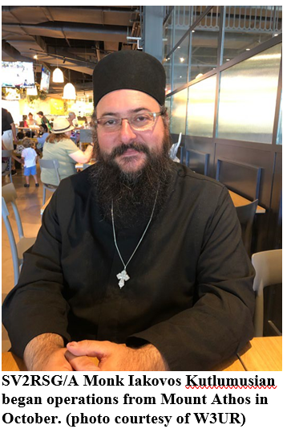
January: This year it was a real tough month propagation wise especially on the upper HF bands and long DX paths. Despite this, at least 219 entities were active, a few less than 2018. Some notable rare to semi-rare stations active included: S01WS, 9G2HO and 9Q6BB (all three active all year on all bands and modes), YJ, S7, TZ, 9L, XZ, HC8, HK0A, TY, 5A and VK0 (Mac.).

February: 5T, V84SAA (58K Q), XX9D (36K), FH, T31EU (39K), T2, A5A and 9U4RI (1.9K).

March: T32, HC8, XR0ZRC (37K), 5V7EI (30K), J5 and YJ. The big disappointment was extreme weather that caused shipboard failures which prevented activating 3Y0I on Bouvet I.

April: VK9N (9.4K), JX7GIA (650 Q), VK9X, XT and OJ0.

May: FW and E31A (37K).
June: 3D2CR (33.8K but 66% FT8), 4W, T2 (4.7K) and XW.

July: E44WE, 1A0C (38K), TX2A (FO/A 25K) and CY9C (25K).

August: VK9APX (LHI), H44, TT8 and TO5M (FP 20K).

September: T6AA, T30L (13.6K), 9U3TMM (4K), 7Q7M, 6O7D (8.5K), C21WW (27K), ZK3A (52.5K) and A82X (EL 46K).
October: Was a very active month especially with DXpeditions. Active were T30GC, ZK3A (52.5K), TT8SN, HK0A, FH, VK9N, VP6R (82.7K), D68, CY0, SV2RSG/A, VU7RI (3.4K) and TO8OSP (FP 35K).

TOP ^
November: 4U1UN returned to the air thanks to the efforts of Adrian, KO8SCA. Also active were H40TT, FW, 5U9AMO, TX7T (FO/M), SV2RSG/A and VK9CZ

December: This was designated YOTA (Youngsters on the Air) month with many stations using call signs with YOTA in same plus several USA stations using 1X1 callsigns. Give them a call and encourage them to join the DX community. A50BOC and A5B as well as 3D2AG/P (Rot.) and SV2RSG/A were active. 9Q6BB was active and finally went QRT after 26.5KQ over several years.
Unauthorized Operations: There were many fake stations including many DXpeditions (before activation). Therefore, DXpeditions are reluctant to give out their call signs before commencing operation for fear that their call sign will be pirated. Some of the pirated call signs during this year included JX7DX, FS5DX, TS4IC, T33T and 9D2DX to name a few. Also a few upcoming DXpeditions such as 3Y0I. WFWL (work first, worry later) still applies but if you know it’s a pirate, don’t waste your time or $$ to support that activity. K9EL often lists pirate call signs on the CQ Magazine Marathon page.

Furthermore, please don’t spot rare DX on the DX Cluster unless you know it’s legit and surely don’t spot rare DX call signs for test purposes. It causes lots of bells to ring worldwide and unnecessary worry. Finally, don’t post rare calls to thank someone for receiving a QSL etc. No one is watching, cares or appreciates this type of boasting.

CTU, CWA and DXU: Let’s not forget Contest University under the direction of Tim, K3LR. It is now in its 13th year having had over 7,500 students in 8 DXCC entities so far. The next session will be held in Dayton in May.

There is CW Academy by CWops, a program to improve CW skills. CWops just celebrated its 10th anniversary. “Improving Your CW” is another Morse Trainer by G4FON. Also, there is DX University at DX oriented conventions.

IOTA: Poor propagation also affected some IOTA (Islands on the Air) DXpeditions to rare IOTAs. This program is arguably the most active DX program after the DXCC. Let’s face it, many of the islands are DX and over 100 DXCC entities are already separate IOTAs. Chasing IOTAs can fill in the gap when an operator has worked all the active DXCC entities and wants to remain active on the bands.

The IOTA program website is www.iota-world.org It is filled with info on the program and the almost 1,200 IOTAs that are available. So far only about 1,135 IOTAs have been activated. At least 43 IOTA chasers have achieved IOTA 1100 level. Several rare activations were K7TRI (NA211), R26RRC (AS204), R205NEW (AS205 ATNO), XR1RRC (SA069), VE3LYC/KL7 (NA150), JX7GIA (EU022), KP3RE (NA249) and K6VVA/KL7 (NA004). Remember that QSLing can now be conducted for some IOTA operations using Club Log.
DX Contesting: DX contests are everywhere using CW, SSB and digital modes. The most popular DX contests are arguably the CQ Magazine SSB and CW and the ARRL CW and SSB DX. However, there are many other DX contests sponsored by organizations around the world. As mentioned above, DXers should help the youth to get involved in contesting, especially DX. Younger operators are showing interest especially since most contests require computer logging.

Contest rates are slowly climbing with new software and more spotting websites despite poorer propagation. Logs are often required online usually within a few days after the contest.

TOP ^
Contests often yield new band countries and modes sometimes even before the contest as stations test out their equipment. The WA7BNM Contest Calendar is a great source of contest activity. The ARRL Contest Update is a monthly newsletter that often has interesting tidbits on operating etc.

Equipment and Technology: New gear is constantly appearing especially from the major radio manufacturers such as Elecraft, ICOM, Kenwood, Yaesu and Flex Radio. Many of these companies are now employing SDR (Software Defined Radio) technology to improve performance. QST and RadCom (RSGB) often publish detailed reports on their performance. Also check out Sherwood Engineering by NC0B www.sherweng.com for info on reciprocal mixing of these radios. Likewise, new antennas, power amplifiers, apparatus as well as software programs are very popular.

Safety: This is a very important part of ham radio, especially with high performance antennas. We all remember Rev. Paul, W0AIH falling to his death from a tower in late 2018. Unfortunately, there were several such accidents this past year. One was right here in NH when a 40-foot un-guyed tower with two hams on top fell over. One person did not survive and the other is still in pretty bad shape. This could have been avoided.

PV8ADI had a similar accident like W0AIH and he did not survive. Also, N3LPJ had a tower collapse and lost his life. These are just a few that we know of. Safety equipment is very important on tower or antenna work. Better yet, have a professional tower crew do the work. K1IR has a video showing “Tower Safety” and is well worth viewing www.maarc.ca/news/tower-safety-video. This reminds us that every tower climber death is preventable.

Strained eyes from tablets, phones and computers are also a problem. A recent paper from Cleveland Clinic gives several suggestions they call the 20/20/20 rule. This includes 20 second breaks every 20 minutes and looking 20 feet away to relax your eyes. Frequent blinking is also recommended.
Ham Radio and the Internet: Nowadays the Internet plays an important part in Ham Radio. Most DX clusters are now on the Internet as well as LOTW (more on this shortly) and Club Log to mention a few. Also, many contests require logs to be submitted via the internet within a few days after the contest.

With the rise of many new communication modes etc. it’s often important when spotting a station on the DX Cluster that is out of the usual band segment to specify the mode in the remarks column such as SSB, CW, FT8, FT8 F/H, FT4 etc. Of course, it is never proper to post foul language etc.

QSLing and DXpedition Costs: QSLing seems to be slowly dying. Postage rates are going out of sight worldwide. DXCC credit via LOTW (Log Book of the World) is very popular with DXers, especially those that don’t want or need to collect QSL cards. Club Log and their OQRS (Online QSL Request Service) are also popular for those who prefer a paper QSL It pays to check a stations QRZ page to see how they prefer to QSL. DXpeditions often send their logs to LOTW after several months.

Recently N2OO has acquired the DXpedition logs of W6KG and W6QL as well as VP2VB.

Operating techniques: This past year was a tough one especially for DXpeditions. A few made almost 50% of their contacts on FT8! CW was right up there too. The RST report on CW is almost always 599! Split frequency operation, a must, is almost always used. Unfortunately, many call right on the DX frequency and hence cause panic!

TOP ^
DQRM (Deliberate QRM) is still a major problem. Calling out of turn or calling continuously is still a big problem. It slows down the pileup so fewer callers get into the log. Tuning up for long periods of time (greater than a few seconds) on a DX station is a big problem. There is always plenty of spectrum to tune up away from the DX operations. Modern rigs usually have antenna tuners so it should only take a few seconds to tune.
Holding down the key is a real problem. If you need to tune up for a long time, keep moving your frequency slightly. It will seldom affect the tuning.

Again, make sure to review the DX Code of Conduct (www.dx-code.org). On CW some DX stations transmit at 30 to even 35 WPM and/or seldom sign their call signs or where they are listening. Some operators just can’t copy their call sign that fast. Some of the problems may be the limitations of code readers especially for newer operators. The old adage still applies: Listen Listen Listen before you start calling.

Try not to rag chew or tie up frequencies frequented by rare DX such as 3.795, 14.025 and 14.195 MHz as well as 14.040 and 14.260 MHz for IOTA. Other suggested frequencies to avoid are listed in “The Daily DX.”

Transmitting on these frequencies will make it difficult for others who are experiencing poorer propagation than you are.

2019 DXCC and ARRL Matters: There were no major changes to the DXCC Rules this year so the active entities stands at 340. However, the rules now prohibit automated contacts.

Rumors in the news media tell us that Bougainville, an autonomous region in Papua New Guinea (P29), has voted to become an independent nation. This could take years to happen before it is added to the active list.

The DXCC yearbook has been published for many years but now it only lists those who submitted DXCC updates during the year. If you want to see the latest DXCC standings, click “on the air” at www.arrl.org/dxcc- standings on the ARRL website for the DXCC standings.

Of course, the ARRL runs LOTW and is constantly updating it. The LOTW now has over one billion QSOs on file. You now can import FT4 QSOs. New publications are scheduled for 2020 which will be primarily aimed at assisting newcomers to the hobby. The ARRL QSL bureau is another service.
And now the Drum Roll: There were approximately fifty-seven (57) entities that are NOT believed to have been active during 2019 as follows: *

Africa (17): 3B6, 3C, 3C0, 3X, 3Y/B, FT/G, FT/J, FT/T, FT/W, FT/X, FT/Z, TL, TN, VK0H, and ZS8.

Antarctica (1): 3Y0 (Peter 1)

Asia (9): 1S, 7O, BS7H, BV9P, EZ, P5, VU4, YK and ZC4.

Europe (1): R1F

North America (7): FJ, FO/C, KP1, KP5, TI9, XF4 and YV0.

Oceania (14): FK/C, KH1, KH3, KH4, KH5, KH7K, KH8/S, KH9, T33, VK9/M, VK9/W, VP6D, ZL8 and ZL9.

TOP ^
South America (8): CE0/X, HK0/M, PY0/S, PY0/T, VP8 (S. GA), VP8 (S. Orkney), VP8 (S. Shetland) and VP8 (S. Sandwich).

(*Please note that some rare entities may not be on this list for 2019 because some operations were short, set up schedules or only on VHF, EME (Earth-Moon-Earth) etc.)

The DXCC entities that are not believed to have been activated in ten (10) or more years has increased and now includes: 3Y/B, 3Y/P, BV9P, BS7H, CE0X, EZ, FT/G, FT/W, KH7K, KH3, P5 and YV0. This means that an avid DXers working hard at DXCC may take just over 10 years to make it to the DXCC Honor Roll. This list also serves as a guide to those planning DXpeditions to rare entities. As for me, the top of my need list for the DX Challenge has not changed in many years and not surprisingly goes to P5, BS7H, FT5/W and BQ9P in that order.
Upcoming DXpeditions: There is still a chance for 3Y0I to activate Bouvet Island. Other promised activity in January are ZC4UW, E44RU, VK9NK and TI9C followed by VP8/VP8DXU (South Orkney) in February.
Later in 2020 you can expect KH8S, T30, TU, FJ, KH4, CY0C to name a few. 2020 looks like an exciting year for DXers. Stay tuned and check the www.ng3k.com/misc/adxo.html and Daily DX calendars at: http://www.dailydx.com/the-daily-dx-calendar/ for future operations.

Looking ahead to 2020 and Beyond: SC 24 is on its last legs. Solar activity is near minimum as we wait for the official Solar Minimum and the start of SC 25, probably during 2020.

DX means different things to each DXer. Some DXers chase the DXCC Honor Roll, the DXCC Challenge or the DX Marathon. I’d estimate from the latest DXCC mixed listings on the ARRL “DX Standing” list that there are well over 2,000 persons worldwide that have confirmed all 340 on the present DXCC entities list. Fernando, EA8AK now has an amazing 3264 entities to lead the DXCC Challenge. More than 185 DXers have now achieved the very difficult DXCC Challenge 3000 level.

The top 6-meter station, LZ2CC has an amazing 280 entities. There are only about 20 NA stations to break the 6-meter 150 entities level. K2ZD has 209 and W7GJ has 204 confirmed. 6-meter EME is being more frequently used by major DXpeditions and is now a very important factor for leading North American 6-meter DXers.

It’s time to improve your 20 and 17 meters as well as your 80- and 160-meter antennas. Then there are the never-ending DX Contests, DX Marathon, DXCC Challenge and IOTA chasing. There are lots of things to do. Don’t let the airways die for lack of activity. HF radio conditions on the mid-bands are still fair but improving on the lower bands. Stay active and join the fun. Also don’t forget to support the various DX Foundations around the world that help make DXpedition possible!
Finally: We hope this review has been informative especially for historical purposes. Using DX publications and the Internet are a great way to keeping us up to date on what is happening now and in the future. Once again, I am honored to be asked by Bernie, W3UR to write this review for the 15th year and for his valuable inputs and critique. Thanks also to John, K9EL, Michael, G7VJR and especially Frank, W3LPL for their valuable inputs as well as my son Jim, AD1C for his computer help! Previous reviews can be read on the K8CX Ham Gallery website.

TOP ^
NOTE: Obviously all the opinions etc. expressed are solely mine as are any errors that I have made. This End of Year Review is copyrighted. Therefore, copies or use of this review MUST first be approved by Bernie, W3UR and then a courtesy copy of the reprint sent to Joe, W1JR. Best of DX to you in 2020. I’ll see you in the pile ups.

73, Joe Reisert, W1JR

DX news
ARLD010 DX news

This week's bulletin was made possible with information provided by JA1GZV, LU5AG, PP2BT, The Daily DX, the OPDX Bulletin, 425 DX News, DXNL, Contest Corral from QST and the ARRL Contest Calendar and WA7BNM web sites. Thanks to all.

RODRIGUES ISLAND, 3B9. David, F8AAN will be QRV as 3B9AN from March 9 to 18. Activity will be holiday style during his night time hours on 80 to 17 meters. QSL direct to home call.

ZAMBIA, 9J. A group of operators are QRV as 9J2LA until March 15.
Activity is on 160 to 6 meters using CW, SSB and various digital modes. QSL via M0OXO.

KYRGYZSTAN, EX. Yuri, R2DY, Pavel, R2DX and Eugene, RW3FB are QRV as EX0QR from the south bank of Issyk-Kul Lake until March 17. Activity is on 160 to 10 meters using CW, SSB and various digital modes. QSL via R2DX.

NEW CALEDONIA, FK. Moto, JA1GZV will be QRV as TX8A from Noumea, IOTA OC-032, from March 10 to 18. Activity will be on 40, 30, 20 and 17 meters. QSL direct to home call.

ST. MARTIN, FS. A group of operators will be QRV as TO0A in the ARRL International DX SSB contest. QSL via LoTW.

JERSEY, GJ. A group of operators will be QRV as MH0ESP from March 8 to 20. QSL via SP1EG.

VATICAN, HV. Francesco, IK0FVC will be QRV as HV0A in the ARRL International DX SSB contest. QSL via IK0FVC or LoTW.

ST. LUCIA, J6. Steven, NY3B is QRV as J68SS until March 11. Activity is on all HF bands. This includes being a Multi/Single entry in the ARRL International DX SSB contest. QSL via LoTW.

ARGENTINA, LU. Members of Radio Club QRM Belgrano will be QRV as LU4AAO on March 7 and 8 to celebrate International Women's Day. Activity will be on 80, 40 and 20 meters, and VHF bands, using SSB, FM, SSTV and FT8. QSL direct to LU4AAO.

TOP ^
ARUBA, P4. John, KK9A is QRV as P40A until March 8. Activity is on 160 to 10 meters using CW and SSB. This includes being an entry in the ARRL International DX SSB contest. QSL via WD9DZV.

FERNANDO DE NORONHA, PY0. Stephano, PT2IC will be QRV as PY0F as a Single Op/Single Band/High Power entry in the ARRL International DX SSB contest. QSL direct to PY7RP.

SOMALIA, T5. Ali, EP3CQ is QRV as 6O1OO from Mogadishu until March 25. Activity is on 160 to 6 meters, with an emphasis on 60 meters, using CW, SSB and FT8. QSL direct to home call.

EAST KIRIBATI, T32. Ken, KH6QJ is QRV as T32AZ from Christmas Island, IOTA OC-024, until March 11. Activity is on the HF bands, mainly on 80 meters, using SSB. This includes being an entry in the ARRL International DX SSB contest. QSL to home call.

EUROPEAN RUSSIA, UA. Special event station R100FA is QRV until March 25 to mark the 100th birthday of the Russian writer Fyodor Abramov. QSL via RN1ON.

ANTIGUA AND BARBUDA, V2. Flavio, IW2NEF is QRV as V26FP from Jolly Harbour, Antigua, IOTA NA-100, until March 13. Activity is on 40 to 10 meters using SSB and FT8. QSL direct to IK2DUW.

ST. KITTS AND NEVIS, V4. Matt, K0BBC and Paul, W6PNG are QRV as V4/home calls from St. Kitts, IOTA NA-104, until March 11. Activity is on 80 to 6 meters using SSB and FT8. This includes being active as V47P in the ARRL International DX SSB contest. QSL via LoTW and V4/K0BBC via M0OXO.

BRUNEI, V8. Operator JO1RUR will be QRV as V85RH in the ARRL International DX SSB contest as a Single Op/All Band/High Power entry. QSL via LoTW.

VIET NAM, XV. Sven, HB9DXB will be QRV as XV9DXB from Nha Trang beginning March 10. QSL via EB7DX.

CAYMAN ISLANDS, ZF. Joel, NF3R is QRV as ZF2RJ until March 10. Activity is on the HF bands. This includes being an entry in the ARRL International DX SSB contest. QSL via LoTW.

THIS WEEKEND ON THE RADIO. The ARRL International DX SSB Contest, NCCC RTTY Sprint, QRP 80-Meter CW Fox Hunt, NCCC CW Sprint, Novice Rig Roundup, Wake-Up. QRP CW Sprint, SKCC Weekend CW Sprintathon, Open Ukraine RTTY Championship, UBA Spring CW Contest and the WAB
3.5 MHz Phone/CW will certainly keep contesters busy this upcoming weekend.

The 4 States QRP Group Second Sunday Sprint is scheduled for March 9.

The CWops Mini-CWT Test, RSGB 80-Meter Club CW Championship, AWA John Rollins Memorial DX CW Contest, QRP 40-Meter CW Fox Hunt and Phone Fray are all scheduled for March 11.

Please see March QST, page 79, and the ARRL and WA7BNM Contest Web Sites for details.

####

TOP ^

Special Events

- 03/13/2020 | Bataan Memorial Death March
Mar 13-Mar 16, 1800Z-0600Z, K5B, Las Cruces, NM. Mesilla Valley Radio Club. 147.180 +(100) Mega Link talk-in; 147.350 +(100) Mega Link talk; 7.070 USB PSK 31 40Night 20day 14.250 Voice 20M Day 40M Night. QSL. Mesilla Valley Radio Club, P.O. Box 1443, Las Cruces, NM 88004. General Communication Operations in support of Bataan Memorial Death March Race. Operation of Ham Camp for HF communication and introduction of Ham Radio to the public attending the race. HF operations on PSK 31, *.070 20 m day and 40 m nights. Voice general *.250 on 20m day and 40m nights. Local 28.400 USB or 29.600 FM calling. QSL by request SASE. www.n5bl.org

- 03/14/2020 | Battle of Picacho Peak Anniversary
Mar 14, 1600Z-2100Z, K7T, Tucson, AZ. Oro Valley ARC. 7.040 CW 14.040 CW 14.250 USB 18.100 FT-8. Certificate. Email, qsl@TucsonHamRadio.org, for certificate. No paper QSLs please. www.TucsonHamRadio.org

- 03/14/2020 | PI Day March 14, 2020
Mar 14-Mar 15, 0500Z-0500Z, N2RE, Princeton, NJ. David Sarnoff Radio Club. 14.250 14.050 7.120 7.050. QSL. Bob Uhrik, 104 Knoll Way, Rocky Hill, NJ 08553-1013. www.qrz.com/db/N2RE

- 03/14/2020 | The American Legion's 101st Birthday Celebration
Mar 14, 1700Z-2300Z, K9TAL, Indianapolis, IN. The American Legion Amateur Radio Club. 14.275 7.225; *CrossRds* EchoLink Conference IRLP Reflector 9735. Certificate & QSL. The American Legion Amateur Radio Club, 700 N. Pennsylvania St., Indianapolis, IN 46204. The year 2020 marks the beginning of The American Legion's 2nd century of service to our Nation and our veterans. Any ham radio operator who contacts the station is eligible to receive a QSL card and a commemorative certificate to document their participation. To receive a QSL card and certificate after working K9TAL, send your name, address, call sign, and a 9x12-inch self-addressed stamped envelope to The American Legion Amateur Radio Club, 700 N. Pennsylvania Street, Indianapolis, IN 46204. k9tal@legion.org or legion.org/hamradio

- 03/14/2020 | USS Midway Museum Ship Special Event; Launching of USS Midway
Mar 14, 1700Z-2359Z, NI6IW, San Diego, CA. USS Midway (CV-41) Museum Ship. 14.320 7.250 PSK31 14.070 DSTAR REF001C. QSL. USS Midway Museum Ship COMEDTRA, 910 N Harbor Drive, San Diego, CA 92101.

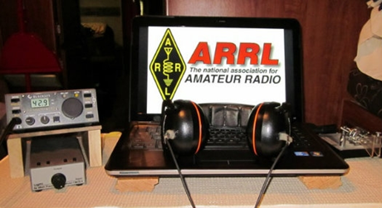
ARRL Contest Corner

An expanded, downloadable version of QST's Contest Corral is available as a PDF. Check the sponsor's Web site for information on operating time restrictions and other instructions.

TOP ^

Attention ALL Ohio…

Mark April 4, 2020 (Saturday) as our ARES OHIO SPRING CONFERENCE!

We have the Marion Tech lecture hall reserved (THANKS MARION ARES!!!) and we’ll begin planning some important topics! More information will be forth coming.

This event is always “Standing Room Only” so we do ask that you register ahead of time so that we can be properly prepared for how many are coming. It’s quick and painless and we will even send you a confirmation email back. Here’s the link to get registered!! http://arrl-ohio.org/SEC/form.html

####

NVIS DAY IS COMING!

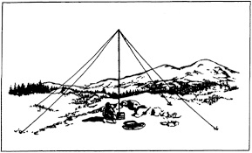
NVIS Day is the ARRL Ohio Section event to test your NVIS antenna designs and builds. Join us on Saturday, April 25th to show how well amateur radio can keep Ohio communicating! This is not a contest: it’s an event for Ohio stations to operate with other Ohio stations and understand how well they hear and are heard.

THE DETAILS
Date: Saturday, April 25
Time: Start at 10 A.M., end at 4 P.M.
Power: Up to but no more than 100w
Exchange: six-digit grid, power, and true—measured—signal report
Schedule: This isn’t a contest, so take your time! Try different designs! Have lunch!

2020 Weather Safety Week Events

- Ohio’s Severe Weather Awareness Week: March 22-28
- Statewide Tornado Drill: Wednesday, March 25 at 9:50 am

V.E. Test Sessions

For the latest testing site information please >> Click Here << The ARRL site tracks all of the VE testing sites that register with them, including W5YI and Laurel. ARRL gives you a number of different ways of sorting to find that site that is closest to you as well.

TOP ^

One Question Questionnaire
Hey Gang,

Ok.. “Survey Says”….. 35% of you have forgotten to move your clocks ahead for Daylight Saving Time.

Ok, I’ve got another NEW – one question – for you to answer. With “Makers Fairs” going on all over the country, this next question is for those who participate in them.

“Will you build a kit if it requires you to install Surface Mount Components???”

You’ll find the “One Question” questionnaire on the Ohio Section Website! http://arrlohio.org It’s all in fun and it’s not a scientific survey in any way, but we are learning some things that we didn’t know from these questions. I hope that you are enjoying answering these “One Question” questionnaires.

“ARES Connect”
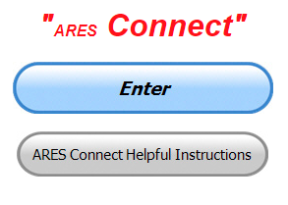
Everyone – please make sure to go into all of the events that you have signed up for and get your hours registered no later than 5 days after the event has ended.

Folks, I’m seeing a lot of folks that have signed up for events not entering their time after the event. This is a very important piece of using “Connect.” Your hours need to be recorded and it’s so easy to do.

Let’s run through how so in case you have forgotten. If you have already gotten signed up for an event, all you have to do afterword to get your time entered is at any time after the event has ended, log into “Connect.” And then click on your name in the upper right-hand corner of the page. This will bring up a drop-down menu where you will then click on “View Hours.”

This brings up another screen where you can “Report Hours” as well as “View Hour History” You’ll want to click on “Report Hours.” You will then be presented one at a time by chronological order each event that you have signed up for and hours have not yet been reported on. Type in those hours in the “Hours Worked” box and hit “Submit”…

Keep doing this until you have no more hours to report…. That’s all there is to it. Now, if you are following the request above and doing this at least every 5 days or more often, this will only take you a minute or so to complete.

Now, isn’t that easy? Yes, and we all need to be diligent at doing it promptly.

TOP ^
Here’s the top 5 hours earners so far for March:

 | Name | Events | Hours
1 | Dan Stahl (KC8PBU) | 19 | 36.75
2 | Bret Stemen (KD8SCL) | 9 | 27.50
3 | James Yoder (w8erw) | 6 | 23.00
4 | Alan Rothweiler (N8CJ) | 8 | 18.00
5 | Christopher Domenick (KC8CAD) | 5 | 17.25

Let’s get everyone in the Ohio Section on “ARES Connect!!!” Simply go to: https://arrl.volunteerhub.com/lp/oh/ and get yourself registered and using the system.

Admins… If you are wondering how to get an overview of all of your events you can simply go into reports and using the new Event by Participation by Event (version 2) you can not only see who registered for your event, but you also can see if he/she has inputted their hours for it as well. Take advantage of this new report to help you get the time entered into your events.

We still have a number of recurring events created but no activity reported for them. Please, if this event is no longer needed, let me know and I can delete it from the masters. I know that many of you setup recurring events to learn how, but if they aren’t going to be used, let’s get them cleared out.

Also… If you are setting up events, please don’t set a limit for how many folks can sign-up unless absolutely necessary. This causes issues when doing reports. It’s also counter-productive since the reason for you to list the event is to get as many volunteers as you can to attend. When you set limits, it discourages folks from signing up.

Special NIMS Training Available

G-557 RAPID ASSESSMENT PLANNING COURSE
Hosted by: Fulton County Emergency Management Agency
Tuesday, June 9, 2020

Course Description: This course provides information and resources to enable participants to develop an effective Damage Assessment Program and conduct rapid and effective needs assessments. A good assessment allows community leaders to prioritize response actions ensuring the greatest life-saving and life sustaining benefits. Since resources are often limited in the first few hours of a disaster or emergency an effective rapid needs assessment allows for the efficient and effective use of those resources. Likewise, it allows local officials to evaluate their needs and request those resources that are not available in their jurisdiction to support life sustaining and life saving measures.

This is a “Required” course in the Advanced Professional Series (APS) program
Application Deadline: May 26, 2020
Time of Course: Registration: 7:45 am – 8:00 am
Course Time: 8:00 am – 4:00 pm
Location: Fulton County Welcome Center/EOC - 8848 State Highway 108 Wauseon, Ohio 43567
Supported By: The Ohio Emergency Management Agency

TOP ^
Recommended Participants: Local officials who are responsible for assessing, collecting, and reporting damages during and after any event that causes damage of private, public, and critical infrastructure.

Recommended Prerequisite: IS0100.c, Introduction to the Incident Command System, ICS 100; IS0200.c, Incident Command System for Single Resources and Initial Action Incidents; IS0700.b, National Incident Management System, An Introduction; IS0800.b, National Response Framework, An Introduction; IS0120.a, An Introduction to Exercises; and IS0130, Exercise Evaluation and Improvement Planning. These courses are available online by going to https://training.fema.gov/is/crslist.aspx?all=true

Enrollment: Students must enroll via the Department of Public Safety Training Campus website: https://trainingcampus.dps.ohio.gov/cm/cm710/pstc/pstc.html Course registration will generally close 10 working days prior to the course start date. You can check enrollment/approval status via the Department of Public Safety Training Campus website.

Course Costs: This course is free to participants. Lodging, meals and all other expenses are the students’ responsibility.

County Point of Contact: Peggy Volkman, Administrative Assistant, (419) 337-9207, peggyvolkman@fultoncountyoh.com

State Point of Contact: Matt Jaksetic, State Training Coordinator, Ohio EMA (614) 799-3666, mtjaksetic@dps.ohio.gov

Other courses being scheduled…

G-271 Hazardous Weather and Flooding Preparedness 9/23-23/20
G-272 Weather Warning Coordination 10/20-21/20
OH-606 Disaster Recovery and OH-607 PA Cost Recovery/Damage Assessment 11/5/20.

####

Below is a status update of upcoming training classes. Please look at the list, there is a variety of topics, and I would appreciate it if you would consider registering for one (1) or more if your schedule allows.

Some of the classes you can register for on the FCEM&HS website; go to the “Training Opportunities” site https://fcemhs.org/Training-Exercises/Training-Opportunities (where you can find the information flyer on all of the classes) and then click on the “FCEM&HS Training Registration” link https://fcemhs.org/Training-Exercises/FCEMHS-Training-Registration

The rest of the classes you will need to register on the Ohio Public Safety Training Campus https://trainingcampus.dps.ohio.gov/cm/cm710/pstc/

For those classes that are being instructed through TEEX, once you register with me, I will send you an approval email with a link to then register on the TEEX website.

TOP ^
CLASS | DATE | TIME | LOCATION
OH/L-146 Homeland Security Exercise and Evaluation Program (HSEEP) (Register via OH Public Safety Training Campus) | March  25-27 | 8am-5pm (24 hrs) | FCEM&HS
AWR-376 Understanding Targeted Cyber Attacks (Register via paper registration or the FCEM&HS website) | April 7 | 8am-5pm (8 hrs) | FCEM&HS
AWR-213 Critical Infrastructure Security & Resilience Awareness of Critical Infrastructure/Key Resources (Register via paper registration or the FCEM&HS website) | April 15 | 8am-5pm (8 hrs) | FCEM&HS
MGT-317 Disaster Management for Public Services (Register via paper registration or the FCEM&HS website) | April 21&22 | 8am-5pm (16 hrs) | FCEM&HS

####

EMA-G289 PUBLIC INFORMATION OFFICER (PIO) AWARENESS
Hosted by: Youngstown State University Police Department
April 7, 2020

Course Description: The Public Information Officer (PIO) Awareness Course is a “Free” course designed to familiarize participants with the concepts underlying the PIO role. The material provides a basic understanding of the PIO function for those new to the position. It orients the participants to the public information function and the role of the PIO in the public safety / emergency management environment. This training forms the foundation for more advanced training that takes participants from the awareness level to the mastery level in their public information careers. Additionally, it provides those in executive level roles the necessary knowledge of PIO roles and responsibilities during an emergency.

Application Deadline: March 24, 2020
Time of Course: Registration: 7:30 am – 8:00 am Course Time: 8:00 am – 5:00 pm
Location: Youngstown State University Police Department - 266 West Wood St. Youngstown
Supported By: The Ohio Emergency Management Agency

Recommended Participants: The primary audience for this training is individuals who have public information responsibilities as their main job or as an auxiliary function at the federal, state, local, tribal, or territorial level of government, and in the private and nongovernmental sectors.

Recommended Prerequisite: IS-100 Introduction to Incident Command System; IS-702 NIMS Public Information Systems; and IS-909 Community Preparedness: Implementing Activities for Everyone

Enrollment: Students must enroll via the Department of Public Safety Training Campus website: https://trainingcampus.dps.ohio.gov/cm/cm710/pstc/pstc.html. Course registration will generally close 10 working days prior to the course start date. You can check enrollment/approval status via the Department of Public Safety Training Campus website.

TOP ^
Course Costs: This course is free to participants. Lodging, Meals, Per Diem and all other travel expenses are the responsibility of the student or the parent organization. The FY 2019/2020 Ohio EMA Training Catalog at http://ema.ohio.gov/Training.aspx provides additional information.

County Point of Contact: Adam Guerrieri. (330) 503 – 4626. ajguerrieri@ysu.edu

####

Below are trainings that can be found by following this link: https://services.dps.ohio.gov/CIMS/.

- G-191 ICS-EOC Interface (Lawrence County April 2020)
- G-289 Public Information Officer (PIO) Awareness (Fulton County April 2020)
- G-289 Public Information Officer (PIO) Awareness (Hocking County April 2020)
- G-318 Mitigation Planning Workshop (Cuyahoga County April 2020)
- G-402 ICS Overview for Executives and Senior Officials (Franklin County April 2020)
- OH-202 Debris Management Workshop (Stark County April 2020)

Intended Audience: Law Enforcement, Emergency Services, Emergency Managers, Communications, Government, Volunteers, State, Local, Tribal, and Territorial Personnel

For more questions or concerns regarding CIMS please contact CIMS@dps.ohio.gov.

####

EMA-ICS300 Licking County May 19-21

This 21-hour course provides training for personnel who require advanced application of the Incident Command System (ICS). This course expands upon information covered in the ICS-100 and ICS-200 courses. This course is for individuals who may assume a supervisory role in incidents. Note: During a Type 3 incident, some or all of the Command and General Staff positions may be activated, as well as Division/Group Supervisor and/or Unit Leader level positions. These incidents may extend into multiple operational periods.

Licking County EMA/911 783 Irving Wick Drive West Heath, Ohio 4305

####

EMA-ICS400 Licking County May 27-28

This training is a 15-hour classroom course that provides training for personnel who require advanced application of the Incident Command System (ICS). This course expands upon information covered in ICS-100, 200, 700, 800 and ICS-300 courses, which are the prerequisites for the ICS-400 course.

The target audience for this course is senior personnel who are expected to perform in a management capacity in an Area Command or Multi-Agency Coordination Entity.

Licking County EMA/911 783 Irving Wick Drive West Heath, Ohio 43056

####

TOP ^
AWR 148: Crisis Management for School-Based Incidents – June 9th
Training sponsored by: Licking County EMA
Location: Licking County Administration Building Room “A” in Basement - 20 South 2nd Street - Newark

AWR 148: Crisis Management for School-Based Incidents - Partnering Rural Law Enforcement, First Responders, and Local School Systems is an 8-hour, OHS-approved course designed to educate rural law enforcement personnel as well as school administrators and staff on the elements that would allow for an effective response to school-based emergencies. Schools in small, rural, and remote areas across the country account for almost 23 percent of the total student population (more than 11 million students) .

Rural schools, law enforcement, and other emergency responders are often limited in resources, so it is imperative that all potentially affected parties collaborate on planning, preparing, communicating, responding, and recovering from a school-based incident.

This tuition-free course is beneficial for rural police and sheriff departments, school administrators, school resource officers, counselors, and others involved in school safety and security.

Topics covered include:
• Introduction to Incident Planning and Preparedness
• Proactive Threat Mitigation
• Incident Response
• Incident Recovery
• Vulnerability Assessments
• Threat Assessment Management
• Incident Defusing and Debriefing
• Reunification
• Anniversaries, Memorials, "Copy-Cats"

To register, please visit our website:
https://www.ruraltraining.org/training/schedule/2020-06-09-awr148-newark-oh-001/

Please sign-up no later than May 26, 2020 as a minimum of 20 registrations must be received by this date to confirm the class will be held. Should you have any questions regarding the facility or location please contact John Wieber at 740-404-5034 or jwieber@lcounty.com

####

MGT 417: Crisis Management for School Based Incidence – July 23 - 24
Training sponsored by: Licking County EMA
Location: Licking County Administration Building
Room “A” in Basement - 20 South 2nd Street - Newark

The purpose of this performance-level course is to provide the operational-level details to support many of the topics covered in the U.S. Department of Homeland Security (OHS) approved AWR 148: Crisis Management for School-Based Incidents - Partnering Rural Law Enforcement and the Local School Systems awareness-level course. Rural schools, law enforcement, other emergency responders, and community stakeholders are often limited in their access to resources, so it is imperative that all potentially affected parties collaborate in planning, preparation, communication, response, and recovery in the event of a school-based incident.

TOP ^
Moreover, these affected parties must come together to practice their interoperable skills through drills and exercises to ensure the strategies in place provide for an effective crisis response and collaborative recovery.

With the intent of building upon the foundation of the AWR 148 course and utilizing an all-hazards approach, this two-day course will provide content instruction, develop concept-specific skills, and provide opportunities for law enforcement , school personnel, and community stakeholders to collaboratively apply the course objectives in scenario­ based applications.

Topics covered in this course include:
• All-Hazards Planning and Preparedness
• Vulnerability Assessments
• Threat Assessment Management
• All-Hazards Response
• All-Hazards Recovery
• Scenario-Based Activities

Registration Deadline: July 9, 2020

To register, please visit our website:
https://www.ruraltraining.org/training/schedule/2020-07-23-mgt417-newark-oh-001/

Please sign-up no later than May 26, 2020 as a minimum of 20 registrations must be received by this date to confirm the class will be held. Should you have any questions regarding the facility or location please contact John Wieber at 740-404-5034 or jwieber@lcounty.com

Final.. Final..
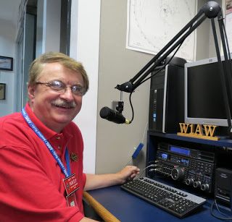
Hey Gang...

Boy, there’s sure been a lot going in around here lately. I’ve been involved in a number of phone calls and webinars helping folks from around the country get started with ARES Connect. It’s been fun and really exciting to be able to have a direct part in getting folks up and running! I’ve also been involved with a project that several of us Section Managers are doing with writing a “How To” manual to help everyone better understand ARES Connect. It’s now in Beta Testing and we will very soon release it to the world. It’s written to help answer all those questions that most folks have when they get started with ARES Connect.

Moving down the log a bit… Over the past several weeks we have had a couple of changes in our District Emergency Coordinators. In District 3 Fred Stone, W8LLY had decided to retire from the DEC post and recommended Don Parker, KB8PSL to take the reins, which he did in mid-February. Just within this past week Eric Jessen, N8AUC, District Emergency Coordinator for District 10 also decided to step down. Eric was another DEC that has held the post for a lot of years, so there was another big set of shoes to fill.

TOP ^
But we have been blessed, Mat Nichoson, KC8NZJ has agreed to step into the roll as DEC for District 10. I’m sure Mat’s name is familiar with most of you, serving as EC for Cuyahoga County during the Republican National Convention in 2016. It’s great having Mat now fill the DEC position. Mat will also be serving as EC for Cuyahoga County. At least until he can find a replacement.

And, if that weren’t enough excitement, we also added a new Local Government Liaison to the staff. So, with all the fanfare that you can muster, please give a big hand for our new LGL Tim Price, K8WFL!!!

Now, that’s not all, we added Marcel Casavant, AD8CM as an Official Relay Station back in late February as well. Bringing our total Official Relay Station appointments back to a good operating level of 21.

Now, for those other 20 ORS’s in the Ohio Section. Make sure that you are fulfilling your obligation to your post by getting Dave, WA3EZN our Section Traffic Manager a report every month as you promised to do! And, don’t forget that you also promised to maintain your ARRL dues too.

I want to encourage all of you to make sure that your ARRL dues are up-to-date. I know that his must sound like a broken record, but… “Being a part of a great organization like ARRL is really important to you and to all of us. Your voice is heard and heard loud and clear not only here in Ohio, but also at Headquarters.

Whelp, final go around before gong QRT… That’s going to do it for this week. Stay safe, enjoy the sunshine when we have it, and most of all… have FUN and get on the air!!

73,

Scott, N8SY

Spring Arrives!!

The spring equinox (also called the March equinox or vernal equinox) falls on Thursday, March 19, which is earlier than it's been in over a century!

This event marks the astronomical first day of spring in the Northern Hemisphere.

Ohio Section Cabinet
Section Manager – Scott Yonally, N8SY | Assistant Section Manager – John Perone, W8RXX
Section Emergency Coordinator – Stan Broadway, N8BHL | Section Traffic Manager – David Maynard, WA3EZN
Technical Coordinator – Jeff Kopcak, K8JTK | Affiliated Clubs Coordinator – Tom Sly, WB8LCD
State Government Liaison – Bob Winston, W2THU | Public Information Coordinator – John Ross, KD8IDJ
Section Youth Coordinator – Anthony Lascre, K8ZT

TOP ^

Swap & Shop Has Come to the Ohio Section Website

Hey Gang,

Have you taken a look at the Swap & Shop page on the Ohio Section webpage yet??

Here’s a link that will take you there… http://arrl-ohio.org/sm/s-s.html

Do you have equipment that you just don’t need or want anymore? Here’s a great venue to advertise it, and it’s FREE!! No, it won’t be listed in this newsletter because it would take up way too much space, so your ad will only appear on the website. It is there for any individual to post equipment Wanted / For Sale or Give-Away. No licensed vehicles/trailers or business advertising will be posted.

Postings are text only (no pictures or graphics) will be posted for a maximum of 1 month from date posting and require a contact phone number or email within the posting.

Send your Wanted / For Sale or Give-Away post to: swap@arrlohio.org

Welcome New Subscribers

Lawrence, NB8Z; Casey, KC8EVW

Back Issues of the PostScript and Ohio Section Journal

Hey, did you know that PostScript and Ohio Section Journal (OSJ) are archived on the website? You can go back and look at any edition simply by clicking:
http://arrl-ohio.org/news/index.html

Updated Information... Want to Share your Club Newsletter With Others?

We have a new webpage where you can download and read all of the newsletters that I get from around the state.

Here’s the link to the page…. http://arrl-ohio.org/club_news/index.html

Please, if you don’t see your club newsletter posted, it’s probably because I’m not receiving it, or I just cannot convert it over to Adobe Acrobat. Have your newsletter editor contact me and let’s see if we can get your club’s newsletter on the site!! We all learn and steal (I mean, share) from each other’s work. So, let’s give this new webpage a real workout and send me your newsletter!!! Send it to: n8sy@n8sy.com

TOP ^

Chit – Chat, and All That!

Do you know someone that’s not getting these Newsletters? Please, forward a copy of this Newsletter over to them and have them “Opt-In” to start receiving them. Heck just have them send me an email n8sy@n8sy.com and I’ll get them added to the Ohio Section Emailing list.

We now have many thousands of readers receiving these newsletters weekly. Quite impressive, I’d say! I urge all of you to make sure that everyone, regardless of whether they are a League member or not, get signed up to receive these weekly Newsletters.

You can always “Opt-Out” at any time if you feel this is not what you were expecting. It’s fun and very informative. All of your favorite past newsletters are now archived too.
You can go back at any time and read them. Just go to: http://arrl-ohio.org/news/

Got questions, concerns or would just like to sit and chat awhile? Heck, I’ll even buy the coffee!! Give me a call at (419) 512-4445 or email me at: n8sy@n8sy.com

The pictures on the front page and throughout this newsletter are from various newsletters, Facebook posts and/or were sent directly to me in recent weeks. Take a good look at them, you just might be in one of the pictures! “SMILE… you’re in the Ohio Section News!!”

TOP ^

PostScript is produced as a weekly newsletter. I want to thank everyone that has contributed articles and ideas to make this an even better news source. I sincerely hope that you have enjoyed this edition and will encourage your friends to join with you in receiving the latest news and information about the Ohio Section, and news and events happening around the world!

