[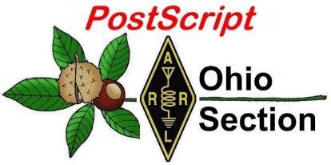](http://arrl-ohio.org/news/) ***March 2nd***

***Edition***

🡪 National News 🡪 The Handbook Give Away

🡪 Club Corner 🡪 Hamfests

🡪 DX This Week 🡪 One Question Questionnaire

🡪 VE Testing 🡪 ARES Connect

🡪 Special NIMS Training 🡪 Final.. Final..

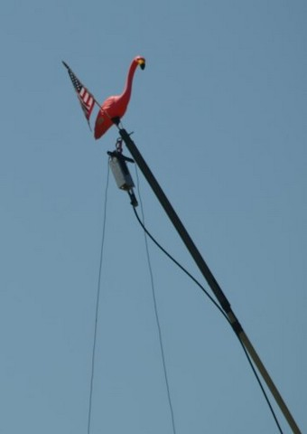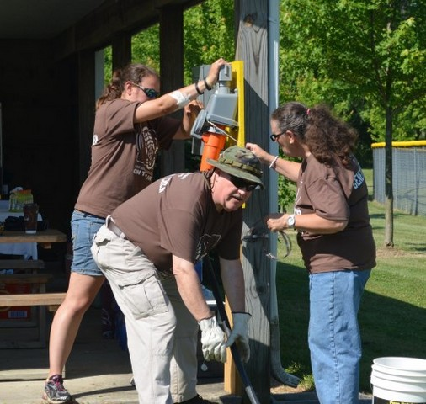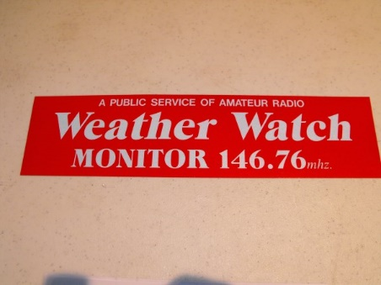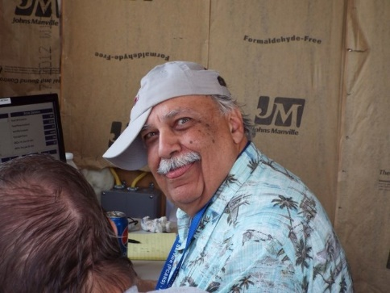

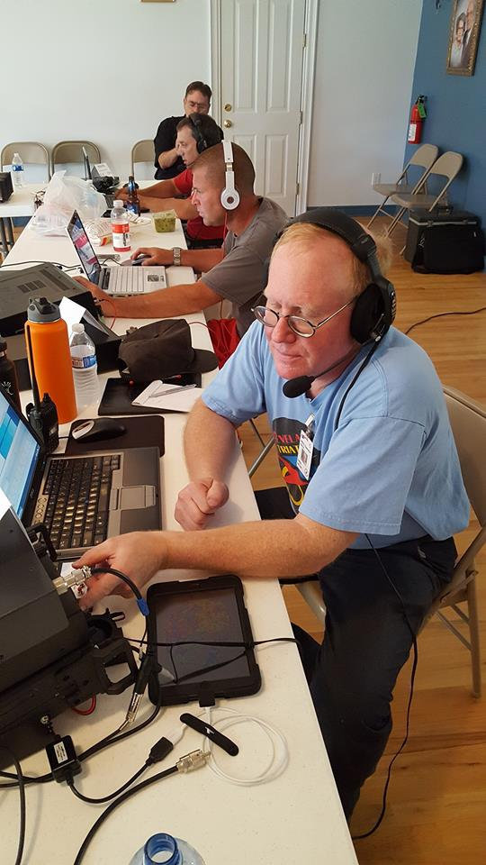

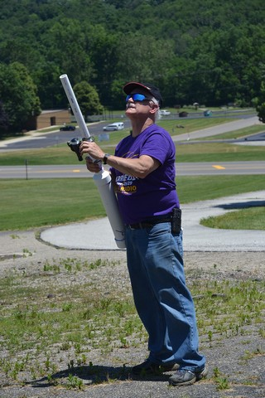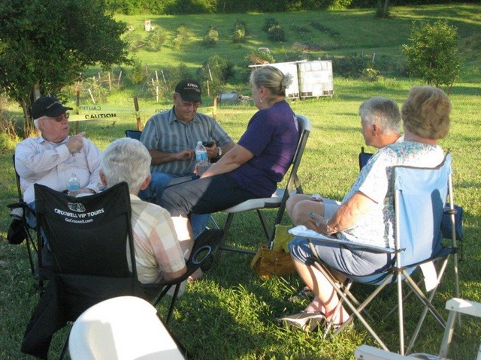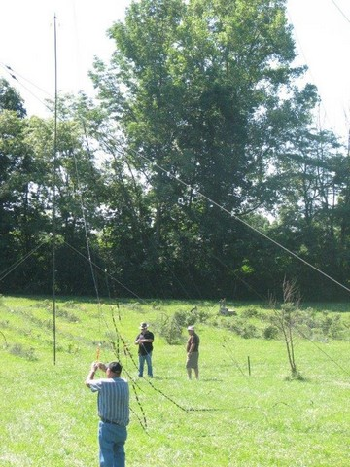

***National News***

*(from arrl and other sources)*

***Mississippi ARES® Emergency Coordinator Credits Training for Effective Tornado Response***

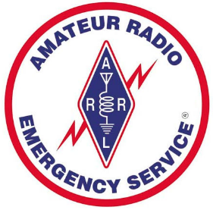

Amateur Radio Emergency Service® (ARES®) volunteers in DeSoto County, Mississippi, devoted several days in January to assisting local emergency managers in responding to tornado damage in the region. Desoto County Emergency Coordinator Ricky Chambers, KF5WVJ; Assistant EC Gene Adams, KF5KVL; Tate County EC Brad Kerley, KG5TTU, and Andy Luscomb, AG5FG, reported at 3 AM on January 11 to the DeSoto County Emergency Operations Center (EOC) to open a SKYWARN weather watch. After a tornado warning was issued for DeSoto County, Chambers activated an emergency net on a local repeater. Ten minutes into the net, however, the repeater went down, and the net switched to simplex. The net subsequently moved to another operational repeater.

Initial reports of downed trees blocking roadways and an eyewitness report of a possible tornado southwest of Hernando came in just after 5 AM. The ARES team at the EOC began taking damage reports, answering the telephone, and monitoring and taking calls from public safety dispatchers. When the deputy EMA director requested traffic control in Lewisburg, three of the ARES volunteers accompanied EMA director Chris Olson to Lewisburg. Chambers and Kerley assumed traffic control, and Olson asked that Chambers put out a call for ARES/RACES volunteers and EMA reservists to report to the EOC. The ham radio volunteers also handled welfare checks.

A dozen ARES/RACES and EMA reservists returned the next day to conduct door-to-door damage assessment. For the next 10 days, Chambers reported, the DeSoto County volunteers assisted in handling telephone traffic in the EOC, freeing up first responders to do their primary jobs.

“I attribute our effective response to the training we have conducted on a monthly basis,” Chambers said, noting that training included recommended ARRL courses. “We were able to see how the Incident Command System worked on a first-hand basis as the incident unfolded, based on the ICS training courses we have taken. My group went from 0 to 110 MPH in seconds, never missing a beat [and] everyone performed on a professional level.”*— Thanks to DeSoto County and EMA Reservist Coordinator EC Ricky Chambers, KF5WVJ*

####

***ARRL Teachers Institute on Wireless Technology 2020***

 As part of our educational outreach to schools through our [**Education & Technology Program**](http://www.arrl.org/education-technology-program), each summer the ARRL offers multiple sessions of the Teachers Institute on Wireless Technology, an expenses-paid professional development seminar, in locations through the U.S. The Teachers Institute provides teachers at all grade levels with tools and strategies to introduce basic electronics, the science of radio, space technology and satellite communications, as well as weather science, introduction to micro-controllers and basic robotics into their classrooms.

TOP ^

The curriculum is designed for motivated teachers and other school staff who want to learn more about wireless technology and bring that knowledge to their students.

**Summer 2020 Teachers Institute**

**Prog Location Dates Instructor**

**TI-2 Newington, CT July 6 – July 10 Matt Severin, N8MS**

**TI-1 Dayton, OH July 13 – July 17 Larry Kendall, K6NDL**

**TI-1 Newington, CT July 20 – July 24Tommy Gober, N5DUX**

**The deadline to apply will be May 1st, 2020.** Early applications are recommended. [**Click here**](http://www.arrl.org/teachers-institute-application)to view the most recent application.

[**Click here**](http://www.arrl.org/files/file/2020%20Teachers%20Institute%20Brochure%20no%20trim%20marks.pdf) to view the most recent brochure.

[**Register with us**](http://www.arrl.org/teacher-registration) to receive news about Education & Technology Program activities.

####

***Can mobile networks connect first responders in remote areas?***

*(Submitted by Gregory Drezdzon, WD9FTZ)*

The National Institute of Standards and Technology (NIST) has published an article that looks at the challenges of providing communications in remote areas   
  
The high plateaus of Colorado’s Rocky Mountains, known for panoramic vistas, wildlife, old gold mines and sports of all kinds, are attracting new pioneers: engineers working to improve emergency communications. First responders face many communications challenges, including a lack of cell towers in uninhabited places and incompatible equipment. Public safety agencies need to find ways to share voice, text, instant messages, video and data reliably while responding to wild land fires and other emergencies.   
  
Researchers with NIST, in collaboration with the Department of Homeland Security (DHS) Science and Technology Directorate, are mounting miniature mobile communications networks on pickup trucks and uncrewed aerial systems to measure signal strength and coverage in mountain areas lacking wireless infrastructure.  
  
NIST researchers study “deployable systems” to help create ad hoc, interoperable networks. Deployable systems are needed not only for rural areas but also for other situations where wireless coverage is compromised, or large-scale events cause network congestion. Some deployable systems are available commercially, but NIST is working on generic technologies that could be used by anyone.  
  
The NIST experiments at the Gypsum site use Long Term Evolution (LTE) systems, the latest wireless standards that are widely available for cellphones.

TOP ^

The nation’s estimated 5 million public safety personnel have traditionally used walkie-talkies (land mobile radio), but many are supplementing their capabilities with LTE systems, which offer data transmission rates up to 1,000 times higher.

Read the full article at:  <https://www.nist.gov/news-events/news/2020/02/can-mobile-networks-connect-first-responders-remote-areas>

####

***FAA's Proposed Remote Identification Rules Would Affect Drones, Hobby Planes***

The Federal Aviation Administration ([FAA](http://www.faa.gov)) is proposing to require remote identification of so-called "unmanned aircraft systems" (UAS), which include drones and hobby aircraft. A growing number of radio amateurs utilize camera-equipped drones for aerial photography purposes, to examine antenna systems, and to operate hobby aircraft remotely on amateur radio frequencies. Comments on the *Notice of Proposed Rule Making* (*NPRM*) in [Docket FAA-2019-11](https://www.federalregister.gov/documents/2019/12/31/2019-28100/remote-identification-of-unmanned-aircraft-systems), are due by March 2.

"The remote identification of unmanned aircraft systems in the airspace of the United States would address safety, national security, and law enforcement concerns regarding the further integration of these aircraft into the airspace of the United States while also enabling greater operational capabilities," the FAA said in proposing the new requirements.

The FAA defines remote identification, or Remote ID, as the ability of an in-flight unmanned aircraft "to provide certain identification and location information that people on the ground and other airspace users can receive." The FAA called the move "an important building block in the unmanned traffic management ecosystem."

"For example, the ability to identify and locate UAS operating in the airspace of the United States provides additional situational awareness to manned and unmanned aircraft," the FAA said. "This will become even more important as the number of UAS operations in all classes of airspace increases. In addition, the ability to identify and locate UAS provides critical information to law enforcement and other officials charged with ensuring public safety."

The FAA said it envisions that the remote identification network "will form the foundation for the development of other technologies that can enable expanded operations."

With few exceptions, all UAS operating in US airspace would be subject to the rule's requirements and would have to comply, "regardless of whether they conduct recreational or commercial operations, except those flying UAS that are not otherwise required to be registered under the FAA's existing rules."

To comment, click on the “Submit a Formal Comment” button on the top of the *Federal Register* page that includes the *NPRM* text.

####

TOP ^

***CISA Returns to Provide Auxiliary Communications (AUXCOMM) Training in Conjunction with Hamvention® 2020***

The Cybersecurity and Infrastructure Security Agency (CISA) will be on hand at Hamvention® 2020 to conduct its nationally recognized NIMS/ICS compliant AuxComm course. Over 3,000 amateur radio operators from around the country have taken this course. The purpose of this course is to train qualified amateur radio operators, so they may assist their local, county and state governments with emergency backup communications if requested to do so. This course introduces the auxiliary communicator to the other positions within the Communications Unit (COMU) and how to provision emergency communications in a public safety context. The course also goes deeper into the National Qualifications System (NQS) /National Incident Management System (NIMS) framework. The location of the course will be at the Beavercreek Fire Department Training Room in Beavercreek, Ohio from 12-14 May 2020. There are only 30 slots available for this class, and the cutoff for registrations is 15 April 2020.

***Registration for this course is ongoing:*** Students wishing to attend the DHS Auxiliary Communications (AuxComm) Course must meet all prerequisites and provide electronic/scanned images of the following required documents prior to 15 Apr 2020:

**Prerequisites:**

o   A signed copy of your current valid FCC issued amateur radio license

* IS-100 certificate (FEMA issued)
* IS-200 certificate (FEMA issued)
* IS-700 certificate (FEMA issued)
* IS-800 certificate (FEMA issued)
* The name of the public safety entity, and its contact information, that you would support upon completing this course

Please scan copies of this information, attached it to an email, and then send to [COMU@.cisa.dhs.gov](mailto:COMU@.cisa.dhs.gov). In the subject line, please put Hamvention AUXCOMM. Your information will be reviewed, and a reply sent back to you indicating whether you have been selected for a seat in the course.

This will be an intensive three-day version of the course with facilitated lectures and student exercises conducted by professional AUXCOMM instructors. This course provides time for interactive discussions and exercises. Should you have any questions regarding this course, please send them to [COMU@cisa.dhs.gov](mailto:COMU@hq.dhs.gov).

One final note, please mark your calendar, to come see us at the AUXCOMM forum at Hamvention. You will be given a glimpse at the new AUXCOMM Position Description/509, the new AUXCOMM Sub-committee of the Communications Section Task Force (within SAFECOM) and a look into the what’s in store for AUXCOMM in the future.

####

TOP ^

***5 Tips on Etiquette and Good Manners using FM Ham Radio Satellites***

*(By Sean Kutzko, KX9X, submitted by Gregory Drezdzon, WD9FTZ)*

***AN AMATEUR RADIO BLOG BY DX ENGINEERING***

Manners are a good thing. Manners help us make a good impression and build our reputation at work, school, or any social gathering.

People generally like hanging out with positive people and not the grumpy, negative ones. Amateur Radio is no different. Hams want to make radio contacts without interfering with others trying to do the same thing. We all share our little corner of the radio spectrum and a little courtesy can go a long way.

Satellite operating comes with several challenges, not the least of which is it is one of the ultimate shared resources in the hobby. While there are several satellites to choose from, a given satellite is only above the horizon for a maximum of 15 minutes or so.

Too many people attempting to access a satellite during a short window of opportunity can create problems, and that can bring out some undesirable behavior.

There is a natural sense of urgency that develops if a pass is close to ending and you still have not gotten through to a station you want to contact. In other cases, new operators, still actively learning how to hear and make it into a satellite, may not have been introduced or grasped some of the finer techniques.

The full story is at:   <https://www.onallbands.com/ham-radio-satellite-operating-etiquette/>

***Maple Dale Elementary School, Cincinnati, ARISS PR***

(From Rosalie White, K1STO [k1sto@arrl.org](mailto:k1sto@arrl.org))

All,

Along with the ham radio STEM activities and space STEM activities done by teachers, here is a list (below) of ARISS / ham radio PR I found for Maple Dale Elementary School in Cincinnati. I heard that a local radio broadcast station would soon be running an interview, too.

I learned also that an ARISS volunteer in California who was giving a ham radio talk to students and teachers at a school an hour from his home, set up the Maple Dale Facebook page so that the California kids/teachers could watch the ARISS contact live.

First, students and teachers are interested in starting a school ham club and are considering these names for their club: Bacon Buddies or Ham Pals.

Second, an 11th-grade girl who had earned her ham license a year ago, initiated the ARISS contact, and afterwards, quipped that she'd had her license 3 months longer than Drew Morgan (the astronaut) had his ham license!

TOP ^

* N8SY’s Video of Dr Drew Morgan answering the kids questions along with still pictures of the kids that attended the program. <https://www.youtube.com/watch?v=nNGSp9pUOVQ&feature=youtu.be>

* WKRC Local 12--talks about ham radio at the beginning

<https://local12.com/news/local/sycamore-students-get-the-chance-to-speak-with-iss-astronauts>

* WLWT NBC    Dale Williams is quoted about ham radio

[https://www.wlwt.com/article/local-second-graders-talk-to-astronaut-aboard-the-international-space-station/31028142#](https://www.wlwt.com/article/local-second-graders-talk-to-astronaut-aboard-the-international-space-station/31028142)

2 for 1    * a NASA blog posted a daily summary (this one, Feb. 20) of ISS events -- and it was picked up by Space Ref, a space industry news site "On-Orbit Status Report" -- see 2nd paragraph

<http://spaceref.com/international-space-station/nasa-space-station-on-orbit-status-20-february-2020---new-bone-research.html>

* Maple Dale livestreamed the ARISS contact on their Facebook page, garnering 714 views

<https://www.facebook.com/pg/sycamoreschools/posts/?ref=page_internal>

* Sycamore Community Schools did a pre-contact announcement including mention of ARISS and the OH-KY-IN Amateur Radio Society

<https://www.sycamoreschools.org/site/default.aspx?PageType=3&DomainID=12&ModuleInstanceID=11&ViewID=6446EE88-D30C-497E-9316-3F8874B3E108&RenderLoc=0&FlexDataID=4779&PageID=17&Comments=true>

73, Rosalie K1STO

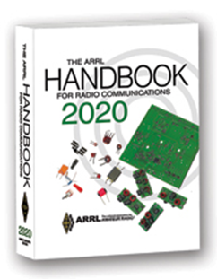***The Handbook Give Away***

Hey Gang,

The winner of the February Give Away is… ***Lori Bitzer, KE8JEH***

Many of you ask me just how do I know when the drawing is on? Well, that’s easy all you need to do is check in on the Ohio Section Website on a regular basis and watch for the big **RED** Arrow that will appear on the left side of the page.

This is the sign that the drawing is on and you need to get registered. So, keep a sharp eye out on the website and check in often! <http://arrl-ohio.org/>

####

TOP ^

***Club Corner***

This is YOUR cornner of the newsletter. Send me what your club is doing and I’ll make sure that it gets in. Got a special event or club project that you want everyone to know about? Send it to me!. Need help with a project? Send it to me.

Let me know what you club is up to. Are you going to have a special guest at your meeting or are you having a special anniversary? Just sent it to: [n8sy@n8sy.com](mailto:n8sy@n8sy.com)

####

***Mahoning Valley ARA to hold Two-Meter Contest***

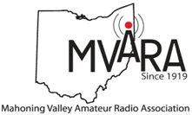The MVARA is excited to announce the Mahoning Valley Two Meter Contest **Saturday March 21, 2020 from 7:00 to 10:00 pm.** We thought it would be fun to see if valley hams would enjoy shaking off the winter doldrums by getting on the air for a local contest. It will be an opportunity to talk to old friends and make new ones.

Old timers may remember participating in the Lou Malice Memorial Contest years ago. The MV 2 Meter Contest will be a similar two-meter simplex contest. Stations will simply exchange grid squares as defined in the contest rules. The contest format will allow participants to evaluate their stations simplex capabilities.

This information could be valuable in an emergency.  No 100-watt base station, no problem. There will be a low power category of 5 watts or less and a high-power category of greater than 5 watts so everyone will have a level playing field. Awards will be given for the highest scoring Low Power Home, High Power Home, Low Power Rover, and High-Power Rover stations at the June 11, 2020 MVARA meeting.

For contest rules and a list of rover stations and the grids they plan to activate go to [www.mvara.org/Mv2mc.html](http://www.mvara.org/Mv2mc.html)

This year the contest will be dedicated to the memory of pioneer Valley ham Lou Malice WA8PKN whose dedication to amateur radio touched the lives of all of us. Even if you never had the pleasure of knowing Lou you are still part of his legacy. Chances are good that the hams who inspired and encouraged you to become part of amateur radio were, themselves, inspired, encouraged, and trained by Lou.

We hope to hear you on the air! Scott Wilton   KE4UHC – President

####

TOP ^

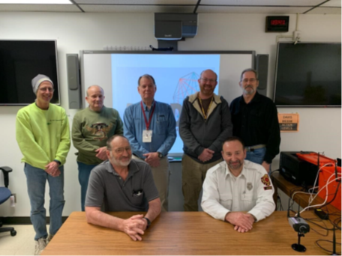***Volunteers Donate 1,015 Hours***

The Sandusky County Commissioners would like to thank mem-bers of our Sandusky County ARES (Amateur Radio Emergency Services). In 2019 they VOLUNTEERED 1,015 hours of time to Sandusky County.

This is a highly dedicated group of volunteers for the EMA that not only provide the county with back up radio communications but are also trained in damage assessment, CERT members and some have agreed to be on the County Drone Team.

Thank You again for everything you do for EMA and Sandusky County.

####

***Technician License Classes Scheduled in Newark***

Classes are being hosted and sponsored by:  Earl, W8BR, in conjunction with, Newark Amateur Radio Association and the American Red Cross - East & South-Central Ohio Chapter

**Place:**  143 S. 30th St., Newark, Ohio 43055  <https://goo.gl/maps/CSbgxAbaU322>

**Dates: Saturday, March 14; March 21; March 28; April 4; April 11**. Saturday, April 18 will be the exam.

**Time:** 9:00 AM to 12:00 PM  (No lunch break)

**Registration:**  Students must register in advance with Mr. Earl Paazig, [email@paazig.net](mailto:email@paazig.net) or by phone at 740-828-1057 or 740-504-1950.  Registrations may be limited.

**Cost to participants:** *The course is free however participants must provide and come prepared with writing and note‑taking materials.*  This will be a fast-paced course.  You won’t want to miss a note.  *Students will be required to download and print a free copy of the Study Guide available at:*  [*https://paazig.net/owncloud/index.php/s/wT13jVN4zm1BTOP/download*](https://paazig.net/owncloud/index.php/s/wT13jVN4zm1BTOP/download)

Optionally, the participants would be encouraged to purchase a book costing $32.95 plus shipping.  <http://www.arrl.org/shop/Ham-Radio-License-Manual/?page=1>

####

***Pan Ohio Hope Ride Heroes of Hope! SAG Support***

The American Cancer Society will be hosting a ride in Columbus Ohio. Heroes of Hope is a single-day, family-friendly event that will give families and casual cyclists the opportunity to join the Pan Ohio Hope Ride community in support of vital American Cancer Society research, programs, and patient services.

TOP ^

To volunteer to provide SAG support for this event, please: [sign up here](https://neoesg.us3.list-manage.com/track/click?u=a811553bee61b09b593d805c3&id=9278ecdb55&e=39e07a5153)

When: **Sunday, April 26, 2020**

Where: Scioto Audubon Metro Park, Columbus, OH

Details:

• Family-friendly trail routes ranging from 3-15 miles (all ages welcome)

• Fully-supported, scenic road routes of approximately 32.8 and 62 miles (18+ only)

• Post-ride celebration with food and fun for all ages

• Inspiration from some Heroes of Hope in the fight against cancer - researchers, patient navigators, and survivors

• Costume and bike decorating contests for kids and adults

• After party at local family-friendly brewery

####

***Skywarn Net Control Training March Meeting***

All,

In case you missed it at the February meeting, there was some interest in having GEARS organize a Skywarn program in the county.

Skywarn is a program of the National Weather Service that uses amateur radio as one component, and to that end, GEARS will be a participant.  Our job is to get accurate and high-quality reports to NWS in a timely fashion during severe weather situations.

At the March GEARS meeting (March 11 at 7:00PM), I will present a training program designed to help us learn how to run high-quality Skywarn nets.  We'll discuss the general structure of the amateur radio portion of the Skywarn program and then get into the details of running and participating in nets.

I have secured permission from Eric KF8YK to use any of his repeaters in the county (146.94, 444.225, 444.8125, 444.5625) for Skywarn.  We'll have a comms plan soon. He's also offered to install a weather alerting system on 94 for us when he finds time.

Note that this will not be the same as Skywarn spotter training from the National Weather Service.  As I am not a meteorologist, I am not qualified to train you on actual weather spotting.  This is specific training for amateur radio operators who wish to participate in Skywarn nets.  There will be no Skywarn spotter training from NWS this year.

Starting with the GEARS net this Monday, March 2nd, we will have an additional portion of the net with Skywarn information.  This training is in the new version of the net script that will be sent out, and we'll include this section from the beginning of March through the end of October.

I am aware that there has previously been a Skywarn group in the county, and we will ensure we do not interfere with them.

See you on the 11th! - Dave/AD8G

####

TOP ^

***Ashland County Skywarn Training***

Hello Everyone

Skywarn Training will be held on Wednesday, March 4th with check-in registration starting at 6:00 pm, the class will start at 6:30 pm.

The class will be held at the Ashland County Sheriff's Office Annex. 1205 East Main Street in Ashland. The class will be presented by a representative from the Cleveland Office of the National weather Service. Skywarn

Training is open to anyone interested in severe weather spotting or weather in general. No matter how many times you have been to previous classes, you will always learn something new each time you attend.

I hope everyone is able to attend this year, it would be nice to see a large turnout of Amateur Radio operators come to the training. to show support for the EMA office.

I also hope for your participation on the Skywarn nets when severe weather strikes our area.

Any questions? Contact Doyle ..KI8L.. 419/281-2757

####

***Cleveland Marathon***

As always, we are looking for a lot of help for the Cleveland Marathon **May 16 and 17**. Yes, it's unfortunately on Hamvention weekend as usual and no, they aren't going to change the date of the marathon just because of that (yes people have suggested that. Seriously)

We normally need about 10 people to work the 5k on Saturday ending about noon and about 40 to work the actual Marathon on Sunday ending about 3p. If you are available to help, please sign up. If you need to leave early, that usually is not a problem so please don't be afraid to ask. [Please sign up here.](https://neoesg.us3.list-manage.com/track/click?u=a811553bee61b09b593d805c3&id=b358d93bb7&e=39e07a5153)

####

***Maker Faire Coming***



**Saturday, May 16, 2020** from 10 a.m.-3 p.m.

**The University of Akron Wayne College**  
1901 Smucker Road  
Orrville, OH 44667

[**>> Click Here <<**](https://waynecounty.makerfaire.com/) **for more information**

####

TOP ^

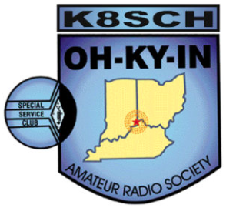***OH-KY-IN Classes and Exams***

OH-KY-IN is proud to host class and exam sessions for Tech, General and Extra level amateur radio licenses. Please note, our classes are free, but you will be required to purchase your own copy of the approved study guide to bring to the first class.

| **Class** | **Dates** | **Location** |
| --- | --- | --- |
| Technician | Five consecutive Monday evenings starting April 6th, 2020 and running through May 4th from 7:00 PM to 9:00 PM. | American Red Cross - 2111 Dana Ave, Cincinnati, OH 45207 |
| General | Five consecutive Monday evenings starting April 6th, 2020 and running through May 4th from 7:00 PM to 9:00 PM. | American Red Cross - 2111 Dana Ave, Cincinnati, OH 45207 |
| Extra | Five consecutive Monday evenings starting March 2nd, 2020 and running through May 4th from 7:00 PM to 9:00 PM. | Hamilton County Communications Center 2377 Civic Center Dr, Cincinnati, OH 45231 |

**Exam Session**

* What – OH-KY-IN is holding an amateur radio licensing exam session.
* When – Saturday May 9th , 9:00 AM
* Where – American Red Cross – 2111 Dana Ave, Cincinnati, OH 45207.
* Who – Anyone can take the exam; taking the OH-KY-IN class is not required.
* How – Please refer to the following link for what to bring to an ARRL exam session: <http://www.arrl.org/what-to-bring-to-an-exam-session>. The current exam fee is $15.

**For all questions or to sign up for a class, please email**[**Mike/KD8ZLB**](mailto:kd8zlb@gmail.com?subject=Classes/Exams)

[***Upcoming Hamfests***](http://arrl-ohio.org/hamfests.html) ***for 2020***

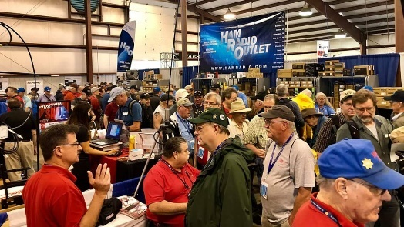

**03/14-15/2020 | Toledo Hamfest,**

**ARRL Great Lakes Division Convention**Location: Perrysburg, OH  
Sponsor: Toledo Mobile Radio Association  
Website:  <http://www.toledoglc.org/>

TOP ^

***Great Lakes Convention Banquet***

The clock is ticking fast to get your reservations for the Convention Banquet. If you are planning on going now is the time to get those reservations in to assure your seat at the banquet. Go to: <http://www.toledoglc.org/> for all the details on the banquet as well as the hamfest too!!

***Wouff Hong Ceremony at the Great Lakes Convention***

A Wouff Hong Ceremony will be held just after the ARRL Banquet on Saturday, March 14th

If you are interested in being inducted into the Royal Order of the Wouff Hong we need you to pre-register. This will assure you that you will have a seat at the Conclave.

[>> Click Here <<](http://arrl-ohio.org/wouff-hong.html)    to get registered

**========================================================**

**03/21/2020 | Mid-Ohio Valley ARC Hamfest**

Location: Gallipolis, OH

Sponsor: Mid-Ohio Valley Amateur Radio Club, Inc.

Website: <http://sites.google.com/site/midohiovalleyarc/>

**04/11/2020 | 66th Annual Cuyahoga Falls Amateur Radio Club Hamfest**  
Location: Cuyahoga Falls, OH  
Sponsor: Cuyahoga Falls Amateur Radio Club, Inc.  
Website: <http://www.cfarc.org/hamfest.php>

**04/18/2020 | Portsmouth Radio Club Hamfest**Location: Portsmouth , OH  
Sponsor: Portsmouth Radio Club  
Website: [http://portsmouthradioclub.com](http://portsmouthradioclub.com/)

**04/26/2020 | Athens Hamfest**  
Location: Athens, OH  
Sponsor: Athens County Amateur Radio Association  
Website: <http://www.ac-ara.org/>

**05/15-16-17/2020 | Dayton Hamvention**

Location: Xenia, OH

Sponsor: Dayton Amateur Radio Association

Website: <https://hamvention.org/>

####

TOP ^

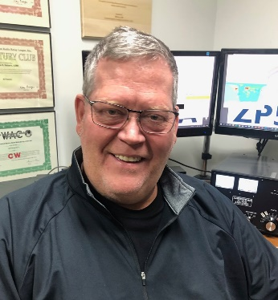***DX This Week***

*(from Bill, AJ8B)*

***DX This Week – Interview with LA7GIA***

***Bill AJ8B (***[***aj8b@arrl.net***](mailto:aj8b@arrl.net)***, @AJ8B, or*** [***www.aj8b.com***](http://www.aj8b.com)***)   
 CWOPs Member #1567***

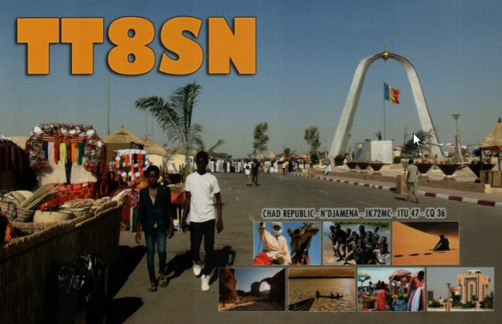On the heels of the 160M DX contest, there are several DXPeditions underway as well as some excellent DX being spotted. Although the total number of entities seems to be down, their location is impressive! Argentina, Australia, Azores, Belgium, Belize, Bolivia, Bonaire, Bulgaria, Cayman Islands, China, Colombia, European Russia, Falkland Islands, Fiji, Guam, Guernsey, Hawaii, Honduras, Iceland, India, Japan, Kazakhstan, Mongolia, Montenegro, New Caledonia, New Zealand, Norfolk Island, Panama, Qatar, Sint Maarten, South Orkney Islands, Spain, and Timor – Leste were spotted from the Midwest in the past week. Did you work the contest or work some of these entities?

The Mailman delivered cards from VP6R – Pitcairn Island, , TR8CA – Gabon, II8FTDM – Special Event Station from Italy, YS1RR – El Salvador, SV1CQN – Greece and TT8SN (Pictured). What did you get?

I also received two excellent emails, one from Chris, KV8Z, and one from Dave, W8RIT. These guys are excellent DXers and I was very pleased to hear from them. As we used to say, “Keep the cards and letters coming”. (Guess it should be Keep those emails and tweets coming)

We always get to hear about the success of various DXPeditions and we occasionally hear about the failures. Our friend, Ken, LA7GIA, had a rather harrowing experience while in Chad as TT8KO. This diary was reprinted with Ken’s permission, and the permission of the SouthWest OH DX Association. I hope it gives you a bit of a feeling from the “other side”.

The Perils of Being “DX”

*Several of our members have been in situations that would make us nervous. Currently, LA7GIA, Ken, is in just such a situation as TT8KO*

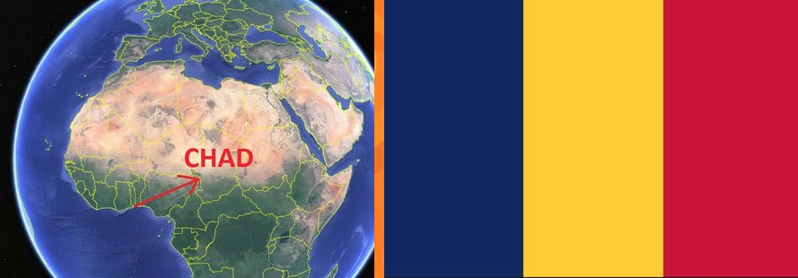OCTOBER 10, 2018 - SECURITY POLICE SHUT DOWN THE STATION THIS EVENING. TT8KO IS TEMPORARY QRT UNTIL TOMORROW 10 UTC WHEN THEY WILL DECIDE IF I CAN CONTINUE.

TOP ^

I THINK THIS IS TEMPORARY UNTIL ALL LICENSE AND EQUIPMENT ADMISSION DOCUMENTS HAVE BEEN REVIEWED BY SECURITY POLICE TOGETHER WITH MINISTRY, FOLLOWED BY A CW DEMO. SO FAR 2150 QS IN LOG FIRST 24 HOURS. ALL ANTENNAS HAVE BEEN INSTALLED EXCEPT 160M VERTICAL.

OCTOBER 11, 2018 - THE INSPECTION OF THE EQUIPMENT BY THE NATIONAL SECURITY POLICE HAS BEEN POSTPONED UNTIL TOMORROW. NO TIME GIVEN. EQUIPMENT HAS BEEN DISCONNECTED. THE HEAD OF THE POLICE HIMSELF IS TRAVELLING WITH THE PRESIDENT, AND WHEN THEY RETURN FROM ABROAD TOMORROW, THE HEAD OF POLICE WILL CHECK THE EQUIPMENT PERSONALLY WITH HIS TECHNICIANS. ALL PAPERS ARE OK AND ISSUED BY MINISTRY. APART FROM THAT, ALL IS OK HERE. UNTIL THEN I CATCH UP WITH SOME SLEEP, IT WAS A VERY INTENSE FIRST 24H COMPLETING THE INSTALLATION AND BEING ON THE AIR SAME TIME WITH 2135 QS. THE HOTEL IS REALLY GREAT, FANTASTIC TAKE-OFF. THE BEVERAGE IS ALSO WORKING VERY WELL. YESTERDAY THE MOSLEY BEAM FAILED, BUT I REPLACED ONE INDUCTOR THIS MORNING. I WAS RUNNING ON THE 40M DIPOLE ON 15M LAST 30 MIN YESTERDAY. FANTASTIC SIGNALS FROM NA ON 15 AND 40M! UNTIL THEN THE LOG FOR THE FIRST 24H HAS BEEN UPLOADED TO CLUB LOG.

OCTOBER 12, 2018 @ 12:45z - WAITING FOR THE PRESIDENT OF REPUBLIC OF TCHAD (IDRISS DEBY) TO RETURN TO THE COUNTRY AT 15:00 UTC TODAY. AFTER THAT THE CHIEF OF NATIONAL SECURITY POLICE, WHO IS WITH THE PRESIDENT, WILL PERSONALLY CHECK THE RADIO HIMSELF. IT’S NO JOKE. THEY SAY I PROBABLY CAN CONTINUE TODAY, BUT NO PROMISES. IF THIS DELAY CONTINUES EVEN MORE I WILL RETURN HOME.

OCTOBER 13, 2018 @ 19:10z - MANANA MANANA. I HAVE BEEN THROUGH 2 INTERROGATIONS BY THE SECURITY POLICE. MORE ABOUT THAT LATER. MY GEAR HAS BEEN DISCONNECTED.

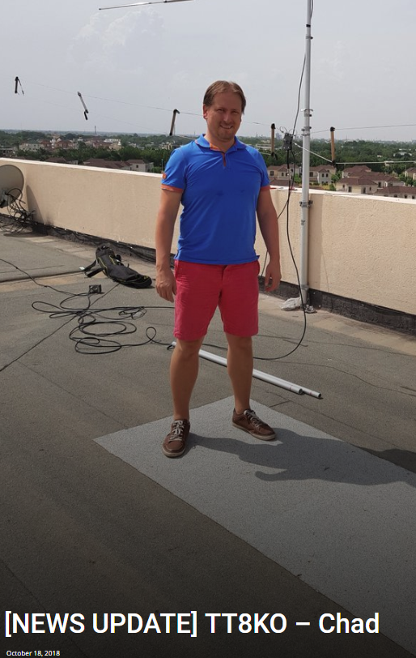THE ANTENNAS ON THE ROOF ARE LOCKED DOWN, I CANNOT ACCESS THEM EVEN FOR VISUAL INSPECTION OR MAINTENANCE. I AM NOT ALLOWED TO TOUCH ANYTHING. AND I MEAN ANYTHING. WHEN I DID IT WAS REPORTED. EVERYTHING HAS TO REMAIN IN THE SAME POSITION, NO ALTERATIONS ARE ACCEPTED, NOT EVEN TO TIGHTEN A LOOSE NUT. THE BEAM FAILED ONCE DURING THE FIRST 24 HOURS WHICH I MANAGED TO FIX WITH A SPARE PART. FROM GROUND LEVEL I CAN NOW SEE THE REFLECTOR ELEMENT IS OUT OF POSITION, AS YESTERDAY WE HAD A BRIEF STORM.

THIS MORNING I ALSO SAW MY RED BEVERAGE WIRE BEING HIT BY APPARENTLY A COLOUR BLIND BIRD DURING LANDING – VERY POOR LANDING SKILL! THE SECURITY POLICE HAVE – THROUGH THEIR INVESTIGATION – CONCLUDED THAT ALL MY DOCUMENTS ARE OK – AND I HAVE DONE ALL CORRECTLY. HOWEVER, WHAT NOW CAUSES THE DELAY IS THE FACT THAT ARCEP, WHO ISSUED ALL DOCUMENTS, DID NOT INFORM THE SECURITY POLICE. THE POLICE DO NOT ISSUE AUTHORIZATIONS BUT SUPERVISE THE NATIONAL SECURITY. THE POLICE ARE NOW AFTER ARCEP, NOT ME.

TOP ^

STILL, EVEN AFTER LOTS OF MEETINGS, BELIEVE ME, I HAVE TRIED EVERYTHING, THEY CAN’T SAY WHEN THEY WILL INFORM ME.

SO, WHILE WAITING FOR THE POLICE – THERE IS ABSOLUTELY NOTHING MORE TO BE DONE. I MIGHT GET A PHONE CALL IN 5 MIN OR NEVER. I DON’T KNOW. IF THERE IS NO DECISION BY THE POLICE VERY SOON – I WILL RETURN HOME. THANKS TO EVERYONE FOR SUPPORTING ME – MY SAFETY HERE IS NO PROBLEM!

OCTOBER 17, 2018 @ 10:15z - THIS MORNING I CHANGED MY RETURN TICKET SO WILL LEAVE CHAD ON THURSDAY 18TH – WITHIN 24H FROM NOW. HOWEVER, I AM STILL NOT ALLOWED TO DISASSEMBLE THE EQUIPMENT UNTIL INSPECTION IS COMPLETED AS EVERYTHING MUST REMAIN AS IS. I INTEND TO TAKE MY ELECRAFT K3 RADIO AND ANTENNAS WITH ME, BUT I DON’T HAVE MORE INFO THAN THAT. WILL KEEP YOU UPDATED IF ANY CHANGE. THANKS FOR ALL KIND WORDS.

OCTOBER 18, 2018 @ 13:30z - LAST NIGHT I WAS INFORMED THAT A POLICE ORDER HAS BEEN ISSUED PREVENTING ME FROM LEAVING CHAD, EVEN W/O EQUIPMENT. STATUS OF MY RETURN FLIGHT HAS CHANGED TO “OPEN”. THE NORWEGIAN EMBASSY AND FOREIGN MINISTRY IS NOW WORKING ON THE ISSUE. I GET MANY EMAILS EVERY DAY FROM DXERS AROUND THE WORLD WITH KIND WORDS – IT KEEPS THE SPIRIT UP – THANKS! HOTEL STAFF ALSO VERY SUPPORTIVE. STILL WAITING.  
  
OCTOBER 23, 2018 @ 18:30z - There isn’t much progress. Yesterday’s meeting was fake news – it never happened. The Norwegian Embassy is working on the case. we are still waiting for the case to be processed by security police. All my antennas are still locked down.

The beam, dipoles and beverage still up. 80m antenna fell down during a local TT PARTY BUT is now packed in the bag. I am safe and in the hotel compound doing absolutely nothing. I really appreciate all emails, I read all of them. ALSO, thanks to everybody who spend 5 min or even hours chatting with me, it really keeps the spirit up.

OCTOBER 24, 2018 @ 12:15Z - I received the news that I can leave Chad immediately. I am not allowed to transmit. All antennas are to be taken down today before sunset because there is a Presidential event at the hotel tomorrow, and he will be here. Hotel is now packed with VIPs, police and military personnel. I am done with the sightseeing, so my flight is booked for tomorrow.

**PROPAGATION CHARTS PROPAGATION CHARTS**

Below are the propagation charts offered by the ARRL at <http://www.arrl.org/propagation> for March. I would recommend that you reference the excellent QST article by Jerry Hall, K1TD. This originally appeared in QST, October of 1994. The explanation for the charts from the ARRL is below:

TOP ^

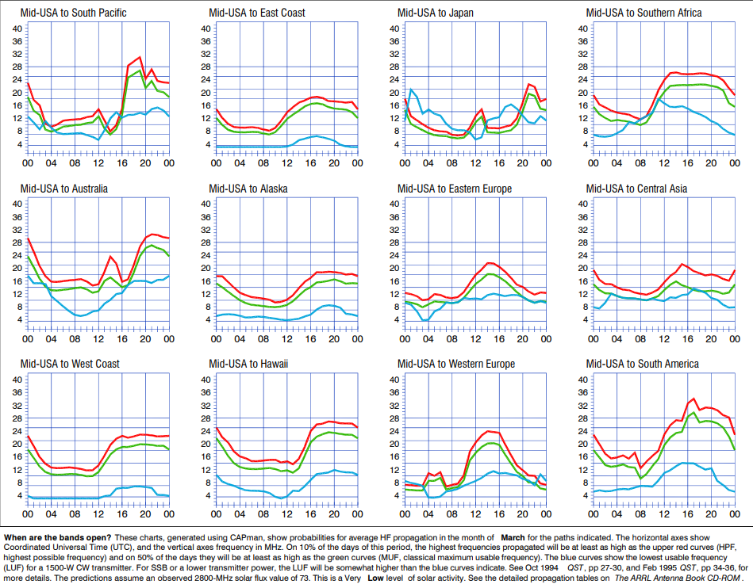

*When are the bands open? These charts, generated using CAPman, show probabilities for average HF propagation in the month of February for the paths indicated. The horizontal axes show Coordinated Universal Time (UTC), and the vertical axes frequency in MHz. On 10% of the days of this period, the highest frequencies propagated will be at least as high as the upper red curves (HPF, highest possible frequency) and on 50% of the days they will be at least as high as the green curves (MUF, classical maximum usable frequency). The blue curves show the lowest usable frequency (LUF) for a 1500-W CW transmitter. For SSB or a lower transmitter power, the LUF will be somewhat higher than the blue curves indicate.*

*See Oct 1994 QST, pp 27-30, and Feb 1995 QST, pp 34-36, for more details. The predictions assume an observed 2800-MHz solar flux value of 73. This is a Very Low level of solar activity. See the detailed propagation tables on The ARRL Antenna Book CD-ROM.*

*Reprinted with permission of the ARRL © 2020*

***CQDX CQDX CQDX CQDX CQDX CQDX CQDX CQDX CQDX***

Here is an update from Bernie, W3UR, of the DailyDX and the WeeklyDX, the best source for DX information. <http://www.dailydx.com/>. Bernie has this to report:

**VU4 – Andaman and Nicobar Islands -** From the VU4R Team’s press release 1, they will be on the air March 20-31 mainly focusing on 160, 80 and 40 and hoping to get on 60 meters too, a first-time thing from there.  They will also be in the CQ WPX Contest.  They are concerned about recent changes to 160M band limitations there and will announce their frequency and operating schedule for that later.  The QTH will be the northern tip of Neil Island with a clear shot to Europe and North America.

TOP ^

All the antennas will be on the beach.  QSL via M0OXO.  There will also be a Club Log upload when the network connection allows.  They will be active on the Eshail satellite one day.  Otherwise, there will be at least three stations on the air.  They will have a SteppIR and hexbeam for the higher bands and verticals for the lower ones. They will hire a boat from Port Blair and note that the island has intermittent commercial power, so they will rent generators and other needed items and book rooms in the resort for 11 days.

Though the antennas will be on the beach, the operating site will be 150 meters away, so they are taking a lot of LMR coax, poles and other items, all of which means contributions are welcome due to all of the above expenses.  Individuals giving 25 USD or more will get a direct QSL.  50 USD or more direct QSL and VU4 pin, 100 USD or more, QSL, VU4 pin and custom T-shirt.  [http://vu4r.vu3rsb.org](http://r20.rs6.net/tn.jsp?f=001Uq8NVK5SBY3h-VsAirK-DfN1LxaikRDqPyaKNP1KdF0l9pW5h6fOKm3c1nX-GNItVKvZqZTI8HWQ1nFFAOSFYIH2L42qP83NrDVjlvl48kFgcgt2Q4YGiR8n6cZsWGv150nJ35ZcjJVoEuw5mv9hVQ==&c=01ZuthryM09M1jwxNQDpBYpbI02V8S7r0g38mkUo4pC6g8-QIGlg8g==&ch=xRZ_0KVrhC74-wNpkUV0c1NUZQEYZXPqp8xcC7N1BK2KiJxH55kqIQ==).  They suggest PayPal or international bank transfer to send financial support, says VU2RS (ex-VU3RSB).

On the operator list for this Andamans operation are VU2ABS, VU2BGS, VU2DED, VU2DSI, VU2GHO, VU2KWJ, VU2NT, VU2RS (ex-VU3RSB) and VU3UFE.

**VP8 – South Orkney -** VP8PJ is currently active, operating on 15, 20 and 17M this morning.  The ops say they cannot get a solid satellite connection and are going to try another satellite.  They are putting up additional antennas but say it is cold and difficult to work in the wind.  Chief pilot back in North America is KE4KY, Glenn, who says the satellite problem is due to the terrain and path to the satellite, limited connectivity and dropped connection and previous operations from South Orkney had the same issues.  The ops ask that you please do not email them asking for them to check the log to see if you’re in it or for busted call checks.  K6TU says this page is interesting:   [https://www.k6tu.net/?q=node/add/dx-prediction-vp8-signy](http://r20.rs6.net/tn.jsp?f=001Uq8NVK5SBY3h-VsAirK-DfN1LxaikRDqPyaKNP1KdF0l9pW5h6fOKgX5BPqpPc95PosnfBTWsD2WDIkzpK3h3zDkWIwD7IfmqL0WGy9xCcqp5EjctyyK25Blluim-TYkt6OuJAVZh-6YGYthux-ZrptBxol76GFFfR4srV8EcoPk23dxiS5i75Wn7nwEvCkFpIn0CRYtsMM=&c=01ZuthryM09M1jwxNQDpBYpbI02V8S7r0g38mkUo4pC6g8-QIGlg8g==&ch=xRZ_0KVrhC74-wNpkUV0c1NUZQEYZXPqp8xcC7N1BK2KiJxH55kqIQ==)

**W8S – Swains Island -** Dear supporter of the Swains2020 – W8S – project,

Following the disappointing news earlier this week the Swains2020 team is extremely happy that we can announce the new schedule for the W8S DXPedition to Swains Island. The team will be on the island from September 23 until October 6, 2020.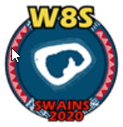 We like to thank all our sponsors and supporters for the understanding and confidence we have received after the message about the forced postponement of the DXPedition.

We are therefore very happy that we can already share the new planning with you.

The Swains 2020 Team

**T30 – Western Kiribati -** 5B4ALX has had a flight schedule change and is staying on Tarawa a bit longer.  He will have T30ET on the air March 18-April 6, SSB, CW and digital on 160-6.  He will use the multi-answer protocol on FT8, focusing on 20M daytime and 40 at night.  Nighttime there is 07-17Z.  QSL to him through OQRS or LoTW.   [http://www.5b4alx.cloud/t30et-tarawa-atoll-2020/](http://r20.rs6.net/tn.jsp?f=001Uq8NVK5SBY3h-VsAirK-DfN1LxaikRDqPyaKNP1KdF0l9pW5h6fOKiM-dSv33Lgx5lPAtDPP2EUba6ID9yILZKIuU019GTgF7L9D5lbK46_JF_siyL93UM-OMViyAtoq7Zp5ca8O6c2oVI-7Yk21_f9NsKLo1BPdqhrhCG-Gr0AibzLQe7UzyQ==&c=01ZuthryM09M1jwxNQDpBYpbI02V8S7r0g38mkUo4pC6g8-QIGlg8g==&ch=xRZ_0KVrhC74-wNpkUV0c1NUZQEYZXPqp8xcC7N1BK2KiJxH55kqIQ==).

**UA – Russia -** UE45SA July 11-19 will celebrate the 45 years since the Apollo-Soyuz Test Project of July, 1975, the first joint US-Soviet space flight.  QSL via RV3YR or through OQRS.

####

TOP ^

***DX news***



***ARLD009 DX news***

This week's bulletin was made possible with information provided by AA4NC, KK9A, W3UR, The Daily DX, the OPDX Bulletin, 425 DX News, DXNL, Contest Corral from QST and the ARRL Contest Calendar and WA7BNM web sites. Thanks to all.

**MALDIVES, 8Q.**  Ivan, UR9IDX is QRV as 8Q7VR from Naifaru Island, IOTA AS-013. Activity has been mainly on 80 and 40 meters using CW with some SSB. His length of stay is unknown. QSL via EA5EL.

**RWANDA, 9X.** Harald, DF2WO will be QRV as 9X2AW from March 4 to 22.

Activity will be on the HF bands, possibly including 160 meters and Satellite QO-100 upon requests, using mainly FT8 with some CW and SSB. QSL via M0OXO.

**TAIWAN, BV.** Special event station BV120SU is QRV until August 4 to celebrate the 120th anniversary of Soochow University. Activity is on the HF bands. QSL via BU2EQ.

**SOLOMON ISLANDS, H4.** Will, AA4NC and Ron, AA4VK will be QRV as H44NC and H44VK, respectively, from March 1 to 3. Activity will be holiday style on the HF bands using CW, SSB and FT8. QSL H44NC via EA5GL and H44VK direct to home call.

**PANAMA, HP.** Operators Alvaro, HP1DAV, Jay, HP3AK, Roger, G4BVY, Peter, G4CLA and Martin, GD4XUM will be QRV as H33K from Volcan/Province Chiriqui from March 2 to 13. Activity will be on

160 to 10 meters using CW, SSB and FT8. This includes being an entry in the upcoming ARRL International DX SSB contest. QSL direct to HP1DAV.

**ITALY, I.** Special event stations IO3RT and IO3AF are QRV until the end of May to commemorate the 100th anniversary of Arturo Ferrarin's first flight from Rome to Tokyo. Activity is on 80 to 6 meters using CW, SSB and various digital modes. QSL both calls to IQ3BM.

**OGASAWARA, JD1.** Operators Take, JA1UII and Kami, JH1HHC are QRV as JD1BON and JD1BPH, respectively, from Komagari, Chichijima Island, IOTA AS-031, until March 5. Activity is on 160 to 6 meters using CW, SSB, RTTY and FT8. QSL to home calls.

**PAPUA NEW GUINEA, P2.** Will, AA4NC and Ron, AA4VK are QRV as P29NC and P29VK, respectively, until March 1. Activity is holiday style on the HF bands using CW, SSB and FT8. QSL P29NC via EA5GL and P29VK direct to home call.

**ARUBA, P4.**  John, KK9A will be QRV as P40A from March 1 to 8. Activity will be on 160 to 10 meters using CW and SSB. This includes being an entry in the upcoming ARRL International DX SSB contest. QSL via WD9DZV.

TOP ^

**SOMALIA, T5.** Ali, EP3CQ is QRV as 6O1OO from Mogadishu until March 25. Activity is on 160 to 6 meters, with an emphasis on 60 meters, using CW, SSB and FT8. QSL direct to home call.

**EAST KIRIBATI, T32.**  Ken, KH6QJ will be QRV as T32AZ from Christmas Island, IOTA OC-024, from March 4 to 11. Activity is on the HF bands, mainly on 80 meters, using SSB. This includes being active in the upcoming ARRL International DX SSB contest. QSL to home call.

**BELIZE, V3.** Iain, G4SGX plans to be QRV as V31GX from Ambergris Caye, IOTA NA-073, during March. This includes being an entry in the upcoming RSGB Commonwealth contest. QSL via M0OXO.

**BRUNEI, V8.** Special event station V84HSK is QRV until March 2 to commemorate the 36th anniversary of the country's independence. Activity is on the HF bands using CW, SSB and various digital modes. QSL direct to V85TL.

**SOUTH ORKNEY ISLANDS, VP8.** Members of the Perseverance DX Group are QRV as VP8PJ from Signy Island, IOTA AN-008, until March 5. Activity is on 160 to 10 meters using CW, SSB, RTTY and FT8 in DXpedition mode. QSL via M0URX.

**VANUATU, YJ.** Will, AA4NC and Ron, AA4VK will be QRV as YJ0NC and YJ0VK, respectively, from New Hebrides, IOTA OC-035, from March 3 to 6. Activity will be holiday style on the HF bands using CW, SSB and FT8. QSL YJ0NC via EA5GL and YJ0VK direct to home call.

**SOUTH SUDAN, Z8.** Sigfrido, Z81S, a member of the United Nations Mission in South Sudan has been active on 20 meters using SSB around 1630 to 1730z. QSL direct to IT9YVO.

**CAYMAN ISLANDS, ZF.** Joel, NF3R will be QRV as ZF2RJ from March 3 to 10. Activity will be on the HF bands. This includes being an entry in the upcoming ARRL International DX SSB contest. QSL via LoTW.

THIS WEEKEND ON THE RADIO. The North American RTTY QSO Party, North American Collegiate RTTY Championship, NCCC RTTY Sprint, QRP 80-Meter CW Fox Hunt, NCCC CW Sprint, Feld Hell Sprint, EurAsia HF Championship, FT4 DX Contest, UBA DX CW Contest, South Carolina QSO Party, SARL Hamnet 40-Meter Simulated Emergency Contest and North Carolina QSO Party are all on tap for this upcoming weekend.

RSGB 80-Meter Club Data Championship is scheduled for March 2. The AGCW YL-CW Party and ARS Spartan CW Sprint are scheduled for March 3.

The CWops Mini-CWT Test, UKEICC 80-Meter SSB Contest, 40-meter QRP CW Fox Hunt and Phone Fray are scheduled for March 4.

***Special Events***

* **03/05/2020 | C-47 Skytrain**

**Mar 5-Mar 12, 0000Z-0000Z, W5S**, Oklahoma City, OK. Mid-Del Amateur Radio Club. 144.200 14.280 7.280. QSL. Mid-Del Amateur Radio Club, P.O. Box 30512, Midwest City, OK 73140. [www.w5mwc.org](http://www.w5mwc.org/)

TOP ^

* **03/13/2020 | Bataan Memorial Death March**

**Mar 13-Mar 16, 1800Z-0600Z, K5B**, Las Cruces, NM. Mesilla Valley Radio Club. 147.180 +(100) Mega Link talk-in; 147.350 +(100) Mega Link talk; 7.070 USB PSK 31 40Night 20day 14.250 Voice 20M Day 40M Night. QSL. Mesilla Valley Radio Club, P.O. Box 1443, Las Cruces, NM 88004. General Communication Operations in support of Bataan Memorial Death March Race. Operation of Ham Camp for HF communication and introduction of Ham Radio to the public attending the race. HF operations on PSK 31, *.070 20 m day and 40 m nights. Voice general *.250 on 20m day and 40m nights. Local 28.400 USB or 29.600 FM calling. QSL by request SASE. [www.n5bl.org](http://www.n5bl.org/)

* **03/14/2020 | Battle of Picacho Peak Anniversary**

**Mar 14, 1600Z-2100Z, K7T**, Tucson, AZ. Oro Valley ARC. 7.040 CW 14.040 CW 14.250 USB 18.100 FT-8. Certificate. Email, qsl@TucsonHamRadio.org, for certificate. No paper QSLs please. [www.TucsonHamRadio.org](http://www.tucsonhamradio.org/)

* **03/14/2020 | PI Day March 14, 2020**

**Mar 14-Mar 15, 0500Z-0500Z, N2RE**, Princeton, NJ. David Sarnoff Radio Club. 14.250 14.050 7.120 7.050. QSL. Bob Uhrik, 104 Knoll Way, Rocky Hill, NJ 08553-1013. [www.qrz.com/db/N2RE](http://www.qrz.com/db/N2RE)

* **03/14/2020 | The American Legion's 101st Birthday Celebration**

**Mar 14, 1700Z-2300Z, K9TAL**, Indianapolis, IN. The American Legion Amateur Radio Club. 14.275 7.225; *CrossRds* EchoLink Conference IRLP Reflector 9735. Certificate & QSL. The American Legion Amateur Radio Club, 700 N. Pennsylvania St., Indianapolis, IN 46204. The year 2020 marks the beginning of The American Legion's 2nd century of service to our Nation and our veterans. Any ham radio operator who contacts the station is eligible to receive a QSL card and a commemorative certificate to document their participation. To receive a QSL card and certificate after working K9TAL, send your name, address, call sign, and a 9x12-inch self-addressed stamped envelope to The American Legion Amateur Radio Club, 700 N. Pennsylvania Street, Indianapolis, IN 46204. k9tal@legion.org or [legion.org/hamradio](http://legion.org/hamradio)

* **03/14/2020 | USS Midway Museum Ship Special Event; Launching of USS Midway**

**Mar 14, 1700Z-2359Z, NI6IW**, San Diego, CA. USS Midway (CV-41) Museum Ship. 14.320 7.250 PSK31 14.070 DSTAR REF001C. QSL. USS Midway Museum Ship COMEDTRA, 910 N Harbor Drive, San Diego, CA 92101.

* **03/14/2020 | WHOA/SCOTA**

**Mar 14, 1300Z-1900Z, W1M**, Russell, MA. Western Mass Council--Scouting USA. 7.030 7.190 14.060 14.290. QSL. Tom Barker, 329 Faraway Road, Whitefield, NH 03598. Paper logging is used--there will be a delay in sending out qsl cards.

* **03/16/2020 | Maine Bicentennial Special Event**

**Mar 16-Mar 22, 0000Z-2359Z, W1L**, Boothbay Harbor, ME. Boothbay Harbor Memorial Library. 14.262 7.262 3.962. Certificate. Via email: director@bbhlibrary.org, or from , website, www.bbhlibrary.org . W1L will be operating from Boothbay Harbor, ME. Other participating calls include K1B, K1J, K1P, W1C, W1H, W1K, W1L, W1O, W1P, W1S, W1W, and W1Y. Certificate for contact; endorsements for bands, modes, and clean sweep of contact with each of the Maine 200 Special Event call signs. www.maine200specialevent.com for Bicentennial information; for W1L information, n1mhc@arrl.net or [www.bbhlibrary.org](http://www.bbhlibrary.org/)

TOP ^

**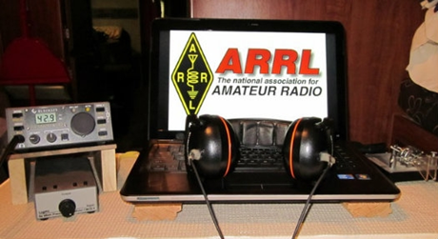*ARRL Contest Corner***

An expanded, downloadable version of *QST'*s [**Contest Corral**](http://www.arrl.org/contest-calendar) is available as a PDF. Check the sponsor's Web site for information on operating time restrictions and other instructions.

|  |  |
| --- | --- |
| **March 3**   * [ARS Spartan Sprint](http://arsqrp.blogspot.com/2009/02/so-whats-spartan-sprint-and-how-do-i.html)   [AGCW YL-CW Party](http://www.agcw.org/index.php/en/contests-and-cw-activities/yl-cw-party) | **March 4**   * [QRP Fox Hunt](http://www.qrpfoxhunt.org/winter_rules.htm) * [Phone Fray](http://www.perluma.com/Phone_Fray_Contest_Rules.pdf) * [CWops Mini-CWT Test](https://cwops.org/cwops-tests/) * [UKEICC 80m Contest](https://www.ukeicc.com/80m-rules.php) |

***Attention ALL Ohio…***

***Mark April 4, 2020 (Saturday) as our ARES OHIO SPRING CONFERENCE!***

We have the Marion Tech lecture hall reserved (THANKS MARION ARES!!!) and we’ll begin planning some important topics! More information will be forth coming.

This event is always “Standing Room Only” so we do ask that you register ahead of time so that we can be properly prepared for how many are coming. It’s quick and painless and we will even send you a confirmation email back.

**Here’s the link to get registered!!** [**http://arrl-ohio.org/SEC/form.html**](http://arrl-ohio.org/SEC/form.html)

####

***NVIS DAY IS COMING!***

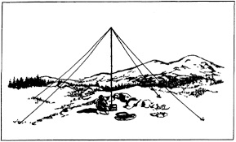

Is your station ready to establish and maintain high-reliability communication with other stations around Ohio when repeaters, phone, and internet service are impaired?

When infrastructure just isn’t there, HF radio using Near-Vertical Incidence Skywave (NVIS) propagation offers the ability to stay in contact on frequencies of 2–30 MHz for distances of about 30–400 miles.

NVIS Day is the ARRL Ohio Section event to test your NVIS antenna designs and builds. Join us on Saturday, April 25th to show how well amateur radio can keep Ohio communicating! This is not a contest: it’s an event for Ohio stations to operate with other Ohio stations and understand how well they hear and are heard.

TOP ^

**THE DETAILS**

**Date: Saturday, April 25**

**Time: Start at 10 A.M., end at 4 P.M.**

**Power: Up to but no more than 100w**

**Exchange: six-digit grid, power, and true—measured—signal report**

**Schedule: This isn’t a contest, so take your time! Try different designs! Have lunch!**

***2020 Weather Safety Week Events***

* Ohio’s Severe Weather Awareness Week: March 22-28
* **Statewide Tornado Drill: Wednesday, March 25 at 9:50 am**
* Lightning Safety Awareness Week: June 21-27
* Ohio’s Winter Safety Awareness Week: November 15-21

***V.E. Test Sessions***

**

For the latest testing site information please **>>** [**Click Here**](http://www.arrl.org/find-an-amateur-radio-license-exam-session) **<<** The ARRL site tracks all of the VE testing sites that register with them, including W5YI and Laurel. ARRL gives you a number of different ways of sorting to find that site that is closest to you as well.

***One Question Questionnaire***



Hey Gang,

Ok.. “Survey Says”….. 19% of you scheduled antenna work to be done for last week!

Ok, I’ve got another NEW – one question – for you to answer. With Daylight Saving Time coming for this Sunday….

**“Have you ever forgotten to move your clock ahead 1 hour for Daylight Saving Time??”**

You’ll find the “One Question” questionnaire on the Ohio Section Website! <http://arrlohio.org> It’s all in fun and it’s not a scientific survey in any way, but we are learning some things that we didn’t know from these questions. I hope that you are enjoying answering these “One Question” questionnaires.

TOP ^

***“ARES Connect”***

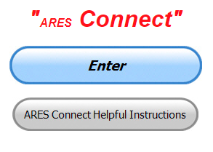

**Everyone –** please make sure to go into all of the events that you have signed up ***for and get your hours registered no later than 5 days after the event has ended****.*

Folks, I’m seeing a lot of folks that have signed up for events not entering their time after the event. This is a very important piece of using “Connect.” Your hours need to be recorded and it’s so easy to do.

Let’s run through how so in case you have forgotten. If you have already gotten signed up for an event, all you have to do afterword to get your time entered is at any time after the event has ended, log into “Connect.” And then click on your name in the upper right-hand corner of the page. This will bring up a drop-down menu where you will then click on “View Hours.”

This brings up another screen where you can “Report Hours” as well as “View Hour History” You’ll want to click on “Report Hours.” You will then be presented one at a time by chronological order each event that you have signed up for and hours have not yet been reported on. Type in those hours in the “Hours Worked” box and hit “Submit”… Keep doing this until you have no more hours to report…. That’s all there is to it. Now, if you are following the request above and doing this at least every 5 days or more often, this will only take you a minute or so to complete.

**Now, isn’t that easy? Yes, and we all need to be diligent at doing it promptly.**

***Here’s the top 5 hours earners so far for February:***

|  |  |  |  |
| --- | --- | --- | --- |
|  | **Name** | **Events** | **Hours** |
| 1 | Greg Dersarkisian (KD8SSJ) | 23 | 155.00 |
| 2 | James Yoder (w8erw) | 23 | 114.91 |
| 3 | Bret Stemen (KD8SCL) | 33 | 111.00 |
| 4 | Dwight Bonifield (W8TJT) | 65 | 107.50 |
| 5 | Earl Paazig (W8BR) | 14 | 97.00 |

**Let’s get everyone in the Ohio Section on “ARES Connect!!!” Simply go to:** <https://arrl.volunteerhub.com/lp/oh/> and get yourself registered and using the system.

**Admins…** If you are wondering how to get an overview of all of your events you can simply go into reports and using the new Event by Participation by Event (version 2) you can not only see who registered for your event, but you also can see if he/she has inputted their hours for it as well. Take advantage of this new report to help you get the time entered into your events.

**We still have a number of recurring events created but no activity reported for them.** Please, if this event is no longer needed, let me know and I can delete it from the masters. I know that many of you setup recurring events to learn how, but if they aren’t going to be used, let’s get them cleared out.

TOP ^

Also… If you are setting up events, please don’t set a limit for how many folks can sign-up unless absolutely necessary. This causes issues when doing reports. It’s also counter-productive since the reason for you to list the event is to get as many volunteers as you can to attend. When you set limits, it discourages folks from signing up.

***Special NIMS Training Available***

**G-557 RAPID ASSESSMENT PLANNING COURSE**

Hosted by: Fulton County Emergency Management Agency

**Tuesday, June 9, 2020**

Course Description: This course provides information and resources to enable participants to develop an effective Damage Assessment Program and conduct rapid and effective needs assessments. A good assessment allows community leaders to prioritize response actions ensuring the greatest life-saving and life sustaining benefits. Since resources are often limited in the first few hours of a disaster or emergency an effective rapid needs assessment allows for the efficient and effective use of those resources. Likewise, it allows local officials to evaluate their needs and request those resources that are not available in their jurisdiction to support life sustaining and life saving measures.

This is a “Required” course in the Advanced Professional Series (APS) program

Application Deadline: **May 26, 2020**

Time of Course: Registration: 7:45 am – 8:00 am

Course Time: 8:00 am – 4:00 pm

Location: Fulton County Welcome Center/EOC - 8848 State Highway 108 Wauseon, Ohio 43567

Supported By: The Ohio Emergency Management Agency

Recommended Participants: Local officials who are responsible for assessing, collecting, and reporting damages during and after any event that causes damage of private, public, and critical infrastructure.

Recommended Prerequisite: IS0100.c, Introduction to the Incident Command System, ICS 100; IS0200.c, Incident Command System for Single Resources and Initial Action Incidents; IS0700.b, National Incident Management System, An Introduction; IS0800.b, National Response Framework, An Introduction; IS0120.a, An Introduction to Exercises; and IS0130, Exercise Evaluation and Improvement Planning. These courses are available online by going to https://training.fema.gov/is/crslist.aspx?all=true.

Enrollment: Students must enroll via the Department of Public Safety Training Campus website: <https://trainingcampus.dps.ohio.gov/cm/cm710/pstc/pstc.html> Course registration will generally close 10 working days prior to the course start date. You can check enrollment/approval status via the Department of Public Safety Training Campus website.

Course Costs: This course is free to participants. Lodging, meals and all other expenses are the students’ responsibility.

TOP ^

County Point of Contact: Peggy Volkman, Administrative Assistant, (419) 337-9207, [peggyvolkman@fultoncountyoh.com](mailto:peggyvolkman@fultoncountyoh.com)

State Point of Contact: Matt Jaksetic, State Training Coordinator, Ohio EMA (614) 799-3666, [mtjaksetic@dps.ohio.gov](mailto:mtjaksetic@dps.ohio.gov)

***Other courses being scheduled…***

**G-271** Hazardous Weather and Flooding Preparedness 9/23-23/20

**G-272** Weather Warning Coordination 10/20-21/20

**OH-606** Disaster Recovery and **OH-607** PA Cost Recovery/Damage Assessment 11/5/20.

####

**ICS400 ADVANCED FOR COMMAND & GENERAL STAFF MGT905**

Hosted by: Mahoning County Emergency Management Agency

**March 30 – 31, 2020**

**Application Deadline: March 16, 2020**

Course Registration time: 7:30 am – 8:00 am (on day one)

Course Time: 8:00 am to 5:00 pm – Both days One-hour Lunch each day

Training Location: Boardman Fire Department, Station 71 7440 Market Street Boardman, OH 44512

Required Prerequisites: Individuals must complete the IS-100.c Introduction to the Incident Command

System, IS-200.c Basic Incident Command System for Initial Response, IS-700.b An Introduction to the

National Incident Management System and the IS-800.c National Response Framework, an Introduction

courses.

In addition, ICS-300 Intermediate courses prior to attending the ICS-400 Advanced course and

provide copies of their certificates of completion to the instructors on day one of the course.

Enrollment: Students must enroll via the Department of Public Safety Training Campus website:

<https://trainingcampus.dps.ohio.gov/cm/cm710/pstc/pstc.html> Course registration will generally close 10

working days prior to the course start date and applicants can check enrollment/approval status via the

Department of Public Safety Training Campus website.

Course Costs: There is no charge for participants to attend this course. However, Lodging, Meals, Per

Diem and all other travel expenses are the responsibility of the student or the parent organization.

State Point of Contact: Lisa Jones, DSC 2, Ohio EMA, SAA Training Point of Contact, (614) 799-3824

[ljones@dps.ohio.gov](mailto:ljones@dps.ohio.gov)

####

Below is a status update of upcoming training classes.  Please look at the list, there is a variety of topics, and I would appreciate it if you would consider registering for one (1) or more if your schedule allows.

TOP ^

Some of the classes you can register for on the FCEM&HS website; go to the “Training Opportunities” site <https://fcemhs.org/Training-Exercises/Training-Opportunities>  (where you can find the information flyer on all of the classes) and then click on the “FCEM&HS Training Registration” link <https://fcemhs.org/Training-Exercises/FCEMHS-Training-Registration>

The rest of the classes you will need to register on the Ohio Public Safety Training Campus <https://trainingcampus.dps.ohio.gov/cm/cm710/pstc/>

For those classes that are being instructed through TEEX, once you register with me, I will send you an approval email with a link to then register on the TEEX website.

|  |  |  |  |
| --- | --- | --- | --- |
| CLASS | DATE | TIME | LOCATION |
| MGT-467 Sport and Special Event Public Information and Emergency Notification (Register via paper registration or the FCEM&HS website) | March 3&4 | 8am-5pm (16 hrs) | OSU Airport |
| OH/L-146 Homeland Security Exercise and Evaluation Program (HSEEP) (Register via OH Public Safety Training Campus) | March  25-27 | 8am-5pm (24 hrs) | FCEM&HS |
| AWR-376 Understanding Targeted Cyber Attacks (Register via paper registration or the FCEM&HS website) | April 7 | 8am-5pm  (8 hrs) | FCEM&HS |
| AWR-213 Critical Infrastructure Security & Resilience Awareness of Critical Infrastructure/Key Resources (Register via paper registration or the FCEM&HS website) | April 15 | 8am-5pm  (8 hrs) | FCEM&HS |
| MGT-317 Disaster Management for Public Services (Register via paper registration or the FCEM&HS website) | April 21&22 | 8am-5pm (16 hrs) | FCEM&HS |

####

**EMA-G289 PUBLIC INFORMATION OFFICER (PIO) AWARENESS**

**Hosted by: Youngstown State University Police Department**

**April 7, 2020**

**Course Description:** The Public Information Officer (PIO) Awareness Course is a “Free” course designed to familiarize participants with the concepts underlying the PIO role. The material provides a basic understanding of the PIO function for those new to the position. It orients the participants to the public information function and the role of the PIO in the public safety / emergency management environment. This training forms the foundation for more advanced training that takes participants from the awareness level to the mastery level in their public information careers. Additionally, it provides those in executive level roles the necessary knowledge of PIO roles and responsibilities during an emergency.

TOP ^

**Application Deadline:** March 24, 2020

**Time of Course:** Registration: 7:30 am – 8:00 am

Course Time: 8:00 am – 5:00 pm

**Location:** Youngstown State University Police Department

266 West Wood St. Youngstown, Ohio 44555

**Supported By:** The Ohio Emergency Management Agency

**Recommended Participants:** The primary audience for this training is individuals who have public information responsibilities as their main job or as an auxiliary function at the federal, state, local, tribal, or territorial level of government, and in the private and nongovernmental sectors.

**Recommended Prerequisite:** IS-100 Introduction to Incident Command System; IS-702 NIMS Public Information Systems; and IS-909 Community Preparedness: Implementing Activities for Everyone

**Enrollment:** Students must enroll via the Department of Public Safety Training Campus website: <https://trainingcampus.dps.ohio.gov/cm/cm710/pstc/pstc.html>.

Course registration will generally close 10 working days prior to the course start date. You can check enrollment/approval status via the Department of Public Safety Training Campus website.

**Course Costs:** This course is free to participants. Lodging, Meals, Per Diem and all other travel expenses are the responsibility of the student or the parent organization

The FY 2019/2020 Ohio EMA Training Catalog at http://ema.ohio.gov/Training.aspx provides additional information.

**County Point of Contact:** Adam Guerrieri. (330) 503 – 4626. [ajguerrieri@ysu.edu](mailto:ajguerrieri@ysu.edu)

####

Below are trainings that can be found by following this link: <https://services.dps.ohio.gov/CIMS/>.

* **G-191 ICS-EOC Interface (Lawrence County April 2020)**
* **G-289 Public Information Officer (PIO) Awareness (Fulton County April 2020)**
* **G-289 Public Information Officer (PIO) Awareness (Hocking County April 2020)**
* **G-318 Mitigation Planning Workshop (Cuyahoga County April 2020)**
* **G-402 ICS Overview for Executives and Senior Officials (Franklin County April 2020)**
* **OH-202 Debris Management Workshop (Stark County April 2020)**

**Intended Audience: Law Enforcement, Emergency Services, Emergency Managers, Communications, Government, Volunteers, State, Local, Tribal, and Territorial Personnel**

For more questions or concerns regarding CIMS please contact [CIMS@dps.ohio.gov](mailto:CIMS@dps.ohio.gov).

####

TOP ^

***Campbell County Kentucky Office of Emergency Management Upcoming Training***

Campbell County Kentucky Office of Emergency Management **FREE** Training Opportunities

**Hazardous Weather Preparedness for Campuses (AWR-332) – March 4, 2020** – (NDPTC) / **Tentative/Requested**

**Readiness: Training Identification and Preparedness Planning (MGT-418) – March 11-12, 2020** - TEEX / Register: <https://train.ncbrt.lsu.edu/Student/Register?ClassID=26374>

Registration Password: NCBRT418 If you have trained with NCBRT before, enter your FEMA SID, Last Name, and First Name. If your training record is found, your registration form will be pre-filled for you. Otherwise, click Register as New Person to fill out a blank registration form.

**Evacuation and Re-Entry Planning Course – March 25-26, 2020** / **Requested through KYEM Training Division**

**Pediatric Disaster Response and Emergency Preparedness (MGT-439) – April 8-9, 2020** / TEEX / Register: <https://qrgo.page.link/GFf4>

**Debris Management Planning Course – April 15-17, 2020** / **Requested thought KYEM Training Division**

**Intermediate ICS-300 for Expanding Incidents w/Forms (MGT-904) – April 22-24, 2020 / TEEX / Register:** [**https://qrgo.page.link/HzT2**](https://qrgo.page.link/HzT2)

####

***OPENWEBRX VERSION 0.18.0 RELEASED***

*(Submitted by Gregory Drezdzon, WD9FTZ)*

In early January, there was an article about how the popular web based SDR and RTL-SDR compatible receiver software known as OpenWebRX was officially discontinued by the original author.

Thanks to it's open source license, code contributor Jakob Ketterl (DD5JFK) has been able to continue developing the code and is taking over as the lead developer on [his own fork of the code](https://github.com/jketterl/openwebrx).

Recently Ketterl released version 0.18.0 of OpenWebRX which includes a few major upgrades including the much needed shift to Python 3, and the inclusion of multiple new decoders for DMR, D-Star, YSF, NXDN, FT8, FT4, WSPR, JT65, JT9, APRS and Pocsag.

The full story is at:  <https://www.rtl-sdr.com/openwebrx-version-0-18-0-released-new-decoders-for-digital-voice-digital-ham-modes-and-more/>

TOP ^

***Final.. Final..***

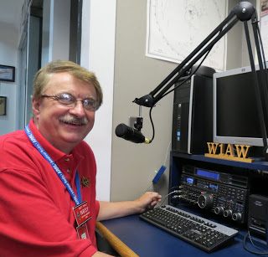

Hey Gang...

This past week has really flown by. Even though we did get some snow this past week, it sure doesn’t seem as bad this year as last!

Janie has finally settled down on moving pictures and furniture around the house. I think she just plain got tired of moving things. I’m just hoping that she doesn’t get her second wind and starts up again.

Moving down the log a bit… I want to encourage all of you to make sure that your ARRL dues are up-to-date. I know that his must sound like a broken record, but… “Being a part of a great organization like ARRL is really important to you and to all of us. Your voice is heard and heard loud and clear not only here in Ohio, but also at Headquarters.

Please remember that the ARRL is our only advocate to keep and expand our amateur radio frequencies. And this is not the only benefit as a member of the ARRL. Where else will you get insurance as inexpensively as the ARRL provides for its membership? There’s also all of the ARRL awards that you are eligible for as well. Hey, membership to ARRL is less than $1 per week. Less than a cup of coffee at McDonald’s!!!

Oh, I will also add, ARRL does have a **90-day FREE** trial offer, if you are still not sure if this is something that you would enjoy. What have you got to lose? It’s FREE. Oh, don’t forget that if your YL is a ham you’ll want to get her a membership as well.

Whelp, final go around before gong QRT… That’s going to do it for this week. Stay safe, enjoy the sunshine when we have it, and most of all… have FUN and get on the air!!

73,

***Scott, N8SY***

Ohio Section Cabinet

|  |  |
| --- | --- |
| Section Manager – Scott Yonally, N8SY | Assistant Section Manager – John Perone, W8RXX |
| Section Emergency Coordinator – Stan Broadway, N8BHL | Section Traffic Manager – David Maynard, WA3EZN |
| Technical Coordinator – Jeff Kopcak, K8JTK | Affiliated Clubs Coordinator – Tom Sly, WB8LCD |
| State Government Liaison – Bob Winston, W2THU | Public Information Coordinator – John Ross, KD8IDJ |
| Section Youth Coordinator – Anthony Lascre, K8ZT | |

TOP ^

***Swap & Shop Has Come to the Ohio Section Website***

Hey Gang,

Have you taken a look at the **Swap & Shop** page on the Ohio Section webpage yet??

Here’s a link that will take you there… <http://arrl-ohio.org/sm/s-s.html>

Do you have equipment that you just don’t need or want anymore? Here’s a great venue to advertise it, and it’s FREE!! No, it won’t be listed in this newsletter because it would take up way too much space, so your ad will only appear on the website. It is there for any individual to post equipment Wanted / For Sale or Give-Away. No licensed vehicles/trailers or business advertising will be posted.

Postings are text only (no pictures or graphics) will be posted for a maximum of 1 month from date posting and require a contact phone number or email within the posting.

Send your Wanted / For Sale or Give-Away post to:  [swap@arrlohio.org](mailto:swap@arrlohio.org)

***Welcome New Subscribers***

Paul, N8RLB

***Back Issues of the PostScript and Ohio Section Journal***

Hey, did you know that PostScript and Ohio Section Journal (OSJ) are archived on the website? You can go back and look at any edition simply by clicking:

<http://arrl-ohio.org/news/index.html>

*****Spring Forward***

Don’t forget to set your clocks forward this coming Saturday night, March 7th before going to bed. **Sunday, March 8th** we “Spring” ahead one hour. If you don’t do it you just might just be late for church, or wherever you may be going to on Sunday!

TOP ^

***Updated Information... Want to Share your Club Newsletter With Others?***

We have a new webpage where you can download and read all of the newsletters that I get from around the state.

Here’s the link to the page…. <http://arrl-ohio.org/club_news/index.html>

Please, if you don’t see your club newsletter posted, it’s probably because I’m not receiving it, or I just cannot convert it over to Adobe Acrobat. Have your newsletter editor contact me and let’s see if we can get your club’s newsletter on the site!! We all learn and steal (I mean, share) from each other’s work. So, let’s give this new webpage a real workout and send me your newsletter!!! Send it to: [n8sy@n8sy.com](mailto:n8sy@n8sy.com)

***Chit – Chat, and All That!***

Do you know someone that’s not getting these Newsletters? Please, forward a copy of this Newsletter over to them and have them “[Opt-In](http://arrl-ohio.org/forwarder/forwarding.html)” to start receiving them. Heck just have them send me an email [n8sy@n8sy.com](mailto:n8sy@n8sy.com) and I’ll get them added to the Ohio Section Emailing list.

We now have many thousands of readers receiving these newsletters weekly. Quite impressive, I’d say! I urge all of you to make sure that everyone, regardless of whether they are a League member or not, get signed up to receive these weekly Newsletters.

You can always “[Opt-Out](http://arrl-ohio.org/forwarder/forwarding.html)” at any time if you feel this is not what you were expecting. It’s fun and very informative. All of your favorite past newsletters are now archived too.

You can go back at any time and read them. Just go to: <http://arrl-ohio.org/news/>

Got questions, concerns or would just like to sit and chat awhile? Heck, I’ll even buy the coffee!! Give me a call at (419) 512-4445 or email me at: [n8sy@n8sy.com](mailto:n8sy@n8sy.com)

The pictures on the front page and throughout this newsletter are from various newsletters, Facebook posts and/or were sent directly to me in recent weeks. Take a good look at them, you just might be in one of the pictures! “SMILE… you’re in the Ohio Section News!!”

TOP ^

*PostScript is produced as a weekly newsletter. I want to thank everyone that has contributed articles and ideas to make this an even better news source. I sincerely hope that you have enjoyed this edition and will encourage your friends to join with you in receiving the latest news and information about the Ohio Section, and news and events happening around the world!*