[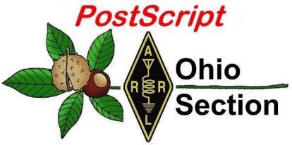](http://arrl-ohio.org/news/) ***Presidents Day***

***Edition***

🡪 National News 🡪 The Handbook Give Away

🡪 Club Corner 🡪 Hamfests

🡪 DX This Week 🡪 One Question Questionnaire

🡪 VE Testing 🡪 ARES Connect

🡪 Special NIMS Training 🡪 Final.. Final..

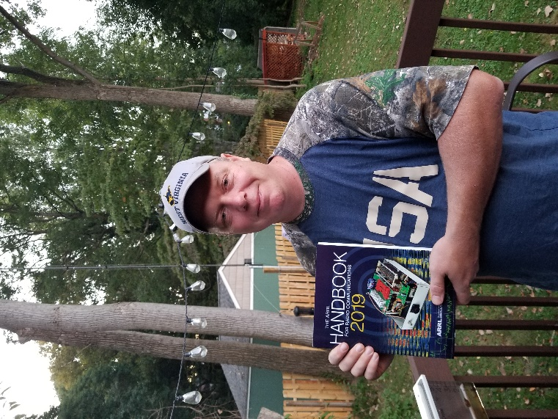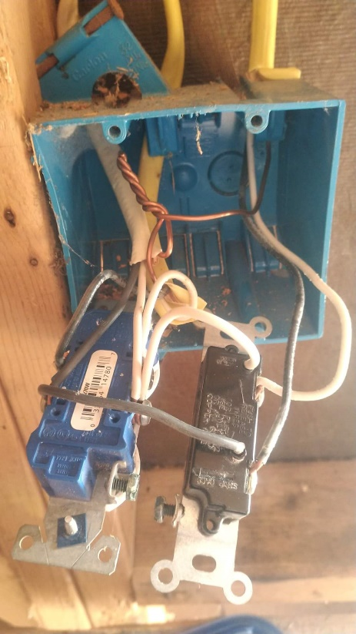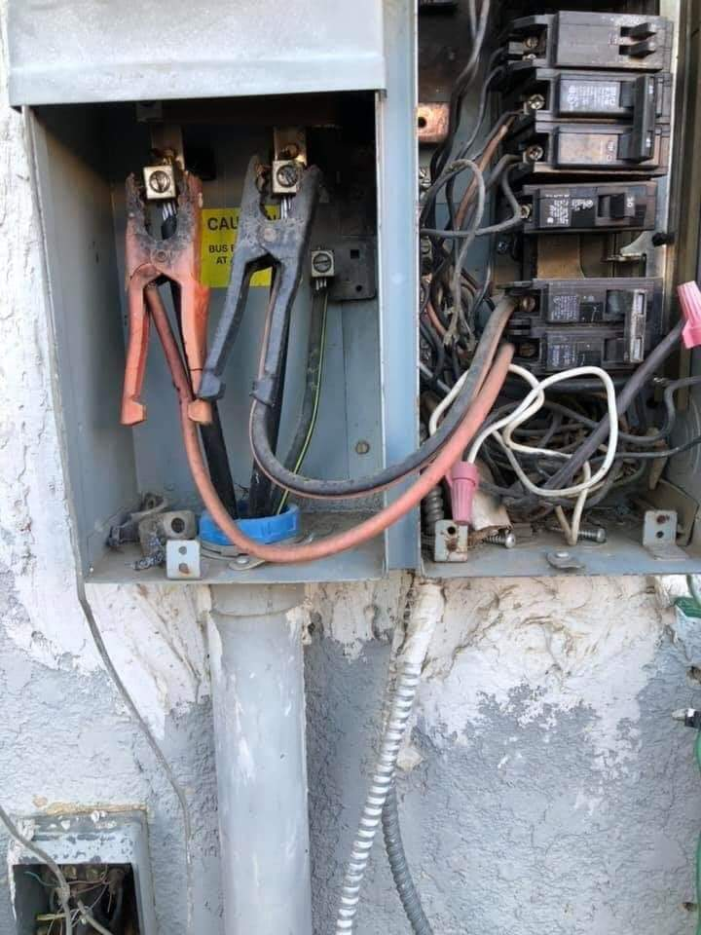

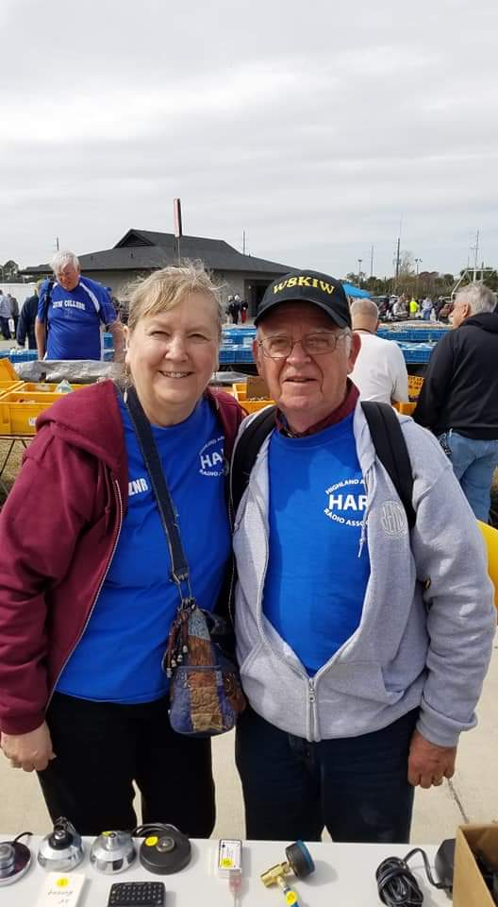

***National News***

*(from arrl and other sources)*

***Dayton Hamvention 2020 Web Portal Opens for Tickets, Exhibit Space***

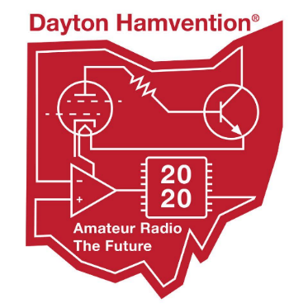

Online orders for [**Dayton Hamvention**](http://www.hamvention.org/)® 2020 tickets, inside exhibit spaces, and flea market spots can now be placed online. Those who ordered online in 2019 should have their user IDs and passwords available when placing orders. Hamvention’s all-volunteer staff will work as quickly as possible to respond to orders. If you encounter difficulties, email the appropriate committee: [**Tickets**](mailto:tickets@hamvention.org), [**Inside Exhibits**](mailto:exhibits@hamvention.org), or [**Flea Market**](mailto:fleamarket@hamvention.org).

Hamvention announced in December that it would be increasing the cost of admission and its booth fees. General admission is now $26 in advance or $31 at the gate for all 3 days. The cost of flea market spots has risen by $5 per space, and inside exhibitors will pay $30.

Hamvention 2020 takes place May 15 – 17 at the Greene County Fairgrounds and Exhibition Center, 210 Fairground Road, Xenia, Ohio.

####

***ARRL Creates New HF Band Planning Discussion Group***

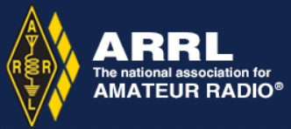

ARRL has created a new [**HF Band Planning Discussion Group**](https://groups.arrl.org/g/ARRL-HF-Band-Planning). HF Band Planning Committee Chair Mike Raisbeck, K1TWF, will moderate the group, which will focus on the ARRL HF Band Planning Committee’s recommendations and other band-planning activities. Earlier this month, the ARRL HF Band Planning Committee [**invited comments and suggestions**](http://www.arrl.org/bandplan) from the Amateur Radio community on its [**report**](http://www.arrl.org/files/file/Bandplanning/2520Bandplanning20FINAL%20(d).pdf)to the ARRL Board.

At the Board’s January meeting, the committee presented its [**specific recommendations**](http://www.arrl.org/files/file/Bandplanning/2520BP_Committee_recs20(h).pdf) in graphical form for each HF band and each US license class, with the goal of increasing harmony on the HF bands, particularly between CW and digital users. Those responding to the initial call for comments and suggestions are encouraged to cross-post their remarks to the new HF Band Planning Discussion Group.

####

***CubeSats Set for Deployment from the ISS***



Several CubeSats are scheduled to be deployed from the ISS on February 12, including Phoenix, a 3U CubeSat developed by Arizona State University (ASU) to study the effects of urban heat islands through remote infrared sensing. The ASU operations team would appreciate help from the amateur satellite community with identifying the spacecraft and verifying that it is operational following its deployment at 0830 UTC.

TOP ^

Two CubeSats being deployed on February 12 — Phoenix and QARMAN — share the frequency of 437.35 MHz and utilize an AX.25 9,600-baud protocol with GMSK modulation. Because both CubeSats will be deployed within an hour and a half of each other, they will be close to each other in orbit. [**More information**](http://phxcubesat.asu.edu/content/amateur-operations) is available on the Phoenix website.*— Thanks to Phoenix Project Manager Sarah Rogers, KI7OOY*

####

***“WOW Signal” Documentary Now Available Online***

Retired Ohio State University Professor and Ohio’s own, Robert Dixon, W8ERD, says a documentary about the 1977 discovery of a signal from the cosmos detected by the Ohio State University Radio Telescope is now available from at least one internet video site and was to become available from Amazon and Google Play.

The so-called “WOW signal” is regarded as the best candidate for a signal originating from extraterrestrial intelligence. Dixon directed the radio telescope program. Dixon says the award-winning 88-minute film, *WOW Signal*, is available on [**FandangoNow**](https://www.fandangonow.com/details/movie/wow-signal-2019/MMVA05DE7DE8D77D391A035F07275B904486). The documentary’s trailer is free; the film itself is available for rent or purchase. *— Thanks to Robert Dixon, W8ERD*

####

***ARISS Coming to Cincinnati Area School***

As was reported back in September of last year, Maple Dale Elementary School in suburban Cincinnati was chosen to be one of the very lucky schools to get to talk to the astronauts aboard the Space Station.

After months of preparation, sweat and hard work, everything has come together and just this past week we’ve received word of the date of this event, February 20th. Yes, this Thursday!

Gordon, KD8COH, our technical mentor for ARISS sent out the notice of the window of opportunity for the most optimum communications with the Space Station. Cesi, KD8OOB, coordinator for the OH-KY-IN Club, which is the sponsoring Amateur Radio Club stated that all is a go and they are ready for contact!

I will be there as well as the Great Lakes Director and Vice Director to watch with anticipation as the kids get to talk with the astronauts.

####

***Trump signs order to test U.S. infrastructure's vulnerability to GPS outage***

*(By: David Shepardson, submitted by Gregory Drezdzon, WD9FTZ)*

WASHINGTON (Reuters) - U.S. President Donald Trump on Wednesday, Feb. 12, signed an executive order directing U.S. agencies to test the vulnerabilities of critical infrastructure systems in the event of a disruption or manipulation of satellite-based global positioning system services (GPS).

TOP ^

GPS is key to the functioning of electrical power grids, weather forecasting, traffic signals, smartphone applications, financial services, vehicle navigation, aircraft, the United States’ National Airspace System, and maritime, among a host of other systems.

The order, directing federal agencies to develop a plan to test infrastructure systems within one year, said “disruption or manipulation of these services has the potential to adversely affect the national and economic security of the United States.”

Congress has raised concerns about GPS systems and satellite communications in the past. A group of U.S. lawmakers wrote the Trump administration in May 2019 saying GPS signals were “exceptionally weak and easily disrupted.”

To read the full story, click on the following link:  <https://www.reuters.com/article/us-usa-communications-trump/trump-signs-order-to-test-vulnerabilities-of-u-s-infrastructure-to-gps-outage-idUSKBN206282>

Other:  <https://www.faa.gov/about/office_org/headquarters_offices/ato/service_units/techops/navservices/gnss/>

***The Handbook Give Away***

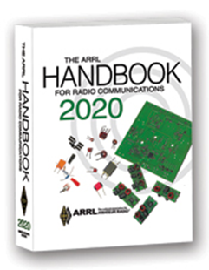

Hey Gang,

Have you registered for the “Handbook Giveaway” drawing for this month yet? If you haven’t, go to: <http://arrl-ohio.org/handbook.html> and get yourself registered now!

What’s the catch? I want to get everyone checking in to the Ohio Section website as often as possible, and in order to register each month, you have to visit the website often! There’s nothing else to it. I pay all expenses and I usually “Give Away” more than just a Handbook too!!

Many of you ask me just how do I know when the drawing is on? Well, that’s easy all you need to do is check in on the Ohio Section Website on a regular basis and watch for the big [**RED**](http://arrl-ohio.org/handbook.html)Arrow that will appear on the left side of the page. This is the sign that the drawing is on and you need to get registered. So, keep a sharp eye out on the website and check in often!

***Club Corner***

This is YOUR cornner of the newsletter. Send me what your club is doing and I’ll make sure that it gets in. Got a special event or club project that you want everyone to know about? Send it to me!. Need help with a project? Send it to me.

Let me know what you club is up to. Are you going to have a special guest at your meeting or are you having a special anniversary? Just sent it to: [n8sy@n8sy.com](mailto:n8sy@n8sy.com)

####

TOP ^

***Cuyahoga Amateur Radio Society (CARS) 2020 Winter Ham Radio Classes!***

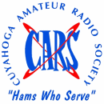Thursday evenings starting **February 20, 2020** and ending April 2, 2020 at 6:30 pm. April 2nd will be a special VE Test session for all license classes.

To register, please follow the link at: [www.2cars.org](http://www.2cars.org) and complete the on-line application.

Classes will be held at the Seven Hills City Hall, 7325 Summit View Dr, Seven Hills, OH 44131 in room “C” at 6:30 pm every Thursday. All class materials are provided.

####

***Mahoning Valley ARA to hold Two-Meter Contest***

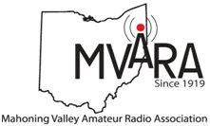The MVARA is excited to announce the Mahoning Valley Two Meter Contest **Saturday March 21, 2020 from 7:00 to 10:00 pm.** We thought it would be fun to see if valley hams would enjoy shaking off the winter doldrums by getting on the air for a local contest. It will be an opportunity to talk to old friends and make new ones.

Old timers may remember participating in the Lou Malice Memorial Contest years ago. The MV 2 Meter Contest will be a similar two-meter simplex contest. Stations will simply exchange grid squares as defined in the contest rules. The contest format will allow participants to evaluate their stations simplex capabilities. This information could be valuable in an emergency.

No 100-watt base station, no problem. There will be a low power category of 5 watts or less and a high-power category of greater than 5 watts so everyone will have a level playing field. Awards will be given for the highest scoring Low Power Home, High Power Home, Low Power Rover, and High-Power Rover stations at the June 11, 2020 MVARA meeting.

For contest rules and a list of rover stations and the grids they plan to activate go to [www.mvara.org/Mv2mc.html](http://www.mvara.org/Mv2mc.html)

This year the contest will be dedicated to the memory of pioneer Valley ham Lou Malice WA8PKN whose dedication to amateur radio touched the lives of all of us. Even if you never had the pleasure of knowing Lou you are still part of his legacy. Chances are good that the hams who inspired and encouraged you to become part of amateur radio were, themselves, inspired, encouraged, and trained by Lou.

We hope to hear you on the air! Scott Wilton   KE4UHC – President

####

***Technician License Classes Scheduled in Newark***

Classes are being hosted and sponsored by:  Earl, W8BR, in conjunction with, Newark Amateur Radio Association and the American Red Cross - East & South-Central Ohio Chapter

TOP ^

**Place:**  143 S. 30th St., Newark, Ohio 43055  <https://goo.gl/maps/CSbgxAbaU322>

**Dates:** Saturday, March 14; March 21; March 28; April 4; April 11. Saturday, April 18 will be the exam.

**Time:** 9:00 AM to 12:00 PM  (No lunch break)

**Registration:**  Students must register in advance with Mr. Earl Paazig, [email@paazig.net](mailto:email@paazig.net) or by phone at 740-828-1057 or 740-504-1950.  Registrations may be limited.

**Cost to participants:** *The course is free however participants must provide and come prepared with writing and note‑taking materials.*  This will be a fast-paced course.  You won’t want to miss a note.  *Students will be required to download and print a free copy of the Study Guide available at:*  [*https://paazig.net/owncloud/index.php/s/wT13jVN4zm1BTOP/download*](https://paazig.net/owncloud/index.php/s/wT13jVN4zm1BTOP/download)

Optionally, the participants would be encouraged to purchase a book costing $32.95 plus shipping.  <http://www.arrl.org/shop/Ham-Radio-License-Manual/?page=1>

####

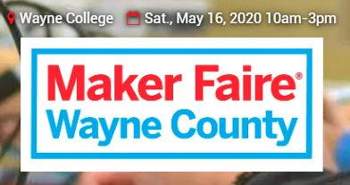

Saturday, May 16, 2020 from 10 a.m.-3 p.m.

**The University of Akron Wayne College**  
1901 Smucker Road  
Orrville, OH 44667

[**>> Click Here <<**](https://waynecounty.makerfaire.com/) **for more information**

[***Upcoming Hamfests***](http://arrl-ohio.org/hamfests.html) ***for 2020***

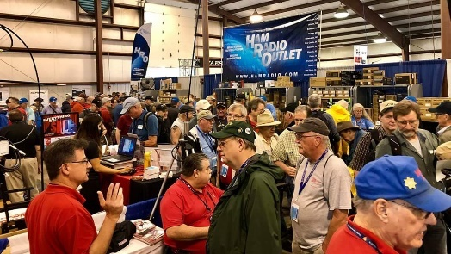

**03/01/2020 | WinterHamFest**  
Location: Elyria, OH  
Sponsor: Northern Ohio Amateur Radio Society  
Website:  [www.wp.noars.net/hamfests/winter-hamfest/](http://www.wp.noars.net/hamfests/winter-hamfest/)

**03/14-15/2020 | Toledo Hamfest,**

**ARRL Great Lakes Division Convention**Location: Perrysburg, OH  
Sponsor: Toledo Mobile Radio Association  
Website:  <http://www.toledoglc.org/>

TOP ^

***Great Lakes Convention Banquet***

Hey Gang,

The clock is ticking fast to get your reservations for the Convention Banquet. If you are planning on going now is the time to get those reservations in to assure your seat at the banquet. Go to: <http://www.toledoglc.org/> for all the details on the banquet as well as the hamfest too!!

***Wouff Hong Ceremony at the Great Lakes Convention***

A Wouff Hong Ceremony will be held just after the ARRL Banquet on Saturday, March 14th

If you are interested in being inducted into the Royal Order of the Wouff Hong we need you to pre-register. This will assure you that you will have a seat at the Conclave.

[>> Click Here <<](http://arrl-ohio.org/wouff-hong.html)    to get registered

**========================================================**

**03/21/2020 | Mid-Ohio Valley ARC Hamfest**

Location: Gallipolis, OH

Sponsor: Mid-Ohio Valley Amateur Radio Club, Inc.

Website: <http://sites.google.com/site/midohiovalleyarc/>

**04/11/2020 | 66th Annual Cuyahoga Falls Amateur Radio Club Hamfest**  
Location: Cuyahoga Falls, OH  
Sponsor: Cuyahoga Falls Amateur Radio Club, Inc.  
Website: <http://www.cfarc.org/hamfest.php>

**04/18/2020 | Portsmouth Radio Club Hamfest**Location: Portsmouth , OH  
Sponsor: Portsmouth Radio Club  
Website: [http://portsmouthradioclub.com](http://portsmouthradioclub.com/)

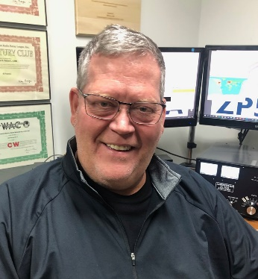***DX This Week***

*(from Bill, AJ8B)*

***DX This Week – Working Splits***

***Bill AJ8B (***[***aj8b@arrl.net***](mailto:aj8b@arrl.net)***, @AJ8B, or*** [***www.aj8b.com***](http://www.aj8b.com)***)   
 CWOPs Member #1567***

TOP ^

This was a tough week to work DX. There was less prime DX on the bands, but still quite a lot of Entities out there to fill band spots. DX Spots that originated in the Midwest included Alaska, Argentina, Aruba, Belize, Bolivia, Brazil, Canary Islands, Cayman Islands, Chile, Colombia, Costa Rica, Curacao, Dominica, Dominican Republic, El Salvador, French Guiana, Gabon, Guadeloupe, Guatemala, Hawaii, Indonesia, Luxembourg, Madeira Islands, Martinique, Mauritania, Nauru, Norfolk Island, Palestine, Portugal, Puerto Rico, Saba & St. Eustatius, Senegal, Sint Maarten, Spain, St. Kitts & Nevis, St. Martin, Tajikistan, Tanzania, United Arab Emirates, Uruguay, Vietnam. Hope you were able to work some of these stations.

The Mailman delivered a most excellent card from Iceland – TF2CT (Pictured), as well as YS1MAE – El Salvador, F1MWV & F6CBA – France, PJ4/DL5YM – Bonaire, XR208A – Chile, and 4M1K – Venezuala.

What did you get?

Uncle Frank and I were chatting on 40M CW and the topic of operating split came up. This is one of those topics that we all seem to learn about the hard way! If you have ever listened to a pileup you know that there are several things going on. The first is that the DX station is telling you where to listen. Often, they will say “Up 5” or “Up 5 to 10”. This allows the DX station to spread out the callers to make it easier for them to pick out calls and then work the calling station. The rarer the DX, the wider the split. Uncle Frank and I expect HUGE splits will be needed if Korea ever gets activated!

One of the great things about being a member of a DX club is that you get to learn from those who have “been on the other side” of the pileup. I have had the pleasure of discussing this with both Joe, W8GEX, and Jay, K4ZLE. They have been on the DX side of some huge pileups and have taught me several things. The most obvious of which is that if the DX station can’t hear you, they can’t work you! The cartoon shown helps to reinforce this idea. The DX is located around 14.150 and all the callers are between 14.0 and 14.150. (I know this is backwards, but it is just an example!) Sylvester is licking his chops as he will be calling above 14.150 where no one is listening! My gut is that he will work the DX.

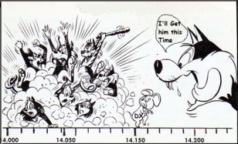For several years I had my FT-897 in the car trying to obtain DXCC Mobile. I thought that I would be restricted in what I could do as I had limited power and limited antenna profile. One thing I could do was to LISTEN. I can’t stress that enough – LISTEN. If you happen upon a decent pileup, it is extremely educational to listen to what the DX station is saying and how the pileup responds. Many hams simply disregard the instructions that are being given. For instance, the DX station may say “Up 5” and people will still call on frequency. The DX Station may say “The station with Bravo in the call” and others will still respond.

TOP ^

My favorite is the station who will give the DX station a “solid 59+” and then ask them to repeat their information several times. Others will jump into the pileup, diligently work the station, and then ask what the call is!

Other instructions may include “Full Calls Only”, or areas of the world such as NA or EU. Follow the instructions given. Just because you can hear them clearly doesn’t mean they can hear you. Don’t make any assumptions.

Two other tricks come to mind. First, try to find the frequency that the current calling station is on and make a note of it. My FT-950 has a TXW button that allows me to listen on the frequency I currently have set for transmit. For instance, you are attempting to work XT2TT in Burkina Faso. He is transmitting at 14.235 and seems to be working a steady stream of stations. Listening for the stations he is working may yield something like 14.240, 14.242, 14.244, 14.246, 14.248, and 14.250. The next station worked is 14.240. This should give you an idea of where he will be listening next based on the current QSO.

The next “trick” is from K8LEE (SK), Wayne. About 2 years ago, I had the chance to meet Wayne and learn about his experiences. There is a great story associated with Wayne about calling for “Full Calls Only”, but that is beyond the scope of this article. Wayne told me to REALLY listen and note the frequencies that the DX is working people on. What he meant was that if you don’t hear a station for a brief period, listen dramatically higher *or lower.* He told me that many DXPeditioners want to make sure that those back home in the club get in the log and may listen below the calling frequency even though they have said “Up 5 to 10”. You can be that I do that now!

I am always on the prowl for other sources of information from hams far more experienced than I! In researching this topic, I came across an article by Dave, W8RIT, at <https://www.qsl.net/w8rit/working_splits.htm>. Dave kindly gave me permission to reprint his article. He has other topics at this site and I would encourage you to check them out. Below is what Dave had to say about Working Splits. (Thanks Dave!)

*One definition of a split is to transmit on one frequency and receive on another. There are a few reasons to do this. A 2M FM repeater uses split frequency to avoid desensitization of the transmitter/receiver circuitry; by this I mean it would attenuate the receiver by a strong signal being transmitted on the same frequency it was simultaneously listening on. On HF, a DX station would use a split frequency to avoid interference of those trying to listen for his signal. He operates in split mode by transmitting on one frequency and receiving on another frequency. This way if hams that are in a pileup are still calling him as he wishes to go back to another station; that station he is trying to call can hear him. A split is usually announced by him or on a DX packet spotting cluster as "QSX". Most often the DX station will state during his exchange info like: "UP", "UP 1", "UP 3 to 5", or possibly another frequency like "listening 245". The latter might indicate if he were operating on 40M that he was listening for calls on 7245 kHz. In the case of 40M I have worked DX by listening in LSB mode in the CW sub-portion. Other countries can transmit in voice where we here in the US can only transmit in CW. So, it is quite common to hear a DX station transmitting for example on 7060 kHz and receiving on 7245 kHz. (The frequencies are picked arbitrarily).*

*Sometimes the DX station is listening for us on a small slice of frequencies, like when he says "5 to 10 up". That is 5 to 10 kHz up from where he is transmitting. There are different techniques to getting a freq to transmit on. You might first want to listen to where you want to transmit. You would do this so as not to interfere with another ongoing communication by other hams. You probably wouldn't like it if you were talking with another ham and suddenly other ham start transmitting without any regard for your transmission.*

TOP ^

*You would also be listening for a clear (or relatively) clear frequency. At times this may be downright impossible with many other stations in the pileup. If you're quick enough with changing your VFO's you might hear the DX station working W8RIT and then you would listen at the time W8RIT might be transmitting in the portion 5 to 10 up. If you do hear that station, you would then know that is where the DX is/was listening. Different DX stations have their own techniques; some sweep up and down the 5 to 10 portion listening for the stations they will work. Others may listen for a few minutes on one frequency and then move up or down. Some go randomly from one end to another and stop whenever they hear a strong signal.*

*Everyone makes a mistake now and then. If you make a mistake, you may hear "band cops" say "UP". Sometimes they can be rather unpleasant in their demeanor. Sometimes they create more interference than they're trying to solve. It's only a reflection of that personality, not you. Everyone is human and makes a mistake occasionally. If you feel the need to correct someone in this case, you first might want to think twice...will it really help or will I create more noise? If you do, you may want to state their callsign to attract their attention (not to single them out) that it was them who needs to operate split. You might want to state simply, "W8RIT up please". If you can, transmit at a time when you will not interfere with the DX station as someone else may be trying to get their exchange and you cover it up. It may be a rare thing for them to work a DX station, get through the pileup, only to have you transmit over the top of the DX station. Also, never, ever, transmit where you do not have license frequency or mode privileges. If someone is operating on the wrong split frequency, such as, 7060 in LSB, that does not give you the right to transmit there to inform them. You are then intentionally breaking the law; they are unintentionally doing it.*

***CQDX CQDX CQDX CQDX CQDX CQDX CQDX CQDX CQDX***

Here is an update from Bernie, W3UR, of the DailyDX and the WeeklyDX, the best source for DX information. <http://www.dailydx.com/>. Bernie has this to report:

**VP8/O – South Orkney Islands -** Over this past weekend members of the much anticipated VP8PJ South Orkney Islands began arriving in Punta Arenas, Chile. NG2H, Ken; K5GS, Gene; N7QT, Rob; HB9BXE, Hans Peter; were there and waiting for W1SRD, Steve; and K3EL, Dave to arrive late yesterday. HA0NAR, Laci, arrived this morning (local time) at 3 AM. The rest of the team should be arriving by today. The VP8PJ team expect to be QRV from February 21 to March 6. VP8NO, Mike, in Stanley, Falklands reported the Braveheart was departing Stanley Harbour heading to Punta Arenas. The Braveheart will be taking the VP8PJ guys to Signy Island, South Orkney Islands.

**V4 – St. Kitts and Nevis -** W3UL, Bill, is back on Nevis Island and notes “Some BPL RFI issues now - especially on the lower bands!” As V47UM he is using an “inverted vee perched atop a hill 100 ft off the deck and facing NA”. In addition he has a “full sized beam point at NA” on 20 meters. Bill was QRV in the CQ WPX RTTY Contest and plans to be on this weekend in the ARRL DX CW Contest as well as the Wednesday CWOps events. Logs will “eventually” be uploaded to Club Log and LoTW. Bill also reminds us N2NT, Andy, will be on for the ARRL DX CW as V47T and K3VX with W3WH will be a multi-single as V4/K3VX, both of these operations from St. Kitts.

**6W – Senegal -** EA4ATI, Dani, is currently in Dakar for the next few weeks. He has been QRV as 6W1/EA4ATI using a 100 watt FT-857D and HyGain AV14VQ. Activity will be on SSB on 40, 20, 15 and 10 meters until February 26th. QSL via EA4R (ex EA4CWN) and LoTW.

TOP ^

**5H – Tanzania -** NK8O/VE3ISD, Chas, will again put 5H3DX on the air from Zinga between February 23 and March 23.  He will be at the pediatric hospital there, operating holiday style.  He will have 100 watts, the legal limit there, to a hexbeam for 40-6 including the WARC-79 bands, plus phased verticals for 40, 30 and 20.  It will be primarily CW with some PSK31, FT8, SSB and 60 meters too.  Chas’ radio is a KX3 to KXPA100 amplifier.  His QSL address is on QRZ.com.  LoTW and eQSL will work too, “no bureau” cards.

**HP – Panama -** H33K is a special event callsign March 2-13 during the ARRL DX SSB contest and local field day.  HP1DAV and HP3AK will be joined by G4BVY, G4CLA and GD4XUM, operating from Chiriqui Province.  With SSB on the weekend of course, they will also do CW and FT8 the other days.  They ask that you not contact them asking for “skeds.”

They will be working hard getting ready for the big weekend operation.  They will be operating casually on those weekdays and the field day operation will be limited.  QSLs and online confirmations through LoTW and Club Log will be available within six weeks.  QSL to:

HP1DAV

Alvaro Andrade Berroa

P.O. Box 0860-0522

PANAMA

Republic of Panama

**KH8/S – Swains Island -**  The upcoming (March 10-25) W8S DXPedition team heading to Swains have announced the following pilot stations: Low bands (160 & 80 meters) world wide – PA3FQA, Dick; South America – HK3W, Siso; North America – N1DG, Don; United Kingdom – G3WGV, John; and handling Africa, Asia and Europe will be DL7JAN, Jan. “More info on procedures and communication” are expected soon.

***DX news***



***ARLD007 DX news***

This week's bulletin was made possible with information provided by AA4NC, HK6O, N3BNA, W1UE, W2GD, The Daily DX, the OPDX Bulletin, 425

DX News, DXNL, Contest Corral from QST and the ARRL Contest Calendar

and WA7BNM web sites. Thanks to all.

**MALDIVES, 8Q.** Juan, HK4A is QRV as 8Q7AR until February 17. Activity is on FM Satellites AO-91, AO-92, IO-86, and with APRS via the ISS from Grid Square MJ64. QSL via LoTW.

**NEPAL, 9N.** Yuris, YL2GM and Eugene, EA5EL are QRV as 9N7AM until February 16. Activity is on 160 to 10 meters using CW, SSB, RTTY and FT8 in DXpedition mode with two stations active. QSL direct to YL2GN.

**CUBA, CO.** Members of the Punta Maya DX Group are QRV as T45FM until February 16 from the Punta Maya Lighthouse, ARLHS CUB-032. Activity is on 160 to 10 meters using mainly SSB and FT8. QSL via RW6HS.

TOP ^

**PHILIPPINES, DU.**  Pres, N6SS will be QRV as DU6/N6SS in the ARRL International DX CW contest as a Single Op/Single Band on 80 meters entry. QSL via LoTW.

**PALESTINE, E4.** Members of the Radio Club de Provins are QRV as E44CC until February 17. Activity is on 160 to 10 meters using CW, SSB, RTTY, PSK, FT8 and FT4. QSL via F5GSJ.

**MARTINIQUE, FM.** Yuri, VE3DZ will be QRV as TO4A in the ARRL International DX CW contest as an All Band entry. QSL to home call.

**FRENCH POLYNESIA, FO.** Will, AA4NC and Ron, AA4VK are QRV as TX4N and TX4VK, respectively, from Tahiti until February 17. Activity is on all HF bands using CW, SSB, FT8 and FT4. This includes being

active as TX4N in the ARRL International DX CW contest. QSL TX4N via EA5GL and TX4VK direct to home call.

**HONDURAS, HR.** Dennis, W1UE will be QRV as HQ9X from Roatan Island, IOTA NA-057, in the ARRL International DX CW contest as a Single Op/All Band entry. QSL via KQ1F.

**US VIRGIN ISLANDS, KP2.** Brian, ND3F is QRV as KP2/ND3F from St. Croix, IOTA NA-106, until February 18. This includes being an entry in the ARRL International DX CW contest. QSL via EA5GL.

**GREENLAND, OX.** Bo, OZ1DJJ is QRV as OX3LX from Aasiaat Island, IOTA NA-134, for the new few weeks. He may also be active from Disko Island, IOTA NA-134. QSL via LoTW.

**ARUBA, P4.** John, W2GD is QRV as P44W until February 17. Activity is on 160 to 10 meters. This includes being an entry in the ARRL International DX CW contest. QSL direct to N2MM.

**NETHERLANDS, PA.** Special event station PA75OV is QRV from Gennep until February 16 to commemorate Operation Veritable that took place in February and March 1945. QSL via bureau.

**CURACAO, PJ2.** Thilo, DL9NBJ is QRV as PJ2/DL9NBJ until February 19. Activity is on the HF bands using CW, SSB and FT8. QSL via Club Log.

**CONGO, TN.**  Konstantin, UA9FGR is QRV as TN/UA9FGR from Brazzaville until February 29. Activity is on 40 to 17 meters, and possibly 6 meters, using CW, SSB and FT8, all with low power. QSL to home call.

**MALI, TZ.** Ulmar, DK1CE is QRV as TZ1CE from Bamako until February 20. Activity is on the HF bands using CW, SSB and some FT8. QSL to home call.

**ST. KITTS AND NEVIS, V4.** Laurence, K3VX and William, W3WH are QRV as V4/home calls from St. Kitts Island, IOTA NA-102. They will be active as V4/K3VX in the ARRL International DX CW contest. QSL to home calls.

**TURKS AND CAICOS ISLANDS, VP5.** Bill, AC0W and Pat, K0PC are QRV as VP5/AC0W and VP5/K0PC, respectively, from Providenciales, IOTA NA-002, until February 17. Activity is on 160 to 10 meters using mostly CW. They will be active as VP5K in the ARRL International DX CW contest. QSL VP5K via K0PC and others to home calls.

TOP ^

**NEW ZEALAND, ZL.** Mark, ZL3AB, Geoff, ZL3GA and Phil, ZL3PAH will be QRV as ZL3X in the ARRL International DX CW contest. QSL via LoTW.

**PARAGUAY, ZP.** Dale, N3BNA, Bud, N7CW and Edgar, KC2RG will be QRV as ZP0R in the ARRL International DX CW contest. Look for ZP/KC2RG and ZP/N3BNA to be active using CW and various digital modes, respectively. QSL via operators' instructions.

THIS WEEKEND ON THE RADIO. The ARRL International DX CW Contest, American Lighthouse Activity Weekend, PODXS 070 Club Valentine Sprint, NCCC RTTY Sprint, QRP 80-Meter CW Fox Hunt, NCCC CW Sprint, Russian PSK World Wide Contest, Feld Hell Sprint and the AWA Amplitude Modulation QSO Party are all on tap for this weekend.

The Run for the Bacon QRP CW Contest is scheduled for February 17.

The CWops Mini-CWT Test, AGCW Semi-Automatic Key Evening, QRP 40-Meter CW Fox Hunt and Phone Fray are scheduled for February 19.

***Special Events***

* **02/17/2020 | SES H L Hunley Commemorative Station N4HLH**

**Feb 17, 1400Z-2100Z, N4HLH**, Charleston, SC. Trident Amateur Radio Club. 14.262 USB 7.262 LSB 7.117 CW. QSL. Larry Gatton, PO Box 60732, Charleston, SC 29416. [tridenthams.org/hunley.htm](http://tridenthams.org/hunley.htm)

* **02/21/2020 | George Washington's Birthday**

**Feb 21-Feb 23, 2359Z-2359Z, WS7G**, Moses Lake, WA. Columbia Basin DX Club. 14.255 7.222 3.855. QSL. Brian Nielson, 11650 Road 1 SE, Moses Lake, WA 98837. [cbn.homestead.com/WS7G.html](http://cbn.homestead.com/WS7G.html)

* **02/22/2020 | Titan Missile Museum**

**Feb 22, 1600Z-2100Z, K7T**, Tucson, AZ. Oro Valley Amateur Radio Club. 7.040 CW 14.040 CW 14.250 USB 18.100 FT-8. Certificate. Email , qsl@TucsonHamRadio.org, No paper QSL's please.. [www.TucsonHamRadio.org](http://www.tucsonhamradio.org/)

* **02/26/2020 | Snowbird Field Day**

**Feb 26, 1500Z-2100Z, W7ASL**, Mesa, AZ. Sunlife ARC. 14.230 7.200. QSL. Tom Goforth, 4324 E Dragoon Cir, Mesa, AZ 85206. Please see the website for the most up to date information. <https://www.sunlifearc.org/index.php/events/2-uncategorised/28-snowbird-field-day>

* **02/29/2020 | "2019 Rare Disease Day" Special Event**

**Feb 29, 0000Z-2359Z, WA4CZD**, Sparta, TN. WA4CZD. 14.246 7.246 7.115. QSL. Jill Dybka, WA4CZD, 7737 Sprata Hwy, Sparta, TN 38583. QSL to home call of WA4CZD including via BURO. Also using LoTW.

* **03/01/2020 | Nebraska Statehood Day**

**Mar 1, 1300Z-2300Z, N0N**, Lincoln, NE. Southeast Nebraska Amateur Radio Club. 7.180 18.150 14.292 14.265. Certificate & QSL. Charles Bennett, KD0PTK, P.O. Box 67181, Lincoln, NE 68506. Hams will be broadcasting from the 14th floor of the State Capitol building. Clubs across Nebraska are encouraged to participate. Please include SASE. <https://www.facebook.com/SENRC>

####

TOP ^

**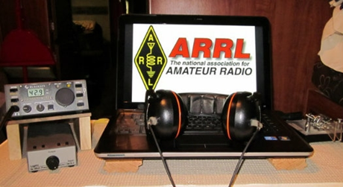*ARRL Contest Corner***

An expanded, downloadable version of *QST'*s [**Contest Corral**](http://www.arrl.org/contest-calendar) is available as a PDF. Check the sponsor's Web site for information on operating time restrictions and other instructions.

***Attention ALL Ohio…***

***Mark April 4, 2020 (Saturday) as our ARES OHIO SPRING CONFERENCE!***

We have the Marion Tech lecture hall reserved (THANKS MARION ARES!!!) and we’ll begin planning some important topics! More information will be forth coming.

This event is always “Standing Room Only” so we do ask that you register ahead of time so that we can be properly prepared for how many are coming. It’s quick and painless and we will even send you a confirmation email back.

**Here’s the link to get registered!!** [**http://arrl-ohio.org/SEC/form.html**](http://arrl-ohio.org/SEC/form.html)

####

***NVIS DAY IS COMING!***

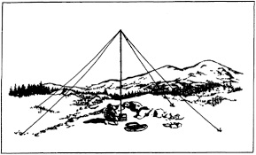

Is your station ready to establish and maintain high-reliability communication with other stations around Ohio when repeaters, phone, and internet service are impaired?

When infrastructure just isn’t there, HF radio using Near-Vertical Incidence Skywave (NVIS) propagation offers the ability to stay in contact on frequencies of 2–30 MHz for distances of about 30–400 miles.

NVIS Day is the ARRL Ohio Section event to test your NVIS antenna designs and builds. Join us on Saturday, April 25th to show how well amateur radio can keep Ohio communicating! This is not a contest: it’s an event for Ohio stations to operate with other Ohio stations and understand how well they hear and are heard.

**THE DETAILS**

**Date: Saturday, April 25**

**Time: Start at 10 A.M., end at 4 P.M.**

**Power: Up to but no more than 100w**

**Exchange: six-digit grid, power, and true—measured—signal report**

**Schedule: This isn’t a contest, so take your time! Try different designs! Have lunch!**

TOP ^

***V.E. Test Sessions***

**

For the latest testing site information please **>>** [**Click Here**](http://www.arrl.org/find-an-amateur-radio-license-exam-session) **<<** The ARRL site tracks all of the VE testing sites that register with them, including W5YI and Laurel. ARRL gives you a number of different ways of sorting to find that site that is closest to you as well.

***One Question Questionnaire***



Hey Gang,

Ok.. “Survey Says”….. 55% of you have gotten up in the wee morning hours and worked DX. Alright!!! Such dedication is really great!

Ok, I’ve got another NEW – one question – for you to answer. Everywhere you turn there seems to be an ad with big screen TV’s for sale in it.

So, my question this week is… **“Does your Ham Shack have a 48 inch or larger TV in it ?? ”**

You’ll find the “One Question” questionnaire on the Ohio Section Website! <http://arrlohio.org> It’s all in fun and it’s not a scientific survey in any way, but we are learning some things that we didn’t know from these questions. I hope that you are enjoying answering these “One Question” questionnaires.

***“Connect”***

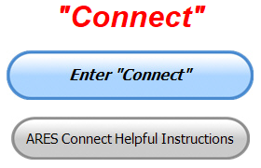**Everyone –** please make sure to go into all of the events that you have signed up ***for and get your hours registered no later than 5 days after the event has ended****.*

I need you to be as prompt as possible in reporting your hours. I’m noticing a number of events that aren’t getting hours credited and that is due to you not going back into your account and registering your hours! Please, don’t miss out on your hours just because you missed on very important step, record hours!! It’s so simple and quick to do.

***Here’s the top 5 hours earners so far for February:***

|  |  |  |  |
| --- | --- | --- | --- |
|  | **Name** | **Events** | **Hours** |
| 1 | Earl Paazig (W8BR) | 8 | 76.00 |
| 2 | Greg Dersarkisian (KD8SSJ) | 11 | 74.50 |
| 3 | James Yoder (w8erw) | 12 | 60.33 |
| 4 | Robert Northrup (Kc8psw) | 13 | 50.50 |
| 5 | Alan Rothweiler (N8CJ) | 13 | 46.50 |

TOP ^

**Let’s get everyone in the Ohio Section on “Connect!!!” Simply go to:** <https://arrl.volunteerhub.com/lp/oh/> and get yourself registered and using the system.

**Admins…** If you are wondering how to get an overview of all of your events you can simply go into reports and using the new Event by Participation by Event (version 2) you can not only see who registered for your event, but you also can see if he/she has inputted their hours for it as well. Take advantage of this new report to help you get the time entered into your events.

**We still have a number of recurring events created but no activity reported for them.** Please, if this event is no longer needed, let me know and I can delete it from the masters. I know that many of you setup recurring events to learn how, but if they aren’t going to be used, let’s get them cleared out.

Also… If you are setting up events, please don’t set a limit for how many folks can sign-up unless absolutely necessary. This causes issues when doing reports. It’s also counter-productive since the reason for you to list the event is to get as many volunteers as you can to attend. When you set limits, it discourages folks from signing up.

***Special NIMS Training Available***

**G-557 RAPID ASSESSMENT PLANNING COURSE**

Hosted by: Fulton County Emergency Management Agency

**Tuesday, June 9, 2020**

Course Description: This course provides information and resources to enable participants to develop an effective Damage Assessment Program and conduct rapid and effective needs assessments. A good assessment allows community leaders to prioritize response actions ensuring the greatest life-saving and life sustaining benefits. Since resources are often limited in the first few hours of a disaster or emergency an effective rapid needs assessment allows for the efficient and effective use of those resources. Likewise, it allows local officials to evaluate their needs and request those resources that are not available in their jurisdiction to support life sustaining and life saving measures.

This is a “Required” course in the Advanced Professional Series (APS) program

Application Deadline: **May 26, 2020**

Time of Course: Registration: 7:45 am – 8:00 am

Course Time: 8:00 am – 4:00 pm

Location: Fulton County Welcome Center/EOC - 8848 State Highway 108 Wauseon, Ohio 43567

Supported By: The Ohio Emergency Management Agency

Recommended Participants: Local officials who are responsible for assessing, collecting, and reporting damages during and after any event that causes damage of private, public, and critical infrastructure.

TOP ^

Recommended Prerequisite: IS0100.c, Introduction to the Incident Command System, ICS 100; IS0200.c, Incident Command System for Single Resources and Initial Action Incidents; IS0700.b, National Incident Management System, An Introduction; IS0800.b, National Response Framework, An Introduction; IS0120.a, An Introduction to Exercises; and IS0130, Exercise Evaluation and Improvement Planning. These courses are available online by going to https://training.fema.gov/is/crslist.aspx?all=true.

Enrollment: Students must enroll via the Department of Public Safety Training Campus website: <https://trainingcampus.dps.ohio.gov/cm/cm710/pstc/pstc.html> Course registration will generally close 10 working days prior to the course start date. You can check enrollment/approval status via the Department of Public Safety Training Campus website.

Course Costs: This course is free to participants. Lodging, meals and all other expenses are the students’ responsibility.

County Point of Contact: Peggy Volkman, Administrative Assistant, (419) 337-9207, [peggyvolkman@fultoncountyoh.com](mailto:peggyvolkman@fultoncountyoh.com)

State Point of Contact: Matt Jaksetic, State Training Coordinator, Ohio EMA (614) 799-3666, [mtjaksetic@dps.ohio.gov](mailto:mtjaksetic@dps.ohio.gov)

Other courses being scheduled…

**G-271** Hazardous Weather and Flooding Preparedness 9/23-23/20

**G-272** Weather Warning Coordination 10/20-21/20

**OH-606** Disaster Recovery and **OH-607** PA Cost Recovery/Damage Assessment 11/5/20.

####

**ICS400 ADVANCED FOR COMMAND & GENERAL STAFF MGT905**

Hosted by: Mahoning County Emergency Management Agency

**March 30 – 31, 2020**

**Application Deadline: March 16, 2020**

Course Registration time: 7:30 am – 8:00 am (on day one)

Course Time: 8:00 am to 5:00 pm – Both days One-hour Lunch each day

Training Location: Boardman Fire Department, Station 71 7440 Market Street Boardman, OH 44512

Required Prerequisites: Individuals must complete the IS-100.c Introduction to the Incident Command

System, IS-200.c Basic Incident Command System for Initial Response, IS-700.b An Introduction to the

National Incident Management System and the IS-800.c National Response Framework, an Introduction

courses.

In addition, ICS-300 Intermediate courses prior to attending the ICS-400 Advanced course and

provide copies of their certificates of completion to the instructors on day one of the course.

TOP ^

Enrollment: Students must enroll via the Department of Public Safety Training Campus website:

<https://trainingcampus.dps.ohio.gov/cm/cm710/pstc/pstc.html> Course registration will generally close 10

working days prior to the course start date and applicants can check enrollment/approval status via the

Department of Public Safety Training Campus website.

Course Costs: There is no charge for participants to attend this course. However, Lodging, Meals, Per

Diem and all other travel expenses are the responsibility of the student or the parent organization.

State Point of Contact: Lisa Jones, DSC 2, Ohio EMA, SAA Training Point of Contact, (614) 799-3824

[ljones@dps.ohio.gov](mailto:ljones@dps.ohio.gov)

####

**G-386 MASS FATALITIES**

Hosted by: Franklin County Emergency Management & Homeland Security **February 20 - 21, 2020**

[pktickle@franklincountyohio.gov](mailto:pktickle@franklincountyohio.gov)

####

Below is a status update of upcoming training classes.  Please look at the list, there is a variety of topics, and I would appreciate it if you would consider registering for one (1) or more if your schedule allows.

Some of the classes you can register for on the FCEM&HS website; go to the “Training Opportunities” site <https://fcemhs.org/Training-Exercises/Training-Opportunities>  (where you can find the information flyer on all of the classes) and then click on the “FCEM&HS Training Registration” link <https://fcemhs.org/Training-Exercises/FCEMHS-Training-Registration>

The rest of the classes you will need to register on the Ohio Public Safety Training Campus <https://trainingcampus.dps.ohio.gov/cm/cm710/pstc/>

For those classes that are being instructed through TEEX, once you register with me, I will send you an approval email with a link to then register on the TEEX website.

|  |  |  |  |
| --- | --- | --- | --- |
| CLASS | DATE | TIME | LOCATION |
| G-386 Mass Fatalities (Register via OH Public Safety Training Campus) | February 20&21 | 8am-4pm (14 hrs) | FCEM&HS |
| AWR-364 STRIVE (Strategic, Tactical, and Resilient Interdiction of Violent Extremism) (Register via paper registration or the FCEM&HS website) | February 25&26 | 8am-5pm (16 hrs) | FCEM&HS |
| MGT-467 Sport and Special Event Public Information and Emergency Notification (Register via paper registration or the FCEM&HS website) | March 3&4 | 8am-5pm (16 hrs) | OSU Airport |

TOP ^

|  |  |  |  |
| --- | --- | --- | --- |
| OH/L-146 Homeland Security Exercise and Evaluation Program (HSEEP) (Register via OH Public Safety Training Campus) | March  25-27 | 8am-5pm (24 hrs) | FCEM&HS |
| AWR-376 Understanding Targeted Cyber Attacks (Register via paper registration or the FCEM&HS website) | April 7 | 8am-5pm  (8 hrs) | FCEM&HS |
| AWR-213 Critical Infrastructure Security & Resilience Awareness of Critical Infrastructure/Key Resources (Register via paper registration or the FCEM&HS website) | April 15 | 8am-5pm  (8 hrs) | FCEM&HS |
| MGT-317 Disaster Management for Public Services (Register via paper registration or the FCEM&HS website) | April 21&22 | 8am-5pm (16 hrs) | FCEM&HS |

####

**EMA-G289 PUBLIC INFORMATION OFFICER (PIO) AWARENESS**

**Hosted by: Youngstown State University Police Department**

**April 7, 2020**

**Course Description:** The Public Information Officer (PIO) Awareness Course is a “Free” course designed to familiarize participants with the concepts underlying the PIO role. The material provides a basic understanding of the PIO function for those new to the position. It orients the participants to the public information function and the role of the PIO in the public safety / emergency management environment. This training forms the foundation for more advanced training that takes participants from the awareness level to the mastery level in their public information careers. Additionally, it provides those in executive level roles the necessary knowledge of PIO roles and responsibilities during an emergency.

**Application Deadline:** March 24, 2020

**Time of Course:** Registration: 7:30 am – 8:00 am

Course Time: 8:00 am – 5:00 pm

**Location:** Youngstown State University Police Department

266 West Wood St. Youngstown, Ohio 44555

**Supported By:** The Ohio Emergency Management Agency

**Recommended Participants:** The primary audience for this training is individuals who have public information responsibilities as their main job or as an auxiliary function at the federal, state, local, tribal, or territorial level of government, and in the private and nongovernmental sectors.

**Recommended Prerequisite:** IS-100 Introduction to Incident Command System; IS-702 NIMS Public Information Systems; and IS-909 Community Preparedness: Implementing Activities for Everyone

**Enrollment:** Students must enroll via the Department of Public Safety Training Campus website: <https://trainingcampus.dps.ohio.gov/cm/cm710/pstc/pstc.html>.

TOP ^

Course registration will generally close 10 working days prior to the course start date. You can check enrollment/approval status via the Department of Public Safety Training Campus website.

**Course Costs:** This course is free to participants. Lodging, Meals, Per Diem and all other travel expenses are the responsibility of the student or the parent organization

The FY 2019/2020 Ohio EMA Training Catalog at http://ema.ohio.gov/Training.aspx provides additional information.

**County Point of Contact:** Adam Guerrieri. (330) 503 – 4626. [ajguerrieri@ysu.edu](mailto:ajguerrieri@ysu.edu)

**State Point of Contact:** Matt Jaksetic, State Training Coordinator, Ohio EMA (614) 799-3666, [mtjaksetic@dps.ohio.gov](mailto:mtjaksetic@dps.ohio.gov)

####

Below are trainings that can be found by following this link: <https://services.dps.ohio.gov/CIMS/>.

* **G-191 ICS-EOC Interface (Lawrence County April 2020)**
* **G-289 Public Information Officer (PIO) Awareness (Fulton County April 2020)**
* **G-289 Public Information Officer (PIO) Awareness (Hocking County April 2020)**
* **G-318 Mitigation Planning Workshop (Cuyahoga County April 2020)**
* **G-402 ICS Overview for Executives and Senior Officials (Franklin County April 2020)**
* **OH-202 Debris Management Workshop (Stark County April 2020)**

**Intended Audience: Law Enforcement, Emergency Services, Emergency Managers, Communications, Government, Volunteers, State, Local, Tribal, and Territorial Personnel**

For more questions or concerns regarding CIMS please contact [CIMS@dps.ohio.gov](mailto:CIMS@dps.ohio.gov).

####

***Campbell County Kentucky Office of Emergency Management Upcoming Training***

Campbell County Kentucky Office of Emergency Management **FREE** Training Opportunities

**Hazardous Weather Preparedness for Campuses (AWR-332) – March 4, 2020** – (NDPTC) / **Tentative/Requested**

**Readiness: Training Identification and Preparedness Planning (MGT-418) – March 11-12, 2020** - TEEX / Register: <https://train.ncbrt.lsu.edu/Student/Register?ClassID=26374>

TOP ^

Registration Password: NCBRT418 If you have trained with NCBRT before, enter your FEMA SID, Last Name, and First Name. If your training record is found, your registration form will be pre-filled for you. Otherwise, click Register as New Person to fill out a blank registration form.

**Evacuation and Re-Entry Planning Course – March 25-26, 2020** / **Requested through KYEM Training Division**

**Pediatric Disaster Response and Emergency Preparedness (MGT-439) – April 8-9, 2020** / TEEX / Register: <https://qrgo.page.link/GFf4>

**Debris Management Planning Course – April 15-17, 2020** / **Requested thought KYEM Training Division**

**Intermediate ICS-300 for Expanding Incidents w/Forms (MGT-904) – April 22-24, 2020 / TEEX / Register:** [**https://qrgo.page.link/HzT2**](https://qrgo.page.link/HzT2)

***OHIO | COMMENTARY:***

***As newspapers face challenges, the importance of public support grows***

*(By Caitlin Johnson Ohio Capital Journal)*



Newspapers build strong, informed communities. Imagine Cleveland without the Plain Dealer journalists who uncovered the lead poisoning crisis and the rape kit backlog, forcing important reforms. Cincinnati Enquirer reporters, photographers and editors painstakingly depicted the mercilessness of the drug crisis and the toll it takes on nearly every aspect of life. The Columbus Dispatch exposed how middlemen hiked up prescription drug prices to get bigger reimbursements from Ohio’s Medicaid program.

The people who tell these stories work in the newsroom as reporters, editors, photographers and designers. In 2018, Ohio had 43 percent fewer of those jobs than in 2012. The industry as a whole had 58 percent fewer jobs in 2017 than it did in 2004. Between 2004 and today, 32 percent of Ohio’s newspapers — most of them weeklies — closed, according to Policy Matters Ohio.

An industry plagued by declining circulation and advertising revenues wouldn’t seem like a smart investment decision, but that’s not the way hedge funds see it. Struggling newspapers make easy targets for media conglomerates, especially those owned or managed by hedge funds. When a private investment company takes control of newspapers you can expect cutting, merging and consolidation as owners try to wring out every last drop of profit.

Ohio is ground zero for newspaper mergers and consolidations. That trend recently intensified with GateHouse Media — owner of the Columbus Dispatch, the Akron Beacon Journal and others — purchasing Gannett and taking on its name. Gannett previously owned the Cincinnati Enquirer and 10 other Ohio papers. GateHouse was owned by the publicly traded New Media Investment Group Inc. but managed by the $70 billion Fortress Investment Group.

TOP ^

They have a clear playbook: consolidate, cut and outsource. So far, Gannett moved Dispatch printing operations to Indiana and Enquirer printing from Columbus to Kentucky.

In Dayton, private equity firm Apollo Global Management recently purchased Cox Media Group, which owns the Dayton Daily News as well as several Ohio radio stations and TV stations around the country. A Federal Communications Commission (FCC) rule prohibits a company from operating a TV station and a daily newspaper in the same market (the 120-year-old Cox was grandfathered in), so last month Apollo announced plans to publish the Dayton Daily News just three days a week. This week, the FCC gave Apollo more time to find a buyer for its newspaper properties, which would allow them to keep publishing every day.

Ohio made national news over the summer when the locally owned Youngstown Vindicator couldn’t compete in a landscape dominated by mega companies and closed its doors. The name carries on, but only as an edition of the Warren Chronicle Tribune, which hired some Vindicator staff and bought the paper’s circulation list, domain name and masthead.

Study after study shows the dire consequences of losing newspapers. Local governments become less efficient and accrue more debt. Civic engagement and voter participation drop. In some cases, pollution even rises.

The internet, the rise of Craigslist and other online classifieds, and the loss of local business all combined to undermine newspapers’ business model, which was dependent on local ads. As circulation drops and more people get their news online, Facebook and Google rake in the profits – hoarding more than 60 percent of the $120 billion in digital ad revenue in 2018. People use these sites to share and access news, but newspapers aren’t getting much of the wealth.

The numbers look bleak, but lawmakers can help. Ohio legislators can preserve some local news by increasing support for public broadcasting, which has received long-time state support. An additional $5 million would be a good place to start. Ohio can follow New Jersey’s lead and form a publicly funded civic consortium to support local news through partnerships with educational institutions and community-based organizations. Federally, Congress should allow newspapers to more easily become nonprofits and should tax Facebook and Google. That revenue can fund the journalism that provides these sites with content they depend on — and serve as an antidote to the false reports they often help spread.

There are policy solutions. Those of us who care about democracy just need to demand them.

***Illinois Jury Awards Motorola $764.6M in Theft of Trade Secrets Case Against Hytera***

*(By Danny Ramey, Radioresource ,submitted by Gregory Drezdzon, WD9FTZ)*

A jury for the U.S. District Court of the Northern District of Illinois found in favor of Motorola Solutions in its theft of trade secrets and copyright infringement lawsuit against Hytera Communications, awarding Motorola $764.6 million in damages.

Of those damages, $418.8 million is punitive damages and $345.8 million is compensatory damages. $764.6 million was the maximum amount that Motorola Solutions had asked for in damages.

Following the verdict, the company is seeking a global injunction that would prevent Hytera from trade secret misappropriation and copyright infringement, a Motorola spokesperson said. “Today’s verdicts are a tremendous victory for Motorola Solutions and a clear repudiation of the illegal and anticompetitive tactics employed by Hytera over the last decade.”

TOP ^

The company is seeking an initial temporary injunction, as well as a long-term permanent injunction. A hearing to discuss injunctions is scheduled for Friday, Feb. 21.

Motorola sued Hytera in the Illinois district court in 2017 for theft of trade secrets, alleging that several former Motorola employees had illegally downloaded proprietary Motorola documents and brought the documents with them when they went to work for Hytera, which then included Motorola trade secrets in its *Digital Mobile Radio (DMR)* products. Motorola also later added a claim of copyright infringement into the case.

The lawsuit win is the fourth legal win Motorola has scored against Hytera. In 2018, the U.S International Trade Commission (ITC) ruled that Hytera had infringed several Motorola patents and issued an exclusion order preventing the importation, distribution or sale of Hytera products found infringing the Motorola patents.

Two German courts have also ruled that Hytera infringed Motorola patents and implemented injunctions against those infringing products.

“We presented clear facts and evidence of Hytera’s theft and infringement and are pleased the jury found in favor of our client, Motorola Solutions,” said Mike De Vries, partner at Kirkland & Ellis, which represented Motorola in the case. “This positive outcome, in combination with the findings of other courts in jurisdictions around the world, further validates Motorola Solutions’ global litigation against Hytera. Kirkland is committed to defending our clients’ valuable intellectual property.”

***Final.. Final..***

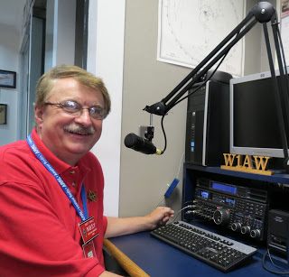

Hey Gang...

Has this been a crazy week for weather? One day it’s almost 40 and that night it’s Zero! Wow. At least the snow hasn’t really been a big factor this year, YET! We are still about 4 weeks out yet until spring arrives on March 19th!! So, anything can and usually will happen.

I had a blast attending several meetings and I even did a presentation for the Wayne County ARC this past week. Of course, attendance at the Mansfield Mid*Winter Hamfest was an absolute given. Dale, Tom and I really had a blast with all of you answering your questions and just saying “Hey”…

Now, an update on the moving furniture. Furniture is still moving around quite a bit even though we took delivery of the new sectional several weeks ago. I’m telling you that it’s absolutely dangerous to walk around the house late at night with low lighting. You never know just what you’re gonna’ run into around here. The other night I fell over my own footstool. Now I’m sure you’re wondering why I did that. Well, it’s because that footstool normally is in my radio room. Now it seems to have found a new home in the living room! What’s next??

TOP ^

Moving down the log a bit… I know that his must sound like a broken record, but… “Have you joined or renewed your ARRL dues yet?” If not, why not. The ARRL is your only advocate to keep and expand your amateur radio frequencies. And this is not the only benefit to be a member of the ARRL. Where else will you get insurance as inexpensively as the ARRL provides for its membership? There’s also all of the ARRL awards that you are eligible for as well. Hey, membership to ARRL is less than $1 per week. Less than a cup of coffee at McDonald’s!!!

Oh, I will also add, ARRL does have a **90-day FREE** trial offer, if you are still not sure if this is something that you would enjoy. What have you got to lose? It’s FREE. Oh, don’t forget that if your YL is a ham you’ll want to get her a membership as well.

Whelp, final go around before gong QRT… That’s going to do it for this week. Stay safe, enjoy the sunshine when we have it, and most of all… have FUN and get on the air!!

73,

***Scott, N8SY***

Ohio Section Cabinet

|  |  |
| --- | --- |
| Section Manager – Scott Yonally, N8SY | Assistant Section Manager – John Perone, W8RXX |
| Section Emergency Coordinator – Stan Broadway, N8BHL | Section Traffic Manager – David Maynard, WA3EZN |
| Technical Coordinator – Jeff Kopcak, K8JTK | Affiliated Clubs Coordinator – Tom Sly, WB8LCD |
| State Government Liaison – Bob Winston, W2THU | Public Information Coordinator – John Ross, KD8IDJ |
| Section Youth Coordinator – Anthony Lascre, K8ZT | |

***Swap & Shop Has Come to the Ohio Section Website***

Hey Gang,

Have you taken a look at the **Swap & Shop** page on the Ohio Section webpage yet??

Here’s a link that will take you there… <http://arrl-ohio.org/sm/s-s.html>

Do you have equipment that you just don’t need or want anymore? Here’s a great venue to advertise it, and it’s FREE!! No, it won’t be listed in this newsletter because it would take up way too much space, so your ad will only appear on the website. It is there for any individual to post equipment Wanted / For Sale or Give-Away. No licensed vehicles/trailers or business advertising will be posted.

Postings are text only (no pictures or graphics) will be posted for a maximum of 1 month from date posting and require a contact phone number or email within the posting.

Send your Wanted / For Sale or Give-Away post to:  [swap@arrlohio.org](mailto:swap@arrlohio.org)

TOP ^

***Special Exercise Being Held***

Matt Curtin, KD8TTE will be doing a presentation at an Emergency Communications Conference in Gainesville, Florida on February 29 and March 1. On Sunday, March 1, we'll be conducting an exercise to be announced just as the exercise begins that will require traffic handling stations outside of Florida—and even outside of 4RN—to support for success.

Total runtime of the exercise will be a few hours in the early afternoon hours of March 1. We are looking primarily for stations able to follow an ICS 205 Incident Communications Plan, make contact with remote stations, take traffic and see to it that the traffic handled properly according to NTS procedure.

Offers to volunteer and questions can be directed to me, [kd8tte@protonmail.com](mailto:kd8tte@protonmail.com).

***Back Issues of the PostScript and Ohio Section Journal***

Hey, did you know that PostScript and Ohio Section Journal (OSJ) are archived on the website? You can go back and look at any edition simply by clicking:

<http://arrl-ohio.org/news/index.html>

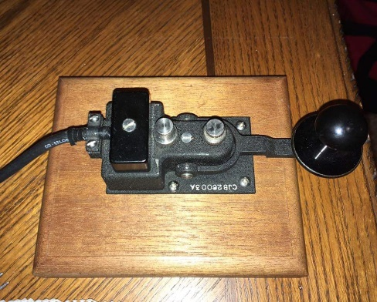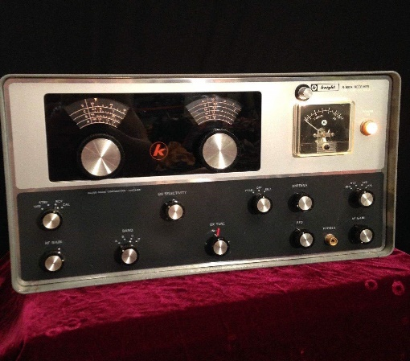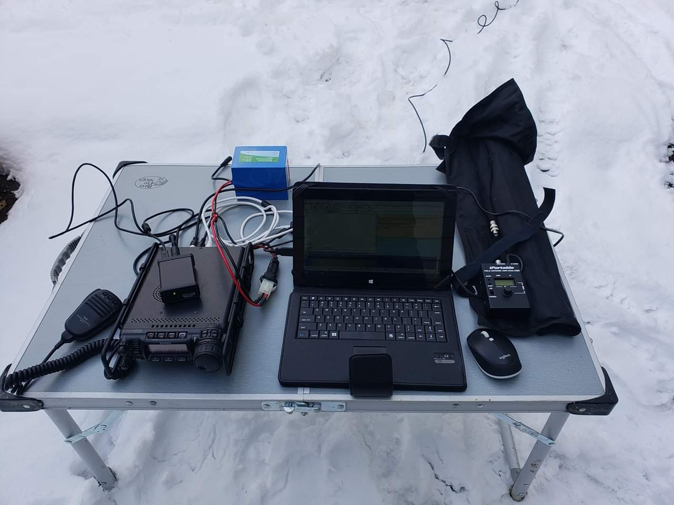

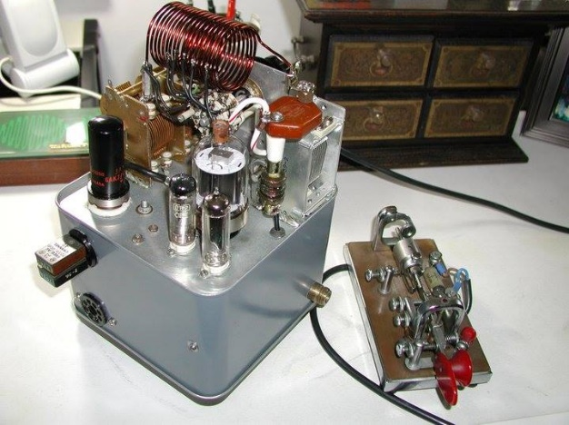

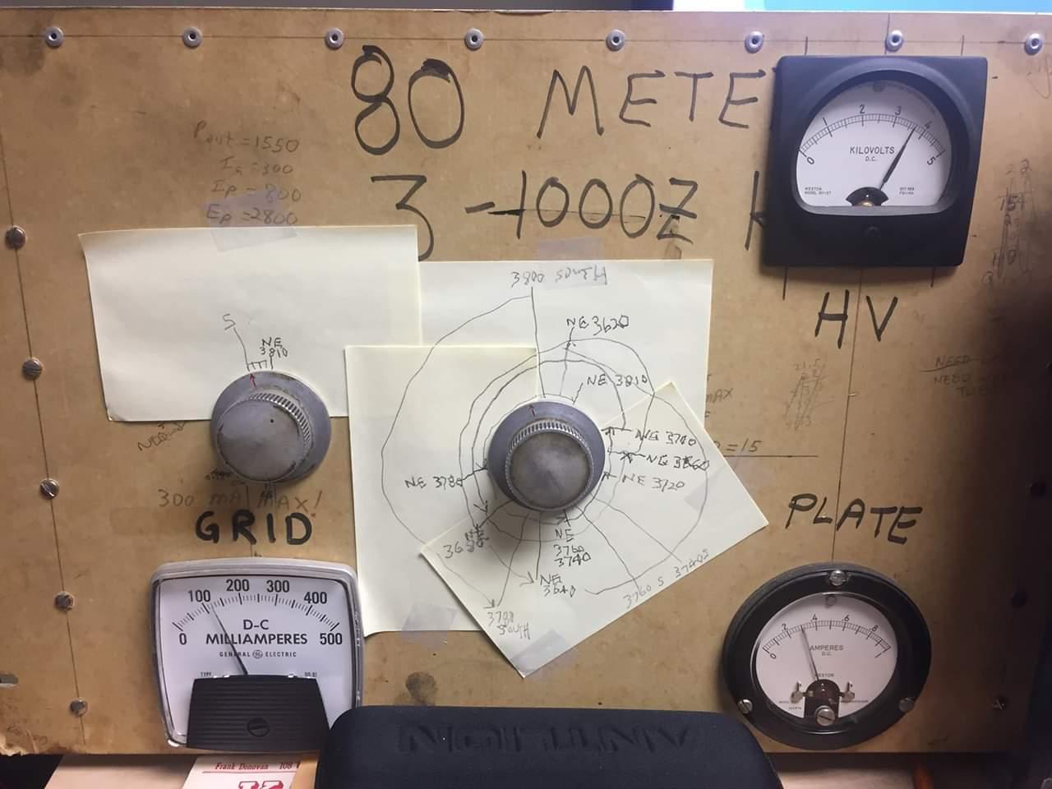

***Updated Information... Want to Share your Club Newsletter With Others?***

We have a new webpage where you can download and read all of the newsletters that I get from around the state.

Here’s the link to the page…. <http://arrl-ohio.org/club_news/index.html>

Please, if you don’t see your club newsletter posted, it’s probably because I’m not receiving it, or I just cannot convert it over to Adobe Acrobat. Have your newsletter editor contact me and let’s see if we can get your club’s newsletter on the site!! We all learn and steal (I mean, share) from each other’s work. So, let’s give this new webpage a real workout and send me your newsletter!!! Send it to: [n8sy@n8sy.com](mailto:n8sy@n8sy.com)

***Chit – Chat, and All That!***

Do you know someone that’s not getting these Newsletters? Please, forward a copy of this Newsletter over to them and have them “[Opt-In](http://arrl-ohio.org/forwarder/forwarding.html)” to start receiving them. Heck just have them send me an email [n8sy@n8sy.com](mailto:n8sy@n8sy.com) and I’ll get them added to the Ohio Section Emailing list.

We now have many thousands of readers receiving these newsletters weekly. Quite impressive, I’d say! I urge all of you to make sure that everyone, regardless of whether they are a League member or not, get signed up to receive these weekly Newsletters.

You can always “[Opt-Out](http://arrl-ohio.org/forwarder/forwarding.html)” at any time if you feel this is not what you were expecting. It’s fun and very informative. All of your favorite past newsletters are now archived too.

You can go back at any time and read them. Just go to: <http://arrl-ohio.org/news/>

Got questions, concerns or would just like to sit and chat awhile? Heck, I’ll even buy the coffee!! Give me a call at (419) 512-4445 or email me at: [n8sy@n8sy.com](mailto:n8sy@n8sy.com)

The pictures on the front page and throughout this newsletter are from various newsletters, Facebook posts and/or were sent directly to me in recent weeks. Take a good look at them, you just might be in one of the pictures! “SMILE… you’re in the Ohio Section News!!”

TOP ^

*PostScript is produced as a weekly newsletter. I want to thank everyone that has contributed articles and ideas to make this an even better news source. I sincerely hope that you have enjoyed this edition and will encourage your friends to join with you in receiving the latest news and information about the Ohio Section, and news and events happening around the world!*