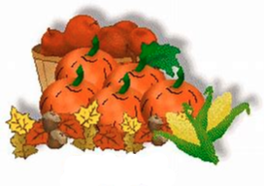***[](http://arrl-ohio.org) September***

***Edition***

|  |  |
| --- | --- |
| 🡪 From the Technical Coordinator | **🡪** From the Section Emergency Coordinator |
| 🡪 From the Affiliated Club Coordinator | **🡪** From the Public Information Coordinator |
| 🡪 From the Section Youth Coordinator | **🡪** From the Section Traffic Manager |
| 🡪 ARES Training Update | 🡪 From the Assistant Section Manager |
| **🡪** From the State Government Liaison | **🡪** National News |
| **🡪** The Handbook Give Away | 🡪 Club Corner |
| 🡪 Hamfests | 🡪 DX This Week |
| 🡪 ARES Connect | 🡪 One Question Questionnaire |
| **🡪** VE Testing | 🡪 From The South 40 |
| 🡪 Final.. Final.. | |
|  | |

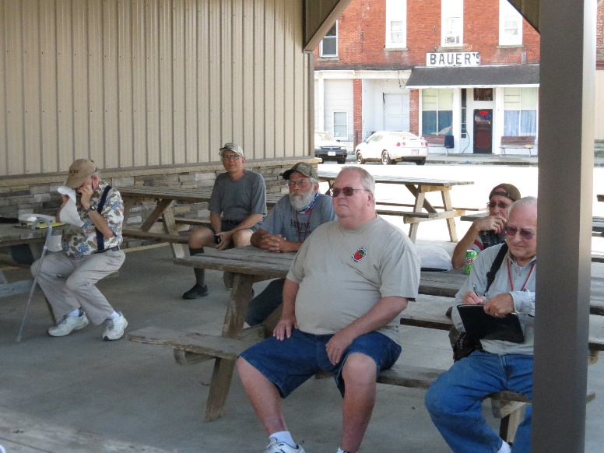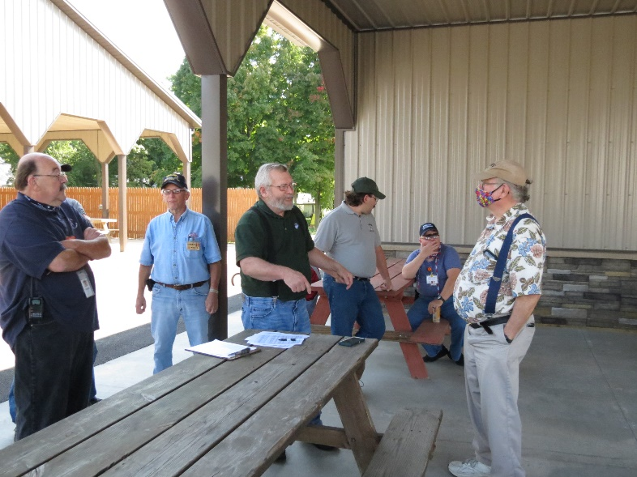

***From the Technical Coordinator***

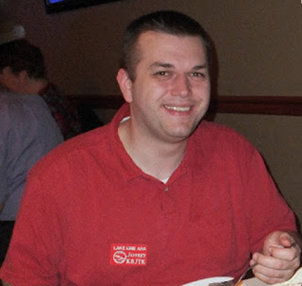***Jeff Kopcak – K8JTK TC***

[k8jtk@arrl.net](mailto:k8jtk@arrl.net)

Hey gang,

On this month’s edition of “Pi Talk” – just when you thought I couldn’t talk about Pi anymore! I received a question from Chet – K8KIZ who has a laptop used for station operation. He wanted to replace it with a Raspberry Pi. In searching, he found way too many choices and wanted help to set him on the right path. This might be a question that others have or one they are considering. He soon found out it was a lot more complicated than originally thought.

Over the past number of years, I’ve done a lot of integration work which involves making one system or application talk to or replace another. It frequently involves bridging communications with other services such as databases or API’s (application programming interface) and facilitating data flow between them. Sales, Account Managers, and System Engineers for the new vendor will always throw around buzzwords and catch phrases – “setup and integration are easy and seamless,” “automated,” “zero configuration,” “drop-in replacement,” “pays for itself in three days” (not really), “reduce costs.” List goes on and on. It is never any of those things.

They have absolutely no idea about your environment, how involved, and how costly it will be to utilize their services. They just want you to buy them. Soon after comes the nickel-and-dimming: “you want to process how much data? That’s an extra couple thousand dollars” or “that doesn’t come with the license you purchased, that will cost you an extra-large-number with many 0’s!” Internal business units do this too. They weren’t prepared or made it seem like they are in position to handle a situation and were not. Feature requests take an extraordinarily long time to implement or claims of not having enough man-power soon follow.

The FCC is in a situation similar to this or they’re making it seem like they are: ‘oh, our licensing process is **all digital** and we can eliminate that pesky licensing fee!’ And the peasants rejoice. Reading the latest [news about the FCC wanting to reinstate license service fees](http://www.arrl.org/news/fcc-proposes-to-reinstate-amateur-radio-service-fees), “...we propose a nominal application fee of $50 due to automating the processes, routine ULS maintenance, and limited instances where staff input is required.” Wait, isn’t that why they went digital to reduce these costs? Someone sold them a bill-of-goods that didn’t actually reduce their costs or they’re looking to recoup costs elsewhere.

Not wanting the same thing to happen to Chet, where the alternative didn’t actually improve his situation, I took the approach of having him think about his station. What does he use his station for and what he would consider “a success” of replacing his laptop with a Raspberry Pi? Anytime anyone is looking to replace X with Y, an evaluation of this nature. What is X used for and are the pros/cons of Y sustainable?

In Chet’s case, replacing a laptop used for ham radio with a Raspberry Pi, he would need to consider things such as:

* Is the current laptop setup Windows or Linux?
* If it's Windows, would he want to climb the Linux learning curve?
* Is he using any software apps that are Windows only? Examples would be: RT Systems programmers, Ham Radio Deluxe, N3FJP logging, SmartSDR, N1MM, Wires-X, etc., etc.

TOP^

* Can those Windows only apps be replaced by Linux apps - and are those Linux apps equally as good?
* Does he have any hardware requirements (like multiple serial or parallel ports)? The Pi has [UART via GPIO pins](https://www.raspberrypi.org/documentation/configuration/uart.md) but two or more serial ports require USB-to-Serial converters.
* How many USB ports are required? Pi’s only have 4. 2 ports would be taken up by using a wired keyboard and mouse.
* Do all of his hardware devices and interfaces work in Linux? These would be things like radio programming, control (CI-V) or firmware flashing, audio mixers and audio interfaces.

This is not an all-inclusive list especially since I didn’t know anything about his station – though I seem to remember he was into Vibroplex CW key tuning and repair from a local hamfest. I thought through scenarios that might apply to the majority of HF operators and came up with that list.

Some Windows programs can be run under Linux using a compatibility layer program such as WINE or run virtual machines (VMs). That would contribute to the Linux learning curve. Raspberry Pi isn’t powerful enough today to run VMs. VMs or hypervisors maybe an option for some Linux desktop/laptop situations.

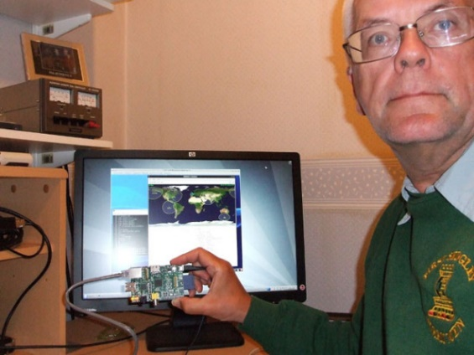

G4DPZ running GPredict on a Pi (amsat-uk.org)

Instead of wired keyboards and mice, Bluetooth devices could be a replacement option but are more costly. Wired is preferred to wireless for reducing interference problems. Built-in antennas for Bluetooth or Wi-Fi aren’t going to be as good as laptop antennas. Additionally, monitors without HDMI or mini-HDMI connectors will need adapters, cables, or outright replaced if it doesn’t have compatible connectors. USB hubs are an option for expanding the number of USB ports. I have yet to find a USB hub that is problem free. They don’t work well with some operating systems, attached devices do not fare well with temporary connection interruptions, and they tend to break down after a short time.

Best way to track these considerations and more is to make a list. Start by looking at all connections to the existing laptop, both physical and virtual (like with an SDR). Include any software used during operating (radio control, prediction modeling, packet, digital, etc.). Programming radios? Those tend to be Windows (or DOS) programs along with firmware updaters. If using a Raspberry Pi is still desired, another Windows machine will be needed for programming and firmware updates. Include all of these in the list and evaluate solutions on the Raspberry Pi or Linux platform for alternatives that meet the requirements. Consider splitting non-supported, but essential, functionality to another Windows machine.

Another way to approach evaluation would be to operate with a new “Pi” system, hands-on, but keeping the old system up-and-running nearby. The old system would be used as a reference for program settings, coping or migrating data files (such as export from one and import to the other), and a comparison point when evaluating Linux programs.

Lastly, completely ditching the previous system and entirely starting from scratch is an option. This type of evaluation style is more draconian by ripping and replacing. Most people have their own operating style and rarely want to deviate from their ritual. Rip-and-replace might be needed if they’re fed up with a current setup and want to start over with something else. The operator, in this case, would not care about migrating previous data, starting out anew, and take whatever options are offered by a different platform.

TOP^

To future proof, I’d recommend going with the latest version of the Pi. Currently, that would be a Raspberry Pi 4 Model B with at least 4GB RAM ($60), 8GB ($90) if able to spring for the extra RAM. Quality of the power supply and SD card plays a role in stability as [I talked about in July](http://www.k8jtk.org/2020/07/26/ohio-section-journal-the-technical-coordinator-july-2020-edition/). Data corruption possibility is still not zero. Even on a desktop PC. Corruption seems to be more prevalent on Pi’s, likely because of cheap components chosen by the user.

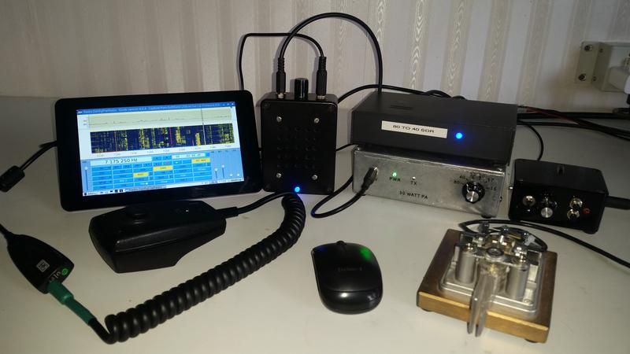

Raspberry Pi 3 projects for Ham Radio with 7-inch touchscreen (qrznow.com)

I strongly recommend making frequent data backups. This applies to any system. There should be 3 copies of data: the local copy (on the Pi), another copy on a storage device like a USB Hard Drive or Network Attached Storage (NAS). A third copy, off-site, located at a friend’s house, relative’s house, or a work location. Another off-site storage location would be cloud storage or backup service provider. Think about where you would be if you lost those LOTW logs, FT8 contacts, SSTV images, or Winlink messages. This strategy is known as the 3-2-1 backup strategy and should be used for ANY important data. 3 copies of data, 2 on different medium, and 1 copy off-site.

Starting out, I would consider the "Ham Pi" or "Build a Pi" projects [I discussed in August](http://www.k8jtk.org/2020/08/30/ohio-section-journal-the-technical-coordinator-august-2020-edition/) initially. “Ham Pi” has just about every Linux ham radio application pre-installed. That would allow an operator to try different programs, find one that suits their needs or one they prefer. “Build a Pi” can be a little more tailored to operating style. You can also get down and dirty by compiling programs from source, depending on Linux experience or desire to tinker with Linux.

That just about covers broad considerations. Chet realized this was a larger undertaking than finding a plug-and-play option. He appreciated the analysis of the issues at hand. I hope he is able to find a working solution to replace his station laptop. When considering major overhauls such as this, know that for most people, it’s a little more complex and involved than most realize.

A quick note about Winlink. The [WINMOR protocol has been deprecated](https://winlink.org/content/winmor_deprecated) systemwide and will soon be removed from the client software application. First introduced by Rick – KN6KB in 2008, it was the first ‘sound card’ mode offered by Winlink as an alternative to modem hardware needed at the time. Rick and the Winlink Team have moved on to developing robust and speedier protocols such as Amateur Radio Digital Open Protocol (ARDOP) and VERA HF. RMS gateways will only support ARDOP, VARA HF, and Pactor 3 or 4 (where applicable) near term. If you are still using WINMOR, it’s likely been hard to find gateways that support the protocol because sysops have been asked to remove in favor of the other modes. WINMOR had a great run and was the mode I used when I first got on Winlink.

**Thanks for reading and 73… de Jeff – K8JTK**

TOP^

***From the Section Emergency Coordinator***

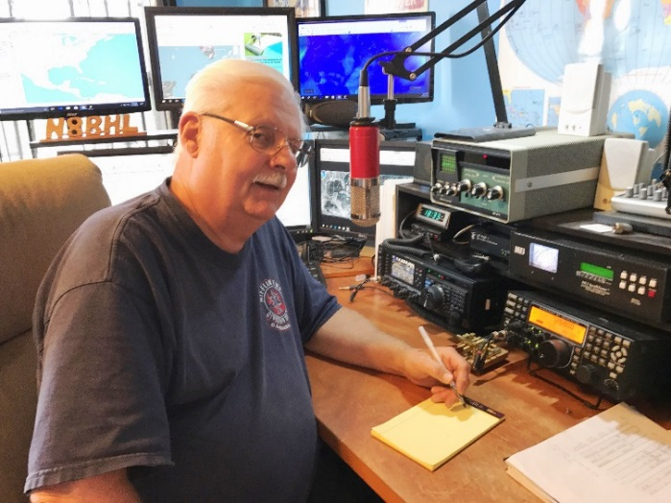***Stan Broadway, N8BHL - SEC***

[broadways@standi.com](mailto:broadways@standi.com)

***Is the League turning a corner?***

The ARRL shot itself in the foot a few years ago when then Emergency Director Mike Cory declared, “We don’t do emergency communications! We do ‘Public Service’. “

That article was a cliff over which Mike jumped, and for years after it would bring ARRL members well into his ‘personal space’ as they decried that sentiment. It instantly brought the competition to change its “Public Service” column to “Emergency Radio” and steal some serious thunder from venerable QST.

Yes, we DO handle emergency communication, regularly, and with expertise. But there are some serious bumps in that road. One crater in the path has been the relationship between ARES and NTS traffic. I think it’s fair to say that traditionally, ARES has been convinced that NTS isn’t interested and has not been there when given the opportunity to play. In all honesty that has been the case in Ohio, where SET messages were held until an evening net instead of being handled as priority messages right then and there. Messages have been received days after SET was concluded.

As we have been progressing this year, we’re seeing that change in Ohio with the advent of Buckeye Net’s masterful handling of digital traffic and willingness to spin up immediately for emergencies. They “get it”. I’m tremendously encouraged by the potential marriage to increase our ability to communicate here.

Another encouragement comes from the hiring of Paul Gilbert KE5ZW. He is head of a new “Emergency Department” indicating a little more attention may be paid to bring the league’s treatment into the current century. Something else with this announcement is important: they’ve placed NTS under the same Emergency Department- bringing the two functions together where they should have been all along. So, we’ll hope to get more support and guidance from the League in our joint efforts. Our SET in October should show this marriage as a strong working partnership as county ARES units, engaged in their own situations, are able to hand traffic off to district level nets, then to Buckeye Net. Like putting an envelope in a mailbox, our concern is done- the message will get there through Buckeye Net and free us up to handle our own situations. Nice the way that works.

In the fire and medical services, there is one word which is absolutely forbidden: “Quiet”. Once uttered, it cannot be retracted and there is no avoiding the avalanche of activity that will always follow. Back-to-back runs forcing a crew to miss dinner, bathroom breaks, and about anything else scheduled for that shift. A silent Emergency Room crew watches the blinking lights as medic after medic backs into the dock. No dinner tonight!

So, it is with trepidation that I hesitantly reach for the “Q” word to describe our ARES activity in Ohio. But truth is truth. Lack of events does not mean lack of activity!

TOP^

Many counties and districts are training (yours SHOULD be!!) and one of the primary topics is in keeping with our “next step up” direction. ASEC Matt Curtin, KD8TTE, has formulated an entire series of well-organized, easy-to-swallow YouTube videos on handling traffic- from simple origination to fairly complex applications. A couple deal directly with our coming Simulated Emergency Test (SET) October 3-4. I strongly urge you to view these! In fact, these are so germane we plan to organize them into a course of study and make them available as another step to achieving ARES Level 2. We’ll have more on that after SET.

Along with the “Q” word comes another condition that usually follows… “Lethargy”. Without frequent activations and public events, it’s easy to just decide to sit this one out. After long years, it’s easy to figure the new guys can get all that digital stuff. But what would happen if nobody responds? We ALL need to continue investing our time and effort to make this whole thing work!

We’re pitching ARES and amateur radio at the very highest levels (yes, that includes Washington DC) as a viable backup system that still works today. In fact, that’s the way amateur radio is perceived at the highest levels. That claim will only be true if YOU continue to participate! We have over the past few years had a couple really well thought out programs that tanked simply because nobody responded. I urge you to take the bait! Keep your interest, keep showing up, and keep responding! I know systems are much stronger than they used to be, and we may not get called as often, but when it gets ~really~ bad, we have to be able to make this work! We are constantly looking at alternative ways amateur radio can be of service under those conditions. The “Watch Desk” project of situational awareness is one of those.

But there are some basics we expect of ARES members that can be put to test in emergencies: Put an antenna together from scrap, solder a connector, figure out how to get power from a battery or vehicle. Understand how to operate in a net. Be fluent in handling messages. Be available! We need to keep this machine well oiled and working and that’s up to you!

Let’s exercise our abilities for the SET! Hope to hear you on the air.

Gang, if you’re not signed up, if you don’t plan to participate in the Annual Ohio Section Simulated Emergency Test (S.E.T.), YOU’RE GONNA MISS IT!!

Matt has been talking message handling for weeks- training us all on the capability to serve our partner agencies.   It’s getting closer!

Remember we’re offering 7AM and 7PM Google Meet sessions for your live questions and answers!!  And here’s the latest video to get us familiar with what’s happening:

<https://youtu.be/IW5eG_qIeaE>

**\*\* You can view all of the SEC’s monthly reports on the website..** <http://arrl-ohio.org/SEC/default.html>

TOP^

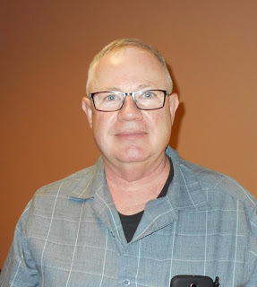***From the Affiliated Club Coordinator***

***Tom Sly, WB8LCD - ACC***

[tomsly29@gmail.com](mailto:tomsly29@gmail.com)

October 2020. Is this year ever going to end? Some say this will be the “New Normal”. I *HATE* that idea! (Yeah, I know. I said that before.) They say that the only thing constant is change, so I guess things are going to be different. We need to harness the “change” and use it to make things “better”.

The objectives of any successful club should include the following:

1. Provide a place where people of like-minded interests can gather together. There are all sorts of clubs for special interests: ham radio, sports cars, sports, woodworking, book reading, art, beer making, wine tasting, Civil War re-enacting, public service. There are probably many more, but the whole point is to create a group where you can mingle with others who share your interests.
2. Provide a place where every member can feel as if *they* are a part of something. If a club wants to attract active and supporting members, there should be an opportunity to create friendships and relationships that support the special interests of both the individual and the group. In a successful club there will be no room for prejudice of any sort. A club should go out of its way to be inclusive. Sometimes that is a tough thing to do in a club that has people from different social, ethnic, political, educational and spiritual backgrounds. (Personally, I applaud any club who has, and involves, that *one* person who is just about a half-bubble off plumb, for whatever reason.)
3. Be visible in the community. How else are others with similar interests going to find you?

Ham Radio Clubs should include those traits, but we can add many more, and differentiate our clubs from each other by what our other objectives are. Ham Radio, as a hobby, is almost a club unto itself. The membership badge is your Ham Radio license.

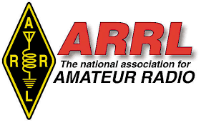The next level down would be the ARRL. (I’m not going to look this up right now, but from past information I’ve looked at, I’m guessing that the membership of the ARRL is somewhere in the range of 40-50% of the total Ham population. More on that later…) Next up, there are some clubs that are not as big as ARRL, but still much larger than the “typical” local Amateur Radio club. These would include clubs such as AMSAT, QRP ARCI, Dayton Amateur Radio Association. The final tier includes larger local clubs (I’ve got to call out PCARS here! Just shy of 200 paid members in 2020) all the way down to clubs that might have only 5-20 members. No matter what size, the three objectives above are important to every Ham Radio Club!

I’ve always said that Ham Radio is many different hobbies within a hobby. That’s one of the ways that Ham Radio Clubs can differentiate themselves from other clubs – back in the 1970’s I remember “repeater clubs” were all the rage. Their main purpose being to build and maintain local repeaters. There are local QRP clubs whose main mission is to further the art and science of low power operating.

TOP^

There are public service clubs that provide communications as a service to other organizations ( think of anything with “thon” at the end of it – marathon for instance ) and there are other public service clubs that exist to provide emergency communications – ARES clubs are a good example.

There are clubs that exist to find, refurbish, maintain and operate vintage Amateur Radio Equipment (think of the Collins Radio club). Many clubs have broad or narrow purposes for their existence, but the important thing is to identify and incorporate that purpose into the club operation.

2020 has been a tough year for many clubs, yet other clubs have thrived. Many clubs have found “alternative” ways to have their meetings. Alternative ways to reach out to their membership. Alternative ways to attract new hams and help them get licensed. What has your club done, or discussed, as an alternative to keep your activities going? I really want to know! Email me, [wb8lcd@arrl.net](mailto:wb8lcd@arrl.net) . I’ll compile all the suggestions and include them in a future issue.

Moving on, I think *every* ham should belong to a local club. Being an active member of a club can help keep you an “active” ham radio operator. Being an active member of a club can keep you interested in experimenting with new and different communications techniques. The more you continue to learn, the more valuable you become to your fellow hams. I can honestly say that my involvement in local clubs has always been a motivator and has pushed me to improve my station, and my skills as a ham. I’ve started many ham radio projects that would have ended in disaster (or at least wasted time, motion and money) without the knowledge and help from members of the clubs I’ve belonged to through the years. I’ve made some valuable friendships and relationships because of the clubs I’ve belonged to through the years. Most of my friends are hams. My business partner is a ham. One of my daughters is a ham. Ham Radio is a big part of my life. Being a part of Ham Radio clubs helps me keep expanding my social circle with friends who all share a common interest, but who also have other interests both in and beyond Ham Radio than mine. In addition to belonging to a club that you would consider your “home” club, I would also encourage you to belong to one or two other local clubs. Each one has a different style. Expand your horizons! Even if you don’t want to belong, look for opportunities to visit with other clubs.

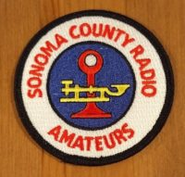Anytime you’re travelling, check out the local clubs at your destination, and if the timing fits, drop in for a visit. I was visiting my aunt in Santa Rosa, California about 4 years ago and it happened I would be there when SCRA – Sonoma County Radio Amateurs - had their monthly meeting. I stopped in, unannounced, and had a fantastic time with them! It was their “homebrew” night and it really was a fun evening. Check them out at their website: <http://sonomacountyradioamateurs.com/wp/>

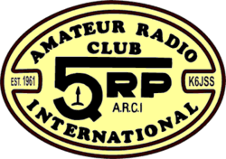

Here’s another one: QRP Aamateur Radio Club, International. <https://www.qrparci.org/> You’ve probably heard of these guys – every year they put on the Four Days In May (FDIM) in conjunction with the Dayton Hamvention. It’s a very good program and always well attended. I’ve heard it said that “Life’s too short for QRP” but, if you really want to develop some skills, QRP will help you get the most out of everything you put into your station. They have a FANTASTIC quarterly magazine and they offer some nice awards. Check out the 1000 miles per watt award! Not really all that tough. WAS qrp – that’s a bit harder, but, very doable!

This is an international group and will give you a chance to meet with some DX’rs from all over the world. Lots of really cool stuff.

TOP^

Here’s another one that I’ve only recently become a member of: INDEXA – the International DX Association, Inc. <https://indexa.org/index.html> This organization exists to promote and support DX operations in countries that have limited or no amateur radio activity. Support is usually to DXpeditions to rare DXCC entities. INDEXA also supports “Goodwill” among Amateur Radio Operators worldwide as well as good amateur radio operation practices. At the Dayton Hamvention they sponsor the DX Dinner which is definitely worth attending. They always have top notch speakers and a fantastic bunch of door prizes!

Dayton Amateur Radio Association [www.w8bi.org](http://www.w8bi.org) is another club that everyone should consider belonging to and supporting! They sponsor and present one of the 3 largest Ham Radio events in the world every year. And, as a ham in the OH Section, ITS RIGHT IN OUR BACKYARD! I’m telling you, and I want you to tell your local club members, if you’ve never been to Hamvention – start making plans now. There is a reason 40,000+ show up for this and 2021 is going to be fantastic!

These are just a few of the clubs I belong to and participate with. My personal experience has been that all of them are open to any ham who wants to expand their horizons and make new friends in the hobby. I think your “local” club should be the first one that you join and get active in. Your local club should impress upon you the importance of the second club every ham should join and support: ARRL.

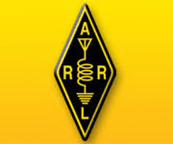ARRL falls into a category all unto itself. [www.arrl.org](http://www.arrl.org) Probably the largest radio club in the world, it provides a lot of products, activities and services directly to its members. They are probably the largest publisher in the world of books and technical reports of interest to the Amateur Radio community. They sponsor a few of the larger operating events in the world – Field Day and November Sweepstakes are two of my favorites! Most people don’t realize how important ARRL is to our hobby, especially in the US. If you ever get a chance to look at a Spectrum Allocation Chart it shows the entire radio spectrum and all of the services that share that spectrum. When you look at how much spectrum is allocated to Amateur Radio it doesn’t take long to realize that our frequency allocations would be worth $Bazillions on the open market. Between business, government and the military, they would love to legislate us out of existence. The ARRL is the ONLY organization in the US that represents our interest in the radio spectrum and protects our allocations. I say again: The ONLY organization that protects our interests in spectrum being stripped from the Amateur service and sold to the highest bidder. Don’t think it couldn’t happen! We need the ARRL. Please support them.

I mentioned earlier that only about 50% (that’s being generous) of hams belong to the ARRL. We could do better. Don’t forget, members can join, and renew ARRL through your affiliated club, and your club earns a commission on each and every one. Contact me directly if you would like to know about how that works. Every year, positions in the ARRL are open for election and/or re-election. Again, only about 50% (being generous again) of ARRL members bother to submit their vote. That means less than 25% of all hams are choosing the leaders who will stand for us before the FCC and other regulatory agencies. That’s an apathetic response. We need to do better. I’m asking you to vote, to urge your local club members to vote, and to motivate those hams who are not ARRL members to become members!

**73, Tom WB8LCD**

TOP^

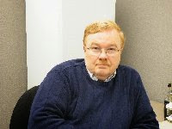***From the Public Information Coordinator***

***John Ross, KD8IDJ - PIC***

[john.ross3@worldnet.att.net](mailto:john.ross3@worldnet.att.net)



**FROM THE PIC**

**HURRICANES…and HAMS**

By now we know that Hurricane Laura hit land as a category 2 storm and the results were catastrophic. Hurricanes, tornadoes and many other disasters seem to be occurring all too frequently….but Amateur Radio has been there every time to help.

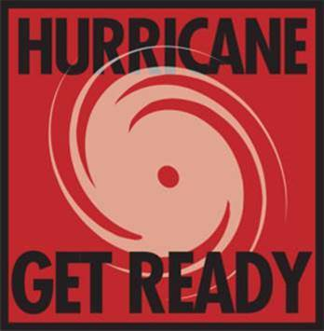The Hurricane nets have been active and if you scanned across the bands you could hear hams working the contacts and doing all they could to keep communications going. The FCC even restricted some of the frequencies for emergency use only and, as another hurricane and tropical storm approach, you can be sure hams will be ready.

We don’t often get a lot of publicity for the hard work that Amateur Radio does in emergency situations and, I guess, I am personally OK with that. What we do in emergencies is pretty much what we do every time we pick up the microphone or “fist bump” our key. As hams we take away a lot of personal satisfaction just knowing we were, and can be, in the right place at the right time and offer assistance. Our conversations every day on the local repeaters, our long range QSO’s and our training keep us sharp, ready and able to communicate in any situation. We are proud of that and we work hard…even if doesn’t seem that that way to us…to do always do our best.

I can’t think of another hobby that offers as much as Amateur Radio. If you are working the nets and traffic from down south…THANKS…I know it makes a difference and it keeps Amateur Radio right out front.

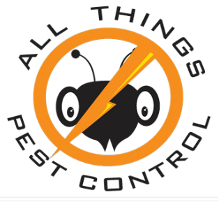

**PEST CONTROL…AND HAMS**

Generally speaking…bugs…the kind that fly and crawl around your house…don’t usually come up in conversations about Amateur Radio. It might be just me but I seem find Amateur Radio in some of the strangest places.

While sitting on my porch last night a man literally rolled up on a giant, battery powered…wheel….just one wheel no side mounted training wheels, no handlebars, no seat, no nothing but a wheel! He was there to sell me pest control and proceeded to tell me how much better his company was than just about every other business from the flyswatter up to a crop duster airplane. I wasn’t buying it…or his one-wheel balancing act…until he said, “ I like your shirt. I’ve been thinking about getting my ham license.” What???? The conversation had suddenly changed from killing bugs to getting an Amateur Radio license!!! Then I realized I had on my favorite ARRL …walking billboard…embossed shirt. Now… this guy had two good things going for him….he recognized the ARRL and he wanted to be one of us!!!

TOP^

***HALLIELJUA PUT YOUR HANDS ON THE MICROPHONE!!!***

So, I gave this guy my elevator speech on why it’s great to be a ham and that getting licensed, even under COVID 19 restrictions, is easy and the rewards are priceless. To my surprise…he GOT IT!  He understood that sometimes the internet and cell phones go out and…wait for it…ham radio can fill that gap! I gave him my number and ARRL’s web address…he smiled and said, “ I’m going to do it”…and then hopped on his one wheel and rolled away!

For me, another satisfied customer….for him not so much…no bugs to kill but a good life ahead as an Amateur Radio operator.

The moral here….sometimes pests….can become hams!!!



**2021 OHIO SECTION NEWSLETTER CONTEST…AND HAMS**

I can’t write a PIC column without mentioning our Ohio Section Newsletter Contest. The 2020 edition went well despite changes in the world order due to COVID 19. All great winners and all great newsletters.

The 2021 contest is just three months away! You can start sending your January newsletters in late December. Remember you’ll need two copies from different months to eligible.

That’s it for this month.  Have a great October…watch some football and get ready for Halloween…but be safe with all you do.

73

**John, KD8IDJ**

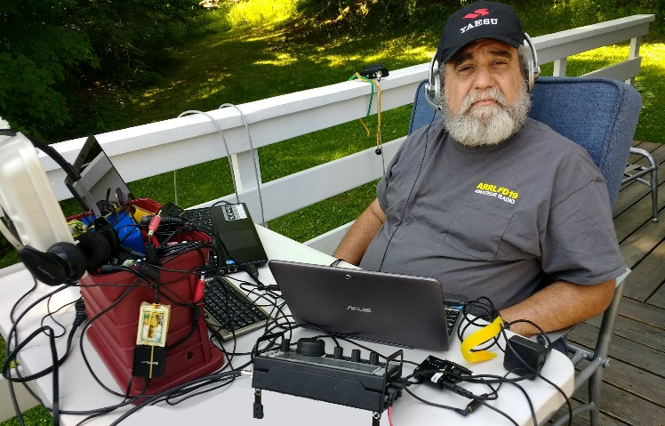***From the Section Youth Coordinator***

***Anthony Luscre, K8ZT - SYC***

[k8zt@arrl.net](mailto:k8zt@arrl.net)

***A Few Activities for Your Club***

In the months of COVID-19, many Amateur Radio Clubs have not been able to hold their usual in-person meetings. Having activities for club members is an important part of any group. Many clubs have gone the online route having meetings and programs via Zoom, WebEx, Google Meet, Skype, etc. Others have gone the on-air route having meetings via the club repeater. Many have done both. Although they don’t have the personal interaction and small group discussions that can really only occur in person, these online and on-air meeting have both had some good points:

TOP^

* Location is not a problem as members and presenters do not need to be in the same area
* Those with limited mobility, medical conditions or other issues that prevents them attending in person have been able to participate
* Wider selection of presenters available for programs (in September I have done presentations in England, Texas and Arizona in addition to Ohio)

So if your club hasn’t tried online meetings/programs please give it a try, I might even be available as a guest speaker.

Many clubs have weekly 2 Meter nets, usually via the club repeater. Some also have additional nets on 440, 6 Meters or HF. My local club, Cuyahoga Falls ARC (w[www.cfarc.org](http://www.cfarc.org)), has been holding a 10 Meter net following the weekly 2 M net for years. Recently we decided to spice things up and expand the net to additional HF bands. We have been informally calling it the Band Explorers Net as each week we rotate bands.

* First Monday- 6 Meters
* Second Monday- 10 Meters
* Third Monday- 40 Meters
* 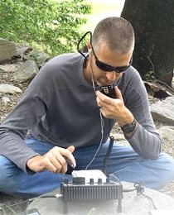Fourth Monday- 80 Meters
* When there is a Fifth Monday we rotate through:
  + 160 M
  + 60 M
  + 17 M
  + 12 M

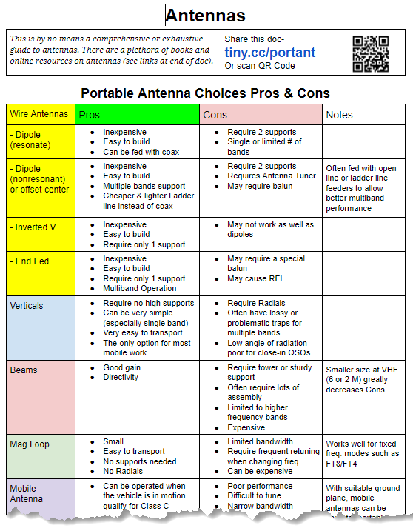

This new net has had a number of good effects:

* More members have been checking in
* Members have been trying new bands that they did not routinely operate on
* Some members have put up new antennas to try bands they had not been operating on

TOP^

* Those unfamiliar with HF and non-repeater operating are becoming familiar with new operating styles
* Everyone is learning a little about propagation, antenna orientation (horizontal versus vertical) and other great stuff

We provided a resource on portable and other types of simple antennas with ideas for those needing something for the new bands- Antennas- [tiny.cc/portant](http://tiny.cc/portant)

If you are thinking about something along these lines for your club here are a few suggestions/tips:

* We kept operation in the General portion of the band to accommodate the largest number of members and two of the weeks use bands/frequencies that are also available to Technician class licensees (6M & 10M).
* We checked potential frequencies for existing nets-
  + By listening during time/day slot over a few weeks
  + Checking lists of existing nets, special mode operations, calling frequencies, etc.
    - ARRL Search for a Net- [www.arrl.org/resources/nets/client/netsearch.html](http://www.arrl.org/resources/nets/client/netsearch.html)
    - Band Plan- [www.arrl.org/band-plan](http://www.arrl.org/band-plan)
    - The Considerate Operator’s Frequency Guide- [www.arrl.org/files/file/conop.pdf](http://www.arrl.org/files/file/conop.pdf)
    - Band Plan by Activities- [www.bandplans.com](http://www.bandplans.com)
    - HF Automated Links- [http://hflink.com/bandplans](http://hflink.com/bandplans/)
    - [N1YZ Nets List](https://www.qsl.net/w5rin/FILES/Ham%20Radio%20HF%20Nets.pdf)
    - [Net List Amateur HAM Radio](http://hamnetlist.blogspot.com/p/hf.html)
* You will need to be flexible to existing activity on the new bands because you are just starting on these new frequencies. This may require weekly operations to move up or down slightly to accommodate other operators and band activity. Although this may seem an inconvenience, this is actually good practice for running an Emergency communications net. In some instances, you may find the originally selected frequencies may need to be changed to accommodate band conditions.
* These types of club nets can provide an incentive for having equipment and antennas in place to operate on many different bands
* Increase Emergency preparedness by expanding the number of bands members are equipped for and have experience operating on.
* Provide an incentive for current Technician licensees to upgrade to General class licenses.
* Have fun with new challenges
* Finally, for those members that do not have an HF radio or antenna for any of the bands, members can utilize the free online tunable SDRs at [tiny.cc/freerx](http://tiny.cc/freerx) to listen to the club HF net.

The last suggestion for a club activity is an online class for members to learn something new. You can either sponsor the class or take advantage of existing classes already scheduled. Classes might include:

* Licensing or License Upgrade Classes
* Training on a specific mode or type of operation
* Training on use of a specific piece of Amateur Radios software (Logging, Contesting, etc.)
* Training on using test equipment
* CW (two existing classes include CW Ops- [*CW Academy*](https://cwops.org/cw-academy/) and[*Long Island CW Club Online Classes*](https://longislandcwclub.org/cw-online-classes/)

**73, Anthony K8ZT**

TOP^

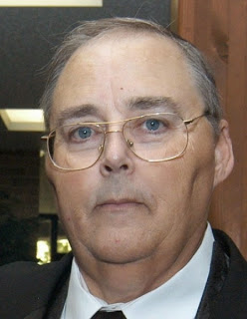***From the Section Traffic Manager***

***David Maynard, WA3EZN – STM***

[wa3ezn@att.net](mailto:wa3ezn@att.net)

***EMERGENCY! EMERGENCY!***

*Some my think Emergency*! is an American television series that combines the medical drama and action-adventure. However an *emergency* is a situation that poses an immediate risk to health, life, property, or environment. Most *emergencies* require urgent intervention to prevent a worsening of the situation, although in some situations, mitigation may not be possible and agencies may only be able to offer palliative care for the aftermath.

With this being National Preparedness Month which is recognized each September to promote family and community disaster planning now and throughout the year. As our nation continues to respond to COVID-19, there is no better time to be involved than this September. The 2020 National Preparedness Month theme is: "Disasters Don't Wait”. More information on personal preparedness can be found at <https://www.ready.gov/september>

***SIMULATED EMERGENCY TEST***

Although the main ARRL SET weekend this year is October 3-4, local and section-wide exercises may be held throughout the fall season. The primary League-sponsored national emergency exercise is designed to assess the skills and preparedness of ARES® and other organizations involved with emergency and disaster response. SET guidelines and reporting forms for Emergency Coordinators and Net Managers can be found at <http://www.arrl.org/public-service-field-services-forms>

“Prepare for SET: Be Ready to Activate” by Matthew Curtin, KD8TTE was part of the August 2020 Ohio Section Journal. If you didn't get the email link to The Ohio Section Journal – August Edition go to [www.arrl-ohio.org](http://www.arrl-ohio.org/). You will find it under the news section. It is a detailed article on reporting SET activity.

For new or experienced operators, the SET is an opportunity to learn and practice you traffic handling, net operations and emergency communications skills. Take some time and make-up some radiograms and send them through the system to your friends or family and make the SET in Ohio a success.

Check into your local net and ask them what they are planning for the weekend. Be sure to prepare for emergency power operation and possible simplex operation as part of an SET scenario. To participate and practice you emergency radio skills contact your net manager or check in with your ARES group and get involved.

If disaster struck you hometown right now, would you know what to do? If an inattentive backhoe operator cut the telephone trunk lines to your local hospital, could you be of service? You and other hams will have to go to the places where communications are needed. You will probably need to bring your own radio gear.

Is all the equipment that you would need ready to go right now? Are your batteries charged? Could you get on the air quickly and effectively from a disaster site or a damaged facility?

TOP^

What agencies and institutions will you be able to help? What will they expect of you? With whom will these agencies want to communicate? What radio paths will you use to contact or send messages to the people that they need to reach?

Simply put, if you haven't put some serious thought and effort into answering questions like these in advance, then you are not yet prepared to be an emergency communicator. You might become one of the scores of hams who will get on the air to talk to each other about the disaster, but you won't provide any real support to the citizens of your community unless you are prepared.

***How to Join the SET***

On Saturday, October 3rd, Amateur radio operators across our region, state, and nation will participate in SET (Simulated Emergency Test). SET, the largest nationwide exercise in emergency communications, provides Amateur radio operators the unique opportunity to focus on strengths and weaknesses, in order to enhance overall emergency communications capabilities within each community. This exercise attempts to "overload" the network and provides a real-life scenario type 'hands-on'” training opportunity for the less experienced members. This year's exercises, could include scenarios ranging from severe weather events to threats to homeland security and will be extremely fast paced in nature. The dynamic nature of these drills will provide an extremely accurate feel of what communications in an 'actual' emergency would consist of.

Each net and section is to report their activity to the ARRL using forms on the ARRL website. The activity reports will be analyzed, and a report will be issued later as sort of a grade for each section. You are encouraged to consider participating in this year’s Simulated Emergency Test and to prepare for it as a demonstration of Amateur Radio’s readiness and as an active participant in national preparedness. If you are at all cognoscente of what is in the news you will already know how possible it is to have a widespread disaster.

In Matt's own words the BLACK SWAN Communications Exercise purpose is to test the ability for volunteer and government agencies to communicate across services in emergency conditions through amateur radio. The exercise will serve as the annual Simulated Emergency Test (SET) for the Ohio Section of the American Radio Relay League.

**TIP FOR SUCCESS:** The earlier you send your SET radiograms the more chance you have to send them without delay. Every year some stations wait until the last minute to send their radiograms and they run into a 'traffic jam' on the OSSBN. The OSSBN plan is to have nets at 10:30 AM, 4:15 PM and 6:45 PM. For SET these nets will run until all traffic is collected or passed. Check their frequency periodically if you have traffic as additional nets may be held if needed. Also, local VHF nets as listed below may be available to take your traffic.

One of the first steps on the way to a successful SET is to try to get as many people involved as possible and especially new hams. In a real emergency, we find amateurs with all sorts of varied interests coming out of the woodwork. Let's get them involved in SET so they will know more about how emergency communications should be handled. Promote SET on nets and repeaters, and sign up new, enthusiastic radio amateurs. Many of those offering to help will be inexperienced in public-service activities. It's up to you to explain what's going on to them and provide them with useful roles. They may like it so much that they become a permanent fixture in your ARES or NTS group.

Amateur Radio Emergency Service ® (ARES®), National Traffic System (NTS), Radio Amateur Civil Emergency Service (RACES) , CERTS and other public-service oriented groups can be involved.

TOP^

The SET weekend gives communicators the opportunity to focus on the emergency-communications capability within the community while interacting with NTS nets.

The purpose of SET is to find out the strengths and weaknesses of ARES, NTS, RACES and other groups in providing emergency communications. It also should provide a public demonstration to served agencies such as the American Red Cross, the Emergency Management Agency and through the news media of the value to the public that Amateur Radio provides, particularly in time of need. To help radio amateurs gain experience in communications using standard procedures and a variety of modes under simulated-emergency conditions.

To give you a head start here is some sample radiogram text to show you what type of radiogram you can send during SET if not directly involved in ARES. First some fun ones you can send.

73 ROUTINE (YOUR CALL) 9 ANYTOWN OH OCT 1

ANY HAM OPERATOR

ANYWHERE USA

BT

SENDING MESSAGES TO OTHERS BY

RADIOGRAMS IS A FUN ACTIVITY

73

BT

(YOUR NAME AND CALL)

NR 1 ROUTINE (YOUR CALL) 10 (YOUR CITY AND STATE) (DATE OCT 1)

ANOTHER HAM

ADDRESS

CITY STATE ZIP

PHONE

BT

PLEASE SEND ME A RADIOGRAM

DURING SIMULATED EMERGENCY TEST 73

BT

(YOUR NAME AND CALL)

NR 2 ROUTINE (YOUR CALL)

DAVID MAYNARD WA3EZN

4815 MIDLANE DRIVE

HILLIARD OH 43026

OHIO SECTION TRAFFIC MANAGER

BT

AM PARTICIPATING IN SET BY

SENDING YOU THIS RADIOGRAM 73

BT

(YOUR NAME AND CALL)

If you make them sound like a real emergency during SET the text must start with the word exercise and end with the word exercise so we don’t cause unnecessary alarm by individuals who may intercept your practice radiograms.

TOP^

2 ROUTINE (YOUR CALL) 16 (YOUR LOCATION) OCT 2

ARES DUTY OFFICER

INCIDNET COMMAND CENTER

C/O WA3EZN HILLIARD OHIO

BT

EXERCISE CAN YOU SEND RELIEF

OPERATOR TO STAGING AREA QUERY

IF SO PLEASE ADVISE ETA

EXERCISE

BT

(YOUR CALL)

AMATEUR RADIO VOLUNTEER

STAGING AREA

88 ROUTINE (YOUR CALL) 14 (YOUR LOCATION) OCT 3

ANYONE ANYWHERE

BT

EXERCISE SEND GENERATOR TO SHELTER

ADAM X POWER FAILURE AND

ICE CREAM MELTING EXERCISE

BT

(YOUR NAME AND CALL)

73 (YOUR CALL) 11 (YOUR LOCATION) OCT 2

ANYONE ANYWHERE

BT

EXERCISE NEED MORE COTS AND

SANITATION KITS AT SHELTER BROVO

EXERCISE

BT

(YOUR NAME AND CALL)

73 ROUTINE (YOUR CALL) 11 ANYTOWN OH OCT 2

ANY HAM OPERATOR

ANYWHERE USA

BT

SENDING MESSAGES TO OTHERS BY

RADIOGRAMS IS A FUN ACTIVITY

73

BT

(YOUR NAME AND CALL)

NR 1 ROUTINE (YOUR CALL) 10 (YOUR CITY AND STATE) (DATE OCT 2)

ANOTHER HAM

ADDRESS

CITY STATE ZIP

PHONE

BT

TOP^

PLEASE SEND ME A RADIOGRAM

DURING SIMULATED EMERGENCY TEST 73

BT

(YOUR NAME AND CALL)

NR 2 ROUTINE (YOUR CALL) 10 (YOUR LOCATION) DATE

DAVID MAYNARD WA3EZN

HILLIARD OH 43026

OHIO SECTION TRAFFIC MANAGER

BT

AM PARTICIPATING IN SET BY

SENDING YOU THIS RADIOGRAM 73

BT

(YOUR NAME AND CALL)

Have fun and start early to prepare your SET radiograms. Maybe we can break our state record and score higher this year.........

OHIO SINGLE SIDEBAND NET

["Specializing in the first and last mile of NTS delivery in Ohio."](http://www.ossbn.org/)

|  |  |  |  |
| --- | --- | --- | --- |
| **Morning session** | **10:30 AM** | **3972.5 KHz** | **every day** |
| **Afternoon session** | **4:15 PM** | **3972.5 KHz** | **every day** |
| **Evening session** | **6:45 PM** | **3972.5 KHz** | **every day** |

Ohio has three very fine CW nets. These nets are looking for new CW operators to check in and the Ohio slow Net is in need of a net manager. Thanks to WB8YLO for collecting the OSN net reports and sending the monthly report to the Section Traffic Manager

**OHIO HF CW TRAFFIC NETS**

|  |  |  |  |
| --- | --- | --- | --- |
| **HF CW NETS** | **NET TIMES** | **FREQUENCY** | **NET MANAGERS** |
| **Buckeye Early** | **6:45 PM** | **3.580** | **WB8YLO** |
| **Buckeye Late** | **10:00 PM** | **3.590** | **WB9LBI** |
| **Ohio Slow Net** | **6:00 PM** | **3.53535** | **NEEDED** |

All net frequencies plus or minus QRM. .

TOP^

**OHIO LOCAL VHF TRAFFIC NETS**

|  |  |  |  |
| --- | --- | --- | --- |
| **VHF NETS** | **NET TIMES** | **FREQUENCY** | **NET MANAGERS** |
| **BRTN** | **MON, WED, SAT 9:30 PM** | **145.230**  **PL 110.9** | **W8DJG** |
| **COTN** | **7:15 PM DAILY** | **146.970** | **KD8TTE** |
| **MVTN** | **7:00 PM Mon** | **146.640** | **KC8HTP** |
| **NWOHARES** | **6:30 PM DAILY** | **147.375** | **N8TNV** |
| **TCTTN** | **Sun, Tues, Wed, Fri 9 PM** | **146.94** | **WB8YYS** |
| **TATN** | **8:00 PM DAILY** | **146.670 PL123** | **WG8Z** |

These VHF net times and frequencies are those that have been reported to me by the net managers.

"An amateur will train until he gets it right; a professional trains until he cannot get it wrong!"

73

**David, WA3EZN**

**\*\*You can view the STM’s monthly report on the website..** [**http://arrl-ohio.org/stm/stm.html**](http://arrl-ohio.org/stm/stm.html)

*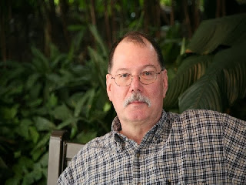****ARES Training Update***

***Jim Yoder, W8ERW – ARES Data Manager***

[w8erw@arrl.net](mailto:w8erw@arrl.net)

***ARES Training Update***

Sometimes things just do not add up…. Have you ever come to that point when what you are seeing or hearing just doesn’t make sense or resonate with what you have been told or reasonably expect? I bet so, I have. One interesting situation that I have encountered twice involved the use of commercial surge protectors. I’ve always used the ISOBAR brand from Tripp Lite. They are well made, certified and provide insurance when properly used. However, they do exhibit an anomaly that I found difficult to grasp at first. I call it such as it came totally unexpected and took a bit of effort to discern the cause. Both cases are similar and the first was when I decided to use an ISOBAR in my newly reconfigured shack. I connected my HF rig, a Kenwood TS-830S and the companion VFO-230 to the ISOBAR thinking the protection would be a good safety precaution and worthy of the ISOBAR protection. I was thoroughly confused when I fired up the rig and VFO only to find the tuning was totally erratic and the VFO useless. I had just shut both down prior to connecting them to the ISOBAR and everything had been fine.

TOP^

After a few frustrating moments, I reconnected to the wall outlet and everything was again normal. I then started doing some research online and found that the design of the ISOBAR isolates ground between outlets which allows the ground to float, something that does not work well when Amateur gear likes to be at the same ground potential. The fix then was to properly ground both the rig and VFO to the station ground eliminating the ground loop that formed because of the Isolation characteristics of the ISOBAR. This honestly should have been done regardless of the surge protection. Lesson learned.

The second time was similar and was with my dear friend Charlie KS8L, now SK. Charlie had purchased a second video editing device to provide some enhanced flexibility in editing the videos he was commercially producing. He called me telling of his woes that were messing up everything with the same symptoms that I had seen not too long before with my station equipment. Charlie in disbelief, was not too eager to accept my suggestion to use different outlets and not to connect both devices to the surge protector he was using. He was quite surprised when everything worked as it should after separating the power connections. He was not able to ground the devices as they were not equipped to do so. I wonder how many others have experienced this frustration.

In another nonrelated instance, I had a situation with a router provided by AT&T as a part of a VOIP telephone service they were offering at the time. The router was a Linksys device having the additional function of a VOIP analog telephone adapter. After using the service and device for several years, the phone line stopped working. Everything appeared to be normal in the setup etc., just no phone. I called AT&T customer service and told them what was happening, and they sent a new Linksys device overnight. It connected the new router right away only to find the same problem, no phone. Another call to AT&T and a second new Linksys router was delivered the next day. Oh no, same issue. By now I was sure it was a software issue on their end. It was in the wee hours of the next morning when I called AT&T again. I was connected to a really knowledgeable technician this time rather than a script reader. She walked me through several steps which with her verifying over the network found nothing awry. She finally asked me if I had changed the wall wart power device. I said that I had but also went to check. I had not. I had started to do so, and the new unit was ready to swap, but in my haste, I had not yet done so. I immediately did so and wonder of wonders, the phone was back and working. All the while the router function had been working completely without issue. Sometimes those little things just get you. I’ve learned to not to over think or assume anything. Oh, and yes, not long after that AT&T decided to drop their VOIP service and I had three nice routers to retire to the shelf.

Our Training statistics remain good and both new course certificates and ARES Connect registrations continue to increase. I will say however that we have a significant number of our Ohio Hams who participate with ARES and have not yet registered on ARES Connect. Folks, you are missing out. ARES Connect has become the go to reference to everything that is happening within the Ohio Section. Hamfests and ARES events are listed along with meetings, training sessions and all of what we would like to see for reference is all there in one convenient place. This is in addition to collecting the information we need to document the time we all spend supporting ARES and our community service activities. If you have not and ARES is not the only reason to do so, I urge you to take a few minutes to log into ARES Connect. There is a convenient link to do so on the ARRL-Ohio.org web page.

Including access to ARES Connect, the Ohio Section Web Page also has a lot of current information on everything we need to know throughout the Ohio Section. You will find the latest DRM code plugs, Hamfest Updates, ARES forms and information, contact information for the Ohio Section cabinet and a lot more. You can also sign up to receive our Section weekly and monthly updates, PostScript and the Ohio Section Journal. Our Section Manager does a great job on both, detailing the activities and events in Ohio and elsewhere. Both are packed full of the latest information and it’s easy to sign up and be in the know.

TOP^

Please do take the time to visit the Ohio Section web page, ARRL-Ohio.org and get signed up to receive both newsletters.

As of this date, we now have 1,848 Members in the training database. 1,440 have registered on ARES Connect. The numbers are as follows: Level 1 - 923, Level - 725 and Level 3 - 199. There is now a total of 9,685 course completion certificates on file. As you can see, we are showing continuous growth and advancement to higher Levels. Of course, we need to give those at Level 1 some attention. All it takes is completion of the 4 NIMS courses, ICS-100, ICS-200, ICS 700 and ICS-800 to advance to Level 2 which all ARES members should be working towards. ICS-400 and ICS-400 will advance you to Level 3 and if you are not able to attend the classroom sessions to get these two courses, you can also advance to Level 3 by completing the alternate online courses from FEMA, ICS-120, ICS-230, ICS-240, ICS-241, ICS-242, ICS-244 and ICS-288. After you complete these 7, go after ICS-235 and FEMA will issue the Professional Development Series Certificate. All of these are online and free of any charge. You will need to first register with FEMA and get your student number. It’s all quick and easy. The NIMS courses and others are all designed to give you the information and knowledge you need to be effective in any disaster situation. They are interesting and give you some real insight and working knowledge of how a disaster is managed and the roles of all the players who may become involved. It is all great information to have and once you get into the courses, you will see why we emphasize the importance of this training.

Thank you again everyone for your efforts to support the Ohio Section and ARES. You are appreciated and valued and help us all to justify our use of allocated spectrum. Keep up the good work.

Thank you and 73,

Jim, W8ERW

*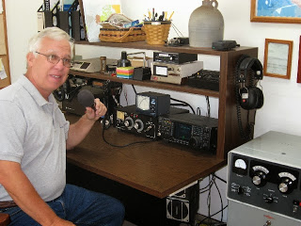****From the Assistant Section Manager***

***John Perone, W8RXX – ASM***

[w8rxx@arrl.net](mailto:w8rxx@arrl.net)

This may not be directly amateur radio related, but saving lives is. I have noticed many do not understand the proper process of mask wearing even after many months have passed.

Many continue to wear it below their nose which defeats the purpose of wearing a mask at all.

While masks protect the wearer from COVID-19 to some degree, the mask primary purpose is source control. It limits the amount of infectious droplets coming out of the wearer’s respiratory tract -- both the mouth and nose.

Unfortunately, relative to spreading COVID-19, the nose appears to be at an advantage over the mouth.

Researchers have found the cells that line the nose were significantly more likely to become infected and shed virus compared to the throat or lungs. Every time a person exhales through their nose, they are likely generating a higher concentration of infections aerosol than if they were breathing through their mouth.

TOP^

This means in order to block the infectious cloud from escaping to infect other people, it is just as important if not more important to cover your nose with the mask.

Providing a public service is one aspect of our hobby. Even without being on the air we can help others understand how to properly wear a mask to eliminate the spread. If you see someone half masked will you step up to nicely educate them? Who knows, the life you save may possibly be a future amateur?

Thank you for doing your part to help to totally eliminate the virus before Dayton / Xenia 2021. We can only hope…

**73, John W8RXX**

***From the State Government Liaison***

***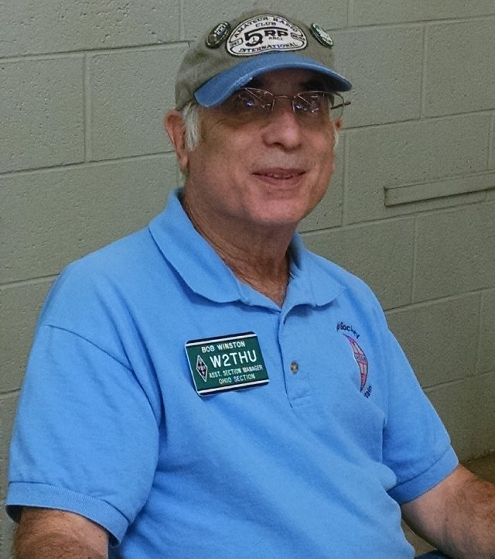*Bob Winston W2THU – SGL**

[w2thu@arrl.net](mailto:w2thu@arrl.net)

***RENEWING YOUR AMATEUR RADIO LICENSE PLATE***

I recently heard from several hams here in northeast Ohio that due to COVID-19 causing long lines at their deputy registrars, they opted to renew their registration through the regular mail. One ham told me that he mailed in his renewal form, copy of his FCC ticket and a check last May, and never heard from the BMV. His check was not cashed, so he went to his local deputy registrar and successful renewed. Of course, his concern was that the BMV in Columbus would eventually cash his check resulting in paying twice. The deputy told him that the Columbus BMV would see that he renewed locally and return his check. He is still waiting. However, another ham in the same scenario, told me that his check was returned after he renewed locally.

I was asked, as Ohio SGL, to look into the matter. I went on the BMV website and started a chat. The chat responded that due to excessive demand, it would be a while before someone came into the chat room. I waited an hour and gave up. The next day I tried again with the same result, so I sent an email. That was about 3 weeks ago, and I have received no response. It would be very helpful if you have a personal contact at the BMV in Columbus. Please let me know.

***STATUS OF THE ANTI-TEXTING BILL –***

Senate Bill 285 was introduced into the Ohio Senate on 18 February of this year. About two weeks later it was referred to the committee on *Local Government,* *Public Safety and Veterans Affairs*. As of today (24 September 2020), almost 6 months later, it is still there. Word has it that the committee has agreed to an amendment excluding amateur radio operations, which is what we wanted, but there is no official report on this subject. If there is any change, I’ll let you know.

When and if this bill is voted out of committee it returns to the full Senate for a vote. If passed, it then goes to the House, where a similar procedure occurs. If the House version and the Senate version are not the same, then it goes to a joint committee to work out the differences, and if approved by both bodies, it goes to the Governor for his signature.

TOP^

Remember, we do want to stop texting and other distractive behavior while driving, but we don’t want to inhibit amateur radio mobile use.

***LOCAL GOVERNMENT LIAISONS –***

In many past columns that I have written for the Ohio Section Journal I ask for volunteers to join our team as Local Government Liaisons. However, not many folks have responded, which leaves a big gap in our section to monitor government activity that could affect your ability to go on the air, either fixed or mobile. If you enjoy attending your municipality’s council meetings or zoning meetings, then you would be the ideal volunteer. Contact me via email (w2thu (at) arrl.net) for further information.

Along these lines, I thought it would be interesting to see if other ARRL sections even have a State Government Liaison (SGL) or Local Government Liaison (LGL). To do this, I decided to visit the websites of other sections. Keeping in mind that there are 71 ARRL sections, I began my task by visiting those in neighboring states. I started with Pennsylvania, which has 2 sections. The Western Pennsylvania section doesn’t even list SGL as a staff position, while the Eastern Pennsylvania section says that this position is vacant and is soliciting volunteers. Moving on to West Virginia, I found a picture of their SGL, Bill Hunter, K8BS, on the section’s League website. I’m not sure if this is up to date because the upcoming events posted there were all for 2018.

Kentucky’s SM just appointed a new SGL, Jack Hedges, KY4TPR, only yesterday. Jack is working on the revision of amateur radio license plates, which is another function that the SGL can handle. Finally, the Indiana Section SGL is Dave Spoelstra, N9KT.

This is a small sample. I have 66 sections to go. But I did learn a few things. First, not all sections even have their own website. They defer to the League’s webpage that lists all the sections. Second, not all sections have SGLs or LGLs. Third, not all sections have a monthly newsletter. I’m pretty sure that only our Ohio section has a monthly newsletter (OSJ) **plus** a weekly update, all thanks to our SM Scott, N8SY and the regular contributors to these journals.

While we wait for things to return to normal, stay healthy!

**73, Bob W2THU**

***National News***

*(from arrl and other sources)*

***Venerable AO-7 Satellite Approaching a Return to Full Solar Illumination***

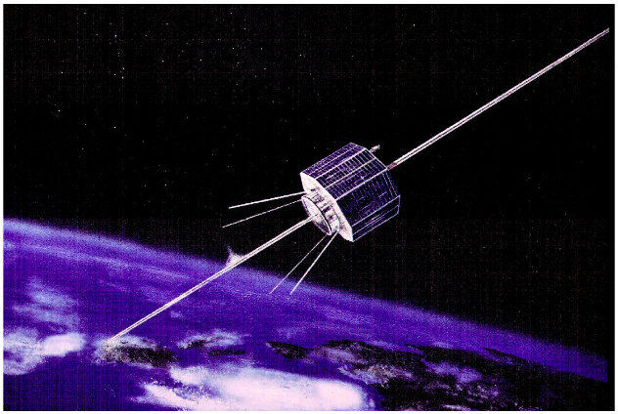

AMSAT-OSCAR 7 ([**AO-7**](https://www.amsat.org/two-way-satellites/ao-7/)), the oldest amateur radio satellite still in operation, is nearing a return to full illumination by the sun, which should take place around September 25 and continue until around December 26. AMSAT’s vice president of operations Drew Glasbrenner, KO4MA, says that during this period, AO-7 likely will switch between modes A (2 meters up/10 meters down) and B (70 centimeters up/2 meters down) every 24 hours.

TOP^

He reminded users to use only the minimum necessary power and to avoid “ditting” to find their signals in the passband, which can bounce the entire passband up and down and sometimes even cause the transponder to reset to mode A.

“Try to find yourself with very low power, or on SSB, or best, with full Doppler control,” Glasbrenner said. “If you have to use high power to find yourself, your receive antenna and system probably needs improvement.”

Last May, the nearly 46-year-old AO-7 made possible a contact between Argentina and South Africa — a distance of more than 4,300 miles. Both stations were aiming just 2° or 3° above the horizon. AO-7 only works when it’s receiving direct sunlight and shuts down when in eclipse.

Launched in 1974, AO-7 surprised the amateur satellite community by suddenly coming back to life in 2002 after being dormant for nearly 30 years and periodically re-emerging. AMSAT considers AO-7 “semi-operational.” Theory is that AO-7 initially went dark after several years of operation when a battery shorted, and it returned to operation when the short circuit opened. With no working batteries, AO-7 now only functions when it’s receiving direct sunlight, and it shuts down when in eclipse.

Built by a multinational team under AMSAT’s direction, AO-7 carries a non-inverting Mode A transponder (145.850 – 950 MHz up/29.400 – 500 MHz down) and an inverting Mode B (432.180 – 120 MHz up/145.920 – 980 MHz down) linear transponder. It has beacons on 29.502 and 145.975 MHz, used in conjunction with Mode A and Mode B/C (low-power mode B), respectively. A 435.100 MHz beacon has an intermittent problem, switching between 400 mW and 10 mW.

**####**

***MARS Communications Exercise will Involve Amateur Radio Community***

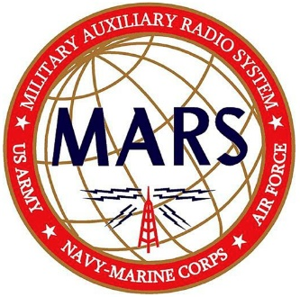Military Auxiliary Radio System (MARS) volunteers will take part in the Department of Defense (DOD) Communications Exercise 20-4, starting on October 3 and concluding on October 26.

The MARS focus is interoperability with ARRL and the amateur radio community. “Throughout the month of October, MARS members will interoperate with various amateur radio organizations that will be conducting their annual simulated emergency tests with state, county, and local emergency management personnel,” said MARS Chief Paul English, WD8DBY.

“MARS members will send a DOD-approved message to the amateur radio organizations recognizing this cooperative interoperability effort.” MARS members will also train with the ARRL National Traffic System (NTS) and Radio Relay International (RRI) to send [ICS 213](http://www.ics213.com/downloads/ics213.pdf) general messages to numerous amateur radio leaders across the US. “This exercise will culminate with MARS Auxiliarists sending a number of summary messages in support of a larger DOD communications exercise taking place October 20 – 26,” English added.

Throughout October, MARS stations will operate on 60 meters, and WWV/WWVH will broadcast messages to the amateur radio community. English assures no disruption to communications throughout the month-long series of training events.

####

TOP^

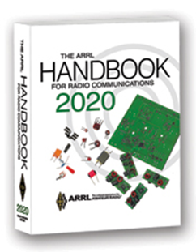***The Handbook Give Away***

Hey Gang,

Have you registered for the “Handbook Giveaway” drawing for this month yet? If you haven’t, you’ve only got a couple of days left to get registered... Hurry up and go to: <http://arrl-ohio.org/handbook.html> and get yourself registered now!

What’s the catch? I want to get everyone checking in to the Ohio Section website as often as possible, and in order to register each month, you have to visit the website often! There’s nothing else to it. I pay all expenses and I usually “Give Away” more than just a Handbook too!!

Many of you ask me just how do I know when the drawing is on? Well, that’s easy all you need to do is check in on the Ohio Section Website on a regular basis and watch for the big [**RED**](http://arrl-ohio.org/handbook.html)Arrow that will appear on the left side of the page. This is the sign that the drawing is on and you need to get registered. So, keep a sharp eye out on the website and check in often!

***Club Corner***

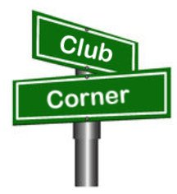

This is YOUR cornner of the newsletter. Send me what your club is doing and I’ll make sure that it gets in. Got a special event or club project that you want everyone to know about? Send it to me!. Need help with a project? Send it to me.

Let me know what you club is up to. Are you going to have a special guest at your meeting or are you having a special anniversary? Just sent it to: [n8sy@n8sy.com](mailto:n8sy@n8sy.com)

####

***Cuyahoga Falls ARC Free Online Technician Licensing Class***

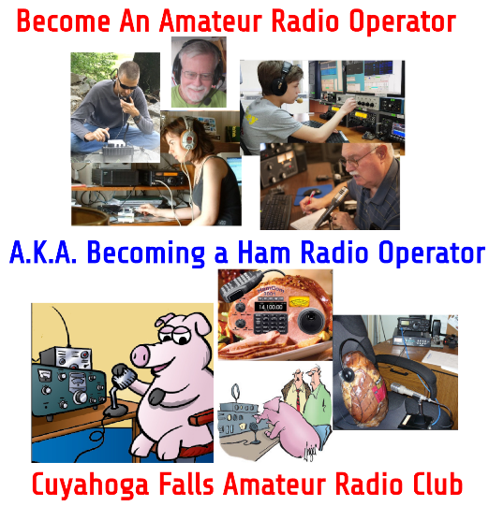

The Cuyahoga Falls ARC will hold a free Online Technician Licensing Class. Prospective hams from around the state or even outside of Ohio are invited to participate. The class will be held using Google Classroom and Meet and will be all online. We will be using the HamRadioSchool.com textbook. The students will need to buy their own copies of the book but there are no other fees. The class will meet on Sunday afternoons, beginning on October 4th, and continuing through Nov 8th. This will be the first of two online courses with a General Class Licensing course beginning in January, 2021.

TOP^

Students must register at <https://cfarc-edu.org/course>. We especially encourage younger candidates that often have trouble traveling to in-person classes. For more information, you can [view this short slideshow](https://docs.google.com/presentation/d/e/2PACX-1vQU9aeMBjS5jeJn_Zz5bpxiFNKOdGkGePYGbXe_hk96aE2iabOZWtFcn4ONEdqMwsdnR6KTUQ4_jWNK/pub?start=false&loop=false&delayms=3000).

If you have questions, please contact Jim Grover- [grizgrover@gmail.com](mailto:grizgrover@gmail.com) or Anthony Luscre- [k8zt@arrl.net](mailto:k8zt@arrl.net)

####

***Fairfield ARES participates in drill***

*(from Diane Warner, KE8HLD)*

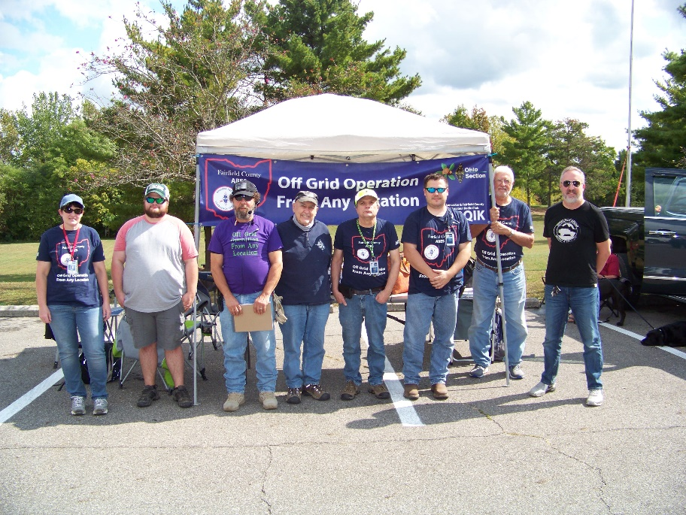The Fairfield County ARES team set up off grid at Alley Park for field training.  Prior to the field exercise, we learned about various aspects of emergency communications.  Afterwards, the scenario given to the team.  The scenario involved two isolated towns with communication damages after a tornado.  The team set off in groups of two using a park map to their designated location.  Upon arrival at their location, they "assessed the damage" (a sealed envelope) and relayed their information through the "county" back to Net Control.  It was a good experience for all as we learned a lot about what we could improve on.

[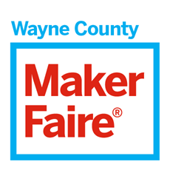](https://waynecounty.makerfaire.com/)

Hello everyone,

The [Maker Faire Wayne County](https://waynecounty.makerfaire.com/) is a **family-friendly showcase of invention, creativity and resourcefulness** and a celebration of the Maker Movement.  It’s a place where people show what they are making and share what they are learning.  Makers range from tech enthusiasts to crafters to homesteaders to scientists to garage tinkerers.  They are of all ages and backgrounds.  The aim of Maker Faire is to **entertain, inform, connect and grow this community.**

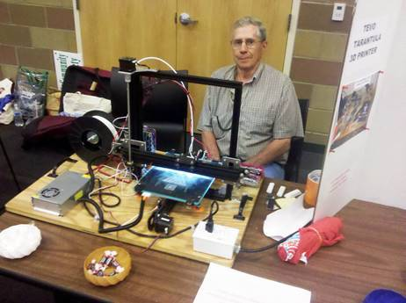

The Daily Record said it best: “Dubbed the ‘Greatest Show and Tell on Earth’; over **1,200 people** flocked to the third annual faire at the University of Akron Wayne College the summer before last.  It was a fresh experience with **favorite makers from previous years** along with new makers and new things to see and do.

TOP^

[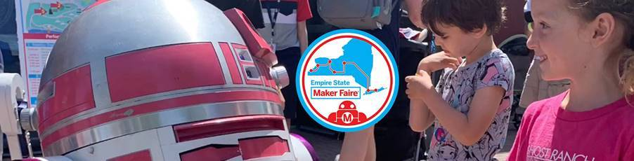**Empire State Maker Faire 2020 is coming!**](https://makerfaire.com/empire-maker-faire-2020/)  Offered virtually this October 16th & 17th, regional faires throughout New York state have banded together to create a **virtual interactive experience!**  Empire State Maker Faire will share the creative work and technical know-how of all kinds of makers who share a passion for making.  The event features **demonstrations, performances and how-to workshops,** and an online project showcase.

Empire State Maker Faire is **free and open to the public.**This is a “virtual” maker faire, meaning you can attend and participate from your computer, **right at home!**  Makers from around the world are encouraged to apply.

We are **proud to showcase Ohio makers** who participated in Maker Faire Wayne County.  One of these people is **Natalie Wardega of** [**RePlay for Kids**](http://www.replayforkids.org/)**.** RePlay has been training volunteers to adapt toys since 1999.  Its mission is to increase the availability of adapted toys and assistive devices for children with disabilities.  RePlay for Kids repairs, adapts, and distributes toys and assistive devices free of charge.  In doing so, they strive to raise awareness and increase the number and variety of toys and devices available to the children who need them.  Last year, they gave away over 1,500 toys to children and agencies.

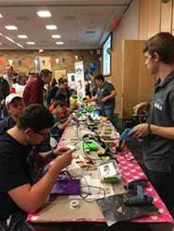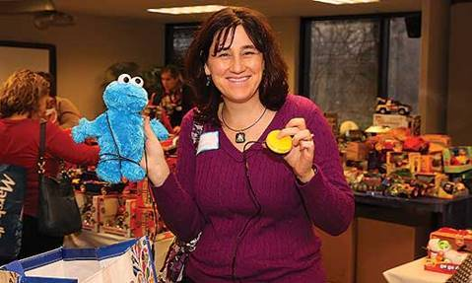

At Maker Faire Wayne County, [RePlay for Kids](http://www.replayforkids.org/) taught volunteers to **adapt toys for kids with disabilities.**  Volunteers learned how to solder a wire in parallel with the original switch so that a child can activate the toy teaching them “cause and effect”.  Their booth at the faire was a hit!  There was a **continual stream of children and adults** learning how to adapt toys hands on with instruction.  We are so glad Replay for Kids supports the Maker community.

TOP^

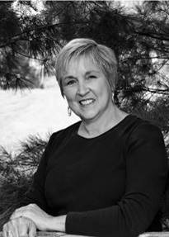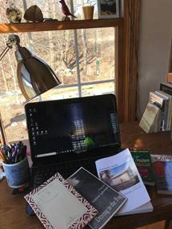Another person who participated in Maker Faire Wayne County is **Joanne Lehman.**  Many people dream of **becoming a published author.**  This is not an unrealistic goal if you're willing to dedicate time and energy towards your dream.  As an experienced author who has published books of poetry, fiction, and nonfiction, Joanne gave advice and guidance at Maker Faire Wayne County to would-be authors.  Attendees learned about the steps that will take them from that first creative impulse, to developing a manuscript, to finding a publisher (or self-publishing), and finally, to marketing a book to its potential audience.

Joanne Lehman **teaches English Composition and Literature courses** at University of Akron Wayne College.  She holds a B.A. in Communication Arts from Malone University and an MFA in Creative Writing from Ashland University.

She has published three books of poetry, most recently FOUNTAIN NOOK published by The Orchard Street Press, ltd.  Her poetry chapbook MORNING SONG won the 2004 Wick Poetry Prize from Kent State University.  In addition to poetry, Joanne has **published a novel** and a book of creative nonfiction . She is currently working on a novel targeted to the Inspirational Fiction/Women's Fiction market.  During her five decades as a writer, Joanne has published numerous articles and poems in local newspapers, religious periodicals, and literary magazines.  Joanne and her husband Ralph are lifelong residents of Wayne County.

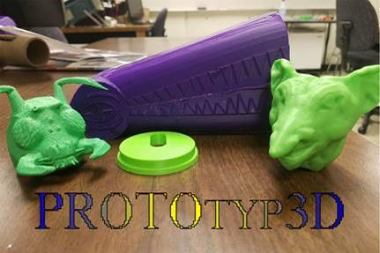

Rounding out our participating makers is **Josh Baker.**  Josh is a **civil engineering student** at the University of Akron.  He loves buildings and hopes to design them one day.  In the meantime, Josh fell in-love with 3D modeling.  He loves everything about the design process.  Josh has four years of modeling experience, mostly in SolidWorks, but also in AutoCAD and various sculpting programs.

Josh has done a lot recreations for people and quite a few original projects as well. At the Maker Faire last year, he promoted **ProtoTyp3D,** a 3D design and printing service.  Josh showed faire attendees how to draw 3D models whether they are originals or recreations.  At Josh’s table, people **learned about the design process** and checked out some of his past projects.

If you would like to know more about RePlay for Kids, Joanne’s authoring and publishing advice, or Josh’s 3D printed creations, please reply to this email!

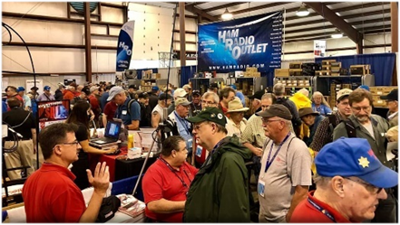

[***Upcoming Hamfests***](http://arrl-ohio.org/hamfests.html) ***for 2020***

**10/10/2020 - Northwest Ohio Amateur Radio Club (NWOARC) Fall Hamfest  
 *Canceled***

TOP^

**10/10/2020 - Northwest Ohio Amateur Radio Club (NWOARC) Fall Hamfest*****Canceled***

**11/01/2020 - 60th Massillon Hamfest**Location: Massillon, OH  
Sponsor: Massillon Amateur Radio Club  
Website: <http://w8np.org/hamfest.htm>

***New Location…***

The new location is: The MAPS (Military Air Preservation Society) large Hangar at 5383 Massillon Road, Green, OH (route 241).

***Masks are required!***

***Temperatures will be taken on everyone entering the facility***

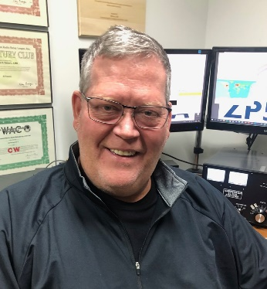***DX This Week***

*(from Bill, AJ8B)*

***DX This Week – TA1BM & FoxMikeHotel***

***Bill AJ8B (aj8b@arrl.net, @AJ8B, or www.aj8b.com)***

***CWOPs Member #1567***

This past week really supplied some interesting DX. There were many entities spotted in the Midwest including Alaska, Andorra, Anguilla, Argentina, Australia, Austria, Balearic Islands, Brazil, Bulgaria, Canary Islands, Ceuta & Melilla, Chile, Cuba, Ecuador, England, Fed. Rep. of Germany, France, Ghana, Gibraltar, Greece, Guatemala, Hawaii, Isle of Man, Italy, Japan, Kenya, Liechtenstein, Madeira Islands, Mexico, Montenegro, Netherlands, Northern Ireland, Norway, Panama, Poland, San Marino, Sicily, Spain, Switzerland, Trinidad & Tobago, and Ukraine. Let me know what you worked.

QSL cards received included E6ET, Alex from Niue Island and S79LD, Mike from Mahe Island in the Seychelles. Let me know if you received any.

|  |  |
| --- | --- |
|  |  |

***DAH DIT DIT DIT DAH DAH DIT DIT DIT DAH***

TOP^

This week I have two tidbits for you to munch on while tuning the bands. The first is an interview with TA1BM, Ismail. Ismail is a world class operator and I hope you enjoy the interview. Thanks to the SWODXA for permission to reprint here.

The second is a new contest created by Frank, K4MFH. This article first appeared in the National Contest Journal. I contacted Frank and Scott, K9MD, and received permission to reprint it here. The purpose of this contest is “The Fox Mike Hotel *Portable Operations Challenge* is designed to optimize equal operating conditions for portable operating during a contest involving non-portable stations.”

***DAH DIT DIT DIT DAH DAH DIT DIT DIT DAH***

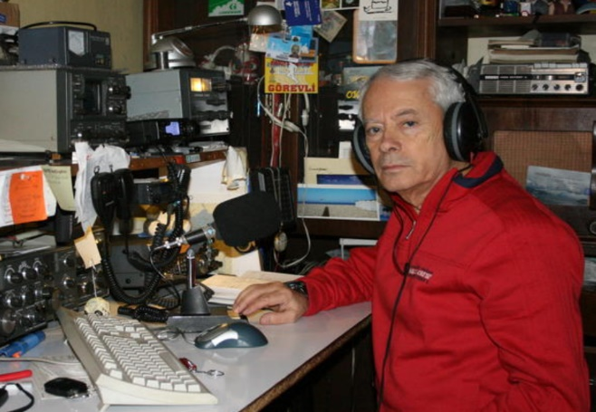**Interview with TA1BM—Ismail**

*Ismail was the first TA station I finally confirmed on RTTY. I checked out his QRZ.com webpage and found a large collection of awards and plaques. He is also an accomplished ham, experimenting with all modes and bands. Check out his page! Ismail can be reached at ta1bm@hotmail.com.*

**AJ8B:** How did you first get interested in amateur radio?

**TA1BM:** I was following the monthly magazine of TRAC Turkish Radio Amateur Club which was established in 1963 and I made simple transceivers.

**AJ8B:** When did you get on the air?

**TA1BM:** In 1984, our country allowed us to test 10M. I tried it with Kenwood TS830s.

**AJ8B:** Do you have a favorite band or mode?

**TA1BM:** Favorite mode RTTY, PSK, SSTV all digital modes.

**AJ8B:** In reviewing your QRZ.com page, I see that you have been very successful with chasing countries and with contests. Any secrets to your success?

**TA1BM:** The secret to success is to be the fastest.

**AJ8B:** You are an extremely accomplished contester. Any tips that you can share?

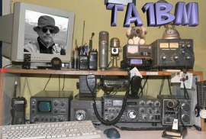**TA1BM:** Compete with yourself and take it seriously.

**AJ8B:** What license levels do you have in Turkey?

**TA1BM:** Class A

**AJ8B:** Describe what you are currently using:

**TA1BM:** My station is simple Kenwood TS830S, TS2000, HM Yagi antennas and Delta loop 100 watts.

**AJ8B:** What advice do you have for those of us trying to break pileups to work DX?

**TA1BM:** Study the DX and be patient.

TOP^

**AJ8B:** What coaching/advice would you give new amateurs?

**TA1BM:** For my new radio amateurs my advice is to practice listening. There is much to read about radio amateurs.

**AJ8B:** Thanks for taking the time to answer my questions. Is there anything you would like to share with us?

**TA1BM:** I am very fond of radio amateur.

Thank you very much for your attention Bill

***DAH DIT DIT DIT DAH DAH DIT DIT DIT DAH***

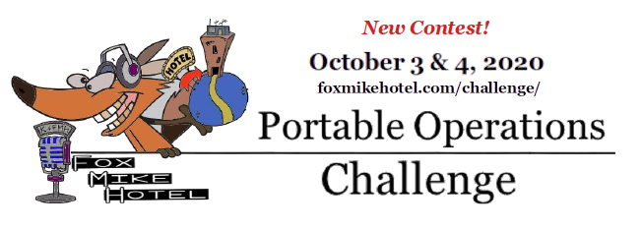

The Fox Mike Hotel *Portable Operations Challenge* is designed to optimize equal operating conditions for portable operating during a contest involving non-portable stations. The scoring allows and encourages regular home-based station operations (“QTHers”) to take part while offering a handicap-style scoring algorithm to be more equalized for portable stations. The approach is akin to the handicap index in the sport of golf.

More difficult courses are scored with a higher slope value, indicating a greater challenge to achieve a normal par score of 72 on that course with a *handicap* of subtracting strokes for golfers who do not typically shoot as low a score as other golfers. A number of factors go into deriving the slope rating for a golf course, but they represent the challenge that the course presents to each participant golfer and the golfer’s capability for playing the course.

Similarly, a number of factors go into the challenge to make contacts in an amateur radio contest. These include RF power, mode of transmission, how far away a potential contact is and whether the operator is in a location away from the optimized shack at a ham’s usual QTH. The conveniences at a conventional home station are almost always more productive than a portable operation for scoring points in an amateur radio contest. Additional power output, gain with directional beams, multiple radios and operators, are but a few of these accouterments of the QTHer that, for the most part, are not enjoyed by the portable operator.

**POC DATES**

First weekend in October, which is **October 3rd & 4th this year, 2020**. Contest operation time – 8-hour contiguous window within the 48-hours – chosen by the contestant to suit the appropriate region in the world where the entrant resides. The organizers wish the contestants to consider all dangers in the time window that they chose (e.g. putting up or taking down a portable station in the dark is not recommended).

TOP^

Operation outside of this 8-hour window contacting other POC competing stations is not allowed and will be controlled through log checking – this is to avoid entrants “cherry picking” of the best 8 hours from their log should the contestant operate a longer period than 8 hours in the POC. Contestants must also work within any local regulations, such as those to control the COVID-19 pandemic.

**Examples:**

A single operator portable station in Germany may decide to operate from 0800 UTC on Saturday 3 October until 1600 UTC on the same day. In eastern Australia however, another single operator portable station may choose to operate from 2300 UTC on the 3 October until 0700 on the 4 October.

In this example both stations are operating from 10am for 8 hours local time (and hence operating while it is daylight). The German station has decided to operate on (local) Saturday, the Australian on (local) Sunday.

*The****POC****aims to make portable operations “on par” with more typical QTH-based operations while preserving the enjoyment of being in a new operating environment. Moreover, QTH-based operators can also easily participate in the action, challenging the handicapped-scoring for portable ops. Can the Super Station contester best the Little Pistol portable operation? If we use a scoring metric that reduces the advantages of QTH-bound stations to that of pure radio sport operating, is there a chance that an efficient portable operator or team can come out ahead of the current winning contest station operators? That’s why this is called the****Portable Operations Challenge!***

*Frank K4FMH*

***DAH DIT DIT DIT DAH DAH DIT DIT DIT DAH***

***CQDX CQDX CQDX CQDX CQDX CQDX CQDX CQDX CQDX***

Here is an update from Bernie, W3UR, of the DailyDX and the WeeklyDX, the best source for DX information. <http://www>.dailydx.com/. Bernie has this to report:

**YI – Iraq -** After operating last week as YI/IU5HWS, Giorgio, has now received an official callsign YI9WS thanks to the support of the Iraq Amateur Radio Society members YI1WL, YI3WHR and YI1SA. The YI9WS callsign is issued by Iraqi’s National Communications and Media Commission (CMC). In order to operate legally from Iraq one must have approval from both the National Communications and Media Commission (CMC) and the Iraqi Amateur Radio Society (IARS). If you worked YI/IU5HWS last week it would behoove you to work him again with this new callsign.

**HC – Ecuador -** EA5RM, Toni Gonzalez, tells us “The HCDX Group will be active as HD1X from a remaining tropical rainforest from Chocó ecoregion (Grid FI09iv), promoting the biodiversity of their country, Ecuador. The special callsign HD1X will be active from October 31 (17h00 UTC) to November 3 (17h00 UTC) in HF bands including WARC, working modes: Phone, SSTV, Digimodes (FT4 and FT8). VHF & UHF will be activated on FM and SSB ham Satellites. QSL via EC5R.”

**PJ2 – Curacao -** PJ2C is the call for ops PJ2AFM, PJ2CF and PJ2SM in their special event operation October 10 to commemorate the administrative change of the Netherlands Antilles islands, Curacao and St. Maarten, on October 10, 2010, when they became “constituent countries of the Kingdom of the Netherlands.”  QSL PJ2C via EC5AHA.  The ops say the change “marked a new start for the islands, one that put the well-being of the islands’ people first.”  Here is the direct QSL address:

TOP^

Toni Canto - C/ La Serrella 21 – 5 - CP:46012 – Valencia - SPAIN

**HB0 – Liechtenstein -** ON4ANN says he is heading to HB0 for a week, September 26 to October 3.

***DAH DIT DIT DIT DAH DAH DIT DIT DIT DAH***

**Solar Cycle 25 Has Begun!**

Last week SpaceWeather.com announced “Solar Cycle 25 is officially underway. NASA and NOAA made the announcement during a media teleconference earlier today. According to an international panel of experts, sunspot counts hit rock bottom in Dec. 2019, and have been slowly increasing since. What can you expect in the months ahead? Visit [Spaceweather.com](http://r20.rs6.net/tn.jsp?f=001XT08V9y0J95E0Fi4hsseXl94Kiq4NfOL91LLVtXwILXMWbczAFbi9Q3SCsacsnACX_yBPOym60imxPCKoPzKifuzK7jZs3rJHFhzVsXMEs0PXqWbwLJp3kLenHUydC0Rdep4tY7CUM0p7M0RyKisBST9WpaVIZeaOqSFRmtnE3Rr0EiSe6AUB_QMAUo5OxavMQ21hbDDIz09yvZ7PmovFMbkxh4LT1RDkn3wNXYZOBWLvPDW8JJZz2rknradisFPOkMrf_KhAiRDWzim7Y_m0A==&c=2tHv1ivbM0s_T3HZRGHEGb1alRB4tMKWwBDYRzidNaAFYDXysVA4FQ==&ch=BUT-_JjB1OX1UNgL8O_09UhP8OHGl8YDZdho8RU90SRXJ9_zqNOv9Q==) for answers.

***DAH DIT DIT DIT DAH DAH DIT DIT DIT DAH***

As promised last week, you will find a list of upcoming contests in the “Contest Corner”. I think this is important for someone who is trying to move up the DXCC ladder since entities that are on the rarer side and easiest to work in contests. Some of my best “catches” have been on the Sunday afternoon of a contest when the rarer entities are begging for QSOs. Of course, the gamble is that if you wait until Sunday, conditions may change or they simply won’t be workable. However, it is not a bad gamble. Of course, why not work the contest and have some fun!

The contests in red are those that I plan to spend some significant participation time on. PLEASE let me know if you are working contests and how you fared.

Thanks!

|  |  |  |
| --- | --- | --- |
| Sept. 26-27 | CQWW RTTY DX Contest | [www.cqwwrtty.com](http://www.cqwwrtty.com) |
|  | Maine QSO Party | [www.ws1sm.com/MEQP.html](http://www.ws1sm.com/MEQP.html) |
|  | Nancy Kott-Fists Memorial KNOWCW | <http://fistsna.org/operating.html> |
| Sept. 28 | RSGB FT4 Contest Series | <http://bit.ly/38xg9V7> |
| Sept. 30 | UKEICC 80m Contests CW | <http://bit>.ly/2MbaURB |
| October 2020 | | |
| Oct. 1 | SARL 80m QSO Party | <http://bit.ly/H0IqQf> |
| Oct. 3 | German Telegraphy Contest | <http://bit.ly/291wozN> |
| Oct. 3-4 | YLRL DX/NA YL Anniversary Contest | <https://ylrl.org/wp/dx-na-yl-contest> |
|  | California QSO Party | [www.cqp.org/Rules.html](http://www.cqp.org/Rules.html) |
|  | Oceania Phone DX Contest | [www.oceaniadxcontest.com](http://www.oceaniadxcontest.com) |
|  | Russian WW Digital Contest | <http://bit.ly/2MF8xoC> |
|  | SKCC QSO Party | <http://bit.ly/2Xl2vyx> |
|  | TRC DX Contest | <https://trcdx.org/rules-trc-dx> |
| Oct. 4 | Peanut Power QRP Sprint | [www.nogaqrp.org](http://www.nogaqrp.org) |
| Oct. 4 | RSGB DX Contest | <https://bit.ly/3iWoeZQ> |

TOP^

|  |  |  |
| --- | --- | --- |
| Oct. 5 | RSGB Autumn Series CW | <https://bit.ly/2XF8mSB> |
| Oct. 7 | UKEICC 80m Contest SSB | <http://bit.ly/2MbaURB> |
| Oct. 9-11 | Nevada QSO Party | <http://nvqso.com/contest-rules> |
| Oct. 10 | 10-10 Intl. 10-10 Day Sprint | <http://bit.ly/1FrFeBc> |
|  | FISTS Fall Unlimited Sprint | [www.fistsna.org/operating.html#sprints](http://www.fistsna.org/operating.html#sprints) |
|  | QRP ARCI Fall QSO Party | [www.qrparci.org/contests](http://www.qrparci.org/contests) |
| Oct. 10-11 | Arizona QSO Party | [www.azqsoparty.org](http://www.azqsoparty.org) |

***DX News***

***ARLD039 DX news***

This week's bulletin was made possible with information provided by W5AJ, The Daily DX, the OPDX Bulletin, 425 DX News, DXNL, Contest Corral from QST and the ARRL Contest Calendar and WA7BNM web sites. Thanks to all.

**TUNISIA, 3V.** Ash, KF5EYY will be QRV as 3V8SS from Sousse in the CQ World Wide DX RTTY contest as a Single Op/All Band/Low Power entry.

QSL via LX1NO.

**GEORGIA, 4L.** Vaho, 4L8A will be QRV from Tbilisi in the CQ World Wide DX RTTY contest as a Single Op/Single Band entry. QSL via M0OXO.

**BARBADOS, 8P.** Dean, 8P6SH plans to be QRV as 8P2K in the CQ World Wide DX RTTY contest. QSL via LoTW.

**CANARY ISLANDS, EA8.** Station EA8AQV will be QRV in the CQ World Wide DX RTTY contest as a Single Op/All Band/Low Power entry. QSL to home call.

**ETHIOPIA, ET.** Members of the ET3AA club plan to be QRV in the CQ World Wide DX RTTY contest. QSL direct.

**PERU, OA.** Special event station OA2TP20 is QRV until September 27 in celebration of Spring in Trujillo. Activity is on 40, 30, and 20 meters using SSB and FT8. QSL via operators' instructions.

**ALAND ISLANDS, OH0.**  Gaby, DF9TM and Frank, DL2SWW are QRV as OH0/DF9TM and OH0/DL2SWW, respectively, until September 26. Activity is on the HF bands. QSL direct to home calls.

**MARKET REEF, OJ0.** Henri, OH3JR is QRV as OJ0JR until September 26. Activity is in his free time on 160 to 10 meters using CW, SSB, and FT8. QSL to home call.

**DENMARK, OZ.** Volker, DJ8VW is QRV as 5P8VW from Romo Island, IOTA EU-125, until September 28. Activity is on 160 to 6 meters, including the newer bands, using CW, SSB, and FT8. QSL direct to home call.

TOP^

**ARUBA, P4.**  Robert, W5AJ is QRV as P42WW until September 30 to commemorate the 75th anniversary of the end of World War II. Activity is on the HF bands using CW and RTTY. He will be active as P40P in the CQ Worldwide DX RTTY Contest as a Single Op/All Band entry. QSL P42WW via P41G and P40P direct to W5AJ.

**AFGHANISTAN, T6.** Robert, S53R will be QRV as T6A in the CQ World Wide DX RTTY contest as a Single Op/All Band entry. QSL to home call.

**ASIATIC RUSSIA, UA0.** Andrey, R1FW is QRV as R1FW/0 until September 30 from Sakhalin, IOTA AS-018, Iturup, IOTA AS-025, and Kunashir, IOTA AS-025. Activity is on 40, 30, and 20 meters using CW and SSB. QSL to home call.

**INDONESIA, YB.** Members of the ORARI Lokal Kulon Progo are QRV as 8I69K from Wates, Jogjakarta, Java Island, IOTA OC-021, to celebrate the 69th anniversary of Kulon Progo. Activity is on various HF and VHF bands. The length of their activity is unknown. QSL direct to 8I69K.

**CAYMAN ISLANDS, ZF.** Bill, W9KKN will be QRV as ZF1A in the CQ World Wide DX RTTY contest as a Single Op/All Band entry. QSL via K6AM.

THIS WEEKEND ON THE RADIO. The CQ Worldwide DX RTTY Contest, NCCC RTTY Sprint, NCCC Sprint, Maine QSO Party and AGCW VHF/UHF Contest are all on tap for this upcoming weekend.

The RSGB FT4 Contest Series, K1USN Slow Speed Test and QCX CW Challenge are scheduled for September 28.

The 222 MHz Fall Sprint, Worldwide Sideband Activity Contest and RTTYOPS Weeksprint are scheduled for September 29.

The UKEICC 80-Meter CW Contest, Phone Fray and CWops Mini-CWT Test are scheduled for September 30.

**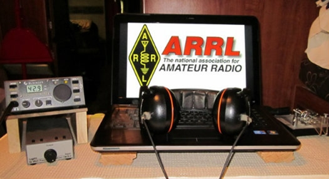*ARRL Contest Corner***

An expanded, downloadable version of *QST'*s’[**Contest Corral**](http://www.arrl.org/contest-calendar) is available as a PDF. Check the sponsor's’Web site for information on operating time restrictions and other instructions.

***Special Events***

* **10/02/2020 | Anniversary of the dedication of Mission Dolores, San Francisco, 1776**

**Oct 2-Oct 12, 0000Z-2359Z, N6D**, Healdsburg, CA. Will Pattullo, AE6YB. 14.265 7.265. QSL. Will Pattullo, 161 Presidential Circle, Healdsburg, CA 95448. Special Event commemorating the dedication anniversary of Mission Dolores, San Francisco, California, October 9, 1776. <https://www.qrz.com/db/AE6YB>

TOP^

* **10/02/2020 | Lester Dent - Doc Savage Special Event**

**Oct 2-Oct 3, 1500Z-2300Z, W0D**, Macon, MO. Macon County Amateur Radio Club. 14.270 7.200 3.950. Certificate. Macon County ARC, P.O. Box 13, Macon, MO 63552. The Macon County Amateur Radio Club will operate the Lester Dent-Doc Savage Mystery Special Event W0D, in Macon, MO. The purpose of the Special Event is to honor of the accomplishments of Lester Dent, one of the most prolific writers of Pulp Fiction, world class adventurer, pilot, creator of the Dent Master Fiction Plot Formula and an Amateur Radio Operator. The Special Event also commemorates the 87th "Birthday" of Doc Savage the first modern superhero, Lester Dent's creation. A colorful certificate will be provided to those that contact the Special Event Station and send a QSL including a # 10 SASE to the Macon County Amateur Radio Club, PO Box 13, Macon, MO 63552. dbagley@cvalley.net or [https://www.maconcountymissouriarc.org](https://www.maconcountymissouriarc.org/)

* **10/03/2020 | California QSO Party - Trinity County**

**Oct 3-Oct 4, 1600Z-2200Z, K6KS**, Lewiston, CA. Northern California Contest Club. 14.220; 80 40 20 15 meters SSB. QSL. Steve Mosconi, PO Box 990331, Redding, CA 96099. I will be active from Trinity County, California, for the 55th Running of the California QSO Party. I will be active on 80, 40, 20 and 15 meter SSB. [www.qrz.com/db/k6ks](http://www.qrz.com/db/k6ks)

* **10/03/2020 | New England Wireless & Steam Museum Yankee Steam-Up**

**Oct 3, 1300Z-2000Z, N1EPJ**, East Greenwich, RI. Massie Wireless Club. 3.558 14.058 7.25 14.258. QSL. Massie Wireless Club N1EPJ, P.O. Box 883, East Greenwich, RI 02818. The Massie Wireless Club will activate call sign N1EPJ to commemorate Steam-Up Day, an annual event for over 50 years. For QSL, send a SASE to: Massie Wireless Club N1EPJ, P.O. Box 883, East Greenwich, RI 02818. Suggested CW frequencies: 3.558, 7.058, and 14.058. Suggested SSB frequencies: 3.825, 7.25, and 14.258. Operating from morning to late afternoon (13:00 - 20:00 UTC). Check the museum website (http://www.newsm.org) and QRZ page for updated details [NEWSM.ORG](http://newsm.org/)

* **10/04/2020 | Nation Fire Prevention Week Special Event**

**Oct 4-Oct 10, 0001Z-2359Z, N3F**, Dickson City, PA. KB3WLE. 14.250 7.245. Certificate & QSL. KD2CUO, c/o Siemens Fire Safety USA, 8 Fernwood Road, Florham Park, NJ 07932. [hamfire.com](http://hamfire.com/)

* **10/08/2020 | Anniversary of Towamencin Encampment**

**Oct 8-Oct 16, 0400Z-2359Z, W3T**, Harleysville, PA. WV2M. 14.074 14.030 7.074 7.030; modes are SSB, CW and FT8. Primary Mode will be FT8. QSL. Frank Gallo, 106 Tweed Way, Harleysville, PA 19438. [www.w3t.info](http://www.w3t.info/)

* **10/10/2020 | Arizona QSO Party**

**Oct 10-Oct 11, 1500Z-0500Z, W7A**, Tucson, AZ. Radio Society of Tucson. 14.248 14.048 7.189 3.848. Certificate. Bill, Clark, 222 N Suntan Dr, Vail, AZ 85641. [https://www.azqsoparty.org](https://www.azqsoparty.org/)

* **10/10/2020 | Eisenhower Birthday Special Event**

**Oct 10-Oct 18, 0000Z-2359Z, W5I/W5K/W5E**, Sherman, TX. Grayson County ARC. 14.250 7.250 14.040 7.040. QSL. Grayson County ARC, PO Box 642, Sherman, TX 75091. Help us celebrate the birthday of Dwight D. Eisenhower, the 34th president of the United States by contacting each of the call signs we'll be using...W5I, W5K & W5E. Contact all 3 and you'll spell IKE. IKE was born on October 14,1890 in Denison, Texas. Please visit qrz.com/db/w5i for additional information about Ike and QSL information. [https://graysoncountyarc.org](https://graysoncountyarc.org/)

TOP^

* **10/10/2020 | Third Annual Get Your Parks ON!**

**Oct 10-Oct 18, 0000Z-2359Z, Various**, Various. World Wide Flora and Fauna. 14.244 14.044 10.124 7.044. Certificate. N9MM, 4245 Holstein Dr., Cleveland, TX 77328. In celebration of Earth Science Week. The event is open to Amateur Radio operators around the world and is sponsored by the U.S. affiliate of World Wide Flora and Fauna. Since October 1998, the American Geosciences Institute has organized Earth Science Week, a national and international event to help the public gain a better understanding and appreciation of the Earth sciences and to encourage stewardship of the Earth, common goals shared by the Amateur Radio program World Wide Flora and Fauna. Both programs encourage their participants to get outside and enjoy nature. During this International and on-the-air celebration hams throughout the world can participate in one of two ways. First, hams can be Activators who will set up and operate their radio stations in geological and nature centers, be they places like National or State Parks, National Monuments, protected nature habitats, or National or State Forests, or they can be Hunters that will operate from their home stations, search out the Activators, and make over-the-air radio contacts. Get Your Park ON! will start October 10 at 0000 UTC and run through October 18 at 2359 UTC. Operators from around the world are encouraged to participate in this year’s International event. Adjunct to the Get Your Park ON! on the air activities, Earth Science Week 2020 [www.wwff.us](http://www.wwff.us/)

* **10/10/2020 | USS Midway Museum Ship Special Event: Celebrating birthday of US Navy in Oct 1775**

**Oct 10, 1600Z-2300Z, NI6IW**, San Diego, CA. USS Midway (CV-41) Museum Ship. 14.320 7.250 14.070 (PSK31) D-STAR on various reflectors. QSL. USS Midway Museum Ship (COMEDTRA), 910 N Harbor Drive, San Diego, CA 92101.

***ONLINE-ICS-300 INTERMEDIATE ICS FOR EXPANDING EVENTS***

*(Hosted by: Wayne County EMA - November 2 – 5, 2020 (4 partial days)*

**Course Description:** This 21-hour classroom course provides training for personnel who require advanced application of the Incident Command System (ICS) and Individuals who may assume a supervisory role in incidents. This course expands upon information covered in the ICS 100 and ICS 200 courses.

**Application Deadline:** Ten working days prior to the course - Seating availability is limited so register early

**Course Registration time:** 8:00 am – 8:30 am (on day one)

**Course Time:** 8:30 am to 3:30 pm on day one with a one-hour lunch

8:30 am to 1:30 pm – day two, three and four of the courses

**Training Location:** Virtually Online via Microsoft’s MS Teams Software

**Recommended Participants:** FEMA designed this course for individuals who may assume a supervisory role in expanding incidents or Type 3 incidents.

**Note:** During a Type 3 incident, some or all of the Command and General Staff positions may be activated, as well as Division/Group Supervisor and/or Unit Leader level positions. These incidents may extend into multiple operational periods.

TOP^

**Required Prerequisites:** Individuals must complete the IS-100.c Introduction to the Incident Command System, IS-200.c Basic Incident Command System for Initial Response, IS-700.b An Introduction to the National Incident Management System and IS-800.c National Response Framework courses prior to attending the ICS-300 Intermediate course and provide copies of their certificates of completion to the instructors on day one of the course.

**Enrollment:** Students must enroll via the Department of Public Safety Training Campus website: https://trainingcampus.dps.ohio.gov/CourseMill/home.html. Course registration will close 10 working days prior to the course start date and applicants can check enrollment/approval status via the Department of Public Safety Training Campus website.

**Course Costs:** There is no charge for participants to attend this course. However, Lodging, Meals, Per Diem and all other travel expenses are the responsibility of the student or the parent organization.

**State Point of Contact:** Gary Lehman, Planner 3, Ohio EMA, Training Point of Contact, (614) 799-3663 [gdlehman@dps.ohio.gov](mailto:gdlehman@dps.ohio.gov)

**It is the goal of Ohio EMA to ensure that all students have the tools necessary for successful course completion. If students require additional accommodations, they should make the Ohio EMA training office aware, and staff will confidentially meet reasonable requests.**

####

***ONLINE-ICS-400 ADVANCED ICS FOR COMMAND & GENERAL STAFF***

*(Hosted by: Wayne County EMA - November 16 – 18, 2020 (3 partial days)*

**Course Description:** This 15-hour classroom course provides training for personnel who require advanced application of the Incident Command System (ICS). This course expands upon information covered in ICS-100, 200, 700, 800 and ICS-300 courses, which are the prerequisites for the ICS-400 course. The target audience for this course is senior personnel who expect to perform in a management capacity in an Area Command or Multi-Agency Coordination Entity.

**Application Deadline:** Ten working days prior to the course - Seating availability is limited so register early

**Course Registration time:** 8:00 am – 8:30 am (on day one)

**Course Time:** 8:30 am to 1:30 pm all three days of the course

**Training Location:** Virtually Online via Microsoft’s MS Teams Software

**Recommended Participants:** FEMA designed the course for Senior Personnel who expect to perform in a management capacity in an Area Command or Multi-Agency Coordination Entity.

**Required Prerequisites:** Individuals must complete the IS-100.c Introduction to the Incident Command System, IS-200.c Basic Incident Command System for Initial Response, IS-700.b An Introduction to the National Incident Management System and the IS-800.c National Response Framework, an Introduction courses. In addition, ICS-300 Intermediate courses prior to attending the ICS-400 Advanced course and provide copies of their certificates of completion to the instructors on day one of the course.

TOP^

**Enrollment:** Students must enroll via the Department of Public Safety Training Campus website: https://trainingcampus.dps.ohio.gov/CourseMill/home.html. Course registration will close 10 working days prior to the course start date and applicants can check enrollment/approval status via the Department of Public Safety Training Campus website.

**Course Costs:** There is no charge for participants to attend this course. However, Lodging, Meals, Per Diem and all other travel expenses are the responsibility of the student or the parent organization.

**State Point of Contact:** Gary Lehman, Planner 3, Ohio EMA, Training Point of Contact, (614) 799-3663 [gdlehman@dps.ohio.gov](mailto:gdlehman@dps.ohio.gov)

***“ARES Connect”***

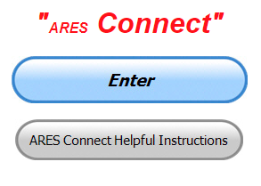

***Connecting Amateur Radio Volunteers with a Purpose***

Hey everyone… please make sure to go in and register your time to all of the events that you have signed up for. Don’t forget to get this done no later than **5 days** after the event has ended. I’m asking you to do this for our ability to run reports accurately.

**I want to remind all of you that you do not have to be an ARES or ARRL member to use this system. All licensed amateur radio operators throughout the country are welcome and strongly encouraged to use it.**

**Don’t forget to check out the “Frequently Asked Questions” area that has been added to the Ohio Section website.** It’s there to help you through any difficulties that you may have with ARES Connect. Now, if you don’t any posts that relate to what you are having difficulties with, we now also have an on-line “Guru” area as well. This will allow you to ask any questions that you may have about ARES Connect.

**Let’s get everyone in the Ohio Section on “ARES Connect!!!” Simply go to:** <https://arrl.volunteerhub.com/lp/oh/> and get yourself registered and using the system.

***Here’s the top 10 hour earners so far in September:***

|  |  |  |  |
| --- | --- | --- | --- |
|  | **Name** | **Events** | **Hours** |
| **1** | Dwight Bonifield (W8TJT) | 154 | 226.00 |
| **2** | Leo Dubois, Jr. (KE8OOS) | 149 | 152.33 |
| **3** | James Yoder (W8ERW) | 17 | 102.90 |
| **4** | Dan Stahl (KC8PBU) | 66 | 100.00 |
| **5** | Alan Rothweiler (N8CJ) | 28 | 98.50 |
| **6** | Greg Dersarkisian (KD8SSJ) | 16 | 85.50 |
| **7** | Christopher Domenick (KC8CAD) | 27 | 84.15 |
| **8** | Bret Stemen (KD8SCL) | 28 | 82.00 |
| **9** | Diane Warner (KE8HLD) | 19 | 60.00 |
| **10** | Ron Wilch (KE8PX) | 87 | 47.50 |

TOP^

***One Question Questionnaire***

Hey Gang,

“Survey Says”….. Yes - 57.14% of you’ve changed the batteries in your smoke and CO detectors. There were 33.77% of you that stated that you haven’t. I hope you will soon, and 9.09% that don’t have a carbon monoxide detector!! We definitely need to change that last statistic. No one stated that they didn’t have at least a smoke detector. That’s really good to hear!

Ok, now since this upcoming weekend is the Simulated Emergency Test (S.E.T.) that is what the next question is about.

***“Will you be participating in the annual S.E.T. this year??”***

You’ll find the “One Question” questionnaire on the Ohio Section Website! <http://arrlohio.org> It’s all in fun and it’s not a scientific survey in any way, but we are learning some things that we didn’t know from these questions. I hope that you are enjoying answering these “One Question” questionnaires.

***V.E. Test Sessions***

**

Many V.E.’s have decided to start testing once again, but with restrictions that need to be adhered to for sure. Here’s the link to find that V.E. Test session and what is expected of YOU before going. <http://www.arrl.org/find-an-amateur-radio-license-exam-session>

***Want to take a General class?***

Hi--

I've finally set the date for the online General Class. The class will start on **Monday, October 5, 2020** and consist of eight, two-hour sessions starting at 9 pm EDT (6pm PDT) and running until 11 pm EDT (8pm PDT).

The eight sessions will take place on the following dates:

• Monday, October 5

• Thursday, October 8

• Monday, October 12

• Thursday, October 15

• Monday, October 19

• Thursday, October 22

TOP^

The cost is $25 for adults. High school and college students can attend for free. If you’re a student, all you have to do to register is send an email to [cwgeek@kb6nu.com](mailto:cwgeek@kb6nu.com) stating that you want to take the class. All others can register using PayPal or Amazon Pay here.

I’ll be using my No-Nonsense General-Class License Study Guide (for tests given between July 2019 and June

2023). It’s available as an ebook, paperback book, or audiobook.

|  |  |
| --- | --- |
| |  | | --- | | [**Register for the online General class starting Monday, October 5**](https://click.mlsend.com/link/c/YT0xNTE1MzQ1ODkxOTc0NzE1Mzc1JmM9bTl5MiZlPTc2NTMyOTEyJmI9NDEzNzY5MjIxJmQ9YTNoMGUzeg==.fNUI1SVBhioZj_f-NDOPvoVUDNoLQQ2bmbPT108RKhg) | |

If you have any questions, please contact me.

Dan KB6NU - [cwgeek@kb6nu.com](mailto:cwgeek@kb6nu.com)

***National Weather Service - Wilmington live online spotter training webinar scheduled***

The National Weather Service in Wilmington has scheduled a live online spotter training class for this autumn season on **October 5 - from 6 pm to 8 pm EDT**.

NWS partners and the general public are welcome to attend the live online spotter training class.

Registration is required, and can be completed at:

<https://register.gotowebinar.com/register/4844007736691537676>

**As a reminder, if an individual registers, then becomes unable to attend, the individual is encouraged**

**to cancel, freeing up that spot for another person.**

Feel free to share this with others within your counties or jurisdictions. Within a couple days, we will

also promote this class via social media and on our office webpage.

One note: if a significant severe weather or flood event is forecast for or occurs on October 5, there is

the possibility this webinar would need to be postponed.

Please let me know if you have any questions or comments.

Thanks,

Brandon Peloquin - Warning Coordination Meteorologist - NWS Wilmington, OH

####

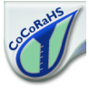***Introduction to CoCoRaHS***

When: Tuesday October 6, 2020 6pm-7pm (online)

Where: "Community Collaborative Rain, Hail, and Snow Network":

TOP^

The National Weather Service relies on volunteer weather observers who take precipitation readings in their own backyard. Many observers are needed because precipitation is highly variable. You can help and anyone can join!

All you need is a rain gauge and internet access.

Details at: <https://www.weather.gov/media/iln/Volunteer/cocorahs.pdf>

***From The South 40***

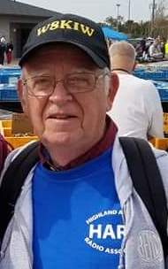*(from John Levo,* [*W8KIW@arrl.net*](mailto:W8KIW@arrl.net)*)*

Welcome again to news of what’s happening from the South 40.

During the recent ARRL Board of Directors meeting the Marietta Amateur Radio Club was recognized for its 100 years being an ARRL Affiliated Club. That is a most impressive achievement. The next time you catch W8HH on the air, be sure to congratulate them.

From across the river, according to correspondent Brent Wells, N4BDW, the Greater Mason County ARA provided communications for the annual Limestone Bicycle Tour on September 12. According to Wells, the club assisted the organizers and kept track of over 600 riders on four different courses leading from Maysville. There was one major incident with a rider going down and receiving major injuries. However, two GMCARA members were the first on the scene to request medical assistance.

Highland ARA President Jeff Collins, KD8VUY, reports the long-awaited linking of the Hillsboro 147.21 repeater with the Club’s Greenfield 146.685 repeater in has been accomplished. Early reports indicate the link is working well. This linking will greatly improve the footprint of each machine. The Hillsboro machine has a 100 pl and Greenfield has a 118.8 one. Jeff invites those who would like to try the system to check into the Club’s Monday evening 9 pm net. Your editor, W8KIW, (with a little help from N8ZNR and W8BCC) will be the October net control.

Ironton’s Southern Ohio ARA has cancelled all club meetings for the remainder of the year according to Information Officer Mike Love. He states even the annual Christmas dinner is now questionable.

Since the start of the health emergency, the Athens County ARA has been holding their monthly meetings by video conferencing. At their September meeting it was decided to delay the annual elections by a month. Therefore, officer nominations will be made at the October meeting with elections at the November one.

The Tri State ARA held its annual Campfire Cookout at the West Virginia Museum of Radio and Technology in Huntington with a good turnout of members and friends. The club will also sponsor a VE test session on October 10 at the Museum. Because of state gathering regulations, pre-registration is required and only one seat remains not spoken for. Pre-registration is at [w8va@qsl.net](mailto:w8va@qsl.net) Masks and social distancing will be required.

TOP^

Word is the Hocking Valley ARC will hold their next Hocking County Fox Hunt on Saturday, October 10. Those wishing to participate need to “register” beginning at 9:45 am. The hunt will start at 10 am. Four teams participated in the September event. More details will be given on the K8LGN repeater and on the club’s website as the date draws nearer.

According to club officers, the Highland ARA’s annual club picnic was well attended with members from as far as Scioto County attending. Hosts Barb and Dave (K8BAZ and KD8TUR) furnished great food to enjoy under the big top tent. It’s reported no one seemed to away hungry.

Many Southern Ohio hams had their eyes to the skies and their ears to the radio this past week during the evening passes of the International Space Station over our part of Ohio. I have yet to hear of any successful contacts to our area. However, I did hear VE4MM on two nights working into 8 land through the new spacecraft repeater as it streaked through the nighttime sky.

During the Ohio State Parks on the Air event, Glouster’s Sunday Creek ARF operated from Burr Oak State Park. Operating in the high-power class, they achieved 391 contacts and 42 unique state parks. The log entry deadline was Saturday, so it will be interesting to see what other Southern Ohio clubs were able to do.

According to Jeff Slattery, N8SUZ, this past Saturday the Athens County ARC held a club DIY project where each participating member was able to build their own cactus folding J-Pole antenna.

In closing, don’t forget to register for the upcoming on-line Storm Spotter Training being conducted by the Wilmington Office of the National Weather Service. It will be Monday, October 5 between 6 and 8. It will be in a Webinar format. Registration is required in order to participate. More information is available at [www.weatherspotter.gov/iln/onlinespotter](http://www.weatherspotter.gov/iln/onlinespotter)

This is an outstanding opportunity to learn about the program and how to participate.

***Time for SET: BLACK SWAN 20 Is Here***

*(C. Matthew Curtin, KD8TTE)*

The pioneering emergency communication exercise BLACK SWAN begins at 8 p.m. Ohio time on Tuesday, September 29. We’ve been training and building capability in the Ohio Section all summer. We tested the concept of message relay during the Red Cross exercise on May 30, and every week since July we’ve been exercising radio message relay in the County Information Report Project 20. We’ve done the building that we’re going to do. Now it’s time to test what we’ve built.

Each of us providing emergency communications services with amateur radio has a role to play, and the SET is how we test that capability, demonstrate it to those who would need to use it, and give experience to those who would need to provide it.

Emergency Coordinators and assistants at the local, district, and section levels: stay in touch with your contacts you support, and those who support you. Take the time this week to understand what everyone is intending for their hours of operation, and how you can help to get resources where they are needed when the scenario starts to fill in the information.

TOP^

Check in with Buckeye Net <https://buckeyenetweb.wordpress.com/> to be sure that you know the operation. Daily NBEMS nets will begin early in the week, and more frequent nets will be running during SET. Make sure you know which nets can help you, and how they can help you. Be sure the local groups have a way to get to those nets. It’s not just EOC to EOC, although that will be happening. It’s not just hospital to hospital, although that will be happening. It’s not just disaster scene to EOC, although that will be happening. All of these lines of communication and others will be exercised, and performance will be measured.

Whatever you do, remember to enjoy yourself. This is a no-fault learning environment. The system is being tested, not you. Every one of us will make mistakes. Every one of us will do things right. We will honestly assess our performance, and use it as the basis to establish our training priorities and schedule for the coming year.

I’m looking forward to hearing you on the air and working with you to see what we can do, and to show that in times of emergency, Ohio’s corps of amateur radio stations are there to provide communication when all else fails.

I offer the following outline of critical milestones as the exercise gets underway.

|  |  |  |
| --- | --- | --- |
| ***Critical Milestones (All Times Local Ohio Time, 24-hour clock)*** | | |
| *Date* | *Time* | *Synopsis* |
| Tue Sep 29 | 2000 | Start of BLACK SWAN exercise play.  Agency messaging will begin. Bulletins sent to agency players will start moving through amateur radio.  Pay attention to bulletins to build up situational awareness.  Authorization for amateur/government station interoperability on 60m (Ch 4) for BLACK SWAN begins. |
| Wed Sep 30 |  | Emergency Coordinators and Net Managers should know their intended hours of operation. |
| Thu Oct 1 |  | Emergency Coordinators and Net Managers should advise one another, as well as DECs, and volunteers, of intended hours of operation. By this time, you should be communicating daily. Regular communications still work at this point, so be sure you’re using them. Email regularly, daily, use the phone, make sure you know who is there and what they’ll be doing so when the problems arise, you’ll know whom to contact, and how to contact them when radio is the only option. Hint: it’s more than your local county, and it’s more than your local net. You might need to release a message to someone to relay it and solicit an answer. |

TOP^

|  |  |  |
| --- | --- | --- |
| Fri Oct 2 | 1200- | Groups registered with BLACK SWAN controllers will get activation calls with information:   1. Number of operations in-county, 2. Size of operations in-county (how many radio operators needed), 3. Hours of requested operation (based on information provided during registration), 4. Types of operation (e.g., hospital, incident command post, or emergency operations center) to simulate, 5. Address of location (will be a video conference rather than physical location), 6. Contact information for the agency contact played by the exercise controller. |
| Fri Oct 2 | 1200- | Activated groups:   1. Organize their schedules to have requested stations covered, rotation of operators, etc., 2. Organize their operations to include net support of deployed stations, 3. Organize liaison between county and district, or county to section where no district net available. 4. Advise DEC of intended operation, including excess or requested resources. |
| Fri Oct 2 | 1600- | DECs, advise SEC:   1. Intended operations in your district, 2. Unfulfilled resource requests in your district, 3. Resources available to lend from your district, 4. Plan of message relay between counties in-district and section.   NMs, advise STM:   1. Intended operations on your net, and 2. Outlets you provide (agencies or other nets for message relay). |
| Sat Oct 3 | 0000 | Start of SET: any activity starting now for the next 48 hours can be counted for SET operation points.   1. ARES operations may begin according to local plans in support of requests from agencies or according to local scenario. 2. Net operations may begin according to needs of served agencies, ARES groups providing operators to agencies, or for the public according to local scenario. |
| Sat Oct 3 |  | Local, district, and section operations in accordance with exercise scenario. |

TOP^

|  |  |  |
| --- | --- | --- |
| Sun Oct 4 |  | Local, district, and section operations in accordance with exercise scenario. |
| Sun Oct 4 | 2359 | End of SET; no activity past this point will count for SET operation points if you are following the Ohio Section schedule and started at midnight Saturday. |
| Mon 5 Oct |  | ECs, start compiling your statistics. Use Form A! NMs, start compiling your statistics. Use Form B! |

***Final.. Final..***

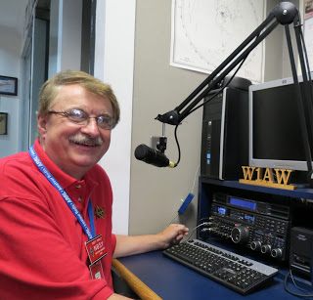Hi Gang,

The weather this past week has really been great for getting out and doing yard work and getting things ready for winter. It seems like just yesterday that Janie and I were planting seeds in the garden and removing the leaves and old mulch to get ready for spring!

This past week just flew by for me. I was busy with Zoom club meetings and even several in-person meetings. I also got to help out on another V.E. test session this week. We did this one outdoors in a park, we had a pavilion all to ourselves and the weather was great, sunny but not too warm. It worked out for everyone and we did get a new ham out of it as well.

I did a couple of presentations and participated in our county’s annual Mitigation planning meeting too. I was extra busy with ARES Connect this past week, helping several Sections get some of their volunteers loaded into the system and teaching some of the newer S.E.C.’s on how to get their folks vetted and run some basic reports.

We are growing in the numbers of folks entered into the system as well as the number of Sections now using ARES Connect as their exclusive reporting system.

Have you looked at the breakdown per county on the website yet? We have a “per county” dashboard of the hours recorded in ARES Connect for each county. We also list those District only events as well as the hours recorded for Section wide functions. These are the hours of actual volunteers and not anonymous hours. Want to see how many hours your county has gotten so far? Go to… <http://arrl-ohio.org/SEC/reports.html>

This page is updated regularly, so you can see what’s happening in real time in your county. Don’t see hours recorded in your county? That’s because you haven’t done **your part** and gotten your time recorded.

TOP^

Whelp, my final go around before gong QRT… I’m really hoping that we call can get back to those great “in-person” meetings very soon. Enjoy this fantastic weather while we still have a chance. Remember these times when it’s 20 below zero and the wind and snow are howling outside your window!!

Stay safe my friends! I want to see all of you soon at a meeting or hamfest! We will get through this and when we do, we’ll have so much to talk about. Most of all… have FUN and get on the airwaves!!

73,

[***Scott, N8SY***](mailto:n8sy@n8sy.com)

***Website Stats***

|  |  |
| --- | --- |
| **Summary** |  |
| |  |  |  |  |  |  | | --- | --- | --- | --- | --- | --- | | **Reported period** | Year 2020 | | | | | | **First visit** | 01 Jan 2020 - 00:02 | | | | | | **Last visit** | 25 Sep 2020 - 06:06 | | | | | |  | Unique visitors | Number of visits | Pages | Hits | Bandwidth | | Viewed traffic * | **<= 32,963** Exact value not available in 'Year' view | **66,075** (2 visits/visitor) | **2,862,032** (43.31 Pages/Visit) | **7,661,749** (115.95 Hits/Visit) | **208.80 GB** (3313.58 KB/Visit) | | |

***Swap & Shop Has Added Club Raffles To Its Listings On The Webpage***

Hey Gang,

Have you taken a look at the **Swap & Shop** page on the Ohio Section webpage yet?? Here’s a link that will take you there…

<http://arrl-ohio.org/sm/s-s.html>

Do you have equipment that you just don’t need or want anymore? Here’s a great venue to advertise it, and it’s FREE!!

Is your club doing a fund raiser to help raise money? After a lot of thought, it was decided that the Swap & Shop webpage could also contain these types of items as well.

The same rules will apply as do for the For Sales and Give-A-Ways and will only be posted for a month at a time. Please see the Terms & Conditions on the webpage.

TOP^

If your club is doing a fund raiser and wants more exposure, please forward the information to me and I’ll advertise it on the Swap & Shop webpage for you. Now, I still want to remind you that it won’t be listed in this newsletter because it would take up way too much space, so your ad will only appear on the website. It is there for any individual to post equipment Wanted / For Sale or Give-Away as well as for Club Fund Raisers. No licensed vehicles/trailers or business advertising will be posted.

Postings are text only (no pictures or graphics) will be posted for a maximum of 1 month from date posting and require a contact phone number or email within the posting. Send your Wanted / For Sale or Give-Away post to:  [swap@arrlohio.org](mailto:swap@arrlohio.org)

***Want to Share your Club Newsletter With Others?***



We have a webpage where you can download and read all of the newsletters that I get from around the state and even other sections!

Here’s the link to the page…. <http://arrl-ohio.org/club_news/index.html>

Please, if you don’t see your club newsletter posted, it’s because I’m not receiving it. Just have your newsletter editor contact me and I’ll get your club’s newsletter listed on the site!!

We all learn and steal (I mean, share) from each other’s work. So, get me your newsletter!!! Send it to: [n8sy@n8sy.com](mailto:n8sy@n8sy.com)

***Back Issues of the PostScript and Ohio Section Journal***



Hey, did you know that PostScript and Ohio Section Journal (OSJ) are archived on the website? You can go back and look at any edition simply by clicking:

<http://arrl-ohio.org/news/index.html>

***Welcome New Subscriber(s)***

**Marty, WA8YBV; Lee, N2LC; Jon, N8MXX; Sean, KI6OOF**

Ohio Section Cabinet

|  |  |
| --- | --- |
| Section Manager – Scott Yonally, N8SY | Assistant Section Manager – John Perone, W8RXX |
| Section Emergency Coordinator – Stan Broadway, N8BHL | Section Traffic Manager – David Maynard, WA3EZN |
| Technical Coordinator – Jeff Kopcak, K8JTK | Affiliated Clubs Coordinator – Tom Sly, WB8LCD |
| State Government Liaison – Bob Winston, W2THU | Public Information Coordinator – John Ross, KD8IDJ |
| Section Youth Coordinator – Anthony Lascre, K8ZT | |

TOP^

***Chit – Chat, and All That!***

Do you know someone that’s not getting these Newsletters? Please, forward a copy of this Newsletter over to them and have them “[Opt-In](mailto:Opt-In)” to start receiving them. Heck just have them send me an email [n8sy@n8sy.com](mailto:n8sy@n8sy.com) and I’ll get them added to the Ohio Section Emailing list.

We now have many thousands of readers receiving these newsletters weekly. Quite impressive, I’d say! I urge all of you to make sure that everyone, regardless of whether they are a League member or not, get signed up to receive these weekly Newsletters.

You can always “Opt-Out” at any time if you feel this is not what you were expecting. It’s fun and very informative. All of your favorite past newsletters are now archived too.

You can go back at any time and read them. Just go to: <http://arrl-ohio.org/news/>

Got questions, concerns or would just like to sit and chat awhile? Heck, I’ll even buy the coffee!! Give me a call at (419) 512-4445 or email me at: [n8sy@n8sy.com](mailto:n8sy@n8sy.com)

The pictures on the front page and throughout this newsletter are from various newsletters, Facebook posts and/or were sent directly to me in recent weeks. Take a good look at them, you just might be in one of the pictures! “SMILE… you’re in the Ohio Section News!!”

***You’ve reached the end.***

***It’s time to turn the lights out on this edition!!***

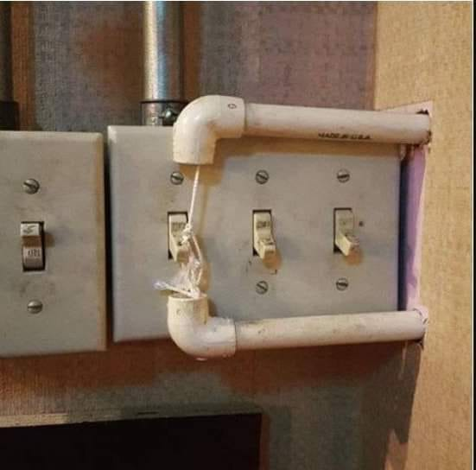

TOP^

*The Ohio Section Journal (OSJ) is produced as a comprehensive look at all the programs within the Ohio Section. I sincerely hope that you have enjoyed this edition of the* *OSJ and will encourage your friends to join with you in receiving the latest news and information about the Ohio Section, and from around the world!*