***[](http://arrl-ohio.org) Halloween***

***Edition***

|  |  |
| --- | --- |
| 🡪 From the Technical Coordinator | **🡪** From the Section Emergency Coordinator |
| 🡪 From the Affiliated Club Coordinator | **🡪** From the Public Information Coordinator |
| 🡪 From the Section Youth Coordinator | **🡪** From the Section Traffic Manager |
| 🡪 ARES Training Update | **🡪** National News |
| **🡪** The Handbook Give Away | 🡪 Club Corner |
| 🡪 Hamfests | 🡪 DX This Week |
| 🡪 ARES Connect | 🡪 One Question Questionnaire |
| **🡪** VE Testing | 🡪 From The South 40 |
| 🡪 Final.. Final.. | |

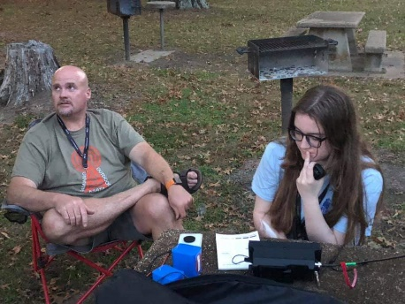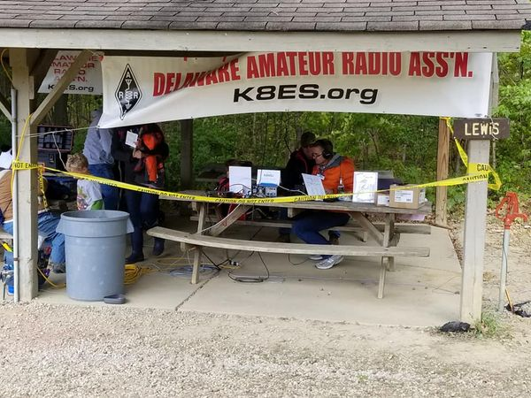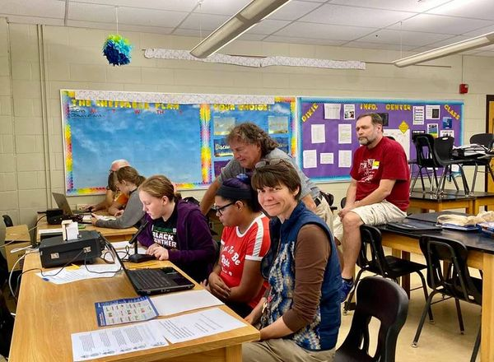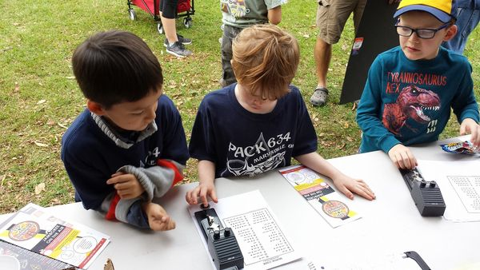

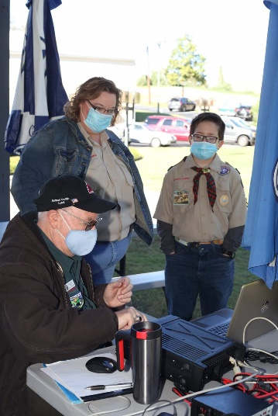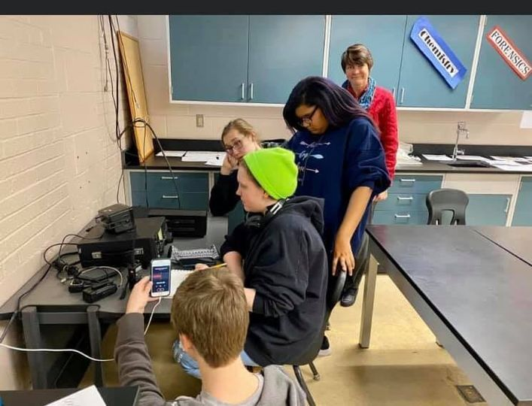

***From the Technical Coordinator***

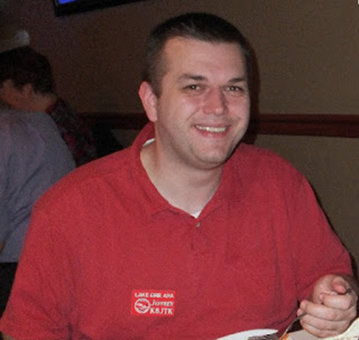***Jeff Kopcak – K8JTK TC***

[k8jtk@arrl.net](mailto:k8jtk@arrl.net)

Hey gang,

October is associated with a number of things: apple cider, fall weather, foliage displays, pumpkins, and Halloween costumes. One thing that might be gruesome, like some Halloween costumes, is most people’s cyber hygiene. Cyber hygiene relates to practices and precautions users take to keep their data safe and secure from outside attacks. October, in addition to the above, is Cybersecurity Awareness Month. It is a way to raise awareness about the importance of cybersecurity and give everyone resources to be more secure online.

First up, web browser. This is the portal and gateway to modern computing. A browser should be current, supported, and one that is updated. Current web browsers are ones like [Chrome](https://www.google.com/chrome/), [Firefox](https://www.mozilla.org/en-US/firefox/), [Microsoft Edge](https://www.microsoft.com/en-us/edge), and [Opera](https://www.opera.com/). These are constantly being updated to support newer technologies, protect users, and eliminate known vulnerabilities. Don’t use a camera, microphone, or other accessories during browsing interactions? Disable access to them in the browser’s options. I’m not sure the last time I used a MIDI interface. Disabling it hasn’t affected my browsing in Chrome.

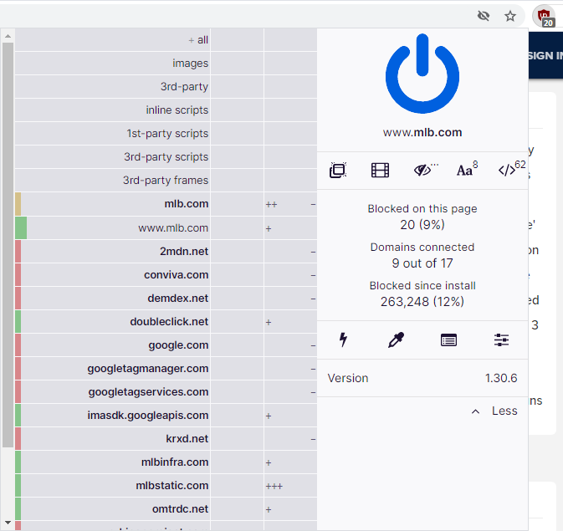

uBlock Origin on mlb.com

Browser extensions (or plugins): Limit the number of installed extensions and make sure they are also current and being updated. The one extension I have on every browser I use, including at work, is [uBlock Origin](https://ublockorigin.com/). It is an excellent ad-blocker and does it very effectively. Additional features include ability to block other sources of vulnerabilities, such as scripts, large media items, like videos, and known bad domains. A lot of people love [NoScript](https://noscript.net/). It’s even better, security-wise, than uBlock Origin. However, like everything in security, there are tradeoffs. NoScript does what it says, block scrips like JavaScript because they are a major source of security problems. This is great in principle but it basically breaks every site on the Internet. Whitelisting necessary scripts to make a trusted site work, I think, is more effort than it’s worth. Choose the better option for you. For me, it’s uBlock.

TOP^

Another good browser extension is [HTTPS Everywhere](https://www.eff.org/https-everywhere). When a site is loaded over an unsecure connection, this extension upgrades it to a secure connection is one is available. Most severs configured by capable admins are now serving up HTTPS by default and redirecting HTTP connections to HTTPS. Finally, [PrivacyBadger](https://privacybadger.org/) is good at blocking third-party tracking and [browser fingerprinting](https://panopticlick.eff.org/). Browser fingerprinting is the ability for a site to interrogate the browser about the system it is running on. For example, which browser, is it accepting cookies, plugins installed, time zone, screen size and color depth, system fonts, language, OS and platform, touch device, and device memory. PrivacyBadger blocks sites from accessing many of these properties.

Bad sites: [In August](http://www.k8jtk.org/2020/08/30/ohio-section-journal-the-technical-coordinator-august-2020-edition/), I talked about the [Pi-Hole](https://pi-hole.net/) security device. This device provides similar blocking to uBlock Origin but at the *network level*. Any browser plugins only add protection to sessions in that browser. It doesn’t block tracking, malware, or ads in other applications running on the PC. It doesn’t offer protection for any other device on the network such as phones, tablets, streaming, surveillance, and “smart” devices. That is where Pi-Hole comes in by blocking known bad domains at the network level. It will keep ads off smart TVs, Roku’s, and keep digital footprints to a minimum. A caveat, devices using hardcoded DNS servers (usually IoT, [DNS over HTTPS](https://en.wikipedia.org/wiki/DNS_over_HTTPS)) will bypass any Pi-Hole filtering. Routers that can perform NAT Redirection can re-route requests to Pi-Hole and block DOH.

If you don’t want to add a device like Pi-Hole, changing DNS servers in a home router will offer more protection. I recommend [OpenDNS](https://www.opendns.com/home-internet-security/) as a security focused DNS service. OpenDNS is free to use and enabled by simply setting Primary DNS and Secondary DNS to these IPs: **208.67.222.222** & **208.67.220.220** – does not matter which goes into primary/secondary. They do offer paid services which can categorically block sites and does require a little more setup. Another good DNS filtering service is “[Quad 9](https://www.quad9.net/)” or **9.9.9.9** as the DNS server. These services block access to known infected sites made through DNS requests.

Password managers: sites do a relatively poor job of securing their user and password databases. On the other hand, users do a poor job of choosing strong passwords. We know this because of sites like [Have I Been Pwned](https://haveibeenpwned.com/) (pronounced “owned”) which search stolen password databases for associated Email addresses. Showing as ‘pwned’ on that site indicates the Email address was found in a database breach. Searching an old Email address of mine found two services I did not recognize. I suspect the data changed hands through company acquisition but, more likely, my information was sold to the highest bidder.

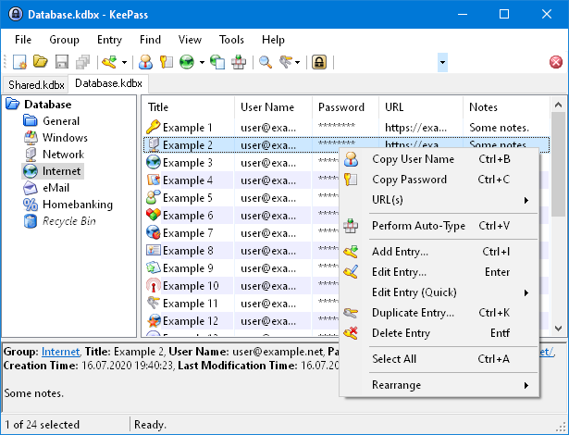

KeePass main window (keepass.info)

Lists are published of the [most commonly used passwords](https://github.com/danielmiessler/SecLists/blob/master/Passwords/Common-Credentials/10-million-password-list-top-1000.txt) from these breaches. Many are even easy to guess like 123456, password, qwerty, dragon, baseball, monkey, and letmein. A password manager will generate strong passwords and remember them so you don’t have to. In general, if you can remember passwords for services, you’re doing it wrong. It’s good to know the password for logging on to the computer and the password for your password manager. That’s about it anymore. Being able to remember passwords means they’re probably easy to guess.

TOP^

*55@[hg@owtWF(6eDOXR0* – is not be an easy to guess password, has lots of [entropy](https://en.wikipedia.org/wiki/Entropy_(computing)), and would take around *1.15 thousand trillion trillion centuries* [to guess](https://www.grc.com/haystack.htm) using one thousand guesses per second.

[LastPass](https://www.lastpass.com/) & [KeePass](https://keepass.info/) will do the job of creating strong passwords and remembering (saving) them. Both of these password managers are considered best-of-breed because of their features, history of responding to issues quickly, and constantly squashing bugs. Other password managers do not have this reputation and most don’t offer adequate protection from attacks. LastPass is an online service. They have a free option but useful features will be found in the $3/month for single user and $4/mo. for families. If you don’t trust “the cloud” or want to manage your own password database(s) offline, KeePass is what you want.

Both have the ability to generate, store passwords, and save notes associated with an account. Largely they’re both available on multiple platforms in multiple browsers. LastPass apps tightly integrate many device types with their service. KeePass relies largely on the community to implement addons and create apps for platforms like Android. LastPass has nice features allowing sharing among family members or sharing banking credentials with a spouse. Another feature I like in LastPass is the ‘dark web’ monitoring and alerting for breached credentials. These alerts let you know it’s time to change that password. To retrieve stored usernames and passwords from a password manager, they’re copied and pasted from the app or automatically filled into a webpage using a browser extension.

Both services require some sort of master password which **MUST** be remembered. LastPass gets its name from the password used to access their service as the ‘last password’ you’ll ever need. An easy way to generate such as password would be to find a famous speech, song, or lines from a movie. Take the first letter of each word, throw in some numbers, and voila! Strong master password. This method will create a password that is hard to crack but easy for you to remember. As an example, take the first line of the Gettysburg Address:

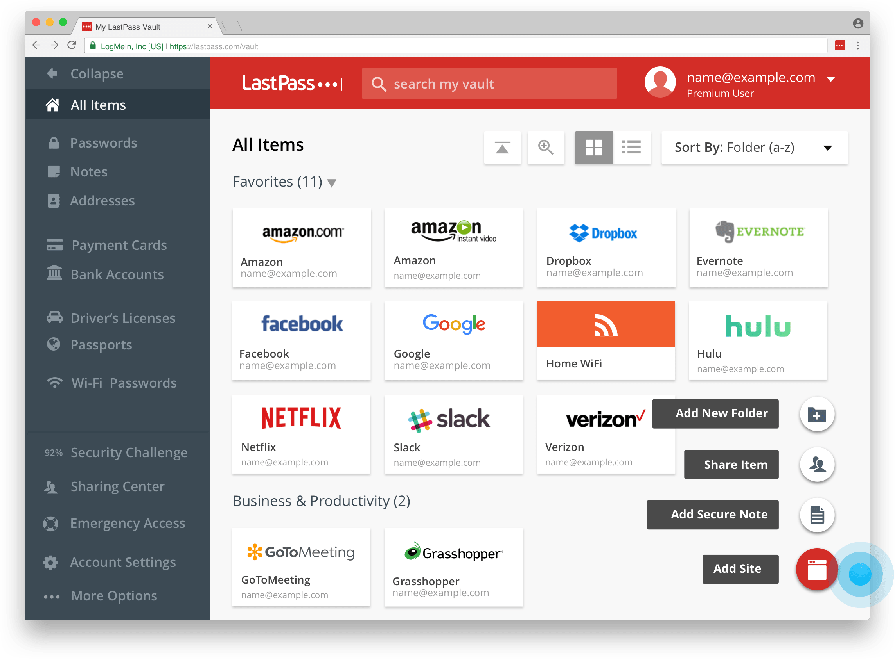

LastPass interface (lastpass.com)

*Four score and seven years ago our fathers brought forth upon this continent, a new nation, conceived in liberty, and dedicated to the proposition that all men are created equal.*

Taking the first character of each word:

*Fsasyaofbfutc* – even to the first comma is 14 characters and already on its way to being very strong. Get creative, maybe take the second or third letter of every word. Throw in some random capitalization. Then add maybe parts of an old phone number, an old address, old work address, old dorm room number, kids ages, etc. Then it becomes: *FsasyaOfbfuTC219419216* – all of a sudden you have a password that takes *8.75 hundred trillion trillion centuries* to guess. Sure, you’ll want to write down this password until its memorized. Destroy the written copy after it’s definitely committed to memory.

TOP^

All this assumes there is no monitoring of the computer or device, no key logging, no intercepting communications, no monitoring the clipboard, etc. The strongest password does no good if it’s used on a compromised machine or used over an unsecure communication channel such as HTTP, FTP, or Telnet – which all use plain-text passwords.

Should there be a situation where you can’t create a completely random password in a password manager or want to use a password that can be more easily remembered in certain situations (not your master password, that would be bad practice), use the [xkpasswd generator](https://xkpasswd.net/s/). Inspired by [an XKCD comic](https://xkcd.com/936/), it uses a method of random numbers and common words to create memorable passwords. The example they give: *correcthorsebatterystaple* – correct, horse, battery, staple.

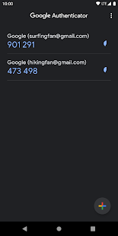

Google Authenticator (play.google.com)

Last practice I’ll mention this time around is use multifactor authentication. This is also commonly referred to as 2-factor authentication (2fa) or MFA. MFA uses more than one authentication method to validate identity. Usually consisting of something you know, a password, and something you have – a phone app or hardware token. This approach is an additional layer of authentication with the hope that miscreants don’t have access to one or more of those authentication methods. Good multifactor auth changes or rotates every time it’s used or changes after a set amount of time. Modern multifactor technology has been around for more than 15 years. Many companies are rapidly adopting it for all employees because they see value and it has proven to be a good way of keeping miscreants out of their systems. More and more services are adding [two factor authentication](https://twofactorauth.org/).

Multi-factor works by going to site-I-login-to[dot]com. Enter your username and password. Usually after clicking log on, you are presented with a multi-factor prompt. Consisting of a pin that rotates frequently, clicking ‘approve’ in a mobile app, hitting a button on a hardware token, or being sent a unique code via SMS text or Email to enter into the site. A lot of services use SMS text messages and Emails. Those two **should not** be the primary multi-factor validation. SMS messages can be intercepted by miscreants who could have hijacked or cloned the SIM card from the carrier. If they have your password and hijacked SIM card, they might as well be you. Email is readily accessible to organizations hosting the mail server and often transmitted on the wire in the clear – though progress is being made to encrypt email messages in transit.

I like [TOTP](https://en.wikipedia.org/wiki/Time-based_One-time_Password_algorithm) (time-based one-time password) solutions such as Google Authenticator on a phone or tablet. The password manager database is on the computer or in the cloud. The app lives on the phone, separate from the database. TOTP is an open standard, supported in nearly all services that offer multi-factor auth, doesn’t need a data connection, and isn’t stored anywhere except in a protected database on the phone. These passwords change every 30 seconds and are 6 digits long. In the case where a phone might get lost, there are “recovery” tokens that are generated at the time TOTP is configured. Where should the recovery tokens should be stored? They can be printed and stored in safe, or use your new password manager to secure them!

TOP^

It’s a couple years old, but Krebs on Security’s [Scrap Value of a Hacked PC](https://krebsonsecurity.com/2012/10/the-scrap-value-of-a-hacked-pc-revisited/) takes a look at all the things miscreants could do with information learned from a compromised machine. Things like hostage attacks through [ransomware](https://en.wikipedia.org/wiki/Ransomware) (encrypt files and demand payment to decrypt) and reputation hijacking of the social medias or credit scores. Brian’s site is also entertaining reading for taking a peek into the ‘dark web’ on things criminals do with stolen data and credit cards. Other useful security tools are [Security Planner](https://securityplanner.consumerreports.org/) which walks you through creating a customized security plan based on interests and goals. [PrivacyTools](https://www.privacytools.io/) provides tools and knowledge for protection against mass surveillance.

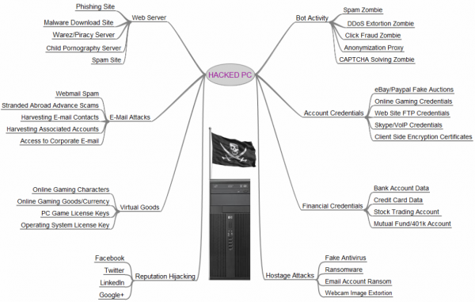

Scrap Value of a Hacked PC (krebsonsecurity.com)

These steps and suggestions from known good resources will greatly improve your cyber hygrine for Cybersecurity Awareness month.

**Thanks for reading and 73… de Jeff – K8JTK**

***From the Section Emergency Coordinator***

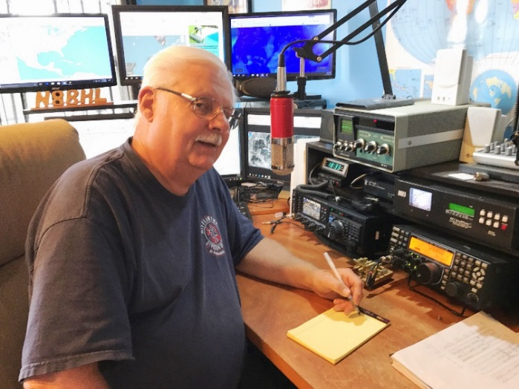***Stan Broadway, N8BHL - SEC***

[broadways@standi.com](mailto:broadways@standi.com)

The Ohio SET – Win or Lose?

On this writing we’re only days past the Ohio Simulated Emergency Test (SET) so I don’t have a great deal of solid numbers yet.

***Before it started***

Major applause is due Matt Curtin, KD8TTE, who spent literally months creating a major exercise that affected not only amateur radio but several major agencies as well. In fact, the Director of FEMA was briefed on the event, and congratulatory messages from the government’s IPAWS (Integrated Public Alert and Warning System… or, “Lookout here come the nukes!”) organization were received. Matt’s approach was to play us as we would when a real emergency blossomed – keeping everyone including me in the dark, except to know that we were to activate for the weekend. Here’s a view of those who registered:

|  |  |
| --- | --- |
| * Sponsor: 4th Civil Support and Sustainment Brigade (OHMR) | * Guernsey County ARES |
| * Participants: | * Hamilton County ARES |

TOP^

|  |  |
| --- | --- |
| * FEMA Integrated Public Alert and Warning System (IPAWS) R&D | * Jefferson County Ohio ARES |
| * DHS SHARES | * Lake County ARES |
| * US Coast Guard Auxiliary | * Licking Co. ARES |
| * 121st Air Refueling Wing (Ohio Air National Guard) | * Lorain County ARES |
| * 179th Airlift Wing (Ohio Air National Guard) | * Mahoning County ARES |
| * Ohio Emergency Management Agency AUXCOM | * Marietta Memorial Hospital AUXCOM |
| * National Traffic System (NTS), Ohio Section, American Radio Relay League (ARRL) | * Medina County ARES |
| * Amateur Radio Emergency Service (ARES), Ohio Section, ARRL | * Montgomery County ARES |
| * Affiliates of Radio Relay International | * Noble County ARC |
| * Brian F. Griffin, MD, DAAPM | * Northwest Ohio ARES Traffic Net |
| * Buckeye Net | * Ohio Digital Emergency Net |
| * Central Ohio Poison Center | * Ohio Single Sideband Net |
| * Central Ohio Traffic Net | * Preble County ARES |
| * Clinton County ARES | * REACT International |
| * Columbiana County Ohio EMA AUXCOM | * Salvation Army SATERN West Mi. N Indiana |
| * Coshocton County ARES | * Seneca County ARES |
| * Cuyahoga County ARES | * Tri-County Traffic Training Net |
| * Delaware County ARES | * Warren County Amateur Radio Emergency Service |
| * Eastern Ohio Amateur Wireless Association (Belmont County) | * Washington County ARES |
| * Fairfield County ARES | * Wayne County ARES |
| * Franklin County Ohio Amateur Radio Emergency Service | * Wood County West Virginia ARES |
| * Franklin County Emergency Management & Homeland Security AUXCOM | * Wyandot Area Ham Operators Organization |
| * Greene County ARES | |

**That’s a pretty good array of emergency communicators! My sincere thanks to all, registered or not!**

***The goal***

We had one thing in mind this year: getting back to basics and that involves sending messages. Being able to handle formal traffic has not been an emphasis of ARES, somehow, we figured we would just be able to walk into a situation and slay the giant. Well, it doesn’t work that way and it was way past time to study up and get to the next level of performance. In addition, we wanted to practice ‘real world’ alerting and activation. We could not deploy, of course, so Matt worked up a series of video conferences in Google Meet which would put the ham operator in ‘face to face’ communication with the agency person.

TOP^

***The scenario***

There were at least three major medical scenarios spread across the state, and message traffic was being conducted from the scenes to hospitals and medical advisors elsewhere. In order to create the situation and be there for ham operators, a group of leading physicians developed the scenarios, and took hours to create the video meets involved.

***The play***

Some went exceedingly well. Some were more on the dismal side. A lot of that had to do with counties that either weren’t alerted or weren’t brought into play. That happened to about three counties. Others were busy, a few were not. It was spotty. There were some delays in handling the traffic. On the good side, a lot of messages did get passed, and in particular Buckeye Net, and it’s stellar design to join the flexibility of voice net checkins with digital net movement of traffic, shone beyond expectations. Steve Judd, WB8YLO, spent four years designing the system and this first field test worked very well. “Going the extra mile” kudos go to District 10 EC Mat Nickoson, KC8NZJ, who worked into the wee hours Saturday night to create specific additional injects for the Northeast Ohio gang.

***The result***

We know where we stand. We’ve set a baseline of capability and we now are very solid with what training we need to pursue for the rest of the year and beyond. All participants are to be congratulated on something very important- *very* important during times of stress and deployment- and that is the good nature and professional attitude everyone displayed.

We’ll have more detailed reports as we wade through the traffic that was gathered. We want to look at delivery times, accuracy, and possible bottlenecks. We want to look at ways we can redesign the system to make this work better in real life. So there’s more to come. In the meantime, my thanks and thanks again for all who invested their time and energy to make it happen.

**\*\* You can view all of the SEC’s monthly reports on the website..** <http://arrl-ohio.org/SEC/default.html>

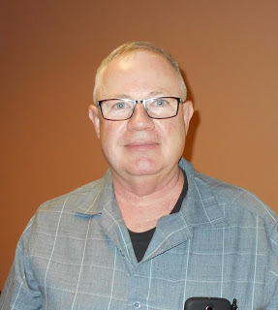***From the Affiliated Club Coordinator***

***Tom Sly, WB8LCD - ACC***

[tomsly29@gmail.com](mailto:tomsly29@gmail.com)

ACC October 2020

First off – I made an error in last month’s column. I talked about going to the DX Dinner at the Dayton Hamvention and mentioned that it was sponsored by INDEXA. INDEXA does not put on the DX dinner. That is South West Ohio DX Association (SWODXA) who permits INDEXA to have their program collocated after the dinner. My error. From their website: “**SWODXA sponsors the annual DX Dinner held on the Friday evening of Hamvention weekend in Dayton, Ohio.**

TOP^

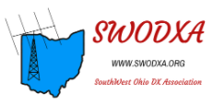**In addition, SWODXA members moderate the Hamvention® DX Forum. SWODXA is also the creator and proud sponsor of the DXPedition® of the Year Award.”** My apologies to both SWODXA and INDEXA for my confusion. I’ve mentioned many times in this column, and other places, that it’s OK, and even preferable, to belong to more than one club. If you have an interest in working and/or being DX, *both* of these clubs would be worthwhile belonging to!

Most people join a club because they want to surround themselves with people who share the same interests. They want to surround themselves with the activities and the knowledge that will help them improve their own experience with whatever hobby they have interest in. Clubs play an important role in helping their members improve their experience with the subject of the club.

When looking for an Amateur Radio club to participate in, the newcomer will quickly discover that some clubs are better than others at welcoming new members in. Some clubs are more socially oriented versus others that are more radio activity and / or educationally oriented. Even others specialize in community or emergency services. There are lots of choices. And here’s the point: you don’t have to join the closest club, and nothing says you can’t belong to multiple clubs. Most areas in the OH Section have more than one club to choose from, and now, with “virtual” experiences becoming more common, you don’t even need to be in the area to belong and participate in some clubs.

As a young, or new Ham, you look at clubs from a “selfish” point of view as in “how will belonging to this club help me become a better Ham?” At some point in your participation with the hobby there needs to be a realization that for Ham Radio to continue to exist YOU need to become an active participant in helping others to become proficient as a Ham. Doing that through service to your club is one of the best ways that you can help others.

So, we talk a lot about clubs, and what they have to offer. But what about the members of the clubs? What about you? What do your offer to your club, and what is your responsibility as a club member? I’m going to talk to you about that, but first I want to tell you a story that illustrates the point I’m trying to make. By the way, in addition to being the OH Section ACC, I am also currently the President of the Portage County Amateur Radio Service (PCARS).

As a club, PCARS will be celebrating our 15-year anniversary in November of this year. We’ve had a pretty good run, a lot of fun, and I truly believe we have helped a whole bunch of hams to enjoy and improve themselves in the hobby. I’ll admit that luck has had a part in it. Very early on, we were blessed to be involved in a real estate deal that has given us a huge benefit. We had a club member who worked for ODOT. He found out that ODOT was going to have their facility in Ravenna, OH bulldozed over, including the communications tower. He came to me (I was also the first president of PCARS) and said that PCARS should buy this property for the club. We were in our first year as a club. We had hardly any assets, a small membership, and there was no way we were going to be able to take on a project like this. But our Vice President at the time, Jim – KC8PD was also on the board of a local charitable organization called Family and Community Services (F&CS). Family & Community Services was looking for a property.

TOP^

The ODOT facility was a good fit for their needs. They ended up getting the property for a “token” and ODOT was able to leave, saving the state hundreds of thousands of dollars not to have to demolish the facility. Two guys (both board members at the time) were looking out for the club.

As a result, PCARS has a “Club House” in space that F&CS makes available to us at very little cost. PCARS members put in hundreds of man-hours to make the building, and specifically the area we occupy, suitable for us to use. And let me tell you, it was a disaster when F&CS took control of the property.

So that brings me up to the present. In the space we have, there was one space that was never rehabbed and just like everything else originally was, it was a disaster. Earlier this year I had suggested that if rehabbed, this space would be perfect for a PCARS office. COVID hit and nothing happened. Nothing until last month. Our current club Past-President Jim – AC8NT, his wife Linda, their son JC – KC3JXQ and their grandson Jax, took it upon themselves to come in last month and make the space a usable office. They bought the materials and provided all the labor. They didn’t have to do that, but they did. And they didn’t do some “crummy, lets get it over with” job. It’s outstanding! It will make a difference for our club and I want to publicly Thank them for their support!

I’ve told you all before that I have always been inspired by quotes from people in the past. I’m reminded of a quote from a famous life insurance salesman, Joe Gandolfo: “Ideas are a dime a dozen….but the man who puts them into practice is priceless”. There are a lot of good people out there, with some very good ideas, but unless you have the motivation and the drive to make them happen, it’s like hopping up and down on one foot (wasted motion).

The worst thing I can think of for a club officer to hear from their membership is the phrase “I’ll do it if no-one else will.” I want to change the conversation to what kind of an attitude do the members of a successful club have, compared to a so-so club, or even a dead club.

When you look at most Amateur Radio clubs, a big part of their budget comes from their annual membership dues. So having members on the roster is a benefit that helps most clubs. But most every club has members that complain, that no matter what the dues are, it’s too expensive. Dues for most (if not all) Amateur Radio clubs are pretty darn inexpensive! If you really *belong* to a club, you might want to pay your dues, on time, with a big smile realizing what a bargain it probably is. And here’s a little secret that most club members have not picked up on: you can deposit *more* than what the club requires!

After joining a club, the next best thing you can do is SHOW UP! Meetings, operating events, activities, weekly nets – whatever. The most demoralizing thing for your club officers is to put a program together and have no-one show up. (Vice-versa true also – if a member committee puts a program together and none of the officers or board members show up.) Take it even further, say your club has a license class running. You aren’t the teacher, or a class member, but you show up! The teacher now has some backup support. The class members are impressed with what a “friendly” club you have. Everyone’s a winner!

I think you get the idea here. We need to be active and involved in the clubs we belong to for them to be successful. Be the guy (or gal) that makes it happen! Don’t wait to be asked, jump in and get it done.

I’ve got one last thing to say about PCARS. We could use your help! Every year since our first, we have used our club’s November meeting to raise funds for a local charity called “The Center of Hope” (COH).

TOP^

Our 50/50 for November we always donate the club’s half to COH. We also ask for straight donations. This year, 2020 has been one (*&&)(&*^%()%^%% year!

Most of us are pretty fortunate, but many in our community are not. COH provides hot meals and grocery items for those families that have need in Portage county. 94 cents of every dollar collected goes directly to the served community. Our contribution has been in the $9,000 - $10,000 range for the past couple years. Our goal for this year is $12,000! You can go to the PCARS website and make a donation:

<http://www.portcars.org/wp/?page_id=12438>

Or, you can by 50/50 tickets to be in our November drawing on the same page (for the first time ever, the winner does NOT need to be present for the drawing), and, if you are so motivated, you can also *JOIN* PCARS from the button on the same page. (Please forgive my unabashed promotion here)

In the last few months, I think I have pointed out my personal opinion of the year 2020! Hold on, 2021 is coming. I don’t usually celebrate New Year’s Eve; in fact I joke that at our house we have our celebration at midnight (**UTC**) and go to bed early. This year will be an exception. It’s going to be a PARTY to celebrate the end of 2020. I think 2021 can only be better. I think our hobby will only get better. Our clubs will get better.

A key point to everything getting better is YOU getting better, and our clubs working hard to make every member better. Through 2020 I have seen lots of new hams looking for ways to figure out how to get involved and learn more about the hobby. Clubs are the key here. If you go to just about any club’s website or promotional materials, they all have license classes. They all talk about “Elmering” new hams. But, how many clubs have an actual game plan or strategy for “Elmering” those new hams? Unfortunately, it’s a buzzword that sounds good, but really has no defined meaning. I want to challenge your club to work on that as a part of your 2021 club goals. In my view, Elmering has to include several things on an “intentional” basis: Activities. New hams need to have opportunities to have fun with their new hobby, and at the same time learn about the equipment and the techniques available to them as a ham. Field Day. I hope everyone does this. Fox hunts. A fun afternoon or evening activity you can participate in even if you’re not licensed yet! Portable operations – yes, you can go out in the field at times other than Field Day. Classes. You might be surprised how many new hams would like to learn the morse code. Digital modes – lots of ground to cover here. Basic soldering. Not something everyone knows how to do these days. You get the idea here, new hams need to have opportunity to *learn* about everything that’s not necessarily covered in the license materials!

Take it one step further – how about a “New Ham Boot-camp”? Could be a couple hours, a day, even a couple days! New hams get their license and a Handi-talkie. They need to have some help with a basic “add-on” antenna so they can actually hit the repeater with a readable signal. (Just because they can hit the PTT switch and hear the repeater BEEP doesn’t mean they can have actual communications) Maybe this is where they could build that basic “tape measure” two-meter yagi for fox-hunting that will also help them check into the local nets. Maybe they just need someone to go over all the settings that new HT has and what they all mean and do. How about an add on battery or power supply? Get them the right power cords they’ll need and help them get standardized with PowerPole connectors. We take all these simple things for granted, but to a new guy it can be overwhelming. Helping them get their license is not the same as setting them up for success!

TOP^

A final thought, once again in a post-COVID world, many things can be done by a “consortium” of clubs! We need to look for ways to work together and help each other make our clubs a more valuable asset for each individual member. Sure, events like Field Day are a “competition” (but not a contest) and we all want Our Club to do well. But, in most other areas we will do better for everyone by working together. Think about that in the coming year!

**73, Tom WB8LCD**

***From the Public Information Coordinator***

***John Ross, KD8IDJ - PIC***

[john.ross3@worldnet.att.net](mailto:john.ross3@worldnet.att.net)



**FROM THE PIC**



**TALK…ON AND OFF AIR**

For the past eight months I think we have all noticed an increase in on-air QSO’s. That’s a great thing and the more we use our frequencies the better. But sometimes just talking in person can yield valuable knowledge and insight not just to our friends but for ourselves as well.

Last week I met a good friend for lunch. He’s not only an Army buddy but an amateur radio operator. Somehow, we began comparing our childhoods and how we got where we are now as hams. Surprisingly we have lived almost parallel lives. By the age of eight we both had been “experimenting” with the electronics of the day…blowing up capacitors, smoking resistors, discharging cathode ray tubes! Both of us had been dragging old TV’s and radio’s home from the trash and making them work again with a little help from the drug store tube tester.

We graduated to making crystal receivers, transmitters and many other dangerous electronic concoctions both unaware we were really getting a hands-on learning experience that would serve as well for the rest of lives. It was truly amazing that two guys who grew up miles and decades apart would someday be sharing our experiences as active amateur radio operators. Maybe it was something in the water, DNA or just something in the smoke but it was all good…and I think necessary.

We need to get to know each other on and off the air…it completes the amateur radio experience and give us more good memories of why we do what we do…and what we have done. So, pick up a microphone, pick up a telephone or pick up the check at lunch and get a glimpse of your past, present and future! Who knows…someday they might invent a drug store double sided circuit board tester!

TOP^

**HAM$$$**

By now you have probably heard about the FCC introducing some new rules that will increase the fees for Amateur Radio Licensing.

ARRL Great Lakes Division Director Dale Williams, WA8EFK [wa8efk@arrl.org](mailto:wa8efk@arrl.org) sent an email a week ago outlining the proposed increases and fees and issuing a CALL TO ACTION for us to let the FCC know what we think.

Dale could not have said it better in suggesting we express our objections with (good) arguments to the proposed fees,

**Here are Dales suggestions:**

1.We do not recommend arguing that the $50. fee every 10 years, which amounts to $5.00 a year, will “kill” amateur radio, even though as proposed this is for each covered application, which includes upgrade applications.  Tech-General-Extra could be $150. If exams taken at different sessions, a substantial amount.  But it “rings” the wrong way to say the whole service turns on $5/year for each licensee. If that’s all it would take ….

2. The Commission argues that the charges are required by the statute.  The word used is “shall”, which is mandatory, not optional.  But the statute does not set the amount, nor does it prohibit reasonable exceptions – evidenced by the Commission’s proposal to exempt from fees administrative update applications based on policy grounds.

3. This is not “aimed at amateur radio to kill it.”  There is a long history and precedent on charging fees for the licensing service involved, just as there is for passports, green cards, drivers' licenses (issued by states), etc.  Better to make pertinent arguments on why the fees would impair the public benefits of the amateur radio service than argue that the whole service might die as a result of a fee that, in fact, is less than the fee many of us paid in the 1960’s and 1970’s.

4. For background: this proceeding is being handled by staff unfamiliar with amateur radio.  It is being handled in the FCC’s Office of Managing Director (OMD), not in the Wireless Telecommunications Bureau where the amateur-specific Part 97 matters are handled.  The focus of OMD is accounting – budgets and the like for the entire Commission.

The fee proposals cover every FCC license and service across the board and the consideration was directed by Congress.  It is recommended keeping “ham jargon” out of comments, it won’t be understood by the intended recipients.



**PUMPKIN PATROL HAM RADIO STYLE**

Trick or Treating will be little different this year…with EVERYONE wearing a mask of some kind! Most communities have agreed to let the Trick or Treating continue but along with that is the safety of our kids.

TOP^

Many Amateur Radio Clubs will be working the Pumpkin Patrol…using mobile hams to keep track of any Witches, Goblins or Superheroes who stray and might me in danger. These folks deserve a lot of THANKS and appreciation for their efforts. If you can, try to help this year. It’s another great thing that ham can do.

**2021 Newsletter Contest**

One semi-final note about the 2021 Ohio Section Newsletter Contest.

Entries can be sent beginning in DECEMBER if you send your January newsletter then…so for some clubs just about a month away!

Remember you will need newsletters from two different months to be officially entered.

But don’t worry…l will remind you next month!!

That’s it for how…have a great  and Safe Halloween

73,

**John, KD8IDJ**

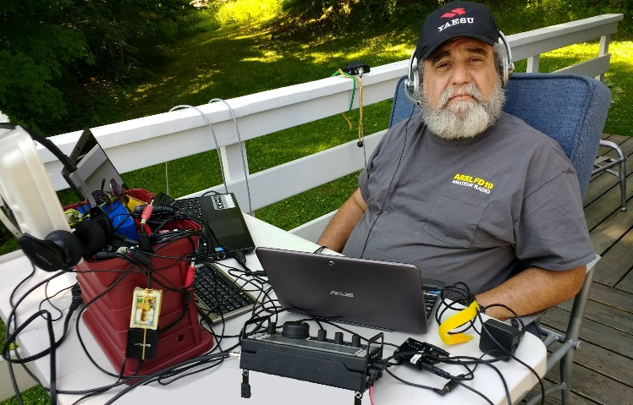***From the Section Youth Coordinator***

***Anthony Luscre, K8ZT - SYC***

[k8zt@arrl.net](mailto:k8zt@arrl.net)

**Preparing for Winter, Ham Radio Activities**

In the summer months of COVID-19, many of us tried to spend some time outside, in nature, away from other people; but as winter approaches, we will be spending more time indoors, mostly isolated in our homes. I have a couple of ideas for using Amateur Radio to fill your indoor days (and nights).

**Contesting**

One big Amateur Radio activity over the winter is contesting. If you are already an avid contester, I don’t need to say anymore, but here are some tips for getting started if you are not. Recently I put together a slideshow “[Introduction to Amateur Radio Contesting](http://tiny.cc/contestintro)” for presentation at an ARRL Learning Network Webinar on November 3rd, 1:00 PM EST (1800 UTC). If you are an ARRL member, you can [register to attend live](https://register.gotowebinar.com/register/6505060844889642766) or view the recorded session at your leisure.

Getting started in Amateur Radio Contesting is not difficult, and it can have many positive effects even without winning or even scoring highly. You may want to view the complete slideshow ([tiny.cc/contestintro](http://tiny.cc/contestintro)) for details, but I will boil it down to six steps for this article:

TOP^

1. 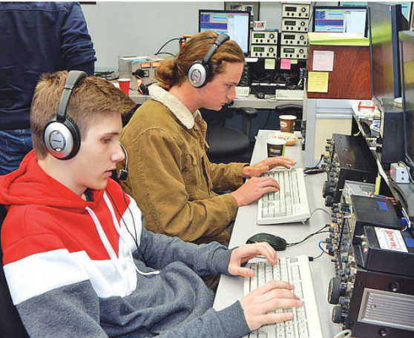Have an HF Radio and suitable antennas for bands you plan to operate on
2. Find out [Contest Information](https://www.contestcalendar.com/) (dates, times and rules)
3. Prepare for Contest Logging
   1. Install Computer Logging Software (two popular programs- [N1MM](https://n1mmwp.hamdocs.com/) free or [N3FJP](https://www.n3fjp.com/) $)
   2. Or use paper logs or your general logging software if you will not be submitting an entry.
4. Know your exchange for the contest (read rules for exchange)
   1. Help Finding your CQ Zone, ITU Zone, Grid, etc.
      1. [Zone-Check](https://zone-check.eu/)
      2. [CQ Amateur Radio](http://www.cq-amateur-radio.com/cq_awards/cq_waz_awards/cq_waz_list.html)
      3. [Finding your Grid Square](http://tiny.cc/find-grid)
      4. [Mapability EI8IC](http://www.mapability.com/ei8ic/maps/maps.php)
      5. [Levin Central](http://www.levinecentral.com/ham/grid_square.php)
5. Get on the air and make contacts.
   1. Listen for people calling CQ Test, Contest, or specific contest name.
   2. Answer their calls and give your exchange when they respond
   3. Log your contact
6. Submit your log to the sponsoring group (see rules)

A few other things that may help with AR Contesting:

* Find a friend who is familiar with contesting for help and advice.
* Watch Youtube videos on contesting.
* Visit the [Contesting](http://www.k8zt.com/contesting2) page of my website ([www.k8zt.com](http://www.k8zt.com))

**Learn Morse Code (CW) or Increase Your Skills**

Now that it is no longer required for AR licensing in the US, CW is something you can choose to learn and use, but why would you bother learning CW if it’s not required?

* 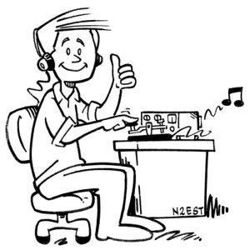It can be fun
* CW gets through even in poor band conditions.
* It is prevalent in contesting.

I have a slideshow in this (yes, I know I probably have way too many slideshows) [“Having Fun With Morse](http://tiny.cc/fwm).” It discusses learning CW, using it to make contacts even when your skills are not so good or just rusty. By the way, one of the best ways to learn Morse is with a buddy or even a whole group. Two groups have online classes available to help you learn and use Morse:

* CW Ops’s CW Academy- <https://cwops.org/cw-academy>
* Long Island CW Club- <https://longislandcwclub.org/cw-online-classes> (they have both kid and adult classes)

**Upgrade Your Amateur Radio License**

Winter is a great time to study for an Amateur Radio License upgrade (Tech to General or General to Extra). Both upgrades will get you a lot more operating privileges and/or frequencies.

TOP^

Again, one of the best ways to do this is with a group. Many local radio clubs run classes for all three levels of licensing (Tech, General and Extra). My local club, the [Cuyahoga Falls ARC](http://www.cfarc.org), is doing our classes online this time around (we are currently completing a Technician licensing class and will be starting a General level class after New Year). If you want to go the solo route, there are many licensing manuals available. Also, there are many online sample tests you can take to get ready.

**Get On The Air!**

Finally, plan to get on the air more. You may even want to consider a few new activities:

* Try a new band
  + 160M is at its best in the Winter
  + Give the so-called WARC bands a try (30, 17 and 12 Meters)
  + Give 60 Meters a try
  + Go really low and try our two newest bands, 2200 and 630 Meters
* Try a new mode
  + [FT8 and FT4](http://tiny.cc/ft8ft4) are two hot new modes
  + On the VHF/UHF front, try one of the digital modes- DMR, D-Star, System Fusion II (C4FM)
* Try a new activity
  + Participate in a Net- HF, VHF or UHF
  + Try contesting
  + Start award chasing with WAS or DXCC; if you already have them try other awards- [www.qsl.net/va3rj/awards_usa.html](https://www.qsl.net/va3rj/awards_usa.html)

**73, Anthony K8ZT**

-------------------------------------------------------------------------

***ARRL Learning Network Webinars***

ARRL members may visit the Learning Network website to [register](http://www.arrl.org/arrl-learning-network) for upcoming sessions and to view previously recorded sessions. The schedule is subject to change.

**How to Get Started in Amateur Radio Contesting: Anthony Luscre, K8ZT**

Why do hams contest? How would I benefit from contesting? What do I need to get started in contesting? What are good contests for beginners? Where can I learn more? This session will answer all of these questions and more.

**Tuesday, November 3, 2020, 10 AM PST/1 PM EST (1800 UTC)**

TOP^

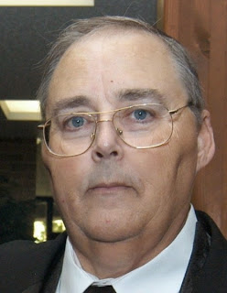***From the Section Traffic Manager***

***David Maynard, WA3EZN – STM***

[wa3ezn@att.net](mailto:wa3ezn@att.net)

The 2020 recipient of the Ohio Single Sideband Net Garlock Award is Dick Wayt, WD8SDH. Dick is a former Chief of Police, Cambridge, Ohio PD. Dick is retired now after 35 years of service to the community and 21 years USAF active and Guard service as a master sergeant. He keeps very busy with his Amateur Radio Emergency Services Coordinator position. The CARA and local First Presbyterian congregational committee. Dick holds an Extra class ham ticket and is very active with his net control and liaison duties with the Ohio Single Sideband net. Courtesy of W8SU

The Ohio Slow Net has a new net manager, Mike W8MAL. Mike has volunteered to be the OSN Net manager. I am glad to have Mike aboard and filling a position that I was unable to fill for many months. Thanks also go to the Buckeye Early Net manager WB8YLO who has filled in to collect slow net data and file the monthly OSN reports for many months.

While on the subject of nets the West Virginia Mid Day Net meets daily at 11:45 AM Local Time 7.235 or 3.810 MHz. And the West Virginia Fone Net meets daily at 6:00 PM Local Time on 3.810 MHz. I mention this as a possible resource for them when there is no West Virginia representative on 8RN to take their traffic. Also as a reminder there is no digital station for West Virginia traffic and seldom is there a representative on the Interstate Sideband Net ISBN

OHIO SINGLE SIDEBAND NET

["Specializing in the first and last mile of NTS delivery in Ohio."](http://www.ossbn.org/)

|  |  |  |  |
| --- | --- | --- | --- |
| Morning session | 10:30 AM | 3972.5 KHz | every day |
| Afternoon session | 4:15 PM | 3972.5 KHz | every day |
| Evening session | 6:45 PM | 3972.5 KHz | every day |



Ohio has three very fine CW nets. These nets are looking for new CW operators to check in and the Ohio slow Net is in need of a net manager. Thanks to WB8YLO for collecting the OSN net reports and sending the monthly report to the Section Traffic Manager

TOP^

**OHIO LOCAL VHF TRAFFIC NETS**

|  |  |  |  |
| --- | --- | --- | --- |
| VHF NETS | NET TIMES | FREQUENCY | NET MANAGERS |
| BRTN | MON, WED, SAT 9:30 PM | 145.230  PL 110.9 | W8DJG |
| COTN | 7:15 PM DAILY | 146.970 | KD8TTE |
| MVTN | 7:00 PM Mon | 146.640 | KC8HTP |
| NWOHARES | 6:30 PM DAILY | 147.375 | N8TNV |
| TCTTN | Sun, Tues, Wed, Fri 9 PM | 146.94 | WB8YYS |
| TATN | 8:00 PM DAILY | 146.670 PL123 | WG8Z |

These VHF net times and frequencies are those that have been reported to me by the net managers.

**OHIO HF CW TRAFFIC NETS**

|  |  |  |  |
| --- | --- | --- | --- |
| HF CW NETS | NET TIMES | FREQUENCY | NET MANAGERS |
| Buckeye Early | 6:45 PM | 3.580 | WB8YLO |
| Buckeye Late | 10:00 PM | 3.590 | WB9LBI |
| Ohio Slow Net | 6:00 PM | 3.53535 | NEEDED |

All net frequencies plus or minus QRM. .

**Why Morse Code?**

If you can talk FM on two meters, or SSB on HF, why should you be concerned at all about Morse Code, also known as CW.

However, there are good reasons why you should learn Morse code. Having a level of Morse proficiency that is of real use on the air, meaning that if you can copy at 10-12 wpm or more, will add immeasurably to your enjoyment of Amateur Radio. Such rewarding HF activities as DXing, contesting and QRP operating still rely heavily on CW. Thousands of hams enjoy CW for its own appeal as a relaxing mode different from most other means of communication. And even on VHF and higher frequencies, you'll find that exciting activities such as Moon bounce and weak-signal work still require Morse skills for full participation. Every day is a good day to operate on CW, but set some time aside on New Year’s Eve and Day to enjoy [Straight Key Night](http://www.arrl.org/straight-key-night) (SKN). The annual event gets under way a 0000 UTC on January first (New Year’s Eve in US time zones). The 24 hour event is not a contest but a day dedicated to celebrating our CW heritage.

Many newcomers exploring ham radio were discouraged by the need to learn Morse code. In the United States, that requirement to know Morse code to get an amateur radio license was dropped in 1991, and completely removed in 2007.

TOP^

Morse Code used to be required as an entry requirement to HF ham communications. The entry level speed was 5 words per minute (WPM). That speed is slow enough to learn the basics, get on the air, and increase your speed through practice. Yes, I started as a Novice way back at 5 WPM, and could copy 13 WPM to get my

General license.

I thought I'd want to get enough code speed to get on SSB voice. I did that but discovered something I didn't expect. Sometimes, the band was so poor that I couldn't hear a single voice station on SSB. But, when I tuned down to the Morse code CW portion of the band, lo and behold, there were CW contacts going on.

I learned that Morse code needs only about a tenth of the power of SSB to make a contact. Or, stated another way, if you use Morse code, it's like getting an amplifier for your transmitter for free! We all know that there are days you'd be desperate for a contact with SSB, and it appears that you can make contacts with Morse code!

In the early days if you lived in Ohio and wanted to test for a ham license you went to an FCC office in Cleveland or Detroit. The test I took for my general was given in an office setting with phone ringing and office type activity all around me. Since those early days the FCC decided to use Volunteer Examiners to do their testing. This provided a quieter and more relaxed atmosphere to take the test especially after the FCC dropped the code test requirements

If you didn't have a buddy to learn code with you had to use records like the Ameco code course like I did. You supplemented you record course by copying W1AW code transmissions over the air. At that time, it was common to count dots and dashed and mentally convert them to letters to write on paper.

Since then it has become commonly known that the best way to learn code was not to count dots and dashes but to learn the sound of each individual letter. Also available today are a multitude of websites, clubs and computer programs to use to learn the code the proper way.

**Why not slower than 15 words per minute?**

Because at a somewhat slower speed you can count the individual dots and dashes rather than having your brain treat each character as a distinct, integrated sound pattern. When you hear Morse Code sent at 5 wpm for learning such a slow speed is counterproductive. You don't learn the sounds that lead to instantaneous recognition. And, far worse, it programs the brain to count individual dots and dashes — precisely what you don’t want it to do! This eventually has to be unlearned and presents a formidable barrier to actually learning useful code.

To some degree, previous government regulations are to blame: In earlier times the FCC imposed a Morse code requirement of 5 wpm for the Novice Class amateur radio license, causing legions of radio amateurs to get on precisely the wrong track. And to this day there are well-intentioned individuals, clubs, and organizations that recommend starting at 5 wpm!

You should start on your road to success by throwing some time-honored ham-radio traditions onto the window where they belong. These are:

1. Slow (5 wpm) code -- It ought to be illegal to teach anyone code at 5 wpm. Every minute spent toying with 5 wpm code is irrevocably wasted. In addition, as we'll see later, starting with slow code is a virtually guaranteed path to frustration and quitting. Morse at 5 wpm and Morse at 15 or 20 wpm are completely different critters, and you don't want to waste time on the wrong one.

TOP^

1. Charts, mnemonics, musical cues and other "memory aids" -- These things make you think about what you're doing while trying to copy code. That is deadly to proficient copying.
2. Code tapes -- In very short order, and unconsciously, you'll memorize the tape. This will lull you into false confidence in your ability. That false confidence will be quickly shattered when you hear transmitted text that you haven't memorized.
3. Copying QSOs off the air -- You don't know the speed of code you find on the bands, and much code on the air is pretty badly sent. All this makes it useless for training purposes. Formal code-practice sessions, such as those on W1AW, are OK, however.

Now that you know what your not going to do, let's start examining just how you can best gain code proficiency.

There are hundreds if not thousands of websites available about Morse code. To get you started below here are a few of the websites with information and programs to help you get started on you adventure into the world of Morse code. Remember that you are not going to count dot and dashes a 5 WPM but you are going to want to start at a higher speed and learn the sounds.

<http://www.g4fon.net/>

<http://www.justlearnmorsecode.com/>

* 1. Daily Morse Code Practice QST Source

<http://www.arrl.org/code-practice-qst-source>

* + 1. K6RAU Code Course

<https://www.podomatic.com/podcasts/k6rau>

* + 1. [More Code Courses:](http://home.earthlink.net/~rbeals/)

<https://www.w3vpr.org/morse>

<http://ac6v.com/morseprograms.htm>

<https://lcwo.net/>

<http://www.arrl.org/learning-morse-code>

If you start now you can be ready for Straight Key Night in January. You could also be ready for that next CW DX contest.

And now more on the business side of traffic handling here is a list of things that I hear on the OSSBN that are just wrong. We all need to make improvements and become more efficient.

* Please roger my traffic…just say “number”
* Please copy number…. just say “number”
* Today’s date…just give the date
* Going to…..is not an NTS pro-word don’t use it
* Going to your station….just give them the call
* Break for text…. just say “break”
* Break for signature…just say “break”
* End number………just say “end”

TOP^

* Roger number..…..just say “roger”
* Roger your traffic.. just say “roger”
* Common text…,,,. Is not used anymore it is “BOOK”
* Common parts…,. is not an NTS pro-word just say “BOOK of”

Also, it is important that we all use the same Phonetic Alphabet. The standard Amateur Radio Phonetic Alphabet is what we are all expecting to hear and when we hear ABLE instead of ALFA we have to take an extra second to comprehend and record it.

Amateur Radio Phonetic Alphabet

|  |  |  |
| --- | --- | --- |
| Letter to be transmitted | Code word to be used | Spoken as |
| A | Alfa | AL FAH |
| B | Bravo | BRAH VOH |
| C | Charlie | CHAR LEE or SHAR LEE |
| D | Delta | DELL TAH |
| E | Echo | ECK OH |
| F | Foxtrot | FOKS TROT |
| G | Golf | GOLF |
| H | Hotel | HOH TELL |
| I | India | IN DEE AH |
| J | Juliett | JEW LEE ETT |
| K | Kilo | KEY LOH |
| L | Lima | LEE MAH |
| M | Mike | MIKE |
| N | November | NO VEM BER |
| O | Oscar | OSS CAH |
| P | Papa | PAH PAH |
| Q | Quebec | KEHBECK |
| R | Romeo | ROW ME OH |
| S | Sierra | SEE AIR RAH |
| T | Tango | TANG GO |
| U | Uniform | YOU NEE FORM |
| V | Victor | VIK TAH |
| W | Whiskey | WISS KEY |
| X | X-ray | ECKS RAY |
| Y | Yankee | YANG KEY |
| Z | Zulu | ZOO LOO |

Let us not forget that amateur radio got its start as a public service. Amateur radio exists today because it is a public service.

"An amateur trains until he gets it right; a professional trains until he cannot get it wrong!"

TOP^

Until next time remember without training you are not a part of the solution, but you could be part of the problem.

HAVE A HAPPY BEGGER'S NIGHT.

**David, WA3EZN**

Ohio Section Traffic Manager

**You can view the STM’s monthly report on the website..** [**http://arrl-ohio.org/stm/stm.html**](http://arrl-ohio.org/stm/stm.html)

*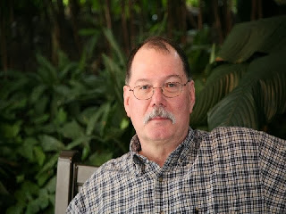****ARES Training Update***

***Jim Yoder, W8ERW – ARES Data Manager***

[w8erw@arrl.net](mailto:w8erw@arrl.net)

***ARES Training Update***

I posed this question at a recent meeting of the Seneca Radio Club, “What is the Seneca Radio Club”. Sounds a bit simple does it not? Perhaps it’s more complex than we thought. Some of the thoughts to be explored might start with Experience. As I looked around the room I saw quite a bit of grey hair, something I suspect each of you might observe at your respective club meetings. Now I know it is hard to believe, I don’t look like it and it amazes me too, but last June 3rd, I was 71 years old.

Yes, in our midst there is a lot of experience not only as Amateurs, but in life itself. It has often been said that experience is the best teacher, and I cannot argue that. We have Doctors, Lawyers, Accountants, Engineers, Business and Political leaders, Skilled Trades and Technicians, Salespeople, Crafts People, Dedicated Labors among our midst. I would be remiss if I did not also mention our Lady Hams who often too have titles and professions. We are proud to have you gals with us and your contribution is appreciated and recognized. Many are also Mothers as well. In addition to being proficient Radio Amateurs, you give life. What greater calling could there be?

So, then a club has experienced a lot of which comes from the time invested. What else is a Radio Club? Knowledge to share should be high on the attributes of a successful club organization. We as Hams do enjoy sharing our experiences and knowledge whenever possible. Yes, I think we all love to talk and perhaps that is essential to the hobby. We also derive great pleasure in helping others to be successful and enjoy their individual pursuit of Amateur Radio.

TOP^

Curiosity also comes to mind when describing how we participate in clubs. We hams are not inclined to accept that something works. We also want to know the how and why of it. In seeking this further knowledge, we become able to adapt to any situation which provides a solid foundation for our ability to provide a service to the public. “When all else fails, Amateur Radio works”. Curiosity along with the practice of our Hobby enables this.

Hams are also a dedicated bunch. We strive to enrich our hobby through our experience, knowledge and a desire to help others. Amateur Radio would not exist if it were not so. A single lonely Ham would not have a lot to do. Our Strength and that of a strong and viable club organization come from each of us doing a little towards our common interest while encouraging others to participate with us. We offer our assistance to those who are just beginning and to others who are expanding their knowledge into new areas.

So where was I going when I started this discussion during the Seneca radio Club? My goal was to encourage the club to provide a brief period during our monthly meetings for members to pose whatever questions they might have.

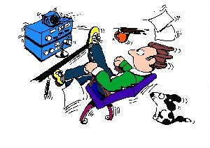Let’s make sure that we do everything that we can to promote and assist our newest Hams and members to become active. Too often meetings become canned and not relative. Let’s make sure we include everyone. It is also important to remember that each of these new members and beginning Amateurs has a skill set aside from an interest in being a part of our hobby. That new person sitting beside you at his or her first meeting may well be a future leader. We all have a mutual responsibility to be inclusive and the diversity of each member doing a little provides for the strength and enjoyment of all. Let us not either forget that having fun is high on the list of accomplishments to strive for. This is what a club is, the membership.

Our ARES Training submissions have grown again during the past month. There are now 9,692 certificates for training registered. We have 931 members at Level 1, another 726 at Level 2 and 200 at Level 3. ARES Connect registrations have also increased and now total 1,459. We will soon be at the end of the year. While we are observing precautions due to the Covid-19 situation with high hopes that it does end soon, let’s use some of the time we may have to advance a level and kick the ball over the goal post by the New Year.

While you are at it, take the time to get registered on ARES Connect. Both are excellent ways to support our use of spectrum and demonstrate our commitment to assisting our communities when called to do so.

Thank you all for your continued support of Amateur Radio and ARES. Questions and concerns are always welcome,

Thank you and 73,

**Jim, W8ERW**

TOP^

***National News***

*(from arrl and other sources)*

***ARRL Logbook of The World Harmonizes Designation of FST4 Protocol***

The Logbook of The World (LoTW) Committee worked with *WSJT-X* developer Joe Taylor, K1JT, to harmonize the designation of FST4 among *WSJT-X*, the ADIF standard, and LoTW. At present, FST4 is only supported in a [**recently released beta version**](http://www.arrl.org/news/wsjt-x-beta-release-introduces-digital-protocols-designed-for-lf-and-mf-bands) of *WSJT-X*. The committee’s action was to avoid the sort of confusion that cropped up among LoTW users logging contacts in FT4 when that protocol was first included in *WSJT-X*. In the case of FST4, the committee acted proactively to help users avoid difficulties and obtain the maximum number of contact matches. The ADIF standard has been updated to support FST4 as a sub-mode of MFSK, and configuration file CONFIG.xml for LoTW has been updated to version 11.13, accordingly, to support FST4. Users will be offered the update when they run TQSL.

Again, FST4 is only available in *WSJT-X*. An ADIF file emitted by *WSJT-X* should properly identify FST4, so that contacts will upload smoothly into LoTW, *provided* the CONFIG file has been updated. *— Thanks to Greg Widin, K0GW*

####

***2021 Hamvention® Award Nominations Open on November 1***

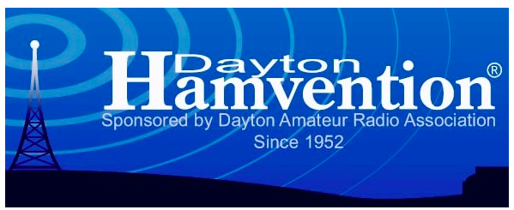

Nominations for the 2021 Hamvention Awards will open on November 1. [**Hamvention**](http://www.hamvention.org/) will grant awards in the categories of technical achievement, special achievement, amateur radio operator of the year, and amateur radio club of the year.

**The Technical Achievement Award** recognizes important contributions toward technical excellence in the world of radio. Examples are inventions, processes, discoveries, experiments, or any other outstanding technical achievements that contributed to amateur radio.

**The Special Achievement Award** goes to a radio amateur who has made an outstanding contribution to the advancement of the radio art and or science. This award typically is conferred upon a respected amateur who has spearheaded a single, significant project.

**The Amateur of the Year Award** honors a radio amateur who has made a long-term commitment to the advancement of amateur radio. This individual will usually have a history of giving back to ham radio contributions and exhibits dedication to service, professionalism, and a desire to advance amateur radio.

TOP^

**The Club of the Year** recognizes a club’s involvement in varied aspects of amateur radio for the greater good of the community and/or the nation.

These awards are conferred annually. Nominations close on February 15, 2021. [**Nomination forms**](https://hamvention.org/event-details/awards/) are available. Additional information may be included as attachments. Provide a means to contact the nominee. Submit forms by [**email**](mailto:awards@hamvention.org) or US mail Hamvention, Attn: Awards Committee, P.O. Box 964, Dayton, OH 45401-0964. Award recipients and their accomplishments will be posted on the Hamvention website and in the Hamvention program. Awards will be presented on the Saturday evening of Hamvention.

####

***Robert Bankston, KE4AL, is New AMSAT President***

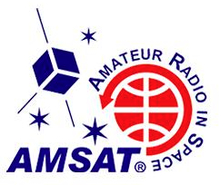

Robert Bankston, KE4AL, of Dothan, Alabama, is the new president of [**AMSAT**](http://www.amsat.org/). The AMSAT Board of Directors elected Bankston at its annual meeting on October 18, to succeed Clayton Coleman, W5PFG. Bankston has served as treasurer and Vice President of User Services. He is a life member of both ARRL and AMSAT. He volunteered to develop and launch AMSAT’s online member portal and chaired the 2018 AMSAT Space Symposium.

For his part, Coleman said that it had been “both a joy and a privilege” to serve as AMSAT president during 2020, which he called “a rather difficult year” for many in amateur radio. “With the talented and capable individuals sitting on AMSAT’s new Board and its officers, I am confident in a bright future ahead for AMSAT and the amateur radio satellite service.”

Other officers elected included Paul Stoetzer, N8HM, as Executive Vice President; Jerry Buxton, N0JY, as Vice President of Engineering; Drew Glasbrenner, KO4MA, as Vice President of Operations; Jeff Davis, KE9V, as Secretary; Steve Belter, N9IP, as Treasurer; Martha Saragovitz as Manager; Alan Johnston, KU2Y, as Vice President of  Educational Relations, and Frank Karnauskas, N1UW, as Vice President of Development. *—*

*Thanks to*AMSAT News Service

####

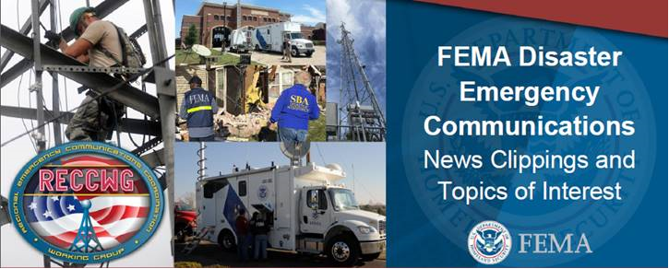 ***IPAWS - Winlink and the Ohio Section ARES during S.E.T.***

***IPAWS-Winlink Demonstration***

The DHS SHAred RESources (SHARES) HF Radio Program brought the FEMA Integrated Public Alert & Warning System (IPAWS) and the Winlink HF Email development team together to demonstrate delivery of an IPAWS message by HF radio in the event of an internet outage. The Ohio Military Reserve “Black Swan” exercise (29 SEP to 03 OCT 2020) provided the opportunity to demonstrate this capability.

TOP^

Ideally, there would be a SHARES Winlink station at the location of the IPAWS message originator. Since that could not be implemented within the time and budget constraints of the exercise, internet was used to get IPAWS messages from the point of origination to the SHARES HQ program office in Arlington VA, where custom software written by Phil Sherrod, chief programmer of the Winlink Development Team, detected the IPAWS message, and forwarded it by SHARES Winlink Hybrid HF Radio Email Network automatically, with no human intervention, **to exercise participants in Ohio**.

Due to COVID-19, there were no station personnel present in the HQ SHARES Radio Station building. Messages were retrieved by SHARES operators over SHARES Winlink and given to Amateur Radio operators who manually relayed them to county and city emergency management agencies at different times of the day to simulate variations in propagation conditions. ARRL Amateur Radio Emergency Service (ARES®), the ARRL National Traffic System (NTS) and amateur radio operators participated through the Government’s AuxComm program. DHS project coordinators were Scott Johnson of Sawdey Solutions, a FEMA contractor, and Ross Merlin, SHARES HF Radio Program Manager, of the Cybersecurity and Information Security Agency (CISA).

The SHARES Hybrid Winlink Radio Email Network is provided to the U.S. Government at no charge by the Amateur Radio Safety Foundation, Inc. For further information about Winlink, see <https://www.winlink.org>, for SHARES see <https://www.cisa.gov/shares>, and for IPAWS see <https://www.fema.gov/ipaws>

####

***Call To Action - FCC Fees for Radio Amateurs***

As many of you read, we are being asked to submit our views and opinions about the proposed 20-270 Rulemaking and the deadline to file your comments is November 16th so you don’t have much time.

Many of you have been asking if there’s a sample letter to help you with wording. Yes, there is a sample letter, but we really want this letter to be in YOUR words and not just another form letter.

So, if you want to have an idea of how to word your letter, you can download the sample letter that I have on the website. Please, don’t just put your name at the bottom of this sample letter, write this letter in YOUR words so that it’s from YOU.

My sample letter and the instructions for how to file your comments on the FCC website are found at: <http://arrl-ohio.org/sm/20-270/> You can select from either a MS Word (.docx) file or an Adobe Acrobat (.pdf) file.

Again, we want this letter to come from YOU, in YOUR words, and not just another form letter that the FCC will just toss aside like junk mail. Let them know how YOU feel about this.

TOP^

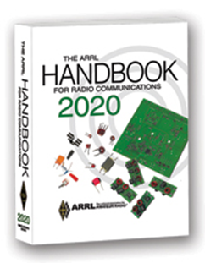***The Handbook Give Away***

Hey Gang,

Have you registered for the “Handbook Giveaway” drawing for this month yet? If you haven’t, you’ve only got a couple of days left to get registered... Hurry up and go to: <http://arrl-ohio.org/handbook.html> and get yourself registered now!

What’s the catch? I want to get everyone checking in to the Ohio Section website as often as possible, and in order to register each month, you have to visit the website often! There’s nothing else to it. I pay all expenses and I usually “Give Away” more than just a Handbook too!!

Many of you ask me just how do I know when the drawing is on? Well, that’s easy all you need to do is check in on the Ohio Section Website on a regular basis and watch for the big [**RED**](http://arrl-ohio.org/handbook.html)Arrow that will appear on the left side of the page. This is the sign that the drawing is on and you need to get registered. So, keep a sharp eye out on the website and check in often!

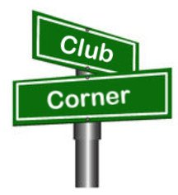***Club Corner***

This is YOUR cornner of the newsletter. Send me what your club is doing and I’ll make sure that it gets in. Got a special event or club project that you want everyone to know about? Send it to me!. Need help with a project? Send it to me.

Let me know what you club is up to. Are you going to have a special guest at your meeting or are you having a special anniversary? Just sent it to: [n8sy@n8sy.com](mailto:n8sy@n8sy.com)

####

***Highland County Amateur Radio Association (HARA) Becomes Special Service Club***

It’s with great pleasure that I introduce you to the newest of the Special Service Clubs, the Highland County ARA just got approved this past week. Let’s all give a big round of applause for their accomplishment!!

####

***Is It Time For Your Club To Submit Their Annual Report?***

The Ohio Section has 114 active Affiliated Clubs and with the year starting to come to a close, I thought it might be a good time to put this reminder about making sure your club has done its annual report in the newsletter. Is your club listed below? If it is then you need to contact your club officers and let them know that they need to go in and do their club’s annual report because it’s either past due or coming close to the time it needs updating.

TOP^

This is really important to your club to keep this record updated so that new folks as well as others know how to contact you if needed. Why should we care about that?

Over the years I’ve received phone calls from folks taking care of estates and such and are looking for a club near them to donate equipment and such. This has been very beneficial to several clubs, as that in one instance it netted them a complete new Icom HF and VHF station.

Who needs to be the one to update the record? Any of the officers of your club. Not sure how to do this? It’s very quick and easy to do. You do need to be logged into the ARRL website as a user. So, if YOUR dues are due, please make sure that you’ve taken care of that first!

Here’s a link to get you started. <http://www.arrl.org/Groups/view/grant-amateur-radio-club/type:club>   just click on the “edit” button in the upper right-hand corner of the page, make any changes necessary and then click the “Submit” button. That’s all there is to it. The following are the clubs that need attention at this time.

|  |  |
| --- | --- |
| Pioneer A R Fellowship | Morgan Amateur Radio Club |
| Voice Of Aladdin ARC | North Coast Contesters |
| SUNDAY CREEK AR FEDERATION | Dial Radio Club |
| Champaign Logan ARC Inc | TOLEDO RADIO AMATEUR CLUB |
| Wood County Amateur Club | SOUTHWEST OHIO DX ASSOCIATION |
| MORROW COUNTY AMATEUR RADIO SERVICE | Newark Amateur Radio Assn |
| MAD RIVER RADIO CLUB | GEAUGA AMATEUR RADIO ASSOCIATION |
| CASE AMATEUR RADIO CLUB | Lake County ARA Inc |
| NOT QUITE WORKABLE CONTEST CLUB | Union County Amateur Radio Club |
| Conneaut Amateur Radio Club | PORTSMOUTH RADIO CLUB |
| Ottawa County ARC | Franklin County Ohio ARES |
| CUYAHOGA FALLS ARC | CENTRAL OH SEVERE WEATHER NET |
| Preble Amateur Radio Assn | KENTON AMATEUR RADIO CLUB |
| BUTLER COUNTY AMATEUR RADIO ASSOCIATION | FIRELANDS AMATEUR REPEATER ASSOCIATION |
| GRANT AMATEUR RADIO CLUB | CLARK COUNTY ARA |
| BUTLER COUNTY VHF ASSOCIATION | Southeast Amateur Radio Net |
| HAMILTON AMATEUR RADIO CLUB | TOLEDO MOBILE RADIO ASSOCIATION |
| JACKSON COUNTY AMATEUR RADIO CLUB | Miami County Arc |
| Lancaster & Fairfield Cty ARC | VAN WERT AMATEUR RADIO CLUB; INC. |
| LISBON AREA AMATEUR RADIO ASSOCIATION | Warren Amateur Radio Assn |
| Portage ARC Inc | FULTON COUNTY ARC |
| MARIETTA AMATEUR RADIO CLUB | DeForest ARC; Inc. |
| Marion ARC | WESTERN RESERVE AMATEUR RADIO CLUB |
| 20 OVER 9 RADIO CLUB INC | |

If you have problems please don’t put this off, contact me and I’ll walk you right through it. It will only take a few minutes of your time. I promise!

####

TOP^

***New DMR Repeater On The Air***

Last month a survey was sent out asking about DMR use in D-3 counties. District 3 now has a new DMR repeater online as of Tuesday, October 20, 2020.

Let me introduce you to the N8NQH BrandMeister DMR repeater on the west side of Dayton. Frequency 444.43750 +5 MHz, Color Code 11 Local 2 Cin-Day Cluster = Talk Group 2 and Local N8NQH/R = Talk Group 310557 are both on Repeater Slot 2.

Talk Group 310557 should be used for all local contacts. Please use Repeater Slot 1 for all other Talk Groups and for Digital APRS-GPS.

Greene County DMR Net every Tuesday at 8:30 pm local time on TG 310557 and TS 2.

####

***New WinLink Repeater On The Air***

We now have WinLink repeaters located west of Dayton, the repeaters should help western District 3 county area coverage.

W6CDR - Winlink RMS Gateway is W6CDR-10 on 145.010 MHz simplex.

There is also a digipeater on the same frequency with callsign W6CDR-4.

####

***Lake County ARA Needs Help with Marathon***

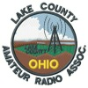

All,

We are still looking for Volunteer radio operators to help with the Northern Ohio Marathon and 5 team relays coming up on **November 1st**. This year's route is a 13-mile course thru northern Mentor. Start /Finish is Mentor Civic Center. Contact  [wb8zgh@arrl.net](mailto:%20wb8zgh@arrl.net) or [kb8bke@arrl.net](mailto:kb8bke@arrl.net) if you have questions.

Please use the attached form to sign up.  
<https://docs.google.com/forms/d/e/1FAIpQLSeGKv2ssCPJu83p_XH1sGIddGylePBWQv0KRXj6F1v8XenD5g/viewform?usp=sf_link>

####

TOP^

***Pumpkin Patrol***

Lorain County is looking for additional volunteers for Pumpkin Patrol. During the evenings of **October 30, 31, and November 1**, volunteers will be assigned to locations throughout Lorain County to watch for any suspicious activity occurring around area bridges.

Net control will be run out of the Lorain Ohio Highway Patrol post to have direct contact with Troopers in case activity is observed. Shifts start around 6PM and go until approximately midnight.

To sign up, contact Keith KD8GXL at [kd8gxl@gmail.com](mailto:kd8gxl@gmail.com)

**I'm told there may also be free home cooked chili!**

####

***Two Great Speakers and Programs Coming to the Cuyahoga Falls ARC***

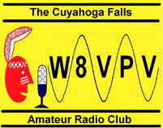

The Cuyahoga Falls Amateur Radio Club ([www.cfarc.org](http://www.cfarc.org)) is inviting you to attend one or both of its upcoming programs online via Zoom on October 28th (7:15 PM) and Nov 11th (6:15 PM). Two well-known speakers, one from just across the state line and one from across the Atlantic, will be providing two great presentations:



* **Oct 28th- Tim Duffy, K3LR**, world-famous contester and Chief Executive Officer of DX Engineering, will present ***"DXing and DX University.”***
* **Nov 11th- Steve Nichols, G0KYA**, famous author from England, will present ***“Antennas for a Small (or even no) Garden"*** (*garden* is the British expression for the American *backyard*)

For Zoom connection information and other details, [visit this link](https://sites.google.com/site/cfarccal/qst/oct28thnov11th-cfarcmeetingprograms-specialguests).

####

TOP^

***New DMR Repeater Installed in Alliance***

A new DMR repeater has been permanently installed at Mt. Union Fire Station in Alliance. The repeater was installed by Dave, WD8AYE, and a crew of helpers from the club. It is on 444.7875.

More information about the repeater can be found at <http://w8lky.org/Files/Misc_Files/W8NP-East.pdf>. More information about DMR can be found at <http://wd8aye.net/DMR.htm>.

Thanks go out to Paul;, K2ASA, Tony, KD8BBK, John, KD8MQ, & Chris, AC8VN who handled the antenna install.

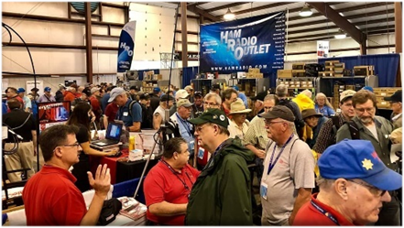

[***Upcoming Hamfests***](http://arrl-ohio.org/hamfests.html) ***for 2020***

**11/01/2020 – 60th Massillon Hamfest**Location: Massillon, OH  
Sponsor: Massillon Amateur Radio Club  
Website: <http://w8np.org/hamfest.htm>

***New Location…***

The new location is: The MAPS (Military Air Preservation Society) large Hangar at 5383 Massillon Road, Green, OH (route 241). VE exams will be given.  Registration at 8:30 a.m.  Exams at 9 a.m.

*Masks are required! Temperatures will be taken on everyone entering the facility*

**11/08/2020 – Outdoor Swap N Shop**

Location: Livonia Michigan

Sponsor: The Livonia Amateur Radio Repeater Group Outdoor

Website: <https://www.dropbox.com/s/66utqgicbs2pxrz/Repeater%20Swap-page-001.jpg?dl=0>

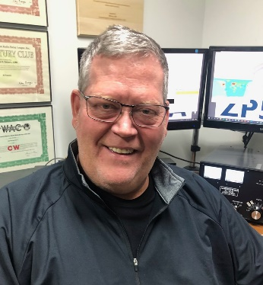***DX This Week***

*(from Bill, AJ8B)*

***DX This Week – 9G2DX Interview***

***Bill AJ8B (aj8b@arrl.net, @AJ8B, or www.aj8b.com)***

***CWOPs Member #1567***

This week we have a variety of items to review. First is the entities spotted in the Midwest. Then I share the QSL cards received. We can then move on to part 2 of the excellent article on 160M by Carl, K9LA. After that we have part 1 of the interview with 4Z1ZV regarding his 9G2DX DXPedtion to Ghana. Finally, we have the weekly tidbits from W3UR and the Daily DX and then Contest Corner. Enjoy!

TOP^

This week there was a wide variety of DX spotted in the Midwest. With the upcoming CQWW SSB context coming up, there should be quite a bit of “local” DX. By that I mean that islands like J8 – St. Vincent and FP – St. Pierre may be active. Some of us need these for the CQ Marathon!

Argentina, Armenia, Belgium, Brazil, Curacao, Dominica, England, Fed. Rep. of Germany, France, Ireland, Isle of Man, Italy, Kenya, Kingdom of Eswatini, Luxembourg, Mali, Mexico, Montenegro, Namibia, Netherlands, Northern Ireland, Puerto Rico, Republic of Kosovo, Reunion Island, Rwanda, Scotland, Seychelles, Slovenia, South Africa, Spain, Svalbard, Sweden, Trinidad & Tobago, Uruguay, Vienna Intl Ctr, and Zambia were all spotted in the Midwest. Let me know what you worked.

***DAH DIT DIT DIT DAH DAH DIT DIT DIT DAH***

I did receive QSL cards from LU3IEA, Hector in Argentina, EI20C, Mark in County Cork, Ireland, VE7UF, Duane on Vancouver Island, Canada, and German SWL Station, DE0WAF, Walter. Walter allowed me to interview him and that will appear in this section in 2021.

|  |  |
| --- | --- |
|  |  |
|  |  |

***DAH DIT DIT DIT DAH DAH DIT DIT DIT DAH***

Last week I reprinted part 1 of the excellent article by K9LA, Carl, on 160 M. Below is the rest of the article.

**Worldwide Allocations -** If your goal on 160m is to work DX, then it would be helpful to know where all the DX entities can operate on 160m. An up-to-date list of these allocations can be found at [**www.qsl.net/n1eu/topband/160FreqAlloc.xls**](http://www.qsl.net/n1eu/topband/160FreqAlloc.xls%20)

TOP^

**Aids for 160m Operating -** The side bar accompanying this article lists several sources of information to learn more about 160m ñ from more effective transmitting antennas (better than those described earlier) to low-noise receiving antennas (like those mentioned earlier) to the intricacies of propagation on 160m to planned DXpeditions to general topics. If you have the desire to go deeper into any of theses areas, check out those references.

**ON4UN.s Low-Band DXing** by John Devoldere ON4UN

(Fourth Edition, published by the ARRL)

This book is an excellent source of vast technical information for serious 160m aficionados. It covers propagation, transmitting antennas, receiving antennas, receiver performance, transmitter performance, and more. The ranking of the effectiveness of common low-noise receiving antennas in the text of the article

came from the RDF values on page 7-97 of this book.

**DXing on the Edge. The Thrill of 160 Meters** by Jeff Briggs K1ZM (published by the ARRL)

This is an easy-read book with a chronology of 160m DXing from the 1930s to the present, many operator biographies and station descriptions, descriptions of simple antenna systems, and general operating information. It includes a CD with memorable moments on 160m.

**The TopBand reflector** - The TopBand reflector, moderated by Bill Tippett W4ZV, is an on-line source of 160m information. It includes help information, operating practices, early announcements of 160m DXpeditions, and technical discussions. You can subscribe to it by going to [www.contesting.com](http://www.contesting.com), and then clicking on Other Lists on the left.

**W8JI website -** Tom Rauch W8JI maintains a website (www.w8ji.com) dedicated to many low band topics, with many informative technical discussions.

**The Low Band Monitor -** This is a monthly periodical edited and published by Steve Gecewicz K0CS (under the pen name Lance Johnson) devoted to 160m, 80m, and 40m operating. Several annual operating awards are offered to low band enthusiasts. For more information visit www.lowbandmonitor.com.

**Summary -** As mentioned several times in this article, 160m is also known as the Gentleman’s Band. The current users of 160m would like it to stay that way. So regardless of your operating preference (rag chewer, DXer, contester, digital enthusiast, QRPer, or whatever) please strive to uphold the reputation of 160m.

The advice and solutions offered in this article probably won’t get you to the Top of the DXCC Honor Roll on 160m. But they will allow you to sample the challenge and adventure of 160m. Where you go from there is up to you.

**160m Tips**

The following is a list of tips, slanted toward the DX aspect of operation on 160mn, to help you enjoy your experience on 160m.

**Station issues**

Put out as much wire as possible for your transmit antenna Work with the utility company and/or neighbors to fix noise sources. Further improve your ability to hear by using low-noise receive antennas

TOP^

**Operating issues**

Listen, listen, listen Don’t call incessantly in a DX pile-up. Be courteous and uphold the reputation of 160m as the Gentleman’s Band

**Propagation issues**

Know when the desired path is in or very near darkness Pay particular attention to sunrise and sunset times

Don’t shy away from elevated K indices ñ there may be skewed paths Check paths to the southwest at your sunrise and southeast at your sunset

***DAH DIT DIT DIT DAH DAH DIT DIT DIT DAH***

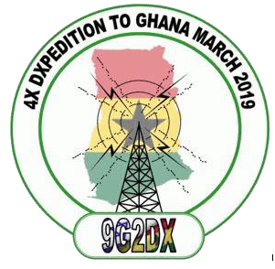**9G2DX – 4X DXPedition to Ghana**Part 1—March 2019   
Written by: Zvika Segal 4Z1ZV

*Courtesy of Joe, W8GEX*

As in a typical legend, this amazing adventure began about 2 years ago. Innocently enough, I took the challenge to handle the importation and installation of DMR repeaters being donated by an “unknown” radio ham in Africa. The donator was Haim Lewy, an Israeli Ham based in Accra Ghana and the owner of SkyLinks, communication company doing business in Africa.

My close friend, Dov Gavish 4Z4DX, ham extraordinaire, immediately recognized the opportunity to operate in a rare QTH.

An additional plus was to include locations in the WWFF (Flora and fauna, national parks), and to be the first one worldwide to operate in Ghana on 30/60/80 meter. Initially, it looked like a weird vision, but fortunately, Haim took the challenge to arrange this DXPedition.

It turns out that getting to Ghana, as well as importing radio equipment, is not a trivial task. Haim arranged for us to get the visas, purchased most of the heavy and costly equipment such as: an IC-7300 transceiver, ALS-500 Solid State Linear, Spider Beam antennas, poles, cables, ropes, tools and so on.

Getting a visa for entry into Ghana is a challenge. You must have a local invitation as well as the yellow International Certificate of Vaccination with at least a proof of recent Yellow Fever vaccination, 8 photographs and substantial fee in cash.

Haim worked with the NCA (the local communication authority), to get approval and a special call sign – 9G2DX – for this special event. As a point of reference, you can count more fingers on your hand than the number of local hams in Ghana. Actually, we met 100% of them, … Two.

Dealing with the difficulties in setting dates for the 4X DXPedition, a heterogeneous and well-balanced group was formed that consisted of people who were willing to invest their free time, efforts and money.

TOP^

Among the group was Dov Gavish, 4Z4DX, a well-known figure in the ham community with over 50 years of seasoning. 4Z4DX has ham radio experience on all modes and has participated in delegations to Himalayas and meeting King Hussain in Jordan. Joining 4Z4DX was Simon Heger 4Z1SH, a mature senior citizen with personal passion for rag-chewing on SSB. Zeev Stadler 4X5ZS, “the youngster” in the group, is a man with fire in his eyes and the determination to be dedicated and to perfect his tasks. The last member of the group was Zvika Segal 4Z1ZV (that’s me), acting as problem creator and problem solver. I was also charged with managing communications issues supervisor especially at the personal level (which is one of the challenges with such a unique group…).

On the start date we landed at Accra’s new and modern international airport. A VIP service was offered as part of our welcome mat. Once we collected our luggage, we were ushered through friendly immigration and customs and loaded up two 4X4 vehicles that waited for us and our belonging.

The first evening we spent in Accra, the capital, in high class hotel and had top notch dinner with Haim and his family at the Rockefeller sushi restaurant.



Early in the morning, we moved to Haim’s facility to pack and load the equipment. With the help of the local drivers, we moved two fully loaded off road cars to the first operating site; a new beach resort, still under construction, that was opened especially for us. We got a whole section facing the Atlantic Ocean and few local guys to take care of us, as well as having a dedicated driver and car 24/7.

The way to the beach was a real adventure. We were introduced to an interesting trade system, “the mobile supermarket”. Local people, the majority of them females, carry whatever you can imagine on their heads. This includes bread, ice, drinks to sewing machines or gas containers. They approach and offer merchandize (a process through which you can try to improve your negotiation skill). Fifty percent off “list price” is usual result.

At the beach resort we started the installation of our gear. Every electrical and lighting pole was turned into an antenna tower. With the gracious help of the local people, we secured a block and line as the basic mechanism to haul up and lower down wire antennas.

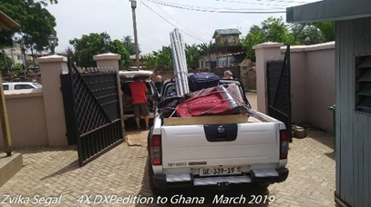The first installed antenna was a simple END FED, a 9:1 one transformer (AKA 9:1 balun) and 22 meters of wire with no radials. Performance of this basic antenna was impressive. We had a reasonable VSWR down to 60 meters and were rewarded with QSOs from all over the globe. This helped us get Dov operating CW, and simultaneously removed him from hounding us so we could continue install other antennas without “supervision”. The first station used an IC-7300 transceiver, an ALS-500 (about 400W solid state linear), an MFJ manual antenna tuner, and Dov’s favorite log software – the old and stable version of MIXW.

TOP^

Our plan was to install the “Compact and Portable” Spider Beam antenna. I must say that other than the name and stated performance (up to 9 dBi gain) there is nothing there to justify the term “Designed for DXPedition”. If the intention is to have a long stay at the same location (and you have some engineers on the team), then the antenna would be practical. Once you open the box, you realize that the manual was correctly titled – “Fabrication Instructions”. Actually, you get a KIT, with a Bill of Materials (i.e. poles, screws, rolls of ropes and wires, epoxy glue, uncut Velcro stripes, etc.).

Even the 1:1 Balun is a kit that need to be “fabricated”. A good knowledge of reading complex and unclear instructions, as well as the ability to measure and to cut wires to specific lengths, and good soldering skills are all needed.

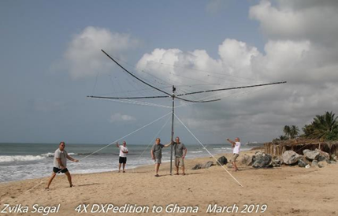It required very gentle handling to avoid breaking the carbon support poles and tangling the wires (which were everywhere). However, once the antenna was set up and running (at least for that one day), the performance was beyond our expectations. Unlike the Cob Web or Hex Beam, this is a real 5-band 3 elements Yagi (4 elements on 10 meters).

Once we understood the complexity of building the Spider antenna, we started to install other wire antennas, such as: a multi-band commercial antenna by Icom, a 40 meter dipole, and last but not least, the 80/160 meters Inverted V antenna recommended by Pop, YU7EF. This antenna was constructed of 30 meters of copper wire and an 8.5-meter vertical on an African bamboo pole. Loading coil for 160 meters was fabricated using empty mineral water plastic bottle and a tuning capacitor for 80 meters was a piece of open ended RG58 coax.

Performance of the antenna made Dov very happy as well as about 80 hams who were rewarded with their first Ghana QSO’s. Thank you, Pop.

Later on, we tested a short version of a 20-meter wire dipole antenna with loading coils built by Shimon. The center was supported by an African pole (i.e. a piece of a tree). We were surprised and delighted as this setup yielded many QSOs to North America and Japan.

Operating conditions from the beach resort were excellent. It is widely open to south America, and provided good conditions to the USA, especially on 20 meters during evening and nighttime. It also gave us good conditions to Europe and Japan. We even made a few QSO’s with Antarctica. The ongoing challenge was pacifying Dov who was very upset with Simon’s SSB operating method.

As a user of LOG4OM log S/W, Shimon transmitted to each ham his name as well as sharing with him the weather condition in Ghana. This drove Dov crazy, who’s focus was to serve the global community with as much as possible QSOs. We also sacrificed time during some of our meals in that it required driving for a total of one hour to get to a western style restaurant. Dov kept calculating the hundreds of “lost QSOs” due to eating and driving. In response, we decided to change the culinary process by leaving Dov to have fun with the rig while the rest of the team headed out for a meal.

TOP^

Even the pizza that was ordered for Dov was a waste of time and food, as Dov needs only one apple per 8 hours of continuous operation.

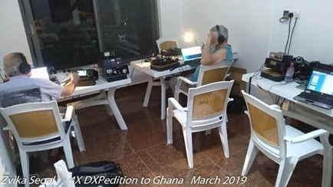One event that made me extremely happy was once when Haim was staring at the radio station, we encouraged him to step in and operate. In few seconds he started to manage the pileup in most professional way. Haim was a member of the known “4X4HQ” club in Tel Aviv over 30 years. For him it was like riding a bicycle following a long period of time. Just like that.

We set up 3 radio stations: IC-7300 with the SS Linear, IC-7000 with the LDG IT-100 antenna tuner, and the IC-718 which operated as the FT8 station. Most of the QSOs on FT8 made by the Zeev – “the youngster” (over 1,000), which through his IT skills and dedication, perfectly met the requirements of such computer to computer digital communication technology.

Part of operating characteristics in Africa is the time domain and constant. Everything takes longer than planned, looks different than expected, and is subject to weird electrical stability. One evening there was a sudden power outage whereby all the nearby village lights started blinking like a hazard signal.

When the village power came back and ours was still down, we learned the magic of the “pre-paid” electricity meter which sometimes resets itself after power failure. Our host needed to drive to the nearby office, pay the bill, and hope that it would propagate through the slow network. We continued to operate on batteries until they were also exhausted. Unfortunately, nobody was able to operate the generator since it was mysteriously not onsite. (Part 2 Next Week)

***CQDX CQDX CQDX CQDX CQDX CQDX CQDX CQDX CQDX***

Here is an update from Bernie, W3UR, of the DailyDX and the WeeklyDX, the best source for DX information. <http://www>.dailydx.com/. Bernie has this to report:

**W – USA -** The Stillwater Amateur Radio Association, SARA, runs an operation for the 16thyear remembering the Edmund Fitzgerald ship, which sank in Lake Superior during a storm on November 10, 1975 with 29 aboard. Callsigns W0JH and W0F will be on the air November 6-8. W0JH will be SSB only. W0F will be on CW and digital modes. A commemorative certificate is available by emailing your request to: [EdFitzgerald2020@radioham.org](mailto:EdFitzgerald2020@radioham.org). Include QSO info. An auto reply will let you know your request is received.

For more info look at W0JH on [www.QRZ.com](http://www.QRZ.com).

**4X and A6 – Israel and the United Arab Emirates -** To celebrate the Abraham Accords Peace Agreement: Treaty of peace, diplomatic relations and full normalization between the United Arab Emirates and the State of Israel special event stations 4X0AAP and 4Z0AAP will be activated by members of the Israel Amateur Radio Club and members of the Emirates Amateur Radio Society will operate A60AAP from October 16, 2020 and January 11, 2021. As with many other recent UAE special event stations this one will be operating with serial numbers at the end of the call. QSL 4X0AAP and 4Z0AAP only via the bureau and A60AAP via EA7FTR. For A60AAP/# QSL via on air instructions.

TOP^

**7Q – Malawi-** Member of the Russian Robinson Club “planned to visit three exotic African countries on October-November 2020 but just only Malawi borders are open for foreigners”. The team including RA1ZZ, R7AL and RZ3K are planning to operate as 7Q7RU near Embangweni. They are set to depart Moscow on November 6th and be QRV from November 7-18. Equipment includes two K3’s, an IC-7000 and K2. Three of the four stations will have KW amplifiers. Activity will be on 160 through 10 meters on CW, SSB, FT8 (Fox and Hound).

**PJ7 – Sint Maarten -** PJ7FM, Frank is a newly licensed Amateur Radio operator from the Dutch side of the island. He received his license yesterday.

**HC – Ecuador -** In celebration of the 200th anniversary of the independence of the city of Cuenca, Ecuador special event station HD200C will be QRV from October 31 and November 3.

**General Class starting November 5th By K3RA, Rol Anders**

I am starting a General Class course on Zoom beginning Thursday, November 5, and running for 9 sessions. Due to holiday breaks, the course ends January 21. Sessions will start at 6:30 Easter Standard Time (2330 UTC), and run 3 hours. No charge, of course. These are the classes sponsored by the National Electronics Museum that we have been holding for years. Please publicize this with anyone you know whom you think would be interested. Those wishing to sign up should email me at [roland.anders@comcast.net](mailto:roland.anders@comcast.net).

***DAH DIT DIT DIT DAH DAH DIT DIT DIT DAH***



As promised last week, you will find a list of upcoming contests in the “Contest Corner”. I think this is important for someone who is trying to move up the DXCC ladder since entities that are on the rarer side and easiest to work in contests. Some of my best “catches” have been on the Sunday afternoon of a contest when the rarer entities are begging for QSOs. Of course, the gamble is that if you wait until Sunday, conditions may change, or they simply won’t be workable. However, it is not a bad gamble. Of course, why not work the contest and have some fun!

The contests in red are those that I plan to spend some significant participation time on. PLEASE let me know if you are working contests and how you fared.

|  |  |  |
| --- | --- | --- |
| Oct. 21 | AGCW Semi-Automatic Key Evening | <http://bit.ly/2LCDywm> |
| Oct. 29 | RSGB Autumn Series SSB | <https://bit.ly/2XF8mSB> |
| Oct. 24–25 | CQWW SSB | <https://www.cqww.com/> |
| Oct. 28 | UKEICC 80m Contest CW | <http://bit.ly/2MbaURB> |
| Oct. 29 | RSGB Autumn Series SSB | <https://bit.ly/2XF8mSB> |
| Oct. 31-Nov. 1 | North American SSB Sprint Contest | <https://ssbsprint.com/rules> |
| Oct. 31-Nov.1 | Russian WW MultiMode Contest | <http://bit.ly/2CMbWOM> |

TOP^

|  |  |  |
| --- | --- | --- |
| Oct. 31-Nov.1 | UK/EI DX Contest | [www.ukeicc.com/dx-contest-rules.php](http://www.ukeicc.com/dx-contest-rules.php) |
| Nov. 1 | High Speed Club CW Contest | [www.highspeedclub.org](http://www.highspeedclub.org) |
| Nov. 1-4 | Fall Classic Exchange CW | <https://bit.ly/3fYa9Iv> |
| Nov. 2 | RSGB Autumn Series, Data | <https://bit.ly/2XF8mSB> |
| Nov. 4 | UKEICC 80 Meter Contest SSB | <http://bit.ly/2MbaURB> |
| Nov. 7-8 | IPARC Contest Ukrainian DX Contest | www.iparc.de |
| Nov. 7-9 | ARRL CW Sweepstakes | [www.arrl.org/sweepstakes](http://www.arrl.org/sweepstakes) |
| Nov. 8 | ANET Sprint Contest | <https://fediea.org/news/?news=20201108> |
| Nov. 8 | FIRAC HF Contest | [www.firac.de/html/contest.html](http://www.firac.de/html/contest.html) |
| Nov. 11 | RSGB Autumn Series, SSB | <https://bit.ly/2XF8mSB> |
| Nov. 14-15 | 10-10 Digital Fall Contest | <http://bit.ly/1FrFeBc> |
| Nov. 14-15 | JIDX Phone Contest | [www.jidx.org](http://www.jidx.org) |
| Nov. 14-15 | OK/OM CW DX Contest | <http://bit.ly/19rrRjl> |
| Nov. 14-15 | Worked All Europe RTTY Contest | <http://bit.ly/2vufgcb> |
| Nov. 14-16 | CQ-WE Contest | <http://cqwe.cboh.org/rules.html> |
| Nov. 14-16 | PODXS070 Club Triple Play Low Band Sprint | <http://bit.ly/2Cq2yUA> |
| Nov. 28–29 | CQWW CW | <https://www.cqww.com/> |
| Dec. 4 – 6 | ARRL 160M | <http://www.arrl.org/160-meter> |
| Jan 29 – 31 | CQWW 160M | <https://cq160.com/> |
|  | Winter FD | <https://www.winterfieldday.com/> |
| Feb. 20 – 21 | ARRL CW | <http://www.arrl.org/arrl-dx> |
| Mar. 6 – 7 | ARRL SSB | <http://www.arrl.org/arrl-dx> |
| Mar. 27 – 28 | CQWW WPX SSB | <https://www.cqwpx.com/> |
| May 21 | SWODXA DXDinner | [www.swodxaevents.org](http://www.swodxaevents.org) |
| May 29 – 30 | CQWW WPX CW | <https://www.cqwpx.com/> |
| August 28 | Ohio QSO Party | <https://www.ohqp.org/> |
| August 28 | W8DXCC Convention | [www.w8dxcc.com](http://www.w8dxcc.com) |

TOP^

***DX News***

***ARLD043 DX news***

This week's bulletin was made possible with information provided by W2GD, The Daily DX, the OPDX Bulletin, 425 DX News, DXNL, Contest Corral from QST and the ARRL Contest Calendar and WA7BNM web sites. Thanks to all.

****TUNISIA, 3V.** Ash, KF5EYY will be QRV as 3V8SS from the Radio Club Station of Tunisian Scouts in Sousse in the CQ World Wide DX SSB contest as a Single Op/All Band/Low Power entry. QSL via LX1NO.

**GEORGIA, 4L.** Members of the National Association Radio Amateurs of Georgia and Contest Station will be QRV as 4L0G from Tbilisi as a Multi Op entry in the CQ World Wide DX SSB contest. QSL via EA7FTR.

**MALAWI, 7Q.** Don, K6ZO will be QRV as 7Q6M in the CQ World Wide DX SSB contest. QSL direct to home call.

**EAST MALAYSIA, 9M6.** Saty, JE1JKL will be QRV as 9M6NA in the CQ World Wide DX SSB contest. Activity will be on 40 to 10 meters. QSL via LoTW.

**OMAN, A4.** Operator A41CK will be QRV as A42K in the CQ World Wide DX SSB contest as a Single Op/All Band entry. QSL via LoTW.

**CHINA, BY.** Dale, BA4TB will be QRV as BD9XE in the CQ World Wide DX SSB contest as a Single Op/All Band/High Power entry from Zone 23. QSL via BD9XE.

**CHILE, CE.** Members of the CE DX Group will be QRV as CB1D from La Huayca, Pozo Almonte, Atacama Desert in the CQ World Wide DX SSB contest as a Multi-2 entry. QSL via XQ1FM.

**MOROCCO, CN.** Special event station 5E1EC is QRV to honor the memory of Boumehdi El Moujahid, CN8EC. QSL via RW6HS.

**CANARY ISLANDS, EA8.** Juan, EA8RM plans to be QRV in the CQ World Wide DX SSB contest. Activity will be on all bands. QSL via LoTW.

**ITALY, I.** Operator IT9WDC will be QRV with special call IF9A from Favignana Island, IOTA EU-054, during the CQ World Wide DX SSB contest. QSL via IT9ATF.

**MONGOLIA, JT.** Members of the Young Technician Castle will be QRV as JT1KAI from Sukhbaatar Province in the CQ World Wide DX SSB contest. QSL via JT1KAI.

TOP^

**ALAND ISLANDS, OH0.**  Pekka, OH2TA will be QRV as OH0X from Brando Island in the CQ World Wide DX SSB contest as a Single Op/Single Band on 20 meter entry. QSL via OH2TA.

**BELGIUM, ON.** Members of the Oostkust Radioclub are QRV with special event call OR39CLM until November 13 to commemorate the liberation of the city Knokke-Heist by Canadian forces on November 1, 1944. Activity is on various HF bands and modes. QSL via ON6HC.

**ARUBA, P4.** John, W2GD is QRV as P40W until October 26. Activity is on the HF bands as time permits. This includes being an entry in the CQ World Wide DX SSB contest. QSL via LoTW.

**BONAIRE, PJ4.** Marty, W1MD is QRV as PJ4/W1MD. He will be active as PJ4X during the CQ World Wide DX SSB contest as a Single Op/Single Band entry, possibly on 15 meters. QSL PJ4X via LoTW and PJ4/W1MD to home call.

**BELIZE, V3.** Jim, W2JHP is QRV as V31TA from Turneffe Atoll, IOTA NA-123, until November 8. Activity is holiday style on the HF bands using SSB and some digital modes. QSL direct to EA5GL. In addition, Marc, V31MA will be QRV as V3A in the CQ World Wide DX SSB contest on all bands. QSL via M0OXO.

**BERMUDA, VP9.** Jeff, N1SNB is QRV as VP9I in the CQ World Wide DX SSB contest. QSL to home call.

**INDONESIA, YB.** Yohanes, YB2DX will be QRV in the CQ World Wide DX SSB contest as an All Band entry. QSL direct to home call.

**GIBRALTAR, ZB.**  Robert, ZB2TT will be QRV in the CQ World Wide DX SSB contest as a Single Op/All Band/Low Power entry.

**CAYMAN ISLANDS, ZF.** Marty, NN1C is QRV as ZF1A. This includes being active in the CQ World Wide DX SSB contest as a Single Op/All Band/High Power entry. QSL via K7ZO.

**NEW ZEALAND, ZL.** A small team of youth operators will be QRV as ZM4T in the CQ World Wide DX SSB contest as a Multi-2 entry. QSL via operators' instructions.

**PARAGUAY, ZP.** Manu, ZP9MCE will be QRV from Hohenau during the CQ World Wide DX SSB and the upcoming CQ World Wide DX CW contest as Single Op/All Band/High Power entries with a focus on the Low Bands. QSL via LoTW.

THIS WEEKEND ON THE RADIO. The CQ Worldwide DX SSB Contest, NCCC RTTY Sprint, NCCC CW Sprint, Kentucky State Parks on the Air and RTTYOPS Weekend Sprint are all on tap for this upcoming weekend.

The K1USN Slow Speed CW Test and QCX Challenge are scheduled for October 26.

TOP^

The RTTYOPS Weeksprint, Worldwide Sideband Activity Contest and QCX Challenge are scheduled for October 27.

The CWops Mini-CWT Test, UKEICC 80-Meter CW Contest, SKCC CW Sprint and Phone Fray are scheduled for October 28.

Please see October 2020 QST, page 69, and the ARRL Contest Calendar and WA7BNM Contest websites for details.

**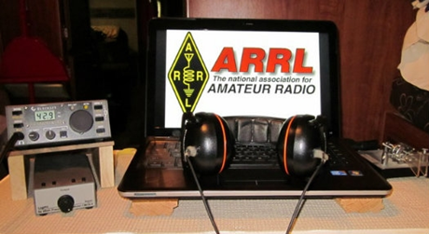*ARRL Contest Corner***

An expanded, downloadable version of *QST'*s’[**Contest Corral**](http://www.arrl.org/contest-calendar) is available as a PDF. Check the sponsor's’Web site for information on operating time restrictions and other instructions.

***Special Events***

**10/31/2020 | A Night On Bald Mountain**

Oct 31-Nov 1, 2100Z-0500Z, WA4TRS, Fairview, NC. The Road Show Amateur Radio Club Inc.. 7.250. Certificate & QSL. The Road Show ARC, 57 Echo Lake Drive, Fairview, NC 28730. Join Us, for a Night in The Cemetery on Top of Bald Mountain, don't worry there are accommodation available for YOU! Just Check the Website [roadshowarc.org](http://roadshowarc.org/)

* **10/31/2020 | Boo to You !**

**Oct 31-Nov 1, 0000Z-0559Z, KC5BOO**, Cleburne, TX. KC5BOO. 14.240. QSL. Judy Cox, 3701 Park Rd. 21, Cleburne, TX 76033. [kc5boo@yahoo.com](mailto:)

* **10/31/2020 | Halloween from Transylvania (La)**

**Oct 31, 1400Z-2230Z, K5ZRO**, Transylvania, LA. Vicksburg Amateur Radio Club. 7.270 SSB 14.270 SSB. Certificate. Malcolm Keown, 64 Lake Circle, Vicksburg, MS 39180. Info@vicksburgarc.club or [www.vicksburgarc.club](http://www.vicksburgarc.club/)

* **10/31/2020 | Missles and More Museum**

**Oct 31, 1300Z-2000Z, NC4PC**, Hampstead, NC. Hampstead Hams. 7.074 7.272 14.310 21.390. Certificate. Randy Scott KA4SQN, PO Box 117, Hampstead, NC 28443. Other frequencies: 28.460 146.520 146.820 443.550 [town.dale@yahoo.com](mailto:)

* **10/31/2020 | National World War I Museum and Memorial**

**Oct 31, 1500Z-2300Z, WW1USA**, Kansas City, MO. National World War I Museum and Memorial. 14.225 SSB 7.250 SSB 14.060 CW 7.060 CW. Certificate. WW1USA Amateur Radio Station, World War 1 Museum and Memorial, 2 Memorial Drive, Kansas City, MO 64108.

TOP^

We will be commemorating the 102nd anniversary of the Armistice, which ended the fighting in World War 1. Our operation will be inside the Museum, in the Postcard Gallery. All local and visiting hams are invited to come visit. ww1isa@theworldwar.org or [www.qrz.com/db/ww1isa](http://www.qrz.com/db/ww1isa)

* **11/01/2020 | 4th Annual 27 Lighthouses in the South West Desert**

**Nov 1-Nov 11, 0000Z-0023Z, K7LHC**, Lake Havasu City, AZ. London Bridge Amateur Radio Association. 21.300 18.145 14.250 7.250. Certificate. LBARA, P.O. Box 984, Lake Havasu City, AZ 86405. [www.lbara.org](http://www.lbara.org/)

* **11/01/2020 | KDKA 100 Year Anniversary**

**Nov 1-Nov 30, 0000Z-2359Z, W8XK, K3A/D/K**, Pittsburgh, PA. KDKA 100 Group. 14.260 14.030 7.260 7.030. Certificate & QSL. See website, for QSL and certificate, information. Special event stations Celebrating 100 years of KDKA as the 1st commercial broadcast station located in East Pittsburgh, Saxonburg and Hampton Township Pennsylvania. The special event operation is for entire month of November. Multiple Pittsburgh area amateur radio clubs will be participating. Look for special event call signs K3A, K3D, K3K and W8XK.

* **11/01/2020 | Star City of the South**

**Nov 1, 1400Z-2100Z, W4CA**, Roanoke, VA. Roanoke Valley Amateur Radio Club. 7.245 14.245. QSL. Roanoke Valley ARC, P.O Box 2002, Roanoke, VA 24009. Commemorating the Roanoke Star on Mill Mountain shining its light on the city below since November 1949 and giving the nickname "Star City Of The South" to Roanoke, VA. www.millmountainstar.com or [www.w4ca.com](http://www.w4ca.com/)

* **11/01/2020 | USCG Auxiliary 81st Anniversary**

**Nov 1-Nov 8, 0800Z-0621Z, W2G**, Freeport, NY. USCG Auxiliary Division 13 Station Jones Beach. 14.200 10.118 7.190 3.885. QSL. W2G, 3813 Verleye St , Seaford, NY 11783. USCG Station Jones Beach, NY - Maritime Operations from CG 45706 are possible. Please SASE Only for QSL. Via W2ANQ

* **11/01/2020 | Veterans Day**

**Nov 1-Nov 14, 0000Z-0000Z, N5VET**, Cleburne, TX. Club KC5NX. 14.235 14.270 14.045 7.235. QSL. Club KC5NX, 9200 Summit Court West, Cleburne, TX 76033. We will be back on the air again this year for our Annual Veterans Day Special Event. Please QSL to Club KC5NX with SASE. We will have multi operators and will be on as many bands as possible. club.kc5nx@gmail.com or <https://www.dxwatch.com/dxsd1/dxsd1.php?f=0&c=N5VET&t=dx>

***“ARES Connect”***

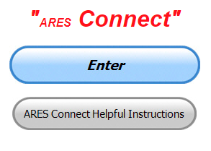

***Connecting Amateur Radio Volunteers with a Purpose***

Hey everyone… please make sure to go in and register your time to all of the events that you have signed up for. Don’t forget to get this done no later than **5 days** after the event has ended. I’m asking you to do this for our ability to run reports accurately.

TOP^

**I want to remind all of you that you do not have to be an ARES or ARRL member to use this system. All licensed amateur radio operators throughout the country are welcome and strongly encouraged to use it.**

**Don’t forget to check out the “Frequently Asked Questions” area that has been added to the Ohio Section website.** It’s there to help you through any difficulties that you may have with ARES Connect. Now, if you don’t any posts that relate to what you are having difficulties with, we now also have an on-line “Guru” area as well. This will allow you to ask any questions that you may have about ARES Connect.

**Let’s get everyone in the Ohio Section on “ARES Connect!!!” Simply go to:** <https://arrl.volunteerhub.com/lp/oh/> and get yourself registered and using the system.

***Here’s the top 10 hour earners so far in October:***

|  |  |  |  |
| --- | --- | --- | --- |
|  | **Name** | **Events** | **Hours** |
| **1** | Dwight Bonifield (W8TJT) | 117 | 154.70 |
| **2** | Dan Stahl (KC8PBU) | 126 | 152.60 |
| **3** | Leo Dubois, Jr. (KE8OOS) | 57 | 98.95 |
| **4** | Greg Dersarkisian (KD8SSJ) | 17 | 93.70 |
| **5** | Christopher Domenick (KC8CAD) | 25 | 84.55 |
| **6** | Bret Stemen (KD8SCL) | 20 | 82.50 |
| **7** | Ron Wilch (KE8PX) | 113 | 82.00 |
| **8** | James Yoder (W8ERW) | 15 | 78.01 |
| **9** | John Hilliard (W8OF) | 18 | 70.00 |
| **10** | Michael Lacumsky (W8MAL) | 58 | 67.95 |

**There has been a change within VolunteerHub that effects the use of emails within ARES Connect.**

The changes are as follows…

1. Users will now have the option to “Opt-Out” of 3 different types of emails that the system generates (see below)
2. Email bounces are now tracked. This doesn’t really mean much to most that have a legit email as that this only effects emails that bounce. This is a bit of a technical term that email servers’ use. They are broken down to 2 categories “Soft” and “Hard”

“Soft” is simply that the server was busy at the time the email came through and it caused the email to bounce. It also can be that the user’s email is full. Either way, it is a legit email, and it was an anomaly that it bounced.

“Hard” is when the email address is no longer available or never existed. This happens a lot to our @arrl.net accounts when a person doesn’t renew his dues. The account is suspended, and any email sent to that account is bounced back to the sender email server as a “No Longer A Working Email”.  A “Hard” bounce will now cause VolunteerHub to delete the listed email in a user’s account. This will mean that when the volunteer goes to sign-up for an event within ARES Connect and they don’t have a legit email listed, they will be forced to submit a new email.

TOP^

Here's the instructions if you want to change the way you receive emails from ARES Connect. If you are OK with what you are receiving, you don’t have to do anything. You’re all set!

To access the Notifications Settings, you need to log into the system and click on your name. This will bring up a drop-down menu. Click on Notification Settings

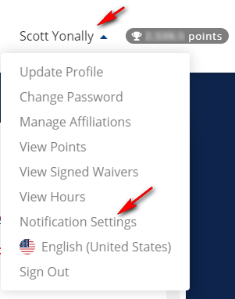

From there you will be given the option to “Opt-Out” of the following

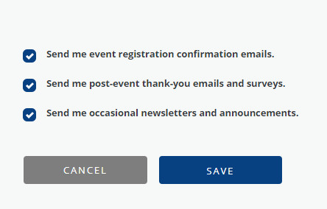

TOP^

De-select what you don’t want to get emails for and save. That’s it. These options aren’t cast in stone, so if you change your mind later, you can simply go in and click on the options you have changed your mind on and save. Please keep in mind, everything you “Opt-Out” of does have some benefits that you will no longer get.

***Emergency Communications Training 2020-21***

*(C. Matthew Curtin KD8TTE)*

If we’re to communicate “when all else fails,” we need to be prepared to operate in any condition. That’s why skills developed in antenna construction, power management, station siting, and coordinating with others are so important. We develop and exercise those skills throughout the year, and we have a lot of fun doing it.

We don’t generally treat contests and other on-air events as emergency communications training opportunities. While many of our ARES groups will say that it is training, and in fact a good part of how they train, the events aren’t often treated as part of a program of training.

Next week we’re expecting to release the After-Action Report / Improvement Plan for the Ohio Section’s participation in BLACK SWAN 20 and it will establish the basis of training priorities for the coming year. To be prepared to act on the information presented there, I want to highlight the types of training that should be taking place, and a schedule for training in the coming year.

First, the types of training. Homeland Security Exercise Evaluation Program (HSEEP) specifies a progression of training types. Initial steps are *discussion-based* and the final steps are *operations-based*. I emphasize that this is *progressive* training. One doesn’t simply “do a tabletop” and expect much good to come from it. The tabletop isn’t the first step, and without any follow up steps, there isn’t the follow through necessary to make any lessons that are learned stick.

Here is a synopsis of exercise types, presented in order. These are “terms of art,” they have precise meaning and shouldn’t be conflated. This description follows the HSEEP doctrine revised in 2020. (https://preptoolkit.fema.gov/documents/1269813/1269861/HSEEP_Revision_Jan20_Final.pdf)

1. *Seminar*. (Discussion.) This is a presentation, where one speaker is sharing information with a group, perhaps introducing a procedure or set of procedures.
2. *Workshop*. (Discussion.) This follows a seminar but instead of just being one person to a group, workshops are groups to groups, often producing a product of some sort. Where a seminar might introduce a framework for a set of procedures, a workshop would include each participating group to work together to create a draft of their procedures.
3. *Tabletop*. (Discussion.) These exercises bring people together to talk their way through a scenario. Using the standards available, ideally those introduced through seminar and made actionable in a workshop, the players resolve the problems before them and get a sense of how well the standards will support resolution efforts.
4. *Game*. (Disussion.) Like tabletops, games involve discussion through scenarios, but go a step further, where actions have consequences that are either scripted ahead of time or decided dynamically and impact subsequent decisions. Games can also be held in competitive (as well as “semi competitive” or “noncompetitive”) forms.

TOP^

1. *Drill*. (Operations.) This is the first activity in the progression that is hands-on. Focus is on a specific function or capability, locally, where the process is validated. This is good for addressing new procedures, policies, and equipment, as well as maintaining skills and preparing for more advanced exercises.
2. *Functional Exercise*. (Operations.) In these exercises, organizations can exercise multiple functions, interdependent groups of activities, to see how the parts all work together. This includes the command and control functions, as well as the specific tasks needed to achieve operational objectives.
3. *Full Scale Exercise*. (Operations.) This is the largest of the exercise types, where the complete process is exercised, including across organizations. BLACK SWAN is a Full Scale Exercise, sponsored by an agency of the State of Ohio, joined by other state, as well as local, and federal players, and their partners.

Second, we look at the training opportunities before us. This is not a complete list, and the work being done in government agencies and by the Ohio Section does not take the place of local training. The Ohio Section does not push local training down into the counties; the Ohio Section provides resources that can be requested by District Emergency Coordinators or local Emergency Coordinators (EC). All ARES activity is overseen by the local EC: the EC must ask for help to get it. If you are interested in having training brought to you, *please ask*. We’re happy to help.

Looking at the year ahead of us we can see several well-published opportunities for emergency communications training as part of fun and focused events that we are normally undertaking. Let’s have a look at some of the big ones in Ohio. Think of this as “save the date” and notice to start thinking about what might make sense for you to do locally.

1. *VHF+ Contest, January, Second Saturday*. Our focus is to make contacts at 50 MHz and up. Why not look at how you can make VHF work for emergency communications? Try establishing a VHF net with stations spread around the county, or coordinated with other counties in district to see how many stations you can get joined into the net, along with a six-digit grid? Why not use the net for spotting to help stations make contact with one another?
2. *NVIS Day, April, Fourth Saturday*. Just as with the VHF+ Contest, how about establishing several NVIS stations around the county, coordinated ahead of time, where everyone will report the types of antennas that they’re using, and exchange signal reports with different antennas to see what works best under which conditions? How about building up a map of stations able to join nets? How about keeping track of which stations can be heard at which frequencies at different times of day? Why not include a local VHF component like established in January to help with spotting or other coordination?
3. *Field Day, June, Fourth Weekend*. This is an opportunity to show amateur radio. Look at all of those points for safety officers, visits from emergency management and public officials, and for emergency power! How about working with your local served agency to establish a 24-hour operation that demonstrates the use of ICS to bring amateur radio into service for the agency? Can you coordinate with the local CERT to establish the boundaries and manage visitors to the site? Can you engage CERT to perform some simulated task like damage assessment that will result in additional points for your Field Day operation, perhaps by using a free VHF station at an EOC?
4. *SET, October, First Weekend*. This is “the big one.” Everything comes together here, including activation, scheduling, operation, and measured performance. Nothing fundamentally new should be happening here: this should be making use of procedures developed and exercised throughout the year.

TOP^

If you look at this schedule, you’ll see fairly regular operation throughout the year, but only four times. January is the smallest and most focused on-air event in the series. NVIS Day brings in the additional complexity of HF and different types of propagation, the sort of thing that changes throughout the course of a day.

Field Day introduces working with agencies and the public. SET brings it all together. Look at this as a progressive schedule, and then you can see what might make sense for you to focus on for your own seminars, workshops, tabletops, games, and drills to conduct in the months between. If there’s something that you do well *let us know!* We want to share your expertise with others in the Section. If there’s something you’d like to do better *let us know!* We want to connect you with others who have that skill, procedure, or experience.

Watch for the BLACK SWAN 20 AAR/IP, where we’ll identify the relative strengths and weaknesses of our performance this year, establish priorities for training, and an improvement plan that will make the most of these events to give every volunteer from rank newbie to sixty-year veteran an opportunity to learn, share, and have fun, all while helping to make Ohio’s communities safer and more resilient.

***One Question Questionnaire***

Hey Gang,

Survey Says”….. about 2% of you will be upgrading this next year. We also found out that 74% of you already have your Extra! This is fantastic!

Ok, now since this is the Halloween Edition, we have to ask a question about this ghoulish time of the year. So, here goes….

***“Have you ever experienced a Paranormal experience that you just couldn’t explain??”***

You’ll find the “One Question” questionnaire on the Ohio Section Website! <http://arrlohio.org> It’s all in fun and it’s not a scientific survey in any way, but we are learning some things that we didn’t know from these questions. I hope that you are enjoying answering these “One Question” questionnaires.

*****V.E. Test Sessions***

Many V.E.’s have decided to start testing once again, but with restrictions that need to be adhered to for sure. Here’s the link to find that V.E. Test session and what is expected of YOU before going. <http://www.arrl.org/find-an-amateur-radio-license-exam-session>

Hey Gang… have you seen the latest information about V.E. Testing from the ARRL?

Here’s a link.. <http://arrl-ohio.org/club_news/Oct-20/ARRL%20VE%20Newsletter%20October%202020.pdf>

####

TOP^

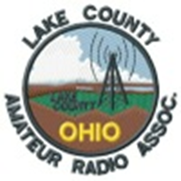

Scott, KO8O, and his team will be holding a VE Testing session on **Saturday, December 5th**, at the Lake County History Center.

For more information please visit:    <https://www.lcara.org/ve-testing/>

***Website Stats for arrl-ohio.org***

Unique visitors Number of visits Pages Hits Bandwidth

Total 36,118 72,329 3,156,876 8,558,402 231.31 GB

***From The South 40***

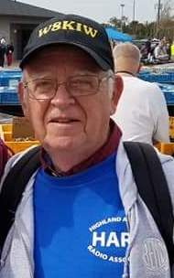*(from John Levo,* [*W8KIW@arrl.net*](mailto:W8KIW@arrl.net)*)*

The Highland ARA will conduct a Laurel test session on Saturday, November 7 at the Highland County EMA Office in Hillsboro. It begins at 1 pm. Pre-registration is required. Contact Tom Mongold, KD8LDS, for more information at 937-272-4207. The Greater Mason County ARA’s VE Coordinator Greg Taylor, KY4OD, announces the Club will conduct an ARRL license exam on Saturday, November 21 at the Mason County Technical College in Maysville, KY. It will start at 10 am.

After polling the members of the Southern Ohio ARA, President Tim Nicely decided to cancel last week’s scheduled in-person meeting because of COVID-19 member concerns. Because of the continuing health crises, the Club will conduct its November via Zoom with details about participating forthcoming. Athens County ARA President Eric McFadden, WD8RIF, tells us the Club’s October 20 meeting was held via Zoom with a number of topics discussed.

On Monday evening’s Highland ARA two-meter net, President Jeff Collins, KD8VUY, announced he received official word the Club’s application to become the ARRL’s newest Special Service Club had been approved by Newington. According to Ohio Section Manager Scott Yonally, N8SY, Ohio now leads the nation with the number of SSC designated clubs. However, Scott also calls attention to the number of clubs that have not renewed their Affiliated Club status. Several of them are in Southern Ohio. Why not check the ARRL club website and hopefully not find your club among them?

TOP^

We want to send our congratulations out to the Southern Ohio Amateur Radio Association (SOARA) for getting the Special Service Club designation renewed for another 2 years with the ARRL. I mentioned earlier about making sure that your Affiliation has been taken care of, and while you’re doing that, if your club is/was and SSC, make sure that this is renewed as well.

Blanchester Radio Club member Don Gephart, KC8BHB, reports the club has cancelled all remaining meetings and activities because of the COVID-19 and concerns about their member’s health. They hope this pandemic gets behind them so they can restart their gatherings and their show and tell programs.

Thanks to Kim Paquette, N8YWX for letting us know the Adams County’s DeForest ARC held their October 8 meeting over the 147.00 Cherry Fork repeater. It was decided the December meeting will also be over the air. According to club president KB8OMG the upcoming elections were also a topic of discussion with voting to take place via the mail.

For the past few weeks, I’ve been receiving inquiries about hamfests and flea markets still planning to be held in the coming months. Unfortunately, with the cancellations of the Sunday Creek ARF’s Nelsonville affair as well as the Grant RC hamfest at Georgetown I do not know of any still planned in the Southern Ohio region. I understand the big show in Fort Wayne is also not going to happen this November. Cave City and Mansfield might be the first ones on the horizon.

A special shout out to new Ohio Section Journal reader KJ8I, Bill “Vondon” Applegate from Peebles. For those of you who do not recognize the call, Vondon’s reputation is known far and wide as the former net control for the old 75-meter 3898 Traders Net. And he is also known as the major victim of the “sewer line explosion” at the old HamVention site in Dayton. It was beneath his flea market space where the contents of the pipe decided to raise to the surface. We locals still kid him about the experience and he just takes it in stride. I think he and sidekick Larry Chapman, Greenfield’s NE8V, used to hit most hamfests in the Eastern US and knew every good bar b que joint South of the Mason Dixon.

Congratulations go to Stephanie Santoro who traveled from Columbus to Athens on Monday evening to attend the Athens County ARC’s test session. According to Jeff Slattery, N8SUZ, her trip was fruitful as she returned home with a CSCE for a Technician license. Slattery further states this is the final scheduled test session for 2020. The next one should be in March.

Broadcasting will observe its 100th anniversary next month. Pittsburgh’s KDKA is often credited being America’s first broadcast station due to broadcasting the results of the November 2, 1920 Harding-Cox presidential election. However, there were at least three other stations that did so. But did you know that KDKA did not exist on that date and amateur radio was originally involved? In fact, the station did not use the KDKA call letters until two days later!

The radio equipment was owned by Westinghouse and used as a radiotelegraph link between Pittsburgh and a plant in Cleveland along with others. Prior to the election plans were made with the American Radio Relay League to broadcast the returns using amateur radio station 8XK. But plans were changed when government authorities gave a “special amateur grant” to Westinghouse to use the call 8ZZ and a 545 kc. frequency. And as it is said “the rest is history”.

TOP^

***Final.. Final..***

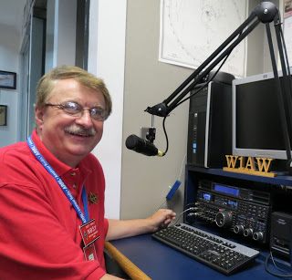Hi Gang,

Wow… The beauty of this time of year is really indescribable for sure. I love this time of year for all the rich colors and wonderful things that it brings. Even though we are in the middle of a pandemic where you can really do much, getting out into the woods and just taking in all the beauty that is there is really refreshing and definitely re-generating for sure.

This past week I attended several in-person club meetings and a bunch of on-line ones, so it’s been another busy week, but I love the fact that all of us are starting to socialize much more than we did just 2 months ago. We still have to keep our distance (2-meters) and wash our hands very frequently, but with this added precaution we are able to get back to a somewhat normal routine.

I want to give a “shout-out” to the Highland Amateur Radio Association for becoming a Special Service Club this past week as well. Congrats to them and all the hard work that they do for their community. It’s well deserved for sure!

I hope that you’ve seen the changes to ARES Connect email system. If you have questions please feel free to contact me about them. I was again in contact this past week with VolunteerHub on a few other items that we need changed to make this system even better. They have agreed that those suggestions need to be sent to the top of the list for changes to be made and hopefully they will be forth coming. I did get to do a little more training and instruction with some folks in the southern part of the country this past week as well. I’m looking forward to seeing their reports being generated from this system very soon.

Have you taken the time to check out the reports that are on-line? These reports are there for you. Take advantage of them to boost up your training as well as your ham radio participation! Here’s a link to just one of the reports… <http://arrl-ohio.org/SEC/reports.html>

Whelp, that’s going to do it for this week my friends! I need to get out and mulch up some of the millions of leaves from all my maple trees. I’m still looking forward to visiting with all of you live or via Zoom, WebEX or whatever.

I really can’t wait for that time when we can all get together in person once again. Those are the times I cherish the most!!! Stay safe! We will get through this and when we do, we’ll have so much to talk about. Most of all… have FUN and get on the airwaves!!

73,

[***Scott, N8SY***](mailto:n8sy@n8sy.com)

TOP^

***“Swap & Shop” on the website***

Hey Gang,

Have you taken a look at the **Swap & Shop** page on the Ohio Section webpage yet?? Here’s a link that will take you there…

<http://arrl-ohio.org/sm/s-s.html>

Do you have equipment that you just don’t need or want anymore? Here’s a great venue to advertise it, and it’s FREE!!

Is your club doing a fund raiser to help raise money? After a lot of thought, it was decided that the Swap & Shop webpage could also contain these types of items as well.

The same rules will apply as do for the For Sales and Give-A-Ways and will only be posted for a month at a time. Please see the Terms & Conditions on the webpage.

If your club is doing a fund raiser and wants more exposure, please forward the information to me and I’ll advertise it on the Swap & Shop webpage for you. Now, I still want to remind you that it won’t be listed in this newsletter because it would take up way too much space, so your ad will only appear on the website. It is there for any individual to post equipment Wanted / For Sale or Give-Away as well as for Club Fund Raisers. No licensed vehicles/trailers or business advertising will be posted.

Postings are text only (no pictures or graphics) will be posted for a maximum of 1 month from date posting and require a contact phone number or email within the posting. Send your Wanted / For Sale or Give-Away post to:  [swap@arrlohio.org](mailto:swap@arrlohio.org)

***Want to Share your Club Newsletter With Others?***



We have a webpage where you can download and read all of the newsletters that I get from around the state and even other sections!

Here’s the link to the page…. <http://arrl-ohio.org/club_news/index.html>

Please, if you don’t see your club newsletter posted, it’s because I’m not receiving it. Just have your newsletter editor contact me and I’ll get your club’s newsletter listed on the site!!

We all learn and steal (I mean, share) from each other’s work. So, get me your newsletter!!! Send it to: [n8sy@n8sy.com](mailto:n8sy@n8sy.com)

TOP^

***Back Issues of the PostScript and Ohio Section Journal***



Hey, did you know that PostScript and Ohio Section Journal (OSJ) are archived on the website? You can go back and look at any edition simply by clicking:

<http://arrl-ohio.org/news/index.html>

Ohio Section Cabinet

|  |  |
| --- | --- |
| Section Manager – Scott Yonally, N8SY | Assistant Section Manager – John Perone, W8RXX |
| Section Emergency Coordinator – Stan Broadway, N8BHL | Section Traffic Manager – David Maynard, WA3EZN |
| Technical Coordinator – Jeff Kopcak, K8JTK | Affiliated Clubs Coordinator – Tom Sly, WB8LCD |
| State Government Liaison – Bob Winston, W2THU | Public Information Coordinator – John Ross, KD8IDJ |
| Section Youth Coordinator – Anthony Lascre, K8ZT | |

***Halloween***

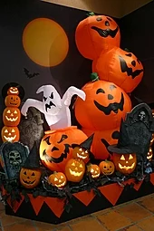Or Hallowe'en (a contraction of Hallows' Even or Hallows' Evening), also known as Allhalloween, All Hallows' Eve, or All Saints' Eve, is a celebration observed in many countries on 31 October, the eve of the Western Christian feast of All Hallows' Day. It begins the three-day observance of Allhallowtide, the time in the liturgical year dedicated to remembering the dead, including saints (hallows), martyrs, and all the faithful departed.

One theory holds that many Halloween traditions originated from ancient Celtic harvest festivals, particularly the Gaelic festival Samhain, which may have had pagan roots and that Samhain itself was Christianized as Halloween by the early Church. Other scholars believe, however, that Halloween began solely as a Christian holiday, separate from ancient festivals like Samhain.

Halloween activities include trick-or-treating (or the related guising and souling), attending Halloween costume parties, carving pumpkins into jack-o'-lanterns, lighting bonfires, apple bobbing, divination games, playing pranks, visiting haunted attractions, telling scary stories, as well as watching horror films.

In many parts of the world, the Christian religious observances of All Hallows' Eve, including attending church services and lighting candles on the graves of the dead, remain popular, although elsewhere it is a more commercial and secular celebration. Some Christians historically abstained from meat on All Hallows' Eve, a tradition reflected in the eating of certain vegetarian foods on this vigil day, including apples, potato pancakes, and soul cakes.

TOP^

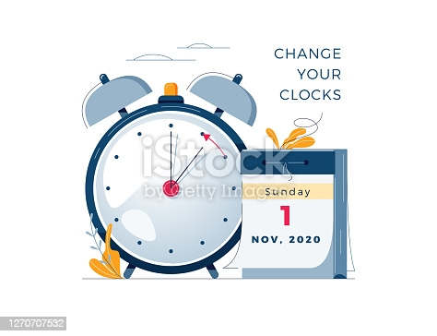***Turn Your Clocks Back 1 Hour***

Hi Gang,

Yes, that’s right, it’s that time once again to gain back that hour of sleep that you lost earlier this spring. A lot of us didn’t even notice it this year since we were already home due to COVID-19 shutting everything down, so it didn’t hurt quite as much as it usually does.

But now it’s time to gain that hour back!!! So, at precisely 2am on

November 1st you are turn all of your clocks back one hour!!! I do want you to be careful when doing this however!! Please, don’t run into any witches or goblins along your path to your clocks!!!

***Chit – Chat, and All That!***

Do you know someone that’s not getting these Newsletters? Please, forward a copy of this Newsletter over to them and have them “[Opt-In](mailto:Opt-In)” to start receiving them. Heck just have them send me an email [n8sy@n8sy.com](mailto:n8sy@n8sy.com) and I’ll get them added to the Ohio Section Emailing list.

We now have many thousands of readers receiving these newsletters weekly. Quite impressive, I’d say! I urge all of you to make sure that everyone, regardless of whether they are a League member or not, get signed up to receive these weekly Newsletters.

You can always “Opt-Out” at any time if you feel this is not what you were expecting. It’s fun and very informative. All of your favorite past newsletters are now archived too.

You can go back at any time and read them. Just go to: <http://arrl-ohio.org/news/>

Got questions, concerns or would just like to sit and chat awhile? Heck, I’ll even buy the coffee!! Give me a call at (419) 512-4445 or email me at: [n8sy@n8sy.com](mailto:n8sy@n8sy.com)

The pictures on the front page and throughout this newsletter are from various newsletters, Facebook posts and/or were sent directly to me in recent weeks. Take a good look at them, you just might be in one of the pictures! “SMILE… you’re in the Ohio Section News!!”

TOP^

*The Ohio Section Journal (OSJ) is produced as a comprehensive look at all the programs within the Ohio Section. I sincerely hope that you have enjoyed this edition of the* *OSJ and will encourage your friends to join with you in receiving the latest news and information about the Ohio Section, and from around the world!*