***[](http://arrl-ohio.org)July Edition***

|  |  |
| --- | --- |
| 🡪 From the Technical Coordinator | **🡪** From the Section Emergency Coordinator |
| 🡪 From the Affiliated Club Coordinator | **🡪** From the Public Information Coordinator |
| 🡪 From the Section Youth Coordinator | **🡪** From the Section Traffic Manager |
| 🡪 ARES Training Update | **🡪** National News |
| **🡪** The Handbook Give Away | 🡪 Club Corner |
| 🡪 Hamfests | 🡪 DX This Week |
| 🡪 One Question Questionnaire | 🡪 ARES Connect |
| 🡪 VE Testing | 🡪 Final.. Final.. |
|  | |

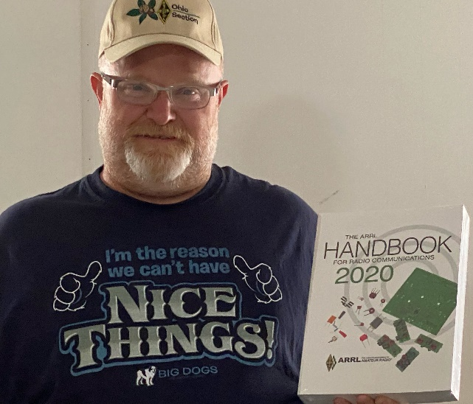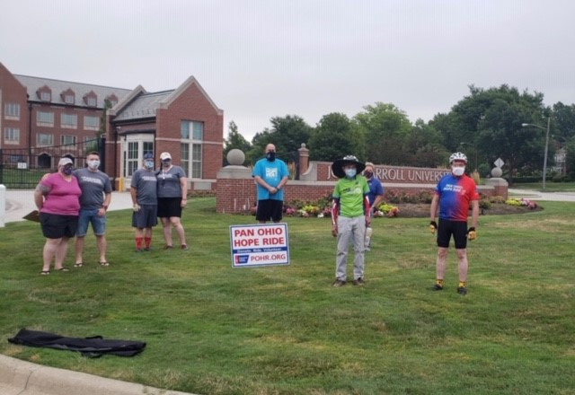

***From the Technical Coordinator***

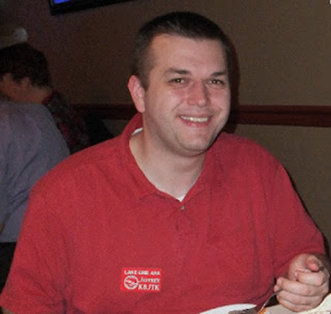***Jeff Kopcak – K8JTK TC***

[k8jtk@arrl.net](mailto:k8jtk@arrl.net)

Hey gang,

Since its release, the Raspberry Pi 4 has had a couple problems. It’s not the first device in the lineup to have hardware problems. Raspberry Pi devices are single-board computers that are about the size of a credit card. The smaller Raspberry Pi Zeros are about the size of a 9-volt battery. Created to foster Computer Science in schools, they have become very popular with robotics, weather monitoring, and even ham radio. Size makes these devices very portable, they draw minimal power, and cost anywhere from $10 - $75 for a high-end model. In addition, they are capable of running Linux which makes them a great substitute for single applications or toying around with Linux - versus using older PC hardware consuming more power.

Dubbed the [Xenon Death Flash](https://www.raspberrypi.org/blog/xenon-death-flash-a-free-physics-lesson/), electromagnetic radiation penetrated the wafer-thin packaging of an on-board chip responsible for switching regulation. Taking a flash picture of the Pi would cause the entire board to shut down. A Power over Ethernet (POE) Hardware Attached on Top (HAT) module had major [power fluctuations and delivered significantly less power](http://linuxgizmos.com/refund-offered-for-raspberry-pi-poe-hat-due-to-power-issues/) to the USB ports than normal. The POE HAT was delivering 200mA. 500mA is standard through a USB 2.0 port.

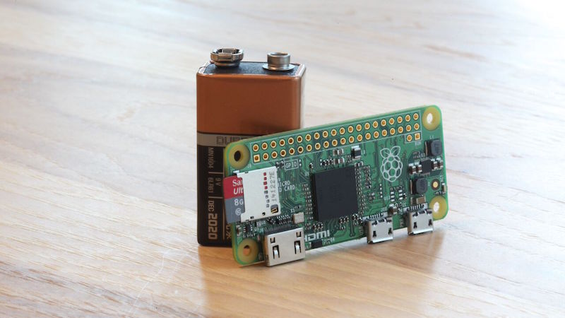

Raspberry Pi Zero and 9V-battery (lifehacker.com)

This time around, the Pi 4 lineup was released but not all the necessary drivers were made available in the official Raspbian Operating System. A minor annoyance. This is an easy fix in software and corrected shortly after release.

The issue that received all the press: USB-C power port on the Pi 4 [didn’t follow published specifications](https://arstechnica.com/gadgets/2019/07/raspberry-pi-4-uses-incorrect-usb-c-design-wont-work-with-some-chargers/). [USB-C connector](https://en.wikipedia.org/wiki/USB-C) is a symmetrical connector meaning it is reversible. Designed to deliver high power for charging, digital audio, digital video, and high-speed data. Android users are familiar with these connectors as phones in the last 4 years utilize USB-C replacing the Micro USB connector. Popular on PC docking stations as it allows the laptop to be charged while driving multiple HD monitors, including audio, utilize high speed Ethernet, and regular USB connections – all at the same time. E-marked (or electronically marked) cables will connect more of the 24 pins found in the USB-C connector unlocking features like additional power. These cables are found on power supplies of advanced devices such as Apple MacBooks and other laptops. These USB-C E-marked cables were a problem for the Pi. Non-E-marked cables worked fine.

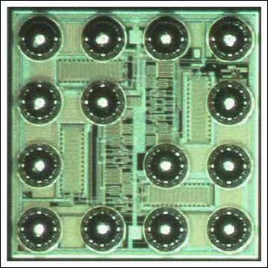

Die resposible for the Xenon Death Flash in the WL-CSP package, enormiously magnified (raspberrypi.org)

In February, it was officially announced that a [fixed model was available](https://www.theregister.co.uk/2020/02/21/pi_4_fixed/) for the USB-C problem. How do you tell which board has the fix? That’s a little more complicated. Speculation is that board version 1.2 is the fixed revision. If you feel up to modifying an existing board by hand, [that can be done too](https://www.raspberrypi.org/forums/viewtopic.php?t=249975#p1526692) (insert standard disclaimers here). Best advice was to get a newer board and try it with an E-marked cable. *Good going, guys.*

TOP^

That’s it, right? Not so fast. I found a post over at Hackaday that reported cranking up the HDMI resolution [jammed the Pi’s own Wi-Fi](https://hackaday.com/2019/11/28/raspberry-pi-4-hdmi-is-jamming-its-own-wif). Using a display resolution of 2560x1440 ([QHD](https://en.wikipedia.org/wiki/Graphics_display_resolution#2560_×_1440_(QHD,_WQHD)) resolution), the Wi-Fi drops out. At that resolution, the Pi emits noise in the range of Wi-Fi channel 1. Using a different channel might work but causing unnecessary RFI to other Wi-Fi users is unacceptable. The Raspberry Pi Foundation acknowledged the issue and issued a firmware update a few weeks later. Update the Pi using: **sudo rpi-update** at the command line if you haven’t done so in the last number of months.

I get it, designing things is hard especially devices that cost $35 and USB-C specifications running 329 pages. You would think the spec thoroughly covers power delivery but it does not. Consumers hope these issues would come out in testing and be fixed before they make a purchase. Working in the Information Technology field, likely these problems were observed in testing but was shrugged off as an ‘anomaly’ or ‘unable to reproduce’ or ‘affects a limited number of deployments.’ When the problem makes it into production and customers start complaining because everyone can now reproduce the problem, it gives customers a bad feeling about the device and company. Especially repeat offenders.

Unfortunately, the Great Lakes Division Convention and Toledo Hamfest was canceled in March due to the closure of the state. In my Raspberry Pi presentation, I was going to cover general tips when experiencing issues operating your Pi. They often boil-down to: crappie components. Stop buying the cheapest option overseas and expecting grade A+ performance!

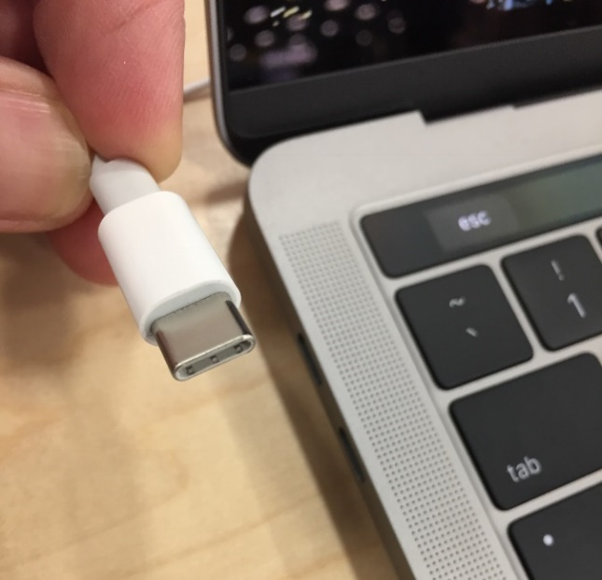

MacBook USB-C connector (wikipedia.org)

90% of the time, problems are power related. “Under-voltage detected!” in the system logs are the result of an under powered 5V power supply, one that cannot deliver consistent voltage, insufficient AWG power lines of the USB cable, or both. Early Pi’s (Pi 1) can get away with a 1A power supply. Pi 2 & 3 really need a 2A. Pi 4 need 3A USB-C. The Pi’s will only draw as much power as needed.

Everyone forgets about the USB/power cable from the supply to the Pi. Not all cables are created equal! Power supplies with wired cables can be assumed to carry the full output of the supply to the device. A power supply can output 2A but the connecting USB cable is likely limiting power delivery due to the wire gauge. For delivery of 2A to the Pi requires a cable rated 28AWG/24AWG. This is printed on the cable itself. The first specification is the data cable wire gauge (28AWG) and doesn’t matter for carrying power. The second specification (24AWG) is the power cable gauge. Unless specifically printed on the cable, cables can be assumed to be a lesser 28/28 specification. A lower number is better in this case.

This is the reason a cell phone will seem to charge slower. I had an OEM cable that came with a new cell phone rated 28/28. The phone would charge for hours. When I upgraded to a 2A power supply and a 28/24 cable, it was charged in under 90 minutes from drained. This only really apples to Android devices because they use standard connectors. Genuine Apple chargers and Lightning cables will meet Apple’s specifications for device charging.

It is hard to find the AWG rating because most sellers don’t list it. One place that does list that spec is Monoprice. This [Type-A to Micro Type-B cable](https://www.monoprice.com/product?p_id=5458) will work for a Raspberry Pi (not 4) as a replacement cell phone USB charging cable. Keep the cable as short as needed. Don’t use 15 feet when 6 will do because it will reduce the amperage that reaches the device.

TOP^

Crashes and SD card corruption problems are often attributed to bad power too. However, the aforementioned quality of the component itself also plays a role. Look for SD cards with lots of positive ratings. Most often recommend are SanDisk SD cards. I’ve had no reliability issues with G.Skill cards either. Quality 32GB MicroSD cards are under $10 these days. Validate the card is at least “class 10” which is usually signified on the card itself by a “C” and a “10” in the middle of the C. They come in classes 2, 4, 6, 8, or 10 - with 10 being the fastest. UHS (Ultra High Speed) cards are on the market and are slightly more expensive at over $20 for a 32GB UHS-3. UHS will have a “U” with a “1” or “3” in the middle. Class 10 and UHS 1 [are equivalent](https://kb.sandisk.com/app/answers/detail/a_id/1996/~/difference-between-speed-class%2C-uhs-speed-class%2C-speed-ratings-(performance)) in write speeds at 10MB/s.

Pi 4 generates significantly more heat than their predecessors. I’ve heard estimates of 50% more heat is generated while idle compared to the Pi 3. Many cases include a fan which is a moving component that could fail and be a problem if the device is at a hard-to-reach location. Heat sinks are an alternative, assuming decent airflow. The Raspberry Pi Blog includes [tips and updates to lessen CPU temperature](https://www.raspberrypi.org/blog/thermal-testing-raspberry-pi-4/).

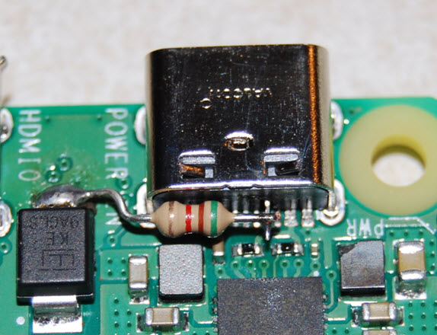

Raspberry Pi 4 USB-C power port modification (raspberrypi.org)

Does your project require the latest and greatest Pi board? Consider the project. Will all that processor power and memory be utilized? An upgrade to a USB-C power supply is required for power and micro-HDMI cables/adapters if you plan to connect a monitor to a Pi 4. It may come down to price. I see many places currently charging more for the Pi 2 and Pi 3 than a 4. Pi 2 is sufficient for headless wired Ethernet applications. Pi 3 if a little more CPU or Wi-Fi/Bluetooth features are needed.

Pi 3 and 4 boards include a 64-bit processor. As of this writing, the Raspberry Pi foundation has not made an official 64-bit Operating System release. Though a [beta is available](https://www.raspberrypi.org/forums/viewtopic.php?f=117&t=275370). The Pi 3 boards have been out since February 2016 and the Pi 4 boards since June 2019 – and there’s still no official 64-bit OS? A 32-bit OS can only address 4GB of RAM (4,294,967,296 possible addresses) and no Pi had more than 4GB. Other images for the Pi have taken advantage of the 64-bit processor. The Pi foundation still recommends the 32-bit OS for all Pi devices.

An [announcement at the end of May](https://www.raspberrypi.org/blog/8gb-raspberry-pi-4-on-sale-now-at-75/) unveiled a new Pi 4 addition, an 8GB RAM version for $75. Some minor improvements were made but the device is basically the same as the other Pi 4 versions. A 64-bit OS will be needed to address all 8GB of RAM though. In the same announcement, the official Raspberry Pi Operating System images are now renamed to “Raspberry Pi OS.” It will no longer be referred to as “Raspbian” though the name will probably stick around out of habit. The name change will likely be gradual over time. A card I burned with the new Raspberry Pi OS still referenced Raspbian in /etc/os-release.

Next time I’ll talk about (mostly) ham radio things you can do with the Raspberry Pi.

**Thanks for reading and 73… de Jeff – K8JTK**

TOP^

***From the Section Emergency Coordinator***

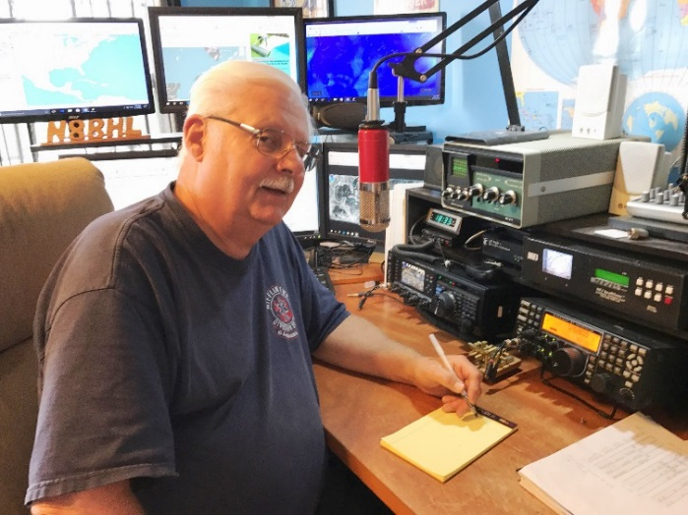***Stan Broadway, N8BHL - SEC***

[broadways@standi.com](mailto:broadways@standi.com)

***What can we offer?***

Our served agencies (EMA, Law, etc.) have learned a lot over the years about the need for robust communications! These days, although all the eggs are in one big ‘basket’, there is a focus on backups and strength. So if you were to walk into your EMA Director’s office, how would you ‘sell’ amateur radio and ARES as a system they would want to have?

**What resources do we offer?**

It sometimes is good to review why we exist, and what we can offer our partner agencies in our home County.

**We offer a lot!**

First, obviously, is easy ubiquitous voice communication for emergencies or public service. That might be simplex, or through a repeater. We also offer voice communication on HF bands if VHF and above don’t reach. We can easily talk to the Ohio EOC or any other county EOC. Using digital modes like Fusion and DMR we not only can participate in the statewide talk groups, but actually reach anywhere *in the world*!

We have the capability to send digital (computer-to-computer) communications via VHF through HF using the software fldigi. This software allows us to send FEMA, Red Cross, and other custom forms via radio. In addition, we have the capability of sending email anywhere in the world (plus or minus the Internet) by using WinLink- the proven emergency communications link. Winlink also offers FEMA, Red Cross, even Earthquake reporting forms.

**Our capabilities were tested during the Red Cross drill, and they were very pleased with the result.**

Another capability we have in many counties is the AREDN “MESH” network. This is available to send video, voice, files, and many other forms of data.

**What do we offer on the state level?**

Just as in the discussion above, Ohio ARES is very strong in being able to provide a service to the state. We can be very quick to respond to any emergency - after all, we’re already deployed because we *live* there!! We have a robust system of local nets, and a growing system of statewide nets all capable of passing message traffic.

Of course, the standard is set by the Ohio ARES HF Net (3.902) which can be activated for any emergent situation. There is OHDEN, the digital arm of ARES in Ohio, capable of transmitting various forms and messages to the state EOC and from county to county.

We have made significant advances with our “Watch Desk Project”, wherein we can use the digital modes to provide intense coverage across the entire state. We recently load-tested the capabilities by linking the DMR 3139 “Ohio Talk Group” with the Fusion statewide talk channel- allowing us to key over 200 repeaters to canvas the state.

TOP^

This will be invaluable in times of very larger severe weather outbreaks in order to report damage and sitreps to the state. This also allows the entire state to monitor the progress of the storm/ice/wind/blizzard without the static crashing on HF radio during those times. In lesser events, “The Sarge” will likely be listening to either/both statewide groups in a low-profile manner.

Something relatively new is the ability to send and receive HF WinLink messages. This is the gold standard for emergency communications around the world, and we’re now capable of participating.

Another new development is the growing capability of Buckeye Net to stage a well-organized digital net for the purpose of sending traffic. Using a voice frequency to check in and coordinate, then making use of pre-designed macros in fldigi to jump to different frequencies and modes for sending traffic, this net is capable of sending many messages at the same time. This is something we can use to lessen the burden of a high message count.

So, what keeps us sharp? Practice! Matt Curtin, KD8TTE, has been working on some pretty cool stuff for us this summer. Since we don’t have a lot of public service work to stay practiced, we’re going to be doing more ‘operating events’ and traffic exercises… just what we need to stay sharp!

So- with all of that one of our MOST important resources is-- YOU! Your capability to string together a station under emergency conditions is extremely valuable at all times! We may not receive much advanced notice, and that means we need to be able to “ad-lib” a station on the fly. That comes from practice, understanding antennas, batteries, power supplies and radio operation. We can’t do it without you, and I’m confident that we collectively have the capacity for great service!

So as these opportunities come your way, jump in! Get active with your radios, get into some new modes, and have fun all the while getting better and better at our mission of service our communities!

***Wanted:  Skilled, dedicated operators.***

The Ohio Emergency Operations Center in northwest Columbus has a well-equipped amateur station, W8SGT. “The Sarge” is activated whenever the EOC is put in high gear, and we cooperate with the “Watch Desk” to provide firsthand observations which help them shape their decisions.  To maintain the high regard for amateur radio we need to build a much larger team of skilled operators.

* General or above license
* NIMS 100, 200, 700, 800 minimum, Auxcomm desired,  300-400 a plus
* Specific operating skills (experience in two or more below):
  + Net control
  + Contesting
  + Message traffic
  + Digital communications (DMR/Fusion/fldigi/WinLink/etc.)
* Military or Emergency response a plus  (MARS, SHARES, MARCS. etc.)
* Level head, able to handle stress and high activity
* Desired: within one-hour drive to 161/315 vicinity

TOP^

* Ability to dedicate time and energy to an important program
  + Responsible for one Tuesday evening net per month, on call that week
  + training on the last Tuesday of each month
  + Ability to respond if activated
* Ability to pass background check

If you are interested, email [stan@standi.com](mailto:stan@standi.com) or [kd8phg@gmail.com](mailto:kd8phg@gmail.com).

**\*\* You can view all of the SEC’s monthly reports on the website..** <http://arrl-ohio.org/SEC/default.html>

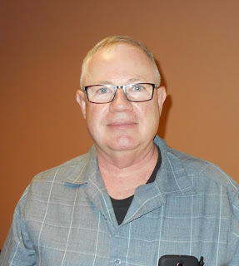***From the Affiliated Club Coordinator***

***Tom Sly, WB8LCD - ACC***

[tomsly29@gmail.com](mailto:tomsly29@gmail.com)

August 2020. Is this year ever going to end? Some say this will be the “New Normal”. I *HATE* that idea! But – “We’re all in this together” – I pretty much despise hearing that too. OK. Got that out of my system. Keep er movin.

Clubs, by definition, are places where we get together with other like-minded hams and do the activities of Ham Radio. Not being able gather as we’ve always done, we’ve found some ways to get together while still keeping our distance. The “webinar” is the big winner here. If your group hasn’t tried it yet, it’s a pretty good alternative. Lots of different platforms to choose from. We’ve used it for club meetings and board meetings. Has anyone started using them for licensing classes yet? Has anyone tried a project build via zoom?

I’ve always thought about the concept of a “virtual hamfest” – as I’m writing this, there are a couple on the horizon. First off is the DX Engineering Virtual Hamfest and DX Academy. (Probably last weekend as you’re reading this) The folks at DXE are always putting together good things to keep us hams occupied and the agenda for this presentation looks pretty interesting!

Next up is the ARRL’s QSO Today Virtual Ham Expo – August 8 & 9. (Probably next week as your reading this) It’ll be interesting to see how this works, spread out over 2 days. Either one of these looks to be very informative and entertaining. The fact that you can attend both in a 3-week period is pretty cool, and the fact that both are FREE is outstanding! Get yourself signed up – there’s some pretty good speakers and topics.

Also coming up in August is the OH QSO Party on Saturday August 22nd. Your members can operate individually, but then turn in their scores to be aggregated into a club score. Let’s see which of the OH clubs can get their members on the air and rack up some big scores. I also have to mention that Saturday September 12th is OH State Parks On The Air (OSPOTA) – get some of your club members together, outside in the fresh air (properly social distanced of course), and have some fun!

What other ways have you found to have club activities that did not require you all to be together, yet still doing the activity together?

TOP^

One of these days we will be getting together again as a club. When that happens, we’re going to need some story tellers. What if we wiped the slate clean and asked everyone to create a new story about their personal “Ham Radio” journey? I’ll give you a list of activities that you could do, on your own, even if we’re totally locked down.

You pick one, something you’ve never done before, and get it figured out. Then, take your experience and put it into a story form and share it with your own, and other clubs. If everyone did this, we’d have a whole bunch of new excitement in our clubs! Go ahead, pick one and do it!

Make satellite contacts; work Q’s with the International Space Station; find a unique place for, and operate as an “in State” DXpedition; set up and run a Special Event station; learn some digital modes (FT-8, FT-4) and make some Q’s with them; learn Morse code and get your speed up to where you can actually make some Q’s on the air; build a “home-brew” or Kit radio; get a “boat anchor radio” and restore it to operating condition; operate QRP – get a 1000-mile per watt award; start County Hunting; see how many “special event” stations you can work before we get back to normal. Most importantly – do something you’ve never done before! Operate from somewhere you’ve never gone before. Learn something new.

While we’re in lockdown you may want to consider doing some of these things: create some “open space” on the horizontal surfaces in your radio shack! Label all of your coax runs. Organize all your parts so you can find components at proper value without spending a day looking. Get the license manual, study, upgrade at the first possible exam session. Read those QST, CQ and maybe even 73 Magazine that you’ve put off until you have some spare time. Go through your stuff, toss the trash, EBAY the good stuff you have no use for anymore, inventory the rest. Staying outside, teach the neighborhood kids to build a crystal radio, teach them how to Fox-Hunt. Write an article for a magazine, or maybe your club newsletter.

Got some special skill or project? Put together a presentation, get the word out and present your program as a zoom meeting then put the digital file out as a Youtube video. Ham Radio is all about having FUN! Keep doing the activities of Ham Radio through these tough times and I promise you won’t be bored!

73,

This will all be over soon!

**73, Tom WB8LCD**

***From the Public Information Coordinator***

***John Ross, KD8IDJ - PIC***

[john.ross3@worldnet.att.net](mailto:john.ross3@worldnet.att.net)



**FROM THE PIC**

**OHIO SECTION 2020 NEWSLETTER**

**CONTEST**

TOP^



….but first a word from our judges!

Judge Steve Wilson:

“***WHEW !!! Difficult to handle newsletter judging with Covid-19, but also difficult to handle the business of putting the newsletters together. Our hats off to everyone who kept working despite the Coronavirus.”***

Our 2020 Newsletter contest was certainly different this year but we learned many new things about our newsletters and our process….more on that in a moment…let’s get right to the winners.

**1st Place…Alliance ARC – ZERO BEAT**

**2nd Place…Portage County ARS PCARS - Radiogram**

**3rd Place…TIE - Mahoning  Valley ARC -Voice Coil and Delaware County ARC -DELARA NEWS**

**4th Place…ATCO Amateur Television Central Ohio – ATCO NEWSLETTER**

Honorable Mention…**Cincinnati FM Club CFMC –** **The SPARK**

CONGRATULATIONS to our winners and to everyone… a job well done!

This was a challenging year to say the least. We made the decision for the judges not to meet in person to stay safe from the Coronavirus. We devised our first-ever ELECTRONIC judging …also known as PLAN B… and that opened up a few doors and gave us some different opportunities to consider. First, instead of having printed copies, each judge had to access the club’s website and view the newsletters from there. In the past we did this for the few clubs that had online newsletters only but now the playing field was a little different…perhaps a little more level! We were able to see the newsletters in their “natural surroundings” navigate through them and see how they appeared on-screen as opposed to on-paper.

While the newsletters were not judged on these new dynamics per say, we felt some suggestions would be in order. First, if your newsletter is accessible from your website make the button **LARGE** and predominate on the front page. This will make it easier for current members, new members and prospective members to find your newsletter quickly. Also take a look at your newsletter, not only a computer, but on a cell/smart phone as well. Sometimes the layout and navigation will not be the same or work as well on a phone screen. It’s a good idea as well to check the navigation, page turning, on your newsletter so readers can easily flip pages.

Some clubs do not attach their newsletters to their website for fear of a breach of sensitive material. If that’s the case here are a few things to consider. First, if you have sensitive information in your newsletter, you might consider sharing that with club members via regular email or mailing. If your club is a *501 (c) (3)* your information is a matter of public record and can be shared or viewed by anyone. Also remember that all of the Ohio Section newsletters are on our website and are very popular viewing by clubs around the country!

TOP^

I’m impressed what our judges did this year…adapted to a new process but kept their professional integrity intact while offering some good suggestions that will help all of us who toil as wordsmiths.

Again…CONGRATULATIONS to the winners and THANKS to all for another great contest.

**TOM DELANEY**

In case you missed the announcement this past weekend our Great Lake Vice Director, Tom Delaney W8WTD, has decided not to run for re-election.

Here’s his official announcement:

*“Greetings Great Lakes Division ARRL Members.  
  
After much consideration, I have decided not to run for re-election as Vice Director for the Great Lakes Division. It has been a privilege to serve in this capacity.  I remain committed to the ARRL and its goals  
for amateur radio.  Thanks to all who have shown me such support and encouragement over these past six years.  
  
Very 73,  
  
Tom Delaney W8WTD”*

Tom has been an ever-present factor in the success of our division and a personal inspiration for me. Every time I heard him speak, he did so from the heart, offering wisdom, guidance, advice and a friendly handshake. He made me sit up and listen to his experiences about Amateur Radio and his knowledge of our hobby is second to none.

We all have benefitted from his work and he help establish foundation for future.

**POWER DOWN**

WOW...what a month! Newsletter judging, hamfest withdrawal, and adding ham radio themed masks to my daily wardrobe!

I still hear increased activity on most bands…would be good to hear more if you’re looking for something to do.

The Hurricane Season is ramping up. Keep a close eye…and ear…on that. I’m sure Amateur Radio will be needed.

That’s it for now…BE SAFE…KEEP TALKING!

73

John E. Ross

ARRL Ohio Section Public Information Coordinator

KD8IDJ

TOP^

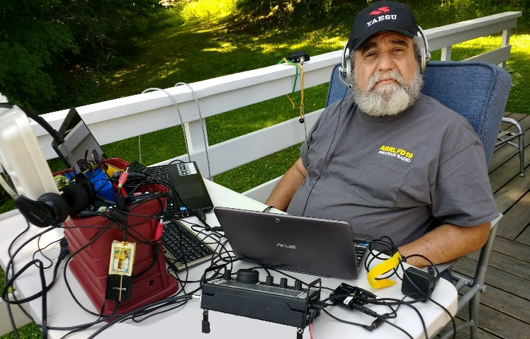***From the Section Youth Coordinator***

***Anthony Luscre, K8ZT - SYC***

[k8zt@arrl.net](mailto:k8zt@arrl.net)

***Behind the Scenes Activities of SYC***

***(Section Youth Coordinator)***

In this Spring and Summer of COVID-19, I have been spending a lot of time working on SYC activities behind the scenes:

* **New Presentation for Clubs on Youth in Amateur Radio**
* **Working with others SYCs from around the country**
  + **Creating an SYC Group**
  + **Meeting together online**
  + **Setting up a mailing list**
  + **Sharing resources**
* **Assistant Section Youth Coordinator(s) for Ohio**

**New Presentation for Clubs on Youth in Amateur Radio**

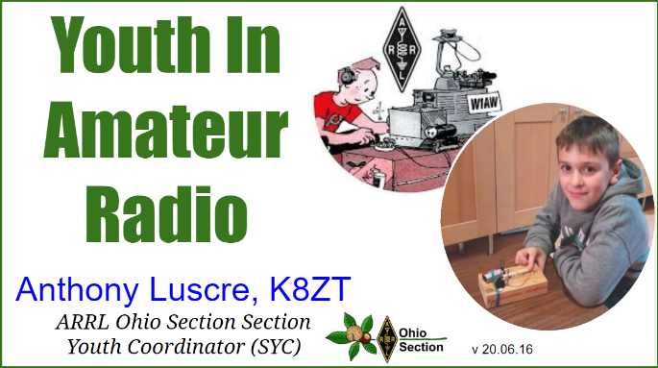

A recent writing project was a new slideshow I did for future presentations. **“**[**Youth in Amateur Radio**](http://tiny.cc/yiar)**”** is inspired by my recent article on the subject in March 2020 CQ Magazine. You are welcome to read through the slideshow and/or your club might like to book a live online presentation. It has a wide variety of ideas, tips and resources for working with youth in a number of ways involving Amateur Radio.

I will be presenting the slideshow live online for the [DXE Virtual Hamfest and DX Academy](https://www.dxengineering.com/techarticles/dxepressreleases/mark-your-calendars-for-the-dxe-virtual-hamfest-and-dx-academy-in-july?ibanner=DXEHPB2007002) July 25th. If your local club is interested in a similar presentation online please email to plan a date and time k8zt@arrl.net.

**SYCs from around the country**

Recently, I received an email from a newly appointed SYC from Florida. Grant had a number of questions about my SYC activities and SYC activities around the country. His email and subsequent phone conversation rekindle some ideas I had a few years ago about cooperation between SYCs from other ARRL Sections.

I requested a list of current SYCs from the ARRL. Armed with this spreadsheet, I began my project. The initial list showed that 38 of the 71 sections did not have an SYC listed. My first action was to inquire with Section Managers from the sections that did not have an SYC listed. This resulted in the addition of SYCs for two additional sections and another 10 sections where SYC duties were covered by another Section Staff member. Unfortunately, that still left over 25 sections with no SYC but hopefully, that will improve over time. Next, I surveyed the SYCs for a date and time that we could meet online.

TOP^

We had our first online get together of SYCs on July 16th. We discussed ways for the group to continue sharing information, including developing our own mailing list. Our agenda also included:

* Goals & Roles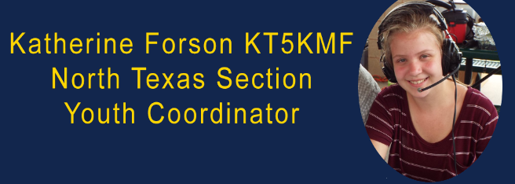
* Resources
* Issues of individual SYCs
* Resources and Sharing Resources
* Current Projects
* Specific SYCs to act as resource persons across sections for specific projects (ARISS, Teacher Institue, etc.)
* A variety of other topics

**Assistant Section Youth Coordinator**

One of the items discussed was the use and role of Assistant SYCs. This has prompted me to begin the search for one or two Assistant Section Youth Coordinators that would work with me to help support youth activities across the Ohio Section. If you are interested in this position or know someone that might be interested please email me <[k8zt@arrl.net](mailto:k8zt@arrl.net)> with information.

**Youth Activities During COVID**

The question I have received from a number of hams is what can we do about Youth Activities, interactions with schools, etc. My response is that this is a time for us to be patient in scheduling activities and instead a time for planning our future projects. One activity that I think is a good match for the current and near-future are online Amateur Radio Licensing Classes. Our local club is planning an online Technician Class later this year and we hoping to include more youth in our class. There are a number of reasons that online class may actually be a much better fit for youth than traditional in-person radio classes.

* Impediments for Youth In-person Classes
  + Hard for youth to find time & transportation for off-site classes
  + Parents leery of unknown class, instructors, locations, etc.
  + Long duration classes difficult commitment
  + Youth can be intimidated by other adult classmates

If you club is considering online courses, I suggest you look for members that might have experience in teaching online courses, working with youth, etc. If you are interested in sharing your ideas with others in the section please let me know so I can include them in future columns

That’s it for this month. Remember all of us writers for the Ohio Section Journal love to get you feedback, questions and comments so please email me [k8zt@arrl.net](mailto:k8zt@arrl.net)

**73, Anthony K8ZT**

####

TOP^

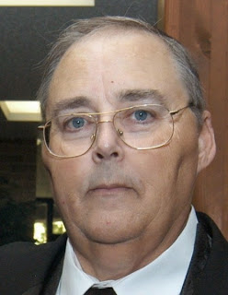***From the Section Traffic Manager***

***David Maynard, WA3EZN – STM***

[wa3ezn@att.net](mailto:wa3ezn@att.net)

Hot! Hot! Hot! As I start to write this the outside temperature here in Columbus and most of Ohio is in the 90’s with high humidity and it is stifling to be outside. The Covid-19 pandemic seems to be headed to a second peak. When I do get out and about I see many people in small groups that must think they are immune to the virus because they are not wearing masks. Not me, I may be imitating chicken little but I am going to wear a face mask pandemic hoax or not. Give it a try the life you save could be your own or one of your love ones.



With this being the new normal and a statewide directive to social distance it is not looking good for a gathering and meeting for the Ohio Single Sideband Net. During the on air discussions Mike KC8WH expressed a desire to still have a meeting. It will be up to Mike and the advisory board to determine if and when it will happen. Keep checking into the OSSBN for any updates. While on the subject check into the OSSBN and some of these fine Ohio HF traffic nets:

OHIO SINGLE SIDEBAND NET

["Specializing in the first and last mile of NTS delivery in Ohio."](http://www.ossbn.org/)

|  |  |  |  |
| --- | --- | --- | --- |
| **Morning session** | **10:30 AM** | **3972.5 KHz** | **every day** |
| **Afternoon session** | **4:15 PM** | **3972.5 KHz** | **every day** |
| **Evening session** | **6:45 PM** | **3972.5 KHz** | **every day** |

Ohio has three very fine CW nets. These nets are looking for new CW operators to check in and the Ohio slow Net is in need of a net manager. Thanks to WB8YLO for collecting the OSN net reports and sending the monthly report to the Section Traffic Manager

**OHIO HF CW TRAFFIC NETS**

|  |  |  |  |
| --- | --- | --- | --- |
| **HF CW NETS** | **NET TIMES** | **FREQUENCY** | **NET MANAGERS** |
| **Buckeye Early** | **6:45 PM** | **3.580** | **WB8YLO** |
| **Buckeye Late** | **10:00 PM** | **3.590** | **WB9LBI** |
| **Ohio Slow Net** | **6:00 PM** | **3.53535** | **NEEDED** |

All net frequencies plus or minus QRM. .

TOP^

**OHIO LOCAL VHF TRAFFIC NETS**

|  |  |  |  |
| --- | --- | --- | --- |
| **VHF NETS** | **NET TIMES** | **FREQUENCY** | **NET MANAGERS** |
| **BRTN** | **MON, WED, SAT 9:30 PM** | **145.230**  **PL 110.9** | **W8DJG** |
| **COTN** | **7:15 PM DAILY** | **146.970** | **KD8TTE** |
| **MVTN** | **7:00 PM Mon** | **146.640** | **KC8HTP** |
| **NWOHARES** | **6:30 PM DAILY** | **147.375** | **N8TNV** |
| **TCTTN** | **Sun, Tues, Wed, Fri 9 PM** | **146.94** | **WB8YYS** |
| **TATN** | **8:00 PM DAILY** | **146.670 PL123** | **WG8Z** |

These VHF net times and frequencies are those that have been reported to me by the net managers.

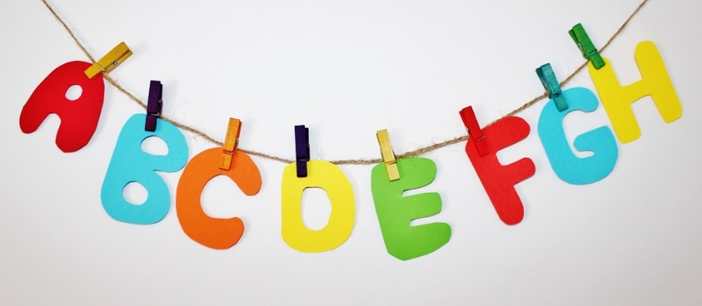

One of the first things a ham needs to learn when they get on the air is the phonetic alphabet. Because many alphabet letters sound the same over the air it is important to use phonetics when spelling out words or giving your call sign accurately. This is particularly important when checking into a radio net, which is where many hams get started.

Proper amateur radio protocol uses the International Telecommunication Union (ITU) phonetic alphabet. You are likely to hear other phonetic alphabets on the air but should learn the ITU version and use it.

|  |  |  |
| --- | --- | --- |
| 0 | Zero | ZEE-RO |
| 1 | One | WUN |
| 2 | Two | TOO |
| 3 | Three | TREE |
| 4 | Four | FOW-ER |
| 5 | Five | FIFE |
| 6 | Six | SIX |
| 7 | Seven | SEV-EN |
| 8 | Eight | AIT |
| 9 | Nine | NIN-ER |

The best way to learn phonetics alphabet is to practice. Familiarize yourself with the phonetics and then practice by spelling words out. A great way to do this is while sitting idle at a traffic light or while walking through a parking lot. Just start spelling out signs and license plates phonetically. When you see a stop sign, think “Sierra Tango Oscar Papa.”

Note that there are official pronunciations for each character and a few may seem a little odd; this is to accommodate many native languages, not just American English. There are also specific ways of pronouncing certain numbers (niner is the most obvious one) and punctuation. Be advised that the official ITU number pronunciation is very odd (a mixture of languages) and the ones shown here are more common for amateur radio usage.

I realize this may be difficult to remember when passing traffic as I myself have difficulty remembering to say fife for five and have yet to master tree for three. But after 50 years of ham radio I have struggled with this concept since it was introduced to ham radio a couple of years ago.

TOP^

|  |  |  |  |
| --- | --- | --- | --- |
| **Phonetic Alphabet** | | | |
| **A** | Alpha | **N** | November |
| **B** | Bravo | **O** | Oscar |
| **C** | Charlie | **P** | Papa |
| **D** | Delta | **Q** | Quebec |
| **E** | Echo | **R** | Romeo |
| **F** | Foxtrot | **S** | Sierra |
| **G** | Golf | **T** | Tango |
| **H** | Hotel | **U** | Uniform |
| **I** | India | **V** | Victor |
| **J** | Juliet | **W** | Whiskey |
| **K** | Kilo | **X** | X-ray |
| **L** | Lima | **Y** | Yankee |
| **M** | Mike | **Z** | Zulu |

Not so with this phonetic alphabet as hams have been using it for the whole time, I have been a ham. The “International Phonetic Alphabet” (IPA) that is adopted by the ARRL and used today has a history that goes back to the early days of radio and was formally adopted in 1927 by the the International Telecommunication Union (ITU). The alphabet has evolved since it was first adopted until what is currently used today.

Military, aviation, maritime, law enforcement, Amateur Radio, as well as other entities all use phonetic alphabets. With the exception of a large number of American law enforcement agencies, most of the world now uses the current form of the International Phonetic Alphabet. By using a standardized alphabet, a mind that has learned it will understand the unique sounds of the words even in poor receiving conditions. I know this is true because radiograms I have copied would not have been “rogered” with complicated words or addresses spelled out without phonetics.

**The National Traffic System**

The National Traffic System (NTS) is a structure that allows for rapid movement of traffic from origin to destination and training amateur operators to handle written traffic and participate in directed nets. These two objectives, which sometimes conflict with each other, are the underlying foundations of the NTS. NTS operates daily, even continuously with advanced digital links.

The personnel consist of operators who participate for one or two periods a week, and some who are active daily. The National Traffic System is an organized effort to handle traffic in accordance with a plan which is easily understood and employs modern methods of network traffic handling in general acceptance today.

NTS is not intended as a deterrent or competition for the many independently organized traffic networks. When necessitated by overload or lack of outlet for traffic, the facilities of such networks can function as alternate traffic routings where this is indicated in the best interest of efficient message relay and/or delivery.

One of the most important features of NTS is the system concept. No NTS net is an independent entity which can conduct its activities without concern for or consideration of other NTS nets. Each net performs its function and only its function in the overall organization. If nets fail to perform their functions or perform functions intended for other nets, the overall system may be adversely affected. Nets may sometimes find it necessary to adopt temporary measures to ensure the movement of traffic, and this is considered improper operation only when no attempt is made to return to the normal schedule. Nevertheless, improper operation of any NTS net is the concern of all NTS nets, and every effort should be made to assist in returning any non-functioning or improperly functioning net to its normal operation.

**Membership in NTS**

Frequently, ARRL Headquarters is asked how a net or digital node (BBS) may become a part of NTS. This usually isn't easy, because NTS is not a "club for nets" which any existing net may join at will. In addition, making nets a part of NTS is less a matter of official action than a "state of mind" of the net itself. In this connection, the following points deserve mention:

* Nets or packet nodes (BBS's) operating within ARRL section boundaries, or otherwise at local or section level, may become a part of NTS by performing the functions of such.

TOP^

* Nets whose coverage extends beyond section boundaries but within region (roughly, call area) boundaries may become a part of NTS only by foregoing their general membership and setting up to operate as a session of the region net. Such nets would act as one of that region's net sessions and would be under the jurisdiction of the region net manager appointed by ARRL. All present NTS region nets were organized specifically at the outset for NTS region coverage.
* HF digital stations capable of storing-and-forwarding NTS messages in a system of such stations may be certified as NTS Digital Relay Stations by NTS Officials known as Area Digital Coordinators. They are responsible for handling NTS traffic to the same high standards as their counterparts in the traditional system.
* Since operation at the area level is so specialized, it is not possible for nets whose coverage extends beyond region boundaries to be a part of NTS at any level.
* Any net or digital node which becomes a part of NTS is expected to observe the general principles of NTS procedures.
* Generally speaking, participation in NTS is best performed by individual-station participation in an already-existing NTS net, at any level.
* Lack of recognition as an NTS net does not imply that such a net is without ARRL recognition or support. Many public service nets on which information is received are included in the League's on-line *Net Directory*, and activities are often summarized in the appropriate part of the ARRL Web. Although NTS is the League-sponsored organization for systematic traffic handling, it is far from being the League's only interest in public service communication.

**Mode**

The National Traffic System is not dedicated specifically to any mode or to any type of emission, nor to the exclusion of any of them, but to the use of the best mode for whatever purpose is involved. The aim is to handle formal written traffic systematically, by whatever mode best suits the purpose at hand. Whether voice, NTSD, CW, RTTY, AMTOR, packet or other digital mode is used for any specific purpose is up to the Net Manager or managers concerned and the dictates of logic. There is only one National Traffic System, not separate systems for each mode. Modes used should be in accordance with their respective merits, personnel availabilities and liaison practicalities. Whatever mode or modes are used, we all work together in a single and thoroughly integrated National Traffic System.

**Explanation of Precedence’s and Handling Instructions**

All messages handled by Amateur Radio should contain precedence’s -- that is, an evaluation of each message's importance, made by the originating station. A precedence is an "order of handling." There are four precedents in the ARRL message form: Emergency, Priority (P), Welfare (W) and Routine (R), in that order of handling. When and as they appear on a net or any other kind of circuit, messages will be handled in this order.

**Emergency**

Any message having life and death urgency to any person or group of persons, which is transmitted by Amateur Radio in the absence of regular commercial facilities. This includes official messages of welfare agencies during emergencies requesting supplies, materials or instructions vital to relief to stricken populace in emergency areas. During normal times, it will be very rare. On CW, RTTY, AMTOR and packet this designation will always be spelled out. When in doubt, do not use this designation.

**Priority**

Use abbreviation P on CW, RTTY, AMTOR and packet. This classification is for important messages having a specific time limit, official messages not covered in the emergency category, press dispatches and emergency-related traffic not of the utmost urgency.

TOP^

**Welfare**

This classification, abbreviated as W on CW, RTTY, AMTOR and packet, refers to either an inquiry as to the health and welfare of an individual in the disaster area or an advisory from the disaster area that indicates all is well. Welfare traffic is handled only after all emergency and priority traffic is cleared. The Red Cross equivalent to an incoming Welfare message is DWI (Disaster Welfare Inquiry).

**Routine**

Most traffic in normal times will bear this designation. In disaster situations, traffic labeled Routine (R on CW, RTTY, AMTOR and packet) should be handled last, or not at all when circuits are busy with higher-precedence traffic.

The precedence will follow, but is not a part of the message number. For example, a message may begin with NR 207 R on CW, "Number Two Zero Seven, Routine" on phone.

**Handling Instructions**

Handling instructions (HX) are less used but quite useful in handling messages. They serve to convey any special instructions to handling and delivering operators. This "prosign," when used, is inserted in the message preamble between the precedence and the station of origin. Its use is optional with the originating stations, but once inserted is mandatory with all relaying stations.

The following definitions apply:

* ***HXA***--(Followed by number) Collect landline delivery authorized by addressee within *X* miles. (If no number, authorization is unlimited.)
* ***HXB***--(Followed by number) Cancel message if not delivered within *X* hours of filing time; service originating station.
* ***HXC***--Report date and time of delivery (TOD) to originating station.
* ***HXD***--Report to originating station the identity of station from which received, plus date and time. Report identity of station to which relayed, plus date and time, or if delivered report date, time and method of delivery.
* ***HXE***--Delivering station get reply from addressee, originate message back.
* ***HXF***--(Followed by number.) Hold delivery until...(specific date).
* ***HXG***--Delivery by mail or landline toll call not required. If toll or other expense involved, cancel message and service originating station.

***(Example: NR 207 R HXA50 W4MLE 12...(etc.).***

If more than one HX pro-sign is used, they can be combined if no numbers are to be inserted, otherwise the HX should be repeated thus: NR 207 R HXAC W4MLE...(etc.). On phone, use phonetics for the letter or letters following the HX, to ensure accuracy.

**On Getting More Traffic**

A concern has been expressed that the addition of digital stations will "rob" traditional NTS nets of their lifeblood, traffic. A look at the current net statistics will show that many region nets are handling only a few messages per session. There is no question that without traffic, NTS nets will starve and die.

Each and every one of us, therefore, must do our part to support the origination of more traffic:

TOP^

1. Each Section or Local NTS net in the section should sponsor a message fair at a public place or event once or more a year. Nets should coordinate their scheduling of events throughout the year. This may be a good project for even a Region Net, that could sponsor a message booth at a large, regional exposition, for example. Not only would this program of public contact generate more traffic, but it would also provide a great social event for Net members themselves, resulting in closer bonding and higher morale.
2. Each Official Relay Station appointee should be encouraged to originate a minimum of 10 messages per month.
3. Each traffic handler in the section should be encouraged to bring at least one message per Net check-in. Checking in QRU is to be frowned upon, akin to going to a pot-luck supper without your contribution of a dish! "*Each one, bring one*," should be every net's motto.
4. Section Traffic Managers should install Local NTS Nets on repeaters to gain access to new Technicians. New traffic handlers mean more traffic. A side-benefit is that there will be new candidates for upper level liaison and NCS functions following service of their apprenticeships at the Section level and below. Far too many Region Nets, for example, rely on one or two Net members to carry the workload over the majority of sessions per week.
5. PBBS software should be incorporated on NTS-cooperative boards to prompt/teach users on how to originate/send a message in radiogram format. A separate, stand-alone program should also be developed for use "off-line" to accomplish the same function.
6. Basic educational/motivational articles should appear more regularly in *QST* and other League publications. Send your contributions to HQ for use in *QST*.
7. The traffic handling community are encouraged to take advantage of the NTS awards program (PSHR, BPL, etc.) sponsored by ARRL.
8. NTS Officials are to be encouraged to put on traffic handling seminars for new hams at conventions, hamfests and club meetings to generate interest in our activity.

**Counting Net Traffic - Net Traffic Count**

The basic count for traffic handled in nets is one point for each time a message in standard ARRL form is transmitted and received during a net session, at the direction of the net control station. This has nothing to do with the individual station traffic count. In a net count there is no breakdown of originated, received, sent and delivered traffic as there is for individual stations. The count is the number of message handlings accomplished during the net's directed sessions. This is simple enough, yet there seems to be considerable confusion about it.

A few examples may be helpful:

* Upon conclusion of his directed net, an NCS operator finds that there were 23 messages reported into the net and that 20 of these were "cleared" -- that is, at his direction the messages were transmitted by the station holding them and receipted for by the station receiving them. The total traffic count for this net session was therefore 20. It makes no difference to the total count whether the messages were originals with the transmitting station, whether he is relaying them, whether they are addressed to the receiving station, delivered by the latter or relayed by him. All the net is concerned with is handling them, from one station to the other. Note that the net does not get credit for traffic reported, only for traffic cleared.

* The net control must base his count on the figures reported to him by net stations. Thus, if a station reporting into the net says he has five messages and later succeeds in clearing them at net control's direction, the net gets credit for handling five messages. However, if the net control dispatches this station and the station to receive the messages to a side frequency to clear them, then closes the net five minutes later, the NCS won't know whether the traffic was successfully cleared, or how many were cleared.

TOP^

* If he checks with the operators later, he can enter the exact count. Otherwise, knowing the ability of the two operators concerned, he can estimate what proportion of the traffic was cleared. It is not considered ethical to QNY large amounts of traffic just prior to closing a net and then count all such traffic as having been cleared during QND.
* Booked messages may be reported into the net as book traffic while indicating the necessary routing information to the net control station. The practice of counting book traffic as "3 for 1" has been discontinued for both net and individual traffic counts.

Don't waste valuable net time fussing about the count. The important thing is to get the traffic handled!

**Individual Traffic Count**

As already mentioned, the individual's traffic count does not have any correlation to the net's traffic count; it is a separate count that each traffic handler should report to his/her Section Traffic Manager or Section Manager each month. Traffic totals may be included in the SM's monthly report. Here are the definitions of each message category:

1. ***Originated*** -- One point for each message from a third party for sending via your station. This "extra" credit is given for an off-the-air function because of the value of contact with the general public.
2. ***Sent*** -- Every message sent over the air from your station to another amateur receives a point in this category. Thus, a message that is eligible for an Originated point as above receives another point when it is sent on the air. Likewise, a message that is received on the air conveys a Sent point when it is relayed to another station. A message that you initiate yourself, while it gets no Originated point, gets a Sent point when cleared. All Sent points require on-the-air sending.
3. ***Received*** -- A message received over the air gets a Received point, whether received for relaying (sending) or for delivery to the addressee. Any message received which is not eligible for a Delivery point (such as one addressed to yourself) is nevertheless eligible for a Received point.
4. ***Delivered*** -- The act of delivery of a message to a third party receives a point in this category, in addition to a Received point. This is strictly an off-the-air function and must be coupled with receipt of the message at your station. Thus you can't get a Delivered point unless you first get a Received point.

**Operating Tip: Room to Run**

Be aware that if a frequency sounds unoccupied to you, it may not be elsewhere in the world.

While you're running, occasionally ask stations that are calling you how they are copying you,

and if there's any interference on their end. Another indicator that your run frequency may be busy is stations giving their call signs, but not responding when you call them back. A precipitous drop in your rate could indicate interference or changing band conditions. If you are allowed to use spots in your entry category, seeing DX spotted near your run frequency can also indicate that your rate is in peril.

"An amateur will train until he gets it right; a professional will train until he cannot get it wrong!"

73

David WA3EZN

Ohio Section Traffic Manager

**\*\*You can view the STM’s monthly report on the website..** [**http://arrl-ohio.org/stm/stm.html**](http://arrl-ohio.org/stm/stm.html)

TOP^

*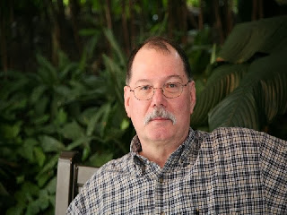****ARES Training Update***

***Jim Yoder, W8ERW – ARES Data Manager***

[w8erw@arrl.net](mailto:w8erw@arrl.net)

ARES Training Update

Another month has past, and our lives continue to be altered by Covid-19. Our meetings have been canceled or replaced by online streaming arrangements. And finally, thus far we have a year that has been devoid of Hamfests. It all has been stressful not only for Amateurs but especially, so I am sure for families with school age children. There just are not good answers to address the situation with solutions that meet a normal lifestyle.

Vacation plans have been altered or dismissed and travel restricted. One day we are told that Masks are essential, and we should be using them whenever we do venture out in public. The next news item says, no the masks do not help. The reporting of Covid-19 statistics has been called into question as well with reports of widespread fuzzy counting. I, like many of you am confused and not entirely sure of anything I am reading.

While we may have to wait a while longer to enable a return to what we can again call normal, the situation has presented both a challenge and opportunity for participating in our hobby in some new and innovative ways. Field Day this year is but one example. Although we were not able to operate as groups, this year’s Field Day rules allowed us to set up individually and aggregate our scores with those of others doing the same in our clubs and other groups. The results being reported by ARRL Newington are impressive with many of us having participated as individual stations. My own results were not of any great significance although I thoroughly enjoyed setting up and operating out of the “She Shed” my XYL graciously helped me organize into a comfortable temporary Ham Shack. I was also able to introduce one of my grandsons to the world of Amateur Radio. I can see some Elmer duty in the future and a possible new Ham in the making.

Here in District 1, the Lucas County group continues to explore opportunities for using the AREDN MESH Network to support ARES activities. They have organized and conducted a group meet out in the field while observing precautionary measures for Covid-19. MESH nodes were deployed along with an impressive list of potential services and applications that would be useful in an active ARES deployment. Live video feeds, messaging, remote connectivity and emergency power are just a few of the many possibilities that were explored during this operation.

Our Ohio Section Technical Coordinator, Jeff Kopcak K8JTK has also recently taken a bite into the AREDN MESH Network. Jeff contacted me about connecting to our local Seneca and Sandusky County network via the VTUN or tunneling arrangement. He is now connected to our MESH along with several local stations including the EOC in both counties. Many of our “MESH ’ing” Amateurs have also deployed Hamshack Hotline on the MESH and we have the service in the communication rooms of the EOC in both Counties. W8MAL has also connected from Ottawa County including his connection into Lucas and Wood Counties. All of this is providing experience and a vision of what the capabilities are and how to best configure and utilize the AREDN MESH Network in an ARES deployment.

TOP^

Our ARES training efforts continue with a steady influx of new ARES Connect registrations and NIMS certificates being submitted. We are not seeing the submissions that previous years have shown, but as we have grown, we are approaching the point of having a significant number of ARES participants being NIMS qualified. Of course, there is room to grow both in terms of overall participation and in additional course submissions. FEMA has over 265 online courses available and many of you are taking advantage of the training. K8RJH continues to add to his list and remains the King of the realm with a total of 282 certificates on file. The folder he keeps them all in must now be bulging. We currently have 227 ARES Members at Level 1, 654 at Level 2 and 189 at Level 3. The total of all certificate submissions as of today is 9,602 submitted by 1,106 ARES Members. The database consists of known participants from the 88 County ARES rosters, ARES Connect and our statewide leadership with 1,816 total registrations. No, we don’t have you all but its growing. Thank you…

I encourage everyone who has not done so to get on ARES Connect and get registered. And if you have not gotten started with NIMS training please consider doing so. It’s free and you will receive a certificate for each class taken which I would love to add to those we have recorded in the database. Our Ohio Hams have done a spectacular job of embracing ARES and NIMS training. We are the envy of and the example for the remaining ARRL Sections. Let’s keep the momentum. Your efforts are much appreciated and recognized throughout the country.

Thanks & 73,

Jim W8ERW

[w8erw@arrl.net](mailto:w8erw@arrl.net)

***National News***

*(from arrl and other sources)*

***ARRL Members to Lead New 30-Minute Amateur Radio Webinar Series***

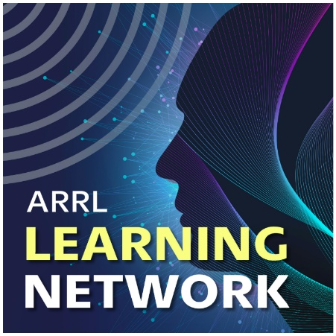ARRL is launching a new webinar series to help introduce more members to the variety of activities and opportunities that radio amateurs enjoy. The [**ARRL Learning Network**](https://www.arrl.org/ARRL-Learning-Network)  will offer live presentations by member-volunteers, for members. Like hamfest forums and radio club presentations, the webinars are intended to help participants get more active, involved, and engaged in amateur radio.

Presentations are 30 minutes each, making them easy to fit into a lunch break or as a short evening activity. A 15-minute question-and-answer period follows each presentation for those who can participate longer. The webinars will be hosted initially using *GotoWebinar*.

Webinars will be recorded, and some presentations will be available for future viewing by members and ARRL-affiliated radio clubs as part of an ARRL Learning Network library.

A [**running list**](http://www.arrl.org/ARRL-Learning-Network) of upcoming live presentations is available. The web page is the place to register to attend each webinar and requires members to log onto the ARRL website.

TOP^

**Relay Stations and the Art of Traffic Handling**

Aaron Hulett, K8AMH, Section Traffic Manager for ARRL North Texas Section

Tuesday, July 28, 2020, 10 AM PDT / 1 PM EDT (1700 UTC)

**Fun with Digital Signal Modes FT4 and FT8**

Anthony Luscre, K8ZT

Thursday, July 30, 2020, 12:30 PM PDT / 3:30 PM EDT (1930 UTC)

**Introduction to Digital FM Modes**

Korey Chandler, Sr., WA5RR

Tuesday, August 11, 2020, 5 PM PDT / 8 PM EDT (0000 UTC on Wednesday, August 12)

**Capture the Magic of 6 Meters**

Jim Wilson, K5ND

Tuesday, August 18, 2020, 10 AM PDT / 1 PM EDT (1700 UTC)

**The Sport of Finding Hidden Transmitters on Foot**

Robert Frey, WA6EZV, ARRL Amateur Radio Direction Finding Committee

Thursday, August 20, 2020, 12:30 PM PDT / 3:30 PM EDT (1930 UTC)

The webinars continue a string of new ARRL benefits introduced in 2020 that has included

[***On TheAir***](http://www.arrl.org/on-the-air-magazine)  magazine, expanded member access to all ARRL digital [**magazines**](http://www.arrl.org/arrl-magazines), and the new

[***On the Air***](http://www.arrl.org/on-the-air-podcast) and [***Eclectic Tech***](http://www.arrl.org/eclectic) podcasts.

“The ARRL Learning Network puts experienced member-volunteers at the forefront as a regular source of knowledge-sharing in amateur radio,” ARRL Lifelong Learning Manager Kris Bickell, K1BIC, said. “We hope members participating in the ARRL Learning Network — including presenters — will find it particularly rewarding to share experiences and learning that will motivate more of our community toward lifelong journeys as radio amateurs.”

Members who would like to be considered for future ARRL Learning Network webinars should have experience in delivering presentations, including familiarity with online webinar technology, live video, and screen sharing. Prospective presenters may complete a [**Call for Speakers**](http://www.arrl.org/ARRL-Learning-Network-Speakers-Form) form.

####

***ARRL Foundation Announces 2020 Scholarship Awards***

The ARRL Foundation has announced the recipients of its 2020 scholarship awards. There were 103 awards this year, totaling $144,450. The non-profit Amateur Radio Digital Communications (ARDC) has generously awarded a grant to the ARRL Foundation to match each scholarship award on a dollar-for-dollar basis, lifting the grand total of scholarships awarded to $288,900.

TOP^

**The ARRL Foundation General Fund Scholarship**

* **Frances E. Bonte, KE8HPA, of Westerville, Ohio**
* Kathleen S. Botterbush, KA9RLK, of Godfrey, Illinois
* Wyatt R. Law, AI6V, of Lakewood, California
* Garth V. Naillon, KF7KJG, of St. Helens, Oregon
* Jeffrey R. Purchatzke, KM6UFK, of San Diego, California
* Hannah E. Rosenfeld, W7HER, of Eugene, Oregon
* Robert M. Tenny, KD0WEZ, of Leawood, Kansas
* Nicholas Walter, KC9RMR, of Columbus, Indiana
* Ruth Willet, KM4LAO, of Cana, Virginia
* Levi J. Zima, KN4YHS, of Sorrento, Florida

The list of other scholarship winners is quite lengthy and can be found at: [ScholarshipWinners](http://www.arrl.org/news/arrl-foundation-announces-2020-scholarship-awards)

####

***Chris Brault, KD8YVJ, is 2020 Amateur Radio Newsline Young Ham of the Year***

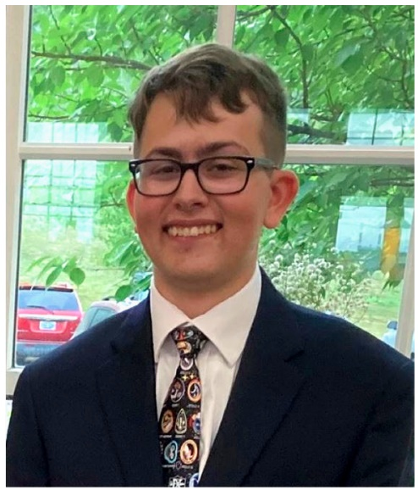

Christopher “Chris” Brault, KD8YVJ, of Liberty Township, Ohio, has been selected as the 2020 Bill Pasternak WA6ITF Memorial [***Amateur Radio Newsline***](http://www.arnewsline.org/) Young Ham of the Year (YHOTY). The son of Jocelyn, KD8VRX, and Kimberly Brault, Chris, 18, was the recipient of the 2015 ARRL [**Hiram Percy Maxim Award**](http://www.arrl.org/hiram-percy-maxim-award). A ham since 2014, he credits his father for being his guide into amateur radio, recalling watching and listening to his dad operating mobile.

“We would be on a road trip somewhere,” Chris said. “We’d be talking to people along the way, it seemed like fun.” Chris is a member of the Dayton Amateur Radio Association, the West Chester Amateur Radio Association, and the Ohio Valley Experimenters Club.

A senior and honor student at Saint Xavier High School in Cincinnati, Chris helped restart the school’s amateur radio club, W8GYH. He has also been recognized as the 2017 ARRL Great Lakes Division Young Amateur of the Year, and he took part in the 2017 Dave Kalter Youth DX Adventure to Costa Rica with other up-and-coming young radio amateurs. In 2017, he was a Youth Forum presenter at Dayton Hamvention® and HamCation in Orlando.

Chris serves as social media director for the [**Youth on the Air**](https://youthontheair.org/) organization and is a contesting mentor for young hams involved in its programs. He is a tour guide for the National Voice of America Museum of Broadcasting in West Chester, Ohio, and assists in mentoring young operators at its ham station, WC8VOA. He participates with his dad in Scouting’s Jamboree on the Air (JOTA) each October.

The YHOTY award is traditionally presented during the Huntsville Hamfest in August, but the event was canceled this year because of the COVID-19 pandemic. The Young Ham of the Year Award was established in 1986 by *Newsline* editor Bill Pasternak, WA6ITF, who died in 2015. *— Thanks to CQ Communications*

####

TOP^

***More than 12,000 Register Early for QSO Today Virtual Ham Expo***

More than 12,000 have registered to attend the first [***QSO Today* Virtual Ham Expo**](http://www.qsotodayhamexpo.com/), August 8 – 9, *QSO Today* host Eric Guth, 4Z1UG, said this week.

“Since the Expo is a completely new experience for the ham radio community, it’s great that so many people are excited and already registered,” he said. “And with almost 3 weeks before the event, the number of registrants continues to increase.” Attendance is free and early-bird registrants are eligible for prizes if they signed up by July 24.

More than a typical web meeting, the Expo is built on a live virtual platform commonly used by Fortune 500 companies and major universities. The platform simulates a convention experience with an exhibit hall and booths staffed by live attendants, a speaker auditorium, and even a lobby. Attendance just requires an internet connection and a computer, tablet, or smartphone.

The Expo will offer four separate speaker tracks focusing on a range of topics. Speakers will also be able to provide related material, such as slides and white papers, that attendees can download. Every session will have a Q&A where attendees can submit questions in real time via chat.

More than 30 booths will be open for attendees to visit, and exhibitors will have different options to engage with attendees. Exhibitor booths can provide downloadable content, such as videos, spec sheets, and manuals, and attendees can save content in a virtual briefcase to read later. Visitors will also be able to interact one-on-one with booth representatives, using a Skype-like system.

“The experience of a virtual expo is not meant to replace in-person conventions,” Guth said. “However, I strongly believe that virtual events in our community are here to stay.  Given COVID-19 and its likely lasting impact on travel, especially given our demographic, this virtual expo enables the ham community to continue coming together to learn and engage.”

Guth said that younger hams who have grown up with the internet will feel comfortable with the Expo platform, “making it easier for them to participate and find their place in this remarkable hobby.”

Access to all speaker presentations and exhibitor booth content will remain on the Expo site for 30 days following the event.

The *QSO Today* Virtual Ham Expo is an ARRL-sanctioned [**hamfest**](http://www.arrl.org/hamfests).

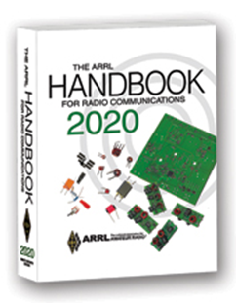***The Handbook Give Away***

Hey Gang,

Have you registered for the “Handbook Giveaway” drawing for this month yet? If you haven’t, you’ve only got a couple of days left to get registered... Hurry up and go to: <http://arrl-ohio.org/handbook.html> and get yourself registered now!

TOP^

What’s the catch? I want to get everyone checking in to the Ohio Section website as often as possible, and in order to register each month, you have to visit the website often! There’s nothing else to it. I pay all expenses and I usually “Give Away” more than just a Handbook too!!

Many of you ask me just how do I know when the drawing is on? Well, that’s easy all you need to do is check in on the Ohio Section Website on a regular basis and watch for the big [**RED**](http://arrl-ohio.org/handbook.html)Arrow that will appear on the left side of the page. This is the sign that the drawing is on and you need to get registered. So, keep a sharp eye out on the website and check in often!

***Club Corner***

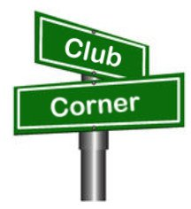

This is YOUR cornner of the newsletter. Send me what your club is doing and I’ll make sure that it gets in. Got a special event or club project that you want everyone to know about? Send it to me!. Need help with a project? Send it to me.

Let me know what you club is up to. Are you going to have a special guest at your meeting or are you having a special anniversary? Just sent it to: [n8sy@n8sy.com](mailto:n8sy@n8sy.com)

####

***Radio Operators Assist At COVID19 Test Sites***

*(from Your Hometown Enquirer)*

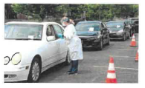

Ham radio operators from the Hamilton County Amateur Radio Emergency Service (ARES) are working with Hamilton County Public Health (HCPH) to monitor the weather at outdoor testing sites. They are also there to provide an extra communications link for the people on the ground back to HCPH, where there is a dedicated ham radio station.

ARES members who are trained Skywarn Spotters are monitoring the local weather for potential impacts that could affect the safety of the participants at the COVID-19 testing sites. These Hams will be on site during the next several weeks, sharing weather information with HCPH administration. This allows the administration teams to focus on the operations of the site while knowing that someone is keeping a watchful eye on the weather conditions, ready to relay and alert as necessary.

One such incident occurred on Tuesday, June 30. At approximately 3:30 pm HCPH administration and local officials decided to pause from the Anderson Library testing due to lightning detected in the area.

Based on additional information provided by the Ham operators, health officials continued the pause until the local area was clear of threatening weather. This 'real time' weather information is critical and adds an extra layer of support and safety to workers and visitors. All in all, ARES is projecting to put in hundreds of volunteer hours assisting the HCPH during this pandemic crisis. In anticipation of the further use of their volunteer services ARES has begun conducting exercises in the event they are needed for communications should a vaccine for COVID-19 be developed.

TOP^

In this potential situation radio operators would be located at the Public Health PODs (Point of Dispense) to again serve as a backup link between the staff at the site and a communicator at the Public Health station.

To prepare they have started by running a tabletop exercise over Zoom to assess their equipment needs and discuss any challenges that may be involved for radio communication between sites. This is to be followed by actual testing of radio capabilities between sites in the field to ensure they will be ready to serve their community in time of need.

Justin Moore, Hamilton County

Amateur Radio Emergency Service

####

***The Northwest Ohio ARES Traffic Net Needs Help***

The Northwest Ohio ARES Traffic Net is in need of General and/or Extra Class licensees with either voice or CW capabilities to relay traffic from the VHF net to the HF nets, no experience is necessary.

The NW Ohio ARES Traffic Net meets daily at 6:30PM on the W8RZM 147.375 repeater.

The Ohio Single Sideband Net meets daily at 10:30AM, 4:15PM and 6:45PM on 3.9725 MHz. The Ohio Section also has three CW Nets, the Ohio Slow Net meets daily at 6:00PM on 3.53535 and runs at approximately 10 WPM.

The Buckeye Net-Early meets daily at 6:45PM on 3.580 and runs between 15-20 WPM. Finally, the Buckeye Net-Late meets daily at 10PM on 3.590 and runs in the same range as the Early Net. Currently, there are only 2 volunteers that cover 7 days a week, and most nets there isn't a volunteer at all. Please consider volunteering for an hour a week, you never know, you may like it.

For more information on traffic handling, or volunteering to assist relaying traffic please check into the VHF net or contact Colleen Roth N8TNV, Steve Denniss KC8IDM, or Michael Lacumsky W8MAL.

####

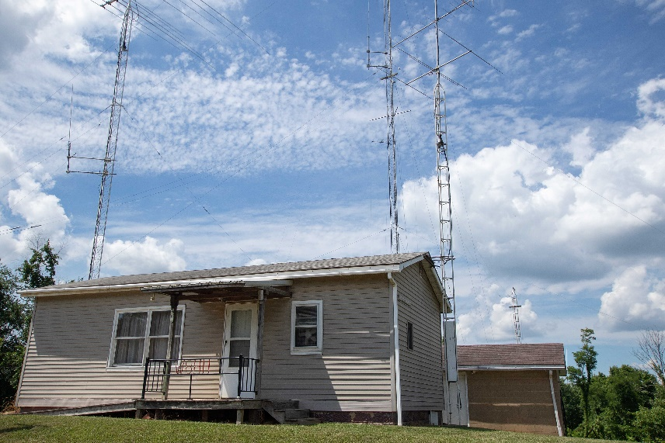***Marietta ARC Will Soon Celebrate Its 100th Anniversary***

*(from Dick Miller, K8KYE)*

***A Brief History of the Marietta Amateur Radio Club***

The first reference we have to an amateur radio organization in Marietta, Ohio is a “Charter of Affiliation” issued by the American Radio Relay League, to the *Marietta Radio League* on August 27, 1920. This Charter, signed by Hiram Percy Maxim, is still displayed in the current club house.

TOP^

The earliest known call sign for the club was W8KYC, issued to the *Marietta Amateur Radio Society,* in 1934*.* At that time the club met at the YMCA building located at 312 Second Street, Marietta.

Later, the organization’s name was changed to the *Marietta Amateur Radio Club*. The current call, W8HH, was secured around 1959. This call had previously been issued to James W. Sesher, a Marietta resident who died in 1935.

In the 1950’s the club moved to a Quonset Hut at 730 Glendale Road, Marietta.

In 1964/1965 the club relocated to its current site atop a hill on Hartline Road, outside the Marietta City Limits.

We will be celebrating our 100th Anniversary in conjunction with the Ohio QSO Party on August 22, 2020.

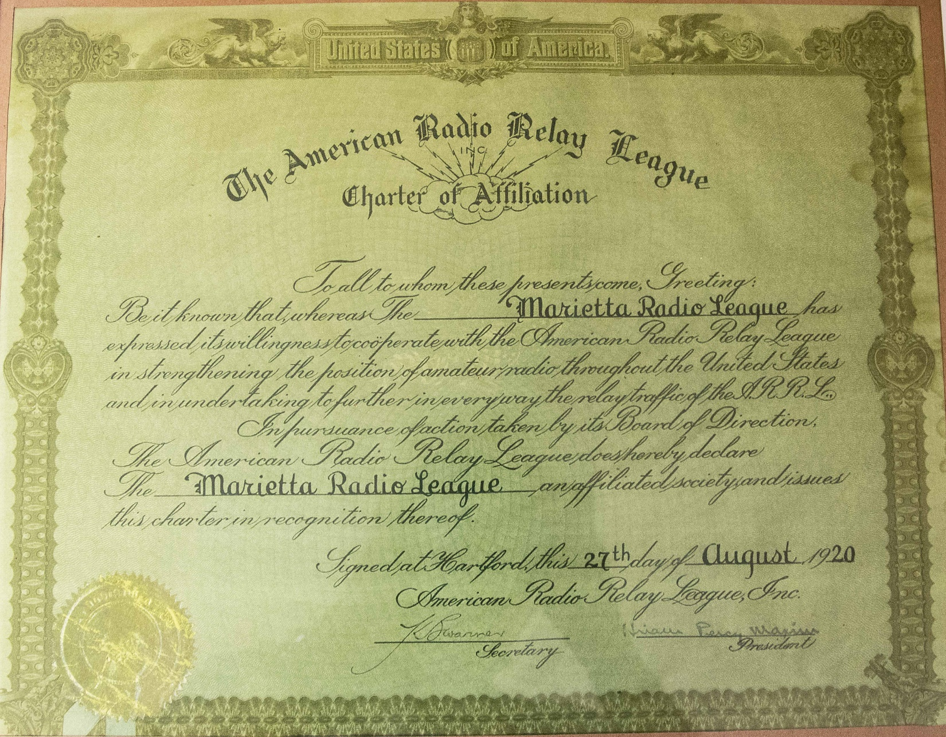

####

TOP^

***Upcoming Event Status Update***

***Friends of MS150 Ride***

A small group of MS150 riders will be participating in a socially distanced ride starting in Middleburg Heights, heading out to Lorain, and then returning.

We will need a limited number of SAG vehicles to provide limited support. SAGs will stage along the route and wait to be dispatched to requests for assistance. There will be no patrolling of the route and contact with cyclists will be limited to only when absolutely necessary.

This is a privately organized ride that is not being run by or in conjunction with the MS society.

**All volunteers will be required to wear masks any time they are interacting with or transporting cyclists. All cyclists will also be required to wear masks while interacting with others.**

Please sign up here: <https://forms.gle/WkctWzxuZFpCzxiB9>

***Upcoming Event Status Update***

Our events are dwindling down to almost nothing. I was told the Making Strides Walk has been cancelled now as well. However, there may be some sort of event planned that will require a little support. Nothing is firm yet though. More details will follow towards the end of summer.

Our friends over at the Geauga Amateur Radio Association have begun compiling a list of as many radio related cancellations as they can. Be sure to check it frequently at https://geaugaara.org/coronavirus/.

Below is a list of events STILL HAPPENING Cleveland area that Event Support Group will be participating in. We still need volunteers for all! Be sure to click and bookmark the "View Full Event Calendar" link below.

• AFSP Out of the Darkness Walk Communications Support on **September 26**, 2020 09:30

• Cleveland Hamfest Volunteers on **September 27**, 2020 06:00

• Making Strides of Cleveland *Communications Support* on **October 10**, 2020 08:00

Our friends over at the Geauga Amateur Radio Association have begun compiling a list of as many radio related cancellations as they can. Be sure to check it frequently at <https://geaugaara.org/coronavirus/>

####

***2020 Cleveland Hamfest STILL ON!***

That's right, the 2020 Cleveland Hamfest is NOT CANCELLED. We are watching the situation very closely and will update everyone if anything changes. As of now the Hamfest Association of Cleveland is still moving forward with plans for the 2020 Cleveland Hamfest on Sunday, September 27. Indoor Vendors, please visit [www.hac.org](http://www.hac.org) and click “vendor information” at the top for more info.

Make sure you head on over to [www.hac.org](http://www.hac.org) for the latest info and be sure to click “Join Our Mailing List” to get all the latest updates.

####

TOP^

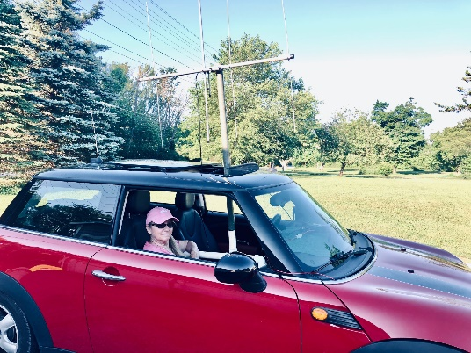***Fox Hunts Return to Ashtabula County***

*(from Stan Williams)*

After a nearly 20 year hiatus, our club, Ashtabula County Amateur Radio Club, has resumed the weekly tradition of having Fox Hunts. Details may be found on our website, [www.K8CY.org](http://www.K8CY.org)

You can also check in on our weekly Thursday evening net at 8pm via echolink, N8CT-L for more info.

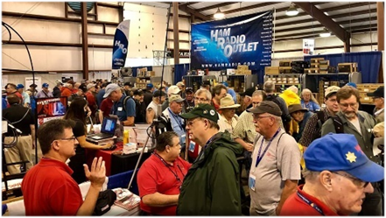

[***Upcoming Hamfests***](http://arrl-ohio.org/hamfests.html) ***for 2020***

**08/15/2020 - Clinton County Ohio ARA Hamfest**

***Canceled***

|  |  |
| --- | --- |
| **09/13/2020 - Findlay Hamfest  *Canceled*** | **09/27/2020 | Cleveland Hamfest and**  **Computer Show** Location: Berea, OH Sponsor: Hamfest Association of Cleveland Website: [http://www.hac.org](http://www.hac.org/) |
| **10/10/2020 - Northwest Ohio Amateur Radio Club (NWOARC) Fall Hamfest Location: Westminster, OH Sponsor: NWOARC, Northwest Ohio Amateur Radio Club Website:**[**http://www.nwoarc.com**](http://www.nwoarc.com/) | |

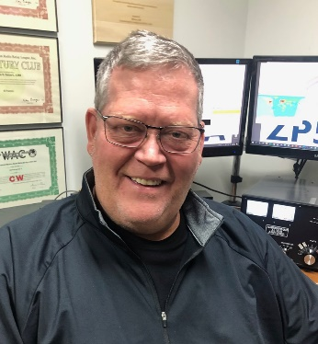***DX This Week***

*(from Bill, AJ8B)*

***DX This Week – Zones 18,19, and 20***

***Bill AJ8B (***[***aj8b@arrl.net***](mailto:aj8b@arrl.net)***, @AJ8B, or*** [***www.aj8b.com***](http://www.aj8b.com)***)   
 CWOPs Member #1567***

Hope you are staying safe and tuning the bands. I worked a couple of stations that were not on my “spot” list and actually filled a couple of band slots this past week. There were some interesting entities spotted includingAlaska, Algeria, Argentian, Belgium, Bonaire, Brazil, Bulgaria, Canada, Chile, Costa Rica, Cuba, England, European Russia, Germany, Ghana, Greece, Hungary, Ireland, Isle of Man, Italy, Kuwait, Luxembourg, Mali, Mexico, Moldova, Montenegro, North Macedonia, Oman, Panama, Puerto Rico, Slovenia, Spain, St. Lucia, Turkey, Ukraine, and Uruguay. Let me know what you worked!

TOP^

I received QSL cards from EB2AM, Julen in Spain, and F5MYH, Alex in France.

|  |  |
| --- | --- |
|  |  |

So far this year, we have covered CQ zones 1 through 17. This week we will review Zones 18,19,and 20. Below is a list of the entities in each zone and the estimated number of hams in each country, for the data I could find.

**Zone 18. Central Siberian Zone:** UA8,9 (H,I,O,P,U, V,Y,Z), and UAO (A, B, H, O,R, S,T, U,V, W)

**Zone 19. Eastern Siberian Zone:** UA0 (C, D, F, I, J, K, L, Q, X, Z)

**Zone 20. Balkan Zone:** E4 (Palestine), JY (Jordan) - 133, LZ (Bulgaria) – 4,950, OD (Lebanon) – 205, SV (Greece) - 2,950, SV/A (Mt. Athos) - 1, SV5 (Dodecanese), SV9 (Crete), TA (Turkey) - 1,200, YK (Syria), YO (Romania) – 3,500, ZC4 (UK Sov. Base), 4X (Israel) - 1,225 and 5B (Cyprus) - 578.

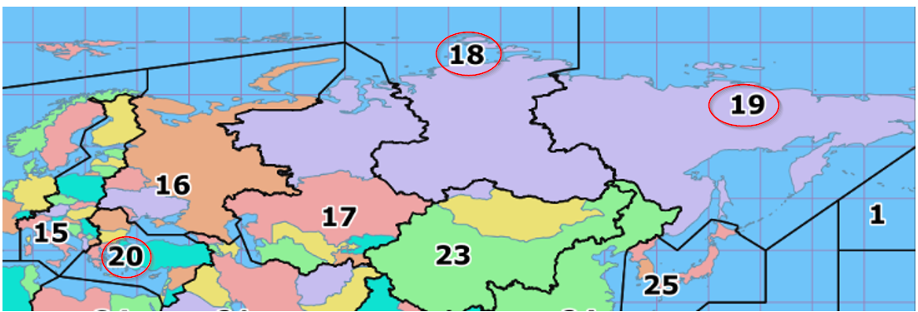This is an interesting collection of entities to work and confirm. Zones 18 and 19 are a collection of callsign alphabet soup. If I hear a UA8 or a UA0, I just work them. I will sort out the prefix later!

Zone 20 has some rare entities in it! Palenstine, E4, is very difficult simply because they are not on the air that much. SV/A, Mt. Athos, is another rare one; not due to the location but due to the operating schedule of the monk that resides there. Monk Apollo was the resident ham for years until he passed away in May of 2019. Monk Iakovos is the ham who currently operates from Mt. Athos. (<https://www.dx-world.net/sv2rsg-mt-athos/>)

ZC4 is the British Sovereign Bases in Cyprus. In my almost 50 years of operating, I have not heard this station on. I am sure that there were DXPeditions and activations from time to time and I just missed them!

Good Hunting

TOP^

***CQDX CQDX CQDX CQDX CQDX CQDX CQDX CQDX CQDX***

Here is an update from Bernie, W3UR, of the DailyDX and the WeeklyDX, the best source for DX information. <http://www.dailydx.com/>. Bernie has this to report:

**JX – Jan Mayen By LA7GIA, Ken Opskar** - Thanks for promoting JX0X so far, we appreciate that you include info about our planned trip in your newsletters. We would be happy if you could include that: We have a website up and running. This trip will depend on support from the DX community, the clubs and foundations as our budget is 90k+ USD. The cost for the vessel that will take us there for 3 weeks as we approach the winter storms is of course a major concern. We’re in the process of securing the vessel, and are currently negotiating the details. Anyone who wants to support us can use this weblink. (<https://www.paypal.com/donate/?token=aEeKyY7p5vVNhsPpExrl12AEUxEqd3rlbgPaMDHagc1QNzkl89k0FdqYbpWfwFSQTy3Njm&country.x=GB&locale.x=GB>)

**XW – Laos -** XW2DX is now on the air with ex-UA0XB, Mikhail Yurievich Bochkarev, operating. He has an IC-706 to a dipole. The license covers July 1 this year to June 30 next year, allowing operation on 20, 15 and 10M SSB and RTTY. Despite these apparent restrictions, he was reportedly on 30 and 20 CW these last two days, so maybe there is more to the permission story. QSL via RM0L.

**9G – Ghana 9G5GS by IZ4YGS -** Matteo, will again be on from the Western Region, in an area of jungle, palm trees, swamps, snakes and crocodiles, a few hundred meters from the Atlantic. Matteo will be on August 8 to September 15, operating in his spare time, most evenings he says, between 21-00Z. He will be on 160- 10M mostly FT8 F/H and SSB, with his FT-891 to a vertical. For FT8 Fox and Hound frequencies he is looking at 3590, 7056, 10131, 14090, 18095, 21091, 24926 and 28091. FT8 standard mode he will be on the standard FT8 frequencies. He asks you send report first, not the location. Matteo also plans to use the QO100 geostationary satellite, USB. He will do daily Club Log updates. QSL direct to IZ4YGS, or through LoTW or eQSL.

**E5 – North Cook Islands E51WL -** Warwick, says “finally, an end to this disaster is in sight.” He is now scheduled to leave New Zealand on July 25, arriving on Penrhyn Atoll on July 28. He has had five months with no work and no income. Warwick says he will get on the air toward the end of July, as quickly as he can. He is excited to be taking with him a 2M amplifier to do EME and antenna which, he says, “Some of you may be able to hear from north.” ZL1RS, Bob, has helped get things together for the return. On QSLs, he says couriers lost his cards for 3-1/2 months but they have just now shown up so he has sent out all the cards up to date. He expects a “mountain of cards” is waiting for him back on Penrhyn, “so please be patient.” The postal service from the island may still be a problem.

***DX News***

***ARLD030 DX news***

This week's bulletin was made possible with information provided by The Daily DX, the OPDX Bulletin, 425 DX News, DXNL, Contest Corral from QST and the ARRL Contest Calendar and WA7BNM web sites. Thanks to all.

**UNITED ARAB EMIRATES, A6.** Special event stations A60EMM/1 through

A60EMM/9 are QRV to commemorate the Hope Probe project as part of the UAE's involvement in the exploration of the planet Mars. QSL via operators' instructions.

TOP^

****TAIWAN, BV.** Bruce, BV2KI will be QRV as BV0WPX from Liu-Chiu Yu Island, IOTA AS-155, in the RSGB IOTA contest as a Single Op/Island DXpedition/Assisted entry. QSL to home call.

**CHINA, BY.** Operator BA4MY will be QRV as BG4OP from Lingshan Island, IOTA AS-150, in the RSGB IOTA contest. QSL via BI4IIZ.

**PORTUGAL, CT.** Members of the Portuguese DX Group will be QRV as CS5DX from Pessegueiro Island, IOTA EU-167, during the RSGB IOTA contest. Activity will be on 40, 20, 15 and 10 meters using CW, SSB and FT8. QSL direct to CS5DX.

**MADEIRA ISLAND, CT3.** Ulf, DL5AXX will be QRV as CT9ABV in the RSGB IOTA contest as a 12 Hour Mixed entry. Paul, DL5CW will be QRV as either CR3W or CT9/DL5CW in the remaining 12 Hour Mixed category. QSL to home calls.

**FEDERAL REPUBLIC OF GERMANY, DA.** Mike, DG5LAC is QRV as DG5LAC/p from Hooge Island, IOTA EU-042, until July 28. Activity is on the HF bands using SSB, FT8 and FT4. This includes being an entry in the RSGB IOTA contest. QSL to home call.

**PHILIPPINES, DU.** Operators DV8VMI, DX8CAD and DX9EVM will be QRV from Mindanao, IOTA OC-130, in the RSGB IOTA contest. DV8VMI will be active on 40 meters, with DX8CAD and DX9EVM being active on all bands. QSL via operators' instructions.

**ESTONIA, ES.** Igor, ES0IA will be QRV from Kassaar Island, IOTA EU-034, in the RSGB IOTA contest. QSL to home call.

**HUNGARY, HA.** Members of the Hungarian FIRAC are QRV with special event call sign HA70MAV from Budapest until December 1 to celebrate the 70th anniversary of the Hungarian Railway. Activity is on various HF bands. QSL via LoTW.

**ITALY, I.** Raf, IH9YMC will be QRV from Pantelleria Island, IOTA AF-018, in the RSGB IOTA contest. QSL via LoTW.

**BELGIUM, ON.** Ivan, ON4IBM will be QRV as PA/ON4IBM from Schouwen Duiveland, IOTA EU-146, during the RSGB IOTA contest as a Single Op/SSB Mode/24 Hrs/High Power entry. QSL to home call.

**DENMARK, OZ.** Palle, OZ2PBS will be QRV from Zealand Island, IOTA EU-029, in the RSGB IOTA contest as a Single Op/All Band/Assisted/High Power entry. QSL to home call.

**POLAND, SP.** Kuba, SQ6NEJ will be QRV from Wolin Island, IOTA EU-132, in the RSGB IOTA contest as a Single Op/40 to 10 meter/SSB Mode entry. QSL via bureau.

**GREECE, SV.** Thomas, SV2CLJ will be QRV as J48L from Amoliani Island, IOTA EU-174, in the RSGB IOTA contest. QSL direct to home call.

**DODECANESE, SV5.** Stathis, SV5DKL plans to be QRV from Rhodes Island, IOTA EU-001, in the RSGB IOTA contest as a Single Op/All Band/CW Mode/Assisted/High Power entry. QSL to home call.

TOP^

**BRUNEI, V8.** Special event station V84SPU is QRV until July 31 to celebrate the 74th birthday of his Majesty Sultan. Activity will be on all bands and modes. QSL via operators' instructions.

**LAOS, XW.** Mike, XW2DX is QRV from Vientiane and is here for the next 5 years. Activity is on 20, 15 and 10 meters. QSL via RM0L.

THIS WEEKEND ON THE RADIO. The QRP 20-Meter CW Fox Hunt, NCCC RTTY Sprint, NCCC CW Sprint, RSGB IOTA Contest and the ARS CW Flight of the Bumblebees are all on tap for this upcoming weekend.

The RSGB FT4 Contest Series is scheduled for July 27. The RTTYOPS Weeksprint, Worldwide Sideband Activity Contest and QCX CW Challenge are scheduled for July 28. The CWops Mini-CWT Test and Phone Fray are scheduled for July 29.

**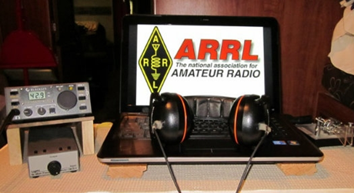*ARRL Contest Corner***

An expanded, downloadable version of *QST'*s’[**Contest Corral**](http://www.arrl.org/contest-calendar) is available as a PDF. Check the sponsor's’Web site for information on operating time restrictions and other instructions.

|  |  |
| --- | --- |
| **July 27**   * [RSGB FT4 Contest Series](https://www.rsgbcc.org/hf/rules/2020/r80m_ft4.shtml) * [QCX Challenge](http://www.qrp-labs.com/party.html) | **July 28**   * [Worldwide Sideband Activity Contest](https://wwsac.com/rules.html) * [QCX Challenge](http://www.qrp-labs.com/party.html)   [RTTYOPS Weeksprint](https://rttyops.wordpress.com/rtty-mini-contests/rttyops-weeksprint/) |
| **July 29**   * [Phone Fray](http://www.perluma.com/Phone_Fray_Contest_Rules.pdf)   [CWops Mini-CWT Test](https://cwops.org/cwops-tests/) | **July 30**   * [CWops Mini-CWT Test](https://cwops.org/cwops-tests/)   [RTTYOPS Weeksprint](https://rttyops.wordpress.com/rtty-mini-contests/rttyops-weeksprint/) |
| **July 31**   * [QRP Fox Hunt](http://www.qrpfoxhunt.org/summer_rules.htm) * [NCCC RTTY Sprint](http://www.ncccsprint.com/rttyns.html)   [NCCC Sprint](http://www.ncccsprint.com/rules.html) | **August 1**   * [Batavia FT8 Contest](https://batavia-ft8.com) * [10-10 Int. Summer Contest, SSB](http://www.ten-ten.org/index.php/activity/2013-07-22-20-26-48/qso-party-rules) * [European HF Championship](http://lea.hamradio.si/~scc/euhf/euhfcrules.htm) * [WAB 144 MHz Low Power Phone](http://wab.intermip.net/Contest%20Rules.php) * [RTTYOPS Weekend Sprint](https://rttyops.wordpress.com/rtty-mini-contests/rttyops-weekend-sprint/) * [**ARRL 222 MHz and Up Distance Contest**](http://www.arrl.org/222-mhz-and-up-distance-contest)   [**North American QSO Party, CW**](http://www.ncjweb.com/NAQP-Rules.pdf) |
| **August 2**   * [**SARL HF Phone Contest**](http://www.sarl.org.za/Web3/Members/DoDocDownload.aspx?X=20191211183027qzNhzFo0EI.PDF) | **August 4**   * [**Worldwide Sideband Activity Contest**](https://wwsac.com/rules.html) * [**ARS Spartan Sprint**](http://arsqrp.blogspot.com/2009/02/so-whats-spartan-sprint-and-how-do-i.html) * [**RTTYOPS Weeksprint**](https://rttyops.wordpress.com/rtty-mini-contests/rttyops-weeksprint/) |

TOP^

***Special Events***

* **07/31/2020 | Sheboygan Brat Days**

**Jul 31-Aug 2, 1700Z-0100Z, W9B**, Sheboygan, WI. Sheboygan County Amateur Radio Club. 14.240 7.240. Certificate. Sheboygan County Amateur Radio Club, c/o Steve Eisold, 4235 N. 29th St., Sheboygan, WI 53083. 67th Annual Sheboygan Brat Days, celebrating the sausage that made Sheboygan famous! 14.240, 7.240 - noon to 8:00 p.m. CDT Friday and Saturday. Certificate only:

W9VCL Sheboygan County Amateur Radio Club, 4235 N. 29th Street, Sheboygan, WI 53083. Please include $2.00 for 8-1/2x11 mailed in manila envelope or send $1 and SASE #10 (certificate will be folded). More information: [https://www.w9vcl.com](https://www.w9vcl.com/)

* **08/01/2020 | Pro Football Hall of Fame Enshrinement Festival - THIS EVENT HAS BEEN CANCELED**

**Aug 1-Aug 9, 0000Z-2359Z, W8AL**, Canton, OH. Canton Amateur Radio Club. 14.300 14.030 7.250 7.030 3.950 3.530 (Watch for FT8 or other digital modes); BM DMR 313989. Certificate. Canton ARC - W8AL, C/O: Justin W8JKC, PO BOX 8673, Canton, OH 44711-8673. THIS EVENT HAS BEEN CANCELLED [www.w8al.org](http://www.w8al.org/)

* **08/01/2020 | W5G : OK Green Corn Rebellion 103rd Anniversary**

**Aug 1-Aug 14, 0000Z-2359Z, W5G**, Edmond, OK. KG5JST. 14.074 7.078 7.074. QSL. James M Branum, KG5JST, P.O. Box 721411, Oklahoma City, OK 73172. This special event station will be operating field day style from several locations in Oklahoma (including at some of the sites of the events of the Green Corn Rebellion of 1917). I primarily will be on FT8 and JS8Call but also will be doing some voice (SSB and FM). QSL via LOTW, QRZ.com or by postal. A special QSL card will be sent to anyone who asks for one, including SWLs. [greencorn.org/w5g](http://greencorn.org/w5g)

* **08/02/2020 | River City Days**

**Aug 2, 1400Z-2020Z, W0R**, Red Wing, MN. Hiawatha Valley Amateur Radio Club. 14.250 7.250 147.300. Certificate. Bill Eichenlaub, 1966 Launa Ave, Red Wing, MN 55066. This is a celebration of the Mississippi River and what it has done for this river town. [hvamateurradioclub.com](http://hvamateurradioclub.com/)

* **08/03/2020 | National Order of the Arrow Conference**

**Aug 3-Aug 8, 1300Z-2300Z, K2BSA/various**, Various cities. Boy Scouts of America Order of the Arrow. 21.360 14.290 14.065 7.190. QSL. QSL , per operator's, instructions. The National Order of the Arrow Conference, scheduled for Michigan State University, has been cancelled, so amateurs who are OA members will be operating K2BSA in many call areas during the week of August 3. QSL via operator's instructions. [k2bsa.net](http://k2bsa.net/)

* **08/04/2020 | US Coast Guard 230th Birthday**

**Aug 4-Aug 5, 1400Z-0400Z, K1CG**, Port Angeles, WA. CG CW Operators Association. 21.052 14.052 7.052 3.552. QSL. CG CW Operators Association, Fred Goodwin, 424 N. Bagley Creek Rd, Port Angeles, WA 98362. [www.qrz.com/db/k1cg](http://www.qrz.com/db/k1cg)

TOP^

* **08/08/2020 | USS Midway Museum Ship Special Event: USS Nautilus first sub under the North Pole on 8/3/58**

**Aug 8, 1600Z-2300Z, NI6IW**, San Diego, CA. USS Midway (CV-41) Museum Ship. 14.320 7.250 14.070 (PSK31) D-STAR on various reflectors. QSL. USS Midway Museum Ship (COMEDTRA), 910 N Harbor Drive, San Diego, CA 92101.

* **08/11/2020 | Navajo Code Talkers S/E**

**Aug 11-Aug 15, 0000Z-0000Z, N7C**, Window Rock, AZ. Herbert Goodluck, N7HG. 18.133 14.265 7.265. Certificate & QSL. Navajo Code Talkers, PO Box 06, Chinle, AZ 86503. [www.qrz.com/db/n7c](http://www.qrz.com/db/n7c)

* **08/12/2020 | 2020 IL State Fair**

**Aug 12-Aug 24, 0000Z-0000Z, W9I**, Springfield, IL. Sangamon Valley Radio Club. 14.250 7.150. QSL. J. Mitch Hopper, K9ZXO, 536 E. Mill St., Rochester, IL 62563. [www.svrc.org](http://www.svrc.org/)

***From Paper Logs to Simple Electronic Format***

*(by Anthony Luscre, K8ZT)*

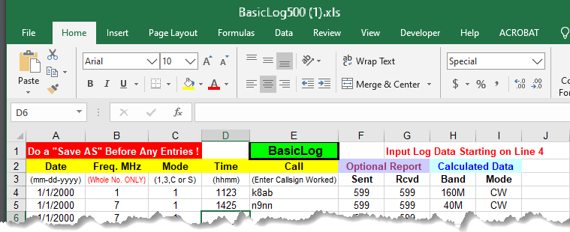Many veteran Hams (and even some newcomers) have logs they have kept on paper and now want to upload the QSO records to LoTW (Log Book of The World) or other online sites that require electronic files in ADIF or ADI formats.

You could use a logging program to enter all of your paper records but that can be overkill if you are not interested in maintaining an electronic log or not interested in the sometimes steep learning curve of using the logging software. The approach described here is fairly simple and quick, but it is still rather tedious if you have a lot of QSOs to enter or you are not a fast typist. The solution for the later may be to recruit a family member or friend to assist in data entry and with this method, it is easy for even a non-ham to understand. And even though this is not a long-term solution for further logging if you decide later to move to an all-electronic log you can upload your work from this project fairly easily into most logging programs.

TOP^

The approach is based on a free spreadsheet from the ARRL (ARRL BasicLog500) that can be used with Excel, OpenOffice or even Google Sheets. First, you will need to download the file at this link- [www.arrl.org/files/file/LoTW%2520Resources/BasicLog500.xls](http://www.arrl.org/files/file/LoTW%2520Resources/BasicLog500.xls). There are also additional instructions available at - [www.arrl.org/files/file/LoTW%20Resources/Instructions%20for%20BasicLog%20(2).pdf](http://www.arrl.org/files/file/LoTW%20Resources/Instructions%20for%20BasicLog%20(2).pdf). Because LoTW and many other programs only need simple information there is no need to enter the exact frequency (just the band) and no need for signal reports or other exchanges. This and the use of shortcuts for mode and band speed up the entry process.

After completing your data entry you can upload the saved ADIF file to LoTW using the TQSL software (of course you still need to first go through the process of registering for LoTW- [*www.arrl.org/quick-start*](http://www.arrl.org/quick-start)). You can also convert this ADIF into file format used for entries for many contests- Cabrillo (.log) with [ADIF2CABR](http://www.sp7dqr.pl/download/download.php?id=119). For additional information on electronic QSLing, view slideshow- “***QSLing in an Online World***”- [tiny.cc/qx3](http://tiny.cc/qx3).

***“ARES Connect”***

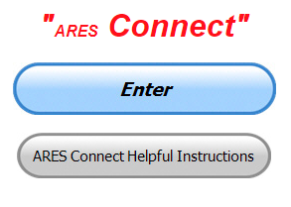

***Connecting Amateur Radio Volunteers with a Purpose***

Hey everyone… please make sure to go in and register your time to all of the events that you have signed up for. Don’t forget to get this done no later than 5 days after the event has ended. I’m asking you to do this for our ability to run reports accurately.

**I want to remind all of you that you do not have to be an ARES or ARRL member to use this system. All licensed amateur radio operators throughout the country are welcome and strongly encouraged to use it.**

Folks, I’m seeing a lot of folks that have signed up for events not entering their time after the event. This is a very important piece of using “Connect.” Your hours need to be recorded and it’s so easy to do.

***Here’s are the top 10 hours earners so far the month of July:***

|  |  |  |  |
| --- | --- | --- | --- |
|  | **Name** | **Events** | **Hours** |
| **1** | Dwight Bonifield (W8TJT) | 139 | 145.90 |
| **2** | James Yoder (W8ERW) | 13 | 86.41 |
| **3** | Dan Stahl (KC8PBU) | 74 | 81.16 |
| **4** | Christopher Domenick (KC8CAD) | 23 | 77.60 |
| **5** | Leo Dubois, Jr. (KE8OOS) | 43 | 66.75 |
| **6** | Alan Rothweiler (N8CJ) | 24 | 66.50 |
| **7** | Bret Stemen (KD8SCL) | 35 | 62.50 |
| **8** | Elmer Thomas (KE8HNK) | 49 | 46.75 |
| **9** | Joseph Wigal (W8JTW) | 42 | 42.75 |
| **10** | Daniel Schlick (KB8LKH) | 18 | 39.50 |

**Let’s get everyone in the Ohio Section on “ARES Connect!!!” Simply go to:** <https://arrl.volunteerhub.com/lp/oh/> and get yourself registered and using the system.

TOP^

***Joining the County Information Report Project 20 [CIR pt 3]***

*(from C. Matthew Curtin KD8TTE)*

The Ohio Section continues to test and improve radio messaging with our County Information Report (“CIR”) Project 20. We’re seeing more participants, and we’re grateful for the support. Our goal is to establish a system of highly resilient and highly reliable messaging that operates completely on amateur radio: no Internet, no phone, and no other telecommunications infrastructure.

In this week’s discussion, I want to talk less about the grandiose picture and how all of the various pieces will work together, and more directly to what you can do to be part of making amateur radio able to fulfill its promise to serve the public in times of disaster or emergency. I’ll give a basic checklist for different audiences. You might be part of more than one, in which case you can choose to focus on one aspect or participate in several.

How can I participate in CIR Project 20? That depends on your role:

1. Aspiring ARES member,
2. Local (county) ARES member,
3. Local NTS traffic handler,
4. County Emergency Coordinator,
5. District Emergency Coordinator, or
6. Section NTS traffic handler.

We’ll discuss each in turn, with a numbered heading so you can read just the parts that are for you, then skip to the bottom for the conclusion. (A Choose Your Own Adventure article: how cool is that!)

**1. If you are an aspiring ARES member**

If you’re interested in the Amateur Radio Emergency Service (ARES) program in Ohio but aren’t yet a member take a look at the web page for our Section Emergency Coordinator. Emergency Coordinators (ECs) are the organizers of ARES programs, which are organized at the county level. They’re supported by District Emergency Coordinators (DECs), who can provide additional resources from neighboring counties, or request still other resources from the Ohio Section of the American Radio Relay League (ARRL). The Section Emergency Coordinator (SEC) web page has all of the information you need to understand the structure and organization of the program. <http://www.arrl-ohio.org/SEC/>

Take a look at the “Monthly Reports / Dashboard” button there to get an idea of what’s happening in your county and district. If you don’t see a report from your county, don’t despair: you can reach work through your district; perhaps a neighboring county covers yours!

Getting started is usually just a matter of finding your county’s ARES program. If you can’t find it locally you’re welcome to contact me by email at [kd8tte@pm.me](mailto:kd8tte@pm.me). I’ll be happy to get you connected with your local EC.

TOP^

**2. If you are a local (county) ARES member**

If you’re already in the ARES program, this is the time to get up to speed on third-party message handling procedure. While the CW and voice nets are running every day of the year, as are the store-and-forward systems of the Digital Traffic Net (DTN) and Winlink Global Radio Email, are you able to use them?

Are you able to use the Narrow Band Emergency Management Software (NBEMS), fldigi and the related suite?

Whether you’re up to speed on them or not, you can volunteer yourself to your local EC to help with the County Information Report Project 20: represent your ARES group to the District, to traffic nets, or whatever other outlets you have to ensure that you get a message from outside of your county or you can get a message from your local net outside of the county.

If you’ve volunteered to take the duty, you can work with your EC to understand how to do that job, others in your ARES group, another club, or traffic net who have the skills and will work with you. No one expects you to operate perfectly on Day One: building and maintaining capability is a process. It will take time, so you can start now, and be on the lookout for opportunities to help others who volunteer and can learn from your experience!

**3. If you are a local NTS traffic handler**

If you’re already an NTS traffic handler, look for opportunities to develop your capabilities. Can you learn to use HF? How about another mode like CW? DTN? Winlink? NBEMS? A traffic handler who can move messages reliably with voice is valuable. A traffic handler who can move a message in any mode on any net is even more so, able to choose the mode and means that best fit the needs of the traffic.

Talk to your Net Manager about what roles might need filled locally. Perhaps you can take a regularly-scheduled slot as a net liaison, representing the net to another net. Perhaps you can take a regularly-scheduled slot as the net control operator. Perhaps you can represent an ARES program to the net, and vice-versa.

Are you already a part of your ARES program? Make sure that if you’re not, you become part of your local ARES, and let your EC know that you’re a traffic handler and can represent the ARES program on the local traffic system outlet!

**4. If you are a county Emergency Coordinator**

Local ECs are the lifeblood of the ARES program. Without an effective EC, volunteers have time and resources not put to good use, and things that need to be done, aren’t. ARES is a *program* of activity, not a badge-holder club, which means that if the resources aren’t being put to use and the job isn’t being done, the local program simply isn’t participating.

Getting with the program will require several steps. We’ll outline them here, then discuss each.

1. Make sure not to do everything yourself!
2. Determine which nets you’ll maintain liaisons.
3. Make a schedule for the liaisons.
4. Make a way for radio operators to get messages to and from the liaisons.
5. Watch for the CIR Instructions messages (they come out weekly) and follow them!

TOP^

It’s tempting for the most experienced operator, or the operator with the most powerful station, to become the EC and essentially the Chief Radio Operator. A capable station and operating experience are both valuable, but the most valuable thing of all is for those resources to be used to train and to organize others. Getting them to improve their station capabilities and their operation makes the entire program more capable than any one even perfect operator can be.

For the CIR Project specifically, and for messaging more generally, be sure that you’ve established the net(s) with whom your net will liaise. Does your ARES District have a net? Do you use it? Does your county have a local NTS net? Do you use it? Do you use the Section NTS nets? Do you use the ARES HF nets?

NTS nets meet every day of the year. You can make your entire program better connected to the rest of the ARRL program, able to receive and release bulletins, regular messages, and emergency notices, by establishing a schedule. Imagine that you’ve got a local NTS net that usually meets in the evening on a 2m repeater in the area. Make a schedule where you establish for each day of the week who will represent your ARES program on that net. Work up to seven operators and your ARES program is active every day, while no operator needs to work more than one other net per week, and you don’t need to be the one there at all!

If you don’t have a local NTS net, you can establish liaison with a Section net in exactly the same way. The important thing is to make a schedule, and to have people responsible for filling the slots. If you don’t have enough for seven days every week, don’t worry. Even one is a start, and have the one help another, and you’ve got two. Have them help others, and you’ll have four. Have them help others and you’ll have eight.

With liaison to the message handling nets established, you’ll need to be sure that messages from the county ARES operators can get to the liaison stations, and that whatever messages the liaison stations bring back can be delivered. Will the weekly net work? Is there a regular repeater or frequency where a call can be made and find its way to its destination? It’s especially important that you, the EC, can be reached (by radio!) and that you can reach your liaisons

Finally, with all of that stuff done (I call that the “adult supervision” part!), be sure that you’re getting the weekly radio messages from your DECs with the CIR objectives. Take care of whatever the instructions call for and then create a response message, then get it to the liaison that will get that message back to me.

**5. District Emergency Coordinator**

DECs provide a critical role in the CIR Project. The Section releases the objectives not to the local ECs but to the DECs. It’s up to the DECs to be sure that the District is represented on the Section nets. Just like with ECs establishing their liaisons, DECs will do the same to be sure that the needs of the district are properly addressed.

The Ohio Single Side-Band Net (OSSBN) meets thrice daily: 10:30, 16:15, and 18:45. Usually operating on 75 meter sideband and with a relatively large number of operators, OSSBN is generally easy to reach, and the operators there have become adept at handling relay when HF conditions require (which is often, these days). Details at <http://ossbn.org/>.

The Buckeye Net has two CW sessions that meet every day of the week: one at 18:45 and another at 22:00. These are great because CW works even when sideband just won’t. The downside is that you need competent CW operators, which can be developed but that will take time. There’s also a slow net at 18:00 daily, which can be good for new operators but moving messages takes a long time at 5-10 words per minute. See <http://buckeyenetweb.wordpress.com/> for more information.

TOP^

The Buckeye Net also has a mixed-mode (control by voice, message passing by NBEMS; can also use CW) session starting. At the moment, that net meets at 19:00 on Thursday. This is the net session where the weekly CIR Project messages to DECs are released. A slide deck describes that net and how to use it at <https://docs.google.com/presentation/d/e/2PACX-1vQ-v7AqvrVghVBMauNnwVnP0tE1lKPrFSWCkOxR7drkSSqQGjxZPclilam3-CAVNnDvCgRbHDXDpUHw/pub?slide=id.gd9c453428_0_16>.

Finally, I’ve also got a training video on establishing or using an NTS traffic net as the ARES District Net using Central Ohio Traffic Net (ARES D7) as the example since I’m most familiar with my own home net. See <https://youtu.be/4pTexoJl-5s>.

**6. Section NTS traffic handler**

If you’re a section net traffic handler, the most important thing that you can do in support of the project is to operate well, and to help others to operate well. Go out of your way to welcome new operators, to provide them the help (probably off-air) to become effective. Be cognizant that in the CIR Project, NTS Net Managers also have objectives to perform (those are often different from the ARES objectives). Volunteer to help your Net Manager get the messages from the section, to develop the responses, and to get them back to me.

WHATEVER YOUR EXPERIENCE, remember that we’re all doing our part to make a valuable and viable public service. Contact me with any question or comment! Find my radio training videos at <https://www.youtube.com/channel/UCA1NTJpAdzOEtP-vJ7_TH-Q>, subscribe to see it as it comes out! 73

***One Question Questionnaire***

Hey Gang,

“Survey Says”….. about 58**%** of you are not up-to-date on your First Aid training! I’m not all that surprised by this since we’ve been in quarantine for 4 months or so. Please, don’t forget once things start opening up to get this training. This is something that you can use while working those special events as well as at home. I can’t tell you how many times it has paid off around here. Remember, this training is an investment, just like your equipment. You have to make sure it’s in good working order just like that fancy antenna that’s hanging up in the air at 50 feet or so.

Ok, now, on to next question… Let’s find out how many of you have a “straight” key for sending CW. Many of you, including me, have one of those fancy “keyers” that do a really great job of sending CW pretty fast, but what about the day that it quits on you. Do you have a straight key? I keep my J-38 straight key in line just in case my “keyer” fails. So, let’s find out if you do as well. So, the next question is…

***“Do You Have A Straight Key For Sending CW??”***

TOP^

You’ll find the “One Question” questionnaire on the Ohio Section Website! <http://arrlohio.org> It’s all in fun and it’s not a scientific survey in any way, but we are learning some things that we didn’t know from these questions. I hope that you are enjoying answering these “One Question” questionnaires.

***The Need For Basic Training***

Hey Gang,

I started posting the “One Question – Questionnaire” a number of years ago with the goal that I would hear from you what the Section might need or want. I never dreamed it would save a life, but it has. The question last week was about your First Aide Training and whether you’ve kept up on it. Well my friends, it seems that at least one of you sure did. Here’s the story as I received it.

Citizen CPR is SO important in sudden cardiac arrest. Every minute of delay is a 10% decrease in the chance of survival. Congrats to Tim on the save. As a paramedic I would love to see more immediate recognition and early CPR like this.

Several years ago, I was contacted by a former co-worker that I had trained in CPR.  She let me know that even after ten years, the training kicked in when her young son wandered away and almost drowned in a neighbor's swimming pool. Another good save.

Keep up the good work!

73

Jeff, N8SUZ

District Emergency Coordinator

On Thursday, July 23, 2020, 12:45:08 PM EDT, Michael Love <[mlove82a@zoominternet.net](mailto:mlove82a@zoominternet.net)> wrote:

Tim Breeding, N8SLA, a Southern Ohio Amateur Radio Association (SOARA) member received CPR training, August 27, 2018 with other members of SOARA at the Lawrence County, Ohio EMA training facility, Ironton, Ohio. The training was sponsored by the Lawrence County, EMS.

The following article from the Huntington, West Virginia Herald-Dispatch, July 23, 2020 details events where Tim Breeding utilized his CPR training skills to save a life.

Michael Love, WB8YKS - SOARA / ARES - PIO

HUNTINGTON — On a hot summer morning in late June, Jim Case thought he’d ride home in his vehicle after playing pickleball, but he didn’t.

Tim Breedings didn’t expect to be called a hero at the end of the day, either, but he was.

After playing each other in a match at the Ritter Park pickleball courts, Case went to sit in his lawn chair near the courts. Breedings had crossed the street to use the restroom before returning to the court.

TOP^

When he came back, the 72-year-old Case was unresponsive and had slumped back in his chair, alarming the others in his group that something was wrong. One witness said his eyes rolled back into his head, and he began convulsing.

That’s when Breedings sprang into action, asking for help in getting Case, who was having a heart attack, to the ground before administering CPR for several minutes before first responders were able to arrive on the scene and take over.

“It’s something that stuck in my mind for several days after. To think if I did the right thing, did I act quick enough, did I do it right,” Breedings said. “I can’t say enough about our first responders and the work that they do. This was a first for me, but they are a special group of people that do this all the time.”

Breedings said that he gone through numerous CPR trainings, but he had never had to use that training until Case collapsed. Huntington Fire Department Chief Jan Rader was one of the first emergency responders on the scene and later returned to update the group on Case’s condition.

“(Rader) said 90 percent of the time when they arrive on the scene, nobody is doing anything. They’re standing there waiting to the ambulance to arrive. By that time it’s too late,” Breedings said. “She said without us, Jim would not have survived.”

﻿<https://www.herald-dispatch.com/news/pickleball-group-reunited-after-player-suffered-heart-attack-received-cpr-from-friend/article_020ab839-7d8c-59bb-8b49-fe7587bebc32.html?utm_medium=social&utm_source=email&utm_campaign=user-share>

***V.E. Test Sessions***

**

Many V.E.’s have decided to start testing once again, but with restrictions that need to be adhered to for sure. Here’s the link to find that V.E. Test session and what is expected of YOU before going. <http://www.arrl.org/find-an-amateur-radio-license-exam-session>

####

***Lake County ARA Holding V.E. Testing in August***

Lake County ARA will be holding a V.E. Test Session on **August 1st** at the Lake County Metroparks – Chapin Forest Reservation. The address is: 9938 Chillicothe Road (Rt 306) - Quarry Shelter

Chapin Forest is 3.3 miles south of I-90 on Route 306, in Kirtland. The park is on the west (the right side going south) of 306. The Quarry Shelter is almost immediately on the right as one enters the reservation.

The tests will start at **12 noon.** Please arrive a few minutes earlier. Pre-registration is suggested, although we hope to have plenty of seats available.

To register, you will need the NCVEC 605 Form, which will be available at the test. If you would like to complete one ahead of time, be sure it is the Sept 2017 version or later. You can find it by Googling “NCVEC quick-form 605” and clicking on the url for a pdf of the form.

TOP^

Be sure to bring **the original and a copy of both your license** **and any CSCEs you may have to the exam.** The cost is $15.00, and if you wish to pay by check, it should be made out to the ARRL/VEC. Identification with your picture is also necessary, such as a driver’s license. To pre-register, or if you have any questions, please contact Scott Farnham, KO8O, at (440)256-0320, or [scottfarnham@roadrunner.com](mailto:scottfarnham@roadrunner.com)

***Ok… Now for a huge announcement… I want to take a few minutes of your time to introduce you to the latest Allan Severson, AB8P Award recipient.***

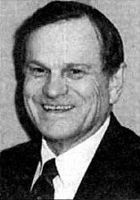

It’s been my privilege for many years now to present the most prestigious award that the Ohio Section gives out. Normally this is done with all of the Pomp and Circumstance that can be mustered at a conference or convention, but unfortunately this year the COVID-19 pandemic has taken away that opportunity.

Since I can’t be with all of you to do this introduction like we normally would do, I want you to standup while your reading this introduction, we’ll save the Pomp and Circumstance for a safer time. But trust me, it will happen for sure!!!

Our recipient is one that you might not have heard of unless you are from the Central Ohio area. But don’t let that fact skew his worthiness of this award. The recipient has worked hard for the better part of 20 years on a very special project that has included amateur radio and the Ohio Section for all of those years. He is a medical doctor with not only an interest in saving lives, but one that has found a way to combine his professional vocation with amateur radio.

Allan Severson, AB8P

It all started back when a very famous person wanted to start a project that turned into one of the largest multi-sports activities in North America. Obviously, such an event will require the services of medical teams that can treat any injured athlete, but it goes much further than that. As with any large sporting event before COVID-19, it always seems to generate huge crowds of people that are interested in those sports. This creates another problem. Anytime you gather huge crowds, you have medical problems that need attention. And, with the larger the crowds, the more complexed it gets getting the proper help to those folks in need.

Our recipient used his skills and knowledge that he learned as an amateur radio operator and combined it with his skills and training as a medical doctor to put together one of the most advanced and well trained mass care units ever conceived for an athletic event. He trained hundreds of his fellow doctors and nurses, paramedics, EMT’s and YES, even amateur radio operators to form small fast responding “Medical Teams” to take care of everyone attending this sporting event every year.

Here is just a little overview of what these teams had accomplished:

Our all-volunteer medical teams were nearly always physician led teams with both medical and communications support on site with ALS backup immediately available.  We used the Mass Casualty Incident Command structure and, in 20 years, had no deaths (in spite of a half dozen cardiac arrests), no persistent spinal cord damage (3 severe cervical fractures), and a rough total of 6,000 injuries seen and maybe 200+ EMS transports.

TOP^

Over the course of these past 20 years our growth kept pace with the ever-expanding event, including at the time of the addition of the Ohio Exposition Center (Ohio fairgrounds) in 2015 with the need for more teams/volunteers and logistics.  This past year our two command centers fielded almost 40 medical teams simultaneously at our peak effort from two major sites and 4 remote sites and took care of 587 injuries with 22 EMS transports.  The event is more than twice the size of the Olympics and completed in a much shorter time period.

Our teams performed flawlessly, and the thousands of wonderful volunteers that worked with us -  attending & resident physicians, DCs, LPNs, RNs, NPs, PAs, EMTs of all levels, medical students, athletic trainers, Amateur Radio Operators, Boy Scouts and our registration and support personnel. We successfully handled everything that was thrown at us!

So, now with everyone standing and waiting for me to announce the name……

Our recipient is….

***Dr. Brian Griffin, KE8DRD***

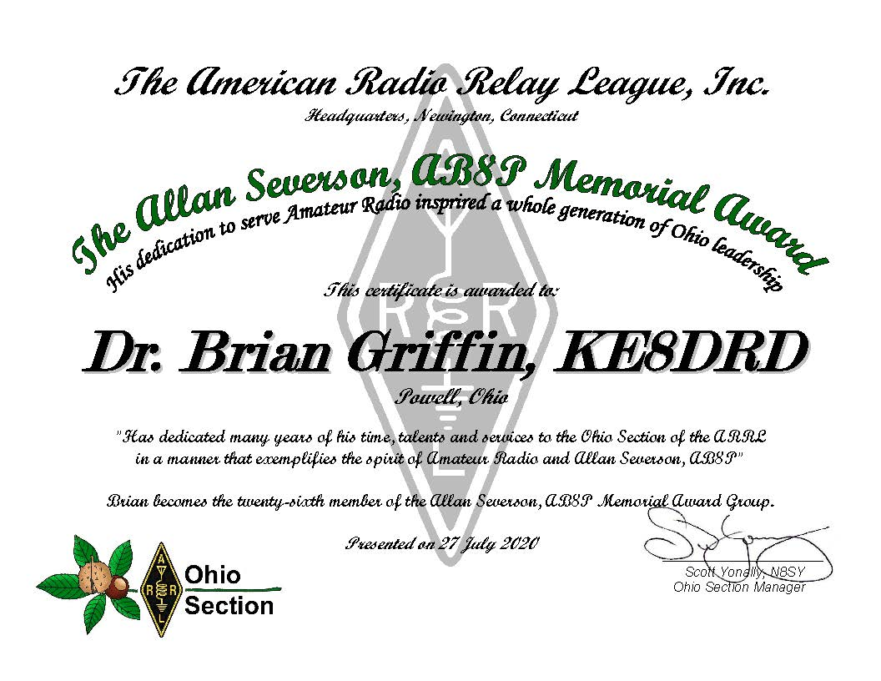

TOP^

***Final.. Final..***

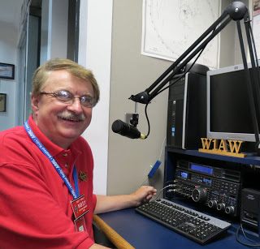Hi Gang,

Wow… we finally got a few drops of rain here this past week. It’s been so hot and humid my grass still looks brown instead of green and it “crunches” when you walk on it. I’m sure hoping that this sprinkling of a few drops of water that the rains have brought will help perk it up. Yes, I know that it will also cause it to grow, which means that I’ll have to mow. That’s ok, I’m actually one of those nuts that loves to get out on the riding mower and do my thing with the grass every week or so. I put on my noise cancelling headphones that also are blue-tooth compatible and really get down on my 50’s and 60’s music while riding back and forth in the yard.

**Ok, moving on to another subject…** First let me say Congratulations to Dr. Brian Griffin for being the 26th recipient of the Allan Severson Award!! I also want to Congratulate Chris Brault, KD8YVJ, on his receiving the 2020 Amateur Radio Newsline Young Ham of the Year Award as well.

Did you read our PIC’s article above? I have to say a huge “Thank You” to not only John, KD8IDJ, but to his judges as well. Even though we didn’t have our State Convention this year and we are still in the middle of a nationwide pandemic, he and his group of judges still found a way to judge all the newsletters that were submitted and our ARRL Ohio Section Newsletter Contest continues! And, YES, John has the winners posted in his column, but I have to say that every newsletter out there, whether submitted or not, is a winner in my book.

The idea for this contest was spawn many years ago to help improve and enrich our newsletters and their editors. Over those many years they have done just that, in fact, they have improved so much that it’s now very hard to pick just one top winner. But, the job of the judges is to do just that, and they did. You’ll have to read John’s article to see just who they all are!

Oh, and if you want to see all the newsletters that I receive, just go to:

<http://arrl-ohio.org/club_news/index.html> There you’ll not only see many familiar newsletters, but I’m sure you’ll see some from other sections as well. They are listed by month so just pick a month and sit back and enjoy!

**Moving on to another subject…** How many of you attended the virtual hamfest with DX Engineering over this past weekend? I didn’t get to sit in on much of it unfortunately, but from everything that I heard, it was a really great ‘fest.

Speaking of hamfests. Don’t forget to take a look at the hamfest listing on the website before setting out on your hamfest adventures. It seems that more and more of them are deciding to play it safe for their members and attendee’s and are canceling them. So before you set out on that adventure [>>click here<<](http://www.arrl-ohio.org/hamfests.html)  first!!

TOP^

The latest to cancel was the Clinton County Hamfest (August 15th) and the Findlay Hamfest (September 13th), that were scheduled to happen soon. I received word from their hamfest organizers that they felt that it was just too risky to go forward. Both groups said that they will try again next year.

I know that canceling a hamfest is a huge decision to make, not just because of the money involved, but also the time and efforts that go into planning and logistics of it. It’s a huge job for those folks that organize these hamfests and for them to make the decision to cancel is very hard. I want to thank all of the organizers around the state that do this very big job of making sure we have a hamfest somewhere in the state to go to. My hat is off to all of you!!!

**Let’s not forget to take a quick look at ARES Connect**

Have you looked at the breakdown per county on the website yet? We have a “per county” dashboard of the hours recorded in ARES Connect for each county. We also list those District only events as well as the hours recorded for Section wide functions. These are the hours of actual volunteers and not anonymous hours. Want to see how many hours your county has gotten so far? Go to… <http://arrl-ohio.org/SEC/reports.html>

This page is updated regularly, so you can see what’s happening in real time in your county. Don’t see hours recorded in your county? That’s because you haven’t done **your part** and gotten your time recorded.

Don’t know how? Let me know, I’ll teach you everything that you need to know to get you started.

Have you seen the latest Section Emergency Coordinators report? If not, you can view it by going to:

<http://arrl-ohio.org/SEC/reports.html>

These are just a few of the postings on the Ohio Section Website. Did you know that the website has been around since 1999? Yes, it’s now celebrating its 21st birthday. Let’s all say, “Happy Birthday” and take a look around at all of the various pages that are there. Just an FYI… We have over 2,500 pages for your enjoyment.

Whelp, my final go around before gong QRT… Stay safe my friends! I want to see all of you soon at a meeting or hamfest! We will get through this and when we do, we’ll have so much to talk about. Most of all… have FUN and get on the airwaves!!

73,

[***Scott, N8SY***](mailto:n8sy@n8sy.com)

***Back Issues of the PostScript and Ohio Section Journal***



Hey, did you know that PostScript and Ohio Section Journal (OSJ) are archived on the website? You can go back and look at any edition simply by clicking:

<http://arrl-ohio.org/news/index.html>

***Welcome New Subscriber(s)***

**Joseph, KE8JUS; Bob, KZ9ACK; Leo, KE8OOS**

TOP^

***Swap & Shop Has Added Club Raffles To Its Listings On The Webpage***

Hey Gang,

Have you taken a look at the **Swap & Shop** page on the Ohio Section webpage yet?? Here’s a link that will take you there…

<http://arrl-ohio.org/sm/s-s.html>

Do you have equipment that you just don’t need or want anymore? Here’s a great venue to advertise it, and it’s FREE!!

Is your club doing a fund raiser to help raise money? After a lot of thought, it was decided that the Swap & Shop webpage could also contain these types of items as well.

The same rules will apply as do for the For Sales and Give-A-Ways and will only be posted for a month at a time. Please see the Terms & Conditions on the webpage.

If your club is doing a fund raiser and wants more exposure, please forward the information to me and I’ll advertise it on the Swap & Shop webpage for you. Now, I still want to remind you that it won’t be listed in this newsletter because it would take up way too much space, so your ad will only appear on the website. It is there for any individual to post equipment Wanted / For Sale or Give-Away as well as for Club Fund Raisers. No licensed vehicles/trailers or business advertising will be posted.

Postings are text only (no pictures or graphics) will be posted for a maximum of 1 month from date posting and require a contact phone number or email within the posting. Send your Wanted / For Sale or Give-Away post to:  [swap@arrlohio.org](mailto:swap@arrlohio.org)

***Want to Share your Club Newsletter With Others?***



We have a webpage where you can download and read all of the newsletters that I get from around the state and even other sections!

Here’s the link to the page…. <http://arrl-ohio.org/club_news/index.html>

Please, if you don’t see your club newsletter posted, it’s because I’m not receiving it. Just have your newsletter editor contact me and I’ll get your club’s newsletter listed on the site!!

We all learn and steal (I mean, share) from each other’s work. So, get me your newsletter!!! Send it to: [n8sy@n8sy.com](mailto:n8sy@n8sy.com)

TOP^

Ohio Section Cabinet

|  |  |
| --- | --- |
| Section Manager – Scott Yonally, N8SY | Assistant Section Manager – John Perone, W8RXX |
| Section Emergency Coordinator – Stan Broadway, N8BHL | Section Traffic Manager – David Maynard, WA3EZN |
| Technical Coordinator – Jeff Kopcak, K8JTK | Affiliated Clubs Coordinator – Tom Sly, WB8LCD |
| State Government Liaison – Bob Winston, W2THU | Public Information Coordinator – John Ross, KD8IDJ |
| Section Youth Coordinator – Anthony Lascre, K8ZT | |

***Chit – Chat, and All That!***

Do you know someone that’s not getting these Newsletters? Please, forward a copy of this Newsletter over to them and have them “[Opt-In](mailto:Opt-In)” to start receiving them. Heck just have them send me an email [n8sy@n8sy.com](mailto:n8sy@n8sy.com) and I’ll get them added to the Ohio Section Emailing list.

We now have many thousands of readers receiving these newsletters weekly. Quite impressive, I’d say! I urge all of you to make sure that everyone, regardless of whether they are a League member or not, get signed up to receive these weekly Newsletters.

You can always “Opt-Out” at any time if you feel this is not what you were expecting. It’s fun and very informative. All of your favorite past newsletters are now archived too.

You can go back at any time and read them. Just go to: <http://arrl-ohio.org/news/>

Got questions, concerns or would just like to sit and chat awhile? Heck, I’ll even buy the coffee!! Give me a call at (419) 512-4445 or email me at: [n8sy@n8sy.com](mailto:n8sy@n8sy.com)

The pictures on the front page and throughout this newsletter are from various newsletters, Facebook posts and/or were sent directly to me in recent weeks. Take a good look at them, you just might be in one of the pictures! “SMILE… you’re in the Ohio Section News!!”

TOP^

*The Ohio Section Journal (OSJ) is produced as a comprehensive look at all the programs within the Ohio Section. I sincerely hope that you have enjoyed this edition of the* *OSJ and will encourage your friends to join with you in receiving the latest news and information about the Ohio Section, and from around the world!*