***[](http://arrl-ohio.org) New Year’s***

***Edition***



|  |  |
| --- | --- |
| 🡪 From the Technical Coordinator | **🡪** From the Section Emergency Coordinator |
| 🡪 From the Affiliated Club Coordinator | **🡪** From the Public Information Coordinator |
| 🡪 From the Section Youth Coordinator | **🡪** From the Section Traffic Manager |
| 🡪 ARES Training Update | 🡪 From the Assistant Section Manager |
| **🡪** National News | **🡪** The Handbook Give Away |
| 🡪 Club Corner | 🡪 DX This Week |
| 🡪 ARES Connect | 🡪 One Question Questionnaire |
| 🡪 From The South 40 | **🡪** VE Testing |
| 🡪 Final.. Final.. | |

***From the Technical Coordinator***

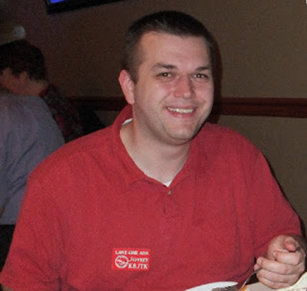***Jeff Kopcak – K8JTK TC***

[k8jtk@arrl.net](mailto:k8jtk@arrl.net)

Hey gang,

One of the things I’ve been working on during my time at home is the [Digital VoIP Multimode Interlink System (DVMIS)](http://www.k8jtk.org/ham-radio/k8jtk-hub-digital-voip-mutimode-interlink-system/), also called the K8JTK Hub. About a year-and-a-half ago, I came up with this bright idea to setup a system that would interlink many different ham radio VoIP (Voice over IP) modes for interoperability and experimentation. Through trials and tribulations, it’s experiencing some success, caught the interest of some nets, and a podcast.

Many digital modes sit on their own island and are restricted from crossing over to the analog world or to other digital networks. Some may say this is for quality-of-service but does nothing for interoperability or the ability to link and communicate across different systems. Original D-STAR DPLUS reflectors banned analog connections. My Hub supports ham radio experimentation by allowing hams to discover ways of utilizing a system that can link different modes. Utilization of ham radio spectrum is a priority through the use of hot spots and repeaters. Connections without RF are not a priority. Hamshack Hotline was provisioned because of use in Emergency Operation Centers. Many times, I’ve been asked about stations that don’t have access to RF hotspots or radios. They still have options including the Echolink app on [Android](https://play.google.com/store/apps/details?id=org.echolink.android&hl=en_US&gl=US) and [iOS](https://apps.apple.com/us/app/echolink/id350688562) devices, [Hamshack Hotline](http://www.k8jtk.org/2020/01/26/ohio-section-journal-the-technical-coordinator-january-2020-edition/) phone which can be purchased for $30 (I’ve heard deals as low as $5 for a compatible phone), or the [DudeStar](https://github.com/nostar/dudestar/releases) app. The servers are hosted in a Chicago data center to provide resiliency against hardware, power, weather, and Internet outages, but still be fairly inexpensive.

All this is possible through integration of open-sourced packages including: [AllStarLink](https://www.allstarlink.org/) which is a world wide network of Amateur Radio repeaters, remote base stations and hot spots accessible to each other via the Internet and/or private IP networks. Built on an open-sourced PBX system called Asterisk, Jim Dixon – WB6NIL (SK) built the apt_rpt module emulating functionality of a repeater controller. [Jonathan – G4KLX](https://github.com/g4klx) authored programs that support D-Star, DMR, System Fusion, P25, and NXDN which are utilized in MMDVM devices like most hotspots. [DVSwitch](https://dvswitch.groups.io/g/main/topics) is a suite of applications for provisioning and operating Amateur Radio digital voice networks maintained by Steve – N4IRS and Mike - N4IRR. The [DVSwitch Mobile app](https://play.google.com/store/apps/details?id=org.dvswitch&hl=en_US) was designed to operate analog and digital modes utilizing an Android phone in conjunction with server applications running on a Linux server or Raspberry Pi. The [ASL to DMR documentation](https://dvswitch.groups.io/g/allstarlink/files/ASL%20to%20DMR%20Bridge.pdf) (groups.io account required) got me started experimenting with these applications and ultimately lead to the build out of the system. [XLXD](https://github.com/LX3JL/xlxd) is a multiprotocol reflector server for D-STAR by Jean-Luc – LX3JL & Luc – LX1IQ. Skip - WB6YMH & others maintain [thebridge](http://cqinet.sourceforge.net/), an Echolink compatible conference bridge.

Originally, hosted on 2 servers, after troubleshooting some issues, it was more reliable to host everything across 3 VPSes (Virtual Private Servers) running Debian Linux. Parts of the system can go down and individual parts will continue to function. Aside from the VPSes, a Raspberry Pi with a [Northwest Digital Radio DV3000](http://nwdigitalradio.com/thumbdv-and-dv3000-resource-page/) provides D-STAR audio transcoding to the system.

TOP^

Wires-X is available through the use of additional remote hardware. Wires-X is proprietary to Yaesu radios and repeaters. Wires-X is not available through open-source implementations such as YSFReflector or MMDVM without additional devices. I’d like to get the DV3000s in a reliable data center but doing so is prohibitively expensive. AllStar Link is the “Hub” that provides connectivity and linking control between all networks.

Putting all of this together provides a system with access to ten different networks and eight different modes! Any user on one network can communicate with users on other networks. Access is available through these nodes and connections:

* AllStar Link: **50394**
* DMR: **Brandmeister Talk Group 3172783**
* DMR: **TGIF TG 31983**
* D-STAR: **XLX983A** (A = Analog Bridge. Pi-STAR = DCS983A, OpenSpot = XLX983A)
* Echolink: **\*DVMIS* conference 600008**
* Hamshack Hotline: **94026** (*99 - TX, # - RX)
* NXDN: **TG 31983**
* P25: **TG 31983**
* YSF: **K8JTK-Hub 31983**
* Wires-X: **K8JTK-ROOM 40680** (available upon request)

**Dashboards:**

* AllStar Link Allmon2: [Allmon2.K8JTK.org](https://allmon2.k8jtk.org/link.php?nodes=1000,50394,1202,1203)
* DMR: [Brandmeister Last Heard 3172783](https://brandmeister.network/?page=lh&jsonquery=%7b%22condition%22%3A%22AND%22%2C%22rules%22%3A%5B%7b%22id%22%3A%22DestinationID%22%2C%22field%22%3A%22DestinationID%22%2C%22type%22%3A%22integer%22%2C%22input%22%3A%22text%22%2C%22operator%22%3A%22equal%22%2C%22value%22%3A%223172783%22%7d%5D%7d)
* D-STAR: [XLX983.K8JTK.org](https://xlx983.k8jtk.org/)
* NXDN: [NXDNReflector31983.K8JTK.org](https://nxdnreflector31983.k8jtk.org/)
* P25: [P25Reflector31983.K8JTK.org](https://p25reflector31983.k8jtk.org/)
* YSF: [YSFReflector31983.K8JTK.org](https://ysfreflector31983.k8jtk.org/)

Building this system has not been without problems. Luckily, I’m able to work around known issues. In order from least frustrating to most frustrating: all programs use IP addresses and ports to communicate, keeping all of that straight was a challenge initially. Using IPs allows for great flexibility utilizing network links such as private networks and VPNs. Dependency hell as a result of additions and changes to programs made a constant deployment from one day to the next an issue. XLXD changed its implementation to include YSF which then conflicted with the port used for the YSFReflector. Changing the YSFReflector port required propagation to Pi-STAR host files and OpenSpot DNS.

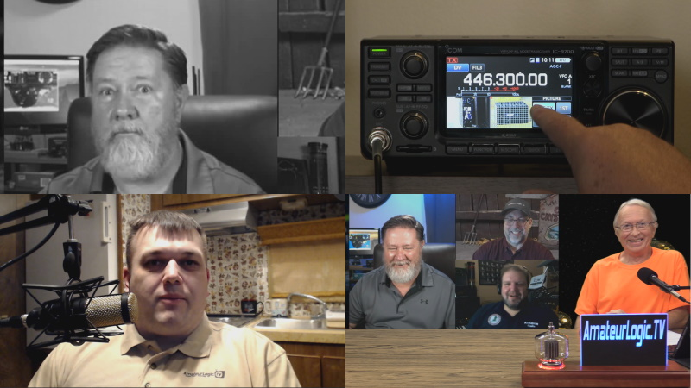

Amateur Logic episode 149

TOP^

DVSwitch has been rewritten two times since I’ve implemented it and they’ve released another round of changes. Data center provider choices resulted in issues with packet loss. Moving the servers to another provider yielded much better results. The previous provider finally acknowledged and supposedly resolved the issue a year after it was reported, and after I moved.

Use of physical hardware for D-STAR. OP25 software codec can transcode D-STAR but “you won’t be happy” to quote a post in the forums. D-STAR looooves IP addresses. DNS is great for switching IP addresses easily (like when moving data centers or spinning up different servers). However, D-STAR relies only on IP addresses. As a result, reflector IP changes take about a day to propagate to online hotspots/repeaters. Using AMBEServer with the DV3000 on a remote device resulted in very choppy audio. After some time, had the idea to move Audio Bridge to the same device as the DV3000 then use IP routing to send audio to and from AB. Worked great.

In order to compile AllStar Link from source takes a lot of time to get right and includes A LOT of dependencies. Finally, one that drove me crazy was the chan_echolink module for AllStar which provides Echolink connectivity natively to AllStar. When load testing with many connections, something was making stations sound as though they were transmitting underwater. After observing patterns, determined it was audio originating on the Hub being sent out to Echolink connections. Incoming audio from Echolink stations was OK and audio sent to all other nodes was also good. The problem seemed intermittent until I consulted groups.io and further determined chan_echolink has audio quality problems when more than three EL stations are connected simultaneously. Not ideal for a hub. Best workaround was to implement an Echolink Conference server. Then only allow chan_echolink connection to that conference server. Echolink users would then connect to the same conference server. This issue took a lot of time and a lot of hair pulling but implemented a workable solution that offers a quality system. Root cause is still unknown as an AllStar developer hadn’t chimed-in with any suggestions or possible reasons.

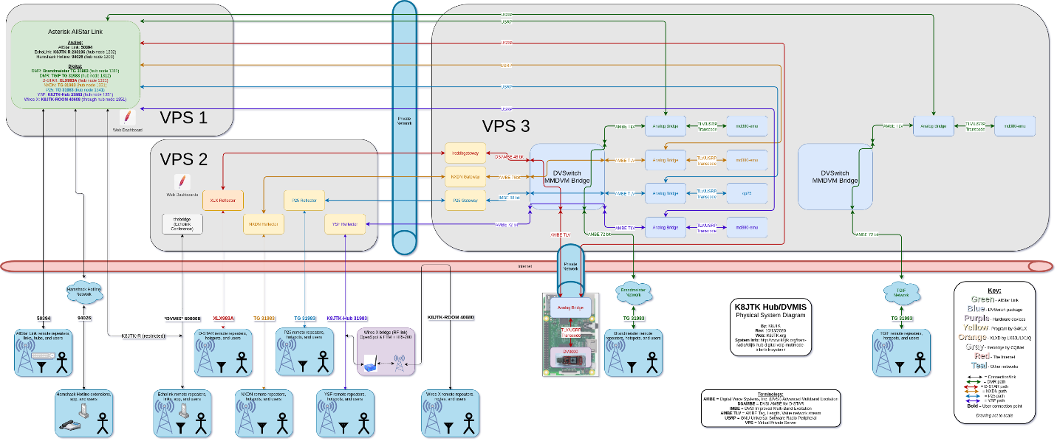

K8JTK Hub/DVMIS connections (larger version available at K8JTK.org)

TOP^

The DVMIS hub hosts a couple nets. Tuesday nights at 9pm eastern, since about the first-time stay-at-home orders were put in place, is the Amateur Logic Sound Check net. The net encourages checkins to utilize as many modes as possible during the net to test equipment. If you haven’t seen the [Amateur Logic](https://www.amateurlogic.tv/) podcast, it has been going for over 15 years and they release two shows monthly. The regular podcast has segments about technology and Ham Radio. “Ham College” is an educational show for those wanting to get licensed or upgrade. The guys asked me to put together a segment for the show. My segment can be found in [episode 149](https://www.amateurlogic.tv/blog/?p=1389). A huge thanks goes out to the ALTV crew and everyone checking into the net which helped me identify and resolve system issues. They’ve also been great in keeping up with all the changes over the last 9 months. At the end of December, I’ve been testing with the West Chester Amateur Radio Association – WC8VOA to add digital modes to their net on Monday evenings at 8pm.

Around the time my segment was airing on ALTV, Brandmeister did not approve of the linking method and linking to other networks. Brandmeister uses the [MCC](https://en.wikipedia.org/wiki/Mobile_country_code) standard and they manage talkgroup IDs consisting of 3, 4, or 5 digits. 6- or 7-digit IDs are repeater IDs and user IDs respectively and can be used however the assigned owner would like. The BM TG in the ALTV episode is now 3172783 and is correct in the listing above.

The Hub is open for all to use in testing equipment, software, or linking up with friends. I keep status updates listed on the page linked at the beginning of this article. For this and any linked system, please remember a couple practices. When keying your radio, pause a second or two to allow all links to rise, otherwise the first couple words maybe lost. Pause a minimum 3-5 seconds between transmissions to give time for links to reset and other stations to break in. Do not “tailgate.” Enjoy and join the nets to get a feel for the Interlink System’s capabilities.

Slow Scan TV has become big over the last couple years due to [ARISS](https://www.ariss.org/) (Amateur Radio on the International Space Station) events. One of the longer events will have begun before OSJ publication: starting **December 24 at 16:40 UTC** and continue through **December 31 ending at 18:15 UTC**. Dates are subject to change due to ISS operational adjustments. Images will be downlinked at 145.800 MHz +/- 3 KHz for Doppler shift and the expected SSTV mode of operation is PD 120. Radio enthusiasts participating in the event can post images they receive at the ARISS SSTV Gallery at <https://www.spaceflightsoftware.com/ARISS_SSTV/>. After your image is posted at the gallery, you can acquire a special award by linking to <https://ariss.pzk.org.pl/sstv/> and follow directions for submitting a digital copy of your received image. Even an HT can receive images from the space station. If you would like to receive images using MMSSTV on Windows, head over to [my tutorial](http://www.k8jtk.org/2015/04/16/getting-started-with-mmsstv/).

Congratulations to Scott Yonally - N8SY who won his election as Great Lakes Division Vice Director! Since he cannot hold more than one elected position at a time, he will be stepping down from his current Section Manager position when he assumes the Vice Director position on Jan 1. I wish him nothing but the best in his new role as he has done a lot for the Ohio Section during his tenure. We will then welcome Tom Sly – WB8LCD who will be appointed the new Section Manager for Ohio!

Thanks for reading. Happy holidays, Merry Christmas, and Happy New Year!

**73… de Jeff – K8JTK**

####

TOP^

***From the Section Emergency Coordinator***

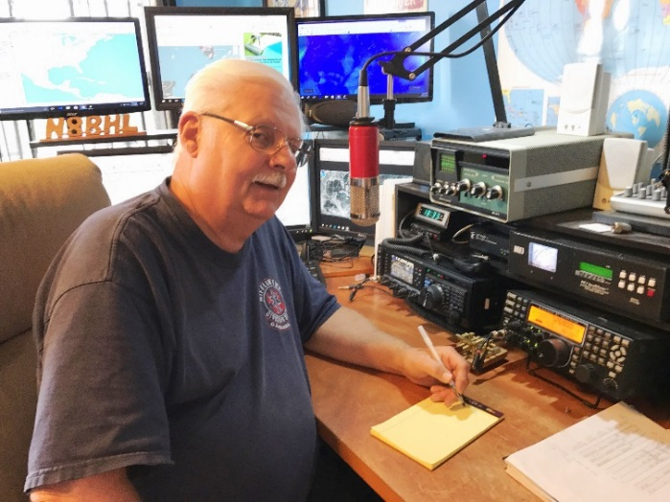***Stan Broadway, N8BHL - SEC***

[broadways@standi.com](mailto:broadways@standi.com)

***What do we do when no one’s looking?***

There’s an old measure of character that asks if one does the right thing when no one’s looking. This looney year of 2020 and all its cancelled events saw the Amateur Radio Emergency Service (ARES) busy doing things even though the general public and many of our agencies haven’t been there to see.

Much of what we did involve training and refreshing our basic skills- operating radios, sending messages and staying ready for any potential activation. And our numbers so far this year reflect our duty to stay “ready”.

|  |  |  |  |
| --- | --- | --- | --- |
|  | # of Events / Category | # of Persons | # of Hours |
| Communications Emergency | 38 | 72 | 161.75 |
| Community Event | 265 | 469 | 2,868.90 |
| Exercise | 61 | 562 | 1,170.60 |
| Meeting | 479 | 2188 | 4,712.38 |
| Net | 6278 | 24375 | 24,045.51 |
| Skywarn | 230 | 1727 | 1,664.67 |
| Training | 750 | 2470 | 8,472.51 |
| Miscellaneous | 492 | 679 | 4,661.35 |
| Unclassified – All events not listed above | 6086 | 20209 | 29,474.69 |
|  |  |  |  |
| **Totals** | **14,679** | **52,751** | **77,232.36** |

Overall, 945 individual volunteers have contributed over 77,000 hours of service! According to the Independent Sector each hour is valued at $27.20. Thus over 2020, ARES volunteers have contributed over $2.1 Million to our agencies, activities and neighbors throughout Ohio.

We’re already working on activities for 2021! One of the first is a contest which is really an opportunity for amateur operators to test their VHF/UHF antenna capabilities. We call it the ARES VHF contest- and we provide a “score” for the number of counties a station can contact. This provides a means for each county organization to plot where they have radio coverage, and where they need to improve. It’s a good time for all operators while service a greater purpose. The 2021 VHF simplex contest is set for January 9.

Another operating event tests our abilities to construct and deploy “NVIS” antennas – those which are designed to bounce signals within the state of Ohio, so that on HF frequencies we are able to stay in contact. This has been great fun over the years and promises more fun this year.

TOP^

We traditionally have a state conference at the beginning of April. 2021 may have some holdover from 2020 forcing us to go ‘virtual’. If that’s the case, we’ll have the ability to welcome a much greater number of people and even break out into different interest areas. We’re planning that now.

I have to offer my sincere thanks to all of you who participated this year in ARES activities!! Your dedication of time and energy has kept ARES a welcomed partner with the Ohio EMA, Red Cross and other agencies. Big thanks to ASEC Matt Curtin, KD8TTE, whose tireless work in traffic handling has brought us up considerably higher in skill level. Also, thanks to ASEC Tim Price, K8WFL, who traditionally is our “Idea Man” – always coming up with great ideas. And thanks to each of our ten District EC’s- who all have significant skill at ‘herding cats’ as well as promoting activity to all our county EC’s. As you know, I consider our whole structure to be upside-down…. That is, we all exist to support you as a county EC! Your shoulders carry the burden of local relationships with EMA Directors and others to keep ARES and amateur radio in front of their planning as a viable partner. Without your efforts, this would fail. So thanks to each and every volunteer- we are all working together as a great team for our neighbors!

Let’s do more next year!

73,

**\*\* You can view all of the SEC’s monthly reports on the website..** <http://arrl-ohio.org/SEC/default.html>

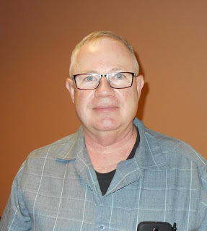***From the Affiliated Club Coordinator***

***Tom Sly, WB8LCD - ACC***

[tomsly29@gmail.com](mailto:tomsly29@gmail.com)

I certainly hope that everyone had a peaceful and joyous Christmas!

I’ve mentioned several times how happy I’m going to be when 2020 is over, we’re now just days away. I can hardly wait. Traditionally, New Years is a time of “resolutions”, unfortunately most of which go unkept. That’s because most resolutions are for “silly” things – you know, like going on a diet, spending more time at the gym, saving a million-dollars out of your $52,000 annual salary….. Let’s talk about something more important – Ham Radio.

We’ll start this month by getting back to some basics. Why are we allowed the exclusive use of what would be *BILLIONS,* maybe *TRILLIONS* of dollars, worth of radio spectrum for our exclusive use and enjoyment? It’s codified into law, that’s why. Everyone should be familiar with this:

**§ 97.1 Basis and purpose.**

The rules and regulations in this part are designed to provide an amateur radio service having a fundamental purpose as expressed in the following principles:

TOP^

**(a)** Recognition and enhancement of the value of the amateur service to the public as a voluntary noncommercial communication service, particularly with respect to providing emergency communications.

**(b)** Continuation and extension of the amateur's proven ability to contribute to the advancement of the radio art.

**(c)** Encouragement and improvement of the amateur service through rules which provide for advancing skills in both the communication and technical phases of the art.

**(d)** Expansion of the existing reservoir within the amateur radio service of trained operators, technicians, and electronics experts.

**(e)** Continuation and extension of the amateur's unique ability to enhance international goodwill.

This is why we exist. If we live up to the “Basis and purpose” of the amateur radio service, then perhaps we will be allowed to continue to exist. Laws change all the time. Once we fail to live up to this “Basis and purpose” we may find that we are no longer allowed to exist. It’s up to *US* to make sure this never happens! Let’s look at this piece by piece. I believe that all pieces are of equal importance to the “Basis and purpose” of the amateur service and are given in no particular order of importance.

Section (a) talks about “Service to the Public”, being a “Voluntary noncommercial communication service”, and “Providing Emergency Communications”. Sometimes we get just a little bit introverted and believe that amateur radio is our own personal domain. We need to constantly reinforce that we exist as a service to the public and be prepared to provide that service where required. It’s doubtful that the public will search us out for their communications needs, so it’s up to us to be aware of where we could be of value to the public and design communications plans that would be of value to the served segment of the public. One example of this is the “thons” – marathons, bike-a-thons, fun runs, things of this nature. Because amateur radio operators are properly trained and have appropriate equipment, we can usually provide a better communications solution than when they have tried to do it for themselves with CB radios, FRS radios, cell-phones…..whatever. They may have tools that could work, but they lack the experience and training to properly deploy them in a workable communications system. We provide this as a service on a non-paid basis. (Remember when we worried that if we were given a T-shirt from an event that that might be considered “compensation” and result in a visit from the FCC compliance officers?) Nothing in the rules precludes us from “showcasing” our hobby in hopes of intriguing more people to get involved with amateur radio. Remember, at these events everyone sees how you act, dress, talk and relate to “the public” and to each other. We need to reinforce a public perception that amateur radio is something they want to learn more about!

Emergency Communications is probably where we spend most of our time, training, and public relations efforts. It’s probably where we get the most opportunity to be recognized when we are activated. Because an “Emergency” can happen anytime, anywhere, every Ham needs to have at least some basic training to be able to assist if called upon. This is also an area where we need to get it right and respond with an air of professionalism.

In relation to Emergency Communications, I like to relate the story of the 2006 Sago Mine disaster in WV. Twelve miners were trapped underground after a mine explosion. Families of the miners gathered at a church about a mile away from the mine to wait for word of the fate of their family members. Word finally came, all the miners survived and would be there soon! I’m sure the families were ecstatic. Just one problem – the communication was wrong. Only one of the miners survived.

TOP^

(Remember, that was only one mistake, in college that would have been an A.) When it comes to emergency communications, we have to get it right, every time. EVERY ham should have basic EmComm training and understand the importance of message handling. Side note: the miner that survived, Randall McCloy is KC8VKZ.

Sections (b), (c) and (d) allude to the fact that in the beginning, all advancement in radio was the result of experimenting by amateurs. As science and technology progressed, licensed amateur radio operators have been involved in moving both forward, both on their own and as part of the industry that evolved around radio. In fact, many areas of science and technology (medicine for example) have been enhanced by the technical and scientific knowledge that amateur radio operators bring with them into their chosen fields. Amateur radio is uniquely qualified to provide an educational experience far beyond just what the student could get from a textbook class. “Amateur Radio Operator” can definitely be a resume enhancer for those in the fields of science, technology and engineering. It’s our responsibility to make sure that those who become amateur radio operators are given the opportunity to get that education from our clubs and activities that they can participate in. It’s also our responsibility to put ourselves out there as a resource for education and learning both in and beyond what happens in the school setting. I believe this is *especially* true in light of the recent events that have shaken up the norms of traditional education. We are a valuable resource that could be used to enhance the educational experience. But I’m afraid that they won’t find us. We have to promote and invite them to partner with us to make this happen.

Finally, section (e). Enhance International goodwill. That’s an awesome responsibility! Yes, we certainly have a unique ability and opportunity. Not only internationally, but within our own country too. Unfortunately, both require the building of personal relationships. That’s not gonna’ happen on FT-8! And if you look at most contest activity, “59 Ohio – good luck in the contest” is not exactly a relationship builder. The art of the “rag chew” seems to be lost in the on-air experience. (Except those guys late night on either 40 or 80, and unless you’re already one of them, don’t try breaking in.) We need to look for opportunities and events where we can build those personal relationships both on-air and in person. New hams need to be welcomed into the hobby. Since most new hams come in at Technician class those first on-air experiences will happen on local repeaters. We need to make sure it’s not a disappointment for them. If your club has a repeater – listen to it! Make the opportunity for some new ham to find someone to talk to. Be nice to new hams. Especially younger ones. Go out of your way to let them know that they have joined the greatest hobby in the world – *and we’re glad they did*! If their first experiences aren’t fun, why would we expect them to hang around?

To sum it all up, if we look at the basis for our existence, we have some responsibilities we need to take care of. They won’t happen by accident. We need to be intentional in our approach to doing our part, both as clubs and as individuals. If we take it seriously, we could increase our ranks substantially. We could attract a younger crowd, along with younger ideas which could push the state of the art along faster than if we just wait for it to happen. These would all be good for the hobby and good for the groups that make them happen. Circumstances of the last year have created some outstanding opportunities – let’s not miss them!

So, as we move into 2021, I want to wish you all a happy and prosperous new year. Make it the year you want it to be, not just the year that happens to you.

73,

Tom WB8LCD – SM/ACC

TOP^

***From the Public Information Coordinator***

***John Ross, KD8IDJ - PIC***

[john.ross3@worldnet.att.net](mailto:john.ross3@worldnet.att.net)



**FROM THE PIC**



**OHIO SECTION 2021 NEWSLETTER CONTEST IS OPEN FOR ENTRIES**

Ohio ARRL Amateur Radio clubs can now send their entries for the 2021 Ohio Section Newsletter Contest! The contest runs from January to June but if you issue your January edition in December it will count as an entry. Two entries from different months are needed to make it official…the deadline is midnight June 30th…and the winners will be announced in early August.

You can send a PDF of your newsletter, an active link directly to your newsletter or a link to your club’s website where the newsletter resides. You are also welcomed to send a printed copy and my address and contact numbers are below.

It looks like the judging will again be electronic…or virtual this year. All of our judges are back and have the capability of accessing your newsletter on many different platforms, so everyone gets a fair look at their work.

Believe me, this is an exciting contest…the best in the nation. We have many talented editors and writers all with a common goal of sharing stories and information about Amateur Radio.

With all of the changes in 2020 I believe 2021 will be another stellar year. So…edit away and send in your entries.



**FIRST CONTACT!**

The past nine months of working from home has had its advantages. A fully stocked kitchen just steps away (a real plus) and a ham radio “always on” monitoring several different frequencies.

TOP^

I’ve heard a lot of interesting conversations, radio checks and plenty of just plain kur-chunks making sure the repeater was operating. I also had a great opportunity to make “first contract” with a newly licensed ham.

The first, first contact came via email. The ham was having trouble accessing the local repeaters and somehow found my name and email address. We talked briefly on the phone about the type of radio he had and if it was programmed with the correct PL tone. Once all of that was determined to be OK, I asked him to change frequencies to our 16/76 machine here in Columbus and in just seconds…WA-LA… the real FIRST CONTACT! It was almost as exciting for me as it was him. We had a nice QSO and I learned his ticket was just approved a few days earlier and he had already joined our local club!! He was using a handheld and had some white noise on his signal, so he changed locations and the signal got better. We also discussed mag mount antennas for his car and experimenting with a couple of different options.

It was all good…and a reminder…that maybe some of us more mature operators need to take more time helping the “newbies” so they feel comfortable on the air and with the rest of the hams on the air. Nothing can sour and alienate a great hobby quicker than not making opportunities for newly licensed operators.

So, when you hear a new ham on the air…offer to talk and to help. It will make a difference and it will keep our hobby moving forward.

**OHIO SECTION MANAGER SCOTT YONALLY -N8SY- ELECTED GREAT LAKES DIVISION VICE-DIRECTOR**

Several years ago, when I received a call from Scott Yonally asking if I would serve as the Public Information Coordinator for the Ohio Section I was thrilled. It was an opportunity to use my journalism background to write about my favorite hobby… Amateur Radio. Little did I know then just how much of an influence Scott would have on my life and the life of the Ohio Section as a whole.

First, he has always been a friend…willing to help, to listen and make suggestions how we can make things better. Second, he has always been truthful, honest, above board and a caring leader. Not many people share those qualities…Scott does. He has been an ever present, visible Section Manager and it’s why the Ohio Section is considered the best in the nation. His hard work behind the scenes has allowed us to move the hobby forward, with measurable results, and keep Amateur Radio in Ohio growing.

I’m sure he will be a great asset as Vice-Director and carry on in the tradition he helped establish for us.

CONGRATULATIONS Scott…many happy frequencies and clear bands ahead.

TOP^

**HOLIDAY GREETINGS TO ALL**

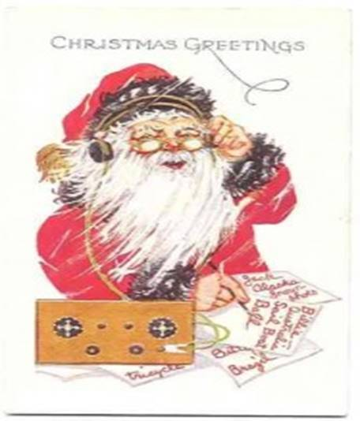

That’s it for this month and this year. From my family to yours:

**MERRY CHRISTMAS**!

73, John, KD8IDJ

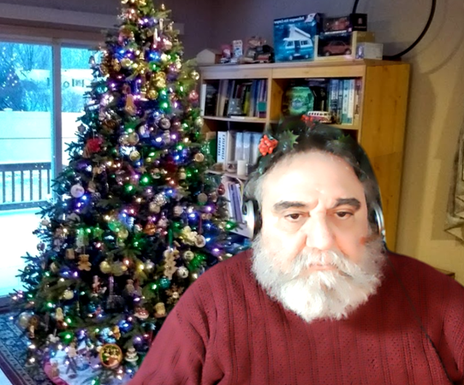***From the Section Youth Coordinator***

***Anthony Luscre, K8ZT - SYC***

[k8zt@arrl.net](mailto:k8zt@arrl.net)

**A Holiday Present**

At this time of the year, I love to give presents. In order to provide something to all of you it needs to be virtual, so I am sharing a slideshow that I recently used for a presentation for our local radio club’s Holiday Meeting along with three other virtual gifts and the best part is you can re-gift them without guilt (in fact you are encouraged to share them).

Normally my local club, Cuyahoga Falls ARC ([www.cfarc.org](http://www.cfarc.org)) has its holiday meeting at a restaurant. We invite members to bring their spouses or other guests, have drinks, dinner and a general interest program (a.k.a. not Ham Radio). With this year’s COVID-19 we had to go the virtual route. We had a Zoom meeting. We started with breakout rooms so members could chat in small groups (in place of usual socializing over pre-dinner drinks). The presentation was definitely not as Ham-free as usual but it was at least focused more on the Commercial Broadcasting aspect of radio.

[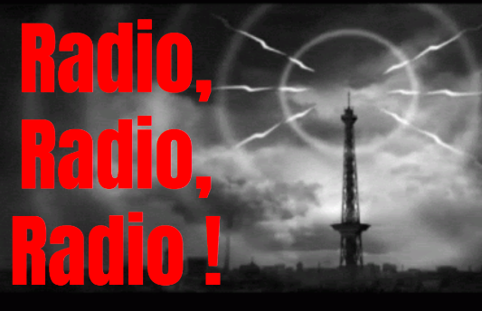](http://tiny.cc/rrradio)**Gift #1**

Here is a copy of the slideshow for your holiday perusal, as usual, it is packed with links to online resources including downloads of old-time radio shows, youtube videos and biographies of radio pioneers- [tiny.cc/rrradio](http://tiny.cc/rrradio). Or if you prefer you can watch me present the slideshow at <https://youtu.be/UzXro1E2Tnc>.

TOP^

**Gift #2**

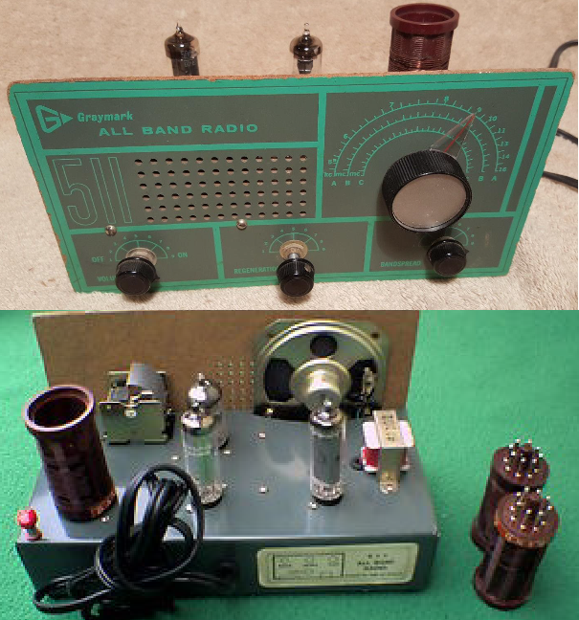Gift #2 is one that is especially great for re-gifting especially if you have a youngster to share it with.

One of my favorite gifts of my youth was a Shortwave Radio Kit, the [*Graymark 551*](http://www.radiomuseum.org/r/graymark_511.html) from my parents. Yes, I still have it today and no, I’m not going to give you my Graymark kit, but I have something that is a much better receiver with selectivity and sensitivity many times greater than the Graymark and the best part is no antenna is required.

[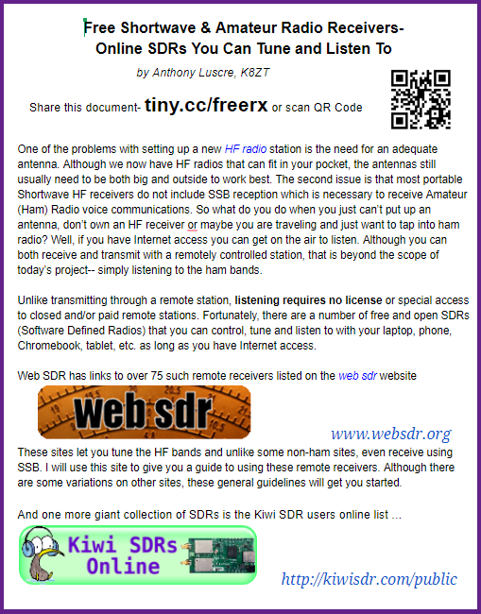](http://tiny.cc/freerx)

My document on [**“Free Online Tunable SDRs**”](http://tiny.cc/freerx) will let you receive all bands and could be just the thing to spark an interest in radio for a youngster. The link is [tiny.cc/freerx](http://tiny.cc/freerx)



**Gift #3**

By now you might be getting tired of all the radio-related gifts so I have something completely different for you. I love to cook (and eat) and I was lucky to have two Italian grandmothers and a mother who were wonderful cooks. So my final gift is a PDF of a family recipe book. Here is the link- <http://www.k8zt.com/feast> and when you are done with those recipes here is a who page of recipe and food sites to keep you busy through the New Year- [www.k8zt.com/cooking-food](http://www.k8zt.com/cooking-food).

TOP^

**Gift #4**

My final gift is more a wish or set of wishes actually…

* Have a great holiday, no matter what you celebrate this time of year
* Have a safe COVID free holiday
* Have a happy New Year and say a glad goodbye to 2020
* ... and may all your 2021 contacts be rare DX and all you contest contacts new multipliers

73, Merry Christmas and HNY

Anthony, K8ZT

***From the Section Traffic Manager***

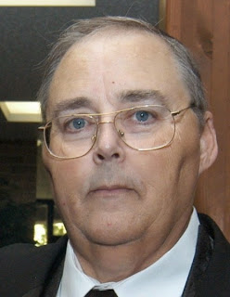***David Maynard, WA3EZN – STM***

[wa3ezn@att.net](mailto:wa3ezn@att.net)

REMINDER: Straight Key Night is held every January 1 from 0000 UTC through 2359 UTC.

Objective: This 24-hour event is not a contest; rather it is a day dedicated to celebrating our CW heritage. Participants are encouraged to get on the air and simply make enjoyable, conversational CW QSOs. The use of straight keys or bugs to send CW is preferred. There are no points scored and all who participate are winners. More info at <http://www.arrl.org/straight-key-night>

Also remember that the OSSBN is now starting the 6:45 net at 6:15 due to poor band conditions. You are asked that if you have traffic be on frequency on time a prepared to pass your traffic. At this time an attempt will be made to pass all traffic prior to having role call and before the band goes long. Everyone should also be on frequency by 6:15 and prepared to take traffic. Those able to hear weak stations will be needed to relay traffic and thanks you all for doing so.

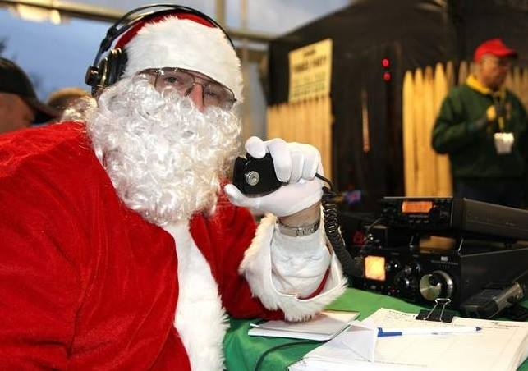

With the cancellation of the Mansfield Midwinter Hamfest the Ohio Single Sideband Net is once again going to have to find a way to hold their next meeting. Keep tuned in and checking into the OSSBN for discussions and updates on the next meeting.

TOP^

OHIO SINGLE SIDEBAND NET

["Specializing in the first and last mile of NTS delivery in Ohio."](http://www.ossbn.org/)

|  |  |  |  |
| --- | --- | --- | --- |
| **Morning session** | **10:30 AM** | **3972.5 KHz** | **every day** |
| **Afternoon session** | **4:15 PM** | **3972.5 KHz** | **every day** |
| **Evening session** | **6:15 PM** | **3972.5 KHz** | **every day** |

**OHIO HF CW TRAFFIC NETS**

|  |  |  |  |
| --- | --- | --- | --- |
| **HF CW NETS** | **NET TIMES** | **FREQUENCY** | **NET MANAGERS** |
| **Buckeye Early** | **6:45 PM** | **3.580** | **WB8YLO** |
| **Buckeye Late** | **10:00 PM** | **3.590** | **WB9LBI** |
| **Ohio Slow Net** | **6:00 PM** | **3.53535** | **W8MAL** |

All net frequencies plus or minus QRM. .

**OHIO LOCAL VHF TRAFFIC NETS**

|  |  |  |  |
| --- | --- | --- | --- |
| **VHF NETS** | **NET TIMES** | **FREQUENCY** | **NET MANAGERS** |
| **BRTN** | **9:30 PM DAILY** | **145.230 PL 110.9** | **W8DJG** |
| **COTN** | **7:15 PM DAILY** | **146.970** | **KD8TTE** |
| **MVTN** | **7:00 PM Mon** | **146.640** | **KC8HTP** |
| **NWOHARES** | **6:30 PM DAILY** | **147.375** | **N8TNV** |
| **TCTTN** | **9 PM Sun, Tues, Fri** | **146.94** | **WB8YYS** |
| **TATN** | **8:00 PM DAILY** | **146.670 PL123** | **WG8Z** |

These VHF net times and frequencies are those that have been reported to me by the net managers.

While on the subject of nets the West Virginia Mid Day Net meets daily at 11:45 AM Local Time 7.235 or 3.810 MHz. And the West Virginia Fone Net meets daily at 6:00 PM Local Time on 3.810 MHz. I mention this as a possible resource for them when there is no West Virginia representative on 8RN to take their traffic. Also as a reminder there is no digital station for West Virginia traffic and seldom is there a representative on the Interstate Sideband Net ISBN

TOP^

**And now some simple steps to stay safe until spring.**

**Surviving Winter Weather and Blizzards**

Listening to the weather predictions of a colder than usual winter with more snow the usual I offer the following tips for survival.

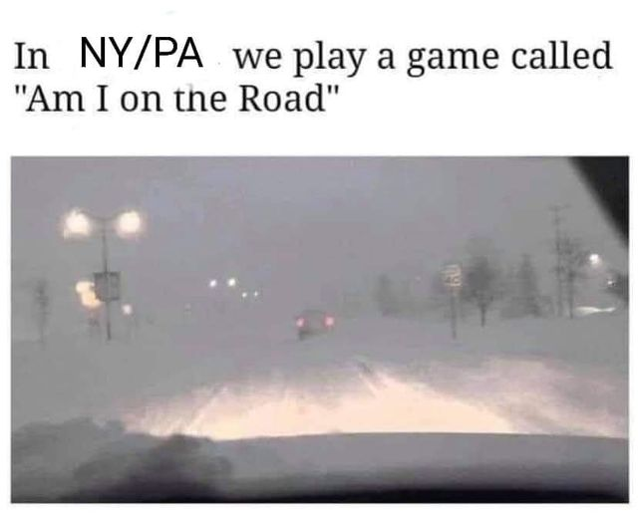

Those that have never lived-in areas like New York, Pennsylvania or northern Ohio along the lakes where snowfalls can be great may not understand exactly what a blackout blizzard is. This is conditions where the power goes out often, and the conditions are so that you cannot see to move outside. You pretty much have to stay put. Getting caught away from home in a blackout blizzard can be life-threatening if someone is not prepared. If you can avoid being on the road during major snowstorms, then staying home is always the first step towards safety. Some employers will let you go home a bit early if it means a safer trip for you.

A lot of experts are predicting that this winter will prove to be a cold one with a lot of higher-than-average snow fall occurring in areas. This has led to some people thinking about winter preps a little more. If you have not considered your winter preparations, then perhaps now is the time. It doesn’t take much snowfall or very long of a storm to cause a lot of trouble. If you live in the suburbs or a rural area, then you may be cut off from supplies for a while. There is no use being uncomfortable during a severe snowstorm or blizzard if you don’t have to be.

**Have provisions stocked ahead of time**

Blizzards are one of the many natural events that prep come in handy for. With the modern weather forecasting, technology and radar people can access from their cell phones, there is little excuse to not know well in advance that a major storm is coming. I know that weather can also just pop up to so having a week or two worth of food, beverages, and medication on hand at all times during the winter season is recommended.

**You can become trapped during a blizzard.**

Keeping a few shovels in your house where you can get to them in case you need to shovel your way out of the house. A major blizzard can block doorways and 1st story windows in some cases. You are probably not going to be able to wait until it melts to get out so it is best to be prepared and deal with the fact you may get a little snow in the house while you are creating a way to get out.

**Have an excellent car kit if you live in blizzard-prone areas**

Everyone should have a car kit that can get them out of some emergency situations or break downs, but if you live in an area with severe weather, then you need to take your car kit more seriously than those of that live in hot climates. Food, water, and warmth are critical.

TOP^

Emergency blankets, a few gallons of water, and food for five days is what is recommend along with a good medical kit. Keep a full suit of heavyweight thermal underwear in our vehicle at all times too. A portable urinal would make it more livable if you got stuck in a black out blizzard and had to pull over. You would not want to get out of your car so a way of using the bathroom would help you avoid the temptation.

**Just because you have 4 wheel or all wheel drive doesn’t mean you can go the speed limit in the snow and ice.**

I see so many people charging along in the snow and ice at close to their normal speed because they think that just having a 4×4 or all-wheel drive car is enough to keep them going. Sure these systems help you go but they are not going to help you stop that well. Take it easy regardless of how nice or loaded of a truck or SUV you have. Think about others on the highway and how being too bold could change their lives forever.

**Keep vehicles well maintained**

It is not cheap to maintain a vehicle, but one way to avoid being broke down in a storm is to keep up with your maintenance. If you have an older vehicle that is on its last legs, then you may want to consider not using it too much in the winter if you can avoid trips out.

**Know when to pull over**

Keeping going during whiteout conditions is very dangerous. At the same time, it can be hazardous or impossible to pull over in a lot of places, so you may have to make a difficult choice. If you really are starting to have trouble seeing, then you need to be looking for a place to pull over and give it some time.

Now is not the time to try to make it to the next exit where there is a less expensive hotel. Conditions can deteriorate rapidly, and you can find yourself stuck in your car for hours when you could have got a room for the night.

**Stay Warm**

If I have wood and a fire source you can stay warm. You may not want to rely on just an electric heat source or heaters that require electricity to run parts of their systems. The likelihood of no electricity during a major weather event is substantial.

If you live close enough to a town that your power is never out for more than a few hours, it is generally just a tree falling on a transformer or something like that. Ice storms can be terrible though. You can be trapped inside because the entire outside area is just slick like glass.

**Check fuel levels in oil tanks and propane units.**

Topping off before the storm may be a good idea if you are running a little low. Remember that trucks can have a hard time getting to you after a bad storm and demand will be high. You can pick up 5 or 10 gallons of heating oil at a gas station and have it in reserve to top off a low tank during an emergency.

**Remember entertainment**

If you don’t care where you find yourself in a blizzard; there is a good chance that having something to entertain yourself with would be appreciated. Those that keep an e-reader with some books on it and charged up are usually pretty prepared. You can have a whole library on one low drain device that charges with a USB. If you are at home, then your entertainment options may be a bit better. If you have some backup power, then that is a big help too.

TOP^

**Have your vice on hand**

If you have a vice, then it is best to have some extra. I am not saying your vices should be your priority, but you may want to avoid the discomfort of doing without if you really don’t have to. Chocolate, Nicotine, Soda, Energy Drinks, whatever it might be, have a week worth on hand

**Have an alternative cooking method**

Many gas ranges can be used without electricity, but many ovens will not work without power. I have a Coleman camp stove that uses propane that I can use in an emergency as well as a grill with a griddle and grill box. If you have a covered area that is clear then cooking outside during somewhat cold conditions may not be so bad, but this will depend on the severity of your weather.

I would be doing okay in an emergency even if there were a lot of people to cook for. I have looked for various ways to cook without power, and I have to say that at this price, the oven/stove is the best deal out there for a new stove especially.

**Be ready to melt snow and filter for drinking water**

Snow melts fast when brought into a warm house. You can run this through a good filter and be fine for drinking water during the emergency. Snow is some “fluffy” water so you might be surprised how much snow it takes to melt into a single quart of water. This is another reason it may be good to have a few food grade buckets on hand during an emergency since you can haul so many things in them if needed.



**NOW SOME ADVICE FROM A RESPIRATORY THERAPIST ABOUT COVID**

Just in case you get the virus and develop symptoms, here’s some good advice from a respiratory therapist to help stay out of the hospital and recover quickly.

**CORONA Common Sense**

Since they are calling on Respiratory therapist to help fight the Corona virus, and I am a retired one, too old to work in a hospital setting. I'm gonna’ share some commonsense wisdom with those that have the virus and trying to stay home. If my advice is followed as given you will improve your chances of not ending up in the hospital on a ventilator. This applies to the otherwise generally healthy population, so use discretion.

* 1. Only high temperatures kill a virus, so let your fever run high. Tylenol, Advil. Motrin, Ibuprofen etc. will bring your fever down allowing the virus to live longer. They are saying that ibuprofen, Advil etc will actually exacerbate the virus. Use common sense and don't let fever go over 103 or 104 if you got the guts. If it gets higher than that take your Tylenol, not ibuprofen or Advil to keep it regulated. It helps to keep house warm and cover up with blankets, so body does not have to work so hard to generate the heat. It usually takes about 3 days of this to break the fever.

TOP^

1. The body is going to dehydrate with the elevated temperature so you must rehydrate yourself regularly, whether you like it or not. Gatorade with real sugar, or Pedialyte with real sugar for kids, works well. Why the sugar? Sugar will give your body back the energy it is using up to create the fever. The electrolytes and fluid you are losing will also be replenished by the Gatorade. If you don't do this and end up in the hospital, they will start an IV and give you D5W (sugar water) and Normal Saline to replenish electrolytes. Gatorade is much cheaper, pain free, and comes in an assortment of flavors

* You must keep your lungs moist. Best done by taking long steamy showers on a regular basis, if you’re wheezing or congested use a real minty toothpaste and brush your teeth while taking the steamy shower and deep breath through your mouth. This will provide some bronchial dilation and help loosen the phlegm. Force yourself to cough into a wet washcloth pressed firmly over your mouth and nose, which will cause greater pressure in your lungs forcing them to expand more and break loose more of the congestion.

1. Eat healthy and regularly. Gotta’ keep your strength up.
2. Once the fever breaks, start moving around to get the body back in shape and blood circulating.
3. Deep breath on a regular basis, even when it hurts. If you don't it becomes easy to develop pneumonia. Pursed lip breathing really helps. That's breathing in deep and slow then exhaling through tight lips as if your blowing out a candle, blow until you have completely emptied your lungs and you will be able to breath in an even deeper breath. This helps keep lungs expanded as well as increase your oxygen level.
4. Remember that every medication you take is merely relieving the symptoms, not making you well.
5. If your still dying, go to ER.

After preparing your PSHR report don't forget to send you traffic count to the traffic manager WA3EZN. Unlike the PSHR report there is no limit on the number of points you claim for this activity. Your traffic report should be a simple three-word message.

Until next time remember to obey the state 10PM curfew, don't assemble in large groups, wear you masks and try to have a good new year.

As time marches on it will soon be a new year – 2021. Happy New Year

73

David WA3EZN

Ohio Section Traffic Manager

**You can view the STM’s monthly report on the website..** [**http://arrl-ohio.org/stm/stm.html**](http://arrl-ohio.org/stm/stm.html)

TOP^

*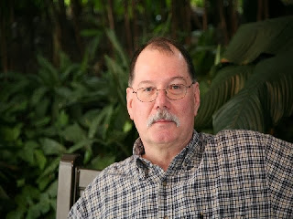****ARES Training Update***

***Jim Yoder, W8ERW – ARES Data Manager***

[w8erw@arrl.net](mailto:w8erw@arrl.net)

**ARES Training Update**

Here we are at the end of this very trying year. We have endured months of constant fear of contracting Covid-19 while at the same time being bombarded with endless political advertisements. The division of our country has reached an all-time high. Oh, what a nice Hamfest could do to raise my spirits. Much could be said about this past year. I won’t begin to repeat or offer an opinion here. Suffice it to say that I hope each of you has been able to avoid the Corona Virus and I pray for our nation that we will overcome and return to both normalcy and our position of strength. And let’s all hope that as Hamfest season approaches for 2021 that we will be able to enjoy a few and renew the friendships and community of Amateur Radio together once again.

Soon we’ll also have a new Section Manager as Scott transitions into his new role as Vice Director for our Great Lakes Division. Congratulations Scott and for those who also ran, I challenge you to not sit in the background. Both Scott and our new Section Manager are going to need our help, your help. We need to continue to grow our ranks and work together towards success. The pool of talent throughout our Ohio Section and the Great Lakes Division is enormous and we do have what it takes to achieve our goals. Let us all work together and make sure it happens in 2021.

We are going to have challenges as we proceed. Recent FCC developments are proof of our need to work together and demonstrate our value as Amateur Radio Operators. ARRL is our best advocate to protect our interests and has stepped up to support us as the FCC now suggests we should be paying a fee to have a license to operate. Spectrum allocation also is and will always be ours to lose. It is imperative that we address these issues from a position of strength and advocacy. Like you, all of this is upsetting to me. We have the high road. Let’s work together towards a common goal to protect our hobby from these efforts against us. We can do much in a positive and constructive manner if we come together as one voice while demonstrating our value.

Zoom and a few other platforms have gotten a serious workout this past year as we were forced to think out of the box to enable meetings and other club and organizational functions to continue. Some of us including myself had to stretch a bit to embrace all this new application of technology. Is not that a big part of what we as Hams are all about? We gave new meaning to social distancing by doing what we know how to do best, communicate. As we enter the New Year with new leadership, we must continue to look for additional ways to enhance our capabilities and to operate in an environment that is not the most conducive to our goals. I think we are up for this challenge and I encourage everyone to be involved, participate and help spin this next year into a very positive one for Amateur radio.

TOP^

Now for the training stats, I know you were wondering when I would finish my admonishments here and tell you the numbers. As is the norm, the holiday season brings with it a general slowing down of training activity. Still, we have grown. As of this writing, there are 1,880 Ohio Amateurs listed in the training database, of those 1,478 are registered on ARES Connect. We have 951 Level 1, 729, Level 2 and 200 at Level 3. Total training certificate submissions to date are 9,743. I must also advise that 46 of those listed in the database have now become silent keys. As we end this year, let us remember them all and the contribution each gave to our hobby.

We have the prospects of a great year ahead. There is plenty of room for growth and let’s not forget that an important part of our hobby is to have fun. Do that. Get signed up on ARES Connect if you have not done so. It’s a great place to keep abreast of what’s happening locally and around Ohio and can serve as your go to calendar for events of interest. Visit the ARRL-Ohio.org web page often as there is a wealth of information there to keep you in the loop on the latest developments from ARRL and our Ohio Section. While you are there be sure to sign up for our monthly and weekly newsletters.

I would like to wish each of you a very wonderful holiday season along with the best of the New Year. Thank you all for the dedicated effort supporting ARES and training in Ohio. Each of you doing a little makes us all strong.

73 and Thank You,

**Jim W8ERW**

[w8erw@arrl.net](mailto:w8erw@arrl.net)



***From the Assistant Section Manager***

***John Perone, W8RXX – ASM***

[w8rxx@arrl.net](mailto:w8rxx@arrl.net)

I sincerely want to wish Scott, N8SY the best in his newly elected position as Great Lakes Division, Vice Director. We will all miss him as our Ohio Section manager.

As Scott is leaving as Section Manager, I am stepping down as Assistant Section Manager.

I leave you with what 2020 has come down to…

1.  The dumbest thing I ever bought was a 2020 planner.

2.  I got so bored I called Jake from State Farm just to speak to someone.   
3.  2019: Stay away from negative people.  2020: Stay away from positive people.    
4.  Old folks are sneaking out of the house and their kids are yelling at them to stay indoors.    
5. Can we take showers yet or should we just keep washing our hands?    
6.  I need to practice social distancing from the refrigerator.

TOP^

7.  Never before could I walk up to a bank teller wearing a mask and ask for money.    
8. The continued spread of COVID-19 is based on 2 things:

1.   How dense the population is.

2.   How dense the population is.

Merry Christmas to all, and to all a Happy 2021…

**73, John W8RXX**

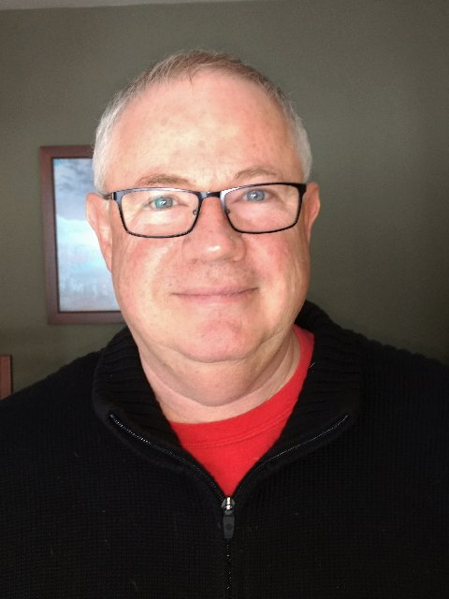***National News***

*(from arrl and other sources)*

***Tom Sly, WB8LCD, Appointed as Ohio Section Manager***

Tom Sly, WB8LCD, of Kent, has been appointed as the Ohio Section Manager, effective January 1, 2021. Sly will assume the seat that incumbent Section Manager Scott Yonally, N8SY, is vacating to become Great Lakes Division Vice Director, after serving as Ohio Section Manager since 2014.

Sly was appointed by ARRL Radiosport and Field Services Manager Bart Jahnke, W9JJ, after consulting with Great Lakes Division Director Dale Williams, WA8EFK. The Section Manager appointment extends through September 30, 2022.

Sly is an ARRL Life Member and has served as Ohio Section Affiliated Club Coordinator since 2017. He is past president of the Portage County Amateur Radio Service (PCARS) and has been a radio amateur since 1968.

####

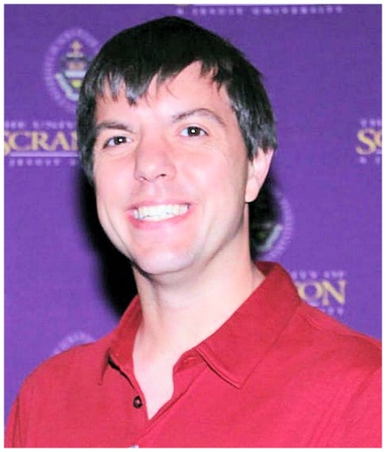***Nathaniel Frissell, W2NAF, Awarded National Science Foundation CAREER Grant***

Nathaniel Frissell, W2NAF, an assistant professor of physics and electrical engineering at Scranton University, has won a highly competitive National Science Foundation (NSF) [**CAREER grant**](https://news.scranton.edu/articles/2020/12/news-faculty-nsf-careergrant-frissell.shtml). The $616,054 award will fund a 5-year initiative that integrates original ionospheric research into undergraduate course curricula and undergraduate and graduate research projects at the university. NSF CAREER grants are only available to early-career, tenure-track faculty members and must include tightly integrated research and education components.

TOP^

Frissell told ARRL the grant will offer significant support to develop the university’s newly formed ham radio club, W3USR, over the next few years.

“I am grateful to have this opportunity to advance the field of ionospheric physics, work with students and colleagues, and build up the amateur radio club, W3USR, at Scranton University,” said Frissell, who founded **[HamSCI](http://www.hamsci.org/)**, an international citizen science space physics research collective.

Frissell’s NSF CAREER proposal builds on his previously awarded $1.3 million [**NSF grant**](https://news.scranton.edu/articles/2019/11/news-faculty-nsfgrant-frissell.shtml) to develop modular, ground-based space science observation equipment and software for collecting and analyzing data from an international network of amateur radio users, including the ham radio club at Scranton.

“Space weather significantly impacts important modern technological systems, and the effective operation of such systems is dependent on the state of the ionosphere,” Frissell explained in the introduction to his grant proposal. “Understanding the connection between traveling ionospheric disturbances and atmospheric gravity wave sources in the lower atmospheric regions could improve the ability to predict the ionospheric state and thus its impact on navigation and communications systems.”

Through the NSF CAREER grant, Frissell will apply sophisticated, physics-based atmospheric/ionospheric models to extensive new data collected via the amateur radio network of Personal Space Weather Stations, which he helped to develop. The new funding supports two graduate engineering research assistants at Scranton University who will conduct data analysis and run models and code implementation using a new Linux-based analysis server that the NSF proposal will also fund.

In addition, Frissell will introduce physics and engineering students to space physics research and develop the skills needed to conduct this research through an introductory physics course for first-year students and, at a more sophisticated level, through an upper-level undergraduate “Introduction to Space Science and the Atmosphere”course he teaches, the university explained.

####

***FCC starts crackdown on pirate radio landlords***

*(Submitted by Gregory Drezdzon, WD9FTZ)*

The Federal Communications Commission’s Enforcement Bureau has begun targeting property owners and managers that tolerate pirate broadcasting on their properties.

It started today by notifying owners of three properties in Queens in New York City that there is apparent illegal broadcasting happening at their buildings.

The bureau issued an announcement that it is exercising the FCC’s new authority under the recently enacted “PIRATE Act,” which gave the commission a significant new hammer in its anti-pirate toolkit: “Parties that knowingly facilitate illegal broadcasting on their property are liable for fines of up to $2 million,” it stated.

TOP^

Enforcement Bureau Chief Rosemary Harold said, “It is unacceptable — and plainly illegal under the new law — for landlords and property managers to simply opt to ignore pirate radio operations. Once they are aware of these unauthorized broadcasts, they must take steps to stop it from continuing in their buildings or at other sites they own or control.”

If they don’t, she said, they risk a heavy fine, followed by collection action in court. “In addition, our enforcement actions will be made public, which may create further unforeseen business risks.” She emphasized what the FCC and broadcasters have acknowledged for years:  that pirate radio is illegal, and can interfere with licensed stations and emergency alerting

Read the full story at:  
<https://www.radioworld.com/news-and-business/headlines/fcc-starts-crackdown-on-pirate-radio-landlords>

####

***FREE QRP Book***

*(By Gregory Drezdzon, WD9FTZ)*

Here is the link to a FREE QRP book that could keep one busy on these cold winter days!

<https://drive.google.com/file/d/1dw61-PQ-4JA9feh93H_KrldD4RpN1zZT/view>

####

***FCC Posts Email Address Reminder On ULS Landing Page***

The FCC is encouraging users of the Universal Licensing Service ([**ULS**](https://www.fcc.gov/wireless/systems-utilities/universal-licensing-system)) to have an email address on file with the FCC.

“Applicants are strongly encouraged to provide an email address on their license application(s), which will trigger the electronic issuance of an official copy of their license(s) to the email provided upon application grant. Per the timing specified in Rulemaking [**FCC 20-126**](https://docs.fcc.gov/public/attachments/FCC-20-126A1.pdf), the FCC will no longer print, and licensees will no longer be able to request, hard copy license authorizations sent by mail.”

The FCC has not yet established the date by which an email address will be required on all applications. ARRL VEC already has begun including email addresses on FCC applications for as many applicants as possible.

####

TOP^

***Christmas / New Years Handbook Give Away***

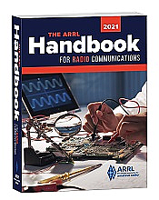

Hey Gang,

The winner of the Christmas Day Give Away is…

***Dennis Blair, Jr KE8OQA***

Now I want you to know that it ain’t over yet… There’s going to be another drawing on New Years!! And… if you were registered for the Christmas Drawing, you’re already registered for this one too. If you haven’t gotten registered yet, you only have until New Year’s Eve night to get registered. So, with that said, you’d better get jumpin’ right now.

Go to: <http://arrl-ohio.org/handbook-christmas.html> and get registered NOW.

What’s the catch? I want to get everyone checking in to the Ohio Section website as often as possible, and in order to register each month, you have to visit the website often! There’s nothing else to it. I pay all expenses, and from time to time,

Many of you ask me just how do I know when the drawing is on? Well, that’s easy all you need to do is check in on the Ohio Section Website on a regular basis and watch for the big **RED** Arrow that will appear on the left side of the page. This is the sign that the drawing is on and you need to get registered. So, keep a sharp eye out on the website and check in often! <http://arrl-ohio.org/>

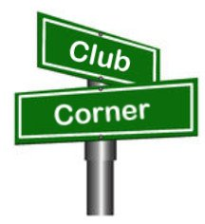***Club Corner***

This is YOUR cornner of the newsletter. Send me what your club is doing and I’ll make sure that it gets in. Got a special event or club project that you want everyone to know about? Send it to me!. Need help with a project? Send it to me.

Let me know what you club is up to. Are you going to have a special guest at your meeting or are you having a special anniversary? Just sent it to: [n8sy@n8sy.com](mailto:n8sy@n8sy.com)

####

TOP^

1. ***Online General License Course***

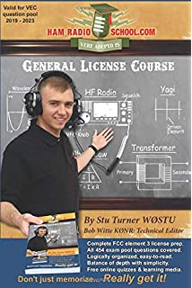**The Cuyahoga Falls Amateur Radio Club is offering an online General Licensing Course** starting **10 January 2021**.

There is no fee, but the students are responsible for purchasing a copy of **Ham Radio School’s General License Course book**.

The six consecutive Sunday classes will start at 1:30 PM and go to 3:30 PM.

Most sessions will be followed by a demonstration of amateur radio activities.

To register, go to <https://cfarc-edu.org/course/>.

For more details contact [education@cfarc.org](mailto:education@cfarc.org).

####

***Seneca ARC Held a Pizza Party***

Seneca radio club held its annual Christmas pizza party on December 14th.

We were socially separated but together for a wonderful time of fellowship. We were also visited by Santa Claus from Buffalo Wild Wings who gave out Fusion radios as door prizes.

Everyone there had a really great time and fellowship, not to mention that the pizza was really good as well!!

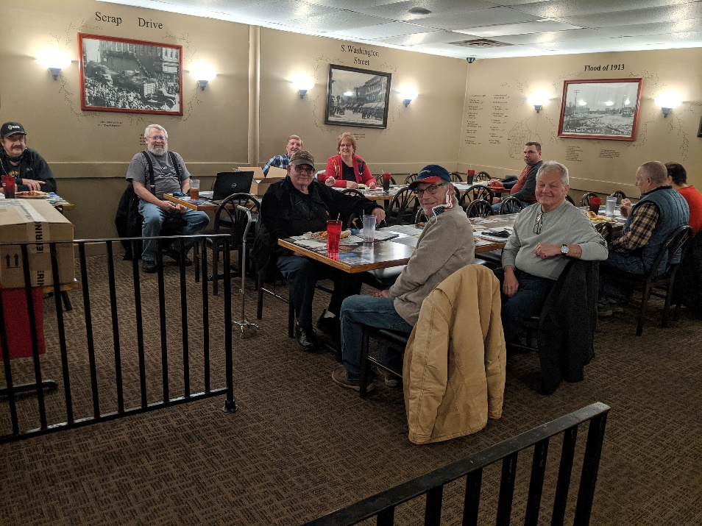

####

TOP^



Hello everyone,

With the pleasant (and somewhat alarming) snowfall a couple of days ago, it feels more like the holidays than ever!  The fall semester finished up last week; engineering students risked robotic life-and-limb with the annual Battle Bots Tournament while others completed homework and chilled in the tranquil 3D Lab environment.  Having finished their final round of exams, our students look forward to a month of taking it easy and being with loved ones.

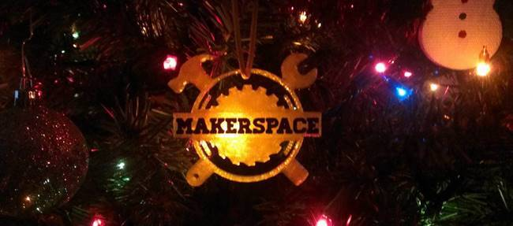

Despite coronavirus restrictions, regular community member requests kept us busy in the 3D Lab.  Almost every day our lab staff received materials & design files, fabricated the requests on our 3D printers, laser engraver, and other equipment, then folks picked them up.  While we miss the in-person interaction, networking, and friendship when people come together, we know this will resume after the pandemic subsides.

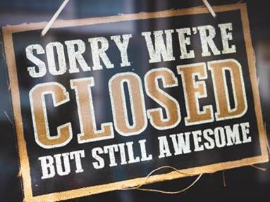

Even though the 3D Lab is closed over the winter break due to COVID precautions, its services are ready and available starting January 4th, 2021.  If you have projects that need 3D printed, laser engraved, vinyl signage made, etc., reply to this email with your request at that time.  We will perform the work in the 3D Lab at no cost for pick-up later.  [Here is a list of our equipment](https://blogs.uakron.edu/waynec3/equipment/) to aid in making your projects come to life.

Why buy Christmas gifts when you can make them?  Handmade gifts are original and have sentimental value; they also are a “gift” to the maker simply from the joy of creating something new!  Tessa, one of our community members, enlisted the help of her father to cut wine bottles in-half, creating one-of-a-kind drinking glasses.  She then designed emblems with family names that were laser engraved onto the glasses, creating images with a nice, frosted look.  The result was low-cost, original, and quite lovely!

TOP^

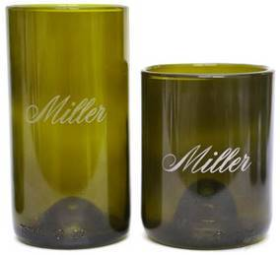

Our [Epilog-brand laser engraver](https://www.epiloglaser.com/) has a wonderful company behind it, providing top-notch support years after ownership.  They also have a webpage full of creative ideas of things.  Epilog calls it their [Sample Club](https://www.epiloglaser.com/resources/sample-club.htm) where people from all over the world submit pictures and instructions for others to replicate in their own makerspaces.

One such idea is an intricate wreath, laser carved from 1/8” plywood, then sprayed with glitter paint.  Our staff added a red, wooden bow with a family’s name engraved on it, resulting in a beautiful, personalized Christmas gift.  Epilog included the design files for cutting the 12” wreaths, so it was a piece of cake to make these.

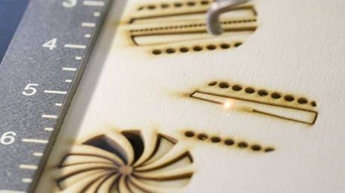

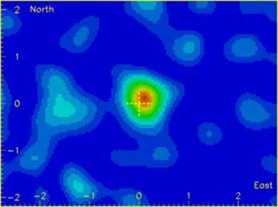Community member Elliott continues to make strides with his Muon Telescope that the built several years ago.  A muon is one of several secondary cosmic ray particles.  The primary cosmic rays composed of mostly protons and alpha particles (electrons) originate in deep space or possibly from our sun.  They enter the Earth's upper atmosphere and interact with or hit the nuclei of molecules such as oxygen and nitrogen, forming several new secondary particles including muons.

Muons are of particular interest because they are heavier than the other secondary particles, travel at 0.998 times the speed of light, and can penetrate several hundred feet into the earth.  Recently, because of the ability of muons to penetrate massive rock formations, muon telescopes have been used map the inside of the pyramids in Egypt.  This process revealed additional chambers that were not previously known to exist.

TOP^

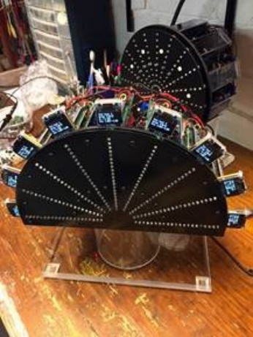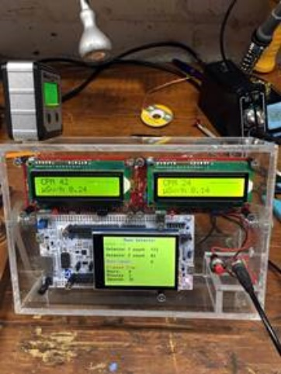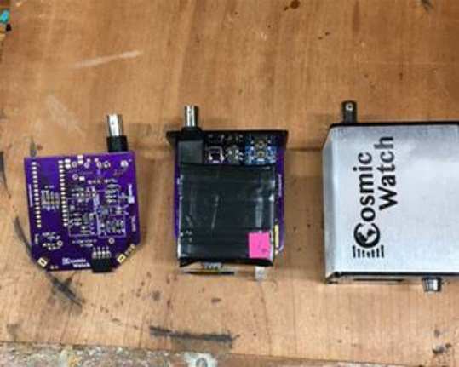Elliott’s muon telescope detects and records the number of  muons coming from different areas (angles) of the sky.  The first version of his telescope produced random flashing of 36 LED's in a 6 X 6 matrix. This provided limited muon detection by observation of 3 or more LED's flashing simultaneously in a single line.  The current version not only detects muons, but shows their relative direction using a strings of 21 LED's and counts them, too.

[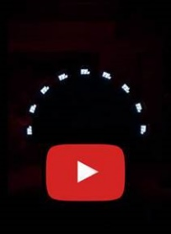](https://youtu.be/Fld68wDDzGg)

Each string or arm of the muon telescope has two Geiger counters with the Geiger tube sensors spaced about 3/4" apart in the direction of the LED light strings.  Each pair of Geiger counters is connected to a NAND gate coincidence detector that register muon particles passing (almost) simultaneously through both Geiger tubes and illuminates a full string of LED's .  The processing is done by an Arduino Nano and recorded on the OLED screen.  Here is a [video](https://youtu.be/Fld68wDDzGg) if Elliott’s telescope in-action!

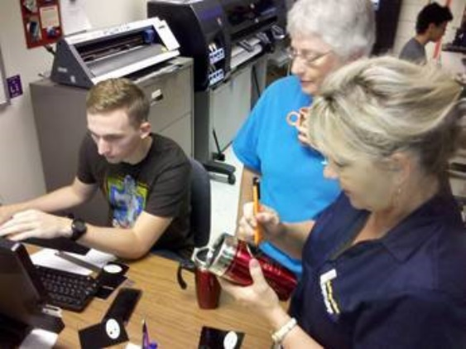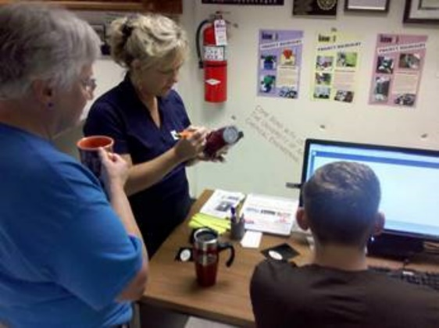

Earlier this year, Jackie and a community member wanted to make commemorative gifts for an award ceremony.  Lab staff Nathan was happy to enlist himself to the project!  Metal thermos bottles were laser engraved with imagery, producing a shiny silver design against the metallic red paint.  Nathan then designed additional graphics with the vinyl cutter, creating a two-tone effect.  The result was professional!

Stay tuned in January as we introduce more interesting folks who participated in last year’s Maker Faire!

Until then,

Tom Hammond, M.A. - Technical Support Services

####

TOP^

***2021 Cleveland Marathon***

I'm excited to announce that the 2021 Cleveland Marathon and 2021 Hamvention will be on different weekends. Hopefully this means we will be able to get many more volunteers for the marathon. As you may know, it takes 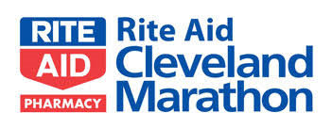at least 40 people to staff the marathon and the City of Cleveland even officially activates ARES for it.

To volunteer for the marathon, please click here <https://forms.gle/f6dYw8vb6KAptaVk8>

I know it's early, so expect to hear me talking about this a lot more over the coming months.

• Cleveland Marathon May 15-16, 2021

• Hamvention May 21-23, 2021

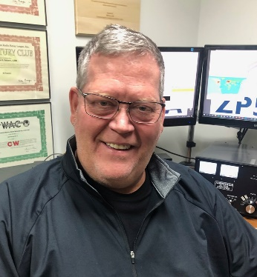***DX This Week***

*(from Bill, AJ8B)*

***DX This Week – 2021 Goals***

***Bill AJ8B (aj8b@arrl.net, @AJ8B, or www.aj8b.com)***

***CWOPs Member #1567***

The Midwest DX Cluster spots were rolling in last week. They included Algeria, Anguilla, Antarctica, Austria, Azores, Belgium, Belize, Bulgaria, Canary Islands, Chile, Crete, Croatia, England, Fed. Rep. of Germany, France, Gibraltar, Greenland, Hungary, India, Ireland, Isle of Man, Israel, Italy, Japan, Luxembourg, Mali, Mauritania, Mauritius, Mexico, Namibia, Netherlands, New Zealand, Northern Ireland, Norway, Portugal, San Marino, Scotland, Slovenia, South Africa, Spain, Sudan, Switzerland, Thailand, Trinidad & Tobago, United Arab Emirates, US Virgin Islands, Vienna Intl Ctr, Wales, and Western Sahara.

***DAH DIT DIT DIT DAH DAH DIT DIT DIT DAH***

QSL cards received this week included YE6YE – Tara in Medan, Indonesia, and YD9VE – Suwardi in Indonesia, YO7YO – Max in Romania, and AJ8A – Seiji in TN.

|  |  |
| --- | --- |
|  |  |

TOP^

***DAH DIT DIT DIT DAH DAH DIT DIT DIT DAH***

My elmer (and OM), K8DWE (SK), convinced me early on that the only person that I had to compete with on the bands was myself! I would never have the biggest station, best antennas, most power, etc. so I had to set goals for myself. During my career at HP, I learned about *stretch* goals. Most people set goals for themselves, but, they either forget about them or make them too easy to attain. Additionally, you must revisit your goals frequently and set up procedures and practices that support your goals. What does all of this have to do with DX? I took these teachings to heart years ago and set several short term and long term goals. I review them annually and then monthly. I keep an eye out for things that can help me achieve these goals and implement those things when I can. My 2021 goals include:

* **Long Term Goals**
  + Achieving DXCC Honor Roll
  + Exceeding 2,000 on the ARRL DXCC Challenge roster
* **Short Term Annual Goals**
  + Participate in the 8 major contests (CQWW DX RTTY, CQWW DX SSB, CQWW DX CW, CQWW WPX SSB, CQWW WPX CW, ARRL 160, CQ 160, and 8th Area QSO party.)
  + My short-term goal is to exceed my previous years’ score in the annual CQ Marathon.
  + Increase my 160M DXCC count
  + Work at least 6 entities every day via any mode

What are your goals for 2021? I thought this would be a great topic for this edition as we are getting close to the end of the year. If you don’t have any goals, but like to chase DX, I would ask you to consider participating in the CQ Marathon DX chase. One of the great things about the award is that confirmations are not required.

However, you need to be honest!

The rules read “*QSLs are not required.  The operator is expected to claim contacts only from stations the operator has every reason to believe are legitimate, and only to claim contacts in which an accurate two-way exchange was clearly accomplished. Scores will be adjusted by the DX Marathon committee for claimed contacts with pirates or any station not considered legitimate.  Submissions may be penalized or voided in cases of fraud or poor sportsmanship. Every QSO may be subject to verification by the DX Marathon Manager. Decisions of the DX Marathon Manager are final.”*

**The following information is from the CQ Marathon website (**[**http://www.dxmarathon.com/**](http://www.dxmarathon.com/)**) :**

Starting January 1 of each year, the DX Marathon is the perfect answer for the DXer who needs that extra incentive to get on the air every day! Simply work as many countries and CQ Zones as you can in each calendar year, regardless of the band or mode. Each country and zone counts only once, so you can concentrate on working new ones rather than working the same ones on multiple bands and modes. Many awards are given for the top overall scores in four classes plus top scores in modes, bands, US call areas and more!

Each year there are pirates, operations that are not approved, callsigns that are copied incorrectly and unusual operations that are valid. We attempt to document as many of these operations as possible - see the lists of valid callsigns, invalid callsigns, and callsign notes.

TOP^

We encourage you to share your findings on pirates, illegal operations or confusing callsigns with us. Please send your callsign updates to the DX Marathon administrator at: [k9el@dxmarathon.com](mailto:k9el@dxmarathon.com)

Many points are lost each year due to bad spots on the packet cluster network. We have assembled an extensive list of bad spots - please check the list before entering any of these callsigns!

Please check USA/VE zones carefully - use [www.qrz.com](http://www.qrz.com) to check zones before submitting. The number in the callsign does not necessarily match the location. Did you know that West Virginia (W8) is in Zone 5? and that Alabama (W4) is in Zone 4? Also, check Zone 2 submissions carefully.

When a prefix can count for more than one country (e.g. E51) double check your entry. Although you can use the same QSO for a country and a Zone, if there is an error, two points will be lost! We suggest using a different QSO for country and zone. Review your submission carefully and make sure your logging program country database is up to date.

This list of separate countries (entities) for the CQ World Wide DX Contest and the CQ DX Marathon is based on a combination of the ARRL DXCC list, additional entities on the WAE (Worked All Europe) list and the Italian islands of Lampedusa (IG9) & Pantelleria (IH9), in CQ Zone 33 off the coast of North Africa. This provides a total of 346 entities, based on 340 DXCC entities, six additional WAE entities (GM/Shetland, IT/Sicily, TA1/European Turkey, 4U1VIC, JW/Bear Is.) plus African Italy.

Total CQ Countries: 346 (This list last updated February 11, 2018)

This gives you a reason to work Canada, England, France, Spain etc. again in 2021! It is a clean slate and you can start all over to better your score from the previous year. I have been able to increase my score each year, even with sunspots declining. In 2017, as propagation started to fail, I had to get something up for 80M. This past year, I added 160M to my set of tools.

There is an excellent book that details one man’s chase to win the Marathon. That book, A Year of DX, by Bob, W9KNI, is an excellent read whether you will be chasing countries for the Marathon or not. He has some excellent tips on using Gray line, propagation, and breaking pileups. I have read it 3 times and learn something every time. (Great stocking stuffer)

If you are going to participate in the CQ Marathon, please let me know and let me know what your ongoing count is. I can publish here to add some spice to the challenge. As of 12/22, I am at 160 entities and 37 zones for a total of 197. Slightly behind last year, but if it were easy, it would not be worth doing!

I want to wish you Merry Christmas, Happy New Year and great DX in 2021. Please drop me a note from time to time to let me know that I am publishing what you want to read about. Also, if there are topics you would like me to include, let me know. I have some plans for 2021 and I will let you know in our next weekly issue what you can expect.

***DAH DIT DIT DIT DAH DAH DIT DIT DIT DAH***

From the Contest University Chairman, Tim K3LR, and reprinted with the permission of W3UR, Bernie, we have news about an afternoon of Sunspots!

TOP^

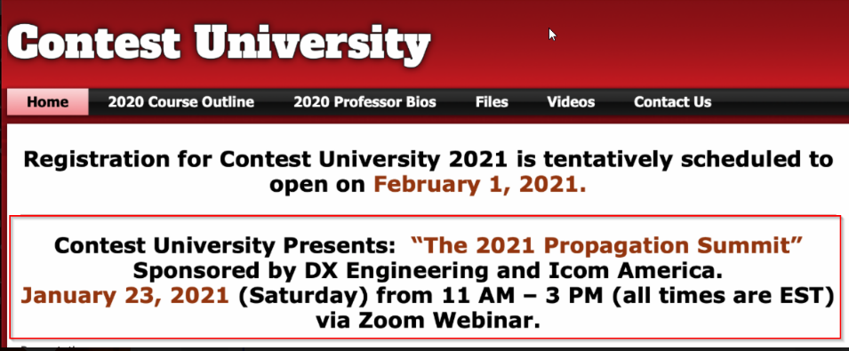Contest University will host Propagation Summit on January 23, 2021. All times are USA EST. Here is the program:

11 AM - "Update on the Personal Space Weather Station Project & HamSCI activities for 2021" - Dr. Nathaniel Frissell, W2NAF

Noon - "Solar Cycle 25 Predictions & Progress" - Carl Luetzelschwab, K9LA

1 PM - "Maximizing Performance of HF Antennas with Irregular Terrain" - Dr. James Breakall, WA3FET

2 PM - "HF Ionospheric Propagation" - Frank Donovan, W3LPL

Drawing for an Icom IC-705 donated by Icom America and DX Engineering - both CTU sponsors. Winner must be present on Zoom to win.

**To register for this free CTU Propagation Summit Webinar please go to :**

**<**[**https://zoom.us/webinar/register/WN_dfLvFDxaTyakOWd_C7_puw**](http://r20.rs6.net/tn.jsp?f=001Yu9p2cr-NhmbhLVmry_OBp78Nitxmmu-03i3aZld92NRUwuohebai1HNPlvtz-D-XD5OGgU5W4QPJR02lSbAhN4wQdimDaf5NktRKil5eNL8uAlq5bw4mfiAE8OfSO-he6rb5zgvipr3TJh9qDabWz_mO6bcODn95ymY2QxQU0CbKwvOc9oF_zv43GqzGulY&c=-vqC6Njl3vHRE6nFrfJGu8YLurxumxkjT-_Jo4085gruJ06u5PXwEQ==&ch=2IrrzCR_v78B2s03ZnQDFKJ7tZibxe-SCRKDGG3ecijp1RAd2NiQFg==)

**Stay tuned to Contest University:**[**https://www.contestuniversity.com/**](http://r20.rs6.net/tn.jsp?f=001Yu9p2cr-NhmbhLVmry_OBp78Nitxmmu-03i3aZld92NRUwuohebaiztLe8yi2EPXR1wVByqnIxjZ_GIWnbv3maUnMkNK19oWCOIChnI4CtaIlJUc3bbiBXOQZ8ntMXCHurXpsIiPwagYgCQLSfVqNAD_om1NZ84T&c=-vqC6Njl3vHRE6nFrfJGu8YLurxumxkjT-_Jo4085gruJ06u5PXwEQ==&ch=2IrrzCR_v78B2s03ZnQDFKJ7tZibxe-SCRKDGG3ecijp1RAd2NiQFg==)

***DAH DIT DIT DIT DAH DAH DIT DIT DIT DAH***

**Top Band Soap Box -** As previously mentioned, I will include news and notes about activity on 160M. The two guys that will be providing me with the scoop will be Dave, K8DV, and Chuck, K8CR. Both have achieved DXCC on 160 and both are active on 160M.

The Top Band Troubadours told me to be patient and to ***LISTEN.*** I have done that and had a 5-night span where I worked a new one each night, on CW no less! I now have DL, E7, EA, OM, and OK in the log. I also worked for over an hour to dig out an HB with no luck.

K8DV, Dave had this to report: “This past week once again proved to be some good Openings to Asia around 09:00z with mostly JAs but did here an HL on CW.  Had one good opening that I was able to pick up a few new ones in Europe working a GI and OH0 on FT8 about an hour after sunset.   Saw a few guys working KLs on FT8 but never copied any at my QTH.  Topband is somewhat like 6 meters you must be there when the DX is.  Good hunting.”

***CQDX CQDX CQDX CQDX CQDX CQDX CQDX CQDX CQDX***

TOP^

Here is an update from Bernie, W3UR, of the DailyDX and the WeeklyDX, the best source for DX information. <http://www>.dailydx.com/. Bernie has this to report:

**ZD8 – Ascension Island -** TA1HZ, Tevfik Aydin Kazancioglu, tells us, “I will be on Ascension Island AF-003 for the duration of 2021 working on a project”. He estimates having his Yaesu FT-991 and Windom antenna up and running by mid-January. Look for [ZD8HZ](http://r20.rs6.net/tn.jsp?f=001Iy2Gv2PfmV9eg5q5FotqZa3BiscjD1ysr3zqKUYqutqwXeLkjEVaDwl1jJvuWefRcj5rQI9rH8kSpHOtq3wV0MZUfEnG8-ZPPzjjQHzghZ-lTHpY7XgDNLXGmYSzOi-8RUncEklOXqJBcCLliAekRw==&c=IgLdP5uFUssv_wIk09SsYeV5YgCfQufFOrIhAqDRlHKEefVR-tFF7Q==&ch=B1du1-SWAtPfHxCJpSP-E1OZlktRmXygQHRE-sPxSn1TH4uN072tzg==), Tevfik, to be QRV on SSB and FT8 on 80 through 10 meters, in his spare time. About QSLing Tevfik asks everyone, “Please do not send any direct QSL requests before 2022 as I will not be able to check my POB 73/TCSWAT address in 2021”. At the end of each month, he hopes to be able to upload his QSOs to LoTW, eQSL and Club Log.

**JW – Svalbard -**JW7QIA (LA7QIA), Peter, departed Svalbard and all QSOs have been uploaded to LoTW.

**JD1/O – Ogasawara Islands-** JD1BMH (JG7PSJ), Harry, tweeted “Due to the policy change of the Japanese government, there is a possibility that the schedule of this trip will be shortened”. He is currently scheduled to be on Chichijima until January 9, 2021.

**KL7 – Alaska-** “Mike, AL7KC in North Pole, Alaska is now active and focusing on 17m phone this winter as time allows. Listen for him on weekends (typically around 2000-2400) and weekdays during lunch breaks (for up to an hour around 2100 - 2300, usually on the low end of the band.) He is running a 12-element Tennadyne log periodic and 500W pointed towards US, Caribbean, and S. America.

**KL7 – Alaska-** Jim, KL7KK in Bethel, Alaska is being very diligent and active calling CQ on 80m phone daily. Look for him around 3.790 between 1500-1600, 1700 - 1900. He is running phased quarter wave verticals, and K3 station with 1400w.”

**Western Sahara-** As was expected Western Sahara has been removed from the United States Department of State Dependencies and Areas of Special Sovereignty list. This does not affect the status of S0 on the ARRL DXCC list.

***DAH DIT DIT DIT DAH DAH DIT DIT DIT DAH***

Below is a list of upcoming contests in the “Contest Corner”. I think this is important for someone who is trying to move up the DXCC ladder since entities that are on the rarer side and easiest to work in contests. Some of my best “catches” have been on the Sunday afternoon of a contest when the rarer entities are begging for QSOs. Of course, the gamble is that if you wait until Sunday, conditions may change, or they simply won’t be workable. However, it is not a bad gamble. Of course, why not work the contest and have some fun!  
Check out the WA7BNM Contest Calendar page (<https://www.contestcalendar.com/>) for more contests or more details.

The contests in red are those that I plan to spend some significant participation time on. PLEASE let me know if you are working contests and how you fared.

Thanks!

TOP^

|  |  |  |
| --- | --- | --- |
| Jan. 1 | ARRL Straight Key Night | [www.arrl.org/straight-key-night](http://www.arrl.org/straight-key-night) |
| Jan. 1 | QRP ARCI New Year’s Day Sprint | [www.qrparci.org/contests](http://www.qrparci.org/contests) |
| Jan. 1 | SARTG New Year RTTY Contest | [www.sartg.com/contest/nyrules.htm](http://www.sartg.com/contest/nyrules.htm) |
| Jan. 1 | AGCW Happy New Year Contest | https://bit.ly/35nBqSR |
| Jan. 2-3 | ARRL RTTY Roundup | [www.arrl.org/rtty-roundup](http://www.arrl.org/rtty-roundup) |
| Jan. 2-3 | EU CW 160m Contest | [www.eucw.org/eu160.html](http://www.eucw.org/eu160.html) |
| Jan. 2-3 | Original QRP Contest | [www.qrpcc.de/contestrules/index.html](http://www.qrpcc.de/contestrules/index.html) |
| Jan. 3 | Veron SWL New Year Contest | <http://bit.ly/2L9eT1L> |
| Jan. 6 | UKEICC 80 Meter Contest SSB | https://bit.ly/2SDPqQQ |
| Jan. 9 | YB DX Contest SSB | https://ybdxcontest.com |
| Jan. 9-10 | AWA Linc Cundall Memorial Contest | https://bit.ly/3iDUm34 |
| Jan. 9-10 | North American CW QSO Party | <http://ncjweb.com/naqp> |
| Jan. 9-10 | UBA PSK63 Prefix Contest | <http://bit.ly/2Oi8fsa> |
| Jan. 10 | DARC 10-Meter Contest | <http://bit.ly/2pCiRo1> |
| Jan. 10 | NRAU – Baltic SSB Contest | [www.nrau.net](http://www.nrau.net/) |
| Jan. 10 | NRAU – Baltic CW Contest | [www.nrau.net](http://www.nrau.net/) |
| Jan 29 – 31 | CQWW 160M | <https://cq160.com/> |
| Mar. 27 – 28 | CQWW WPX SSB | <https://www.cqwpx.com/> |
| May 21 | SWODXA DXDinner | [www.swodxaevents.org](http://www.swodxaevents.org) |
| May 29 – 30 | CQWW WPX CW | <https://www.cqwpx.com/> |
| August 28 | Ohio QSO Party | <https://www.ohqp.org/> |
| August 28 | W8DXCC Convention | [www.w8dxcc.com](http://www.w8dxcc.com) |

**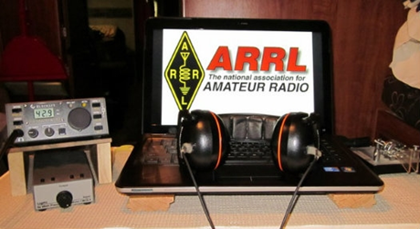*ARRL Contest Corner***

An expanded, downloadable version of *QST'*s’[**Contest Corral**](http://www.arrl.org/contest-calendar) is available as a PDF. Check the sponsor's’Web site for information on operating time restrictions and other instructions.

TOP^

***Ohio ARES VHF Simplex Contest - 2021***

***January 9 – 10AM through 4PM EDT.***



With Christmas behind us, it’s time for everyone to start thinking about their participation in the Ohio VHF+ Simplex Contest.

Sponsored by the ARRL Ohio Section and Ohio ARES, this event is a six-hour contest to inspire amateurs around Ohio to operate in simplex mode to simulate repeater-less emergency communications. 99% of the contest traffic is FM mode so it’s accessible even to HTs.

Additionally, since it’s VHF+ (i.e. 50Mhz and up), this contest is fully available to all Technician Class license holders.

Visit <https://ohsimplex.org> to read the rules, see who is operating, and announce your own planned operations.

For the old timers and to the new license holders, and everyone in between, this is a great way to get involved in a fun, local contest. If you have any questions about this event or how you can participate, please reach out to Jason N8EI ([jason@mfamily.org](mailto:jason@mfamily.org)).

Also, here are some tips on operating in this contest so you can see just how accessible this contest is even to a new ham with limited equipment or budget.

**General VHF+ Simplex Operating Tips**

Here are some general operating tips for working simplex stations on VHF, UHF, and up:

* Simplex operations are not like repeater operations. Leave the squelch wide open or only very very slightly closed so weak-signal stations can be heard.
* Ensure that PL/CTCSS and DCS are disabled and the radio is not doing an automatic repeater offset (i.e. shifting on transmit)
* Height is king. VHF, UHF, etc. are line-of-sight modes. If one doesn’t have a fixed station with a good antenna, consider erecting a temporary mast with a dual-band or tri-band vertical at the top. Since this is a short contest, consider going mobile or portable to high ground in your area.
* Consider building a c[heap J-Pole antenna](http://clackamasares.org/wp/wp-content/uploads/2018/12/MENTORFEST_ANTENNA.pdf) and get it up in the air on a temporary mast or even hanging it from a tree. This will be better than any HT and almost any mobile mount. You can use it even with your HT with the right feedline and 5W will go surprisingly far when properly elevated.
* Operation will go in spurts when a new station appears or when a rover station gets to their destination. Don’t get discouraged by long periods of static.
* Don’t be afraid to call CQ. Technician Class holders may not be familiar with this [classic HF concept](https://calcoara.com/calling-cq-on-amateur-radio-a-complete-guide/). Calling out “CQ CQ this is WW8TF in Summit County for the Ohio Simplex Contest” is all you need to do. As always, listen first before transmitting to ensure the frequency is not in use. With VHF+ simplex contesting, various hams will “take turns” on the common 2m and 70cm frequencies. Don’t be afraid to ask another ham who has been calling CQ without response if you can take a turn on the frequency. Most hams are glad to be accommodating.

TOP^

* Unlike repeater operations or casual ragchew, you will need to keep a log. If this is an unfamiliar operation, do the log on paper. With the Ohio Simplex contest, you do not need to submit in the contesting-standard Cabrillo log format, so a software package is unnecessary. A simple sheet of paper with the headings of Time, Frequency, Callsign, County, and Bonuses will be all you need. The bonuses field is where one records the “extra” points such as communicating with an Emergency Operations Center (EOC) or an ARES official.

***Special Events***

* **01/01/2021 | Battle of Princeton**

**Jan 1-Jan 10, 0000Z-2359Z, W2P**, Trenton, NJ. Delaware Valley Radio Association. 14.250. Certificate & QSL. DVRA, PO Box 7024, Trenton, NJ 08628. Info on www.w2zq.com or on qrz.com QSL for SASE to DVRA PO Box 7024 West Trenton NJ 08628. Certificate of Commission in Continental Army Signal Corps for $5 and address label to DVRA DVRA PO Box 7024 West Trenton NJ 08628. [https://www.w2zq.com](https://www.w2zq.com/)

* **01/02/2021 | 15th Annual Straight Key Month**

**Jan 2-Jan 31, 0000Z-2359Z, K3Y**, Ellicott City, MD. SKCC - Straight Key Century Club. 3.550 7.055 14.050 21.050. Certificate & QSL. Jeremy Downard, KD8VSQ, 511 W. Pottawatamie St., Tecumseh, MI 49286. K3Y/0 thru 9 plus KH6, KL7, KP4 and DX member stations in six WAC areas operating straight key, bug and cootie keys. QSL card confirms one QSO per area, up to 19 for all-area sweep. See URL for sched, map, stats, etc. [www.skccgroup.com/k3y](http://www.skccgroup.com/k3y)

* **01/08/2021 | 206th Anniversary of The Battle of New Orleans**

**Jan 8-Jan 9, 1800Z-0000Z, W5IR**, Metairie, LA. The Mystic Knights of The Louisiana Roundtable. 18.145 14.275 7.270 7.045 . QSL. Dale F. Budenski, 4713 Neyrey Dr, Metairie, LA 70002. FT8 on the usual freq. More details on QRZ.com. harry504@outlook.com or [www.qrz.com/db/w5ir](http://www.qrz.com/db/w5ir)

* **01/09/2021 | 120th Anniversary of the Lucas Gusher**

**Jan 9-Jan 10, 0900Z-1500Z, K5S**, Beaumont, TX. Beaumont Amateur Radio Club. 14.0025 14.250 7.025 7.250. Certificate. BARC, 4839 Hwy 326N, Kountze, TX 77625. Celebrate the discovery of oil in Texas. Look us up on QRZ for certificate instructions. k5s,lucasgusher@gmail.com or <https://www.qsl.net/w5rin>

* **01/09/2021 | 2021 Daytona 500/Speedweeks**

**Jan 9-Feb 14, 0001Z-2359Z, N4DAB**, Daytona Beach, FL. Daytona Beach CERT ART. 14.255 14.070 7.255 7.070. Certificate & QSL. DB CERT ART/Steve Szabo, WB4OMM, License Trustee, 536 Central Park Blvd., Port Orange, FL 32127-1136. See Web Page for QSL and Certificate information. High Quality laser printed certificate and photo quality QSL Card. Operating hours dependent on propagation and availability. Phone, CW, and Digital modes scheduled. [www.n4dab.com](http://www.n4dab.com/)

* **01/15/2021 | Alaska "RST" QSO Party**

**Jan 15-Feb 15, 0000Z-2359Z, KL7RST**, various, AK. North Country DX Association. 28.450 21.350 14.250 7.250. QSL. John F. Reisenauer, Jr, 2573 Old Georgetown Rd. W., Kershaw, SC 29067. KL7RST, KL7RST/KL7, VY1RST/KL7, VE8RST/KL7 and VY0RST/KL7. Certificate by email for working any 3 of the above when you QSL. [www.qrz.com/db/k7ice](http://www.qrz.com/db/k7ice)

TOP^

***“ARES Connect”***

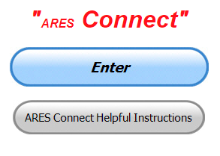

***Connecting Amateur Radio Volunteers with a Purpose***

Hey everyone… please make sure to go in and register your time to all of the events that you have signed up for. Don’t forget to get this done no later than **5 days** after the event has ended. I’m asking you to do this for our ability to run reports accurately.

**I want to remind all of you that you do not have to be an ARES or ARRL member to use this system. All licensed amateur radio operators throughout the country are welcome and strongly encouraged to use it.**

**Don’t forget to check out the “Frequently Asked Questions” area that has been added to the Ohio Section website.** It’s there to help you through any difficulties that you may have with ARES Connect. Now, if you don’t any posts that relate to what you are having difficulties with, we now also have an on-line “Guru” area as well. This will allow you to ask any questions that you may have about ARES Connect.

**Let’s get everyone in the Ohio Section on “ARES Connect!!!” Simply go to:** <https://arrl.volunteerhub.com/lp/oh/> and get yourself registered and using the system.

####

***National Incident Management System (NIMS) Fact Sheet for Nonprofit Organizations***

I’m often asked why we need NIMS training and why is so much effort is being placed on it. I got my license and hand-held, what more do I need than that.

Here’s a short, but very precise description of what NIMS is all about and why it’s so important for us as Amateur Radio operators to have this training.

**Introduction**

Nonprofit organizations (nonprofits), such as community-based, faith-based, or national organizations (e.g., National Voluntary Organizations Active in Disaster, American Red Cross, and YES, even Amateur Radio), play vital roles in incident management regardless of size or type of incident. Integrating with governmental incident management efforts, to include planning, equipment, training, and preparedness exercises, will enable both governments and nonprofits to maximize their impact. The National Incident Management System (NIMS) supports this unity of effort and provides stakeholders across the whole community with the shared vocabulary, systems, and processes to work together to meet challenges beyond the capacity of any single jurisdiction or organization.

TOP^

**How NIMS benefits Nonprofits and the Nation**

Every day in the United States, organizations work together to share resources, integrate tactics, and collaborate. Whether these organizations are in a leading or supporting role, their efforts are magnified by the unity of effort enabled by NIMS’s common approach to sharing resources, coordinating and managing incidents, and communicating information. NIMS can be used for planned events or incidents, to manage efforts preventing, protecting against, responding to, recovering from, and mitigating against all hazards. It can be applied both within your organization as well as externally to guide your organization’s work with all levels of government (local, state, tribal, territorial, and Federal). NIMS provides stakeholders across the whole community with the shared vocabulary, systems, and processes to conduct well integrated, accessible and effective incident management operations.

While implementing NIMS is not mandatory for nonfederal entities, adopting NIMS procedures and terminology supports the integration of separate organizations’ activities and resources into a community’s overarching incident management efforts, and strengthens our national capability to manage any type of event or incident.

Effective incident management of internal and external operations can make the difference between advancing or damaging an organization’s reputation.

**NIMS Guiding Principles**

NIMS is the culmination of more than 40 years of efforts to improve interoperability in incident management, and reflects lessons learned from exercises and real incidents. It applies to **ALL** incident personnel, from the local command post to the Federal Emergency Management Agency’s (FEMA) National Response Coordination Center. Incident management priorities include saving lives, stabilizing the incident, and protecting property and the environment.

To achieve these priorities, incident personnel apply and implement NIMS components in accordance with NIMS Guiding Principles of flexibility, standardization, equal access, and unity of effort:

▪ Flexibility allows NIMS to be scalable and, therefore, applicable for incidents that vary widely in terms of hazard, geography, demographics, climate, culture, and organizational authorities.

▪ Standardization is essential to interoperability among multiple organizations in incident response.

▪ Equal access….

▪ Unity of effort means coordinating activities among various organizations to achieve common objectives.

***One Question Questionnaire***



Hey Gang,

Survey Says”….. around 23% of you have a New Year’s resolution. That’s really great to hear. I sincerely hope that we all can get back to normal this year!!

Ok, now on to the next question…

TOP^

***Do you monitor Public Service frequencies with your VHF / UHF transceiver??”***

You’ll find the “One Question” questionnaire on the Ohio Section Website! <http://arrlohio.org> It’s all for fun and it’s not a scientific survey in any way, but we are learning some things that we didn’t know from these questions. I hope that you are enjoying answering these “One Question” questionnaires

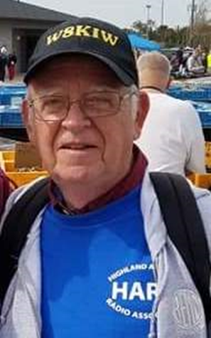***From The South 40***

*(from John Levo,* [*W8KIW@arrl.net*](mailto:W8KIW@arrl.net)*)*

**Happy New Year from the South 40**

By no sense of the imagination, Christmas this year was very different than in the past. Perhaps you had those memories of the days when your children got more joy out of the wrapping paper, bows and empty boxes than what they contained. Or Aunt Bertha having a little too much of the spiked punch or the cat thinking that tree in the living room was too realistic and did its thing beneath it. Regardless, we hope your Christmas was a joyous one with family and friends, even if it was via the phone or Zoom.

Now 2021 is only days away and only hours are left to complete those projects you stated you would during 2020. But before leaping into the New Year, there is some last-minute news to pass along.

Most regional clubs already held their elections, but Brown County’s **Grant RC** and Highland County’s **Highland ARA** each held their 2021 leadership elections in the past couple of weeks. In the coming year Ken Klosterman, KD8FKU, will lead the Grant club as their President with Al Norris, W8UJM, as his Vice President. Doug Kieffer, K8CMM, will again serve as the Treasurer and Steve Neal, KB8CWC, will be the Secretary. Patty Spraulding will edit the Club newsletter and Daun Sutton will handle the Web presence. Bill Rea is to be the Net Manager and Jerry Silman the Sargent At Arms. Next door in Highland County the reins of the HARA President will be handed to Pat Hagen, N8BAP as Jeff Collins, KD8VUY, joins the Executive Committee as Past President. Tom Mongold, KD8LDS, was elected Vice President and Kathy Levo, N8ZNR, retains her Secretary/Treasurer post. Ken Lightner, KE8JEL, was elected the three-year trustee and will join trustees Patrick Gilifillen (N8EWH) and Richie Hagen (N8CUB) to round up the Executive Committee. The **Hocking Valley ARC** recently held their election with the following results: Chris Boch, KC8RYM, was elected President; James Martin, W8LGN, Vice President; Bill Hopstetter, W8LGX, Secretary and Roy Vickers, KC8TFW is Treasurer. Ray Webb, KB8GUN, will serve as a trustee and Dave Brimner, KB8OTU, will be the Emergency Coordinator.

Former Martinsville Mayor, **Clinton County ARA** President and current Clinton County EMA Chairman Mike Boyle (WF8B) was honored by the Agency at its recent annual meeting with its “EMA Service Recognition” award. Boyle commented that his EMA involvement began when the remnants of Hurricane Ike hit Clinton County and caused widespread damage and the loss of electricity and communications for days. He said it was through amateur radio that citizens were informed of locations where they could seek shelter, warm meals, water and critical supplies.

TOP^

The New Year is to be rung in and celebrated over the annual **Highland ARA**’s New Year’s Eve Net. With the WWV tone on the stroke of Midnight, John Willis, KE8JEM, will start the tolling of the large bell in the front of the county museum. The pealing of the bell will be broadcast over HARA’s Hillsboro 147.21 and Greenfield’s 146.685 repeaters. There have even been some hints of other repeaters in the region linking in through All Star. Following the bell ringing any amateur throughout the area is welcomed to drop in their callsign and pass along their greetings. It’s not a formal net so to allow people to return to their own celebrations. But some interesting discussions usually break out and last into the wee hours of the New Year. So, take a listen and feel free to check in. If you can’t make one of the machines, send an email to [highlandara@gmail.com](mailto:highlandara@gmail.com) to let them know you were listening and be acknowledged. With machines now linked it will be interesting to know where people are listening from.

The **Hocking Valley ARC** has placed their popular fox hunts on hold until Spring. Club officials say Hocking County road conditions get very iffy during the winter and the club would rather hold safe events and not put participants at risk. Plus it also gives folks time to refine those DF’ing antennas.

Six seats remain open for the January 16 VE Test Session in Hillsboro. It will be at 9 am at the Highland County EMA Office located near the northern edge of town on North High Street (US 62). This is a Laurel Test with all elements given. There is no charge for taking or retaking a test however you must come with proper identification and the now FCC required FRN. All registrations must be in advance as there will be no walk-in testing. You may sign up on [www.signupgenius.com/go/10C0D48ADAC23A7FEC16-hara3](http://www.signupgenius.com/go/10C0D48ADAC23A7FEC16-hara3) Social distancing and mask wearing are requested in order to comply with county health department and EMA requirements.

Who says there isn’t any activity on 10 meters? Don’t tell that to the fellows at the **Athens County ARA**. Each year during the ARRL’s December 10 Meter Contest they hold a member challenge called the ‘NC8V Memorial Trophy’ contest. The ACARA member scoring the highest during the contest takes possession of the trophy for the following year. This year Eric McFadden, WD8RIF, made 99 CW contacts to take the honors. Carl Denbow, N8VZ, placed second with 68 SSB contacts and Paul Schulz, WD8SCV, came in third place with 46 contacts on SSB. Fourth place went to John Biddle, W8PG, with 40 on SSB and Jeff Slattery, N8SUZ, made a single contact on SSB to get fifth place bragging rights.

January brings a couple of events those interested in VHF/UHF operating may find of interest. On January 9 the Ohio ARES Simplex Contest will take to the air on all bands from six meters up. It is a short event starting at 10 am and running until 4. It’s an excellent opportunity to check out how your antennas are preforming and determine what your coverage area might be and serves well as a reason to check out other modes. The second event is the annual ARRL VHF contest beginning on January 16 at 1900 UTC and going through the 18th at 0359. Operation can take place on all bands 50 MHz and above and all modes may be used. Repeater contacts are not valid. Your grid square is a part of the exchange. Complete rules can be found at [www.arrl.org/january-vhf](http://www.arrl.org/january-vhf) Unfortunately, in past years these fun contests haven’t had much participation from Southern Ohio.

For those who have been inquiring, COVID appears to have knocked the socks off the region’s normally scheduled hamfests for the near future. The only one apparently still on tap is Kentucky’s largest hamfest--sponsored by the **Mammoth Cave ARC** at the Cave City, KY Convention Center on March 6. Although a bit of a distance for some, it is a most easy drive as it’s four lanes almost all the way once you cross the Ohio River. It’s size and its Southern Hospitality makes it worth the trip.

TOP^

DX’ers operating 60 meters received an early Christmas present this past week. According to the Joe Pater, W8GEX, ‘60 Meter DX’ newsletter amateurs in Austria have received permission to operate on 60 plus 630 meters.

With the conclusion of the old year, I wish to extend a huge THANK YOU and best wishes to our friend Tom Delaney, W8WTD, who has served the Eighth Call District (and especially our Southern Ohio region) as our Assistant Section Director for a number of years. Tom was always there whenever a regional club had a question, problem or suggestion. You could also count on seeing him out meeting the troops at hamfests and other special occasions regardless of it being in Ohio, Kentucky or Michigan. Although he’s leaving the ARRL work, he’s going to remain active in the **Queen City Emergency Net** and along with his wife perhaps spend a bit more time at their North Central Ohio lake property.

Like most of you, N8ZNR and I will be happy to put 2020 behind us. I hope the over the air and Zoom meetings and such activities were only stop gap measures and 2021 sees the resumption of hamfests and other ham radio gathering activities where we can physically see and chat with our friends. In the meantime, we take this opportunity to wish each of you the

Best DX, 73 and Happy New Year.

***Weather Underground and Other Ham Weather Stations***

[](http://arrl-ohio.org/wus.html)

Hey Gang,

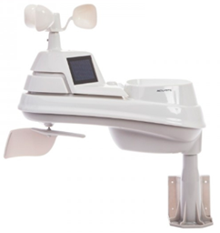This has really grown into a really cool area with reports literally coming in from all over the state!!

It’s really fun to see just how much the weather varies across the state and this gives you access to each individual station very quickly and easily.

Hey gang, if you haven’t looked at your Weather Underground dashboard lately you might want to. It seems that the nice folks there have taken the time to upgrade your dashboard.

The new design is still being worked on from what information that I could gather, but they have done a really nice job. The new design is really easy to view and contains the same information at before, but it’s laid out in a really professional manor.

Now, our list of stations is growing all the time. How’s about your station? Is it listed with us? It doesn’t necessarily have to be a Weather Underground reporting station.

TOP^

I’d love to have any weather station that is connected to the internet available for all of us to view, especially when the weather gets bad out. The more stations reporting the better.

Thanks to everyone who has contributed to this effort. If you haven’t, you really should take a look at the various weather stations around the state when we get bad weather coming in. You can really see just where the line of storms are as they cross through the state. It is very fascinating to watch it all unfold right you’re your easy chair, and all the data is real time! Here’s a link to all of those listed… <http://arrl-ohio.org/wus.html>

We’re got a really good collection of stations from all over and have tons of room to add more for sure. How’s about sharing your weather information with all of us! All that you need to do is send me your Weather Underground ID and your call sign and I’ll take it from there. Sent it to: [webmaster@arrl-ohio.org](mailto:webmaster@arrl-ohio.org)

*****V.E. Test Sessions***

Many V.E.’s have decided to start testing once again, but with restrictions that need to be adhered to for sure. Here’s the link to find that V.E. Test session and what is expected of YOU before going. <http://www.arrl.org/find-an-amateur-radio-license-exam-session>

***Final.. Final..***

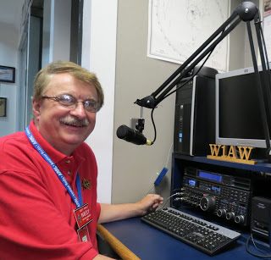

Hi Gang,

Wow, this is my final Ohio Section Journal as your Section Manager! The time has gone by so fast. It was just 7 short years ago I took over and it has been a really fun and exciting ride for sure. We’ve gone through good times and some really great times together as a TEAM, and I wouldn’t trade one second of it! The Ohio Section shines brightly above any of the other Sections in the country, and that’s because of YOU. You are the best.

As your new Vice Director, I am even more excited to take what we’ve built on here in the Ohio Section and apply it to the Division. It’s gonna’ be really exciting and fun for sure.

As that this is the end of the year, please take a minute and check on your club dues as well as your ARRL dues. Remember, your local club and ARRL dues are important in order for them to operate. Please, don’t let your dues lapse. Not a member of ARRL? Why not? Who else is there fighting everyday for your frequencies and protection! The ARRL offers a lot for just $49 a year. Are you taking advantage of all that the ARRL has to offer?

TOP^

Affiliated Clubs, have you taken a look to make sure that someone has filed your annual report with ARRL? This is one of the most common mistakes that I hear about from club officials, they either didn’t know, or just thought someone else has taken care of this. Please, check your club’s affiliation record annually. Oh, and those clubs that have been - or are - currently Special Service Clubs, make sure to check on your renewal date on that as well. Since the SSC is renewed on a 2-year basis, this is even more forgotten about. Both of these renewals are quick and easy to do online.

Now, on a Divisional note. We are in need of a QSL incoming Card Sorter within the 8th Call District. We are specifically looking for the letter “X” as that we now have a vacancy just open up.

The 8th call area incoming QSL bureau operates as part of the ARRL's volunteer QSL bureau system. The 8th Call Area is comprised of 3 states, Michigan, Ohio and West Virginia and serves ALL amateurs, regardless of what state you may live in. Cards having the numeral 8 (such as K8, N8, W8, AA8-AK8, KA8-KZ8, and WA8-WZ8) in the call sign, as well as American Samoa cards (AH8, KH8, WH8) are handled through this Bureau.

The 8th Call Area Incoming QSL Bureau is split between the Great Lakes Division and the Roanoke Division.

If you haven’t seen the notices yet, the FCC is encouraging all users of the Universal Licensing Service (ULS) to have an email address on file with them. Their reasoning for this is because they will no longer be issuing hard copies of licensing anymore. Email will eventually be the only way that you will be able to get your license. Fortunately, they haven’t decided yet on just when all of this will be fully implemented, so you still have some time left to get this done, if you haven’t done so already.

As that this week ends a real downer of a year for all of us, my wish for the New Year is for each and every one of us to have Peace, Joy, Happiness and most of all….. Hamfests for 2021!!!! May we all get our lives back to normal in this upcoming year and meet face to face at a hamfest where we can enjoy each other’s company once again.

Well, that’s about all that I have. Thanks so much for all of your wonderful support over these many years.

73,

[***Scott, N8SY***](mailto:n8sy@n8sy.com)

***“Swap & Shop” on the website***

Hey Gang,

Have you taken a look at the **Swap & Shop** page on the Ohio Section webpage yet?? Here’s a link that will take you there…

<http://arrl-ohio.org/sm/s-s.html>

Do you have equipment that you just don’t need or want anymore? Here’s a great venue to advertise it, and it’s FREE!!

TOP^

Is your club doing a fund raiser to help raise money? After a lot of thought, it was decided that the Swap & Shop webpage could also contain these types of items as well.

The same rules will apply as do for the For Sales and Give-A-Ways and will only be posted for a month at a time. Please see the Terms & Conditions on the webpage.

If your club is doing a fund raiser and wants more exposure, please forward the information to me and I’ll advertise it on the Swap & Shop webpage for you. Now, I still want to remind you that it won’t be listed in this newsletter because it would take up way too much space, so your ad will only appear on the website. It is there for any individual to post equipment Wanted / For Sale or Give-Away as well as for Club Fund Raisers. No licensed vehicles/trailers or business advertising will be posted.

Postings are text only (no pictures or graphics) will be posted for a maximum of 1 month from date posting and require a contact phone number or email within the posting. Send your Wanted / For Sale or Give-Away post to:  [swap@arrlohio.org](mailto:swap@arrlohio.org)

***Welcome New Subscriber(s)***



**Bob, KC8GAE; Scott, KE8PWR**

***Back Issues of the PostScript and Ohio Section Journal***

Hey, did you know that PostScript and Ohio Section Journal (OSJ) are archived on the website? You can go back and look at any edition simply by clicking:

<http://arrl-ohio.org/news/index.html>

Ohio Section Cabinet

|  |  |
| --- | --- |
| Section Manager – Tom Sly, WB8LCD | Section Emergency Coordinator – Stan Broadway, N8BHL |
| Technical Coordinator – Jeff Kopcak, K8JTK | Section Traffic Manager – David Maynard, WA3EZN |
| State Government Liaison – Bob Winston, W2THU | Affiliated Clubs Coordinator – Tom Sly, WB8LCD |
| Section Youth Coordinator – Anthony Lascre, K8ZT | Public Information Coordinator – John Ross, KD8IDJ |

TOP^

***Chit – Chat, and All That!***

Do you know someone that’s not getting these Newsletters? Please, forward a copy of this Newsletter over to them and have them “[Opt-In](mailto:Opt-In)” to start receiving them. Heck just have them send an email to: [webmaster@arrl-ohio.org](mailto:webmaster@arrl-ohio.org) to be added.

We now have many thousands of readers receiving these newsletters weekly. Quite impressive, I’d say! I urge all of you to make sure that everyone, regardless of whether they are a League member or not, get signed up to receive these weekly Newsletters.

You can always “Opt-Out” at any time if you feel this is not what you were expecting. It’s fun and very informative. All of your favorite past newsletters are now archived too.

You can go back at any time and read them. Just go to: <http://arrl-ohio.org/news/>

The pictures on the front page and throughout this newsletter are from various newsletters, Facebook posts and/or were sent directly to me in recent weeks. Take a good look at them, you just might be in one of the pictures! “SMILE… you’re in the Ohio Section News!!”

**Stop… We’ll be back next week with another exciting adventure for your reading pleasure!!**

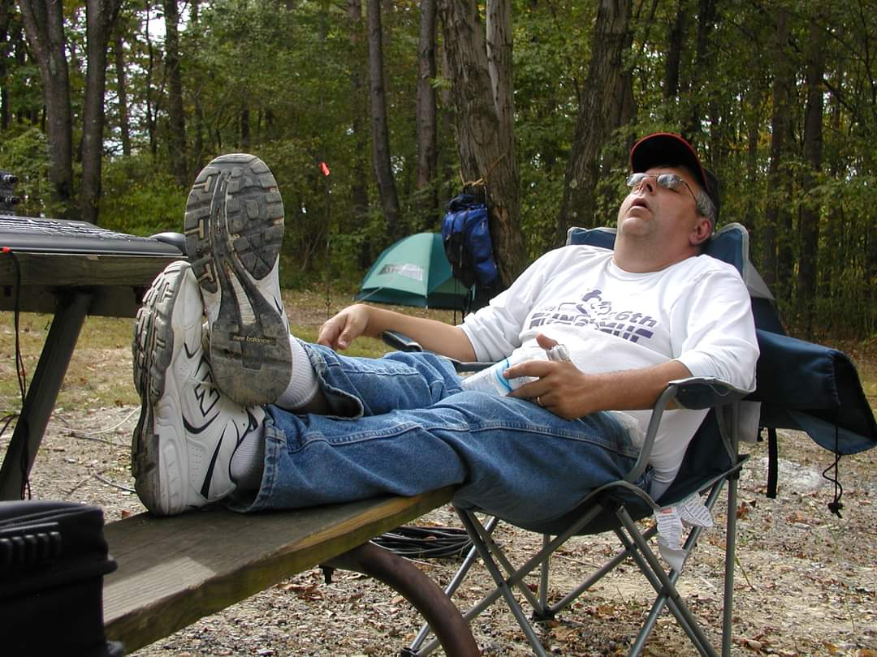

TOP^

*The Ohio Section Journal (OSJ) is produced as a comprehensive look at all the programs within the Ohio Section. I sincerely hope that you have enjoyed this edition of the* *OSJ and will encourage your friends to join with you in receiving the latest news and information about the Ohio Section, and from around the world!*