[](http://arrl-ohio.org/news/) ***New Year’s***

***Edition***

🡪 National News 🡪 The Handbook Give Away

🡪 Club Corner 🡪 Hamfests

🡪 DX This Week 🡪 One Question Questionnaire

🡪 VE Testing 🡪 ARES Connect

🡪 Special NIMS Training 🡪 Final.. Final..

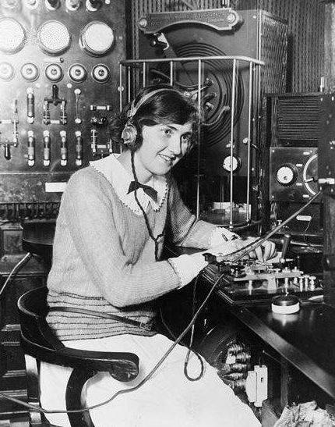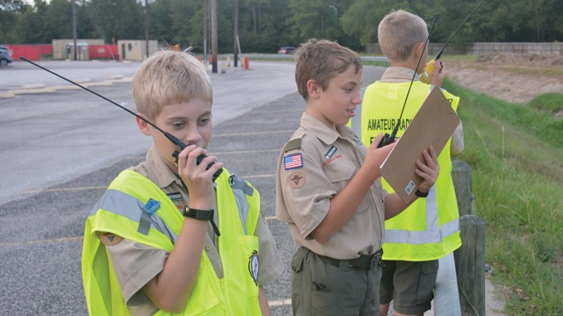

***National News***

*(from arrl and other sources)*

***CAMSAT CAS-6 Amateur Radio Satellite Launched Successfully***

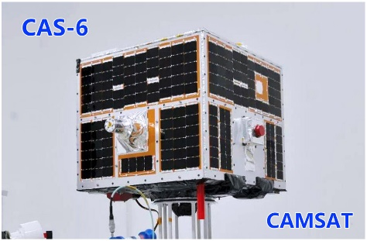CAMSAT has announced that the CAMSAT CAS-6 amateur radio payload launched successfully on December 20, piggybacked on a TIANQIN-1 technology test satellite.

“The satellite is currently in orbital testing,” CAMSAT’s Alan Kung, BA1DU, told ARRL on December 20. “The amateur radio payload is expected to be operational in about 3 days.”

The microsatellite will be known as CAS-6/TIANQIN-1, and the call sign is BJ1SO. The primary launch payload is the China-Brazil Earth Resources Satellite, CBERS-4A. CAS-6 is in a sun-synchronous orbit with an apogee of 390 miles. It carries a U/V linear transponder, with a downlink of 145.925, 20 kHz passband (inverted) and an uplink of 435.28 MHz. The CW telemetry beacon is on 145.910 MHz, while 4k9 baud GMSK telemetry will be transmitted on 145.890 MHz. CAMSAT has provided [***CAS-6 Satellite Digital Telemetry Description***](http://www.arrl.org/files/media/News/CAS-6%20Satellites%20Digital%20Telemetry%20Description.pdf) and [***CW Telemetry Beacon Encoding Format***](http://www.arrl.org/files/media/News/CAS-6%20CW%20Telemetry%20Encoding%20Format.pdf) documents. *— Thanks to Alan Kung, BA1DU*

####

***Over-the-Horizon Radars Causing Widespread Interference on 40 Meters***

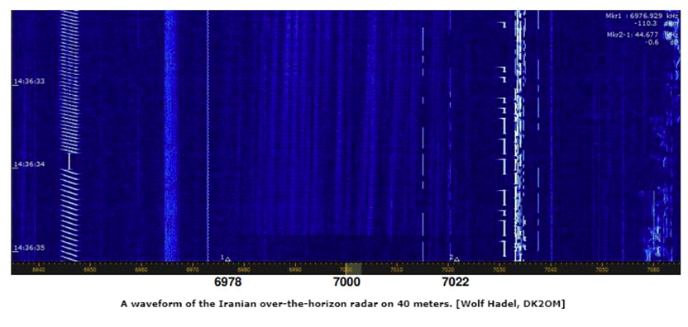Over-the-horizon (OTH) radars continue to plague various amateur radio bands. Those operating on exclusive ham radio allocations have been complaining for years, but military systems have a blanket waiver to use amateur radio frequencies.

The latest edition of the International Amateur Radio Union Monitoring System ([**IARUMS**](https://www.iarums-r1.org/)) [**newsletter**](http://www.iarums-r1.org/iarums/news2019/news1911.pdf) reports that a radar in northern Iran — likely military — has been operating 40 meters (6978 – 7022 kHz). Several Russian and Chinese OTH radars have become mainstays in the ham bands. While these sort of signals are operating on exclusive amateur radio allocations, the International Telecommunication Union (ITU) [**Convention**](http://search.itu.int/history/HistoryDigitalCollectionDocLibrary/5.22.61.en.100.pdf) essentially gives military stations free reign in the spectrum. Article 48 says, “Member States retain their entire freedom with regard to military radio installations.” Member states are countries that have agreed to follow the Convention, and that is not a given.

TOP ^

The Convention goes on to say, however, “Nevertheless, these installations must, so far as possible, observe statutory provisions relative to giving assistance in case of distress *and to the measures to be taken to prevent harmful interference* [emphasis added], and the provisions of the Administrative Regulations concerning the types of emission and the frequencies to be used, according to the nature of the service performed by such installations.”

According to IARUMS, the Iranian OTH radar was centered on 7000 kHz using amplitude modulation on pulse (AMOP) at 81 sweeps per second. [**Recordings of military transmissions**](https://www.sigidwiki.com/wiki/Category:Military) are available on the SIGIDWIKI signal identification site.

The South African Amateur Radio League (SARL) News reported this week that radio amateurs in Europe and South America have reported major interference from Russian OTH radar stations on several parts of 40 meters — with 12 kHz-wide signals. The radar transmissions have been heard on 7064, 7109, 7170, and 7190 kHz.

Several European IARU member-societies have already sent complaints to their respective telecommunications regulators.

####

***Commemorative ARISS Slow-Scan TV Transmissions Set***

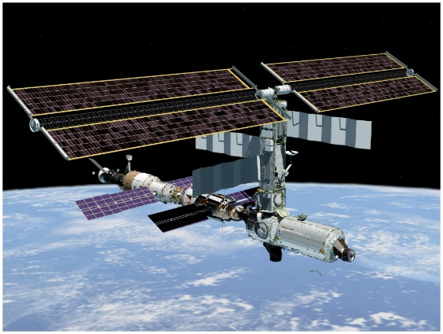

Amateur Radio on the International Space Station ([**ARISS**](http://www.ariss.org/)) will support slow-scan television (SSTV) transmissions worldwide in memory of cosmonauts Alexei Leonov, Valery Bykovsky, and Sigmund Jaehn. Transmissions are scheduled to start at 1100 UTC on December 28 and continuing until 1820 on January 1. Transmissions will take place on 145.800 MHz and in the PD 120 format, using the call sign RS0ISS. The Polish ARISS Team has prepared an [**award**](https://ariss.pzk.org.pl/sstv/) for participants in the SSTV experiment. *— Thanks to Gaston Bertels, ON4WF*

####

***2020 Dayton ConTest University***

I am proud to announce that student registration is now open for the **2020 Dayton ConTest University** ("CTU") to be held all day on Thursday May 14th, 2020, at the Crowne Plaza in Dayton, Ohio. ([http://contestuniversity.com](http://contestuniversity.com/?fbclid=IwAR3YD7eWs5aLVTi2nCMQsLwqgjZi4fv1FtLS5BS_RV10RHS-CHMjtlhUYBc))

This is the day before Hamvention opens in Xenia, Ohio.

Registration opened on December 16, 2019, and already 50 contesters have signed up!. Last year (2019 was a sell out with 350 attending).

Eight different countries have hosted CTUs over the past thirteen years.

TOP ^

USA, Australia, Russia, Germany, Italy, England, Brazil and Finland. Over 8500 students have attended these CTUs with more than 100 CTU Professors sharing their contesting experiences. 2020 will be the 14th year in a row for CTU Dayton. To give you an idea of the quality of the CTU content and activities you can see videos and PDFs from past CTUs on the CTU web site at: [http://contestuniversity.com](https://l.facebook.com/l.php?u=http%3A%2F%2Fcontestuniversity.com%2F%3Ffbclid%3DIwAR0CZj5sqYhAvKFziYT0HQg7LBuI_TMHLNAbXA8th7_PSVVloJ4MmeVvAvA&h=AT0GP-0brtn3xTtzyRjo_9o6Zm5ovvZVf5Cgj8bG_2ACph_Qyvp6-vFCFtNPoYvzCkIBBZoXNfhWK020J0TOs2Ls71Zvz8FfXP9v5b3Mc8bWXroHsb8bk9cu7UOhS-MQVAx8Eddwd4gk8nzRr1JMG3nxkY0gSfYuYd8)

The 2020 CTU Professor line up will be posted on the CTU website very soon.

Thanks to our returning professors NC0B, W0YK, K3LR, W3LPL, N6TV, W3YQ, N0AX and K1DG. You will notice additional NEW professors for 2020 once the posting is complete and posted. CTU professor stalwart Frank, W3LPL, is back for CTU 2020 after his sabbatical in 2019. Frank has taught many many sessions at CTU over the past 13 years. The 2020 CTU Dayton course outline will be posted soon. Check the CTU website for updates.

Each presentation is carefully prepared with up to date information. There are scholarships (registration fee paid) available for CTU through a grant from the Northern California DX Foundation (NCDXF) for those students 25 years old and younger. Please use the "contact us" button on the CTU website to get more information.

2020 Student registration information is on the CTU web site at: [http://contestuniversity.com](https://l.facebook.com/l.php?u=http%3A%2F%2Fcontestuniversity.com%2F%3Ffbclid%3DIwAR32C80F6fe_ORgtebhhbZfjv-v5IQbXcgH0HTGWqAhiJgLSItSScYtZdDE&h=AT0YocOqIH3eHjw2z8vZaUVaWSdELR1-oqLInsdkzZSn5fhIobEzbIKj-_kJtke5kD68PZPGtpdSUYzXVG8vSN19pTdwuKc6QU5xYwWEYtHNMEyCDmznKY-LwYGIY_6Zo5EMaCT1bTUi0Nly2Qfuqw) CTU registration makes a great Christmas gift! Important - as we did last year - if you want to sign up for CTU 2020 Dayton and you have given (or will give one by Hamvention 2020) a talk about Amateur Radio to any club, Hamfest or group since May 14, 2019 - you qualify for a 10.00 USDs registration fee discount. Please choose the "Registration with Club talk discount" option to get the 10.00 USDs discount.

Spreading the word about amateur radio is lots of fun and can save you money at CTU! Thanks to all of the CTU sponsors including Icom America, DX Engineering, the Northern California DX Foundation, YASME, the Radio Club of America and CQ Magazine for making CTU possible.

Thanks to K8MNJ and K1SO for all of their help with CTU. Special thanks to Scott, KA9FOX from QTH.com for hosting and constructing the CTU headquarters web site.

CU in Dayton at CTU 2020 and Merry Christmas, ***Tim, K3LR -*** Contest University Chairman

####

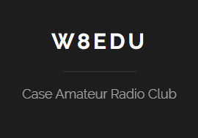***Case Amateur Radio Club engages Case Western Reserve University Civil Engineering Class for Field Day Help***

*(from David Kazdan, AD8Y)*

Now here’s one that I bet none of you ever thought of doing before, the folks at Case Amateur Radio Club have enlisted the help from the Civil Engineering Surveying Class at Case Western Reserve University’s as consultants to help them with Field Day. This took a long running start between the class's professor, Katie Wheaton, the CARC faculty advisor David Kazdan, AD8Y, and the class teaching assistant Rachel Zable, KE8HWA.

TOP ^

CARC made a client's presentation to the class about Field Day and the club's annual Field Day activities at the CWRU research farm.  It requested a survey of the grounds with particular emphasis on the trees used for antenna supports.  It further requested recommendations about which trees to use for dipoles on 80, 40, and 20 meters, best and safest paths for cables, and lengths of cables that would be required.  
  
The class met twice to prepare a surveying plan, then traveled to the farm three times to collect data.  Students spent the rest of the semester in the department's computer labs reducing the data they had collected with theodolites and surveyor's chains.  They made a formal presentation of maps and recommendations at the end of the semester.  
  
I believe this interaction between a class and an amateur radio club is a first.  We very much appreciate everyone's help.  The professor and students were entirely enthusiastic about the work and many of them wish to join the radio club in spring semester and prepare for license exams.  I am sure that those who will be in town over the summer will join us for Field Day.  
  
The campus newspaper published an article on the activity:  
  
<https://observer.case.edu/case-amateur-radio-club-partners-with-department-of-civil-engineering-to-prepare-for-disaster/>

Want to see the report that the Civil Engineering Surveying Class did.

<http://arrl-ohio.org/club_news/casearc/survey.pdf>   
  
There is interest now in the civil engineering department in exploring antenna and antenna support (tower) structural issues as a curricular, project, and research area.  
  
This was fun--just as amateur radio should be!

PS… The Civil Engineering department chairman has been quite supportive, including using this as part of the professor’s promotion portfolio.  He is planning on touring our station with particular emphasis on the towers.  The same student who TA’ed the surveying class was president of CWRU’s Steel Bridge Competition team, which took second place nationally this year; I have pointed out to her and to the chair that towers are basically upended bridges and might be worthy of study.  They were interested in the problems of optimizing size and weight with the complications of wind load and rotor torque, for example.  It’s hard to imagine any fundamentally new tower designs but who knows!

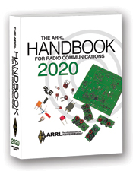***The Handbook Give Away***

Hey Gang,

The winner of the Christmas Day Give Away is…

***Frank Counts, KC8EVS.***

TOP ^

Now I want you to know that it ain’t over yet… There’s going to be another drawing on New Years!! And… if you were registered for the Christmas Drawing, you’re already registered for this one too. If you haven’t gotten registered yet, you only have until New Year’s Eve night to get registered. So, with that said, you’d better get jumpin’ right now.

Go to: <http://arrl-ohio.org/handbook-christmas.html> and get registered NOW.

What’s the catch? I want to get everyone checking in to the Ohio Section website as often as possible, and in order to register each month, you have to visit the website often! There’s nothing else to it. I pay all expenses, and from time to time,

Many of you ask me just how do I know when the drawing is on? Well, that’s easy all you need to do is check in on the Ohio Section Website on a regular basis and watch for the big **RED** Arrow that will appear on the left side of the page. This is the sign that the drawing is on and you need to get registered. So, keep a sharp eye out on the website and check in often! <http://arrl-ohio.org/>

***Club Corner***

This is YOUR cornner of the newsletter. Send me what your club is doing and I’ll make sure that it gets in. Got a special event or club project that you want everyone to know about? Send it to me!. Need help with a project? Send it to me.

Let me know what you club is up to. Are you going to have a special guest at your meeting or are you having a special anniversary? Just sent it to: [n8sy@n8sy.com](mailto:n8sy@n8sy.com)

####

**RINGING IN THE NEW YEAR**

Midnight December 31/January 1 marks one of the Highland ARA’s newest traditions.  It is the ringing in of the New Year by the huge bell in front of the Highland House Museum.  Our own John Willis, KE8JEM, will be one of the gents putting the muscle to getting that monster Hillsboro manufactured CS Bell swinging and chiming in the New Year.  The tolling of the bell will be transmitted on HARA’s 147.21 repeater at the stroke of Midnight.

At the conclusion of the ringing, there will be a non-formal net where all can drop in their callsign and wish each a “Happy New Year”.      Although there is no formal recall, usually several stay around afterwards, and some conversations even break out.  Any amateur within the foot­print of the Hillsboro 147.21 repeater is welcome to join in this fun and ham radio way to start the New Year.

####

**The Highland ARA is starting a Technician Class** in the not too distant future.  On Sunday, **January 19** there will be an Introduction to Ham Radio program held at the Hillsboro Methodist Church.  In addition to the usual ham radio videos and handouts, there will be new and old hams telling those present ‘what got them   interested in ham radio and what they have gotten out of the hobby and service’.

TOP ^

**Actual instruction will start on Sunday, February 9** and be held each Sunday afternoon into March.  Each weekly session will last about two hours.  A $25 fee will be charged which covers the cost of the ARRL Technician License Manual.  More information is available from John Levo, W8KIW, 937-393-4951.

**####**

**Technician License Class:** Mondays, **January 13 to March 16,** 2020, **7:00 to 9:00 PM**, Red Cross of Southeastern Ohio, 100 South May Avenue, Athens, OH 45701. No charge for class. Book approx. $25. Test on March 16 is $15.

**####**

***Alliance Amateur Radio Club to Hold General Classes***

The AARC plans to initiate classes starting on **08 January 2020**. It will be held in the cafeteria conference room starting at **6PM**. The classes will be over a 12-week time span and will be two hours a session.

It is suggested the students bring a SD card or thumb drive with at least one gigabyte of free space to receive all the information needed to get the license. It can be used for home study and also holds the Technician class information as well as the General class.

Contact Frank, WA8WHP for more information. He can be reached at [wa8whp@gmail.com](mailto:wa8whp@gmail.com)

####

***Amateur Radio Extra License Class 2020***

***The Franklin County Ohio Amateur Radio Emergency Service*** group will offer classes to achieve an Extra Class license. Classes will be held at the Whitehall Branch public library at 4445 E. Broad Street, Whitehall, OH. You do not need to be a member of the FCOHARES to participate. .

This is a no cost course of study. **Classes begin January 2 through February 27, Thursdays from 6 to 8:30 PM**. Your only cost may be for a study guide and testing fee, depending on which organization you choose to test with, and which study guide you select.

Each student should acquire a study guide to begin familiarization with the material prior to starting the class. Although this is an advanced level technology course no advanced level math is involved. Some demonstrations will be presented during classes.

Pre-registration is recommended. To register, send an email to John Buck at [kd8rtp@arrl.net](mailto:kd8rtp@arrl.net). Please include name, email address, phone/text number.

Technician and General level classes will also be offered as requested. Dates and times to be determined. Contact John Buck at [kd8rtp@arrl.net](mailto:kd8rtp@arrl.net)

####

TOP ^

***Cuyahoga Falls Amateur Radio Club to Hold General Class***

CFARC will hold its fifth annual General Class Licensing Course starting **16 February 2020** running for 5 weeks of instruction and a 6th week of a public VE session.

The class will be held in the main branch of the Akron-Summit County Public Library. The meeting time is 1:15 PM to 4:45 PM each Sunday for the 6 weeks. For detail contact Jim, N8PZL at [education@cfarc.org](mailto:education@cfarc.org).

Additional details and the course web page can be found at [j-grover.com/general](https://j-grover.com/general/index.htm).

####

***Cuyahoga Amateur Radio Society (CARS) 2020 Winter Ham Radio Classes!***

Thursday evenings starting **February 20, 2020** and ending April 2, 2020 at 6:30 pm. April 2nd will be a special VE Test session for all license classes.

To register, please follow the link at: [www.2cars.org](http://www.2cars.org) and complete the on-line application.

Classes will be held at the Seven Hills City Hall, 7325 Summit View Dr, Seven Hills, OH 44131 in room “C” at 6:30 pm every Thursday. All class materials are provided.

####

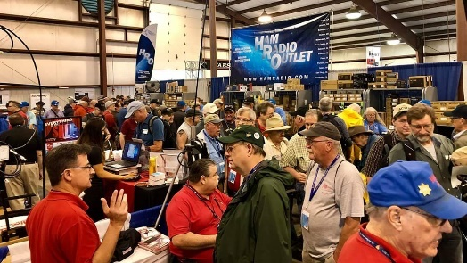[***Upcoming Hamfests***](http://arrl-ohio.org/hamfests.html) ***for 2020***

**01/19/2020 | Sunday Creek Annual Hamfest**  
Location: Nelsonville, OH  
Sponsor: Sunday Creek Amateur Radio Federation

**01/26/2020 | Tusco Amateur Radio Club's 30th Annual Hamfest, Electronics and Computer Show**  
Location: Strasburg, OH  
Sponsor: Tusco Amateur Radio Club  
Website: [http://www.tuscoarc.org](http://www.tuscoarc.org/)

**02/16/2020 | Mansfield Mid-Winter Hamfest**Location: Mansfield, OH  
Sponsor: Intercity Amateur Radio Club  
Website: [http://WWW.IARC.CLUB](http://www.iarc.club/)

**03/01/2020 | WinterHamFest**  
Location: Elyria, OH  
Sponsor: Northern Ohio Amateur Radio Society  
Website: [http://noars.net](http://noars.net/)

TOP ^

**03/14-15/2020 | Toledo Hamfest,**

**ARRL Great Lakes Division Convention**Location: Perrysburg, OH  
Sponsor: Toledo Mobile Radio Association  
Website: [http://www.tmrahamradio.org](http://www.tmrahamradio.org/)

**03/21/2020 | Mid-Ohio Valley ARC Hamfest**

Location: Gallipolis, OH

Sponsor: Mid-Ohio Valley Amateur Radio Club, Inc.

Website: <http://sites.google.com/site/midohiovalleyarc/>

**04/11/2020 | 66th Annual Cuyahoga Falls Amateur Radio Club Hamfest**  
Location: Cuyahoga Falls, OH  
Sponsor: Cuyahoga Falls Amateur Radio Club, Inc.  
Website: <http://www.cfarc.org/hamfest.php>

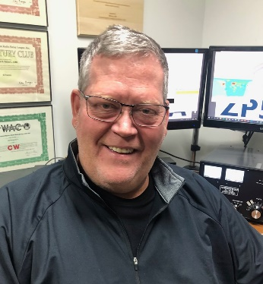***DX This Week***

*(from Bill, AJ8B)*

***DX This Week – 2020 Goals***

***Bill AJ8B (***[***aj8b@arrl.net***](mailto:aj8b@arrl.net)***, @AJ8B, or*** [***www.aj8b.com***](http://www.aj8b.com)***)   
 CWOPs Member #1567***

DX Spots that originated in the Midwest included Argentina, Australia, Azerbaijan, Azores, Canary Islands, Chad, Chile, Colombia, Czech Republic, Dominican Republic, European Russia, Finland, Hawaii, Honduras, Jamaica, Japan, Kenya, Kuwait, Moldova, Monaco, Montenegro, Slovenia, South Africa, St. Helena, St. Kitts & Nevis, Suriname, Uruguay, Venezuela. I hope you took part.

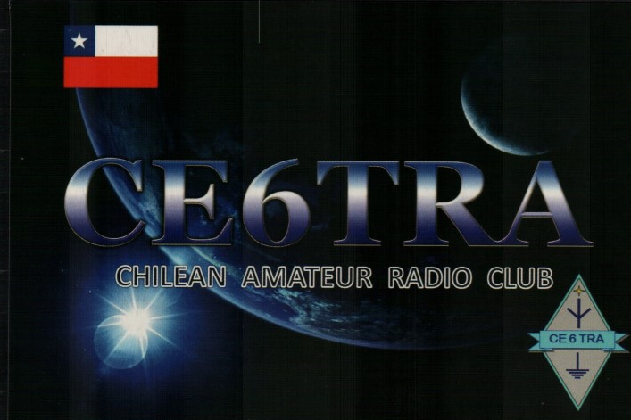This week, the mailman only brought me CE6TRA. However, a great card for a great QSO (Pictured). What did you get? Send me an image and some details!

I will also be sending out “N” sorter card packs this week. I hope you have some goodies coming your way.

One of the most popular DXpeditions that occurred this year was the Pitcairn Island DXpedition, VP6R, from October 18th to November 1st. They have released a short video that might give you a taste of the destination and the trip:

<https://drive.google.com/file/d/1UYRkN8_41zUCoZcyofzKqp0pJ_JsA6jZ/view>

TOP ^

Well, as happy as I was last week by working Chad and getting a QSL route for my remaining worked but not confirmed QSO, I went well backwards this week. My FT-950 is showing a high SWR no matter what frequency I tune to or what antenna is connected. I was able to work with Yaesu to determine that it is an issue in the final and I need to send it off to Yaesu. So, out of mothballs comes by Heathkit HW-101. I have spent most of this weekend getting various cables built to support CW, interface with my Ameritron AMP, and work with FT-8. There is no capability for computer control, so, I am back to my first station in the 70s. But, I am sure that it will be fun. Hope to work you with this rig.

My elmer (and OM), K8DWE (SK), convinced me early on that the only person that I had to compete with on the bands was myself! I would never have the biggest station, best antennas, most power, etc. so I had to set goals for myself. During my career at HP, I learned about *stretch* goals. Most people set goals for themselves, but, their either forget about them or make them too easy to attain. Additionally, you must revisit your goals frequently and set up procedures and practices that support your goals. What does all of this have to do with DX? I took these teachings to heart years ago and set several short term and long term goals. I review them annually and then monthly. I keep an eye out for things that can help me achieve these goals and implement those things when I can. For instance, my two long term goals are achieving DXCC Honor Roll and exceeding 2,000 on the ARRL DXCC Challenge roster. My short-term goal is to exceed my previous years’ score in the annual CQ Marathon. If I can exceed my annual goal and keep an eye on my longer-term goals, I can achieve them all.

What are your goals for 2020? I thought this would be a great topic for this edition as we are getting close to the end of the year. If you don’t have any goals, but like to chase DX, I would ask you to consider chasing the CQ Marathon award. One of the great things about the award is that confirmations are not required. However, you need to be honest! The rules read “*QSLs are not required.  The operator is expected to claim contacts only from stations the operator has every reason to believe are legitimate, and only to claim contacts in which an accurate two-way exchange was clearly accomplished. Scores will be adjusted by the DX Marathon committee for claimed contacts with pirates or any station not considered legitimate.  Submissions may be penalized or voided in cases of fraud or poor sportsmanship. Every QSO may be subject to verification by the DX Marathon Manager. Decisions of the DX Marathon Manager are final.”*

The following information is from the CQ Marathon website (<http://www.dxmarathon.com/>) :

**Starting January 1 of each year**, the DX Marathon is the perfect answer for the DXer who needs that extra incentive to get on the air every day! Simply work as many countries and CQ Zones as you can in each calendar year, regardless of the band or mode. Each country and zone counts only once, so you can concentrate on working new ones rather than working the same ones on multiple bands and modes. Many awards are given for the top overall scores in four classes plus top scores in modes, bands, US call areas and more!

Each year there are pirates, operations that are not approved, callsigns that are copied incorrectly and unusual operations that are valid. We attempt to document as many of these operations as possible - see the lists of valid callsigns, invalid callsigns, and callsign notes. We encourage you to share your findings on pirates, illegal operations or confusing callsigns with us. Please send your callsign updates to the DX Marathon administrator at: [k9el@dxmarathon.com](mailto:k9el@dxmarathon.com)

Many points are lost each year due to bad spots on the packet cluster network. We have assembled an extensive list of bad spots - please check the list before entering any of these callsigns!

TOP ^

Please check USA/VE zones carefully - use www.qrz.com to check zones before submitting. The number in the callsign does not necessarily match the location. Did you know that West Virginia (W8) is in Zone 5? and that Alabama (W4) is in Zone 4? Check Zone 2 submissions carefully.

When a prefix can count for more than country (e.g. E51) double check your entry. Although you can use the same QSO for a country and a Zone, if there is an error, two points will be lost! We suggest using a different QSO for country and zone. Review your submission carefully and make sure your logging program country database is up to date.

This list of separate countries (entities) for the CQ World Wide DX Contest and the CQ DX Marathon is based on a combination of the ARRL DXCC list, additional entities on the WAE (Worked All Europe) list and the Italian islands of Lampedusa (IG9) & Pantelleria (IH9), in CQ Zone 33 off the coast of North Africa. This provides a total of 346 entities, based on 340 DXCC entities, six additional WAE entities (GM/Shetland, IT/Sicily, TA1/European Turkey, 4U1VIC, JW/Bear Is.) plus African Italy.

Total CQ Countries: 346 (This list last updated February 11, 2018)

This gives you a reason to work Canada, England, France, Spain etc. again in 2020! It is a clean slate and you can start all over to better your score from the previous year. I have been able to increase my score each year, even with sunspots declining. As propagation started to fail, I had to get something up for 80M. The past year, I had to add FT8 to my set of tools.

There is an excellent book that details one man’s chase to win the Marathon. That book, A Year of DX, by Bob, W9KNI, is an excellent read whether you will be chasing countries for the Marathon or not. He has some excellent tips on using Gray line, propagation, and breaking pileups. I have read it 3 times and learn something every time. (Great stocking stuffer)

If you are going to participate in the CQ Marathon, please let me know and let me know what your ongoing count is. I can publish here to add some spice to the challenge. As of 12/22, I am at 173 entities and 37 zones for a total of 210. This is my personal best score ever and I will have an appropriate goal for 2020!

I want to wish you Merry Christmas, Happy New Year and great DX in 2020. Please drop me a note from time to time to let me know that I am publishing what you want to read about. Also, if there are topics you would like me to include, let me know. I have some plans for 2020 and I will let you know in our next weekly issue what you can expect.

**CQDX CQDX CQDX CQDX CQDX CQDX CQDX CQDX CQDX**

Here is an update from Bernie, W3UR, of the DailyDX and the WeeklyDX, the best source for DX information. <http://www.dailydx.com/> ) Bernie has this to report:

**9J – Zambia -** Since 2016 ZS6JBS, Bernd “Jerry” Sinner, has been living near Mufulira a town in the Copperbelt Province some 300 kilometers north of Lusaka. On Friday December 13th he was issued the call 9J2BS. “I am restricted with antennas where I live as it is a protected wildlife area, so wire antennas in trees are the order of the day”, says Jerry. He is operating a Kenwood TS-480SAT while home and an FT-857D when mobile. From home he uses a ZS6BKW version of a G5RV up in a tree some 14 meters above the ground and when mobile a 56” whip Tarheel II.

TOP ^

He can be found on 20 meters SSB running 100 watts on or near 14.200 MHz in the 1330 to 1530Z time frame. Jerry plans to stay in 9J for the next five years, with a hopeful move in about six months to Mufulira and which time he hopes to “put up decent antennas”. QSL via LoTW.

**SP – Poland -** In celebration of Poland’s IARU Society, PZK 90th anniversary in 2020 stations from Poland will be using multiple special event calls with the number 90. Some of these calls include 3Z90PZK, HF90PZK, SN90PZK, SP90PZK, HF90TPAR, HF90TPBB, HF90TPBF and HF90TPCF. Activity will be from January 1 to December 31, 2020.

**J6 – St. Lucia -** AI6LY, John, plans a vacation style DX operation from Soufriere, St. Lucia as J6/AI6LY from January 4-11. He’ll be running a K3 and KW into a dipole and vertical for 80 meters and a SteppIR DB42 for activity on SSB on 80 through 15 meters. Logs will be uploaded to Club Log and LoTW. QSL direct to AI6LY.

**HR – Honduras -** WA4DT, Dirk, is heading to West Bay, Roatan Island (NA-057) where he will be QRV as HR9/WA4DT from January 19 to February 2. He will have an IC-7300 running 100 watts into a dipole for activity on CW and some FT8 on 40 meters. QSL direct only with SASE to WA4DT.

**JT – Mongolia -** K1LZ, Krassy, and K1ZM, Jeff, “expect to be there from around 20 Jan to 30 Jan - dates not yet set in stone” says Jeff. As most low band ops will recognize these two calls looks like those needing CQ Zone 23 will get a decent shot as they will focus their efforts on the eastern half of North America and I am sure other areas. Details to follow.

**6W – Senegal -** ON4AVT, Willy, is planning to be back here and QRV as 6W7/ON4AVT sometime in February 2020. He will probably be mostly on 60 meters.

**PZ – Suriname -** PZ5RA, Ramon, reports the station PZ/PA4ARI is operating illegally as Ramon “checked with the authorities and no such call was ever submitted”. As with many other countries “foreigners should apply for a call” and in this case “they will get a PZ5... call”.

***DX news***

***ARLD051 DX news***

This week's bulletin was made possible with information provided by UR5BCP, The Daily DX, the OPDX Bulletin, 425 DX News, DXNL, Contest Corral from QST and the ARRL Contest Calendar and WA7BNM web sites.

Thanks to all.

**CYPRUS, 5B.** In celebration of the 60th anniversary of the proclamation of the Republic of Cyprus, all members of the Cyprus Amateur Radio Society will replace their current prefix with 5B60 from January 1, 2020 to December 31, 2020.

**ALGERIA, 7X.** A large group of operators will be QRV as 7X7T from Bejaia from December 28 to January 20, 2020. Activity will be on the HF bands using CW, SSB and FT8. QSL via 7X2RO.

TOP ^

**MALDIVES, 8Q.** Sergey, RX3AMY will be QRV as 8Q7BS from Mahibadhoo and Maafushi Islands, IOTA AS-013, from January 3 to 23, 2020. Activity will be holiday style mainly on 40 and 20 meters using SSB, and possibly CW. QSL to home call.

**THE GAMBIA, C5.** Przemyslaw, SP3PS is QRV as C5SP until January 17, 2020. Activity is on the HF bands, with a preference of 20 meters, using SSB, FT8 and FT4. QSL to home call.

**EASTER ISLAND, CE0.** Oleh, UR5BCP will be QRV as CE0Y/UR5BCP from December 28 to 31. Activity will be on 60 to 6 meters using CW, SSB, FT8 and FT4. QSL via KD7WPJ.

**CUBA, CO.** Members of the Radio Club of Caibarien will be QRV as T46W from December 29 to 31 to commemorates the centennial of the first transmission of Cuba's radio pioneer Manuel Antonio Alvarez.

Activity will be on 80 to 10 meters using CW, SSB and FT8. QSL via LoTW.

**FEDERAL REPUBLIC OF GERMANY, DA.** Special event station DL30GER will be QRV from December 31, 2019 to December 31, 2020 to celebrate the 30th anniversary of the German reunification process. QSL via bureau.

**SWITZERLAND, HB.** Special event station HE2JOJ will be QRV from January 1 to 31, 2020, to mark the 3rd edition of the Winter Youth Olympic Games. QSL via HB9HI.

**ANTARCTICA.** Chris, W2RTO is QRV as KC4/W2RTO and KC4USV from the McMurdo Station, IOTA AN-011, until February 21, 2020. Activity is on the HF bands using SSB, FT8 and some PSK31. QSL via K7MT.

**BRAZIL, PY.** Members of the UBRO DX Team are QRV as ZZ1R from Rats Island, IOTA SA-029, until December 29. Activity is on 80 to 10 meters using CW, SSB, FT8 and FT4. QSL via PY2AE.

**ICELAND, TF.** Col, MM0NDX and Jonathan, MM0OKG will be QRV as TF/OJ0Y and TF/MM0OKG, respectively, from December 31 to January 2, 2020. Activity will be on 80 to 10 meters, and possibly 160 and 60 meters, using CW, SSB and FT8. QSL TF/OJ0Y via EB7DX and TF/MM0OKG via LoTW.

**SOUTH SUDAN, Z8.** Diya, YI1DZ is QRV as Z81D from Juba for at least six months. Activity is on 80 to 10 meters using SSB, FT8 and possibly FT4. This includes possibly being active on 60 meters as well. QSL via OM3JW.

THIS WEEKEND ON THE RADIO. The Stew Perry Topband CW Challenge, NCCC RTTY Sprint, NCCC CW Sprint, RAC Winter Contest, Gedebage CW Contest, Original QRP CW Contest and RAEM CW Contest are all on tap for this weekend.

The QCX CW Challenge is scheduled for December 30. The Bogor Old and New SSB Contest is scheduled for December 31.

**ARRL Straight Key Night is scheduled for January 1, 2020.**

The QRP ARCI New Year’s CW Sprint, UKEICC 80-Meter CW Contest, CWops Mini-CWT Test, AGCW VHF/UHF Contest, SARTG New Year RTTY Contest, AGCW Happy New Year CW Contest, Phone Fray, QRP 40-Meter CW Fox Hunt and AGB New Year Snowball Contest are all scheduled for January 1, 2020.

TOP ^

The Canadian National Parks on the Air, CNPOTA, operating event runs for the entire year of 2019, with special stations active from Canada's parks and historic sites.

During December look for a number of stations active with the YOTA suffix for Youngsters On The Air. QSL via LoTW or direct to M0SDV.

Please see December QST, page 63, January 2020 QST, page 81, and the ARRL and WA7BNM Contest Web Sites for details.

***Special Events***

* **12/31/2019 | Commemorating the US Revolutionary War – Historic “Battle of Princeton”**

**Dec 31-Jan 6, 0000Z-2359Z, W2P**, Trenton, NJ. Delaware Valley Radio Association. 14.225 7.175. Certificate & QSL. Delaware Valley Radio Association, PO BOX 7024, West Trenton, NJ 08628-0024. [https://www.w2zq.com](https://www.w2zq.com/)

* **01/01/2020 | NCDXA 5th Annual Worked All RST Special Event**

**Jan 1-Feb 28, 0000Z-2359Z, KL7RST**, Anchorage, AK. North Country DX Association (K7ICE). 14.250 14.075 7.190 7.050. QSL. J. Reisenauer, 2573 Old Georgetown Rd. W., Kershaw, SC 29067. [www.qrz.com/db/kl7rst](http://www.qrz.com/db/kl7rst)

* **01/02/2020 | 14th Annual Straight Key CW Event**

**Jan 2-Jan 31, 0000Z-2359Z, K3Y**, various cities. SKCC - Straight Key Century Club. 21.050 14.050 7.055 3.550. Certificate & QSL. SKCC c/o Jeremy Downard, KD8VSQ, 511 W. Pottawatamie St., Tecumseh, MI 49286. K3Y/0 thru 9 plus KH6, KL7, KP4 and DX member stations in six WAC areas operating straight key, bug and cootie keys. QSL card confirms one QSO per area, up to 19 for all-area sweep. See URL for schedule, map, stats, etc. [www.skccgroup.com/k3y](http://www.skccgroup.com/k3y)

* **01/07/2020 | Florence Nightingale Bi-Centenary**

**Jan 7-Feb 3, 1000Z-0900Z, GB200FN**, ROMSEY, UNITED KINGDOM. RSGB. 14.200 MHz 7.95 MHz. QSL. John Wakefield, Oakhurst, Lower Common Road, West Wellow, ROMSEY SO51 6BT, UNITED KINGDOM. Direct QSL to include postage. Full details on QRZ.com. [www.qrz.com/db/gb200fn](http://www.qrz.com/db/gb200fn)

* **01/08/2020 | 9th Annual Balloon Festival**

**Jan 8-Jan 12, 0000Z-2359Z, K7B**, Lake Havasu City, AZ. London Bridge Amateur Radio Association. 18.145 14,263 7.195 3.905. Certificate. Garry F. Fisher K9WZB, 1850 Rainbow Ave S, Lake Havasu City, AZ 86403. [www.lbara.club](http://www.lbara.club/)

* **01/11/2020 | 119th Anniversary of the Lucas Gusher**

**Jan 11-Jan 12, 1400Z-2300Z, K5S**, Beaumont, TX. Beaumont Amateur Radio Club. 7.245 14.250 7.074 14.074. Certificate & QSL. Beaumont Amateur Radio Club, 4839 Hwy 326 N., Kountze, TX 77625. Visit our QRZ page for qsl and certificate information as well as updated times and frequencies. [www.qrz.com/db/w5rin](http://www.qrz.com/db/w5rin)

* **01/11/2020 | USS Midway Museum Ship Special Event; Desert Storm Kickoff**

**Jan 11, 1700Z-2359Z, NI6IW**, San Diego, CA. USS Midway (CV-41) Museum Ship. 14.320 7.250 PSK31 14.070 DSTAR REF001C. QSL. USS Midway Museum Ship COMEDTRA, 910 N Harbor Drive, San Diego, CA 92101.

####

TOP ^

***Straight Key Night***

**Objective:** This 24-hour event is not a contest; rather it is a day dedicated to celebrating our CW heritage. Participants are encouraged to get on the air and simply make enjoyable, conversational CW QSOs. The use of straight keys or bugs to send CW is preferred. There are no points scored and all who participate are winners.

**Contest Details**

    **Dates**  
    Straight Key Night is held every **January 1 from 0000 UTC through 2359 UTC**.  
  
**Terms Of Entry**  
    - Entrants agree to be bound by the provisions and intent of ARRL contest rules.  
    - Entrants agree to be bound by the regulations of their national licensing authority.  
    - Entrants agree to be bound by the decisions of the ARRL Awards Committee.  
    - Log contents used to determine final score and awards will be available to the public.  
    - All entries become the property of the ARRL.  
  
**Bands**  
All authorized Amateur frequencies, but activity has traditionally been centered on the HF bands.  
  
**Log Submission Deadline**  
Entries for Straight Key Night must be received by January 31. Votes for ‘Best Fist’ and “Most Interesting QSO” will be tabulated and included in the results.  
      
**Send your information to**[**straightkey@arrl.org**](mailto:StraightKey@arrl.org)Contact Information: [contests@arrl.org](mailto:contests@arrl.org)

**A Straight Key Night Story:**  
By Dan Henderson, N1ND  
  
In my early days in amateur radio, I was privileged to have three top-flight Elmers.  Each shared with me new interests and enthusiasm for different parts of the hobby.  The first, Col. Frank, WB4JMG, was special because we shared the same birthday and he taught me most of what I learned in those early days about electronic theory. The second Everest, W4DYW, was special because not only because our families were so close – he was my principle mentor for on-the-air operations, especially CW traffic nets.  
  
Unless your Elmer was one of your parents, you probably can’t say what my third Elmer could say about our relationship.  Dr. Mac, WA4VNV (later N4IX), would honestly say he knew me my entire life.  Not only was he a dedicated amateur operator – he was my mother’s OBGYN and was the man who literally “delivered me” to the world, and helped me find the world of amateur radio in later years.  
  
I had been attending club meetings with the old Asheville Radio Club (which merged with the Buncombe County VHF Society to later form the Western Carolina Amateur Radio Society) for months before I was first licensed.  And being the precocious teenager that I was, I jumped in with both feet.  In mid-1971 I agreed to take over as editor of the ARC’s monthly newsletter, known as Smoke-test from Dr. Mac.  He agreed to help me as a regular contributor, but slyly with one caveat–he would only provide news stories for me for the newsletter if I would copy them over the air using CW, since I was only a novice and had no phone privileges during those years.

TOP ^

I accepted his offer, and began two years of almost daily QSOs on 3725 KHz– because that was one of the few crystals I had for the HeathKit HW-16, which Col. Frank had been commissioned by my parents to build for my Christmas present in 1970.  It was a unique experience, but one which served to continue building what became my passion for Morse code.  In later years I would follow in Dr. Mac’s footsteps once again when I became the ARES EC and RACES Radio Office for the county (but that’s a topic for another article).

Between the efforts of my three Elmers, my CW speed quickly increased from the nervous 5 WPM necessary to earn my license to being able to conduct a coherent rag chew in the 25-30 WPM range.  And the mantra of all three was simple – If you want to be competent in CW, you have to use it.  
  
So each year from 0000 UTC to 2359 UTC PM January 1st I have the chance to pay a small bit of homage back to the Elmers when I have the opportunity to participate in the annual ARRL Straight Key Night. This 24-hour event is not a contest; rather it is a day dedicated to celebrating our CW heritage. Participants are encouraged to get on-the-air and simply make enjoyable, conversational QSOs.  There are no points scored and all who participate are winners.  
  
In the decade since I wrote my first SKN announcement for QST, I have seen marvelous metamorphosis occur.  The number of entries has grown almost every year, even with the elimination of CW as a licensing requirement in the US.  Participants have also used this popular annual event for more than just demonstrating their prowess pounding a brass key. Numerous participants use SKN to test out and “show off” their vintage equipment.  Some will plug in their old CW “bugs” and join in.   The common bond for all of them is to have fun in a more relaxed setting. You will even find CW enthusiasts who get on to enjoy the rag chewing   And that’s the purpose of this popular operating event, so don’t get hung up about the equipment.  
  
When participating in SKN instead of sending RST before sending the signal report send the letters SKN, to indicate your participation, and to clue in passers-by who may be listening that SKN is going strong.  After SKN, send the Contest Branch a list of stations worked, plus your vote for the best fist you heard (it doesn’t have to be one you worked).  Also, include your vote for the most interesting QSO you had or monitored.  
  
Don’t forget to post your comments and interesting photographs from your SKN adventure to the ARRL Contest Online Soapbox. Entries should be emailed to the Contest Branch at [StraightKey@arrl.org](mailto:StraightKey@arrl.org)or may be sent via regular mail to SKN, ARRL, 225 Main St, Newington, CT 06111. The Soapbox becomes an online album of stores and photographs to share with others.

####

***AMSAT CW Day is January 1***

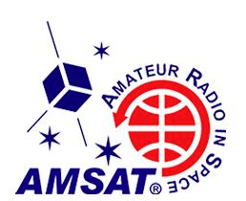

AMSAT CW Activity Day 2020 will take place on January 1, 2020 (UTC), sponsored by [**AMSAT**](http://www.amsat.org/). All radio amateurs are invited to participate in the annual event — in 2020 being held in memory of Larry Brown, W7LB, and Keith Pugh, W5IU.

Participation is easy: Operate on CW through any Amateur Radio satellite on New Year’s Day. Straight keys or bugs are encouraged but not required.

If you use AO-7, observe the QRP rules currently in effect for the 45-year-old satellite.*— thanks to AMSAT Senior Advisor Ray Soifer, W2RS*

####

TOP ^

***Kids Day is Saturday, January 4***

The first Saturday in January is Kids Day -- the time to get youngsters on the air to share in the joy and fun that amateur radio can provide. Kids Day gets under way on Saturday, January 4, at 1800 UTC and concludes at 2359 UTC. Sponsored by the Boring (Oregon) Amateur Radio Club, this event has a simple exchange, suitable for younger operators: First name, age, location, and favorite color. After that, the contact can be as long or as short as each participant prefers. Kids Day is the perfect opportunity to open your shack door and invite kids over to see what amateur radio has to offer. [Details](http://www.arrl.org/kids-day) are on the ARRL website.

***Attention ALL Ohio…***

***Mark January 11 (Saturday)  10AM -  4PM for the ARES VHF Simplex Contest!***

This is more important in 2020 as a follow-up to our SET, which was designed to map our simplex footprints. Now, we can exercise that information and get even more by participating!  It’s a fun event with a purpose.

The purpose of our annual simplex activity is to improve our station and antenna capabilities, and to test our coverage areas on simplex frequencies.

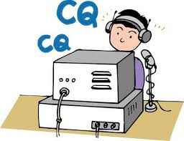These may be very important in times of emergency, when repeaters have failed, and simplex is the only method of emergency communication. We are NOT giving any consideration for backup power- this exercise is aimed at testing antennas and determining coverage areas.

**We’ve just gotta’ thank Jason McCormick N8EI for setting up a website with the complete rules, scoring and who’s operating.** [**https://ohsimplex.org/#rules**](https://ohsimplex.org/#rules)

####

***Mark April 4, 2020 (Saturday) as our ARES OHIO SPRING CONFERENCE!***

We have the Marion Tech lecture hall reserved (THANKS MARION ARES!!!) and we’ll begin planning some important topics! More information will be forth coming.

####

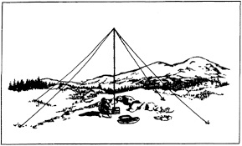

***NVIS DAY IS COMING!***

Is your station ready to establish and maintain high-reliability communication with other stations around Ohio when repeaters, phone, and internet service are impaired?

TOP ^

When infrastructure just isn’t there, HF radio using Near-Vertical Incidence Skywave (NVIS) propagation offers the ability to stay in contact on frequencies of 2–30 MHz for distances of about 30–400 miles.

NVIS Day is the ARRL Ohio Section event to test your NVIS antenna designs and builds. Join us on Saturday, April 25th to show how well amateur radio can keep Ohio communicating! This is not a contest: it’s an event for Ohio stations to operate with other Ohio stations and understand how well they hear and are heard.

**THE DETAILS**

**Date: Saturday, April 25**

**Time: Start at 10 A.M., end at 4 P.M.**

**Power: Up to but no more than 100w**

**Exchange: six-digit grid, power, and true—measured—signal report**

**Schedule: This isn’t a contest, so take your time! Try different designs! Have lunch!**

**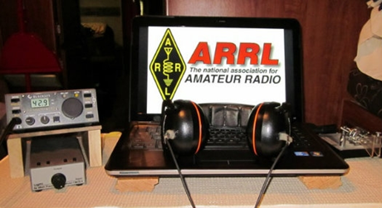*ARRL Contest Corner***

An expanded, downloadable version of *QST'*s [**Contest Corral**](http://www.arrl.org/contest-calendar) is available as a PDF. Check the sponsor's Web site for information on operating time restrictions and other instructions.

Just Ahead in Radiosport

* December 30 - 31 -- QCX Challenge (CW)
* December 31 -- Bogor Old and New Contest (Phone)
* **January 1 --** [**Straight Key Night**](http://www.arrl.org/straight-key-night)
* January 1 -- AGB New Year Snowball Contest (CW, phone, digital)
* January 1 -- SARTG New Year RTTY Contest
* January 1 -- AGCW Happy New Year Contest (CW)
* January 1 -- AGCW VHF/UHF Contest (CW)
* January 1 -- QRP ARCI New Year's Sprint (CW)
* January 1 -- 3.5 UKEICC 80-Meter Contest (Phone)
* January 2 -- NRAU 10-Meter Activity Contest (CW, phone, digital)
* January 2 -- SKCC Sprint Europe (CW)
* **January 4 --** [**ARRL Kids Day**](http://www.arrl.org/kids-day) **(Phone)**
* January 4 -- PODXS 070 Club PSKFest (Digital)
* January 4 -- RSGB AFS Contest, CW
* January 4 - 5 -- WW PMC Contest (CW, phone)
* **January 4 - 5 --** [**ARRL RTTY Roundup**](http://www.arrl.org/rtty-roundup)
* January 4 - 5 -- EUCW 160-Meter Contest (CW)
* January 6 - 12 -- All IQRP Quarterly Marathon (CW, phone, digital)
* January 7 -- ARS Spartan Sprint (CW)
* January 8 - 12 -- AWA Linc Cundall Memorial CW Contest

TOP ^

*****V.E. Test Sessions***

For the latest testing site information please **>>** [**Click Here**](http://www.arrl.org/find-an-amateur-radio-license-exam-session) **<<** The ARRL site tracks all of the VE testing sites that register with them, including W5YI and Laurel. ARRL gives you a number of different ways of sorting to find that site that is closest to you as well.

***One Question Questionnaire***

Hey Gang, 

“Survey Says” about 43**%** of you opened a Christmas gift before Christmas day. I actually figured that number would be much higher than that!

Ok, I’ve got another NEW – one question – for you to answer. Since over the past 6 months or so you’ve heard me talk about installing new antennas at my QTH. One of them is a wire 75-meter antenna that is spread between two trees. It took some doing with my spud gun to get it positioned just right, now that I’ve got it just where I want it, it’s working like a champ for sure. So, with that in mind, here’s my next question!

**“Do you use trees to support any of your antennas?”**

You’ll find the “One Question” questionnaire on the Ohio Section Website! <http://arrlohio.org> It’s all in fun and it’s not a scientific survey in any way, but we are learning some things that we didn’t know from these questions. I hope that you are enjoying answering these “One Question” questionnaires.

*(Ed Note.. If you haven’t seen the announcement by ARRL, they are discontinuing Quick Stats from QST magazine as of the January 2020 edition.)*

**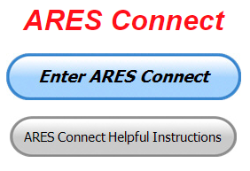*ARES Connect***

**Everyone –** please make sure to go into all of the events that you have signed up for and get your hours registered no later than 7 days after the event has ended.

I need you to be as prompt as possible in reporting your hours. I’m noticing a number of events that aren’t getting hours credited and that is due to you not going back into your account and registering your hours! Please, don’t miss out on your hours just because you missed on very important step, record hours!!

Admins – Make sure that you are as prompt about approving those hours as well. I’ve set the timer for 7 days after the event, this should be more than ample amount of time to make sure hours are recorded for every volunteer that signed up and get those hours approved.

TOP ^

***Here’s the top 10 hours earners so far in December:***

|  |  |  |  |
| --- | --- | --- | --- |
|  | **Name** | **Events** | **Hours** |
| 1 | James Yoder (w8erw) | 24 | 103.00 |
| 2 | Bret Stemen (KD8SCL) | 30 | 89.00 |
| 3 | Christopher Domenick (KC8CAD) | 18 | 56.25 |
| 4 | Dan Stahl (KC8PBU) | 56 | 53.28 |
| 5 | Diane Warner (KE8HLD) | 22 | 48.00 |
| 6 | Greg Dersarkisian (KD8SSJ) | 22 | 44.00 |
| 7 | Alan Rothweiler (N8CJ) | 23 | 38.50 |
| 8 | Marcel Casavant (AD8CM) | 31 | 27.30 |
| 9 | John Hilliard (w8of) | 22 | 26.50 |
| 10 | Michael Lacumsky (w8mal) | 29 | 24.85 |

Here’s a quick overview of what we report to Headquarters that comes from the data collected by ARES Connect…

The month of May was the very first report with all the data coming from ARES Connect. The Ohio Section was also, and still remaining true today, the only Section where the data collected for the monthly report comes from ARES Connect.

With all of the additions to ARES Connect that we now have, there is absolutely no longer any excuses for all of you to not use the system!!

I’m setting a goal for all of you out there. **Let’s get everyone in the Ohio Section on ARES Connect before the end of this year!!! Simply go to:**  <https://arrl.volunteerhub.com/lp/oh/> and get yourself registered and using the system.

Why is this so important? Hey, I am just going to say this… The end of the year is coming up fast, and now with the ability to catch yourself up on past events, there’s gonna’ be a very special “End of the Year” award for the person with the most hours in 2019! . Will that be you? You now can make that happen!

**Admins…** If you are wondering how to get an overview of all of your events you can simply go into reports and using the new Event by Participation by Event (version 2) you can not only see who registered for your event, but you also can see if he/she has inputted their hours for it as well. Take advantage of this new report to help you get the time entered into your events.

**I’m also seeing a number of recurring events created but no activity reported for them.** Please, if this event is no longer needed, let me know and I can delete it from the masters. I know that many of you setup recurring events to learn how, but if they aren’t going to be used, let’s get them cleared out.

Also… If you are setting up events, please don’t set a limit for how many folks can sign-up unless absolutely necessary. This causes issues when doing reports. It’s also counter-productive since the reason for you to list the event is to get as many volunteers as you can to attend. When you set limits, it discourages folks from signing up.

TOP ^

***Special NIMS Training Available***

**ICS300 INTERMEDIATE ICS FOR EXPANDING EVENTS MGT904**

Hosted by: Mahoning County Emergency Management Agency

**January 13 – 15, 2020**

**Application Deadline: December 30, 2019**

Course Registration time: 7:30 am – 8:00 am (on day one)

Course Time: 8:00 am to 5:00 pm – All three (3) days One-hour Lunch each day

Training Location: Boardman Fire Department, Station 71 7440 Market Street Boardman, OH 44512

Recommended Participants: FEMA designed this course for individuals who may assume a

supervisory role in expanding incidents or Type 3 incidents.

Required Prerequisites: Individuals must complete the IS-100.c Introduction to the Incident Command

System, IS-200.c Basic Incident Command System for Initial Response, IS-700.b An Introduction to the

National Incident Management System and IS-800.c National Response Framework courses prior to

attending the ICS-300 Intermediate course and provide copies of their certificates of completion to the

instructors on day one of the course.

Enrollment: Students must enroll via the Department of Public Safety Training Campus website:

<https://trainingcampus.dps.ohio.gov/cm/cm710/pstc/pstc.html> Course registration will generally close 10

working days prior to the course start date and applicants can check enrollment/approval status via the

Department of Public Safety Training Campus website.

Course Costs: There is no charge for participants to attend this course. However, Lodging, Meals, Per

Diem and all other travel expenses are the responsibility of the student or the parent organization.

State Point of Contact: Lisa Jones, DSC 2, Ohio EMA, SAA Training Point of Contact, (614) 799-3824

[ljones@dps.ohio.gov](mailto:ljones@dps.ohio.gov)

####

**ICS400 ADVANCED FOR COMMAND & GENERAL STAFF MGT905**

Hosted by: Mahoning County Emergency Management Agency

**March 30 – 31, 2020**

**Application Deadline:** March 16, 2020

Course Registration time: 7:30 am – 8:00 am (on day one)

Course Time: 8:00 am to 5:00 pm – Both days One-hour Lunch each day

Training Location: Boardman Fire Department, Station 71 7440 Market Street Boardman, OH 44512

Required Prerequisites: Individuals must complete the IS-100.c Introduction to the Incident Command

System, IS-200.c Basic Incident Command System for Initial Response, IS-700.b An Introduction to the

National Incident Management System and the IS-800.c National Response Framework, an Introduction

courses.

TOP ^

In addition, ICS-300 Intermediate courses prior to attending the ICS-400 Advanced course and

provide copies of their certificates of completion to the instructors on day one of the course.

Enrollment: Students must enroll via the Department of Public Safety Training Campus website:

<https://trainingcampus.dps.ohio.gov/cm/cm710/pstc/pstc.html> Course registration will generally close 10

working days prior to the course start date and applicants can check enrollment/approval status via the

Department of Public Safety Training Campus website.

Course Costs: There is no charge for participants to attend this course. However, Lodging, Meals, Per

Diem and all other travel expenses are the responsibility of the student or the parent organization.

State Point of Contact: Lisa Jones, DSC 2, Ohio EMA, SAA Training Point of Contact, (614) 799-3824

[ljones@dps.ohio.gov](mailto:ljones@dps.ohio.gov)

####

**G-386 MASS FATALITIES**

Hosted by: Franklin County Emergency Management & Homeland Security **February 20 - 21, 2020**

**This is an “Elective” course in the Advanced Professional Series (APS) program**

**Application Deadline:** February 10, 2020

**Time of Course:** Registration: 7:30 am – 8:00 am Course Time: 8:00 am – 4:00 pm

**Location:** Franklin County EM&HS - 5300 Strawberry Farms Blvd. - Columbus, OH 43230

**Supported By:** The Ohio Emergency Management Agency

**Enrollment:** Students must enroll via the Department of Public Safety Training Campus website: <https://trainingcampus.dps.ohio.gov/cm/cm710/pstc/pstc.html>

**Course Costs:** This course is free to participants. Lodging, meals and all other expenses are the students’ responsibility.

**County Point of Contact:** Pam Tickle, Franklin County EM&HS (614) 794 – 0213, [pktickle@franklincountyohio.gov](mailto:pktickle@franklincountyohio.gov)

####

***Below is information on upcoming ICS-300/ICS-400 classes for those interested.***

Please be advised that we have listed the following ICS courses on the Ohio EMA Public Safety Training Campus (PSTC) website for students to register for the courses; <https://trainingcampus.dps.ohio.gov/cm/cm710/pstc/>

|  |  |  |  |  |  |
| --- | --- | --- | --- | --- | --- |
| **Course ID** | **Name** | **Session** | **Location** | **Enroll** | |
| ICS300LorainCoJan2020 | ICS-300 Intermediate ICS | January 7 - 9, 2020 | Oberlin Fire Department 430 South Main Street Oberlin, OH 44074 | | [Enroll](https://trainingcampus.dps.ohio.gov/cm/cm710/pstc/pstc.html) |

TOP ^

|  |  |  |  |  |
| --- | --- | --- | --- | --- |
| ICS300PrebleCoJan2020 | ICS-300 Intermediate ICS | January 11, 12 & 18, 2020 | Eaton City Fire Department, Station 2 391 West Lexington Road Eaton, Ohio 45320 | [Enroll](https://trainingcampus.dps.ohio.gov/cm/cm710/pstc/pstc.html) |
| ICS400AshtabulaCoJan2020 | ICS-400 Advanced ICS | January 13 - 14, 2020 | Ashtabula County Engineers Office 186 East Satin Street Jefferson, Ohio 44047 | [Enroll](https://trainingcampus.dps.ohio.gov/cm/cm710/pstc/pstc.html) |
| ICS300MahoningCoJan2020 | ICS-300 Intermediate ICS | January 13 - 15, 2020 | Boardman Fire Department, Station 71 7440 Market Street Boardman, OH 44512 | [Enroll](https://trainingcampus.dps.ohio.gov/cm/cm710/pstc/pstc.html) |
| ICS400OttawaCoJan2020 | ICS-400 Advanced ICS | January 16 - 17, 2020 | Magruder Hospital 615 Fulton Street Port Clinton, OH 43452 | [Enroll](https://trainingcampus.dps.ohio.gov/cm/cm710/pstc/pstc.html) |

####

***Campbell County Kentucky Office of Emergency Management Upcoming Training***

Campbell County Kentucky Office of Emergency Management **FREE** Training Opportunities

Working with the Media: A Short Course for Emergency Responders (AWR-209) – January 22, 2020 – RDPC / Register: <https://qrgo.page.link/o2Gs>

Isolation and Quarantine for Communities (MGT-433) – February 19, 2020 – RDPC / **Tentative/Requested**

Hazardous Weather Preparedness for Campuses (AWR-332) – March 4, 2020 – (NDPTC) / **Tentative/Requested**

Readiness: Training Identification and Preparedness Planning (MGT-418) – March 11-12, 2020 - TEEX / Register: <https://train.ncbrt.lsu.edu/Student/Register?ClassID=26374>

Registration Password: NCBRT418 If you have trained with NCBRT before, enter your FEMA SID, Last Name, and First Name. If your training record is found, your registration form will be pre-filled for you. Otherwise, click Register as New Person to fill out a blank registration form.

Evacuation and Re-Entry Planning Course – March 25-26, 2020 / **Requested through KYEM Training Division**

Pediatric Disaster Response and Emergency Preparedness (MGT-439) – April 8-9, 2020 / TEEX / Register: <https://qrgo.page.link/GFf4>

TOP ^

Debris Management Planning Course – April 15-17, 2020 / **Requested thought KYEM Training Division**

**Intermediate ICS-300 for Expanding Incidents w/Forms (MGT-904) – April 22-24, 2020 / TEEX / Register:** [**https://qrgo.page.link/HzT2**](https://qrgo.page.link/HzT2)

***Final.. Final..***

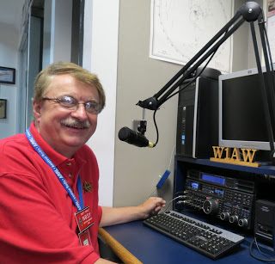

Hey Gang...

This past week was just a blur. I can’t believe how warm and nice it got outside. Wednesday it actually got above 60 degrees here! That was all it took for Janie and I to get the tricycles out and go for several bike rides. It was a little bit of a test for me as that before I had put mine way in November, I had the guys at the bike shop do a little modification on it. I had ordered a new main sprocket which would have given me eight more gears to use. But when they went to add the sprocket to the sprocket cluster, they found that it wasn’t the right one. So, instead of having them mess around much with it, or go through the process of ordering another sprocket, I had them order an entirely new crank and rear sprockets to match. By doing this it gives me a whole new drive train, one that custom, and no one else has the gearing I have on my trike. I like it that way, it gives me bragging rights that no one could have the exact combination of gears on the model that I have. Anyway, the new sprockets are geared for a much faster bike on the upper end (larger diameter) and the lower gears allow me to easily peddle up the steepest of hills with very little effort. Believe you me, my ride this week let me go down the bike path faster than ever before. Now, I don’t want to say it’s like riding a motorcycle, but it’s darn near!!!

Needing to test the lower gears I picked the steepest hill I could think of, my driveway. I walked right up the drive like it was flat ground. I couldn’t believe it. It looked so funny, I was peddling really fast, but with little effort, and just slowly but surely climbing the hill. I’m now ready for just about any terrain that Janie can take me on this next year and yes, she’s already plotting out new bike trails around Ohio and other states for us to try!!!

Ok.. Let’s slide down the band a bit and get a little more serious… I have added a brand-new statewide code plug on the website for the TYT MD UV 380/390 radio, thanks to Kurt Ashcraft, WD8KAA who wrote it. This is the first code plug that I’ve uploaded to the website for some time now. I’m hoping that’s because most of you are now getting proficient at modifying your already existing code plugs and are now venturing out on your own and writing your own code plugs.

You know that brings up a real sore spot with me. Almost all radios, including the big HF radios, now require some kind of programming by adding a computer into the mix. This is all well and fine when you have the time and are in the shack all nice and comfy, but what’s happening is we are now getting these radios so complexed that when you go into the field I’m afraid that we will become “technically challenged” and will be of little use if we can’t simply change our radio’s frequency without the aid of a computer and all the cabling that goes with it.

TOP ^

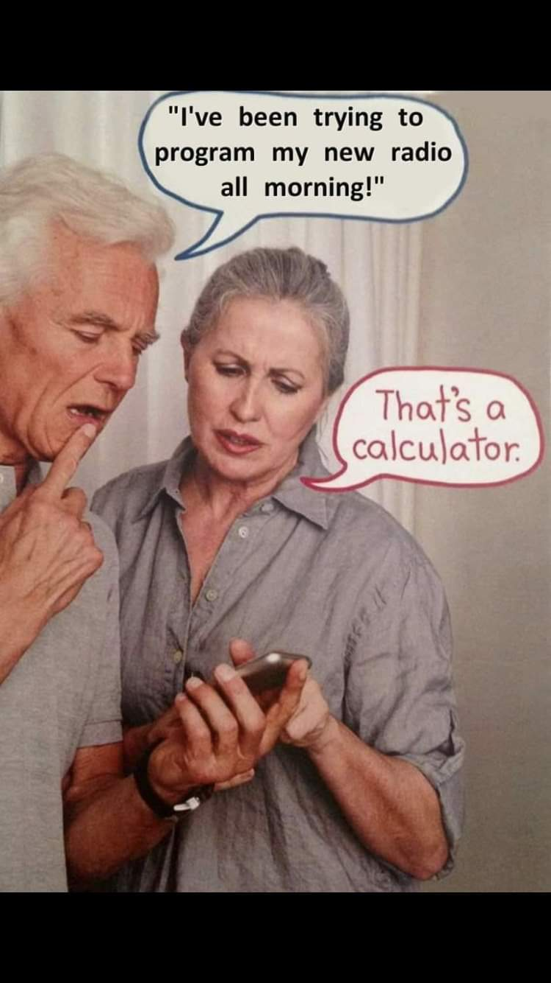What I’m leading up to is this. Back in the day Icom had a neat little compact radio named the ICOM 2AT. It was a cutie for sure. To change the frequency all you had to do is rotate the thumbwheels and you’re on a different repeater, or you could go simplex very quickly. It did have a touch-tone keypad to be able it give repeater controllers commands if needed, but the simplicity of the radio with its ability to switch from repeater to simplex with the flip of a switch or to be able to go from 146.52 to 146.46 or event 145.555 with little work and no computer is still something that we need to consider when working in the field. Heck, it even had an optional alkaline battery box that slipped on in place of the NiCad pack. This option was one that I took advantage of many times when I was assigned to the field and had no power to charge my big NiCad’s. It was great because you could buy AA batteries anywhere and during big emergencies, they usually have them available for free for the volunteers for flashlights and such. No, I’m not advocating we give up all the technology, and I certainly don’t work for Icom, but we do need to keep in mind when building our Emergency Plans and “Go Boxes” to keep things as simple as possible. When you program a radio that might go into the field for emergency use, plan on not having repeaters available. Remember, here in Ohio we do have tornadoes and they seem to hate trailer parks and towers with a passion. So, even if you program that fancy hand-held with every repeater in the state, it still might not be enough. You need to think about going simplex too. This past S.E.T. our exercise was to test simplex to find out for ourselves just what it takes to operate without the repeaters and such. Can we do an effective job for our served agencies without all the fancy stuff? That is something that I want you to consider for this next year as well. Yes, we have probably more repeaters than any other state, but if we don’t have the ability to quickly change over to something that works, how are we really serving the community and our served agencies.

I’m a firm believer in the K.I.S.S. principal. Haven’t heard of this? It stands for Keep It Simple Stupid. It has saved many folks over the years. This next year, consider KISS. Also, if you’ve had the FEMA training you know that your E.C. and YES, even YOU should have an ICS 205 form already completed on the frequencies that you would use for any given situation.

Now, switching bands… The Hamfest Calendar is filling up fast for 2020. I added the Cleveland Hamfest in September just this week!

Even though it isn’t technically a Hamfest, don’t forget that DX Engineering is holding their annual Winter Sale on January 18th starting at 9am. Now, like I said, it’s technically not a hamfest you’ll have to wait until August 8th for that, but it has all the makings of a hamfest for sure. Great equipment for sale and lots of great talk between fellow hams. What more could you ask for!!

Now, being the hearty Ohioans as we are, we have two Hamfests scheduled for the dead of January! <http://arrl-ohio.org/hamfests.html> - 01/19/2020 | Sunday Creek Annual Hamfest and on 01/26/2020 | Tusco Amateur Radio Club's 30th Annual Hamfest, Electronics and Computer Show. We also have the Mansfield Mid*Winter Hamfest in February as well!

Speaking of Hamfests, we have two big conventions coming up this next year I want you to save these dates on your calendars now!!! March 14-15 for the Toledo Hamfest and Great Lakes Division Convention and then later on into the summer, August 8th we have the DX Engineering Hamfest and Ohio Section State Convention.

TOP ^

We will be announcing the winners of the Ohio Section Newsletter Contest and the Allan Severson, AB8P Memorial Award recipient at our State Convention at the DX Engineering Hamfest.

Switching bands once again… Some of you are still are sitting on the fence about getting registered in ARES Connect. I am still hearing that some of you think that it is just for ARES. **This is absolutely not so!** **ARES Connect is for anyone and everyone, plain and simple.** So, now that this rumor has been put to bed, let’s get yourselves registered in ARES Connect today. My personal goal is to get everyone in the Ohio Section registered and using this new system by the end of this year! Help me out on that and get registered.

**We want no one left behind! Let’s get it going…. Get registered and start using the system!**

Sliding down the band a bit more… Please, if you haven’t renewed or joined ARRL, maybe now is the time. Here’s a great idea for you, even though it’s now after Christmas, why not ask for that extra special gift from Santa, you know, the one that “keeps on giving!” Oh, I will also add, ARRL does have a 90-day FREE trial offer, if you are still not sure if this is something that you would enjoy. What have you got to lose? It’s FREE.

I am still hearing from some of you that you just haven’t taken the time yet to do anything with that newly acquired license. Why not? Do you need help? Hey, my best advice for you is to seek out a club and go and listen. You’ll be amazed at how much knowledge is floating around that is just looking for a place to land. You got it… ON YOU! Have fun with it! Get on the Air!!!

Whelp, final go around before gong QRT… That’s going to do it for this week. Stay safe, enjoy the sunshine when we have it, and most of all… have FUN and get on the air!! Oh, I will add this very last suggestion, please don’t drink and drive on New Year’s Eve. Leave the drinking to me. I’ll do enough for all of us!!

73,

***Scott, N8SY Go Bucks!!! Janie and I wish you all a Fantastic New Year!***

***FT8 used for record-breaking 432 MHz contacts***

*(Submitted by Gregory Drezdzon, WD9FTZ)*

On Saturday morning, December 28, there were at least two record-breaking 432 MHz contacts of 4163 km and a 4544 km contact using the digital mode **FT8**.  
  
The Netherlands Ham News service reported at 0900 GMT on Saturday, December 28, a troposcatter contact was made between D41CV on the Cape Verde islands and EI3KD in Carrigaline, County Cork, Eire over a distance of 4163 kilometers using FT8.  
  
This was followed by tweet from the @DC4_team that at 1108 GMT on December 28 GM3SEK successfully completed a 4544 km 432 MHz FT8 contact with D41CV: <https://twitter.com/D4C_team/status/1210885272214355969>  
  
Read the Ham News story in Google English at: <https://tinyurl.com/NetherlandsHamNews>

TOP ^

***Swap & Shop Has Come to the Ohio Section Website***

Hey Gang,

Have you taken a look at the **Swap & Shop** page on the Ohio Section webpage yet??

Here’s a link that will take you there… <http://arrl-ohio.org/sm/s-s.html>

There’s already been some great activity going on up there. Do you have equipment that you just don’t need or want anymore? Here’s a great venue to advertise it, and it’s FREE!! No, it won’t be listed in this newsletter because it would take up way too much space, so your ad will only appear on the website.

It is there for any individual to post equipment Wanted / For Sale or Give-Away. No licensed vehicles/trailers or business advertising will be posted.

Postings are text only (no pictures or graphics) will be posted for a maximum of 1 month from date posting

and require a contact phone number or email within the posting.

Send your Wanted / For Sale or Give-Away post to:  [swap@arrlohio.org](mailto:swap@arrlohio.org)

***Welcome New Subscriber***

Robert, WA4SUH; Ron, AA8PI and Greg, WB5GM

***Updated Information... Want to Share your Club Newsletter With Others?***

We have a new webpage where you can download and read all of the newsletters that I get from around the state.

Here’s the link to the page…. <http://arrl-ohio.org/club_news/index.html/>

Please, if you don’t see your club newsletter posted, it’s probably because I’m not receiving it, or I just cannot convert it over to Adobe Acrobat. Have your newsletter editor contact me and let’s see if we can get your club’s newsletter on the site!! We all learn and steal (I mean, share) from each other’s work. So, let’s give this new webpage a real workout and send me your newsletter!!! Send it to: [n8sy@n8sy.com](mailto:n8sy@n8sy.com)

***Back Issues of the PostScript and Ohio Section Journal***

Hey, did you know that PostScript and Ohio Section Journal (OSJ) are archived on the website? You can go back and look at any edition simply by clicking:

<http://arrl-ohio.org/news/index.html>

***Chit – Chat, and All That!***

Do you know someone that’s not getting these Newsletters? Please, forward a copy of this Newsletter over to them and have them “[Opt-In](http://arrl-ohio.org/forwarder/forwarding.html)” to start receiving them. Heck just have them send me an email [n8sy@n8sy.com](mailto:n8sy@n8sy.com) and I’ll get them added to the Ohio Section Emailing list.

We now have many thousands of readers receiving these newsletters weekly. Quite impressive, I’d say! I urge all of you to make sure that everyone, regardless of whether they are a League member or not, get signed up to receive these weekly Newsletters.

You can always “[Opt-Out](http://arrl-ohio.org/forwarder/forwarding.html)” at any time if you feel this is not what you were expecting. It’s fun and very informative. All of your favorite past newsletters are now archived too.

You can go back at any time and read them. Just go to: <http://arrl-ohio.org/news/>

Got questions, concerns or would just like to sit and chat awhile? Heck, I’ll even buy the coffee!! Give me a call at (419) 512-4445 or email me at: [n8sy@n8sy.com](mailto:n8sy@n8sy.com)

The pictures on the front page and throughout this newsletter are from various newsletters, Facebook posts and/or were sent directly to me in recent weeks. Take a good look at them, you just might be in one of the pictures! “SMILE… you’re in the Ohio Section News!!”

TOP ^

*PostScript is produced as a weekly newsletter. I want to thank everyone that has contributed articles and ideas to make this an even better news source. I sincerely hope that you have enjoyed this edition and will encourage your friends to join with you in receiving the latest news and information about the Ohio Section, and news and events happening around the world!*