[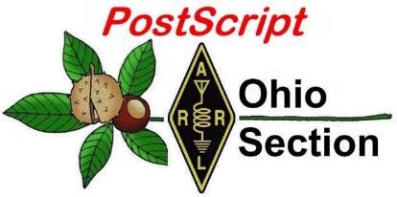](http://arrl-ohio.org/news/) ***Cyber Monday***

***Edition***

🡪 National News 🡪 The Handbook Give Away

🡪 Club Corner 🡪 Hamfests

🡪 DX This Week 🡪 One Question Questionnaire

🡪 VE Testing 🡪 ARES Connect

🡪 Special NIMS Training 🡪 Final.. Final..

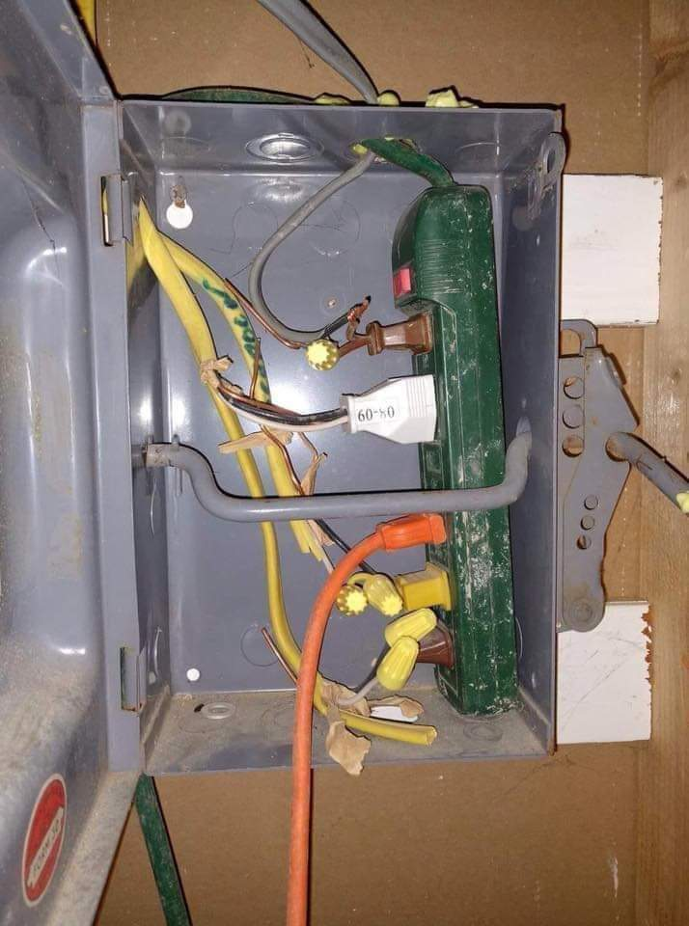

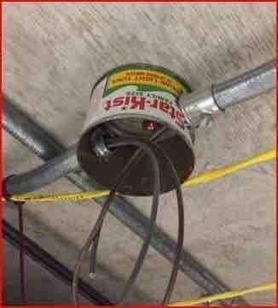

***National News***

*(from arrl and other sources)*

***ARRL to Oppose Proposal to Eliminate 3.3 – 3.5 GHz Amateur Allocation***



At its December 12 open meeting, the FCC will consider adopting a *Notice of Proposed Rulemaking* (*NPRM*) that proposes to remove the amateur radio 9-centimeter allocation at 3.3 – 3.5 GHz. ARRL plans to comment in opposition to the proposed action. According to an FCC “[**Fact Sheet**](https://docs.fcc.gov/public/attachments/DOC-360941A1.pdf),” the proceeding WT Docket 19-348, “Facilitating Shared Use in the 3.1 – 3.55 GHz Band,” is a follow-on from the MOBILE NOW Act, approved by the 115th Congress, which requires the FCC and the US Department of Commerce to make available new spectrum for mobile and fixed wireless broadband use. It also requires the FCC to work with the National Telecommunications and Information Administration ([**NTIA**](https://www.ntia.doc.gov/)) to evaluate whether commercial wireless services and federal incumbents could share spectrum between 3.1 and 3.55 GHz. NTIA manages spectrum allocated to federal government users.

“This *Notice of Proposed Rulemaking* would propose to remove the existing non-federal allocations in the 3.3 – 3.55 GHz band as a step towards potential future shared use between federal incumbents and commercial users,” the FCC Fact Sheet explains. “By taking the initial step needed to clear the band of allocations for non-federal incumbents, the Commission furthers its continued efforts to make more mid-band spectrum potentially available to support next generation wireless networks — consistent with the mandate of the MOBILE NOW [Making Opportunities for Broadband Investment and Limiting Excessive and Needless Obstacles to Wireless] Act.”

The *NPRM* proposes to clear the 3.3 – 3.55 GHz band of existing non-federal users by removing *non-federal secondary radiolocation and amateur allocations* [emphasis added] in the 3.3 – 3.55 GHz band and to relocate incumbent non-federal users out of the band. The FCC would seek comment on relocation options and “transition mechanisms” for incumbent non-federal users, either to the 3.1 – 3.3 GHz band or to other frequencies, and on how to ensure that non-federal secondary operations in the 3.1 – 3.3 GHz band will continue to protect federal radar systems.

Regarding the Amateur and Amateur-Satellite Service allocations, the FCC *NPRM* asks whether existing amateur spectrum in other bands might support operations currently conducted in the 3.3 – 3.5 GHz band. The 3.40 – 3.41 GHz segment is designated for amateur satellite communication. “We seek comment on the extent to which the band is used for this purpose, whether existing satellites can operate on other amateur satellite bands, and on an appropriate timeframe for terminating these operations in this band,” the FCC *NPRM* says.

Also at its December 12 meeting, the FCC will consider another *NPRM* in WT Docket 19-138 that would “take a fresh and comprehensive look” at the rules for the 5.9 GHz band and propose, among other things, to make the lower 45 MHz of the band available for unlicensed operations and to permit “Cellular Vehicle-to-Everything” (C-V2X) operations in the upper 20 MHz of the band. The FCC is*not* proposing to delete or otherwise amend the amateur allocation, and it would continue as a secondary allocation, but the primary allocation for 5.850 – 5.925 GHz would change.

The amateur radio 5-centimeter allocation is 5650.0 – 5925.0 MHz, and the *NPRM*, if approved, would address the top 75 MHz of that amateur secondary band. While no changes are proposed to the amateur allocation, anticipated more intensive use by primary users could restrict secondary amateur use.

TOP ^

The band 5.850 – 5.925 GHz has been reserved for use by dedicated short-range communications (DSRC), a service in the intelligent transportation system (ITS) designed to enable vehicle-related communications, the FCC said in a [**Fact Sheet**](https://docs.fcc.gov/public/attachments/DOC-360940A1.pdf) in WT Docket 19-138. “The Commission initiates this *Notice of Proposed Rulemaking* to take a fresh and comprehensive look at the 5.9 GHz band rules and propose appropriate changes to ensure the spectrum supports its highest and best use.” ARRL also will file comments opposing any changes affecting the 5-centimeter amateur allocation.

Both draft FCC proposals are subject to change prior to a vote at the December 12 FCC meeting, and there will be opportunity to file comments and reply comments on the final proposals after they are released.

####

***FCC Invites Comments on Digital AM Broadcasting Proposal***



The FCC has invited comments on a *Notice of Proposed Rulemaking* ([***NPRM***](https://docs.fcc.gov/public/attachments/FCC-19-123A1.pdf)), that would allow AM broadcasters to transmit an all-digital signal using the HD Radio in-band on-channel (IBOC) mode, known as MA3.1

“We tentatively conclude that a voluntary transition to all-digital broadcasting has the potential to benefit AM stations and provide improved AM service to the listening public,” the FCC said. “We seek comments on proposed operating standards for all-digital stations and the impact of such operations on existing analog stations and listeners.”

The proceeding was initiated by a March 2019 *Petition for Rulemaking* (Petition) filed by Bryan Broadcasting Corporation. “This proceeding continues the Commission’s efforts to improve and update the AM radio service to provide a better listening experience for consumers and enhanced service offerings, as part of our continuing effort to revitalize AM broadcasting,” the FCC said in the introduction to the NPRM.

Comments are due 60 days after the *NPRM* appears in *The Federal Register*.

####

***WSJT-X Development Group Announces Second Bug-Fix Release, WSJT-X Version 2.1.2***

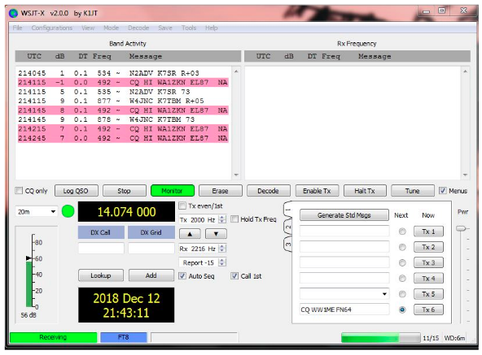The WSJT Development Group, which just this week announced the release of *WSJT-X* version 2.1.1, has now issued a second bug-fix release, version 2.1.2. **WSJT-X** is the free software suite that includes the FT4 and FT8 protocols. According to the developers, an error in the code broke the WSJT-X rig control features for certain Icom radios. The [**Release Notes**](http://physics.princeton.edu/pulsar/k1jt/Release_Notes.txt) detail program changes made since *WSJT-X* 2.1.0. The *WSJT-X* 2.1 *User Guide* has also been updated. Upgrading from earlier versions of *WSJT-X* should be seamless, with no need to uninstall previous versions or move any files.

To installation packages for Windows, Linux, and Macintosh are available. *WSJT-X* is licensed under the terms of Version 3 of the GNU General Public License (GPL). Development of this software is a cooperative project to which many amateur radio operators have contributed. The WSJT Development Group asks those using the code to let the developers know, as well as to report bugs or suggest improvements to the code.

TOP ^

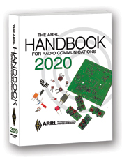***The Handbook Give Away***

Hey Gang,

This month we’ve had 2 major winners of the Give Away! Yes, we had the very special Thanksgiving drawing as well as our usual end of the month winner too. I can’t tell you just how happy I am with the fantastic response from all of you. It’s really wonderful to have all of you looking at the Ohio Section Website.

Anyway.. I’ll skip all the other things I was going to say because I’m sure you’re more interested in knowing who won anyway...

The winners are…. Thanksgiving ***Phillip Bennett, KE8JWD***

End of the Month ***Fred Fisher, KE8LNQ***

Many of you ask me just how do I know when the drawing is on? Well, that’s easy all you need to do is check in on the Ohio Section Website on a regular basis and watch for the big RED Arrow that will appear on the left side of the page. This is the sign that the drawing is on and you need to get registered. So, keep a sharp eye out on the website and check in often! <http://arrl-ohio.org>

***Now, hang on to your socks because we’re gonna’ do this again for Christmas and New Year’s***

***Club Corner***

This is YOUR cornner of the newsletter. Send me what your club is doing and I’ll make sure that it gets in. Got a special event or club project that you want everyone to know about? Send it to me!. Need help with a project? Send it to me.

Let me know what you club is up to. Are you going to have a special guest at your meeting or are you having a special anniversary? Just sent it to: [n8sy@n8sy.com](mailto:n8sy@n8sy.com)

####

*(from the Monday Morning Memo – John Levo, W8KIW editor)*

The annual **Hocking Valley ARC** Christmas carry-in dinner will be Tuesday, December 3 at the Antioch Alliance Church in Logan. The church is located at 11947 Antioch Road.  The doors will open at 6 pm. The dinner will take the place of the usual monthly meeting.

The annual ***Cambridge ARA*** awards banquet will be at 6 pm on December 4 at Theo’s Restaurant in Cambridge.  Ordering will be from the menu.

The ***Clinton County ARA*** will celebrate the season with a carry-in dinner and elections at the Wilmington Faith Lutheran Church at 6 pm on the 4th.  Please note this is a change from the normal meeting night.

TOP ^

December 6 marks the annual Christmas celebration dinner of the **Grant ARC**.  The Lake Manor Restaurant near Mount Orab is the location for the dinner.

The ***Scioto Valley ARC*** will hold their Christmas dinner at the Tumbleweed Restaurant in Chillicothe. According to Michael Mathuews, KC8WIW, the group will gather on December 7 at 1 pm.

The ***Portsmouth ARC*** will meet at the Gathering Place in Wheelersburg later that evening with a new caterer providing the food this year.  The evening’s fun will begin at 6 pm.

The ***Highland ARA***’s annual Christmas dinner at the Hillsboro Methodist Church. Each year this catered dinner seems to grow and Secretary Kathy Levo, N8ZNR, reports reservations are already coming in.  Last year representatives from several regional clubs were among the approximate 80 attendees present.

The ***DeForest ARA*** will a hold their carry-in dinner and club elections at the Senior Nutrition Center in West Union.  It begins at 6:30 pm.  The club will be furnishing the meats and those attending are asked to bring a side dish or desert.

The Cibo e Uno in Middletown will be the December 16 site for the annual Christmas gathering of the members of the ***South West Ohio DX Association***.

The ***Athens County ARA*** will hold their annual club Christmas dinner at the Lui Lui Restaurant in Athens on December 17 normal business meeting on December 12 instead.

**SOARA OFFICERS ELECTED**—The ***Southern Ohio ARA*** announced the club’s officers for 2020 at its recent “Christmas In November” dinner party.  Those taking the 2020 reins are Tim Nicely-AC8VQ-President; Jerry Lockhart-W8HIC-Vice President; Dave Bruce-KD8NYN-Treasurer; James Reneau-N4REN-Secretary and Randy France-KD8VRU-is the new trustee.  Ohio ARRL Section Manager Scott Yonally, N8SY, was the featured speaker.

####

***PCARS and the Center of Hope Donation***

We did an outstanding job collecting money for the Center of Hope. Our donation check for **$8,350** was presented to Mark Frisone on Tuesday November 19th.

Mark was all smiles at the generosity of our club. It will feed a lot of people this holiday season. I am incredibly proud of this club and its support of the Center of Hope. An important part of our mission is supporting our community with projects like this.

Thanks again for all your help.

####

TOP ^

***Alliance Amateur Radio Club To Assist The Salvation Army***

For the first time, members of the Alliance Amateur Radio Club will be supporting the Salvation Army of Alliance, by manning one of the familiar Red Kettles. From 10 AM to 8 PM On Saturday, December 7th, we will be manning the Save -A-Lot location in the College Plaza. We are looking for volunteers to help that day. If you would like to help, please contact Ron, KE8HCY. You may contact Ron by phone at 330-821-5454, or E-mail him at rtritt25775@gmail.com According to the November 16th edition of the Alliance Review, the Salvation army has already signed up 500 children to take part in their Angel Tree program They are also holding up another sign-up day to reach all of the families whose children had formerly took part in the Alliance Fire Department’s toy drive.

####

***Drawing at November Meeting Breaks Record***

The Alliance Amateur Radio Club November meeting was one of our best attended of the year, as we held our annual drawing to Benefit the Alliance Fire Department Toy Drive.

Unfortunately, the news broke a couple days later that the Fire Department was ending their drive after 45 years. So, after conferring with the board of trustees, and the membership, it was decided to donate this year’s funds to the Alliance FOP Lodge #73 “Cops Helping Kids” project.

According to Ron, KE8HCY, FOP 73 helps between 50-60 kids obtain necessary winter clothing, such as coats, boots, hats, gloves, snow pants and other essentials.

They run several fund raisers internally and also receive outside funding. The project's cost is between $9-10,000 annually. The off-duty Alliance Police Department officers, assemble the kids on a certain day, transport them via bus provided by our local bus company to Walmart. The Police Officers help each kid pick out the items After all the shopping is done, the kids are bused to Christopher Columbus Pizza here in Alliance for a Pizza Party. The kids go home with new clothes and their tummies are full!

####

***The DEARS / KD8NOM operated in the SSB Sweepstakes***

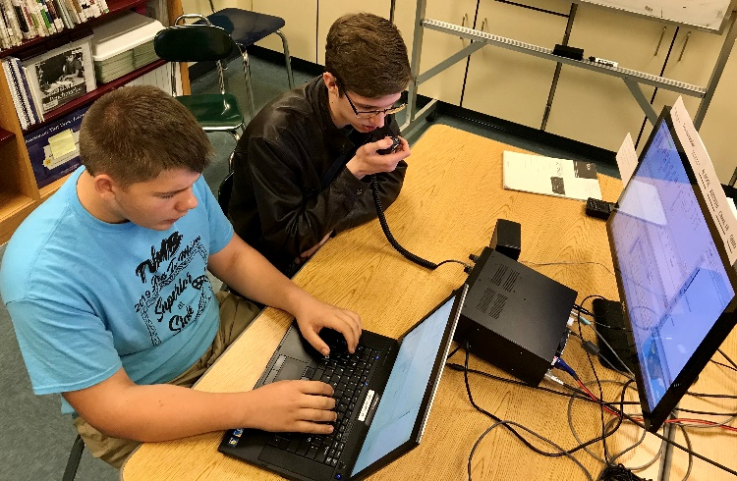The kids made 230 contacts in 17 hours. They worked 77 out of the 83 sections available. Some we never heard or spotted on the air.

A Total of 35,420 CLAIMED points. The logs are sent in!

Now we wait!

TOP ^

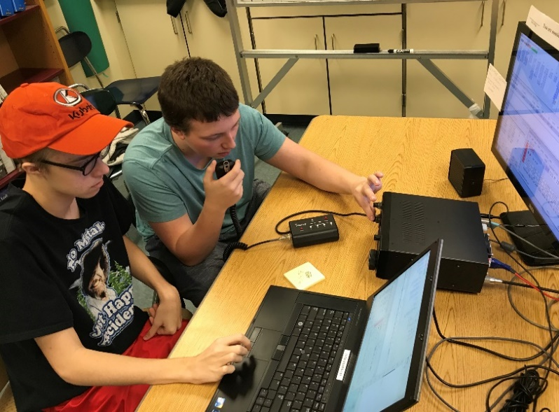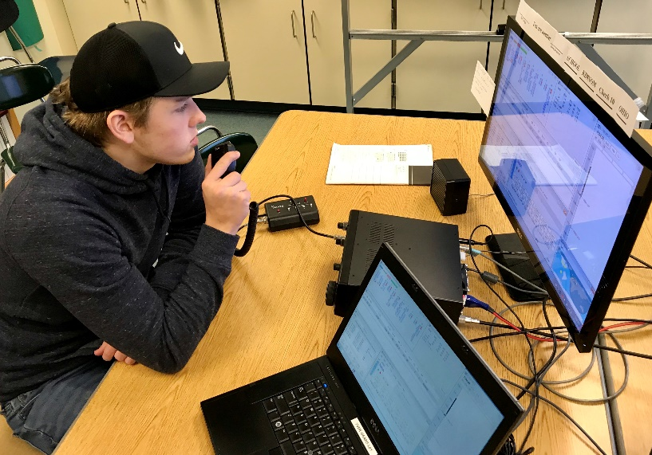

####

***Alliance Amateur Radio Club to Hold General Classes***

The AARC plans to initiate classes starting on **08 January 2020**. It will be held in the cafeteria conference room starting at **6PM**.

The classes will be over a 12-week time span and will be two hours a session.

It is suggested the students bring a SD card or thumb drive with at least one gigabyte of free space to receive all the information needed to get the license. It can be used for home study and also holds the Technician class information as well as the General class.

Contact Frank, WA8WHP for more information. He can be reached at [wa8whp@gmail.com](mailto:wa8whp@gmail.com)

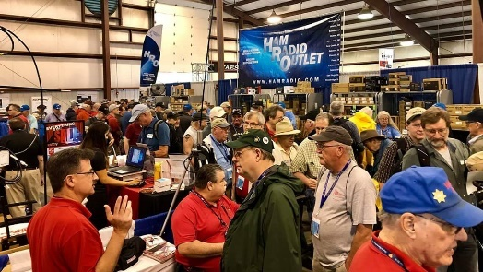[***Upcoming Hamfests***](http://arrl-ohio.org/hamfests.html) ***for 2019***

**12/07/2019 | Fulton County ARC Winterfest**  
Location: Delta, OH  
Sponsor: Fulton County Amateur Radio Club  
Website: <http://k8bxq.org/hamfest>

***Upcoming 2020 Hamfests***

**01/19/2020 | Sunday Creek Annual Hamfest**  
Location: Nelsonville, OH  
Sponsor: Sunday Creek Amateur Radio Federation

**01/26/2020 | Tusco Amateur Radio Club's 30th Annual Hamfest, Electronics and Computer Show**  
Location: Strasburg, OH  
Sponsor: Tusco Amateur Radio Club  
Website: [http://www.tuscoarc.org](http://www.tuscoarc.org/)

TOP ^

**02/16/2020 | Mansfield Mid-Winter Hamfest**Location: Mansfield, OH  
Sponsor: Intercity Amateur Radio Club  
Website: [http://WWW.IARC.CLUB](http://www.iarc.club/)

**03/01/2020 | WinterHamFest**  
Location: Elyria, OH  
Sponsor: Northern Ohio Amateur Radio Society  
Website: [http://noars.net](http://noars.net/)

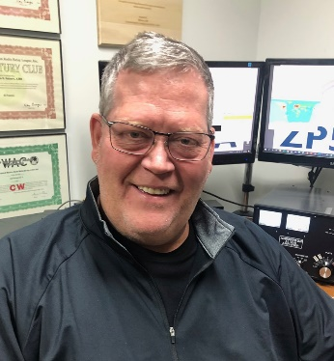***DX This Week***

*(from Bill, AJ8B)*

***DX This Week – Mobile DXCC***

***Bill AJ8B (***[***aj8b@arrl.net***](mailto:aj8b@arrl.net)***, @AJ8B, or*** [***www.aj8b.com***](http://www.aj8b.com)***)   
 CWOPs Member #1567***

DX Spots that originated in the Midwest included Alaska, Andorra, Anguilla, Aruba, Asiatic Russia, Asiatic Turkey, Australia, Barbados, Belgium, Belize, Bermuda, Bolivia, Bonaire, Bosnia-Herzegovina, British Virgin Islands, Bulgaria, Canary Islands, Cayman Islands, Corsica, Costa Rica, Crete, Croatia, Cyprus, Czech Republic, Dominican Republic, European Russia, Faroe Islands, Fernando de Noronha, Fiji, Gabon, Georgia, Ghana, Greece, Guam, Guatemala, Guyana, Haiti, Hawaii, Hungary, Iceland, Indonesia, Isle of Man, Israel, Japan, Kaliningrad, Kazakhstan, Luxembourg, Madagascar, Madeira Islands, Mauritania, Mexico, Micronesia, Moldova, Mongolia, Montserrat, Morocco, Netherlands, New Caledonia, New Zealand, Nicaragua, Nigeria, North Macedonia, Norway, Oman, Panama, Paraguay, Peru, Philippines, Poland, Puerto Rico, Republic of Korea, Saba & St. Eustatius, Sardinia, Saudi Arabia, Scotland, Senegal, Serbia, Sicily, Sint Maarten, Slovenia, St. Helena, Suriname, Taiwan, Tanzania, Temotu Province, Trinidad & Tobago, Ukraine, US Virgin Islands, Venezuela, Vietnam, and Wales. There was a lot of DX activity with the upcoming CQWW CW contest that I hope you took advantage of.

This week, the mailman delivered T45FM – Cuba, CT1FMX – Portugal, a rather “racy” card from SP8AWL, and a nostalgic card from F5BZB – France. (Pictured) What did you get? Send me an image and some details!

Several years ago, I jumped into the mobile ham radio arena by purchasing a used Yaesu FT-857D and a Yaesu atas-120a mobile antenna. We were a bit higher in Cycle 24 and I was able to work over 130 entities in an 18-month period. In addition to “normal” DX, I was able to work Japan, Australia, New Zealand, Namibia, the Falkland Islands, Israel, Guinea-Bissau, Senegal, Burkina Faso, and Clipperton Island!

TOP ^

I became a much better operator by operating mobile for over 2 hours a day. He biggest lesson learned, which I thought I knew, was to ***listen, listen, and then listen.*** When you have time to really listen and study a DX station working down a pileup, you quickly learn how many hams simple don’t listen! They will call while the DX station is transmitting, they won’t listen to the directions of the DX station, and they don’t pay attention to the operating practice of the DX station. More on this in a couple of weeks. To use a fishing analogy, it is much more efficient to cast where the fish are than to just cast!

I finally took the initiative to apply for the DXCC Mobile certificate. Unlike the standard DXCC, this does not require verification of mobile QSOs made, it is not serialized, there are no endorsements, and it does not have the same “official feel” of the standard DXCC award. It is truly just an acknowledgment that you have worked over 100 entities while operating mobile.

***CQDX CQDX CQDX CQDX CQDX CQDX CQDX CQDX CQDX***

Here is an update from Bernie, W3UR, of the DailyDX and the WeeklyDX, the best source for DX information. (<http://www.dailydx.com/> ) Bernie has this to report:

**5V – Togo** - KB9IJI, Andy, has been living and working as a missionary in Mango since 2016 and expects to remain here for the foreseeable future. It has taken three years to obtain carte de séjour (residence permit). “Since I'm the first long-term applicant under the new rules, they granted me special permission to legally operate [as 5V/KB9IJI] until the application is approved, hopefully before the end of the year”, says Andy. He has an IC735 and FT-818 and will be running between 5 and 100 watts, powered by solar or battery. The “local power is very dirty and unstable, so 100W solar panel charging deep-cycle battery provides all power I need” reports Andy. In addition, he also has “a mobile 10m/2m station for in-country emergencies.” For antennas he has a homemade 80-meter dipole up 30 feet and a coil-loaded multiband vertical at 20 feet. Andy plans to be active on voice, data and CW on all HF bands as well as 2m/70cm for local QSOs. Logs will be uploaded to both LoTW and eQSL.

**6O – Somalia -** About 6O1OO, operator Ali, aka EP3CQ, tells us from Germany he goes back to Somalia December 4. He plans to have his Somalia station on the air December 4- 19 and then again for four weeks starting January 7. Further operations are planned from February onwards. He notes he has now been operating from Somalia for two years and is feeling the financial pinch. He says high humidity and the hot salt air are causing a need for antenna upgrades. The environment also causes power supply and transmitter issues and he has to get new ones almost quarterly, spending half his salary to keep the station going.

TOP ^

**C5 – The Gambia -** ON7YK, Andre, is on the air with the C5YK callsign. He started up November 16 and plans to be there until early March. He likes digital modes, particularly FT8, SSB, and “some CW.” He has been on 60-10 meters. QSL to his home QTH or use LoTW or eQSL. His log search is here.

**4S – Sri Lanka** - 4S7DLG by DK7TF, Bernhard, will operate from Ambalangoda starting November 25, mostly SSB and FT8. QSL through the M0OXO OQRS.

***DX news***

***ARLD047 DX news***

This week's bulletin was made possible with information provided by CE2ML, W3UR, The Daily DX, the OPDX Bulletin, 425 DX News, DXNL, Contest Corral from QST and the ARRL Contest Calendar and WA7BNM web sites. Thanks to all.

**SRI LANKA, 4S.** Bernhard, DK7TF is QRV as 4S7DLG from Ambalangoda, IOTA AS-003. Activity is on the HF bands using mainly SSB and FT8. His length of stay is unknown. QSL via M0OXO.

**MALAWI, 7Q.** Karl, DK2WV is QRV as 7Q7W from Lilongwe for about three weeks. Activity is on 40 to 6 meters using CW, SSB and FT8. QSL to home call.

**ZAMBIA, 9J.** Mario, IK1MYT is active as 9J2MYT from Lusaka until May 2020. He is QRV on 80, 40, 20, 15 and 10 meters. QSL direct to IZ3KVD.

**WEST MALAYSIA, 9M2.** Rich, PA0RRS will be QRV as 9M2MRS from Penang Island, IOTA AS-015, from December 3 to February 27, 2020. Activity is on the HF bands using CW and various digital modes. QSL to home call.

**THE GAMBIA, C5.** Paul, SA6PIS is QRV as C56PIS until December 13. Activity is holiday style. QSL to home call. In addition, Andre, ON7YK is QRV as C5YK from Bijilo until early March 2020. Activity is on 60 to 10 meters using some CW, SSB and various digital modes, especially FT8. QSL to home call.

**CHILE, CE.** Special event call XR2YOTA is QRV during all of December to commemorate Youngsters On The Air month. QSL via LoTW.

**SPAIN, EA.** Members of the Mike Delta Victor DX Group will be QRV with special call sign EG3PCD from December 2 to 5 during United Nations' International Day of Persons with Disabilities. QSL via LoTW.

**ECUADOR, HC.** Antonio, EA5RM plans to be QRV as HC3/EA5RM from Loja and possibly also as HC2/EA5RM from Guayaquil from December 2 to January 5, 2020. Activity will be on 40 to 10 meters using SSB and various digital modes. QSL to home call.

**ITALY, I.** Members of the ARI section Fidenza will be QRV with special call sign II4TIB during December to commemorate Ugo Tiberio, one of Italy's pioneers in the history of radio. QSL via IQ4FE.

**US VIRGIN ISLAND, KP2.** Ryan, KC7RW is QRV as KP2/KC7RW until November 30. Activity is on 40 to 15 meters using SSB, FT8 and FT4 as conditions permits. QSL to home call.

TOP ^

**BULGARIA, LZ.** Members of the Bulgarian Radio Club Blagovestnik will be QRV as special event call sign LZ4408SPA during December to honor the memory of Bulgarian saints. QSL via bureau.

**PERU, OA.** Special event station OC3CS will be QRV from the archaeological site Cerro Sechin on November 29 and 30. Activity will be on the HF bands using SSB and various digital modes. QSL via OA4O.

**SOMALIA, T5.** Ali, EP3CQ will be QRV as 6O1OO from December 4 to 19. QSL to home call.

**EUROPEAN RUSSIA, UA.** Members of the International Miller DX Club are QRV as R2019DX and UE29DX until December 1 to celebrate the club's 29th anniversary. QSL via RQ7L.

**MICRONESIA, V6.** Haru, JA1XGI will be QRV as V6K from Kosrae, IOTA OC-059, from December 2 to 9. This includes being an entry in the upcoming ARRL 160 Meter contest. QSL to home call.

**TURKS AND CAICOS ISLANDS, VP5.** Gerald, WA2TTI will be QRV as VP5/WA2TTI from Turtle Cove, Providenciales Island, IOTA NA-002, from December 2 to 7. Activity will be holiday style. QSL direct to home call.

**INDIA, VU.** Datta, VU2DSI is QRV as AU2JCB until December 16 to commemorate the birthdate of Indian physicist and radio pioneer Jagadish Chandra Bose. Activity is on 80, 40, 20, 15 and 10 meters. QSL direct to home call.

**BURKINA FASO, XT.** Harald, DF2WO will be QRV as XT2AW from Ouagadougou from December 2 to 20. Activity will be on the HF bands with a focus on 160, 80 and 60 meters and also on various satellites. QSL via M0OXO.

**MYANMAR, XZ.** Martti, OH2BH is QRV as XZ2D until April 17, 2020. Activity is generally on 15 and 10 meters. QSL to home call.

THIS WEEKEND ON THE RADIO. The NCCC RTTY Sprint, NCCC CW Sprint and the Russian Worldwide MultiMode Contest are on tap for this upcoming weekend. The ARS Spartan CW Sprint is scheduled for December 3.

The Canadian National Parks on the Air, CNPOTA, operating event runs for the entire year of 2019, with special stations active from Canada's parks and historic sites.

Please see November QST, page 89, December QST, page 63, and the ARRL and WA7BNM Contest Web Sites for details.

***Special Events***

* **12/05/2019 | Pearl Harbor Remembrance Day**

Dec 5-Dec 10, 0000Z-0000Z, W5W, Cleburne, TX. Club KC5NX. 14.225 14.045 7.225 7.045. QSL. Club KC5NX, 9200 Summit Court West, Cleburne, TX 76033-8212. Club KC5NX will be on the air again this year as W5W to bring to remembrance the December 07,1942 loss at Pearl Harbor....

TOP ^

The damage done, the lives lost, and the coming together of the American People at that time.... Multi-operators will be covering most bands and modes.... Special request? we look forward to them... [club.kc5nx@gmail.com](mailto:club.kc5nx@gmail.com) [www.qrz.com/db/kc5nx](http://www.qrz.com/db/kc5nx)

* **12/06/2019 | 125 Years - Ripley's Crookedest Street, Snake Alley**

Dec 6-Dec 7, 1600Z-2200Z, W0FUN, Burlington, Iowa. Iowa Radiosport Society. 14.240 14.059 7.220 7.059. QSL. Iowa Radiosport Society, P.O. Box 73, Denmark, IA 52624-0073.

* **12/07/2019 | 80th Anniversary of the Sikorsky VS-300 Helicopter**

Dec 7-Dec 15, 0000Z-2359Z, K1S, Stratford, CT. Stratford Amateur Radio Club SARC. 18.150 14.240 7.230 3.925. QSL. SARC c/o Dave Arruzza, 32 Benz Street, Ansonia, CT 06401. SASE for commemorative QSL card.

* **12/07/2019 | Pearl Harbor Day Memorial**

Dec 7, 1600Z-2200Z, K7UAZ, Tucson, AZ. Oro Valley ARC. 14.250 USB 7.035 CW. Certificate. send, email, to qsl@tucsonhamradio.org. From the USS Arizona Memorial on the University of Arizona campus. For certificate, email to qsl@tucsonhamradio.org. No paper QSLs, please. [TucsonHamRadio.org](http://tucsonhamradio.org/)

* **12/07/2019 | Skywarn Recognition Day**

Dec 7, 0000Z-2359Z, N0W, Fruita, CO. Mesa County Skywarn. 14.286 7.235 3.990. Certificate & QSL. Al Acker, WA4HND, 1685 Mae Ct., Fruita, CO 81521. [WA4HND@GMAIL.COM](mailto:)

* **12/09/2019 | Tuscaloosa, Alabama 200th Birthday Celebration**

Dec 9-Dec 15, 0000Z-0000Z, N4T, Tuscaloosa, AL. Tuscaloosa area operators. 21.335 14.235 7.235 3.935. QSL. Kirk Junkin, Tuscaloosa 200 Birthday Event, PO Box 21174, Tuscaloosa, AL 35402-1174. Multi-Operators will be on-air from different areas of the city during the week of December 9 - 15th, 2019, celebrating the Bicentennial Birthday of Tuscaloosa, Alabama, with N4T.

All HF bands/modes, including FT4/FT8, as well as 6M and 2M contacts will be available. Check website and DX-spotting sites for exact frequencies and times. Plans to operate from downtown Tuscaloosa on Friday, December 13th (the actual birthday) and Saturday, December 14th, weather and conditions permitting. [https://www.bamaradio.biz](https://www.bamaradio.biz/)

* **12/12/2019 | WX3MAS Special Event**

Dec 12-Dec 15, 1400Z-2200Z, WX3MAS, Nazareth, PA. Christmas City Amateur Radio Club. CW and PSK31 on 20 and 40 meters; 14.265 7.270 3.850. QSL. Christmas City Amateur Radio Club, 14 Gracedale Ave, Greystone Building, Nazareth, PA 18064. 50 Anniversary! Christmas City ARC and the Delaware-Lehigh ARC. . Send QSL and SASE (A6 size or larger for 4”x 6” card) to WX3MAS, 14 Gracedale Ave, Greystone Building, Nazareth, PA 18064. Operation details at [www.dlarc.org](http://www.dlarc.org/)

* **12/14/2019 | Bethlehem on the Air**

Dec 14-Dec 15, 1500Z-0000Z, W9WWI, New Washington, IN. Clark County Amateur Radio Club of Southern Indiana . 14.250 7.200; All Bands, All Modes. Certificate. Clark County Amateur Radio Club, W9WWI, Richard Humphrey Secretary , 4208 Perry Crossing Road, Sellersburg, IN 47172. In celebration of the holiday season. Look for us on FT8, n9dprh@gmail.com or [www.clarkcountyarc.org](http://www.clarkcountyarc.org/)

TOP ^

* **12/14/2019 | Christmas in Bethlehem**

Dec 14-Dec 24, 1400Z-2359Z, KC5OUR, Belen, NM. Valencia County Amateur Radio Association. 14.283 7.183 3.883 21.183. QSL. VCARA, PO Box 268, Peralta, NM 87042. Celebrating Christmas in Bethlehem New Mexico. [kc5our@arrl.net](mailto:)

* **12/14/2019 | Pearl Harbor Remembrance Day Special Event**

Dec 14, 1700Z-2359Z, NI6IW, San Diego, CA. USS Midway (CV-41) Museum Ship. 14.320 7.250 PSK31 14.070 DSTAR REF001C. QSL. USS Midway Museum Ship COMEDTRA, 910 N Harbor Drive, San Diego, CA 92101.

* **12/17/2019 | 52 Years of Amateur Radio**

Dec 17-Dec 31, 0001Z-2359Z, K4Q, St Simons Island, GA. N4XU. 7.037. QSL. Bob Wilson, N4XU, 209 Broadway Street, Saint Simons Island, GA 31522. Will try to operate 3 kHz down from IOTA Meeting Frequencies on cw, and any available spot in the USA General-class portion on ssb. Multi-band/mode contacts are welcome. <https://www.qrz.com/db/K4Q>

* **12/26/2019 | Commemorating the US Revolutionary War – Historic “Battle of Trenton”**

Dec 26-Dec 30, 0000Z-2359Z, W2T, West Trenton, NJ. Delaware Valley Radio Association. 14.225 7.175. Certificate & QSL. Delaware Valley Radio Association, PO Box 7024, Trenton, NJ 08628-0024. [www.w2zq.com](http://www.w2zq.com/)

* **12/29/2019 | 21st Annual Ham Radio University Educational Conference**

Dec 29-Jan 5, 0000Z-0300Z, W2HRU, Lindenhurst, NY. Ham Radio University. 14.273 7.273 7.074 3.923. Certificate & QSL. Phil Lewis, N2MUN, 22 Belle Terre West, Lindenhurst, NY 11757. Operating at various times on SSB and FT8. Electronic QSL via eQSL and LoTW. Paper QSL via W2 QSL Bureau or direct w/SASE to Phil Lewis, N2MUN, 22 Belle Terre West, Lindenhurst, NY 11757. On-Line printable QSL Certificate available at: https://www.elemcoshopfloor.com/w2hru_cert. [hamradiouniversity.org](http://hamradiouniversity.org/)

* **12/31/2019 | Commemorating the US Revolutionary War – Historic “Battle of Princeton”**

Dec 31-Jan 6, 0000Z-2359Z, W2P, Trenton, NJ. Delaware Valley Radio Association. 14.225 7.175. Certificate & QSL. Delaware Valley Radio Association, PO BOX 7024, West Trenton, NJ 08628-0024. [https://www.w2zq.com](https://www.w2zq.com/)

* **01/01/2020 | NCDXA 5th Annual Worked All RST Special Event**

**Jan 1-Feb 28, 0000Z-2359Z, KL7RST**, Anchorage, AK. North Country DX Association (K7ICE). 14.250 14.075 7.190 7.050. QSL. J. Reisenauer, 2573 Old Georgetown Rd. W., Kershaw, SC 29067. [www.qrz.com/db/kl7rst](http://www.qrz.com/db/kl7rst)

* **01/02/2020 | 14th Annual Straight Key CW Event**

**Jan 2-Jan 31, 0000Z-2359Z, K3Y**, various cities. SKCC - Straight Key Century Club. 21.050 14.050 7.055 3.550. Certificate & QSL. SKCC c/o Jeremy Downard, KD8VSQ, 511 W. Pottawatamie St., Tecumseh, MI 49286. K3Y/0 thru 9 plus KH6, KL7, KP4 and DX member stations in six WAC areas operating straight key, bug and cootie keys. QSL card confirms one QSO per area, up to 19 for all-area sweep. See URL for schedule, map, stats, etc. [www.skccgroup.com/k3y](http://www.skccgroup.com/k3y)

TOP ^

***Ohio ARES VHF Simplex Contest***

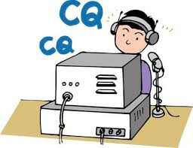

***Saturday - January 11 – Are you getting ready???***

The purpose of our annual simplex activity is to improve our station and antenna capabilities, and to test our coverage areas on simplex frequencies.

These may be very important in times of emergency, when repeaters have failed, and simplex is the only method of emergency communication. We are NOT giving any consideration for backup power- this exercise is aimed at testing antennas and determining coverage areas.

More details will be coming very soon. But, in the meantime, start planning now on where you are going to setup and operate!!!

**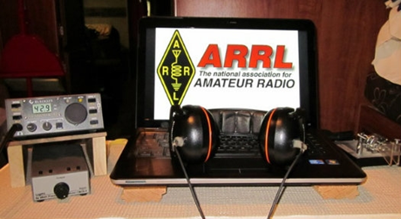*ARRL Contest Corner***

An expanded, downloadable version of *QST'*s [**Contest Corral**](http://www.arrl.org/contest-calendar) is available as a PDF. Check the sponsor's Web site for information on operating time restrictions and other instructions.

*****V.E. Test Sessions***

For the latest testing site information please **>>** [**Click Here**](http://www.arrl.org/find-an-amateur-radio-license-exam-session) **<<** The ARRL site tracks all of the VE testing sites that register with them, including W5YI and Laurel. ARRL gives you a number of different ways of sorting to find that site that is closest to you as well.

***One Question Questionnaire***

Hey Gang, Hey Gang,

“Survey Says” about **80%** of you didn’t operate your Ham Station with visitors there. Wow.. I would have thought that would have been the perfect way of showing off what you spend those hundreds of hours volunteering for. Oh well, maybe Christmas is a better time. That way you can show off all of your new toys while you’re at it!!

TOP ^

I’ve got another NEW – one question – for you to think about. We’ve had “Black Friday. Shop Local Saturday and now today is Cyber Monday. Has any of those days inspired you? With that lead in comes my next question that all of us just have to know.…

**“Do you wait until December 24th to do your Christmas shopping?”**

You’ll find the “One Question” questionnaire on the Ohio Section Website! <http://arrlohio.org> It’s all in fun and it’s not a scientific survey in any way, but we are learning some things that we didn’t know from these questions. I hope that you are enjoying answering these “One Question” questionnaires.

**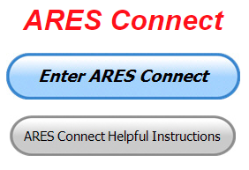*ARES Connect***

**ADMINS – please make sure to go into all of the events that you have setup no later than 7 days after they have ended and approve the hours your volunteers have typed in that they did. I’m noticing a number of events that aren’t getting hours credited because the Admin isn’t going back and approving hours.**

With all of the additions to ARES Connect that we now have, there is absolutely no longer any excuses for all of you to not use the system!!

I’m setting a goal for all of you out there. **Let’s get everyone in the Ohio Section on ARES Connect before the end of this year!!! Simply go to:**  <https://arrl.volunteerhub.com/lp/oh/> and get yourself registered and using the system.

***Here’s the top 10 hours earners for November:***

|  |  |  |  |
| --- | --- | --- | --- |
|  | **Name** | **Events** | **Hours** |
| 1 | James Yoder (w8erw) | 21 | 94.18 |
| 2 | Greg Dersarkisian (KD8SSJ) | 26 | 76.50 |
| 3 | Diane Warner (KE8HLD) | 26 | 75.00 |
| 4 | Bret Stemen (KD8SCL) | 28 | 71.00 |
| 5 | Christopher Domenick (KC8CAD) | 26 | 68.50 |
| 6 | John Hilliard (w8of) | 25 | 65.50 |
| 7 | Dan Stahl (KC8PBU) | 64 | 58.29 |
| 8 | Mark Griggs (KB8YMN) | 7 | 55.50 |
| 9 | Richard Wynkoop (KD8PHG) | 5 | 53.00 |
| 10 | Alan Rothweiler (N8CJ) | 27 | 49.00 |

Why is this so important? Hey, I am just going to say this… The end of the year is coming up fast, and now with the ability to catch yourself up on past events, there’s gonna’ be a very special “End of the Year” award for the person with the most hours in 2019! . Will that be you? You now can make that happen!

TOP ^

Admins… If you are wondering how to get an overview of all of your events you can simply go into reports and using the new Event by Participation by Event (version 2) you can not only see who registered for your event, but you also can see if he/she has inputted their hours for it as well. Take advantage of this new report to help you get the time entered into your events.

**I’m also seeing a number of recurring events created but no activity reported for them.** Please, if this event is no longer needed, let me know and I can delete it from the masters. I know that many of you setup recurring events to learn how, but if they aren’t going to be used, let’s get them cleared out.

Also… If you are setting up events, please don’t set a limit for how many folks can sign-up unless absolutely necessary. This causes issues when doing reports. It’s also counter-productive since the reason for you to list the event is to get as many volunteers as you can to attend. When you set limits, it discourages folks from signing up.

***Special NIMS Training Available***

**G-386 MASS FATALITIES**

Hosted by: Franklin County Emergency Management & Homeland Security **February 20 - 21, 2020**

**This is an “Elective” course in the Advanced Professional Series (APS) program**

**Application Deadline:** February 10, 2020

**Time of Course:** Registration: 7:30 am – 8:00 am

Course Time: 8:00 am – 4:00 pm

**Location:** Franklin County EM&HS

5300 Strawberry Farms Blvd.

Columbus, OH 43230

**Supported By:** The Ohio Emergency Management Agency

**Recommended Participants:** The target audience for this course is local responders who may have responsibility for the recovery, handling, identification, and return of remains following a mass fatalities incident.

**Recommended Prerequisite:** N/A

**Enrollment:** Students must enroll via the Department of Public Safety Training Campus website: <https://trainingcampus.dps.ohio.gov/cm/cm710/pstc/pstc.html> Course registration will generally close 10 working days prior to the course start date. You can check enrollment/approval status via the Department of Public Safety Training Campus website.

**Course Costs:** This course is free to participants. Lodging, meals and all other expenses are the students’ responsibility.

**County Point of Contact:** Pam Tickle, Franklin County EM&HS (614) 794 – 0213, [pktickle@franklincountyohio.gov](mailto:pktickle@franklincountyohio.gov)

**State Point of Contact:** Matt Jaksetic, State Training Coordinator, Ohio EMA (614) 799-3666, [mtjaksetic@dps.ohio.gov](mailto:mtjaksetic@dps.ohio.gov)

TOP ^

***Below is information on upcoming ICS-300/ICS-400 classes for those interested.***

Please be advised that we have listed the following ICS courses on the Ohio EMA Public Safety Training Campus (PSTC) website for students to register for the courses; <https://trainingcampus.dps.ohio.gov/cm/cm710/pstc/>

TOP ^

Feel free to share these course offerings with the targeted audiences.

|  |  |  |  |  |  |
| --- | --- | --- | --- | --- | --- |
| **Course ID** | **Name** | **Session** | **Location** | **Enroll** | |
| ICS300OttawaCoDec2019 | ICS-300 Intermediate ICS | December 3 - 5, 2019 | Magruder Hospital 615 Fulton Street Port Clinton, OH 43452 | | [Enroll](https://trainingcampus.dps.ohio.gov/cm/cm710/pstc/pstc.html) |
| ICS300FranklinCoUpperArlingtonDec2019 | ICS-300 Intermediate ICS | December 3 - 5, 2019 | Upper Arlington Fire Station 72 3861 Reed Road Upper Arlington, Ohio 43220 | | [Enroll](https://trainingcampus.dps.ohio.gov/cm/cm710/pstc/pstc.html) |
| ICS300AshtabulaCoDec2019 | ICS-300 Intermediate ICS | December 3 - 5, 2019 | Ashtabula County Engineers Office 186 East Satin Street Jefferson, Ohio 44047 | | [Enroll](https://trainingcampus.dps.ohio.gov/cm/cm710/pstc/pstc.html) |
| ICS300LorainCoJan2020 | ICS-300 Intermediate ICS | January 7 - 9, 2020 | Oberlin Fire Department 430 South Main Street Oberlin, OH 44074 | | [Enroll](https://trainingcampus.dps.ohio.gov/cm/cm710/pstc/pstc.html) |
| ICS300PrebleCoJan2020 | ICS-300 Intermediate ICS | January 11, 12 & 18, 2020 | Eaton City Fire Department, Station 2 391 West Lexington Road Eaton, Ohio 45320 | | [Enroll](https://trainingcampus.dps.ohio.gov/cm/cm710/pstc/pstc.html) |
| ICS400AshtabulaCoJan2020 | ICS-400 Advanced ICS | January 13 - 14, 2020 | Ashtabula County Engineers Office 186 East Satin Street Jefferson, Ohio 44047 | | [Enroll](https://trainingcampus.dps.ohio.gov/cm/cm710/pstc/pstc.html) |
| ICS300MahoningCoJan2020 | ICS-300 Intermediate ICS | January 13 - 15, 2020 | Boardman Fire Department, Station 71 7440 Market Street Boardman, OH 44512 | | [Enroll](https://trainingcampus.dps.ohio.gov/cm/cm710/pstc/pstc.html) |
| ICS400OttawaCoJan2020 | ICS-400 Advanced ICS | January 16 - 17, 2020 | Magruder Hospital 615 Fulton Street Port Clinton, OH 43452 | | [Enroll](https://trainingcampus.dps.ohio.gov/cm/cm710/pstc/pstc.html) |

####

TOP ^

***Campbell County Kentucky Office of Emergency Management Upcoming Training***

Campbell County Kentucky Office of Emergency Management **FREE** Training Opportunities

Working with the Media: A Short Course for Emergency Responders (AWR-209) – January 22, 2020 – RDPC / Register: <https://qrgo.page.link/o2Gs>

Isolation and Quarantine for Communities (MGT-433) – February 19, 2020 – RDPC / **Tentative/Requested**

Hazardous Weather Preparedness for Campuses (AWR-332) – March 4, 2020 – (NDPTC) / **Tentative/Requested**

Readiness: Training Identification and Preparedness Planning (MGT-418) – March 11-12, 2020 - TEEX / Register: <https://train.ncbrt.lsu.edu/Student/Register?ClassID=26374>

Registration Password: NCBRT418  If you have trained with NCBRT before, enter your FEMA SID, Last Name, and First Name. If your training record is found, your registration form will be pre-filled for you. Otherwise, click Register as New Person to fill out a blank registration form.

Evacuation and Re-Entry Planning Course – March 25-26, 2020 / **Requested through KYEM Training Division**

Pediatric Disaster Response and Emergency Preparedness (MGT-439) – April 8-9, 2020 / TEEX / Register: <https://qrgo.page.link/GFf4>

Debris Management Planning Course – April 15-17, 2020 / **Requested thought KYEM Training Division**

**Intermediate ICS-300 for Expanding Incidents w/Forms (MGT-904) – April 22-24, 2020 / TEEX / Register:** [**https://qrgo.page.link/HzT2**](https://qrgo.page.link/HzT2)

Disaster Preparedness for Hospitals and Healthcare Organizations within the Community Infrastructure (MGT341) – May 13-14, 2020 / **Requested**

***December is Youngsters on the Air (YOTA) Month***

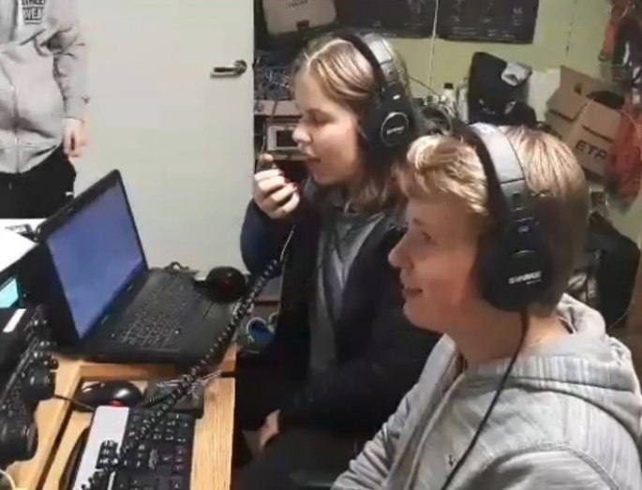

December is Youngsters on the Air Month ([**YOTA Month**](https://events.ham-yota.com/)**)**. Listen for stations on the air with YOTA as the call sign suffix.

“The idea for this is to show the Amateur Radio hobby to young people and to encourage youngsters to be active on the amateur bands,” said Tomi Varro, HA9T. “This is a great moment to show Amateur Radio to the world and to invite newcomers.”

TOP ^

YOTA is primarily an International Amateur Radio Union ([**IARU**](http://www.iaru.org/)) Region 1 (Europe and Africa) activity, but youngsters from the US in Region 2 (the Americas) have attended YOTA summer camps, which are held in a different country each year. Varro said both licensed and unlicensed youth will be making contacts. “Be helpful on the bands — maybe these young operators are just making their first ever contacts,” he advised.

YOTA stations are, in general, operated by individuals 25 or younger. The operating event takes place for the entire month of December UTC.

For more information and updates, visit YOTA’s [**Facebook page**](https://facebook.com/groups/youngstersontheair).

***Finding Old & Lost Ham Computer Software***

*(By Anthony Luscre, K8ZT)*

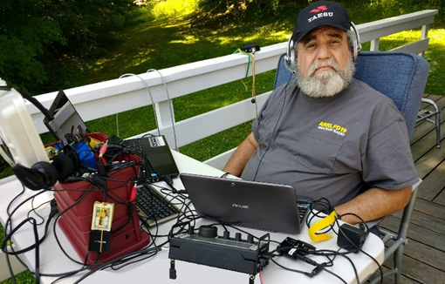I’ve done it many times and I am guessing you have done it also. You find a great free ham radio computer program. You use it for a number of years then you change computers, have a hard drive crash or just plain forget where you saved it. No problem I will just use the Internet to download another copy. Fortunately, after a few days of racking your brain, you remember the name of the program or site you downloaded it from. You go to the website and surprise you are greeted by “404 Error- Page not found” or that always friendly “this site is for sale” page!

Unlike mainstream software like Microsoft WordTM most ham radio software has a limited number of users and is usually produced by an individual or very small companies. So, after a while, the producer may lose interest in the project or even worse become a silent key. Sometimes the software is still there but you want an older version that is no longer available. In either case, you can search the internet for copies of the software. Fortunately, in part, because many hams are pack-rats, in many cases you might find it on a fellow ham’s website like my [www.k8zt.com](http://www.k8zt.com) site. But what if you can’t find it where do you look next?

Fortunately, there is a place on the Internet that stores copies of old websites and even some old software (unfortunately not much ham software). The site is [www.archive.org](http://www.archive.org), also known as the WayBackMachine. Here you might find the original website that housed the software. You can try clicking on the software link, but unfortunately, not all links are archived so your results will vary.

Recently I found a website that had a hoard of old software including a number of Ham Radio programs--[HintLink.com](http://hintlink.com/). The specific link you want is <http://hintlink.com/ham_applications_body.htm>.

Below is a montage of available programs. The site also has a large number of other non-ham radio programs. Please let me know of any other similar websites you find or know of by emailing me at [k8zt@arrl.net](mailto:k8zt@arrl.net)

TOP ^

TOP ^

***CARBON MONOXIDE (CO) POISONING***

Hi Gang,

I’m sure that a number of you are asking what the heck is the Section Manager writing about this stuff, it’s not Amateur Radio related!! Well my friends, you are very mistaken. It’s not only Amateur Radio related, it’s something that as a HAM operator you may not ever have thought about. Where's your ham shack located? In the basement, garage or outbuilding? Most generally ham shacks are **not** in the living room or main part of the house. As such, heating devices are usually some sort of a supplemental heater/furnace, and that’s why I’m writing about this.

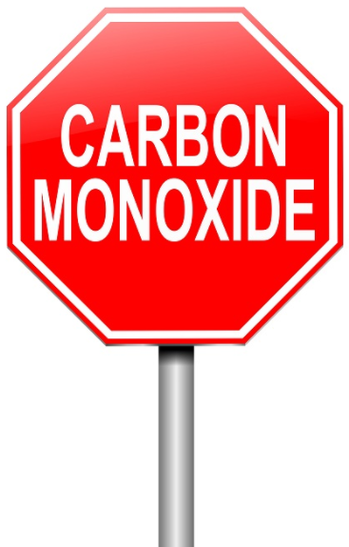

First, let’s describe what Carbon Monoxide (CO) is. Carbon Monoxide (CO) is the poisonous gases emitted from carbon fueled heat sources (i.e.. gas or fuel oil furnaces, wood burning fireplaces or stoves, kerosene heaters, propane heaters). I could go on, but I think you get the idea. It’s colorless, odorless and it will definitely kill you if you breathe very much of it in. How does this gas kill? It actually migrates into the blood stream and replaces the oxygen in your blood with the Carbon Monoxide. Once it invades your blood stream it will be with you for a very long time, in fact, most of your life! Just ask any firefighter about that. Going into burning buildings without a Self-Contained Breathing Apparatus (SCBA) on will definitely subject you to Carbon Monoxide poisoning, and it takes years and years to get it out of your system, if ever.

Sometimes, if consumed in a large enough quantity, you may need a complete blood transfusion to just keep you alive. Yes Virginia, it is that deadly!!

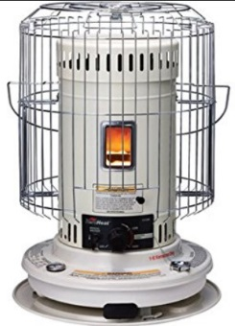Why am I writing about this? It’s very personal to me. A number of years ago a very close friend (and his entire family) died in their sleep because they consumed Carbon Monoxide (CO) without knowing it. They lived in an old house on the north side of Mansfield and because it was old, it was drafty with leaks around the doors, windows and the walls didn’t have any insulation in them. We had gotten a cold snap in early November, and back in the middle 1970’s kerosene heaters were all the rage to supplement heat in just this kind of house. Well, with the help of my co-workers we were able to purchase a big kerosene heater to help them through this cold snap. They got the heater all set up and running and all was fine for the first several days, then on the third day the dad came to work complaining of a very bad headache. None of us thought much about it that day and the dad continued his job on the assembly line with the rest of us. The next afternoon we all found out that the heater had been malfunctioning and every member of the family had died of this very dangerous gas.

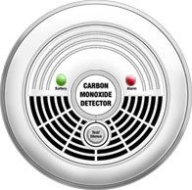I was absolutely torn apart. I had been one of several people at work that helped take up the collection to purchase the heater. It took me a long, long time to get over that. Don’t get me wrong, there’s nothing wrong with using these types of supplemental heating sources but be very careful when you do. At that time CO detectors were truly non-existent for homes, and the ones that were available were for scientific and commercial use, and cost hundreds and hundreds of dollars. That’s all changed now. CO detectors are as cheap now as smoke detectors. You can get one for as little as $10 now. That’s an extremely cheap form of protection from this deadly gas.

TOP ^

Winter is here. I don’t know about how it is at your house, but here in the little burg of Lexington, when it gets cold outside, you’ll see the smoke coming out of many chimneys around here. That means that the temperature has dropped to below where it is comfortable. This is the point where the furnaces come on and people start thinking about lighting up the fireplaces and so forth. Now if these devices haven’t been recently serviced, birds can make nests in the chimney’s and like your car, the heat source most likely needs a tune-up to make sure that it’s running efficiently and safely. Having the chimney stuffed up with bird nests or the heat source not burning correctly can cause Carbon Monoxide to accumulate in your house without you even knowing it. That’s where the CO detector comes into play... Please, please buy one, or two of these really inexpensive CO detectors for your safety and use it!

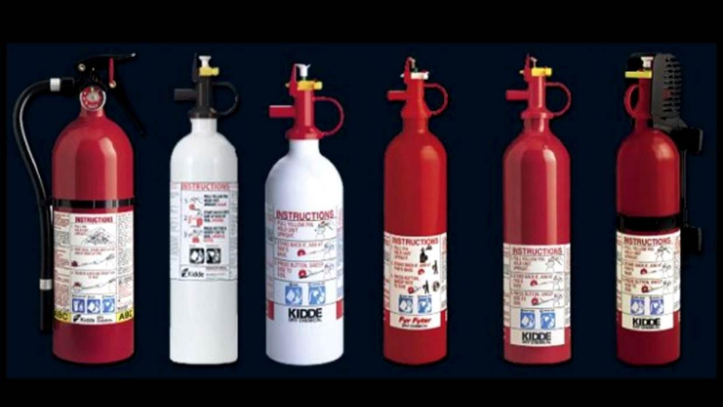By the way, it’s not all about detection either. Do you have a properly rated fire extinguisher within your reach? If not, get one. Learn how to properly use it. It will save you from a lot of damage if you know how to use it properly. Don’t assume that all you do is pull the pin and squeeze the trigger. It’s about knowing how to sweep and aim at the base of the fire. Do yourself a HUGE favor, buy an extinguisher or two and teach your entire family how to properly use them!

Yes, even the kids need to know how to properly use a fire extinguisher!

**####**

***Swap & Shop Has Come to the Ohio Section Website***

Hey Gang,

Have you taken a look at the **Swap & Shop** page on the Ohio Section webpage yet?? Here’s a link that will take you there… <http://arrl-ohio.org/sm/s-s.html>

There’s already been some great activity going on up there. Do you have equipment that you just don’t need or want anymore? Here’s a great venue to advertise it, and it’s FREE!! No, it won’t be listed in this newsletter because it would take up way too much space, so your ad will only appear on the website.

It is there for any individual to post equipment Wanted / For Sale or Give-Away. No licensed vehicles/trailers or business advertising will be posted.

Postings are text only (no pictures or graphics) will be posted for a maximum of 1 month from date posting

and require a contact phone number or email within the posting.

Send your Wanted / For Sale or Give-Away post to:  [swap@arrlohio.org](mailto:swap@arrlohio.org)

TOP ^

***Final.. Final..***

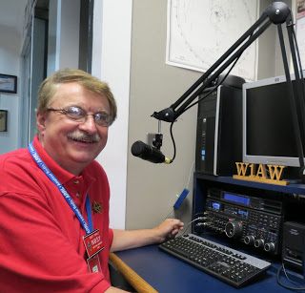

Hey Gang...

I trust most of you did like me on Thanksgiving, you gobbled up as much as you could and then waddled over to the easy chair and crashed for the rest of the day! We had a number of the relatives over for Thanksgiving dinner and there was so much food it was somewhat embarrassing. You could have fed the entire Ohio State Football team on just what we gave away to everyone leaving at the end of the day. My stomach is just now starting to feel like I even want to look at food again.

I’m also happy to announce that I didn’t have any accidents, so it was definitely a good day for me.

This next week is filled with meetings, so it will be a busy one for sure. I’ll be wrapping up the week at 2-day conference with most of the EMA Directors from around the state at the EMAO Winter Conference. It’s always good to get to talk one-on-one with all of the EMA Directors. Some of them are hams, so there’s lots in common and the conversations are always good.

Moving down the band a bit... As the year is fast winding down, I do want to let you all know that we are already working hard on activities for 2020. If you didn’t notice above, Stan, N8BHL, our SEC has already got the date set for the Annual Ohio Simplex Day! If you didn’t read it, it will be held on January 11th. We’ll have all the details finalized for the next week’s edition, but at least you now have the date so that you can, and all of your crew can start planning. You do want to participate, don’t you?? Stan and I are working on plans for the annual ARES Conference as well. Oh, I don’t want to forget to let all of the newsletter editors out there that John, KD8IDJ, our PIC already has the rules posted for next year’s Newsletter competition as well...

<http://arrl-ohio.org/pic_page/pic.html>

I am working on the 2019 Yearbook that will come out at the end of December. For those of you new folks, this is a review of all the Ohio Section’s activities in 2019 as well as an overview of the Ohio Section Cabinet and all of their great work.

Now let’s not forget that our Hamfest Calendar is fast filling up for 2020 as well. Being hearty Ohioans as we are, we have 2 Hamfests on the schedule for January! <http://arrl-ohio.org/hamfests.html> and 1 in February so far. Speaking of Hamfests, we have 2 big conventions coming up this next year as well! Save March 14-15 on your calendar for the Toledo Hamfest and Great Lakes Division Convention and later on into the summer August 8th we have the DX Engineering Hamfest and Ohio Section State Convention. We will be announcing the winners of the Ohio Section Newsletter Contest and the Allan Severson, AB8P Memorial Award recipient at our State Convention at the DX Engineering Hamfest.

Sliding down the band a bit… I know that this sounds like a broken record, and I apologize to the folks that are registered, but for some they still are sitting on the fence as to getting themselves registered in ARES Connect.

So, I am addressing those who are still sitting (that fence post has to be getting awful painful by now), we’ve had quite a few advancements with ARES Connect recently. These advancements are to help you the user and Admin get the events entered and hours registered better.

TOP ^

Our goal is to get everyone in the Ohio Section registered and using this new system by the end of the year! We want no one left behind. Hey, it’s time to ease the pain from that picket fence, get registered, and start using this great new system!

Oh, there’s another feature that I want to tell you about. If you’ve registered for an event and you forget to log your hours for that event after 24 hours, the system can, and if setup correctly, send you an email thanking you for your participation. But here’s what I want you to really pay particular attention to... there will also be a link in that email that if you click on it will take you directly to the area to get your hours logged!! Wow... this is a real bonus, as that even if you forget to log your hours the system will remind you and even make it convenient for you to log them.

Sliding down the band a bit more… Have you gotten on the air lately? With winter here now, there’s really no excuse for not getting on the air. I am still hearing from some of you that you just haven’t taken the time yet to do anything with that newly acquired license. Why not? Do you need help? Hey, my best advice for you is to seek out a club and go and listen. You’ll be amazed at how much knowledge is floating around that is just looking for a place to land. You got it… ON YOU! Have fun with it! Get on the Air!!!

Don’t know where the clubs are? Hey, here’s a link to our 117 ARRL Affiliated Clubs in Ohio…

<http://arrl-ohio.org/sm/affiliated-clubs.html>

Is your club doing any special activities that you’d like the Section to know about? As you can see by the posts in the Club Corner, many clubs are already taking advantage of getting the word out to over 8,000 readers every week.

Whelp… That’s going to do it for this time around. Stay safe, enjoy the sunshine while we have it, and most of all… have FUN!!

73,

***Scott, N8SY Go Bucks!!!***

***Welcome New Subscriber***

Tony, WB3KGT

***Updated Information... Want to Share your Club Newsletter With Others?***

It seems that I got the request wrong when I was asked about sharing newsletters. It seems that Frank Tompkins, W8EZT wanted to have me actually post the newsletters that I receive and not just the club link where they can be found. Well, after some hard thought, I decided to give it a try and we’ll all just see if posting them is more useful for all of you. I am now starting to put all the newsletters that either come to me in Adobe Acrobat or I can convert over to Adobe Acrobat up on the website. I will have them separated by month so that you’ll be able to see the various months without having to dig too far into the archives.

TOP ^

I’m starting with December and a few that have come out in late November. Here’s the link to the page….

<http://arrl-ohio.org/club_news/index.html> Please, if you don’t see your club newsletter posted, it’s probably because I’m not receiving it, or I just cannot convert it over to Adobe Acrobat. Have your newsletter editor contact me and let’s see if we can change that.

Now, I realize that some of you editors are very bashful and feel your hard work isn’t up to sharing, but that’s not true. We all learn and steal (I mean, share) from each other’s work. So, let’s give this new webpage a real workout and send me your newsletter!!! Send it to: [n8sy@n8sy.com](mailto:n8sy@n8sy.com)

***Back Issues of the PostScript and Ohio Section Journal (OSJ)***

Hey, did you know that PostScript and Ohio Section Journal (OSJ) are archived on the website? You can go back and look at any edition simply by clicking:

<http://arrl-ohio.org/news/index.html>

***Chit – Chat, and All That!***

Do you know someone that’s not getting these Newsletters? Please, forward a copy of this Newsletter over to them and have them “[Opt-In](http://arrl-ohio.org/forwarder/forwarding.html)” to start receiving them. Heck just have them send me an email [n8sy@n8sy.com](mailto:n8sy@n8sy.com) and I’ll get them added to the Ohio Section Emailing list.

We now have many thousands of readers receiving these newsletters weekly. Quite impressive, I’d say! I urge all of you to make sure that everyone, regardless of whether they are a League member or not, get signed up to receive these weekly Newsletters.

You can always “[Opt-Out](http://arrl-ohio.org/forwarder/forwarding.html)” at any time if you feel this is not what you were expecting. It’s fun and very informative. All of your favorite past newsletters are now archived too.

You can go back at any time and read them. Just go to: <http://arrl-ohio.org/news/>

Got questions, concerns or would just like to sit and chat awhile? Heck, I’ll even buy the coffee!! Give me a call at (419) 512-4445 or email me at: [n8sy@n8sy.com](mailto:n8sy@n8sy.com)

The pictures on the front page are from various newsletters, Facebook posts and/or were sent directly to me in recent weeks. Take a good look at them, you just might be in one of the pictures! “SMILE… you’re on the Ohio Section News!!”

TOP ^

*PostScript is produced as a weekly newsletter. I want to thank everyone that has contributed articles and ideas to make this an even better news source. I sincerely hope that you have enjoyed this edition and will encourage your friends to join with you in receiving the latest news and information about the Ohio Section, and news and events happening around the world!*