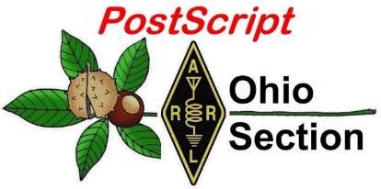
Veterans Day
Edition

National News The Handbook Give Away

Club Corner Hamfests

DX This Week One Question Questionnaire

VE Testing ARES Connect

Special NIMS Training Final.. Final..

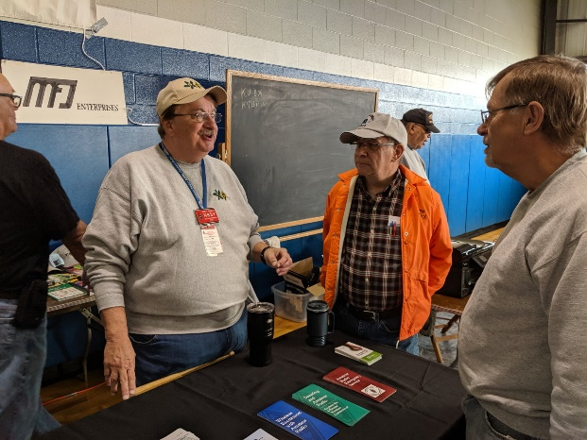
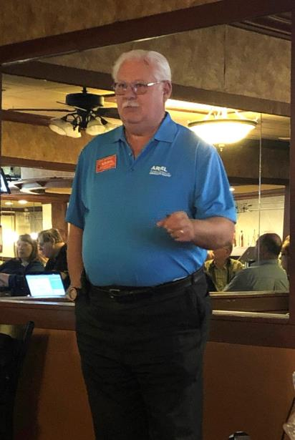
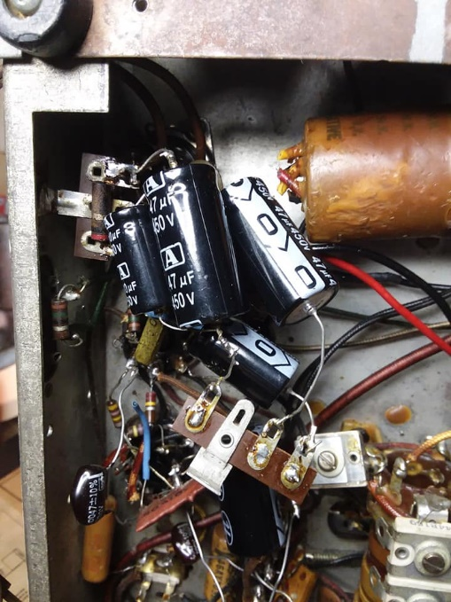
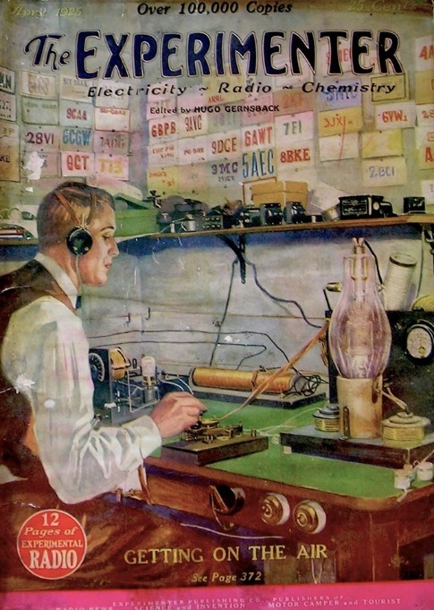
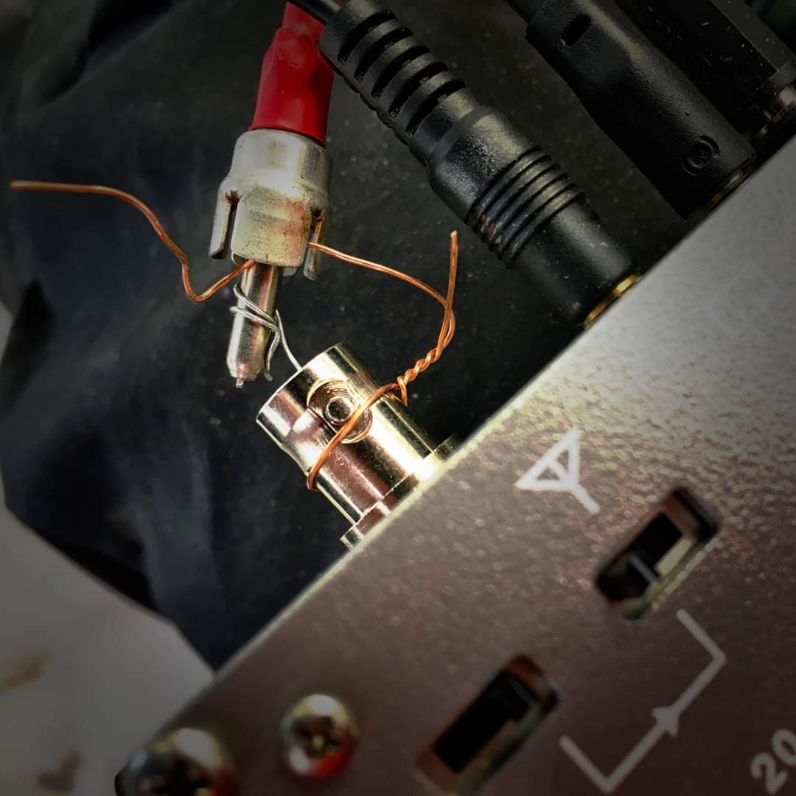

National News
(from arrl and other sources)

Preparations Resume for 3Y0I Bouvet Island DXpedition

Another attempt to activate Bouvet Island is in the planning stages, according to the 3Y0I website. Efforts are under way to secure the necessary funds.

“As you probably know, our first attempt to reach the island of Bouvet in March 2019 failed,” the news update said. “Despite complex preparations and training received in Cape Town, South Africa, our vessel got hit by a big storm so badly that we had no choice but to sail back to Cape Town to reshuffle our plans. We were so close — just 63 nautical miles offshore!” The 3Y0I sponsors estimate that a second attempt would cost around $170,000. “[W]e have already secured half of the required budget to go back to Bouvet,” the announcement said, adding that it’s beyond the capacity of the DXpedition team members to cover the entire cost, so they are trying to collect $85,000 to fund the second attempt.

The 3Y0I team has a GoFundMe page, set up by 3Y0I team leader Dom Grzyb, 3Z9DX. No time frame was given for the second attempt by Grzyb’s team, and it’s not known if Grzyb has obtained operating permission from the Norwegian government. The 19-square-mile subantarctic island is a Norwegian dependency.
“Our intentions are clear: If we don’t reach our fundraising goal, we won’t receive nor spend a single cent you donate and it would be returned to your GoFundMe account for withdrawal or to support any other GoFundMe project of your choice,” the announcement says.

“The future of amateur radio expeditions, especially in terms of activating entities placed across cold high-latitude seas, isn’t bright,” the 3Y0I statement says. “Apart from the uncertainty of future solar cycles’ strength that may badly reflect radio propagations, there are still very few of us who realize that visiting remote cold islands may become very seldom or even almost impossible.”

According to Club Log’s DXCC Most Wanted List, Bouvet Island is No. 2, right behind North Korea. The unrelated 3Y0Z Dxpedition attempt to land on Bouvet in early 2018 failed after the vessel transporting the team developed engine issues as it lay just offshore. The last successful Bouvet activation was 3Y0E, during a scientific expedition over the winter of 2007 – 2008. — Thanks to Southgate Amateur Radio News via OPDX

#########

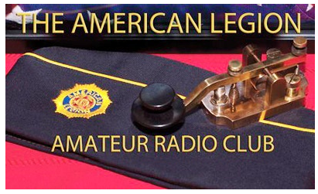
The American Legion Amateur Radio Club to Operate Special Event Station N9V on Veterans Day, November 11.

The American Legion Amateur Radio Club (TALARC) headquarters station, K9TAL, will anchor Veterans Day operations for special event N9V on Monday, November 11.

TOP ^
K9TAL will be joined by several TALARC stations around the US for its annual national salute to veterans. The American Legion is celebrating its 100th anniversary this year. Operation will be from 1800 to 0000 UTC on or about 7.285, 14.285, and 21.285 MHz.

Certificates will be available to all sending a QSL card. More information is on the N9V profile page on QRZ.com. — Thanks to Jim Harris, W0EM, and The National Legion Amateur Radio Club

#########

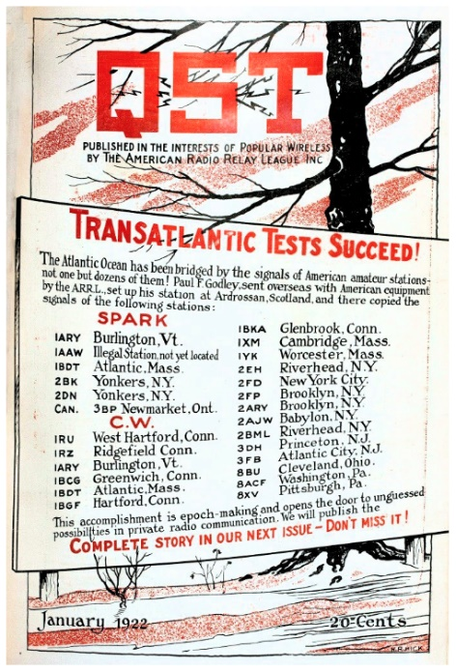
W1AW to Commemorate 98th Anniversary of First Amateur Radio Signals to Span the Atlantic

December 11 marks the 98th anniversary of the success of ARRL’s Transatlantic Tests in 1921, organized to see if low-power amateur radio stations could be heard across the Atlantic using shortwave frequencies (i.e., above 200 meters). On that day, a message transmitted by a group of Radio Club of America members at 1BCG in Greenwich, Connecticut, was copied by Paul Godley, 2ZE, in Scotland.

While the first two-way contact would not take place until 1923, the 1921 transatlantic success marked the beginning of what would become routine communication between US radio amateurs and those in other parts of the world — literally the birth of DX.

To commemorate this amateur radio milestone, Maxim Memorial Station W1AW will be on the air through the day on December 11 with volunteer operators. The goal is to encourage contacts between radio amateurs in the US and Europe while showcasing the significance of the transmissions that pioneered global communication and laid the groundwork for technology widely used today. The event will run from 1300 until 0000 UTC. Some details are still being worked out, but operation will focus on 40 and 20 meters (SSB).

W1AW 2019/2020 Winter Operating Schedule

ARRL Bulletin 22 ARLB022
From ARRL Headquarters
Newington CT November 5, 2019
To all radio amateurs

SB QST ARL ARLB022
ARLB022 W1AW 2019/2020 Winter Operating Schedule

Morning Schedule:

Time Mode Days
------------------- ---- ---------
1400 UTC (9 AM EST) CWs Wed, Fri
1400 UTC (9 AM EST) CWf Tue, Thu

TOP ^
Daily Visitor Operating Hours:

1500 UTC to 1700 UTC - (10 AM to 12 PM EST)
1800 UTC to 2045 UTC - (1 PM to 3:45 PM EST)

(Station closed 1700 to 1800 UTC (12 PM to 1 PM EST))

Afternoon/Evening Schedule:

2100 UTC (4 PM EST) CWf Mon, Wed, Fri
2100 " " CWs Tue, Thu
2200 " (5 PM EST) CWb Daily
2300 " (6 PM EST) DIGITAL Daily
0000 " (7 PM EST) CWs Mon, Wed, Fri
0000 " " CWf Tue, Thu
0100 " (8 PM EST) CWb Daily
0200 " (9 PM EST) DIGITAL Daily
0245 " (9:45 PM EST) VOICE Daily
0300 " (10 PM EST) CWf Mon, Wed, Fri
0300 " " CWs Tue, Thu
0400 " (11 PM EST) CWb Daily

Frequencies (MHz)
-----------------
CW: 1.8025 3.5815 7.0475 14.0475 18.0975 21.0675 28.0675 50.350 147.555
DIGITAL: - 3.5975 7.095 14.095 18.1025 21.095 28.095 50.350 147.555
VOICE: 1.855 3.990 7.290 14.290 18.160 21.390 28.590 50.350 147.555

Notes:
CWs = Morse Code practice (slow) = 5, 7.5, 10, 13 and 15 WPM CWf = Morse Code practice (fast) = 35, 30, 25, 20, 15, 13 and 10 WPM CWb = Morse Code Bulletins = 18 WPM

CW frequencies include code practices, Qualifying Runs and CW bulletins.

DIGITAL = BAUDOT (45.45 baud), BPSK31 and MFSK16 in a revolving schedule.

Code practice texts are from QST, and the source of each practice is given at the beginning of each practice and at the beginning of alternate speeds.

On Tuesdays and Fridays at 2330 UTC (6:30 PM EST), Keplerian Elements for active amateur satellites are sent on the regular digital frequencies.

A DX bulletin replaces or is added to the regular bulletins between 0100 UTC (8 PM EST) Thursdays and 0100 UTC (8 PM EST) Fridays.

Audio from W1AW's CW code practices, CW/digital bulletins and phone bulletin is available using EchoLink via the W1AW Conference Server named "W1AWBDCT."

TOP ^
The monthly W1AW Qualifying Runs are presented here as well. The audio is sent in real-time and runs concurrently with W1AW's regular transmission schedule.

All users who connect to the conference server are muted. Please note that any questions or comments about this server should not be sent via the "Text" window in EchoLink. Please direct any questions or comments to w1aw@arrl.org .

In a communications emergency, monitor W1AW for special bulletins as follows: Voice on the hour, Digital at 15 minutes past the hour, and CW on the half hour.

All licensed amateurs may operate the station from 1500 UTC to 1700 UTC (10 AM to 12 PM EST), and then from 1800 UTC to 2045 UTC (1 PM to 3:45 PM EST) Monday through Friday. Be sure to bring your current FCC amateur radio license or a photocopy.

The W1AW Operating Schedule may also be found on page 100 in the November 2019 issue of QST or on the web at, http://www.arrl.org/w1aw-operating-schedule .

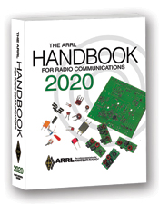
The Handbook Give Away

Hey Gang,

Thanksgiving is coming up very soon and I want to do something special to celebrate! So, be on the lookout for that big RED arrow on the Ohio Section website.

Is there a catch? Nope! I want to get everyone checking in to the Ohio Section website as often as possible, and in order to register each month, you have to visit the website often! There’s nothing else to it. I pay all expenses and I usually “Give Away” more than just a Handbook too!!

Many of you ask me just how do I know when the drawing is on? Well, that’s easy all you need to do is check in on the Ohio Section Website on a regular basis and watch for the big RED Arrow that will appear soon on the left side of the page. This is the sign that the drawing is on and you need to get registered. So, keep a sharp eye out on the website and check in often!

Club Corner

This is YOUR cornner of the newsletter. Send me what your club is doing and I’ll make sure that it gets in. Got a special event or club project that you want everyone to know about? Send it to me!. Need help with a project? Send it to me.

Let me know what you club is up to. Are you going to have a special guest at your meeting or are you having a special anniversary? Just sent it to: n8sy@n8sy.com

#########

TOP ^

PCARS November Monthly Meeting - Monday November 11th at 7 PM
I would like to invite you to visit the Portage County Amateur Radio Service (PCARS) for our November 2019 meeting! Everyone is welcome to attend!

November is the month that PCARS dedicates it's 50/50 drawing to help support a local charitable organization called The Center of Hope.

The Center of Hope provides food and meals to the disadvantaged citizens of Portage County. Our contribution started out small but has grown over the past 15 years. Last year we raised and donated over $9000 to this worthy cause!

We would certainly appreciate your help. For our November 50/50 the club's portion is donated to the Center of Hope and there are usually somewhere between 30 - 50 items to be won! This year's auction will include a new, Yaesu FT-450 HF Radio, some DMR handi-talkies, a handful of BaoFeng handi-talkies and way too much other stuff to list here. It's going to be a fantastic night, and you could go home with a nice prize. (If you are unable to attend but would like to support our effort, you can donate directly to the Center of Hope through the PCARS web-site, www.portcars.org There is a PAYPAL button in the upper right of the homepage designated for the Center of Hope donations.)

Another really good reason to attend is to support our OHIO Section Manager, Scott - N8SY, who will be receiving the ARRL's Knight Distinguished Service Award at the meeting. Presenting the award will be Dale Williams - WA8EFK - the Great Lakes Division Director.

Don't worry, we've got room for everyone who wants to venture out to visit with us! The meeting will be held on Monday November 11, 2019 at 7:00 PM. PCARS meets at the Kent American Legion Post 496, located at 1945 Mogadore Rd. Kent, OH 44240. The meeting will be held in the Underwood Hall in the Legion. I hope you'll join us for fantastic evening!

#########

Morse Code Classes Starting
Learn Morse Code Classes start Tuesday evening the 12 of November at 8:30 PM. Ralph, AA8P and Al, KJ8R will be putting on the classes.

Beginners CW course will be on 145.58 Simplex every Tuesday and Thursday Evening at 8:30 PM. The transmissions will be on 145.58 from AA8P Ralph located near Springfield, Ohio. Anyone interested in learning Morse Code can call me at 937-717-8733 or email me at aa8p@att.net also contact Al at 937-248-1028 or email KJ8R@AOL.COM

TOP ^
You can just show up on Tuesday evening the 12th of November at 8:30 PM. We also have a net every evening at 7:00 pm local time on 145.58 called The Hit or Miss Net, feel free to check in any time so we can test area overage.

Please forward this email to all of your email list in the local Dayton / Springfield area. We hope to have a few interested people join us for the classes. Look forward to seeing you at the classes, Ralph AA8P and Al KJ8R

Honoring our Viet Nam Era Veterans

Greetings Shipments… I am Don Zickefoose, WB8SIQ (aka Ziggy) and I am the Mariner Marlin Association Membership chairman. A few months ago, we did a very special ceremony for our veterans from the Viet Nam era that are also members of the Ohio Single Side-Band Net. They were honored with very special pins (Commemorative Eagle Pin) created just for this occasion.

They also were presented with a copy of the proclamation from President Barack Obama for this special occasion.

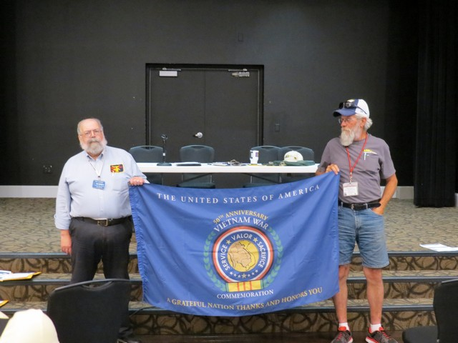 | 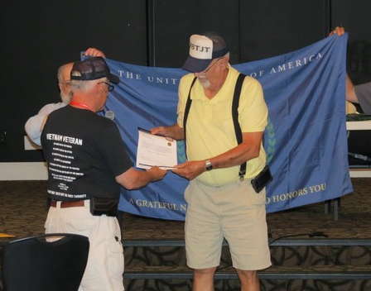  Dwight Bonifield, W8TJT
Daniel (Dan) Rinaman, AC8NP  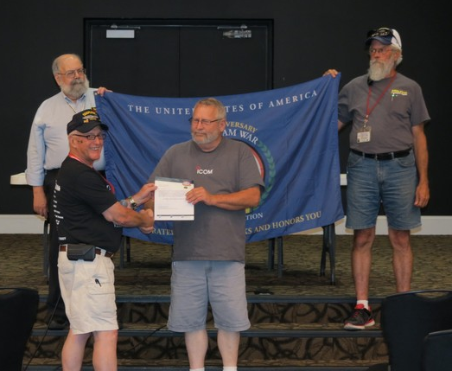 |  | Paul Picking, WD8OJL
TOP ^
Richard (Dick) Fletcher, N8CJS  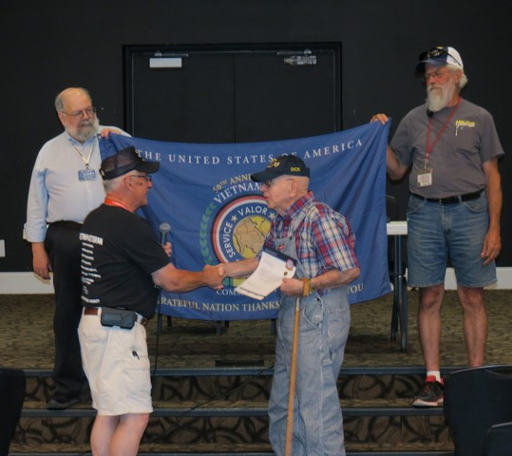 | Ray Suing, N8EQT  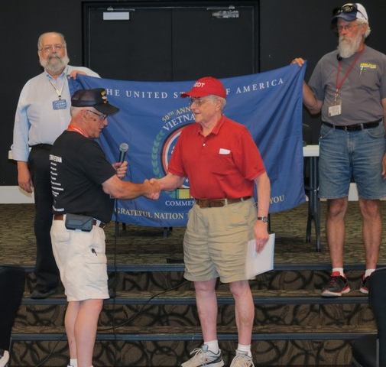
Jerry Rhodes, KB8MAF  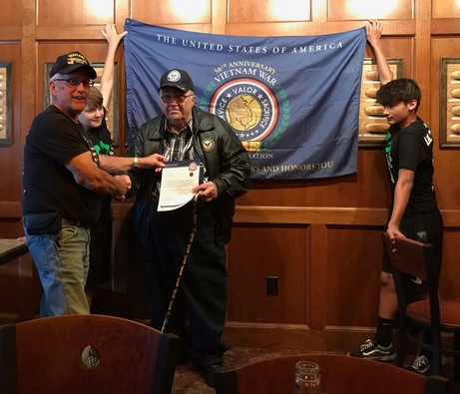 | Juan Duarte, KD8UOT  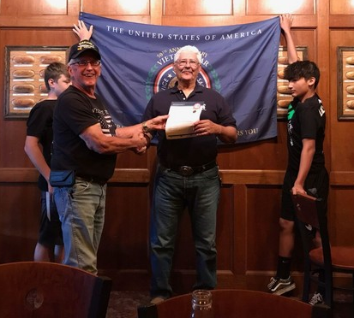

A very special presentation was held for Henry Koenig, WD8Q –
posthumously his wife Barb accepted for him

TOP ^

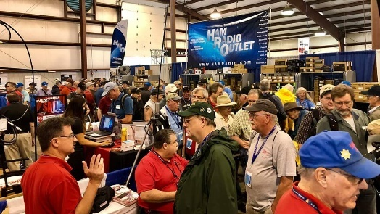
Upcoming Hamfests for 2019

12/07/2019 | Fulton County ARC Winterfest
Location: Delta, OH
Sponsor: Fulton County Amateur Radio Club
Website: http://k8bxq.org/hamfest

Upcoming 2020 Hamfests

01/19/2020 | Sunday Creek Annual Hamfest
Location: Nelsonville , OH
Sponsor: Sunday Creek Amateur Radio Federation
01/26/2020 | Tusco Amateur Radio Club's 30th Annual Hamfest, Electronics and Computer Show
Location: Strasburg,, OH
Sponsor: Tusco Amateur Radio Club
Website: http://www.tuscoarc.org

02/16/2020 | Mansfield Mid-Winter Hamfest
Location: Mansfield , OH
Sponsor: Intercity Amateur Radio Club
Website: http://WWW.IARC.CLUB

DX This Week
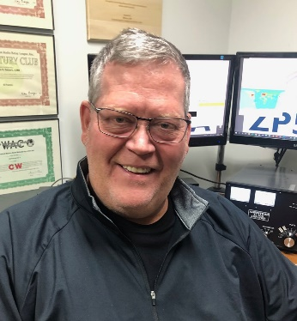
(from Bill, AJ8B)

Bill AJ8B (aj8b@arrl.net, @AJ8B, or www.aj8b.com)
CWOPs Member #1567

DX Spots that originated in the Midwest included Anguilla, Armenia, Ascension Island, Asiatic Russia, Australia, Austria, Azores, Belgium, Bolivia, Bonaire, Bosnia-Herzegovina, Bulgaria, Cayman Islands, Chile, Costa Rica, Crete, Cyprus, Czech Republic, Denmark, Dominican Republic, Ecuador, European Russia, Falkland Islands, Faroe Islands, Greece, Grenada, Hungary, Italy, Japan, Kenya, Madeira Islands, Malta, Moldova, Montenegro, Netherlands, New Zealand, Northern Ireland, Norway, Oman, Panama, Peru, Philippines, Puerto Rico, Sao Tome & Principe, Scotland, Seychelles, Sicily, Slovenia, Somalia, St. Helena, St. Lucia, St. Vincent, Switzerland, Tunisia, and Venezuela. Just wait for the sunspots to increase!

TOP ^
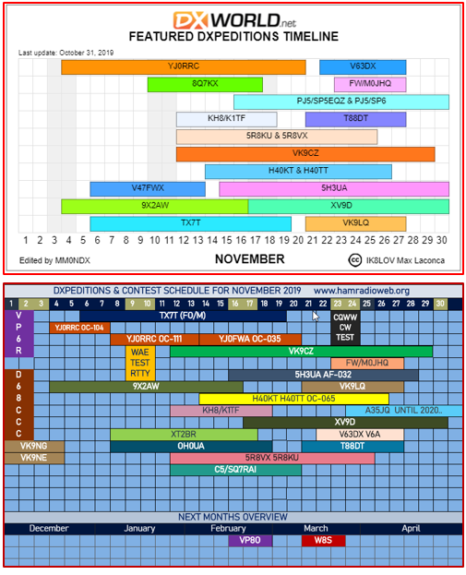
This week, the mailman delivered WD8AJD, 6Y5WJ - Jamaica, and T77C – San Marino. (Pictured)
What did you get? Send me an image and some details!

Here is the monthly DX Calendar featuring Contexts and DXPeditions. I got this information from www.dx-world.net and www.hamradioweb.org. I really encourage you to visit these sites regularly as they always have great information.

Of course, for the most accurate and real time info, you should visit www.dailydx.com. Bernie, W3UR, kindly allows me to reprint any info that I choose to in our weekly section newsletter and I very much appreciate that!

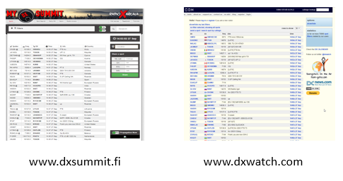
I have gotten a few queries about “clusters” and “spots”. I thought it would be a good idea to go into a bit of detail about these items. Years ago, we had a local “spotting network”. If there was some rare DX that was showing up, we had a group of hams that would call each other – independent upon the time of day (or night). As technology developed, we started using 2-meter repeaters and 2-meter clusters to share the same information. One of the advantages of this approach was that you could load your local country needed list and the 2-meter clusters would “beep” your terminal when a country was “spotted” for a band or mode that you needed. These spots usually consist of quite a bit of information: Callsign, Prefix, Frequency, Mode and Comments. The comments field varied from a signal report to what frequency the station was worked at to QSL information and any other information the person who entered the data (the spotter) wanted to provide. As the internet became a standard piece of our equipment in our ham shack, websites sprang up with “spotting pages” such as these.

TOP ^
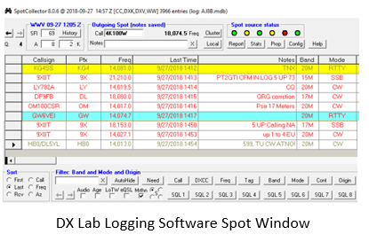

Logging programs have also taken advantage of the spotting network. This picture is from my logging software spots received window. Each spot is color coded indicating that it is a new mode, band, country, or zone, or some combination of these. It will also indicate that the station uses Log Book of the World and/or eQSL.cc. It also gives you the ability to search on various criteria as shown on the buttons at the bottom of the screen. Clicking on the spot of interest will set your rig to the correct frequency and mode and can also set up a split frequency if applicable. You can also configure this software to automatically turn the rotor to the appropriate heading; something that Uncle Frank takes advantage of, but I don’t need with my vertical!

CQDX CQDX CQDX CQDX CQDX CQDX CQDX CQDX CQDX CQDX CQDX CQDX

Here is an update from Bernie, W3UR, of the DailyDX and the WeeklyDX, the best source for DX information. (http://www.dailydx.com/ ) Bernie has this to report:

5Z4 – Kenya - K5CKS, Rory, has been swapping emails with Andy, 5Z4/G3AB, who says all he has is a 20M dipole on his balcony right now. It’s his early days in Kenya of a four-year stay. Andy also plans trips to other nearby countries. He is waiting for delivery of additional radios and antennas which will improve his capabilities on the air.

TZ – Mali - TZ4AM, Jeff, says he is “back in Bamako,” starting with putting his station on the air three days ago, Friday, November 1 and again Saturday and Sunday, 20 CW between 1730-1900Z. On Sunday he reported to us he still has a few kinks to work out but expects to be on the air the next three weeks.

4L – Georgia - 4L/TA1HZ will be operating from the 4L6QC QTH with an AV-680 Hy-Gain vertical antenna and 100 watts from a Yaesu FT-991, mainly FT8 and FT4 “on lower bands.” The dates of his weeklong operation are December 13-20. QSL direct to TA1HZ or go through Logbook of the World.

P29 – Papua New Guinea - P29ZL, Tim, is experimenting with various antennas and various bands at his QTH in Ukarumpa. Tim says he has been pleased with his results on 15 and will be on others too.

C5 – The Gambia - C5/SQ7RAI, Artur, is in Brusubi, November 13-20, with an FT-100 radio, 100 watts to an SP3PL delta, operating on 20-6 SSB and FT8. QSL direct or bureau to his home QTH or LoTW. He is getting a lot of information on how to get his own C5 callsign. He will be operating from the C5SP station.

YS – El Salvador - YS1/HK4GOO has an upcoming operation, November 9-16. Op Gabo (Gabriel Ochoa) has a Yaesu FT-450D and Icom 706MKIIG and will have antennas covering 160-10, planning the SSB and FT8 modes. He says 5 USD sent on PayPal will cover a direct QSL from him and he will also have Club Log and LoTW. https://www.qrz.com/db/YS1/HK4GOO .

TOP ^
VP6 – Pitcairn Island - The VP6R group put out their final press release on Saturday, “now history with 82,700 Qs in the log.” They say they had excellent weather for the takedown, got everything packed and aboard the Braveheart ship which was taking them to Mangareva on Sunday. They would then travel onward to Punta Arenas, Chile. They note the oldest resident of Pitcairn passed away on Friday and they attended the funeral Saturday morning. He was laid to rest next to VP6TC, Tom Christian, who gave many of us our first Pitcairn QSOs. The funeral was “a moving experience,” they say.
During their stay on the island they helped two locals get on the air. VP6MW, Meralda Warren, has a new 40/30 and 15 vertical and is set up to do FT8. VP6AZ’s vertical is fixed and he has a new beam. Both ops are now on the air. One CQ from VP6MW on 15M FT8 resulted in an instant pileup.
K0IR, Ralph, is credited with the prep for the VP6R operation, though he was unable, at the last minute, to go along. www.pitcairndx.com. The trip home for most of the operators will take a week or more. OQRS will then be activated and will be the best way to get a QSL. Eventually the whole log will be up on LoTW. And you may QSL via K9CT.

CQDX CQDX CQDX CQDX CQDX CQDX CQDX CQDX CQDX CQDX CQDX CQDX

DX news

ARLD044 DX news

This week's bulletin was made possible with information provided by VK3ZZX, The Daily DX, the OPDX Bulletin, 425 DX News, DXNL, Contest Corral from QST and the ARRL Contest Calendar and WA7BNM web sites.
Thanks to all.

MADAGASCAR, 5R. Hiro, JF1OCQ and Kuni, JA8VE will be QRV as 5R8VX and 5R8KU, respectively, from Nosy Be Island, IOTA AF-057, from November 12 to 25. Activity will be with two stations on the HF bands using CW, SSB, FT8, FT4 and other digital modes. QSL to home calls.

MALDIVES, 8Q. Tommy, DL8KX will be QRV as 8Q7KX from Baa Atoll, IOTA AS-013, from November 10 to 17. Activity will be holiday style on 40, 30, 20, 15 and 10 meters using CW. QSL to home call. In addition, Roly, ZL1BQD will be QRV as 8Q7XR from November 10 to December 30. Activity will be on 80 to 10 meters using CW, SSB and FT8. QSL to home call.

RWANDA, 9X. Harald, DF2WO is QRV as 9X2AW from Kigali until November 20. Activity is on 160 to 10 meters using mostly FT8 and some CW and SSB. This may include some satellite activity as well.
QSL via M0OXO.

THE GAMBIA, C5. Alan, G3XAQ and Don, G3XTT will be QRV as C56XA and C56DF, respectively, from November 12 to 26. Activity will be on the HF bands. This includes being active in the upcoming CQ World Wide DX CW contest. QSL C56XA via G3SWH and C56DF via G3XTT. In addition, Artur, SQ7RAI will be QRV as C5/SQ7RAI from November 12 to 20. Activity will be on 20 to 6 meters using SSB and FT8. QSL to home call.

MARQUESAS ISLANDS, FO. A group of operators are QRV as TX7T from Hiva Oa until November 18. Activity is on the HF bands using CW, SSB and FT8 with three or four stations active. QSL via LoTW.

TOP ^
PANAMA, HP. Special event station 3E1FP is QRV to celebrate the 116th anniversary of the Republic of Panama. Activity is on 80 to 10 meters using CW, SSB and various digital modes. QSL via HP1DAV.

THAILAND, HS. Lars, SM6NT will be QRV as HS0ZME from November 12 to April 5, 2020. QSL to home call.

AMERICAN SAMOA, KH8. Tom, JA1VND will be QRV as KH8/K1TF from Pago Pago, IOTA OC-045, from November 12 to 18. Activity will be on the HF bands using CW, SSB and various digital modes. QSL to home call.

ALAND ISLANDS, OH0. Mart, DL6UAA is QRV as OH0UA until November 18. Activity is on 160 to 10 meters using CW, RTTY and FT8. QSL to home call.

COCOS (KEELING) ISLANDS, VK9C. Chris, GM3WOJ and Keith, GM4YXI will be QRV as VK9CZ from November 12 to 29. Activity will be on 160 to 10 meters using CW, SSB and FT8 with a focus on the low bands. This includes being an entry in the upcoming CQ World Wide DX CW contest. QSL via N3SL.

INDONESIA, YB. Operators YE1AR, YC1KK, YC1BIQ and YB1MAE are QRV as home calls/p from Biawak Island, IOTA OC-237, until November 14. Activity is on 160 to 10 meters using FT8 with some CW and SSB. QSL via operators' instructions.

BURKINA FASO, XT. Al, F8FUA is QRV as XT2BR from Ouagadougou until November 17. Activity is on the HF bands using CW, SSB and various digital modes. QSL to home call.

EL SALVADOR, YS. Gabo, HK4GOO will be QRV as YS1/HK4GOO from November 9 to 16. Activity will be on 160 to 10 meters using SSB and FT8. QSL via LoTW.

THIS WEEKEND ON THE RADIO. The Japan International DX Phone Contest, Worked All Europe DX RTTY Contest, North American SSB Sprint Contest, NCCC RTTY Sprint, QRP 80-Meter CW Fox Hunt, NCCC CW Sprint, PODXS 070 Club Triple Play Low Band Sprint, 10-10 International Fall Digital Contest, SARL VHF/UHF Analogue Contest, SKCC Weekend CW Sprintathon, OK/OM DX CW Contest, CQ-WE Contest and AWA Bruce Kelley 1929 CW QSO Party are all on tap for this upcoming weekend.

The RSGB 80-Meter Autumn Data Series and 4 States QRP Group Second Sunday Sprint are scheduled for November 11.

The CWops Mini-CWT Test, Phone Fray and QRP 40-Meter CW Fox Hunt are scheduled for November 13.

The Canadian National Parks on the Air, CNPOTA, operating event runs for the entire year of 2019, with special stations active from Canada's parks and historic sites.

Please see November QST, page 89, and the ARRL and WA7BNM Contest Web Sites for details.

#########

TOP ^

Special Events

11/11/2019 | Veterans Day Special Event
On Monday Nov 11, 2019 The American Legion Amateur Radio Club Post 641 (W8BVL) in Belle Valley, Ohio will be on the air from 12:00 Noon EST to 4:00 PM EST in Observance of Veterans day. We will be broadcasting on or around 7.225 and /or 14.275 depending on participants and ban conditions. For more info contact: Gary Oliver, KD8OSI garyoliver523@gmail.com

01/02/2020 | 14th Annual Straight Key CW Event
Jan 2-Jan 31, 0000Z-2359Z, K3Y, Tecumseh, MI. SKCC - Straight Key Century Club. 21.050 14.050 7.055 3.550. Certificate & QSL. SKCC c/o Jeremy Downard, KD8VSQ, 511 W. Pottawatamie St., Tecumseh, MI 49286. K3Y/0 thru 9 plus KH6, KL7, KP4 and DX member stations in six WAC areas operating straight key, bug and cootie keys. QSL card confirms one QSO per area, up to 19 for all-area sweep. See URL for schedule, map, stats, etc.

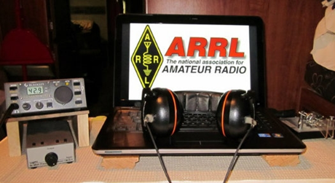
ARRL Contest Corner

An expanded, downloadable version of QST's Contest Corral is available as a PDF. Check the sponsor's Web site for information on operating time restrictions and other instructions.

November 11  - CQ-WE Contest  - 4 States QRP Group Second Sunday Sprint  - RSGB 80m Autumn Series, Data | November 13  - Phone Fray  - CWops Mini-CWT Test

November 9 - 17 -- AWA Bruce Kelley 1929 QSO Party (CW)
November 15 -- YO International PSK31 Contest

#########

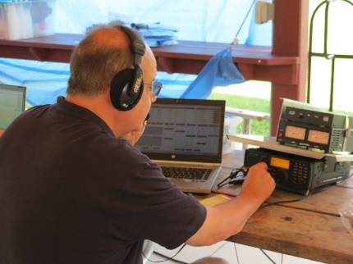
2019 Field Day Results...

As it has been a tradition of mine for many years to list the results from our Field Day exercise. The listing shows the Top 10 from Ohio in each of the categories. And YES, Ohio does shine very brightly in these results. Everyone should be very proud, no matter where your group fell in the listings.

TOP ^

Three or More Person Club/Non-Club Portable 1A |  |  | One or Two Person Club/Non-Club Portable  1B – 1 Operator
Not Case ARC | 1st |  | K1LT | 1st
3A - Battery |  |  | W8AN | 7th
Northern Ohio QRP Club | 4th
Middle Bass Amateurs | 7th |  | 1B - 1 Operator Commercial
 |  |  | N8VWY | 10th
3A - Commercial |  |  | 1B - 2 Operator Battery
Coshocton County ARC | 6th |  | N8PW | 2nd
4A |  |  | 2B – 2 Operators
Portage County Amateur Radio Service | 3rd |  | W8REH | 1st
4A - Commercial |  |  | 2B – 2 Operators - Battery
K8UU | 4th |  | KB8ZUN | 8th
Hocking Valley ARC | 8th
Home Stations Commercial Power
1D
 |  |  | KV8Q | 3rd
5A
Black River Radio Ops | 6th |  | Home Stations Emergency Power  1E
 |  |  | KW8N | 2nd
5A - Battery |  |  | W8CAR | 6th
North Coast ARC | 4th |  | WX8J | 8th
6A
Cuyahoga ARS | 4th
Lake County ARA | 6th |  | EOC Stations  1F
 |  |  | Wayne ARC | 10th
4F
Delaware ARA | 1st
W8FY | 4th

TOP ^

V.E. Test Sessions

For the latest testing site information please >> Click Here << The ARRL site tracks all of the VE testing sites that register with them, including W5YI and Laurel. ARRL gives you a number of different ways of sorting to find that site that is closest to you as well.

One Question Questionnaire

Hey Gang,

“Survey Says” --- 24% of you have started your Christmas shopping!! Fantastic!! You can drop off mine anytime!!

I’ve got another NEW – one question – for you on the Ohio Section Website! Now that winter seems to be upon us, we’ll be spending more time on the bands since we’re shut in, which leads me to my next question…

“Have you finished up all of your antenna projects yet?”

These One Question questionnaires are all in fun and I hope that you are enjoying answering them.

You’ll find the “One Question” questionnaire on the Ohio Section Website! http://arrlohio.org It’s all in fun and it’s not a scientific survey in any way, but we are learning some things that we didn’t know from these questions. I hope that you are enjoying answering these “One Question” questionnaires.

ARES Connect

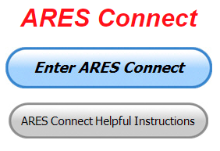
I really am hoping that everyone is starting to take advantage of being able to go backwards on the calendar and picking up those events that you did get registered for already. If you’ve tried to do this and still don’t understand how to do it, please, don’t wait any longer, contact me right away. I’ll walk you right through it. For the rest of you, please be sure to get your hours entered in by no later than the 7th of the next month.

With all of the additions to ARES Connect that we now have, there is absolutely no longer any excuses for you not to use the system!!

I’m setting a goal for all of you out there. Let’s get everyone in the Ohio Section on ARES Connect before the end of this year!!! Simply go to: https://arrl.volunteerhub.com/lp/oh/ and get yourself registered and using the system.

TOP ^
Here’s the top 10 hours earners so far for November:

 | Name | Events | Hours
1 | Mark Griggs (KB8YMN) | 2 | 48.00
2 | James Sage (AC8FR) | 1 | 48.00
3 | Richard Wynkoop (KD8PHG) | 3 | 48.00
4 | Greg Dersarkisian (KD8SSJ) | 8 | 38.50
5 | Dan Stahl (KC8PBU) | 19 | 34.67
6 | John Hilliard (w8of) | 8 | 32.50
7 | Diane Warner (KE8HLD) | 8 | 31.50
8 | Bret Stemen (KD8SCL) | 8 | 28.50
9 | Christopher Domenick (KC8CAD) | 8 | 23.00
10 | Spenser Snyder (KE8AFF) | 4 | 20.25

Why is this so important? Hey, I am just going to say this… The end of the year is coming up fast, and now with the ability to catch yourself up on past events, there’s gonna’ be a very special “End of the Year” award for the person with the most hours in 2019! . Will that be you? You now can make that happen!

Admins… If you are wondering how to get an overview of all of your events you can simply go into reports and using the new Event by Participation by Event (version 2) you can not only see who registered for your event, but you also can see if he/she has inputted their hours for it as well. Take advantage of this new report to help you get the time entered into your events.

I’m also seeing a number of recurring events created but no activity reported for them. Please, if this event is no longer needed, let me know and I can delete it from the masters. I know that many of you setup recurring events to learn how, but if they aren’t going to be used, let’s get them cleared out.

Special NIMS Training Available

Campbell County Office of Emergency Management Upcoming Training
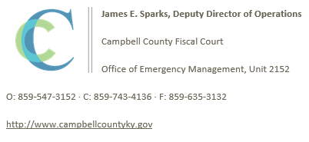
Campbell County Kentucky Office of Emergency Management FREE Training Opportunities

Emergency Propane Water Injection Course – November 12, 2019 – Hebron Fire Protection District / Registration will open soon.

Managing Critical Incidents at Institutions of Higher Education: A Whole Community Approach (MGT-361) - December 10-12, 2019 - TEEX / Register: https://goo.gl/Qa3tUs

#########

TOP ^

Swap & Shop Has Come to the Ohio Section Website

Hey Gang,

Have you taken a look at the Swap & Shop page on the Ohio Section webpage yet?? Here’s a link that will take you there… http://arrl-ohio.org/sm/s-s.html

There’s already been some great activity going on up there. Do you have equipment that you just don’t need or want anymore? Here’s a great venue to advertise it, and it’s FREE!! No, it won’t be listed in this newsletter because it would take up way too much space, so your ad will only appear on the website.

It is there for any individual to post equipment Wanted / For Sale or Give-Away. No licensed vehicles/trailers or business advertising will be posted.

Postings are text only (no pictures or graphics) will be posted for a maximum of 1 month from date posting
and require a contact phone number or email within the posting.

Send your Wanted / For Sale or Give-Away post to: swap@arrlohio.org

Want to Share your Club Newsletter With Others?

Is your club’s newsletter available to share? I’ve got a new webpage that has links to all of the known websites where club newsletters can be accessed throughout Ohio.

Now, as we all know when any list is published, it’s outdated immediately. That’s ok, just send me the link to your club’s newsletter and I’ll get it on the webpage – n8sy@n8sy.com

Here’s the link: http://arrl-ohio.org/club_link/links-to-newsletters.html Remember, we’re all here to help each other. What a great way to share the news about Amateur Radio!!

Welcome New Subscriber

Warren, N7WEB

#########

TOP ^

Final.. Final..
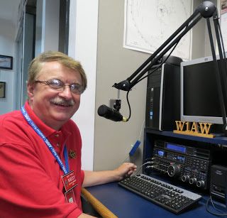
Hey Gang...

Wow.. Winter is here for sure! I’m really glad that I got my antenna work done some months ago. Although they tell me that the best time to do antenna work is when winter is at its hardest. You don’t fiddle around with things; you just get them done as quickly and professionally as you can and then get inside and hope that you did everything right!

Sliding down the band a bit… I know that this sounds like a broken record, but for some they still are sitting on the fence as to getting themselves registered in ARES Connect. So, I am addressing those who are still sitting. We’ve had quite a few advancements with ARES Connect recently. These advancements are to help you the user and Admin get the events entered and hours registered better. Our goal is to get everyone in the Ohio Section registered and using this new system by the end of the year! We want no one left behind.

Oh, there’s another feature that I want to tell you about. If you’ve registered for an event and you forget to log your hours for that event after 24 hours, the system can, and if setup correctly, will send you an email thanking you for your participation. But, here’s what I want you to really pay particular attention to.. there will also be a link in that email that if you click on it will take you directly to the area to get your hours logged!! Wow.. this is a real bonus, as that even if you forget to log your hours the system will remind you and even make it convenient for you to log them.

Sliding down the band a bit more… Have you gotten on the air lately? With winter here now, there’s really no excuse for not getting on, but I am still hearing from some of you that you just haven’t taken the time yet to do anything with that newly acquired license yet. Why not? Do you need help? Hey, my best advice for you is to seek out a club and go and listen. You’ll be amazed at how much knowledge is floating around that is just looking for a place to land. You got it, ON YOU!. Have fun with it! Get on the Air!!!

Don’t know where the clubs are? Hey, here’s a link to our 117 ARRL Affiliated Clubs in Ohio…
http://arrl-ohio.org/sm/affiliated-clubs.html

Is your club doing any special activities that you’d like the Section to know about? As you can see by the posts in the Club Corner, many clubs are already taking advantage of getting the word out to over 8,000 readers every week.

Whelp… That’s going to do it for this time around. Stay safe, enjoy the sunshine while we have it, and most of all… have FUN!!

73,

Scott, N8SY

TOP^

Back Issues of the PostScript and Ohio Section Journal (OSJ)

Hey, did you know that PostScript and Ohio Section Journal (OSJ) are archived on the website? You can go back and look at any edition simply by clicking:
http://arrl-ohio.org/news/index.html

Chit – Chat, and All That!

Do you know someone that’s not getting these Newsletters? Please, forward a copy of this Newsletter over to them and have them “Opt-In” to start receiving them. Heck, just have them send me an email n8sy@n8sy.com and I’ll get them added to the Ohio Section Emailing list.

We now have many thousands of readers receiving these newsletters weekly. Quite impressive, I’d say! I urge all of you to make sure that everyone, regardless of whether they are a League member or not, get signed up to receive these weekly Newsletters.

You can always “Opt-Out” at any time if you feel this is not what you were expecting. It’s fun and very informative. All of your favorite past newsletters are now archived too.
You can go back at any time and read them. Just go to: http://arrl-ohio.org/news/

Got questions, concerns or would just like to sit and chat awhile? Heck, I’ll even buy the coffee!! Give me a call at (419) 512-4445 or email me at: n8sy@n8sy.com

The pictures on the front page are from various newsletters, Facebook posts and/or were sent directly to me in recent weeks. Take a good look at them, you just might be in one of the pictures! “SMILE… you’re on the Ohio Section News!!”

TOP ^

This is Veterans Day…
This is a day to remember all of those who gave so much for all of us.

Please, say thanks to those that have – or are serving!

PostScript is produced as a weekly newsletter. I want to thank everyone that has contributed articles and ideas to make this an even better news source. I sincerely hope that you have enjoyed this edition and will encourage your friends to join with you in receiving the latest news and information about the Ohio Section, and news and events happening around the world!

