[](http://arrl-ohio.org/news/) ***October 21st***

***Edition***

🡪 National News 🡪 The Handbook Give Away

🡪 Club Corner 🡪 Hamfests

🡪 DX This Week 🡪 One Question Questionnaire

🡪 VE Testing 🡪 ARES Connect

🡪 Special NIMS Training 🡪 Final.. Final..

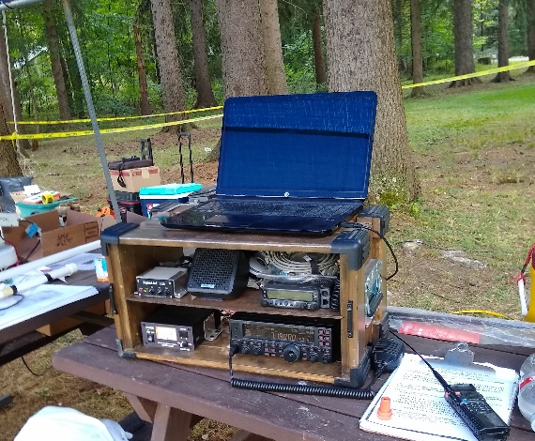

***National News***

*(from arrl and other sources)*

***ARRL to Launch New On the Air Magazine in January***

ARRL is launching a new magazine, *On the Air,* in January 2020. To be published on a bimonthly basis, *On the Air* will offer new and beginner-to-intermediate-level radio amateurs a fresh approach to exploring radio communication. Each issue will include advice and insights on topics from the variety of Amateur Radio interests and activities: radio technology, operating, equipment, project building, and emergency communication. The goal of this new magazine is to be a vital resource in helping new and newer radio amateurs get active and involved in radio communications.

“*On the Air* responds to the brand new and not-so-brand-new radio amateur seeking ideas and answers,” said *QST* Managing Editor Becky Schoenfeld, W1BXY. Schoenfeld is part of the ARRL staff team that developed the new magazine. The planning included an extensive national-level study of new Amateur Radio licensees, identifying their motivations for getting licensed and their experiences of getting started. A focus group responded positively to a trial sample edition of the magazine.

“Too many new licensees never take the next step,” says Schoenfeld. “We’re excited to introduce a new Amateur Radio magazine for this audience, aimed at getting them active, getting them involved, and getting them on the air.”

The first issue of *On the Air* will be published in January 2020 (January/February issue) and will be introduced as a new ARRL membership benefit. Effective November 1, when eligible US radio amateurs join ARRL or renew their memberships, they will be prompted to select the print magazine of their choice — *On the Air* or *QST*. Current members receiving the print edition of *QST*, upon renewal, may choose to continue receiving the monthly print edition of *QST* or the print edition of the bimonthly *On the Air*.

All ARRL members, including international members, will be able to access digital editions of both *QST* and *On the Air*. Members who already access *QST* on the web or from the mobile app will be able to access *QST* and *On the Air* starting in January.

#########

**IARU Secretary David Sumner, K1ZZ, Offers Amateur Radio Perspective on WRC-19**

Writing in a special World Radiocommunication Conference 2019 (WRC-19) edition of [***ITU News Magazine***](https://www.itu.int/en/itunews/Documents/2019/2019-05/2019_ITUNews05-en.pdf), International Amateur Radio Union ([**IARU**](http://www.iaru.org/)) Secretary David Sumner, K1ZZ, offers an overview of conference agenda items and issues pertaining to Amateur Radio. In his article, “Views of the International Amateur Radio Union on WRC‑19 agenda items,” Sumner noted that the IARU has participated in ITU conferences since 1927 and is a member of the ITU Radiocommunication and Development sectors.

TOP ^

According to Sumner, the IARU’s overall objectives for WRC‑19 are global harmonization of the amateur 50 – 54 MHz allocation; maintenance of existing spectrum access for amateurs and strengthening protections for radiocommunication services against interference from other RF generators.

“When new technology is developed that generates radiofrequency energy, it is essential that adequate protection of radiocommunication services be included in the system design,” Sumner said.

He concluded by noting, “No future agenda items for new or harmonized spectrum allocations for the amateur services are being sought at WRC‑19. This position does not preclude seeking specific allocations in the unallocated spectrum above 275 GHz, if allocations to other services are considered. IARU is carefully monitoring proposals for future agenda items that may impact existing amateur and amateur-satellite allocations.”

#########

***School Club Roundup***

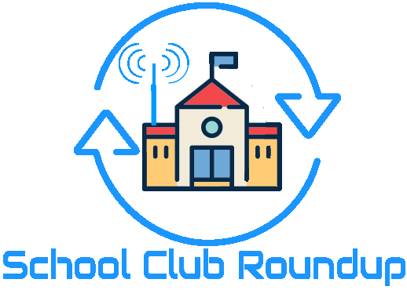The Fall Term running of the School Club Roundup will take place **October 21-25, 2019.**

**Objective:** To exchange QSO information with club stations that are part of an elementary, middle, high school or college. Non-school clubs and individuals are encouraged to participate.

Sponsored by the ARRL, its Hudson Division Education Task Force and the Long Island Mobile Amateur Radio Club (LIMARC) to foster contacts with and among school radio clubs. Award certificates will be issued for the following US and DX categories:

* Schools: Elementary, Middle/Intermediate/Junior High School, High School and College/University
* Non-school Clubs
* Individuals

For additional details visit- [www.arrl.org/school-club-roundup](http://www.arrl.org/school-club-roundup).

If you are involved with a School, Youth Group or Scouting Radio Club, please consider registering your group with the ARRL Ohio Section Youth Coordinator by using this [link](http://tiny.cc/osl-form) to fill out a registration form or if you know someone who is involved please share this link with them- <http://tiny.cc/osl-form>. When registering you will have complete control of what information will be shared with the public about your group. Anthony, K8ZT will make the approved registration information available on the ARRL Ohio Section website cabinet page- [www.arrl-ohio.org/syc/index.html](http://www.arrl-ohio.org/syc/index.html).

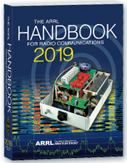***The Handbook Give Away***

Hey Gang,

Have you registered for the “Handbook Giveaway” drawing for this month yet? If you haven’t, go to: <http://arrl-ohio.org/handbook.html> and get yourself registered now!

TOP ^

What’s the catch? I want to get everyone checking in to the Ohio Section website as often as possible, and in order to register each month, you have to visit the website often! There’s nothing else to it. I pay all expenses and I usually “Give Away” more than just a Handbook too!!

Many of you ask me just how do I know when the drawing is on? Well, that’s easy all you need to do is check in on the Ohio Section Website on a regular basis and watch for the big [**RED**](http://arrl-ohio.org/handbook.html)Arrow that will appear on the left side of the page. This is the sign that the drawing is on and you need to get registered. So, keep a sharp eye out on the website and check in often!

***Club Corner***

This is YOUR cornner of the newsletter. Send me what your club is doing and I’ll make sure that it gets in. Got a special event or club project that you want everyone to know about? Send it to me!. Need help with a project? Send it to me.

Let me know what you club is up to. Are you going to have a special guest at your meeting or are you having a special anniversary? Just sent it to: [n8sy@n8sy.com](mailto:n8sy@n8sy.com)

#########

***Medina County Amateur Radio Club*** has scheduled six Technician Licensing Classes at the Medina County Career Center (JVS) beginning **October 23rd from 6:30pm to 9:00pm** in Room 246.  The last class will be the exam.

Interested attendees should contact Doug or me for more information about the first class:  Doug KD8SST  330-304-8571, [dmcclure1@zoominternet.net](mailto:dmcclure1@zoominternet.net), or Jane K8JGR 216-570-8500,  [jane@K8JGR.radio](mailto:jane@K8JGR.radio)

#########

***Skywarn Recognition Day 2020 - THE FINAL YEAR AT HOPKINS***

Skywarn Recognition Day will be taking place nationally on Saturday, **December 7th, 2019** for 24 hours starting at 0000Z (Friday, Dec 6th, 7:00 PM Eastern until Saturday, Dec 7th, 7:00 PM Eastern). The NWS Cleveland Office will be participating from 12:00 PM until 7:00 PM on Saturday, December 7th, 2019. We will be operating under the call sign WX8CLE and will be active on UHF, VHF, and HF (HF bands to be determined later). We will also periodically spin the dial on local repeaters.

Just like last year, we will operate UHF/VHF inside the office and HF outside in the new vehicle. Anyone interested in attending is encouraged to sign up here, but since we will be partially operating from outside, last minute walk ins are welcome. Access to the inside of the building will be restricted based on attendance as the operating area can only accommodate a certain number of people at once.

TOP ^

Additionally, any sort of severe weather event could potentially result in us cancelling the operation. Those who sign up will be advised of any last-minute changes, or we can be contacted on the Skywarn simplex frequency of 146.475 (we will do our best to keep a radio on this the entire time).

When you arrive on site, please check in with the operators in the vehicle. They will then arrange access to the building should you desire to come inside. if no one is present, call us on 146.475 simplex.

As you may know, the Cleveland NWS office will be relocating in spring 2020 so this will be the last time to operate from the office at the airport!

The address for the National Weather Service Cleveland is 5301 W Hangar Rd, Cleveland, OH 44135. This is off of Brookpark Rd, between NASA and Hopkins, behind the UPS hangar.

#########

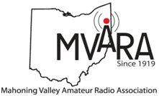***The Mahoning Valley Amateur Radio Association***, celebrating its 100th Anniversary this year was asked by the Boy Scouts to help them celebrate the 100th Anniversary of Camp Stambaugh with Special Event Stations.  At first, they had some pretty high expectations and visions of us contacting the birthplace of scouting in England.  We explained propagation and sunspot cycles and agreed we would have better results with contacts in the US.  Our plan was to operate on 20, 40 and 80 meters and the Friday before the event we went to the camp to put up antennas.  What we thought was going to take a couple of hours rapidly became six hours, but we had a lot of laughs and a lot of fun.

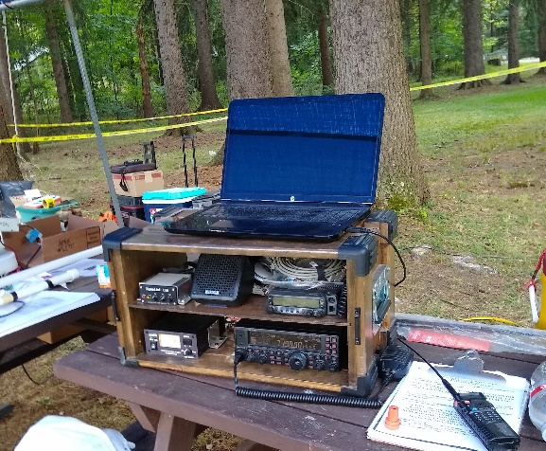Saturday before dawn, we met at the Canfield Fair Grounds and piled in to one car that contained all the equipment and anything, we thought we might need.  We set up in the dark and were on the air just as 800+ Boy Scouts, their troop leaders and parents paraded into the campground.  It was quite a sight!  We saw a lot of Scouts that day.

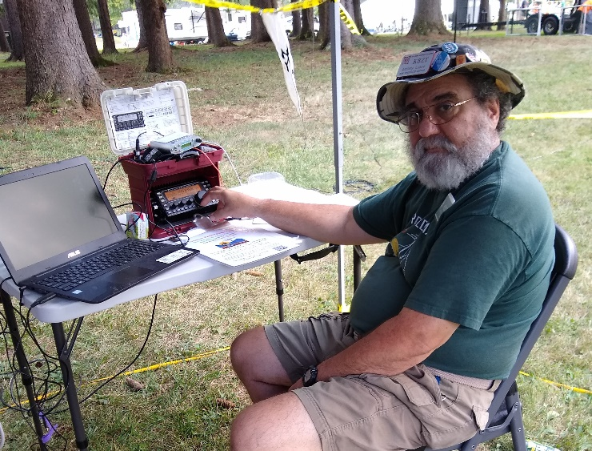Dave Brett KD8NZF had to have been a barker in another life because he could reel those Scouts in and get them interested. Dave and Nancy KD8QNY used the W8QLY repeater for conversations between local hams and the Scouts before passing them on to our Morse or HF operators. The help from our club members was fantastic making sure there was a voice on the other end of the repeater.   Anthony Luscre K8ZT would then show them Morse Code and have them use a key to send their own name so they could hear what it sounded like.  Frank Sole WB8YHD and Scott Wilton KE4UHC manned the HF radios and had Scouts try their hand at talking on the radio.

TOP ^

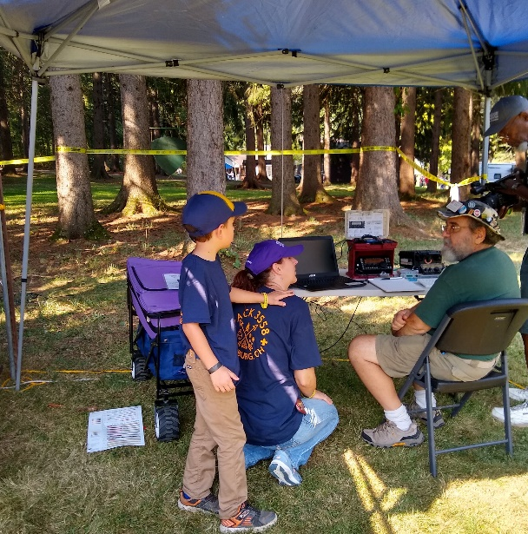We were able to talk to many Scouts about how to get licensed and how to contact our club for help or more information.  There were a couple of Scouts that dragged their dads back to the radios several times during the day.  One Scout, who participated in our Radio Merit Badge Class last year, dragged his dad back four times. At one point he had an HT in each hand, was listening to another radio and telling other people how to operate.  I think we have a budding new ham.

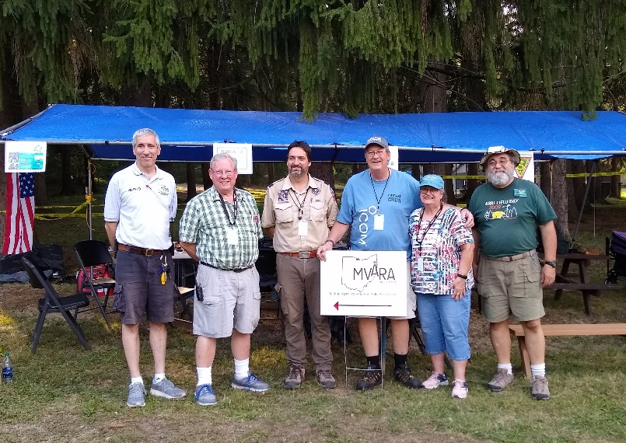After a year in planning, numerous meetings, emails, phone calls and one very tiring weekend it all came together beautifully.

We had a great time working with the Scouts and hope that the Scouts had just as good a time.  Many thanks to Frank WB8YHD, Joe N8SEJ, Dave KD8NZF, Nancy KD8QNY and Anthony K8ZT (Ohio Section Youth Coordinator) for their help at Camp Stambaugh and a special thanks to the Hams on 146.745 for being the voice on the other end of the HT!

Now it’s time for JOTA.

73

Scott Wilton KE4UHC

#########

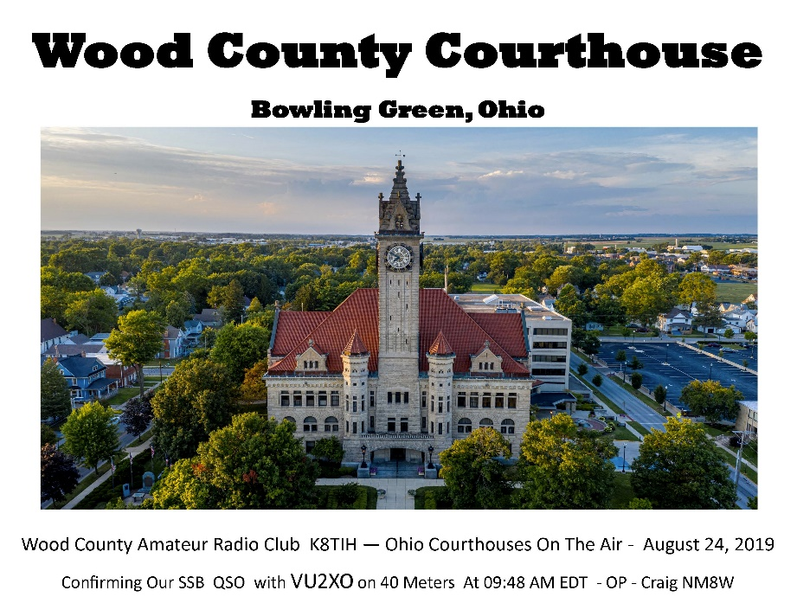

#########

TOP ^

***Link To Seneca County***

Here's some information on a weekly net originating out of Seneca County on the KC8RCI Linked Repeater System.  The North Central Ohio Traffic and Information Net is held at 10:15 am every Wednesday morning and has been developed as a step off net for NTS Traffic and to provide various information on amateur news items and events.

There are many linked repeaters available to access the KC8RCI System and the net: 147.255 & 444.4375/107.2 Republic; 443.075/151.4 Mansfield; 146.805/110.9 & 442.675/162.2 Berlin Heights; 443.9875/162.2 Elyria; 443.625/162.2 POLK; 53.290/52.290/107.2 VERMILION

#########



**Sunday - October 27, 2019** @ 12:00 PM Lunch/meeting

We will be meeting at the ABB Process Automation Cafeteria at 579 Executive Campus Drive. For more information contact: Art - WA8RMC at 614-891-9273

Lunch is provided – Door Prizes – Bring a friend and see old buddies. Mini Hamfest – Show and Tell

#########

***Lawrence County ARES - Simulated Emergency Test***

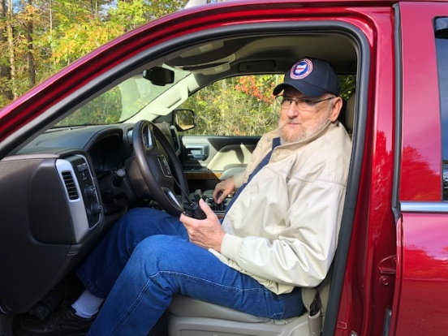Eddie Jenkins N8URU Lawrence County ARES, EC requested all members to meet at the Lawrence County Emergency Operations Center at 515 Park Avenue Ironton, Ohio on Saturday, October 19 at 8 AM to participate in the annual simulated emergency test.

The following are ARES members who participated: James Rowe N8TVO AEC, Keith Brooks N8DKB AEC, Eddie Jenkins N8URU EC, Tim Nicely AC8VQ President of SOARA and Mike Love WB8YKS PIO.

The training exercise scenario included field deployment of mobile operators to establish field communications utilizing only simplex. The scenario assumed all amateur radio repeaters were out of service and only simplex communications would be possible. Additionally, in the scenario critical communication was required from a remote northern part of the county.

TOP ^

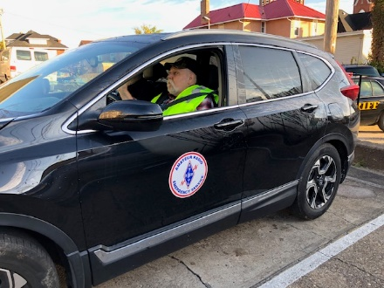Immediately the team discussed options as to the best way to deploy limited resources maximizing on time, equipment and manpower. They reviewed topo maps and a 2016 publication of the Lawrence County roadway system. Elevation in Lawrence County is critical to achieve distant communications using simplex, especially along State Route 93 to Blackfork approximately 29 miles north from the EOC.

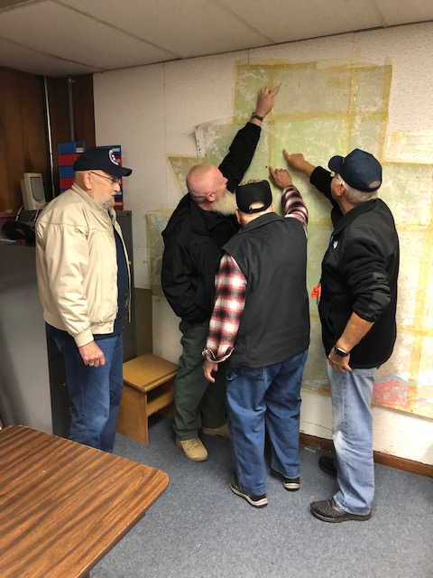Two mobile units were dispatched, one to Dean State Forest which is one of the highest elevations in Lawrence County and the other proceeded north to Blackfork to establish a communications post for critical emergency communications to the EOC.

Once the mobiles were in place communications was establish and relayed from Blackfork to Dean State Forest and relayed to the Lawrence County EOC. Official communication using the ARRL Radiogram format was successfully passed, received, and relayed. Additionally, a second relay location was later established at the highest elevation at Lake Vesuvius.

Although, this was just an exercise it certainly could have been a real event. Therefore, training is paramount for the ARES team to keep their skills sharp and equipment ready to deploy at a moment’s notice.

Mike Love, WB8YKS, Ohio Section PIO

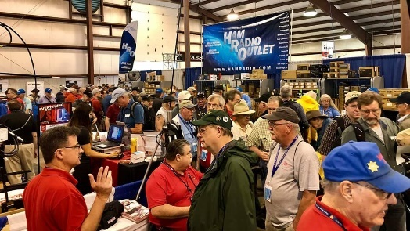[***Upcoming Hamfests***](http://arrl-ohio.org/hamfests.html)

**11/02/2019 | GARC Hamfest**Location: Georgetown, OH  
Sponsor:Grant Amateur Radio Club  
Website:<https://www.facebook.com/Grant-Amateur-Radio-Club-775764122477536/?modal=admin_todo_tour>

|  |  |
| --- | --- |
| **11/03/2019 | Massillon ARC Hamfest** Location: Massillon, OH Sponsor: Massillon Amateur Radio Club Website:[http://www.w8np.org](http://www.w8np.org/) | **12/07/2019 | Fulton County ARC Winterfest** Location: Delta, OH Sponsor: Fulton County Amateur Radio Club Website: <http://k8bxq.org/hamfest> |

TOP ^

***DX This Week***

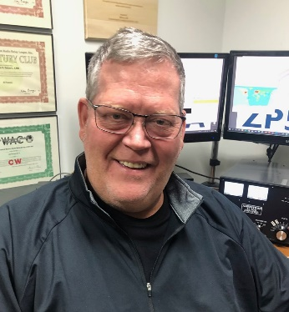*(from Bill, AJ8B)*

***DX This Week – A Year of DX***

***Bill AJ8B (***[***aj8b@arrl.net***](mailto:aj8b@arrl.net)***, @AJ8B, or*** [***www.aj8b.com***](http://www.aj8b.com)***)   
 CWOPs Member #1567***

I hope you have been listening to the bands and calling CQ! It always amazes me how people react during major contest weekends. They are surprised at the station on the air as if the contests are scheduled during better propagation days! If no one ever calls CQ, it is going to send dead!

Although the sunspots are down, there has been quite a bit of DX in the air. I have been following Uncle Franks advice and checking [www.dxsummit.fi](http://www.dxsummit.fi) to help me keep an eye on propagation. There were about 45 DX Entities spotted by midwestern hams the past week including Argentina, Bermuda, Brazil, Bulgaria, Chile, Colombia, Dominican Republic, Ecuador, Ghana, Greenland, Japan, Kuwait, Lesotho, Peru, Scotland, St. Pierre & Miquelon, Suriname, Switzerland, Ukraine, and Venezuela. Just wait for the sunspots to increase!

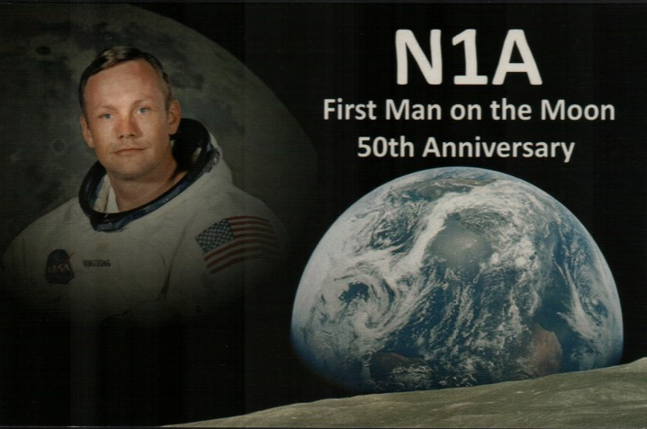This week, the mailman delivered a few goodies including JF1IRW – Japan, S51YI – Slovenia, and N1A – The commemorative QSL from the Milford Amateur Radio Club celebrating the 50th Anniversary of the First Man on the Moon. (Pictured) Kudos to K8DV and his group for running a great event and getting the cards out. I saw the incoming bundle of cards and it was impressive!

What did you get? Send me an image and some details!

This month, I am including an article, with his permission, from Carl, K9LA. Carl is a leading authority on propagation and a prolific writer. He spoke at the W8DXCC DX Convention last year and I have a hunch he will make another appearance this June! This is a fascinating article about the new operating modes and propagation. I am in the midst of operating during my 5th solar cycle and I can tell you from experience that, previous to these modes, when sunspots were low, there was nothing on. You would often check to see if your antenna was still connected! Thanks to Carl and SWODXA for the permission to reprint this article. Carl has other excellent articles at [www.k9la.us](http://www.k9la.us)

***What Mode of Propagation Enables JT65/JT9/FT8/FT4?***By *Carl Luetzelschwab, K9LA (K9la@arrl.net* )

{The purpose of this article is not to rigorously analyze how much improvement each JT mode offers – the purpose is to introduce the concept of a well-documented but less well-known mode of HF propagation and how it ties into the success of the JT modes. —K9LA}

TOP ^

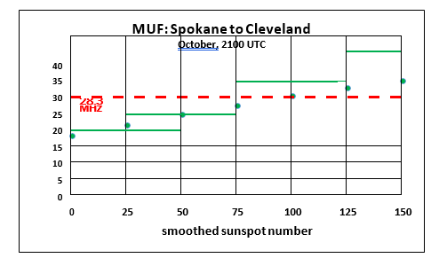It should be obvious that K1JT’s JT65/JT9/FT8/FT4 digital modes are making big changes in band usage, especially on the higher bands as we approach solar minimum between Cycle 24 and Cycle 25. Is there a new propagation mode lurking here? Or is it just a less-known propagation mode that hasn’t received much attention? Let’s analyze a 10-Meter path between Spokane, WA and Cleveland, OH (approximately 3000 km – one-hop via the F2 region) to understand what’s going on.

We’ll use VOACAP to do this at a frequency of 28.3 MHz, with the transmitter in Spokane at 47.66o North latitude / 117.43o West longitude and the receiver in Cleveland at 41.50o North latitude / 81.70o West longitude. The month is October (a very good month for ionospheric propagation via the F2 region in the northern hemisphere) and the time is 2100 UTC (the best time for F2 region propagation between Spokane and Cleveland).

The antennas at both ends are assumed to be small Yagis at 40 feet over flat ground. The ground parameters used are for average ground – a conductivity of .005 Siemens per meter and a relative permittivity of 13. The resulting antenna gain is about 12 dBi at a peak elevation angle of 13 degrees. The transmit power is 100 Watts. The following are the predicted MUFs (maximum useable frequencies) from VOACAP at various smoothed sunspot numbers.

The MUF is the first parameter needed for a QSO to be made – it must be high enough to assure that the signal gets from Spokane to Cleveland.

The above plotted data is that F2 region propagation at 28.3 MHz should only be supported on this path when the smoothed sunspot number is greater than 75 because the MUF is greater than the operating frequency. The usual assumption here is that refraction occurs when the MUF is greater than the operating frequency. In other words, the ionization is enough to refract (bend) signals back to Earth. When the MUF is less than the operating frequency, the signal is not refracted enough and goes off into space, with no signal reaching the target.

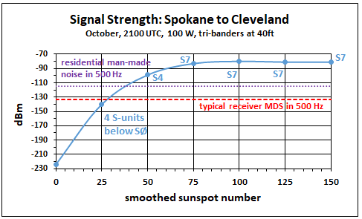Now let’s look at the predicted signal strength from VOACAP. Signal strength is the second parameter needed for a QSO to be made – the losses must be low enough so you can hear the other station’s signal. Here’s what VOACAP says for signal strength versus smoothed sunspot number for the selected path.

There are two important observations to be made from this data. The first observation is that when the smoothed sunspot number is high enough so that the MUF is above the operating frequency (greater than 75 in this example), the signal strength is pretty much constant. This signal strength (actually signal power) is around -83 dBm, which translates to around S7 (as annotated on the plot) assuming S9 = -73 dBm and an S-unit is 5 dB (which is what I’ve measured on my receivers).

TOP ^

What’s happening when the smoothed sunspot number is greater than 75 is refraction coupled with minimal ionospheric absorption (absorption is inversely proportional to the square of the frequency – it is less than a dB per hop on 10-Meters – this is one of the reasons why 10-Meter signals can be so strong). As a side note, all the signal strength values include the antenna elevation pattern of both Yagis at 40 feet.

 Note that when the smoothed sunspot number is greater than 75, there is a huge amount of dB difference between S7 and the typical MDS (minimum discernible signal – a.k.a. sensitivity) of our receivers at around -133 dBm (the dashed red line) in a bandwidth of 500 Hz (a typical CW bandwidth). The difference is around 50 dB! This means the Spokane station could reduce his/her transmit power by 50 dB (to 1 milliwatt – now that’s QRP!) and still be heard in Cleveland.

But we need to watch it here – usually man-made noise, even on 10-Meters, limits the sensitivity of our receiving system. Using the data in the ITU (International Telecommunications Union) document ITU-R P.372-13 for a residential noise environment indicates the true sensitivity of the Cleveland station is limited to around -115 dBm in a 500 Hz bandwidth (the dotted purple line). Realistically the Spokane station could now only reduce his/her power to 100 milliwatts when the smoothed sunspot number is greater than 75. Still not bad, though!

The second observation is that VOACAP still predicts signal strengths when the smoothed sunspot number is less than 75 – in other words, it predicts that propagation is still possible although full refraction cannot happen. At a smoothed sunspot number of 50, the predicted signal level is -99 dBm, which translates to around S4 and it is still above the man-made noise level. Is this an error on VOACAP’s part? No, it isn’t. VOACAP is simply trying to reflect (no pun intended) the real world.

In the real world, measurements over many paths have shown that a readable signal is still present even when the MUF is below the operating frequency. This called an above-the-MUF mode of propagation, and VOACAP includes the Phillips-Abel theory (note 1) to do the necessary math to predict propagation under this condition (note 2).

The mechanism for an above-the-MUF mode is believed to involve random patches of ionization that have a higher electron density than the background plasma and/or scatter – it could be ionospheric scatter, ground scatter or even sea scatter (note 3).

Regardless of the specific mechanism, the one thing in common is additional loss. Thus the difference between the MUF and operating frequency is critically important – the more the difference, the more the loss. In summary, the above-the-MUF mode is why VOACAP still predicts signal strength (instead of abruptly cutting off the prediction) when the MUF is below the operating frequency.

Now that we’ve looked at the normal “decode with ear” scenario, let’s move on to the JT65/JT9/FT8/FT4 scenario. Our analysis will make three major changes – we’ll switch from signal strength to SNR (signal-to-noise ratio), we’ll switch from 100 Watts to 10 Watts and we’ll use a 2.5 KHz bandwidth. These changes put the analysis in line with current JT65/JT9/FT8/FT4 practices (note 4). The SNR versus smoothed sunspot number follows (note 5). The data point at a smoothed sunspot number of 0 is not plotted to give better resolution to the other data.

If Spokane is operating on CW at 10 Watts, Cleveland should be able to decode by ear the Spokane station’s 10-Meter signal in the 2.5 KHz bandwidth when the smoothed sunspot number is above 50. This assumes humans can copy CW at an SNR of 0 dB, which is a realistic assumption.

TOP ^

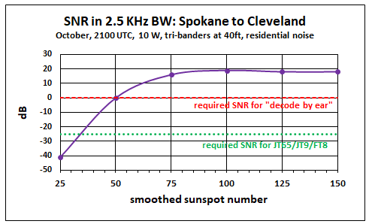But by using JT65/JT9/FT8/FT4, we should be able to make the QSO all the way down to a smoothed sunspot number of around 35. This assumes JT65/JT9/FT8/FT4 can decode down to an SNR of around -25 dB (a ballpark value for all three modes in the 2.5 KHz bandwidth – remember the purpose of this article is not to rigorously analyze the improvement with each JT mode). The 10- Meter band may be “dead” assuming the normal definition, but JT65/JT9/FT8/FT4 gives us the possibility of still making QSOs via the above-the-MUF mode.

An interesting corollary here is that VOACAP should be able to be used to predict JT65/JT9/FT8/FT4 openings on our higher bands (15-Meters, 12-Meters and 10-Meters) as Cycle 24 declines and we go through solar minimum. How accurate would it be? Recording observed openings and comparing to SNR data from VOACAP (using appropriate power levels, noise environments, bandwidth and antennas) would shed light on that question.

As far as I’m aware, the Phillips-Abel theory should also apply to 6-Meters. Unfortunately, VOACAP does NOT include 6-Meters, so you can’t use VOACAP for any above-the-MUF predictions on 6-Meters. However, one might be able to extract the Phillips-Abel losses for the above-the-MUF mode from VOACAP, and then apply these losses to real-time MUF data (for example, at http://af7ti.com/).

In summary, there appears to be a lot of RF flying around up above us that is below our normal noise level thanks to what we can generally call “scatter”. Using JT65/JT9/FT8/FT4 allows us to “hear” some of that. Finally, to reiterate, there doesn’t appear to be a new propagation mode for JT65/JT9/FT8/FT4. It’s just a less-known propagation mode that hasn’t received much attention.

1. **Notes**J. L. Wheeler, Transmission Loss of Ionospheric Propagation Above the Standard MUF, Radio Science, Vol. 1, No. 11, November 1966
2. For analysis of above-the-MUF modes, see L. F. McNamara, T. W. Bullett, E. Mishin and Y. M. Yampolski, Nighttime above-the MUF HF propagation on a midlatitude circuit, Radio Science, Vol. 43, RS2004, doi:10.1029/2007RS003742, 2008
3. R. Silberstein, Great-Circle and Deviated-Path Observations on CW Signals Using a Simple Technique, IEEE Transactions on Antennas and Propagation, January 1965
4. Steve Ford, Work the World with JT65 and JT9, ARRL, First Edition Second Printing, 2015- 2017
5. Although a 2.5 KHz bandwidth is used in the plot for an apples-to-apples comparison, most CW operators use a narrower bandwidth (around 500 Hz) – which would offer CW a 7 dB performance improvement over that in the plot

TOP ^

+ --------------------------------------------------------------------------------------------------+

Here is an update from Bernie, W3UR, of the DailyDX and the WeeklyDX,

the best source for DX information.

(<http://www.dailydx.com/> ) Bernie has this to report:

+ --------------------------------------------------------------------------------------------------+

**VP2M – Montserrat -** VP2MSW will be on for the CQWW SSB October 26-27 by K3SW.  He plans to be a single operator all band high power assisted.  QSL through LoTW.  His inclusive dates on the island are October 22-28.  If possible, he says, he will get on the air before the CQWW starts.  On the 28th he has to disassemble the station so he will likely not be on the air that day.  Though LoTW is the primary route he recommends, you can get a direct QSL from K3SW by sending $3 US for QSLs outside the US and $1 for US postage within the US, "but be patient."  
  
**EA8 - Canary Island -** ED8W is planned for the October 26-27 CQWW SSB weekend, a multiop.  On the operator list are EA7LL, EA7RU, EA7FQB, EA8LF, EA8DIG, OM5RW, TF3CW and EA8DO.  QSL via LoTW.

**T8 – Palau -** T88KZ will be operator Jery Juhn, HL5BHH, at the VIP Guest Hotel on Koror.  He will be holiday style October 21-24, with his activity mostly on SSB and possibly FT8, on 80-6 meters.  He says he will not have paper QSLs for this operation but will upload everything to LoTW as soon as he is back home.

**S7 – Seychelles -** S79ZM will be the callsign October 18-31 for OK1FZM and OK1WZM, a husband and wife team, Martin and Lenka.  They will be on CW and SSB with 100 watts from a Yaesu FT-891 and dipoles and verticals from Mahe Island the first week and Praslin Island the second week.  If conditions seem worthwhile, they will get on during the CQWW DX SSB contest to give out some points and the multiplier and have fun.

They will be on 80-10 "but mostly on 30-17M."  Martin will do CW and SSB and Lenka will stay on SSB.  QSLs for OK and OM stations will go out through the bureau.  They say, "Don't send your QSL!" All QSOs will get a "traditional bureau card."  Or go direct to OK1FZM using the QRZ.com address.  No Club Log, no LoTW. Martin says "Please, don't expect a DXpedition; 'holiday style' are the real words.  All equipment will be carried in a backpack, so no PAs or big antennas."  
  
**8P – Barbados** - W2SC at 8P5A will light up the airwaves again for the CQWW SSB contest, single op all band high power, October 26-27.  QSL via HA1AG or use LoTW.

***DX news***

***ARLD041 DX news***

This week's bulletin was made possible with information provided by PP2BT, The Daily DX, the OPDX Bulletin, 425 DX News, DXNL, Contest Corral from QST and the ARRL Contest Calendar and WA7BNM web sites.

Thanks to all.

**VIET NAM, 3W.** Geri, DK8KW is QRV as 3W9KW from Hanoi until October 26. Activity is on the HF bands using CW and SSB. QSL to home call.

TOP ^

**MALTA, 9H.** Rene, DL2JRM is QRV as 9H3YY until October 22. This includes being an entry in the Worked All Germany contest. QSL to home call.

**BOTSWANA, A2.** A large group of operators will be QRV as A21EME from October 20 to 29. Activity will be on 6 and 2 meters, and 70 centimeters, using CW and JT65 on EME. Next, they will be active on 23, 13, 9, 6, and 3 centimeters using CW and JT65. QSL 6 meter, 2 meter, 70 centimeter and QO-100 contacts via PA3CMC. QSL all others via HB9Q.

**COMOROS, D6.** Members the Mediterraneo DX Club will be QRV as D68CCC from October 21 to November 2. Activity will be on 160 to 10 meters using CW, SSB, RTTY and FT8. QSL via IK2VUC.

**ST. LUCIA, J6.** Medical Amateur Radio Council members Jay, AA4FL, Bob, K4RLC, Bruce, KM2L, Diane, N2HIW and Dave, KN2M are QRV as J6/home calls until November 2. Activity is on the HF bands. This includes being active as J68MD in the upcoming CQ Worldwide DX SSB contest. QSL J68MD via N2HIW and all others via operators' instructions.

**ST. MAARTEN, PJ7.** Ed, N2HX will be QRV as PJ7PL from October 19 to November 2. Activity will be on the HF bands using SSB, RTTY, FT8 or FT4. This includes being an entry in the upcoming CQ Worldwide DX SSB contest. QSL to home call.

**FERNANDO DE NORONHA, PY0F.**  Members of the Noronha Contest Group will be QRV as PY0F from October 21 to 25 while preparing for their entry in the upcoming CQ Worldwide DX SSB contest. Activity will be on the HF bands, including 160 and 80 meters. QSL direct to PY7RP.

**SURINAME, PZ.** A group of operators will be QRV as PZ5K from October 23 to 29. Activity will be on the HF bands. This includes being an entry in the upcoming CQ Worldwide DX SSB contest. QSL via G3NKC.

**SEYCHELLES, S7.** Janusz, SP9FIH and Leszek, SP6CIK are QRV as S79W and S79CI, respectively, until October 29. Activity is on 160 to 10 meters using CW, SSB, RTTY and FT8. This includes being an entry in the upcoming CQ World Wide DX SSB contest. QSL to home calls.

**PALAU, T8.** Jery, HL5BHH will be QRV as T88KZ from October 21 to 24. Activity will be holiday style on 80 to 6 meters using SSB and some FT8. QSL via LoTW.

**ST. KITTS AND NEVIS, V4.** John, W5JON is QRV as V47JA from Calypso Bay, St. Kitts, IOTA NA-104, until October 22. Activity is on 160 to 6 meters using SSB and FT8. QSL direct to home call.

**NORFOLK ISLAND, VK9N.** Mek, SP7VC is QRV as VK9NC using digital modes until October 28. Jacek, SP5EAQ is QRV as VK9NE using SSB until November 4. Marcin, SP5ES will be QRV as VK9NG using CW from October 28 to November 4. QSL all calls to SP7VC.

**PITCAIRN ISLAND, VP6.** A large group of operators are QRV as VP6R until November 1. Activity is on 160 to 6 meters with eight stations active using CW, SSB, RTTY and FT8. This includes being an entry in the upcoming CQ World Wide DX SSB contest. QSL via LoTW.

TOP ^

**LAKSHADWEEP ISLANDS, VU7.** Operators Sree, VU2OB, Shabu, VU2CAC and Samson, VU3XTG will be QRV as VU7RI from October 10 to 30. Activity will be on 80, 40, 30, 20 and 15 meters using CW, SSB and FT8. QSL via M0KRI.

**VANUATU, YJ.**  Chris, VK2YUS will be QRV as YJ0CA from Efate Island, IOTA OC-035, from October 22 to 30. Activity will be on 40, 20 and 15 meters, and possibly 10 meters, using SSB. This includes an entry in the upcoming CQ World Wide DX SSB contest. QSL direct to home call.

THIS WEEKEND ON THE RADIO. The ARRL EME Contest, Stew Perry Topband Challenge, 10-10 International Fall CW Contest, NCCC RTTY Sprint, NCCC CW Sprint, JARTS World Wide RTTY Contest, Araucaria World Wide VHF Contest, New York QSO Party, Worked All Germany Contest, Feld Hell Sprint, Argentina National 7 MHz Contest, Asia-Pacific Fall CW Sprint, UBA ON 2-Meter Contest, Illinois QSO Party and the RSGB RoLo 80-Meter CW will certainly keep contesters busy this upcoming weekend.

The Run for the Bacon QRP Contest and Telephone Pioneers QSO Party are scheduled for October 21.

The CWops Mini-CWT Test, RSGB 80-Meter Autumn Data Series, SKCC CW Sprint and Phone Fray are scheduled for October 23.

The ARRL School Club Roundup runs from October 21 to 25.

The Canadian National Parks on the Air, CNPOTA, operating event runs for the entire year of 2019, with special stations active from Canada's parks and historic sites.

Please see October QST page 90 and the ARRL and WA7BNM Contest Web Sites for details.

***Special Events***

**11/02/2019 | 44th Anniversary, Sinking of the Edmund Fitzgerald**

**Nov 2-Nov 17, 0000Z-2359Z, W8F**, Detroit, MI. Livonia Amateur Radio Club. 14.260 7.040 14.040 7.240. Certificate. Tas Foley, K8TAS, 37255 Euraka Rd., Romulus, MI 48207. On Saturday, November 2, W8F will operate from the Dossin Great Lakes Museum, Detroit MI 1600-2030 UTC. SASE FOR QSL CERTIFICATE [livoniaarc.com](http://livoniaarc.com/)

**11/11/2019 | Veterans Day Special Event**

On Monday Nov 11, 2019 The American Legion Amateur Radio Club Post 641 (W8BVL) in Belle Valley, Ohio will be on the air from 12:00 Noon EST to 4:00 PM EST in Observance of Veterans day. We will be broadcasting on or around 7.225 and /or 14.275 depending on participants and ban conditions. For more info contact: Gary Oliver, KD8OSI [garyoliver523@gmail.com](mailto:garyoliver523@gmail.com)

**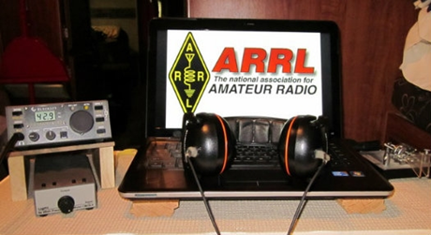*ARRL Contest Corner***

An expanded, downloadable version of *QST'*s [Contest Corral](http://www.arrl.org/contest-calendar) is available as a PDF. Check the sponsor's Web site for information on operating time restrictions and other instructions.

TOP ^

*****V.E. Test Sessions***

For the latest testing site information please **>>** [Click Here](http://www.arrl.org/find-an-amateur-radio-license-exam-session) **<<** The ARRL site tracks all of the VE testing sites that register with them, including W5YI and Laurel. ARRL gives you a number of different ways of sorting to find that site that is closest to you as well.

***One Question Questionnaire***

Hey Gang,

Wow, “Survey Says” --- 76% of you assemble your own PowerPole connectors. That’s really fantastic!!

I’ve got another NEW – one question – for you on the Ohio Section Website!

**“Do you have a S.A.M.E. weather radio in your shack?”**

These One Question questionnaires are all in fun and I hope that you are enjoying answering them.

You’ll find the “One Question” questionnaire on the Ohio Section Website! <http://arrlohio.org> It’s all in fun and it’s not a scientific survey in any way, but we are learning some things that we didn’t know from these questions. I hope that you are enjoying answering these “One Question” questionnaires.

***ARES Connect***

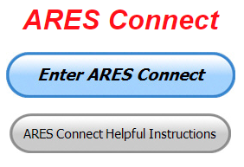This week I want to change things up a little. I want to do a little Q & A with some questions that have been cropping up from all over the country.

As many of you know I was asked by Headquarters to take on the challenge of being the troubleshooter for ARES Connect nationwide. Yes, it’s a big challenge for sure, but one that I really like doing. So, with that said, let’s get down to it.

**Q:** Why the need for doing all of this. I never had to do this before, so why now.

**A:** You are correct! You never had to do it before, and the numbers reflected it. Most of you never had a clue as to where the numbers came from. You just knew that there were numbers being turned in. The numbers actually came from the E.C.’s remembering to do their monthly reports. They also had to remember who did what, where, when and why as well as remember just how much time was involved. Now, for the biggies like tornadoes and flooding events that was easy to remember, but for those “Spandex” races and long nights at the repeater site fixing a sick repeater the E.C. most likely didn’t know who really was involved and just how many hours were spent? So many hours that could have been reported were lost, as well as who participated. It’s now being captured by ARES Connect and your participation with it.

TOP ^

**Q:** Why do I need to sign up for an event and then go back afterward and assign my time to that event. Why can’t I just assign my time to the event alone and skip signing up for it in advance. If I’m there, I’m there.

**A:** By signing up for an event in advance the event coordinator will know just how many volunteers he can count on before the event. It’s really no different than having that dreaded “Sign-up Sheet” get passed around at a meeting, except that you don’t have the peer pressure to sign up for something that doesn’t interest you. Signing up in advance can also benefit YOU in the case where an event gets cancelled or moved, the system can send you an email to let you know of the changes BEFORE you get to the event. It also can send you a reminder so that you don’t forget that you have an event coming up. And, here’s one that happened just the other week. Folks were asked to sign-up in ARES Connect so that they could have an accurate count to know how much pizza to order for a meeting. If you didn’t let them know in advance, you could be the one sitting there not enjoying the pizza. Hey, look at it this way, you have a built in “personal secretary” that reminds you of your important events!

This step is also there so that the E.C. doesn’t have to keep a separate list of volunteers like he used to do. You have no idea of how hard it actually is to have an accurate listing of folks who “just showed up” for an event, let alone keep track of their hours spent on that event. And, if there’s more than just a couple of events in the month, those lists could (and have) gotten lost, or worse, just forgotten about. ARES Connect keeps a permanent record that the Admins can go back years in the past and look up information about if needed. This beats any paper record hands down.

The process of you going in after the event and recording your time is to your benefit. Who better than YOU know’s just how much time you spent at an event? I will also tell you that you have just 29 days to enter your time for a past event.

**I want to stress that events happening near, or at the end of the month, we desperately need you to get your time turned quickly. For now, we are doing a monthly report to Headquarters until they switch over everyone in the county to ARES Connect. In order to have the most accurate numbers for the report, we need everyone to make sure your time is entered by no later than the 6th of each month for the month past.** I am asking this of you so that when we start the process of going through the tabulations for the report, we have the most up-to-date information possible.

**Q:** Will my time still count even if I get it entered late.

**A:** Yes, this is a “live” system and is being updated with new information every day. That means that the numbers generated today will not necessarily be the same as yesterday. So, it really behooves all of us to be prompt at getting our time recorded as soon as possible.

**Q:** I don’t like signing up for events that I may not be able to make but I have to with ARES Connect.

**A:** Yes, this is true, the system wants you to sign-up for events knowing that you may not always be able to make it. The system does have a feature built in that will allow you to cancel your “sign up” if you just can’t make it and know in advance. We all know and understand that family and work take precedence over Amateur Radio.

**Q:** Are hours recorded for me even if I don’t participate in an event even though I signed up for it?

TOP ^

**A:** No, that’s the real beauty of this system. No hours will be recorded for you automatically. This is why you need to go in after the event and record your time. If you didn’t participate, then you can just skip this part of the process.

**Q:** When I go into ARES Connect, I see all these pages of events. I’m not interested in seeing anything but the county I live in. Can I change this?

**A:** Yes, you can select down to the county level at any time. If you’re a person that doesn’t clear his “cookies” out much in your browser, the listing or calendar will return to the last view that you selected. This means that if you selected down to a county, it will show only that when you sign in again. If you do clear out your “cookies” you will need to reselect how you want to view the events.

You can also do a search for any particular event or county that you want to view. In the upper right-hand corner of the screen is an icon resembling a magnifying glass, click on that icon and it will open up a search box. Just enter in the name of the event or county and then hit enter. It will take you to what it has found.

**Q:** Is my information secure on ARES Connect?

**A:** Yes, your information is secured. Here’s a quick way of telling whether your information is on a secured server.  Notice the lock at the left, that means it’s a secured server. If you don’t see that on a website it isn’t secure. Now, while I have you looking at the URL, please make sure that you see the **/lp/oh/** at the end of the URL. This assures that you are on the Ohio Section landing page, and YES, it does make a huge difference.

Do you need help with how to sign-up for an event or log your hours? How about you Administrators, do you have questions about approving your volunteer’s hours or how-to set-up a recurring event? I’ve got the answer for all of you. I have a new webpage with step-by-step instructions on how to do those things and many more.

I also have a “Hints and Kinks” section that has a lot of great information on how to do something or why something works like it does. Here’s the page: <http://arrl-ohio.org/SEC/connect/index.html> You can also find this link on the main page of the Ohio Section website as well.. It’s just under the “Enter ARES Connect” link.

I am seeing a number of folks creating more than one account because they can’t remember their password from the one that they originally setup. Please don’t do this. The system has a really good way of sending you a link to your email address so that you can refresh your password. If you are experiencing problems with getting to this link, contact me: [n8sy@n8sy.com](mailto:n8sy@n8sy.com) and I’ll get it fixed for you.

We now have **1,265** registered and growing every day in the system. What’s really interesting is as of this same date there are **11,917** registered in the entire country. This means that the Ohio Section makes up over **10.61%** of those registered.

Here’s a link to get you started... <http://www.arrl-ohio.org/SEC/connect/ares_connect_directions.pdf>

Please, don’t just hurry through the questions, read them carefully, if you don’t understand something, please ask me, I’m here to answer your questions.

TOP ^

***Here’s the top 10 hours earners so far for October:***

|  |  |  |  |
| --- | --- | --- | --- |
|  | **Name** | **Events** | **Hours** |
| 1 | Daniel Schlick (KB8LKH) | 10 | 87.50 |
| 2 | Christopher Domenick (KC8CAD) | 15 | 56.75 |
| 3 | Dan Stahl (KC8PBU) | 39 | 55.36 |
| 4 | Bryan Hoffman (kc8egv) | 9 | 45.50 |
| 5 | James Yoder (w8erw) | 10 | 37.25 |
| 6 | Dennis Niehaus (KD8ZLB) | 13 | 37.00 |
| 7 | John Westerkamp (W8LRJ) | 24 | 34.17 |
| 8 | Bret Stemen (KD8SCL) | 14 | 34.00 |
| 9 | Chris Thomas (KD8YVF) | 9 | 33.50 |
| 10 | William Penfield (w8get) | 3 | 32.50 |

As you can see from the above listing, we can get real time information that shows how many hours, who volunteered and what they volunteered for. There’s a ton of information that we can draw out of the system.

#########

***Special NIMS Training Available***

**ICS-300 on November 13-15, 2019** (29 seats available)

Training Location:

Franklin County Sheriff's Academy

6373 Young Road

Grove City, OH 43123

There will be some additional classes posted soon (**ICS-300 December 3-5, 2019** at Upper Arlington Fire Station 72, 3861 Reed Road, Upper Arlington and **ICS-400 February 4&5, 2020** at Upper Arlington Fire Station 72, 3861 Reed Road, Upper Arlington) For more info: [pktickle@franklincountyohio.gov](mailto:pktickle@franklincountyohio.gov)

#########

***EMA-G2300 INTERMEDIATE EOC FUNCTIONS***

**Hosted by: Franklin County Emergency Management & Homeland Security November 13 - 15, 2019**

**Course Description:** The G 2300 Intermediate Emergency Operations Center Functions is a three-day course with the goal of assisting individuals and jurisdictions who desire to develop or improve their Emergency Operation Centers (EOC). By the end of the course, students will be able to demonstrate, through activities and a Final Exam, the managerial and operational roles of the modern-day EOC as a NIMS Command and Coordination functional group operating within a Multiagency Coordination System (MACS).

**Application Deadline:** October 30, 2019

**Time of Course:** Registration: 7:30 am – 8:00 am (on day one)

Course Time: 8:00 am – 5:00 pm

TOP ^

**Location:** Franklin County Emergency Management & Homeland Security

5300 Strawberry Farms Blvd Columbus, Ohio 43230

**Supported By:** The Ohio Emergency Management Agency

**Recommended Participants:** Federal, state, tribal, territorial, local level, business and nongovernmental emergency management personnel who may be designated to support an Emergency Operations Center (EOC) within their jurisdiction or organization. The materials were developed with the assumption that audience members may have little or no actual experience as a member of an EOC Staff.

**Recommended Prerequisite:**

**ICS-100**: An Introduction to the Incident Command System,

**IS-2200: Basic Emergency Operations Center Functions**

**IS-700**: An Introduction to the National Incident Management System

**IS-800**: National Response Framework, An Introduction

**G-191**: Emergency Operations Center/Incident Command Interface

**IS-200: Basic Incident Command System for Initial Response.**

**Enrollment:** Students must enroll via the Department of Public Safety Training Campus website: https://trainingcampus.dps.ohio.gov/cm/cm710/pstc/pstc.html. Course registration will generally close 10 working days prior to the course start date. You can check enrollment/approval status via the Department of Public Safety Training Campus website. **Mission Statement** To coordinate activities to mitigate, prepare for, respond to, and recover from disasters.

**Course Costs:** This course is free to participants.

**Additional Information:** Lodging, meals, and all other expenses are the students’ responsibility.

**State Point of Contact:** Matt Jaksetic, State Training Coordinator, Ohio EMA (614) 799-3666, [mtjaksetic@dps.ohio.gov](mailto:mtjaksetic@dps.ohio.gov)

#########

***Campbell County Office of Emergency Management Upcoming Training***

Campbell County Kentucky Office of Emergency Management **FREE** Training Opportunities

**Physical and Cybersecurity for Critical Infrastructure (MGT 452)** – **October 16, 2019** – TTX / Register here; <https://qrgo.page.link/SkdRb>

**Advanced ICS-400** Command and General Staff-Complex Incidents - **October 23-24, 2019** - TEEX / Register here; <https://goo.gl/dVqj43>

**Sport and Special Event Evacuation Training and Exercise** - **November 6-7, 2019** - TEEX / **Tentative/Requested**

TOP ^

**Emergency Propane Water Injection Course** – **November 12, 2019** – Hebron Fire Protection District / Registration will open soon.

**Managing Critical Incidents at Institutions of Higher Education:** A Whole Community Approach (MGT-361) - **December 10-12, 2019** - TEEX / Register: <https://goo.gl/Qa3tUs>

***Swap & Shop Has Come to the Ohio Section Website***

Hey Gang,

Have you taken a look at the **Swap & Shop** page on the Ohio Section webpage yet?? Here’s a link that will take you there… <http://arrl-ohio.org/sm/s-s.html>

There’s already been some great activity going on up there, so I know that some folks have visited for sure. Do you have equipment that you just don’t need or want anymore? Here’s a great venue to advertise it, and it’s FREE!! No, it won’t be listed in this newsletter because it would take up way too much space, so your ad will only appear on the website.

It is there for any individual to post equipment Wanted / For Sale or Give-Away. No licensed vehicles/trailers or business advertising will be posted.

Postings are text only (no pictures or graphics) will be posted for a maximum of 1 month from date posting

and require a contact phone number or email within the posting.

Send your Wanted / For Sale or Give-Away post to:  [swap@arrlohio.org](mailto:swap@arrlohio.org)

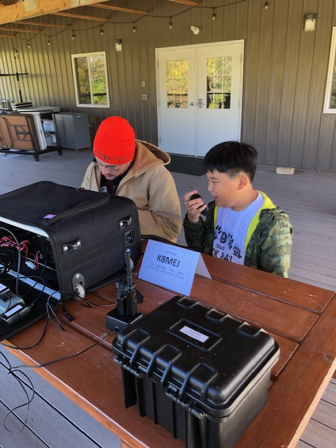

***JOTA in Central Ohio***

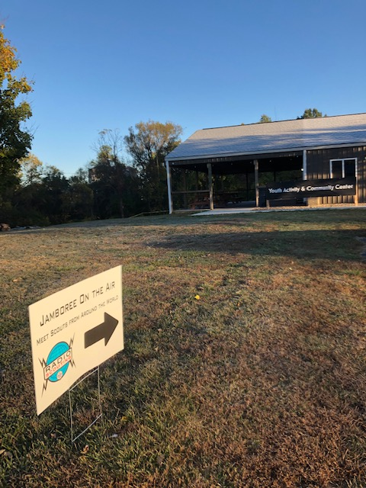

TOP ^

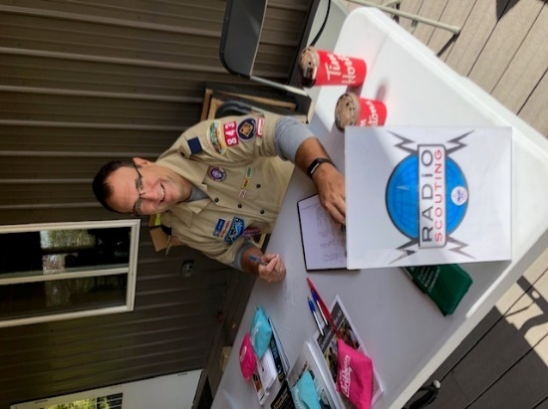

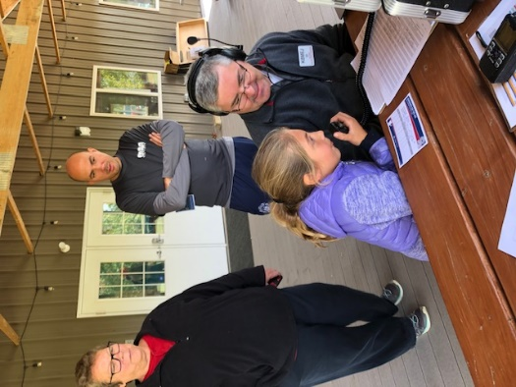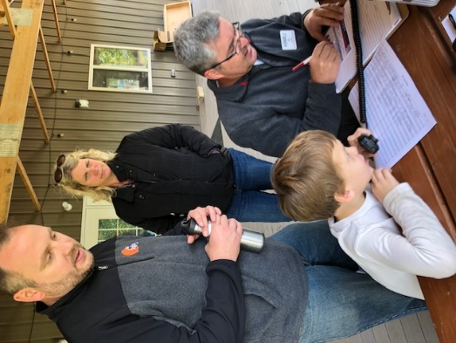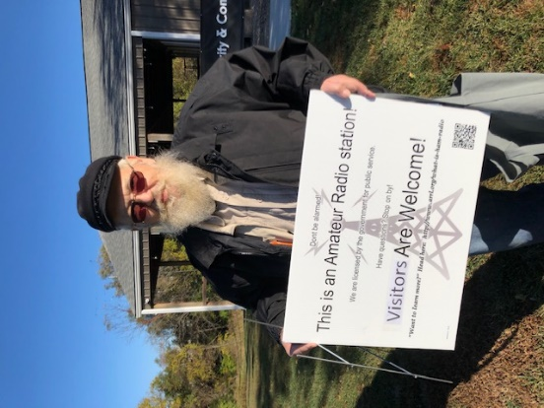

***Final.. Final..***

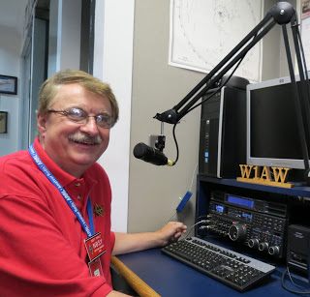

Hey Gang...

Wow.. I had a blast in Florida that past week, but now it’s time for me to get back home and back to work!

I had fun with the guys and gals of the InterCity ARC doing a V.E. Test Session. We acquired a new Technician and General out of it. I also had a blast at the Central Ohio Repeater Club (CORC) meeting last night. I did a presentation for them about the Ohio Section and how we stack up as a leadership Section for the entire country.

Sliding down the band a bit… Have you gotten on the air lately? It seems that many of you are getting licensed and then just not doing anything with it. Have fun with it! Get on the Air!!!

Is your club doing any special activities that you’d like the Section to know about? As you can see by the posts in the Club Corner, many clubs are already taking advantage of getting the word out to over 8,000 readers every week.

Do you have a story that you’d like to tell about something that you or your club has or is doing? Let me know about it and let’s get it in the next edition!

Whelp… That’s going to do it for this time around. Stay safe, enjoy the sunshine while we have it, and most of all… have FUN!!

73,

***Scott, N8SY***

TOP ^

***Welcome New Subscribers***

Tim, NC8X

***Want to Share your Club Newsletter With Others?***

Is your club’s newsletter available to share? I’ve got a new webpage that has links to all of the known websites where club newsletters can be accessed throughout Ohio.

Now, as we all know when any list is published, it’s outdated immediately. That’s ok, just send me the link to your club’s newsletter and I’ll get it on the webpage – [n8sy@n8sy.com](mailto:n8sy@n8sy.com)

Here’s the link: <http://arrl-ohio.org/club_link/links-to-newsletters.html> Remember, we’re all here to help each other. What a great way to share the news about Amateur Radio!!

***The Origin of "Old Sayings"***

*(from Tom (Parky) Parkinson, KB8UUZ)*

Early aircraft throttles had a ball on the end of it, in order to go full throttle, the pilot had to push the throttle all the way forward into the wall of the instrument panel. Hence "balls to the wall" for going very fast. And now you know the rest of the story.

During WWII, U.S. Airplanes were armed with belts of ammo, which they would shoot during dogfights and on strafing runs. These belts were folded into the wing compartments that fed their machine guns. These belts measure 27 feet and contained hundreds of cartridges. Often times, the pilots would return from their missions having expended all of their bullets on various targets. They would say, "I gave them the whole nine yards," meaning they used up all of their ammunition.

Did you know the saying "God willing and the creek don't rise" was in reference to the Creek Indians and not a body of water? It was written by Benjamin Hawkins in the late 18th century. He was a politician and Indian diplomat. While in the South, Hawkins was requested by the President to return to Washington. In his response, he was said to write, "God willing and the Creek don't rise." Because he capitalized the word "Creek" he was referring to the Creek Indian tribe and not a body of water.

In George Washington's days, there were no cameras. One's image was either sculpted or painted. Some paintings of George Washington him standing behind a desk with one arm behind his back while others showed both legs and both arms. Prices charged by painters were not based on how many people were to be painted, but by how many limbs were to be painted.

Arms and legs are 'limbs,' therefore painting them would cost the buyer more. Hence the expression, 'Okay, but it'll cost you an arm and a leg.' (Artists know hands and arms are more difficult to paint.)

#########

TOP ^

***Back Issues of the PostScript and Ohio Section Journal (OSJ)***

Hey, did you know that PostScript and Ohio Section Journal (OSJ) are archived on the website? You can go back and look at any edition simply by clicking:

<http://arrl-ohio.org/news/index.html>

***Chit – Chat, and All That!***

Do you know someone that’s not getting these Newsletters? Please, forward a copy of this Newsletter over to them and have them “[Opt-In](http://arrl-ohio.org/forwarder/forwarding.html)” to start receiving them. Heck, just have them send me an email [n8sy@n8sy.com](mailto:n8sy@n8sy.com) and I’ll get them added to the Ohio Section Emailing list.

We now have many thousands of readers receiving these newsletters weekly. Quite impressive, I’d say! I urge all of you to make sure that everyone, regardless of whether they are a League member or not, get signed up to receive these weekly Newsletters.

You can always “[Opt-Out](http://arrl-ohio.org/forwarder/forwarding.html)” at any time if you feel this is not what you were expecting. It’s fun and very informative. All of your favorite past newsletters are now archived too.

You can go back at any time and read them. Just go to: <http://arrl-ohio.org/news/>

Got questions, concerns or would just like to sit and chat awhile? Heck, I’ll even buy the coffee!! Give me a call at (419) 512-4445 or email me at: [n8sy@n8sy.com](mailto:n8sy@n8sy.com)

The pictures on the front page are from various newsletters, Facebook posts and/or were sent directly to me in recent weeks. Take a good look at them, you just might be in one of the pictures! “SMILE… you’re on the Ohio Section News!!”

TOP ^

*PostScript is produced as a weekly newsletter. I want to thank everyone that has contributed articles and ideas to make this an even better news source. I sincerely hope that you have enjoyed this edition and will encourage your friends to join with you in receiving the latest news and information about the Ohio Section, and news and events happening around the world!*