[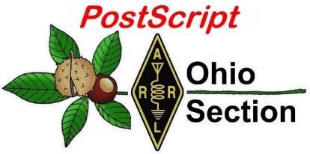](http://arrl-ohio.org/news/) ***October 14th***

***Edition***

🡪 National News 🡪 The Handbook Give Away

🡪 Club Corner 🡪 Hamfests

🡪 DX This Week 🡪 One Question Questionnaire

🡪 VE Testing 🡪 ARES Connect

🡪 Special NIMS Training 🡪 Final.. Final..

***National News***

*(from arrl and other sources)*

***Bidding in ARRL Online Auction Begins on October 17***



More than 230 items will go on the block as bidding begins on Thursday, October 17, at 10 AM EST (1400 UTC) for the 14th Annual [**ARRL Online Auction**](http://arrl.auctionanything.com/). The auction will continue through Thursday, October 24, closing at 10 PM EST. An auction preview opens on Monday, October 14.

The 2019 auction includes lab-tested *QST* “Product Review” gear, vintage books, used equipment, and one-of-a-kind items, plus the ARRL Lab team has contributed four of its very popular “mystery boxes.”

Some premier “Product Review” items up for bid include the Elecraft KAP 1500 legal-limit HF and 6-meter linear amplifier, the Icom IC-7610 HF and 6-meter transceiver, the Palstar LA-1K 160 – 6 meter amplifier, the FlexRadio Systems FLEX-6400M HF and 6-meter SDR transceiver, the Kenwood TS-890 HF and 6-meter transceiver, and many more items.

The auction will also offer items donated from the popular television series *Last Man Standing*, starring Tim Allen, an actual radio amateur who portrays the fictional Mike Baxter, KA0XTT, in the show, which has featured ham radio in some episodes.

Among book offerings in the auction are the “sold out” *2019 Handbook Boxed Set,*a special defense edition of *The Radio Amateur’s Handbook* from 1942, and a 1949 *ARRL Antenna Book.*

Proceeds from the annual Online Auction benefit ARRL education programs. These include activities to license new hams, strengthen Amateur Radio Emergency Service (ARES®) training, offer continuing technical and operating education, and create instructional materials.

All bidders must register (your **arrl.org** user ID and password will not work on the auction site). If you have registered for a previous ARRL Online Auction, you may use the same log-in information. If you have forgotten your user ID or password, click on the “Help” tab for instructions on how to retrieve these credentials. Make sure your correct address and other information are up to date. The auction site only accepts Visa and MasterCard.

#########

**FCC Proposes Fining New York Radio Amateur $17,000 for Deliberate Interference**

A New York Radio Amateur — Harold Guretzky, K6DPZ, of Richmond Hill — is facing a $17,000 fine imposed by the FCC. Guretzky was issued a *Notice of Apparent Liability for Forfeiture* ([***NAL***](https://docs.fcc.gov/public/attachments/DA-19-989A1.pdf)) on October 3 for causing intentional interference on a local repeater and preventing other radio amateurs from using it.

“Given his history as a repeat offender, this violation warrants a significant penalty,” the FCC said in the *NAL*.

TOP ^

The *NAL* recounted numerous complaints alleging that Guretzky was deliberately interfering with a repeater in Glen Oaks, New York. In June of 2017, the FCC issued a *Warning Letter* to Guretzky, advising him of the nature of the allegations against him and directing him to stop using the repeater going forward. Nonetheless, additional complaints were filed. In April 2018, agents from the FCC New York Enforcement Bureau office drove to Richmond Hill to investigate. Following an inspection of Guretzky’s station, the agents advised him in writing that he was prohibited from using the local repeater.

After the FCC received further complaints regarding Guretzky’s continued operation on the local repeater, an Enforcement Bureau agent again drove to Richmond Hill to investigate. The agent monitored the VHF repeater’s input and output frequencies and, after observing deliberate interference to other stations, used direction-finding techniques to identify the source of the transmission as Guretzky’s station.

“The agent monitored and recorded the transmissions emanating from Guretzky’s station for several hours that afternoon and heard him interfering with the local repeater,” the *NAL* said. “Later, the agent heard Guretzky making threatening comments toward other amateur operators. These transmissions were a deliberate act to control the frequency and prevent other Amateur Radio operators from conducting legitimate communications.”

The following month, FCC Regional Director David Dombrowski spoke with Guretzky via telephone, noting that the Commission was still receiving complaints about his continued use of the repeater and cautioning him against using the repeater.

The FCC said Guretzky “apparently willfully violated” Section 333 of the Communications Act and Section 97.101(d) of the FCC’s Amateur Service Rules, demonstrating “a deliberate disregard for the Commission’s authority and the very spirit of the Amateur Radio Service by continuing to interfere with the local repeater” despite having been warned.

#########

***What time is it?***

*(By: Chris Tran, GM3WOJ -- submitted by Gregory Drezdzon, WD9FTZ)*

What do you do when you need to know the exact time?  You look at your phone or your watch, or you look at the time on your laptop or iPad etc. All very easy if you have internet connectivity or mobile phone coverage (and if your watch battery has not gone flat).

All right - what do you do if you are on a DXpedition to a remote (Pacific or Scottish) island where there is no mobile phone network and the internet connectivity is patchy – sometimes disappearing completely for hours or days?  Not a problem – most laptop internal clocks only loose or gain a few seconds per day – perfectly OK for logging the DXpedition QSOs – yes?

No – DXpeditions at this low point in the sunspot cycle need to operate FT8 and FT4, both of which modes rely on very accurate timings for transmit and receive periods.  FT8 transmissions last for 12.64s in a 15.0s period, FT4 transmissions last for 4.48s in a 6.0s period – you cannot use either mode if your PC clock is inaccurate by any significant amount.

If you have internet connectivity, accurate PC timing is easy – just install one of a number of software packages designed to keep your PC clock synchronized to a very accurate online source – two examples of suitable software are Meinberg NTP and Dimension4. Network Time Protocol (NTP) servers can keep your PC clock accurate to under 0.1s under normal internet traffic conditions.

TOP ^

Back to the problem – no reliable internet, no 4G – what can we do?  Let’s turn our eyes to the sky – the Global Positioning System is the answer. The GPS system depends on super-accurate clocks (four in each satellite) hurtling around above our heads – let’s access that accuracy on our remote island.

My first approach turned out to be a dead end. I found software online called ToyNtp 1.2 written by Alex Shovkoplyas VE3NEA (DXatlas, Skimmer, etc).  The Garmin GPS-18x LVC  unit he specified was quite expensive – about £70 – so I decided to build a QRP Labs QLG-1 GPS module kit and see if it would work with the ToyNtp software – it did not!

The photo below shows the QLG-1 module, powered from a +5.0V DC supply.  The supplied ceramic patch antenna (not shown) is very effective, but I fitted the optional SMA socket and used an external powered GPS antenna, which improves sensitivity.

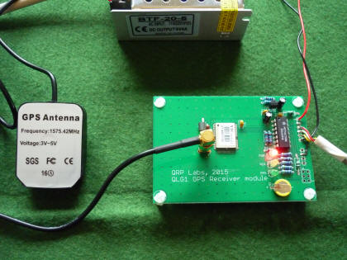

The green LED flashes at 1 pulse per second once satellites have been acquired – the serial data output is then connected to a COM port on your PC.

(I’ll now use this module with a QRP Labs ‘Prog Rock’ kit to make a GPS disciplined 10MHz oscillator for my shack.)

I then looked around the internet more carefully and found exactly what I needed.  The software is called GPS2Time and is written by Doug Hunter VK4ADC and made available as freeware – thanks Doug!  Download and unzip this software into a separate directory, where you will see the .exe file and two log files will be created (once the software runs for the first time).

I purchased a cheap USB car GPS/GNSS receiver on eBay (£10.99) – I ordered a type G-mouse VK-162 as specified by VK4ADC on his webpage, but the unit that arrived was a U-blox 7 (but labeled G-mouse) – I think they are all similar anyway.

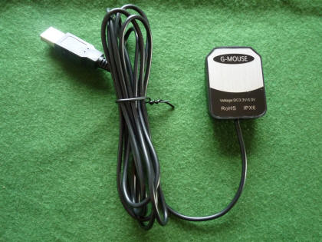

This is a much simpler approach – the U-blox 7 plugs directly into a USB port on your laptop/PC and is powered by the USB port. This is convenient for a DXpedition where carrying extra power supplies, etc. can be difficult.

You need to download and install the drivers for the U-blox 7 – Windows then recognizes the GPS module as a new COM port, which you then point the GPS2Time software to.

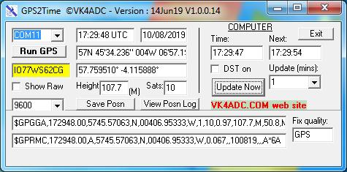

To the right is a screen shot of the GPS2Time software – the GPS receiver is connected on COM11 and receiving 10 satellites with the baud rate is set to 9600. The update time is set to 1 minute but can be longer of course. As a bonus, you get an accurate position and height fix.

TOP ^

I have tested this software with three different Operating Systems – Windows XP SP3, Windows 7 Pro 64-bit and Windows 10 64-bit. It works well in all 3 cases, however there are a few things to watch – with W7 and W10 you have to run the software as an Administrator, but with XP I found it only worked if I did not ‘Run as Administrator’

.

Note - the software will not run unless you first select a Baud rate with the pull-down menu e.g. 9600 as above - you may also need to delete / refresh some COM ports on your PC. Important – make sure you have ‘Internet time sync’ switched OFF on your laptop or PC.

Doug, VK4ADC, recently wrote a new version of the software, including an improved version for Windows XP which he e-mailed me. The GPS mouse will automatically switch baud rates so while you have used 9600, you can set the software’s baud value to 57,600 (or even 115kB) and it all still works.

In fact the faster the baud rate then the lower the timing error because the software decodes the GPS’s time stream closer to the Seconds “change-over” point and sets the PC clock closer as a result. The worst case condition is going to be a 1 second inaccuracy but it can be a lot better than that with a high baud rate”.

Happy GPS timing!!!

 73,  Chris, GM3WOJ                 [www.vk9cz2019.com](http://www.vk9cz2019.com/)

*********

GPS2Time software download :

<https://www.vk4adc.com/web/software-projects/55-vk4adc-utils/181-gps2time>

U-blox 7 driver download (select 32-bit or 64-bit):

<https://www.driverscape.com/download/u-blox-7-gps-gnss-receiver>

(the u-blox.com support website is very cluttered and it is difficult to find the driver there – it must be there)

[ If you are interested in GPS disciplined oscillator control/timing etc. try running this strangely-named software with your U-blox 7 GPS RX  (it can’t control your PC clock):   <http://www.ke5fx.com/heather/readme.htm> ]

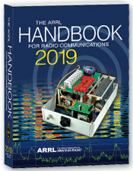***The Handbook Give Away***

Hey Gang,

Have you registered for the “Handbook Giveaway” drawing for this month yet? If you haven’t, go to: <http://arrl-ohio.org/handbook.html> and get yourself registered now!

What’s the catch? I want to get everyone checking in to the Ohio Section website as often as possible, and in order to register each month, you have to visit the website often! There’s nothing else to it. I pay all expenses and I usually “Give Away” more than just a Handbook too!!

Many of you ask me just how do I know when the drawing is on? Well, that’s easy all you need to do is check in on the Ohio Section Website on a regular basis and watch for the big [**RED**](http://arrl-ohio.org/handbook.html)Arrow that will appear on the left side of the page. This is the sign that the drawing is on and you need to get registered. So, keep a sharp eye out on the website and check in often!

TOP ^

***Club Corner***

This is YOUR cornner of the newsletter. Send me what your club is doing and I’ll make sure that it gets in. Got a special event or club project that you want everyone to know about? Send it to me!. Need help with a project? Send it to me.

Let me know what you club is up to. Are you going to have a special guest at your meeting or are you having a special anniversary? Just sent it to: [n8sy@n8sy.com](mailto:n8sy@n8sy.com)

#########

***Ohio VOAD Needs Help***

Ohio VOAD is looking for a **Communications Chairperson** that can take over the responsibilities of posting information on their Facebook and Twitter accounts.

Qualifications needed to apply: Experience posting to Facebook, Twitter and other Social Media sites a must. Having experience with updating websites is a plus, but not mandatory. Able to attend daytime meetings in Columbus and willing to post items to these various sites as they happen.

This is a position for a person that is a true volunteer and wants to give back to their community. For more information contact Scott, N8SY at [n8sy@n8sy.com](mailto:n8sy@n8sy.com)

#########

***Air Force MARS Broadcast Resumes***

*(from: Broadcast Manager, Air Force MARS, MARSCOMM)*

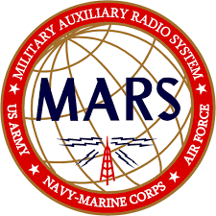In May 2019 the Air Force MARS resumed a favorite from the past.  Every other Friday there are a series of Air Force MARS Broadcast which are distributed to all Air Force MARS stations.  The message is from the Chief of Air Force MARS and the Deputy Chief of Air Force MARS.  The message is Unclassified and does not contain For Official Use Only (FOUO) information so other interested parties may listen in on the message(s).

The next series of Broadcasts begin this coming Friday night, October 4, 2019.  The full Broadcast schedule is:

East CONUS      Friday                   Oct 18, 2019        2300Z    11.121 MHz

                                          Friday                   Oct 18, 2019        2320Z    4.485 MHz

            Central CONUS   Saturday               Oct 19, 2019        0000Z    11.121 MHz

                                          Saturday               Oct 19, 2019        0020Z    4.485 MHz

             West CONUS      Saturday               Oct 19, 2019        0100Z    11.121 MHz

                                          Saturday               Oct 19, 2019        0120Z    4.485 MHz

TOP ^

The message is typically 7-10 minutes long and the transmissions are in Upper Sideband (USB).  Come and listen in!

#########

***Skywarn Recognition Day 2020 - THE FINAL YEAR AT HOPKINS***

starting at 0000Z (Friday, Dec 6th, 7:00 PM Eastern until Saturday, Dec 7th, 7:00 PM Eastern). The NWS Cleveland Office will be participating from 12:00 PM until 7:00 PM on Saturday, December 7th, 2019. We will be operating under the call sign WX8CLE and will be active on UHF, VHF, and HF (HF bands to be determined later). We will also periodically spin the dial on local repeaters.

Just like last year, we will operate UHF/VHF inside the office and HF outside in the new vehicle. Anyone interested in attending is encouraged to sign up here, but since we will be partially operating from outside, last minute walk ins are welcome. Access to the inside of the building will be restricted based on attendance as the operating area can only accommodate a certain number of people at once. Additionally, any sort of severe weather event could potentially result in us cancelling the operation. Those who sign up will be advised of any last-minute changes, or we can be contacted on the Skywarn simplex frequency of 146.475 (we will do our best to keep a radio on this the entire time).

When you arrive on site, please check in with the operators in the vehicle. They will then arrange access to the building should you desire to come inside. if no one is present, call us on 146.475 simplex.

As you may know, the Cleveland NWS office will be relocating in spring 2020 so this will be the last time to operate from the office at the airport!

The address for the National Weather Service Cleveland is 5301 W Hangar Rd, Cleveland, OH 44135. This is off of Brookpark Rd, between NASA and Hopkins, behind the UPS hangar.

#########

***Green County Sheriff’s Office Participates in Ohio’s S.E.T.***

The annual Amateur Radio Emergency Service (ARES) Simulated Emergency Test (SET) is an opportunity for local ARES groups to demonstrate to public officials their ability to communicate under disaster conditions. For the Greene County Ohio ARES (GCARES) one public official not only observed the test but participated. Greene County Sheriff Gene Fischer, KX8GCS, checked in when the Resource Net Control, Bob Baker, N8ADO, of Beavercreek, called for volunteers.

Although the suggested scenario called for only using simplex, GCARES used the Xenia Amateur Radio Weather Net (XWARN) repeater for its resource net to maximize number of amateur operators who would be able to volunteer. Once checked into the resource net volunteers were asked to switch to a simplex tactical net to communicate with the GCARES Command Center located in Beavercreek Township Fire Station 64.

TOP ^

Sheriff Fischer, at the Dayton Amateur Radio Association (DARA) meeting the evening before the SET told Greene County ARES Emergency Coordinator Henry Ruminski, W8HJR, that he would participate in the SET so that he could determine how well his handheld radio would perform under the test conditions. While it was more than adequate for checking into the resource net on a repeater, he learned that it was lacking for effective simplex operation from outside the Sheriff's office.

The sheriff had an intense introduction to ham radio in the Spring of 2017 when the Dayton Hamvention moved to the Greene County Fairgrounds and Exposition Center in Xenia. He was very active during that Hamvention as his department dealt with traffic control and other issues created by the influx of more than 25,000 hams.

A number of hams that year, urged him to get an amateur radio license. He also had some urging at home from his wife, Gail, who had been licensed but let it expire. Both decided to take the Technician License course offer by GCARES in the Fall of 2017. Both passed the technician exam in November of 2017. Gail became KE8IFF and Gene, KE8IGE. The next month both received vanity calls; Gail, her former call, KA8DQK and Gene, KX8GCS. He said the X is for Xenia where they live and where he served in the police department for many years. The GCS is for Greene County Sheriff. Gene took the GCARES General course in the Spring of 2018 and upgraded.

The SET was relatively successful according to Ruminski. The goal was to communicate from as many fire, health and law enforcement locations as possible to the command station. While the signals could have been better from some locations, most stations were able to communicate with command. The lessons learned will be used to improve emergency communication plans for the future.

#########



***Medina County Amateur Radio Club*** has scheduled six Technician Licensing Classes at the Medina County Career Center (JVS) beginning **October 23rd from 6:30pm to 9:00pm** in Room 246.  The last class will be the exam.

Interested attendees should contact Doug or me for more information about the first class:  Doug KD8SST  330-304-8571, [dmcclure1@zoominternet.net](mailto:dmcclure1@zoominternet.net), or Jane K8JGR 216-570-8500,  [jane@K8JGR.radio](mailto:jane@K8JGR.radio)

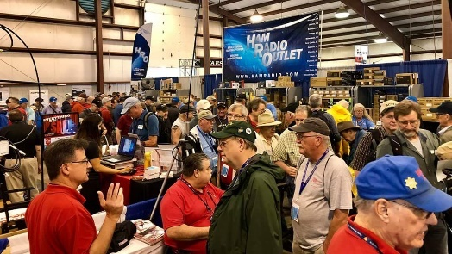[***Upcoming Hamfests***](http://arrl-ohio.org/hamfests.html)

**11/02/2019 | GARC Hamfest**Location: Georgetown, OH  
Sponsor:Grant Amateur Radio Club  
Website:<https://www.facebook.com/Grant-Amateur-Radio-Club-775764122477536/?modal=admin_todo_tour>

|  |  |
| --- | --- |
| **11/03/2019 | Massillon ARC Hamfest** Location: Massillon, OH Sponsor: Massillon Amateur Radio Club Website:[http://www.w8np.org](http://www.w8np.org/) | **12/07/2019 | Fulton County ARC Winterfest** Location: Delta, OH Sponsor: Fulton County Amateur Radio Club Website: <http://k8bxq.org/hamfest> |

TOP ^

***DX This Week***

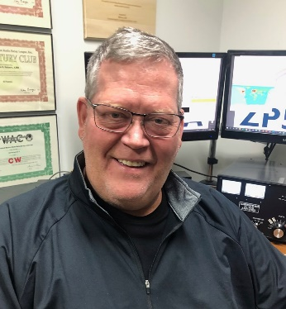*(from Bill, AJ8B)*

***DX This Week – A Year of DX***

Bill AJ8B ([aj8b@arrl.net](mailto:aj8b@arrl.net), @AJ8B, or [www.aj8b.com](http://www.aj8b.com))   
 CWOPs Member #1567

Figure 1 is the DXpedition and Contest Calendar for the Month of October. These calendars are from [www.DX-world.net](http://www.DX-world.net) and [www.hamradioweb.org/forums/](http://www.hamradioweb.org/forums/). I keep a printed version handy by my rig to make sure that I remember to listen for the ones that I need on a regular basis.

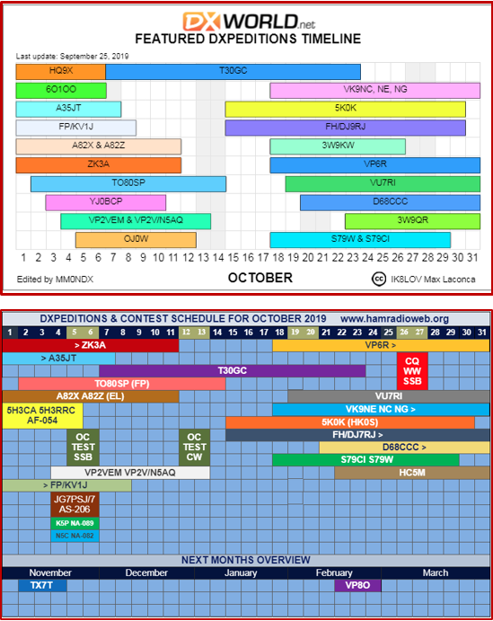

Figure - DXPedtion and Contest Calendar for October

I hope you have been tuning around and calling CQ! Although the sunspots are down, there has been quite a bit of DX ”in the air.” Uncle Frank always checks [www.dxsummit.fi](http://www.dxsummit.fi) to perform some historic checking on all of the spots that may have occurred in the past week or so. Based on the spots, and the spots that I received at my QTH, there were about 53 DX Entities that were spotted including Alaska, Argentina, Belgium, Belize, British Virgin Islands, China, Colombia, Czech Republic, Denmark, Ecuador, Greece, Haiti, Kazakhstan, Liberia, Paraguay, Slovenia, St. Pierre & Miquelon, Tokelau Islands, Turks & Caicos Islands, and Western Kiribati. I sort out those spots that were entered by hams outside of the Midwest because they just would not have any meaning to us. Just wait for the sunspots to increase!!

This week, the mailman delivered a few goodies including TA2LG – Turkey, 9G1SDC – Ghana, CY9C – St. Paul Island, GU0VPA – Guernsey, and A41CK - Oman (Pictured) What did you get? Send me an image and some details!

There are a couple of things that get me “jazzed” up to get on the air. One is receiving QSL cards, one is working a CW contest, and one is reading A Year of DX by Bob Locher, W9KNI. I have read both of his books, but, this one seems to really resonate with me. Before I get into the details, I wanted to share two reviews from [www.eham.net](http://www.eham.net).

TOP ^

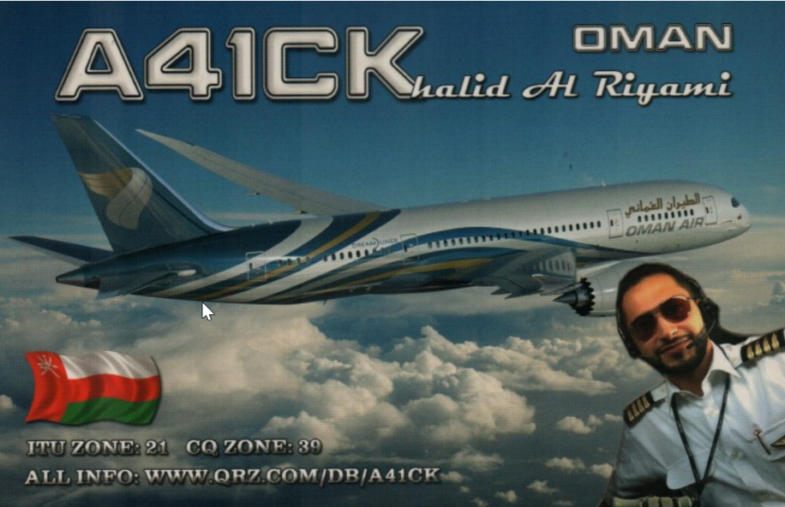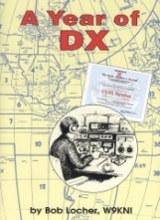*“Can a DX'er from a small town in southwest Oregon hope to compete in the Big Leagues of DX'ing? Bob Locher, W9KNI, author of the bestselling DX Book ever, "The Complete DX'er", set out on a mission to prove it was possible. "A Year of DX" is Bob's personal account of the challenges, joys and sorrows in pursuit of the Holy Grail -- winning the CQ DX Marathon. Look over Bob's shoulder as he works country after country, yes, and missing a few along the way, but always trying to optimize his chances and the hope of logging the next one.*

*Mixed in is a wealth of other material, some dealing with equipment optimization, some thoughtful, some humorous. Anyone who enjoyed "The Complete DX'er" will surely be delighted with this book. 280 pages.”*

*“Another great read from W9KNI. A Year of DX chronicles Bob's pursuit of the 2008 CQ DX Marathon award. Twelve chapter's covering DX pursued and worked each month of the year are interleaved with another dozen or so technical and perspective chapters. That mix provides the reader with an enjoyable blend of operating adventure and DXing advice.*

*Bob's writing style makes you feel as though you are sitting in the chair next to him as he chases another new one. The intensity that this year long marathon contest requires is apparent as he tries to work every country that is active during the year. All the effort paid off as W9KNI finished 2nd in 2008 and 1st in 2009.*

*Just as was the case with Bob’s The Complete DXer, there are lots of tips and techniques exposed in this book. It is one of those books you just can’t put down.”*

I am not a book reviewer, but I do have some observations. The book centers around W9KNI’s quest to win the 2008 CQ DX Marathon. To win the Marathon, you need to work as many countries as you can between January first and December thirty-first. You get points for the total number of entities and for the total number of zones. There are 40 possible zones and over 300 possible entities. However, the challenge really comes in when you realize that not all countries are “on” during a 12-month period. Some are on for only a week or two at a time. Some may be regional due to propagation. You can only worry about YOUR total count and hope that those you are competing against are also having the same issues. There is no running score or “tote” board so it is a race to the finish on New Years Eve.

What really makes the book interesting for me is the challenge that a top level DXer has to work them, how he makes mistakes, and how he balances his quest against family times and other commitments. Just like me but without a beam and all that skill!

TOP ^

Bob goes into detail about how he uses resources at his disposal to find, work, and then confirm the DX. There are many times I can “hear” the station that he is tracking in the noise and I can think along with him as he strategizes on how to work the station. What I find most interesting is the way the book is broken down into chapters corresponding to the months of the year and the corresponding challenges that come with seasonal propagation.

Bob has a couple of extra chapters in which he shares his thoughts on Keeping Current, Transmitters, Audio Quality, Headphones, and other topics. Although some of the technology is a bit dated by todays standards, the thrill of the chase and the excitement of Bob snagging them and building up his country count month by month until he reaches…well..you will have to read it. I highly recommend this!

+ --------------------------------------------------------------------------------------------------+

Here is an update from Bernie, W3UR, of the DailyDX and the WeeklyDX,

the best source for DX information. (<http://www.dailydx.com/> ) Bernie has this to report:

+ --------------------------------------------------------------------------------------------------+

**3W – Vietnam -** JJ1DQR, Yosuke Sato, will have the 3W9QR callsign on from Danang  
October 23 to November 1, QRV on 40-10, "mainly SSB," he says.  He will be in the CQWW SSB event that included weekend.  QSL bureau or direct to him, JJ1DQR.

**D4 - Cape Verde** - OK7JR, Jan, with the D44EA callsign, plans to be there on holiday October 10-22.  He will be on Sal Island, AF-086 and will do some operating from the Ponta to Sino Lighthouse.  QSL to his home QTH.  
  
**CE – Chile** - The Antofagasta Contest Group will put CB1H on the air in the October  
26-27 CQWW DX SSB event, multiop.  QSL direct or bureau via CB1H, or use LoTW or OQRS.

**HK – Colombia** - Special callsigns will mark the 500th anniversary of the passing of  
Leonardo da Vinci.  The calls are 5J500LDV, 5J5OOL, 5J5OOD and 5J5OOV. You will note, they are for Da Vinci's initials.  These are scheduled for October 17-31, active on 80-10M CW, SSB and digital.  QSL via HK3VHZ or use LoTW or eQSL.  Club Log will have a logsearch to see if you made it into the log.  <https://www.qrz.com/db/5J500LDV>.  There will be certificates available to decorate your hamshack wall.

***DX news***

***ARLD040 DX news***

This week's bulletin was made possible with information provided by HK6O, The Daily DX, the OPDX Bulletin, 425 DX News, DXNL, Contest Corral from QST and the ARRL Contest Calendar and WA7BNM web sites.

Thanks to all.

**ZAMBIA, 9J.** Mario, IK1MYT is QRV as 9J2MYT from Lusaka until June 2020. Activity is on 40, 20, 15 and 10 meters. QSL to home call.

TOP ^

**AZORES, CU.** Operators DG0OHD, DG5AA, DK8YY, DL1AOB, DL1AWD, DL7ZZ and DL8ALU will be QRV as CT8/home calls from Graciosa Island, IOTA EU-175, from October 13 to 21. During the upcoming Worked All Germany contest they will be active as CR2Y. QSL CR2Y via DH7WW and all others to home calls.

**GUADELOUPE, FG.** Philippe, F1DUZ will be QRV as FG4KH from October 14 to 29. Activity will be on 80 to 10 meters using SSB and FT8. QSL to home call.

**MAYOTTE, FH.** Willy, DJ7RJ will be QRV as FH/DJ7RJ from October 15 to November 3. Activity will be on 160 to 10 meters using CW and SSB. QSL to home call.

**COLOMBIA, HK.** Special event station 5K6MZL is QRV from Manizales until October 14 in celebration of the 170th anniversary of the city of Manizales. Activity is on 160 to 2 meters using CW, SSB and various digital modes. QSL via bureau. In addition, look for special event stations 5J500LDV, 5J500L, 5J500D and 5J500V to be QRV from October 16 to 30 in remembrance of 500 years of the passing of Leonardo da Vinci. Activity will be on 80 to 10 meters using CW, SSB and various digital modes. QSL via bureau.

**SAN ANDRES AND PROVIDENCIA, HK0.** A large group of operators will be QRV as 5K0K from San Andres Island, IOTA NA-033, from October 15 to 30. Activity will be on 160 to 10 meters using CW, SSB, RTTY and FT8. QSL via OK6DJ.

**JAPAN, JA.** Markus, DJ4EL will be QRV as JR6/DJ4EL from Yomitan, Okinawa, IOTA AS-017, from October 13 to 25. Activity will be on 20 meters. He also plans to visit other islands and maybe be active on other bands as well. QSL to home call.

**SVLBARD, JW.** Operators Erling, LA6VM, Halvard, LA7XK and Just, LA9DL are QRV as JW6VM, JW7XK, and JW9DL, respectively, from Longyearbyen, IOTA EU-026, until October 14. They will be active as JW5X in the Scandinavian Activity SSB contest. QSL JW5X via LA5X and all others to home calls.

**NETHERLANDS, PA.** Special event station PH100ADL is QRV until the end of 2019 to commemorate the first commercial flight in the Netherlands 100 years ago. Activity is on the HF bands using CW and SSB. QSL via bureau.

**PALAU, T8.** Operators JH7IPR, JQ6FQI and JA6KYU are QRV as T88UW, T88WM and T88HS, respectively, from Koror, IOTA OC-009, until October 16. Activity is on the HF bands and 6 metersd using CW, AM, SSB, FSK, FT8 and FT4. This includes being an entry in the Oceania DX CW contest. QSL via operators' instructions.

**ASIATIC RUSSIA, UA0.** Vlado, UA0LCZ is QRV as UA0LCZ/p from Popov Island, IOTA AS-066, until October 14. Activity is on 80 to 17 meters using CW. QSL to home call.

**ST. KITTS AND NEVIS, V4.** John, W5JON will be QRV as V47JA from St. Kitts, IOTA NA-104, from October 16 to 22. Activity will be on 160 to 6 meters using SSB and FT8. QSL direct to home call.

**BERMUDA, VP9.** Josh, W9HT will be QRV as W9HT/VP9 from Hamilton Parish from October 12 to 15. Activity will be on the HF bands and 6 meters. QSL to home call.

TOP ^

**SOUTH SUDAN, Z8.**  James, Z81C is QRV from Juba while working for a non-governmental organization for the next 18 months. Activity is mostly on SSB. QSL via operator's instructions.

THIS WEEKEND ON THE RADIO. The Makrothen RTTY Contest, Oceania DX CW Contest, NCCC RTTY Sprint, NCCC CW Sprint, QRP ARCI Fall CW QSO Party, Nevada QSO Party, Microwave Fall Sprint, SKCC Weekend CW Sprintathon, Scandinavian Activity SSB Contest, Pennsylvania QSO Party, Arizona QSO Party, FISTS Fall Unlimited CW Sprint, South Dakota QSO Party, PODXS 070 Club 160-Meter Great Pumpkin Sprint, UBA ON 80-Meter CW Contest and UBA ON 6-meter Contest will certainly keep contesters busy this upcoming weekend.

The 4 States QRP Group Second Sunday Sprint and RSGB 80-Meter Autumn CW Series are scheduled for October 14.

The CWops Mini-CWT Test and Phone Fray are scheduled for October 16. The Canadian National Parks on the Air, CNPOTA, operating event runs for the entire year of 2019, with special stations active from Canada's parks and historic sites.

Please see October QST page 90 and the ARRL and WA7BNM Contest Web Sites for details.

***Special Events***

**10/18/2020 | Commemorating 80th Anniversary of U.S.C.G Auxiliary**

**Oct 18-Oct 20, 1400Z-2300Z, N4U**, Benton, KY. United States Coast Guard Auxiliary. 14.070 14.250 7.070 7.250. QSL. Mary Husfield, 4156 Barge Island Road, Benton, KY 42025-6039. 80th Anniversary of United States Coast Guard Auxiliary. QSL to KC4TIE, Special Card returned with SASE. Mainly digital modes.

**10/19/2019 | 100th Anniversary of Michigan State University Amateur Radio Club**

**10/19/2019 | 1600Z-2200Z, W8SH**, East Lansing, MI. Michigan State University Amateur Radio Club. 14.250 14.050 7.250 7.050. QSL. MSUARC/W8SH, ECE Dept. #2121, 428 S. Shaw Ln. , East Lansing, MI 48824. Original call 8YG. [msuarc@egr.msu.edu](mailto:)

**11/02/2019 | 44th Anniversary, Sinking of the Edmund Fitzgerald**

**Nov 2-Nov 17, 0000Z-2359Z, W8F**, Detroit, MI. Livonia Amateur Radio Club. 14.260 7.040 14.040 7.240. Certificate. Tas Foley, K8TAS, 37255 Euraka Rd., Romulus, MI 48207. On Saturday, November 2, W8F will operate from the Dossin Great Lakes Museum, Detroit MI 1600-2030 UTC. SASE FOR QSL CERTIFICATE [livoniaarc.com](http://livoniaarc.com/)

**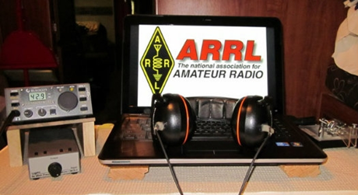*ARRL Contest Corner***

An expanded, downloadable version of *QST'*s [Contest Corral](http://www.arrl.org/contest-calendar) is available as a PDF. Check the sponsor's Web site for information on operating time restrictions and other instructions.

TOP ^

***School Club Roundup***

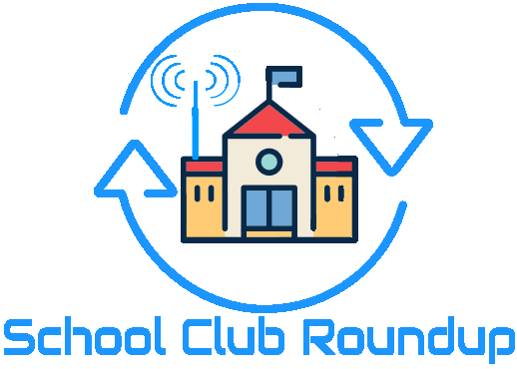The Fall Term running of the School Club Roundup will take place **October 21-25, 2019.**

**Objective:** To exchange QSO information with club stations that are part of an elementary, middle, high school or college. Non-school clubs and individuals are encouraged to participate.

Sponsored by the ARRL, its Hudson Division Education Task Force and the Long Island Mobile Amateur Radio Club (LIMARC) to foster contacts with and among school radio clubs. Award certificates will be issued for the following US and DX categories:

* Schools: Elementary, Middle/Intermediate/Junior High School, High School and College/University
* Non-school Clubs
* Individuals

For additional details visit- [www.arrl.org/school-club-roundup](http://www.arrl.org/school-club-roundup).

If you are involved with a School, Youth Group or Scouting Radio Club, please consider registering your group with the ARRL Ohio Section Youth Coordinator by using this [link](http://tiny.cc/osl-form) to fill out a registration form or if you know someone who is involved please share this link with them- <http://tiny.cc/osl-form>. When registering you will have complete control of what information will be shared with the public about your group. Anthony, K8ZT will make the approved registration information available on the ARRL Ohio Section website cabinet page- [www.arrl-ohio.org/syc/index.html](http://www.arrl-ohio.org/syc/index.html).

#########

***Jamboree-on-the-Air***



The 62nd Annual Jamboree On The Air will be held on the weekend of Oct 18-20th. Jamboree-on-the-Air, or JOTA, is the largest Scouting event in the world. It is held annually the third full weekend in October. JOTA uses amateur radio to link Scouts and hams around the world, around the nation, and in your own community. This jamboree requires no travel, other than to a nearby amateur radio operator’s ham shack. Many times you can find the hams will come to you by setting up a station at your Scout camporee, at the park down the block, or perhaps at a ham shack already set up at your council’s camp.

TOP ^

To find registered JOTA stations in your area visit [*https://k2bsa.net/registered-jamboree-on-the-air-stations*](https://k2bsa.net/registered-jamboree-on-the-air-stations). If you or your local club is planning a JOTA operation you can register it at [*https://k2bsa.net/jota-station-registration*](https://k2bsa.net/jota-station-registration).

For additional information on planning your JOTA operations visit:

* JOTA- [*www.scouting.org/jota*](http://www.scouting.org/jota)
* JOTA-[*www.arrl.org/jamboree-on-the-air-jota*](http://www.arrl.org/jamboree-on-the-air-jota)
* JOTA- [*www.jotajoti.info*](https://www.jotajoti.info)
* JOTA- [*https://k2bsa.net/jota*](https://k2bsa.net/jota/)
* JOTA [*suggested frequencies*](https://www.jotajoti.info/jota-rules/)
* JOTA [*sample questions*](https://k2bsa.net/on-air-questions-to-ask-scouts/)

For additional information on Scouting and Amateur Radio visit:

* Scouting & Amateur Radio- Ideas & Resources-[*tiny.cc/ar-scout*](http://tiny.cc/ar-scout)
* [*Radio Merit Badge*](https://k2bsa.net/radio-merit-badge-2/)
* [*Girls Scouts Radio Patch*](http://www.arrl.org/girl-scouts-radio-patch)
* [*Troop Program Feature: Radio*](https://k2bsa.net/troop-program-feature-radio/)

*****V.E. Test Sessions***

For the latest testing site information please **>>** [Click Here](http://www.arrl.org/find-an-amateur-radio-license-exam-session) **<<** The ARRL site tracks all of the VE testing sites that register with them, including W5YI and Laurel. ARRL gives you a number of different ways of sorting to find that site that is closest to you as well.

***One Question Questionnaire***

Hey Gang,

Wow, 22% of you should be really proud that you’ve make a 2-meter contact over 60 miles on simplex!!

I’ve got another NEW – one question – on the Ohio Section Website for you to answer! Now here’s next week’s question. I’ve targeted the “builders” of the group.

**“Do you assemble your own Anderson PowerPole connectors?”**

These One Question questionnaires are all in fun and I hope that you are enjoying answering them.

You’ll find the “One Question” questionnaire on the Ohio Section Website! <http://arrlohio.org> It’s all in fun and it’s not a scientific survey in any way, but we are learning some things that we didn’t know from these questions. I hope that you are enjoying answering these “One Question” questionnaires.

TOP ^

***ARES Connect***

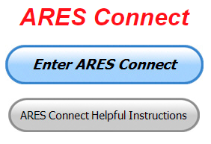Yes, here we go with the broken record once again. **Let’s get everyone in the Ohio Section on ARES Connect before the end of this year!!!**

Do you need help with how to sign-up for an event or log your hours? How about you Administrators, do you have questions about approving your volunteer’s hours or how-to set-up a recurring event? I’ve got the answer for all of you. I have a new webpage with step-by-step instructions on how to do those things and many more.

I also have a “Hints and Kinks” section that has a lot of great information on how to do something or why something works like it does. Here’s the page: <http://arrl-ohio.org/SEC/connect/index.html> You can also find this link on the main page of the Ohio Section website as well.. It’s just under the “Enter ARES Connect” link.

If you live in **Ohio** and you haven’t registered yet, we need you to get registered now. We need you to only use this URL to get registered <https://arrl.volunteerhub.com/lp/oh/>. Using any other entrance to register will only slow down your registration process. Again, this is for those living in Ohio only. If you are an out of state person (not Ohio), you can simply change the **/oh/** to your 2-letter state designation. This will put you in the correct state for signing up.

Now, I am starting to see folks creating more than one account because they can’t remember their password from the one that they originally setup. Please don’t do this. The system has a really good way of sending you a link to your email address so that you can refresh your password. If you are experiencing problems with getting to this link, contact me: [n8sy@n8sy.com](mailto:n8sy@n8sy.com) and I’ll get it fixed for you.

***Here’s the top 10 hours earners so far for October:***

|  |  |  |  |
| --- | --- | --- | --- |
|  | **Name** | **Events** | **Hours** |
| 1 | Dan Stahl (KC8PBU) | 27 | 50.61 |
| 2 | Christopher Domenick (KC8CAD) | 9 | 40.50 |
| 3 | John Westerkamp (W8LRJ) | 16 | 30.42 |
| 4 | Bret Stemen (KD8SCL) | 8 | 30.00 |
| 5 | John Major (KD8MMY) | 9 | 29.50 |
| 6 | Edward Kopcak (KB8BKE) | 5 | 26.50 |
| 7 | Andrew Gross (K8ALG) | 7 | 26.00 |
| 8 | Steve Wheatcraft (AA8BN) | 10 | 24.65 |
| 9 | Harry Melke (KM8N) | 14 | 22.90 |
| 10 | Frederick Myers (Kk6zhw) | 5 | 22.50 |

As you can see from the above listing, we can get real time information that shows how many hours, who volunteered and what they volunteered for. There’s a ton of information that we can draw out of the system.

We now have **1,258** registered and growing every day in the system. What’s really interesting is as of this same date there are **11,842** registered in the entire country. This means that the Ohio Section makes up over **1%** of those registered.

TOP ^

Here’s a link to get you started... <http://www.arrl-ohio.org/SEC/connect/ares_connect_directions.pdf>

Please, don’t just hurry through the questions, read them carefully, if you don’t understand something, please ask me, I’m here to answer your questions.

I have also been hearing from some that they are not getting to record their time for events that they have done. After some investigation it was found that there is a time limit on just how long of a time you can go before getting locked out of recording your time. It’s 29 days. Then you have to have an administrator complete your time, if it wasn’t done already. I have been noticing that there’s a lot of events being created, but after that, no one is actually recording their time. Please, we need you to go in as soon as you can after the event and record your time. This way you don’t forget it and it makes reporting much easier when you are prompt.

I’m being asked a lot lately about just what can we record as an ARES Connect Event. Well, there’s really no simple answer to that tough question… It can be a RACES, CERT, Skywarn, Red Cross or LEPC meeting where you or a group of you are there representing your club or Amateur Radio in general.

For the most part, we are doing really good in identifying those events that we should be tracking. If you have questions about whether an event should be created in ARES Connect, here’s a simple “litmus test” to help you decide whether it should be an event or not. We have 7 categories for events that are built into ARES Connect.

They are: **Communications Emergency; Community Event; Exercise; Meeting; Net; Skywarn; Training**

As you can see, this covers a huge amount of territory right off the bat. Most everything that you will want to create an event for will fit into one of these 7 categories. But, as I’m being asked the question, not everything that you are doing fits into one of these 7, and that’s where most of your questions come from “do I count this or not.”

Work you did on the club trailer, repeater, website, field day and associated other similar events, parades, newsletter or just having fun keeping track of all those spandex folks during every kind of bicycle and foot race imaginable are really good examples of events that should be included, but just don’t fit well into one of those 7 categories. I could go on and on about what you could include as an event, but the fact is there are so many different kinds of things that we do to represent ourselves in Amateur Radio and our giving back to the communities that it would be virtually be impossible to make a list of those items that should and shouldn’t be events in ARES Connect.

This is where your “Common Sense” has to be applied. If you ask yourself this one question, I think you’ll have your answer. “Did we do this event as amateur radio operators?” No, the event doesn’t always have to involve using amateur radio, but if you have an event that isn’t serving amateur radio or your community, then I think you’d have to agree, it probably shouldn’t be an event in ARES Connect. Again, let me stress this point, if you have an event that doesn’t fit into one of the 7 categories above, you need to apply some “common sense” as to whether this event is something that should be in ARES Connect.

One last item that I need to discuss is that when you have completed the event don’t forget to get back into your account and register your hours. For the most part we are doing well with this, but there seems to be some of you that just might not know or understand that as a volunteer you have 2 things to do with ARES Connect. The first is to get registered for the events and then you need to report how much time you spent doing that event. It’s really quick and easy to do. Don’t know how, just ask. Your Admin or I can show you how to do this very quickly and easily.

#########

TOP ^

***Special NIMS Training Available***

**ICS-300 on November 13-15, 2019** (29 seats available)

Training Location:

Franklin County Sheriff's Academy

6373 Young Road

Grove City, OH 43123

There will be some additional classes posted soon (**ICS-300 December 3-5, 2019** at Upper Arlington Fire Station 72, 3861 Reed Road, Upper Arlington and **ICS-400 February 4&5, 2020** at Upper Arlington Fire Station 72, 3861 Reed Road, Upper Arlington) For more info: [pktickle@franklincountyohio.gov](mailto:pktickle@franklincountyohio.gov)

#########

***EMA-G2300 INTERMEDIATE EOC FUNCTIONS***

**Hosted by: Franklin County Emergency Management & Homeland Security November 13 - 15, 2019**

**Course Description:** The G 2300 Intermediate Emergency Operations Center Functions is a three-day course with the goal of assisting individuals and jurisdictions who desire to develop or improve their Emergency Operation Centers (EOC). By the end of the course, students will be able to demonstrate, through activities and a Final Exam, the managerial and operational roles of the modern-day EOC as a NIMS Command and Coordination functional group operating within a Multiagency Coordination System (MACS).

**Application Deadline:** October 30, 2019

**Time of Course:** Registration: 7:30 am – 8:00 am (on day one)

Course Time: 8:00 am – 5:00 pm

**Location:** Franklin County Emergency Management & Homeland Security

5300 Strawberry Farms Blvd Columbus, Ohio 43230

**Supported By:** The Ohio Emergency Management Agency

**Recommended Participants:** Federal, state, tribal, territorial, local level, business and nongovernmental emergency management personnel who may be designated to support an Emergency Operations Center (EOC) within their jurisdiction or organization. The materials were developed with the assumption that audience members may have little or no actual experience as a member of an EOC Staff.

**Recommended Prerequisite:**

**ICS-100**: An Introduction to the Incident Command System,

**IS-2200: Basic Emergency Operations Center Functions**

**IS-700**: An Introduction to the National Incident Management System

**IS-800**: National Response Framework, An Introduction

**G-191**: Emergency Operations Center/Incident Command Interface

**IS-200: Basic Incident Command System for Initial Response.**

TOP ^

**Enrollment:** Students must enroll via the Department of Public Safety Training Campus website: https://trainingcampus.dps.ohio.gov/cm/cm710/pstc/pstc.html. Course registration will generally close 10 working days prior to the course start date. You can check enrollment/approval status via the Department of Public Safety Training Campus website. **Mission Statement** To coordinate activities to mitigate, prepare for, respond to, and recover from disasters.

**Course Costs:** This course is free to participants.

**Additional Information:** Lodging, meals, and all other expenses are the students’ responsibility.

**State Point of Contact:** Matt Jaksetic, State Training Coordinator, Ohio EMA (614) 799-3666, [mtjaksetic@dps.ohio.gov](mailto:mtjaksetic@dps.ohio.gov)

#########

***Campbell County Office of Emergency Management Upcoming Training***

Campbell County Kentucky Office of Emergency Management **FREE** Training Opportunities

**Physical and Cybersecurity for Critical Infrastructure (MGT 452)** – **October 16, 2019** – TTX / Register here; <https://qrgo.page.link/SkdRb>

**Advanced ICS-400** Command and General Staff-Complex Incidents - **October 23-24, 2019** - TEEX / Register here; <https://goo.gl/dVqj43>

**Sport and Special Event Evacuation Training and Exercise** - **November 6-7, 2019** - TEEX / **Tentative/Requested**

**Emergency Propane Water Injection Course** – **November 12, 2019** – Hebron Fire Protection District / Registration will open soon.

**Managing Critical Incidents at Institutions of Higher Education:** A Whole Community Approach (MGT-361) - **December 10-12, 2019** - TEEX / Register: <https://goo.gl/Qa3tUs>

#########

***Swap & Shop Has Come to the Ohio Section Website***

Hey Gang,

Have you taken a look at the **Swap & Shop** page on the Ohio Section webpage yet?? Here’s a link that will take you there… <http://arrl-ohio.org/sm/s-s.html>

TOP ^

There’s already been some great activity going on up there, so I know that some folks have visited for sure. Do you have equipment that you just don’t need or want anymore? Here’s a great venue to advertise it, and it’s FREE!! No, it won’t be listed in this newsletter because it would take up way too much space, so your ad will only appear on the website.

It is there for any individual to post equipment Wanted / For Sale or Give-Away. No licensed vehicles/trailers or business advertising will be posted.

Postings are text only (no pictures or graphics) will be posted for a maximum of 1 month from date posting

and require a contact phone number or email within the posting.

Send your Wanted / For Sale or Give-Away post to:  [swap@arrlohio.org](mailto:swap@arrlohio.org)

***Formal Message Handling in Emergencies***

*(By C. Matthew Curtin, KD8TTE)*

Effective radio operators working to support agencies and the public during emergencies need to know more than how to tune a radio to a frequency and what to say when hitting the push-to-talk button. Knowing how to get the required communication established means connecting to the right circuit: the combination of frequency, operating mode, and procedures that accomplish the task at hand. It does not follow that VHF FM voice communication will do the job, nor that 75m SSB voice will do the job. Not even the venerable 80m CW will get every job done.

This isn’t to say that these aren’t valuable, even necessary skills. They are foundational: the basis upon which other skills are built, and only the operator who has experience with all of them will be able to choose which skills are appropriate for the task at hand. If all you know how to use is a hammer, everything looks like a nail. With a complete toolbox that includes hammers, saws, screwdrivers, planers, and joiners—and the experience in using them—you’re far better able to focus on the problem at hand and come up with a result that best fits the need.

The Amateur Radio Emergency Service (ARES) has long provided the corps of volunteers who work with local agencies and can work the radios. Typically trained through monthly meetings, weekly nets to check radio equipment, and in volunteering as “eyes and ears” spread across the area hosting a public event like a bicycle race or marathon, these volunteers are experienced in the operation of directed nets. With net control stations functioning as dispatchers, the radio operators can be moved from one place to another, with information flowing to the dispatcher’s location as required.

Ohio has greater capability within its ARES organization than most ARRL Sections, going beyond the highly localized VHF operations with the weekly HF net operating on 75m and the weekly Ohio Digital Emergency Net (OHDEN) operating on 80m.

ARES nets generally employ a design where all participating stations are spokes of a single hub, like deployed assets that connect back to a single dispatcher in fire and police forces. These nets are ideal for very short tactical messages between the hub and any of the spokes. We’ve seen this put effectively to use during the Memorial Day tornado outbreak this year, when we had stations monitoring local VHF nets and sending the substance of those messages back to the Ohio EMA Watch Desk via the Ohio ARES HF Net.

TOP ^

This design begins to stress to the point of failure, however, in several cases: (1) when spokes need to talk directly to each other, (2) where the requirements are for passing of formal messages (such as presented in an ICS-213 or other form), (3) where propagation or interference isolate some stations from each other, and (4) when an event has a very large number of stations participating at varying levels.

During the exercise VIGILANT GUARD 2019, the Ohio EOC was active, as were stations at the Ohio Military Reserve (OHMR) headquarters at Haubrich Armory in Columbus, and a station at Columbiana County EMA. Propagation was poor. Atmospheric noise was high. Stations often struggled to hear each other.

An OHMR element had been physically deployed to Columbiana County for a mass care mission, and OHMR headquarters needed to get an ICS-213 formatted message to the deployed element. Through amateur radio, the message made it—because the OHMR headquarters station knew to expect the Ohio EMA to be on 3902 kHz, for county EMAs to be in contact with Ohio EMA there, and for the deployed OHMR element to be in contact with Columbiana County EMA.

Net control sent the OHMR and Columbiana County stations to the Ohio Single Sideband Net (OSSBN) primary frequency of 3972.5 kHz to move the traffic—but they could not hear each other, so Medina County EMA station joined them, and the three stations moved the message so it went from Columbus to Medina County to Columbiana County, and once in Columbiana County, went to the deployed element via VHF.

As this example shows, the skill of message relay, and the means to move traffic between spokes are requirements for amateur radio to serve the needs of the agency. The example also shows that operators need more than just the knowledge to use the radio in front of them, but they need to know which nets will provide which outlets, and stations need to connect to the right nets such that messages headed their way will find them.

The operators involved didn’t pick up their skills by relying solely on county ARES experience. As the agencies make use of their Emergency Coordinators and the ARES groups they lead, requirements become more complex, and ARES groups need to expand their capabilities. A big area of focus is in the handling of third-party messages.

Fortunately, there is already a corps of volunteers and a system of organization for them that covers the entire Ohio Section and beyond, in the National Traffic System (NTS). Some operators have ignorantly dismissed NTS as a toy short-message service incapable of handling messages over 25 words or messages to be presented in a form that agencies expect. Some complain that messages arrive days later instead of real-time—without bothering to note that the problem comes because an untrained operator created the message in the first place without indicating the precedence of the traffic as anything more urgent than “Routine,” and then injecting it into a net that meets only three times weekly. These problems are all solvable through training and experience.

As demonstrated in recent SETs, various local, state, and federal exercises, as well as calls to activity in Franklin County, the traffic relay system is a valuable tool that must be understood and used when appropriate by competent radio volunteers.

During this year’s SET, the Central Ohio Traffic Net (COTN) went into an “active” mode, where it established operations over the course of the entire weekend of October 5 and 6. We called a net at midnight, checked in stations, moved traffic, and then closed the net. We called the next net at 6 a.m., and ran it in “emergency mode,” which is to say that we checked in stations that listed their traffic—indicating *precedence*, an important feature of message handling, as well as destination and quantity—and moved the traffic.

TOP ^

Once the traffic was moved, we switched the net from a *directed net* to a *free net*. In a free net, net control is still in place, as are any stations that care to stay on frequency. Those that leave the net advise net control before doing so. Stations may join the net at any time, whether they have traffic to send, or can provide an outlet for traffic.

At the top of the next hour, another net control station will call up the net again as a directed net, and repeat the cycle. In this way we maintained constant operation between the hours of 6 a.m. and 8 p.m., with a special session at midnight of each day. Final tabulation shows 28 separate sessions recording a total of 186 checkins, moving 122 pieces of traffic (12 priority, 33 welfare, 71 routine, and 6 ICS-213), for a total of 25 hours and 55 minutes of operation.

Traffic nets are not appropriate for all conditions. Short, tactical messages between two stations that can hear each other—particularly when one of those stations is the hub and another is a spoke on it—are best addressed in dispatch-style nets. As the needs of the served agencies becomes more complex, however, it becomes imperative for ECs and all ARES operators to understand how to reach the traffic system, how to bring messages to it for relay, where to bring it, and how to establish liaison necessary to take messages headed into the served agency or the area.

Furthermore, traffic net managers and their members also have work to do. We need to ensure that we have the ability to recognize the various forms that agencies will ask their operators to move. We need to organize our nets such that they have the ability to turn to emergency mode operations so that when a message presents, it can be moved immediately. We need to make it possible for stations to join and to leave the net as required to keep that traffic moving. We need to understand how to use the various modes available. While voice relay is widely accessible, it is very, very slow, and works only in certain conditions. Digital modes are available, but without using proper procedures, they turn into an intolerably slow and confusing morass of of frustrated operators.

The ARRL guidance on the NTS, its use in emergencies, and its support of ARES, is spelled out in the *Methods, Practices, and Guidelines* (MPG) document. The document is large because it is complete, and covers almost any contingency and any mode that might be needed. It is available at <http://www.arrl.org/files/file/NTS_MPG2014.pdf>, and I strongly recommend that every EC, and volunteer be familiar with its contents. I also will remind my fellow traffic net managers that it stresses the need for creating reliable circuits for moving third-party traffic. We’re there to serve the need of the message originator and recipient, not the other way around.

All that said, expect further changes to come as a result of operating experience and integration of lessons learned through exercises such as VITAL CONNECTION, VIGILANT GUARD, and BLACK SWAN.

It’s an exciting time to be in emergency communication. Watch this space for further information on the role of the traffic system and how to improve the utility of all amateur radio by better integrating the various means of serving the public and the agencies that serve them.

#########

TOP ^

***STARK COUNTY SHERIFF'S OFFICE MAKES ARRESTS IN STOLEN RADIO IDS ON THE MARCS RADIO SYSTEM***

*(submitted by: Greg, WD9FTZ)*

Stark County Sheriff George T. Maier announced the arrests after a lengthy investigation into stolen radio IDs on the statewide MARCS radio system. (MARCS) Multi-Agency Radio Communications System, is a statewide emergency public radio system used by numerous public safety agencies throughout Ohio.

Authorities were notified of suspicious activity by officials with Ohio MARCS, which led investigators to execute numerous search warrants in the Canton area on Monday, October 22, 2018, in connection to the stolen radio IDs operating on the MARCS radio system. The stolen IDs were being used to illegally program radios to operate on the system designed for first responders. The suspects were part of an organization who all worked together to facilitate this crime. Public Safety Radio Templates were pirated and illegally sold and distributed to unauthorized individuals for personal use.

Sheriff Maier stated, “It is critical that we do everything to ensure the MARCS radio system, which provides lifesaving communication capabilities to our first responders, is protected. We are committed to holding those accountable who interfere with our emergency communication here in Stark County and across the state of Ohio. The arrests are another example of agencies working together for the safety of our community. We appreciate the cooperation of Ohio MARCS, Motorola, and the Stark County Prosecutor’s Office.”

Some other links:

<https://www.news5cleveland.com/news/local-news/oh-stark/5-people-charged-for-using-stolen-ids-on-police-radio-system-that-could-put-first-responders-at-risk>

<https://www.whbc.com/five-arrested-following-marcs-radio-investigation/>

***Final.. Final..***

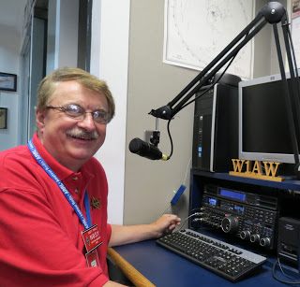

Hey Gang...

This has been a rather relaxing week for me. I’m here on the beach soaking up some sun and fun. No, I’m not at Cedar Point, I’m here in Fort Myers / Sanibel Florida for a few days. I’ve been taking in the sights and just having some with the better half. It’s not often I get to do things like this, so I took advantage of the opportunity when it came along. No club meetings, breakfasts with the guys or hamfests this week to report on. I can tell you that all’s quiet on the Gulf Coast and the seafood is to die for!!! The boat races were fantastic, and we even had the Vice President of the United States come and join in on the fun.

I for sure will make up for the mini vacation as soon as I land back in Ohio.

TOP ^

Sliding down the band a bit… Stan, N8BHL has reported that the S.E.T. when extremely well and he’ll have a report on it in the near future. I will say, I got to participate a little and I had a blast with all of the folks in Mansfield that really did a great job of finding out just where they can and cannot operate simplex to. I hope you did the same.

I’m gonna keep it short this week so I can get back to the pool and sun, but before I go I do want to ask this…. Is your club doing any special activities that you’d like the Section to know about? As you can see by the posts in the Club Corner, many clubs are already taking advantage of getting the word out to over 8,000 readers every week.

Do you have a story that you’d like to tell about something that you or your club has or is doing? Let me know about it and let’s get it in the next edition!

Whelp… That’s going to do it for this time around. Stay safe, enjoy the sunshine while we have it, and most of all… have FUN!!

73,

***Scott, N8SY***

***Welcome New Subscribers***

James, ke8iju; Grant, K8BCI

***Want to Share your Club Newsletter With Others?***

Is your club’s newsletter available to share? I’ve got a new webpage that has links to all of the known websites where club newsletters can be accessed throughout Ohio.

Now, as we all know when any list is published, it’s outdated immediately. That’s ok, just send me the link to your club’s newsletter and I’ll get it on the webpage – [n8sy@n8sy.com](mailto:n8sy@n8sy.com)

Here’s the link: <http://arrl-ohio.org/club_link/links-to-newsletters.html> Remember, we’re all here to help each other. What a great way to share the news about Amateur Radio!!

***Back Issues of the PostScript and Ohio Section Journal (OSJ)***

Hey, did you know that PostScript and Ohio Section Journal (OSJ) are archived on the website? You can go back and look at any edition simply by clicking:

<http://arrl-ohio.org/news/index.html>

TOP ^

***Chit – Chat, and All That!***

Do you know someone that’s not getting these Newsletters? Please, forward a copy of this Newsletter over to them and have them “[Opt-In](http://arrl-ohio.org/forwarder/forwarding.html)” to start receiving them. Heck, just have them send me an email [n8sy@n8sy.com](mailto:n8sy@n8sy.com) and I’ll get them added to the Ohio Section Emailing list.

We now have many thousands of readers receiving these newsletters weekly. Quite impressive, I’d say! I urge all of you to make sure that everyone, regardless of whether they are a League member or not, get signed up to receive these weekly Newsletters.

You can always “[Opt-Out](http://arrl-ohio.org/forwarder/forwarding.html)” at any time if you feel this is not what you were expecting. It’s fun and very informative. All of your favorite past newsletters are now archived too.

You can go back at any time and read them. Just go to: <http://arrl-ohio.org/news/>

Got questions, concerns or would just like to sit and chat awhile? Heck, I’ll even buy the coffee!! Give me a call at (419) 512-4445 or email me at: [n8sy@n8sy.com](mailto:n8sy@n8sy.com)

The pictures on the front page are from various newsletters, Facebook posts and/or were sent directly to me in recent weeks. Take a good look at them, you just might be in one of the pictures! “SMILE… you’re on the Ohio Section News!!”

TOP ^

*PostScript is produced as a weekly newsletter. I want to thank everyone that has contributed articles and ideas to make this an even better news source. I sincerely hope that you have enjoyed this edition and will encourage your friends to join with you in receiving the latest news and information about the Ohio Section, and news and events happening around the world!*