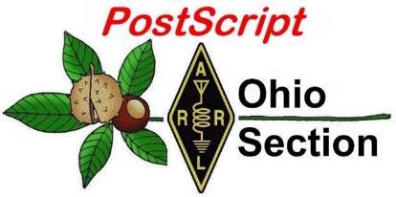
Christopher
Columbus
Edition

National News The Handbook Give Away

Club Corner Hamfests

DX This Week One Question Questionnaire

VE Testing ARES Connect

Special NIMS Training Final.. Final..

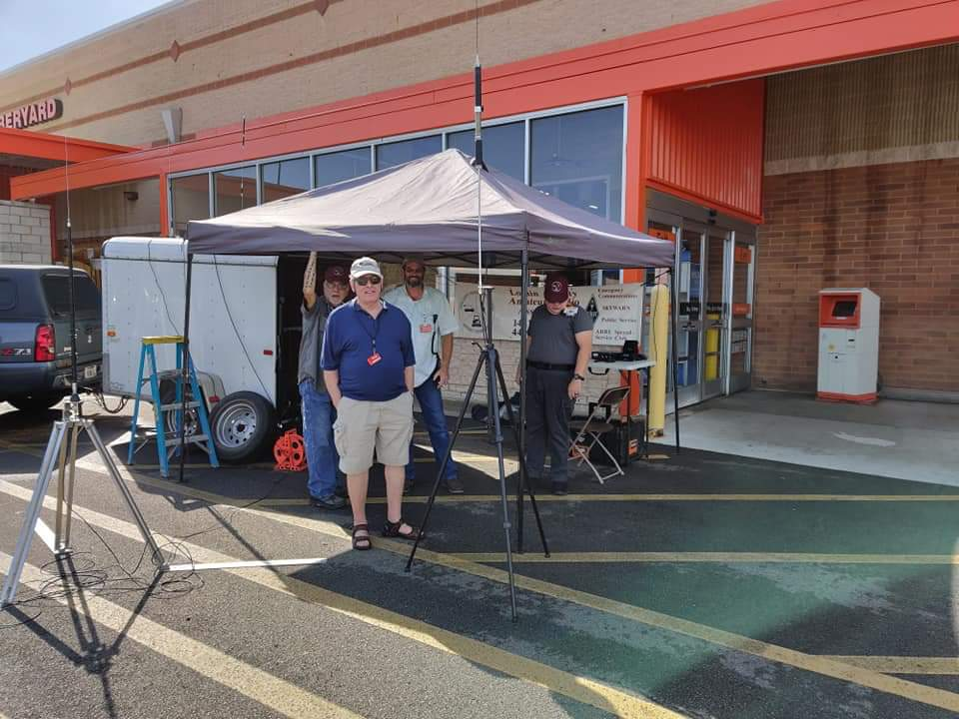
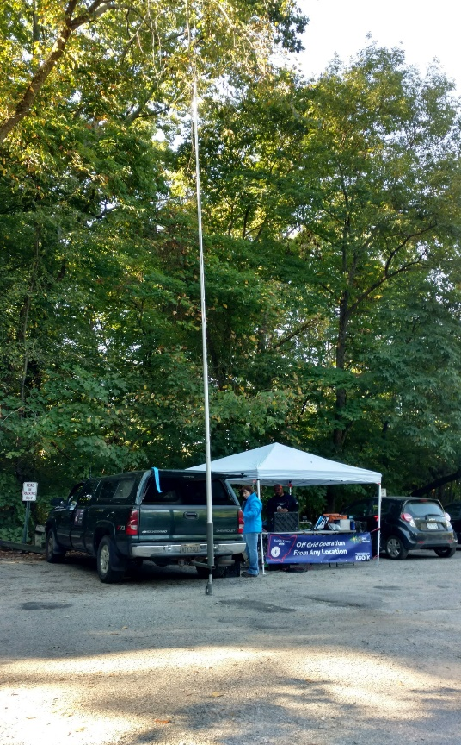
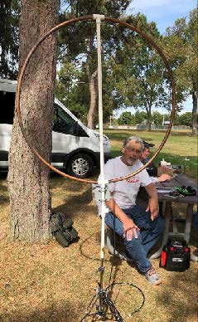
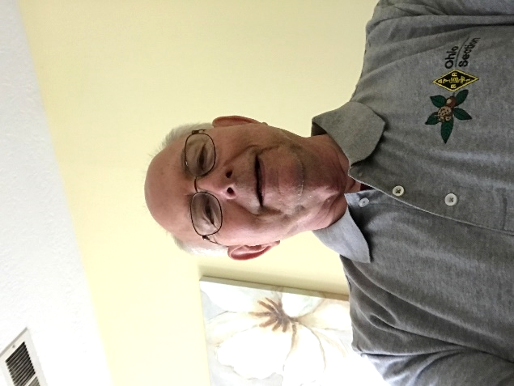
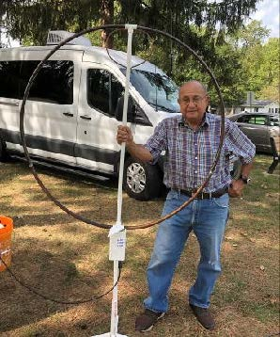

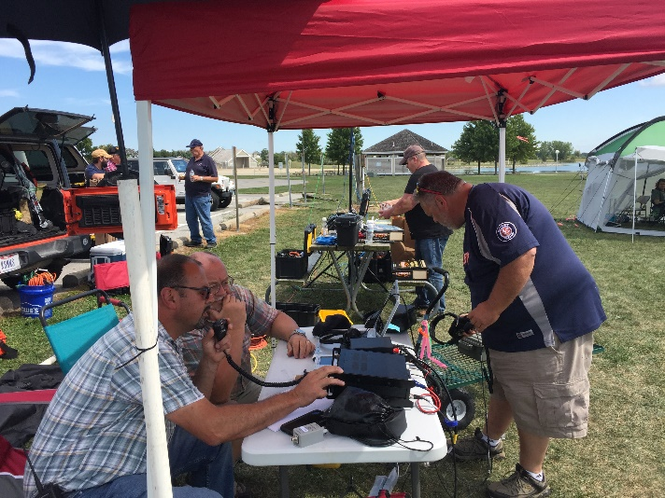

National News
(from arrl and other sources)

The Weather Channel Cites “Old School Tech” Amateur Radio as Storm Resource

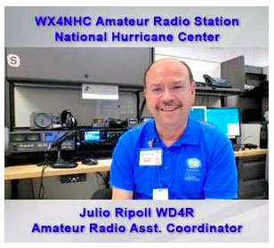
Julio Ripoll, WD4R, Amateur Radio Assistant Coordinator of WX4NHC at the National Hurricane Center (NHC) explained Amateur Radio’s role during severe weather situations to interviewers from The Weather Channel (TWC). In a September 16 segment headlined as “Using Old School Tech During a Storm,” Ripoll — seated at WX4NHC — told Weather Channel interviewers Rick Knabb and Mike Bettes, that information NHC forecasters receive via Amateur Radio volunteers and spotters “sometimes fills in gaps they can’t get from satellites or reconnaissance.”

Knabb recounted an occasion when he was trying to pin down information about a storm system in Central America. “The only way I was able to accurately document what happened with that system in Central America was because of data through the ham radio operators that relayed it,” he told Ripoll.

Ripoll cited the WX4NHC volunteer staff of approximately 30 radio amateurs who gather and essentially screen information gathered via Amateur Radio for weather data that may be of use to forecasters.

Pointing to the continued use of analog technology in a digital world, Bettes said Amateur Radio “may be a dinosaur, but you’re not extinct.”

For his own part, Ripoll over the weekend expressed appreciation to WX4NHC, Hurricane Watch Net, and VoIP Hurricane Net volunteers for the time they donate during hurricanes and the reports they send to WX4NHC.

“Sometimes, we sit for hours listening to static. Sometimes, we receive many reports that are unremarkable. Sometimes, we receive very few reports. But then there are those times that one or two reports make a difference,” Ripoll said. He noted that NHC Hurricane Specialist Stacy Stewart cited Amateur Radio in a Hurricane Humberto advisory.

The advisory noted, “An Amateur Radio operator at Ports Island near the southern end of Bermuda reported a sustained wind of 75 MPH and a gust to 104 MPH during the past hour. An Amateur Radio operator in Somerset Village recently reported a sustained wind of 70 MPH and a gust to 89 MPH.” — Thanks to Julio Ripoll, WD4R

#########

TOP ^
ARRL Sets Facebook Live Event for Collegiate Amateur Radio Clubs

ARRL is inviting campus radio clubs to join a Facebook Live Event on Wednesday, October 16, at 6:30 PM PDT and MST; 7:30 PM MDT; 8:30 PM CDT, or 9:30 PM EDT. The University of Arizona Amateur Radio Club (K7UAZ) is hosting the event.
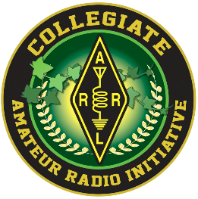
ARRL staff member Bob Inderbitzen, NQ1R, and students from the radio club will discuss topics involving Amateur Radio clubs at colleges and universities, including how to recruit student members, popular activities for campus radio clubs, and Amateur Radio as a springboard for career connections, networking, and practical experience. Your ideas and questions are welcome, and student radio club members and advisors may participate.

This event will stream live on the ARRL Collegiate Amateur Radio Initiative (CARI) Facebook group, where collegiate radio clubs may share information, techniques, and resources. The ARRL Collegiate Amateur Radio Initiative is sponsored in part by the W1YSM Snyder Family Collegiate Amateur Radio Endowment Fund.

#########

To All Former OO’s and OOC’s

Since sending the message with notifying you of the formal closing of the OO programs, many OO’s are sending in applications to be part of the new Volunteer Monitor Program.

We appreciate your continued interest, but as noted yet again in last week’s message, the deadline for applying for the new program was July 15th. We are sorry if you missed the several messages on the ARRL Web, and other League news outlets about the application deadline opening and the closing on July 15th. At this time, we are not accepting any additional applications for the program, even from former OO’s. There is a sufficient pool of applicants to meet the program objective of about 200 volunteer monitors in the new program. There will of course be attrition from the new program. As those happen, the program administrator has selected a “reserve pool” of potential new VM’s to add to the active VM roster as necessary. When it is appropriate, we will reopen the application process in the next several years to replenish the pool as necessary but will not be accepting any applications at this time.

Again, thanks for your previous service as an OO. Should the need arise to reopen the application process, an announcement will be made on the ARRL Web.

73

Dan Henderson, N1ND
Assistant Secretary – American Radio Relay League, Inc.
Regulatory Information Manager
ARRL, the national association for Amateur Radio ®
860-594-0236
dhenderson@arrl.org

#########

TOP ^
FCC Proposes Fining New York Radio Amateur $17,000 for Deliberate Interference

A New York Radio Amateur — Harold Guretzky, K6DPZ, of Richmond Hill — is facing a $17,000 fine imposed by the FCC. Guretzky was issued a Notice of Apparent Liability for Forfeiture (NAL) on October 3 for causing intentional interference on a local repeater and preventing other radio amateurs from using it.

“Given his history as a repeat offender, this violation warrants a significant penalty,” the FCC said in the NAL.
The NAL recounted numerous complaints alleging that Guretzky was deliberately interfering with a repeater in Glen Oaks, New York. In June of 2017, the FCC issued a Warning Letter to Guretzky, advising him of the nature of the allegations against him and directing him to stop using the repeater going forward. Nonetheless, additional complaints were filed. In April 2018, agents from the FCC New York Enforcement Bureau office drove to Richmond Hill to investigate. Following an inspection of Guretzky’s station, the agents advised him in writing that he was prohibited from using the local repeater.

After the FCC received further complaints regarding Guretzky’s continued operation on the local repeater, an Enforcement Bureau agent again drove to Richmond Hill to investigate. The agent monitored the VHF repeater’s input and output frequencies and, after observing deliberate interference to other stations, used direction-finding techniques to identify the source of the transmission as Guretzky’s station.

“The agent monitored and recorded the transmissions emanating from Guretzky’s station for several hours that afternoon and heard him interfering with the local repeater,” the NAL said. “Later, the agent heard Guretzky making threatening comments toward other amateur operators. These transmissions were a deliberate act to control the frequency and prevent other Amateur Radio operators from conducting legitimate communications.”
The following month, FCC Regional Director David Dombrowski spoke with Guretzky via telephone, noting that the Commission was still receiving complaints about his continued use of the repeater and cautioning him against using the repeater.

The FCC said Guretzky “apparently willfully violated” Section 333 of the Communications Act and Section 97.101(d) of the FCC’s Amateur Service Rules, demonstrating “a deliberate disregard for the Commission’s authority and the very spirit of the Amateur Radio Service by continuing to interfere with the local repeater” despite having been warned

From Amateur Radio Social Club to 50 Years of Disaster Response
(By Jim McKay / OCTOBER 3, 2019 – Emergency Management Newsletter)

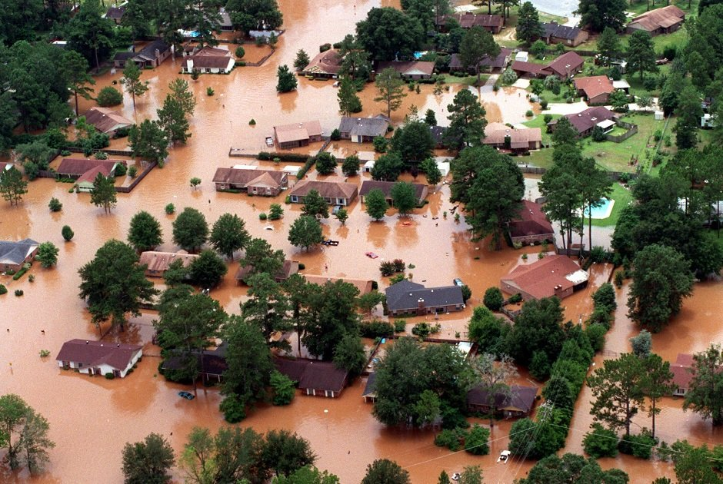
Steve Landers started with a two-way, amateur (ham) radio club that felt like family, led to participation in disaster response that continued through a lifetime of emergencies and disasters in Macon-Bibb County, Ga.
Muddy floodwaters cover a subdivision in Albany, Ga., Wednesday, July 7, 1994. After 86 hours of rain, widespread flooding started in west-central and southwestern Georgia along the Flingt and Ocmulgee river basins. In Albany, the Flint inundated 4,200 residences, forcing 15,000 people to evacuate. ASSOCIATED PRESS

TOP ^
From Amateur Radio Social Club to 50 Years of Disaster Response Steve Landers started with a two-way, amateur (ham) radio club that felt like family, led to participation in disaster response that continued through a lifetime of emergencies and disasters in Macon-Bibb County, Ga.
Steve Landers was about 16 years old when he joined a group of amateur radio enthusiasts. He found a unique camaraderie within the group and deep desire to help those in need.
Those feelings still run deep, countless disasters and 50 years later.

Of that initial ham radio group, Landers said, “Basically it was a social club of two-way radio enthusiasts, but it didn’t take long to figure out that the main interest was the support of the civil aid unit.”

Landers has volunteered his services as part of the Macon-Bibb, Ga., Emergency Management Agency (EMA) Volunteer Group ever since, starting with dragging the Ocmulgee River for drowning victims to responding to fatal traffic accidents on the motorway, to responding to tornadoes, to participating in the response during the devastating floods of 1994.

The group assists the Macon-Bibb EMA whenever there is a need to activate the EOC, whether is a natural or man-made disaster. “Anytime you hear of a tornado or other storm in the Macon area, you can bet our group is going to be out there,” Landers said.

Landers’ specialty, of course, is radio communications, but Angela Billiot, president of the board of the volunteer group, called Landers a jack-of-all trades.

“I can put him on the radio, and he is comfortable,” Billiot said. “I can put him in our mobile command, listening to the radio or in the office in front of computer or on the street directing traffic. He’s done search and rescue, civic events, tornadoes, hurricanes, fatalities on the interstate, and he was around when the flood of 1994 came through Georgia.”

The group, about 15 now, takes on the overflow 911 calls that dispatch can’t handle. A couple of them operate the mobile command unit. The group does a lot of damage assessment after storms in the county and surrounding counties and has been instrumental in helping other counties get the recovery money they need.

Landers does all of the above and has taken a dozen or more courses, including courses at FEMA’s Emergency Management Institute in Emmitsburg, Md. The volunteers are very well trained, thanks in large part to the relationship with the Macon-Bibb EMA and its director, Spencer Hawkins.
“We’re lucky to have such a great relationship with the county and a great director,” Billiot said. “We’re allowed to participate in all drills, civic events, conferences — he will sign off on any training they want.”
That opportunity to grow, learn, participate and feel needed is why so many volunteers stick with it so long. Billiot said that along with Landers, there are other members who’ve participated for more than 20 years and up to 40.
Hawkins is grateful for the dedication. “Macon-Bibb County is lucky to have someone like Steve Landers,” he said in an email. “There are untold number of people that Mr. Landers has either inspired to volunteer themselves or were made safer during disaster situations because of his actions.”

TOP ^
Landers considers himself more of a radio guy for which he’s gotten most of his training, dating back to those teen years when his group trained with the American Red Cross. He remembers a turning point when he was sitting in his little office that his Dad built at their home trying to do homework but listening to the radio about the search for a missing person. He knew that’s where he needed to be.

He remembers his first forays into disaster response and the messy job of dragging the river, sometimes several times a year, for bodies. “We had a Macon Motorboat Club, which contained a specially trained group of guys who knew how to navigate the river and drag at the same time with grapnel hooks. You drag up and down the river until you hook the body,” he said. “It’s not a pleasant sight, to say the least.”

That was when it was called Civil Defense, and during the Cold War when the threat of nuclear war seemed ominous. “We were highly trained at dealing with nuclear fallout,” he said. “I’ve been to radiation school; I’ve worn the mask. “Now they call it Homeland Security and it means that if there’s a storm, a real storm, you can count on us getting called out and the National Guard getting called out,” Landers said.
He said he has worked with the National Guard numerous times, helping with two-way radio communication. But he will do anything. He remembers days on end during those July 1994 floods handing out, of all things, water.

It started with Tropical Storm Alberto, which before it was over, had delivered enough rain to have brought the worst flooding in the state’s history, until Hurricane Michael in 2018. “Wall-to-wall water,” is what Landers remembers. “There was devastation everywhere. Rows of houses that were just wiped out, water up to the ceilings.”

But the worst thing he has seen in his 50 years? “I think I can answer that one quickly. The worst I’ve seen is a deceased victim in a motor vehicle accident laying across a seat. That’s not a pretty sight.”

So why does he keep on? He explains that his family “had some issues” when he was growing up. “Then I found the radio group and they were like the family I wanted but couldn’t have, so I buried myself in that group and in school.

He said there’s never been a day when he wondered why he joined. “The maturity that I got, the camaraderie, the training that it offered was better than any medical care or counseling I could have gotten. And it still is.”
#########

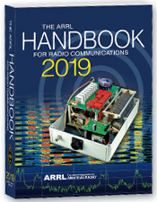
The Handbook Give Away

Hey Gang,

We had another fantastic response this month, but I’m sure you’re more interested in knowing just who won the Handbook this month...

And the winner is…. Jim Grimes, KD8OCW

We've had another a great response after with the Give Away so… I decided to also give away something really special this time around. Since the weather has changed from cold to really hot and sticky, why not give out official Ohio Section Polo Shirts!

TOP ^
So, I'm sending out an Official Ohio Section Logo Polo Shirt to: Douglas Voshel, W8DHV &
Dave Lewis, K8DL!

Many of you ask me just how do I know when the drawing is on? Well, that’s easy all you need to do is check in on the Ohio Section Website on a regular basis and watch for the big RED Arrow that will appear on the left side of the page. This is the sign that the drawing is on and you need to get registered. So, keep a sharp eye out on the website and check in often! http://arrl-ohio.org

You just never know... You just might be the next winner!

Club Corner

This is YOUR cornner of the newsletter. Send me what your club is doing and I’ll make sure that it gets in. Got a special event or club project that you want everyone to know about? Send it to me!. Need help with a project? Send it to me.

Let me know what you club is up to. Are you going to have a special guest at your meeting or are you having a special anniversary? Just sent it to: n8sy@n8sy.com

#########

Ohio VOAD Needs Help

Ohio VOAD is looking for a Communications Chairperson that can take over the responsibilities of posting information on their Facebook and Twitter accounts.

Qualifications needed to apply: Experience posting to Facebook, Twitter and other Social Media sites a must. Having experience with updating websites is a plus, but not mandatory. Able to attend daytime meetings in Columbus and willing to post items to these various sites as they happen.

This is a position for a person that is a true volunteer and wants to give back to their community. For more information contact Scott, N8SY at n8sy@n8sy.com

#########

Germantown ARS Twisted Pretzel Tour a Big Success
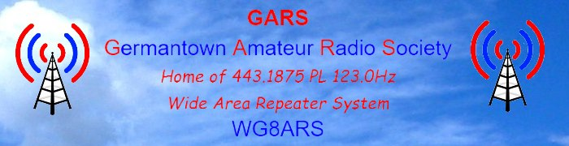
Steve Mersch of the Lion's Club said that we did a great job. Thanks to Gary-W8WGR for working 3 posts.

Tactical call signs worked well. We had about 530 bicyclists (official total at a later time).

TOP ^
There was 1 bicyclist down with no injuries. There was one bicyclist with serious injuries: broken elbow & hip and was knocked unconscious. She is in the hospital. The incident was called in by GARS volunteer. Two ambulances and an officer were on the scene immediately.

There were 27 posts and 25 volunteers. Thanks go out to everyone that participated. This is what Amateur Radio is all about, helping our communities!!

#########

Air Force MARS Broadcast Resumes
(from: Broadcast Manager, Air Force MARS, MARSCOMM)

In May 2019 the Air Force MARS resumed a favorite from the past. Every other Friday there are a series of Air Force MARS Broadcast which are distributed to all Air Force MARS stations. The message is from the Chief of Air Force MARS and the Deputy Chief of Air Force MARS. The message is Unclassified and does not contain For Official Use Only (FOUO) information so other interested parties may listen in on the message(s).

The next series of Broadcasts begin this coming Friday night, October 4, 2019. The full Broadcast schedule is:

East CONUS Friday Oct 18, 2019 2300Z 11.121 MHz
Friday Oct 18, 2019 2320Z 4.485 MHz
Central CONUS Saturday Oct 19, 2019 0000Z 11.121 MHz
Saturday Oct 19, 2019 0020Z 4.485 MHz
West CONUS Saturday Oct 19, 2019 0100Z 11.121 MHz
Saturday Oct 19, 2019 0120Z 4.485 MHz

The message is typically 7-10 minutes long and the transmissions are in Upper Sideband (USB). Come and listen in!

#########

American Cancer Society Making Strides of Cleveland HELP STILL NEEDED

The public service season in Cleveland will be wrapping up in just a couple weeks with our final event, the ACS Making Strides of Cleveland. This is a walk that benefits the American Cancer Society and is specifically focused on breast cancer.

The event route has not been finalized yet but will probably end up being about a 5k. This event should be over by around 12 PM or 1 PM and the best news is, the event starts at 10 AM. That means everyone gets to sleep in AND be home for lunch. We will have a morning meeting at about 9 AM and be in place by 9:30 AM.

The strides walk takes place on Saturday October 12, 2019. If you are able to help please SIGN UP HERE .

####

TOP ^
Skywarn Recognition Day 2020 - THE FINAL YEAR AT HOPKINS

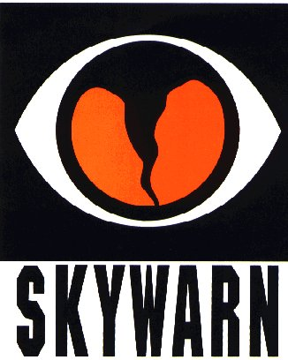
Skywarn Recognition Day will be taking place nationally on Saturday, December 7th, 2019 for 24 hours starting at 0000Z (Friday, Dec 6th, 7:00 PM Eastern until Saturday, Dec 7th, 7:00 PM Eastern). The NWS Cleveland Office will be participating from 12:00 PM until 7:00 PM on Saturday, December 7th, 2019. We will be operating under the call sign WX8CLE and will be active on UHF, VHF, and HF (HF bands to be determined later). We will also periodically spin the dial on local repeaters.

Just like last year, we will operate UHF/VHF inside the office and HF outside in the new vehicle. Anyone interested in attending is encouraged to sign up here, but since we will be partially operating from outside, last minute walk ins are welcome. Access to the inside of the building will be restricted based on attendance as the operating area can only accommodate a certain number of people at once. Additionally, any sort of severe weather event could potentially result in us cancelling the operation. Those who sign up will be advised of any last-minute changes, or we can be contacted on the Skywarn simplex frequency of 146.475 (we will do our best to keep a radio on this the entire time).

When you arrive on site, please check in with the operators in the vehicle. They will then arrange access to the building should you desire to come inside. if no one is present, call us on 146.475 simplex.

As you may know, the Cleveland NWS office will be relocating in spring 2020 so this will be the last time to operate from the office at the airport!

The address for the National Weather Service Cleveland is 5301 W Hangar Rd, Cleveland, OH 44135. This is off of Brookpark Rd, between NASA and Hopkins, behind the UPS hangar.

#########

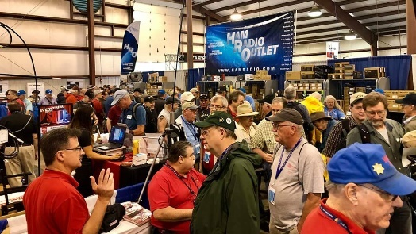
Upcoming Hamfests

10/12/2019 | NWOARC Fall Hamfest
Location: Lima, OH
Sponsor: Northwest Ohio Amateur Radio Club
Website: http://www.nwoarc.com

11/02/2019 | GARC Hamfest
Location: Georgetown, OH
Sponsor: Grant Amateur Radio Club
Website: https://www.facebook.com/Grant-Amateur-Radio-Club-775764122477536/?modal=admin_todo_tour

11/03/2019 | Massillon ARC Hamfest  Location: Massillon, OH  Sponsor: Massillon Amateur Radio Club  Website: http://www.w8np.org | 12/07/2019 | Fulton County ARC Winterfest  Location: Delta, OH  Sponsor: Fulton County Amateur Radio Club  Website: http://k8bxq.org/hamfest

TOP ^

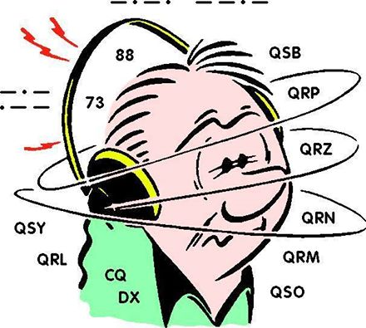
DX This Week
(from Bill, AJ8B)

DX This Week – Morse Runner
Bill AJ8B (aj8b@arrl.net, @AJ8B,
www.aj8b.com or www.swodxa.org )
CWOPs Member #1567

This week, the mailman delivered 9G2DX (Ghana), HB9ODP (Switzerland), and SV8/SV1CEI – Kea Island - Greece (Pictured). What did you get? Send me an image and some details!

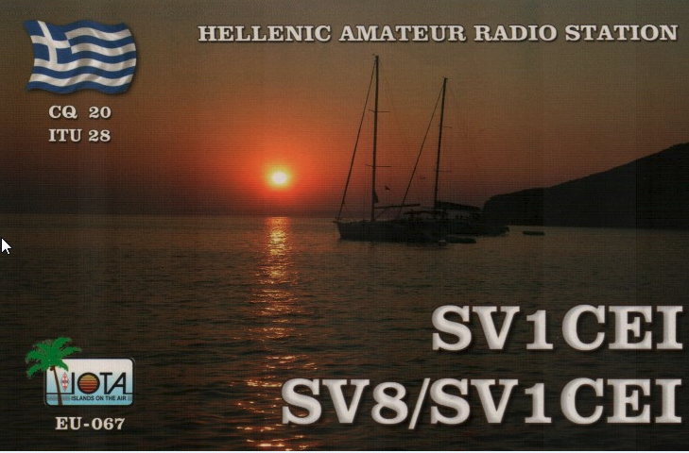
I received an email from K8ZT, Anthony, sharing with us a couple of excellent QSL Cards that he has recently received. They are “7O6T- CW & SSB with 5 watts on my end” and “E51WL - 160M FT8 with 5 watts on my end and 60' sloper antenna.”

Anthony, K8ZT is the Ohio Section Youth Coordinator & Education Outreach Coordinator. He has a terrific website at www.k8zt.com.

Anthony has kindly allowed me to reprint articles and use him as a web resource reference. He is also quite the operator! Thanks, Anthony, for your help and all you do for Amateur Radio.

TOP ^
Figure 1 QSL card for K8ZT from 7O6T

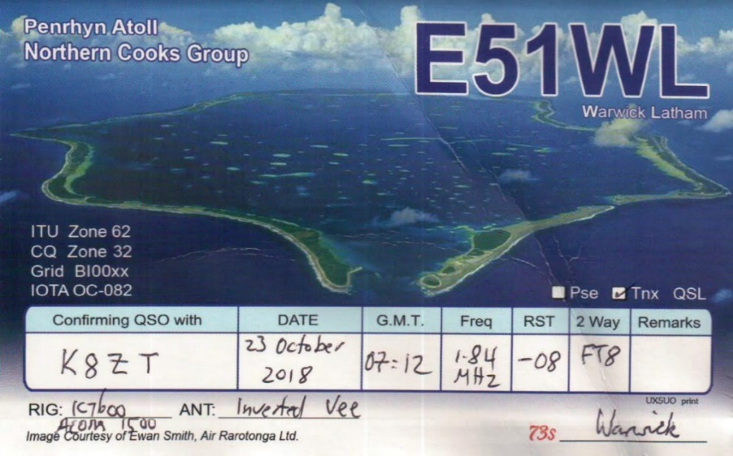
Figure 2 QSL card for K8ZT from E51WL
I hope you had a chance to check out RufzXP. The next program to discuss, and one of the neatest pieces of software I have used in a long time, is Morse Runner. Morse Runner was created by VE3NEA, Alex. The purpose is to simulate a CW contest. The program has several options that make it a very valuable tool.

TOP ^
You are not only challenged to copy callsigns at various speeds, elements such as QRM (Interference), QRN (Static), QSB (Signal Fading), Flutter (The sound of a signal passing over the poles), and LIDS (poor or illegal operators) are added as well.

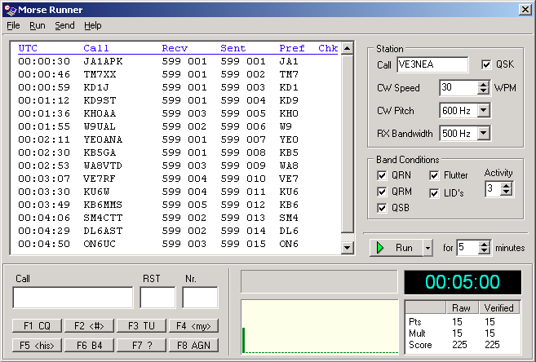
Figure 3 is a screen shot of Morse Runner. The options for adding the elements are enclosed in the red box. I would recommend unchecking all of them until you are familiar with the software.
Figure 3 Morse Runner

The area shown in yellow is the user setup fields area. I would also recommend unchecking QSK (receiving between Morse code elements) until you are comfortable.

Just below the user setup area, is the start button and the area where you can set the length of time you want to operate.

The final area to review is the purple area, the Function keys. These are the keys you will use to interact with the software. Just click the “Run” button and you will hear signals from your speakers. Call CQ by pressing F1. Your CQ will be “Sent” and then the fun begins. Listen for stations calling you and enter the one that you copy in to the Call Field and press <Enter>. Your exchange will be sent which will include the station you copied, the signal report and your serial number, automatically updated after sending. Listen for the station call you back and enter the Serial Number that they send you into the Nr. Field. Hitting enter will log the QSO. If there was an error, you will see it noted in the display field.

Otherwise, your score will increment. There may be another station calling you. At that point, just repeat the above process. If no one is immediately calling you, clicking F3 will send a TU (Thank You) followed by your call. Be prepared for other stations to call!

I have also seen instances where you have to call CQ several times before anyone comes back to you. (Very realistic, at least for ME!)

Beware…this becomes addictive and it will sharpen your skills. The software can be found at http://www.dxatlas.com/morserunner. There is an excellent video on using the software at https://www.youtube.com/watch?v=1tENliEvQwc

Give this a try and let me know how you do!

Good Hunting!

+ --------------------------------------------------------------------------------------------------+
Here is an update from Bernie, W3UR, of the DailyDX and the WeeklyDX,
the best source for DX information.
(http://www.dailydx.com/ ) Bernie has this to report:
+ --------------------------------------------------------------------------------------------------+

TOP ^
S7 – Seychelles - Members of the Polish DXPeditions group are planning to activate S79W and S79CI from Mahe Island (AF-024) between October 18 and 29. They will have an IC7200 and K3 along with two Expert 1.3K-FA amplifiers capable of putting out 400 watts. Activity will be on SSB, CW, RTTY and FT8 on 1.8 through 28 MHz using verticals. QSL via the operator’s home call. Logs will be uploaded to Club Log and eventually to LoTW. www.s79.dxpeditions.org
OY - Faroe Islands - LB5GI, Gjermund, will be in Eidi, Eysturoy for a work assignment and some radio activity as his time and QTH permit. Listen for OY/LB5GI between September 30 and October 4. He will have an FT-857D running 100 watts into and End Fed for activity on FT8 and SSB on 40, 20, 15 and 10 meters. Logs will be uploaded to Club Log and LoTW. QSL via his home call.
F – France - Members of the Radio Club de Vineuil (F6KJX) will be operating special event station TM20CI to commemorate the 500th anniversary of the death of Leonard de Vinci. The dates will be October 27-27, November 1-11 and November 23-24. QSL via F6KJX.
6O7O update from LA7GIA's, Ken, DXpedition Facebook page. The beverage and Mosley beam has been taken down. I will QRT 28th at 0315 UTC shortly after 40m NA session.
I am running on my African dipoles on 20/17. 160/80/40/30 will be up until tomorrow as well.
This trip included trenching a DX Engineering RX coax 250 meter (buried 4" or 10 cm). I had to cross a public street and obtain permit to install on public ground.
I have setup a small humanitarian fundraiser for a Norwegian organization that helps children in Africa. I hope you will consider a small contribution. Donation via PayPal kenneth@opskar.no. All QSL goes to this fundraiser. See www.la7gia.com
____________________________________________________________
On The WWW
_____________________________________________________________
The A35JT team have announced their "Press Release #2: Finally up and running!" at
https://vk5gr-iota.net/2019-a35jt-oc-049-tonga/2032/
The Ukrainian members of the ZK3A DXpedition team have departed for Tokelau - https://tokelau2019.com/news/f/ukrainian-team-departed-for-tokelau
The ZK3A website announced their Tokelau DXpedition has been approved for DXCC credit.
https://tokelau2019.com/news/f/dxcc-credit-approved
(Remember the old days when the ARRL made these announcements?)

#########

TOP ^

DX news

ARLD039 DX news

This week's bulletin was made possible with information provided by The Daily DX, the OPDX Bulletin, 425 DX News, DXNL, Contest Corral from QST and the ARRL Contest Calendar and WA7BNM web sites. Thanks to all.

ST. PIERRE AND MIQUELON, FP. Look for Manfred, DK1BT, Wolf, DL4WK, Annette, DL6SAK, Sigi, DL7DF, Frank, DL7UFR, Jan, SP3CYY and Leszek, SP3DOI as TO80SP until October 14. They are QRV on 160 to 10 meters using CW, SSB and digital modes. QSL via DL7DF.

TONGA, A3. Grant, VK5GR, Oly, VK5XDX and Andrew, VK5AKH are QRV as A35JT from Tongatapu, IOTA OC 049, until October 7. Activity is on 80 to 10 meters using CW, SSB and various digital modes. This includes being active in the CQ World Wide RTTY DX and upcoming Oceania DX contests. QSL via M0OXO.

CAPE VERDE, D4. Harald, DF2WO will be QRV as D44TWO from Sao Tiago, IOTA AF-005, until October 13. Activity will be on the HF bands and possibly various satellites. QSL via M0OXO.

LUXEMBOURG, LX. Gerard, PA0PIW, Gert, PA2LO, Maarten, PA3EYC, Tymen, PA3GRM, and Bert, PD0GP will be signing LX/home calls from October 4 to 7 on 80 to 10 meters using CW, SSB, RTTY and FT8. QSL via PA3EYC, LoTW.

WESTERN KIRIBATI, T30. Stan, LZ1GC, Karel, OK2WM and Mitko, LZ3NY will be QRV as T30GC from October 7 to 23. They plan to be active on 160 to 10 meters using CW, SSB and RTTY. QSL via ClubLog OQRS, LoTW or LZ1GC.

LIBERIA, EL. Members of the Italian DXpedition Team will be QRV as A82X and A82Z until October 11. Activity will be on 160 to 10 meters using CW, SSB, RTTY and FT8 with five stations. QSL direct to I2YSB.

PERU, OA. Members of Radio Club Peruano are QRV with special call sign OC19IARU until October 6 during the 20th General Assembly of IARU Region 2. QSL via bureau.

FERNANDO DE NORONHA, PY0F. Members of the Noronha Contest Group plan to participate in the CQ WW DX SSB Contest as PY0F. They will be QRV on 160 to 10 meters. QSL via PY7RP or ClubLog OQRS.

UGANDA, 5X. Anton, ON6NL is QRV as 5X8C from Entebbe until October 7. Activity is in his spare time while working and teaching telecom training classes. QSL to home call.

VIETNAM, 3W. Sven, HB9DXB is operating as XV9DXB until October 9. He is QRV on 40 and 20 meters using CW and SSB. QSL via EB7DX. Also, Geri, DK8KW will be active as 3W9KW in Hanoi from October 18 to 26. Activity will be on various HF bands running QRP, mostly CW and possibly some SSB. QSL via home call.

TOP ^
SEYCHELLES, S7. Ravi, VU2IIX will be QRV as S79VU from Mahe Island, IOTA AF-024, until June 30, 2021. Activity will be on 80 to 10 meters using SSB and various digital modes. QSL via operator's instructions.

DODECANESE, SV5. Wolf, DL3DRN is QRV as SV5/DL3DRN from Rhodes, IOTA EU-001, until October 10. Activity is on the HF bands using CW, SSB and RTTY. QSL via LoTW.

GABON, TR. Roland, F8EN will be QRV as TR8CR until December 15. Activity will be on the HF bands using CW. QSL via F6AJA.

VANUATU, YJ. Oleh, KD7WPJ will be QRV as YJ0BCP from Efate, IOTA OC-035, until October 10. Activity will be on 40 to 6 meters using CW, SSB and FT8. QSL to home call.

THIS WEEKEND ON THE RADIO. The TRC DX Contest, The Oceana DX Contest Phone, Russian WW Digital Contest, YLRL DX/NA YL Contest, International HELL-Contest, California QSO Party, FISTS Fall Slow Speed Sprint, SKCC QSO Party, RSGB DX Contest, UBA ON Contest SSB and the Peanut Power QRP Sprint are all on tap for this weekend.

Special Events

10/18/2020 | Commemorating 80th Anniversary of U.S.C.G Auxiliary
Oct 18-Oct 20, 1400Z-2300Z, N4U, Benton, KY. United States Coast Guard Auxiliary. 14.070 14.250 7.070 7.250. QSL. Mary Husfield, 4156 Barge Island Road, Benton, KY 42025-6039. 80th Anniversary of United States Coast Guard Auxiliary. QSL to KC4TIE, Special Card returned with SASE. Mainly digital modes.

10/19/2019 | 100th Anniversary of Michigan State University Amateur Radio Club

10/19/2019 | 1600Z-2200Z, W8SH, East Lansing, MI. Michigan State University Amateur Radio Club. 14.250 14.050 7.250 7.050. QSL. MSUARC/W8SH, ECE Dept. #2121, 428 S. Shaw Ln. , East Lansing, MI 48824. Original call 8YG. msuarc@egr.msu.edu

11/02/2019 | 44th Anniversary, Sinking of the Edmund Fitzgerald
Nov 2-Nov 17, 0000Z-2359Z, W8F, Detroit, MI. Livonia Amateur Radio Club. 14.260 7.040 14.040 7.240. Certificate. Tas Foley, K8TAS, 37255 Euraka Rd., Romulus, MI 48207. On Saturday, November 2, W8F will operate from the Dossin Great Lakes Museum, Detroit MI 1600-2030 UTC. SASE FOR QSL CERTIFICATE livoniaarc.com

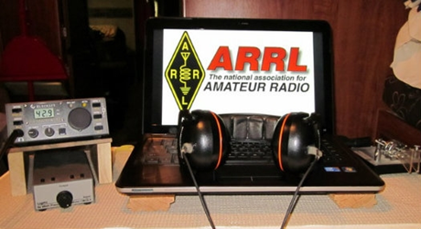
ARRL Contest Corner

An expanded, downloadable version of QST's Contest Corral is available as a PDF. Check the sponsor's Web site for information on operating time restrictions and other instructions.

TOP ^

School Club Roundup

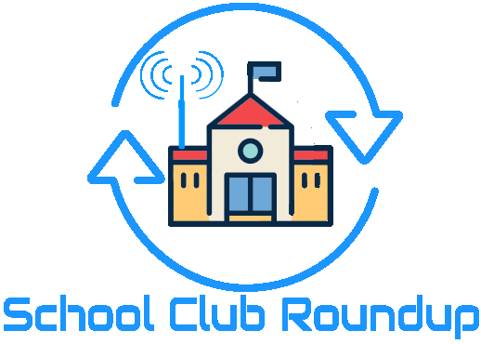
The Fall Term running of the School Club Roundup will take place October 21-25, 2019.

Objective: To exchange QSO information with club stations that are part of an elementary, middle, high school or college. Non-school clubs and individuals are encouraged to participate.

Sponsored by the ARRL, its Hudson Division Education Task Force and the Long Island Mobile Amateur Radio Club (LIMARC) to foster contacts with and among school radio clubs. Award certificates will be issued for the following US and DX categories:
- Schools: Elementary, Middle/Intermediate/Junior High School, High School and College/University
- Non-school Clubs
- Individuals

For additional details visit- www.arrl.org/school-club-roundup.

If you are involved with a School, Youth Group or Scouting Radio Club, please consider registering your group with the ARRL Ohio Section Youth Coordinator by using this link to fill out a registration form or if you know someone who is involved please share this link with them- http://tiny.cc/osl-form. When registering you will have complete control of what information will be shared with the public about your group. Anthony, K8ZT will make the approved registration information available on the ARRL Ohio Section website cabinet page- www.arrl-ohio.org/syc/index.html.

#########

Jamboree-on-the-Air
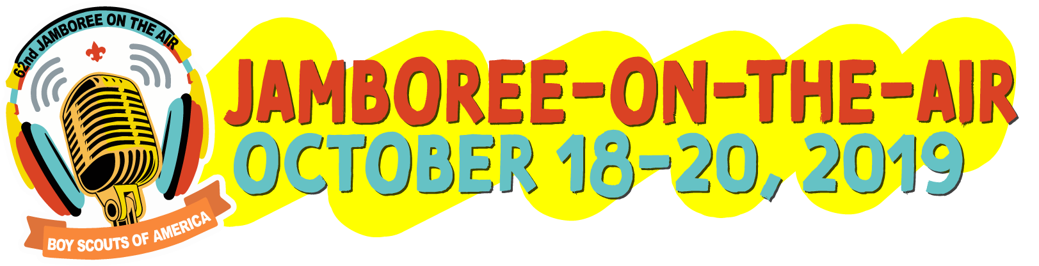

The 62nd Annual Jamboree On The Air will be held on the weekend of Oct 18-20th. Jamboree-on-the-Air, or JOTA, is the largest Scouting event in the world. It is held annually the third full weekend in October. JOTA uses amateur radio to link Scouts and hams around the world, around the nation, and in your own community. This jamboree requires no travel, other than to a nearby amateur radio operator’s ham shack. Many times you can find the hams will come to you by setting up a station at your Scout camporee, at the park down the block, or perhaps at a ham shack already set up at your council’s camp.

TOP ^
To find registered JOTA stations in your area visit https://k2bsa.net/registered-jamboree-on-the-air-stations. If you or your local club is planning a JOTA operation you can register it at https://k2bsa.net/jota-station-registration.

For additional information on planning your JOTA operations visit:
- JOTA- www.scouting.org/jota
- JOTA- www.arrl.org/jamboree-on-the-air-jota
- JOTA- www.jotajoti.info
- JOTA- https://k2bsa.net/jota
- JOTA suggested frequencies
- JOTA sample questions

For additional information on Scouting and Amateur Radio visit:
- Scouting & Amateur Radio- Ideas & Resources- tiny.cc/ar-scout
- Radio Merit Badge
- Girls Scouts Radio Patch
- Troop Program Feature: Radio

V.E. Test Sessions

For the latest testing site information please >> Click Here << The ARRL site tracks all of the VE testing sites that register with them, including W5YI and Laurel. ARRL gives you a number of different ways of sorting to find that site that is closest to you as well.

One Question Questionnaire

Hey Gang,

Wow, almost 63% of you didn’t participate in the annual Simulated Emergency Test this past weekend. I am really surprised at this number. This year’s S.E.T. was one that I would have thought everyone would have gotten involved with for sure. It was just as simple as going out and testing how far you could go and still be in contact with your Net Control. All done on simplex. No repeaters, no internet, just raw power and antenna performance. Why did we do this? Do you know how effective your radio is without the repeater? Do you know where you can and cannot operate effectively if there’s no additional machinery involved? Most of us can’t say with any certainty that we know. That’s why this was so important for everyone to participate in this exercise.

I’ve got another NEW – one question – on the Ohio Section Website for you to answer! I thought I’d do a follow up question that pertains to what we did for the S.E.T. this year. So, Here’s the question for this next week.

“How far away was your most distant mobile/portable simplex contact on 2-meters??”

TOP ^
These One Question questionnaires are all in fun and I hope that you are enjoying answering them.

You’ll find the “One Question” questionnaire on the Ohio Section Website! http://arrlohio.org It’s all in fun and it’s not a scientific survey in any way, but we are learning some things that we didn’t know from these questions. I hope that you are enjoying answering these “One Question” questionnaires.

ARES Connect

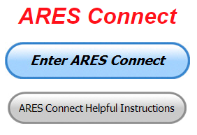
OK.. I’m setting a goal for all of you out there. Let’s get everyone in the Ohio Section on ARES Connect before the end of this year!!!

Do you need help with how to sign-up for an event or log your hours? How about you Administrators, do you have questions about approving your volunteer’s hours or how-to set-up a recurring event? I’ve got the answer for all of you. I have a new webpage with step-by-step instructions on how to do those things and many more.

I also have a “Hints and Kinks” section that has a lot of great information on how to do something or why something works like it does. Here’s the page: http://arrl-ohio.org/SEC/connect/index.html You can also find this link on the main page of the Ohio Section website as well.. It’s just under the “Enter ARES Connect” link.

If you live in Ohio and you haven’t registered yet, we need you to get registered now. We need you to only use this URL to get registered https://arrl.volunteerhub.com/lp/oh/. Using any other entrance to register will only slow down your registration process. Again, this is for those living in Ohio only. If you are an out of state person (not Ohio), you can simply change the /oh/ to your 2-letter state designation. This will put you in the correct state for signing up.

Now, I am starting to see folks creating more than one account because they can’t remember their password from the one that they originally setup. Please don’t do this. The system has a really good way of sending you a link to your email address so that you can refresh your password. If you are experiencing problems with getting to this link, contact me: n8sy@n8sy.com and I’ll get it fixed for you.

Here’s the top 10 hours earners so far for October:

 | Name | Events | Hours
1 | Dan Stahl (KC8PBU) | 14 | 35.26
2 | Christopher Domenick (KC8CAD) | 4 | 24.25
3 | John Westerkamp (W8LRJ) | 8 | 23.00
4 | Greg Dersarkisian (KD8SSJ) | 2 | 20.00
5 | Diane Warner (KE8HLD) | 2 | 18.00
6 | Jason Pecora (KB8O) | 5 | 16.50
7 | Andrew Gross (K8ALG) | 3 | 16.00
8 | Bret Stemen (KD8SCL) | 7 | 14.00
9 | Arthur Burnett (KB8UNJ) | 2 | 12.00
10 | Steve Wheatcraft (AA8BN) | 3 | 12.00

TOP ^
As you can see from the above listing, we can get real time information that shows how many hours, who volunteered and what they volunteered for. There’s a ton of information that we can draw out of the system.

We now have 1,254 registered and growing every day in the system. What’s really interesting is as of this same date there are 11,799 registered in the entire country. This means that the Ohio Section makes up over 10.62% of those registered.

Here’s a link to get you started... http://www.arrl-ohio.org/SEC/connect/ares_connect_directions.pdf
Please, don’t just hurry through the questions, read them carefully, if you don’t understand something, please ask me, I’m here to answer your questions.

I have also been hearing from some that they are not getting to record their time for events that they have done. After some investigation it was found that there is a time limit on just how long of a time you can go before getting locked out of recording your time. It’s 29 days. Then you have to have an administrator complete your time, if it wasn’t done already. I have been noticing that there’s a lot of events being created, but after that, no one is actually recording their time. Please, we need you to go in as soon as you can after the event and record your time. This way you don’t forget it and it makes reporting much easier when you are prompt.

I’m being asked a lot lately about just what can we record as an ARES Connect Event. Well, there’s really no simple answer to that tough question… It can be a RACES, CERT, Skywarn, Red Cross or LEPC meeting where you or a group of you are there representing your club or Amateur Radio in general.

For the most part, we are doing really good in identifying those events that we should be tracking. If you have questions about whether an event should be created in ARES Connect, here’s a simple “litmus test” to help you decide whether it should be an event or not. We have 7 categories for events that are built into ARES Connect.

They are: Communications Emergency; Community Event; Exercise; Meeting; Net; Skywarn; Training

As you can see, this covers a huge amount of territory right off the bat. Most everything that you will want to create an event for will fit into one of these 7 categories. But, as I’m being asked the question, not everything that you are doing fits into one of these 7, and that’s where most of your questions come from “do I count this or not.”

Work you did on the club trailer, repeater, website, field day and associated other similar events, parades, newsletter or just having fun keeping track of all those spandex folks during every kind of bicycle and foot race imaginable are really good examples of events that should be included, but just don’t fit well into one of those 7 categories. I could go on and on about what you could include as an event, but the fact is there are so many different kinds of things that we do to represent ourselves in Amateur Radio and our giving back to the communities that it would be virtually be impossible to make a list of those items that should and shouldn’t be events in ARES Connect.

This is where your “Common Sense” has to be applied. If you ask yourself this one question, I think you’ll have your answer. “Did we do this event as amateur radio operators?” No, the event doesn’t always have to involve using amateur radio, but if you have an event that isn’t serving amateur radio or your community, then I think you’d have to agree, it probably shouldn’t be an event in ARES Connect. Again, let me stress this point, if you have an event that doesn’t fit into one of the 7 categories above, you need to apply some “common sense” as to whether this event is something that should be in ARES Connect.

TOP ^
One last item that I need to discuss is that when you have completed the event don’t forget to get back into your account and register your hours. For the most part we are doing well with this, but there seems to be some of you that just might not know or understand that as a volunteer you have 2 things to do with ARES Connect. The first is to get registered for the events and then you need to report how much time you spent doing that event. It’s really quick and easy to do. Don’t know how, just ask. Your Admin or I can show you how to do this very quickly and easily.

#########

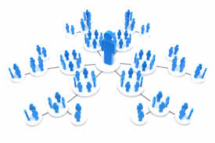
W8SGT - The Force Multiplier October, 2019
(from Stan, N8BHL)

The Amateur Radio Emergency Service (ARES) is part of the Ohio Auxcomm Team that keeps the amateur radio station W8SGT on the air at the Ohio Emergency Operations Center. This station is in service to link Ohio’s county ARES organizations, county EOC’s and other partner agencies directly to the Ohio EOC in northwest Columbus. The station is well provisioned with solid radio equipment and good antennas, with capabilities in both voice and digital across the amateur radio spectrum. The station is capable of operating within the SHARES radio system as well.

Amateur Radio has stepped into a new relationship with the “Watch Desk Project” by enhancing a partnership with ESF-5 intelligence which is fulfilled by the “Watch Desk” staff. This statewide information-gathering activity increases the profile of W8SGT and at the same time places further demands on personnel.

Another product of W8SGT is the transmission of digital messaging- sending computer generated messages across HF frequencies. Initially this network came up as the “Ohio Digital Emergency Network” or OHDEN. Operated from the homes of network managers, this net like the voice net is tested on a weekly basis.

The management team of W8SGT has developed a strategic plan to increase the functionality of amateur radio reporting at the same time making the staffing much deeper and more dependable than ever before. We call it “Force Multiplying.”

The Current Situation
W8SGT is staffed by approximately ten licensed operators who rotate weekly to conduct the “Tuesday Night Readiness Check” on voice, and check into the OHDEN digital net thereafter. Like any volunteer organization, there are time constraints on our operators. With this number, a long-term activation of a week or more would certainly present the likelihood of personnel shortages and burnout. In addition, in HF radio the band conditions often dictate that communications is spotty between certain areas.

On the digital side, remote operation of the OHDEN net places an intermediate control station in between the typical communications path, wherein most if not all messages are aimed at the W8SGT facility. This adds a layer which can slow or hinder completion of the message delivery.

TOP ^
These conditions create several areas for improvement:
- Additional trained manpower is needed to expand the capability of the staff
- Some method of counteracting the difficult band conditions is needed to enhance connectivity between outlying stations and W8SGT.
- We need to re-arrange the structure of OHDEN to make message delivery and net management more efficient.
- A majority of trained amateur operators in the Columbus area are currently participating with the Franklin County HS/EMA and we do not wish to rob their manpower resources.
- We need to figure out how to use outlying operators without the time delay of a drive to Columbus.

The Solution
Interestingly, the same solution can be applied to both the voice and data networks: force multiplying. Our proposal is to add a limited number of trained and capable operators around the state who can function as “relay stations” or “backup net controls” during periods of activation for W8SGT. These operators will be familiar with our procedures, with adequate radio systems at their homes. They can be placed into service in a stand-by condition any time W8SGT is active. They will be valuable in helping us control the net and making sure we don’t miss any calls.
- They will be able to listen to their respective nets as we conduct business, offering assistance in relaying calls and passing messages.
- They will be a resource to anchor the net if W8SGT is not able to operate. This may be because of manpower shortage, equipment/antenna failure or many other conditions. W8SGT managers Richard Wynkoop and Stan Broadway would be able to hand off control to these stations as needed.
- They will be able to participate in “pass around” net control operation: when the bands are not conducive to solid connection across the entire state, control of the net would be passed from one station to another so that each area of the state could be reached.
- These operators will be ‘regulars’ on our routine nets, and will have the training and orientation at the EOC station needed to carry on the net.
OHDEN improvements will be added to this program to increase the efficiency of message transmission. When OHDEN was originally brought up, the digital capabilities at the W8SGT station did not exist. Therefore, OHDEN was operated as a separate outside function. Especially with current net manager Eldon Peterson’s hours of dedication, the net has flourished. Along with that growth, W8SGT now has a dedicated digital station capable of anchoring OHDEN.

Taking the net control function in-house will centralize the focus of the net at W8SGT streamlining the flow of communication. In the same fashion as the voice net, we anticipate tapping Eldon and several others to be our relay/backup control stations during our operation. This spread of stations will also increase our coverage during less than optimal conditions.

As we step up our responsibilities to Ohio’s EMA, we feel the “Force Multiplier” program will step up our ability to provide better, wider, and longer service. We are in the process of identifying operators whom we feel will enhance our operation.

#########

TOP ^

Special NIMS Training Available

ICS-300 on November 13-15, 2019 (29 seats available)
Training Location:
Franklin County Sheriff's Academy
6373 Young Road
Grove City, OH 43123

There will be some additional classes posted soon (ICS-300 December 3-5, 2019 at Upper Arlington Fire Station 72, 3861 Reed Road, Upper Arlington and ICS-400 February 4&5, 2020 at Upper Arlington Fire Station 72, 3861 Reed Road, Upper Arlington) For more info: pktickle@franklincountyohio.gov

#########

EMA-G2300 INTERMEDIATE EOC FUNCTIONS
Hosted by: Franklin County Emergency Management & Homeland Security November 13 - 15, 2019

Course Description: The G 2300 Intermediate Emergency Operations Center Functions is a three-day course with the goal of assisting individuals and jurisdictions who desire to develop or improve their Emergency Operation Centers (EOC). By the end of the course, students will be able to demonstrate, through activities and a Final Exam, the managerial and operational roles of the modern-day EOC as a NIMS Command and Coordination functional group operating within a Multiagency Coordination System (MACS).

Application Deadline: October 30, 2019
Time of Course: Registration: 7:30 am – 8:00 am (on day one)
Course Time: 8:00 am – 5:00 pm

Location: Franklin County Emergency Management & Homeland Security
5300 Strawberry Farms Blvd Columbus, Ohio 43230

Supported By: The Ohio Emergency Management Agency

Recommended Participants: Federal, state, tribal, territorial, local level, business and nongovernmental emergency management personnel who may be designated to support an Emergency Operations Center (EOC) within their jurisdiction or organization. The materials were developed with the assumption that audience members may have little or no actual experience as a member of an EOC Staff.

Recommended Prerequisite:
ICS-100: An Introduction to the Incident Command System,
IS-2200: Basic Emergency Operations Center Functions
IS-700: An Introduction to the National Incident Management System
IS-800: National Response Framework, An Introduction
G-191: Emergency Operations Center/Incident Command Interface
IS-200: Basic Incident Command System for Initial Response.

TOP ^
Enrollment: Students must enroll via the Department of Public Safety Training Campus website: https://trainingcampus.dps.ohio.gov/cm/cm710/pstc/pstc.html. Course registration will generally close 10 working days prior to the course start date. You can check enrollment/approval status via the Department of Public Safety Training Campus website. Mission Statement To coordinate activities to mitigate, prepare for, respond to, and recover from disasters.

Course Costs: This course is free to participants.
Additional Information: Lodging, meals, and all other expenses are the students’ responsibility.
State Point of Contact: Matt Jaksetic, State Training Coordinator, Ohio EMA (614) 799-3666, mtjaksetic@dps.ohio.gov

#########

Campbell County Office of Emergency Management Upcoming Training
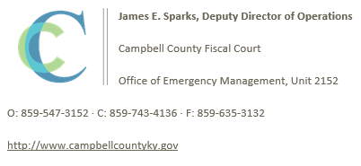
Campbell County Kentucky Office of Emergency Management FREE Training Opportunities

Physical and Cybersecurity for Critical Infrastructure (MGT 452) – October 16, 2019 – TTX / Register here; https://qrgo.page.link/SkdRb

Advanced ICS-400 Command and General Staff-Complex Incidents - October 23-24, 2019 - TEEX / Register here; https://goo.gl/dVqj43

Sport and Special Event Evacuation Training and Exercise - November 6-7, 2019 - TEEX / **Tentative/Requested**

Emergency Propane Water Injection Course – November 12, 2019 – Hebron Fire Protection District / Registration will open soon.

Managing Critical Incidents at Institutions of Higher Education: A Whole Community Approach (MGT-361) - December 10-12, 2019 - TEEX / Register: https://goo.gl/Qa3tUs

#########

Swap & Shop Has Come to the Ohio Section Website

Hey Gang,

Have you taken a look at the new webpage yet?? There’s already been some activity up there, so I know that some folks have for sure. Do you have equipment that you just don’t need or want anymore? Here’s a great venue to advertise it, and it’s FREE!!

TOP ^
It is there for any individual to post equipment Wanted / For Sale or Give-Away. No licensed vehicles/trailers or business advertising will be posted.

Postings are text only (no pictures or graphics) will be posted for a maximum of 1 month from date posting
and require a contact phone number or email within the posting.

Send your Wanted / For Sale or Give-Away post to: swap@arrlohio.org

Final.. Final..
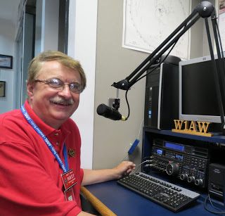
Hey Gang...

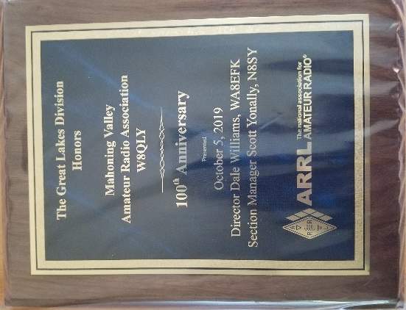
Wow… This has been another really busy week! I got to speak to all the great folks at the Union County Amateur Radio Club as well at the Mahoning Valley Amateur Radio Association’s 100th Anniversary Dinner. Wow, what a very special night that was.

Nancy, KD8QNY, and all the folks at the Mahoning Valley ARA really did a nice job with the celebration. It was great camaraderie between all the folks. Great food! And, a great time had by everyone that attended. Yes, we now officially have 2 clubs in the Ohio Section that have made it over 100 years! Congratulations!!! What a milestone this is.

The Ohio Section is so very lucky to have so many great clubs that just never stop doing things for their membership and citizens in their area. The MVARA is one of those clubs, deep in the spirit of giving back to their community. There are so many projects that the club does it would be impossible to list them all here, but believe you me, they do a great job of representing what’s good in the Ohio Section and Amateur Radio!

Does your club give back to the community? Want to know more about how to get things started in your club? Contact our Affiliated Clubs Coordinator Tom, WB8LCD at wb8lcd@arrl.net He’ll help guide you through what it takes to get things started.

Sliding down the band a bit… Did you read the article by Stan, N8BHL about our new role with the “Watch Desk” at the State Emergency Operations Center? This is a huge deal for ARES and the Ohio Section. This is something that all of us need to be supportive of as well as proud of. Getting deeper embedded into our state operations is something that every Section Emergency Coordinator dreams about!

One last round before going QRT… Is your club doing any special activities that you’d like the Section to know about? As you can see by the posts in the Club Corner, many clubs are already taking advantage of getting the word out to over 8,000 readers every week.

TOP ^
Do you have a story that you’d like to tell about something that you or your club has or is doing? Let me know about it and let’s get it in the next edition!

Whelp… That’s going to do it for this time around. Stay safe, enjoy the sunshine while we have it, and most of all… have FUN!!

73,

Scott, N8SY

Welcome New Subscribers

Robert, KD8IF; Jim, N8YDM; Terrence, KE8MVN; Tom, W8KYZ; Gary, KE8FSB;
Bryan, W8JMI; John, K8LVZ; Les, W8LTB

New Webpages Added to the Ohio Section Website

Is your club’s newsletter available to share? I’ve got a new webpage that has links to all of the known websites where club newsletters can be accessed throughout Ohio.

Now, as we all know when any list is published, it’s outdated immediately. That’s ok, just send me the link to your club’s newsletter and I’ll get it on the webpage – n8sy@n8sy.com

Here’s the link: http://arrl-ohio.org/club_link/links-to-newsletters.html Remember, we’re all here to help each other. What a great way to share the news about Amateur Radio!!

Columbus Day – Saturday October 12th

Columbus led his three ships - the Nina, the Pinta and the Santa Maria - out of the Spanish port of Palos on August 3, 1492. His objective was to sail west until he reached Asia (the Indies) where the riches of gold, pearls and spice awaited. His first stop was the Canary Islands where the lack of wind left his expedition becalmed until September 6.

Once underway, Columbus benefited from calm seas and steady winds that pushed him steadily westward (Columbus had discovered the southern "Trades" that in the future would fuel the sailing ships carrying goods to the New World). However, the trip was long, longer than anticipated by either Columbus or his crew. In order to mollify his crew's apprehensions, Columbus kept two sets of logs: one showing the true distance traveled each day and one showing a lesser distance. The first log was kept secret. The latter log quieted the crew's anxiety by under-reporting the true distance they had traveled from their homeland.

TOP ^
This deception had only a temporary effect; by October 10 the crew's apprehension had increased to the point of near mutiny. Columbus headed off disaster by promising his crew that if land was not sighted in two days, they would return home. The next day land was discovered.

"Friday October 12

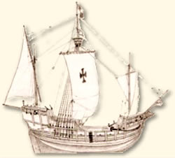
The vessels were waiting for daylight; and on Friday they arrived at a small island of the Lucayos, called, in the language of the Indians, Guanahani.

Presently they saw naked people. The Admiral went on shore in the armed boat, and Martin Alonso Pinzon, and Vicente Yanez, his brother, who was captain of the Niña. The Admiral took the royal standard, and the captains went with two banners of the green cross, which the Admiral took in all the ships as a sign, with an F and a Y and a crown over each letter, one on one side of the cross and the other on the other.

Having landed, they saw trees very green, and much water, and fruits of diverse kinds. The Admiral called to the two captains, and to the others who leaped on shore, and to Rodrigo Escovedo, secretary of the whole fleet, and to Rodrigo Sanchez of Segovia, and said that they should bear faithful testimony that he, in presence of all, had taken, as he now took, possession of the said island for the King and for the Queen his Lords, making the declarations that are required, as is now largely set forth in the testimonies which were then made in writing."

Shortly after landing, many of the island's inhabitants assembled on the beach and Columbus gave them gifts of red hats and beads. The natives reciprocated with gifts of parrots, cotton and other goods. In describing the natives, Columbus wrote: "They go as naked as when their mothers bore them, and so do the women, although I did not see more than one girl. They are very well made, with very handsome bodies, and very good countenances."

A new world was born. And that’s why we celebrate Columbus Day on October 12th!!

Murphy’s Laws
- You check the paper and find that you have all six numbers, but then you find the newspaper misprinted two of the numbers.
- The Jackpot gets to $40,000,000 and the numbers match all the numbers on your lotto slip, but you forgot to buy your ticket.
- The Jackpot gets to $40,000,000 and you finally win, then you find out 3,000 other people also won first place.
- You match 4 numbers, but you lost your ticket.
- You've been playing the same numbers in the Lotto since the beginning. Then they change the Lotto game saying it's what the people wanted
- The only time you win, it's a pitifully small amount.
- Your spouse wins, then leaves you.
- You finally hit it big, then you find out all the friends you never had.
- You finally hit it big, then you die the same day.

Back Issues of the PostScript and Ohio Section Journal (OSJ)

Hey, did you know that PostScript and Ohio Section Journal (OSJ) are archived on the website? You can go back and look at any edition simply by clicking:
http://arrl-ohio.org/news/index.html

Chit – Chat, and All That!

Do you know someone that’s not getting these Newsletters? Please, forward a copy of this Newsletter over to them and have them “Opt-In” to start receiving them. Heck, just have them send me an email n8sy@n8sy.com and I’ll get them added to the Ohio Section Emailing list.

We now have many thousands of readers receiving these newsletters weekly. Quite impressive, I’d say! I urge all of you to make sure that everyone, regardless of whether they are a League member or not, get signed up to receive these weekly Newsletters.

You can always “Opt-Out” at any time if you feel this is not what you were expecting. It’s fun and very informative. All of your favorite past newsletters are now archived too.
You can go back at any time and read them. Just go to: http://arrl-ohio.org/news/

Got questions, concerns or would just like to sit and chat awhile? Heck, I’ll even buy the coffee!! Give me a call at (419) 512-4445 or email me at: n8sy@n8sy.com

The pictures on the front page are from various newsletters, Facebook posts and/or were sent directly to me in recent weeks. Take a good look at them, you just might be in one of the pictures! “SMILE… you’re on the Ohio Section News!!”

TOP ^

PostScript is produced as a weekly newsletter. I want to thank everyone that has contributed articles and ideas to make this an even better news source. I sincerely hope that you have enjoyed this edition and will encourage your friends to join with you in receiving the latest news and information about the Ohio Section, and news and events happening around the world!

