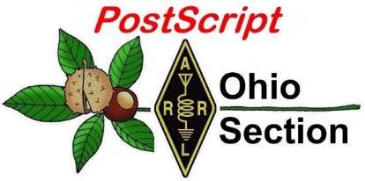
September 30th
Edition

National News The Handbook Give Away

Club Corner Hamfests

DX This Week One Question Questionnaire

VE Testing ARES Connect

Special NIMS Training Final.. Final..

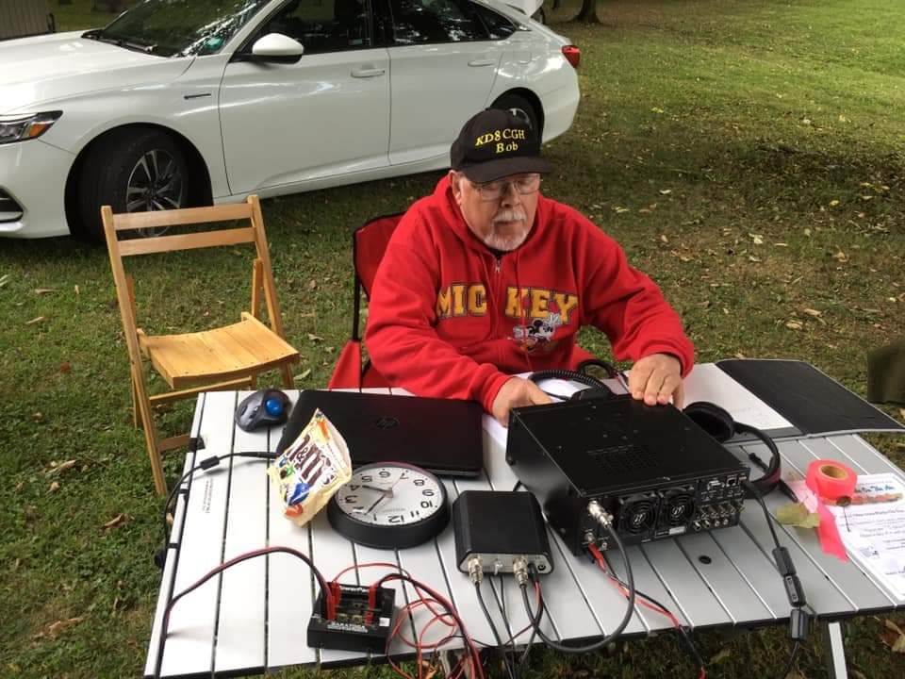
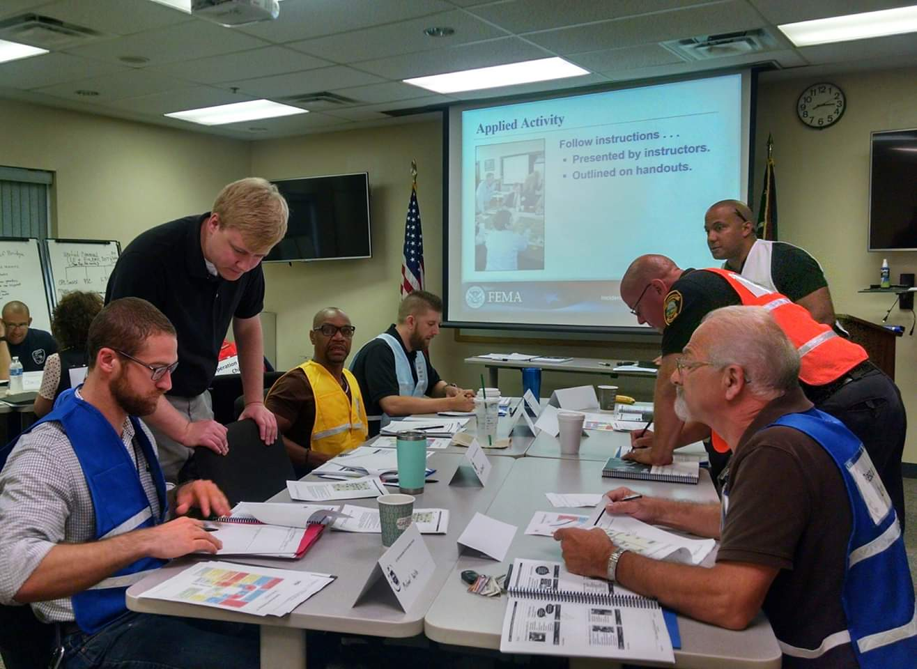
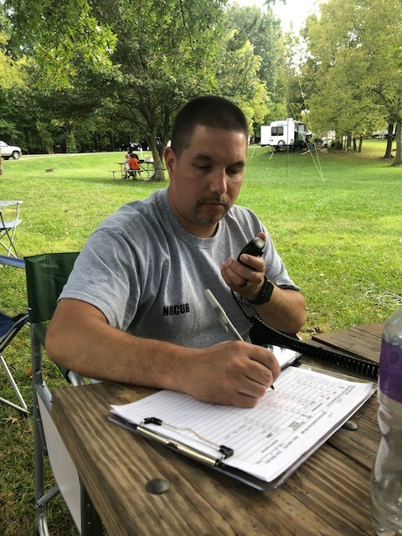
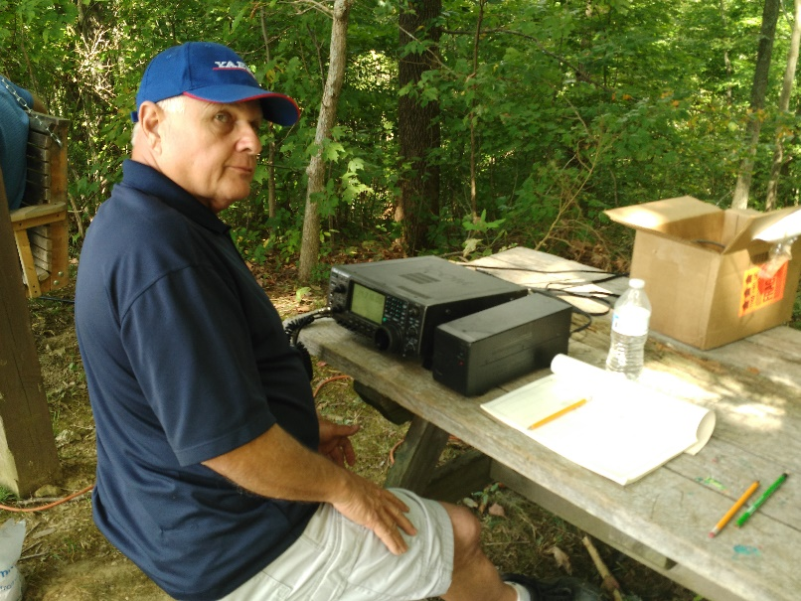
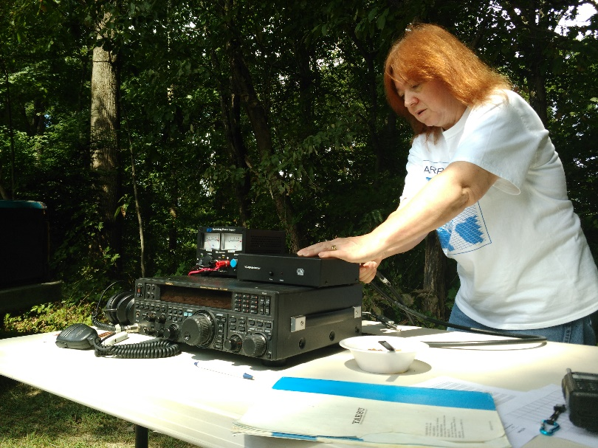

National News
(from arrl and other sources)
ARRL Thanks Official Observers, as Volunteer Monitor Program is Set to Debut

As the September 30 date for the closing of the Official Observer program nears, ARRL has expressed deep appreciation to the hundreds of volunteers who gave their time as Official Observers (OOs) to help preserve the integrity of the Amateur Radio frequencies.

The Official Observer program has served the Amateur Radio community and assisted the FCC Enforcement Bureau for more than 85 years. The OO program is giving way to the new Volunteer Monitor (VM) program, established as part of a formal partnership between ARRL and the FCC. ARRL and the FCC signed a Memorandum of Understanding (MOU) earlier this year that establishes the Volunteer Monitor program as a successor to the Official Observers. The first Volunteer Monitors should be in place and ready to begin their duties this fall.

“Thank you for your dedication and service,” ARRL Regulatory Information Manager Dan Henderson, N1ND, said. “It was the good work of the OOs over many years that laid the foundation for the FCC to recommend this new agreement for enforcement.” The FCC proposed the program following the closures of several FCC regional offices and a reduction in field staff.

Last February, Riley Hollingsworth, K4ZDH, who once handled Amateur Radio enforcement for the FCC, was named to oversee the development and implementation phases of the Volunteer Monitor program.
Under the new VM program, volunteers trained and vetted by ARRL will monitor the airwaves and gather evidence that could be used to correct misconduct as well as to recognize exemplary on-air operation. ARRL will refer instances of flagrant violation to the FCC for action, in accordance with FCC guidelines, and the FCC will give priority to enforcement cases developed by the VM program.
Official Observers were invited to apply to become Volunteer Monitors, and many did. The requirements for being a Volunteer Monitor include:

+ Ability to utilize state-of-the-art receiving equipment and to access no-cost remote receive sites; strong writing and communication skills

+ An understanding of the importance of thorough documentation

+ Basic word processing and data entry skills

+ The ability to send such information, including recordings, to ARRL electronically.

Applicants also must be ARRL members, have no history of FCC enforcement action, hold a Technician or higher license class, and been licensed for at least 3 years.

Applicants underwent a training and certification program administered by ARRL and were vetted by ARRL through at least one oral interview and a preliminary evaluation by ARRL staff. Volunteer Monitors will serve 3-year terms at the pleasure of ARRL.

####

TOP ^
Final report from the Ohio OOC...

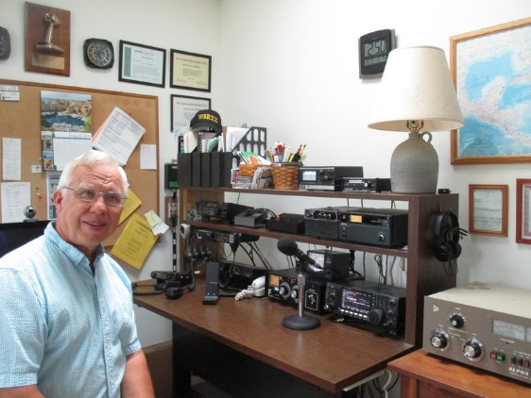
After more than 85 years the ARRL OO program will officially end September 30, 2019. The new Volunteer Monitor (VM) program begins October 1, 2019.

The ARRL has spent more than two years working with the FCC developing an enhanced program to support the FCC Enforcement staff with monitoring and reporting alleged problems arising on the Amateur Radio bands.

The VM program will have great support from the FCC as administrator Riley Hollingsworth, K4ZDH was former FCC Special Council for Enforcement before retirement.

I want to greatly thank all the Ohio OO's that have monitored countless hours, sent out both informative and good operator OO cards, and assisted in the OO program over the years.

My job is done as the Ohio OOC and now can concentrate on my new Assistant Section Manager position.

73,

John / W8RXX

#########

ARRL Sets Facebook Live Event for Collegiate Amateur Radio Clubs

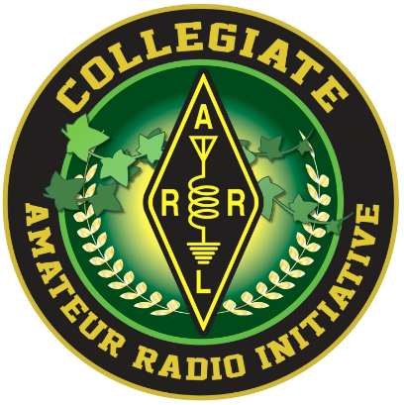
ARRL is inviting campus radio clubs to join a Facebook Live Event on Wednesday, October 16, at 6:30 PM PDT and MST; 7:30 PM MDT; 8:30 PM CDT, or 9:30 PM EDT. The University of Arizona Amateur Radio Club (K7UAZ) is hosting the event.

ARRL staff member Bob Inderbitzen, NQ1R, and students from the radio club will discuss topics involving Amateur Radio clubs at colleges and universities, including how to recruit student members, popular activities for campus radio clubs, and Amateur Radio as a springboard for career connections, networking, and practical experience. Your ideas and questions are welcome, and student radio club members and advisors may participate.

This event will stream live on the ARRL Collegiate Amateur Radio Initiative (CARI) Facebook group, where collegiate radio clubs may share information, techniques, and resources. The ARRL Collegiate Amateur Radio Initiative is sponsored in part by the W1YSM Snyder Family Collegiate Amateur Radio Endowment Fund.

TOP ^

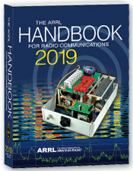
The Handbook Give Away

Hey Gang,

Last call to get registered for the “Handbook Giveaway” drawing for this month yet? If you haven’t, go to: http://arrl-ohio.org/handbook.html and get yourself registered now!

What’s the catch? I want to get everyone checking in to the Ohio Section website as often as possible, and in order to register each month, you have to visit the website often! There’s nothing else to it. I pay all expenses and I usually “Give Away” more than just a Handbook too!!

Many of you ask me just how do I know when the drawing is on? Well, that’s easy all you need to do is check in on the Ohio Section Website on a regular basis and watch for the big RED Arrow that will appear on the left side of the page. This is the sign that the drawing is on and you need to get registered. So, keep a sharp eye out on the website and check in often!

Club Corner

This is YOUR cornner of the newsletter. Send me what your club is doing and I’ll make sure that it gets in. Got a special event or club project that you want everyone to know about? Send it to me!. Need help with a project? Send it to me.

Let me know what you club is up to. Are you going to have a special guest at your meeting or are you having a special anniversary? Just sent it to: n8sy@n8sy.com

#########

Geauga Emergency Amateur Radio Service Needs Help

Huntsburg Pumpkin Festival October 5-6, 2019
The Pumpkin Festival is approaching quickly, and GEARS needs volunteers! We have the following responsibilities:

- Crosswalk: Assist pedestrians at the crosswalk in front of the town hall on Mayfield Road (SR322). This will require stopping vehicle traffic for pedestrians.
- Walking the Grounds: Walk the grounds and keep an eye out for any security incidents or medical issues and report them over the radio.
- Parades: Crowd and traffic control for the parades.
  - Important: Please only sign up to work the parades if you can commit to those times.
- Display Table: Man the amateur radio display table inside the community center.

We operate from 8AM-7PM.
As with the Fair, we are asking people to sign up for general availability - we've split each day into Morning, Afternoon and Evening. Please indicate when you'll be available. The exception to this is the parades on Saturday and Sunday, we need more exact commitments for those.

TOP ^
Setup is Friday, October 4 around 5:30PM, we will meet behind the Huntsburg Community Center (previously the elementary school).

Please sign up to join us and please forward the signup link to your friends! Sign Up Here!

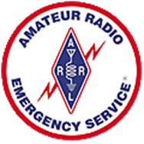
#########

Lake County ARES is seeking volunteer operators for the Lake Health Running Series Northern Ohio Marathon / Half Marathon / Relay being held Sunday, October 6th. The event start/finish is Mentor Headlands State Park and the course route includes Grand River, Mentor, Willoughby, and Mentor-on-the-Lake. If you would like to help, you may use the link below to register, or contact Mike Goffos (WB8ZGH) for more information.
https://docs.google.com/forms/d/e/1FAIpQLSeGKv2ssCPJu83p_XH1sGIddGylePBWQv0KRXj6F1v8XenD5g/viewform?usp=sf_link
#########

Festival of Frequency Measurement Set to Honor WWV Centennial

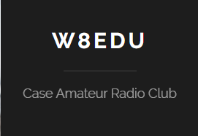
HamSCI and our own Case Amateur Radio Club of Case Western Reserve University (W8EDU) will sponsor a “Festival of Frequency Measurement” on WWV’s centennial, October 1, from 0000 to 2359 UTC (starting on Monday evening, September 30, in the Americas).

The event invites radio amateurs, short-wave listeners, and others capable of making high-quality frequency measurements on HF to participate and publish their data to the HamSCI community on the Zenodo open-data sharing site.

“Changes in ionospheric electron density caused by space weather and diurnal solar changes are known to cause Doppler shifts on HF ray paths,” the event announcement says. “HamSCI’s first attempt at a measurement of these Doppler shifts was during the August 2017 total solar eclipse. We plan a careful measurement during the 2024 eclipse.”

Some of the questions the research event is hoping to answer include how WWV’s 5 MHz propagation path varies over a given calendar day, and how various measurement techniques for understanding the path variations compare. The objectives are to measure Doppler shifts caused by the effect of space weather on the ionosphere, and to use a specified measurement protocol available to Amateur Radio operators and other citizen-scientists. The experiment will use August 1, 2019 (UTC) as a control date.

“The recordings in this experiment are expected to show formations of the D-layer at stations’ local sunrise and other daily events of the ionosphere,” the announcement said. “Space weather varies day to day and some features may be prominent. We’ll see what we get!”

Full information is on the Festival of Frequency Measurement website.

#########

TOP ^
American Cancer Society Making Strides of Cleveland FINAL EVENT OF 2019

Summer is over and we have ONE LAST EVENT (that I am currently aware of)! The public service season in Cleveland will be wrapping up in just a couple weeks with our final event, the ACS Making Strides of Cleveland. This is a walk that benefits the American Cancer Society and is specifically focused on breast cancer.

The event route has not been finalized yet but will probably end up being about a 5k. This event should be over by around 12 PM or 1 PM and the best news is, the event starts at 10 AM. That means everyone gets to sleep in AND be home for lunch. We will have a morning meeting at about 9 AM and be in place by 9:30 AM.

The strides walk takes place on Saturday October 12, 2019. If you are able to help please SIGN UP HERE.

#########

Highland County EMA and Highland Amateur Radio Association Working Together
(Submitted by David Bushelman, director, Highland County EMA)

A collaboration between two local businesses and a group of licensed local amateur radio operators recently assisted the Highland County Emergency Management Agency (EMA) to add an additional tower section to an existing tower, install a new antenna feedline and place a new dual band radio amateur radio antenna to improve communications.

Highland County EMA Director David Bushelman said the upgrades will result in better coverage to all areas of the county, even with low powered hand-held radios in hilly areas.

Highland Amateur Radio Association Information Officer John Levo advised that too often natural disasters and/or emergencies render cell, telephone, broadcast and the Internet to either overloador fail due to infrastructure, equipment or other communication-related issues. In such cases, the Federal Communications Commission requests amateurs to offer their services and personal equipment to local and state governmental agencies to provide much needed communication assistance when they safely can do so.

Tom Archibald is a federally licensed amateur radio operator and serves as the county’s assistant amateur radio emergency coordinator, as well as recently being appointed to the Local Emergency Planning Committee. Archibald said the State of Ohio strongly urges local governments to reach out to the amateur radio community and develop relationships where local amateurs advanced communications and support to local agencies in the event of a local, regional or national disaster or emergency.

In some areas of Ohio these units become certified by the Amateur Radio Emergency Services network of amateur radio operators. FEMA provides amateurs with classes to become familiar with government radio operating procedures so that “hams” and government officials “are speaking the same language”.
County Emergency Coordinator Harley Mains said that once another antenna is installed prior to winter, this simple wire antenna will not only provide hams with communications directly into the suburban Columbus State Emergency Center, but it will serve as a gateway to various FEMA, military, National Weather Service and other federal agency and civilian response centers around the United States.

TOP ^
Besides thanking the amateurs who assisted, Bushelman said he would like to thank Barry Stratton and Bruce Davis of S & S Electrical Contractors for the tower and ground support work, amateur radio operator Chris Campton for assisting with the on-tower antenna installation, and Chad Abbott Signs for providing the truck and equipment to lift and position the new tower section and antenna to the tower top.

“This project would not have been possible without everyone donating their time, services and equipment,” Bushelman said.

Additional information about the Highland County Emergency Management Agency can be obtained by contacting Bushelman at www.highlandcountyema.com orcalling 937-393-5880.

#########

ARISS Coming to Cincinnati Area School
(From Cesi, KD8OOB)

I just receive word from Gordon KD8COH, our technical mentor, that our equipment plan for our ARISS school contact with Maple Dale has been approved by NASA!

Our next steps will happen after we receive our contact window. I will update our agreement with the ARRL to get our loaner station, have that shipped, and then schedule several setup and test at Maple Dale.

I am unbelievably excited about this! Thanks to everyone for all the help and work to get us to this point!

73!

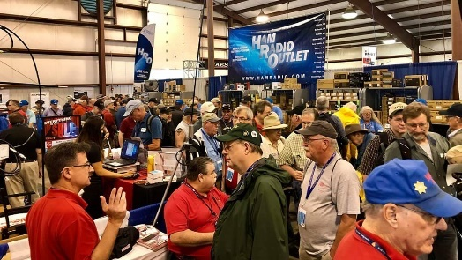
Upcoming Hamfests

10/05/2019 | Scioto Valley Amateur Radio Hamfest
Location: Chillicothe, OH
Sponsor: Scioto Valley Amateur Radio Club

10/12/2019 | NWOARC Fall Hamfest
Location: Lima, OH
Sponsor: Northwest Ohio Amateur Radio Club
Website: http://www.nwoarc.com

11/02/2019 | GARC Hamfest  Location: Georgetown, OH  Sponsor: Grant Amateur Radio Club  Website: https://www.facebook.com/Grant-Amateur-Radio-Club-1775764122477536/?modal=admin_todo_tour | 11/03/2019 | Massillon ARC Hamfest  Location: Massillon, OH  Sponsor: Massillon Amateur Radio Club  Website: http://www.w8np.org

TOP ^

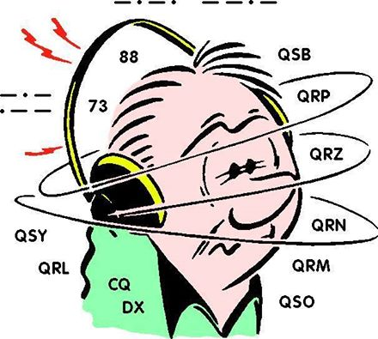
DX This Week
(from Bill, AJ8B)

DX This Week – RUFZXP
Bill AJ8B (aj8b@arrl.net, @AJ8B,
www.aj8b.com or www.swodxa.org )
CWOPs Member #1567

This week, the mailman delivered GM5YTT – Scotland, TG9IN – Guatemala, TI2TBO – Costa Rica, CN2MA – Morocco, and 9K2OW - Kuwait. (Pictured). What did you get? Send me an image and some details!

Uncle Frank and I were chatting on 80-meter RTTY about contesting and the question came up about the best way to really get ready for CQWW CW contest in November. Frank feels that the only way to do it is to get on CW and sharpen your skills on a regular basis. I would have agreed until I was introduced to CW Ops and the CW Academy. They are a group of CW minded hams whose focus is the promotion of CW. They recommend a variety of tools and one of them is RufzXP.
What is RufzXP? RufzXP is a great tool for you to use to develop your speed and to get used to the challenge of a contest. This tool is used in most of the CWOps booths such as the Xenia Hamfest and SEDCO, with awards given to those who can correctly copy at the highest speed. Here are the details directly from the website (http://www.rufzxp.net/).

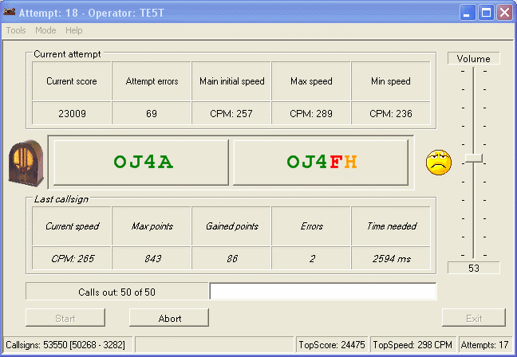
“Rufz” is the abbreviation of the German word “Rufzeichen-Hören”, which means “Callsign Hearing”. RufzXP is an excellent training application for improving code speed and CW practice, particularly (ultra) high speed memory copying of true amateur radio calls. Focusing on the improvement of CW proficiency, it is no contest simulator and does not provide for QRM. It provides additional tools for keeping track of training progress and comparing with other operators via International RufzXP Toplist.
RufzXP is a “must” for every serious high-speed telegraphy operator and is an official competition of IARU High Speed Telegraphy Championships.

The appendix “XP” indicates that this version runs on Windows platforms

TOP ^
How does it work? RufzXP is pretty simple. You do not need a manual for the basic functions. It sends a chosen number of random selected true amateur radio callsigns (50 by default) to be typed with the keyboard into a field on the screen. After the Enter key is pressed, the computer gives its next call. If the previous call was copied correctly, the transmitting speed increases slightly, if not, it decreases. So, the software automatically adapts its transmitting speed to the user’s maximum performance. The previous call is repeated by pressing F6 key (50% penalty).
The number of points for each call is primarily related to the CW speed sent, the number of errors, and the length of the call. Typing time is of minor influence.

- Tone settings and other options can be modified in Option Form. (F2/F12).
- <START> button or F5-key starts the attempt. Good luck!
- For more details see built-in help. (F1)

At the end of each run the software gives you a precise score. This enables you to track your performance. And with a little practice you will see good progress very soon.
You may compete with others around the globe. Simply use the integrated function to post your encrypted score to the RufzXP International Toplist. There are already more than 2000 participants with their scores.
The current champ is Stanislau Hauralenka, EW8GS, who broke the 300k points limit! He reached a maximum speed of 195 wpm!
Congrats on this outstanding achievement!

Give this a try and let me know how you do!

Good Hunting!

+ --------------------------------------------------------------------------------------------------+
Here is an update from Bernie, W3UR, of the DailyDX and the WeeklyDX, the best source for
DX information. (http://www.dailydx.com/ ) Bernie has this to report:
+ --------------------------------------------------------------------------------------------------+

HV - The Vatican - As previously noted, Amateur Radio operations from The Vatican (HV) use full callsigns (i.e. HV1A, HV0NAC, HV3SJ, etc.). The Vatican is not part of CEPT and HV authorities do not issue HV or HV#/home calls, which will not count for DXCC. On September 17th HV0/IW0CUK was reported QRV on FT4 and FT8 on 40, 20 and 17 meters. Your editor contacted IW0CUK, Pino, who reported his transmissions as HV0/IW0CUK was "not part of DX activity, but of experimentation aimed at [his] statistic on the current propagation". He said the "sporadically and suddenly" operations were "in temporary lease adjacent to the Vatican City" using a portable station with low power.

SV5 - Dodecanese Islands - Starting today, through October 10th, DL3DRN, Wolf, is QRV again from Kolymbia on Rhodes Island. Activity will be on CW, SSB and RTTY on all bands. QSL via the bureau, direct or LoTW.
V3 – Belize - NK0S, Hutch, arrives in Belize on October 7, departing October 12 and operations are expected between October 8 and 11.

TOP ^
Albania - ZA/OH2BH this weekend by OH2BH, Martti Laine
It was July, 1970 when rare OH2BH/ZA was activated for the first time from the coastal city of Durres in Albania. Now 50-years later, same callsign with different order, ZA/OH2BH, now with residence in Durres will be active again.
But many things have changed since and now you can reach once the rarest country of Europe by direct flights from most of the major cities in Europe, such as from Finland and other Nordic countries. Now luxury hotels are dotting the Adriatic Coastline.
While United Kingdom will soon depart the European Union (EU) it is expected that Albania would soon take their place, keeping the number of member countries (28) the same. Under the Finland's EU Presidency, the membership negotiations are expected to start this November.
Albania has made a great progress in past 50 years and we will be happy to have them among the family of EU countries.

DX news

ARLD038 DX news

This week's bulletin was made possible with information provided by KD7WPJ, WB0TEV, The Daily DX, the OPDX Bulletin, 425 DX News, DXNL, Contest Corral from QST and the ARRL Contest Calendar and WA7BNM web sites. Thanks to all.

VIET NAM, 3W. Jacek, SP5APW is QRV as 3W9KJ from Dao Co To Island, IOTA AS-132, until October 3. Activity is on the HF bands using FT8 and FT4. QSL to home call.

UGANDA, 5X. Anton, ON6NL is QRV as 5X8C from Entebbe until October 7. Activity is in his spare time while working and teaching telecom training classes. He hopes to be active in the CQ World Wide DX RTTY contest. QSL to home call.

KUWAIT, 9K. Abdallah, 9K2GS will be QRV as 9K2K in the CQ World Wide DX RTTY contest as a Single Op/All Band/High Power entry. This includes an entry in the upcoming CQ World Wide DX SSB contest. QSL via LoTW.

TONGA, A3. Grant, VK5GR, Oly, VK5XDX and Andrew, VK5AKH are QRV as A35JT from Tongatapu, IOTA OC 049, until October 7. Activity is on 80 to 10 meters using CW, SSB and various digital modes. This includes being active in the CQ World Wide RTTY DX and upcoming Oceania DX contests. QSL via M0OXO.

BAHRAIN, A9. Look for A92AA to be a Single Op/All Band entry in the CQ World Wide DX RTTY contest. QSL to home call.

CUBA, CO. Members of the Santiago de Cuba Contest Team will be QRV as T48SC as a Multi/2 entry in the CQ World Wide DX RTTY contest. QSL via operators' instructions.

TOP ^
CAPE VERDE, D4. Harald, DF2WO will be QRV as D44TWO from Sao Tiago, IOTA AF-005, from September 29 to October 13. Activity will be on the HF bands and possibly various satellites. QSL via M0OXO.

CANARY ISLANDS, EA8. Operators SM7BHM, SM7GXR, SM4RGD, YL2KF, OH9GIT and OH2BP will be QRV as EA8DED from Tenerife, IOTA AF-004, in the CQ World Wide DX RTTY contest. QSL via OH2BP.

LIBERIA, EL. Members of the Italian DXpedition Team will be QRV as A82X and A82Z from September 30 to October 11. Activity will be on 160 to 10 meters using CW, SSB, RTTY and FT8 with five stations.
QSL direct to I2YSB.

PERU, OA. Members of Radio Club Peruano are QRV with special callsign OC19IARU until October 6 during the 20th General Assembly of IARU Region 2. QSL via bureau.

SURINAME, PZ. Ramon, PZ5RA will be QRV in the CQ World Wide DX RTTY contest. QSL to home call.

SEYCHELLES, S7. Ravi, VU2IIX will be QRV as S79VU from Mahe Island, IOTA AF-024, from September 30 to June 30, 2021. Activity will be on 80 to 10 meters using SSB and various digital modes. QSL via operator's instructions.

DODECANESE, SV5. Wolf, DL3DRN is QRV as SV5/DL3DRN from Rhodes, IOTA EU-001, until October 10. Activity is on the HF bands using CW, SSB and RTTY. QSL via LoTW.

TURKEY, TA. Turkey Youth Contest Team members TA7AZC and TA6AEK are QRV as TC2Y until September 30 and plan to be active in the CQ World Wide DX RTTY contest as a Multi Op entry. QSL via operators' instructions.

GABON, TR. Roland, F8EN will be QRV as TR8CR until December 15. Activity will be on the HF bands using CW. QSL via F6AJA.

BELIZE, V3. Victor, WB0TEV and Scott, K5PS are QRV as V31VP and V31CQ, respectively, until September 30, from Maya Hill Lodge. Activity is on 160 to 10 meters using CW, SSB, RTTY and FT8. This includes being active as V31VP as a Multi/Single entry in the CQ World Wide RTTY contest. QSL to home calls.

VANUATU, YJ. Oleh, KD7WPJ will be QRV as YJ0BCP from Efate, IOTA OC-035, from October 3 to 10. Activity will be on 40 to 6 meters using CW, SSB and FT8. QSL to home call.

TOKELAU ISLANDS, ZK3. A large group of operators will be QRV as ZK3A from October 1 to 11. Activity will be on 160 to 10 meters using CW, SSB, RTTY, EME and FT8. QSL direct to YT1AD.

THIS WEEKEND ON THE RADIO. The CQ Worldwide DX RTTY Contest, NCCC RTTY Sprint, NCCC CW Sprint, Maine QSO Party and the AGCW VHF/UHF Contest are all on tap for this weekend.

The QCX CW Challenge is scheduled for September 30.

The 222 MHz Fall Sprint is scheduled for October 1.

TOP ^
The UKEICC 80-meter SSB Contest, CWops Mini-CWT Test and Phone Fray are scheduled for October 2.

The IQRP Quarterly Marathon runs from October 1 to 7.

The Canadian National Parks on the Air, CNPOTA, operating event runs for the entire year of 2019, with special stations active from Canada's parks and historic sites.

Please see September QST, page 80, October QST, page 90, and the ARRL and WA7BNM Contest Web Sites for details.

Special Events

10/18/2020 | Commemorating 80th Anniversary of U.S.C.G Auxiliary
Oct 18-Oct 20, 1400Z-2300Z, N4U, Benton, KY. United States Coast Guard Auxiliary. 14.070 14.250 7.070 7.250. QSL. Mary Husfield, 4156 Barge Island Road, Benton, KY 42025-6039. 80th Anniversary of United States Coast Guard Auxiliary. QSL to KC4TIE, Special Card returned with SASE. Mainly digital modes.

10/19/2019 | 100th Anniversary of Michigan State University Amateur Radio Club

10/19/2019 | 1600Z-2200Z, W8SH, East Lansing, MI. Michigan State University Amateur Radio Club. 14.250 14.050 7.250 7.050. QSL. MSUARC/W8SH, ECE Dept. #2121, 428 S. Shaw Ln. , East Lansing, MI 48824. Original call 8YG. msuarc@egr.msu.edu

11/02/2019 | 44th Anniversary, Sinking of the Edmund Fitzgerald
Nov 2-Nov 17, 0000Z-2359Z, W8F, Detroit, MI. Livonia Amateur Radio Club. 14.260 7.040 14.040 7.240. Certificate. Tas Foley, K8TAS, 37255 Euraka Rd., Romulus, MI 48207. On Saturday, November 2, W8F will operate from the Dossin Great Lakes Museum, Detroit MI 1600-2030 UTC. SASE FOR QSL CERTIFICATE livoniaarc.com

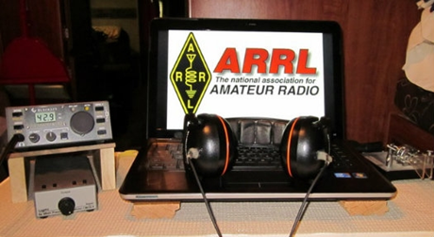
ARRL Contest Corner

An expanded, downloadable version of QST's Contest Corral is available as a PDF. Check the sponsor's Web site for information on operating time restrictions and other instructions.

September 30
- QCX Challenge

October 1  - QCX Challenge  - IQRP Quarterly Marathon  - 222 MHz Fall Sprint | October 2  - Phone Fray  - CWops Mini-CWT Test  UKEICC 80m Contest

TOP ^

V.E. Test Sessions

For the latest testing site information please >> Click Here << The ARRL site tracks all of the VE testing sites that register with them, including W5YI and Laurel. ARRL gives you a number of different ways of sorting to find that site that is closest to you as well.

One Question Questionnaire

Hey Gang,

OK, I guess most of you are expecting a visit from Santa this year with a boat load of radios in his sack since only 11% of you actually going to purchase a new radio this year! I blew my pocketbook out with the purchase of the CS 800D and associated goodies for it and vertical HF antenna this summer. I don’t know about you, but I will have some test equipment on Santa’s list for sure this year.

I’ve got another NEW – one question – on the Ohio Section Website for you to answer! With the annual Simulated Emergency Test (S.E.T) coming up this weekend, I thought I’d get a feel for how many of you will be participating. So, Here’s the question for this next week.

“Will you be participating in the S.E.T. this year??”

These One Question questionnaires are all in fun and I hope that you are enjoying answering them.

You’ll find the “One Question” questionnaire on the Ohio Section Website! http://arrlohio.org It’s all in fun and it’s not a scientific survey in any way, but we are learning some things that we didn’t know from these questions. I hope that you are enjoying answering these “One Question” questionnaires.

ARES Connect

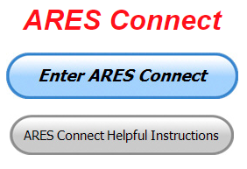
OK.. I’m setting a goal for all of you out there. Let’s get everyone in the Ohio Section on ARES Connect before the end of this year!!!

Do you need help with how to sign-up for an event or log your hours? How about you Administrators, do you have questions about approving your volunteer’s hours or how-to set-up a recurring event? I’ve got the answer for all of you. I have a new webpage with step-by-step instructions on how to do those things and many more.

I also have a “Hints and Kinks” section that has a lot of great information on how to do something or why something works like it does. Here’s the page: http://arrl-ohio.org/SEC/connect/index.html You can also find this link on the main page of the Ohio Section website as well.. It’s just under the “Enter ARES Connect” link.

TOP ^
If you live in Ohio and you haven’t registered yet, we need you to get registered now. We need you to only use this URL to get registered https://arrl.volunteerhub.com/lp/oh/. Using any other entrance to register will only slow down your registration process. Again, this is for those living in Ohio only. If you are an out of state person (not Ohio), you can simply change the /oh/ to your 2-letter state designation. This will put you in the correct state for signing up.

Now, I am starting to see folks creating more than one account because they can’t remember their password from the one that they originally setup. Please don’t do this. The system has a really good way of sending you a link to your email address so that you can refresh your password. If you are experiencing problems with getting to this link, contact me: n8sy@n8sy.com and I’ll get it fixed for you.

Here’s the top 10 hours earners so far for September:

 | Name | Events | Hours
1 | Alan Rothweiler (N8CJ) | 32 | 128.50
2 | Greg Dersarkisian (KD8SSJ) | 17 | 111.00
3 | James Yoder (w8erw) | 16 | 105.95
4 | Bret Stemen (KD8SCL) | 36 | 102.00
5 | Christopher Domenick (KC8CAD) | 26 | 82.75
6 | Bryan Hoffman (kc8egv) | 13 | 68.25
7 | Dan Stahl (KC8PBU) | 67 | 66.39
8 | Juan Duarte (kd8uot) | 26 | 61.00
9 | Diane Warner (KE8HLD) | 20 | 60.00
10 | John Major (KD8MMY) | 21 | 59.75

As you can see from the above listing, we can get real time information that shows how many hours, who volunteered and what they volunteered for. There’s a ton of information that we can draw out of the system.

We now have 1,243 registered and growing every day in the system. What’s really interesting is as of this same date there are 11,716 registered in the entire country. This means that the Ohio Section makes up over 10.60% of those registered.

Here’s a link to get you started... http://www.arrl-ohio.org/SEC/connect/ares_connect_directions.pdf
Please, don’t just hurry through the questions, read them carefully, if you don’t understand something, please ask me, I’m here to answer your questions.

Please don’t create a new account if you can’t seem to access your old one. If you just forgotten your password, or you had someone else create your account and you don’t know the password, simply use the “Forgot My Password” link. It will guide you right through the process of not only accessing your account, but you can also reset your password to something that you won’t forget. If you still can’t access your account, please, contact me at: n8sy@n8sy.com and I can get it fixed for you.

I’m being asked a lot lately about just what can we record as an ARES Connect Event. Well, there’s really no simple answer to that tough question… It can be a RACES, CERT, Skywarn, Red Cross or LEPC meeting where you or a group of you are there representing your club or Amateur Radio in general.

TOP ^
For the most part, we are doing really good in identifying those events that we should be tracking. If you have questions about whether an event should be created in ARES Connect, here’s a simple “litmus test” to help you decide whether it should be an event or not. We have 7 categories for events that are built into ARES Connect. They are:

- Communications Emergency
- Community Event
- Exercise
- Meeting
- Net
- Skywarn
- Training

As you can see, this covers a huge amount of territory right off the bat. Most everything that you will want to create an event for will fit into one of these 7 categories. But, as I’m being asked the question, not everything that you are doing fits into one of these 7, and that’s where most of your questions come from “do I count this or not.”

Work you did on the club trailer, repeater, website, field day and associated other similar events, parades, newsletter or just having fun keeping track of all those spandex folks during every kind of bicycle and foot race imaginable are really good examples of events that should be included, but just don’t fit well into one of those 7 categories. I could go on and on about what you could include as an event, but the fact is there are so many different kinds of things that we do to represent ourselves in Amateur Radio and our giving back to the communities that it would be virtually be impossible to make a list of those items that should and shouldn’t be events in ARES Connect.

This is where your “Common Sense” has to be applied. If you ask yourself this one question, I think you’ll have your answer. “Did we do this event as amateur radio operators?” No, the event doesn’t always have to involve using amateur radio, but if you have an event that isn’t serving amateur radio or your community, then I think you’d have to agree, it probably shouldn’t be an event in ARES Connect. Again, let me stress this point, if you have an event that doesn’t fit into one of the 7 categories above, you need to apply some “common sense” as to whether this event is something that should be in ARES Connect.

One last item that I need to discuss is that when you have completed the event don’t forget to get back into your account and register your hours. For the most part we are doing well with this, but there seems to be some of you that just might not know or understand that as a volunteer you have 2 things to do with ARES Connect. The first is to get registered for the events and then you need to report how much time you spent doing that event. It’s really quick and easy to do. Don’t know how, just ask. Your Admin or I can show you how to do this very quickly and easily.

Special NIMS Training Available

ICS-300 on November 13-15, 2019 (29 seats available)
Training Location:
Franklin County Sheriff's Academy
6373 Young Road
Grove City, OH 43123

TOP ^
There will be some additional classes posted soon (ICS-300 December 3-5, 2019 at Upper Arlington Fire Station 72, 3861 Reed Road, Upper Arlington and ICS-400 February 4&5, 2020 at Upper Arlington Fire Station 72, 3861 Reed Road, Upper Arlington) For more info: pktickle@franklincountyohio.gov

#########

EMA-G2300 INTERMEDIATE EOC FUNCTIONS
Hosted by: Franklin County Emergency Management & Homeland Security November 13 - 15, 2019

Course Description: The G 2300 Intermediate Emergency Operations Center Functions is a three-day course with the goal of assisting individuals and jurisdictions who desire to develop or improve their Emergency Operation Centers (EOC). By the end of the course, students will be able to demonstrate, through activities and a Final Exam, the managerial and operational roles of the modern-day EOC as a NIMS Command and Coordination functional group operating within a Multiagency Coordination System (MACS).

Application Deadline: October 30, 2019
Time of Course: Registration: 7:30 am – 8:00 am (on day one)
Course Time: 8:00 am – 5:00 pm

Location: Franklin County Emergency Management &
Homeland Security
5300 Strawberry Farms Blvd Columbus, Ohio 43230

Supported By: The Ohio Emergency Management Agency

Recommended Participants: Federal, state, tribal, territorial, local level, business and nongovernmental emergency management personnel who may be designated to support an Emergency Operations Center (EOC) within their jurisdiction or organization. The materials were developed with the assumption that audience members may have little or no actual experience as a member of an EOC Staff.
The audience may include students from a variety of agencies, organizations and functional disciplines, including fire service, law enforcement, emergency management, public works departments, as well as public health organizations, medical emergency teams, and hospitals, businesses and non-governmental organizations

Recommended Prerequisite:
ICS-100: An Introduction to the Incident Command System,
IS-2200: Basic Emergency Operations Center Functions
IS-700: An Introduction to the National Incident Management System
IS-800: National Response Framework, An Introduction
G-191: Emergency Operations Center/Incident Command Interface
IS-200: Basic Incident Command System for Initial Response.

Enrollment: Students must enroll via the Department of Public Safety Training Campus website: https://trainingcampus.dps.ohio.gov/cm/cm710/pstc/pstc.html. Course registration will generally close 10 working days prior to the course start date. You can check enrollment/approval status via the Department of Public Safety Training Campus website. Mission Statement To coordinate activities to mitigate, prepare for, respond to, and recover from disasters.

TOP ^
Course Costs: This course is free to participants.

Additional Information: Lodging, meals, and all other expenses are the students’ responsibility.
State Point of Contact: Matt Jaksetic, State Training Coordinator, Ohio EMA (614) 799-3666, mtjaksetic@dps.ohio.gov

#########

Campbell County Office of Emergency Management Upcoming Training
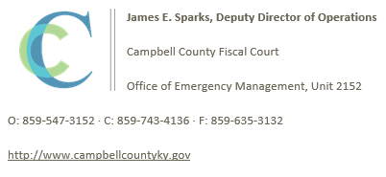
Campbell County Kentucky Office of Emergency Management FREE Training Opportunities

Hazmat Technician Refresher Training – Kenton County Fire Training Center – September 25-28, 2019 – Register; https://qrgo.page.link/Y3eti

Intermediate ICS-300 for Expanding Incidents with Incident Command Systems Forms Review (MGT-905) - September 24-26, 2019 - TEEX / Register here; https://goo.gl/7NktXo

Physical and Cybersecurity for Critical Infrastructure (MGT 452) – October 16, 2019 – TTX / Register here; https://qrgo.page.link/SkdRb

Advanced ICS-400 Command and General Staff-Complex Incidents - October 23-24, 2019 - TEEX / Register here; https://goo.gl/dVqj43

Sport and Special Event Evacuation Training and Exercise - November 6-7, 2019 - TEEX / **Tentative/Requested**

Emergency Propane Water Injection Course – November 12, 2019 – Hebron Fire Protection District / Registration will open soon.

Managing Critical Incidents at Institutions of Higher Education: A Whole Community Approach (MGT-361) - December 10-12, 2019 - TEEX / Register: https://goo.gl/Qa3tUs

Swap & Shop Has Come to the Ohio Section Website

Hey Gang,

I’ve been asked for some time now why can’t we have a Swap & Shop area on the website. We heard you and now there is!!

It is there for any individual to post equipment Wanted / For Sale or Give-Away.

No licensed vehicles/trailers or business advertising will be posted. All Buyers and Sellers must agree to the "Terms & Conditions" of this website

TOP ^
Postings are text only (no pictures or graphics) will be posted for a maximum of 1 month from date posting
and require a contact phone number or email within the posting.

Send your Wanted / For Sale or Give-Away post to: swap@arrlohio.org

Final.. Final..
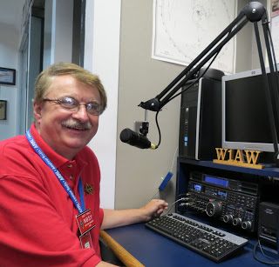
Hey Gang...

Wow… This has been another really busy week! I got to speak to all the great folks at the Geauga Amateur Radio Association as well as the folks at the Lucas County ARES.

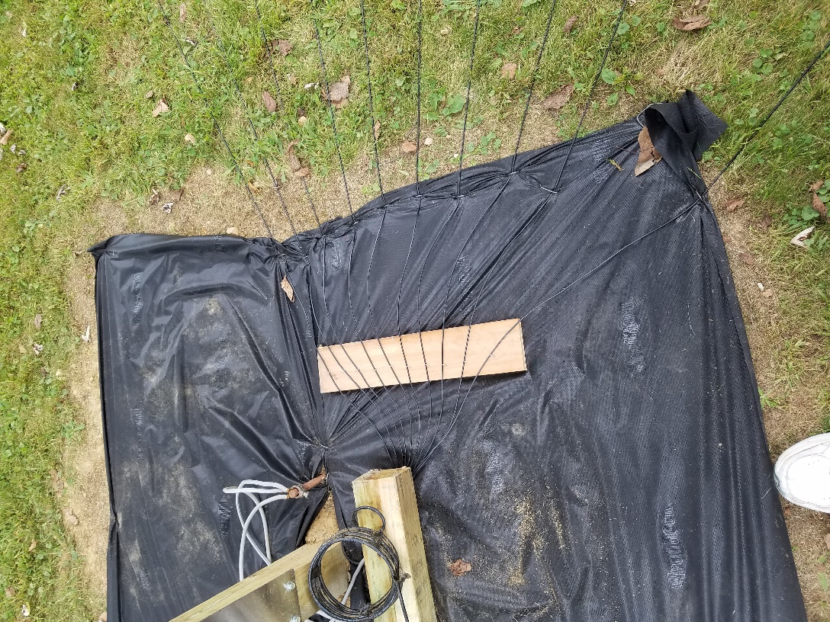
I do believe that I have gotten rid of my wood eating chipmunk, I think, but in his absence, I seem to have had some ground bees (possibly hornets) move in. Given the choice between the two, I think I’d rather have the chipmunk back. At least he didn’t sting! I’ve been stung a number of times trying to get them to move out of the little hole what they dug in our front garden. Unfortunately, it seems that they want to stay put for a bit. I’m sure that cold weather that is coming soon will have some effect on them and if I can just wait them out, I will spray the heck out of their underground nest when it gets colder. It’s just that they’ve been targeting anything that gets close to them. Birds, mailpersons, me and even the neighborhood cat. They seem very vicious and not willing to share their space with anything or anyone right now.

I did get to play a little with my new vertical antenna. I put 4 radials out at 20 foot each and listened in on SDR to see just how my signal sounded. It wasn’t as much as I have been led to believe and my SWR still isn’t all that impressive. My signal did come up around ½ to 1 “S” unit. I then put out 6 more radials for a total of 10. My signal strength came up about ½ to ¾ more, but that’s it. My SWR is still around 2.0. I don’t seem to be able to get the resonance to change much. I did add 10 more 20-foot radials, bringing the total up to 20 – 20-foot radials. After adding the radials, I tested the antenna once more and I saw a little more improvement in the “S” reading by about 2 to 2 ½ units.

Unfortunately, I didn’t see a marked improvement in the SWR. It’s hovering around 2.0 to 1.

TOP ^

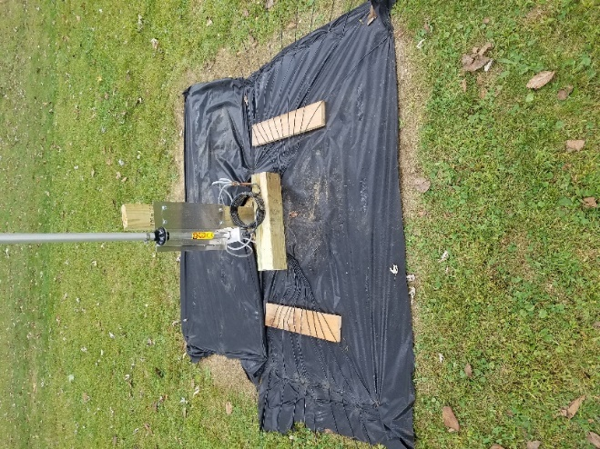
I messed around with the lengths of the various stages of the antenna but didn’t see much improvement there either. I have seen a huge difference with the amplifier in the circuit and out. I’ve always been told that my tubed amplifier would act like an antenna tuner when on, but I also found it does change the impendence of the line even with it off and still in the line. I’ll be doing more experiments as time goes on, but for now I’m going to stop at 20 radials each at 20 foot long. Oh, by the way, the black material that you see in the picture is a weed control mat that I put down. I figured that I might as well make sure that when spring rolls around I don’t have to hand weed that area.

Sliding down the band a bit… There has been one more item that’s been keeping me really busy this week. My better half has decided that we both need more exercise – go figure! It seems that walking a couple of miles a week isn’t doing what she wants. So, it was off to the bicycle shop to see what they had that would give us more exercise. Wow... is all that I can say!! I hadn’t ridden a bicycle since I was way younger and thinner. Motorcycles have been the only 2 wheeled vehicles that I wanted to ride for over 50 years. Bicycles just weren’t in my vocabulary, at least until now. No more motorcycles for me. There are just too many crazies out there with a driver’s license looking to install you as their new hood ornament!

I will say that I figured I’d end up on some 20-inch, banana seated single speed coaster like I had when I was 12 years old. If memory serves, it even had the high handlebars like the big bad bikers had on their choppers of the day. To get it to make noise we used playing cards mounded with clothes pins flipping across the spokes. It was cheap, but I got into all sorts of trouble when I used my mom’s good canasta cards for my motor sounds. She didn’t see the humor in her weekly canasta group not being able to play with the full 4 decks of cards that are used in canasta. It seems that even when I put the cards back there was an issue. It seems that the cards were definitely marked after being flopped over the spokes a few hundred thousand times. I do remember not getting an allowance for a very long time. Anyway, we walked into this little bike shop in Gahanna and walked down the isles where there were bikes of every kind that you could imagine. There were 1 wheeled, 2 wheeled and there were also 3 wheeled. There was even one that was 4 wheeled, but my wife said no immediately to that one, you see it sat a bunch of folks on either side and you all peddled down the street. There were bikes with ½ wide tires and there were bikes with 4-inch-wide tires. There were bikes with seats that in no way would I even attempt to sit on. I’m sure that the seat post would be more comfortable. Then there were bikes with seats that were more like my easy chair, with way more adjustments than my easy chair for sure! There were bikes with gas filled shocks and disk brakes and there were bikes that seemed to have more gears than sense! Can you imagine a bike with over 30 gears? All you would get done doing is shifting. By the time you got the bike into 30th gear you’d be doing over 60 miles an hour and knowing my luck, I’d get a speeding ticket.

I just couldn’t believe the prices on these bikes either. I remember when I was young saving all summer long to get a bike that cost $80. Now you start at around $800 and work up, very quickly I might add.

I remember years ago I thought I was in heaven when I was able to get a bike with 3 gears. It was amazing to be able to shift into low gear and get up a hill that I always had to get off and push the bike up on. Now we have bikes that climb hills better and faster than a mountain goat. It’s absolutely amazing. Motorcycles don’t even have these abilities!

TOP ^
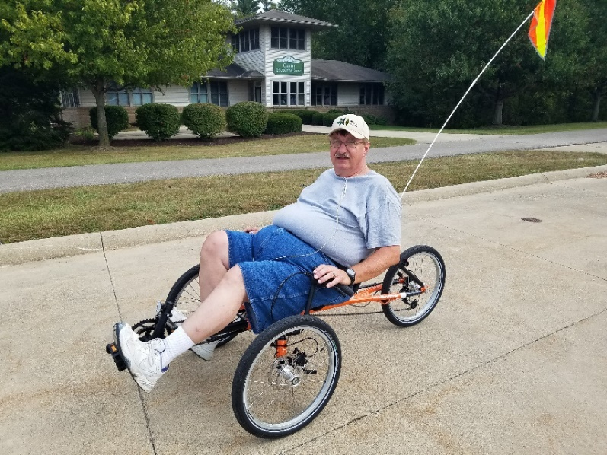
So, looking and negotiating we decided to rent a couple of bikes first to see what would fit our needs and pocketbook. After experimenting with several models and riding for about a week now, here’s what I’ve settled on. Yes, it’s comfortable and if I decide to just stop and watch the squirrels I can.

It’s easy on back and my bad leg. It’s a 16 gear so I will be able to motivate around with a cruising speed of around 12mph and a top end around 25mph.

I am getting it modified a bit, I’m having a bigger wheel in the back installed soon. That will take the top speed up to around 35mph or so. That’s way plenty fast for me. Sitting that close to the ground and going that fast can lead to a very unhappy afternoon, if I’m not paying attention.

My future plans for the bike are to replace that silly fiberglass flag you see hanging from the back and replace it with a mobile VHF/UHF antenna. There’s plenty of room behind the seat for a radio and all sorts of extra goodies so that I can have some extra fun. I plan on having my DMR with me and just using the hand mic that I have for it and leave it hooked to the back of the seat.

One last round before going QRT… Is your club doing any special activities that you’d like the Section to know about? As you can see by the posts in the Club Corner, many clubs are already taking advantage of getting the word out to over 8,000 readers every week.

Do you have a story that you’d like to tell about something that you or your club has or is doing? Let me know about it and let’s get it in the next edition!

Whelp… That’s going to do it for this time around. Stay safe, enjoy the sunshine while we have it, and most of all… have FUN!!

73,

Scott, N8SY

New Webpages Added to the Ohio Section Website

Is your club’s newsletter available to share? I’ve got a new webpage that has links to all of the known websites where club newsletters can be accessed throughout Ohio.

Now, as we all know when any list is published, it’s outdated immediately. That’s ok, just send me the link to your club’s newsletter and I’ll get it on the webpage – n8sy@n8sy.com

Here’s the link: http://arrl-ohio.org/club_link/links-to-newsletters.html Remember, we’re all here to help each other. What a great way to share the news about Amateur Radio!!

TOP ^

Back Issues of the PostScript and Ohio Section Journal (OSJ)

Hey, did you know that PostScript and Ohio Section Journal (OSJ) are archived on the website? You can go back and look at any edition simply by clicking:
http://arrl-ohio.org/news/index.html

Chit – Chat, and All That!

Do you know someone that’s not getting these Newsletters? Please, forward a copy of this Newsletter over to them and have them “Opt-In” to start receiving them. Heck, just have them send me an email n8sy@n8sy.com and I’ll get them added to the Ohio Section Emailing list.

We now have many thousands of readers receiving these newsletters weekly. Quite impressive, I’d say! I urge all of you to make sure that everyone, regardless of whether they are a League member or not, get signed up to receive these weekly Newsletters.

You can always “Opt-Out” at any time if you feel this is not what you were expecting. It’s fun and very informative. All of your favorite past newsletters are now archived too.
You can go back at any time and read them. Just go to: http://arrl-ohio.org/news/

Got questions, concerns or would just like to sit and chat awhile? Heck, I’ll even buy the coffee!! Give me a call at (419) 512-4445 or email me at: n8sy@n8sy.com

The pictures on the front page are from various newsletters, Facebook posts and/or were sent directly to me in recent weeks. Take a good look at them, you just might be in one of the pictures! “SMILE… you’re on the Ohio Section News!!”

TOP ^

PostScript is produced as a weekly newsletter. I want to thank everyone that has contributed articles and ideas to make this an even better news source. I sincerely hope that you have enjoyed this edition and will encourage your friends to join with you in receiving the latest news and information about the Ohio Section, and news and events happening around the world!

