[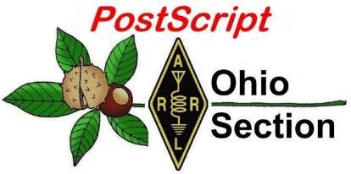](http://arrl-ohio.org/news/) ***Palindrome Week***

***Edition***

🡪 National News 🡪 The Handbook Give Away

🡪 Club Corner 🡪 Hamfests

🡪 DX This Week 🡪 One Question Questionnaire

🡪 VE Testing 🡪 ARES Connect

🡪 This and That’s 🡪 Final.. Final..

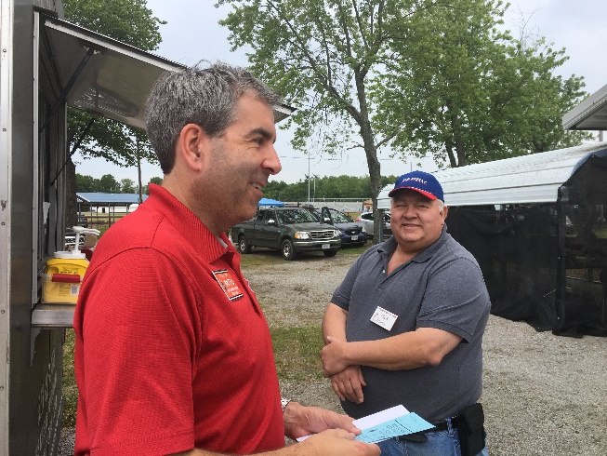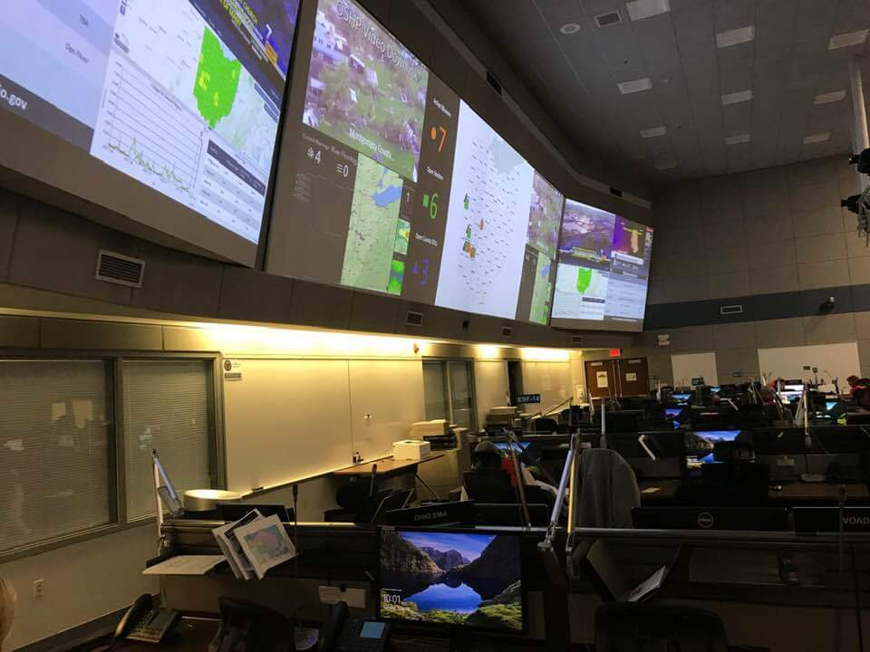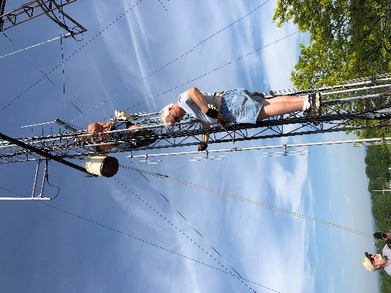

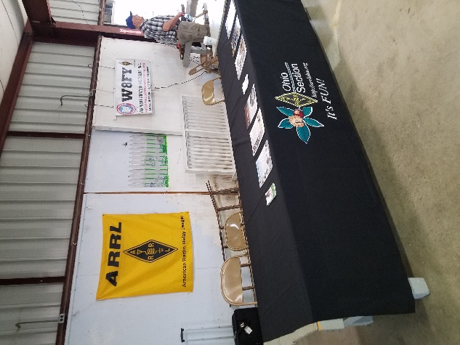

***National News***

*(from arrl and other sources)*

***FCC Proposes to Make All Universal Licensing System Filings Electronic***

The FCC is seeking comment on a *Notice of Proposed Rulemaking* ([*NPRM*](https://docs.fcc.gov/public/attachments/FCC-19-87A1.pdf)) that is part of an overall plan to transition completely to electronic filing, licenses, authorizations, and correspondence. The notice proposes to make all filings to the Universal Licensing System (ULS) completely electronic, expand electronic filing and correspondence elements for related systems, and require applicants to provide an email address on the FCC Forms related to these systems. Although much of the FCC’s ULS filings are already electronic, the changes suggested in the *NPRM* (in WT Docket No. 19-212) would require all Amateur Radio Service applications to be filed electronically. Under current rules, Amateur Radio applications may still be filed manually, with the exception of those filed by Volunteer Examiner Coordinators (VECs).

“Given the drastic changes that have occurred with regard to the ubiquity of the internet and increased personal computer access, we find it unlikely that electronic filing remains infeasible or cost-prohibitive for the previously exempted types of filers, or that they lack resources to file electronically,” the FCC said in the *NPRM*, which was released on September 6. “We therefore propose to eliminate Section 1.913’s exemptions to mandatory electronic filing.”

The FCC said that while the vast majority of ULS applications today are submitted electronically, some are still manually filed, largely from exempted filers, such as radio amateurs. Last year, the FCC received some 5,000 manually filed applications out of a total of some 425,000 applications. Among other aspects, the FCC is seeking comment on whether its underlying assumptions about the ease of electronic filing for previously exempted filers are valid.

This *NPRM* also seeks comment on additional rule changes that would further expand the use of electronic filing and electronic service.

“Together, these proposals will facilitate the remaining steps to transition these systems from paper to electronic, reducing regulatory burdens and environmental waste, and making interaction with these systems more accessible and efficient for those who rely on them,” the FCC said.

Comments are due within 30 days of the *NPRM*’s release.

#########

***Turn a GD-77 into a DMR Only Hot Spot Using A Raspberry Pi, & Radio Firmware***

*(submitted by: Greg Drezdzon, WD9FTZ)*

This option will give users a 1-watt hot spot that is about 100 times more power than the average hot spot, plus ability to attach an external antenna for more range. <https://www.rogerclark.net/opengd77-hotspot-mode/>

#########

TOP ^

***Eddie De Young, AE7AA, Named CQ Awards Editor***

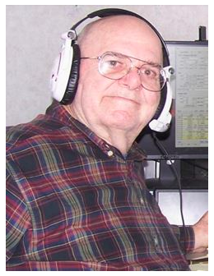Eddie De Young, AE7AA, of Clearwater, Florida, has been named Awards Editor of *CQ* Amateur Radio magazine. His first Awards column appears in the September 2019 issue. De Young succeeds Ted Melinosky, K1BV, who served both as Awards Editor and USA-Counties Award Custodian for more than 20 years. Brian Bird, NX0X, now is USA-CA custodian.

Licensed since 1954, De Young has held more than two dozen call signs in 11 different countries over the years. While living in Australia, he served as Awards Manager for the Wireless Institute of Australia.

#########

***Nine Schools and Organizations Make the Cut for Ham Contacts with ISS Crew***

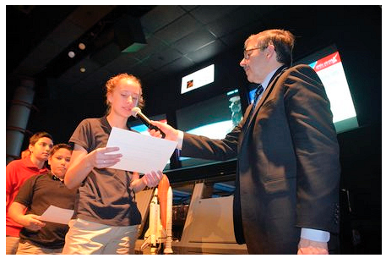

Amateur Radio on the International Space Station ([**ARISS**](http://www.ariss.org/)) has announced that nine schools and organizations have been selected to host Amateur Radio contacts with International Space Station crew members during the first half of 2020. The selected host organizations must now complete equipment plans that demonstrate their ability to execute the ham radio contact. Once a plan is approved, the final selected schools/organizations will have contacts scheduled as their availability matches up with the opportunities offered by NASA.

The schools and host organizations are: Celia Hays Elementary School, Rockwall, Texas; Golden Gate Middle School, Naples, Florida; J.P. McConnell Middle School, Loganville, Georgia; Kittredge Magnet School, Atlanta, Georgia; **Maple Dale Elementary School, Cincinnati, Ohio**; Monroe Carrell Jr. Children’s Hospital at Vanderbilt, Nashville, Tennessee; Oakwood School, Morgan Hill, California; Ramona Lutheran School, Ramona, California, and River Ridge High School, New Port Richey Florida.

The primary goal of the ARISS program is to engage young people in science, technology, engineering, arts, and math (STEAM) activities and raise their awareness of space communication, radio communication, space exploration, and related areas of study and career possibilities.

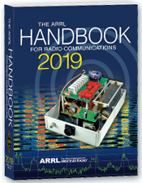***The Handbook Give Away***

Hey Gang,

Have you registered for the “Handbook Giveaway” drawing for this month yet? If you haven’t, go to: <http://arrl-ohio.org/handbook.html> and get yourself registered now!

What’s the catch? I want to get everyone checking in to the Ohio Section website as often as possible, and in order to register each month, you have to visit the website often! There’s nothing else to it. I pay all expenses and I usually “Give Away” more than just a Handbook too!!

TOP ^

Many of you ask me just how do I know when the drawing is on? Well, that’s easy all you need to do is check in on the Ohio Section Website on a regular basis and watch for the big [**RED**](http://arrl-ohio.org/handbook.html)Arrow that will appear on the left side of the page. This is the sign that the drawing is on and you need to get registered. So, keep a sharp eye out on the website and check in often!

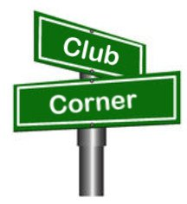***Club Corner***

This is YOUR cornner of the newsletter. Send me what your club is doing and I’ll make sure that it gets in. Got a special event or club project that you want everyone to know about? Send it to me!. Need help with a project? Send it to me.

Let me know what you club is up to. Are you going to have a special guest at your meeting or are you having a special anniversary? Just sent it to: [n8sy@n8sy.com](mailto:n8sy@n8sy.com)

#########

***POW – MIA Event***

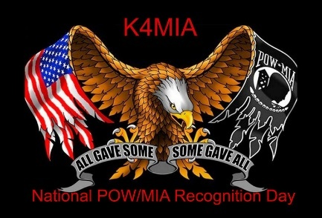On **September 13 thru the 22nd** of 2019 We will honor and support our Veterans with a Special Event on the air as K4MIA/8. Linda N8LRS and Metro W8MET will be the sister-station from Ohio for our 4th year.

This event originated from K4MIA, Mike from Florida with other sister-stations involved. Details can be found on the ARRL website under “ON-THE-AIR” under SPECIAL EVENT under the call-letters of K4MIA.

Also, this Special Event will be in the September QST. Please take part in this Special Event for our Veterans. QSL is available with SASE. We will be operating on 40 meter's SSB. GOD BLESS AMERICA 73, Linda and Metro

#########

***The Ohio State University Amateur Radio Club Will Be On The Air***

TOP ^

**W8LT**, the amateur radio club at Ohio State University, will be on the air for the ARRL Collegiate Initiative QSO Party from **10 am to 5 pm EDT on Saturday Sept. 21st**  Because the event will occur on the weekend of a home football game, we will be set up near the South-East corner of the Ohio Stadium in the university’s Mobile Design Lab See attached photo).

We would like to have as many OSU alumni and friends give us a call as possible.  We plan to be on SSB on 20 and/or 40 meters and possible on FT-8.  The rules specify only one transmitter at a time, so we will try to post our frequency as the day rolls by.

#########

***Twisted Pretzel Tour 2019 - Saturday, September 28, 2019***



Germantown Amateur Radio Society will once again be providing communications support for the ever-growing Twisted Pretzel Tour (TPT) to be held on Saturday morning, September the 28th.

The TPT has over 600 bicyclists covering four routes consisting of 8, 21, 39, and 50 miles each in the Germantown Farmersville areas.

It takes many amateurs to cover these routes. Your help is needed for this very popular public service event, which runs starting at 7am and lasting until approximately 12 noon.

We will be utilizing the ***GARS*** 443.1875 repeater. Please note a PL 123.0 is needed to access this repeater.

**Amateur operators are needed !!!** If interested please contact Phil Thomas, W8RMJ at 937-902-6738.

#########

***VE Testing At Alliance***

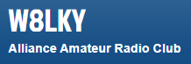There will be a walk-in test session 4PM on 21 September in the Cafeteria Conference room in Alliance Community Hospital.

Contact [wa8whp@gmail.com](mailto:wa8whp@gmail.com) for full details.

#########

***Mahoning Valley Amateur Radio Club Helping out Scouting***

The local Boy Scout Camp (Camp Stambaugh) in Youngstown is celebrating 100 years this year.  Our club **The Mahoning Valley Amateur Radio Association** was asked to come out and set up some radios for the day and make some contacts.

We will be operating on the calling frequencies on the 20, 40, and 80-meter bands under the club call sign of W8QLY.  On Saturday **September 21st**.  Operating during the hours of 8:00 A.M. to 5:00 P.M.

TOP ^

We will be letting Scouts and parents that are interested in trying their hand on the on the air, try if they would like to try so please be patient and either be prepared to answer lots of questions or ask lots of them.  For those of you that can help we would greatly appreciate it. 

#########

***Summit County ARES Needs Help With Race***



Summit County ARES is looking for help with the Akron Marathon on **September 28th** from 6AM until 2PM. This is a 28-mile run and we could use at least 20 operators or maybe more if more show up.

 Sign-ups are available on our website [www.summitares.org](http://www.summitares.org) and I also have it on ARES Connect

#########

***Huron County Emergency Management Agency Presents –***

***Technician Level (beginner) Amateur Radio License Prep Course***

This six-week course is FREE and open to the public. It will be held Monday evenings beginning **16 September**, from 6:30pm to 8:30 pm. The course will be held at the Huron County EMA , 255 B Shady Lane Dr, Norwalk, OH 44857.

We will be using the Amateur Radio Relay League License Manual as our primary study guide. This is available from multiple online sources. It would be very helpful, but not required to have a copy of the current manual.

If purchasing the manual, please make sure it is Level 1, Technician.

In addition to the ARRL manual, we will have seasoned Amateurs from the area to assist and answer questions to help you prepare for the course.

Registration is requested but not required by calling the Huron County Emergency Management Agency at: 419-633-5772

#########

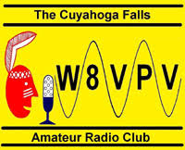***Technician License Class Starting***

The Cuyahoga Falls Amateur Radio Club n will be conducting a 6-week course for Technician class for new licensees. The classes will be on **Sunday afternoon starting the 29th of September to the 3rd of November**, from 1:15pm to 4:45pm at Main Branch of the Akron-Summit County Public Library, 60 South High Street, Akron, OH 44308. There is free parking in the attached parking deck.

TOP ^

There is $30 charge for this course. The course will be instructed by CFARC team of instructors who have taught a dozen other offerings of licensing courses. For more details consult cfarc.org or contact: [education@cfarc.org](mailto:education@cfarc.org)

#########

***National Preparedness Month Program - Stark County ARES***

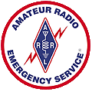(Sept 11, 2019) - -  Continuing with our participation in National Preparedness Month, Stark County ARES participated in a two hour radio program hosted by the County EMA office and broadcast over local AM station WHBC that focused on plans our local our local government and public service organizations have put into place to serve citizens during a disaster, and on things the local populace can do in the event of a major emergency. The program was live streamed over the station facebook page,

Guests included both Canton Hospitals, EMA Staff, police and fire officials and city health departments. Our county ARES was represented by EC Terry Russ, N8ATZ, and Assistant EC David Beltz, WD8AYE our liaison to the EMA office. We briefly discussed how we interact with local civil authorities and how we provide support communications during emergencies and our local Skywarn program.

The program is available for replay on the Stark County EMA facebook page in the video's section.

[Click Here for the replay....](https://www.facebook.com/1480whbc/videos/2419708998065111)

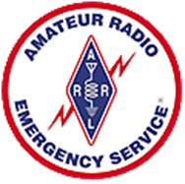#########

**Lake County ARES** is seeking volunteer operators for the Lake Health Running Series Northern Ohio Marathon / Half Marathon / Relay being held **Sunday, October 6th**. The event start/finish is Mentor Headlands State Park and the course route includes Grand River, Mentor, Willoughby, and Mentor-on-the-Lake. If you would like to help, you may use the link below to register, or contact Mike Goffos (WB8ZGH) for more information.  
  
<https://docs.google.com/forms/d/e/1FAIpQLSeGKv2ssCPJu83p_XH1sGIddGylePBWQv0KRXj6F1v8XenD5g/viewform?usp=sf_link>

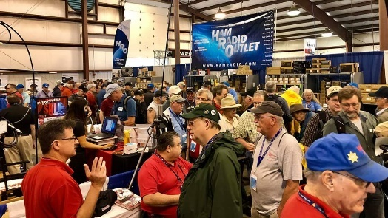[***Upcoming Hamfests***](http://arrl-ohio.org/hamfests.html)

**09/21/2019 | The OHKYIN ARS Hamfest**

Location: Cincinnati, OH  
Sponsor: OHKYIN Amateur Radio Society  
Website: [http://www.ohkyin.org](http://www.ohkyin.org/)

**09/22/2019 | Cleveland Hamfest and Computer Show**

Location: Berea, OH  
Sponsor: Hamfest Association of Cleveland  
Website: [http://www.hac.org](http://www.hac.org/)

TOP ^

|  |  |
| --- | --- |
| **10/05/2019 | Scioto Valley Amateur Radio Hamfest**  Location: Chillicothe, OH Sponsor: Scioto Valley Amateur Radio Club | **10/12/2019 | NWOARC Fall Hamfest**  Location: Lima, OH Sponsor: Northwest Ohio Amateur Radio Club  Website:[http://www.nwoarc.com](http://www.nwoarc.com/) |
| **11/02/2019 | GARC Hamfest** Location: Georgetown, OH Sponsor:Grant Amateur Radio Club Website:<https://www.facebook.com/Grant-Amateur-Radio-Club-1775764122477536/?modal=admin_todo_tour> | **11/03/2019 | Massillon ARC Hamfest** Location: Massillon, OH Sponsor: Massillon Amateur Radio Club Website:[http://www.w8np.org](http://www.w8np.org/) |

***NEW Hamfest/Convention Information….***

Now, I want everyone to breakout your **2020 calendars** because I have 2 dates that I want you to mark on those calendars for events that are coming.

First, is the **Toledo Hamfest and ARRL Great Lakes Division Convention**. This is going to be a 2-day affair starting on **Saturday. March 14th** with a full day of forums & Maker Projects with a fantastic banquet and awards presentations as well. On **Sunday, March 15th** you can enjoy a super Hamfest sponsored by the Toledo Mobile Radio Association (TMRA) all located on the Owens Community College Campus.

The next date to mark down is **August 8th**… This will be the **DX Engineering Hamfest and ARRL Ohio Section Convention.** John, KD8IDJ will be announcing the 28th Annual ARRL Ohio Section Newsletter Contest winners and I will be announcing the newest inductee of the Allan Severson, AB8P Award. There will be numerous forums and great deals on all kinds of equipment and parts. If you thought they had a good hamfest this year, you ain’t seen nothin’ yet!!

Get those calendars out and mark these dates now. We want to see everyone at these 2 fantastic events next year!!

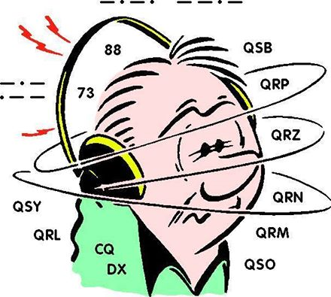***DX This Week***

*(from Bill, AJ8B)*

***DX This Week – A year in Review***

Bill AJ8B [aj8b@arrl.net](mailto:aj8b@arrl.net), @AJ8B, [www.aj8b.com](http://www.aj8b.com) or [www.swodxa.org](http://www.swodxa.org)   
 CWOPs Member #1567

As you know, I like to get the “Old Business” wrapped up before moving on to the topic of the week.

TOP ^

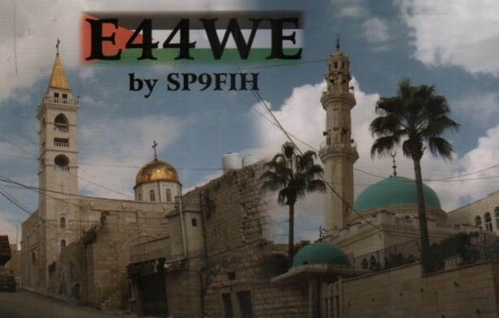The QSL cards that I received in the past week included Z81D – South Sudan, S9A – Sao Tome, 3E3E – Panama, 5W1SA – Western Samoa, OE1SGU – Austria, and E44WE – Palestine (Pictured)

Did you get a chance to work the CW Open contest? I like this contest because it is comprised of 3 4-hour segments. Each segment is scored separately and there is a total score as well. Although it is sponsored by the CWOPs organization ([www.cwops.org](http://www.cwops.org)), you don’t have to be a member to participate.

This year, I was concentrating on “interleaving 2 VFOs on 2 Bands” to try to get my score up. (More on that in the future) I was able to increase my score by about 40% over last year! Although this is not Single Op, 2 Radio, (SO2R) it is does allow me to access more QSOs than I was able to before. No matter what I try, I know that I have a top end that will not be good enough for any significant score. However, my goal every year is to just beat my previous score. This year I was able to do that. I would love to be able to sit down and just watch N8AA, John, or N8BJQ, Steve, run a contest. These guys really crunch through the QSOs! Let me know if you gave it a shot and what your thoughts (and scores) were!

It was just over a year ago at the Milford Hamfest that I met Scott, N8SY. We had a chat and he asked me to consider submitting articles for the Oh Section Newsletter. My initial thought was “I don’t know nearly what I need to know” to do something like that! However, the more I thought about it, the more I realized that, although I did not have the direct knowledge, I *KNEW* guys who had the knowledge and I could use them as a reference. So, I said, what the heck! Now, a year later, we are going strong (I think), and have more ideas and thoughts in the queue.

In the past year, we have covered topics such as Sunspot Basics, What is an Entity?, QSL Cards, SEDCO (W4DXCC), DX Spots, QSL Routes, Clublog, Solar Numbers, CW QSOs, QSL Buro, CW Shorthand, Top 100 Entities, FT8, Gray Line, Pilot Stations, Contests, Working Split, CWOps, CW Academy, 60 Meters, Card Checking, DXCC LoTW, UAAC, Digital Clubs, and eQsl. I have also shared interviews with various DX Stations. I hope you have enjoyed the first year. Of course, there are other topics we will cover in the next year and I would welcome your input!

A big THANKS to Scott for his encouragement and help!

Good Hunting!

+ --------------------------------------------------------------------------------------------------+

Here is an update from Bernie, W3UR, of the DailyDX and the WeeklyDX,

the best source for DX information. (<http://www.dailydx.com/> ) Bernie has this to report:

+ --------------------------------------------------------------------------------------------------+

**C21 – Nauru -** C21WW is the new callsign for the operation September 16-25 by YL2GM, YL2KA, YL1ZF and YL3JA. This is a callsign change from the previous C21W they thought they would have. On 160-6M, "possibly 60," this comes after their current T30L Western Kiribati operation.

They plan CW, SSB, RTTY and FT8 modes. Look for them on: CW: 1826.5/1821, 3524, 7024, 10113, 14024, 18083, 21024, 24903 and 28024. SSB: 3790, 7090, 14190, 18140, 21290, 24940 and 28490. RTTY: 3583, 7043, 10143, 14083, 18105, 21083, 24923 and 28083. FT8: 1836, 3565, 7070, 10143, 14090, 18095, 21090, 24910 and 28090. FT8 is F/H mode.

TOP ^

They will always operate split, up 2 on CW but down 2 on 160, listening for JA when on 160, between 1810-1820. On SSB and RTTY, listening up 5. QSL direct via YL2GN or use Club Log for direct or bureau replies.

**OK - Czech Republic -** Station OL75CARBON celebrates the 75th anniversary of World War II Operation CARBON, paratroopers who jumped into the Protectorate of Bohemia and Moravia. This station will be on the air September 5 to November 30, on all bands and modes depending on the propagation conditions, mostly CW.

They will also be on SSB, FM and possibly digital modes. They will send out bureau cards for all the QSOs and say "Please do not send your cards." They say they will answer with pleasure every SWL report sent via the bureau to OK2PXJ or through email. If you need a direct answer, send an SASE or equivalent. This group remembers the "CLAY" Operation earlier this year, callsign OL75CLAY. OK2BMA, Pavel, says "We want to express our thanks and pay tribute not only to the members of the Carbon and Clay groups but also to all the others who did not hesitate to battle for their native country even at the cost of their own lives. They deserve our admiration and recognition."

**7Q – Malawi -** 7Q7WW and 7Q6M by KC4D and K6ZO respectively are active from the Embangweni Mission Hospital in northwest Malawi "off and on" starting a few days ago, September 4 and going through September 25. They are busy with mission projects and meetings. They have a rotatable hex beam at 65 feet for 20 and above, and a multiband 80M OCF sloper and other wires for lower bands. For the gear it's a K3 and TenTec Titan amplifier. They are working on receiving beverages and a wire vertical for better 160 and 80M capability, as time permits and say received signals are typically very weak with a high noise level from leaky commercial power lines, but they have had some success using FT8 on 40 and 80 "and a bit" on 20 and 40 CW as well. They will upload the log to LoTW when they're back home. N3CW and N3AC have updated the web page for the two ops. The QSL card design is being planned. Cards should be sent to the KC4D address on QRZ.com, SASE for US, 1 USD for those outside the US, with SAE.

***DX news***

***ARLD036 DX news***

This week's bulletin was made possible with information provided by The Daily DX, the OPDX Bulletin, 425 DX News, DXNL, Contest Corral from QST and the ARRL Contest Calendar and WA7BNM web sites. Thanks to all.

**SWAZILAND, 3DA.** Pista, HA5AO will be QRV as 3DA0AO from September

16 to 30. Activity will be on 80 to 10 meters using CW, RTTY and FT8. QSL to home call.

**SOMALIA, 6O.** Ken, LA7GIA will be QRV as 6O7O from September 14 to 28. Activity will be on 160 to 10 meters using mostly CW, with some SSB and FT8 on one or two bands. QSL via M0OXO.

**ZAMBIA, 9J.** Brian, 9J2BO is usually active on 40 meters using CW around his morning sunrise at 0340 to 0430z. QSL direct to G3TEV.

**TONGA, A3.** Heli, DD0VR will be QRV as A35JY from September 16 to 21. Activity will be on the HF bands using SSB. QSL to home call.

TOP ^

**BAHRAIN, A9.** Station A91ARS is QRV until September 25 to recognize Saudi Arabia's National Day.

**NAURU, C2.** A group of operators will be QRV as C21WW from September 16 to 25. Activity will be on 160 to 10 meters using CW, SSB, RTTY and FT8 in DXpedition mode. QSL via YL2GN.

**CEUTA AND MELILLA, EA9.** Rene, DL2JRM is QRV as EA9/DL2JRM and plans to be an entry in the Worked All Europe DX SSB contest. QSL to home call.

**DOMINICA, J7.** Walter, HB9MFM is QRV as J79WTA on Nature Island for the next six months. Activity is on the HF bands, and eventually 6 meters, in his spare time. QSL to home call.

**MARIANA ISLANDS, KH0.** Harry, JG7PSJ will be QRV as WH0RU from Saipan Island, IOTA OC-086, from September 15 to 22. Activity will be on 40 to 10 meters using CW, SSB and RTTY. QSL direct to home call.

**HAWAII, KH6.** Bernd, DL8UI plans to be QRV as KH6/DL8UI from O'ahu, IOTA OC-019, in the Worked All Europe DX SSB contest. QSL to home call.

**AUSTRIA, OE.** Special event station OE15SOTA is QRV until September 22 to celebrate 15 years of SOTA activity in Austria. QSL via bureau.

**CZECH REPUBLIC, OK.** Special event station OL75CARBON is QRV until November 30 to celebrate the 75th anniversary of World War II Operation CARBON, consisting of paratroopers who jumped into the Protectorate of Bohemia and Moravia. Activity is on all bands using mostly CW, but also SSB, FM, and other digital modes. QSL via operators' instructions.

**DENMARK, OZ.** Rosel, DL3KWR is QRV with special call OZ6SYL near Faxe on Sjaelland Island, IOTA EU-029, until September 23. Activity will be holiday style using CW. This includes being an entry in the upcoming Scandinavian Activity CW contest. QSL via OZ7AGR.

**NETHERLANDS, PA.** Special event station PA75LIMBURG is QRV until March 2020 to commemorate the liberation of the province Limburg 75 years ago. QSL via PC8DB.

**EAST KIRIBATI, T32.** Ken, KH6QJ is QRV as T32AZ on Kiritimati Island, IOTA OC-024, until September 24. This includes being an entry in the upcoming All Asia SSB contest. QSL to home call.

**PALAU, T8.** Toshi, JM1LIG, Yas, JA6UBY and Miyo, JO3LVG are QRV as T88FM, T88RR and T88MK, respectively, from Koror Island, IOTA OC-009, until September 20. Activity is on the HF bands using CW, SSB and various digital modes. QSL direct to home calls.

**CHAD, TT.**  Jean Louis, ZS6AAG is QRV as TT8JLH from N'Djamena until October 14 while on work assignment with Medecins Sans Frontiers. Activity is in his spare time on 20 meters using SSB. QSL to home call.

THIS WEEKEND ON THE RADIO. The ARRL September VHF Contest, North American RTTY Sprint, NCCC RTTY Sprint, NCCC CW Sprint, Worked All Europe DX SSB Contest, FOC CW QSO Party, SARL Field Day Contest, Texas QSO Party, Alabama QSO Party, Russian Cup Digital Contest, Classic CW Exchange and BARTG Sprint 75 will certainly keep contesters busy this upcoming weekend.

TOP ^

The Run for the Bacon QRP Contest is scheduled for September 16.

The RSGB 80-Meter Autumn CW Series, CWops Mini-CWT Test and Phone Fray are scheduled for September 18.

The Canadian National Parks on the Air, CNPOTA, operating event runs for the entire year of 2019, with special stations active from Canada's parks and historic sites.

Please see September QST, page 80, and the ARRL and WA7BNM Contest Web Sites for details.

***Unraveling the Mystery of 1 × 1 Call Signs***

The [1 × 1 Special Event Call Signs](http://www.1x1callsigns.org/) system offers a way for clubs, groups, or even individuals to use a short call sign of special significance to the amateur community. These 1 × 1 call signs are [reserved](http://www.1x1callsigns.org/index.php/request) in advance for use in conjunction with short-term special events and commemorative operations. The FCC does not assign 1 × 1 call signs, so they are not "official."

On the matter of special event call signs, the FCC says, in Section 97.3(a)(11)(iii) of the Amateur Service rules: "The call sign is selected by the station licensee from a list of call signs shown on a common database coordinated, maintained and disseminated by the amateur station special event call sign data base coordinators. The call sign must have the single letter prefix K, N, or W, followed by a single numeral 0 through 9, followed by a single letter A through W or Y or Z (for example K1A). The special event call sign is substituted for the call sign shown on the station license grant while the station is transmitting."

The FCC also says in Section 97.119 (d): "Additionally, the station must transmit its *assigned call sign* at least once per hour during such transmissions."This requirement tends to be widely flouted, however.

A 1 × 1 Special Event Call Sign aids other radio amateurs by calling attention to the special event or other occasion. 1 × 1 call signs may be used for a variety of purposes, such as conventions, festivals, dedications, anniversaries, commemorations, and ARRL Field Day. Even local events qualify.

There are 750 1 × 1 Special Event Call Sign possibilities, and radio amateurs of any license class may reserve one as far as a year in advance to use for up to 15 days. Of course, 1 × 1 Special Event Call Signs are recycled. It's first come, first served. See the [Frequently Asked Questions](http://www.1x1callsigns.org/index.php/faq) page for more information.

The FCC has selected coordinators to approve and post 1 × 1 Special Event Call Sign reservations to a [searchable database](http://www.1x1callsigns.org/index.php/search). -- *Thanks to* The Radiogram *(Portage County Amateur Radio Society newsletter)*

TOP ^

***Special Events***

**09/13-22/2019 |** We will honor and support our Veterans with a Special Event on the air as K4MIA/8. Linda N8LRS and Metro W8MET will be the sister-station from Ohio for the 4th year.

**09/21/2019 | Voice of America-Bethany Relay Station 75th Anniversary**

**Sep 21, 1500Z-2200Z, WC8VOA,** West Chester, OH. West Chester Amateur Radio Association. 14.240 14.270. Certificate. Mike Braun, PO Box 913, West Chester, OH 45071. Certificate will be available 72 hours after the event at wc8voa.org [wc8voa.org](http://wc8voa.org/)

**09/22/2019 | Flying Beers International Fall FUN Raiser**

**Sep 22, 1000Z-1800Z, K8FBI**, Ferndale, MI. Flying Beers International. 14.240 7.240. QSL. Flying Beers International ARC, 600 Woodward Heights, Ferndale, MI 48220. Operating on 40 and possibly 20 as conditions allow, CW, SSB and Yay-Em. Physical QSL cards will be sent for the fun of it. [www.FlyingBeers.org](http://www.flyingbeers.org/)

**09/28/2019 | Boy Scouts of America Rendezvous in the D**

**Sep 28, 1300Z-2000Z, K2BSA/8**, Detroit, MI. Great Lakes Scout Radio Club. 14.290 7.270. QSL. Frank Maynard, NF8M, 44683 Mansfield Dr., Novi, MI 48375. <https://www.qrz.com/db/wb8bsa>

**10/19/2019 | 100th Anniversary of Michigan State University Amateur Radio Club**

**Oct 19, 1600Z-2200Z, W8SH**, East Lansing, MI. Michigan State University Amateur Radio Club. 14.250 14.050 7.250 7.050. QSL. MSUARC/W8SH, ECE Dept. #2121, 428 S. Shaw Ln. , East Lansing, MI 48824. Original call 8YG. [msuarc@egr.msu.edu](mailto:)

**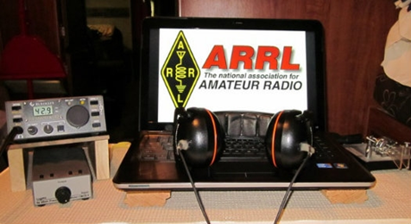*ARRL Contest Corner***

An expanded, downloadable version of *QST'*s [Contest Corral](http://www.arrl.org/contest-calendar) is available as a PDF. Check the sponsor's Web site for information on operating time restrictions and other instructions.

*****V.E. Test Sessions***

For the latest testing site information please **>>** [Click Here](http://www.arrl.org/find-an-amateur-radio-license-exam-session) **<<** The ARRL site tracks all of the VE testing sites that register with them, including W5YI and Laurel. ARRL gives you a number of different ways of sorting to find that site that is closest to you as well.

TOP ^

***One Question Questionnaire***

Hey Gang,

OK, this last question seems to have hit a nerve.. Only about **35%** of you seem confident enough to build your own amplifier. Well, don’t feel too bad, I haven’t built one of my own either.

I’ve got another NEW – one question – on the Ohio Section Website for you to answer!

Here’s the question for this next week.

**“Have you ever forgotten to UNGROUND your antennas before you started using the radio??”**

These One Question questionnaires are all in fun and I hope that you are enjoying answering them.

You’ll find the “One Question” questionnaire on the Ohio Section Website! <http://arrlohio.org> It’s all in fun and it’s not a scientific survey in any way, but we are learning some things that we didn’t know from these questions. I hope that you are enjoying answering these “One Question” questionnaires.

***ARES Connect***

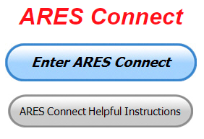OK.. I’m setting a goal for all of you out there. **Let’s get everyone in the Ohio Section on ARES Connect before the end of this year!!!**

Do you need help with how to sign-up for an event or log your hours? How about you Administrators, do you have questions about approving your volunteer’s hours or how-to set-up a recurring event? I’ve got the answer for all of you. I have a new webpage with step-by-step instructions on how to do those things and many more.

I also have a “Hints and Kinks” section that has a lot of great information on how to do something or why something works like it does. Here’s the page: <http://arrl-ohio.org/SEC/connect/index.html> You can also find this link on the main page of the Ohio Section website as well.. It’s just under the “Enter ARES Connect” link.

If you live in **Ohio** and you haven’t registered yet, we need you to get registered now. We need you to only use this URL to get registered <https://arrl.volunteerhub.com/lp/oh/>. Using any other entrance to register will only slow down your registration process. Again, this is for those living in Ohio only. If you are an out of state person (not Ohio), you can simply change the **/oh/** to your 2-letter state designation. This will put you in the correct state for signing up.

Now, I am starting to see folks creating more than one account because they can’t remember their password from the one that they originally setup. Please don’t do this. The system has a really good way of sending you a link to your email address so that you can refresh your password. If you are experiencing problems with getting to this link, contact me: [n8sy@n8sy.com](mailto:n8sy@n8sy.com) and I’ll get it fixed for you.

TOP ^

***Here’s the top 10 hours earners so far for September:***

|  |  |  |  |
| --- | --- | --- | --- |
|  | **Name** | **Events** | **Hours** |
| 1 | Bret Stemen (KD8SCL) | 18 | 44.50 |
| 2 | Dan Stahl (KC8PBU) | 32 | 43.21 |
| 3 | Alan Rothweiler (N8CJ) | 18 | 40.50 |
| 4 | Christopher Domenick (KC8CAD) | 12 | 37.00 |
| 5 | James Yoder (w8erw) | 4 | 34.25 |
| 6 | Michael Lacumsky (w8mal) | 13 | 34.00 |
| 7 | Donald Kemp (NN8B) | 5 | 28.00 |
| 8 | Kenneth Warner (KE8HBN) | 6 | 27.50 |
| 9 | James Smith (ke8iju) | 7 | 25.00 |
| 10 | Juan Duarte (kd8uot) | 15 | 23.00 |

As you can see from the above listing, we can get real time information that shows how many hours, who volunteered and what they volunteered for. There’s a ton of information that we can draw out of the system.

We now have **1,292** registered and growing every day in the system. What’s really interesting is as of this same date there are **11,638** registered in the entire country. This means that the Ohio Section makes up over **11.10%** of those registered.

Here’s a link to get you started... <http://www.arrl-ohio.org/SEC/connect/ares_connect_directions.pdf>

Please, don’t just hurry through the questions, read them carefully, if you don’t understand something, please ask me, I’m here to answer your questions.

Please don’t create a new account if you can’t seem to access your old one. If you just forgotten your password, or you had someone else create your account and you don’t know the password, simply use the “Forgot My Password” link. It will guide you right through the process of not only accessing your account, but you can also reset your password to something that you won’t forget. If you still can’t access your account, please, contact me at: [n8sy@n8sy.com](mailto:n8sy@n8sy.com) and I can get it fixed for you.

I’m being asked a lot lately about just what can we record as an ARES Connect Event. Well, there’s really no simple answer to that tough question… It can be a RACES, CERT, Skywarn, Red Cross or LEPC meeting where you or a group of you are there representing your club or Amateur Radio in general.

For the most part, we are doing really good in identifying those events that we should be tracking. If you have questions about whether an event should be created in ARES Connect, here’s a simple “litmus test” to help you decide whether it should be an event or not. We have 7 categories for events that are built into ARES Connect. They are:

* Communications Emergency
* Community Event
* Exercise
* Meeting
* Net

TOP ^

* Skywarn
* Training

As you can see, this covers a huge amount of territory right off the bat. Most everything that you will want to create an event for will fit into one of these 7 categories. But, as I’m being asked the question, not everything that you are doing fits into one of these 7, and that’s where most of your questions come from “do I count this or not.”

Work you did on the club trailer, repeater, website, field day and associated other similar events, parades, newsletter or just having fun keeping track of all those spandex folks during every kind of bicycle and foot race imaginable are really good examples of events that should be included, but just don’t fit well into one of those 7 categories. I could go on and on about what you could include as an event, but the fact is there are so many different kinds of things that we do to represent ourselves in Amateur Radio and our giving back to the communities that it would be virtually be impossible to make a list of those items that should and shouldn’t be events in ARES Connect.

This is where your “Common Sense” has to be applied. If you ask yourself this one question, I think you’ll have your answer. “Did we do this event as amateur radio operators?” No, the event doesn’t always have to involve using amateur radio, but if you have an event that isn’t serving amateur radio or your community, then I think you’d have to agree, it probably shouldn’t be an event in ARES Connect. Again, let me stress this point, if you have an event that doesn’t fit into one of the 7 categories above, you need to apply some “common sense” as to whether this event is something that should be in ARES Connect.

One last item that I need to discuss is that when you have completed the event don’t forget to get back into your account and register your hours. For the most part we are doing well with this, but there seems to be some of you that just might not know or understand that as a volunteer you have 2 things to do with ARES Connect. The first is to get registered for the events and then you need to report how much time you spent doing that event. It’s really quick and easy to do. Don’t know how, just ask. Your Admin or I can show you how to do this very quickly and easily.

***This and That’s***

***Amateur Radio Emergency Service group seeks new members***

*(By Jack Rooney / Staff Writer – The Dailey Record)*

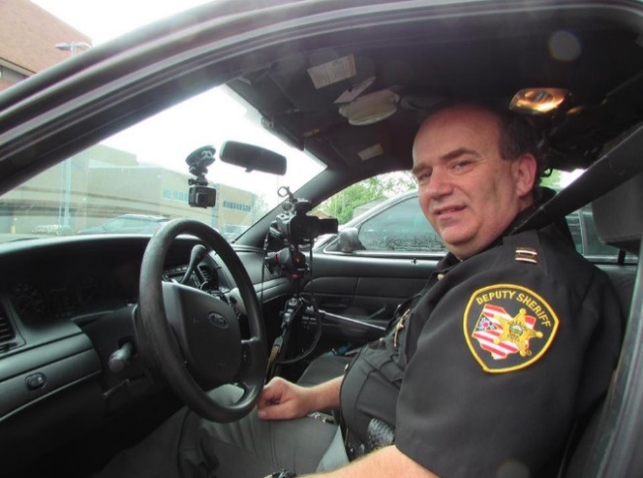

WOOSTER — When disaster strikes, bringing with it the possibility of disabled cellular networks, first responders rely on radio communications.

“It supplements other sorts of communications such as cell phones. And in the event of a disaster, it’s entirely possible that cell phone communications may not be available, so radio communications might be the only means of communication available” said Capt. Doug Hunter of the Wayne County Sheriff’s Office, who also serves as the Amateur Radio Emergency Service coordinator for Wayne County .

TOP ^

Hunter recently took on this role, and oversees the training, organization and emergency participation of people interested in serving as amateur radio operators. The group has been around for many years, Hunter said, but its membership has dwindled to about 12 people. So, during this National Preparedness Month, Hunter is hosting an informational meeting to “give a jump start” to the group.

The meeting will be Monday, Sept. 16 at 6:30 p.m. at the Red Cross building at 244 W. South St. in Wooster. The meeting, Hunter said, is open to “anybody who has an interest in becoming a licensed amateur radio operator and has a willingness to utilize their knowledge and equipment to help their community on many different levels.”

To become a part of the group, interested citizens also will need to pass a certification test, a background check and receive incident command training “on par with that of many first responders,” Hunter said.

“We want to ensure that the people that are involved with ARES are qualified and able to provide true assistance rather than just be a liability,” he said.

Information on the training and certification requirements will be available at the meeting. But, “to attend the meeting, nothing is needed other than a willingness to help,” Hunter added.

During Hunter’s time with the ARES group, he said members have not been called upon to respond to an active emergency, but they were standing by during the July 21 flooding. And along with preparing for emergencies such as floods, tornadoes and snow and ice storms, members of the ARES groups also attend community events where they can keep their radio skills sharp.

Most recently, Hunter said, group members were stationed along the route of the Heart and Sole Race in Wooster, where they could relay any medical emergencies to EMS personnel, if necessary. Outside of Wayne County, Hunter said, amateur radio operators assisted in the emergency response to the 2013 Boston Marathon bombings.

So ultimately, Hunter said, the Wayne County ARES group gives the community another tool at its disposal during disasters.

“It’s important to Wayne County because Wayne County residents and citizens across the country rely heavily on the ability to communicate with others,” he said. “And while our communications system is stronger than ever before, there are points of failure,” and amateur radio operators help fill those gaps.

And locally, Hunter said, active amateur radio operators are always happy to share their abundant knowledge with new people interested in serving.

“Many of the people that are currently involved and have been for many years, and they’re aging,” he said. “And part of my goal is to bring in a newer, fresher set of operators that can learn from those who have been doing this over the years while they’re still around and can share their knowledge.

″... In my short time with this, I’ve been really impressed with the amount of knowledge that these seasoned amateur radio operators possess,” Hunter added. ”...They’re always willing to help others who are interested in becoming a part of this hobby.

#########

TOP ^

***Contester Activities to Remain at Crowne Plaza during 2020 Dayton Hamvention***

Tim Duffy, K3LR, reports that after checking out available facilities in the Dayton/Xenia area to host contest-related activities during the 2020 Dayton Hamvention®, the contester [Super Suites](http://contestsupersuite.com/) will remain at the Crowne Plaza in downtown Dayton.

“Local authorities have given assurances that there will be improvements during our stay for 2020,” Duffy said, noting that hotel security issues have been addressed and that parking garage work will be completed in time.

Contest University ([CTU](http://contestuniversity.com/)) USA 2020 will be held at the Crowne Plaza on Thursday, May 14, all day, with registration on Wednesday, May 13. [Reservations](http://contesthotel.com/) at the Crowne Plaza open on September 16 (Contest University room block — group code “CON”). Those who already filled out a 2020 Crowne Plaza hotel reservation form will receive an email confirmation.

Others planning to attend may call the reservation line instead of registering online: (800) 689-5586 or (937) 229-9853.

Other contesting-related activities at the Crowne Plaza will include the [Top Band Dinner](http://topbanddinner.com/) on Friday, May 16, and the 28th annual [Contest Dinner](http://contestdinner.com/) on Saturday, May 17.

#########

***FCC Seeks to Streamline its Hearings Process***

The FCC is asking for public comments on procedural changes that, if adopted, would streamline many administrative hearings under the Communications Act of 1934, as amended.

"Currently, these hearings typically are conducted like trials in civil litigation and include, among other things, live testimony before an administrative law judge, cross-examination of witnesses, and an initial decision by the administrative law judge that is subject to review by the Commission," the FCC said in a Notice of Proposed Rulemaking (NPRM) in EB Docket 19-214. The FCC said its proposals "are designed to supplement the Commission's current administrative law judge referral process and promote more efficient resolution of hearings."

The NPRM can be found in PDF format at,

<https://docs.fcc.gov/public/attachments/FCC-19-86A1.pdf>

If adopted, the proposals would:

* Codify and expand the use of a process that would rely on written testimony and documentary evidence in lieu of live testimony and cross-examination.

* Enable Commission staff to act as a case manager that would supervise development of the written hearing record when the Commission designates itself as the presiding officer at a hearing.

* Dispense with the preparation of an intermediate opinion, whenever the record of a proceeding can be certified to the Commission for final decision.

TOP ^

According to the FCC, the proposed procedures would expedite its hearing processes, consistent with the requirements of the Communications Act and the Administrative Procedure Act (APA) while ensuring transparency and procedural fairness.

The FCC's current hearing rules provide that "any hearing upon an application shall be a full hearing in which the applicant and all other parties in interest shall be permitted to participate." The FCC noted that it has, on numerous occasions, curtailed the use of oral testimony and cross-examination in particular proceedings, in order to expedite the hearing process.

"In our experience, disputes in Commission proceedings typically involve criticisms by one party of the evidence proffered by another party or the legal significance of that evidence, not actual conflicts in testimony between two witnesses concerning outcome-determinative facts," the FCC said.

"We contemplate codifying and expanding the use of a written hearing process that can be used in most adjudicative proceedings, including those conducted by an administrative law judge. In particular, we propose to authorize the presiding officer to conduct a written hearing whenever factual disputes can be adequately resolved on a written record."

Among other proposed changes, the FCC would prohibit staff members who have taken an active part in investigating, prosecuting, or advocating in a case from serving as a case manager and from advising or assisting the case manager in the same case.

#########

***A Few Seats Left for ICS 300 & 400 In Franklin County***

For those looking for ICS-300 and/or ICS-400 classes, below are the classes that are closest and are now open for registration on the Ohio Public Safety Training Campus: <https://trainingcampus.dps.ohio.gov/cm/cm710/pstc/pstc.html>

**ICS-300 on October 4-6, 2019** (down to 5 seats available)

Training Location:

Ohio Emergency Management Agency

2855 West Dublin Granville Road

Columbus, Ohio 43235

**ICS-300 on November 13-15, 2019** (29 seats available)

Training Location:

Franklin County Sheriff's Academy

6373 Young Road

Grove City, OH 43123

There will be some additional classes posted soon (**ICS-300 December 3-5, 2019** at Upper Arlington Fire Station 72, 3861 Reed Road, Upper Arlington and **ICS-400 February 4&5, 2020** at Upper Arlington Fire Station 72, 3861 Reed Road, Upper Arlington) For more info: [pktickle@franklincountyohio.gov](mailto:pktickle@franklincountyohio.gov)

#########

TOP ^

***EMA-G2300 INTERMEDIATE EOC FUNCTIONS***

**Hosted by: Franklin County Emergency Management & Homeland Security November 13 - 15, 2019**

**Course Description:** The G 2300 Intermediate Emergency Operations Center Functions is a three-day course with the goal of assisting individuals and jurisdictions who desire to develop or improve their Emergency Operation Centers (EOC). By the end of the course, students will be able to demonstrate, through activities and a Final Exam, the managerial and operational roles of the modern-day EOC as a NIMS Command and Coordination functional group operating within a Multiagency Coordination System (MACS).

**Application Deadline:** October 30, 2019

**Time of Course:** Registration: 7:30 am – 8:00 am (on day one)

Course Time: 8:00 am – 5:00 pm

**Location:** Franklin County Emergency Management &

Homeland Security

5300 Strawberry Farms Blvd Columbus, Ohio 43230

**Supported By:** The Ohio Emergency Management Agency

**Recommended Participants:** Federal, state, tribal, territorial, local level, business and nongovernmental emergency management personnel who may be designated to support an Emergency Operations Center (EOC) within their jurisdiction or organization. The materials were developed with the assumption that audience members may have little or no actual experience as a member of an EOC Staff.

The audience may include students from a variety of agencies, organizations and functional disciplines, including fire service, law enforcement, emergency management, public works departments, as well as public health organizations, medical emergency teams, and hospitals, businesses and non-governmental organizations

**Recommended Prerequisite:**

**ICS-100**: An Introduction to the Incident Command System,

**IS-2200: Basic Emergency Operations Center Functions**

**IS-700**: An Introduction to the National Incident Management System

**IS-800**: National Response Framework, An Introduction

**G-191**: Emergency Operations Center/Incident Command Interface

**IS-200: Basic Incident Command System for Initial Response.**

**Enrollment:** Students must enroll via the Department of Public Safety Training Campus website: https://trainingcampus.dps.ohio.gov/cm/cm710/pstc/pstc.html. Course registration will generally close 10 working days prior to the course start date. You can check enrollment/approval status via the Department of Public Safety Training Campus website. **Mission Statement** To coordinate activities to mitigate, prepare for, respond to, and recover from disasters.

**Course Costs:** This course is free to participants.

**Additional Information:** Lodging, meals, and all other expenses are the students’ responsibility.

**State Point of Contact:** Matt Jaksetic, State Training Coordinator, Ohio EMA (614) 799-3666, [mtjaksetic@dps.ohio.gov](mailto:mtjaksetic@dps.ohio.gov)

#########

TOP ^

**MGT904 INTERMEDIATE ICS-300 FOR EXPANDING INCIDENTS**

**Hosted by: Franklin County EM & HS February 5 – 7, 2020**

**Course Description:** This TEEX 21-hour classroom course provides training for personnel who require

advanced application of the Incident Command System (ICS) and Individuals who may assume a

supervisory role in incidents. This course expands upon information covered in the ICS 100 and ICS 200

courses.

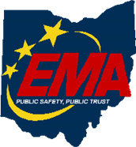**Application Deadline:** January 22, 2019

**Course Registration time:** 7:30 am – 8:00 am (on day one)

**Course Time:** 8:00 am to 5:00 pm – All three (3) days

One-hour Lunch each day

**Training Location:** Franklin County Emergency

Management & Homeland Security

5300 Strawberry Farms Blvd.

Columbus, Ohio 43230

**Recommended Participants:** FEMA designed this course for individuals who may assume a

supervisory role in expanding incidents or Type 3 incidents.

Note: During a Type 3 incident, some or all of the Command and General Staff positions may be

activated, as well as Division/Group Supervisor and/or Unit Leader level positions. These incidents may

extend into multiple operational periods.

**Required Prerequisites:** Applicants must provide the following prerequisites to Pam Tickle at

pktickle@franklincountyohio.gov as soon as possible for consideration to attend the course. Preferably

the most recent version of the IS-100 Introduction to the ICS, IS-200 Basic ICS for Initial Response, IS-

700 an Introduction to the NIMS and IS-800 National Response Framework.

**Enrollment:** Students must enroll via the Department of Public Safety Training Campus website:

<https://trainingcampus.dps.ohio.gov/cm/cm710/pstc/pstc.html> Course registration will generally close 10

working days prior to the course start date and applicants can check enrollment/approval status via the

Department of Public Safety Training Campus website.

**Course Costs:** There is **no charge** for participants to attend this course. However, Lodging, Meals, Per

Diem and all other travel expenses are the responsibility of the student or the parent organization.

**State Point of Contact:** Lisa Jones, DSC 2, Ohio EMA, SAA Training Point of Contact, (614) 799-3824

[ljones@dps.ohio.gov](mailto:ljones@dps.ohio.gov)

#########

TOP ^

**ICS-400 ADVANCED ICS FOR COMMAND & GENERAL STAFF**

**Hosted by: Franklin County EM & HS March 18 - 19, 2020**

**Course Description:** This 15-hour classroom course provides training for personnel who require

advanced application of the Incident Command System (ICS). This course expands upon information

covered in ICS-100, 200, 700, 800 and ICS-300 courses, which are the prerequisites for the ICS-400

course. The target audience for this course is senior personnel who are expected to perform in a

management capacity in an Area Command or Multi-Agency Coordination Entity.

**Application Deadline:** February 25, 2020

**Course Registration time:** 7:30 am – 8:00 am (on day one)



**Course Time:** 8:00 am to 5:00 pm – Both days

One-hour Lunch each day

**Training Location:** Franklin County Emergency

Management & Homeland Security

5300 Strawberry Farms Blvd.

Columbus, Ohio 43230

**Recommended Participants:** FEMA designed the course for Senior Personnel who expect to perform in

a management capacity in an Area Command or Multi-Agency Coordination Entity.

**Required Prerequisites:** Applicants must provide the following prerequisites to Pam Tickle at

pktickle@franklincountyohio.gov as soon as possible for consideration to attend the course. Preferably

the most recent version of the IS-100 Introduction to the ICS, IS-200 Basic ICS for Initial Response, IS-

700 an Introduction to the NIMS, IS-800 National Response Framework and the ICS-300 Intermediate

course.

**Enrollment:** Students must enroll via the Department of Public Safety Training Campus website:

https://trainingcampus.dps.ohio.gov/cm/cm710/pstc/pstc.html. Course registration will generally close 10

working days prior to the course start date and applicants can check enrollment/approval status via the

Department of Public Safety Training Campus website.

**Course Costs:** There is **no charge** for participants to attend this course. However, Lodging, Meals, Per

Diem and all other travel expenses are the responsibility of the student or the parent organization.

State Point of Contact: Lisa Jones, DSC 2, Ohio EMA, SAA Training Point of Contact, (614) 799-3824

[ljones@dps.ohio.gov](mailto:ljones@dps.ohio.gov)

#########

***Campbell County Office of Emergency Management Upcoming Training***

** *\*\*2020 Classes Added\*\****

Campbell County Office of Emergency Management **FREE** Training Opportunities

TOP ^

**Regional Search and Rescue (SAR) Training Weekend** - **September 20-22, 2019** - For further and registration; <https://www.facebook.com/events/309154889701112/>

**Basic Search & Rescue (BSAR)** - **September 20-22, 2019** - Register; [www.kyem.ky.gov/training](http://www.kyem.ky.gov/training)

**Search Management for the Initial Response Incident Commander** - **September 20-22, 2019** - Register; [www.kyem.ky.gov/training](http://www.kyem.ky.gov/training)

**Hug-A-Tree and Survive Train-the-Trainer** - **September 20, 2019** - Register here; <https://goo.gl/cT1fYT>

**International Search & Rescue Incident Database (ISRID Form 400) Training** - **September 21, 2019** - Register; [www.kyem.ky.gov/training](http://www.kyem.ky.gov/training)

**Writing Incident Action Plans for SAR Missions** - **September 21, 2019** - Register here; <https://goo.gl/ZMDDpv>

**Stop-the-Bleed Training Class** - **September 22, 2019** - Register here; <https://goo.gl/3s7doq>

**Hazmat Technician Refresher Training** – Kenton County Fire Training Center – **September 25-28, 2019** – Register; <https://qrgo.page.link/Y3eti>

**Intermediate ICS-300** for Expanding Incidents with Incident Command Systems Forms Review (MGT-905) - **September 24-26, 2019** - TEEX / Register here; <https://goo.gl/7NktXo>

**Physical and Cybersecurity for Critical Infrastructure (MGT 452)** – **October 16, 2019** – TTX / Register here; <https://qrgo.page.link/SkdRb>

**Advanced ICS-400** Command and General Staff-Complex Incidents - **October 23-24, 2019** - TEEX / Register here; <https://goo.gl/dVqj43>

**Hazmat Technician Training Course** – Kenton County Fire Training Center – **October 21-25, 2019** – Register; <https://qrgo.page.link/EFM15>

**Sport and Special Event Evacuation Training and Exercise** - **November 6-7, 2019** - TEEX / **Tentative/Requested**

**Emergency Propane Water Injection Course** – **November 12, 2019** – Hebron Fire Protection District / Registration will open soon.

**Managing Critical Incidents at Institutions of Higher Education:** A Whole Community Approach (MGT-361) - **December 10-12, 2019** - TEEX / Register: <https://goo.gl/Qa3tUs>

**Working with the Media:** A Short Course for Emergency Responders (AWR-209) – **January 22, 2020** – RDPC / Register: <https://qrgo.page.link/o2Gs>

**Isolation and Quarantine for Communities (MGT-433)** – **February 19, 2020** – RDPC / **Tentative/Requested**

TOP ^

**Hazardous Weather Preparedness for Campuses (AWR-332)** – **March 4, 2020** – (NDPTC) / **Tentative/Requested**

**Readiness: Training Identification and Preparedness Planning (MGT-418)** – **March 11-12, 2020** - TEEX / Register: <https://train.ncbrt.lsu.edu/Student/Register?ClassID=26374>

**Registration Password: NCBRT418**  If you have trained with NCBRT before, enter your FEMA SID, Last Name, and First Name. If your training record is found, your registration form will be pre-filled for you. Otherwise, click Register as New Person to fill out a blank registration form.

**Evacuation and Re-Entry Planning Course – March 25-26, 2020** / **Requested through KYEM Training Division**

**Pediatric Disaster Response and Emergency Preparedness (MGT-439) – April 8-9, 2020** / TEEX / Register: <https://qrgo.page.link/GFf4>

**Debris Management Planning Course – April 15-17, 2020** / **Requested thought KYEM Training Division**

**Intermediate ICS-300** for Expanding Incidents w/Forms (MGT-904) – **April 22-24, 2020** / TEEX / Register: <https://qrgo.page.link/HzT2>

**Disaster Preparedness for Hospitals and Healthcare Organizations within the Community Infrastructure (MGT341) – May 13-14, 2020** / **Requested**

**Advanced ICS-400** Command and General Staff-Complex Incidents (MGT-905) – May 27-28, 2020 / TEEX / **Approved**

**Surviving an Active Threat: Run. Hide. Fight. (PER-375) w/TTT – June 10-11, 2020** – (NCBRT) **(Tentative)**

**NIMS ICS All-Hazards Position Specific Incident Commander E/L 950 – June 22-26, 2020** – KYEM -  **(Requested through KYEM Training Branch / Tentative)**

**Disaster Resilience for Small Businesses and Organizations – July 8, 2020** – (NDPTC) / **Requested**

**Emergency Planning Course – July 14-15, 2020** / **Requested through KYEM Training Division**

**Disaster Management for Water and Wastewater Utilities (MGT-343) – July 22-23, 2020** / **Requested**

**Mitigation for Emergency Managers Course – August 5-7, 2020** / **Requested through KYEM Training Division**

**Volunteer Reception Center Management Course – September 15-16, 2020** / **Requested through KYEM Training Division**

**Intermediate ICS-300** for Expanding Incidents w/Forms – **September 23-25, 2020** / **Requested**

**Advanced ICS-400** Command and General Staff-Complex Incidents – **October 21-22, 2020** / **Requested**

TOP ^

Follow us on Facebook @CampbellCoKYEmergencyManagement and Twitter @CampbellCoOEM

Visit our Training Calendar at the below link for all our FREE training opportunities with training announcements and registration information.

Click here: <https://calendar.google.com/calendar/embed?src=brbq8bhmk0ikhtp0k6ivjpdack%40group.calendar.google.com&ctz=America%2FNew_York>

**#########**

***Raspberry Pi for Ham Radio***

*(article by Karl-Heinz Krawczyk, DL1GKK, and submitted by Gregory Drezdzon, WD9FTZ)*

The article describes how to install amateur radio software on the Raspberry Pi to provide the popular data modes, SSTV, satellite tracking, SDR, rig control and logbook   
  
The English language article is available on the site of Indonesia's national amateur radio society ORARI.

Karl-Heinz says "I am a big friend of the small Raspberry Pi which and use this gladly for amateur radio. With version 4 it is fast enough to fulfill all tasks. There are many ways and many software to make the Pi fit for Ham Radio. Below is the installation how I use it. My choice of programs has the advantage that they are compatible with each other."  
  
The article can be found at: <https://orari.or.id/index.php/2019/09/02/setup-raspberry-pi-for-ham-radio/>

#########

***Southern Ohio Amateur Radio Association And The Space Program***

(by Michael Love, WB8YKS – PIO)

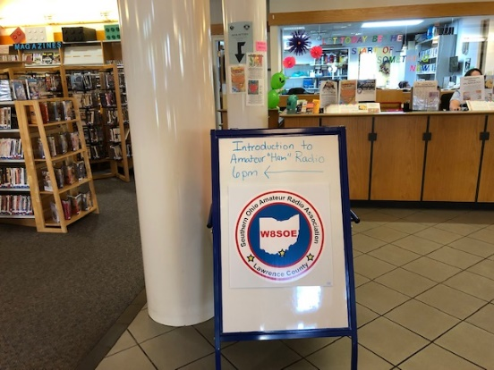

Jan Gullet, Briggs Public Library Southern Branch Children’s Reading Librarian made a request to the Southern Ohio Amateur Radio Association (SOARA) to present a program about an Introduction to Ham Radio with a special focus on space communications. The program was to coincide with a special reading program offered at the library this summer for youth and adults about space. The presentation was a huge success. Jan Gullet said, “I had no idea that amateur radio was this diverse and encompassed so many different aspects of communications. I did certainly learn a lot this evening.”

TOP ^

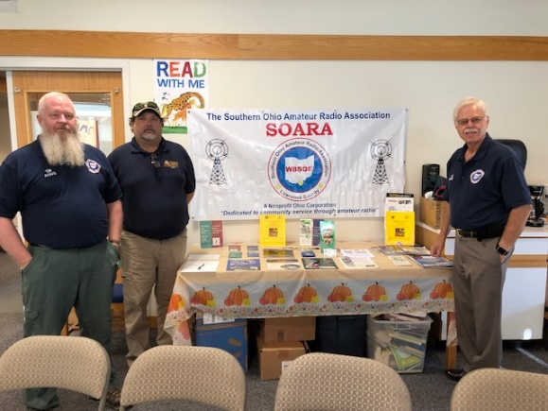SOARA members, Tim Nicely AC8VQ President of SOARO, Mark Killen KD8QIH SOARA Member and Treasurer of the Radio Museum in Huntington, West Virginia, Eddie Jenkins N8URU Lawrence County Amateur Radio Emergency Service EC, Teresa Killen KD8QIH, Keith Brooks N8DKB Remote Control Operator and Michael Love WB8YKS Public Information Officer all participated in the evenings presentation and activities.

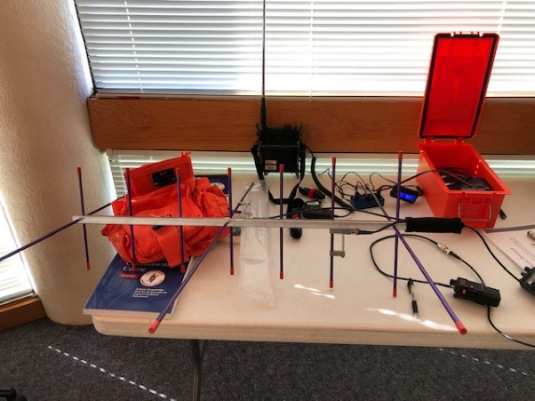Mark Killen said, “this was an outstanding educational opportunity to showcase amateur radio and its capabilities concerning space communications as well as emergency services here in Lawrence County, Ohio. The one-and-a-half-hour presentation went by quickly and was engaging with the audience.”

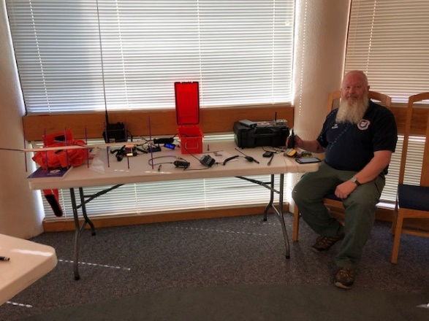Tim Nicely, displayed an array of ham radio equipment and discussed its operation. Of course, how to become a ham radio operator was presented and

a number of resources for additional information was provided.

The dynamics of the evening’s presentation was unprecedented for providing and in-depth look at the many opportunities for ham radio from, Across the Street to Outer Space, said Michael Love, Public Information Officer. He went on to say that working with the Lawrence County Briggs Public Library staff was a great partnership and one that we will continue to build on. As an additional resource, the library has a number of publications concerning Ham Radio.

***Final.. Final..***

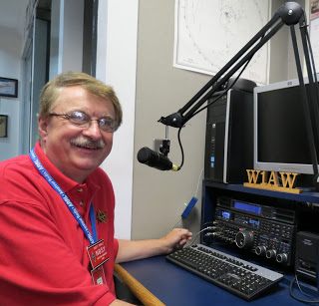

Hey Gang...

Wow… Has this ever been a hot and humid week!

My yard work has been piling up since I think spending time with you at meetings and hamfests is way more fun. So, this week has been catching up on those yard chores that have been let go until they can no longer be left go. Yes, I had to do all of those French things this week… you know, “trim de’ lawn” and “mow de’ grass.”

I also played the role of Paul Bunion and trimmed up some of the bushes and even a couple of trees this week as well. WOW, am I ever sore! I used muscles that I didn’t know I had until afterward, when they started aching. Then it was time for the Ben Gay!

TOP ^

Since yard work took precedence this week, I didn’t really get to play much with my new vertical antenna. I still have some testing to do to get that baseline, then the radials will get put down and we’ll just see how much improvement it really makes.

Oh, there has been one more item that’s been keeping me really busy this week. I seem to have picked up a squatter in my yard. The little animal has been making quite a mess of things. He has chewed right through my wood flooring in my shed. I now have a hole the size of a silver dollar right under my lawn tractor. I didn’t see any evidence that he is storing nuts or making a nest yet, but I’m sure that’s not far behind. I have discovered that he really likes peanut butter. I have a small live trap just for little critters like this one and it seems to have figured out just how much pressure he can exert on the trip plate before the trap door comes down. He’s been robbing me of the peanut butter and anything else that I put in there for bate for a full week now. Yes, I’ll get him one way or the other. I have to. A couple of years back I had one of these little critters eat not only a piece out of the floor, but he also ate the insulation off of the wiring on my lawn tractor as well. I’m not going through that again. It cost almost $400 for the wiring harness and it took a full day to rewire the tractor. What a mess that was.

Now you may ask why did he eat the insulation off of the wiring? Well, if you didn’t know this, you will now. Most car manufacturers and lawn equipment companies have gone to a more environmentally friendly way of making wiring harnesses. The insulation is made from vegetable oil!!!! Yes, it’s made from the veggies in your garden! It’s no wonder the animals like it, it’s made from the same items that they eat out of your garden all summer long. Oh, let me say this as well. Janie and I have our golf clubs stored out there, and you guessed it, the grips are made from the same thing.

So, you see, it’s not just the fact that this little critter ate a hole in my HE SHED, it’s what’s next that’s bothering me. Stay tuned, I’ll have an update for you. So far, it’s chipmunk 5 - Scott nothing. I plan on changing that statistic very soon!

Switching bands… Have you seen the really great writeup about the Dresden Elementary Amateur Radio Station, KD8NOM?? They got a 3-page spread in the October issue of QST!! Jim Mayercak, WX8J did a fantastic job writing the article and I have to say, this school is a dream come true for the kids. Want to know more about their program? Just talk to Jim - [jimwx8j@yahoo.com](mailto:jimwx8j@yahoo.com) He can give you all the in’s and out’s of how to get an amateur station in a school.

Switching bands one last time… I’ve been toying around with the idea of a “Swap & Shop” section on the Ohio Section website for some time now. I don’t want to compete with what may already be out there and it would be something for the website only. So, you won’t have to worry about seeing page after page of stuff for sale in the newsletter. So, here’s the question for you. Is this something that we can do to help serve YOU? Send your thoughts to [n8sy@n8sy.com](mailto:n8sy@n8sy.com)

One last round before going QRT… Is your club doing any special activities that you’d like the Section to know about? Do you have a story that you’d like to tell about something that you or your club has or is doing? Let me know about it and let’s get it in the next edition!

Whelp… That’s going to do it for this time around. Stay safe, enjoy the sunshine while we have it, and most of all… have FUN!!

73,

***Scott, N8SY***

TOP ^

***'Palindrome week' isn't once in a century. Oh, and it's really 10 days long.***

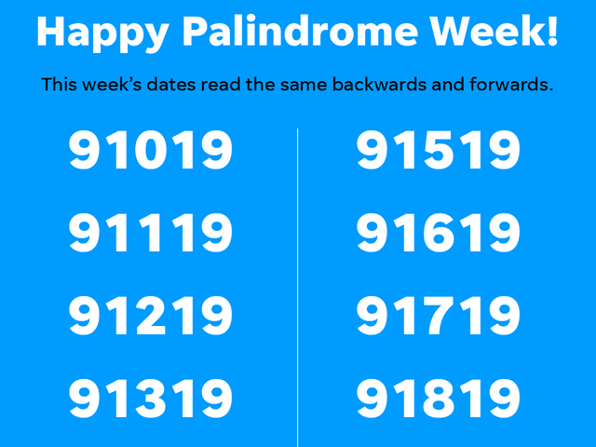The dates from 9/10/19 through 9/19/19 are all palindromes. But it's not that rare and it's not the last one this century.

This week, many Americans celebrated “palindrome week” -- a string of days in which the date is the same whether written forward or backward. For example, 9/10/19 is "91/01/9" backward -- if you take out the slashes, then the numbers are in the exact same order.

However, this is only true when the dates are written in the American method and referring to it as a “week” is a misnomer, but we’ll get to all of that in a second.

The next palindrome week begins as recently as January of 2021. January 20 will start it off with the date of 1/20/21 and the palindrome dating will continue until 1/29/21. There will be another palindrome week later that year in December when the date becomes 12/1/21 and will continue until 12/9/21. There will also be palindrome days on 12/11/21 and 12/22/21.

That makes this palindrome week the last of the decade, but not the last of the century. There will be several other palindrome weeks throughout the next decade.

This occasion happens because of the American date-writing method of MM/DD/YY. In other parts of the world where the date is written DD/MM/YY, consecutive days where the date is a palindrome never occur because the front part of the date changes every day.

Even with the American method, you have to write the date out in very specific ways to create the palindrome effect. Writing today’s date as 9/13/19 would a palindrome but writing it as 09/13/19 would not. Likewise, writing the date as 12/01/21 in December of 2021’s palindrome week would make it so the date is no longer a palindrome. A whole different wrench is thrown into the mix when all four numbers are written out in the year, regardless if it’s MM/DD/YYYY or DD/MM/YYYY.

“Palindrome week” also doesn’t fit the definition of a week in anyway. This year’s palindrome week started on a Tuesday and it lasts for 10 days rather than seven.

***New Webpages Added to the Ohio Section Website***

Is your club’s newsletter available to share? I’ve got a new webpage that has links to all of the known websites where club newsletters can be accessed throughout Ohio.

Now, as we all know when any list is published, it’s outdated immediately. That’s ok, just send me the link to your club’s newsletter and I’ll get it on the webpage – [n8sy@n8sy.com](mailto:n8sy@n8sy.com)

Here’s the link: <http://arrl-ohio.org/club_link/links-to-newsletters.html> Remember, we’re all here to help each other. What a great way to share the news about Amateur Radio!!

TOP ^

***Back Issues of the PostScript and Ohio Section Journal (OSJ)***

Hey, did you know that PostScript and Ohio Section Journal (OSJ) are archived on the website? You can go back and look at any edition simply by clicking:

<http://arrl-ohio.org/news/index.html>

***Chit – Chat, and All That!***

Do you know someone that’s not getting these Newsletters? Please, forward a copy of this Newsletter over to them and have them “[Opt-In](http://arrl-ohio.org/forwarder/forwarding.html)” to start receiving them. Heck, just have them send me an email [n8sy@n8sy.com](mailto:n8sy@n8sy.com) and I’ll get them added to the Ohio Section Emailing list.

We now have many thousands of readers receiving these newsletters weekly. Quite impressive, I’d say! I urge all of you to make sure that everyone, regardless of whether they are a League member or not, get signed up to receive these weekly Newsletters.

You can always “[Opt-Out](http://arrl-ohio.org/forwarder/forwarding.html)” at any time if you feel this is not what you were expecting. It’s fun and very informative. All of your favorite past newsletters are now archived too.

You can go back at any time and read them. Just go to: <http://arrl-ohio.org/news/>

Got questions, concerns or would just like to sit and chat awhile? Heck, I’ll even buy the coffee!! Give me a call at (419) 512-4445 or email me at: [n8sy@n8sy.com](mailto:n8sy@n8sy.com)

The pictures on the front page are from various newsletters, Facebook posts and/or were sent directly to me in recent weeks. Take a good look at them, you just might be in one of the pictures! “SMILE… you’re on the Ohio Section News!!”

TOP ^

*PostScript is produced as a weekly newsletter. I want to thank everyone that has contributed articles and ideas to make this an even better news source. I sincerely hope that you have enjoyed this edition and will encourage your friends to join with you in receiving the latest news and information about the Ohio Section, and news and events happening around the world!*