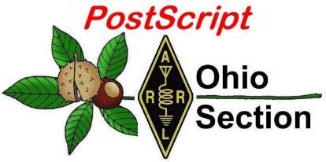
August 19th
Edition

National News The Handbook Give Away

Club Corner Hamfests

DX This Week One Question Questionnaire

VE Testing ARES Connect

Final.. Final..

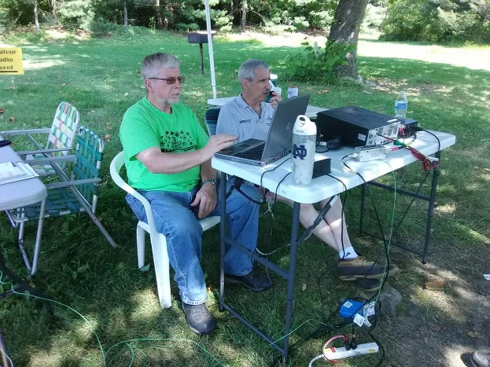
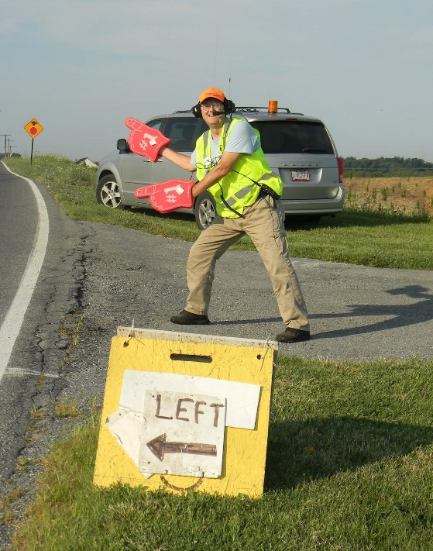
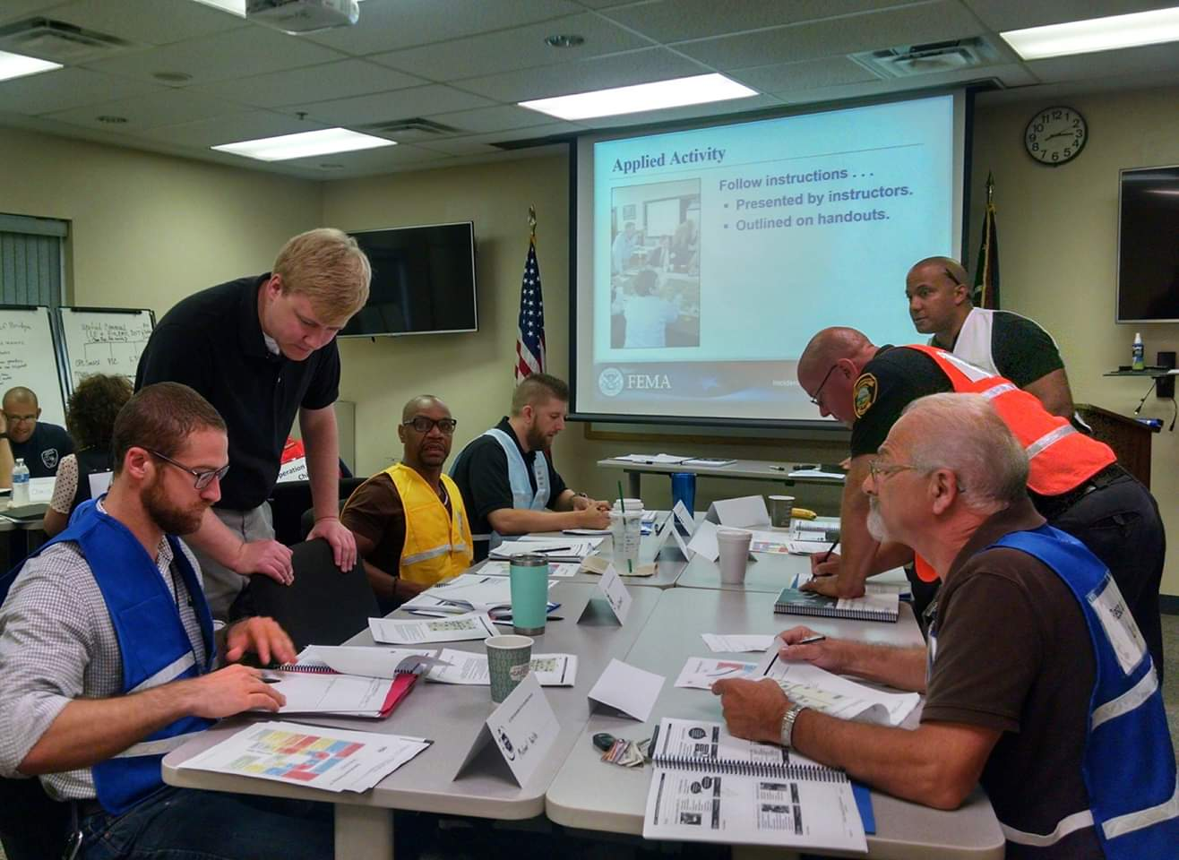
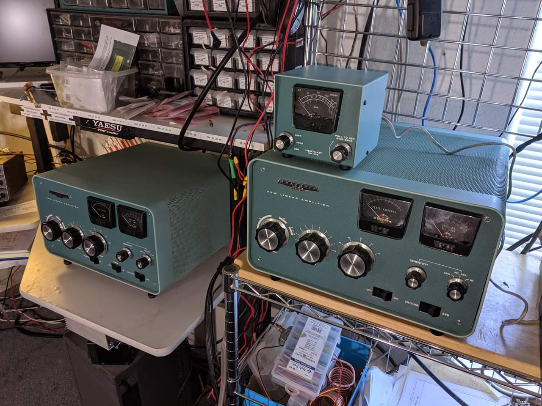

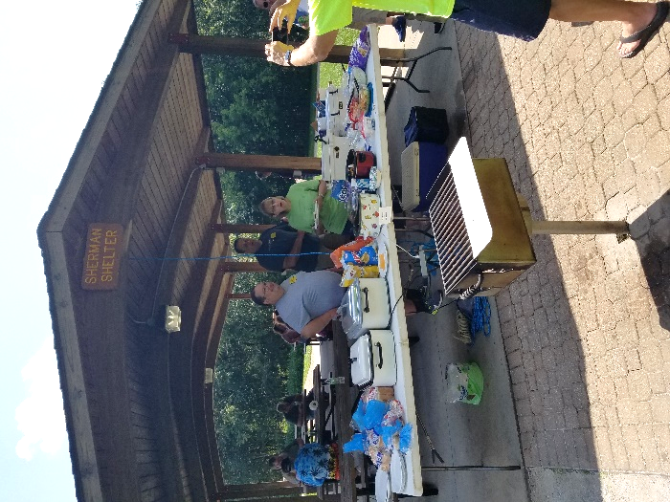

National News
(from arrl and other sources)

Dayton Hamvention Radio Club of the Year to Hold Ham Bootcamp at New England Convention

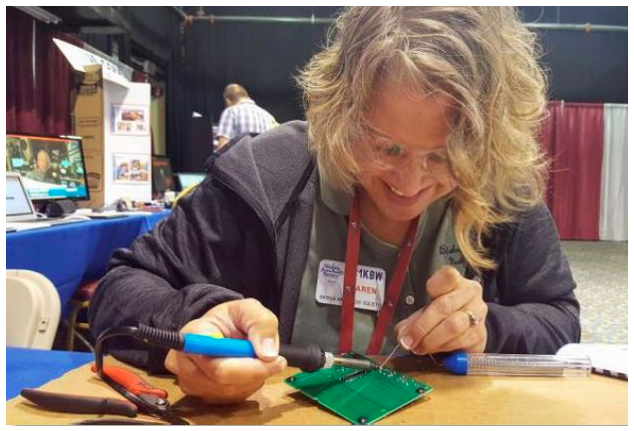
The Nashua (New Hampshire) Area Radio Society (NARS) will conduct a free Ham Bootcamp at the ARRL New England Division Convention next month to encourage and assist new and inexperienced radio amateurs in becoming more active and engaged in the various facets of ham radio. NARS, the Dayton Hamvention® Club of the Year for 2019, operated a guest exhibit for ARRL at this year’s show. It will also sponsor a Ham Expo for Young People at the New England Division Convention, with hands-on activities, videos, and displays about Amateur Radio and wireless communication.

The newly renamed HamXposition — formerly known as “Boxboro” — is hosting the ARRL New England Division Convention September 6 – 8 in Boxborough, Massachusetts. Exhibits will open on Saturday and Sunday.

The NARS Ham Bootcamp will cover a broad range of activities. The club describes the event as “a package of hands-on activities designed to help recently licensed and upgraded hams to get on the air and have fun.” The Bootcamp is also aimed at prospective hams interested in seeing what Amateur Radio has to offer. It will include Technician, General, and combined tracks. One featured activity will be a guided tour of the vendor and exhibit area at HamXposition to introduce participants to some of the equipment that’s available. Some of the topics covered will include:

- How to make a contact and join a repeater net
- Putting together an HF station
- Radio, antenna, and feed line choice
- Getting started with FT8 and digital modes
- Exchanging QSL cards
- Learning Morse code
- Tips on upgrading
- Introduction to ham radio kit building
- Handheld radio programming tutorials

The Ham Bootcamp will take place at HamXposition on Saturday, September 7, from 9 AM to noon. Maximum enrollment is 100, first come, first served.

NARS (Karen Crivac KC1KBW building kit)

#########

TOP ^
ARRL Bestows Honor To Great Lakes Division Ham.

Each year, the ARRL offers an award to recognize someone who has served admirably as an ARRL Section Manager. The Knight Distinguished Service Award recognizes exceptionally notable contributions by a Section Manager to the health and vitality of the League. The first such award was presented to Joe T. Knight, W5PDY (now SK) in 2003 -- for whom the award was named -- in recognition of his exemplary service not only as the ARRL Section New Mexico Section Manager for more than a quarter century, but also for his willingness to share his knowledge and skills.

The Knight Distinguished Service Award may be awarded to an ARRL Section Manager who has distinguished himself or herself in accordance with the following ideals:

Exceptionably notable contributions over an extended period of time within his or her Section and beyond.

Demonstrated efforts that have contributed to the health and vitality of the ARRL and its Field Organization.

Displayed actions that are in the spirit of the unselfish contributions of Joe T. Knight, W5PDY.

Nominations may be made by any ARRL member and accompanied by a narrative of the accomplishments of the nominee identifying the long-term contributions of the nominee to ARRL and its Field Organization.
The nominations are reviewed by the ARRL Programs and Service Committee, which makes the formal recommendation to the ARRL Board of Directors.

With that background, I am truly pleased to announce to all, at its July meeting, the ARRL Board of Directors honored Ohio Section Manager Scott Yonally N8SY with the Knight Distinguished Service Award. Scott easily met all of the required criteria and most certainly has shown exemplary service to the members of the ARRL Ohio Section, Great Lakes Division and the entire ARRL Field Organization.

Please join Vice Director Tom Delaney W8WTD and me in congratulating Scott on this very special occasion.

#########

ARRL Board Pledges to Oppose French Proposal for 2 Meters

At its July meeting, the ARRL Board of Directors resolved that “at the appropriate time” ARRL will oppose a proposal by France to include 144 – 146 MHz among spectrum to study for non-safety Aeronautical Mobile Service applications with an eye toward sharing the spectrum with the Amateur Services. The action came as the Board met July 19 – 20 in Windsor, Connecticut for its second meeting of 2019. The Board pointed out that 144 – 146 MHz is allocated globally to the Amateur Service on a primary basis and enjoys widespread use for emergency communication. It also pointed to the investment by radio amateurs of money and effort to build repeaters, beacons, space infrastructure, and propagation research systems that have global reach. The AMSAT and ARISS communities would be severely affected as many spacecraft use 2 meters to facilitate communication, the Board noted.

ARRL International Affairs Vice President Jay Bellows, K0QB, recommended continuing to monitor the proposal. If it is added as an agenda item for study for WRC 2023, the Board should consider action, he advised.

TOP ^
Digital Communication Issues
The Board instructed Washington Counsel David Siddall, K3ZJ, to take appropriate steps to obtain FCC approval for several changes to the Part 97 Amateur Radio Service rules. The requested changes stemmed from discussions regarding the interference potential of automatically controlled digital stations (ACDS); the prohibition of Amateur Radio message traffic that’s encoded to obscure its meaning, and false assertions that ARRL — despite its record of steadfast opposition — supports or encourages encrypted transmissions. The Board directed that the FCC be asked to make rule changes that would:

♦ Remove the current 300 baud rate limitation, subject to the conditions requested by the ARRL.
♦ Authorize all automatically controlled digital (data) stations (ACDS) below 30 MHz, regardless of occupied bandwidth, to operate only within the ACDS bands designated in §97.221(b) of the Amateur Service rules.
♦ Require all digital mode stations operating with a bandwidth greater than 500 Hz to operate within the ACDS bands, whether or not these stations are automatically controlled.
♦ Limit the maximum bandwidth of digital mode signals below 29 MHz to 2.8 kHz.
♦ Reiterate to the FCC that ARRL’s position is unchanged from that expressed in ARRL’s 2013 comments on a Petition for Rulemaking (RM-11699) filed by Don Rolph, AB1PH. Those comments specifically addressed encryption of messages and made clear that such messages generally are prohibited in Amateur communications by §97.113 of the FCC rules and by Article 25, §2 of the International Radio Regulations and should remain prohibited.

The Board also wants to request that the FCC remind radio amateurs “by whatever appropriate means available” of the current prohibition in §97.113(a)(4) and Article 25, §2 of the International Radio Regulations against transmitting “messages encoded for the purpose of obscuring their meaning.”

ARRL-initiated mediation efforts for rival parties to reach consensus on all or some of the issues they raised in the so-called “Symbol Rate” proceeding ended a few days prior to the July Board meeting with useful discussion but no agreement among those parties on recommendations to the FCC.

Other Actions
The Board tasked its Administration and Finance (A&F) Committee to assess the feasibility of a Research Working Group (RWG) and, if warranted, to establish one. The group would help the Board and ARRL management to better gauge trends, collect more accurate membership information, and more closely track the progress of programs. The Board suggested that the RWG be led by a statistical coordinator appointed by the President. ARRL CEO Howard Michel, WB2ITX, would chair the RWG. The A&F Committee will report back to the full Board at its January 2020 meeting.

Upon the recommendation of the Programs and Services Committee, the Board directed that the rules for all ARRL contests be revised to require that each claimed contact include contemporaneous direct initiation by the operator on both sides of the contact. Contact initiation may be local or remote. The Board further voted to amend the DXCC rules to establish the same requirement for that program.
The Board voted to add a QRP Single Operator subcategory for the ARRL RTTY Roundup.

Reports
In his report to the Board, CEO Michel expressed concern that the number of new amateur licenses was down, and, if the trend continues, it could pose a potential risk to ARRL. Michel told the Board that Headquarters staff will move forward with a new On The Air magazine aimed toward new licensees.

TOP ^
“Keeping new amateurs engaged with a publication geared toward the newcomer is a primary goal,” Michel explained. He added that the new podcast So Now What? Is off to a good start with encouraging response.
Treasurer Rick Niswander, K7GM, told the Board that ARRL’s investment portfolio returns were in line with approximated market returns in the equity and credit markets, but he remains concerned that the markets are richly priced in an underlying economic environment that is starting to show some signs of strain.

Chief Financial Officer Diane Middleton, W2DLM, reported that the League continues to have a financially strong balance sheet and generated a larger-than-expected gain from operations through June 30. Total revenues were greater than forecast, while expenses were lower than forecast. Cash flow also continued to be healthy.

Censure Rescinded
The Board acted to rescind its public censure of ARRL Southwestern Division Director Richard Norton, N6AA. The censure action, taken at a special Board meeting in November 2017, was based on Norton’s alleged violation of the ARRL Policy on Board Governance and Conduct of Members of the Board of Directors and Vice Directors, adopted in January of that year and itself since rescinded.

Minutes of the July ARRL Board of Directors meeting are available on the ARRL website at http://www.arrl.org/files/file/201920of%20Directors/Final20July%202019.pdf.

#########

Results Posted for USA, IARU Region 2 ARDF Championships in North Carolina

The results of the 19th USA ARDF Championships and 10th IARU Region 2 ARDF Championships in Amateur Radio Direction Finding (ARDF) are now in the record books. The joint event was held earlier this month in North Carolina. Results from these championships will factor into the equation to determine the makeup of ARDF Team USA at the 20th ARDF World Championships, set for September 2020 in Serbia.
Separate youth and adult courses ensured regulation courses for foxhunters of all ages, with 36 competitors from the US. Visiting competitors from Australia, Germany, and China practiced and competed alongside Team USA hopefuls. Competitors ranged in age from 8 to 73. Adult and youth championships were held simultaneously in William B. Umstead State Park, with their separate events held on opposite radio bands to avoid interference.

Events began on August 1, with Foxoring, a combination of radio direction finding and classic orienteering on 80 meters, followed the next day with the sprint event. The classic 2-meter and 80-meter adult and youth competitions took place on August 3 and 4.

“Sprint ARDF is a fast-paced event, where quick thinking generally beats fast running,” ARRL ARDF Co-Coordinator Charles Scharlau, NZ0I, explained. “The courses are short enough that elite competitors can complete them in 15 minutes. Two sets of five transmitters, operating on two different 80-meter frequencies, transmit in consecutive 12-second bursts during each minute of the event. Small groups composed of competitors in different categories start together every 2 minutes.” As they run between the groups of transmitters, competitors pass through an open spectator area, where they can be seen and cheered on by supporters, Scharlau added.

US competitors in the six IARU age categories for males (M19 – M70) and five for females (W19 – W60) are under consideration for membership in ARDF Team USA. Up to three competitors in each age-gender category may be on a national team.

TOP ^
Because of the large number of young people taking part, awards were presented in youth categories M10, M12, M14, M16, W12, and W14. Parents of younger age-group participants were allowed to follow their sons and daughters but not assist them.

“American youth competitors held their own, despite the stiff competition,” Scharlau said. In a crowded field of 10 M14 competitors, Tobias Reed took overall gold in the 80-meter classic, silver in sprint, and bronze in foxoring. Other American youth medalists included M12 competitor Marcus Enochs, who won silver in foxoring; M10 competitor Gavin Burkhead, who picked up the gold in foxoring, and M10 competitor James Harker, who went home with gold in the 2-meter classic.

Veteran ARDF competitors and medalists Ruth Bromer, WB4QZG, and Joseph Huberman, K5JGH, were lead organizers and hosts for the event. David Waller; Patrick Sears, AK4JE, and Kelly Sears, KN4PAE, were primary course setters. Nadia Scharlau designed the adult classic courses. Members of the Backwoods
Orienteering Klub assisted throughout the competition.

Contact the ARRL ARDF Committee for more information on ARDF and on attending, participating in, or hosting ARDF competitions. ARDF participants do not need an Amateur Radio license. For more information on Amateur Radio Direction Finding, visit the Homing In website of Joe Moell, K0OV.

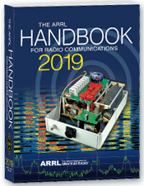
The Handbook Give Away

Hey Gang,

Have you registered for the “Handbook Giveaway” drawing for this month yet? If you haven’t, go to: http://arrl-ohio.org/handbook.html and get yourself registered now!

What’s the catch? I want to get everyone checking in to the Ohio Section website as often as possible, and in order to register each month, you have to visit the website often! There’s nothing else to it. I pay all expenses and I usually “Give Away” more than just a Handbook too!!

Many of you ask me just how do I know when the drawing is on? Well, that’s easy all you need to do is check in on the Ohio Section Website on a regular basis and watch for the big RED Arrow that will appear on the left side of the page. This is the sign that the drawing is on and you need to get registered. So, keep a sharp eye out on the website and check in often!

Club Corner

This is YOUR cornner of the newsletter. Send me what your club is doing and I’ll make sure that it gets in. Got a special event or club project that you want everyone to know about? Send it to me!. Need help with a project? Send it to me.

Let me know what you club is up to. Are you going to have a special guest at your meeting or are you having a special anniversary? Just sent it to:
n8sy@n8sy.com

#########

TOP ^
Help Needed for the Potato Stomp

The Mantua Potato Stomp will be holding their annual foot race on Saturday September 7th in the Mantua-Hiram area. This event consists of a four-mile and a nine-mile race on various roads in Mantua Village and Township and Hiram Township. Radio operators will be needed to staff the intersections on the course, provide a Shadow to the race director, a NCS, and a sweep.

Ed, K8IV recently installed a UHF repeater at the tower on the hill just east of Mantua Village. It was used for the Headwaters Adventure Race, which is in the same area that the Mantua Potato Stomp race will take place. The coverage of this repeater in the local area is superb and allows Radio Operators to use just a UHF hand-held at almost every location in the area with full quieting coverage. Because of this we will no longer have to rely on establishing cross-band repeaters to get coverage throughout the course.

This is also the date for OSPOTA so I know many of you will be involved with that. But, for those who are not, I would sincerely appreciate your help. If you’re new to public service communications support and are reluctant to do it alone, let me know and I’ll pair you with an experienced operator so you’ll get a chance to observe, learn and participate. Drop me a note at k8cav.coms@gmail.com if you can help with this event. Thanks!

#########

USAF Marathon Needs Help

Approximately 70 amateur radio operators are needed to support the USAF Marathon at Wright Patterson Air Force Base on Saturday, September 21, 2019 to provide the USAF Marathon Staff with emergency and logistic communications. This world class event has over 20,000 participants, volunteers, and spectators in attendance every year.
Amateur radio operators are indispensable in rapidly communicating information on runner’s locations and status, heat index settings, severe weather notifications, as well as emergencies and logistic issues. Plus, APRS is utilized to track lead runners and “Tail End Charlie’s”, thus allowing race officials and emergency services to more accurately monitor the race progression.

Multiple races are held on this day including: 10K, Half Marathon, Full Marathon, and Wheelchair. The volunteer registration website for the USAF Marathon is now open.

If you will be in the Dayton, Ohio area on Saturday, September 21, 2019 and would like to take part in this world class event, please go to the USAF Marathon website at http://www.usafmarathon.com/volunteer and click the volunteer now link, scroll down to the amateur radio section to register. Training will be provided prior to the event.

How to register online:
- Go to the website above.
- Click on the Volunteer Now button.
- Acknowledge that you’re going to a new website.

TOP ^
- On the new website, ignore the “password” entry box near the top of the page. Scroll down to the “Amateur Radio Operator” section and click the check box for the Amateur Radio Operator Position and only that position.
- Scroll to the bottom, past all the other volunteer positions, and fill in your name and other required data.
- Check the box below the waiver paragraph and then type in your name for a digital signature.
- Click the “Sign Up to Volunteer” button.
- You’re done!
- You should get an automated email response from Jeanette Monaghan acknowledging your registration.
- Contact Phil Verret if you have any questions or concerns.

Registration closes August 31, 2019.

If you have any questions please email to: Phil Verret, KA8ZKR@ARRL.NET

#########

Geauga Amateur Radio Association Needs Help

All - the 197th ever Great Geauga County Fair is just a few weeks away! As usual, it's Labor Day weekend, Thursday through Monday.

The Geauga Emergency Amateur Radio Service has been invited by the sheriff's office once again to participate. We have a few functions at the fair:

- Dispatch and drive golf carts to help people get around the fairgrounds and to and from the parking lot.
- Staff the sheriff’s office building outside of Gate 1.
- Walk the fairgrounds to provide eyes and ears for the on-duty fire departments and the sheriff’s office.
- Perform other miscellaneous tasks to assist the sheriff’s office and fire departments.
- Help the county firefighters' association clean up fire station 1 on Thursday, August 22.

If any of these sound like fun, please join us!

Note that you do not need to be a ham radio operator to drive a golf cart! We use county radio frequencies for the golf cart portion. Feel free to bring a co-pilot/navigator or a friend, we'd appreciate their help! (Please make sure you register them as well, so we have an accurate headcount).

When signing up, you'll tell us what days and which parts of those days you'd like to work. We have three very loosely-defined "shifts":
- Morning - roughly 9:00AM-1:00PM
- Afternoon - roughly 1:00PM-5:00PM
- Evening - roughly 5:00PM-9:00PM (and beyond if you can stay)

These are here to give us a very rough idea of when you'll be available. If you can only come out for an hour or two, that's fine, just choose the option(s) that work best for you. Please sign up using the following link: http://bit.ly/2019geaugafair If you have any questions or concerns, please email info@ohiogears.org.

#########

TOP ^
POW – MIA Event
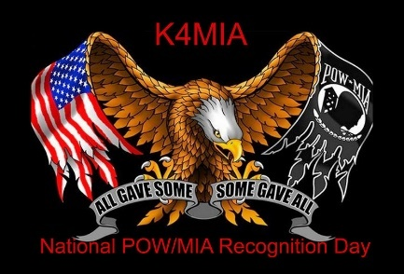
On September 13 thru the 22nd of 2019 We will honor and support our Veterans with a Special Event on the air as K4MIA/8. Linda N8LRS and Metro W8MET will be the sister-station from Ohio for our 4th year.

This event originated from K4MIA , Mike from Florida with other sister-stations involved. Details can be found on the ARRL website under “ON-THE-AIR” under SPECIAL EVENT under the call-letters of K4MIA.

Also, this Special Event will be in the September QST. Please take part in this Special Event for our Veterans. QSL is available with SASE. We will be operating on 40 meter's SSB. GOD BLESS AMERICA 73, Linda and Metro

#########

Bike Cleveland Fundo September 7

We are seeking volunteers for Bike Cleveland Fundo on Saturday, September 7th at Edgewater Park. It's a 30 mile and 60-mile bicycle ride starting at Edgewater Park and ends at Edgewater Park. The 30-mile riders depart at 9AM and the 60 mile riders depart at 8AM.

I am seeking volunteers for SAG, Rest Stops, and Net Control. Volunteers receive a free t-shirt and a delicious lunch. Please sign up at www.w8dec.net. Click on events and you'll see the Fundo listed. Password is fundo2019!

If you can only volunteer for part of the day, that's ok we'll have an assignment to accommodate your schedule.

#########

Twisted Pretzel Tour 2019 - Saturday, September 28, 2019

Germantown Amateur Radio Society will once again be providing communications support for the ever-growing Twisted Pretzel Tour (TPT) to be held on Saturday morning, September the 28th.

The TPT has over 600 bicyclists covering four routes consisting of 8, 21, of 8, 21, 39, and 50 miles each in the Germantown Farmersville areas.

It takes many amateurs to cover these routes. Your help is needed for this very popular public service event, which runs starting at 7am and lasting until approximately 12 noon.

We will be utilizing the GARS 443.1875 repeater. Please note a PL 123.0 is needed to access this repeater.

Amateur operators are needed !!! If interested please contact Phil Thomas, W8RMJ at 937-902-6738.

#########

TOP ^
Lake County ARA Needs Help With Event
This event is sponsored by Painesville Township and will be held on the grounds of the Lake County History Center. Kid friendly activities including Jungle Terry, safety vehicles, a landing by a Life Flight helicopter, and food vendors. Museum will be open for self-guided tours.
Lake County ARA will be deploying our comm trailer and provide assistance facilitating parking for visitors. We are seeking volunteers. If you can help, contact Mike Goffos, WB8ZGH at mgoffos@ymail.com or Ed Kopcak, KB8BKE at kb8bke@gmail.com .

#########

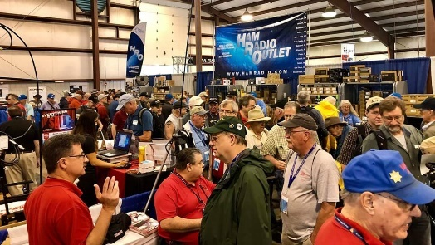
Upcoming Hamfests

09/08/2019 | Findlay Hamfest
Location: Findlay, OH
Sponsor: Findlay Radio Club
Website: http://www.findlayradioclub.org

09/21/2019 | The OHKYIN ARS Hamfest  Location: Cincinnati, OH  Sponsor: OHKYIN Amateur Radio Society  Website: http://www.ohkyin.org | 09/22/2019 | Cleveland Hamfest and Computer Show  Location: Berea, OH  Sponsor: Hamfest Association of Cleveland  Website: http://www.hac.org
10/05/2019 | Scioto Valley Amateur Radio Hamfest  Location: Chillicothe, OH  Sponsor: Scioto Valley Amateur Radio Club | 10/12/2019 | NWOARC Fall Hamfest  Location: Lima, OH  Sponsor: Northwest Ohio Amateur Radio Club  Website: http://www.nwoarc.com
11/02/2019 | GARC Hamfest  Location: Georgetown, OH  Sponsor: Grant Amateur Radio Club  Website: https://www.facebook.com/Grant-Amateur-Radio-Club-1775764122477536/?modal=admin_todo_tour | 11/03/2019 | Massillon ARC Hamfest  Location: Massillon, OH  Sponsor: Massillon Amateur Radio Club  Website: http://www.w8np.org

TOP ^

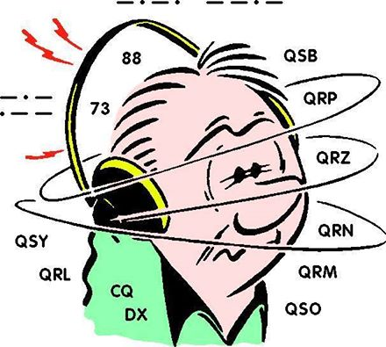
DX This Week
(from Bill, AJ8B)

DX This Week – Ohio QSO Party

Bill AJ8B (aj8b@arrl.net, @AJ8B, www.aj8b.com or www.swodxa.org )
I try to participate in as many contests as I can during the year. I consider the contest season running from the fourth Saturday in August to Memorial Day weekend of the next year. The significance of August to May is that the Ohio QSO party (OQP) is held on the fourth weekend in August and the CQWW WPX CW contest is held during the last weekend in May. Although I do participate in as many state QSO parties (and other contests) as I can, my focus is on the Ohio QSO Party. The majority of the information presented here is from the Ohio QSO Party website and is used here courtesy of the Mad River Radio Club.

Why the Ohio QSO Party? The objective of the contest is:

- For Amateurs inside the state of Ohio to contact as many Amateurs as possible both inside and outside of Ohio.
- For Amateurs outside the state of Ohio to contact as many Ohio stations as possible. Non-Ohio stations may work only Ohio stations, while Ohio stations may contact anyone.
- The Ohio QSO Party is an opportunity for amateur radio operators around the world to celebrate the great state of Ohio.

What does this have to do with DX? Well, chasing DX requires operating skill, patience, and a solid knowledge of your equipment. Contests require all of this for an extended period. In the case of the OQP, this is a 12-hour long contest where one of the biggest factors is BITS. (Butt in the Seat – Thanks Dave, K8DV) In addition, it is really a lot of fun!

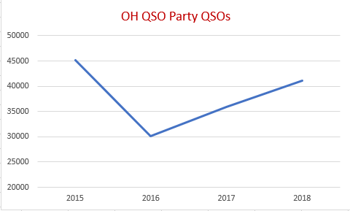
If you have any interest at all, please visit https://www.ohqp.org/ and browse the links on the left hand side and explore the site. You’ll find the rules, past scores, planned operations for this year’s event, scoring records and more.
Figure 1 - OQP Activity

If you review Figure 1 and you will see that there is a lot of activity during this contest. Since 2015, the OQP has had an average of 38,091 QSOs submitted. I hope that it is even busier this year. I know that sunspots are down, but they were down last year and some of us had our best scores ever!

If you’re not a ‘ham’ and this sounds like a foreign language to you, please visit the American Radio Relay League web site. The ARRL site has resources that explain amateur radio and how you can become licensed and join in the fun.

TOP ^
How to get up to the minute info on OhQP, post questions or tell everyone about your OhQP experience…
OhQP has a mail list (reflector). You can subscribe (allowing you to post messages or to view the archives. This is the only place on the web to get “official” information on the Ohio QSO Party. We are not on FaceBook, Twitter or anywhere else. Since 1999 the Mad River Radio Club has brought you the Ohio QSO Party.

+ --------------------------------------------------------------------------------------------------------------------+
Here is an update from Bernie, W3UR, of the DailyDX and the WeeklyDX,
the best source for DX information. (http://www.dailydx.com/ ) Bernie has this to report:
+ --------------------------------------------------------------------------------------------------------------------+

H4 - Solomon Islands - DL2GMI, Michael; and DL2GAC (aka H44MS), Bernhard; plan an upcoming operation August 23 to September 2 and Bernhard July 7 to "at least" September 20. The QTH will be Malaita, OC-047, callsign H44MI. Michael's radio will be an IC-7300 and Bernhard's a KX3. Bernhard has an amplifier that could put out as much as a KW but Michael says he understands it is currently not working.

The antenna farm is a 3-element beam covering 20, 17, 15, 12, 10 and 6 and a dipole for 80 and 40. Between the two of them they plan some SSB, FT8 and "maybe RTTY" operating. QSL DL2GMI via the DARC Bureau in Germany, or direct or LoTW. He says yes on LoTW also. On Club Log, "not sure yet." www.Qrz.com/db/h44mi.

T30 - Western Kiribati - T30L is planned for September 6-15 by ops YL2GM, YL1ZF, YL3JA and YL2KA. Then they go to Nauru. See the next story just below.

C2 – Nauru - C21W by the same ops above, YL2GM, YL1ZF, YL3JA and YL2KA follows their T30 operation. Nauru will be September 16-25. They note that YL2GM, Yuris, has organized four successful expeditions in recent years, including EP2A, S21ZEE/S21ZED, 3C0L/3C1L and 3C3W/3C0W. And this two-entity operation is in memory of their friend K7GEX/SK, Andy.

Z8 - South Sudan - After a short visit to Baghdad, where he has the YI1DZ callsign, Z81D, Diya, returns to Juba, South Sudan, today. If work commitments are not too heavy, he hopes to be back on the air by August 17, SSB and FT8 on 80- 10M. His contract in South Sudan runs to October 10. Sometime during this period, he will go to Denmark for a few days. Diya's log for his Z8 operation that ended 10 days ago is now on Club Log. QSL via OM3JW.

DX news

ARLD032 DX news

This week's bulletin was made possible with information provided by The Daily DX, the OPDX Bulletin, 425 DX News, DXNL, Contest Corral from QST and the ARRL Contest Calendar and WA7BNM web sites. Thanks to all.

TRINIDAD AND TOBAGO, 9Y. Look for 9Y4XD to be QRV from Chacachacare Lighthouse, ILLW TT0002, on Trinidad, IOTA SA-011, during the International Lighthouse/Lightship Weekend. QSL via operators'
instructions.

TOP ^
MOROCCO, CN. Members of the Royal Amateur Radio Association of Morocco are QRV with special event call sign 5E6A until September 29 for their National Celebration. QSL direct to EA7FTR.

FEDERAL REPUBLIC OF GERMANY, DA. Members of the newly founded DL-AMSAT Operator Group will be QRV as DA0SAT and with other calls from the Kamp-Karnin-Oberfeuer Lighthouse, ILLW DE0072, during International Lighthouse/Lightship Weekend. Activity is on the HF bands. QSL via LoTW.

FRANCE, F. A group of operators are QRV as TM0BSM from the Berck-sur-Mer Lighthouse during the International Lighthouse/Lightship Weekend. QSL direct to DK5OPA.

PANAMA, HP. Members of the Panama Digital Group and the Radio Association of the Panama Canal will be QRV as H92L during the International Lighthouse/Lightship Weekend. Activity will be on 80 to 10 meters, including 60 meters, using CW, SSB, RTTY and FT8. QSL via HP1AVS.

MARKET REEF, OJ0. Operators DS4EOI, JE6HIB, JH4RHF and W5XU will be QRV as OJ0O from August 17 to 24. Activity will be on the HF bands. This includes being active during the International Lighthouse/Lightship Weekend. QSL via OE1ZKC.

FAROE ISLANDS, OY. Alessandro, IZ1AZA will be QRV as OY/IZ1AZA from August 21 to 26. Activity will be on 40 to 10 meters using CW and SSB. QSL to home call.

BRAZIL, PY. Members of the GRC DX Group are QRV with special event call ZY160CAT until August 30 to celebrate the 160th anniversary of the city of Catalao in the state of Goias. Activity is on 80, 40, 20, 17, 15 and 10 meters using CW, SSB and digital modes. QSL direct to PP2BO.

GREECE, SV, Michele, IW7EGQ will be QRV as SV8/IW7EGQ from Zakynthos Island, IOTA EU-052, from August 20 to 28. QSL via M0OXO.

KALININGRAD, UA2. Operators SP7VC, SP5Y, SP5DL and SQ7OYL are QRV as RA2/home calls from Lesnoj until August 18. Activity is on the HF bands and 2 meters, as well as 5.7, 10 and 24 GHz, using CW, SSB, FT8 and MSK144. QSL via operators' instructions.

ASIATIC RUSSIA, UA0. Operators Valdimir, RV1CC and Yuri, RM0F are QRV as RV1CC/0 and RM0F/P, respectively, from Iturup Island, IOTA AS-025, until August 22. Activity will be on various HF bands. QSL via operators' instructions.

AUSTRALIA, VK. Members of the Warrnambool Radio Amateurs Group will be QRV as VK3DX from Portland's Whalers Bluff Lighthouse during the International Lighthouse/Lightship Weekend. QSL via operators'
instructions.

MEXICO, XE. Members of the Radioaficionados Yucatecos will be QRV as XF3LL from Cozumel Island, IOTA NA-090, and from the Celarain Lighthouse, ILLW MX0011, during the International Lighthouse/Lightship Weekend. Activity is on 40 to 10 meters using SSB, various digital modes, and on various satellites. QSL via EA5GL.

TOP ^
THIS WEEKEND ON THE RADIO. The ARRL 10 GHz and Up Contest, ARRL RTTY Rookie Roundup, International Lighthouse/Lightship Weekend, North American SSB QSO Party, QRP 20-Meter CW Fox Hunt, NCCC RTTY Sprint, NCCC CW Sprint, SARTG World Wide RTTY Contest, Russian District Award Contest, Keyman's Club of Japan CW Contest, Feld Hell Sprint, CVA DX CW Contest, SARL HF Digital Contest and the NJQRP Skeeter Hunt will certainly keep contesters busy this upcoming weekend.

The Run for the Bacon QRP CW Contest is scheduled for August 19.

The CWops Mini-CWT Test and Phone Fray are scheduled for August 21.

The Canadian National Parks on the Air, CNPOTA, operating event runs for the entire year of 2019, with special stations active from Canada's parks and historic sites.

Please see August QST, page 84, and the ARRL and WA7BNM Contest Web Sites for details.

#########

Special Events

09/13-22/2019 | We will honor and support our Veterans with a Special Event on the air as K4MIA/8. Linda N8LRS and Metro W8MET will be the sister-station from Ohio for the 4th year.

09/14/2019 | Harvey Houses on the Air Special Event Stations
Harvey Houses on the Air Special Event Stations will activate many of the 84 historic Harvey Houses each year on the second Saturday of September (in 2019, this is September 14). Last year there were seven HHOTA activations and this year we are expecting 15.

You probably know Fred Harvey built and operated Harvey House Hotels and Restaurants (both commonly referred to as Harvey Houses) along western railroads. Apparently, the only Harvey House in Ohio was in Cleveland’s Union Terminal Station. HHOTA information is at www.qsl.net/vcara which includes links to more information about Harvey Houses and the famous Harvey Girls recruited as staff.

Thank you and 73, Andrew Eldridge, AE5NM HHOTA Coordinator
New Mexico’s Valencia County Amateur Radio Association is sponsoring HHOTA.

Ohio Statewide Courthouses On The Air Special Event, August 24, 2019

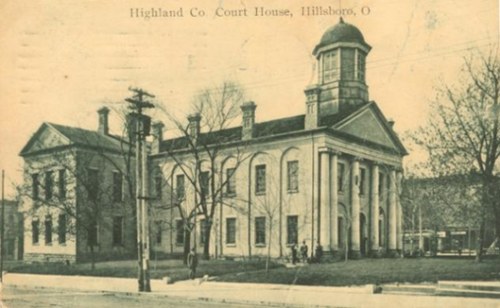
Event Background
Last year there was the Ohio Covered Bridge Special Event that was led by John Levo, W8KIW Editor of the Highland ARC’s Monday Morning Memo. Several clubs participated and was a complete success. Additionally, there were several folks interested in Ham Radio at the event who have now become new Hams. Yes, anytime there is a public event resulting in a gain to the Ham Radio community, it is a total success.

TOP ^
This year in keeping with the historical event series, John and the members of the Highland ARC decided to do a special event from their courthouse lawn. John published an article in the Monday Morning Memo which attracted the attention of Michael Love, WB8YKS Southern Ohio Amateur Radio Association (SOARA) PIO. John and Mike decided that there may be interest in an all-state special event celebrating the courthouses in all of Ohio’s 88 counties. Scott Yonally, N8SY Ohio Section Manager thought it was a fantastic idea and requested John and Mike to reach out across the state to determine the level of support for the event. The Ohio Section has 117 affiliated clubs of which 48 are Special Service Clubs and there are 29 PIOs. There may not be a club listed in each county by address, but we do have Hams in each county.

Promoting Ham Radio
This may be a first for the ARRL and the Ohio Section. This event has all the opportunities for a FUNFILLED family day engaging the public and our government officials. Additionally, one county’s club is partnering with their county commissioners, historical society, EMA, sheriff’s office, public library, chamber of commerce, and news media. The club has decided to use a large tent as the event will take place rain or shine.

Their PIO will make handouts available about ham radio and promoting the ARRL, ARES, RACES, Ohio Section and their local club. A special focus will be made to spotlight the public awareness of the hobby and the benefits of a Ham radio license, emergency and community service. The public will be invited to talk on the radios under the direct supervision of a licensed operator. Several clubs plan to provide contact QSL cards and/or certificates to capture this historical event.

Event Details
Yes, we are excited and hopefully you are as well, about participating in this historical Ohio Courthouses on the Air Special Event. We are requesting ALL Ohio Clubs and Hams to consider supporting this special event. The event will take place on, Saturday, August 24, 2019, from 9:00 AM to 4:00 PM. However, the hours can be extended by each club. Additionally, each club will determine the frequencies and modes they will use.

Another opportunity presents itself as the Ohio QSO Party www.ohqp.org is also on the air, Saturday, August 24th. Therefore, these two events will complement each other providing contacts not only from within Ohio but across the country. All Hams are invited to participate.

Contacts for additional information:
Michael Love, wb8yks@arrl.net or John Levo, W8KIW highlandara@yahoo.com

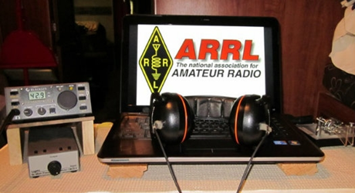
ARRL Contest Corner

An expanded, downloadable version of QST's Contest Corral is available as a PDF. Check the sponsor's Web site for information on operating time restrictions and other instructions.

TOP ^

ARDF National and Region 2 Championship
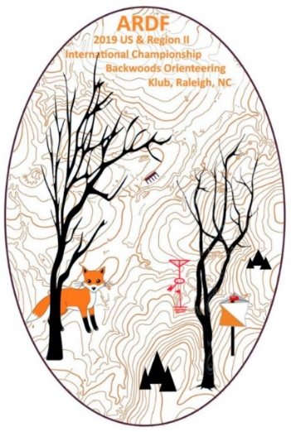
Just a quick note to let all of you know that the Great Lakes Division was well represented at this years’ ARDF National and Region 2 Championships in Raleigh, NC.

More information is available at http://www.homingin.com/farsnews.html#raleigh19

Below are results and some pictures.

Bob Frey, WA6EZV

Brian DeYoung | K4BRI |  | M50, 2M Classic - Region 2/USA- Bronze
Alexandria, KY
Dick Arnett | WB4SUV |  | M70, 80M Classic - Region 2/USA - Gold
Erlanger, KY
Matt Robbins | AA9YH |  | M50, Fox-O - Region 2/USA - Silver
Cincinnati, OH |  |  | M50, Sprint - Region 2/USA - Silver
Margie Garrett | KJ4ZKC |  | W60, 2M Classic - Region 2/USA - Silver
Alexandria, Ky |  |  | W60, 80M Classic - Region 2/USA - Silver
Bob Frey | WA6EZV |  | M70, Fox-O - Region 2/USA - Silver
Hamilton, OH |  |  | M70, Sprint - Region 2/USA - Gold
 |  |  | M70, 2M Classic - Region 2/USA - Gold
 |  |  | M70, 80M Classic - Region 2/USA - Silver
* Mike Minium | OCIN |  | M50, Fox-O, Region 2/USA - Gold
Hamilton, OH |  |  | M50, Sprint - Region 2/USA - Bronze
 |  |  | M50, 2M Classic - Region 2/USA - Silver
 |  |  | M50, 80M Classic - Region 2/USA - Silver
Joe Burkhead | KE8MKR |  | M40, Fox-O - Region 2/USA - Silver
Chelsea, MI |  |  | M40, 2M Classic - Region 2/USA - Gold
 |  |  | M40, Sprint - Region 2/USA - Silver
* OCIN - Cincinnati Orienteering Club - Non Ham
All Photos by Charles Scharlau - NZ0I

TOP ^
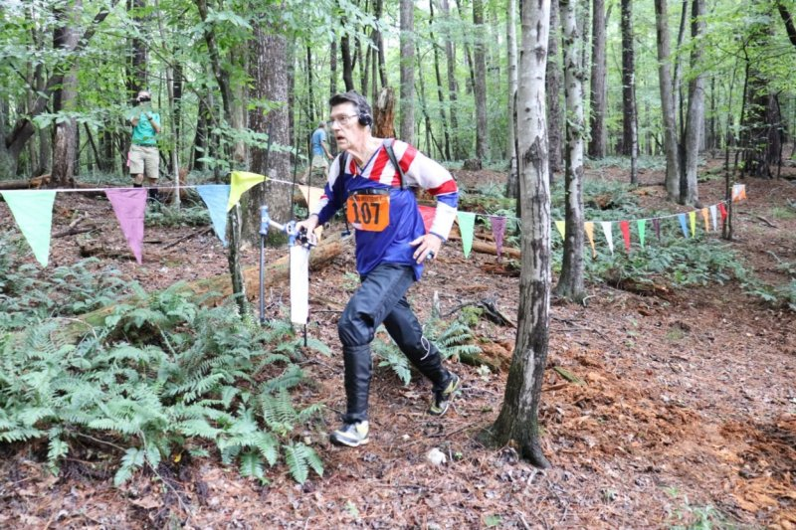
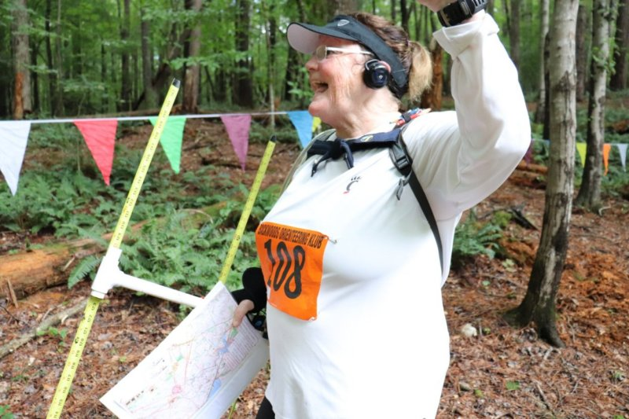
Bob Frey Maggie Garrett

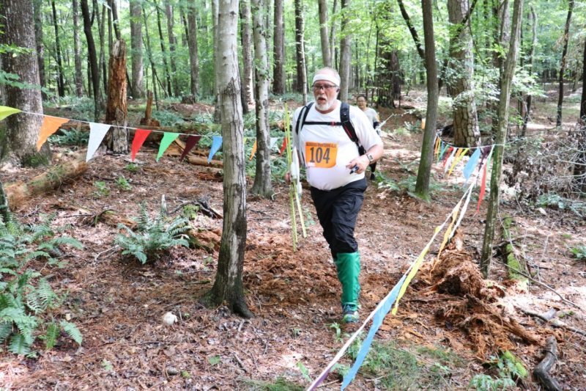
Joe Burkhead Brian DeYoung
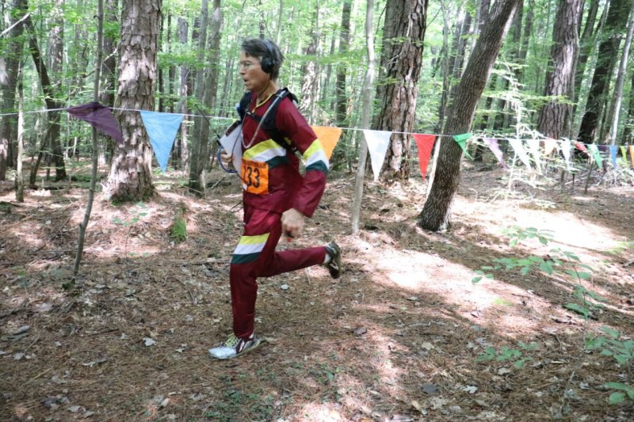
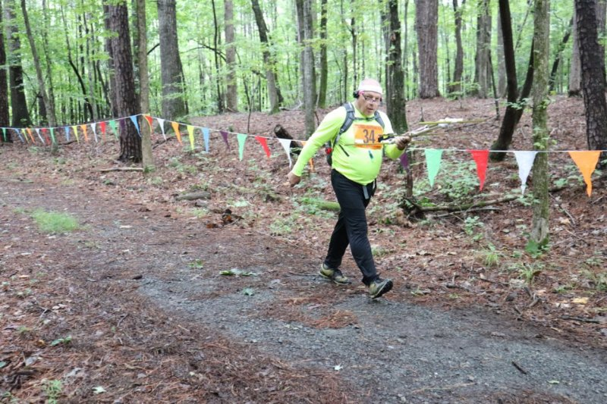
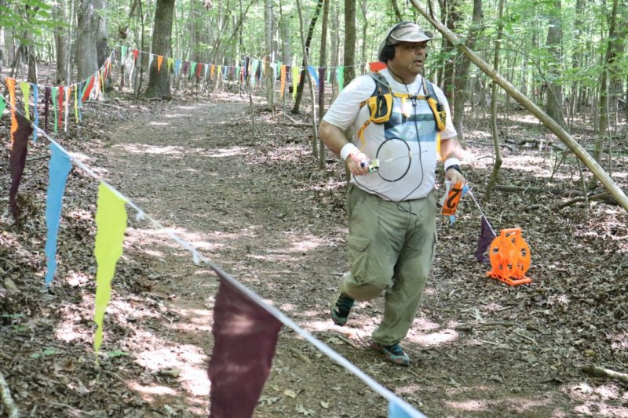
Dick Arnett Matt Robins

Mike Minium
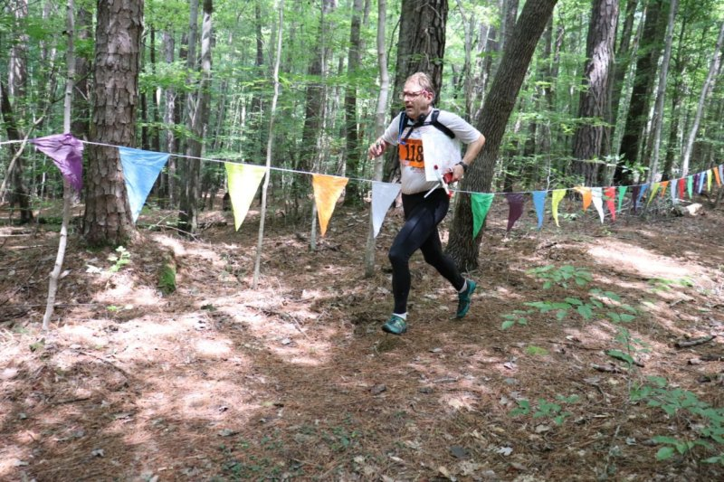

V.E. Test Sessions

For the latest testing site information please >> Click Here << The ARRL site tracks all of the VE testing sites that register with them, including W5YI and Laurel. ARRL gives you a number of different ways of sorting to find that site that is closest to you as well.

#########

One Question Questionnaire

Hey Gang,

It seems that about 40% of you will pay the asking price for used gear at a hamfest. Wow.. I am really surprised at that one! I haven’t run into any hams yet that will pay the asking price. Most of the folks I’m with will walk away from a deal if the seller doesn’t reduce the price some.

I’ve got another NEW – one question – on the Ohio Section Website for you to answer!

Having NASCAR in town last weekend with all the hoop-la and big bucks that gets thrown around by the out-of-towners, I happened to notice quite a few folks wearing headphones covering both ears while drive around this big metropolis of Lexington. I find that observation really shocking, as that Ohio law prohibits the wearing of any type of earphones or ear protection that covers both ears. This law has been on the books for many years here in Ohio.

TOP ^
There are a few exceptions to the law (ie.. any person wearing a hearing aid; law enforcement personnel while on duty; fire department personnel and emergency medical service personnel while on duty; any person engaged in the operation of equipment for use in the maintenance or repair of any highway; or any person engaged in the operation of refuse collection – garbage pickup). Now before the folks on motorcycles get upset at me, there is one other exception and that is it does not include speakers or other listening devices that are built into protective headgear (helmets). The folks I saw weren’t LEO’s, firefighters and so on through the list… they were just plain citizens driving around with headphones covering both ears and this got me to thinking. Many hams have mobile rigs in their vehicles and with the QRN the way it has been lately, it brings to me this next question.

“Do you wear headphones when driving your car to work those rare stations??”

These One Question questionnaires are all in fun and I hope that you are enjoying answering them.

You’ll find the “One Question” questionnaire on the Ohio Section Website! http://arrlohio.org It’s all in fun and it’s not a scientific survey in any way, but we are learning some things that we didn’t know from these questions. I hope that you are enjoying answering these “One Question” questionnaires.

ARES Connect

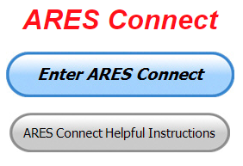
OK.. Now that we’ve all gotten over some of the scary stuff with ARES Connect let’s get down to really using this new system for everything that it’s worth. We still have a bunch of folks that aren’t signed up yet. Let’s get everyone on ARES Connect before the end of the year!!!

Do you need help with how to sign-up for an event or log your hours? How about you Administrators, do you have questions about approving your volunteer’s hours or how-to set-up an recurring event? I’ve got the answer for all of you. I have a new webpage with step-by-step instructions on how to do those things and many more. I also have a “Hints and Kinks” section that has a lot of great information on how to do something or why something works like it does. Here’s the page: http://arrl-ohio.org/SEC/connect/index.html You can also find this link on the main page of the Ohio Section website as well.. It’s just under the “Enter ARES Connect” link.

If you live in Ohio and you haven’t registered yet, we need you to get registered now. We need you to only use this URL to get registered https://arrl.volunteerhub.com/lp/oh/. Using any other entrance to register will only slow down your registration process. Again, this is for those living in Ohio only. If you are an out of state person (not Ohio), you can simply change the /oh/ to your 2-letter state designation. This will put you in the correct state for signing up

Your time adds up quickly. Make sure that all that fun and dedication counts. Get your hours logged now! If you want your name to appear in this listing, you’ll have to start recording your time!

TOP ^

Here’s the top 10 hours earners so far August:

 | Name | Events | Hours
1 | Bret Stemen (KD8SCL) | 22 | 100.00
2 | Christopher Domenick (KC8CAD) | 15 | 72.00
3 | James Grimes (AD8AP) | 9 | 67.00
4 | Alan Rothweiler (N8CJ) | 16 | 63.00
5 | Donald Kemp (NN8B) | 11 | 60.00
6 | John Major (KD8MMY) | 15 | 58.50
7 | Eric Jessen (N8AUC) | 9 | 56.50
8 | Mathew Nickoson (KC8NZJ) | 4 | 48.00
9 | Steve Wheatcraft (AA8BN) | 14 | 45.75
10 | Dan Stahl (KC8PBU) | 32 | 44.86

As you can see from the above listing, we can get real time information that shows how many hours, who volunteered and what they volunteered for. There’s a ton of information that we can draw out of the system.

We now have 1,210 registered and growing every day in the system. What’s really interesting is as of this same date there are 11,422 registered in the entire country. This means that the Ohio Section makes up over 10.59% of those registered.

Here’s a link to get you started... http://www.arrl-ohio.org/SEC/connect/ares_connect_directions.pdf
Please, don’t just hurry through the questions, read them carefully, if you don’t understand something, please ask me, I’m here to answer your questions.

Hey, let me say that this system is really great if you forget a meeting time or location? Just look it up on the calendar and there you have it. If setup, you can even see the location on a map! I have attended many meetings and gatherings just because it was listed on ARES Connect and I found it just browsing around. I wouldn’t have known about it if it hadn’t been on the ARES Connect Calendar!

This and That’s

ICS 300 & 400 Classes Being Offered

ICS-300 INTERMEDIATE ICS FOR EXPANDING EVENTS
Hosted by: Ashland County HS & EMA and Holmes County EMA September 20 - 22, 2019

Course Description: This 21-hour classroom course provides training for personnel who require advanced application of the Incident Command System (ICS) and Individuals who may assume a supervisory role in incidents. This course expands upon information covered in the ICS 100 and ICS 200 courses.

Application Deadline: September 6, 2019

Course Registration time: 5:30 pm to 6:00 pm (day one)

TOP ^
Course Time: 6:00 pm to 9:00 pm (day one)
8:00 am to 6:00 pm (day two & three) (one-hour for lunch on day two & three)

Training Location: Loudonville Fire Station 200 North Market Street Loudonville, Ohio 44842

Recommended Participants: FEMA designed this course for individuals who may assume a supervisory role in expanding incidents or Type 3 incidents.

Note: During a Type 3 incident, some or all of the Command and General Staff positions may be activated, as well as Division/Group Supervisor and/or Unit Leader level positions. These incidents may extend into multiple operational periods.

Required Prerequisites: Individuals must complete the IS-100.c Introduction to the Incident Command System, IS-200.c Basic Incident Command System for Initial Response, IS-700.b An Introduction to the National Incident Management System and IS-800.c National Response Framework courses prior to attending the ICS-300 Intermediate course and provide copies of their certificates of completion to the instructors on day one of the course.

Enrollment: Students must enroll via the Department of Public Safety Training Campus website: https://trainingcampus.dps.ohio.gov/cm/cm710/pstc/pstc.html. Course registration will generally close 10 working days prior to the course start date and applicants can check enrollment/approval status via the Department of Public Safety Training Campus website.

Course Costs: There is no charge for participants to attend this course. However, Lodging, Meals, Per Diem and all other travel expenses are the responsibility of the student or the parent organization.

State Point of Contact: Lisa Jones, DSC 2, Ohio EMA, SAA Training Point of Contact, (614) 799-3824 ljones@dps.ohio.gov.

********

ICS-400 ADVANCED ICS FOR COMMAND & GENERAL STAFF
Hosted by: Ashland County HS & EMA and Holmes County EMA September 28 – 29, 2019

Course Description: This 15-hour classroom course provides training for personnel who require advanced application of the Incident Command System (ICS). This course expands upon information covered in ICS-100, 200, 700, 800 and ICS-300 courses, which are the prerequisites for the ICS-400 course. The target audience for this course is senior personnel who are expected to perform in a management capacity in an Area Command or Multi-Agency Coordination Entity.
Application Deadline: September 14, 2019

Course Registration time: 7:30 am to 8:00 am (day one)

Course Time: 8:00 am to 5:00 pm (day one & two) (one-hour lunch each day)

Training Location: Loudonville Fire Station 200 North Market Street Loudonville, Ohio 44842

TOP ^
Recommended Participants: FEMA designed the course for Senior Personnel who expect to perform in a management capacity in an Area Command or Multi-Agency Coordination Entity.

Required Prerequisites: Prior to attending the ICS-400 Advanced course, individuals must complete the IS-100.c Introduction to the Incident Command System course; IS-200.c Basic Incident Command System for Initial Response; IS-700.b An Introduction to the National Incident Management System; IS-
800.c National Response Framework, an Introduction, and ICS-300 Intermediate courses. Students must provide these certificates of completion to the instructors on day one of the course.

Enrollment: Students must enroll via the Department of Public Safety Training Campus website: https://trainingcampus.dps.ohio.gov/cm/cm710/pstc/pstc.html. Course registration will generally close 10 working days prior to the course start date and applicants can check enrollment/approval status via the Department of Public Safety Training Campus website.

Course Costs: There is no charge for participants to attend this course. However, Lodging, Meals, Per Diem and all other travel expenses are the responsibility of the student or the parent organization.

State Point of Contact: Lisa Jones, DSC 2, Ohio EMA, SAA Training Point of Contact, (614) 799-3824 ljones@dps.ohio.gov.

It is the goal of Ohio EMA to ensure that all students have the tools necessary for successful course completion. If students require additional accommodations, they should make the Ohio EMA training office aware, and staff will confidentially meet reasonable requests.

#########

Ohio QSO Party

OHQP August 24, Saturday, noon till midnight EDST (1600 Z –0400 Z) rules @ https://www.ohqp.org/

Many mobiles and rovers will be out activating Ohio counties (at this time we have 79 counties with planned activity) It is encouraged to have EOC station on in their county if possible.

#########

Want to Work 6, 10 or 12 Meters But No Sunspots?
Don't Miss Your Chance with Summer E Skip and FT8
(from Anthony Luscre, K8ZT)

You may have heard the doom and gloom about being in the depths of the 11-year sunspot cycle:

No propagation above 20 Meters
Ten is dead!
Might as well sell the radio
Sunspots will never return
80 & 160 Meters are only good for the next few years

TOP ^
Well, the idea to concentrate on 160 and 80 Meters is a good idea, but not until late fall or winter. In the meantime, there is a way to make contacts on 6, 10 or 12 Meters most days of the week by taking advantage of the summer enhanced sporadic E Skip season and utilizing the mode of FT8.

Typically, during high sunspot activity (solar flux) ionization of the F layer of the atmosphere facilitates refraction of signals on higher HF bands allowing worldwide communications.

The E layer, about 90 to 150 km above the Earth, is below the F layer and is responsible for a propagation type known to abnormally effect VHF and higher HF frequencies called sporadic E or E skip. This happens when ionized particles appear in the E layer of the ionosphere.

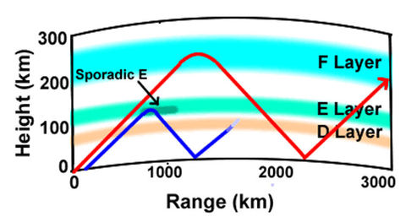
Sporadic E, as the name implies, occurs sporadically throughout the year and is not dependent on 11-year sunspot cycle. In the Northern hemisphere, sporadic E activities are more frequent during the summer months.

The lower height of the E layer results in shorter skips than the F layer. During sporadic E events, the E layer becomes heavily ionized in specific small thin areas, sometimes called clouds. This can last a few minutes or up to several hours.

The effect is normally more pronounced with lower frequencies. The short duration of this type of propagation can mean openings can easily be missed so frequent monitoring of bands is important. Fortunately, in this internet age, there are websites that can predict or at least define sporadic E, DXMaps.com has maps similar to the one below.

Another good tool to monitor activity, especially with FT8 contacts is PSK Reporter.
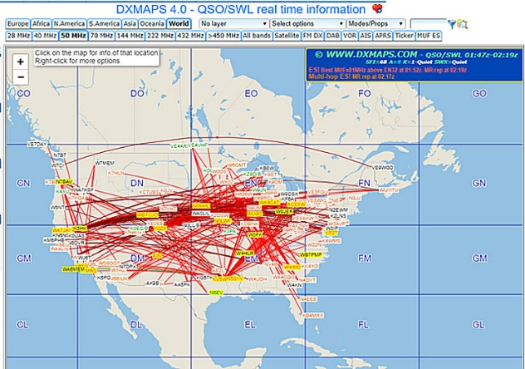
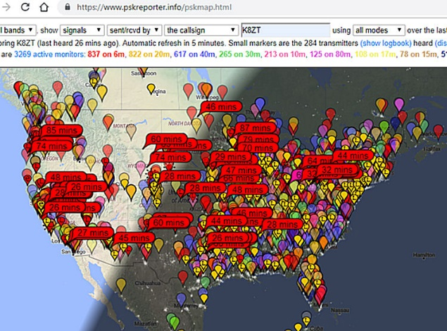

FT8 it is a great way to maximize your number of contacts during the sometimes marginal propagation characteristics of Sporadic E. For information on FT8 visit www.k8zt.com/digital.

In addition to PSK Reporter, www.k8zt.com/propagation for other Propagation and Spotting Resources.

TOP ^
Getting Everyone’s Attention

The following graphic will be used at the Lawrence County Chamber of Commerce. It will be displayed on their South Point electronic multimedia marquis facing US State, Route 52 were tens of thousands of cars pass each day. It will be displayed in full HD color 24 hours, seven days a week until, August 25.

This is a fantastic advertising outreach for the Southern Ohio Amateur Radio Association (SOARA). The Chamber of Commerce has partnered with SOARA in the past and continues to support them in every possible way.

One unique feature about this graphic is that it was created by the Lawrence County, Ohio Emergency Management Agency Director, Michael Boster. Michael is a strong supporter of SOARA and ARES in Lawrence County. It is certainly a team effort in everything that we do, said Eddie Jenkins ARES, EC.

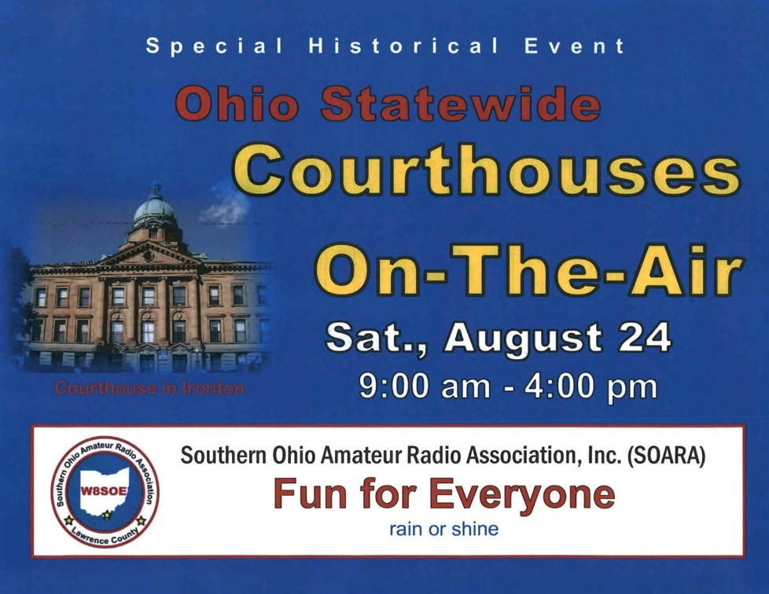

#########

TOP ^
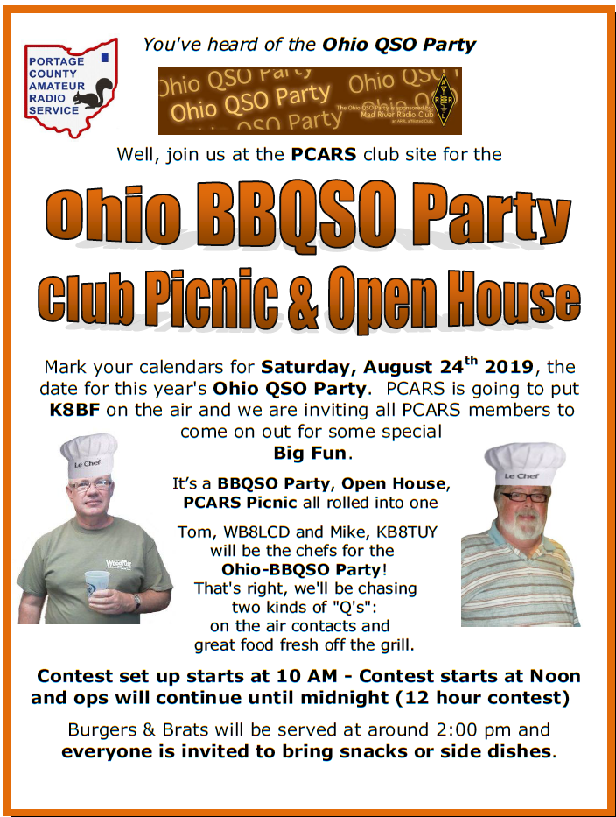

#########

New Webpage Added to the Ohio Section Website
Is your club’s newsletter available to share? I’ve got a new webpage that has links to all of the known websites where club newsletters can be accessed throughout Ohio.

Now, as we all know when any list is published, it’s outdated immediately. That’s ok, just send me the link to your club’s newsletter and I’ll get it on the webpage – n8sy@n8sy.com

Here’s the link: http://arrl-ohio.org/club_link/links-to-newsletters.html Remember, we’re all here to help each other. What a great way to share the news about Amateur Radio!!

TOP ^

Final.. Final..
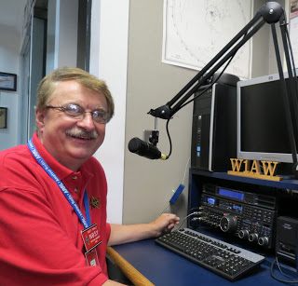
Hey Gang...

Wow.., what a wild week this has been. I do want to thank the ARRL Board of Directors and all of you in the Ohio Section for the award. What a surprise that was! Coming off of what had to be the event of the year “DX Engineering Hamfest.” This was a week that I’ll never forget for sure!

Sliding up the band a bit… I’ve created a new page on the website that has links to those clubs that post their newsletters on their clubs’ website. This was an idea from Frank, W8EZT and I think it’s a great one. You can find the page at:
http://arrl-ohio.org/club_link/links-to-newsletters.html

My antenna project is still on hold for a while. I’ll get to it, but most likely it will be when it’s cold, windy and 4 feet of snow on the ground before I get my vertical antenna up and in the air. Oh well, that’s the perfect time to do antenna work anyway, right!!!

Switching bands… Have you taken the time to get signed up in “Connect” yet? I know that this must sound like a broken record, but it is important for everyone to not only get signed up but start using as well. Please, don’t let the name ARES fool you, this new system is for everyone and not just for ARES. So, if you haven’t already signed up, now is the time. I’ve set a goal of everyone getting signed up by the end of the year!

Is your club doing any special activities that you’d like the Section to know about? Do you have a story that you’d like to tell about something that you or your club has or is doing? Let me know about it and let’s get it in the next edition!

Whelp… That’s going to do it for this time around. Stay safe, enjoy the sunshine while we have it, and most of all… have FUN!!

73,

Scott, N8SY

Welcome New Subscribers

Javan, N8JLM; Alexis, KE8MTL; Paul, KD8DEL

TOP ^

Back Issues of the PostScript and Ohio Section Journal (OSJ)

Hey, did you know that PostScript and Ohio Section Journal (OSJ) are archived on the website? You can go back and look at any edition simply by clicking:
http://arrl-ohio.org/news/index.html

Chit – Chat, and All That!

Do you know someone that’s not getting these Newsletters? Please, forward a copy of this Newsletter over to them and have them “Opt-In” to start receiving them. Heck, just have them send me an email n8sy@n8sy.com and I’ll get them added to the Ohio Section Emailing list.

We now have many thousands of readers receiving these newsletters weekly. Quite impressive, I’d say! I urge all of you to make sure that everyone, regardless of whether they are a League member or not, get signed up to receive these weekly Newsletters.

You can always “Opt-Out” at any time if you feel this is not what you were expecting. It’s fun and very informative. All of your favorite past newsletters are now archived too.
You can go back at any time and read them. Just go to: http://arrl-ohio.org/news/

Got questions, concerns or would just like to sit and chat awhile? Heck, I’ll even buy the coffee!! Give me a call at (419) 512-4445 or email me at: n8sy@n8sy.com

The pictures on the front page are from various newsletters, Facebook posts and/or were sent directly to me in recent weeks. Take a good look at them, you just might be in one of the pictures! “SMILE… you’re on the Ohio Section News!!”

TOP ^

PostScript is produced as a weekly newsletter. I want to thank everyone that has contributed articles and ideas to make this an even better news source. I sincerely hope that you have enjoyed this edition and will encourage your friends to join with you in receiving the latest news and information about the Ohio Section, and news and events happening around the world!

