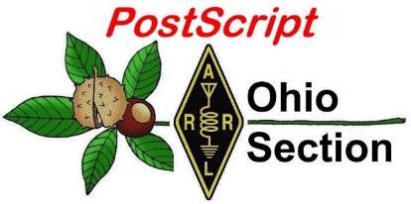
50th Anniversary of
Woodstock Edition

National News The Handbook Give Away

Club Corner Hamfests

DX This Week One Question Questionnaire

VE Testing ARES Connect

Final.. Final..

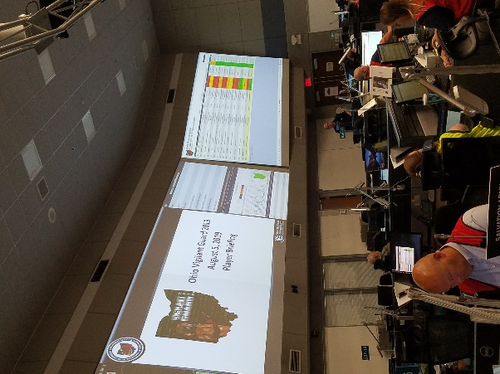
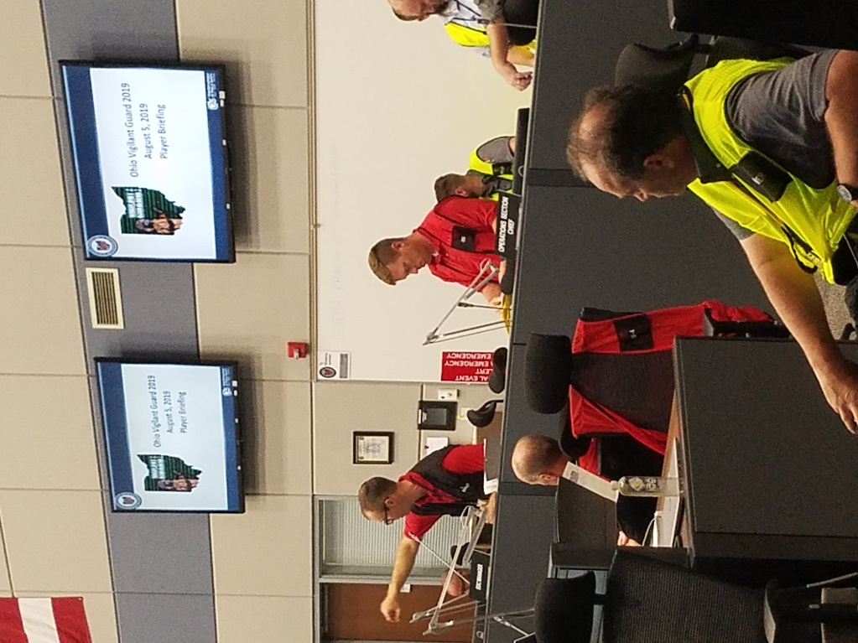
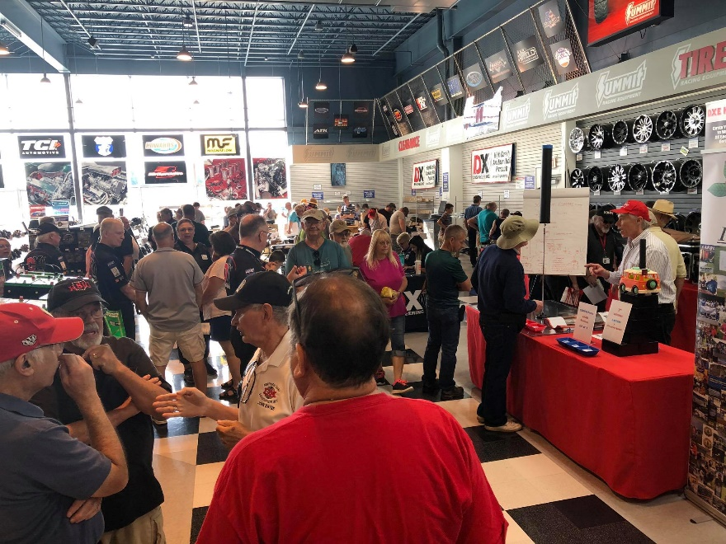
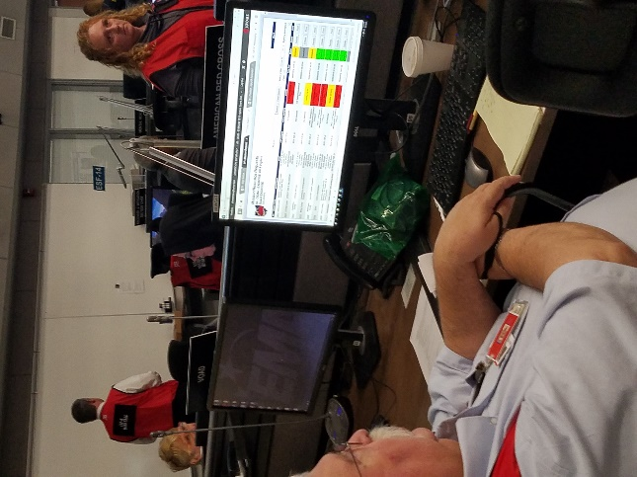

National News
(from arrl and other sources)

Article: Global Institutions Support Amateur Radio Communication and Experimentation

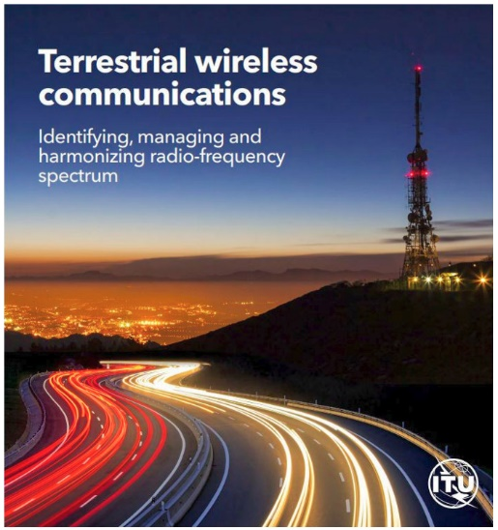
Former ARRL CEO David Sumner, K1ZZ, has contributed to the latest edition of ITU News Magazine — published by the International Telecommunication Union (ITU). The issue is devoted to “terrestrial wireless communications,” which includes the Amateur Radio and Amateur Satellite services. Sumner’s article, “Self-training, intercommunication and technical investigations: the amateur service in the 21st Century,” discusses Amateur Radio within the context of a global network of experimenters and communicators who, in Sumner’s words, “expand the body of human knowledge and technical skills that are essential to development and offer a resource that can literally save lives when natural disasters disrupt normal communications channels.”
“Amateur licensees are grateful that ITU member-states continue to recognize the benefits of providing direct access to the radio spectrum to qualified individuals,” said Sumner, who now serves as secretary of the International Amateur Radio Union (IARU), an ITU sector member.

Sumner points out that access to frequency bands “spaced throughout the radio spectrum” is critical to Amateur Radio’s future. He notes that the initial pattern of ham allocations dates back to 1927 and the International Radiotelegraph Conference. Allocations have been extended and expanded at subsequent conferences, most recently at World Radiocomunication Conference 2015 (WRC-15), when ham radio obtained a tiny secondary band near 5.3 MHz. (An earlier WRC was responsible for the Amateur Service’s two lowest-frequency allocations, 135.7 – 137.8 kHz and 472 – 479 kHz.)

On the other end of the radio spectrum, the 1979 World Administrative Radio Conference (WARC) extended terrestrial allocations above 40 GHz to include amateur allocations. “If a future World Radiocommunication Conference extends allocations above 275 GHz, adequate provisions for amateur experimentation should be made,” Sumner observed.

The first item on the agenda for WRC-19, which takes place this fall in Egypt, calls on delegates to consider an allocation at 50 MHz to the Amateur Service in ITU Region 1 (Europe, Africa, and the Middle East) that aligns with existing allocations in Regions 2 and 3. “Harmonized allocations highly facilitate intercommunication,” Sumner asserted.

Sumner notes that ITU “plays an essential role” in keeping the spectrum clear of unwanted interference and emissions, an effort he said is “especially vital to the Amateur Service, which uses sensitive receivers to compensate for practical and regulatory limitations on antennas and transmitter power levels.”

Sumner also pointed to the role radio amateurs can play in developing and refining communication protocols, including digital techniques, to improve weak-signal performance. He noted that Joseph Taylor, K1JT — a codeveloper of such digital modes as FT8, FT4, and JT65 — received an ITU Gold Medal in recognition of his outstanding contributions to radiocommunication.

TOP ^
Sumner explained that the IARU — a federation of more than 140 member-societies —represents the interests of radio amateurs around the world before ITU. The IARU’s contribution to the work of ITU began in 1932 with its admission to participate in the work of the International Radiocommmunicaiton Consultative Committee (CCIR). IARU is a member of the ITU Radiocommunication and Development sectors.

“The IARU is proud to be an active member of the ITU community,” Sumner said in conclusion.

#########

Ninth YOTA Summer Camp Gets Under Way on August 11
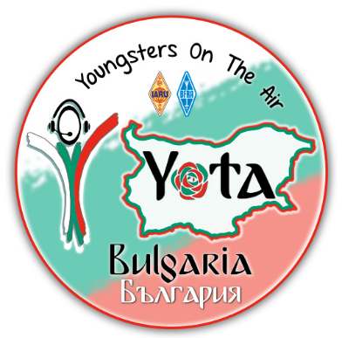
Up to 80 young radio amateurs, primarily from IARU Region 1 but including participants from other parts of the world, will gather in Bulgaria on August 11 for the ninth annual Youngsters on the Air (YOTA) Summer Camp. Special call sign LZ19YOTA will be on the air during the weeklong event, hosted by the Bulgarian Federation of Radio Amateurs (BFRA).

The event offers an opportunity for the participants to foster international friendships and goodwill and learn new Amateur Radio skills. The main theme will be “train the trainer” (TTT). Participants will be working on the future of Amateur Radio and be involved in workshops to gain skills to start similar ham radio youth events when they get back home.

“We are aiming to create a snowball effect,” the YOTA announcement said. “There will be more and more YOTA events all over the world. This also allows other youngsters and newcomers to enjoy Amateur Radio.”
Activities will include kit building and an opportunity to visit the surrounding region, including the ACOM amplifier factory. QSL LZ19YOTA via the bureau to LZ1BJ.

#########

ARRL Dayton Hamvention Videos Available

Video recordings of presentations made by several ARRL officials at the 2019 Dayton Hamvention® and ARRL National Convention are now available for viewing on the ARRL YouTube channel. Most of the videos were shot and edited by ARRL Great Lakes Division Vice Director Tom Delaney, W8WTD, with assistance from David Vine, WA1EAW, during the ARRL Members Forum and during other ARRL-sponsored forums at Hamvention. Videos include one from the Public Service Communications forum that was produced by Jim Palmer, KB1KQW, and one produced by Michelle Patnode, W3MVP, of ARRL Chief Executive Officer Howard Michel, WB2ITX, at the ARRL Donor Dinner.

Michel is also featured in a video conducting a brief discussion of the status of ARRL as an organization and his vision for its future, recorded at the ARRL Members Forum.

Additional available videos are:
- ARRL President Rick Roderick, K5UR, offering an overview of ARRL activities and challenging ARRL members to help recruit younger people into Amateur Radio and ARRL membership.

TOP ^
- ARRL Pacific Division Director Jim Tiemstra, K6JAT, chair of the ARRL Legislative Advisory Committee, discussing the status of the organization’s efforts to reassess its strategy for enacting improved Amateur Radio Parity Act legislation.
- Riley Hollingsworth, K4ZDH, former FCC enforcement official, outlining the mission of the new joint FCC-ARRL Volunteer Monitor program and how the program will be organized.
- ARRL Roanoke Division Director Bud Hippisley, W2RU, chair of the ARRL’s Public Service Enhancement Working Group, discussing ongoing efforts to enhance the ARES program, and other issues related to emergency communication.
- ARRL Teachers Institute instructors Tommy Gober, N5DUX, and Larry Kendall, K6NDL, offering strategies and advice for including Amateur Radio in the classroom.
- A panel of representatives from Amateur Radio’s largest organizations active during disasters and emergencies discussing a wide range of topics, including training, partnerships, interoperability, and leadership development.

#########

FCC Fines North Carolina Man for Unauthorized and Misleading Public Safety Transmissions
The FCC this week issued a $39,278 Forfeiture Order against Ocean Hinson of Surry County, North Carolina, for intentional misuse of a local public safety radio communications network, in violation of §301 of the Communications Act of 1934, as amended.

“Mr. Hinson impersonated first responders in unauthorized radio communications on Surry County’s licensed public safety frequency,” the FCC said. “On October 17, 2017, Surry County officials, responding to a fire alarm triggered at a local residence, transmitted a request for a unit from the Westfield Volunteer Fire Department. Shortly thereafter, Mr. Hinson, posing as ‘Westfield VFD Unit 7331,’ responded, using the mobile radio in his personal vehicle and stated that he was en route to the scene of the alarm. Approximately 4 minutes later, Mr. Hinson…cancelled the call. As a result of these two transmissions, no real first responder investigated the triggered residential fire alarm. Fortunately, no fire actually occurred at the scene of the alarm.”

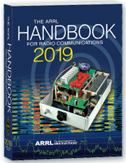
The Handbook Give Away

Hey Gang,

Have you registered for the “Handbook Giveaway” drawing for this month yet? If you haven’t, go to: http://arrl-ohio.org/handbook.html and get yourself registered now!

What’s the catch? I want to get everyone checking in to the Ohio Section website as often as possible, and in order to register each month, you have to visit the website often! There’s nothing else to it. I pay all expenses and I usually “Give Away” more than just a Handbook too!!

Many of you ask me just how do I know when the drawing is on? Well, that’s easy all you need to do is check in on the Ohio Section Website on a regular basis and watch for the big RED Arrow that will appear on the left side of the page. This is the sign that the drawing is on and you need to get registered. So, keep a sharp eye out on the website and check in often!

TOP ^

Club Corner

This is YOUR cornner of the newsletter. Send me what your club is doing and I’ll make sure that it gets in. Got a special event or club project that you want everyone to know about? Send it to me!. Need help with a project? Send it to me.

Let me know what you club is up to. Are you going to have a special guest at your meeting or are you having a special anniversary? Just sent it to:
n8sy@n8sy.com

#########

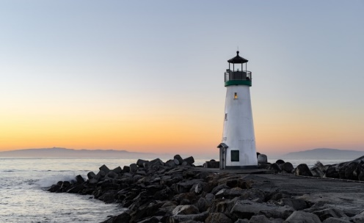
Lighthouses on the Air

On Saturday, August 17th I will be activating the Fairport West Breakwater Light for the International Lighthouse Special Event, using the call N8L. I will go it alone and just hang a wire off of the observation deck if I have to. But ideally, I would like to run a couple of radios simultaneously 24/7 for the weekend.

The accommodations are really quite nice. There will be a Dropbox link to photos below. I am looking to gather a crew of a half dozen to a dozen Hams to work the project, much like a Field Day style operation, but without the contesting. This will be an open to the public operation and visitors will be welcome. Due to the ruggedness of the terrain to get to the Lighthouse, I will be working on arranging a secondary location at the Fairport Harbor Lighthouse Museum for those who cannot make the trek along the break wall, climb a ladder or up the steps of the base. This will also serve as a backup location in the case of inclement weather.

If you are interested in participating in event as part of the crew, help with set-up, tear down, supplying equipment, radios, antennas, feed lines, analyzers, food, etc., please contact me to begin making some plans.
The Lighthouse is fully furnished, but with no running water. It uses a composting toilet. There is a 5,700 watt (7,100 peak) generator on site, and a small portable as well. We need to furnish our own gasoline, of course. Besides the lights and radios, the only appliances we would be running would be the refrigerator, the coffee pot, and maybe the microwave. Here is a link to the Dropbox folder with pictures.
https://www.dropbox.com/sh/6b8lc06zb2c3lxj/AADJaxCp0DHps0bICdKq6TGma?dl=0
My Contact is: dspondike@aol.com or call 330-801-0089

#########

I'm Dave, N8SAX, from Copley, Ohio. I grew up in Painesville and Mentor and sail regularly out of Fairport Harbor. I am going to activate the West Breakwater Light from inside the lighthouse the 3rd weekend of August. (I am exploring the idea of setting up a secondary station at the Lighthouse Museum in case of inclement weather and for those who cannot get to the breakwater light.).

I have access to the lighthouse from August 16th through the 18th (can stretch to the 19th) and have acquired the 1x1 Call N8L for the special event.

TOP ^
I am working to interest members of the SARA Club (Silver Creek) to crew and participate in the project

For those hams who cannot make the trek along the break wall, I may be able to arrange boat access, but even those steps are a bit treacherous. Please let me know if you or anyone might be interested in working this event.

My contact info is: 330-801-0089 email: dspondike@gmail.com or dspondike@aol.com

Sincerely,
David Spondike, N8SAX

#########

Wayne ARC in Wooster converted their UHF machine to multi-mode digital. It's on the air on 443.175. It's doing YSF, DMR, and D-STAR. The dashboard is viewable at https://w8woo.megalink.network.

The repeater has YSF static links to OHIO-LINK, DMR to Ohio Statewide, Ohio WX, and Ohio ARES, and D-STAR to my reflector XRF330A.

#########

Help Needed for the Potato Stomp

The Mantua Potato Stomp will be holding their annual foot race on Saturday September 7th in the Mantua-Hiram area. This event consists of a four-mile and a nine-mile race on various roads in Mantua Village and Township and Hiram Township. Radio operators will be needed to staff the intersections on the course, provide a Shadow to the race director, a NCS, and a sweep.

Ed, K8IV recently installed a UHF repeater at the tower on the hill just east of Mantua Village. It was used for the Headwaters Adventure Race, which is in the same area that the Mantua Potato Stomp race will take place. The coverage of this repeater in the local area is superb and allows Radio Operators to use just a UHF hand-held at almost every location in the area with full quieting coverage. Because of this we will no longer have to rely on establishing cross-band repeaters to get coverage throughout the course.

This is also the date for OSPOTA so I know many of you will be involved with that. But, for those who are not, I would sincerely appreciate your help. If you’re new to public service communications support and are reluctant to do it alone, let me know and I’ll pair you with an experienced operator so you’ll get a chance to observe, learn and participate. Drop me a note at k8cav.coms@gmail.com if you can help with this event. Thanks!

#########

TOP ^
USAF Marathon Needs Help

Approximately 70 amateur radio operators are needed to support the USAF Marathon at Wright Patterson Air Force Base on Saturday, September 21, 2019 to provide the USAF Marathon Staff with emergency and logistic communications. This world class event has over 20,000 participants, volunteers, and spectators in attendance every year.
Amateur radio operators are indispensable in rapidly communicating information on runner’s locations and status, heat index settings, severe weather notifications, as well as emergencies and logistic issues. Plus, APRS is utilized to track lead runners and “Tail End Charlie’s”, thus allowing race officials and emergency services to more accurately monitor the race progression.

Multiple races are held on this day including: 10K, Half Marathon, Full Marathon, and Wheelchair. The volunteer registration website for the USAF Marathon is now open.

If you will be in the Dayton, Ohio area on Saturday, September 21, 2019 and would like to take part in this world class event, please go to the USAF Marathon website at http://www.usafmarathon.com/volunteer and click the volunteer now link, scroll down to the amateur radio section to register. Training will be provided prior to the event.

How to register online:
- Go to the website above.
- Click on the Volunteer Now button.
- Acknowledge that you’re going to a new website.
- On the new website, ignore the “password” entry box near the top of the page. Scroll down to the “Amateur Radio Operator” section and click the check box for the Amateur Radio Operator Position and only that position.
- Scroll to the bottom, past all the other volunteer positions, and fill in your name and other required data.
- Check the box below the waiver paragraph and then type in your name for a digital signature.
- Click the “Sign Up to Volunteer” button.
- You’re done!
- You should get an automated email response from Jeanette Monaghan acknowledging your registration.
- Contact Phil Verret if you have any questions or concerns.

Registration closes August 31, 2019.

If you have any questions please email to: Phil Verret, KA8ZKR@ARRL.NET

#########

Geauga Amateur Radio Association Needs Help

All - the 197th ever Great Geauga County Fair is just a few weeks away! As usual, it's Labor Day weekend, Thursday through Monday.

The Geauga Emergency Amateur Radio Service has been invited by the sheriff's office once again to participate. We have a few functions at the fair:

TOP ^
- Dispatch and drive golf carts to help people get around the fairgrounds and to and from the parking lot.
- Staff the sheriff’s office building outside of Gate 1.
- Walk the fairgrounds to provide eyes and ears for the on-duty fire departments and the sheriff’s office.
- Perform other miscellaneous tasks to assist the sheriff’s office and fire departments.
- Help the county firefighters' association clean up fire station 1 on Thursday, August 22.

If any of these sound like fun, please join us!

Note that you do not need to be a ham radio operator to drive a golf cart! We use county radio frequencies for the golf cart portion. Feel free to bring a co-pilot/navigator or a friend, we'd appreciate their help! (Please make sure you register them as well, so we have an accurate headcount).

When signing up, you'll tell us what days and which parts of those days you'd like to work. We have three very loosely-defined "shifts":

- Morning - roughly 9:00AM-1:00PM
- Afternoon - roughly 1:00PM-5:00PM
- Evening - roughly 5:00PM-9:00PM (and beyond if you can stay)

These are here to give us a very rough idea of when you'll be available. If you can only come out for an hour or two, that's fine, just choose the option(s) that work best for you. That said, please only sign up for days and times you can commit to working. This helps us plan resources.

Thanks for your interest and we hope to see you at the fair! Please sign up using the following link: http://bit.ly/2019geaugafair If you have any questions or concerns, please email info@ohiogears.org.

#########

POW – MIA Event

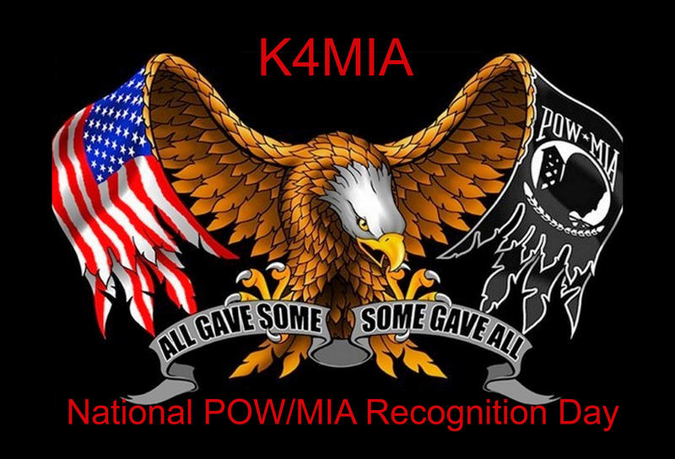
On September 13 thru the 22nd of 2019 We will honor and support our Veterans with a Special Event on the air as K4MIA/8. Linda N8LRS and Metro W8MET will be the sister-station from Ohio for our 4th year.

This event originated from K4MIA , Mike from Florida with other sister-stations involved. Details can be found on the ARRL website under “ON-THE-AIR” under SPECIAL EVENT under the call-letters of K4MIA.

Also, this Special Event will be in the September QST. Please take part in this Special Event for our Veterans. QSL is available with SASE. We will be operating on 40 meter's SSB. GOD BLESS AMERICA 73, Linda and Metro

#########

TOP ^
Bike Cleveland Fundo September 7

We are seeking volunteers for Bike Cleveland Fundo on Saturday, September 7th at Edgewater Park. It's a 30 mile and 60 mile bicycle ride starting at Edgewater Park and ends at Edgewater Park. The 30 mile riders depart at 9AM and the 60 mile riders depart at 8AM.

I am seeking volunteers for SAG, Rest Stops, and Net Control. Volunteers receive a free t-shirt and a delicious lunch. Please sign up at www.w8dec.net. Click on events and you'll see the Fundo listed. Password is fundo2019!

If you can only volunteer for part of the day, that's ok we'll have an assignment to accommodate your schedule.

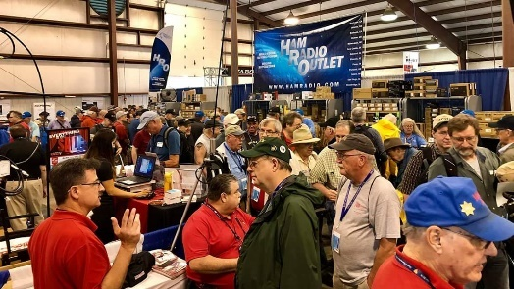
Upcoming Hamfests

08/17/2019 | GARS 2019 HamFest
Location: Germantown , OH
Sponsor: Germantown Amateur Radio Society
Website: http://www.WG8ARS.org

08/18/2019 | Warren Tailgate Swap Meet  Location: Warren, OH  Sponsor: Warren Amateur Radio Association  Website: http://www.w8vtd.com/2019/05/30/2019-tailgate-swap-meet/ | 09/08/2019 | Findlay Hamfest  Location: Findlay, OH  Sponsor: Findlay Radio Club  Website: http://www.findlayradioclub.org
09/21/2019 | The OHKYIN ARS Hamfest  Location: Cincinnati, OH  Sponsor: OHKYIN Amateur Radio Society  Website: http://www.ohkyin.org | 09/22/2019 | Cleveland Hamfest and Computer Show  Location: Berea, OH  Sponsor: Hamfest Association of Cleveland  Website: http://www.hac.org
10/05/2019 | Scioto Valley Amateur Radio Hamfest  Location: Chillicothe, OH  Sponsor: Scioto Valley Amateur Radio Club | 10/12/2019 | NWOARC Fall Hamfest  Location: Lima, OH  Sponsor: Northwest Ohio Amateur Radio Club  Website: http://www.nwoarc.com
11/02/2019 | GARC Hamfest  Location: Georgetown, OH  Sponsor: Grant Amateur Radio Club  Website: https://www.facebook.com/Grant-Amateur-Radio-Club-1775764122477536/?modal=admin_todo_tour | 11/03/2019 | Massillon ARC Hamfest  Location: Massillon, OH  Sponsor: Massillon Amateur Radio Club  Website: http://www.w8np.org

TOP ^

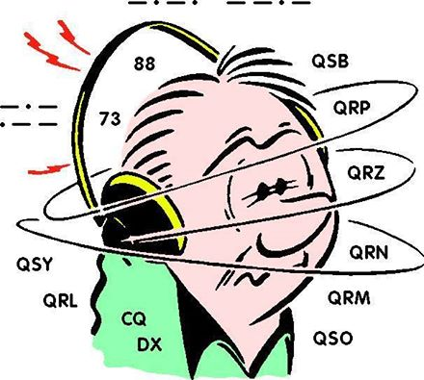
DX This Week
(from Bill, AJ8B)

DX This Week – Interview with HA8RM

Bill AJ8B (aj8b@arrl.net, @AJ8B, www.aj8b.com or www.swodxa.org )
CWOPs Member #1567

Uncle Frank and I had our weekly 40-meter QSO and he was discussing his QSL manager activities for his 4V1 station. I was describing my process of handling the “N” cards for the 8th area ARRL incoming QSL bureau. He started to ask a few more questions and I thought it might be a good time to share the process with you. The process is my process, not necessarily the process of others who are letter card sorters.

The previous “N” letter sorter, Len, K8NKQ, passed his cards and information on temporarily to WD8ANZ, Darrell. I noticed that there was a letter sorter needed for the “N” cards and I volunteered via N8DX, Jack, the bureau manager. WD8ANZ was kind enough to meet me for lunch and pass along all the material that he had as well as solid advice and some wisdom. Thanks to Darrell for that!

Not one to reinvent the wheel, I also gathered advice from other members of our DX club who are also card sorters; N8DX – Jack, the “C” sorter, K4ZLE – Jay, the “O” sorter, and K8DV – Dave, the “Q” sorter. This group comprises years of experience and really helped me ramp up quickly.

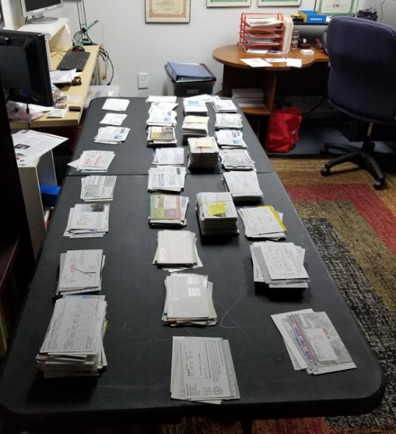
Here are my steps after N8DX has given me the box(es) of cards for AA8N through WW8NZZ.

As shown in the picture, I sort them by the second letter of the prefix. For instance, I may have a stack of cards for those with 8NC in the call such as KD8NCN, W8NCN, WA8NCN, KB8NCP, KD8NCP, N8NCP, KA8NCQ, KA8NCR, N8NCR, and WD8NCR. The only deviation from this are cards from those amateurs that you KNOW will be receiving a large quantity of cards. They get their own stack!
Every ham that I have received cards for at one time has a manila folder with their call on it. These folders are stored in hanging folder boxes. I take the stacks of sorted calls QSL cards and place them in the appropriate hanging folders. (Then I put my XYLs card tables away!)
I take another pass through the folders and I mail cards for anyone who has cards and an SASE on file (or equivalent postage etc.). If I am sending them their last SASE on file, I stamp the outside of the envelope as such and mail it.

The next task is more time consuming. If a ham has cards, but, not an SASE, postage, or money on file, I will send an email to him indicating that he needs to get an SASE to me so I can send his cards to him. Many times, hams respond quickly with an SASE to get the cards. Many other times, hams will tell me that they are no longer interested in the cards and to throw them out.

TOP ^
If a ham doesn’t have an email address, and many don’t, I will mail them a letter indicating what is needed and what they need to do. I only do this annually due to the expense of mailing these letters.

It is time consuming, but, it is also enjoyable. We are always looking for volunteers so, if you are interested, drop me a note!

I have had the pleasure of working HA8RM many times on many bands in various modes. Peter has always had an outstanding signal. The last time we worked, I took a minute to review all the information on his QRZ.com webpage. I was so impressed with his antenna skills that I asked for an article, but he modestly refused. He did, however, agree to answer questions. If you have other questions, please contact Peter via his email address. He was fast to respond and complete in his answers. Thanks Peter!

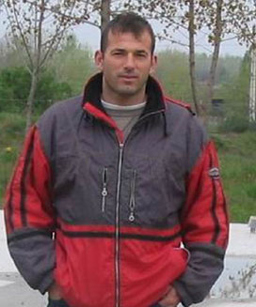
HA8RM — A BIG gun from Hungary
An interview with Peter, HA8RM—yagimaker@gmail.com

AJ8B: Peter. Thank You for agreeing to this interview. I have worked you many times and have heard your excellent signal many more, so I have been curious about your station. For starters, please tell me how you got in to ham radio.

AJ8B: When did you build your first ham station?

HA8RM: At the early eighties, when I was student in elementary school I built my very first, modest station. I lived with my parents then, had a pretty nice small shack, where I could build my very first (separated RX – TX ) 80m QRP equipment.

AJ8B: When did you get on the air?

HA8RM: I started the ont he air operation at my age of 13.

AJ8B: Do you have a favorite band or mode?

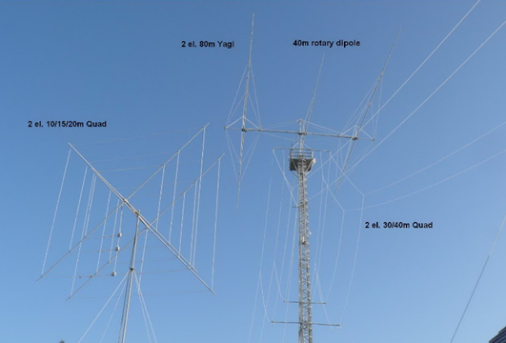
HA8RM: I always loved the 80m band best, it has a special atmosphere, I feel comfortably myself there. CW or SSB, it doesn’t matter, I like both. All the digital modes are ignored in my HAM life.

AJ8B: In reviewing your QRZ.com page, it is obvious that your have a talent for designing and building low band antennas. How did you get started?

HA8RM: Independently of all, I knew from the beginning, my main special interest area is the low band DXing. As many of us, I started this job with different kind of simple antennas (dipole, vertical, loops, …), the breakthrought was ON4UN’s Low Band DXing book. I read it many times over, I always get new information, ideas, inspirations, .. how to improve my station.

TOP ^
AJ8B: Describe what you are currently using:

HA8RM: Now I have an IC-765 radio, some home-built power amplifiers. My favourite amp is „HA-Power”, that is tribute to his professional „OM-Power 3500”. I copied some details of the famous product and use the same GU78B tube.

The antennas are:
-160m Vertical Delta Loop - apex is 100ft height
-80m 2 elements Yagi (covers the whole band in 6 switchable segments) 110ft height
-40m 2 elements full sized Yagi (covers the whole band in 2 switchable segments) 110ft height
-20/15/10m 2 elements Cubical Quad

Some Beverages for reception.

AJ8B: What are you working on now?

HA8RM: My main job is technician at a communication company, for more than 20 years. I also exist as a sound technician for more than 25 years. We support the technical background for the gigs, concerts.

AJ8B: You also wrote that you know that most people buy professional devices, but, you have built most of your own. What have you built?

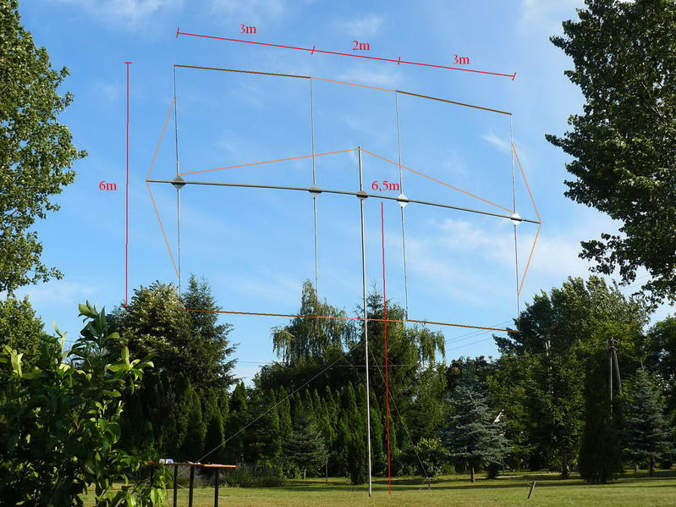
HA8RM: As I look around, I found only home brewed tools, except the main radio.
Just a couple of examples below:
- 3 different power amplifiers for HF
- Different kind of power supplies
(HV, High Amps, …)
- Antenna switching unites (remote and outdoor)
- Speech processor (Auto CQ for SSB contests)
- Converters for VHF band (tipically 2m/10m)
- All the above mentioned antennas
- Antenna tuner units
- Many home made radios, before I owned my professional RIG

AJ8B: What advice do you have for those of us trying to break pileups to work DX?

HA8RM: I guess, you will never know the good answer from me, haven’t too much practical experiencesin that. You know, I don’t really like the DXpeditions, I tried to avoid them mostly instead of wasting my time there.

Anyway, during contesting or my DXing, I prefer the most operative partner, I reply him first. A good CW or SSB skilled operator can be succesfull very often, yet if he hasn’t extreme power or antenna. Catching the right rhytm is also very important! Sometime tuning away 50-80 Hz also recommended!

AJ8B: Any QSLing hints?

TOP ^
HA8RM: I prefer the direct QSL change, as I wrote it at my QRZ.com page. This way everybody get my card quickly and safety, who really need it.

AJ8B: Thanks for taking the time to answer my questions. Is there anything you would like to share with us?

HA8RM: Thank you Bill, I really appreciated that you found me from the other part of Globe and made this interwiev.
My message is for all: There is no limitation in real life, just in the mind. Many years over I was a defeatist, I could not imagine, that I can have a good low band station, even a rotatable 80m Yagi. Then I started thinking different way, after some unsteady steps, I became braver and braver and finally realized my dreams.

I wish good success and DX for you and the kind Readers!

Peter, HA8RM

+ ----------------------------------------------------+

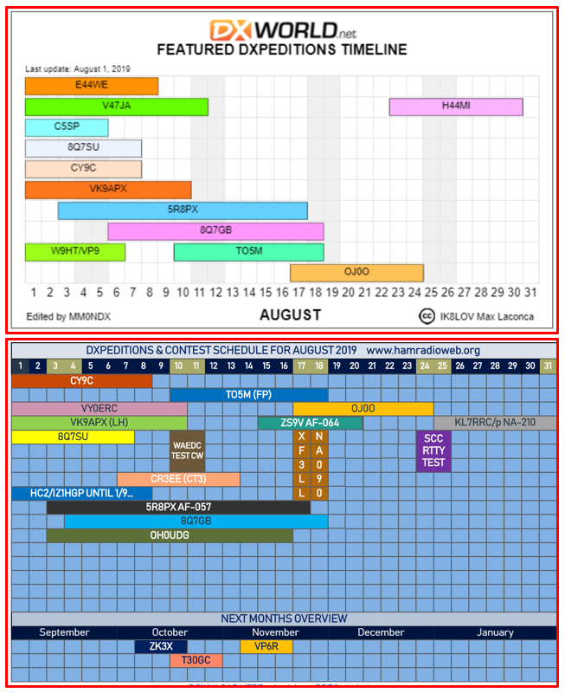
It is time for our monthly DX Calendar. These two calendars come from dx-world.net and hamradioweb.org.

TOP ^

DX news

ARLD031 DX news

This week's bulletin was made possible with information provided by The Daily DX, the OPDX Bulletin, 425 DX News, DXNL, Contest Corral from QST and the ARRL Contest Calendar and WA7BNM web sites. Thanks to all.

MALDIVES, 8Q. Gil, IZ2DLV is active as 8Q7GB from Nika Island until August 18. Activity is holiday style on 40, 30, 20, 17 and 15 meters using CW, SSB and FT8. QSL via LoTW or ClubLog.

LORD HOWE ISLAND, VK9L. Rick, AI5P is active as VK9APX until August 10. Activity is on 40 to 17 meters using CW and FT8. QSL via AI5P, direct or by the Bureau only. Also, look for Michael, DF8AN, to be active as VK9LQ from November 21 to 27. Activity will be on 160 to 6 meters using CW, RTTY, FT8 and other Digital modes. QSL via home call, direct, by the Bureau or eQSL.

GHANA, 9G. Chip, KB1QU will be active as 9G5QU from September 8 to 21. Activity will be on 40, 30 and 20 meters using CW, FT8 and FT4. QSL via N4GNR direct.

WESTERN KIRIBATI, T30. Operators Yuris, YL2GM, Jack, YL2KA, Kaspars, YL1ZF and Kristers, YL3JA will be active as T30L from September 6 to 15. Activity will be on 160 to 6 meters, and possibly 60 meters, using CW, SSB, RTTY and FT8. QSL via YL2GN direct or via ClubLog.

NAURU, C21. Operators Yuris, YL2GM, Jack, YL2KA, Kaspars, YL1ZF and Kristers, YL3JA will be active as C21W from September 16 to 25, after their Western Kiribati operation. Activity will be on 160 to 6 meters, and possibly 60 meters, using CW, SSB, RTTY and FT8. QSL via YL2GN direct or via ClubLog.

MADEIRA ISLANDS, CT9. Operators Gerd, DF9TS, Detlef, DK3QZ, Michael, DK6QW, Marcus, DL1EKC, Kai, DL3HAH and Andreas, DL3YM will be active as CR3W from Santana during the Worked All Europe DX CW Contest, August 10 and 11 as a Multi-Single entry. QSL CR3W via DL5AXX, OQRS or LoTW. Look for operators to be active outside of the contest as CT9/home call usually on 160 to 10 meters using CW, SSB and RTTY. QSL via their home call signs.

SOLOMON ISLANDS, H4. Operators Michael, DL2GMI and Bernhard, DL2GAC will be QRV as H44MI and H44MS, respectively, from August 23 to September 2. Activity will be on 80, 40, 20, 15, 10 and 6 meters using SSB, RTTY and FT8. QSL via their home call sign, by the Bureau, direct or LoTW.

THE NETHERLANDS, PA75. Look for special event station PA75OMG to be active September 12 to 22 to celebrate the anniversary of freedom and Operation Market Garden during World War II. QSL via the info on QRZ.com.

CUBA, T45. Members of the DX Punta Maya Group will be active as T45FM from the Punta Maya Lighthouse (NA-105, ILLW CU-032, ARLHS CU-005) from August 15 to 19. Activity will be on 160 to 10 meters using CW, SSB and the Digital modes. An emphasis will be on the International Light-house/Lightship Weekend (ILLW). QSL via RW6HS.

TOP ^
LIBERIA, A8. The Italian DXpedition Team of 11 operators will be active from September 28 to October 11. They plan to use two call signs: A82X for CW, SSB and RTTY and A82Z for FT8 only. Activity will be on 160 to 10 meters using CW, SSB, RTTY and FT8. They are planning to use 5 stations with maximum flexibility. QSL via OQRS, I2YSB direct only or LoTW after the operation.

ANTIGUA, V2. Bud, AA3B will be active as V26K from September 8 to 20. Activity will be sporadic because he is doing maintenance on the station but will be primarily CW on various HF bands. QSL via LoTW or via AA3B, direct or by the Bureau. An OQRS will be available via ClubLog.

MICRONESIA, V6. Al, K7AR will be active as V63AR from November 18 to 26. Activity will be on various HF bands with a focus on 160 and 80 meters, including an effort in the CQWW DX CW Contest (November
23 and 24). QSL via home call.

THIS WEEKEND ON THE RADIO. The WAE DX Contest, CW, QRP ARCI European Sprint, SKCC Weekend Sprintathon, Maryland-DC QSO Party and The 4 States QRP Group Second Sunday Sprint are all on tap for this weekend. Please see August QST, page 84 and the ARRL and WA7BNM contest web sites for details.

#########

Special Events

08/15/2019 | D-Day Conneaut
Aug 15-Aug 18, 1600Z-0400Z, W8D, Conneaut, OH. Conneaut Amateur Radio Club. 14.285 7.190 3.996 3.885. QSL. Garret Scott W8D, 10236 Birch Hill Ln., Knoxville, TN 37932. D-Day Conneaut recognizes the 75th anniversary of the World War II Allied D-Day Landings on the beaches of France in 1944. Event will include the country's largest reenactment of the D-Day landings with more than 1,800 WWII reenactors from around the world participating. Radio operations will include vintage WWII equipment https://www.facebook.com/W8BHZ

08/17/2019 | Port Clinton Lighthouse Festival
Aug 17, 1500Z-2100Z, W8GNM/8, Port Clinton, OH. Port Clinton Lighthouse Conservancy. 14.335 14.285 7.230 7.200. QSL. Geoff Mendenhall, 4720 E. Terrace Cir, Port Clinton, OH 43452. Lighthouse activation in conjunction with International Lighthouse and Lightship Day. Check web cluster for operating frequencies. QSL via LoTW only to W8GNM/8 portclintonlighthouse.org

08/17/2019 | WA8Q 30th Anniversary Celebration
Aug 17-Aug 18, 1600Z-0359Z, N8OWS, Independence, OH. Woodchuck Amateur Radio Club. 14.250 7.180 3.825. Certificate & QSL. Woodchuck ARC, 965 Primrose Drive, Independence, OH 44131. www.woodchuckarc.com

09/13-22/2019 | We will honor and support our Veterans with a Special Event on the air as K4MIA/8. Linda N8LRS and Metro W8MET will be the sister-station from Ohio for the 4th year.

09/14/2019 | Harvey Houses on the Air Special Event Stations
Harvey Houses on the Air Special Event Stations will activate many of the 84 historic Harvey Houses each year on the second Saturday of September (in 2019, this is September 14). Last year there were seven HHOTA activations and this year we are expecting 15.

TOP ^
You probably know Fred Harvey built and operated Harvey House Hotels and Restaurants (both commonly referred to as Harvey Houses) along western railroads. Apparently, the only Harvey House in Ohio was in Cleveland’s Union Terminal Station. HHOTA information is at www.qsl.net/vcara which includes links to more information about Harvey Houses and the famous Harvey Girls recruited as staff.

Thank you and 73,
Andrew Eldridge, AE5NM
HHOTA Coordinator
New Mexico’s Valencia County Amateur Radio Association is sponsoring HHOTA.

Ohio Statewide Courthouses On The Air Special Event, August 24, 2019

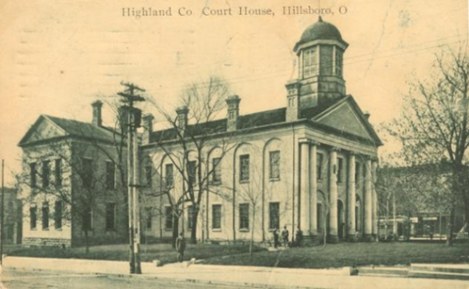
Event Background
Last year there was the Ohio Covered Bridge Special Event that was led by John Levo, W8KIW Editor of the Highland ARC’s Monday Morning Memo. Several clubs participated and was a complete success. Additionally, there were several folks interested in Ham Radio at the event who have now become new Hams. Yes, anytime there is a public event resulting in a gain to the Ham Radio community, it is a total success.

This year in keeping with the historical event series, John and the members of the Highland ARC decided to do a special event from their courthouse lawn. John published an article in the Monday Morning Memo which attracted the attention of Michael Love, WB8YKS Southern Ohio Amateur Radio Association (SOARA) PIO. John and Mike decided that there may be interest in an all-state special event celebrating the courthouses in all of Ohio’s 88 counties. Scott Yonally, N8SY Ohio Section Manager thought it was a fantastic idea and requested John and Mike to reach out across the state to determine the level of support for the event. The Ohio Section has 117 affiliated clubs of which 48 are Special Service Clubs and there are 29 PIOs. There may not be a club listed in each county by address, but we do have Hams in each county.

Promoting Ham Radio
This may be a first for the ARRL and the Ohio Section. This event has all the opportunities for a FUNFILLED family day engaging the public and our government officials. Additionally, one county’s club is partnering with their county commissioners, historical society, EMA, sheriff’s office, public library, chamber of commerce, and news media. The club has decided to use a large tent as the event will take place rain or shine. Their PIO will make handouts available about ham radio and promoting the ARRL, ARES, RACES, Ohio Section and their local club. A special focus will be made to spotlight the public awareness of the hobby and the benefits of a Ham radio license, emergency and community service. The public will be invited to talk on the radios under the direct supervision of a licensed operator. Several clubs plan to provide contact QSL cards and/or certificates to capture this historical event.

Event Details
Yes, we are excited and hopefully you are as well, about participating in this historical Ohio Courthouses on the Air Special Event. We are requesting ALL Ohio Clubs and Hams to consider supporting this special event. The event will take place on, Saturday, August 24, 2019, from 9:00 AM to 4:00 PM. However, the hours can be extended by each club. Additionally, each club will determine the frequencies and modes they will use.

TOP ^
Another opportunity presents itself as the Ohio QSO Party www.ohqp.org is also on the air, Saturday, August 24th. Therefore, these two events will complement each other providing contacts not only from within Ohio but across the country. All Hams are invited to participate.

Contacts for additional information:
Michael Love, wb8yks@arrl.net or John Levo, W8KIW highlandara@yahoo.com

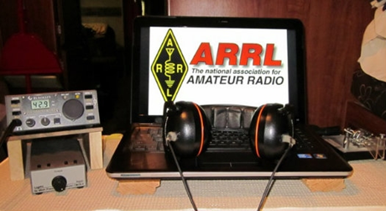
ARRL Contest Corner

An expanded, downloadable version of QST's Contest Corral is available as a PDF. Check the sponsor's Web site for information on operating time restrictions and other instructions.

V.E. Test Sessions

For the latest testing site information please >> Click Here << The ARRL site tracks all of the VE testing sites that register with them, including W5YI and Laurel. ARRL gives you a number of different ways of sorting to find that site that is closest to you as well.

One Question Questionnaire

Hey Gang,

It seems that about 76% of you have seen a fly over of the International Space Station. That’s really fantastic!

I’ve got another NEW – one question – questionnaire on the Ohio Section Website!

Attending a really great hamfest this past weekend, I noticed a lot of gear being sold and traded. So, with that in mind, this week’s question has to do with that subject for you to answer.

“How likely are you to pay the asking price for used gear at a hamfest??”

These One Question questionnaires are all in fun and I hope that you are enjoying answering them.

TOP ^
You’ll find the “One Question” questionnaire on the Ohio Section Website! http://arrlohio.org It’s all in fun and it’s not a scientific survey in any way, but we are learning some things that we didn’t know from these questions. I hope that you are enjoying answering these “One Question” questionnaires.

ARES Connect

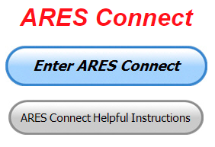
OK.. Now that we’ve all gotten over some of the scary stuff with ARES Connect let’s get down to really using this new system for everything that it’s worth. I'm here to tell you that it's to be used for ANY event that involves Amateur Radio. It can be a RACES, CERT, Skywarn, Red Cross or hams gathered at an impromptu meeting to talk about Amateur Radio. It all counts! Club meetings, hamfests, working on that club trailer, repeater, website, field day, parades, newsletter or just having fun keeping track of all those spandex folks during every kind of race imaginable are perfect examples of hours that count that are not necessarily ARES directly related but do have an impact on your community.

Do you need help with how to sign-up for an event or log your hours? How about you Administrators, do you have questions about approving your volunteer’s hours or how-to set-up an recurring event? I’ve got the answer for all of you. I have a new webpage with step-by-step instructions on how to do those things and many more. I also have a “Hints and Kinks” section that has a lot of great information on how to do something or why something works like it does. Here’s the page: http://arrl-ohio.org/SEC/connect/index.html You can also find this link on the main page of the Ohio Section website as well.. It’s just under the “Enter ARES Connect” link.

If you live in Ohio and you haven’t registered yet, we need you to get registered now. We need you to only use this URL to get registered https://arrl.volunteerhub.com/lp/oh/. Using any other entrance to register will only slow down your registration process. Again, this is for those living in Ohio only. If you are an out of state person (not Ohio), you can simply change the /oh/ to your 2-letter state designation. This will put you in the correct state for signing up

Your time adds up quickly. Make sure that all that fun and dedication counts. Get your hours logged now!

Here’s the top 10 hours earners so far August:

 | Name | Events | Hours
1 | Bret Stemen (KD8SCL) | 14 | 77.00
2 | James Grimes (AD8AP) | 8 | 66.00
3 | Alan Rothweiler (N8CJ) | 16 | 60.00
4 | Donald Kemp (NN8B) | 9 | 59.00
5 | John Major (KD8MMY) | 13 | 55.50
6 | Christopher Domenick (KC8CAD) | 10 | 55.00
7 | Dan Stahl (KC8PBU) | 22 | 38.30
8 | Grant Reed, Jr (N8KZL) | 5 | 28.45
9 | Bryan Hoffman (kc8egv) | 7 | 26.50
10 | Gordon Broadway (N8BHL) | 4 | 25.00

If you want your name to appear in this listing, you’ll have to start recording your time!

TOP ^
As you can see from the above listing, we can get real time information that shows how many hours, who volunteered and what they volunteered for. There’s a ton of information that we can draw out of the system.

We now have 1,205 registered and growing every day in the system. What’s really interesting is as of this same date there are 11,290 registered in the entire country. This means that the Ohio Section makes up over 10.68% of those registered.

Here’s a link to get you started... http://www.arrl-ohio.org/SEC/connect/ares_connect_directions.pdf
Please, don’t just hurry through the questions, read them carefully, if you don’t understand something, please ask me, I’m here to answer your questions.

Hey, let me say that this system is really great if you forget a meeting time or location? Just look it up on the calendar and there you have it. If setup, you can even see the location on a map! I have attended many meetings and gatherings just because it was listed on ARES Connect and I found it just browsing around. I wouldn’t have known about it if it hadn’t been on the ARES Connect Calendar!

This and That’s
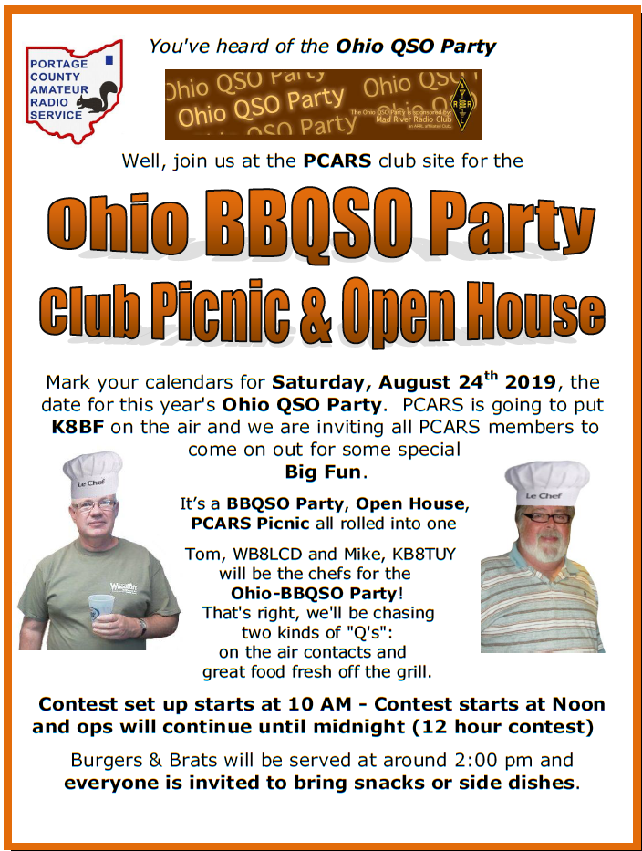

TOP ^

ICS 300 & 400 Classes Being Offered

ICS-300 INTERMEDIATE ICS FOR EXPANDING EVENTS
Hosted by: Ashland County HS & EMA and Holmes County EMA September 20 - 22, 2019

Course Description: This 21-hour classroom course provides training for personnel who require advanced application of the Incident Command System (ICS) and Individuals who may assume a supervisory role in incidents. This course expands upon information covered in the ICS 100 and ICS 200 courses.

Application Deadline: September 6, 2019

Course Registration time: 5:30 pm to 6:00 pm (day one)

Course Time: 6:00 pm to 9:00 pm (day one)
8:00 am to 6:00 pm (day two & three) (one-hour for lunch on day two & three)

Training Location: Loudonville Fire Station 200 North Market Street Loudonville, Ohio 44842

Recommended Participants: FEMA designed this course for individuals who may assume a supervisory role in expanding incidents or Type 3 incidents.

Note: During a Type 3 incident, some or all of the Command and General Staff positions may be activated, as well as Division/Group Supervisor and/or Unit Leader level positions. These incidents may extend into multiple operational periods.

Required Prerequisites: Individuals must complete the IS-100.c Introduction to the Incident Command System, IS-200.c Basic Incident Command System for Initial Response, IS-700.b An Introduction to the National Incident Management System and IS-800.c National Response Framework courses prior to attending the ICS-300 Intermediate course and provide copies of their certificates of completion to the instructors on day one of the course.

Enrollment: Students must enroll via the Department of Public Safety Training Campus website: https://trainingcampus.dps.ohio.gov/cm/cm710/pstc/pstc.html. Course registration will generally close 10 working days prior to the course start date and applicants can check enrollment/approval status via the Department of Public Safety Training Campus website.

Course Costs: There is no charge for participants to attend this course. However, Lodging, Meals, Per Diem and all other travel expenses are the responsibility of the student or the parent organization.

State Point of Contact: Lisa Jones, DSC 2, Ohio EMA, SAA Training Point of Contact, (614) 799-3824 ljones@dps.ohio.gov.

********

TOP ^
ICS-400 ADVANCED ICS FOR COMMAND & GENERAL STAFF
Hosted by: Ashland County HS & EMA and Holmes County EMA September 28 – 29, 2019

Course Description: This 15-hour classroom course provides training for personnel who require advanced application of the Incident Command System (ICS). This course expands upon information covered in ICS-100, 200, 700, 800 and ICS-300 courses, which are the prerequisites for the ICS-400 course. The target audience for this course is senior personnel who are expected to perform in a management capacity in an Area Command or Multi-Agency Coordination Entity.
Application Deadline: September 14, 2019

Course Registration time: 7:30 am to 8:00 am (day one)

Course Time: 8:00 am to 5:00 pm (day one & two) (one-hour lunch each day)

Training Location: Loudonville Fire Station 200 North Market Street Loudonville, Ohio 44842

Recommended Participants: FEMA designed the course for Senior Personnel who expect to perform in a management capacity in an Area Command or Multi-Agency Coordination Entity.

Required Prerequisites: Prior to attending the ICS-400 Advanced course, individuals must complete the IS-100.c Introduction to the Incident Command System course; IS-200.c Basic Incident Command System for Initial Response; IS-700.b An Introduction to the National Incident Management System; IS-
800.c National Response Framework, an Introduction, and ICS-300 Intermediate courses. Students must provide these certificates of completion to the instructors on day one of the course.

Enrollment: Students must enroll via the Department of Public Safety Training Campus website: https://trainingcampus.dps.ohio.gov/cm/cm710/pstc/pstc.html. Course registration will generally close 10 working days prior to the course start date and applicants can check enrollment/approval status via the Department of Public Safety Training Campus website.

Course Costs: There is no charge for participants to attend this course. However, Lodging, Meals, Per Diem and all other travel expenses are the responsibility of the student or the parent organization.

State Point of Contact: Lisa Jones, DSC 2, Ohio EMA, SAA Training Point of Contact, (614) 799-3824 ljones@dps.ohio.gov.

It is the goal of Ohio EMA to ensure that all students have the tools necessary for successful course completion. If students require additional accommodations, they should make the Ohio EMA training office aware, and staff will confidentially meet reasonable requests.

#########

TOP ^
A different Kind of Program
(from John, W8KIW)

On Tuesday, August 13 the Highland County Amateur Radio Association will present a different, but fitting program, to say “Goodbye to Summer”.

Ken Lightner, KE8JEL, will present a program on the proper way to make an ice cream float.

Following his demonstration, those attending will be given a hands-on opportunity to make their own root beer, crème soda or Coke float and then enjoy it while engaging in good conversation and fellowship with the others doing the same.

The meeting and program is open to all amateurs and others interested in radio and electronics. It’s hoped others from area clubs will attend and help bridge the relationship between clubs. There is no charge to attend the 7 pm meeting being held in the basement meeting room of the Highland County Administration Building in Hillsboro.

Final.. Final..
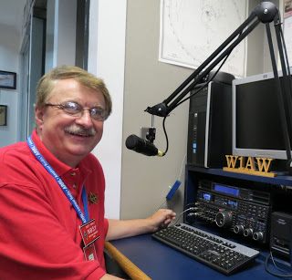
Hey Gang...

Wow.., another great week of fantastic weather, well at least form most of us. We did have an EF-1 tornado go through Huron County this week. In fact, it happened just a couple of hours before we had our monthly Northern Ohio Skywarn meeting at the EMA in Norwalk. Talk about timing!!

This past week was full of Vigilant Guard. I spent most of Monday afternoon at the Sarge. Oh yeah, I too take and pass traffic, just ask the guys of the Ohio Single Sideband Net. I do want to thank Stan, Richard, Terry, Mark and all the others that participated in this really big event. I saw in a PR blip later that said that there were over 3,300 volunteers involved. Federal, State and local government agencies took part in this exercise, and YES, Amateur Radio was utilized heavily both days of the exercise. HF, HF Digital, VHF (analog) and DMR were the main modes of communication around the state. Each mode worked without incident. This just proves once again that we can get through when most other communications fail.

It was really neat to watch the live video of a drone monitoring the locks along the Ohio river, and then seeing the counties light up on the big screens in the EOC as they got involved in the exercise. If you ever get an opportunity to visit and tour the state EOC I highly recommend it. Only then will you get a good look at the technology that we have available to us. It’s absolutely amazing.

TOP ^
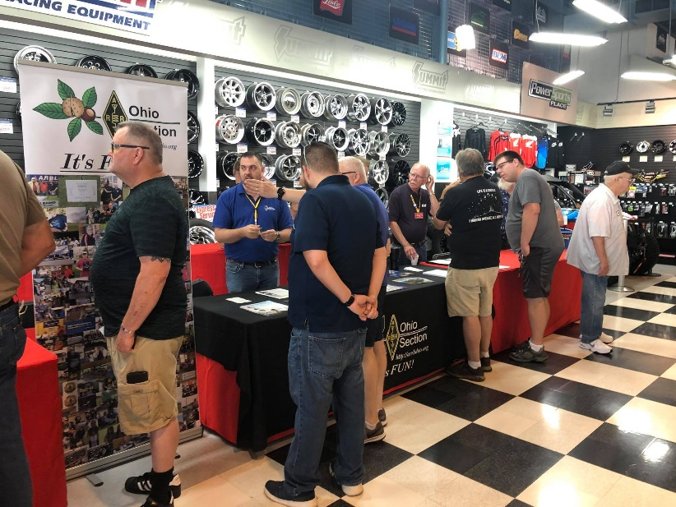

Saturday was spent with Dale Williams, WA8EFK having a blast at the first ever DX Engineering Hamfest in Talmadge. It was super crowded, and Dale and I were absolutely swamped with folks coming up to the table to just say “Hey.” I also want to say a big “Thanks” to John Lewis, AI3I, who is the Affiliated Clubs Coordinator for Western Pennsylvania who came over and lent a big helping hand at the ARRL table. Thanks, so much John!

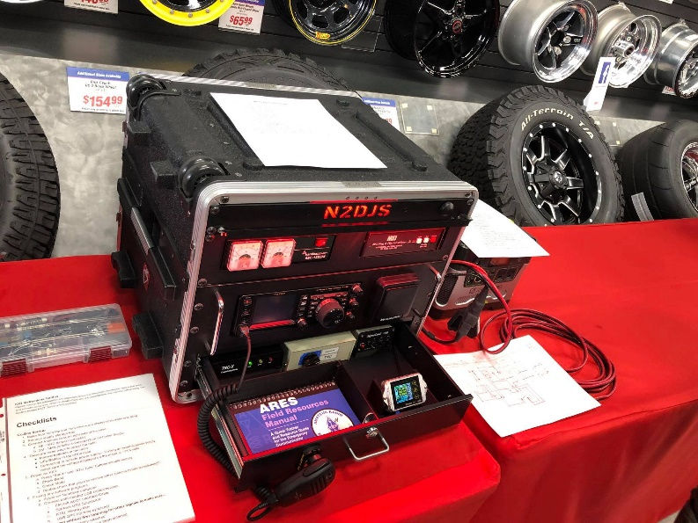

I judged the “Go Box” competition and I do have to say it was really stiff competition between the various Go Boxes. Dennis, N2DJS won the Go Box competition. He had a great Go Box with every goodie loaded in it that you could think of and he walked away with $100. Bob, K8MD, won second place and won a $50 gift Certificate from the ARRL. Congrats to everyone that brought a Go Box. Your ingenuity in designing and building these boxes is absolutely amazing for sure!
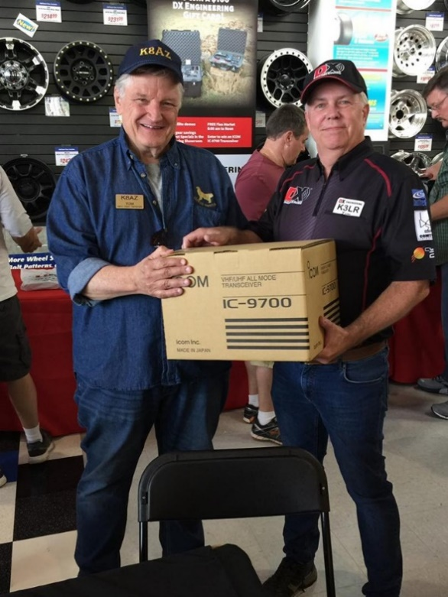

Oh, in case you’re wondering, Tom, K8AZ won the main prize, which was an IC 9700, an all mode VHF/UHF transceiver! Congrats to Tom!

As some of you know, DX Engineering is a part of Summit Racing and their complex is HUGE. Well, I’m here to tell ya’ that it was packed Saturday. Yes, it was completely taken over by Amateur Radio.

I did see a couple of guys trying to sandwich their way through the mob to get to the racing tires. They turned to me and asked what the heck was going on. I laughed and told them that their world had just been invaded by electronics geeks. I then handed them some info on what Amateur Radio is all about. I think I’ve got a couple of motorheads looking into Amateur Radio!

TOP ^
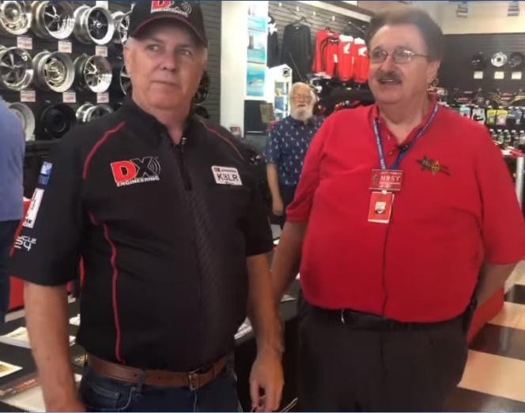
Anyway, it was a great day for everyone for sure. Oh, the flea market guys were also treated to the best day of weather so far this year. Not too hot and not to cold. In fact, the only complaint that I heard was “It was too bright.”!!! Guess we need to find that fella some sunglasses to cure that ill. Tim and I even cut a video right in the middle of the hamfest!

Thanks, so much Tim, K3LR, Ken, KA8OAD, Teri Grizer, K8MNJ and all the gang at DX Engineering for making this a really great hamfest! I’m really excited to see this even get even bigger and better next year!!

Sliding up the band a bit… My antenna project is on hold for a while. I’ll get to it, but most likely it will be cold, windy and 4 feet of snow on the ground before I get my vertical antenna up and in the air. Oh well, that’s the perfect time to do antenna work anyway, right!!! I do have my 75-meter dipole up and it’s working just great, so I’m not entirely off HF.

Sliding down the band a bit… I do want to mention that Neil Friedman, N3DF had his letter to the editor published in the September issue of QST. If you get a chance, you’ll want to read it. You’ll find it in the Correspondence – Letters from our Members section, page 24.

Switching bands… Have you taken the time to get signed up in “Connect” yet? I know that this must sound like a broken record, but it is important for everyone to not only get signed up but start using as well. Please, don’t let the name ARES fool you, this new system is for everyone and not just for ARES. So, if you haven’t already signed up, now is the time. I know that this must sound like a broken record to most of you, but you won’t believe how many folks I meet every week that still tells me they haven’t heard of it yet.

On last check of the frequencies before going QRT… Website updates… We’ve had another update this week from Daniel, KB8LKH on the CS-800D and CS-800 instruction sheets. If you haven’t seen the changes yet, you’ll want to check them out!

Is your club doing any special activities that you’d like the Section to know about? Do you have a story that you’d like to tell about something that you or your club has or is doing? Let me know about it and let’s get it in the next edition!

Whelp… That’s going to do it for this time around. Stay safe, enjoy the sunshine while we have it, and most of all… have FUN!!

73,

Scott, N8SY

PS.. For those of us old enough to have been a part of one of the biggest musical events to ever have taken place in America, this week celebrates 50 years since Woodstock. There were over 500,000 young people gathered on a farm in New York celebrating life. Wow. What a fantastic time in history this was!

TOP ^

Welcome New Subscribers

Amy, KD8LTB; David, KD8PSB; Dennis, KD8MEL

#########

DX Engineering Hamfest
(Pictures provided by DX Engineering)
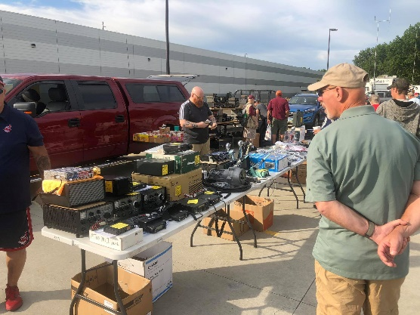
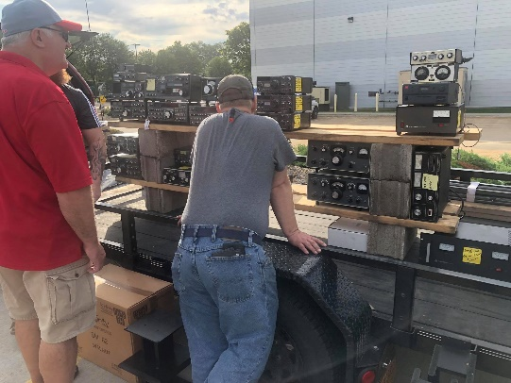
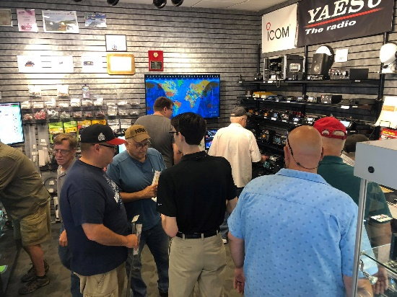

TOP ^
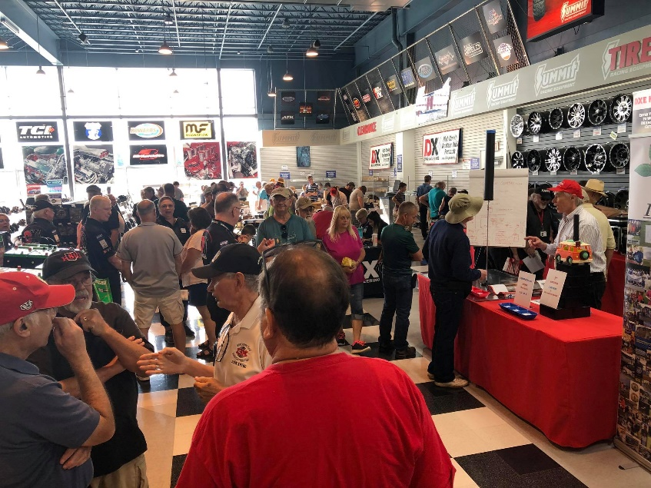
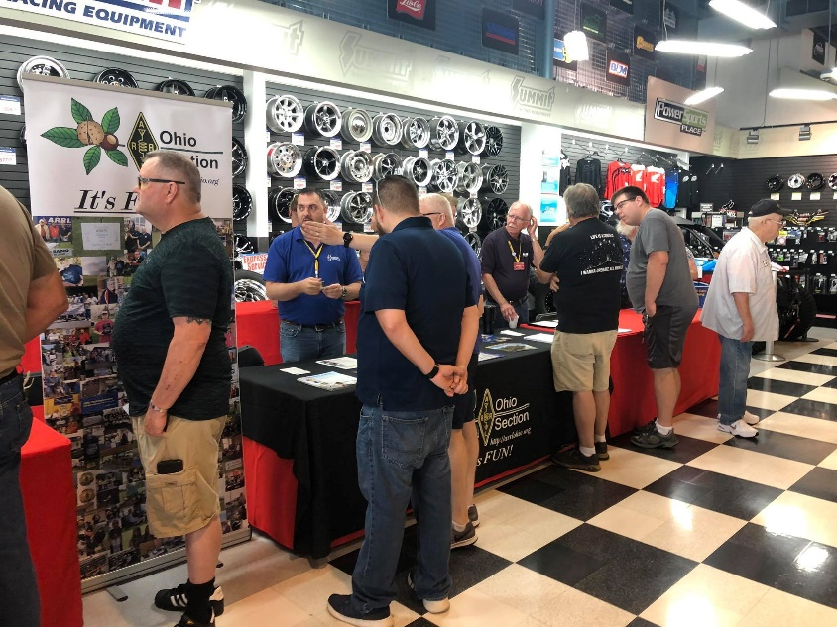

TOP ^

Back Issues of the PostScript and Ohio Section Journal (OSJ)

Hey, did you know that PostScript and Ohio Section Journal (OSJ) are archived on the website? You can go back and look at any edition simply by clicking:
http://arrl-ohio.org/news/index.html

Chit – Chat, and All That!

Do you know someone that’s not getting these Newsletters? Please, forward a copy of this Newsletter over to them and have them “Opt-In” to start receiving them. Heck, just have them send me an email n8sy@n8sy.com and I’ll get them added to the Ohio Section Emailing list.

We now have many thousands of readers receiving these newsletters weekly. Quite impressive, I’d say! I urge all of you to make sure that everyone, regardless of whether they are a League member or not, get signed up to receive these weekly Newsletters.

You can always “Opt-Out” at any time if you feel this is not what you were expecting. It’s fun and very informative. All of your favorite past newsletters are now archived too.
You can go back at any time and read them. Just go to: http://arrl-ohio.org/news/

Got questions, concerns or would just like to sit and chat awhile? Heck, I’ll even buy the coffee!! Give me a call at (419) 512-4445 or email me at: n8sy@n8sy.com

The pictures on the front page are from various newsletters, Facebook posts and/or were sent directly to me in recent weeks. Take a good look at them, you just might be in one of the pictures! “SMILE… you’re on the Ohio Section News!!”

TOP ^

PostScript is produced as a weekly newsletter. I want to thank everyone that has contributed articles and ideas to make this an even better news source. I sincerely hope that you have enjoyed this edition and will encourage your friends to join with you in receiving the latest news and information about the Ohio Section, and news and events happening around the world!

