[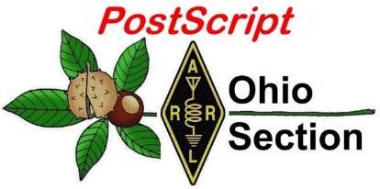](http://arrl-ohio.org/news/) ***August 5th***

***Edition***

🡪 National News 🡪 The Handbook Give Away

🡪 Club Corner 🡪 Hamfests

🡪 DX This Week 🡪 One Question Questionnaire

🡪 VE Testing 🡪 ARES Connect

🡪 Final.. Final..

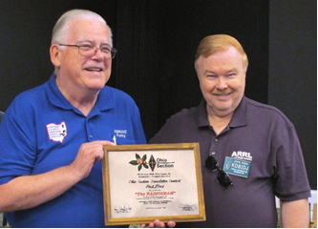

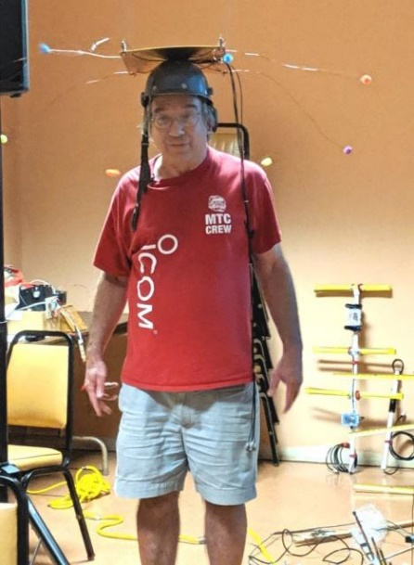

***National News***

(from arrl and other sources)

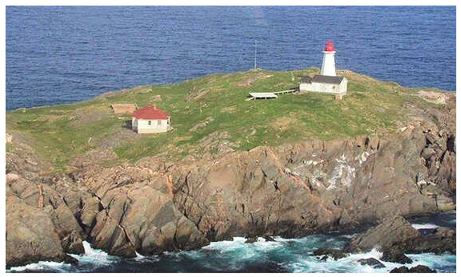

***St. Paul Island CY9C DXpedition Hits the Airwaves***

The slightly delayed CY9C St. Paul Island DXpedition is now on the air. CY9C has been spotted on 40, 30, and 20 meters, with a lot of initial activity on FT8 (Fox/Hound mode) in addition to some CW and SSB. The CY9C DXpedition by Murray Adams, WA4DAN, and six others, will continue until **August 8**. All operations will be from the Northeast Island. The CY9C DXpedition already has been approved for DXCC credit.

#########

***One Dead, One Injured in New Hampshire Ham Radio Tower Mishap***

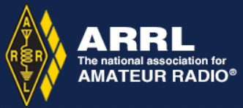A tower dismantling turned tragic on Saturday, July 27, in Deerfield, New Hampshire, when two radio amateurs working some 40 feet up on the tower were carried to the ground when the structure collapsed. Joseph Areyzaga, K1JGA, 52, of Goffstown, New Hampshire, did not survive his injuries sustained in the fall, while the tower’s owner, Michael Rancourt, K1EEE, 65, was seriously injured and remains hospitalized. Rancourt was taking down the tower in preparation for selling his house, and the pair had nearly completed their work. They were tied into the tower and went down with it as it collapsed.

The tower, a tilt-over model said to be 40 to 50 feet, had been bolted to prevent it from tilting as it was being dismantled.

A law enforcement source said a number of people were at the site at the time for a social gathering as the tower was being taken down, and they witnessed the tragedy.

No official determination has been made regarding the cause of the structural failure, but a radio amateur who visited the scene afterward observed that two of the tower’s three legs were clearly compromised and split cleanly and the third leg bent, just above the fully intact tilt base.

The New Hampshire Amateur Radio tower-related fatality is the second such deadly incident in a little more than 6 weeks. In mid-June, a Pennsylvania radio amateur died when the tower he was installing collapsed as he was attempting to attach a guy line to the structure’s bottom section.

#########

***RSGB Announces New FT4 Contests***

The Radio Society of Great Britain Contest Committee has announced a [**series of contests**](https://www.rsgbcc.org/hf/rules/2019/r80m_ft4.shtml) using the new digital mode FT4. The three short-duration events on 80 meters (dial frequency 3575 kHz USB) are aimed at offering experience to FT4 newcomers.

TOP ^

“As this series is experimental, there are likely to be changes as we develop experience with this mode, so please check the rules prior to each event,” the announcement said. The objective is to score as many points as possible based on the distance between stations (subject to a maximum score per contact).

The contests will take place on Monday, September 2, 1900 – 1959 UTC; Monday, October 7, 1900 – 1959 UTC, and Monday, November 4, 2000 – 2059 UTC. Visit the [**RSGB Contest Committee**](https://www.rsgbcc.org/hf/rules/2019/r80m_ft4.shtml) website for details. The FT4 protocol is within the [***WSJT-X 2.1.0 suite***](http://physics.princeton.edu/pulsar/k1jt/wsjtx.html) and is available for download for several platforms.

FacebookTwitterLinkedInRedditMore

***2019 Ohio Section Newsletter Winners Announced***

At the August 3rd Columbus Hamfest John Ross, KD8IDJ, the Ohio Section Public Information Coordinator announced the winners of the 2019 Annual Ohio Section Newsletter Contest.

Here’s the announcement from John!!

Just when I thought I had heard it all from the judges…they continue to excel in selecting the winners…and the discussion was even more exciting.

So, here are your 2019 Newsletter Contest winners:

**First Place: The RADIOGRAM….Portage County Amateur Radio Society**

**Second Place: Posts from the Union County Amateur Radio Club**

**Third Place: DELARA News…Delaware County Amateur Radio Association**

**Fourth Place: ATCO…Amateur television in Central Ohio**

**Honor Mention…MVRC The Mount Vernon Radio Club newsletter**

***2019 Allan Severson, AB8P Recipient Announced***

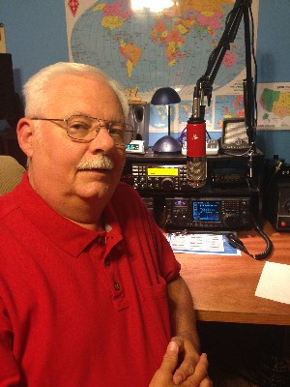

Scott, N8SY announced the latest recipient of the Allan Severson, AB8P award. This year the award goes to none other than **Stan Broadway, N8BHL**!!

Stan becomes the 25th recipient of this very prestegious award.

TOP ^

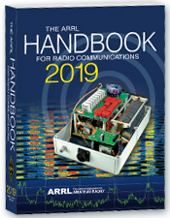***The Handbook Give Away***

Hey Gang,

We had another fantastic response this month, but I’m sure you’re more interested in knowing just who won the Handbook this month...

And the winner is…. ***John Cerny, KD8VMK***

We've had another a great response after with the Give Away so… I decided to also give away something really special this time around. Since the weather has changed from cold to really hot and sticky, why not give out official Ohio Section T-Shirts!

So, I'm sending out an o***fficial Ohio Section T-Shirt*** to:

***Bill Edwards, WB8WOB & Stephen Villanova, WD8BQS!***

Many of you ask me just how do I know when the drawing is on? Well, that’s easy all you need to do is check in on the Ohio Section Website on a regular basis and watch for the big RED Arrow that will appear on the left side of the page. This is the sign that the drawing is on and you need to get registered. So, keep a sharp eye out on the website and check in often! <http://arrl-ohio.org>

You just never know.. You just might be the next winner!

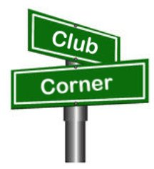***Club Corner***

This is YOUR cornner of the newsletter. Send me what your club is doing and I’ll make sure that it gets in. Got a special event or club project that you want everyone to know about? Send it to me!. Need help with a project? Send it to me.

Let me know what you club is up to. Are you going to have a special guest at your meeting or are you having a special anniversary? Just sent it to:

[n8sy@n8sy.com](mailto:n8sy@n8sy.com)

#########

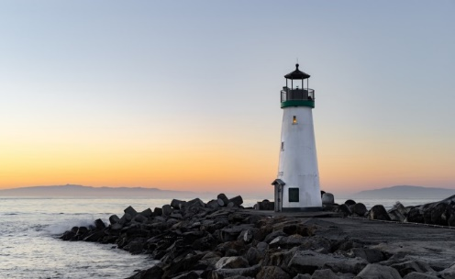***Lighthouses on the Air***

Hello SARA members and friends.

On Saturday, **August 17th** I will be activating the Fairport West Breakwater Light for the International Lighthouse Special Event, using the call N8L. I will go it alone and just hang a wire off of the observation deck if I have to. But ideally, I would like to run a couple of radios simultaneously 24/7 for the weekend.

TOP ^

The accommodations are really quite nice. There will be a Dropbox link to photos below. I am looking to gather a crew of a half dozen to a dozen Hams to work the project, much like a Field Day style operation, but without the contesting. This will be an open to the public operation and visitors will be welcome.

Due to the ruggedness of the terrain to get to the Lighthouse, I will be working on arranging a secondary location at the Fairport Harbor Lighthouse Museum for those who cannot make the trek along the break wall, climb a ladder or up the steps of the base. This will also serve as a backup location in the case of inclement weather.

If you are interested in participating in event as part of the crew, help with set-up, tear down, supplying equipment, radios, antennas, feed lines, analyzers, food, etc., please contact me to begin making some plans.

The Lighthouse is fully furnished, but with no running water. It uses a composting toilet. There is a 5,700 watt (7,100 peak) generator on site, and a small portable as well. We need to furnish our own gasoline, of course. Besides the lights and radios, the only appliances we would be running would be the refrigerator, the coffee pot, and maybe the microwave. Here is a link to the Dropbox folder with pictures.  
<https://www.dropbox.com/sh/6b8lc06zb2c3lxj/AADJaxCp0DHps0bICdKq6TGma?dl=0>

My Contact is: [dspondike@aol.com](mailto:dspondike@aol.com) or call 330-801-0089

#########

***Toledo Mobile Radio Association (TMRA) Sponsoring Fox Hunts***

TMRA will be holding a park fox-hunt (transmitter hunt) very soon!  Please come out and join us! These particular hunt will be “learning” oriented and experienced hunters will be focused on making sure that those newer to the activity are learning and successfully using their equipment to find the hidden transmitters.  (However, of course, experienced hunters are very welcome to both hunt or elmer!)   Some additional/spare fox-hunt equipment will be available for those that don’t have any (but feel free to bring your own!)  The hunt will have two hidden transmitters.  (one on 145.555MHz and one on 144.002 MHz).  Please note that active lightening or rain will cancel the event (listen for 147.27 for info).

**August 10th** (Hunt starts at 11am) – Location = start at Buchner Center off of Oak Openings Parkway (near Mallard Lake) in Oak Openings Metropark.

#########

***Help Needed for the Potato Stomp***

The Mantua Potato Stomp will be holding their annual foot race on **Saturday September 7th** in the Mantua-Hiram area. This event consists of a four-mile and a nine-mile race on various roads in Mantua Village and Township and Hiram Township. Radio operators will be needed to staff the intersections on the course, provide a Shadow to the race director, a NCS, and a sweep.

TOP ^

Ed, K8IV recently installed a UHF repeater at the tower on the hill just east of Mantua Village. It was used for the Headwaters Adventure Race, which is in the same area that the Mantua Potato Stomp race will take place. The coverage of this repeater in the local area is superb and allows Radio Operators to use just a UHF hand-held at almost every location in the area with full quieting coverage. Because of this we will no longer have to rely on establishing cross-band repeaters to get coverage throughout the course.

This is also the date for OSPOTA so I know many of you will be involved with that. But, for those who are not, I would sincerely appreciate your help. If you’re new to public service communications support and are reluctant to do it alone, let me know and I’ll pair you with an experienced operator so you’ll get a chance to observe, learn and participate. Drop me a note at [k8cav.coms@gmail.com](mailto:k8cav.coms@gmail.com) if you can help with this event. Thanks!

#########

***USAF Marathon Needs Help***

Approximately 70 amateur radio operators are needed to support the USAF Marathon at Wright Patterson Air Force Base on **Saturday, September 21, 2019** to provide the USAF Marathon Staff with emergency and logistic communications. This world class event has over 20,000 participants, volunteers, and spectators in attendance every year.

Amateur radio operators are indispensable in rapidly communicating information on runner’s locations and status, heat index settings, severe weather notifications, as well as emergencies and logistic issues. Plus, APRS is utilized to track lead runners and “Tail End Charlie’s”, thus allowing race officials and emergency services to more accurately monitor the race progression.

According to Brandon Hough, the USAF Marathon Race Director, the senior base leaders rely on the communication skills of our amateur radios operators and use them as a vital resource.

Multiple races are held on this day including: 10K, Half Marathon, Full Marathon, and Wheelchair. The volunteer registration website for the USAF Marathon is now open.

If you will be in the Dayton, Ohio area on Saturday, September 21, 2019 and would like to take part in this world class event, please go to the USAF Marathon website at <http://www.usafmarathon.com/volunteer>  and click the volunteer now link, scroll down to the amateur radio section to register. Training will be provided prior to the event.

How to register online:

1. Go to the website above.
2. Click on the Volunteer Now button.
3. Acknowledge that you’re going to a new website.
4. On the new website, ignore the “password” entry box near the top of the page. Scroll down to the “Amateur Radio Operator” section and click the check box for the Amateur Radio Operator Position and only that position.
5. Scroll to the bottom, past all the other volunteer positions, and fill in your name and other required data.
6. Check the box below the waiver paragraph and then type in your name for a digital signature.
7. Click the “Sign Up to Volunteer” button.

TOP ^

1. You’re done!
2. You should get an automated email response from Jeanette Monaghan acknowledging your registration.
3. Contact Phil Verret if you have any questions or concerns.

**Registration closes August 31, 2019**.

If you have any questions please email to: Phil Verret, [KA8ZKR@ARRL.NET](mailto:KA8ZKR@ARRL.NET)

#########

***Geauga Amateur Radio Association Needs Help***

All - the 197th *ever* Great Geauga County Fair is **just a few weeks away!**  As usual, it's Labor Day weekend, Thursday through Monday.

The Geauga Emergency Amateur Radio Service has been invited by the sheriff's office once again to participate. We have a few functions at the fair:

* Dispatch and drive golf carts to help people get around the fairgrounds and to and from the parking lot.
* Staff the sheriff’s office building outside of Gate 1.
* Walk the fairgrounds to provide eyes and ears for the on-duty fire departments and the sheriff’s office.
* Perform other miscellaneous tasks to assist the sheriff’s office and fire departments.
* Help the county firefighters' association clean up fire station 1 on Thursday, August 22.

If any of these sound like fun, please join us!

Note that you do not need to be a ham radio operator to drive a golf cart!  We use county radio frequencies for the golf cart portion. Feel free to bring a co-pilot/navigator or a friend, we'd appreciate their help! (Please make sure you register them as well, so we have an accurate headcount).

When signing up, you'll tell us what days and which parts of those days you'd like to work.  We have three very loosely-defined "shifts":

* Morning - *roughly* 9:00AM-1:00PM
* Afternoon - *roughly* 1:00PM-5:00PM
* Evening - *roughly* 5:00PM-9:00PM (and beyond if you can stay)

These are here to give us a very rough idea of when you'll be available.  If you can only come out for an hour or two, that's fine, just choose the option(s) that work best for you.  That said, please only sign up for days and times you can commit to working.  This helps us plan resources.

Thanks for your interest and we hope to see you at the fair! Please sign up using the following link: [http://bit.ly/2019geaugafair](https://ohiogears.org/wp-content/plugins/civicrm/civicrm/extern/url.php?u=34&qid=1493) If you have any questions or concerns, please email [info@ohiogears.org](https://ohiogears.org/wp-content/plugins/civicrm/civicrm/extern/url.php?u=35&qid=1493).

#########

TOP ^

***Paulding County ARC Gets A Great Donation***

The Paulding County Ohio Amateur Radio Club recently became a 501 (c) (3) corporation. The leg work was completed by a couple of the members with guidance from the County Prosecuting Attorney.

Because the club became a non-profit, they just recently received a donation of a 32-foot travel trailer! It is currently being converted into a communications trailer with the first trial run (hopefully) being the Ohio Courthouses on the Air event on August 24th.

For those of you that are in or around our area, we do hold a net every Monday evening at 19:00 on 147.135 with a 141.3 tone and we’d love to have you check in.

Fred Pieper, N8OXQ

#########

***POW – MIA Event***

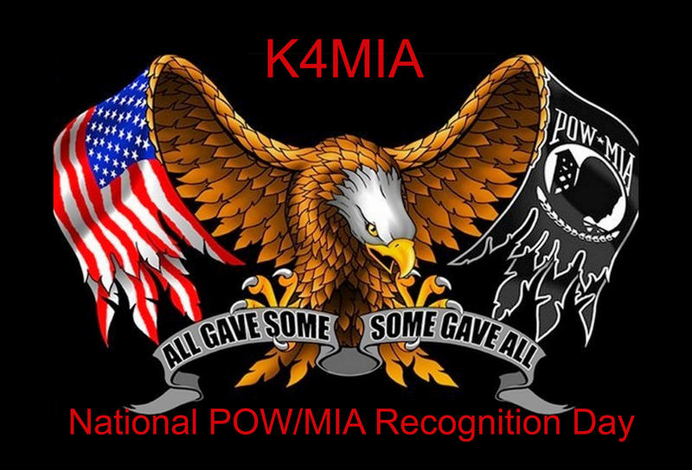On **September 13 thru the 22nd** of 2019 We will honor and support our Veterans with a Special Event on the air as K4MIA/8. Linda N8LRS and Metro W8MET will be the sister-station from Ohio for our 4th year.

This event originated from K4MIA , Mike from Florida with other sister-stations involved. Details can be found on the ARRL website under “ON-THE-AIR” under SPECIAL EVENT under the call-letters of K4MIA.

Also, this Special Event will be in the September QST. Please take part in this Special Event for our Veterans. QSL is available with SASE. We will be operating on 40 meter's SSB. GOD BLESS AMERICA 73, Linda and Metro

#########

***Vigilant Guard Exercise***

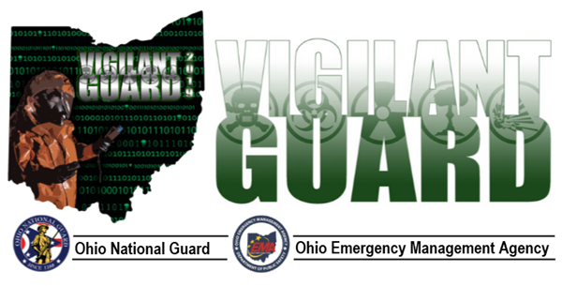Hi gang!  It’s getting time for the Vigilant Guard exercise. We will be playing Monday and Tuesday from the Sarge. I don’t have information on the what’s and when’s, but I do know there will be a communication blackout…which means amateur radio will be the only source of activity during that time.   The Blackout will be on Tuesday from 10am to 2pm, so that’s when we’ll need you all on your toes (and on radios :-)

TOP ^

There are a few counties playing- but for ALL if you have someone who can listen to 3902 or the Ohio State DMR talk group on Monday especially, it would be good. That way we can prove our abilities to those watching.   We will also be listening on 76 in Columbus plus repeater-hopping as needed.

The good news is this might be more realistic because we don’t know when and what… so as always, be on your toes!

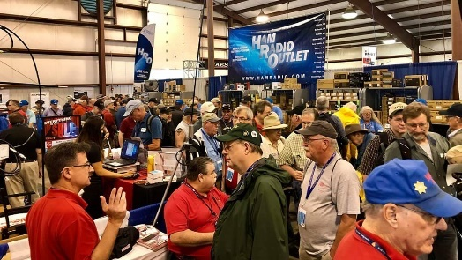[***Upcoming Hamfests***](http://arrl-ohio.org/hamfests.html)

|  |
| --- |
| **08/10/2019 | DX Engineering Hamfest**  Location: Tallmadge, OH  Sponsor: DX Engineering  Website: <https://www.dxengineering.com/> |

|  |  |
| --- | --- |
|  |  |
| **08/17/2019 | GARS 2019 HamFest**  Location: Germantown , OH Sponsor: Germantown Amateur Radio Society  Website: [http://www.WG8ARS.org](http://www.wg8ars.org/) | **08/18/2019 | Warren Tailgate Swap Meet**  Location: Warren, OH Sponsor: Warren Amateur Radio Association  Website: <http://www.w8vtd.com/2019/05/30/2019-tailgate-swap-meet/> |
| **09/08/2019 | Findlay Hamfest**  Location: Findlay, OH Sponsor: Findlay Radio Club Website: [http://www.findlayradioclub.org](http://www.findlayradioclub.org/) | **09/21/2019 | The OHKYIN ARS Hamfest**  Location: Cincinnati, OH Sponsor: OHKYIN Amateur Radio Society Website: [http://www.ohkyin.org](http://www.ohkyin.org/) |

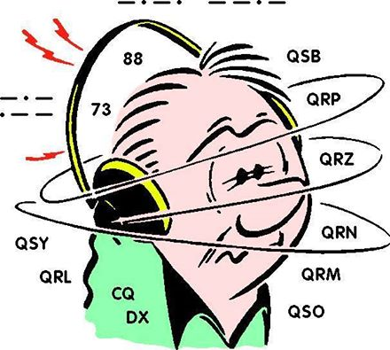***DX This Week – Support and Reference #2***

*(from Bill, AJ8B)*

DX This Week – QRM

Bill AJ8B ([aj8b@arrl.net](mailto:aj8b@arrl.net), @AJ8B, [www.aj8b.com](http://www.aj8b.com) or [www.swodxa.org](http://www.swodxa.org) )  
 CWOPs Member #1567

Next week, I will give an overview of the ARRL card sorter, part of the Incoming QSL Buro. I have gone through the latest set of cards that I received, and I need address information for several hams. I searched the FCC database (as mush as I could) as well as QRZ.com. If your call appears below, or if you have the address for one of these hams, please contact me. I have QSL cards for them! => AA8NT, K8NMN, K8NST, K8NTM, K8NVI, K8NYU, KA8NY, KB8NTU, KE8NQ, KK8NON, KN8NY, KO8NK, N8NAO, N8NLI, N8NO, N8NON, W8NBJ, W8NGT, W8NNP, WA8NDE, WB8NGC, WX8NC

TOP ^

Depending upon the amount of time you have spent chasing DX, you have undoubtedly been in pileups that were pure chaos. I remember the K5D – Desecheo DXPedition. There seemed to be a large quantity of hams wanting to assist me in the QSL route, what frequency to transmit on, and where to put my microphone! As disappointing as this can be, it happens! My friend, WB2REM, Jim, has been a licensed psychologist for more than three decades. Additionally, Jim has been on many DXPeditions, so he has seen both sides of the pileup. Below, reprinted with permission from Jim and CQ Magazine, are Jim’s thoughts on “What makes this person act this way?”

**Psychology of the QRMer**

BY JAMES MILLNER,* WB2REM

Have you ever been in a radio conversation only to have someone throw a carrier on you or make a rude comment without identifying? I know I have, and with increasing frequency. I have been an amateur radio operator for over fifty years and during that time, I have observed a gradual decline in good operating habits and procedures which may also mirror the general decline in civility that we've seen among the public at large in recent years.

So, what and who is a QRMer? By definition, QRM is interference caused by man and a QRMer (pronounced by some as "Quarmer'') is a person who demonstrates these attributes while operating. This behavior can be seen as either unintentional or intentional in nature with the latter fitting into the category of malicious interference. Once we understand why the QRMer interferes with us, it should be easier to address his/her behavior in a more positive manner.

I believe the deterioration in behavior among hams has its roots in a number of arenas. These include:

• Intolerance of divergent views  
• A general lack of operating experience  
• Feelings of station inferiority  
• Group diffused inappropriate behavior  
• Operating under the influence  
• Acts by truly emotionally sick individuals

**Unintentional QRM**

Unintentional interference can be found in many forms. For example, it could come from a station operating close to another's frequency. Likewise, when two hams unknowingly share a frequency in a state of ionospheric transition, they may find themselves suddenly in competition with each other. In this instance, the stations need to become aware of what has happened and politely agree to change frequency.

Very loud stations, although within normal frequency bandwidth, can create the perception of splattering across the band. The affected station, whose receiver may be over­ loaded, may blame the stronger station for the interference. This can sometimes be corrected by turning off the receiver's noise blanker and/or pre-amplifier.

Nets with established frequencies of operation can also create interference to QSOs already in progress. A net may not assume ownership of a frequency. However, in cases like this, if you politely explain that a net is scheduled to come up on frequency, the stations in conversation will likely respond positively and move. The worst thing that can be done is to proceed with the net, pretending the other stations in QSO do not exist. This is bound to create animosity and lead to possible intentional interference to the net.

TOP ^

Contest participants may also precipitate predictable unintentional QRM and generate anger from non-contesters who are affected by competition for a frequency. The demand for frequency spectrum is greatest during these times, which can result in overcrowding and frayed tempers. Contesters sometimes forget that the frequency used is not exclusive to them and that non-contest stations have the right to operate within the same spectrum. Stations that are not involved in the contest activities might want to find less active frequencies in order to avoid confrontation. The WAAC bands (30, 17 and 12 meters) may be a good refuge during contest weekends, since virtually all contest sponsors exclude these bands from competition.

**Intentional QRM**

Malicious or intentional interference first appeared in a very noticeable form in the 1990s. With the appearance of FCC Counsel Riley Hollingsworth on the scene in 2000, the FCC began to crack down on violators. The active citing and prosecution of offenders for intentional interference and rule violation resulted in a reduction of malicious interference. However, malicious interference has returned again in recent years in the form of cursing, singing, carrier-throwing, and other rude and generally obnoxious behavior.

*[Ed. Note: The perception of increased FCC enforcement during Riley's tenure resulted in a general improvement in on-air behavior. Riley's retirement coincided with changes in FCC privacy practices that resulted in fewer public notices regarding enforcement actions and the perception of reduced enforcement activities, even though there was actually very little change. But the perception of reduced enforcement has resulted in a broader deterioration in on-air behavior.-W2VU]*

Stations operating from rare DX entities are also prime targets for intentional interference, especially if they employ the common and generally recommended practice of transmitting and listening on different frequencies. The wider the frequency "split" that is chosen by the DX operation (occasionally up to 20 kHz), the more likely it is that interference will occur to ongoing QSOs. This type of operation and associated interference tends to create anger and animosity toward the DX station as well as producing a higher likelihood of retaliation by stations affected by the interference.

DX stations, whenever possible, should scan the frequency or frequencies on which they will be listening for availability, before announcing the split.

Very loud stations seem to attract QRMers. I can only speculate that this is because less powerful stations feel intimidated by their presence or that they are just heard by more people, which in turn attracts more listeners. One way of addressing the problem is to make people who are listening feel comfortable about breaking into a conversation if they so desire.

When stations engage in discussions of controversial topics such as politics or religion, it can incite stations who may be monitoring on the frequency and inadvertently provoke an emotional reaction. This can put the normally passive listener on the defensive and possibly lead to disruptive and illegal transmissions.

Substance use/abuse has affected all aspects of society. Unfortunately, station owners sometime encounter malicious interference from those who have lost their inhibitions through alcohol and/or other drugs. The only way to address these individuals is to ignore them. As would be surmised, engaging in fruitful conversation with someone inebriated would not be productive.

TOP ^

**Underlying Factors**

As a licensed psychologist of 35 years, I have come in contact with many personality types. I feel that many of the operators creating malicious interference are psychologically troubled individuals. The behavior we observe from QRMers, for the most part, is not driven by us, but by the overall mental health of the offending operator. Most of us could agree that people who willfully interfere have a need for attention and recognition. These operators tend to employ displaced aggression, which is anger directed onto others rather than onto the actual source of their frustration, all the while acting out with somewhat infantile behavior. These hams tend to rationalize their behaviors by thinking that others believe the same way they do and they may project their negative self-image onto others. The overuse of defense mechanisms by such individuals tends to create anxiety and emotional turmoil.

Inappropriate group behavior is created by a diffused sense of responsibility. Some troubling hotspots of QRM­ where cursing, insults, and poor operating procedures occur­ are self-perpetuated by a "monkey-see, monkey-do" attitude. There is a feeling that if someone else can get away with the behavior, so can I. It's useful to avoid these frequencies to lessen their impact and reduce the size of the audience these people are so desperately seeking.

**What You Can Do**

How can you make your ham radio experience more pleasurable? You can avoid the frequencies which promote toxic, provocative and attention-getting behavior. Like children, these stations crave attention. If they are denied this attention, they will feel unrewarded and often will leave the frequency. If someone chooses to QRM you, ignore them. Challenging them just lets them know that they have gotten to you and reinforces their resolution to continue. In the worst-case scenario, when the offending station is transmitting, announce a change in frequency and move.

Are you seeing yourself in the mirror here? At times, stress and anger affects all of us. When it gets bad, turn off your radio! Recognize your feelings before they get you in trouble and address the malcontent in an appropriate arena. Amateur radio is a great hobby which provides most of us with a positive life outlet. Let's not ruin it with self-defeating behavior that diminishes the quality of our hobby

+ --------------------------------------------------------------------------------------------------------------------+

Here is an update from Bernie, W3UR, of the DailyDX and the WeeklyDX, the best source for DX information. (<http://www.dailydx.com/> ) Bernie has this to report:

+ --------------------------------------------------------------------------------------------------------------------+

**EL - Liberia EL2EF**, Eric, in Monrovia, has received a new G5RV and expects to soon be QRV on more bands. Typically, he has been found in the past on 20 meters SSB, between 14195 and 14220. QSL via N2OO.

**V6 - Micronesia V63AR** will be the call for K7AR, Al, from the South Park Hotel in Pohnpei, November 18-26 including a single op weekend in the CQWW CW event. While there he will give special attention to 160 and 80M looking for the US East Coast, the Caribbean, and Europe. He will have a K3 to KPA500 amplifier, a Steppir CrankIR, 160M inverted L and 160M pennant for receive.

**9G - Ghana** KB1QU, Chip, will be on as 9Q5QU September 8-21, QRV on 40, 30 and 20m CW, plus FT8/FT4, and "SSB if conditions warrant." QSL direct via N4GNR, or LoTW. He says the log will also be on Club Log. Chip will be working in several different hospitals and will be operating in his spare time, from Accra and other cities. He has an FT-891 to a "Sotabeam" dipole.

TOP ^

**CY9 - St. Paul Island** Randy Rowe, N0TG, says plans are on track for the July 31 to August 8 operation, just two days from now. Three vehicles are loaded with gear and supplies, all on their way from different starting points for the departure point, Dingwall, Nova Scotia, where a helicopter and pilot will be waiting. The helicopter is actually leaving New York today for Dingwall. Setup begins Wednesday, July 30 "with a full-up operation planned for Wednesday, 31 July." Donations are being accepted at this site: http://www.CY9C.com. Donors will get quick automatic confirmation of QSOs, says Randy.

**5R - Madagascar** From the 425 DX News, Giovanni, IZ2DPZ, will put 5R8PX on the air from Nosy Be, IOTA AF-057, August 3-17. He plans to be on HF SSB and digital modes. He will upload to Club Log and LoTW, or go through IK2DUW direct.

***DX news***

ARLD030 DX news

This week's bulletin was made possible with information provided by K1KI, The Daily DX, The OPDX Bulletin, 425 DX News, DXNL, Contest Corral from QST and the ARRL Contest Calendar and WA7BNM web sites.

Thanks to all.

**GEORGIA, 4L.** Darek, SP9DLM will be QRV as 4L/SP9DLM from Kobuleti from August 4 to 16. Activity will be on 40, 20, 15 and 10 meters. QSL to home call.

**MADAGASCAR, 5R.** Giovanni, IZ2DPX will be QRV as 5R8PX from Nosy Be, IOTA AF-057, from August 3 to 17. Activity will be on the HF bands using SSB and various digital modes. QSL via IK2DUW.

**MALDIVES, 8Q.** Gil, IZ2DLV plans to be QRV as 8Q7GB from Nika Island, IOTA AS-013, from August 4 to 18. Activity will be holiday style on 40 to 15 meters using CW, SSB and FT8. QSL via LoTW.

**CHILE, CE.** Special event calls CB70E, CB70K, CB70O and CB70Y are QRV until August 31 to celebrate the 70th anniversary of Condorito, a Chilean cartoon character very popular throughout Latin America.

QSL via operators' instructions.

**ST. PAUL ISLAND, CY9.** A group of operators are QRV as CY9C until August 8. Activity is on 160 to 6 meters using CW, SSB, FT8 in DXpedition mode, EME, and on various Satellites. QSL direct to WA4DAN.

**ENGLAND, G.** Members of the Martello Tower Group are QRV with special event call GB55RC until August 5 to celebrate 55 years of Radio Caroline. QSL via bureau.

**ECUADOR, HC.** Joe, IZ1HGP is QRV as HC2/IZ1HGP until the end of August. Activity is on 160 to 6 meters. QSL to home call.

**PANAMA, HP.** Members of the Radio Club de Panama are QRV with special event call sign HO1D during August to celebrate the 500th anniversary of Panama City. QSL direct to HP1RCP.

TOP ^

**ITALY, I.**  Members of the ARI Section Fidenza are QRV with special event call II4BRD during August to commemorate Cesare Bardeloni, one of Italy's pioneers in the history of radio. QSL via IQ4FE.

**LITHUANIA, LY.** Special event station LY30A is QRV until September 29 to commemorate Black Ribbon Day. QSL via LY5A.

**BULGARIA, LZ.** Members of the Bulgarian Radio Club Blagovestnik are QRV with special event station LZ304AE during August to honor Orthodox Saints. QSL via bureau.

**ALAND ISLAND, OH0.** A group of operators will be QRV as OH0UDG from August 3 to 17. Activity is on 80 to 10 meters using CW, SSB and various digital modes. QSL via M0OXO.

**CZECH REPUBLIC, OK.** A large group of operators are QRV with special event call signs OL88YL and OL88YL/p until August 8. This includes various SOTA activations. QSL via HB9FPM.

**LORD HOWE ISLAND, VK9L.** Rick, AI5P is QRV as VK9APX until August 10. Activity is holiday style on 40 to 17 meters using CW and FT8. QSL to home call.

**BERMUDA, VP9.** Joshua, W9HT is QRV as W9HT/VP9 from Hamilton Parish, IOTA NA-005, until August 6. Activity is on the HF bands and 6 meters. QSL direct to home call.

OPERATIONS APPROVED FOR DXCC CREDIT. The following operations are approved for DXCC credit: St. Paul Island, CY9C, 2019 operation; Afghanistan, T6AA and T6A, 2019 operations.

COUNTRY NAME CORRECTION. As reported in 2019 DX News bulletin ARLD029, the correct country for Kalanchakskiye Island, IOTA EU 179, is Ukraine.

THIS WEEKEND ON THE RADIO. The ARRL 222 MHz and Up Distance Contest, 10-10 International Summer SSB Contest, North American CW QSO Party, QRP 20-Meter CW Fox Hunt, NCCC RTTY Sprint, NCCC CW Sprint, European HF Championship, WAB 144 MHz Low Power Phone and the SARL HF Phone Contest are all scheduled for this upcoming weekend.

The ARS Spartan CW Sprint is scheduled for August 6.

The CWops Mini-CWT Test and Phone Fray are scheduled for August 7.

The Canadian National Parks on the Air, CNPOTA, operating event runs for the entire year of 2019, with special stations active from Canada's parks and historic sites.

Please see August QST, page 84, and the ARRL and WA7BNM Contest Web Sites for details.

#########

TOP ^

***Special Events***

**08/15/2019 | D-Day Conneaut**

**Aug 15-Aug 18, 1600Z-0400Z, W8D**, Conneaut, OH. Conneaut Amateur Radio Club. 14.285 7.190 3.996 3.885. QSL. Garret Scott W8D, 10236 Birch Hill Ln., Knoxville, TN 37932. D-Day Conneaut recognizes the 75th anniversary of the World War II Allied D-Day Landings on the beaches of France in 1944. Event will include the country's largest reenactment of the D-Day landings with more than 1,800 WWII reenactors from around the world participating. Radio operations will include vintage WWII equipment <https://www.facebook.com/W8BHZ>

**08/17/2019 | Port Clinton Lighthouse Festival**

**Aug 17, 1500Z-2100Z, W8GNM/8**, Port Clinton, OH. Port Clinton Lighthouse Conservancy. 14.335 14.285 7.230 7.200. QSL. Geoff Mendenhall, 4720 E. Terrace Cir, Port Clinton, OH 43452. Lighthouse activation in conjunction with International Lighthouse and Lightship Day. Check web cluster for operating frequencies. QSL via LoTW only to W8GNM/8 [portclintonlighthouse.org](http://portclintonlighthouse.org/)

**08/17/2019 | WA8Q 30th Anniversary Celebration**

**Aug 17-Aug 18, 1600Z-0359Z, N8OWS**, Independence, OH. Woodchuck Amateur Radio Club. 14.250 7.180 3.825. Certificate & QSL. Woodchuck ARC, 965 Primrose Drive, Independence, OH 44131. [www.woodchuckarc.com](http://www.woodchuckarc.com)

**08/24/2019 | Ohio Statewide Courthouses On The Air**

**Aug 24, 0900Z-1600Z, various**, statewide, OH. Ohio Section. all bands, all modes. QSL. QSL to, amateur , contacted. Ohio QSO Party is also on this date. [wb8yks@arrl.net](mailto:wb8yks@arrl.net)

**September 13 thru the 22nd** We will honor and support our Veterans with a Special Event on the air as K4MIA/8. Linda N8LRS and Metro W8MET will be the sister-station from Ohio for the 4th year.

**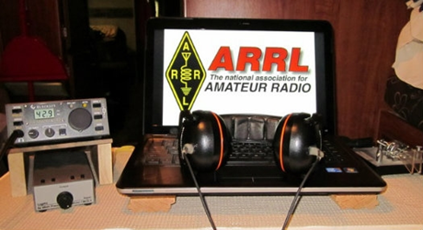*ARRL Contest Corner***

An expanded, downloadable version of *QST'*s [Contest Corral](http://www.arrl.org/contest-calendar) is available as a PDF. Check the sponsor's Web site for information on operating time restrictions and other instructions.

|  |  |
| --- | --- |
| **August 6**   * [ARS Spartan Sprint](http://arsqrp.blogspot.com/2009/02/so-whats-spartan-sprint-and-how-do-i.html) | **August 7**   * [Phone Fray](http://www.perluma.com/Phone_Fray_Contest_Rules.pdf) * [CWops Mini-CWT Test](https://cwops.org/cwops-tests/) |

#########

TOP ^

***One Question Questionnaire***

Hey Gang,

It seems that about 16% of you do have worked some sort of meteor-scatter on 6-meters. That’s more than I thought it would be for sure!

I’ve got another NEW – one question – questionnaire on the Ohio Section Website!

I noticed this week several postings about the International Space Station listing the times and approximate location where it will be doing a fly over and you might be able to see it as it races across the sky. So, that’s this week’s question for you to answer.

**“Have you been lucky enough to see the International Space Station fly overhead?”**

These One Question questionnaires are all in fun and I hope that you are enjoying answering them.

You’ll find the “One Question” questionnaire on the Ohio Section Website! <http://arrlohio.org> It’s all in fun and it’s not a scientific survey in any way, but we are learning some things that we didn’t know from these questions. I hope that you are enjoying answering these “One Question” questionnaires.

*****V.E. Test Sessions***

For the latest testing site information please **>>** [**Click Here**](http://www.arrl.org/find-an-amateur-radio-license-exam-session) **<<** The ARRL site tracks all of the VE testing sites that register with them, including W5YI and Laurel. ARRL gives you a number of different ways of sorting to find that site that is closest to you as well.

***(ARES) Ham Radio “Connect”***

It seems as though the name "ARES Connect" is getting folks confused about who all should be using this system. Maybe we should just call it **“Ham Radio Connect”** or how’s about just plain **“Connect”** instead! Whatcha’ think? Would you think the system was for everyone then?

This system is new to everyone and it seems that the moniker ARES that got hung on this new system is keeping a lot of folks from using it. Let’s clear the air on that right now. It’s not just for ARES events. I'm here to tell you that it's to be used for ANY event that involves Amateur Radio. It can be a RACES, CERT, Skywarn, Red Cross or just a few hams gathered at a table to talk about Amateur Radio. It all counts!

Club meetings, hamfests, working on that club trailer, repeater, website, field day, parades, newsletter or just having fun keeping track of all those spandex folks during every kind of race imaginable are perfect examples of hours that count that are not necessarily ARES directly related but do have an impact on your community.

TOP ^

Any Amateur Radio related activity should be an event in ARES Connect and your hours recorded. Why? These hours will help demonstrate to the FCC and all of our government officials (local, state and federal), as well as all of our served agencies our willingness to volunteer and help our fellow citizens. These are not just hours; they are dollars that are given back to our communities, and we want our government officials to know just how much we give back to help keep the frequencies that we have, as well as future frequencies that may be available later. Showing them in dollars how much we give back is what keeps their attention and helps preserve our current frequencies.

Just because the name of this system has ARES in it, doesn't mean that we only record ARES events. If it involves Amateur Radio **IN ANY WAY** then it needs to have an event established and hours recorded for it.

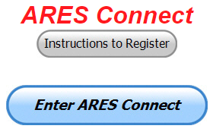Here’s the really great news about this system. It’s never too late to get those valuable hours recorded, even if the event has already passed. The Admins of this system can setup events anytime and add you and your hours to those events.

Yes, I agree, the name of this system may not necessarily fit what it’s all about, but HEY… what’s in a name anyway!!! Now, are you registered in the system yet? We need to make sure that no one is left behind, and we know that not everyone is entered into the system yet.

If you live in **Ohio** and you haven’t registered yet, we need you to get registered now. We need you to only use this URL to get registered [**https://arrl.volunteerhub.com/lp/oh/**](https://arrl.volunteerhub.com/lp/oh/). Using any other entrance to register will only slow down your registration process. Again, this is for those living in Ohio only. If you are an out of state person (not Ohio), you can simply change the **/oh/** to your 2-letter state designation. This will put you in the correct state for signing up

Your time adds up quickly. Make sure that all that fun and dedication counts. Get your hours logged now!

***Here’s the top 10 hours earners for July:***

|  |  |  |  |
| --- | --- | --- | --- |
|  | **Name** | **Events** | **Hours** |
| 1 | Mathew Nickoson (KC8NZJ) | 10 | 169.50 |
| 2 | Bret Stemen (KD8SCL) | 49 | 167.00 |
| 3 | Michael Klaiss (KC8BUJ) | 17 | 116.20 |
| 4 | Timothy Gray (KD8IZU) | 13 | 108.75 |
| 5 | Dan Stahl (KC8PBU) | 43 | 106.75 |
| 6 | Robert Baker (N8ado) | 26 | 105.90 |
| 7 | Greg Dersarkisian (KD8SSJ) | 20 | 100.00 |
| 8 | James Yoder (w8erw) | 9 | 99.70 |
| 9 | John Westerkamp (W8LRJ) | 43 | 97.41 |
| 10 | Diane Warner (KE8HLD) | 22 | 93.50 |

With this new reporting system, we can get real time information that shows how many hours, who volunteered and what did they volunteer for. There’s a ton of information that we can draw out of the system.

TOP ^

We now have **1,191** registered and growing every day in the system. What’s really interesting is as of this same date there are **10,864** registered in the entire country. This means that the Ohio Section makes up over 10.96% of those registered.

We have a set of instructions on how to get registered right above the button to enter ARES Connect. I would strongly suggest that if you haven’t registered yet, that you read these instructions first.

**For those of you who already have an account in ARES Connect and can’t seem to get access to it, please DON’T just make another account, this really plays havoc with the reports when you do that. If you can’t remember your password there is an automated way of getting it reset. If this isn’t the problem, please contact me as soon as you can, and I can get it straightened out for you.**

Here’s a link to get you started... <http://arrl-ohio.org/ares_connect_directions.pdf> Please, don’t just hurry through the questions, read them carefully, if you don’t understand something, please ask me, I’m here to answer your questions.

We know that you mean well by answering that you do have the needed courses in, but I will let you know that we are verifying what you say you have with what is showing for you in our statewide database when we are completing your registration. So, how can you find out if you are already listed in our statewide database? Easy, here’s a link: <http://arrl-ohio.org/SEC/special/ICS%20Complete%20by%20County%20and%20Name.pdf>

As you can see by the numbers above, we are now at the point where we will all need to be registered in this system for our hours to count. We will no longer need to depend on our EC’s and DEC’s to remember our hours of volunteering and report those hours for us on their monthly reports.

The EC and DEC monthly numbers are no longer necessary, we will maintain a monthly reporting system for EC/DEC’s, but it will only be for them to submit a narrative only for the month!

The time that was spent in getting your information and making sure it is up-to-date and on file with the EC, as well as transferring all of those records when a new EC takes over is no longer be needed. This system takes care of all of that automatically.

Now, it has a lot of benefit for you too... Forget a meeting time or location? Just look it up on the calendar and there you have it. If set, you can even see the location on a map! I have attended many meetings and gatherings just because it was listed on ARES Connect and I found it just browsing around. I wouldn’t have known about it if it hadn’t been on the ARES Connect Calendar!

Why is this so important? These hours are what is shown to those we go to for funding as well as for more frequencies to operate on. Yes, we have to justify why we need the money or frequencies to those in government that want “just the facts.” This system allows us to show them the facts, anytime and with great accuracy.

Now a quick word for the EC’s and DEC’s… EC’s… it’s past time for you to have your Narrative reports in. It’s getting very close to the deadline for the DEC’s as well. Please, you no longer need to worry about getting all the tabulations together as that we only want the Narrative reports from you know. Remember, the quicker you get your Narrative reports in to Stan the more he can include in his report.

#########

TOP ^

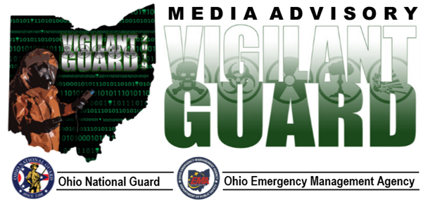

For Immediate Release July 22, 2019

Stephanie Beougher, Ohio Adjutant General’s Dept. (614-336-7369)

Vigilant Guard Exercise – Media Day

Columbus, OH – The Ohio National Guard will host a Media Day that includes a flight aboard a UH-60 Black Hawk helicopter to observe select Vigilant Guard exercise sites on Aug. 7, 2019, at Rickenbacker Air National Guard Base in Columbus and the Knox County Fairgrounds in Mount Vernon, Ohio.

Vigilant Guard is the largest disaster response exercise in the state of Ohio’s history. The exercise is sponsored by U.S. Northern Command (NORTHCOM) in conjunction with the National Guard Bureau (NGB) and hosted locally by the Ohio National Guard and Ohio Emergency Management Agency.

Vigilant Guard is designed to help local, state, and federal agencies coordinate emergency relief efforts, as well as response and recovery management.

Starting on Saturday, Aug. 3 and continuing through Thursday, Aug. 8, the public may notice a heavy presence of first responders, military personnel, military aircraft, and emergency vehicles in multiple areas throughout Ohio.

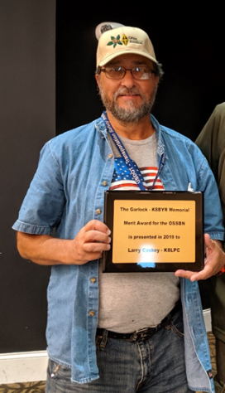***Omar Garlock Award Given at Columbus Hamfest***

The 2019 Omar Garlock Award recipient was announced at the Columbus Hamfest. This award is given out to the most outstanding traffic handler with the Ohio Single Side-Band Net. This year’s recipient was none other than Larry Caskey, K8LPC.

TOP ^

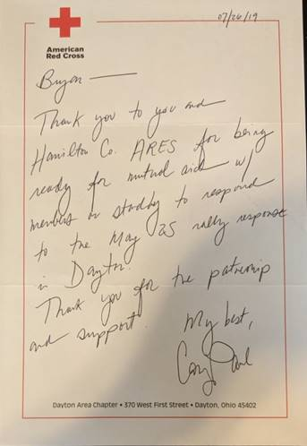**From:** Bryan   
**Sent:** Wednesday, July 31, 2019 3:11 PM  
**To:** Stan Broadway; Steve Lewis  
**Subject:** Dayton Red Cross Letter

Stan and Steve.

I received a nice letter in the mail from Cory Paul who is the Executive Director of the Dayton Area Chapter of the Red Cross.

Apparently, he found out that HamCo ARES was available for mutual aid if needed on May 25. This was the day of the KKK Rally and other events.

I'll be sharing this with the entire membership.

Once again, it feels good to make a difference!

--------

Bryan Hoffman, KC8EGV, COM-L AuxComm

Emergency Coordinator

Hamilton County, OH ARES

[hamcoares.net](http://hamcoares.net)

ARRL, the national association for Amateur Radio®

***This and That’s***

***Why do doorbells use 12v AC instead of DC?***

There are two reason that doorbells use low voltage AC instead of DC.

* You have AC in the home. Converting to DC requires an additional rectifier which is more complex and more expensive.
* Originally, the doorbell was a solenoid that drove a plunger against a bell. These do not work with DC. Drive the bell with DC and you get a single “ding” from the bell each time you push the button. The AC bell is the simplest design.

There is a trend here. Simplicity.

The reason that low voltage is used is safety and ease of installation. You can use small gauge wire run directly through walls without conduit and have no fear of electrocution or fire. The transformer was designed so that when shorted, it would not develop enough current to overheat the wire or transformer.

#########

TOP ^

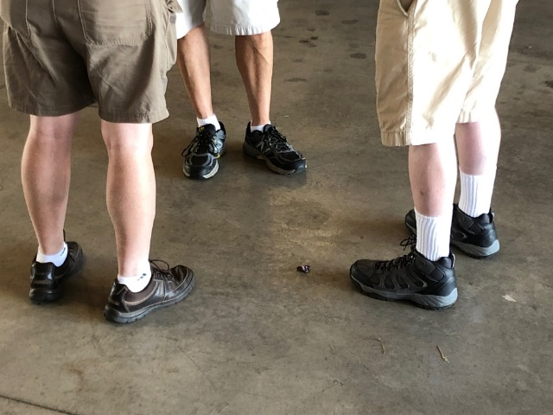

OK.. Now can you tell me which one of these folks is the Ham Radio Operator??

#########

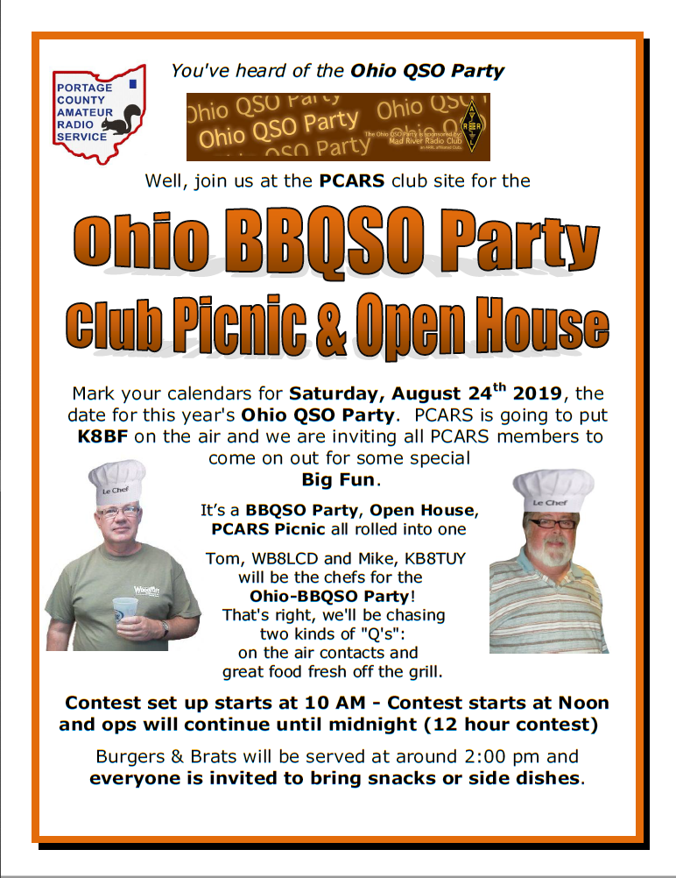

TOP ^

***ICS 300 & 400 Classes Being Offered***

**ICS-300 INTERMEDIATE ICS FOR EXPANDING EVENTS**

**Hosted by: Ashland County HS & EMA and Holmes County EMA September 20 - 22, 2019**

**Course Description:** This 21-hour classroom course provides training for personnel who require advanced application of the Incident Command System (ICS) and Individuals who may assume a supervisory role in incidents. This course expands upon information covered in the ICS 100 and ICS 200 courses.

**Application Deadline: September 6, 2019**

**Course Registration time:** 5:30 pm to 6:00 pm (day one)

**Course Time:** 6:00 pm to 9:00 pm (day one)

8:00 am to 6:00 pm (day two & three) (one-hour for lunch on day two & three)

**Training Location:** Loudonville Fire Station 200 North Market Street Loudonville, Ohio 44842

**Recommended Participants:** FEMA designed this course for individuals who may assume a supervisory role in expanding incidents or Type 3 incidents.

**Note:** During a Type 3 incident, some or all of the Command and General Staff positions may be activated, as well as Division/Group Supervisor and/or Unit Leader level positions. These incidents may extend into multiple operational periods.

**Required Prerequisites:** Individuals must complete the IS-100.c Introduction to the Incident Command System, IS-200.c Basic Incident Command System for Initial Response, IS-700.b An Introduction to the National Incident Management System and IS-800.c National Response Framework courses prior to attending the ICS-300 Intermediate course and provide copies of their certificates of completion to the instructors on day one of the course.

**Enrollment:** Students must enroll via the Department of Public Safety Training Campus website: https://trainingcampus.dps.ohio.gov/cm/cm710/pstc/pstc.html. Course registration will generally close 10 working days prior to the course start date and applicants can check enrollment/approval status via the Department of Public Safety Training Campus website.

**Course Costs:** There is no charge for participants to attend this course. However, Lodging, Meals, Per Diem and all other travel expenses are the responsibility of the student or the parent organization.

**State Point of Contact:** Lisa Jones, DSC 2, Ohio EMA, SAA Training Point of Contact, (614) 799-3824 [ljones@dps.ohio.gov.](mailto:ljones@dps.ohio.gov)

********

TOP ^

**ICS-400 ADVANCED ICS FOR COMMAND & GENERAL STAFF**

**Hosted by: Ashland County HS & EMA and Holmes County EMA September 28 – 29, 2019**

**Course Description:** This 15-hour classroom course provides training for personnel who require advanced application of the Incident Command System (ICS). This course expands upon information covered in ICS-100, 200, 700, 800 and ICS-300 courses, which are the prerequisites for the ICS-400 course. The target audience for this course is senior personnel who are expected to perform in a management capacity in an Area Command or Multi-Agency Coordination Entity.

**Application Deadline: September 14, 2019**

**Course Registration time:** 7:30 am to 8:00 am (day one)

**Course Time:** 8:00 am to 5:00 pm (day one & two) (one-hour lunch each day)

**Training Location:** Loudonville Fire Station 200 North Market Street Loudonville, Ohio 44842

**Recommended Participants:** FEMA designed the course for Senior Personnel who expect to perform in a management capacity in an Area Command or Multi-Agency Coordination Entity.

**Required Prerequisites:** Prior to attending the ICS-400 Advanced course, individuals must complete the IS-100.c Introduction to the Incident Command System course; IS-200.c Basic Incident Command System for Initial Response; IS-700.b An Introduction to the National Incident Management System; IS-

800.c National Response Framework, an Introduction, and ICS-300 Intermediate courses. Students must provide these certificates of completion to the instructors on day one of the course.

**Enrollment:** Students must enroll via the Department of Public Safety Training Campus website: https://trainingcampus.dps.ohio.gov/cm/cm710/pstc/pstc.html. Course registration will generally close 10 working days prior to the course start date and applicants can check enrollment/approval status via the Department of Public Safety Training Campus website.

**Course Costs:** There is no charge for participants to attend this course. However, Lodging, Meals, Per Diem and all other travel expenses are the responsibility of the student or the parent organization.

**State Point of Contact:** Lisa Jones, DSC 2, Ohio EMA, SAA Training Point of Contact, (614) 799-3824 [ljones@dps.ohio.gov.](mailto:ljones@dps.ohio.gov)

**It is the goal of Ohio EMA to ensure that all students have the tools necessary for successful course completion. If students require additional accommodations, they should make the Ohio EMA training office aware, and staff will confidentially meet reasonable requests.**

TOP ^

***Final.. Final..***

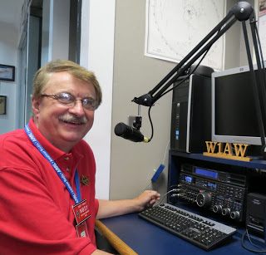

Hey Gang...

Wow.. another great week of fantastic weather!! This past week again was full of meetings, webinars and just some plain fun as well. Tom Delaney, W8WTD and I had a blast at the Columbus Hamfest this past weekend for sure. It’s always fun to be able to get around and talk with everyone.

I’m still debating about which antenna to get (a vertical or the Compact) antenna. I do have to say that after talking with a lot of you I have been leaning more toward the Hustler 4BTV vertical antenna. This would allow me to run my amplifier when I want to.

Yup, I’m looking at all of my options right now, and with the trees newly trimmed, I’ve got more options on just where to put this new antenna. I’ll keep you all informed on its performance and “customer satisfaction...!!”

Sliding down the band a bit… Have you taken the time to get signed up in “Connect” yet? I know that this must sound like a broken record, but it is important for everyone to not only get signed up but start using as well. Please, don’t let the name ARES fool you, this new system is for everyone and not just for ARES. So, if you haven’t already signed up, now is the time. I know that this must sound like a broken record to most of you, but you won’t believe how many folks I meet every week that still tells me they haven’t heard of it yet.

Here in the Ohio Section we only require our Level 2 volunteers to have the 4 basic courses, IS 100, 200, 700 & 800. For our Level 3 volunteers we do require the additional ICS 300 / 400, or the equivalent professional series courses IS 120, 230, 240, 241, 242, 244 & 288.

These equivalent courses are all on-line classes just like your basic 4 NIMS courses are and being offered as an alternative way for you to get credit for taking the professional series courses in the event you just cannot get scheduled into an ICS 300/400 class. By the way, if you decide to take these 7 on-line courses and complete them all, you will want to take just one more class **IS-235.** By completing this additional course, you will get a really great looking certificate from FEMA recognizing that you have completed the entire Professional Series courses. I do hope that this clears up the confusion that has been going around lately. As we have stated on the website and in this newsletter many times “We want no one left behind.”

Yes, the Ohio Section is extremely lucky to have the relationships that we do with Law Enforcement, EMA, fire and other government agencies, that’s why we’ve partnered with EMAO, OP3 and Ohio VOAD to show our support for them and our Ohio citizens.

Moving up the band a bit… I hope everyone saw the article above that announced the winning Newsletters in this year’s competition. It’s great to have the only on-going newsletter contest in the nation. We have over 40 entries every year for this coveted award. I gotta’ say this about the newsletters...

TOP ^

In my book everyone is a winner!! You all do such fantastic jobs on them that I know the judges have a very hard time deciding who is the best out of all of them. The winner of this year’s contest (Radiogram) will go in to the the Divisional Contest that will be held at the Great Lakes Division Convention in March.

I also hope that you saw who the recipient of the Allan Severson was, AB8P award was, and congratulate him the next time you see him. Stan, N8BHL, you are the greatest!!!

Website updates… We’ve had another update this week on the DMR Net Listings that Greg, WD9FTZ maintains. He’s also updated the District Map as well. I had an update from Daniel, KB8LKH on the CS-800D instruction sheet. It’s been quite some time, but we also had an update on a new personal weather station was added to the list. Thanks, so much Jeremy, W4JER for sending me the link to your station. If you haven’t seen these changes yet, you’ll want to check them out soon!

Is your club doing any special activities that you’d like the Section to know about? Do you have a story that you’d like to tell about something that you or your club has or is doing? Let me know about it and let’s get it in the next edition!

Whelp… That’s going to do it for this time around. Stay safe, enjoy the sunshine while we have it, and most of all… have FUN!!

73,

***Scott, N8SY***

***Welcome New Subscribers***

Shannon, KE8LUA; Norberto Melendez

#########

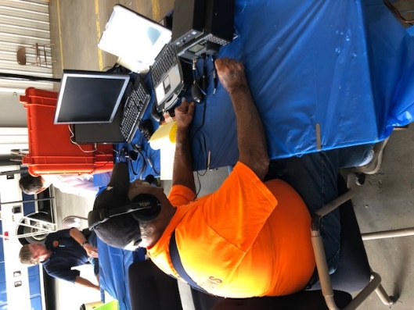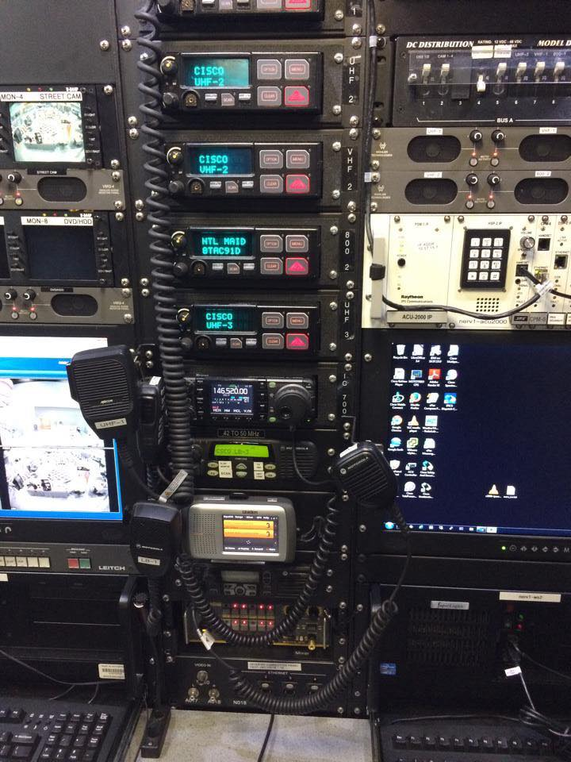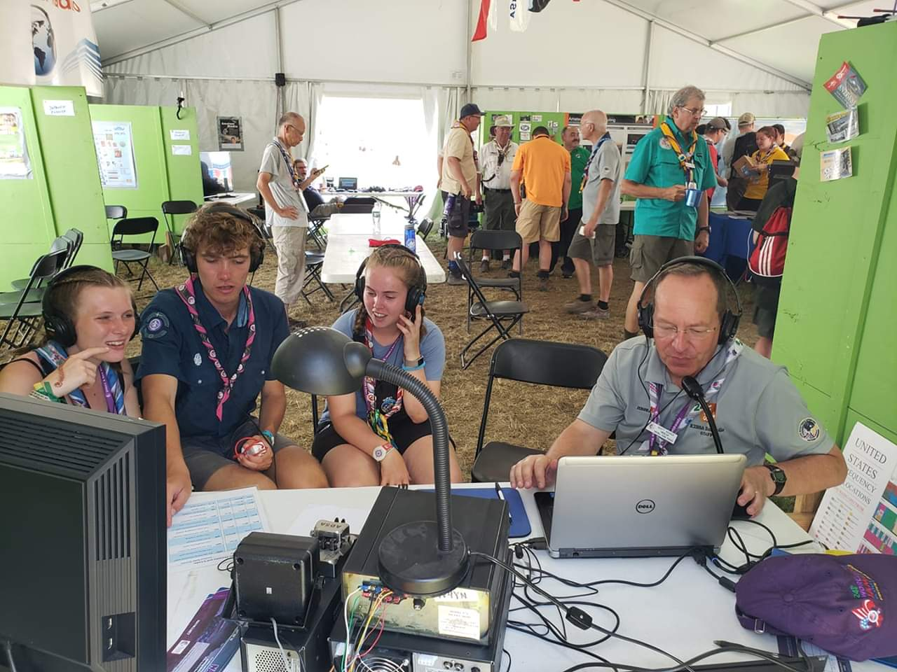

TOP ^

***Back Issues of the PostScript and Ohio Section Journal (OSJ)***

Hey, did you know that PostScript and Ohio Section Journal (OSJ) are archived on the website? You can go back and look at any edition simply by clicking:

<http://arrl-ohio.org/news/index.html>

***Chit – Chat, and All That!***

Do you know someone that’s not getting these Newsletters? Please, forward a copy of this Newsletter over to them and have them “[Opt-In](http://arrl-ohio.org/forwarder/forwarding.html)” to start receiving them. Heck, just have them send me an email [n8sy@n8sy.com](mailto:n8sy@n8sy.com) and I’ll get them added to the Ohio Section Emailing list.

We now have many thousands of readers receiving these newsletters weekly. Quite impressive, I’d say! I urge all of you to make sure that everyone, regardless of whether they are a League member or not, get signed up to receive these weekly Newsletters.

You can always “[Opt-Out](http://arrl-ohio.org/forwarder/forwarding.html)” at any time if you feel this is not what you were expecting. It’s fun and very informative. All of your favorite past newsletters are now archived too.

You can go back at any time and read them. Just go to: <http://arrl-ohio.org/news/>

Got questions, concerns or would just like to sit and chat awhile? Heck, I’ll even buy the coffee!! Give me a call at (419) 512-4445 or email me at: [n8sy@n8sy.com](mailto:n8sy@n8sy.com)

The pictures on the front page are from various newsletters, Facebook posts and/or were sent directly to me in recent weeks. Take a good look at them, you just might be in one of the pictures! “SMILE… you’re on the Ohio Section News!!”

TOP ^

*PostScript is produced as a weekly newsletter. I want to thank everyone that has contributed articles and ideas to make this an even better news source. I sincerely hope that you have enjoyed this edition and will encourage your friends to join with you in receiving the latest news and information about the Ohio Section, and news and events happening around the world!*