[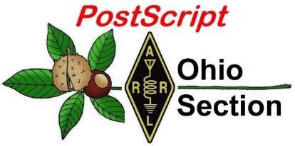](http://arrl-ohio.org/news/) ***50th Anniversary of***

***Apollo 11 Moon***

***Landing***

🡪 National News 🡪 The Handbook Give Away

🡪 Club Corner 🡪 Hamfests

🡪 DX This Week 🡪 One Question Questionnaire

🡪 VE Testing 🡪 ARES Connect

🡪 Final.. Final..

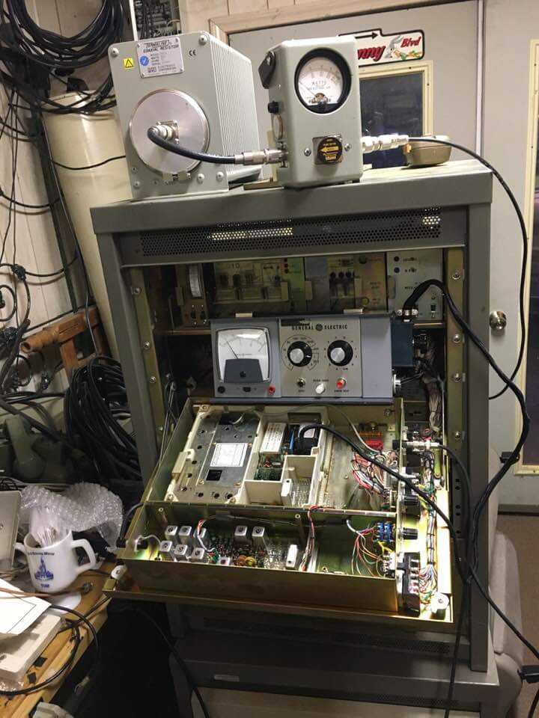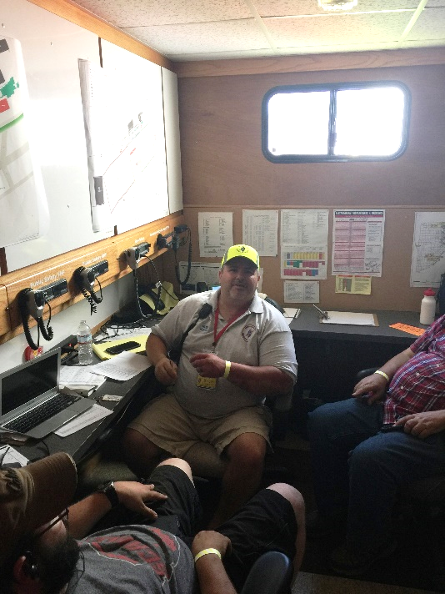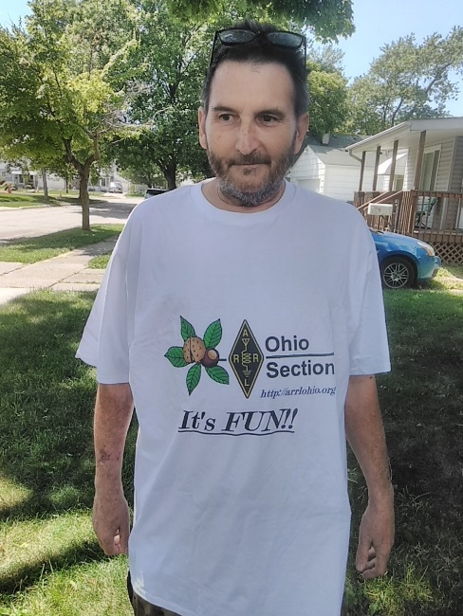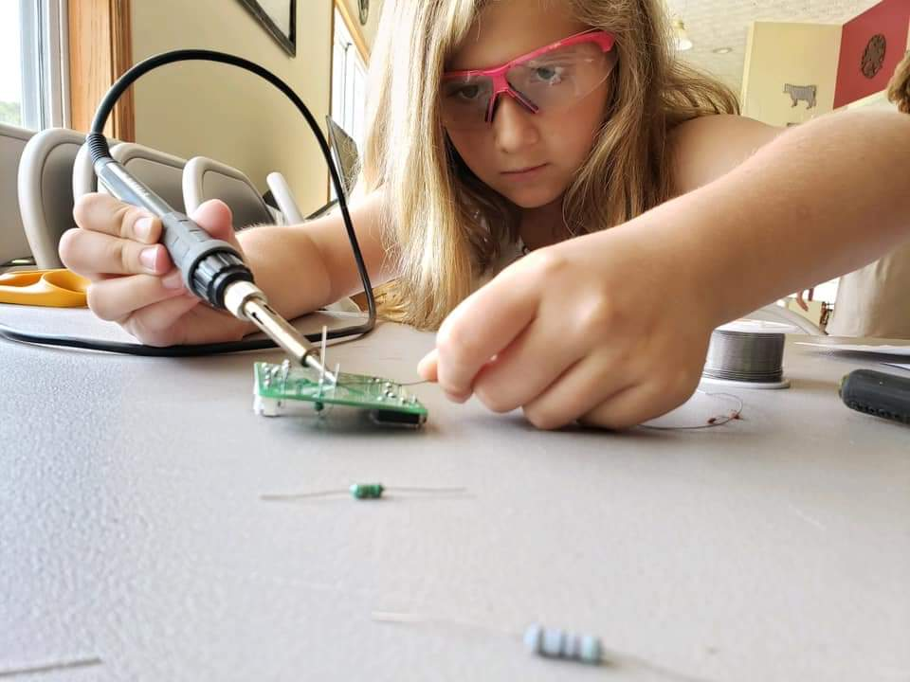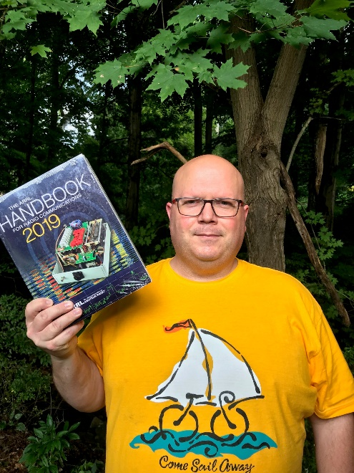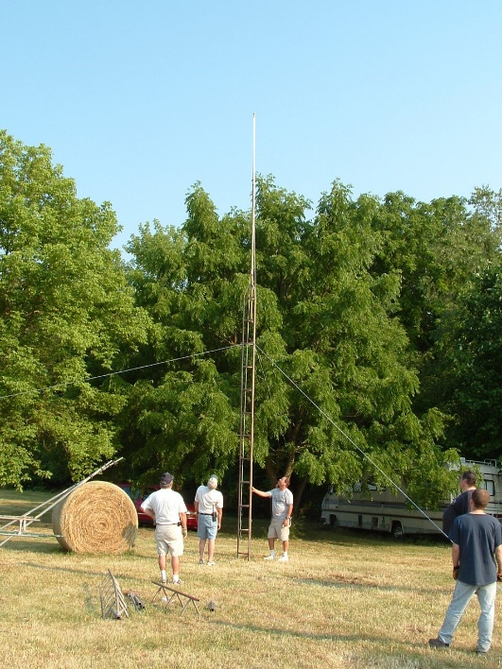

***National News***

(from arrl and other sources)

***Report: California Earthquakes Disrupted HF Propagation on West Coast***

British Columbia radio amateur Alex Schwarz, VE7DXW, said that an Independence Day magnitude 6.4 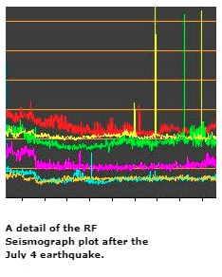earthquake in California’s Mojave Desert and multiple aftershocks negatively affected HF propagation on the US west coast. Schwarz, who maintains the “[**RF Seismograph**](http://users.skynet.be/myspace/mdsr/index.html)” and has drawn a correlation between earthquake activity and HF band conditions, said the radio disruption began at around 1600 UTC on July 4, and continued into July 5. He said that on July 4, the blackout was total except for 20 meters, where conditions were “severely attenuated,” Schwarz said. The RF Seismograph also detected the magnitude 7.1 earthquake on July 6 in the same vicinity, Schwarz reported. The distance between the monitoring station in Vancouver, British Columbia, and that quake’s epicenter is 1,240 miles.

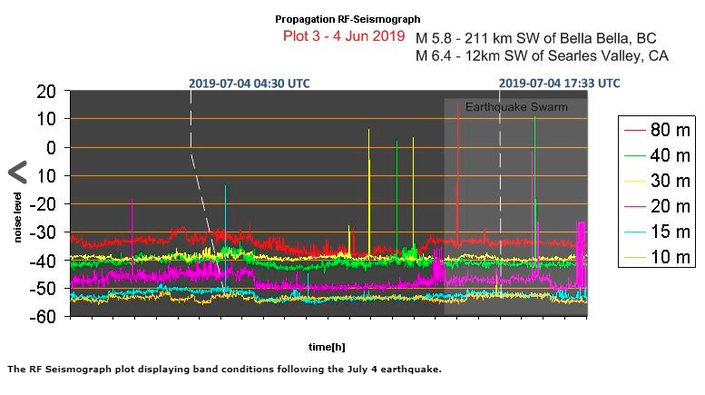“Things are back to normal after the strong quake, as far as the ionosphere is concerned, but the unrest has not stopped yet,” Schwarz told ARRL on July 8. “There were over 7,000 mostly small quakes, and these do not seem to have the energy to effect the ionosphere. We all hope that this will settle down soon.” Schwarz said the RF Seismometer detected a magnitude 6.9 earthquake in Indonesia.

Over the holiday weekend, Schwarz had reported “a massive short-wave radio blackout” on the west coast. “It is not caused by the sun (the sun is quiet), but the field lines of the ’quakes themselves,” he said. A magnitude 6.2 earthquake took place off Vancouver Island, British Columbia, on July 4.

On July 6, Schwarz said, the RF Seismograph showed an increase in noise on 80 meters some 13 hours beforehand, as well as some propagation changes on 40 and 30 meters — low before the quake and increasing in its wake. Increases in noise on 15 and 10 meters were detected some 10 hours before the earthquake, diminishing about 3 hours afterward. In addition, noise level and propagation changes on 20 meters some 3 hours before the earthquake.

TOP ^

Schwarz said larger quakes spur longer periods of 80-meter noise which cross the day/night boundary. “The difficulty is the 80 meter noise difference between day and night, which is hard to subtract from the graphs,” he added. With earthquakes of lesser magnitude (4.0 to 5.9), the RF Seismograph displays the rise and fall typically within daytime or nighttime propagation, making it more obvious. “The measurement on the other bands is more consistent, and the quake can have either an amplifying or attenuating effect on propagation,” Schwarz told ARRL.

All of the earthquakes of the past few days occurred within a 4-square-mile area in and around Ridgecrest in San Bernardino County. Several injuries were reported, along with property damage. ARES and the Sierra Amateur Radio Club (SARC) have actively supported communications during the earthquake swarm and magnitude 7.1 quake in and around Ridgecrest, in the Mojave Desert. “Many club members are busy collecting information, running an emergency net, as well as staffing a back-up communication van,” Mike Herr, WA6ARA, told ARRL on July 7.

The RF Seismograph propagation tool employs an omnidirectional multiband antenna to monitor JT65 frequencies (±10 kHz) on 80, 40, 30, 20, 15, and 10 meters. Recorders monitor the background noise and display the result in six color-coded, long-duration graphs displaying 6 hours of scans. When signals are present on a band, its graph trace starts to resemble a series of vertical bars.

The RF Seismograph recorded the magnitude 7.5 earthquake in Ecuador on February 22.

Schwarz [**recounted**](http://www.arrl.org/news/ve7dxw-s-rf-seismograph-may-be-real-seismograph) that noise on 15 meters began to be visible about 1 hour before the quake; then, 2 hours after the quake released, 15 meters started to recover. It did not affect 80 meters. “The earthquakes show up as RF noise because of the electric field lines, now scientifically confirmed to change the way the ionosphere reflects RF,” Schwarz said.

Schwarz has cited an article in the October 2018 edition of *Scientific American*, which, he says, explains the phenomenon. (See Erik Vance’s “[**Earthquakes in the sky**](http://www.ep.sci.hokudai.ac.jp/~heki/pdf/Scientific_American_Vance2018.pdf),” *Scientific American*, October 2018, p. 44.)

The *Scientific American* article explores measurements in Japan and how earthquakes can create electric field lines that extend into the atmosphere. Schwarz said 171 earthquakes — all magnitude 6.0 events or greater — were studied, and only 15 of them had no RF noise associated with them.

RF Seismograph is now a [**project**](https://scistarter.com/project/21138-RF-Seismograph) on Scistarter.com, facilitated through Arizona State University.

Contact [**Schwarz**](mailto:alexschwarz@telus.net) for additional information.

#########

***AMSAT Announces New Board of Directors Election Process***

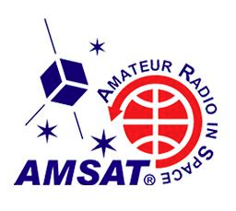[**AMSAT**](http://www.amsat.org/) will provide its members with online voting as the 2019 AMSAT Board of Directors election gets under way. This year, AMSAT has contracted with a single, independent vendor, [**ElectionBuddy**](https://electionbuddy.com/), to conduct and fully manage the election process, instead of with multiple vendors as it’s done in the past.

“AMSAT believes this voting system will result in greater election integrity, as it removes the potential for any perceived conflicts of interest,” AMSAT Secretary Clayton Coleman, W5PFG, said in announcing the changes. “ElectionBuddy will manage AMSAT’s voter list and interaction with members regarding the election. This ensures voter anonymity.”

TOP ^

A ballot card will be mailed to all current members by July 15, in accordance with AMSAT’s bylaws. Members may cast their ballots by visiting a unique URL or by utilizing a QR code printed on the card. Members who do not receive their ballots by July 15 should contact ElectionBuddy, which will be responsible for distributing and collecting ballots and for tallying votes. Individual ballot responses will never be shared with any volunteer or paid AMSAT staff.

Candidates’ statements of qualification will be published on AMSAT’s website and displayed on the ElectionBuddy website for eligible voters.

Eight candidates will be on the ballot. The four candidates receiving the highest number of votes will be seated as voting members of the Board of Directors. Two alternate directors will be selected based on the next highest number of votes received.

Coleman stressed that ElectionBuddy will be voters’ single point of contact regarding any ballot issues for the 2019 AMSAT Board election. Questions will not be answered on the AMSAT-BB or via organizational social media accounts.

“In the event that you are unwilling or unable to cast your ballot via the online mechanism, ElectionBuddy will mail you a specific ballot that must be returned to them within the parameters of our election time frame, so that it is received by the office no later than September 15, 2019,” Coleman said in his announcement. “If you choose this option, please understand it is at an increased cost to the organization.”

The 2019 candidates for the AMSAT Board of Directors, in alphabetical order by last name, are:

* Jerry Buxton, N0JY
* Howard (Howie) De Felice, AB2S
* Drew Glasbrenner, KO4MA
* Jeff Johns, WE4B
* Brennan Price, N4QX
* Patrick Stoddard, WD9EWK
* Paul Stoetzer, N8HM
* Michelle Thompson, W5NYV

#########

***Happy 150th - Hiram Percy Maxim Birthday Celebration***

The ARRL is celebrating the 150th anniversary of the birth of ARRL’s first president and co-founder Hiram Percy Maxim (HPM), W1AW, born on September 2nd, 1869.

The ARRL will hold an operating event this summer to celebrate HPM’s legacy from **0000 UTC on August 31st and continue until 2359 UTC on September 8th.** It is open to all radio amateurs.

W1AW and all ARRL members will append “/150” to their callsigns during this event (DX operators who are ARRL members may operate as <call sign>/150, if permitted by their country of license.)

For more details, see the ARRL Web page at:  
<http://www.arrl.org/news/view/arrl-announces-happy-150-hiram-percy-maxim-birthday-celebration>

#########

TOP ^

***Window Closing on July 15 for Volunteer Monitor Program Applications***

As of the close of business on Monday, July 15, applications for the new [**Volunteer Monitor Program**](http://www.arrl.org/volunteer-monitor-program) no longer will be accepted. Some 250 applications have been submitted to fill approximately 150 Volunteer Monitor (VM) positions in the program, which is succeeding the Official Observer (OO) program. Retired FCC special counsel and former Atlantic Division Vice Director Riley Hollingsworth, K4ZDH, is overseeing ARRL’s role in the development and implementation of the program, and he has been interviewing every applicant. Those not selected as VMs will be placed in a reserve pool. Current OOs were invited to apply for appointments.

Approved by the ARRL Board of Directors at its July 2018 meeting, the new Volunteer Monitor Program represents a formal agreement between the FCC and ARRL in which volunteers trained and vetted by ARRL will monitor the airwaves and collect evidence that can be used to correct misconduct as well as to recognize exemplary on-air operation. ARRL will refer incidents of flagrant violations to the FCC for action, in accordance with FCC guidelines, and the FCC will give priority to enforcement cases developed by the Volunteer Monitor Program. The FCC proposed the program following the closures of several FCC regional office and a reduction in field staff.

ARRL and the FCC have signed a *Memorandum of Understanding* (*MOU*) that establishes the Volunteer Monitor Program as a replacement for the Official Observers.

The first Volunteer Monitors could be in place and ready to begin their duties by this fall.

#########

***FAA Reauthorization Act Language Serves to Exclude Vast Majority of Amateur Radio Towers***

Language in the Federal Aviation Administration (FAA) [**Reauthorization Act of 2018**](https://www.congress.gov/115/bills/hr302/BILLS-115hr302enr.pdf) will exclude all but a small number of Amateur Radio towers from marking requirements. Thanks to action taken in 2017 and 2018 by ARRL, the bill’s original language was amended to the extent that amateur towers, as well as residential towers used for over-the-air TV reception, were effectively exempted from marking requirements.

The topic was addressed at the annual “Ham Radio and the Law” forum at the [**Dayton Hamvention**](http://www.hamvention.org/)® this past May. Some key points from that presentation: (1) Towers covered by the rules are structures at least 50 feet tall that support an antenna and are located in a rural area or on farmland or immediately adjacent to such land. (2) According to the Act, the term “covered tower” does *not* include any structure that is adjacent to a house, barn, or other building, and “is within the curtilage of a farmstead or adjacent to another building or visible structure.”

ARRL Regulatory Information Manager Dan Henderson, N1ND, explains that, while a few Amateur Radio towers will fall under the Act’s marking requirements and will have to be registered, towers in residential yards or within farmland are specifically exempted.

TOP ^

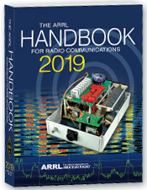***The Handbook Give Away***

Hey Gang,

Have you registered for the “Handbook Giveaway” drawing for this month yet? If you haven’t, go to: <http://arrl-ohio.org/handbook.html> and get yourself registered now!

What’s the catch? I want to get everyone checking in to the Ohio Section website as often as possible, and in order to register each month, you have to visit the website often! There’s nothing else to it. I pay all expenses and I usually “Give Away” more than just a Handbook too!!

Many of you ask me just how do I know when the drawing is on? Well, that’s easy all you need to do is check in on the Ohio Section Website on a regular basis and watch for the big [**RED**](http://arrl-ohio.org/handbook.html)Arrow that will appear on the left side of the page. This is the sign that the drawing is on and you need to get registered. So, keep a sharp eye out on the website and check in often!

***Club Corner***

This is YOUR cornner of the newsletter. Send me what your club is doing and I’ll make sure that it gets in. Got a special event or club project that you want everyone to know about? Send it to me!. Need help with a project? Send it to me.

Let me know what you club is up to. Are you going to have a special guest at your meeting or are you having a special anniversary? Just sent it to:

[n8sy@n8sy.com](mailto:n8sy@n8sy.com)

#########

***Lighthouses on the Air***

Hello SARA members and friends.

On Saturday, **August 17th** I will be activating the Fairport West Breakwater Light for the International Lighthouse Special Event, using the call N8L. I will go it alone and just hang a wire off of the observation deck if I have to. But ideally, I would like to run a couple of radios simultaneously 24/7 for the weekend.

The accommodations are really quite nice. There will be a Dropbox link to photos below. I am looking to gather a crew of a half dozen to a dozen Hams to work the project, much like a Field Day style operation, but without the contesting. This will be an open to the public operation and visitors will be welcome. Due to the ruggedness of the terrain to get to the Lighthouse, I will be working on arranging a secondary location at the Fairport Harbor Lighthouse Museum for those who cannot make the trek along the break wall, climb a ladder or up the steps of the base. This will also serve as a backup location in the case of inclement weather.

If you are interested in participating in event as part of the crew, help with set-up, tear down, supplying equipment, radios, antennas, feed lines, analyzers, food, etc., please contact me to begin making some plans.

TOP ^

The Lighthouse is fully furnished, but with no running water. It uses a composting toilet. There is a 5,700 watt (7,100 peak) generator on site, and a small portable as well. We need to furnish our own gasoline, of course. Besides the lights and radios, the only appliances we would be running would be the refrigerator, the coffee pot, and maybe the microwave.

Here is a link to the Dropbox folder with pictures.  
<https://www.dropbox.com/sh/6b8lc06zb2c3lxj/AADJaxCp0DHps0bICdKq6TGma?dl=0>

My Contact is: [dspondike@aol.com](mailto:dspondike@aol.com) or call 330-801-0089

#########

***Toledo Mobile Radio Association (TMRA) Sponsoring Fox Hunts***

TMRA will be holding two park fox-hunts (transmitter hunts) very soon!  Please come out and join us! These particular hunts will be “learning” oriented and experienced hunters will be focused on making sure that those newer to the activity are learning and successfully using their equipment to find the hidden transmitters.  (However, of course, experienced hunters are very welcome to both hunt or elmer!)   Some additional/spare fox-hunt equipment will be available for those that don’t have any (but feel free to bring your own!)  Both hunts will have two hidden transmitters.  (one on 145.555MHz and one on 144.002 MHz).  Please note that active lightening or rain will cancel the event (listen for 147.27 for info).

**July 31st** (Hunt starts at 7pm) – Location= Nature and Photography Center Parking Lot @ Secor Metropark located on W. Tupelo Way near Wolfinger Rd.

**August 10th** (Hunt starts at 11am) – Location = start at Buchner Center off of Oak Openings Parkway (near Mallard Lake) in Oak Openings Metropark.

#########

***Help Needed***

I know a lot of us are just recovering from the Air Show, but we've got a couple events coming up soon. The Sylvania SuperKids is Saturday, **Aug 3rd**. The race starts at 7:30 and we're usually done before 11.

The next day, Sunday **Aug 4th** is the Sylvania Triathlon. Race time is 7:30 and the course closes at 1. Both races are in the vicinity of Olander park in Sylvania.

We need about 10 operators for the SuperKids and 20 for the Triathlon. If you have questions or would like to volunteer, please contact me at either [k8rks@arrl.net](mailto:k8rks@arrl.net) or 419-471-0573.

##########

TOP ^

***USAF Marathon Needs Help***

Approximately 70 amateur radio operators are needed to support the USAF Marathon at Wright Patterson Air Force Base on **Saturday, September 21, 2019** to provide the USAF Marathon Staff with emergency and logistic communications. This world class event has over 20,000 participants, volunteers, and spectators in attendance every year.

Amateur radio operators are indispensable in rapidly communicating information on runner’s locations and status, heat index settings, severe weather notifications, as well as emergencies and logistic issues. Plus, APRS is utilized to track lead runners and “Tail End Charlie’s”, thus allowing race officials and emergency services to more accurately monitor the race progression.

According to Brandon Hough, the USAF Marathon Race Director, the senior base leaders rely on the communication skills of our amateur radios operators and use them as a vital resource.

Multiple races are held on this day including: 10K, Half Marathon, Full Marathon, and Wheelchair. The volunteer registration website for the USAF Marathon is now open.

If you will be in the Dayton, Ohio area on Saturday, September 21, 2019 and would like to take part in this world class event, please go to the USAF Marathon website at <http://www.usafmarathon.com/volunteer>  and click the volunteer now link, scroll down to the amateur radio section to register. Training will be provided prior to the event.

How to register online:

1. Go to the website above.
2. Click on the Volunteer Now button.
3. Acknowledge that you’re going to a new website.
4. On the new website, ignore the “password” entry box near the top of the page. Scroll down to the “Amateur Radio Operator” section and click the check box for the Amateur Radio Operator Position and only that position.
5. Scroll to the bottom, past all the other volunteer positions, and fill in your name and other required data.
6. Check the box below the waiver paragraph and then type in your name for a digital signature.
7. Click the “Sign Up to Volunteer” button.
8. You’re done!
9. You should get an automated email response from Jeanette Monaghan acknowledging your registration.
10. Contact Phil Verret if you have any questions or concerns.

**Registration closes August 31, 2019**.

If you have any questions please email to: Phil Verret, [KA8ZKR@ARRL.NET](mailto:KA8ZKR@ARRL.NET)

#########

TOP ^

***Dave Kalter Youth DX Adventure***

The Dave Kalter Youth DX Adventure is returning to the PJ2T Contest Station in Curacao again this year.  Thanks to our host Uli - DL8OBQ and the Caribbean Contesting Consortium we will be live beginning late **July 14-18, 2019**.  Once again, we have applied for the PJ2Y special call sign that we had last year.

This year’s youth team includes a veteran of the 2017 team (due to an emergency fill) of Bryant Rascoll KG5HVO so look for some great CW contacts.  Also, on the team is Audrey McElroy KM4BUN and her brother Jack KM4ZIA.

Depending on conditions we plan to be on all bands and modes, SSB, CW, FT8 and possibly some satellites.  Watch our website [www.qsl.net/n6jrl](http://www.qsl.net/n6jrl) for updates while on site.

#########

***Parks on the Air Operation***

Del, N8OFP and Bryan, KF8G will be doing Parks on the Air **August 3/4** 2019 from West Branch State Park. We're planning on operating on 20/40/80-meters as band conditions allow. Hopefully we will also do FT-8 and some CW. We will be running under the N8OFP callsign for the event. Look for us on the air!!!

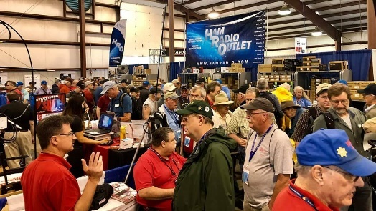[***Upcoming Hamfests***](http://arrl-ohio.org/hamfests.html)

|  |  |
| --- | --- |
| **07/20/2019 | NOARSFEST**  Location: Elyria, OH  Sponsor: Northern Ohio Amateur Radio Society  Website: <http://noars.net/hamfests/noarsfest> | **07/21/2018 | Van Wert Hamfest** Location: Van Wert, OH Sponsor: Van Wert Amateur Radio Club Website: [http://w8fy.org](http://w8fy.org/) |
| **07/28/2019 |**[**Portage Hamfair '19**](http://www.arrl.org/hamfests/portage-hamfair-19)  Location: Ravenna, OH Sponsor: Portage Amateur Radio Club Website: [http://hamfair.com](http://hamfair.com/)  TOP ^ | **08/03/2019 | Columbus, Ohio Hamfest** Location: Grove City, OH Sponsor: Voice of Aladdin Amateur Radio Club Website: [http://www.columbushamfest.com](http://www.columbushamfest.com/) |
| **08/03/2019 | Mound Swap Meet**  Location: Miamisburg, OH  Sponsor: Mound Amateur Radio Association  Website: <https://www.w8dyy.org/> | **08/10/2019 | DX Engineering Hamfest**  Location: Tallmadge, OH  Sponsor: DX Engineering  Website: <https://www.dxengineering.com/> |
| **08/17/2019 | GARS 2019 HamFest**  Location: Germantown , OH Sponsor: Germantown Amateur Radio Society  Website: [http://www.WG8ARS.org](http://www.wg8ars.org/) | **08/18/2019 | Warren Tailgate Swap Meet**  Location: Warren, OH Sponsor: Warren Amateur Radio Association  Website: <http://www.w8vtd.com/2019/05/30/2019-tailgate-swap-meet/> |
| **09/08/2019 | Findlay Hamfest**  Location: Findlay, OH Sponsor: Findlay Radio Club Website: [http://www.findlayradioclub.org](http://www.findlayradioclub.org/) | **09/21/2019 | The OHKYIN ARS Hamfest**  Location: Cincinnati, OH Type: ARRL Hamfest Sponsor: OHKYIN Amateur Radio Society Website: [http://www.ohkyin.org](http://www.ohkyin.org/) |

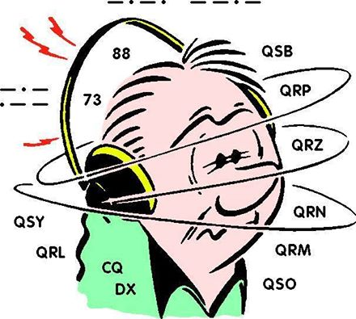***DX This Week***

*(from Bill, AJ8B)*

***DX This Week – Support and Reference #2***

Bill AJ8B ([aj8b@arrl.net](mailto:aj8b@arrl.net), @AJ8B, [www.aj8b.com](http://www.aj8b.com) or [www.swodxa.org](http://www.swodxa.org) )  
 CWOPs Member #1567

So, how is the summer going? Tough conditions for sure. However, FT8 has been active and some DX was found on CW.

I have an update on the article last week regarding great DX websites. I received this from K8ZT, Anthony Luscre: “Please feel free to share my DX Resources page in your future listings of online DX resources- [www.k8zt.com/dx](http://www.k8zt.com/dx)”

I checked it out and it is as complete as any single source that I have used. It is now marked as a favorite in my Brower! Thanks Anthony for that info.

At the Milford Hamfest, a ham approached me at the SWODXA table and asked what was so interesting about DX? He said “There is a guy in our neighborhood that has two large towers with plenty of antenna on each. He runs high power and claims that if he can hear them, he will work them. What is so interesting?” I had to go back to analogy that my Elmer and Dad, K8DWE (SK) used to share. Chasing DX is a lot like fishing. Many days you will catch nothing and other days you will get your fill of bluegill. However, occasionally, independent of the season, weather, time of day, sun, and all the other factors that are used to predict the best times to fish, you will get a big one, or THE big one! That is what makes it interesting. I recalled that discussion last Sunday morning. (July 7th) I needed GB13COL for a clean sweep of the 13 colonies event and I heard him on 40-meter CW early in the morning. He was fading, but I was able to copy his 449 signal.

TOP ^

However, I could not work him! I researched his operating habits for the past week and noticed that GB13COL would be showing up on FT8 for a bit before the band died for the morning. So, I switched modes and power (down from 100 to 45 Watts!) and listened for 40 Meter FT8 stations. I never did hear him or work him, but, I did work the following over the next hour: BD7LNE – China, 5T5PA - Mauritania, VK2AHE – Australia, JA1FJJ – Japan, DU1IST – The Philippines, KH6RDO – Hawaii. I also started a QSO with YC0SAS in Indonesia, but, could not close the QSO for credit. So, stations 8 to 10,000 miles away, but, not England 3,000 miles away.

One of the things about DX that I really enjoy is learning about other countries and the challenges that those hams face. I had a chance to work ZM4T several times during a contest and contacted them. Holger agreed to submit an article for the SWODXA Newsletter. The article below is reprinted from the 3rd edition of Volume 1 of The Exchange. Hope you enjoy it! (Reprinted with permission of SWODXA.)

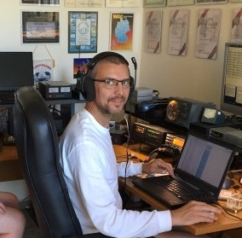***Amateur Radio Challenges from New Zealand***

By Holger Hannemann, ZL2IO/ZL3IO/ZM4T

**New Zealand facts:**

New Zealand is a one of the youngest countries (geologically and by human habitation) located at the end of the world. It consists of two main islands (North & South) and many smaller islands around the costs line.

There are a few outer territories which we will touch on later. The North-South dimensions of the main island are about 1200 miles and there is hardly any point further away from the Ocean than 70 miles.

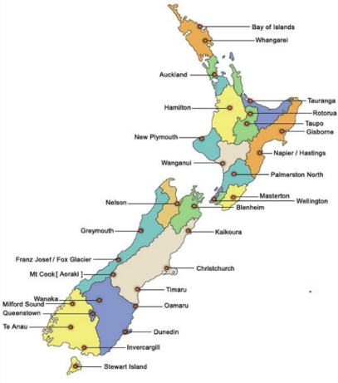About 700 years ago the first Polynesian sailors arrived. At the end of the 18th century started the second settlement wave mainly by British. Today the population is about 4.5 million people strong. The majority has European roots. About 5% are Maori which are the descendants of the early Polynesian arrivals or indigenous people. We still are a country of immigrants. About 25% of the population are first generation immigrants and born outside of New Zealand. Another 60% are here in the second generation. Currently the ethnical Asian population is growing the fastest and Auckland as our biggest city with 1.5 million inhabitants (30% of the NZ population) has already a very Asian touch.

The capital is Wellington at the Southern tip of the North Island with a population of about 300,000. The South Island is very densely populated and has less than 1 million people living here.

Climate ranges from sub-Tropical in the North to sub-Antarctic in the South but typically it’s very mild. Due to the long isolation from any other land, the flora and fauna is very different here. When you wander through fern tree forests hearing the local birds you often feel like transferred millions of years back and expect Dinosaur coming around the next corner. The winters are relatively mild due to the dominant thermal mass of the Ocean. As a result, the native plants are evergreen and don’t lose their leaves in winter. There were also no mammals here. Due to the lack of enemies many local birds could not fly anymore like our national bird the Kiwi.

TOP ^

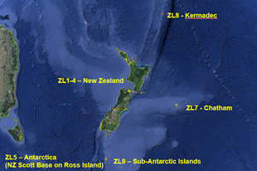New Zealand is not an industrial country and agriculture and tourism are the main sources of income. Th number one industry is dairy farming and so it is no wonder that the world’s number one dairy company is Fonterra, a cooperative of about 11,000 farmers. The products are mainly supplied into Asia with PR China being the biggest market. Even if we could quadruple the output we would not be able to saturate this market.

The number two industry is tourism and third is forestry. Due to the nice climate here, trees like the Pina Radiata grow twice as fast as they do in e.g. California. Otherwise we have strong fruit and meat exports from here.

The government and public services in New Zealand are very stable and one of the most integer ones in the world. We are a promoter of free trade and no country in the world has more free trade agreements than New Zealand. It is also a relatively safe place. Our police typically do not carry guns.

**Amateur radio in New Zealand:**

With a ZL call sign you can be active from five different DXCC entities that can be distinguished by their prefixes. ZL1-4 are stations on the North & South Island plus coastal island groups. In the past we had a territory allocation by the number with ZL1 being the upper North Island, ZL2 the lower North Island, ZL3 the upper South Island and ZL4 the lower South Island but for over 10 years now that is not the case anymore. ZL5 is reserved for activities from Antarctica. NZ has a research base on Ross Island next to the American Amundsen base. ZL7 is Chatham Island, ZL8 is Kermadec & Raoul Islands and ZL9 is for the NZ sub-Antarctic Islands (Auckland, Campbell, Snares). The ZL6 prefix is reserved for activities of our national organization NZART.

We have about 4000 licensed HAMs but only 1700 are organized in the NZART. The average age is well above 65 years and most of the HAMs are only active on UHF/VHF via repeaters or modes like D-Star. The building code is due to living in an earthquake prone environment very strict and antenna towers are restricted to 10-15m (30-45 ft) in most areas. Some districts allow up to 25m/75ft. Even utilities are restricted to 30m/90ft max towers for e.g. transmission lines. Setting up a contest station with 200 ft towers is impossible. With low installed antennas and based on the end of the world DXing is a challenge. The DXing community is very small, probably 100 HAMs or less. The contesting community is even smaller and only about 20 HAMs strong. Can you imagine a local contest down here…? Yes, it takes about ten or fifteen minutes of activity and you worked them all. Therefore, we can work each other again after each hour to get at least few hundred QSO’s into the log during a 24-hour event.

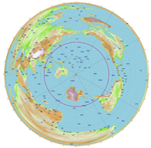In New Zealand a Ham can have a primary and a secondary plus a special (event) call sign. The Kiwi’s are very mobile and work in one corner of the country while they may have their home in different region. The primary and secondary call sign rule is still a relic from the time when we had regional number allocations. When we came to New Zealand we started in Christchurch on the South Island where I got ZL3IO as my primary call. Today we live on the lower East coast of the North Island in Hawke’s Bay and I use ZL2IO which is my secondary call from here for radioing. I also hold the special call ZL4T. That is used for contesting where we can use the ZM prefix à ZM4T. The picture to the left shows the azimuthal map for New Zealand. An additional circle shows the 5600 miles horizon. As you can see there is a lot of water around us but not any of the main radio populations nearby.

Japan/China is the closest one but is still further away from ZL than it is from EU or the US West coast!

TOP ^

Within this horizon we have about 50,000 Hams, probably 50% of them do not speak English (Indonesia). Among those are about 500 DXer and 100 contesters. If you compare this to any US location, you have around 800,000 Hams or more around you with probably 50,000 DXers and 2,000 plus contesters.

If you guys participate in a contest you have tree focus regions for rates. EU, AS or SA. We often can hear you very well and may try to break into your pile up but we a few hops more and come from 90 or 180 degrees into your antennas.

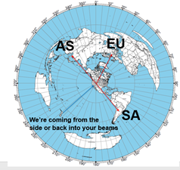

ZL take off Angles

So here we were, located at the end of the world, off the track of the main radio links and limited by building regulations. How to be successful and loud under those circumstances?

When we investigated the material available from the ARRL handbook regarding statistical take off angles (TOA) it became clear that a 30 or 60 ft tower in flat country was not the solution. You have to achieve maximum antenna gain at TOA’s of 1-15 degrees or you only heat the ionosphere. The only option with local antenna height restrictions is to use your terrain or Go hill top!

Once that was clear, we had a specification for the real estate agents. Hill top location, underground main power supply 400V/3~, free visibility to 300-360 degrees (AS/EU-sp), 40-60 (NA), 120-150 (SA, EU-lp) with steep down sloping terrain into those directions, sea views would be a bonus. While those guys did raise their eyebrows and wondered about the spec., we found a spot that was accepted but the girls as well, bought it, installed a few antennas and built a house on it.

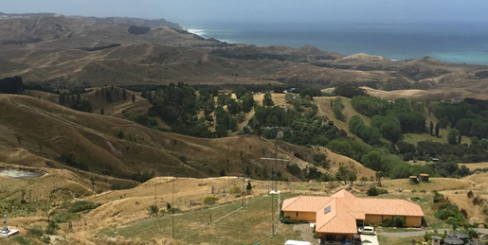The location is about 1000 ft high, the district plans allow towers up to 75 ft. we use 60ft towers with multiple beam antennas available from 40 m upwards. Location and height of antennas are optimized for target direction to achieve lowest possible TOA. Max gain is always achieved below 10 degrees! Antennas are combined via stack matches.

The biggest challenge for our location is wind. New Zealand is the Saudi Arabia of the wind and has the highest average onshore wind speeds of the world. We experience 80-120 mile/hr every month! So there is a learning curve of what antennas survive our windy conditions. Where we live we luckily have no thunderstorms (lightning) or ice but strong winds. We are classified as “extreme wind” location and every structure here needs to be designed and built for 120 miles/hr or more wind speeds. Most commercial beams failed, and the current antennas are all special mechanical designs.

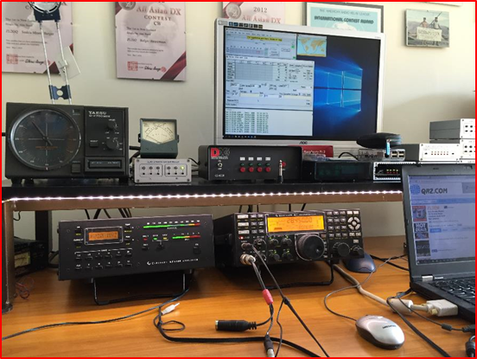The radio shack is very average with K3 transceivers and KPA500 amplifiers. The setup is made for M/S or M/2 operation. The automation is all homemade reading band data and switching low and high-power band-pass filters and antennas plus four stack match units for 40-10m. On 80m we have a 4 square and on 160m a dipole or vertical antenna.

Does it work? It works reasonably okay. We can’t compete with the Caribbean stations but within New Zealand we hold many records and are one of the more competitive contest stations.

TOP ^

+ --------------------------------------------------------------------------------------------------------------------+

Here is an update from Bernie, W3UR, of the DailyDX and the WeeklyDX,

the best source for DX information. (<http://www.dailydx.com/> ) Bernie has this to report:

+ --------------------------------------------------------------------------------------------------------------------+

**PJ7 - St. Maarten -** PJ7PL will be in the CQWW SSB Contest October 26-27, with N2HX operating.  QSL via N2HX, bureau or direct, no LoTW, eQSL or Club Log. He plans to be in the single operator low power category.  He expects to also be on the air the week before and the week after the weekend event, doing SSB, RTTY and FT8 or FT4.  The QTH will be Simpson Bay, inclusive dates October 19 to November 2.  Op Ed will have a K3S, 100 watts to a Buddistick antenna.  This is his 12th trip to St. Maarten and he is already planning his 2020 trip, maybe even two trips next year.  It is a regular vacation trip he and his wife enjoy together.  
  
**GW – Wales -** GB200TT is a special call to celebrate the bicentenary of the Menai Bridge.  The radio operation will be August 10-11.  Eyri DX is organizing the operation.  The Menai Bridge is a suspension bridge carrying traffic between mainland Wales and the island of Anglesey.  
  
**D4 - Cape Verde -** D44TEG by HB9EBT will be on the air July 22-29 from Tarrafal on Sao Tiago Island, AF-005.  He plans to be on 40-10 meter CW with 100 watts from a K3, vertical dipole and SG-239 tuner, hoping for a lot of QSOs. QSL bureau or direct to his home call but, he says, please do not send IRCs; his local post office does not accept them.

**PA - The Netherlands -** PA75OMG September 12-22 will commemorate the "Operation Market Garden" multi-nation army paratrooper operation of the 82nd Airborne landing in the Nijmegen region on September 17, 1944.  The ops have surveyed their site and chosen antennas and how to position them and have gotten all the gear together.  PI4NYM has provided bandpass filters and others have put in gear.  [http://www.pa75omg.NL](http://www.pa75omg.nl/).

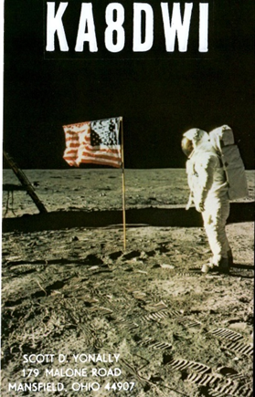***A******RLD027 DX news***

This week's bulletin was made possible with information provided by The Daily DX, The OPDX Bulletin, 425 DX News, DXNL, Contest Corral from QST and the ARRL Contest Calendar and WA7BNM web sites. Thanks to all.

**GEORGIA, 4L.** David, AD0PY/DL7ZM will be QRV as 4L/DL7ZM from July

13 to 21. Activity will be on 6 meters using CW, SSB and FT8. This includes being an entry in the upcoming CQ World Wide VHF contest.

QSL direct to home call.

**EAST MALAYSIA, 9M6.**  Saty, JE1JKL is QRV as 9M6NA from Labuan Island, IOTA OC-133, until July 16. His focus is on 6 meters using FT8. This includes being an entry in the IARU HF World Championship. QSL via LoTW.

**PHILIPPINES, DU.** Chris, OZ1GNN is QRV as DU1/OZ1GNN from Antipolo, Grid Square PK04on, until July 26. QSL via LoTW.

**PALESTINE, E4.** Janusz, SP9FIH is QRV as E44WE from Bethlehem until August 6. Activity is on 80, 30, 20 and 6 meters using SSB, RTTY and FT8. QSL to home call.

TOP ^

**ENGLAND, G.** Members of the Leicester Radio Society are QRV with special call sign GB5EHL until July 28 to commemorate the first Moon landing. Activity is on the HF bands using CW, SSB, RTTY, SSTV, PSK and FT8. QSL via operators' instructions.

**ISLE OF MAN, GD.** Dave, WJ2O is QRV as MD/WJ2O until July 17. This includes being active in the IARU HF World Championship. QSL via N2ZN.

**SOLOMON ISLANDS, H4.** Bernhard, DL2GAC is QRV as H44MS from Malaita Island, IOTA OC-047, until September 25. Activity is on 80 to 6 meters using only SSB. QSL to home call.

**ECUADOR, HC.** Dervin, PD9DX is QRV as HC5BDT until July 18. This includes being an entry in the IARU HF World Championship. QSL via M0URX.

**REPUBLIC OF KOREA, HL.** Special event station D73F is QRV until August 18 during the 18th World Aquatics Championships in Gwangju. QSL via HL4CCM.

**THAILAND, HS.** Look for RAST HQ station E2HQ to be QRV in the IARU HF World Championship. QSL via LoTW. In addition, HS0AC will be activated by Rookie Hams from ITU Zone 49. QSL via HS5NMF. Jack, HS1FVL will be QRV with the R3 Multiplier. QSL to home call.

**ALASKA, KL.** Rick, K6VVA plans to be QRV as K6VVA/KL7 from Endicott Island, IOTA NA-004, from July 16 to 19. Activity will be on 40, 30 and 20 meters using mostly CW with some SSB. QSL via his instructions found on QRZ.com.

**LUXEMBOURG, LX.** Members of the Luxembourg Amateur Radio Union are QRV with special call sign LX50MOON during July to commemorate the first Moon landing. QSL via LoTW.

**MARKET REEF, OJ0.** A group of operators will be QRV as OJ0C from July 13 to 20. QSL via OH3JR.

**DENMARK, OZ.** Carsten, OZ4CG is QRV as OZ4SOP from Bornholm, IOTA EU-030, during July to support the Sea of Peace award. This includes being an entry in the IARU HF World Championship. QSL via LoTW.

**ARUBA, P4.** John, W2GD will be QRV as P44W in the IARU HF World Championship as a Single Op/All Band/High Power CW entry. QSL via LoTW.

**NETHERLANDS, PA.** Special event station PA11APOLLO is QRV until August 2 to commemorate the first Moon landing. QSL via PA1UN.

**CORSICA, TK.** Frans, DJ0TP is QRV as TK/DJ0TP until August 8. Activity is holiday style. QSL to home call.

**AUSTRALIA, VK.** Special event station VI3MOON will be QRV from July

16 to 24 to commemorate the first Moon landing. QSL via bureau.

**BERMUDA, VP9.** Steven, KU9C and Stephen, KL7SB are QRV as home calls/VP9 until July 15. They will be active as VP9HQ in the IARU HF World Championship. QSL KU9C/VP9 and VP9HQ via KU9C and

KL7SB/VP9 via N4GNR.

TOP ^

**GIBRALTAR, ZB.** Members of the Gibraltar Amateur Radio Society are QRV with special event station ZB2IG19 until July 30 during the 18th Gibraltar Island Games 2019. QSL direct to ZB2BU.

**CAYMAN ISLANDS, ZF.** Operators K6GO and NA6MB are QRV as ZF2GO and ZF2NA, respectively, until July 21. Activity is on 160 to 10 meters. They will be QRV as ZF1A as the Cayman Island HQ station in the IARU HF Word Championship. They will also be QRV in the upcoming North American RTTY QSO Party. QSL via operators' instructions.

**NEW ZEALAND, ZL.** Frank, ZL2BR plans to be QRV as ZL6HQ as the New Zealand HQ station in the IARU HF World Championship. Activity will be with CW. QSL via the bureau.

THIS WEEKEND ON THE RADIO. The IARU HF World Championship, QRP 20-Meter CW Fox Hunt, NCCC RTTY Sprint, NCCC CW Sprint, FISTS Summer Unlimited CW Sprint, SKCC Weekend CW Sprintathon and the QRP ARCI Summer Homebrew CW Sprint will certainly keep contesters busy this upcoming weekend.

The 4 States QRP Group Second Sunday Sprint is scheduled for July 15.

The CWops Mini-CWT CW Test and Phone Fray are scheduled for July 17.

The Canadian National Parks on the Air, CNPOTA, operating event runs for the entire year of 2019, with special stations active from Canada's parks and historic sites.

Please see July QST, page 85, and the ARRL and WA7BNM Contest Web Sites for details.

***Special Events***

**07/20/2019 | Honoring the 50th Anniversary of the Apollo 11 Moon Landing**

**Jul 20, 1400Z-2000Z, K8QYL**, Wapakoneta, OH. Reservoir Amateur Radio Association. 14.250 7.250. QSL. Rich Spencer, W8GZ, 05925 Vogel Rd., Saint Marys, OH 45885. From the Neil Armstrong Air and Space Museum

**07/22/2019 | Seneca County Fair**

**Jul 22-Jul 29, 1600Z-0200Z, W8ID**, Tiffin, OH. Seneca Radio Club. 7.225 3.895. QSL. Seneca Radio Club W8ID, P.O. Box 67, Tiffin, OH 44883. W8ID will be celebrating 177 years of the Seneca County Fair! Join us for the cotton candy! Join us for all the fun! We can’t wait! [www.w8id.org](http://www.w8id.org/)

**07/27/2019 | USCGAUX/Sea Scout Safety at Sea Day**

**Jul 27, 1300Z-2000Z, N9E, Lorain, OH. USCGAUX/BSA Sea Scouts. 14.270 14.290 7.180 7.290. QSL.** USCGAUX Radio Officer, Coast Guard Station Lorain, 110 Alabama Ave, Lorain, OH 44052.

**08/01/2019 | W8LKY Carnation Festival Special Event**

**08/01-11/2019, 0000Z-2359Z, W8LKY**, Alliance, OH. Alliance Amateur Radio Club. 14.240 14.045 7.240 7.045. Certificate & QSL. Alliance Amateur Radio Club, P.O. Box 3344, Alliance, OH 44601. The Alliance ARC(W8LKY) will be on the air at various times throughout our Carnation festival festivities. We'll be on the air from various locations in the Carnation city. We may pop up on the bands at any time. Check the spotting networks, and our web page for upcoming activations. [www.w8lky.org](http://www.w8lky.org/)

TOP ^

**08/15/2019 | D-Day Conneaut**

**Aug 15-Aug 18, 1600Z-0400Z, W8D**, Conneaut, OH. Conneaut Amateur Radio Club. 14.285 7.190 3.996 3.885. QSL. Garret Scott W8D, 10236 Birch Hill Ln., Knoxville, TN 37932. D-Day Conneaut recognizes the 75th anniversary of the World War II Allied D-Day Landings on the beaches of France in 1944. Event will include the country's largest reenactment of the D-Day landings with more than 1,800 WWII reenactors from around the world participating. Radio operations will include vintage WWII equipment <https://www.facebook.com/W8BHZ>

**08/17/2019 | Port Clinton Lighthouse Festival**

**Aug 17, 1500Z-2100Z, W8GNM/8**, Port Clinton, OH. Port Clinton Lighthouse Conservancy. 14.335 14.285 7.230 7.200. QSL. Geoff Mendenhall, 4720 E. Terrace Cir, Port Clinton, OH 43452. Lighthouse activation in conjunction with International Lighthouse and Lightship Day. Check web cluster for operating frequencies. QSL via LoTW only to W8GNM/8 [portclintonlighthouse.org](http://portclintonlighthouse.org/)

**08/17/2019 | WA8Q 30th Anniversary Celebration**

**Aug 17-Aug 18, 1600Z-0359Z, N8OWS**, Independence, OH. Woodchuck Amateur Radio Club. 14.250 7.180 3.825. Certificate & QSL. Woodchuck ARC, 965 Primrose Drive, Independence, OH 44131. [www.woodchuckarc.com](http://www.woodchuckarc.com/)

**08/24/2019 | Ohio Statewide Courthouses On The Air**

**Aug 24, 0900Z-1600Z, various**, statewide, OH. Ohio Section. all bands, all modes. QSL. QSL to, amateur , contacted. Ohio QSO Party is also on this date. [wb8yks@arrl.net](mailto:wb8yks@arrl.net)

***Need Your Field Day Pictures***

Now that Field Day is over and you’ve had a good night’s sleep, don’t forget to send me those great pictures of your Field Day! These pictures will be added into the Field Day gallery and some of them may even find their way to the next Ohio Section Banner as well.

***Please send your Field Day pictures to me for publication on the Ohio Section website!! Send them to:*** [n8sy@n8sy.com](mailto:n8sy@n8sy.com) and to view what I have received go to: <http://arrl-ohio.org/fd-19/>

**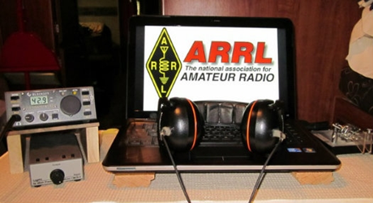*ARRL Contest Corner***

An expanded, downloadable version of *QST'*s [Contest Corral](http://www.arrl.org/contest-calendar) is available as a PDF. Check the sponsor's Web site for information on operating time restrictions and other instructions.

TOP ^

***One Question Questionnaire***

Hey Gang,

It seems that 71% of you do have lighting protection on your antennas. That’s fantastic.

I’ve got another NEW – one question – questionnaire on the Ohio Section Website! Go to: <http://arrlohio.org>

This past weekend I put up a ½ wave dipole for 75-meters. It’s the first time that I’ve had a ½ wave dipole up in over 16 years, and boy, what a difference it has made. I now can hear things that I haven’t heard in quite a few years. So, with that on my mind, the question for this next week is:

**“Do you have a ½ wave dipole up and operational at your home??”**

These One Question questionnaires are all in fun and I hope that you are enjoying answering them.

You’ll find the “One Question” questionnaire on the Ohio Section Website! <http://arrlohio.org> It’s all in fun and it’s not a scientific survey in any way, but we are learning some things that we didn’t know from these questions. I hope that you are enjoying answering these “One Question” questionnaires.

*****V.E. Test Sessions***

For the latest testing site information please **>>** [**Click Here**](http://www.arrl.org/find-an-amateur-radio-license-exam-session) **<<** The ARRL site tracks all of the VE testing sites that register with them, including W5YI and Laurel. ARRL gives you a number of different ways of sorting to find that site that is closest to you as well.

***ARES Connect***

It seems as though the name "ARES Connect" is getting folks confused about who all should be using this system. Maybe we should just call it **“Ham Radio Connect”** or how’s about just plain **“Connect”** instead! Whatcha’ think? Would you think the system was for everyone then?

This system is new to everyone and it seems that the moniker ARES that got hung on this new system is keeping a lot of folks from using it. Let’s clear the air on that right now. It’s not just for ARES events. I'm here to tell you that it's to be used for ANY event that involves Amateur Radio. It can be a RACES, CERT, Skywarn, Red Cross or just a few hams gathered at a table to talk about Amateur Radio. It all counts!

TOP ^

Club meetings, hamfests, working on that club trailer, repeater, website, field day, parades, newsletter or just having fun keeping track of all those spandex folks during every kind of race imaginable are perfect examples of hours that count that are not necessarily ARES directly related but do have an impact on your community. Any Amateur Radio related activity should be an event in ARES Connect and your hours recorded. Why? These hours will help demonstrate to the FCC and all of our government officials (local, state and federal), as well as all of our served agencies our willingness to volunteer and help our fellow citizens. These are not just hours; they are dollars that are given back to our communities, and we want our government officials to know just how much we give back to help keep the frequencies that we have, as well as future frequencies that may be available later. Showing them in dollars how much we give back is what keeps their attention and helps preserve our current frequencies.

Just because the name of this system has ARES in it, doesn't mean that we only record ARES events. If it involves Amateur Radio **IN ANY WAY** then it needs to have an event established and hours recorded for it.

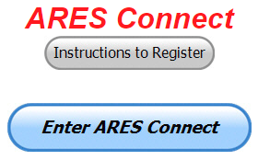Here’s the really great news about this system. It’s never too late to get those valuable hours recorded, even if the event has already passed. The Admins of this system can setup events anytime and add you and your hours to those events.

Yes, I agree, the name of this system may not necessarily fit what it’s all about, but HEY… what’s in a name anyway!!! Now, are you registered in the system yet? We need to make sure that no one is left behind, and we know that not everyone is entered into the system yet.

If you live in **Ohio** and you haven’t registered yet, we need you to get registered now. We need you to only use this URL to get registered [**https://arrl.volunteerhub.com/lp/oh/**](https://arrl.volunteerhub.com/lp/oh/). Using any other entrance to register will only slow down your registration process. Again, this is for those living in Ohio only. If you are an out of state person (not Ohio), you can simply change the **/oh/** to your 2-letter state designation. This will put you in the correct state for signing up

Your time adds up quickly. Make sure that all that fun and dedication counts. Get your hours logged now! We logged over 14,750 hours last month! No, that’s not our all-time record high, we did that in 2017 with over 15,000 logged, but it does come in second best and that’s absolutely incredible since this is only the second month of using ARES Connect exclusively for our monthly reports!!

***Here’s the top 10 hours earners so far for July:***

|  |  |  |  |
| --- | --- | --- | --- |
|  | **Name** | **Events** | **Hours** |
| 1 | Bret Stemen (KD8SCL) | 21 | 70.50 |
| 2 | Dan Stahl (KC8PBU) | 16 | 34.65 |
| 3 | Timothy Gray (KD8IZU) | 6 | 30.75 |
| 4 | Alan Rothweiler (N8CJ) | 12 | 29.00 |
| 5 | Christopher Domenick (KC8CAD) | 3 | 20.00 |
| 6 | Steven Ashenfelter (N8XSF) | 3 | 19.00 |
| 7 | Robert Northrup (Kc8psw) | 9 | 18.50 |
| 8 | Richard King (KE8IJV) | 3 | 16.50 |
| 9 | John Malarky (KE8IWZ) | 15 | 16.25 |
| 10 | Michael Lacumsky (w8mal) | 7 | 15.15 |

TOP ^

With this new reporting system, we can get real time information that shows how many hours, who volunteered and what did they volunteer for. There’s a ton of information that we can draw out of the system.

We now have **1155** registered and growing every day in the system. What’s really interesting is as of this same date there are 9**,099** registered in the entire country. This means that the Ohio Section makes up over 12.69% of those registered.

We have a set of instructions on how to get registered right above the button to enter ARES Connect. I would strongly suggest that if you haven’t registered yet, that you read these instructions first.

Here’s a link to get you started... <http://arrl-ohio.org/ares_connect_directions.pdf> Please, don’t just hurry through the questions, read them carefully, if you don’t understand something, please ask me, I’m here to answer your questions.

We know that you mean well by answering that you do have the needed courses in, but I will let you know that we are verifying what you say you have with what is showing for you in our statewide database when we are completing your registration. So, how can you find out if you are already listed in our statewide database? Easy, here’s a link: <http://arrl-ohio.org/SEC/special/ICS%20Complete%20by%20County%20and%20Name.pdf>

As you can see by the numbers above, we are now at the point where we will all need to be registered in this system for our hours to count. We will no longer need to depend on our EC’s and DEC’s to remember our hours of volunteering and report those hours for us on their monthly reports.

The EC and DEC monthly numbers are no longer necessary, we will maintain a monthly reporting system for EC/DEC’s, but it will only be for them to submit a narrative only for the month!

The time that was spent in getting your information and making sure it is up-to-date and on file with the EC, as well as transferring all of those records when a new EC takes over is no longer be needed. This system takes care of all of that automatically.

Now, it has a lot of benefit for you too... Forget a meeting time or location? Just look it up on the calendar and there you have it. If set, you can even see the location on a map! I have attended many meetings and gatherings just because it was listed on ARES Connect and I found it just browsing around. I wouldn’t have known about it if it hadn’t been on the ARES Connect Calendar!

Why is this so important? These hours are what is shown to those we go to for funding as well as for more frequencies to operate on. Yes, we have to justify why we need the money or frequencies to those in government that want “just the facts.” This system allows us to show them the facts, anytime and with great accuracy.

***Incident Command System (ICS) Training Schedule***

All current trainings are listed on the Ohio EMA training calendar located at:

<https://webeoctraining.dps.ohio.gov/TrainingAndExercise/courselist.aspx>

I’ve been asked to also include a link to the Kentucky EMA training calendar as well..

<https://kyem.ky.gov/training/Pages/default.aspx>

<https://sites.google.com/site/ccoemtraining/home>

TOP ^

Please pay particular attention to these courses listed above, as that there’s a lot of ICS 300 & 400 classes listed that are very useful for all Amateurs to have under their belts. I will also state that G775 is also a very good course to take as well. These 3 courses are multiple day in class courses, so please be prepared to spend some time taking them.

We do recognize that IS-300/400 requires multiple days of actual classroom training that is not easily obtained. So, if you just can't find the time to fit these classroom courses in, we do have an alternative method for getting you to Level 3.

Completing the following **“FREE”** and **“ONLINE”** courses will act as substitute for you FEMA Leadership Development Course requirements. You absolutely will need to complete all **7** of these courses to get your ICS 300/400 credit.  Here are the courses that you need to take:  **IS-120, 230, 240, 241, 242, 244 & 288.**

***Now, if you are looking for wallpaper and have a little extra time, taking IS-235 in addition to the 7 listed courses above, you will get a really cool looking certificate from FEMA stating that you have completed the Professional Development Series. That’s impressive in itself!***

***This and That’s***

***World Scout Jamboree coming to southern West Virginia***

The 10,600-acre Boy Scouts camp near Beckley, West Virginia will mark the first world jamboree held in the United States in more than 40 years. The Boy Scouts of America camp has been selected to host the 2019 World Scout Jamboree starting on July 22nd and running through August 2nd.  
  
The conference comprises 160 national scouting associations representing 220 countries and territories. Each association is able to send Scouts to represent their country at a world jamboree every four years.   
  
At the West Virginia event, attendees for the first time will be able to participate in whitewater rafting, rock climbing and mountain biking, said James Turley, the Scouts' international commissioner.  
  
"We are very pleased that the conference saw the wealth of new and exciting activities that will be available at this site and will make it available to young people in the program," Turley said.  
  
Aimed at 14- to 17-year-olds, it will mark the first world jamboree held in the United States in more than 40 years. "That's going to be great for the state of West Virginia and the entire Appalachian region," said Dale D. Musgrave, an executive with a Parkersburg-based Scouts council.  
  
Scouting organizations from Canada and Mexico will share hosting duties for the world jamboree with their U.S. counterpart.

**#########**

TOP ^

***104-year-old radio ham who helped put humans on the moon***

*(from the Tennessean – submitted by* *Greg, WD9FTZ )*

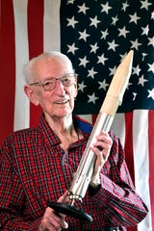The Tennessean reports on the contribution of scientist and radio amateur J. Cary Nettles, W5SRR, of Columbia, Tenn., to the US space program. Cary celebrated his 104th birthday on July 8

In the 1950s, Nettles ran the country’s largest supersonic wind tunnel in Ohio at the now [NASA Glenn Research Center](https://www.nasa.gov/centers/glenn/about/fs05grc.html) in Cleveland, where they tested what happens with jets and rockets going ridiculously high speeds tumbling through space or shooting through the sky.

Then-President John F. Kennedy announced in 1961 the U.S. would be the first to land astronauts on the moon, but several test rockets blew up on the launch pad or exploded shortly after liftoff.

Nettles and his team came up with the solution — put an exhaust pipe on the bottom of the rocket like the ones on the back of cars.

After the rockets were launched, hot exhaust was turning back into the rocket and destroying them.

“So we put a stove pipe on it,” Nettles said, smiling and pointing to a small piece at the bottom of a model rocket in his house.

“Since I put the correction adaptation on the Atlas rocket, it has not failed from that source anymore,” he said, nodding his head once emphatically.

The fix helped the U.S. beat the Soviets in the race to putting astronauts on the moon. Buzz Aldrin and Neil Armstrong took those steps off Apollo 11 on July 20, 1969.

“My life today? I live alone, make meals, do laundry, some ham radio, watch some TV programs, follow the Braves baseball team mainly,” he said. “I use up time.”  
  
Nettles, believed to be the nation’s oldest living rocket scientist, helped save the U.S. space program that put humans on the moon 50 years ago.

Cary was licensed 74 years ago in 1945 and is currently active on the 40m, 2m and 70cm bands.

***Welcome New Subscribers***

Dakota, KC3FHZ; Jared, KC3AKS; Shawn, KD0DMJ; John, AI3I; Richard, W8KU; Shaun, KE8MOX;

#########

TOP ^

***Final.. Final..***

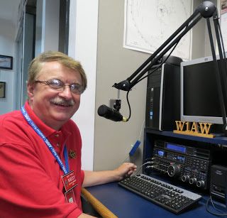

Hey Gang...

Wow.. This past week has been a blast. I got to visit with many of you at your club meetings and one very special planning meeting for the Great Lakes Division Hamfest that’s coming up next March 14th & 15th!! Yes, it’s going to be a 2-day affair. And for those who missed out at Dayton this year, we are planning on having a Wouff Hong as well. . It will be in conjunction with the TMRA Hamfest, so it’s gonna’ be a really big show..!!

As you know I had the trees trimmed around the house a few weeks back and with that I finally found the time to get a ½ wave 75-meter dipole up this past weekend. It works so much better than that old folded dipole ever did. I’m still in awe over how much better this antenna sounds over the old one. Now some of you had made the comment to me don’t bother with a dipole, put up a tower and beam. I do have to tell ya’, I love the adventure of making my own antennas and then working folks around the world on them. That’s what Amateur Radio is all about!!

Sliding down the band a bit… Have you taken the time to get signed up in “Connect” yet? I know that this must sound like a broken record, but it is important for everyone to not only get signed up but start using as well. Please, don’t let the name ARES fool you, this new system is for everyone and not just for ARES. So, if you haven’t already signed up, now is the time. I know that this must sound like a broken record to most of you, but you won’t believe how many folks I meet every week that still tells me they haven’t heard of it yet.

Here in the Ohio Section we only require our Level 2 volunteers to have the 4 basic courses, IS 100, 200, 700 & 800. For our Level 3 volunteers we do require the additional ICS 300 / 400, or the equivalent professional series courses IS 120, 230, 240, 241, 242, 244 & 288. These equivalent courses are all on-line classes just like your basic 4 NIMS courses are and being offered as an alternative way for you to get credit for taking the professional series courses in the event you just cannot get scheduled into an ICS 300/400 class. By the way, if you decide to take these 7 on-line courses and complete them all, you will want to take just one more class **IS-235.** By completing this additional course, you will get a really great looking certificate from FEMA recognizing that you have completed the entire Professional Series courses. I do hope that this clears up the confusion that has been going around lately. As we have stated on the website and in this newsletter many times “We want no one left behind.”

Yes, the Ohio Section is extremely lucky to have the relationships that we do with Law Enforcement, EMA, fire and other government agencies, that’s why we’ve partnered with EMAO, OP3 and Ohio VOAD to show our support for them and our Ohio citizens.

Moving up the band a bit… Newsletter Editors… are you ready for the results of the 2019 ARRL Ohio Section Newsletter Contest! John, KD8IDJ sat down with his judges recently and they’ve selected the best of the best, but you won’t find out who won until it is announced by John at the Columbus Hamfest. Yes, John will be announcing the winners on August 3rd at the Columbus Hamfest.

TOP ^

Oh, I do want to mention this now as well, the winner of the Newsletter Contest this year will go on to the Divisional Contest held at the Great Lakes Division Convention in March. Which newsletter do you think won?

Now, I haven’t really mentioned it yet this year, but I do have another recipient of the Allan Severson, AB8P award chosen and that person’s name will be announced on August 3rd at the hamfest as well.

Moving down the band one last time… We did have another change to the website this past week. Greg, WD9FTZ updated the DMR Net Listing again. Wow, we have some of the best folks keeping up with what all is going on with DMR.

Is your club doing any special activities that you’d like the Section to know about? Do you have a story that you’d like to tell about something that you or your club has or is doing? Let me know about it and let’s get it in the next edition!

Finally, for those interested, the Board of Directors of the ARRL will be meeting this week (July 19 & 20). There’s lots of items on the agenda for them to discuss and I’m sure we’ll be hearing back from Dale and Tom about some of those items.

Whelp… That’s going to do it for this time around. Stay safe, enjoy the sunshine while we have it, and most of all… have FUN!!

73,

***Scott, N8SY***

***Murphy’s Laws***

* The clock in the instructor's room will be wrong.
* Disaster will occur when visitors are in the room.
* A subject interesting to the teacher will bore students.
* The time a teacher takes in explaining is inversely proportional to the information retained by students.
* A meeting's length will be directly proportional to the boredom the speaker produces.
* Students who are doing better are credited with working harder. If children start to do poorly, the teacher will be blamed.
* The problem child will be a school board member's son.
* When the instructor is late, he will meet the principal in the hall.

TOP ^

***Apollo 11 Mission Overview***

***[](https://www.nasa.gov/sites/default/files/thumbnails/image/s69-34875_0.jpg)"The Eagle has landed…"***

Many of you reading this article weren’t even born when this took place. As one that watched it all I can tell you this. It was THE most exciting night that you could ever imagine, and a time when all of us here in the U.S. were so proud to be an American.

**Mission Objective**The primary objective of Apollo 11 was to complete a national goal set by President John F. Kennedy on May 25, 1961: perform a crewed lunar landing and return to Earth.

Additional flight objectives included scientific exploration by the lunar module, or LM, crew; deployment of a television camera to transmit signals to Earth; and deployment of a solar wind composition experiment, seismic experiment package and a Laser Ranging Retroreflector. During the exploration, the two astronauts were to gather samples of lunar-surface materials for return to Earth. They also were to extensively photograph the lunar terrain, the deployed scientific equipment, the LM spacecraft, and each other, both with still and motion picture cameras. This was to be the last Apollo mission to fly a "free-return" trajectory, which would enable a return to Earth with no engine firing, providing a ready abort of the mission at any time prior to lunar orbit insertion.

**Mission Highlights**

Apollo 11 launched from Cape Kennedy on July 16, 1969, carrying Commander Neil Armstrong, Command Module Pilot Michael Collins and Lunar Module Pilot Edwin "Buzz" Aldrin into an initial Earth-orbit of 114 by 116 miles. An estimated 650 million people watched Armstrong's televised image and heard his voice describe the event as he took "...one small step for a man, one giant leap for mankind" on July 20, 1969.

Two hours, 44 minutes and one-and-a-half revolutions after launch, the S-IVB stage reignited for a second burn of five minutes, 48 seconds, placing Apollo 11 into a translunar orbit. The command and service module, or CSM, Columbia separated from the stage, which included the spacecraft-lunar module adapter, or SLA, containing the lunar module, or LM, Eagle. After transposition and jettisoning of the SLA panels on the S-IVB stage, the CSM docked with the LM. The S-IVB stage separated and injected into heliocentric orbit four hours, 40 minutes into the flight.

The first color TV transmission to Earth from Apollo 11 occurred during the translunar coast of the CSM/LM. Later, on July 17, a three-second burn of the SPS was made to perform the second of four scheduled midcourse corrections programmed for the flight. The launch had been so successful that the other three were not needed.

On July 18, Armstrong and Aldrin put on their spacesuits and climbed through the docking tunnel from Columbia to Eagle to check out the LM, and to make the second TV transmission.

On July 19, after Apollo 11 had flown behind the moon out of contact with Earth, came the first lunar orbit insertion maneuver. At about 75 hours, 50 minutes into the flight, a retrograde firing of the SPS for 357.5 seconds placed the spacecraft into an initial, elliptical-lunar orbit of 69 by 190 miles. Later, a second burn of the SPS for 17 seconds placed the docked vehicles into a lunar orbit of 62 by 70.5 miles, which was calculated to change the orbit of the CSM piloted by Collins.

TOP ^

The change happened because of lunar-gravity perturbations to the nominal 69 miles required for subsequent LM rendezvous and docking after completion of the lunar landing. Before this second SPS firing, another TV transmission was made, this time from the surface of the moon.

On July 20, Armstrong and Aldrin entered the LM again, made a final check, and at 100 hours, 12 minutes into the flight, the Eagle undocked and separated from Columbia for visual inspection. At 101 hours, 36 minutes, when the LM was behind the moon on its 13th orbit, the LM descent engine fired for 30 seconds to provide retrograde thrust and commence descent orbit insertion, changing to an orbit of 9 by 67 miles, on a trajectory that was virtually identical to that flown by Apollo 10. At 102 hours, 33 minutes, after Columbia and Eagle had reappeared from behind the moon and when the LM was about 300 miles uprange, powered descent initiation was performed with the descent engine firing for 756.3 seconds. After eight minutes, the LM was at "high gate" about 26,000 feet above the surface and about five miles from the landing site.

The descent engine continued to provide braking thrust until about 102 hours, 45 minutes into the mission. Partially piloted manually by Armstrong, the Eagle landed in the Sea of Tranquility in Site 2 at 0 degrees, 41 minutes, 15 seconds north latitude and 23 degrees, 26 minutes east longitude. This was about four miles downrange from the predicted touchdown point and occurred almost one-and-a-half minutes earlier than scheduled. It included a powered descent that ran a mere nominal 40 seconds longer than preflight planning due to translation maneuvers to avoid a crater during the final phase of landing. Attached to the descent stage was a commemorative plaque signed by President Richard M. Nixon and the three astronauts.

The flight plan called for the first EVA to begin after a four-hour rest period, but it was advanced to begin as soon as possible. Nonetheless, it was almost four hours later that Armstrong emerged from the Eagle and deployed the TV camera for the transmission of the event to Earth. At about 109 hours, 42 minutes after launch, Armstrong stepped onto the moon. About 20 minutes later, Aldrin followed him. The camera was then positioned on a tripod about 30 feet from the LM. Half an hour later, President Nixon spoke by telephone link with the astronauts.

Commemorative medallions bearing the names of the three Apollo 1 astronauts who lost their lives in a launch pad fire, and two cosmonauts who also died in accidents, were left on the moon's surface. A one-and-a-half inch silicon disk, containing micro miniaturized goodwill messages from 73 countries, and the names of congressional and NASA leaders, also stayed behind.

During the EVA, in which they both ranged up to 300 feet from the Eagle, Aldrin deployed the Early Apollo Scientific Experiments Package, or EASEP, experiments, and Armstrong and Aldrin gathered and verbally reported on the lunar surface samples. After Aldrin had spent one hour, 33 minutes on the surface, he re-entered the LM, followed 41 minutes later by Armstrong. The entire EVA phase lasted more than two-and-a-half hours, ending at 111 hours, 39 minutes into the mission.

Armstrong and Aldrin spent 21 hours, 36 minutes on the moon's surface. After a rest period that included seven hours of sleep, the ascent stage engine fired at 124 hours, 22 minutes. It was shut down 435 seconds later when the Eagle reached an initial orbit of 11 by 55 miles above the moon, and when Columbia was on its 25th revolution. As the ascent stage reached apolune at 125 hours, 19 minutes, the reaction control system, or RCS, fired so as to nearly circularize the Eagle orbit at about 56 miles, some 13 miles below and slightly behind Columbia. Subsequent firings of the LM RCS changed the orbit to 57 by 72 miles. Docking with Columbia occurred on the CSM's 27th revolution at 128 hours, three minutes into the mission. Armstrong and Aldrin returned to the CSM with Collins. Four hours later, the LM jettisoned and remained in lunar orbit.

TOP ^

Trans-Earth injection of the CSM began July 21 as the SPS fired for two-and-a-half minutes when Columbia was behind the moon in its 59th hour of lunar orbit. Following this, the astronauts slept for about 10 hours. An 11.2 second firing of the SPS accomplished the only midcourse correction required on the return flight. The correction was made July 22 at about 150 hours, 30 minutes into the mission. Two more television transmissions were made during the trans-Earth coast.

Re-entry procedures were initiated July 24, 44 hours after leaving lunar orbit. The SM separated from the CM, which was re-oriented to a heat-shield-forward position. Parachute deployment occurred at 195 hours, 13 minutes. After a flight of 195 hours, 18 minutes, 35 seconds - about 36 minutes longer than planned - Apollo 11 splashed down in the Pacific Ocean, 13 miles from the recovery ship USS Hornet. Because of bad weather in the target area, the landing point was changed by about 250 miles. Apollo 11 landed 13 degrees, 19 minutes north latitude and 169 degrees, nine minutes west longitude July 24, 1969.

**Crew**Neil Armstrong, Commander  
Edwin E. Aldrin Jr., Lunar Module Pilot  
Michael Collins, Command Module Pilot

**Backup Crew**James A. Lovell, Commander  
Fred W. Haise Jr., Lunar Module Pilot  
William A. Anders, Command Module Pilot

**Payload**Columbia (CSM-107)  
Eagle (LM-5)

**Launch**July 16, 1969; 9:32 a.m. EDT  
Launch Pad 39A  
Saturn-V AS-506  
High Bay 1  
Mobile Launcher Platform-1  
Firing Room 1

**Orbit**Altitude: 118.65 miles  
Inclination: 32.521 degrees  
Orbits: 30 revolutions  
Duration: eight days, three hours, 18 min, 35 seconds  
Distance: 953,054 miles  
Lunar Location: Sea of Tranquility  
Lunar Coordinates: .71 degrees north, 23.63 degrees east

**Landing**July 24, 1969; 12:50 p.m. EDT  
Pacific Ocean  
Recovery Ship: USS Hornet

TOP ^

***Back Issues of the PostScript and Ohio Section Journal (OSJ)***

Hey, did you know that PostScript and Ohio Section Journal (OSJ) are archived on the website? You can go back and look at any edition simply by clicking:

<http://arrl-ohio.org/news/index.html>

***Chit – Chat, and All That!***

Do you know someone that’s not getting these Newsletters? Please, forward a copy of this Newsletter over to them and have them “[Opt-In](http://arrl-ohio.org/forwarder/forwarding.html)” to start receiving them. Heck, just have them send me an email [n8sy@n8sy.com](mailto:n8sy@n8sy.com) and I’ll get them added to the Ohio Section Emailing list.

We now have many thousands of readers receiving these newsletters weekly. Quite impressive, I’d say! I urge all of you to make sure that everyone, regardless of whether they are a League member or not, get signed up to receive these weekly Newsletters.

You can always “[Opt-Out](http://arrl-ohio.org/forwarder/forwarding.html)” at any time if you feel this is not what you were expecting. It’s fun and very informative. All of your favorite past newsletters are now archived too.

You can go back at any time and read them. Just go to: <http://arrl-ohio.org/news/>

Got questions, concerns or would just like to sit and chat awhile? Heck, I’ll even buy the coffee!! Give me a call at (419) 512-4445 or email me at: [n8sy@n8sy.com](mailto:n8sy@n8sy.com)

The pictures on the front page are from various newsletters, Facebook posts and/or were sent directly to me in recent weeks. Take a good look at them, you just might be in one of the pictures! “SMILE… you’re on the Ohio Section News!!”

TOP ^

*PostScript is produced as a weekly newsletter. I want to thank everyone that has contributed articles and ideas to make this an even better news source. I sincerely hope that you have enjoyed this edition and will encourage your friends to join with you in receiving the latest news and information about the Ohio Section, and news and events happening around the world!*